

Executive Summary 3

Part 1: An overview of the EU financing system 5

1. Key facts about Own Resources 5

1.1. The EU budget has remained stable over the past two decades... 5

1.2. … but the structure of the revenue side has changed over time and is dominated by the Gross National Income–based contribution 6

1.3. The system has proved successful in providing the EU with stable revenues, but has been difficult to reform 8

1.4. The system of rebates and corrections has become complex over time 10

2. Recent contributions about the reform of the Own Resources System 11

2.1. Report of the High Level Group on Own Resources 11

2.2. The Commission Reflection Paper on the future of EU finances 12

2.3. The Multiannual Financial Framework communication as a contribution to the Leader's discussion 12

3. Financing the EU budget in a globalising context 13

3.1. The revenue side could contribute to addressing the budgetary gap 13

3.2. Economic developments challenge the national taxation and statistical systems 13

3.3. Rethinking efficiency and equity between the EU and Member States 14

4. Summary 15

Part 2: Reforming the EU budget revenue 16

1. Assessing the existing Own Resources: the need to modernise 16

1.1. Traditional Own Resources (customs duties) 16

1.2. Gross National Income-based Own Resource 18

1.3. Simplifying Member States' contributions: reform of the Value Added Tax-based Own Resource 19

1.3.1. Rationale 19

1.3.2. Objective of the reform 20

1.3.3. How to reform the Value Added Tax -based Own Resource? 21

1.3.4. Quantification 22

2. Proposing a basket of new Own Resources linked to EU policies 23

2.1. Common Consolidated Corporate Tax Base 23

2.1.1. Rationale 23

2.1.2. How would it work? 23

2.1.3. Estimated revenues 24

2.2. Own Resource based on the Auctioning revenue from the EU Emissions Trading System 24

2.2.1. Rationale 24

2.2.1. How would it work? 25

2.2.2. Estimated revenues 26

2.3. Own Resource contribution based on Plastic Packaging Waste 26

2.3.1. Rationale 26

2.3.2. How would it work? 27

2.3.3. Estimated revenues 28

3. Making better use of ‘Other Revenues’ 28

3.1. Other revenues: a wide range of sources of revenues 28

3.2. Mapping other future revenues 30

4. Phasing out Corrections 32

5. Summary 33

Part 3: A Basket of Own Resources: Building on Complementarities to Enhance Fiscal Coherence, Resilience and Fairness 34

1. Timing and phasing in of new Own Resources 34

2. Complementarities with national budgets: increased fiscal coherence on the revenue side 36

2.1. Complementarities between EU and national level: Structure of the budget 36

2.2. Complementarities between the EU and the national level: the cyclicality of the basket of Own Resources 39

3. The in-built burden-sharing mechanism of EU financing 40

4. Reporting EU contributions in national budgets: Heterogeneity across Member States 42

5. Summary 44

# Executive Summary

This staff working document accompanies the Commission proposal for a new Own Resources Decision and substantiates the key novelties therein. It takes stock of the reform debate and provides background information especially as regards the new Own Resources proposed.

Part I recapitulates the evolution of the EU budget's revenue side. The EU financing system based on the Own Resources Decision has in essence remained stable over time and has provided reliable sources of revenue to the EU budget. However, the composition of Own Resources has evolved to rely increasingly on national contributions alongside which a system of rebates and corrections emerged, making the overall system complex and difficult to explain to non-experts. Moreover, only customs duties currently display a clear link to EU policies and competences. The EU added value requirement has not been applied systematically to the Own Resources system. There have been repeated calls for a better articulation of the EU's political priorities, its key policy objectives and the system of financing the EU budget.

Since 1988, when the Commission launched the Single Market project and then enlarged to new countries, no new Own Resources have been introduced. The new Own Resource agreed upon at that time – based on Gross National Product – aimed to ensure financial autonomy and to balance an expenditure-driven budget. Since then, the reforms proposed have failed for various reasons, amongst which the perceived merits of a simple and stable system. During the economic and financial crisis, the proposals on new Own Resources – Value Added Tax and the Financial Transaction Tax – did not reach consensus between Member States.

The case for a reform of the EU financing system is compelling; a momentum exists as a consequence of the United Kingdom's withdrawal and the discontinuation of the correction for the United Kingdom. In addition, economic developments are challenging national fiscal authorities, as rising intangible assets and further digitalisation have highlighted the inadequacy of current national tax frameworks, while large multinational companies which greatly benefit from the Single Market exploit the different national tax regimes to minimise their tax liabilities. Climate change and global pollution consequences cannot be seen in isolation either and can only be properly addressed at EU level. Viable alternative, or supplementary, revenue sources with a manifest link to EU policies have been identified.

Part II analyses how the revenue side of the EU budget can be reformed. The reform would build on the existing system, but aim to make it more flexible and responsive to national developments, while increasing the mutual absorption of shocks within the strict framework of budgetary discipline. First, the traditional Own Resources (mainly customs duties) would be maintained, but collection costs would be decreased to 10%. Second, Gross National Income-based contributions would be maintained as a balancing resource, but its overall share would be decreased. Third, the current system of the Value Added Tax-based Own Resource would be reformed and simplified. Fourth, several new Own Resources would be proposed, based on: (i) the Common Consolidated Corporate Tax Base; (ii) the national revenue stemming from the auctioning in the framework of the European Emissions Trading System; and (iii) a national contribution calculated on the basis of the weight of plastic packaging waste that is not recycled. Finally, there would be some leeway to make better use of 'other revenues' accruing to the EU budget, like the fees arising from the European Travel Information and Authorisation System.

Part III analyses the merits of introducing a basket of Own Resources for the EU budget. The new basket of Own Resources would provide a better link to key EU policies (climate change, environmental policy, internal market). It would also provide some fresh money to the EU budget. While most of the proposed new revenue sources would not create entirely new public revenue streams, they are clearly linked to the EU level and thus reflect directly or indirectly the added value of EU policies. The diversification of revenue sources would also result in making the Own Resources system more resilient. Furthermore, the increasing of the cyclicality of the EU budget's revenue side would strengthen the alignment with the relative economic performance of the Member States. As such, the role of the Gross National Income-based Own Resource as a balancing item, would be more pronounced.

# Part 1: An overview of the EU financing system

The EU financing system based on the Own Resources Decision has remained stable over time and has provided reliable sources of revenues to the EU budget. However, the composition of Own Resources has evolved to rely increasingly on Gross National Income contributions. In turn, this has led to a system of rebates and corrections which have made the overall system less transparent and difficult to explain to non-experts. Moreover, only the customs duties display a clear link to EU policies and competences. By contrast, the Gross National Income-based Own Resource does not display a clear EU added value. There have been repeated calls for a better articulation of the EU's political priorities, its key policy objectives and the system of financing the EU budget. Today, the case for a reform of the EU financing system is convincing and it is reinforced by the United Kingdom's withdrawal and discontinuation of the correction mechanism for the United Kingdom.

Section 1 presents stylised facts and describes the evolution of Own Resources over time. Section 2 summarises recent key contributions – including the recommendations of the High Level Group on Own Resources – on the advantages, drawbacks and challenges of the current system and the opportunities for reform. Section 3 elaborates on the overall rationale for an Own Resource reform. Section 4 concludes.

# Key facts about Own Resources

## The EU budget has remained stable over the past two decades...

**The revenue side of the EU budget has always been driven by the changes in spending**. The overall size of the budget is confined by the Multiannual Financial Framework for 7 years. Multiannual Financial Framework ceilings for commitments and payments are agreed before the beginning of the seven-year period, usually with a stable time-profile. The medium-term stability of expenditure is thus matched by a predictability of revenue requirements. However, the Own Resources and other revenues only have to cover the level of payments appropriations as voted, and eventually the executed payments. These are usually below the level of the ceilings, albeit in varying proportion in individual years, thus determining a slightly more dynamic profile.

**The EU budget has increased steadily until the early 1990s and then stagnated around 1% of Gross National Income** (Figure 1). Expenditure has remained essentially focussed on two main broad domains – agriculture and cohesion. The broadening scope of EU-level actions over the past two decades has not been matched by equivalent increases of resources. This has made increased flexibility and efficient spending necessary.

**The stability of the EU budget has helped weather the crisis**. This in-built stability has allowed EU-funded public investments and transfers – e.g. for training unemployed people or for urban and rural development – to act as countercyclical forces during the depths of the 'great recession' that began in 2009, despite the relatively modest share of EU spending out of national governments' total expenditure (Figure 1)[1].

Figure 1 - EU budget as a proportion of Gross National Income and of total public expenditure

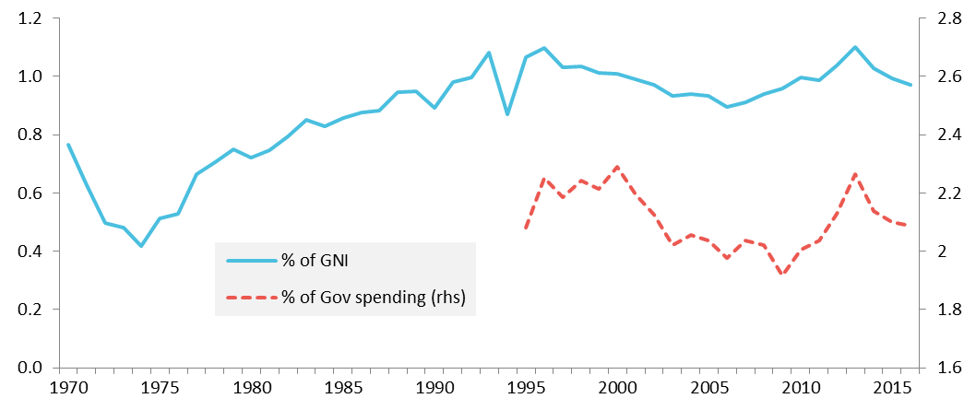

Source: European Commission Services own calculation based on Eurostat.

Note: executed budget of the EU, with varying numbers of Member States over time (from EU-6 to EU-28).

## … but the structure of the revenue side has changed over time and is dominated by the Gross National Income–based contribution

Under the present system, there are three main categories of Own Resource – Traditional Own Resources, the Value Added Tax-based resource and the contributions based on Gross National Income – and some correction mechanisms.

**Traditional Own Resources today account for roughly 13% of the EU budget** (Figure 2). While proceeds from Traditional Own Resources sufficed to finance large parts of the budget throughout the 1970s, their share decreased progressively and was supplemented by other Own Resources. Traditional Own Resources stem from the functioning of the customs union and accrue directly to the EU budget. More specifically, they consist of customs duties levied on imports of agricultural and non-agricultural products from third countries, at rates based on the Common Customs Tariff as well as anti-dumping and countervailing duties[2]. In practice, the Member States’ customs authorities collect the amounts on behalf of the EU, after deduction of 20 % retained as ‘collection costs’[3].

**The Value Added Tax-based Own Resource was introduced with the Own Resources Decision of 1970** and became the main source of revenue as of 1979, covering around 50% of EU expenditure, before decreasing to reach 10-12% of the present EU budget (Figure 2). Value Added Tax-based Own Resource contributions derive from the application of a uniform call rate to Member States’ Value Added Tax bases, set according to harmonised rules[4]. As Gross National Income gained ground as a basis for determining Member States' contributions, the Value Added Tax-based Own Resource call rate was progressively reduced to the current level of 0.3%. The Value Added Tax base of each Member State is currently capped at 50% of Gross National Income, to remedy the regressive aspects of the Value Added Tax-based resource, which penalises Member States with higher shares of consumption in final demand. Finally, for the 2014-2020 Multiannual Financial Framework, the call rate is reduced to 0.15% for Germany, the Netherlands and Sweden.

**The Own Resource based on Gross National Product (later replaced by Gross National Income) was introduced in 1988**. This new category of revenue was considered as the most representative indicator of Member States economic activity and ability to pay[5]. It became the balancing resource and was expected to provide the necessary financing of the budget within the Own Resource ceiling. Initially at 10% of total revenue, the share of the Gross National Income-based contribution increased to reach around 70 %.

**In addition to the Own Resources, the EU budget is financed by ‘other revenues’**. This category encompasses a wide range of income sources such as taxes paid by EU staff on their salaries, contributions from non-EU countries to certain EU programmes, and fines paid by companies for breaching EU law. Any surplus from a financial year is also entered in the budget for the following year as revenue. Although the proceeds of some of these sources of revenue are unpredictable and volatile or even 'one-off' in nature, they are not a *'quantité négligeable'*.

Figure 2 – Composition of the EU budget, % of Gross National Income

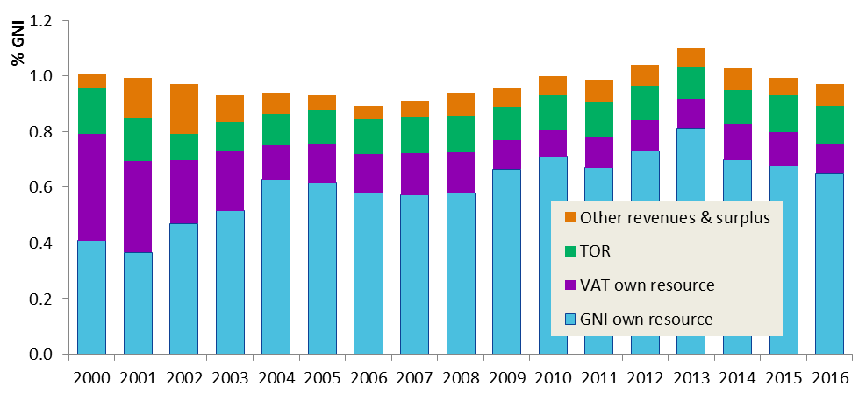

Source: European Commission Services, Financial reports (<http://ec.europa.eu/budget/figures/interactive/index_en.cfm>).

Note: the corrections, lump sum reductions and adjustments granted to various countries (UK, DK, DE, NL, AT, SE) as well as the effects of the retro-active implementation of Own Resources Decisions are accounted for under 'Gross National Income Own Resource'; Traditional Own Resources are net of the share withheld by national administrations; 'Other revenues' include any surpluses from either the European Agriculture Guarantee and Guidance Fund-Guarantee or the external aid guarantee fund (both nil since 2009).

**The Gross National Income-based contributions are the keystone of the Own Resources system**, as each year they provide the revenue required to balance the EU budget (Table 1). In practice, the Gross National Income-based Own Resource is calculated in two steps. First, taking account of 'other revenues', the proceeds of traditional Own Resources and the Value Added Tax-based Own Resource are quantified on the basis of the forecasts given by the Member States and jointly endorsed. Second, the amount which remains to cover the level of annual payment appropriations is calculated and split into national contributions resulting from the application of a uniform call rate to the Member States’ Gross National Income. On average, the call rate has been at 0.6% over the past two decades, but rising in recent years (0.7% over 2012-2016).

Table 1– Gross National Income call rate

|  |  |  |  |  |  |
| --- | --- | --- | --- | --- | --- |
|  |  | 2000 | 2014 | 2015 | 2016 |
| TOTAL REVENUES | € bn | 92,795 | 143,940 | 146,027 | 144,089 |
|  | *% GNI* | *1.02%* | *1.03%* | *1.00%* | *0.97%* |
| TOTAL Own Resources (after corrections) | € bn | 88,040 | 132,961 | 137,335 | 132,174 |
| *% GNI* | *0.97%* | *0.96%* | *0.94%* | *0.89%* |
| GNI-based Own Resource (after corrections) | € bn | 37,581 | 97,922 | 99,284 | 96,185 |
| *% GNI* | *0.41%* | *0.70%* | *0.68%* | *0.65%* |
| *GNI call rate (before corrections)* |  | *0.41%* | *0.71%* | *0.69%* | *0.65%* |

Source: European Commission Services.

Note: to compute the Gross National Income-call rate, the sum of all other Own Resources of all Member States, established or forecast according to their specific rules, is subtracted from the total Own Resources needed to cover the annual payments of the EU. This yields the total Gross National Income-contribution needed in the year. Its ratio to the EU's Gross National Income is the call rate before corrections.

## The system has proved successful in providing the EU with stable revenues, but has been difficult to reform

The Treaty on the Functioning of the European Union introduced significant changes to the rules according to which the EU budget is financed, creating the opportunity to make the implementation of the Own Resources system sufficiently flexible within the framework and limits set out by the Own Resource decision (Box 1).

**The existing system has provided sufficient and stable revenues to the EU budget**. It ensured timely and efficient financing, with the flexibility made necessary by the annual fluctuations of expenditure. Even in budget years marked by unforeseen changes in the level of payment appropriations[6], the adjustability of the Gross National Income-based Own Resource allows for a swift follow-up in terms of providing the treasury means. On the other hand, under-execution compared to budgeted appropriations can lead to end-of-year treasury surpluses.

**The general perception that the revenue side of the budget is by and large functioning satisfactorily results in a very stable system, which has proved difficult to reform**. Over the decades, the Own Resources system has only been amended incrementally and no new categories of Own Resources have been introduced since 1988, when it was decided to introduce a new category of resource based on Member States' Gross National Product. At that time, the introduction of a new source of revenue was justified by the inadequacy of the revenues to cover the Community's growing needs[7].

In 2011, during the economic crisis, in order to support the necessary budgetary consolidation in Member States, the Commission proposed to simplify the Value Added Tax Own Resource and introduce a new Own Resource based on the Financial Transaction Tax. The new Own Resource based on the Financial Transaction Tax would have provided a new source of revenues for both EU and national budgets. The proposal did not reach a consensus among Member States, although the need for reform was acknowledged[8].

**Recent analyses highlighted significant weaknesses of the present Own Resources system dominated by national contributions[9]**. The weaknesses relate to the complicated calculations necessitated by the system of rebates and corrections, which reduce transparency. Moreover, the predominant role of the Gross National Income-based contribution fosters the common perception that EU revenues just reflect the Member States' capacity to pay and is hence used to justify the focus on net balances and the existence of corrections. The predominant weight of national contributions on overall EU financing fuels the expectation that the EU returns a 'fair share' of its spending to each Member State, in proportion to their contributions. This in turn has been identified as one element hampering a more consequential reform of the expenditure side in line with a collective logic of European added value.

**Box 1 – Legal framework**

The legislative acts governing the Own Resources and their implementation are anchored under Title II (Financial Provisions) of Part Six (Institutional and Financial Provisions) of the Treaty on the Functioning of the European Union. This title sets out several 'special legislative procedures' for the different types of legal acts. It provides for a hierarchy of relevant acts with specific legal bases for the different components – i.e. the Own Resource decision, its implementing rules and the regulation on making the Own Resources available.

Article 311 of the Treaty on the Functioning of the European Union sets out the key principles of EU financing:

* First, "*without prejudice to other revenue, the budget shall be financed wholly from Own Resources*". The revenue of the general budget of the EU can be divided into Own Resources and other revenue.
* Secondly, the provisions related to the system of Own Resources are set out in a decision – the Own Resources decision – adopted unanimously by the Council after consulting the European Parliament, in accordance with a special legislative procedure that "*shall not enter into force until it is approved by the Member States in accordance with their respective constitutional requirements*", to preserve national sovereignty in tax matters. The Treaty is explicit in that the Council "*may establish new categories of Own Resources or abolish an existing category*".
* Thirdly, the Treaty provides – as a new element – that the Council, acting by means of regulations in accordance with a special legislative procedure, and after obtaining the consent of the European Parliament, may lay down implementing measures for the Union's Own Resources system "*in so far as this is provided for in the [Own Resources] decision*".

In addition, Article 322§2 lays down provisions on the methods and procedures whereby the budget revenue provided under the arrangements relating to the Union's Own Resources "*shall be made available*" to the Commission.

## The system of rebates and corrections has become complex over time

**For historical reasons, some Member States benefit from rebates and corrections**. Today, the bulk of EU financing relies on the Gross National Income-based and the Value Added Tax-based Own Resources, but corrections have been introduced over time to address the specific budgetary situation of certain Member States. Unlike Own Resources, corrections are not provided for in the Treaty but result instead from political agreements.

**The correction mechanism for the United Kingdom ('the UK rebate') was created to address the specific situation of the United Kingdom in the mid-1980s,** namely a relatively low-income Member State with comparatively high payments into the budget and comparatively limited payments from EU funds. The Fontainebleau European Summit in June 1984 concluded that "*any Member State sustaining a budgetary burden which is excessive in relation to its relative prosperity may benefit from a correction at the appropriate time*".[10] The most important of these mechanisms was 'the UK rebate', which was at the time justified as these two cumulative criteria were fulfilled. First, the United Kingdom was relatively poorer than the EU average. Secondly, the United Kingdom benefited less than the others from the EU budget, of which 70% were spent on agricultural subsidies. None of these two cumulative criteria are fulfilled today.

**As a legacy of 'the UK Rebate' and the Fontainebleau logic, other Member States benefited from corrections in order to alleviate their net position**. Together with 'the UK rebate', it was first decided that other net contributors would benefit from a reduction in the financing of 'the UK rebate'. From 1985, Germany's part in financing the UK correction was limited to two thirds of its normal share. Since 2002, Germany and also Austria, the Netherlands and Sweden have benefited from a permanent reduction in their contribution to 'the UK rebate', paying 25% of their respective share. These reductions are known as the "rebates on the rebate".

**In addition to 'the UK rebate', an increasing number of other corrections have developed over time**. Building on the rebate of the rebate example, certain Member States have argued that their EU budgetary burden is excessive, requesting different forms of reduction in their contribution. Temporary corrections agreed for 2014-2020 include a reduced call rate on the Value Added Tax-based Own Resource for Germany, the Netherlands and Sweden and lump-sum reductions to Gross National Income-based contributions for Austria (only 2014-2016), the Netherlands, Sweden and Denmark. Although these corrections are not strictly related to 'the UK rebate', they are justified by the same logic of limiting net operating budgetary balances.

**Finally, the increase in collection costs for custom duties** (from 10% to 25% and eventually back to 20%) has resulted in reducing the financial contributions of Member States located at major entry points for imports into the EU (see Part II, Section 1).

The amounts of corrections other than 'the UK rebate' itself exceeded a gross amount of on average EUR 5 billion annually over the first five years of the current Multiannual Financial Framework (Figure 3).

Figure 3: Average annual corrections and rebates over the 2014-2018 period (EUR bn)

Source: European Commission Services

Note: For the reduced GNI contributions, the gross amount is used, i.e. not subtracting the share which the recipient has to pay to finance its own reduction.

# Recent contributions about the reform of the Own Resources System

## Report of the High Level Group on Own Resources

**After the adoption of the Own Resources Decision 2014, the demand for reform of the revenue side of the EU budget persisted**. A High Level Group on Own Resources was created as part of the final agreement on the Multiannual Financial Framework 2014-2020 in December 2013 when the Council, the European Parliament and the European Commission adopted a Joint Declaration on Own Resources. It stated that the question on Own Resources required further work and that a High Level Group would be convened in order to undertake a general review of the Own Resources system. On the basis of the work of the High Level Group, the Commission would assess if new Own Resources initiatives would be appropriate with a view to possible reforms to be considered for the period of the next multiannual financial framework. After regular deliberations which included the consultation of academics and stakeholders as well as national parliaments, the group submitted its final report in December 2016.

**The report of the High Level Group argues that the case for reform of the Own Resources system is stronger than ever[11]**. The group noted that the next negotiation will take place in the unique context of, on the one hand, greater pressure on reforming expenditure towards more added value and on the other hand, one of the main net contributors negotiating its exit, lifting a three-decade-long lock on the Own Resources decision. For this reason, the High Level Group found that no significant reform of the revenue will be achieved if there is no concomitant significant reform of expenditure. The report also shows that new spending instruments bring more added value, but efforts need to be pursued to bring legitimacy back to EU spending.

**Own Resources are viewed as one of the means to contribute to EU policy objectives** by addressing the EU sustainability gaps (economic, social, environmental), correcting negative externalities and addressing market/ government failures, in addition to simplifying the financing of the EU budget. The report examined in detail current and possible candidate Own Resources, identifying their strong and weak points. Beyond the traditional assessment criteria, new Own Resources should display a link with policies and thus bring added value by contributing to the achievement of policies as is the case in national fiscal systems.

## The Commission Reflection Paper on the future of EU finances

**The Reflection Paper on EU finances**[12] **published in 2017 confirms the need to reform the EU budget.** The Paper brings together the policy priorities presented in the March White Paper[13] and their financing. Building on the arguments of the High Level Group on Own Resources, the Paper discusses how to conceptualise European added value and whether the Own Resources system should be reformed. It maps out new challenges, possibilities and reform options as well as risks and trade-offs for the future of EU finances.

**EU finances may face a shortfall arising from the United Kingdom’s withdrawal and from the emerging financing needs for new priorities**. The Reflection Paper regards these issues as a big problem but also as an opportunity to modernise the EU budget and as a responsibility to equip it better to respond to existing and new challenges. The principle of EU added value is emphasised as crucial to the aim of achieving better alignment between priorities and available resources. Like any public budget, the EU budget should provide resources to cater for the provision of public goods, but in this case, these should be specifically public goods of a European dimension.

**In the same vein, the Reflection Paper also indicates reform options on the revenue side**. Future proposals on Own Resources should be mutually reinforcing with the structural shift towards more common public goods and EU added value on the spending side, bringing truly European revenue.

## The Multiannual Financial Framework communication as a contribution to the Leader's discussion

**The Commission published its options for reform in February 2018**. The Communication on "A New, modern Multiannual Financial Framework for a EU that delivers efficiently on its priorities post 2020"[14], which was adopted as a contribution to the Informal Leaders' meeting of 23 February, set out further concrete options for reform, identifying areas where choices would have to be made on both the expenditure and the revenue sides of the EU budget. A reform of the revenue side could contribute to strengthening the EU value added and overall simplification.

# Financing the EU budget in a globalising context

## The revenue side could contribute to addressing the budgetary gap

**The United Kingdom's withdrawal from the EU will leave a gap in the EU budget**. The United Kingdom is currently a net contributor, even when taking account of the so-called 'British rebate'. Its average share of the Own Resources during the 2014-2016 period has slightly exceeded EUR 17 billion, while the share of EU expenditure it has received in the same period has been just above EUR 7 billion. The latter, of course, does not take into account the extent to which the United Kingdom benefits from the common EU expenditure devoted to, for example, external policy or development aid. Looking into the future, and taking into account the growing EU budget up to 2020, the United Kingdom's withdrawal may leave a gap of EUR 12-14 billion in the annual EU budget. However, it makes the rebates and other correction mechanisms obsolete, providing a unique opportunity to render the EU budget more coherent and streamlined.

**In addition, the Own Resource ceiling will need to constrain a growing expenditure**. The Own Resources Decision includes a ceiling for annual calls for Own Resources, intended to warrant certainty for Member States in view of shielding them from 'surprises' for their national budgetary and financial planning. Today, this ceiling is set at "1.20% of the sum of all the Member States' Gross National Income". With the United Kingdom withdrawal, this ceiling automatically decreases by approximately 16% in nominal terms (i.e. the share of the United Kingdom's Gross National Income in the EU's). In addition, it is important to note that beyond the payment needs under the Multiannual Financial Framework, budgetary resources necessary to cover financial liability linked to loans or financial facilities guaranteed from the EU budget must remain below this ceiling. With the increasing use of such instruments, including for the possible euro-area investment stabilisation function, this ceiling will also need to be increased.

**External contributions, notably from the United Kingdom, may alleviate the strain on Own Resources**. Potential additional contributions by the United Kingdom honouring its obligations assumed as an EU Member State that have to be paid beyond 2020 could reduce the financing needs to be covered by Own Resources, particularly at the beginning of the next Multiannual Financial Framework. However, such contributions cannot be factored in with certainty as long as no withdrawal agreement has been signed with the United Kingdom.

## Economic developments challenge the national taxation and statistical systems

**Globalisation and technical change have brought about profound changes in the structure of firms and in the localisation of production.** There is a growing dematerialisation of many services, which can reach European customers through online delivery with very limited infrastructure on EU territory. The economy is influenced by the reduced impact of transport costs on the international supply of goods and by the rapid spread of e-commerce and other digital services for both intermediate and final consumption. The weight of intangible assets such as intellectual property is growing. And there are large and rapid fluctuations in foreign capital investments. All these phenomena challenge the capacity of national authorities to assess value creation within their jurisdiction, which is the first basis for assessing taxable bases. The swift and massive transfer of intangible assets between countries, decided by large multinational companies in response to tax or regulatory incentives has also the potential to affect national accounts[15].

**Globalisation and the increasing role of digital companies are also posing challenges to both national tax authorities and national statistical authorities**. In recent years, the rise of intangibles has made capital mobility quick and easy and the debate has shifted to the inadequacy of national taxation frameworks to properly address these developments. In September 2013, the Organisation for Economic Co-operation and Development (OECD) has launched an initiative – Base Erosion and Profit Shifting (BEPS) – aiming to provide governments with the tools to ensure that profits are taxed where the economic activities generating them are performed and where value is created[16].

**Globalisation and digitalisation not only impact the way of doing business but also influence the way tax authorities manage their tax systems**. To safeguard revenues, tax administrations must be increasingly efficient and effective. To this end, enhancing tax compliance and fighting tax avoidance and fraud are major challenges. Reforming the revenue side of the EU Budget therefore also entails supporting Member States in their efforts to modernise their tax administration and deepen their cooperation, for the benefit of both the national and EU budget[17].

## Rethinking efficiency and equity between the EU and Member States

**From an administrative perspective, the EU budget is cost-efficient as the operating costs of the current system are very modest**. Without the system of rebates and other corrections, it will also be relatively transparent. However, the revenue side of the EU budget cannot be isolated from the major economic, social and environmental challenges which are faced by national budgets.

**For a growing set of policies, the EU is the appropriate level of government to provide public goods and tackle externalities**. Preventing climate change, protecting the environment, improving the functioning of the Single Market and managing monetary policy or financial markets are activities that transcend national borders. The benefits generated by these policies are substantial. The EU climate policy has contributed to reducing greenhouse gas emissions which decreased by 23% between 1990 and 2016[18]. The Single Market integration, by opening markets and increasing the mobility of production factors, led to higher income in 'old' (+3.4%) and 'new' (+7.5%) Member States alike[19]. Citizens and companies benefit from these services and policies.

**However, the EU does not have the power to levy taxes[20] and therefore cannot generate direct revenues from the Single Market and/or other policies**[21]**.** Existing fiscal instruments are mainly deployed at national level, although in some areas, the EU provides rules to harmonise tax bases and, in certain cases, apply minimum rates (e.g. Value Added Tax).[22]. This improves fairness for EU citizens and companies in different EU countries and provides means to collect tax revenues that are otherwise eroded by tax avoidance. Similarly, tax and levies to address external costs caused by pollution and climate change are mostly imposed at national level. The exception to this is the EU Emissions Trading System given the global nature of greenhouse gas emissions (see Part II). As a consequence, in most cases, fiscal revenues need to be shared between the EU and national budgets. This is called 'vertical equity'.

**Finally, fairness among Member States needs to be looked at from both the revenue and the expenditure sides** ('horizontal equity'). The purpose of EU budget is not to collect or distribute money equally across Member States, according to their economic or demographic size, but rather to finance projects of EU added value and support cohesion. Although some disparities in the degree to which Member States directly benefit from EU expenditure (per capita, or per unit of Gross National Income) are generally accepted, different levels of contribution to their financing – compared to the respective Gross National Income levels – appear more controversial and have led to the widespread use of rebates and corrections.

# Summary

The case to reform the EU budget is justified for various reasons.

The United Kingdom's withdrawal and the discontinuation of the corrections provide an opportunity to simplify and modernise the current system. At the same time, economic, social and environmental developments in the EU and the rest of the world have been challenging national authorities. Furthermore, most of these challenges – climate change, internal market, environment- can be addressed most effectively at EU level. This can be done by the prioritising of expenditure programmes, but also through more effective linking of the Own Resources system with EU policies.

# Part 2: Reforming the EU budget revenue

This part analyses how the revenue side of the EU budget can be reformed. It assesses the existing and potential new Own Resources and discusses their main strengths and weaknesses. The analysis is based on the various reports published recently and goes a step further by attempting to identify the room for simplification and to operationalise the calculation of Own Resource for the new candidates.

Section 1 focuses on existing Own Resources. Section 2 reviews new Own Resources. Section 3 assesses how to make better use of "other revenues". Section 4 assesses the phasing out of corrections. Section 5 concludes.

# Assessing the existing Own Resources: the need to modernise

## Traditional Own Resources (customs duties)

**The amount of customs duties collected on behalf of the EU reflects trade flows**. The presence of two large commercial ports in Belgium and the Netherlands, through which goods enter the customs union, explains the two countries' role in channelling imports also for other Member States and thus their much higher share of customs duties compared with their overall economic weight (Figures 4 and 6).

**Figure 4: Imports of goods from outside the EU-28, 2013-2017 average (EUR billion)**

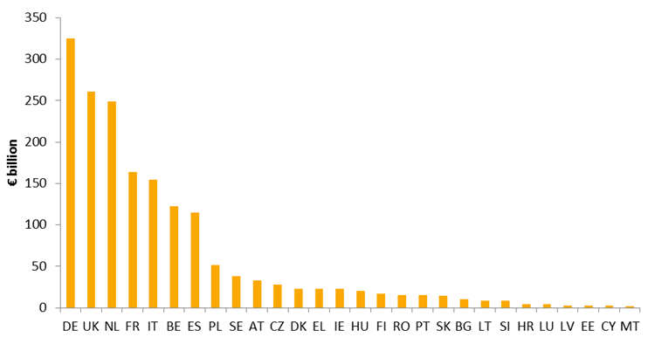

Source: Eurostat, international trade statistics; current prices in EUR billion; imports CIF (cost, insurance, freight) of EU-28 Member States from non-EU countries. Average of 2013-2017

**The so called traditional Own Resources accrue directly to the EU budget** and are generally considered as arising 'naturally' from the functioning of the customs union and the common external commercial and trade policies. Customs duties are levied on imports of products from third countries, at rates determined by the Common Customs Tariff.

**Member States collect the customs duties on behalf of the EU** and make them available to the Commission after a deduction of 20% which can be retained as 'collection costs'. This percentage, which was 10% over the period 1970 to 2000, was raised to 25 % from 2001 onwards. Under the 2014 Own Resources Decision, the percentage was reduced to 20 %, as the result of a political compromise following the Commission proposal to reduce the percentage back to 10 % (figure 5-6).

**Figure 5: Retention rates since 1970**

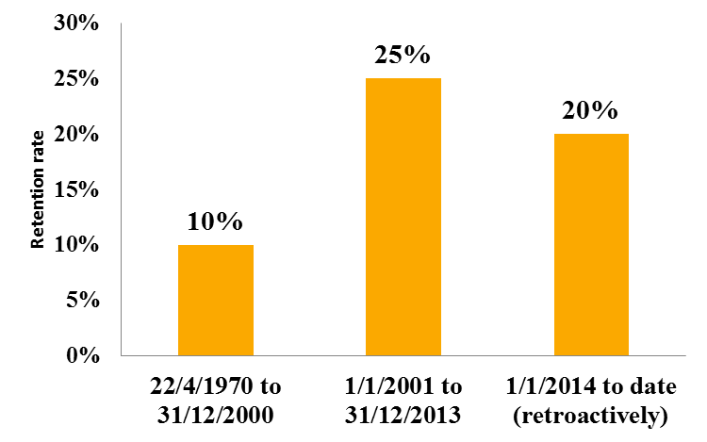

Source: European Commission Services

**Figure 6: Amounts retained by Member States as collection costs for 2017**



Source: European Commission Services

**The share of customs duties in total revenue tended to go down over time** as increases in trade volumes were generally compensated or even overcompensated by decreases in average tariffs, following the various rounds of trade negotiations at World Trade Organization level. In recent years, the share has become rather stable (around 13-15 %). Future evolution will depend mainly on trade volumes and developments in customs regimes and tariffs.

**In most Member States, the intensity of customs controls has being decreasing.** The last Customs Union Performance figures shows a decreasing trend for control rates over the last few years whereas the retention rates simultaneously increased from 10 to 25%. At EU level 2.1 % of imported items were subject to controls during customs clearance in 2016 but this rate varies widely among Member States.

**The amounts retained by Member States as collection costs do not necessarily support the customs activities directly.** Moreover, recent developments show that fewer human resources are available in national administrations for performing controls, which means that only a limited part of the available resources is dedicated to the customs operations and the protection of customs duties. Simplified procedures and automation help improve the cost effectiveness of the inspections.

**There is a clear evidence of imbalances between Member States**. While countries managing long land borders and numerous crossing points would need increased resources to finance their equipment for customs controls, they have only a limited share of collection costs; conversely, collection of large amount of custom duties is the prerogative of large commercial ports in some Member States.

**Moreover, for certain Member States, an increase in the retention rate represents a net decrease in their financial contribution to the EU budget**. This is the case of those Member States which collect a large proportion of customs duties at major EU entry points. This, rather than the actual collection cost, was the main motivation in the past for some Member States to have a higher retention rate. However, these Member States are also likely to be among the strongest beneficiaries of the Single Market, by dint of their openness to trade.

**Given the EU dimension of customs, only expenditure at EU level can address the imbalance in a fair manner**. For example, increased EU support to Member States on the area of customs equipment under the Integrated Border Management Policy and the related expenditure programmes would help address these imbalances. Common investment in the methods for carrying out customs checks and the collection of customs duties could yield considerable economies of scale.

## Gross National Income-based Own Resource

**In addition to its relative stability over time, the Gross National Income-contribution ensures the greatest sufficiency among existing Own Resources, thanks to its broad base**. When it was first introduced in 1988, Gross National Income was supposed to balance the (increasing) budget, against the background of long-declining customs duties and agricultural levies (i.e. the Traditional Own Resources). The Gross National Income-based contribution's share of the EU budget has gradually increased to around 70 % in recent years.

**The statistical revisions of** **Gross National Income further increased its reliability**. In 2014, most Member States made significant revisions to their Gross National Income data, due to two main factors: (i) the updated European System of Accounts (ESA) 2010 replaced the old ESA 95 across the EU, leading to an increase of the EU-28 Gross National Income of around 2.3 %, although not evenly spread across Member States: the impact was larger on those with higher spending on Research & Development (Figure 6); some Member States also used this opportunity to introduce benchmark revisions; (ii) 2014 also was the deadline given by the Commission to Member States in the context of Own Resource inspections to address their specific reservations.

**Figure 7 – Impact of methodological changes due to the update of the European System of Accounts (ESA) on the 2010 Gross Domestic Product** (% points)

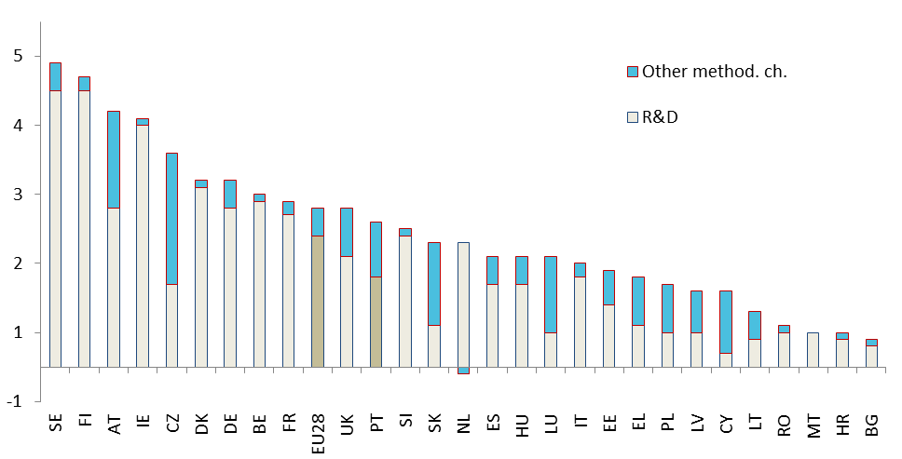

Source: Eurostat

**Strong reliance on the Gross National Income-contribution does not reflect the EU dimension and the increasing interdependencies of economies**. A contribution based on Gross National Income is a good indicator of the ability to pay of Member States[23], but it is not linked to the benefits linked to EU policies. The impact of EU policies tackling externalities or creating public goods (for example in trade, security, competition, climate change), over and above the sum of national contributions to the EU, is largely captured by Member States' Gross National Income. These benefits depend on many factors such as location of activities, mobility of capital, energy and carbon intensities and tax regimes.

Still, convergence in per-capita Gross National Income levels across the EU is one of its main policy goals and measure, providing a direct link between the EU's success in integrating the national economies and the distribution of its financing burden. Thus, the Gross National Income's overall reliability makes it a solid reference point for calculating the contribution to the EU budget and sharing it across Member States. This Own Resource could be supplemented by a number of other financing sources in order to better mirror the different EU policies and their value added.

## Simplifying Member States' contributions: reform of the Value Added Tax-based Own Resource

### Rationale

**The Value Added Tax is a common tax paid by all European citizens when consuming goods or services in the single market**. This common tax is a core element of the single market, which is one of the European Union's greatest achievements. Value Added Tax operates in all Member States as a broadly based consumption tax within a common framework set by EU Directives. It has been progressively harmonised over the past decades in terms of tax base and rates although differences remain across Member States. The Commission launched in 2016 a Value Added Tax Action Plan to create a single EU Value Added Tax area by 2022.

**Value Added Tax has proved to be a solid and reliable Own Resource since 1980 providing predictable revenues even during adverse economic cycles**. It accounts for a significant share of the EU budget (around 15%) but for only 0.3% of the Member States' Value Added Tax base. The call rate has been reduced several times since 1980 as the revenues of the EU budget shifted to Gross National Income-based contributions (see Part I, Section 1.2).

Figure 8 – Value Added Tax-based Own Resources revenue 2011-2015 (EU28, EUR billion)

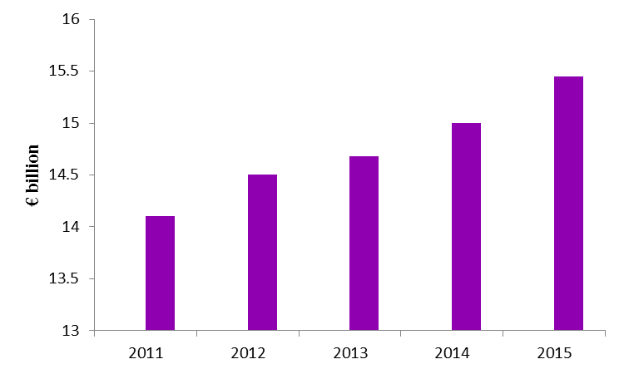

Source: European Commission Services

**However, the main weakness of the current Value Added Tax-based Own Resource is that its calculation is based on a complex methodology**. This complexity is not due to the Value Added Tax itself but to the number of statistical compensations calculated and controlled to harmonise the 28 Value Added Tax bases of the Member States. These compensations are considered necessary as the current Value Added Tax system is characterised by national derogations from the Value Added Tax Directive. The purpose of these compensations is to 'neutralise' different Value Added Tax rates and derogations, and to apply a call rate on a harmonised tax base. The method is well established, but it leads to unwieldy computations. Moreover, the compensation calculations are cumbersome and generate onerous administrative work while their material impact has been at a consistently very low level for many years.

### Objective of the reform

The reform of the Value Added Tax-based Own Resource would radically simplify calculations and inspections while enhancing the connection with the single market and maintaining fairness across Member States.

The reformed Value Added Tax-based Own Resource has the following aims:

**The first aim would be to tackle the complexity of the existing calculation by abolishing the current system of calculatedcompensations**. The calculation of the new Value Added Tax base will be simple and transparent, using only fiscal data. The redesigned calculation builds on the receipts collected annually by Member States and controlled by national Parliaments and national audit institutions. Calculation and control costs could be drastically reduced.

**The second aim would be to ensure fairness**. The new Value Added Tax base focuses on receipts from standard-rated supplies, which are consumed by all EU citizens in the Single Market. The simplified calculation only takes into account standard-rated supplies, excluding reduced rates on goods and services. To ensure fairness, across the 27 Member States, a uniform percentage equal to 45% of supplies is considered to be standard-rated in every Member State (see Box 2).

**The third aim of a simplified Value Added Tax-based Own Resource would be to make it more consistent with the Value Added Tax Action** **Plan** launched by the Commission in 2016 to create a single EU Value Added Tax area by 2022. This Action Plan sets out the progressive steps required towards achieving a definitive and harmonised Value Added Tax system for the 27 Member States, setting out actions to tackle Value Added Tax fraud and adapt the Value Added Tax system to the digital economy and the needs of Small and Medium Enterprises. Furthermore, the Action Plan includes a proposal to reform the rules on Value Added Tax rates; the proposal for a new Value Added Tax -based Own Resource will be compatible with the new Value Added Tax rate regime as proposed.

### How to reform the Value Added Tax -based Own Resource?

The reform proposes a simple and transparent way to calculate the Value Added Tax Own Resource base. It builds on the Value Added Tax receipts annually collected by Member States:

The first step is to take the Value Added Tax receipts collected by each Member State in a given year, corrected for some – usually minor – territorial specificities enshrined in EU law as foreseen by Member States' accession Treaties. Receipts from standard-rated supplies would be then determined by applying a 45% common Union share to these receipts (see Box 2).

(1) Standard-rated receipts = 45 % * annual Value Added Tax receipts (incl. corrections)

The second step is to calculate the standard-rated taxable base, i.e. the value of goods and services on which the Member State levied the Value Added Tax receipts. The standard-rated taxable base is calculated by dividing the standard-rated receipts by the Value Added Tax standard rate applied in each Member State:

(2) Standard-rated taxable base = Standard-rated receipts / Standard rate

The third step is to apply a uniform call rate, i.e. the same for all Member States, to the standard-rated taxable base:

(3) Value Added Tax -based Own Resource = call rate * Standard-rated taxable base

The new Value Added Tax -based Own Resource would be radically simplified and transparent. It would be calculated using only fiscal data, i.e. the annual Value Added Tax receipts collected and corrected by Member States. Subsequently, these data would be inspected by the Commission and audited by the European Court of Auditors, through systems which are already in place.

Moreover, the new Value Added Tax -based Own Resource would lead to a significant reduction of administrative costs for calculations and inspections and could be easily implemented in the 2021-2027 Multiannual Financial Framework. The Member States and the Commission have experience in the calculation and control of Value Added Tax receipts and well-established methods to do so.

**Box 2 – How was the 45% common Union share of standard-rated supplies to final consumption calculated?**

Besides standard rates set by the Value Added Tax Directive, Member States can tax at reduced or zero rates. In general, this applies to essential consumption goods and/or to merit goods and services deserving a favourable tax treatment. There is some heterogeneity across Member States on the Value Added Tax structure (Figure A).

The common Union share has been computed using data from Value Added Tax statements calculated by Member States, inspected by the Commission and audited by the European Court of Auditors. According to the methodology to calculate the Value Added Tax based Own Resource[24], the Weighted Average Rate allocates all taxable goods and services to the appropriate Value Added Tax rate using data from national accounts, which makes it possible to identify the share of standard-rated goods and services in each country. The Weighted Average Rate is included in the Value Added Tax Statement sent annually by Member States.

**Figure A – Value Added Tax structure per Member State 2011-2015\***

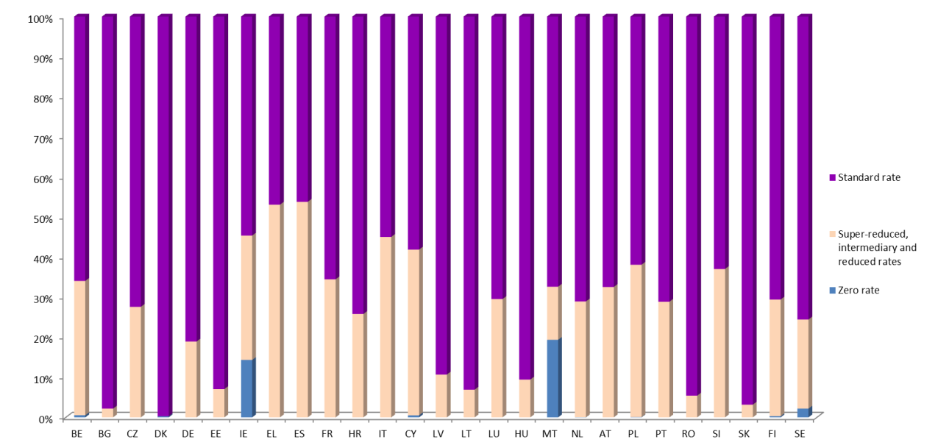

Source: European Commission Services. * for Croatia 2013-2015

Between 2011 and 2015, the average share of the standard-rated goods was 73,84% going from 99,73% to 46,22% Taking the average of the lowest share of standard-rated goods and services across the 27 Member States over a period of five years (2011-2015) gives a common Union share of 45%. This average percentage captures the common share of standard-rated supplies among countries, thus ensuring that the Own Resource system does not penalise any Member State.

### Quantification

The tax base is large, around EUR 1,825 billion in 2015. With a call rate between 1% and 2 %, revenues are estimated between around EUR 25 billion and EUR 49 billion on average in the 2021-2027 period.

# Proposing a basket of new Own Resources linked to EU policies

## Common Consolidated Corporate Tax Base

### Rationale

**Multinational companies benefit in particular from the advantages of the internal market**. With easy access to an integrated, barrier-free European market, the expansion of such companies is facilitated and their profitability increased. Differences in corporate tax rules across the EU are a long-standing problem that allow multinationals to engage in profit shifting and tax optimisation, distorting competition with smaller firms and subtracting resources from national budgets. Ongoing technological and economic developments such as globalisation and dematerialisation are also contributing to this.

**In 2016, the Commission relaunched its proposal to harmonise corporate income tax systems to ensure a fair allocation and distribution of taxable profits to the Member States**. The Common Consolidated Corporate Tax Base establishes a common set of rules which simplify tax compliance, reduces administrative costs for both companies and governments and increases transparency and efficiency[25]. The Common Consolidated Corporate Tax Base also introduces the use of an apportionment formula, by which profits are allocated to Member States based on sales, labour and assets. Therefore, taxes will be paid in the Member States where the profits are generated, which should reduce distortions.

**An Own Resource based on the Common Consolidated Corporate Tax Base would directly acknowledge the link between the financing of the EU budget and its benefits[26]**, as it would emphasise the Member States' common interest in ensuring a level playing field for companies operating in the single market. The Common Consolidated Corporate Tax Base would enable businesses to enjoy a level playing field, legal certainty and minimal obstacles when operating across borders. Only one set of tax declarations would be required for the all EU operations. Companies would apply the same rules when calculating their taxable profits thus reducing transfer-pricing planning opportunities.

### How would it work?

The Common Consolidated Corporate Tax Base proposal provides requirements for companies or groups of companies having total worldwide consolidated revenue above a certain threshold and meeting certain ownership criteria. Companies below the revenue threshold may also opt to apply the rules of the Directive. The consolidated tax base would then be apportioned among Member States by a formula, comprising three equally-weighted factors: labour (composed of both payroll cost and the number of employees with equal weights), assets and sales.

A Common Consolidated Corporate Tax Base -based Own Resource would be calculated by applying the call rate on the value of the taxable profits of those companies for which the Common Consolidated Corporate Tax Base is compulsory, as apportioned to each Member State. The amounts would be transferred to the EU budget by the Member States. Taxable profits of companies outside the mandatory scope of the Directive (i.e. below the size threshold or outside the other criteria) would be excluded for the purposes of Own Resources.

Applying a uniform call rate to a common, consolidated tax base after apportionment would ensure fairness of the distribution across Member States, in accordance with elements of the formula for apportioning the profits of company groups to the Member States where they operate[27]. The EU Own Resource to be made available by each Member State would therefore be calculated as follows:

Common Consolidated Corporate Tax Base based Own Resource = call rate * apportioned tax base (mandatory part)

### Estimated revenues

Based on 2012 data, the total tax base in the EU-27 was estimated at nearly EUR 380 billion[28]. A call rate between 1% and 6%would generate around EUR 4 billion to EUR 23 billion on average for the period 2021-2027 (2012 data)[29].

## Own Resource based on the Auctioning revenue from the EU Emissions Trading System

### Rationale

**The EU is building an Energy Union framework strategy, with five priority dimensions**: (i) energy security, solidarity and trust; (ii) a fully integrated European energy market; (iii) energy efficiency contributing to moderation of demand; (iv) decarbonising the economy; and (v) research, innovation and competitiveness. This framework requires significant investment in clean energy infrastructure over the next decade, a part of which will be financed by the EU budget. In the context of the Paris Agreement adopted on 12 December 2015 under the United Nations Framework Convention on Climate Change (UNFCCC), the EU committed to reducing its emissions by at least 40 % between 1990 and 2030.

**The Emissions Trading System is one of the main instruments to reduce greenhouse gas emission in the EU**. It provides a maximum (cap) on the total amount of greenhouse gases that can be emitted by the sectors covered. Companies receive or buy emission allowances which they can trade with one another as needed. This cap and trade system ensures that emissions are reduced with the cheapest abatement cost possible. It applies to over 11 000 power plants and industrial installations across the EU, as well as to aviation for flights within the European Economic Area. Allowances are auctioned or allocated for free to the industry.

**The Emissions Trading System is an EU-wide instrument**. Installations covered by the system are subject to the same rules across the EU. There is a single carbon price across the EU for the sectors covered.

**The auctioning of allowances provides revenues to the Member States** who collected EUR 21.3 billion over the period 2013-2017 (including the United Kingdom). To date, most of the auctioning revenues are redistributed among Member States according to their share of verified emissions during the 2005-2007 period. At least 50% of those revenues should be used for climate-related purposes. According to the most recent information available, more than 80% of these revenues have been used or are planned to be used for climate and energy purposes[30].

**The Emissions Trading System provides the same carbon price to all economic operators**. In terms of costs, most of the auctioned allowances are used by the power sector. With the development of interconnections between Member States, wholesale electricity markets in the EU are becoming increasingly integrated. Installations consequently increasingly pass the carbon price on to consumers throughout the EU and not only in the country where they are located.

**The Emissions Trading System is a unique Pan-European policy instrument which benefits all citizens across the EU**. This policy instrument has been fully harmonised at EU-level since 2013, with the exception of the sharing of the revenues, which remain mostly allocated based on the share of verified emissions during the 2005-2007 period. In terms of environmental benefits, the emission reductions generated by this policy have an EU added-value.

### How would it work?

The Own Resources contribution would only apply to the allowances distributed to all Member States on the basis of 2005-2007 emissions[31]. This covers 90% of the allowances available for auctioning and excludes the allowances auctioned for aviation. The Own Resources contribution would also include the allowances which are designated for auctioning, but which may on the basis of an optional derogation, be allocated for free to the power sector in certain Member States[32] for use in modernising their electricity generation sector[33]. Currently, 10 Member States have the possibility to allocate for free up to 40% of their allowances[34]. To ensure that the decision whether or not to use the free allocation option for the power sector is based on economic grounds as originally provided for in the Directive, the Own Resource would also cover these allowances.

To ensure fairness, some allowances distributed to the lower income Member States would not be covered by the Own Resource. This corresponds to the 10 % of allowances available for auctioning, which are redistributed for the purposes of solidarity, growth and interconnections[35]. Similarly, the revised Directive established a Modernisation Fund intended for use at modernising the energy sector in the less wealthy Member States. The amount of allowances dedicated to financing this fund (2 % of the total cap) will not be subject to the Own Resource contribution.

Emissions Trading System-based Own Resource = call rate * allowances * auction clearing price[36]

### Estimated revenues

Estimated annual average revenues could vary between EUR 1.2 and 3.0 billion[37] depending on the carbon price and auction volumes, which are subject to the operation of the Emissions Trading System market stability reserve.

## Own Resource contribution based on Plastic Packaging Waste

### Rationale

**Plastic packaging generates pollution**. Plastic makes a positive contribution to the European economy and improves the daily lives of the European citizens. At the same time, Europeans generate 25 million tonnes of plastic waste of which less than 30 % is collected for recycling. Pollution from plastics affects not only the environment but also human health.

**The pollution generated by plastics and micro-plastics goes beyond national borders.** Marine litter and micro-plastics are a particular concern and threaten the conservation of the seas' biological resources. Early in 2018, the Commission adopted a European Strategy for Plastics in a Circular Economy**[38]**. This strategy will contribute to tackling the environmental problems, in particular by improving the economics of recycling and reducing the leakage of plastic litter into the environment. This strategy also aims to increase plastics sustainability, while stimulating and rewarding innovation, competitiveness and job creation. It provides an EU-wide recycling target of 50% by 2015 for plastic packaging waste. This rate will increase to 55% in 2030.

**The strategy also recommends introducing measures of a fiscal nature encouraging environmentally friendly behaviours**. Such measures will contribute to stimulate investment in recycling facilities[39]. They will complement the other measures of the package.

**The EU budget would contribute to meeting the objectives of the Plastics strategy**. The proposed Own Resource contribution would be directly proportional to the quantity of Plastic Packaging Waste generated in each Member State that is not recycled. The contribution will therefore provide an incentive for the Member States to reduce these waste streams through efforts to increase recycling and/or to reduce plastic packaging volume.

**Box 3 – Options for a Plastic based Own Resource**

The production and consumption of plastics generates pollution and harms human health. Marine litter and micro-plastics is a particular concern. In order to fight plastic waste, and in particular waste from single use plastic packaging, some Member States have started to implement tax measures according to the “polluter pays” principle. Denmark introduced a plastic bag tax in 1994. Consumption halved from around 800 million bags to 400 million bags. In 2002, Ireland enforced a plastic bag tax. In consequence of a 15-cent fee, plastic carrier bag consumption fell by 94%, meaning that yearly Irish consumption decreased by about 1 billion bags. Approximately EUR 10 million were raised from this tax in the first year. In some Member States, discussions have started about taxing plastic bottles. Other Member States put in place regulatory instruments. Italy and France banned plastic bags not deriving from biodegradable sources. Finland, Luxembourg, the Netherlands and Germany have also introduced measures to contrast the distribution of plastic bags with effective results.

Several options have been explored so that the revenue side of the budget contributes to the objective of the Plastic strategy. A tax on production would have taxed inputs or outputs along the principle of polluter payer. This would have had a negative impact on industrial competitiveness and entailed a risk of production leakage. Applying a retail tax on a limited number of plastic items would influence consumer behaviour. According to an estimate, a tax on plastic bags would collect from EUR 0.4 billion to EUR 7.5 billion[40]. However, an EU wide tax would have possibly overlapped with existing national measures and would hardly limit as much as possible the administrative burden for both tax administrations and retailers. Finally, an option based on a national contribution would request them to contribute to the EU budget proportionally to the annual quantity of plastic packaging waste that is not recycled. National authorities would be incentivised to reduce this quantity of waste. At the same time, in line with the principle of subsidiarity, they would enjoy some discretion as to the most appropriate economic and regulatory measures to meet this objective.

### How would it work?

The Own Resource contribution would be proportional to the quantity of Plastic Packaging Waste that is not recycled. The contribution of Member States to this Own Resource would be calculated by applying a call rate to this quantity.

Plastic-based Own Resource = call rate * kg of non-recycled plastic packaging waste

High quality and timely EU waste statistics are needed on the generated Plastics Packaging Waste, as well as for the recycled amount. The data on plastic packaging generation and recycling are already reported to the Commission (Eurostat) pursuant to Article 12 of the European Parliament and Council Directive 94/62/EC of 20 December 1994 on packaging and packaging waste[41]. There is consequently an appropriate legal basis for gathering these data. The quality of Plastic Packaging Waste statistics will further improve with the adoption of the amendment of the Plastic Packaging Waste Directive in 2018. Pursuant to that revised Directive, by March 2019, the EU will adopt implementing acts to establish methodological rules to ensure data quality and comparability across Member States.

**Box 4 - Collection of data on Plastic Packaging Waste**

Member States are required to report data on generated and recycled Plastic Packaging Waste to the Commission (Eurostat) in accordance with Directive 94/62/EC on packaging and packaging waste, which includes EU binding targets for the recycling of plastic packaging. Data on Plastic Packaging Waste are most of the time collected by Extended Producer Responsibility organisations, regional authorities or statistical offices and reported to the national authority, which in turn report the data to the Commission following the rules and formats established by Commission Decision 2005/270/EC.

A careful review of Plastic Packaging Waste statistics demonstrates that data quality has improved over time. It could be considered fit for the purposes for many Member States already now. In particular, data on waste per capita are strongly correlated with the level of income across Member States. Therefore, the differences across Member States as regards generated Plastics Packaging Waste can to a large extent be attributed to differences in terms of consumption levels rather than to statistical factors. Nonetheless, the data should be further improved, in particular for some Member States and as regards recycled plastics packaging.

The new waste legislation due for formal adoption in May 2018 will further improve data quality and comparability across Member States. The amendment of Directive 94/62/EC introduces strict and harmonised calculation rules. It envisages that only waste amounts that enter a recycling operation shall be considered as recycled, and that the data on packaging waste generated and recycled shall be submitted to the Commission every year within 18 months of the end of the reporting period and shall be accompanied by a quality check report. The description of the system for collecting data and of the methods used will be subject to verifications on behalf of the Commission, and where necessary visits in Member States would occur, including inspections as foreseen under Own Resource legislation,.

### Estimated revenues

According to the most recent data available, the EU-27 (excl. the United Kingdom) generated in 2015 13.6 million tonnes of Plastic Packaging Waste, of which 40% were recycled. According to certain estimates[42], this quantity is expected to increase by approximately 300 thousand tonnes per year in the next decade. However, if the EU and its Member States put in place measures to meet the objectives of the Plastics strategy, the recycling rate will also increase to 50% by 2025 and to 55% by 2030. All in all, revenues are expected to remain relatively stable during the 2021-2027 period; depending on the call rate applied they could range between EUR 4 billion and 8 billion per year.

# Making better use of ‘Other Revenues’

## Other revenues: a wide range of sources of revenues

**'Other Revenues' supplementing the Own Resources stem from a wide range of sources.** They include the following: (i) the surplus from the previous year; (ii) contributions from third parties for the participation in certain programmes; and (iii) income stemming from interests and fines or penalties due to infringement of EU law. To the extent that the revenue is generated by the implementation of EU legislation itself, it can be earmarked to cover related expenditure.

**The proceeds stemming from many of these sources are largely unpredictable and volatile**. Only some items are known 'ex ante' (i.e. at the time the budget is approved) and can be entered in the budget in the beginning of the year. For example, the other revenue budgeted in 2018 will be equivalent to around 1.3 % of overall revenue. Other items are only known later in the course of budget execution and carry a 'p.m.' entry. Only in hindsight (i.e. looking at 'outturn' figures) can a full overview of other revenue be shown.

**Except for 'sufficiency and stability', 'other revenues' score rather high against most of the traditional assessment criteria**. They are immediately linked with EU policies and legal competences, are easy to administer, and, if earmarked, do not crowd out expenditure under the Multiannual Financial Framework ceilings or Own Resources under the Own Resources ceiling. Furthermore, as they are not transferred from national treasuries, they are not included under the national contributions that would be subsumed into the operating budgetary balances and therefore constitute an independent, 'genuine' EU income source.

**In fact, under the present system, 'other revenues' already constitutes a genuine, albeit mostly unpredictable income source** for the EU budget outside the Own Resources Decision. Between 2010 and 2016 and depending on which exact items are counted, the amounts thus received as 'other revenues' ranged between EUR 3 billion and 10 billion per year.

**Figure 9 – Other revenue, excluding surplus and revenue from third parties**

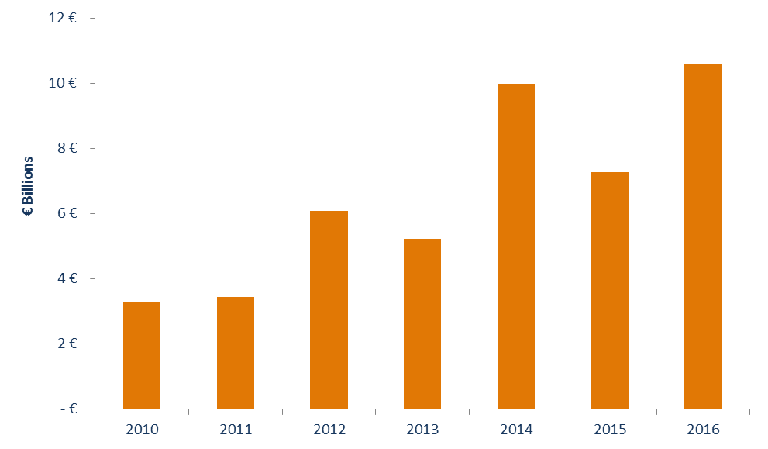

Source: European Commission Services

**Subject to its legal base, origin and purpose, other revenue is registered either as 'general revenue' or as 'assigned revenue'**. As a rule, other revenue is balanced out through the Gross National Income-based Own Resource, thus leading to lower needs for national contributions from the Member States (see Part I, Section 1.2). Other revenue which is registered as 'assigned' revenue is used to provide additional appropriations to finance expenditure. The related expenditure lines must be clearly stated in the budget documents.

**The present level of other revenue allocated to the EU budget could be increased if the opportunities were more systematically exploited**. The final report of the High Level Group on Own Resources recommends that as a matter of principle all revenue that is created by common EU level rules should accrue to the EU budget. In the past, revenue created by EU legislation has sometimes been allocated to national budgets, like the auctioning proceeds of the Emissions Trading Schemes. The European Travel and Information Authorisation System (ETIAS) as proposed by the Commission foresees that the fees/Visa waivers to be paid by visitors to the Schengen area from third countries should constitute assigned revenue (to allow for additional appropriations on selected budget lines). The EU budget might receive approximatively EUR 100 million per year[43].

## Mapping other future revenues

The High Level Group on Own Resources published its final report and recommendations in January 2017. As a follow-up, Commission services have thoroughly analysed these recommendations and examined possible variants in view of operationalising the candidates as well as a few additional options which were not included in the report. Whilst these candidates have their potential merits, they were not retained in the final basket as proposed by the Commission for a variety of reasons.

Excise duties, such as for tobacco or other consumer items can be subject to EU level harmonisation. In many cases, they also pursue a double purpose: revenue generation and behavioural change. To the extent that they already build on a minimum harmonisation at EU level, such surcharges would, in principle, lend themselves as a basis for an Own Resource for the EU budget.

An Own Resource based on cigarettes taxation was analysed. In recent years, the European Union has strengthened its focus on tobacco-related policies, pursuing fiscal harmonisation and fighting tobacco smuggling. A directive on the structure and rate of excise duties already exists. Another directive – the Tobacco Products Directive - aims to tackle illicit trade in tobacco products, which costs national (and indirectly the EU-) budgets over EUR 10 billion per year.

Similarly, a sugary drink tax coordinated or harmonised at EU level could address negative externalities of consuming sugar, in terms of health problems and healthcare costs. The rate of obesity is among the indicators for the Sustainable Development Goals. Such a tax could be a way to regulate (i.e., discourage) the consumption of sugary drinks while avoiding distortions in the Single Market. A (minimum) EU-level sugary drinks tax, along the lines of those already existing at national level could have been designed as an Own-Resource.

In the field of environment taxation, other Own Resource candidates were explored. A motor fuel surcharge could have built on a broad existing tax base and be in line with the aim of decarbonising the transport sector[44]. Moreover, an Own Resource linked to petrol could build on an existing framework of harmonisation.

A border carbon adjustment scheme[45] was explored. Similar to the levying of custom duties, this would build on the EU's legal prerogatives with respect to the common external borders. Compliance with the rules of the World Trade Organization would have to be ensured. The introduction of additional duties on imports would require an equivalent measure affecting producers in the Union in order to ensure non-discrimination of imported products. A carbon tax in non-Emissions Trading System sectors could be applied to both domestic and imported products but the precise definition of a tax base would be difficult in practice. It would have to reflect the actual carbon footprint throughout the production chain of each product.

A seigniorage-based own resource was analysed. Such revenues are not only the addition of what national revenues from printing money used to generate before the creation of the euro, they also result from the fact that the euro has become an international reserve currency, a status most national currencies did not have. Such revenue source, however, can only be legitimately seen in the context of the euro area and not the EU as a whole, in particular in the context of the European and Monetary Union and stabilisation instrument.

As part of the Multiannual Financial Framework package in 2011, the Commission had proposed the introduction of a new Own Resource based on a new Financial Transaction Tax[46]. As no unanimity could be mustered for the Financial Transaction Tax, in 2013 the Commission tabled a proposal for a Council Directive implementing enhanced cooperation. The negotiations are still ongoing in the Council. The detailed provisions which should govern the creation of the harmonised Financial Transaction Tax are still to be decided upon by unanimity by the now 10 participating Member States[47]. Nevertheless, the Financial Transaction Tax-based Own Resource could be a viable 'candidate' which fulfils many criteria (in particular its mobile tax base and cross-border nature) which can only be regulated effectively - or taxed efficiently - at EU level. As such, it would have a marked EU added value dimension.

Finally, digital taxation has been analysed. Current tax rules, which are based on the physical presence of activities, do not properly grasp the development of the digital economy. The application of national digital taxes with different rates and different rules would remain suboptimal and create additional administrative costs for the participants. Furthermore, the eventual economic incidence of the tax and its costs are difficult to locate by Member State since it is incompatible with a logic of national jurisdiction. In March 2018, the Commission presented a proposal on a Digital Services Tax[48] which would allow digital players to be taxed through a fair and harmonised system. The proposal combines a long-term (comprehensive) solution, based on a Directive addressing 'where' and 'what' to tax and providing for future integration with the Common Consolidated Corporate Tax Base; and a short-term solution applicable in the interim.

# Phasing out Corrections

**In addition to being complex, the system of rebates is interrelated with the concept of net balances, which is also to become obsolete as regards the evolution of the EU budget.** Net balances cannot be used either as an exact measure of solidarity or excessive budgetary burden, nor as a proxy for ‘cost-benefit’ assessments. Expenditure from the EU budget allocated to a specific Member State often benefits other Member States as well or even addresses a common European public good. In fact, net balances ignore, almost by definition, any European added value not directly measurable.

**The net-balances approach is even less relevant in the context of a modern budget focused on common priorities and European public goods.** The decreasing weight of nationally allocated programmes, in particular the Common Agricultural Policy and Cohesion Policy, and the growing share of spending priorities such as research and innovation, mobility, border management, security and defence, call for a truly European approach with the resulting added value not captured by net balances. Introducing new revenue components which, by their very nature, reflect collective benefits of cooperation and coordination at EU level should further attenuate the perception of the EU budget as a zero-sum transfer system.

**Removing corrections immediately could however lead to a significant and sudden increase in the contributions of Member States** having benefitted from corrections in 2020. Therefore, lump sum reductions to their Gross National Income-based contribution are proposed, which will be gradually phased out. To this end, the gross reductions in the Gross National Income-based contributions granted to Denmark, the Netherlands and Sweden, the reduced call rate for the Value Added Tax-based Own Resource for Germany, the Netherlands and Sweden and the amount of corrections resulting from the reduced contribution to the United Kingdom correction granted to Germany, the Netherlands, Austria and Sweden are converted into a corresponding single lump sum for each Member State concerned. The ‘rebates on the rebate’ are included in this calculation as they determine the national contributions financing key of Member States in 2020. Abolishing the UK rebate and the Member States contributions to finance it changes the financing key for all Member States. While there is an increasing financing share for Germany, the Netherlands, Austria and Sweden, the share in national contributions for all other Member States diminishes. The baseline for determining the lump sums is the sum of corrections granted in 2020. They will be granted as gross reductions in the Member States’ Gross National Income-based contributions and reduced by equal steps over the period 2021 and 2025 to be phased out by the end of 2025 (Figure 10).

**Figure 10 – Phasing out corrections (gross reductions to GNI-based contributions, 2018 prices)**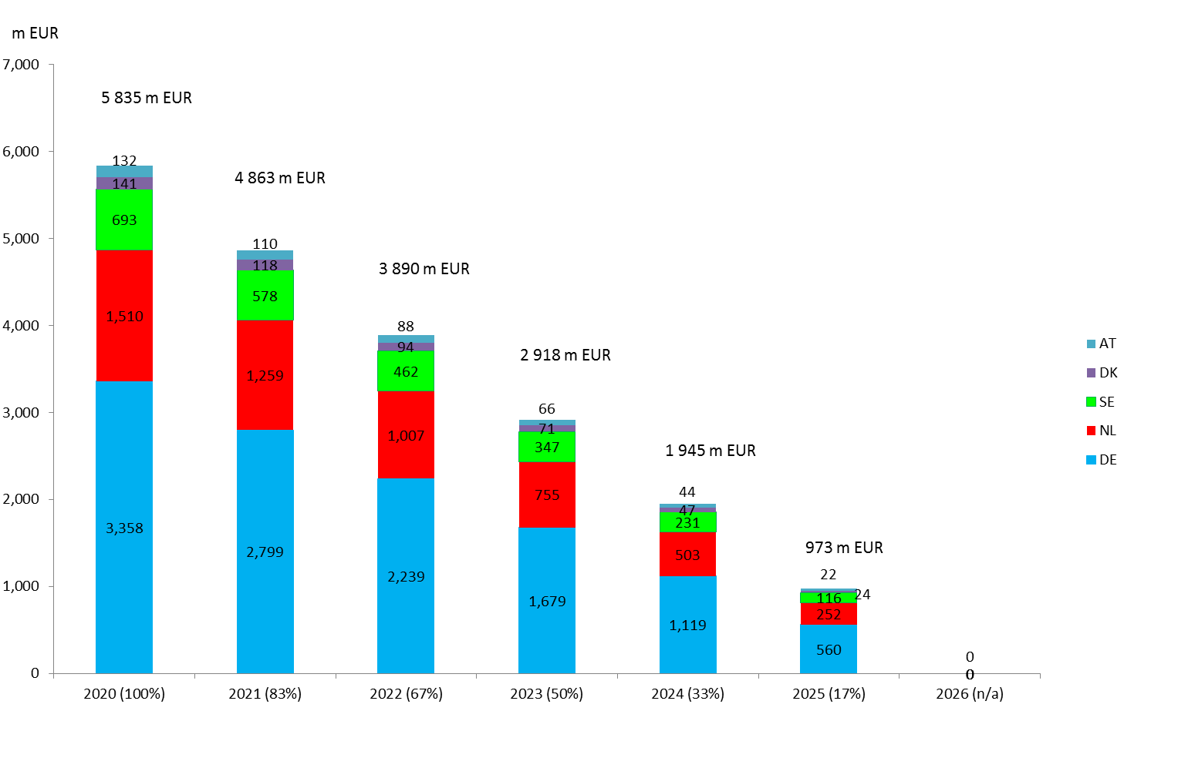

**Source: European Commission Services**

# Summary

The reform of the revenue side could be conceived in a comprehensive way and comprise several elements yet without jeopardising those features of the present system of Own Resources which have proven their worth.

The modernisation of existing Own Resources could be achieved through simplification and lowering the share of the Gross National Income-based contribution to make it a true residual item, balancing the Own Resource system as originally designed.

The introduction of new types of Own Resources would create a more direct link between the budget's revenue side and EU policies. Diversifying the revenue sources would make the EU budget more responsive to national evolutions.

Corrections will be gradually phased out as they do not correspond any more to the increasing focus on EU added value expenditure.

# Part 3: A Basket of Own Resources: Building on Complementarities to Enhance Fiscal Coherence, Resilience and Fairness

This part analyses the merits of proposing a basket of Own Resources for the EU budget. Since 1988, when the Commission launched the Single Market project and then enlarged to new countries, no new categories of Own-Resources have been introduced. The new Own Resource created at that time aimed to ensure financial autonomy and the capacity to balance an expenditure driven budget. Since then, the proposed reforms have not been approved for various reasons, including the perceived merits of a simple and stable system based on national contributions[49]. A mixture of financial interests, political and institutional considerations have stood in the way of finding agreement and overcoming veto threats ever since (Part I).

However, the increasing challenges posed by globalisation and digitalisation, the stronger integration of European economies and the need to reinforce the sustainability of growth, reveal some weaknesses in the current system on both the revenue and expenditure sides. The economic and financial crisis, as well as the recent migration crisis, has shown the need to increase the reactivity and flexibility of the EU budget. The Mid-Term Review of the Multiannual Financial Framework has addressed some of these shortcomings by increasing the flexibility of the expenditure side.

Section 1 describes how the different Own Resources could be phased in in the EU budget, taking account of the ongoing policy discussions at the EU level. Section 2 highlights the increased fiscal coherence between EU and national budgets on the revenue side. Section 3 describes how the basket of Own Resources amplifies the existing adjustment system ensured by the Gross National Income-based contribution. Section 4 discusses how the coherence of reporting national contributions to the EU budget could be improved. Section 5 concludes.

# Timing and phasing in of new Own Resources

**Due to the ratification requirement, Own Resources decisions only enter into force with a time lag** which can last up to over two years. It can be applied with retroactive effect, which in the past has further complicated the working of correction mechanisms. However, the allocation of new Own Resources to the EU budget can also start at a later stage, or be conditional, for example, upon the coming into effect of a relevant basic act.

**A basket of new Own Resources will provide some fresh money to the EU budget**. While most of the proposed new revenue sources will not create entirely new revenue streams, they are clearly linked to initiatives taken at EU level and reflect directly or indirectly the added value of the Own Resources system. In terms of estimated revenue, the new Own Resources have the potential to provide a significant share of the necessary income. Depending on the agreed ceiling for payments under the next Multiannual Financial Framework, as well as on the impact of the proposed changes to the existing Own Resources (i.e. customs duties and the reformed Value Added Tax) revenues from the new Own Resources could provide (i) additional revenues to contribute to the closing of the financing gap (Part I, Section 2) and/or (ii) replace part of the Gross National Income-based contributions (Figure 11).

Figure 11 – A new basket of Own Resources adding to, or partly replacing, Gross National Income-contributions

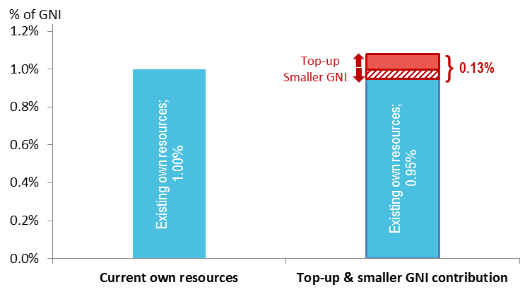  
Source: European Commission Services

**A basket of new Own Resources could be phased in progressively**. Table 2 assumes that the Own Resources based on Value Added Tax, the Emissions Trading System and Plastic Packaging Waste that is not recycled will be collected as of the entry into force of the Own Resources Decision, whereas the Own Resource based on the Common Consolidated Corporate Tax Base is projected to 'kick in' in 2023, once the relative legislation is transposed and applied by corporations to declare their taxable profits.

Table 2 – Reform of the revenue side of the EU budget: phasing in of Own Resources

|  |  |  |  |  |  |  |  |  |  |
| --- | --- | --- | --- | --- | --- | --- | --- | --- | --- |
| *% shares* | **2018** | **2021** | **2022** | **2023** | **2024** | **2025** | **2026** | **2027** | **Average 2021-2027** |
| *GNI-based Own Resource* | 71 | 64 | 64 | 57 | 57 | 56 | 56 | 56 | 58 |
| *Value Added Tax-based Own Resource* | 12 | 14 | 14 | 13 | 14 | 14 | 14 | 14 | 14 |
| *Traditional Own Resources* | 16 | 15 | 15 | 14 | 15 | 15 | 15 | 15 | 15 |
| *CCCTB-based Own Resource* |  |  |  | 9 | 9 | 9 | 9 | 9 | 6 |
| *ETS-based Own Resource* |  | 2 | 2 | 2 | 2 | 2 | 2 | 2 | 2 |
| *Plastic-based Own Resource* |  | 4 | 4 | 4 | 4 | 4 | 4 | 3 | 4 |
| TOTAL Own Resources | **99** | **99** | **99** | **99** | **99** | **99** | **99** | **99** | **99** |
| *Other revenues* | 1 | 1 | 1 | 1 | 1 | 1 | 1 | 1 | 1 |
| TOTAL revenues | **100** | **100** | **100** | **100** | **100** | **100** | **100** | **100** | **100** |

Source: European Commission services long-term projections.

Call rates: Value Added Tax-Own Resource: 2018-21: 0.3% on final base; as from 2021: 1% on standard-rated base; Common Consolidated Corporate Tax Base: 3% on tax base; Plastic: EUR 0.80 per kg of non-recycled Plastic Packaging Waste. The Common Consolidated Corporate Tax Base-based Own Resource revenues start flowing only in 2023.

Note: The table is built on purely illustrative, smoothed figures: it takes as starting point the 2016 outturns or 2018 adopted projections, and applies to them the growth rates of Gross Domestic Product in the long-term projections developed by the Commission for e.g. the Sustainability report, also used to project Multiannual Financial Framework expenditure. Conversely, the revenues from Plastic Packaging Waste and Emissions Trading System Own Resources are estimated to remain stable over time in nominal terms.

Note: This presentation does not include the United Kingdom’s payments on outstanding commitments and liabilities at the end of 2020 due in line with the terms agreed in the draft withdrawal agreement.

Comparing the present revenue composition in 2018 with that projected in 2027 shows the continuity and the innovation in the reform of the EU budget. Under the current system, depending on the year and the stage of the annual budget cycle, the Gross National Income-based Own Resource covers between two thirds and three quarters of total revenue. Once the new Own Resources are introduced, the Gross National Income would cover more than half of total revenue and would continue to 'absorb' the fluctuations of annual payments from the EU budget.

# Complementarities with national budgets: increased fiscal coherence on the revenue side

## Complementarities between EU and national level: Structure of the budget

**The diversification of Own Resources enhances the EU dimension of budget revenues**. As shown in Figure 10, the degree of national and supranational decision-making matches with the link to EU competences for each proposed Own Resource. More upwards and rightwards in the matrix are the revenue sources satisfying both these criteria of fiscal coherence[50].

**Figure 12 – Assessment matrix for Own Resources**

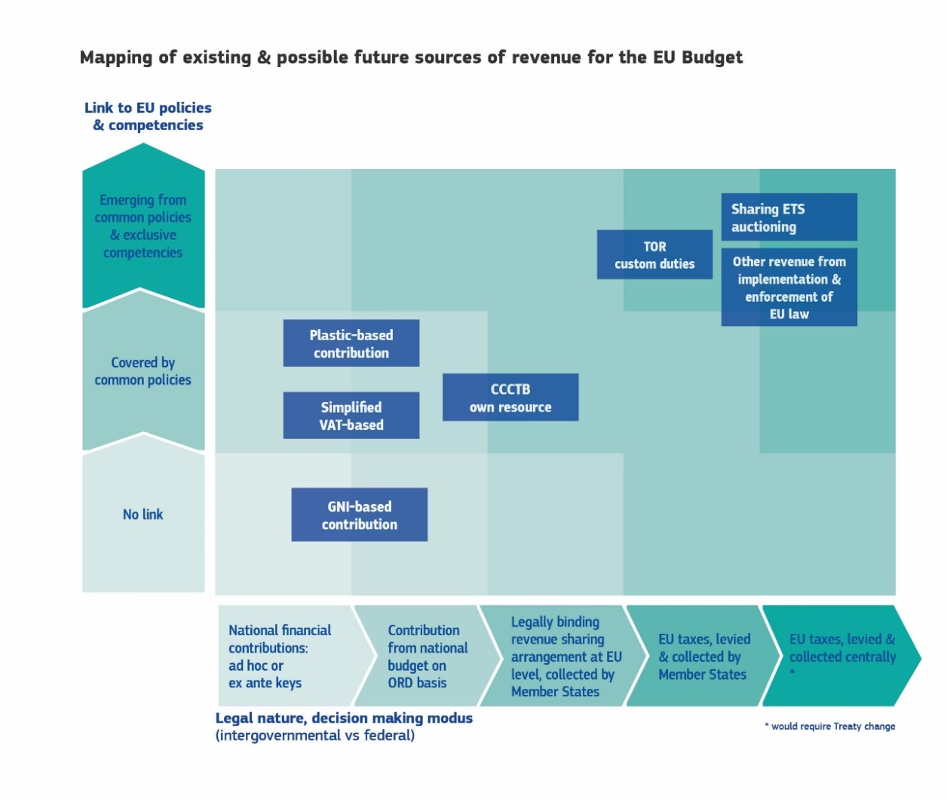

Source: European Commission Services adapted from the final report of the High-Level Group on Own Resources.

The "basket" approach puts back genuine Own Resources in terms of linking them to key EU policies. It displays a strong relation to EU policies and the need to act at EU level when it comes to address negative externalities (greenhouse gas emissions, plastic waste). At the same time, they are also linked to the benefits of the internal market generated by trade and tax harmonisation. EU initiatives on Value Added Tax and corporate taxation contribute to ensuring a level playing field for companies and consumers.

**As a result, the composition of the EU budget revenue side would be more akin to the structure of national budgets**[51] (Figure 13; Box 6). Depending on the call rates applied, the EU budget could get a significant share from consumption tax (Value Added Tax), corporate income tax (Common Consolidated Corporate Tax Base) and from environmental contributions (Emissions Trading System, plastic). The rest would be financed by a Gross National Income-contribution (which can, in some sense, loosely mirror the role of personal income tax revenues in national budgets).

Currently, most of national budget revenues come from personal income tax, including social contribution. Consumption taxes are also a substantial source of revenues while environmental revenues constitute a lower share, and account for 6.7% of national tax revenues on average.

**Figure 13 – Composition of revenues in Member States and new proposed EU budget**

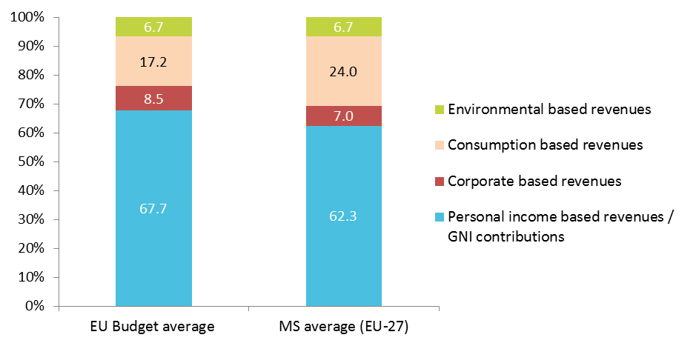

Source: European Commission Services, based on Eurostat.

Note: The chart presents a backward simulation of how the EU budget could have been funded, compared with average of the 27 national budgets, based on Eurostat data for 2011-2016, weighted with Gross National Income. Personal income-based revenues also include social contributions. EU budget revenues comprise the Gross National Income-based and Value Added Tax-based contributions (average over 2011-2016), Common Consolidated Corporate Tax Base revenues (3% call rate) which are based on 2012 estimates made with the CORTAX model, and environmental-based revenues that include the Emissions Trading System- and Plastic-based Own Resources (2016 estimates).

**Box 6: Comparison of budget structure in federal systems**

In size, the EU budget will remain relatively small (around 1% of EU Gross National Income) and cannot be compared to the size of national budgets where the share of revenues varies from 26% of Gross Domestic Product in Ireland to 53% in Denmark and France). However, the basket of new Own Resources would considerably change the structure of the EU budget, making it more comparable to national ones.

Figure A shows the composition of different sources of revenues allocated between the levels of government for Germany, the United States and the EU. For Germany and the United States, "non-federal" consists of tax income revenues at the state/regional and local levels. In the United States, corporate income tax is mainly a federal revenue and consumption (sales) tax a state or local one. In Germany, the main taxes are shared between the federal and state government levels, whereas social contributions are managed by a separate entity at federal level.

All these systems are not comparable in terms of governance and institutions, but in most cases, central and national budgets display some form of relationship in terms of structure and size of revenues[52]. At present, the EU has a remarkably high share of national contributions based on Gross National Income and little direct relationship with national budgets.

**Figure A – Revenues by level of governance in the EU and in two federal systems**

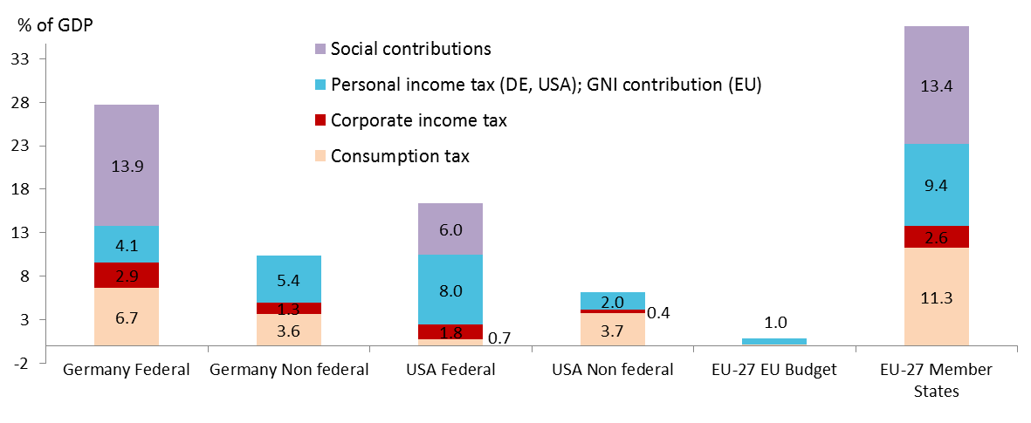

Source: European Commission Services.

Note: The data are presented as a percentage of Gross Domestic Product (and of the EU-27 total Gross National Income for the EU Budget).

**Overall the diversification of revenues of the EU budget would not concentrate the burden on a few Member States.** The underlying bases for the new Own Resources States in recent years have been comparable to that of Gross National Income (Figure 14). The coefficients of variation across countries of Gross National Income, Value Added Tax and corporate income tax are all around 1.6 over the 2011-2015 period. For plastics and the Emissions Trading System, they are even lower.

Figure 14 – Variability of Gross National Income and candidate Own Resources

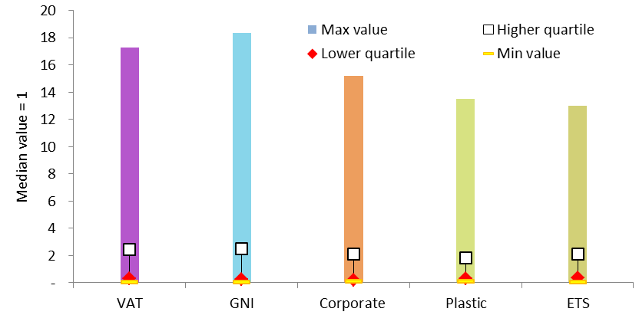

Source: European Commission Services, based on Eurostat (national revenue and Gross National Income data).

Note: minimum, maximum and quartiles values of the distribution of each resource are scaled to the respective median value (used as numéraire).

## Complementarities between the EU and the national level: the cyclicality of the basket of Own Resources

**The revenue profile of each Own Resource differs** (Figure 15). Looking at the cyclical fluctuations over the past two decades, Value Added Tax revenues follow quite closely the economic cycle, whereas among the newly proposed Own Resources the corporate tax is expected to experience wider fluctuations, judging from past swings in taxable corporate income.

By contrast, revenues from Plastic packaging waste-related contributions can be considered as less cyclical as they are determined both by economic activity and by the policy undertaken in these areas. As regards the Emissions Trading System Own Resource, experience shows that the revenues from the auctioning of allowances are correlated with economic activity, as well as with the EU policy targets in both the climate mitigation and the renewables sector. Emissions Trading System revenues are also strongly influenced by exogenous factors such as the relative price of gas relative to coal. The specific evolution of the Emissions Trading System revenues in the 2013-2016 period displayed in Figure 15 is furthermore explained by the introduction of legislative measures to address the surplus of allowances on the EU carbon market.

**Figure 15 – Developments of Gross National Income and (candidate) Own Resources**

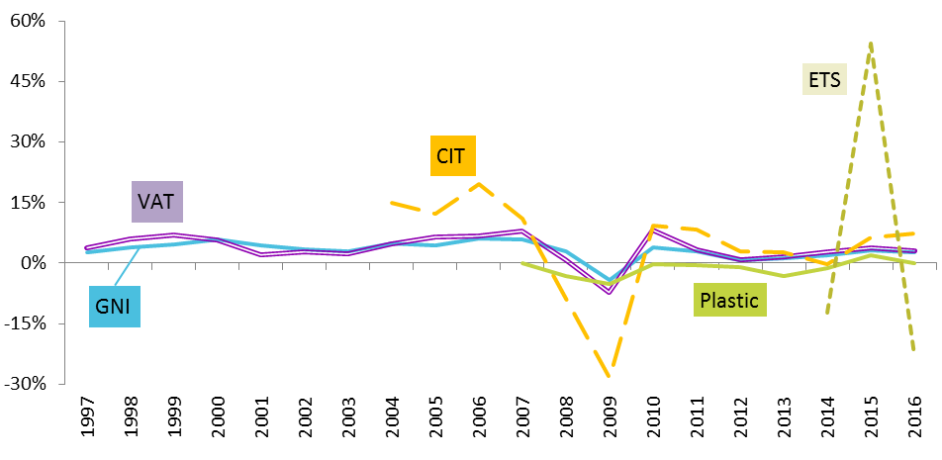

Source: European Commission Services.

Note: Annual % change of the respective bases on which Own Resources are (to be) calculated. EU-27 (without UK), current prices in EUR except for plastics (quantity). For Value Added Tax and Corporate Income Tax, the respective national tax receipts are shown; for Plastic, the quantity of non-recycled Plastic Packaging Waste; for Emissions Trading System, the quantity of allowances available for auctioning. For Gross National Income actual dynamics are depicted.

**The revenue cycles could make the different Own Resources complementary**. One advantage of having a basket that includes a plurality of Own Resources with differentiated responses to the cycle is that the ups and downs in their annual revenues might compensate each other, contributing to a greater stability of the basket as a whole – and hence of EU budget revenues. However, the tax base of environmental Own Resource is smaller, which means that these Own Resources may only partially dampen the fluctuations in the more cyclical ones.

# The in-built burden-sharing mechanism of EU financing

**The adjustment mechanism played by the Gross National Income will be amplified[53]**. The Gross National Income-contribution is determined by the difference between expenditure and other resources and revenues. As expenditure is decided on a multiannual basis, it remains quite stable and independent from national economic cycles (Part I). This has played a buffering role during the economic and financial crisis. For example, recent evolutions show that EU investment funds have played a positive role, maintaining public investment in those countries hit by the crisis, such as Greece, Portugal, Slovenia and Cyprus (Figure 16).

**Figure 16: Share of EU Investment Funds in national government investment**

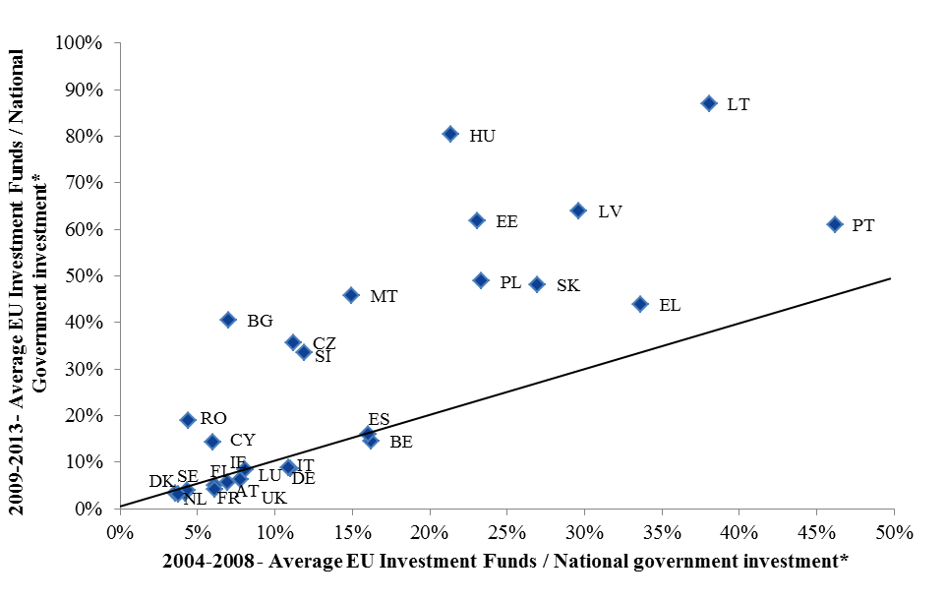

* EU Investment fund corresponds to Heading 1 of the EU budget.

Source: AMECO and European Commission Services

In order to maintain the level of EU expenditure during an adverse business cycle in one or more Member States, Gross National Income contributions take up the slack in the other Own Resources. Any potential decrease of revenues needs to be compensated by a higher Gross National Income contribution which is shared among Member States according to their Gross National Income. The mechanism works already with the current structure of EU revenues. More cyclical revenues would amplify this mechanism.

**As a result, more cyclical revenues for the EU would better sustain national economies hit by potential asymmetric shocks**. The greater cyclicality of revenues from the basket would reduce the contributions to the EU of the Member States in question more than proportionally (i.e. compared with Gross National Income-based Own Resource only), while the other Member States would share the extra burden. Thus, the basket would ensure an in-built capacity to provide support to one or more Member States hit by an asymmetric shock (see Box 7). Conversely, in the case of symmetric shocks the residual Gross National Income contribution would increase proportionally for all Member States, ensuring that the impact is equally distributed (i.e. no relief for specific countries).

Figure 17 shows what the composition of EU revenues would have been in the past decade if the new Own Resources had already been in place[54]. The more cyclical 'fiscal revenues' would have dropped, needing Gross National Income call rates to increase. The reverse would have happened in the economic recovery phase.

Mirroring the higher cyclicality of the basket of Own Resources, the Gross National Income call rates would have been lower and would also have fluctuated more (see the lower marks in Figure 18).

F**igure 17 – Backward simulation of EU revenue composition with basket of Own Resources**

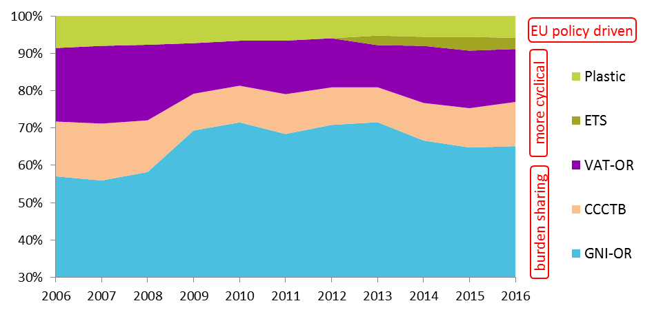

Source: European Commission Services

Figure 18 – Gross National Income call rates: actual and simulated (with basket of Own Resources)

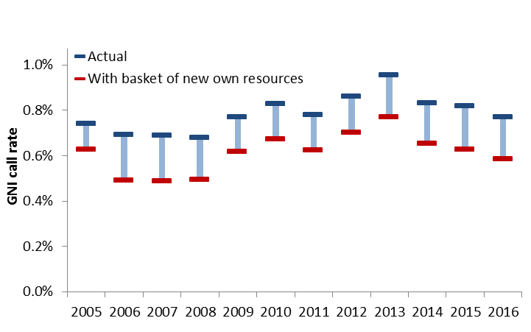

Source: European Commission Services

**Positive economic developments would also have a distributive impact**, i.e. all countries would benefit from increased revenues from EU instruments, but to a different extent. For instance, in 2015, Emissions Trading System revenues increased by EUR 1.7 billion. Had the EU Emissions Trading System already been part of the EU Own Resources, by itself this revenue would have helped reduce Gross National Income-contributions for everyone, including the most carbon intensive economies.

**Box 7: Amplifying the in-built burden sharing mechanism.**

1. Assume that the total Own Resources required to finance the EU budget are constant over a period of time and that Gross National Income is also constant in each Member State over that period.

2. In year *n* the Common Consolidated Corporate Tax Base revenues in country A drop sharply compared with *n-1*, e.g. by EUR 4 billion;

3. For simplicity, assume that a 5% EU call rate on the corporate tax base is equal to one-tenth of national revenues: this implies an initial EUR 400-million shortfall for the EU budget;

4. In order to offset the EUR 400 million, a differentiated basket of Own Resources would make it possible that the shortfall is offset entirely within the budget (e.g. through an increase in Common Consolidated Corporate Tax Base revenues from other countries), although it is equally possible that the overall impact is deepened (simultaneous decrease of several Own Resources). In any case, the Gross National Income contribution will play its role of balancing item: for simplicity, let's say that it will increase by EUR 400 million, via a proportionally higher call rate on every Member State. Country A will also pay a higher Gross National Income contribution, in proportion to its weight on the total.

In sum, this simulation shows the interplay of two mechanisms, both relieving a country hit by an asymmetric shock from bearing its whole burden. Of course, in this example, country A would still bear nine-tenths of its revenue shortfall and pay a smaller additional Gross National Income contribution. This minimises the wrong incentives for country A, e.g. to avoid making high efforts to collect taxes.

Although the example is fictitious, it illustrates how the mechanism could have worked during the recent economic and financial crisis. Had a corporate-income-based Own Resource been present then, the EU budget could have slightly relieved some Member States from bearing the burden of its revenue shock, by automatically sharing it with the other Member States not hit by the shock.

# Reporting EU contributions in national budgets: Heterogeneity across Member States

As mentioned above the EU budget is characterised by a high proportion of national contributions compared to other areas. These contributions aim to finance EU public goods as well as other more nationally based expenditures.

**At present, the description and classification of contributions to the EU budget in Member States' accounts and budgets vary widely**. Despite the high degree of harmonisation of national accounts, which is framed by the Regulation on the European System of Accounts[55], only a few Member States (notably Austria, France, Germany and Romania) classify EU contributions in their budget as an attribution of fiscal receipts (or 'negative income'). Most Member States treat them as government expenditure. Some Member States differentiate between the Gross National Income -based contributions, the Value Added Tax-based contributions and the traditional Own Resources (table 3)[56].

Table 3: Overview of the treatment of contributions to the EU budget

| **Member State** | **Value Added Tax** | **Gross National Income** | **Traditional Own Resource** |
| --- | --- | --- | --- |
| BE | Reduction in federal government's receipts (an attribution to the sub-national entities) | Government expenditure |  |
| FR |  | A levy on state revenue (an equivalent to the attributions to the local governments) |  |
| DE |  | Reduction in government income |  |
| BG |  | An attribution of government receipts |  |
| CZ |  | Separate government expenditure |  |
| DK |  | Government expenditure |  |
| EE |  | Government expenditure |  |
| IE |  | Government expenditure |  |
| ES |  | Central government expenditure |  |
| IT | Central government expenditure | Central government expenditure | Central government expenditure |
| CY | Expenditure (transfers) by the Ministry of Finance | Expenditure (transfers) by the Ministry of Finance | Expenditure (transfers) by the Ministry of Finance |
| LT |  | Expenditure on general public services |  |
| LU | Deduction from the government revenues | Government expenditure | Deduction from the government revenues |
| HR |  | Government expenditure ("International membership fees and payments to the EU") |  |
| NL | Government expenditure | Government expenditure | Government expenditure (sugar levies) |
| AT |  | Negative income (on the income side of the budget), i.e. a "reduction of earnings and deposits to public expenditures" |  |
| PL |  | Government expenditure ("Own Resources of the European Union") |  |
| PT |  | Central government expenditure |  |
| RO |  | Deduction from the receipts from the EU budget (not an attribution of government revenue nor government expenditure) |  |
| FI | Government expenditure | Government expenditure |  |
| SE | Government expenditure | Government expenditure | Government expenditure (customs tariffs, sugar fees) |

Source: based on European Parliament study (2014), How do Member States handle contributions to the EU budget in their national budget.

**Member States apply inconsistent accounting rules to their contributions to the EU budget**. Although different treatments in national budgets are made neutral for the purpose of fiscal surveillance (i.e. they ensure compliance with the Stability and Growth Pact), reporting national contributions as government expenditure may have implications on the way the EU budget is portrayed in national political debates.

The ratification of the Own Resources decision by national parliaments should shield it from interference during Member States' annual budgetary sessions: even if classified under government expenditure, the transfers due to the EU should be ring-fenced from any spending cuts or reallocations, as well as from any spending review exercises or other mechanisms to attribute revenues and expenditure across levels of government. However, defining those transfers as an outlay of national governments may lend arguments to politicians who see the EU uniquely as a burden and ignore its added value.

**A more harmonised reporting at national level would herald a willingness to improve fiscal coherence**. As the final report of the High Level Group on Own Resources points out, the above-mentioned inconsistencies are indicative of the prevailing perception of Own Resources payments as a national 'transfer' to the EU budget. As a step towards more fiscal coherence between the national and EU level, the competent authorities could treat the 'national contribution' in a more consistent manner. National budgets should clearly indicate that these are public revenues to be allocated to the EU level rather than expenditure items in competition with other public investment.

# Summary

The diversification of revenue sources would bring some benefits compared to the current system. It builds on the major improvements made in the past - the introduction of the Gross National Income contribution as a balancing item – and exploits the mechanism in a way that would make the revenue side of the EU budget closer to EU and national evolutions.

From a policy perspective, the basket of Own resources would increase the link between the revenue side of the EU budget and key EU policies (climate change, environment, Single Market).

From a budgetary perspective, it would provide fresh money and improve the synergies between the revenue and expenditure side.

From an economic perspective, the basket of new Own Resources would increase the flexibility of the revenue side of the EU budget given the different cyclical pattern of these Own Resources. Furthermore, it would amplify the in-built burden sharing mechanism and the smoothing effect of the EU budget and assimilate it better to national economic developments.



1. Merler S. (2016), *Income convergence: did EU funds provide a buffer*, Bruegel, Working Paper, Issue 6, 2016. The author finds that EU funds have contributed to limiting the negative effect of the economic and financial crisis, in particular in helping disadvantaged regions. See also Nunez Ferrer J. (2014), What are the effects of the EU budget: Driving force or drop in the Ocean. In *EU Budget and National Budgets: Facts, figures and Impact*. Study, European Parliament, Directorate General for Internal Policies.
2. Duties levied on agricultural products were identified separately over the period 1970-2008, but are now grouped with customs duties. Until 30 September 2017, when the production quotas for sugar ended, traditional customs duties also included sugar levies.
3. This percentage was 10% over the period 1970-2000, 25% from 2001 to 2013, and then 20% as from 2014.
4. The call rate was firstly fixed at 1% and later raised to 1.4%.
5. European Union Public Finance (2014), 5th Edition.
6. For example, in 2013 or 2014, the pace of programme execution deviated from forecasts and amending budgets were adopted.
7. European Union Public Finance (2014), 5th edition.
8. Council Conclusion 7-8 February 2013.
9. See section two for the report of the High Level Group on Own Resources. See also Benedetto G. (2017), Institutions and the route to reform the European Union's budget revenue 1970-2017, *Empirica*, 44:615-633; Schratzenstaller M. et al.(2014), *Own Resource EU Taxes as Genuine Own Resource to finance the EU Budget – Pro, cons and Sustainability-oriented Criteria to evaluate Potential Tax Candidates*. FairTax Working Paper Series, n°3; Schratzenstaller M., Reform Options for the EU's System of Own Resources, *Revue de l'OFCE*, n°132, 347-355; European Parliament, *Report on reform of the EU's system of Own Resources* (2017/2053(INI)), A8-0041/2018.
10. Conclusions of the European Council meeting of 25-26 June 1984 in Fontainebleau, p.2 (<http://www.consilium.europa.eu/media/20673/1984_june_-_fontainebleau__eng_.pdf>)
11. *Future Financing of the EU. Final report and recommendations of the High Level Group on Own Resources*. December 2016.
12. *Reflection paper on the future of EU finances*. COM(2017) 358 of 28 June 2017.
13. COM(2017) 2025 of 1 March 2017.
14. COM(2018)98.
15. In 2016, Ireland gave notification that its nominal Gross National Income of 2015 had increased by 25%, i.e. much more than foreseen just a year before, mainly due to the transfer of intangible assets from foreign companies to their Irish branches.
16. The Commission has also relaunched the proposal for a Common Consolidated Corporate Income Tax in 2016 and has proposed a tax on digital services in March 2018.
17. On the expenditure side, the FISCALIS programme supports cooperation between Member States in this area.
18. COM(2017) 646 final.
19. G. Felbermayr, J. Gröschl, I. Heiland (2018), *Undoing Europe in a New Quantitative Trade Model*, ifo Working Paper n° 250.
20. Report of the High Level Group on Own Resources.
21. Kotsogiannis C., (2016), European Union and Own Revenue Resources: (Brief) Lessons from Fiscally Decentralised Economies. Chapter in *The Future of EU-Finances*, Working Papers for the Brussels Symposium on 14 January 2016, Edited by T. Buettner and M. Thöne.
22. Bénassy-Quéré A., Trannoy A., Wolff G. (2014), Tax Harmonisation in Europe: Moving Forward. Conseil d'Analyse Economique, n°14, July.
23. C. Fuest (2017), Reforming the EU Budget: Small changes can bring considerable improvements, in T.Büttner, M.Broer, C.Fuest, C.Waldhoff, M.Schratzenstaller, P.Becker, J.Haas and C.B. Blankart, "Die Zukunft der EU-Finanzen: Neue Wege der Finanzierung und der Verteilung?", *ifo Schnelldienst 70 (06)*, 2017, 03–25.
24. Regulation 1553/89.
25. Commission proposals for Council Directives COM(2016)683 final and COM(2016)685 final.
26. Candau F., and Le Cacheux, J. (2017), *Corporate Income Tax as a Genuine Own Resource* Available at SSRN: https://ssrn.com/abstract=2939938 or <http://dx.doi.org/10.2139/ssrn.2939938>. Berger M. and al., (2017), *How Europe can deliver. Optimising the division of competences among the EU and its member states*. Case study 3 on corporate taxation. Bertelsmann Stiftung, Gütersloh.
27. The proposed Directive states that the consolidated tax base – when positive – shall be shared between the company group members at the end of each tax year on the basis of a formula for apportionment. In determining the apportioned share of a group member A, the formula shall take the following form, giving equal weight to the factors of sales, labour and assets:

    
28. Due to data limitations, these estimates are for all multinational groups, which is the best estimate for groups with consolidated global turnover above EUR 750 million. The estimates are based on the CORTAX simulations for the Impact Assessment of the Common Consolidated Corporate Tax Base (more specifically, scenario 4 of Table 11). For more information on CORTAX, see *Modelling corporate tax reform in the EU: new calibration and simulations with the CORTAX model*. Working Paper n°66, 2016. Taxation Papers.
29. Assuming it enters into force in 2023. See Part III, section 1.
30. Article 10(3) of the Emissions Trading System Directive.
31. Or in 2005 and 2007. Article 10(2)(a) of the Directive.
32. Article 10a and 10b of the Directive.
33. Article 10c of the Directive.
34. Note that the share of allowances can be increased to 60%, using allowances redistributed for reasons of solidarity, growth and interconnections, if from that same amount allowances are also transferred to the Modernisation Fund established under the Directive.
35. Article 10(2)(b) of the Directive.
36. Except for allowances freely allocated to the power sector, for which the contribution is equal to the relevant share of the market value of these allowances.
37. The lower price estimate is EUR 10/ton which corresponds to market price in the first months of 2018. The upper price estimate is EUR 25/ton which corresponds to the central scenario of the impact assessment conducted for the proposed Emissions Trading System revision during phase 4 (2021-2030)
38. COM/2018/028 final.
39. Achieving the objectives laid out in this strategy will require major investments in both infrastructure and innovation. Meeting ambitious goals on plastics recycling alone will require an estimated additional investment of between EUR 8.4 and 16.6 billion. See Deloitte, (2015) *Increased EU Plastics Recycling Targets: Environmental, Economic and Social Impact Assessment*.
40. Schratzenstaller M., (2018), A Plastic Tax as Sustainability-oriented Tax-based Own Resource for the EU Budget. Input to the Plastic Packaging Roundtable of 22 March 2018. To be published
41. OJ No L 365/10 of 31.12.94
42. ICF Consulting Services Ltd (2018), Plastics: Reuse, Recycling and Marine Litter”, a study prepared for the European Commission, (forthcoming).
43. These estimated numbers rely on the statistics available in the Smart Border Technical Study.
44. Thöne M. (2016), Transferring taxes to the Union: the case of European road transport fuel taxes. Chapter in The Future of EU-Finances, Working Papers for the Brussels Symposium on 14 January 2016, Edited by T. Buettner and M. Thöne.
45. Condon M., Ignaciuk A. (2013), Border Carbon Adjustment and International Trade. A literature review. OECD Working Papers 2013/06; Helm D. and al. (2012), Trade, climate change and the political game theory of border carbon adjustments. Oxford Review of Economics Policy, Volume 28, Number 2, 2012, 168-394; Krenek A. and al. (2017), Sustainability-oriented future EU funding: A European border carbon adjustment. FairTax Working Paper Series, n°15.
46. This proposal was designed during the economic and financial crisis where most governments had to provide extensive support to their financial sectors. Since the crisis, the EU has adopted several regulatory reforms for the financial sector. See IMF(2010), *A Fair and Substantial Contribution by the Financial Sector.*
47. Austria, Belgium, Germany, Greece, Spain, France, Italy, Portugal, Slovenia and Slovakia.
48. COM(2018) 148 final of 21 March 2018.
49. See Part I. In 2011, the Commission proposed to introduce a new Own Resource based on the Financial Transaction Tax and to simplify the Value Added Tax-based Own Resource.
50. On the competences between the EU and Member States, see Lipatov V., Weichenrieder A., (2016), The subsidiarity principle as a guideline for financing the European Budget, in *The Future of EU-Finances*, Working Papers for the Brussels Symposium on 14 January 2016, by T. Buettner and M. Thöne (*eds.*). See also Barbier-Gauchard, European public expenditures: Community level and National level. In *EU Budget and National Budgets: Facts, figures and Impact*. Study, European Parliament, Directorate General for Internal Policies. On the structure of budgetary revenues, see A. Boiar (2015), Optimal structure of International Union budgetary revenues. *Romanian Journal of Economics, Institute of National Economy*, vol. 40(1(49)), pp 72-88.
51. Note that in general, the comparison between EU and national budget is done for expenditures. See Mathis A., (2014), Key figures on National Budgets and EU budget. In *EU Budget and National Budgets: Facts, figures and Impact*. Study, European Parliament, Directorate General for Internal Policies.
52. See Hagelstam K., and al. (2017), *The Fiscal Governance Frameworks of the United States and the European Union: Comparing 'Apples and Pears'*. European Parliament, Economic Governance Support Unit.
53. For the smoothing effect of the current system, see Buettner T., Revenue smoothing by the EU funding system, in *The Future of EU-Finances*, Working Papers for the Brussels Symposium on 14 January 2016, Edited by T. Buettner and M. Thöne.
54. For simplicity excluding Traditional Own Resources
55. Regulation 549/2013 of the European Parliament and the Council of 21 May 2013 on the European system of national and regional accounts in the European Union (ESA 2010) covers the reporting of public finances and specifies very precisely how the own resources should be reflected in national accounts: recording of taxes which are collected by national governments on behalf of the EU (e.g. custom duties) is prescribed in article 4.25 and recording of Value Added Tax- and Gross National Income-based resources is prescribed in article 4.140.
56. *How do Member States handle contributions to the EU budget in their national budgets?* Study conducted by the Centre for European Policy Studies for the European Parliament's Committee on Budgets, 17.7.2014.