

Table of contents

[Annex 1: Procedural information 3](#_Toc500951692)

[1.1. Lead DG, Decide Planning/CWP references 3](#_Toc500951693)

[1.2. Organisation and timing 3](#_Toc500951694)

[1.3. Consultation of the RSB 3](#_Toc500951695)

[1.4. Evidence, sources and quality 5](#_Toc500951696)

[Annex 2: Stakeholder consultation 7](#_Toc500951697)

[2.1. Introduction 7](#_Toc500951698)

[2.2. Consultation methods 7](#_Toc500951699)

[2.2.1. Stakeholder seminar in Valletta, Malta 7](#_Toc500951700)

[2.2.2. Meetings with key stakeholders 8](#_Toc500951701)

[2.2.3. Targeted stakeholder survey and interviews 8](#_Toc500951702)

[2.2.4. Open Public Consultation 9](#_Toc500951703)

[2.2.5. Meetings of the Committees on Tunnel Safety and on Infrastructure Safety Management 10](#_Toc500951704)

[2.3. Results of consultation activities 10](#_Toc500951705)

[2.3.1. Assessment of the current regime 10](#_Toc500951706)

[2.3.2. Justification to act 16](#_Toc500951707)

[2.3.3. Impact of policy options 20](#_Toc500951708)

[2.4. Use of consultation results 23](#_Toc500951709)

[Annex 3: Who is affected and how? 24](#_Toc500951710)

[3.1 Practical implications of the initiative 24](#_Toc500951711)

[3.2 Summary of costs and benefits 25](#_Toc500951712)

[Annex 4: Analytical methods 27](#_Toc500951713)

[4.1. Description of analytical models used 27](#_Toc500951714)

[4.1.1. PRIMES-TREMOVE transport model 27](#_Toc500951715)

[4.1.2. TRL model 28](#_Toc500951716)

[4.1.3. COWI model 32](#_Toc500951717)

[4.1.4. PRIMES-TREMOVE, TRL and COWI models role in the impact assessment 35](#_Toc500951718)

[4.2. Baseline scenario 36](#_Toc500951719)

[4.2.1. Scenario design, consultation process and quality assurance 36](#_Toc500951720)

[4.2.2. Main assumptions of the Baseline scenario 37](#_Toc500951721)

[4.2.3. Summary of main results of the Baseline scenario 41](#_Toc500951722)

[4.2.4. Baseline scenario – sensitivity analysis 45](#_Toc500951723)

[4.3. Detailed results of policy options by Member State 47](#_Toc500951724)

[4.3.1. Social impacts 47](#_Toc500951725)

[4.3.2. Economic impacts – regulatory costs 58](#_Toc500951726)

Annex 1: Procedural information

## Lead DG, Decide Planning/CWP references

|  |  |  |
| --- | --- | --- |
| Agenda Planning Reference AP N° | Short title | Foreseen adoption |
| 2016/MOVE/007 | Road infrastructure and tunnel safety | Spring 2018 (Commission proposal) |

## Organisation and timing

The Inter Service Steering Group (ISSG) for the Impact Assessment was set up in January 2016 and includes the following DGs and Services: SG, SJ, CONNECT and GROW as well as INEA (Innovations and Networks Executive Agency). Representatives of EIB were also invited to participate in the work of the Steering Group.

Six meetings of the Steering Group were organised between 8 January 2016 and 7 November 2017. Further consultations with the ISSG were carried out by e-mail.

The ISSG approved the Inception Impact Assessment. The ISSG also discussed the main milestones in the process, in particular the consultation strategy and main stakeholder consultation activities, the task specifications to launch the contract for the external IA support study, key deliverables from the support study, and the draft impact assessment report before the submission to the Regulatory Scrutiny Board.

## Consultation of the RSB

The impact assessment was submitted to the Commission’s Regulatory Scrutiny Board on 15 December 2017. Following the meeting on 17 January 2018, the Board issued a positive opinion with reservations on 19 January 2018. The Board made recommendations. Those were addressed in the revised IA report as follows:

|  |  |
| --- | --- |
| **Main considerations** | **Modification of the IA report** |
| (1) The report does not sufficiently delimit the expected contribution of this initiative within the comprehensive approach to road safety of the Safe System. It does not well explain the relationship and complementarity with the parallel general safety of vehicles and pedestrian safety initiative. | Explanations on the Safe System approach, the contribution of individual initiatives, the relationship with the parallel general safety of vehicles and pedestrian safety initiative and their respective contributions to the general objective were added in section 1, section 1.1.1, section 2.6 and section 8. |
| (2) The report does not sufficiently demonstrate that the preferred policy option is proportionate. It does not clearly identify the constraints by EU and national financial resources and how lacking resources hinder the full enforcement of the Directive. | The lack of funding has been added to problem driver 3 (section 2.3.3) and the fourth specific objective has been extended to take into account the financial constraints (section 4.2). Compliance costs by Member State for 2030 have been included in sections 6.1.2 and 6.2.2. |
| (3) The problems analysis does not take up some of the conclusions of the evaluations, in particular for the tunnel safety Directive. The report fails to explain how enforcement problems of the existing Directives will be addressed. |  |
| **Further considerations and adjustment requirements** |  |
| (1) The report should clarify the (limited) contribution of this initiative to the overall road safety objectives. It should clarify the relation, prioritisation and complementarity with the parallel initiative on general vehicle and pedestrian safety. It should better explain how the scope of this initiative fits into the overall road safety policy.  For this purpose, the report should include a description of the Safe System approach that is common to both initiatives. It should present all initiatives on road safety and their respective contributions to the common objectives. The impact analysis should describe the interaction with the vehicle and pedestrian safety initiative. It should show how the two initiatives complement each other and together contribute to multiple safety layers. The report should also clarify how the methodologies of the studies for the two proposals have been developed to avoid double counting within and between proposals.  It should elaborate on how its cost-effectiveness is justified compared to alternative measures (such as the vehicle safety features or more targeted enforcement measures of the existing Directive). For this purpose, the report should include a "chapeau" on the safety system that is common to both initiatives in order to strengthen the mutual reinforcement of the respective contributions to the common objectives. The impact analysis should describe the relation with the road vehicle safety initiative, i.e. show how the two initiatives complement (or overlap) each other (clarify how both initiatives together contribute to multiple safety layers). | A description of the Safe System approach and the relation with vehicle and pedestrian safety initiative was added in section 1. The relation with other road safety initiatives was further described in section 1.1.1.  Explanations on the complementarity between road infrastructure and vehicle safety measures were added in section 2.6. However, in the same section, it is acklowledged that there are overlapping effects between the impacts of the policies, in the same way as there is nearly always more than one factor in accident causation. In other words the combined effect of road infrastructure and vehicles safety measures deployed together, is going to be somewhat lower than the sum of their individual effects.  A discussion of the relative contribution of the road safety infastructure measures and the vehicle and pedestrian safety initiative has been added in section 8. |
| (2) The report should demonstrate that the preferred policy option is proportionate. As the choice of the preferred option is the result of a trade-off between road safety and enforcement costs, the financial constraints should be integrated into the policy objectives. The report needs to assess the compatibility of the policy options with the national budgets; this necessitates repatriating information from the annexes to the main report about the financial impacts on the various Member States. The report should demonstrate how likely EU and national resources can ensure the financing of the policy options. The impact analysis (and the annex) should provide more information about the underlying methodology for the estimates (e.g. explain the varying impacts of options 2 and 3 on individual Member States, provide a sensitivity analysis of the impacts). Finally the impact analysis should reflect the overall contribution of the initiative with the 2020 objectives on road fatalities. The analysis should also inform whether the distribution of costs and benefits across Member States of the final option allows addressing the critical bottlenecks to achieve the EU target. | The lack of funding has been added to problem driver 3 (section 2.3.3) and the fourth specific objective has been extended to take into account the financial constraints (section 4.2).  The impacts on compliance costs by Member State for 2030 have been included in sections 6.1.2 and 6.2.2. A section on sensitivity analysis has been added (section 6.3) and additional considerations related to sensitivity analysis have been added in section 7.2. |
| (3) The report should more closely link the problems analysis to the outcomes of the evaluations of the two Directives. In particular, it should explain how the identified loopholes of the tunnel safety Directive will be addressed. The report should explain more in details how stakeholders concerns or proposals have been addressed. | More details on how stakeholder concerns and proposals have been addressed have been added to the report, in particular in sections 2.3.3, 3.2 and 4.2, and in the stakeholder consultation annex. |
| (4) The analysis should include a discussion of the REFIT dimension of the initiative. It should as a minimum explain expected simplification of the legislative framework. It should also give indications on future updates of the legislation. Equally important is to explain the efforts to simplify the stock of possible outdated regulatory dispositions in view of potential cost reduction. | Further elements on the REFIT dimension of the initiative have been added to section 2.4. |

## Evidence, sources and quality

The starting point to the drafting of the Impact Assessment report was the ex-post evaluations of the RISM Directive and the Tunnel Directive. The findings of the ex-post evaluations have been described in two separate Evaluation Reports[[1]](#footnote-1),[[2]](#footnote-2).

Information provided by the stakeholders through the stakeholder consultation activities were an important source of information (see Annex 2). It was completed by information provided ad hoc by different stakeholders to the Commission.

The Commission sought external expertise through a contract for a support study with a consortium led by Ecorys and consisting of experts from COWI and SWOV, which was launched in September 2016. The findings of the impact assessment report build on the final report from this contract.

In addition, an external expert (Professor George Yannis from the Technical University of Athens) was contracted to provide complementary analysis, scientific review and additional validation.

A non-exhaustive list of external studies used as input for the drafting of the Impact Assessment report is provided below:

* Elvik, R., T. Vaa, A. Hove and M. Sorensen eds. (2012) The Handbook of Road Safety Measures
* ICF (2015). Study on the implementation and effects of Directive 2004/54/EC on minimum safety requirements for road tunnels in the trans-European road network. ICF Consulting Services in association with TRT Trasporti e Territorio, London.
* OECD/ITF (2015). Road Infrastructure Safety Management. Research Report. International Transport Forum. International Traffic Safety Data and Analyses Group.
* Ricardo-AEA, et al. (2014). Update of Handbook of External costs. Final report
* TML (2014a). Study on the effectiveness and on the improvement of the EU legislative framework on road infrastructure safety management: ex post evaluation – final report". Transport & Mobility, Leuven.
* TML (2014b). Final Report. Study on the effectiveness and on the improvement of the EU legislative framework on road infrastructure safety management (Directive 2008/96/EC): preliminary analysis of some crucial areas for road safety and for safety of road infrastructure – Final report, Transport & Mobility, Leuven. December 2014

Overall, the sources used for the drafting of the Impact Assessment report are numerous, largely exhaustive and representative of the different stakeholder groups.

Annex 2: Stakeholder consultation

## Introduction

In the context of the preparation of the Impact Assessment for the revision of Directives 2008/96/EC on road infrastructure management (the RISM Directive) and Directive 2004/54/EC on minimum safety requirements for road tunnels in the trans-European network (the Tunnel Safety Directive), the European Commission (DG MOVE) has carried out a number of stakeholder consultation activities. Some of these were part of the Impact Assessment support study (by an external contractor, COWI), which was launched in September 2016 to assist the Commission in assessing options for the revision of the two directives.

This annex provides an overview of the stakeholder groups that were consulted as well as a summary and analysis of the responses received. The consultation covered all aspects of the Impact Assessment (problem definition, EU dimension, options and potential impacts). In particular, the consultation was crucial in getting a better view on the scope of the issues identified in the ex-post evaluations of the two directives and in identifying the policy measures that could be most suitable to address them.

The following consultation activities have been carried out:

* Stakeholder seminar organised by the European Commission in March 2017 in Valletta, Malta
* Meetings with key stakeholders
* A targeted stakeholder survey (by COWI)
* Individual interviews with selected stakeholders (by COWI)
* An Open Public Consultation, conducted between 14 June and 10 September 2017
* Meetings of the Committee on Tunnel Safety and of the Committee on Infrastructure Safety Management

## Consultation methods

### Stakeholder seminar in Valletta, Malta

The Maltese Presidency, in collaboration with the European Commission, organised a high-level stakeholder meeting and Ministerial Conference in Malta on 28 and 29 March 2017, bringing together road safety experts, stakeholders, and policy-makers. The stakeholder meeting was held in a participatory form, encouraging open discussions around the key pressure points of the road safety system. The conclusions, which were presented to Transport Ministers on the following day, included a set of recommendations specifically relating to infrastructure safety[[3]](#footnote-3).

### Meetings with key stakeholders

Throughout the period of preparing the Impact Assessment, Commission services have met with a wide variety of stakeholders, including Abertis (manager of toll roads in a number of European countries), ACEM (Association des Constructeurs Européens de Motocycles), ASECAP (Association Européenne des Concessionnaires d'Autoroutes et d'Ouvrages à Péage), the Task Force on Road Infrastructure Safety of the CCE (Conseil de Coopération Economique, an advisory board under the patronage of the Spanish, French, Italian and Portuguese governments), CEDR (Conference of European Directors of Roads), ECF (the European Cyclists' Federation), ETSC (European Transport Safety Council), Michelin and 3M (manufacturer of road markings and road signs). In addition, Commission services have been in contact with national authorities through established forums, in particular the High Level Group on road safety (expert group) as well as the Road Infrastructure Safety Management Committee and the Road Tunnel Safety Committee.

### Targeted stakeholder survey and interviews

As part of the Impact Assessment support study, COWI circulated a survey to road authorities, road user organisations, traffic safety experts and NGOs, aiming at a wide and geographically balanced coverage of stakeholder types. Out of 120 potential respondents, 27 replies were received, some of which partial.

In addition, COWI conducted a number of interviews with selected stakeholders, to gather in-depth information and to fill data and knowledge gaps.

The stakeholders involved in the survey and interviews included the following:

- Member State authorities: Austrian Ministry for Transport, Innovation and Technology, Ministry of Transport, Communication and Works of the Republic of Cyprus, Danish Road Directorate, Highways England, Finnish Transport Agency and Finnish Transport Safety Agency, Agency of Roads and Traffic and Department of Mobility and Public Works of Flanders (Belgium), Ministry in charge of Transports (MTES, France), Federal Ministry of Transport and Digital Infrastructure (Germany), Budapest Capital Government Office Department for Transport (Hungary), Italian Ministry for Infrastructure and Transport, Ministère du Développement durable et des Infrastructures (Luxembourg), Ministry of the Interior (Bulgaria), Ministerio de Formento (Spain), Swedish Transport Agency, Swedish Tunnel Agency and Swedish supercising Authority according to RISM, Ministry of Infrastructure and the Environment (the Netherlands), Ministry of Transport and Construction of the Slovak Republic, Federal Roads Office (Switzerland)

- Road operators: ASFINAG (Austrian publicly owned corporation which plans, finances, builds, maintains and collects tolls for Austrian motorways), EGNATIA ODOS S.A. (company responsible for the design, construction, operation and maintenance of the homonym motorway across northern Greece), Association of Portuguese Concession Companies of Toll Motorways or Bridges, [Compania Nationala de Administrare a Infrastructurii Rutier](https://www.google.be/url?sa=t&rct=j&q=&esrc=s&source=web&cd=1&cad=rja&uact=8&ved=0ahUKEwiGwtjNu6rXAhVGORoKHUJEC2QQFggmMAA&url=http%3A%2F%2Fwww.cnadnr.ro%2F&usg=AOvVaw3tunAYoia87UHS529_RloI)e (Romania), Spanish toll concessions, CEDR, ASECAP, ECOROADS

- Road user organisations: OAMTC (Austrian Club of Motorists and Cyclists), Danish Road User Organisation (FDM)

- Traffic safety experts: Public Enterprise Road and Transport Research Institute (Lithuania), Institute of Transport Economics (Norway)

- NGOs: European Union Road Federation, iRAP/EuroRAP

- EU: European Investment Bank

In view of the low response rate to the targeted survey especially of representatives of vulnerable road users, the Commission held meetings with the ETSC, ACEM and ECF specifically to discuss the needs of vulnerable road users in the context of this initiative.

### Open Public Consultation

An Open Public Consultation (OPC) ran from 14 June to 10 September 2017 on the European Commission's "Your Voice in Europe" platform. The consultation resulted in 74 replies from 19 EU countries, 46 of which from organisations and 28 from individuals.

Figure 1: Number of OPC respondents per country

*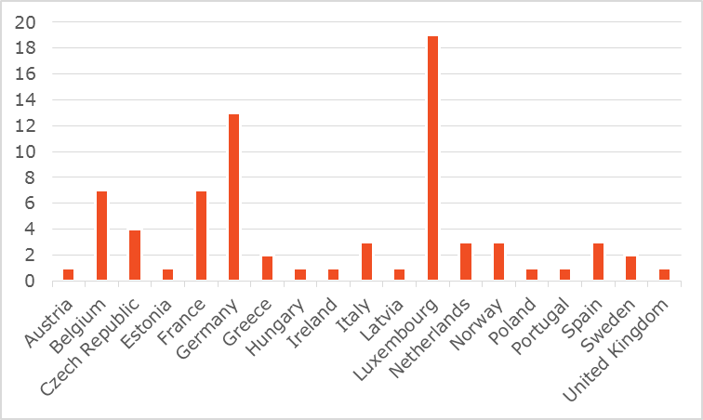*

Figure 2: Number of OPC respondents by type

*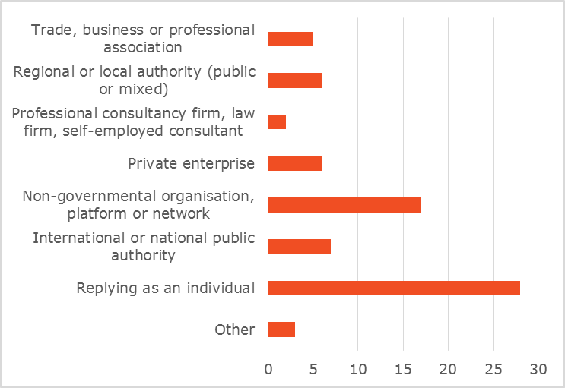*

Individuals from Luxembourg were strongly overrepresented (19 out of 74 respondents), which had to be borne in mind in analysing the results.

### Meetings of the Committees on Tunnel Safety and on Infrastructure Safety Management

The two Committees associated to the Tunnel and RISM Directives, composed of representatives of national administrations of EU Member States and chaired by DG MOVE, with EEA countries and sectoral stakeholders as observers, met on 8 November 2017. A COWI representative presented preliminary results of the Impact Assessment support study, including the problem definition, possible measures and possible policy options. Members were invited to comment on all three aspects.

## Results of consultation activities

### Assessment of the current regime

**Comparative safety of roads**

A large majority of respondents to the OPC rated the safety of EU motorways in general high or very high (86%). The safety of national/main roads was seen as medium high by a majority (53%), with 32% rating it high. Opinions on the safety of regional/local/urban roads were most divided, ranging between medium (35%), high (27%) and low (26%). Ratings were more varied when respondents were asked about the safety of the three types of roads in the country they know best.

Figure 3: Perceived safety of motorways "in the country that you know best"

Figure 4: Perceived safety of national/main roads "in the country that you know best"

Figure 5: Perceived safety of regional/local/urban roads "in the country that you know best"

58% of OPC respondents have experienced some difference in the road infrastructure safety on the TEN-T network between countries, and 85% have experienced some or significant differences. Respondents who replied on behalf of organisations saw bigger differences than individuals.

Figure 6: OPC replies to the question "Have you experienced any variation in road infrastructure safety on the TEN-T network between countries?"

These general results are complemented by comments on specific aspects. For example, Egnatia ODOS (motorway operator) from Greece listed some specific differences in the level of road or tunnel infrastructure safety across countries:

- Level of pavement maintenance

- Road markings visibility

- Mobile communication coverage inside tunnels

- Linear chainage reference system to identify easily your location on the network

- Level of accessibility (for elderly, children, people with special needs) of emergency exits and cross passages inside tunnels

The public authority for transport infrastructure in Ireland highlighted differences across countries depending on whether TEN-T roads are dual carriageways or single carriageways with poorer safety performance. It also referred to the safety differences between the core and comprehensive road network. Finally, it pointed out that there are variations between Eastern and Western Europe also with respect to the age of the road infrastructure.

**Tunnel safety**

The OPC respondents tended to rate the safety level of road tunnels very high in the country they know best (although this result is biased by the large number of individual respondents from Luxembourg). In comparison, the safety level of tunnels in the EU in general is getting a medium to high rating. Overall, the respondents rate the safety level in road tunnels as high.

Figure 7: The safety level in road tunnels with respect to infrastructure in the EU in general vs "in the country that you know best"

*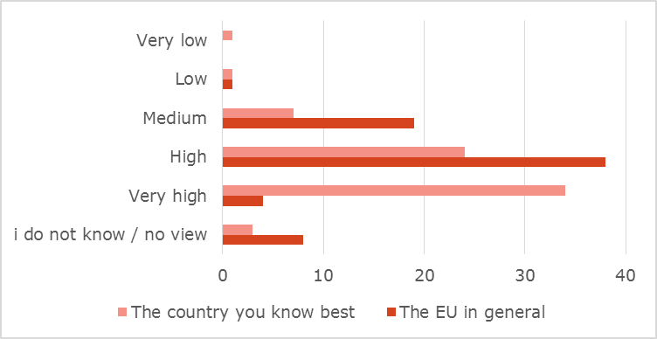*

**Readiness for deployment of automated and connected driving**

58% of OPC respondents do not think that the existing road infrastructure is ready for the deployment of automated and connected driving.

Figure 8: OPC replies to the question "In your opinion how ready is the existing road infrastructure for the deployment of automated and connected driving?"

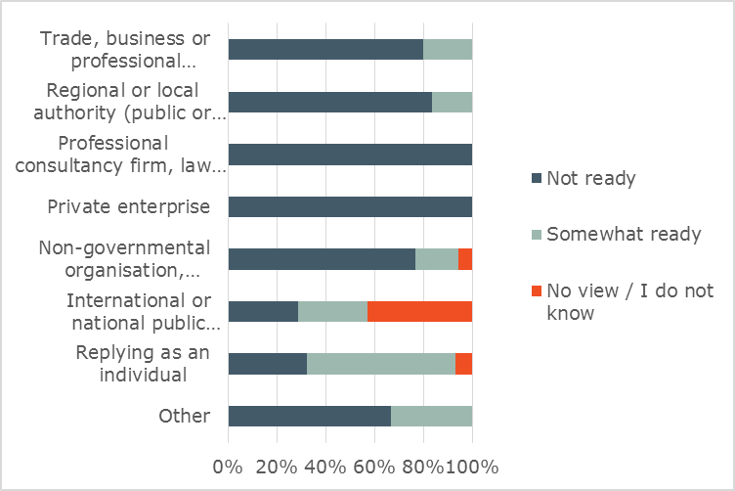

The Swedish and Norwegian motorcyclist organisations both commented that there is not yet enough knowledge about how connected driving will influence road users. The Latvian Ministry for Transport highlighted the variation in the level of readiness for automated driving across Member States. It attributed this difference to the current state of the infrastructure and the availability of funding. In Latvia for example, 40% of all roads were in poor conditions due to lack of funding for maintenance; therefore, it was necessary to prioritise the basic needs of road users while automated driving had low priority. This view is supported by the European Motorcyclist Federation (FEMA) and the Italian Assoprevenzione NGO, pointing out that many highways are ready, but most other roads are not, and highlighting the lack of universal road signs in particular.

The European Union Road Federation (ERF) commented in the targeted stakeholder consultation that more needed to be done to link the RISM Directive to ITS. Particularly, it mentioned the need for maintenance of road markings and signs as a necessity for in-vehicle systems to work properly. It underlined that the Directive should more explicitly promote a better understanding of the interaction between the vehicle systems and the road infrastructure, including road equipment.

ASECAP considered that road infrastructure has a key role to play in C-ITS, since it is the infrastructure manager who provides significant safety instructions to the vehicles (closed lanes/tunnels/bridges, work zones etc), manages the traffic flows and decides which measures to take based on improved information available.

A private company working with ITS submitted that an automated and connected car must have the ability to detect and avoid moving and static objects. Physical infrastructure performance needs for e.g. vehicle sensors must be recognised. Clear visibility of road infrastructure, including lane markings, road signs, speed limit signs, traffic signs indicating change of speed limits / entrance to towns must be ensured. Deployment of digital infrastructure enabling V2X communication was still missing in the EU, although V2X communication based on ITS-G5 (802.11p) had been tested for more than ten years and was ready for roll-out. Road-side units (RSUs) could be deployed in much of the existing roadway infrastructure, including traffic lights and traffic signs. To make automated and connected driving a reality on European roads, a harmonised, EU-wide approach to accelerate and coordinate infrastructure upgrades was needed.

On the other hand, France pointed out that, as far as automated driving was concerned, the logic had to be that the development of automated driving takes into account the existing infrastructure and adapts to it, not the other way round:

* The rhythm of infrastructure renewal was much slower than that of vehicle renewal;
* The European road networks were mature and very large (...), which means that to adapt the entire network would imply prohibitive costs;
* Putting into question the rules of road conception, developed and honed over decades for the human driver, could harm the road safety for those drivers;
* It was technically impossible for a road infrastructure manager to guarantee, for example, a minimum level of contrast of horizontal signalling at every moment. The wear of the horizontal signalling depended on the number of tyre passages and of the meteorological conditions, and the moment at which it would fall under a certain threshold was thus unpredictable. Even with unlimited financial means, it was impossible to guarantee that an automated vehicle would never come across horizontal signalling erased following an unplanned event (accident, severe weather).

This was in fact the logic that vehicle manufacturers apply in their experiments. On-board sensors, algorithms of reconstituting lines and embedded intelligence were continuously improving to adapt to driving conditions on existing infrastructure.

Having thoroughly studied the arguments of both sides of this discussion, the Commission concludes that a certain degree of harmonisation of the physical infrastructure will be needed in order to allow a smooth roll-out of higher levels of automation and to ensure that automated vehicles behave safely in mixed traffic. This is confirmed in a recent report of the TM 2.0 Task Force on Road Automation (composed of representatives of public authorities, service providers, suppliers, manufacturers and researchers), which concludes:

*"It is expected that, at least for mixed fleets of vehicles, spatial or temporal restrictions may be enforced on the circulation of automated vehicles. All traffic signs and road delineation relevant to such restrictions should be harmonised among countries, to allow interoperability of automated functions, as they may be based on the recognition of such markings and signs. (…) Good lane markings condition can support the accurate positioning of automated vehicles. Stricter criteria and maintenance processes as regards the condition of lane markings should be studied."[[4]](#footnote-4)*

**Performance of the directives**

A large majority of respondents to the targeted stakeholder consultation (27 replies, mostly from Member State authorities) considered that the current EU legislative framework both for infrastructure safety management and for tunnel safety addresses the problem of road safety to a large extent (11 replies) or to a fairly good extent (6 replies).

In the targeted stakeholder survey, respondents referred in particular to the following as problems of the current framework: lack of harmonisation, lack of information sharing and a limited scope.

The lack of harmonisation was mentioned by road operators in Portugal and Greece and the European Union Road Federation – all pointing to the fact that the RISM Directive does not include specific guidelines and therefore management procedures vary across Member States. The Greek Motorway operator also mentioned the lack of harmonised reporting forms.

Regarding sharing of information, the Flanders Agency of Roads and Traffic called for sharing of information about accepted alternative risk-reduction measures for tunnels. The Cypriot Ministry for Transport, Communication and Worksemphasised the challenge for Member States with very few tunnels to establish comprehensive national procedures and that information sharing would be useful.

The limited scope of the RISM Directive was mentioned as a specific issue by one respondent suggesting that the RISM should be extended beyond the TEN-T road network (Public Enterprise Road and Transport Research Institute from Lithuania).

**National implementation**

As regards implementation of the RISM provisions by Member States, 5 out of 27 respondents to the targeted stakeholder survey considered RISM national procedures to be ineffective while four other respondents indicated that the procedures in national legislation were too complex for practical use (two of these are from Spain, one from Austria and one from Portugal). The remaining 18 respondents did not see any particular implementation issues.

According to the results of the targeted stakeholder consultations, in some Member States only few inspections are carried out. However, the questionnaire referred to a single year (2016). Data for a longer period would be necessary to draw more reliable conclusions. Bulgaria also referred to a lack of financing, in particular as regards tunnels that were built before the two directives were transposed into Bulgarian legislation.

Table 1: Overview of the use of RISM procedures and number of auditors and inspectors - responses based on the targeted stakeholder survey

| MS | How many times have the procedures been applied in the country you represent on TEN-T roads in 2016? | | | | How many certified road safety auditors and inspectors are there in the country you represent? |
| --- | --- | --- | --- | --- | --- |
|  | **RSI** | **RSIA** | **RSA** | **NSM** |  |
| LT | All state roads network - once in 7 years. | All new road projects and near road structure projects. | All projects | "Black spots" - once per year. Network safety ranking - once per 3 years. | No certifications. Auditors are chosen by the road owner according to the eligible experience in road safety. Inspectors are the road safety experts of Public Enterprise Road and Transport Research Institute (under the Ministry of Transport). |
| AT | 9 | 0 | 15 | 1 | 24 |
| DK | 0 | N/A | N/A | 1 | 150 road auditors. There is no certification for inspectors/and it is not required according to the RISM directive. |
| CH | 2016: 4 | 2014: 1 | 2016: 8 RSA on maintenance/updating projects | 2016 (each year) | Safety auditors: Approx. 150 Inspectors: Approx. 80 |
| DE | Road safety inspections have been carried out on the whole national road network. | RSIA is an integrated part of the road planning process. All measures which are part of the Federal Transport Master 2030 plan have been assessed. | Between 2007 and 2011 over 3,300 audits have been carried out. The audits have not only been carried out on TEN-T roads but on all kind of roads. | The NSM is a permanent task carried out by local authorities. Results are published on a national level at the website of the Federal Highway Research Institute (www.bast.de) | With a view to the high number of audits, no estimate can be given on the number |
| HU | n/a | n/a | n/a | n/a | 150 |
| IT | "2015" 514[[5]](#footnote-5) | 0 | 3 | 0 | 0[[6]](#footnote-6) |
| LU | 2x RSI (20% of network) | 0 | 0 | 2x NSM (25% of network) | 3 |
| NL | About 40 | About 15 | About 60 | 1 | RSA: 13 RSI: 4 |
| RO | - | - | - | - | 12 |
| SK | n/a | 1 | 4 | n/a | 1 auditors and 17 inspectors |
| UK | This is ongoing activity - a number cannot be estimated. | Estimate in 2016 of 100 | Estimate in 2016 of 750 | This is ongoing activity - a number cannot be estimated. we have no way of guessing. | Road Safety Auditors with a Certificate of Competency in the UK is 425. [[7]](#footnote-7) |
| CY | 10 | 0 | 4 | 1 - national level | 10 RSA. No requirement for certified inspectors |
| BE (Fl) | About 2 | About 3 | About 25 | 1 | 15 (June 2017) |
| SE |  | Don’t have compiled statistics  Approx. 5-10 | Don’t have compiled statistics Yearly approx. 5-10 | Yearly mapping and planning of actions/activities | 20 |
| FI | Several | Several | Several | Once | 35 persons |
| FR | All the national road network is inspected on a 3-year basis cycle. The 3rd cycle began in 2015 and will end in 2017. | Fully applied (about 10 cases in 2016) | About 90 | Almost all local manager units of national roads has carried out the network safety ranking dating less than 3 years. At least 50 safety diagnosis and 30 action plans have been launched since 2006 | Around 160 inspectors and 160 auditors. |

### Justification to act

Among respondents to the OPC, there was near unanimity that improvements are needed to the maintenance and repair of existing roads (97% think that they need some or significant improvements), to upgrading safety features of existing roads (92% think that they need some or significant improvements) and to improving the protection of vulnerable road users (89% think that some or significant improvements are needed). 81% also thought that the design and construction of new roads need some or significant improvement. Opinions were more divided as to whether improvements are needed to the quality of road equipment, the visibility of road markings and the visibility of road signs, with however still a clear majority of respondents considering improvements necessary.

There was wide agreement among respondents to the OPC that there should be common EU performance requirements for road equipment (88% fully or rather agree), for the visibility of road markings (88% fully or rather agree) and for the visibility of road signs (88% fully or rather agree).

However, there was also wide agreement (80% fully or rather agree) in reply to the following question: "Do you agree that rather than aiming for common EU minimum performance requirements, the exchange of best practices regarding road infrastructure safety management should be promoted at EU level?" This shows a flaw in the formulation of the question (presupposing the exchange of best practice as an alternative to performance requirements). The interpretation of this result can therefore not be unequivocal. However, the most likely explanation is that respondents consider the exchange of best practice useful *in addition* to performance requirements.

The OPC also showed wide agreement that the safety of road infrastructure should be measured across the EU using comparable methodologies (47% fully agree, 88% fully or rather agree).

47% of respondents (i.e. 33 respondents) fully agreed that minimum road safety requirements should be established for roads that are part of the TEN-T network. 25% rather agreed to this proposition. However, 23% also fully disagreed and 7% rather disagreed.

Figure 9: OPC replies to the question "Do you agree that minimum road infrastructure safety requirements should be established for roads that are part of the trans-European transport network guaranteeing road users a certain minimum level of safety on these roads?"

*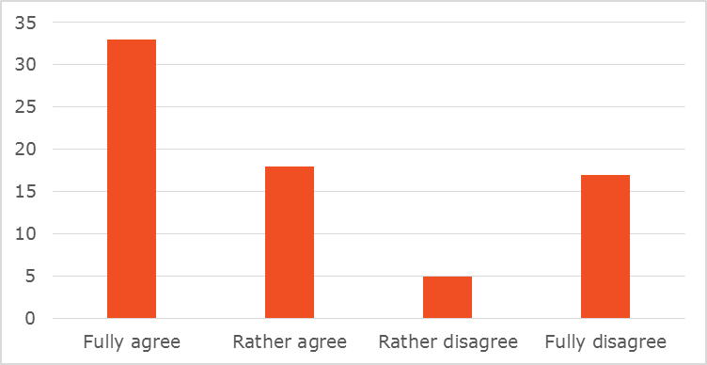*

There were few comments in the OPC addressing the question of minimum safety requirements. A few individuals and associations emphasised a need for more harmonised road safety standards across EU Member States. For example, The European Federation of Road Traffic Victims (FEVR) called for more common approaches and that best practices be promoted throughout the EU.

The Latvian Ministry of Transport commented that although common procedures and legislation could be relevant, this may put a financial strain on countries where funding is a problem.

A private French company suggested that whatever approaches were applied, they should promote innovations. There was a potential for innovations leading to higher road infrastructure safety levels.

ASECAP expressed the view that there was no need to amend the two directives. It asked to maintain a certain degree of flexibility. Changes should not lead to an increasing complexity of procedures and costs that might threaten to compromise the existing high safety standards.

**Vulnerable road users**

As regards vulnerable road users, the targeted stakeholder survey showed that Germany, the Netherlands, Austria, Denmark, Luxembourg, the UK, Belgium and Sweden have already installed motorcycle friendly guardrails.

Sveriges Motorcyclister (a Swedish association of motorcyclists) stated in the OPC that the choice of measures in Sweden was based entirely on persons travelling in cars. The choice of barriers was the most obvious example. While a cable barrier saved lives of persons in cars, they caused severe injuries and fatal accidents among riders every year. Motorcycle Protection Systems were not used in Sweden. Hooks and protruding parts were allowed on obstacles on the roads on highways in Sweden. A roadside barrier was seen as safe for all road users, and forgiving roadsides were rarely used. The association asked that the safety of all road users be considered in designing and constructing roads, that all existing regulations should be reviewed to include them in all EU countries and to include safety of all road users when deciding on the choice of method to repair and maintain the roads.

FEMA, the European Association of Motorcyclists, saw large differences on TEN-T roads between countries in terms of maintenance, safe/unsafe design (obstacle-free roadsides, unsafe exits, etc.) and in the safety of road-side infrastructure. It recommended (1) applying barriers that are safer for motorcycles or applying MPS on existing barriers on dangerous spots (bends, exits, etc.), (2) applying obstacle-free roadsides (both to avoid collisions and to improve the view) and (3) banning cable barriers. In addition, it called for uniformity and standards for signs, markings and traffic calmers.

The CCE, an advisory board under the patronage of the Spanish, French, Italian and Portuguese governments, considered that systems for the protection of motorcyclists in dangerous curves should be installed systematically. However, as there was no harmonised norm for these products, it would not be possible to define a proper performance level.

This comment highlights the difficulty in prescribing individual measures for certain types of vulnerable road users. On balance, the Commission considers that it is preferable not to prescribe such specific measures, but rather to mandate a general requirement to take the needs of all groups of vulnerable road users into account in road safety management procedures and to find the most appropriate solution adapted to the local circumstances.

The European Cyclists' Federation (ECF) submitted that even if the scope of the Directive stayed limited to the TEN-T network, an average 10% of people killed on motorways in Europe were pedestrians, up to 20% in some countries. This number did not even include cyclists, people killed on TEN-T roads other than motorways, and many lower-class roads that were affected by TEN-T road design, for example in the interchanges area. It recommended

1. Provision of safe, comfortable and direct active mobility routes – functional connections of settlements and workplaces along the (re)constructed road;
2. Sufficient density of safe and comfortable crossings across (re)constructed roads;
3. Upgrade of other roads affected by the (re)construction project to safe standards;
4. Safe active mobility option or an attractive alternative for tunnels;
5. Minimum quality requirements for cycling infrastructure;
6. Cycling infrastructure included in training and certification of road safety auditors.

As regards this last point made by the ECF, it is true that there is currently no systematic information about the content of training and certification of road safety auditors as regards the needs of vulnerable road users. Neither is there an association of auditors that could facilitate the exchange of good practice in this regard. This is the reason why the Commission's preferred option includes the setting up of a Forum of Exchange for auditors.

**Road markings and signs**

In terms of the visibility of road markings and signs, FIA Region I stated that simple measures like appropriate basic standards for road marking and signs could be implemented at low cost. FIA Region I also highlighted that, in view of the upcoming revision of the General Safety Regulation, three out of the eighteen technologies identified for possible inclusion depend on the existence of a well maintained infrastructure: Automatic Emergency Breaking (AEB) depends on pavements, Intelligent Speed assistance (ISA) depends on traffic signs and Lane Keeping Assistance (LKA) depends on road markings.

The European Automobile Manufacturers' Association took the view that vehicle safety features as provided for in the General Safety Regulation will be very effective to reduce fatalities and injuries. But to achieve the highest level of effectivity the contribution of the infrastructure was needed. For example Lane Keeping Assistance needed appropriate road edges in order to detect them as precisely as possible, and to reduce accidents with vehicles in cities, the layout of the inner city roads should be modified in the relevant areas e.g. to avoid crossings of bicycle-lanes with vehicle lanes.

In addition ACEA referred to discussions about the implementation of an Intelligent Speed Adaptation. For this, it was key to transmit the applicable speed limit to the car in any situation and on every road, which was currently not possible due to too heterogeneous signs, hidden signs and temporary limitations. Therefore the infrastructure should be updated first at this point and then the Intelligent Speed Adaptation could be set on this basis.

This comment reinforces the argument advanced by the ERF, ASECAP and a private ITS company (see "Readiness for deployment of automated and connected driving" above), confirmed by the final report of the TM 2.0 Task Force on Automation. As stated above, the Commission shares this view.

The CCE stressed the importance of being able to evaluate the performance of road markings along their full lifecycle. It suggested that the Directive could require each Member State to set its own performance level for road markings (with a view to subsequently developing a standard) and oblige the operators to maintain a certain performance level of the road marking.

**Overall approach**

Stakeholders represented at the stakeholder conference in Malta in March 2017 recommended that the Commission should review the RISM directive to focus on measured outputs and less on inputs, in addition to reviewing programme goals (for TEN-T) and financial instruments.

### Impact of policy options

#### Options within current scope

In the targeted stakeholder survey, respondents were asked to comment on the impact that they expected a number of policy options to have. The policy options have however evolved during the impact assessment process and are no longer identical to the ones formulated in the survey. Therefore, the following analysis is qualitative rather than based on respondents' ratings of the options.

Most respondents (20 out of 27 respondents were public authorities) considered that all proposed options would have relatively limited impact.

As regards what is now **Policy Option 1** (light intervention in current scope (TEN-T) – including in particular best practice sharing, publication of information about procedures), most of the respondents expected no significant effect on safety, with some however pointing out that the exchange of best practices could have a positive effect.

A number of respondents answered that the focus on vulnerable road users in their countries would have no impact, as they generally are not allowed on the TEN-T roads. Motorcyclists were, however present, but they were generally protected in risk zones (guard rails in curves etc.).

As regards what is now **Policy Option 2** (moderate intervention in current scope – including in particular mandatory follow-up of procedures, network-wide inspections), 47% of OPC respondents fully agreed that the safety of road infrastructure should be measured across the EU using comparable methodologies. 41% rather agreed with this proposition. The OPC also showed wide support for general performance requirements concerning the visibility of road markings (47% fully agree, 41% rather agree) and concerning the visibility of road signs (45% fully agree, 43% rather agree). The European Transport Safety Council (ETSC) asked to include requirements for automated and semi-automated vehicles such as clear road markings and adapted intersections in the revision of the Directive. It also recommended that systematic and periodic inspections should be undertaken for the detection of high risk sites, and it asked that, to enable better monitoring and evaluation, annual reporting to the Commission should be introduced and made public.

France commented that the allocation of safety performance ratings did not appear to be relevant. Apart from the difficulty to define indicators for this rating, the question arose as to the use of this information and their real impact on safety which remained to be proven. It considered that, instead, greater transparency could be envisaged concerning the road safety statistics and actions towards the public, notably in the framework of making accessible data concerning the national road network.

The CCE on the other hand considered a rating system a good way to raise awareness regarding the operator's maintenance of the roads. According to the CCE, it could be a real lever to encourage them to improve the safety level of the infrastructures under their supervision, and it would be a good tool to aid decision-making in prioritising investments. The CCE added that a rating system could also – in future – promote the development of autonomous vehicles, determining the areas where they can work well. The CCE advocated using the EuroRAP programme.

As regards **Policy Option 3** (ambitious intervention in current scope – in particular introducing a minimum star rating for TEN-T roads), 45% of OPC respondents fully agreed that minimum road infrastructure safety requirements should be established for roads that are part of the TEN-T network. 25% rather agreed. However, there were also 24% of respondents who strongly disagreed with the latter proposition. The ETSC recommended introducing a Network Safety Management assessment of the road network and setting a target of upgrading roads to 3-star or better on all roads and 4-star or better on roads with high traffic volume. The ERF raised doubts about making certain requirements mandatory: Setting compulsory minimum requirements in the RISM Directive would never be acceptable to Member States/road authorities as a matter of principle. At the same time, they understood the value of establishing some minimum requirements that could support road automation. But this should be done on a voluntary basis amongst NRA's and with a solid technical basis. Where the RISM Directive could help was to point out the need for setting general performance requirements but allow these requirements to be defined by industry/authorities/other relevant bodies.

Member State authorities supported this view. The Dutch Ministry for Transport, the Ministry for Transport in Luxembourg and the Italian Ministry for Transport stated that it would be impossible to implement minimum standards on existing roads.

The German Ministry of Transport also pointed out that a further update of minimum standards for tunnels was unnecessary.

#### Possible extension of scope beyond TEN-T

Opinions expressed in the OPC about a possible extension in the scope of the legislation beyond the TEN-T network diverged. 37% replied that the TEN-T network should be the scope of EU legislation, 20% that it should cover road infrastructure "of European importance", 19% all main or national roads and 18% all roads. Private enterprises and NGOs were most likely to consider that all roads or all main and national roads should be the scope of legislation, whereas public authorities tended to consider that the TEN-T network should be the scope.

Figure 10: OPC replies to the question "In your opinion, what should be the scope of EU legislation in the area of road infrastructure safety management?"

*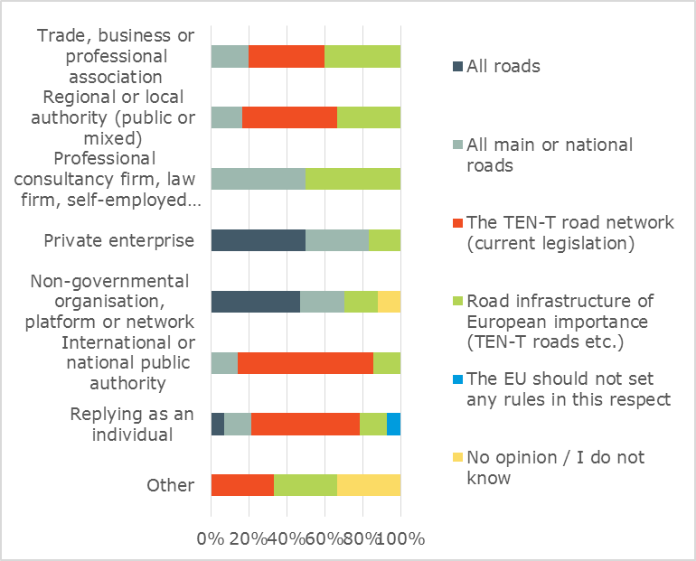*

OPC replies to the question of the geographical scope of tunnel safety legislation are very similar to the above, with 37% of respondents in favour of the current scope of the legislation (tunnels longer than 500m on the TEN-T network). Again private enterprises and NGOs tend to favour an extension, whereas public authorities favour the current scope.

Figure 11: OPC replies to the question "In your opinion, what should be the scope of EU legislation in the area of road tunnel safety?"

A number of respondents to the targeted stakeholder survey mentioned "the reluctance of Member States to accept the extension to non-TEN-T roads" on subsidiarity grounds. A number of countries have already extended the application of the legislation, but as one respondent put it "they prefer this to be their own choice". However, respondents also recognised the large potential in reducing fatalities, given that most fatal accidents happen outside the TEN-T network.

France commented that apart from the subsidiarity question, it was preferable not to extend the scope of the directives (beyond TEN-T), in order to maintain the possibility to adapt the approaches and provisions to the specificities of the networks and their managers.

On the other hands, one of the conclusions of the stakeholders represented at the stakeholder conference in Malta in March 2017 was:

"*The majority of road deaths, and travel, are concentrated on 10% of Europe's roads. This economically important, largely rural network, comprises the TEN-T, national roads and busy regional roads. Europe's safety goal requires targeting this network."*

The CCE took the view that including non-TEN-T main roads in the scope of the Directive would simplify regulations for Member States, as more roads of the national network will need to meet the same safety requirements. The main drawback of extending the scope would likely be economic, as main roads are usually older than those on the TEN-T network.

The European Cyclists' Federation (ECF) submitted that the potential extension of the scope of the RISM Directive should be accompanied by changes in training and certification of road safety auditors (for example to take into account different requirements for cycling infrastructure in lower speed environments) and by EU level guidance on cycling infrastructure. Introducing obligatory provisions for cyclists and pedestrians, as well as minimum quality requirements for cycling infrastructure, should be a prerequisite for the scope extension.

The Commission shares the concern related to ensuring that an extension of the scope of the Directive takes the needs of vulnerable road users into account. This is the reason why the Commission's preferred option includes the setting up of a Forum of Exchange for auditors, in order to facilitate the spreading of best practice in this regard. Additional comments from NGOs and road associations in the OPC focused on the need for having similar road safety standards across all EU. AISCAT, the Italian Association of Tunnel and Motorway Concessionaire Companies, cautioned that legislation only on TEN-T roads would lead to an over-legislation on the safest roads, whereas the most dangerous roads were not addressed. A similar opinion was expressed by the Spanish Road Association emphasising that it was not acceptable that some roads were subject to legislation and had very high standards, whereas others were not addressed at all by safety procedures. The Polish NGO *Zielone Mazowsze* believed that safety audits on selected roads should be undertaken by the EU using EU funds to ensure a common minimum safety standard.

The ETSC argued that the scope of the legislation should be extended to cover all motorways, all EU (co-)financed roads and all main rural and main urban roads. This was required in view of the new objective to focus on reducing serious injuries as well as deaths (because a larger proportion of injuries occur in urban areas) and because citizens should be entitled to equal levels of safety on all roads.

#### Merging of the directives

Reactions to the proposition of merging the two directives in the targeted stakeholder survey were clearly negative. 15 out of 27 respondents said that the directives should not be merged, 4 answered yes, 1 answered Don't know and 6 did not answer at all.

Among the respondents who were against merging the two directives, the main concern was that it could in fact increase the administrative burden. This point was made by national road authorities or transport ministries such as the Dutch Rijkswaterstraat, the UK Department for Transport, the German Federal Ministry of Transport, the Danish Road Directorate and the Budapest Capital Government Office, Department for Transport. Moreover, these respondents did not see any positive effect, because the two directives had a different scope, were using different systems and that the safety procedures used were not related to each other.

On the other hand, the respondents who answered Yes (such as the Lithuanian Public Enterprise Road and Transport Research Institute and the Cyprus Ministry for Transport) did believe that the merging could bring a higher safety level in tunnels if RISM procedures were applied.

The Italian Ministry for Infrastructure and Transport stated that the RISM Directive acted on a different and higher level than the Tunnel Directive. RISM recommendations should be applied to complete roads (including tunnels), implementing the actual minimum safety tunnel requirements and eventually introducing specific requirements for roads.

## Use of consultation results

The findings from the consultation activities have been used to analyse the problems, define the right policy alternatives and fine-tune the proposed measures. Input from stakeholders with a high level of technical expertise also served to validate the information from existing reports and studies.

Where relevant, references have been made in the Impact Assessment Report to the outcome of the stakeholder consultations.

Annex 3: Who is affected and how?

## Practical implications of the initiative

The stakeholders affected by the initiative and their key interests are described in the table below.

| Stakeholder | Description | Key interests/ Key impacts |
| --- | --- | --- |
| Road users | People travelling on the road by all means of transport including motorised transport but also cyclists and pedestrians | * To have safe road infrastructure which helps road users to avoid accidents ("self-explaining roads") and protects them when accidents do happen ("forgiving roads") * Road users will benefit from the reduction in the number of fatalities (14,650) and serious injuries (97,502) over the 30 year reference period |
| Road transport operators | Companies involved in the transport of passengers or goods by road | * To have safe and efficient road infrastructure which enables smooth and reliable road transport operations to be carried out * Road transport operators will benefit from less disruption and congestion on the network as a result of fewer and less serious accidents (impact not quantified) |
| Road authorities | These are the national or regional authorities in Member States that are reponsible for the road network. | * Implementation and enforcement of the requirements under the Directive * Road authorities will bear the regulatory costs associated with the Directive. The costs include the cost of RISM procedures (road safety inspections etc.) and the costs of making the necessary improvements to road infrastructure |
| Manufacturers of road vehicles | Manufacturers of passenger cars, trucks, buses, motorcycles etc. | * To have safe road infrastructure that enables and supports the reliable operation of vehicle safety technologies ("roads that cars can read") * More reliable operation of active vehicle safety technologies as a result of improved quality of road markings |
| Road construction companies and maintenance contractors | Companies involved in the construction and maintenance of the road network | * These companies will benefit from the increased spending on road safety upgrades and road maintenance as a result of the follow-up to the findings of RISM procedures. SMEs are expected to benefit in particular from increased road maintenance spending |
| Manufacturers of road equipment and materials | Companies involved in the manufacturing of materials used in the construction, maintenance and operation of roads (e.g. asphalt, paint for road markings, road signs, road furniture such as crash barriers etc.) | * To have legislation that maximises the market opportunities for the materials and equipment produced |
| EU citizens | Road safety affects not only road trauma victims but also their families and everyone else due to the social costs of road fatalities and injuries | * To have safe road infrastructure that helps minimise the number of road accidents and their severity * Society at large will benefit from the reduction of the social costs of road fatalities and serious injuries |

## Summary of costs and benefits

|  |  |  |
| --- | --- | --- |
| I. Overview of Benefits (total for all provisions) – Preferred Option | | |
| Description | Amount (in million euro) | Comments |
| Direct benefits | | |
| Reduced fatalities and injuries on EU roads (in Policy option 2 and Policy option C combined) | 25,277 | Present value for the period 2020-2050. Includes value of reduced fatalities and serious injuries.  Benefit estimates include reductions in authority costs for hospital care, emergency services etc., and for those involved in accidents, and their relatives. |
| Indirect benefits | | |
| - | - | - |

|  |  |  |  |  |  |  |
| --- | --- | --- | --- | --- | --- | --- |
| II. Overview of costs – Preferred option | | | | | | |
|  | | Citizens/Consumers | | Businesses | | Administrations |
| One-off | Recurrent | One-off | Recurrent | One-off and Recurrent (net present value in million euro for 2020-2050)[[8]](#footnote-8) |
| Policy option 2 | Direct costs |  |  |  |  | 2,004 |
| Indirect costs |  |  |  |  | - |
| Policy option C | Direct costs |  |  |  |  | 7,440 |
| Indirect costs |  |  |  |  | 2,004 |

*Note: The one-off costs for the preferred option comprise costs related to undertaking assessment programmes, for investing in new road safety installations in the infrastructure and for maintaining these new installations. The costs are distributed throughout the evaluation period 2020-2050 and include both installation costs and recurring maintenance costs. The costs are not calculated separately, as the sources used report total costs. The costs are therefore reported as the present value of all costs covering the entire period.*

Annex 4: Analytical methods

## Description of analytical models used

A model suite has been used for the analytical work: PRIMES-TREMOVE transport model, a specific model developed by TRL in the programming language Python[[9]](#footnote-9) with inputs and outputs produced in Microsoft Excel spreadsheets and an Excel-based tool developed by COWI. While PRIMES-TREMOVE is a transport model covering the entire transport system, used for the development of the EU Reference scenario 2016, TRL and COWI models specifically focus on evaluating the impacts of vehicle technologies and infrastructure measures on road safety, respectively. A brief description of each model is provided below, followed by an explanation of each model’s role in the context of this impact assessment.

### PRIMES-TREMOVE transport model

The PRIMES-TREMOVE transport model projects the evolution of demand for passengers and freight transport by transport mode and transport mean. It is essentially a dynamic system of multi-agent choices under several constraints, which are not necessarily binding simultaneously. The model consists of two main modules, the transport demand allocation module and the technology choice and equipment operation module. The two modules interact with each other and are solved simultaneously.

The projections include details for a large number of transport means, technologies and fuels, including conventional and alternative types, and their penetration in various transport market segments for each EU Member State. They also include details about greenhouse gas and air pollution emissions (e.g. NOx, PM, SOx, CO), as well as impacts on external costs of congestion, noise and accidents.

In the transport field, PRIMES-TREMOVE is suitable for modelling *soft measures* (e.g. eco-driving, deployment of Intelligent Transport Systems, labelling), *economic measures* (e.g. subsidies and taxes on fuels, vehicles, emissions; ETS for transport when linked with PRIMES; pricing of congestion and other externalities such as air pollution, accidents and noise; measures supporting R&D), *regulatory measures* (e.g. CO2 emission performance standards for new passenger cars and new light commercial vehicles; EURO standards on road transport vehicles; technology standards for non-road transport technologies), *infrastructure policies for alternative fuels* (e.g. deployment of refuelling/recharging infrastructure for electricity, hydrogen, LNG, CNG). Used as a module which contributes to a broader PRIMES scenario, it can show how policies and trends in the field of transport contribute to economy wide trends in energy use and emissions. Using data disaggregated per Member State, it can show differentiated trends across Member States.

PRIMES-TREMOVE has been used for the 2011 White Paper on Transport, Low Carbon Economy and Energy 2050 Roadmaps, the 2030 policy framework for climate and energy and more recently for the Effort Sharing Regulation, the review of the Energy Efficiency Directive, the recast of the Renewables Energy Directive, the European strategy on low-emission mobility, the revision of the Eurovignette Directive and the recast of the Regulations on CO2 standards for light duty vehicles.

The PRIMES-TREMOVE is a private model that has been developed and is maintained by E3MLab/ICCS of National Technical University of Athens[[10]](#footnote-10), based on, but extending features of the open source TREMOVE model developed by the TREMOVE[[11]](#footnote-11) modelling community. Part of the model (e.g. the utility nested tree) was built following the TREMOVE model[[12]](#footnote-12). Other parts, like the component on fuel consumption and emissions, follow the COPERT model.

As module of the PRIMES energy system model, PRIMES-TREMOVE[[13]](#footnote-13) has been successfully peer reviewed[[14]](#footnote-14), most recently in 2011[[15]](#footnote-15).

### TRL model

A simulation model was developed by TRL to estimate the benefits (monetary values of casualties prevented by safety measures) and costs (cost to vehicle manufacturers of fitment of safety measures to new vehicles) associated with policy measures assessed in the context of the revision of the General Safety Regulation and Pedestrian Safety Regulation. The model was implemented in the programming language Python[[16]](#footnote-16) with inputs and outputs produced in Microsoft Excel spreadsheets. The model is represented at EU28 level. Figure 12 presents a simplified visualisation of the structure and calculation steps of the model.

The vehicle fleet calculation model determines how the vehicle safety measures disperse into the fleet. The model determines the effect of mandating a measure for all new types, and two years later for all new registered vehicles, on the overall proportion of the fleet equipped. Benefits conferred by a safety measure, that is, casualties prevented, will only be realised by equipped vehicles. However, the legacy fleet will also be affected by active safety measures; for example, if a rear-end shunt is avoided by autonomous emergency braking for driving and still-standing vehicles ahead (AEB-VEH), the vehicle in front, will benefit from the measure even if it is a legacy vehicle. This is taken into account in the benefit calculations.

Figure 12: Flowchart of the TRL simulation model to calculate benefit-to-cost ratios

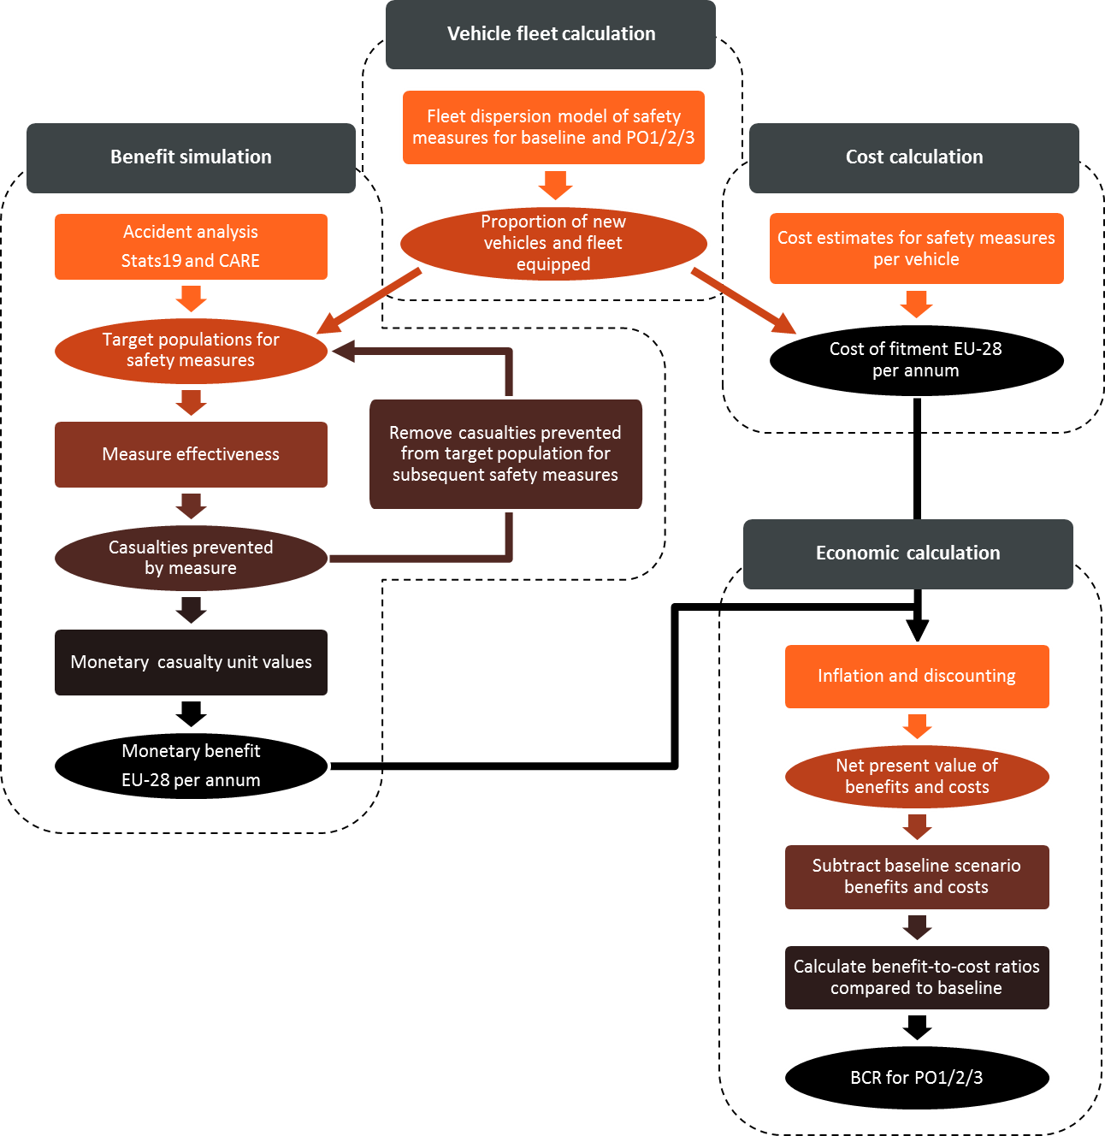

To simulate the casualties prevented by each measure, an accident data analysis was performed based on UK national road accident data (Stats19) to determine the casualty target population for each proposed measure, i.e. the number of fatal, serious and slight injuries that could potentially be affected by a safety measure based on relevant characteristics of the collision (e.g., collision geometry or contributory factors). The target populations were scaled to EU28 level using weighting factors, based on severity and vehicle categories involved, derived from analysis of the pan-European CARE database. The target populations found are multiplied with effectiveness values for each safety measure, i.e. a percentage value indicating what proportion of the relevant accidents will be avoided or mitigated by the measure. Mitigated casualties (fatal turned to serious casualty, or serious to slight casualty) are added to the target population of the next lower injury severity level for other measures. The casualties prevented are multiplied with monetary values for casualty prevention to calculate the monetary benefit.

|  |
| --- |
| **Evaluation period**  To model the costs and benefits of the safety measures, it was necessary to set an evaluation window which allowed technology sufficient time to propagate through the vehicle fleet and into the collision population. This was set by considering the earliest time at which a measure could affect all new vehicles (year 2023, 2 years after introduction for new approved types); then an allowance was added for the age of the traffic population (mileage contribution to total miles driven is not constant over the vehicle age). Previous evidence, established for the car fleet in London, has demonstrated that about 88% of the traffic is 0 to 11 years old and 97% of the traffic is 0 to 14 years old. Vehicles which are 15 years old account for only about 1% of the traffic and about 2% of collisions involving cars. Therefore, 14 years was added to new vehicle implementation date to allow the full cycle of fleet benefits to be captured. This period also matches the length of time allocated for the majority of voluntary uptake measures to reach close-to-full adoption levels. As such, the evaluation period was set to extend from 2021 to 2037. |

The model also addresses the interaction of different safety measures on overlapping casualty groups. To give an example, there are collisions where a driver was exceeding the speed limit, left the lane and suffered a frontal impact. These collisions will be in the target populations for multiple measures, but they can only be prevented once by either one of these systems. This is addressed in the model by removing casualties prevented by one measure from the subsequent target population of the other measures. The impact of highly effective existing safety measures, which have been mandatory for a few years, but are still dispersing into the vehicle fleet is also modelled to reduce the remaining target populations for the proposed measures.

|  |  |  |
| --- | --- | --- |
| **Fleet dispersion of vehicle technology safety measures**  There are two aspects to the fleet fitment estimates which are vital to the process of establishing the cost-effectiveness for the measures related to vehicle technologies.   * The voluntary uptake which defines a ‘do nothing’ scenario. In this case, the propagation of technology is led by the willingness of manufacturers to fit the necessary components to vehicles and the willingness of consumers to pay for them. * The mandatory uptake brought about by a policy intervention. In this case, all new vehicles or all vehicle types will be required to meet the regulatory requirements by an implementation date. The effects of this will be superimposed at that moment in time.   To model the uptake of technology alongside each of the measures, it was necessary to define the uptake by new vehicles and also the penetration into the fleet due to fleet expansion and ‘churn’ (the rolling addition of new vehicles and scrappage of old). This textbox provides an illustration on the way in which the model accounts for technology propagation on a voluntary or mandatory basis.  Estimates of technology adoption were based on evidence provided by a Tier 1 supplier for Electronic Stability Control (ESC) uptake within the car fleet. These data of new vehicle adoption and penetration into the fleet generated two s-shaped curves, as shown in Figure 13 for the new vehicles and Figure 14 for the total car fleet.  This precedent also indicates the way in which regulatory requirements can shape the adoption of a measure. With ESC, all new vehicle types had to make this safety feature available by November 2011 with all new vehicles having to be sold with ESC before 2014. This has the effect of boosting voluntary fitment from a plateau at around 80% in 2008 and 2009 up to 100% by 2014.  Even with full fitment in new vehicles, it still takes time for those vehicles to replace existing vehicles on the road. This explains the lag in the vehicle fleet curve, where an effective 100% fitment will be reached sometime before 2025.   |  |  | | --- | --- | | \\trllimited\individual\mseidl\My Documents\General Safety 3\Results (final3)\19-57\BestEstimate\PO2\Cost_Graphs\ESC_M1_NVE_P.jpeg  Figure 13: Percentage of newly registered cars equipped with ESC | \\trllimited\individual\mseidl\My Documents\General Safety 3\Results (final3)\19-57\BestEstimate\PO2\Cost_Graphs\ESC_M1_AE_P.jpeg  Figure 14: Percentage of all cars within the vehicle fleet equipped with ESC |   By including the average vehicle age in the model calculations an effort was made to account for the fact that some of the vehicles being scrapped in the churn process would also have the technology fitted. Otherwise, an overly optimistic estimate of technology penetration would be generated.  Voluntary fleet fitment estimates were based on evidence identified previously (Seidl *et al.*, 2017), comments provided by stakeholders and, in the absence of other information, opinions of an expert panel within TRL based on observations of similar technologies and expectations of pressures on the industry (for instance, whether a measure is likely to be incentivised by Euro NCAP).  The launch date for a technology was used to define the x-axis (time) start point for the s-shaped curves of fitment. This relates to the first time a system was released with the characteristics likely to be required in order to meet the regulatory requirements. As a general rule, the launch date was intended to be independent of vehicle category; assuming general transfer of technologies was possible, with some exceptions.  The voluntary take up of technology and the implementation within the fleet was selected to be one of three possible options:   * None = No voluntary uptake, regulatory action required to drive adoption * Medium = 40% voluntary propagation within the fleet without additional stimuli * High = 80% voluntary propagation leaving the 20% of vehicles which wouldn’t be equipped without regulatory action   These values represent point estimates for the resulting final take up in the fleet. The s-shaped curve for percentage of newly registered cars equipped is modelled to form a plateau at this value. |

The cost of a policy option is calculated by multiplying per-vehicle cost estimates for each measure with the number of new vehicles of each vehicle category across EU28 that are equipped with the measure in the given year of the analysis according to the output of the fleet calculation model. In the economic calculation model, the monetary values of costs and benefits are subjected to inflation and discounting to determine their present value. The present values of benefits and costs, calculated for individual years and summed over the study period, are compared in order to arrive at cost-effectiveness estimates.

A more detailed description of the TRL model is provided in the support study accompanying the revision of the General Safety Regulation and Pedestrian Safety Regulation.

### COWI model

An Excel-based tool was developed by COWI to assess the impacts of measures related to infrastructure on road safety. The tool covers each EU Member State individually and distingueshes between the TEN-T and non-TEN-T network, drawing on the CARE database[[17]](#footnote-17) and the TENtec information system[[18]](#footnote-18).

The approach to quantify impacts on fatalities and injuries includes a number of calculation steps:

* Estimation of the effect of each measure expressed as a percentage reduction of the baseline number of fatalities and serious injuries;
* Estimation of the share of fatalities and serious injuries that the measure apply to;
* Calculation of the expected reduction in the number of fatalities and serious injuries by Member State for the proportion of the fatalities and injuries that are covered by the measure;
* Application of social unit costs of fatalities and serious injuries to the above-calculated reduction to derive the estimated benefits.

The sources for the estimation of the impacts on the number of fatalities and serious injuries are based on two main studies: the Safety Cube project and the Handbook of Road Safety Measures. These studies include almost all evidence available on the impacts of infrastructure on road safety.

|  |
| --- |
| **SafetyCube review project**[[19]](#footnote-19)  The SafetyCube project is a Horizon2020 research project, which aims at ”*…developing an innovative road safety Decision Support System (DSS) that will enable policy-makers and stakeholders to select and implement the most appropriate strategies, measures and cost-effective approaches to reduce casualties of all road user types and all severities”.*  The project involves a review of some 50 infrastructure related road **safety risk factors** and 48 associated **improvement measure**s. In total, some 800 papers/studies were coded. Many of the studies reviewed as part of the SafetyCube project are specific **Case studies**, where certain risk factors are analysed in certain geographical locations, including examples of measures applied to address these factors.  **The Handbook of Road Safety Measures[[20]](#footnote-20)**  Contains summaries regarding the effects of 128 road safety measures. It covers various areas of road safety including: traffic control; vehicle inspection; driver training; publicity campaigns; police enforcement; and, general policy instruments. It also covers topics such as post-accident care, and speed cameras.  The main sections and topics of the handbook are:  − Literature Survey and Meta-Analysis  − Factors Contributing to Road Accidents  − Basic Concepts of Road Safety Research  − Assessing the Quality of Evaluation Studies  − Road Design and Road Equipment  − Road Maintenance  − Traffic Control  − Vehicle design and protective devices  − Vehicle and Garage Inspection  − Driver Training and Regulation of Professional Drivers  − Public Education and Information  − Police Enforcement and Sanctions  − Post-Accident Care  − General-Purpose Policy Instruments  The handbook builds upon a large number of case studies, research papers and reports and studies undertaken in many different projects. It is recognised among road safety experts as a central reference point. |

The compliance costs[[21]](#footnote-21) are closely related to the share of fatalities and injuries that are influenced by each measure. For the calculation of the compliance costs (costs of applying the road infrastructure safety management procedures and subsequent investments in changes to the infrastructure), the calculation steps include:

* Estimation of the relevant unit costs per kilometre of road of each measure;
* Estimation of the share of roads (typically in km) where the measure would be applied;
* Calculation of the total compliance costs of the measure.

In the compliance costs estimation, it is assumed that the same share (length) of roads is subject to each measure as the one used for the estimation of the reduced number of fatalities and injuries. There are, however, deviations from this general assumption. For example, the assumption is changed when considering motorcycle friendly guard rails. Such rails are installed where the risk of a crash is high (in turns where there are road side objects etc.). This will typically not be along the entire stretch of road. Therefore, we assume a smaller number of kilometres where the rails are installed, but retain the full impact of the measure on all VRU fatalities and injuries.

Another important assumption is that investments are made firstly where the impacts are highest. This is also the approach outlined in the 14 *case studies* of the EuroRAP SENSOR project[[22]](#footnote-22) looking at Southern and Eastern European countries. The textbox below outlines how the case study has been used to estimate investment costs needed to correct the safety defects in Member States where there is no specific information about costs of making upgrades.

|  |
| --- |
| **SENSOR case studies and the use to estimate costs**  The outcome of the SENSOR study is an application of the iRAP EuroRAP method to assess roads using automated detection vehicles. The results are shown in section 4 of the impact assessment support study for the investigated EU Member States[[23]](#footnote-23).  Part of the work also included a bottom up approach to calculate investments costs in order to remedy the detected safety issues. For the broad categories of issues (e.g. obstacles placed close to the road, missing centre and edge lines, barriers, road surface, additional lanes etc.), measures to correct the defects were proposed and cost-benefit analysis was carried out. For measures with an overall positive evaluation, these were added up in so-called *Safer Roads Investment Plans (SRIP)*.  The costs per km of road is the factor that has been used to calculate the total costs. The costs are adjusted by using *Price level index* and the *Purchase Power Parity (PPP)* to undertake value transfer to other countries.  When calculating costs, it has been assumed that the costs in the SRIP correspond to lifting all roads in the observed countries to 3 star roads.[[24]](#footnote-24) This means that 1 star roads must be “lifted by two stars”, whereas 2 star roads must be “lifted only one star”. This implies that on average, there are twice as many defects to be adjusted on 1 star roads compared to 2 star roads.[[25]](#footnote-25) For each country, we therefore assume that one km of 1 star roads is twice as costly to adjust compared to one km of 2 star road. The distribution between 1 and 2 star roads in the observed SENSOR countries is used to calculate the weighted average of lifting a road by one star. Or in mathematical terms: $$Cost per star lifted per km=2*\frac{{\#km}_{1 star}}{{\#km}_{1 star}+{\#km}_{2 star}}SRIP costs per km+\frac{{\#km}_{2 star}}{{\#km}_{1 star}+{\#km}_{2 star}} SRIP costs per km$$ The resulting weighted average costs per km to lift a road by one star is then applied to other countries where specific costs are not provided (after adjusting to the price level in this country). |

The resulting average unit costs per km using the approach outlined in the text box are shown in Table 2. The resulting compliance costs per km of road that is improved by one star are shown for each country in annex G of the impact assessment support study.

Table 2: Estimated costs per km of carriageway[[26]](#footnote-26) to address the identified safety defects using the EuroRAP methodology

|  |  |  |
| --- | --- | --- |
| Country | Country code | Price adjusted million euro/carriageway km |
| Bulgaria | BG | 0.3369 |
| Croatia | HR | 0.1102 |
| Greece | EL | 0.1556 |
| Hungary | HU | 0.0852 |
| Romania | RO | 0.2201 |
| Slovakia | SK | 0.1052 |
| Slovenia | SI | 0.0624 |
| Average |  | 0.1537 |

*Source: SENSOR case study. Note: Prices are adjusted according to price level indexes***.**

The assessment of administrative costs is based on the EU Standard Cost Model, covering the costs of reporting obligations.

To calculate the present values of the benefits (and the costs), the following set of assumptions has been applied.

Table 3: Cost benefit analysis - assumptions

|  |  |  |  |
| --- | --- | --- | --- |
| Parameter | Unit | Assumption | Comment |
| Time horizon | years | 2020-2050 | A sensitivity analysis is carried out, where only a ten year period is analysed (2020-2030) |
| First year of effect from measures | year | 2020 | It is assumed that the measures will have an effect on the number of fatalities and injuries from 2020 onwards |
| Implementation period | years | 10 | It is assumed that all measures are implemented gradually over ten years and the effects follow the implementation. |
| Social discount rate (SDR) | % | 4% | The Better Regulation Guidelines suggest the use of 4% as the social discount rate for impact assessments. It is mentioned that when considering road infrastructure with long life times, a lower or a declining rate could be used. |
| Inflation | % per year | Harmonized Index of Consumer Prices (HICP) | All costs and benefits have been expressed in 2016 prices based on the HICP from Eurostat. |
| Price Level Index | Index | Calculated for all countries | The price level index, drawing on Eurostat and European Central Bank, is used to account for the different price levels in each country. |

### PRIMES-TREMOVE, TRL and COWI models role in the impact assessment

The *PRIMES-TREMOVE* *transport model* is a building block of the modelling framework used for developing the EU Reference scenario 2016, and has a successful record of use in the Commission's transport, climate and energy policy analytical work – it is the same model as used for the 2011 White Paper on Transport and the 2016 European strategy on low-emission mobility.

The *TRL model* is a simulation tool assessing the impact of vehicle technologies on road safety in the context of the revision of the General Safety Regulation and Pedestrian Safety Regulation.

In this impact assessment, building on an update of the EU Reference scenario 2016 (including few policy measures that have been adopted after its cut-off date i.e. end of 2014), the PRIMES-TREMOVE model together with the TRL model have been used to define the common Baseline scenario used for the purpose of the present impact assessment report and for the impact assessment accompanying the revision of the General Safety Regulation and Pedestrian Safety Regulation. In the first step, the TRL model has been calibrated on the projected evolution of the vehicle stock from the update of the EU Reference scenario 2016. In the second step, the impact of mandatory and voluntary vehicle technology measures on the number of fatalities, serious and slight injuries has been assessed at EU28 and Member State levels with the TRL and PRIMES-TREMOVE models drawing on input from TRL.

The COWI tool has been calibrated on the Baseline scenario developed with the PRIMES-TREMOVE and TRL model and has been subsequently used for assessing the impacts of infastructure measures on road safety and performing cost-benefit analysis in the context of this impact assessment. The TRL model has been used for assessing the impacts of vehicle tehchnologies on road safety and performing cost-benefit analysis in the context of the impact assessment accompaying the revision of the General Safety Regulation and Pedestrian Safety Regulation.

## Baseline scenario

### Scenario design, consultation process and quality assurance

The Baseline scenario used in this impact assessment builds on the EU Reference scenario 2016 but additionally includes few policy measures adopted after its cut-off date (end of 2014) and some updates in the technology costs assumptions.

Building an the EU Reference scenario is a regular exercise by the Commission. It is coordinated by DGs ENER, CLIMA and MOVE in association with the JRC, and the involvement of other services via a specific inter-service group.

For the EU Reference scenario 2016, Member States were consulted throughout the development process through a specific Reference scenario expert group which met three times during its development. Member States provided information about adopted national policies via a specific questionnaire, key assumptions have been discussed and in each modelling step, draft Member State specific results were sent for consultation. Comments of Member States were addressed to the extent possible, keeping in mind the need for overall comparability and consistency of the results.

Quality of modelling results was assured by using state of the art modelling tools, detailed checks of assumptions and results by the coordinating Commission services as well as by the country specific comments by Member States.

The EU Reference scenario 2016 projects EU and Member States energy, transport and GHG emission-related developments up to 2050, given current global and EU market trends and adopted EU and Member States' energy, transport, climate and related relevant policies. "Adopted policies" refer to those that have been cast in legislation in the EU or in MS (with a cut-off date end of 2014[[27]](#footnote-27)). Therefore, the binding 2020 targets are assumed to be reached in the projection. This concerns greenhouse gas emission reduction targets as well as renewables targets, including renewables energy in transport. The EU Reference scenario 2016 provides projections, not forecasts. Unlike forecasts, projections do not make predictions about what the future will be. They rather indicate what would happen if the assumptions which underpin the projection actually occur. Still, the scenario allows for a consistent approach in the assessment of energy and climate trends across the EU and its Member States.

The report "EU Reference Scenario 2016: Energy, transport and GHG emissions - Trends to 2050"[[28]](#footnote-28) describes the inputs and results in detail. In addition, its main messages are summarised in the impact assessments accompanying the Effort Sharing Regulation[[29]](#footnote-29) and the revision of the Energy Efficiency Directive[[30]](#footnote-30), and the analytical work accompanying the European strategy on low-emission mobility[[31]](#footnote-31).

PRIMES-TREMOVE is one of the core models of the modelling framework used for developing the EU Reference scenario 2016 and has also been used for developing the Baseline scenario of this impact assessment in connection with the TRL model. The model was calibrated on transport and energy data up to year 2013 from Eurostat and other sources.

### Main assumptions of the Baseline scenario

The projections are based on a set of assumptions, including on population growth, macroeconomic and oil price developments, technology improvements, and policies.

*Macroeconomic assumptions*

The Baseline scenario uses the same macroeconomic assumptions as the EU Reference scenario 2016. The population projections draw on the European Population Projections (EUROPOP 2013) by Eurostat. The key drivers for demographic change are: higher life expectancy, convergence in the fertility rates across Member States in the long term, and inward migration. The EU28 population is expected to grow by 0.2% per year during 2010-2030 (0.1% for 2010-2050), to 516 million in 2030 (522 million by 2050). Elderly people, aged 65 or more, would account for 24% of the total population by 2030 (28% by 2050) as opposed to 18% today.

GDP projections mirror the joint work of DG ECFIN and the Economic Policy Committee, presented in the 2015 Ageing Report[[32]](#footnote-32). The average EU GDP growth rate is projected to remain relatively low at 1.2% per year for 2010-2020, down from 1.9% per year during 1995-2010. In the medium to long term, higher expected growth rates (1.4% per year for 2020-2030 and 1.5% per year for 2030-2050) are taking account of the catching up potential of countries with relatively low GDP per capita, assuming convergence to a total factor productivity growth rate of 1% in the long run.

*Fossil fuel price assumptions*

Oil prices used in the Baseline scenario are the same with those of the EU Reference scenario 2016. Following a gradual adjustment process with reduced investments in upstream productive capacities by non-OPEC[[33]](#footnote-33) countries, the quota discipline is assumed to gradually improve among OPEC members and thus the oil price is projected to reach 87 $/barrel in 2020 (in year 2013-prices). Beyond 2020, as a result of persistent demand growth in non-OECD countries driven by economic growth and the increasing number of passenger cars, oil price would rise to 113 $/barrel by 2030 and 130 $/barrel by 2050.

*Techno-economic assumptions*

For all transport means, except for light duty vehicles (i.e. passenger cars and light commercial vehicles), the Baseline scenario uses the same technology costs assumptions as the EU Reference scenario 2016.

For light duty vehicles, the data for technology costs and emissions savings has been updated based on a recent study commissioned by DG CLIMA[[34]](#footnote-34). Battery costs for electric vehicles are assumed to go down to 205 euro/kWh by 2030 and 160 euro/kWh by 2050; further reductions in the cost of both spark ignition gasoline and compression ignition diesel are assumed to take place. Technology cost assumptions are based on extensive literature review, modelling and simulation, consultation with relevant stakeholders, and further assessment by the Joint Research Centre (JRC) of the European Commission.

*Specific policy assumptions*

The key policies included in the Baseline scenario, similarly to the EU Reference scenario 2016, are[[35]](#footnote-35):

* CO2 standards for cars and vans regulations ([Regulation (EC) No 443/2009](http://eur-lex.europa.eu/LexUriServ/LexUriServ.do?uri=CELEX:32009R0443:EN:NOT), amended by Regulation (EU) No 333/2014 and Regulation (EU) No 510/2011, amended by Regulation (EU) No 253/2014); CO2 standards for cars are assumed to be 95gCO2/km as of 2021 and for vans 147gCO2/km as of 2020, based on the NEDC test cycle, in line with current legislation. No policy action to strengthen the stringency of the target is assumed after 2020/2021.
* The Renewable Energy Directive (Directive 2009/28/EC) and Fuel Quality Directive (Directive 2009/30/EC) including ILUC amendment (Directive 2015/1513/EU): achievement of the legally binding RES target for 2020 (10% RES in transport target) for each Member State, taking into account the use of flexibility mechanisms when relevant as well as of the cap on the amount of food or feed based biofuels (7%). Member States' specific renewable energy policies for the heating and cooling sector are also reflected where relevant.
* Directive on the deployment of alternative fuels infrastructure ([Directive 2014/94/EU](http://eur-lex.europa.eu/LexUriServ/LexUriServ.do?uri=OJ:L:2009:140:0088:0113:EN:PDF)).
* Directive on the charging of heavy goods vehicles for the use of certain infrastructures (Directive 2011/76/EU amending Directive 1999/62/EC).
* Relevant national policies, for instance on the promotion of renewable energy, on fuel and vehicle taxation, are taken into account.

In addition, a few policy measures adopted after the cut-off date of the EU Reference scenario 2016 at both EU and Member State level, have been included in the Baseline scenario:

* Directive on weights & dimensions (Directive 2015/719/EU);
* Directive as regards the opening of the market for domestic passenger transport services by rail and the governance of the railway infrastructure (Directive 2016/2370/EU);
* Directive on technical requirements for inland waterway vessels (Directive 2016/1629/EU), part of the Naiades II package;
* Regulation establishing a framework on market access to port services and financial transparency of ports[[36]](#footnote-36);
* The replacement of the New European Driving Cycle (NEDC) test cycle by the new Worldwide harmonized Light-vehicles Test Procedure (WLTP) has been implemented in the Baseline scenario, drawing on work by JRC. Estimates by JRC show a WLTP to NEDC CO2 emissions ratio of approximately 1.21 when comparing the sales-weighted fleet-wide average CO2 emissions. WLTP to NEDC conversion factors are considered by individual vehicle segments, representing different vehicle and technology categories[[37]](#footnote-37).
* Changes in road charges in Germany, Austria, Belgium and Latvia.

*Safety measures assumptions*

Reflecting the plateauing in the number of fatalities and injuries in the recent years, in the Baseline scenario it has been assumed that post-2016 vehicle technologies would be the main source of reduction in fatalities, serious and slight injuries while measures addressing infrastructure safety (such as the existing RISM and Tunnel Directives), and driver behaviour (such as legislation improving enforcement across borders, namely Directive 2015/413/EU facilitating cross-border exchange of information on road safety related traffic offences) would compensate for the increase in traffic over time. The following vehicle technologies safety measures are covered by the Baseline scenario:

* The impact of highly effective existing vehicle technologies safety measures, which have been mandatory for a few years, but are still dispersing into the vehicle fleet (standard electronic stability control systems for all vehicle categories, and advanced emergency braking systems and lane departure warning systems for all new heavy goods vehicles and buses), are modelled to reduce the remaining target populations for the proposed measures.[[38]](#footnote-38)
* Voluntary uptake of vehicle technology safety measures. The list of these measures is provided in Table 4.

Table 4: List of vehicle technology safety measures considered for voluntary uptake

| **Measure** | **Description** | **Applicable vehicle categories** | | | |
| --- | --- | --- | --- | --- | --- |
| **AEB-VEH** | Autonomous emergency braking for vehicles (moving and stationary targets) | M1 |  | N1 |  |
| **AEB-PCD** | Autonomous emergency braking for pedestrians and cyclists | M1 |  | N1 |  |
| **ALC** | Alcohol interlock installation document | M1 | M2&M3 | N1 | N2&N3 |
| **DDR-DAD** | Drowsiness and attention detection | M1 | M2&M3 | N1 | N2&N3 |
| **DDR-ADR** | Advanced distraction recognition | M1 | M2&M3 | N1 | N2&N3 |
| **EDR** | Event data recorder | M1 |  | N1 |  |
| **ESS** | Emergency stop signal | M1 | M2&M3 | N1 | N2&N3 |
| **FFW-137** | Full-width frontal occupant protection (current R137 configuration with Hybrid III ATDs) | M1 |  | N1 |  |
| **FFW-THO** | Full-width frontal occupant protection (introduction of THOR-M ATDs and lower appropriate injury criteria thresholds to encourage adaptive restraints) | M1 |  | N1 |  |
| **HED-MGI** | Adult head-to-windscreen impact (mandatory HIC limit in headform-to-glass impact tests; no mandatory A-pillar impact) | M1 |  | N1 |  |
| **ISA-VOL** | Intelligent speed assistance (voluntary type system; can be overridden by driver and switched off for the rest of journey) | M1 | M2&M3 | N1 | N2&N3 |
| **LKA-ELK** | Lane keeping assist (emergency lane keeping system that intervenes only in case of an imminent threat such as leaving the road, or leaving the lane with oncoming traffic) | M1 |  | N1 |  |
| **PSI** | Pole side impact occupant protection | M1 |  | N1 |  |
| **REV** | Reversing camera system | M1 | M2&M3 | N1 | N2&N3 |
| **TPM** | Tyre pressure monitoring system |  | M2&M3 | N1 | N2&N3 |
| **VIS-DET** | Front and side vulnerable road user detection and warning (no auto braking) |  | M2&M3 |  | N2&N3 |
| **VIS-DIV** | Minimum direct vision requirement (best-in-class approach) |  | M2&M3 |  | N2&N3 |

The year that full voluntary implementation is achieved represents the time necessary for the measure to reach maturity in terms of full voluntary adoption into new vehicle registrations. All but three measures were assumed to have a long voluntary implementation phase, with 14 years between launch of the technology and full voluntary implementation. Car fitment Event Data Recorders (EDR) and Full-width frontal protection for UN Regulation No. 137 with the Hybrid III dummy (FFW-137) were given a shorter voluntary uptake period of 6 years. This was justified based on the percentage of vehicles in the fleet already expected to meet the regulatory requirements for the system, which matches the predicted final voluntary uptake levels. A medium and a long length adoption period were used for vans and heavier vehicle uptake of EDRs, respectively. The full voluntary implementation years for the various measures are provided in Table 5.

The voluntary uptake up of technology and the implementation within the fleet was selected to be one of three possible options:

1. None = No voluntary uptake, regulatory action required to drive adoption
2. Medium = 40% voluntary propagation within the fleet without additional stimuli
3. High = 80% voluntary propagation leaving the 20% of vehicles which wouldn’t be equipped without regulatory action

These values represent point estimates for the resulting final uptake in the fleet.

Table 5: Maximum voluntary uptake of vehicle technologies for new registrations

|  | **M1** | **M2&M3** | **N1** | **N2&N3** |
| --- | --- | --- | --- | --- |
| **AEB-VEH** | High | High | High | High |
| **AEB-PCD (pedestrian)** | High | n/a | Medium | n/a |
| **AEB-PCD (cyclist)** | High | n/a | Medium | n/a |
| **ALC** | None | None | None | None |
| **DDR-DAD** | Medium | Medium | Medium | Medium |
| **DDR-ADR** | None | None | None | None |
| **EDR** | Medium | n/a | Medium | n/a |
| **ESC** | High | High | High | High |
| **ESS** | High | High | High | High |
| **FFW-137** | High | n/a | Medium | n/a |
| **FFW-THO** | High | n/a | Medium | n/a |
| **HED-MGI** | None | n/a | None | n/a |
| **ISA-VOL** | None | None | None | None |
| **LDW** | n/a | High | n/a | High |
| **LKA-ELK** | Medium | n/a | Medium | n/a |
| **PSI** | High | n/a | None | n/a |
| **REV** | Medium | None | Medium | None |
| **TPM** | n/a | None | None | None |
| **VIS-DET** | n/a | None | n/a | None |
| **VIS-DIV** | n/a | Medium | n/a | Medium |

### Summary of main results of the Baseline scenario

**EU transport activity is expected to continue growing** under current trends and adopted policies beyond 2015, albeit at a slower pace than in the past. Freight transport activity for inland modes is projected to increase by 36% between 2010 and 2030 (1.5% per year) and 60% for 2010-2050 (1.2% per year). Passenger traffic growth would be slightly lower than for freight at 23% by 2030 (1% per year) and 42% by 2050 (0.9% per year for 2010-2050). The annual growth rates by mode, for passenger and freight transport, are provided in Figure 15[[39]](#footnote-39).

Road transport would maintain its dominant role within the EU. The share of road transport in inland freight is expected to slightly decrease at 70% by 2030 and 69% by 2050. The activity of heavy goods vehicles expressed in tonnes kilometres is projected to grow by 35% between 2010 and 2030 (56% for 2010-2050) in the Baseline scenario, while light goods vehicles activity would go up by 27% during 2010-2030 (50% for 2010-2050). For passenger transport, road modal share is projected to decrease by 4 percentage points by 2030 and by additional 3 percentage points by 2050. Passenger cars and vans would still contribute 70% of passenger traffic by 2030 and about two thirds by 2050, despite growing at lower pace (17% for 2010-2030 and 31% during 2010-2050) relative to other modes, due to slowdown in car ownership increase which is close to saturation levels in many EU15 Member States and shifts towards rail.

Figure 15: EU passenger and freight transport projections (average growth rate per year)

 

*Source: Baseline scenario, PRIMES-TREMOVE transport model (ICCS-E3MLab)*

*Note: For aviation, domestic and international intra-EU activity is reported, to maintain the comparability with reported statistics.*

High congestion levels are expected to seriously affect road transport in several Member States by 2030 in the absence of effective countervailing measures such as road pricing. While urban congestion will mainly depend on car ownership levels, urban sprawl and the availability of public transport alternatives, congestion on the inter-urban network would be the result of growing freight transport activity along specific corridors, in particular where these corridors cross urban areas with heavy local traffic. The largest part of congestion will be concentrated near densely populated zones with high economic activity such as Belgium and the Netherlands – to a certain extent as a result of port and transhipment operations – and in large parts of Germany, the United Kingdom and northern Italy.

The PRIMES-TREMOVE model considers the stock of transport means inherited from previous periods, calculates scrapping due to technical lifetime, evaluates the economics of possible premature scrapping and determines the best choice of new transport means, which are needed to meet demand. The choices are based on cost minimisation, which include anticipation factors.[[40]](#footnote-40)

The road transport vehicle fleet is projected to continue growing over time, driven by developments in transport activity. The heavy goods vehicle fleet is projected to grow by 27% between 2015 and 2030 (1.6% per year) and 52% for 2015-2050 (0.9% per year). Growth in the light commercial vehicle stock is projected to be somewhat lower at 15% between 2015 and 2030 (0.9% per year) and 33% during 2015-2050 (0.8% per year).

The passenger cars fleet would grow at a lower pace compared to heavy goods and light commercial vehicles: 9% by 2030 (0.6% per year) and 24% by 2050 (0.6% per year), driven by slowdown in car ownership increase which as explained above is close to saturation levels in many EU15 Member States. The buses and coaches fleet is also projected to go up, at rates similar to those of light commericial vehicles: 15% increase between 2015 and 2030 (0.9% per year) and 28% during 2015-2050 (0.5% per year).

Figure 16: Road transport vehicle stock projections by type of vehicle (average growth rate per year) at EU level

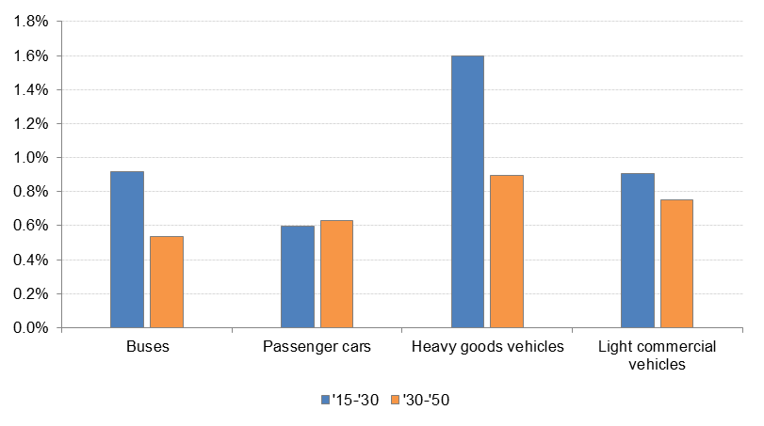

*Source: Baseline scenario, PRIMES-TREMOVE transport model (ICCS-E3MLab)*

Under current trends and adopted policies, measures addressing infrastructure safety and driver behaviour would compensate for the increase in traffic over time while the uptake of the mandatory and voluntary vehicle technology safety measures described above would result in further decreases in the number of fatalities, serious and slight injuries over time. The number of fatalities is projected to go down by 11% between 2015 and 2030 (9% for 2016-2030) and 16% during 2015-2050 (14% for 2016-2050), while the reduction in the serious injuries is expected to be lower at 7% by 2030 (6% for 2016-2030) and 10% by 2050 (10% for 2016-2050). Slight injuries are also projected to drop by 2050, however, at much lower pace than fatalities and serious injuries (5% for 2015-2030 and 7% for 2015-2050).

Figure 17: Evolution of fatalities, serious and slight injuries over the 2015-2050 time horizon (average growth rate per year)

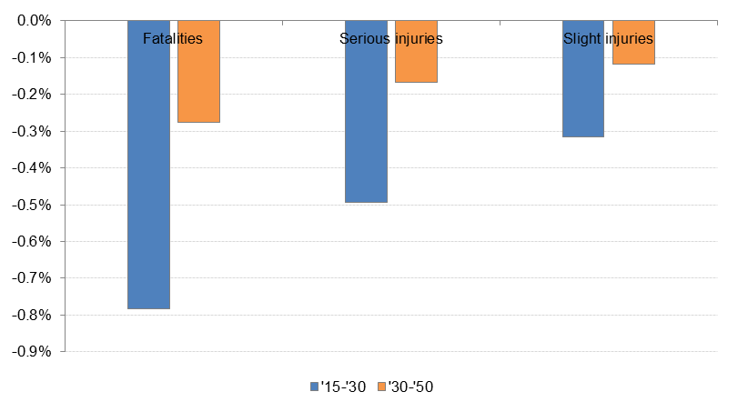

*Source: Baseline scenario, TRL model and PRIMES-TREMOVE transport model (ICCS-E3MLab)*

In the Baseline scenario, the evolution of fatalities, serious and slight injuries by EU region continues recent trends observed in the historical data, with the Eastern and Southern EU countries showing the highest decrease in the number of casualties.

Figure 18: Evolution of fatalities, serious and slight injuries by EU region between 2015 and 2030 (cumulative growth rates)

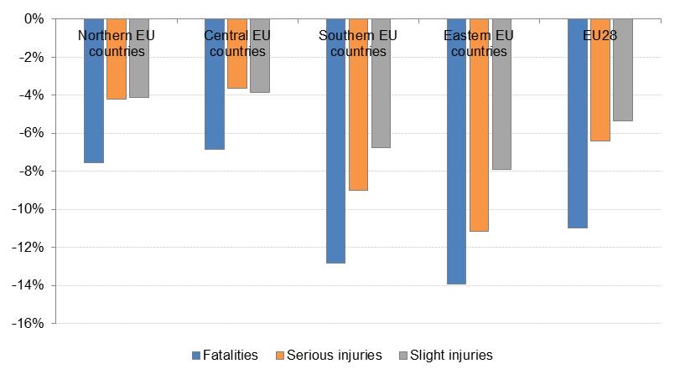

*Source: Baseline scenario, PRIMES-TREMOVE transport model (ICCS-E3MLab) and TRL model*

### Baseline scenario – sensitivity analysis

Considering the high uncertainty surrounding the evolution of fatalities and injuries, sensitivity analysis has been performed on the Baseline scenario. An alternative optimistic and a pessimistic baseline scenario have been considered:

* In the optimistic baseline scenario, it is assumed that the slight reduction of fatalities and serious injuries observed during 2014-2016 (0.7% per year) would come from infrastructure, driver behaviour and other factors (mandatory vehicles technologies) and the trend would be continued in time. In addition, the voluntary uptake of vehicle technologies measures is assumed to be the same as in the main Baseline scenario.
* In the pessimistic baseline scenario, it is assumed that post-2016 vehicle technologies would be the main source of reductions in fatalities, serious and slight injuries, while measures addressing infrastructure safety and driver behaviour and other factors would compensate for the increase in traffic over time. However, the voluntary uptake of vehicle technologies in new vehicles is reduced by a factor.

The projected evolution of fatalities, serious and slight injuries over the 2015-2050 horizon in the optimistic and pessimistic baseline scenarios is presented in Figure 19 to Figure 20. It is compared with the central baseline scenario described in the previous section. In cumulative terms, between 2016 and 2030 the number of fatalities is projected to go down by 18% in the optimistic baseline scenario and 6% in the pessimistic scenario relative to 9% in the central baseline scenario. Similarly, serious injuries would decrease by 15% in the optimistic baseline and 4% in the pessimistic baseline compared to 6% in the central baseline scenario while slight injuries would go down by 15% in the optimistic baseline and 4% in the pessimistic baseline relative to 7% in the central baseline scenario.

Figure 19: Evolution of fatalities over the 2015-2050 time horizon (average growth rate per year) in the optimistic and pessimistic baseline scenarios



*Source: Baseline scenario, TRL model and PRIMES-TREMOVE transport model (ICCS-E3MLab)*

Figure 20: Evolution of serious injuries over the 2015-2050 time horizon (average growth rate per year) in the optimistic and pessimistic baseline scenarios



*Source: Baseline scenario, TRL model and PRIMES-TREMOVE transport model (ICCS-E3MLab)*

Figure 21: Evolution of slight injuries over the 2015-2050 time horizon (average growth rate per year) in the optimistic and pessimistic baseline scenarios



*Source: Baseline scenario, TRL model and PRIMES-TREMOVE transport model (ICCS-E3MLab)*

Similarly to the central baseline scenario, the evolution of fatalities, serious and slight injuries by EU region in the optimistic and pessimistic baseline scenarios continues recent trends observed in the historical data, with the Eastern and Southern EU countries showing higher decreases in the number of casualties relative to the Northern and Central EU countries.

Figure 22: Evolution of fatalities, serious and slight injuries by EU reagion between 2015 and 2030 (cumulative growth rates) in the optimistic baseline scenario

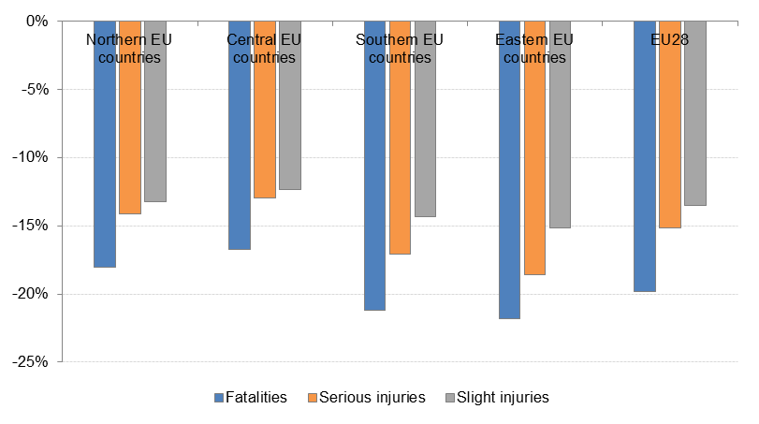

*Source: Baseline scenario, PRIMES-TREMOVE transport model (ICCS-E3MLab) and TRL model*

Figure 23: Evolution of fatalities, serious and slight injuries by EU reagion between 2015 and 2030 (cumulative growth rates) in the pessimistic baseline scenario

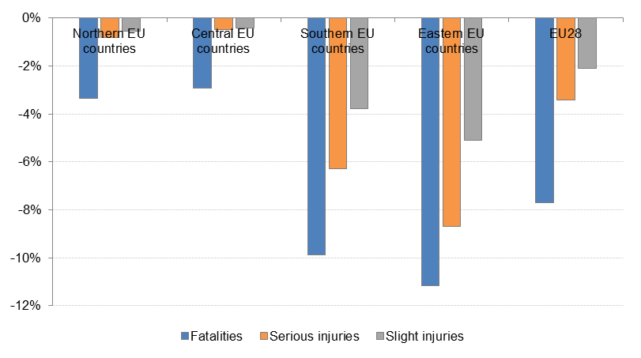

*Source: Baseline scenario, PRIMES-TREMOVE transport model (ICCS-E3MLab) and TRL model*

## Detailed results of policy options by Member State

This section presents the detailed social and economic impacts by Member State for each policy option (policy options 1 to 3 and A to C).

### Social impacts

In terms of social impacts, as explained in section 6 of the Impact Assessment report, the main effect of the policy options is the reduction in the number of fatalities and serious injuries from road crashes. This effect is achieved either through a reduction in the number of road crashes or through a reduction in the impact on the persons involved in the crashes. These further have impacts on public or private health costs, production loss etc. They are included in the monetisation of fatalities and of severe injuries.

For each policy option (policy options 1 to 3 and A to C) a table is included that presents the expected social impacts of individual policy measures used in the quantification of effects. As explained in section 4.1.3, the sources for the estimation of the impacts on the number of fatalities and serious injuries are based on two main studies: the Safety Cube project and the Handbook of Road Safety Measures. These studies include almost all evidence available on the impacts of infrastructure on road safety.

**Policy option 1 (PO1)**

The expected social impacts of the individual policy measures included in PO1 are presented in the table below.

Table 6: Effect of each measure of PO1 (light intervention – best practice sharing, publication of information about procedures) on the number of injuries and fatalities

| No. | Measures | Effect  (% reduction in fatalities and serious injuries) |
| --- | --- | --- |
| 1. | Promote knowledge sharing by publishing national best practices in central EU repository | Positive, but not quantified |
| 2. | Create a European Forum of Road Safety Auditors | Positive, but not quantified |
| 8. | Make information about procedures publicly available | Positive, but not quantified |
| 4. | Include clear reference to assessing safety of vulnerable road users in all RISM procedures | R:5-10 %  CE: 7.5% |
| 5. | Include clear reference to supporting deployment of C-ITS and automation on the TEN-T in all road infrastructure safety management procedures | Positive, but not quantified |
| 3. | Create interface between the RISM and Tunnel Directives | Positive, but not quantified |

*Source: COWI/SWOV (2017); Note: R=range and CE = central estimate*

The social impacts of PO1 (light intervention – best practice sharing, publication of information about procedures) are presented in the table below. The results are presented both as the percentage reduction compared to the baseline and the change in absolute numbers in 2030 relative to the baseline. The estimated reduction in fatalities and serious injuries is due to the increased focus of RISM procedures on the safety of vulnerable road users, in particular motorcyclists.

Table 7: Estimated reduction in the number of fatalities and serious injuries in PO1 in 2030 compared to the Baseline

| Member State | Fatalities | | Serious injuries | |
| --- | --- | --- | --- | --- |
|  | % change | Absolute change | % change | Absolute change |
| AT | 0.7% | 0 | 0.7% | 3 |
| BE | 0.7% | 0 | 0.7% | 1 |
| BG | 0.8% | 0 | 0.8% | 1 |
| CY | 1.1% | 0 | 1.1% | 0 |
| CZ | 0.9% | 1 | 0.9% | 3 |
| DE | 0.8% | 1 | 0.8% | 23 |
| DK | 0.7% | 0 | 0.7% | 1 |
| EE | 1.1% | 0 | 1.1% | 1 |
| EL | 1.5% | 1 | 1.5% | 1 |
| ES | 0.9% | 1 | 0.9% | 7 |
| FI | 0.9% | 1 | 0.9% | 1 |
| FR | 0.9% | 1 | 0.9% | 11 |
| HR | 1.2% | 0 | 1.2% | 2 |
| HU | 1.0% | 0 | 1.0% | 3 |
| IE | 0.9% | 0 | 0.9% | 1 |
| IT | 1.0% | 1 | 1.0% | 19 |
| LT | 1.3% | 0 | 1.3% | 1 |
| LU | 0.6% | 0 | 0.6% | 0 |
| LV | 1.4% | 0 | 1.4% | 1 |
| MT | 1.4% | 0 | 1.4% | 1 |
| NL | 0.6% | 0 | 0.6% | 1 |
| PL | 1.2% | 1 | 1.2% | 5 |
| PT | 0.7% | 0 | 0.7% | 1 |
| RO | 1.3% | 1 | 1.3% | 4 |
| SE | 1.0% | 1 | 1.0% | 9 |
| SI | 0.6% | 0 | 0.6% | 1 |
| SK | 0.7% | 0 | 0.7% | 1 |
| UK | 1.2% | 1 | 1.1% | 13 |
| Total (TEN-T roads) | 1.0% | 14 | 0.9% | 116 |
| Total (whole network) | 0.1% | 14 | 0.1% | 116 |

*Source: COWI/SWOV (2017)*

**Policy option 2 (PO2)**

The table below summarises the impacts of the individual measures in PO2 on fatalities and serious injuries.

Table 8: Effect of each measure of PO2 on the number of fatalities and serious injuries on the roads where they are implemented (moderate intervention – mandatory follow-up, network-wide inspections)

| Measures | Effect  (% reduction in fatalities and serious injuries) on roads where implemented |
| --- | --- |
| Obligation to compile a risk-based prioritised action plan | R: 10-20%  CE: 15% |
| Carry out road assessment programmes |
| Establish general performance requirements for road markings on TEN-T | Edge lines/Centre lines  R: 1-3%/0-1%  CE: 2%/1% |

*Source: COWI/SWOV (2017); Note: R=range and CE = central estimate*

The overall impacts on the number of fatalities and injuries in PO2 compared to the Baseline are shown in the table below. The impacts of PO2 are mainly due to better follow-up of the findings of existing RISM procedures and to the positive effects of running road assessment programmes in addition to the existing procedures. General performance requirements for road markings contribute to these positive results.

PO2 has a relatively low effect in some countries (e.g. Sweden, the Netherlands and the UK). This is because these countries already apply road assessment programmes and have high safety levels on their TEN-T roads.

Table 9: Estimated reduction in the number of fatalities and serious injuries on the road network concerned in PO2 in 2030 compared to the Baseline

| Member State | Fatalities | | | | | Serious injuries | | | |
| --- | --- | --- | --- | --- | --- | --- | --- | --- | --- |
|  | % change | | Absolute change | | | % change | | Absolute change | |
| AT | | 1.4% | | 0 | 1.4% | | 7 | |
| BE | | 12.3% | | 3 | 12.3% | | 19 | |
| BG | | 14.4% | | 5 | 14.4% | | 17 | |
| CY | | 16.8% | | 1 | 16.8% | | 8 | |
| CZ | | 13.5% | | 9 | 13.5% | | 38 | |
| DE | | 0.9% | | 1 | 0.9% | | 28 | |
| DK | | 9.1% | | 2 | 9.1% | | 15 | |
| EE | | 18.4% | | 4 | 18.4% | | 23 | |
| EL | | 18.1% | | 11 | 18.1% | | 15 | |
| ES | | 1.4% | | 2 | 1.4% | | 10 | |
| FI | | 7.1% | | 6 | 7.1% | | 11 | |
| FR | | 12.5% | | 18 | 12.5% | | 146 | |
| HR | | 11.2% | | 2 | 11.2% | | 23 | |
| HU | | 13.6% | | 4 | 13.6% | | 41 | |
| IE | | 2.9% | | 1 | 2.9% | | 2 | |
| IT | | 8.8% | | 11 | 8.8% | | 172 | |
| LT | | 7.4% | | 2 | 7.4% | | 5 | |
| LU | | 4.3% | | 0 | 4.3% | | 0 | |
| LV | | 15.1% | | 4 | 15.1% | | 11 | |
| MT | | 15.1% | | 0 | 15.1% | | 6 | |
| NL | | 1.6% | | 0 | 1.6% | | 4 | |
| PL | | 14.6% | | 16 | 14.6% | | 59 | |
| PT | | 16.2% | | 7 | 16.2% | | 29 | |
| RO | | 14.8% | | 10 | 14.8% | | 49 | |
| SE | | 3.2% | | 3 | 3.2% | | 27 | |
| SI | | 8.3% | | 1 | 8.3% | | 8 | |
| SK | | 13.5% | | 3 | 13.5% | | 11 | |
| UK | | 2.6% | | 2 | 2.6% | | 29 | |
| Total (TEN-T roads) | | **8.8%** | | **129** | **6.5%** | | **815** | |
| Total (whole network) | | 0.6% | | 129 | 0.4% | | 815 | |

*Source: COWI/SWOV (2017)*

**Policy option 3 (PO3)**

The overall assumptions supporting the quantification of PO3 (ambitious intervention – minimum star rating) are largely based on experience from the EuroRAP/iRAP road assessment programmes and their estimation of the impact of better safety ratings. This measure of setting a minimum safety level is defined in the assessments as similar to requiring all roads to have a minimum 3 star rating according to the iRAP definition. According to EuroRAP, when a road is upgraded from 1 star to 2, this will lead to a reduction in fatalities of 30%. An improvement from 2 to 3 stars will reduce fatalities by 40%.

The table below summarises the impacts of the individual measures in PO3 on fatalities and serious injuries.

Table 10: Effect of each measure of PO3 on the number of injuries and fatalities (ambitious intervention – minimum star rating)[[41]](#footnote-41)

| No | Measures | Effect  (% reduction in fatalities and injuries) |
| --- | --- | --- |
|  | Implement corrective actions to meet minimum safety levels (3 stars) on 1 star roads | R: 25-39%  CE: 30% |
|  | Implement corrective actions to meet minimum safety levels (3 stars) on 2 star roads [[42]](#footnote-42) | R: 33-48%  CE: 40% |
|  | Establish general performance requirements for road furniture on TEN-T (e.g. motorcycle friendly guardrails) | New guardrails along the roadside/ Guardrails in central lane  R: 41-52%/23-36%  CE: 45%/30 |

*Source: COWI/SWOV (2017); Note: R=range and CE = central estimate*

The quantification of impacts of PO3 shows a significant reduction in the number of fatalities and injuries as shown in the table below. The distribution of impacts is to a large extent similar to that in PO2, where countries with large road networks or a relatively high number of fatalities and injuries would experience a higher total impact. The relative impact is highest in countries with a relatively low safety rating of roads in the baseline (e.g. Greece, Hungary and Romania). The higher reduction in the number of fatalities and serious injuries compared to PO2 is mainly due to the compulsory improvements to road infrastructure which will be carried out to meet minimum safety requirements on the road network concerned. This is complemented by general performance requirements for road furniture (guardrails).

Table 11: Estimated reduction in the number of fatalities and serious injuries on the road network concerned in PO3 in 2030 compared to the Baseline

| Member State | Fatalities | | Severe injuries | |
| --- | --- | --- | --- | --- |
|  | % change | Absolute change | % change | Absolute change |
| AT | 4.9% | 1 | 4.9% | 23 |
| BE | 4.1% | 1 | 4.1% | 6 |
| BG | 42.3% | 15 | 42.3% | 51 |
| CY | 13.8% | 1 | 13.6% | 6 |
| CZ | 16.3% | 11 | 16.2% | 45 |
| DE | 2.0% | 3 | 2.0% | 60 |
| DK | 2.3% | 1 | 2.4% | 4 |
| EE | 33.3% | 6 | 33.3% | 42 |
| EL | 32.6% | 21 | 32.6% | 27 |
| ES | 3.5% | 5 | 3.5% | 27 |
| FI | 8.2% | 7 | 8.2% | 13 |
| FR | 4.1% | 6 | 4.1% | 47 |
| HR | 36.9% | 8 | 36.9% | 77 |
| HU | 21.3% | 7 | 21.4% | 65 |
| IE | 15.3% | 5 | 15.3% | 11 |
| IT | 6.2% | 8 | 6.2% | 121 |
| LT | 32.3% | 10 | 32.3% | 23 |
| LU | 0.6% | 0 | 0.6% | 0 |
| LV | 37.8% | 9 | 37.8% | 29 |
| MT | 38.1% | 1 | 38.1% | 15 |
| NL | 0.6% | 0 | 0.6% | 1 |
| PL | 38.1% | 41 | 38.1% | 154 |
| PT | 8.2% | 4 | 8.2% | 15 |
| RO | 35.4% | 24 | 35.5% | 118 |
| SE | 1.0% | 1 | 1.0% | 9 |
| SI | 2.2% | 0 | 2.2% | 2 |
| SK | 23.1% | 5 | 22.7% | 19 |
| UK | 5.8% | 5 | 5.7% | 65 |
| Total (TEN-T roads) | **13.8%** | **204** | **8.6%** | **1,076** |
| Total (whole network) | 0.88% | 204 | 0.46% | 1,076 |

*Source: COWI/SWOV (2017)*

The reductions in fatalities and injuries under PO3 are significant. It is estimated that the annual reduction in fatalities on the TEN-T road network in 2030 would be 13.8% compared to the baseline. There are variations between countries due to the differences in the current star rating level of their roads.

**Policy option A (PO A)**

The table below indicates the estimated social impact of the proposed measure and identifies the extent of the road network that it concerns.

Table 12: Effect of the measure on the number of severe injuries and fatalities in PO A (Conditionality of EU funds)

| Measures | Effect  (% reduction in injuries) | Applies to |
| --- | --- | --- |
| Apply the provisions of the current RISM Directive to parts of the national road infrastructure that is built using EU funding | R: 3-10%  CE: 5% | All fatalities and injuries on non-TEN-T road built with EU funding in those Member States that are not already conducting RISM procedures on non-TEN-T roads |

*Source: COWI/SWOV (2017); Note: R=range and CE = central estimate*

The estimated social impacts of PO A are presented below. Improvements are assumed to be limited to those Member States that receive funding from the EU and that have not yet extended the application of RISM procedures to their national road networks on a voluntary basis.

Table 13: Estimated reduction in the number of fatalities and serious injuries on the road network concerned in PO A in 2030 compared to the Baseline

| Member State | Fatalities | | Serious injuries | |
| --- | --- | --- | --- | --- |
|  | % change | Absolute change | % change | Absolute change |
| AT | 0,00% | 0 | 0,00% | 0 |
| BE | 0,00% | 0 | 0,00% | 0 |
| BG | 0,00% | 0 | 0,00% | 0 |
| CY | 0,00% | 0 | 0,00% | 0 |
| CZ | 0,00% | 0 | 0,00% | 0 |
| DE | 0,00% | 0 | 0,00% | 0 |
| DK | 0,00% | 0 | 0,00% | 0 |
| EE | 0,03% | 0 | 0,18% | 0 |
| EL | 2,13% | 0 | 1,75% | 1 |
| ES | 0,01% | 0 | 0,03% | 0 |
| FI | 0,00% | 0 | 0,00% | 0 |
| FR | 0,00% | 0 | 0,00% | 0 |
| HR | 0,01% | 0 | 0,10% | 0 |
| HU | 0,00% | 0 | 0,00% | 0 |
| IE | 0,00% | 0 | 0,00% | 0 |
| IT | 0,00% | 0 | 0,00% | 0 |
| LT | 0,00% | 0 | 0,00% | 0 |
| LU | 0,00% | 0 | 0,00% | 0 |
| LV | 0,00% | 0 | 0,00% | 0 |
| MT | 0,00% | 0 | 0,00% | 0 |
| NL | 0,00% | 0 | 0,00% | 0 |
| PL | 0,24% | 0 | 0,49% | 4 |
| PT | 0,00% | 0 | 0,00% | 0 |
| RO | 0,00% | 0 | 0,00% | 0 |
| SE | 0,00% | 0 | 0,00% | 0 |
| SI | 0,01% | 0 | 0,02% | 0 |
| SK | 0,19% | 0 | 0,53% | 1 |
| UK | 0,00% | 0 | 0,00% | 0 |
| Total (non-TEN-T motorways and main roads) including cross-border projects | **0,02%** | **1** | **0,02%** | **6** |

*Source: COWI/SWOV (2017)*

**Policy option B (PO B)**

The table below summarises the impacts of the measures in PO B on fatalities and serious injuries.

Table 14: Effect of the measure of PO B on the number of severe injuries and fatalities (Extension of current RISM provisions to main/national roads)

| Measures | Effect  (% reduction in fatalities and serious injuries) | Applies to |
| --- | --- | --- |
| Apply the provisions of the current RISM Directive to national roads | R: 3-10%  CE: 5% | All fatalities and injuries on national roads in those Member States that are not already conducting RISM procedures on non-TEN-T roads |

*Source: COWI/SWOV (2017); Note: R=range and CE = central estimate*

The overall social impacts estimated for PO B in 2030 relative to the Baseline are presented below. PO B provides significant social benefits in countries where RISM procedures have not been extended to non-TEN-T roads so far. It is assumed that PO B will not have an impact on those Member States that already apply RISM procedures on non-TEN-T national roads.

Table 15: Estimated reduction in the number of fatalities and serious injuries on the road network concerned in PO B in 2030 compared to the Baseline

| Member State | Fatalities | | Serious injuries | |
| --- | --- | --- | --- | --- |
|  | % change | Absolute change | % change | Absolute change |
| AT | 0.0% | 0 | 0.0% | 0 |
| BE | 0.0% | 0 | 0.0% | 0 |
| BG | 0.0% | 0 | 0.0% | 0 |
| CY | 0.0% | 0 | 0.0% | 0 |
| CZ | 0.0% | 0 | 0.0% | 0 |
| DE | 0.0% | 0 | 0.0% | 0 |
| DK | 7.5% | 3 | 7.5% | 23 |
| EE | 7.5% | 3 | 7.5% | 18 |
| EL | 7.5% | 3 | 7.5% | 4 |
| ES | 7.5% | 38 | 7.5% | 208 |
| FI | 7.5% | 9 | 7.5% | 18 |
| FR | 0.0% | 0 | 0.0% | 0 |
| HR | 7.5% | 7 | 7.5% | 71 |
| HU | 0.0% | 0 | 0.0% | 0 |
| IE | 7.5% | 3 | 7.5% | 8 |
| IT | 0.0% | 0 | 0.0% | 0 |
| LT | 0.0% | 0 | 0.0% | 0 |
| LU | 0.0% | 0 | 0.0% | 0 |
| LV | 0.0% | 0 | 0.0% | 0 |
| MT | 0.0% | 0 | 0.0% | 0 |
| NL | 0.0% | 0 | 0.0% | 0 |
| PL | 7.5% | 12 | 7.5% | 47 |
| PT | 0.0% | 0 | 0.0% | 0 |
| RO | 0.0% | 0 | 0.0% | 0 |
| SE | 0.0% | 0 | 0.0% | 0 |
| SI | 7.5% | 1 | 7.5% | 11 |
| SK | 7.5% | 3 | 7.5% | 10 |
| UK | 0.0% | 0 | 0.0% | 0 |
| Total (non-TEN-T motorways and main roads) | **1.8%** | **83** | **0.8%** | **418** |
| Total (whole network) | 0.4% | 83 | 0.2% | 418 |

*Source: COWI/SWOV (2017)*

**Policy option C (PO C)**

The table below shows the effects of individual measures used to quantify the impacts of PO C. The option contains measures that are also used in PO2 for TEN-T roads. The impacts of PO C are therefore quantified using the same assumptions as those used for the measures in PO2, however extending the scope beyond TEN-T roads.

Table 16: Effect of each measure of PO C on the number of severe injuries and fatalities

| No | Measures | Effect  (% reduction in fatalities and serious injuries) |
| --- | --- | --- |
| 8. | Make information about procedures publicly available | - |
| 9. | Compulsory follow-up of findings using a plan based on risk-based prioritisation of actions | R: 10-20%  CE: 15% |
| 10. | Carry out road assessment programmes |

*Source: COWI/SWOV (2017); Note: R=range and CE = central estimate*

The estimated social impacts of PO C are presented in the Table below.

Table 17: Estimated reduction in the number of fatalities and serious injuries on the road network concerned in PO C in 2030 compared to the Baseline

| Member State | Fatalities | | Severe injuries | |
| --- | --- | --- | --- | --- |
|  | % change | Absolute change | % change | Absolute change |
| AT | 0.0% | 0 | 0.0% | 0 |
| BE | 11.3% | 10 | 11.3% | 69 |
| BG | 11.3% | 2 | 11.3% | 5 |
| CY | 15.0% | 1 | 15.0% | 10 |
| CZ | 11.3% | 20 | 11.3% | 83 |
| DE | 0.0% | 0 | 0.0% | 0 |
| DK | 17.9% | 8 | 17.9% | 55 |
| EE | 21.4% | 8 | 21.4% | 51 |
| EL | 21.4% | 9 | 21.4% | 12 |
| ES | 21.4% | 108 | 21.4% | 594 |
| FI | 21.4% | 26 | 21.4% | 51 |
| FR | 11.3% | 80 | 11.3% | 630 |
| HR | 21.4% | 21 | 21.4% | 202 |
| HU | 11.3% | 3 | 11.3% | 28 |
| IE | 21.4% | 10 | 21.4% | 23 |
| IT | 7.5% | 43 | 7.5% | 684 |
| LT | 0.0% | 0 | 0.0% | 0 |
| LU | 3.7% | 1 | 3.8% | 5 |
| LV | 11.3% | 0 | 11.3% | 0 |
| MT | 0.0% | 0 | 0.0% | 0 |
| NL | 0.0% | 0 | 0.0% | 0 |
| PL | 21.4% | 35 | 21.4% | 133 |
| PT | 15.0% | 21 | 15.0% | 82 |
| RO | 11.3% | 18 | 11.3% | 86 |
| SE | 0.0% | 0 | 0.0% | 0 |
| SI | 17.9% | 4 | 17.9% | 27 |
| SK | 21.4% | 7 | 21.4% | 29 |
| UK | 0.0% | 0 | 0.0% | 0 |
| Total (non-TEN-T motorways and main roads) | **9.4%** | **433** | **5.6%** | **2,860** |
| Total (whole network) | 1.9% | 433 | 1.2% | 2,860 |

*Source: COWI/SWOV (2017)*

### Economic impacts – regulatory costs

The economic impacts relate to the regulatory costs associated with the policy measures. These regulatory costs include in particular: (i) compliance costs related to the costs of using the road infrastructure safety management procedures and to implementation costs related to making the necessary improvements to the road infrastructure; (ii) administrative costs borne by businesses, citizens, civil society organisations and public authorities as a result of administrative activities performed to comply with information obligations included in legal rules; (iii) enforcement costs representing the resources that authorities need to monitor and enforce the legislation. As the RISM Directive put the responsibilities for compliance directly on national road authorities, no enforcement costs are expected.

While the unit cost of RISM procedures can be quite stable (notwithstanding the differences in labour costs between Member States), the implementation part of compliance costs will always depend on the actual condition of the infrastructure and the specific infrastructure countermeasures required to address the safety shortcoming detected by the procedures carried out. Therefore significant differences in total compliance costs are expected between Member States.

**Policy option 1 to 3 (PO1 to PO3)**

Using the cost assumptions and the data on the length of TEN-T roads, the compliance costs for PO1 to PO3 (where the scope of the legislation is limited to TEN-T roads) are presented in the table below. The specific assumptions on how these elements have been estimated are presented in the Impact Assessment Support Study.

As the scope of the measures increase, so does the cost of compliance. The major part of the compliance costs associated with PO2 and PO3 are the costs of the infrastructure upgrades resulting from the improved follow-up of RISM procedures and in case of PO3 specifically the infrastructure costs required for all the TEN-T roads to meet the agreed minimum safety requirements. Differences between costs by Member State are due to the length of the roads concerned and their current level of safety.

Table 18: Compliance costs in million euro in PO1 to PO3 (TEN-T roads) over the period 2020-2050

| Member State | PO1 | PO2 | PO3 |
| --- | --- | --- | --- |
| AT | 2 | 2 | 92 |
| BE | 2 | 72 | 111 |
| BG | 1 | 89 | 323 |
| CY | 0 | 19 | 34 |
| CZ | 1 | 46 | 82 |
| DE | 14 | 14 | 664 |
| DK | 2 | 57 | 28 |
| EE | 1 | 48 | 89 |
| EL | 3 | 173 | 390 |
| ES | 12 | 12 | 255 |
| FI | 4 | 79 | 83 |
| FR | 18 | 575 | 642 |
| HR | 1 | 19 | 71 |
| HU | 1 | 34 | 85 |
| IE | 2 | 3 | 110 |
| IT | 12 | 257 | 902 |
| LT | 1 | 18 | 130 |
| LU | 0 | 1 | 5 |
| LV | 1 | 42 | 111 |
| MT | 0 | 3 | 9 |
| NL | 2 | 2 | 2 |
| PL | 3 | 158 | 513 |
| PT | 2 | 107 | 168 |
| RO | 2 | 123 | 347 |
| SE | 7 | 7 | 7 |
| SI | 1 | 7 | 14 |
| SK | 1 | 27 | 74 |
| UK | 8 | 9 | 224 |
| Total | **103** | **2,004** | **5,563** |

*Source: COWI/SWOV (2017)*

**Policy option A to C (PO A to PO C)**

For the policy options involving a change in the scope of the legislation (to include roads beyond the TEN-T), the compliance costs by Member States are presented in the table below.

The compliance costs for the policy options include the compliance costs associated with the necessary upgrade of the road infrastructure concerned. The very significant estimated compliance costs for PO C are largely the result of the implementation of the findings of road assessment programmes. The distribution of the costs by Member State is influenced by the length of road (some Member States have very large primary road networks) and by the current state and safety level of the existing road infrastructure in the scope.

Table 19: Compliance costs in million euro in PO A to PO C over the period 2020-2050

| Member state | PO A | | PO B | | PO C | |
| --- | --- | --- | --- | --- | --- | --- |
| AT | | 0.0 | | 0.0 | | 0 | |
| BE | | 0.0 | | 0.0 | | 243 | |
| BG | | 0.0 | | 0.0 | | 36 | |
| CY | | 0.0 | | 0.0 | | 22 | |
| CZ | | 0.0 | | 0.0 | | 122 | |
| DE | | 0.0 | | 0.0 | | 0 | |
| DK | | 0.0 | | 31.0 | | 171 | |
| EE | | 4.4 | | 30.8 | | 123 | |
| EL | | 32.6 | | 37.1 | | 148 | |
| ES | | 14.0 | | 0.0 | | 1,591 | |
| FI | | 0.0 | | 38.7 | | 504 | |
| FR | | 0.0 | | 0.0 | | 2,066 | |
| HR | | 1.8 | | 27.4 | | 192 | |
| HU | | 0.0 | | 0.0 | | 25 | |
| IE | | 0.0 | | 0.0 | | 162 | |
| IT | | 0.0 | | 0.0 | | 958 | |
| LT | | 0.0 | | 0.0 | | 0 | |
| LU | | 0.0 | | 0.0 | | 8 | |
| LV | | 0.0 | | 0.0 | | 2 | |
| MT | | 0.0 | | 0.0 | | 0 | |
| NL | | 0.0 | | 0.0 | | 0 | |
| PL[[43]](#footnote-43) | | 114.6 | | 75.5 | | 378 | |
| PT | | 0.0 | | 0.0 | | 324 | |
| RO | | 0.0 | | 0.0 | | 280 | |
| SE | | 0.0 | | 0.0 | | 0 | |
| SI | | 0.5 | | 3.4 | | 19 | |
| SK | | 15.6 | | 12.9 | | 64 | |
| UK | | 0.0 | | 0.0 | | 0 | |
| Total | | **203.3** | | **257** | | **7,440** | |

*Source: COWI/SWOV (2017)*

1. <http://ec.europa.eu/transport/facts-fundings/evaluations/doc/2014-12-ex-post-evaluation-study-road-infra-safety-mgmnt.pdf> [↑](#footnote-ref-1)
2. <http://ec.europa.eu/transport/facts-fundings/evaluations/doc/tunnel_final_report.pdf> [↑](#footnote-ref-2)
3. <https://ec.europa.eu/transport/road_safety/sites/roadsafety/files/rapporteurs_summary_reports_28_march_03.pdf> [↑](#footnote-ref-3)
4. http://2r1c5r3mxgzc49mg1ey897em.wpengine.netdna-cdn.com/wp-content/uploads/sites/8/2018/01/TM2.0\_TF\_RoadAutomation\_report3\_FINAL.pdf [↑](#footnote-ref-4)
5. An inquiry has been sent to the respondent about what the number covers. It is interpreted as the number of road sections that are inspected. [↑](#footnote-ref-5)
6. In Italy no certified - according to D.Lgs. 35/2011 - road safety auditors and inspectors are present because the decree on new training courses is in the process of being defined. However, pursuant to Article 12, paragraph 4 of D.Lgs. n. 35/2011, there is a transitional list of experts with experience requirements. [↑](#footnote-ref-6)
7. The UK does not specify specific qualifications for inspectors in the UK. Highway authorities in the UK generally use private sector companies. The company that employs the inspectors must ensure that suitable, competent people are used and that the selection takes account of the range of skills required for different types of inspection. [↑](#footnote-ref-7)
8. The net present value of estimated compliance costs over the 2020-2050 period. Recurrent costs are included in the estimated present value of compliance costs. They are estimated at 10,000 euro annually per Member State for Policy option 2 and 30,000 euro annually per Member State for Policy option C. [↑](#footnote-ref-8)
9. https://www.python.org/ [↑](#footnote-ref-9)
10. Source: http://www.e3mlab.ntua.gr/e3mlab/ [↑](#footnote-ref-10)
11. Source: <http://www.tmleuven.be/methode/tremove/home.htm> [↑](#footnote-ref-11)
12. Several model enhancements were made compared to the standard TREMOVE model, as for example: for the number of vintages (allowing representation of the choice of second-hand cars); for the technology categories which include vehicle types using electricity from the grid and fuel cells. The model also incorporates additional fuel types, such as biofuels (when they differ from standard fossil fuel technologies), LPG and LNG. In addition, representation of infrastructure for refuelling and recharging are among the model refinements, influencing fuel choices. A major model enhancement concerns the inclusion of heterogeneity in the distance of stylised trips; the model considers that the trip distances follow a distribution function with different distances and frequencies. The inclusion of heterogeneity was found to be of significant influence in the choice of vehicle-fuels especially for vehicles-fuels with range limitations. [↑](#footnote-ref-12)
13. The model can be run either as a stand-alone tool (e.g. for the 2011 White Paper on Transport and for the 2016 Strategy on low-emission mobility) or fully integrated in the rest of the PRIMES energy systems model (e.g. for the Low Carbon Economy and Energy 2050 Roadmaps, for the 2030 policy framework for climate and energy, for the Effort Sharing Regulation, for the review of the Energy Efficiency Directive and for the recast of the Renewables Energy Directive). When coupled with PRIMES, interaction with the energy sector is taken into account in an iterative way. [↑](#footnote-ref-13)
14. Source: <http://ec.europa.eu/clima/policies/strategies/analysis/models/docs/primes_model_2013-2014_en.pdf>. [↑](#footnote-ref-14)
15. <https://ec.europa.eu/energy/sites/ener/files/documents/sec_2011_1569_2.pdf> [↑](#footnote-ref-15)
16. https://www.python.org/ [↑](#footnote-ref-16)
17. Source: https://ec.europa.eu/transport/road\_safety/specialist/statistics\_en [↑](#footnote-ref-17)
18. Source : https://ec.europa.eu/transport/themes/infrastructure-ten-t-connecting-europe/tentec-information-system\_en [↑](#footnote-ref-18)
19. See e.g. Filtness A. & Papadimitriou E. (Eds) (2016), Identification of Infrastructure Related Risk Factors, Deliverable 5.1 of the H2020 project SafetyCube. [↑](#footnote-ref-19)
20. Elvik, R., T. Vaa, A. Hove and M. Sorensen eds. (2012) The Handbook of Road Safety Measures: Forth Edition in Norwegian Second ed. In English, 2009. [↑](#footnote-ref-20)
21. In the quantification of economic impacts, ’compliance costs’ are costs both to undertake the different procedures and the costs of investing in the safety changes recommended as part of the procedures. [↑](#footnote-ref-21)
22. These case studies are documented in a set of national reports and in a joint summary report: EuroRAP (2016) [↑](#footnote-ref-22)
23. COWI/SWOV (2017), "Impact assessment support study for the revision of Directive 2008/96/EC on road infrastructure safety management and Directive 2004/54/EC on minimum safety requirements for road tunnels in the trans-European network" [↑](#footnote-ref-23)
24. IRAP and EuroRAP use 3 star roads as the reference point for safe roads. Hence, on average the identified defects in the SENSOR study is aiming at lifting roads to 3 stars. [↑](#footnote-ref-24)
25. In reality there may be more individual things to change in lifting a 1 star road to 2 star than a road lifted from 2 star to 3 stars. On the other hand, the possibly fewer things to improve on 2-star roads will be on average more expensive. Due to variations between the specific roads, the assumption is that the total costs per km ”per star” that is lifted is the same. [↑](#footnote-ref-25)
26. Carriageways corresponds to main roads and motorways, but not to smaller roads, nor to general urban roads. The costs are estimated in the SENSOR study. They are not the result of actual investments made. [↑](#footnote-ref-26)
27. In addition, amendments to two Directives only adopted in the beginning of 2015 were also considered. This concerns notably the ILUC amendment to the Renewables Directive and the Market Stability Reserve Decision amending the ETS Directive. [↑](#footnote-ref-27)
28. ICCS-E3MLab et al. (2016), EU Reference Scenario 2016: Energy, transport and GHG emissions - Trends to 2050 [↑](#footnote-ref-28)
29. SWD(2016) 247 [↑](#footnote-ref-29)
30. SWD(2016) 405 [↑](#footnote-ref-30)
31. SWD(2016) 244 [↑](#footnote-ref-31)
32. European Commission/DG ECFIN (2014), The 2015 Ageing Report: Underlying Assumptions and Projection Methodologies, European Economy 8/2014. [↑](#footnote-ref-32)
33. OPEC stands for Organization of Petroleum Exporting Countries. [↑](#footnote-ref-33)
34. Source: <https://ec.europa.eu/clima/sites/clima/files/transport/vehicles/docs/technology_results_web.xlsx> [↑](#footnote-ref-34)
35. For a comprehensive discussion see the Reference scenario report: “EU Reference Scenario 2016: Energy, transport and GHG emissions - Trends to 2050” [↑](#footnote-ref-35)
36. Awaiting signature of act (Source : <http://www.europarl.europa.eu/oeil/popups/ficheprocedure.do?reference=2013/0157(COD)&l=en)> [↑](#footnote-ref-36)
37. Simulation at individual vehicle level is combined with fleet composition data, retrieved from the official European CO2 emissions monitoring database, and publicly available data regarding individual vehicle characteristics, in order to calculate vehicle CO2 emissions and fuel consumption over different conditions. Vehicle CO2 emissions are initially simulated over the present test protocol (NEDC) for the 2015 passenger car fleet; the accuracy of the method is validated against officially monitored CO2 values and experimental data. [↑](#footnote-ref-37)
38. Standard electronic stability control systems are mandatory for all new vehicles and vehicle categories since 1 November 2014 and from 1 November 2015, all new trucks and buses must also be equipped with advanced emergency braking systems as well as lane departure warning systems. [↑](#footnote-ref-38)
39. Projections for international maritime and international extra-EU aviation are presented separately and not included in the total passenger and freight transport activity to preserve comparability with statistics for the historical period. [↑](#footnote-ref-39)
40. There are several factors influencing the choice of a new transport means, covering payable and non-payable elements. True payable costs include all cost elements over the lifetime of the candidate transport means: purchasing cost; annual fixed costs for maintenance, insurance and ownership/circulation taxation; variable costs for fuel consumption depending on trip type and operation conditions; other variable costs including congestion charges, parking fees, etc. Other factors, like perceived cost factors, which do not necessarily imply true payments by the user but may imply indirect costs are influencing decisions about choice of new vehicles. They reflect technical risk of yet immature technologies, acceptance factors representing market penetration, density of refuelling/recharging infrastructure applicable to technologies using alternative fuels and those that have range limitations. [↑](#footnote-ref-40)
41. Star ratings are not currently available for all Member States. Available data include observations for 14 Member States. Findings from these Member States have been used for other countries in the same regions. See footnote 54 for more details. [↑](#footnote-ref-41)
42. [↑](#footnote-ref-42)
43. Poland has a very large national road network compared to other countries; Hence, road safety upgrades will require more investment than in other countries. Poland has also by far received the most funding from the structural funds historically. The assumption in the calculations is that the same will be the case in the future. This implies that the length of road to which RISM procedures will apply is high, which results in high costs of making the required adjustments. [↑](#footnote-ref-43)