

Contents

1. A New European Agenda for Culture – key actions proposed 3

1.1 Objective 1 – harnessing the power of culture for social cohesion and wellbeing 3

Mobility 3

Assessing the impacts of cultural cross-overs 4

Integrating refugees and other migrants 5

Gender 6

Cultural participation and creativity in cities 6

1.2 Objective 2 - Supporting culture-based creativity in education and innovation, and for jobs and growth 6

Creativity in education 6

Skills 8

Working with the music sector 8

Culture in cities and regions 9

Supporting innovation and entrepreneurship 10

Sustainable cultural tourism 11

Fair remuneration 13

1.3 Objective 3 - Strengthening international cultural relations 13

Implementing the Joint Communication on International Cultural Relations 13

Supporting culture as an engine for sustainable social and economic development 15

Promoting culture and intercultural dialogue for peaceful inter-community relations 17

Reinforcing cooperation on cultural heritage 19

2. 2018 European Year of Cultural Heritage 20

2.1 Ten European Initiatives 20

EYCH Initiative 1 – Sharing heritage, history and values 21

EYCH Initiative 2 – Heritage at school 22

EYCH Initiative 3 – Youth for heritage 23

EYCH Initiative 4 – Heritage in transition 24

EYCH Initiative 5 – Tourism and heritage 25

EYCH Initiative 6 – Cherishing heritage: quality principles 26

EYCH Initiative 7 – Heritage at risk: fighting illicit trade, managing heritage site risks 27

EYCH Initiative 8 – Skills for heritage: for traditional and new professions 28

EYCH Initiative 9 – Heritage for all: citizen participation and social innovation 29

EYCH Initiative 10 – Science for heritage: research, innovation, science and technology 30

3. Digital4Culture 32

Digital4Culture Initiative 1 – 33

Europeana: an enabler of digital transformation for cultural heritage 33

Digital4Culture Initiative 2 – Digitization centres for monuments and sites 34

Digital4culture Initiative 3 – Digital Creative Hubs 35

Digital4culture Initiative 4 - Enhancing the availability and visibility of EU films 36

Digital4culture Initiative 5 New mentoring schemes for audiovisual professionals 37

Digital4culture Initiative 6 Stimulating cross-overs from culture to innovation in society and industry 37

4. Stakeholder Views 38

4.1 Stakeholder meeting summary 38

4.2 EUSurvey – summary of MS and Stakeholder responses 42

5. Summary and Main Results of the 2007 European Agenda for Culture 46

5.1 Objectives 46

5.2 Implementation 47

5.3 Outputs – Council Work Plans for Culture 48

5.4 Outputs - structured dialogue 54

6. Statistics 57

6.1 Eurostat 57

6.2 Eurobarometer 62

Key findings on shared values and the role of culture 62

Key findings on cultural heritage 64

# 1. A New European Agenda for Culture – key actions proposed

The following main actions will be carried out under three strategic objectives, in order to support Member States implementing the New Agenda for Culture.

## 1.1 Objective 1 – harnessing the power of culture for social cohesion and wellbeing

### Mobility

The arts sector is possibly unique, in its contribution to Europe's innovation capacity, and in being driven by a specialised workforce that is highly mobile across national borders. Nowadays geographical mobility is such an intrinsic aspect of an artist's professional development that in many cases, working internationally is the only choice for young professionals. Artists have a special place also because with their mobility they strengthen the common European cultural space and foster participation in European integration.

But there are also many problems. Working frequently and for short periods in different Member States, often in atypical and precarious forms of employment, under successive employers and with irregular and unpredictable income, artists face both regulatory and administrative barriers in their cross-border activities. These include the risk of double taxation in the countries where they perform as well as those where they reside[1].

A pilot project on artists mobility was carried out in 2008 and 2009, focusing on identification and exchange of good practice, networking of structures supporting mobility and a feasibility study by ECOTEC on "Information systems to support the mobility of artists and other professionals in the culture field" <http://ec.europa.eu/assets/eac/culture/policy/cultural-creative-industries/documents/mobility-systems_en.pdf> .

This was followed in June 2010 by a report of an Open Method of Coordination working group on the mobility of artists and culture professionals with recommendations on mobility information provision for artists and culture professionals, including guidelines for Mobility Information Services. In 2011 the Council asked the Commission to establish an Expert Group tasked with preparing a set of guidelines (Mobility Information Standards) on common content and quality standards for establishing or further developing information and advisory services for artists and culture professionals[2].

In April 2013 and June 2014, the European Commission organised two thematic seminars to analyse administrative practices creating obstacles to the mobility of artists and culture professionals. The seminars focused on:

* Schengen visas
* social security
* cross-border taxation
* information provision for artists and culture professionals

The events facilitated an exchange of information and best practice between representatives from EU Member State governments and the culture sector. In May 2016, the European Commission organised a stocktaking meeting to assess follow-up initiatives and progress made since 2014 regarding the abovementioned topics in the context of cultural and artistic mobility. The exercise brought together different European Commission services, government experts from 22 EU Member States (Culture, Social Affairs and Finance ministries and public bodies), representatives of cultural organisations, festivals, professional associations, and agencies supporting or promoting the international mobility of artists and culture professionals, artists' federations and trade unions, employers, university professors, lawyers, independent experts, and cultural practitioners. The stocktaking allowed concluding that despite higher awareness of the obstacles to artistic and cultural mobility, numerous problems persist.

Incentives: A **mobility scheme for artists and creative people** has been included in the 2018 Commission Work Programme. It aims at testing a funding scheme to be activated on a regular basis from 2021 onwards. In particular, the following objectives will be pursued:

* Study the feasibility of a mobility fund active at European level. In particular, the project would evaluate the best conditions for the administration, management and evaluation of the work of such initiative in the mid-/long-term;
* Design and run a pilot mobility fund that would act in complementarity of existing mobility schemes available at local, regional and/or national levels. In particular, the project would establish the conditions, criteria, communication strategy, feedback and evaluation mechanisms for an effective funding scheme;
* Formulate policy recommendations to the European Commission, the European Parliament and Member States towards the full implementation of such a fund in the next generation of EU programmes.

In this first stage, the scheme will cover the following sectors: visual arts, music, performing arts and literature, covering cross border travel and visa costs for individual European artists for specific performances, taking part in solo or group exhibitions, travel costs to residency places; within or outside an EU country taking part in the Creative Europe programme.

The budget for the implementation of the action in 2018 should be EUR 1 million allowing for the participation of +/- 200 individuals.

Administrative and fiscal obstacles continue to hinder the mobility of artists and culture professionals: for this reason the Commission calls on Member States to remove remaining obstacles to mobility for performing artists, by the end of the next Council Work Plan

### Assessing the impacts of cultural cross-overs

The Commission services will support research on cultural cross-overs, assessing the impacts of culture in different fields such as health and well-being. , building on

* the Council Conclusions of May 2015 on "Cultural and creative cross-overs to stimulate, innovation, economic sustainability and social inclusion",
* the work of the 2017-2018 OMC Working Group on Fostering the contribution of culture to social inclusion, which is look into how public policies can encourage and support cultural institutions in working within partnerships with other sectors (healthcare, social care, prison service)
* research activities including under the EUR 9 million Horizon 2020 call on "The societal value of culture and the impact of cultural policies in Europe"

Work in this area will be undertaken by the Commission's Joint Research Centre and through dedicated studies to be agreed under the Creative Europe programme

### Integrating refugees and other migrants

There was unprecedented interest in the 2016 Creative Europe special call on support for **refugee integration** (274 project applications, requesting a total of EUR 48 million): [12 projects were selected with a budget of EUR 2.35](https://eacea.ec.europa.eu/creative-europe/selection-results/refugee-integration-projects-eacea-122016_en) million. In light of the many high quality applications which could not be funded under this call, the Commission made cultural projects for migrant inclusion eligible under other EU programmes including the Asylum & Migration Integration Fund, Rights, Equalities & Citizenship programme, Erasmus+ and Europe for Citizens. It is also possible for relevant projects to be supported under the European Structural and Investment Funds, including in rural areas.

In its 2017 report "[How culture and the arts can promote intercultural dialogue in the context of the migratory and refugee crisis](https://publications.europa.eu/en/publication-detail/-/publication/31240289-3169-11e7-9412-01aa75ed71a1/language-en)", a working group of Member States experts under the culture OMC made a number of recommendations to cultural policymakers at EU, national and local level, on empowerment, inter-sectoral working and evaluation. These included calls to:

* Support and fund networking, self-organisation and active participation of refugees and migrants in the arts and culture.
* Provide spaces and opportunities for refugees and migrants to lead, as well as participate in arts and culture, including new museums and new exhibitions dedicated to migration
* Support and fund networks (formal and informal) with publicly funded cultural organisations, civil society and other stakeholders, to contribute to policy-making processes.
* Prioritise funding for cultural and artistic projects for the integration of refugees and
* migrants under national and EU programmes, including those outside the field of culture (e.g. at EU level under the Europe for Citizens programme, Asylum & Migration Fund, and Rights, Equality and Citizenship programme as well as Creative Europe).
* Broaden and deepen evaluation of publicly funded culture projects, beyond financial and quantitative aspects, to assess their societal impacts and their effectiveness in promoting intercultural dialogue.

In its [deliberations on the EU's 2020 multiannual financial framework](http://www.emeeting.europarl.europa.eu/committees/agenda/201802/BUDG/BUDG(2018)0221_1/sitt-7666336), the European Parliament has also recognised the importance of cultural programmes in integrating refugees and migrants into European society.

The Commission services will therefore continue to promote such actions in relevant programmes under the next financial framework, including the successor programme to Creative Europe, taking into account the OMC group's 2017 recommendations, and inform cultural and creative stakeholders of the opportunities available.

### Gender

Increasing female labour participation is one of the policy objectives of the European Commission, which is committed to promoting gender equality in the labour market through a mix of legislation, policy guidance and financial support. However, as in the overall economy, men's share in cultural employment is higher than women’s, at 54 %.

In order to encourage greater participation by women, in the successor programme to Creative Europe, the Commission services will propose selection criteria that reward projects guaranteeing gender equality in their organisation.

### Cultural participation and creativity in cities

The 2018 Creative Europe Work Programme foresees the launch of a EUR 1.5 million call for proposals for *Cultural and creative spaces and cities*. The action will address creative hubs, which have recently and rapidly developed in numerous cities throughout the EU. A creative hub is an infrastructure or venue that uses a part of its leasable or available space for networking, organisational and business development to the cultural and creative sectors. Many co-working spaces in the creative sector also refer to themselves as "creative hubs".

Apart from creative hubs, the action aims to provide support to cultural and creative spaces as well as other stakeholders in particular at the local level, including local, municipal and regional authorities.

The project will build on results achieved and policy lessons derived from previous actions funded under the Creative Europe cross-sectoral strand (European Network of Creative Hubs, Culture for Cities and Regions), other relevant projects such as the Trans-Europe Halles network and "Creative Lenses", funded under Creative Europe, the European Network of Cultural Centres (ENCC) as well as the successful experiences of urban regeneration driven by a number of European Capitals of Culture (ECOC).

## 1.2 Objective 2 - Supporting culture-based creativity in education and innovation, and for jobs and growth

### Creativity in education

The Commission's Proposal for a Council Recommendation on High Quality Early Childhood Education and Care Systems acknowledges the important role of music and the arts. Specifically it recommends that Member States should "Enhance the development of early years' curricula so that it can meet wellbeing and educational needs of children. Approaches that support curriculum development and support social, emotional and linguistic competences of children include: ensuring an appropriate balance of social-emotional and pre-academic learning, acknowledging the importance of the role of music, arts and physical activity”. The Erasmus+ programme and its successor will support Member States in making music and the arts a priority theme in education, including through greater use of e-twinning.

In 2017-18 the European Commission teamed up with the OECD in the CREASSESS project in order to prototype and test internationally an assessment tool that will help teachers assess the creative and critical thinking skills of their students. Another important outcome of the project will be the production of a toolkit comprising three outputs: 1) an assessment rubric that teachers can use to assess students’ creativity and critical thinking skills, 2) a portfolio of pedagogical activities and exercises making the space for these skills to be expressed, and 3) a portfolio of student work produced during these activities exemplifying different levels of achievement in creative and critical thinking skills.

A final outcome for the OECD Project is to prepare a second phase of validation and to scale up the intervention at a system-wide level encompassing other levels of schooling and disciplines. In a third phase, a summative assessment tool for creativity and critical thinking could be developed and items integrated in international tests such as the standardised tests of the OECD Programme for International Student Assessment (PISA).

Given the importance of developing creative and critical thinking skills in the education process, the Commission proposes to support with the Creative Europe programme also the validation phase of the project in 2019, and is developing, again teaming up with the OECD, a similar approach also in the area of higher education.

This will complement work just launched under a Creative Europe EUR 1.5 million experimental call for proposals to design innovative interdisciplinary modules for Master degrees, combining arts and ICT with entrepreneurial and business skills. The modules will be designed with a view to:

* Equipping students in arts and creativity, business and technology with the knowledge and competences needed to work across cultural and creative sectors and disciplines;
* Improving the quality and relevance of teaching and learning in arts and culture disciplines by linking creativity, business and technology;
* Developing an entrepreneurial culture among the students and the teaching staff;
* Stimulating innovative learning environments within and across disciplines through the integration of creative, digital and entrepreneurial education;

The implementation of the modules will entail:

* Testing, validating the modules and improving their content if needed;
* Applying the European Credit Transfer and Accumulation System to the modules;
* Sharing of results and exchanges on most effective practices and lessons learnt among the partners;
* Identifying the potential of transfer of the most efficient and innovative practices to other courses or discipline

In its 2017 Communication on a renewed EU agenda for higher education[3], the Commission announced it would launch an up-scaled EU STE(A)M coalition. The coalition would bring together different education sectors, business and public sector employers to promote the uptake of relevant Science, Technology, Engineering, Arts and Maths subjects, and modernise STE(A)M and other curricula, including through more multi-disciplinary programmes and cooperation between relevant faculties and HEIs. The Communication indicated that the evolution from STEM to STEAM reflects recognition within higher education of the increased importance of inter-disciplinary approaches. The interaction between STEM and art and design is driving substantive innovation and creativity.

Cultural awareness and expression remains one of eight key competences recognised at EU level in the revised Key Competence Framework for Lifelong Learning. Building on recent policy collaboration in this area, under the new Agenda there will be further targeted cross-sectoral action to expand understanding and visibility of cultural awareness and expression.

### Skills

In 2018-19 the Commission services will carry out a pilot project on "Finance, Learning, Innovation and Patenting for Cultural and Creative Industries" which will define and test policies and actions for sustaining and developing cultural and creative industries; the project will focus on 4 areas:

* A new skill classification model for CCIs;
* CCI-skills and traditional education and skills development systems;
* Recognition of intangibles for CCI loans and
* Valuing and defending intellectual property produced by CCIs

The Commission services will also explore launching with the European Institute of Innovation and Technology (EIT) an Innovation Community on skills for CCIs and heritage.

The Digital Competence Framework and European Entrepreneurship Competence Framework (EntreComp) are also relevant to the development of transversal skills in the cultural and creative sectors. The Commission services will aim to provide guidance in this regard.

The Interreg programmes contribute to the cultural and to creativity skills development among the countries, regions and at cross-border level[4].

At macro-regional level, culture is also related to the development of skills and expertise, education, and training.

### Working with the music sector

The music industry is changing and finds itself in uncharted territory, paving the way for the other content industries. The unstable music industry ecosystem calls for an increasing need to mobilise the sector as well as the policy makers to face the new challenges and explore the related new opportunities. As actions and policy initiatives at national level often prove neither sufficient nor suitable to encompass the global nature of the industry and of the consumption schemes, there is a need and a demand for an EU intervention to support Europe's key assets in the music field: creativity, diversity and competiveness in a context of globalisation.

A new Preparatory Action, Music Moves Europe, included in the 2018 EU Budget, will take into account the results from the recent EU level dialogue with music stakeholders on addressing the sector's specific needs in the short and medium terms. It aims at testing suitable actions for more targeted funding for music and which could support European diversity and talent, the competitiveness of the sector as well as increased access of citizens to music in all its diversity.

The Preparatory Action is designed to meet four specific objectives:

* to develop a better understanding of the market trends and to propose sustainable mechanisms on how to monitor them, as well as to identify funding needs of the music sector,
* to identify innovative and sustainable distribution models that would support European music diversity (promoting the circulation of local repertoire beyond mainstream international hits),
* to promote the cross-border mobility of artists through implementing different cross-sectorial training schemes which are bridging industry silos and addressing the most relevant gaps in knowledge of the sector,
* to develop a strategic approach for the promotion of European music on the international market.

To address the specific challenges in the music ecosystem the Commission is committed to organise a regular dialogue with the sector at EU level.

### Culture in cities and regions

The first (2017) edition of the Cultural and Creative Cities Monitor developed by the Commission's Joint Research Centre[5] shows how well 168 selected cities in 30 European countries perform on a range of measures describing the ‘Cultural Vibrancy’, the ‘Creative Economy’ and the ‘Enabling Environment’ of a city.

Its main objective is to help national, regional and municipal policy makers identify local strengths and opportunities and benchmark their cities against peers based on similar population, income and employment rate, using both quantitative and qualitative data. Its principal value added is thus in fostering exchange and learning between cities, while researchers will be able to explore a large pool of comparable data to assess the role of culture and creativity in cities’ social and economic wellbeing.

The accompanying online tool allows users to browse the 168 selected cities, simulate the impact of policy actions (e.g. increased number of creative jobs) on the scores as well as create new city entries, thus giving any interested city the possibility to assess its performance.

As highlighted in the EC Communication on "Strengthening innovation in Europe's regions: Towards resilient, inclusive and sustainable growth at territorial level"[6] , Europe's competitive edge is increasingly dependent on its capacity to promote new growth models at regional level, by targeting investments in innovative sectors with significant growth potential and high added value addressing challenges such as increasing cooperation in innovation investments across regions and harnessing synergies and complementarities between EU policies and instruments.

The Smart Specialisation approach[7] contributes to a new role of the internal market to integrate the fragmented efforts in countries and regions in a process of co-creation of new value chains and new markets based on interactions between place-based innovation ecosystems. Regional smart specialisation strategies are being implemented across the EU, and around 6% of all 1,300 regional smart specialisation priorities[8] refer to culture under different angles (e.g. cultural heritage, creative industries, etc).

Under the European Regional Development Fund from 2014-2020, many European regions have designated cultural and creative industries as priority sectors in their Research & Innovation Strategies for Smart Specialisation. EU regions have been very good at tapping into this extraordinary potential as a way to promote socio-economic development - including through the use of EU Structural Funds.

There has also been effective EU collaboration in the framework of European Territorial Cooperation, Interreg, and other transnational, interregional, and cross-border programmes, as well as within macro-regional strategies and sea-basin strategies where culture is an important thematic area[9].

In particular, the macro-regional strategies are associated among others with networks of Cities. These are platforms such as the Forum of Adriatic and Ionian Cities "FAIC”[10], which is relevant for the EU Strategy for the Adriatic and Ionian Region (EUSAIR) and the Council of Danube Cities and Regions. These associations bring together respectively the cities of the countries of the Adriatic-Ionian Basin and of the Daube basin. They aim to build and develop the economic, social, environmental and cultural heritage of the Adriatic and Ionian cities and to collaborate on European integration and enlargement. It pursues this goal by promoting innovative forms of multi-level decentralized cooperation and partnerships among local authorities of the member Countries.

There is scope to build on this, capitalising the experience gained so far and further enhancing the role of culture as priority domain for innovation-led territorial development.

### Supporting innovation and entrepreneurship

Promoting cross-sectoral dialogue and cooperation between cultural and creative sectors, technological companies, and traditional industries is key to trigger innovation processes. In line with the Renewed EU Industrial Policy Strategy[11] the Commission is supporting the creation of incubation networks for creativity-driven innovation and partnerships (among creative people, traditional manufacturing, IT and science) through COSME (Europe’s programme for small and medium-sized enterprises), the Creative Europe programme and its Cultural and Creative Sector Guarantee Facility Fund, the European Fund for Strategic Investments, and the Structural Funds.

With the WORTH Partnership Project[12] supported under COSME, the Commission supports transnational collaborations between fashion designers, creative people, manufacturing enterprises (SMEs) and technology firms. The objective is to support 150 cross-boundary partnership projects between creatives, manufacturers and technology professionals, involving a minimum of 450 companies throughout the four-year project.

The initiative "European Incubation Network for creativity-driven innovation[13]" Supports trans-national networks of business incubators and accelerators with a focus on SMEs and start-ups in the CCIs sector. In 2018, the pilot phase addressed two industry sectors: Fashion and new technologies and tourism.

The Europe Enterprise Network, under the COSME programme, supports SMEs to go international by organising B2B match-making events in international tradeshows and providing tailor-made advice on a wide range of topics such as protection of intellectual property, international trade. A dedicated sector group for Creative Industries combines international business expertise with local and sectoral knowledge.

Common to creative industries is that the economic relevance of micro enterprises is much higher than in other industry sectors. The vast majority of European creative industries enterprises (95%) are microenterprises (with fewer than 10 employees), which however only account for 35% of employment[14].The role of Cluster Organisations is essential to support those micro-enterprises and enable their collaboration with other sectors and regions. The European Cluster Collaboration Platform – ECCP - lists 33 core creative industries (media, design, arts) Clusters in Europe, and out of its 750 Clusters, around 160 have a cultural and creative dimension[15]. The ECCP supports their collaboration with clusters in other regions and sectors, which enables the integration of creative SMEs in larger trans-European emerging industries value-chains, there through boosting the overall competitiveness of the European Industry.

### Sustainable cultural tourism

Promoting cross-border mobility through tourism and especially cultural tourism can create bonds between citizens, enhance mutual understanding and build a shared identity that relies on common values. Cultural and historical attractions are one of the main reasons for travelling (Eurobarometer 2016 - Europeans travel for culture 26% and city trips 27%) and for wanting to return to the same place for holiday (31%). Travelling to different EU countries for leisure or business, EU citizens discover local traditions and heritage and find connections across borders. It is worth noting that half of EU citizens took at least part of their holidays in another European country.

Coastal and maritime tourism is the most important sub-sector of tourism and the largest maritime activity in Europe. Europe has rich fisheries and maritime culture including many underwater cultural heritage sites such as ancient shipwrecks and sunken cities that are still insufficiently explored, valued and protected. In rural areas, Geographical Indications for food, wine and spirits contribute to European cultural heritage, and it is important also to make links between cultural and natural heritage.

The Commission services will promote sustainable cultural tourism through a dedicated European initiative under the 2018 European Year of Cultural Heritage (see separate section on EYCH initiatives for more details). Clusters of countries, regions, and cross-border cooperation between countries are also contributing to promotion of Europe as a destination in long-haul world markets, via macro-regional cultural routes, working on common cultural priorities among regions and countries.

Below are examples of European Commission actions in the area of cultural tourism (in addition to the support provided under COSME mentioned previously):,

1. Cooperation with the Council of Europe on the European Cultural Routes

The EU has supported the Council of Europe's programme on European Cultural Routes established in 1987 with the aim of showing “by means of a journey through space and time, how the heritage of the different countries and cultures of Europe contributes to a shared cultural heritage”. More information: http://www.culture-routes.net/cultural-routes. A new support programme for the years 2018-2020 aims at strengthening the macro-regional dimension of Cultural Routes and develops new Cultural Routes in the framework of the four existing macro regional strategies[16].

2. Cooperation with UNESCO on "World Heritage Journeys of the European Union"

Under the 1st phase of the Preparatory Action in 2016-2017 UNESCO focused on the development and promotion of 4 thematic trans-European cultural routes (i.e. Royal Europe, Romantic Europe, Ancient Europe and Underground Europe), each linking 8 to 9 iconic and lesser-known UNESCO World Heritage sites. The promotion of these cultural routes is planned in cooperation with National Geographic under the 2nd phase of the project in 2018-2019. More information: <http://whc.unesco.org/en/activities/875/>. In addition an evaluation of spatial overlaps between Natura 2000 and UNESCO areas is under preparation with a view to promoting integrated management[17].

3. Cooperation with UNWTO on the Western Silk Road Tourism Development Initiative

Cooperation with UNWTO took place in 2016-2017 under an ad-hoc grant on the Western Silk Road Tourism Development Initiative. The project resulted in publishing the Western Silk Road Roadmap. More information: <http://silkroad.unwto.org/project/western-silk-road-tourism-initiative>. UNWTO works on the expansion of this project to the macro-regions in order to set up transnational itineraries of related cultural sites.

4. COSME co-funded projects on cultural tourism

Since 2011 the European Commission regularly publishes calls for proposals to support the development and promotion of thematic tourism products, including physical or virtual routes that have a transnational or European dimension and are based on cultural heritage.

More information: <http://ec.europa.eu/growth/sectors/tourism/offer/cultural/index_en.htm>

5. The Commission is using its European Maritime and Fisheries Fund (EMFF) to support development of technologies to help discover underwater cultural heritage sites. It is also funding several transnational touristic thematic routes based on underwater cultural heritage or other nautical activities and including promoting cultural attractiveness of our coastal regions. EMFF financial resources are also available to Fisheries Action Local Groups (FLAGS) to help supporting social well-being and cultural heritage actions in fisheries and maritime communities.

6. European Destinations of Excellence – EDEN 2017 Cultural tourism

The European Destinations of Excellence (EDEN) is a European Commission initiative which awards and promotes sustainable tourism development models. In 2017 the competition focused on cultural tourism, and 18 countries selected one tourist destination of excellence for its local tangible cultural assets. More information: <http://ec.europa.eu/eden>

### Fair remuneration

The proposal for a directive on copyright in the Digital Single Market (COM(2016) 593 final) contains a set of targeted measures to increase transparency and balance in the contractual relations of authors and performers. In particular, these measures cover ex-post aspects in contractual arrangements, in order to remedy lack of transparency and unbalanced bargaining positions: i.e. reporting obligations covering as a minimum modes of exploitation of works and related revenues coupled with a “better-seller” clause mechanism enabling creators to request an adjustment of contracts in case of disproportion between their remuneration and the revenues and benefits derived from the exploitation of their works. Such reporting obligations and contract adjustment mechanism are to be backed up by a voluntary dispute resolution mechanism. The reporting obligation, the contract adjustment mechanism and the dispute resolution mechanism will complement and reinforce each other resulting in a strong "transparency triangle" for individual authors and performers.

These proposals are an important step towards a fair market place - one where creators are fairly compensated. On the other hand, the proposal does not exhaust all issues, including with regard to ex-ante aspects (i.e.: before contracts are defined), and leaves an ample margin for national intervention.

The Commission, as confirmed in the Communication accompanying the proposed Directive, (COM(2016) 592 final) is committed to continue engaging with stakeholders. This will be done through general or sector-specific dialogues, to discuss developments and the need for further action. The effective deployment of these measures will require Member States to organise sector-specific discussions to define in practice the appropriate transparency obligations by type of content and industry. The Commission services will therefore closely follow this work at Member State level to ensure the efficiency and coherence of the results. In addition, they will continue to engage with all interested parties from the cultural and creative sectors, through general or sector specific dialogues, to discuss developments and the need for further action.

## 1.3 Objective 3 - Strengthening international cultural relations

### Implementing the Joint Communication on International Cultural Relations

The Joint Communication of the European Commission and the High Representative of the Union for Foreign Affairs and Security Policy "Towards an EU Strategy on International Cultural Relations" of 8 June 2016 (JOIN/2016/029 final) called for enhanced cooperation with EU national Cultural Institutes. In this respect, an EU Cultural Diplomacy Platform[18] has been set up to provide advice on external cultural policy, facilitate networking, carry out activities with cultural stakeholders and develop training programmes for cultural leadership.

The Council Conclusions of 23 May 2017 on "An EU strategic approach to international cultural relations" also invited the Member States, the Commission and the EEAS to consider pilot projects in third countries to test forms of collaboration involving local cultural actors, national cultural institutes, EUNIC clusters and EU delegations.

On 16 May 2017 the EEAS, the Commission services (DG EAC) and the organisation of EU National Institutes for Culture (EUNIC), agreed an administrative arrangement outlining the joint principles, values and objectives underpinning their cooperation as well as priority areas based on the Joint Communication and practical arrangements. The Arrangement outlines joint principles, values and objectives, which are intended to underpin this cooperation. It also points out the priority areas for cooperation, together with the practical arrangements for its implementation through pilot activities developed by EUNIC in partnership with the EC services and the EEAS. As indicated in the Administrative Arrangement, the joint pilot activities should:

* help test method(s) of ‘enhanced cooperation’ between EU Delegations (or their headquarters when relevant) and cultural institutes in partner countries, including aspects of planning, resourcing, implementation, monitoring and evaluation;
* help analyse and test possible financing and partnership models in line with the existing rules and regulations.

The Administrative Arrangement envisaged that such joint activities 'will be developed in those countries where the conditions are more favourable'. In this regard, ‘more favourable’ has been defined as those countries with mature clusters already cooperating with EU Delegations. Activities are being monitored in 14 countries: Brazil, Japan, USA, Bosnia and Herzegovina, Serbia, Ukraine, Egypt, Morocco, Tunisia, Jordan, Ethiopia, Democratic Republic of Congo, Senegal and Sudan. EUNIC did the same with their "clusters".

Examples of pilot activities include:

* Egypt: 18-month pilot project between EUNIC Egypt and EU Delegation in Cairo commencing in September 2017, focus on cultural and creative economy (EUR 120,000)
* Tunisia: a EUR 4 million programme in support of the cultural sector sub-granted to the British Council and EUNIC was launched and already supports 20 local projects.
* Morocco: preventing radicalism through building capacities of young people in the cultural sector across Morocco and Moroccan diasporas in the EU – in preparation responding to a call of the EUDEL
* Ukraine: a project for EUR 1.3 million for EU-Ukraine exchanges, reconciliation and internal cohesion through cultural projects, development of cultural management skills, and seed funding
* Sudan: service contract for the professionalization of the Sudanese fashion design sector
* DRC: professionalization of Congolese cultural sector through the promotion of European cultural values and focus on creative industries (photo, cinema, music, literature)

In the implementation of the strategy, all relevant stakeholders must join forces to ensure impact, complementarity and synergies. The EU Delegations will act as an enabler and contribute by encouraging synergies and cooperation between European and local cultural institutes and foundations, as well as private and public enterprises, as appropriate.

EU Delegations can help identify local needs and opportunities, ensuring that actions fit with local cultural contexts and engage the local population, while simultaneously serving the EU's strategic objectives. Continuous and improved communication and information sharing between HQ and EU Delegations and with international organisations at field level are required for a more integrated and cooperative approach.

Cultural focal points in EU Delegations are receiving training on the cultural dimension of development and external relations to better disseminate best practice and better answer to the expectations of the counterparts. The European External Action Service now runs 139 EU Delegations and Offices operating around the world, which represent the EU and its citizens globally. The potential for cooperation and coordination to advance the EU's cultural cooperation and diplomacy is therefore considerable

Other actions are under way or in preparation under each strand of the Joint Communication:

### Supporting culture as an engine for sustainable social and economic development

The cultural and creative sector is one of the economic sub-sectors with the highest growth in the world, representing around 3% of the world's GDP and 30 million jobs and with great potential in terms of further job creation and income generation.

A new Africa, Caribbean and Pacific (ACP) Culture programme, focussing on creation and production, access to market and circulation, image education, and technological and financial innovation, is just starting. Together with the programme "Investing in Culture and Creativity[19]" it represents the new generation of programmes conceived to give full implementation to the 2016 Joint Communication. Increased cooperation in the audiovisual sector with other regions - in addition to the one included in the ACP Culture programme - is being considered.

A third phase of the Eastern Partnership Culture programme will also be launched, to mobilise funds from the Instrument for Pre-Accession Assistance (IPA) for culture in Enlargement countries; a new phase of the programme MED-CULTURE is also foreseen to contribute to the strengthening of civil society in Mediterranean countries.

The external dimension of the European Year of Cultural Heritage will include a Silk Road Corridor programme (described below). The potential of culture to tackle fragile situations and bring people out of situations of economic and social fragility will also be supported through Ethical Fashion and Creative Business and Sharing Initiatives, addressing some of the root causes of migration and building a more positive "branding" for the countries concerned.

All of these initiatives will support the implementation of the 2005 UNESCO Convention on the protection and promotion of the diversity of cultural expressions, to which the EU and all Member States are parties.

The macro-regional strategies establish structured frameworks of development plans, which make transnational, interregional, cross-border and national investments in culture and creative industries very successful. Culture is an important policy area in all four existing macro-regional strategies that is related to growth and jobs investments. However, its approach varies per macro-region.

(i) The Policy Area "Culture"[20] is one of 13 policy areas of the EU Strategy for the Baltic Sea Region (EUSBSR) that was introduced as the EU's first macro-regional strategy in 2009. The *Ministry of Culture and National Heritage of Poland* and the *Ministry of Justice, Cultural and European Affairs of Land Schleswig-Holstein* (Germany) are the Policy Area Coordinators.

The actions of PA Culture are:

1. Promoting the Baltic Sea region cultural and creative industries, encouraging creative entrepreneurship

2. Promoting and presenting Baltic Sea region culture, using the innovative force of culture for societal development

3. Preserving and presenting the Baltic Sea region cultural heritage, strengthening the cultural identity of the region

4. Developing an efficient framework for Baltic Sea region cultural cooperation

PA Culture contributes to the EUSBSR objective of "Increase prosperity" and "Connect the Region". Norway, Russia and Belarus participate in flagship projects of PA Culture.

(ii) In the framework of the second macro-regional strategy launched in 2010: the EU Strategy for the Danube Region (EUSDR)[21] culture is comprised in the Priority Area 3 “To Promote Culture, Tourism and People to People Contacts”.

The Priority Area coordination is by the Ministry of Regional Development, Public Administration and European funds in Romania, and the Ministry of Tourism in Bulgaria. Among the targets set by the participating counties of the Strategy, the following have been prioritised for cultural cooperation in the region:

(a) Develop a Danube Brand for the entire Danube Region based on already existing work,

(b) Develop new and support existing Cultural Routes relevant in the Danube Region

(c) To create a ‘Blue Book’ on Danube cultural identity

(d) Ensure the sustainable preservation of cultural heritage and natural values by developing relevant clusters, and networks of museums, interpretation and visitors centres within the Danube Region

(e) Promoting exchange and networking in the field of contemporary arts in the Danube Region

The Strategy links fourteen EU and non-EU countries[22] under its priority areas and targets.

(iii) Within the structure of EU Strategy for the Adriatic and Ionian Region (EUSAIR)[23] adopted in 2014, culture is highly considered and it is linked to the Pillar IV "Sustainable Tourism". The Ministry of Tourism of Croatia together with the Ministry of Economic Development, Tourism, Trade and SME of Albania are the coordinators of this pillar. An expert network (thematic steering group) of four EU and four nor EU countries[24] work together in order to obtain smart, sustainable and inclusive growth, via the following topics:

(a) “Sustainable and thematic tourist routes’;

b) “Fostering Adriatic-Ionian cultural heritage”;

(c) "Initiative to improve quality for sustainable tourism offer";

(d) "Improving accessibility for Adriatic -Ionian tourism products and services"

(e) "Upgrade of the Adriatic Ionian tourism products"

(f) "Promoting the Region in world markets"

(g) "Expanding the tourist season to all year-round" through cultural activities and creative industries

(h) "Training in vocational and entrepreneurial skills"

Furthermore, SMEs development, research and innovation are predominant in these topics.

This macro-region has a big potential for developing cultural heritage related projects and actions[25].

(iv) Last but not least, the EU Strategy for the Alpine Region (EUSALP)[26] adopted in 2015 relates 5 EU member states with two non EU member states[27] in cultural actions under its Objective 3: "Ensuring sustainability in the Alps: preserving the Alpine heritage and promoting a sustainable use of natural and cultural resources". In fact, one of the main features of the Alpine Region is its outstanding natural and cultural heritage. Natural resources (in particular, clean and abundant water, minerals, a variety of landscapes and great biodiversity), and strong and diverse cultural life are major assets of this region. One of the main priorities of this Thematic Policy Area would be reinforcing Alpine natural and cultural resources as assets of a high quality living area.

Culture in this macro-region can be also related to health tourism, which is its specific cultural asset, as well as to the creative industries that are mainly linked to SMEs development, research and innovation.

Cooperation on culture, media and arts has been proved to be a solid way to help countries and regions working together for efficient and sustainable projects in the framework of the Interreg programmes. Culture is the second most popular topic in Interreg for the programming period 2014-2020[28].

While Interreg combines culture and activates its spill-overs in other economic sectors, such as tourism, entrepreneurship, research and innovation, environment, blue growth and agriculture, the macro-regional strategies can ensemble existing structures to work together as platforms promoting macro-regional traditions, arts, and creativity.

At the launch of the EU Year for Cultural Heritage more than 50 Interreg projects have been selected to obtain the EYCH 2018 logo.

### Promoting culture and intercultural dialogue for peaceful inter-community relations

Models of cooperation with the national cultural institutes will be further explored thanks to a Preparatory Action on European Houses of Culture in 2018-19. Such Houses would be based on a partnership between the EU and partner countries and "would enable cultural institutes and other stakeholders to come together and provide services to the local population, engage in joint projects and offer scholarships, cultural and educational exchanges".

The preparatory action will test initial experiences and analyse their potential in helping Member States to work together with EU Delegations in third countries in delivering the EU strategy on international cultural relations. The project will be developed over two years, in order to allow sufficient time to test new models of Houses of Culture and assess the results with a view to further recommendations.

Following the appointment of Cultural focal points in EU delegations, the next step towards a more coordinated EU approach is the development of Regional strategies. In this respect, taking account of policy priorities, linguistic factors and the availability of funding, the Commission and the European External Action Service propose to start with the regions of Latin America, the Middle East and North African countries, and the Western Balkans.

In particular, for the Western Balkans integration, the EU strategy for the Danube Region together with the EU Strategy for the Adriatic and Ionian Region are also relevant[29].

The recent Communication from the European Commission on the " EU-Western Balkans Strategy: a credible enlargement perspective or and enhanced EU engagement with the Western Balkans" (COM(2018) 65 final,) issued on 6th February, refers to further developed collaboration with the EU countries, including the macro-regional cooperation and Interreg programmes.

Intercultural dialogue is an essential part of EU action to promote global citizenship, cultural diversity, peace and security. Thus, a new action to promote intercultural and interreligious dialogue, cultural diversity, and respect for equal dignity of all people has just been launched by the Commission (DG DEVCO)[30].

The action has the global objective of promoting intercultural dialogue, cultural diversity and respect for equal dignity of all people in the project countries. It comprises two lots:

* Enhancing understanding, tolerance and respect for cultural and religious diversity, with the specific objective of enhancing cultural pluralism and intercultural understanding, including aspects relating to religion or belief in the project countries
* Culture as enabler of social inclusion and cohesion of disadvantaged populations, with the specific objective of enhancing dialogue and social inclusion (notably of vulnerable and disadvantaged populations such as persons belonging to minorities, migrants, women and girls, disabled) skills development and social cohesion in the project countries.

Civil society and cultural operators should also be supported as key actors in improving governance through inclusive policy-making at local level, or through the European Instrument for Democracy and Human Rights, should cultural rights be at stake.

### Reinforcing cooperation on cultural heritage

The action supporting the Silk Road Heritage Corridors in Central Asia, Afghanistan and Iran will strengthen the contribution of cultural heritage to prosperity, peace and citizenship building, social cohesion, and intercultural dialogue along the Silk Roads corridors in the region.

Actions have also been identified in countries of the Middle East and Central Asia, both strongly affected by recent conflicts. These actions aim to protect and rehabilitate damaged cultural heritage, and to promote job creation and better livelihoods for local communities, including those who have been forcibly displaced as a result of conflict. Projects are already about to start in Yemen and Afghanistan (supported by the Instrument contributing to Peace and Stability) and Iraq, in the context of the EU Mission under the Common Security and Defence Policy (CSDP).

Building on these developments, the issue of the protection of cultural heritage could be integrated in the planning processes of CSDP Missions and Operations where appropriate. Awareness raising on protection of cultural heritage could be incorporated in pre-deployment courses and trainings, and cultural heritage points of contact could be considered as part of CSDP Missions and Operations where appropriate and where existing resources allow.

Actions directed to the valorisation and protection of cultural heritage (through mobility and vocational training) for Cuba and the Latin American region will also be part of the priorities of cooperation for the 2018-20 period.

Finally, actions to combat the illicit traffic in cultural goods are detailed in this document in the "fiche" on the EYCH Initiative 7: "Heritage at risk".

# 2. 2018 European Year of Cultural Heritage

## 2.1 Ten European Initiatives

In the 2018 European Year of Cultural Heritage, thousands of projects, events and initiatives are being organised at local, regional and national levels across the European Union to celebrate Europe's cultural heritage.

To make sure these efforts leave an imprint beyond 2018, the European Commission will run long-term projects around 10 themes. The graphic below summarises the 10 European Initiatives being taken forward by the Commission for the European Year of Cultural Heritage.

These are grouped under four pillars which define what Europe's Cultural Heritage stands for: engagement, sustainability, protection and innovation. More details of each initiative are set out in the following pages.

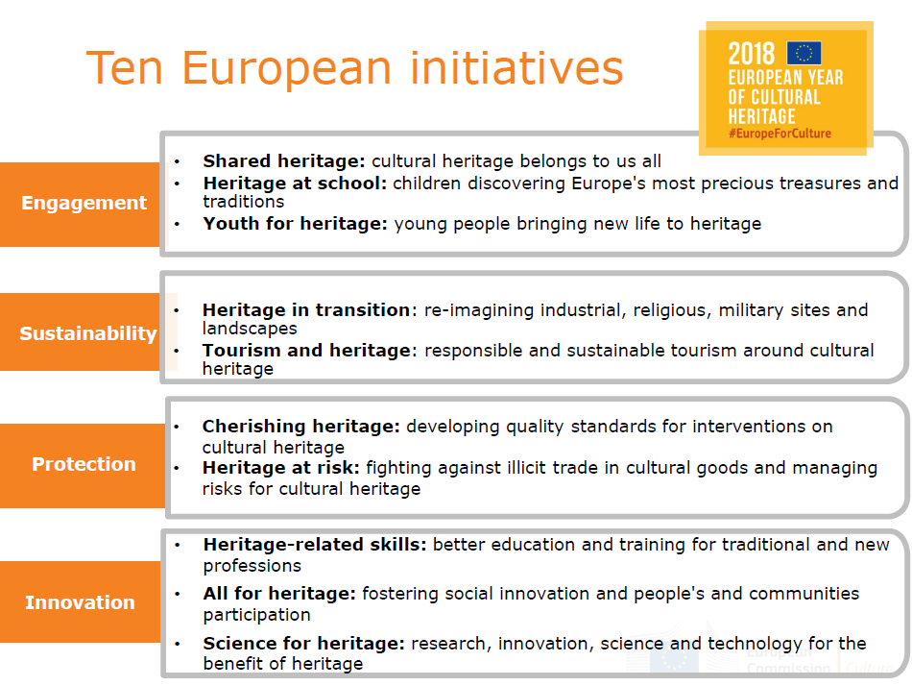

### **EYCH Initiative 1 – Sharing heritage, history and values**

**WHY? - Objectives**

One of the aims of the European Year is to encourage people-centred and inclusive approaches to cultural heritage, and to make cultural heritage **accessible** to all by removing social, cultural and physical barriers. The Year also aims at raising the profile of Europe's cultural heritage in **local communities**, helping people draw connections between the local and the European, and re(discover) how much of our heritage is shared. Putting our common values, shared history and heritage on the spotlight can contribute to reinforce a **sense of belonging** to Europe, and ultimately bring us closer together.

**FOR WHOM? - Target groups**

General public, local communities, older people and hard-to-reach groups including people with special needs and those at risk of social exclusion.

**WHAT? - Content of the initiative**

**I Special EYCH edition of the European Heritage Days**

(1) a "Call for European Heritage Stories" to collect testimonies of how communities understand the European dimension of their local heritage;

(2) "European Heritage Makers Week" to inspire children and youth to explore surroundings, discover the European dimension of their local heritage and share stories; and

(3) "Funding trans-border projects", to enable realisation of small–scale cross-border projects.

**II Special EYCH editions of the EU Prize for Cultural Heritage/Europa Nostra Award and the European Heritage Label**

The *EU Prize for Cultural Heritage/Europa Nostra Awards* annually recognises best practices of conservation, management, research, education and communication of Europe's shared heritage. The 2018 award ceremony takes place in June during a high-level European Heritage Summit in Berlin.

The *European Heritage Label (EHL)* celebrates heritage sites which symbolize European ideals, values, history and integration. A touring exhibition on the European Heritage Label sites will be launched and a high-level award ceremony for the 9 new labelled sites will be organised in March 2018 in Plovdiv.

**III Sharing heritage, digitally**

* Interactive map-based interface for cultural heritage developed by the Joint Research Centre (JRC)
* Europeana flagship project: Connecting European Citizens through shared culture,
* Europa Nostra's #Ode2Joy Challenge

**IV Removing barriers and increasing access to cultural heritage**

* An EU Access City Award will be launched by DG EMPL, to reward the efforts of small and bigger cities in the EU in granting access to physically disabled people.
* WeAre#EuropeForCulture project: aiming to promote heritage among hard-to-reach groups, this DG EAC led project will facilitate pop-up exhibitions of cultural heritage.

### **EYCH Initiative 2 – Heritage at school**

**WHY? - Objectives**

The European Year aims to **raise awareness** of the importance of cultural heritage for Europe through **education and lifelong learning**, with a particular focus on children, young and elderly people and local communities. The aim of this initiative is to maximise the impact of Erasmus + in the field of cultural **heritage education** and to encourage greater awareness of Europe's rich cultural heritage in schools. Within the classroom, visits, encounters with heritage experts and **playful educational activities** are being organised. Children and their parents are also invited to engage with cultural heritage beyond the classroom, through informal and non-formal learning, drawing on the experiences of elderly people (e.g. grandparents) and their local communities, thus contributing to intergenerational and intercultural dialogue and to foster participatory approaches to heritage.

**FOR WHOM? - Target groups**

School children (in particular 10-15 years old), teachers, parents, local communities.

**WHAT? - Content of the initiative**

**I Valorising Erasmus + projects on cultural heritage and stimulating new initiatives**

**II Awareness raising activities: joint UNESCO project, toolkit for schools**

* A joint EU-UNESCO project will be implemented through a series of activities with schools in EU Member States, working in particular with members of the UNESCO Associated Schools Project Network (about 2000 schools in Europe).
* A cultural heritage toolkit for schools is under preparation. It will combine new communication material and existing resources by UNESCO, the House of the European History, EUROPEANA, Interpret Europe and other partners. The material will target teachers and pupils in primary and secondary schools and will be disseminated through existing teachers networks, including e-twinning, the School Education Gateway and EUROCLIO - European Association of History Educators

**III Activities for children in the framework of the European Heritage Days**

The European Heritage Days (EHDs) 2018 will implement the 'European Heritage Makers Week Competition', a new dedicated action targeting school children to encourage them to explore their surroundings, discover the European dimension of their local heritage and share their unique stories.

**IV Strengthening Europe through education and culture with EESC and CoR**

* "United in diversity: a younger future for European culture" is an initiative led by the European Economic and Social Committee (EESC) that will bring secondary school pupils, from 28 EU Member States and five candidate countries, to visit Brussels to discuss the role of culture and heritage in their lives and make policy recommendations.
* The European Committee of the Regions (CoR) will organise a debate with its members on ' Cities and regions as key drivers for strengthening European identity through education and Culture', with the aim of promoting the role of culture, cultural heritage and education among European local and regional authorities.

### **EYCH Initiative 3 – Youth for heritage**

**WHY? - Objectives**

The Year aims to **empower young people** to **better appreciate** their cultural heritage, interact with it, and through it, to **participate in and contribute to society**. It is also an opportunity for them to engage in projects where their skills can make a difference, for instance as volunteers in activities that aim at protecting, safeguarding and promoting heritage. Ultimately, the Year can stimulate young people to reflect on what Europe they want to build. The objective is also to increase their access to cultural heritage, including by digital means, and to support their creativity and talent when it comes to cultural heritage.

**FOR WHOM? - Target groups**

Young people (between 15 and 29), Erasmus + generation, cultural heritage organisations and youth organisations.

**WHAT? - Content of the initiative**

**I A joint project with UNESCO: Empowering European youth through a Young Heritage Experts Forum**

The project, to be implemented by UNESCO and its national commissions, aims to raise young people's awareness of heritage diversity, conservation and transmission.

**II Youth volunteering for cultural heritage**

The activities under this component are mainly of an awareness raising nature, with two objectives: 1) to inform young people about existing European opportunities for volunteering in the field of cultural heritage, particularly the European Solidarity Corps, and 2) to encourage cultural heritage organisations and sites to host more young people.

**III Engaging with young people through social media**.

Social media is changing how we connect with culture and cultural heritage, particularly for younger audiences. The activities in this initiative focus on young people’s interactions with cultural heritage, and their perceptions of it. They include an Instagram photo competition, heritage quizzes and short video campaigns.

### **EYCH Initiative 4 – Heritage in transition**

**WHY? - Objectives**

One of the aims of the European Year is "to integrate cultural heritage into **environmental, architectural and planning policies**". This initiative will promote good practice in the transformation of Europe's industrial, religious and military heritage for new uses and the socio-economic development of European cities and regions.

Through **smart restoration and adaptive reuse**, old buildings and sites can be given new leases of life. Transformed into cultural venues or attractions, they can bring economic and social dynamism to cities and regions and contribute towards EU implementation of the UN **Sustainable Development** **Goals**.

**FOR WHOM? - Target groups**

Local/regional authorities and communities, heritage professionals and architects.

**WHAT? - Content of the initiative**

**I Exchange of good practice**

- The initiative will identify and showcase successful re-use of industrial, religious and military heritage. Creative Europe-funded networks as well as ICOMOS committees will organise conferences to share experiences and discuss reuse challenges.

- The European Commission will dedicate one of the sessions of the European Cultural Heritage Summit to reuse and highlight good examples through EU Prizes for Cultural Heritage (Europa Nostra) and Contemporary Architecture (Mies van der Rohe Foundation).

**II Engagement**

To celebrate industrial heritage and its reuse, the European Route of Industrial Heritage (ERIH) will launch *Work it out!,* a pan-European dance performance in industrial heritage sites. E-Faith will launch a campaign for cross-border twinning between associations while the Torch Initiative run by Future for Religious Heritage (FRH) will collect personal stories related to religious heritage throughout Europe.

**III Urban/rural regeneration and sustainable development**

The findings of EU regional or research projects will be used to promote the positive impact that the adaptive reuse of built heritage can have on the revival of urban and rural areas. Heritage-led regeneration often provides a catalyst for social, economic and cultural renewal in cities and villages. Environmental issues – such as the embodied energy of heritage buildings – will also be addressed. Local and regional decision-makers will be reached through Eurocities, the European Committee of Regions, the Urban Group of the European Parliament, the EU Rural Networks and partners of EU projects.

### **EYCH Initiative 5 – Tourism and heritage**

**WHY? - Objectives**

There is much debate around the concept of ‘sustainable tourism’. The word sustainable suggests a state that can be maintained and perhaps even unchanging, whereas tourism implies constant adaptation to consumer demands. The Year is an opportunity to examine this concept, focusing on the sustainability of cultural heritage along with the economic benefits of tourism.

The combination of culture and tourism can be a powerful driver of economic activity, but only if managed in a sustainable way so that communities and the actual essence of cultural heritage remains intact.

**FOR WHOM? - Target groups**

Policy makers, cultural heritage professionals, research communities, tourism organisations.

**WHAT? - Content of the initiative**

**I Towards policy recommendations on sustainable cultural tourism**

An Open Method of Coordination (OMC) expert group is examining sustainable cultural tourism practices across Europe. The group is identifying good and poor practices with a view to mapping methods and tools to make Europe's cultural heritage accessible to and interoperable with a sustainable system of tourism promotion and marketing.

**II Natural heritage and Natura 2000**

Synergies with the Natura 2000 network are being developed for EYCH, including:

(1) Evaluation of **spatial overlaps** between Natura 2000 and cultural heritage areas and development and dissemination of **good practices and case studies**[31]

(2) Links with the pan-European **Natura 2000 Awards**[32]**,** which recognise excellence in the management and conservation of Natura 2000 sites

**III Promoting Europe's Cultural Routes**

Sustainable cultural routes will receive a new boost in 2018, for long-term outreach and sustainability aspects. Notably:

(1) Cultural routes with the Council of Europe

(2) UNESCO World Heritage Journeys in the EU:

(3) The Balkans itineraries

**IV Awarding excellence - European Destination of Excellence Award**

The 2017/2018 edition of the European Destinations of Excellence (EDEN) focuses on Cultural Tourism. EDEN is a Commission initiative that awards and promotes sustainable tourism development models across the EU and Candidate Countries. A total of 140 destinations from 27 participating countries have been awarded the EDEN prize since 2007. The winners are emerging, little-known destinations committed to social, cultural and environmental sustainability of tourism.

### **EYCH Initiative 6 – Cherishing heritage: quality principles**

**WHY? - Objectives**

The Year aims to promote debate, research and exchange of good practices on the **quality of conservation and of contemporary interventions** on cultural heritage. Interventions on cultural heritage are actions that impact, or have potential to impact, structures, places or sites of heritage interest, causing any physical change or alteration.

The EU supports cultural heritage through several programmes, including the structural funds. But investments can also put heritage in danger, especially when, in the attempt to give heritage a “second life”, issues of **reconstruction and authenticity** are not properly addressed, wiping off centuries of history and cultural values.

This initiative aims at finding the right **balance between** on the one hand **quality in conservation** and safeguarding, and on the other hand **dynamic approaches** to restoration and maintenance, innovative re-use and enhancement of cultural heritage.

**FOR WHOM? - Target groups**

Policy makers, cultural heritage professionals, heritage organisations, civil society.

**WHAT? - Content of the initiative**

**I Research and sharing good practice**

Building on the "Venice Charter ", the most influential document on conservation since 1964, an expert group coordinated by ICOMOS (International Council on Monuments and Sites), in close collaboration with the European Commission, is working to produce an updated document on quality principles for cultural heritage interventions in Europe. The aim is to ensure that decisions on any major changes in the historical environment are based on proper assessment of its values.

A workshop (50-60 participants) will feed the work of the group with lessons from practical examples/cases of good and bad practices in interventions on heritage through EU funds.

**II Consultation and consensus building**

The Commission services will consult an enlarged group of key stakeholders (Including UNESCO, ICCROM, ICOM and Europa Nostra and other members of the EYCH Stakeholders Committee) to build broad consensus on key quality principles for interventions on cultural heritage.

The final document would guide future discussion on the use of EU funds for interventions on cultural heritage, and possibly be mentioned in next regulations. Links will be ensured with the work of the Technical Committee on European standards for cultural heritage CEN/TC346 of the European committee for standardisation.

### **EYCH Initiative 7 – Heritage at risk: fighting illicit trade, managing heritage site risks**

**WHY? - Objectives**

The Year aims to encourage synergies between the EU and its Member States to strengthen initiatives to **prevent the illicit trafficking** of cultural goods. This initiative aims, on the one hand, at enhancing cooperation on **risk management** for cultural heritage in Europe and, on the other hand, at **raising awareness** about the implications of illicit trade in cultural goods – both within and outside of the EU.

**FOR WHOM? - Target groups**

National authorities competent for heritage protection, policy makers, enforcement authorities, art market, research communities.

**WHAT? - Content of the initiative**

**I Regulatory measures**

In July 2017 the Commission adopted a proposal for a regulation on the import of cultural goods. Adoption by the legislator will lead to the strengthening of the EU legislative framework on combatting illicit trade in cultural goods. The Commission services will support its implementation through an Action Plan which includes the initiatives below.

**II Awareness raising and capacity building activities**

Two joint projects with UNESCO will be implemented:

(1) "Engaging the European art market in the fight against the illicit trafficking of cultural property" will focus on reinforcing due diligence in the European art trade and sensitizing relevant stakeholders to the implications of illicit trade in cultural property.

(2) "Training to enforcement authorities" will train Member States' authorities on the legal framework and practical ways of investigating heritage related crimes

**III Improving evidence and sharing experience**

1. An EC Study on 'Safeguarding Cultural Heritage from Natural and Man-Made Disasters' will facilitate sharing experience between Member States on effective ways to protect cultural heritage at risk and pave the way for future cooperation.

2. An EC study on the dimensions of illicit trade in cultural goods in the EU and on the use of new technologies to combat it will improve understanding of the routes, volumes and operational modes of traffickers in the EU.

3. The award of a grant for a social platform on cultural heritage in danger to bring together the research community, public and private actors, and policy makers at national and international levels working on issues related to the illicit trade of cultural goods and on the protection, preservation or reconstruction of cultural heritage.

**IV** **Cooperation with third countries**

The EU will cooperate with third countries to protect their cultural heritage against trafficking, looting and destruction. In particular, a joint project with UNESCO will provide for rapid assessments and immediate safeguarding measures of cultural assets affected by conflict or disaster in Iraq, Libya, Syria and Yemen; and the on-going project on safeguarding Syrian cultural heritage will be continued. The EU will reflect on how to contribute to the protection of cultural heritage in the context of fragile countries or crisis situations, notably through its Common Security and Defence Policy (CSDP) instruments.

### **EYCH Initiative 8 – Skills for heritage: for traditional and new professions**

**WHY? - Objectives**

Europe is renowned for its exceptional skills in the field of cultural heritage. But European excellence in heritage preservation and conservation is jeopardised by the combined effect of the age pyramid and cuts in public budgets; this affects the **transmission of heritage knowledge and skills** to younger generations. A lack of high-level professionals in "traditional" heritage occupations is already predictable.

This initiative aims to support the development of **specialised skills** and improve **knowledge transfer** in the cultural heritage sector, attracting young people to heritage-related jobs, while accompanying the adaptation of heritage-related professions to the **digital world**.

**FOR WHOM? - Target groups**

Cultural heritage training professionals, young people.

**WHAT? - Content of the initiative**

**I Experience sharing and policy recommendations**

Under the Agenda for Culture, 26 Experts from EU Member States have already started working to exchange good practices and design policy recommendations for Ministries of Culture and Education. Their discussions will be enriched by the contribution of a group of 35 relevant stakeholders, under the 'Voices of Culture'' structured dialogue, which has produced a Brainstorming report on skills for Heritage.

**II Opportunities for cultural heritage professionals and young people**

* Promotion of Erasmus + and Horizon 2020 funding possibilities for cultural heritage professional skills and training needs.
* Opportunities for training for young people available through Erasmus +, Erasmus Mundus masters and the Marie Skłodowska-Curie Actions will be promoted, increasing synergies with the EU Heritage Prize/Europa Nostra Awards winners in the category "Education and training".
* The Erasmus+-funded Mu.SA project (Museum Sector Skills Alliance) is investigating necessary skills and competences to support museum professionals in their digital transformation journey. The project will inform the development of specific training programmes for developing both hard/digital and transferable skills for ICT related jobs for museum professionals.
* The value of heritage-related professions will be promoted in large-scale events such as the 2018 European Vocational Skills Week (VET Week) and the Leipzig Denkmal Fair.

### **EYCH Initiative 9 – Heritage for all: citizen participation and social innovation**

**WHY? - Objectives**

Objects, places and traditions are important not by themselves, but because of the meanings and uses that people attach to them and the values they represent. Heritage is a common good, it does not only belong to professionals, but to communities and people in general.

In the spirit of the **Faro convention** of the Council of Europe, this initiative promotes a wider understanding of heritage, placing people and communities at the centre and involving them in making decisions about heritage. Research, experimentation and practice will engage and empower a large number of actors to care for heritage. New models of participatory governance and management of cultural heritage will be tested; **social innovation** and links with other sectors are also being encouraged.

**FOR WHOM? - Target groups**

Heritage professionals, development bodies, tourism agencies, cultural and creative industries, experts and practitioners, associations and interest groups representative of non-professionals and local societies, and policy-makers in local, regional and national authorities.

**WHAT? - Content of the initiative**

The "Heritage for all" initiative draws inspiration from the work of the Open Method of Coordination expert group on participative governance. The group investigated the concept of participatory governance, identified best cases, and published a report in 2017.

**I Improving evidence, research and exchange of good practice**

Two Horizon 2020 projects will contribute to develop, test and promote innovative models of participatory governance:

- The Horizon 2020 social platform "REACH" (worth EUR 1.5 million) will map research and practice, evaluate bottle-necks and create European networks in this field

- A larger Horizon 2020 research project (worth EUR 2,5 million) will assess the current state of cultural institutions and focus on how to support them to become cultural service providers and hubs of social innovation.

The initiative will also showcase successful people-centred approaches to heritage in existing EU schemes, such as the European Capitals of Culture, the European Heritage Awards, the European Heritage Label and the European Heritage Days.

**II Testing and policy recommendations**

In cooperation with the Council of Europe, the Commission services will implement the pilot project STEPS, which engages communities in Lisbon and Rijeka, in the heritage mapping of their neighbourhoods, creating, testing and evaluating a methodology for participative governance. Four other pilot projects of the social platform REACH will target minority (Roma) heritage, institutional heritage, rural heritage and small towns' heritage. Tests will result in policy recommendations to be presented and discussed with national and regional policymakers, in several conferences throughout 2018.

### **EYCH Initiative 10 – Science for heritage: research, innovation, science and technology**

**WHY? - Objectives**

From providing digital access to physically inaccessible sites, to helping preserve priceless artefacts, Research and Innovation (R&I) can nurture smart and technologically advanced solutions to the challenges Europe is facing in trying to protect its cultural heritage. The Year is an opportunity to showcase and intensify the investments that the EU has made in the development of a worldly-known European expertise the field, through the EU Research and Innovation programme **'Horizon 2020'** and the Commission's **Joint Research Centre** (JRC).

**FOR WHOM? - Target groups**

Researchers, innovators, academics, heritage professionals and experts, public authorities.

**WHAT? - Content of the initiative**

**I Promoting excellence**

* Policy Review showcasing results and good practices of EU-funded research on cultural heritage, presented at a March 2018 event in Brussels.
* Horizon 2020 research actions in 2018-19 have the following indicative budgets:
* EUR 18 million for cost-effective technologies to increase resilience or reconstruct damaged historic areas after disasters
* EUR 12 million for "Collaborative approaches to cultural heritage for social cohesion"
* EUR 10 million for "Curation of digital assets and advanced digitisation"
* EUR 9 million for "innovative approaches to urban and regional development through cultural tourism"
* EUR 9 million for "The societal value of culture and the impact of cultural policies in Europe"
* EUR 9 million for "Digitisation, digital single market and European culture: new challenges for creativity, intellectual property rights and copyright"
* EUR 7.5 million for "inclusive and sustainable growth through cultural and creative industries and the arts"
* Horizon 2020 initiatives will also be launched in the following areas:
* "Innovative and affordable solutions for preventive conservation of cultural heritage"
* "Transforming historic urban areas and cultural landscapes into hubs of entrepreneurship and social and cultural integration"
* JRC innovations to benefit the cultural heritage sector:
* Testing smart materials on historic masonry to improve seismic resistance, and to allow post-earthquake structural assessment
* 3D laser scanning for damage assessment and reconstruction planning

**II Generating expertise**

In 2018, two research communities will be established: 1) a Community of Innovators on Cultural Heritage and 2) the EU R&I Ambassadors on Cultural Heritage. These will each gather around 300 universities, research centres, municipalities, industries and SMEs, cultural heritage organizations and practitioners to promote the uptake of R&I successful results and encourage international cooperation on the field.

In addition, two Horizon 2020 networks will be established: 1) A Network to promote heritage-led innovation and diplomacy and to provide expertise in EU and beyond, and 2) A 'Social platform on endangered cultural heritage and on illicit trafficking of cultural goods' (see factsheet n°7).

# 3. Digital4Culture

The digital revolution and modern Information and Communication Technologies (ICT) offer many new possibilities and opportunities for the cultural and creative sectors to make content accessible, preserve it digitally for future generations, and engage with audiences and online visitors via different channels.

The Commission services are preparing a Digital4Culture strategy aiming to support the cultural and creative sectors in overcoming the challenges brought by the digital transformation and globalisation and to help them make better use of the opportunities provided by the digital shift.

Digital4Culture will be a cross-cutting strategy, which especially supports the citizenship dimension of the Digital Single Market. Its aim will be to enable cultural and creative sectors to reach out to new audiences, adapt to the digital era, and thrive in the connected Digital Single Market.

The strategy will be based on the premise that digital means allow broader and more democratic access to culture, helping to overcome geographical and linguistic borders, and storing and making available huge amounts of data. The digital revolution also enables the creation of new and innovative artistic creations, as well as innovative ways of presenting and consuming cultural content (e.g. via virtual reality or social media).

The Commission services are developing the following initiatives as part of the Digital4Culture strategy.

### **Digital4Culture Initiative 1 –**

### **Europeana: an enabler of digital transformation for cultural heritage**

Europeana is Europe's digital platform for cultural heritage. It currently provides access to over 51 million items, (including image, text, sound, video and 3D material) from the collections of over 3,700 libraries, archives, museums, galleries and audio-visual collections across Europe. The Europeana Network of cultural heritage, creative and technology professionals exchange and promote best practice on digitisation and metadata standardisation, and stimulate capacity building in the cultural heritage community.

The action aims at increasing Europeana's significance as the unique pan-European initiative, empowering cultural heritage institutions to take advantage of the digital transformation to broaden access to and preservation of their collections. It can also act as a showcase of the benefits stemming from sharing and using high quality digital cultural heritage material, democratizing access to culture. The digital platform can strengthen its position as a comprehensive multilingual record of the richness of Europe's cultural identities and the diversity of its people, underpinning a sense of shared history and identity among European citizens. Advanced forms of content – 3D and virtual reality content, curated multilingual content, smart content – can enhance the platform’s offering.

Europeana can lead the digital transformation of the cultural heritage sector, fostering cross-border collaboration and standardisation activities in Europe. Europeana can also act as a catalyst and innovator for cultural heritage institutions, supporting EU Member States to address challenges faced in the digital transformation of access to culture. It can also act as a showcase for leveraging digital opportunities to maximise the impact of cultural heritage institutions’ activities and outreach, including the research and innovation activities funded under Horizon 2020 Societal Challenge 6 and under its successor programme post-2020. The initiative is backed by an independent evaluation of Europeana, carried out by the Commission in response to Council Conclusions (CC) on the role of Europeana for the digital access, visibility and use of European cultural heritage[33], adopted by the Education, Culture, Youth and Sports Council in May 2016, with expected completion at the end of Q2 2018.

**Target groups**:

Cultural heritage institutions and professionals;

European citizens;

Cross-sectors: including education and research.

**Content of the initiative**

The Commission services will:

* Put forward a vision on the way forward for **Europeana**, Europe's digital platform for cultural heritage, as a pan-European enabler of the digital transformation of cultural heritage and a key initiative regarding democratic access to culture, by the end of 2018.
* Implement the vision post-2020 under the new Digital Programme.

### **Digital4Culture Initiative 2 – Digitization centres for monuments and sites**

The increasing occurrence of natural disasters such as floods, earthquakes, fires, and pollution can cause irreversible damage to cultural heritage sites or even destroy entire areas. According to the World Bank’s Independent Evaluation Group (IEG, 2006), the cost of disaster damage is rising and the number of natural disaster events grew by 400% between 1975 and 2005[34]. If this trend continues, Europe’s 352 UNESCO cultural heritage sites[35] and many more monuments and historic buildings across the Member States are in danger. Apart from losing our heritage, the culture and creative sectors, and related industries such as tourism and hospitality rely heavily on the appeal and conservation of cultural heritage sites and monuments. Digital technology can help preserve the knowledge of threatened heritage monuments and sites and make them accessible for citizens across Europe and for future generations. In addition, online access to high quality digital replicas of a site and monument may increase the appeal and promotion of a place, city or Member State, thus supporting the local tourism and hospitality industries.

**Target groups**:

Social dimension: citizens – democratisation of access to cultural heritage and preservation for the future.

Economic dimension: potential increased visits/activities for the culture and creative sectors, as well as associated industries such as tourism and hospitality.

International dimension: tourism, promotion and increased appeal of sites or monuments can play a strong role in diplomacy and enhancing the soft power of the Union.

**Content of the initiative**

**A large-scale action to digitise endangered monuments and sites** is proposed in order to ensure their preservation and transmission to future generations, implemented through digitisation centres.

This initiative will connect digitisation centres across the European Union with the objective of fostering an ecosystem for preserving cultural heritage monuments and sites, and making them accessible for the future.

The core objective of the digitisation centres will be to safeguard the knowledge of endangered heritage monuments. These digitisation centres also have the potential to act as multipliers in the cultural heritage sector by promoting the digital transformation of the cultural heritage institutions and the upskilling of their workforce. Cultural heritage institutions would receive support to fully leverage new state of the art digital technologies by sharing best practices on technical, legal, and online publishing requirements, etc. as well as to increase cooperation in the sector and to avoid duplication of work.

The initiative will be launched in an initial phase under Horizon 2020 Societal Challenge 6 and then at scale under the Digital Programme.

### **Digital4culture Initiative 3 – Digital Creative & Innovation Hubs**

Engaged in fierce worldwide competition and dominated by micro-enterprises, **averaging only** **1.8 FTE per enterprise**, Cultural and Creative Industries (CCI’s) in Europe provide more than 12 million full-time jobs, which amounts to 7.5 % of the EU’s work force, creating approximately **EUR 509 billion in value added to GDP**.

Through a versatile approach of coordination, access to finance, ecosystem and skill development, the Commission may establish a pan-European network of **Digital Creative & Innovation Hubs** to offer one-stop shops that strengthen the Cultural and Creative Industries’ ability to compete in the transcending digitization of their sector.

**Target groups:**

Creative enterprises, cultural enterprises, professionals in CCI’s, creative micro-enterprises and entrepreneurial ecosystems.

**Content of the initiative**

The objective is to establish a pan-European network of Digital Creative & Innovation Hubs, providing one-stop shops for the cultural and creative industries. This initiative will complement the actions of the Knowledge and Innovation Community (KIC) initiative on creative industries, through:

**Digital Innovation and Creative Learning Labs**

CCIs operate within highly versatile markets and technologies. Maintaining the required skill-sets is a major challenge for small and medium sized structures alike. The initiative will offer digital lab facilities for CCI’s.

**Funding and Business support**

Digital transformation is characterised by rapid and radical changes, which require the application of new and adaptable business models in the CCI’s as well as access to the appropriate level of risk and funding. The initiative will offer guidance on funding in view of supporting an innovation friendly and supportive legal environment for the creation and experimentation of new business models, products and services through strategic partnerships between producers, distributors and promoters and for support for the activities of business incubators.

**Technology take-up and acceleration**

It is crucial for the CCIs to be on the forefront of paradigms such as high performance computing (HPC), cloud computing, artificial intelligence (AI) or the Internet of things (IoT) which impact each part of the value chain from creation and production to distribution and exploitation. The initiative will support accelerated testing, experimentation, deployment and take-up of technologies with application potential in CCI’s.

**Coordination**

Lifting the CCI’s at EU level additionally requires strong coordination activities. The initiative will apply a cross-sectoral approach fostering interaction between micro-, small, medium and large enterprises and between non-profit organisations and commercial companies in the CCIs

### **Digital4culture Initiative 4 - Enhancing the availability and visibility of EU films**

In order to foster creativity and cultural diversity in Europe's audiovisual works, the European audiovisual sector needs to take full advantage of the access and distribution opportunities offered by the digital revolution. Young people, in particular, should be able to enjoy the diversity of European audiovisual content, which has the potential of promoting EU values and creating a sense of belonging, especially for the younger generation.

**Target groups**:

Directory of European films: professionals of the audiovisual sector (distributors, sales agents, producers) and potential audiences

EU Film Week: school pupils, students

**Content of the initiative**

In order to foster creativity and cultural diversity in Europe's audiovisual works, the European audiovisual sector needs to take full advantage of the access and distribution opportunities offered by the digital revolution. Young people, in particular, should be able to enjoy the diversity of European audiovisual content, which has the potential of promoting EU values and creating a sense of belonging, especially for the younger generation.

In order to enhance the availability and visibility of EU films, the Commission services will implement two parallel initiatives: the creation of an online directory of European films and the "EU Film Week".

*Directory of European films*

In order for the directory to be created, the Commission is considering a two-step action plan.

In a first phase, we would facilitate the creation of a directory of European films providing constantly updated and reliable information on the availability of European films online in the different Member States. In a second phase, building on the results of the first phase and on the continuous discussions with the stakeholders, the possibility of creating an online tool building on such data and providing access to the films could be explored.

A prototype of a business-to-business database of European films covering a sample of films to be selected could be launched in October 2018. This is particularly pertinent because 2018 is the European Year of Cultural Heritage, which includes film heritage.

This project would contribute to complement the Commission's efforts in strengthening the position of European works through its proposed legislation for the audiovisual sector.

*EU Film Week*

Furthermore, an initiative named “EU Film Week” will be implemented with MEDIA funding in 2019. The initiative will make available a catalogue of EU heritage films in schools across all Member States during the same week. This would help raise the young generation's awareness about Europe’s common history, culture and values.

The objective of this action is to constitute an online catalogue of major European classic films to be made available to schools across Europe. A dedicated call for proposals will be published in the last quarter of 2018.

### **Digital4culture Initiative 5 - New mentoring schemes for audiovisual professionals**

New mentoring schemes could be introduced by experienced professionals in the field of audiovisual to bring new talent on stage, e.g. mentoring schemes run by experienced film-makers and directed towards young film professionals. Feedback from industry indicates that this type of professional support can be an effective way of sharing knowledge and experience.

**Target groups**:

Such schemes should in particular be focused on women and groups that are currently underrepresented in film crews.

**Content of the initiative**

The schemes would strengthen digital skills in particular, as digital is transforming all parts of the industry, and also use digital technology as a tool for delivering the mentoring.

Within the MEDIA 2019 Work Programme, mentoring activities will be encouraged as part of the Training scheme. A call for proposals may be launched as of end 2018.

### **Digital4culture Initiative 6 –**

### **Stimulating cross-overs from culture to innovation in society and industry**

The 2015 Latvian presidency Council Conclusions[36] on ‘*Creative crossovers to stimulate innovation in society and business*'   recommend ‘...*combining knowledge and skills of the cultural/creative sectors with [technological] sectors in order to generate innovative solutions for today’s societal challenges*’. This action will help implement these recommendations. It will build on first steps made in H2020 under the heading of S+T+ARTS = STARTS, innovation at the nexus of science, technology and the Arts.

**Target groups**:

All industry sectors and technology organisations interested in crossovers from art to innovation, Cultural/creative sector companies, professionals in CCI’s, creative SMSs, artists

**Content of the initiative**

The initiative aims at helping to set up centres across Europe that actively enable collaboration between art and technology to achieve sustainable innovation on a local (urban) and regional level. It will leverage the contribution of culture to the competitiveness of European industry by including the creativity and critical thinking of artists (and more generally culture) in the process of converting technological and scientific knowledge into products and services.

# 4. Stakeholder Views

## 4.1 Stakeholder meeting summary

**PREPARING A NEW EUROPEAN AGENDA FOR CULTURE**

**Stakeholder Consultation Meeting, 19 February 2018, Brussels**

**1.** **Introduction.** The Commission welcomed participants, thanked them for their attendance and contributions to date, and set out the aim of the meeting: gathering stakeholders' views to inform a Commission proposal for a New Agenda for European Culture. This was a time of unprecedented political momentum on culture policy at EU level, on the agenda of leaders at November's Gothenburg Summit and December European Council, and in the context of EYCH 2018. Commissioner Navracsics hoped to present a New European Agenda for Culture in May as part of a package of measures, also on education and youth, and language learning.

**2. Policy framework.** The 2007 Agenda had three overarching objectives: 1) cultural diversity and intercultural dialogue, 2) culture as a catalyst of creativity, 3) culture as a vital element of external relations. Most felt these remained relevant, but would also prioritise the following:

- culture as a vehicle for social cohesion, especially in light of migration and diasporas

- arts education, non-formal education, civic education through arts

- mobility of artists and artworks an area of clear added value at European level

- more ambition, more funding, stressing culture and heritage as strategic resource

- diversity of cultural expressions: multilingualism, improving choice, access, discoverability

- better linkage of external and internal policies, especially with neighbouring countries

- better digital access, with more 3D and AV content,

- copyright law more conducive to digitisation, balanced for sustainable remuneration

- better connection of centre and periphery; urban and rural; city, regional and local authorities

- more support to small cultural centres as first point of access for young creative talent

- reprioritisation of artistic freedom, which is sadly starting to be challenged in parts of EU.

- more attention to gender equality, combating bullying and harassment

- fairer contractual conditions and remuneration for artists, greater professional recognition

- ongoing importance of UNESCO 2005 Convention, for gender, youth, artistic freedom.

- promotion of CoE Faro Convention with a view to adoption by all EU27

**3. European added value.** The Agenda aims to add value to culture policy-making and actions at national/regional/local levels, by promoting collaboration among and within MS, and by informing and supporting policymaking, implementation and evaluation. Key points:

* EU added value on culture underestimated: key to participation, democracy, circulation of ideas.
* EU could be more assertive about culture's role promoting belonging while supporting diversity.
* And more ambitious: call on MS to adapt national policies, eg arts education, funding
* But EU culture agenda and programmes also valued because not mediated by MS institutions.
* In some MS EU level is only opportunity for stakeholder input/influence, none at national level
* Need to influence MS on input of culture to other policies (eg SDGs), EU values (democracy)
* Build understanding and capacity in non-culture Ministries & EC DGs, culture in all policies
* EU should lead more on evidence-gathering: qualitative as well as quantitative impacts.
* Do more to reach grass roots, eg through regions networking small and large orgs
* Project-based programmes not sustainable, longer-term networks add value
* Promote European interpretations of heritage, not just local/national.
* Lead by example in EU programmes eg requiring fair conditions for artists in selection criteria
* Informing is key: EU heritage mapping great example, shows all relevant policies/programmes
* EU collaboration with UNESCO and CoE also adds value
* EU support to mobility and infrastructures is main added value, promoting access
* Europeana impact framework and playbook could be used to assess European agenda

**4. Working methods.** The Agenda set out two main working methods: structured dialogue (SD) with the cultural sector, currently Voices of Culture (VoC) and European Culture Forum, (ECF), and open method of coordination (OMC) among Member States.

Key points on Voices of Culture:

- generally appreciated, allows cultural sectors to be heard, to network and influence policy

- framing of discussions is important; the questions sent beforehand are very helpful

- challenges include diversity/representativeness of participants and sectors, short timelines

- need to reach out to other actors and sectors, eg researchers, and involve artists themselves

- webstreaming meetings could be useful, allowing questions from outside the room

- thematic approach was developed to have timely policy impact eg in relation to OMC topics

- some preferred previous SD platform approach, to current thematic approach in VoC

- compromise might be sectors bringing own themes as well as contributing to OMC topics

- no external relations theme yet; could be useful, but hard to involve external stakeholders.

on the European Culture Forum:

- increase diversity of attendees: ethnicities, artists, grassroots, private sector, researchers.

- use more diverse methods to hear more people, and increase interaction, eg 'speed dating'

- more controversial topics could be chosen, more challenges posed to cultural sector and EU

- could allow participants to help set / influence agenda (like European Development Days)

- fewer formal presentations, more workshops / specific themes (like Education Summit)

- possible to complement with an online platform to allow debate online in between Forums

- venues outside Brussels appreciated, allows different organizations to participate

**5. Key actors.** Key actors are MS culture officials / experts, cultural and creative organizations and networks, and EC. Should others participate? If so how?

- other govt/EC departments, eg economy/research/health – on thematic, ad-hoc basis

- other EU institutions: EP, CoR, EESC (to reach employers and unions).

- UN agencies eg for culture in conflict prevention / crisis management

- regional/city/local authorities, including smaller cities, perhaps through peer-learning, UCLG, or dialogues with mayors. [EC recalls need to respect MS constitutional order, very disparate]

- should be EU-wide commitment to geodemographic inclusion, for people outside big cities

- educational authorities and schools

- foundations and banks, many of who struggle to engage with EU projects

- research institutions

- civil society organizations, including those involved in SDGs

- already hard for cultural sector to be represented, others should only be involved if needed

- could be scope for webstreaming and online platforms allowing questions from others

**6. Strengthening policy-programme links.** Discussion on if/how to strengthen links between EU-funded project outcomes (under Creative Europe – CE - or other EU programmes and their successors) and culture policy collaboration. Timely, as consultation on policy priorities for Agenda will inform funding priorities for future programme(s). Public consultation on Multi-Annual Financial Framework is currently open, deadline 8 March, covering programmes and actions on cultural diversity, creativity, European values, mobility, education, historical memory.

Key points:

- CE is a very important ecosystem, allowing small organizations to work on long-term projects

- arguably a victim of its own success, bidding starts to feel like a lottery as there are not enough funds

- culture-specific programme should remain, and other EU programmes should be more open to culture

- Agenda policy objectives should be reflected in programme(s): eg on mobility, for individual artists

- access to CE strands could be widened, eg to make literary translation funds available for theatre texts

- support should be available to small organizations, for small amounts, and/or partner with larger orgs

- funding mechanisms are currently limited to grants & procurements, would be good to consider others

- EC: sympathetic to many of these points but EU financial regulations are strict and closely supervised

- we as culture sector have a responsibility to lobby nationally and at EU parliament

- culture funds should be more flexible, less rigid, linked to other programmes eg Horizon 2020

- better links needed between tech innovation and creative content production eg STARTS project.

- EAC/EACEA could help more with disseminating project outcomes

- ESIF (INTERREG, LEADER) supports infrastructure and buildings, could be used more for culture [EC agrees in principle but recalls that MS and regions define their own priorities for structural funds]

- should be possible to adjust EU programmes more often than every 7 years, eg to respond to events such as migrant crisis. EC: Oettinger aiming for this but there are constraints.

- when project applications dramatically exceed funding available (eg for CE call on refugees) would be useful if EC could consider alternative / complementary project funding in parallel

- key policy challenge for publishers is discoverability of books (eg promoting choice via smaller online providers). Issue apparently too big for Creative Europe, too small for Connected Europe.

- CE funding for literary translation has arguably failed; intended to diffuse books from smaller to bigger mediator languages, but has mostly subsidised translations from major languages to smaller languages. Must give added value in terms of promoting diversity, and true European value, not sector in itself.

**7. Sector-specific work/themes.** To date, EU collaboration under the Agenda for Culture has tended not to address individual cultural or creative sectors - with the clear exceptions of heritage and film, and arguably publishing/literature (OMC subgroup). Is it desirable to have sector-specific work/themes in future Agenda - if so, which sector(s)/theme(s) of clear added value at EU level in next 2-5 years?

- a majority of stakeholders opposed sectoral approaches and argued for transversal funding schemes, on the grounds that culture is increasingly multi-disciplinary, overarching themes such as participation, diversity and freedom of expression should be preferred, and introducing sector-specific themes might create unnecessary conflict.

- others thought there should be room for both trans-sectoral and sector-specific approaches, in cases of clear EU added value

- museum and live performance organizations strongly preferred multidisciplinary approaches, supporting all content creation. Sectoral approaches might leave live arts particularly underrepresented.

- division of EU media and culture programmes may have made sense at the time, but growth in screen-based activity in all cultural genres argues for culture and media to be reunited.

- music and publishing organizations felt that while many issues are transversal, in their sectors there are issues calling for sector-specific dialogue at EU level, including in areas of EU regulatory competence.

- heritage organizations called for multi-disciplinary approach breaking down silos of heritage professionals, but with particular focus on adaptive re-use of heritage, and illicit trade in cultural goods.

- mapping of culture professions was mentioned as useful for the heritage sector. It was recalled that DG EMPL (ESCO) had conducted such a mapping involving many culture experts.

- visual arts received little attention at EU level, and promoting mobility of artworks (via a pan-European public guarantee scheme) would merit more attention.

- if sectors and themes are to be considered in the future EU Agenda, it’s necessary to convince MS and demonstrate EU added-value, focussing on cross-border aspects and cooperation.

**8. Your top priority** for the New European Agenda for Culture.Stakeholders were asked if they could emphasise or change **just one** aspect of current EU policy collaboration on culture, what would it be?

Points mentioned by more than one stakeholder:

- support mobility of artists and artworks including repertoire and performances

- support smaller organizations and community arts: funding, capacity-building, dissemination

- link culture and education, capacity-building and lifelong arts education for pros and amateurs

- balance the intrinsic value of culture with instrumental role of culture for social inclusion

Points mentioned by one stakeholder each:

- culture in all policies

- achieve a clear legacy for EYCH in policy and funding

- create safer conditions for artists

- support creation

- defend artistic freedom

- strengthen "meaning-making" to foster understanding of EU values and social cohesion

- conduct a mapping of heritage professionals

- address threats: global monopolies, homogenous markets, diversity (including linguistic)

- improve evidence of impact – create a gold standard for cultural impact studies across Europe

- create sustainable communities through cross-border cooperation

- create an industrial policy for culture, incorporating access to finance

- promote critical thinking

- promote independence, integrity and professionalism of cultural institutions

- translate new EU strategy on culture in external relations into concrete actions, with CSOs.

- maintain effective structured dialogue, ensure clear link to policy and programmes.

- connect internal and external EU policies to address issues of migration/post-colonialism

- keep European audiovisual content as world-leading, through cross-sectoral collaboration

- integrating true learning into Agenda processes so outcomes don’t end up on a shelf

- include more stakeholders, civil society, and culture in other sectors: academia, economy

- promote synergies between culture, education and research.

- continue to support UNESCO 2005 Convention.

- put arts and culture at heart of local development, and external relations.

- put heritage online to improve access

- promote private heritage and landscapes.

- remove regulatory exceptions which hinder art and artists, and create new ones which help.

- create better partnerships between cities and CCIs including through non-financial support.

## 4.2 EUSurvey – summary of MS and Stakeholder responses

Following the 19 February stakeholder meeting, an online questionnaire was published on EUSurvey and shared widely with stakeholders, including Member State representatives in Council. 142 responses were received in time to be reflected in this document, including submissions from organizations or individuals in every EU Member State.

The type of respondents were categorised as follows:

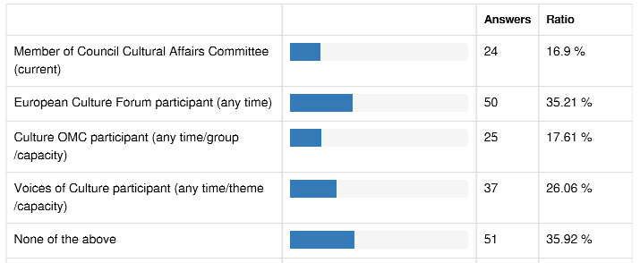

Respondents were asked how relevant they feel the three objectives of the 2007 European Agenda currently are.

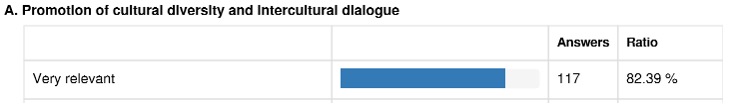

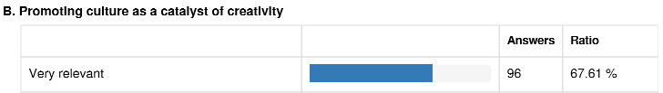

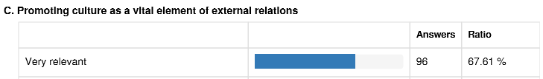

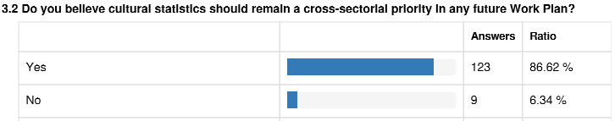

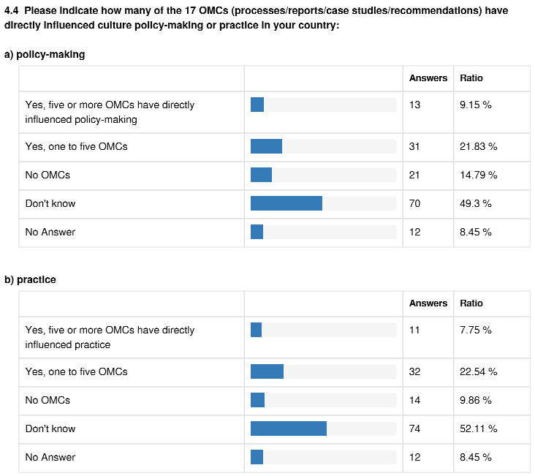



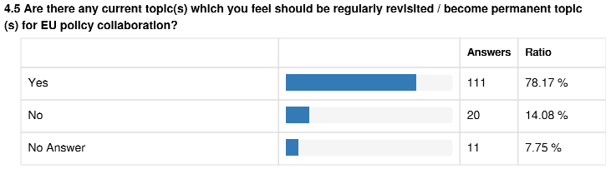

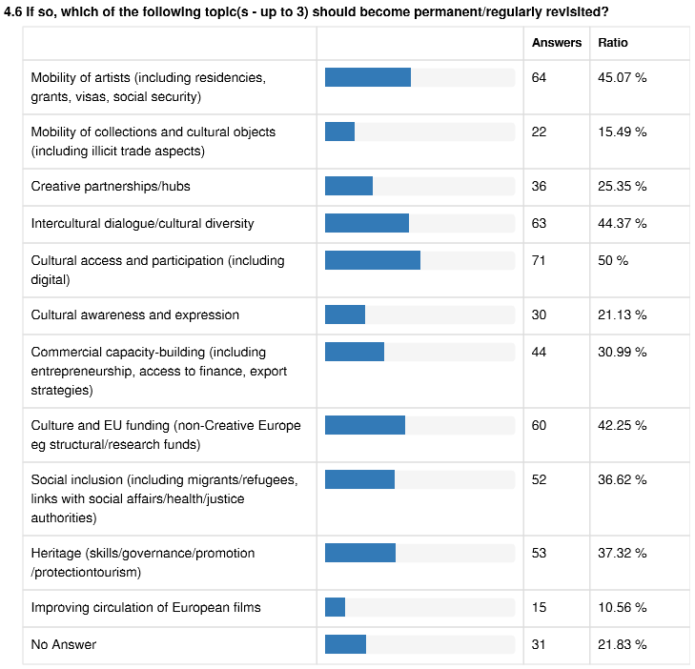

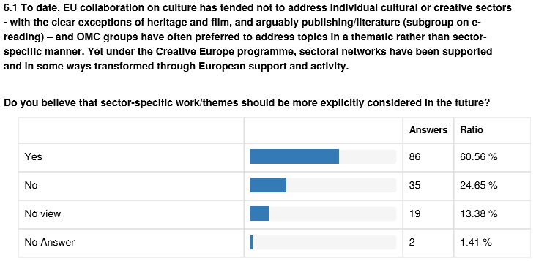

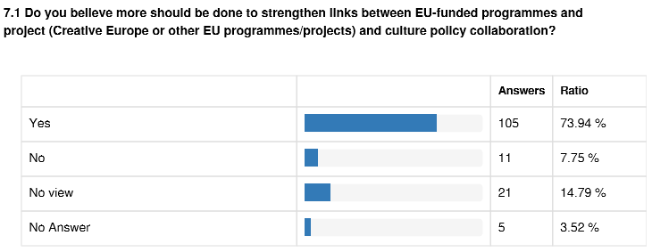

# 5. Summary and Main Results of the 2007 European Agenda for Culture

## 5.1 Objectives

The "European Agenda for Culture in a globalizing world" is a Commission Communication adopted on 10 May 2007. It proposed to establish an Open Method of Coordination in culture around three strategic objectives. The Council in a subsequent Resolution endorsed the strategic objectives and specified that the Agenda was to be implemented through Work Plans covering priorities determined by the Council as suited for the Open Method of Coordination. The objectives of the 2007 European Agenda are as follows:

A. As regards Promotion of cultural diversity and intercultural dialogue:

* encouraging the mobility of artists and other professionals in the culture field,
* promoting cultural heritage, namely by facilitating the mobility of collections and fostering the process of digitisation, with a view to improving public access to different forms of cultural and linguistic expressions,
* promoting intercultural dialogue as a sustainable process contributing to European identity, citizenship and social cohesion, including by the development of the intercultural competences of citizens;

B. As regards Promoting culture as a catalyst of creativity:

* promoting better use of synergies between culture and education, in particular by encouraging art education and active participation in cultural activities with a view to developing creativity and innovation,
* promoting the availability of managerial, business and entrepreneurial training capacities specifically tailored to professionals in the cultural and creative fields,
* fostering a favourable environment for the development of cultural and creative industries, including the audiovisual sector, thus maximizing their potential, in particular that of SMEs, namely by making better use of existing programmes and initiatives and by stimulating creative partnerships between the cultural sector and other sectors, including in the context of local and regional development;

C. As regards culture as a vital element of international cultural relations:

* enhancing the role of culture in the EU's external relations and development policy,
* promoting the Unesco Convention on the Protection and Promotion of the Diversity of Cultural Expressions and contributing to its implementation at international level,
* fostering intercultural dialogue and interaction between civil societies of EU Member States and third countries,
* encouraging further cooperation between cultural institutions of EU Member States, including cultural institutes, in third countries and with their counterparts in those countries

## 5.2 Implementation

The Commission reviewed the implementation of the European Agenda for Culture in 2010[37]. It found the OMC and structured dialogue frameworks were generally working well, and were influencing policy in many areas, citing examples from 18 Member States. The report suggested adjustments to both processes.

On the OMC:

- moving to a 4-year perspective for OMC topics (through Council Work Plans for Culture)

- limiting the number of topics to 4 or 5

- supporting OMC work with other activities such as peer learning hosted by Member States

- providing funding from the Culture Programme for peer learning and dissemination activities.

On the Structured Dialogue

- adjusting thematic platforms to "mirror" and connect to OMC topics, for greater policy focus

- supplementing the biennial European Culture Forum with smaller-scale events

The Commission also produces reports on the implementation of the OMC process, including a 2014 report on the relevance and efficiency of the 2011-2014 Work Plan[38]. The 2015-2018 Work Plan was also subject to a mid-term review in 2016, which was discussed in the Council Cultural Affairs Committee, and did not give rise to significant changes.

## 5.3 Outputs – Council Work Plans for Culture

The table below summarises outputs of the 2007 European Agenda for Culture under the three Council Work Plans for Culture, 2008-10, 2011-14 and 2015-18. OMC refers to Open Method of Coordination working groups of Member State experts. Those listed in italics are ongoing.

For more details about the OMC process see <https://ec.europa.eu/culture/policy/strategic-framework/european-coop_en>.

Copies of OMC reports are available here: <https://ec.europa.eu/culture/library_en>.

|  |  |  |  |
| --- | --- | --- | --- |
| **Priority** | **2015-2018** | **2011-2014** | **2008-2010** |
| **Access to culture**  **& intercultural dialogue** | *OMC: Contribution of culture to social inclusion (2017-2018)*  Council Conclusions: Promoting access to culture via digital means (November 2017)  Study on audience development - How to place audiences at the centre of cultural Organisation (2017)  OMC: Promoting access to culture via digital means with a focus on audience development (2015-2016)  OMC: Intercultural Dialogue in the context of the migratory and refugee crisis (2016)  OMC: Promoting reading in the digital environment (2015) | OMC: Promotion of creative partnerships (2012 – 2013)  OMC: The role of public arts and cultural institutions in the promotion of cultural diversity and intercultural Dialogue (2012-2013)  OMC: Better access to and wider participation in culture (2011-2012) | Council Conclusions: Intercultural competences (May 2008)  European Year of intercultural Dialogue 2008 |
| **Priority** | **2015-2018** | **2011-2014** | **2008-2010** |
| **Culture and education** | OMC: Development of the key competence cultural awareness and expression (2014-2015) | OMC: Development of the key competence cultural awareness and expression (2014-2015) | Council Conclusions: Developing the creativity and innovative capacity of children and young people through cultural expression and access to culture (November 2009)  OMC: Developing synergies with education, especially arts education (2008-2010)  COM Study: Access of young people to culture (2008) |
| **Cultural heritage** | European Year of Cultural Heritage 2018  *Council conclusions: The need to bring cultural heritage to the fore across policies in the EU (May 2018)*  *COM: Risk assessment and prevention for safeguarding cultural heritage from the effects of natural disasters and threats caused by human action (2018)*  *OMC: Skills, training and knowledge transfer: Traditional and emerging heritage professions (2017-2018)*  OMC: Participatory governance of cultural heritage (2016 -2017) | Council Conclusions: Participatory governance of cultural heritage (November 2014)  COM Communication: Towards an integrated approach to cultural heritage for Europe (July 2014)  Council Conclusions: Cultural heritage as a strategic resource for a sustainable Europe (May 2014) | Council Conclusions: Creation of a European heritage label by the European Union (November 2008)  COM Proposal: Establishing a European Union action for the European Heritage Label (March 2010)  COM Communication: Online access to Europe’s cultural heritage (August 2008) |
| **Priority** | **2015-2018** | **2011-2014** | **2008-2010** |
| **Cultural and creative sectors** | *Council conclusions: Cultural and media sectors in the digital world [working title] (November 2018)*  *OMC: Sustainable cultural tourism (2017-2018)*  OMC: Developing entrepreneurial and innovation potential of the cultural and creative sectors (2016-2017)  COM Study: Creative Value Chains (2017)  COM Study: Boosting the competitiveness of cultural and creative industries for growth and jobs (2016)  OMC: Access to finance for cultural and creative sectors (2014 -2015)  Council Conclusions: Cultural and creative cross-overs to stimulate innovation, economic sustainability and social inclusion (May 2015)  COM Study / Project / Website: Crowdfunding4culture (2017) | OMC: Export and Internationalisation support strategies (2012 -2013)  COM Communication: Promoting cultural and creative sectors for growth and jobs in the EU (September 2012)  OMC: Culture & Structural Funds (2011-2012)  OMC: Access to finance for cultural and creative sectors (2014 -2015) | COM Green Paper: Unlocking the potential of cultural and creative industries (2010)  COM Study: The entrepreneurial dimension of the cultural and creative industries (2010)  COM Study: The Contribution of Culture to Local and Regional Development (2010)  Council Conclusions: Contribution of culture to regional and local development (May 2010)  OMC: Maximising the potential of creative and cultural industries, in particular that of SMEs (2008-2010)  COM Study: The impact of culture on creativity (2009) |
| **Priority** | **2015-2018** | **2011-2014** | **2008-2010** |
| **Culture in EU external relations** | *Friends of Presidency Group (2017-2018)*  Council Conclusions: EU strategic approach to international cultural relations (May 2017)  Joint Commission/EEAS Communication “Towards an EU strategy for international cultural relations” (June 2016)  *Ad-hoc task group on culture and development cooperation (2017-2018)*  COM Mapping: EU funding for culture in the ENP (April 2017)  Joint informal meetings between senior officials of Ministries of Cultures and Ministries of Foreign Affairs (2 meetings in 2015-2017)  Council Conclusions: Culture in the EU's external relations with a focus on culture in development cooperation (November 2015) | Preparatory Action ‘Culture in EU External Relations’ (2012-2014)  Joint informal meetings between senior officials of Ministries of Cultures and Ministries of Foreign Affairs (5 meetings 2011-2014)  Expert Group: Culture and External Relations – China (2012) | UNESCO - promotion of the ratification and implementation of the Convention  Conclusions of the Council and of the Representatives of the Governments of the Member States: Promotion of cultural diversity and intercultural dialogue in the external relations of the Union and its Member States (November 2008) |
| **Priority** | **2015-2018** | **2011-2014** | **2008-2010** |
| **Mobility of artists** | Stocktaking Meeting: Mobility of artists and cultural professionals (May 2016) | OMC: Artists’ residencies (2013-2014)  OMC: Mobility support programmes (2011-2012)  Council Conclusions: Mobility information services for artists and for culture professionals (May 2011) | COM study: Information systems to support the mobility of artists and other professionals in the culture field (March 2009)  COM study: Mobility Matters - Programmes and Schemes to Support the Mobility of Artists and Cultural Professionals (October 2008)  OMC: Improving the conditions for the mobility of artists & culture professionals (2008-2010) |
| **Mobility of collections** | *Stocktaking Meeting (2018)* | OMC: Mobility of Collections – Practical Ways to reduce the cost of lending and borrowing of cultural objects (2011-2012) | OMC: Mobility of Collections (2008-2010) |
| **Priority** | **2015-2018** | **2011-2014** | **2008-2010** |
| **Illicit trafficking of cultural goods** | COM proposal: Regulation of the European Parliament and of the Council on the Import of Cultural Goods (July 2017)  COM study: Fighting illicit trafficking in cultural goods and analysis of customs issues in the EU (June 2017) | COM: Brainstorming Meeting on creation of a tool kit on fight against illicit trafficking in cultural goods (18 October 2013)  EU CULTNET: Council Resolution on the creation of an informal network of law enforcement authorities and expertise competent in the field of cultural goods (October 2012)  COM Study: Preventing and fighting illicit trafficking in cultural goods in the European Union (2011) |  |
| **Cultural statistics** | Eurostat publication: "Culture statistics" (2016): <http://ec.europa.eu/eurostat/web/products-statistical-books/-/KS-04-15-737> ;  Several articles on Eurostat website <http://ec.europa.eu/eurostat/statistics-explained/index.php/Culture> ;  Seven domains under "Culture" in Eurostat database available online <http://ec.europa.eu/eurostat/data/database> -Culture  Feasibility study: Data collection and analysis in the cultural and creative sectors in the EU (2016) | Eurostat publication: "Culture Statistics" (2011)  COM project: ESSnet Culture (2009-2011) |  |
| **Film policy** | *OMC: Improving circulation of European films (2017-2018)* |  |  |

## 5.4 Outputs - structured dialogue

The table below lists outputs of the Commission's structured dialogue with the cultural sector under the 2007 European Agenda for Culture. In addition to the thematic activities described, the Commission held biennial European Culture Forums as part of the structured dialogue. These took place in Milan in [December 2017](https://ec.europa.eu/culture/event/forum-2017_en), and in Brussels in [April 2016](http://ec.europa.eu/culture/forum/index_en.htm) (postponed from 2015), November 2013 and October 2011.

For information about the structured dialogue please see <https://ec.europa.eu/culture/policy/strategic-framework/stakeholder-dialogue_en>

For information about the Voices of Culture dialogue (since 2015) please see [www.voicesofculture.eu](http://www.voicesofculture.eu)

|  |  |  |
| --- | --- | --- |
| **Theme** | **2015-2018** | **2007-2014** |
| **Social inclusion / intercultural dialogue** | [Culture for social inclusion – partnering with other sectors](http://www.voicesofculture.eu/social-inclusion/)  - Brainstorming meeting: April 2018, Brussels  - Dialogue meeting: September 2018, Brussels  - Brainstorming report to follow  Will present to OMC on Fostering the contribution of culture to social inclusion  [Promoting intercultural dialogue and bringing communities together through culture in shared public spaces](http://www.voicesofculture.eu/intercultural-dialogue-culture-in-shared-public-spaces/)  - Brainstorming meeting: March 2016, Barcelona  - Dialogue meeting: April 2016, Brussels  - [Brainstorming report](http://www.goethe.de/mmo/priv/15850701-STANDARD.pdf)  Presented to OMC on Intercultural dialogue in the context of the migratory and refugee crisis.  [The inclusion of refugees and migrants through culture](http://www.voicesofculture.eu/the-inclusion-of-refugees-migrants-through-culture/)  - Brainstorming meeting: June 2016, Brussels  - Dialogue meeting: September 2016, Brussels  - [Brainstorming report](http://www.goethe.de/mmo/priv/15850701-STANDARD.pdf)  Presented to OMC on Intercultural dialogue in the context of the migratory and refugee crisis. | [Platform for Intercultural Europe](http://intercultural-europe.org/content/page/about-platform-intercultural-europe)  Developed in response to 2008 European Year of Intercultural Dialogue.  Active from 2008-2013, with annual reports available for each year.  Financed by operating grants from EU Culture Programme, 2009-2013. |
| **Cultural and creative sectors** | [Developing the entrepreneurial and innovation potential of the cultural and creative sectors](http://www.voicesofculture.eu/developing-entrepreneurial-innovation-potential-of-ccs/)  - Brainstorming meeting: February 2016, Berlin  - Dialogue meeting: April 2016, Brussels  - [Brainstorming report](http://www.goethe.de/mmo/priv/15247190-STANDARD.pdf)  Presented to the OMC group on the same topic | Platform on the Potential of Cultural and Creative Industries.  Active from 2008-2013, supported by the EU Culture Programme. |
| **Accessible and Inclusive culture** | [Promoting access to culture via digital means: policies and strategies for audience development](http://www.voicesofculture.eu/audience-development-via-digital-means/)  - Brainstorming meeting: June 2015, Amsterdam  - Dialogue meeting: October 2015, Brussels  - Brainstorming report  Presented to the OMC group on the same topic | Platform on Access to Culture.  Active from 2008-2013, supported by the EU Culture Programme. |
| **Cultural heritage** | [Participatory governance for cultural heritage](http://www.voicesofculture.eu/participatory-governance-of-cultural-heritage/)  - Brainstorming meeting: July 2015, Florence  - Dialogue meeting: September 2015, Brussels  - [Brainstorming report](http://www.goethe.de/mmo/priv/14903520-STANDARD.pdf)  Presented to the OMC group on the same topic  [Skills, training and knowledge transfer: traditional and emerging heritage](http://www.voicesofculture.eu/skills-training-knowledge-transfer-in-cultural-heritage/)  - Brainstorming meeting: June 2017, Brussels  - Dialogue meeting: September 2017, Brussels  - [Brainstorming report](http://www.voicesofculture.eu/wp-content/uploads/2017/12/VoC-Skills-and-training-Final-report-with-Appendix1.pdf)  Presented to the OMC group on the same topic  [European Year of Cultural Heritage - Stakeholders Committee](http://www.voicesofculture.eu/stakeholders-committee/)  - 2017 meetings: April, September (Brussels), December (Milan)  - 2018 meetings: March, June, November (tbc) |  |

# 6. Statistics

## 6.1 Eurostat

Under the European Agenda for Culture, the EU's statistical office, Eurostat, has stepped up the collection of culture statistics. In addition to the data available online in Eurobase under the domain “Culture”, there are several articles on the Eurostat website devoted to culture: - [cultural employment](http://ec.europa.eu/eurostat/statistics-explained/index.php/Culture_statistics_-_cultural_employment)

- [cultural enterprises](http://ec.europa.eu/eurostat/statistics-explained/index.php/Culture_statistics_-_cultural_enterprises)

- [cultural participation by socioeconomic background](http://ec.europa.eu/eurostat/statistics-explained/index.php/Culture_statistics_-_cultural_participation_by_socioeconomic_background)

- [frequency and obstacles in participation](http://ec.europa.eu/eurostat/statistics-explained/index.php/Culture_statistics_-_frequency_and_obstacles_in_participation)

- [international trade in cultural goods](http://ec.europa.eu/eurostat/statistics-explained/index.php/Culture_statistics_-_international_trade_in_cultural_goods)

- [private cultural expenditure](http://ec.europa.eu/eurostat/statistics-explained/index.php/Culture_statistics_-_private_expenditure_on_culture)

- [use of ICT for cultural purposes](http://ec.europa.eu/eurostat/statistics-explained/index.php/Culture_statistics_-_use_of_ICT_for_cultural_purposes)

- [government expenditure on recreation, culture and religion](http://ec.europa.eu/eurostat/statistics-explained/index.php/Government_expenditure_on_recreation,_culture_and_religion)

- [tourism and culture in cities](http://ec.europa.eu/eurostat/statistics-explained/index.php/Urban_Europe_%E2%80%94_statistics_on_cities,_towns_and_suburbs_%E2%80%94_tourism_and_culture_in_cities)

In this section we present a few of the key statistics cited in the accompanying Communication.

**Cultural participation, by cultural activity, 2015 - % of population aged 16 and over. (**[**Eurostat, 2017**](http://ec.europa.eu/eurostat/statistics-explained/index.php/File:Table_1_Cultural_participation,_by_cultural_activity,_2015_(%25_of_population_aged_16_and_over).png)**)**

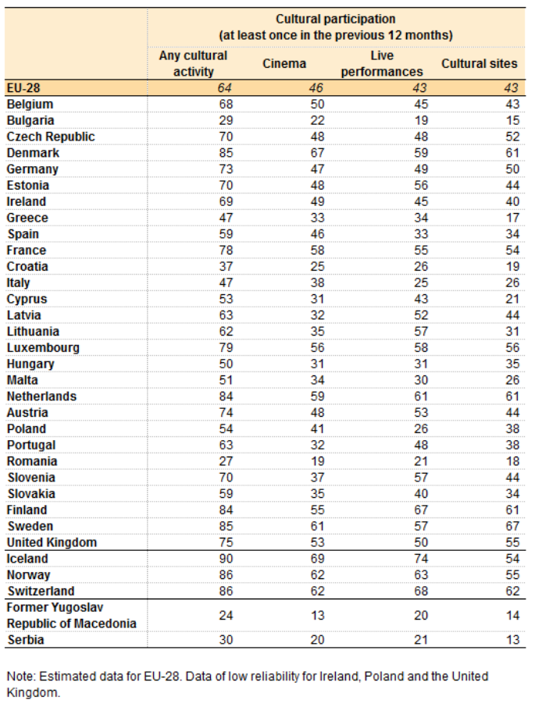

**Cultural employment over time** [**(Eurostat, 2018)**](http://ec.europa.eu/eurostat/statistics-explained/index.php/File:Table_1_Cultural_employment_over_time.png)

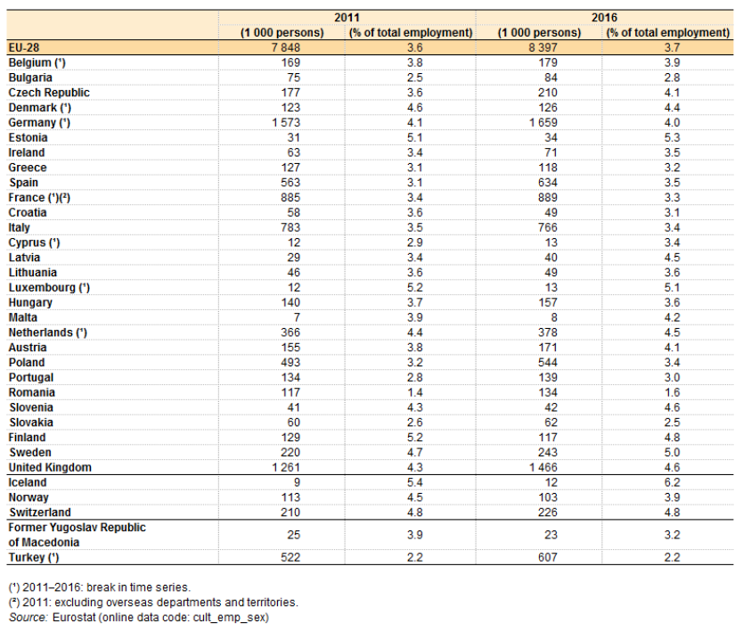

**Extra-EU trade in cultural goods, EU-28, 2011 and 2016** [(Eurostat, 2018)](http://ec.europa.eu/eurostat/statistics-explained/index.php/File:Table_1_Extra-EU_trade_in_cultural_goods,_EU-28,_2011_and_2016.png)

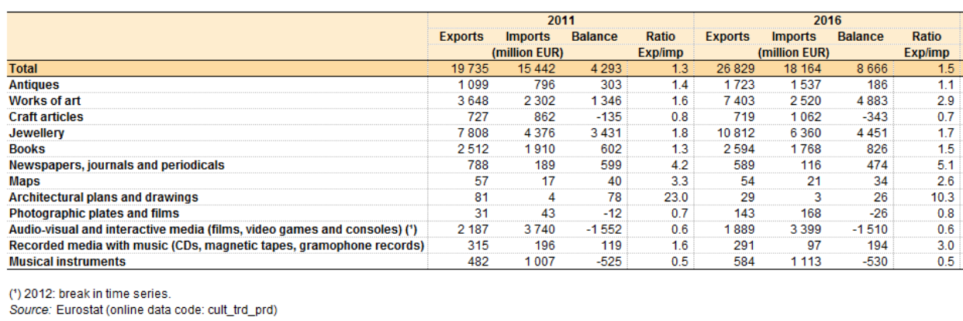

**List of all ISCO-08 and NACE Rev.2 codes included in the scope of cultural employment (revised in 2016)**

NACE Rev.2 codes:

181 Printing and service activities related to printing

182 Reproduction of recorded media

322 Manufacture of musical instruments

581 Publishing of books, periodicals and other publishing activities

59 Motion picture, video and television programme production, sound recording and music publishing activities

60 Programming and broadcasting activities

741 Specialised design activities

742 Photographic activities

90 Creative, arts and entertainment activities

91 Libraries, archives, museums and other cultural activities

ISCO-08 codes:

2161 Building architects

2162 Landscape architects

2163 Product and garment designers

2164 Town and traffic planners

2165 Cartographers and surveyors

2166 Graphic and multimedia designers

2353 Language teachers

2354 Other music teachers

2355 Other arts teachers

262 Librarians, archivists and curators

264 Authors, journalists and linguists

265 Creative and performing artists

3431 Photographers

3432 Interior designers and decorators

3433 Gallery, museum and library technicians

3435 Other artistic and cultural associate professionals

3521 Broadcasting and audiovisual technicians

4411 Library clerks

7312 Musical instrument makers and tuners

7313 Jewellery and precious-metal workers

7314 Potters and related workers

7315 Glass makers, cutters, grinders and finishers

7316 Sign writers, decorative painters, engravers and etchers

7317 Handicraft workers in wood, basketry and related materials

7318 Handicraft workers in textile, leather and related materials

7319 Handicraft workers not elsewhere classified

## 6.2 Eurobarometer

### Key findings on shared values and the role of culture

From Standard Eurobarometer 87, May 2017: <http://ec.europa.eu/commfrontoffice/publicopinion/index.cfm/Survey/getSurveyDetail/instruments/STANDARD/surveyKy/2142> 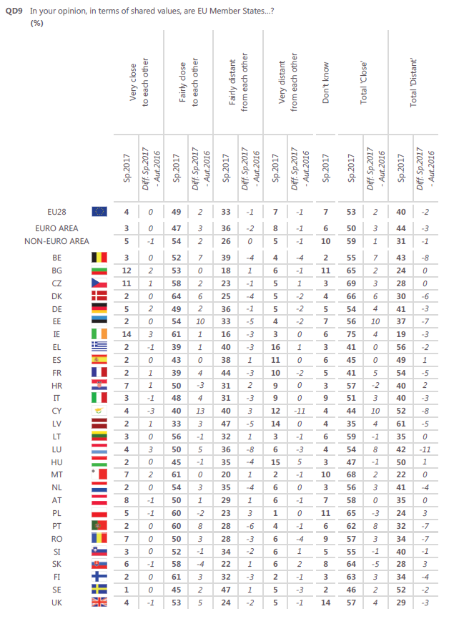

|  |  |
| --- | --- |
|  |  |

### Key findings on cultural heritage

From the 2017 Special Eurobarometer on cultural heritage <http://europa.eu/cultural-heritage/toolkits/special-eurobarometer-europeans-and-cultural-heritage_en>

**The majority of Europeans say they live close to historic monuments or sites, and just over half have some personal involvement in cultural heritage**

▪ More than seven in ten respondents (73%) live near some form of cultural heritage. In particular 60% say they live close to historical monuments or sites, 37% live close to traditional events or festivals and 32% live near works of art, for example in museums or galleries.

▪ Just over half (51%) are personally involved in cultural heritage, with the most likely involvement being regular visits to sites or going to events such as monuments, museums, festivals, concerts and so on (31%) or living in a historic environment, area, city or building that is considered as being of cultural heritage value (17%).

▪ More than half (55%) have used the Internet in the last 12 months for at least one of a range of cultural heritage purposes. The most common activities were looking up general information related to cultural heritage, such as the accessibility, facilities and main features of a museum, historical monument, or traditional event in preparation for a visit or a holiday (31%).

▪ More than two thirds (68%) agree the presence of cultural heritage can have an influence on their holiday destination, and the majority of respondents in each EU Member State agrees.

**Large majorities think cultural heritage is important to them personally, as well as to their community, region, country and the EU as a whole**

▪ More than eight in ten (84%) think cultural heritage is important to them personally. The same proportion of respondents (84%) think cultural heritage is important for their local community, 87% think it is important for their region and 91% think cultural heritage is important for their country.

▪ Eight in ten (80%) think cultural heritage is important for the European Union.

▪ More than two thirds of respondents would like to know more about Europe’s cultural heritage (68%).

**Large majorities take pride in cultural heritage, and agree it can improve quality of life and a sense of belonging to Europe**

▪ A large majority (82%) agree they feel pride in a historical monument or site, work of art or tradition from their region or country.

▪ Seven in ten agree they feel pride in a historical monument or site, work of art or tradition from a European country other than their own, or that living close to places related to Europe's cultural heritage can give people a sense of belonging to Europe (both 70%).

▪ More than seven in ten agree living close to places related to Europe's cultural heritage can improve people's quality of life (71%).

▪ Eight in ten (80%) say their view corresponds well to the idea that it is the diversity of European culture that sets it apart and gives it its particular value.

▪ More than six in ten (62%) say their view corresponds well to the idea that through globalisation, European culture will become more dynamic and widespread in the world. Just over half (54%) say their view corresponds well to the idea that there is no common European culture because European countries are too different from one another.

▪ Just over one third (35%) say their view corresponds well to the idea that there is no specific European culture, only a global western culture which is, for example, the same in Europe and the US.

**Respondents have accessed a wide range of cultural heritage in the last 12 months yet lack of time is the most common barrier to access cultural heritage sites or activities, followed by cost and lack of interest**

▪ In the last 12 months, 61% of respondents have visited a historical monument or site, 52% have attended a traditional event and 50% have visited a museum or gallery.

▪ More than four in ten have seen a traditional or classical performing arts event (43%), while three in ten have visited a traditional craft workplace or visited a library or archive (both 30%). Just over one quarter have been to the cinema or a film heritage festival to see a classic European film produced at least 10 years ago.

▪ Participation in cultural heritage activities varies widely across countries.

▪ A lack of time is the most common barrier to access cultural heritage sites or activities (37%), followed by cost (34%), a lack of interest (31%) or a lack of information (25%).

**A large majority think cultural heritage and related activities create jobs**

▪ Almost eight in ten respondents agree Europe’s cultural heritage or cultural heritage-related activities create jobs in the EU (79%).

▪ The majority (56%) disagree that Europe’s cultural heritage is more for visitors from outside the EU than for EU citizens, but almost four in ten (38%) respondents agree.

**Most respondents think public authorities should allocate more resources to cultural heritage, and that public authorities including the EU should do the most to protect cultural heritage**

▪ A large majority of respondents (88%) agree Europe's cultural heritage should be taught in schools, as it tells us about our history and culture. More than three quarters in each EU Member State agrees.

▪ Almost three quarters of respondents (74%) agree public authorities should allocate more resources to Europe’s cultural heritage.

▪ When it comes to actors that should do the most to protect Europe’s cultural heritage, respondents mentioned national authorities (46%), the EU (40%), local and regional authorities (39%) or citizens themselves (34%).

1. As noted also in the Communication adopted by the European Commission on 20 September 2017 on Boosting growth and cohesion in border regions. <http://ec.europa.eu/regional_policy/en/information/publications/communications/2017/boosting-growth-and-cohesion-in-eu-border-regions>
2. <http://ec.europa.eu/assets/eac/culture/library/publications/mobility-info-standards_en.pdf>
3. [COM(2017)](http://eur-lex.europa.eu/legal-content/EN/TXT/?qid=1496304694958&uri=COM:2017:247:FIN)247
4. <http://www.interregeurope.eu/crinma/> for instance, the interregional programme Interreg Europe 2014-2020 has granted the project CRinMA "Cultural resources in the mountain areas” which is focused on the mountain-related heritage in folk architecture, traditions, customs, and skills. The project was selected as representative for the EYCH 2018.
5. <https://composite-indicators.jrc.ec.europa.eu/cultural-creative-cities-monitor/>
6. COM(2017)376 final of 18 July 2017
7. See <http://s3platform.jrc.ec.europa.eu>
8. <http://s3platform.jrc.ec.europa.eu/map>
9. [Interreg](http://www.keep.eu); [EU Strategy for the Baltic Sea Region](https://www.balticsea-region-strategy.eu/action-plan); [EU Strategy for the Danube Region](https://www.danube-region.eu/component/edocman/action-plan-eusdr-pdf); [EU Strategy for the Adriatic and Ionian Region](http://www.adriatic-ionian.eu/component/edocman/34-action-plan-eusair-pdf); [EU Strategy for the Alpine Region](http://ec.europa.eu/regional_policy/sources/cooperate/alpine/eusalp_action_plan.pdf); [Westmed-initiative](http://www.westmed-initiative.eu/); [Atlantic strategy](http://www.atlanticstrategy.eu/en/themes/priority-4); [Black-sea-synergy](https://eeas.europa.eu/headquarters/headquarters-homepage/346/black-sea-synergy_en)
10. <http://www.faic.eu/index_en.asp>
11. COM(2017) 479 final
12. <http://www.worthproject.eu/>
13. <https://ec.europa.eu/easme/en/cos-einet-2017-3-04-european-incubation-networks-creativity-driven-innovation>
14. European Cluster Panorama 2014
15. <https://www.clustercollaboration.eu/cluster-list>
16. Routes4U is the Joint Programme between the European Commission and the Council of Europe for the creation of cultural routes in the macro-regions: <https://www.coe.int/en/web/cultural-routes/eu-jp-2017-20> It was signed in December 2017
17. <http://ec.europa.eu/environment/nature/natura2000/management/links_natural_cultural_heritage_en.htm>
18. [www.cultureinexternalrelations.eu](http://www.cultureinexternalrelations.eu)
19. <https://ec.europa.eu/europeaid/sites/devco/files/commission-implementing-decision_c2017_-_8725_-_annex_2_en.pdf>
20. <http://www.eusbsrculture.eu/homepage/about.html>
21. <http://www.danube-region.eu/>
22. <http://www.danube-region.eu/about/the-danube-region>
23. <http://www.adriatic-ionian.eu/>
24. <http://www.adriatic-ionian.eu/about-eusair/adriatic-ionian-region/>
25. Although tourism is already one of the fastest growing economic activities in the Adriatic- Ionian Region, and one of the main contributors to the area’s GDP, the full potential of the Region’s rich natural, cultural, historic and archaeological heritage is not yet exploited in a sustainable and responsible way.
26. <https://www.alpine-region.eu/>
27. <https://www.alpine-region.eu/7-countries-and-48-regions>
28. At present and for the timeline of 2014-2020, more than 8.6% of the overall Interreg budget is financing “cultural heritage and arts”. This implies the 2nd place in number of projects within Interreg investments and scores culture as a very popular Interreg topic. This data derives from the Keep.eu website (<https://www.keep.eu/keep/>): Keep is the only source of aggregated data regarding projects and beneficiaries of European Union cross-border, transnational and interregional cooperation programmes among the member States, and between member States and neighbouring countries.
29. This has also been highlighted in the European Union Communication on the added value of the macro-regional strategies COM(2013) 468 final, on 27.6.2013, where improved cooperation with neighbouring countries and the principle of partnership are main topics

    [http://ec.europa.eu/regional_policy/sources/docoffic/official/communic/baltic/com_added_value_macro_region_ strategy_en.pdf](http://ec.europa.eu/regional_policy/sources/docoffic/official/communic/baltic/com_added_value_macro_region_strategy_en.pdf)
30. <https://webgate.ec.europa.eu/europeaid/online-services/index.cfm?ADSSChck=1490868839190&do=publi.detPUB&aoref=154498&orderbyad=Desc&searchtype=QS&page=2&orderby=upd&nbPubliList=15&userlanguage=en>
31. <http://ec.europa.eu/environment/nature/natura2000/management/links_natural_cultural_heritage_en.htm>
32. <http://ec.europa.eu/environment/nature/natura2000/awards/index_en.htm>
33. [Council Conclusions on the role of Europeana for the digital access, visibility and use of European cultural heritage](http://data.consilium.europa.eu/doc/document/ST-9643-2016-INIT/en/pdf) of 31 May 2016
34. <https://ieg.worldbankgroup.org/>
35. Statistic as of 2017, does not include natural or mixed sites. <http://whc.unesco.org/en/list>
36. [http://eur-lex.europa.eu/legal-content/EN/TXT/PDF/?uri=CELEX:52015XG0527(03)&qid=1442927546088&from=EN](https://myremote.ec.europa.eu/owa/,DanaInfo=.arfolD1kiujswLrqOu.979vV1G,SSL+redir.aspx?C=Jc0tl1Ab3mOE7UZeFSie11fCaWD24E8Umu0LvmrBNOHGnP1py4HVCA..&URL=http%3a%2f%2feur-lex.europa.eu%2flegal-content%2fEN%2fTXT%2fPDF%2f%3furi%3dCELEX%3a52015XG0527(03)%26qid%3d1442927546088%26from%3dEN)
37. COM(2010)390: <http://eur-lex.europa.eu/LexUriServ/LexUriServ.do?uri=COM:2010:0390:FIN:EN:PDF>
38. COM(2014)535: <http://eur-lex.europa.eu/legal-content/EN/TXT/?uri=CELEX:52014DC0535>