

Table of Contents

**ANNEX** 1

**Analytical graphs from the 2017 Key Data on Teaching Languages at School in Europe** 1

**ANNEX**

**Analytical graphs from the 2017 Key Data on Teaching Languages at School in Europe**

**Figure 1: Average number of foreign languages learnt per student, primary and secondary education (ISCED 1-3), 2014**

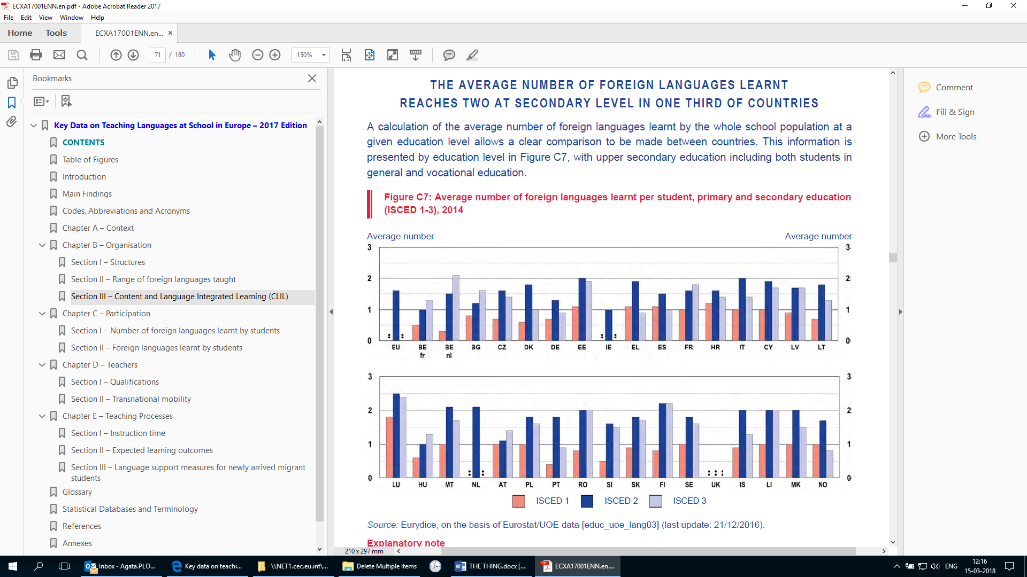

*Source*: Country specific notes: *European Commission/EACEA/Eurydice (2017), Key Data on Teaching Languages at School in Europe, 2017*, page 69

*Explanatory note*: The average number of foreign languages learnt is calculated with respect to all students in all years of the education level concerned, regardless of whether they are learning one or more foreign languages in all grades.

**Figure 2: Starting ages at which the first and second foreign languages are compulsory subjects for all students in pre-primary, primary and/or general secondary education, 2015/16**

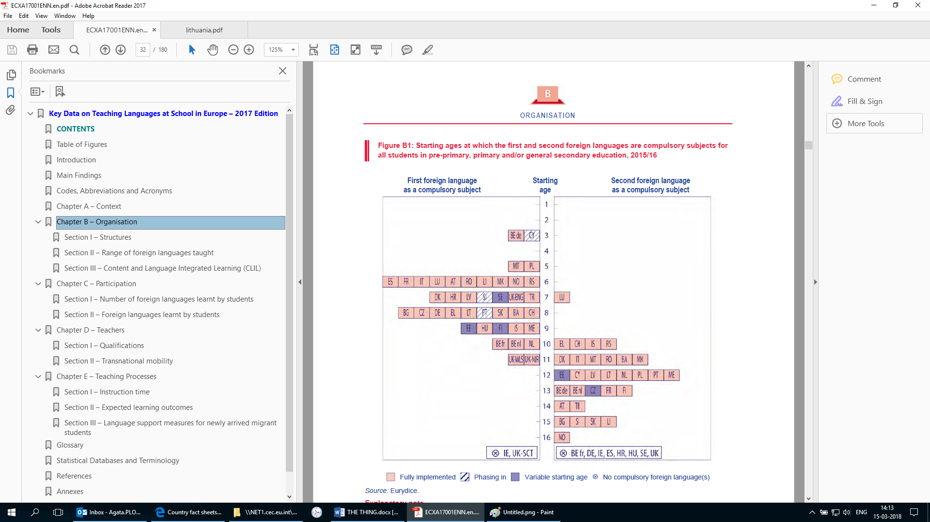

*Source*: Country specific notes: European Commission/EACEA/Eurydice (2017), *Key Data on Teaching Languages at School in Europe, 2017*, page 30

*Explanatory note*: This Figure deals primarily with languages described as 'foreign' (or 'modern') in the curriculum. Regional and/or minority languages (see Figure B12) and classical languages (see Figure B13) are included only when the curriculum designates them as alternatives to foreign languages. The starting ages reflect the normal age of students when foreign language teaching begins; they do not take into account early or late entry to school, grade repetition or other interruptions to schooling (students' notional age).

'Phasing in' means that the reforms are being implemented in 2015/16. Where implementation does not begin until after this academic year, the reforms are reported solely in the text. 'Second language' means a language learned by students in addition to the first, which results in students learning two different languages at the same time.

**Figure 3 : Period during which learning a foreign language is compulsory in pre-primary, primary and/or general secondary education, 2002/03, 2010/11, 2015/16**

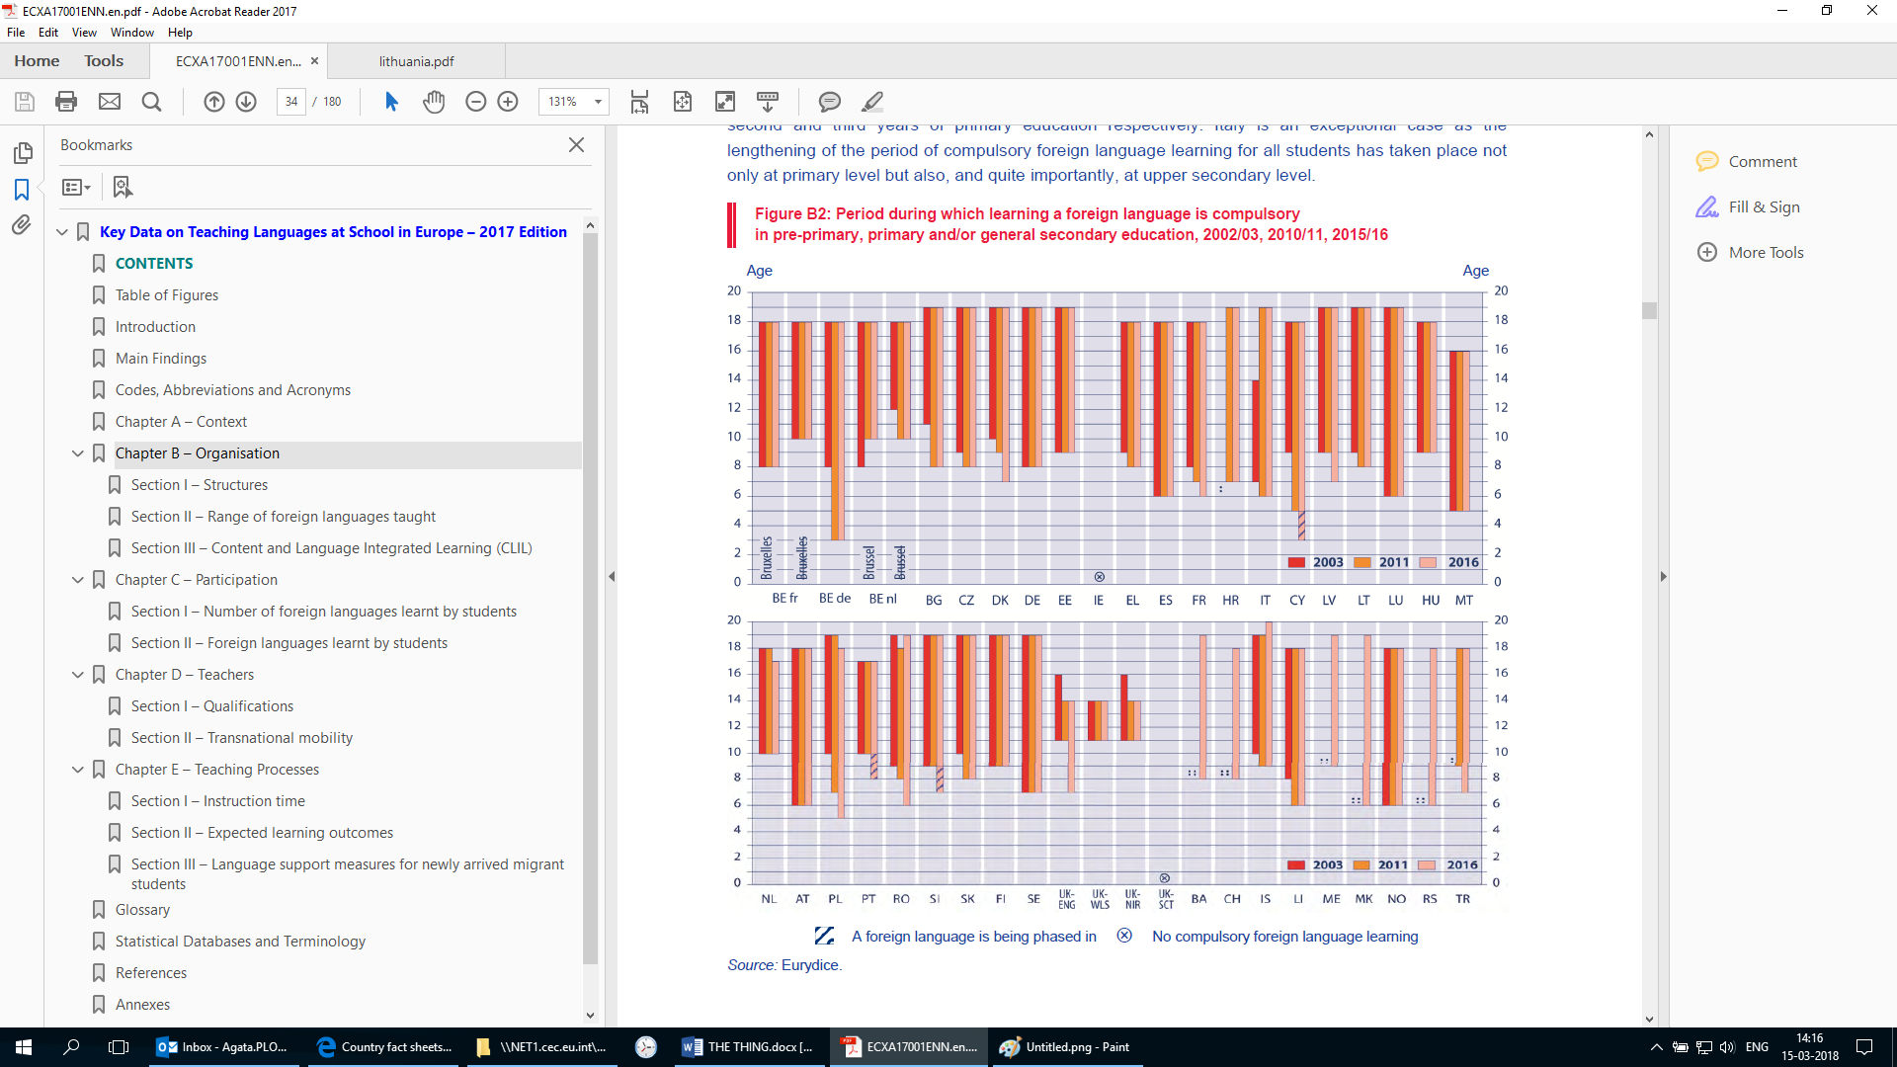

*Source:* Country specific notes: European Commission/EACEA/Eurydice (2017), *Key Data on Teaching Languages at School in Europe, 2017*, page 32

*Explanatory note*: This Figure deals primarily with languages described as 'foreign' (or 'modern') in the curriculum. Regional and/or minority languages (see Figure B12) and classical languages (see Figure B13) are included only when the curriculum designates them as alternatives to foreign languages.

The starting age refers to the first compulsory foreign language and reflects the normal age of students (students' notional age); it does not take into account early or late entry to school, grade repetition or other interruptions to schooling. The duration of provision refers to any language learnt.

For 2015/16 when the measure is 'being phased in', this is indicated. However, for the years 2003 and 2011, even if a reform were being phased in at this time, it is not shown.

**Table 1: Mandatory foreign languages taught during compulsory education, 2002/03, 2010/11, 2015/16**

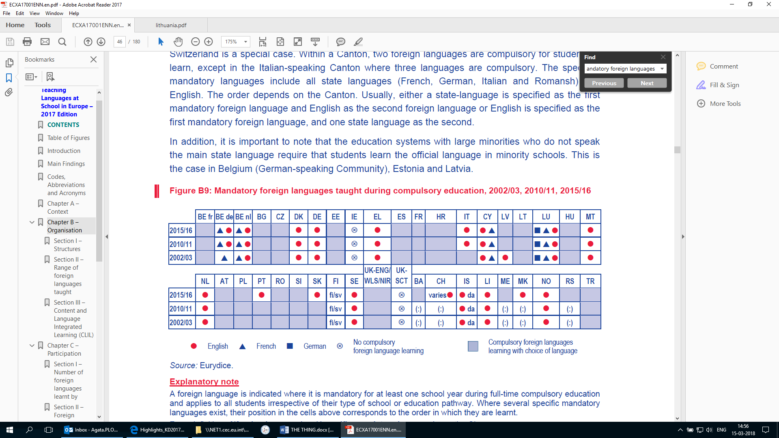

*Source*: Country specific notes: European Commission/EACEA/Eurydice (2017), *Key Data on Teaching Languages at School in Europe, 2017*, page 44

*Explanatory note*: A foreign language is indicated where it is mandatory for at least one school year during full-time compulsory education and applies to all students irrespective of their type of school or education pathway. Where several specific mandatory languages exist, their position in the cells above corresponds to the order in which they are learnt.

.**Figure 4: The second most learnt foreign language, primary and secondary education (ISCED 1-3), 2014**

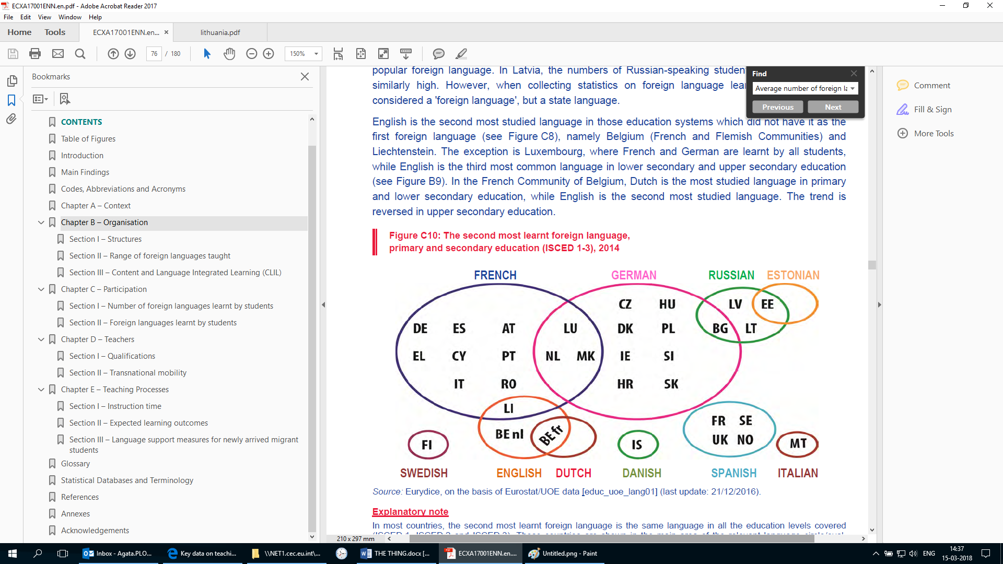

*Source*: European Commission/EACEA/Eurydice (2017), *Key Data on Teaching Languages at School in Europe, 2017*, page 74

*Explanatory note*: In most countries, the second most learnt foreign language is the same language in all the education levels covered (ISCED 1, ISCED 2 and ISCED 3). These countries are shown in the main area of the relevant language circle/oval. Where the second most learnt foreign language learnt varies depending on the level of education, the country is shown in the intersection of the relevant languages. The Figure only takes into account languages learnt by more than 10 % of students.

**Figure 5: Minimum duration and level of initial teacher education of specialist or semi-specialist foreign language teachers in primary and general secondary education, 2015/16**

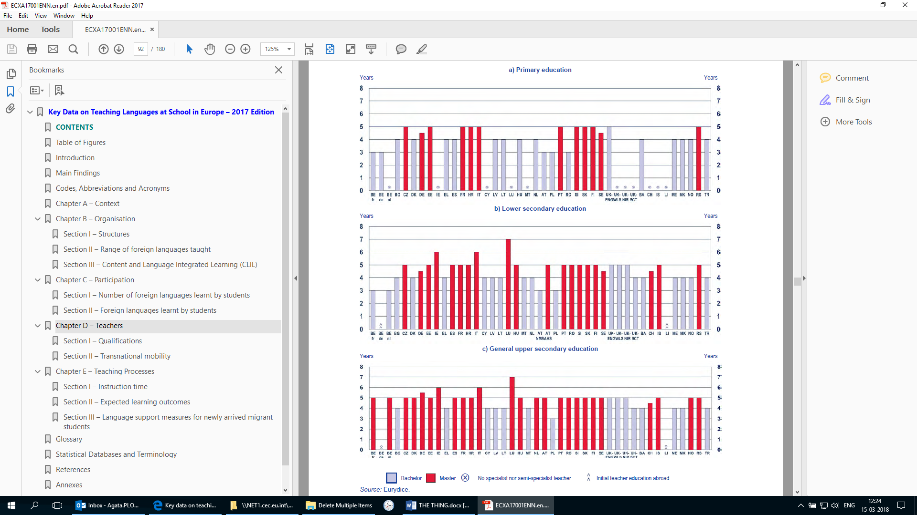

*Source*: European Commission/EACEA/Eurydice (2017), *Key Data on Teaching Languages at School in Europe, 2017*, page 90

*Explanatory note*: In some education systems, there are no central recommendations on the degree of specialisation or they only mention generalist teachers for one or more education levels (see Figures D1 and D2). If, in practice, specialist and/or semi specialist teachers have been recruited at the education level(s) concerned during the reference year, the minimum duration and education level of initial teacher education of these teachers is represented in the Figure.

**Figure 6: Existence of central recommendations on ITE content and a period to be spent in the target language country for prospective foreign language teachers, 2015/16**

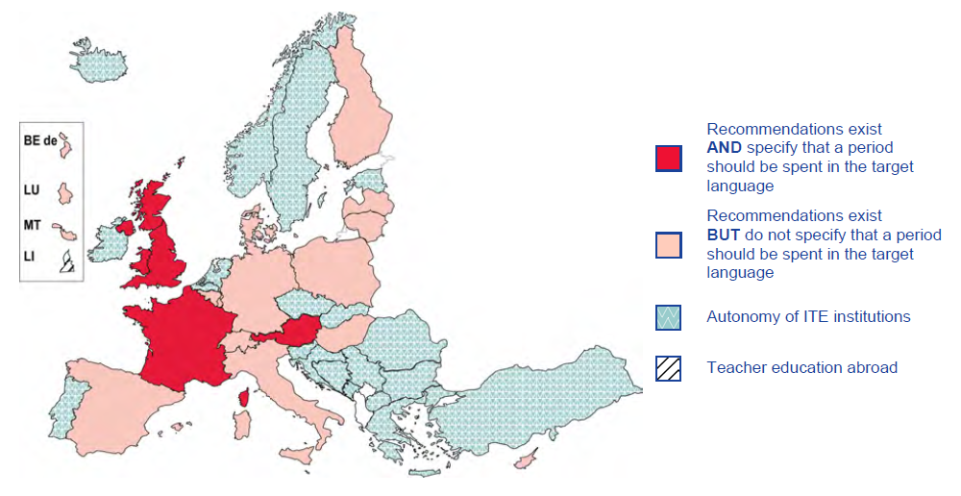

*Source*: European Commission/EACEA/Eurydice (2017), *Key Data on Teaching Languages at School in Europe, 2017*, page 98

*Explanatory note*: Where recommendations on the content of initial teacher education exist for at least one type of foreign language teacher (i.e. generalist, specialist or semi-specialist teachers) or one educational level, the country is classified, depending on the situation, either under the category 'Recommendations exist AND specify that a period should be spent in the target language' or the category 'Recommendations exist BUT do not specify that a period should be spent in the target language'. Where foreign language teachers spend a period of time in a country or region in which the language to be taught (target language) is spoken, this may include time spent in a school (as an assistant), at a university (attending courses) or on work placements. The aim is to give prospective teachers direct contact with the language they will teach and the culture of the country concerned.

**Figure 7: Proportion of modern foreign language teachers in lower secondary education who have been abroad for professional purposes with support from a transnational mobility programme, 2013**

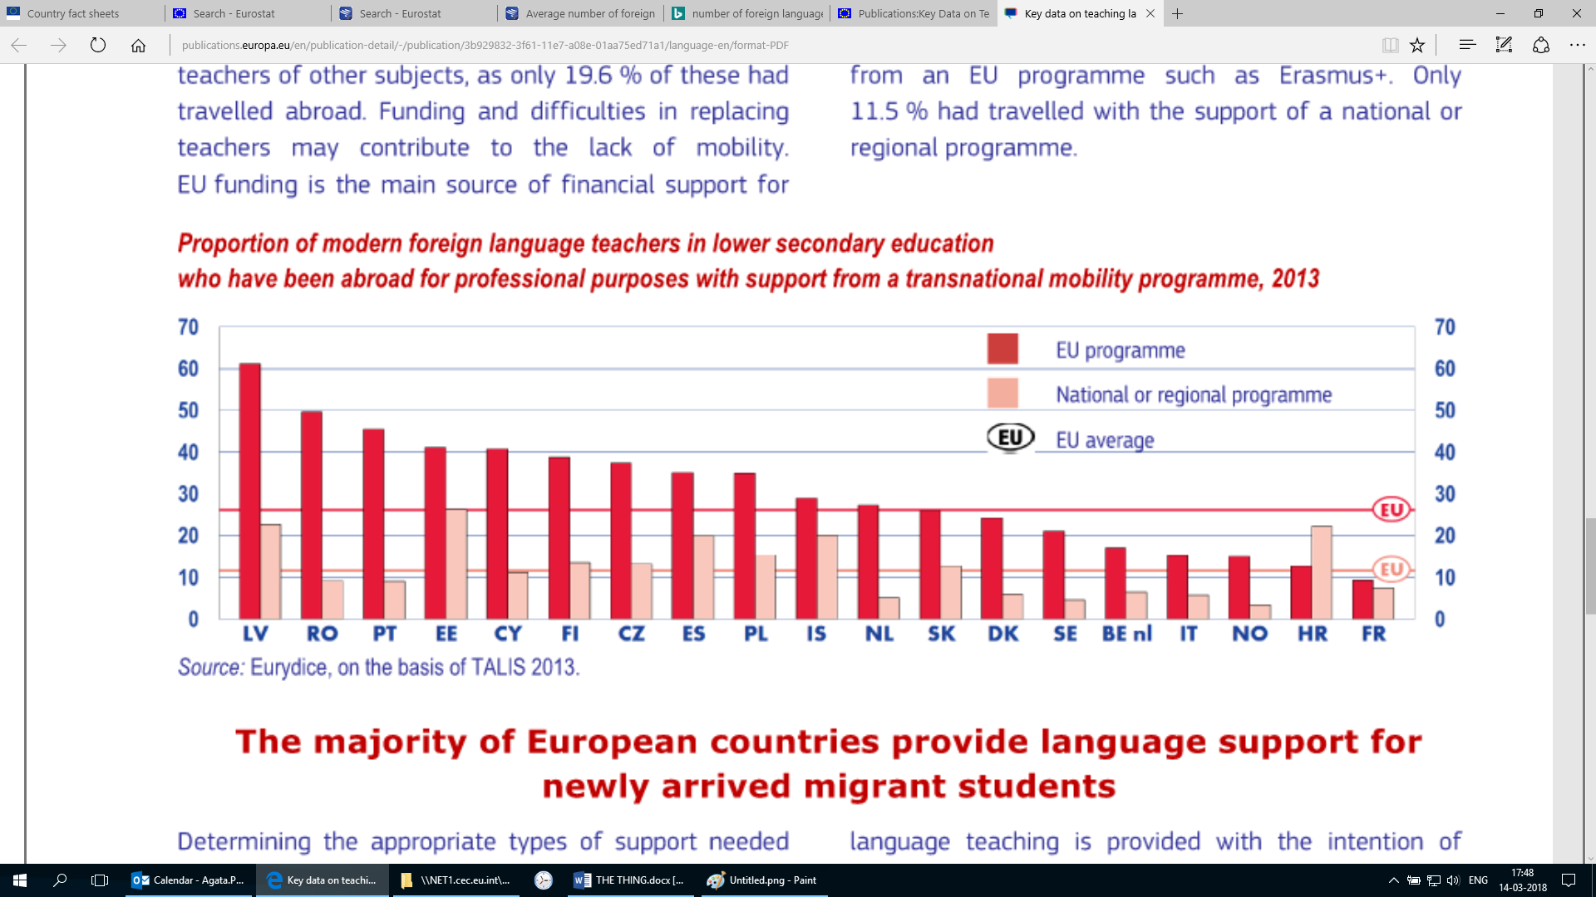

*Source*: European Commission/EACEA/Eurydice (2017), *Key Data on Teaching Languages at School in Europe, 2017*, page 102

*Explanatory note*: The values indicated in the Figure are an estimation based on the survey results. See Annexe 3 for the exact data and standard errors of the estimates.

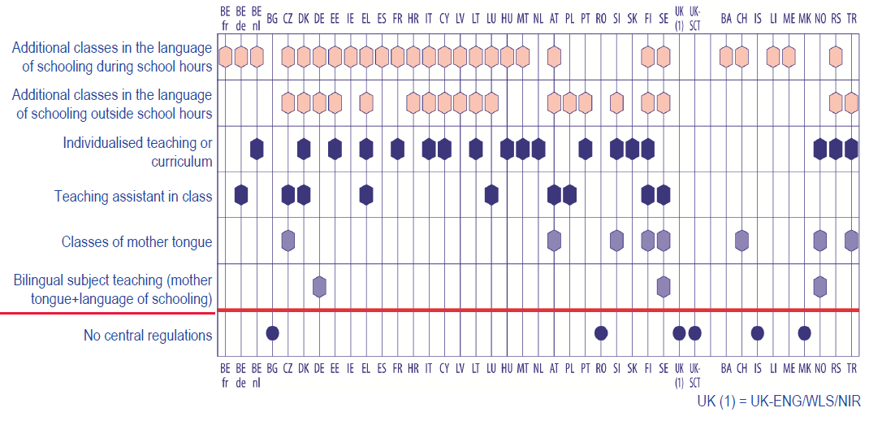 **Figure 8: Language learning support measures for migrant students in mainstream education, primary and lower secondary education, 2015/16**

*Source*: European Commission/EACEA/Eurydice (2017), *Key Data on Teaching Languages at School in Europe, 2017*, page 137

*Explanatory note*: Only measures recommended/required by central education authorities or measures financially supported by central education authorities are shown. For example, mother tongue courses organised by embassies or other institutions set up by the country of origin of migrants are not considered.