

Table of Contents

1. Context 3

2. Rationale 4

2.1. Background 4

2.2. Fitness check results 4

2.3. Objective and legal basis 5

2.4. Data collection and stakeholder consultation 6

3. The EU domestic passenger fleet 7

3.1. Overview of the fleet according to the material of construction 9

3.2. EU internal market 12

3.3. Accident statistics 15

4. Performance based regulatory approach 16

4.1. Background 16

4.2. The New Approach 17

4.3. Goal-based standard approach 22

4.4. Existing experience with the GBS framework 23

5. The proposed Small Passenger Ship Guide 26

5.1. Development and main issues 26

5.2. Structure 28

5.2.1. Tier I: Goals 29

5.2.2. Tier II: Functional requirements 29

6. Next steps 30

Annex 1: Summary of online consultation on safety goals and functional requirements for small passenger ships 32

Annex 2: Overview of targeted consultation carried out in the framework of the Passenger Ship Safety Expert Group 43

Annex 3: Summary of replies to the questionnaire on the Small Passenger Ship Guide 47

1. Context

On 20 December 2017, the amendments to Directive 2009/45/EC of the European Parliament and of the Council[1] entered into force, excluding small passenger ships (i.e. ships below 24 m in length) made of steel or an equivalent material from its scope. This resulted from the recommendations of the REFIT Fitness Check on EU passenger ship safety legislation[2].

The fitness check concluded that the prescriptive EU approach applicable only to small ships falling within the scope of Directive 2009/45/EC failed to bring about a common high safety level across the EU and internal market benefits in respect of these smaller vessels. Instead, the fitness check recommended a goal based standards framework for small passenger ships as the only regulatory approach that would be proportionate and generate EU added value.

Such a goal based standard approach provides for a regulatory framework that sets broad objectives and performance requirements. It can be complemented by detailed rules and standards, developed and verified to conform to the general goals and performance requirements.

In recital 8 of Directive (EU) 2017/2108 of the European Parliament and of the Council[3] amending Directive 2009/45/EC, the co-legislators invited the Commission to adopt guidelines for small passenger ships as soon as possible, so Member States can take them into account when determining their own national safety standards. Such guidelines should take into consideration any international agreements and conventions by the International Maritime Organization (IMO), as appropriate, and should avoid introducing additional requirements that go beyond existing international rules.

This initiative has been included under the Regulatory Fitness and Performance Programme (REFIT) in the Commission's Work Programme for 2017. It demonstrates that a common approach to the safety of small passenger ships is feasible. It defines a common benchmark at EU level for the safety of small passenger ships that could, if embraced by Member States and further developed, provide a reference for passengers sailing domestically on these ships in EU waters and facilitate access for EU manufacturers to the wider EU market.

In view of the novelty of this approach in the area of passenger ship safety and the diversity of existing national practices in regulating small ships, its acceptance and uptake by EU Member States is key to its success.

1. Rationale
   1. Background

Directive 2009/45/EC is the most extensive EU legislative instrument covering passenger ships made of steel or equivalent material and high speed craft sailing on domestic voyages (i.e. between the ports of the same Member State). Where applicable and feasible, it is based on internationally agreed standards, namely the International Convention for the Safety of Life At Sea (SOLAS), establishing detailed technical requirements on vessel construction, stability, fire protection and life-saving equipment.

Directive 2009/45/EC has brought about a uniform high safety level across the EU and significant internal market benefits. However, it has failed to do so regarding small ships (below 24 meters in length) for which several key safety aspects have not been harmonised (reflecting the difficulty to apply the current prescriptive standards in a common manner to the large variety of small ships and conditions they operate in throughout the EU). It has also become clear that the wide range of services that these vessels are built for produces a very broad range of designs and technical solutions. This has made identifying a common set of detailed rules extremely challenging and necessitated a different regulatory approach.

Such new approach, based on performance rather than prescriptive requirements, leaves a degree of freedom to adjust for local circumstances where necessary and promotes innovative designs – subject to verification that the required safety level is met. It also better reflects the wide variety of designs, materials and operation of small passenger ships, which are more sensitive to local operational conditions.

* 1. Fitness check results

The REFIT fitness check[4] showed that only about 60 small steel ships out of almost two thousand small ships in total have been certified under Directive 2009/45/EC. This is due to the fact that the vast majority of such ships are currently built in materials other than steel (see chapter 6 for more details). For such ships, no common standards or safety benchmark currently exist, either at EU or international level. Every Member State has therefore put in place a different approach to regulating their safety leading to differences in measures, approaches and interpretations. This makes the construction of such ships for a wider internal market a challenge.

Although the statistics on the internal market potential for small passenger ships outside the scope of the Directive is not available (commercial databases do not in general cover ships of less than 24 m in length), the fitness check showed that the EU passenger ship safety legislation facilitated the free movement of ships between EU Member States. The evidence demonstrates that the change of flag increased by 400% since 1998 for ships falling under the scope of Directive 2009/45/EC (presenting 30% of the passenger fleet in terms of number of vessels).

The absence of harmonised safety standards presents an important challenge especially for smaller European ship-owners, relying on the second hand market of small passenger ships (for comparison, 72% out of ca. 360 ship-owners with passenger ships under Directive 2009/45/EC operate only one such ship). In case the ship is not certified according to the Directive, the principle of mutual recognition should, apply. In practice, however, as every ship is close to being a prototype, i.e. built for a specific purpose according to technical specifications determined by its future owner, this is not the case. In case of a change of flag, the ship may need to be modified and re-certified – with the associated additional costs that this implies.

In the course of fitness check, several stakeholders (namely shipyards) and Member States (e.g. Denmark, Portugal, Sweden, Croatia) highlighted that the internal market would be facilitated by agreeing on an EU common safety level for this segment of ships, irrespectively of the material from which they are built.

Although the accident statistics does not reveal any imminent safety concern, the revealed absence of certain requirements in some Member States (e.g. on subdivision of small ships) or the variable stringency of requirements on e.g. fire insulation, created the need for further consideration of the achieved safety level (determined by additional measures tailored to local and geophysical conditions, such as navigation restrictions).

* 1. Objective and legal basis

In the spirit of the Commission's REFIT and Better Regulation agenda and as a follow-up to the fitness check, the objective of this initiative is to pave the way for a more common approach as regards safety for small passenger ships operating on domestic voyages within EU waters and developing an internal market therefor.

The legal basis is Article 292 TFEU, providing for the Council to adopt recommendations, on a proposal from the Commission. This initiative is also linked to measures related to sea transport, envisaged by Article 100 (2) TFEU. In view of the novelty of the proposed approach, its uptake by EU Member States is key to its success. This initiative is therefore put forward in a form of a Commission Proposal for a Council Recommendation, inviting Member States to embrace the recommended performance based safety approach and to support its further development.

The safety goals and functional requirements annexed to the Recommendation are based on such performance standards framework and have been developed on the basis of existing practices and jointly with the experts from national administrations and stakeholder organisations. They are put forward to Member States as an inspiration and guidance, to demonstrate that a common approach to the safety of passenger ships is feasible. In no case they are intended to be applied in a mandatory manner.

* 1. Data collection and stakeholder consultation

Concerning the data on the fleet and accidents, this initiative builds on the data collected during the REFIT fitness check process and reported in the Commission Staff Working Document 'Adjusting course: EU Passenger Ship Safety Legislation Fitness Check', adopted in 16 October 2015[5]. Findings of external study carried out in support of the fitness check have also been used[6], as well as the results of the previous work on this issue. The European Maritime Safety Agency (EMSA) provided the key technical assistance in this process, including an overview of the most relevant existing practices for these ships.

The REFIT data gathering exercise concerning the EU domestic passenger fleet was the first of its kind and required several rounds of consultations, corrections and effort both on the part of national administrations and EMSA/Commission. A database has been created and is planned to be updated at regular intervals corresponding to the evaluation cycles of the EU passenger ship safety regulatory framework.

The safety goals and functional requirements for small passenger ships (the Small Passenger Ship Guide)[7] have been developed with national experts and stakeholder organisations in the framework of the Passenger Ship Safety (PSS) Expert Group, which has been enlarged for this purpose to include stakeholder observers. The technical work has been coordinated by the European Maritime Safety Agency, which organised a specific workshop on 13 November 2017 in addition to the regular meetings of the PSS Expert Group and coordinated a correspondence group set up for this purpose.

While the large majority of experts from national competent authorities and stakeholder organisations have been supportive to this initiative, there were some questions on the need for and value added of this initiative. The overview of and feedback provided to these questions is reported in Chapter 6 and Annex 3. In summary, it was agreed that if the common EU approach for small passenger ships was to be further developed, all alternative policy options of doing so would need to be looked at and carefully assessed, including the form which the final framework should take (i.e. mandatory, non-mandatory etc.). This approach follows the Commission's Better Regulation principles and does not pre-empt any result of future impact analysis or the final Commission decision that might be taken. The summary of the meetings of the PSS Expert Group have been published in the Register of expert groups.[8]

Furthermore, an online consultation was organised between July and November 2017[9]. This consultation was targeted at economic operators involved in building of and trading with passenger ships below 24 meters in length, such as shipyards, designers, owners and operators thereof. All other stakeholders could contribute to this consultation as they felt fit.

This consultation was launched to collect views of economic operators, especially the small and very small ones, on the extent to which common EU rules for small passenger ships could facilitate the internal market with small passenger ships. The consultation also aimed at gathering anecdotal evidence in support thereof. It complemented the above mentioned consultation with national authorities and stakeholders that focused on the technical development of the safety goals and functional requirements themselves. The summary of the consultation is provided in Annex 1.

Replies were provided in total by 43 respondents from 13 Member States, with the majority of respondents being micro or small enterprises, which corresponded well to the targeted sector of small passenger ships owners or operators. Overall, the results have shown that this initiative is strongly supported by economic operators (as well as 5 national administrations who also submitted their replies or positions) and that common EU safety rules for small passenger ships are seen to have potentially very positive or positive impact on establishing and facilitating internal market with these vessels, increasing competition and possibly also innovation on the market. In their general comments the respondents stressed that any common EU rules should not re-invent the wheel and should be sufficiently flexible to allow for local operating conditions and expertise to be well reflected.

1. The EU domestic passenger fleet

Passenger ships play an important role in the mobility of EU citizens - more than 400 million people pass through EU ports every year, with 120 million passengers being transported between ports in the same Member State. This initiative addresses exclusively small passenger ships sailing on domestic voyages, i.e. on ships carrying more than 12 passengers on board, which are shorter than 24 metres[10] and sailing between ports of the same Member State[11].

Overall, the existing EU fleet of ships below 24 m is constituted by around 60 ships in steel, 170 ships in aluminium, 600 ships in composite and 1000 ships in wood (see Table 1)[12]. It needs to be kept in mind that this initiative is not intended to apply to existing ships - therefore these figures give only an indication of potential magnitude of application of the common standards framework, if fully developed and applied[13]. In such case, the fleet replacement rate of such vessels will determine what impact the framework will have, given the life time of these assets (average age of passenger ships in the EU exceeds 25 years). It is a well-established practice in the maritime sector that existing assets are normally "grandfathered" unless there is an urgent safety concern.

**Table 1: EU domestic passenger fleet - classification per size and number of vessels**

|  |  |  |  |  |
| --- | --- | --- | --- | --- |
|  | **No. Ships >=24m** | **No. ships <24m** | **% Ships >=24m** | **% Ships <24m** |
| **Aluminium[14]** | 251 | 168 | 60% | 40% |
| **Composite** | 120 | 589 | 17% | 83% |
| **Wood** | 142 | 1014 | 12% | 88% |
| **Steel** | 682 | 60 | 92% | 8% |
| **Total** | 1195 | 1831 | 39% | 61% |

*Source: MS 2014/09 FC Questionnaire, EMSA 2018*

In terms of geographical distribution, in total there are around 1800 ships of less than 24 m sailing in sea areas A, B, C or D. Around half of these vessels operate in Italy and Greece combined and another third in Spain and France combined. This means that 4 Member States have almost 85% of the fleet of such ships. However, it must be noted that only sea areas A, B, C or D are being considered and that the Scandinavian archipelagos and port areas, where many small passenger ships also operate have been excluded from this calculation.

It should be noted that the largest ships in the EU domestic passenger fleet fall inside the scope of EU passenger ship safety legislation, namely Directive 2009/45/EC: ca. 70% of the ships bigger than 24 m in length are certified according to this Directive. On the other hand, only ca. 4% of ships smaller than 24 m length have been certified under this Directive[15].

While small passenger ships present a majority in terms of the number of vessels of the EU domestic passenger fleet (ca. 60%), the picture is opposite in terms of passenger capacity given that the larger the ship, the larger the passenger capacity. Nonetheless, as the following table shows, a significant portion of passengers is carried on smaller vessels.

**Table 2: EU domestic passenger fleet - classification per size and passenger capacity**

|  |  |  |  |  |
| --- | --- | --- | --- | --- |
|  | **Passenger capacity >=24m** | **Passenger capacity <24m** | **% Passenger capacity >=24m** | **% Passenger capacity <24m** |
| **Aluminium[16]** | 81,193 | 17,534 | 82% | 18% |
| **Composite** | 23,333 | 52,837 | 31% | 69% |
| **Wood** | 32,585 | 77,004 | 30% | 70% |
| **Steel** | 320,555 | 6,893 | 98% | 2% |
| **Total** | 457,666 | 154,268 | 75% | 25% |

*Source: MS 2014/09 FC Questionnaire, EMSA 2018*

* 1. Overview of the fleet according to the material of construction

Small passenger ships are mainly built from materials other than steel: aluminium, composite or wood. The following figures show the distribution of this fleet according to the size and Member State of operation.

France has the largest share of aluminium built ships, followed by Italy and Greece. Spain has the largest fleet of composite built ships[17], followed by France and Italy. Italy has by far the largest share of wooden built ships (ca. 60%), followed by Spain and Greece (around 10% each). Greece and Italy have the largest fleet of ships made of steel (primarily larger than 24 m in length).

**Figure 1: Aluminium ships - classification per size and Member State of operation**

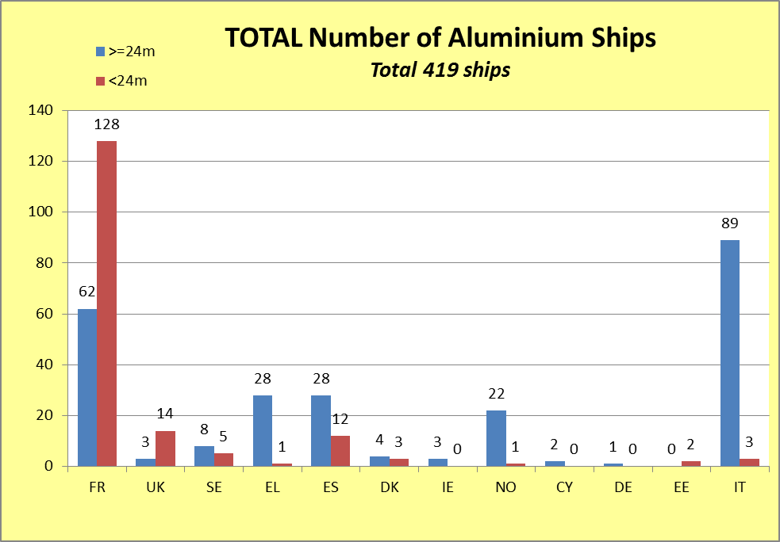*Source: MS 2014/09 FC Questionnaire, EMSA 2018*

**Figure 2: Composite ships - classification per size and Member State of operation**

*Source: MS 2014/09 FC Questionnaire, EMSA 2018*

**Figure 3: Wooden ships - classification per size and Member State of operation**

*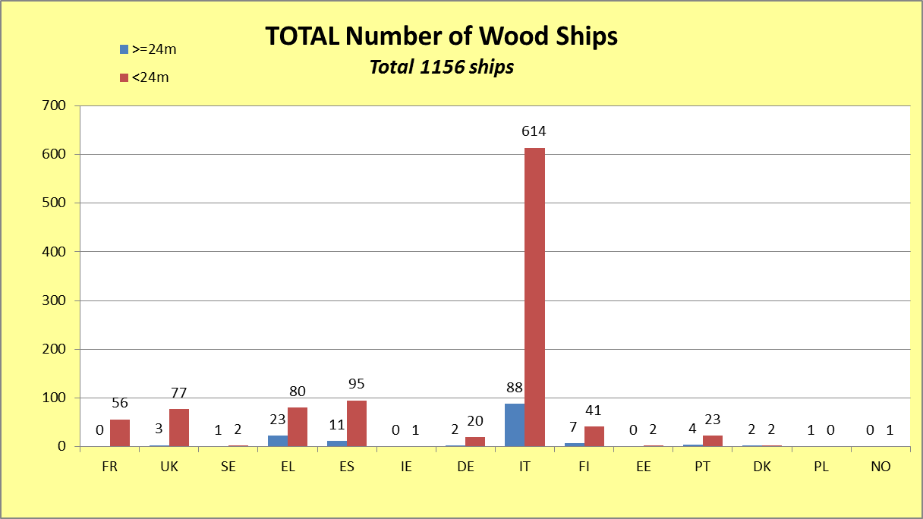Source: MS 2014/09 FC Questionnaire, EMSA 2018*

**Figure 4: Steel ships - classification per size and Member State of operation**

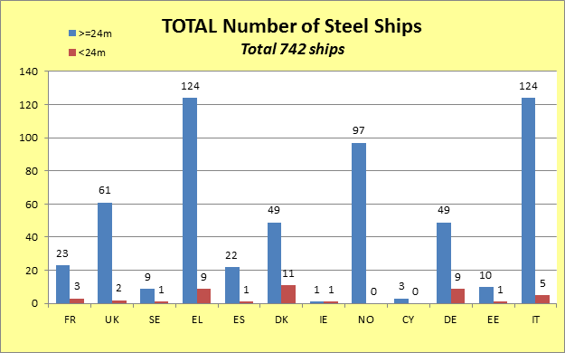

*Source: MS 2014/09 FC Questionnaire, EMSA 2018*

* 1. EU internal market

A measure of the internal market dimension or cross-border transactions in maritime passenger transport can described according to three main indicators: (1) changes of flag; (2) cabotage (i.e. passenger ships operating in Member States other than the state of registry); and (3) shipbuilding (passenger ships built in one Member State and operated in another).

The first one is by far the most relevant for the small passenger ships.

The “**changes of flag**” indicator reflects the (lack of) internal barriers in changing the state of registry where a domestic passenger ship operates. In principle and unless justified by safety reasons, a ship certified according to common EU standards should be accepted in another EU State without requests for modification (indeed, the results of the fitness check showed that the EU passenger ship safety legislation has facilitated the free movement of ships between EU Member States[18]).

The information on flag changes of small passenger ships is not available because commercial databases do not in general cover ships of this size. Despite this lack of information, some of these changes of flag do occur even though in a sporadic manner, which can be supported by the anecdotal evidence from the online consultation, such as: *"I went through this last year and it was a nightmare. […] I would not have done it if I had known beforehand; […] In many cases, it is not possible to move ships within the EU either technically or economically; […] A lot of buyers, despite repeated warnings believe that if a vessel is certified in another state then it is acceptable here. This is not the case and leads to additional cost."*

Furthermore, a ship is a capital intensive investment which takes years to pay off and the value of a ship is still relevant also for an ageing fleet (taking into account that in shipping discount rates are calculated on life cycle of 25 years). Therefore, any ship flag change represents a significant value.

Where common standards do not exist (such as in the case of small passenger ships), mutual recognition should, in principle, apply.[19] In practice, however, every ship is close to being a prototype, i.e. built for a specific purpose according to technical specifications determined by its future owner. In the absence of harmonised safety standards, the ship needs to be therefore carefully checked against relevant national standards and in case of differences in safety requirements, the ship would need to be modified and re-certified – with the associated additional costs that this would imply (even making such transfer impossible – as noted in the online consultation).

**Box 1: Consultation results concerning the second hand market with small passenger ships**

In the consultation, the large majority of respondents (25 out of 37 economic operators or passengers[20]) considered that the existence of different standards in each EU Member State present a trade barrier to sell or buy an existing small passenger ship to or from another EU Member State to a high or medium extent, sometimes making the transfer impossible altogether (especially if the adaptations are very costly and involve essential construction features of the ship). More specifically, barriers such as differences in the requirements for safety equipment on board, flag registration, technical fitness assessment, or disproportionate operating restrictions have been mentioned.

All 4 national administrations who also responded to the questionnaire considered the existence of different standards in each EU Member State to be a trade barrier, either to a high extent (1 response) or a medium extent (3 responses), highlighting that *"different rules in each Member State cause additional work, risks and administrative burdens in flag changes",* even making the transfer impossible.

Similarly, the corresponding cost of technical modifications and administrative re-certification was considered by the large majority of economic operators as highly significant or significant, noting for example *"safety equipment and safety standards as well as fire prevention and firefighting standards that are 'miles apart' in different Member States"* and highlighting the non-quantifiable cost of *"total confusion"*, the waiting and processing time, language differences and the lack of knowledge of the permission procedures in different Member States.

*Source: Online consultation, 2017*

With regard to the second indicator, number of ships operating domestically in a State different from their flag (i.e. **cabotage**), there are only 11 ships in this situation in the EU (out of which only 1 smaller than 24 m in length). Although there is no restriction in the Member State of the flag that a ship must fly, it may be more attractive for an operator to choose the same flag as the State in which it operates (for reasons of inspection regimes, commercial reasons etc.). The relevance of this indicator for small passenger ships is therefore relatively limited and it has not been explored further.

And finally, as a third indicator, **ship-building**. For small passenger ships, the shipbuilding activity is more concentrated in the countries where these ships then operate such as Italy, Spain, France, UK[21]. Ship operators can choose to buy ships in any of the Member States or third countries with ship-building industry, in function of their own criteria, e.g. where the expertise and price are best for the type of ships they want to buy. As regards the ship building market for ships below 24 m, statistics are not available due to the reasons mentioned above but the results of the online consultation illustrate the positive impact of potential common EU rules (i.e. small size ships not included in commercial databases).

**Box 2: Consultation results concerning the shipbuilding and procurement of small passenger ships**

The large majority of economic operators who responded to the questionnaire indicated that the existence of common EU safety requirements would have a strong or moderate positive influence on the decision of buyers to procure a newly built small passenger ship from a ship-yard located in another EU Member State. The respondents highlighted for example the potential of common EU rules to facilitate the procurement process, eliminate red tape, avoid disproportionate national requirements and reduce (albeit not completely eliminate) language barriers. Positive impact on confidence, consistency and surveyors' work has also been mentioned. It was also noted that in the case of small ships in particular, the second hand market is more important than the new builds.

Remarkably, there was a unanimous agreement that common EU safety requirements would have a very positive or positive impact on the design and construction of a new small passenger ship for a client from another EU Member State. These replies were corroborated by explaining that for example national markets would open to competitive operators from other Member States, increasing the offer for the clients possibly at lower price; less time would be spent studying each rule for each country, equipment would be standardised etc., leading to lower cost; positive impact on safety. More generally, it was noted that common EU rules eliminating existing excessive requirements may have a positive impact on renewing the fleet where aging and often less suitable vessels are kept in operation longer than they should.

Concerning innovation, albeit the majority of respondents considered that common EU rules would foster it to a high or medium extent, it was also noted that it may be more relevant for the bigger shipyards who could invest in innovative designs rather that the majority of small yards.

On competition, 27 out of 37 responding economic operators indicated that common EU rules would lead to moderate increase in competition, highlighting different production costs in Member States and higher easiness to participate in tenders across the EU. It was however also noted that case of small passenger ships, a large part of the selection of a designer is prior experience in working with and trust in the designer.

Similarly to the economic operators, national administrations highlighted positive impact on the competition, level playing field and the second hand market, its value and the transfer of ships between Member States. They also noted that "*Common safety requirements, especially adopted for small ships, would promote investment in commercially profitable new buildings. Excessive new building requirements prevent regeneration of vessel fleet."*

* 1. Accident statistics

The accident statistics reported below are based on the European Marine Casualty Information Platform (EMCIP), the EU database on maritime accidents established by Directive 2009/18/EC of the European Parliament and of the Council[22] and operated on behalf of the Commission by EMSA. This database was established rather recently and the number of years for which data is available in EMCIP is therefore still relatively limited[23].

Table 6 shows the evolution of accidents reported in EMCIP for passenger ships of less than 24 m in length. As can be noted, the reporting of accidents has been increasing since the establishment of the database (most likely due to improved reporting) but has recently stabilised.

**Table 3: Accidents of small passenger ships**

|  |  |
| --- | --- |
| **Year** | **Accidents reported** |
| **2011** | 34 |
| **2012** | 56 |
| **2013** | 72 |
| **2014** | 72 |
| **2015** | 93 |
| **2016** | 113 |
| **2017** | 116 |

*Source: EMSA on the basis of EMCIP data, 2018*

The accident statistics available for the REFIT fitness check (with data until January 2015) showed for small passenger ships 252 accidents recorded in EMCIP, with 139 injured people and 5 fatalities. This meant approximately 2 fatalities every 100 accidents and 1 person injured every 2 accidents. For the purpose of this Staff Working Document, the statistics has been updated with data until January 2018 but no major change in the trend has been experienced. This situation looks as follows:

**Table 4: Evolution of accident statistics for small passenger ships**

|  |  |  |  |  |  |  |  |  |
| --- | --- | --- | --- | --- | --- | --- | --- | --- |
|  | **No. Accid.** | **Accid. per year** | **Serious or very serious** | **% Serious or very serious** | **Fatalities** | **Fatalities/ 100 accid.** | **Injured** | **Injured per accid.** |
| **Until January 2015** | 252 | 63 | 96 | 38% | 5 | 2 | 139 | 0.55 |
| **Updated until january 2018** | 555 | 79 | 177 | 32% | 11 | 2 | 165 | 0.30 |

*Source: EMSA on the basis of EMCIP data, 2018*

As Table 7 shows, there the number of accidents reported per year increased but the percentage of serious/very serious accidents has decreased – most likely as a consequence of increased reporting of marine incidents and less serious accidents. This is a positive development.

With regards to additional fatalities, it can be noted that all 5 fatalities recorded until January 2015 were due to occupational accidents, while out of the additional 6 fatalities, there are 4 passengers and 2 crew members[24]. All in all, the ratio of fatalities per 100 accidents has remained constant. Finally, the ratio of injured people per accident has decreased, which is most likely also the effect of increased reporting of less serious accidents.

1. Performance based regulatory approach
   1. Background

Performance based regulations are known and applied since ancient times[25] and gained an increased attention and application in modern times. Setting a performance target allows economic operators the flexibility to achieve a certain goal rather than to follow specified technologies, procedures or processes. Such simple principles can be applied differently in different regulatory approaches and a complete taxonomy does not (yet) exist. The application of performance based rules therefore differs even in the same sector, depending on the political and administrative environment where these rules for rules are developed or the sector specific adaptations.

Furthermore, the boundary between prescriptive and performance based regulation is not always clear-cut; performance based criteria can be specified either very narrowly (for example by prescribing the performance of a specific pump in an industrial process), offering thus little room for manoeuvre to economic operators, or can be defined very broadly (for example by specifying the safety level of vessels), offering more latitude for implementation to economic operators. However also in this latter case, such broad definitions may need to verified by strict adherence to certain models (physical or virtual), transferring de facto the prescriptive requirements to the next layer of regulation.

A key element of the performance based rules is the "opt-out" principle by which the economic operators have to demonstrate that they can achieve a comparable level of performance through other means. This is often implemented by requiring some specific technologies or designs, while adding to the regulation the so-called equivalency clauses for alternative compliance mechanisms. The difference in application stems from various combinations of prescriptive standards, as well as elements of tiered regulations, equivalency clauses, alternative compliance mechanisms, or industrial codes of practice. Any given performance based regulation may require performance thresholds and specific technologies, or may set performance goals and provide prescriptive guidance in the form of codes of practice.

The application of performance based regulation in the maritime sector is well understood both at European and at international level, albeit its application somewhat differs, as described in the following chapters.

* 1. The New Approach

At the EU level, the so-called New Approach constituted an essential step in preparing for the establishment of the single market in 1992. Instead of detailed legislative texts containing all the necessary technical and administrative requirements, the New Approach consisted in restricting the content of legislation to ‘essential requirements’, leaving the technical details to the European harmonised standards. The basic elements on which the New Approach is built are: Notification, accreditation, conformity assessment, marking and market surveillance.

The objective is to ensure that products lawfully manufactured or marketed in any of the Member States meet equivalent levels of performance and can move freely throughout the EU. Barriers to free movement which result from differences in national legislation may be accepted only if national measures:

- are necessary to satisfy mandatory requirements (such as health, safety, consumer protection and environmental protection),

- serve a legitimate purpose which justifies overriding the principle of free movement of goods, and

- can be justified with regard to the legitimate purpose and are proportionate with the aims.

Besides the marine equipment, the New Approach applies in other EU sectoral legislation, such as toys, machinery, radio equipment, pressure equipment, medical devices, recreational crafts, explosives, pyrotechnic articles or personal protective equipment. In total, there are around 20 product-related directives aligned with the New Approach. Nonetheless, it should be also noted that the New Approach is not applied in the area of chemicals (REACH) and motor vehicles.

In regulatory terms, the New Approach consists of:

* **Regulation (EC) 765/2008**[26]setting out the requirements for accreditation and the market surveillance of products;
* **Decision 768/2008**[27] on a common framework for the marketing of products. In effect, it is a template for future product harmonisation legislation;
* **Regulation (EC) 764/2008**[28]laying down procedures relating to the application of certain national technical rules to products lawfully marketed in another EU country.

In addition, the Blue Guide (2016) constitutes the overall guidance.

In more detail, the common main features and structure of the New Approach are as follows:

Essential requirements

* + Legislative harmonisation should be limited to the essential requirements, preferably performance or **functional requirements**;
  + This approach is appropriate only where it is possible to distinguish between **essential requirements and technical specifications**;
  + As the scope of such legislation is **risk-related**, the wide range of products covered has to be sufficiently homogeneous for common essential requirements to be applicable;
  + Articles placed on EU market must conform to essential (safety) requirements
  + The essential requirements are usually described in an annex of the respective New Approach Legislation and vary from general to very detailed;
  + If articles conform, they receive a “CE marking” and can be placed on market anywhere in EU.

Harmonised standards

* European Standards remain voluntary and there is no legal obligation to apply them;
* Any producer (or service provider) who chooses not to follow a harmonised standard is obliged to prove that their products (or services) conform to the essential requirements;
* European standards, which are referenced in the OJEU, provide *“****presumption of conformity****”* with the New Approach Directives;
* European Standards (EN) must be implemented as National Standards by each national standardisation body;
* Conflicting national standards must be withdrawn;
* Commission mandates CEN to adapt existing and draft additional standards;
* CEN can work in collaboration with ISO, through Vienna Agreement;
* A strong legislative basis facilitates the drafting process for standards.

**Figure 5: New Approach – Essential requirements and harmonised standards**

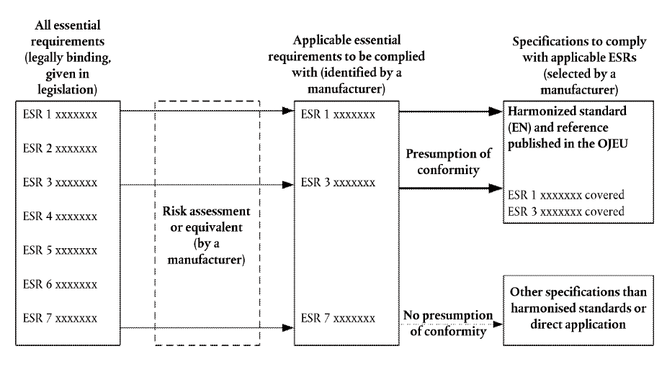

*Source: DG GROW, 2017*

Conformity assessment

* The procedures for conformity assessment are contained in Decision No 768/2008/EC on a common framework for the marketing of products;
* Conformity assessment is either performed as self-assessment (module a) or as an assessment by a third party (notified body) (EN ISO/EIC 17000 series);
* While self-assessment is allowed for some products (e.g. toys), there is mandatory third-party assessment for others (e.g. explosives).

**Figure 6: New Approach – Conformity assessment**



*Source: DG GROW, 2017*

Chapter 4 of Decision No 768/2008/EC contains a template of the standard rules for NBs:

* Accreditation preferred;
* No conflict of interest;
* Qualified personnel and access to facilities;
* Shall participate in/be informed of NB For a;
* Procedure for challenge of competence.

CE marking

General principles are contained in Regulation (EC) 765/2008 setting out the requirements for accreditation and market surveillance relating to the marketing of products:

* CE marking is affixed by the manufacturer or authorised representative;
* May be affixed only where it is required by the legislation;
* Is the only marking attesting conformity with the applicable requirements.

Market surveillance

General principles are contained in chapter III of Regulation (EC) 765/2008:

* Member States shall either draw up general market surveillance programmes or sector specific ones;
* Rules for products presenting a serious risk and restrictive measures (*lex generalis*);
* RAPEX, ICSMS and ADCOs.

Finally, the box below illustrates a specific application of the New Approach in the sector most relevant to small passenger ships, i.e. small boats operated for recreational purposes (not for commercial purpose as in case of passenger ships). In this sector, the experience has shown that the New Approach works well in this sector and should be maintained and even further promoted[29].

**Box 3: Directive 2013/53/EU on recreational craft and personal watercraft[30]**

This Directive was adopted in the context of establishing the internal market in order to harmonise safety characteristics of recreational craft in all Member States and to remove obstacles to trade in recreational craft between Member States. It covers recreational craft of a minimum hull length of 2,5 m and a maximum length of 24 m and is based on the New Approach principles. Thus, it sets out only the essential requirements applying to recreational craft, whereas technical details are adopted by the European Committee for Standardisation (CEN) and the European Committee for Electrotechnical Standardisation (CENELEC). These harmonised standards provide a presumption of conformity with the requirements of the Directive.

More specifically, this Directive contains notions that the manufacturer, having detailed knowledge of the design and production process, is best placed to carry out the complete conformity assessment procedure. Conformity assessment should therefore remain the obligation of the manufacturer alone in the frame of this Directive. As a consequence, in order to ensure compliance with the essential requirements, it is necessary to lay down appropriate conformity assessment procedures to be followed by the manufacturer. Those procedures are set by reference to conformity assessment modules laid down in Decision No 768/2008/EC and devised in the light of the level of the risk which may be inherent in the watercraft, engines and components. Therefore each category of conformity is supplemented by an appropriate procedure or a choice between several equivalent procedures. Furthermore, obligatory requirements are set for conformity assessment bodies wishing to be notified in order to provide conformity assessment services under this Directive.

*Source: Directive 2013/53/EU*

* 1. Goal-based standard approach

In the maritime safety sector, the benchmark for performance based regulatory approach is the model of the International Maritime Organization (IMO) known as Goal Based Standards (GBS) framework.

Primarily aimed at ensuring an adequate level of safety, the IMO GBS framework provides for a methodology to develop detailed regulations for a specific field, i.e. rules for rules. Albeit driven by the same performance based principle as the New Approach, the GBS framework is defined in a different manner – a hierarchical structure of tiers. While some of the New Approach elements may be directly compared to these tiers (i.e. essential requirements, harmonised standards), other elements have a different twist with respect to the IMO GBS framework (such as the conformity assessment and market surveillance). A specific EU element of CE marking is completely missing.

The GBS tiers range from more general principles (goals and functional requirements) to detailed rules and industry standards. Between the general principles and the detailed rules there is a verification procedure through which it is assessed whether the detailed rules fulfil the general principles.

Similarly to the New Approach, the GBS framework has many advantages with respect to a pure prescriptive framework where the general level of safety is not explicit. For example, in case a manufacturer or shipyard would like to innovate in a certain area of the ship design, the prescriptive requirements could represent an important obstacle. In such case, the innovator has to interpret the subjacent safety principles of the relevant prescriptive requirement, extract performance requirements and then prepare an innovative proposal fulfilling those principles.

In the GBS approach, any prescriptive requirement is linked to safety principles and performance requirements and, accordingly, the assessment of innovative solutions against the intended safety level is significantly facilitated. On the other hand, such assessment also necessitates adequate technical knowledge and resources.

Another advantage of making the general safety principles explicit is that they provide a baseline for assessing the need for any exemption or additional measures that may arise due to specific design or operational conditions. The GBS framework, while setting high-level safety goals to be met, therefore allows for adaptation to local circumstances which proves to be necessary in the EU context.

It also needs to be stressed that the complete GBS framework includes detailed technical requirements, even if they are not mandatory. This is very important especially for stakeholders with little technical capacity or those wishing to use a standard design “from the shelf”.

The main principles and characteristics of the IMO GBS framework can be found in the Generic guidelines for developing IMO goal-based standards[31] and are illustrated in Figure 1 below.

**Figure 7: IMO goal-based standards framework**

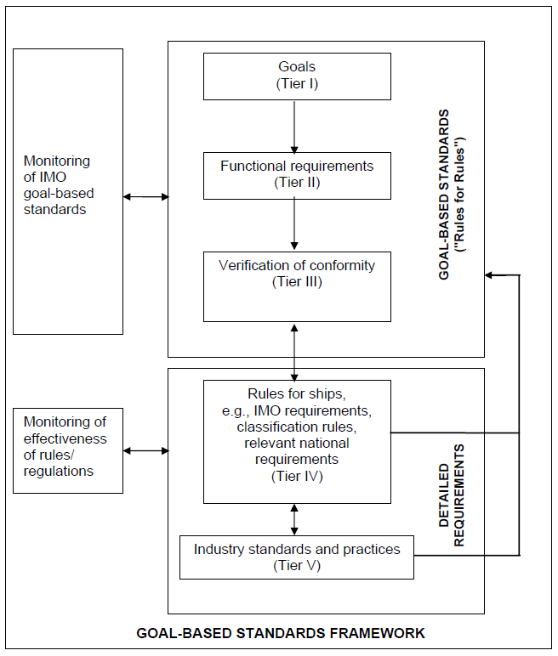

*Source: IMO, 2015*

* 1. Existing experience with the GBS framework

At international level, the transfer from prescriptive regulations to the GBS framework has proven resource intensive both with regards to the need for technical expertise as well as time. The development of regulations at IMO following the GBS model can take years of work with the participation of many specialists in the field.

The model has been used to its full extent only for a specific part of certain ship types, i.e. for structural rules for tankers and bulk carriers[32]. In this particular case, the GBS were developed at the IMO and the Classification Societies presented detailed rules with a self-assessment showing the fulfilment of the GBS. Later, three auditing teams were formed from IMO experts to verify that in fact the GBS was respected.

The Polar Code[33] and the IGF Code[34] have been also developed following GBS standards, although not to the full extent. For example, the functional requirements lack performance requirements and there was no formal verification. Chapter II-2 of SOLAS[35] was also framed taking into account the GBS philosophy, albeit in a limited manner. The most recent example corresponds to SOLAS Chapter III, where substantial work has been carried out in the last years in developing a GBS model and is still ongoing. In the view of this experience, it is very likely that the IMO GBS Guidelines will be further improved to become more operational for the use in the international environment.

**Figure 8: Overview of the GBS use at IMO**

|  |  |  |  |  |
| --- | --- | --- | --- | --- |
|  | **Polar Code** | **IGF Code** | **ANEP -77** | **Ch.III SOLAS** |
| Description | √ | √ | √ | √ |
| Rationale (hazards) | X | X | √ | X |
| Expected Performance | X | X | √ | √  (qualitative) |

*Source: EMSA, 2017*

Another existing model at international level is the ANEP 77[36], a NATO goal-based model developed for Naval ships. This model is quite robust and complete; however it is too complex to be applied to passenger ships of less than 24m and is therefore not described in further detail here.

At national level, the use of the GBS model similar to the one described above has been successfully introduced so far by one Member State, Sweden. Sweden has developed a set of goal-based regulations for those ships not falling under International Conventions or EU legislation. While the structure followed by Sweden is similar to the GBS model, goals and functional requirements, i.e. tiers I and II, have been merged. Tiers IV and V are based on previous existing rules and regulations. Finally, tier III (verification of conformity) includes a self-assessment by the ship-owner or shipyard.

**Box 4: GBS in Sweden**

Sweden is a pioneer Member State in developing GBS legislation for its national maritime sector. The new regulatory framework entered into force in the course of 2017[37], and the practical experience with its implementation is still being collected.

During a Commission/EMSA fact-finding mission in autumn 2016[38], the Swedish authorities explained the three main factors justifying the need for a new regulatory approach: (a) the current legislation is very old and there was a need to update it; (b) some of the technical requirements were disproportionate; and (c) there should be room for innovation. The process to develop the new regulatory framework started in 2013. It was a comprehensive exercise which required a cost-benefit analysis and the involvement of more than 100 stakeholders including unions, ship-owners, shipyards, fishermen, consultants and other authorities.

The new legislation is applicable to all ships of 5 meters in length or above used in commercial traffic (such as passenger, cargo and fishing) not covered under international or EU legislation which accounts for, approximately, 6,000 Swedish ships. Out of that fleet, around 1,000 ships are nationally certified and 5,000 do not carry any certificate.

The regulatory framework is structured in 3 different layers: (1) The first establishes the general functional requirements to be met (includes Tier I and II of the GBS IMO framework); (2) the second layer includes the so-called “general advice” which includes in more detail the way in which the functional-based requirements can be met (corresponds to Tier III and IV of the IMO framework); and (3) finally, the “complementary information” includes additional relevant standards (equivalent to Tier V of the IMO system). The ship-owner can choose any established regulation/standards to build the ship (national, classification societies, or even from a third country) fulfilling the functional-based requirements and present them to the Swedish authorities for approval.

The key element of the new regulatory framework is the increased responsibility for the safety of the ships by the operators. Each vessel has to document how it complies with the function-based requirements, as well as any limitations to the vessel’s operation. To ensure that such self-monitoring is carried out with high quality, there are requirements for a safety management system. This aims to ensure that rules and regulations are being followed and that risks within the business are handled. For the parts of vessels that are not considered suitable for self-monitoring, the ship-owner has to contact an operator to whom the Swedish Transport Agency delegated the oversight tasks. The Swedish Authorities will carry out risk-based oversights.

In addition, an IT support was created to make it easier for the industry to study the regulations, supplementary information and general advice, and to make it easy to carry out self-monitoring and report the results and status of the ship. Through the IT support, ship-owners can also obtain specific information intended for their own business and keep themselves up to date with current requirements and safety information.

*Source: Sweden, EMSA and Commission, 2016*

1. **The proposed Small Passenger Ship Guide**[39]

The proposed Small Passenger Ship Guide (the Guide) provides for safety goals and functional requirements for small passenger ships. It has been inspired by the performance based regulatory approaches described above, in particular the IMO GBS model and the experience with its application at international and national level.

The Guide covers:

* Ships falling outside the scope of EU passenger ship safety legislation;
* Passenger ships below 24 m in length of any type (excluding high speed passenger craft[40]) or activity (i.e. regular or seasonal);
* Any building material (steel, aluminium, composite or wood); and
* Ships sailing in the sea areas as defined in Directive 2009/45/EC (i.e. sea areas A, B, C or D).
  1. Development and main issues

The first draft of the Guide was developed by EMSA using the existing sources and principles and it was further developed with the relevant stakeholders and experts from national administrations. More specifically, the following fundamental questions and comments have been addressed and clarified in the first consultation round:

* + - * 1. Status of the Guide: The Guide is non-binding and it is up to each Member State to decide on the use thereof. Accordingly, it does not have any legally binding effects or enforcement requirements.
        2. Material of construction: The Guide has been drafted regardless of the construction material of the ship.
        3. Role of recognised organisations is intended to correspond to the role these organisations have under Directive 2009/45/EC.
        4. Retroactive use: The Guide has been drafted in respect of new constructions only.
        5. Scope/type of ships included: The Guide is intended to have the same scope as Directive 2009/45/EC. Accordingly, it does not cover the specificities of sailing ships, tenders, offshore service ships, cable ferries, inland waterways ships, etc.
        6. The issue of very small passenger ships was extensively discussed. Some experts have indicated that very small passenger ships might not fulfil some of the functional requirements. While recognising the validity of the comment, it was also observed that it should be considered whether the requirement cannot be fulfilled in these ships because there is no physical space or because the hazard underlying the requirement is not applicable to that ship and the requirement is irrelevant.

If the justification is only the lack of sufficient physical space, then it is worth reflecting whether ships of that size should be allowed to be commercially exploitable passenger ships in the EU. In addition, it should not be the case that passengers using very small passenger ships are subject to higher risks.

It was finally concluded that if a threshold for a particular requirement is considered appropriate, it would be relevant under Tier IV.

The second draft of the Guide was developed on the basis of results of the targeted consultation that aimed to get precise feedback from experts on some of the technical proposals made in the first consultation round.

The high number of replies and comments received in the second consultation round reflected the interest of experts in this initiative. For some of the questions raised there was almost a consensus, like for example the exclusion of ships without a full deck, the need of a simplified safety management system adapted to this category of ships and the use by default of the definitions included in Directive 2009/45/EC. However, for other more technical subjects there was significant divergence of views. Accordingly, these issues were included in the second version of the Guide with square brackets and comprehensive explanations of the diverging views and a proposed way forward for discussion in the following meetings.

The third, final version of the Guide was developed after two dedicated meetings with experts, with only two issues left open for final feedback: one related to the application of the Marine Equipment Directive (MED)[41] and the other to the capacity and distribution of survival systems.

* + - * 1. Concerning MED application, it was noted that there was an inconsistency in the Guide. The MED was only mentioned for Chapter III, whereas it also affects Chapters II-2, IV and V. In order to avoid mentioning the MED in all the Chapters, it was proposed to make a general reference in Chapter I and to clarify the MED application as follows: "Except in duly justified exceptional circumstances, marine equipment which complies with the requirements of Directive 2014/90/EU of the European Parliament of the Council shall be installed on ships falling within the scope of this Code. In circumstances where the competent flag State administration permits the installation of equipment which does not comply with the requirements of the above mentioned Directive, it shall ensure that such equipment provides an equivalent level of safety in the intended operational conditions." The application of the MED to equipment installed on board of vessels carrying passengers for commercial purposes will indeed ensure the highest safety standards today available.
        2. The experts agreed to keep sufficient survival system capacity to accommodate all persons on board, should one of the survival systems be lost. On the other hand, there was extensive discussion on the capacity to be provided on each side if survival systems intended to be thrown over board could not be transferred from side to side. The latter principle has therefore been written as a more general functional requirement and worded as follows: "Each ship must carry survival systems distributed throughout the ship with sufficient capacity, such that, in the event that any one survival system is lost or rendered unserviceable, the remaining survival systems can accommodate the total number of persons the ship is certified to carry. The distribution, deployment arrangements and capacity of the survival systems shall allow all persons that the ship is certified to carry to be accommodated on either side of the ship."[42]

The feedback on the final version of the Guide did not bring any new insights that would not have been already raised and jointly discussed. More specifically, three Member State's experts commented on the final version of the Guide. These additional comments related either to further editorial improvements or clarifications of the text (which have been accepted), or to the already expressed disagreement with specific parts of the Guide or its entirety.[43]

* 1. Structure

The structure of the Guide follows the safety categories and sub-categories in existing maritime codes. An alternative of identifying new safety categories and sub-categories on basis of a hazard identification (HAZID) exercise has been discarded because it was unlikely that they would be different from those already existing for passenger ships in general (stability, fire safety etc.).

The Guide corresponds to the first two tiers of the IMO GBS framework (i.e. goals and functional requirements) and it was developed around the following structure:

* + - * 1. Safety category (Chapter), e.g. fire safety

Safety sub-category (Regulation), e.g., ignition, including:

Functional requirement

Hazard addressed

Performance requirement

* + 1. Tier I: Goals

According to the IMO GBS Guidelines[44], Goals are defined as *“High-level objectives to be met. A goal should address the issue(s) of concern and reflect the required level of safety”.*

In practice however, the concrete examples of goals showed that it can be rather difficult to define them in a sufficiently specific way to reflect the level of safety. For example, in the Polar Code it is stated that: *"The goal of this chapter is to ensure adequate subdivision and stability in both intact and damaged conditions."[45]* From this wording it is difficult to conclude the required level of safety. Goals, by their own nature, are very broad and can be therefore expressed in general terms only. Accordingly, the process to verify that the functional requirements (Tier II) cover all the areas of the goal (Tier I) can be rather subjective.

As the experience at international level has shown, defining a separate layer of goals for each specific functional requirement could risk keeping the discussion too theoretical and delaying the entire process for relatively little added value. Accordingly, and in line with the Swedish approach, in the Guide the goals and functional requirements have been merged (Tiers I and II). Nonetheless, and on the basis of the feedback from experts, a number of general goals have been designed for the Guide in its entirety (rather than for each requirement).

It should be also noted that the development of the GBS framework is iterative. It might be the case that if Tier IV is introduced, some of the functional or performance requirements may need to be amended, no longer needed or some may be missing.

* + 1. Tier II: Functional requirements

The functional requirements follow the approach of the IMO guidelines[46], according to which functional requirements should:

cover all areas necessary to meet the goal;

address all relevant hazards;

provide the criteria for compliance with the goal, i.e. the criteria against which regulations and rules are justified/verified by tier III;

be independent from technical realisation for leaving space for further technological development; and

clearly describe what function has to be achieved.

Furthermore, functional requirements should be formulated considering the following three elements:

Description: a specific and short explanation of the required function;

Rationale: assignment of hazards to be mitigated by the function under consideration; and

Expected performance: description of the necessary function in quantitative terms. This description should cover all aspect necessary for verifying compliance and the conditions under which these have to be reached.

In the Guide, the functional requirements have been extracted from or inspired by existing sources and experiences described earlier. For example, for the requirements on fire safety and radio communication, the functional requirements identified in SOLAS were taken as a basis. Requirements on life-saving appliances have been inspired by the ongoing work at IMO. For stability, freeboard, structure, power, propulsion etc., the functional requirements included in the Swedish Code and in ANEP 77 were taken into consideration. Where available, the same sources were used to establish the hazards addressed and the corresponding performance requirements. The wording of the functional requirements has been fine-tuned together with the experts, as described above and in Annex. In case of diverging views, the solution supported by the majority of experts has been retained, highlighting the potential of the Guide to be used, further developed and adapted to local operational conditions as Member States may see fit for purpose.

As a matter of principle, the Guide has been carefully worded to avoid, as much as possible, qualitative wording and specific technical solutions (to avoid ambiguity and not to hinder innovation).

Finally, the Guide was subjected to the Commission's inter-service consultation, during which it has been reviewed from the legal perspective and the specific risks related to batteries from propulsion have been added, as well as the reference to Galileo which offers services with hundreds meters accuracy in identifying a vessel in distress and a very short reaction time.

1. **Next steps**

From the perspective of economic operators involved in the building of and trading in passenger ships below 24 meters in length, the consultation has shown that they consider common EU safety requirements to have potentially a very positive or positive impact on the internal market with small passenger ships.

Further development of the recommended performance based framework would necessitate the identification and assessment of alternative options and the possible impacts thereof. The basis for such options could be the various regulatory schemes already known and described above, ranging from the IMO GBS tiered approach to the EU New Approach (as used for example in the case of recreational craft) and combinations thereof.

In particular, the experts highlighted the importance of demonstrating and verifying that the detailed standards conform to the functional requirements. This element presents a necessary condition for a fully functioning performance based regulatory framework and acts as a bridge between the general principles and more detailed requirements. This is embedded both in the IMO GBS approach (as the verification of conformity in Tier III) and the EU New Approach (as the conformity assessment).

# Annex 1: Summary of online consultation on safety goals and functional requirements for small passenger ships

The objective of this consultation targeted at economic operators involved in building of and trading in passenger ships below 24 meters in length was to collect views of economic operators on the extent to which common EU rules for small passenger ships could facilitate the internal market with small passenger ships. The consultation also aimed at gathering anecdotal evidence in support thereof.

**Consultation period**

Stakeholders had 4 months to provide their replies, with the deadline initially set on 30 October 2017 and extended to 30 November 2017.

**Format and process followed**

The questionnaire consisted of three main parts: respondent details, new built small passenger ships, second-hand market with small passenger ships, general comments and finally the possibility to attach relevant documents. All contributions were submitted through the online questionnaire, which was ultimately made available in all official languages of the EU.

**Replies**

Replies were provided in total by 43 respondents from 13 Member States. More specifically, respondents from BE, DE, DK, ES, FI, FR, IE, LUX, MT, NL, RO, SE, UK participated in the consultation. Out of the 43 respondents, 37 respondents belonged to the targeted category of economic operators or passengers. It should be noted that out of the 37 respondents, 3 replied under the name of the same entity, namely ARMAM (Armateurs de vedettes à passagers manche atlantique méditerranée). Although these 3 replies were similar, they were not identical and are therefore reported separately.

In addition, 5 replies were provided by national maritime authorities; these replies are summarised under a separate heading at the end of this Annex. Their input has been assessed and taken into consideration, but it has not been included in the statistics that will be presented below. These have been limited to the respondents from the targeted category of economic operators or passengers. The results are presented on a question by question basis, following the same order as in the questionnaire.

Finally, 1 reply was submitted under the research and academia category. However, given that this respondent indicated under all questions "Don’t know", this reply is not included in the statistics below.

**Results**

**A. Respondent details**

**Question 1** identified on behalf of which organisation the respondents replied. It should be noted that most respondents identified themselves under more than one category; therefore the grouping below is only indicative.

|  |  |
| --- | --- |
| **Organisation** | |
| Ship owners/Ship operators/Ship designers/Ship yards/Charterers/Passengers | 34 |
| Consultancies | 2 |
| Classification societies | 1 |

**Questions 2, 3, 4, 6 and 8(1)** related to more specific details about the respondent's identity, namely the name, registration in the EU Transparency Register, e-mail address and the agreement to publish the response either in its entirety or on an anonymous basis. Individual replies have been published accordingly on the following consultation website: <https://ec.europa.eu/info/consultations/targeted-consultation-safety-goals-and-functional-requirements-small-passenger-ships_en>

**Question 5** aimed at identifying the type and size of the enterprise. It can be observed that the large majority of respondents are micro or small enterprises, which corresponds well to the targeted sector of small passenger ships owners or operators.

|  |  |
| --- | --- |
| **The size of the enterprise** | |
| Medium enterprise (50-249 employees) | 3 |
| Micro enterprise (1-9 employees) | 17 |
| Other | 3 |
| Self-employed | 4 |
| Small enterprise (10-49 employees) | 8[47] |
| No response given | 2 |

**Question 7** gave the overview of the Member States where respondents lived or were established, namely BE, DE, DK, ES, FI, FR, IE, LUX, MT, NL, RO, SE and UK.

|  |  |
| --- | --- |
| **Country of origin** | |
| BE | 1 |
| DE | 1 |
| DK | 1 |
| ES | 1 |
| FI | 2 |
| FR | 12 |
| IE | 5 |
| MT | 5 |
| NL | 3 |
| RO | 1 |
| SE | 3 |
| UK | 2 |

**B. New built small passenger ships**

The first part of the questionnaire focused on internal potential for newly built small passenger ships.

**Question 8(2)** asked the respondents to indicate, in their view, to what extent the existence of common EU safety requirements would positively influence the decision of buyers to procure a newly built small passenger ship from a ship-yard located in another EU Member State. 15 respondents indicated strong influence, 17 answered moderate influence, 2 indicated low influence and 1 replied no influence. 2 respondents did not know.

The large majority of respondents provided further explanations to their answers. Additional comments related to the strong or moderate positive influence highlighted the potential of common EU rules to facilitate the procurement process, eliminate red tape, overcome the stringent national certification rules creating de facto monopoly on the national market, reduce the complexity and resource intensity of the upgrade to national rules, or avoid disproportionate national legislation and reduce (albeit not completely eliminate) language barriers. Positive impact on confidence, consistency and surveyors' work has been also mentioned.

The replies indicating low or no influence noted that the main driver is cost and that designers and yards design and build the ship to meet the rules of the country in which it will operate. It was also noted that in the case of small ships in particular, the second hand market is more important than the new builds.

|  |  |
| --- | --- |
| **Impact of common EU rules on the decision of buyers to procure a newly built small passenger ship in another EU Member State** | |
| Strong influence | 15 |
| Moderate influence | 17 |
| Low influence | 2 |
| No influence | 1 |
| Don't know | 2 |

**Question 9** aimed at finding out how the existence of common EU safety requirements would impact the design and construction of a new small passenger ship for a client from another EU Member State. 7 replies indicated very positive impact and 27 replies positive impact. No respondent indicated neutral or negative impact.

Respondents were also asked to provide a concrete example of such impact. The following very positive or positive impact of common EU rules has been indicated (without any order of preference):

- Opening national markets to competitive operators from other Member States, increasing the offer for the clients possibly at lower price.

- Less time spent studying each rule for each country, standardization of equipment etc., leading to lower cost.

- Positive impact on safety in those Member States without detailed requirements, creating level playing field across the board.

- Confidence of the client from other Member State that he will not face major problems and costs to refit the ship to local standards.

- Easier to move ships between Member States because of common safety level and understanding between the different authorities.

- Better regulation avoiding excessive requirements may have a positive impact on renewing the fleet where aging and often less suitable vessels are kept in operation longer than they should.

|  |  |
| --- | --- |
| **Impact of common EU safety requirements on the design and construction of a new small passenger ship for a client from another EU Member State** | |
| Very positive impact | 7 |
| Positive impact | 27 |
| No impact | 0 |
| Negative impact | 0 |
| Very negative impact | 0 |
| Don't know | 4 |

**Question 10** asked to which extent the common EU safety requirements for small passenger ships, based on a functional requirements framework, could foster innovation in the ship building industry. 9 respondents indicated a high extent, 14 replied a medium extent, 4 respondents indicated a low extent and 7 replied not at all. There were 2 respondents who did not know and one who gave no response.

The respondents who indicated a high or medium impact of common EU rule on innovation highlighted the added value of goal driven regulation, importance of keeping up with the technological progress and new approaches, clarity and common level of safety requirements that the new designs would have to meet, as well as the increase in competition that would drive innovation. It was however also pointed out that innovation is many times too costly for a small series of ships of this size. It maybe therefore bigger shipyards who could invest in innovative designs rather that the majority of small yards.

For the replies of a low or no extent, the respondents noted that there is little flexibility in the current designs that have evolved for a reason and that the current legislation is so restrictive that it hinders innovation. This latest remark is interesting because it is in fact the objective of the common EU rules based on functional requirements to overcome such effect of prescriptive rules.

|  |  |
| --- | --- |
| **To which extent could the common EU safety requirements for small passenger ships, based on a functional requirements framework, foster innovation in the ship building industry?** | |
| To a high extent | 9 |
| To a medium extent | 14 |
| To a low extent | 4 |
| Not at all | 7 |
| Don't know | 2 |
| No response given | 1 |

**Question 11** enquired about the impact the existence of common EU safety requirements for small passenger ships would have on competition in the ship building industry. 27 respondents indicated a moderate increase in competition, while 6 replied that there would be no impact on competition or even moderate decrease (2 replies).

The respondents who indicated a moderate increase in competition noted different production costs in Member States, including social cost (also the notion of increased "social dumping" was mentioned). It was also mentioned that it would be easier for yards in all Member States to participate in tenders and reduce national protection to local industries.

Those who replied that there would be no impact on competition noted that in case of small passenger ships, a large part of the selection of a designer is prior experience in working with and trust in the designer, as well as that shipyards should be able to build ships to any specification another yard can build. Concerning the replies indicating moderate decrease in competition, there seems to be an uncertainty concerning the impact on smaller shipyards in case adhering to the new rules or standards proves to be an expensive or difficult process.

|  |  |
| --- | --- |
| **What impact would the existence of common EU safety requirements for small passenger ships have on competition in the ship building industry?** | |
| Strong increase in competition | 0 |
| Moderate increase in competition | 27 |
| No impact on competition | 6 |
| Moderate decrease in competition | 2 |
| Strong decrease in competition | 0 |
| Don't know | 2 |

**C. Second-hand market with small passenger ships**

The second part of the questionnaire focused on internal potential for second hand market with small passenger ships.

**Question 12** aimed at finding out to what extent the existence of different standards in each EU Member State present a trade barrier to sell or buy an existing small passenger ship to or from another EU Member State. 14 respondents replied to a high extent, 11 to a medium extent and 9 to a low extent.

Respondents were also asked to provide a concrete example of such trade barrier. Those who indicated a high or medium impact mentioned several specific or general examples of those barriers, such as:

- Any boat not built under Irish department supervision is restricted to operate 3 miles from land. Very costly modifications to a vessel bought in France and imported to Ireland.

- Germany demands catalysers to be fitted, France does not.

- Different requirements in flag registration, endowment or technical fitness assessment.

- Differences in the requirements for safety equipment on board, making it difficult to change the flag of commercial charter boats between Member States.

- It is sometimes not only very costly to adapt the vessel to conform with local rules but physically impossible.

- The new flag State refusing to accept a ship built in another Member State for fundamental rule compliance reasons.

Those who replied that different national standards present a trade barrier to a low extent provided a specific example of ships built in France that face no problems to be sold to other Member States given the stringency of the French standards. It was however noted that for the same reason, the situation is more difficult for ships imported to France.

|  |  |
| --- | --- |
| **To what extent the existence of different standards in each EU Member State present a trade barrier to sell or buy an existing small passenger ship to or from another EU Member State?** | |
| To a high extent | 14 |
| To a medium extent | 11 |
| To a low extent | 9 |
| Not at all | 0 |
| Don't know | 3 |

**Question 13a** enquired about the significance of the cost of additional technical modifications that have to be done in order to be adapted to importing Member State's regulatory requirements when transferring a small passenger ship between EU Member States. 16 respondents classified such cost as highly significant and 13 respondents as significant. 7 replies indicated that such cost is less significant and no reply indicated that they would be insignificant. Also, there is one reply with don't know.

The concrete examples of technical modifications deemed to be highly significant or significant included the cost and fitting of a catalyser (ca EUR 10000); new equipment including new life rafts, radar reflectors, extra flares etc. plus cost for new inspections (ca EUR 10000); comparison between a specific national and EU standard requires an additional investment of ca EUR 80000; safety equipment and safety standards as well as fire prevention and firefighting standards that are "miles apart" in different Member States; high risk of unforeseen modifications; significant cost to modify a ship construction regarding e.g. hull strength.

Similarly to question 12, the respondents who replied that such cost is less significant referred to the stringency of existing French standards.

|  |  |
| --- | --- |
| **When transferring a small passenger ship between EU Member States, how significant is the cost of additional technical modifications that have to be done in order to be adapted to importing Member State's regulatory requirements**? | |
| Highly significant | 16 |
| Significant | 13 |
| Less significant | 7 |
| Insignificant | 0 |
| Don't know | 1 |

**Question 13b** refers to the significance of administrative cost of re-certifying the ship in accordance with the importing Member State's regulatory requirements when transferring a small passenger ship between EU Member States. 10 respondents classified such cost as highly significant and 17 respondents as significant. 3 replies indicated that such cost is less significant and 2 replies indicated that they would be insignificant. There were 4 replies given with don't know and 1 respondent did not give any reply.

The concrete examples of such cost deemed to be highly significant or significant included stability and safety surveys; transfer and certification fees; non-quantifiable cost of "total confusion", the waiting and processing time, language differences and the lack of knowledge of the permission procedures in different Member States. It was also highlighted that it often depends on the good will of the receiving national administration.

Some of the respondents indicating this cost to be insignificant mentioned an example of a small surveying fee or identified, more generally, the re-certification cost to be typically well below 1-3% of the vessel costs.

|  |  |
| --- | --- |
| **When transferring a small passenger ship between EU Member States, how significant in your opinion is the administrative cost of re-certifying the ship in accordance with the importing Member State's regulatory requirements?** | |
| Highly significant | 10 |
| Significant | 17 |
| Less significant | 3 |
| Insignificant | 2 |
| Don’t know | 4 |
| No response given | 1 |

**Question 14** enquired about the impact the existence of common EU safety requirements for small passenger ships would have on the opportunity to export these ships to third countries. 8 replies indicated a strong increase and 16 replies a moderate increase. No impact on export opportunities was indicated by 9 respondents. 1 respondent indicated a strong decrease in export opportunity and 3 did not know.

In their additional comments, the respondents who replied that common EU rules would have a strong or moderate positive impact on the export opportunity to third countries, noted that third countries may accept vessels built under common EU rules without additional costs; consider it as a mark of quality and use it as a standard for their vessels. It was however also highlighted that the ships need to be adapted to different climatic conditions in third countries.

Some of the replies that indicated no impact on export opportunities were further explained by experience that EU builds are primarily searched for their quality, aesthetics and design innovation rather than their safety certification and that the French builds have already a strong image abroad (especially in Africa). The respondent who indicated strong decrease in export opportunity explained that this would be the case for the French yards facing increased competition from other Member States with lower costs.

|  |  |
| --- | --- |
| **What impact would the existence of common EU safety requirements for small passenger ships have on the opportunity to export these ships to third countries?** | |
| Strong increase in export opportunities | 8 |
| Moderate increase in export opportunities | 16 |
| No impact on export opportunities | 9 |
| Moderate decrease in export opportunities | 0 |
| Strong decrease in export opportunities | 1 |
| Don’t know | 3 |

**D. General comments**

In most of their general comments, the respondents reiterated their position indicated in the specific questions, expressing their support for common EU rules or adding other specific comments. Importantly, it was stressed that any common EU rules should not re-invent the wheel and should be sufficiently flexible to allow for local operating conditions and expertise to be well reflected. On the other hand, it was also noted that Member States should not make additional restrictions. Specific comments were also expressed in relation to charter vessels and crew qualifications.

**National maritime administrations**

Replies on the questionnaire were also provided by 4 national maritime authorities/administrations (from LUX, FI, NL and FR) and can be briefly summarised as follows. In addition, 1 national authority (from FI) submitted a position paper that is summarised at the end of this section.

Regarding the newly built small passenger ships, the national administrations were of the view that common EU rules would have a strong or moderate positive influence on the decision of buyers to procure a newly built small passenger ship from a ship-yard located in another EU Member State (question 8(2)), highlighting positive impact on the competition, level playing field and the second hand market, its value and the transfer of ships between Member States. Similarly to the comments from economic operators, it was also noted that "*Common safety requirements, especially adopted for small ships, would promote investment in commercially profitable new buildings. Excessive new building requirements prevent regeneration of vessel fleet."*

Concerning the impact of common EU rules on the design and construction of a new small passenger ship for a client from another EU Member State (question 9), national administration considered that such impact would be positive or very positive, commenting that excessive requirements for small ships are too costly and prevent operators from making investments into new ships and that common rules would ensure a common safety level and provide a certainty for the clients to transfer the vessel across the EU.

The replies of the national administration were more nuanced on the possible impact of common EU rules on innovation (question 10), with 2 replies arguing for high positive impact, 1 for low impact and 1 did not know. There was nonetheless an agreement that goal based rules have in principle a positive impact on innovation. The situation was similar for the question on competition (question 11), with 1 reply indicating no impact of common EU rules on competition, 2 replies for moderate increase in competition and 1 did not know. Comments referred also to higher performant and less polluting ships.

The existence of different standards in each EU Member State was considered to be a trade barrier (question 12) by all responding national administrations, either to a high extent (1 response) or a medium extent (3 responses), highlighting that *"different rules in each Member State cause additional work, risks and administrative burdens in flag changes",* even making the transfer impossible.

Concerning the cost of additional technical modifications that have to be done in order to be adapted to importing Member State's regulatory requirements (question 13a), 2 national administrations replied that they do not know, while the opinion of the two other ones was very divergent – 1 replying that such cost is very significant while the other replies that it is insignificant (noting that only vessels easily adaptable to the national rules in question are transferred in the first place). It was noted that this is always a case by case situation and the cost cannot be therefore estimated but it may be so high for the transfer to become impractical.

Similar divergence in replies concerned the question on the administrative cost of re-certifying the vessels (question 13b), with the replies ranging from don’t know to less significant (indicating cost of EUR 350/hour), highly significant (providing examples of noise measurement reports and asbestos that are in some cases missing) and insignificant (recalling that only vessels easily adaptable to the national rules in question are transferred in the first place but recognising that common EU rules would facilitate the re-certification of such vessels).

The impact of common EU rules on the opportunity to export these ships to third countries (question 13) was considered moderate by 1 national administration (noting that *"high EU level safety standards offered to reasonable cost would be attractive also to third country buyers"),* with 2 respondents identifying no impact (noting that these countries use their own rules) and 1 did not know (commenting that common EU rules may could possibly become a reference standard internationally and hence facilitate export).

In their general comments, the national administration highlighted that the new rules should be built on existing national experiences and applicable to new ships only (and possibly voluntary for existing vessels to facilitate second hand market) and in any case should not increase the cost of newbuilds; and called for sailing ships to be included in the common EU rules.

Finally, one national administration (from FI) submitted a position paper in which it expressed its support for common EU rules that should be developed in such a way as to enable the single market to operate effectively, whilst leaving enough room for their adaptation to national circumstances. It was also stressed that such rules should apply to new builds only. Importance of automation, safety for persons with reduced mobility and reduction of administrative burdens was also mentioned.

# Annex 2: Overview of targeted consultation carried out in the framework of the Passenger Ship Safety Expert Group

1. Introduction

The first draft of the Small Passenger Ship Guide was developed by EMSA using the sources and principles described in the chapter dedicated to the GBS. However, there was a need to improve it in conjunction with the relevant stakeholders who will use it in practice: Member States administrations and industry.

Accordingly, a group of consulting technical experts was created within the framework of the Passenger Ship Safety Expert Group. This Group is constituted by experts in passenger ship safety from the relevant bodies of the Member States administrations and observers from the maritime industry.

Several consultation rounds and meetings/workshops were carried out according to the following calendar:

|  |  |  |
| --- | --- | --- |
| **TASK** | **Start Date** | **End Date** |
| **1st Consultation round** | 20 March | 28 April |
| **PSS Expert Group Meeting (Brussels)** | 30 March | 30 March |
| **2nd Consultation round** | 29 June | 4 September |
| **Circulation of 2nd version** | 16 October | 16 October |
| **PSS Expert Group Meeting (Brussels)** | 23 October | 23 October |
| **Workshop on SCC (Lisbon)** | 13 November | 13 November |
| **Draft Final Guide circulated** | 30 November | 12 December |
| **Final Guide** | 20 December | 20 December |

1. First round of consultation

The first consultation started on 20 March and consisted in the circulation of the first draft of the Guide. The experts were requested to provide comments on the first draft, particularly concerning:

a) The structure of the Guide, including the safety categories and sub-categories, functional requirements, addressed hazards and the corresponding performance requirements.

b) Initial feedback on the substance of the identified functional and performance requirements.

The first draft was introduced in a meeting with the experts on 30 March 2017 within the framework of the Passenger Ship Safety Expert Group. Following this meeting, experts had a four week period to provide feedback.

In total, 13 experts from Member States replied and 3 observers from the industry. The replies allowed to conclude an agreement on the structure of the Guide, although they included several fundamental questions (reported in Chapter 5 of this Staff Working Document) and provided detailed technical comments to the Guide.

1. Second round of consultation

In view of the feedback provided in the first consultation, it was decided that the main purpose of the second consultation should be the clarification of the fundamental issues raised. In addition, to continue the progress on the technical side, some of the technical matters raised by the experts during the first consultation were also included in that round. Finally, experts were provided with the opportunity to comment to the first draft of the Guide if they had not done so yet.

The second consultation was framed around a questionnaire with 42 questions to get precise feedback from experts in the fundamental questions and on some of the technical proposals made by experts. In addition, a second document was circulated including 57 comments from EMSA explaining why some of the proposals had not been included in the questionnaire so that there was full transparency and could be contested if appropriate.

To reply it was provided a period of 9 weeks as the summer season was in the middle of this consultation. In total, 14 experts from Member States replied together with 4 observers. This meant processing more than 750 replies and more than 400 specific comments.

The results of the questionnaire were sent to all the experts together with the comments in an excel file to ensure transparency together with a brief quantitative analysis as shown in the following excerpt:

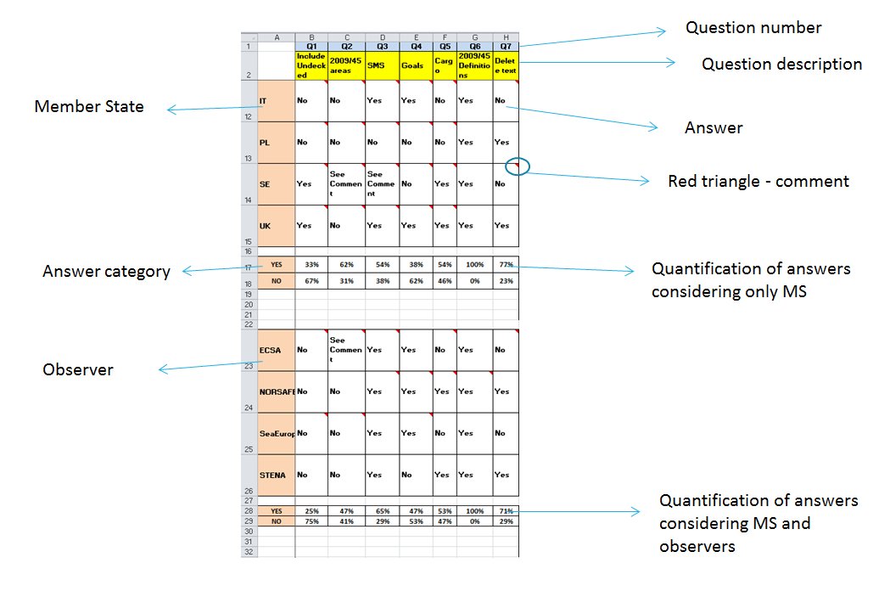

As it can be noted, for each question, the relevant percentages were shown first considering only the members of the group, i.e., experts from Member States, and then considering also the input from the observers. This analysis provided a good overview to the group of experts on the results of the questionnaire and ensured that any expert had access to the views of the others.

The high number of replies and comments received reflected the interest of experts in this initiative. For some of the questions raised there was almost a consensus, while for other more technical subjects there was an important divergence of views. Accordingly, these issues were included in the second version of the Guide with square brackets and comprehensive explanations of the diverging views and proposing a way forward to be discussed in the following meetings. Summary of this consultation feedback is provided in Annex 3.

1. Third round of consultation

Based on the results of the questionnaire, EMSA prepared a second version of the Guide which was circulated to the experts on 16 October. In this second version, all the modifications, including minor editorials, were provided in track changes with respect to the first version to facilitate the revision. In some instances, explanatory footnotes were added to explain the origin of the proposals.

Each regulation changed included an explanatory box with the results of the last questionnaire, a brief explanation of the subject and the implication in the document. In the occasions where expert comments were conflicting to each other the majority criteria was taken as a basis to modify the Guide. However, all the comments were analysed and taken into consideration.

Some experts provided new proposals on aspects not included in the questionnaire. Such proposals were included with a footnote or in square brackets so that they could be easily identified and discussed during the meetings.

This second version was discussed in detail, regulation per regulation, during two meetings. The first took place on 23 October 2017 within the framework of the Passenger Ship Safety Expert Group. In this meeting the group went through all the results of the questionnaire, modifications and proposals related to the first two chapters of the Guide.

Following this meeting, EMSA circulated to the group of experts a note on 27 October 2017, summarising the technical discussions on the second version of the Small Passenger Ship Guide to facilitate the forthcoming discussion in the second meeting, a dedicated workshop held at EMSA premises in Lisbon on 13 November 2017. In addition, the note provided a deadline to provide additional written comments until 6 November 2017. Three Member States took advantage of this opportunity and provided comments in writing before the workshop which were processed and presented to the group for further consideration. Another Member State provided editorial comments after the workshop.

During the workshop, the group of experts went through the results, modifications and proposals of the remaining chapters of the Guide and came back to the issues left open of the first two chapters.

1. Finalisation of the Guide

Two matters remained open after the workshop: one related to the status of the shipborne equipment under the scope of Directive 2014/90/EU (Marine Equipment Directive) and the other related to the capacity and distribution of survival systems. During the meeting it was agreed that EMSA would prepare a draft final version of the Guide with editorial improvements and two proposals for the two above-mentioned topics based on the discussions held in the workshop.

EMSA circulated the draft final version of the Guide on 30 November with a deadline to reply 12 December.

Three Member State's experts sent comments before that deadline. The comments referred to editorial improvements were introduced in the text. With regards to the two open issues, no comment was received on the proposal for the capacity and distribution of survival systems.

As for the MED application, one national expert indicated that there was a conflict between the text proposed and the MED as it provided too much flexibility (however such a conflict was not found). Another national expert indicated the contrary, that more flexibility was needed as the text proposed contradicted the national legislation. In view of these diverging views and considering that only two Member States commented on this issue, the wording was retained as proposed.

Finally, the comments which insisted on points that had been already raised during the consultation and that had not found sufficient support within the PSS Expert Group were not taken on board. This included comments related to specific national circumstances that could be addressed at national level through specific additional safety measures if necessary.

# Annex 3: Summary of replies to the questionnaire on the Small Passenger Ship Guide

This Annex provides a summary of the replies to the questionnaire circulated to the members and observers of the Passenger Ship Safety Expert Group in the second consultation round on the Small Passenger Ship Guide (described in more general in Annex 2).

**Questions related to Chapter I**

1. The first question was referred to the inclusion under the scope of open (undecked) ships. The large majority of the Member States expressed their opinion that open (undecked) ships should be out of the scope of the Guide: 67%. When the opinion of observers is included the proportion increases to 75%. Accordingly, open ships were left out of the scope.

2. With regard to the sea areas model, about 60% of Member States preferred a model based on Directive 2009/45 versus 31% who preferred a flexible model with operational conditions to be defined for each ship. When considering the observers as well, the overall proportion changed to 47% in favour of the 2009/45 model and 41% in favour of the operational conditions.

Considering the tight margin, the final text agreed is broad. On the one hand it accepts the fact that the standards of the ship will depend on the specific operational conditions and on the other hand does not really specify the way in which those conditions are to be defined, i.e., rigid or flexible model, so as to leave space for this aspect being defined at Tier IV stage.

3. About 55% of the Member States supported the introduction of a Safety Management System (SMS) in the Guide. When including the observers, the proportion increased to almost 65%. Accordingly, the SMS was included. However, the comments, even those in favour of the SMS system, showed some concerns with regard to the level of detail that such a system should have. The concerns were related to adding “red tape” for small ships usually ran by small companies and the fact that this Guide should only cover “hardware” issues and not operational aspects, which in any case would not hamper the internal market. In addition, there are Member States that already have a domestic SMS system applicable to these ships. Accordingly, this article was simplified by deleting the detail of what the SMS should cover.

4. About 62% of the Member States did not support the introduction of goals in the Guide at this stage and 38% were in favour of adding them. When considering the observers, the proportion was 53%/41%.

5. About 55% of the Member States supported the introduction of the carriage of cargo and 46% were against it. The proportion did not change when including the observers. Accordingly, there was a slight majority supporting the introduction. However, considering the comments indicating that national legislation already exists in some Member States, it was important to avoid any contradiction. Accordingly, a general text based on the Swedish performance-based rules was added.

6. It was proposed that unless provided otherwise, the general definitions and those for each chapter of Directive 2009/45/EC would apply. All Member States and all observers agreed.

**Questions related to Chapter II-1**

7. In regulation 1, it was proposed to delete the text *“For the design life of the ship”.* About 77% of Member States were in favour of the proposal and 23% were against. When including the observers, the proportion changed as follows: 71% and 29%, respectively. Accordingly, the text was deleted.

8. For regulation 2, about 62% of Member States were in favour of the title *“Anchoring”,* another 15% were in favour of the title *“Holding the ship at sea bed”* and, finally, 8% were in favour of the title *“Holding the ship stationary at sea”.* When including the observers, the proportion changed as follows: 59%, 24% and 6%, respectively. Accordingly, the first option was adopted.

9. About 31% of Member States were in favour of the proposal to adopt a power-dependant system in regulation 2 and 69% were against. When including the observers, the proportion changed as follows: 38% and 63%, respectively. Accordingly, the proposal was not adopted.

10. About 67% of Member States were in favour of the proposal to delete the speed requirement in regulation 4 and 33% were against. When including the observers, the proportion changed as follows: 73% and 27%, respectively. Accordingly, the requirement was deleted.

11. About 62% of Member States were in favour of the proposal requiring a safe tank entry in regulation 5 and 38% were against. When including the observers, the proportion changed as follows: 59% and 41%, respectively. Accordingly, the proposal was adopted.

12. About 8% of Member States were in favour of the proposal of deleting the regulation 6 on embarking and disembarking and 92% were against. When including the observers, the proportion changed as follows: 29% and 71%, respectively. Accordingly, the regulation was not deleted.

13. About 23% of Member States were in favour of merging regulations 7, 8 and 9 whereas 77% were in favour of leaving the three regulations separate. When including the observers, the proportion changed as follows: 75% and 25%, respectively. Accordingly, the regulations remained separate.

14. About 31% of Member States were in favour of establishing a threshold to require a freeboard mark and 69% were against. When including the observers, the proportion changed as follows: 35% and 65%, respectively. Accordingly, the proposal was not adopted.

15. About 75% of Member States were in favour of the proposal to delete the text specifying the places where fall overboard protection should be installed and 25% were against. When including the observers, the proportion changed as follows: 69% and 31%, respectively. Accordingly, the text was deleted.

16. About 17% of Member States were in favour of the proposal to delete the need to have propulsion redundancy and 83% were against. When including the observers, the proportion changed as follows: 25% and 75%, respectively. Accordingly, the text was kept.

17. About 75% of Member States showed preference to keep a general text for the maximum angles at which the propulsion system should be able to operate, remaining the same proportion when including the observers. Therefore, that has been the chosen option.

18. About 42% of Member States were in favour of the proposal requiring a regulation dedicated to the main source of power and 58% were against. When including the observers, the proportion changed as follows: 44% and 56%, respectively. Accordingly, the proposal was not adopted.

**Questions related to Chapter II-2**

19. About 55% of Member States were in favour of allowing fuels with a FP<60oC. When including the observers, the proportion increased to 63%.

20. With regard to question 20, the majority of Member States (about 60%) was of the view that a Performance Requirement for fuels with a FP<60oC was not needed at this stage.

21. With regard to question 21, the large majority (about 70%) agreed to include LNG as a potential fuel for propulsion. Most of the comments made reference to the IGF Code as the standard that should be required in case low flashpoint fuels are used. In addition, many comments were of the view that there is no need to make an explicit indication that LNG is permitted as it is a particular case of a low flashpoint fuel.

22. With regard to question 22 about 77% of Member States were in favour of deleting FR(3) of regulation 2: *“The use of combustible materials shall be restricted.”* When including observers, the proportion decreased to 70%. Accordingly, it was deleted.

23. In question 23 there was an almost unanimous agreement (92%) to replace the hazard wording of regulation 2. *“Uncontrolled fire”* was replaced by *“Spread of fire”.*

24. There was no clear majority in question 24, related to the equivalent standard to the FTP Code (text in brackets in PR(a) and PR(b)). 31% of the Member States wanted to delete the reference , 31% were in favour of replacing it by ISO standards and 38% preferred other solution. The experts from the observers were also in a similar proportion. This was kept for discussion during the workshop and finally no reference to the FTP Code was made as the reference to the Marine Equipment Directive already covers that Code.

25. In question 25, 85% of Member States were in favour of deleting the text in brackets in PR(a) of regulation 4. Accordingly, it was deleted. However, during the meetings the comments of SE and UK indicating that any high fire risk space, including those in open decks, should have a fire detection system were discussed and agreed.

26. About 25% of Member States were in favour of deleting PR(c) and PR (d) of regulation 4 and 60% in favour of keeping them. When considering the observers, 38% were in favour of deleting and 50% of keeping them. Accordingly, they were kept but modified during the meetings.

27. In PR (a.1) of regulation 8 a new space was added per unanimity: battery compartments.

28. In PR (a.2) of regulation 8 a new space was added per unanimity: compartments used for electrical energy conversion.

29. In PR(f) of regulation 8 about 75% of the Member States agreed to replace *“below the deepest draught”* by *“in contact with the shell”.*

30. About 80% of the Member State experts agreed that the text *“all high fire risk spaces”* is more appropriate in PR(d) of regulation 7. The observers also agreed in the same proportion.

31. About 75% of the Member States experts agreed that the fire-fighters outfits should not be included as a requirement. When considering the observers the proportion decreased but very slightly to 70%. Accordingly, the fire-fighter outfits were not included.

**Questions related to Chapter III**

32. In regulation 1, about 31% of Member States were in favour of merging PR (c) & (d) (related to MED), 31% were also in favour but as basis for further development or review and, finally, 38% were against. When including the observers, the proportion changed as follows: 41%, 24% and 35%, respectively. This issue was further discussed during the meetings and in the final written consultation. The result of the discussion is explained in the main text of this document.

33. There was no clear majority in question 33, related to the addition of a new PR to regulation 1 as follows: *“i) able to protect occupants from exposure”.* 50% of the Member States were in favour and 50% against. When including the observers, the proportion in favour got reduced to 44%. In view of this situation, the proposal was not accepted.

34. There was no clear majority in question 34, related to the deletion of the fourth HA of regulation 4: 50% of the Member States were in favour and 50% against. When including the observers, the proportion in favour of deletion increased to 63%. In view of this situation and considering the fact that it was already covered in II-2.8, it was deleted.

35. About 31% of Member States were in favour of deleting PR (b) of regulation 4 related to the minimum area per person in assembly stations, 54% proposed to keep it and the rest proposed different alternatives to the text. When including the observers, the percentage in favour of deletion increased to 47%, although some additional alternatives were proposed. According to the comments provided, flexibility was added to the final text keeping the idea that the space in assembly stations should be considered but without requesting a fixed value so that it can be adapted to the ship design.

36. There was a slight majority in question 36, related to keep the second HA of regulation 5: 58% of the Member States were in favour and 42% against. When including the observers, the proportions were nearly the same (56%/44%). Considering that this question was linked to question 37 (marshalling), proposals and conclusions are shown in answers to the latter.

37. There was a tight majority in question 37, related to the deletion of PR (c) of regulation 5: 42% of the Member States were in favour and 50% against. When including the observers, the proportions were nearly the same (44%/50%). In view of this tight situation (similar in question 36) and considering that, at least, three Member States considered unclear the PR, and following discussions during the workshop, the marshalling requirements were deleted and if necessary, might be added at Tier IV.

**Questions related to Chapter IV**

38. About 85% of Member States agreed that the functional requirements of this Chapter should be based on the GMDSS. See also Commission Decision 2013/638/EU.

**Questions related to Chapter V**

39. 58% of Member States agreed that Chapter V is not needed as SOLAS Chapter V is anyhow applicable. However, when observers were taken into consideration, the proportion was 50/50. Considering the comments made by some of the Member States indicating that the application of certain regulations of SOLAS Chapter V depends on the criteria of the flag, then, in order to have consistency and a harmonised approach in a possible future development of Tier IV, it was decided to keep the current chapter in general terms.

40. 67% of Member States agreed in deleting the text *“and surrounding ships”* of PR(b). When observers were taken into consideration, the proportion was 56/44.

41. 67% of Member States agreed in deleting the text under PR (c) *“to determine and display the range and bearing of radar transponders and of other surface craft, obstructions, buoys, shorelines and navigational marks*”. The justification was that the observation on radar transponders requires as a minimum a 9 GHz radar capable of displaying SART signals. This might not be possible or necessary for all ships in this category. When observers were taken into consideration, the proportion is 56/44. Accordingly, it was deleted.

1. Directive 2009/45/EC of the European Parliament and of the Council of 6 May 2009 on safety rules and standards for passenger ships (OJ L 163, 25.6.2009, p. 1–140).
2. COM(2015)508.
3. Directive (EU) 2017/2108 of the European Parliament and of the Council of 15 November 2017 amending Directive 2009/45/EC on safety rules and standards for passenger ships (OJ L 315, 30.11.2017, p. 40–51).
4. SWD(2015)197.
5. SWD(2015)197.
6. Tractebel, 2015. Support Study for the Fitness Check (FC) – Evaluation of Passenger Ship Safety Legislation (published at the EU bookshop: <https://publications.europa.eu/en/web/general-publications/publications>)
7. Initially developed under the working title "Small Craft Code".
8. <http://ec.europa.eu/transparency/regexpert/>.
9. Consultation website: <https://ec.europa.eu/info/consultations/targeted-consultation-safety-goals-and-functional-requirements-small-passenger-ships>.
10. It should be noted that where the text refers to ships above 24 m in length, it should be read as above or equal 24 m in length.
11. In the sea areas A, B, C or D, as defined in Directive 2009/45/EC.
12. The main criterion for presenting the EU domestic passenger fleet is the size of the vessel, irrespectively of whether it has been certified under Directive 2009/45/EC or not.
13. Furthermore, these figures include also high speed passenger craft which is not covered by this initiative.
14. Excludes the ships operating in French Overseas Territories (New Caledonia etc.).
15. For more details on the passenger ships falling inside the scope of Directive 2009/45/EC, see COM(2015)197. Small passenger ships have been excluded from the scope of Directive 2009/45/EC by Directive (EU) 2017/2108, which entered into force on 20 December 2017 and shall be applied by Member States as of 21 December 2019.
16. Excludes the ships operating in French Overseas Territories (New Caledonia etc.).
17. Composite built ships have been reported by the Member States with several material denominations, such as composite, GRP, glass/epoxy or plastic which, however, all fall under the composite material classification. Composite material (similarly to aluminium) is being increasingly used as an alternative, lighter and more fuel efficient option to steel, albeit primarily for smaller ships and high-speed craft.
18. On the basis of the data collected on the changes of flag under Directive 2009/45/EC and the results of the online consultation, it can be expected that in a harmonized regulatory environment also changes of flags for passengers ships below 24 m would start to happen in a more systemic manner; this market segment is now in the same situation as the larger ships before the entry into force of Directive 2009/45/EC (i.e. its predecessor Directive 98/18/EC). For more details, see SWD(2015)197.
19. See Regulation (EC) No 789/2004 of the European Parliament and of the Council of 21 April 2004 on the transfer of cargo and passenger ships between registers within the Community and repealing Council Regulation (EEC) No 613/91 (OJ L 138, 30.4.2004, p. 19–23).
20. Most respondents identified themselves under more than one category; their grouping is therefore only indicative. The replies of national administrations are reported separately. For more details, see Annex 1.
21. For reference, the number of shipyards that have built domestic passenger ships under Directive 2009/45/EC is highest in Norway - followed by Germany, Italy and Greece.
22. Directive 2009/18/EC of the European Parliament and of the Council of 23 April 2009 establishing the fundamental principles governing the investigation of accidents in the maritime transport sector and amending Council Directive 1999/35/EC and Directive 2002/59/EC of the European Parliament and of the Council (OJ L 131, 28.5.2009, p. 114–127).
23. Furthermore, given the novelty of the system, accidents may have been under-reported in the first years of its operation, namely 2011 and 2012.
24. 4 of the fatalities occurred when a private fast boat collided at full speed with and practically cut in two pieces a small passenger ship in Greece; the other two fatalities are fall-overboard accidents.
25. Enshrined in the very first Code of Laws, the Hammurabi Code; for example in the construction section – Rule **229** "If a builder builds a house for someone, and does not construct it properly, and the house which he built falls in and kills its owner, then that builder shall be put to death".
26. Regulation (EC) No 765/2008 of the European Parliament and of the Council of 9 July 2008 setting out the requirements for accreditation and market surveillance relating to the marketing of products and repealing Regulation (EEC) No 339/93 (OJ L 218, 13.8.2008, p. 30–47).
27. Decision No 768/2008/EC of the European Parliament and of the Council of 9 July 2008 on a common framework for the marketing of products, and repealing Council Decision 93/465/EEC (OJ L 218, 13.8.2008, p. 82–128).
28. Regulation (EC) No 764/2008 of the European Parliament and of the Council of 9 July 2008 laying down procedures relating to the application of certain national technical rules to products lawfully marketed in another Member State and repealing Decision No 3052/95/EC (OJ L 218, 13.8.2008, p. 21–29).
29. Recital 3 of Directive 2013/53/EU.
30. Directive 2013/53/EU of the European Parliament and of the Council of 20 November 2013 on recreational craft and personal watercraft and repealing Directive 94/25/EC (OJ L 354, 28.12.2013, p. 90–131).
31. MSC.1/Circ.1394/Rev.1 of 22 June 2015.
32. Chapter II-1 Regulation 3-10 of the 1974 SOLAS Convention.
33. International Code for Ships Operating in Polar Waters.
34. International Code of Safety for Ships using Gases or other Low-flashpoint Fuels.
35. International Convention for the Safety of Life at Sea, 1974.
36. Allied Naval Engineering Publication ANEP-77, NAVAL SHIP CODE .
37. Notified measure: <http://ec.europa.eu/growth/tools-databases/tris/en/search/?trisaction=search.detail&year=2016&num=683>.
38. EMSA and Commission joint visit to Sweden in autumn 2016. It should be noted that the procedures described at that time may have been adapted during the policy making process afterwards.
39. The Guide has been developed under the working title "Small Craft Code". As suggested during the consultation, it has been renamed to better reflect its non-binding and non-exhaustive nature, as well as the main subject it deals with.
40. High speed passenger craft remains included in Directive 2009/45/EC and the corresponding safety standards driven by the International Code for Safety of High speed Craft. On the other hand, the Guide does not cover the specificities of sailing ships, tenders, offshore service ships, cable ferries, inland waterways ships, etc., which are also excluded from Directive 2009/45/EC.
41. Directive 2014/90/EU of the European Parliament and of the Council of 23 July 2014 on marine equipment and repealing Council Directive 96/98/EC (OJ L 257, 28.8.2014, p. 146–185).
42. This requirement does not necessarily mean that 100% capacity is needed on each side of the ship. It is possible to use survival systems which could be deployed from either side of the ship.
43. For more details on the consultation of experts, see Annexes 2 and 3.
44. MSC.1/Circ.1394 Rev.1.
45. Polar Code, Part I-A, Regulation 4.1: Goal.
46. MSC.1/Circ.1394/Rev.1 Generic guidelines for developing IMO goal-based standards.
47. This should be in fact 7, given that ARMAM was also identified under the category OTHER.