

# Introduction

**The European Semester and country-specific recommendations provide yearly guidance for national reforms.** Last November,at the start of the 2018 cycle, the Annual Growth Survey ([1]) identified the economic and social priorities of the Union and its Member States for the year ahead. It highlighted that the ‘virtuous triangle’ of boosting investment, pursuing structural reforms and ensuring responsible fiscal policies is delivering results. This year’s country-specific recommendations continue to reflect these key policy priorities while taking into account the favourable economic and social situation. The recommendation on the economic policy of the euro area ([2]), adopted by the Council on 14 May 2018, has also provided a clear steer in the preparation of recommendations for all concerned countries.

**Europe’s economy is growing at its fastest pace in a decade, supported by record high employment, recovering investment and improved public finances.** The current favourable conditions have opened up a window of opportunity to make Europe’s economies stronger and more resilient. All but one Member State are now under the preventive arm of the Stability and Growth Pact. According to the Commission’s 2018 spring forecast, growth will continue at a robust but slightly slower pace, as global financial market volatility and trade protectionism increasingly pose risks to the economic expansion. These developments remind us that there is no room for complacency: now is the time to prepare the Union and its Member States for the challenges of the future.

**As President Juncker stressed in his 2017 State of the Union Address: Europe needs to fix its roof while the sun is shining.** The Commission’s proposals for the 2018 country-specific recommendations intend to take full advantage of the positive economic outlook and guide Member States in their pursuit of the necessary structural reforms and sound fiscal policies. Building on positive recent trends, efforts should continue towards fostering economic and social convergence between and within Member States. While addressing the legacy of the crisis and correcting imbalances remain a priority in various countries, the proposed recommendations seek to promote a more forward-looking approach and focus on building the basis for sustainable, inclusive and long-term growth. At the same time, they encourage the completion of reforms tackling vulnerability and adaptability to shocks, as these remain key to avoid abrupt downturns in the future.

**The recommendations build on the comprehensive analysis presented in the latest country reports, which highlight several challenges for long-term growth**. Europe needs to pursue structural reforms that improve the business environment and provide enabling conditions for investment, especially through product and service market reforms, fostering innovation, improving small and medium-sized enterprises’ access to finance, strengthening public institutions in full respect of the rule of law and fighting corruption. Europe also needs to promote reforms that prepare its workforce for the future and increasing digitalisation, reduce income inequalities and foster employment opportunities, for young people in particular. Last but not least, Europe needs reforms that strengthen its economic resilience vis-à-vis long-term challenges, such as demographic trends, migration, decarbonisation and pressure on natural resources. Only resilient economies can ensure long-term economic convergence and the reduction of social disparities.

**This year’s country-specific recommendations dedicate special attention to social challenges, building on the European Pillar of Social Rights proclaimed by the European Parliament, the Council and the Commission on 17 November 2017 ([3]).** The Pillar is designed as a compass for a renewed process of upward convergence towards better working and living conditions in the European Union, supporting productivity and ensuring the sustainability of welfare systems. The European Semester offers Member States with an opportunity to foster and report progress in the delivery of the Pillar. Against this background, and with due regard to national competences, the Commission has recently invited Member States to set out renewed priorities and actions at national level, through their National Reform Programmes ([4]). The proposed recommendations support this process and encourage Member States to advance national reforms addressing the three dimensions of the Pillar: equal opportunities and access to the labour market, fair working conditions, and social protection and inclusion. In this context, particular emphasis is placed on providing adequate skills, effective and adequate social safety nets and improved social dialogue to ensure sustainable outcomes.

**Under the mandate of this Commission, the European Semester has become increasingly streamlined and inclusive,** **as the Commission made significant efforts to strengthen national ownership and implementation of the country-specific recommendations**. The Commission has taken a number of measures to ensure that the process is more streamlined, the recommendations are more relevant and targeted, their analytical foundations more robust and that opportunities for dialogue are enhanced. The measures taken include the establishment of a network of European Semester officers based in the Member States, more and closer contacts between the Commission and the Member States at all levels of the administration and at political level both in Brussels and in the Member States, and an inclusive dialogue with social partners and stakeholders. Since the publication of the latest country reports, consultative meetings with national authorities, social partners and other relevant stakeholders were held all across Europe to discuss how the key challenges identified in the reports could translate into country-specific recommendations. The Commission has also continued its practice of consulting Member States on the analytical parts of the country reports prior to their publication. Despite the Commission's efforts, Member States' track-record in the implementation of the recommendations still falls short of expectations.

**To further support Member States in the implementation of agreed reforms, the Commission is proposing an enhanced set of budgetary tools.** As of 2015, the Commission has been providing technical support through its Structural Reform Support Service to improve the design and implementation of growth-enhancing reforms in the Member States. Since the Structural Reform Support Programme was launched, requests for support by Member States have significantly exceeded the amount of funding available for the annual cycles. In 2017, requests for support were submitted by 24 Member States and a predominant share of the projects selected for funding addresses challenges identified in the European Semester ([5]). In its proposals on the deepening of the Economic and Monetary Union of 6 December 2017, the Commission advocated strengthening this technical support and presented a pilot tool to deliver reform that offers Member States new possibilities for financial support ([6]). Building on these initiatives, the Commission will present in early June a new streamlined instrument for the post-2020 multiannual financial framework that will provide both technical and financial support for the implementation of national reform commitments in order to further enhance the resilience of the Economic and Monetary Union.

# Overall progress in reforms and correcting imbalances

**The current economic environment provides a favourable window of opportunity to step up reform implementation.** In the framework of the European Semester, a number of steps have been taken to build consensus around the key economic and social challenges, increase national ownership of the reform agenda and improve the implementation record of recommendations. As recalled above, these steps include intensifying the multi-level policy dialogue before the Commission proposes recommendations, streamlining the number of recommendations, focusing on reform steps that can be implemented within 12-18 months, making the recommended policy actions less prescriptive and communicating more transparently how reform progress is assessed.

**Despite such efforts, implementation of reforms embedded in the country-specific recommendations has advanced slowly and has not been satisfactory across all policy areas**. With the economic crisis firmly behind us, reform efforts are at risk of slowing down further and the initiation and implementation of complex reforms may face delays as external pressures unwind. Instead, Member States should rekindle their commitment to strengthen the foundations and resilience of their economies, not least since experience has shown that important reforms − with tangible positive impacts on growth and jobs − need time and resolve to be fully implemented.

**Since the outset of the European Semester in 2011, more than two-thirds of country-specific recommendations have been implemented with at least ‘*some progress*’** (Figure 1). The multiannual assessment of recommendations is more positive than the assessment of progress year-by-year (see Figure 2), which confirms that important reforms are eventually being carried out, though in many cases the process takes time. The different speed of implementation often reflects the urgency of progress in specific areas, but also reveals the need for consensus building, notably where reform benefits are not uniformly spread. For instance, Member States have made most progress over the years in financial services, fiscal policy and fiscal governance, reflecting the priority given to the stabilisation of public finances and the financial sector in response to the economic and financial crisis, which required determined policy action. In the same vein, steps to promote job creation on permanent contracts and address labour market segmentation are reflected in the sound implementation record of relevant recommendations. On the other hand, Member States have not yet fully addressed shortcomings in tax regimes, such as a narrow tax base. Also, there is room for further action to address health and long-term care. Reforms in this field tend to take time, given the magnitude of the challenges faced and potential impacts on administrative structures (Figure 3).

*Figure 1: Current level of implementation of 2011-2017 CSRs (multiannual assessment)*

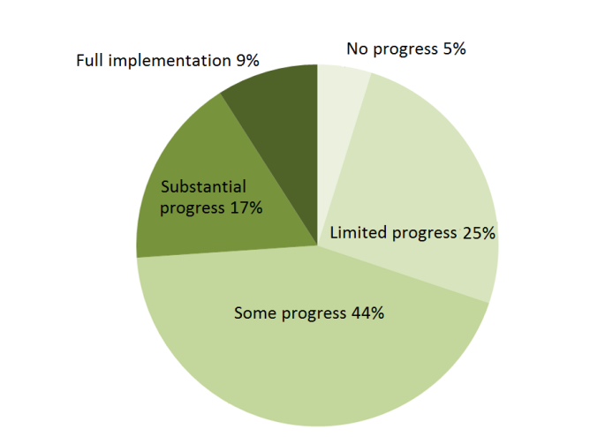

*Note: The multiannual assessment looks at implementation from the time the recommendations were first adopted until publication of this Communication in May 2018. The overall assessment of the country-specific recommendations related to fiscal policy includes compliance with the Stability and Growth Pact.*

*Figure 2: Implementation of country-specific recommendations: annual assessment in each consecutive year since 2011 versus implementation to date*

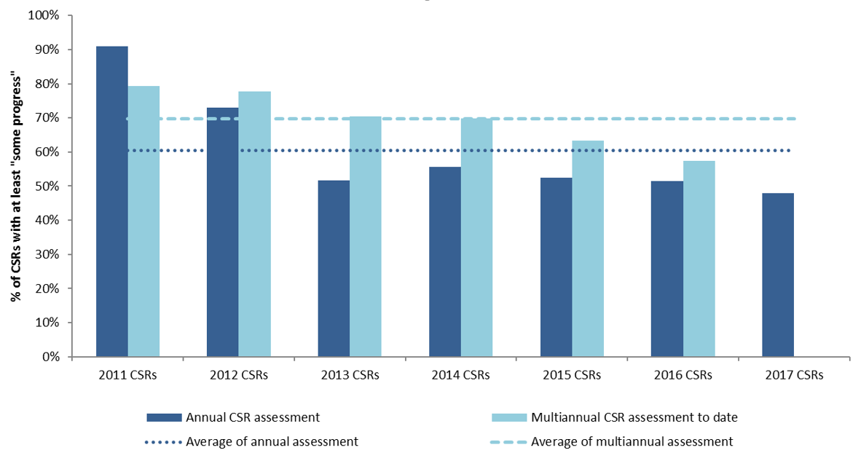

*Note: The multiannual assessment looks at implementation from the time the recommendations were first adopted until publication of this Communication in May 2018. For the years 2011 and 2012 it is more difficult to compare the annual with the multiannual assessment due to different assessment categories of the country–specific recommendations.*

**From an annual perspective, the implementation track-record is less satisfactory, as progress remains uneven across policy areas**. Compared to last year, Member States made the most progress in reforming their financial sectors, for instance by improving financing conditions, facilitating a durable resolution of non-performing loans and improving banking supervision.Sound progress has also been made in active labour market policies, which have become increasingly diverse and generally focused on a more tailored approach to individual needs. Research and development is also increasingly supported by governments' efforts to finance public research and development activities, increased profitability in the private sector and improving financing conditions. On the other hand, fighting tax evasion, improving tax administration, tackling tax avoidance and fighting against corruption showed mixed results. Modest progress has also been recorded in addressing the challenges posed by an ageing population to the long-term sustainability of public finances. This policy area is addressed in a high number of recommendations, but progress has only been limited. Education reforms, notably those aiming at improving access for disadvantaged groups and raising the overall quality of education, continue to represent a challenge, as only limited progress has been made in a majority of the Member States that received a recommendation in this area in 2017 (see Figure 3 and Appendix 2).

*Figure 3: Policy areas displaying highest and lowest level of CSR implementation*

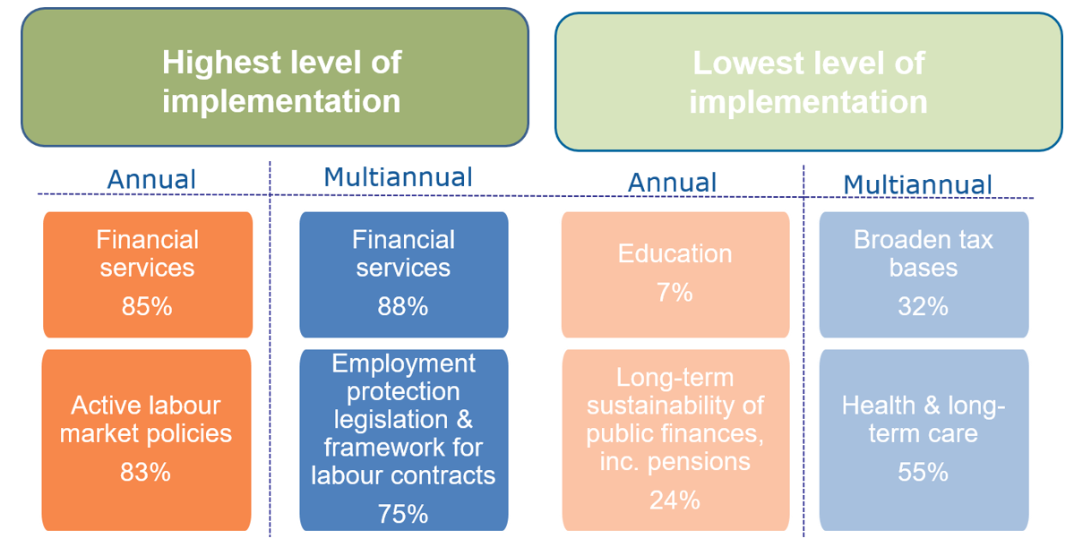

*Note: The percentages corresponds to the share of subparts with at least ‘some progress’ by policy area across Member States with a recommendation in that policy area.*

**The correction of macroeconomic imbalances continues, but in some Member States, different sources of imbalances remain unaddressed, and new risks have emerged.** While the large euro area current account surplus has stabilised, progress differs from country to country. In several countries, the previously large current account deficits have been corrected, while persistent surpluses are broadly unchanged in others. In some countries, levels of private, public and external debt remain persistently high. Deleveraging is taking place at an uneven pace, with faster reductions not always recorded where debt is higher. Keeping the debt on a solid declining path is key to resolutely reduce vulnerabilities in a context where monetary policy conditions are likely to gradually normalise. Further rebalancing could be supported if Member States with current account deficits or high external debt were to safeguard recent improvements in price competitiveness. Member States with large surpluses should promote faster wage growth and strengthen investment. For all countries, measures to enhance productivity are key to promote long-term growth and support real wage dynamics, which remain subdued in most countries and sectors, despite tightening labour markets. More dynamic wage developments, when translated into greater domestic demand, would support further the ongoing economic expansion. In a growing number of Member States, challenges linked to strong house price movements require close monitoring, as most of the previous undervaluation gaps are closing. This points to country-specific economic and financial challenges that are of particular importance for the well-functioning of the euro area, due to the strong economic and financial linkages between members of the currency union.

**Country-specific recommendations issued to the eleven Member States with identified imbalances will contribute to reducing these imbalances.** Improving economic conditions were reflected in the Commission's conclusions on macroeconomic imbalance procedure categorisation ([7]). Based on in-depth reviews of twelve Member States, the Commission identified imbalances in eleven of them. It was concluded that Slovenia is no longer experiencing imbalances and that the imbalances of Bulgaria, France and Portugal are no longer excessive. Overall, eight countries are currently identified as experiencing imbalances (Bulgaria, France, Germany, Ireland, Portugal, Spain, the Netherlands, and Sweden) and three countries experiencing excessive imbalances (Croatia, Cyprus and Italy). As in previous years, specific monitoring under the Macroeconomic Imbalances Procedure will take place for all countries with identified imbalances or excessive imbalances, with the depth of this monitoring process reflecting the scope of the challenges and the severity of the imbalances([8]).

**The 2018 Convergence Report ([9]) shows that further progress is needed for Member States with a derogation to be in a position to adopt the euro.** The euro, used every day by around 342 million people in 19 Member States, is meant to be the single currency of the European Union as a whole. All Member States, except Denmark and the United Kingdom, are required to adopt the euro, once they have achieved a high degree of sustainable convergence. Euro area accession is an open and rules-based process, regulated by the Treaty on the Functioning of the European Union and by Protocol No 13 on the convergence criteria. This year's biennial Convergence Report covers the seven Member States that are legally committed to adopt the euro: Bulgaria, the Czech Republic, Croatia, Hungary, Poland, Romania and Sweden. It examines the compatibility of national legislation and the progress of these Member States towards achieving a high degree of sustainable economic convergence by looking at the convergence criteria (price stability, public finances, exchange rate stability, and long-term interest rates). The Report also takes account of other factors mentioned in the Treaty on the Functioning of the European Union that are relevant to assess the sustainability of convergence.

**The Report concludes that at the moment, none of the countries examined fulfils all conditions for adopting the euro.** All seven Member States meet the criterion on public finances, with Bulgaria being the best performer by far with public debt below 30 % of GDP. All, except the Czech Republic, Hungary and Romania, meet the price stability criterion, with Bulgaria’s average inflation rate at only 1.4 %. Likewise, all examined Member States, except Poland and Romania, meet the criterion on long-term interest rates. On the other hand, no country fulfils the exchange rate criterion, as none of them has entered the European Exchange Rate Mechanism (ERM) II. Bulgaria's currency, the lev, is already pegged to the euro since 1999. The Bulgarian economy is therefore used to operate without a flexible exchange rate – similar to what ERMII membership requires. The review of other factors shows that while the countries are generally well integrated economically and financially in the EU, some of them still experience macroeconomic vulnerabilities and/or face challenges related to their business environment and institutional framework, which may pose risks as to the sustainability of the convergence process. Full legal compatibility is achieved only by one country, Croatia. Thorough preparation for euro area membership is essential and the Commission stands ready to help Member States on their path to joining the euro. As part of its proposals for the next Multiannual Financial Framework, the Commission will soon propose a dedicated programme supporting such convergence efforts.

# Key objectives of the country-specific recommendations

**The overall objective of the recommendations is to encourage the Member States to use the current favourable economic momentum to further strengthen the resilience of their economies.** Given the positive cyclical conditions, all Member States should prioritise reforms that increase their growth potential and make it more inclusive, improve the institutional and business environment, remove bottlenecks to investment, improve resource efficiency, support the creation of quality jobs, reduce inequalities, address skills challenges, ensure effective, resilient and accessible healthcare and improve social safety nets.

*Public finance, taxation and financial sector*

**Looking back, the flexibility under the Stability and Growth Pact, identified by the Commission with the support of the Council, allowed striking the right balance between ensuring fiscal responsibility and supporting growth in the short and medium run.** The Commission conducted a review on the use of flexibility within the existing rules since its introduction in 2015([10]). First, the modulation of the required budgetary adjustment helped preserve the recovery where it was most fragile, while supporting the achievement of a sound budgetary position and promoting debt reduction at satisfactory pace although building fiscal buffers remains a priority for some Member States. Second, the use of flexibility to foster structural reforms and public investment appears to have been appropriate and economically justified for those Member States that actually benefitted from it. At the same time, the full impact of reforms and investment on growth can only be assessed over the medium term.

**As economic conditions steadily improve, it is the time to rebuild fiscal buffers in high-debt countries and use the fiscal space in surplus countries to make their economies more resilient and support growth.** Public finances in the Union are set to continue improving**.** Benefiting from the broadening economic expansion, the general government deficit decreased in 2017 to 1.0 % of GDP in the European Union, and is expected to further decline. By the same token, general government debt fell to 83.1 % of GDP in the European Union and is projected to continue its steadily declining path. The fiscal stance was broadly neutral in 2017 and should remain so in 2018. With unchanged policies, most countries − including several ones with high public debt − are forecast to expand or only marginally reduce their structural deficit in 2019 and would thus remain exposed to possible future shocks. The country-specific recommendations set a required fiscal adjustment effort consistent with the Stability and Growth Pact for Member States which have not yet reached their medium-term budgetary objective. However, Member States with adequate scope are also recommended to use fiscal and structural policies within the rules of the Stability and Growth Pact to support growth to facilitate their economic rebalancing and provide non-negligible spill-overs to other Member States. The resultant mix of fiscal policies among Member States would make the aggregate fiscal stance for the euro area in 2019 broadly neutral, striking the right balance between attaining public finance sustainability and safeguarding the ongoing economic expansion and pick-up in employment.

**Over the years, Member States have significantly improved their fiscal frameworks, and this is now paying off in terms of contribution to the improved budgetary outlook.** Reforms have to continue in some Member States to reap the benefits of strong domestic fiscal frameworks and to ensure that Member States collectively contribute to fiscal prudence at the Union level. While Croatia and Romania are recommended to enact or implement broad reforms to their fiscal framework, Belgium and Poland require targeted improvements, such as coordination across levels of government, improvement of budgetary procedures or independent monitoring.

**To ensure that public finances are available for medium-to-long-term investment projects, close attention should be payed to their composition.** Appropriate allocation of public revenues and expenditures across various policy areas would result in a mix that is more conducive to growth. Further efforts are also needed to make taxation and expenditure more efficient and more effective at all levels of government. Rigorously implemented spending reviews are a useful tool to improve the allocation of taxpayers’ money. In line with this year’s recommendations, Austria, Belgium, Bulgaria, Finland, France, Hungary, Poland, Portugal and Romania should take action in this area.

**The impact of an ageing population on national budget warrants reforms of the pension, healthcare and long-term care systems.** These are key to ensure long-term sustainability of public finances as well as adequate and accessible social security and healthcare. Experience has proven that this area is one of the most challenging to reform, which is why reforms need to be legislated promptly but implemented gradually, so that affected groups are given the opportunity to adapt. Various Member States have nevertheless taken steps to reform their pension and health systems, and audacity is needed to preserve those reforms. The Commission recommends further reforms in these areas for a number of Member States, for example the Czech Republic, Ireland, Hungary or Lithuania.

**Further efforts are necessary to address high levels of labour taxes while safeguarding the necessary revenue for public policies**, to increase incentives to work and support job creation for more vulnerable population groups**.** Several Member States continued their efforts to reduce the tax burden on labour, focusing in particular on low-income earners, and further efforts are recommended this year to Austria, Germany, Italy and Latvia. Nevertheless, tax reforms have to protect the revenue for adequate social protection and investment. In this context, a number of recommendations to broaden the tax base are issued for Croatia, Italy or Lithuania, for example by introducing a recurrent property tax in Croatia.

**Improving tax rules and administration is essential to ensure the sustainability of Member States' tax systems and secure a level playing field and a positive business environment for companies.** A stable, simple and cost-efficient tax system can improve tax compliance and contribute to a positive investment climate. Recommendations are therefore proposed to simplify the tax system in France and Hungary, increase its efficiency in Germany, and improve tax administration and compliance in Bulgaria, Lithuania and Romania. As indicated in the 2018 euro area recommendation, the fight against taxpayers' aggressive tax planning strategies is essential to impede distortions of competition between firms, provide fair treatment of taxpayers, and safeguard public finances, thereby also helping preserve social cohesion and fight inequalities. Spill-over effects of taxpayers' aggressive tax planning strategies between Member States call for a coordinated action of national policies to complement the Union legislation.Member States have engaged at European level to enhance tax transparency and agree on a minimum level of protection against abuse. They have also taken steps at national level, for example by amending or repealing their patent box that facilitated aggressive tax planning, or changing their tax residency rules. Despite this progress, a thorough review of tax rules and relevant economic indicators shows that the tax system of a number of Member States continues to be exploited by multinationals that engage in aggressive tax planning.

**Progress has been made over the last year to strengthen the financial sector in a number of Member States, bringing down both the stock and the flows of non-performing loans.** Steps have notably been taken to improve the insolvency framework, to strengthen the supervisory framework and reduce non-performing loans, including through asset management companies. Further actions are recommended to Bulgaria, Cyprus and Malta to strengthen the supervision of the financial sector in those segments where national authorities remain competent. A number of Member States also continue to be affected by large shares of non-performing loans. Country-specific recommendations are addressed to Bulgaria, Cyprus, Ireland, Italy and Malta in this sense.

**Developments in the housing market can have a destabilising impact on the financial sector, requiring action in some Member States**. Housing is generally the main asset held by households, and real estate is also routinely used as collateral for loans by companies. Preventing booms and busts would thus increase the resilience of economies to potential shocks, especially if there is correction in housing prices. On that account, Ireland, the United Kingdom, the Netherlands and Sweden are recommended to reduce bottlenecks to housing supply. Reducing the debt bias, created notably by the tax system, such as mortgage interest deductibility, would contribute to decrease the high indebtedness of households in Sweden.

|  |
| --- |
| **Box 1. Update on surveillance under the Stability and Growth Pact**  Based on the assessment of the 2018 Stability and Converge Programmes, the Commission has also taken a number of steps under the Stability and Growth Pact.  The Commission recommends that the excessive deficit procedure is closed for France. This would leave only Spain, which has a deadline of 2018 to correct its excessive deficit, under the corrective arm of the Pact.  The Commission has adopted reports for Belgium and Italy under Article 126(3) TFEU, in which it reviews their compliance with the debt criterion of the Treaty. For Italy, the conclusion is that the debt criterion should be considered as currently complied with. For Belgium, there was no sufficient evidence to fully conclude on whether the debt criterion is or is not complied with. However, in both countries the fiscal adjustment in 2018 currently appears inadequate. The Commission will reassess compliance on the basis of the ex-post data for 2018 to be notified in Spring 2019.  The Commission also recommends the Council to decide that Romania has not taken effective action in response to the Recommendation of December 2017 under the significant deviation procedure. The latter was opened in June 2017 following the observed significant deviation in 2016. Furthermore, the Commission is addressing a warning to Hungary and Romania on the existence of a significant deviation from the adjustment path toward the medium-term budgetary objective in 2017. This is the second warning addressed to Romania. The Commission recommends the Council to adopt a recommendation for Hungary and Romania to respond appropriately with a view to correcting this significant deviation. The significant deviation procedure provides the authorities the opportunity to take corrective action in order to avoid the opening of an excessive deficit procedure. |

*Labour market, education and social policies*

**While labour market conditions are improving across the board, further efforts are needed to ensure everyone benefits from the recovery and to improve sustainability of welfare systems.** Significant gaps persist in the rate of participation of different population groups in the labour market. This is the notably the case of the low-skilled, young, older people, persons with a migrant background, or people with disabilities. Austria, Belgium and France are recommended to adopt measures to improve the labour market situation of persons with a migrant background. Austria, the Czech Republic, Estonia, Italy and Poland should tackle the gender gap in terms of employment rate and pay level, often caused by a lack of adequate care services, work-life balance opportunities or disincentives enshrined in the tax and benefit system. In Spain, the Netherlands, Poland and Portugal, labour market segmentation should be addressed, by measures such as promoting transitions towards open-ended contracts, tackling incentives for employers to hire temporary employees and ensure equal access to social protection for workers under those arrangements.

**In light of technological change and demographic challenges, further investment in skills is essential to sustain innovation and productivity growth**. Reskilling and upskilling are key to make labour markets more dynamic and inclusive, so that everyone can participate fully in society or engage in entrepreneurship. Transitions from lower-skilled to higher-skilled career opportunities should be supported, with resolute policy action and adequate investment recommended for Ireland, Latvia, Slovakia or the United Kingdom. Belgium is recommended to increase the proportion of graduates in science, technology, engineering and mathematics.

**Efforts should also focus on improving the quality of education and training systems and ensuring equal access**, including for disadvantaged groups such as Roma, persons with a migrant background and people with disabilities. Educational inequality, and its inter-generational transmission, represents a threat to social cohesion and the long-term prosperity of European societies. This year’s recommendations thus focus on quality and achievement in basic skills in Austria, reducing early school leaving in Spain, improving the situation of teachers in the Czech Republic, increasing labour market relevance of education in Croatia, Latvia or Lithuania, improving adult learning in Poland, Lithuania, Slovenia and Portugal, and vocational training in Cyprus, France and Italy. Recommendations have been addressed to Bulgaria, Czech Republic, Hungary, Romania and Slovakia to improve access to quality and inclusive mainstream education for disadvantaged groups, in particular Roma.

**With employment recovering, the social situation is improving in most Member States.** However, as evidenced by the Social Scoreboard, critical socioeconomic developments such as high income inequality and in-work poverty, low impact of social transfers or limited access to social services are identified in a number of Member States. This year's country-specific recommendations devote particular attention to the inclusiveness and effectiveness of social protection schemes, for example in Spain, Hungary, Croatia, Estonia, Lithuania and Latvia.

**Health systems need to be reformed to offset the impact of an ageing population and improving access to healthcare**. Many Member States have recently undertaken a number of reforms of their healthcare systems in order to increase cost-effectiveness, financial sustainability, resilience, affordability and accessibility and improve the health status of their populations. Recommendations thus encourage Member States to implement recently adopted or soon-to-be-agreed reforms for better cost-effectiveness and accessibility in Cyprus, Finland, Lithuania and Slovenia, take decisive action to ensure adequate and efficient budgeting in Portugal, increase  fiscal sustainability and cost-effectiveness in Malta, Austria and Ireland, strengthen primary and outpatient care in Latvia, Lithuania and Romania, invest in disease prevention in Lithuania, improve the situation regarding health workforce in Bulgaria and Slovakia and reduce out-of-pocket payments in Bulgaria and Latvia.

**The contribution of social dialogue when designing and implementing policy is important for improving co-ownership of reforms and ensuring that they are successful, sustainable and inclusive**. Since the adoption of the 2017 country-specific recommendations, some Member States have taken action to increase opportunities for structured dialogue and the participation of employers’ organisations and trade unions. In other cases such a framework does not exist or only plays a marginal role. While there is no single model that serves as a reference, there is room for more social dialogue and a greater involvement of social partners in policy design in Hungary and Romania.

*Sectoral policies to foster investment and productivity growth*

**Good progress in overcoming the legacy of the crisis has allowed focusing on the underlying productivity challenges**. While most Member States have received country-specific recommendations in areas related to productivity growth already in the past, the time has now come to make more substantial progress in advancing these reforms. Investment in infrastructure and research and development are essential in this respect. Ensuring that investment in innovations is channelled into the most productive areas requires various steps: Regulatory obstacles need to be removed, business environment improved and entrepreneurship supported. Accordingly, country-specific recommendations are more targeted at the specific needs of each Member State to foster investment and rekindle productivity growth.

**Innovation and investment in research and development and digitisation policies will have a positive and durable impact on productivity, but priorities vary significantly across Member States**. Digitalisation levels vary considerably across countries in terms of infrastructures or the availability of digital skills and even those Member States with good overall performance may show significant internal differences across regions. Strengthening public or private research and development in terms of investment or effectiveness through better targeting is recommended for Estonia, Spain, France, Ireland, Italy Lithuania, or Slovakia. Closer collaboration between business and research institutions should be promoted in France, Ireland, Lithuania and Poland.

**Sustained investment in infrastructure is necessary to improve the business environment and boost the potential for growth**. Good network infrastructure lowers the cost of starting or operating a business, and interconnections between Member States and regions are key to capitalise the full potential of the Single Market. The crisis has led to less investment in infrastructure, especially in the most affected Member States. In those cases, investment was especially low in transport, energy and digital infrastructure, which has significant negative externalities for society and the environment. These sectors still requires significant investment, including in those Member States that fared well during the crisis. In a number of countries, waste and water management infrastructures also require further investments to ensure their modernisation and support the transition towards a more circular economy. Recommendations concerning infrastructure are proposed for Belgium, the Czech Republic, Germany, Ireland and Romania.

**Reforms to create competitive and dynamic markets would open up** **new growth opportunities that firms could easily take advantage of in good economic times.** Reforms that facilitate market opening, market entry, firm growth, restructuring or market exit of inefficient firms, and the creation of new business models stimulate productivity and benefit citizens and the wider economy. Restrictive regulation in the services sector increases significantly the costs for large consumers of services, such as manufacturing industries. In particular, the reforms in business services, that present an increasingly important input into other industries, will result in productivity growth by lowering costs and increasing the availability and quality of the services inputs offered. Recommendations on regulatory reform, notably in services, are addressed to Austria, Belgium, Croatia, Germany, Italy, France, Hungary, Luxembourg and Slovenia.

*Public administration and the business environment*

**The business environment has improved due to the strong upswing but also thanks to structural reforms.** Efforts in that direction should continue in the future, including in those countries with a relatively better position in order to keep their advantage at the global level. Recommendations for improving various aspects of efficiency and quality of public administration are issued this year for Cyprus, Croatia, and Italy. Governance and economic performance of state-owned enterprises remain an issue in many Member States and recommendations have been addressed to Bulgaria, Cyprus, Croatia, Italy, Portugal and Romania.

**Further efforts to ensure independence and effectiveness of the justice system, improve public procurement and tackle corruption are needed in a number of Member States**. Addressing these challenges is essential for improving business confidence and the investment climate, and for ensuring the success of other structural reforms. Measures have been taken to improve the functioning of public procurement in several countries, including the introduction of e-procurement. However, competition, transparency aggregation and professionalization in public procurement remain areas for improvement, and also the potential of strategic public procurement stays largely untapped. The Czech Republic, Spain, Hungary, Romania, Slovenia and Slovakia are addressed recommendations related to public procurement. Although some Member States have adopted new anti-corruption measures, corruption remains an acute issue in several Member States, with negative impacts on the potential for economic growth and the business environment. In various cases, there is a need to strengthen effective investigation and prosecution of corruption and improve prevention. Whistle-blower protection, lobbying legislation, assets and interests disclosure and verifications, adequate resourcing of anti-corruption bodies as well as transparency and public access to information are also areas requiring further improvements. A number of Member States have received recommendations focussing on these aspects. Croatia, Cyprus, Italy, Portugal and Slovakia have received a recommendation to improve the effectiveness of their justice systems.

**Access to finance has improved thanks to reforms and the economic upswing, but future resilience depends on providing firms with more equity financing options**. Access to finance has improved considerably thanks to the tailwinds from the business cycle but also thanks to reforms in a number of countries. It remains however subdued in some Member States, notably as regards small and medium-sized enterprises. In particular, young, innovative and fast growing companies depend on venture capital and access to public capital markets for their funding needs in the early and later stages of growth. Country-specific recommendations on access to finance are proposed for Cyprus, Italy and Portugal.

# Conclusion

**The improved economic and social climate offers a unique opportunity to make Europe’s economies stronger and more resilient**. With its continued focus on the 'virtuous triangle' of investment, structural reforms, and responsible fiscal policies, the European Semester helps Member States take full advantage of this opportunity. As the economy expands, it is high time that Member States step up efforts in the pursuit of greater macro-economic resilience and growth-enhancing reforms.

**The Commission calls on the Council to endorse the proposed approach for the 2018-2019 country-specific recommendations** **and the related decisions under the Stability and Growth Pact.** It calls on the Member States to implement them fully and in a timely manner, in dialogue with social partners and all relevant stakeholders. For its part, the Commission remains committed to maintaining an open, inclusive dialogue with national stakeholders throughout the European Semester process. Moreover, the Commission stands ready to provide Member States with support, should they so request, through the Structural Reform Support Service. To further support the implementation of national reform agendas, the Commission intends to present a new Reform Support Programme as part of its proposals for the post-2020 multiannual financial framework. The programme will have an overall budget of EUR 25 billion and will offer financial and technical support to all Member States for the pursuit of priority reforms identified in the context of the European Semester.

**Appendix 1: Overview of issues covered in the country-specific recommendations for 2018-2019**

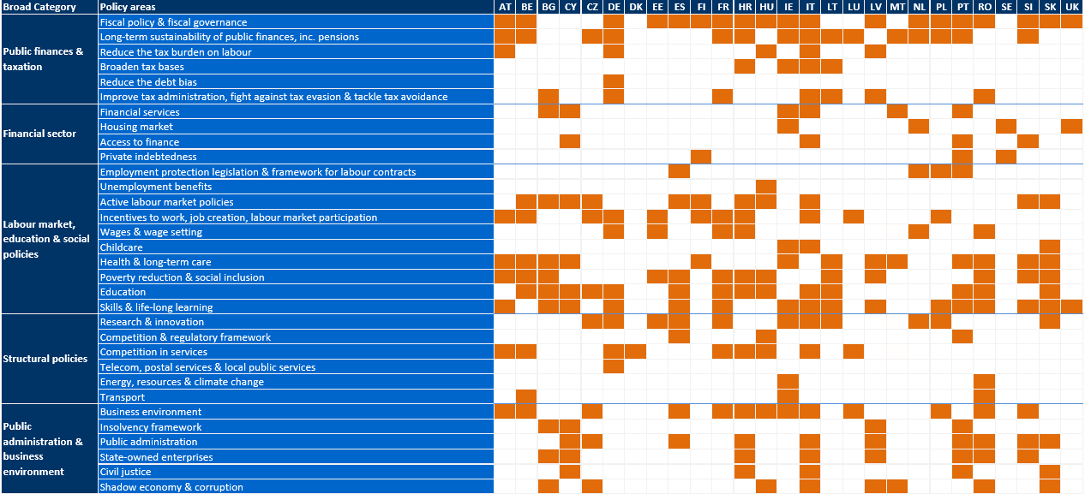

**Appendix 2: Assessment of progress on 2017 country-specific recommendations by policy area** 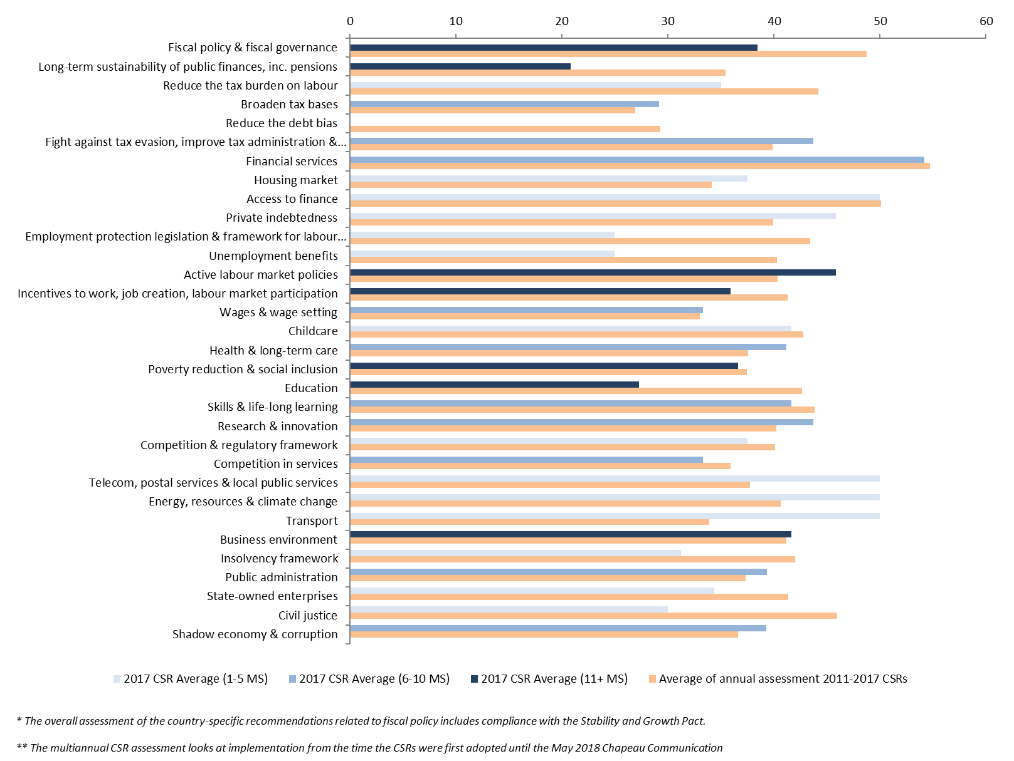

1. Communication from the Commission to the European Parliament, the Council, the European Central Bank, the European Economic and Social Committee, the Committee of Regions and the European Investment Bank: Annual Growth Survey 2018, COM(2017) 690 final.
2. Council recommendation on the economic policy of the euro area, 14 May 2018.
3. Interinstitutional proclamation endorsing the European Pillar of Social Rights, 17 November 2017.
4. Communication from the Commission to the European Parliament, the Council and the European Economic and Social Committee: Monitoring the implementation of the European Pillar of Social Rights, COM(2018)130 final.
5. Regulation (EU) No 2017/825 of the European Parliament and of the Council of 17 May 2017, on the establishment of the Structural Reform Support Programme - Work Programme for 2018.
6. Targeted changes in the Common Provisions Regulation to mobilise funds in support of national reforms, COM(2017) 826 final.
7. Communication from the Commission to the European Parliament, the Council, the European Central Bank and the Eurogroup: 2018 European Semester: Assessment of progress on structural reforms, prevention and correction of macroeconomic imbalances, and results of in-depth reviews under Regulation (EU) No 1176/2011, COM(2018) 120 final.
8. For Bulgaria and Portugal, the Commission decided specifically on 7 March 2018 that policy commitments and the evolution of imbalances will be monitored closely as further efforts remain necessary to achieve a sustainable correction.
9. Report from the Commission to the European Parliament and the Council – Convergence Report 2018, COM(2018) 370 final.
10. Communication from the Commission to the European Parliament, the Council, the European Central Bank, the European Economic and Social Committee and the European investment Bank on the review of the flexibility under the Stability and Growth Pact, COM(2018) 335 final.