

Table of Contents

1. Introduction: Political and legal context 4

1.1. Scope and context 4

1.2. Lessons learned from previous programmes 10

2. The objectives 14

2.1. Challenges for the programmes of the next MFF 14

2.2. Objectives 21

3. Programme structure and priorities 24

3.1. Subsidiarity and added value of the ERDF and CF 24

3.2. Policy options 29

3.3. Simplifying and consolidating the priority objectives 39

3.4. Coherence and synergies with other policies 52

4. Delivery mechanisms of the intended funding 59

4.1. Programming: flexibility for emerging needs, return to "n+2" 59

4.2. Enabling conditions and governance 60

4.3. Simplification 62

4.4. Financial instruments ("FIs"): simplification and streamlining 66

4.5. Performance, flexibility and simplification: conclusions on the new system of priorities and delivery 68

5. How will performance be monitored and evaluated? 69

5.1. Monitoring 69

5.2. Evaluation 74

1. Lead DG(s), D*e*cide Planning/CWP references 76

2. Organisation and timing 76

3. Consultation of the Regulatory Scrutiny Board (RSB) 76

4. Evidence, sources and quality 78

**Figures, maps and tables**

Figure 1 - ERDF planned spending by key priorities 2014-20 (EUR bn) 7

Figure 2 - CF Planned spending, 2014-20 (EUR bn) 8

Figure 3 - Impact of 2021-2027 ERDF and CF programmes on GDP, 2030 18

Figure 4 - ERDF and CF as % of public investment, 2015-2017 24

Figure 5 - Thematic concentration increases under the preferred option 30

Figure 6 – Impact of the options on EU GDP 31

Figure 7 - GDP impact of the preferred option 3, 2030 and 2040 32

Figure 8 - Impact of 2020-2027 RTD programmes on EU-27 GDP, 2020-2035 52

Figure 9 - What do you see as the main benefit of the performance framework? 70

Map 1 - ERDF eligibility 2014-20 6

Map 2 - Cohesion Fund eligibility 2014-20 9

Map 3 - Impact of 2020-2027 regional policy programmes on GDP, 2030 20

Map 5 - Risk factors linked to globalisation and technological change 34

Map 6 - Regional distribution of FP7 expenditure 52

Map 7 – RTD component of 2020-2027 ERDF: impact on regional GDP, 2030 54

Table 1 – ERDF and CF envelope for 2021-27 5

Table 2 - EU and national contributions to the ERDF, 2014-20 (euro billion) 5

Table 3 - EU and national contributions to the CF and ERDF, 2014-20 (euro billion) 8

Table 4 - Evaluation lessons: what was addressed in 2014-20, what remains? 13

Table 5 - Links between challenges and policy proposals 22

Table 6 - Firms supported and jobs created 2014-20 28

Table 7 – Comparison of key features of baseline and options 30

Table 9 - % impact on GDP 2030 and 2040 31

Table 10 - Thematic concentration thresholds 36

Table 11 - EU and national contributions to the ERDF and CF, 2014-20 (euro billion) 37

Table 12 - Proposed priorities in the new period with target indicators 43

Table 13 - The complementary roles of FP9, COSME and ERDF 51

Table 14 - Main monitoring data collected for ERDF and CF 2014-2020 68

Table 15 - Evaluations planned by Member States 2014-2020 73

**Glossary**

|  |  |
| --- | --- |
| ***Term or acronym*** | ***Meaning or definition*** |
| AMIF | Asylum and Migration Fund |
| CEF | Connecting Europe Facility |
| CF | Cohesion Fund |
| Cohesion Policy | CF, ERDF and ESF |
| COSME | EU programme for competitiveness of SMEs |
| CPR | Common Provisions Regulation. Will provide common regulations for all shared management funds (including ESI Funds and AMIF) |
| DEP | Digital Europe Programme |
| DG REGIO | Directorate General for Regional and Urban Policy |
| EAFRD | European Agricultural Fund for Rural Development |
| EMFF | European Maritime and Fisheries Fund |
| ERDF | European Regional Development Fund |
| ESF | European Social Fund |
| ESI Funds | European Structural and Investment Funds – the collective name for CF, EAFRD, EMFF, ERDF and ESF |
| ETC | European Territorial Cooperation ("Interreg") |
| EU | European Union |
| EU-13 | All Member States that joined the EU since 2004 |
| FI | Financial Instrument. In the context of ERDF and CF this will typically be loan, equity or guarantee. |
| FP7 and 9 | 7th and 9th EU Framework Programmes for Research and Innovation |
| GDP | Gross Domestic Product |
| GNI | Gross National Income |
| IA | Impact Assessment |
| ICT | Information and communication technology |
| MFF | Multi-annual Financial Framework |
| OPs | Operational Programmes – individual regional or national programmes for the ERDF. |
| QUEST | Macroeconomic model, used to model impact of ERDF and CF |
| RIS3 | Research and Innovation Strategies for Smart Specialisation |
| RSB | Regulatory Scrutiny Board |
| Rhomolo | Macroeconomic model, used to model impact of ERDF and CF |
| TEN-E, TEN-T | Trans-European Energy and Transport Networks |
| TO | Thematic Objective |

# Introduction: Political and legal context

## Scope and context

*"What should the future EU budget focus on? First, reducing economic and social divergences between and within Member States is crucial for a Union that aims for a highly competitive social market economy" (Reflection paper on EU finances[1])*

On 2 May 2018, the European Commission adopted its proposals for a new Multiannual Financial Framework (MFF) for 2021-2027. Under [these proposals](https://ec.europa.eu/commission/priorities/democratic-change/future-europe/eu-budget-future_en), the European Regional Development Fund (ERDF) and Cohesion Fund (CF) will have a budget of EUR 273 billion over the period. This impact assessment report reflects the decisions of the MFF proposals and focuses on the changes and policy choices which are specific to the ERDF and CF.

The mission of the ERDF and CF is laid down in the treaties (see box below): economic, social and territorial cohesion. This means[2] reducing regional and national disparities across a broad range of themes: innovation, competitiveness, jobs, environment, transport, education and health infrastructure. It also means cross-border co-operation and sustainable urban development.

The ERDF and CF are key investment policies in the EU Budget, equivalent in the 2014-20 programme period to 8.5% of government capital investment in the EU, rising to 41% for the EU-13[3]. Both funds contribute to achieving EU objectives, including jobs, growth and investment, digital single market and Energy Union.

|  |
| --- |
| **The Treaty basis**  Article 174 of The Treaty on the Functioning of the European Union: *"The Union shall develop and pursue its actions leading to the strengthening of its economic, social and territorial cohesion. In particular, the Union shall aim at reducing disparities between the levels of development of the various regions and the backwardness of the least favoured regions".*  Article 176: *The European Regional Development Fund is intended to help to redress the main regional imbalances in the Union through participation in the development and structural adjustment of regions whose development is lagging behind and in the conversion of declining industrial regions.*  Article 177: *A Cohesion Fund set up in accordance with the same procedure shall provide a financial contribution to projects in the fields of environment and trans-European networks in the area of transport infrastructure.* |

There will be common rules for shared management funds – the Common Provisions Regulation (CPR). This convergence of rules will enhance coherence and synergies among the Funds. The CPR will therefore cover the following funds:

* ERDF and CF – the subject of the current impact assessment
* ESF+: European Social Fund +
* EMFF: European Maritime and Fisheries Fund
* AMIF: Asylum and Migration Fund
* ISF: Internal Security Fund
* BMVI: Border Management and Visa Instrument

The other funds have their own impact assessments. This impact assessment satisfies the requirements of the Financial Regulation in respect of preparing an ex-ante evaluation.

Table 1 – ERDF and CF envelope for 2021-27

|  |  |
| --- | --- |
| **ERDF and CF total** | **273 000** |
| **European Regional Development Fund (ERDF)** | **226 308** |
| * Investment for growth and jobs | 215 172 |
| * European territorial cooperation | 9 500 |
| * Outermost regions and sparsely populated areas | 1 637 |
| **Cohesion Fund (CF)** | **46 692** |
| * of which contribution to CEF Transport | 11 285 |

**ERDF – regional development, economic transformation, territorial co-operation**

The ERDF was set up in 1975 and provides financial support for regional development, economic change and transformation, and territorial cooperation. All EU regions are eligible (see Map 1). Resources are distributed so that the highest aid intensity is in the less developed regions (see Table 2).

Table 2 - EU and national contributions to the ERDF, 2014-20 (euro billion)

|  |  |  |  |  |
| --- | --- | --- | --- | --- |
|  | EU amount | National cofinancing | total funding | % EU amount |
| Less developed | 130.3 | 36.2 | 166.5 | 78% |
| More developed | 32.3 | 29.6 | 61.9 | 52% |
| Northern sparsely populated and outermost regions | 1.6 | 1.0 | 2.5 | 62% |
| Transition | 25.4 | 10.9 | 36.3 | 70% |
| Interreg | 9.8 | 3.3 | 13.1 | 75% |
| Total ERDF | 199.4 | 80.9 | 280.3 | 71% |

*Less developed regions: those with GDP/head < 75% of the EU 27 average  
Transition region: GDP/head between 75% and 90% of the EU 27 average  
Eligibility for this period was calculated with UK but without Croatia  
Source: ESI fund Open Data Platform -* [*https://cohesiondata.ec.europa.eu/*](https://cohesiondata.ec.europa.eu/) *(February 2018)*

Map 1 - ERDF eligibility 2014-20

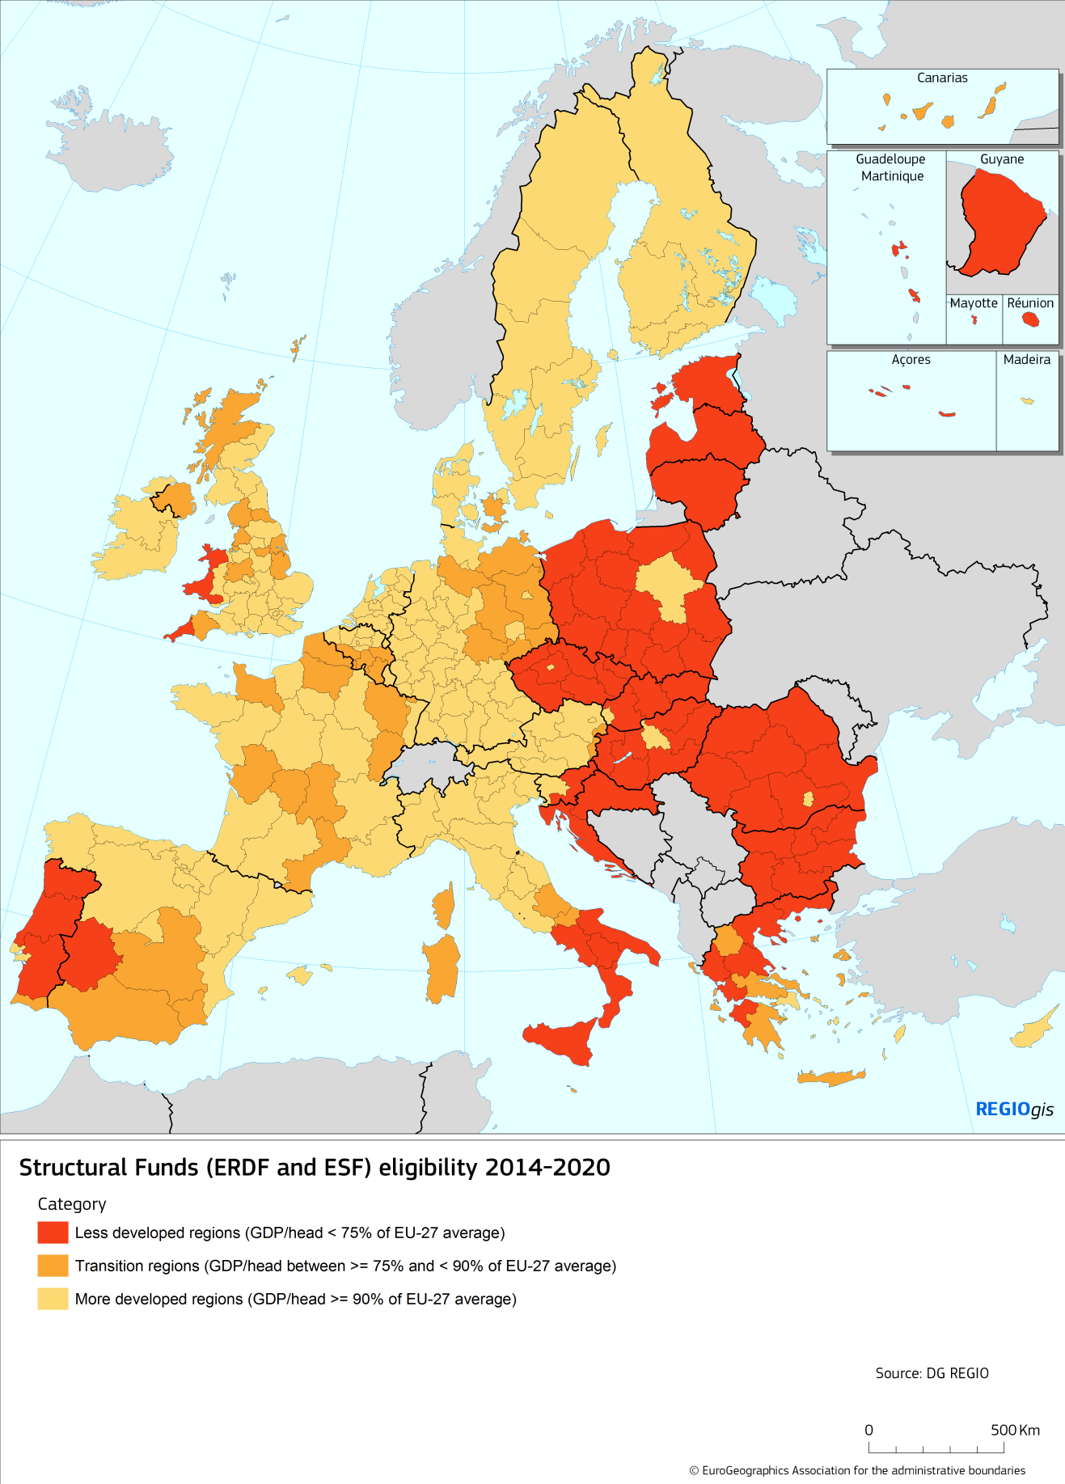

Figure 1 - ERDF planned spending by key priorities 2014-20 (EUR bn)

*Source: ESI fund Open Data Platform -* [*https://cohesiondata.ec.europa.eu/*](https://cohesiondata.ec.europa.eu/) *(September 2017[4])*

In line with its broad overall mission (see treaties, above), the ERDF tackles a wide variety of investment priorities, covering the full range of economic, social and territorial cohesion (see Figure 1). But in line with the priority for structural adjustment and economic conversion, nearly half of the money (45%) is invested in smart growth – research and innovation, ICT and SME support. A further quarter (28%) is invested in various environmental measures, notably the transition to the low carbon economy.

Three noteworthy priorities are cross-border, transnational and inter-regional co-operation, the outermost regions and Northern sparsely populated regions.

**CF – transport and environmental infrastructure in poorer countries**

Since 1994, the Cohesion Fund has supported environmental measures and trans-European transport and energy networks – particularly high-priority projects of European interest. The Cohesion Fund may also be used to finance the priorities of the EU's environmental protection policy. Investment is divided relatively evenly between transport and energy projects on the one hand and environmental projects (including energy projects) on the other (see Figure 2).

Eligible countries are referred to in this report as Cohesion Countries (see Map 2). These are Member States with a Gross National Income (GNI) per inhabitant below 90 % of the EU average, i.e. the 13 Member States that have joined the EU since 2004, as well as in Greece and Portugal.

Figure 2 - CF Planned spending, 2014-20 (EUR bn)

*Source: ESI fund Open Data Platform -* [*https://cohesiondata.ec.europa.eu/*](https://cohesiondata.ec.europa.eu/) *(September 2017)*

Table 3 - EU and national contributions to the CF and ERDF, 2014-20 (euro billion)

|  |  |  |  |  |
| --- | --- | --- | --- | --- |
|  | EU amount | National cofinancing | total funding | % EU amount |
| CF | 63.3 | 12.1 | 75.4 | 84% |
| ERDF | 199.4 | 80.9 | 280.3 | 71% |
| total | 262.7 | 93.1 | 355.7 | 74% |

*Source: ESI fund Open Data Platform -* [*https://cohesiondata.ec.europa.eu/*](https://cohesiondata.ec.europa.eu/) *(February 2018)*

**Shared management – a key feature in assessing added value and delivery reforms**

The ERDF and CF are delivered under shared management. Programmes are not run directly by the Commission, instead they are implemented in partnership with the Member States. The principles and priorities of Cohesion Policy are distilled through a process of discussion between the Commission and Member States. But day to day management is in the hands of managing authorities appointed by the Member States.

A managing authority may be a national ministry, a regional authority, a local council, or another public or private body that has been nominated and approved by a Member State. They are responsible for efficient management and implementation of a programme.

Map 2 - Cohesion Fund eligibility 2014-20

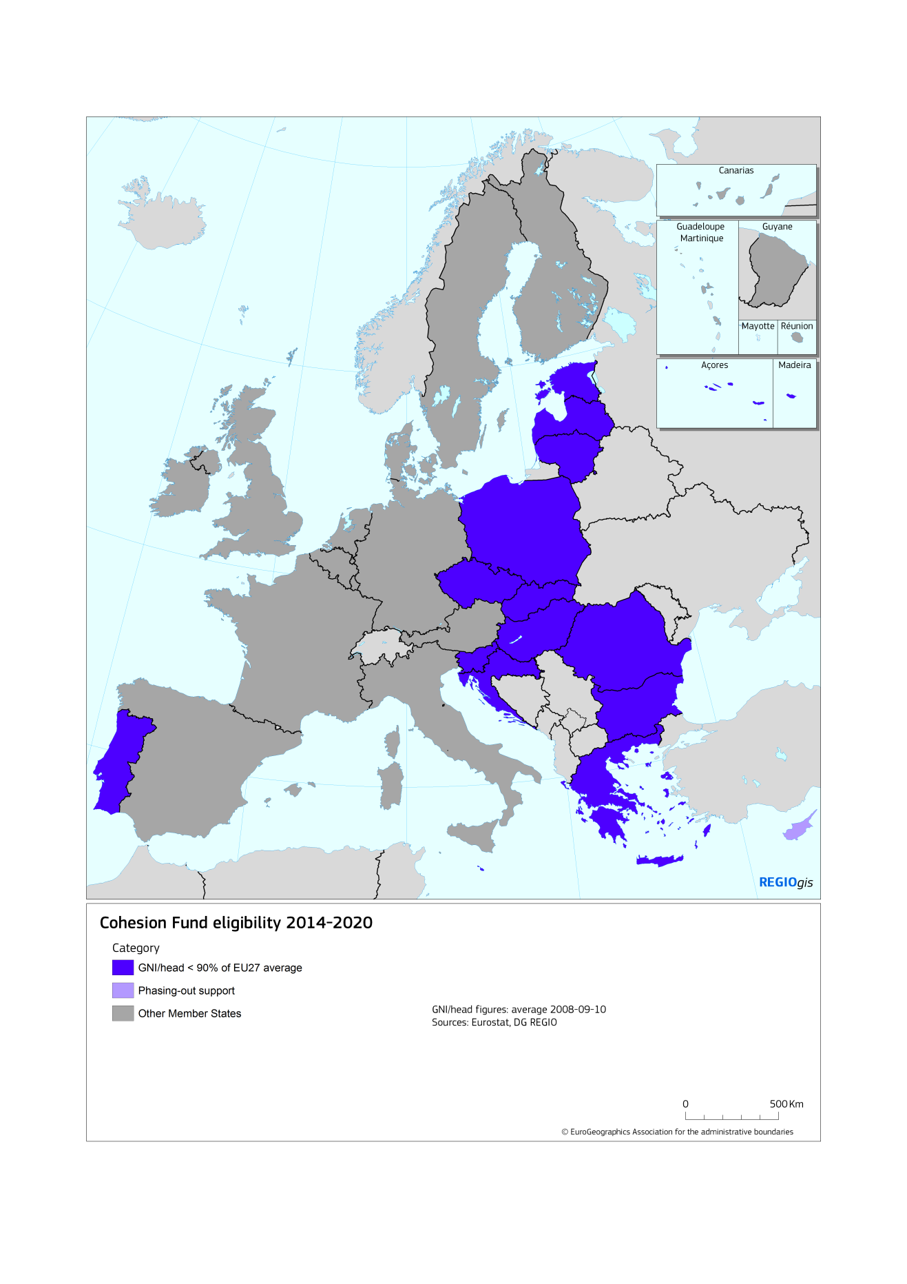

## Lessons learned from previous programmes[5]

The ex post evaluation of the ERDF and CF[6] for 2007-13 found **a wide range of achievements** across the fields of economic, social and territorial cohesion, including:

* 400 000 SMEs were financially supported and this support led directly to the creation of 1.1 million jobs. Although this is only 2% of firms in the EU, support focussed on strategic enterprises – in the manufacturing sector, an estimated 15% of small firms and over a third of medium sized firms received financial support.
* Transport bottlenecks were removed, travel times reduced and urban trams and metros supported, often with substantial environmental benefits such as reduced local air pollution. This included the construction of 4900 km of roads, mostly motorways (of which 2400 km on the TEN-T). It also included the construction or upgrading to necessary standards of 2600 km of TEN-T railway.
* The ERDF and CF also made a significant contribution to the environment: a substantial number of landfill sites which did not comply with EU standards were closed down while in the Czech Republic, Hungary, Lithuania, Poland and Slovenia, as well as Croatia, the proportion of waste which was recycled was increased by over 10 percentage points.
* Investment in social infrastructure led to the modernisation of schools and colleges in Portugal, benefiting 300 000 children and young people as well as the upgrading of schools and healthcare facilities in Poland for 1.9 million people.
* Despite the relatively small funding intensity of Interreg cross-border programmes (EUR 20 per head of population), by end 2013 they had funded over 6800 projects in policy areas which are EU priorities. These included the creation and expansion of economic clusters, centres of excellence, high education and training centres, cooperation networks between research centres and cross-border advisory services for enterprises and business start-ups and joint management across borders of natural resources, including sea and river basins.

|  |
| --- |
| **Economic transformation and flexibility**  Economic transformation is a treaty mandate of the ERDF (see section 1) and has been a key mission since its inception. The evaluation noted that the 2007-13 programmes were implemented in the context of a deep global economic and financial crisis. This strongly influenced business opportunities and the private investment climate. It also influenced public finances and the capacity of governments to invest.  It was crucial for the ERDF to respond to the crisis. Programmes were adapted, EU cofinancing rates increased and eligibility rules changed to finance working capital – this last change enabled firms to remain in business and to maintain employment.  The need for economic transformation and a move up the value chain was a key theme in SME support. A major result of support was helping SMEs withstand the effects of the crisis by providing credit when other sources of finance had dried up. It enabled SMEs to invest in modernising or expanding plant and equipment. Moreover, many programmes used ERDF support not just to survive the crisis, but to experiment and innovate. |

**Lessons for the content of the policy**

Some of the key lessons were linked to the importance of the local business environment and innovation ecosystem, helping regions move up the value chain. For example:

* Support to large enterprises needs to be very selective, targeting firms which match the structure of the regional economy and can make links to local enterprises, research centres and universities. **The most effective strategy to attract large enterprises is not financial incentives** but improving local conditions such as the local business environment, transport and communication networks, the skills of the local workforce, the social amenities available and so on. This avoids a wasteful subsidy race.
* Support to SMEs should focus more on helping dynamic SMEs grow, on smart specialisation strategies and **facilitating regions to move up the economic chain**, rather than trying to maintain the economy of the past (see box on economic transformation).

Other lessons for scope and content included:

* Past ERDF and CF investments in the waste and water sectors mean that fewer Member States still need work to achieve the acquis requirements.
* It is questionable whether the ERDF should continue to finance road building, except in the EU13. Similarly airport investments have tended to perform poorly – only in the outermost regions can a strong case be made.
* Conversely, there is a strong case for investing in local and urban transport networks, even when they are not part of the TEN-T.

**Lessons for delivery**

**1. The need to have the flexibility to respond to emerging needs.** The adaptation of programmes to the economic crisis was one of the success stories in 2007-13 (see box above) and should be built upon.

**2. Simplification: the need to reduce the administrative burden.** This was a key and repeated finding. A narrow majority of stakeholders[7] (55%) thought the administrative burden of project application and implementation too high in relation to funding, with overcomplex management, control and audits systems. This was the source of administrative uncertainty, as well as project delays – 62% of those interviewed considered that the complexity of internal administrative rules and procedures caused **delays in project selection**, especially in the EU12 countries.

Complexity was a particular issue in EU15 countries where the funding was relatively smaller, suggesting a need for **proportionality**.

**3. The need for a greater focus on results, not just spending.** There was a strong focus on investing the money, delivering projects and generating outputs. However, very few 2007-13 programmes had a "focus on results" – setting clear goals for changes at the level of the region, selecting projects accordingly and tracking progress towards those goals. Examples included:

* A lack of monitoring of the results sought. For example, all 9 of the financial instrument case study programmes had a rationale of promoting productivity, innovation and other aspects of business quality, but only 1 programme (the NE of England) actually monitored this – the others monitored spending and jobs created. This lack of strategic tracking meant that projects were often selected more for ability to absorb funding in a given year than for their contribution to the objectives of the programme.
* Evaluations which focus on process, not results. The evaluation of the delivery system found that, in the evaluations conducted by Members States and Managing Authorities, there was a predominance of process evaluations (44%) and monitoring-type evaluations (44%) over impact evaluations (22%)[8]. Although the lack of impact evaluations was partly explained by early delays in implementation, this is still imbalanced.

**4. The potential of financial instruments.** The evaluation found that these have the potential to be a more efficient means of funding investment in some policy areas, but the inexperience of many implementing bodies led to delays in implementation. A further challenge is spreading financial instruments beyond enterprise support, where over 90% of 2007-13 financial instrument funding was concentrated.

**Addressing the lessons learned**

The ex post evaluation of 2007-13 was completed in 2016, while the 2014-20 period was prepared from 2011 onwards. It was therefore not possible to directly feed evaluation results into the 2014 reform.

Many of the lessons were already clear in implementation and have to some extent been addressed (Table 4). However, in most cases, while something has been done, the situation continues to evolve and there is a need to build on previous work. Two clear particularly clear cases where the challenge is ongoing: the need to respond flexibly to the challenge of economic transition and the need to simplify and reduce the administrative burden.

Table 4 - Evaluation lessons: what was addressed in 2014-20, what remains?

|  |  |
| --- | --- |
| **Lesson** | **Addressed in 2014-20?** |
| Priorities, e.g. economic transition (moving SMEs up the value chain), local and urban transport | Partially. E.g. smart specialisation strategies provide a focus on moving up the value chain. Focus on high value added sectors and interregional cooperation will be reinforced post-2020 (see section 3.3 and Table 11). |
| Negative priorities, such as support for large enterprises, airports. | Partially. Large enterprise support was restricted to innovation themes in 2014-20. These issues are further addressed post-2020 with a list of negative priorities and exclusions (section 3.3). |
| Flexible programming for emerging needs (including economic transition) | The ad hoc system of reprogramming worked reasonable well in 2007-13, so this issue was not formally addressed. But post-2020, the challenges of globalisation and migration will be addressed in the thematic priorities (see section 3.3 and Table 11). Flexibility more generally will be addressed by proposals for post-2020 (see section 4.1). |
| Simplification: reducing the administrative burden | Partly addressed via a range of elements (including single audit principle and simplified cost options), estimated to have reduced the administrative burden on final beneficiaries by 9-14%. Further simplification is however necessary. These issues are discussed in detail in section 4.3. |
| A focus on results, not just spending | These issues were addressed through the result orientation and performance framework of 2014-20. This will be developed further post-2020 by a common set of result indicators (see section 5). |
| Broadening the use of financial instruments | Addressed. The use of financial instruments was broadened in 2014-20 and more guidance given. However more remains to be done to make these instruments accessible, simpler to administer and with more legal certainty (see 4.4). |

# The objectives

## Challenges for the programmes of the next MFF

In this section we summarize the main challenges and problems for post-2020 ERDF and CF based on recent Council, Parliament and Commission reflections, as well as stakeholder feedback from the public consultation. While the comments cover many issues, the twin ongoing challenges identified in the evaluation lessons – responding flexibly and innovatively to the challenge of economic transition, simplification and reduction of the administrative burden – are a recurrent theme.

**Challenges related to scope, priorities and coherence with other policies**

In the recent public consultation[9], respondents identified *reduction of regional disparities* as the most important challenge (94% of respondents considered it as very or rather important), followed by *reducing unemployment* (92%). *Promoting economic growth in the EU*, *transition to low-carbon economy, fostering research and innovation and social inclusion* were also regarded as key challenges. The respondents considered these challenges to be successfully addressed by Cohesion Policy.

On the other hand, there are some other challenges which respondent considered to be only to some extent or not at all addressed by Cohesion Policy, such as *globalisation*, *common values* and *sound economic governance and reforms.*

The Council set out a view of Cohesion Policy which is forward looking, flexible and innovative[10]: *"Cohesion Policy post-2020 must therefore be a proactive, forward looking policy, which is sufficiently flexible to address new challenges and facilitate the development of innovative solutions throughout the EU, while continuing to provide a stable and predictable investment and cooperation framework to reduce the disparities between the levels of development of the various regions."*

Likewise, the European Parliament stresses that *Cohesion Policy post-2020 should remain the main investment policy of the European Union covering all EU regions, in order to tackle complex socio-economic challenges.* It underlined that *beyond the goal of reducing the disparities between levels of development and enhancing convergence as enshrined in the Treaty, Cohesion Policy should focus on the achievement of the EU’s broad EU political objectives[11].*

The Reflection Paper on EU finances[12] details this as:

* **Addressing a broad range of economic and social disparities.** *Reducing economic and social divergences between and within Member States* *is crucial for a Union that aims for a highly competitive social market economy.*
* Geographic targeting of funding which goes **beyond GDP***: "the current system of allocation of the funds could be revised. New criteria could be added, for instance linked to the challenges Europe faces, from demographics and unemployment to social inclusion and migration, from innovation to climate change."*
* Tackling the impact of **globalisation.** *While the benefits of globalisation are widely spread, the costs are often localised. Recent evidence suggests that many regions across Europe are much more likely than others to be exposed to sudden shocks;*
* **The low carbon economy:** *Shift towards new, sustainable growth models that combine economic, social and environmental considerations in a holistic and integrated way.* This includes investment in low carbon energy generation, transmission and distribution, in energy efficiency, climate resilience, environmental protection and will help the EU contribute to the sustainable development goals.

Further key challenges identified in other EU recent documents include:

* Boosting the **research, innovation and competitiveness** potential of European regions, as a this is the only sound basis for sustainable growth[13];
* Increasing **interregional cooperation** and overcoming obstacles to cross-border interactions of people and firms[14];
* The challenges of **urban areas** where congestion, unemployment, poverty, inflow of migrants are concentrated; these challenges require an integrated, tailor-made approach (“Pact of Amsterdam”[15]);
* Challenges faced by EU **outermost regions**[16] (see box).

|  |
| --- |
| **Box: the outermost regions of the EU**  Article 349 of the TFEU Treaty acknowledges the special characteristics of the outermost regions and affords them a special status. In October 2017, the President of the Commission launched a new strategy for these regions[17].  The outermost regions face serious challenges. Their remoteness, small size, vulnerability to climate change and (for most of them) insularity represent permanent constraints on development. Most of them need to invest in basic infrastructure - such as roads, water and waste management facilities - and their economy depends largely on imports. All this brings additional costs to their companies, which are primarily SMEs. As a result, GDP per capita is much lower than the EU average, and unemployment is critically high, above 40% in the young population.  The new strategy aims at better tackling these challenges, developing smart specialisation strategies to build on areas such as the blue economy, renewable energy, cooperation with neighbours and innovation in traditional sectors such as fisheries and agri-food, as well as supporting the young people. Better air and maritime transport links and better digital connectivity are crucial. |

In order to overcome these challenges, the main issue is prioritisation of the resources of the ERDF and CF on the right geographic and thematic objectives (see section 3). The Council stated that **"thematic concentration" on innovation, SMEs and green growth while essential, must be balanced against other needs** in the Member States or region[18]: *"Thematic concentration … contributing the most to reaching the targets of the Europe 2020 Strategy… however, a balance must be maintained between the predefined requirements for concentration on a limited number of thematic areas and the needs of Member States, including the flexibility to respond during the programming period to specific national and regional development challenges*".

Another challenge is **policy coherence** among EU instruments. The European Parliament underlines the need *to ensure better synergies and communication between and about the ESI Funds and other Union funds and programmes, including EFSI, and to facilitate the implementation of multi-fund operations*[19]*.* The Reflection Paper stressed that coherence between EU funds is needed *to ensure that they all support EU objectives and facilitate reforms in Member States…. Rules and conditions applying in the same policy area should be aligned. There is also evidence of competition and crowding out effects between EU programmes[20]*.

**Challenges related to the delivery system**

In the public consultation, stakeholders were asked about the main obstacles to achieving the objectives of Cohesion Policy. Complex procedures were considered by far the most important obstacle, followed by heavy audit and control requirements, lack of flexibility, difficulty to ensure financial sustainability and late disbursements/delays in payments[21]. In other words, several issues related to **complexity and administrative burden**, as well as the need for **flexibility** and for **sustained funding**.

The Council, Parliament and the Reflection Paper on EU finances identified the following main challenges regarding delivery:

1) **Flexibility**: the challenge is to make ERDF and CF "*more flexible to face new challenges, for example through an unallocated capacity[22]"*. The recent migration crisis has shown the need for rapid reaction in the face of a new pan-European challenge.

2) **Simplification**: the Council considers that *“the amount and complexity of rules introduced for the 2014-2020 programming period remain a challenge for beneficiaries and Member States. Complex and extensive rules are one of the main causes for errors and contribute to delays under cohesion policy”* [23]*.*  The European Parliament highlights *the need to simplify the Cohesion Policy’s overall management system at all governance levels, facilitating the programming, management and evaluation of operational programmes, in order to make it more accessible, flexible and effective*.*[24]*;*.*

3) **Governance:** the European Parliament considers that *there must be a balanced link between Cohesion Policy and economic governance processes in the European Semester and that this link should be reciprocal; is of the opinion that a greater recognition of the territorial dimension would be beneficial for the European Semester[25].* According to the Council, *"While the fulfilment of ex-ante conditionalities sometimes requires significant time and resources to implement legislative changes or complex reforms, they have a positive effect on the overall investment environment, the strengthening of administrative capacity and good governance in many Member States." [26]*

4) **The use of financial instruments:** the Council called on the Commission to “*create better conditions for the combination of grants and financial instruments and simplify the implementation of financial instruments by bringing the rules closer to usual financial market practices*”[27].

**Expected impacts**

If the ERDF and CF continue as at present[28], GDP in the EU is expected to be almost 0.4% higher in 2030 as a result of the interventions. The impact is the highest in the main beneficiaries of the policy. For example, at the end of the implementation period, GDP in Croatia and Poland is expected to be 3.2% higher thanks to the ERDF and CF investments while in Lithuania and Slovakia, it is around 3.0% higher. On average, the impact in the EU-13 is around 2.7% in 2030.

The impact of cohesion policy is particularly high in the regions which are the main beneficiaries (see Map 3). By the end of programme implementation (2030), GDP in Észak-Magyarország and Észak-Alföld (Hungary) is expected to be more than 8% higher than in a scenario without regional policy.

In the non-cohesion countries ("EU-14" in Figure 3), the impact of ERDF and CF is smaller but positive for all Member States. This is because the effect of higher taxes to finance the investment[29] concerned is more than compensated by the long term boost in trade with (now richer) net recipient countries. At the regional level, all regions benefit, with the smallest impact in 2030 found in Nordjylland (Denmark) and corresponds to around 0.01% of GDP.

Figure 3 - Impact of 2021-2027 ERDF and CF programmes on GDP, 2030

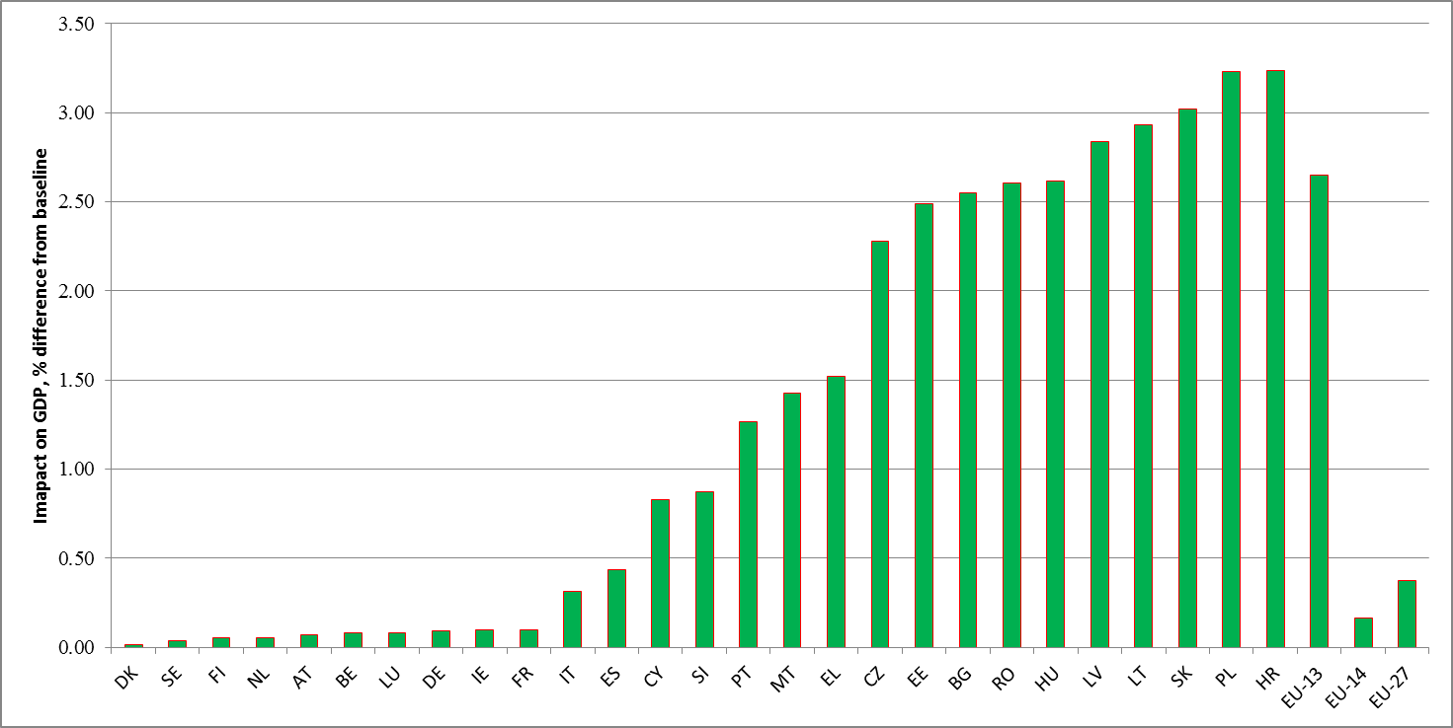

*Source: QUEST*

A useful measure is the impact per euro spent – the ratio between the cumulated impact on GDP up to a given year and the cumulated amounts spent up to the same year. Five years after the end of the programming period, the impact per euro spent is expected to be around 2.9 euros in the EU-27. Since this impact occurs over a period of 17 years, it corresponds to an annual average return of around 7%. This represents good value for money in the public sector but a little below returns on private investments – only to be expected when a policy has other goals (redistributive, social or environmental) than simply the highest return.

The above results are in line with impacts of previous modelling work, which suggested similar impacts (an extra 3% on the GDP of cohesion countries for each period). They are also in line with counterfactual econometric models which, by comparing regions with different rates of assistance (notably the richest less developed regions with the poorest more developed regions, since these are similar) have tended to produce estimates of between ½ and 1 % extra on growth per year, therefore 3.5%-7% extra GDP over the period[30].

Map 3 - Impact of 2020-2027 regional policy programmes on GDP, 2030

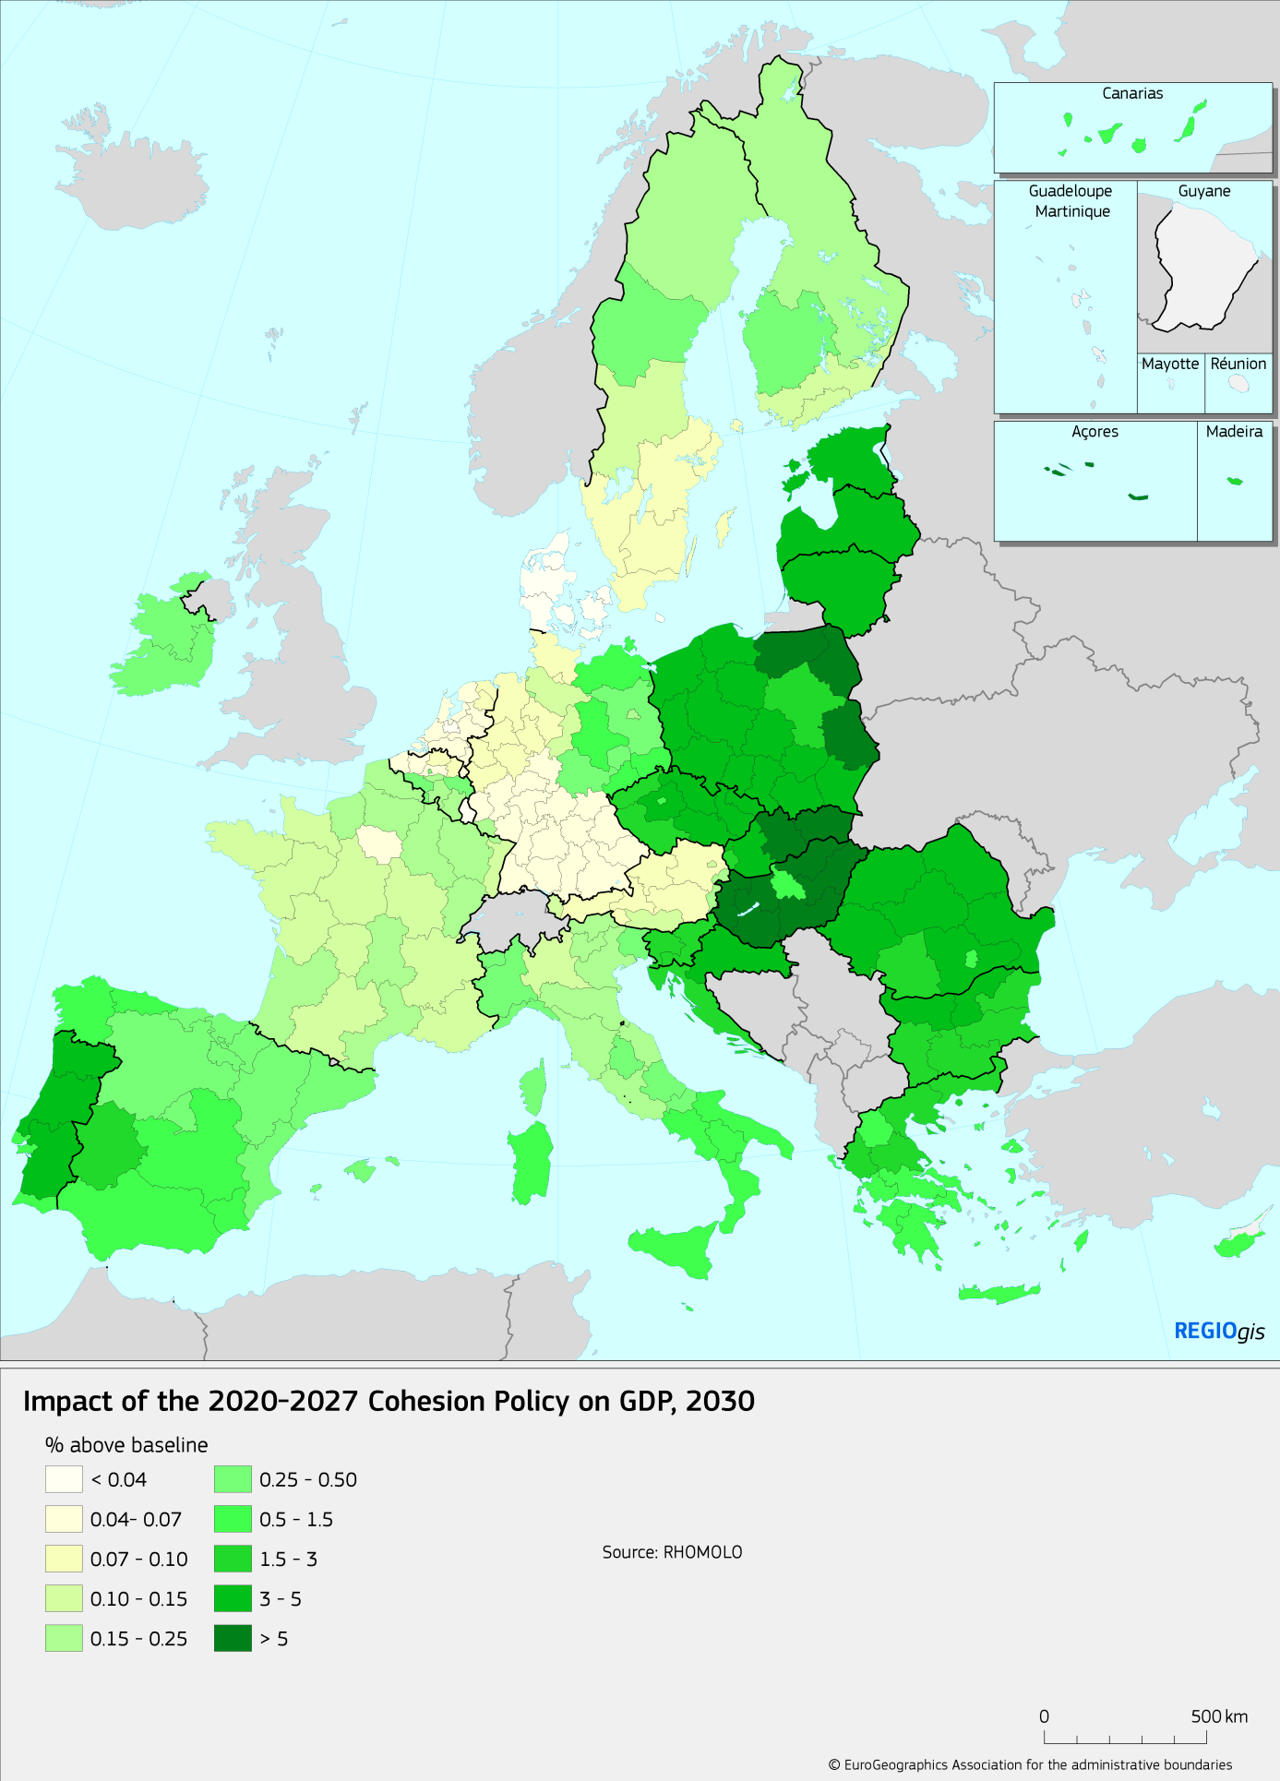

## Objectives

The **general objective** remains that defined in the Treaty: economic, social and territorial cohesion, reducing disparities between the levels of development of the various regions.

This general objective will comprise 5 policy objectives (see section 3.2 and Table 11):

1. A smarter Europe - innovative and smart industrial transformation
2. A greener, low carbon Europe - clean and fair energy transition, green and blue investment, circular economy, climate adaptation and risk prevention
3. A more connected Europe - mobility and regional ICT connectivity
4. A more social Europe - implementing the European Pillar of Social Rights
5. Europe closer to citizens – sustainable and integrated development of urban, rural and coastal areas through local initiatives

Progress towards these policy objectives will be measured:

* On a 3 yearly basis though the Cohesion Report, which examines a broad range of economic, social and territorial indicators at the national, regional and other levels, as well as by regular progress reports.
* By a series of common output and (for the first time in the ERDF and CF) common result indicators. These will be established at the level of the programmes and aggregated to the European level. The indicators are set out in Table 11, and further details on monitoring and evaluation in section 5.

To rise to the challenges set in the previous chapters, we are proposing a number of policy responses falling into two categories (see

Table 5):

1. For the content and priorities of the ERDF and CF. A key proposal to reinforce economic transition – smart growth and a transition to the digital and low carbon economy. These proposals will be tackled in section 3 on the programme structure and priorities.
2. For the delivery systems of the policy. Arguably the majority of our proposals, including more flexible programming, better links with governance and an increased use of financial instruments. These proposals will be tackled in section 4 on the delivery system.

Table 5 - Links between challenges and policy proposals

|  |  |
| --- | --- |
| **Challenges (section 2.2)** | **Policy response** |
| Regional disparities remain in terms of a broad range of economic, social and territorial themes. Moreover, sustained and sustainable growth requires a transition to an innovative and low carbon economy – this is a challenge for most regions. While smart growth and a transition to the low carbon economy should be the main focus, other themes should still be addressed.  In addition to the challenges faced by lagging regions, there are specific challenges and opportunities for the outermost regions, sustainable urban development and cooperation. | A reinforced focus on the thematic priorities of smart growth (including a transition to the digital economy) and the transition to the low carbon economy, while maintaining investment in other sectors in less developed countries (section 3.3) |
| Geographic coverage which continues for all regions, including specific provisions for outermost regions, sustainable urban development and European territorial cooperation (3.2) |
| There should be better co-ordination and synergies between different EU policies. | Clearer demarcation of roles with other policies, better alignment of rules, notably within the ESI Fund family (3.4) |
| Globalisation, economic transition, migration and other emerging needs mean that programmes need to respond quickly | More flexible programming, including a "5+2" system where the last 2 years are only programmed at the end (4.1) |
| Shortcomings in administrative capacity and institutional quality are often key obstacles to economic, social and territorial progress. | A strengthened and streamlined process of ex ante conditionalities, better links to the European Semester (4.2) |
| Excessive complexity, high administrative costs/burdens, delays in implementation | Various simplification measures, including simpler payment systems and more proportionality in audit (4.3) |
| High complexity and low take up of financial instruments | Promoting financial instruments by simplifying their use, possibility to use budgetary guarantees via InvestEU (4.4) |

# Programme structure and priorities

## Subsidiarity and added value of the ERDF and CF

An important point in assessing subsidiarity: the funds are delivered through shared management (see section 1). This means that the European Commission is a partner at the strategic level, including programming and financing. But day to day management is vested in national and regional managing authorities.

In other words, for elements where there is high EU added value (this will be developed further below) the EU level retains a key role. But in other areas (day to day running, the selection and management of projects, first level audit, etc) the regional and national levels run the programmes. There is already an element of subsidiarity baked into the very nature of the ERDF and CF.

|  |
| --- |
| **The framework we are using to assess subsidiarity and EU added value**  Subsidiarity and EU added value are complementary principles:   * Subsidiarity is the principle that "The EU should not take action unless it is more effective than action taken at national, regional or local level"*[31]*. * EU added value is the criterion for determining exceptions to this rule "There is a clear value added when action at European level goes further than national efforts could"[32]   EU added value "requires consideration of the value and improvements which are caused by the EU **rather than another party** taking action" (our emphasis)[33]. In other words, it is not primarily a judgement of the absolute value of ERDF and CF actions (for this, see the elements on evaluation), but rather on the relative value of action at the European level.  The better regulations guidelines[34] identify 3 potential sources of EU added value:   * Effectiveness: where EU action is the only way to get results to create missing links, avoid fragmentation, and realise the potential of a border-free Europe. * Efficiency: where the EU offers better value for money because externalities can be addressed, resources or expertise can be pooled, an action can be better coordinated. * Synergy: where EU action is necessary to complement, stimulate, and leverage action to reduce disparities, raise standards, and create synergies. This can notably include the promotion of EU goals and policy priorities. |

**Effectiveness: where EU action goes further in getting results**

That ERDF and CF activities can only be delivered by EU action is relatively easy to demonstrate **for poorer countries and regions**. In many countries, Cohesion Policy represents around 50% (or more) of public investment – these member states would not have the financial capacity to carry out such investments otherwise (Figure 4). Even in the poorer regions of richer countries, Cohesion Policy can represent a significant fraction of public investment.

Figure 4 - ERDF and CF as % of public investment, 2015-2017

*Note: Government capital expenditure is the sum of General Government gross fixed capital formation plus capital transfers, adjusted for any abnormal transfers to banks and other companies.*

*Source: Open data platform, Eurostat - Government statistics*

Moreover, and as the EU finance paper notes, the nature of the policy is "a redistribution (coupled with the financing and provision of public goods) through cohesion policy, which promotes economic convergence as well as social and territorial cohesion"[35]. In a Europe where the more and less developed regions are so unevenly distributed between countries, such a redistribution has to be organised at a level higher than the national one.

However, there is also evidence of **EU added value in more developed member states and regions**. There are effects in terms of innovation and SME support which would not happen without the ERDF. That added value can be demonstrated in these sectors is noteworthy since, as was noted in section 2 above, this is where most of the ERDF money is invested in more developed regions.

For example, **smart specialisation strategies (RIS3) would not exist in most regions, whether more or less developed**, nor would they be maintained, without the ERDF:

* RIS3 hardly existed before they were promoted within Cohesion Policy, and in 60%[36] of cases the programmes had an ex ante conditionality to develop or improve the plan in 2014. As the 7th Cohesion Report notes[37] "Since smart specialisation became one of the ex-ante conditionalities for the ESI Funds, over 120 smart specialisation strategies have been formulated through partnership, multi-level governance and a bottom-up approach. EUR 65.8 billion are available to support these strategies from the ERDF (and EAFRD), in addition to national and regional funding."
* 70% of managing authorities and regional actors believe[38] that these are "a paradigm shift in innovation policy governance" and about 50% of respondents indicate that recent launches of new policy programmes and measures can be attributed to RIS3 (only 10% feel there is no influence of RIS3 on new policy measures).
* Significantly in terms of establishing EU added value, the benefits are seen to be highest in the Nordic countries, Austria, Germany, Benelux and France. In fact the highest satisfaction was found in Denmark, Sweden and Finland where 80% are sure that the benefits outweigh the costs (and none feel costs outweigh benefits) and 85% believe the process is still gaining momentum.

**Furthermore, there is a stabilisation effect at the SME level which has been noted in all regions**. The ex post evaluation of the ERDF and CF[39] found that a major result of support was helping SMEs withstand the effects of the crisis, providing credit **when other sources of finance had dried up**:

The ERDF *"played a role in helping firms survive the crisis." "The evaluation found that a major result of support was helping SMEs withstand the effects of the crisis by providing credit when other sources of finance had dried up… this enabled firms to remain in business and to maintain employment… a deep recession may force too much restructuring, too quickly and that the evaluation does show that support prevented significant job losses in the medium term."*

Finally, as the ex post evaluation noted "**Interreg is the only policy instrument in its field**. It is therefore crucial for ensuring continuity and linkages of common projects across borders and (for transnational and EU wide programmes) across the EU"[40]. The reflection paper on EU finances further noted "Cross-border programmes have transformed border areas, helping to remove sources of conflict and create new economic opportunities."[41]

|  |
| --- |
| **Added value and the public consultation**  In the public consultation, three quarters of respondents considered that Cohesion Policy programmes effectively add value to a large or a fairly large extent in comparison to what Member States could achieve alone. The elements of added value most frequently identified were cross-border cooperation, higher financial support than from national resources, contribution to reducing regional disparities, policy innovativeness, high institutional standards of this policy. See Annex 2 for further details. |

**Efficiency: where the EU offers better value for money**

For Cohesion Policy, this is notably when resources or expertise can be pooled or an action can be better coordinated. The ex post evaluation of the ERDF and CF[42] found a variety of examples of this:

* In various fields, the multi-annual programming and strategic approach of ERDF provided a focus for interventions over a medium term period. ERDF support proved decisive for early identification, better financial planning and complementarity of projects. In particular, the evaluation of transport found that Cohesion Policy pushed Member States towards long term strategic planning.
* This stable framework led to institutional learning and increased professional capacity of actors involved in planning and implementing the interventions in several sectors.
* The various learning platforms such as INTERACT (support for co-operation), URBACT (for urban programmes) and ESPON (spatial planning) provide a possibility of pooling expertise. Transnational programmes under Interreg tackle specific common problems through collaboration, joint research or exchange of experience and best practice.
* The development of monitoring and evaluation systems. The exchange of experience and quality control function of the European level (more in section 5) represents a key source of EU added value.

Moreover, as the Cohesion Report found[43], there are **significant potential spillovers across national and regional boundaries**: investments in innovation and SMEs in one region or country can (but do not always) spill over borders. There is a role for the EU level to ensure that such spillovers do not lead to underinvestment[44] and indeed that investments are designed in such a way as to maximise spillovers. This latter point is a rationale for regional co-operation on smart specialisation strategies.

**Synergy and the promotion of EU goals and policy priorities**

The ERDF and CF contribute to broader EU policy priorities and goals. This is firstly **in terms of growth – and cushioning the adverse economic and social effects of economic downturns.** The reflection paper on EU finances recognised this by saying "Investments made under Cohesion Policy in one region or Member State contribute to macroeconomic stability and increase the growth potential of the Union as a whole."[45]

The 7th Cohesion Report found[46] that in the long-run, these spill-over benefits represent a substantial share of the total impact of the policy on the non-cohesion counties economies. By 2030, the impact of the 2007-2013 programmes is estimated to be around 0.36% of GDP in non-cohesion countries, of which around a third (0.11%) is due to spillovers from spending in cohesion countries. This effect is particularly pronounced for Austria and Germany because of trading links. In Austria, more than half the impact of the policy is due to investment in the cohesion countries.

It also serves as a stabilising factor over the macroeconomic cycle: "The EU budget has some stabilising effects for some Member States, notably due to its stability over 7 years, which provides a constant level of investment independent of the economic cycle"[47]

Secondly, the ERDF and CF **contribute to other EU priorities.** The ex post evaluation found that "Cohesion Policy enabled budget limited public authorities to meet EU policy goals even during the financial crisis. For example it funded infrastructure for water and waste management to ensure timely compliance with the relevant EU Directives. Further, it provided incentives for significant shifts in the EU13 and Convergence regions in the South of EU15 in the disposal of waste away from landfills and towards recycling in line with the EU policy."

Thirdly, **the ERDF and CF address important structural challenges**. The ex ante conditionalities for reform and other links to structural reform will be further outlined in section 4 below, but 60% of the respondents to the public consultation on the ex post evaluation of the ERDF and CF said that the ERDF and CF "have provided crucial support to structural reforms of labour market, transport, environment, energy, education and social policies and programmes".

Fourth, the ERDF and CF encourage **modernisation of administration**. This includes peer to peer and integrity pacts on fair public procurement as well as ex-ante conditionalities on public procurement and state aid (including training plans).

Finally, they deliver **tangible results in areas which matter to European citizens.** The opening lines of the reflection paper say "The EU budget helps to deliver on the things that matter for Europeans"[48]. Helping regions adapt to the challenge of globalisation, supporting 1.1 million SMEs in the 2014-20 period with 420 000 new jobs as a result, tackling urban poverty – all these are priorities for citizens. It should be noted (see Table 6) that many of these results are particularly evident outside the cohesion countries.

Moreover, the delivery system via local partnerships – and especially for community led local development – represents a crucial form of outreach to local people and the local level which is unusual at the European level.

Table 6 - Firms supported and jobs created 2014-20

|  |  |  |
| --- | --- | --- |
|  | FIRMS: All firms | Direct jobs created |
| Cohesion countries | 260 000 | 150 000 |
| Other Member States | 840 000 | 270 000 |
| Total EU | 1 100 000 | 420 000 |

*For context, cohesion country programmes focus on a wide range of actions, whereas programmes outside these countries focus far more on SMEs and jobs  
Source: open data platform*

## 3.2. Policy options

The budget of 273 billion represents a real term reduction of around 10%. For making this reduction there are essentially 3 broad options:

1. A more or less equal cut across the board – all themes, regions and Member States face similar reductions.
2. A cut which focusses geographically (e.g. support is maintained in the less developed, "cohesion" countries, but cut elsewhere).
3. A scenario which focusses on those themes with the highest EU added value and evidence for impact (e.g. innovation) and reduces funding for those of lower priority (e.g. transport).

For this reason, four detailed scenarios are considered. A baseline (the current situation) plus one representing each of the three choices above:

* **Baseline.** The "status quo", i.e. a continuation of the current regional and thematic allocations (the only change being the removal of the UK). This scenario is not realistic for a variety of reasons, including: the reduced cohesion policy envelope; the relative GDP of different countries has changed (and therefore the distribution between them has changed). Nevertheless, it is useful as a baseline and for comparison purposes.
* **Option 1: Reductions across the board**, both thematically and geographically. The reduction is applied in the same proportion everywhere. This option also includes (of course) an updating of the regional and national allocations in line with changes in GDP/head. In other words, the same method (see box on Berlin method) for allocation, but using the latest data and a smaller budget.
* **Option 2: Geographic concentration** – current levels of expenditure are maintained in cohesion countries, the reduction falls entirely on more developed countries. Within each category of country (more or less developed), funding is distributed according to the usual method, using the latest data. This scenario is a development of scenarios presented for reflection by the Commission in February[49].
* **Option 3: Thematic concentration** – this is the same geographic allocation as option 1, but the thematic focus on innovation, SMEs and the environment is increased. This will preserve a critical mass of spending in these areas, while the cut will tend to focus on infrastructure (notably transport). **This is the preferred option.**

|  |
| --- |
| **Box: The Berlin method and financial allocation**  The 1999 Berlin council set a method for financial allocation of cohesion policy, including ERDF and CF. The method is based mostly on regional GDP/head, with input from other indicators such as national GNI and population. While the exact application has evolved, the basic method has remained the same for nearly two decades.  The Berlin method is familiar to – and understood by – key stakeholders. Retaining the method brings stability in a time of change. It also responds to the requests of various stakeholders – including Council and respondents to the public consultation – to maintain the principles of distribution of funding (see section 2.1 and annex on public consultation). |

Table 7 – Comparison of key features of baseline and options

|  |  |  |  |  |
| --- | --- | --- | --- | --- |
|  | **Baseline** | **Option 1** | **Option 2** | **Option 3** |
| ERDF and CF envelope | Current | -10% | -10% | -10% |
| Geographic allocation … | Current method, using data available when the allocation was made | Current method, updated data | Expenditure maintained in EU-13, cut in more developed countries. Within categories, distribution by current method, updated data. | Current method, updated data |
| Thematic allocation | Current | Current | Current | Concentration on innovation, SMEs and environment |
| Includes the UK? | Neither as contributor nor beneficiary | Neither as contributor nor beneficiary | Neither as contributor nor beneficiary | Neither as contributor nor beneficiary |

*See text for more explanations*

The distinctive feature of option 3 is the increased focus on innovation, broadband and SME support (i.e. the new priority objective 1 – see section 3.3) in option 3. The thematic concentration criteria of this option mean that spending in these fields goes from around 30% of total ERDF and CF to around 46% at the EU level.

Figure 5 - Thematic concentration increases under the preferred option

*Percentage of spending in the new PO1, former TOs 1-3: innovation, broadband, SME support*

*Source: DG Regional and urban policy, based on reporting by Member States*

The impact of the various options on EU GDP is similar – and positive – over time. The baseline scenario (not unexpectedly) has the initial advantage in terms of impact, since it represents roughly 10% more money. Interestingly however, in the long term, option 3 of thematic concentration has greater impact – investment in innovation and SMEs has a greater long term impact.

Figure 6 – Impact of the options on EU GDP

*Source: Quest.*

The impact by country depends on factors such as the volume of funding, as well as its thematic distribution. In 2030 (i.e. just after the end of spending), the scenarios have a roughly equal impact for the EU27 as a group: the cohesion countries do best under option 2, while the more developed countries do best under options 1 and 3. However, in the long term, there is a tendency for cohesion and non-cohesion countries to do better under option 3, because of the greater long term impact of this option.

Table 8 - % impact on GDP 2030 and 2040

|  |  |  |  |  |
| --- | --- | --- | --- | --- |
|  | **Baseline** | **Option 1** | **Option 2** | **Option 3** |
| **2030** | | | | |
| EU-27 | 0.37 | 0.34 | 0.34 | 0.34 |
| Cohesion countries | 2.01 | 1.69 | 2.01 | 1.74 |
| Non-cohesion countries | 0.14 | 0.15 | 0.10 | 0.14 |
| **2040** | | | | |
| EU-27 | 0.42 | 0.39 | 0.37 | 0.46 |
| Cohesion countries | 2.14 | 1.81 | 2.15 | 2.35 |
| Non-cohesion countries | 0.17 | 0.18 | 0.12 | 0.19 |

*Source: Quest – highlight indicates the option (other than baseline) with the highest impact for those countries*

Figure 7 - GDP impact of the preferred option 3, 2030 and 2040

*Source: Quest*

**Pros and cons of the various options**

**Option 1 (similar cuts across the board)** has two key advantages: simplicity and a sense of fairness. It is relatively easy to apply and does not disturb the balance between various sectors and different partners. Moreover, it also recognises that all regions continue to have needs in a changing economy, and that these needs cover a broad range of sectors.

However, in the context of a significant reduction in real budget, it can hardly be said to represent a strategic decision. Moreover, experience shows the importance of targeting and critical mass – both evaluations and experience have tended to drive a certain amount of thematic concentration, especially in smaller programmes. For these programmes in particular, in order to be effective with a smaller budget it is necessary to have some kind of concentration, whether geographic or thematic.

Finally, the world has changed over the years since the last period was prepared. The challenges of globalisation and technology, migration and the environment have intensified – it would be odd to maintain the same geographic and thematic focus.

**Option 2 (geographic concentration)** has several clear advantages:

* The mission of the ERDF and CF is to support regions and countries with the greatest economic, social and territorial needs – this option has a tight focus on cohesion countries where these needs are greatest.
* Demonstrable EU added value (see section 3.1). This focusses on Member States which can least afford to pay for such measures (the effectiveness argument), who have the lowest institutional capacity and therefore the most potential to learn (the efficiency argument) and where regions tend to be furthest from EU goals and priorities, such as in environmental standards (synergy argument).
* Redistribution of resources from the most to least developed regions. EU policy stimulates growth in the latter ones (at least in the short term, through multiplier effects), which fosters regional convergence.

However, while all of the above arguments demonstrate the need to focus support on cohesion countries, none of them is an argument against some support in non-cohesion countries. And in fact, in all the scenarios the bulk of the investment would remain in cohesion countries.

Moreover, there are also strong arguments for continued support outside of cohesion countries, including:

* The needs of these regions, including emerging needs such as globalisation and economic transition, including to the low carbon economy (for more details, see arguments for option 3 below).
* Added value arguments. This includes innovation and SME support and smart specialisation strategies, much of which would not happen without the ERDF. It also includes cross-border spill-over effects, as well as the linkages and knowledge exchange between lagging and leading regions (for more details, see arguments for option 3 below and added value section 3.1).

Finally, in the public consultation and elsewhere, very few stakeholders expressed support for reducing the proportion of spending outside cohesion countries – there seems to be a strong consensus in favour of the current balance, with a focus on cohesion countries but significant spending elsewhere. Even the less developed Member States themselves are not in favour of this option (“Cohesion Policy should remain the policy for all EU regions with special attention to the less developed ones”[50]).

Map 4 - Risk factors linked to globalisation and technological change

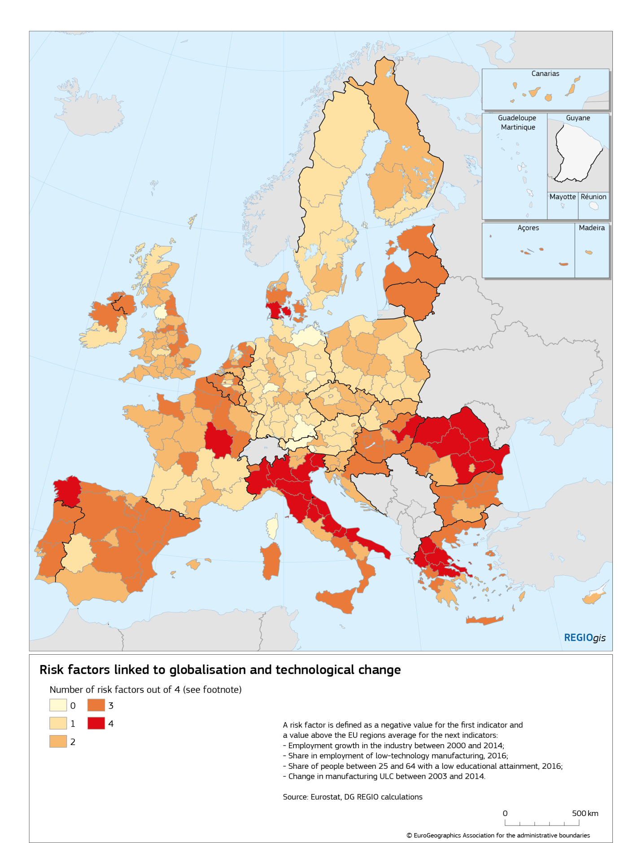

**Option 3 (thematic concentration) – the preferred option**

In this scenario, support is maintained in those themes and sectors which have the highest added value and where evidence of impacts are strongest. For less developed regions, a case can be made for public investments across the board and administrative modernisation. But for more developed regions, it makes sense to concentrate funds on research and innovation, digitalisation, smart transformation and transition to a low carbon economy – indeed arguments for continuing support to all regions apply mostly to these themes of intervention, as well as to cooperation and sustainable urban development:

* The challenges of globalisation and economic transformation increasingly affect many regions across the EU, including both richer and less developed ones. In today's fast moving economy, few regions can be said to be beyond risk (and indeed, most regions have at least one of the key risk factors – see Map 4). This requires constant investments in the productive base to keep up the pace.
* ERDF support is a key factor behind the development of smart specialisation strategies in the EU; the added value of these strategies is considered to be highest in the Nordic countries, Austria, Germany, Benelux and France.
* The contribution to EU priorities, such as structural reforms, climate change, low-carbon economy and the creation of jobs: 2/3 of the jobs created by the ERDF and CF, and 3/4 of the SMEs supported, are outside of the cohesion countries.
* Environmental challenges such as air and marine pollution, climate adaptation and disaster risk management challenges are still present throughout the EU, in both developed and poorer regions, and often have a cross-border element.
* Urban deprivation and sub-regional pockets of poverty are often found in more developed regions (and are in fact more concentrated in rich metropolitan regions).
* Migration is another European challenge, with its impacts concentrated in some, usually more developed, regions. EU support to the integration of migrants and refuges is necessary as a sign of European solidarity in all regions.

This is in line with academic literature[51] which underlines that various groups of regions face different challenges and require dedicated policy support. For the most advanced EU regions and countries, regional policy funds must sustain Europe’s world-class regions in the face of global competition and support them in moving up the technology-quality ladder. For the medium level regions, regional policy must help overcome their “middle income trap”, which involves being too expensive for some activities but not innovative or productive enough for others, including investments to reinforce the knowledge base as well as knowledge transfer. For the less developed EU regions, investment support is needed to overcome their manifold existing barriers to productivity[52].

This option is also in line with requests from stakeholders, including the Council which supported greater thematic concentration on innovation, SMEs and green growth while retaining a place for other needs[53]: *"Thematic concentration … contributing the most to reaching the targets of the Europe 2020 Strategy… however, a balance must be maintained between the predefined requirements for concentration on a limited number of thematic areas and… the flexibility to respond during the programming period to specific national and regional development challenges*".

This flexibility will be provided by a change to the current system, determined at the regional level. The calculation will be simplified and thresholds established at the national level (see Table 9) – this makes sense since fiscal capacity (and therefore considerations of added value in policy objectives 3-5) is mostly determined at the national level. As can be seen in Figure 6, these thresholds affect many member states, and the proportion of spending on smart growth will go from around 30% at present to 46% of ERDF and CF in the future.

Table 9 - Thematic concentration thresholds

|  |  |  |
| --- | --- | --- |
| **Type of region** | Smart growth | Green and low carbon growth |
| GNI/head in PPS < 75% of EU average | 40% | 60% |
| GNI/head in PPS 75% - 100% | 50% | 70% |
| GNI/head > 100% of EU average | 60% | 80% |

*Smart growth corresponds to the new PO1, green and low carbon to the new PO2  
See section 3.3 for more details*

**Reducing cofinancing rates**

EU cofinancing rates increased – and national cofinancing rates decreased – in the 2007-13 period. This was a response to the financial crisis, to maintain essential investments in a time of tight public budgets (see

Table 10). Historic levels of EU cofinancing were lower – 50% for the more developed regions, and less than 75% for the less developed ones.

Table 10 - EU and national contributions to the ERDF and CF, 2014-20 (euro billion)

|  |  |  |  |  |
| --- | --- | --- | --- | --- |
|  | EU amount | National cofinancing | total funding | % EU amount |
| CF | 63.3 | 12.1 | 75.4 | 84% |
| ERDF less developed regions | 130.3 | 36.2 | 166.5 | 78% |
| ERDF transition regions | 25.4 | 10.9 | 36.3 | 70% |
| ERDF Interreg | 9.8 | 3.3 | 13.1 | 75% |
| Northern sparsely populated and outermost regions | 1.6 | 1.0 | 2.5 | 62% |
| ERDF more developed | 32.3 | 29.6 | 61.9 | 52% |

*Less developed regions: those with GDP/head < 75% of the EU 27 average  
Transition region: GDP/head between 75% and 90% of the EU 27 average  
Source: ESI fund Open Data Platform -* [*https://cohesiondata.ec.europa.eu/*](https://cohesiondata.ec.europa.eu/) *(February 2018)*

EU cofinancing will return to at least historic levels. This is to promote "ownership" as well as to make the reduced EU contribution go further. Cofinancing rates would be determined at national level, rather than by region or fund – this makes sense since it is at the national level that fiscal capacity is determined. It also enables financing flexibility within a country.

## 3.3. Simplifying and consolidating the priority objectives

There will be **a consolidation of the 11 thematic objectives** of 2014-2020 programming period into 5 objectives (see Table 11 for the objectives and indicators and the box below for excluded activities). The strength of the current division is that, because of the 11 way split, it is analytical and provides a good level of detail on financial allocations. However, there have been various signs that a lower level of disaggregation would be more practical:

* The ex post evaluation noted that the distinction between innovation and SME support is often artificial and sometimes caused confusion at the programme level for those tasked with classifying spending.
* Many measures are natural complements – SME support, R&D and IT is an obvious example, but so are various forms of social spending. Being able to put them into one priority axis as one objective would make it easier for programmes to (1) put complementary measures together, exploiting synergies and (2) move funding flexibly between measures in a given priority, according to needs.
* For reporting, the distinction between various forms of social spending is not easy to communicate. The same is also true for the various forms of environmental support and business/innovation support.

The last point is particularly telling, since fine grained reporting is the main advantage of the 11 way division. But in practice, reporting (eg in the ex post evaluation or cohesion report) often merged the thematic objectives into broader categories, thus negating this main advantage.

The 5 way division therefore represents a simplification in classification and reporting, as well as the opportunity to be flexible and exploit policy synergies within the new objectives. The objectives are expected to be common across the CPR, but here we discuss them in the context of the ERDF and CF.

|  |
| --- |
| **Excluded activities**  The list of thematic priorities includes a list of "negative priorities" or excluded activities. These fall into 2 broad categories:   1. Activities which have been evaluated as having low impact or a low cost benefit ratio or return on investment. Notable examples are support to large enterprises and to regional airports (except those in the outermost regions). For further information, see section 1.2 on evaluations and lessons learned. 2. Activities which are not in line with EU priorities. Notable examples are landfill and fossil fuels (for their negative impact on the environment) and tobacco (fore the negative impact on health). |

The first policy objective is **“A Smarter Europe**. ERDF support in this field is currently divided between three thematic objectives: strengthening research and innovation, ICT and SME competitiveness. This breakdown is artificial as the three are closely related: post-2020 they will be combined in one priority.

The “Smarter Europe” priority objective will reinforce and expand smart specialisation, digitalisation, regional and local innovation and entrepreneurial ecosystems. It will also incorporate the human capital aspects of innovation and entrepreneurship and be based on smart specialisation strategies.

Since 2014, the ERDF programmes have been based on a smart specialisation approach. Member States and regions have developed over 120 smart specialisation strategies which enable, through a bottom-up and partnership approach, to prioritise public research and innovation investments for the economic transformation of regions. A recent communication on this topic[54] confirms the contribution of smart specialisation to promoting innovation-oriented growth at regional level. It also identifies directions for future, including the need to scale-up interregional innovation projects.

The promotion of interregional innovation projects via smart specialisation platforms is a key tool in promoting EU-wide value chains as well as the diffusion of innovation across borders. Since 2015, three Thematic Smart Specialisation Platforms have been set up to foster inter-regional cooperation in the field of energy, agri-food and industrial modernisation. Around 100 regions take part in 20 partnerships covering issues ranging from smart sensor systems in agri-food to innovative textile, from industry 4.0 to solar energy. Building on these experiences, the Commission is testing approaches for scaling-up post-2020.

The approach in "Smarter Europe" is complementary to other EU instruments such as FP9 since it focusses on regional relevance, i.e. local capacity, local ecosystems and local uptake, while FP9 focusses on European excellence (for more, see section 3.4 on coherence and synergies below).

The second priority objective is **“A green and low carbon Europe”** coveringsupport to the low carbon and climate resilient economy, including energy efficiency, renewable energy, smart grids and reinforced efforts to engage citizens and communities in the energy transition. ERDF and CF support in this area is important for achieving goals of the new 2030 policy framework on energy and climate. Transition to clean energy provides new business opportunities, cleaner environment and health benefits for citizens. At the same time, it also requires significant changes in Europe's economies. It comes with a social cost linked to the move away from traditional sectors (e.g. coal) and a need for significant investment in electricity generation, networks and energy efficiency, estimated at some EUR 200 billion annually in the next decade[55]. Due to the existing market failures, support from the EU budget remains necessary for a part of this investment. In particular, EU support is frequently needed to untapped energy efficiency potentials.

The effects of energy transition and climate change are unevenly dispersed in the EU. A number of regions in Poland, Czech Republic and Germany face challenges in their energy transition, due to large volumes of solid fuel production and the high share of solid fuels (primarily hard coal and lignite) in their electricity generation mix[56]. Climate change affects all EU regions but to varying degrees, with the south of Europe most severely affected. The potential for wind and ocean energies is higher in coastal regions and for solar energy in the southern regions. They also represent a sustainable solution for energy-self-sufficiency in many island and outermost regions. For these reasons, targeted measures from the ERDF will be needed post-2020 in all regions. Different local circumstances often do not allow for one-size-fits-all solutions. Cohesion policy offers placed-based solutions and is particularly well suited to mobilise the relevant energy transition actors on the ground.

A greener Europe also covers investment in environmental infrastructure, circular economy, blue economy and climate change adaptation. Environment is one of the two CF fields of intervention set in the Treaty. There remain gaps to comply with the acquis in the waste, water, seawater, air quality and nature areas, especially in less developed Member States and regions. For instance, total needs for sewerage collection systems and treatment plants under the Urban Waste Water Treatment directive[57] are estimated at EUR 49 billion. And Member States will have to invest in the transition towards a circular economy as outlined in the Circular Economy Action Plan[58] (and in its related initiatives for example the Communication Waste to Energy[59], the European Strategy for Plastics in the Circular economy[60], etc.) and to reach the more ambitious recycling targets set by the newly EU waste legislation.

In fact, it is important that any future investments under all priority objectives, but notably in infrastructure with lifecycles of significantly over 20 years, must be resilient to protect assets and infrastructure from climate risks (including sea-rise levels or heavy storm events) if we are to avoid damage to infrastructure or lock-ins. This could build on strengthened climate-proofing guidance for major projects, covering both climate resilience and greenhouse gas emission reductions, applied also to other relevant programmes and financial instruments.

The third policy objective is **“A more Connected Europe”** covering investment in European, national and regional transport networks and digital connectivity. Investment in trans-European transport networks (TEN-T) is one of two fields of intervention of the Cohesion Fund. However, support from the ERDF for regional transport infrastructure is also needed, especially in less developed regions, in order to fulfil the existing gaps in regional networks, improve links to the TEN-T and TEN-E network, and to deploy low-carbon transport systems and technologies.

Digital connectivity has become one of the decisive factors for closing economic, social and territorial divides. The digitisation of European industry but also the modernisation of sectors like healthcare, education and public administration depend on networks. Connectivity creates new markets and a growth environment for SMEs, supports the modernisation of local economies and increases the capacity of labour market to adapt to new challenges even in disadvantaged areas. Digital solutions like e-health and smart mobility not only improve lives of citizens but also significantly reduce the costs of such services, depending however on the universal access to high capacity digital networks.

The fourth policy objective is **“A more social Europe”.** While this policy objective is covered mainly by ESF investment, the ERDF will continue providing support to social, health and educational infrastructure and to integration of migrants (see section 3.4 for complementarities with other EU policies in this field).

The fifth new policy objective is “**Europe closer to citizens”**. This new policy objective will cover sustainable and integrated development of urban, rural and coastal areas through local initiatives. This would give enhanced visibility to urban issues and deliver on the Amsterdam pact[61]. Previously spread (somewhat artificially) across various themes, this consolidation places citizens' needs at the heart of the investments. It also enables integrated approaches, influenced by local and urban authorities.

|  |
| --- |
| **Interreg post-2020**  Building on the success of previous Interreg programmes (see above), we are proposing an evolution along the following lines:   * Crossborder programmes should change from primarily managing and distributing funds toward acting as institutions of exchange, facilitating cross-border activity and being a centre for strategic planning.[62] * The addition of co-operation outside the EU. This will take the form of (1) a specific strand for outermost regions (2) the incorporation of current IPA/ENI funding to support enlargement and cooperation with neighbourhood countries.   Interreg will continue to be able to draw on all of the priority objectives (where appropriate) and although funded by ERDF will be covered in an ETC regulation. |

|  |
| --- |
| **European cross-border mechanisms**  The impact and European added value of Interreg programmes are well recognised (see main text). However, in many cases cross-border barriers (especially in relation to health services, labour regulation, local public transport and business development) stem from differences in administrative practices and national legal frameworks. In fact, it has been estimated that if 20% of existing legal and administrative obstacles across internal EU borders were addressed, border regions would gain 2% in GDP[63].  These administrative obstacles are difficult for programmes to address alone, requiring decisions beyond programme structures. Therefore in 2015 the Luxembourg Presidency and several Member States explored the use of one Member State's rules in a neighouring Member State[64].  The Commission proposes to facilitate such solutions with an "off-the-shelf" legal instrument. Since the action is voluntary and optional, being used (or not) at the initiative of Member States concerned, it respects subsidiarity and proportionality. It also has no cost incidence for the EU budget.  The instrument offers two options: a European Cross-Border Commitment ("ECBC") (which itself enables derogation from normal rules[65]) or a European Cross-Border Statement ("ECBS") (signatories undertake formally to legislate to amend normal rules[66]). The mechanism will:   * Remain voluntary: Member States have the option to select the mechanism or use other effective mechanisms to resolve legal border barriers. * Focus on intra-EU land borders, while allowing Member States to also apply the mechanism to maritime and external borders.   Cover joint projects for any item of infrastructure with impact in a cross-border region or any service of general economic interest provided in a cross-border region. |

Under each objective, it is possible to invest in **administrative capacity to deliver that policy objective.** As noted in the ex post evaluation and 7th Cohesion Report, ERDF and CF is not only about money, but also about know-how and good governance. This is a long term investment and should be a priority for cohesion policy post-2020, including such actions as:

* Peer to peer learning, exchange of good practices.
* Professionalization of fund management, development of competencies.
* Public procurement: guidance, studies, exchange of good governance practices, strategic procurement.
* State aid: training, seminars, expert support.
* Anti-fraud and anti-corruption, including integrity pacts.

Table 11 - Proposed priorities in the new period with target indicators

* These are common priorities across the CPR – in some cases (notably 4.1 and 4.2) other funds will lead, with ERDF or CF as support only.
* Within each specific objective, it is possible to support operations in favour of (a) improving institutions and governance and (b) cooperation with partners outside the programme area.
* In the context of shared management, targets will be set by managing authorities

|  |  |  |  |
| --- | --- | --- | --- |
| **Policy Objective** | **Specific Objective** | **Common output indicators** | **Common result indicators** |
| **1. A smarter Europe - innovative and smart industrial transformation** | 1.1 Enhancing innovation capacity | RCO 01 - Enterprises supported (of which: micro, small, medium, large) RCO 02 - Enterprises supported by grants RCO 03 - Enterprises supported by FIs RCO 04 - Enterprises with non-financial support RCO 05 - Start-ups supported RCO 06 - Researchers working in supported research facilities  RCO 07 - Research institutions participating in joint research projects RCO 08 - Nominal value of research and innovation equipment RCO 10 - Enterprises cooperating with research institutions | RCR 01 - Jobs created in supported entities  RCR 02 - Private investments matching public support (of which: grants, FIs) RCR 03 - SMEs introducing product or process innovation RCR 04 - SMEs introducing marketing or organisational innovation RCR 05 - SMEs innovating in-house RCR 06 - Patent applications submitted to EPO  RCR 07 - Trademark and design applications  RCR 08 - Public-private co-publications |
| 1.2 Reaping the benefits of digitalisation for citizens, companies and governments | RCO 12 - Enterprises supported to digitise their products and services RCO 13 - Digital services and products developed for enterprises RCO 14 - Public institutions supported to develop digital services and applications | RCR 11 - Users of new public digital services and applications RCR 12 - Users of new digital products, services and applications developed by enterprises RCR 13 - Enterprises reaching high digital intensity RCR 14 - Enterprises using public digital services |
| 1.3 Enhancing growth and competitiveness of SMEs | RCO 15 - Capacity of incubation created | RCR 16 - High growth enterprises supported RCR 17 - 3-year old enterprises surviving in the market RCR 18 - SMEs using incubator services one year after the incubator creation RCR 19 - Enterprises with higher turnover |
| 1.4 Developing skills for smart specialisation, industrial transition and entrepreneurship | RCO 16 - Stakeholders participating in entrepreneurial discovery process RCO 17 - Acquisition of know-how for smart specialisation and industrial transition (million euro) | RCR 24 - Staff supported to gain know how for smart specialisation and industrial transition  RCR 25 - Value added per employee in supported SMEs |
| **2. Low carbon and greener Europe - clean and fair energy transition, green and blue investments, circular economy, climate adaptation and risk prevention** | 2.1 Promoting energy efficiency measures | RCO 18 - Households supported to improve energy performance of their dwelling RCO 19 - Public buildings supported to improve energy performance RCO 20 - District heating network lines newly constructed or improved | RCR 26 - Annual final energy consumption (of which: residential, private non-residential, public non-residential) RCR 27 - Households with improved energy performance of their dwellings RCR 28 - Buildings with improved energy classification (number) (of which: residential, private non-residential, public non-residential) RCR 29 - Estimated GHG emissions RCR 30 - Enterprises with improved energy performance |
| 2.2 Renewable energy through investments in generation capacity | RCO 22 - Additional production capacity for renewable energy (of which: electricity, thermal) | RCR 31 - Total renewable energy produced (of which: electricity, thermal) RCR 32 - Capacity for renewable energy connected to the grid/ operational |
| 2.3 Smart energy systems - smart grids low and medium voltage and related storage | RCO 23 - Digital management systems for smart grids | RCR 33 - Users connected to smart grids RCR 34 - Roll-out of projects for smart grids |
| 2.4 Climate change adaptation, risk prevention and disaster resilience | RCO 24 - New or upgraded disaster monitoring, warning and response systems  RCO 25 - Coastal strip, river banks and lakeshores, and landslide protection newly built or consolidated to protect people and property  RCO 26 - Green infrastructure built for adaptation to climate change RCO 27 - National/ regional/ local strategies addressing climate change adaptation  RCO 28 - Areas covered by protection measures against forest fires | RCR 35 - Population benefiting from flood protection measures RCR 36 - Population benefiting from forest fires protection measures RCR 37 - Population benefiting from protection measures against natural disasters (other than floods and forest fires) RCR 38 - Estimated average response time to disaster situations |
| 2.5 Water efficiency | RCO 30 - Length of new or consolidated pipes for household water connections RCO 31 - Length of sewage collection newtorks newly constructed or consolidated  RCO 32 - New or upgraded capacity for waste water treatment | RCR 41 - Population connected to improved water supply  RCR 42 - Additional population connected to at least secondary waste water treatment RCR 43 - Water losses RCR 44 - Waste water properly treated |
| 2.6 Circular economy - investments in waste and resource efficiency | RCO 34 - Additional capacity for waste recycling | RCR 46 - Population served by waste recycling facilities and small waste management systems  RCR 47 - Waste recycled RCR 48 - Recycled waste used as raw materials  RCR 49 - Waste recovered |
| 2.7 Green infrastructure in urban environment and reduced pollution | RCO 36 - Surface of green infrastructure in urban areas RCO 37 - Surface area of habitats supported to attain a better conservation status (of which: NATURA 2000, other) RCO 38 - Surface area of rehabilitated land RCO 39 - Systems for monitoring air pollution installed | RCR 50 - Population benefiting from measures for air quality RCR 51 - Population benefiting from measures for noise reduction RCR 52 - Rehabilitated land used for green areas, social housing, economic or community activities |
| **3. A more connected Europe - Mobility and regional ICT connectivity** | 3.1 Digital connectivity | RCO 41 - Additional households with broadband access of very high capacity RCO 42 - Additional enterprises with broadband access of very high capacity | RCR 53 - Households with broadband subscriptions of at least 100 Mbps RCR 54 - Enterprises with broadband subscription of at least 100 Mbps |
| 3.2 Road TEN-T and regional and local mobility | RCO 43 - Length of new roads supported - TEN-T RCO 44 - Length of new roads supported - other RCO 45 - Length of roads reconstructed or upgraded - TEN-T RCO 46 - Length of roads reconstructed or upgraded - other | RCR 55 - Users served by improved road traffic  RCR 56 - Time savings due to improved road traffic |
| 3.3 Rail TEN-T (and inland waterways?), intermodal regional | RCO 47 - Length of new rails supported - TEN-T RCO 48 - Length of new rails supported - other  RCO 49 - Length of rails reconstructed or upgraded - TEN-T  RCO 50 - Length of rails reconstructed or upgraded - other  RCO 51 - Length of new or upgraded inland waterways - TEN-T  RCO 52 - Length of new or upgraded inland waterways - other RCO 53 - Railways stations and facilities - new or upgraded  RCO 54 - Intermodal connections - new or upgraded | RCR 57 - Length of ERTMS equipped railways in operation  RCR 58 - Annual number of passengers on supported railways RCR 59 - Freight transport on rail RCR 60 - Freight transport on inland waterways |
| 3.4 Sustainable multimodal urban mobility | RCO 55 - Length of tram and metro lines- new RCO 56 - Length of tram and metro lines- reconstructed/ upgraded RCO 57 - Environmentally friendly rolling stock for public transport  RCO 58 - Dedicated cycling infrastructure RCO 59 - Alternative fuels infrastructure (refuelling/ recharging points)  RCO 60 - Cities and towns with new or upgraded digitised urban transport systems | RCR 62 - Annual passengers of public transport  RCR 63 - Annual users of new/ upgraded tram and metro lines RCR 64 - Annual users of dedicated cycling infrastructure |
| **4. A more social Europe - European Pillar of Social Rights** | 4.1. Well-functioning labour markets and welfare systems | RCO 61 - Annual unemployed persons served by enhanced facilities for employment services | RCR 65 - Job seekers using annually the services of the employment services supported |
| 4.2 Socio-economic integration and marginalised communities, migrants and disadvantaged groups | RCO 63 - Capacity of temporary reception infrastructure created RCO 64 - Capacity of rehabilitated housing - migrants and refugees  RCO 65 - Capacity of rehabilitated housing - other | RCR 66 - Occupancy of temporary reception infrastructure built or renovated  RCR 67 - Occupancy of rehabilitated housing - migrants and refugees  RCR 68 - Occupancy of rehabilitated housing - other |
| 4.3 Reducing inequalities - access to education and training | RCO 66 - Classroom capacity of supported childcare infrastructure (new or upgraded) RCO 67 - Classroom capacity of supported education infrastructure (new or upgraded) | RCR 70 - Annual number of children using childcare infrastructure supported RCR 71 - Annual number of students using education infrastructure supported |
| 4.4 Equal opportunities - health care and social services | RCO 69 - Capacity of supported health care infrastructure RCO 70 - Capacity of supported social infrastructure (other than housing) | RCR 72 - People with access to improved health care services  RCR 73 - Annual number of persons using the health care facilities supported RCR 74 - Annual number of persons using the social care facilities supported  RCR 75 - Average response time for medical emergencies in the area supported |
| **5. Europe closer to citizens - integrated urban and territorial development** | 5.1 Integrated social, economic, cultural and environmental development and security in urban areas | RCO 74 - Population covered by strategies for integrated urban development RCO 75 - Integrated strategies for urban development RCO 76 - Collaborative projects RCO 77 - Capacity of cultural infrastructure supported | RCR 76 - Stakeholders involved in the preparation and implementation of strategies of urban development  RCR 77 - Tourists/ visits to supported sites  RCR 78 - Users benefiting from cultural infrastructure supported |
| 5.2 Integrated social, economic, cultural and environmental development, including for rural and coastal areas | RCO 80 - CLLD strategies for local development |  |
| Horizontal - Implementation | Administrative capacity and efficiency | RCO 95 - Staff financed by ERDF and Cohesion Fund | RCR 91 - Average time for launch of calls, selection of projects and signature of contracts RCR 92 - Average time for tendering (from launch of procurement until signature of contracts) RCR 93 - Average time for project implementation (from signature of contract to last payment)  RCR 94 - Single bidding for ERDF and Cohesion Fund interventions |
| Horizontal - ETC | ETC indicators | RCO 81 - Participants in cross-border mobility initiatives RCO 82 - Participants in joint actions promoting gender equality, equal opportunities and social inclusion RCO 83 - Joint strategies/ action plans developed or implemented RCO 84 - Joint pilot activities implemented in projects RCO 85 - Participants in joint training schemes RCO 86 - Joint administrative or legal agreements signed RCO 87 - Organisations cooperating across borders RCO 88 - Projects across national borders for peer-learning to enhance cooperation activities RCO 89 - Projects across borders to improve multilevel governance  RCO 90 - Projects across national borders leading to networks/clusters | RCR 79 - Joint strategies/ action plans taken up by organisations at/after project completion RCR 80 - Joint pilot activities taken up or up-scaled by organisations at/after project completion RCR 81 - Participants completing joint training schemes RCR 82 - Legal or administrative obstacles addressed or alleviated RCR 83 - Persons covered by joint agreements signed RCR 84 - Organisations cooperating across borders 6-12 months after project completion RCR 85 - Participants in joint actions 6-12 months after project completion  RCR 86 - Stakeholders/ institutions with enhanced cooperation capacity beyond national borders |

## 3.4. Coherence and synergies with other policies[67]

The common provisions regulation (CPR) covering the ESI Funds family has created a convergence of rules which has already borne fruit. However, a recent study[68] shows that the stakeholders still see many overlaps in EU funding of various policy areas, especially between ESI funds and other EU instruments. The study also notes a high degree of (perceived) complexity of the funding portfolio of EU instruments and differences of rules and processes between funds. The study recommendations include:

* Further alignment of rules with other ESI funds.
* Clearer demarcation of roles with related thematic areas such as FP9, COSME, CEF, Digital Europe, LIFE and AMF.

There will be **a common set of rules for ESI Funds,** in a defined set of areas such as programming and financial management (in a successor to the CPR, "common provisions regulation"). This will include many of the general proposals for delivery set out in chapter 4, notably as regards simplification. Common rules should continue to allow investments combining complementary aspects such as investment in people (financed by the ESF+) and in social infrastructure (financed by the ERDF).

**Overlaps within the ESI Funds family** create a situation of competition between funds ("double guichet") and represent a source of additional complexity for final beneficiaries. The following demarcation lines have been agreed:

* Investments in large infrastructures, including for broadband, could be solely supported by ERDF, while the EAFRD and EMFF would still support small infrastructures with a clear local relevance.
* Business development in rural and coastal areas will move to the ERDF, except where it is linked to agricultural and forestry production or farm household income (for the EAFRD) or to complementary activities related to fishing or aquaculture (EMFF).
* In rural areas, nature conservation action (Natura 2000) will be dealt with exclusively by EAFRD. However, to avoid gaps the ERDF will still be able to finance this outside rural areas (and notably in peri-urban areas).

A key challenge, given the focus on smart specialisation, is **coherence with the FP9 programme and COSME.** In the current 2014-20 period, Horizon 2020 is investing EUR 77 billion on research and innovation, and the ERDF some 41 billion. COSME is the EU programme for competitiveness of SMEs, with a budget of EUR 2.3 billion. While many initiatives have been implemented in the current period at all levels (strategic, programming, operational) to improve synergies and complementarities, for the post-2020 period there is still much un-exploited and under-exploited R&I potential across the EU. The differentiation will be "European excellence" (the goal of FP9), "competitiveness" (COSME) and "regional relevance” (the goal of the ERDF)[69].

Table 12 - The complementary roles of FP9, COSME and ERDF

|  |  |  |
| --- | --- | --- |
| FP9 | **European excellence** – the generation and exploitation of new knowledge. This is usually in a few key regions – although the situation is evolving, just 4 regions[70] received 20% of FP7 in 2007-13 and 50% of the money was spent in regions representing just one-sixth of the population. | FP9 will continue to focus on leading edge research and innovation, strengthening the European Research Area and reforms to the research and innovation system. |
| COSME | **Competitiveness,** promoting the uptake of specific solutions for larger groups of SMEs. | COSME will focus on competitiveness of enterprises, of SMEs, making strategic use of SME intermediaries such as clusters. |
| ERDF | **Regional relevance** – diffusion of existing knowledge and technology to places that need it, embedding it locally via smart specialization strategies. The Rhomolo model estimates that ERDF investment in RTD will have a similar impact to FP9 (both around 0.15% of EU GDP in 2030 – see chart and FP9 IA) but precisely in those regions where FP7 had the least impact (see Map 5 and Map 6). | ERDF will invest via smart specialization strategies in the diffusion and adaptation of knowledge and technology to all regions in Europe. These broader smart specialization strategies, including improvement of local innovation systems, will become an ex ante conditionality in the new period. |
| All 3 funds will work together to enable the flow of knowledge, facilitating transnational co-operation, partnership in international research and innovation networks. Complementarities will also be reinforced through an alignment of relevant rules.  The "seal of excellence" (SOE) concept will be reinforced and projects which cannot, due to lack of budget be funded by FP9, may be picked up by ESIF funds and funded under the same conditions (including for state aids) as FP9. | | |

Figure 8 - Impact of 2020-2027 RTD programmes on EU-27 GDP, 2020-2035

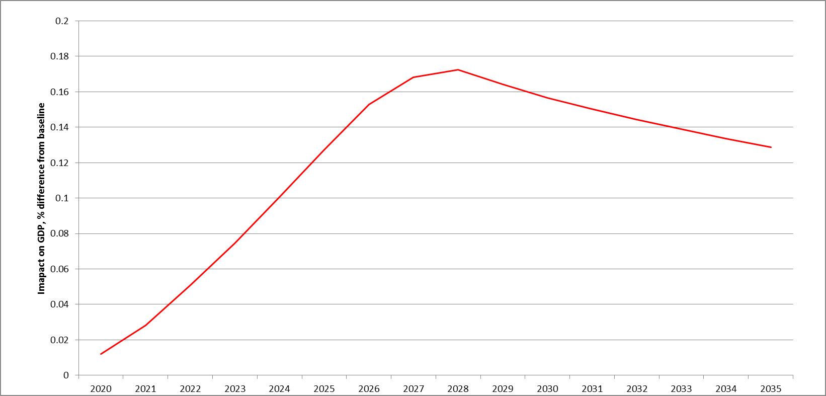

*Source: RHOMOLO*

Map 5 - Regional distribution of FP7 expenditure[71]

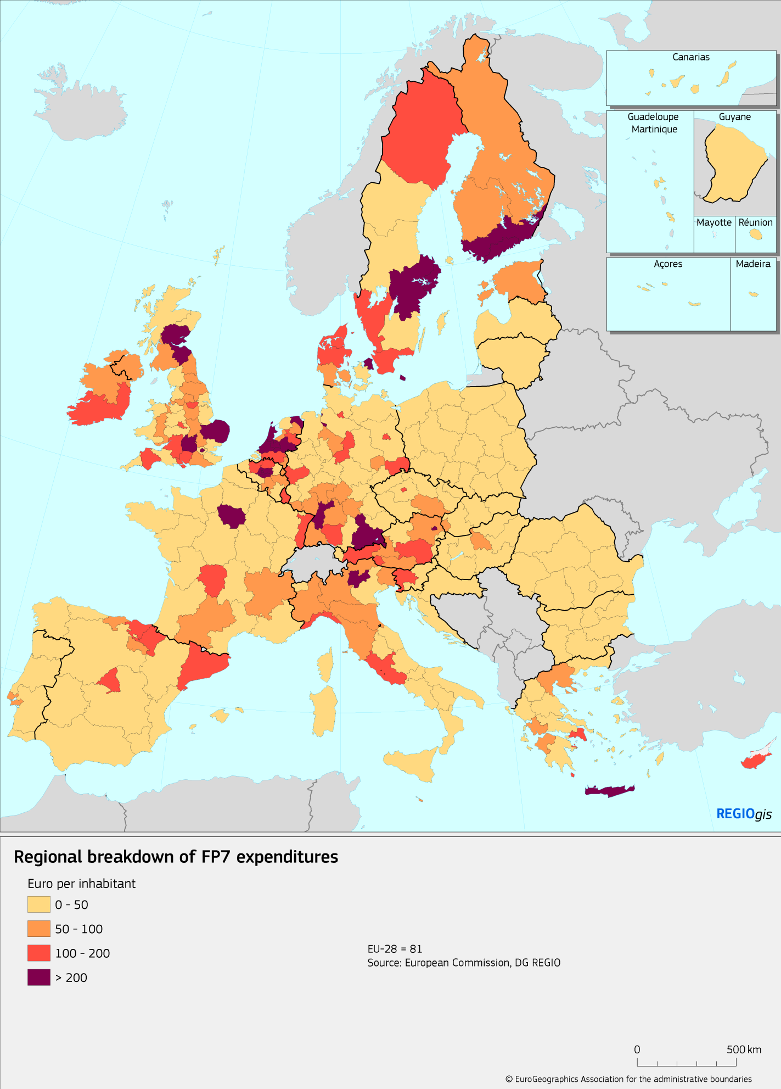

Map 6 – RTD component of 2020-2027 ERDF: impact on regional GDP, 2030

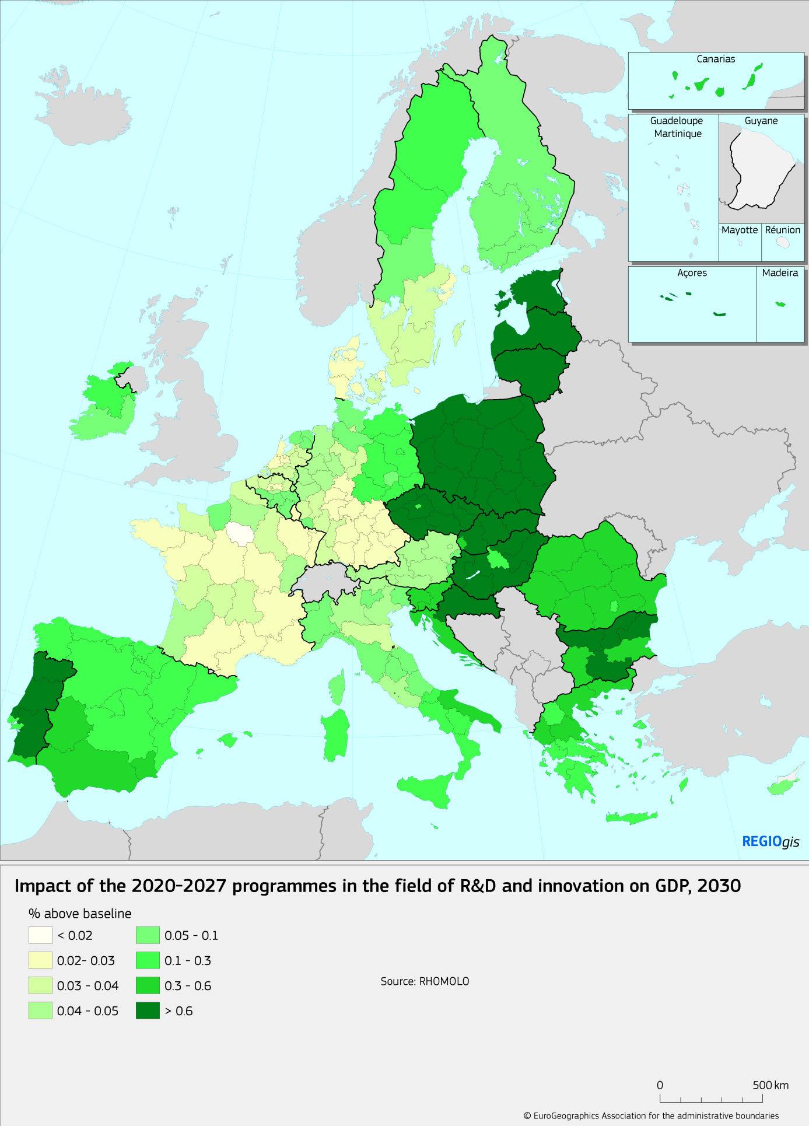

Trans-European transport networks projects will continue to be financed from the Cohesion Fund via both shared management and the direct implementation mode under the **Connecting Europe Facility (CEF)**. EUR 11 billion of the Cohesion Fund will be transferred to the CEF for this purpose. Co-ordination with the CEF will include:

* A simple demarcation, where the CEF will focus in particular on the core network and the ERDF and CF on ensuring that the comprehensive network, including ensuring regional and local access to the network.
* Alignment of approaches, including alignment of eligibility criteria, coherent conditionality and a clear view on the project pipeline across multiple instruments.
* Maximising synergies between transport, energy and telecommunications sectors, to promote smart, low-emission and safe mobility (e.g. energy infrastructure, alternative-fuels, connected and autonomous vehicles) which should be deployed in pan-European way.
* In the area of broadband, reinforced ERDF support to ensure the rollout of digital networks in view of covering all territories throughout the EU, including rural, isolated, and sparsely populated areas. The ERDF would focus on areas where more severe market failures are observed and where higher intensity grants are required to render the network deployment viable. CEF would cover areas where milder market failures are encountered to render a network deployment viable. CEF would also support strategic digital projects, for example the deployment of 5G corridors.

The new **Digital Europe Programme** focuses on deployment and capacity building in key digital areas at European level, in order to promote global competitiveness through digital transformation. All five areas covered (cybersecurity, digital transformation of industry, digital transformation of Services of Public Interest, high performance computing and advanced digital skills) have a clear regional impact. An alignment will be made with EU initiatives in this field, such as the Digitising European Industry initiative[72], necessary to complete the digital single market; and with eGovernment Action Plan and Tallinn Ministerial Declaration on eGovernment[73], both related to the modernisation of public administration and digital transformation.

Synergies will be ensured with the **LIFE** programme for Environmental and Climate Action, in particular through LIFE strategic integrated projects, to optimise the uptake of funds supporting environmental investments. ERDF and CF may fund activities that complement LIFE projects, as well as by promoting the wider use of solutions, methods and approaches validated under LIFE (inter alia, including investments in green infrastructure, energy efficiency, eco-innovation, ecosystem-based solutions, and the adoption of related innovative technologies).

Regarding **migration-related challenges**, all Cohesion Policy Funds will address long-term needs linked to integration, while the Asylum and Migration Fund will focus on shorter term needs. AMIF will mainly support actions in the early stage of integration and with a focus on 3rd country nationals, while the ERDF will target more general longer term measures, notably development of infrastructures, social housing and measures touching entrepreneurship. The ESF will complement these investments with softer long term integration measures.

On **security**, synergies will be sought on the protection and securisation of public spaces, transport hubs and other critical infrastructure, cybercrime and the prevention of radicalisation. The Internal Security Fund (ISF) will mainly focus on supporting information exchange and operational cooperation between law enforcement authorities. In relation to infrastructure, the ISF will support immediate security needs and innovative actions which do not require heavy investments. The ERDF may invest in security infrastructure in regeneration of deprived communities. The ERDF may complement border management interventions under the integrated border management fund (IBMF) with infrastructure for border crossing points (eg transport facilities including roads).

Finally, **EU macro-regional and sea basin strategies**, which aim at better coordination of policies and funds in a specific geographical area, represent an effective tool for increasing coherence and synergies with other policies.

# Delivery mechanisms of the intended funding

## Programming: flexibility for emerging needs, return to "n+2"

The shared management system of the ERDF and CF is based on a programme agreed between the Member State and the Commission at the beginning of the period. In the current 2014-20 period, this programme allocates funding by priority for the full 7 years.

There is a trade-off between stable long term planning (a foundation of ERDF and CF success, smart specialisation strategies being a notable example) and the flexibility to respond to new developments and emerging needs. Although there is some flexibility in the current system – for example the ability to transfer up to 10% of funding between priorities towards the end of the period – circumstances have proved that more flexibility is needed.

The economic crisis in the 2007-13 period, migration events and the ongoing challenge of technical changes – all of these challenges require the ability to respond flexibility and effectively.

In future there will therefore be **a 5+2 programming system**: only the first 5 years' funding will be programmed. The remaining 2 years will be assigned to the national envelope and programmed in a midterm review.

Performance framework targets will be set for 2024, for the last 2 years new targets will be set in the context of the reprogramming exercise. There will be no performance reserve. Instead, the programming of the last 2 years' allocation will take into account:

1. Whether the weight of the priorities (or their existence) still holds after the 4th year of implementation. Priorities will be confirm or adjusted in the light of emerging needs, changing circumstances and relevant CSRs (see below).
2. Progress towards performance targets.

In the current period, spending is subject to an n+3 rule. These rules mean that 3 years after the year money is allocated, if it is not spent it will be decommitted. While a certain "grace period" is necessary to programme and implement complex programmes, it was noted in earlier chapters that there is considerable delay at the beginning of programmes, as well as "overhang" of previous programmes.

In order to correct this issue, we are proposing programming which **catches up to n+2 by the end of the period**. This catch up should be possible because of administrative simplifications in programming and payments proposed below.

## Enabling conditions[74] and governance

The effectiveness of public investments and the durability of results depend on suitable conditions. Unsound policy frameworks and regulatory, administrative and institutional weaknesses are major systemic obstacles hindering effective and efficient public spending. It is therefore of the utmost importance that such weaknesses are identified and addressed at the beginning of the programming period[75].

This is why a key reform of the ESI Funds for the 2014-2020 programming period was the introduction of *ex ante* conditionalities (ExAC). These are sector-specific or general preconditions that needed to be met at an early stage of programme implementation and by the end of 2016 at the latest (see box).

|  |
| --- |
| **What are enabling conditions and ex ante conditionalities?**  A precondition for programmes. In the current round of the ERDF and CF they are called "ex ante conditionalities" (ExACs) and fall into five broad categories[76]:   1. Improving the investment environment in the EU. Many ExACs address horizontal and sector-specific barriers that hinder investment. 2. Supporting structural changes and implementation of country specific recommendations (CSRs) under the European Semester process. 3. Accelerating the transposition and implementation of the EU acquis, e.g. in public procurement, state aid, environment, non-discrimination, gender and disability. 4. Better targeting of support from ESI funds and other public funds. For example, via a needs analysis or strategic policy documents. 5. Improving administrative capacity and coordination.   Around 75% of all applicable ex ante conditionalities were fulfilled at the time of adoption of the 2014-20 ESI Fund programmes. For the non-fulfilled ones, over 800 distinct action plans were included in the programmes[77].  Post-2020, ExACs will be simplified, streamlined and renamed "enabling conditions". |

A review of the ex ante conditionalities[78] found that they helped set the conditions for programme success. In their absence, reforms might not have happened or happened at a much slower pace. However several lessons were learned:

* There were too many of them. There will therefore be far **fewer enabling conditions.** One key tool to reduce their number is to tightly focus on those that have the most impact on the effectiveness of ERDF and CF support. These would usually be strategies or framework tools directly related to ERDF and CF interventions (for example a smart specialisation strategy). The other key tool is to avoid enabling conditions:
  + Which repeat existing legal obligations.
  + Which Require Member States to revise recently submitted documents.
  + Where other tools are more appropriate, such as programming priorities, project eligibility criteria or administrative capacity measures.
* There were too complex. In future, **fulfilment criteria shall be few, clear, tangible and measurable –** and with a clear link to programme success. This means no more administrative capacity elements (such as training).
* They were set at the beginning of the programme and not revisited – the assessment was a one off exercise. There will be **follow-up across the period**. For example, strategic documents should be reflected in project selection criteria, enabling conditions could be monitored on the ground or the subject of evaluations.

**Governance**

The ERDF and CF will be more closely aligned with the European Semester of economic policy coordination, which will also reinforce its regional dimension. The detailed analysis of Member States' challenges in the context of the European Semester will serve as a basis for the programming of the funds at the start and at mid-term of the next period. This will serve as the roadmap for the short, mid- and long-term planning and monitoring of the funds.

In supporting the country specific recommendations (CSRs) stemming from the **European semester process**, it is important to ensure better alignment – currently there are few investment related CSRs and those which do fall into this category tend to be too vague to be operational. Alignment will be promoted:

* At the programming stage: Member States will identify relevant CSRs from the latest two years (2019 and 2020), to include in the programmes.
* At annual review meetings: CSR progress will be discussed between Commission and Member State (and at monitoring committee meetings) as part of the annual policy dialogue.
* At the 5+2 review stage: as outlined above, this will take account of CSRs of years 2023 and 2024 at the performance review in year 5.
* Member States will estimate upfront the % funding addressing CSRs per specific priority and this could be tracked via payment claims. This will enable estimation of how much funding is going to various CSRs.

This will lead to transparency and accountability in addressing CSRs through ERDF and CF. Moreover, through the European Semester process the Commission and the Member States (notably through their National Reform Programmes) will ensure coordination and complementarity of financing from cohesion policy funds and the new **Reform Support Programme** with regard to the support to structural reforms.

Conditionality linked to the **rule of law** (i.e. justice system) will be dealt with in a separate regulation concerning various EU policies and instruments (and not only Cohesion Policy). The issue of rule of law goes beyond Cohesion Policy and a separate, cross-cutting regulation enables a common approach across the various relevant policies and instruments.

**Macroeconomic conditionality** (i.e. linked to the Stability and Growth Pact) is maintained but will be streamlined. They will also be refined and made smarter, to avoid aggravating the economic situation by cutting investments in time of crisis.

## Simplification

The 2014-2020 programmes have already seen various simplification measures, including:

* Common principles for ESI Funds in terms of strategic planning, eligibility and durability, complemented with fund specific rules;
* Introduction of e-Cohesion principle, ensuring exchanges of information between beneficiaries and programme by electronic data exchange systems;
* Proportional control and audit procedures, with a single-audit principle;
* Extended use of simplified cost options (SCO) to reimburse eligible expenditure: flat-rate financing, standard scales of unit costs and lump sums.
* Simpler rules for revenue-generating projects, including flat rates.

These measures brought a reduction of ERDF and CF administrative costs for managing authorities by 4-8% and a reduction of administrative burden on final beneficiaries by 9-14%[79].

However, further simplification is necessary:

* There is evidence of substantial administrative costs, estimated in a recent study[80] at 3% of average programme costs for the ERDF and 2.2% for Cohesion Fund. The administrative burdens on beneficiaries are even higher. Complex procedures also lead to delays – and a focus on procedure at the expense of results.
* In the public consultation linked to this proposal, some 80% of respondents considered complex procedures as an obstacle preventing funds from achieving their objectives.
* The High Level Group on Simplification of Cohesion Policy (see box) found a number of elements which could be improved.

|  |
| --- |
| **Key recommendations of High Level Group on Simplification of Cohesion Policy[81]**   * Alignment of rules between EU Funds: Cohesion Policy funds should not receive more restrictive treatment than similar projects under central EU management. * Fewer, clearer, shorter rules: replacing current 600 pages of regulations and 5000+ pages of guidelines. Shorter, more strategic texts of programmes. * Genuine subsidiarity and proportionality: reliance on national public expenditure procedures to a much larger extent. * A stable yet flexible framework: no need to re-appoint institutions for the next programming period. Programmes should also be modified more easily. * Single audit principle: extension of the single audit principle, each level of control builds on the preceding one. Additional checks needed if Member State or regions have serious deficiencies. |

There is however a trade-off: the current delivery mechanism is strong in assuring legality and regularity: detailed rules ensure compliance with applicable legislation, fiduciary risk, fraud detection, financial control, risk monitoring etc[82]. The focus on regularity is the main driver of rules, procedures and controls – regularity can only be ensured if the rule is sufficiently clear.

The following measures will promote simplification while still maintaining a sufficient focus on legality and regularity.

A key simplification is **moving further away from payments based on expenditure** – the classic payment method of the ERDF and CF. This method can impose a heavy burden, since expenditure *"often consists of a multiplicity of small items incurred by small beneficiaries. As a result, national administrations complain about the resources needed to verify boxes of documents and timesheets, while beneficiaries are at a loss to understand why they must reimburse money to the EU for participants’ bus tickets long after the ink has faded on those tickets. Failure to ensure that the necessary verifications take place can lead to unacceptably high rates of error and, consequently, the necessity to interrupt and suspend payments to the Member States. Implementation of the necessary corrective actions, ensuring legal, regular and eligible spending of the funds, can lead to Operational Programmes being blocked for up to several years"*[83].

To reduce this burden, the regulations will:

1. **To extend the scope of simplified cost options ("SCOs").**

In this system, instead of reimbursing actual expenditure item by item, payment is based on flat-rate reimbursement, standard scales of unit costs or lump sums. Such measures are being already being used for around 4% of the budget in the 2014-20 programmes. Managing authorities[84] appreciate SCOs for their simplicity and reduction of administrative burden, but are apprehensive about the risk and uncertainty of moving to this new system. They also request further support.

SCOs will be encouraged by simplifying rules and calculation methods, providing more off-the-shelf options and making them compulsory for small amounts. Extending the use of simplified cost options for the ERDF/CF could substantially reduce total administrative costs, even by 20-25% in an ambitious scenario[85]. Other advantages related to the use of SCO include a reduced rate of errors and irregularities.

1. **To introduce a new option: payments based on conditions**.

This makes payment conditional on results/outputs or even policy actions or processes. It represents a radical simplification, moving completely away from checking invoices. A study undertaken for the Commission[86] recommended testing this system in the ERDF and CF, since it has the potential to reduce the administrative burden, especially on beneficiaries. It also changes the focus from costs and reimbursement to tracking results and as such represents good practice elsewhere (such as the World Bank’s Programme for Results[87]).

However, the study also noted that this approach has potential pitfalls:

* It is crucially dependent on having clear and trackable indicators for the conditions, and on the monitoring system more generally. While the monitoring and evaluation system of the ERDF and CF is already good and is being further improved (see section 5), this means that the system would only apply in sectors where appropriate indicators could be found.
* It depends on national audit and assurance systems to make it work (see 4.3 below on proportionality).
* It may make EU contributions and actions less visible.

To gather more information, the approach is being tested in the framework of the omnibus for some types of ERDF investment, such as energy efficiency (see box). It will then be offered as an option to programmes in the new period, and their proposals will be discussed with the Commission in the preparation of programmes.

|  |
| --- |
| **Box: Payment based on conditions – case of energy efficiency**  The Commission is developing together with Member States a pilot scheme of payments based on the fulfilment of conditions in the field of energy efficiency. Under this scheme, the conditions for payments would be the calculated savings in energy use or in CO2 emissions resulting from the improved energy performance. The financing conditions would be proposed by Member States; the Commission would assess them and modify operational programmes to include the payments based on conditions schemes; payment by the Commission would occur once the financing conditions have been fulfilled, or intermediate steps ("milestones") reached.  The advantage of such an approach is twofold: on the one hand reduced administrative cost, on the other a much keener focus on results. |

In addition to simplified cost options and payments based on conditions, there will be a series of simplification measures including:

1. **Simplified programming at the start of the programme**: The main strategic document for ESI Funds at national level, Partnership Agreement, will be much shorter. Similarly, the text of operational programmes will be “lighter”, focusing on achievement of objectives and funds allocations. The intervention logic is also expected to be simplified, focused on broad policy objectives and European specific objectives. There will be no performance reserve. The number of ex-ante conditionalities will be lower. These changes are expected to shorten substantially the start-up phase.
2. **Simplified designation of authorities.** The CPR for 2014-2020 period includes a complex procedure of designation of managing, certifying and audit authorities[88]. Designation was meant to obtain assurance regarding the adequate setup of management and control systems, prior to first payments. This process has proven to be heavy and time consuming, especially for audit authorities. For post-2020, systems would largely be "rolled over" to the next programming period, without requirement for programmes to undergo a new full-fledged designation process. Assurance would still be obtained by early systems audits. Roll over is expected to contribute to a speedier start of the next programming period.
3. **No specific rules for revenue generating programmes**: Currently the CPR has rules for projects which generate revenue[89]. These rules are in addition to State aid rules and aim to avoid over-financing, but are cumbersome in application: a study of implementation in 2014-20[90] found that even small simplifications of rules for revenue-generating projects bring greater administrative cost reductions than expected. The main advantage of these rules is to avoid over-financing, but this can be achieved more simply and easily by a decrease in EU co-financing rates (see chapter 3). Specific rules on revenue generating investments will therefore be eliminated, though of course, state aid rules will continue to apply. The measure is expected to reduce total administrative costs by some 1%[91].
4. **No specific rules for major projects.** Following intensive work by JASPERS and Commission in the 2014-2020 period, the quality of major project administration has increased substantially[92] in many countries. The main challenge now is to extend the analysis to flagship projects in sectors such as R&D/innovation which, while strategically important, often fall below cost thresholds. The process is replaced by "projects of strategic importance" – the monitoring committee themselves will be responsible for identifying and following flagship projects, reporting on progress and results. More upstream work will be encouraged and Jaspers will remain available to national and regional administrations who want to improve the project pipeline.
5. **Reducing the number of verifications:** Currently 100% of payment claims are covered by administrative verifications, while on-the-spot verifications are sample based. Possible changes include making management verifications risk-based, instead of covering 100%. This more proportionate approach to audits would imply an important reduction of the audit burden for “low risk” programmes, reducing total administrative costs of the ERDF and CF by 2-3%[93].
6. **A more proportionate approach to audits**: As regards audits, reduction of the administrative cost could come in particular from the application of a more proportionate approach with lower audit requirements for programmes with low risk. This could mean carrying out only a limited number of audits of operations would be carried out. The selection of “low risk” programmes should be based on objective criteria, such as good track record and/or low co-financing rates. In addition, the number of audits covering territorial cooperation programmes could be drastically reduced, by introducing a common audit sample for ETC programmes.

## Financial instruments ("FIs"): simplification and streamlining

The use of financial instruments in ERDF and CF has increased significantly in recent years. In 2007-2013 around EUR 12 billion of Structural Funds was invested in this way, while in 2014-2020 this is over EUR 21 billion, of which over 95% through the ERDF and CF. SMEs account for just over half of planned investment – together with innovation and the low carbon economy, they represent the bulk.

Financial instruments are acknowledged to be a successful and useful tool in the ERDF and CF. The ex post evaluation noted their "potential to be a more efficient means of funding investment"[94], based on (among other things) their revolving nature. A study of the implementation of FIs found them to be financially sustainable and cost-effective[95].

In addition the ex post evaluation[96] found that FIs:

* Assisted in the development of private financial markets in a number of regions.
* Played a crucial role in providing funding to SMEs during the credit crunch.
* Promoted investment in new technology and improving production processes.

However, FIs are not a goal in themselves. They are a means to an end – and there are cases where grants are preferable or more effective. This means that **there will not be binding targets for their use, or an obligation to use them in certain areas**.

Instead FIs will be promoted by removing obstacles to implementation. One third of managing authorities find FIs too administratively complex and a further third lack knowledge of these instruments[97]. Although there is perception of improvement in 2014-20, most managing authorities still want more administrative and legal certainty, especially for audit.

To tackle these twin problems of complexity and lack of certainty, management and control systems will be consolidated into **one assurance system for both grants and FIs**. Checks and verifications will usually be at the fund level, not the individual operation. This will simplify the overall audit system and increase legal certainty for FIs for managing authorities. It will also reduce the burden for final beneficiaries.

Similarly, **FI-specific reporting[98] will be incorporated in the general reporting cycle**. Such alignment will reduce the widespread perception that FIs entail a lot of extra reporting.

The **ex-ante assessment will be streamlined and shortened:**

* The market gap and needs assessment will be consolidated into the needs assessment section of the programme. This enhances the role of the monitoring committee in identifying needs – and whether a grant or FI is most appropriate to meet them.
* Elements with genuine added value (e.g. implementation arrangements, products, final recipients targeted) will be addressed in a shortened ex ante assessment.
* Relevant elements of a previous ex ante assessment can be rolled over to the new one.

**Provisions on eligibility will be simplified and thresholds for management fees rationalised**. These have generated a lot of need for guidance, as well as some confusion. In future: only minimum eligibility rules will to be set at EU level, leaving more detailed provisions to the Member State.

Factors which **disrupt the flow from one programming period to the next** will be smoothed out. Regulations which lead to questions after the end of the programming period (eg use of funds, reflows…) will be simplified to only define minimum standards. This will facilitate a smooth start to implementation and payments from day one of the new period.

|  |
| --- |
| **A Single Investment Fund at the European level**  Currently there are multiple EU-level FI instruments, with the potential to cause confusion among beneficiaries. These will be simplified and delivered through one single investment fund - the Invest EU Fund. There will also be provisions to ensure better complementarity between the InvestEU Fund and FIs under shared management.  Member States will have an option to channel a part their ERDF and CF resources via a Budgetary Guarantee under the InvestEU Fund. To do so, the Member State would set out their intention in the Partnership Agreement, explaining the goals of the transfer, which of the thematic windows they wish to use (SMEs, innovation etc.) and geographic earmarking. The InvestEU Fund impact assessment report includes further details. |

## Performance, flexibility and simplification: conclusions on the new system of priorities and delivery

The new system of priorities and delivery of ERDF and CF promotes performance, flexibility and simplification.

Performance, including in terms of:

* A stronger concentration on smart and green growth - the areas with greatest impact and highest EU added value (see section 3.3).
* A clearer division of labour and more coherence with other relevant EU funding streams, especially the other ESI funds and Horizon2020 (3.4).
* Scheduled reprogramming which explicitly refocuses on performance and on emerging needs (4.1).
* Accelerating the programming process, returning to the "n+2" standard (4.1), enabled by the various simplifications (e.g. 4.3 and 4.4).
* A greater focus on the preconditions of success, setting the enabling conditions and making explicit links with economic governance (4.2).
* Opening the possibility of payments based on conditions (4.3).
* Removing the obstacles to, and promoting, Financial Instruments. These can be more cost-effective than grants (4.4).

Flexibility in programming, including:

* More broadly drawn priorities which enable easy transfer of funding and synergies between related themes now included in one priority (eg innovation and SME support)(3.3).
* More flexibility in reprogramming, notably a "5+2" programming system where the last 2 years are not programmed until closer to the time (4.1).

Simplification and reduction of the administrative burden on managers and beneficiaries:

* A simpler set of priority objectives (3.3)
* Simpler relationships between various EU funds, including the elimination of several "double guichet"s (3.4).
* Simpler reprogramming (4.1)
* A simpler set of "enabling conditions" and simpler links to the European Semester (4.2)
* A systematic series of simplifications to reimbursement, audit, management and control (4.3).
* Simplification of management, audit and reporting of financial instruments, aligning the system as far as possible with that for other forms of support (4.4).

# How will performance be monitored and evaluated?

## Monitoring

The ERDF and CF monitoring system has been developed and refined over successive programme periods. In the current period, key elements include (Table 13):

* Financial data such as allocations, project selection and expenditure declared and certified. Some of the data are disaggregated along several dimensions, including intervention fields (e.g. rail), territorial dimension (e.g. urban), and finance (e.g. grants).
* EU payments to the programmes, recorded in real time in the Commission's IT system.
* Output indicators: 46 common output indicators and various programme specific outputs. These are collected through monitoring systems – achieved values are reported by Member States in annual implementation reports ("AIRs"). The common indicators can be aggregated at EU level and are tracked publicly on the ESI Funds Open Data Platform (see box).
* Policy results, akin to impact indicators (as defined in the Better Regulation Guidelines), and measured by statistical data at regional or national levels. Annual values are reported in the AIRs during the implementation period. The main sources of data for these result indicators are national and regional statistical systems, as well as by Eurostat.

Table 13 - Main monitoring data collected for ERDF and CF 2014-2020

|  |  |  |  |
| --- | --- | --- | --- |
| **Type of data** | **Frequency** | **Who collects** | **Source** |
| Various financial data | Jan, June, July, October | Managing authority | Programme data |
| EU payments | Continuous | EU level | Payments system |
| Output indicators | Annual (in June) | Managing authority | Monitoring systems |
| Policy results | Annual (in June) | Managing authority | Monitoring, national statistics or Eurostat |

Because of shared management, most output and result indicators are collected by Member States. But there is a clear structure at EU level for (1) selection of indicators and targets (2) quality checks and reporting.

The 2014-20 programmes had a clear process for selection of indicators and setting of targets:

* Managing authorities proposed output and policy result indicators in the programmes. For output indicators, the starting point was the 46 common output indicators which were all used where appropriate[99]. Programmes then added programme specific output indicators, as well as policy result indicator – at least one per investment priority, which captured the main goal of that priority. Output and result indicators were examined as part of discussion with the Commission.
* Targets were set using unit costs derived from experience in the programme itself, elsewhere in that Member State or elsewhere in the EU. The process of setting targets was part of programme discussion with the Commission, and the calculation methods were documented either in the programme itself, or (more usually) in a working document accompanying the programme.

A study of the 2014-20 performance framework[100] found that Member States made significant efforts to establish the performance framework on a solid basis. Setting milestones and indicators was mainly straightforward – only 20% of programmes had a lot of difficulty in doing this.

Quality checks and structured electronic reporting are essential features, built into the system:

* The monitoring systems for 2014-2020 benefit from reinforced scrutiny. The programming rules require a declaration of assurance of the Managing Authority on the reliability of data[101], while the audit strategy established by Member State Audit authorities includes systems audits to ensure performance data reliability[102]. An audit trail on performance data is required[103], and reliability of performance data is part of the audits on operations[104].
* Indicators are transmitted electronically to the Commission in a structured format via an information system, SFC.[105] This structured data has enabled swift reporting on ESI Fund investments for a variety of audiences[106].
* A Monitoring Helpdesk has been established so that REGIO can digest the data presented, internally analyse performance of the operational programmes and identify possible outliers through the use of automated systems. Weaknesses or apparent implausibility in the data are commented by the Commission and where necessary corrections sought.
* In addition, the Open Data Platform tracks the achievement values as reported by the Member States and is publicly available. This offers unprecedented transparency and encourages “peer pressure” in reporting reliable data.
* This is an iterative, annual process. Managing authorities gain in experience and accuracy – there has been a noticeable year on year improvement, with fewer errors detected in the plausibility checks.

|  |
| --- |
| **The open data platform**  The European Structural and Investment Funds Open Data Platform presents data and graphs for five funds, 28 countries, and more than 530 programmes, covering 42% of the EU budget. The platform is regularly updated and is an important communication tool for the general public, the media, analysts, and researchers. For more specialised audiences, the platform offers open access to detailed data at programme level, including time-series of planed and implemented resources and achievements, thus facilitating in-depth analysis of the funds.  The platform meets several objectives: transparency and communication; promoting excellence among Member States by providing a comparison tool; and enabling analysis and research. In March 2017, the platform received the first EU Ombudsman Award for Excellence in Open Administration. |

The 2014-20 performance framework was highly appreciated by programme stakeholders, who noted that it helped focus the programme from the outset, served as a guide for implementation and defined realistic targets and expectations (see Figure 9). Only 10% of respondents saw no benefit. Moreover, there is evidence that the development of performance frameworks generated considerable and useful debate within Member States and between Member States and the Commission[107].

Figure 9 - What do you see as the main benefit of the performance framework?



*Source: Sweco, ÖIR, Spatial Foresight (2015) "Implementation of the performance frameworks in the 2014-2020 European Structural and Investment (ESI) Funds". Respondents were asked to select one answer only.*

**Monitoring post-2020**

The post 2020 system will therefore build on the strengths of the 2014-20 system, retaining the shared management system, quality checks, structured reporting and open data platform. But experience shows the need for several improvements.

**1. Introducing direct result indicators, in line with best practice elsewhere.** The 2014-20 system of indicators for ERDF and CF includes currently only two levels: outputs and "policy results" (which correspond to "impact indicators" in other systems). The study on the performance framework noted the sharp dichotomy between outputs on the one hand and impacts on the other. Post-2020, an intermediate layer of direct results will be created, in line with the Commission's "Better Regulation Guidelines".

**2. Extending the common indicator set – from outputs only to results and impacts.** Common output indicators based on agreed definitions have proven a success. Of all instances of indicator use in the 2014-20 ERDF and CF programmes, the 46 common output indicators account for 60% by number and 60-70% by financial allocation. These common indicators can be aggregated across programmes and countries (in contrast to programme specific indicators) and are therefore key tools in accountability, transparency and communication.

Post-2020, there will be a menu of common indicators at all three levels: outputs, direct results and policy result/impact indicators (see Table 11 earlier for initial proposals for outputs and direct results). Programmes will still be able to propose programme specific indicators, but will be encouraged to use common indicators where possible. There will be stronger methodological support in terms of detailed definitions and methods of calculation for outputs and results. Having common indicator sets will mean we can communicate result and impact indicators at the EU level.

**3. More electronic transmission of data, lighter annual reports, more debate on results.** The electronic exchange of information between Managing Authorities and Commission via SFC has reduced administrative burden and increased the scope of data transmitted. Conversely, the added value of annual reports is questionable. The quantitative and the qualitative information included in them is outdated by at least half a year when they are submitted and by 9 months or more by the time the review process is finished and the data published.

Post-2020, there will therefore be:

* More frequent transmission of all quantitative data (notably outputs and results) by electronic means six times a year (instead of once via the annual report). It will be published rapidly via the open data platform, rather than 9-12 months later.
* A revamped annual review meeting between the Commission and the Member State. Instead of discussion on the basis of a document representing the state of play from 9 (or more) months previous, the meeting will be focus on policy dialogue on current issues. The qualitative side of the annual report will be replaced by a short public record of the outcome of the meeting.

## Evaluation

The 2014-2020 period saw the introduction of a regulatory requirement for impact evaluations by programmes[108]. This has borne fruit and we expect nearly 1000 evidence-based impact evaluations to be completed by 2024 (Table 14).

To build on this post-2020, there will be measures for:

**1. Improved evaluation design.** To align with evaluations carried out by the European Commission, there will be a regulatory requirement for Member States to address in their evaluations the five main evaluation criteria (EU added value, effectiveness, efficiency, coherence and relevance) from the EC Better Regulations Guidelines. This would put impact evaluations on a more coherent basis and feed into evaluation and reporting carried out at the Commission level.

Member States will continue to be required to carry out evaluation plans and submit them to the Commission. This will enable the Commission to assess the quality of the plans – and ask Member States to correct potential gaps in their evaluation strategy.

DG REGIO will continue to promote a full toolbox of methods, depending on the topic. The 2007-13 ex-post evaluations include counterfactual analysis, theory–based impact evaluation, network analysis, case studies, as well as modelling (with QUEST and RHOMOLO).[109]

**2. Better data availability.** The systematic collection of indicator data outlined above will provide a better basis for evaluation. In addition, there will be:

* Clearer reflection in Member State evaluation plans on data needs. Notably in the case of counterfactual analyses, which requires data on non-beneficiaries as well as beneficiaries.
* Systematic collection of data at operation level. One of the major challenges of evaluations for Cohesion Policy has traditionally been data at the operation level – Commission evaluations usually start by collecting such data. The new provisions will require managing authorities to collect and publish basic operation data on a consistent basis, notably start and end date, Fund, specific objective, total financing, public and private, EU contribution, and intervention field(s).
* Supporting Member States in the use of "big data solutions", including the cross-linking of various forms of administrative and firm-level data. It may be advantageous to involve in the evaluations the bodies responsible for this data.

**3. Continued support to Member States to enhance their evaluation capacity.** In the 2014-20 period, DG REGIO established an Evaluation Helpdesk which provides a number of support services as follows: feedback on evaluations plans received from Member States, organization of annual summer schools on evaluation issues, syntheses of the results of evaluation from Member States, peer review analyses of selected evaluations upon demand from Member States, methodological support tailored to the needs expressed by Managing Authorities, as well as an online library of evaluation studies from Member States, with extended abstracts in English for selected studies. Additional support activities include exchange of information on evaluation results, consultations, and promotion of good practices, as well as REGIO-led Evaluation Network meetings, organised 2-3 times a year.

**4. Collection and synthesis of interim evaluations.** The above requirements will lead to a higher proportion and higher quality of impact evaluations. These evaluations will be collected, summarised and the lessons drawn together. In the light of gaps and outstanding questions, the Commission may also launch complementary ad hoc evaluations on specific topics. This will enable interim evaluation findings by 2024/5 to feed into the last two years of programming, as well as preparations for the next MFF.

**5. Ex-post evaluations.** The Commission will conduct a systematic ex post evaluation for the end of the period. Member States will also be required to conduct retrospective evaluations to assess the impact of their programmes. Moreover, the ex post evaluation of 2014-2020 will be launched in 2022 and the related findings will be available in 2024/5, in time for the revision of the last two years of programming and for the preparation of the next MFF. The design of the ex-post evaluation will take into account primarily the results available from the evaluations carried out by the Member States and the findings of a gap analysis of the areas of investments not sufficiently covered by these evaluations.

Table 14 - Evaluations planned by Member States 2014-2020

|  |  |  |  |  |  |  |
| --- | --- | --- | --- | --- | --- | --- |
|  | ERDF+CF | | multi-Fund | | Total | |
|  | No. | % | No. | % | No. | % |
| Impact-oriented | 294 | 38 | 344 | 47 | 638 | 43 |
| Impact and procedure/implementation and/or monitoring/progress-oriented | 184 | 24 | 150 | 20 | 334 | 22 |
| Procedure/implementation-oriented | 120 | 16 | 107 | 14 | 227 | 15 |
| Monitoring/progress-oriented | 91 | 12 | 84 | 11 | 175 | 12 |
| Procedure/implementation ***and*** monitoring/progress-oriented | 30 | 4 | 36 | 5 | 66 | 4 |
| Other | 46 | 6 | 19 | 3 | 65 | 4 |
| **Total** | **765** | **100** | **740** | **100** | **1,505** | **100** |

SWD(2017)452 Strategic report on the implementation of the ESI Funds

<https://eur-lex.europa.eu/legal-content/EN/TXT/?uri=SWD:2017:452:FIN>

Annex 1: Procedural information

# Lead DG(s), D*e*cide Planning/CWP references

DG for Regional and Urban Policy (DG REGIO)

# Organisation and timing

This impact assessment accompanies the legislative proposals for the ERDF and the Cohesion Fund, prepared in the context of the post-2020 MFF. It has been drafted by the staff of DG REGIO.

The work on the Impact Assessment was supervised by the Inter-Service Steering Group (ISSG), which met twice in February and March 2018. 21 DGs participated in the ISSG meetings[110].

An internet-based public consultation took place took place between the 10th January and 9th March 2018. The results are presented in annex 2.

# Consultation of the Regulatory Scrutiny Board (RSB)

* An informal upstream meeting was held on 31 January with RSB representatives and the participation of SG, DG BUDG and JRC. During this discussion Board members and representatives of the horizontal Services provided early feedback and advice on the basis of the inception impact assessment. Board members' feedback did not prejudge in any way the subsequent formal deliberations of the RSB.
* A formal hearing with the RSB was held on 18 April 2018 and a negative opinion delivered on 20 April.
* These comments were taken on board (see table below) and the document resubmitted to the RSB on 3 May. A positive opinion with reservations was delivered on 7 May. These comments were taken on board as in the table below.

|  |  |
| --- | --- |
| **RSB opinion** | **How addressed** |
| **Round 1: Negative opinion**  (1) The report does not consider implications of reducing ERDF and CF funding capacities.  (2) The report does not explain how changed objectives and allocation criteria would redirect the programme.  (3) It does not consider possible (sub-) options for geographic coverage, regional eligibility and means for financial allocations under the ERDF/CF.  (4) The report does not sufficiently explore implications of changes to the delivery mechanisms. | (1) A 10% cut in funding is now modelled in section 3.2, using three different options.  (2) The text and graphs of section 3.2 show how the programme would be redirected under the various options.  (3) Three options for geographic and thematic allocations are outlined in section 3.2, with indications of the main line of redirection.  (4) The chapter on delivery mechanisms has been developed along the lines requested by the RSB (see section on comment 8 below). |
| **Round 2: positive opinion, with the following reservations:**  (1) The content and the implications of the preferred option (thematic concentration) are not sufficiently clear. The revised report does not provide sufficient evidence that thematic concentration will contribute to reducing regional and national disparities.  (2) The report does not spell out future modalities for the implementation of the 'Berlin method' for financial allocation and reasons for not considering alternative options.  (3) The report does not describe the scope and the potential impacts of a European cross-border mechanism.  (4) The report does not clarify the consistency/complementarity between the ERDF/CF and the new Reform Support Programme. | (1) The content of all options is now spelled out on pages 28-29 and compared in tabular form in table 7. Figure 5 considers the thematic impact of the preferred option by Member State. The impacts of the various options on regional and national growth rates are examined and compared by the QUEST macroeconomic model in the text on pages 30-31 as well as in the numbers in table 9 and figures 6 and 7.  (2) The key features of the Berlin method are now outlined in a box on page 29, along with the reasons for retaining this method and not considering alternative options.  (3) The cross-border mechanism is described on pages 41-42. A report on potential impacts is quoted and the source footnoted.  (4) The relationship with the Reform Support Programme is now explained on page 60. |

# Evidence, sources and quality

**Evaluations carried for the Commission (DG REGIO)**

Ex Post Evaluation of the ERDF and Cohesion Fund 2007-2013 – including the Commission’s summary and 14 thematic work packages prepared by external evaluators for DG REGIO:

<http://ec.europa.eu/regional_policy/en/policy/evaluations/ec/2007-2013/>

**Cohesion Report**

The 7th Report on Economic, Social and Territorial Cohesion, published by the Commission in October 2017, analysed the state of the EU's economic, social and territorial cohesion and set the scene for cohesion policy after 2020.

<http://ec.europa.eu/regional_policy/sources/docoffic/official/reports/cohesion7/7cr.pdf>

**Studies carried out for DG REGIO in preparation for post-2020 EU funds:**

Study “The use of new provisions during the programming phase of the European Structural and Investment Funds”

<http://ec.europa.eu/regional_policy/en/information/publications/studies/2016/the-use-of-new-provisions-during-the-programming-phase-of-the-european-structural-and-investment-funds>

Study “The implementation of the provisions in relation to the ex ante conditionalities during the programming phase of the European Structural and Investment (ESI) Funds”

<http://ec.europa.eu/regional_policy/en/information/publications/studies/2016/the-implementation-of-the-provisions-in-relation-to-the-ex-ante-conditionalities-during-the-programming-phase-of-the-european-structural-and-investment-esi-funds>

Study "Implementation of the performance frameworks in the 2014-2020 European Structural and Investment (ESI) Funds" <http://ec.europa.eu/regional_policy/sources/policy/how/studies_integration/impl_pf_esif_report_en.pdf>

Study “Implementation of the partnership principle and multi-level governance during the 2014-2020 ESI Funds”

<http://ec.europa.eu/regional_policy/en/information/publications/studies/2016/implementation-of-the-partnership-principle-and-multi-level-governance-during-the-2014-2020-esi-funds>

Study “Setting up a database to assess impacts and effects of certain thresholds and limits in Regulation (EU) No 1303/2013 (CPR)”

<http://ec.europa.eu/regional_policy/en/information/publications/studies/2016/setting-up-a-database-to-assess-impacts-and-effects-of-certain-thresholds-and-limits-in-regulation-no-1303-2013-cpr>

Study “Use of new provisions on simplification during the early implementation phase of ESIF”

<http://ec.europa.eu/regional_policy/en/information/publications/studies/2017/use-of-new-provisions-on-simplification-during-the-early-implementation-phase-of-esif>

Study “Improving the take-up and effectiveness of financial instruments”

<http://ec.europa.eu/regional_policy/en/information/publications/studies/2017/improving-the-take-up-and-effectiveness-of-financial-instruments>

**Studies for DG REGIO to be published in 2018**

Study on the coordination and harmonisation of ESI Funds and other EU instruments

Feasibility study for a potential use of Budget Support to deliver ESI Funds

Study “Effective and efficient delivery of ESI Funds - Exploring alternative delivery mechanisms”

Study “New assessment of administrative costs and burdens in ESI Funds”

**Other relevant documents**

Report “Competitiveness in low-income and low-growth regions”

<http://ec.europa.eu/regional_policy/sources/docgener/studies/pdf/lagging_regions%20report_en.pdf>

Communication “Strengthening Innovation in Europe's Regions: Strategies for resilient, inclusive and sustainable growth

<http://ec.europa.eu/regional_policy/sources/docoffic/2014/com_2017_376_2_en.pdf>

Communication “A stronger and renewed strategic partnership with the EU's outermost regions”

<http://ec.europa.eu/regional_policy/en/information/publications/communications/2017/un-partenariat-privilegie-renouvele-et-renforce-avec-les-regions-ultraperipheriques>

Communication “Boosting growth and cohesion in EU border regions”

<http://ec.europa.eu/regional_policy/en/information/publications/communications/2017/boosting-growth-and-cohesion-in-eu-border-regions>

Summary of the LSE – DG REGIO academic conference “Reassessing economic development policies for regions and cities”

<http://ec.europa.eu/regional_policy/en/information/publications/brochures/2016/reassessing-economic-development-policies-for-regions-and-cities-growth-and-equity-institutions-and-governance-people-and-places>

Report from the OECD- DG REGIO seminars “Rethinking Regional Development Policy Making”

<http://www.oecd.org/governance/rethinking-regional-development-policy-making-9789264293014-en.htm>

Annex 2: Stakeholder consultation – synopsis report

The stakeholder consultation on post-2020 regional policy proposals included several elements:

* Cohesion Forum, held in June 2017 - a large scale high-level political event (700+ participants) to discuss cohesion policy responses to the main EU economic and social challenges;
* Cohesion Report (7th report on economic, social and territorial cohesion), October 2017 which analysed the state of the EU's economic, social and territorial cohesion and set the scene for cohesion policy after 2020. The adoption of the report was followed by numerous presentations and discussions with various stakeholders.
* Debates and exchanges on post-2020 with the Council, Parliament and the Committee of Regions. Meetings of the Structured Dialogue with ESIF partners at EU level.
* Conferences and workshops with the academics (with the European Regional Studies Association – ERSA and the Regional Studies Association – RSA) and international organisations (OECD).

The main element of the consultation process was online public consultation on cohesion policy, which took place between the 10th January and 9th March 2018. The questionnaire used the EU survey site: <https://ec.europa.eu/info/consultations/public-consultation-eu-funds-area-cohesion_en>. Intensive communication was carried out in order to encourage a high level of participation across the EU.

The scope of the public consultation was broader than the scope of the impact assessment and covered not only the ERDF and the Cohesion Fund, but also the ESF (European Social Fund), the FEAD (European Aid to the Most Deprived), the EGF (European Globalisation Fund) and the EaSI (European Programme for Employment and Social Innovation).

The questions covered both the assessment of the performance of the current policy as well as the views on key aspects of future policy design. The questionnaire included 5 sets of closed questions (multiple choice) and 4 open questions. There was also a possibility to upload concise documents, such as position papers.

Altogether 4395 replies were received in the public consultation and 676 documents (mainly position papers) were uploaded. The analysis was made in line with Better Regulation Guidelines and Toolbox (Tool 54), with a support of external consultants[111]. The methodology included, first, elimination of duplicates and identification of the responses being part of a campaign, which were separated from the rest with only one set of replies being included in the main analysis. After in this way, the number of questionnaires was reduced from 4334 to 3958. The analysis of replies combined the reading of the text with computer-assisted text analysis.

Out of 3958 questionnaires analysed, 47% of replies were submitted by individuals and 53% by organisations including regional or local authorities (18%), NGOs (8%), national authorities (4%), enterprises, business associations, consultancies and academia (3% each), churches and religious communities (2%). Responses to the consultation were submitted from all Member States. The largest number of responses came from Italy (21%), followed by Poland (14%), France, Germany and Spain. Some 74% of respondents reported having experience with the ERDF and/or the Cohesion Fund, while 57% with ESF; 10% of respondents did not indicate experience of any of the funds.

**Replies to multiple-choice questions**

Closed questions concerned:

1) the importance of main policy challenges;

2) the extent to which current programmes address these challenges;

3) added value of EU funds;

4) main obstacles preventing current programmes from achieving objectives;

5) actions needed to further simplify the delivery of funds.

1) Question on the importance of selected challenges to Cohesion Policy.

Among 14 challenges pre-identified and included in the questionnaire, the results indicate that the respondents consider *reduction of regional disparities* as the most important challenge (94% of respondents considered it as very or rather important), followed by *reducing unemployment* (92%). *Promoting social inclusion, promoting economic growth in the EU*, fostering *research and innovation* and *transition to low carbon economy* were also among the most important challenges. The smallest proportion saw *addressing the adverse side-effects of globalisation* (72%) and *promoting sound economic governance and reforms* (68%) as important.

**Figure 1: Share of replies to the question about the importance of policy challenges**

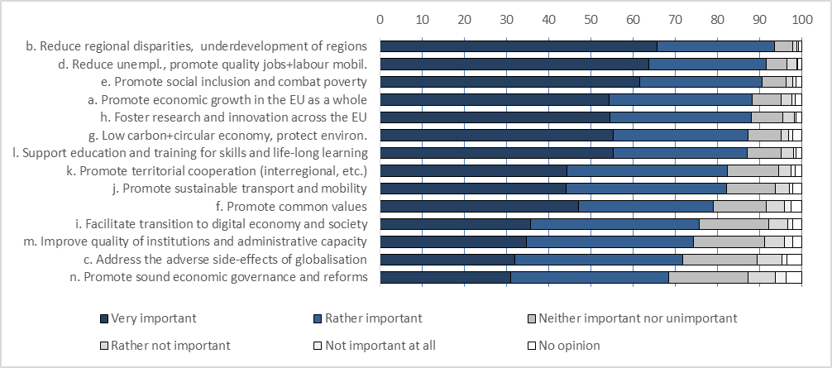

Respondents with experience of the ERDF/CF and those with experience of the ESF had much the same view of the relative importance of the different challenges. There was also little difference between countries in the relative importance attached to the different challenges, despite differences in national circumstances, which might suggest a tendency for respondents to take an EU-wide perspective on the challenges. On the other hand, organisations tend to assign higher importance to challenges in the area of their specific interest; for example regional and local authorities - to territorial cohesion and reducing regional disparities.

Apart from the challenges listed in the questionnaire, other challenges mentioned by the respondents included security, the cultural heritage, demographic change, combating corruption and migration (less than 1% of responses each).

2) Question on the extent to which current programmes address already these challenges.

The challenges which, according to respondents, are addressed most successfully are: *research and innovation* (61% of respondents considered them as successfully addressed to a large or fairly large extent)*, territorial cooperation* (59%) and *education and long-term learning* (56%)*.*

On the other hand, there are some other challenges which are only to some extent or not at all addresses by funds, such as *globalisation*, *sound economic governance* *and reforms, quality of institutions* and *promotion of common values.* The challenges considered the least successful in addressing challenges were the also perceived as the least important for Cohesion Policy in the previous question. This may reflect the perception of the respondents that that funds covered by the public consultation (apart from the EGF) are not directly targeted at these challenges.

**Figure 2: Share of replies to the question to what extent the current programmes/funds successfully address these challenges**

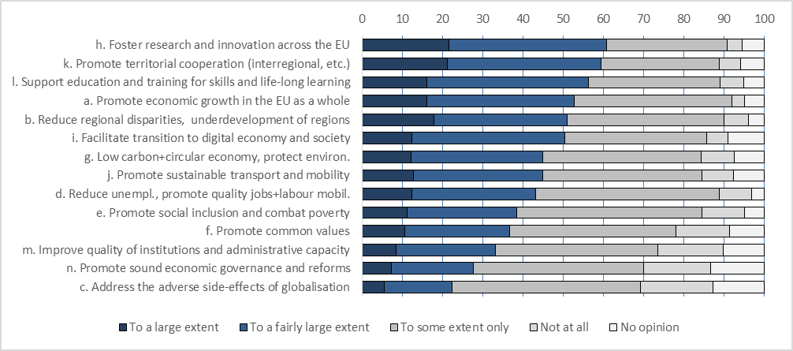

Respondents with experience of a given fund tended to have a more likely to have favourable view of its success. In general, respondents with experience in the ERDF/CF tended to view the Funds as being more successful in addressing most of the challenges than ESF ones. There are also some differences between countries and categories of respondents in the perception of success of policy in addressing various challenges. Those from Italy, Slovakia, Hungary and Bulgaria regarded policy as being less successful than the respondents from the other countries, while those from Luxembourg, Romania, Malta, Finland and Denmark considered it more successful. Among different categories of respondents, regional and national authorities had the most favourable view of the policy’s success.

3) Question to what extent Cohesion Policy programmes add value to what Member States could achieve at national, regional and/or local levels without such funds.

Three quarters of the respondents consider that the current Cohesion Policy programmes effectively add value to a large or a fairly large extent to what Member States could achieve. Some 20% replied that they add value to some extent only, and 2% - that not at all.

**Figure 3: Share of replies to the question to what extent the current programmes/funds add value compared to what Member States could achieve without EU funds?**

Public authorities at all level had a more favourable of the added-value of the Funds than the other respondents. Respondents from Denmark, Lithuania, Luxembourg, the UK, Greece, Poland and Slovenia had the most positive opinion of the added-value of the Funds (over 85% responded that they added value to a large or fairly large extent), while Austria, Croatia, Romania and Italy had the least positive opinion.

4) Question about the obstacles preventing Cohesion Policy funds / programmes from successfully achieving their objectives.

*Complex procedures* were considered as a by far the most important obstacle: 86% of respondents consider it as an obstacle to a large or to a fairly large extent. *Heavy audit and control procedures* were regarded as the second most important obstacle (68% indicating this), followed by *lack of flexibility to react to unforeseen circumstances* (60%). *Insufficient ownership of projects* was considered the least important obstacle, followed by *co-financing rates* and *insufficient information about funding and project selection*. The opinions of ERDF and EMPL respondents do not differ much in this respect.

Other obstacles in addition to those listed in the questionnaire, indicated in the replies, included corruption, lack of transparency in managing the Funds, lack of strategy and priority setting in their allocation and insufficient integration with other EU funds.

**Figure 4: Share of replies to the question on the obstacles preventing funds from achieving objectives**

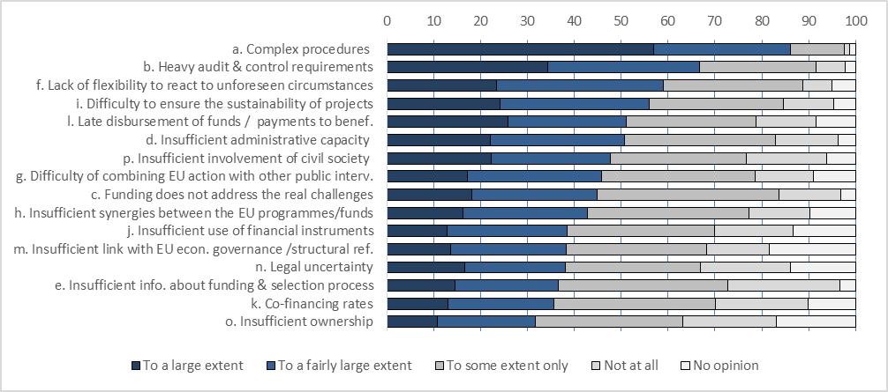

5) Question about the actions which would best help further simplify and reduce administrative burdens for beneficiaries.

The most frequent choice was *fewer, clearer, shorter rules*, with 92% of the respondents indicating that this would help to simplify and reduce administrative burdens to a large or a fairly large extent. It was followed by *alignment of rules between EU funds* and *more flexibility once funding is available*. The least frequent choice was *More freedom for national authorities to set rules’*, as more than half of respondents considered that it would not help simplify and reduce burden at all, or only to some extent.

**Figure 5: Share of replies to the question about the steps to further simplify and reduce administrative burden**

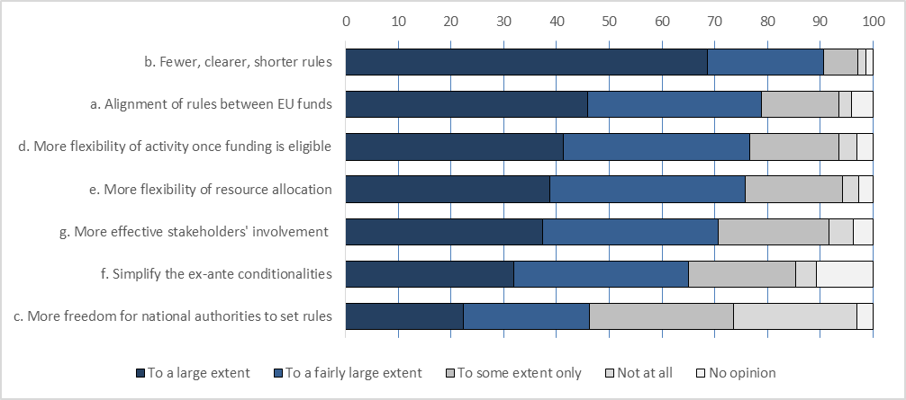**Replies to open questions**

Four open questions were included in the consultation questionnaire:

1) the added value of cohesion policy in comparison to national policies;

2) principal objectives of Cohesion Policy;

3) synergies between programmes or funds;

4) a general question for respondents to add any further points they wished.

There were 2170 usable and relevant replies to the first question, 1647 to the second, 1441 to the third and 602 to the open question.

Question 1: Added-value of cohesion policy

The points made in reply to this question can be grouped under a number of themes summarised below, ordered below in terms of the number of replies focusing on them:

*Territorial cooperation.* Transnational and cross-border cooperation initiatives are a clear example of the added-value of the Cohesion Policy, facilitating the transfer of knowledge and exchange of good practice as well as investment which has strong cross-border spill-over effects. They also help lagging regions to tap into measures applied in more developed ones and enable joint initiatives to be undertaken to tackle common challenges (energy security, climate change adaptation and mitigation, water management and safeguarding biodiversity.

A more social and inclusive society. The contribution to social integration and a more inclusive Europe is an important aspect of cohesion policy added-value. Cohesion policy, together with the additional resources it provides, have made it possible to carry out social initiatives across the EU, so helping to combat poverty and to support the disadvantaged. It has also helped to spread common values, such as equality and non-discrimination.

*Policy innovation.* An essential feature of EU added-value is related to the support given to policy experimentation and innovation.

*Adoption of higher standards.* An important element of the added-value of Cohesion policy lies in the set of common objectives and rules that requires high institutional standards (transparency, evidence-based policies) and which leads to the investment financed being more efficient and effective than for national or regional policies. It has also strengthened institutional capacity.

*Financial support.* Added-value is seen in the financial support that cohesion policy gives to regional and national policies and the fact that the funding for national policies would have been much smaller in many cases without the support provided.

*Economic and territorial cohesion.* Added-value stems from Cohesion policy reducing regional disparities and facilitating convergence. It is also seen in the contribution that the EU funding made to mitigate the negative effects of the global economic and financial crisis, which would have been significantly more serious without EU support.

*Networking and exchanges within countries.* Added-value arises not only from ETC programmes but also from the opportunities for cooperation and partnership between MAs within countries.

Question 2: Necessary changes in objectives of Cohesion Policy funds/programmes

The replies to this question focused mainly on changing the priority given to particular objectives rather than on suggesting how existing ones might be extended or modified.

*Environment, energy, sustainable urban development.* Cohesion policy in future should put more emphasis on objectives such as climate change mitigation and adaptation, energy transition, biodiversity, sustainable use of natural resources and environmental protection and remediation.

*Transregional cooperation.* Since cross-border cooperation programmes have significant added-value, they should have greater strategic and financial importance in the next programming period. However, such programmes should not focus on specific themes (such as innovation) but need to be more flexible so as to be able to respond to emerging transregional challenges (e.g. common public services, clean transport, energy transition and climate change).

*Territorial competitiveness: SMEs and tourism*. Tourism is one of the main levers for achieving economic growth, employment and social development at local level. In consequence, more emphasis should be put on supporting tourism in the future programming period, along with innovation in SMEs.

*Administrative simplification.* Many responses under this theme focused on the need to overcome the administrative and management issues that limit the effectiveness and efficiency of cohesion policy funds rather than on providing suggestions relating to objectives. They called for simplification in this regard so that efforts can be focused on the real objectives of policy.

*Education and employment.* According to respondents, ESF support should be multi-stage and comprehensive and be able to extend beyond the timeframe of a single programming period. A number of ESF initiative (such as the Youth Guarantee), should be reviewed to make them less restrictive and open to more broadly-defined target groups (such as in terms of age).

*Combating poverty and promoting social inclusion.* ESF and FEAD support for creating a more inclusive society in the next programming period should be increased.

Question 3: Strengthening synergies between programmes/funds.

Most of the replies under this theme suggested merging funds, harmonising their regulations or ensuring more coordination between programmes in terms of their objectives and implementation.

The need for simplification was again stressed either as a potential outcome of merging funds or as a major objective in itself which was more important than increasing synergies or reducing overlaps, which many regarded as not being important. A number of respondents called for funds to be merged so long as it led to simplification and a reduction in administrative burdens.

Question 4: Further points raised by the respondents

*Need for streamlining and simplifying administrative requirements.* Cohesion Policy procedures involve excessive complexity and bureaucracy, which limits the effectiveness of programmes. The regulations need to be simplified and made more flexible. Excessive auditing and too many controls are a particular problem in respect of a small projects or small OPs. The focus should be more on results and less on administrative aspects.

*Doing more to address local, social and territorial challenges*. Cohesion policy is important in building more democratic, prosperous, inclusive and resilient societies throughout the EU and not only in the less developed regions. Cohesion policy should maintain its current strategic focus and framework and continue to be the main public investment policy in the next programming period. The current configuration of Funds, geographical coverage and the core principles should be maintained, but the share of cohesion policy in the future EU Budget needs to be increased or at least kept unchanged. Information, and publicity, on the projects supported should improve to ensure more transparency and make people more aware of the EU added-value which is generated.

*The place-based dimension of development policies*should be strengthened and there should be greater flexibility in priority setting and resource allocation in order to promote ‘smart strategies’ targeted at tackling different territorial needs.

*Smart and sustainable urban development*. The urban dimension is of major importance in local and regional development. After 2020, cohesion policy should pay greater attention to urban planning and aspects which can increase the attractiveness of cities as well as their economic potential. However, cities and metropolitan areas cannot prosper at the expense of surrounding rural areas, so particular attention should be given to infrastructure connecting urban and rural areas if balanced development is to be achieved and depopulation avoided.

**Position papers**

Overall 676 documents were uploaded by 582 different respondents –around 15% of all those who participated in the consultation. Over half of all papers were uploaded by respondents from four countries: Germany, Belgium, France and Italy. The vast majority - nearly 90% - of the papers were uploaded by organisations or individuals responding in a professional capacity, mainly by regional or local authorities and NGOs.

In general the papers had a clear link with the main issues covered by the consultation and which were developed in some detail in the reflection papers published by the Commission, particularly the reflection paper on the Future of EU Finance. In many cases, they reiterated the points made in the replies to the open questions summarised above. The main points to come out of the positions papers are outlined below.

The most frequently quoted *objective* of cohesion policy should continue in the post-2020 period to be to reduce disparities between regions and to promote economic, social and territorial cohesion across the EU.

In terms of *eligibility*, while some respondents emphasised that all EU regions should be supported, the consensus was that the focus should continue to be on the less developed ones.

There were a number of proposals to broaden the set of indicators used beyond GDP (or GNP) per head to determine the *allocation* of funding. These indicators should cover employment, education, demography and the environment, though a note of caution was expressed that any extension should not reduce the concentration of support on the less developed regions.

Bottom-up approaches, *shared management* structures and multi-level governance were considered by virtually all respondents as more suitable for addressing local needs than centralised structures. Some expressed the need for a more meaningful application of the partnership principle.

*Result-orientation* should continue to be the Leitmotif of cohesion policy in the post-2020 period according to all respondents who expressed a view on this issue. An efficient monitoring system, appropriate indicators and independent evaluations are recognised as essential pillars of a result-oriented policy.

Most respondents agree that *thematic concentration* is helping to achieve larger impacts and more significant results. It should continue to be a principle in the next period. Some consider in addition that ex ante conditionality has helped to avoid dispersion of funding and to ensure stronger links between cohesion policy objectives and national strategies and structural reforms.

A number of *investment priorities* were advocated, in particular i) research, innovation and SMEs support; ii) digital infrastructure and ITC; iii) urban development based on digitalisation (i.e. smart city development); iv) environment and energy efficiency; v) combating poverty and social exclusion.

*Cooperation between regions* should be strongly supported not only in the form of cross-border cooperation but also across regions all over Europe. This is essential for making smart specialisation happen. Innovation in high tech sectors often depends on knowledge exchanges and spill-overs from cooperation between clusters or knowledge hubs across Europe.

Very different positions were expressed in respect of the organisation and the *management of the funds* in the future. Proposals range from harmonising rules and regulations to creating a unique fund merging all the current ones together. The objective is better coordination and integration of the instruments.

Better coordination and *streamlining* is not only needed between the different ESI funds but also with the other EU funding instruments. Regulations should be harmonised and horizontal rules, such as state aid rules, should be the same everywhere.

There is a strong call for simplification of procedures and rules, less control and more trust. *Controls* and audits are perceived as excessive and working against the effective application of the subsidiarity, proportionality and partnership principles. Excessive control causes delay in programme implementation. Proposals for improvement range from the ‘single audit principle’ to ‘performance-based approaches’.

*Simplification*of regulations and procedures was called for by national and local authorities in particular. Regulations should define the essential structural elements but Member States should be given flexibility to adapt the framework to their specific national and regional needs. The simplified cost option is seen as an effective tool for simplifying and accelerating payment procedures.

Many of the respondents urge better *communication* in respect of EU policy objectives and outcomes and the role of Europe in people’s daily lives.

Annex 3: Relevant Evaluations

The ex post evaluation of the ERDF and Cohesion Fund 2007-13 was completed in 2016. The results include the Commission’s summary[112], a synthesis report[113] and 14 thematic work packages. They are available on website: <http://ec.europa.eu/regional_policy/en/policy/evaluations/ec/2007-2013/>

The Commission’s summary was discussed with the Regulatory Scrutiny Board in June 2016 and revised following its opinion[114].

To ensure independence, the ex post evaluation was tendered to independent evaluation companies or consortia, split into 14 lots (with 63 programme and 20 project case studies) to enable each to be given to a specialist in the field. Over 3000 beneficiaries and 1000 Managing authority employees were interviewed, 530 stakeholders participated in 10 seminars to discuss the results. For each thematic contract, scientific experts external to the companies commented on each main deliverable.

Here is the summary of the evaluation.

|  |
| --- |
| **Ex post evaluation of the ERDF and Cohesion Fund 2007-13: summary**[115]  Cohesion Policy is the key investment policy at the European level, delivering EUR 346.5 billion of European money in the 2007-2013 programming period. This evaluation examines the impact of two of the three funds which make up Cohesion Policy – the European Regional Development Fund and Cohesion Fund (total EUR 269.9 billion).  The ERDF and Cohesion Fund supported a wide range of projects – from enterprise support to infrastructure, from urban regeneration to culture and social infrastructure. For almost all the Cohesion Countries, the sum of these two funds was equivalent to between 20% and 60% of government capital investment – a crucial contribution in a period including the economic and financial crisis.  The goals of Cohesion Policy are the reduction of disparities in regional development and the promotion of economic, social and territorial cohesion. The evaluation examined outcomes in terms of overall development (e.g. in terms of GDP/head) as well as at the level of the various individual policy themes which are major constituents of economic, social and territorial cohesion.  Impact on regional income and GDP/head  For the aggregate level, the ex post evaluation estimated that 1 euro of Cohesion Policy investment in the period 2007-13 will generate 2.74 euros of additional GDP by 2023. In other words, Cohesion Policy will be responsible for nearly EUR 1 trillion of additional GDP (at EUR 950 billion, equivalent to almost the entire EUR 975.8 billion of EU budget for 2007-13 – a strong return on investment).  Every region and country in the European Union benefits from Cohesion Policy, even the net payers. The positive effect takes account of the financing of Cohesion Policy via the EU budget and is the sum of direct effects (via the investment) and indirect effects (via increased trade) minus the contribution. The impact averages 4.2% of GDP in cohesion countries and is small but always positive in non-cohesion countries, averaging 0.4% of GDP by 2023.  In previous programming periods (notably 1994-99 and 2000-2006), Cohesion Policy contributed to a steady process of convergence (a reduction in regional disparities in GDP/head) in the EU, in a context where other developed countries generally experienced no convergence (or even divergence). The financial crisis of 2007-2008 came at the beginning of the programming period examined in this document, and created a poor climate for investment and convergence. The result is that regional convergence over the period was very small, with the strong suggestion from econometric work that there would have been divergence without Cohesion Policy.  Regional GDP/head is just one indicator of impact. A more detailed and complete picture can be seen by examining the contribution to various individual policy themes across the fields of economic, social and territorial cohesion.  Impact across various fields of economic, social and territorial cohesion  Estimates based on available monitoring data indicate that 400 000 SMEs were financially supported. Although this is only 2% of firms in the EU, support focussed on strategic enterprises – in the manufacturing sector, an estimated 15% of small firms and over a third of medium sized firms received direct financial support. Monitoring data also indicates that this support led directly to the creation of 1 million jobs – to put this into perspective, a net total of 3 million jobs were created in the EU economy over the 2007-13 period.  A major result of support was helping SMEs withstand the effects of the crisis by providing credit when other sources of finance had dried up. Moreover, some of the programmes used ERDF support as a test-bed for experimental and innovative policy - research and innovation in Denmark, Sweden and Finland, the ‘Living Labs’ experiment in Puglia (Italy) or the Inno-voucher scheme in Lithuania.  3700 large enterprises were also supported, bringing new technology and improved productivity to the region as well as generating spillovers to SMEs, the human capital base and social infrastructure.  Transport bottlenecks have been removed, travel times reduced and urban trams and metros supported. Vital to economic development and often contributing to environmental quality, this includes the construction of 4900 km of roads, mostly motorways (of which 2400 km on the TEN-T). It also includes the construction or upgrading to necessary standards of 2600 km of TEN-T railway.  Cohesion Policy has also made a significant contribution to the environment: a substantial number of landfill sites which did not comply with EU standards were closed down while in the Czech Republic, Hungary, Lithuania, Poland and Slovenia, as well as Croatia, the proportion of waste which was recycled was increased by over 10 percentage points. Moreover, in Lithuania, energy efficiency measures in 864 public buildings reduced consumption 236 GWh a year by end 2014, which implies a cut of almost 3% in overall annual energy consumption in the country.  Investment in social infrastructure led to the modernisation of schools and colleges in Portugal, benefiting over 300 000 children and young people as well as the upgrading of schools and healthcare facilities in Poland for 1.9 million people.  Lessons for the future  The evaluation found many lessons specific to individual policy themes. However two particular cross-cutting lessons for the future emerged:  - The monitoring of Cohesion Policy improved from the previous 2000-2006 period, and there was a strong focus on investing the money, delivering projects and generating outputs. However very few 2007-13 programmes had a "focus on results", setting clear goals for changes at the level of the region, selecting projects accordingly and tracking progress towards those goals. This was addressed in the 2014-20 regulations through the result orientation, but systematic delivery through the period will require a cultural shift in many cases.  - An important feature of the 2007-13 period was the increased use of financial instruments3 (EUR 11.5 billion, up from 1 billion in the previous period). These have the potential to be a more efficient means of funding investment across many policy areas, but the legal provisions were not detailed enough in 2007-2013. This, together with the inexperience of many implementing bodies, led to delays in implementation. A further challenge is spreading financial instruments beyond enterprise support, where over 90% of 2007-13 financial instrument funding was concentrated. |

Annex 4: the macro-economic models

**Quest**

QUEST has been developed by DG Economic and Financial Affairs (DG ECFIN) of the European Commission. The model is regularly used for the analysis of key fiscal and monetary policy scenarios, for assessing the impact of the structural reforms, or else for contributing to the economic projections of DG ECFIN. For the analysis of the Cohesion and Regional Funds, we adopted the R&D version of QUEST III (see Roeger, W. et al., 2008[116]) which is a semi-endogenous growth framework based on Jones (2005)[117].

The model belongs to the class of New-Keynesian dynamic general equilibrium (DGE) models that are now widely used in economic policy institutions. It provides a fully micro-founded, integrated and optimization-based representation of the economies of the Member States.

QUEST is structured around building blocks which represent the behaviour of fundamental economic agents and interactions. The model describes fully the dynamics of the system in a general equilibrium framework where changes in the conditions for a particular block are transmitted to the other blocks though various market interactions.

The model allows also considering a wide range of policy interventions being closely related to the EU Regional Policy, from support to R&D to the provision of public infrastructure. The model covers the 27 Member States and their trade links among each other, and with the rest of the world. The model also allows for international R&D spillovers in order to capture the fact that technology is not fully appropriable and that innovation can also be absorbed by non-innovative agents (e.g. through imitation). In this respect, the model takes into account the fact that programmes implemented in a particular Member States produce an impact in the other countries by affecting the intensity of trade and/or knowledge flows.

In general, the analysis is conducted by simulating and comparing two scenarios. The baseline scenario relies on the natural trend in the economy, excluding any policy intervention. The second scenario features the policy interventions for cohesion and rural development and, by comparison with the baseline, it allows for the analysis of the impacts of the policy on the economy. For a given variable the difference between the values obtained under the two scenarios is interpreted as the impact attributable to the policy, and it is expressed as a percentage deviation from the baseline[118].

**Further reading**

Varga J. and J. in 't Veld (2014), "A model-based analysis of the impact of Cohesion Policy expenditure 2000-05: Simulations with the Quest III endogenous R&D model," Economic Modelling 28: 647-663;

<http://ec.europa.eu/economy_finance/publications/pages/publication16016_en.pdf>

**Rhomolo**

RHOMOLO is a dynamic and spatial computable general equilibrium model developed jointly by the DG REGIO and the Joint Research Centre of the European Commission. The model simulates the impact of policy interventions on the economies of 267 EU NUTS-2 regions, taking into account the spatial spill-overs that are most relevant for the policy.

The model heavily borrows from New Economic Geography and endogenizes the distribution of economic activity across the regions concerned, therefore allowing to capture the impact of the policy on location choices and spatial organization of economic activities in the EU.

The model distinguishes investment in transport infrastructure from the other investment in infrastructure. Such investments are indeed assumed to reduce transport costs inside and between the regions concerned which makes the model capable of simulating the specific impact of this type of interventions. Improvement in transport infrastructure implies that regions have a better access to the EU markets and hence which allows increasing their exports and hence boosts the level of economic activity. Enhanced accessibility also means a reduction in the price of imported intermediate goods and of consumption which contributes to reduce firms' production costs and increase real income of households[119].

1. European Commission (2018) "Reflection paper on the future of EU finances" p22
2. European Commission (2017) "7th Report on Economic, Social and Territorial Cohesion" (for links to this and other reports see Annex 1
3. All Member States that joined the EU since 2004
4. All expenditure data to be updated before publication of the IA. Thematic split will not change significantly, though implementation obviously will.
5. This section considers lessons learned from the ex post evaluation. Reflections from Council and Parliament, as well as the 2018 public consultation arguably cover the current period more than the previous period.
6. Ex Post Evaluation of the ERDF and Cohesion Fund 2007-2013  
   <http://ec.europa.eu/regional_policy/en/policy/evaluations/ec/2007-2013/>
7. The evaluation of the delivery system included a large survey with responses from 2500 stakeholders, including 1100 programme and intermediate managers, as well as 1400 beneficiaries at the project level
8. Some evaluations covered more than one topic, so figures add to more than 100%
9. See Annex 2
10. Council of the European Union "Making Cohesion Policy more effective, relevant and visible to our citizens" 25 April 2017, paragraph 18
11. European Parliament, Resolution of 14 March 2018 on the next MFF: Preparing the Parliament’s position on the MFF post-2020, paragraph 89
12. <https://ec.europa.eu/commission/publications/reflection-paper-future-eu-finances_en>
13. Communication “Strengthening Innovation in Europe's Regions: Strategies for resilient, inclusive and sustainable growth”, COM(2017) 376
14. Communication “Boosting growth and cohesion in EU border regions”, COM(2017) 534
15. Urban Agenda for the EU - “Pact of Amsterdam”, <http://ec.europa.eu/regional_policy/sources/policy/themes/urban-development/agenda/pact-of-amsterdam.pdf>
16. The EU outermost regions are Guadeloupe, French Guiana, Martinique, Mayotte, Reunion Island and Saint-Martin (France), Canary Islands (Spain), the Azores and Madeira (Portugal)
17. Communication “A stronger and renewed strategic partnership with the EU's outermost regions”, COM(2017) 623
18. Council of the European Union "Results and New Elements of Cohesion Policy and the European Structural and Investment Funds" 15 November 2016, paragraphs 19 and 20
19. European Parliament, Committee on Regional Development, Report on building blocks for a post-2020 EU cohesion policy (2016/2326(INI), May 2017, paragraph 21
20. Reflection Paper on EU finances, p.23
21. See annex 2 for more details on the public consultation.
22. Reflection Paper on EU finances, p.24
23. Council of the European Union "Synergies and simplification of Cohesion Policy" 15 November 2017, paragraph 10
24. European Parliament, Committee on Regional Development, Report on building blocks for a post-2020 EU cohesion policy, paragraph 16.
25. Ibidem, paragraph 13.
26. Council of the European Union "Making Cohesion Policy more effective, relevant and visible to our citizens" 25 April 2017, paragraph 7
27. Council of the European Union "Synergies and simplification of Cohesion Policy" 15 November 2017, paragraph 14
28. Macroeconomic impacts modelled with QUEST and Rhomolo (see Annex). The modelling assumes the status quo, ie national allocations remain unchanged, as well as the distribution among the various fields of interventions, but without the UK.
29. The largest element of the EU budget is “GNI based contributions”, which is not straightforward to capture in the model. Therefore we model an implicit tax on consumption, which mirrors VAT + duties, the second largest element.
30. For instance, a paper of Pellegrini et al., *Measuring the effects of European Regional Policy on economic growth: A regression discontinuity approach*. Papers in Regional Science, 92, 2013 found an annual per capita difference of 0.6-0.9 percentage points in favour of regions receiving Cohesion Policy support over 1995-2006 period. A paper of D. Bondonio *The impact of varying per capita intensities of EU Funds on regional growth: Estimating dose response treatment effects through statistical matching,* Ex post evaluation of Cohesion Policy programmes 2007-2013, Work package 14d, came to similar results using propensity score matching.
31. Reflection paper on the future of EU finances, p11
32. Reflection paper on the future of EU finances, p12
33. Better Regulations Guidelines tool #42 "identifying the evaluation criteria and questions"
34. Better Regulations Guidelines tool #42 "identifying the evaluation criteria and questions"
35. Reflection paper on the future of EU finances (p14)
36. insert reference
37. 7th Cohesion Report, chapter 6.2.4
38. Fraunhofer ISI RIS3 Survey (2017 Results)
39. Commission Staff Working Document "Ex post evaluation of the ERDF and Cohesion Fund" pp4 and 20
40. Commission Staff Working Document "Ex post evaluation of the ERDF and Cohesion Fund", section 7.12 on EU added value
41. Reflection paper on the future of EU finances, p12
42. Commission Staff Working Document "Ex post evaluation of the ERDF and Cohesion Fund", various
43. 7th Cohesion Report, p xvii
44. In line with the economic literature on externalities and sub-optimal investment
45. Reflection paper on the future of EU finances, p12
46. 7th Cohesion Report, chapter 6.3 on the macroeconomic impact of the policy
47. Reflection paper on the future of EU finances, p14
48. Reflection paper on the future of EU finances, p6
49. See COM(2018) 98, Communication "A new, modern Multiannual Financial Framework for a European Union that delivers efficiently on its priorities post-2020". Option 3 here is based on scenario 3 from the communication, except that instead of reducing support in non-cohesion countries to zero, it is reduced by enough to accommodate the overall envelope reduction.
50. Joint Paper of the Visegrad Group, Bulgaria, Croatia, Romania and Slovenia on Cohesion Policy after 2020, March 2017
51. S. Iammarino, A. Rodríguez-Pose, M. Storper, Why Regional Development matters for Europe's Economic Future, DG REGIO Working Paper 7/2017 provides a good overview of recent literature
52. Ibidem.
53. Council of the European Union "Results and New Elements of Cohesion Policy and the European Structural and Investment Funds" 15 November 2016, paragraphs 19 and 20
54. SWD(2017)264, Strengthening Innovation in Europe's Regions: Strategies for resilient, inclusive and sustainable growth
55. COM(2015) 80, SWD(2016) 394
56. Eurostat, January 2018
57. Council Directive 91/271/EEC of 21 May 1991
58. COM(2015) 614 final
59. COM(2017) 34 final
60. COM(2018) 28 final
61. Agreed in 2016, the Amsterdam Pact outlines the Urban Agenda for the EU and lays out its key principles

    <http://ec.europa.eu/regional_policy/sources/policy/themes/urban-development/agenda/pact-of-amsterdam.pdf>
62. Territorial impact assessment of 14 March 2018. The full report will be available at: http://cor.europa.eu/en/activities/Pages/tia-documents.aspx.
63. European Commission (2017) "Boosting growth and cohesion in EU border regions" <http://ec.europa.eu/regional_policy/en/information/publications/communications/2017/boosting-growth-and-cohesion-in-eu-border-regions>
64. Input paper for the Informal Ministerial Meeting on Territorial Cohesion under the Luxembourg Presidency, see: [http://www.amenagement-territoire.public.lu/fr/eu-presidency/Informal-Ministerial-Meetings-on-Territorial-Cohesion-and-Urban-Policy-_26-27-November-2015_-Luxembourg-City_.html#](http://www.amenagement-territoire.public.lu/fr/eu-presidency/Informal-Ministerial-Meetings-on-Territorial-Cohesion-and-Urban-Policy-_26-27-November-2015_-Luxembourg-City_.html) ; see also SWD(2017) 307, Point 3.9, p. 49-50.
65. For reasons of parliamentary primacy, legal certainty and transparency, most Member States will need to adopt up-front a formal Parliamentary act to empower the executive authorities to sign an ECBC.
66. Where a Member State decides not to adopt up-front the formal Parliamentary act set out above.
67. InvestEU is covered in section 4.4 on Financial Instruments
68. KPMG and Prognos, Coherence, complementarity and coordination between policy objectives and implementation mechanisms in the context of ESI Funds, study for DG REGIO
69. "From Rivalry to Synergy: R&I Policy and Cohesion Policy" insert reference
70. Île de France, Oberbayern, London and Comunidad de Madrid
71. We will update to an initial mapping of 2014-20 once figures are released in May  
72. <https://ec.europa.eu/digital-single-market/en/policies/digitising-european-industry>
73. <https://ec.europa.eu/digital-single-market/en/news/ministerial-declaration-egovernment-tallinn-declaration>
74. Building on "Ex ante conditionalities" in the 2014-20 period
75. See for example OECD Recommendation on Effective Public Investment Across Levels of Government adopted on March 12, 2014.
76. Commission Staff Working Document (2017) 127 final "The Value Added of Ex ante Conditionalities in the European Structural and Investment Funds"
77. The final deadline for reporting by Member States is end June 2017 in the framework of the Annual Implementation Report for 2016 and end August 2017 in the framework of the Progress Report. The Commission assesses completion of the ExAC action plans on the basis of reporting by Member States.
78. Commission Staff Working Document (2017) 127 final "The Value Added of Ex ante Conditionalities in the European Structural and Investment Funds"
79. t33 & Spatial Foresight, Use of new provisions on simplification during the early implementation phase of ESIF, Final Report, June 2017
80. Spatial Foresight & t33, New assessment of administrative costs and burden in ESI Funds, preliminary results.
81. Full text of the High Level Group recommendations: <http://ec.europa.eu/regional_policy/sources/newsroom/pdf/simplification_proposals_key.pdf>
82. EY, Effective and efficient delivery of European Structural and Investment Funds investments – Exploring alternative delivery mechanisms, to be published in 2018Link to ADM study
83. DG EMPL (2015) Simplified Cost Options in the European Social Fund, Promoting simplification and result orientation.
84. Source: DG Regio survey of managing authority views on SCOs. Replies were received from 208 of 295 OPs, representing 77% of the total ERDF-CF budget.
85. Spatial Foresight & t33, op.cit. preliminary results
86. See budget support study in sources
87. EY, op.cit.
88. Art.123-124 of the CPR.
89. Art. 61 and 65(8) of the CPR.
90. Use of new provisions on simplification during the early implementation phase of ESIF (2017) complete reference
91. Spatial Foresight & t33, op.cit. preliminary results
92. Reference IAS study
93. Ibidem
94. SWD, page 5
95. Implementation and take up study reference
96. SWD, pages 25-26
97. Reference to study. This is based on an online survey of all Managing Authorities of ERDF, CF, ESF and EMFF programmes, plus 110 follow up interviews divided evenly between Managing Authorities and financial intermediaries, including authors of ex ante assessments – results reported here are for ERDF and CF managers.
98. Reference to article 46
99. For example, a programme only reports km of rail constructed if this is one of their investments.
100. Sweco, ÖIR, Spatial Foresight (2015) "Implementation of the performance frameworks in the 2014-2020 European Structural and Investment (ESI) Funds" http://ec.europa.eu/regional_policy/sources/policy/how/studies_integration/impl_pf_esif_report_en.pdf
101. Commission Implementing Regulation (EU) 2015/207, Annex VI - management declaration template.
102. Commission Implementing Regulation (EU) 2015/207 Point 3.2 of Annex VII.
103. Commission Delegated Regulation (EU) 480/2014, Article 25.1(i).
104. Commission Delegated Regulation (EU) 480/2014, Article 27.2 c).
105. SFC stands for System for Fund Management in the EU. SFC is the information system for the programming period used by Managing Authorities of the programmes to report electronically to the Commission, enabling the shared management between the Member States and the Commission.
106. A detailed presentation of the types of reports and their frequency for 14-20 is presented in Annex I.
107. Sweco, ÖIR, Spatial Foresight (2015) "Implementation of the performance frameworks in the 2014-2020 European Structural and Investment (ESI) Funds" http://ec.europa.eu/regional_policy/sources/policy/how/studies_integration/impl_pf_esif_report_en.pdf
108. Previously, there was an obligation for evaluation during the period, but a large majority focussed on process and delivery, not impacts.
109. <http://ec.europa.eu/regional_policy/en/policy/evaluations/ec/2007-2013/>
110. AGRI, BUDG, CLIMA, CNECT, COMP, ECFIN, ECHO, EMPL, ENER, ENV, GROW, HOME, JRC, JUST, MARE, MOVE, REGIO, RTD, SG, SJ, SRSS.
111. Applica and Ismeri Europe.
112. SWD(2016) 318
113. <http://ec.europa.eu/regional_policy/sources/docgener/evaluation/pdf/expost2013/wp1_synth_report_en.pdf>
114. RSB opinion: <https://ec.europa.eu/info/sites/info/files/rsb_opinion_on_regio_swd22_july_2016.pdf>
115. SWD(2016) 318, section 1: Executive Summary
116. Roeger W., Varga J. and J. in ’t Veld (2008), "Structural reforms in the EU: a simulation based analysis using the QUEST model with endogenous growth", European Economy Economic Paper N° 351. <http://ec.europa.eu/economy_finance/publications/pages/publication_summary13529_en.htm>
117. Jones, C. (1995), "R&D-based models of economic growth", Journal of Political Economy, 103(4):759-84.
118. The baseline is established on the basis of assumptions concerning the trends of key variables which is common practice in modelling exercise. The results, which correspond to the difference between the baseline and the 'with-policy' scenarios, are relatively independent from the baseline.
119. Detailed documentation on the model is available at https://ec.europa.eu/jrc/en/rhomolo.