

Table of contents

Abbreviations III

1. Introduction 1

1.1 Purpose and scope 2

2 Background to the intervention 4

2.1 Description of the intervention and its objectives 4

3 State of play 8

3.1 European Fund for Strategic Investments 8

3.2 The EU Guarantee 9

3.3 European Investment Advisory Hub 9

3.4 European Investment Project Portal 10

4 Methodology 12

5 Analysis and answers to the evaluation questions 16

5.1 European Fund for Strategic Investments 16

5.2 The EU Guarantee 45

5.3 European Investment Advisory Hub 47

5.4 European Investment Project Portal 51

6 Conclusions 55

6.1 European Fund for Strategic Investments 55

6.2 The EU Guarantee 58

6.3 European Investment Advisory Hub 59

6.4 European Investment Project Portal 59

6.5 Lessons learned 60

Annex 1: Procedural information 63

Annex 2: Stakeholder consultation 68

Annex 3: Methods and analytical models 88

Annex 4: EIB products under EFSI IIW 113

Annex 5: Potential overlaps – DEBT & EQUITY PRODUCTS SUPPORTING LENDING TO SMEs, 2014-2020 114

List of Figures

Figure 1 - The Investment Plan for Europe 1

Figure 2 - The EFSI: the EU Guarantee and the EIB risk bearing capacity 5

Figure 3 - EFSI state of play as of 12 April 2018 8

Figure 4 - Published projects per Member State as of end March 2018 11

Figure 5 - Project review analysis 13

Figure 6 - Investment as a % of GDP in EU28 16

Figure 7 - Share of private finance mobilised in total EFSI investment mobilised and in the estimated annual EU investment gap 18

Figure 8 - EFSI geographical distribution (both windows) 19

Figure 9 - Sectoral distribution of the EFSI support - IIW 20

Figure 10 - SMEW sectoral distribution 21

Figure 11 - EFSI Scoreboard 22

Figure 12 - Impact of EFSI and the wider EIB Group on the EU GDP and employment 28

Figure 13 - Project promoters under IIW on EFSI application and appraisal procedure 30

Figure 14 - Evaluation of time elapsed between approvals and signature, IIW 31

Figure 15 - EU programmes and portfolio of financial instruments 32

Figure 16 - Annual commitments made under EIB’s InnovFin products 32

Figure 17 - Risk profile of the EFSI operations compared to non-EFSI EIB operations 39

Figure 18 - Access to alternative financing 41

Figure 19 - Would the project have gone ahead to the same extent and timescale without EFSI 42

Figure 20 - Comparative advantages of EIB financing under EFSI 42

Figure 21 - EIB Special Activities vs standard EIB operations in 2014-2017 46

Figure 22 - Proportion of EFSI in EIB’s Special Activities 46

Figure 23 - EIPP - State of play (March 2018) 52

List of Tables

Table 1 - The split of the EU Guarantee and its development over time 9

Table 2 - Targeted surveys conducted and the response rate 13

Table 3 - Investment level forecasts 17

Table 4 - Increase in the number of approved equity type operations under EFSI IIW 21

Table 5 - EFSI 1.0 performance compared to initial expectations 23

Table 6 - EFSI support - state of play per window 23

Table 7 - EFSI multipliers at aggregate & window level by type of product 24

Table 8 - EFSI financing signed and private finance / investment mobilised (end 2017) 25

Table 9 - Forecast number of direct jobs created 27

Table 10 - Summary of monthly IC meetings, March 2016 – January 2018 30

Table 11 - Types of added value for the EFSI 35

# Abbreviations

|  |  |
| --- | --- |
| **Term or acronym** | **Meaning or definition** |
| ASD | Advisory Services Department |
| CCS | Cultural and Creative Sectors |
| CEE | Central Eastern Europe |
| CEF | Connecting Europe Facility |
| CGE | Computable General Equilibrium |
| COSME | Programme for the Competitiveness of Enterprises and Small and Medium-sized Enterprises |
| CPR | Common Provisions Regulation |
| DI | Debt Instrument |
| EaSI | EU Programme for Employment and Social Innovation |
| EBRD | European Bank for Reconstruction and Development |
| EC | European Commission |
| ECA | European Court of Auditors |
| ECB | European Central Bank |
| ECFIN | Directorate General for Economic and Financial Affairs |
| EFG | Equity Facility for Growth |
| EFSI | European Fund for Strategic Investments |
| EGRF | EFSI Guarantee Request Form |
| EIAH | European Investment Advisory Hub |
| EIB | European Investment Bank |
| EIF | European Investment Fund |
| EIPP | European Investment Project Portal |
| EL | Expected Loss |
| ELTI | European Long-Term Investors |
| EPEC | European PPP Expertise Centre |
| ERR | Economic Rate of Return |
| ESIF | European Structural Investment Funds |
| EU | European Union |
| EUR | Euro |
| FI | Financial Instrument |
| FPA | Framework Partnership Agreement |
| GDP | Gross Domestic Product |
| GIPP | Global Infrastructure Project Pipeline |
| IA | Impact Assessment |
| IC | Investment Committee |
| IIW | EFSI’s Infrastructure and Innovation Window |
| IMF | International Monetary Fund |
| InnovFin | “InnovFin – EU Finance for Innovators” |
| IPE | Investment Plan for Europe |
| JRC | Joint Research Centre |
| KMI | Key Monitoring Indicator |
| KPI | Key Performance Indicator |
| LGF | Loan Guarantee Facility |
| MDB | Multilateral Development Banks |
| MFF | Multiannual Financial Framework |
| MLI | Multilateral Lending Institutions |
| MS | Member States |
| NPB | National Promotional Bank |
| NPBI | National Promotional Bank or Institution |
| NPI | National Promotional Institution |
| OECD | Organisation for Economic Cooperation and Development |
| RAC | Risk Adjusted Capital |
| RCR | Risk Capital Resources |
| R&D | Research and Development |
| RDI | Research, Development and Innovation |
| S&P | Standard & Poor's |
| SACP | Stand-Alone Credit Profile |
| SFSB | Smart Finance for Smart Buildings |
| SIF | Sustainable Infrastructure Foundation |
| SMAF | SME Access to Finance Index |
| SMEG | SME Guarantee |
| SMEW | Small and Medium Enterprise Window |
| SRSS | Structural Reform Support Service |
| SWD | Staff Working Document |
| TA | Technical Assistance |
| TFEU | Treaty on the Functioning of the European Union |
| TFP | Total Factor Productivity |
| TRL | Technology Readiness Level |
| VC | Venture Capital |

# Introduction

As a response to the economic and financial crisis and its negative impact on the level of investment in the EU, the Commission launched in November 2014 the Investment Plan for Europe ('IPE'). It focuses on removing obstacles to investment and seeks to deliver jobs, growth, and innovation in Europe.

The Investment Plan for Europe consists of three mutually reinforcing pillars. **The first pillar**, the European Fund for Strategic Investments ('EFSI') aims at mobilising at EUR 315 billion of additional public and private investment in infrastructure, innovation, and SME financing by mid-2018. This is to be achieved via an EU budgetary guarantee to the EIB Group that allows them to increase the financing of projects with a higher risk-profile. Given EFSI's success in the first two years of implementation, the Commission proposed to extend the EFSI duration and increase its financial capacity to EUR 500 billion by 2020. The amended EFSI Regulation ('EFSI 2.0')[1] was adopted on 13 December 2017.

Figure 1 - The Investment Plan for Europe

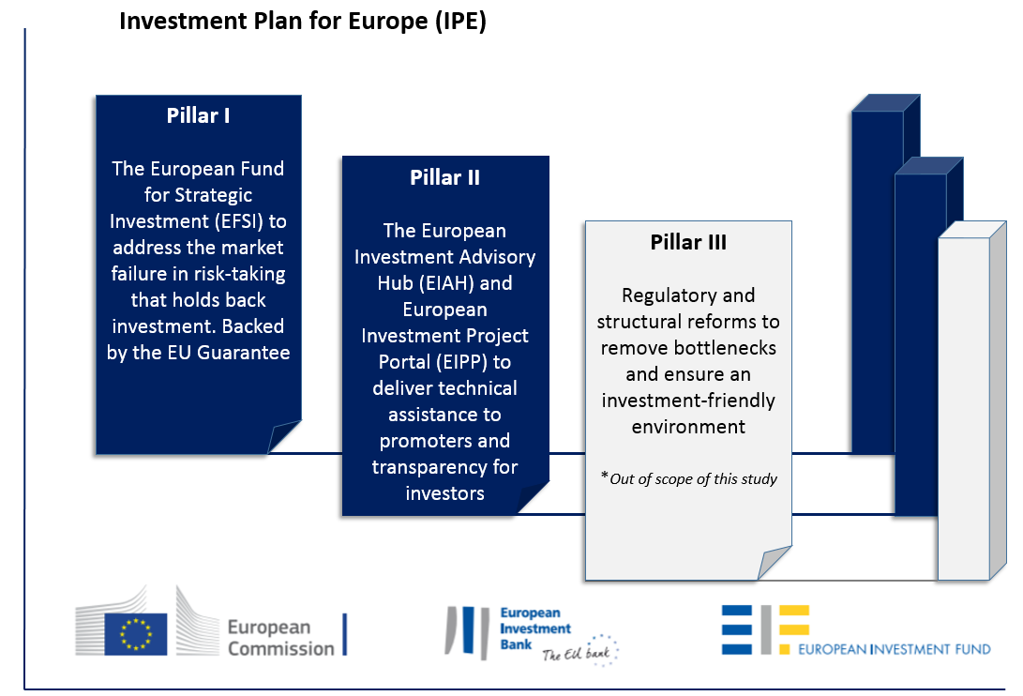

**Source**: ICF adapted from EIB

**The second pillar** of the Investment Plan for Europe helps to ensure that investments reach the real economy by promoting and developing a pipeline of viable investment projects. It consists of the European Investment Advisory Hub (EIAH, the Hub) that provides technical assistance to both private and public project promoters, as well as of the European Investment Project Portal (EIPP, the Portal) that is an online platform connecting EU-based project promoters and investors from the EU and beyond.

**The third pillar** aims at supporting the investment environment by improving regulation at all levels and eliminating barriers to investment. However, it is not in the scope of this evaluation, as the third pillar is not included under the EFSI Regulation. Moreover, the nature of initiatives under pillar three differs significantly from the EFSI, EIAH and EIPP.

## Purpose and scope

The EFSI 2.0 Regulation provides that the Commission has to submit to the European Parliament and the Council an independent evaluation of the application of the EFSI Regulation before tabling any new proposals for a post-2020 investment support instrument.

This Staff Working Document presents the results of an external independent evaluation of the application of the EU Regulation 2015/1017 (the 'EFSI Regulation') and draws on other evaluations (see section 4). This evaluation accompanies an impact assessment as well as a proposal for a Regulation of the European Parliament and of the Council on establishing the InvestEU Programme (referred to as the ‘InvestEU’) for the period 2021-2027.

The evaluation performed by an external contractor, ICF Mostra (thereafter 'the independent evaluation'), covers the functioning of the EFSI, the use of the EU Guarantee, the activity of the EIAH and of the EIPP.

The conclusions and recommendations of the evaluation will serve to assess the extent to which the EFSI, the EIAH, and the EIPP are achieving their objectives. The conclusions will also inform the future Commission legislative proposals related to establishing the investment support instrument for the period 2021-2027 (InvestEU Programme). The EFSI independent evaluation and the InvestEU Impact Assessment have been prepared in parallel, however early results from this evaluation as well as the results of the previous evaluations informed the preparation of the InvestEU Impact Assessment (see Annex 1 for further details).

Unless explicitly specified otherwise, the evaluation covers actions since their launch until 31 December 2017 (EFSI 1.0). Due to its recent adoption, it does not evaluate the effects of the EFSI Regulation as amended on 13 December 2017 (also referred to as EFSI 2.0). To the extent possible, it does however consider the introduced improvements.

Given that the EFSI was launched in July 2015, most signed projects supported by the EFSI have not been completed yet. Investment projects are long term in nature and it can take several years between project approval, signature, disbursement and realisation. The EFSI’s impacts can thus only partially be captured after such a short period. The evaluation, however, evaluates impacts to the extent possible and focuses on the likely expected results. The EFSI Regulation requires another independent evaluation at the end of the investment period. This future evaluation should be able to better capture the EFSI’s impacts, as most projects will have been approved and signed by that time.

The evaluation focuses on the assessment of the relevance, effectiveness, efficiency, EU added value and coherence of the following:

1. **Assessment of the functioning of EFSI**. This assessment in particular includes:

* Whether the EFSI consists of a good use of resources of the EU budget, mobilises a sufficient level of private capital, and crowds-in private and public investment.
* Whether maintaining a scheme for supporting investment is useful from a macro-economic, point of view, in particular its contribution to employment and GDP growth.
* Evaluation of the use of the scoreboard referred to in the EFSI Regulation against the criteria of relevance and effectiveness. This in particular includes the consideration of the appropriateness of each pillar and their relative roles in the assessment.
* Whether the projects supported by the EFSI fulfil the additionality requirements as defined in the EFSI Regulation:
  + operations which address market failures or sub-optimal investment situations;
  + operations which without EFSI could not have been carried out by the EIB, the EIF, or under existing Union financial instruments in the period in which the EU guarantee can be used, or could not have been carried out to the same extent;
  + projects supported by the EFSI shall typically have a higher risk profile than projects supported by normal operations. A risk corresponding to EIB special activities, as defined in Article 16 the EIB Statute is a strong indication of additionality.

1. **Assess the use of the EU Guarantee**. This in particular addresses the question whether the guarantee represents a good use of resources of the EU budget.
2. **Assess the European Investment Advisory Hub (EIAH)**. This includes an assessment of the EIAH's market uptake and complementarity with other existing advisory services.
3. **Assess the** **European Investment Project Portal (EIPP)**. This includes the assessment of EIPP’s relevance, efficiency, effectiveness, coherence, and EU added value.

This Staff Working Document (SWD) and the independent evaluation have been prepared according to the Roadmap published on 21 December 2017[2]. It draws on the final deliverables prepared by ICF Mostra (hereafter ICF) under contract with the European Commission. The report delivered by ICF answers the evaluation questions (see Annex 3) and contains recommendations addressed to the Commission. This SWD however, also draws on previous EFSI evaluations[3] and other relevant studies.

# Background to the intervention

## Description of the intervention and its objectives

In 2014, after more than six years since the onset of the global financial crisis, the pace of economic recovery in the EU was still slow. Low investment has been one of the main reasons for the weakness of the recovery, as noted in the Commission macroeconomic forecasts from that period[4]. Although there was considerable variation between Member States and sectors, EU investment activity in 2013 was 15 percent or some EUR 430 billion below the pre-crisis peak in real terms. In the hardest-hit Member States, the shortfall ranged from 25 to over 60 percent[5]. The weakness reflected low demand growth, low levels of capacity utilisation, heightened economic and policy uncertainty, and, in some countries, the bursting of construction/ housing bubbles, corporate deleveraging and financing constraints.

At that time, the subdued level of investment activity was jeopardising Europe’s long-term growth potential. It led to an erosion of the existing productive capital stock and, worryingly, it meant that Europe was not making the productive investment in human and physical capital that is needed for future competitiveness, growth and employment. This trend undermined the ability of European firms to compete in the global economy and to provide rewarding jobs and a high standard of living.

Back in 2014, annual Gross Domestic Product (GDP) growth in the EU was anticipated to be relatively moderate at 1.3%, while growth in the euro area was expected to be 0.8%. Expected GDP growth, which was already relatively slow before the crisis because of low productivity gains, had fallen further due to low investment and high structural unemployment. It was imperative to find ways to break this vicious circle and turn it into a virtuous circle, where investment projects could contribute towards a stronger increase in employment and demand, as well as to a sustained increase in potential growth.

The IPE was announced in 2014 as a comprehensive investment support strategy that aimed to contribute to restoring EU competitiveness and help boost growth and investments in the European Union.

### European Fund for Strategic Investments (EFSI)

The EFSI is an initiative implemented by the European Investment Bank ('EIB') and the European Investment Fund ('EIF'), together the EIB Group, with the aim to support investments as well as to increase access to finance for SMEs (up to 250 employees) and mid-cap companies (up to 3 000 employees)[6]. The EFSI comprises an EU Guarantee of EUR 26 billion (underpinned by provisioning of budgetary resources of EUR 9.1 billion) offered to the EIB Group from the EU budget, and a capital contribution of EUR 7.5 billion provided by the EIB. Overall, the EFSI targets to mobilise EUR 500 billion of additional investments by end-2020.

The objectives of the EFSI are reflected in two windows: the Infrastructure and Innovation Window ('IIW'), which is composed of the IIW Debt and the IIW Equity sub-windows, both implemented by the EIB, and the SME Window ('SMEW'), which is implemented by the EIF.

EFSI operations backed by the EU Guarantee are part of the EIB Group operations, are assessed according to EIB Group standard rules and procedures and are approved by the EIB Group governing bodies. An EFSI Investment Committee ('IC') composed of eight independent experts decides on the use of the EU Guarantee on projects proposed by the EIB under the IIW, including those with National Promotional Banks ('NPBs') and National Promotional Institutions ('NPIs'), and the IC is also consulted on SMEW products.

### The EU Guarantee

The EU Guarantee is an irrevocable, unconditional, and first demand guarantee to the EIB, which aims to increase the volume of higher risk projects that can be financed by the EIB Group or support otherwise additional projects. A significant part of the EIB and EIF operations under the IIW and the SMEW is covered by the EU Guarantee, while a part is carried out at the own risk of the EIB Group.

The EU maximum guarantee amounts to EUR 16 billion until 6 July 2018 and to EUR 26 billion thereafter. The allocation of the EU Guarantee between the two windows is the following: up to EUR 19.5 billion to the IIW and up to EUR 6.5 billion to the SMEW[7]. In addition, the EIB contributes its own resources of EUR 7.5 billion, resulting in the total EFSI guarantee/risk bearing capacity of EUR 33.5 billion.

Figure 2 - The EFSI: the EU Guarantee and the EIB risk bearing capacity

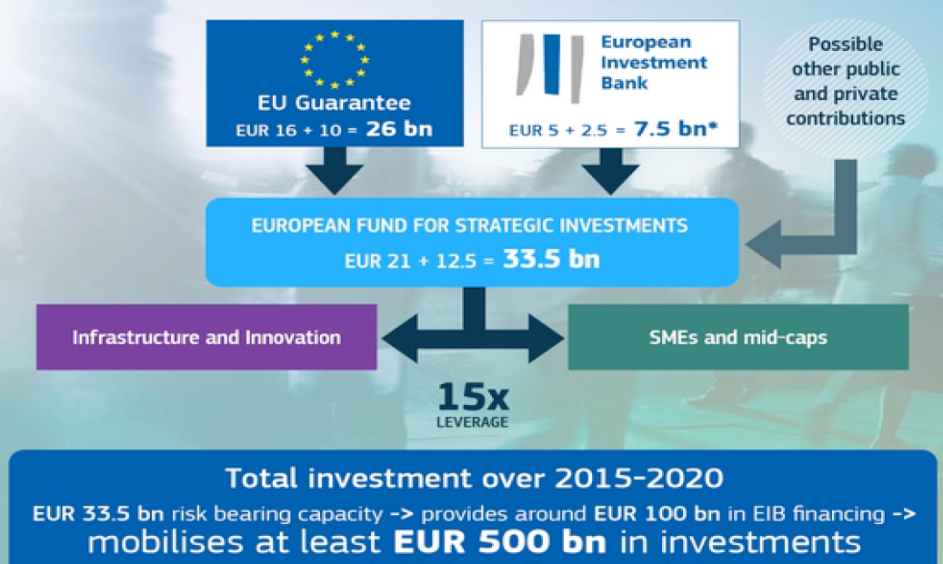

**Source**: Commission services

The EU Guarantee Fund

The EU Guarantee Fund ("the Guarantee Fund') established under Article 12 of the Regulation constitutes a liquidity cushion from which the EIB is to be paid in the event of a default of a supported EFSI operation, i.e. to honour a call on the EU Guarantee. The liquidity cushion is intended to provide an appropriate safety margin and to avoid exposing the Union budget to sudden guarantee calls, which would entail spending cuts or budget amendments. Therefore, it contributes to the transparency and predictability of the budgetary framework.

It is funded from payments from the EU general budget and revenues originating from EFSI-guaranteed operations. The Guarantee Fund has to be maintained at a certain percentage (the “target rate”) of the total amount of the EU-guaranteed obligations. Under EFSI 1.0 the target rate was set at 50%. The target rate was adjusted under EFSI 2.0 and set at 35%.

An EFSI Account, managed by the EIB, has been established to collect the EU revenues resulting from EFSI-guaranteed operations and recovered amounts. To the extent of the available balance, it is also used for the payment of calls under the EU Guarantee.

### European Investment Advisory Hub

The EIAH is a joint Commission and EIB initiative that became operational in September 2015 and to which both institutions contribute financially[8]. The EIAH is established within the EIB, which is responsible for its daily management. The Commission is responsible to award annual grants (based on specific grant agreements) to the EIB, representing 75% of the EIAH’s annual budget. The remaining share is provided by the EIB.

The EIAH aims at providing targeted support to public and private project promoters for the identification, preparation, development and implementation of investment projects across the EU. The EIAH services are meant to be complementary to those provided by other advisory programmes supported by the EU budget and they can be delivered by the EIB itself, by other public entities such as National Promotional Banks or International Financial Institutions (having entered into an agreement with the EIB) or by external service providers.

The EIAH has three main components:

* A single point of entry to a wide range of advisory and technical assistance programmes and initiatives;
* A cooperation platform to leverage, exchange, and disseminate expertise among the EIAH partner institutions and beyond; and
* An instrument to assess and address unmet needs by reinforcing or extending existing advisory services or creating new ones as demand arises.

Capacity building is also provided on a number of issues related to investment projects (i.e. tendering process, cost benefit analysis), access to finance, including using financial instruments based on EU funds. Moreover, the EIAH provides advice to support the potential establishment of investment platforms.

The EIAH operates in four delivery-oriented work streams:

* First work stream - requests coming from the website. Those requests are generally at an initial stage and need further development to receive more detailed technical assistance from the EIAH.
* Second work stream - requests coming via expert sources such as consultancies, NPBs, individual experts, the EIB and EC staff. These requests have undergone some form of “pre-screening” already and have thus a higher chance of being ready to receive more detailed technical assistance.
* Third work stream - development of local presence. The focus is on developing a network of local partners (e.g. NPBs/NPIs) that would ultimately be able to provide technical assistance on behalf of the EIAH in specific geographical/thematic sectors.
* Fourth stream - market development. This stream includes the preparation of targeted studies aimed at identifying the investment potential in priority sectors and the development of investment platforms.

### European Investment Project Portal

The EIPP is an online platform[9] of investment projects whose role is to increase visibility and promote EU-based projects to potential investors around the world.

The lack of transparency represented a barrier to investment in the EU, in particular following the 2008 financial crisis. According to the EFSI Regulation[10], the main purpose of the EIPP is to ensure investment projects have more visibility to investors, ensuring enhanced transparency around EU investment opportunities.

The Commission thus designed and implemented the EIPP to build a bridge between project promoters and investors. Through the Portal, private and public project promoters can present their projects, hence boosting the visibility of existing EU investment opportunities and providing the investors with the possibility to contact directly the project promoters.

To facilitate this, projects are presented in a structured format that enables promoters to disclose as much project information as they deem necessary to attract the investors. The publication on the EIPP is free of charge and a project must fulfil a set of eligibility criteria[11] defined in the Commission Implementing Decision[12].

The EIPP is independent from EFSI financing and the EIAH advisory support or other EU and EIB financial and technical support initiatives and instruments. The publication of an investment project on the EIPP is not a pre-condition for receiving any EU/EIB financing or advisory support.

The Portal is available in all official languages of the EU. It provides useful features, such as a card view and a map view of projects, advanced search and filtering criteria, as well as the option for investors to register and subscribe for project updates and newsletters, making it easy for them to find projects according to their own preferences and interests. The EIPP is thus designed to support international investors specify and devise their own forward-looking pipelines of EU investment projects.

# State of play

## European Fund for Strategic Investments

Less than three years after its introduction, EFSI financing approved amounted to EUR 57.5 billion, representing a total investment mobilised of EUR 287.4 billion across both windows. It is estimated that EFSI investments supported around 3.6 million jobs.

Figure 3 - EFSI state of play as of 15 May 2018

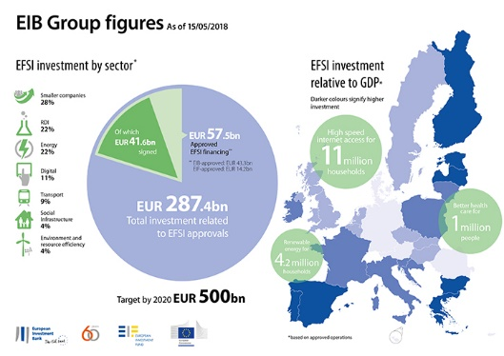

*Source*: EIB

This relates to 396 approved operations under the IIW and 411 transactions under the SMEW. The latter will ease access to finance for an estimated number of around 635,000 SMEs and small mid-cap companies. The transactions approved (including multi-country operations) covered 28 EU Member States across all general objectives set out in the EFSI Regulation. Most of the estimated investment mobilised relates to smaller companies (28%), RDI (22%) and energy investments (22%).

As of 15 May 2018, EFSI support was expected to mobilise EUR 186.2 billion of investments to projects under the IIW and a further EUR 101.2 billion towards projects under the SMEW bringing the total investment mobilised to EUR 287.4 billion. EFSI operations signed by the end of December 2017 are expected to mobilise around EUR 134 billion of private sector investment, representing 64 per cent of the total EFSI investment mobilised. These investments helped bring high-speed internet access to about 11 million households, improved health care for 1 million people, as well as renewable energy for 4.2 million households.

As of 31 December 2017, France, Italy and Spain attracted 17.2, 16.6 and respectively 10.7 per cent of the total amount of signed financing. More generally, EU 15 Member States account for around four fifths of all EFSI financing. However, when compared to corresponding shares in the total EU 28 GDP - EU 15 account for 93 per cent of the total EU 28 output[13]. In other words, the amount of EFSI financing broadly corresponds to the respective size of the Member States’ economies.

Detailed discussion on the EFSI’s state of play can be found in section 5.1, especially in parts on Relevance and Effectiveness.

## The EU Guarantee

Table 1 below presents the changes of the EU Guarantee from EFSI’s launch until May 2018.

At the end of 2017, the overall outstanding disbursed exposure covered by the EU Guarantee amounted to nearly EUR 10.1 billion, up from EUR 4.4 billion in 2016. The exposure of the EU budget to possible future payments under the EU Guarantee in terms of signed operations (disbursed and undisbursed) amounted to EUR 13.5 billion.

As of end-May 2018, there was one default of an EFSI supported operation and consequently one related call on the EU Guarantee. The EU Guarantee has also been called to cover funding costs that were paid out of existing revenues stemming from IIW operations.

Table 1 - The split of the EU Guarantee and its development over time

|  |  |  |  |
| --- | --- | --- | --- |
| (in billion EUR) | **EFSI 1.0** | **EFSI 1.0 adjustment**[14] | **EFSI 2.0** |
| IIW | 13.5 | 13.0 | 19.5 |
| SME | 2.5 | 3.0 | 6.5 |
| **Total EU Guarantee** | **16.0** | **16.0** | **26.0** |
|  |  |  |  |
| EIB risk bearing capacity | 5.0 | 5.0 | 7.5 |
| **Total EFSI guarantee** | **21.0** | **21.0** | **33.5** |

**Source**: Commission services

## European Investment Advisory Hub

The European Investment Advisory Hub was set up in September 2015. The Hub was in a ramp up phase throughout 2015 and 2016 when its capacity and the quality of the demand emerging from project promoters was not yet sufficient to provide for the full support mentioned in its mandate. However, since then, there has been an active management and a sustained effort to balance out the unused budget during the initial phase and the Hub is now operating at full speed.

As of end-May 2018, 770 requests were received by the EIAH. Out of these requests, 603 were related to projects (53% from private sector, 44% from public sector and 3% from other sources). Most of the requests were coming from transport (23%), energy (20%), environment and resource efficiency (15%) and SMEs (10%).

By type of requests, 6% were for proposed cooperation, 13% for general information, 21% for technical assistance, 24% requests for funding and 32% requests for both funding and technical assistance.

The requests are screened by a multi-disciplinary group involving experts from different departments of the EIB. As a result of the screening, 87 requests received or are receiving more detailed technical assistance. The countries with the highest number of requests allocated were Poland (7), Bulgaria (7), Greece (6), Italy (6), Belgium (5), Latvia (5), and Romania (4). Eleven of those specific assignments have been identified as potential EFSI operations.

A two-phase market gap analysis on the identification of market needs was carried out by PwC for the EIAH. The first phase conducted in 2016 focused on the general market gap analysis, while the second on the SME sector in 2017. The objective of the study was to assess the current situation concerning project advisory activities for investments and inform about the technical and functional capacity gaps at EU level.

The study under the first phase concluded that the lack of supply is not the dominant problem at EU level, and that other issues tend to be more dominant, i.e. availability, access, affordability and awareness. The second phase confirmed these results, in as much as the lack of supply is not the main issue slowing down the uptake of advisory services for SMEs. In both phases, the MS were classified according to their needs for advisory services in general and for SMEs in particular.

*Co-operation with the EBRD*

Under the current partnership signed by the EIB and the EBRD in 2017, the EBRD is providing under the EIAH's umbrella their well-established Advice for Small Businesses Support programme to SMEs in Bulgaria, Greece and Romania.

*Co-operation with the National Promotional Banks and Institutions (NPBIs)*

As of end-May 2018, the Hub signed Memoranda of Understanding (MoUs) with 23 NPBIs from 18 MS. The MoU types range from a mutual recognition, cooperation arrangements (level of engagement 1 and 2) to the delivery of technical assistance on the behalf of the EIAH by NPBs (level 3).

In order to support the delivery by NPBs of technical assistance on the behalf of the EIAH, a call for proposals was launched in December 2017 for the delivery of local investment advisory services by NPBs.

## European Investment Project Portal

The European Investment Project Portal was launched in June 2016. The relative belated launch of the Portal compared to the other two IPE initiatives was mainly due to a lower than initially expected number of projects received for publication on the Portal. After a slow start-up however the Portal is now fully operational.

As of end May 2018, 691 projects had been submitted for publication of which 313 projects were published on the EIPP. Out of the 313 published projects, 90 are in the field of digital economy, 65 in energy, 89 in transport, 96 in social infrastructure, 54 in resource & environment and 30 in financing for SMEs and mid-caps.[15] The total project cost of the projects published was EUR 69 billion.

Figure 4 - Published projects per Member State as of end May 2018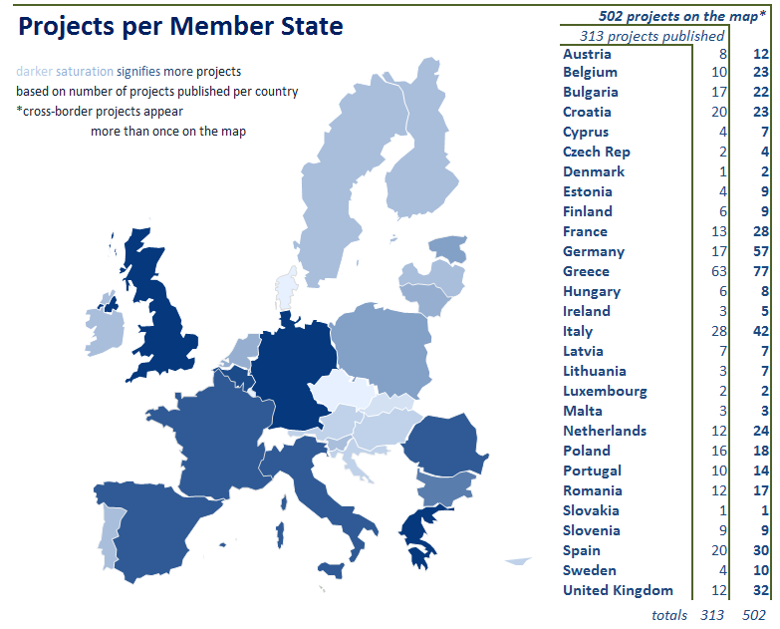

**Source**: Commission services

The published projects cover all MS. However, some countries have published considerably more projects than others have. Greece is the country with the highest number of published projects, namely 63, followed by Italy with 28, Spain and Croatia with 20 each. Countries that have been affected more by the financial crisis seem to be among the most active ones on the EIPP.

Between June 2016 and May 2018 there have been more than 220,000 cumulative visits to the Portal. The weekly numbers varied between around 500 and 2000 visits. The Member States with the highest number of visits in 2018 were Greece with 9%, followed by Italy and Spain with 8% each as well as Belgium with 7%. This suggests that among the countries that visit the website more often are those that have more published projects.

Regarding the contacts between investors and project promoters, they amounted to more than 1,300 over the analysed period and almost 80% of the promoters were contacted by investors.

The profile of organisations having submitted the project is balanced in favour of private organisations. In total, 583 projects (84%) were received from private organisations and 108 from public project promoters.

The company size also varied, most of the organisation that indicated their status being SMEs (508, more than 90%), Mid-Caps (37) and a few large companies (17) based on all the projects submitted for publication.

# Methodology

For the evaluation conducted by ICF, the evidence and the data were collected through several complementary sources including desk research, literature review, portfolio analysis, expert review of the EU Guarantee Fund, as well as interviews and six targeted surveys of main stakeholders. This was further complemented by an in depth review of a sample of EFSI, EIAH, and EIPP projects. Based on this and the triangulation of evidence, this evaluation can be considered reliable and valid.

The literature review focused on barriers and investment gaps related to sectors receiving the largest part of EFSI support (SMEs and mid-caps, Research & Development (R&D), energy & transport).

Box 1 - Examples of documentation/ data reviewed as part of the desk research

|  |
| --- |
| * Portfolio data on operations from both windows available on the EIB and EIF websites as well as provided directly by EIB/ EIF (i.e. Operational and Risk Reports, supplemented by additional data provided by EIB upon ICF request) with the cut-off point for 31 December 2017; * Past assessment and evaluation of EFSI produced by, *inter alia*, the EIB, the European Court of Auditors and independent consultants; * Recent EIB and EIF Operational Plans[16]; * Unpublished/ internal documentation provided by the EIB/ EIF/ ECFIN i.e. relevant parts of the *EIB Credit Risk Policy Guideline*, PowerPoint presentations from the internal meetings, minutes from the IC meetings, EC-EIB communication framework on EFSI; * Essential guidelines i.e. documentation on estimation of multipliers, *Key Performance Indicators/ Key Monitoring Indicators*; * Documentation related to Rhomolo-EIB model developed by Joint Research Centre of the EC in Sevilla, including model specification and description of main assumptions; * DG ECFIN internal documentation related to the estimation of the provisioning/target rate; * EIAH bi-annual technical reports, MoUs signed between the EIAH and NPBs/NPIs, statistics on EIAH requests and their outcome, statistics on the EIPP website visitors and users, as well as projects uploaded, EIAH Framework Partnership Agreement, EIAH Annual Grant Agreements, financials of the EIAH and EIPP; * Eurostat data on GDP and population to determine the take-up of the EFSI in relative terms at a national level; * Analysis of investment gap using Eurostat data. |

**Source**: ICF Evaluation report

Portfolio analysis focused on multipliers and investment targets, sectoral and geographical distributions, share of private investment mobilised as well as analysis of Key Performance and Monitoring Indicators. Comparison of risk rating at portfolio level focused on aggregate information for the whole IIW portfolio as well as risk rating for 60 individual signed operations.

In addition, a sample of 60 EFSI projects was reviewed in detail against the evaluation criteria and, in particular, to assess their additionality.

Figure 5 - Project review analysis

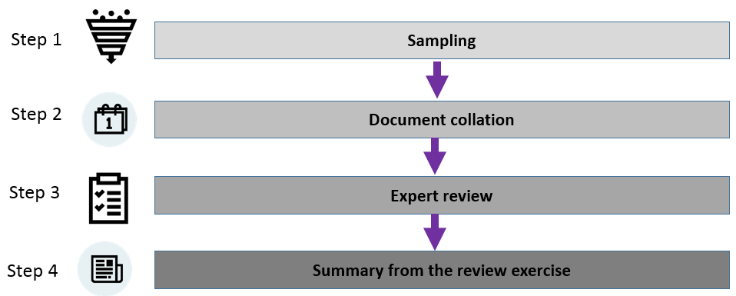

**Source**: ICF Evaluation report

The consultation activities included initial scoping interviews, semi-structured interviews with 71 key stakeholders and 5 targeted surveys.

Table 2 - Targeted surveys conducted and the response rate

| Survey | Number of responses | Response rate [in %] |
| --- | --- | --- |
| Survey of project promoters under IIW | 90 | 45 |
| Survey of financial intermediaries under IIW | 20 | 26 |
| Survey of National Promotional Banks | 12 | 37 |
| Survey of beneficiaries of EIAH assistance | 20 | 17 |
| Survey of project promoters from the EIPP | 61 | 31 |

**Source**: ICF Evaluation report.

To support this evaluation, a 12-week internet-based general open public consultation (OPC) was conducted. It the subject focus of this OPC was the EU Support for Investment[17]. Although a specific OPC for the EFSI was not launched for this evaluation, the results of the above mentioned OPC were useful to complement the results of the targeted consultation. In particular it brought further insight from the wider society and stakeholders about the relevant policy area.

In addition, past evaluations also constituted an important source of information and evidence. This includes in particular:

* a Commission evaluation on the use of the EU Guarantee and the functioning of the EU Guarantee Fund[18] accompanied by an opinion of the Court of Auditors[19],
* an EIB evaluation on the functioning of the EFSI[20], and
* an independent external evaluation on the application of the EFSI Regulation[21].

Main findings of these evaluations were summarised in the Commission Communication on the Investment Plan for Europe (COM (2016) 764)[22].

The main challenges and limitations that affected the independent evaluation were the following:

* At this stage of implementation and given the long-term nature of investment projects, it is difficult to evaluate final outcomes and impacts to the real economy of these initiatives. This is particularly relevant for the EFSI where several years may elapse between project planning and final implementation, but also for the EIAH and the EIPP. The evaluation however assesses impacts to the extent possible and focuses on the likely expected results.
* Due to the negotiations on the amended EFSI Regulation that was adopted only in December 2017, the timing requirements for the delivery were clear only at a relatively late stage. The available time to conduct this evaluation was thus limited.Consequently, several tasks had to be started in parallel with narrowed scope to develop and test propositions. This presents some limits to the extensiveness of the underlying analysis but not to the robustness of its findings.
* Possible stakeholder fatigue –the contractor undertook the evaluation in parallel to the EFSI evaluation commissioned by the EIB as also required by the EFSI Regulation. In addition, the ECA has been performing and EFSI audit during the same period. Consequently, several stakeholders reported a “responded fatigue” during the data collection phase. There is a risk that this affected stakeholders’ willingness to respond to surveys and interviews and potentially in the quantity of provided feedback.
* Challenges in the assessment of 'additionality' – the contractors faced several conceptual and methodological challenges in testing additionality at project level. At a conceptual level, the evaluators identified different interpretations of the concept – one linked to market failures and a broader one linked to policy objectives. Market failure theory justifies public intervention only if it is geared towards fixing market failures and, as such, the ‘acid test’ for determining additionality with reference to market failure is whether the market could have financed the project in the absence of the intervention on reasonable terms and within the same timeframe as the intervention. On the other hand, the notion of sub-optimal investment with reference to policy objectives does not require the existence of a market failure as a pre-condition for demonstrating additionality.

In line with the previous evaluation of EFSI, the independent evaluation assessed additionality on the basis of the (narrower) market failure theory, following the results of the surveys targeting IIW project promoters, financial intermediaries (involved in IIW intermediated operations) and NPBs, which all posed similar questions. The results of these surveys should however, be treated with caution due to the inherent risk of response bias (i.e. the respondent’s tendency to potentially over-state or even under-state additionality to justify public intervention) and the uncertainties associated with hypothetical questions relating to possible counterfactual outcomes.

* The review of the sample of 60 projects that received financing under IIW has some limitations. While 60 operations out of a total of 279 represent 21.5% of the total portfolio, this is not a statistically fully representative sample. Due to timing, resources, logistical limitations, and availability of data, a sample reflecting the main characteristics of the IIW portfolio was used[23]. Even if not fully representative, this review provided valuable additional evidence, particularly when considered in combination with other collected information.
* The survey of financial intermediaries under SMEW was not conducted. This was in light of the available data from earlier surveys/research and also because of survey fatigue. This was mitigated by:
  + “*analysis of the robustness of arguments about the ‘front-loading’ and ‘top-up’ of existing mandates as a main means of achieving the additionality under SMEW;*
  + *interviews with financial intermediaries under SMEW;*
  + *comparison of the characteristics (risk profile, target beneficiaries, geographic coverage) of the EFSI mandates and portfolios;*
  + *analysis of the use of new risk-sharing positions since EFSI; and,*
  + *analysis of the use of new collaborations since EFSI.*”[24]
* The assessment of the EFSI’s impact of on the real economy has been mainly based on the available EIB/JRC modelling exercise (Rhomolo-EIB model). All modelling typically relies on assumptions and results have to be interpreted with care.

To mitigate for these limitations, the evaluation method, as further described in Annex 3, was combined with evidence from previous EFSI evaluations and other sources. Therefore, the reliability and validity of this evaluation can be regarded as strong.

# Analysis and answers to the evaluation questions

## European Fund for Strategic Investments

### Relevance

The assessment of the EFSI’s relevance has been positive and concluded that the EFSI has been a relevant instrument to address investment gaps and market needs, as well as to respond to the needs of project promoters, financial intermediaries and private investors.

The extent to which the EFSI has addressed investment gaps and needs

The EFSI has been created as a demand driven instrument to address the substantial decline of the overall investment as a share of the EU GDP compared to the pre-crisis 1996-2007 level. The evaluation found the existence of substantial and unquestionable investment needs back in 2014 and early 2015.

In the aftermath of the financial crisis, the share of investment in the GDP had declined considerably below the pre-crisis 1996-2007 average for EU 28 Member States (see Figure 6). Investment levels have not yet recovered to their pre-crisis level and have remained well below historical trends.

Figure 6 - Investment as a % of GDP in EU28

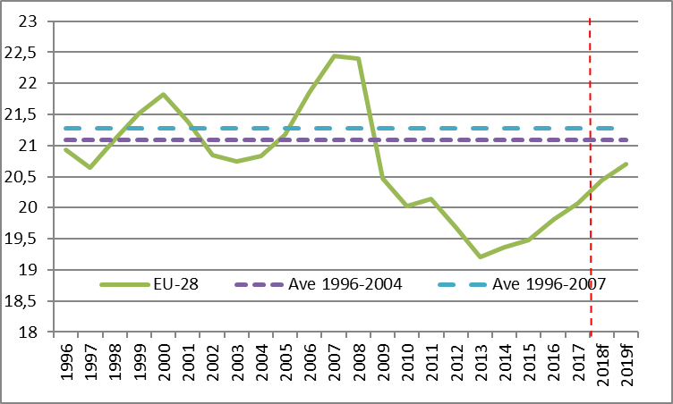

**Source**: ECFIN calculations based on data from the AMECO database

The EIB 2014 and 2016 Competitiveness report[25] pointed to a continued decline in infrastructure investment, with both decreases of government and private investment since 2011. The update report published in 2016 estimated the total annual investment gap in energy (EUR 100 billion), R&D (EUR 130 billion), environment and resource efficiency (EUR 90 billion), ICT (EUR 60 billion), R&D (EUR 130 billion), and the transport sector (EUR 80 billion).

The evaluation concludes that volumes of investment mobilised under the EFSI are relevant and sufficient in scale to make a significant contribution to the investment needs identified at the commencement of the initiative.

To respond to the changing investment environment, EFSI 2.0 has already refocused its support by introducing some policy-oriented measures. In particular, a 40% target under the Infrastructure and Innovation Window to support projects that contribute to climate action. Moreover, additionality criteria have been enhanced to better target sub-optimal investment situations.

Evidence suggests that there is still a need for a demand-driven support like the EFSI. The Spring 2018 ECFIN economic forecast concludes[26]:

* Public investment is expected to grow faster than GDP, though it still has to catch up a lot to reach its previous share of output.
* At the end of 2019, despite its improvements since 2012, potential output growth is estimated to remain below the rates recorded before the crisis. This is mainly because of a still subdued contribution from capital accumulation, despite the recent increase in the ratio between investment and potential output.
* Investment (gross fixed capital formation), which had frequently been identified as the weakest link in the post-crisis recovery, is showing signs of a broad-based pick-up (see table below).
* In 2018, investment growth is expected to pick up to 4.2% in both the euro area and the EU, before slowing in 2019 to 3.4% in the euro area and to 3.2% in the EU. The year 2018 is forecast to be the first year since 2007 in which investment increases in all EU Member States. The continued strength of investment implies strong growth contributions and increases in capital deepening which further support cyclical improvements in labour productivity.

While these forecasts show an improved macroeconomic picture, the investment levels have still not reached the historical average of 21.28% of GDP as observed between 1996 and 2007. This implies an investment gap of around 157 billion in 2017 (see Table 4). Even with the expected growth, investment is forecasted to still remain below the pre-crisis average (20.44% in 2018 and 20.71% in 2019 as opposed to 21.3%). Consequently, even 11 years after the start of the financial crisis, the investment will not have recovered to its pre-crisis levels.

Table 3 - Investment level forecasts

|  |  |  |  |
| --- | --- | --- | --- |
| *(in EUR billion)[27]* | 2017 | 2018 forecast | 2019 forecast |
| EU GDP | 15.327,16 | 15.935,75 | 16.544,88 |
| Investment level | 3.075,90 | 3.257,82 | 3.426,03 |
| Investment gap compared to 1996-2004 investment level average (21.1%) | 157,37 | 103,83 | 64,11 |
| Investment gap compared to 1996-2007 investment level average (21.3%) | 185,39 | 132,97 | 94,36 |
| Investment level | 20,07% | 20,44% | 20,71% |

**Source**: AMECO (May 2018 data, current prices) and Commission services calculations

This Commission assessment is broadly in line with the estimates of the investment gap prepared by the independent evaluation (see Figure 7). Furthermore, the EIB has estimated a large investment gap (i.e. EUR 270 billion) in transport, energy and resource management infrastructure until 2020[28].

Figure 7 - Share of private finance mobilised in total EFSI investment mobilised and in the estimated annual EU investment gap[29]



**Source**: ICF based on data sourced from year-end EFSI operational reports for 2015, 2016 and 2017. Investment gap calculated by ICF in relation to historical trends.

All these data sources lead to conclude that demand-driven EFSI investment support is thus still relevant in the current improved economic environment. Downsizing or discontinuing the support would risk derailing this current positive trend and would risk increasing again the investment gap.

It should be emphasized that the estimates do not include potential sub-optimal investment situations and investment needed to reach EU policy objectives like climate action, sustainability, R&D investment, social investments. An extensive analysis of expected future investment needs and gaps in these areas is included in the InvestEU Impact Assessment, where the Commission has estimated investment needs in several key policy areas over the 2020-2030 period.

Moreover, the independent evaluation also concluded that, while the conditions have improved, especially for access to finance by SMEs, there are still considerable investment gaps. In particular, the independent evaluation concluded that *“Although the overall picture has improved at a macro level, both in terms of the scale of the financing gap and financing conditions (especially for SMEs), there remain substantial and pressing investment needs. For example, infrastructure investment in 2016 was still 20 per cent below pre-crisis levels. And while SMEs, en masse, may have seen improvements in terms of available finance, available evidence suggests that access to finance remains problematic for a substantial share of the SME population, in particular in some countries, and for start-up and early stage growth innovative SMEs even in those Member States with the most developed financial markets. Ongoing EU investment support therefore remains relevant and necessary.”* This conclusion is also consistent with the preliminary results of the Commission’s Impact Assessment on the InvestEU.

To conclude, current evidence suggests that a market-based instrument like the EFSI is still relevant and needed in the coming years. The improvements adopted by EFSI 2.0 should already respond to the improving market environment (focus on climate action and strengthened additionality criteria). Furthermore, given the expected development of investment needs after 2020, the InvestEU Fund proposes a more policy-focused investment approach.

Geographical and sectoral distribution

The EFSI has no specific sector or geographic allocation targets and investment is demand-driven. Nevertheless, the EFSI investment guidelines require that ‘*excessive sectoral and geographical concentration is avoided’*[30] and the EFSI Strategic Orientation sets indicative limits under IIW[31].

The evaluation found that the EFSI has been relevant to address financing market needs and gaps across all EU Member States. The EU 15 Member States account for a big share of EFSI financing - around four fifths under both windows. The 2016 independent evaluation also found that: “*[w]hile sector coverage is generally not seen as an issue by the stakeholders consulted, there is a serious concern on the geographical spread.*”

Figure 8 - EFSI geographical distribution (both windows)

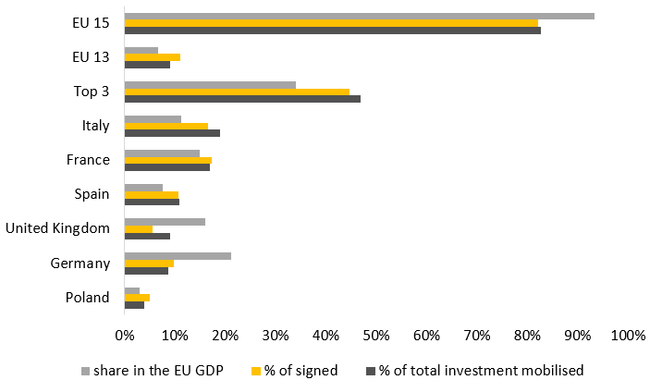

**Source**: ICF based on EIB 2017 EFSI Operational Report and Eurostat data

However, while in absolute terms the largest EU countries take the lion’s share and EU15 accounts for four fifths of the EFSI support, relative to each country’s share in the total EU output, the geographical distribution is much more balanced. In fact, the EU15 stands for 93 per cent of the total EU 28 GDP.

This and previous evaluations found that there are a number of factors behind the perceived lower uptake of the EFSI in some of the ‘New’ Member States (EU13):

* The EFSI is a demand driven instrument and its support distribution depends on market demand and absorption capacity in a given country;
* The geographical distribution closely reflects the actual size of the EU13 economies relative to overall EU 28 GDP;
* The size of typical EFSI projects may exceed the typical size of viable projects in smaller countries; and
* The need of strong capacity building and technical assistance measures to facilitate the origination, preparation and implementation of projects, a point that has been also addressed in EFSI 2.0 through the refocusing of the Advisory Hub. Some Member States might have access to alternative financing, such as other EU programmes that may be perceived as more favourable (i.e. because of the availability of grants).

The EFSI support was able to address market needs and investment gaps in all main sectors. Overall, projects in the RDI sector[32] received around one third of total financing signed under the EFSI, followed by the energy sector and support for smaller companies (see Figure 9 and Figure 10).

Figure 9 - Sectoral distribution of the EFSI support - IIW

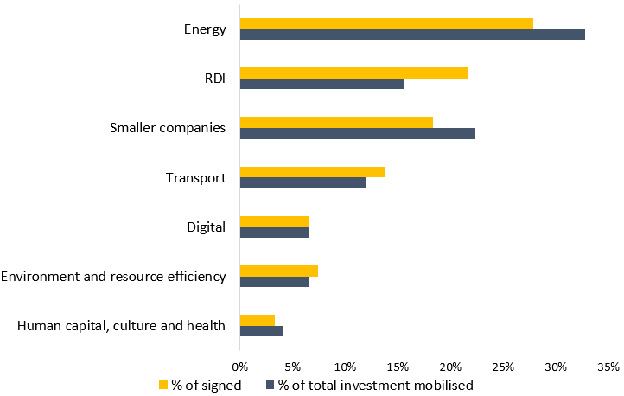

**Source**: ICF based on EIB EFSI 2017 Operational Report

Under the IIW, the energy sector received the biggest share of support, 33% in terms of signed operations (exceeding the indicative 30% sector concentration limit specified in the EFSI Strategic Orientation[33]) and 28% in terms of investment mobilised (see Figure 9). This is a substantial improvement compared to mid-2016 when 46% of signed operations related to the energy sector. Under the SME window, the RDI sector received the highest share of support, 70% in terms of signed operations (to note that there are no indicative limits on EFSI SMEW support per sector) and 37% in terms of investment mobilised (see Figure 9).

Figure 10 - SMEW sectoral distribution

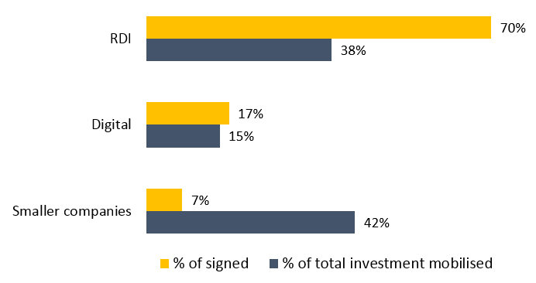

**Source**: ICF based on EIB EFSI 2017 Operational Report

EFSI’s response to the need of project promoters, financial intermediaries, and private investors

Overall, the evaluation found that EFSI responded well to the needs of various stakeholders. The changes brought about by EFSI in terms of the availability of new products and enhancement of existing ones have been assessed as very substantial.

The EIB introduced six new products under EFSI and further six have been enhanced (see Annex 4). Examples include:

* Corporate Hybrid Bonds, focused on low-risk utilities;
* Infrastructure Aggregation Platform;
* ABS Mezzanine, to support lower rated beneficiaries;
* Captive Funds and Investment Platforms which target NPBIs.

Furthermore, there has also been a substantial increase in the number of quasi-equity products under EFSI (see Table 4)

Table 4 - Increase in the number of approved equity type operations under EFSI IIW

| Time | External multiplier | Number of equity operations | Number of equity operations with multiplier ≥ 15 | **Percentage of equity operations with a multiplier ≥ 15** |
| --- | --- | --- | --- | --- |
| End-2016 | 22.93 | 22 | 11 | 70% |
| End-2017 | 14 | 70 | 17 | 40% |

**Source**: ICF based on EIB EFSI 2017 Operational Report

Since 2016, there have also been some new additions to the EIF’s products’ portfolio including: venture debt, uncapped guarantees for riskier (subordinated) loans to innovative SMEs and small mid-caps; uncapped guarantees for the EU Programme for Employment and Social Innovation (EaSI); as well as Investment Platforms[34].

In addition, the increased risk bearing capacity through the EFSI (EU) Guarantee enabled the EIB Group to reach new market areas, new client types and develop new ways of engaging with existing clients (see section 5.1.2 for further analysis).

Relevance of the Scoreboard

The scoreboard is a framework for presenting the results of the appraisal of operations under the EFSI IIW. The scoreboard (Figure 11) is comprised of four pillars, each of which deals with a particular criterion. The EFSI Regulation provides that ‘*the scoreboard […] shall be used by the Investment Committee with a view to ensuring an independent and transparent assessment of the possible use of the EU guarantee’*.

The evaluation found that the scoreboard constitutes a good framework for decision-making. The design of the scoreboard and the evaluation criteria were also found as appropriate.

Figure 11 - EFSI Scoreboard

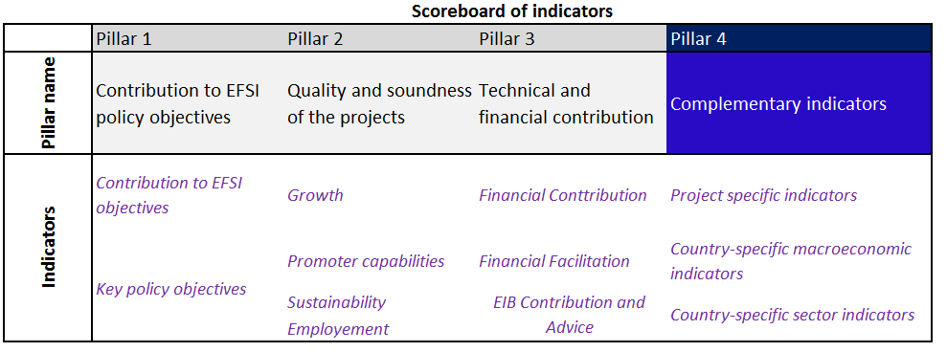

**Source**: ICF, adapted from EIB (2016)

### Effectiveness

Achievement of objectives and targets

The evaluation found that based on approved operations it is likely that the EFSI will come very close to the target of 315 EUR billion of investment mobilised by end-June 2018. Based on approved financing as of 31 December 2017, the EFSI mobilised EUR 256.3 billion of investment, which increased to EUR 287.4 by 15 May 2018.

Table 5 - EFSI 1.0 performance compared to initial expectations

|  |  |  |  |
| --- | --- | --- | --- |
|  | | ***Expectations at the launch of EFSI initiative*** | ***As of 31 Dec 2017*** |
| ***Investment mobilised target*** | Signed | EUR 315 billion***\**** | EUR 207.3 billion |
| Approved | EUR 256.3 billion |
| ***Investment multiplier*** | | 1:15 | 1:13½ |
| ***Job creation[35]*** | | From 1 million to 1.3[36] million new jobs | * 683,075 jobs expected to be created of which 114,593 permanent and 568,482 temporary jobs * 3,603,541 jobs supported * Rhomolo-EIB estimate: 690,000 new and induced jobs by 2020[37] |
| ***Number of SMEs, small mid-caps and mid-caps supported under EFSI*** | | n/a | 549,500 expected to be supported of which  135,785 have already received financing |

**\***Target date: mid-2018

**Source**: Commission services

As of end 2017, EFSI support thus mobilised investment amounting to 81% of the target of EUR 315 billion set for mid-2018 for approved operations. As of May 2018 and based on approved operations, the EFSI achieved 91.2% of its target of expected investment mobilised. In general, it is expected that by mid-2018 the investment to be mobilised based on approved operations will come very close to the initial target of EUR 315 billion.

Table 6 - EFSI support - state of play per window

|  |  |  |  |  |
| --- | --- | --- | --- | --- |
| (in billion EUR) | 31 December 2017 | | 15 May 2018 | |
|  | Signed | Approved | Signed | Approved |
| EFSI IIW – financing | 27.4 | 39.3 | 29.2 | 43.3 |
| EFSI IIW - investment mobilised | 131.4 | 166.7 | 137.9 | 186.2 |
| EFSI SMEW - financing | 10.0 | 12 | 12.4 | 14.2 |
| EFSI SMEW-investment mobilised | 75.9 | 89.5 | 86.7 | 101.2 |
| Total EFSI financing | 37.4 | 51.3 | 41.6 | 57.5 |
| Total EFSI investment mobilised | 207.3 | 256.3 | 224.6 | 287.4 |

**Source**: EIB

In terms of signed operations, the investment mobilised amounted to EUR 207.3 billion at end 2017 and EUR 224 billion at 15 May 2018. The performance under SMEW has been stronger than under IIW compared to initial targets.

In addition, the evaluation found that the level of multipliers is broadly in line with the initial expectation for the EFSI. As of 31 December 2017, the EFSI multiplier for both windows was 13.5. This is currently lower than expected but close to the anticipated multiplier of 15 (see table below as well as Table 5). It is important to acknowledge that there is a potential trade-off between reaching the investment target set by the Regulation and the need to select higher risk projects and ensure additionality. From the Commission perspective, ensuring added value, additionality and impact of the EFSI support should be prioritised compared to the volumes of investment mobilised.

Table 7 - EFSI multipliers at aggregate & window level by type of product

|  | Type | Multiplier |
| --- | --- | --- |
| Aggregate | Hybrid Debt Type | 15.2 |
| Equity Type | 11.4 |
| Standard Debt Type | 15.2 |
| **Aggregate** | **13.5** |
| IIW | Hybrid Debt Type | 15.2 |
| Equity Type | 13.9 |
| Debt Type | 11.7 |
| **Aggregate** | 12.7 |
| SMEW | Equity | 8.6 |
| Debt | 26.6 |
| **Aggregate** | 15.2 |

**Source**: EIB, 2017 Year-end Operational Report

Mobilisation of private capital and crowding-in of private investors

A key objective of the EFSI is to maximise where possible private sector investment. The evaluation found that at the end of December 2017, the EFSI support was expected to mobilise almost EUR 134 billion of private sector investment, which represents 64 per cent of the total EFSI investment mobilised. It is worth noting that equity instruments under the IIW have been particularly successful in attracting private capital – mobilising over 12 euros of private financing for every euro of EFSI financing.

The calculation methodology of investment mobilised is in line with the Financial Regulation[38] provisions and with the general practice used for centrally managed financial instruments. The independent evaluation however, recommended caution with interpreting these results as a strict causality effect could not be determined. It warned that the entire volume of private financing mobilised can not necessarily be attributed to the EFSI. A portion of this financing mobilised would have possibly been committed to projects by private investors anyway, even if most likely at different terms (different rate, maturity). A similar opinion was expressed by the ECA. The discussion on additionality in section 5.1.4.1 demonstrates that some project promoters had access to alternative sources. Their replies however suggest that this alternative financing may have been offered at less favourable terms (lower maturities, higher interest rates, less security requirements) and that the EFSI involvement had a significant signalling effect.

The independent evaluation concludes that there is always a risk that market intervention can crowd out market investors and although there is some evidence under the IIW of a potential crowding out effect, further research would be needed to establish this with more certainty and to determine the nature and scale of any potential crowding out. While the survey, the interviews and the project reviews carried out by the external consultants pointed to the possibility that EFSI may have crowded out private sector investors in some cases, the emphasis put by respondents on signalling effect suggests that the EFSI involvement helped project promoters attract other private investors. In particular, 53% of those project promoters that claimed to have access to other sources of financing stated that the signalling effect is one of EFSI's main benefit. In addition, the respondents also stressed the longer maturity, lower interest rates, and lower or no security requirements (Figure 20) offered with the EFSI support. This suggests that some project promoters who might have had access to alternative financing still benefited from the EFSI support in terms of the signalling effect, longer maturities and lover interest rates.

Table 8 - EFSI financing signed and private finance / investment mobilised (end 2017)

| (EUR bn) | | EFSI financing signed | Private finance mobilised | Investment mobilised | Private sector share of investment mobilised | Private finance mobilised per euro of EFSI financing | Investment mobilised per euro of EFSI financing |
| --- | --- | --- | --- | --- | --- | --- | --- |
| IIW | Debt | 24,133 | 42,296 | 81,678 | 52% | 1.8 | 3.4 |
| Equity | 3,279 | 39,851 | 49,719 | 80% | 12.2 | 15.2 |
| Total | 27,412 | 82,148 | 131,397 | 63% | 3.0 | 4.8 |
| SMEW | Debt | 5,973 | 33,562 | 48,508 | 69% | 5.6 | 8.1 |
| Equity | 4,026 | 17,814 | 27,432 | 65% | 4.4 | 6.8 |
| Total | 9,998 | 51,375 | 75,940 | 68% | 5.1 | 7.6 |
| EFSI total | Debt | 30,106 | 75,858 | 130,186 | 58% | 2.5 | 4.3 |
| Equity | 7,304 | 57,665 | 77,151 | 75% | 7.9 | 10.6 |
| Total | 37,411 | 133,523 | 207,337 | 64% | 3.6 | 5.5 |

**Source**: ICF based on EIB EFSI 2017 Operational Report

Contribution of NPBIs and Investment Platforms to the EFSI Objectives

The increased risk bearing capacity through the EFSI enabled the EIB and the EIF to reach new market areas, new client types and develop new ways of engaging with existing clients. There are indications that there is a need for financing of projects of a smaller size as opposed to large projects under the IIW. In particular, the 2016 independent evaluation concluded that: “*there are indications that there is a need for financing of projects of a smaller size as opposed to large projects under the IIW”*. The ICF independent evaluation found that the EFSI made significant progress, notably through equity-type products, both for new delivery models and collaboration with NPBIs. In particular:

* More than 80 per cent of the clients benefitting from EFSI IIW are new EIB counterparts[39].
* 70-80 per cent of the deals under SMEW have been signed with new counterparts.
* Cooperation with NPBIs has been strongly enhanced under the EFSI. The share of operations co-financed with NPBIs was established as a key monitoring indicator for the EFSI and is included in the operational reporting required from the EIB Group. At the end of 2017, 141 operations signed under EFSI involved NPBIs, amounting to EUR 7.4 billion of EFSI financing. NPBIs have made an important contribution to the delivery of the EFSI policy objectives, as their local presence and knowledge has facilitated transaction origination and enabled smaller deal sizes, which is one recognised means to benefit real economy and financed-constrained beneficiaries. Cooperation and coordination with NPBIs is also an essential element of improving the EU added value of the EFSI and ensures complementarity by reducing overlaps between national schemes and EU level intervention.
* More widely, the new delivery models (e.g. investment platforms, risk sharing models) and collaborations have contributed to financing smaller projects and facilitating local outreach. However, this has led to only a limited contribution to geographical diversification of the EFSI portfolio.

The EIB has also developed new forms of cooperation – moved from partial to full delegation models for risk- sharing[40].

The EFSI has allowed some new instruments to be developed in collaboration with EU programmes and instruments. Examples include:

* The planned financial close of the CEF Broadband Fund which is a layered fund in which the first loss piece will be covered by the CEF equity instrument; the mezzanine tranche by the EFSI, and the more senior tranche by other investors (including NPBs, EIB own financing and private investors)[41]; and
* EFSI contribution to the Pan-European VC funds-of-funds (up to EUR 100 million), together with Horizon 2020's InnovFin Equity scheme (up to EUR 200 million) and COSME EFG (up to EUR 100 million)[42].

Box 2 - Investment platforms under the EFSI

|  |
| --- |
| EFSI Investment platforms are co-investment arrangements structured with a view to catalysing investments in a set of projects (as opposed to individual projects). Investment platforms are a means to aggregate investment projects, reduce transaction and information costs and provide for more efficient risk allocation between various investors.  Investment platforms are particularly suited to addressing the difficulties encountered by smaller projects or less developed regions by:   * pooling smaller or local investment projects, which would by themselves be too small to benefit, and * making bundled projects accessible to new investor groups, for example pension funds or institutional investors, that are less familiar with the EU market.   Investment platforms can be special purpose vehicles, managed accounts, contract-based co-financing or risk sharing arrangements or arrangements established by any other means by which entities channel a financial contribution in order to finance a number of investment projects.  As of December 2017, 35 investment platforms had been approved, and out of which three with EFSI support under the SMEW.  These platforms represent nearly EUR 4 billion of EFSI financing and more than EUR 29 billion of expected investments mobilised.  A majority of investment platforms to date have been set up for energy and environmental projects, smaller infrastructure projects, affordable and social housing, as well as financing of SMEs and innovative midcaps. They generally are single-country investment platforms with a thematic focus. The first platforms approved and signed were in Italy, France and Spain, but further diversification can be seen with examples in Finland, Greece, Poland, Germany and the Netherlands. A couple of examples, such as the CEF Broadband Fund, will cover the whole EU.  The majority of these investment platforms involve NPBIs. |

**Source**: ICF

EFSI’s contribution to jobs and growth

At the end of 2017, signed EFSI operations stood at EUR 37.4 billion, which is expected to mobilise EUR 207 billion of investment. Actual disbursements stood at EUR 10.1 billion under IIW and EUR 10 billion under SMEW. Therefore, given the nature of investment projects, considerable amount of the envelope of IIW remains undisbursed. It is thus early to capture the full impact of the EFSI on employment and the economic growth.

The 2016 independent evaluation concluded that the "*contribution to growth and jobs is currently insufficiently measured and monitored, while these are key ultimate objectives for the longer term*.” However, since then the ICF evaluation underlined considerable efforts by the European Commission and the EIB Group to estimate the potential impact on jobs and growths.

Direct jobs created or sustained is one of the six Key Monitoring Indicators against which the performance of the EFSI is regularly monitored by the Commission[43]. As of end-2017, the EFSI created nearly 115,000 of permanent jobs and over 0.5 million of temporary ones and supported over 3.5 million of jobs.

Table 9 - Forecast number of direct jobs created

|  | Permanent employment | Temporary employment | Jobs supported |
| --- | --- | --- | --- |
| *IIW* | 114,593 | 568,482 | 2,090,117 |
| *SMEW* | : | : | 1,513,424 |

**Source**: ICF based on EIB EFSI 2017 Operational Report

According to European Commission estimations at the outset of the Investment Plan, the Plan had the potential to add EUR 330 to EUR 410 billion to the EU's GDP and create 1 to 1.3 million new jobs in the coming three years. These estimates were based on the expected impact of EFSI and the potential contribution of additional financial instruments under shared management, which are not within the scope of this evaluation. Therefore, we assume that EFSI was expected to contribute to the creation of 1 million jobs. After less than three years of implementation, and half a year before the end of the target period, the forecast number of new jobs created stands at 68% of the estimated impact. Therefore, it is likely that at the end of the target period, the initial expectations in terms of direct jobs created will not be fully met.

However, the EIB estimates include only direct jobs created. The reported numbers do not capture the indirect and induced effects of the EFSI on employment nor its impact on economic growth. To address these and to provide a plausible estimate, the Economic Department of the EIB, in collaboration with the Joint Research Centre (JRC) has undertaken a modelling exercise (using Rhomolo-EIB model).

The EIB reported, based on the Rhomolo-EIB model, that EFSI operations approved since inception up to 31 December 2016[44] mobilised EUR 161 billion of investment, and will have added 0.67 per cent to EU GDP and generate 690,000 new jobs by 2020, compared to the baseline scenario (see Figure 12).

While the Rhomolo EIB model captures also the induced effect on jobs, the current estimate of 690,000 new jobs by 2020 includes only operations signed by end-2016[45]. In addition, the EFSI supported more than 3.5 million jobs. Overall, it is reasonable to expect that the total direct and induced jobs created by the EFSI operations to be approved by mid-2018 will come close to 1 million or slightly above.

Figure 12 - Impact of EFSI and the wider EIB Group on the EU GDP and employment

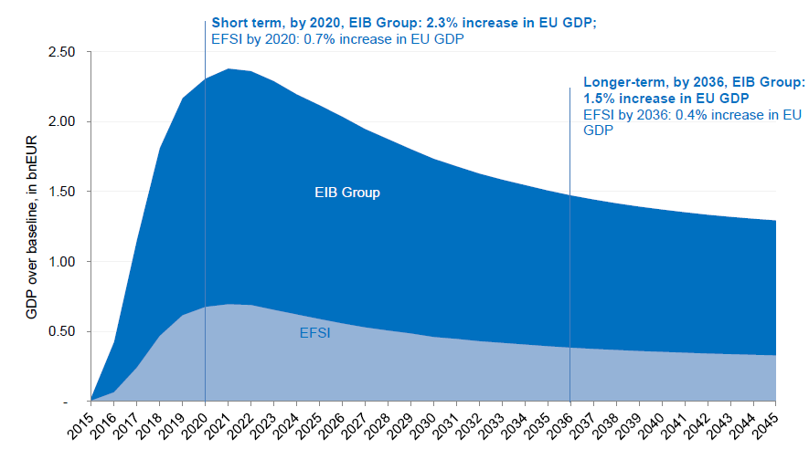

**Source**: EIB, 2018. Assessing the macroeconomic impact of the EIB Group, version from April 2018

The evaluation found some scope of improvement in particular in terms of the transparency behind key assumptions of the Rhomolo-EIB model. Nevertheless, it noted the usefulness of this challenging and complex exercise.

Effectiveness of the scoreboard

The 2016 independent evaluation recommended to *“better weigh the different assessment criteria in the scoreboard and to set minimum thresholds for each of the four criteria according to their importance”.*

This evaluation found the scoreboard to be a relevant (see section 5.1.1) and an effective decision-making framework for the Investment Committee (IC). However, some stakeholders expressed a view that more clarity on how the EIB derives particular rankings is still needed[46].

EFSI 2.0 introduced a requirement for the Steering Board to establish a minimum score for each pillar in the scoreboard with a view to enhancing the assessment of projects. Moreover, the Steering Board may allow the IC to examine a project whose score is below the minimum score under certain conditions. The interviewed IC members sensed that the minimum threshold of 4 out of the total of 13 points for the 4th Pillar could have been higher in order to reduce the volume-driven incentives. However, there is also an argument that this relatively low threshold may present more opportunities for the IC to exercise its independent mandate.

The interviewed IC members also raised the point that currently the EIB project documentation does not include information on the actual effort made by a project promoter to identify alternative sources of financing and to the terms likely to be offered by alternative sources. It is to be noted however, that such information is not required by the EFSI Regulation neither concerning the eligibility nor the additionality criteria.

Past EFSI evaluations, including the ECA’s Report on the Extension of EFSI[47], argued for more transparency, i.e. publication of the scoreboards for the EFSI operations after they are signed. Consequently the EFSI 2.0 envisages the publication of the scoreboard after the signature of the project as well as a publication of the rationale of the IC decisions (from March 2018 onwards).

### Efficiency

EFSI governance

The EFSI governanceincludes a Steering Board, an Investment Committee (IC) and a Managing Director[48]. The potential use of the EU guarantee is examined and evaluated by the Investment Committee. The latter is composed of a Managing Director and eight independent experts with experience in one or more key EFSI-related sectors.

For the IIW projects, the Investment Committee decides on the application of the EU guarantee on the basis on a four-pillar examination (the scoreboard). The EU guarantee to the SMEW products is decided by the EFSI Steering Board and the Managing Director after consultation of the Investment Committee.

This and the past EFSI evaluations found that that the current EFSI governance structure works well. However, the 2016 ECA report called for more transparency and some streamlining[49]. In particular it noted that: *“[…]complex interrelations between the Commission and the EIB, and their respective appointees within the EFSI decision-making process, make it difficult to establish for accountability purposes who is ultimately responsible to the EU budgetary and legislative authorities for the performance and risk management of EFSI as well as to identify potential conflicts of interest between EFSI and non-EFSI roles and responsibilities.*”

It was found that the IC is important for the legitimacy and credibility of EFSI’s governance. Table 10 below summarises information from monthly IC meetings that took place between March 2016 and January 2018.

Table 10 - Summary of monthly IC meetings, March 2016 – January 2018

| Total number of EFSI application assessed | Number of applications where IC decision was unanimous | Number of applications where IC decision was by majority | **Number of applications with no information on the proportion of votes[50]** | Number of applications *rejected* | Number of Conflict of Interests reported |
| --- | --- | --- | --- | --- | --- |
| 294 | 129 | 20 | 143 | 4 | 13 |

**Source**: Copy of minutes provided by the EIB

Interviewed IC members pointed to the absence of feedback from the EIB on the status of projects that have been approved and are being implemented. This could be regarded as a potentially missed opportunity for the IC members to learn from their decisions. According to the EIB, the EFSI Secretariat gives IC members after each Board updated information on projects and provides regular reports on the EFSI implementation and on specific matters such as SMEs, funds, and programme loans. This points at important progresses made on information-sharing between EIB services and the IC.

Application and appraisal process

The surveys of project promoters found that only 15 per cent considered the application procedure difficult, that share increases to 24 per cent for the appraisal procedure.

Figure 13 - Project promoters under IIW on EFSI application and appraisal procedure

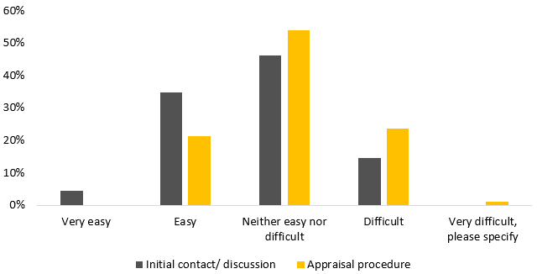

**Source**: Survey of IIW project promoters, N=89

Project promoters sometimes perceived the administrative requirements and paper work as excessive. The efficiency of the appraisal process is seen as dependent on the dedication and pragmatism of the EIB staff, which were often acknowledged as excellent.

Figure 14 shows the improvement of the average time that elapses between the approval of the project and its signature for the current IIW portfolio[51]. The average time (in weeks) between approval and signature of a project has been falling over time, despite an increase in the volume of projects being submitted. This may be also a consequence of some efficiency gains following the inception of the EFSI (e.g. use of delegated approvals) and of the increase in the number of EIB staff.

For the SMEW, comparable data shows that deals implemented by the EIF indicate a very stable pattern. The average duration (in weeks) between the approval and signature of SMEW projects was 12.5, 13.5 and 11.5 weeks in 2015, 2016 and 2017 respectively.

Figure 14 - Evaluation of time elapsed between approvals and signature, IIW

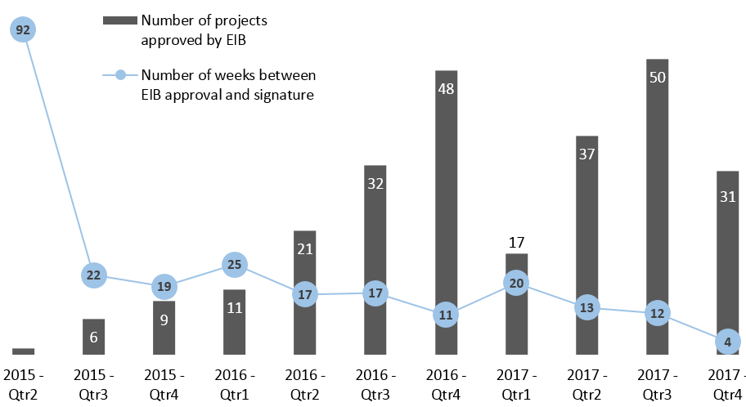

**Source**: ICF based on the EIB data of 264 signed operations, as of 31st December 2017

### Coherence

#### Coherence with other EU Programmes

The EY independent evaluation noted that “[s]*takeholders indicated that there is competition with other EU funds such as certain financial instruments under CEF and H2020 or financial instruments and grants under ESIF*.” It recommended to “*[f]urther develop and facilitate complementarity and synergy, and avoid overlaps, with other financing sources*”. Similar remarks were included in the 2016 EIB evaluation and by other studies[52].

EFSI was created after several other EU financial instruments under the 2014-2020 MFF had already been in place. Figure 14 maps the main current financial instruments and the EFSI. Some initial overlaps have been resolved through prompt action by re-focusing existing instruments towards new market segments (e.g. projects outside the EU or new thematic products in the case of InnovFin’s EIB debt products) and/or developing a deal allocation policy formalising the preferential use of the EFSI (e.g. CEF DI, COSME EGF).

Under the IIW, observed overlaps between the EFSI and the financial instruments concern mainly InnovFin debt products and CEF debt instrument. This in turn led to some ‘cannibalising’ of these existing instruments by the EFSI.

Figure 15 - EU programmes and portfolio of financial instruments

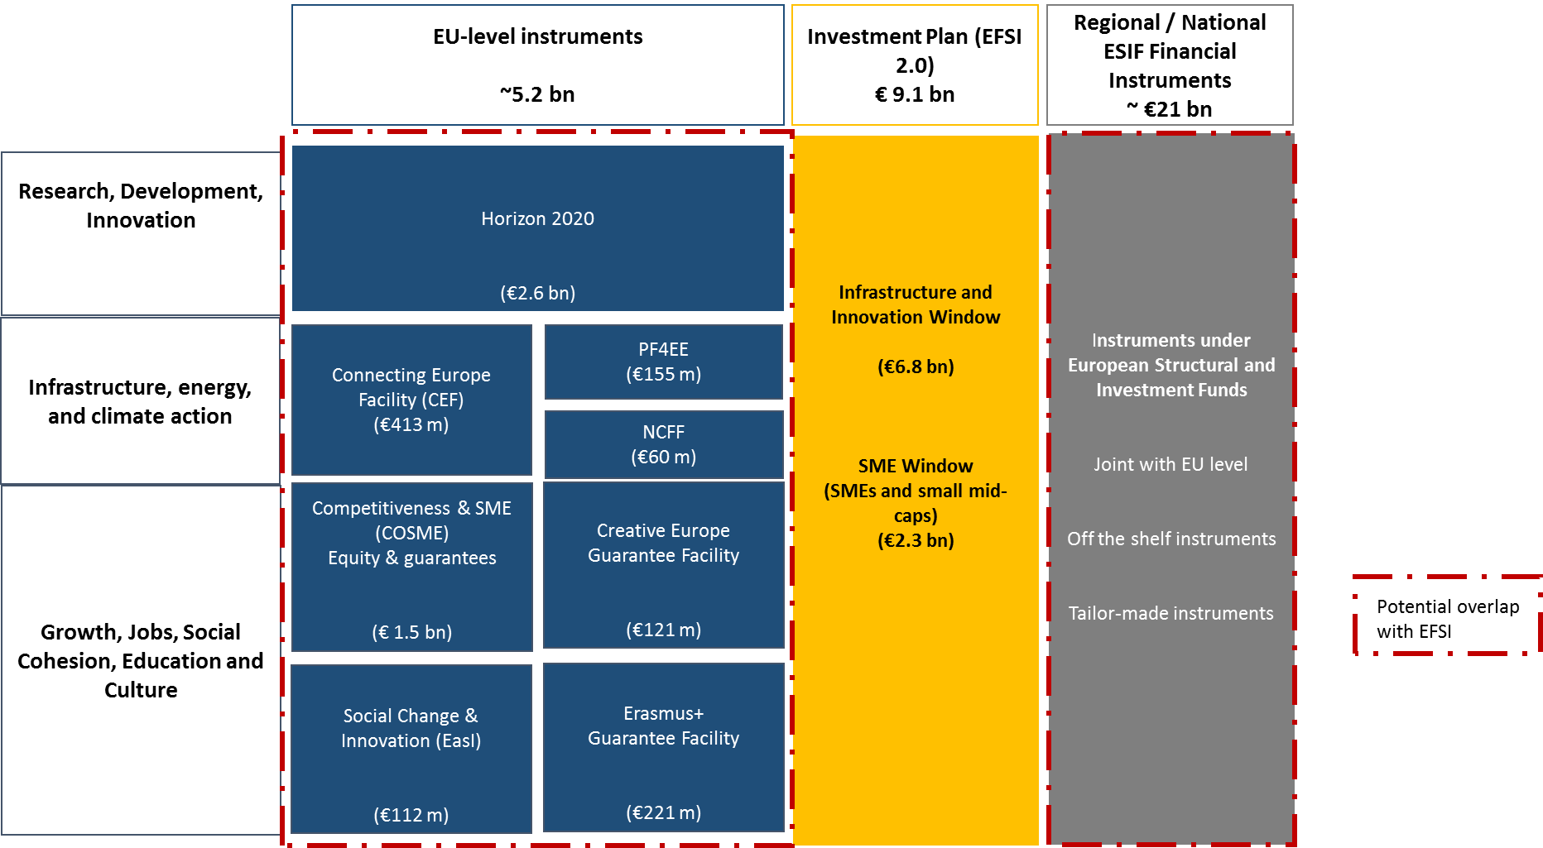

**Source**: ICF

The effect of these overlaps is illustrated in the declining trends of commitments made under EIB’s InnovFin (see Figure 16). In particular, the InnovFin Large Projects had very similar eligibility criteria to the EFSI IIW debt financing and the InnovFin Mid-Cap Guarantee had an equivalent product offering as the EFSI’s Risk Sharing.

Figure 16 - Annual commitments made under EIB’s InnovFin products

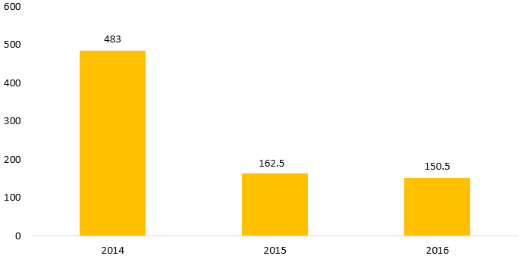

**Source**: ICF based on Art. 140.8 reports: EC (2017) Commission Staff Working Document SWD(2017), EC (2016) Commission Staff Working Document SWD(2016) 335 and EC (2015) Commission Staff Working Document SWD(2015) 206 final. **Note**: covers InnovFin Large Projects, InnovFin MidCap Growth Finance and InnovFin MidCap Guarantee

These issues have to some extent been addressed by refocusing InnovFin’s deployment in light of this new context. New InnovFin facilities were subsequently designed minimising the overlap with the EFSI. They targeted at research organisation, public entities, or target regions which are currently undeserved by InnovFin operations, in particular in Associated Countries and less innovative EU countries)[53].

There were also some identified overlaps with CEF financial instruments. The mid-term evaluation of CEF highlighted that most operations eligible under the CEF debt instrument (DI) are also eligible under the EFSI. Several important energy and transport projects initially envisaged to be supported by the CEF DI were eventually financed under the EFSI[54]. This was later addressed through specific guidance by the CEF DI Steering Committee to set out a deal allocation policy[55]. Moreover, the budget allocated to the CEF DI was significantly reduced compared to the initially programmed allocation.

Under the SMEW, the EFSI has been coherent with existing financial instruments. This is due to the fact that the EFSI has been used first to frontload and then top-up the existing financial instruments and has not created new ones. However, for future investment programmes to be designed under the next MFF, it is not desirable to have an EU instrument topping up another one as a default solution. This may lead to inefficiencies, limited transparency, and create confusion for final beneficiaries and financial intermediaries.

The EFSI allowed the financial instruments, especially COSME LGF and InnovFin SME Guarantee (SMEG), to overcome budget constraints and to be rolled out more quickly.

However, while this is not subject to this evaluation, several additional overlaps have been identified between centrally managed financial instruments themselves. For example, in the area of SME financing, the current MFF has at least 14 different instruments focusing on SMEs under internal, centrally managed EU financial instruments and the EFSI (see Annex 5).

In conclusion, initially the EFSI support and centrally managed financial instruments led to significant overlaps over a number of areas. Moreover, other evaluations found further overlaps between certain centrally managed financial instruments. During the current programming period, some of these overlaps have already been addressed through refocusing certain instruments and/or developing a deal allocation policy formalising the preferential use of the EFSI. For future programmes, the independent evaluation recommended to strengthen ex-ante assessments and ongoing analysis of market failures and needs at a sectoral level to avoid any overlaps between products and to minimise any potential crowding out effects.

Shared management (Decentralised) programmes

The European Structural and Investment Funds' (ESIF) financial instruments and the centrally managed financial instruments financed under the EFSI SMEW typically serve a similar purpose, increasing access to finance for SMEs. As a result, they may target similar beneficiaries. In this context, overlaps may occur between guarantee facilities under the ESIF financial instruments (FIs) and COSME LGF. The recent mid-term evaluation of COSME[56] highlighted competition issues between ESIF FIs and COSME LGF. As ESIF instruments involve MS resources and are often provided below market terms, they are seen as being associated with more burdensome and longer compliance procedures with the State Aid rules. The EFSI support does not constitute State Aid and EU centrally managed financial instruments are considered consistent with State Aid rules. Financial intermediaries might thus have a preference for EU level financial instruments (topped up with EFSI), with potential implications for the planned spending under ESIF. This problem has already been recognised but is still an area where design arrangements still need to be developed building on existing 2016 guidelines[57].

This evaluation has also identified the scope for increasing synergies between the ESIF and the EFSI via combination of support. The number of operations combining the EFSI with ESIF resources however remains relatively limited with 26 such operations being signed under the IIW by end-2017. At the project level, combining ESIF grants[58] with the EFSI support should typically be intended for riskier revenue generating projects that present a funding gap and cannot secure ‘purely commercial’ financing terms. While combining different forms of EU support is possible under EU rules, there are still several obstacles to a more systematic combination when appropriate.

One difficulty for pursuing combinations of ESIF resources and the EFSI support is related to the fact that the EFSI was established when the other instruments and their legal frameworks were already in place, for example with differences as regards timing for investments and eligibility criteria, application procedures, and reporting requirements. As regards the combination of ESIF FIs and the EFSI, the new Omnibus Regulation should facilitate such combinations by introducing simplified rules. For the future programmes it is necessary to better exploit synergies between the centrally managed instruments and instruments under shared management as well as to ensure and further eliminate any undue obstacles for their combination.

#### Internal coherence of EFSI Regulation

The EFSI, the EIAH and the EIPP are independent initiatives with a similar aim to support investment levels in the EU, each in a different way.

The evaluation found that the EFSI, the EIAH and the EIPP are coherent in their distinct ways of supporting investment projects development and mobilisation of financing in the EU. Coherence between these activities has improved since their launch. However, there is scope for further improvement in order to fully exploit potential synergies.

First, complementarity between the EFSI and the EIAH was initially hindered by the demand-driven nature of the two activities whereby financial and advisory support was requested by different projects. EFSI 2.0 foresees however a closer link between the EIAH and the EFSI as the EIAH is explicitly requested to contribute to the sectorial and geographical diversification of the EFSI portfolio. As a result, the EIB loan officers are currently putting a particular emphasis on directing project promoters to the Hub when they perceive that advisory support is needed to improve and speed up the development of the project.

The complementarity between the EIPP and the EIAH is lacking mainly due to EIPP projects being too early in their development stage and not necessarily requiring advisory support. Moreover, there is scope to better exploit the cooperation between the EIPP and the EIB Group (and the financial intermediaries supported by them) in order to increase the number of viable investors looking at the EIPP projects.

### EU Added value

This section analyses the evaluation results concerning the EU added value as well as the additionality criteria as defined by the EFSI Regulation. It also analyses ways to potentially improve the additionality criteria for future programmes.

#### EU Added Value

The sources and nature of the EU added value varies for different interventions. It may result from delivering legal and market certainty, coordination gains, economies of scale, multiplier effects, complementarities, demonstration and catalytic effects, contribution to cross-border activities, capacity building and European integration at different levels.

The Commission report on Examples of EU added value[59] recommends that the EU added value test is performed on the basis of the following three criteria:

* Effectiveness: where EU action is the only way to get results to create missing links, avoid fragmentation, and realise the potential of a border-free Europe;
* Efficiency: where the EU offers better value for money, because externalities can be addressed, resources or expertise can be pooled, an action can be better coordinated; and
* Synergy: where EU action is necessary to complement, stimulate, and leverage action to reduce disparities, raise standards, and create synergies.

Table 11 - Types of added value for the EFSI

|  |  |  |
| --- | --- | --- |
| Types of added value | Judgement | |
| Financial (subsidiarity) |  | + Increasing collaboration with NPBIs  + Mobilisation of investments  - Some potential crowding out of private investors for large debt projects under the IIW or regional / national promotional structures under the SMEW (to be further investigated and addressed for the future programmes) |
| Policy added value |  | + Shift in the debate from austerity to investment  - Lacking some policy dimension given the market-driven nature of the instrument (e.g. sectoral policies, climate, territorial cohesion). |
| Cross border dimension |  | + Contribution to development of internal market for venture capital  + Pan-EU investment platforms  - Only one cross-border project financed under IIW |
| Signalling effect |  | + Strong European seal of approval |
| Demonstration effect, market development, critical mass |  | + Increasing access to higher risk finance  + Adaptation of product mix |
| Knowledge sharing, standard setting and harmonisation |  | + Recognised role in diffusion of best practices  + Increasing role with development of new collaborations |

**Source**: Adopted based on ICF evaluation report

Financial added value (subsidiarity)

Under the IIW, and as also reported by the previous EFSI evaluation[60] and some external studies, there were some indications of potential crowding out effects, including of NPBIs especially for larger projects in the debt segment. However, these do not present conclusive evidence about the existence and the extent of this potential crowding out.

The share of operations co-financed with NPBIs, as of end-2017, amounts to 20 per cent by amount and 23 per cent in terms of number of operations. NPBIs from both EU15 and EU13 are involved in this co-financing.

In this context, there were several calls for the EFSI to involve more systematically NPBIs or take more subordinated positions in co-investments with NPBIs (which will be possible only within the boundaries set by the EFSI’s risk profile). Some stakeholders also proposed a complaint mechanism to address potential crowding out cases[61].

Under the SMEW, instruments are typically implemented through implementing partners and NPBIs are frequently part of the financing chain. The general view from stakeholders is that EU level financial instruments add to national resources in key areas where Member States resources alone would not be capable of addressing financing gaps. Participating financial intermediaries generally highlight that the EU support is key for them to go ahead with their plans[62].

Certain areas for improvements were however raised by the independent evaluation. One such idea was that in the case an NPBI is already running a similar programme (open to all financial players), the EU could focus on counter-guarantees of that scheme (instead of providing direct guarantees to some financial players). Certain EU level associations and COSME LGF intermediaries repeatedly report that acting otherwise could lead to a crowding out of the national promotional instruments and structures[63]. Benefits of this approach are claimed to include: ensuring a higher leverage effect and lower risk volume for the EU, covering the whole market and creating higher additionality from the support provided (through working with NPBIs which, because of their intrinsic promotional mission, perform better than private players when it comes to targeting those in need according to a recent ECA report[64]).

Policy added value

One main source of EU added value for the EFSI was mobilisation of financing to address market failures and sub-optimal investment situations at macro and sectoral level (see sections 5.1.1 and 5.1.2). In relation to this, the EFSI also shifted debate from austerity to investment[ support measures].

However, since the EFSI is a market-driven instrument, one issue that has been raised in this respect has been a lack of support of the EFSI funded projects for the EU’s long-term climate goals[65]. This is already addressed by EFSI 2.0 (Article 9) with a target of a minimum 40 per cent of the EFSI infrastructure and innovation projects to contribute to climate action in line with the Paris Agreement (set as a target). Under EFSI 2.0, investment guidelines also explicitly limit support to motorways in specific cases[66]. In view of the improved economic situation, any future EU investment support schemes might need a better and more targeted policy focus.

Cross-border dimension

Only a very limited number of supported projects concerned cross-border investments involving one or more Member States. This is expected to further improve under EFSI 2.0 which adds in the definition of additionality (Article 5) that projects consisting of physical infrastructure, including e-infrastructure, linking two or more Member States or of the extension of such infrastructure or services linked to such infrastructure from one Member State to one or more Member States are strong indications of additionality. However, the EFSI has been successful in supporting funds and platforms that target projects in two or more Member States. While the sub-projects supported under these funds are usually implemented only in one Member State, this supports the creation of a European market for investments in different sectors.

Another possibility for the EFSI to address the cross-border dimension is to further encourage the set-up of pan-EU investment platforms (as of April 2018, there are six examples of EFSI investment platforms with coverage of more than two EU MS, including the Connecting Europe Facility Broadband Fund and the Marguerite Fund II) and EFSI investment platforms involving collaboration among NPBIs from different Member States (two cases so far).

In addition, the role of the EFSI in overcoming market fragmentation in areas such as venture capital investment is well recognised and is one of the added value of EU level equity instruments[67]. For instance, the EFSI contributed to the Pan-European VC funds-of-funds (up to EUR 100 million), together with Horizon 2020's InnovFin Equity scheme (up to EUR 200 million) and COSME EFG (up to EUR 100 million)[68].

Signalling effect

EU level instruments implemented by the EIB and EIF are considered as a “stamp of approval” and thus help attract other investors. In total, 69% of the IIW project promoters (as well as interviewees) who responded to the ICF survey agreed that this signalling effect to other potential investors about the attractiveness of the project was a substantial or a very substantial comparative advantage. In addition, there was also evidence that the EFSI contributed to attracting new types of investors.

Demonstration effect, market development and critical mass

The EFSI also plays a role in demonstrating the viability or attractiveness of certain asset classes or sectors. For instance, InnovFin SMEG intermediaries recently confirm increasing loan volumes and new riskier market segments being covered[69].

In addition, via investment platforms, the EFSI can help pull in together smaller size projects that otherwise would have been too small for investors[70]. Respondents to ICF's NPB survey confirmed that they saw the investment platforms as a flexible tool that allows funding sectors/ beneficiaries that would otherwise not have access to similar levels or terms of financing. With the recent launch of new products including social incubators, payment-by-result schemes, the EFSI is also expected to raise the profile of the social and education sectors.

In the survey addressed to NPBs, several respondents – particularly NPBs from new Member States and crisis affected countries – claimed that the EFSI had made a significant contribution to increasing access to higher risk finance in their countries.

Knowledge sharing, capacity building, standard setting and harmonisation

The role in the dissemination of best practices and promotion of harmonisation and standards at industry level of the EIB, and especially of the EIF in relation to the venture capital and securitisation market, is widely recognized[71]. This aspect is also supported by new forms of collaboration with the NPBs.

#### Additionality

Article 5.1 of the EFSI 1.0 Regulation defines additionality as:

* Operations which address market failures or sub-optimal investment situations and which could not have been carried out in the period during which the EU Guarantee can be used, or not to the same extent, by the EIB, the EIF or under existing EU financial instruments without EFSI support.
* EFSI financing shall be considered to provide additionality to a project if they carry a risk corresponding to the EIB's “Special Activity” (i.e. loan grade of D- or below) and, where it is not special activity, the project has to demonstrate additionality otherwise.

The original definition of additionality focused on the capacity of EFSI to support the EIB in undertaking riskier activities compared to its own standards. Whether the observed increase in the EIB's EFSI Special Activities is a sufficient indication of additionality has been covered extensively by the previous EFSI evaluations. The independent evaluation of the EFSI concluded in 2016[72] noted that notwithstanding the fact that all EFSI operations were EIB Special Activities, in some cases stakeholders perceived them not to provide for a higher risk compared to what the commercial market could offer. In particular, the evaluation concluded: ”[*w]hile the design of EFSI was and remains relevant, concerns are expressed regarding additionality [and] possible crowding*[…].” In the same context, the EIB evaluation completed in 2016 pointed to the need for a clearer definition of additionality in relation to Special Activities in order to ensure higher consistency in project selection while mitigating potential reputational risks to the EFSI. Similarly, the 2016 independent evaluation as well as the ECA opinion on the EFSI stressed that the fulfilment of the additionality criterion should go beyond “ticking the box” of EIB Special Activities, and that the underlying assessment for additionality should be made more transparent.

In response to the points identified above, the definition of additionality was enhanced in the EFSI 2.0 Regulation, to complement the original requirement considering whether the operations would have been carried out also in the absence of the EFSI by the EIB or EIF to the same extent. In this context, the risk corresponding to EIB Special Activities is no more a sufficient criterion to demonstrate additionality but it only provides a strong indication alongside other relevant criteria in the current context of low interest rates and ample liquidity, such as higher risk coverage including through subordination, exposure to specific risks (e.g. unproven technology and higher-risk counterparts) as well as investments in new cross-border infrastructures. Moreover, the EFSI 2.0 Regulation requires, as an eligibility criteria, that supported projects must address market failures or sub-optimal investment situations. Neither the initial EFSI Regulation nor its extension (EFSI 2.0) defines the concepts and the criteria related to “market failures” and “sub-optimal investment situation”.

The independent evaluation focused on the additionality criteria provided by the EFSI 1.0 Regulation (which was the applicable Regulation during the period under evaluation) to which it added considerations relative to additionality that derive from the market failure theory.

Figure 17 shows that the loan grading of an EFSI operation ranges between D+ and E3+. The weighted-average grading of a standard EIB operation is C. This demonstrates that EFSI operations have a higher risk profile as compared to non-EFSI operations. As per data at December 2017, seven debt operations under the IIW (totalling EUR 850 million of EFSI financing signed) were not classified as Special Activities in line with the Regulation.

Figure 17 - Risk profile of the EFSI operations compared to non-EFSI EIB operations



**Source**: ICF, based on data provided by the EIB. The above figure shows the weighted-average loan grading equivalent of the EFSI and non-EFSI operations by type of counterpart. Data as of 31 December 2017. There are no hybrid non-EFSI operations.

To supplement the evidence collected via surveys and interviews, the independent evaluation also conducted in-depth reviews of 60 IIW projects to review mainly the market failure rationale for these projects. In the judgement of ICF experts, the market failure rationale for EFSI investment was frequently (circa 60 per cent of all IC documentation reviewed) not well established in the project documentation presented to the Investment Committee. This was particularly the case for infrastructure and utility projects. In addition, for several SME and mid cap financing projects reviewed, the existence of market failure was assumed and an analysis of specific characteristics of businesses affected by market failures was absent. The experts expected to see more detailed information and evidence from the EIB on market failures affecting individual projects. Moreover, the independent evaluation considered that it would be helpful if the EIB could provide information on whether the project promoter had approached the market for financing and the outcome of their efforts. It would also be important to better document the efforts made by the EIB to maximise, where possible, the mobilisation of private capital.

The independent evaluation found that SME operations respected both of the main criteria for additionality:

* *Front-loading –* In 2014, there was unmet demand for SME financing as limited volumes were available under existing mandates (such as COSME and InnovFin guarantee products) due to the EU’s annual budget allocations. With the EFSI, the EIF was able to front-load these mandates which enabled them to increase the annual budget for 2015 as well as the annual budgets for the years 2016 to 2020.
* *Top-up (doing more) –* It was initially planned that the EFSI (EU) guarantee would be reduced every year from annual budgetary appropriation under COSME and InnovFin. Due to high demand, the EFSI (EU) guarantee was not released and instead it was used to top-up the mandates.

Before the launch of the EFSI, the annual volume of financing available via COSME and InnovFin was around EUR 100 million and EUR 150 million respectively. Front-loading enabled the EIF to add EUR 500 million to COSME and EUR 750 million to InnovFin in 2015. Thus, the additional finance reached the real economy more quickly. Due to topping up, COSME was increased from EUR 0.9 billion to EUR 1.45 billion whereas the InnovFin guarantee product was increased by EUR 880 million.

As the SMEW helped increase the volume of financing of existing EU financial instruments, other additionality aspects were assessed by relevant evaluations of these respective instruments.

#### Broader analysis of additionality

The independent evaluation and other sources[73] consistently found that the EFSI has respected the additionality criteria as defined in the EFSI Regulation. However, some stakeholders argue that these criteria are broad and that some projects supported under the EFSI may potentially have been able to secure private sources of financing without the EIB Group support under the EFSI. With the adoption of EFSI 2.0, the co-legislators already addressed some of these requests and strengthened the additionality criteria.

The independent evaluation thus also analysed the question of additionality from a broader perspective beyond the legal definition in the EFSI Regulation. It tested whether the EFSI is addressing market failures and sub-optimal investment situation and whether it could potentially be crowding out private investors (would the project go ahead without EFSI involvement under the same conditions and in the same timeframe).

The EFSI Regulation does not provide a definition of what constitutes a market failure or a sub-optimal investment situation. Detailed descriptions of these two concepts were included, for example, in a manual on the ex-ante methodology for financial instruments under shared management produced by the Commission and the EIB[74]. According to the manual:

* Market failure refers to non-functioning aspects of the market, which result in an inefficient allocation of resources and entail the underproduction or overproduction of certain goods and services. The manual also describes the underlying causes of market failure.
* Sub-optimal investment situationsrepresent a specific type of market failure. In essence, this term refers to situations where the existing investment activity is insufficient. According to the manual, sub-optimal investment situationsmust therefore, be directly linked to the evidence of an investment gap i.e. the difference between existing levels of investment and the level required to meet a policy objective (or set of policy objectives).

The broader definition of additionality considered by ICF and other stakeholders who addressed this issue assumes that an “additional project” would not have gone ahead to the same extent and within the same timeframe without EFSI support[75], i.e. would not have been able to secure funding from the EIB Group or other public or private investors.

This definition however presents some limitations and may be difficult to test given the potential lack of counterfactuals. Moreover, the fact that the EFSI is a demand-driven initiative adds to the complexity when assessing the additionality of the financing support provided. As a matter of fact, economically and technically viable projects, such as those targeted by the EFSI, could in principle secure funding from various sources, but sometimes at unfavourable terms and conditions (e.g. high interest rate, short duration, security). This may potentially hinder the deployment of the project itself or have a wider effect by limiting the interest of project promoters to further invest in areas presenting sub-optimal investment situations.

Infrastructure & Innovation Window (IIW)

Notwithstanding the above mentioned limitations, ICF tested such broader definition of additionality through desk research, IIW projects review, surveys, as well as interviews with project promoters.

Half of the IIW project promoter surveyed (45 out of 90) claim that their project would not have gone ahead to the same extent and within the same timeframe without EFSI financing. Of these 45 respondents, 33 (or 76 per cent) indicated that they could have accessed at least part of their financing needs from alternative sources. However, the vast majority (91 per cent) of these respondents indicated that these alternative sources could not have fully met their financing needs. Of this cohort, 44 per cent reported facing difficulties in obtaining finance, mostly in terms of the maturity of financing available from alternative sources not being suitable, or the volume of available financing being insufficient to meet their needs. Figure 18 shows the access to alternative financing for projects whose promoters claimed that without EFSI their project would not have gone ahead to the same extent and within the same timeframe.

Figure 18 - Access to alternative financing

**Source**: ICF survey of IIW project promoters (N=45)

As regards the population of those claiming that they could have obtained financing at the same terms and conditions, 40% (19 out of 45) responded that they would have been able to obtain only partial financing from alternative sources. This raises the question as to how these projects could have gone ahead to the same extent and within the same timeframe without EFSI financing.

The independent evaluation points to the possibility that the survey results are affected by an element of response bias or that the question was not properly understood. Given the above, the external evaluators stress that the above findings need to be treated with caution.

These survey responses suggest that a significant portion of project promoters consider that they could have obtained financing at the same terms and condition and in the same timeframe without EFSI support. However, these results must be interpreted with caution. Figure 20 demonstrates that these same promoters claiming they could obtain financing elsewhere consider that the biggest comparative advantage of EFSI are signalling effect, longer maturities, and lower interest rates. This is contradictory to their previous replies claiming that they could have gotten financing elsewhere at the same terms and conditions. Careful interpretation of this data suggests that the proportion of project that could have received financing from other public or private sources in the same timeframe and under the same condition is probably lower.

Figure 19 - Would the project have gone ahead to the same extent and timescale without EFSI

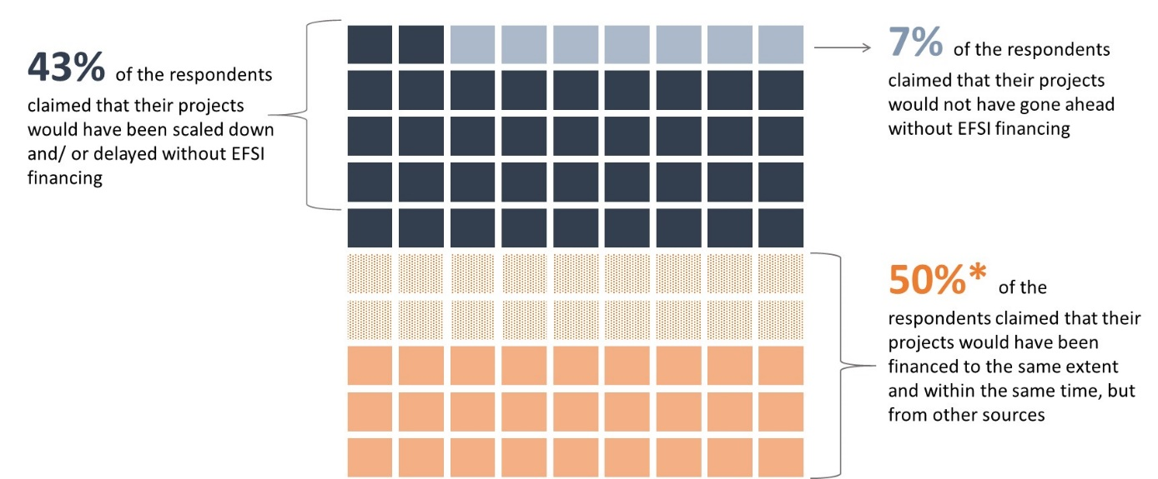

**Source**: ICF survey of IIW project promoters (n= 90)

Figure 20 analyses the responses of all survey respondents, including both those that claimed additionality (in the broader description considered by ICF) and those that claimed non-additionality in the sense that they could have obtained the same funding within the same timeframe and to the same extent without EFSI. The figure shows that signalling effect, lower interest rates and longer maturity are regarded as the most significant comparative advantages of EIB financing under EFSI.

Figure 20 - Comparative advantages of EIB financing under EFSI



**Source**: ICF survey of IIW project promoters (n= 90)

Similar questions were asked to the financial intermediaries benefitting from EFSI support under the IIW. Most of the financial intermediaries attached a high importance to the availability of EIB financing under EFSI in their decision to go ahead with their projects. For equity transactions, the participation of EIB contributed to accelerate fund raising by catalysing investment from other sources.

To supplement the evidence collected via surveys, the independent evaluation also conducted in-depth reviews of 60 IIW projects. In the judgement of ICF experts, the market failure rationale for EFSI investment in the project documentation submitted to the Investment Committee was incomplete or questionable in 22% of cases. In particular, more detailed information and evidence from the EIB on market failures affecting individual projects would have been needed in those cases. However, it was recognised that the quality of information included in the project documentation has progressively increased since the launch of EFSI.

In addition, Investment Committee members interviewed in the context of independent evaluation indicated that the length of the tenor was frequently and, at times, unconvincingly provided as a justification for additionality by the EIB (it was argued by the EIB that there was additionality of EFSI financing, since the same tenor could not be obtained by the project promoter from alternative sources).

The above evidence has to be interpreted with caution due to potential biases in replies (respondents tend to overstate their capacity to raise funding, in particular after having secured such funding from the EIB), relatively low response rate and due to potential differences of understanding of different terms. However, the evidence suggests that additionality criteria under EFSI 1.0 could have been better defined. The reinforcement of the additionality criteria under EFSI 2.0 should have a positive effect. The Commission has started working on a more detailed system to analyse in a comprehensive manner the multi-faceted concept of additionality by considering further additionality criteria to enable a more informed (and documented) decision by the Investment Committee. However, the actual impact can only be measured in a subsequent evaluation or a targeted survey given that operations under EFSI 2.0 started only to be approved in 2018. The evidence also indicates a possibility that in certain cases the EFSI crowded-out some other investors. Due to its broad scope and limited timeframe of the evaluation, it was not possible to test this in more detail and determine the scale of the potential crowding out effect.

SME Window

Under EFSI 1.0 additionality was defined as the support to those operations which address market failures or sub-optimal investment situations and which could not have been carried out in the period during which the EU guarantee can be used, or not to the same extent, by the EIB, the EIF or under existing EU financial instruments without EFSI support. It is widely recognised that access to finance is more difficult for smaller companies than for larger ones for structural reasons (higher risk, lower survival rates for young and small companies, greater unit costs per transaction, limited collateral) which indicates the presence of a market failure. The identified market gaps for debt and equity financing are significantly larger than what EU instruments (also in combination with national or regional instruments) could address.

The SME Window support to lending to SMEs is designed in such a way that it increases the firepower of EU instruments supporting SMEs (loan guarantees under the COSME, InnovFin, EaSI and CCS instruments), and ii) makes their implementation faster. As a result, the additionality of the SME Window can be regarded as supporting a greater number of SMEs, with higher volumes of lending, and supporting them at a faster speed than the EU instruments could have done alone.

In addition, all underlying instruments (COSME, InnovFin, CCS and EaSI) have to respect specific additionality criteria as specified in their respective legal bases. The scope of this evaluation does not include an additionality test of these underlying instruments, but builds on the existing evaluations and audits that tackled this issue and on the interviews with financial intermediaries. They offer a mixed picture on additionality, with mid-term reviews of COSME and Horizon2020 being more positive in this respect. Overall, there are positive results from the underlying financial instruments, but better targeting of beneficiaries is needed.

The 2017 ECA special report on EU-funded loan guarantee instruments[76] recommended a better targeting of these instruments on viable businesses lacking access to finance and on more innovative businesses. The ECA report states that in general loan guarantees delivered on what they were designed to do as they helped beneficiary SMEs grow more in terms of total assets, sales, employee numbers and productivity. The effects were higher for businesses that would potentially have struggled to obtain a loan without the guarantee. However, according to the ECA, a substantial share of beneficiaries was composed of businesses having access to commercial loans. ECA found that only 40 per cent of the loans were provided to businesses that would otherwise have struggled to obtain financing from a commercial lender. Under the InnovFin SME Guarantee (SMEG) facility, the ECA observed that only 35 per cent of the innovative businesses included in the sample would have struggled to obtain a commercial loan without the EU Guarantee (a finding partially questioned by the Commission).

These results may however not present the entire picture of the benefits to SMEs from the intervention through InnovFin and COSME guarantees. As mentioned by the European Commission in the same ECA report, the loan guarantee instruments have been designed to also support SMEs that do have access to financing, but on stricter conditions in terms of collateral required, maturities and/or interest rate. Without the guarantee, the projects would often not have been pursued by SMEs or not to the same extent, resulting in a sub-optimal investment situation. Therefore, the concept of additionality also needs to account for the improvements in the financing conditions achieved thanks to the EFSI support (i.e. lower interest rates than the ones available in the markets and reduced collateral obligations). Also, an increase in the risk appetite of financial intermediaries is an important effect. It helps alleviate information asymmetries between the lender and the borrower that lead innovative businesses not to obtain financing they need.

In this context, a recent evaluation of Horizon 2020 financial instruments[77] provides a positive assessment of additionality of its SMEG facility. It reports that InnovFin SMEG provides additionality of:

* Scale - with intermediaries under the SMEG increasing loan volumes; and,
* Scope - new risky market segments are being covered thanks to the SMEG facility.

The evaluation concludes that “*Notwithstanding concerns among some banks, the fact that there has been such a high take-up of the SMEG indicates that it is proving to be a very successful intervention in helping banks to provide finance to riskier businesses. From a business perspective, there is strong evidence that this product largely benefits firms that would otherwise not have received the debt finance they require to innovate, or only on a much smaller scale and on less favourable conditions. For example, the guarantees free up assets that would otherwise have to be used to provide collateral to receive a bank loan*.”

The results of an online survey of beneficiaries of COSME’s Loan Guarantee Facility (LGF), undertaken in the context of the interim evaluation of the COSME programme[78] show further evidence of additionality. It found that only 37% of the 289 respondents indicated that they had access to other (than COSME supported) sources of finance that would cover all or part of their required amount. In total, 39% of the respondents indicated that COSME-supported financing was the only option available to them, while. 24% of respondents indicated that, even though they did have other options available, they preferred the option that included the EU-COSME guarantee, as the available options would not have covered the full required amount.

As regards equity financing, the SME window improves access to finance by (i) investing in expansion stage funds and catalysing other private investment, thereby increasing the overall amounts of finance for this target group and (ii) in case of funds focusing on early stage investments, the SME window catalysed the creation of a structured investment facility which brings together resources from InnovFin, EIF own resources and EFSI support, and allows more than doubling the volume of investment into early stage funds, compared to what InnovFin could have achieved alone. The additionality is therefore demonstrated by larger intervention volumes and the ability to support more SMEs than EU instruments alone.

Moreover, the results of the interviews conducted by the independent evaluation point to additionality. The findings indicate that the EFSI has allowed financial intermediaries under the SME Window (banks, guarantors, equity funds) to either:

* Expand their current offer i.e. scaling up the level of finance to SMEs in any given sector;
* Target riskier segments of the SME/ mid-cap sector; or
* Offer finance on better terms e.g. reduced collateral requirements, better rates.

Also, in case of equity funds, the EFSI support was claimed critical to secure the first close of the fund, helped attract new investors and/or reach the target fund structure.

## The EU Guarantee

### Relevance

The EU Guarantee, by providing higher risk bearing capacity to the EIB and the EIF, allows for additional financing for use under the IIW and SMEW. According to the independent evaluation, this is captured by the internal multiplier comparing the amount of EU Guarantee and the additional EIB riskier financing, and the new volume of investment to be undertaken reflected in the external (mobilisation) multipliers, and the risk associated with the investment. According to the independent evaluation, the analysis of multipliers confirms this relevance.

The relevance of the EU Guarantee was further enhanced by the change in 2016 of the initial allocation between windows and the shift of EUR 500 million from the IIW to the SMEW, shift which was done based on the observed market absorption.

### Effectiveness

The independent evaluation assessed the adequacy of the size of the EU Guarantee and the provisioning rate. The evaluation concludes that overall the approach to modelling the EFSI target rate appears to be adequate and in line with industry standards. It also appears that all model inputs have been chosen in a conservative manner.

At the same time, the evaluation indicates that certain aspects of the modelling approach have a significant sensitivity to some of the model inputs (e.g. correlation). It is therefore important to continue applying a conservative approach on defining the assumptions and choices of risk parameters and to monitor closely the evolution of the risk profile of the EFSI portfolio.

### Efficiency

The independent evaluation indicates that the level of the EU Guarantee and the EIB contribution was appropriately sized for the period 2015-2018 as it allowed the EIB Group to mobilise a level of investment in line with expectations (EUR 315 billion by July 2018). This was also supported by the EC and the EIB decision to reallocate EUR 500 million from IIW to the SMEW given the strong demand for financing under the SMEW.

The proposal made by the Commission in 2016 and approved by the co-legislators to adjust the EFSI provisioning rate from 50% to 35% resulted in a more efficient use of the EU budget. Moreover, a large part of the additional funds required to provision the Guarantee Fund as a result of the increase of the EU Guarantee from 16 billion to EUR 26 billion, will originate from EFSI revenues and reflows from other financial instruments, hence limiting the impact on other parts of the EU budget.

### Coherence

Coherence is evaluated for the EFSI as a whole (see section 5.1.4).

### EU Added Value

The value added of the EU Guarantee is inter alia demonstrated by its effectiveness in increasing the risk bearing capacity of the EIB. The following graph shows that an almost five-fold increase in the EIB Special Activities that took place between 2014 and 2017 (from EUR 3.2 billion in 2014 to EUR 15.2 billion in 2017). In relative terms, the share of Special Activities increased from 5 per cent to 25 per cent of the EIB’s total lending activities in the EU over the same period.

Figure 21 - EIB Special Activities vs standard EIB operations in 2014-2017

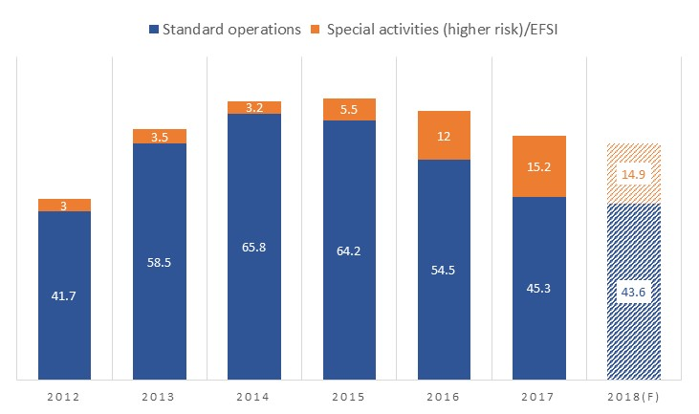

**Source**: EIB

EFSI operations accounted for 95% of EIB Special Activities in 2016 and 2017.

Figure 22 - Proportion of EFSI in EIB’s Special Activities

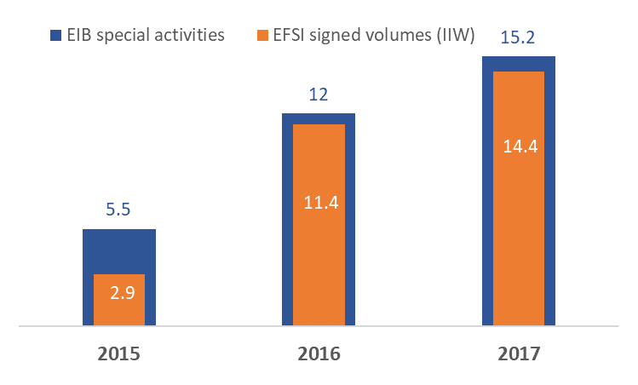

**Source**: ICF based on data compiled from EIB operational plans for various years (EIB special activities) and EFSI operational reports (EFSI signed volumes)

As regards the SMEW, the availability of the EU Guarantee allowed the EIF to considerably increase its support to SMEs and mid-caps through financial intermediaries, which would not have been possible without the support of the EFSI (EU) guarantee.

Alternative uses of funding

The need to provision the Guarantee Fund (initially with a 50 per cent target rate) implies an opportunity cost. It meant that the budget for Horizon 2020 and CEF, as well as the budgetary flexibility in the 2014-2020 MFF, have been reduced: EUR 2.8 billion was redeployed from CEF (mostly reducing the envelope for financial instruments), EUR 2.2 billion from Horizon 2020 and EUR 3 billion funding from unused margins. These changes to the initial EU budget allocations were approved by the co-legislators.

The arguments in support of this redeployment are linked to the fact that the budgetary guarantee under the EFSI entails a higher multiplier effect than grants. The EFSI is meant to mobilise additional public and private funding in the range of 1:15 while grants are typically not meant to do so, except when strategically used for blending purposes. In addition, the use of a budgetary guarantee that includes a contingent liability (provisioning lower than 100 per cent) translates into higher volumes of EU support being available for a given budgetary cost.

The independent evaluation found that the effect of scaling back the CEF financial instruments was limited given that CEF debt instrument projects are also eligible for EFSI financing. Energy and transport sectors have benefited substantially from EFSI IIW support (41 per cent of EFSI IIW signed amount as of end-2017). Still, the nature of the projects supported has been different under the EFSI given its larger scope.

## European Investment Advisory Hub

### Relevance

Overall, the independent evaluation assesses that the Hub addresses a wide range of needs and its activity is broadly relevant to its target groups and legal mandate. The evaluation confirmed that the EIAH provides technical assistance for project promoters in cases when such support is not available through other existing TA offers at EU level and thus the EIAH contributes to facilitating the origination of investment projects in the EU.

However, according to the evaluation, more could be done to further improve awareness and subsequent take-up of the EIAH services. Peer-to-peer exchanges could also be enhanced through the organisation of more frequent events where networking is facilitated.

While the EIAH does not focus exclusively on the EFSI, it can provide advisory services to projects eligible for the EFSI. Following the new requirements introduced in EFSI 2.0, the updated framework partnership agreement between the EU and the EIB group underlines an increased emphasis on the EIAH to support the EFSI projects pipeline, whenever possible and relevant.

*Supporting promoters in developing projects*

The evaluation’s survey sent to the EIAH beneficiaries provided the following findings:

* The majority of survey respondents contacted the Hub to ask for assistance with a one-off project, especially for assistance with project design/preparation, support with structuring project(s) to improve their ability to access finance and implementation;
* Most EIAH beneficiary survey respondents stated that, among users of technical assistance, the services of the EIAH are moderately or well known; and
* The opinions were almost equally split between respondents who think they could have obtained similar support from an organisation in their country and those who disagree; it is hence impossible to draw a conclusion on the relevance of the Hub basing the judgement on the currently data available from the survey.

*Using local knowledge to enable support across the EU*

This objective is mainly delivered through enhanced cooperation with NPBIs. In this context, the EIAH signed 23 memoranda of understanding with NPBIs across the EU.

The bulk of the collaboration was in the area of joint awareness raising and events, followed by capacity building to provide local services. In some cases, the EIB and NPBIs undertake joint project development and cross referrals of projects that may require advisory support. The survey suggests that this activity is still in the development phase and that there is room for increased cooperation between the Hub and the NPBIs. The interviewees showed appreciation for the call for proposals launched in December 2017 for the delivery of local investment advisory services by NPBs aimed to increase the scope and depth of cooperation with individual NPBs.

Cooperation between the EIAH and other institutions to ensure better coverage of EIAH’s services is encouraged by the EFSI Regulation. The current partnership between the EIAH and the European Bank for Reconstruction and Development (EBRD) is one example. EBRD has been providing SME support for 20 years and in 2017 an agreement was reached with the EIB to provide advisory support to SMEs in three countries (Romania, Greece, and Bulgaria) under the EIAH umbrella. The cooperation is in its early stages, and according to the interviewees, it is progressing smoothly.

Moreover, the EIB is also ensuring local presence through its staff present in the EIB offices in the different MS and through existing advisory mandates.

*Enabling peer-to-peer exchanges as well as knowhow sharing*

The EIAH Days yearly event is the main event that facilitates peer-to-peer exchanges and knowledge sharing between the EIB group and NPBIs. In 2017 NPBIs participated in an interactive workshop to discuss better forms of cooperation, while leveraging the services of the Hub. Challenges and opportunities were also shared by participants in the workshop. EIAH roadshow events in individual countries also provide an opportunity for networking and knowhow sharing[79].

### Effectiveness

The EIAH effectiveness was assessed in terms of the volume of investment activity supported by the EIAH and the associated take-up of services, supported by the feedback form the relevant promoters provided on the content and quality of services.

The evaluation indicated that the level of investment supported by the Hub so far has been good, but can be further improved. The demand-driven nature of EIAH had a bearing on the maturity of the projects submitted to it. The market gap analysis for advisory services is helping the Hub to focus its proactive efforts in countries, sectors and type of advisory services to rebalance the initial state of play.

The role of investment platforms is also very important to address sectoral and geographical maturity and project size aspects. The Hub is currently providing support to several investment platforms in more than 10 MS. Other MS are interested in further scoping the potential of investment platforms in different areas.

As regards the quality of services provided, the majority of EIAH beneficiary survey respondents’ consider that the Hub fully met their needs or met their most important needs. Likewise, they considered that the level of the EIAH expertise is high or very high and expressed satisfaction with the services of the Hub.

With regard to the relation with NPBIs, while there is general satisfaction on the efforts undertaken by the Hub, some respondents to the survey indicated that it is too early to comment on the success of the cooperation with the Hub since no new service offer by any NPBI has materialise from this cooperation. Overall, the evaluation found that there is scope for further and faster development notably following the call for proposals published in December 2017. This would enable more NPBs to deliver technical assistance on behalf of the Hub.

Interviews revealed that the level of cooperation between the NPBIs and the EIAH depends on individual demand. NPBIs tend to be very different in terms of services they offer, sectors covered, technical assistance capacity and interest in collaboration with the Hub.

Since the NPBIs are still very different regarding their advisory services offers, the Hub has a role to play to help the less developed organisations to get the right tools to consolidate their knowledge and expertise and develop their capacity in sectors where the Hub can provide support (training, capacity building, twining with other NPBIs etc.). Hence, it is probable that the effectiveness will not be homogeneous amongst all the MS.

### Efficiency

The Commission closely follows the progress and performance of the EIAH services on a semi-annual basis through a set of key performance indicators (e.g. number / distribution of requests processed, proportion / distribution of requests having triggered TA, average first reaction time, number of external partnerships and events organised) and monitoring indicators (e.g. origin of the request, volume of investments generated, number of support provided for establishment of investment platforms, satisfaction survey, number of external partnerships providing proposals and/or becoming service providers). The unicity and the non-standardised offer of the EIAH make it difficult to establish ex-ante benchmarks and targets. However, based on the experience acquired in the first years of operations and the tracking system put in place, such benchmarks should be developed also in view of the future technical assistance component under the InvestEU programme.

***Efficiency of resource used***

During the ramp up phase in 2015 and 2016, the EIAH underspent its allocated budget which showed a certain slowness of implementation compared to initial expectations. Even though the EIAH was included the well-established advisory department within the EIB, it took some time to set up the EIAH team and to make the public aware of the technical assistance offer provided by the Hub, which is essential given the demand-driven nature of the EIAH. Since then, there has been an effort to increase the services offered (and the budget used). The Commission and the EIB should monitor closely the efficiency of the Hub by analysing the deliverables provided by the Hub to the beneficiaries against the time and resources deployed to achieve them.

As regards the use of resources against the various work streams of EIAH, the assistance to project promoters is currently taking up around 60% of resources available, whilst local activities and local support represent around 20% of resources available.

Overall, interviewees considered the level of resources allocated to the EIAH as adequate. However, this may change if interest in and workload of the EIAH picks up. This will depend on the extent that the EIAH needs to build its local presence, the demand for the Hub services and the extent to which the EIAH will be asked to create demand opposed to only responding to it.

The EIAH has a core team and delegates most of its advisory asks to experts in other EIB departments. This organisation of the work is promoting a flexible way to use expert sources.

To improve cost efficiency, a certain standardisation of advisory service products could be envisaged. Moreover, as highlighted in the independent evaluation, communication to potential beneficiaries should be improved to further clarify the services that could be offered by the EIAH and hence reduce the number of applications that ultimately do not lead to actual advisory services.

***Efficiency of the governance model***

In general, evaluation’s interviewees were of the view that the contractual and governance model put in place between the Commission and the EIB is efficient. The framework partnership agreement (FPA) between the EU and the EIB puts in writing the expected activities, the eligible costs and payments, the reporting as well as the template for the yearly specific grant agreements which highlight annual priority areas for the EIAH activity. The Coordination Committee that includes representatives from the EC (ECFIN, REGIO, RTD), and the EIB (Advisory Service Department and the EIB Projects Directorate) is also facilitating coordination aspects. Contributing to the overall efficiency of the governance model are the fortnightly meetings between ECFIN and the EIAH core team, which help in discussing day to day aspects of the EIAH operation.

The results of the beneficiary survey showed that the governance and delivery model of the EIAH is efficient and it does not put any burden on the EIAH's beneficiaries.

***Communication methods***

The initial design of the EIAH with demands originating solely from the website had some limitations and the Hub reinforced its communication methods in order to better focus the type of beneficiaries/partners targeted by the EIAH offer.

Therefore, the EIB undertook specific communication efforts to better communicate the services offered by EIAH and develop a network of partner NPBIs that could serve as local relays to provide technical assistance. Roadshows in order to present the Hub’s activities and offers are also ongoing in the regions highlighted as priority regions in the market gap analysis. The EIAH also revamped its website to facilitate communication.

### Coherence

***Internal coherence***

The evaluation indicates that so far the EIAH has done limited efforts to actively support the identification of projects for the EFSI pipeline. This situation is expected to change following the adoption of the EFSI 2.0 Regulation, where emphasis is placed on this objective.

This could be challenging due to the demand-driven nature of EIAH and the limited control of demand breakdown by sectors. However, increasing efforts are required for the EIAH to contribute effectively to the sectorial and geographical diversification of the EFSI as requested by the EFSI 2.0 Regulation.

As regards the internal coherence within the EIB advisory services offers, the Hub is allocating resources (staffs) or tasks to specialised advisory departments within the EIB such as ELENA, InnovFin Advisory or Decentralised Financial Instruments Advisory (DFIA). This polling system of expert resources seems to be an efficient scheme that could be further expanded and streamlined in the future.

*External coherence*

The evaluation indicates that there are services provided by other organisations that are similar to a certain extent to the ones of the Hub. While positive examples of results of such cooperation have started to emerge, it is too early to judge their effectiveness. In light of this, the EIAH should keep an eye on ensuring complementarity with similar organisations. Efforts have been initiated by the Hub to cooperate with NPBs and the Structural Reform Support Service (SRSS).

The EIAH is currently collaborating on a regular basis with SRSS. The cooperation started in areas where both entities were requested advisory support. In particular, the Romanian government had asked both the EIAH and SRSS for support for the creation of its NPB. Currently, the SRSS is supporting this initiative with a feasibility study whereas the EIAH may provide additional technical assistance support at a later stage. Whilst there is now coordination in place, the cooperation with SRSS could be further enhanced to reduce potential duplications and increase synergies.

Regarding the cooperation with NPBs, interviewees indicated that when the NPBs work in the same areas as the Hub, the latter makes active efforts to reduce duplication and find ways of cooperating.

Concerning private sector initiatives, the EIAH is aware that there are consultancies across the EU that might be providing similar services. To avoid any unintended crowding-out effects of the private sector, the EIAH is constantly monitoring these offers to reduce this risk by substituting other standard services.

As regards the offer of other international financial institutions, the EIAH and the EBRD established a coherent scheme. To avoid duplication of efforts and to develop an efficient synergy mechanism, the Hub and the EBRD agreed on a funding agreement allowing the EBRD to deploy, on the behalf of the Hub, its Small Business Support programme in countries identified by the Hub as priority regions.

### EU Added Value

The added value of the EIAH is the contribution it can make to building the capacity of Member States to develop TA services and project pipelines. In addition, it offers promoters with technical, financial and legal services and provides access to a greater range of investment sources. This in turn should result in improved services and investment capacity to support investment in EU priority areas.

The external evaluation indicates that the EIAH provided EU added value in particular in Member States were technical and functional capacity gaps persist and in supporting knowledge exchange across such Member States. Therefore, the EU added value will vary according to the local TA capacity and the level of cooperation between the EIAH and the local NPBI.

Potential examples of EU added value provided include a Smart-cities investment platform in Slovakia[80], the EU "Smart Finance for Smart Buildings" (SFSB) initiative under the "Clean Energy for All Europeans" package and the urban investment advisory platform (URBIS).

## European Investment Project Portal

### Relevance and effectiveness

The analysis indicates that due to the high number of visits (more than 200,000), numerous contacts between promoters and investors and frequent events organised/attended in several Member States, the Portal is answering in general to the need of more transparency of investment opportunities in the EU and acts as a platform that increases the visibility of projects to investors worldwide and rendered these projects known to a high number of stakeholders.

However, evidence regarding whether the projects published on the Portal received financing after being contacted by investors through the portal is mixed. The recent survey of the project promoters indicated that the proportion of EIPP projects having received financing is below initial expectations. Follow-up interviews identified 18 published projects (8% of the total) as having secured or partly secured financing after being published on the EIPP. It is nevertheless difficult to assess whether the financing was the result of investors finding out about the project from the Portal or other circumstantial factors.

Figure 23 - EIPP - State of play (May 2018)

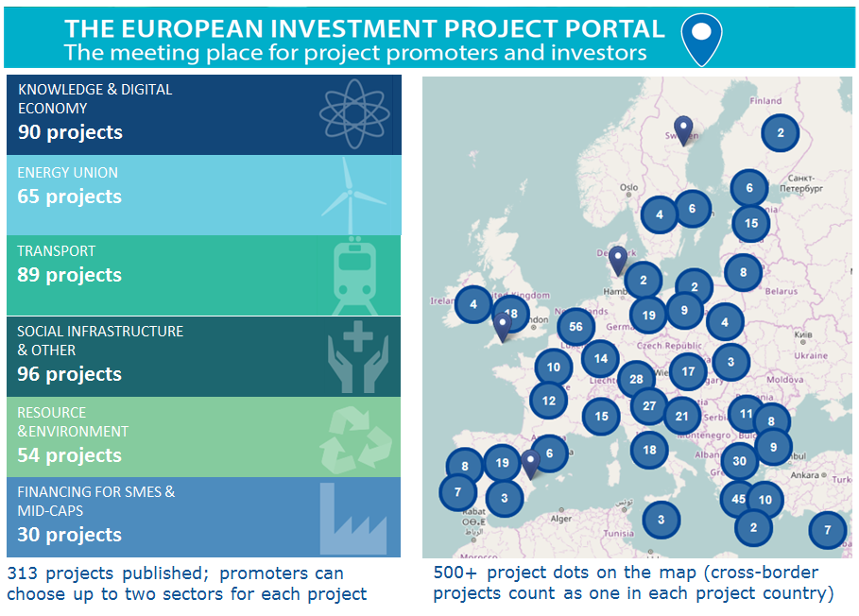

**Source**: Commission services

The **geographical spread** of the published projects is balanced covering all 28 Member States. Regarding the **sectoral allocation**, all the sectors are also fairly covered by the EIPP projects (see Figure 23). These sectors correspond to those under the EFSI mandate, which should support projects with strategic investments completing the internal market in transport, energy interconnections and digital infrastructure, underpinning the development of the energy sector in line with the Energy Union or fostering investments in the social sector.

Regarding the **contacts between investors and project promoters**, they amounted to more than 1,200 unique contacts over the analysed period with more than 80% of the promoters being contacted. The survey of the EIPP project promoters highlighted however some potential issues with the quality of investors, some being perceived by the promoters as being either disingenuous or having dishonest intentions. However, this could also be caused by a different type of situation, namely the fact that some contacts are also made by people not registered on the EIPP as investors. They see the name of the organisation, find the companies’ contact details online and contact the promoters outside the Portal and its registration procedures.

Many efforts were also channelled towards **communication and promotional activities**. The EIPP was present in almost 100 events and meetings (i.e. 92) with potential stakeholders including at least one event in the majority of the Member States. During the events, promotional materials in all EU languages were distributed to participants raising awareness about the Portal and providing information on how the Portal could be useful for all stakeholders, on the projects eligibility criteria and relevant sectors covered. Moreover, following-up on the feedback received from various stakeholders, the Portal is organising more match making and e-pitching events to increase the projects' visibility towards investors and their chances of receiving financing.

Most of the **NPBs** surveyed stated that they are aware of the opportunities and services provided by the Portal. Their high level of awareness constitutes a good starting point for an increase in awareness at local level among potential project promoters and investors. Very few NPBs stated that they do not consider there is a need for a tool such as the EIPP in facilitating visibility for investment projects and/or project development and deal making. NPBs mentioned the following limitations of the Portal in its current form:

* Limited awareness of the existence of the tool at local level and
* More suitable for smaller projects

The limited awareness surrounding the Portal was also the outcome of the survey of IIW financial intermediaries. Most of the latter were not aware or had very limited awareness of the Portal. This explains to a certain extent why only very few IIW financial intermediaries had used the Portal so far.

According to the **project promoters**, the EIPP could be improved by:

* Attracting more investors in particular from underrepresented sectors, such as electricity and gas transport
* Conducting a more in-depth review of the quality and seriousness of investors registering to the Portal;
* Giving the project promoters the option to contact investors;
* Organising pro-active matching making events;
* Offering advisory on how to structure projects and find investors; and
* Providing an easier way of updating the contact or project information.

### Efficiency

The Commission closely follows the progress and performance of the EIPP on a semi-annual basis through a set of key performance indicators and monitoring indicators (e.g. number of projects received for publication/ published, number of organisations having submitted projects for publication, average screening time, number of events attended/organised, number of contacts between investors and promoters, number of visitors to the EIPP website). Since the launch of the EIPP, the relevant progress and performance indicators have continuously improved compared to previous reporting periods.

*Efficiency of resources used*

Overall, interviewees considered the level of financial resources allocated to the EIPP adequate and assessed the usage of the EIPP resources so far as being in line with the initial expectations.

As regards the use of resources against the various work streams of the EIPP, the screening and communication activities are currently taking up around 45% of resources available whilst the IT development costs represent around 55% of resources available.

Moreover the EIPP process efficiency has increased since its launch, likely a function of a learning effect amongst staff undertaking the EIPP projects screening and also due to the elimination of the project submission fee. Whilst previously fees had to be paid by private project promoters, these were removed in spring 2017 leading to a reduction of the administrative burden involved in publishing projects on EIPP and encouraging more potential project promoters to use the Portal.

*Communication methods*

To increase the visibility of the Portal, the EIPP team has increased its communication efforts and promotional activities in particular since 2017 including:

* Promoting the EIPP in major conferences and events organised within the EU and in the social media;
* Developing partnerships and cooperation agreements with financial institutions (IFIs, NPBs) and national, regional or international portals; and
* Organising match-making / e-pitching events in close cooperation with its partners.

The overall resource efficiency will depend on the overall number of projects submitted and published at the end of the five year budget whereby a large number of published projects will improve efficiency on a unit cost basis. The number of projects received for publication on the EIPP greatly increased in the months of March and April 2018 (where 200 projects were submitted), as a direct result of the above-mentioned communication initiatives.

The Portal website undergoes a continuous IT development to add new functionalities aimed at streamlining the project submission process and the search of investment. This included updates to the public portal (freely available on-line featuring now separate dedicated project lists for Infrastructure & Innovation projects and for SMEs reflecting the diversity of project and company sizes on the Portal), to the front office (for registered promoters and investor) and the back-office (for the Commission services working on the projects screening).

### Coherence

The EIPP coherence with the EFSI and the EIAH (*internal coherence*) is covered in section 5.1.4.1 and points to the need to increase synergies with the EIB, the EIF and the financial intermediaries supported by them.

As regards coherence with other EU programmes, the EIPP is already cooperating with several relevant actors (including Commission DGs and executive agencies managing EU programmes) to encourage project promoters receiving EU grants to also apply to the Portal where they have additional financing needs. This activity should be pursued and possibly stepped up to increase the complementarity of the Portal and the number of projects presenting an EU dimension.

As regards the *external coherence*, there are a number of similar initiatives at international or MS/regional level such as the Global Infrastructure Hub (GIH), SIF (Sustainable Infrastructure Foundation)/ SOURCE, both for infrastructure projects, EuroQuity (a platform operated managed by Bpifrance mainly for SMEs covering a number of EU and non-EU countries) and a number of other national or regional project portals/initiatives.

To ensure synergies with the existing initiatives and build on the both parties' combined projects, out-reach and promotional abilities, the EIPP has already signed Cooperation Agreements with all the three portals stated above. The Commission should continue to monitor the development of new initiatives and, where appropriate, set up agreements with relevant organisations.

### EU Added Value

The potential added value of the Portal is to bring together promoters and investors that would not otherwise have been aware of their mutual interest and capacities. The assessment indicates that the EIPP is still in a premature stage to be able to truly assess its EU added value.

Currently sustainable matches between investors and investees do not happen often enough which seems to be a result of two main factors: (i) the Portal having been launched in June 2016 and hence not enough time might have passed for some projects to identify investors and vice versa, and (ii) the quality of investors operating on/through the Portal (ensuring as much as possible that the potential for spamming or even scams attempts are restrained).

To improve the EU added value, the EIPP should undertake further efforts to screen investors operating on the Portal and engage in outreach activities towards potential investors, an objective that could also be achieved by reinforcing links with the EIB, EIF, as well as with NPBIs and financial intermediaries supported under EFSI.

The Portal will also have to keep the inflow of new projects at a reasonable level, to be able to attract larger numbers of potential investors. Diversity in terms of sector and scale of projects was mentioned by some of the interviewees as lacking, hence this aspect could also be improved. The cooperation of the EIB and the Commission services in channelling EU-financed projects to the EIPP would in this regard have a significant impact on the quantity and quality of projects published on the EIPP.

# Conclusions

## European Fund for Strategic Investments

***Relevance***

The independent evaluation concludes that the EFSI has been relevant both in addressing investment gaps and market needs in terms of size, sector and geographical coverage, and in its ability to respond to the needs of project promoters, financial intermediaries and private investors.

Although the overall picture has improved at a macro level, in terms of the scale of the financing gap and of the financing conditions (especially for SMEs), there remain substantial and pressing investment needs. Evidence suggests that persistent market gaps holding back investment are still observed in different policy areas. The recent acceleration of investment in the EU has not yet managed to bring investment rates up to historical averages. Ongoing EU investment support therefore remains relevant and necessary. Moreover, efforts will need to continue beyond 2020 to bring investment back to its long-term sustainable trend with particular focus on current and emerging EU policy priorities.

The evaluation notes further that the products and support offered under the EFSI responded to the needs of project promoters and financial intermediaries. Moreover, the scoreboard has been a relevant tool to assure an independent assessment of the use of the EU Guarantee and its pillars and criteria were judged as appropriate.

***Effectiveness***

From the perspective of mobilisation of additional investment, it is estimated that the EFSI will come close to the target of EUR 315 billion by mid-2018 in terms of approved operations. The external evaluation finds that through its scale, the EFSI has undoubtedly contributed to the observed reduction in the overall investment gap. The evaluation also notes that the multiplier[81] of the EFSI support at the end of 2017 was broadly in line with what had been assumed at the outset – aggregate multiplier of 13.5 across both windows, which is close to the target of 15. The achieved multiplier effect is a function of the risk profile of projects, the intensity of market failures in specific sectors and countries, the risk appetite of other investors, as well as of their willingness and capacity to co-invest.

Overtime and with sustained effort, greater diversification of EFSI financing has been achieved in both geographical and sectorial terms. However, support still remains concentrated. At the end of 2017, three Member States (representing 34 per cent of EU GDP) accounted for 38 per cent of EFSI financing signed (while this share has declined from 46 per cent at the end of 2016). Moreover, at the same date, the energy sector accounted for 33 per cent of the total EFSI financing under the IIW (as per signed operations) exceeding the indicative concentration limit of 30 per cent in a given sector set by the EFSI Steering Board[82].

Based on available evidence, the EFSI has also been effective in contributing to the creation of jobs (it created 115,000 permanent jobs, over 0.5 million temporary ones, and supported over 3.5 million jobs) and contributed to the economic growth (0.67% of GDP by 2020[83]).

With respect to the crowding in of private investment, the evaluation finds that the increased risk bearing capacity brought by the EFSI enabled the EIB and the EIF to reach new market areas, new client types and develop new ways of engaging with existing clients. Moreover, it notes that although EUR 134 billion of private finance was expected to be mobilised by the EFSI guaranteed operations across both windows at end of 2017, not the entire volume can be attributed to EFSI support as there are no objective means to assess whether a portion of this financing could have potentially been committed to projects by private investors anyways. Moreover, these figures do not take into account a potential crowding-out effect of EFSI financing, which was highlighted by the independent evaluation. On the other hand, it is worth noting that the target has been set in relation to the overall investment estimated to be mobilised, without a necessary link to the catalytic effect of EFSI financing support.

The scoreboard of indicators has been generally considered as effective to ensure an independent and transparent assessment of the potential use of the EU Guarantee by the Investment Committee. The Investment Committee members interviewed consider however, that the scoreboard could include more information for some criteria, in particular about the project promoter’s efforts to secure alternative sources of finance.

***Efficiency***

Based on the evidence collected, the evaluation notes that the current EFSI governance structure works well. The EFSI governance structure builds on that of the EIB, which is reported as an important contributing factor to the efficiency of the initiative. Moreover, the evaluation points to the key role played by the Investment Committee for the legitimacy and credibility of the EFSI's governance. In the same vein, the evaluation finds that the lean governance structure of EFSI has been sufficiently responsive to the periodic changes of the markets as demonstrated in the reallocation of the guarantee between the IIW and the SMEW.

The evaluation points to some potential improvements in the communication and information flow between the Investment Committee and the EIB, some of which have been at least partially addressed under the implementation of EFSI 2.0.

Furthermore, the evaluation finds that the average time between approval and signature of a project has been falling over time, which is assessed as a positive factor, given the increase in the volume of projects being appraised by the EIB, which it interprets as a consequence of efficiency gains following the inception of the EFSI (e.g. use of delegated approvals) and substantial increase in the number of EIB staff.

The application and appraisal process under the EFSI were considered efficient by the large majority of beneficiaries surveyed. The appraisal procedure of projects under the IIW was seen by project promoters as generally more difficult than the application procedure. The administrative part of the process was judged as excessive to a certain extent and dependent on the dedication and pragmatism of the EIB staff, which were often acknowledged as excellent.

***Coherence***

Right after the EFSI launch in July 2015, as a result of its broad eligibility criteria, the support provided by other EU level instruments, such as the CEF Debt Instrument or EIB's InnovFin debt products, experienced an uptake lower than foreseen. Later on, however, this was addressed through a redesign of certain products or a reorientation of the scope of some of these instruments, which improved the complementarity among these various forms of EU budget support, as recognised by the independent evaluation.

Under the SMEW, the EFSI has been coherent with existing financial instruments. This is due to the fact that the EFSI has been used first to frontload and then top-up the existing financial instruments and the newly designed equity instrument already takes into account the existing interventions. However, for future investment programmes to be designed under the next MFF, it is not desirable to have an EU instrument topping up another one as a default solution. This may lead to inefficiencies, limited transparency, and create confusion for final beneficiaries and financial intermediaries.

The evaluation highlights a risk of competition between the ESIF financial instruments and COSME LGF (and thus indirectly the EFSI). This is a recognised problem which still needs to be addressed. Guidelines have been introduced to help Managing Authorities to combine EFSI with ESIF funding.

Looking into the internal coherence of EFSI with the other IPE pillars, the evaluation highlights an improvement since the launch of the IPE. However there is still scope for further improving the complementarity and mutual support between the various initiatives. First, following the entry into force of the EFSI 2.0 Regulation, additional efforts should be done by the EIAH to actively support the identification of projects for the EFSI pipeline to effectively contribute to the sectorial and geographical diversification of the EFSI. Secondly, in order to reinforce the investors' participation in the EIPP, there is a need to increase synergies of the latter with the EIB, the EIF and the financial intermediaries supported by them.

***EU Added Value***

Evidence from the independent evaluation suggests clear value added in terms of the EFSI responding to unmet investment needs and supporting the need for counter-cyclical investment. From a political perspective, the EFSI also shifted debate from austerity to investment support measures.

The EFSI support has been channelled to projects that meet the eligibility criteria set in the EFSI Regulation and brought its own added value as a market driven instrument, mobilising private capital, facilitating an increased collaboration with NPBIs both at project and at investment platform level. The EFSI SMEW products have contributed to financing being made available to an additional number of SMEs by topping up existing financial instruments.

However, since the EFSI is a market-driven instrument, one issue that has been raised in this respect is the lack of policy focus and in particular the lack of focus on EU’s long-term climate goals[84]. This is already addressed by EFSI 2.0 with a target of a minimum 40 per cent of EFSI infrastructure and innovation projects to contribute to climate action in line with the Paris Agreement. However, in view of the improved economic situation, any future EU investment support schemes might need a better and more targeted policy focus. In addition, the EFSI supported only a limited number of cross-border projects which typically have a high EU value added dimension.

The main benefits indicated by the EFSI beneficiaries were:

* The signalling effect: the EIB and EIF interventions are considered as a “stamp of approval” and thus help attract other investors;
* The demonstration effect and market development capacity of the instruments deployed under the EFSI by the EIB and the EIF;
* The knowledge sharing, capacity building, standard setting and harmonisation, achieved through new forms of cooperation with NPBIs and by the EIF in respect of guarantee and venture capital instruments for SMEs.

In terms of financial subsidiarity, some criticisms were voiced by NPBIs which expected the EIB to take more often subordinated positions in operations benefitting from the EU Guarantee. This remark did not concern the SMEW, where financing operations are typically implemented through implementing partners and NPBIs are frequently part of the financing chain.

As regards additionality, the independent evaluation finds that the EFSI operations carried out by both the EIB and the EIF were compliant with the (relatively narrow) additionality definition included in the EFSI 1.0.

The independent evaluation also analysed the question of additionality from a broader perspective and tested whether the EFSI could potentially be crowding out private investors (would the project go ahead without EFSI involvement with the same conditions and at the same time). In this context, the response was equally split with half of the IIW project promoters surveyed indicating that their project would not have gone ahead to the same extent and within the same timeframe without the EFSI. However, these results must be interpreted with caution. For example, the same promoters claiming that they could obtain financing elsewhere consider that the biggest comparative advantages of the EFSI are the signalling effect, longer maturities, and lower interest rates, which seems to contradict the indication that that they could have received financing elsewhere with the same terms and conditions and in the same timeframe.

Similar questions were asked to the financial intermediaries benefitting from the EFSI support under the IIW. Most of the financial intermediaries attached a high importance to the availability of EIB and EIF financing under the EFSI in their decision to go ahead with their projects. For equity transactions, the participation of the EIB and the EFSI support contributed to accelerated fund raising by catalysing investment from other sources.

Overall, the evidence suggests that additionality criteria under EFSI 1.0 could have been better defined. The reinforcement of the additionality criteria under EFSI 2.0 should have a positive effect. However, the actual impact can only be measured in a subsequent evaluation given that operations under EFSI 2.0 started only to be approved in 2018. The evidence also indicates a possibility that in certain cases the EFSI crowded-out some other investors. Due to its broad scope and limited timeframe, it was not possible to test this in more detail and determine the scale of the potential crowding out effect. The independent evaluation concludes that, although there is limited evidence under the IIW that some crowding out has occurred as an effect of the EFSI intervention, further research is needed to undergo an assessment of such evidence.

## The EU Guarantee

By providing additional risk bearing capacity to the EIB and the EIF, the EU Guarantee was relevant to the scope of allowing additional higher financing by the EIB Group.

In terms of effectiveness, the independent evaluation concludes that overall the approach to modelling the EFSI target rate appears to be adequate and in line with the industry practice. It also appears that all model inputs have been chosen in a conservative manner. Given the sensitivity to certain assumptions, the risk profile and parameters of the EFSI portfolio should continue to be monitored closely.

The evaluation indicates that the levels of the EU Guarantee and of the EIB contribution were appropriately sized for the period 2015-2018 as it allowed the EIB Group to mobilise a level of investment in line with expectations. The adjustment of the EFSI provisioning rate in 2016 resulted also in a more efficient use of the EU budget. Moreover, a large part of the additional funds required to provision the Guarantee Fund will originate from EFSI revenues and reflows from other financial instruments, hence limiting the impact on other parts of the EU budget and leading to an increased efficiency of EU budget support.

The value added of the EU Guarantee is inter alia demonstrated by its effectiveness in increasing the risk bearing capacity of the EIB. EIB Special Activities experienced an almost five-fold increase between 2014 and 2017 with EFSI accounting for 95% of EIB Special Activities in 2016 and 2017.

As regards the SMEW, the availability of the EU Guarantee allowed the EIF to increase considerably its support to SMEs and mid-caps through financial intermediaries, which would not have been possible without the support of the EFSI (EU) guarantee.

The opportunity cost of redeploying resources from CEF and Horizon 2020 was offset by the higher multiplier effect of the EFSI compared to grants. In addition, the use of a budgetary guarantee that includes a contingent liability (provisioning lower than 100 per cent) translates into higher volumes of EU support being available for a given budgetary cost. Moreover, the effect of scaling back the CEF financial instrument was limited given that CEF debt instrument projects are also eligible for EFSI financing.

## European Investment Advisory Hub

The Hub addresses a number of needs, and can therefore be considered broadly relevant to its target groups and legal mandate. The EIAH provides technical assistance (TA) for projects where such a support is not available through an existing TA offer at EU level. Thus, it contributes to the origination and development of investment projects, which is its main aim.

The level of investment supported by the Hub so far has been good. The demand-driven nature of EIAH had however a bearing on the maturity of the projects submitted to it. The market gap analysis for advisory services is helping the Hub to focus its proactive efforts in countries, sectors and type of advisory services to rebalance the initial state of play.

Moreover, the independent evaluation survey indicated that level of the EIAH expertise is high and expressed satisfaction with the content and quality provided by the services of the Hub. The governance and the organisation of the work are considered efficient and promote a flexible way to use expert sources within the EIB and other partners. However, there is further scope to accelerate the deployment of EIAH services. In addition, more should be done to further improve awareness and subsequent take-up of the EIAH services.

As regards the objective to reinforce advisory services at local level, the independent evaluation, suggests that this activity is still in the development phase and that, while recognising the positive efforts done by the EIB, there is room for increased cooperation between the Hub and NPBIs. The cooperation with the EBRD shows a coherent approach to provide advisory services to SMEs while avoiding duplications and overlaps. The cooperation with the SRSS should be pursued to reinforce complementarity and synergies.

The evaluation indicates that so far EIAH has done limited efforts to actively support the identification of projects for the EFSI pipeline. Therefore, EIAH should put a stronger emphasis on contributing effectively to contribute to the sectorial and geographical diversification of EFSI as requested by the EFSI 2.0 Regulation.

The independent evaluation indicates that the EIAH provided EU added value in particular in Member States were technical and functional capacity gaps persist and in supporting knowledge exchange across such Member States.

The network development and the regular exchanges with the NPBIs, the EIAH is actively contributing to, as well as the call for proposals for NPBs published in December 2017, are elements contributing to the harmonisation of the TA offers that could be delivered at regional or local level by the NPBIs on the behalf of the EIAH. EIAH's support for investment platforms development as well as dissemination of good practices programmes will also improve the standardisation of the project investment environment.

There is a range of existing TA initiatives associated with EU programmes and certain Member State activities (often associated with NPBs and with the private sector) which have potential to overlap or offer synergies with EIAH’s mandate. The EIAH should be continuously mindful of these TA initiatives to avoid overlaps and boost synergies. The way the EIAH is allocating some tasks within the EIB’s Advisory Service Department should be further promoted and replicated outside the EIB to use the expertise in an efficient manner (e.g. EBRD Small Business Support programme performed by the EBRD on the behalf of the Hub).

## European Investment Project Portal

Due to the high number of visits and contacts between promoters and investors as well as to the frequent events organised in several Member States, the Portal answers in general to its mandate: provide more transparency of investment opportunities in the EU. These also show that the Portal has managed to increase transparency of investment opportunities and render these opportunities known to a high number of stakeholders.

The geographical spread of the published projects is balanced covering all 28 Member States and more than 80% of the promoters have already been contacted. The quality of investors operating on the Portal can however be improved. The EIPP is in an early stage to be able to truly assess its EU added value and currently sustainable matches between investors and investees do not happen often enough. Evidence regarding whether the projects published on the Portal received financing after being contacted by investors through the portal is mixed. Follow-up interviews identified almost 8% of published projects having secured or partly secured financing after being published on the EIPP although it is difficult to assess whether the financing was the result of investors finding out about the project from the Portal or other circumstantial factors.

Overall, it is considered that the level of financial resources allocated to the EIPP is adequate and the usage of the EIPP resources so far is assessed as being in line with the initial expectations.

Finally, coherence between the EIPP and the EFSI and the EIAH is subdued. This is partly due to EIPP projects being too early in their development. However, in the future additional measures should be put in place to improve the quality of investors operating on the Portal by establishing synergies with the EIB, the EIF as well as NPBIs and financial intermediaries benefitting from the EFSI support.

## Lessons learned

This and the previous evaluations of the EFSI have highlighted some areas for improvement. Some of these have either already been partly addressed during the EFSI 1.0 implementation or are expected to be addressed with the changes proposed by EFSI 2.0. Some others are to be tackled by the post 2020 investment support instrument – the InvestEU Programme.

The main lessons learned are the following:

* The EFSI has proven relevant for addressing investment market gaps and sub-optimal investment situations in the aftermath of the economic crisis. While investment market gaps persist, there will progressively be a need for a more policy oriented investment support to target specific sub-optimal investment situations. Moreover, in view of the improved economic situation, any future EU investment support schemes need a better and more targeted policy focus.
* The lack of focus on climate, and more generally sustainable, goals has already been partially addressed by EFSI 2.0. The proposed InvestEU Programme should also build on this experience and incorporate where relevant a climate target and a sustainability proofing test.
* The evaluation found the budgetary guarantee under the EFSI to be an efficient mechanism for increasing the impact of limited budgetary resources. The InvestEU Programme is thus expected to be based on a (single) budgetary guarantee. This would require a close monitoring of the risk profile and parameters of the products set up under the InvestEU Fund.
* The EFSI support and centrally managed financial instruments are found to overlap over a number of areas. Other evaluations found further overlaps between several centrally managed financial instruments. During the current programming period, some of these overlaps have been addressed through refocusing certain instruments. While topping up solutions under EFSI helped ensuring coherence with existing financial instruments, for future investment programmes to be designed under the next MFF, it is not desirable to have an EU instrument topping-up another one as a default solution. This may lead to inefficiencies, limited transparency, and create confusion for final beneficiaries and financial intermediaries. The integration of all future EU investment programmes in a single fund, aims at simplification, increased flexibility, and removal of potential overlaps between seemingly similar EU investment support instruments.
* The evaluation identified potential overlaps between EFSI and financial instruments under shared management. It also identified a further need for increasing synergies between ESIF and EFSI via combination of support as the number of operations combining EFSI with ESIF resources remains relatively limited. For the future programmes it is thus necessary to better exploit synergies between the centrally managed instruments and instruments under shared management as well as to ensure and further eliminate any undue obstacles for their combination.
* The evidence suggests that additionality criteria under EFSI 1.0 could have been better defined. Additionality criteria have already been reinforced under EFSI 2.0 and should have a positive effect as of its entry into force in 2018. The Commission will closely monitor the implementation of such new requirements in particular to limit the potential crowding out effect of EFSI operations.
* Building on this experience, the InvestEU Programme could further enhance additionality criteria. Under the InvestEU Programme, a broader set of criteria could be proposed, for example in the scoreboard, with the aim to enable the programme to improve its effectiveness. While in the InvestEU Programme, the ex-ante assessment of additionality is proposed to remain under the competence of the Investment Committee, the transparency of such assessment process would be further enhanced by the presence of additional indicators. Moreover, the scoreboard would be prepared by a Project Team hosted by the Commission and not by the implementing partner, as it is the case today for the EFSI. Furthermore, other monitoring indicators linked to the specific objectives of the Fund and to the individual policy windows will be set up in the context of the InvestEU Programme.
* The evaluation finds that EFSI triggered new forms of cooperation between the EIB and NPBIs although this has taken time to develop. NPBIs are important partners for the delivery of the EFSI as their local presence and knowledge have facilitated transaction origination (particularly, investment platforms) and enabled smaller deal sizes. Cooperation and coordination with NPBIs is also an essential element for improving the EU added value of an instrument like the EFSI by reducing overlaps between national schemes and EU level intervention and for improving complementarity. In order to deploy the NPBIs’ full potential to address local market failures or sub-optimal investment situations, EFSI 2.0 and the future InvestEU Programme should allow the EU Guarantee to take more systematically a subordinated position towards NPBIs’ operations. Additional effort should be undertaken to enhance the EU support to a wider range of NPBIs across the EU and thus ensuring a more balanced geographical distribution.
* This and the past EFSI evaluations found that that the current EFSI governance structure works well. However, the 2016 ECA report called for more transparency and some streamlining. Moreover, in the ECA's opinion, the complex interrelations between the Commission and the EIB make it difficult to establish for accountability purposes who is ultimately responsible to the EU budgetary and legislative authorities for the performance and risk management of EFSI. Therefore, the governance of the InvestEU Programme should be maintained at the Commission level as this will better fulfil the InvestEU Programme’s objectives (i.e. more focused on addressing specific policy objectives) and accountability, and in terms of structure this should ensure an adequate and coherent policy steer.
* Advisory services and technical assistance are highly needed to improve the Member States and project promoters’ capacity to originate, develop and implement investment projects. There is a range of existing TA initiatives associated with EU programmes and activities of NPBIs which have potential to offer synergies with the EIAH’s mandate. For the post-2020 MFF, it is proposed to streamline centrally managed technical assistance initiatives for investment support into the InvestEU Programme.
* As regards the EIPP, it is important to continue increasing the number of projects published on the Portal and to enhance the quality and quantity of registered investors. Therefore, increased cooperation should be set up with the EIB Group, NPBIs and financial intermediaries supported by the EFSI or, in the future, by the InvestEU Fund.

# Annex 1: Procedural information

1. Lead DG, Decide Planning/CWP references

Leading DG: Directorate General Economic and Financial Affairs (**DG ECFIN**)

The requirement for the evaluation of the Evaluation of the European Fund for Strategic Investments, of the European Investment Advisory Hub, and of the European Investment Project Portal derives from the EU Regulation 2015/1017 (EFSI 1.0) amended by the EU Regulation 2017/2396 of 13 December 2017 (EFSI 2.0). The Regulation stipulates in Article 18 that the Commission has to submit to the European Parliament and the Council an independent evaluation of the application of EFSI Regulation before tabling any new proposals for a post-2020 investment support instrument.

The independent external evaluation was performed by an **external contractor**, ICF Mostra. It covers the functioning of the European Fund for Strategic Investments, the use of the EU Guarantee, the activity of the European Investment Advisory Hub, as well as of the European Investment Project Portal. The evaluation covered questions of relevance, effectiveness, efficiency, coherence and EU added value.

An **evaluation roadmap** summarising the design, purpose and scope of the evaluation was published in December 2017 on the Commission's dedicated page: <http://ec.europa.eu/info/law/better-regulation/initiatives/ares-2017-6318655_en>.

This Staff Working Document presents the results of an external evaluation of the application. The conclusions and recommendations of the evaluation will serve to assess the extent to which the EFSI, the EIAH, and the EIPP are achieving their objectives. They will also inform future Commission legislative proposals related to establishing the investment support instruments for the period 2021-2027 (the InvestEU Programme). However, this SWD also draws on previous EFSI evaluations[85] and other relevant studies.

1. Organisation and timing

This evaluation has been steered by DG ECFIN under the scrutiny of an inter-service group (ISG). The ISG was set up in December 2017 in order to provide input for the evaluation and comprised representatives of DG ECFIN, DG REGIO, DG BUDG and the Secretariat-General. The EIB was involved during the course this evaluation and participated at ISG meeting as observer. The group met 3 times during the evaluation process. Two more group meetings are envisaged to finalise the evaluation with the final report due in May and a final workshop foreseen in early June.

The table below summarises the ISG meetings, dates and topics of discussion as well as other consultations.

**Table - Meetings of the ISG**

|  |  |  |
| --- | --- | --- |
| **Date** | **Meeting** | **Topics for discussion** |
| 20 December 2017 | Kick off meeting | * Presentation of the evaluation methodology by ICF Mostra (for IIW, SMEW, the EU Guarantee, the EIAH, and the EIPP) * Overview of main deliverables and timeline * Next steps |
| 5 Feb 2018 | Inception report | * Presentation of the progress made by ICF Mostra (for IIW, SMEW, the EU Guarantee, the EIAH, and the EIPP) * Discussion of preliminary results and findings * Next steps |
| 23 April | Draft final report | * Presentation of the progress made by ICF Mostra (for IIW, SMEW, the EU Guarantee, the EIAH, and the EIPP) * Discussion of draft final results, findings, and recommendations * Next steps |
| Early June | Final workshop | Date still to be confirmed |

1. Exceptions to the better regulation guidelines

Open Public Consultations (OPC) related to the preparation of the post 2020 MFF were organised per group of policy areas. There was thus no specific OPC for this evaluation. This evaluation will mainly consider the results from the OPC on the EU Support for Investment[86]. Any relevant results from OPCs regarding different policy areas like Cohesion; Security, Migration and Asylum; Strategic Infrastructure; Values and Mobility will also be taken into consideration.

Due to considerable timing constraints the ISG was not consulted on the draft SWD before its submission to RSB. The ISG however extensively discussed the draft final evaluation report prepared by ICF that is to a large stent the basis for this SWD.

This evaluation was prepared in parallel with the work on the Impact Assessment for the proposed post 2020 investment support instrument – InvestEU Programme. However, the impact assessment could draw on conclusion from past EFSI evaluations, past evaluation of other related programmes (COSME, CEF, etc.)[87] as well as from preliminary results of this independent evaluation. It is considered that the results of the previous evaluations combined with the draft results from the current one provide a sufficient feedback and evidence for the preparation of the InvestEU Programme Impact Assessment.

The current independent evaluation in particular:

* Confirmed the findings of previous evaluations that EFSI has proven a relevant and effective tool to address investment gaps and sub-optimal investment situations identified in 2014 and 2015.
* Supported the findings of previous evaluations that the EFSI’s EU Guarantee is an efficient tool to address investment needs and found that the current provisioning rate is appropriate. The InvestEU Fund thus proposes a systemic use of a budgetary guarantee for the future EU investment support.
* Highlighted the fact that the investment environment has progressively been improving. Consequently, the InvestEU Fund is designed as a more policy focused instrument compared to EFSI.
* Underlined risks related to additionality and particularly crowding out of private investors. The InvestEU Fund will thus further improve the checks related to additionality.
* Further insights and lessons learned from the independent evaluation will be used before the launch of the InvestEU Fund and during its implementation as not all issues will be tackled by the InvestEU Fund Regulation (design of Key Performance Indicators, improvement of the estimation method for provisioning, etc.).

1. Consultation of the RSB

The RSB consultation took place on 16 May 2018. The board gave a positive opinion.

The table below summarises the changes introduced to this Evaluation SWD in response to the Board’s main comments:

|  |  |
| --- | --- |
| **Main RSB considerations:** | **Changes made to the SWD** |
| The report downplays critical findings of the underlying external study and of earlier evaluations or reports from the European Court of Auditors. In particular, the report’s assessment of EFSI’s additional impact (additionality) does not fairly reflect the available evidence. | Additional evidence from the current ICF independent evaluation, as well as from past evaluations, and the ECA Opinion No 2/2016 has been included in sections on Efficiency (5.2.3), on EU Added Value (5.2.5), Coherence (5.1.4.1) as well as in the conclusions and lessons learned(6.5). |
| The report does not do enough to identify areas for improvement and draw operational conclusions for the new EU investment fund (InvestEU). | Several sections have been updated and clarified to identify areas for improvement including the sections on Additionality (5.1.5.2), Coherence (5.1.4), Relevance as well as conclusions and the section on Lessons learned (6.5). |

1. Literature review

Past evaluations:

1. A Commission [evaluation on the use of the EU Guarantee and the functioning of the EU Guarantee Fund](http://eur-lex.europa.eu/legal-content/EN/TXT/HTML/?uri=CELEX:52016SC0297&from=EN) accompanied by an [opinion of the Court of Auditors](http://www.eca.europa.eu/Lists/News/NEWS1611_11/OP16_02_EN.pdf),
2. [an EIB evaluation on the functioning of EFSI](http://www.eib.org/infocentre/publications/all/evaluation-of-the-functioning-of-the-efsi.htm), and
3. [an independent external evaluation on the application of the EFSI Regulation](https://ec.europa.eu/commission/publications/independent-evaluation-investment-plan_en).
4. Main findings of these evaluations were summarised in [the Commission Communication on the Investment Plan for Europe (COM (2016) 764).](http://ec.europa.eu/transparency/regdoc/rep/1/2016/EN/COM-2016-764-F1-EN-MAIN.PDF)

Other relevant documents:

1. [AFME, 2013. Unlocking funding for European investment and growth](https://www.afme.eu/globalassets/downloads/publications/unlocking-funding-for-european-investment-and-growth-report-14.06.13.pdf). Centre for European Policy Studies, (2016), Europe’s Untapped Capital Market Rethinking financial integration after the crisis, Final Report of the European Capital Markets Expert Group Chaired by Francesco Papadia
2. Centre for European Policy Studies, (2016). Europe’s Untapped Capital Market Rethinking financial integration after the crisis, Final Report of the European Capital Markets Expert Group Chaired by Francesco Papadia
3. Centre for European Policy Studies, (2017). EFSI as a new type of budgetary instrument, European Parliament.
4. CEPS, (2016). Study on the potential and limitations of reforming the financing of the EU budget, June, on behalf of the High Level Group on Own Resources.
5. CEPS, 2017. The European Fund for Strategic Investments as a New Type of Budgetary Instrument
6. Dauerstadt, M. 2015. How to close the European investment gap?
7. DG Regio, 2015: Complementarities between European Fund for Strategic Investments (EFSI) and European Structural and Investment Funds (ESIF)
8. EC, 2016. Study on impact of CRR on on the access to finance for business and long term investment
9. ECA reports i.e. EU Court of Auditors Special Reports: Ports (No. 4, 2012) & Airports (No. 21, 2014)
10. EESC, (2017). The investment plan and the Social Pillar: a step towards a new strategy for Europe
11. [EIB, 2016. Restoring EU Competitiveness.](http://www.eib.org/attachments/efs/restoring_eu_competitiveness_en.pdf)
12. EIB, 2016. Working Paper 2016/01 – Infrastructure Investment in Europe and International Competiveness
13. EPSC, (2016). The European Fund for Strategic Investments (EFSI) – Maximising its Potential, Strategic Note, I issue 11.
14. EU Task Force Report, (2014). Special Task Force on Investment in the EU
15. European Commission, (2012). Ex-ante assessments for InnovFin, COSME and CEF
16. European Commission, (2015). Communication from the Commission to the European Parliament and the Council. Working together for jobs and growth: The role of NPB in supporting the Investment Plan for Europe.
17. European Commission, (2016). Study on impact of CRR on the access to finance for business and long term investment
18. European Commission, (2017). ECFIN: Bank Lending Constraints in the Euro Area
19. European Parliamentary Research Service, (2016), European Fund for Strategic Investments – EFSI 2.0, Briefing – EU Legislation in Progress, 2016.
20. European Parliamentary Research Service, (2016), Revision of the Regulation on the European Fund for Strategic Investments – towards an EFSI 2.0?, Briefing.

European Semester Reports, including Country Recommendation Reports[88]

1. Gros, D. (2014). Investment as the key to recovery in the euro area?
2. Harald, 2017. Innovation, Skills and Investment: A Digital Industrial Policy for Europe
3. IIGCC: [Achieving the Investment Plan for Europe’s €315 billion ambition:12 fixes](http://www.iigcc.org/publications/publication/achieving-the-investment-plan-for-europes-315-billion-ambition12-fixes)
4. Lopez de Silanes Molina, Prof. Florencio et al. (2015). The European Capital Markets Study, Estimating the Financing Gaps of SME.
5. [LSE, 2017. LSE Growth Commission Report.](http://www.lse.ac.uk/researchAndExpertise/units/growthCommission/documents/home.aspx)
6. Myant, M. 2015. The European Commission's investment plan: a critical appraisal and some alternatives, Social Policy in the European Union: state of play 2015
7. Pasimeni, P. and S. Riso, (2016). The redistributive function of the EU budget, November, Macroeconomic Policy Institute, Hans-Böckler-Stiftung
8. Rinaldi, D. (2015). Commission’s Investment Plan Lacks Human Capital Component, Euro-Insight, 18 November.
9. Rubio E., D. Rinaldi and T. Pellerin-Carlin, (2016). Investment in Europe: Making the best of the Juncker Plan with case studies on digital infrastructure and energy efficiency, Studies & Reports No. 108, Jacques Delors Institute, Paris.
10. [S&P, 2017. Prudential rules for private infrastructure capital take two steps forward but have yet to reach the end of the road](http://edhec.infrastructure.institute/wp-content/uploads/2016/12/Prudential-Rules-For-Private-Infrastructure-Capital-Take-Two-Steps-Forward-But-Have-Yet-To-Reach-The-End-Of-The-Road-Nov-30-2016.pdf).
11. S&P, 2017. Europe's Investment Plan Surges To €500 Billion, But Is It Working?
12. Whittle, M., J. Malan and D. Bianchini, (2016). New financial instruments and the role of NPB, Study for the European Parliament, Committee on Budgets.
13. Brugel 2016. Assessing the Juncker Plan after one year
14. Zuleeg, F. and R. Huguenot-Noël, (2016). Rethinking the EU’s investment strategy: EFSI 2.0 needs a Social Pillar to address economic insecurity, EPC Commentary, EPC, Brussels, 15 November 2016.

# Annex 2: Stakeholder consultation

In light of the preparation of the post 2020 Multiannual Financial Framework, Open Public Consultations were organised per group of policy areas. This evaluation mainly considers the results from the OPC on the EU Support for Investment[89].

In addition to this overall OPC, the independent evaluation included 5 different targeted surveys as well as more than 60 interviews with the most relevant stakeholders (see section 4 as well as Annex 3 for details on methodology).

Feedback was also received on the Evaluation Roadmap which was open to the public from 21 December 2017 to 18 January 2018[90].

1. **Results of the targeted consultations**

The consultation activities included initial scoping interviews and semi-structured interviews with 71 key stakeholders and 5 targeted online surveys of key stakeholders.

Table: Targeted surveys conducted and the response rate

| Survey | Number of responses | Response rate [in %] |
| --- | --- | --- |
| Survey of project promoters under IIW | 90 | 45 |
| Survey of financial intermediaries under IIW | 20 | 26 |
| Survey of National Promotional Banks | 12 | 37 |
| Survey of beneficiaries of EIAH assistance | 20 | 17 |
| Survey of project promoters from the EIPP | 61 | 31 |

**Source**: Based on ICF Evaluation report.

The 5 surveys targeted stakeholders like project promoters, beneficiaries, financial intermediaries and NPBIs. The response rates ranged from 17% to 45%.

***A.1 Survey of promoters under the IIW***

In total, 90 project promoters replied, which represents a 45% response rate. In total, 69% of the respondents were private companies, 22% public entities, and 9% special purpose vehicles.

1. **Which challenges with access to finance, if any, did you face when you were seeking funding for your project?**

Source: ICF survey; Replies from those 23 respondents who replied yes to the question “did you face any challenges in securing finance for your project?” Respondents could select multiple answers.

1. **If EIB financing had not been available, were there other similar alternative sources of financing for your projects that you could have realistically relied on?**

Source: ICF survey, N=90

1. **To what extent did the fact that you secured the EIB financing help you in attracting other co-investor(s)**

Source: ICF survey; N=45; Answers were provided by those who replied “yes” to the question “Did you attract any other co-investor(s) for your project, apart from the EIB?”

1. **Please give us your assessment of what would have happened to your project, had EFSI funding not been available**



Source: ICF survey of IIW project promoters (N=90);

*19 out of the 45 respondents (40 per cent) however, would have been able to obtain only partial financing from alternative sources of finance

1. **What is the comparative advantage of EIB financing, if any, compared to other alternative sources of financing you considered?**



Source: ICF survey; N=90. Promoters “claiming no additionality” are those 45 who answered that their project would have been financed to the same extent and within the same time, but from other sources.

1. **How do you think the access to higher risk financing in your sector has changed since 2015?**

Source: ICF survey; N=90.

1. **How do you think the access to higher risk financing for projects in your sector will change during the next 3 years?**

Source: ICF survey; N=90.

1. **How did you find the application procedure for EIB funding?**

Source: ICF survey; N=90.

1. **How did you find the appraisal procedure for EIB funding?**

Source: ICF survey; N=90.

***A.2 Survey of financial intermediaries under IIW***

In total, 20 replies were received from National Promotional Banks (5%), private equity funds (50%), banks (30%), and other intermediaries (15%).

1. **From the perspective of your organisation, please indicate the importance of each of the following characteristics of the EIB financing under EFSI in your decision to use it for your project.**

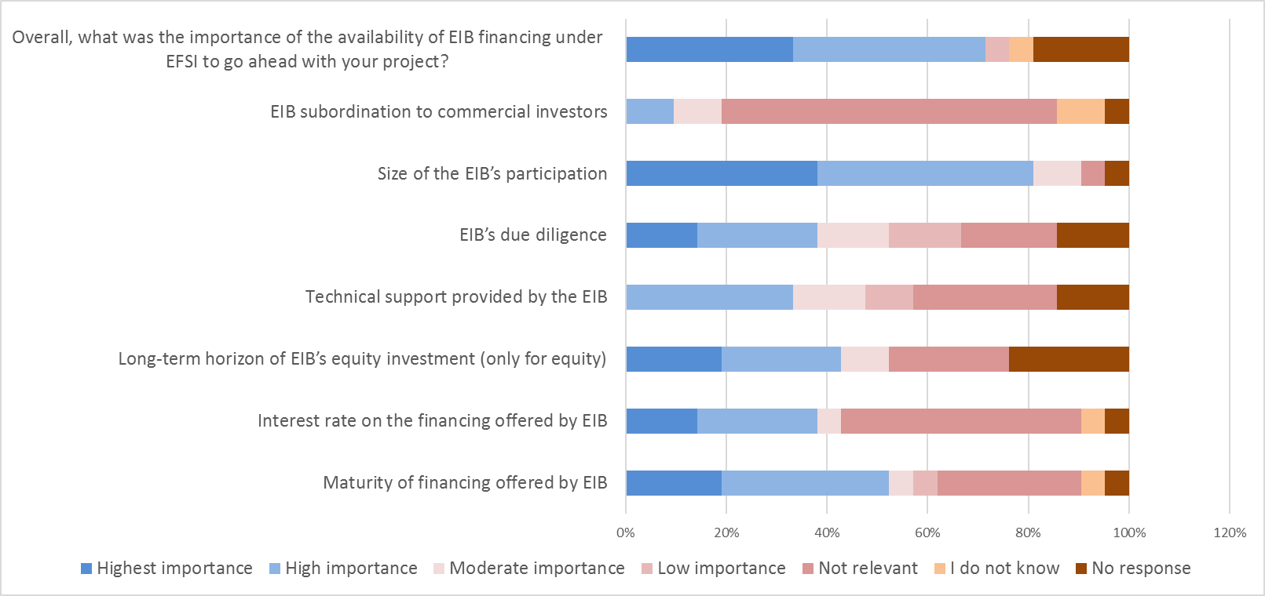

Source: ICF survey

1. **If you had not carried out the EIB supported project, would you have committed the financing/guarantees (if / as applicable) to other non-EIB supported projects over the same time period and to the same extent?**

Source: ICF survey; N=20.

1. **How was your experience, as financial intermediary, with respect to the process in which EIB considered and confirmed the financing for the project?**

Source: ICF survey; N=20.

1. **How has the demand for the type of financing provided by EIB under EFSI changed since 2015?**

Source: ICF survey; N=20.

Replies by policy area:

***A.3 Survey of National Promotional Banks***

* + - 1. **Has the EIB financing under EFSI encouraged an expansion in the capacity of your organisation to deliver investment in your country in response to market failure?**

**Source**: ICF survey, number of respondents: 12

Out of the respondents who answered 'YES' to this question, 57% indicated the number and scale of co-investment opportunities that opened up as a result of such expansion. Secondly, the ability to attract greater private sector interest with a willingness to invest was quoted as another important effect of EIB EFSI financing on the capacity of the respective NPBs, followed by the development of new products and the assistance with the development of technical expertise.

* + - 1. **Overall, do you consider that EFSI has made a significant contribution to increasing access to higher risk finance in your country/ region?**

**Source**: ICF survey, number of respondents: 12

* + - 1. **How would you assess the current financing gaps (i.e. gap between investment needs and financing available from the market) in the following sectors of your country/region of operation?**

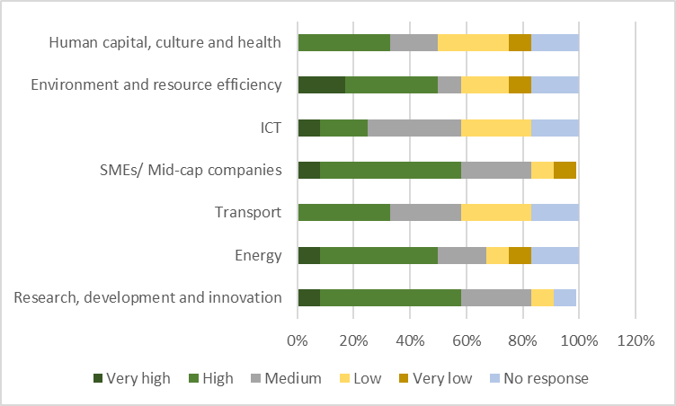

**Source**: ICF survey, number of respondents: 12

***A.4 Survey of beneficiaries of EIAH assistance***

In total, 21 replies were received from private companies (29%), financial intermediaries (5%), NGOs (5%), public entities (57%), and other organisations (5%). Most surveyed beneficiaries received EIAH support for project structuring and preparation. A majority of respondents (72%) evaluated the provided expertise as high or very high and most of them (86%) would recommend the EIAH assistance to other organisations.

1. **In your view how widely known, among users of technical assistance, are the services of the EIAH?**

Source: ICF survey; N=21

1. **What was the type of the assistance that you received from the EIAH?**

Source: ICF survey (possibility of multiple answers)

1. **Do you think you could have received similar assistance from an organisation in your country (e.g. a national promotional institution or via services provided in the marketplace)?**

Source: ICF survey; N=21

1. **How well were your needs met by the information that you received from the EIAH (directly or indirectly)?**

Source: ICF survey; N=21

1. **In your view, what was the level of expertise provided by experts from the EIAH?**

Source: ICF survey; N=21

1. **Would you recommend the services of EIAH to other organisations?**

Source: ICF survey; N=21

***A.5 Survey of project promoters from the EIPP***

The EIPP survey targeted 194 project promoters who published 238 projects. The survey received a total of 61 responses (31% participation rate).

**1. Type of organisation**

Based on the self-assessment of the promoters, most were private companies (76%). Almost half of the private companies were micro companies with less than 10 employees, followed by small and medium sized companies.

**Q: What type of organization do you represent?**

|  |  |  |  |
| --- | --- | --- | --- |
|  |  | **Answers** | **Ratio** |
| Public entity | Generated | 9 | 14.52% |
| Private company | Generated | 47 | 75.81% |
| Financial intermediary |  | 0 | 0% |
| Other | Generated | 6 | 9.68% |
| No Answer |  | 0 | 0% |

**Q: If private company, which category do you fall in?**

|  |  |  |  |
| --- | --- | --- | --- |
|  |  | **Answers** | **Ratio** |
| Micro (<10 employees) | Generated | 30 | 48.39% |
| Small (between 11 and 49 employees) | Generated | 13 | 20.97% |
| Medium (between 50 and 249 employees) | Generated | 2 | 3.23% |
| Mid-cap (between 250 and 3000 employees) | Generated | 1 | 1.61% |
| Large (>3000 employees) |  | 0 | 0% |
| No Answer | Generated | 16 | 25.81% |

**2. Project details**

The highest number of responses received belongs to projects planned to be undertaken in Italy, followed by Spain, Greece and France. In terms of the sectors the highest number of these projects will be implemented in the field of environment and resource efficiency while the lowest in social infrastructure. The majority of the projects are still in the early phases of the project development compared to 3% which are in a late stage.

**Q: What sector(s)/field(s) does your project (or project idea) cover?**

|  |  |  |  |
| --- | --- | --- | --- |
|  |  | **Answers** | **Ratio** |
| Knowledge and digital economy | Generated | 14 | 22.58% |
| Energy | Generated | 13 | 20.97% |
| Transport | Generated | 10 | 16.13% |
| Social infrastructure | Generated | 9 | 14.52% |
| Financing for SMEs and mid-caps | Generated | 14 | 22.58% |
| Environment and resource efficiency | Generated | 16 | 25.81% |
| No Answer |  | 0 | 0% |

**Q: Please indicate the stage at which you submitted your project to the EIPP:**

|  |  |  |  |
| --- | --- | --- | --- |
|  |  | **Answers** | **Ratio** |
| Feasibility assessment | Generated | 10 | 16.13% |
| Structuring | Generated | 11 | 17.74% |
| Procurement | Generated | 2 | 3.23% |
| Partial financing secured | Generated | 14 | 22.58% |
| Early construction | Generated | 6 | 9.68% |
| Late construction | Generated | 2 | 3.23% |
| Other (please specify) | Generated | 7 | 11.29% |
| No Answer | Generated | 10 | 16.13% |

3**. Submission process**

Most of the promoters (more than 90%) found the EIPP registration process easy.

**Q: Was it easy to submit your project(s)?**

|  |  |  |  |
| --- | --- | --- | --- |
|  |  | **Answers** | **Ratio** |
| Yes | Generated | 56 | 90.32% |
| No | Generated | 6 | 9.68% |
| No Answer |  | 0 | 0% |

**4. Contacts by investors**

Almost 80 % of the promoters were contacted by potential investors as a result of their project publication on the EIPP. Out of these, the majority has received up to 10 contacts.

**Q: Have you been contacted by investors/potential business partners as a result of your project(s)' publication on the EIPP?**

|  |  |  |  |
| --- | --- | --- | --- |
|  |  | **Answers** | **Ratio** |
| Yes | Generated | 48 | 77.42% |
| No | Generated | 14 | 22.58% |
| No Answer |  | 0 | 0% |

**Q: If Yes, by how many?**

|  |  |  |  |
| --- | --- | --- | --- |
|  |  | **Answers** | **Ratio** |
| 1 -9 | Generated | 52 | 83.87% |
| 10 - 49 | Generated | 3 | 4.84% |
| > 50 |  | 0 | 0% |
| No Answer | Generated | 7 | 11.29% |

**5. Financing from investors**

Two project promoters mentioned to having received financing followed by the publication of their project on the EIPP. The data provided by these two promoters was not sufficient enough to understand the background of the investment.

NB: Follow-up calls were made to all non-respondent remaining surveyed participants and 18 projects were identified as having fully or partially secured financing after being published on the EIPP.

**Q: Have you received financing as a result of investor contact(s), following the publication of your project(s) on the EIPP?**

|  |  |  |  |
| --- | --- | --- | --- |
|  |  | **Answers** | **Ratio** |
| Yes | Generated | 2 | 3.23% |
| No | Generated | 60 | 96.77% |
| No Answer |  | 0 | 0% |

**6. Participation in events**

87% of project promoters declared an interest to participate in future EIPP matchmaking and/or pitching events. The high express of interest in such events justifies well their organisation and guarantees high attendance.

**Q: Would you be interested in attending EIPP pitching and/or matchmaking events in the future?**

|  |  |  |  |
| --- | --- | --- | --- |
|  |  | **Answers** | **Ratio** |
| Yes | Generated | 54 | 87.1% |
| No | Generated | 8 | 12.9% |
| No Answer |  | 0 | 0% |

**7. User experience and satisfaction**

More than 75% were very satisfied, satisfied or quite satisfied with the EIPP.

**Q: On a scale from 1 (not satisfied) to 5 (very satisfied), how would you rate your overall EIPP user experience and satisfaction?**

|  |  |  |  |
| --- | --- | --- | --- |
|  |  | **Answers** | **Ratio** |
| 1 | Generated | 11 | 17.74% |
| 2 | Generated | 4 | 6.45% |
| 3 | Generated | 17 | 27.42% |
| 4 | Generated | 19 | 30.65% |
| 5 | Generated | 11 | 17.74% |
| No Answer |  | 0 | 0% |

**8. General remarks: Improvement of the EIPP suggested by the promoters**

* Match-making events (matching size and sectors among promoters and investors)
* Investors' profiles should be public
* More serious investors which are capable to invest
* Possibility for promoters to contact investors
* EIPP partners should analyse the published projects
* Focus on investors outside the EU
* Promotion: roadshow with key projects, match-making and consultancy services by the EIPP
* Project/website: updates of the projects more frequently

1. **Feedback received on the Roadmap**

The feedback on the EFSI Evaluation Roadmap[91] highlighted stakeholders' concerns related to the balanced geographical coverage, transparency and sustainability of the EFSI financing support in the future. These are aspects which have been assessed in this evaluation and have also been taken into account in the amendments adopted with the entry into force of the revised EFSI Regulation in 2018.

1. **Results of the Open Public Consultation**

On 10 of January 2018, the European Commission launched an open public consultation (OPC) on EU funds in the area of investment, research & innovation, SMEs and single market. The survey was conducted on the Commission webpage through an online survey consisting primarily of multiple-choice questions, with some open-ended questions.

By the end of the consultation on 9 March 2018, 4052 respondents provided valuable information to the Commission. All citizens, organisations and stakeholders with an interest in issues related to investment, entrepreneurship, research, innovation and SMEs were welcome to respond to this consultation. In total, 1808 respondents answered in their personal capacity, while 2244 in their professional capacity or on behalf of an organisation. Replies from organisations were received from Think Tanks (12), Academia (526) and Research Institution (347). The respondents had to answer to a specific questionnaire and they also had a possibility to attach any relevant document. Graph 1 shows the residence of respondents[92]

Graph 2 highlights the awareness of the respondents of the European programmes in connection to the topic area to which they answer. As the graph shows, Horizon 2020 is the most known programme. In other words, almost 9 out of 10 respondents are aware of the EU R&I programme Horizon 2020, which remains by far the most known EU programme among respondents. This is followed by ESIF (21.7%), EU Health Programme (9%), COSME (8%), EFSI (6.15%) and EaSI (3.15%), which are not recognized as Horizon 2020.

1. **EU support for Investment**

As illustrated in Graph 3, due to the structure of this questionnaire, it was possible to extrapolate the answers of people whose replies concerned the support for investment at European level. In total, 642 out of 4052 replies were dedicated to this topic and, as per Graph 4, the sample covers all the countries in European Union and it only shows those respondents that provided their country of residence.

Moreover, data on the policies awareness on this specific subgroup are in line with the sample presented in Graph 2. The only exception is that more than 20% of the respondents are aware of the EFSI, compared to 6.15% in the total sample.

As far as the ability of the European institutions to intervene, respondents believe that there is room for improvement. According to their opinion, presented in Figure 5, the majority of the respondents believe that European institutions are not sufficiently addressing most of the challenges listed above. In particular, they stress the inability to address unemployment and social disparities, access to finance especially for SMEs and social investment and social innovation.

More interestingly, the respondents on the EU support for investments firmly believe that currents actions at European level bring added value and that this is complementary to what Member States could achieve at national, regional and/or local levels. More than 70% of the respondents affirmed that at least to a fairly good extent the EU intervention adds value

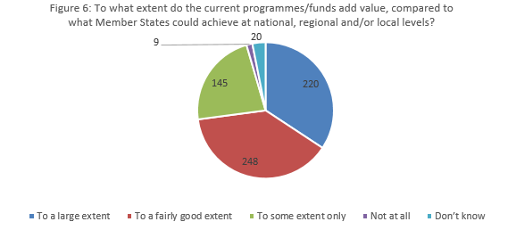

Furthermore, Graph 7 shows the importance that respondents give to preliminary identified policy challenges that according to the European Commission should be targeted in the future. For instance, research and innovation, the facilitation of the transition to low carbon and circular economy, education, skill and training or digitalisation are priorities that new programmes should clearly address.

Finally, Graph 8 confirms the steps that should be undertaken in order to simplify and reduce administrative burden for beneficiaries, according to the importance given by respondents. The entirety of challenges listed by the Commission should be addressed in the future. In particular, respondents believe that simplification of rules is the most important point that could help solve the administrative burdens for beneficiaries. Respondents also stress an alignment of rules between the EU Funds and a stable but flexible framework between programming periods.

# Annex 3: Methods and analytical models

The methodological approach to the evaluation was done in line with the requirements set out in the Better Regulation guidelines.

The methodology included desk research, portfolio review and detailed analysis of 60 IIW projects, targeted interviews, five targeted surveys, as well as review of the EFSI’s credit risk modelling by an expert.

The stakeholders identified through desk research and exchanges with DG ECFIN belonged to four large groups: policy makers and implementing partners at the EU and national level, stakeholders from the financial sphere, from the real economy, and from the wider society.

***Evaluation questions***

The evaluation has drawn upon a set of evaluation questions (presented below) relating to five main criteria: relevance, effectiveness, efficiency, coherence and EU added value.

1. **EFSI[93]**

Relevance of EFSI

| Evaluation question | Judgement criteria | Evidence and analysis required | Source of evidence |
| --- | --- | --- | --- |
| EQ 1: To what extent has the EFSI addressed the investment gaps and the market needs identified initially (in terms of size, sector, and geographical coverage)? | * + To what extent has EFSI addressed the investment needs | * + Desk research/ literature review of the evolution of investment gaps and market needs with forward looking element (up to end of 2020) and some focus on most relevant sectors;   + Portfolio analysis (size, sector, geographical coverage, including trends over time);   + Views expressed by NPBs, investment platforms, financial intermediaries and relevant staff in EIB/EIF regarding changes in market needs   + Policy makers’ satisfaction with the extent to which EFSI has addressed the investment gaps and the market needs. | * + Desk review of relevant literature and reports on the existing and prospect investment gaps and market needs   + Desk review of the EFSI’s evaluations and reports   + Data on EIB/EIF EFSI financed projects (as of 31 December 2017)   + Inputs from the study experts for key sectors   + Survey and Interviews with selected representatives of NPBs/NPIs   + Survey of beneficiaries/ financial intermediaries involved under IIW and SMEW   + Interviews with EIB/EIF staff and financial intermediaries;   + Review of relevant statistics i.e. on SMEs access to finance in particular markets/ geo locations   + EIB IS   + ECB SAFE data   + Flash Eurobarometer   + Relevant national data |
| EQ 2: To what extent has the design of the EFSI responded to the needs of the project promoters, financial intermediaries, and private investors? | * + To what extent have new financial products and new delivery models been introduced to meet investment needs   + Have EFSI products satisfied promotors, intermediaries and investors, especially in reducing the risk profile | * + Description of new debt and equity products and their take-up, by window/sub-window and their contribution to addressing the risk profile of operations;   + Description of new delivery models (with ref to EIAH)   + Views from lenders / investors / beneficiaries on what should have been offered and views on whether any significant improvement in suitability of products / delivery models introduced / planned is needed;   + What barriers continue to limit investment – could EIB/EFSI have better addressed these | * + Survey and Interviews with selected representatives of NPBs/ NPIs   + Survey of beneficiaries/ financial intermediaries involved under IIW and SMEW   + Interviews with the sample of representatives of investors including main banks, representatives of SMEs sector, other national players as appropriate   + Desk review of relevant reports and documentation Including data on the take-up of key products including new products |
| EQ 3: To what extent has the use of the scoreboard (Article 7(4) and Annex II of the EFSI Regulation) been relevant to assure an independent and transparent assessment of the use of the EU Guarantee? To what extent has each pillar of the scoreboard been appropriate and relevant? | * + Is the scoreboard relevant (do pillars focus on the right parameters, does scoreboard adequately inform decision-making)?   + Has the scoreboard satisfied stakeholders in terms of transparency and independence? | * + Review of scoreboard design and application (does it establish market failure and rationale for EFSI);   + Review of actions taken in response to ECA/EIB/E&Y recommendations;   + Feedback from Investment Committee members on relevance and appropriateness of four pillars including:     - whether the assessment of any of four pillars has been more problematic than others, and if so, why?     - whether Scoreboard is suitable for each eligible sector? | * + Review of the rules and practice surrounding the communication about EFSI’s Scoreboard   + Review of the findings from past evaluations   + Review of the sample of Scoreboard assessments as a part of the project review   + Interviews with selected members of the Investment Committee |

Effectiveness of EFSI

| Evaluation question | | Judgement criteria | | Evidence and analysis required | | Source of evidence | |
| --- | --- | --- | --- | --- | --- | --- | --- |
| EQ 7: To what extent has the EFSI been on track to achieve its objectives, in particular the target of mobilising EUR 315 billion of total investment by 4 July 2018? | | * + Has EFSI achieved the target multiplier rates and associated levels of investment | | * + Portfolio analysis of projects financed *via* SMEW and IIW including analysis of multipliers, volume of approved/signed deals and actual disbursements over the time and against the targets.   + Change in total EIB/EIF lending / investing compared to earlier periods   + Use of scoreboard scores - Pillar 1 | | * + Data on EFSI financed projects (for SMEW and IIW as of 31st December 2017)   + Desk review of relevant reports and documentation   + Relevant market data on the demand for finance (i.e. EIB IS, ECB SAFE, Flash Eurobarometer, OECD Scoreboard on financing of SMEs, national sources of data)   + Interviews with selected members of Steering Board and Managing Director’s staff | |
| EQ 8: How likely are the expected results of the EFSI to be achieved within the newly set EFSI 2.0 timeframe, i.e. EUR 500 billion of investment mobilized by 2020? | | * + Is EFSI likely to achieve EUR 500 billion of mobilized investment by 2020 | | * + Portfolio analysis considering EFSI’s multipliers including country and sectorial breakdown as well as multipliers for relatively new products   + Portfolio analysis considering the pace of funding from mid-2015/ mid-2016 up to December 2017 to establish the minimum rate of funding required to hit the target     - Portfolio analysis (trends in approvals/ signatures over the time and total value of approved/signed projects *versus* the target   + Desk research on the prospect demand and persistence of the market failures in SMEs & mid-caps funding     - Review of available market data (i.e. ECB Survey on SMEs access to finance)     - Review of current/prospect polices than may affect the demand (i.e. QE, expected interest rates level, regulatory changes)     - Feedback from key market participants i.e. NPBs/NPIs, venture capital funds | | * + Data on EFSI financed projects (for SMEW and IIW as of 31st December 2017)   + Relevant market data on the demand for finance (i.e. ECB SAFE, Flash Eurobarometer, OECD Scoreboard on financing of SMEs, national sources of data)   + Desk review of relevant reports and documentation   + Interviews with EIB/EIF staff   + Interviews with selected members of NPBs/NPIs | |
| EQ 9: To what extent has the EFSI increased access to financing in the EU policy areas in line with the objectives listed in Article 9.2? | | * + Has access to finance increased in areas defined in Article 9.2 and alignment of projects with EU policy | | * + Portfolio analysis focused on the allocation of EFSI financing into specific sectors/ type of projects listed under Article 9.2 | | * + Survey and follow-up interviews with selected NPBs/NPIs   + Interviews with the sample of representatives of investors including main banks, representatives of SMEs sector, other national players as appropriate | |
| EQ 10: To what extent has the EFSI mobilised private capital and crowded-in private investors?  EQ 34: To what extent have the projects for which the EU Guarantee was extended proved additional? | | * + Has EFSI leveraged investment into riskier operations   + To what extent has EFSI leveraged additional investment (as defined by Art. 5(1)) | | * + Review of IIW operations / loan grading / loan tenor   + Review of new SMEW portfolios   + Extent of crowding-in of lenders / investors and possible displacement (crowding-out)   + Review of the risk profile of selected projects / funds and associated additionality   + Views from IIW beneficiaries and IEF intermediaries on whether alternative financing from other sources to the same extent/ within the same time would have been available had EFSI been absent | | * + Data on EFSI financed projects (for SMEW and IIW as of 31st December 2017)   + Desk review of documentation including EIB biannual consolidated figures on share of private investment   + Desk review of selected IIW projects   + Survey and follow up Interviews with NPBs/ NPIs   + Survey of beneficiaries/ financial intermediaries involved under IIW and SMEW | |
| EQ 11: To what extent have the NPBs and the Investment Platforms contributed to the achievement of the EFSI objectives? | | * + Effectiveness of new collaborations – especially NPBs/NPIs – in stimulating project pipelines in target sectors and crowding-in of private lenders / investors | | * + Establishing the share and value of EFSI’s operations that involved NPBs co-financing (as of 31st 2017)   + Examination of the nature of NPBs’ contributions (financial/ non-financial) at the platform and project level   + Feedback from selected sample of representatives from NPBs covering, inter alia, (i) the nature of their involvement in the EFSI operations, (ii) the extent existing portfolio of EFSI products has been adequate, (iii) type of incentives needed to engage in EFSI operations, (iv) main barriers to engagement   + Perceived effectiveness of new collaborations stimulated by EFSI   NB: *Evidences and analysis will distinguish between SMEW and IIW* | | * + Data on EFSI financed projects (for SMEW and IIW as of 31st December 2017)   + Desk review of relevant documentation and reports   + Survey and follow-up interviews with selected NPBs/ NPIs and investment platforms   + Survey of beneficiaries/ financial intermediaries involved under IIW and SMEW   + Interviews with selected Investment platforms   + Interviews with selected sample of representatives from EIB/EIF   + Interviews/ survey of EFSI’s beneficiaries who dealt with NPBs   + Review of EIAH requests and the extent of involvement of the NPBs | |
| EQ 11: To what extent have the NPBs and the Investment Platforms contributed to the achievement of the EFSI objectives? | | * + Effectiveness of new collaborations – especially NPBs/NPIs – in stimulating project pipelines in target sectors and crowding-in of private lenders / investors | | * + Establishing the share and value of EFSI’s operations that involved NPBs co-financing (as of 31st 2017)   + Examination of the nature of NPBs’ contributions (financial/ non-financial) at the platform and project level   + Feedback from selected sample of representatives from NPBs covering, inter alia, (i) the nature of their involvement in the EFSI operations, (ii) the extent existing portfolio of EFSI products has been adequate, (iii) type of incentives needed to engage in EFSI operations, (iv) main barriers to engagement   + Perceived effectiveness of new collaborations stimulated by EFSI   NB: *Evidences and analysis will distinguish between SMEW and IIW* | | * + Data on EFSI financed projects (for SMEW and IIW as of 31st December 2017)   + Desk review of relevant documentation and reports   + Survey and follow-up interviews with selected NPBs/ NPIs and investment platforms   + Survey of beneficiaries/ financial intermediaries involved under IIW and SMEW   + Interviews with selected Investment platforms   + Interviews with selected sample of representatives from EIB/EIF   + Interviews/ survey of EFSI’s beneficiaries who dealt with NPBs   + Review of EIAH requests and the extent of involvement of the NPBs | |
| EQ 12: To what extent have the projects supported by the EFSI contributed to the creation of jobs and sustainable economic growth? | | * + (Expected) impact of EFSI funded projects on the real economy | | * + Review of approvals, signatures, disbursements and expected time of actual investment   + Review of Effective Rate of Return (ERR) in the scoreboard   + Review of employment (KPI)   + EIB/Joint Research Centre (JRC) Seville modelling output | | * + Data on EFSI financed projects (for SMEW and IIW as of 31st December 2017), including the data on disbursement and KPI 1   + Results from the modelling exercise performed by EIB/EC (and if relevant, external contractors e.g. Rhomolo-EIB model developed by Joint Research Centre of the EC in Sevilla)   + Interview with the representative of the EIB Economic Policy and Strategy Division   + Review of relevant literature and reports | |
| EQ 13: To what extent has the use of the scoreboard (Article 7(4) and Annex II of the EFSI Regulation) been effective in ensuring an independent and transparent assessment of the possible use of the EU Guarantee by the Investment Committee? To what extent have the individual pillars contributed to the scoreboard's effectiveness? | | * + Effectiveness of the scoreboard in aiding project design / appraisal and decision-making | | * + Feedback from IC / project promotors   + Extent of implementation of ECA/EIB/E&Y recommendations and impacts   + Feedback from sector experts when using the scoreboard for project review | | See EQ 3 | |

Efficiency of EFSI

| Evaluation question | Judgement criteria | Evidence and analysis required | Source of evidence |
| --- | --- | --- | --- |
| EQ 20: To what extent have the governance structures of the EFSI in place been efficient in supporting its implementation? | * + Has the operation of the governance structures been efficient - enabling clear/consistent and timely decision-making on loans/investments | * + Descriptive overview of the current governance structure and modus operandi of its specific components   + Desk review of relevant reports and documentation to explore problematic issue around EFSI’s governance   + Feedback on the efficiency of the current structure from representatives from their main components covering, inter alia, clarity on roles and responsibilities, procedures to manage potential conflict of interest/ ensuring independence, lines of communication   + Feedback on the efficiency of the current structure from relevant external stakeholders i.e. European Commission covering, inter alia, clarity on roles and responsibilities, procedures to manage potential conflict of interest/ ensuring independence, lines of communication   + Portfolio analysis (i.e data on time elapsed between approval and signature/ number of projects approved per quarter, etc)   + Suggestions for improvement i.e. how to speed-up due diligence/ approval process.   NB: *Evidences and analysis will distinguish between SMEW and IIW* | * + Data on EFSI financed projects (for SMEW and IIW as of 31st December 2017)   + Interviews with the representatives from key components of the EFSI governance structure: Steering Board, Investment Committee, Management team comprising Managing Director/ Deputy Managing Director   + Interview with DG ECFIN   + Review of relevant reports and documentation |
| NEW EQ: To what extent is new staffing under EFSI efficient | * + Has the increase in staffing associated with EFSI been efficient | * + Analysis of staffing numbers, competencies and responsibilities | * + EIB staffing records |
| EQ 21: To what extent have EFSI communication methods been efficiently used to engage stakeholders? | * + Has the use of EFSI related communication methods engaged key stakeholders efficiently | * + Desk review of key promotional activities/ outputs undertaken by the EIB/EC to promote EFSI   + Analysis of any internal analytical data/ analytical materials related to media coverage and consumption of EFSI related content   + Feedback from stakeholders on communication aspects | * + Monitoring data on the promotional activities and outputs undertaken     - e.g. special seminars for journalists   + Data/analytical materials related to media coverage and consumption on EFSI related content     - e.g. any press and social media analysis provided to DG ECFIN by external contractors     - e.g. review of web statistics on the consumption of key reports related to media   + Interviews with relevant EC staff   (e.g. Spokesperson for economic and financial affairs at DG Communication)   * + Interviews with selected EIB staff including representatives from EIAH team (i.e. members from local offices) |

Coherence of EFSI

| Evaluation question | Judgement criteria | Evidence and analysis required | Source of evidence |
| --- | --- | --- | --- |
| EQ 29: To what extent has EFSI been coherent with other EU interventions (i.e. complementarity, potential synergies and/ or overlaps with the European Structural and Investment Funds, Connecting Europe Facility, Horizon 2020, etc.) in terms of objectives, scope and activities? | * Has the coherence of EFSI with other EU Programmes been adequate | * + Review of the focus of EFSI, CEF, H2020 and ESIF and the areas of potential coherence (i.e. complementarity/ duplication/ contradiction)   + Desk review of relevant reports and documentation discussing the issue of coherence between EFSI and other EU interventions   + Feedback from desk officers responsible for EU programmes (i.e. CEF, COSME, H2020, ESIF) | * + Legal documentation outlining the scope of EFSI and other EU interventions with particular focus on the scope of those   + Review of relevant evaluations/ reports and documentation addressing the issue of coherence   + Interviews with relevant desk officers   responsible for the management of, inter alia, CEF, Horizon 2020 and ESIF |
| EQ 33: To what extent have the actions of the EFSI Regulation (EFSI, EIAH, and EIPP) been internally coherent in terms of potential synergies in contributing to the achievement of the objectives of the Investment Plan for Europe? | * Has internal coherence of EFSI Regulation contributed to the objectives of Investment Plan for Europe | * + Role of EFSI management in providing guidance to EIAH/EIPP operations   + Role of EIAH and EIPP in generating new collaborations and project pipelines leading to EFSI investment   + Role of EIAH and EIPP in determining the sectoral and geographic allocations | * + Operating guidelines for EIAH and EIPP   + Identification and review of operations and portfolios facilitated by EIAH/EIPP |

EU Added Value of EFSI

| Evaluation question | Judgement crieria | Evidence and analysis required | Source of evidence |
| --- | --- | --- | --- |
| NEW EQ: To what extent has EFSI provided EU added value | * + Has EFSI provided added policy value compared to the alternative use of EU funds   + Has EFSI provided added value to Member States in meeting their investment needs (subsidiarity test) | * + Review of use of EU programmes (CEF, H2020) since EFSI (examining changes in scale and focus)   + Views provided by NPBs, project promoters and EIB/EIF   + Views of EFSI on scope for EFSI operations to have been supported by MS / private sector | * + Review of relevant reports and evaluations of CEF, H2020   + Discussion with relevant EU / EFSI desk officers   + Feedback from NPBs and project promotors / intermediaries |

1. **EU Guarantee**

| Evaluation question | | Judgement criteria | Evidence and analysis required | Source of evidence |
| --- | --- | --- | --- | --- |
| **Relevance** | |  |  |  |
| EQ 4: To what extent has the EU Guarantee been used to respond to the identified needs? To what extent do the identified needs still exist? | | Has the EU Guarantee been used in the most appropriate way in response to investment needs – is the allocation between windows optimal | * + Analysis of the levels of investment mobilised and associated provision for expected losses by window   + Consideration of the use of the Guarantee in meeting investment needs under the two windows | * + Interviews with selected members of Investment Committee   + Interviews with Unit L of DG ECFIN and EIB/EIF staff   + Desk review of relevant documentation and report especially needs appraisals |
| **Effectiveness** | |  |  |  |
| EQ 14: To what extent has the EU Guarantee been effectively used to cover the potential losses that the EIB Group may suffer from its EFSI supported investments under the IIW and SMEW? | Is the provisioning rate appropriate for current and future investment levels | | * + Assessment of the adequacy of the size of the EU Guarantee and the provisioning rate   + Review of the annual EU budget flows for the EU Guarantee | * + Interviews with DG ECFIN / EIB/EIF   + Review of risk modelling   + Data on calls on the EU Guarantee collected by Directorate L of DG ECFIN   + Inputs from thematic experts |
| **Efficiency** | |  |  |  |
| EQ 22: To what extent will the level of the EU budget resources available for the EU Guarantee (the provisioning rate) be appropriate in the light of the evolution of the exposures? | | Is the estimate and monitoring of contingent liabilities at the level of the operation adequate | * + Review of the estimated expected loss provision at operational level (for selected projects)   + Review of monitoring and reporting of expected loss | * + Review of selected IIW projects   + Interviews with the relevant staff in DG ECFIN/EIB/   + Data on annual budget flows/ other relevant data related to the usage of the EU Guarantee   + Discussion with Credit Rating Agencies |
| EQ 23: To what extent have the financial resources provided to EFSI, namely the EU Guarantee and the EIB Group resources, been appropriately sized to achieve its expected effects? | | Is the EU Guarantee and the EIB resources appropriately sized  Assessment of capacity to absorb funds at higher volumes and at higher risk from larger Guarantee  Assessment of impact on the EIB credit rating of larger contribution | * + Review of investments needs in light of substantially expanded volume of financing   + Impact on project and portfolio risks of extended financing and feasibility of expanded investment   + Views on the likely reaction of financial markets to a substantial increase (say x2 or x10) of the EIB contribution and effect on EIB credit rating | * + Interviews with the relevant staff in DG ECFIN/EIB/   + Data on annual budget flows/ other relevant data related to the usage of the EU Guarantee   + Interviews with selected members of Steering Board / Investment Committee   + Interview with EFSI Managing Director (MD)/ Deputy Managing Director/MD’s office   + Discussion with Credit Rating Agencies |
| **Coherence** | |  |  |  |
| EQ 30: N/A [Coherence is evaluated for EFSI as a whole. It cannot be evaluated only for the EU Guarantee.] | | *Not applicable* | *Not applicable* | *Not applicable* |
| EQ 33: To what extent have the actions of the EFSI Regulation (EFSI, EIAH, and EIPP) been internally coherent in terms of potential synergies in contributing to the achievement of the Investment Plan for Europe? | | *Addressed under EFSI* | *Addressed under EFSI* | *Addressed under EFSI* |
| **EU Added Value** | |  |  |  |
| EQ 37: To what extent has the EU Guarantee provided added value in terms of an increased risk bearing capacity of the EIB, and in terms of supporting investments and access to financing for SMEs and mid-caps in the Union? | | * + What impact has the EU Guarantee had on the risk bearing capacity of EIB | * + Change in risk bearing capacity as a result of the EU Guarantee – proxied by the change in funding of Special Activities | * + EIB annual reports   + EIB interviews |
| EQ 38: What would be the most likely consequences of discontinuing the EU Guarantee on the EIB's risk-bearing capacity? | | * + What are the potential consequences of discontinuing the EU Guarantee on the EIB risk-bearing capacity | * + Feedback from EIB/EIF and financial intermediaries on possible change in volume and risk of operations (including Special Activities) | * + Interviews with DG ECFIN   + Interviews with relevant EIB/EIF staff |

1. **EIAH**

| Evaluation question | | Judgement criteria | | | | Evidence and analysis required | | Source of evidence | | |
| --- | --- | --- | --- | --- | --- | --- | --- | --- | --- | --- |
| **Relevance** | |  | | | |  | |  | | |
| EQ 5: To what extent have the EIAH’s services (Article 14.2) been relevant for the accomplishment of its mandate (Article 14.1 of the EFSI Regulation)? | | Have EIAH services developed in accordance with its mandate (Article 14 of EFSI Regulation)  Extent to which:   * EIAH activities build upon existing EIB and Commission advisory services * EIAH services correspond to those required by the EFSI regulation (provide a single point of entry for TA in the areas listed in Article 9(2), assisting project promoters, leveraging local knowledge to facilitate EFSI support, provide a platform for p2p exchange and knowledge sharing regarding project development, provide advice on establishment of investment platforms) * EIAH beneficiaries are from private and public sector   EIAH assistance is provided across all sectors listed in Article 9(2) | | | | * Review of the activities taken place * Feedback from EIB/EIF operational teams and beneficiaries i.e. NPBs/ NPIs and project promotors * Establishing the share of EFSI related requests in the total requests received by EIAH * Review of the origin (private/public investors, country), type and nature of EFSI related requests received by EIAH * Breakdown of EFSI related requests by sector coverage origin, and type of services provided by EIAH | | Desk research (review of relevant EIAH documentation such as bi-annual technical reports,  Survey of EIAH beneficiaries  Telephone interviews with NPBs | | |
| **Effectiveness** | |  | | | |  | |  | | |
| EQ 15: To what extent has EIAH deployment fulfilled its mandate and activities as listed in Art 14 of the EFSI Regulation? | | Has EIAH been effective in addressing its mandate, with particular respect to sectors that received the support and the effectiveness of this support  Extent to which:   * EIAH beneficiaries are from private and public sector * EIAH provides capacity building and support to NPB/NPI from MS with less developed markets * EIAH assistance is provided across all sectors listed in Article 9(2)   Stakeholders who are not currently using EIAH services are aware of the offer/EIAH support | | | | * Review of the origin (private/public investors, country), type and nature of EFSI related requests received by EIAH * Share of projects (by sector / MS) that have come through / or been advised / benefitted in material way * Feedback on collaboration from NPBs, promotors * Review of stakeholder awareness of EIAH services | | Desk research (review of relevant EIAH documentation such as EIAH bi-annual technical report, review of MoU signed with NPBs/NPIs),  Survey of EIAH beneficiaries  Survey and follow-up interviews with NPBs / NPIs | | |
| EQ 16: Which sectors listed in Article 9.2 has EIAH been supporting most effectively and why? What are the challenges for making EIAH effective across all eligible sectors and areas and how can they be overcome? | | Extent to which   * EIAH assistance has been provided across sectors listed under Article 9(2). * EIAH assistance provided resulted in implementation through EFSI * EIAH assistance provided resulted in implementation through other EIB/Union mechanisms * Stakeholders identify challenges that hinder the effectiveness of EIAH across sectors/areas of activity   EIAH beneficiary /NPB/ NPI views on:   * Whether EIAH has been effective, and why * Challenges that hinder effectiveness of EIAH across sectors/areas of activity   How these challenges could be mitigated? | | | | * Breakdown of all requests by sector * Breakdown of EFSI related requests by sector coverage * Breakdown of requests that were implemented by EFSI, by sector * Breakdown of requests that were implemented using other EIB/Union mechanisms, by sector   Typology of challenges, e.g.:   * Lack of capacity building function vis-à-vis NPB * Existence of some constraining issues hampering collaboration with NPBs (HUB seen as competition?) * Lack of engagement/local support in countries with less capacity, where EIAH may need to develop partnerships with NPI / local service providers * Lack of demand from certain sectors * Lack of awareness/ misperception of the role of the HUB   How such challenges might be mitigated, for instance:   * More focussed communication and engagement activities towards underrepresented sectors and countries with less capacity * Alternatively: focus on dealing with existing demand, and do not attempt to achieve geographical/sector spread   Offer more tailored incentives to strengthen partnerships with NPB and improve cooperating beyond informing about EIAH | | Desk research (review of relevant EIAH documentation such as EIAH bi-annual technical report, review of MoU signed with NPBs/NPIs),  Survey of EIAH beneficiaries  Survey and follow-up telephone interviews with NPBs / NPIs | | |
| EQ 16: Which sectors listed in Article 9.2 has EIAH been supporting most effectively and why? What are the challenges for making EIAH effective across all eligible sectors and areas and how can they be overcome? | | Extent to which   * EIAH assistance has been provided across sectors listed under Article 9(2). * EIAH assistance provided resulted in implementation through EFSI * EIAH assistance provided resulted in implementation through other EIB/Union mechanisms * Stakeholders identify challenges that hinder the effectiveness of EIAH across sectors/areas of activity   EIAH beneficiary /NPB/ NPI views on:   * Whether EIAH has been effective, and why * Challenges that hinder effectiveness of EIAH across sectors/areas of activity   How these challenges could be mitigated? | | | | * Breakdown of all requests by sector * Breakdown of EFSI related requests by sector coverage * Breakdown of requests that were implemented by EFSI, by sector * Breakdown of requests that were implemented using other EIB/Union mechanisms, by sector   Typology of challenges, e.g.:   * Lack of capacity building function vis-à-vis NPB * Existence of some constraining issues hampering collaboration with NPBs (HUB seen as competition?) * Lack of engagement/local support in countries with less capacity, where EIAH may need to develop partnerships with NPI / local service providers * Lack of demand from certain sectors * Lack of awareness/ misperception of the role of the HUB   How such challenges might be mitigated, for instance:   * More focussed communication and engagement activities towards underrepresented sectors and countries with less capacity * Alternatively: focus on dealing with existing demand, and do not attempt to achieve geographical/sector spread   Offer more tailored incentives to strengthen partnerships with NPB and improve cooperating beyond informing about EIAH | | | Desk research (review of relevant EIAH documentation such as EIAH bi-annual technical report, review of MoU signed with NPBs/NPIs),  Survey of EIAH beneficiaries  Survey and follow-up telephone interviews with NPBs / NPIs | | |
| EQ 17: To what extent has EIAH effectively used the expertise of the EIB, the Commission, the National Promotional Banks or institutions, and the managing authorities of the European Structural and Investment Funds (Article 14.5) to achieve its objective? | | Extent to which   * NPB/NPI and managing authorities of ESIF confirm that they have assisted EIAH * Composition of experts involved in individual projects assisted through EIAH includes staff from EIB, Commission, NPB/NPI and managing authorities   EIAH beneficiaries are of the view that composition of experts was appropriate | | | | * Analysis of expert composition across all projects that were assisted by EIAH, across different project stages and EIAH services * Analysis of expert composition across all projects that were assisted by EIAH and resulted in EFSI supported activities, across project stages and EIAH services * Review of beneficiaries’ responses on quality of expertise offered * Review of NPB/NPI and ESIF MA views on scale and scope of cooperation, and whether this could be organised more effectively to ensure complementary expertise is leveraged | | | Review of MoU signed with NPBs/NPIs,  Survey of EIAH beneficiaries  Telephone interviews with EIB staff, ESIF managing authorities  Survey and follow-up interview with NPBs | | |
| **Efficiency** | |  | | | |  | | |  | | |
| EQ 24: To what extent have the financial resources provided to the Hub been appropriately sized to meet EIAH's objectives and how can they be optimised? | | Extent to which   * EIAH activities are considered to be well-staffed and resourced * EIAH spending is in line with EIAH financial planning * Challenges to effectiveness of EIAH activities could be overcome with extended financial resources   Any room for improvement that can be identified with regards to :   * Unit costs for offering individual types of assistance/service * Targeting resources towards demand, or communication activities towards specific underrepresented countries or sectors   Recovering costs via fees charged by EIAH | | | | * Process mapping of key activities pursued by EIAH and processes underlying each activity * Mapping of average hrs/days spent by EIAH staff and other EIB staff on each main process * Review of spending trajectory at aggregate level against overall annual budget of EUR 26.6 million | | | Desk review of key reports and documentation (EIAH (2015) Framework Partnership Agreement, Annual Grant Agreements, Financials of the EIAH, Memorandum of Understanding on cooperation of EIAH with NPIs Agreement on the delivery of the EBRD Small Business Support Programme in Bulgaria, Greece and Romania under the EIAH umbrella)  Survey and follow-up telephone interviews with NPBs / NPIs | | |
| EQ 25: To what extent is the EIAH governance model efficient in meeting the EIAH objectives? | | Is the governance of EIAH considered to be efficient in stimulating / generating pipeline  To what extent does governance model   * Involve the necessary actors to meet all EIAH objectives * Is flexible enough to accommodate evolving demand for service provision, such as advisory services at local level * allows for the revised set of EIAH objectives as per the proposed EFSI 2.0 regulation to be delivered efficiently. | | | | * Review of the documentation outlining the mandates of the HUB * Review of stakeholder opinions on the governance model and its efficiency, in particular stakeholders at a national and local level * Analysis of share between EIB staff and external experts used by EIAH, and comparison against beneficiary satisfaction and evidence collected against the evaluation of EIAH’s effectiveness | | | Desk review of key reports and documentation (EIAH (2015) Framework Partnership Agreement, Annual Grant Agreements, Financials of the EIAH, Memorandum of Understanding on cooperation of EIAH with NPBs Agreement on the delivery of the EBRD Small Business Support Programme in Bulgaria, Greece and Romania under the EIAH umbrella)  Telephone interviews with EIAH management, NPBs/NPIs, individual external consultants who exert a similar function at local level  Survey of NPBs / NPIs | | |
| EQ 26: To what extent have EIAH communication methods been efficiently used to promote its service to public and private project promoters, National Promotional Banks or institutions, and investment platforms? | | Extent to which   * Communication activities and approach to communication activities are targeted at the right groups, and designed in a way that ensures value for money * NPBs/NPIs and other intermediaries/promotors have learned about EIAH via the EIAH communication activities | | | | For each promotional activity and communication method, analysis of   * Type of activity * Type and size of target group * Results, e.g.: unique visitor/reach of online campaign, visitors at events and conferences * Cost per person reached, by target group (project promoters, NPBs, investment platform representatives) * Awareness amongst key stakeholders, in particular at national and regional level, about the specific products and role of EIAH | | | Desk review of EIAH promotional activities, including:   * Type and number of activities (e.g. online campaigns, events, email campaigns) * Cost breakdown of each campaign * Results of each campaign, e.g. individuals reached, new enquiries to EIAH facilitated, share of new enquiries that led to EFSI projects   Survey and follow-up telephone interviews with NPBs / NPIs and EIAH beneficiaries | | |
| **Coherence** | |  | | | |  | | |  | | |
| EQ 31: To what extent has EIAH proved both coherent to other existing TA initiatives in terms of complementarity, potential synergies and/or overlaps? | | 1. Is there adequate internal coherence of EIAH activity with EFSI – does it drive / advise the pipeline in response to EIB/EIF priorities/needs  2.Is there adequate external coherence of EIAH with the existing TA initiatives | | | | * Role of EIAH in securing the project pipeline * Internal management arrangements to align EIAH with EFSI priorities * Identify other existing TA initiatives and review their mission statement, service offer and target groups (in terms of targeted entities and projects). * Feedback from managers of such initiatives * Analysis of the extent of overlap and potential displacement effect that EIAH might have on such other TA initiatives extent of potential / existing synergies and overlaps | | | Desk research of key EIAH documentation, and documentation describing the activities, services and target groups for similar TA initiatives at European or national level (such as NPB advisory services, advisory services offered by ISIs such as JASPERS, ELENA or Horizon 2020 Innovfin Advisory, FICompass, EIB technical assistance within normal operations, private sector consultants, trade and commercial associations, EC funded technical assistance services)  Interviews with EIAH management, management of other TA initiatives at European or national level (such as such as NPBs/NPIs advisory services, advisory services offered by ISIs such as JASPERS, ELENA or Horizon 2020 Innovfin Advisory, FICompass, EIB technical assistance within normal operations, private sector consultants, trade and commercial associations, EC funded technical assistance services) | | |
| EQ 33: To what extent have the actions of the EFSI Regulation (EFSI, EIAH, and EIPP) been internally coherent in terms of potential synergies in contributing to the achievement of the Investment Plan for Europe? | | | *Addressed under EFSI* | *Addressed under EFSI* | | | | *Addressed under EFSI* | | |
|  | |  | | | |  | | |  | | |
| **EU Added Value** | |  | | | |  | | |  | | |
| EQ 39: To what extent has the EIAH support to project promoters and beneficiaries provided added value? | | 1. Has EIAH helped to develop MS project development capacity in terms of bringing in new partners and expanding the skills and investment capacities of intermediaries  Extent to which:   * EIAH offers support capacity that cannot be met by other, similar initiatives * EIAH promotes expansion of (higher quality) services than existing offers (for instance in countries where financial markets might not be well developed) | | | | * Review of the evidence on existing market needs * Review of the EIAH services provided * Feedback from the management of the EIAH * Analysis of project promoters and beneficiaries’ alternative use of support services (if available) * Ranking of the added value of key type of EIAH services, as perceived by beneficiaries | | | Desk research of key EIAH documentation, and documentation describing the activities, services and target groups for similar TA initiatives at European or national level (such as NPB advisory services, advisory services offered by such as JASPERS, ELENA or Horizon 2020 Innovfin Advisory, FICompass, EIB technical assistance within normal operations, private sector consultants, trade and commercial associations, EC funded technical assistance services)  Previous evaluations of similar TA initiatives at European or national level.  Interviews with EIAH management, management of other TA initiatives at European or national level (such as such as NPB advisory services, advisory services such as JASPERS, ELENA or Horizon 2020 Innovfin Advisory, FICompass, EIB technical assistance within normal operations, private sector consultants, trade and commercial associations, EC funded technical assistance services) | | |

1. **EIPP**

| Evaluation question | Judgement criteria | Evidence and analysis required | | Source of evidence | |
| --- | --- | --- | --- | --- | --- |
| **Relevance** |  |  | |  | |
| EQ 6: To what extent have the EIPP’s activities been relevant to its mandate (Article 15 of the EFSI Regulation)? | Extent to which:  - Current and future investment projects are presented on the portal  - Various stakeholder groups frequent the portal (in particular project promoters and investors)  - Projects cover all of the pre-determined high economic value-added sectors  - Investors and project promoters are matched via the platform  - Investors learn about projects via the platform they would not have identified otherwise | * Establishing statistics on unique visitors, as well as registered users and break down by:   Country of origin/registration  Type of user (investor, project promotor, investee)   * Review of projects uploaded by   country, sector, project stage   * Review of feedback from project promoters regarding the judgement criteria listed on the left | | Desk research (review of relevant EIPP documentation such as user statistics, information about projects uploaded, and any documentation on % of potential projects uploaded that have been implemented)  Telephone interviews with EIPP management, investors registered on EIPP, project promoters and investees registered on EIPP | |
| **Effectiveness** |  |  | |  | |
| EQ 18: To what extent has EIPP deployment fulfilled its mandate as listed in Article 15 of the EFSI Regulation? | Extent to which:  - Current and future investment projects are presented on the portal  - Extent to which various stakeholder groups frequent the portal (in particular project promoters and investors)  - Extent to which projects cover all of the pre-determined high economic value-added sectors  - Extent to which investors and project promoters are matched via the platform | * Establishing statistics on unique visitors, as well as registered users and break down by:   Country of origin/registration  Type of user (investor, project promotor, investee)   * Review of projects uploaded by   country, sector, project stage   * Review of feedback from investors, project promoters and investees regarding the judgement criteria listed on the left | | Desk research (review of relevant EIPP documentation such as user statistics, information about projects uploaded, and any documentation on % of potential projects uploaded that have been implemented)  Telephone interviews with EIPP management, investors registered on EIPP, project promoters and investees registered on EIPP | |
| **Efficiency** |  |  | |  | |
| EQ 27: To what extent have the financial resources used for the EIPP been appropriately sized to meet EIPP's objectives and how can they be optimised | Extent to which   * Promotional activities around EIPP are targeted at the right groups, and designed in a way that ensures value for money * Operational resources are allocated in an efficient way * Promotional/communication activities would be equally effective to what is currently undertaken with reduced resources * Promotional activities could be optimised * Allocation of operational resources could be optimised | For each promotional activity, analysis of   * Type of activity * Type and size of target group * Results, e.g.: unique visitor/reach of online campaign, visitors at events and conferences * Cost per person reached, by target group (project promoters, investees, investors) * Review extent to which synergies are exploited, e.g. promotional activities raise visibility of EIAH and EIPP in an integrated way. * Process mapping of operational activities needed to run the EIPP, and resources used against each activity * Value added of each operational activity in terms of reaching EIPP objectives | | Desk research (review of relevant EIPP documentation such as user statistics, information about projects uploaded, review of EIPP operational and resource plan) | |
| EQ 28: To what extent have EIPP communication methods been efficiently used to promote the Portal? |
| **Coherence** |  |  | |  | |
| EQ 32: To what extent has the EIPP proved coherent with other existing similar initiatives (in terms of complementarity, potential synergies and/or overlaps)? | Extent to which:   * EIPP provides similar service or caters to similar target group than similar initiatives at the national or European level * EIPP offers complementary service or caters to complementary target groups compared to similar initiative at the national or European level * EIPP offers synergies with EFSI pipeline and project pipeline of other TA activities within the EIB Group   Potential synergies with EFSI pipeline and project pipeline of other TA activities within EIB Group are exploited | * Review of target groups and intervention logic for EIPP and other initiatives * Identify any overlap or synergies * Review feedback from EIPP management and managers/staff of similar initiatives regarding the judgment criteria on the left | | Desk review of key documentation on EIPP and similar initiatives at national or European level  Interviews with EIPP management and managers/staff of similar initiatives at national[94] or European level (e.g. activities of the European Investors’ Association). | |
| EQ 33: To what extent have the actions of the EFSI Regulation (EFSI, EIAH, and EIPP) been internally coherent in terms of potential synergies in contributing to the achievement of the Investment Plan for Europe? | *Addressed under EFSI* | *Addressed under EFSI* | *Addressed under EFSI* | |
|  |  |  | |  | |
| **EU Added Value** |  |  | |  | |
| EQ 40: To what extent has the EIPP provided added value for enhancing the visibility of published investment projects from the perspective of project promoters and investors? | Extent to which:   * Investors agree that EIPP helped them to identify investees/projects that they would not have identified otherwise * Project promoters / Investees agree that EIPP helped them to identify investors that they would not have identified otherwise   Web statistics suggest EIPP was conducive in enhancing visibility of investment projects | * Feedback from investors, investees and project promoters regarding the judgement criteria on the left * Unique visitor statistics across EIPP website, and individual sectors, over time | | Desk review of key documentation on EIPP and similar initiatives at national or European level  Interviews with investors, investees and project promoters registered on the EIPP | |

Desk research

The desk research was aimed to ensure a complete and comprehensive understanding of the EFSI operation since its start in 2015, including changes since EFSI 2.0, as well as key issues related to the EU Guarantee, EIAH and EIPP. As part of it, a systematic and thorough review involved both, publicly available information as well as official documentation (>100 stand-alone documents) provided by the Commission, EIB and EIF throughout the duration of the project.

Portfolio analysis

Descriptive analysis of operations by window.

The cut-off point for the data was 31st December 2017.

The data has been used at window level to comment on:

* Achieved multipliers and progress to investment targets and at portfolio level to analyse by number of operations and levels of investment;
* Sectoral distribution;
* Geographic distribution;
* Use of financial instrument (e.g. loan, equities, hybrid)
* Share of private investment mobilised.

**Comparison of risk ratings at the portfolio level**

One of the tests for additionally was the comparison of the risk profile of EFSI operations with the standard EIB portfolio.

As reported by the Commission in mid-2016, EFSI operations are characterized by a higher level of risk compared to standard EIB operations. For example, the typical rating of an EFSI operation ranges between Baa3 (BBB-) and B2 (B) with an average rating between Ba1 (BB+) and Ba2 (BB). The average rating of a standard EIB operation is BBB+ (Baa1)[95].

The analysis focused on the portfolio of IIW projects that possess loan grading. Special Activities dominated the IIW portfolio with 97 per cent of the signed ones having loan grading of D- or below, as of 31st December 2017[96]. For standard portfolio, the available ratings assigned as per EIB’s appraisal process have been also used.

***Project analysis***

*Review of the sample of IIW projects*

A review of 60 EFSI projects was done to assess their additionally, as per the definition in the EFSI Regulation, and to confirm, inter alia, whether the project would not have been funded within the same time period or to the same extent by the EIB without EFSI, but it also sought to look at additionally from the broader perspective in the context of the EU added value.

Projects have been selected with the intention to reflect the key parameters of the IIW portfolio of signed projects and drawn from the 263 signed operations under the IIW, as of 31st December 2017.

*Expert review*

As part of the evaluation, a number of sectoral experts were hired for the appraisal of project proposals and the assessment of technical and financial viability. This was supported by the review of relevant background materials including the EFSI Regulation and relevant parts of the *EIB Credit Risk Policy Guideline*.

The collated project documentation was then reviewed by experts in the ‘data room’ located at the EIB premises. On that basis, experts provided their assessment on the viability and additionality of the projects.

*Review of sample of EIAH requests*

All requests received up the cut-off date of 31st December 2017 were reviewed including those that led to the specific provision of technical assistance, as well as those that were ‘rerouted’ by the EIAH to other services for various reasons, often at the early stage of a request.

The analysis aimed to capture the volume and key characteristics of requests

(including the ones that evolved into TA ) inter alia:

* Origin of the requests (country, sector, private/ public, type of organization requesting);
* Way how they reached the EIAH (i.e via website, expert sources, NPB);
* Their most common nature i.e. requests for financing of funding/ request for TA + funding, proposed cooperation;
* channel through which recipient learnt about the EIAH services
* the degree to which NPBs were involved in those
* type of expertise required degree to which external consultants needed to be involved in those requests

The review focused also on the trends over the time.

Review of sample of EIPP projects

An assessment of the market uptake of the EIPP, starting with the number of published projects and their sectorial/geographical distribution was provided.

Information has been provided on the following aspects:

i. Volume of projects published since January 2016;

ii. Number of investors contacting the promoters;

ii. Sectorial distribution of the projects, highlighting sectors with the highest and lowest numbers of applications;

iii. Geographical distribution of the projects.

Other qualitative aspects were also investigated by means of a survey and interviews, such as:

* The manner in which the investors and project promoters became familiar with EIPP;
* The ease of use of the portal.

The analysis furthermore included the results of a survey of EIPP project promoters

***Targeted surveys***

The study envisaged the following on-line surveys:

* Survey of project promoters under IIW (signed deals only)
* Survey of financial intermediaries involved under IIW (signed deals only)
* Survey of National Promotional Banks;
* Survey of beneficiaries of EIAH assistance;
* Survey of project promoters from the EIPP.

Dissemination of the surveys of IIW project promoters and financial intermediaries (signed deals only) and EIAH survey were facilitated by the EIB. In turn, DG ECFIN supported the dissemination of survey of EIPP beneficiaries while ICF disseminated the survey of NPBIs.

The data collection, including the envisaged on-line surveys, took place shortly after the data collection conducted by the EIB and European Court of Auditors, as part of their evaluations (both mandated by the Regulation as well) that overlap with this study. The survey fatigue has been indicated by wide range of stakeholders involved in this evaluation as a major risk for the response rate and their quality.

Targeted interviews

The focus of interviews varied depending on the stakeholder type. Interviewees received a copy of the semi-structured questionnaire in advance that was then used to guide the discussion, and in some cases to follow-up with additional written responses and comments. In limited cases, where phone or face-to-face interview was not feasible, written feedback was sought.

Review of risk analysis by the expert

The estimation that resulted in the provisioning rate for the EU Guarantee (50 per cent and then reduced recently to 35 per cent) was conducted by the European Commission. More specifically, based on the 39 operations for the IIW EIB signed as at 30 June 2016 and on the historic data for the instruments under the SMEW Enhancement as well as the proposed changes to the SMEW debt sub-window, the Commission calculated an average provisioning rate of 33.4 per cent.

Given the anticipated evolution of EFSI portfolios in terms of the credit risk quality and the possible increase in the exposure of the EU Guarantee driven by continuous EFSI financing (i.e. increase in actual amount of monies disbursed/ riskier operations), it was important to externally examine the risk analysis that was used to derive the latest provisioning rate of 35 per cent, in order to ensure an integrated and holistic approach to financial risk measurement, that takes all types of risk and their interactions into account.

The aim of this task was to review the risk analysis and related EC modelling of the provisioning rate, with a focus on:

* Analysing the validity of the assumptions underlying the mathematical risk measurement model;
* Assessing the ability of the risk measurement model to capture the key risk drivers of the EFSI portfolio risk landscape and the interdependences between different risk factors in the portfolio;
* Re-evaluating the risk measurement model in light of recent, continuous development of quantitative risk management methodology. For instance, the importance of extremes and extremal dependence, of systemic risk and model risk, in particular in the context of credit models.

# Annex 4: EIB products under EFSI IIW

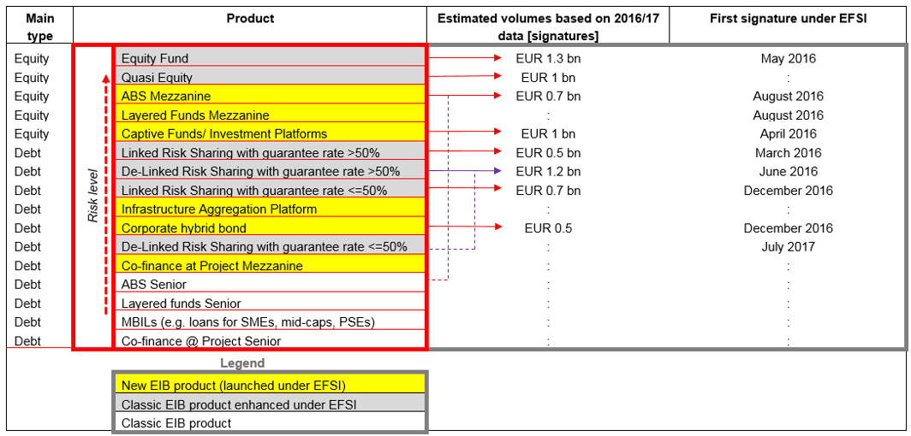

Source:EIB (2016) Evaluation updated and augmented by ICF based on inputs from the EIB equity and debt team provided in April 2018 Note: ‘:’ – missing data

# Annex 5: Potential overlaps – DEBT & EQUITY PRODUCTS SUPPORTING LENDING TO SMEs, 2014-2020

**Debt products supporting lending to SMEs, 2014-2020**

|  |  |  |  |  |  |  |  |  |
| --- | --- | --- | --- | --- | --- | --- | --- | --- |
| Product name | | Budget  (EUR million) | DGs in charge | Manager | Target | Specific focus | Comment | Potential overlap[97] |
| COSME LGF (Loan Guarantee Facility) | | 840 | GROW | EIF | SMEs | SMEs with a high-risk profile | Contributing to SMEI | Joint governance and loan size differentiation  Possible overlap with the SMEI |
| InnovFin SMEG (SME Guarantee) | | 1.060 | RTD | EIF | SMEs and Small Mid-Caps | Innovative and research-intensive SMEs and Small Mid-Caps | Contributing to SMEI |
| EaSI Guarantee Instrument | | 96 | EMPL | EIF | Social enterprises, micro-enterprises and vulnerable groups | Implemented through microcredit providers and social enterprise investors | Guarantee | EASI Sub-fund  Possibly with COSME LGF |
| CCS (Cultural and Creative Sectors) Guarantee Facility | | 121 | CNECT | EIF | SMEs | Cultural and creative sectors | - | COSME LGF  InnovFin SMEG |
| SME Initiative | | 1.137 | REGIO GROWRTD | EIF | SMEs | Developed as an anti-crisis measure. No specific target groups, but focus on participating Countries. | Operational in BG, FI, MT, RO, IT and ES.  InnovFin and COSME resources form part of SMEI resources. | InnovFin SMEG  COSME LGF |
| EASI Sub-fund *(under development)* | | 67 EASI + 133 from EIB/EIF | EMPL | EIF | Social enterprises, micro-enterprises and vulnerable groups | Implemented through microcredit providers and social enterprise investors | Funded product | EaSI Guarantee Instrument |
| EFSI | COSME LGF Frontloading  *Top-up* | 550 | ECFIN |  |  | Cfr. COSME LGF |  |  |
| InnovFin SMEG Frontloading *Top-up* | 880 | ECFIN |  |  | Cfr. InnovFin SMEG |  |  |
| EaSI Guarantee Frontloading *Top-up* | 100 | ECFIN |  |  | Cfr. EaSI Guarantee |  |  |
| CCS Guarantee  *Top-up* | 60 | ECFIN |  |  | Cfr. CCS Guarantee |  |  |
| Securitisation instrument *(under development)* | 100 + 100 from EIB/EIF | ECFIN | EIF | SMEs and Mid-Caps (to be finalised) | Development of the securitisation market | - | COSME LGF securitisation |

**Equity products supporting lending to SMEs, 2014-2020**

|  |  |  |  |  |  |  |  |
| --- | --- | --- | --- | --- | --- | --- | --- |
| Product name | Budget  (EUR million) | DGs in charge | Manager | Target | Specific focus | Comment | Potential overlap[98] |
| COSME EFG (Equity Facility for Growth) | 490 (including fees) | GROW | EIF | SMEs | Companies in expansion stage | Contributes to Pan-EU VC FoF | SMEW Eq. Instr.  Pan-EU VC FoF  ESCALAR  RCR |
| EaSI Capacity Building Investments Window | 16 (including fees) | EMPL | EIF | Micro-credit and social finance providers | Build up of the institutional capacity of financial intermediaries | In exceptional cases providing also loans |  |
| ESCALAR *(under development)* | tbd | GROWECFIN | tbd | SMEs and mid-caps (to be further specified) | Expansion & growth phase, pre IPO | Innovative support to VC funds through guaranteed loans | COSME EFG  SMEW Eq. Instr.  Pan-EU VC FoF  EIB-EIF MFF  RCR |
| RCR | 9.500 (of which 2.500 from EFSI) | - | EIB (mandate to EIF) | SMEs and mid-caps | Companies from pre-seed to expansion. | - | Potentially any other product. |
| IFE (InnovFin Equity) | 495 (including fees) | RTD | EIF | SMEs and Small Mid-Caps | Companies in their pre-seed, seed, and start-up phases in H2020 sectors | No longer stand alone, being fully integrated with SMEW Eq. Instr. (see below) | (see SMEW Equity Instr.) |

|  |  |  |  |  |  |  |  |  |
| --- | --- | --- | --- | --- | --- | --- | --- | --- |
| EFSI | SMEW Equity Instrument | 1.270 (including fees) + 458 from IFE + 290 from EIF | ECFIN RTD | EIF | SMEs and Small Mid-Caps | Companies from pre-seed to expansion. Specific envelopes foreseen for: tech-transfer, business angels, social investment | EFSI resources are combined with IFE and EIF resources into a single product | Potentially any other product. |
| Pan-European Venture Capital Fund of Funds | Up to 300 from SMEW Equity Instr. + up to 100 from COSME | ECFIN RTD GROW | EIF | SMEs and Small Mid-Caps | Companies from pre-seed to expansion | Falling under the SMEW Equity Instrument, it combines COSME resources | COSME EFG  ESCALAR  RCR |
| EIB-EIF SME FIF (Funds Investment Facility) (under EFSI IIW) | 500 | - | EIB (mandate to EIF) | SMEs | Companies from pre-seed to expansion | Co-investment in funds where EIF is already present with non-EFSI resources | COSME EFG  SMEW Eq. Instr.  RCR |
| EIB-EIF MFF (Midcap Funds Facility) (under EFSI IIW) | 500 | - | EIB (mandate to EIF) | Mid-caps | Expansion & growth phase | - | COSME EFG  SMEW Eq. Instr.  ESCALAR  RCR |
| EIB-EIF CIF (Co-investment Facility under IIW) | 100 + 100 EIB | - | EIB (mandate to E | SMEs and Mid-Caps | Companies from pre-seed to expansion | Co-investment alongside funds where EIF is already present | COSME EFG  SMEW Eq. Instr.  ESCALAR  RCR |

1. Regulation 2015/1017 (hereafter also referred as EFSI 1.0 Regulation) as amended by Regulation (EU) 2017/2396 on 13 December 2017 (hereafter also referred to as EFSI 2.0 Regulation).
2. <https://ec.europa.eu/info/law/better-regulation/initiatives/ares-2017-6318655_en>
3. Evaluation of the functioning of the EFSI by the EIB, September 2016. Ad-hoc audit of the application of the Regulation 2015/1017 published on 14 November 2016 and prepared by EY.
4. EC, Autumn 2014. European Economic Forecast:

   <http://ec.europa.eu/economy_finance/publications/european_economy/2014/pdf/ee7_en.pdf>
5. Special Task Force (Member States, Commission, EIB) on Investment in the EU, Final Task Force Report, <http://www.eib.org/attachments/efsi_special_task_force_report_on_investment_in_the_eu_en.pdf>
6. Article 3 of the EFSI Regulation.
7. Article 11 of the EFSI 2.0 Regulation
8. The EU shall contribute 75% of the total EIAH Budget, up to a maximum of EUR 20 million annually (up to EUR 10 million in 2015) whereas the EIB shall contribute 25% of the total EIAH Budget up to a maximum amount of EUR 6.6 million per year (up to EUR 3.3 million in 2015).
9. <https://ec.europa.eu/eipp/>
10. Article 15 of the EFSI Regulation
11. Admission criteria according to the Commission Implementing Decision 2017/919; projects have to (i) have a total cost of at least EUR 1 million, (ii) fall under one of the pre-determined high economic-value-added, (iii) be expected to start within three years of their submission, (iv) be promoted by a public or private legal entity established in an EU Member State, and (v) be compatible with all applicable EU and national laws. Publication of a project can be denied on legal, reputational, or other grounds.
12. Implementing Decision (EU) 2016/1942 of 4 November 2016, as amended by Commission Decision (EU) 2017/919 of 29 May 2017 repealing Implementing Decision (EU) 2015/1214
13. Based on the Eurostat data for the GDP at market prices as of 2016. Available at:

    <http://ec.europa.eu/eurostat/web/national-accounts/data/main-tables>
14. In July 2016, following a high demand for SME products, the Steering Board decided to adjust the allocation of the EU Guarantee between the Innovation and Infrastructure Window (IIW) and the SME Window (SMEW) by increasing the limit for the SMEW up to the maximum amount of EUR 3 billion (EUR 500 million increase).
15. Project promoters can choose up to two sectors. This is based on the first and second sector chosen by the promoters. The actual number of SME projects is however much higher as illustrated by their company size.
16. EIB, 2017. Operational Plans. Available at:

    <http://www.eib.org/infocentre/publications/all/operational-plan-2017-2019.htm> and EIF, 2016. Operational Plan 2017-2019. Available: <http://www.eif.org/news_centre/publications/eif_cop_2017_2019.pdf>
17. This was a subpart of the OPC on Investment, research and innovation, SMEs and single market.
18. <http://eur-lex.europa.eu/legal-content/EN/TXT/HTML/?uri=CELEX:52016SC0297&from=EN>
19. <http://www.eca.europa.eu/Lists/News/NEWS1611_11/OP16_02_EN.pdf>
20. <http://www.eib.org/infocentre/publications/all/evaluation-of-the-functioning-of-the-efsi.htm>
21. <https://ec.europa.eu/commission/publications/independent-evaluation-investment-plan_en>
22. <http://ec.europa.eu/transparency/regdoc/rep/1/2016/EN/COM-2016-764-F1-EN-MAIN.PDF>
23. Note for instance that with the population size of 279, Confidence Level of 95% and Confidence Interval of 5, the minimum size of the sample that would allow to claim the representativeness of the findings is 162.
24. Source: ICF Evaluation report.
25. EIB, 2016. Restoring EU Competitiveness. Available at:

    <http://www.eib.org/attachments/efs/restoring_eu_competitiveness_en.pdf>
26. https://ec.europa.eu/info/sites/info/files/economy-finance/ip077_en.pdf
27. ECFIN calculation based on data from the AMECO database as of 23 May 2018. Gross fixed capital formation at current prices: total economy (UIGT) Unit: Mrd ECU/EUR- Standard aggregation. Gross domestic product at current prices (UVGD) Unit: Mrd ECU/EUR- Standard aggregation. http://ec.europa.eu/economy_finance/ameco/
28. See EIB, 'Restoring EU competitiveness', 2016. The estimate, until 2020, include investments in modernising transportation and logistics, upgrading energy networks, increasing energy savings, renewables, improving resource management, including water and waste.
29. The difference in the market gap calculation between the ICF and Commission estimates are due to differences in methodological approach (for more details see the ICF independent evaluation report).
30. Annex II to the EFSI Regulation, Section 8.
31. For the IIW portfolio: (i) investment should reach all 28 MS, (ii) the share of investment in any three Member States should not exceed 45 per cent of the EFSI portfolio, (iii) an indicative concentration limit of 30 per cent of the IIW portfolio for operations in any one sector.

    For the SMEW portfolio: the EIF should aim at reaching all the EU Member States and achieve a satisfactory geographical diversification among them.
32. Sectors defined as per Article 9 of the EFSI Regulation
33. <http://www.eib.org/attachments/strategies/efsi_steering_board_efsi_strategic_orientation_en.pdf>
34. Three Investment Platforms under SMEW: (1) CDP EFSI Thematic IP for Italian SMEs; over EUR 0.6 billion of signed financing already, (2) NPI EFSI multi-country Investment Platform for SMEs securitisation – for EU 28 MS; signature is still pending, (3) ITAtech EFSI Thematic Investment Platform for Technology Transfer in Italy; 2 transactions side as of early 2018
35. Source: EIB EFSI 2017 Operational Report.

    *Temporary employment* – jobs created to implemented a given project i.e. construction phase of a project; it is measured in person years.

    *Permanent employment* – jobs of long-term character that are anticipated to last beyond the project implementation phase; it is measured in FTE.

    *Jobs supported* – jobs created as a result of multi-beneficiary intermediates loans, risk-sharing structures and funds and other than infrastructure and non-SMEs funds; direct jobs supported are measured based on the information provided by financial intermediaries at the inclusion. See also Table 9.
36. The Investment Plan for Europe: Questions and Answers, 20 July 2015-

    http://europa.eu/rapid/press-release_MEMO-15-5419_en.htm
37. Based on approved operations as of 31 Dec 2016.
38. For centrally managed financial instruments, article 223 Rules of Application Leverage effect (Article 140 of the Financial Regulation) states that “(…) *the leverage effect of Union funds shall be equal to amount of finance to eligible final recipients divided by the amount of the Union contribution.* (…)” This definition implies that all sources of finance flowing into a project are included in the calculation of the “*amount of finance to eligible final recipients*”.
39. EFSI Stakeholders’ consultation Summary report, 8 December 2017
40. In risk-sharing operations, the EIB assumes the risk on underlying transactions to support the origination of an EFSI eligible new portfolio of loans. In partial delegation models, the EIB retains the right to approve/reject any addition to the portfolio. In full delegation models, the EIB delegates to the financial intermediary the selection of the loans based on pre-defined criteria.
41. Interview with CEF programme managers
42. 2017, Technopolis, Interim Evaluation of the COSME Programme, Annex A to the final report, EC, available at: <http://ec.europa.eu/DocsRoom/documents/28084>
43. EIB, 2015. Key Performance Indicators. Available at:

    <http://www.eib.org/attachments/strategies/efsi_steering_board_kpi_kmi_methodology_en.pdf>
44. The EIB and JRC are currently in the process updating the calculations for all approvals up to 31st of December 2017. However, the results are expected to be available in early June and will be publicly available.
45. Due to the time lag of reporting data, the end-2017 results are currently under preparation.
46. Marginal/ acceptable/ good/ excellent in the case of 2nd Pillar, and low/ moderate/ significant/ high for the 3rd Pillar
47. ECA, November 2016. EFSI, an early proposal to extend and expand.
48. EIB, 2017. EFSI Governance. Available at: <http://www.eib.org/efsi/governance/index.htm>
49. ECA, November 2016. EFSI, an early proposal to extend and expand.
50. The minutes documents from the period between June 2016 and March 2017 do not provide the indication whether a given application was approved unanimously or by majority
51. Generally, EFSI operations under IIW are typically more complex than standard EIB operations. Certain projects may require additional time and resources, and the time elapsed between approval and signature is also a function of how efficient is a given project promoter who seeks financing.
52. CEPS 2017 study commissioned by the European Parliament: “*With the ambition of securing the efficiency and effectiveness of present budgetary instruments, it becomes essential to avoid duplication of effort and foster synergies and complementarities between instruments*.”
53. 2017, EC, Interim Evaluation of the Horizon 2020, Staff Working Document, available at: <https://ec.europa.eu/research/evaluations/pdf/archive/h2020_evaluations/swd(2017)221-interim_evaluation-h2020.pdf#view=fit&pagemode=none>
54. Including Grand Contournement Ouest de Strasbourg (A355), A6 Wiesloch in transport and the Transgaz "BRUA" Gas Interconnection Project, Italian-France electricity interconnector in energy.
55. Principles established in September 2015 and "Revised policy guidance regarding complementarity of the CEF DI with EFSI" in July 2017).
56. 2017, Technopolis, Interim Evaluation of the COSME Programme, Annex A to the final report, EC, available at: <http://ec.europa.eu/DocsRoom/documents/28084>
57. <http://ec.europa.eu/regional_policy/en/funding/financial-instruments/>
58. Combining ESIF financial instruments with the EFSI is also possible.
59. Commission staff working documents (SEC(2011) 867 final and SWD(2015) 124 final
60. EY independent evaluation in 2016 expressed concerns about potential crowding out. Similar concerns were expressed also by S&P study of 2017 and Brugel (2016).
61. The EIB Group already has its complaints mechanism, but this is not EFSI-specific.

    <http://www.eif.org/news_centre/publications/Complaints_Mechanism_Policy.htm>
62. 2017, EC, Interim Evaluation of the Horizon 2020, Staff Working Document, available at: <https://ec.europa.eu/research/evaluations/pdf/archive/h2020_evaluations/swd(2017)221-interim_evaluation-h2020.pdf#view=fit&pagemode=none>
63. 2017, Technopolis, Interim Evaluation of the COSME Programme, Annex A to the final report, EC, available at: <http://ec.europa.eu/DocsRoom/documents/28084>
64. Special Report 20/2017
65. CAN Europe & all, 2016. The best laid plans: Why the Investment Plan for Europe does not drive the sustainable energy transition. Available at: <http://www.foeeurope.org/best-laid-plans-investment-europe-sustainable-transition-280916> and FT, 2017. EU president’s scheme to stimulate investment needs adjustments before it expands. Available at: <https://www.ft.com/content/90712920-138b-11e7-b0c1-37e417ee6c76>
66. Exceptions for EFSI support to motorways would be made “*in cohesion countries, in less developed regions or in cross-border transport projects or if it is necessary to upgrade, maintain or improve road safety, develop intelligent transportation system (ITS) devices, guarantee the integrity and standards of existing motorways on the trans-European transport network, in particular safe parking areas, alternative clean fuels stations and electric charging systems, or contribute to the completion of the trans-European transport network by 2030*.”
67. 2017, Technopolis, Interim Evaluation of the COSME Programme, Annex A to the final report, EC, available at: <http://ec.europa.eu/DocsRoom/documents/28084>
68. 2017, Technopolis, Interim Evaluation of the COSME Programme, Annex A to the final report, EC, available at: <http://ec.europa.eu/DocsRoom/documents/28084>
69. 2017, CSES, Interim evaluation of Horizon 2020’s Financial Instruments, EC, available at : https://ec.europa.eu/research/evaluations/pdf/archive/other_reports_studies_and_documents/interim_evaluation_of_horizon_2020's_financial_instruments.pdf
70. See for instance ICF study on feasibility of Investment Platforms in Education and Training from 2016 for DG EAC, European Commission.
71. 2017, Technopolis, Interim Evaluation of the COSME Programme, Annex A to the final report, EC, available at: <http://ec.europa.eu/DocsRoom/documents/28084>
72. See Annex 6 for a detailed discussion of the finding of past EFSI evaluations.
73. ICF evaluation, EY Ad-hoc audit of the application of the EFSI Regulation, Bruegel, ECA opinion No 2/2016.
74. EIB (2014) Ex-ante assessment methodology for financial instruments in the 2014-2020 programming period, General methodology covering all thematic objectives Volume I, Version 1.2 dated April 2014
75. This is different from the EFSI Regulation definition that links additionality to availability of EIB Group financing: “*could not have been carried out in the period during which the EU Guarantee can be used, or not to the same extent, by the EIB, the EIF or under existing Union financial instruments without EFSI support*.”
76. ECA (2017) EU-funded loan guarantee instruments: positive results but better targeting of beneficiaries and coordination with national schemes needed. The report covered: InnovFin SME Guarantee Facility for research- and innovation-driven companies and the COSME Loan Guarantee Facility
77. CSES (2017) Interim Evaluation of Horizon 2020's Financial Instruments
78. Technopolis (2017) Interim Evaluation of the COSME Programme, Annex A to the Final report: Access to Finance thematic area report
79. EIAH, July-December 2017, bi-annual technical report.
80. <http://www.eib.org/infocentre/press/releases/all/2018/2018-014-the-eib-has-provided-eur-8-2bn-in-lending-to-slovakia-since-its-establishment.htm>
81. It is to be noted that the multiplier can only be measured at the end of the investment period at portfolio level.
82. EFSI Strategic Orientation:

    <http://www.eib.org/attachments/strategies/efsi_steering_board_efsi_strategic_orientation_en.pdf>
83. Based approved EFSI operations in 2015 and 2016.
84. CAN Europe & all, 2016. The best laid plans: Why the Investment Plan for Europe does not drive the sustainable energy transition. Available at: <http://www.foeeurope.org/best-laid-plans-investment-europe-sustainable-transition-280916> and FT, 2017. EU president’s scheme to stimulate investment needs adjustments before it expands. Available at: <https://www.ft.com/content/90712920-138b-11e7-b0c1-37e417ee6c76>
85. Evaluation of the functioning of the EFSI by the EIB, September 2016. Ad-hoc "audit” of the application of the Regulation 2015/1017 published on 14 November 2016 by EY.
86. This was a subpart of the OPC on Investment, research and innovation, SMEs and single market.
87. The InvestEU Funds scope is broader than currently under EFSI, therefore the other evaluations were also reviewed.
88. <https://ec.europa.eu/info/publications/2017-european-semester-country-reports_en>
89. This was a subpart of the OPC on Investment, research and innovation, SMEs and single market.
90. https://ec.europa.eu/info/law/better-regulation/initiatives/ares-2017-6318655_en
91. https://ec.europa.eu/info/law/better-regulation/initiatives/ares-2017-6318655_en
92. 1808 respondents out of 4052 answered this question
93. Source of the table: ICF draft final evaluation report.
94. For instance KfW’s Projektdatenbank which presents KfW supported development projects: <https://www.kfw-entwicklungsbank.de/Internationale-Finanzierung/KfW-Entwicklungsbank/Projekte/Projektdatenbank/index.jsp>
95. EC, 2016. SWD. Proposal for a Regulation of the European Parliament and of the Council amending Regulations (EU) No 1316/2013 and (EU) 2015/1017 as regards the extension of the duration of the European Fund for Strategic Investments as well as the introduction of technical enhancements for that Fund and the European Investment Advisory Hub
96. EIB, 2018. Annual Risk Profile Report IIW 2017.
97. In terms of targeted final beneficiaries and expected policy achievements.
98. In terms of targeted final beneficiaries and expected policy achievements.