

# Table of contents

Table of contents 0

Abbreviations 1

Executive Summary 2

1 Introduction 4

2 Background to the intervention 5

2.1 Baseline 5

2.2 Description of AMIF and its objectives 10

3 Implementation / State of Play 17

3.1 Description of the implementation processes 17

3.2 Description of the implementation status 18

4 Method 24

4.1 Short description of the methodology 24

4.2 Evaluation questions 25

4.3 Limitations and robustness of findings 25

5 Analysis and answers to the evaluation questions 27

5.1 How effective has AMIF been so far 27

5.2 How efficient has AMIF been so far 37

5.3 How much simplification and reduction of administrative burden has AMIF brought so far 40

5.4 How relevant has AMIF been so far 42

5.5 How coherent and complementary has AMIF been so far 45

5.6 What is the EU added value of AMIF so far 48

5.7 How sustainable are the actions implemented under AMIF so far 51

6 Conclusions and issues for further consideration 53

6.1 Effectiveness 53

6.2 Efficiency 53

6.3 Simplification and reduction in administrative burden 54

6.4 Relevance 54

6.5 Coherence and complementarity 54

6.6 EU added value 55

6.7 Sustainability 55

Annex 1: Procedural information 56

Annex 2: Methods and analytical models 57

Annex 3: Stakeholder consultation 60

Annex 4: The Evaluation Questions 63

Annex 5: Costs and Benefits associated with the AMIF 66

# Abbreviations

|  |  |
| --- | --- |
| AMIF | Asylum Migration and Integration Fund |
| CEAS | Common European Asylum System |
| CIPS | Specific programme Prevention, Preparedness and Consequence Management of Terrorism and Other Security-related Risks |
| DCI | Development Cooperation Instrument |
| DG HOME | Directorate-General for Migration and Home Affairs |
| EAFRD | European Agricultural Fund for Rural Development |
| EASO | European Asylum Support Office |
| EBF | External Borders Fund |
| EIF | European Fund for the Integration of third-country nationals |
| EMAS | Emergency assistance |
| EMFF | European Maritime and Fisheries Fund |
| EMN | European Migration Network |
| ERF | European Refugee Fund |
| EU | European Union |
| Eurostat | Statistical office of the European Union |
| ERDF | European Regional Development Fund |
| ESIF | European Structural and Investment Funds |
| ESF | European Social Fund |
| EUTF | European Union Emergency Trust Fund for stability and addressing root causes of irregular migration and displaced persons in Africa |
| FEAD | Fund for European Aid to the Most Deprived |
| FTE | Full-time equivalent |
| IOM | International Organisation for Migration |
| ISEC | Specific programme Prevention of and Fight against Organised Crime |
| ISF | Internal Security Fund |
| ISF-BV | ISF Borders and Visa |
| ISF-P | ISF Police |
| RDPP | Regional development and protection programme |
| RF | European Return Fund |
| SOLID | General programme Solidarity and Management of Migration Flows |
| SFC2014 | Shared Fund Management Common System of DG HOME |
| TCN(s) | Third-country national(s) |
| UNHCR | United Nations High Commissioner for Refugees |

|  |
| --- |
| **List of countries** |

|  |  |
| --- | --- |
| AT | Austria |
| BE | Belgium |
| BG | Bulgaria |
| CH | Switzerland |
| CY | Cyprus |
| CZ | Czech Republic |
| DE | Germany |
| DK | Denmark |
| EE | Estonia |
| EL | Greece |
| ES | Spain |
| FI | Finland |
| FR | France |
| HR | Croatia |
| HU | Hungary |
| IS | Iceland |
| IT | Italy |
| LI | Lichtenstein |
| LT | Lithuania |
| LU | Luxembourg |
| LV | Latvia |
| MT | Malta |
| NL | Netherlands |
| NO | Norway |
| PL | Poland |
| PT | Portugal |
| RO | Romania |
| SE | Sweden |
| SI | Slovenia |
| SK | Slovakia |
| TK | Turkey |
| UK | United Kingdom |

# Executive Summary

This staff working document (SWD) presents the main findings of the interim evaluation of the Asylum Migration and Integration Fund (AMIF or ‘the Fund’) for the programming period 2014-2020, specifically covering the years 2014-2017. The evaluation assesses AMIF’s current progress towards meeting its objectives. The findings will inform the legislators and all stakeholders of its achievements so far, provide the evidence base for the Member States and the Commission to address weaknesses and take corrective measures to minimise their impact, and inform the design of future funds.

**Background**

AMIF was designed to promote the efficient management of migration flows and the implementation, strengthening and development of a common EU approach to asylum and immigration. During the implementation period under review, the migration conditions changed drastically due to the sudden and unexpected increase in migratory pressure on the EU’s southern and south-eastern borders.

AMIF’s general objective is to be achieved through: (i) (asylum) strengthening and developing the Common European Asylum System by ensuring that EU legislation in this field is efficiently and uniformly applied; (ii) (legal migration and integration) supporting legal migration to EU States in line with labour market needs and promoting the effective integration of third-country nationals; (iii) (returns) strengthening fair and effective return strategies, which contribute to combating irregular migration and emphasise the sustainability and effectiveness of the return process; and (iv) (solidarity) making sure that EU States which are most affected by migration and asylum flows can count on solidarity from other EU States.

Additionally, the Fund provides special financial incentives for EU States to support (i) the Union resettlement programme, which focuses on common EU priorities and (ii) a similar financial mechanism for transferring people under international protection from an EU State with high migratory pressure to another with lower migratory pressure. It also provides financial resources for the activities and future development of the European Migration Network.

**Resources mobilised by AMIF**

The Fund’s total initial allocation was estimated at EUR 3 137 million, divided as follows:

* EUR 2 752 million for national programmes managed by Member States under shared management; and
* EUR 385 million for the European Migration Network as well as Union actions and emergency assistance managed either directly or indirectly by the Commission.

This budget was substantially increased through top-ups in order to support (i) relocation and resettlement, (ii) integration and return, and (iii) the resources linked to the revision of the Dublin Regulation as well as to show solidarity and share the burden with the most affected Member States. By the end of 2017 it amounted to a total of EUR 6 888 million, an increase of 120 %. Currently, EUR 4 567 million is allocated to support asylum and solidarity, and EUR 2 305 million is allocated for legal migration and integration. The support provided through emergency assistance increased significantly as well, from a total of EUR 160 million to EUR 1 028 million.

**Main lessons learnt**

An interim evaluation has obvious limitations, as the first projects only (barely) started three years ago. Migration, integration and solidarity are long-term endeavours creating an impact that can only be captured in a very partial manner after such a short period. A monitoring system with indicators to systematically track impact (particularly for integration) is also found to be wanting.

Based on the interim evaluation, the following main conclusions could be drawn:

AMIF has played an important role in improving asylum systems and strengthening reception capacity in the Member States, and as a result of the migration crisis the area of asylum was specifically prioritised in many countries. The Fund also paid special attention to the most vulnerable, particularly the unaccompanied minors.

So far, the results of AMIF have been achieved at a reasonable cost in terms of both human and financial resources, thanks to an effective management and control system that ensured the Fund was correctly implemented and irregularities were prevented. Overall, most of the innovative measures (e.g. simplified cost options, multiannual programming) are considered to be especially positive by beneficiaries and appear to have achieved simplification.

Despite the large increase in value of the emergency assistance, and the emergency situation on the ground, AMIF continues to be highly relevant since it has proven to be sufficiently broad and all-encompassing in responding to these different needs. Most national programmes are still in line with the Fund’s general objectives and the Member States’ needs.

AMIF has also proven that it can be complementary to, as well as consistent and strategically aligned with other financial instruments (especially ISF-BV, ESF, ERDF, EAFRD, EMFF, FEAD, EUTF, and DCI) and relevant key EU policy strategies. Overall, AMIF has generated important EU added value, despite the relatively small amount of funding it receives, taking into account the important challenges brought about by the crisis that occurred during this period. The main EU level benefit derives from the transnational dimension of certain actions but also EU level burden-sharing, supported in particular by the emergency assistance and the relocation mechanism. Sustainability has been thoroughly accounted for by AMIF through check mechanisms set in place at programming and implementation stages across most instruments, although to a lesser extent by the emergency assistance due to the nature of the actions.

However, there appears to be room for improvement, especially regarding the internal coherence of the fund (among AMIF’s management modes) as beneficiaries are not very aware of the projects carried out within the AMIF framework. Similarly, the administrative burden appeared to be the main factor that undermined the Fund’s efficiency, including some control measures that appeared too stringent even if AMIF has led to simplification relative to the past. On the other hand, there is limited evidence of increased capacity to develop, monitor and evaluate asylum systems, and, while the EU resettlement programme has made big progress so far, there has been limited contribution towards establishing, developing and implementing national resettlement programmes. Finally, regarding the monitoring and evaluation system that AMIF created, in line with the Better Regulation guidelines, further improvements need to be made, for example, in the definition of its indicators and the collection of data.

Introduction

This Commission staff working document presents the interim evaluation of AMIF in line with Article 57 of Regulation (EU) No 514/2014[1], the Commission Delegated Regulation (EU) 2017/207[2], and the Better Regulation guidelines[3].

Member States submitted to the Commission an interim evaluation report on the implementation of actions and progress towards achieving the objectives of their national programmes by 31 December 2017. On the basis of these reports, the Commission must submit an interim evaluation report on the implementation of Regulation (EU) No 513/2014, Regulation (EU) No 515/2014 and Regulation (EU) No 516/2014 to the European Parliament, to the Council, to the European Economic and Social Committee and to the Committee of the Regions by 30 June 2018.

The purpose of this interim evaluation is:

1) to ensure transparency and accountability in AMIF’s implementation; and

2) to help make the future implementation of EU financial instruments in the fields covered by AMIF more relevant, effective, efficient, and sustainable, and enable them to provide EU added value.

This evaluation looks at the progress made in implementing the programmes, and assesses whether corrective actions are needed to make sure that the programmes are delivered as planned. It will also contribute to the preparation of the next generation of funding instruments (under AMIF’s successor) in the framework of the post-2020 multiannual financial framework.

This evaluation covers all EU Member States except Denmark which does not participate in AMIF. The evaluation covers the period from 1 January 2014 until 30 June 2017[4], reporting on the actions supported under the national programmes of the participating countries, including specific actions and technical assistance, Union actions including emergency assistance and the European Migration Network actions.

Background to the intervention

Baseline

Ensuring a high level of freedom and security within Europe has been at the top of the EU policy agenda since the Tampere Council Conclusions in 1999. Policies such as migration, security and management of the external borders became a strategic priority at EU level through the priorities set by The Hague programme[5] and the Stockholm programme and its action plan[6]. These policies covered areas such as legal migration and integration, asylum, irregular migration and return (migration), prevention of and fight against terrorism and organised crime, police cooperation (security) and management of the external borders and visa policy, as well as the external dimension of these policies.

The overall aim of these policies is to create an area without internal borders where EU citizens and third-country nationals (TCNs):

* may enter, circulate, live and work;
* bring new ideas, capital, knowledge and innovation; and
* fill gaps in national labour markets, confident that their rights are fully respected and their security assured.

Cooperation with third countries and international organisations is crucial to achieving this goal. Home affairs policy priorities should also be seen in the context of the flagship initiatives presented in the Europe 2020 strategy[7] which aim to achieve smart, sustainable and inclusive growth.

To ensure fair responsibility-sharing concerning common migration and asylum policies, the EU has started to provide financial support to strengthen the area of freedom, security and justice, and to increase financial solidarity among the Member States. In this light, under the 2007-2013 programming period, the general programme ‘Solidarity and Management of Migration Flows’ (SOLID)[8] was put in place, with a total contribution of almost EUR 4 billion, to support the development of common policies in the areas of asylum, return and integration, external borders and visa.

The SOLID programme’s legal base has been built up through four separated financial instruments, following the way in which the different policy areas are regulated in the Treaties[9]: the European Refugee Fund (ERF), the European Fund for the Integration of third-country nationals (EIF), the European Return Fund (RF) and the External Borders Fund (EBF)[10]. The ERF, the EIF and the RF, which have become AMIF[11], have supported the following objectives:

* support and encourage Member States efforts in receiving, and in dealing with the consequences of receiving refugees and displaced persons, taking account of Community legislation on those matters (ERF);
* support Member States efforts in enabling third-country nationals of different economic, social, cultural, religious, linguistic and ethnic backgrounds to fulfil the conditions of residence and to facilitate their integration into European societies (EIF);
* contribute to developing and implementing national integration strategies for third-country nationals in all aspects of society, in particular taking into account the principle that integration is a two-way dynamic process of mutual accommodation by all immigrants and Member States residents (EIF); and
* support Member States efforts to improve the integrated management of return in all its dimensions and provide for joint actions to be implemented by Member States or national measures that pursue EU objectives under the solidarity principle, accounting for EU legislation in this field and in full compliance with fundamental rights (RF).

The four funds were implemented under shared management through annual national programmes, and under direct management by means of Community actions and Specific actions.

Moreover, to boost security, the EU provided financial support to deal with and combat terrorism, organised crime, different types of trafficking and security risks potentially affecting EU citizens. The programme ‘Security and Safeguarding Liberties’ was put in place (with almost EUR 800 million in funding) and consists of two separate financial instruments, each following a different legal basis set out in the Treaties[12]: Specific programme ‘Prevention of and Fight against Organised Crime’ (ISEC) and Specific programme Prevention, Preparedness and Consequence Management of Terrorism and other Security-related risks (CIPS)[13].

The SOLID programme, together with the CIPS and ISEC, were replaced by AMIF and the Internal Security Fund (ISF Borders and Visa and ISF Police) in April 2014. The main driver for creating the two-pillar structure was to contribute to the simplification, rationalisation, consolidation and transparency of funding in the field of asylum and migration.

The table below shows the development (in size and scope) of the funds in the home affairs area, how they evolved over time, leading up to the development of the current generation of funds, namely AMIF and the ISF.

Table 1: Summary overview of home affairs funds and programmes during 2007-2013 and 2014-2020[14]

| **General Programme** | **Policy area** | **Fund / Specific Programme**  **Budget, Participation & Objectives** | |
| --- | --- | --- | --- |
|  |  | **Previous Funds (2007-2013)** | **Current Funds (2014-2020)** |
| General programme Solidarity and Management of Migration Flows  *(93 % to 96 % shared management; remainder under centralised direct management)* | Asylum | European Refugee Fund (ERF III)  EUR 614 million[15], All Member States except DK   * + - * + Support and encourage Member States in receiving refugees and displaced persons         + Emergency measures to address sudden mass influx of migrants and asylum seekers | Asylum Migration and Integration Fund (AMIF)  EUR 3 137 million (initial)  All Member States except DK   * + - * + Strengthen and develop all aspects of the Common European Asylum System (CEAS)         + Support legal migration to the Member States and promote effective integration of third-country nationals         + Strengthen fair and effective return strategies and contribute to combating illegal immigration         + Strengthen solidarity and responsibility-sharing between Member States, particularly those most affected by the migratory flows |
| Integration of legally residing TCNs, legal migration | European Fund for the Integration of Third-Country Nationals (EIF)  EUR 825 million, All Member States except DK   * + - * + Support the integration of non-EU immigrants into European societies |
| Return | European Return Fund (RF)  EUR 676 million, All Member States except DK   * + - * + Improve return management         + Encourage development cooperation between Member States and countries of return |
| Integrated border management and visa | External Borders Fund (EBF)  EUR 1 820 million, All Member States (including RO & BG and the Schengen associated states from 2010) except the UK and IE   * + - * + Financial solidarity among Schengen countries         + Manage efficient controls and the flows at the external borders         + Improve management of the consular authorities | Internal Security Fund (ISF)  EUR 3 764 million (initial)  ISF Borders and Visa  All Member States except IE and the UK plus the Schengen associated states CH, IS, LI and NO   * + - * + Ensuring a high level of security in the EU and facilitating legitimate travel         + Visa and support integrated border management   ISF Police  All Member States except DK and the UK   * + - * + Ensure a high level of security in the EU, fight against crime, manage risks and crisis |
| General programme Security and Safeguarding Liberties  *(centralised direct management)* | Prevention of and fight against organised crime | Specific programme Prevention of and Fight against Organised Crime (ISEC)  EUR 600 million, All Member States   * + - * + Crime prevention, law enforcement, witness protection and support, victims protection |
| Combating terrorism and other security-related risks | Specific programme Prevention, Preparedness and Consequence Management of Terrorism and Other Security-related Risks (CIPS)  EUR 140 million, All Member States   * + - * + Protection of citizens and critical infrastructure from terrorist attacks and other security incidents |

The share of funding for home affairs in the EU budget was relatively small but steadily growing — in the period 2007-2013 it amounted to EUR 6.45 billion[16] or 0.77 % of the total EU budget, covering not only the financing of programmes, but also the funding for large-scale IT systems (VIS, SIS, EURODAC)[17] and the agencies. The spending during this period has been characterised by heavy ‘back-loading’ (deferment of payments until the end of the financial periods), increasing from EUR 500 million in 2007 to EUR 1.5 billion in 2013.

The external dimension of home affairs policies was not covered by the SOLID funds themselves but mainly through the thematic programme ‘Cooperation with Third Countries in the Area of Migration and Asylum’[18] and other thematic programmes (approximately EUR 135 million per year).

Results from previous evaluations and stakeholder feedback confirm that these instruments have been generally effective and that EU funding has added genuine value14. Nevertheless, the EU has been facing a number of policy challenges, schematically collected in the table below.

Table 2: Overview of challenges faced by Member States and the EU in the area of home affairs to be addressed in the period 2014-202014

|  |  |
| --- | --- |
| **Asylum** | * + - * + The number of asylum applications varies significantly between Member States with some receiving higher numbers than their systems can handle when trying to process, support and protect asylum applicants, some of whom are particularly vulnerable such as unaccompanied minors, women, and victims of violence (including torture), and when trying to prevent the trafficking of human beings         + At the EU level, the development and implementation of the CEAS was supported primarily by the ERF, which was created to promote solidarity and responsibility-sharing between Member States (including the voluntary transfer of beneficiaries of and applicants for international protection — ‘relocation’). The ERF also provided an additional financial incentive (EUR 4 000 per person.) to Member States who resettle vulnerable groups and people from countries and regions whose designation is based on Member States voluntary pledging).         + Because the allocations for resettlement were taken from the total ERF envelope (12 %), the increasing involvement of Member States in resettlement operations reduced the allocations available for other actions under the annual programmes.         + The ERF also did not provide any additional financial incentive to Member States for the intra-EU transfer of beneficiaries of and applicants for international protection (‘relocation’). Such operations would have used the available allocations, therefore limiting other actions and have been supported by the Community actions (e.g. European Relocation Malta (EUREMA) relocating 260 beneficiaries of international protection from Malta to 10 other Member States).         + The ERF could not financially support the regional protection programmes (RPP) to increase the capacity of areas which are close to regions of origin, or which are areas of transit, in order to protect refugees through the three durable solutions of repatriation, local integration and/or resettlement. |
| **Legal migration and integration** | * + - * + An estimated 20.2 million TCNs were living in the EU in 2010, i.e. 4 % of the total population. Compared to EU citizens, migrants generally experience lower labour market participation rates, attain a poorer than average education and have reduced social mobility, all leading to social difficulties, the cost of which is ultimately borne by the society as a whole. Better integration would help EU’s economy meet the 2020 strategy objective of increasing the employment rate of the population aged 20-64 from the current 69 % to at least 75 % by 2020.         + The integration activities were shared between the ERF (mainly reception and introductory schemes for refugees and people benefiting from other forms of international protection), the EIF (reception and introductory schemes for the legally residing migrants) and the ESF (European Social Fund, focusing on complementary support on access to labour markets).         + There was need to more effectively target specific measures or specific groups of migrants who cannot easily be reached by mainstream instruments.         + The EIF could not provide financial support for developing the EU ‘Global Approach to Migration’ (GAM), in particular the negotiation, signing and implementation of mobility partnerships. |
| **Irregular immigration and return** | * + - * + Because of its clandestine nature, it is very difficult to determine the scale of irregular immigration. Estimates vary significantly, with 4.5 million and 8 million irregular migrants living in the EU in 2009. Approximately 500 000 of these are apprehended annually, most of whom are over stayers choosing to remain for economic reasons. Critically, due to the free movement of people in the Schengen area, the burden of dealing with irregular immigration does not necessarily fall on the country of entry but rather on the destination Member States, with some receiving numbers disproportionate to their capacity to detect, regularise or return such migrants.         + Assisted return is also significantly more cost-effective than forced returns or deportations (more than 66 % less expensive than forced returns when reintegration assistance is taken into account). As a result, Member States felt the need for a comprehensive and sustainable approach to the return process with pre- and post-return (reintegration measures).         + There has also been a need for increased cooperation and coordination in return operations as acknowledged by the increased budget of Frontex that is dedicated to joint return operations (from EUR 5.2 million in 2009 to EUR 10 million in 2011).         + The RF did not provide financial incentives to help third countries cope with the financial burden of readmitting irregular migrants (in the framework of readmission agreements), either in terms of reintegrating their own nationals or onward readmission of third-country nationals to their countries of origin. |

The four different SOLID funds complemented each other and provided a holistic approach to the EU asylum and migration system. However, there were drawbacks, identified by the interim and *ex post* evaluations, by the special reports of the European Court of Auditors[19], as well as during the Commission’s impact assessment accompanying its proposals for the 2014-2020 generation of home affairs funds14.

Those drawbacks included:

* a lack of proper flexibility and high administrative burden on both the Commission and the Member States due to the annual programming;
* a lack of effective monitoring and evaluation systems and common indicators with measurable targets; and
* delays in providing evaluation reports at Member States and Commission level, which carried the risk that activities were not suitably strengthened where they were most needed.

This staff working document also analyses the extent to which the recommendations that came out of the *ex post* evaluations of SOLID have been taken into account in AMIF (see table below).

Table 3: Overview of findings and recommendations that have shaped AMIF

|  |  |
| --- | --- |
| ***Ex post* evaluations of SOLID** | **What has AMIF addressed and how** |
| * + - * + Formulation of national priorities was too broad with a **complex architecture** in terms of articulation between general and speciﬁc objectives, and between general objective and specific priorities         + **Limited flexibility** due to the annual programming that does not allow the funds to be adapted to the objectives and the changing needs of Member States | * + - * + **Simpliﬁcation of the architecture** — four specific objectives supported by additional national objectives         + Shift towards **multiannual programme** to offer more **ﬂexibility** and significantly **reduce administrative burden** towards a more results-driven management of the fund         + **National programmes (national programmes) based on outcomes of a policy dialogue** between the Commission and the Member States to ensure priorities are relevant         + More emphasis on **strategic programming** through **follow-up of those Member States facing implementation difficulties**, and a **mid-term review** on the situation of each Member States to allow for adaptation |
| * + - * + **Eligibility limitations** that prevented the implementation of some actions that could have addressed the identified needs (e.g. the scope of the target group which did not include TCNs residing legally on the territory of Member States but wishing to return to their country of origin under the RF or the limited interpretation of the ‘newly arrived’ target group in the EIF) | * + - * + **A single fund** to cover all migration matters which is expected to reduce the administrative burden placed on Member States and the Commission         + **Expansion of the target group** to include third-country nationals enjoying the right to stay, legal residence and/or international protection or temporary protection for people who wish to voluntarily return to their country of origin |
| * + - * + **Distribution key** updated regularly (Member States found it too burdensome, and was still not able to respond to the EU’s needs on convergence, solidarity, CEAS development and unforeseen crises         + **Lack of efficiency** in supporting less experienced Member States or those facing difficulties in implementing their management and monitoring systems         + **Limited solidarity** and responsibility-sharing | * + - * + Distribution key for the allocations revised, although it still does not completely address the significant changes in migration flows across Europe         + **Burden-sharing is incentivised** through a 90 % co-financing rate in national programmes (specific actions)         + An **emergency mechanism** that focuses on pressing issues and where needs are the largest |
| * + - * + Absence of common monitoring and evaluation mechanisms         + Limited comparability of data | * + - * + An **obligatory common indicator** that requires Member States to have **established monitoring and evaluation systems** with formally designated bodies before receiving funds         + Member States provide more information on the **coherence and complementary** of the funds |
| * + - * + High administrative burden | * + - * + For a detailed analysis, see sub-chapter 5.3 |

Description of AMIF and its objectives

**In a nutshell**

AMIF co-finances national and EU actions that aim to promote the efficient management of migration flows, as well as implement, strengthen and develop a common EU approach to asylum and migration, such as receiving asylum seekers and refugees, the resettlement and integration of third-country nationals and the return of those ordered to leave EU territory.

### AMIF

The legal basis of AMIF is Regulation (EU) No 516/2014 (the Specific Regulation)[20], adopted by the European Parliament and the Council. The legal basis for each of these institutions to act in this area is set out in Articles 78(2), and 79(2) and (4) TFEU. In addition, general provisions for both AMIF and the ISF are laid down in Regulation (EU) No 514/2014 (Horizontal Regulation)1. These two are then complemented by many delegated and implementing regulations, including the Commission’s Delegated Regulation (EU) 2017/2072 on the common monitoring and evaluation framework (CMEF Regulation).

AMIF’s aim is to promote the efficient management of migration flows and implement, strengthen and develop a common EU approach to asylum and immigration. All Member States, with the exception of DK[21], contribute to implementing AMIF. Considering the evolving needs and challenges related to the migration crisis and security concerns, its budget was substantially increased; its initial allocation has been more than doubled. The following analysis on AMIF’s needs should be read in correlation with the answer to the evaluation question on relevance in sub-chapter 5.3.

**Needs addressed by AMIF**

The overview of challenges faced by Member States and the EU in the area of home affairs in the previous period 2007-2013 and presented in Table 2 above, could be translated in the following needs that AMIF tries to address:

* **Asylum**: the need for a joint approach to guarantee high standards of protection for refugees, while ensuring fair and effective procedures throughout the EU and preventing them from being abused;
* **Legal migration and integration**: a uniform application of the EU legal framework for legal migration, taking into account the integration needs of third-country nationals and legal residents;
* **Return**: a harmonised application of fair and effective return strategies which could contribute to combating irregular migration;
* **Solidarity**: a common approach to solidarity and responsibility-sharing, in particular towards those Member States most affected by migration and asylum flows.

**AMIF’s general and specific objectives**

As set out in Article 3 of the Specific Regulation, the general objective of the Fund; *‘…shall be to contribute to the efficient management of migration flows and to the implementation, strengthening and development of the common policy on asylum, subsidiary protection and temporary protection and the common immigration policy, while fully respecting the rights and principles enshrined in the Charter of Fundamental Rights of the European Union’*. This objective further breaks down in four specific objectives on asylum, legal migration and integration, return, solidarity:

*Specific Objective 1: Developing the Common European Asylum System (CEAS)*

*‘strengthen and develop all aspects of the CEAS, including its external dimension’*

The EU had been working on creating a CEAS since 1999, with a view to granting fair and equal treatment to asylum‐seekers across the EU. The backbone of the CEAS is provided by five legislative acts:

* The EURODAC Regulation establishes an EU asylum fingerprint database to help Member States process applications.
* The Dublin II Regulation identifies the Member States in charge of handling an asylum request, which is in principle the first EU country that the applicant enters. It also governs relations between Member States in this field.
* The Reception Conditions Directive (RCD) sets common standards for asylum seekers’ living conditions (e.g. access to food, housing and healthcare).
* The Asylum Procedures Directive (APD) establishes common standards in procedural rules, including safeguards and guarantees.
* The Qualification Directive (QD) sets common grounds for granting asylum in order to avoid different outcomes concerning a given request, depending on the Member States that handles it.

Strengthening and developing all aspects of the CEAS, including its external dimension, has become a priority and is based on three pillars:

* bringing more harmonisation to standards of protection by aligning the asylum legislation of Member States;
* effective and well-supported practical cooperation; and
* increased solidarity and sense of responsibility among EU Member States as well as between EU and third countries[22].

Member States are asked to dedicate 20 % of their share of the Fund towards supporting the efficient and uniform application of the CEAS.[23]

In light of this, AMIF supports the reception and asylum system by focusing on third-country nationals, including refugees, asylum seekers and resettled third-country nationals. AMIF funds actions aimed at strengthening Member States’ capacity to develop, monitor and evaluate their asylum policies and procedures or actions aimed at resettling and transferring applicants for, and beneficiaries of, international protection, and other ad hoc humanitarian admission.

*Specific Objective 2: Supporting legal migration to the EU and promoting the integration of non-EU nationals*

*‘support legal migration to the Member States in accordance with their economic and social needs, such as labour market needs, while safeguarding the integrity of the immigration systems of Member States, and to promote the effective integration of third-country nationals’*

There were 20.7 million non-EU-nationals residing in the EU in 2016, representing 4 % of the EU-28 population[24]. Their integration is thus considered a cornerstone EU objective and constitutes a necessary part of the EU’s goal of promoting economic growth, social cohesion and sustainable development in a climate of safety and security. Member States need to allocate 20 % of the Fund to supporting national integration strategies and actions to enable local authorities and civil society to engage in the process of encouraging integration and mutual trust.23 Similarly, AMIF supports legal migration to the EU in line with Member States labour market needs.

*Specific Objective 3: Combating irregular migration by strengthening fair and effective return strategies*

*‘enhance fair and effective return strategies in the Member States which contribute to combating illegal immigration, with an emphasis on sustainability of return and effective readmission in the countries of origin and transit’*

Under this objective, AMIF supports actions that strengthen fair and effective return strategies and contribute to combating irregular migration, with an emphasis on the sustainability and effectiveness of the return process. Some of these actions include:

* strengthening the capacity to develop effective and sustainable return policies;
* improving operational cooperation between the authorities involved in the return process;
* supporting cooperation between third countries and Member States, including strengthening third countries’ capacities to conduct readmission and reintegration activities; and
* running information campaigns in third countries aimed at raising awareness of the risks of illegal immigration.

Specific measures aim to:

* develop and improve alternatives to detention;
* provide social assistance, information or counselling, legal aid and language assistance;
* prepare return operations;
* exchanging information on the situation in countries of return, best practice, and shared experiences;
* pool resources between Member States;
* assist with voluntary return;
* improve facilities and services for migrants in third countries ensuring temporary accommodation and reception upon arrival; and
* provide specific assistance for vulnerable persons.

*Specific Objective 4: Strengthening a mechanism of solidarity to cope with migration and the migrant crisis among Member States, particularly those most affected*

*‘enhance solidarity and responsibility-sharing between the Member States, in particular towards those most affected by migration and asylum flows, including through practical cooperation’*

At the core of the fund is the willingness to ensure a solidarity mechanism between Member States most affected by migration and asylum flows and other EU States. For example, Member States receive a lump sum for each person who is effectively resettled on their territory from a third country under the Union resettlement programme, as well as for each time they accept someone who is under international protection from another EU Member States.

Finally, AMIF financially supports the European Migration Network (EMN), which provides data on migration and asylum to facilitate policy making in EU institutions and state authorities.

**Target group and beneficiaries of AMIF**

The target group for AMIF actions include[25]:

* those who enjoy refugee status or subsidiary protection status within the meaning of Directive 2011/95/EU (Qualification Directive);
* those who have applied for one of the forms of international protection referred to in the above point and have not yet received a final decision;
* those who enjoy temporary protection within the meaning of Directive 2001/55/EC (Temporary Protection Directive);
* those who are being or have been resettled in or transferred from an Member States;
* TCNs who are residing legally or, where appropriate, are in the process of acquiring legal residence in an Member States;
* TCNs who have not yet received a final negative decision on their request to stay, their legal residence and/or international protection in an Member States, and who may choose to make use of voluntary return;
* TCNs enjoying the right to stay, legal residence and/or international protection within the meaning of Directive 2011/95/EU, or temporary protection within the meaning of Directive 2001/55/EC in an Member States, and who have chosen to make use of voluntary return;
* TCNs who are present in an Member States and do not or no longer fulfil the conditions for entry and/or staying in an Member States, including those TCNs whose removal has been postponed in accordance with Directive 2008/115/EC (Return Directive);
* People from a country or region designated for the implementation of a regional protection programme;
* People from a country or region which has been identified in the UNHCR resettlement forecast and where EU common action would have a significant impact on addressing the protection needs; and
* People belonging to a specific category falling within the UNHCR resettlement criteria.

This means that the Fund’s beneficiaries — those implementing the actions supported by the Fund — range from national, federal, regional or local public authorities to international organisations, non-governmental organisations in civil society, humanitarian organisations, private and public law companies, education and research organisations.

**Eligible actions**

The eligible actions under AMIF are listed in Articles 5 to 13, Article 20 and Annex II of the Specific Regulation. These include: (i) providing support services and assistance, (ii) setting up and improving administrative structures, (iii) training for staff, (iv) establishing and developing reception, accommodation and transit centres, (v) information for local communities, (vi) actions concerning resettlement and humanitarian admission programmes, and (vii) setting up of transnational cooperation networks and pilot projects, etc.

The eligible actions under technical assistance at the initiative of the Commission and the technical assistance at the initiative of the Member States are listed in Articles 9 and 20 of the Horizontal Regulation. These include: (i) expenditure relating to preparing, selecting, appraising, managing and monitoring the programme, actions or projects or audits and on-the-spot checks, (ii) strengthening the administrative capacity, (iii) information and dissemination, and (iv) computerised systems for managing, monitoring and evaluating the programme, etc.

**Financial allocations, top-ups and management modes**

AMIF is implemented through (i) shared management in shared responsibility with the Member States, (ii) direct management by the Commission or indirect management by an entrusted third party, and (iii) the EMN that disseminates objective and reliable data on migration and asylum. A more detailed description can be found in sub-chapter 3.1 on page 18.

The total resources for AMIF’s implementation period 2014-2020 have been initially estimated at EUR 3 137 million[26], so divided:

* EUR 2 752 million or 88 % of the total amount, managed by Member States under the framework of multiannual national programmes (**shared management**) and of which EUR 360 million dedicated to specific actions for the Union resettlement programme;
* EUR 385 million or 12 %, managed by the Commission under annual work programmes focusing on Union actions, Emergency assistance (EMAS), the EMN and technical assistance of the Commission (**direct or indirect management**).

In response to the unforeseen needs provoked by the migration crisis of 2015 and 2016, this budget was substantially increased through top-ups to support the relocation and resettlement, integration and return, the revision of the Dublin Regulation, channelled through the national programmes, the Union actions and EMAS and in order to show solidarity and share the burden with the most affected Member States. By the end of 2017, these top-ups increased the AMIF budget from EUR 3 751 million to the current total of EUR 6 888 million, representing an increase of 120 %.

As a result, current AMIF resources are approximatively as follows[27]:

* EUR 5 391 million or 78 % allocated for the national programmes;
* EUR 462 million or 7 % for the Union actions other than EMAS;
* EUR 1 029 or 15 % for EMAS.

### AMIF’s intervention logic

The table below, based on the legal basis, presents the key aspects of the functioning of the Fund, including the policy areas that it covers and the specific needs and objectives that it seeks to address, all in correlation with the EU resources allocated. In setting out the causal links between AMIF’s activities, outputs, results and impacts, the intervention logic helps to make clear what the Fund is aiming to achieve, how it will achieve it and with what.

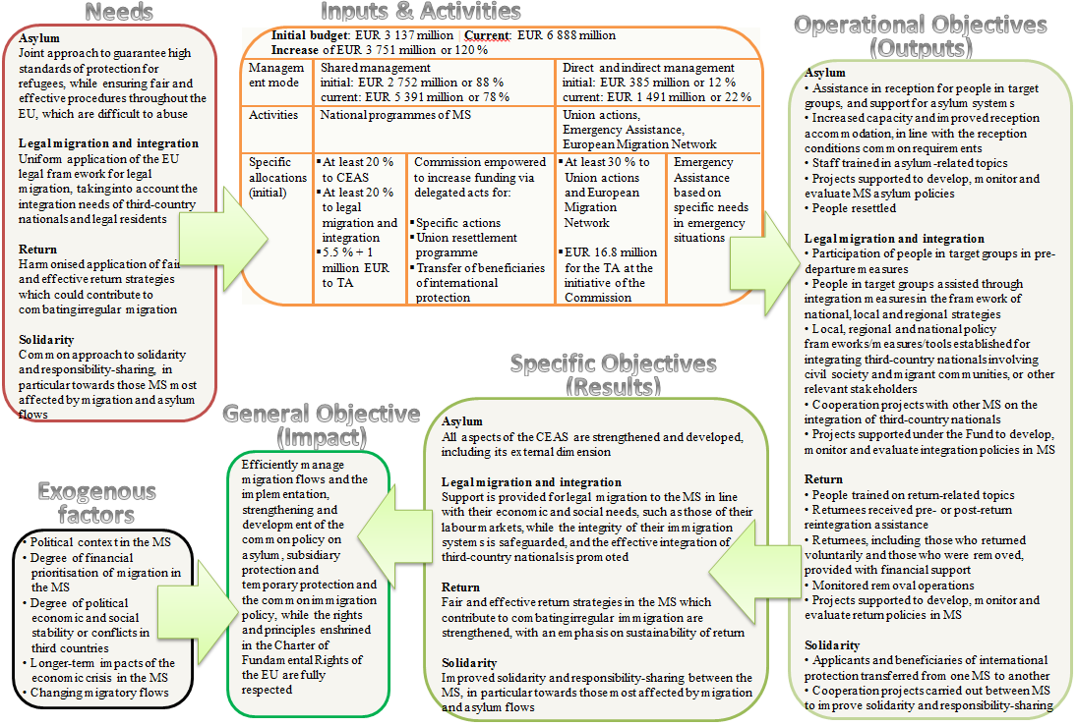

# Implementation / State of Play

Description of the implementation processes

AMIF is implemented either directly by the Commission (direct management), by the Member States (shared management), or indirectly by entrusting the budget implementation to a third party[28] (indirect management).

For shared management, at the beginning of the programming period, all Member States had a policy dialogue with the Commission to enable the national programmes to be the prepared. Based on the outcome of these dialogues, the Member States proposed their multiannual national programmes. The Commission examined these programmes, consulted relevant agencies and eventually approved each national programme.

To implement their national programmes, Member States had to set up a management and control system[29]. The Commission follows the implementation under shared management by examining the annual implementation reports and accounts submitted yearly by the Member States.

Member States are expected to submit two national evaluation reports: an interim evaluation report by the end of 2017 and an *ex post* evaluation report by the end of 2023. The Commission takes these reports into account in its interim and *ex post* evaluations of the Fund which are sent to the European Parliament, to the Council of the EU, to the European Economic and Social Committee and to the Committee of the Regions by 30 June 2018 and 20 June 2024 respectively.

In light of the interim evaluation reports submitted by the Member States, and developments in EU policies and in the Member States, a mid-term review of the situation is planned for the middle of the programming period, i.e. 2018 (Art. 15 of the Horizontal Regulation). Based on the outcome, national programmes can be revised and additional available resources can be allocated to those.

Within the national programmes, Member States are required to allocate a minimum of 20 % of their total allocation of the Fund to asylum and reception, i.e. strengthening and developing all aspects of the CEAS, and 20 % to integration, i.e. in support of legal migration and integration of TCNs[30]. Member States may depart from those minimum percentages only where (i) a detailed explanation is included as to why allocating resources below this level does not jeopardise the achievement of the objective, and (ii) if the Member States is not faced with structural deficiencies in the area of accommodation, infrastructure and services.

A small part was initially allocated to Member States so they could (i) transfer beneficiaries of international protection, (ii) implement the Union resettlement programme, and (iii) implement specific actions (actions implemented under the national programmes, although they respond to specific EU strategic priorities).

In the case of resettlement, the allocation is based on pledging (the number of people identified by a Member States to be resettled, to take place every two years). The funding for specific actions is allocated based on proposals submitted by the Member States, when the Commission invites them to do so. In order to respond to the migration crisis, show solidarity and share the burden with those under the most pressure, the Council adopted two decisions[31] on relocating asylum seekers from Italy and Greece to other Member States where their asylum applications would be processed (see also sub-chapter 3.2.1 below).

A small amount of money equal to 5.5 % of the total national allocation plus EUR 1 million is reserved in the national programmes for technical assistance.

Moreover, each Member States needs to establish a partnership with relevant stakeholders including, other public authorities, international organisations, NGOs and social partners, in order to prepare, implement, monitor and evaluate the national programmes. Stakeholders meet regularly in a monitoring committee set up to follow the national programme’s implementation[32].

The share of the budget managed by the Commission is subject to annual work programmes (annual work programmes) for Union actions. This share comprises:

* grants (awarded on the basis of open or restricted calls for proposals or directly);
* procurement (awarded on the basis of calls for tender or framework contracts); and
* delegation agreements (actions that are entrusted to third parties).

The projects selected receive in co-financing a maximum of 90 % of the eligible costs. EMAS is considered a specific type of Union action.

In addition, the EMN plays an essential role in better equipping the EU to respond to the challenges on migration and asylum, by providing policymakers and the wider public with up-to-date, objective, reliable and comparable information in these areas. Dissemination of information takes place primarily via the EMN website and publications. The Commission coordinates the EMN in cooperation with national contact points (EMN NCPs) appointed by the EU countries plus Norway. In their own countries, the EMN NCPs form national networks with a wide-range of relevant stakeholders.

Description of the implementation status

### Shared management

The AMIF instrument to undergo the biggest increase in total resources allocated is shared management, having increased from EUR 2 752 million (Regulation 516/2014) to EUR 5 391.5 million by the end of 2017. Of these, EUR 3 004 million was programmed and spent during the 2014-2017 period, almost three times compared to the originally envisaged amount of EUR 1 404 million.

The recent top-ups to the budget for shared management were earmarked to support the two relocation schemes adopted to support Italy and Greece (EUR 651 million), the EU resettlement programme (EUR 679 million) and the resettlement — legal admission from Turkey (EUR 193 million). The current EU allocation for shared management is shown in the diagram in Figure 1.

Member States agreed in July 2015 to resettle over 22 000 people in need of international protection during the period 2015-2017. They also agreed in March 2016 under the EU-Turkey Statement to resettle up to 54 000 Syrian refugees from Turkey (in exchange for Syrians being returned to Turkey). As of the end of 2017, 25 980 people had been resettled under both EU schemes.

Figure 2 shows the number of people pledged by the Member States to be resettled under the EU resettlement programme and from Turkey (legally admitted), as compared to the actual rate of people being effectively resettled, by the end of 2017. In total all 27 participating Member States have pledged to resettle under the EU resettlement scheme and 12 of them have also pledged to resettle under the legal admission scheme. The graph omits the seven Member States that have only pledged to resettle under the EU resettlement programme and who have yet to resettle anyone (MT — 14, SK — 100, CY — 138, BG — 160, HR — 350, EL — 354, PL — 900).

Figure 1: AMIF contribution to the shared management (national programmes) as of end 2017

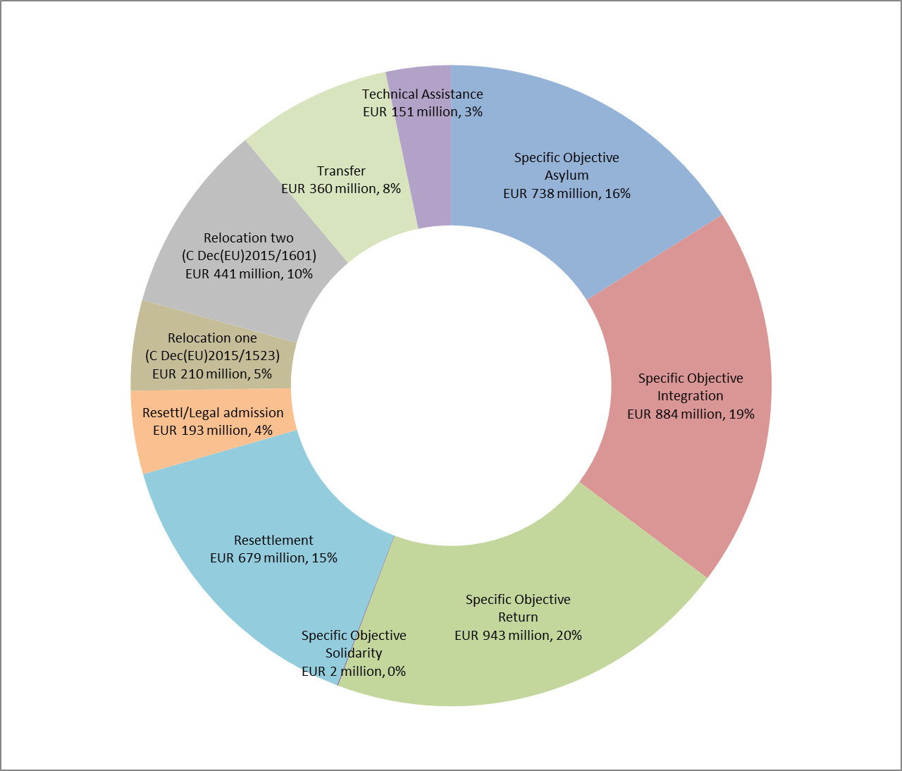

Figure 2: Number of people as pledged to be resettled under the EU resettlement programme and under the legal admission scheme, with rates of people effectively resettled, by the Member States, as of end of 2017

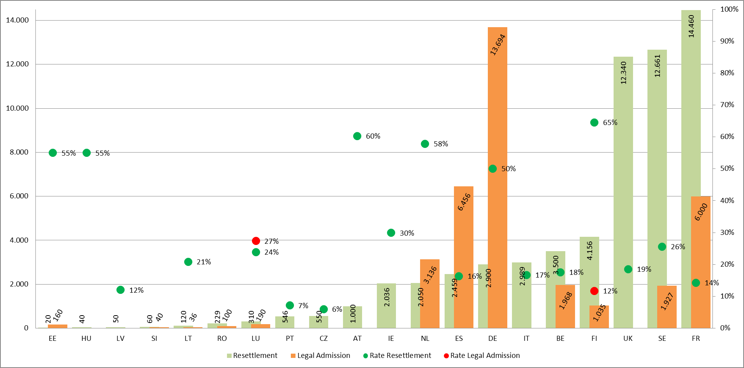

Another way to look at how the Fund has been implemented over 2014-2017 is by analysing the rate of implementation[33] together with the level of payments made to the responsible authorities. These rates can reflect the ability of central and local authorities to prepare, finance and supervise the use of the Fund towards achieving its objectives. Possible reasons that help to explain why the level of payments is still relatively low include: (i) late approval of most of the national programmes and thus the lack of completed projects; (ii) complexity and length of public procurement rules that delayed implementation; (iii) administrative burden (i.e. reporting on the accounts) that delayed implementation; and (iv) low pre-financing rates, hampering Member States commitment and the resulting payments[34].

However, the implementation rate shows that Member States are actually much more advanced in their implementation on the ground and that the difference is expected to be claimed in the financial records over the following years.

A good example of this is presented in Figure 3, which shows the implementation rates for 2016 (dark green) against the payments made in 2016 (light green) and the implementation rate for 2017 (dark red) against the payments made in 2017 (light red). While the payments show the amounts spent and verified during the first 4 years (light green and light red), the implementation rates show the actual implementation on the ground in the Member States (dark green and dark red), meaning there is an important acceleration of the activities as well a certain lapse of time between the activities taking place and the registration of the respective financial expenditure linked to them. With 3 more years to go, this might indicate that for a few Member States the full use of their allocation is easily within reach, while for others this could still be done with an increased effort.

Figure 3: National programmes — Implementation rate (dark green 2016 & dark red 2017) with levels of payments (light green 2016 & light red 2017)

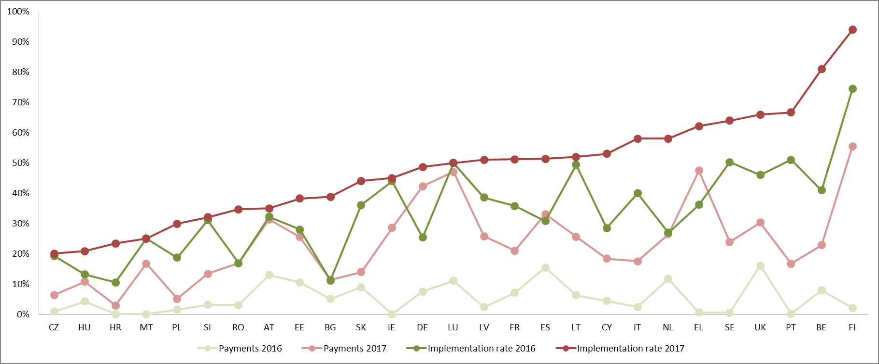

The following graph shows an increasing trend in the Fund payments made in 2015, 2016 and 2017 to the Member States. The total amount of payments made is EUR 103 million for 2015, EUR 363 million in 2016 and EUR 602 million in 2017 and the global amount for the whole period 2015-2017 is of EUR 1 068 million.

Figure 4: Payments made to Member States accounts in 2015, 2016 and 2017

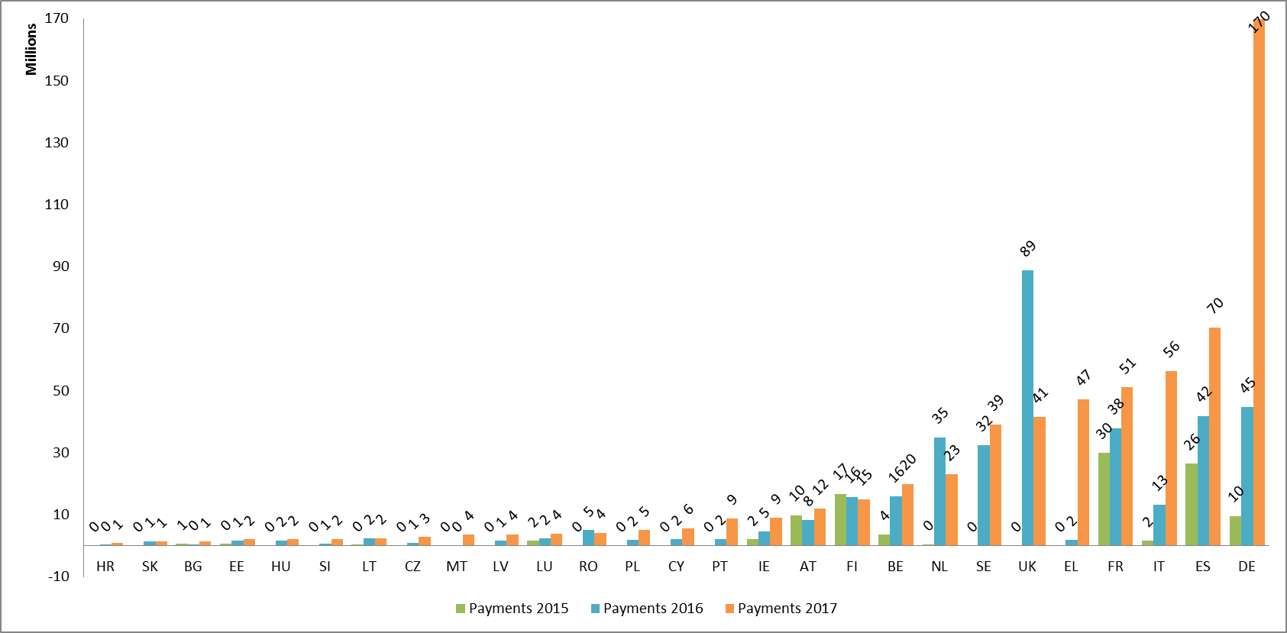

### Direct management

**Union actions**

By the end of 2017, EUR 462 million had been allocated through direct and indirect management to Union actions and EMN activities covering the entire programming period 2014-2020, out of which EUR 336 million was spent during 2014-2017 (EUR 44 million in 2014, EUR 49 million in 2015, EUR 51 million in 2016 and EUR 193 million in 2017). Around 24 % was assigned to projects covering the specific objectives of asylum and solidarity whereas the remaining 76 % was assigned to projects covering the specific objectives of legal migration and integration and return.

By the end of June 2017, four calls for proposals were launched (summarised in Figure 5)[35] and 42 Union actions projects had been awarded funding, most of them on a multiannual basis. Of the 42 Union actions financed by AMIF, the majority concerned integration (13 projects), followed by projects related to preventing trafficking in human beings (8), and asylum (6).

Figure 5: Number of Union actions per call during 2014-2017

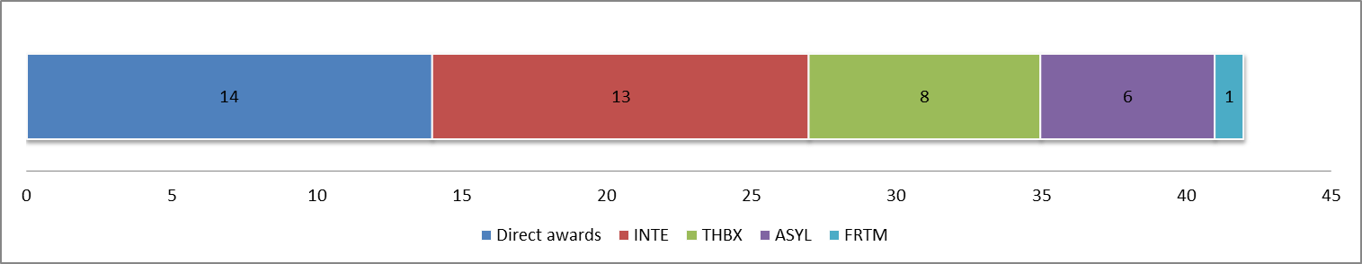

Additionally, the Commission funded 14 projects via the direct award method, which range from funding for the regional development and protection programmes (RDPPs) and the Readmission Capacity Building Facility, to funding for the European Council on Refugees and Exiles (ECRE), , the International Organisation for Migration (IOM) and the UNHCR, the European Reintegration Network (ERIN), various information campaigns, OECD studies, and a pilot project on resettlement and alternative European models to providing protection to refugees.

**Emergency assistance**

EMAS is the AMIF instrument to have the second greatest increase in total resources allocated, having passed from an initial programmed amount of EUR 95 million for 2014-2017 to EUR 929 million (or from 160 to 1 029 million for the entire programming period) distributed as follows: EUR 126 million in 2015; EUR 406.5 million in 2016; EUR 396 million in 2017; and EUR 50 million, EUR 25 million and EUR 25 million respectively for the years 2018, 2019 and 2020.

A total of 45 emergency actions were funded under AMIF during 2014-2017. Most of these actions were implemented in 2015 and 2016, during the height of the migration crisis (24 actions in 2016, 13 in 2015, 7 in 2014 and 1 in 2017). See Figure 6 and Figure 7 for the distribution of actions per country, and, where relevant, for distinguishing between the actions carried out by Member States and by international actors (the IOM, the UNHCR and the European Asylum Support Office (EASO)), as well as the amounts awarded and payments made so far (implementation rate).

The EMAS instrument was used to respond to immediate emergency needs, including (i) providing basic needs like food, shelter and medical care to refugees, (ii) providing reception services and support to unaccompanied minors, (iii) the strengthening of asylum services’ capacity to be able to cope with large numbers of applications, and (iv) providing support to asylum seekers returning to their country of origin and the relocation schemes. Such activities were most pressing in frontline countries like Greece, Italy and Bulgaria, where the sudden influx of migrants during 2015-2016 was most notable.

Figure 6: Number of EMAS grants awarded by Member States and implementing actor

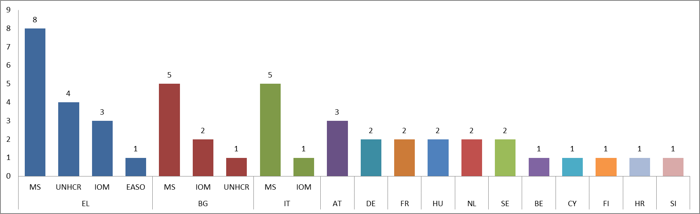

Figure 7: Emergency assistance by Member States and per year (source: European Commission)

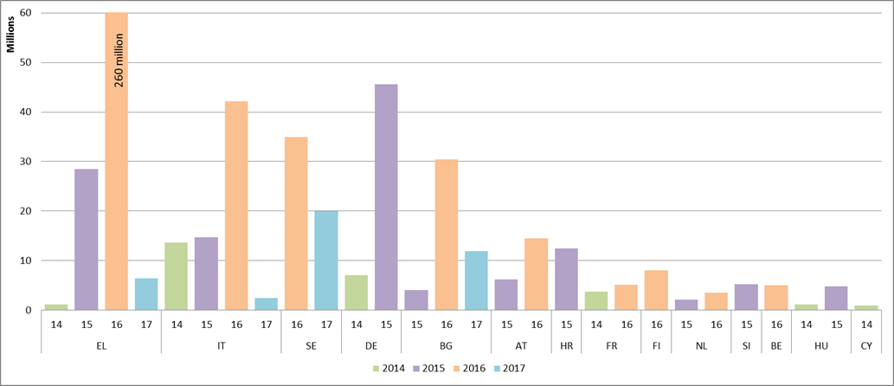

**European Migration Network**

Funding to the EMN is allocated to the Member States national contact points annually. The budget for the implementing EMN activities totalled EUR 6.2 million for 2014, EUR 13.4 million for 2015-2016, and EUR 23.9 million for the 2017-2018. As of 30 June 2017, a total of EUR 15.2 million had been spent on EMN activities over the 2014-2017 period.

# Method

Short description of the methodology[36]

This interim evaluation assesses how the Fund has worked so far and intends to inform the national authorities, the EU institutions, the stakeholders and the general public about the key achievements and limitations of AMIF[37]. The evaluation includes the analysis of the legal basis in relation to the needs and actions implemented and the key changes implemented under AMIF relative to its predecessors, as well as the outlook for the remaining implementation period 2017-2020. This is *the summative dimension*.

The evaluation identifies several lessons learnt to inform the Commission and the Member States on how they could address weaknesses and overcome obstacles, to ensure that during the second half of the implementation period corrective measures are taken and their impact is minimised. This is *the formative dimension* (see also the key findings in Chapter 6). This forward-looking aspect of the evaluation will also contribute to preparing the next generation of funding instruments, post 2020.

This interim evaluation of AMIF has been carried out by an external expert group and has been coordinated by the HOME Funds Evaluation Team in Unit E3 of the Commission’s Directorate-General for Migration and Home Affairs with the support of an Inter-Service Steering Group comprising other Commission services, which has met four times on 24 October and 15 December 2017 and on 1 February and 8 March 2018.

The external study of the interim evaluation started in September 2017 and has been guided by Terms of Reference adopted by the Commission. It has been based on the following data sources.

* Legal acts of the funds including the Specific Regulations, the Horizontal Regulation, implementing and delegated acts, CEAS directives and regulations;
* Joint EU resettlement programme and respective reports; Commission reports to the European Parliament and the Council on the application of various directives and regulations;
* National programmes of the participating Member States; management and control systems, annual implementation reports and annual accounts; and national interim evaluations;
* Union actions:
* Commission annual work programmes;
* grant agreements signed with awarded beneficiaries; and
* interim and final reports of the beneficiaries having implemented Union actions;
* Emergency assistance:
* Commission annual work programmes for emergency assistance;
* grant agreements signed with awarded beneficiaries; and
* interim and final reports of the beneficiaries having implemented EMAS actions;
* European Migration Network reports and studies;
* Reports of the Commission’s monitoring visits (shared and direct management); audit reports drafted by Member States’ audit authorities or by or on behalf of the Commission;
* *Ex post* evaluations:
* *Ex post* evaluations 2011-2013 of the European Refugee Fund, of the European Fund for the Integration of third country nationals, and of the European Return Fund; and
* *Ex post* evaluation of the framework programme ‘Security and Safeguarding Liberties (2007-2013)’, composed of the two programmes — CIPS and ISEC;
* Relevant EU strategies, action plans, communications, recommendations; other relevant studies originating in the academic sector or produced by other institutions;
* Reports and statistics from EU Agencies operating in the justice and home affairs/migration and security area; DG Migration and Home Affairs statistics; Eurostat;
* Consultations of stakeholders.

Evaluation questions

In line with the Better Regulation guidelines, this interim evaluation addresses evaluation questions structured around the five evaluation criteria of effectiveness, efficiency, relevance, coherence and EU added value, as well as the criteria of complementarity, sustainability and simplification and reduction of administrative burden introduced by the Horizontal Regulation[38].

An overview of the answers to the evaluation questions can be found in Chapter 5, while the complete list of questions as set in the legal base can be found in Annex 4.

Limitations and robustness of findings

As not enough time has lapsed since the programming period began and the Fund is still being implemented, the interim evaluation is neither expected nor able to produce a full picture of the programme’s results and impacts. Therefore it cannot draw final conclusions, Most projects, many of which are multiannual, are still ongoing, therefore assessing them is very challenging — projects completed under the national programmes at the time of this evaluation represent only 8 % of the projects started while 25% of the funding allocated has been used.

Whereas for some actions, effects may be expected within a short-term period, such as an increased capacity in the reception facilities, this period is too short for many results and wider impacts to be seen. Some actions have many incremental and short-term effects — easier to capture and to report on — whereas long-term actions (such as integration of third country nationals or the solidarity among Member States) might produce more significant effects in the longer term (e.g. 10 years). These effects are more difficult to capture through the usual indicator systems, which stop collecting data at the end of the projects’ life.

Concerning the indicators, there is a lack of benchmarks to compare performance, mainly because AMIF and the ISF are the first home affairs programmes to have a common monitoring and evaluation framework (CMEF) and a set of indicators (a list of 18 common output indicators has been provided by the Horizontal Regulation, while the CMEF Delegated Regulation sets a list of 24 common result and impact indicators). At the same time, the stakeholders deem that the relevant indicators can be further improved.

There has been a lack of quality in the data and in the Member States annual implementation reports, partly because the CMEF and all the guidance arrived later in the process (early 2017).

Limitations also include issues related to data availability and the measurability of impacts (for example, most of AMIF’s indicators focus on outputs). Often these context indicators are not linked to the Fund’s specific objectives (e.g. unemployment rate). Therefore, it is really difficult to attribute the observed changes to the Fund. Measuring, for example, the sustainability of effects of actions may not be entirely possible because many of the actions are still being implemented, and there is no consistent monitoring of long-lasting effects (instead, the likelihood of actions continuing has been assessed).

Concerning the open public consultation provided for in the Better Regulation guidelines, the Commission has worked on the future multiannual financial framework in clusters setting up a streamlined consultation that covered both forward and backward looking questions on the programmes. Launching a specific consultation for the mid-term evaluations could have created confusion and not provided much added value compared to the broader exercise. In this context, 350 answers and 52 position papers or contributions have been received. The open public consultation for the interim evaluation was therefore replaced by a targeted consultation (involving beneficiaries of Union actions) which has finally been used to contextualise the findings. This consultation only received input from 17 participants.

These limitations have been mitigated to the extent possible, by transparently providing the data sources, all of which are made publicly available. The analysis of the evidence has allowed the Commission services to identify data availability and quality problems that could be dealt with over the course of the interim evaluation. Conclusions are then drawn, where possible, based on the triangulation of evidence from various data sources. Whenever possible, the *ex post* evaluations of the preceding SOLID programmes have been used as a benchmark.

# Analysis and answers to the evaluation questions

How effective has AMIF been so far

This evaluation question aims to provide an insight into whether AMIF is on track to meet its objectives. The Fund has four specific objectives: (i) one linked to CEAS and its external dimension, (ii) one to legal migration and integration, (iii) one to return and combating illegal immigration, and (iv) one to solidarity.

Contextual factors in the first half of the programming period have significantly influenced the effectiveness of AMIF: the unprecedented and unforeseen influx of migrants and asylum seekers in 2015 and 2016 put a severe strain on several Member States asylum and reception systems, and continue to affect legal migration, integration and return policies. The EU sought political solutions that would manage the humanitarian crisis through mechanisms aiming to alleviate the pressures experienced. AMIF’s implementation was delayed because of these events[39]. Within this difficult context, AMIF proved to be an important instrument in handling the situation, by providing emergency support in the short term and building up the capacity of the asylum, integration and return systems in the long term. The findings show that progress varies across AMIF instruments, specific objectives and Member States, but when considered together, they have offered a holistic approach that has contributed to the Fund’s overall objectives.

These exogenous factors, and most notably the migration crisis itself, have demonstrated the extent of the flexibility of the Fund and of the EU budget as a whole, as well as the great potential of the EU in terms of solidarity and burden-sharing. However, they have also transformed the Fund in such a way that almost everything that has been re-prioritised or negatively prioritised during these past 3 years could be explained by emerging urgent needs resulting from the crisis. As a consequence, the interim evaluation views the Fund as being very different from what it was initially intended to be (its volume has more than doubled), having been continuously working in crisis-mode until now.

### Effectiveness in strengthening CEAS and its external dimension[40]

**In a nutshell**

AMIF has played an important role in improving asylum systems and strengthening reception capacity in the Member States. Due to the migration crisis, the area of asylum was especially prioritised in many countries. The Fund also paid special attention to the most vulnerable, including unaccompanied minors, and refugees and asylum seekers in difficult regions like the north and the Horn of Africa.

However, there is limited evidence of increased capacity to develop, monitor and evaluate asylum systems, and, while the EU resettlement programme has been making big progress so far, there is limited contribution towards establishing, developing and implementing national resettlement programmes.

AMIF instruments contributed in varying degrees to **strengthening the CEAS**, but mainly through the following:

* There was a focus on aspects of the CEAS such as asylum procedures and reception conditions (areas prioritised, not least due to the migration crisis), but also to a lesser extent resettlement.
* Collaboration on common standards on asylum was enabled. Beneficiaries of Union actions have underlined how regional or supra-regional collaboration and exchange actions, lead, in the long run, to common standards in the area of migration (particularly true for countries experiencing higher refugee flows for the first time and whose systems are not developed).
* There was increased reception capacity during the unprecedented migration crisis. EMAS has been a very effective way of providing reception accommodation, basic services and additional capacity (the effectiveness of EMAS remains relative to the country’s initial preparedness and capacity for dealing with emergency situations).
* Solidarity between Member States was demonstrated, with the EMAS instrument having proved it can provide important added value, particularly where it was only a fraction of the national budget.

AMIF’s contribution to **developing and improving reception and asylum systems** in the Member States is visible across instruments, with national programmes, EMAS, and Union actions having played the main role, while the EMN has mostly and indirectly contributed to the wider debate on the topic. Evidence shows that the actions resulted in strengthened reception systems, strengthened accommodation (infrastructure) capacity, and better services being provided.

The **strengthened asylum procedures** have been achieved through increased capacity in Member States (local) authorities, by covering Member States costs related to asylum procedures (mainly EMAS and national programmes[41]), or by facilitating the design of new approaches towards asylum procedures. For example, between 2013 and 2017, the number of people in target groups provided with Fund assistance (in reception and asylum systems) increased from 18 944 to 184 122, and of these, the share of people benefiting from legal assistance has risen from 1 % (120) to 27 % (49 202)[42].

AMIF (mainly national programmes and EMAS) has strongly **strengthened those reception conditions** that were put under extreme pressure in 2015 and 2016, thus making it one of the most important topics for many Member States, and becoming one of the Fund’s most visible results so far. This was achieved through:

* increasing the reception accommodation infrastructure capacity across Europe[43];
* increasing the capacity of local authorities to deal with the high number of applicants (for example, concerning registration and first help); and
* developing already existing reception centres and improving the services provided through, among other things, additional staff (with a special focus on health care and psycho-social assistance).

As a result, asylum seekers benefited from a more dignified, safe and healthy environment upon and after arrival.

The number of **places adapted for unaccompanied minors**, an especially vulnerable migrant group and one which was particularly focused on in some Member States, also rose from a low 183 places in 2014 to 17 070 places in 2017, most of them in Italy (13 194 in 2017).

AMIF contributed moderately towards improving the **implementation of the recast Qualification Directive**, mainly through increasing staff and hiring experts (national programmes), training employees working in the asylum process (EMAS) and harmonising the asylum procedures such as setting forensic standards for medical examinations (Union actions and the EMN)[44]. These actions have contributed to strengthening legal certainty in a few Member States (CY, FI, HR, HU, PT and SE) as indicated by the convergence of first instance and final instance recognition rates for applications from the same third country of origin in these same Member States[45]. In other participating Member States there is no clear convergence.

Concerning **resettlement**, the EU resettlement programme has received increasing support from the Fund. While the ERF lacked incentives to encourage Member States to engage in resettlement projects, and its *ex post* evaluation recommended that intra-EU transfers be incentivised and a specific budget be dedicated for resettlement projects and programmes, Member States agreed in July 2015 to an EU resettlement scheme for 2015-2017 for 22 000 people in need of international protection and in March 2016 to an EU-Turkey Statement agreement that the EU would accept up to 54 000 Syrian refugees from Turkey in exchange of returning to Turkey all irregular migrants who crossed from Turkey to the Greek islands[46]. By the end of 2017, almost 26 000 people had been resettled under both EU schemes (see Figure 8 below and more details in sub-chapter 3.2.1, on page 19).

Today, 81 % of the 27 Member States who used AMIF are implementing today resettlement, in a way or another, compared to only 15 % in the previous funding period. Notably, there is an essential difference between the specific objective ‘Solidarity’ that promotes capacity building in Member States for resettlement (with a long-term effect) and the EU resettlement programme that financially incentivises Member States to resettle people (with immediate visible results).

However, findings from the evaluation show limited evidence of increased capacity in the Member States to **develop, monitor and evaluate asylum systems and procedures**, as well as limited progress towards establishing, developing and implementing national resettlement programmes[47] (mainly through the EMN) and strategies[48]. Among the participating countries the results under this objective provide a mixed picture, because (i) Member States were focusing on other types of actions in order to respond to the crisis, and, (ii) as the supporting evidence remains limited, many of the results of the work undertaken until now have yet to materialise fully[49].

Figure 8: Overview of the EU resettlement programme 2014-2017

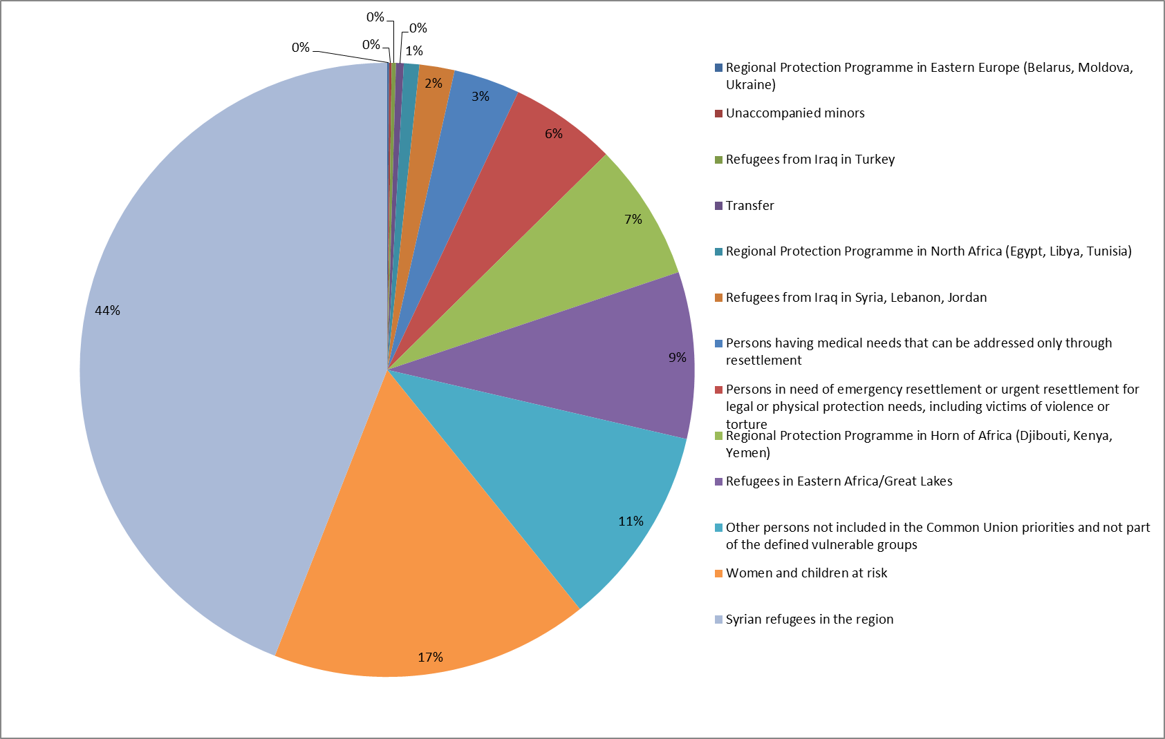

Finally, along with other sources, the Fund contributed to developing an **external dimension**, most notably through two RDPPs (one in the north of Africa and one in the Horn of Africa). These were initiatives from the EU, Member States and other partners (international organisations) designed to help host communities in third countries protect refugees, and strengthen the capacities of local authorities in managing migration.

AMIF has so far funded grants under the 2015 and 2016 annual work programmes to each of the two RDPPs. In total, 16 actions in various countries[50], have received up to EUR 30 million from the Fund. Actions focused on: (i) child protection, (ii) reducing the risk of sexual and gender-based violence including medical or psychological assistance, (iii) advocacy and awareness raising, (iv) vocational training for young people, (v) improving protection for refugees and asylum seekers, and (vi) improving the refugee registration and status determination processes.

Positive results from the support provided by the Fund include:

* the medical support and non-food items provided to migrants which aim to address specific vulnerabilities at disembarkation ports and in detention centres, following their rescue/interception at sea;
* the ‘case de passage’ (guesthouse) set up in Agadez in Niger that provides temporary accommodation to asylum seekers and evacuees from Libya;
* officials trained;
* asylum seekers registered and provided with legal assistance and with health services; and
* reduced first instance Refugee Status Determination[51] in the region.

### Effectiveness in supporting legal migration and in promoting effective integration[52]

**In a nutshell**

AMIF has made good progress on integration issues, where mainly short-term integration measures have been prioritised over long-term measures, while limited progress has been made on legal migration so far, likely due to the contextual factors. The results of those measures are not yet visible, as integration is a long-term process.

The context of the past 3 years has been dominated by factors such as the high influx of asylum seekers, coupled with limited labour market demand and very specific sectoral gaps that could be addressed by legal migration. This has thus translated into national programmes that have not prioritised legal migration, and in turn have made little progress in supporting it[53]. Legal migration, whose main support comes from the EMN with research and knowledge sharing but also the Union actions[54], may gain a stronger focus in the remaining programming period, because applications for family reunification may increase.

The number of target group people who participated in pre-departure measures supported by the Fund has been negligible in some Member States (HU, IE, LV) or nearly non-existent in the vast majority of countries between 2013 and 2017, accept for DE (725 072 in 2015, which fell to 8 880 in 2017) and CY: (0 in 2016 to 13 000 in 2017). However, when analysing progress on legal migration, it is relevant to take into account the increased number of TNCs that have obtained long-term resident status (see also paragraphs below).

As regards integration, AMIF prioritises short-term (e.g. civic orientation) over long-term measures (e.g. integration in the labour market, which would be eligible under the European Structural and Investment Funds (ESIF)). The need for the first measures was already urgent in many Member States, due to the high influx experienced. Since integration is by definition a long-term process, results are still difficult to capture, if any are available at all.

While the labour market integration is highly dependent on demand and the skill profile of migrants (labour market offer), the unprecedented high number of asylum seekers has led to growing gaps in unemployment and educational levels and increased the risk of social exclusion between TCNs and host country nationals. It is difficult, if not impossible, to assess the extent to which AMIF has helped mitigate this, but the progress made is visible, with 1 432 612 TCNs receiving integration assistance through the Fund so far (675 251 in DE and 411 560 in ES).

Complementary to AMIF’s efforts, ESIF funds also achieved progress in 2015 and 2016, seeing 1 831 733 people (mostly in FR, DE, ES, IT and BE) with migrant or minority background participating in integration projects related to social inclusion, educational and vocational training or sustainable quality employment. The projects on social inclusion have seen 853 000 people participating (553 000 in 2016, most of whom are in FR, DE, BE, NL and ES). Some 674 000 people participated in projects on sustainable quality employment (the majority in FR, IT and ES), while some 304 000 people participated in projects on educational and vocational training (of which 219 000 in 2016, the majority in DE followed by BE, FR, ES and IT)[55].

AMIF’s main contribution towards promoting the **effective integration** of TCNs has come through national programmes strengthening public service organisations through the training of personnel, complementary activities such as language courses and civic orientation information[56]. For most Member States, the principal form of support was education, training, democratic participation courses and preparatory actions to facilitate access to the labour market. The proportion of TCNs who received long-term residence status also increased from 30 % in 2013 to 44 % in 2016[57].

Union actions also contributed to integrating TCNs effectively, with activities focusing on providing information including labour market related training or networking, capacity building, identifying victims of trafficking and protection support.

As regards supporting **cooperation among Member States**, as recommended by the *ex post* evaluation of the EIF, Union actions have been the strongest instrument in this area, enabling cross-country collaboration on certain themes, while only a minority of national programmes (and one specific action) have been used for this objective[58].

**Capacity building on integration and legal migration** is another aspect on which moderate progress was reported to have been made through national programmes, and indirectly through EMN activities. Successful examples implemented by the Member States included:

* the strengthening of the existing territorial capacity through pooling resources and using digital tools to set up collaborative platforms mapping integration actors in a given territory (FR);
* the creation of networking structures between relevant institutions and stakeholders to share experience and create synergies (DE);
* the use of immigration mentors or ‘living examples’ of successfully integrated persons (PL); and
* study visits and events promoting multiculturalism.

### Effectiveness in enhancing fair and effective return strategies which contribute to combating illegal immigration[59]

**In a nutshell**

The need for fair, sustainable and effective return strategies has been an objective of growing importance in most Member States, and despite both the voluntary and forced return rates steadily increasing with the Fund’s support, findings show that AMIF could only bring limited contributions to the effective implementation of return strategies.

The need for fair, sustainable and effective return strategies, especially in light of the high influx of asylum seekers, has been an objective of growing topical importance in most Member States. national programmes have contributed to return[60] by supporting measures accompanying assisted-voluntary return procedures, with a steady increase of pre- or post-return reintegration assistance to individuals. specific actions, Union actions and EMN[61] activities have also increased awareness of return issues across the EU including knowledge on effective return strategies.

The return rates across Europe between 2014 and 2016 could also be explained by the high influx of asylum seekers and, subsequently, the rising number of applications handled. In addition, return is subject to major challenges both at EU level and in Member States as it is strictly dependent on (often) bilateral relations and agreements with receiving third countries and on their authorities’ willingness to cooperate in the fields of return and reintegration.

Although there is this clear limit regarding what AMIF can contribute to return, between 2013 and 2017, the number of returnees in general and returnees who received pre- or post-return reintegration assistance co-financed by the Fund has greatly increased. The number of returnees whose return was co-financed by the Fund increased from 5 904 in 2014 to 39 888 in 2015 and to 36 735 in 2017. Of those returned, the proportion of non-voluntary returns has increased from a quarter in 2014 to half in 2017. The two figures below show the general trends in the area of return — TCNs ordered to leave and TCNs effectively returned (total and to a third country).

National programmes also contributed significantly in the area of **voluntary return**. The reported number of people who returned voluntarily (co-financed by the Fund) increased from 3 934 in 2013 to 30 466 in 2015, falling back to 17 736 in 2017[62]. The number of places in detention centres has increased from 8 466 places in 2013 to 11 000 in 2015[63]. The number of monitored removals co-financed by the Fund increased from a low 10 in 2013 to a peak of 6 065 in 2016, falling back to 4 950 in 2017[64].

Figure 9: Total number of returns in the EU, 2008-2016 (source Eurostat, values in thousands)

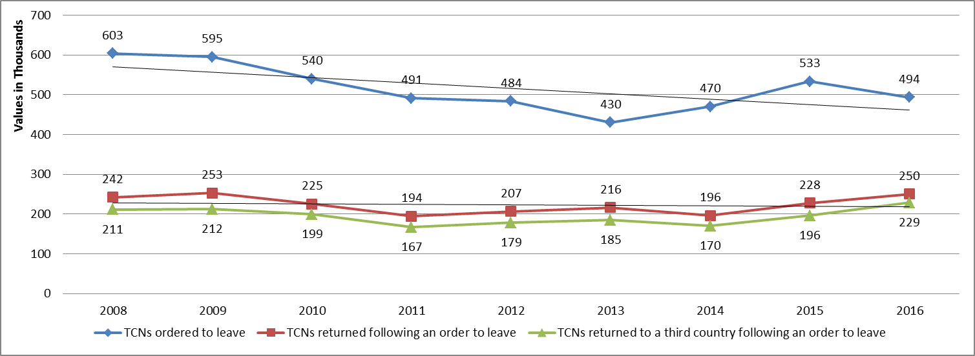

Figure 10: Global return rates in the EU, 2014-2016 (source Eurostat, values in thousands)

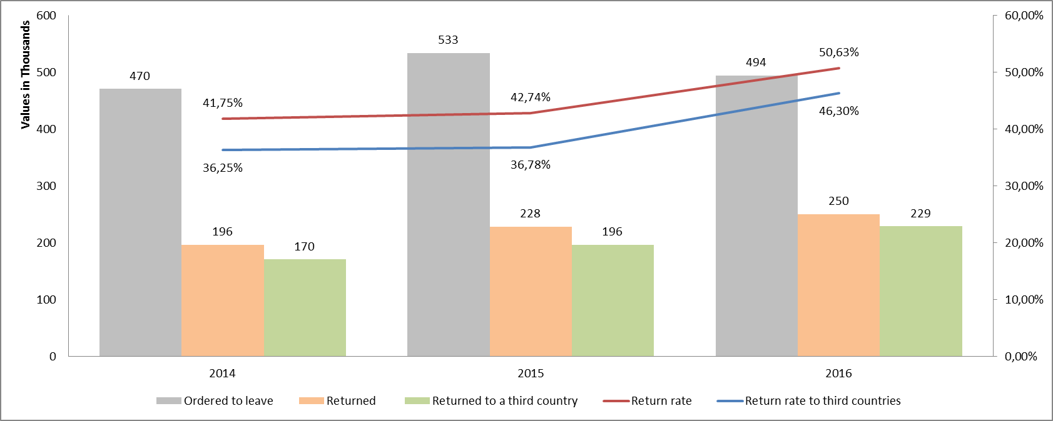

Little EMAS was also focused on accompanying voluntary return, providing support in the preparation of and during the return travel, as well as capacity building through helping officials to identify TCNs in forced return duties.

Some steps were also taken towards improving **practical cooperation between Member States** on return issues (mostly through the EMN through its expert group on return as well as through national programmes[65], specific actions[66], and Union actions). There was also improved cooperation between Member States and third countries on dealing with the trafficking issue (through Union actions), as well as on building capacity on return (through national programmes[67] and the EMN[68]) by training 8 845 people across Member States on return-related topics with the Fund’s assistance (4 026 people trained in 2016 and 3 001 in 2017).

### Effectiveness in strengthening solidarity and responsibility-sharing between the Member States[69]

**In a nutshell**

The strengthening of solidarity and responsibility-sharing between Member States was achieved mainly through EMAS and the relocation mechanisms, and through the EU resettlement programmes.

The findings available suggest that national programmes made limited contributions to both the transfer of asylum seekers and the transfer of beneficiaries of international protection.

Compared to the previous financing period, during which there was little incentive for Member States to engage in solidarity activities, in AMIF, a mechanism of solidarity to cope with migration and migrant crisis has become a core objective. Under this mechanism Member States can receive lump sums for people resettled from a third country, as well as for transferring beneficiaries of international protection from another EU country (see also the overview presented in Table 2 on page 10).

The Fund’s contribution to boosting solidarity and responsibility-sharing between the Member States has been visible mainly through EMAS[70] and the relocation and resettlement mechanisms put in place (see table below). The work carried out under these mechanisms has been deemed as a real and tangible act of solidarity AMIF relieved the burden of the high influx of refugees through financial support to national authorities as well as international organisations. Transfer of asylum seekers[71] or of beneficiaries of international protection[72] remained limited.

Table 5: Target groups that received assistance through resettlement programme (source: National evaluation reports)

|  |  |
| --- | --- |
| Persons having medical needs that can be addressed only through resettlement | 513 |
| Persons in need of emergency resettlement or urgent resettlement for legal or physical protection needs, including victims of violence or torture | 825 |
| Other persons not included in the Common EU priorities and not part of the defined vulnerable groups | 1 560 |
| Refugees from Iraq in Syria, Lebanon, Jordan | 272 |
| Refugees from Iraq in Turkey | 33 |
| Refugees in eastern Africa/Great Lakes | 1 292 |
| Regional Protection Programme in eastern Europe (Belarus, Moldova, Ukraine) | 15 |
| Regional Protection Programme in Horn of Africa (Djibouti, Kenya, Yemen) | 1 065 |
| Regional Protection Programme in north Africa (Egypt, Libya, Tunisia) | 120 |
| Syrian refugees in the region | 6 485 |
| Transfer | 60 |
| Unaccompanied minors | 19 |
| Women and children at risk | 2 465 |
| EU Total | **14 724** |

### Effectiveness in supporting the Member States in emergency situations[73]

**In a nutshell**

AMIF, mainly through EMAS, made significant contributions to MS in emergency situations. EMAS has been a powerful tool for strengthened solidarity in allowing AMIF to support MS in dealing with the 2015 migratory crisis and its follow-up, thanks to a more targeted, easier and faster response to the migration crisis.

The Fund has made significant contributions towards helping Member States cope with the high influx of asylum seekers in emergency situations, through significant top-ups to national programmes and EMAS. AMIF has been able to adapt and respond well in a very short time period to the most imminent needs (see also the data presented in sub-chapter 3.2.1).

The Regulation sets fixed amounts for each Member States based on the funding received under the SOLID programme between 2011 and 2013. The purpose of the mechanism for additional funding is to only fund specific actions listed in Annex II and only in the context of the mid-term review, planned for 2018. Additional support to address emergency situations was to be addressed through emergency assistance. This resulted in the EMAS receiving considerably more funding than originally envisaged through successive top-ups.

Stakeholders interviewed assessed the EMAS instrument as crucial both in terms of its financial support to Member States and in terms of displaying solidarity and burden-sharing (in addition EMAS was seen as helping to kick start AMIF implementation due to the late start of the national programmes). In countries like SE, DE and AT, where a considerable amount of national funding is used in the field of asylum and migration, the input of EMAS was considered to be negligible in financial terms, but crucial in terms of its role in boosting solidarity across Europe. In other countries like BG, EL and IT, EMAS funds were considered important, and the same results could not have been achieved without them.

Despite EMAS actions representing a short-term and small-scale approach, most of them have aimed to strengthen capacity in relation to asylum and return by supporting the development of effective reception conditions and asylum processes. Some emergency actions focused on (i) relocation or resettlement, (ii) providing an appropriate response to the refugee crisis regarding health, (iii) providing subsistence and aid for TCNs, (iv) vulnerable migrants and providing them with tailored assistance or helping them regarding voluntary and forced return.

How efficient has AMIF been so far[74]

This question aims to consider the relation between the inputs of the Fund (i.e. resources, budget, etc.) and the outputs it achieved. It tries to answer two questions: (i) to what extent the effects of the actions were achieved at a reasonable cost in terms of financial and human resources deployed and (ii) what management and control measures were put into place to ensure the Fund was implemented correctly and to prevent, detect, report and follow-up on irregularities.

**In a nutshell**

Overall, in the limits of available data, it could be considered that the results of the Fund were achieved at reasonable costs in terms of both human and financial resources. The administrative burden appears to be the main factor that undermined efficiency, while possibly the low number of human resources available increased the perception of administrative burden. Even if national programmes have been very slow to begin, the Fund’s overall implementation appears to be on track, thanks to EMAS bridging the funding gap and catering to immediate needs, helped by the swift approach applied to its management.

The management and control measures have also been appropriate and effective, with stringent mechanisms to ensure the Fund is correctly implemented and that fraud and irregularities are prevented. However, trade-off between these procedures and the overall efficiency of the Fund was found.

From the data collected by the outsourced evaluation, it appears that the results of the Fund so far have been achieved at a reasonable cost. Implementation of the national programmes has been very slow to take off, leading to an almost two-year gap in funding in some countries, and, as a result, the level or payments for the national programmes (accounts) is still relatively low, though increasing in 2017. This was due to the late approval (July 2014) of the core legislative package establishing AMIF and its implementing rules including the changes in the management and control systems[75] compared to the previous period. Despite the Regulation allowing Member States to start actions and retroactively fund projects, many took a conservative approach and chose not to make commitments in the absence of a fully established legal basis.

Therefore, EMAS actions have been implemented in order to bridge the funding gap, and cater to immediate and urgent needs and to the migration crisis, facilitated by the flexibility of the EMAS instrument, and thus, making the Fund’s overall implementation to be on track.

The late start of the national programmes resulted in challenges for evaluating the cost-effectiveness of the actions, since most projects are still ongoing and there is a lack of data on achieved targets and levels of payments.

The administrative burden could be the main factor undermining efficiency, particularly at the level of beneficiaries — mainly small NGOs (project level). The low number of human resources (at project level) was a factor that most likely increased the perception of the administrative burden — the low staffing ratio (therefore low human resource costs) enabled more funds to be channelled towards activities. However, beneficiaries consequently perceived the overall administrative burden to be relatively higher, in turn causing delays in project schedules and activities.

In their interviews, several of the beneficiaries answered that one factor which might skew the efficiency findings, (and thus the reported human resource costs might not be reflective of the actual work) is that many of the staff involved during the peak of the 2015 crisis in implementing the Union actions and EMAS, and managing the EMN[76], seem to be highly motivated, to the extent that they do more than what they are paid for.

The Commission’s human resources dedicated to managing the Fund have only slightly increased, despite the large increase in value of the EMAS and the emergency situation on the ground following the migration crisis, which have put an enormous strain on the Commission services[77]. From this perspective, data shows that the resources used by the Commission for administering EMAS were extremely efficient not only in terms of full-time equivalents (FTEs) but also as a result of quick technical procedures. No evidence was found to indicate that there is scope to further increase this.

The low level of human resources costs was also associated with implementing the national programmes (at the level of responsible authorities or delegated authorities), therefore creating the efficiency-effectiveness trade-off mentioned above.

In terms of the number of FTEs in the responsible authority, delegated authority and audit authority compared to the number of projects implemented, the large variation found suggests that the number of FTEs required depends on the scope and volume of the projects that Member States need to implement at a particular moment. Values definitely vary over time and among Member States, with average values going from 0.03 per project in SI to 13.3 in DE. In 2016, the value for DE was 30 and for EL it was even higher at 41. On average across the EU, the number of FTEs per project rose from 0.16 in 2014 to 3.65 in 2016 (driven by EL and DE). However, this fell to 1.02 in 2017.

In addition to the efficiency resulting from the flexibility of the national programmes (their multiannuality), the AMIF’s efficiency was increased[78] when:

* beneficiaries were public agencies since they could use their own networks to involve additional resources on an ad hoc basis and at no cost;
* knowledge and expertise had been gained through experience from previous projects (especially the SOLID programme and, in general, multiannual projects); and
* project staff were already occupied in the organisation implementing the project, were experienced and familiar with the topic.

The management and control systems put in place to ensure the correct application of the legal base and to prevent (1), detect (2), report and follow-up (3) on cases of irregularities and fraud have been contributing to a cost-effective implementation, through:

1. Prevention: careful examination of project applications; *ex ante* public procurement control systems; risk analyses by the responsible authority/delegated authority; training on fraud, providing guidance tools and regular communication to beneficiaries and responsible authority staff; and a steering group within the project.
2. Detection: administrative control checks; operational on-the-spot checks; financial on-the-spot checks; and external audits.
3. Report and follow-up: implementation of communication instruments; establishment of procedures for reporting fraud; and establishment of procedures for corrective measures[79].

Some responsible authorities and beneficiaries argue that the control measures are appropriate and effective, saying that stringent mechanisms ensure that the provisions of the Regulations are correctly applied and that fraud and irregularities are prevented. However, experience suggests that there is always a potential trade-off between the procedures in place to avoid irregularities and the Fund’s overall efficiency, in the sense that measures can be seen as very effective for preventing fraud, but they are not necessarily very efficient from a management perspective (on one hand AMIF establishes comprehensive procedures to reduce the risk, but on the other this leads to situations where compliance becomes time-consuming).

The legislative framework establishes a number of obligations on the responsible and audit authorities, but it does not go into detail in instructing how these obligations should be operationalised during implementation. Member States are left to apply their own national rules at their discretion. This approach seems to provide flexibility to authorities, which however go beyond what is just necessary for compliance[80].

Regarding the technical assistance, the agreed amount set aside was 5.5 % of the total amount allocated to an Member States plus EUR 1 million[81]. This evaluation has found little ground for a proper comparative analysis of how the Member States used their technical assistance budgets and therefore of the appropriateness of the ceiling.

A good way to assess the Fund’s overall cost-effectiveness is to look at the proportion of technical assistance needed to implement and manage the national programmes — payments of technical assistance against payments to national programmes. Nonetheless, in a multiannual financing environment it was not possible to establish this rate (with a certain degree or reassurance over its correctness), since Member States decide to submit payment claims in their accounts independently from the real advancement on the ground (rather it depends on when the expenses have been finally incurred and then verified)[82]. However, this rate will be an influential indication of efficiency during the *ex post* evaluation of the Fund.

How much simplification and reduction of administrative burden has AMIF brought so far[83]

This question aims to analyse the innovative procedures that the Fund introduced (simplified cost option, multiannual programming, national eligibility rules, and more comprehensive national programmes allowing for flexibility) and to look at the extent to which they have simplified and reduced the administrative burden for the Fund’s beneficiaries.

**In a nutshell**

At this stage, there is little evidence of a significant reduction in the administrative burden, though AMIF has led to simplification relative to the past. Several new administrative and managerial procedures were introduced, taking into account the lessons learnt from the previous funds. These include adopting the Better Regulation guidelines and toolbox and collecting indicators in order to ensure a more appropriate measure of performance.

Overall, most of the innovative measures (e.g. simplified cost options, multiannual programming) are considered particularly useful by beneficiaries and appear to have achieved simplification. Regarding the new IT tools such as the Shared Fund Management Common System of DG HOME (SFC2014[84]) and the eGrants grant management system, there is little evidence available to date that the implementation of these tools has led to simplification for the beneficiaries of Union actions and the EMN. Despite simplification improvements, the national rules and procedures that apply under the national programmes appear to lead to moderate to high administrative burden, therefore affecting efficiency.

The recommendations from the *ex post* evaluations of the SOLID funds[85] have been taken into account, including those concerning the designing and collecting of indicators*.* AMIF introduced several new administrative and managerial procedures aiming to simplify and reduce administrative burden (e.g. simplified cost option, multiannual programming, national eligibility rules, more comprehensive national programmes allowing for flexibility, new IT tools, requirements for collecting cost data in accordance with the *Better Regulation guidelines and toolbox*).

Overall, most of the innovative measures adopted under AMIF (for instance the simplified cost options, multiannual programming, etc.) were deemed useful by beneficiaries and appear to have achieved simplification. The simplified cost option was deemed by the Member States to have reduced administrative burden, and thus led to faster procedures, though some beneficiaries still requests more training from the Commission. Multiannual programming was identified in all sources of data as a particularly beneficial feature, as it offers Member States the required flexibility to plan and adjust the national programmes’ implementation according to changing needs and capacities. However it comes with some challenges like setting targets for 7 years, reporting multiple times per project or coupling with the co-financiers’ annual commitment capacity since most have annual budgets. The single set of procedures for all areas covered by the Fund and for the both AMIF and the ISF was also found to lead to simplification. However, many of the national eligibility rules were found to be very burdensome, in some cases even a barrier preventing civil society organisations from participating[86].

Regarding the new IT tools such as the SFC2014 and the Horizon 2020 grant management system, the available data shows there is little evidence available to date that these tools have led to simplifications for beneficiaries, though Commission's officials report they are useful for their management of the Fund. Suggested measures to help further in this regard included better communication with beneficiaries, more training opportunities and increasing the user-friendliness of these tools.

Overall, and despite the improvements mentioned, the bottlenecks for creating undue moderate to high burden identified by the evaluation and based on the stakeholders' input were:

* reporting requirements that apply to the different instruments[87] remain complex and overly strict;
* a lack of standardisation across Member States in the shared management;
* delays experienced in evaluating EMAS applications (which also risks undermining the emergency aspect of the instrument); and
* data collection for the common indicators.

In contrast, the procedures under direct management appear clear, more efficient and have reduced the burden compared to SOLID, probably due to higher EU level standardisation.

How relevant has AMIF been so far[88]

This question aims to determine whether the Fund’s original objectives are still relevant and how well they still match the current needs and problems. It also addresses the programme’s flexibility against changing circumstances in the wider context.

**In a nutshell**

Despite all the challenges, AMIF maintains a high relevance since it has proved to be sufficiently flexible, broad and all-encompassing in order to respond to different needs, and most national programmes are still in line with the general objectives of the Fund and with the Member States needs. However, Member States faced changing needs during the implementation period that call for a more flexible system of the financial allocations.

There is a high level of variety in needs across the Member States and across the different fields, i.e. asylum, integration and return, the volumes and scope of which have fluctuated and increased. The area of asylum was notably prioritised in many countries. Due to the migration crisis, the scale of AMIF ended up being very different to what was initially envisaged, proving that the original level of funding of AMIF was insufficient.

The evaluations of the SOLID programme found that the instruments were generally designed to cover a variety of needs and challenges. However, further progress in aligning priorities with needs was required.

* In the area of asylum, there was resource dispersion and lack of hierarchy in the needs to address, which did not allow for a focus on a few priority needs.
* In the area of integration, the broad scope and unclearly defined direction also meant that the Member States were not steered systematically in drafting their annual programmes to adapt to changes.
* In the area of return, the categories of TCNs targeted were too narrowly defined and a need to include migrants residing legally but wishing to return was to be included.

As such, AMIF was designed in a more holistic manner[89] to ensure that comprehensive and new emerging needs can be addressed more effectively, with a more flexible approach. It proved to be comprehensive enough to address all relevant needs[90]. All AMIF’s instruments can be further tailored in the programming stage to be adapted to current needs (e.g. Union actions, EMAS and the EMN through work programmes and national programmes through contextualisation of national objectives and specific actions). This broad and comprehensive approach taken in the legal basis is intended to cover all relevant needs which may require EU funding support.

It soon became very clear that the areas of asylum, migration, integration and return were to be faced with significant and constantly changing needs. The volumes of asylum seekers, refugees, migrants in general and people in return processes have heavily increased compared to the anticipated numbers, putting great pressure on Member States’ reception and asylum systems, and integration and return mechanisms. The scope of all this (the diversity of measures needed to respond to the needs of various migrant groups — the elderly, children, women, people with disabilities etc.) also significantly increased.

The table below presents an overview of how these changes in volume and scope might have stretched the needs that AMIF was supposed to address.

Table 6: Needs of AMIF during its implementation (source: Ramboll report based on academic literature)

|  |
| --- |
| **Asylum**   * + - * + Need to address the increased pressure on the European asylum system (irregular entries and applications for asylum and international protection increased dramatically and the crisis exposed the limitations of the current CEAS, including the lack of safe and lawful ways to access EU territory for people in need of protection, insufficient resettlement capacity and unequal provisions of appropriate reception conditions)         + Need to address the issue of disproportionate burden (that the Dublin system introduced) on the asylum and reception systems of certain Member States (southern European countries where the majority of asylum applications are lodged)         + Need to build the capacity of the Member States to develop, monitor and evaluate asylum policies and procedures (in a systematic manner to be able to respond better to urgent needs)         + Need to build the Member States capacity to ensure effective resettlement, transfer of applications and support for international protection (including sufficient infrastructure)   **Legal migration and integration**   * + - * + Need for pre-departure measures (to support civic orientation, information and awareness raising to the host society)         + Need for effective migrant integration, an ever greater challenge given the continuously growing number of migrants and the different types of migrants — first or second generation or elite migrants, elderly people, young people etc.)         + Need to combat discrimination and public attitudes (because of increasing acts of intolerance towards migrants)         + Need for transitional cooperation for migrant integration (some academic sources highlight a trilateral integration process that includes the migrants, the host society and the country of origin whose support can facilitate integration)   **Return**   * + - * + Need for effective return (according to Eurostat, nearly 500 000 TCNs were ordered to leave in 2016, while the effective return rate is only 46 %, a number that has not changed significantly over recent years), including reintegration measures         + Need to increase coherence in return policy across Europe (Member States have very different return rates and return policies and programmes)         + Need to systematically collect data on returns (there is lack of EU aggregate data and a very limited amount exists on post-return conditions, since few Member States follow-up with the returnees)         + Need to support assisted-voluntary return programmes         + Need to prevent the detention of minors (Member States have pledged to end child immigrant detention)         + Need to maintain human rights in the removal process (including taking into account the negative impact on the well-being of individuals and preventing extreme events of suicide or Sweden’s ‘resignation syndrome’ in minors) |

There is also a high level of variety in needs across the different policy areas, and across Europe. However, AMIF is overall sufficiently broad and all-encompassing to deal with these needs, while the Fund’s measures have proven to be flexible enough to respond to these changes.

Most of the national programmes have been planned on needs assessments that included stakeholder consultations. Figure 11 shows how countries perceived their needs and which area to focus on[91]. Evidence collected by this evaluation shows that the general objectives of most national programmes are still in line with the Member States’ needs. However, Member States faced changing needs under specific or national objectives, not foreseeable during the planning stage. This requires more flexible distribution systems to adjust financial allocations (and thresholds) to the new, actual needs[92]. Therefore, it is clear that AMIF’s allocation system was not appropriate in light of the crisis to cover these dynamic needs.

The EMAS instrument, the main objectives of which in the 2014-2016 annual work programmes were to strengthen solidarity and support humanitarian admission and assistance, adopted a flexible approach towards the shifting priorities to ensure emergency situations were immediately responded to. Due to the migration crisis, the scale of this instrument ended up being different to what was initially envisaged and AMIF ended up being a different type of fund to what was originally planned.

In the case of Union actions, constant dialogue and contact between partners implementing projects was reported in almost all cases as a measure to ensure that projects swiftly adapted to actual needs. In terms of budget for Union actions, the amounts allocated for legal migration and integration rose to 51 % of the total annual work programme in 2015, and 62 % of the total annual work programme in 2016 (see also the sub-chapter on implementation in 3.2 above). Regarding the EMN, ad hoc queries and regular meetings were reported as key mechanisms ensuring that the EMN’s work is in line with actual needs.

Figure 11: National allocations to AMIF priority areas in relation to the overall allocation per national programme (source: SFC2014)



Furthermore, the allocation for each country is composed of a minimum amount and an amount calculated based on the average of the 2011, 2012 and 2013 allocations under the ERF, the EIF and the RF. These were in turn calculated in accordance with the distribution criteria[93] which referred to the proportion of target group people for each fund (admitted/residing in or pending return/removal) in that Member States out of the total for the EU for the same three years.

In 2014, in a number of Member States that were already experiencing a large increase in these target groups, this translated in a non-alignment of the distribution key with the needs. This was due to already outdated data and inadequately funded national programmes. Without the possibility of revising the allocations under national programmes, EMAS became the only (and abused) instrument able to respond to the significantly changed situation.

How coherent[94] and complementary[95] has AMIF been so far

These questions look at the extent to which different AMIF actions work together internally and with other EU actions and to identify whether there are complementarities, gaps and overlaps between different initiatives.

**In a nutshell**

Measures were taken during the Fund’s design, planning and programming stages to ensure coherence and complementarity to, and be strategically aligned with other financial instruments (especially ISF-BV, ESF, ERDF, EAFRD, EMFF, FEAD, EUTF, DCI, EU Health Programme) and with relevant key EU policy strategies, in the case of Union actions and the EMN. During the implementation stage, the Commission services actively worked together and with the Member States, mostly in ad hoc settings, to ensure that EU funds with similar objectives were used in a coordinated way. On a national level, the vast majority of Member States ensured coherence and complementarity through the establishment of coordination mechanisms, mainly monitoring committees involving different responsible authorities.

However, room for improved communication appears to exist with regard to internal coherence (among AMIF instruments) because beneficiaries are not very aware of the actions and projects completed within the AMIF framework, especially with regard to Union actions and EMAS. Nonetheless, there is little evidence of non-coherence, overlaps and duplications, both internally and externally.

The *ex post* evaluations of the SOLID programme found that coordination mechanisms were put in place to a variable extent, and they recommended that synergetic activities be developed between the Home Affairs funds and other EU instruments as well as between national projects and Community actions.

Measures have been taken during AMIF’s design, planning and programming stages to ensure a coherent, non-contradictory, complementarity and strategic alignment with other financial instruments (especially ESIF) and with key EU policy strategies. Some detailed results achieved by ESIF show excellent complementarity to AMIF are presented in sub-chapter 5.1.2.

The migration crisis brought changes of an unforeseen magnitude requiring other EU financial instruments to increasingly take up actions related to the AMIF area, requiring stronger coordination[96] and stronger strategic alignment, especially with funds that have an external dimension. DG HOME has actively worked, during the implementation phase, with relevant stakeholders, other Commission services[97] and other EU financial institutions (especially the European Investment Bank), mostly in ad hoc settings, to ensure that EU funds with similar objectives were used in a coordinated way with AMIF. The degree to which AMIF is coherent with, and complementary to, other EU interventions mostly results from the difference in points at which they intervene, or the different angles taken relative to the implemented activities – short-term, medium- and long-term support, reception phase or long-term integration.

The Commission provided additional detailed guidance[98] on the required coordination to increase synergies between AMIF and ISF and other EU funding instruments in relation to reception and integration of asylum seekers and other migrants, including reviewing the eligible actions and objectives relevant to reception and integration under the specific EU funding instruments. This was also translated in 2015 in ad hoc visits to all Member States affected by the Western Balkan Route, so they could coordinate with the different authorities and run a common needs assessment exercise.

The EU Health programme[99] was used to, for example:

* establish links between key reception areas for refugees and migrants and the health systems;
* expand the use of the Personal Health Record and the Handbook for Health Professionals in evaluating the health status and needs of refugees and migrants;
* to ensure that health assessments and preventive measures are implemented, taking into account the needs of children and other vulnerable groups; and
* to ensure that data initially collected through the electronic personal health record (e-PHR) is stored in a database so that it is available in transit and destination countries.

At national level, the vast majority of Member States worked through established coordination mechanisms, such the monitoring committees involving different responsible authorities. At programme level, better cooperation mechanisms were acknowledged in the field of return — integrated systems of return management — by connecting EU funded programmes and networks that focused on return and readmission (such as ERIN, EURINT and EURLO[100] in collaboration with Frontex)[101]. However, these were not always sufficient to ensure a coordinated approach at project level.

Concerning AMIF actions that relate to third countries, DG HOME together with other DGs and services (EEAS, DEVCO, NEAR, ECHO, JUST, EMPL)[102] used coordination groups at the programming stage to ensure different interventions were coherent and complementary — examples of such assessments are the RDPP; the actions funded by the EU Trust Fund for Africa; the Development Cooperation Instrument; or the Mobility Partnership Facilities supported by Union actions and those by ISF Police and ISF Borders.

Internally, there is high complementarity between national programmes and EMAS (which have clearly supported each other) and high coherence between national programmes and Union actions (the Union actions being clearly designed to complement the national programmes). However, there is room for improvement, especially with regard to Union actions and EMAS and between the EMN and the other instruments, since AMIF beneficiaries are not very aware of the actions and projects completed within the AMIF framework (beneficiaries appear to perceive most coordination as informal, being done on own initiative and not incentivised, while there is a clear need for more formalised information on project and national level). Nonetheless, there is no conclusive evidence of non-coherence, overlaps or duplications[103].

Figure 12: Assessment of the coherence in the national interim evaluations reports (coherence with other interventions with similar objectives and mechanisms to prevent overlap of financial instruments)

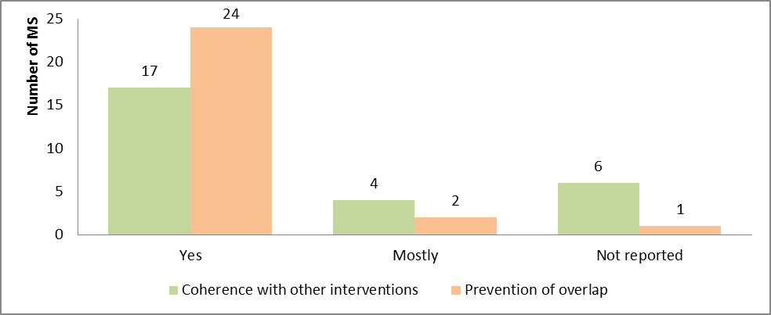

Beneficiaries also found that the Union actions provided funding in very critical fields, especially for countries that experienced bigger refugee flows for the first time, and whose systems were not very well developed. AMIF funding provided these actors with increased independence and increased the possibility for them to carry out the intended activities. Had they only relied on national funding, the impact would not have been as significant.

What is the EU added value of AMIF so far[104]

This question aims to assess the value resulting from AMIF that is additional to that which could result from interventions which would have been carried out by Member States at national level.

**In a nutshell**

Overall AMIF has generated significant EU added value, despite the relatively small size of the funds compared with the important challenges imposed by the crisis that occurred during this period[105]. The main EU level benefit arises from the transnational dimension of certain actions (the EMN and Union actions) as well as EU level burden-sharing, supported in particular by EMAS and the relocation mechanism under national programmes, both of which are solid proof that the principle of solidarity was applied.

AMIF brought significant EU added value in terms of (i) ensuring the effective and efficient management of migratory flows at EU level (volume effects), (ii) optimising procedures related to migration management and increased know-how and capacity built (process effects), (iii) allowing Member States to reach a wider volume of migrants, asylum seekers, refugees and TCNs (scope effects), and (iv) introducing innovations that were created at national and European level (role effects).

The absence of AMIF funding would have been detrimental to the quality of the EU response to the migration crisis and the ability of the Member States to cooperate and implement solutions. The consequences of an interruption in the support would likely have important negative implications and lead to reduced scope and quality of actions implemented, delays in implementation or even an interruption of the actions, including on the application of the principles of solidarity, burden-sharing and mutual trust.

The main EU added value of AMIF can be found in the effects of its volume, process, scope and role. The main EU level benefit of AMIF arises from the transnational dimension of certain actions supported by its instruments (in particular the EMN, Union actions and specific actions) as well as EU level burden-sharing, supported by the top-ups to the national programmes and by EMAS which are solid proof of the application of the principle of solidarity.

Volume effects: Through actions implemented via the national programmes and EMAS, AMIF brought important EU added value in terms of ensuring the effective and efficient management of migratory flows at EU level. This mainly enabled Member States to reach a wider volume of asylum seekers, refugees and third-country nationals (compared to the previous period) and/or to implement actions which otherwise would not have been implemented or would not have been of a similar quality (adapted to the migratory crisis). EMAS was crucial to supporting and boosting the national capacities for dealing with the high influx of refugees in Europe, in particular in Greece, Italy and Bulgaria.

Process effects: AMIF actions implemented under national programmes, Union actions, the EMN and EMAS brought important EU added value in terms of (i) optimising procedures related to migration management, (ii) improving the quality of administration and budgetary processes, (iii) increasing know-how and capacity of officials, and (iv) building cooperation processes and synergies between actors in the field.

Scope effects: The actions implemented under national programmes and EMAS were reported by the Member States to bring important EU added value in terms of:

* extending the types of actions implemented, such as: psychological support, start-up projects, legal support, organisation of cultural and sports events, welcoming programmes, language training, translation services, the purchase of specialist equipment for identifying people, the organisation of meetings with representatives of third countries to establish cooperation and streamline return, return counselling;
* extending the target groups reached, e.g. vulnerable people such as women, the elderly, young people, non-accompanied minors, people with mental health problems, and victims of modern slavery.

Role effects: Through actions implemented under Union actions, the EMN and specific actions under the national programmes, important EU added value resulted from the innovations created at national and European level through their development (e.g. the transnationality of the projects allowed multiple beneficiaries and Member States to benefit from these innovations).

Figure 13: Assessment of the EU added value of AMIF in the national interim evaluation reports

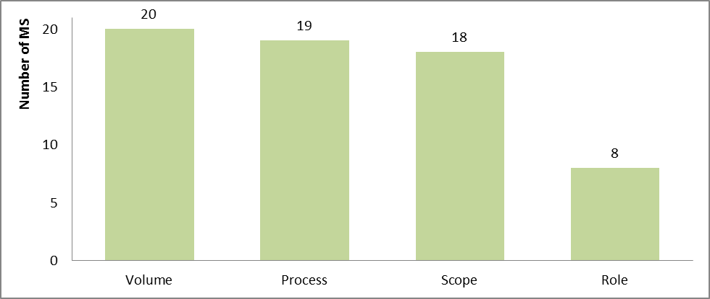

The absence of AMIF funding would have been detrimental to the quality of the EU response to the migration crisis and the ability of the Member States to cooperate and implement innovative solutions — most Member States[106] believe they would still have had to carry out some actions required to implement EU policies, even in the absence of EU funds. However, Member States indicated that such actions would have been implemented only as a minimum to comply with EU legislation, and they would have been limited in scope and/or in quality or would have been implemented primarily in specific areas of interest in the national context such as asylum or return.

Some actions supported under Union actions, the EMN and EMAS would likely have received financing in the absence of AMIF. However, this could have deprived other actions which would have been at risk of not being funded at all or suffering delays.

An interruption of AMIF financing, and especially of the funding to the national programmes, would likely result in:

* strongly negative implications (see also figure below) for the application of the principles of solidarity, burden-sharing and mutual trust between Member States;
* a disruption of the efforts put in place including a reduction of the scope and quality (e.g. the number of target beneficiaries reached, the type of services provided);
* the AMIF’s implementation potentially being discontinued;
* delays in implementation;
* loss of networking capacity;
* less innovative measures;
* a revision of priorities; and
* the risk of Member States not reaching the EU/national goals.

With fewer staff and reduced services, the ability of the national authorities to provide effective assistance to asylum seekers, refugees and other third-country nationals would be constrained.

Figure 14: Assessment of the most likely consequences of an interruption of AMIF in the national interim evaluation reports

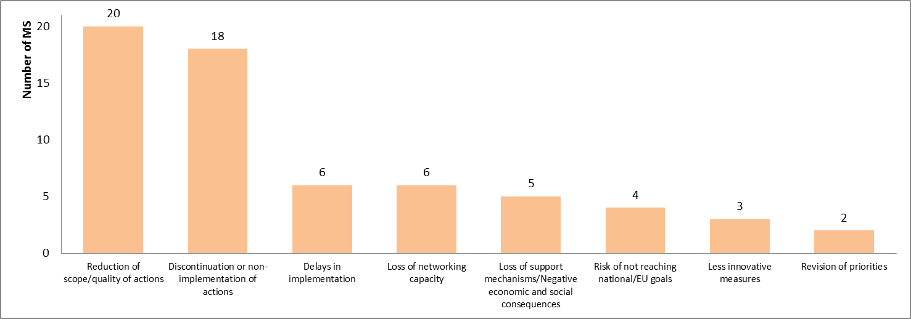

How sustainable are the actions implemented under AMIF so far[107]

This question aims to look at (a) how long the effects of the actions are likely to last after the intervention ends (sustainability of effects), and (b) the extent to which the actions can be continued after the AMIF financing ends (sustainability of actions). The sustainability of effects was also analysed at multiple levels: (i) at the level of target groups (e.g. sustainability of effects on asylum seekers, refugees, etc.), (ii) at the level of organisations (e.g. capacity building, development of new methods, etc.), (iii) at inter-organisational level (e.g. networking effects, etc.) and (iv) at policy area level (e.g. integration, asylum, return).

**In a nutshell**

Sustainability has been thoroughly addressed by AMIF through checks mechanisms set in place at programming and implementation stages across most instruments, although this was ensured to a lesser extent by EMAS due to the nature of the actions. There is room for improvement in considering sustainability criteria when designing the interventions of AMIF.

The sustainability of effects of actions (effects lasting after the intervention ends) and financial sustainability (actions that could continue after AMIF financing ends) vary across different instruments, Member States and areas, and depend on a holistic approach which, if adopted, is likely to yield long-term effects. The sustainability of effects on target groups is likely to differ depending on the focus areas (integration and asylum outcomes are likely to last if they address longer-term needs, while return outcomes are more sustainable if they are based on voluntary return schemes and are supported by efforts for reintegration).

The experience from the previous financing period showed that the financial sustainability of actions could be improved, since only a few projects were successful in seeking alternative means of funding once the support from the SOLID programme ceased, while a few others continued to receive funding from AMIF. The previous evaluations recommended that, in order to avoid recurring financing of the same (less innovative) products, the Commission and/or responsible authorities need to disseminate project results better and encourage Member States to systematically capture and transform lessons learnt into national legislation, practice and procedures.

Sustainability has been systematically addressed by all AMIF instruments, although maybe to a lesser extent by EMAS due to the nature of those actions[108]. Measures and checks mechanisms were set in place at programming and implementation stages across the instruments, in particular Union actions and national programmes. Generally, the most effective sustainability measures depend on the systematic design in which they are embedded — if actions are intended to be sustainable in the long term, then they are more likely to have longer lasting effects. Other measures at the programming stage can be found under Union actions and most national programmes such as (i) the inclusion of an evaluation criterion for applications, (ii) the investment in projects with a long-term perspective, (iii) the establishment of partnerships between stakeholders to encourage cooperation, and (iv) the adoption of rules, guidelines and even the multiannual programming. Furthermore, the reviews, checks, monitoring and evaluation, and dissemination of results all played an important role in verifying sustainability at the implementation phase.

Findings suggest that the sustainability of effects of actions supported by AMIF varies across different instruments, areas and Member States. Sustainability of effects on target groups is likely to differ depending on the focus areas, for example, integration and asylum outcomes are likely to last if they address longer-term needs (e.g. building of skills of target group, integration into the labour market, teaching material) rather than short-term needs (e.g. civic orientation in the host society), while return outcomes were reported to have lasting effects provided they were based on voluntary return schemes[109].

Sustainability of actions in terms of their ability to continue financing the intervention after AMIF funding ends also varies with some instruments, for example, the EMN is less self-sustainable, whereas other actions (Union actions, national programmes, and EMAS) depend on their level of priority and/or urgency and the availability of alternative resources.

Regarding limitations, one important aspect relates to difficulties measuring the sustainability due to a lack of consistent monitoring and specific sustainability-related indicators, for example including over a period of time that extends beyond the end of life of projects. Another one relates to actions that are still being implemented whereby it is difficult to ascertain whether the effects on the target groups and on specific areas will really last.

# Conclusions and issues for further consideration

This final section summarises the evaluation’s main findings and raises a few issues that should be taken into account when implementing AMIF over the next few years and in the planning of the new generation of home affairs financial instruments.

Effectiveness

AMIF proved to be an important instrument in handling the difficult situation, by providing both short-term emergency support and more long-term capacity building of the asylum, integration and return systems. It has played an important role in improving the asylum systems and strengthening reception capacity in the Member States, especially in providing a more dignified, safe and healthy environment for asylum seekers upon and after their arrival. The Fund also registered progress regarding the most vulnerable groups, especially unaccompanied minors.

While there has been limited progress in the area of legal migration so far, Member States have made good progress in the integration area, including capacity building, while short-term integration measures (introductory courses on civic orientation, languages, etc.) have been prioritised over long-term ones (pre-vocational training, further education, etc.). The results of these are not yet visible as integration is a long-term process. Despite limitations, the fund has helped to steadily increase the return rates. While the EU resettlement programme has made big progress so far, there has been limited contribution towards establishing, developing and implementing national resettlement programmes.

Issues for future consideration:

* the holistic design of the Fund’s delivery mechanisms should be maintained and used as a model for future programming periods;
* an emergency instrument should be maintained and its ability further strengthened so it can respond rapidly and efficiently;
* the EMN should be maintained and supported with suitable funding, while further capitalising on its potential to generate comparative knowledge on best practices within Member States;
* a clear intervention logic at the beginning of the future Fund should be developed, starting with the expected impacts (longer-term) and link them to results (medium-term) and outputs (short-term); and
* a full monitoring and evaluation system should be devised, including indicators, early on in the design phase to ensure a consistent and uniform monitoring of progress and effectiveness from the outset.

Efficiency

Available data suggests that the results of the Fund have been achieved at a reasonable cost in terms of both human and financial resources, with some limitations. The perceived administrative burden (complexity in Member States and EU procedures as well as the control mechanisms) has been the main factor undermining efficiency. The management and control measures had stringent mechanisms to ensure prevention of fraud and irregularities and, while considered appropriate and effective, might have increased the administrative burden.

Issues for future consideration:

* further simplification should be addressed in the next generation of funds (e.g. management and control systems and mechanisms, reporting requirements);
* technical assistance both at the initiative of the Commission and of the Member States could be linked to the volume of financial allocations; and
* a sufficient level of pre-financing payments should be planned so that national programmes can be timely implemented.

Simplification and reduction in administrative burden

There is little evidence, at this stage, to show that the administrative burden has been significantly reduced, although AMIF has led to simplification relative to the past. Overall, most of the innovative measures (e.g. simplified cost options, multiannual programming) have been considered by stakeholders particularly beneficial and appeared to have simplified things. Despite the improved simplification, national rules and procedures applicable under the national programmes appeared to have led to a moderate amount of administrative burden.

Issues for future consideration:

* the multiannual programming for future financing periods should be maintained; and
* measures should be taken to have an optimal control and audit procedure, reducing the number of controls for audits and prevention of irregularities and fraud;

Relevance

The Funds still addressed the Member States needs in spite of major changes in the EU and national contexts.

**Issues for future consideration:**

* future financial instruments need to be designed in a way that enables them to address a comprehensive set of needs, as well as ensure flexibility in the case of unexpected changes; and
* a system to distribute funds should be adaptable in order to respond appropriately to changing needs;

Coherence and complementarity

The Fund seemed to be coherent and no overlaps and duplications have been found. It has also proven that it complements its different instruments (national programmes, EMAS etc.) as well as with other EU funding instruments (such as ESIF) and national budgets.

Issues for future consideration:

* further efforts to improve cooperation, coordination and strategic steering in implementing AMIF and other EU level initiatives should be made;
* improved communication appears necessary in relation to AMIF instruments because beneficiaries are not very aware of Union and emergency assistance actions; and
* the future funds should be designed in a similar format (i.e. national programmes aimed at building long-term capacities, emergency assistance aimed at alleviating immediate pressure, Union actions and the EMN with a Pan-European dimension, i.e. clearly and logically designed to support each other).

EU added value

Overall AMIF has generated important EU added value: burden-sharing between Member States, boosting national capacities especially in BG, EL and IT, optimising procedures related to migration management, ensuring synergies etc. Without the Fund the quality of the EU response to the migration crisis would have been reduced.

Issues for future consideration:

* providing support through AMIF and all its instruments should be continued, sending a clear message on the importance of solidarity and cooperation between Member States for effective and fair asylum, integration and return systems at Pan-European level.

Sustainability

Sustainability has been addressed by all the Fund’s instruments, although to a lesser extent by EMAS due to the emergency nature of the actions. The sustainability of effects lasting after the intervention ends vary across different AMIF instruments and Member States: integration and asylum outcomes are likely to last longer, if from the outset they address longer-term needs; return outcomes are sustainable provided that they are based on voluntary return schemes and are supported by efforts at reintegration.

Financial sustainability (actions able to continue after the AMIF financing ends) also varies: some instruments appear not to be self-sustainable (the EMN), whereas the sustainability of other actions (Union actions, national programmes, EMAS) depends on their level or priority and/or urgency and the availability of alternative resources.

Issues for future consideration:

* further focus on selecting projects that have a higher likelihood of having sustainable effects over a longer period of time;
* assess both financial sustainability and sustainability of effects as two separate aspects of the assessment of projects; and
* consider increasing the efforts to improve sustainability by systematically disseminating and supporting the uptake of good practices by other projects.

# Annex 1: Procedural information

|  |  |
| --- | --- |
| Leading Directorate-General | DG HOME |
| Participating units | A2 — Legal affairs  B1 — Legal migration  C1 — Irregular migration and return policy  C3 — Asylum  E1 — Union actions  E2 — National programmes for South and East Europe, evaluation, AMIF/ISF Committee  E3 — National programmes for North and West Europe, budget, MFF, agencies |
| Participating DGs | BUDG, DEVCO, ECHO, EMPL, ENER, ENV, GROW, JRC, OLAF, SANTE, SG, SJ |
| Legal base | According to Art. 57 of Regulation (EU) No 514/2014, the Commission shall submit an interim evaluation report at the level of the Union, by 30 June 2018, to the European Parliament, to the Council, to the European Economic and Social Committee and to the Committee of the Regions. |
| Roadmap approval | 11 April 2017 |
| Decide planning | PLAN/2017/893 |
| Exceptions to the Better Regulation guidelines | Open public consultation of 12 weeks was replaced by a targeted consultation with the beneficiaries of EU actions and emergency assistance funding. |
| External consulting firm specialised in evaluation | Contract signed in September 2017 with Ramboll. |
| Number of steering group meetings | 4 i.e. 24 October and 15 December 2017, 1 February and 8 March 2018 |
| Last deliverable handed in | 19 March 2018 (Final report) |
| Approval of the final report by Steering Group | – |
| Regulatory Scrutiny Board (RSB) meeting | 11 April 2018 |
| Resubmission of the SWD to the RSB |  |

# Annex 2: Methods and analytical models

This chapter presents the methodology employed for the interim evaluation of AMIF, including reference to the challenges experienced and the mitigation strategies employed to mitigate these.

The external study was divided into three phases: inception, interim and final:

* The purpose of the **inception stage** was to prepare the evaluation work to be undertaken, and to ensure that the Steering Group and the contractor shared a common understanding of the study’s scope and objectives. The activities carried out in the inception stage included initial desk research, explorative interviews with the Commission officials, the refinement of the methodology, and the development of data collection tools. This stage culminated in the production of the inception report, which was discussed during a meeting with the Steering Group on 24 October 2017, revised and then approved on 27 November.
* The purpose of the **interim phase** was mostly to collect data. The activities carried out in the interim stage included desk research, in-depth interviews, case studies, meta-analysis of the national interim reports, forward-looking workshop with the Evaluation Network and the analysis of the legal base for preparing the interim report. This stage culminated in the production of the interim report, which was discussed during a meeting with the Steering Group on 15 December 2017, revised and then approved on 22 February 2018.
* The purpose of the **final phase** was to synthesise the data gathered, triangulate findings and provide conclusions on the evaluation questions and recommendations. The activities carried out in the final stage included filling gaps in the data and refining the report, analysing the targeted consultation, and workshops. This stage culminated in the production of the draft final report, which was discussed during a meeting with the Steering Group on 1 February 2018, and is still being revised.

Therefore, the Inter-Service Steering Group has met for a fourth time to discuss the draft staff working documents.

**Desk research** was carried out during the inception phase to identify and assess relevant data sources that can feed into the analysis. The main point of reference was all data that was accessible through SFC2014 (national programmes), as well as additional data available on budget, EMAS, Union actions, the EMN, etc. Desk research in the interim phase built on the data collected during the inception phase and entailed three main types of analyses.

* **Analysis 1:** Context-related qualitative and quantitative data was collected and processed to get a thorough understanding of the context of AMIF at an overarching level and to create the background knowledge required for assessing the relevance, coherence and complementarity as well as of the added value of actions funded under AMIF. This analysis also included a review of most recent relevant literature.
* **Analysis 2:** General financial data on AMIF was analysed to extract relevant performance measurements and to assess AMIF’s implementation so far. Also, data on common results and impact indicators accessible through SFC2014 was collected and processed.
* **Analysis 3:** Qualitative and quantitative data on EMAS, Union actions and the EMN was screened and processed. This included aggregated data (e.g. monitoring data and qualitative data from annual work programmes, audit documents, etc.) and project level data (e.g. as provided by the final reports of the projects). This provided an overview/categorisation of key data for each of the instruments, including funding allocations, lead/partner beneficiaries, objectives, implementation status, and a categorisation of results.

The **in-depth interviews** focused on Union actions and the EMN, as well as aspects related to internal and external coherence and complementarity with other EU funding instruments. In total, the contractor conducted 48 in-depth telephone or face-to-face interviews (interviews for the case studies were excluded). The interviews were carried out using semi-structured interview guides, including a number of pre-defined themes and questions (aligned with the four pillars of AMIF).

The overall aim of the interviews was to (i) identify any issues encountered during the implementation of the Union actions and the EMN; (ii) assess the internal coherence of the AMIF; (iii) assess the level of complementarity and coherence with other AMIF instruments/EU financial instruments, and (iv) seek areas for improvement. In particular, the interviews with stakeholders at the EU level aimed to assess the financed projects according to the evaluative framework at general level while interviews among national stakeholders looked more closely at how financed projects are being implemented at the action level.

Building on the desk-based work assessing the degree to which AMIF is complementary to and coherent with other EU financial instruments’ legal acts, interviews were conducted with representatives of other EU financial instruments (at EU level) that possibly have an impact on asylum seekers and refugees, on integration and on return. The coded data was then analysed and included in the main deliverables through a process of data triangulation.

The purpose of the **case studies** (AT, BG, DE, EL, FR, IT, SE, the IOM and the UNHCR) was to provide in-depth analyses of the interventions, allowing for good and bad practices to be identified and any weaknesses to be mitigated. The focus of the case studies was on EMAS, though the responsible authorities in the countries concerned were also asked more general questions on the Fund’s implementation and whether the EMAS complemented the national programmes.

The case studies consisted of a twofold approach. To assess the implementation of EMAS and its strategic orientation, key stakeholders at EU and national level were interviewed, as well as high ranking people within the IOM and the UNHCR. To assess how EMAS was implemented in the field, project beneficiaries of EMAS as well as the target group were interviewed.

The data collected through the case studies contributed in particular to the assessment of AMIF’s implementation with regard to EMAS, including the existence of linkages between actions implemented in given Member States, and identifying any difficulties encountered and areas for improvement. The results were analysed and synthesised in a standardised reporting template that was beneficiary-specific. The results provided both an assessment of the implementation of EMAS as well as first conclusions.

The objective of the **meta-evaluation of national interim evaluation reports** was to make an aggregate assessment of how national interventions contributed overall. The national interim reports were submitted to the SFC2014 by the responsible authorities by the end of December 2017.

The approaches adopted to synthesise the data contained in the evaluation reports included the coding of qualitative information, and the excel-based synthesis of quantitative data relating to the common indicators. All of the information contained in the 27 interim reports was assessed on the criteria’s completeness, comparability, quality and reliability with the reports being given a rating from 1 (poor quality) to 4 (very good quality) for each criterion on each evaluation criteria (e.g. effectiveness). Overall, 23 reports were rated as good and 3 reports were rated as very good. One report was considered as acceptable, while no report was considered to be poor.

These are the average scores by evaluation criterion (where the average aggregated rating was 11.9 and the maximum rating was 16):

* effectiveness 10.6;
* efficiency 11.7;
* relevance 11.9;
* coherence and complementarity 9.3;
* EU added value 13.9;
* sustainability 13.9;
* simplification and reduction of administrative burden 12.9;
* conclusions and recommendations 10.7; and
* examples of projects 12.1.

A **forward-looking workshop** was organised on the fringes of the Evaluation Network meeting on 30 November with representatives of responsible authorities and the Member States evaluators. The contractor also assisted as an observer to the workshop on the multiannual financial framework organised by the Commission on 6 December.

The purpose of **analysing AMIF’s legal base** was to consider whether it is an obstacle to the Fund’s effectiveness, efficiency and relevance.

The final phase of the study included a process of **filling gaps in the data and refining** the answers to the evaluation questions. Conclusions were drawn per evaluation criterion, drawing on the triangulated results of the evaluation. Recommendations for the Fund’s future and the next funding period were then developed.

A compilation and analysis of the answers received to the **targeted consultation** has been conducted.

In preparing for the finalisation tasks, the contractor held an **internal workshop** involving a brainstorming session with members of the core team and evaluative and thematic quality assurance experts on the findings. The workshop aimed to draw preliminary conclusions and produce recommendations. The workshop’s main purpose was to (i) validate the conclusions; (ii) revise the recommendations to best fit the roles of stakeholders; (iii) address technical and legislative constraints and feasibility concerns; (iv) establish an order of priority among the key recommendations and (v) validate this list.

Based on the work described above, the **final report** for review and acceptance was prepared and compiled.

# Annex 3: Stakeholder consultation

AMIF had a consultation strategy whose objective was to gather input from stakeholders (evidence, data, as well as views and opinions) and ensure that all of them have the opportunity to present their views to the Commission on how well the existing programmes have performed and the extent to which they met the EU’s objectives in these areas. Stakeholders’ input was sought to provide the Commission with valuable insights on how well the current funds are performing, including on the challenges related to the implementation.

The Commission services have worked on the future multiannual financial framework in clusters setting up a streamlined consultation that covered both forward and backward looking questions on the programmes. This open consultation, as provided for in the Better Regulation guidelines and the interim evaluation’s consultation strategy, was meant for the general public and was published for 8 weeks on the Commission’s portal[110]. 350 answers and 52 position papers have been received in this context. No separate, specific open consultation for the mid-term evaluation was carried out. Launching a specific consultation for the mid-term evaluations could have created confusion and not provided much added value compared to the broader exercise.

Instead, a targeted consultation specific for the mid-term evaluation was carried-out, which eventually was used to contextualise the findings. The questionnaires were aimed at the beneficiaries of Union actions and EMAS and were made available in English, French and German. This consultation only received input from 17 participants.

This targeted consultation has complemented the interviews performed in parallel by the consultant. The results of all stakeholders' consultations have been used to answer and contextualise the answers to the evaluation questions.

The **results of the targeted consultation** are presented below:

|  |
| --- |
| * + - * + Of the 17 answers received, half (8) were from individuals answering in their professional capacity and half (9) from respondents answering on behalf of their organisations. Of these, 3 were from non-profit organisations, 9 from public authorities, 3 from the academia and 2 from other type of organisations. All but one have declared knowing AMIF because they have benefitted from its funding and have rated their knowledge of the Fund mostly as very good (3) or good (11).         + The first part of the consultation concerned the importance of the specific objectives of AMIF for the policy priorities in the Member States (CEAS, legal migration, integration, return, solidarity). 7 respondents consider important and 9 very important to have as specific objective the common European asylum system, 6 consider important and 8 very important to have legal migration, 5 consider important and 11 very important to have integration, 6 consider important and 10 very important to have return, and finally 7 consider important and 9 very important to have solidarity.         + The second part of the consultation concerned the extent at which the actions financed by AMIF in the Member States contribute to the Fund's objectives (CEAS, legal migration, integration, return, solidarity). 16 respondents consider that AMIF does contribute to the common European asylum system (5 to some extent, 7 to a great extent and 4 fully), 15 consider that AMIF contributes to legal migration (3 to a limited extent, 4 to some extent, 4 to a great extent and 4 fully), 15 consider that AMIF contributes to the integration objective (1 to a limited extent, 2 to some extent, 8 to a great extent, 4 fully), 16 consider that AMIF does contribute to return (1 to a limited extent, 3 to some extent, 8 to a great extent, 4 fully), and finally 16 respondents consider that AMIF contributes to the solidarity objective (1 to a limited extent, 7 to some extent, 5 to a great extent and 3 fully).         + 10 respondents consider AMIF being able to address new and emerging needs (10 to some extent and 3 fully), while the big majority see AMIF having a positive influence on how Member States work with asylum (16), with integration (14) and with return (13).         + Regarding the cooperation among Member States, respondents consider that AMIF's contribution was positive in the area of asylum (12), integration (11) and return (9).         + Regarding whether the EU policies would have been implemented without the support of AMIF, respondents consider it mostly likely in the area of asylum (12), integration (9) and return (10).         + Looking at AMIF so far, respondents considered that the Fund promotes services and assistance that were not delivered in the Member States before in the area of asylum (7), integration (8) and return (only 4). More than half of respondents (9, 7 and 10 respectively) did not know how to answer these questions. The remaining consider that AMIF does not bring any new services in these policy areas.         + The majority of respondents think that AMIF funded projects help beneficiaries to be better received when entering a receiving country, better integrate into the receiving country, and to better reintegrate into the country of origin.         + Respondents were divided in half who considered AMIF generally easier or much easier (8) to implement AMIF actions and projects compared to the previous programming period (SOLID) and the other half (9) who did not know.         + In what concerns the degree at which actions financed by AMIF are coherent with actions and projects funded by national resources, the majority of respondents were positive (11 in the field of asylum, 10 in the fields of integration and return respectively), with the rest not being able to answer.         + Regarding sustainability, respondents were divided into those who believe actions would continue at least partially also in the absence of the EU financial support (6) and those who believed that this would have not happened (10). More or less the same proportion was then reproduced regarding the achievement of the objectives in the absence of AMIF – 5 who consider that these could have been achieved and 10 who believe it would have not been possible. |

In addition to this, the evaluation reflected the results of a **forward-looking workshop** with representatives of responsible authorities and the Member States evaluators. Its results are presented below:

|  |
| --- |
| * + - * + Changes (as compared to the previous period) with the greatest (positive/negative) impact on the Fund: multi-annual programming, merger of the funds; specific objectives; programming process, organizational set-up, changes to the RA’s)         + Legal base act as an enabler or inhibitor to achieving the objectives   − Horizontal Regulation (514/2014): Programming, Partnership and Policy Dialogue, Eligibility of expenditure, Management and Control Systems, Financial Management, Information, Communication, Monitoring, Evaluation and Reporting  − AMIF Regulation (516/2014): Purpose and scope; Financial and implementation framework: Allocations to various objectives; Multi-Annual Breakdowns   * + - * + Success stories in the implementation         + Key characteristics to be maintained in the future (consider legal base, different funding modalities, various instruments etc.)         + Key characteristics to be changed in the future (consider legal base, different funding modalities, various instruments etc.)?   **PART 1**  **What changes (as compared to the previous period) have had the greatest (positive/negative) impact on the Fund?**  **Positive**   * + - * + AMIF has consolidated what were separate funds under SOLID, for example there can now be a continuum in language training financing across the different pillars, irrespective of TNCs’ status         + Fewer reporting requirements         + Increased flexibility         + Inter-ministerial committee where discuss complementary between the funds   **Negative**   * + - * + Divergence between what is being collected by MS already for financial auditing and what is required from the evaluation perspective with the CMEF; sometimes the data was said to work against each other. It was further mentioned that the staff dealing with the financial data are not aware of evaluation and the differences between outputs and outcomes.         + Administrative burden for beneficiaries – monitoring and justification of costs; BUT this is often a result of national rules rather than AMIF per se         + Setting targets for 7 years was considered long; they will need to be revised multiple times on the basis of needs/changes and a review of progress made on a yearly to 18-month basis. An example was provided of countries that were previously considered safe countries, but whose status has changed due to changing circumstances.   **Mixed picture**   * + - * + Common indicators set by the EC were seen as a good thing in principle, but these could be improved to make them more relevant. Some suggested making them more precise, but others said that there was a danger in doing this due to national differences in data collection. An example was provided of the indicator on the ratio of those people trained in asylum – it was difficult to calculate this due to staff turnover. A “comment” section is important to have so that it can be clarified why given data is not provided or to explain how it has been calculated/the limitation.         + Multi-annual nature of the Fund is positive as provides for more flexibility, but more complicated for forward planning, and while there is only a need to report once, reporting still needs to be done multiple times per project. Moreover, multi-annual payments can put an increased burden on given systems.   **To what extent does the AMIF’s legal base act as an enabler or inhibitor to it achieving its objectives?**   * + - * + Regulation seen mostly as an enabler as wider than SOLID – easier to interpret         + The links between the Regulation and Delegated Acts were not that clear as they were drafted at different moments   *Note: Limited comments on this – few really aware of the legal acts/able to comment*  **What do you perceive as the main strengths and weaknesses / comparative benefits and drawbacks of each of AMIF’s instruments?**   * + - * + Difficulties related to the Specific Actions as limited guidance received from EC – unclear who is responsible for what, difficulties in determining financial flows between partners         + Resettlement was said to work, but the guidelines provided by the EC on who and when could be clearer         + Specific actions – Means attributed did not fit with the needs after crisis; linked to the distribution key. Example provided: some MS more in need of money, after the crisis, than some MS who received a lot initially   *Note: Lack of awareness among those who attended of Union Actions, EMN*  **Can you provide some examples of success stories in the implementation of the Fund in your Member State?**   * + - * + One project has significantly decreased the time needed to check the age of minors and another has made applications easier         + All children refugees have been integrated in schooling thanks to the AMIF         + It was suggested that success could only really be judged on outcome data, but this is not available in many cases as too early on – few projects ended.   **PART 2**  **What are the key characteristics of AMIF to be maintained in the future fund (consider legal base, different funding modalities, various instruments etc.)?**  **To keep:**   * + - * + Reception and asylum as a pillar within AMIF         + The current integrated structure with its 4 pillars         + The CMEF         + Flexible payment process – beneficiaries can ask for money when they need it and not only once per year; MS have this option at their disposal. The flip side of this is the increased administrative burden involved and cash flow issues from the perspective of the RAs.         + Multi-annual nature         + Monitoring Committee – fact that stakeholders are involved   **What are the key characteristics of AMIF to be changed in the future fund (consider legal base, different funding modalities, various instruments etc.)?**  **To change:**   * + - * + Fact that limited to TCNs         + Target nationals more to increase their awareness of AMIF         + Financial year versus calendar year; would be easier for reporting purposes if AMIF followed the calendar year. It was suggested that such a change could represent a problem for Commission processes and timings.         + Simplified costs – there is a need for more guidance for MS on this. It was suggested that a workshop could be organised to this effect.         + 7 years was judged a long time; there may be a need to adapt the NPs to needs and change in a over the course of that period, e.g. once a year         + Decrease the level of ambition with the CMEF indicators – reduce the number, increase clarity, possibly rely mostly on the output (rather than result) indicators as easier to gather data on. |

# Annex 4: The Evaluation Questions

The evaluation questions are listed in the Commission Delegated Regulation (EU) 2017/207 of 3 October 2016 on the common monitoring and evaluation framework provided for in Regulation (EU) No 514/2014 of the European Parliament and of the Council laying down general provisions on the Asylum, Migration and Integration Fund and on the instrument for financial support for police cooperation, preventing and combating crime, and crisis management.

**Effectiveness**

1. To what extent has the Asylum, Migration and Integration Fund (‘Fund’) reached the objectives defined in Regulation (EU) No 516/2014?
2. How did the Fund contribute to strengthening and developing all aspects of the Common European Asylum System, including its external dimension?
3. What progress was made towards strengthening and developing the asylum procedures, and how did the Fund contribute to achieving this progress?
4. What progress was made towards strengthening and developing the reception conditions, and how did the Fund contribute to achieving this progress?
5. What progress was made towards the achievement of a successful implementation of the legal framework of the qualification directive (and its subsequent modifications), and how did the Fund contribute to achieving this progress?
6. What progress was made towards enhancing Member State capacity to develop, monitor and evaluate their asylum policies and procedures, and how did the Fund contribute to achieving this progress?
7. What progress was made towards the establishment, development and implementation of national resettlement programmes and strategies, and other humanitarian admission programmes, and how did the Fund contribute to achieving this progress?
8. How did the Fund contribute to supporting legal migration to the Member States in accordance with their economic and social needs, such as labour market needs, while safeguarding the integrity of the immigration systems of Member States, and to promoting the effective integration of third-country nationals?
9. What progress was made towards supporting legal migration to the Member States in accordance with their economic and social needs, such as labour market needs, and how did the Fund contribute to achieving this progress?
10. What progress was made towards promoting the effective integration of third-country nationals, and how did the Fund contribute to achieving this progress?
11. What progress was made towards supporting cooperation among the Member States, with a view to safeguarding the integrity of the immigration systems of Member States, and how did the Fund contribute to achieving this progress?
12. What progress was made towards building capacity on integration and legal migration within the Member States, and how did the Fund contribute to achieving this progress?
13. How did the Fund contribute to enhancing fair and effective return strategies in the Member States which contribute to combating illegal immigration, with an emphasis on sustainability of return and effective readmission in the countries of origin and transit?
14. What progress was made towards supporting the measures accompanying return procedures, and how did the Fund contribute to achieving this progress?
15. What progress was made towards effective implementation of return measures (voluntary and forced), and how did the Fund contribute to achieving this progress?
16. What progress was made towards enhancing practical cooperation between Member States and/or with authorities of third countries on return measures, and how did the Fund contribute to achieving this progress?
17. What progress was made towards building capacity on return, and how did the Fund contribute to achieving this progress?
18. How did the Fund contribute to enhancing solidarity and responsibility-sharing between the Member States, in particular towards those most affected by migration and asylum flows, including through practical cooperation?
19. How did the Fund contribute to the transfer of asylum applicants (relocation as per Council Decisions (EU) 2015/1523 and (EU) 2015/1601)?
20. How did the Fund contribute to the transfer between Member States of beneficiaries of international protection?
21. How did the Fund contribute to supporting the Member States in duly substantiated emergency situations requiring urgent action?
22. What type of emergency actions was implemented?
23. How did the emergency actions implemented under the Fund contribute to addressing the urgent needs of the Member State?
24. What were the main results of the emergency actions?

**Efficiency (Were the general objectives of the Fund achieved at reasonable cost?)**

1. To what extent were the results of the Fund achieved at reasonable cost in terms of deployed financial and human resources? What measures were put in place to prevent, detect, report and follow-up on cases of fraud and other irregularities, and how did they perform?

**Relevance (Did the objectives of the interventions funded by the Fund correspond to the actual needs?)**

1. Did the objectives set by the Member State in the National Programme respond to the identified needs? Did the objectives set in the Annual Work Programme (Union actions) address the actual needs? Did the objectives set in the Annual Work Programme (Emergency Assistance) address the actual needs? Which measures did the Member State put in place to address changing needs?

**Coherence (Were the objectives set in the national programme Fund coherent with the ones set in other programmes funded by EU resources and applying to similar areas of work? Was the coherence ensured also during the implementation of the Fund?)**

1. Was an assessment of other interventions with similar objectives carried out and taken into account during the programming stage? Were coordination mechanisms between the Fund and other interventions with similar objectives established for the implementing period? Were the actions implemented through the Fund coherent with and non-contradictory to other interventions with similar objectives?

**Complementarity (Were the objectives set in the national programme and the corresponding implemented actions complementary to those set in the framework of other policies, in particular those pursued by the Member State)?**

1. Was an assessment of other interventions with complementary objectives carried out and taken into account during the programming stage? Were coordination mechanisms between the Fund and other interventions with similar objectives established to ensure their complementarity for the implementing period? Were mechanisms aimed to prevent overlapping of financial instruments put in place?

**EU added value (Was any value added brought about by the EU support?)**

1. What are the main types of added value resulting from the Fund support (volume, scope, role, process)? Would the Member State have carried out the actions required to implement the EU policies in the Fund areas without the financial support of the Fund? What would be the most likely consequences of an interruption of the support provided by the Fund? To which extent have actions supported by the Fund resulted in a benefit at the Union level?

**Sustainability (Are the positive effects of the projects supported by the Fund likely to last when the support from FUND will be over?)**

1. What were the main measures adopted by the Member State to ensure the sustainability of the results of the projects implemented with the Fund support (both at programming and implementation stage)? Were mechanisms put in place to ensure a sustainability check at programming and implementation stage? To what extent are the outcomes/benefits of the actions sustained by the Fund expected to continue thereafter?

**Simplification and reduction of administrative burden (Were the Fund management procedures simplified and the administrative burden reduced for its beneficiaries?)**

1. Did the innovative procedures introduced by the Fund (simplified cost option, multiannual programming, national eligibility rules, more comprehensive national programmes allowing for flexibility) bring about simplification for the beneficiaries of the Fund?

# Annex 5: Costs and Benefits associated with the AMIF

The following table analyses the costs incurred by the various actors involved in implementing AMIF, the target group, the beneficiaries, the national administrations and the EU. These costs vary from the administrative/indirect or compliance costs for the beneficiaries, to the administrative costs or technical assistance for the responsible authorities, to the actual financial costs for the EU and to the human resources costs for all the above. The measurement made is qualitative as well as quantitative or monetary.

Table 7: Overview of costs supported by the actors involved in AMIF during 2014-2017

|  |  |
| --- | --- |
| **Target Group** | |
|  | * + - * + n/a |
| **Beneficiaries** | |
| Admin | * + - * + Most beneficiaries of **Union actions and the EMN** consider that the administrative costs were reasonable, as were the number of staff involved in the implementation, especially if they already had experience in managing European funds. Resources for reporting remain burdensome.         + With regard to **EMAS**, interviewees underlined that the main problems were related to the administrative burden of the auditing and procurement processes, because it is difficult to comply with the administrative rules while responding to an emergency situation. Nevertheless, the administrative requirements for EMAS were considered to be simpler compared to those under the national programmes.         + There is evidence suggesting that some of the administrative requirements imposed by the responsible authorities on beneficiaries of the **national programmes** are overly strict and create undue burden. |
| **National administrations** | |
| Technical  Assistance | * + - * + AMIF administrative requirements can be compared to those of similar EU funds.         + 14 Member States (AT, BG, CZ, EL, FR, HR, HU, IE, LU, MT, NL, SE, SI, and the UK) were unable to give a thorough assessment of the cost-effectiveness of deployed financial and human resources, mainly due to the timing of the interim evaluation. The remaining Member States deemed that the actions have been cost-effective (CY, DE, FI, IT, LV, PL, PT, RO and SK) or partially cost-effective (BE, EE, ES and LT).         + The value for the technical assistance is EUR 151 million in allocations and EUR 32.77 million in payments. |
| HR | * + - * + Interviewees familiar with the previous financial period acknowledge there are improvements under AMIF compared to SOLID funds. The innovative measures[111] aimed to achieve simplification have been deemed useful, in particular the multiannual funding and single set of procedures for all areas covered.         + While case officers reported that the IT tools are useful for managing the Fund, there is currently little evidence that these have led to simplification for beneficiaries.         + In 2017 across the EU, there were 447 FTEs in total, with an average of 16.55 FTEs per Member States. |
| **European Union** | |
| Budget  Commit | * + - * + Although of considerable value, AMIF represents a small fraction of the total (EU-wide) expenditure of Member States in the same areas. Nevertheless, the importance of AMIF funding changes from Member State to Member State.         + The total AMIF commitments over 2014 -2017 amount to EUR 6 888 million. |
| Paym | * + - * + Due to the Fund starting late, as well as the multiannual setting that allows the implementation of multiannual projects and claiming of the costs incurred by the Member States at later stages (i.e. after national verifications), the absorption of the funds as seen in the accounts could suggest a relatively low implementation rate. However, the implementation on the ground that looks at the financial commitments already signed by the Member States seems to suggest AMIF’s implementation has been accelerated and is thus on track to be fully used (at least by the Member States who may need it the most) by the end of the financial period.         + EUR 1 068 million, out of which EUR 32.77 million or 3 % represents technical assistance payments (i.e. costs of implementation incurred by Member States but supported by the EU budget). |
| HR | * + - * + Union actions and EMAS have been implemented with low human resources costs. The Commission has used these resources efficiently both in terms of FTEs but also in terms of lean and quick technical procedures.         + Over 2014-2017, on average, 140 FTEs within the Commission were involved in implementing AMIF, with a yearly average cost of approximatively EUR 17.7 million. |

The following table analyses the benefits reaped by the various bodies involved in implementing AMIF, the target group, the beneficiaries, the national administrations and the EU. These benefits vary from intangible such as knowledge developed or capacity built to tangible such as financial support. The analyses made are both qualitative and quantitative (including monetary).

Table 8: Overview of benefits brought by AMIF during 2015-2017

|  |
| --- |
| **Development of asylum procedures** — the contribution made by AMIF so far to strengthening and developing the CEAS, including its external dimension. Benefits: tangible (financial support) and intangible (knowledge). |
| **Target Group** |
| * + - * + 1 062 085 people benefited from information and assistance throughout the asylum procedures;         + 157 609 people benefited from legal assistance and representation; and         + 155 876 vulnerable people and unaccompanied minors benefited from specific assistance. |
| **Beneficiaries** |
| * + - * + EMAS resulted in local authorities increasing their capacity to deal with the high number of applicants caused by the migratory crisis and the increased pressure during 2015 and onwards.         + 14 131 people were trained in asylum-related topics. |
| **National administrations** |
| * + - * + Setting up of administrative structures and training for staff and relevant stakeholders. |
| **European Union** |
| * + - * + A new set of innovative and tailored approaches, tools and methodologies (e.g. for conducting interviews) are put at the disposal of organisations tackling human trafficking, and other relevant actors.         + Exchange of information and identification of best practices concerning procedures to assess and meet the special needs of victims of torture and of extreme violence related to the asylum procedures.         + 5 out of 21 EMN studies and 4 out of 30 EMN Informs published between 2014 and 2016 dealt with asylum procedures. The most frequent topic for ad hoc queries in 2014 and 2015 was international protection and asylum, accounting for 25 % in 2014 and for 41 % in 2015. |
| **Reception conditions —** strengthening and developing the reception conditions of migrants. Benefits: tangible (financial support to Member States authorities and provision of services to migrants) and intangible (increased knowledge and awareness). |
| **Target Group** |
| * + - * + Better identification of the special needs of asylum seekers, victims of trafficking, and victims of torture and extreme violence. Sharing of examples of good practice contributing to the development of harmonised protection standards.         + The additional and improved capacities of reception facilities helped to create a more dignified, safe and healthy environment for refugees upon and after arrival. Respective actions ensured: shelter for a higher number of asylum seekers without delay; more privacy and physical protection in new shelters in accordance with the Reception Conditions Directive; and better medical and psychological coverage of refugees, who were also provided with daily supplies.         + One of the EMAS monitored reception centres ensured that reception infrastructure is set up in line with minimum requirements. In SE, EMAS covered the unforeseen accommodation costs for around 37 % of the total number of asylum seekers (89 831 asylum seekers out of a total of 242 305 asylum seekers were provided with accommodation), while BG plans to bring its overall accommodation capacity of 10 000 places through support from EMAS.         + The ratio of the number of people in the accommodation system out of the total number of asylum applicants increased by 63 % on average across Member States in 2016 compared to 2014. The ratio most significantly increased in RO (270 %), EE (153 %) and SE (141 %).         + The number of asylum applicants considered to be unaccompanied minors (UAM) increased in 2016 as compared to 2016 in most Member States, most significantly in DE by almost 30 000, SE (3 501, after a peak in 2015 with an increase of 23 797 compared to 2014), IT (3 631) and the UK (3 038).         + 17 598 places of new reception accommodation infrastructure were set up in line with the common requirements for reception conditions and 1 997 places were adapted for unaccompanied minors. |
| **Beneficiaries** |
| * + - * + Many projects focused on improving reception conditions.         + Several EMAS measures helped to strengthen the capacity of reception facilities in certain Member States through: additional staff, especially in health, psycho-social & legal assistance; additional housing rented out and/or tents set up; and providing transportation. |
| **National administrations** |
| * + - * + Measures on how to adapt asylum procedures and reception conditions at national level, based on the recast Reception and Procedure Directives were identified.         + In the case of AT and SE, the EMAS support was mainly used to reimburse expenses that would otherwise be covered by the state budget, therefore relieving the pressure on national resources.         + In DE, funding was allocated to rent accommodation to prevent homelessness among asylum seekers. EMAS also helped accelerate the number of interpretation services given at the borders (especially supporting registrations and first help) and during asylum processes. |
| **European Union** |
| * + - * + n/a |
| **Development of asylum procedures** — better implementation of the legal framework of the Qualification Directive. Benefits: increased convergence of the recognition rates[112]. |
| **Target Group** |
| * + - * + Increased level of legal certainty/security in the asylum systems.         + 757 950 people participated in pre-departure measures supported by the Fund. |
| **Beneficiaries** |
| * + - * + n/a |
| **National administrations** |
| * + - * + Two EMAS measures have implicitly contributed to the implementation of Directive 2011/95/EU, since they have provided training for 100 additional employees to support asylum procedures.         + The EMN has also implicitly contributed as harmonising asylum procedures is a topic of discussion that has emerged on several occasions: an EMN Inform dealt with statelessness and found that there is no consistency among Member States in the procedures they use to determine statelessness. Therefore, in 2016 the EMN Platform on Statelessness was formed to raise awareness and to bring together all the relevant stakeholders in the field. |
| **European Union** |
| * + - * + The convergence of first instance and final instance recognition rates by Member States for asylum applicants from a same third country increased in most Member States in 2016 compared to 2014. This is especially true for FI (by 61 %, now at 5 % of divergence), SE (by -57 %, now at -12 % of divergence) and the NL (by 43 %, now at -12 % of divergence).         + By contrast, first instance / final instance recognition rates were less converged in EE, ES and FR compared to 2014, all diverging by more than 50 % in 2016. |
| **Development of asylum procedures** — supporting legal migration to the Member States according to their economic needs, while safeguarding the integrity of Member States immigration systems and promoting the effective integration of third country nationals. Benefits: improved integration of TCNs. |
| **Target Group** |
| * + - * + Some progress through eight Union actions under which capacity building, integration support to victims of trafficking as well as integration and protection measures were implemented.         + 2 out of 21 EMN studies dealt with the topic of effective integration of TCNs:         + The assessment of Member States’ progress in the integration field depicts a less favourable situation and a growing gap between TCNs and host country nationals, visible in many Member States and it likely results from the increased migratory pressure. The gap concerns aspects such as the employment rate (BE, CY, CZ, ES, FI, HU, NL, SE and SK), educational levels (BE, CY, EE, ES, IT, LV and PL) and risk of social exclusion (BE, NL and SE).         + 3 350 554 people were assisted by the Fund through integration measures under national, local and regional strategies. Of these: 690 927 people were assisted through measures focusing on education and training (language training and preparatory actions to facilitate access to the labour market), 85 022 people through the provision of advice and assistance in the area of housing, 18 769 people through the provision of health and psychological care and 719 147 people were assisted through measures related to democratic participation. |
| **Beneficiaries** |
| * + - * + n/a |
| **National administrations** |
| * + - * + There are examples of the EMN’s effectiveness on legal migration, in particular the ad hoc queries used by national governments to learn from other Member States. In 2016, the most frequent themes addressed concerned legal migration (28 % of all queries that year). Covered topics included: family reunification, conditions for granting residence permits, student permits, the period of validity of residence permits granted to third-country nationals, temporary residence permits and the implementation and execution of EU Directives concerning public order or public security. |
| **European Union** |
| * + - * + n/a |
| **National resettlement programmes and strategies** — progress towards establishing, developing and implementing national resettlement programmes and strategies, and other humanitarian admission programmes. Benefits: little evidence and results not yet evident**.** |
| **Target Group** |
| * + - * + With the EU resettlement scheme, Member States agreed in July 2015 to resettle over 22 000 people in need of international protection during the period 2015-2017. Member States also agreed in March 2016 under the EU-Turkey Statement to resettle an additional 54 000 Syrian refugees from Turkey (in exchange for Syrians being returned to Turkey.)         + As of 30 November 2017, 25 980 people had been resettled under both EU schemes.         + In addition, within the EU, 1 632 applicants and beneficiaries of international protection have been transferred from one Member State to another with support from the Fund. |
| **Beneficiaries** |
| * + - * + n/a |
| **National administrations** |
| * + - * + A significant number of Member States have not yet carried out relevant projects to facilitate the implementation of national resettlement programmes and strategies, and other humanitarian admission programmes. Out of those Member States who made an assessment, the overall impression indicates that progress was made with help from the Fund.         + Seven Member States (AT, BE, ES, FR, HU, IT and the UK) have reported that the fund contributed to significant progress towards establishing, developing and implementing national resettlement programmes and strategies, and other humanitarian admission programmes. Four Member States (CZ, DE, FI and LV) reported moderate progress, while none reported that no progress was made.         + One EMAS measure aimed to support the resettlement programme of the EU-Turkey Statement, through (i) assisting EL in meeting the operational requirements, including setting up units in border locations and a back-office, (ii) further deployment of staff in order to examine claims submitted after the EU-Turkey Statement, and (iii) temporarily deploying police officers to support registration procedures.         + A result of the projects funded under AMIF dealing with resettlement, according to interviewees is a stated rise in the number of Member States that are implementing resettlement programmes. In this context, the European Resettlement Network was mentioned as important for this progress. It assists Member States in developing a strategy, setting resettlement priorities, implementing post-arrival and integration phases and supports the inclusion of pre-departure components. 81 % of the 27 funded Member States are currently implementing resettlement programmes in some form, in contrast to only 15 % in the former funding period. |
| **European Union** |
| * + - * + In terms of the EMN, three national conferences were held on the topic of resettlement during 2016 (in FR, SE and the UK). In addition, there was one Study (out of 21) and two EMN Informs (out of 30) dealing with resettlement. |
| * + - * + **Forced and voluntary return** —strengthening fair and effective return strategies. Benefits: (i) awareness sessions and awareness materials, (ii) administrative structures and capacity building, (iii) increased engagement by government and stakeholders, and (iv) training of key stakeholders in countries of origin. |
| **Target Group** |
| * + - * + Three EMAS schemes coordinated by the IOM have facilitated the voluntary return of a considerable number of TCNs so far, offering support in the preparation of and during travel (obtaining visa documents, return tickets, transportation, accommodation for a few days).         + The return rate of TCNs in 2016 (i.e. the number of TCNs returned to a third country following an order to leave) was 46 %, an increase of 10 percentage points across the EU, compared to 2014.         + 62 919 returnees received pre- or post-return reintegration assistance from AMIF between 2014 and 2017. Of the 120 332 returnees whose return was co-financed by AMIF, 79 298 returned voluntarily and 41 034 were removed. |
| **Beneficiaries** |
| * + - * + Several EMN annual conferences dealt with return.         + Within the EMN’s work, return accounted for 16 % of all ad hoc queries in 2014, 21 % in 2015 and 14 % in 2016, addressing issues such as voluntary return and reintegration programmes, financial assistance to returnees and return to specific countries/regions, for example, Afghanistan, Pakistan and West Africa. Other thematic areas frequently addressed were residence and irregular migration. |
| **National administrations** |
| * + - * + Return has been a topic of importance in a majority of Member States. Steps were taken to produce and disseminate knowledge, best practice and to raise awareness. In the EMN’s work, the theme of return received increased interest (see above for beneficiaries). Additional evidence is the large number of applications for actions on return financed under specific actions.         + The return rate of TCNs increased across the EU between 2014 and 2016.         + Between 2014 and 2017, 8 060 people were trained on return-related topics assisted by the Fund; 15 660 people who monitored removal operations were co-financed by the Fund; and 40 997 people who were removed had their return co-financed by the Fund. The Fund also supported the removal of 2 007 people under the framework of joint return operations (assisted-voluntary and forced) and the creation or renovation of 4 889 places in detention centres. |
| **European Union** |
| * + - * + Four Union actions more or less supported of measures accompanying return procedures (information and awareness raising among stakeholders who were trained by civil society representatives and the provision of reintegration assistance to voluntary returnees).         + However, AMIF is limited in terms of effectively implementing return strategies, mainly because successful return measures are bound by agreements with receiving third countries. |
| **Solidarity** — improving solidarity and responsibility-sharing between the Member States, especially towards the Member States most affected by migration and asylum flows. Benefits: providing accommodation and transferring asylum seekers, support services and information, emergency training, improved procedures. |
| **Target Group** |
| * + - * + In response to the increasing need for health care services, the UNHCR through its partners (the Athens Development and Destination Management Agency, Médecins du Monde and Praksis Programmes of Development, Social Support and Medical Cooperation) filled the gaps in services available within the national health care system.         + Relocation candidates, mostly vulnerable families, benefited from transportation and accommodation immediately after being registered.         + At least 2 400 asylum seekers were reached indirectly on a weekly basis and over 1 200 beneficiaries were approached individually by the Danish Refugee Council protection staff in EL. |
| **Beneficiaries** |
| * + - * + Emergency training for participants from the asylum authorities, Hellenic Coast Guard, and NGO partners. |
| **National administrations** |
| * + - * + Significant contribution has been made by the Fund in supporting Member States in emergency situations. The Fund managed to respond well to the relevant needs in emergency situations even if for a few Member States, the value of the assistance was more symbolic than substantial.         + By the end of September 2016, the accommodation capacity in support of the relocation programme reached 13 036 places, representing 65 % of the 20 000 target of UNHCR and its partners by the end of 2016. |
| **European Union** |
| * + - * + n/a |
| **Emergency Situations** — supporting the Member States in duly substantiated emergency situations requiring urgent action. Benefits: (i) support services (such as translation, medical assessment), (ii) setting up of administrative infrastructure, (iii) accommodation and social assistance, (iv) evaluation and supervision of standards of reception, (v) improved capacity of regional or national asylum system to register and process asylum claims, (vi) successful relocation of asylum seekers, (vii) more dignified, safe and healthy environment for refugees upon and after arrival, and (viii) voluntary return and forced return. |
| **Target Group** |
| * + - * + EMAS have made the reception of TCNs more dignified and safe by improving reception conditions (e.g. EMAS/18/EL provided accommodation, food and transportation for 35 272 beneficiaries, while EMAS/37 contributed to the relocation procedure including the pre-registration of 21 768 people).         + 1 585 TCNs were returned — 121 through forced return via the Hellenic Police and 1 464 voluntarily through the IOM.         + 1 060 migrants were assisted by the IOM with their voluntary return (37 vulnerable cases of which 19 UAMs).         + 7 634 people benefited from a pre-departure information session. 7 390 people have been successfully relocated. |
| **Beneficiaries** |
| * + - * + n/a |
| **National administrations** |
| * + - * + EMAS played an important role for the Member States during the migration crisis. The actions helped increase the capacity of authorities when the number of applicants dramatically increased.         + 118 additional staff was seconded to the reception and identification services. |
| **European Union** |
| * + - * + More than 100 centres were visited and based on the monitoring reports, some reception facilities were scrutinised by the local Prefectures and in a few cases were closed down. |

1. Regulation (EU) No 514/2014 of the European Parliament and of the Council of 16 April 2014 laying down general provisions on the Asylum, Migration and Integration Fund and on the instrument for financial support for police cooperation, preventing and combating crime, and crisis management (OJ L 150 of 20 May 2014).
2. Commission Delegated Regulation (EU) 2017/207 of 3 October 2016 on the common monitoring and evaluation framework provided for in Regulation (EU) No 514/2014 laying down general provisions on the Asylum, Migration and Integration Fund and on the instrument for financial support for police cooperation, preventing and combating crime, and crisis management (OJ L 33 of 8 February 2017).
3. https://ec.europa.eu/info/files/better-regulation-guidelines_en
4. Wherever possible and if data was available, the period until 31 December 2017 was taken into account.
5. Communication from the Commission to the Council and the European Parliament: The Hague Programme: Ten priorities for the 2005-2010, The Partnership for European renewal in the field of Freedom, Security and Justice (COM(2005) 184 final — Official Journal C 236 of 24.9.2005).
6. Adopted by the European Council on 2 December 2009 (document no 17024/09), provides a framework for EU action on the issues of citizenship, justice, security, asylum, immigration and visa policy for the period 2010-2014. Action Plan COM(2010) 171final of 20/04/2010.
7. COM(2010) 2020 final of 3/03/2010.
8. COM(2005) 123.
9. Policies on border checks, asylum and immigration are subject to Title V of the Treaty on European Union (Articles 67-80) and subsequently to Chapter 2 of the Treaty of Lisbon (Articles 62-63b).
10. Decision No 574/2007/EC (EBF), Decision No 573/2007/EC (ERF), Decision No 575/2007/EC (RF) — OJ L 144 of 6.6.2007; Council Decision 2007/435/EC (EIF) — OJ L 168 of 28.6.2007.
11. The EBF became the Borders and Visa component of the future Internal Security Fund.
12. Law enforcement, police cooperation and crime prevention are subject to Title VI of the Treaty on European Union (Articles 29-42). Preparedness and consequence management of terrorism refers to civil protection measures, set out in the Treaty establishing the European Community (Article 3(1)(u)).
13. COM/2005/0124 final (GPSSL); Decision No 2007/124/EC 7 (CIPS), Decision 2007/125/JHA (ISEC) — OJ L 58, 24.2.2007.
14. Impact assessment accompanying the proposal for a regulation to establish AMIF (SEC(2011) 1358 of 15.11.2011).
15. After adoption of EASO; takes account of Decision No 458/2010/EU amending the ERF basic act.
16. Figures provided are commitment appropriations (including all budget amendments 2007-2010 and 2011 budget).
17. VIS — Visa Information System, is a database containing information, including biometrics, on visa applications by TCNs requiring a visa to enter the Schengen area.; SIS — Schengen Information System, used to find information about individuals and entities for the purposes of national security, border control and law enforcement; EURODAC — European Dactyloscopy is the EU fingerprint database for identifying asylum seekers and irregular border-crossers.
18. Under budget heading 4 ‘EU as global player’.
19. ECA (2012) Special report No 22, Do the European Integration Fund and the European Refugee Fund contribute effectively to the integration of third-country nationals? & ECA (2014) Special report No 15, The External Borders Fund has fostered financial solidarity but requires better measurement of results and needs to provide further EU added value.
20. Regulation (EU) No 516/2014 of the European Parliament and of the Council of 16 April 2014 establishing the Asylum, Migration and Integration Fund (OJ L 150 of 20 May 2014).
21. The Danish opt‐out from measures under Title V TFEU is now governed by Protocol No 22 attached to the Treaty.
22. European Commission, COM(2008) 360 Final Policy Plan on Asylum: an integrated approach to protection across the EU.
23. Article 15 of the Regulation (EU) No 516/2014.
24. Eurostat Migration and migrant population statistics (2017) indicate that in 2015, 4.7 million people immigrated to one of the EU-28 Member States, of which, 2.7 million were citizens of non-EU member countries.
25. Horizontal Regulation and the Specific Regulation Chapter II, Art. 5.
26. From the budgetary point of view, this amount was divided into two budgetary lines: asylum and solidarity with EUR 1 457 million (46 %), legal migration and integration with EUR 1 663 million (53%) and technical assistance for the Commission with EUR 16.8 million.
27. The sum of this is slightly inferior to the financial programming (EUR 6 888 million) because by the date the report was drafted some budget adjustments were still ongoing.
28. These parties can be countries or the bodies they have designated, international organisations and their agencies (Article 58(1) of Regulation no 966/2012).
29. Horizontal Regulation (EU) 514/2014, Section 2.
30. Art 15 1.(a) of the Horizontal Regulation.
31. Council Decision 2015/1523 of 14 September 2015 establishing provisional measures in the area of international protection for the benefit of Italy and of Greece and Council Decision of 2015/1601 of 22 September 2015 establishing provisional measures in the area of international protection for the benefit of Italy and Greece.
32. Article 20 of the Horizontal Regulation.
33. Implementation shows the level of grant contracts signed by a responsible authority (amount committed by the Member States) against the allocation available for the 2014-2020 period of that same country. The level of payments is the amount cleared (accounts) by the Commission to a responsible authority against the Member States allocation for the seven-year period.
34. Conclusions of the AMIF-ISF Committee Questionnaire, 2016 and interviews with Commission's officials.
35. ASYL 2014 — Asylum Action Grants; INTE 2015 — Actions in the area of Integration; THBX 2015– Actions addressing Trafficking in Human Beings, in particular the integration and the safe and sustainable return of victims of trafficking in human beings; and FRTM 2015 — Actions in the area of Monitoring of Forced Return.
36. A detailed description of the methodology has been added in Annex 2.
37. For the implementation period 2014-2017.
38. Regulation (EU) No 514/2014.
39. 15 Member States — AT, BE, DE, EE, EL, ES, FI, FR, HR, IT, LT, LU, LV, MT and SI — stressed in their evaluation reports that the migration crisis posed challenges in the implementation of their national programmes.
40. Progress made towards strengthening and developing the asylum procedures; Progress made towards strengthening and developing the reception conditions; Progress made towards a successful implementation of the Qualification Directive; Progress made towards strengthening Member States capacity to develop, monitor and evaluate their asylum policies and procedures; Progress made towards the establishment, development and implementation of national resettlement programmes and strategies, and other humanitarian admission programmes.
41. AT, EL, PL and the UK have reported significant progress; BE, DE, EE, ES, FR, HR, HU, IT, LT, NL, PT, RO, SE and SL have reported moderate progress; CZ and IE had no projects financed concerning asylum procedures; CY, FI, LU, LV, MT and SK did not carry out an assessment.
42. Additionally, the number of people trained by the Fund in asylum-related topics increased from less than 1 000 in 2015 to 7 031 in 2017. Despite a peak of 433 462 pending cases with a duration of 6 months, in 2016, the share of final positive decisions at appeal stage has remained fairly constant over time (22%) (source: SFC2014).
43. The yearly capacity set up as a result of projects supported under the Fund increased significantly from 1 109 in 2013 to over 7 000 in 2016 and 2017. The largest number was set up in FR — 1 500 new places per year between 2014 and 2017, BG — 4 200 places in 2016, and ES — 4 934 places in 2017.
44. On the other hand, when looking at the common indicators (SO1 I6 — Convergence of first instance/final instance recognition rates by Member States for asylum applicants from a same third country), the Fund’s contribution is not clear, although we can observe an increased convergence over time in some countries (CY, FI, HR, HU, PT and SE); in others we observe either an increasing divergence (AT, IE and SK), a change in direction (BG and LV) or an up and down movement — divergence and convergence — over time (BE, DE, EL, ES, LT, NL and the UK).
45. There is either an increasing divergence (AT, IE and SK), a change in direction (BG and LV) or an up and down movement over time — first experienced a divergence in 2014 and/or 2015 and a convergence in 2016 (BE, DE, LT, NL and the UK).
46. The aim of the agreement was to break the business model of the smugglers and to offer migrants an alternative to putting their lives at risk (hence the name legal admission agreement).
47. BE, FR, IT, LT, SK and the UK have reported significant progress; EE, ES, HU, LV and RO have reported moderate progress; IE reported no progress; CY, CZ, EL, PT, SL had no relevant projects carried out; AT, DE, FI, HR, LU, MT, NL, PL and SE made no assessment; BG did not report.
48. AT, BE, ES, FR, HU, IT and the UK have reported significant progress; CZ, DE, FI and LV reported moderate progress; no Member States reported no progress, although BG, HR, IE, LU, NL, PT and RO made no assessment, while CY, EE, EL, LT, MT, PL, SE, SK and SL had no relevant project financed by AMIF implemented in this area.
49. Worth mentioning the European resettlement Network and the Facilitating Resettlement and Refugee Admission project, aimed at providing support to new resettlement countries and at supporting the cooperation among resettlement practitioners.
50. Algeria, Egypt, Ethiopia, Kenya, Libya, Mauritania, Morocco, Niger, Sudan, Tunisia.
51. Refugee status determination means an examination by a government authority or UNHCR of whether an individual who has submitted an asylum application or otherwise expressed his or her need for international protection is indeed a refugee – that is, whether his or her situation meets the criteria specified in the applicable refugee definition. A person does not become a refugee by virtue of a recognition decision by the host country or UNHCR, but is recognised because he or she is a refugee. In other words, the recognition decision is declaratory: it acknowledges and formally confirms that the individual concerned is a refugee. (UNUNHCR, Refugee Status Determination. Identifying Who is a Refugee, <http://www.refworld.org/docid/43141f5d4.html>)
52. Progress made towards supporting legal migration according to the economic and social needs of Member States; Progress made towards promoting the effective integration of third-country nationals; Progress made towards safeguarding the integrity of the immigration systems of Member States; Progress made towards building capacity on integration and legal migration.
53. DE, HR, IT and PL proclaimed significant progress; BG, FR, LU and LV reported moderate progress; SE described no progress; AT, BE, CZ, EL, ES, FI, IE, LT, MT, PT, RO and SK (almost half of the Member States) did not carry out any project within this area and finally, CY, EE, HU, NL, SL and the UK made no assessment of the Fund’s contribution.
54. The most visible contribution from the EMN to legal migration has been through ad hoc queries (28% of all ad hoc queries in 2016), covering topics such as: family reunification, conditions to grant residence permits and their period of validity, and student permits. EMN studies and ad hoc queries were said to be influential also at national level: EMN experts from the ad hoc query writing teams became part of working groups on the revision of EE’s quota system or the new legislation on residence permits for foreign investors in FI. Concerning the Union actions, these have seen the amounts dedicated to legal migration constantly increasing over the years (see also sub-chapter 5.3).
55. Data of the European Commission updated on 27 February 2018 and accessed through the open data portal of the ESIF funds at https://cohesiondata.ec.europa.eu/.
56. DE, EE, IT, SE and SK noted significant progress; AT, BE, CZ, ES, FR, LT, LV, NL and RO reported moderate progress; BG and PT reported no progress; EL and HR did not implement any AMIF-funded project with this aim; CY, FI, HU, IE, LU, MT, PL, SL and the UK made no assessment..
57. The highest shares can be found in EE (87%), SE (76%), ET, CZ, IT and DE (60%).
58. DE and IT reported significant progress; CY, LV and the UK described moderate progress; CZ, NL and PT proclaimed no progress; BE, EE, EL, ES, FR, HR, HU, IE, LT, LU, MT, PL, RO, SE, SK and SL reported that they did not carry out any project; BG, AT and FI did not make an assessment.
59. Progress made towards supporting the measures accompanying return procedures; Progress made towards effective implementation of return measures (voluntary and forced); Progress made towards strengthening practical cooperation on return measures; Progress made towards building capacity on return.
60. BE, BG, EL, FR, NL, AT, CZ, DE, EE, ES, HR, HU, IT, LT, LU, PL, RO, SE, and the UK reported significant or moderate progress; IE and MT reported that they did not implement relevant projects; CY, FI, LV, PT, SK and SL made no assessment.
61. Return accounted for 16 % of all ad hoc queries in 2014, 21 % in 2015 and 14 % in 2016 addressing issues such as voluntary return and reintegration programmes, financial assistance to returnees and return to specific geographical countries/regions, like Afghanistan, Pakistan and Western Africa.
62. DE registered 22 482 and the UK 19 659 voluntary returns between 2015 and 2017, FR 17 830 between 2014 and 2017.
63. In 2017, the numbers of detention centres in the following Member States were: the UK — 3 500, EL— 2 544, FR — 1 554, MT — 1 208, ES — 1 179, PL — 575, BE — 572, IT — 539, LV — 128, LT — 96 and EE — 80. Of these, the Fund supported 20% of EL places, 23% of FR places and 100% of LV places.
64. Nearly all of these removals have taken place in FR with more than 4 500 per year in the period 2015-2017, with a peak of 5 959 in 2016.
65. PL noted significant progress made; CZ, DE, SE and the UK reported moderate progress made; CY, EL, ES, FI, FR, HR, HU, IE, IT, LT, LU, LV, NL and SK had not implemented any relevant projects; AT, BE, EE, MT, PT, RO and SL did not perform an assessment; BG did not report any information.
66. Particularly the projects ERIN, EURINT and EURLO — see also sub-chapter 5.5 and footnote 94.
67. EE and PL reported that significant progress was made thanks to AMIF; BE, CZ, DE, FI, HU, LU, LU, NL, SK and the UK reported moderate progress made; BG claimed no progress was made; AT, EL, ES, FR, PT, SE and SL did not complete a clear assessment; CY, HR, IE, IT, LT, LV, MT and RO did not carry out any relevant project.
68. The Integrated Return Management Application (IRMA) is considered by stakeholders to be an important communication platform for monitoring return measures, available in all Member States plus CH and NO. E.g. in EL, IRMA replaced the paper-based and locally established administrative system with a central, fully computerised system on return.
69. Contribution to the transfer of asylum applicants (relocation); Contribution to the transfer of beneficiaries of international protection.
70. Four EMAS projects have focused on supporting the relocation procedures in EL and IT, carrying out health assessments and ‘fit to travel’ checks, providing pre-departure services (including pre-departure orientation sessions and counselling for asylum seekers), conducting administrative procedures in accordance with the Dublin III Regulation and employing additional experts to support officials regarding relocation procedures. There is no evidence that EMAS has contributed to the transfer of beneficiaries of international protection.
71. Of the very few Member States that implemented any relevant projects on the transfer of asylum applicants, LU reported that significant progress was made; BE noted moderate progress was made; BG and EL found no progress was made; CY, DE, ES, FR, HR, IE, LV, SK and SL did not make an assessment.
72. A very limited number of Member States had implemented AMIF-funded projects geared towards transferring beneficiaries of under international protection: AT, BE, CY, CZ, EE, FI, HU, IT, LT, MT, PL, PT, RO, SE, SL and the UK had not implemented relevant projects; FR, HR, IE, LV, NL and SK did not complete a clear assessment; EL reported no progress was made; BG, DE, ES and LU did not report any information. This is further supported by the analysis of common indicators (SO4R1), which reveals that there were very low numbers of beneficiaries of international protection transferred between Member States using support from the Fund: 221 individuals transferred in 2013 to LV, 108 in 2016 to IE and SE and 1 524 in 2017 to BE, BG, IE, LV, RO and SI.
73. Types of emergency actions implemented; Contribution of emergency actions to addressing the urgent needs of the Member States; Results of the emergency actions.
74. Extent at which the results were achieved at reasonable cost in terms of deployed financial and human resources; Measures put in place to prevent, detect, report and follow-up on cases of fraud and other irregularities.
75. Many Member States had to enact institutional changes to revise or to re-establish their management and control systems, which took more time to fully enact.
76. In connection to this, previous evaluations highlighted the fact that the budgetary allocations to Member States do not effectively support the implementation of the EMN’s objectives.
77. The level of workload remained very high and increased further: in 2015, DG HOME was responsible for 260 adoption procedures (20 oral) and in 2016 for 283 adoption procedures (60 oral) on the College agenda, representing a 50% increase in comparison to 2013 and 2014 (AAR 2017).
78. From interviews with responsible authorities and beneficiaries.
79. The presence of fraudulent activity or irregularities appears to be the exception, with only the UK having reported some disallowed payments of various sizes across projects, a very few cases of potential fraud in DE, and indications of irregularities in PT. Many problems of deficiencies or incomplete information arose with first-time applicants’ reporting due to a lack of experience and human resources or varying rules and regulations across different funds (e.g. AMIF and the ESF) or differences in reporting on the controlling mechanisms (e.g. responsible authority and delegated authority).
80. Based on interviews with beneficiaries and reports of monitoring missions of Commission's officials.
81. Art 23 of the Specific Regulation in accordance with Article 20 of the Horizontal Regulation.
82. Technical assistance where procurement contracts are the norm, can incur high interim and final payments (as opposed to high pre-financing for projects), which added to the *ex post* audit authority verification needs can significantly influence the decision of Member States to submit these costs at a later stage.
83. Innovative procedures introduced (such as simplified cost options, multiannual programming, national eligibility rules, more comprehensive national programmes allowing for flexibility) in order to bring about simplification for the beneficiaries.
84. SFC2014 is an IT system used for electronic exchange of information concerning shared fund management between Member States and the European Commission.
85. Creating the option of lump sums; improved communication by the Commission; increased financial and technical support; further streamlining of requirements; use of the Better Regulation guidelines and toolbox so that efficiency can be measured.
86. UNHCR (2018): ‘Follow the Money’: report on the use of AMIF funding at the national level.
87. E.g. reporting obligations formalities, detailed requirements for budgeting, the frequency of progress reports and mismatches in reporting frequencies.
88. Extent to which the objectives set by the Member States in the national programmes respond to the identified needs; extent to which the objectives set in the annual work programmes for Union actions address the actual needs; extent at which the objectives set in the annual work programmes for EMAS address the actual needs; measures put in place to address the changing needs.
89. Compared to SOLID, AMIF has been provided with better objectives, increased target groups, better focus given by the structure of the fund, a better articulation between different delivery mechanisms which allowed to address EU priorities and national priorities, to name a few elements.
90. Based on interviews with responsible authorities and beneficiaries, including of emergency assistance.
91. Member States like SI, SK, IE, EE, RO and BE can also be seen as having a balanced distribution of funds among the three areas of asylum, integration and return, while others have dedicated more than half to one area (MT, PT, PL, LV, CZ, the UK and NL).
92. Member States implemented various mechanisms to cope with these changing needs such as flexible national programmes including flexible disbursements and even notifications to inform projects on recent changes, supporting committees (monitoring committees, supervisory committees), exchange with funded projects to be up to date on developments, and direct award for necessary ad hoc implementations.
93. Decision No 573/2007/EC, Decision 2007/435/EC and Decision No 575/2007/EC.
94. Assessment of other interventions with similar objectives; coordination mechanisms between the Fund and other interventions with similar objectives; being consistent with and not contradictory to other interventions with similar objectives.
95. Assessment of other interventions with complementary objectives; coordination mechanisms between the Fund and other interventions with complementarity objectives; mechanisms aiming to prevent overlapping of financial instruments.
96. European Commission (2015) Synergies between the Asylum Migration and Integration Fund (AMIF) and other EU funding instruments in relation to reception and integration of asylum-seekers and other migrants.
97. As an example, the newly established European Social Fund Transnational Cooperation Network on Migration brought together ESIF actors to, among others, increase synergies in the field of integration.
98. The memo on synergies follows the Union speech delivered by the President of the Commission on 9 September 2015 stating that all means at EU level should be mobilised to support Member States efforts in managing migration.
99. Regulation (EU) No 282/2014 of the European Parliament and of the Council of 11 March 2014 on the establishment of a third Programme for the Union's action in the field of health (2014-2020) and repealing Decision No 1350/2007/EC (OJ L 86 of 21 March 2014).
100. The European Reintegration Network Specific Action Program (ERIN), the European Integrated Return Management Initiative (EURINT), and the European Return Liaison Officers network (EURLO).
101. EU action plan on return, COM(2015) 453 final.
102. European External Action Service, Directorates-General Development and Cooperation, Neighbourhood and Enlargement Negotiations, Humanitarian Aid & Civil Protection, Justice, Employment Social Affairs & Inclusion.
103. Two examples have been mentioned in the interviews with partners and stakeholders: the IOMs and ERIN’s respective responsibilities as well as the financial support (fixed amount) given to returnees by AMIF and by DG DEVCO and DG NEAR efforts providing rather flexible support according to the returnee’s needs.
104. Types of added value resulting from the Fund support (volume, scope, role, process); Would the Member State have carried out the actions without the financial support of the Fund; Consequences of an interruption of the support provided by the Fund; Benefit at EU level resulting from the actions supported by the Fund.
105. From 0.23% (initially planned) to 0.63% (after top-ups) of the EU budget appropriations for 2014-2020.
106. AT, BE, BG, CZ, DE, EE, EL, ES, FI, FR, HR, HU, IT, MT, NL, PL, PT, RO, SE, SI, SK and the UK (22).
107. Measures to ensure the sustainability of the results of the projects; both at programming and implementation stage; Mechanisms to ensure sustainability check at programming and implementation stage; extent to which the outcomes/benefits of the actions are expected to continue.
108. The main measures to ensure the continuity of EMAS activities after the cessation of AMIF support were in relation to securing alternative sources of financing.
109. Other actions found to have longer-term effects were the capacity building at the level of organisations, the development of skills of staff, the set-up of partnerships and collaborations, the development of processes or procedures, the dissemination of best practices, the material outcomes like buildings, reception facilities, all depending however on the extent to which they are utilised in the future.
110. http://ec.europa.eu/info/consultations_en
111. E.g. simplified cost option, multiannual programming, national eligibility rules, more comprehensive national programmes.
112. The findings show limited evidence that the actions under the Fund explicitly focused on this. In cases where there is a strengthened legal certainty (FI and SE) as indicated by the convergence of first instance and final instance recognition rates for applications from the same country, it still remains unclear to what extent this can be linked back to the actions implemented under AMIF.