

Table of contents

Contents

1. INTRODUCTION: POLITICAL AND LEGAL CONTEXT 2

1.1. Scope and context 2

1.1.1. Geopolitical and economic context and EU defence policy initiatives 2

1.1.2. European Commission proposal: addressing the industrial angle 3

1.1.3. Scope of the Impact Assessment 4

1.2. Lessons learned from previous programmes 4

1.2.1. Observations from first implementing experience of PADR and comparison of modalities between PADR and EDIDP 4

1.2.2. Feedback from Stakeholders 5

2. CHALLENGES AND OBJECTIVES 6

2.1. Problems drivers 7

2.1.1. Increasing costs of defence equipment and high R&D costs in rapidly evolving technology environment 7

2.1.2. Cuts in defence spending 8

2.1.3. https://d.adroll.com/cm/index/outLimited cooperation between Member States and few programmes linked to EU priorities 10

2.2. Problems that the Fund aims to tackle 13

2.2.1. Few projects along the entire cycle of capability development 13

2.2.2. Fragmentation and lack of collaboration between undertakings 14

2.3. Baseline scenario 18

2.4. Complementarity with other MFF programmes and Union's initiatives 19

2.5. Objectives and eligible actions 21

2.5.1. General objective 21

2.5.2. Specific objectives 21

2.5.3. Actions to be financed to achieve the general and specific objectives 22

3. priorities, right to act, budgetary amount 23

3.1. Prioritising actions 23

3.2. The right to act 24

3.2.1. The intended legal base 24

3.2.2. The subsidiarity (EU added value) and proportionality 24

3.3. Appropriateness of the budgetary amount 25

3.4. Introduction of Options 26

4. DELIVERY MECHANISMS OF THE INTENDED FUNDING 27

4.1. Structure, delivery mechanisms and related IPRs varying across the Options 27

4.1.1. Programme Structure and Governance (management) 28

4.1.2. General delivery mechanisms 29

4.1.3. Intellectual Property Rights 31

4.1.4. Defence-specific characteristics 32

4.2. How do the Options compare? 36

4.2.1. Overall expected impacts of the chosen Option 38

4.3. Conclusions 39

5. HOW WILL PERFORMANCE BE MONITORED AND EVALUATED? 40

5.1. Monitoring: implementation based indicators 40

5.1.1. Success indicators in the short term 40

5.1.2. Success indicators in the medium and long term 41

5.2. Additional indicators collected from applicants 42

5.3. Additional indicators collected from the EDTIB 43

5.4. Monitoring and Evaluation reports 43

Annex 1: Procedural information 45

Lead DG(s), D*e*cide Planning/CWP references 45

Organisation and timing 45

Consultation of the Regulatory Scrutiny Board 45

Evidence, sources and quality 46

Bibliography 46

Annex 2: Stakeholder consultation 52

Identification of stakeholders 52

Consultation methods 52

Analysis of feedback from the Open Public Consultation 52

Analyses of feedback from position papers and consultations 54

Stakeholders not supporting the objectives of the Fund: 54

Stakeholders supporting the objectives of the Fund 54

Annex 3: Example illustrating fragmentation in the EU defence industry 57

**Glossary**

|  |  |
| --- | --- |
| ***Term or acronym*** | ***Meaning or definition*** |
| CARD | Coordination Annual Review on Defence |
| CDP | Capability Development Plan |
| CSDP | Common Security and Defence Policy |
| EDA | European Defence Agency |
| EDIDP | European Defence Industrial Development Programme |
| EDTIB | European Defence Technological and Industrial base |
| EIB | European Investment Bank |
| EU | European Union |
| IPR | Intellectual Property Rights |
| MFF | Multiannual Financial Framework |
| OCCAR | Organisation for Joint Armament Cooperation |
| PADR | Preparatory Action on Defence Research |
| PCP | Pre-Commercial Procurement |
| PESCO | Permanent Structured Cooperation |
| R&D | Research and Development |
| R&T | Research and Technology |
| SMEs | Small and Medium-sized Enterprises |
| TFEU | Treaty on the Functioning of the European Union |

# INTRODUCTION: POLITICAL AND LEGAL CONTEXT

## Scope and context

### Geopolitical and economic context and EU defence policy initiatives

The EU’s geopolitical context has changed dramatically in the last decade. The situation in Europe's neighbouring regions is unstable and the EU faces a complex and challenging environment combining the emergences of new threats like hybrid and cyber-attacks and the return of more conventional challenges. Faced with this context both European citizens and their political leaders share the view that more has to be done collectively to defend ourselves. 75% of Europeans support a common defence and security policy ([1]). In the joint declaration of 25 March 2017 in Rome, leaders of 27 Member States and the European Council, the European Parliament and the European Commission stated that the Union will strengthen its common security and defence and foster a more competitive and integrated defence industry.

In light of the above, Member States agreed to step up the work of the European Union (EU) in this area with a number of initiatives. Processes have been put in place to identify and prioritise common capability needs; notably through the Capability Development Plan ('CDP') ([2]). To help identify opportunities for new collaborative initiatives, the Coordinated Annual Review on Defence ('CARD') ([3]) can play an important role through monitoring of national defence plans. Furthermore, in the context of the EU's Common Security and Defence Policy ('CSDP') a Permanent Structured Cooperation ('PESCO') has been set up ([4])([5]) to deepen defence cooperation among Members States who are capable and willing to do so. Currently 25 Member States participate, which have made binding commitments relating for example to investment levels on defence equipment or cooperation to improve the interoperability of forces. Its implementation will be rolled out progressively ([6]). Within PESCO participating Member States can carry out cooperative projects ([7]) in the key areas of the commitments relating to capability development and CSDP operations and missions.

Key to the Union to strengthen its common security and defence and to implement the Union's CSDP is to have a defence research and industrial base that is able to deliver the innovative and future defence equipment and technologies Europe needs.

### European Commission proposal: addressing the industrial angle

To address the industrial angle, the Commission decided to contribute by making use of its competences and the tools available to it under the Treaty on the Functioning of the European Union (TFEU).

In his 2016 State of the Union, President Juncker announced a European Defence Action Plan and the creation of a European Defence Fund.

On 7 June 2017, the Commission adopted a Communication launching the European Defence Fund ('the June Communication') ([8]) that consists of two windows: a research window and a capability window. Under the research window the Fund can finance collaborative research in innovative defence products and technologies. Under the capability window the Fund can finance collaboration in the subsequence development phases. To address some of the most common challenges that Member States face when jointly acquiring defence capabilities, tools will be proposed that Member States can voluntarily apply ('the Financial Toolbox'). These tools do not entail EU budgetary spending, but are a mechanism for financial coordination.

A two-step approach was proposed: firstly, to test the approach, initial financing for both research and development would be made available under the 2014-2020 Multi-Annual Financial Framework ('MFF'); secondly, a dedicated Fund would be established under the MFF 2021-2027 scaling up the funding for collaborative research in innovative defence products and technologies and for subsequent stages of the development cycle, including the development of prototypes.

In the first step, the Commission launched under the research window a Preparatory Action on Defence Research ('PADR'), with a total expected budget of EUR 90 million ([9]) over three years, in April 2017. Operational since 2017, it is in its early stages with first grant agreements signed end-2017 and beginning of 2018. Under the capability window the Commission proposed a Regulation for a European Defence Industrial Development Programme (EDIDP) 2019-2020 with a budget of EUR 500 million. The Council and the European Parliament reached a provisional agreement on the EDIDP on 22 May 2018. The EDIDP is planned to become operational in 2019.

The current legislative initiative for the European Defence Fund post-2020 ('the Fund') relates to the second step of financial support under the 2021-2027 MFF.

It is part of the Commission's proposal for the new 2021-2027 MFF ([10]). Under this proposal, the Fund will have a budget of EUR 13 billion (current prices).

### Scope of the Impact Assessment

This Impact Assessment supports the proposal for a Regulation of the European Parliament and of the Council establishing the European Defence Fund for the period 2021-2027.

The legislative proposal is distinct from the specific programme implementing the Framework Programme for Research and Innovation ('Horizon Europe') that focusses on civil applications. A separate impact assessment was carried out to accompany that specific programme.

The legislative initiative does not relate to the Financial Toolbox, which complements this initiative. For example, under the Financial Toolbox standardised models are developed to help organise the financial planning and implementation of the acquisition phase of collaborative projects, which can address problems stemming from the lack of synchronisation of budgetary procedures ([11]). Member States may draw upon these models to facilitate or structure the design of projects financed by the Fund.

The Impact Assessment satisfies the requirements of the Financial Regulation in respect of preparing an ex-ante evaluation.

## Lessons learned from previous programmes

### Observations from first implementing experience of PADR and comparison of modalities between PADR and EDIDP

The programmes established under the current MFF have been in place for a limited time and therefore do not offer important opportunities to learn and take the experience into account in the preparation of this programme.

The preparatory action on defence research was launched in April 2017 with a total budget of EUR 90 million over three years. It has started to bring first concrete results, with the first grant agreements signed at the end of 2017 and beginning of 2018, but all projects are still ongoing.

The applicants to the 2017 calls cover a wide geographical area: entities of 25 EU Member States and Norway applied, including a large number of unique applicants: 187 in total. The projects selected for funding include participants from 17 EU Member States. In terms of type of applicants, the proposals include private sector, both large and small industry, SMEs, public bodies and research centres and universities. SME participation is at 30% in the proposals without the PADR imposing strict rules on SMEs participation. This SME participation rate has been retained in the projects selected for funding with 32% participation of SMEs with a budget value of 14%. This data shows that the calls of the first year of the PADR had a good response and attracted strong interest from the sector. From this good response rate, the preliminary conclusion can be drawn that relevant defence topics have been addressed and generated substantial interest from the sector.

The proposed EDIDP Regulation for 2019-2020 will have a budget of EUR 500 million. The co-legislators reached a compromise agreement on 22 May 2018. The EDIDP should be operational from 1 January 2019.

The compromise agreement found has shown the political will of the co-legislators to rapidly agree on the budget, set-up and implementing modalities of a programme for co-financing of the development of defence products and technologies.

Furthermore, some observations can be made as to which extent the PADR and EDIDP (based on the text of the provisional agreement) are aligned and whether there is scope for further simplification and streamlining:

Whilst both windows provide financial assistance, through grants and procurement of studies, a number of differences exist relating to their operating modalities - mainly linked to the eligibility of entities (e.g. those relating to the location of the establishment, control of the company), funding rates, Intellectual Property Rights ('IPR'), and specific incentives relating for example to the participation of Small and Medium Sized Enterprises ('SMEs').

Whilst some differences could be well justifiable, others are merely the result of the fact that the programmes have been set-up separately and of the outcome of the different adoption processes. In particular, differences in the eligibility conditions seem less justifiable, as both windows have the same general objective.

### Feedback from Stakeholders

To give all stakeholders the possibility to comment, the Commission initiated an Open Public Consultation on the Fund, as part of a larger consultation exercise on all policy areas covered by the EU's long-term budget for 2021-2027. The Open Public Consultation ran from 13 January 2018 to 9 March 2018. Through the dedicated web portal several position papers have been received.

Several Stakeholders also contributed with separate written input.

Annex 2 provides a synopsis report of the Stakeholder consultation.

Stakeholders have been reached that are directly affected by the Fund, such as Member States, Industry and Research Institutions. In addition, Stakeholders have been reached, like citizens and Non-governmental Organisations, that have an opinion on the subject, but are not direct beneficiaries. The latter group includes Stakeholders that are very critical to the initiative putting forward arguments of an ethical nature and arguing that resources should be better spent on civil sector and peacekeeping initiatives.

The directly affected Stakeholders supported the initiative: they commented on the topics to be financed and made suggestions on the structure of the Fund and funding modalities:

* Research Institutions and Industry argued that long/mid-terms research priorities should be prioritised (technology push and disruptive research) with a view to long-term competitiveness of the sector and providing capabilities.
* Industry argued that the Fund should be set up as a holistic capability-driven approach covering the whole technology cycle, outside the Framework Programme for Research and Innovation, on the basis of a single regulation. The Fund should align as much as possible the modalities of the two windows.
* On IPR rules, Stakeholders were united in their views that specific IPR models are needed for defence. Research Institutions argued for preserving the rights of all participants in the projects and not only large industry.
* On funding rates, views were shared that funding rates need to take into account the specifics of the sector. Research Institutions argued for higher financial contributions for research up to 100% to better cover indirect cost notably related to infrastructures. The report from a Group of Personalities on the Preparatory Action for defence-related research (Group of Personalities Report) ([12]) advised that the rules of participation of Horizon 2020 needed to be adjusted to address defence specificities and that the applied 25% flat rate to cover indirect costs is too low. An industrial association confirmed that the current funding rates of PADR and EDIDP only cover around 50% of the real industrial costs, which contrary to the civil sector, is not appropriate for defence as there is one customer who determines the requirements, timetables and export markets. Defence companies cannot risk investing in research activities for a product that may never be acquired by the customer or exported.
* Several inputs called for a simple, but flexible approach: Research Institutions plead for one simple cost method. An industry association argued in favour of lean processes, single-point leadership, a single set of specifications and strong commitment from Member States as regards acquisition. The Group of Personalities Report found that options for co-funding by Member States should be considered e.g. through models like Pre-Commercial Procurement ('PCP'). Also the use of financial instruments in cases where there are civil spin-offs or in case of testing facilities has been suggested.

# CHALLENGES AND OBJECTIVES

The below section presents the current situation and problems that the Fund aims to tackle, focusing first on the problem drivers, then identifying the problems and their consequences and concluding with the elaboration of the Baseline scenario. The building blocks of this analysis are presented in the Problem Tree (Figure 1) ([13]).

Figure 1: Problem tree

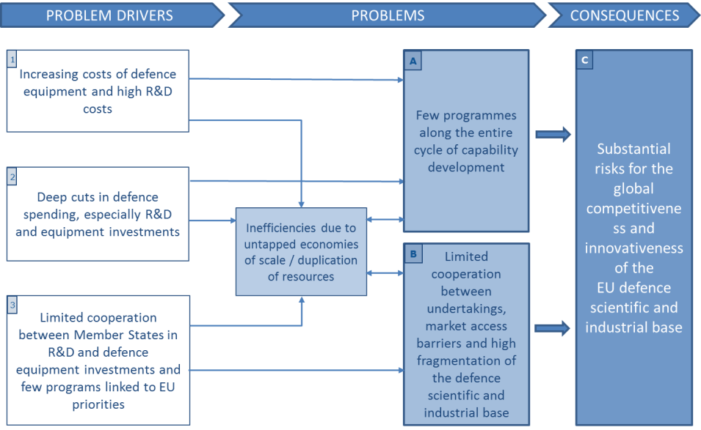

## Problems drivers

### Increasing costs of defence equipment and high R&D costs in rapidly evolving technology environment

The defence sector is characterised by **increasing costs of defence equipment and by high R&D costs [1]** that limit the launch of new defence programmes and directly impact on the competitiveness and innovation capacity of the EU industry.

The costs of successive generations of defence goods increase at a rate that exceeds by far the average inflation rates for civil products. Estimations of intergenerational cost escalation easily reach figures as high as 5% or even 10% per year in real terms ([14]). It is a long-term trend in the defence sector and finds its roots in technological competition in a field where relative performance is paramount and the competition and innovation frequently takes place at the technology frontier which is immensely expensive ([15]).

This trend exerts a key structuring effect on the defence sector: “*… the resulting rate of cost escalation, being much faster than any peacetime budget growth (or decline), has been the primary determinant (via changing ratios of budget to unit costs) of the numbers and types of equipment procured and, thence, of both military and industrial roles and structures*” ([16]). Costs rising at a pace that cannot be matched by an equivalent increase in defence equipment budgets has led to a falling number of units that national budgets can afford, a reduction in the length of the series produced, a limited capacity to tap on economies of scale and a lower frequency of new development projects.

The magnitude of R&D expenses in relation to the recurring costs is also a key factor in the defence sector. The share of development costs in acquisition costs may significantly depend on the type of equipment developed, 25% being considered as a good average indicator ([17]). The ratio of R&D costs to recurring costs of defence programmes is considered several times higher than the corresponding ratio for civil programmes ([18]).

To provide an order of magnitude, the development costs of the Eurofighter Typhoon to the four partner nations are estimated at more than EUR 20 billion (prices of 2012) ([19]). This figure is 33 times higher than the combined yearly defence R&D budgets of 24 European Defence Agency ('EDA') participating Member States other than France, Germany and the UK and more than 333 times higher than the defence R&D expenses of a medium-sized Member State such as the Netherlands. With cost increasing steeply between successive generations of defence systems, many of the future development programmes will be beyond the financial capacity of individual Member States.

Limited and dispersed investments will fail to produce the necessary effects as critical mass thresholds would not be reached. Literature provides evidence of such critical mass effects showing that below a certain threshold “*it is not optimal to invest any money*” ([20]).

In view of the cost escalation, of the magnitude of non-recurring R&D expenses and of the small series that can be procured nationally, the development of a new generation of major defence systems and of new defence technologies is increasingly beyond the reach of single EU Member States. The resulting difficulties are further increased by the recent trends in defence spending described below.

### Cuts in defence spending

The situation of the defence sector has been further exacerbated by **important cuts in defence budgets across Europe [2]** in the past 10 years, affecting in particular R&D and equipment expenditures. Between 2006 and 2013 real defence expenditure levels in the EDA participating Member States were reduced by 12% ([21]). Defence R&D expenditures suffered more and their share in total defence expenditures is expected to be 4.2% in 2016 compared to 4.9% in 2006.

The most drastic cuts have affected defence the early stages of the R&D cycle i.e. the Research &Technology ('R&T') expenditure: accounting for EUR 2.7 billion in 2006 it is estimated at EUR 2.1 billion in 2016 (a reduction by more than 22%). Defence R&T’s share in total defence spending has fallen from 1.32% to estimated levels of only 1.06% in 2015 and 1% in 2016, which is half of the benchmark level agreed on by the EDA’s Ministerial Steering Board in November 2007.

Figure 2: Defence R&T expenditures as percentage of total defence spending

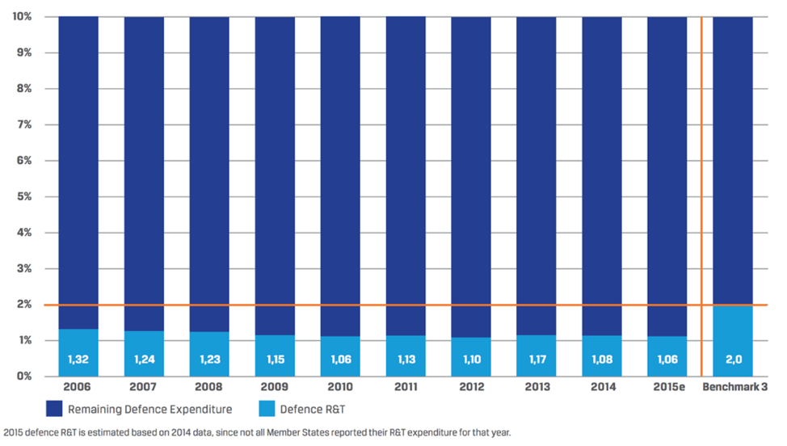

Source: European Defence Agency, 2018, p. 40.

Considering that defence R&T is the basis for the development of the future cutting edge defence technologies, such trends are particularly worrying and pose a serious challenge to the capacity to maintain EU’s defence industry competitiveness over the long term.

Defence equipment and R&D expenditures in the EU are also substantially lower than those of the United States. Figure 3 below shows that in 2011 defence equipment procurement expenses in the EU were three times lower and defence R&D expenditures were seven times lower than those of the United States.

Figure 3: Defence investment breakdown in absolute values [EUR billion]

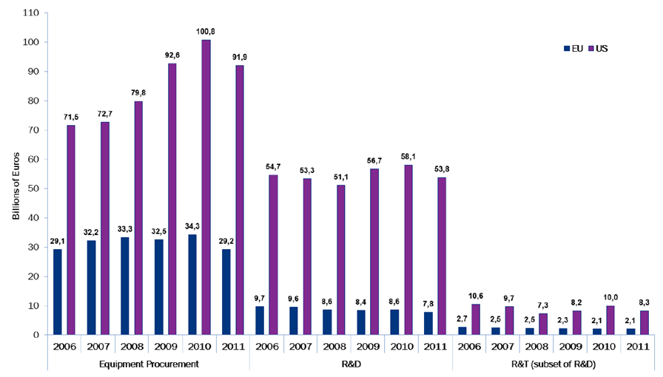

Source: European Defence Agency, 2013, p.10.

Finally, in the defence sector it cannot be expected that a lack of publicly funded projects could be offset by an increase in privately funded investments ([22]). The demand addressed to the industry comes almost exclusively from States and in particular from their defence national budgets. The sector is also subject to a strict regulation by the host States, the production and exports of armament being subject to specific authorisation systems. Sensitive technology transfers are also controlled and specific dispositions aimed at ensuring security of information and security of supply are also put in place. Unlike most civil sectors, there is therefore no market demand composed by a large number of independent customers that industry can freely serve on its own initiative. In view of the fact that demand, and therefore investment, is entirely driven by Member States, the industry would normally not embark on substantial spontaneous self-funded defence Research and Technology or development projects. It will rather work on demand for a State which, being in a situation of monopsony, will be funding the full R&D costs through a contract for the procurement of these services. The Group of Personalities Report notes: “*The defence market is unique and does not follow the conventional rules and business models that govern more traditional markets, such as those for consumer goods. A clear example is that the prevailing worldwide model of product development for large defence systems involves national governments funding almost 100% of the R&T costs*” ([23].) An assessment of the origin of the R&D budgets of French companies ([24]) also puts in evidence the importance of public funding and the very low levels of self-funding for the enterprises that received defence R&D funding.

### https://d.adroll.com/cm/index/outLimited cooperation between Member States and few programmes linked to EU priorities

Despite the interplay between increasing costs and decreasing spending, defence planning and defence spending on R&D and procurement of equipment has remained largely at national level with **very limited cooperation between Member States in defence equipment investments [3]**. Additionally, when implemented, only **few programs are also linked to EU capability priorities [3].**

Weak levels of collaboration are extremely worrying in a longer-term perspective: "*static defence budgets and low equipment spending means that a competitive defence industry is not sustainable on a national basis anymore*" ([25]).

In 2015 only 16% of equipment was procured through European collaborative procurement, far away from the agreed collective benchmark of 35% (Figure 4). This is the second worst performance observed; while the best level attained (2011) was still more than 10 percentage points short of the benchmark level.

Figure 4: European collaborative defence equipment procurement as a percentage of defence equipment procurement [%]

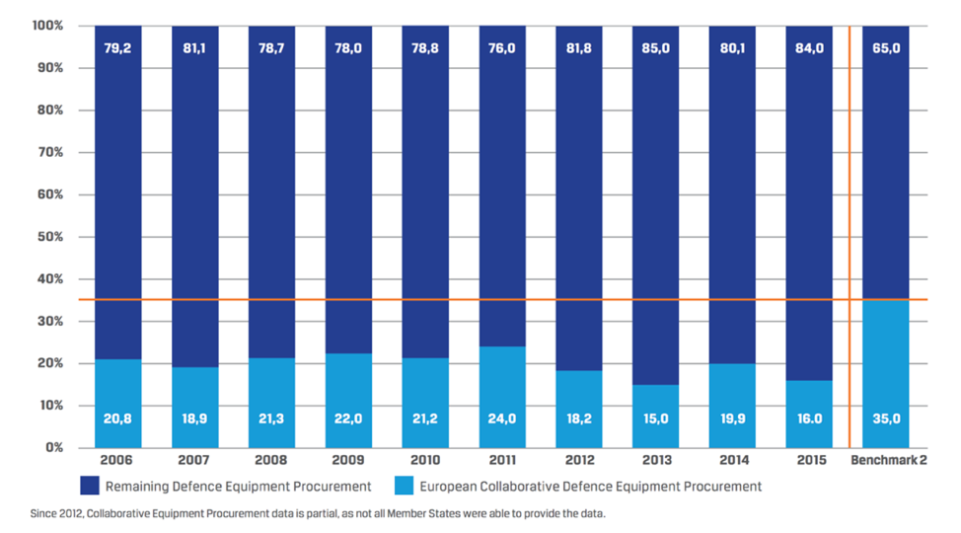

Source: European Defence Agency, 2018, p. 40.

The share of European collaboration in defence R&T (estimated level for 2015 of only 7.2%) is also very far from the agreed collective benchmark of 20%. Since 2012 more than 90% of defence R&T has been run on a national basis.

Figure 5: European collaborative defence R&T as a percentage of defence R&T spending [%]

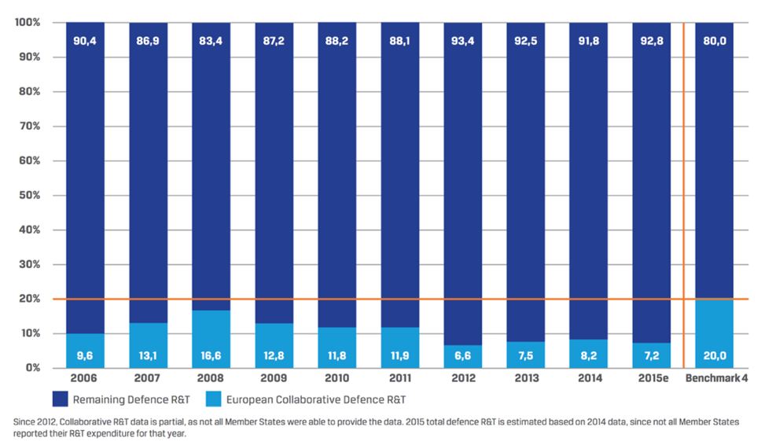

Source: European Defence Agency, 2018, p. 40.

Several reasons can explain the reluctance of Member States to step up cooperation.

First, Member States may desire to preserve full sovereignty as regards some types of capabilities and therefore attempt to keep a completely independent national industrial capacity to sustain the latter. Considering however cost escalation and budgetary trends, cooperation has no viable alternative but for a very restricted set of areas.

Second, experience with past collaborative projects points to issues that can increase the costs and reduce the net benefits of collaborative projects in comparison with an equivalent one-nation project ([26]). It should however be noted that, even by taking into account that collaborative projects can imply additional costs compared to equivalent theoretical national projects, the development costs are shared amongst the participants. The financial burden that falls on the individual participating Member States in a collaborative programme is thus lower than if they had to undertake the development in isolation ([27]). This enables in particular the realisation of large projects that would not be affordable for a single Member State, as well as achieving higher scales of production leading to lower unit costs.

As regards the difficulties experienced in past defence collaboration programmes, the following elements can be noted. The governance of collaborative programmes is more complex and requires an additional layer of discussions and negotiations to take place and higher levels of transactions costs to be supported. Issues linked to a lack of common defence planning and of synchronisation of capability procurement policies and calendars between Member States have often limited or prevented the possibility for collaboration ([28]). Problems with the synchronisation of budgetary procedures also have a negative impact on collaborative projects ([29]). The allocation of work shares in collaborative projects is also generally defined on the basis of the financial contributions by each participating country rather than on the basis of economic efficiency and competitiveness (“*juste retour*” principle). Duplications are thus not entirely avoided and work is often not allocated in most efficient way.

Last, but not least, the difficulty in defining common technical specifications has been a major issue ([30]). Failure to harmonise requirements increases the system’s complexity, inflates costs and causes delays. It reduces the benefits of collaboration as low commonality has also negative effects on economies of scale. It even can make collaboration impossible ([31]). Standardization and interoperability are thus reduced. Difficulty in agreeing on common technical specifications can be the result of national differences stemming from diverging doctrines, assessments of needs and operational requirements, but also national industrial interest can be a motive. When capability priorities are commonly agreed at the EU level, notably through the CDP and implemented under PESCO, a higher degree of convergence regarding the above-mentioned elements can be expected. This should make the definition of common technical specifications easier. However, such joint definition of capability priorities has not yet been sufficiently prioritised by Member States, while critical shortages of key enablers, such as air-to-air refuelling and strategic lift have become apparent ([32]) and the need “*to invest adequately”* in a large area of key capabilities has been recognised by the Council of the European Union([33]).

## Problems that the Fund aims to tackle

The roots causes described above challenge the capacity of the EU defence industry to sustain the industrial and technological capabilities necessary to preserve its competitiveness and leadership.

### Few projects along the entire cycle of capability development

A first major consequence of increasing costs, defence spending cuts and limited cooperation between Member States is the general **lack of opportunities in terms of new major defence technological and industrial projects [A]**, including a lack of European collaborative programmes ([34]). Such a situation puts the EU industry at a serious disadvantage in a sector characterised by strong competition on technology and a high importance of R&D activities.

The cuts in defence R&T have substantially reduced the overall opportunities for scientists to deploy efforts in this field. Lack of investments pose a threat even in the short term: troops deployed in mission often face new or unexpected threats which call for a quick generation of innovative solutions. This however “*requires investing ex ante in a large scope of technological bricks, with the relevant funding to deliver appropriate performance and to be able to combine these bricks into new capabilities” ([35]).*

Moreover, in the long run the EU defence industry faces the serious threat of not being able to develop the technologies of the future. As noted in the Group of Personalities Report "*R&T activities are the first necessary step to prepare for future capability developments allowing for the maturing of technologies and the reduction of risks. The defence R&T investment made today will underpin the freedom of action available tomorrow, the preservation of operational and technological advantage, the reinforcement of industrial competitiveness and employment opportunities*" ([36]).

The potential negative effects of reduced opportunities to engage in defence-related research are indeed not limited to the defence sector only. Defence research, in particular of explorative and forward-looking nature, can also be at the origin of major technological breakthroughs. Focused on technological superiority, rather than on profitability, defence research can play a specific role in the process of innovation and is often at the origin of major spin-off effects in the civilian economy ([37]).

The difficulties that the sector faces are even more substantial as regards defence development projects through which technology needs to transition towards final products and technologies. Such projects, crucial for the competitiveness of the EU defence industry, may not proceed forward, even if the initial stages of R&T have already been funded. Bridging the "valley of death" between R&T and development is a lengthy process that entails important technical and financial risks that individual Member States may not assume on their own.

The development and testing of prototypes is a phase in the development process that is particularly difficult because of the high costs involved and the important risks of failure still present. At the development stage the distance to the acquisition phase is shorter, which requires a high degree of customisation to the needs of a specific client. From industry’s point of view this implies high level of asset specificity and substantial sunk costs. The funding will be normally expected to come from the client.

### Fragmentation and lack of collaboration between undertakings

Limited collaboration of Member States in defence implies duplications and results in a **defence industry that remains highly fragmented along national borders [B]**. The lack of integration on the demand side of the market, i.e. between Member States, indeed fails to generate incentives for trans-border collaboration between undertakings and for further integration of the industry.

The dependence on national markets still remains important in particular for those companies that exhibit a high proportion of defence-related activities. Looking at 32 major European companies active in the defence industry a study ([38]) notes that five companies show a share of domestic sales in their turnover that is above 50% and for a majority of 20 companies the proportion varies in the interval 20%-50%.

While Europe spends three times less on defence procurement and seven times less on defence R&D, there are 36 defence platforms and systems in production in Europe against only 11 in the US ([39]). Unnecessary fragmentation implies a failure to capture economies of scale and learning, important opportunity costs through reduced money available to develop capabilities in other sectors and as a probable final result "*European countries become less technologically advanced; more expensive platforms and systems obtain a narrower range of military capabilities in a less productive and innovative industry*" ([40]).

Resulting duplications prevent the industry from achieving optimal size of production as comparatively small national markets are served in isolation following the prevalence of a “*systematic bias in favour of a domestic solution*” and “*a domestically oriented organization of R&D*” ([41]). 11 armoured infantry vehicles and personnel carriers are for instance in production in Europe ([42]).

Combat aircrafts provide another illustration of the fragmentation of the EU defence industry, of the economies and efficiency gains foregone as a consequence and of the resulting impact on industry’s competitiveness. Three types of combat aircraft are currently in production in Europe: the Eurofighter Typhoon, the Rafale and the Gripen. A 2013 study on the costs of non-Europe in the defence field ([43]) noted that the total R&D costs of the three European projects together largely exceed those of the US-led Joint Strike Fighter F-35 programme while the total expected output is almost 1,800 units lower and divided between three different aircrafts which significantly reduces the economies of scale and learning.

Annex 3 provides a more detailed assessment of this case. It shows that if only one of the three above-mentioned European aircrafts had been developed and had realised sales equivalent to those of the existing three programmes, the R&D cost per unit produced could have been reduced by 41 to 76%. This very simple comparison only takes account of the distribution of R&D costs over a larger production scale, but ignores the effects of the other sources of economies of scale and learning.

Existing research clearly shows that the expected positive impact of increased scale of production on the cost-effectiveness of the industry can be very significant – according to different studies, costs reductions of 10-20% can be achieved when production is doubled or increased from minimum efficient scale to the ideal level ([44]).

It can be noted that even large trans-border consolidations have not necessarily led to a genuine and deep consolidation of industrial assets at the EU level but have often led to the creation of “multi-domestic” companies ([45]). Nor has the prevalence of rigid work-share arrangements based on the “juste retour” principle allowed achieving the full potential of cooperative programmes to reduce duplications and market fragmentation. The concluding remarks of the European Parliament’s study on the overall condition of the European defence industry are that “*all sectors show excess capacities in production. This is expressed in many but small producers which are specialized in similar areas but do not compete against each other for the first production lot due to markets with high barrier for non-domestic suppliers*” ([46]).

The fragmentation of the European defence industry is not only limited to the weakness of horizontal collaboration at the level of system integrators. It also affects cross-border access to the defence industry supply chains. The latter have been predominantly set up on a national basis ([47]). Access for new suppliers, especially for those located in other Member States, remains limited ([48]) leading to low levels of cross-border engagement in the defence industry’s supply chains. Dependence on defence markets is shown to substantially and negatively affect the propensity of system integrators to resort to foreign suppliers ([49]). Data provided by the Organisation for Joint Armament Cooperation ('OCCAR') regarding defence programmes managed by the organisation ([50]), estimates that approximately 5.6% of the value of the work performed in programmes goes cross-border: 2.4% of the total workshare goes cross-border between the 12 States participating in Programmes managed by the OCCAR ([51]) and 3.2% goes to other States.

Obstacles to the cross-border access to defence supply chains pose a serious challenge for a large number of companies for which this is the only access to the market. These companies represent the vast majority of enterprises involved in the defence industry as it is estimated that the top Tier accounts for only 2% of the companies in the overall industry supply chain ([52]). The Final Report of the European Commission Advisory expert group on cross-border access for SMEs to defence and security contracts ('Advisory Group Report on cross-border access for SMEs') explicitly recognised that “*the issue of cross-border market access and open supply chains is considered particularly important for the functioning of the European Defence Equipment Market*” ([53]). The existence of important barriers to cross-border engagement in the defence supply chains is also clearly recognised by a recent study ([54]).

Barriers to the cross-border participation in the supply chains have particularly negative effects on SMEs’ capacity to take full benefits of participation in the defence market. As noted in a Resolution of the European Parliament: “*the fragmentation of the European defence market is an obstacle to the ability of SMEs to market their products*” ([55]).

SMEs play an important role in the defence industry and are “*a key enabler for competitiveness*” ([56]). They have recognised strengths such as flexibility, innovativeness and specialised knowledge ([57]). A recent study ([58]) identified almost 1,600 SMEs active in the defence sector in Europe and estimated the total number of SMEs in defence supply chains at 2,000-2,500.

Data on their involvement is however scarce. It is estimated that they account for between 11 and 17 per cent share of the estimated defence equipment sales in the EU ([59]). The share however varies significantly across Member States and segments. Studies report a lower participation of SMEs in the sector compared to the manufacturing sector in general ([60]). Defence R&D expenditures appear to be more concentrated in large enterprises comparatively to other sectors, but SMEs active in the defence sector appear to be investing more in R&D that other SMEs ([61]). Data on the participation of SMEs in defence R&D projects is extremely limited ([62]).

SMEs in particular, but also suppliers in general, assume increasing responsibilities through the extension of the use of risk-sharing partnerships by the large system integrators where the costs and risks of development are distributed across system integrator and partners in its supply chain ([63]). System integrators may also exert their market power to extract harsh financial conditions from suppliers thus limiting the "cascading" of R&D funding down the supply chain ([64]). Defence SMEs also face a number of additional challenges: 1) they suffer from important information problems ([65]); 2) they face difficulties in access to finance ([66]); 3) they suffer much more from administrative burden and costs (e.g. related to IPR protection); 4) they need to obtain quick return on investment ([67]). Mid-caps are also affected by some of these issues, but to a more limited extent than SMEs ([68]).

The problems described above have led to a situation where the **defence industry in Europe faces a serious threat of losing its innovative capacity and technological superiority in global competition [C].** Europe’s capacity to develop and produce high-tech systems needed for its defence is thus threatened.

## Baseline scenario

As explained above, the current trends and identified problems and their drivers have not been reversed nor is it likely that they will be in the near future. The existence of cooperative mechanisms, such as under the EDA, have not been sufficient to reverse this overall trend of diminishing volumes of R&D cooperation. Whilst initiatives like CDP and CARD address some of the previously identified issues, notably by identifying priority European defence capability gaps and scope for coordination of defence planning and cooperation, and whilst PESCO offers a new framework for cooperative projects between Member States, these initiatives neither specifically address the industrial angle, nor do they include funding to incentivise collaborative projects.

Under the status quo (Baseline Scenario) the EU budgetary support under a small-scale PADR with an annual budget of around EUR 30 million focussing on a limited number of key research projects and under the EDIDP with an annual budget of around EUR 250 million would continue until 2027.

Given the costs of collaborative defence R&D projects and the long lifecycle of defence equipment, it is unlikely that these two small scale actions would be sufficient to bring about a sustainable and long-term change in the level of industrial cooperation and innovative capacity of European defence industry. Main problems identified would not be sufficiently addressed; collaborative investments in defence R&D projects would remain comparatively limited.

Furthermore, the identified differences between the two programmes would continue to exist, thereby foregoing scope for simplification and alignment and not responding to the wishes of many Stakeholders.

Whilst other funding programmes under the 2021-2027 MFF are also to a certain extent accessible for defence companies, they would not bring about the required change, as they will not explicitly address the defence-specific problems described above. In case of EU financial instruments limitations apply based on the European Investment Bank's ('EIB') lending conditions excluding the involvement in sectors as ammunition and weapons as well as military/police equipment or infrastructure ([69]).

The Baseline Scenario is therefore not the optimal scenario.

## Complementarity with other MFF programmes and Union's initiatives

The implementation of the Fund will take place in close coordination with activities of the Commission and the High Representative for Foreign Affairs and Security Policy in the area of defence, including the Financial Toolbox. There will be close links between the Fund and projects implemented in the framework of PESCO.

In order to ensure coherence and complementarity in the promotion of the defence interests of the Union, under the 2021-2027 MFF the Commission will seek to ensure synergies with other EU initiatives in the field of civil R&D, such as security and cyber security, border control, coast guard, maritime transport and space.

In particular synergies should be sought with:

- the specific programme implementing Horizon Europe with a focus on civil applications, so that results from defence R&D will benefit civil R&D and *vice-versa*. The Fund only finances defence R&D actions aimed at supporting the capacity for innovation and competitiveness of the defence industry in relation to high-tech defence systems. The Fund does not support pure basic research, which should be supported by other schemes, but it may include defence-oriented basic research likely to form the basis of the solution to recognised or expected problems or possibilities. The projects to be financed by the Fund may thus benefit from the results of research projects funded under Horizon Europe. Results from Horizon Europe could be used for additional defence-oriented research and development activities under the Fund, given that defence applications have stricter certification and security requirements;

- the Union space programme, in particular its components Governmental Satellite Communication (GOVSATCOM), Space Surveillance and Tracking Support (SST) and Copernicus. This may be done notably by ensuring technical compatibility where the projects make use of global navigation satellites system (GNSS) and GOVSATCOM capabilities. This may also be done by developing upgraded sensors, exchange platforms for classified data, applications based on data or information and services that are provided by the space programme's components;

- EU initiatives in the field of cybersecurity; such as those announced in the Joint Communication on cybersecurity ([70]). In particular the cyber security competence centre to be set up should seek synergies between the civilian and defence dimensions of cybersecurity. It could actively support Member States and other relevant actors by providing advice, sharing expertise and facilitating collaboration with regard to projects and actions as well as when requested by Member States acting as a project manager in relation to actions under the European Defence Fund;

- the actions identified under the coordinated civil military maritime security research agenda and with maritime transport, and;

- other relevant EU programmes in the field of security, such as the Internal Security Fund and the Integrated Border Management Fund.

The Fund also complements defence activities implemented through the Connected Europe facility (as regards military mobility) and the European Peace Facility, an off-budget instrument proposed outside the MFF.

The defence sector has been proposed as an eligible sector for support through budgetary guarantees under the InvestEU Fund which is put forward as a cross-sectoral and over-arching framework supporting investment in various policy fields, underpinned by an EU budgetary guarantee.

Financial instruments, which may take the form of equity or quasi-equity investments, loans or guarantees, targeting the defence sector are not in place under the current MFF. Their future deployment under the InvestEU Fund will thus make an important addition to the actions supported under the Fund, also considering the budgetary efficiency of these instruments. Financial instruments reduce financial risk, but contrary to grants, cost sharing is limited to situations in which risks materialise.

The possibility to use financial instruments for defence-specific research activities is more limited as market uptake is usually not imminent and the specificities of the sector imply important difficulties in estimating the possibilities for the technology to be met by demand. However, financial instruments for defence development projects, which involve very substantial costs and important risks, could be possibly useful to support projects in specific situations where for instance important civil spin-offs or large volumes of sales to other States are foreseen.

Also the availability of financial instruments can be important if despite EU funding being provided at the top levels of the supply chains, severe constraints are still present hampering participation by suppliers located down the supply chains ([71]). This may put some suppliers in a situation where they need to wait for the production phase to recover R&D investments made for the project ([72])with all the additional risks that this implies ([73]). Budgetary guarantees can be a fiscally efficient way to address risks in the supply chain and could facilitate its participation in individual projects by addressing the risks or capital funding bottlenecks encountered at that level ([74]).

The extent to which financial instruments can be applied depends on the extent to which limitations continue to be applied in the lending policy of financial intermediaries (notably the EIB) towards defence-specific activities ([75]).

To enable full synergies to be exploited, it is proposed to introduce the possibility of blending support under the Fund with the provision of financing backed by the Invest EU Fund.

The possibilities for deployment of financial instruments in the defence sector are amongst the elements explored in the framework of the Financial Toolbox developed by the Commission together with Member States. More generally, the Financial Toolbox, which is separate from the current legislative proposal, aims to further facilitate joint development and acquisition of defence capabilities through the standardisation of EU and national financing mechanisms ranging from pooling to joint ownership. The financing models for capability acquisition included in the Financial Toolbox can also serve as a voluntary reference for Member States wishing to jointly procure the products and technology developed through the European Defence Fund and the Commission will thus ensure that the full potential for synergies is achieved.

## Objectives and eligible actions

The Fund will support and incentivise collaborative defence research and development projects in the EU by providing funding from the EU budget, thus contributing to addressing capability shortfalls in the EU. The intervention aims at funding the entire cycle of collaborative research and development of cutting edge defence technologies and systems for modern armament and equipment programmes.

The Fund finances projects in line with capability priorities commonly agreed by Member States within the EU within the framework of the CSDP.

### General objective

In the above context, the **general objective** is to foster the competitiveness, efficiency and innovation capacity of the European defence industry, by supporting collaborative actions and cross-border cooperation between legal entities throughout the Union, including SMEs and mid-caps as well as fostering the better exploitation of the industrial potential of innovation, research and technological development, at each stage of the industrial, thus contributing to the freedom of action of the Union and its autonomy, in particular in technological and industrial terms.

### Specific objectives

Two **specific objectives** can be defined relating the research and development actions.

(a) Support collaborative research projects that could significantly boost the performance of future capabilities; aiming at maximising innovation and introducing new defence products and technologies, including disruptive ones;

(b) Support collaborative capability development projects of defence products and technologies consistent with defence capability priorities commonly agreed by Member States within the framework of the Common Foreign and Security Policy, thus contributing to greater efficiency in defence spending within the Union, achieving greater economies of scale, reducing the risk of unnecessary duplication and as such reducing the fragmentation of defence products and technologies throughout the Union. Ultimately, the Fund will lead to greater interoperability between Member States' capabilities.

### Actions to be financed to achieve the general and specific objectives

The **scope of the actions** will include actions from the lower level of maturity (upstream technology) up to the higher levels resulting in development and as such take into account short-, mid- and long-term capability needs. The scope of the actions should thus range from research in critical defence technologies, future and emerging disruptive technologies, defence technology demonstrators, the feasibility and definition stage, design, prototypes, testing and up to standardisation/certification.

To support and leverage cooperation, only collaborative cross-border actions should be financed consisting of **consortia** of at least three entities based in at least three different Member States.

Given the Fund's general objective of fostering the European defence industrial and scientific base, only legal entities **established in the Union** or associated countriesshould be eligible for support. To ensure the protection of essential security interests of the Union and its Member States, the infrastructure, facilities, assets and resources used by the beneficiaries and their subcontractors in actions supported by the Fund should not be located on the territory of non-EU States/associated countries. Beneficiaries of the Fund and their subcontractors should not be subject **to control** by a third country or third country entities. The Regulation frames exceptions, which are subject to conditions being met.

In view of the observed negative effects in case of a failure to agree on **common technical specifications**, this should be a condition in order to benefit from the Union's support as regards in particular prototypes. Also the **intention of Member States to procure**, including in the form of joint procurement, the final product or use the technology is a requirement for actions concerning prototyping or later development stages.

Figure 6 illustrates the objectives and conditions as regards the actions to be financed by the Fund.

Figure 6: Objectives and actions

# priorities, right to act, budgetary amount

## Prioritising actions

The priorities for research and capability development will be essentially based on the input from Member States, which set the defence priorities in the framework of the CSDP ([76]). The Fund will be informed by the priorities identified notably through the CDP and will take into account CARD, notably as regards the implementation of these priorities and the identification of new cooperative opportunities. Through this process, Member States will be incentivised to compare and define their projects and find common ground.

The priorities for funding will be defined in the annual or multi-annual work-programmes drafted by the European Commission. The work programme will take the form of implementing acts that will be adopted in line with comitology procedures, where on a proposal by the Commission, a Programme Committee of Member States votes by qualified majority. Given its specific role in the EU Treaty in supporting the CSDP policy, the EDA will have an observer status to provide its views and expertise and the European External Action Service will be invited to assist.

Once adopted the work programme will be implemented through projects normally selected with the help of independent experts after a call for proposals.

## The right to act

### The intended legal base

The European Defence Fund aims at fostering the competitiveness and innovativeness of the EU's defence technological and industrial base by supporting defence-oriented R&D activities. It is based on the TFEU Titles 'Industry' and 'Research and technological development and space' (Articles 173, 182, 183 and 188).

Article 173 of the Treaty on the Functioning of the European Union (TFEU) constitutes the legal base for actions aimed at, inter alia, encouraging an environment favourable to the development of undertakings throughout the Union, particularly SMEs, and favourable to cooperation between undertakings and fostering better exploitation of the industrial potential of policies of innovation, research and technological development.

As the Fund aims at fostering the competitiveness and innovativeness of the EU's defence technological and industrial base by supporting defence-oriented R&D activities, its aim and its content justify the choice of 173 TFEU as legal basis. Defence-oriented research actions also form an integral part of the European Defence Fund. Their aim and content also justify Article 182 TFEU as an additional legal basis.

Pursuant to the TFEU all research activities shall be covered by a multiannual framework research programme. The basic act of the multiannual research and innovation framework programme post-2020 Horizon Europe contains the necessary provisions establishing setting out the links between the framework programme and the specific programmes established by it on defence research and on implementing Horizon Europe (which has a focus on civil applications of research and innovation activities).

The detailed provisions for Union funding to defence research projects and its budget allocation are fixed in the current Regulation on the European Defence Fund, which defines the rules of participation for defence research. Research and innovation activities carried out under the European Defence Fund have an exclusive focus on defence applications.

### The subsidiarity (EU added value) and proportionality

In today's world, guaranteeing security means dealing with threats that transcend borders. No single country can address these alone. The EU will need to take greater responsibility for protecting its interests, values and the European way of life, in complementarity and in cooperation with NATO.

Efforts to meet the EU's level of ambition in security and defence (as endorsed by the European Council in 2016) will contribute to this objective. To be ready to face tomorrow's threats and to protect its citizens, the EU needs to enhance its strategic autonomy. This requires the development of key technologies in critical areas and strategic capabilities to ensure technological leadership. Greater cooperation at all levels is the only way to meet EU citizens' expectations.

By encouraging cooperation, the EU can help maximise the output and quality of Member States' investment in defence. The Fund will bring EU added value by incentivising joint research on and development of products and technologies in the area of defence to increase the efficiency of public expenditure and contribute to the EU's operational autonomy.

Decisions on defence investments and defence development programmes remain the prerogative and the responsibility of Member States.

The proposed policy approach can be expected to be proportionate to the scale and gravity of the identified problems. The decision to sustain investments in defence and launch defence development programmes remains the prerogative and the responsibility of Member States. The EU cannot and should not make up for the low levels of defence investments of Member States. However, as explained in Section 2 it can complement, leverage and consolidate their collaborative efforts in developing defence capabilities to support the European defence industry and respond to security challenge. This would avoid duplication, allow for a more efficient use of taxpayers' money, improve the interoperability of defence equipment, minimise fragmentation and boost competitiveness and innovation in the European defence technological and industrial base.

The initiative is therefore clearly limited to goals that Member States cannot achieve satisfactorily on their own and where the EU can be expected to do better. The proposed Fund will aim at limiting financial and administrative costs.

## Appropriateness of the budgetary amount

The Commission proposed the budgetary amount for the Fund in its proposal for the MFF 2021-2027: EUR 13 billion (current prices) of which EUR 4.1 billion to fund collaborative defence research and EUR 8.9 billion to fund collaborative defence development projects. The proposed budget of the Fund for the MFF 2021-2027 has the appropriate magnitude to achieve a genuine impact.

As regards **defence research investment,** taking into account the scale of existing national defence research budgets and the high costs of developing cutting-edge defence technologies, an annual budget of EUR 585.7 million appears appropriate in order to make a substantial difference. It is in line with the conclusions of the Group of Personalities Report ([77]), as well as with the report of the European Parliament on the European Defence Union of November 2016 ([78]). With an investment of EUR 585.7 million on an annual basis the EU will match the Member States with the highest levels of R&T funding. If the data for 2014 is used as a reference and the UK is excluded, the Fund’s contribution will account for approximately 28% of the total defence R&T effort in the EU. Indeed, the total European expenditure on defence R&T amounted to approximately EUR 2 billion annually ([79]) in 2014. France spent approximately EUR 750 million, Germany and UK just below EUR 500 million annually. Under the same assumptions an EU investment of EUR 585.7 million would result in an increase from 1.03% to 1.42% of the share of defence R&T in total defence spending, thus providing a significant contribution in closing the gap with the 2% EDA Benchmark. The share of EU collaborative defence R&T in total defence R&T will thus substantially increase to 36.26%, a percentage that is largely superior to the EDA Benchmark of 20%.

**Defence development expenses** in Europe in 2014 were approximately EUR 6.8 billion in 2014 ([80]). If the UK is however excluded, the figure is reduced to slightly more than EUR 3.5 billion. On this basis, an annual EU contribution of EUR 1.27 billion will represent approximately 26% of the total defence development spending and will make a substantial addition to Member States efforts in this field. Moreover, considering that in most cases the EU is expected to co-finance development projects, the total value of the investments realized, including the part co-funded by Member States or other sources, will range between EUR 1.27 billion and EUR 6.35 billion per year depending on the rate of EU co-financing. No Benchmark concerning defence R&D expenses has been adopted in the EDA framework, but the data on the benchmark on collaborative defence equipment procurement presented in 2.1.3 shows a significant “collaboration deficit”. Taking into account the average ratio of R&D to equipment expenses in EDA participating Member States, a study has estimated that the necessary collaborative R&D expenses to resorb this deficit would range between EUR 700 million and EUR 2 billion per year ([81]).

## Introduction of Options

In order to assess as to how to deliver in the most optimal manner on the set objectives and the eligible actions, current experience - however limited it may be - needs to be taken into account as well as possible scope for further alignment and simplification, the political consensus that has been reached on the EDIDP, the comments received from Stakeholders.

Three Options will be assessed below focusing mainly on the best Fund architecture and delivery mechanisms, which have been built on two criteria: their structure as compared to the Baseline scenario and the depth of the changes that they introduce compared to the Baseline. In all three Options the budget is substantially higher than the Baseline scenario in line with the Commission's proposal for the MFF 2021-2027.

1.1.1. Option 1: Continuity

Option 1 is based on a maximum level of continuity with the PADR and the co-legislator’s consensus on the EDIDP albeit with more than six times higher budget.

1.1.2. Option 2: Flexibility and simplification

Option 2 builds on Option 1, but proposes to simplify the Fund's Structure by integrating the two windows in one single Fund covering the scope of the PADR the EDIDP. Option 2 also introduces some limited content changes, for instance by expanding the scope of the instruments to achieve the Fund's objectives; thereby offering further flexibility and simplification for beneficiaries.

1.1.3. Option 3: Prescriptive

Option 3 builds on the changes introduced in Option 2 as regards the Structure and the scope of instruments, but replaces other features of Option 1 and 2 thereby changing the approach based on incentives and bonuses under Options 1 and 2 with a more prescriptive approach with obligations and a reinforced EU role. Option 3 represents an attempt to be more intrusive in addressing the identified problems through a more directive approach.

The logic behind such definition of Options is presented in Figure 7 below.

Figure 7: Definition of the Options

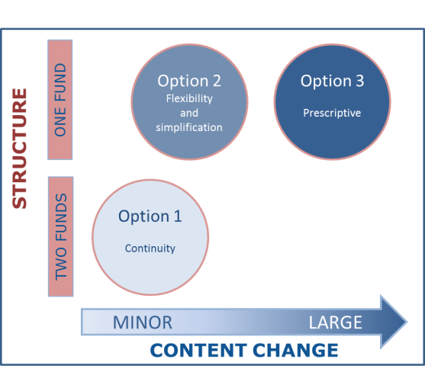

# DELIVERY MECHANISMS OF THE INTENDED FUNDING

A detailed assessment of the key differences between the Options and of their main advantages and limitations is presented below; after which the trade-offs between each of the Options is analysed in terms of their ability to deliver the objectives in most the optimal manner.

## Structure, delivery mechanisms and related IPRs varying across the Options

The Options relate to variables in relation to the Fund's Structure, including: governance (4.1.1.); general delivery mechanisms including funding instruments, funding levels (4.1.2.), IPR aspects (4.1.3.), and defence-specific mechanisms linked to the promotion of cross-border and SME participation, PESCO-related aspects and continued cooperation (4.1.4.). The visual representation of such factors is provided in Figure 8 underneath.

Figure 8: Array of delivery mechanisms across the three options

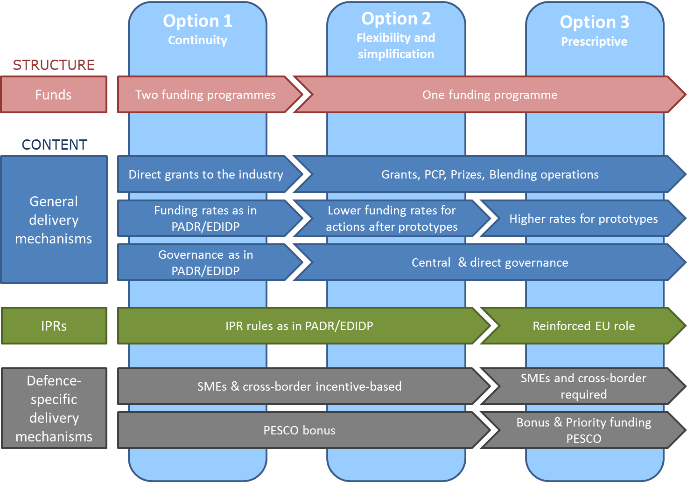

### Programme Structure and Governance (management)

Under O**ption 1 t**he ***existing structure and governance*** of the Baseline scenario would continue with a higher funding level; meaning two separate Programmes. Although such Structure has the obvious advantage of providing certainty and continuity, it does not take account of efficiency gains of streamlined processes for the two windows, which has been put forward as a critical success factor by Stakeholders (1.2.2), and scope for alignment of rules of participation. Having different structures might lead to confusion, coordination problems and foregone opportunities for coherence and streamlining.

Under O**ption 2 and 3**, compared to the ***Structure*** under the Baseline scenario of having two separate programmes, one single Fund would be set up. It would allow a better harmonisation of rules of participation between PADR and EDIDP in view of supporting the full cycle of defence-oriented research and development of defence capabilities to ensure the uptake of research results in the development stage.

Concerning ***Governance***, the Fund would be implemented under a single management mode. Under Option 2 and 3 the Fund would be implemented directly by the Commission. Such structure would best ensure simple, streamlined and lean processes. It also is the most optimal way to allow the Commission to control, monitor, and possibly correct implementation and assume its accountability towards the budgetary Discharge Authority in line with its obligations under Article 317 TFEU. The financial expertise in implementing the EU budget, which is the main element for the implementation, is available in the Commission. In view of the specificities of the sector, management needs to be done in a secure manner. The Commission has the infrastructure and IT-systems to ensure secure handling and exchange of EU Classified Information (EUCI). Regulation 1049/2001 on access to documents foresees several protection layers to ensure confidentiality of defence documents.

Direct management would also recognise the role and needs and technical expertise of end-users (military) and national governments (Ministries of Defence) when defining defence priorities and when managing projects at technical level. Comitology procedures at work programme level ensure technical input from Member States.

### General delivery mechanisms

#### Instruments

**Under Option 1** the Fund would continue to rely on the main instruments used for research and development actions in the PADR and EDIDP under the Baseline scenario, which are principally direct grants to legal entities and to a lesser extent procurement with regard to studies. The grant instrument is a broadly tested instrument not needing major further adaptations to be applied to the defence sector. It is an appropriate instrument to promote defence research and development activities. However, this Option does not provide a response to Stakeholder feedback advocating for more flexibility and funding possibilities that better adhere to the specificities of the sector.

**Under Option 2 and 3**, the Fund could introduce further flexibility and build on experience with more innovative instruments gained through other existing Union programmes, which allow for example for a) grants to groups of buyers to allow for PCP and b) for prizes to support demand for innovative solutions and user-driven innovation. It also allows for c) the use of financial blending operations.

a) Grant to a consortium of buyers:

In the 2014-2020 MFF other Union Programmes started to apply more innovative grant instruments to fund a group of procurers ('buyers group') to undertake together joint PCP in cases where there needs to be a close link between procurer ('public buyer') and the contractor ('research organisation or company'). Given these specifics the innovative instrument of using grants to finance PCP could be a suitable solution in certain cases to achieve the objectives of the Fund. The advantage may be that it follows well the business reality in the sector and allows EU budget financing to feed into a project between industry and Member States where the management is done by the buyers group of Member States usually through a contracting authority/project manager.

1. Prizes:

Also prizes could be a suitable instrument for specific defence research activities where organisations compete in offering the best solution to a specific technological challenge.

1. Blending operations:

As explained in Section 2.4, the defence sector is proposed to be an eligible sector for support through budgetary guarantees under the InvestEU Fund. In order to allow the exploitation of the potential of blending operations, combining funding provided under the European defence Fund and the provision of financing backed by the InvestEU fund, a standard clause enabling such operations is introduced under **Options 2 and 3.**

The combination of project-oriented support under the Fund along with targeted financing in the defence sector can make a powerful contribution to strengthening the resilience of the sector and addressing the vulnerabilities observed, in particular for innovative SMEs and Midcaps.

#### Funding rates and reimbursement methods

Under **Option 1** the funding rates will remain unchanged in comparison with the Baseline scenario. More projects would nevertheless be financed because of the higher budget available. Reimbursable eligible cost for grants will continue to be calculated ex-post on the basis of a cost declaration ('cost declaration method'). Indirect cost will be covered by continuing to use a 25% flat rate of total eligible direct costs excluding subcontracting. The advantages are that this is a well-established method to which participants of Horizon 2020 and PADR are used. Although the use of a flat rate limits administrative burden, the disadvantage is that it does not take into account concerns of Stakeholders on the funding levels for indirect costs being insufficient considering the specificities of the sector.

**Option 2** takes account of the concern ofStakeholders that funding levels for indirect cost are too low in the methodology applied in the Baseline scenario. The specific characteristics of the sector, including the dependence on a single buyer and the important limitations to commercially exploit the results from defence-oriented R&D, should be acknowledged. Under Option 2, flexibility will be introduced allowing better covering indirect cost, where appropriate.

Option 2 also introduces the possibility for simplification measures in relation to the reimbursement method for grants to lower administrative cost through a single lump sum contribution. However, the risk in relying on lumps sums is that ex-ante estimations could be either too high, which would come at a cost for the budget, or too low which may lead to low uptake. It is also not a broadly tested method and the Commission has limited experience in setting the right level of lump sum due to different costs in the various EU Member States. In the present case such risks would be mitigated by using the lump sum cost calculation for development projects where the majority of costs are co-funded by Member States/ associated countries relying in their experience in determining cost reimbursement levels for such projects.

Option 2 also takes into account that actions beyond the prototype phase and thus closer to product and technology finalisation may involve lower risks, whilst at the same time involving still substantial cost and needing continued commitment from Member States/ associated countries to cooperate at these later stage of development. In balance, under Option 2 the EU co-funding for R&D actions beyond the prototype stage would be capped at 80%. This maximum level of funding would still provide the necessary flexibility to achieve the objectives of the Fund.

Under **Option 3**, a greater Union involvement as regards the development of prototypes would be established by providing a higher standard EU co-funding rate for prototypes. Whilst this may seem attractive, there are important drawbacks. Higher funding by the Union and lower co-funding by Member States may go against the wish of Member States to stay in lead of the project in the prototype phase allowing them to take decisions as to project structure, workload distribution etc. A higher involvement of the Union may be received as too intrusive at the development stage and being a minority partner may also lower the commitment of participating Member States. It is also important to ensure, at this crucial stage of the development process, that Member States have the necessary commitment to and ownership of the project. This can only be achieved through a significant financial commitment of Member States. A cap (for example of 50%) for EU funding of prototypes could be envisaged to address the above risks. It may however have financial budgetary implications risking that the first prototypes financed already absorb a large portion of the available budget.

### Intellectual Property Rights

Intellectual Property Rights (IPR) arrangements in the area of publicly funded research and development need to strike a balance between maximising the impact of the public funding for the benefit of the taxpayer and making attractive for the research community and industry the participation to the Fund.

**Under Option 2** the core IPR arrangements are the same as those under the Baseline scenario.

As regards research actions, results of actions are owned by the beneficiaries generating them beneficiaries with small restrictions and right to use other co-beneficiaries' results for the exploitation of their own results under terms and conditions. The Union has a royalty-free access to all the results for non-competitive and non-commercial use. Member States/ associated countries have royalty free access to a report, which provides them with all the necessary information to assess the content of the action and of the results, without revealing information on know-how. In the case that at a later stage, two or more Member States/ associated countries conclude a contract with a beneficiary of a project to further exploit the results funded by the research window of the Fund and owned by the participant, these Member States/ associated countries have royalty free access to those results.

As regards development actions, in consistence with the EDIDP, the Union will not own IPRs resulting from the actions funded under the Fund, as at this stage of the development the Fund is mainly co-funding the development of defence products and technologies. It is for the Member States/ associated countries, together with beneficiaries, to define IPR arrangements.

However, when the Commission procures a study, it will own the IPRs and grant Member States and associated countries a non-exclusive licence for use.

**Under Option 3,** additional measures could be introduced to better allow the Union to ensure that the results are available in the EU and ensure its strategic autonomy. Under Option 3 for development projects with the co-funding of Member States/ associated countries and low EU budget contribution, the rules could be aligned to those of the PADR e.g. by asking a royalty free access right for the Union and providing a report to all the Member States/ associated countries.

However, Option 3 is not yet mature and the described possibilities have not been properly tested or discussed with Member States or the wider stakeholder community. For these reasons this Option is not recommended to be implemented at the outset of the Fund. Possibly Option 3 could be further considered at a later stage when more experience with the IPR provisions has been attained and if Stakeholders agree on the added value.

### Defence-specific characteristics

#### Cross-border participation of SMEs and Mid-Caps

As explained in Section 2.2.2 cross-border participation at the level of the defence industry supply chains is very limited and this affects in particular SMEs and to a lower degree mid-caps.

The very introduction of an EU Fund supporting collaborative research and development projects significantly contributes in fostering cross-border collaboration between legal entities, including in the defence supply chains. The initiation of common cross-border EU projects was one of the key recommendations of the Advisory Group Report on cross-border access for SMEs ([82]).

Measures aiming at enhancing cross-border participation and participation of SMEs and mid-caps in projects supported by the Fund can also be enacted in different ways.

Under the Baseline scenario, under the PADR annual work programme included topics where SMEs have higher chances to participate. For some specific calls for proposals, a wider collaboration was also required taking the form of an increased minimal number of participants from more Member States.

As regards the EDIDP, several dedicated measures of incentivising nature have been introduced in the Programme’s base legal act:

* an award criterion for participation of SMEs and of cross-border SMEs ([83])
* EU funding rate bonuses for: participation of SMEs; participation of cross-border SMEs; participation of mid-caps[84]
* An obligation to include a specific category of projects dedicated to SMEs in the work programme
* a global target specifying that the work programme should ensure that at least 10% of the overall budget will benefit the cross-border participation of SMEs

Considering that complex combinations of different funding rate bonuses can in particular make the budget allocation per category of projects extremely difficult, a cap to the overall increase of funding rates through bonuses has been fixed at 35 percentage points.

**Under Option 1**, the different approaches under the Baseline scenario as adopted for the PADR and the EDIDP will be preserved, taking in particular into consideration that some of the dissimilarities can be linked to specific features distinguishing research from development. For instance, research actions being fully funded by the EU budget, EU funding rate bonuses are rendered inoperable by definition ([85]).

To operate efficiently a system based on incentives however needs to be sufficiently simple and well targeted. It will also benefit from a strong focus on stimulating the participation of those categories of enterprises which face the highest barriers instead of dispersing the efforts. A high complexity and administrative burden can also undermine the efficiency of such a system in addressing the barriers to cross-border collaboration.

**Option 2** therefore foresees a simpler system that focuses on the main issue at stake, i.e. the cross-border participation of SMEs and mid-caps ([86]). It relies mainly on two components: EU funding rate bonuses for cross-border participation of SMEs and mid-caps and an award criterion incentivising the creation of new cross-border cooperation, in particular through the cross-border participation of SMEs.

The focus of the bonuses is put on the most challenging issue: the cross-border participation of SMEs and mid-caps. Stronger incentives are provided for the cross-border participation of SMEs considering that they are affected by some types of barriers to a higher degree than mid-caps. This allows concentrating the incentives on the inclusion of those companies that suffer from both disadvantages linked to size and from barriers to cross-border participation. Funding rate bonuses also take into account the fact that increased cross-border participation may also have a cost, for instance in the form of additional coordination, transaction and supplier searching costs that may be necessary when establishing new industrial partnerships ([87]).

Flexible bonuses ([88]) have been chosen as they provide a continuous incentive and minimise the risks linked to possible errors in the definition of the thresholds. A cap to the overall increase of EU funding through bonuses (for cross-border SMEs and mid-caps participation and PESCO projects) ensures that the level of ex ante uncertainty about the exact amount of EU funding that would be necessary for a specific call will remain limited and will not pose a problem for the efficient implementation of the Fund.

Bonuses are however applicable only to eligible actions that are not fully funded by the EU and, as a consequence, are not applicable to research actions in particular. The award criterion usefully complements the bonus system, incentivising when the latter are not applicable and rewarding increased levels of cross-border participation.

The introduction of a category of projects dedicated to SMEs in the work programme is not a direct answer to the core issue of incentivising the integration of cross-border SMEs and mid-caps in the supply chains of the large industrial players. Therefore no obligation for including such a category in the work programmes is proposed in the base legal act. Nothing however prevents the possibility to introduce such a category in the work programmes, especially if the experience under the EDIDP proves to be positive. The definition of the work programme will also take into account the need to enhance the possibilities for cross-border participation and of SMEs and mid-caps.

Within the logic of **Option 3** the approach based on incentives would be replaced by a stricter set of mandatory requirements and targets applicable at the level of individual projects. Moreover, unlike under Options 1 and 2 where full freedom is left as regards the process through which sub-contractors will be selected, Option 3 could impose, for a specified share of the value of a supported project, the use of procedures for the selection of sub-contractors such as open, fair and transparent competitive calls accessible to all EU legal entities fulfilling the conditions specified in the Fund’s legal base.

Mandatory targets at project level would have the advantage of triggering immediate change in the industrial organisation of projects through a more deterministic process. Focus would shift towards achieving concrete results determined ex ante. Such an approach however requires high levels of precision in defining appropriate quantitative targets and requirements. It implies a higher level of Commission intervention. In a field where previous experience is more than limited and reliable data and information is scarce, the risks involved would be substantial. In particular, if targets for cross-border and SME participation are too demanding, the uptake of the Fund could be endangered as consortia would fail to fulfil the necessary criteria. Alternatively, unrealistic requirements may induce an artificial industrial organisation that would lead to inflated costs and distortions thus potentially defeating the very objective pursued.

Imposing open section procedures will balance the advantages of higher transparency in the selection of suppliers against increased administrative burden and complexity. In addition, it is worth noting that previous experience with such systems implemented on a voluntary basis has not necessary brought satisfactory results ([89]).

#### PESCO

Eligible collaborative actions developed in the context of PESCO should ensure enhanced cooperation between different Member States on a continuous basis and thus directly contribute to the aims of the Fund. Such projects should thus be eligible for a priority treatment.

Under **Option 1 and 2** the PESCO bonus would continue as it is proposed now under the Baseline scenario for EDIDP, meaning that for selected projects that are also undertaken in PESCO context ('PESCO projects') a financial bonus of 10% will be given.

Under **Option 3,** in addition to a bonus, the Fund could foresee that work programme would give priority to PESCO projects that fulfil the eligibility and award criteria. PESCO projects eligible for the Fund could also get direct funding without competitive selection.Whilst such elements can reinforce the links of the Fund with PESCO, the value added of their introduction is very limited as the Programme Committee can already decide to consider PESCO projects as priority. The introduction of the abovementioned elements may meet resistance from Member States, including from those who do not participate in PESCO that may consider that this will restrain unnecessarily the decisions of the Programme Committee. The approach proposed under Option 2 is thus considered preferable.

#### Demonstration of an intent to collaborate beyond the procurement phase

As mentioned in Section 3.1 a collaborative approach covering the entire life-cycle of defence equipment allows rationalisation of through-life costs and enables very substantial efficiency gains and economies to be realised. Nevertheless, collaboration at the level of R&D and even procurement does not guarantee that the following stages will also be performed in a collaborative manner enabling the materialisation of the full potential economies and the preservation of the initial levels of interoperability. A good example of this is provided with regard to the Transall collaborative project: “*The Transall was a joint effort of France and Germany, but once the Transall was put into service cooperation ended. It is now impossible to exchange a French with a German Transall because the spare parts are no longer the same and the operational function of each has evolved in different ways*” ([90]).

Under **Option 1 and 2** the Baseline scenario would continue whereby the consortium demonstrates for development actions that at least two participating Member States and/ or associated countries intend to procure jointly the final product or use the technology in a coordinated way. An award criterion is also in place taking into account the potential efficiencies across the lifecycle of the developed defence projects and categories.

Under the logic of **Option 3**, for actions pertaining to prototyping, testing, qualification and certification it could be envisaged to require the formal demonstration of the intent of Member States/ associated countries not only to procure, but also to continue collaboration beyond the procurement phase by performing jointly activities such as maintenance, repair and overhaul. A risk however exists that Member States/ associated countries may not be willing to demonstrate such intent so early in the development cycle which could reduce the number of projects proposed for funding and may endanger the achievement of the Fund's objectives. In addition, actions where Member States would be ready to provide evidence of their intent to collaborate beyond the procurement can be catered for through the award criterion already in place under Options 1 and 2.

## How do the Options compare?

This section presents a short overview of the above presented three Options evaluating their efficiency and effectiveness in achieving the elements of the general objective of the initiative. It also assesses to which extent each option adheres to the overarching MFF objectives of simplification, flexibility, coherence and synergies and focus on performance.

Table 1: Comparison of Options

|  |  |  |  |
| --- | --- | --- | --- |
|  | **Option 1** | **Option 2** | **Option 3** |
| **Elements Fund's general objective** |  |  |  |
| Support collaborative projects through the entire R&D cycle | + | ++ | + |
| Leverage cooperation between legal entities, including SMEs, mid-caps. | + | ++ | ++ |
|  |  |  |  |
| **MFF Objectives** ([91]) |  |  |  |
| Simplification | - | +++ | -/+ |
| Additional flexibility | - | +++ | + |
| Coherence and synergies | - | ++ | ++ |
| Focus on performance | + | + | ++ |

To summarise the comparison of Options, the following observations can be made:

* **Option 1** relies on the obvious advantage of continuity with the Baseline situation albeit with a higher budget. Being based on the PADR and on the architecture of the EDIDP and with more funding it is expected to be more effective and deliver better results compared to the Baseline scenario. However, the separation between research and development can hamper achieving the full potential of coherence, synergies and simplification. Also, a Fund running over a longer period may require higher degrees of flexibility than short term programmes such as the PADR and the EDIDP and may benefit from additional delivery mechanisms to achieve the Fund's objective in the most optimal way. Therefore, compared to the other two Options, a lower efficiency and effectiveness in achieving the Fund's objectives and the overarching MFF objectives are expected.
* **Option 2** builds on the strengths of the Baseline scenario and the higher funding levels of Option 1 but maximises synergies and introduces simplification by introducing one single and coherent Fund providing support for the full cycle of research and development of defence capabilities covering activities from defence-oriented basic research up to the end of the development process. It will thus maximise the synergies between the two windows of the Fund. An additional flexibility will be put in place, through measures such as the introduction of a wider array of support instruments. The introduction, for the development phase, of support mechanisms such as grants to consortia of buyers (e.g. PCP) allowing EU support to reach industry through one single procedure (procurement) coordinated by Member States/ associated countries could be an important measure of simplification too. The introduction of lump sums can also provide a valuable contribution in reducing the administrative burden for all actors involved, to facilitate enhanced cooperation between them and increase the efficiency of the Fund compared to Option 1. Therefore, compared to Option 1, Option 2 is expected to be more efficient and effective in achieving the Fund's and the overarching MFF objectives.
* **Option 3** incorporates many of the advantages of Option 2 compared to the Baseline scenario and Option 1 but relies on a more prescriptive approach aimed at addressing the identified problems in a more intrusive way with the aim to reach results faster. However, while this approach may have a better focus on achieving results, it also implies important risks, especially with regard to the uptake and thus to the capacity of the Fund to achieve its objectives. The more so because the available data and information as well as prior experience are extremely limited. Ultimately, being too prescriptive without disposing of the necessary analytical tools and experience can become counterproductive by discouraging participation by industry and Member States/ associated countries and resulting in less projects applying for support. This is a substantial risk also because the inputs from Stakeholders did not plead for such measures. Because of the additional requirements, Option 3 may come with higher administrative burden for stakeholders. Therefore, compared to the Baseline scenario and Option 1 and 2, the expected positive impact on effectiveness coming from of the more prescriptive approach under Option 3 is offset by the high risks involved and higher burdens. The risks of an insufficient uptake in particular questions the effectiveness of the Fund in providing sufficient support to collaborative projects through the entire research and development cycle of defence oriented products and technologies. As a consequence, Option 3 in inferior to Option 2 and cannot be considered as the preferred option.
* However, even if Option 3 as a package when assessing the design of the Fund’s base legal act implies too high risks, it may be worthwhile considering the potential benefits of some of its individual elements at a later stage when implementing the Fund as an intermediate approach between Options 2 and 3. When considered appropriate and supported by the Programme Committee, individual elements of the type examined under Option 3 could be taken into consideration in the definition of the work programmes or when publishing calls for proposals.

### Overall expected impacts of the chosen Option

The Fund under the preferred Option 2 is expected to boost the competitiveness and innovation capacity of the European defence industrial base in the most optimal way, in particular:

* Improved economic efficiencies in the defence industrial base and capturing size effects by reducing duplications and enabling economies of scale ([92]). This will improve the competitiveness of the EU defence industry, resulting in reduced dependence on non-EU sources for critical defence technologies.
* A more integrated European Defence Technology and Industrial Base ('EDTIB') by reducing the barriers to cross-border collaboration and by reducing fragmentation of demand and supply along national lines.
* Enhanced cross-border involvement of SMEs and mid-caps in the defence supply chains and establishment of cross-border partnerships.
* Improved defence technology by enhancing the quality and the variety of technologies being developed in the EU, enabling better use of limited budgetary resources and stimulating the EDTIB to also develop technologies in fields that currently lack sufficient investment.
* Enhanced Member States' collaboration in defence R&D projects by establishing a framework for more efficient collaboration and by incentivising common technical requirements.
* Benefit for the Member States as buyers through lower unit costs of equipment and allowing them to develop and procure the modern defence equipment needed ([93]) as well as improving interoperability.

Wider **economic effects** would include positive macroeconomic effects, similar to those of other categories of public spending, as regards effects on Gross Domestic Product (GDP), tax and employment, but significantly higher as regards impacts on R&D([94]). Beyond the macroeconomic effects on R&D, defence R&D is at the origin of important spin-offs that benefit both the defence and the civil sector. A study on the economic benefits of the Eurofighter Typhoon programme values its technological externalities at USD 7.2 billion (minimum) ([95]). Investments in defence R&D may also improve the productivity of the economy by transferring resources to highly productive activities.

The initiative is also expected to have positive **societal impacts**. High skilled jobs in a high tech intensive sector that are at risk due to the lack of new programmes may be secured. Evidence from past collaborative projects suggests that an important number of jobs across different Member States will be supported ([96]). Such projects traditionally require highly skilled engineering and technical staff and involve specialised skills that have proved to be highly transferable towards a wide range of both defence and civil activities ([97]).

Finally, the initiative is expected to contribute to **filling capability gaps in the EU** and improving the quality of the defence products and technologies available to the Member States. Thereby standardisation will be fostered as well as interoperability of equipment. This will enable significant savings, in support and maintenance, repair and overhaul activities, and will facilitate joint operations.

## Conclusions

This Impact Assessment highlights the need for an EU initiative aimed at supporting the competitiveness and innovation capacity of the European defence industrial base that will allow strengthening European strategic autonomy and reducing dependencies for key defence competencies and capabilities. This is of key importance for the credibility of the EU's foreign and defence policy. As explained, cooperation is an effective way to achieve this, since it is likely that in the long run no single European country can afford to maintain a full-spectrum defence industrial base and corresponding defence capabilities on its own. The EU can make a substantive contribution to fostering defence cooperation schemes and provide targeted incentives to support legal entities in developing new defence products and technologies while bearing in mind the specificities of the defence market where solely Member States as end-users create the demand.

A globally competitive defence industry in Europe is not only crucial from a defence perspective, it is also economically significant. European defence companies yield high annual turnovers and are important employers of highly skilled individuals. Furthermore, important synergies exist between the defence and civil sectors. Investing in the defence sector produces positives externalities not only in terms of direct creation of high value-added within the EU, but also indirect spill-over in other sectors. It will bring benefits to the whole “eco-system” including notably SMEs and Research Institutions, as well as prime contractors.

Defence R&D forms the basis for Member States to foster an effective and credible defence capability – and this is where the EU could play a key role to move away from the status quo. Currently, defence-oriented research and development is primarily a national affair where incentives to cooperate are lacking or inadequate. The Commission should incentivize maturing technologies and mitigating risks upstream in the development and implementation of programmes, while striving for inclusiveness and promoting cross-borders partnerships within the EU.

To conclude, this Impact Assessment recommends Option 2 as the most optimal way for implementing the Fund, with a view to:

* promoting the integration and strengthening of the global competitiveness of the EDTIB;
* supporting the development of defence products and technologies in the EU by acting as a catalyst for R&D cooperation programmes in Europe in key capability areas; this should lead to follow-on collaborative defence investment programmes aiming at answering Member States’ future capability needs and at strengthening the development of future capabilities through increased cooperation;
* ensuring EU added value - the added value of a European approach lies with its ability to coordinate a wide variety of stakeholders ranging from national Ministries of Defence (as exclusive customers) to defence industries (as sole providers of defence products) in order to achieve outputs to the benefit of all, yet without substituting national efforts.

# HOW WILL PERFORMANCE BE MONITORED AND EVALUATED?

## Monitoring: implementation based indicators

To monitor the intervention and to allow for corrective action if necessary, a monitoring system will be developed. Indicators based on existing sources of data/ implementation reports will allow giving an indication of the fulfilment of the objectives. These indicators are not politically sensitive or expensive to collect. Drawbacks are that they can only give an indirect indication, some are long term indicators and it is difficult to set a baseline and target value to achieve. A particularity with defence capability research and development projects is the long lead times from idea, through research and development, until there is a product on the market. It is not uncommon with ten or fifteen years from research and / or development to procurement. This implies that the long term effects of the Fund will not measurable within the time span of one Multiannual Financial Framework.

### Success indicators in the short term

In the short term, the implementation of the Fund is expected to tackle problem drivers through two key elements:

• Make more funding available: The establishment of the Fund will make an increased amount of funding available in the EU. This increasing funding should better equip the EDTIB to better cope with the ever-increasing unit costs of product development. Making more funding available will contribute to preserve existing industrial, technological and defence capabilities and to potentially develop new ones.

• Incentivise cooperation: EU funding is expected to incentivise and be linked to the condition of cross-border cooperation. This is expected to decrease fragmentation, create economies of scale and create a further streamlining of R&D activities. As a result, it will also lead to increased effectiveness and efficiency in the use of available funding and thus, in the longer term, increase the innovative capacity of the EU defence industry in as well as its competitiveness.

The short term success of the Fund will thus be measured in terms of increased number and value of European defence research and development collaborative projects.

### Success indicators in the medium and long term

In the medium and long run, the impact of the Fund is expected to strengthen the competitiveness of the EU defence industry and to enhance the strategic defence autonomy of Europe. Arguably, the most important aspect of this competitiveness is the ability of the EDTIB to meet Europe’s defence needs, as well as the defence requirements of Member States. Technological independence is a key component of strategic autonomy. Therefore, the security of supply for critical defence equipment, technology and defence material is considered essential. By ensuring the competitiveness of the EU defence industry, the establishment of the Fund will contribute to the wider security objectives of the EU.

The second aspect is the EDTIB’s competitiveness vis-á-vis global competitors. The value of defence systems can only be interpreted in relative terms, i.e. as compared to the performance of the equipment possessed by rivals. As a result, being able to keep ahead of – or at least keep pace with – potential adversaries is essential for the armed forces. The Fund is expected to strengthen the EDTIB’s ability to deliver such high-end equipment for EU member states’ defence forces.

These impacts could be delivered through four core mechanisms.

• First, development of new defence technology through investment in a portfolio of innovative R&D programmes;

• Second, greater harmonisation of requirements leading to greater commonality of systems and increased interoperability between European nations thus increasing the ability of European forces to fight effectively together;

• Third, maintaining and developing high-end industrial competences and infrastructure that preserve European strategic autonomy in key defence capabilities (including support, maintenance and upgrade of existing systems);

• Finally, creation of a more efficient defence enterprise across Europe that is better able to target spending on battle-winning capabilities and strategic advantage over adversaries.

The medium and longer term success will thus be measured by assessing European technological superiority on the global market and the ability of the EDTIB to deliver priority capabilities to European Armed Forces.

The Figure below outlines the problem drivers, the corresponding proposed indicators and how they link to the overall general objective. A target value to achieve is not set yet as no previous experience is available.

Figure 9: Monitoring indicators and the related objectives

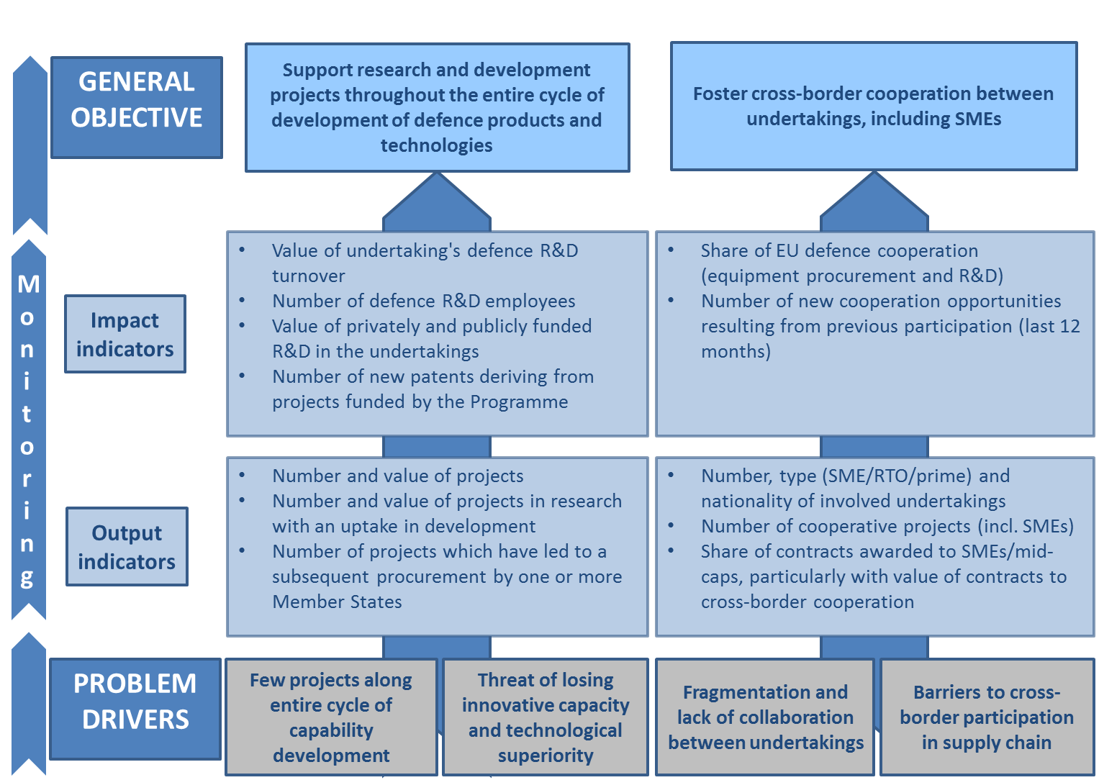

Network indicators ([98]) can be developed based on the implementation reports. The network indicators are able to provide insights into the level of cooperation and a measure of how it evolves over time. However, these indicators are not suitable for monitoring. They are in particular relevant for the evaluation of the Fund when sufficient data is available.

## Additional indicators collected from applicants

These indicators are however not sufficient to provide a full picture of the different objectives. Innovation indicators ([99]) could also be useful. The level of research and development is a measure of the innovative capability. In turn, innovative capability in the field of defence where technological superiority is vital; is a driving force for a competitive EDTIB. For this reason the different calls could include a set of indicators for the applicants to reply to along with their application. These indicators could be: a) Turnover related defence / military activity b) Number of employees working on defence / military related matters c) Level of privately funded research and development activities d) Level of publicly funded research and development activities. d) Number of new cooperation opportunities as a result of previous Fund participation last 12 months.

This information would be cost effective to collect and provide important insights as it would allow a comparison before and after participation to the Fund. However, the company-level data would be sensitive and / or classified and needs to be treated accordingly. The data at aggregated level only would be releasable as part of a public evaluation report.

## Additional indicators collected from the EDTIB

Implementation based indicators and additional indicators collected from applicants are however not sufficient to establish a baseline for the EDTIB to compare with. To date there is no reliable comparable data for the EDTIB. It is therefore appropriate to establish a mechanism to acquire the necessary data. The collection of this data should cover a representative sample of the EDTIB, not only from participating entities, allowing for comparative analysis. This will allow for an indication of the impact of the Fund on the EDTIB as a whole. As such it will cover the spin-off effects for the whole of EDTIB and provide more information on its effects. This will help to better evaluate the Fund and potentially offer more relevant policy options to improve the Fund over time. However, it will be more expensive and EUROSTAT needs to be ready to help establish the data gathering procedure. Potentially the indicators listed in chapter 5.2 could be collected from the wider EDTIB as part of the Structural Business Statistics data or the Community Innovation Survey.

Collecting this type of information from the EDTIB is sensitive as the data may be considered as EU Classified Information. Companies cannot be obliged to reply and might be reluctant to provide information.

## Monitoring and Evaluation reports

Based on the monitoring scheme proposed above an annual performance review could be foreseen where results will be progressively available. Monitoring information will include in the early years information on input indicators (such as number and types of projects); and depending of the length of the projects half way through the programming period information on output indicators would become available; progressively followed by information on results indicators (such as subsequent procurement by Member States and patents) in the later years of the Fund.

An interim evaluation of the Fund will be performed once there is sufficient information available about the implementation of the Fund and timing will be aligned with that of the ex-post evaluations of the PADR and the EDIDP at the latest four years after the start of the implementation.

The Commission will carry out a final evaluation is at the end of the implementation period when the lion-share of projects will have been finalised.

# Annex 1: Procedural information

## Lead DG(s), D*e*cide Planning/CWP references

The lead department for this evaluation was the Directorate-General for Internal Market, Industry, Entrepreneurship and SMEs of the European Commission. In particular, the evaluation has been carried out by Units I4 and I5 (Defence 1 and 2).

## Organisation and timing

As per the Better Regulation Guidelines on impact assessments and ex-ante evaluations, an inter-service steering group was set up to follow and steer the process. For this impact assessment it included the following Commission’s departments: the Directorate-General for Internal Market, Industry, Entrepreneurship and SMEs (lead service); Budget; Communications Networks, Content and Technology, Competition; Economic and Financial Affairs; European Political Strategy Centre; Eurostat; Migration and Home Affairs; Mobility and transport; Research and Innovation; Secretariat-General; Legal Service; Trade; as well as European External Action Service.

The inter-service steering group met for the first time on 7 February 2018 and was involved – through three meetings and several written exchanges – in the process from the drafting of the Staff Working Document.

## Consultation of the Regulatory Scrutiny Board

An informal upstream meeting was held on 26 January 2018 with Regulatory Scrutiny Board representatives where early feedback and advice was provided without prejudging the subsequent formal deliberations of the Regulatory Scrutiny Board. On 11 April the Regulatory Scrutiny Board issued a positive opinion on the Report.

The board recommended clarifying the legal base of the initiative and potential overlaps with research funded in the other Horizon Europe specific programme, to adjust the narrative on delivery mechanisms to allow for a more selective approach, and to better justify the proposed direct management mode for the Fund. The impact assessment report has been amended accordingly, in line with the board's recommendations.

Section 3.2.1 of the Impact Assessment has been fully updated in line with the first recommendation. The wording of Section 2.4 has been improved and now clearly explains the delineation between the European Defence Fund and the specific Programme implementing Horizon Europe with regard to civil applications. To better explain the delineation and strengths and weaknesses of the different options, the wording across Section 4.1 has been adjusted and also the assessment of the Options in Section 4.2, which now includes the possibility to implement, on a case-by-case basis and where appropriate, some measures inspired by the logic of Option 3. Finally, specific wording to justify the direct management mode is included in Section 4.1.1.

## Evidence, sources and quality

The analysis presented in this document was based on several data sources, in particular: various data sources, academic papers, consultations with Member States and Stakeholders (see bibliography below and Annex 2). It builds on the ex-ante evaluation ([100]) prepared in June 2017 for the proposal of the EDIDP, supported by an external study, which analysed existing data and literature.

It is important to point that one of important risks concerning any evaluation to be carried out with regards to the defence sector is the lack of publicly available statistical data on this industry. In particular, Eurostat does not have separate statistics on defence or the defence industry (civil and military use are not separated), whereas data from Member States is often classified.

Work on this Impact Assessment was predominantly carried out in-house. As far as the academic papers and other publications used for the Impact Assessment are concerned, these are provided in the bibliography (overleaf).

### Bibliography

Aerospace and Defence Industries Association of Europe (ASD), *Position Paper on Providing a Concept For The European Defence Research* Programme (EDRP), 2017 [Accessed at [http://www.asd-europe.org/position-paper-on-providing-a-concept-for-the-european-defence-research-programme-edrp on 20 March 2018](http://www.asd-europe.org/position-paper-on-providing-a-concept-for-the-european-defence-research-programme-edrp%20on%2020%20March%202018)]

Aerospace and Defence Industries Association of Europe (ASD), *Position Paper on the Proposal for a Regulation establishing the European Defence Industrial Development Programme* (COM), 2017

Bellais, R. & Droff, J., 'La nécessaire réorganisation de l'industrie de défense en Europe', *Revue Défense Nationale*, Comité d'études de défense nationale, Paris, 2013, pp. 47-52.

Bellais, R., ‘Chapter 6: The Economic Imperative of Europeanizing Defense Innovation’, N. Karampekios et al. (eds.), *The Emergence of EU Defense Research Policy*, Springer International Publishing AG, 2018, pp. 93-109.

Bellais, R., *‘Production d'armes et puissance des nations’*, L’Harmattan, Paris, 1999.

Bellouard, P. & Fonfria, A., *‘Prime Contractor/SME Relationship. How to Best Manage and Fund Cooperative Programmes’*, ARES Policy Paper, 2018.

Briani, V., 'The costs of non-Europe in the defence field', Centre for Studies on Federalism and Instituto Affari Internazionali, April 2013a.

Briani, V., 'Armaments duplication in Europe: A quantitative assessment', *CEPS Policy brief*, No. 297, Brussels, 16 July 2013b.

Council Decision (CFSP) 2017/2315 of 11 December 2017 establishing permanent structured cooperation (PESCO) and determining the list of participating Member States.

Council Decision (CFSP) 2018/340 of 6 March 2018 establishing the list of projects to be developed under PESCO.

Council of the European Union, ‘Council conclusions on implementing the EU Global Strategy in the area of Security and Defence’, Brussels, 14 November 2016.

Council Recommendation of 6 March 2018 (6588/1/18) concerning a roadmap for the implementation of PESCO.

Cour des Comptes, *La Coopération Européenne En Matière D’armement - Un renforcement nécessaire, soumis à des conditions exigeantes*, 2018.

Europe Economics, *“Study on R&D/R&T contracting policies in support of SMEs”,* London, 2009a. *This work has received funding from the European Defence Agency. It reflects only the author’s views.*

Europe Economics, “*Study on the Competitiveness of European Small and Medium sized Enterprises (SMEs) in the Defence Sector*, London, 2009b.

Europe Economics, *The economic case for investing in Europe's defence industry*, London, 2013. *This work has received funding from the European Defence Agency. It reflects only the author’s views.*

Europe Economics, *Defence SMEs and Defence Supply Chains - Final Report,* London 2018.

European Commission Advisory Group Report, ‘European Commission Advisory expert group on cross-border access for SMEs to defence and security contracts: Final Report and Recommendations’, Brussels, 2016

European Commission Public Consultation, *On EU funds in the area of security*, 2018 [Accessed at [https://ec.europa.eu/info/consultations/eu-funds-area-security_en on 20 March 2018](https://ec.europa.eu/info/consultations/eu-funds-area-security_en%20on%2020%20March%202018) on 20 March 2018]  
European Commission DG Communications Networks, Content & Technology Final Report Quantifying the impact of Pre-Commercial Procurement (PCP) in Europe based on evidence from the ICT sector, 2015.

European Commission Staff Working Document SWD (2013) 279 of the European Commission of 24 July 2013 accompanying the document “Towards a more competitive and efficient defence and security sector”.

European Commission Staff Working Document SWD (2017) 228 of the European Commission of 7 June 2017 “ accompanying the document “Proposal for a Regulation of the European Parliament and of the Council establishing the European Defence Industrial Development Programme aiming at supporting the competitiveness and innovative capacity of the EU defence industry”.

European Commission Staff Working Document SWD (2017) 220 of the European Commission of 29 June 2017 "In-depth interim evaluation of H2020".European Council, *European Council meeting (15 December 2016) – Conclusions*, Brussels, 15 December 2016.European Defence Agency, *Guidelines for facilitating SMEs' access to the defence market*, Brussels, 2015.

European Defence Agency, Table *EDA-27 Collective and national data 2005-2014,* 2016 [Accessed at <http://www.eda.europa.eu/docs/default-source/brochures/eda-collective-and-national-defence-data-2005-2014-(excel).xlsx> on 20 March 2018]

European Defence Agency, ‘*Defence data 2006-2016’*, Brussels, 2018 [Accessed at [https://www.eda.europa.eu/docs/default-source/documents/eda-defence-data-2006-2016 on 20 March 2018](https://www.eda.europa.eu/docs/default-source/documents/eda-defence-data-2006-2016%20on%2020%20March%202018)]

European External Action Service, ‘*Launching the European Defence Fund, 07 June 2017’*, Brussels, 2017

European Commission, Communication from the Commission to the European Parliament, the Council, the European Economic and Social Committee and the Committee of the Regions – Launching the European Defence Fund, COM (2017) 295 final, 2017.

European Commission, Communication from the Commission to the European Parliament, the European Council, the Council, the European Economic and Social Committee and the Committee of the Regions - A Modern Budget for a Union that Protects, Empowers and Defends - The Multiannual Financial Framework for 2021-2027, COM(2018) 321 final, 2018.

Council of the EU, Proposal (15536/17) for a Regulation of the European Parliament and of the Council establishing the European Defence Industrial Development Programme aiming at supporting the competitiveness and innovation capacity of the Union's defence industry (First reading) - General approach, June 2017.

European Parliament Committee on Industry, Research and Energy, Draft Report 2017/0125 (COD) on the proposal for a regulation of the European Parliament and of the Council establishing the European Defence Industrial Development Programme aiming at supporting the competitiveness and innovative capacity of the EU defence industry, 2017. [Accessed at <http://www.europarl.europa.eu/sides/getDoc.do?pubRef=-//EP//NONSGML+COMPARL+PE-608.022+01+DOC+PDF+V0//EN&language=EN> on 20 March 2018].

European Parliament, Resolution 2013/2125(INI) of 21 November 2013 on the European Defence Technological and Industrial Base. [Accessed at <http://www.europarl.europa.eu/sides/getDoc.do?pubRef=-//EP//TEXT+TA+P7-TA-2013-0514+0+DOC+XML+V0//EN&language=GA> on 20 March 2018]

Resolution 2013/2125(INI) of the European Parliament of 21 November 2013 on the European Defence Technological and Industrial Base.

European Parliament, Directorate-General for External Policies, *Study: The future of EU defence research*, Brussels, 2016.

European Parliament, Directorate-General for External Policies, *The Development of a European Defence Technological and Industrial Base (EDTIB)*, Brussels, 2013.

European Parliament, Report on the European Defence Union (2016/2052(INI)), 2016. [Accessed at <http://www.europarl.europa.eu/sides/getDoc.do?pubRef=-//EP//TEXT+REPORT+A8-2016-0316+0+DOC+XML+V0//EN> on 20 March 2018]

European Political Strategy Centre (EPSC), 'In defence of Europe: Defence integration as a response to Europe's strategic moment', *EPSC Strategic Notes*, Issue 4, Brussels, 15 June 2015.

European Union Institute for Security Studies (EUISS), 'Lessons learned from European defence equipment programmes', *Occasional paper*, No. 69, Brussels, 2007.

European Union Institute for Security Studies (EUISS) and European Commission, *Report of the* *Group of Personalities on the Preparatory Action for CSDP-related research. European defence research. The case for an EU-funded defence R&T programme*, Brussels, 2016.Fiott, D., *Funding EU defence cooperation*, European Union Institute for Security Studies (EUISS), Brussels, April 2017.

Hartley, K., 'Defence industrial policy in a military alliance', *Journal of Peace Research*, Vol. 43, No. 4, Sage Publications, London, 2006, pp. 473-489.

Hartley, K., *The industrial and economic benefits of Eurofighter Typhoon*, University of York, York, 2008. [Accessed at [http://www.defense-aerospace.com/dae/articles/reports/Typhoon_studyJune2006.pdf on 20 April 2018](http://www.defense-aerospace.com/dae/articles/reports/Typhoon_studyJune2006.pdf%20on%2020%20April%202018)]

Hartley, K., ‘Chapter 5 The Economics of European Defense Industrial Policy’, N. Karampekios et al. (eds.), *The Emergence of EU Defense Research Policy*, Springer International Publishing AG, 2018, pp. 77-92.

Heuninckx, B., 'A Primer to Collaborative Defence Procurement in Europe: troubles, Achievements and Prospects', *Public Procurement Law review*, Vol. 17, Issue 3, Sweet & Maxwell, Nottingham, 2008, pp. 123-145.

Hove, K. & Lillekvelland, T., 'Investment cost escalation – An overview of the literature and revised estimates', *Defence and Peace Economics*, Vol. 27, No. 2, Taylor & Francis, London, 2016, pp. 208-230.

Ianakiev, G. & Mladenov, N., 'Offset Policies in Defence Procurement: Lessons for the European Defence market', *Défense nationale et sécurité collective – Les marchés publics de défense*, Comité d'études de défense nationale, Paris, 2008, pp. 185-194.

Ianakiev, G., 'Defence Offsets: Regulation and Impact on the Integration of the European Defence Equipment Market', *The Evolving Boundaries of Defence: An Assessment of Recent Shifts in Defence Activities*, ed. Renaud Bellais, Emerald, Bingley, 2014, pp. 251-270.

IHS, ‘*Analysis of defence-related SMEs’* composition in EU’, 2017. *This work has received funding from the European Defence Agency. It reflects only the author’s views.*

IHS, ‘*Support to the Implementation of the Supply Chain Action Plan’*, 2016. *This work has received funding from the European Defence Agency. It reflects only the author’s views.*

Kirkpatrick, D. L. I., “The rising unit cost of defence equipment — The reasons and the results”, Defence and Peace Economics, 6:4, 1995, pp. 263-288.

Kirkpatrick, D. L. I., “Trends in the costs of weapon systems and the consequences”, Defence and Peace Economics, 15:3, 2004, pp. 259-273.

Maldera, N., *L’immense gâchis des frégates françaises*, iFRAP, 2017 [Accessed at <http://www.ifrap.org/etat-et-collectivites/limmense-gachis-des-fregates-francaises> on 20 March 2018]

Martin, S. & Hartley, K., ‘UK firms’ experience and perceptions of defence offsets: Survey results’, *Defence and Peace Economics*, 6:2, 1993, pp. 123-139.

Masson, H., 'Comprendre le profil des principaux fournisseurs européens d’équipements de défense', *Défense & Industries*, No. 4, Fondation pour la recherche stratégique, Paris, June 2015.   
  
Maulny, J-P., Mattely, S., Colomina, P. and Bellouard, P., Magnitude of the Cost Structure of Defence Research and Development Programmes and Optimal EU Intervention to Incentivize Cooperation, *Institute for International and Strategic Affairs* (IRIS), 2018.

Mauro, F., *Preparatory Study for the European Commission On the budget ‘Development Programme for the Defence Industry”,* European Commission, Brussels, 2017.

McKinsey, ‘*More European, More Connected and More Capable Building the European Armed Forces of the Future’*, Munich Security Conference Report, McKinsey & Company, Brussels, 2017.

McKinsey, *The future of European defence: Tackling the productivity challenge*, McKinsey & Company, Brussels, 2013.

Middleton A., Bowns S., Hartley K. and Reid J., *The effect of defence R&D on military equipment quality*, Defence and Peace Economics,17:2, 2006, pp. 117- 139.

Moura, S. & Oudot, J.,‘Performances of the defense industrial base in France: the role of small and medium enterprises’, *Defence and Peace Economics*, 2016.

Moura, S., ‘L'Etat dans le financement de la R et D militaire des entreprises’, *Observatoire économique de la Défense*, ECOeDEF issue 54, February 2011.

National Audit Office, *Maximising the benefits of defence equipment co-operation*, London, 2001.

Nordlund, P., 'Defence-specific inflation – The Swedish perspective', *Defence and Peace Economics*, Vol. 27, No. 2, Taylor & Francis, London, 2016, pp. 258-279.

OECD, Frascati Manual 2015: Guidelines for Collecting and Reporting Data on Research and Experimental Development, OECD Publishing, Paris, 2015.

Official Journal of the European Union, L 328, 12 December 2017.

Oudot, J., ‘Stratégies et performances des entreprises de défense à l’international’, *L’Observatoire Économique de la Défense*, ECOeDEF issue 90, March 2017.

Oxford Economics, *Economic case for investing in the UK defence industry: A report for ASD and the Defence Industries Council*, Oxford, 2011.

Pugh, P., *Source book of defence equipment costs*, P. G. Pugh, Bedford, 2009.

Pugh, P., *The cost of seapower*, Conway Maritime Press, London, 1986.

Pugh, P., 'The procurement nexus', *Defence Economics*, Vol. 4, No. 2, Taylor & Francis, London, 1993, pp. 179-194.

Setter, O. and Tishler, A., 'Theory and application to the US military', *Defence and Peace Economics,* 18:2, 2006, pp. 133 – 155.

Special Eurobarometer 461, *Public Opinion on defence in the EU*, 2017 [Accessed at <http://ec.europa.eu/commfrontoffice/publicopinion/index.cfm/ResultDoc/download/DocumentKy/78720> on 20 March 2018]

The Rome Declaration, 2017 [Accessed at <http://www.consilium.europa.eu/en/press/press-releases/2017/03/25/rome-declaration/> on 20 March 2018]

Treaty on European Union, Maastricht 1993 [Accessed at <https://europa.eu/european-union/law/treaties_en> on 20 March 2018].

Unites States Government Accountability Office (US GAO), *‘Defense Acquisitions: Assessments of Selected Weapon Programs’*, 2017

# Annex 2: Stakeholder consultation

This annex is the synopsis report of stakeholder consultation activities carried out to prepare the proposal for a Regulation of the European Defence Fund 2021-2027 to seek stakeholders' views on the goal, structure and implementing modalities of the Fund.

The stakeholder consultation built upon the views already obtained when setting up two limited testing programmes under the 2014-2020 EU budgetary period; namely the Preparatory Action on Defence Research (PADR) launched in April 2017 and the Commission proposal for a regulation for a European Defence Industrial Development Programme (EDIDP) adopted in June 2017.

## Identification of stakeholders

The identified stakeholders cover those that are directly affected by the Fund and have a high level of awareness of the initiative, such as Member States, Industry and Research Institutions. It also covers stakeholders that may have an opinion on the subject, e.g. citizens and certain Non-governmental Organisations with strong views and committed to the subject.

## Consultation methods

To seek external advice in the short and longer terms on defence research policy Commissioner Bienkowska convened a group of sixteen high-level persons active in the area of defence; including industry, research organisations, European/ national parliaments, and policy-focussed institutes. Following regular conversations and consultations this 'Group of Personalities' published a report on "European Defence Research - the case for an EU-funded R&T programme" (Group of Personalities Report) in January 2016.

To give all stakeholders the possibility to comment, the Commission initiated an Open Public Consultation on the European Defence Fund, as part of a larger consultation exercise on all policy areas covered by the EU's long-term budget for 2021-2027. The Open Public Consultation ran from 13 January 2018 to 9 March 2018. The questionnaire was accessible in 23 EU languages.

Through the Open Public Consultation web portal also five Position Papers have been received by Non-governmental Organisations and Research Institutions.

In addition to the Open Public Consultation, the Commission received position papers from the industrial organisations and some Member States.

## Analysis of feedback from the Open Public Consultation

The response rate to the consultation on the Fund ([101]) was low: 48 replied have been received from private enterprises, business associations, Non-governmental Organisations, public authorities, research and academia and a religious community (see figure below). A likely reason for the low uptake could be that, being part of a general consultation exercise where a set of standardised questions has been asked focussing on past experience, the questions were only applicable to a limited extent to the Fund ([102]). Also for this reason five respondents have submitted position papers allowing them provide their views and opinions.

The Consultation asked questions on the importance of the policy challenges, conceived EU-added value, and experience with current funding possibilities under the European Defence Fund.

A large majority of respondents (84%) considers that the policy challenge that the Fund aims to address is rather to very important. Only 2% of respondents are of the view that this is not an important challenge. When asked to what extent the programmes adds value, compared to what Member States could achieve at national, regional and/or local levels; 92% considered the programme adds value: with 37.5 % believing that it adds value to some extent; 42% to a fairly large extent and 12.5% to a large extent. Only 2% found that it does not at all add value.

The Table below shows which obstacles respondents considered to a lesser or large extent to hamper the achievement of objectives of the fund under the 2014-2020 MFF. Although it is difficult to draw conclusions from the below given the limited number of replies and limited the operational experience with the Fund, some observations can be made: administrative burden and the difficulty to ensure sustainability after the funding period are considered as the most burdensome obstacles by respondents. On the contrary, respondents were less concerned about possible insufficient use of financial instruments, insufficient stakeholder involvement, or administrative capacity to manage the projects.

|  |  |  |  |  |  |
| --- | --- | --- | --- | --- | --- |
| Obstacle | Large extent | Fairly large extent | Some extent | Not at all | *Total no respondents* |
| High administrative burden and delays | 10 | **26** | 7 | 1 | *44* |
| Lack of critical mass | 11 | **15** | 11 | 6 | *43* |
| Insufficient administrative capacity to manage | 6 | **15** | 14 | 5 | *40* |
| Lack of flexibility | 8 | **23** | 9 | 3 | *43* |
| Difficulty of combining EU action with other public interventions | 12 | 13 | 16 | 3 | *44* |
| Insufficient focus on performance | 6 | 15 | 8 | 9 | *38* |
| Difficultly to ensure sustainability of projects | **17** | 12 | 6 | 5 | *40* |
| Insufficient use financial instruments | 3 | **13** | 11 | 8 | *35* |
| Insufficient involvement stakeholders | 10 | 12 | **13** | 7 | *42* |

## Analyses of feedback from position papers and consultations

A first broad distinction can be made between those Stakeholders that do not support the objectives of the initiative and those that do support it:

### Stakeholders not supporting the objectives of the Fund:

The Stakeholders that oppose the initiative or are very critical to it mainly put forward arguments of an ethical nature. According to a Non-governmental Organisation the Fund is not a good instrument to preserve jobs and growth, as it diverts resources from the civil research to the military industry leading to 'crowding out effects' whilst the civil sector contributes more to growth and jobs. This contributor also argued that the Fund will not strengthen the European military industry, as nothing is done to overcome Member States' tendencies to serve short-term national industrial interests and as the meaning of European strategic autonomy is not defined and no requirements are set to resolve duplication of weapon systems. The contributor concluded that military solutions are not the best to support a global peaceful economic growth. Money should be rather spent to address the security challenges in a peaceful and sustainable manner; for example through humanitarian aid programmes. Another contributor underlined that the EU should focus on long-standing human security and sustainable peace and not on the business interests of the defence industry. It also called to ban ethically problematic technologies from funding and to establish an advisory body to elaborate ethical and legal guidelines.

### Stakeholders supporting the objectives of the Fund

The Group of Stakeholders with a high awareness of the Fund expressed their support for the initiative. This Group covers Research Institutions, Member States and defence companies and business associations. Inputs received from these Stakeholders focussed on (I) the type of activities that the Fund should finance and on (II) the structure of the Fund and delivery mechanisms.

#### (I) Topics to be financed

A Research Institute argued that Defence Research should combine a top-down approach (capability pull) with a bottom-up approach (technology push), as the latter provides insights and guidance to decision-makers on most relevant technologies and challenging that determine strategic autonomy and technological leadership. European research and innovation activities on critical defence technologies should be intensified to ensure own up-to-date applications and the EU’s strategic autonomy. The Institute identified seven grand defence-technology challenges for Europe post-2020 and proposed research topics within these challenges: artificial intelligence and autonomy; digital battlefield; quantum technologies for defence applications; advanced radar technologies; power supply and efficiency; next-generation effectors; human performance enhancement. Another Research Institute underlined that there should be a balance between short-term goals and long/mid-terms research priorities to improve competitiveness. In *its* view it is important to support new technologies and advanced concepts (emerging, disruptive, or coming from other sectors) that can have a major impact on future defence capabilities and those that provide solutions for interoperability and common standards. Also input from other research organisations argued to reinforce the inclusion of lower RTL research to enable disruptive results. An industrial association identified four top level capability areas in which investments are needed: Gaining Information Superiority: Enabling Expeditionary Operations: Protecting EU Territory: Maritime Mobility and Operational Capability at Sea. To support such top-level capability areas, the Fund could fund research and development projects in Mission oriented projects, Capability development projects, Critical technologies, and disruptive technologies. A research association welcomed the Fund as an important step towards intensified defence cooperation. Harmonisation and synchronization of capability development projects are necessary for the effectiveness of the fund. It recommended setting up a “European Requirements and Synchronisation Evaluation Office or board”. As the most important technical and cooperation decisions of a major capability development project are taken in the early stages and as they are also the least costly phase of capability development, it recommended focussing the funding on the first phase of each project. This would allow supporting more projects and a higher contribution percentage.

#### (II) Structure of the Fund and funding modalities

An industry organisation argued for a holistic capability-driven approach to the whole technology cycle, based on integrated planning for both research and development. It recommended establishing the Fund separately from the Framework Programme for Research and Innovation, on the basis of a single regulation covering both the research and the capability window. The Fund should align as much as possible the modalities of the two windows, but also taking into account the differences between research and development actions.

On Rules of Participation, a research organisation put forward that the Fund's rules of participation should build as much as possible on those for the EU civil programmes and only differentiate where necessary. As regards third country participation: It commented that that rules should be set avoiding dissemination of knowledge beyond EU member States.

On IPR rules, Stakeholders were also united in their views that IPR models need to be adapted for defence. Research Institutes asked for a specific attention to IPR rules, which should preserve the right of all participants in the project and not only large industry.

All inputs received on the funding rates shared the view that funding rates need to take into account the specifics of the sector. As regards the research window 100% EU financial contribution is necessary according to one research organisation. Different research institutes argued that the cost of infrastructures needs to be covered. The Group of Personalities Report advised that the rules of participation of Horizon 2020 needed to be adjusted to address defence specificities. In particular, they argued that a percentage higher than 25% to cover indirect costs should be allowed. An industrial association commented that the funding rates cover in reality only around 50% of the real industrial costs, which contrary to the civil sector, is not appropriate for defence as there is one customer who determines the requirements, timetables and export markets. Defence companies cannot risk investing in R&T activities for a product that may never be acquired by the customer or exported.

On simplification and flexibility: Several inputs called for a simple, but flexible approach: A research institute plead for one simple cost method. An industrial association argued that "*the Golden Rules of successful cooperative programmes must be followed: lean processes, single-point leadership, a strong participation and commitment from Member States to the acquisition road, and a single set of specifications*". The Group of Personalities Report found that options for co-funding by Member States should be considered e.g. through models like PCP.

# Annex 3: Example illustrating fragmentation in the EU defence industry

As mentioned in Section 2.2.2, one relevant illustration of the fragmentation and the resulting impact on the competitiveness of the industry can be found in relation to combat aircraft. The Table below provides a comparison between the R&D costs and the expected sales of the three European aircrafts (Eurofighter Typhoon, the Rafale and the Gripen) and the US-led Joint Strike Fighter F-35 programme. It is mainly based on figures provided in the 2013 study on the costs of non-Europe in the defence field ([103]) with the addition of recent data on the Joint Strike Fighter F-35 programme because of the magnitude of the difference in the corresponding figures.

Table: Comparison between the European aircraft projects and the US-led Joint Strike Fighter ([104])



The Table clearly illustrates the difference in the size of the expected production output between the three European Programmes and the Joint Strike Fighter F-35 Programme. One can note that even with the most recent figures on the Joint Strike Fighter F-35 Programme ([105]), which show lower expected sales and more importantly substantially higher R&D costs, the level of R&D costs per unit remains comparable to those of the European aircraft because the scale of production is still greatly superior ([106]). To provide a simple illustration of the consequences of fragmentation, the last three columns were added to the table showing the difference in the amount of R&D costs per unit that could have resulted if only one EU project has been realised with sales equivalent to those achieved by the existing three.

1. Special Eurobarometer 461 (2017).
2. The CDP is produced by the European Defence Agency to address long-term security and defence challenges. It looks at future security scenarios and makes recommendations about the capabilities European militaries will need to react to a variety of potential developments. The CDP is a comprehensive tool providing a picture of European military capabilities over time.
3. This monitoring is currently in a trial phase ahead of a full implementation planned for autumn 2019.
4. OJ L 328, 12.12.2017, p. 19.
5. Article 42(6) and 46 and Protocol 10 of the Treaty on European Union.
6. Council Recommendation of 6 March 2018 (6588/1/18) concerning a roadmap for the implementation of PESCO.
7. Council Decision (CFSP) 2018/340 of 6 March 2018 establishing the list of projects to be developed under PESCO.
8. European Commission, Communication on launching the European Defence Fund, COM (2017) 295 final.
9. The budget of 2017 and 2018 has been committed; the budget for 2019 has been requested to the budgetary authorities.
10. European Commission, Communication on the Multiannual Financial Framework for 2021-2027, COM (2018) 321 final.
11. The Cooperative Financial Mechanism (CFM) developed by the EDA is an example of such a mechanism.
12. European Union Institute for Security Studies and European Commission (2016)
13. The numbers or letters in square brackets in the text of the next section refer to the blocks of problems as presented on the Problem Tree.
14. Kirkpatrick (1995) and (2004); Pugh (1986), (1993) and (2009); Hove & Lillekvelland (2016); and Nordlund (2016).
15. Hove & Lillekvelland (2016).
16. Pugh (1993), p. 179.
17. Mauro (2017). See also Pugh (2009) and Maulny et al. (2018).
18. European Parliament (2016), p. 33.
19. Europe Economics (2013). Official information on the development costs, approximately GBP 6.7 billion, of the Eurofighter Typhoon to the UK budget is provided by the UK National Audit Office (2001).
20. Setter and Tishler, (2006), p.150.
21. European Defence Agency (2018).
22. See for instance EUISS and European Commission (2016), p.43. Moura (2011) provides figures for France showing that State funding is significantly more important for firms who receive defence State R&D funding (37% against 8% for all enterprises performing R&D) while the level of self-funding is much lower (20% against 73%).
23. EUISS and European Commission (2016), p.43
24. Moura (2011).
25. European Union Institute for Security Studies (2007).
26. Comparing real collaborative and national projects does not provide clear evidence of an efficiency disadvantage of the former, the latter being also frequently affected by important cost overruns and delays. Hartley (2008) shows that the Eurofighter Typhoon’s cost and time escalation is not abnormal in comparison with other contemporary national defence projects. Hartley also notes that industrial duplications in the project were limited to the final assembly line which represented only 5% of production costs. Hartley (2018) looks at a limited sample of projects and notes that it shows “*national projects with higher cost increases compared with collaborative projects and similar delays*”. Heuninckx (2008) also confirms that once collaborative defence procurement has been launched the cost overruns and delays of collaborative projects and similar national projects appear comparable.
27. See for instance Hartley (1993). A recent report from the French Court of Auditors also underlines the importance of sharing development cost though collaborative programmes (Cour des Comptes 2018).
28. In the 1980s France and Germany considered the joint development of a new tank, but German plans required the tank to be made available quickly while France was planning for a decade later (European Union Institute for Security Studies 2007).
29. In some cases countries has to pay temporarily on behalf of other participating States facing issues with budgetary approval procedures (European Union Institute for Security Studies 2007).
30. In the Tiger helicopter project two substantially different versions were developed to respond to respectively French and German specifications (European Union Institute for Security Studies 2007). The NH-90 helicopter has 22 versions and 60 standards thus significantly reducing the financial benefits of collaboration (Cour des Comptes 2018).
31. The reasons for decision of the UK to withdraw from the Horizon frigate project included the impossibility to agree to common specifications with the other participating Member States (European Union Institute for Security Studies 2007).
32. European Political Strategy Centre (2015).
33. Council of the European Union (2016), p. 8.
34. European Union Institute for Security Studies and European Commission (2016).
35. Bellais (2018).
36. European Union Institute for Security Studies and European Commission (2016), p.43.
37. See for instance Bellais (1999). The author also notes that project failure should not be necessarily negatively perceived in the field of defence research: it provides a degree of reassurance that a given technological field cannot be usefully exploited by a potential adversary to achieve a military advantage.
38. Masson (2015).
39. Briani (2013b). Fragmentation is the highest in the land segment with 17 open production lines in the EU against 2 in the US. In the naval segment the ratio is 5 to 1, while the air segment is more balanced.
40. Briani (2013b) p.2.
41. Bellais (2018).
42. Briani (2013b) p.3.
43. Briani (2013a).
44. McKinsey (2013), estimates that each doubling of volume results in an efficiency increase of approx. 20% that would lead to total potential saving of 17% of the total weapon system procurement costs under the assumption of a 40% labour costs share. National Audit Office (2001), considers that equipment unit production costs could fall by up to 10% as output doubles. Hartley (2006), estimates the median unit cost saving by increasing scale from the minimum to the ideal level at 10-20%.
45. Bellais & Droff (2013).
46. European Parliament (2013) p.47.
47. Constraints to cross-border engagement may for instance originate in reasons pertaining to national autonomy, protection of the ownership of defence technology and associated spillovers, employment generation and economic barriers such as higher costs of organisation and administration, transaction and search costs (Europe Economics 2018).
48. See for instance Ianakiev & Mladenov (2008); Ianakiev (2014).
49. Oudot (2017).
50. Data is based on a total of EUR 57.7 Billion, economic conditions March 2018 and relies on the Global Balance data collected by the OCCAR that allows comparison between the workshare and the cost share of Participating States in a Programme.
51. States participating in and spending money on an OCCAR Programme.
52. IHS (2016), p.25.
53. European Council (2016), p. 7.
54. Europe Economics (2018).
55. European Parliament Resolution 2013/2125(INI), point 31.
56. European Commission Advisory Group Report (2016), p. 3.
57. See for instance Europe Economics (2009b) and Europe Economics (2018).
58. IHS (2017).
59. Europe Economics (2009b).
60. Europe Economics (2009a), Europe Economics (2009b) and Moura & Oudot (2016).
61. Moura & Oudot (2016).
62. Europe Economics (2018).
63. European Commission Advisory Group Report (2016).
64. Bellouard & Fonfria (2018).
65. E.g. difficulties in obtaining information on future capability requirements and business opportunities, but also a lack of visibility to large companies, in particular in a cross-border context, which results in the presence of important search and switching costs and of a preference for existing suppliers or suppliers closely located to the contractor (see for instance Europe Economics (2018), Ianakiev & Mladenov (2008); Ianakiev (2014).
66. Europe Economics (2009b) and (2018), Bellouard & Fonfria (2018).
67. European Commission Staff Working Document SWD (2013) 279. The important difficulties that SMEs face in developing their activities in the defence sector are also recognised by the EDA: "SMEs have identified a number of difficulties in participating in the defence market including access to information, defence procurement, supply chain and finance". "As defence supply chains have a substantial national focus, there are additional challenges for SMEs that wish to enter defence supply chains in other European countries." European Defence Agency (2015), p. 3.
68. Europe Economics (2018).
69. In response to the European Council call of 19 October 2017 on the EIB to examine further steps with a view to supporting investments in defence research and development activities, the latter approved in December 2017 the "European Security Initiative - Protect, Secure, Defend". As part of it the EIB will strengthen its support for Research, Development and Innovation for dual-use technologies, cybersecurity and civilian security infrastructure. The objective set by the EIB is ambitious as it targets EUR 6 billion in total financing for these sectors for the coming 3 years compared to the same envelope for the period between 2001 and 2016. The EIB's list of areas excluded from financing remains however unchanged.
70. Such as those announced in the 2017 Joint Communication "Resilience, Deterrence and Defence: Building strong cybersecurity for the EU. The Joint Communication in particular notes that: “*The high level of resilience required in cyber defence calls for specific targeting of research and technology efforts*.” It also notes that “*The cyber defence projects or technologies developed by undertakings could benefit from European Defence Fund*”.
71. Such constrains may stem from acknowledged disadvantages of SMEs engaging in defence-specific R&D to access finance that may be particularly acute for SMEs and mid-caps (Europe Economics (2009), Europe Economics (2018)). The difficulties encountered can be further reinforced by the increased reliance on risk-sharing partnerships and even the of exercise of market power by Prime contractors.
72. Bellouard & Fonfria (2018).
73. For instance, Member States, as a sole client, may decide not to proceed with the production phase, or the supplier may not be retained in that phase.
74. Unless such needs are already sufficiently covered by horizontal EU financial instruments whose availability may increase in case of a change of the restrictions to the lending or investment policy of the EIB or if other institutions are granted access to EU-supported Guarantee Funds in the future.
75. Alternatively, the possibility of enlarging access to the relevant Guarantee Funds to institutions which are not bound by such restrictions could be contemplated. The viability of the latter possibility will however depend to some extent on the ability of such institutions to ensure equal access to the relevant financial instruments across the EU.
76. Where appropriate, regional and international initiatives can be also taken into account when they serve the Union's security and defence interests.
77. European Union Institute for Security Studies and European Commission (2016).
78. European Parliament report on the European Defence Union (2016/2052(INI) adopted on 22 November 2016 which notes that "the European Defence Research Programme will need a total budget of at least EUR 500 million per year over that period in order to be credible and make a substantial difference".
79. Based on the EDA Defence Data for the 27 EDA participating Member States (European Defence Agency 2016).
80. Based on EDA Defence Data. The amount of development expenses is calculated by subtracting the amount corresponding to defence R&T from the data provided on defence R&D (European Defence Agency 2016).
81. Mauro (2017). The variation takes account of different assumptions on the evolution of spending in respect to the EDA benchmark of investment and R&D expenses reaching 20% of total defence expenditure as well as the North Atlantic Treaty Organization spending target of 2% of GDP.
82. Advisory Group Report (2016) on cross-border access for SMEs, p.15. The report also advocates for investing more extensively in R&T in order to “create additional business opportunities and enable supply chains to expand more easily and to be more flexible.
83. SMEs which are established in Member States other than those where the undertakings in the consortium which are not SMEs are established.
84. Defined for the purpose of the EDIDP Regulation as meaning enterprises having a number of employees up to 3,000 where the staff headcount is calculated in accordance with Articles 3, 4, 5 and 6 of the Title I of the Annex to the Commission Recommendation 2003/361/EC and which are not SMEs.
85. Absence of co-funding also implies lower political pressure on the definition of the industrial organisation of the projects. In addition, in research projects the number of participating entities is expected to be lower in comparison with important development projects.
86. Europe Economics (2018) finds evidence pointing at “significant barriers to cross-border engagement … while problems faced by SMEs in a purely national context appear to be of a less significant magnitude” (Europe Economics 2018, p. 36).
87. Europe Economics (2018).
88. Where the EU funding rate is increased proportionally to the degree of cross-border participation of SMEs and mid-caps.
89. An example of past experience in this field is provided by the Electronic Bulletin Board established in the Framework of Code of Best Practice in the Supply Chain of the European Defence Agency.
90. European Union Institute for Security Studies, 2007, p.21.
91. Comparison between new post-2020 MFF programme and PADR/EDIDP under the MFF 2014-2020.
92. See Section 2.2.2 for more detailed information on the importance of economies of scale and learning in the sector.
93. According to Middleton et al. (2006) a correlation can be established between past levels of defence R&D spending and the quality of the defence equipment in the inventories of the corresponding country.
94. See for instance Europe Economics (2013).
95. Hartley, 2008. Technological benefits included carbon fibre technology; super plastic forming and fusion bonding; modular avionics; the flight control system; and aero-engine technology. Technology spin-offs were also identified from the Typhoon Programme to civil aircraft, to motor car industries (including Formula 1 racing cars in Italy and the UK) and to supply chains. For other examples see also Bellais (1999).
96. Hartley (2008), p. 9. See also more general estimations on employment effects of investments in the defence sector in Oxford economics (2011) or Europe Economics (2013).
97. Hartley (2008).
98. Weighted degree or cluster coefficient to measure how cooperation in EDTIB evolves and the number of relationships and level of cooperation.
99. Measuring the level of R&D in company collected from participating entities.
100. European Commission Staff Working Document SWD (2017) 228and its annexes. It includes a list of literature sources.
101. European Commission Public Consultation (2018).
102. Most questions asked about the respondents experience with programmes under the current EU budgetary period 2014-2020. It should be kept in mind that the European Defence Fund has been only operational to a very limited extent at the moment of the Open Public Consultation.
103. Briani (2013a).
104. The Eurofighter Typhoon Programme is a programme performed in cooperation by four EU Member States (UK, DE, IT and ES). The Joint Strike Fighter F-35 is a US-led Programme performed in collaboration with partner nations that include four EU Member States (UK, IT, NE, DK). The remaining two programmes are national ones (they would thus not be affected by possible additional costs of cooperation as described in Section 2.1.3).
105. Unites States Government Accountability Office (US GAO) 2017, p. 165.
106. It is important to note that looking only at the data on costs does not provide information on the differences in the performance of the different aircrafts. The Joint Strike Fighter F-35 is for instance a more recent project integrating very advanced technologies. The objective here is not to provide a comprehensive assessment of the different programs, but to only demonstrate the effects of fragmentation and scale.