

1 Annex 1: Procedural information concerning the process to prepare the impact assessment report and the related initiative 3

1.1 Organisation and timing 3

1.2 Consultation of the Regulatory Scrutiny Board (RSB) 3

1.3 External expertise 11

2 Annex 2: Stakeholder consultation 12

2.1 Introduction 12

2.2 Public consultation 13

2.2.1 Process and quantitative results 13

2.2.2 Replies to key issues 14

2.3 Use of the stakeholder input for the impact assessment 18

3 Annex 3: Who is affected by the initiative and how 19

3.1 Practical implications of the initiative 19

3.2 Summary of costs and benefits of the different EU fleet-wide CO2 target level options 21

4 Annex 4: Analytical models used in preparing the impact assessment 24

4.1 PRIMES-TREMOVE transport model 24

4.2 DIONE model (JRC) 26

4.3 Macro-economic model - EXIOMOD 28

4.4 Baseline and policy scenarios 29

5 Annex 5: Introduction to the Impact Assessment – complementary information 33

5.1 Description of the HDV sector 33

5.2 Specificities of the HDV sector compared to LDVs 35

5.3 Overview of international HDV CO2 or fuel economy standards 37

6 Annex 6: Policy initiatives addressing transport emissions 39

6.1 Overview of recent Commission initiatives 39

6.2 Overview of broader EU mobility policies relevant for HDVs 40

6.3 Link with problem drivers 42

7 Annex 7: Problems and drivers – complementary information 43

7.1 Problem 1: HDV sector is a significant and growing source of GHG emissions 43

7.2 Problem 3: EU HDV manufacturers and component suppliers are at risk of losing their technological and innovation leadership position 44

7.3 Driver 1: Road freight transport activity is increasing 45

7.4 Driver 3: Limited use of zero- and low-emission vehicles in the HDV sector 46

8 Annex 8: Step-wise approach for regulating HDV CO2 emissions: VECTO, Certification and monitoring/reporting of HDV CO2 emissions. 47

8.1 VECTO 48

8.1.1 Introduction 48

8.1.2 Schematic overview of simulation model and computational programme 49

8.1.3 Adequacy of VECTO as a simulation tool 51

8.1.4 Future development steps of the VECTO tool 52

8.2 Certification Regulation 53

8.3 Monitoring and reporting 56

9 Annex 9 – Description of the options - complementary information 57

9.1 Policy option categories 57

9.2 Target levels – baseline and overview of options 58

9.3 Incentives for Zero- and Low-Emission Vehicles (ZEV/LEV)- context 59

9.4 Banking and borrowing – design elements 60

10 Annex 10: Impacts of policy options – complementary information 61

10.1 Fleet composition under different target level options 61

10.2 Net economic savings over the vehicle lifetime from a societal perspective 62

10.3 Avoided CO2 costs 63

10.4 TCO-first use (5 years) 63

10.5 TCO-second use 64

10.6 Sensitivity – economic impacts *with varying international oil price* 64

10.7 Energy system impact of different target level options 66

10.8 Freight (HDV) transport impact of different target level options 67

10.9 Macro-economic impacts, including employment (EXIOMOD results), of different target level options 69

10.10 Environmental impacts of different target level options: CO2 emissions and air pollutant emissions 74

10.11 Sensitivity – results for EU-27, without UK 74

10.12 Contribution to the ESR targets 75

10.13 Penalties – economic impacts 75

11 Annex 11: Distribution of the EU fleet-wide target between the various lorry families (sub-)groups and manufacturers 79

11.1 Sub-group targets 79

11.2 Assessment of compliance 79

12 Annex 12: Weighting of mission profiles for calculating CO2 emissions for the purpose of assessing compliance with CO2 targets 81

12.1 Mission profiles in VECTO 81

12.2 Weighting of VECTO mission profiles 81

# Annex 1: Procedural information concerning the process to prepare the impact assessment report and the related initiative

## Organisation and timing

The Directorate-General for Climate Action is the lead service for the preparation of the initiative (PLAN/2017/1474) and the work on the impact assessment.

An inter-service steering group (ISG), chaired by the Secretariat-General, was set up in December 2017 with the participation of the following Commission Directorates-General: Legal Service; Economic and Financial Affairs; Internal Market, Industry, Entrepreneurship and SMEs; Environment; Mobility and Transport; Joint Research Centre; Taxation and Customs Union; Justice and Consumers, Employment, Social Affairs and Inclusion, Research and Innovation, Competition, Energy, Communications Networks, Content & Technology.

The ISG met three times between December 2017 and the end of February 2018, to discuss the draft impact assessment.

## Consultation of the Regulatory Scrutiny Board (RSB)

The Regulatory Scrutiny Board received the draft version of the present impact assessment report on 28 February 2018 and following the Board meeting on 28 March 2018 issued a negative opinion on 4 April 2018.

The Board made the following recommendations, which were addressed in the revised draft impact assessment report as indicated below.

|  |  |
| --- | --- |
| **Main RSB considerations** | **Response** |
| The Board acknowledges efforts to quantify impacts of the policy options, and takes note of planned clarifications to the draft report.  However, the Board gives a negative opinion, because the report contains important shortcomings that need to be addressed particularly with respect to the following key aspects: |  |
| (1) The options seek to correct market failures that allegedly lead HDV producers to underinvest in fuel efficiency and emissions reduction. The report does not convincingly establish the scale and relevance of such market failures. | The description of the barriers hindering the uptake of more fuel-efficient technologies and their relevance, as presented in section 2.2.2 of the report, has been revised, clarified and expanded.  The different causes have been described in section 2.2.2. The first key issue is that market players do not take into account environmental benefits for society to the extent they do not enter their profit calculations as costs and benefits are not directly priced into the market.  Next to this, there is imperfect and information asymmetry. Sellers know better than buyers the potential of fuel-saving technologies. Buyers of lorries find it difficult differentiating fuel savings resulting from individual technologies. Furthermore, the net savings of those individual technologies will be perceived as rather modest, as most of them do not save more than about 0.5% of the total operating costs. If transport operators want to reap the full benefits, they will have to select a number of technologies at the same time, which makes the purchasing decision more complex. As a result, the market penetration of such readily available technologies is limited, despite their considerable net savings over time.  The availability of VECTO data from 2019 will help addressing asymmetries but is unlikely to be sufficient to close them as the access to this technical informal will not be automatic and will remain complex for transport operators which are mainly SMEs. This is confirmed by the experience in the US.  The barrier on asymmetry of information also results in an 'adverse selection' problem.  These issues are enhanced by the concentrated market situation on the side of the manufacturers, which contributes to low competitive pressure.  Furthermore, the market providing transport services is very competitive, and it is likely that a part of the fuels savings is passed through via a reduction of freight cost to the final customer of transport services. Because of that, transport operators will be uncertain to what extent purchasing a highly fuel efficient truck will translate into a higher income for them.  The US experience shows that despite convincing evidence of underinvestment in fuel-efficient technologies, empirical evidence for its drivers is more difficult to establish. |

|  |  |
| --- | --- |
| (2) The report downplays uncertainties about capabilities and costs of technologies to increase fuel efficiency. It does not assess how these uncertainties affect the choice of fuel efficiency targets, or whether these targets should be voluntary or mandatory. | On these points, the report has been revised and the analysis expanded in several places.  The newly-added Table 1 provides an overview of technologies for reducing CO2 emissions, grouping them into five categories according to their current and future market penetration, and constraints for their widespread deployment.  As illustrated in the newly-added Table 2 and Figure 4, the first key finding is that a series of cost-effective technologies are readily available, but still have a limited market penetration, despite their low costs and the high net savings they deliver. Other technologies will become soon readily available. Together, these technologies would yield emission reductions of up to 15-20% within the 2025 time frame.  On the other hand, the time frame for the widespread market penetration of more prospective technologies and alternative powertrains, which are less mature, as well as their cost saving potential, is more uncertain.  Section 7 has also been expended to provide more information on the associated uncertainties on a range of options.  Furthermore, the revised Sections 5.1.5, 6.2.5 and 7 discuss the pros and cons of making a target for 2030 mandatory as opposed to aspirational.  The option of setting only voluntary or aspirational targets is reflected in the baseline option for the target levels, as experience with a voluntary approach in the light-duty vehicles sector has proven that this does not result in higher emission reductions than what could be expected as a result of “autonomous improvements”. |
| **Further RSB considerations and adjustment requirements** | **Response** |
| (1) The report should more clearly present the Commission’s proposed strategy to reduce CO2 emissions from Heavy Duty Vehicles by 2030. The overview should explain why and how the initiative’s scope may evolve. It should explain the sequence of various measures, including external ones that would allow an extension of the scope. It should clarify the purposes of the mid-term review. | The Commission’s past and future work on measures to reduce CO2 emissions from Heavy Duty Vehicles by 2030 is further explained in Section 1.4 of the report.  The initiatives for extending the scope have been further elaborated in Section 5.1.1.  This work is further detailed in the dedicated Annex 8.  The purposes of the mid-term review are threefold:  • establish or confirm the 2030 targets for the vehicle groups covered by the first phase of the CO2 standards;  • extend the scope to other groups of HDVs, taking account of the updates of VECTO and the Certification Regulation;  • review the modalities for implementation.  This is further detailed in Section 5.1.5 |
| (2) The problem definition section should do more to establish that HDV owners currently underinvest in fuel-saving technologies. The report's current explanations for this market failure are not convincing in view of the report’s assumptions on the market structure in trucking and vehicle manufacturing. The behaviour of market participants rather seems to suggest doubts about how effectively technological innovations will deliver fuel savings and at what cost, and thus provide a sufficient return on additional investments in technology. Evidence to support this latter explanation comes from the stakeholder consultations and the backing of the VECTO system presented in annexes. | Section 2 of the report has been thoroughly revised on this point, after revisiting existing literature and considering in particular the US experience in this area. This includes the newly added Table 2.  The text now indicates which are the main causes for the underinvestment. Also, the role of information asymmetries resulting in underinvestment has been further highlighted.  US experience confirms that there is ample evidence of underinvestment, but the empirical evidence for its drivers is more difficult to establish. |
| (3) The report should spell out uncertainties surrounding the basic parameters of the initiative. It should consider these uncertainties when analysing the large net savings gains and comparing options. Doing so would clarify potential risks surrounding the political choice of setting target HDV CO2 emission reductions. Similarly, the report should discuss the pros and cons of making a target for 2030 mandatory as opposed to aspirational. | The newly-added Table 1 provides an overview of technologies for reducing CO2 emissions, grouped according to their current and future market penetration, and constraints for their widespread deployment.  Based on this analysis, the report distinguishes two main categories of technologies.  On the one hand, there is a series of readily available technologies, for which the emission reduction performance and costs are well established and which can deliver CO2 savings up to 20% in the short term.  Other technologies are less mature and their widespread deployment less certain. Uncertainties are higher with regards to these technologies.  The link between these technologies and the target levels and impacts is described in Sections 5.1.4 and 6.2.4, respectively.  Section 7 and Annex 3.2 provides for a summary of the costs, benefits and associated uncertainties of the range of options considered. Text has been added to sections 5.1.5, 6.2.5 and 7, discussing the pros and cons of making a target for 2030 mandatory as opposed to aspirational. |
| (4) The report should better reflect the positions of all different stakeholder groups. This applies especially to the position of HDV manufacturers, who would seem to prefer an overall approach to emission reduction that does not impose emission reduction standards. These manufacturers may not agree with the initiative’s expectations about the costs and benefits of the technological advances. The report should clarify how the initiative takes their concerns into consideration. | In addition to the overview in Annex 2, information about stakeholders’ views has been added, e.g. in Sections 2.1.3, 2.4, 3.3, 5.1.4, 5.2 and 5.4.3.  In Section 6.1, it has been clarified how the use of the “high” cost curves relates to the concerns expressed by stakeholders from the automotive manufacturing sector, reflecting the uncertainties over the costs and availability of new technologies for 2030. |
| (5) The initiative aims to preserve the competitiveness of the EU HDV manufacturers, but the report does not explain how effective the options would be in achieving this objective. | As clarified in Section 2.1.3 of the report, the focus of the third problem identified is on the risk for EU manufacturers to lag behind in terms of innovation in new technologies and hence to lose global technological leadership.  In Section 6, this aspect has been considered where relevant and a new Section 6.2.4.2.7 has been added to illustrate the impact of the target level options on innovation and technological leadership. Section 7 has also been further elaborated on this point. |

The Board received a revised draft version of the present impact assessment report on 11 April 2018 and issued a positive opinion on 19 April 2018.

The Board made the following recommendations, which were addressed in the revised impact assessment report as indicated below.

|  |  |
| --- | --- |
| **Main RSB considerations** | **Response** |
| The Board acknowledges the clarifications to the draft report, in particular on market information asymmetries and uncertainties related to technical progress.  The Board gives a positive opinion, with a recommendation to further improve the report with respect to the following key aspect: |  |
| The report could better explain what causes inertia of the trucking industry in developing new fuel saving technologies and how market uncertainties lead transport operators to underinvest in these technologies. | The revised report contains an additional box in section 2.2.2 related to the drivers for inertia in the HDV sector. The box provides more specific information and explains more clearly the causes of such inertia.  This concerns firstly the structure of the market where sellers offer packages of additional technologies generally as ‘premium’ options and not as standard technologies. It is a profitable strategy that allows sellers to charge more to "premium customers". As such, market forces are not likely to incentivise manufacturers to promote technologies: their products would may not be bought by buyers with a short-term cost awareness, and also the margins they make on premium buyers would shrink. Furthermore, the absence of a regulatory framework creates uncertainties for the required investments from manufacturers in new technologies.  This situation is likely to persist in the existing concentrated market structure. The market is indeed very concentrated on the side of the HDV manufacturers, which contributes to low competitive pressure. In contrast, the majority of freight operators are small businesses working on tight margins.  The box also clarifies that a second driver is the presence of market uncertainties. Transport operators have difficulties with assessing fuel savings resulting from technology adoption. Other considerations are the widespread perception of transport operators that operational measures such as driver training are sufficient to reduce fuel consumption and that the first user might not be able to charge a premium when selling second-hand.  Section 7 has also been revised to consider the effectiveness of the various options, regarding the target levels and the timing, in addressing the market uncertainties and inertia in the HDV market. |
| **Further considerations and recommendations for improvement** | **Response** |
| (1) The revised report better presents the Commission's strategy to reduce CO2 emissions from HDVs by 2030. Information about this could usefully be consolidated and presented upfront. The report could better highlight the importance of earlier work, e.g. on measuring, certification, monitoring and reporting, for regulating CO2 emissions in the HDV sector. | The revised report adds and explains upfront, in section 1.4, the 2014 Commission's Strategy for reducing HDVs fuel consumption and CO2 emissions. The Strategy provided the basis for the action taken to address CO2 emissions from this sector.  The section also presents more clearly the work carried out as a follow-up to the Strategy in the form of the development of VECTO simulation tool, the adoption of the Certification Regulation and the preparation of the Monitoring and Reporting Regulations.  The revised section also underlines the importance of this earlier work which is a pre-requisite for regulating CO2 emissions from HDVs, while improving the transparency and information on emissions and fuel consumption. |
| (2) The revised report adds information on basic assumptions behind the calculations on expected savings. The report sees major untapped opportunities in fuel saving technical progress in the vehicle industry and in cost reduction by trucking companies. It could better explain what causes inertia on the side of the trucking industry in developing fuel saving new technologies, and how transport market uncertainties lead operators to underinvest in new low emission technologies.  The Board takes note of the quantification of the various costs and benefits associated with the different target level options of this initiative, as assessed in the report considered by the Board and summarised in the attached quantification tables. | See reply above under the main RSB consideration. |

## External expertise

Further information was gathered through support studies commissioned from external contractors[1] and involving the JRC[2], in particular addressing the following issues:

* the available technologies that can be deployed in the relevant time period to reduce new HDV CO2 emissions, as well as their effectiveness and cost;
* elements potentially impacting industrial competitiveness and employment;
* the impact of different regulatory approaches, regulatory metrics and possible design elements (modalities);
* impacts on GHG and pollutant emissions.

# Annex 2: Stakeholder consultation

## Introduction

Stakeholders' views have been an important element of input to the preparation of legislative action in the area of CO2 emissions from Heavy Duty Vehicles (HDVs). The main purpose of the consultation was to verify the accuracy of the information available to the Commission and to enhance its understanding of the views of stakeholders with regard to different aspects of the possible future regulatory framework on CO2 emissions from HDVs.

A mapping of stakeholders at the initial stages of the impact assessment allowed identifying the following relevant stakeholder groups:

* Member States (national, regional authorities)
* Individual vehicle manufacturers and associations of vehicle manufacturers
* Automotive component suppliers and their associations
* Vehicle fleet operators and their associations
* Environmental non-governmental organisations
* Federations or associations of fuel and manufacturing industries
* Transport and logistics federations or associations
* Purchaser and user organisations (leasing companies, drivers associations, consumer groups, etc.)
* Social partners

The Commission sought feedback from stakeholders through the following elements:

* a public on-line consultation (20 November 2017 until 29 January 2018)
* a stakeholder workshop (16 January 2018);
* meetings with relevant industry associations representing vehicle manufacturers, components and materials suppliers, fuel suppliers.
* meetings with Member State authorities, vehicle manufacturers, suppliers, social partners and NGOs;
* position papers submitted by stakeholders or Member States.

The feedback received at the stakeholder event organised on 16 January 2018 was generally in line with stakeholders' views as submitted to the public consultation.

## Public consultation

### Process and quantitative results

An on-line public consultation was carried out between 20 November 2017 and 29 January 2018 on the EU Survey website[3]. The consultation addressed the following key issues, reflecting the key elements of the impact assessment:

* Main problem to be addressed
* The need for EU action
* Main policy objectives
* Form that action should take to reduce HDV CO2 emissions
* Options to consider for regulating CO2 emissions of HDV
* Governance - HDV CO2 certification and real driving emissions

The results of the public consultation are presented below for each key element. The replies are differentiated across stakeholder groups and summarised as factually as possible. The summary considers diverging views between or within stakeholder groups.

The consultation received 88 replies in total. Most responses were received from professional organisations (37 or 42%) followed by private enterprises (19 or 22%). Civil society organisations submitted 11 replies (13%) and public authorities and individuals (8 or 9% each). Three replies (3%) were received from research institutions. Two “other” submissions were submitted by a Horizon 2020 research project and a public enterprise. [4]

Professional organisations comprised national and EU level associations representing mainly vehicle manufacturers, fuel industry and logistics operators. Private enterprises included mainly automotive component suppliers and vehicle manufacturers. Civil society organisations included environmental and/or transport NGOs. Public authorities included national and regional ministries as well as one city council. Table 1 summarises the distribution of respondents by category.

Table 1: Distribution of respondents by category

| **Category** | Number of respondents | Percentage of total number of respondents |
| --- | --- | --- |
| Academic / Research institution | 3 | 3% |
| Civil society organisation | 11 | 13% |
| Individual / private person | 8 | 9% |
| International organisation | 0 | 0% |
| Private enterprise | 19 | 22% |
| Professional organisation | 37 | 42% |
| Public authority | 8 | 9% |
| Other | 2 | 2% |
| **Total** | **88** | **100%** |

Most responses were submitted from stakeholders based in Belgium (22), followed by Germany (17), the United Kingdom and Sweden (7 each), the Netherlands (6), Denmark (5), France (4) as well as Spain, Italy, Hungary, Finland (3 each) and Poland, Czech Republic (2 each) and Austria, Ireland, Portugal (1 each). Three responses were received from stakeholders that were based outside the EU: Canada (1), Norway (1), and the United States (1).

### Replies to key issues

*Main problem to be addressed*

Concerning the main problem to be addressed, **the majority of stakeholders considered the growing GHG emissions from the HDV sector as “very important” or “important”**. It was considered “very important” by all civil society organisations and all public authorities as well as professional organisations representing the fuels industry. Professional organisations representing manufacturers and component suppliers considered this problem mostly “important”, whereas the increasing competitiveness challenges for vehicle manufacturers was considered by them as “very important”. Few stakeholders across all stakeholder groups considered the fact that transport operators and their clients miss out on possible fuel savings and reduced fuel bills as more important in comparison to the other two problems.

When asked if other key problems should be addressed, stakeholders representing the gas sector pointed to risks related to high levels of air pollutants such as NOx and PM. A few stakeholders representing vehicle manufacturer associations underlined the importance of a credible baseline for CO2 limits based on VECTO as well as the need for an integrated approach that looks also at the efficient use of HDVs. One civil society organisation pointed to the need to decrease traffic.

*The need for EU action*

While more stakeholders considered it likely rather than unlikely that Member States would individually implement legislation to reduce HDV CO2 emissions in the absence of EU action, a considerable number of respondents were neutral on that point. However, a clear majority of all respondents across all stakeholder groups expect that **national legislation would lead to market fragmentation and higher costs** (78% of all replies) and that **Member States would have difficulty to achieve the necessary reductions to meet EU climate goals** (73% of all replies). Concerning other potential effects in the absence of EU action, several stakeholders representing different sectors pointed to possible negative consequences at the international level, e.g. barriers to trade, EU’s loss of technological leadership, and non-EU Member States that follow EU level action would also not take action to reduce HDV CO2 emissions.

*Main policy objectives*

**Reducing the climate impact of HDVs was clearly identified as the main policy objective** **by all stakeholder groups** (“very important” in 78% of all replies; “important” in 16% of all replies). The second most important policy objective across all stakeholder groups was to facilitate a reduction in the total cost of ownership for transport operators (“very important” in 48% or all replies; “important” in 31% of all replies). The policy objective to contribute to the improvement of the competitiveness of the European HDV and component manufacturers was considered highly important by the majority of stakeholders (“very important” in 32% or all replies; “important” in 41% of all replies). In terms of other key objectives, some stakeholders representing the gas sector referred to the promotion of alternative powertrains and alternative fuels. Some vehicle manufacturer associations underlined the need for a stable legislative framework, whereas a logistics operators association and a vehicle manufacturers association suggested increased market transparency as a key policy objective.

*Form that action should take to reduce HDV CO2 emissions*

When asked, by order of importance, which were their preferred options to reduce CO2 emission from new HDVs and to contribute to the 2030 energy and climate targets, **the preferred option across all stakeholders was legislation setting HDV CO2 emission targets at EU level** (1st priority for 45% of all respondents and 2nd priority for 23% of all respondents).

However, while all civil society organisations favour binding HDV CO2 targets at EU level, **some stakeholders representing vehicle manufacturers and automotive suppliers preferred other policy options** via a comprehensive approach including legislation defining a CO2 labelling scheme at EU level, inclusion of the transport sector in the EU Emissions Trading Scheme, other incentives such as fuel taxes at national level, or CO2 based road charging.

While the setting up of CO2 emission standards for HDVs is not the preferred option expressed by manufacturers, they have proposed to implement 2025 and 2030 CO2 emission targets at the lower range of the options considered.

It is to be noted that manufacturers of light- and heavy-duty vehicles have a similar attitude and are generally reluctant to the setting of overly ambitious emission performance standards. Nevertheless CO2 emission standards for cars and vans have been introduced worldwide and the effect of these standards on the environment and for final consumers have been positive.

In view of these positive developments in the light-duty sector, significant markets such as the US, Canada, China, Japan, India and Mexico have in recent years implemented fuel consumption and/or emission standards for HDVs.

**The least preferred option (except for “no action”) across all stakeholder groups was a voluntary agreement with industry,** followed by Member State actions to influence vehicle choice and use in other ways such as labelling schemes based on VECTO or best practice dissemination.

*Options to consider for regulating CO2 emissions of HDV*

Basic regulatory approach

Across all stakeholder groups there was a **clear preference for CO2 emission standards for the whole vehicle based on VECTO simulations** (1st preference in 49% of all replies; 2nd preference in 34% of all replies) except for a **civil society organisation which preferred separate CO2 emission standards for engines and complete vehicles**. Stakeholders preferring a whole-vehicle approach underlined the importance of addressing the problem holistically in order to exploit the most cost-effective CO2 reduction potential of a vehicle. Civil society organisation referred to the limited regulatory burden for engine standards and the high emission reduction potential. **CO2 emission standards defined for the engines only was the least preferred option.** In support of this option it was argued that it would allow also covering vocational vehicles which would not be possible under whole-vehicle standards due to the complexity of these vehicles. As regards other possible options for the basic regulatory approach, stakeholders from the gas sector argued for a Well-To-Wheel approach and several civil society organisations were in favour of a zero-emission vehicle mandate or benchmark.

Types of targets

**Average targets per vehicle group on the basis of the vehicles placed on the market by each manufacturer**, i.e. a similar approach as for cars and light commercial vehicles, was the first preference by the majority of stakeholders across all stakeholder groups (66% of all replies). Targets at the level of each individual vehicle where CO2 emissions would be limited at the level of individual vehicles/engines was the second preferred option. Several stakeholders justified their preference by considering vehicle specific targets as too complex and highlighting the advantage of more flexibility for manufacturers when targets are set for vehicle groups. A few stakeholders argued that real freight efficiency should be taken into account when setting targets.

Timing of the targets

**A strong majority across all stakeholder groups preferred fixed dates for applicable targets** (1st preference: 66% of all replies) instead of annual reduction targets (1st preference: 14% of all replies). Stakeholders justified their preference referring to the need for planning certainty, the necessary lead time for industry to develop the technology taking account of the long product cycle for HDVs.

Setting quantitative targets

**The majority across all stakeholder groups was of the opinion that targets should be defined ex-ante by the legislation by relative technology improvements over some baseline** as is done for cars and vans (1st preference: 66% of all replies). Only very few stakeholders from all stakeholder groups except civil society organisations and logistics operators prefer target setting on the basis of the performance of a certain percentile of best performing vehicles in a certain year (“top runner” approach) with a minimum yearly target (1st preference: 11%). Arguments put forward against the “top runner” approach were that it would not be in line with a technology neutral approach, that “top runner” vehicles would not be representative of the total market and that overall such an approach would be less ambitious.

Scope of the legislation

There was **no clear preference across stakeholder groups** on the scope of the legislation. Overall the preferred option was that certain vocational vehicles are excluded from the first regulatory step (1st preference: 42% of all replies; 2nd preference: 15%). However, considering both the 1st and 2nd preference, separate targets for vocational vehicles within the 4 main vehicle groups, on the basis of VECTO urban, municipal and construction mission profiles was the preferred option (1st preference: 26% of all replies; 2nd preference: 53%). While civil society organisations prefer the latter approach pointing to the risk of loopholes when certain vehicles are excluded from the scope, vehicle manufacturers and component suppliers prefer the former approach underlining the specificity of vocational vehicles.

Metric for expressing the target

Overall and in particular among stakeholders representing vehicle manufacturers, automotive component suppliers as well as representatives of the gas sector, **the preferred option for expressing the targets was the metric in terms of g CO2/tkm**. The main argument put forward in support of this approach was that it would provide for a better incentive for efficiency improvements since it includes a load related element in the metric reflecting the utilisation of the vehicle. By contrast, **most civil society organisations preferred expressing the targets in g CO2/km**. This option was considered more appropriate since manufacturers have no influence on the usage of the vehicles and the weight of the goods transported. Some suggested that default payloads should be part of the new regulatory framework. Stakeholders from the logistics sector and public authorities had mixed views on this. Other options put forward by stakeholders arguing in favour of engine standards was the metric g CO2/kWh. Some stakeholders referred to g CO2/passenger km for busses.

Mission profiles

Respondents did not show a strong preference on how the different mission profiles used in the VECTO simulation should be used for target setting. **Across stakeholder groups there was a slight majority in favour of comparing the targets with a weighted average of the mission profiles** (35 positive replies, 22 negative replies). Some stakeholders in favour of this option argued that this approach would allow for taking account of different driving patterns and payloads. This option was followed by the option to define targets for each mission profile separately (32 positive replies, 31 negative replies) with some respondents arguing that this would contribute to transparency. Applying all four mission profiles to all HDVs was the least preferred option (27 positive replies, 36 negative replies).

Utility parameter

**Vehicle manufacturers and automotive component suppliers were mostly in favour of using a utility parameter for defining future targets.** More specifically, some of the stakeholders suggested to use cabin size/length and engine power as utility parameter. By contrast, **civil society organisations were against the use of a utility parameter**. Stakeholders representing logistics operators and the gas sector were neutral on this issue.

Cost-effective implementation

**The majority of stakeholders across all stakeholder groups was in favour of all proposed options** (pooling, banking and borrowing, trading, transfer of credits between vehicle groups) to support the cost-effective implementation of the targets. Some argued that a credit system is necessary since not all technologies can be fitted in all vehicle categories and such system would therefore allow for cost-effective target compliance. However, **civil society organisations supported trading only** and argued that the other options may undermine the legislation if, for example, manufacturers would invest in efficiency improvements in one vehicle category only.

Governance - HDV CO2 certification and real driving emissions

**A clear majority across all stakeholder groups was of the opinion that it would be important to develop processes assessing the certified CO2 emissions against real driving emissions** (68% of all replies). Only some automotive component suppliers and vehicle manufacturers were either neutral or explicitly against. They emphasised the specific characteristics of lorries making real-driving tests difficult. However, most automotive component suppliers and vehicle manufacturers were against – or to a lesser extent neutral – the introduction of an ex-post feedback mechanism requiring compliance of the certified CO2 emissions with real-driving emissions. Such an ex-post feedback mechanism was supported by logistics operators, vehicle fleet operators, and civil society organisations.

## Use of the stakeholder input for the impact assessment

Stakeholder input received during the stakeholder consultation was an important tool during the impact assessment. The results from the analysis of the stakeholder input have been used to develop and assess the policy options. Statements or positions brought forward by certain stakeholders have been clearly highlighted as such.

# Annex 3: Who is affected by the initiative and how

## Practical implications of the initiative

The following key target groups of this initiative have been identified.

* HDV manufacturers
* Suppliers of components and materials from which vehicles are constructed
* HDV users (transport operators)
* Suppliers of fuels
* Workforce in automotive sector
* Other users of fuel and oil-related products (e.g. chemical industry, heating)
* Society at large

Table 2 summarises how these target groups are affected by this policy initiative. In some cases the analysis showed overlaps between identified target groups (e.g. vehicle manufacturers and suppliers of components and materials) as a result of which certain effects may be repeated.

Table 2: Overview of how stakeholders are affected by the policy initiative

|  |  |
| --- | --- |
| **Type of stakeholder** | **Practical implications** |
| **Vehicle Manufacturers** | Investment needs / manufacturing costs  CO2 standards require vehicle manufacturers to reduce CO2 emissions as a result of which they will have to introduce technical CO2 reduction measures. In the short-term, this is likely to result in increased production costs and could affect the structure of their product portfolios. As a consequence, they will have increased investment costs for production capacity and new technologies.  Benefits  As demand for low carbon vehicles is expected to increase throughout the world due to the development of stricter climate change policies, the introduction of standards will spur manufacturers to become more environmentally efficient. That will ensure they remain at the head of technological development, retaining their competitive position in the global automotive sector.  Cost / benefits  There would be different impacts on different manufacturers which depend on the actual reduction level required and the current level of investment and focus by the manufacturer on reducing emissions. The introduction of stricter limits can be positive for those HDV manufacturers who can produce more efficient vehicles as this should enable them to retain their technological leadership position. For manufacturers of HDVs who have to implement more measures to reduce emissions, the costs associated are likely to be larger. |

|  |  |
| --- | --- |
| **Suppliers of components and materials from which vehicles are constructed** | Investment costs / new technologies  Technological advances aimed at improving fuel efficiency will entail costs in research and development as well as in adapting manufacturing processes.  Benefits  The competitive position of European component suppliers relative to non-EU competitors might be improved by the introduction of legislative measures to reduce HDV emissions. If EU measures and targets are more ambitious than those in other countries the technology readiness of European companies may be expected to stay ahead that of suppliers based in other countries.  Requirements leading to the uptake of additional technologies may create extra business activity for suppliers in these sectors. In particular suppliers for more fuel-efficient technologies will largely benefit. |
| **HDV Users**  **(Transport Operators)** | Transport costs/prices  The use of technology to reduce GHG emissions has a cost which is expected to be passed on to the vehicle purchaser. The purchase cost for new more fuel-efficient HDVs is expected to be higher compared to less fuel-efficient vehicles.  Benefits  Reducing the vehicle's CO2 emissions will reduce the energy required and in turn increase fuel cost savings for transport operators. Over the vehicles' lifetime, operational cost savings will compensate the higher procurement costs.  If benefits are passed through, lower freight costs could increase overall demand for road freight transport. Depending on the scale of the efficiency improvement, the related benefits and costs, and the level of the pass through this rebound effect could reduce the overall gains in emission reductions from efficiency improvements. |
| **Suppliers of fuels** | Adjustment costs  Suppliers of conventional fuels are affected by reduced demand leading to less utilisation of existing infrastructure and possible decrease in revenues..  Investment needs/Benefits  If the deployment of vehicles supplied with alternative energy sources lifts up, this may potentially increase the need for other types of infrastructure and create new business opportunities in the medium to long-run. |
| **Workforce in automotive sector** | The production and maintenance of vehicles with new, fuel-efficient technologies will pose challenges to the workforce in the automotive sector including manufacturers and component suppliers as well as repair and maintenance businesses. The workforce will need additional and/or different skills ("upskilling" and "reskilling") to deal with new components and manufacturing processes. |
| **Other users of fuel and oil-related products (e.g. chemical industry, heating)** | Benefits from reduced oil prices  Other users of fuel and oil-related products (e.g. chemical industry, heating) are expected to benefit from lower prices if demand from the transport sector decreases. Sectors other than transport that emit GHGs will avoid demands to further reduce emissions to compensate for increased transport emissions. In so far as these sectors are exposed to competition, this will be important for their competitiveness. |
| **Society at large** | Benefits  Citizens will benefit from better air quality and less associated health problems due to reduced air pollutant emissions. |

## Summary of costs and benefits of the different EU fleet-wide CO2 target level options

Table 3 shows a summary of the main costs and benefits of the different target level options as compared to the corresponding baseline scenario, using the following variables:

* **Net savings per “average” vehicle:** Difference between the fuel savings and the manufacturing costs (see Section 6.2.4.2.2 and Section 6.2.4.2.3 of the Impact Assessment);
* **Manufacturing costs per “average” vehicle:** Additional manufacturing costs in order to reach the targets (equal to the capital costs under a societal perspective (see Section 6.2.4.2.1 of the Impact Assessment);
* **Avoided CO2 costs per “average” vehicle:** The avoided CO2 cost is based on the Update of the External Costs of Transport, with a value of 70 €/tonCO2 for external costs of climate change, averaged over the period 2030-2045[5]
* **NOx reduction:** NOx emissions (in ktons NOx) from road transport with respect to the baseline (see Section 6.2.4.4.3 of the Impact Assessment);
* **PM reduction:** Particulate matter emissions (in ktons PM2.5) from road transport with respect to the baseline (see Section 6.2.4.4.3 of the Impact Assessment);
* **GDP:** Change of Gross Domestic Product in 2025 and 2030 with respect to the baseline (see Section 6.2.4.2.6 of the Impact Assessment);
* **Employment:** Change of number of persons employed in the EU-28 in 2025 and 2030, expressed in percentage with respect to the baseline (see Section 6.2.4.2.6 of the Impact Assessment) .

"n.a." indicates that the data were not available from the analysis.

Table 3: Summary of costs and benefits of different target level options for the base and high cost assumptions

|  |  |  |  |  |  |  |  |  |  |
| --- | --- | --- | --- | --- | --- | --- | --- | --- | --- |
| **2025  Base cost assumptions** | **Costs** | **Benefits** | | | | | | | |
| **Net Savings** | | | **Environmental** | | | **Macro-economic** | |
| Target Level option | Manufacturing costs  EUR/lorry | Societal perspective EUR/lorry | TCO first use EUR/lorry | TCO second use EUR/lorry | Avoided CO2 costs EUR/lorry | NOx %  reduction | PM %  reduction | GDP %  increase | Employment %  increase |
| TL20 | 858 | 8,137 | 7,323 | 5,413 | 1,240 | -0,3% | -0,1% | 0,00% | 0,00% |
| TL30NL | 1,770 | 16,627 | 14,664 | 10,846 | 2,626 | -0,4% | -0,1% | 0,01% | 0,01% |
| TL30 | 3,088 | 27,525 | 23,438 | 17,354 | 4,668 | -0,5% | -0,1% | 0,02% | 0,01% |
| TL32 | 4,492 | 34,820 | 29,659 | 21,950 | 6,054 | -0,6% | -0,1% | 0,02% | 0,02% |
| TL35 | 7,339 | 44,200 | 37,589 | 27,794 | 8,169 | -0,8% | -0,1% | 0,03% | 0,02% |

|  |  |  |  |  |  |  |  |  |  |
| --- | --- | --- | --- | --- | --- | --- | --- | --- | --- |
| **2025  High cost assumptions** | **Costs** | **Benefits** | | | | | | | |
| **Net Savings** | | | **Environmental** | | | **Macro-economic** | |
| Target Level option | Manufacturing costs  EUR/lorry | Societal perspective EUR/lorry | TCO first use EUR/lorry | TCO second use EUR/lorry | Avoided CO2 costs EUR/lorry | NOx %  reduction | PM %  reduction | GDP %  increase | Employment %  increase |
| TL20 | 3,077 | 14,341 | 12,757 | 9,408 | 2,626 | -0,4% | -0,1% | 0.00% | 0.02% |
| TL30NL | 6,344 | 22,934 | 20,871 | 15,358 | 4,376 | -0,6% | -0,1% | n.a. | n.a. |
| TL30 | 10,800 | 28,687 | 26,337 | 19,329 | 6,127 | -0,8% | -0,1% | 0.01% | 0.03% |
| TL32 | 17,720 | 32,455 | 30,997 | 22,637 | 7,805 | -1,0% | -0,2% | n.a. | n.a. |
| TL35 | 27,797 | 32,326 | 33,002 | 23,905 | 9,555 | -1,3% | -0,2% | n.a. | n.a. |

|  |  |  |  |  |  |  |  |  |  |
| --- | --- | --- | --- | --- | --- | --- | --- | --- | --- |
| **2030  Base cost assumptions** | **Costs** | **Benefits** | | | | | | | |
| **Net Savings** | | | **Environmental** | | | **Macro-economic** | |
| Target Level option | Manufacturing costs  EUR/lorry | Societal perspective EUR/lorry | TCO first use EUR/lorry | TCO second use EUR/lorry | Avoided CO2 costs EUR/lorry | NOx %  reduction | PM %  reduction | GDP %  increase | Employment %  increase |
| TL20 | 4,657 | 34,736 | 30,339 | 22,032 | 6,831 | -1,3% | -0,2% | 0.03% | 0.02% |
| TL30 * | 19,291 | 63,071 | 58,005 | 41,805 | 14,289 | -3,2% | -0,4% | 0.09% | 0.05% |
| TL32 | 26,572 | 64,308 | 60,772 | 43,608 | 15,820 | -3,9% | -0,5% | 0.11% | 0.06% |
| TL35 | 33,185 | 69,608 | 72,120 | 51,630 | 17,670 | -4,7% | -0,6% | 0.14% | 0.08% |

* Results for TL30NL are very similar to those for TL30

|  |  |  |  |  |  |  |  |  |  |  |  |
| --- | --- | --- | --- | --- | --- | --- | --- | --- | --- | --- | --- |
| **2030  High cost assumptions** | **Costs** | **Benefits** | | | | | | | | | |
| **Net Savings** | | | **Environmental** | | | **Macro-economic** | | | |
| Target Level option | Manufacturing costs  EUR/lorry | Societal perspective EUR/lorry | TCO first use EUR/lorry | TCO second use EUR/lorry | Avoided CO2 costs EUR/lorry | NOx %  reduction | PM %  reduction | | GDP %  increase | Employment %  increase | | |
| TL20 | 13,721 | 35,120 | 33,128 | 23,793 | 8,479 | -1,9% | -0,3% | 0.01% | | 0.05% |
| TL30 * | 47,618 | 43,436 | 54,771 | 38,499 | 15,624 | -4,2% | -0,6% | 0.02% | | 0.09% |
| TL32 | 52,073 | 49,125 | 65,853 | 46,394 | 17,116 | -4,9% | -0,7% | n.a. | | n.a. |
| TL35 | 58,760 | 57,644 | 82,429 | 58,200 | 19,319 | -5,4% | -0,8% | n.a. | | n.a. |

* Results for TL30NL are very similar to those for TL30

# Annex 4: Analytical models used in preparing the impact assessment

The analytical work underpinning this Impact Assessment uses a series of models: PRIMES-TREMOVE, JRC DIONE and EXIOMOD. They have a successful record of use in the Commission's transport, energy and climate policy impact assessments – including for the 2020 climate and energy package, the 2030 climate and energy policy framework, the Effort Sharing Regulation (ESR), the Energy Efficiency Directive (EED) and the Renewable Energy Directive (RED) proposals, the analytical work underpinning the Low-Emission Mobility Strategy and the proposal for the post-2020 CO2 emission standards for cars and vans.

A brief description of each model is provided below.

## PRIMES-TREMOVE transport model

PRIMES-TREMOVE is a private model that has been developed and is maintained by E3MLab/ICCS of the National Technical University of Athens, based on, but extending features of the open source TREMOVE model developed by the TREMOVE  modelling community. Part of the model (e.g. the utility nested tree) was built following the TREMOVE model. Other parts, like the component on fuel consumption and emissions, follow the COPERT model. When used as a module which contributes to a broader PRIMES scenario, it can show how policies and trends in the field of transport contribute to economy-wide trends in energy use and emissions.

As module of the PRIMES energy system model, PRIMES-TREMOVE has been successfully peer reviewed, most recently in 2011. PRIMES-TREMOVE has been used for the 2011 White Paper on Transport, Low Carbon Economy and Energy 2050 Roadmaps, the 2030 policy framework for climate and energy and more recently for the ESR, the review of the EED, the recast of the RED, the European strategy on Low-Emission Mobility and the proposal for the post-2020 CO2 emission standards for cars and vans.

The PRIMES-TREMOVE transport model projects the evolution of demand for passengers and freight transport by transport mode and transport mean. It is a dynamic system of multi-agent choices under several constraints, which are not necessarily binding simultaneously.

PRIMES-TREMOVE is suitable for modelling soft measures (e.g. eco-driving, deployment of Intelligent Transport Systems, labelling), economic measures (e.g. subsidies and taxes on fuels, vehicles, emissions, pricing of congestion and other externalities such as air pollution, accidents and noise; measures supporting R&D), infrastructure policies for alternative fuels (e.g. deployment of refuelling/recharging infrastructure for electricity, hydrogen, LNG, CNG) and regulatory measures.

Regulatory measures include EU Regulations No 443/2009 and No 510/2011 setting CO2 emission performance standards for new passenger cars and new light commercial vehicles.

PRIMES-TREMOVE simulates the equilibrium of the transport market. It has a modular structure, featuring a module projecting demand for transportation services for passenger and freight mobility and a supply module deriving ways of meeting the demand.

The supply module projects the optimum technology and fuel mix to produce transportation services which meet demand. It includes a vehicle stock sub-module which considers stock of transport means inherited from previous time periods and determines the necessary changes to meet demand.

PRIMES-TREMOVE tracks vehicle vintages and formulates the dynamics of vehicle stock turnover by combining scrapping and new registrations.

The supply module of PRIMES-TREMOVE interacts with the demand module through the so-called generalised prices of transportation (measured in Euro per passenger/ton km). Different generalised prices are calculated for the various alternative trip possibilities included in the decision tree of the demand module (e.g. area, time, distance) by transport mode. When the generalised prices differ from the baseline scenario, the model determines the new demand (for each of the various possible trips) based on the price differential relative to the baseline scenario and the elasticities of substitution (different among the various options) by respecting the overall budget (micro-economic foundation).

Regarding the purchasing of new vehicles, a menu of technology options is considered; for lorries, the available technology portfolio includes different configurations, different technologies having an impact on fuel consumption and fuel types. The purchase choice of lorries follows the approach of discrete choice modelling. A Weibull functional form is used to determine the frequency of choice of a certain lorry. The cost indices entering the Weibull function include several elements in two main categories: (1) internal costs, (2) perceived costs, i.e. market acceptance for each technology, (3) infrastructure availability.

Internal costs (true payable costs) include all cost elements over the lifetime of the candidate transport means: purchasing cost, annual fixed costs for maintenance, insurance and ownership/circulation taxation, variable costs for fuel consumption depending on trip type and operation conditions, other variable costs including congestion fees, parking fees and tolled roads.

Market acceptance factors are used to simulate circumstances where vehicle operators have risk avert behaviours regarding new technologies when they are still in early stages of market deployment. Perception of risk usually concerns technical performance, maintenance costs and operation convenience. When market penetration exceeds a certain threshold, operators imitating each other change behaviour and increasingly accept the innovative technologies giving rise to rapid market diffusion. Therefore, the model simulates reluctance to adopt new technologies in early stages of diffusion and more rapid market penetration in later stages.

The PRIMES-TREMOVE model has been adapted to be able to simulate in a more detailed way the various lorry vehicle/family groups that are influenced by the future targets. The lorry categories considered refer to combinations of rigid lorries and tractors with 4x2 or 6x2 axles for regional delivery or long-haul purposes.

The model simulations assume that the relative share of lorries in the different vehicle groups, i.e. rigid lorries and tractors with 4x2 and 6x2 axles, is kept constant through the entire period of simulation. The respective shares have been calibrated into PRIMES-TREMOVE on the basis of 2016 production data collected from the manufacturers in 2017.

This approach reflects the fact that the choice of a certain vehicle configuration according to the criteria defining the groups is mainly determined by the specific transport purpose, which is relatively constant over time, and the transport utility of lorries of different groups is not easily exchangeable.

When a CO2 target for lorries is set, a representative seller is assumed to offer to the market a variety of vehicles having different technologies installed, leading to different prices and CO2 emissions, which on average have to respect the target.

The assumptions on the costs and CO2 emission reduction potential of new lorries have been updated, for the purposes of this impact assessment, to the most recent available information. The cost-emission reduction potential differs by the various lorry vehicle groups under consideration.

The average performance against the standard is endogenously calculated depending on consumer choice of vehicle types. When a target applies, the average performance of the new fleet has to respect the value of the target. Otherwise, an iterative algorithm is set in motion that increases the costs of the non-complying vehicles, as if the representative seller was aiming to improve the competitive advantage of the vehicles that comply with the target. This cost increase is estimated endogenously and depends on the difference between the value of the standard and the CO2 emission performance of the particular vehicle. This procedure is repeated until average performance of the new fleet meets the value of the standard.

The lorries segment as represented in the PRIMES-TREMOVE include the following options by fuel type: diesel, LNG, hydrogen, electricity. Due to the currently unknown prospects of zero-emission lorries, and the uncertainty prevailing over the commercial maturity of such vehicle options, ZEV fail to penetrate in the PRIMES-TREMOVE projections over the time horizon under consideration in this impact assessment.

Any effects coming from zero-emission lorries, e.g. on the total CO2 emissions of the fleet, therefore have to be calculated externally to PRIMES-TREMOVE. For the lorry categories with a gross vehicle weight > 16 t, PRIMES-TREMOVE simulations indicate that diesel and LNG lorries are expected to be the most relevant lorry technology/fuel options in the time period until 2030. The decision-making in the model is also influenced by the availability of refuelling infrastructure for LNG vehicles. This relates to sufficient availability on the market of LNG fuel as well as supply infrastructure alike.

The current EURO standards on road transport vehicles are explicitly implemented and are important for projecting the future volume of air pollutants in the transport sector and determining the structure of the fleet.

The PRIMES-TREMOVE projections, used for the analysis presented in Section 6 of the Impact Assessment, include details for a large number of transport means, technologies and fuels (both conventional and alternative types), and their penetration in various transport market segments. They include details about greenhouse gas and air pollution emissions (e.g. NOx, PM, SOx, CO), final energy demand.

## DIONE model (JRC)

The DIONE model suite is developed, maintained and run by the JRC. It has been used for the assessment of HDV capital and operating costs presented in Chapter 6 of the Impact Assessment. Different computational modules have been developed previously to support the assessment of policy options for light-duty vehicle CO2 emission reduction, and have been documented in detail in Krause et al (2017)[6]. The following DIONE modules have been modified and employed for the present analysis:

• DIONE Cost Curve Model

• DIONE Cross-Optimization Module

• DIONE Fuel and Energy Cost Module

• DIONE TCO Module

The DIONE Cost Curve Model was used for developing HDV CO2 reduction cost curves. They provide a continuous functional description of the costs associated with reaching given CO2 reductions for the different HDV classes and powertrains.

Cost curves were developed for 8 HDV sub-groups (VECTO groups 4, 5, 9 and 10, each with a long haul and regional delivery focused driving pattern, respectively), for diesel and liquid natural gas (LNG) powertrains, and for the years 2025 and 2030. The cost curve model needs input data on available technologies, their CO2 reduction potentials and costs, as well as their compatibility. This input data was provided by Commission consultants.

Two versions of cost curves were developed, one ‘base’ set of curves based on the best available information as collected by the consultants, and one ‘high’ set of curves which took on board information received from manufacturers after the presentation of the first set of curves.

On the basis of the cost curves, the DIONE Cross-Optimization Module was run to determine the optimal (i.e. technology cost minimizing) CO2 reduction for each HDV group, powertrain and year, given the relevant CO2 targets and fleet compositions for different scenarios. The fleet compositions were taken from the PRIMES-TREMOVE runs.

As the standard cost curves have positive first and second derivatives, this is a mathematical problem that can be solved by a standard optimization algorithm. For the present analysis, a second cross-optimization option was implemented to identify the optimal distribution of CO2 reduction efforts from a societal perspective, i.e., with regard to minimizing additional manufacturing costs minus fuel savings gained through HDV efficiency improvement.

Moreover, while previously optimization was carried out over all classes within a fleet, a new mechanism was implemented to allow setting separate targets for each HDV sub-group. Outputs from the Cross-Optimization Module are optimal CO2 reductions (x_opt) per HDV group and powertrain and the corresponding manufacturing costs (c_opt), which represent the capital costs shown in Chapter 6 of the Impact Assessment.

In the Fuel and Energy Cost Module, fuel costs per powertrain and HDV group are calculated taking into account the scenario specific vehicle energy consumption as well as vehicle mileages and fuel prices. Vehicle mileages per HDV group as well as mileage profiles over vehicle lifetime are based on data analysis provided by Commission consultants. Fuel prices are aligned with PRIMES-TREMOVE. They are discounted and weighted by vehicle class activity over vehicle age, such that they can be used as multipliers within the calculation.

In the DIONE TCO (total cost of ownership) Module, technology costs and fuel costs are aggregated, discounted and weighted where appropriate, to calculate total costs of ownership from the perspectives of first and second end-uses as well as society.

## Macro-economic model - EXIOMOD

The EXIOMOD model - EXtended Input-Output MODel - was developed by TNO. It is a large scale and highly detailed world model built on the detailed Input-output database EXIOBASE[7] for the purpose of measuring the environmental and economic impacts of policies[8].

EXIOMOD is a macro-economic ‘computable general equilibrium’ (CGE) model that divides the global economy in 44 countries and a Rest of World, 129 industry sectors per country, 200 products and various environmental indicators (see Table 4).

Table 4: Environmental indicators covered in the EXIOBASE v3 database

| **Indicator** | **Level of detail** | **Examples** |
| --- | --- | --- |
| Emissions in kg | 31 GHG and non GHG emissions | * CO2 * CH4 * NH3 |
| Land use in ha | 12 types of agricultural land use | * Arable land used for rice * Arable land used for wheat * Arable land used for sugar crops |
| Resource use in kg | 165 types of crops | * Soybeans * Almonds * Cocoa beans |
| 8 types of non-metallic minerals | * Slate * Gravel and sand * Salt |
| 9 types of fossil fuels | * Anthracite * Peat * Crude oil |
| 10 types of metals | * Iron * Copper * Lead |
| Water use in Mm3 | * Consumption green * Consumption blue * Withdrawal blue |  |

The model is presently calibrated on the data for year 2011. The model is dynamic and uses the period 2050 as the time horizon for its calculations with one year increment time steps.

Computable General Equilibrium (CGE) models (and in particular EXIOMOD) are the class of simulation tools that use large datasets of real economic data in combination with complex computational algorithms in order to assess how the economy reacts to changes in governmental policy, technology, availability of resources and other external macro-economic factors.

EXIOMOD model consists of (1) the system of non-linear equations, which describes the behaviour of various economic actors and (2) very detailed database of economic, trade, environmental and physical data. The core part of the model database is the Social Accounting Matrix, which represents in a consistent way all annual economic transactions.

A CGE model accounts for the interaction/feedbacks (a) between price and demand/supply quantities and (b) between economic agents at the macro and sectorial level. Therefore, it gives the economic relations between all industry sectors via their intermediate use.

For the purposes of the present Impact Assessment EXIOMOD is used to quantify the macro-economic impacts of different CO2 targets for HDVs on the wider economy, i.e. GDP, sectoral turnover, employment, net-export. The modelled scenarios use input from PRIMES-TREMOVE, in particular fuel consumption from HDV’s, annuity payments for capital costs for road transport vehicles, new registration for total road transport and new registrations of road transport vehicles. These input parameters are used to fix corresponding variables in EXIOMOD, and quantify the impact of the modelled scenarios on other sectors of the economy.

## Baseline and policy scenarios

The Baseline and policy scenarios used in this impact assessment build for most of their parts on the EU Reference scenario 2016, as it was established at the end of 2014, but additionally include a few more recently adopted policy measures and some updates in the technology costs assumptions.

Building an EU Reference scenario is a regular exercise by the Commission. It is coordinated by DGs ENER, CLIMA and MOVE in association with the JRC, and the involvement of other services via a specific inter-service group.

For the EU Reference scenario 2016, Member States were consulted throughout the development process through a specific Reference scenario expert group which met three times during its development. Member States provided information about adopted national policies via a specific questionnaire, key assumptions have been discussed and in each modelling step, draft Member State specific results were sent for consultation. Comments of Member States were addressed to the extent possible, keeping in mind the need for overall comparability and consistency of the results.

Quality of modelling results was assured by using state of the art modelling tools, detailed checks of assumptions and results by the coordinating Commission services as well as by the country specific comments by Member States.

The EU Reference scenario 2016 projects EU and Member States energy, transport and GHG emission-related developments up to 2050, given current global and EU market trends and adopted EU and Member States' energy, transport, climate and related relevant policies. "Adopted policies" refer to those that have been cast in legislation in the EU or in Member States (with a cut-off date end of 2014[9]). Therefore, the binding 2020 targets are assumed to be reached in the projection. This concerns GHG emission reduction targets as well as renewables targets, including renewable energy in transport.

Initiatives supporting the shift from road to rail transport are complementary to the improvement of energy efficiency of HDVs for the sake of reducing CO2 emissions of the overall freight transport sector. Modal shifts between road and rail on the basis of the 2016 regulatory situation are reflected in the "EU reference scenario" and have been considered for the purposes of the modelling work.

The EU Reference scenario 2016 provides projections, not forecasts. Unlike forecasts, projections do not make predictions about what the future will be. They rather indicate what would happen if the assumptions which underpin the projection actually occur. Still, the scenario allows for a consistent approach in the assessment of energy and climate trends across the EU and its Member States.

The report "EU Reference Scenario 2016: Energy, transport and GHG emissions - Trends to 2050"[10] describes the inputs and results in detail. In addition, its main messages are summarised in the impact assessments accompanying the Effort Sharing Regulation[11] and the revision of the Energy Efficiency Directive[12], and the analytical work accompanying the European strategy on low-emission mobility[13].

The projections are based on a set of assumptions, including on population growth, macroeconomic and oil price developments, technology improvements, and policies.

*Specific policy assumptions*

The key policies included in the Baseline scenario, similarly to the EU Reference scenario 2016, are the following:

* CO2 standards for cars and vans regulations ([Regulation (EC) No 443/2009](http://eur-lex.europa.eu/LexUriServ/LexUriServ.do?uri=CELEX:32009R0443:EN:NOT), amended by Regulation (EU) No 333/2014 and Regulation (EU) No 510/2011, amended by Regulation (EU) No 253/2014): CO2 standards for cars are assumed to be 95 gCO2/km as of 2021 and for vans 147 gCO2/km as of 2020, based on the NEDC test cycle, in line with current legislation. No policy action to strengthen the stringency of the target is assumed after 2020/2021.
* The Renewable Energy Directive (Directive 2009/28/EC) and Fuel Quality Directive (Directive 2009/30/EC) including ILUC amendment (Directive 2015/1513/EU): achievement of the legally binding RES target for 2020 (10% RES in transport target) for each Member State, taking into account the use of flexibility mechanisms when relevant as well as of the cap on the amount of food or feed based biofuels (7%). Member States' specific renewable energy policies for the heating and cooling sector are also reflected where relevant.
* Directive on the deployment of alternative fuels infrastructure ([Directive 2014/94/EU](http://eur-lex.europa.eu/LexUriServ/LexUriServ.do?uri=OJ:L:2009:140:0088:0113:EN:PDF)).
* Directive on the charging of heavy goods vehicles for the use of certain infrastructures (Directive 2011/76/EU amending Directive 1999/62/EC).
* Relevant national policies, for instance on the promotion of renewable energy, on fuel and vehicle taxation, are taken into account.

In addition, a few policy measures adopted after the cut-off date of the EU Reference scenario 2016 at both EU and Member State level, have been included in the Baseline scenario:

* Directive on weights & dimensions (Directive 2015/719/EU);
* Directive as regards the opening of the market for domestic passenger transport services by rail and the governance of the railway infrastructure (Directive 2016/2370/EU);
* Directive on technical requirements for inland waterway vessels (Directive 2016/1629/EU), part of the Naiades II package;
* Regulation establishing a framework on market access to port services and financial transparency of ports[14];
* The replacement of the New European Driving Cycle (NEDC) test cycle by the new Worldwide harmonized Light-vehicles Test Procedure (WLTP) has been implemented in the Baseline scenario, drawing on work by JRC. Estimates by JRC show a WLTP to NEDC CO2 emissions ratio of approximately 1.21 for cars when comparing the sales-weighted fleet-wide average CO2 emissions. WLTP to NEDC conversion factors are considered by individual vehicle segments, representing different vehicle and technology categories.
* For Germany, an extension of the toll network by roughly 40,000 kilometres of federal trunk road from 2018 onwards for all heavy goods vehicles over 7.5t.[15]
* For Austria, the incorporation of exhaust emissions and noise pollution in the distance based charges. All federal highways and motorways, totalling around 2,200 km, are subject to distance based charges.
* For Belgium, a distance based system replaced the former Eurovignette for heavy goods vehicles over 3.5t from April 2016. The system applies to all inter-urban motorways, main (national) roads[16] and all urban roads in Brussels.
* For Latvia, the introduction of a vignette system applied for goods vehicles below 3.5t on the motorways, starting with 1 January 2017. In addition, for all heavy goods vehicles over 3.5t the vignette rates applied on motorways for the EURO 0, EURO I, EURO II are increased by 10% starting with 1 January 2017.

*Technology cost assumptions*

For the baseline and policy scenarios of this impact assessment, the technology cost assumptions used were taken from a study prepared by the Commission’s consultants[17] and the JRC[18] (base costs) or based on data provided by industry stakeholders (high costs). *United Kingdom*

The Baseline scenario and all policy scenarios cover EU-28, so including the UK. A sensitivity was run under which the UK results were removed from the modelling outcome. This is presented in Annex 10.11.

# Annex 5: Introduction to the Impact Assessment – complementary information

## Description of the HDV sector

HDVs are defined as freight vehicles of more than 3.5 tonnes (lorries)[19] or passenger transport vehicles of more than 8 seats (buses and coaches)[20].

Road freight transport is essential for the development of trade and commerce on the European continent. Lorries carry 71.3% of freight transported over land[21]. Many essential public services are delivered by lorries, such as garbage collection, fire and construction services. There are some 16.5 million lorries in circulation in the EU[22].

In the EU, almost 3 million people work in the road freight transport sector, with another 3.5 million people employed in lorry manufacturing, repair, sales, leasing and insurance[23].

The road freight and passenger transport sector largely consists of SMEs, with over 600,000 enterprises across the EU, most of which are very small firms operating just a few lorries or buses/coaches. These include some 554,000 freight transport operators, the remaining being passenger transport operators.

In 2016, around 420,000 HDVs were produced in the EU[24]. As Figure 1 shows, production is concentrated in a few Member States, with Germany accounting for the largest share (32%), followed by the Netherlands (20%), Belgium, France, Sweden and Spain.

Figure 1: HDV Production in the EU by Member State in 2016 [25]

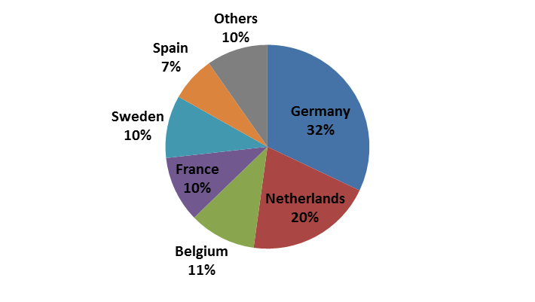

*Source:* *ACEA Pocket Guide 2017/2018*

In 2016, according to industry data[26], the export of lorries above 5 tonnes was worth €5.3 billion and generated a trade balance surplus of €4.9 billion. Some of the main export markets for commercial vehicles in 2016 included Hong Kong, U.S., Turkey, Switzerland and Norway.

The EU lorry market is dominated by 6 major manufacturers: Daimler, DAF[27], M.A.N., Scania, Renault, Volvo and Iveco[28]. Figure 2 shows the breakdown of the EU and US markets by manufacturer. Volkswagen (owning M.A.N. and Scania) has the largest share of the EU market (31%). It shows that several of the HDV manufacturers operating in the EU also have a strong presence in the US market, in particular Daimler (46%), but also PACCAR and Volvo.

Figure 2: 2014 Market Share of Tractor Lorry Manufacturers in the EU and U.S.

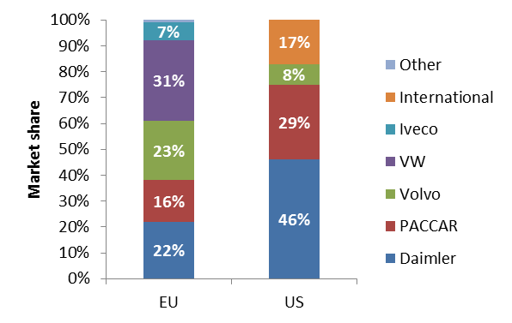

*Source: ICCT (2015)*

Figure 3 shows that, compared to the EU and US, the Chinese and Asia-Pacific HDV markets are less consolidated. They are dominated mainly by domestic manufacturers, although some EU companies such as Daimler and Volvo have joint agreements in place in these regions, which are securing them market access[29].

On a global scale, China is currently the leading producer (30%) of commercial vehicles, followed by North America (23%) and the EU (19%).

Figure 3: Market Share of Manufacturers of Medium- and Heavy Duty Lorries in China and Asia-Pacific

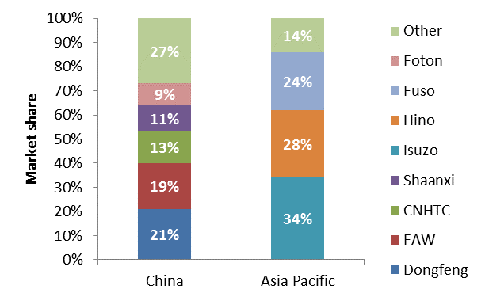

*Source:* *Roland Berger (2017)* *Truck and trailer components – Success factors for suppliers in specialized markets*

## Specificities of the HDV sector compared to LDVs

***Vehicle design and application, technological options***

Compared to cars (and vans), HDVs are used for a much wider range of commercial and vocational purposes, ranging from urban, regional and long-haul deliveries of goods, to specific applications in the construction sector and municipal services. This implies a large variation in cargo weight and combinations of vehicle components, such as the driver cabin, vehicle body, gearbox, engine, axis and auxiliaries.

The average annual mileages of the vehicles also vary considerably depending on the type of activities, from 70,000 km for regional delivery vehicles to around 140,000 km for long haul vehicles. This results in a very wide range of fuel consumption and CO2 emissions from lorries, the latter ranging from 690 g CO2/km to 1080 g CO2/km[30].

Consequently, the HDV sector is much more diversified, with a significant number of different vehicle types and models as well as with a higher degree of customisation. HDVs (lorries) can be categorised into groups and sub-groups according to their size configuration and mission profile (for more information, see Annex 8).

The production cycle for designing and introducing new models or important features for HDVs, for instance a new generation of engines or cabins, is longer than cars: around 10 to 15 years for lorries and buses, versus 6 to 8 years for cars.

Except for buses, alternative powertrain development is less advanced for heavy-duty vehicles than for cars. Electrification is in very early stages.

***Availability of certified data***

The fuel consumption and CO2 performance of new passenger cars and vans is determined through emissions type approval on a chassis dynamometer since 1980[31]. As a result, CO2 emission data at vehicle level has been available for several years.

For HDVs emissions type-approval testing cannot be performed meaningfully through testing on a chassis dynamometer due to the numerous types and configuration of vehicles. Currently, CO2 data is only available for the engines and not at the whole-vehicle level.

While this knowledge gap is currently being addressed for new HDVs through the VECTO and the new certification legislation (see Annex 8), the first certified CO2 and fuel consumption data won't be published until 2020. It will cover only part of the groups of lorries. The certification legislation is still work in progress. With regard to buses, which make some 9.3% of total number of HDVs in 2016[32], smaller lorries and trailers, the certification legislation is not yet even developed. (see Annex 8, Section 0)

Some provisional and estimated CO2 emissions data for the 2016 fleet has been provided to the Commission by lorries manufacturers to support the analysis carried out for this impact assessment. However, these data were not generated in application of the new certification legislation and are not directly comparable between manufacturers due to the different assumptions made.

As regards real world fuel consumption of individual vehicles, the information available is not directly comparable as it is based on different tests and simulations carried out by HDV manufacturers or specialised journals[33] under non-standardised conditions.

***Market structure***

While the EU car market is composed of numerous manufacturers, the EU HDV market only has a small number of major manufacturers, from just a few countries. The scale of the markets is also different with around 420,000 HDVs manufactured in 2016 in the EU versus 16.5 million cars manufactured over the same period.

Also, purchasers of HDVs are mostly businesses, consisting largely of SMEs and micro-enterprises, while the buyers of cars are mainly households. The demand for HDVs can also be very cyclical and subject to prevailing economic conditions. The average age of a lorry in Europe is 11.7 years[34].

The HDV market is more disaggregated than that of passenger cars in that a lorry manufacturer for the most part is only responsible for the base vehicle but not for the final vehicle configuration which includes the addition of bodies or trailers. In contrast to the manufacturers, the trailer and body builder sector is highly diverse, consisting of thousands of organisations most of which operate in local markets.

## Overview of international HDV CO2 or fuel economy standards

***Situation in the US and Canada***

In September 2011, the U.S. adopted regulations on HDV GHG emissions and fuel consumption. The GHG regulations are developed and managed by the Environmental Protection Agency (EPA) and those on fuel consumption by the National Highway Traffic Safety Administration (NHTSA). The drivers behind these legislative measures involved a combination of energy security and environmental protection concerns. The current "Phase I" Regulations run until 2017, after which "Phase II" Regulations will be implemented until 2027.

The Phase I Regulations set standards for new tractors, pickups, vans and all other medium and heavy-duty vehicles of model years 2014 through 2018 and will require manufacturers to improve fuel economy and GHG emissions by up to 20 per cent by 2018. The CO2 emission standards are set in gram/ton-mile. In addition, the proposal comprises new engine standards for CO2 (in g/bhp-hr) and fuel consumption.

As the U.S. lorry market allows the vehicle buyer to choose between different engines, a dual approach applying to engine and vehicle emissions was applied. U.S. engines are certified using an engine dynamometer running two different drive test cycles. The standards for whole vehicle emissions and fuel consumption use the GEM simulation model, which has three different drive cycles and a further two idle cycles for vocational vehicles.

Manufacturers must meet the standards each manufacturing year, but there are flexibility options allowing additional lead-time to introduce technologies to the fleet, such as averaging, banking and a trading scheme that also gives credits for early adoption and advanced technologies.

All vehicles must be certified at the point of sale. Testing is carried out either by the EPA or the manufacturer, and also throughout the useful life of the vehicle. Violations and penalties are issued on the basis of this information. There is a single reporting structure in which manufacturers report their sales for the year and their emissions given in the Certificates of Conformity.

Phase II standards, which will take effect from 2018 while becoming increasingly stringent over the coming decade, will regulate not only lorry efficiency but also trailer efficiency.

Canada followed US standards and adopted the same Phase I and Phase II standards.

***Situation in China***

In 2012, China put in place a type approval standard (Phase I) in order to establish a benchmark against which to design a subsequent round of emission standards. By 2015, these new standards (Phase II) were applied on all new heavy-duty vehicle sales.

Phase II standards differ by fuel and vehicle type and a step function mandates maximum fuel consumption by gross vehicle weight. Testing is performed on a version of the World Harmonised Transient Vehicle Cycle modified to reflect Chinese on-road conditions.

China's Phase III standards, expected to be introduced between 2019 and 2021, target a reduction in fuel consumption of about 15% in 2020 from 2015 levels.

China regulates new type approvals, conducts conformity of production testing and runs inspection and maintenance programmes as a part of its heavy duty emissions regulation programme. The former two compliance mechanisms are the responsibility of the Ministry of Environmental Protection (MEP). The institution implementing the programmes is the Vehicle Emission Control Centre (VECC) under the MEP.

***Situation in Japan***

Japan was the first country to introduce in 2006 a fuel consumption based rule for HDVs, both for energy security reasons and for meeting global climate targets. The standards are given as km/litre and became applicable from April 1st, 2015.

The standards are based on the "Top Runner Programme" which takes the best performing vehicle in the market as the baseline for the standards. For HDVs, the best-in-class vehicles in each category from the model year 2002, plus an additional 12.2% fuel efficiency gain for lorries and 12.1% gain for buses, were used to set the 2015 fleet average fuel efficiency targets. Separate limits were set for 13 categories of lorries and 12 types of buses.

Compliance is determined by use of a computer simulation procedure that calculates fuel efficiency based on engine dynamometer testing. The penalties for non-compliance are relatively loose. The most notable enforcement mechanism is a public announcement by the Authorities, which is considered a severe enough incentive to ensure compliance.

***Situation in other countries***

India introduced HDV efficiency standards for vehicles exceeding 12 tonnes in 2017. The standards will apply during the period 2018 – 2021.

Mexico adopted standards for HDVs in 2018. Starting from 2021 onwards, all new HDVs sold in Mexico will be required to meet the best-in-class tailpipe standards, equivalent to the performance of vehicles in North-America.

Among the countries considering the introduction of fuel efficiency and CO2 standards for HDVs are Russia and South Korea.

# Annex 6: Policy initiatives addressing transport emissions

## Overview of recent Commission initiatives

***2016 European Strategy for low-emission mobility***

In 2016, [the European Strategy for low-emission mobility](http://eur-lex.europa.eu/legal-content/EN/TXT/?qid=1509014203218&uri=CELEX:52016DC0501) reaffirmed the objective of reducing GHG emissions from transport by at least 60% on 1990 level by 2050. At the same time, the Commission proposed 2030 GHG emission reduction targets for the non-ETS sectors for each Member State under the Effort Sharing Regulation[35] and these were recently agreed by the co-legislators. Proposals revising the Energy Efficiency Directive[36] and the Renewable Energy Directive[37] are being discussed in the Council and the European Parliament.

***Communication “Europe on the Move” of May 2017***

The Commission's May 2017 Communication 'Europe on the Move[38]: An agenda for a socially fair transition towards clean, competitive and connected mobility for all' makes clear that ambition is to ensure that the best low-emission, connected and automated mobility solutions, equipment and vehicles will be developed, offered and manufactured in Europe and that we have in place the most modern infrastructure to support them.

***Industrial Policy Strategy of September 2017***

In September 2017, the Commission also adopted its Industrial Policy Strategy aimed at promoting sustainable growth and jobs with a focus on innovation, digitization and decarbonisation.

***Proposal for a Regulation setting CO2 emission performance standards for light-duty vehicles for the period up to 2030***

In November 2017, the Commission adopted a Proposal[39] for a Regulation setting CO2 emission performance standards for light-duty vehicles (cars and vans) for the period up to 2030. These standards will contribute to achieving the targets set out in the Effort Sharing Regulation. However, as indicated in the accompanying impact assessment[40] underlying the proposal, further measures are needed in the road transport sector, in particular as regards Heavy-Duty Vehicles.

## Overview of broader EU mobility policies relevant for HDVs

There are a number of different pieces of EU legislation, which are relevant for the decarbonisation of the road transport sector, including heavy-duty vehicles. These are divided into regulatory and non-regulatory measures and are listed below.

*Regulatory measures*

* The **EU type-approval system** provides a common legal framework for the approval of motor vehicles and their trailers and of systems, components and separate technical units intended for these vehicles. Type approval is compulsory for all categories of whole vehicles, including those built in several stages. For HDVs, the recently adopted **HDV certification legislation** sets out the procedures for certifying CO2 emissions and fuel consumption through VECTO. The data will be monitored and reported to the Commission as of 2020.
* The "**Eurovignette" Directive**[41] aims at internalising negative externalities caused by the road freight transport, such as CO2 emissions, congestion, noise etc. The 2017 Commission proposal for its revision[42] introduces variations in the infrastructure charges depending on the CO2 emissions of HDVs as of 1 January 2022. According to the accompanying Impact Assessment[43], the proposed changes have the potential to reduce CO2 emissions for road transport by approximately 0.7% for the period 2005 – 2030.
* **Directive on maximum authorized weights and dimensions**[44] requires HDVs in the EU to comply with certain rules on weights and dimensionsfor road safety reasons and to avoid damaging roads, bridges and tunnels. It also aims at improving the fuel efficiency of HDVs by allowing appropriate vehicle design. Under this legislation, HDVs may exceed the maximum dimensions permitted provided there are improvements in energy efficiency, aerodynamic and safety performance. Implementing legislation is being prepared to enable this provision.
* The **Clean Vehicles Directive**[45]requires public procurers to consider fuel consumption, CO2, and pollutant emissions when purchasing road transport vehicles, including HDVs. The Commission has proposed a revision of this Directive in order to better support achieving EU policy objectives on climate change and air pollution and to stimulate the market for clean vehicles and increase competitiveness. Targets are proposed for public procurements of clean vehicles, both LDVs and HDVs, to be implemented as of 2025. For HDVs, the proposed definition of a "clean vehicle" refers to the use of alternative fuels and, for the future, to the CO2 standards to be established at EU level. The proposal for a revised Clean Vehicle Directive is expected to result in about 1,800 ktonnes CO2 emission reductions for road transport, which is equivalent to CO2 reductions of approximately 0.2 % for the period 2005 – 2030.[46]
* The **Renewable Energy Directive** (RED) contributes to achieving CO2 savings in road transport by requiring the use of renewable fuels. It sets a target for each Member State of a 10% share of renewable energy in transport by 2020. The 2016 Commission proposal for a revision of the RED[47] reaffirms the importance of renewable energy in the transport sector, aiming by mandating fuel suppliers to provide 6.8% in 2030 of non-food based and advanced low-emission fuels, including renewables. It has been estimated that the changes proposed to the RED have the potential to deliver overall GHG savings in the range of 0.8% - 1.56%[48] in the period 2020 – 2030.
* The **Fuel Quality Directive** (FQD)[49]addresses the provision of common standards and consumer information on cleaner fuels and vehicles. It requires fuel suppliers to reduce the GHG intensity of fuels supplied in 2020 by 6% compared to 2010. This requirement acts as an incentive to promote low-carbon fuels in both light duty and heavy-duty vehicles sectors. It is not intended, though, to keep the GHG provisions of this Directive after 2020 in view of the revision of the RED.
* The **Energy Efficiency Directive** (EED)[50] establishes a set of measures to help the EU reach its 20% energy efficiency target for the whole energy system, including transport. The EED is currently under revision for setting provisions with regards to the period 2021- 2030.
* The **Directive on the deployment of alternative fuels infrastructure (AFID)[51]** aims at promoting the roll-out of alternative fuel infrastructure, which will contribute to the decarbonisation of the EU transport sector and will increase the EU´s overall energy security by reducing the transport sector dependence on imported fuel.In 2016 Member States presented their national plans for roll-out of alternative fuels infrastructure until 2030. As indicated in the Action Plan, adopted as part of the November 2017 Clean Mobility Package, the Commission will support their implementation with an additional EUR 860 million in the next few years.
* **The Energy Taxation Directive** establishes the minimum excise duty rates that Member States must apply to energy products for fuel and transport, and electricity. The actual levels of taxation applied are decided by Member States and could vary considerably from one Member State to another. For example the excise duty for diesel ranges between EUR 0.33/l and EUR 0.67/l, which are rather modest levels with limited impact on fuel sales[52].
* **Tyre labelling**: tyres sold in the EU are subject to energy labelling requirements.[53] Tyre labelsaimsat supporting consumers in the purchasing decisions for more fuel efficient, better wet braking and less noisy tyres.

*Non-regulatory measures*

* The Commission´s **Coach Services Action** aims at further developing of domestic bus and coach services.
* **Horizon 2020** EU Research and Innovation program, aimed at securing Europe's global competitiveness, allocates EUR 6.4 billion to research and innovation initiatives in the transport sector.
* Shift2Rail is the first European rail initiative to seek focused research and innovation (R&I) and market-driven solutions by accelerating the integration of new and advanced technologies into innovative rail product solutions. This initiative is undertaken within the framework of Horizon 2020. It supports the development of a Single European Rail Area (SERA) for a better interoperability of train services in Europe.
* **Green freight programs**, incentivising the sharing of industry best practices. Some of these programs receive financing under the European Structural and Investment Funds, whose transport-related envelope totals EUR 70 billion. That includes EUR 39 billion for supporting the move towards low-emission mobility.[54]

## Link with problem drivers

Table 5provides an assessment of how the EU policies could address the problem drivers identified.

Table 5: Existing and revised EU policies and problem drivers identified

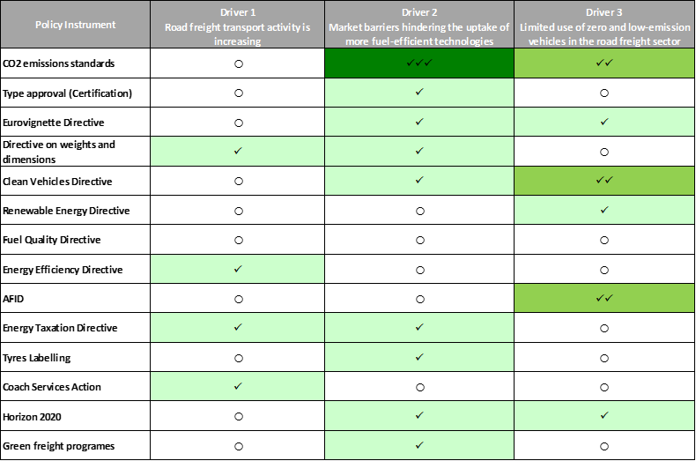



# Annex 7: Problems and drivers – complementary information

## Problem 1: HDV sector is a significant and growing source of GHG emissions

In 2015, CO2 emissions from HDVs represented around 6% of total EU emissions, almost a fifth of all transport emissions and, as shown in Figure 4: Share of HDV and LDV in total road transport CO2 emissions, slightly more than a quarter of road transport emissions.

Figure 4: Share of HDV and LDV in total road transport CO2 emissions

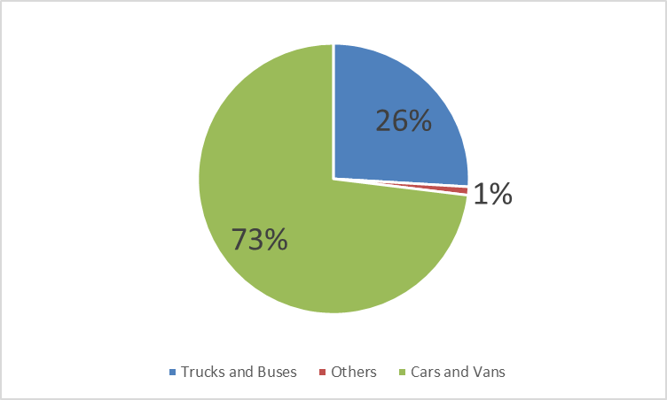

*Source: GHG Inventory data – European Environment Agency* [55]

As Figure 5 shows, GHG emissions from HDVs in 2015 were around 19% higher than in 1990, despite some decrease taking place after 2007. Without further action and HDV activity steadily increasing, HDV CO2 emissions are set to increase by up to 6% between 2015 and 2030[56] and thus to represent an increasing share of road transport emissions, from around 25% in 2015 to around 35% in 2050.

At the same time, as explained in Chapter 1 of the Impact Assessment, the EU has set ambitious targets for reducing GHG emissions by 2030, including for the non-ETS sectors, to which the transport sector must contribute. Cars and vans are already delivering their share and legislation has been proposed[57] so that they continue doing so after 2020.

The EU also has a long-term goal of reducing GHG emissions by 80-95% by 2050 compared to 1990 levels as its contribution to global efforts required to meet the Paris Agreement commitments. All sectors will have to play their part if this level of ambition is to be achieved and if the costs and severe impacts of climate change are to be avoided.

Figure 5: Road Transport GHG emissions 1990 – 2015

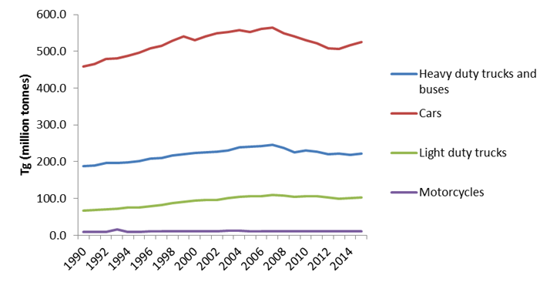

*Source: GHG Inventory data – European Environment Agency* [58]

Figure 6: Projected HDV CO2 emissions 2015-2050

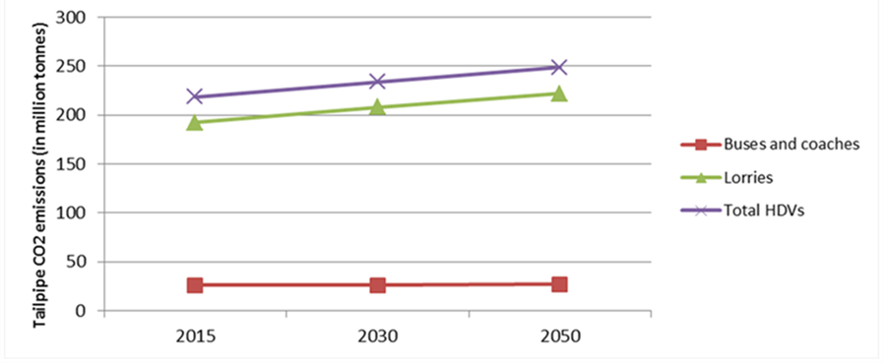

*Source: Primes-Tremove*

## Problem 3: EU HDV manufacturers and component suppliers are at risk of losing their technological and innovation leadership position

The EU HDV manufacturers and component suppliers currently have a global technological leadership position, as EU lorries are more fuel efficient than lorries in other economies. Table 6 shows that new lorries in the EU for medium and heavy freight transport have lower average fuel consumption than lorries in other regions of the world.

Table 6: Typical average fuel consumption of new lorries at representative payloads, by lorry category in selected countries (litres of diesel equivalent/100 km)



*Source: IEA, The future of trucks (2017)*

## Driver 1: Road freight transport activity is increasing

In the longer term, under current trends and adopted policies[59], road freight transport activity is set to increase between 2010 and 2050 by about 56% (1.1% p.a.) due to a strong correlation with economic growth (see Figure 7 below).

Figure 7: Evolution of freight transport activity by mode

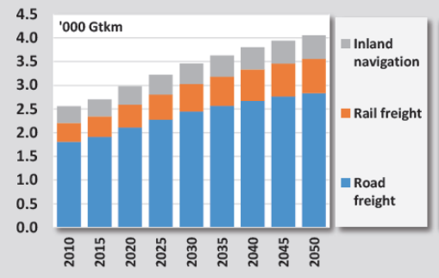

*Source: EU Reference Scenario 2016*

## Driver 3: Limited use of zero- and low-emission vehicles in the HDV sector

As shown in Table 7, almost all traditional manufacturers have announced plans for electrification, even if the potential sales volume would remain small in view of the current high upfront costs.

Table 7: List of manufacturers' and suppliers’ announcements on zero- and low emission HDV[60]

| **Manufacturer or supplier** | **Announcement** |
| --- | --- |
| **Daimler** | Fully electric-powered light lorry |
| **Volvo/Renault** | All-electric lorries in 2019 |
| **Iveco** | Presented a long-haul concept lorry in 2016 |
| **Man** | eTruck (18 to 36 tons for distribution purposes) is currently undergoing tests |
| **Scania** | To develop and commercialise battery cell technology for heavy commercial vehicles with batteries producer Northvolt |
| **Nikola Motor** | ZEV lorries by end 2019 |
| **Cummins** | All-electric powertrain for buses and delivery vehicles by 2019 |
| **BYD** | EU market: launch of 7.5 tons electric lorry planned in July 2018 in view of market availability in 2019  Chinese market: broader range of electric lorries available on the market, including larger lorries, construction and garbage vehicles |
| **Tesla** | Announced an electric lorry. Date of actual release not yet known |

# Annex 8: Step-wise approach for regulating HDV CO2 emissions: VECTO, Certification and monitoring/reporting of HDV CO2 emissions.

The first initiative to tackle HDV GHG emissions in the EU was a strategy adopted in 2014.[61] This strategy focused on short-term action to certify, monitor and report HDV CO2 emissions, which is an essential first step towards reducing them. These actions were confirmed by the 2016 *Low-emission mobility strategy* and the Commission has adopted the following legislation in the course of 2017 to implement them:

* A Commission Regulation on the determination of carbon dioxide emissions and fuel consumption of HDVs[62] (the so-called "Certification Regulation"), which was adopted on 12 December 2017.
* A proposal[63] for a Regulation on the monitoring and reporting of CO2 emission and fuel consumption data, which is currently being discussed by the European Parliament and the Council.

The Certification Regulation requires HDV manufacturers, as of 1 January 2019, to determine the CO2 emissions and fuel consumption of new vehicles they place on the EU market. The CO2 emissions are calculated by using the Vehicle Energy Consumption Calculation Tool (VECTO), which is a simulation tool developed for that purpose by the Commission. Information on the CO2 emissions and fuel consumption of new HDVs will be declared for the registration of vehicles under the EU type-approval legislative framework. The Monitoring and Reporting Regulation requires that these data are monitored and reported to the Commission, and will be made publicly available.

The step-wise approach on the regulation of HDV CO2 emissions is summarized in Figure 8 below. More information on the simulation tool VECTO, on the certification procedure and on the monitoring and reporting system is given in Sections 8.1 to 8.3 below.

Figure 8: Step-wise approach for regulating HDV CO2 emissions

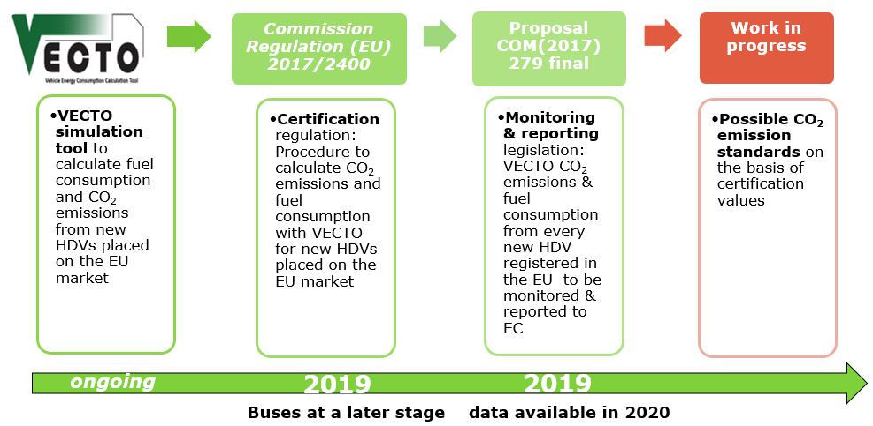

## VECTO

### Introduction

The Commission has since 2009 engaged with main industry stakeholders in the development of a simulation tool for whole vehicles CO2 emissions and fuel consumption that should be applicable to all main categories of HDVs.

In the project “Reduction and testing of Greenhouse Gas Emissions from Heavy duty vehicles”[64] a simulation based test procedure where the relevant components of the HDV were tested and based on this data a simulation tool calculating the fuel consumption and the CO2 emissions in vehicle class specific test cycles was chosen as the method that delivers robust results of CO2 figures for HDVs and appears manageable for the manufacturers and public administrations that have to deal with the test procedure.

The relevant data for the simulation of HDV CO2 that have been identified include the engine fuel efficiency map, vehicle weight, tires rolling resistance coefficients (RRC), aerodynamic drag coefficient multiplied by the frontal area (A) of the vehicle (CdxA), moments of inertia from the vehicle including standardised bodies or trailers, the specifications of the gear boxes and efficiency of the auxiliaries.

Such a simulation based approach should allow cost efficient testing of multiple HDV variations by compiling the measured component data in the simulator. This approach also makes it possible to easily assess the CO2 emissions impact of improved trailer and body structure design. The proposed test procedure has been applied experimentally on four HDV categories so far and appears to give reliable and accurate results.

The simulation-based method consists of:

* On-road measurement of driving resistances
* Determination of drivetrain losses
* Determination of power demand of engine auxiliaries and other consumers
* Measurement of the engine fuel consumption map as extension to the engine's type approval tests
* Simulation of the fuel consumption and the resulting CO2-emisions from the vehicle using the aforementioned input data for predefined representative driving cycles.

The single steps described in brief are as follows:

The driving resistances of the vehicle will be measured during constant speed on a test track. Standardized bodies and trailers will be used to obtain reliable air resistance values. For reproducible results, corrections for influences of road gradient, wind speed, ambient temperature and air pressure as well as for velocity unsteadiness, have to be applied to the measured driving resistance values.

For the body and trailer manufacturers an option for a less extensive procedure can be applied. Improved bodies or trailers (aerodynamics, curb weight) can be tested in comparison to the standard components via constant speed tests. The relative change against the standard body or trailer can then be introduced into the simulation tool to calculate the fuel consumption and the CO2 emissions of the alternative vehicle and body-configuration.

Drivetrain friction losses and the power demand of engine auxiliaries like engine fan, air compressor or heating ventilation and air conditioning system (HVAC), will be defined as default values. If manufacturers use more efficient components, the default values can be replaced by component specific efficiency maps.

Since several technical options to improve the fuel efficiency of HDV have different reduction potentials at varying driving conditions, the definition of representative driving cycles is important for a realistic ranking of the specific fuel consumption. Driving cycles (or mission profiles) for the different categories and usage of HDVs are newly developed to give more realistic results on fuel consumption.

It is desirable for the methodology to address all characteristics that are relevant to the efficiency of the entire vehicle. Realistic values for the fuel efficiency of various HDV in different mission profiles will improve customer information and incentivise manufacturers to develop and apply fuel saving technologies. In future a standardised test procedure could support other measures in the HDV sector including CO2 emissions monitoring, labelling or programmes for HDV customers to calculate HDV fuel efficiency.

The main targets for the test procedure are:

* Repeatable (within same laboratory) and reproducible (between different laboratories)
* Incentive to apply efficient technologies and to optimise the entire vehicle set-up
* High sensitivity for fuel saving measures
* Reasonable costs and efforts to run and examine the procedure
* Simple and robust

### Schematic overview of simulation model and computational programme

Figure 9 gives an overview of the test procedure. Rolling resistance, air resistance, power to accelerate translational and rotatory moved masses, power resulting from road gradients, losses in the transmission system and power demand from auxiliaries are considered in the simulation.

**Figure 9: Schematic picture of the test procedure**

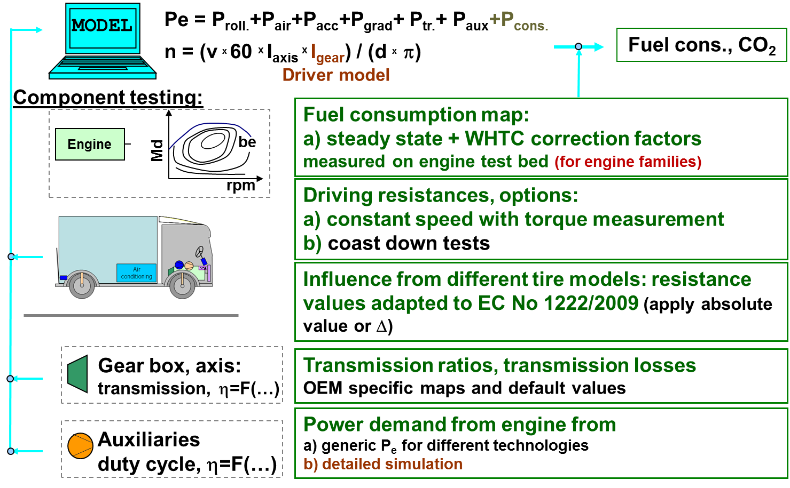

All the measured data of the components / subsystems of a HDV will then be used as input data in a HDV energy/CO2 simulation tool. The structure of the simulation tool is shown in Figure 10.

Figure 10: Structure of the simulation tool

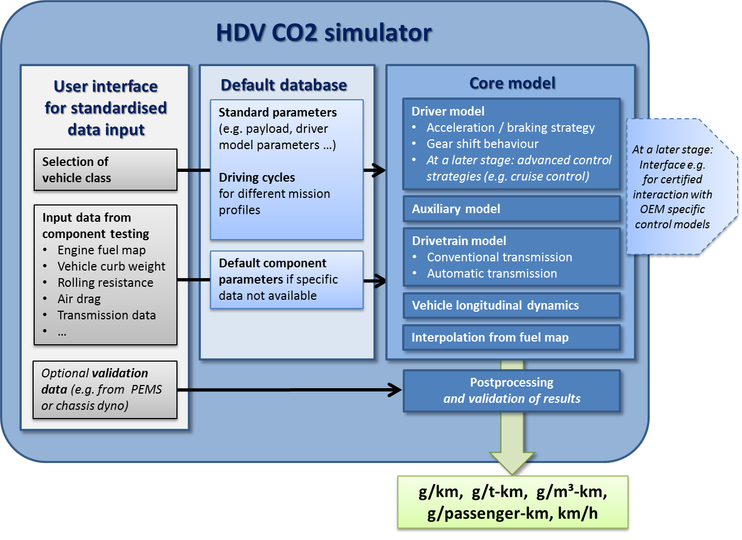

The simulation tool will calculate the energy consumption of the whole HDV and give as a result the fuel consumption or CO2 emissions in g/km, g/tkm, g/m3km or g/passenger.km (for buses).

### Adequacy of VECTO as a simulation tool

In order to evaluate the adequacy of the VECTO simulation tool, the Commission carried out a study aimed at assessing to what extent the effect of relevant technologies on CO2 emissions is properly captured by VECTO. The study was performed by JRC in 2016*[65]*. A number of stakeholders, including HDVs manufacturers and suppliers were consulted.

The study concludes that *“… a large part of the technologies under investigation were already sufficiently captured by VECTO tool and the certification methodology.”* and that *“… VECTO has achieved …a good level of maturity”*

The study also identified some new technologies that are likely to enter into the market in the next couple of years will require additional work to further develop VECTO with software developments.

Such new technologies include Advanced Driver Assist Systems (ADAS), Platooning, Waste Heat Recovery (WHR), hybrids, Electric turbocharger, Air Conditioning efficiency and refrigerant, Active flow systems, Trailer aerodynamic improvements, Dual Clutch Transmission and Neutral idle.

Most of the above mentioned technologies have been already considered in the future development plan of VECTO and will be addressed soon. Additional and detailed technical input from the stakeholders will be required as most of those technologies have not entered into the market yet.

Figure 11 presents an overview of the degree by which VECTO captures the different technology categories in 2016. These categories includes:

* existing technologies which are already simulated accurately as indicated above
* new technologies for which further development in VECTO is required

Further information on the development plans of VECTO is provided in the next section.

Figure 11: Results of survey – views of respondents on level of simulation of different existing and new technologies in VECTO (2016) *[66]*

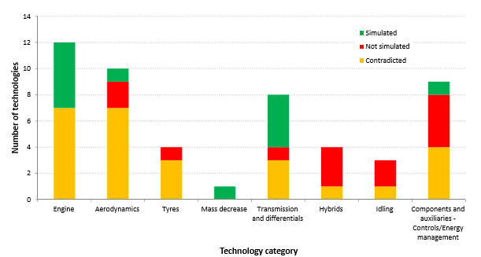

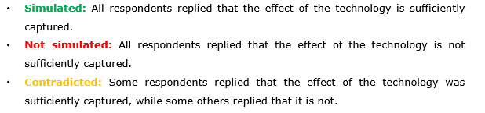

### Future development steps of the VECTO tool

At this stage, VECTO can simulate only lorries above 7.5 tonnes.

The VECTO tool will have to be extended to other categories of HDVs (e.g. city and inter-city buses, municipal utility lorries, service and urban delivery lorries, construction lorries). Moreover, a platform or dedicated webpage that VECTO will be hosted has to be created.

The next phase of development of the VECTO tool, which will take place in the period 2020 - 2021 is thus expected to include:

­ the further development and finalisation of VECTO to cover other categories of HDVs such as city-buses, coaches and small lorries – planned implementation 2020

­ a dedicated webpage where the tool will be hosted; VECTO will be a downloadable executable file that will be uploaded on this page and will be available for all public users (universities, research institutes, independents etc.). A detailed and regularly updated FAQ doc will be also uploaded on the same webpage for reference use;

- certain types of drivetrains (i.e. Hybrids) will be included in VECTO in 2021;

- specific modern technologies, identified by the 2016 JRC study as “not-simulated” in VECTO, such as Advanced Driver Assist Systems (ADAS), Waste Heat Recovery (WHR), Eco-features, gear shifting strategy etc. will be addressed in VECTO by 2020;

- new gear shift strategies for various types of transmissions and mission profiles for M2 and N2 vehicles will be also elaborated;

- review of updates cycles and implementation into VECTO for "Urban delivery" and "Construction" cycles;

applications where both diesel and gas are used as fuels at the same time in different relative shares (dual-fuelled engines) will be taken into account in VECTO;

- update continuously the tyre dimensions table within the tool so any dimensions sold in the future is covered by the list;

­ and the adaptation of the required documentation of the certification/registration process for all relevant categories of vehicles.

## Certification Regulation

By allowing the calculation of the CO2 emissions and fuel consumption of heavy-duty vehicles in a comparable way, VECTO has laid the ground for a certification methodology for those parameters, as part of the type approval of new heavy-duty vehicles before they are placed on the EU market. This methodology is used instead of the testing on a chassis dynamometer carried out for light-duty vehicles as such an approach is not possible for HDVs due to the numerous types and configurations of vehicles.

According to the new Certification Regulation[67], which is an implementing act of the existing type approval legislation[68], each heavy-duty vehicle within the groups covered that is to be placed on the EU market, will need to be simulated with VECTO in order to determine of its CO2 emissions and fuel consumption. Vehicle manufacturers themselves will perform the simulation on the basis of certified input data of all different vehicle components and of a certified process of sourcing, managing and applying such input data.

For the purpose of the Certification Regulation, lorries have been divided into 18 vehicle groups (groups 0 to 17)[69] depending on their axle configuration (4x2, 6x2, 8x2 etc.)[70], chassis configuration (rigid or tractor) and technically permissible maximum laden mass, also called gross vehicle weight (GVW).[71]

The 18 vehicle groups are attributed five different mission profiles according to their specific use – Long Haul, Regional Delivery, Urban Delivery, Municipal Utility and Construction.

The Certification Regulation applies to:

* vehicles in the groups 4, 5, 9 and 10, as from 1 July 2019;
* vehicles in the groups 1, 2, and 3, as from 1 January 2020;
* vehicles in the groups 11, 12 and 16, as from 1 July 2020.

The Certification Regulation will later be extended to cover the remaining lorry groups, as well as buses and coaches, and trailers, once VECTO is ready to simulate these vehicles.

**Table 8** presents a summarized list of the 18 vehicle groups, while Table9 provides a visual illustration of the vehicles in the groups 4, 5, 9 and 10, both without and with trailers.

**Table 8: Overview of certification vehicle groups**

| **Vehicle group** | **Axle configuration** | **Chassis configuration** | **Technically permissible maximum laden mass (tons)** |
| --- | --- | --- | --- |
| **0** | 4x2 | Rigid | >3.5 – <7.5 |
| **1** | 4x2 | Rigid (or tractor) | 7.5 – 10 |
| **2** | 4x2 | Rigid (or tractor) | >10 – 12 |
| **3** | 4x2 | Rigid (or tractor) | >12 – 16 |
| **4** | 4x2 | Rigid | >16 |
| **5** | 4x2 | Tractor | >16 |
| **6** | 4x4 | Rigid | 7.5 – 16 |
| **7** | 4x4 | Rigid | >16 |
| **8** | 4x4 | Tractor | >16 |
| **9** | 6x2 | Rigid | all weights |
| **10** | 6x2 | Tractor | all weights |
| **11** | 6x4 | Rigid | all weights |
| **12** | 6x4 | Tractor | all weights |
| **13** | 6x6 | Rigid | all weights |
| **14** | 6x6 | Tractor | all weights |
| **15** | 8x2 | Rigid | all weights |
| **16** | 8x4 | Rigid | all weights |
| **17** | 8x6 or 8x8 | Rigid | all weights |

**Table 9: Visual illustration of HDVs in groups 4, 5, 9 and 10**

|  |  |  |  |
| --- | --- | --- | --- |
| **Vehicle group** | **Axle and chassis configuration** | **Without trailer** | **With trailer** |
| **4** | 4x2 Rigid |  |  |
| **5** | 4x2 Tractor |  |  |
| **9** | 6x2 Rigid |  |  |
| **10** | 6x2 Tractor | Related image |  |

As shown in Figure 12, based on calculations made in 2012[72], lorries falling in Groups 4, 5, 9 and 10 are together responsible for some 79% of the overall CO2 emissions of the 18 vehicle groups listed above and about 65% to 70% of total HDV CO2 emissions. Buses and coaches represent about 10% of the total HDV CO2 emissions. Annually, some 250,000 new lorries falling into these four groups are registered.

The lorries in group 5 (4x2 tractor with a GVW of more than 16 t) contribute by far the most to the total emissions, accounting for some 54% of the total emissions of the 18 HDV groups shown.

**Figure 12: Estimated share of total CO2 emissions from different HDV (lorry) groups**

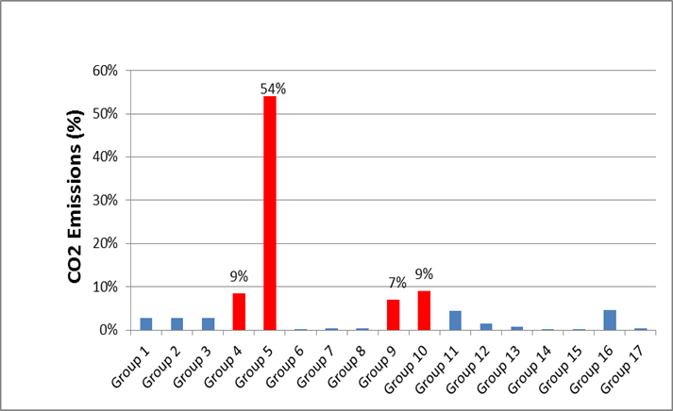

*Source: TU Graz et al, 2012*

In view of the high share of total CO2 emissions of HDV groups 4, 5, 9 and 10, these groups were selected as the first vehicles to be covered by VECTO and to which the Certification Regulation will apply.

In order to ensure that the fuel and CO2 values declared by the vehicle manufacturer accurately reflect the actual values, provisions for verifying such conformity have been introduced in the certification procedure, so-called conformity of production provisions. These tests apply to both vehicle and components manufacturers. The verification test for the whole vehicle is currently being developed, whereas the tests for component manufacturers are already defined in the Regulation.

Once, the vehicle manufacturer has uploaded, according to the certification procedure, the characteristics of the vehicle and the certified input data from the different components into the VECTO simulation tool at the end of the production line, the outcome of the simulation will be a set of files containing a list of parameters, so-called output data.

In particular the VECTO simulation tool will produce two files: the manufacturer’s record file and the customer information file. The manufacturer’s record file includes information on the CO2 emission and fuel consumption of the vehicle for the different mission profiles, loads and fuel combination that are specific to the vehicle as declared by the vehicle manufacturer.

The customer information file is a summary of the most relevant parameters for the buyer of the vehicle, including the CO2 emission and fuel consumption values, in order to provide more transparency on the performance of the vehicle, which currently is lacking in the HDV market.

## Monitoring and reporting

Under the proposed Regulation on monitoring and reporting of CO2 emissions data from HDV, the Commission will collect the CO2 emissions and fuel consumption data resulting from the certification procedure.

The data will be made publicly available by the European Environment Agency (EEA) on behalf of the Commission, starting in 2020 to cover data monitored in 2019. This will increase transparency in the HDV market.

The monitoring data include a subset of the manufacturer’s record file provided by VECTO under the certification procedure, and in particular the CO2 emissions, fuel consumption and other relevant technical parameters.

The EEA will combine the registration data from national authorities with the monitoring data from manufacturers and publish annual monitoring data for each new vehicle registered in the EU that was subject to the certification procedure. For those HDVs not yet covered by the certification, and for which therefore no monitoring data is available yet, the EEA will publish the registration data provided by national authorities.

# Annex 9 – Description of the options - complementary information

## Policy option categories

The options considered in the Impact Assessment cover a number of elements, which are grouped into five categories: (i) CO2 emission targets; (ii) Distribution of target across vehicle groups and manufacturers; (iii) Incentives for zero- and low-emission vehicles; (iv) Elements for cost-effective implementation and (v) Governance.

Table 10 shows how these categories are related to the problems outlined in Section 4 of the Impact Assessment.

**Table 10: Policy options and problems**

|  |  |  |  |
| --- | --- | --- | --- |
| **Key Policy Areas** | Problem 1: HDV sector source of growing emissions | Problem 2: Transport operators missing out on fuel savings | Problem 3: HDV sector risks to loose technological leadership |
| CO2 emission targets | ✓ | ✓ | ✓ |
| Distribution of target across vehicle groups and manufacturers |  | ✓ | ✓ |
| Incentives for zero- and low-emission vehicles | ✓ |  | ✓ |
| Elements for cost-effective implementation |  | ✓ | ✓ |
| Governance | ✓ | ✓ |  |

## Target levels – baseline and overview of options

**Figure 13: EU fleet-wide CO2 emission target level trajectories under different policy options and emission reductions expected under the baseline**

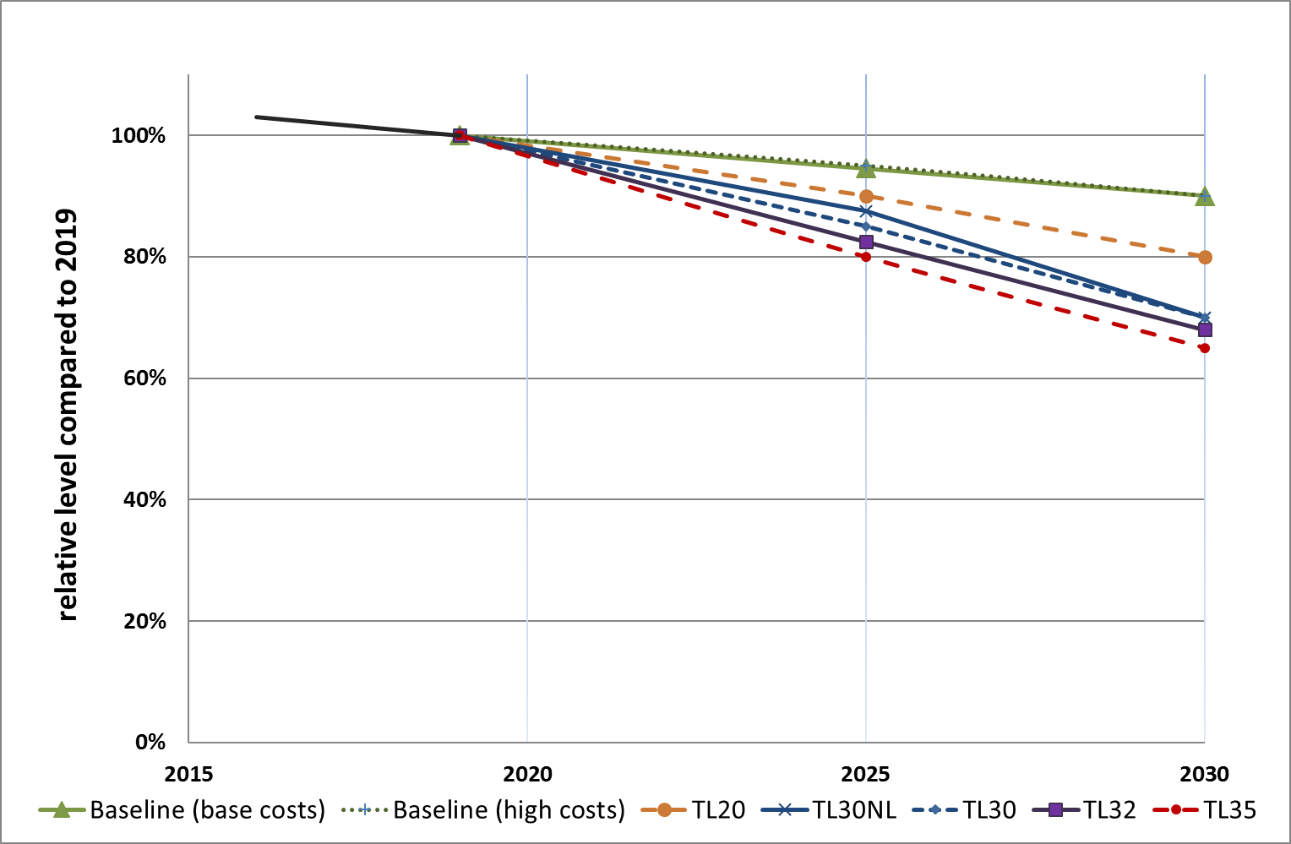

## Incentives for Zero- and Low-Emission Vehicles (ZEV/LEV)- context

The July 2016 Commission's European Strategy for Low-Emission mobility[73] highlighted the increasing role of zero- and low-emission vehicles in delivering CO2 reductions in the road transport sector, especially in the medium- and long-term.

For the Impact Assessment, two main types of vehicles will be considered:

1. **Zero-emission vehicles (ZEV)**: vehicles having no CO2 tailpipe emissions during operation – these are either fully electric or hydrogen-fuelled vehicles;
2. **Low-emission vehicles (LEV)**: vehicles having tailpipe CO2 emissions, which are significantly lower than those of "average" conventional vehicles.

While electrification technologies similar to those available for LDV exist for the smaller HDVs, the barriers for their uptake are much bigger for the heavier lorries in groups 4, 5, 9 and 10, which are the main focus of this Impact Assessment. This is because of their greater size and weight and their more rugged operations. For those lorries, the main challenge is finding ways to reduce battery needs. One way of doing so is through electric road systems (ERS) providing electricity along the road using either overhead catenary lines or inductive power transfer.[74] Pilot applications in Germany, Sweden and the United States have begun installing catenary lines along roadways[75].

Battery and fuel cell electric lorries are currently in the pilot or early deployment stages, mainly amongst the vehicle groups outside the scope of this impact assessment[76]. Some manufacturers have announced plans to develop zero-emission lorries, as illustrated in Annex 7.4. However, only a very limited number of these vehicles are currently being used.

High costs remain one of the main hurdles faced by these lorry technologies. An additional barrier for the uptake of zero- and low-emission vehicles, in addition to the high costs of the vehicle technology, is the current lack of recharging and refuelling infrastructure. This was recently highlighted and addressed in the Commission's Communication establishing an Action Plan on Alternative Fuels Infrastructure.[77]

## Banking and borrowing – design elements

Regarding the option of banking and borrowing, parameters should be set to avoid possible abuse and excessive accumulation of credits. Therefore, the following key parameters would be set as part of this option, as illustrated in Figure 14:

* During the **period 2019-2024**, banking would be allowed in order to reward manufacturers for early action. Credits could be gained if emissions are below a linear trajectory between the 2019 emission levels and the 2025 target of the manufacturer. The credits banked during this period could be used in the year 2025 only.
* During the **period 2025-2029**, the linear trajectory for banking is defined by the 2025 and the 2030 CO2 targets of the manufacturer. In case the 2030 target would be indicative (option Timing 1), the trajectory could be established as part of the review of the legislation in 2022. Credits accumulated could not be carried over to 2030 or beyond.
* In case of exceedance of the emissions target, a manufacturer could choose whether to pay the penalties or to borrow CO2 credits to be redeemed in subsequent years. Borrowing would be limited to a maximum of 5% of the specific emissions target.

**Figure 14 : Banking and borrowing - illustration of the design elements**

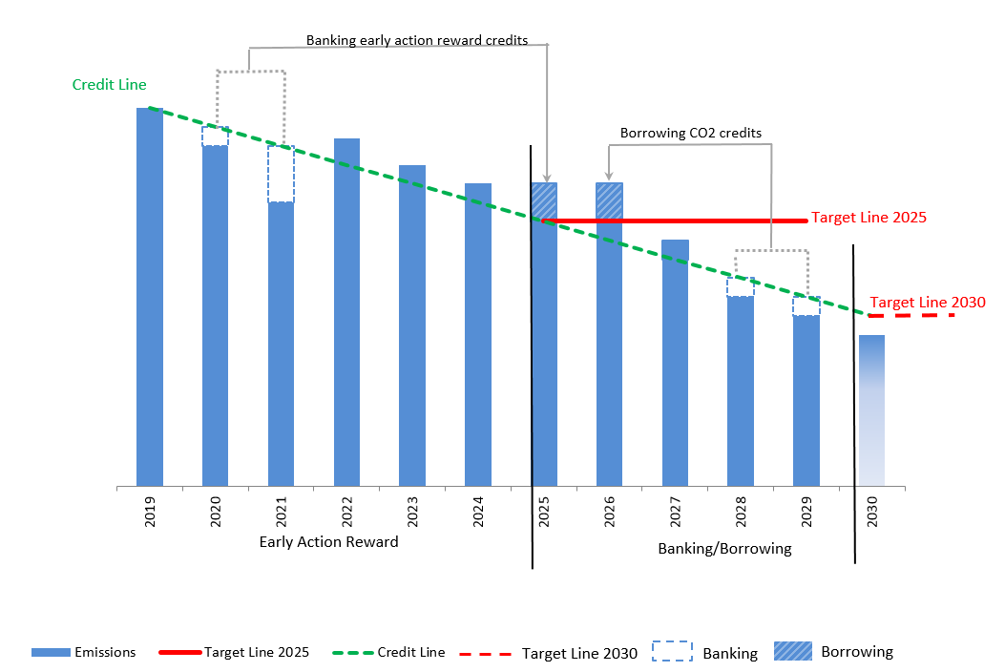

# Annex 10: Impacts of policy options – complementary information

The information in this Annex complements Section 6.2 of the Impact Assessment.

## Fleet composition under different target level options

In the PRIMES-TREMOVE model, the uptake of LNG lorries is limited due to some assumptions about the availability of LNG fuel and supply infrastructure. With these limitations on LNG lorries and the cost curves applied, certain emission reduction targets could not be achieved. For the base cost assumptions, this was the case for the 35% reduction target in 2030 and for the high cost assumptions, this occurred for all targets with more than 30% reduction. Therefore, for modelling those options, limitations in PRIMES-TREMOVE were removed allowing further CO2 emission reductions up to the target level by increasing the LNG share in the fleet.

Table 11 shows the composition of the new lorry fleet in terms of diesel and LNG vehicle share under the baseline and different target level options.

Table 11: New lorry fleet composition in 2025 and 2030 under the baseline and different target level options, using the base and high cost assumptions, respectively

|  |  |  |  |  |
| --- | --- | --- | --- | --- |
| **Base** costs assumptions | **2025** | | **2030** | |
|  | Diesel | LNG | Diesel | LNG |
| Baseline | 97.6% | 2.4% | 96.3% | 3.7% |
| TL20 | 94.0% | 6.0% | 89.6% | 10.4% |
| TL30NL | 91.4% | 8.6% | 81.9% | 18.1% |
| TL30 | 90.6% | 9.4% | 81.3% | 18.7% |
| TL32 | 89.0% | 11.0% | 79.6% | 20.4% |
| TL35 | 87.2% | 12.8% | 77.5% | 22.5% |

|  |  |  |  |  |
| --- | --- | --- | --- | --- |
| **High** costs assumptions | **2025** | | **2030** | |
|  | Diesel | LNG | Diesel | LNG |
| Baseline | 97.6% | 2.4% | 96.3% | 3.7% |
| TL20 | 93.2% | 6.8% | 88.1% | 11.9% |
| TL30NL | 89.6% | 10.4% | 80.4% | 19.6% |
| TL30 | 88.9% | 11.1% | 79.9% | 20.1% |
| TL32 | 87.7% | 12.3% | 78.8% | 21.2% |
| TL35 | 86.9% | 13.1% | 78.4% | 21.6% |

## Net economic savings over the vehicle lifetime from a societal perspective

Table 12: Net economic savings over the vehicle lifetime from a societal perspective in 2025 and 2030 (EUR/lorry)

|  |  |  |  |  |  |  |
| --- | --- | --- | --- | --- | --- | --- |
| **2025 (EUR/lorry)** | **Cost assumptions** | **TL20**  **(10%)** | **TL30NL**  **(12.5%)** | **TL30**  **(15%)** | **TL32**  **(17.5%)** | **TL35**  **(20%)** |
| *Capital cost [1]* | *Base* | 858 | 1,770 | 3,088 | 4,492 | 7,339 |
|  | *High* | 3,077 | 6,344 | 10,800 | 17,720 | 27,797 |
| *Fuel Savings [2]* | *Base* | 8,995 | 18,396 | 30,613 | 39,312 | 51,539 |
|  | *High* | 17,418 | 29,278 | 39,488 | 50,175 | 60,123 |
| ***Net Savings [2] - [1]*** | ***Base*** | **8,137** | **16,627** | **27,525** | **34,820** | **44,200** |
|  | ***High*** | **14,341** | **22,934** | **28,687** | **32,455** | **32,326** |
| **2030 (EUR/lorry)** | **Cost assumptions** | **TL20 (20%)** | **TL30 * (30%)** | | **TL32 (32%)** | **TL35 (35%)** |
| *Capital cost [1]* | *Base* | 4,657 | 19,291 | | 26,572 | 33,185 |
|  | *High* | 13,721 | 47,618 | | 52,073 | 58,760 |
| *Fuel Savings [2]* | *Base* | 39,393 | 82,363 | | 90,881 | 102,793 |
|  | *High* | 48,841 | 91,054 | | 101,198 | 116,404 |
| ***Net Savings [2] - [1]*** | ***Base*** | **34,736** | **63,071** | | **64,308** | **69,608** |
|  | ***High*** | **35,120** | **43,436** | | **49,125** | **57,644** |

* Results for TL30NL in 2030 are very similar to those for TL30

Table 13 shows the average additional manufacturing costs under the different target level options (i.e. the capital costs shown in Table 12) as a percentage of the purchase price of an average lorry, which is assumed to be around 110,000 EUR. It shows that the relative additional manufacturing costs are quite limited in 2025, in particular under the less ambitious target levels options and when taking the base costs assumptions. However, the average relative costs become high, up to half of the vehicle price at the higher target levels in 2030 and when using the high cost assumptions.

Table 13: Additional manufacturing costs in 2025 and 2030 (as a percentage of the vehicle purchase price)

|  |  |  |  |  |  |  |
| --- | --- | --- | --- | --- | --- | --- |
| **2025 capital cost** | **Cost assumptions** | **TL20**  **(10%)** | **TL30NL**  **(12.5%)** | **TL30**  **(15%)** | **TL32**  **(17.5%)** | **TL35**  **(20%)** |
| *(% of vehicle  purchase price)* | *Base* | 0.8% | 1.6% | 2.8% | 4.1% | 6.7% |
| *High* | 2.8% | 5.8% | 9.8% | 16.1% | 25.3% |
| **2030 capital cost** | **Cost assumptions** | **TL20 (20%)** | **TL30 * (30%)** | | **TL32 (32%)** | **TL35 (35%)** |
| *(% of vehicle  purchase price)* | *Base* | 4.2% | 17.5% | | 24.2% | 30.2% |
| *High* | 12.5% | 43.3% | | 47.3% | 53.4% |

* Results for TL30NL in 2030 are very similar to those for TL30

## Avoided CO2 costs

Table 14 shows the estimated additional avoided CO2 costs for lorries in 2025 and 2030 for the different target level options assessed and using the base and high cost assumptions. It shows that these external benefits increase as the CO2 target gets stricter.

Table 14: Avoided CO2 cost over the vehicle lifetime in 2025 and 2030 (EUR/lorry)

|  |  |  |  |  |  |  |
| --- | --- | --- | --- | --- | --- | --- |
| **2025 (EUR/lorry)** | **Cost assumptions** | **TL20**  **(10%)** | **TL30NL**  **(12.5%)** | **TL30**  **(15%)** | **TL32**  **(17.5%)** | **TL35**  **(20%)** |
| *Avoided CO2 costs* | *Base* | 1,240 | 2,626 | 4,668 | 6,054 | 8,169 |
| *High* | 2,626 | 4,376 | 6,127 | 7,805 | 9,555 |
| **2030 (EUR/lorry)** | **Cost assumptions** | **TL20 (20%)** | **TL30 * (30%)** | | **TL32 (32%)** | **TL35 (35%)** |
| *Avoided CO2 costs* | *Base* | 6,831 | 14,289 | | 15,820 | 17,670 |
| *High* | 8,479 | 15,624 | | 17,116 | 19,319 |

* Results for TL30NL in 2030 are very similar to those for TL30

## TCO-first use (5 years)

Table 15: Net economic savings from a first use (5 years) perspective in 2025 and 2030 (EUR/lorry)

|  |  |  |  |  |  |  |
| --- | --- | --- | --- | --- | --- | --- |
| **2025 (EUR/lorry)** | **Cost assumptions** | **TL20**  **(10%)** | **TL30NL**  **(12.5%)** | **TL30**  **(15%)** | **TL32**  **(17.5%)** | **TL35**  **(20%)** |
| *Capital cost [1]* | *Base* | 481 | 991 | 1,729 | 2,516 | 4,110 |
|  | *High* | 1,723 | 3,553 | 6,048 | 9,923 | 15,566 |
| *Fuel Savings [2]* | *Base* | 7,804 | 15,655 | 25,167 | 32,175 | 41,699 |
|  | *High* | 14,480 | 24,424 | 32,385 | 40,920 | 48,568 |
| ***Net Savings [2] - [1]*** | ***Base*** | **7,323** | **14,664** | **23,438** | **29,659** | **37,589** |
|  | ***High*** | **12,757** | **20,871** | **26,337** | **30,997** | **33,002** |
| **2030 (EUR/lorry)** | **Cost assumptions** | **TL20 (20%)** | **TL30 * (30%)** | | **TL32 (32%)** | **TL35 (35%)** |
| *Capital cost [1]* | *Base* | 2,608 | 10,803 | | 14,881 | 18,584 |
|  | *High* | 7,684 | 26,666 | | 29,161 | 32,906 |
| *Fuel Savings [2]* | *Base* | 32,947 | 68,809 | | 75,652 | 90,704 |
|  | *High* | 40,812 | 81,437 | | 95,014 | 115,334 |
| ***Net Savings [2] - [1]*** | ***Base*** | **30,339** | **58,005** | | **60,772** | **72,120** |
|  | ***High*** | **33,128** | **54,771** | | **65,853** | **82,429** |

* Results for TL30NL in 2030 are very similar to those for TL30

## TCO-second use

Table 16: Net economic savings from a second use perspective in 2025 and 2030 (EUR/lorry)

|  |  |  |  |  |  |  |
| --- | --- | --- | --- | --- | --- | --- |
| **2025 (EUR/lorry)** | **Cost assumptions** | **TL20**  **(10%)** | **TL30NL**  **(12.5%)** | **TL30**  **(15%)** | **TL32**  **(17.5%)** | **TL35**  **(20%)** |
| *Capital cost [1]* | *Base* | 378 | 779 | 1,359 | 1,976 | 3,229 |
|  | *High* | 1,354 | 2,791 | 4,752 | 7,797 | 12,231 |
| *Fuel Savings [2]* | *Base* | 5,791 | 11,624 | 18,712 | 23,926 | 31,023 |
|  | *High* | 10,762 | 18,149 | 24,081 | 30,434 | 36,135 |
| ***Net Savings [2] - [1]*** | ***Base*** | **5,413** | **10,846** | **17,354** | **21,950** | **27,794** |
|  | ***High*** | **9,408** | **15,358** | **19,329** | **22,637** | **23,905** |
| **2030 (EUR/lorry)** | **Cost assumptions** | **TL20 (20%)** | **TL30 * (30%)** | | **TL32 (32%)** | **TL35 (35%)** |
| *Capital cost [1]* | *Base* | 2,049 | 8,488 | | 11,692 | 14,601 |
|  | *High* | 6,037 | 20,952 | | 22,912 | 25,854 |
| *Fuel Savings [2]* | *Base* | 24,081 | 50,294 | | 55,299 | 66,232 |
|  | *High* | 29,830 | 59,451 | | 69,306 | 84,055 |
| ***Net Savings [2] - [1]*** | ***Base*** | **22,032** | **41,805** | | **43,608** | **51,630** |
|  | ***High*** | **23,793** | **38,499** | | **46,394** | **58,200** |

* Results for TL30NL in 2030 are very similar to those for TL30

## Sensitivity – economic impacts *with varying international oil price*

Section 6.2.4.2 of the Impact Assessment shows the net economic savings (from different perspectives) from different CO2 target levels. The fuel price projections used for the calculation of the fuel savings are those used in the Reference Scenario 2016[78], both for the baseline and for the policy options.

As a sensitivity analysis, it is relevant to assess the changes to the net economic savings in case of different international fuel price projections. Therefore a scenario is considered assuming a different evolution of the fuel prices. The new projected fuel price used for this sensitivity in 2030 is about 25% lower than in the assumptions used for the Reference Scenario 2016.

The economic analysis was repeated with the lower international fuel prices, both in the baseline and for the various options for the target levels (using the base cost assumptions).

Table 17, Table 18 and Table 19 show the results for the net economic savings from a societal perspective, a first use perspective and a second use perspective, respectively.

This shows that even with the lower oil prices, the CO2 targets continue to have a positive economic effect for all levels considered, with fuel savings continuing to significantly outweigh increased capital expenditures for more efficient vehicles.

**Table 17: Net economic savings over the vehicle lifetime from a societal perspective in 2025 and 2030 (EUR/lorry) under different TL options in case of a lower international fuel price and using the base cost assumptions**

|  |  |  |  |  |  |
| --- | --- | --- | --- | --- | --- |
| 2025 | **TL20**  **(10%)** | **TL30NL**  **(12.5%)** | **TL30**  **(15%)** | **TL32**  **(17.5%)** | **TL35**  **(20%)** |
| ***Net Savings*** | 5,888 | 12,028 | 19,872 | 24,992 | 31,568 |
| 2030 | **TL20 (20%)** | **TL30* (30%)** | | **TL32 (32%)** | **TL35 (35%)** |
| ***Net Savings*** | 24,888 | 42,481 | | 41,588 | 43,910 |

* Results for TL30NL in 2030 are very similar to those for TL30

**Table 18: Net economic savings from a first use (5 years) perspective in 2025 and 2030 (EUR/lorry) under different TL options in case of a lower international fuel price and using the base cost assumptions**

|  |  |  |  |  |  |
| --- | --- | --- | --- | --- | --- |
| 2025 | **TL20**  **(10%)** | **TL30NL**  **(12.5%)** | **TL30**  **(15%)** | **TL32**  **(17.5%)** | **TL35**  **(20%)** |
| ***Net Savings*** | 5,372 | 10,750 | 17,146 | 21,616 | 27,529 |
| 2030 | **TL20 (20%)** | **TL30* (30%)** | | **TL32 (32%)** | **TL35 (35%)** |
| ***Net Savings*** | 22,103 | 40,803 | | 41,859 | 49,444 |

* Results for TL30NL in 2030 are very similar to those for TL30

**Table 19: Net economic savings from a second use perspective in 2025 and 2030 (EUR/lorry) under different TL options in case of a lower international fuel price and using the base cost assumptions**

|  |  |  |  |  |  |
| --- | --- | --- | --- | --- | --- |
| 2025 | **TL20**  **(10%)** | **TL30NL**  **(12.5%)** | **TL30**  **(15%)** | **TL32**  **(17.5%)** | **TL35**  **(20%)** |
| ***Net Savings*** | 3,965 | 7,940 | 12,675 | 15,968 | 20,303 |
| 2030 | **TL20 (20%)** | **TL30* (30%)** | | **TL32 (32%)** | **TL35 (35%)** |
| ***Net Savings*** | 16,012 | 29,232 | | 29,783 | 35,072 |

* Results for TL30NL in 2030 are very similar to those for TL30

## Energy system impact of different target level options

Figure 15 and Table 20 show the impact of the different TL options on the final energy demand for lorries in 2025 and 2030 using the base cost assumptions.

**Figure 15: Final energy demand (ktoe) for lorries over the period in 2025 and 2030 under different TL options using the base cost assumptions**

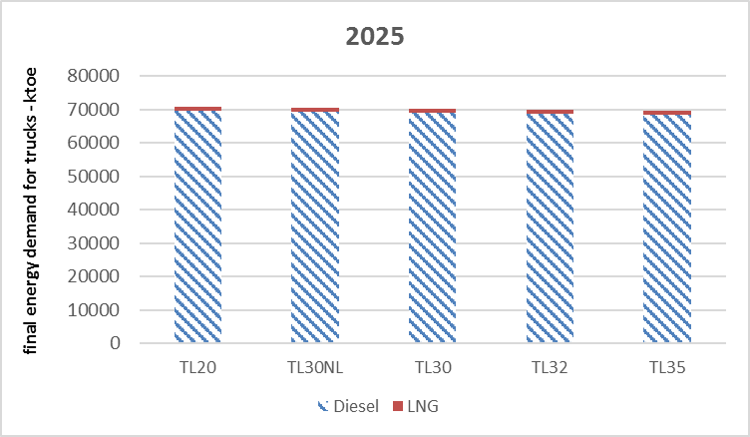

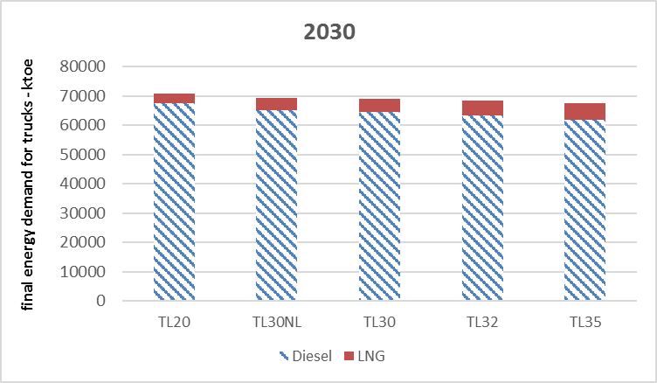

Table 20: Final energy demand (ktoe) for lorries in 2025 and 2030 under different TL options using the base cost assumptions

|  |  |  |  |  |
| --- | --- | --- | --- | --- |
| **Option** | 2025 | | 2030 | |
|  | **Diesel** | **LNG** | **Diesel** | **LNG** |
| Baseline | 70,802 | 499 | 71,377 | 1,301 |
| TL20 | 69,703 | 1,019 | 67,596 | 3,163 |
| TL30NL | 69,395 | 1,079 | 65,135 | 4,167 |
| TL30 | 69,061 | 1,148 | 64,505 | 4,443 |
| TL32 | 68,707 | 1,225 | 63,352 | 5,012 |
| TL35 | 68,302 | 1,320 | 61,877 | 5,690 |

## Freight (HDV) transport impact of different target level options

Freight transport activity is projected to increase slightly over time in the baseline scenario due to increased economic activity. The decrease in the fuel costs lowers freight costs, and consequently increases freight transport activity. However, as shown in Table 21, for all the options assessed, this increase remains limited in the range of 0.2% to 0.4% in 2025 and 0.5% to 0.9% in 2030 depending on the target level option.

Table 21: Freight (HDV) transport activity (Gtkm) evolution with respect to the baseline in the period 2020-2030 under different TL options using the base cost assumptions

|  |  |  |  |
| --- | --- | --- | --- |
|  | **2020** | **2025** | **2030** |
| Baseline (Gtkm) | 2,007 | 2,165 | 2,319 |
| TL20 | 0.0% | 0.2% | 0.5% |
| TL30NL | 0.0% | 0.3% | 0.9% |
| TL30 | 0.0% | 0.3% | 0.9% |
| TL32 | 0.0% | 0.3% | 0.9% |
| TL35 | 0.0% | 0.4% | 0.9% |

As shown in Figure 16 and Figure 17, the target levels have a limited impact on the reduction of the total costs of freight (HDV) transport per activity, by less than 1% in 2025 and in the order of 1 to 3% in 2030.

**Figure 16: Evolution of freight (HDV) transport total costs per activity (Meuro/Gtkm) in the period 2020-2030 under different TL options using the base cost assumptions**

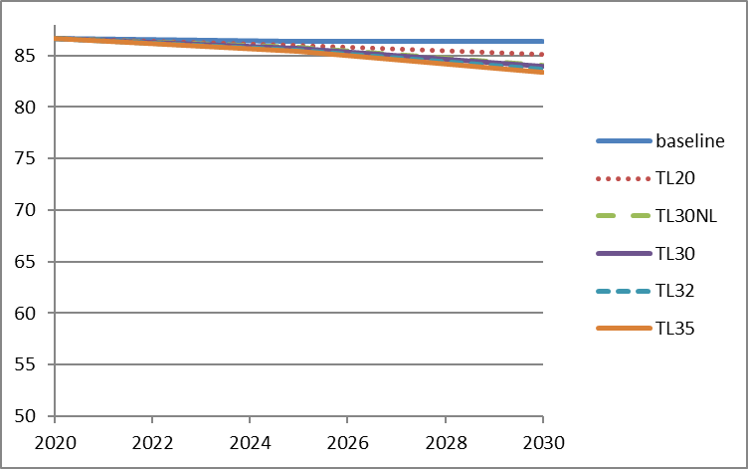

**Figure 17: Evolution of freight (HDV) transport total costs with respect to the baseline in the period 2020-2030 under different TL options using the base cost assumptions**

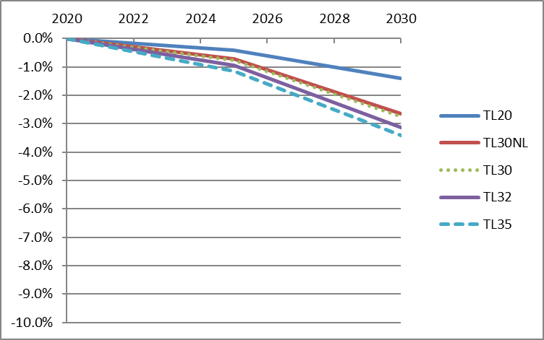

These results are also consistent with the analysis using EXIOMOD. As shown in Table 22, prices for “other land transportation services”, which includes freight transport, decrease by 2.5%–3.0% compared to the baseline in 2025 and by 3.0%–4.5% in 2030 depending on the target level. These price decreases are of the same order of magnitude as the decreases in costs shown in Figure 17.

**Table 22: Prices of “other land transportation services” compared to the baseline[79]**

|  |  |  |
| --- | --- | --- |
| **Option** | **2025** | **2030** |
| TL20 | -2.5% | -3.0% |
| TL30 | -2.7% | -3.8% |
| TL30NL | -2.6% | -3.6% |
| TL32 | -2.8% | -4.1% |
| TL35 | -3.0% | -4.5% |

Figure 18 shows that some fuel savings occur already under the baseline, and stricter targets would reduce fuel consumption even further. The other costs would only increase slightly due to the purchase of fuel-saving technologies.

**Figure 18: Fuel costs incidence on transport operator costs**

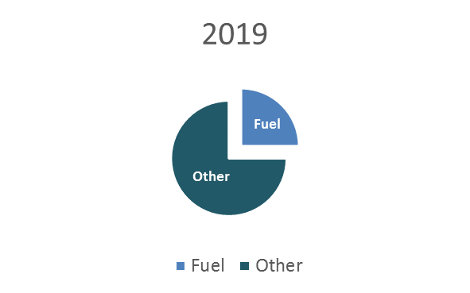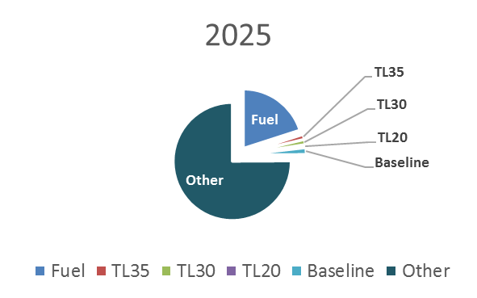

## Macro-economic impacts, including employment (EXIOMOD results), of different target level options

**Table 23: GDP impacts in the baseline (million euros) and percentage change from the baseline under selected options for the CO2 target level when using the high cost assumptions**

|  |  |  |
| --- | --- | --- |
| **Option for target level (high cost assumptions)** | **2025** | **2030** |
| **Baseline (M EUR)** | 15,803,228 | 16,912,315 |
| **TL 20** | 0.00% | 0.01% |
| **TL 30** | 0.01% | 0.02% |

**Table 24**Error! No sequence specified.**: Total number of jobs (000s) under the baseline and percentage changes to the baseline under different policy options when using the high cost assumptions**

|  |  |  |
| --- | --- | --- |
| **Option for target level (high cost assumptions)** | **2025** | **2030** |
| **Baseline (000s)** | 236,347 | 242,105 |
| **TL 20** | 0.02% | 0.05% |
| **TL 30** | 0.03% | 0.09% |

**Table 25: Total employment impacts for key sectors in terms of percentage changes to the baseline when using the base cost assumptions**

|  |  |  |  |  |  |
| --- | --- | --- | --- | --- | --- |
| **2025 - base cost assumptions** | | | | | |
| **Sector/Option** | **TL20** | **TL30NL** | **TL30** | **TL32** | **TL35** |
| Manufacturing of refined petroleum products | -0.1% | -0.1% | -0.1% | -0.2% | -0.2% |
| Manufacturing of motor-vehicles | 0.0% | 0.0% | 0.0% | 0.0% | 0.0% |
| Transportation services[80] | 0.0% | 0.0% | 0.1% | 0.1% | 0.1% |
| Other land transportation services[81] | 0.1% | 0.2% | 0.3% | 0.3% | 0.4% |
| Mining fossil fuel (no petroleum) | 0.0% | 0.0% | 0.0% | 0.0% | 0.0% |
| Extraction crude petroleum | -0.1% | -0.1% | -0.1% | -0.2% | -0.2% |
| Construction | 0.0% | 0.0% | 0.0% | 0.0% | 0.1% |
| Sale and maintenance of motor-vehicles | 0.0% | 0.0% | 0.0% | 0.0% | 0.0% |
| Manufacturing industry (no motor-vehicles) | 0.0% | 0.0% | 0.0% | 0.0% | 0.0% |
| **2030 - base cost assumptions** | | | | | |
| **Sector/Option** | **TL20** | **TL30NL** | **TL30** | **TL32** | **TL35** |
| Manufacturing of refined petroleum products | -0.2% | -0.4% | -0.4% | -0.5% | -0.5% |
| Manufacturing of motor-vehicles | 0.0% | 0.0% | 0.0% | 0.1% | 0.1% |
| Transportation services | 0.1% | 0.2% | 0.3% | 0.3% | 0.4% |
| Other land transportation services | 0.4% | 0.8% | 0.8% | 0.9% | 0.9% |
| Mining fossil fuel (no petroleum) | -0.1% | -0.1% | -0.1% | -0.1% | -0.1% |
| Extraction crude petroleum | -0.2% | -0.5% | -0.5% | -0.6% | -0.7% |
| Construction | 0.0% | 0.1% | 0.1% | 0.2% | 0.2% |
| Sale and maintenance of motor-vehicles | 0.0% | 0.0% | 0.0% | 0.0% | 0.0% |
| Manufacturing industry (no motor-vehicles) | 0.0% | 0.0% | 0.0% | 0.0% | 0.0% |

**Table 26: Total employment impacts for key sectors in terms of percentage changes to the baseline when using the high cost assumptions**

|  |  |  |
| --- | --- | --- |
| 2025 - high cost assumptions | | |
| Sector/Option | TL 20 | TL 30 |
| Manufacturing of refined petroleum products | -0.12% | -0.20% |
| Manufacturing of motor-vehicles | 0.02% | 0.03% |
| Transportation services[82] | 0.09% | 0.15% |
| Other land transportation services[83] | 0.17% | 0.26% |
| Mining fossil fuel (no petroleum) | -0.03% | -0.05% |
| Extraction crude petroleum | -0.16% | -0.26% |
| Construction | 0.04% | 0.07% |
| Sale and maintenance of motor-vehicles | -0.01% | 0.00% |
| Manufacturing industry (no motor-vehicles) | 0.01% | 0.02% |
| 2030 - high cost assumptions | | |
| Manufacturing of refined petroleum products | -0.28% | -0.47% |
| Manufacturing of motor-vehicles | 0.04% | 0.08% |
| Transportation services | 0.26% | 0.48% |
| Other land transportation services | 0.43% | 0.60% |
| Mining fossil fuel (no petroleum) | -0.08% | -0.13% |
| Extraction crude petroleum | -0.40% | -0.69% |
| Construction | 0.12% | 0.23% |
| Sale and maintenance of motor-vehicles | 0.02% | 0.02% |
| Manufacturing industry (no motor-vehicles) | 0.02% | 0.05% |

**Table 27: Impacts on the turnover of the most affected sectors as a percentage change from the baseline when using the base cost assumptions**

|  |  |  |  |  |  |
| --- | --- | --- | --- | --- | --- |
| **2025 - base cost assumptions** | | | | | |
| **Sector/Option** | **TL20** | **TL30NL** | **TL30** | **TL32** | **TL35** |
| Manufacturing of refined petroleum products | -0.1% | -0.1% | -0.1% | -0.2% | -0.2% |
| Manufacturing of motor-vehicles | 0.0% | 0.0% | 0.0% | 0.0% | 0.0% |
| Transportation services[84] | 0.0% | 0.0% | 0.1% | 0.1% | 0.0% |
| Other land transportation services[85] | 0.1% | 0.2% | 0.3% | 0.4% | 0.6% |
| Mining fossil fuel (no petroleum) | 0.0% | 0.0% | 0.0% | 0.0% | -0.1% |
| Extraction crude petroleum | -0.1% | -0.1% | -0.1% | -0.2% | -0.3% |
| Construction | 0.0% | 0.0% | 0.0% | 0.0% | 0.0% |
| Sale and maintenance of motor-vehicles | 0.0% | 0.0% | 0.0% | 0.0% | 0.0% |
| Manufacturing industry (no motor-vehicles) | 0.0% | 0.0% | 0.0% | 0.0% | 0.0% |
| **2030 - base cost assumptions** | | | | | |
| Manufacturing of refined petroleum products | -0.2% | -0.4% | -0.4% | -0.5% | -0.5% |
| Manufacturing of motor-vehicles | 0.0% | 0.0% | 0.0% | 0.0% | 0.0% |
| Transportation services | 0.1% | 0.2% | 0.3% | 0.3% | 0.0% |
| Other land transportation services | 0.6% | 1.4% | 1.6% | 1.9% | 2.4% |
| Mining fossil fuel (no petroleum) | -0.1% | -0.1% | -0.1% | -0.2% | -0.2% |
| Extraction crude petroleum | -0.2% | -0.5% | -0.6% | -0.6% | -0.8% |
| Construction | 0.0% | 0.1% | 0.1% | 0.1% | 0.2% |
| Sale and maintenance of motor-vehicles | -0.1% | -0.1% | -0.1% | -0.1% | 0.0% |
| Manufacturing industry (no motor-vehicles) | 0.0% | 0.0% | 0.0% | 0.0% | 0.0% |

Table 28: Impacts on the turnover of the most affected sectors as a percentage change from the baseline when using the high cost assumptions

|  |  |  |
| --- | --- | --- |
| 2025 - high cost assumptions | | |
| Sector/Option | TL 20 | TL 30 |
| Manufacturing of refined petroleum products | -0.13% | -0.21% |
| Manufacturing of motor-vehicles | 0.01% | 0.02% |
| Transportation services[86] | 0.08% | 0.13% |
| Other land transportation services[87] | 0.46% | 0.77% |
| Mining fossil fuel (no petroleum) | -0.04% | -0.07% |
| Extraction crude petroleum | -0.17% | -0.28% |
| Construction | 0.04% | 0.06% |
| Sale and maintenance of motor-vehicles | -0.01% | -0.02% |
| Manufacturing industry (no motor-vehicles) | 0.00% | 0.01% |
| 2030 - high cost assumptions | | |
| Manufacturing of refined petroleum products | -0.30% | -0.51% |
| Manufacturing of motor-vehicles | 0.03% | 0.05% |
| Transportation services | 0.24% | 0.44% |
| Other land transportation services | 1.46% | 2.67% |
| Mining fossil fuel (no petroleum) | -0.12% | -0.20% |
| Extraction crude petroleum | -0.44% | -0.77% |
| Construction | 0.10% | 0.19% |
| Sale and maintenance of motor-vehicles | -0.05% | -0.05% |
| Manufacturing industry (no motor-vehicles) | 0.00% | 0.01% |

## Environmental impacts of different target level options: CO2 emissions and air pollutant emissions

Figure 19: Cumulative reduction (kt) compared to the baseline over the period 2020-2035 of HDV CO2 emissions for EU-28 using the base cost assumptions

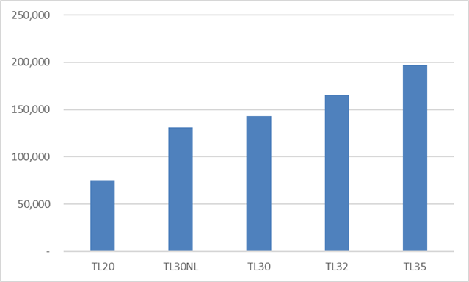

Table 29: NOx and PM2.5 emissions of road transport in EU-28: % reduction compared to the baseline using the base cost assumptions

|  |  |  |  |  |
| --- | --- | --- | --- | --- |
|  | **NOx emissions** | | **PM2.5 emissions** | |
|  | **2025** | **2030** | **2025** | **2030** |
| **TL20** | -0.3% | -1.3% | -0.1% | -0.2% |
| **TL30NL** | -0.4% | -2.8% | -0.1% | -0.3% |
| **TL30** | -0.5% | -3.2% | -0.1% | -0.4% |
| **TL32** | -0.6% | -3.9% | -0.1% | -0.5% |
| **TL35** | -0.8% | -4.7% | -0.1% | -0.6% |

## Sensitivity – results for EU-27, without UK

Some sensitivity analysis was performed in order to estimate the impact of Brexit on some results of the modelling.

This showed that the new lorry fleet composition in 2025 and 2030, i.e. the share of diesel and LNG vehicles in the new fleet, would not be affected. The figures shown in Table 11with regards to the net economic savings would thus equally apply for EU-27.

In terms of CO2 emissions, Figure 20 shows the difference between EU-28 and EU-27 in terms of the cumulative emission reduction (kt) compared to the baseline over the period 2020-2035. While emission reductions are obviously slightly lower for EU-27, the overall trends across the target level options are not affected.

Figure 20: Cumulative reduction (kt) compared to the baseline over the period 2020-2035 of HDV CO2 emissions for EU-28 and for EU-27, without UK, using the base cost assumptions

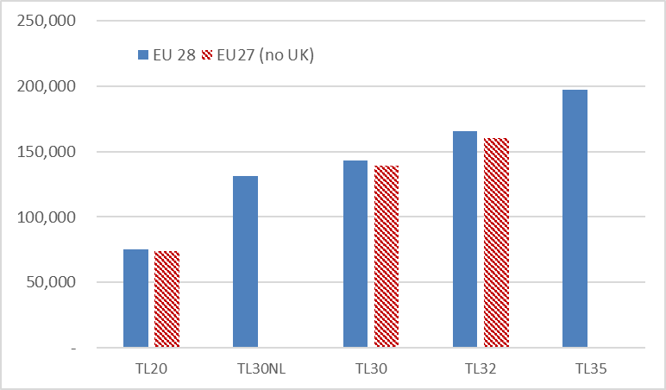

## Contribution to the ESR targets

Table 30: Evolution of GHG emissions between 2005 (100%) and 2030 under the baseline and different policy options

|  |  |  |  |  |  |  |
| --- | --- | --- | --- | --- | --- | --- |
|  | **2005** | **2010** | **2015** | **2020** | **2025** | **2030** |
| **baseline HDV** | 100% | 96% | 95% | 91% | 86% | 83% |
| **Cars + vans proposal** | 100% | 96% | 95% | 91% | 85% | 79% |
| **Cars + vans+HDV TL20** | 100% | 96% | 95% | 91% | 85% | 78% |
| **Cars +vans + HDV TL30** | 100% | 96% | 95% | 91% | 85% | 78% |
| **Cars + vans + HDV TL35** | 100% | 96% | 95% | 91% | 84% | 77% |
| **EuCo30** | 100% | 96% | 94% | 88% | 81% | 75% |

## Penalties – economic impacts

The economic impact of financial penalties will depend on the target level set as this influences the marginal technology costs.

Table **31** summarises the marginal technology costs for meeting the different target levels assessed, based on the base cost assumptions.

**Table 31: Marginal technology costs (€ / (g CO2/km)) in 2025 and 2030**

|  |  |  |
| --- | --- | --- |
| **Option** | **2025** | **2030** |
| TL20 | 27 | 75 |
| TL30NL | 39 | 485 |
| TL30 | 65 | 475 |
| TL32 | 92 | 827 |
| TL35 | 159 | 991 |

HDVs have an average lifetime mileage of around 1.2 million km, which is about six times higher than LDVs. On that basis, the penalty of €95 per g CO2/km of target exceedance, which applies under the EU Regulations for LDV, would translate into a €570 per g CO2/km penalty for HDVs[88].

As

Table **31** shows, such penalty would exceed the marginal technology costs in the HDV sector for most target level options, but not for the most ambitious ones in 2030.

# Annex 11: Distribution of the EU fleet-wide target between the various lorry families (sub-)groups and manufacturers

## Sub-group targets

As described in Section 5.2 of the Impact Assessment, in order to take into account the technical and business characteristics of the various lorries, separate emission targets should be defined for each HDV sub-group (see Annex 8.2).

Within each of the vehicle groups differences occur depending on the mission profile of the vehicles. For the vehicle groups considered in this Impact Assessment, the two most relevant mission profiles listed in the Certification Regulation are Long Haul (LH) and Regional Delivery (RD).

Figure 21 illustrates the differences in fuel consumption between the four vehicle groups considered, distinguishing the LH and RD mission profiles for each of them.

**Figure 21: Average fuel consumption (l/100 tkm) (2016) for the four vehicle groups considered in this impact assessment under the RD and LH mission profiles**

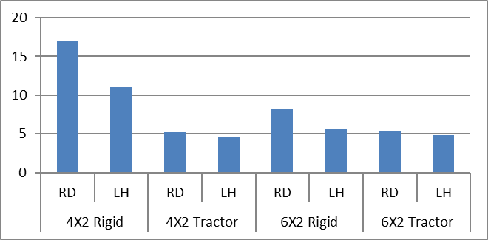

## Assessment of compliance

Under option Distribution 2 starting from the 8 sub-group targets, a single target for each manufacturer would be defined. These manufacturer targets would be calculated as a weighted average of the sub-group targets, taking into account:

(i) the fleet composition of each manufacturer, i.e. the number of vehicles registered by that manufacturer within each sub-group;

(ii) the average mileage and payload of vehicles within each sub-group, as these determine the total CO2 emissions of a vehicle.

The different sub-groups are characterised by different payloads and lifetime mileages. Therefore, the total CO2 emissions of a vehicle with a given emission level in g CO2/tkm will vary depending on the sub-group it belongs to. In order to describe this dependency, a **utility parameter** is defined for each sub-group, which would be used for the weighting of the sub-group targets and emissions:

*(sub-group utility parameter) = ((mileage * payload) of sub-group)/(normalisation parameter)* **[equ. 11.1]**

The *(normalisation parameter)* can in principle be arbitrarily chosen. As the simplest and most transparent approach, it is suggested that the *(mileage * payload)* of the vehicles in the "major" sub-group 5-LH (representing more than 60% of all vehicles in the fleet and an even higher share of CO2 emissions) would be used for this purpose. This would mean that the CO2 emissions of all other sub-groups would be expressed in relation to this major sub-group:

*(normalisation parameter) = ((mileage * payload) of vehicles in sub-group 5-LH)* **[equ. 11.2]**

Using the abovementioned approach, the OEM specific CO2 targets would be defined as follows:

*OEM target = ∑ (sub-group utility parameter) *(sub-group target) * (sub-group share in OEM fleet)* **[equ. 11.3]**

For assessing compliance, the total CO2 emissions of the OEM are calculated as follows:

*OEMtotCO2 =*

*∑ (sub-group utility parameter) *(OEM average CO2 emissions in sub-group) * (sub-group share in OEM fleet)* **[equ. 11.4]**

The sums shown above are over all sub-groups.

Compliance is achieved by an OEM if *OEMtotCO2* < *OEM target*

# Annex 12: Weighting of mission profiles for calculating CO2 emissions for the purpose of assessing compliance with CO2 targets

## Mission profiles in VECTO

For each vehicle VECTO provides a series of CO2 emission values corresponding to different "mission profiles". A mission profile is the simulation of the vehicle following a certain driving pattern, carrying a defined payload. For the vehicle categories 4, 5, 9 and 10 used for the delivery of goods, a regional delivery (RD) and long-haul (LH) driving pattern have been defined, each covering a total distance of 100 km and reflecting typical acceleration and speed profiles of the two missions (e.g. a high share of motorway driving in the long-haul driving pattern).

Both mission profiles are combined with low load (LL) and reference load (RL) conditions, which correspond to an (almost) empty and a fully loaded lorry, respectively. The respective payloads have been defined on the basis of stakeholder input during the VECTO development, reflecting the fact that also on "empty trips" lorries carry some equipment (e.g. empty boxes, palettes etc.) and most "full load trips" are volume rather than weight constraint.

The payloads listed in Table 32 are thus attributed to the different mission profile (LL-RD, RL-RD, LL-LH, RL-LH) and vehicle groups simulated in VECTO:

**Table 32: VECTO payloads of different vehicle sub-groups and mission profiles**

|  |  |  |  |  |
| --- | --- | --- | --- | --- |
| **Payloads (t)** | **LL-RD** | **RL-RD** | **LL-LH** | **RL-LH** |
| **Group 4** | 0.9 | 4.4 | 1.9 | 14 |
| **Group 5**  **Group 10** | 2.6 | 12.9 | 2.6 | 19.3 |
| **Group 9** | 1.4 | 7.1 | 2.6 | 19.3 |

It should be noted that from the VECTO output alone no conclusions can be drawn on the relative shares of "empty" and "full load" trips of a lorry, but the operator can combine different VECTO data according to his own use pattern for non-regulatory purposes.

## Weighting of VECTO mission profiles

As explained in Section 5.2 of this Impact Assessment, for the purpose of assessing compliance with regulatory CO2 emission targets, the vehicle groups have been split further into "regional delivery (RD)" and "long haul (LH)" sub-groups.

Regulatory CO2 emissions of vehicles in each of these sub-groups are calculated as a weighted average of emissions from the different mission profiles:

*(CO2 emissions of a vehicle in sub-group s in gCO2/tkm) =*

*(∑p (weight of mission profile p in sub-group s) * (CO2 emissions of the vehicle on mission profile p in gCO2) ) /*

*(∑p (weight of mission profile p in sub-group s) * (payload of mission profile p in sub-group s)* (mileage of mission profile p))*

**[equ. 12.1]**

With

*Sub-groups s = 4-RD, 4-LH, 5-RD, 5-LH, 9-RD, 9-LH, 10-RD, 10-LH;*

*mission profiles p = LL-RD, RL-RD, LL-LH, RL-LH;*

*(payloads of mission profile p in sub-group s) as given in table 1;*

*mileage of mission profile p = 100 km.*

In [equ. 12.1] vehicles from a certain sub-group may have contributions from all mission profiles. For example, vehicles in the "RD" sub-groups may have some contribution of the LH mission profile and vehicles in the "LH" sub-groups may have some contribution of the RD mission profile.

The weighting of the mission profiles in this equation – which can be different for the different sub-groups - should aim at reproducing the use of an (average) lorry within a vehicle sub-group under real driving conditions.

On the basis of expert judgement of the Commission's contractors and the JRC, the following driving shares for regional delivery and long haul missions have been derived, taking into account the specifics of the RD and LH driving trace in VECTO (for example, also the LH driving trace has some parts driven on regional routes etc.):

**Table 33: Relative shares of mileages driven for regional delivery and long haul missions in the RD and LH vehicle sub-groups**

|  |  |  |
| --- | --- | --- |
| **Vehicle sub-groups** | **Regional delivery (RD)** | **Long haul (LH)** |
| 4-RD, 5-RD, 9-RD, 10-RD | 90% | 10% |
| 4-LH, 5-LH, 9-LH, 10-LH | 10% | 90% |

For separating the effects of loads (i.e. LL and RL) and driving patterns (i.e. RD and LH), the weights of the mission profiles in the sub-groups are represented as the product of the percentages in Table 33 and the weight of the "LL and RL type" mission profiles in the different groups. For this simplification, it was assumed that the relative shares of low load and reference load driving is the same for regional delivery and long haul missions:

*(weight of profile l-RD in sub-group g-RD) = 0,9 *(weight of profile l in group g)*

*(weight of profile l-RD in sub-group g-LH) = 0,1 *(weight of profile l in group g)*

*(weight of profile l-LH in sub-group g-RD) = 0,1 *(weight of profile l in group g)*

*(weight of profile l-LH in sub-group g-LH)= 0,9 *(weight of profile l in group g)*

*with l = LL, RF and g = 4, 5, 9, 10*

**[equ. 12.2]**

In the following the values for the parameters on the left hand side of [equ. 12.2] are determined by relating the average payloads of vehicle sub-groups, when calculated as weighted averages of emissions from the different mission profiles, to real driving emission values:

*(average payload of sub-group s) =*

*∑p (weight of mission profile p in sub-group s) * (payload of mission profile p in sub-group s)*

*with p = LL-RD, RL-RD, LL-LH, RL-LH and*

s = 4-RD, 4-LH, 5-RD, 5-LH, 9-RD, 9-LH, 10-RD, 10-LH;

(*payload of mission profile p in sub-group s)* as given in *Table 32.* **[equ. 12.3]**

The average payloads of the sub-groups have been determined by Commission contractors analysing operational data of vehicles as well as information from literature. From the empirical information available, vehicles could not be linked to a predominant regional delivery or long haul use. Therefore, for solving [equ. 12.3], it has been assumed that all vehicles in a certain group (g = 4, 5, 9, 10) belong to the statistically predominant sub-group within this group (i.e. 4-RD, 5-LH, 9-RD, 10-LH).

Inserting [equ. 12.2] into [equ. 12.3] results in four conditions with four free parameters, from which the *(weights of profile l in group g)* of [equ. 12.2] can be uniquely determined, as shown in the table below:

**Table 34: Weightings of profile types l = LL, RL in the different vehicle groups g**

|  |  |  |
| --- | --- | --- |
| **Vehicle group (g)** | **l = Low load (LL)** | **l = Reference load (RL)** |
| **4** | 0.5 | 0.5 |
| **5** | 0.3 | 0.7 |
| **9** | 0.3 | 0.7 |
| **10** | 0.3 | 0.7 |

With [equ. 12.2] one can then calculate the following weightings for mission profiles.

**Table 35: Weighting of mission profiles in the different vehicle sub-groups**

|  |  |  |  |  |
| --- | --- | --- | --- | --- |
| **Sub-group (s)** | **LL-RD** | **RL-RD** | **LL-LH** | **RL-LH** |
| **4-RD** | 0.45 | 0.45 | 0.05 | 0.05 |
| **4-LH** | 0.05 | 0.05 | 0.45 | 0.45 |
| **5-RD** | 0.27 | 0.63 | 0.03 | 0.07 |
| **5-LH** | 0.03 | 0.07 | 0.27 | 0.63 |
| **9-RD** | 0.27 | 0.63 | 0.03 | 0.07 |
| **9-LH** | 0.03 | 0.07 | 0.27 | 0.63 |
| **10-RD** | 0.27 | 0.63 | 0.03 | 0.07 |
| **10-LH** | 0.03 | 0.07 | 0.27 | 0.63 |

These weightings have been used for calculating the cost curves discussed in Chapter 6 of the Impact Assessment.

1. In particular “Heavy Duty Vehicles - support for preparation of impact assessment for CO2", study by TNO, TUG, CE Delft and ICCT, report to be published
2. "Heavy Duty Vehicles CO2 Emission Reduction Cost Curves and Cost Assessment – enhancement of the DIONE model", to be published
3. <https://ec.europa.eu/clima/consultations/articles/0031_en>.
4. In 13 cases the originally indicated “capacity” under which the reply was submitted was manifestly wrong and therefore had to be corrected. In 7 cases it had to be changed from “other” to “professional organisation”, in 1 case from “civil society organisation” to “professional organisation”, in 3 cases from “international organisation” to “professional organisation, in 2 cases from “international organisation” to “civil society organisation”.
5. <https://ec.europa.eu/transport/sites/transport/files/themes/sustainable/studies/doc/2014-handbookexternal-costs-transport.pdf>
6. Krause, J., Donati, A.V., Thiel, C., Light Duty Vehicle CO2 Emission Reduction Cost Curves and Cost Assessment - the DIONE Model, EUR 28821 EN, Publications Office of the European Union, Luxembourg, 2017, ISBN 978-92-79-74136-4, doi:10.2760/87837, JRC108725
7. [www.exiobase.eu](http://www.exiobase.eu)
8. For a full description and examples of applications of EXIOMOD see Bulavskaya, Hu, Moghayer, & Reynès (2016).
9. In addition, amendments to two Directives only adopted in the beginning of 2015 were also considered. This concerns notably the ILUC amendment to the Renewables Directive and the Market Stability Reserve Decision amending the ETS Directive.
10. ICCS-E3MLab et al. (2016), EU Reference Scenario 2016: Energy, transport and GHG emissions - Trends to 2050
11. SWD(2016) 247
12. SWD(2016) 405
13. SWD(2016) 244
14. Regulation (EU) 2017/352
15. Currently, 15,000 kilometres of federal trunk road and motorways are subject to tolls.
16. E.g. <http://www.viapass.be/fileadmin/viapass/documents/download/VlaanderenE.JPG>
17. “Heavy Duty Vehicles - support for preparation of impact assessment for CO2", study by TNO, TUG, CE Delft and ICCT, report to be published
18. "Heavy Duty Vehicles CO2 Emission Reduction Cost Curves and Cost Assessment – enhancement of the DIONE model", to be published
19. According to international classifications, N2 and N3 vehicles used for the carriage of goods and having a maximum mass between 3.5 tonnes and 12 tonnes (N2) or exceeding 12 tonnes (N3).
20. According to international classifications, M2 and M3 vehicles used for the carriage of passengers and comprising more than eight seats in addition to the driver's seat and having a maximum mass not exceeding 5 tonnes (M2) or exceeding 5 tonnes (M3).
21. European Commission (2017), EU transport in figures – statistical pocketbook 2017, <https://ec.europa.eu/transport/facts-fundings/statistics/pocketbook-2017_en>
22. <http://www.acea.be/uploads/publications/factsheet_trucks.pdf>
23. International Road Transport Union: https://www.iru.org/who-we-are/about-mobility/trucks
24. <http://www.acea.be/uploads/publications/factsheet_trucks.pdf>
25. Data refers to HDVs over 15 tonnes (including articulated trucks).
26. <http://www.acea.be/uploads/publications/factsheet_trucks.pdf>
27. Owned by US manufacturer PACCAR
28. Renault trucks are part of the Volvo Group while M.A.N. and Scania are owned by Volkswagen.
29. For example, Daimler holds a 90% stake in the Japanese company Fuso, which has a 24% share of the Asia-Pacific market.
30. IEA (2017) The Future of Trucks – Implications for Energy and Environment. - 690 g CO2/km for HDVs with gross vehicle weight from 3.5 t to 15 t and 1080 g CO2/km for HDVs with gross vehicle weight above 15 t
31. Council Directive 80/1268/EEC of 16 December 1980 on the approximation of the laws of the Member States relating to the fuel consumption of motor vehicles, OJ L 375, 31.12.1980, p. 36–45
32. Data for 2016, www.oica.net
33. e.g. the German "Lastauto Omnibus"
34. <http://www.acea.be/uploads/publications/factsheet_trucks.pdf>
35. COM (2016) 482 final
36. Proposal for a Directive of the European Parliament and of the Council amending Directive 2012/27/EU on energy efficiency, COM(2016) 761 final – In this, the Commission proposed an energy efficiency target of 30% for 2030.
37. COM(2016) 501 final
38. COM(2017) 283 final
39. COM(2017) 676 final
40. SWD(2017) 650 final
41. Directive 2011/76/EU
42. COM (2017)275
43. SWD(2017) 180 final
44. Directive 2015/719/EU
45. Directive 2009/33/EC
46. SWD(2017) 366 final, Part 1/4
47. COM/2016/0767 final
48. SWD(2016) 418 final, Part 1/4
49. Directive 2009/30/EC
50. Directive 2012/27/EU
51. Directive 2014/94/EU
52. Data for 2016. Source: [Road fuel excise duties in the EU](http://ec.europa.eu/taxation_customs/resources/documents/taxation/excise_duties/energy_products/rates/excise_duties-part_ii_energy_products_en.pdf) provided by  EEA, <https://www.eea.europa.eu/data-and-maps/indicators/fuel-prices-and-taxes/assessment-7>
53. Regulation (EC) No 1222/2009
54. COM (2016) 501 final
55. GHG Inventory data 2016, <http://www.eea.europa.eu/data-and-maps/data/data-viewers/greenhouse-gases-viewer>
56. SWD(2017) 180 final
57. COM(2017) 676 final
58. GHG Inventory data 2016, <http://www.eea.europa.eu/data-and-maps/data/data-viewers/greenhouse-gases-viewer>
59. SWD(2017) 180 final
60. Sources :<http://media.daimler.com/marsMediaSite/en/instance/ko/Daimler-Trucks-launches-E-FUSO-and-all-electric-heavy-duty-truck-Vision-One.xhtml?oid=30010405>

    <http://corporate.renault-trucks.com/en/press-releases/2015-02-23-the-french-poste-office-and-renault-trucks-jointly-test-a-hydrogen-powered-truck-running-on-a-fuel-cell.html>

    <https://www.iveco.com/Corporate-en/Company/Pages/Electric-vehicles.aspx>

    <https://www.volkswagenag.com/en/news/2017/02/man_etruck.html>

    <https://www.scania.com/group/en/electric-trucks-how-the-technology-works/>

    <https://electrek.co/guides/tesla-semi/>

    <http://www.byd.com/>

    <https://www.cummins.com/news/2017/08/29/5-cool-things-about-our-electric-powertrain-concept-truck>

    <https://nikolamotor.com/motor>
61. COM(2014) 285 final
62. Commission Regulation (EU) 2017/2400
63. COM(2017) 0279 final
64. <https://ec.europa.eu/clima/sites/clima/files/transport/vehicles/heavy/docs/hdv_2011_01_09_en.pdf>
65. Report on VECTO Technology Simulation Capabilities and Future Outlook, JRC, 2016
66. Report on VECTO Technology Simulation Capabilities and Future Outlook, JRC, 2016
67. [Commission Regulation (EU) 2017/2400](http://eur-lex.europa.eu/eli/reg/2017/2400/oj)
68. Directive 2007/46/EC
69. See Annex I to [Commission Regulation (EU) 2017/2400](http://eur-lex.europa.eu/eli/reg/2017/2400/oj)
70. A "4x2" axle configuration means that the HDV has a two-drive axles with four wheels (similarly for the other configurations).
71. GVW is the weight of the fully loaded vehicle and / or trailer, including all cargo, fluids, passengers, and optional equipment.
72. TU Graz, TNO, TUV Nord, VVT, AVL, LAT and Heinz Steven (2012), *Reduction and Testing of Greenhouse Gas Emissions from Heavy Duty Vehicles - LOT 2: Development and testing of a certification procedure for CO2 emissions and fuel consumption of HDV*, <https://ec.europa.eu/clima/sites/clima/files/transport/vehicles/heavy/docs/hdv_2011_01_09_en.pdf>
73. https://ec.europa.eu/transparency/regdoc/rep/1/2016/EN/1-2016-501-EN-F1-1.PDF
74. IEA (2017) The Future of Trucks – Implications for Energy and Environment
75. Siemens (2017), “eHighway: Electrified heavy duty road transport” (<https://www.siemens.com/content/dam/webassetpool/mam/tag-siemens-com/smdb/mobility/road/electromobility/ehighway/documents/ehighway-2017.pdf>) and Akerman, P. presentation at joint IEA and JRC workshop, “The future role of trucks for energy and environment”, 8 November 2016, [http://www.iea.org/media/workshops/2016/thefutureroleoftrucks/7_Akerman_PA_eHighway_IEA_JRC_workshop.pdf](http://fwww.iea.org/media/workshops/2016/thefutureroleoftrucks/7_Akerman_PA_eHighway_IEA_JRC_workshop.pdf)
76. IEA (2017) The Future of Trucks – Implications for Energy and Environment
77. COM(2017)652 final
78. <https://ec.europa.eu/energy/sites/ener/files/documents/20160713%20draft_publication_REF2016_v13.pdf>
79. Including freight and passenger transport
80. Including transport via railways; pipelines; sea; inland water; air
81. Including freight and passenger transport
82. Including transport via railways; pipelines; sea; inland water; air
83. Including freight and passenger transport
84. Including transport via railways; pipelines; sea; inland water; air
85. Including freight and passenger transport
86. Including transport via railways; pipelines; sea; inland water; air
87. Including freight and passenger transport
88. Taking into account the average payloads as simulated in VECTO and the relative share of the different vehicle groups in the fleet, this translates into a penalty of around €50 per gCO2/tkm exceedance of the target.