

Table of contents

1. Introduction: Political and legal context 3

2. THE OBJECTIVES 11

3. Programme structure and priorities 21

4. Delivery mechanisms of the intended funding 28

5. How will performance be monitored and evaluated? 31

Annex 1: Procedural information 36

Annex 2: Stakeholder consultation activities 45

Annex 3: Evaluation Results 53

Annex 4: Other intiatives and activities 57

**Glossary**

|  |  |
| --- | --- |
| ***Term or acronym*** | ***Meaning or definition*** |
| AIR | Annual Implementation Report |
| CFP | Common Fisheries Policy |
| CLLD | Community-led Local Development |
| CMES | Common Monitoring and Evaluation System |
| CMO | Common Organisation of the Markets |
| CPR | Common Provisions Regulation |
| EFCA | European Fisheries Control Agency |
| EFF | European Fisheries Fund |
| EMFF | European Maritime and Fisheries Fund |
| EMSA | European Maritime Safety Agency |
| ESIF | European Structural and Investment Funds |
| EUMSS | European Maritime Security Strategy |
| EUMOFA | European Market Observatory for  Fisheries and Aquaculture Products |
| ExAC | Ex-Ante Conditionalities |
| FLAG | Fisheries Local Action Group |
| FRONTEX | European Border and Coast Guard Agency |
| FTE | Full Time Equivalent |
| IUU | Illegal, Unreported and Unregulated fishing |
| MA | Managing Authority |
| MPA | Marine Protected Areas |
| MC | Ministerial Conference |
| MSFD | Marine Strategy Framework Directive |
| MSY | Maximum Sustainable Yield |
| OP | Operational Programme |
| OR | Outermost Regions |
| PO | Producer Organisation |
| SDG | Sustainable Development Goal |
| SSCF | Small Scale Coastal Fleet |
| STECF | Scientific, Technical and Economic Committee for Fisheries |
| TAC | Total Allowable Catch |
| Blue Economy | Blue Economy refers to all sectoral and cross-sectoral economic activities related to oceans, seas and coasts including the Union's Outermost Regions and landlocked countries. The established sectors comprises bioeconomy, marine extraction of oil and gas, ports, warehousing and water projects, shipbuilding and repair, maritime transport and coastal tourism. This includes direct and indirect activities contributing to the sustainable functioning and development of these economic sectors throughout the single market. It also includes emerging sectors as well as economic value based on natural capital and non-market goods and services. Emerging sectors include renewable energy, blue biotechnology, deep-sea mining, desalination, coastal and environmental protection, defence and security, marine research and education and ecosystem services. |
| Maritime Policy | Maritime Policy refers to a Union policy whose aim is to foster integrated and coherent decision-making to maximise the sustainable development, economic growth and social cohesion of the Union, and notably the coastal, insular and outermost regions in the Union, as well as blue economy sectors, through coherent maritime-related policies and relevant international cooperation. |
| Integrated maritime surveillance (IMS) | Integrated maritime surveillance refers to a Union initiative aimed at enhancing effectiveness and efficiency in surveillance activities in respect of the European seas through information exchange and collaboration across sectors and borders. |
| International Ocean Governance | An EU initiative to improve the framework of international and regional processes, agreements, rules and institutions through a coherent cross-sectorial and rules based approach to ensure oceans are healthy, productive, safe, secure and resilient. |
| Coast Guard | Coast Guard refers to national authorities performing Coast Guard functions, which are: maritime safety (including vessel traffic management); maritime security; maritime customs activities; prevention and suppression of trafficking and smuggling and connected maritime law enforcement; maritime border control; maritime surveillance; protection of marine environment and response; search and rescue; accident and disaster response; fisheries control; and other activities related to the above functions. |
| Common information sharing environment (CISE) | Common information sharing environment means a network of systems with a decentralised set-up developed for the exchange of information between users in order to improve their situational awareness of activities at sea. |
| European marine observation and data network (EMODNET) | European marine observation and data network refers to a network that integrates relevant national marine observation and data programmes and make all data, metadata and products quality assured and standardised available, free of restrictions on use into a common and accessible European resource |
| Maritime Spatial Planning (MSP) | Maritime Spatial Planning refers to a process by which the relevant Member State’s authorities analyse and organise human activities in marine areas in order to achieve ecological, economic and social objectives; working across borders. |
| Sea Basin Strategy (SBS) | Sea Basin Strategy refers to an integrated framework to address common marine and maritime challenges faced by Member States and where appropriate third countries located in a sea basin (or in one or more sub-sea basins) promoting cooperation and coordination amongst the relevant countries in order to achieve economic, social and territorial cohesion. It is developed with the initiative by the Commission in cooperation with the Countries concerned and their regions and other stakeholders as appropriate and it may be supported by the European Structural and Investment Funds among other financing sources. |
| Sustainable management of marine resources | Sustainable management of marine resources means management practices that meet the needs of the present without compromising the ability of future generations to meet their own needs. |

# Introduction: Political and legal context

## Scope and context

This impact assessment covers future funding for fisheries, blue growth/maritime policies and international ocean governance. Such funding is a key enabler for implementing the CFP, for promoting an innovative and sustainable blue economy and for delivering on commitments on global processes.

As a global ocean actor and the world's fifth largest producer of seafood, the European Union has a responsibility to protect, conserve and sustainably use the oceans and their resources. Reducing the pressure on our oceans would also be in our own socio-economic interest[1].

In 2016 Europe's blue economy[2] was estimated at EUR 174.2 billion of gross value added and 3.48 million jobs – with potential for further growth in the years to come. The European Parliament has issued a number of reports and opinions both on the EMFF and on how blue growth, maritime policy and the CFP should be financed through the EU’s budget[3] and stresses that seas and oceans are powerful drivers of the European economy with significant potential as regard innovation, growth and jobs. Furthermore, Europeans consistently point to security and safety as a top priority for their Union. Leaders have also called for stronger external borders as a precondition for lifting internal borders[4] taking into account the interagency cooperation on Boarder and Coast Guard set up in 2017. In addition, the Commission reflection paper on the future of EU finances points to the fact that security and safety threats also concern other areas, such as the protection of resilient food chains[5].

During the 2014-2020 period funding for fisheries and maritime policies has been provided through the European Maritime and Fisheries Fund (EMFF). The EMFF is one of the European Investment and Structural Funds (ESIFs). The other ESIFs are the European Regional Development Fund (ERDF), the Cohesion Fund (CF), the European Social Fund (ESF) and the European Agricultural Fund for Rural Development (EAFRD). The Common Provisions Regulation (CPR) provides a common legal basis for all ESIFs in addition to fund-specific rules set out in fund-specific regulations.

This IA report analyses various ways to address these challenges through future funding for fisheries, blue growth/maritime policies and international ocean governance. It satisfies the requirements of the Financial Regulation in respect of preparing an ex-ante evaluation. On 2 May 2018, the European Commission adopted its proposals for a new Multiannual Financial Framework (MFF) for 2021-2027[6]. Under these proposals, the European Maritime and Fisheries Fund will have a budget of EUR million 6.140 in current prices over this period.

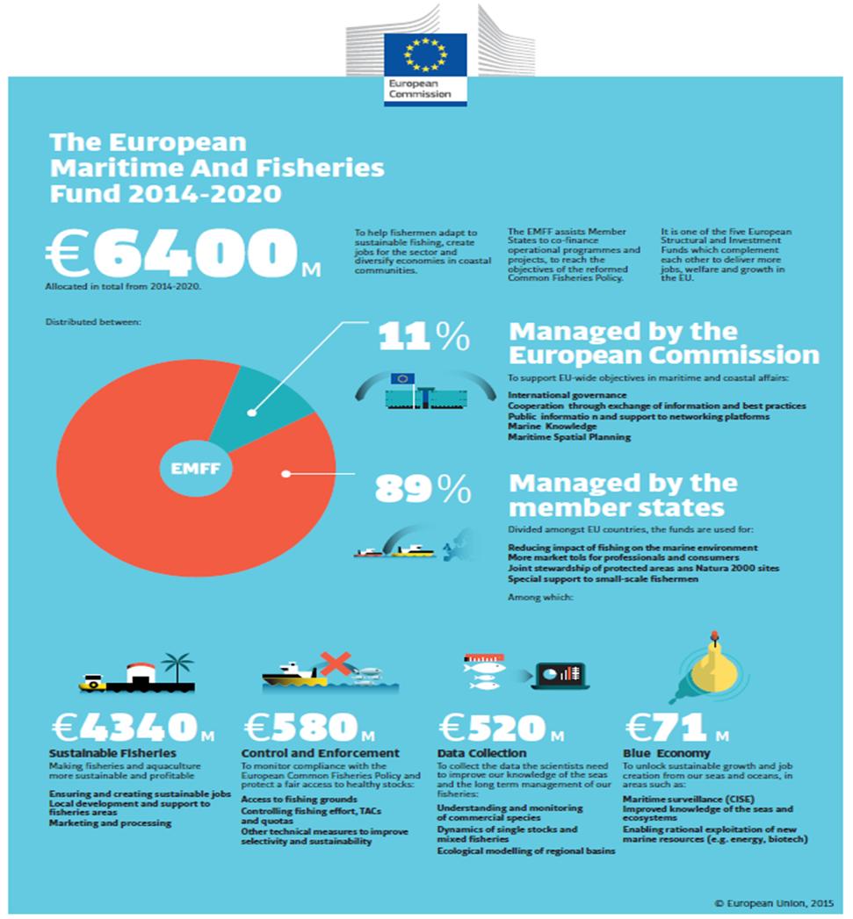

## Lessons learned from previous programmes

During 2007-2013, European fisheries policy was supported through the European Fisheries Fund (EFF)[7]. The results of the EFF were mixed[8]. First, and perhaps most importantly, it contributed to an important reduction in the capacity of the EU fleet. For example, between 2007 and 2015, the capacity of the EU fishing fleet decreased by 17.5% (in gross tonnage), of which more than half (53%) was removed with support from the EFF. Thus, nearly 10% of the EU fleet capacity was removed with the help of the EFF. This also resulted in a 9% decrease of engine power. This reduction in fleet capacity together with other measures contributed to a more sustainable exploitation of fish resources, although the main driver for that development are responsible fisheries management decisions.

However, there were also challenges in the implementation and the ex-post evaluation of the EFF[9] concluded that there was scope for improvement:

|  |
| --- |
| **EFF-ex post evaluation – key conclusions and recommendations**   * It is necessary to improve the link between funding and policy objectives, the sustainable exploitation of fisheries as well as the protection and enhancement of the environment and natural resources (minimising the negative impacts on the marine environment). A key issue is to improve conditionalities for fleet measures so that conservation objectives are better achieved. Fleet measures in the EFF did not deliver good results because of low level of targeting. There was no proof that scrapping schemes were always applied to the fleet segments that were most unbalanced. There was also a lack of sufficient conditionality for granting the aid, which did not prevent re-introduction of capacity through vessel modernisation. Finally, there was no linkage between permanent cessation and fleet capacity objectives of the concerned segments. After scrapping, nothing prevented overcapacity to be rebuilt in a given fleet segment because national fleet capacity objectives were in some cases global, not segmented. * EFF funding did increase the productivity of the EU aquaculture, but this must be seen in the light of the effects of the financial crisis on investment and modernisation during the funding period. There is a widespread view that EFF funding was essential during this difficult period from 2008 onwards that reduced investment and borrowing activity in the aquaculture sector. However, although the aquaculture measure was designed to foster innovation, EFF funding was rarely used for this purpose. Future support should maintain and increase the focus on innovation and environmentally sustainable solutions. * Support to processing and marketing contributed to foster and accelerate the modernisation of the industry. The results in terms of innovation and the development of niche markets are less clear. Future support should maintain and increase the focus on innovation and environmentally sustainable solutions. * The EFF included a measure specifically targeting the small scale coastal fleet (SSCF)[10]. However, this support only accounted for 2% of spending with only EE, PL and FI spending 10% or more of total fisheries on this measure while 16 Member States did not it at all, i.e. GR which has the highest share of SSCF in the EU. The EFF did help to maintain numbers and employment in the small-scale fleet, but overall the viability of the small-scale fleet worsened during the EFF period. SSCF are faced with the same issues and have the same needs as the wider catching sector, but their ability to access funds can be constrained by access to credit and/or lack of organisation. For the future public support should be revisited and alternatives sought to better support these fleets (specific measures, conditions with increased aid intensity). * The administrative burden associated with the delivery of the EFF was too high. At the application stage it acted as a disincentive for applying for support. Moreover, the complexity of certain projects seemed to have created disincentives for potential beneficiaries, in particular in cases where a large network of partners where involved and where significant administrative and coordination capacity where needed. Delays in project selection and payment disbursement also impacted on the efficiency of programme delivery. Additionally, the level of co-financing required was perceived as an issue, in particular for the most fragile categories of stakeholders. Public support should be focussed to ensure greater effectiveness and efficiency * The lack of context, result and output indicators in the EFF increased the difficulty of the analysis of its impacts. Comprehensive sets of relevant (meaningful and useful) context, results and output indicators should thus be identified to monitor progress and to measure the impacts of public support. To ensure consistency these indicators should be harmonised across Member States. |

In addition, evaluation of other financial tools in the area of fisheries (support to common market organisation and producer organisations, compensation schemes in outermost regions, funding of fisheries data collection and control) called for a rationalisation and streamlining of all funding aimed at supporting the CFP, and alleviating the administrative burden of programmes directly managed by the Commission. It also became clear that increased efforts were needed in order to better address the key CFP challenges related to environmental, economic and social sustainability. Support to the outermost regions was not part of the EFF. However, the recent Commission Communication on a stronger and renewed partnership with the EU's outermost regions concludes that the progress towards a sustainable blue economy in these regions is uneven and urges the outermost regions to set up strategic planning and investments in the form of blue economy strategies to improve synergies between public policies and investments[11].

In 2013 the CFP was reformed. Most importantly, the reform took forward the concept of Maximum Sustainable Yield which should be reached at the latest by 2020. Moreover, an additional objective was included, the so-called landing obligation. Discarding is the practice of returning unwanted catches to the sea, either dead or alive, because they are undersized, due to market demand, the fisher has no quota or because catch composition rules impose this. The reform of the CFP aimed at gradually eliminating the wasteful practice of discarding through the introduction of the landing obligation. This radical change in fisheries management aims to improve fishing behaviour through more selective fishing practices.

An additional part of the new CFP is the reformed Common Organisation of the Markets (CMO) which entered into force from 2014. It abolished previous financing mechanisms designed to stabilize fish markets (the intervention mechanisms), signalling an important shift in policy towards market-based instruments and structural support for competitiveness and sustainability in the sector.

A directly managed programme to support the development of maritime policy was established in 2011 with a budget of EUR 40 million for the period 2011-2013[12]. It aimed to develop cross-sectoral tools (Maritime Spatial Planning, the Common Information Sharing Environment and marine knowledge on the oceans, seas and coastal regions) and sea-basin strategies, to promote the protection of the marine environment, the sustainable use of marine and coastal resources including the Marine Strategy Framework Directive[13] to support sustainable economic growth, employment, innovation and new technologies in maritime sectors and in coastal, insular and outermost regions of the Union and to improve and enhance external cooperation and coordination in relation to the objectives of maritime policy. As a result, a Maritime Strategy for the Adriatic-Ionian Seas[14] and an Atlantic Action Plan[15] were adopted respectively in 2012 and 2013 while an MSP Directive[16] was adopted in 2014.

Adopted in May but entering into force with retroactive effect on 1 January 2014, the European Maritime and Fisheries Fund (EMFF) worth EUR 6.4 billion[17] over the 2014-2020 period was designed to respond to the shortcomings of the EFF, as structural support accompanying CFP reform and to boost the implementation of maritime policy. It introduced a number of novel features:

|  |
| --- |
| **New features of the EMFF 2014-2020:**   * Many types of funding brought in under one single umbrella: The EMFF (complemented by the support provided under the Sustainable Fisheries Partnership Agreements) combines all different funding in support of the CFP in a single fund[18].This meant the inclusion of support for data collection, control, market policy, compensation for the Outermost regions and support to maritime policy/blue growth. * Inclusion in the ESIF family: The EMFF is part of the ESIF framework and is covered by the Common Provisions Regulation (CPR) applicable to all ESIFs. The CPR is complemented by fund-specific regulations such as the EMFF, delegated acts and implementing acts. In the CPR there is a requirement to put in place a performance framework and to release a performance reserve based on the achievement of milestones and targets. For this to function, a new monitoring and evaluation system was put in place consisting of common baseline, output and result indicators. * Ex-ante conditionalities: To ensure that investments take place under optimal conditions a requirement to fulfil fund-specific ex-ante conditionalities (ExAC) was introduced (administrative capacity for data collection and control, submission of fleet reports in line with COM guidelines, national strategic plans for aquaculture)[19]. * Compliance with the CFP: Moreover, a compliance mechanism was introduced by which both Member States and operators have to comply with the rules of the CFP from admissibility to implementation to be able to get support. In terms of support measures, the EMFF is more than ever before aligned with the objectives of the CFP and maritime policy. It supports the implementation of the landing obligation through financing of selective gear and the marketing and processing of unwanted catches and assigns a key role to producer organisations (POs) in its implementation. Investments into the cornerstones for sound fisheries management, scientific data collection and control have been substantially upgraded. Support for fleet measures such as permanent cessation[20] of vessels or engine replacement has continued but under strict conditions that are in line with the CFP conservation component. It supports the protection of marine biodiversity and ecosystems, including through the management of Natura 2000 areas and other MPAs. * Maritime policy: A good share of the EMFF allocation is geared towards maritime policy priorities, such as maritime spatial planning, maritime surveillance, marine knowledge, sea basin strategies (and relevant macro-regional strategies) and piloting the blue growth strategy in coastal, insular and outermost regions of the Union. Approximately EUR 275 million is managed directly by the Commission whilst more than EUR 70 million has been programmed in Operational programmes. * Small-scale Coastal Fleet: The EMFF include elements that permit Member States to grant preferential treatment to the small scale coastal fishing fleet (SSCF), which makes up 74% of the active EU fleet. * Community-led local development: The EMFF reinforces the local development of coastal areas through support through FLAGs (Fisheries Local Action Groups) which use the bottom-approach (CLLD) to implement local development strategies in their communities[21]. * Directly managed elements: The European Marine Observation and Data Network (EMODnet) has been one of the success stories of the EMFF. By gathering over 150 public and private organisations in a partnership to deliver marine data that is reliable, accessible and free of restrictions of use it has increased productivity, stimulated innovation and reduced risk for business, public authorities and civil society. These organisations are investing in processes and added-value services that are dependent on the continuation beyond 2020. * Monitoring and evaluation: Development of a Common Monitoring and Evaluation System (CMES) with common indicators at EU-level |

At this stage no evaluations have been completed of the EMFF at EU or Member State level. However, monitoring data from 2017 shows the following:

|  |
| --- |
| * For **shared management** the rate of implementation was generally low in the first years[22] and the risk of decommitment is high[23]. However, during 2017 the rate implementation increased considerably[24]. The number of operations (excluding technical assistance) more than doubled, from 6 200 in 2016 to 15 500 in 2017. The number of commitments (European Maritime and Fisheries Fund + national public) increased from EUR 769 million to EUR 1.5 billion, the total public expenditure increased almost 10 times from EUR 58 million in 2016 to 534 million in 2017 and the EMFF expenditure increased from EUR 39 million in 2016 to EUR 375 million in 2017. The number of fishing vessels benefitting from support almost tripled from 3 600 in 2016 to over 9 600 in 2017. * Despite the fact that the link between the CFP and the EMFF has been strengthened, Member States do not always invest in those areas where investments are mostly needed to achieve the objective of the CFP. For example, the implementation of the landing obligation has been given different priority in different Member States with the result that more investment is needed to support the adaptation of the fishing industry to these challenges[25]. * Administrative complexities at national level slow down the rate of implementation. In **shared management** this is for example the case within aquaculture, CLLD, innovation and to a certain extent maritime policy. On the contrary under **direct management** maritime policy innovation actions (Blue Careers, Blue Labs, Blue Technology calls for proposals) were highly oversubscribed, reaching about 100% budget implementation for the period 2014-2016. |

In addition to evaluations and monitoring data, stakeholder views on fisheries and maritime policies post-2020 were collected through a number of consultation activities[26] (of which more details are provided in Annex 2).

|  |
| --- |
| **Stakeholder views – key issues:**   * Many stakeholders and the European Parliament[27] call for **continuity** and are strongly in favour of keeping dedicated funding for fisheries and maritime policies post-2020. Given the direct link to the fulfilment of CFP objectives, future support for fisheries and external funding strands are not suitable to be mainstreamed into other EU funds * The **achievement of CFP objectives** was noted by the stakeholders as a priority for the future. * For the future support should in particular aim to **rebuild fish stocks** **above the MSY level.** * Many stakeholders argue that any kind of support leading to overfishing should be discontinued. * A polarisation of opinion concerning the support to **fishing fleets** could be observed, with stakeholders split nearly equally between those in favour and those against the continuation of fleet measures, those against claiming that fleet measures are drivers for overfishing. * There is a general consensus around continued support for **data collection and control**, **SSCF, outermost regions, CLLD and professional organisations[28].** * Some stakeholders call for a **differentiated support by sea-basin** according to the specific challenges being faced, including by Brexit, and the need for cooperation with third countries. * Many stakeholders highlight the fact that **innovation** is horizontal to all blue growth sectors including fisheries and recognise sea-basin and macro-regional strategies as an important driver for the territorial development of coastal regions and islands. They recognize the need to enable further policy development and to increase visibility and the political priority of **blue growth** across funds. * For a number of stakeholders the next fund should give priority to **the social dimension** with the promotion of social dialogue, improvement of hygiene, health safety and working conditions, while investing in the training, education, awareness raising. * **Complex administrative delivery** is seen as the biggest shortcoming and many stakeholders call for radical simplification and flexibility. The intervention logic is considered too rigid not allowing Member States to address their own specificities. This could be addressed by **eliminating pre-defined measures** and increase the use of financial instruments. * NGOs, advisory councils and social partners stress that a **conditional approach** to any future spending should continue to be linked to the delivery of objectives the CFP and demonstration of results. In this regard, Member States should be more responsible for reporting how the funding has led to meeting the goals and objectives of the CFP. Moreover, a conditionality clause could be included linking the financial access to the implementation of the CFP regulation and the respect of basic social standards by operators. * Stakeholders signal that the **international framework for oceans is incomplete** and needs further development. They also note there is little coordination between international organisations responsible for oceans, while agreed international rules and arrangements on oceans are often not implemented effectively or enforced uniformly. Stakeholders call for strengthening the safety and security of the maritime space. |

# THE OBJECTIVES

## Challenges for the programme of the next MFF

Compared to the time when the EMFF was drafted the EU fisheries sector has undergone a substantial restructuring and over the period 2008-2016 the economic performance of the EU fleet improved considerably. In 2015 it was generally profitable, generating EUR 7.2 billion in revenue and EUR 798 million in net profit. This represents significant progress taking into account that the EU fleet was barely breaking even in 2009. The positive trend is also reflected in improving positive expectations by the industry as shown by growing investments[29]in recent years.

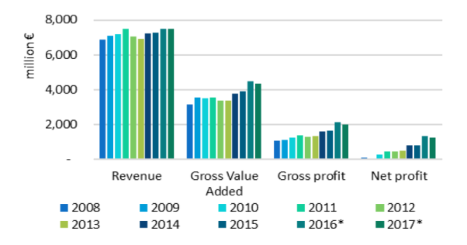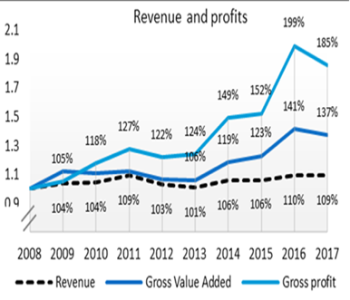

The general improvement is driven by several factors. It coincides with an overall reduction in fleet capacity and low fuel prices[30] but also with an increase in the number of fish stocks being fished at sustainable (or MSY) levels. But although the performance of the EU fleet has improved, the development has been uneven and considerable problems remain in certain fleet segments and geographical areas of the Union. Taking into consideration evaluation recommendation, monitoring data and stakeholder consultations the key challenges for the future can be summarised as follows:

|  |
| --- |
| **Key challenges for the future**:  For fisheries:   * **Overcapacity** is still a serious problem in many segments and across sea-basins In the Mediterranean, **overfishing** is broadly between two and three times MSY overall. For stocks such as hake, red mullet, black-bellied anglerfish and blue whiting, current fishing mortality rates have been up to six times higher than MSY. Despite recent improvements to the availability of data, the status of many stocks remains unknown. * A successful implementation of the CFP will **continue to require and depend on support** for fisheries control and data collection as well as for supporting the fight against IUU both within the EU and internationally. Additionally, control and scientific data collection are areas in which the information collected needs to be used for a **broader scope** of purposes (surveillance and marine knowledge respectively) and requires more inter-operable systems. * Representing 74% of all active vessels in the Union small scale coastal fisheries are fundamental for the viability and resilience of many coastal communities. Although the sector was profitable in 2015 and labour productivity is increasing, the situation is **mixed** at regional level, with 53 out 135 SSCF fleets with **net losses**[31]. * The **lack of attractiveness** of the fisheries sector calls for continued attention. Safety concerns and difficult working conditions aboard fishing vessels (health, hygiene etc.) make the sector unattractive to work in   For aquaculture, marketing and processing:   * To increase the focus on **innovation** and **environmentally sustainable solutions**.   For the blue economy:   * The blue economy is **still** **not delivering** to its full potential and there is a need to remove bottlenecks and support **enabling conditions** to facilitate investment, **innovation** and market development. Continued support is needed for developing marine knowledge, maritime spatial planning, maritime security and cooperation between Member States within the framework of sea-basin strategies. In the blue economy increased efforts are necessary to address sustainability issues including marine litter, the shortage of skills, supply of labour, high development costs, commercialisation of research results and issues related to licensing and standards in emerging blue growth sectors. * Community-led local development has a great potential to help developing the blue economy at local level and ways to **strengthen** this approach should be explored.   Emerging policy issues: the international scene and maritime security   * The EMFF was set up in conjunction with the reform of the CFP, and marginally to support a nascent maritime policy. Since then, **significant developments have taken place** at international level. Besides the continued implementation of these two policies, its successor will have to take into account the objectives of the Paris Agreement, the effects of Brexit and the new Ocean Governance. |

To conclude, the main issue for the future is to further improve the policy in line with evaluation recommendations and stakeholder views, the focus is on evolution rather than radical changes. This means that future support for fisheries and maritime policies should be targeted to deliver on key CFP objectives, notably MSY in all sea-basins by 2020 and beyond, to address persisting market failures in particular related to enabling conditions to facilitate, innovation and market development in the blue economy (including the development of local economies in coastal communities) and to respond to emerging issues. We can group these challenges into four general objectives for the future:

|  |
| --- |
| 1. 1. For fisheries: Fostering sustainable fisheries and the conservation of marine biological resources; 2. 2. For aquaculture, marketing and processing: Contributing to food security in the Union through competitive and sustainable aquaculture and markets; 3. 3. For the blue economy: Enabling the growth of the sustainable blue economy and fostering prosperous coastal communities; 4. 4. For emerging policy issues: Strengthening international ocean governance and enabling safe, secure, clean and sustainably managed oceans. |

2.1.1 Fostering sustainable fisheries and the conservation of marine biological resources

As we have seen, in terms of economic and environmental sustainability the situation today is very different from 2014 when the EMFF was designed. The status of fish stocks is improving and the majority of stocks in the North-East Atlantic, North Sea and Baltic are in a healthy state[32]. In 2018, the EU fleet will operate in a financially stronger and more resilient position than ever over the last decade, leaving financial margin to face remaining challenges ahead.

Public support is necessary to continue supporting the CFP objectives of achieving MSY and the implementation of the landing obligation[33]. Despite progress in recent years and more than three decades of public support, overcapacity is still a serious problem in many segments and across sea-basins. In 2016, on the basis of biological, economic or technical indicators and/or supplementary information, 15 Member States[34] identified a number of their fleet segments as not effectively balanced with their fishing opportunities, or showing latent signs of being imbalanced, and therefore requiring action plans under the Commission guidelines.

Overcapacity is considered a leading cause of overfishing in the Mediterranean Sea, given the general lack of catch controls and the reliance on effort to regulate fishing mortality. **That is why for the future the policy must be more targeted and more focussed in order to better address the issue of overcapacity and overfishing in those segments of the EU fisheries fleet which continue to fish stocks at unsustainable levels.**

The role of Producer Organisations as key actors in the implementation of the CFP for promoting and achieving sustainable fisheries and aquaculture activities is recognised and stakeholders plead for continuity in the support of their production and marketing plans.

As regards small-scale fisheries the situation varies enormously across different sea-basins, with small-scale coastal fishers in the Mediterranean and Baltic Seas suffering the most difficulties in terms of operating losses. For the future, stakeholders signal that it is important to increase support to small-scale fisheries and although in many cases, the problems faced by the SSCF sector are beyond the scope of the EMFF, such as for example access to quota (which is largely determined by Member States).

|  |
| --- |
| **Socio-economic conditions in the fisheries sector**  In 2015 direct employment generated by the sector amounted to 152 700 fishers, corresponding to 114 863 FTEs. Despite the generally good economic outlook, employment in the EU fleet continues to decline. The decrease was on average 1% per year from 2008 to 2015 as a result of a reduction in the number of fishing vessels and the fact that labour is replaced by capital in many vessels. Average annual wage per FTE was estimated at EUR 24.8 thousand, ranging from EUR 1.4 thousand for Cypriot fishers to EUR 75 thousand for Belgian fishers[35]. In the sector ancillary to marine fishing there were 35 000 FTE and EUR 2.8 billion of income in 2009, while in 2014 the corresponding values stood at 36 000 FTE and EUR 2.5 billion. Thus, employment numbers in the ancillary sector were essentially stable between 2009 and 2014. This is clear evidence that employment in the ancillary sector was quite resilient relative to the primary industry[36]. Thus, in the catching sector wages have increased over time while employment has decreased.  Safety concerns and difficult working conditions aboard fishing vessels make the catching sector unattractive to work in. Despite recent investments, the risk of an accident causing an injury or death is 2.4 times greater in the sea fisheries sector than the average of all EU industries. Labour gaps exist when local fishers leave the industry to get better paid jobs and less harsh working conditions elsewhere and due to the lack of interest of local labour filling the gaps. It is particularly difficult to get youth to work within the fisheries sector and securing the intergenerational turnover becomes a challenge. Thus, as fleets have increasing difficulties to complete crews with local, well qualified people it becomes necessary to resort to non-EU nationals and – in small scale fleets – use workers that continue working beyond the legal retirement age[37] [38]. At the same time a recent trend in some parts of the Union is that the local labour gap is decreasing and that fishers who had left the sector are coming back. All these trends have to be taken into account when designing future support for the sector. |

|  |
| --- |
| **Coherence of the Common Fisheries Policy with EU environmental policy**  The main objective of the EMFF is to support the implementation of the CFP which aims to ensure that fishing and aquaculture contribute to long-term environmental, economic and social sustainability.  The CFP contributes to the objectives of EU environmental legislation through the different measures aiming at the conservation of marine biological resources and minimising the negative impact of fishing on marine ecosystems. Through those measures it contributes in particular to the achievement of 'good environmental status' under the MSFD[39].  The conclusions of the fitness check of the EU nature directives[40] and the Court of Auditors report on Natura 2000[41] indicated the need to strengthen investment in Natura 2000, to improve synergies with EU funding instruments and to better ensure tracking of EU funds for Natura 2000.  This is also one of the objectives of the “Action plan for nature, people and the economy”[42] adopted by the Commission in 2016, which was supported by the resolution of the European Parliament[43] and the Council conclusions[44].  Under Action 11 of the Action Plan, the Commission has committed to develop cross-cutting indicators for all EU funds, to consider improvement to existing indicators and to explore the possibility to develop ex-ante conditionalities. The EMFF already has established specific indicators to measure the impact of funding on the Natura 2000 network.  For the 2014-2020 period Member States allocated over EUR 635 million through the EMFF for biodiversity protection, including support to the management, restoration and monitoring of Natura 2000 sites and other MPAs, to promote more selective fishing gear, to avoid accidental by-catch of species (marine mammals and seabirds) and to support aquaculture providing environmental services. With regards to the collection of marine litter, approximately EUR 21 million was allocated by Member States in the 2014-2020 period for different projects. |

SSCF represent the overwhelming majority of the registered 4500 vessels in these regions. In the OR long distance fisheries are better managed than small scale fisheries, which lack scientific advice and adequate management measures to strengthen their sustainability. In addition these regions face challenges due to lack of staff with basic education and entrepreneurial capacity, insufficient infrastructure facilities, limited physical space for aquaculture projects, insufficient scientific knowledge about marine resources to carry out stock assessments.

There is potential to develop blue growth sectors in the OR[45]. However, development is hampered by the limited availability of adequately qualified and trained staff and the absence of links between the education systems and businesses involved in the blue economy. Other challenges include access to finance and coordination and governance for spatial planning, needs and gaps in knowledge of the OR marine ecosystems, which are very different from mainland Europe and for which scientific data, research and management of marine areas (including fisheries) are often weak or insufficient. Without strengthening this management capacity of often very fragile ecosystems the development of blue growth would not be sustainable.

In the current period, EMFF support for the outermost regions consists of two separate envelopes, the regular structural measures that are the same as in other parts of the EU except that co-financing rates and aid intensities are higher, and a ring-fenced envelope to compensate OR operators (catch, aquaculture, processing and marketing sectors) for the difference in costs between ORs and mainland. The EMFF finances 100% of the compensation plans[46].

2.1.2 Contributing to food security in the Union through competitive and sustainable aquaculture and markets

Aquaculture is a key sector that can contribute to supplying future generations with healthy protein in the face of declining fish stocks. With more than EUR 1.2 billion of EMFF resources under shared management in the 2014-2020 period, support for aquaculture is more significant than ever before. In addition, other actions such as support to Producer Organisations, marketing or local development can also help the aquaculture sector.

Although in 2015 fish products farmed in the EU reached the highest values and volume ever registered[47], the aquaculture sector has been characterised by slow growth. Despite decades of support to investments in production, innovation, training, marketing and environmental improvements, the EU only accounts for 1.2% of the global aquaculture production and consumption is dominated by wild products. Key bottlenecks are lengthy licensing procedures and lack of spatial planning which leads to uncertainty and competition for space. These are issues under Member State competence where the contribution of the EMFF is limited although the Maritime Spatial Planning (MSP) Directive[48] and MSP cross-border projects[49] could help to improve the situation. What needs to be addressed is the environmental impact of aquaculture through support to extensive and certain forms of intensive aquaculture based on closed recirculation systems with very limited or no environmental impacts. Another topical issue in aquaculture is risk management. Stock insurance is one of the tools used where demand is higher than current supply and where the gap between the two is widening.

2.1.3 Enabling the growth of the sustainable blue economy and fostering prosperous coastal communities

The total turnover of the EU blue economy was EUR 566.2 billion in 2016 and the blue economy sectors employed directly around 3.48 million persons. In relative terms, direct activities of the blue economy represents about 1.3% of the EU28 GDP and 0.5% of the total EU employment. However, these shares are significantly higher when indirect activities are considered. Blue economy based wages and salaries have grown steadily since reaching a low in 2011. Average salaries, at EUR 28.3 thousand in 2016, increased 15% compared to 2008 (EUR 24.7 thousand).

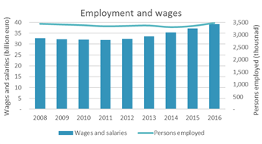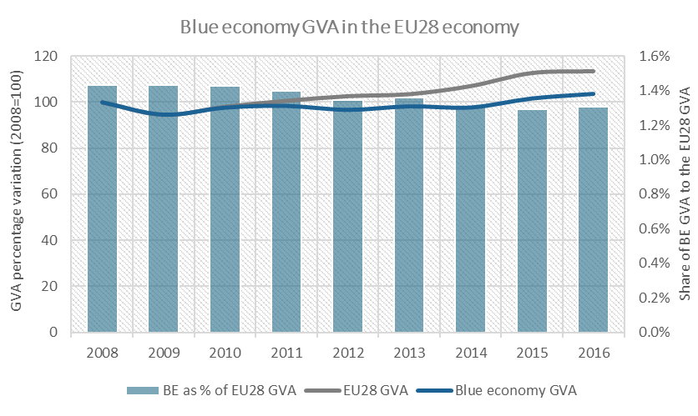

Whilst public investment in the blue economy should be mainstreamed across different funding instruments, also by strengthening cooperation between countries within the framework of sea-basin strategies, future support though fisheries and maritime policies would need to concentrate on enabling conditions and on removing bottlenecks to facilitate investment and the development of new markets and technologies or services. Support would therefore need to focus on close-to-market innovation, supply of missing skills and qualifications, support to new inclusive business models, access to marine data to spur innovation and technology development, maritime security and maritime spatial planning to create opportunities that are compatible with marine ecosystems and the investment predictability necessary to leverage private sector capital/debt funding.

Ensuring that blue growth opportunities can thrive in coastal communities, community-led local development (CLLD) should be extended. At just below 10% of the total EMFF budget, CLLD is implemented by 20 Member States who by the end of 2017 had selected a total of 368 FLAGs.

|  |
| --- |
| Examples of current projects[50]:   * Business development in marginalised and remote communities where a seaweed company has grown from one to four employees. * The shells of mussels are no longer considered waste. With the help of the Fisheries Local Action Group (FLAG), local students and teachers are using crushed shells to create useful objects of all sorts, from moulds created by 3D printing. * Oyster farms are regularly affected by toxic phytoplankton, leading to economic losses. In search of a solution, shellfish farmers teamed up with a biotech start-up to test a new, quick and easy way to detect toxic marine microalgae and anticipate its proliferation. |

Based on available data (that currently does not cover all FLAGs) CLLD covers nearly 250 000 square km and a population of nearly 24 million. By the end of December 2017, the FLAGs had selected more than 1300 projects for implementation. Seven years of implementing bottom-up local development in fisheries areas[51] has demonstrated that this form of support delivers results. It helps reaching target groups that are hard to reach through traditional, top-down funding schemes, it can foster partnerships and joint action between different stakeholder groups and the fact that decision-making happens at local level can encourage more flexible and innovative responses to local problems. It furthermore increases the visibility of EU funding at local level and is increasingly recognised as a valuable opportunity for blue growth sectors, including fisheries sectors to play an active role in local development and its governance issues. Moreover, FLAGs have a potential to help address the challenges faced by the SSCF[52].

2.1.4 Strengthening international ocean governance and enabling safe, secure, clean and sustainably managed oceans

Over the last years, the European Union has made a number of new commitments at international level:

|  |
| --- |
| **New commitments at international level**   * The 2030 Agenda for sustainable development, including Sustainable Development Goal (SDG) 14 "Conserve and sustainably use the oceans, seas and marine resources for sustainable development" – it contains set goals on significantly reducing marine pollution by 2025, reaching 10% of coastal marine surface as MPAs, protecting access rights of small scale fisheries, sustainably manage marine eco-systems, increased scientific cooperation on ocean acidification, ending Illegal Unreported and Unregulated fishing, prohibit by 2020 certain forms of fisheries subsidies which contribute to overcapacity and overfishing[53], eliminate subsidies that contribute to Illegal, Unreported and Unregulated fishing and refrain from introducing new such subsidies, recognizing that appropriate and effective special and differential treatment for developing and least developed countries should be an integral part of the World Trade Organization fisheries subsidies negotiation. ,. * The FAO Port State Measures Agreement to prevent and eliminate IUU fishing that entered into force in June 2016. The EU is a party to the agreement, which calls under Article 21 of the agreement on measures to build capacity for Least Developed Countries and Small Island Developing States to aid them in taking adequate port state measures in order to close the net on illicit fishing activities. The EU has also been actively involved in the development of complementary Monitoring Control and Surveillance Operations, as well as complementary measures and tools that have been developed recently internationally, such as the FAO Voluntary Guidelines on Catch Documentation Schemes and the Global Record of fishing vessels. * The EU is a party to the 1982 UN Convention on the Law of the Sea (UNCLOS) and supports the work of the international bodies the convention and its two implementing agreements have created: The International Tribunal on the Law of the Sea and the International Seabed Authority. It is also a contracting party to a number of Regional Fisheries Bodies across the world and Regional Seas Conventions in its neighbouring seas. Meanwhile, the EU and its Member States are actively engaged in the negotiations on a third implementing agreement under the UNCLOS on the conservation and sustainable use of marine biodiversity in areas beyond national jurisdiction (BBNJ). * The implementation of the Paris Agreement on climate change: which includes the protection of marine and coastal ecosystems including in the vulnerable polar areas, reducing risks resulting from climatic events, restoring and developing “green-blue infrastructure” and developing renewable marine energy. * Strengthening cooperation with key ocean actors in key areas of ocean governance, such as the implementation of ocean-relevant SDGs, capacity building, promoting conservation and sustainable ‘blue growth’, international fisheries management, decent working conditions at sea, the fight against IUU fishing and maritime security. |

However, the current EMFF does not cover or provides very little funding for these activities and in order to deliver on all new international commitments additional funding is needed. If not delivered, not only the economic, environmental and security interests in relation to oceans, seas and marine resources are threatened but also the role of the Union as a key ocean actor would be undermined and its stated commitment to the delivery of the key global processes like the Agenda 2030, the Paris Agreement, the UN process on establishing a binding instrument for BBNJ, the FAO Port State Measures Agreement, its participation in various Regional Fisheries Bodies and Regional Seas Conventions and the WTO negotiations on fisheries subsidies questioned.

|  |
| --- |
| Maritime security is vital to the welfare and prosperity of the EU and the world. As much as 90% of international trade is seaborne, 50% of the EU population lives in maritime regions and 400 million passengers pass through EU ports and harbours each year. Europeans consistently point to security and safety as a top priorityfor their Union[54]. At the same time, security risks and threats on our seas and oceans are becoming more and more complex over time and the deteriorating situation in many parts of the EU's neighbourhood in recent years has given rise to new challenges, notably an increased need for security as pre-condition to the development of the Blue Economy. |

The European Maritime Security Strategy (EUMSS) and its accompanying Action Plan[55] were issued in 2014 in response to the growing need for maritime security in Europe and overseas. Cross sectoral cooperation between different maritime authorities at European level and increased cooperation at sea internationally, between the EU and its maritime partners, will remain a priority for the future. Particular attention will have to be given to maritime surveillance (CISE) and the protection of critical maritime infrastructure (as ports, lines of communication/transport, offshore installations), critical maritime routes and marine resources (including fisheries). Finally, the EU will need to continue to promote targeted responses to threats at sea, both in Europe and globally, and coordinate geographical and sectoral policies in the maritime domain. The interagency cooperation on coast guard functions, established following the revision of the mandates of the EFCA, EMSA and the European Border and Coast Guard Agency (FRONTEX), in line with the EUMSS AP, will be key in this respect.

## Objectives of the programmes of the next MFF

The Treaty of the Functioning of the European Union (TFEU) provides the overall legal basis for the CFP. It contains the following provisions:

|  |
| --- |
| * Article 3(1) (d): the Union has exclusive competence in the conservation of marine biological resources under the common fisheries policy. * Article 4(2) (d): other aspects of fisheries and maritime policy are shared competence between the Union and the Member States. * Article 43(2): The European Parliament and the Council, acting in accordance with the ordinary legislative procedure and after consulting the Economic and Social Committee, shall establish the common fisheries policy. |

The baseline scenario is the current EMFF for the 2014-2020 period (EUR 6.4 billion) excluding the resources allocated to the UK (EUR 230 million). This status quo would allow to address the challenges set out in this section. This IA report does not cover the impacts of Brexit. Such impacts will be considered at a later stage.

The objectives for fisheries and maritime policies post-2020 are of four types - policy, general, specific and cross-cutting - and are defined at two levels, policy objectives common to all ESI Funds and fund-specific general, specific and cross-cutting objectives

Each specific objective is linked to a general objective and is presented as an indent under the general objectives below:

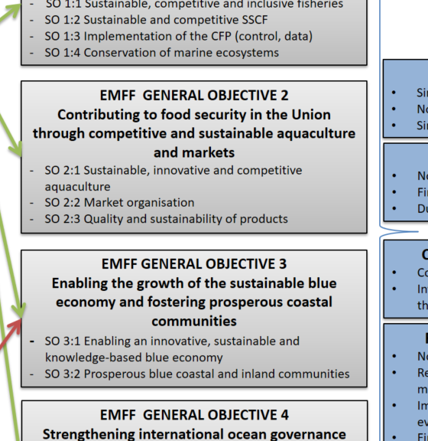

# Programme structure and priorities

3.1 Necessity for EU action:

The CFP is an area of exclusive competence to the EU. Union intervention is therefore necessary as this common policy imposes obligations on the Member States. Financial support to help them meet those obligations is crucial for the attainment of the Union's objectives of the policy – the sustainable use of the oceans. Support is needed in areas like adjusting the capacity of our fishing fleets, investing in health and safety on board, developing scientific knowledge and advice on the state of the fish stocks and improving controls and inspections at sea and in ports.

3.2 Added value of EU action:

The overall aim of future support for fisheries and maritime policies is to help delivering the CFP objectives. Achieving sustainable fisheries may have social impacts for coastal communities in the short to medium term which needs mitigation through diversification both within and outside the fishing sector by for example encouraging fishers to find employment in expanding maritime economy sectors. This is of particular importance to coastal communities depending on fisheries, in particular in areas where the fishing sector still faces serious problems such as the Mediterranean and Black Seas where a policy at EU level can provide real added value, also given the EU exclusive competence on fisheries management. Individual Member States are not in a position to sufficiently address the problems themselves while EU action provides a secure source for stable growth-supporting investment. Many marine aquaculture sites operate in marine ecosystems which go beyond national borders and the planning of the maritime space requires coordinated planning efforts at EU-level. Control and enforcement as well as data collection and scientific advice are core elements for the effective implementation of the CFP. These activities co-ordinated and co-financed at EU-level represent significant savings and synergies in terms of costs and compliance compared to a model where these activities were to be carried out exclusively by the Member States.

Maritime policy and the development of the blue economy is to its character cross-sectoral and transnational, e.g. through the development of sea-basin strategies that cover several Member States and appropriate partner countries, to gain efficiency in the use of funds, application of rules and involvement of bodies/institutions and reduce fragmentation and duplication of actions. Action at EU-level is likely to produce clear benefits compared to action only at Member State/regional level. Marine knowledge assembles data and makes it accessible across the EU, CISE provides a common European maritime surveillance environment, while sharing at EU or sea basin levels coast guard capacities between agencies and Member States increase effectiveness and efficiency of operations at sea. Maritime spatial planning is a way to better coordinate the common European maritime space and ensure coherence across borders (within and outside the EU). In blue growth areas such as ocean energy coordination of activities related to research but also other non-technological issues at European level accelerates the development of the sector (i.e. achieving the critical mass for investment and developing the market). Funding at EU-level supports the drivers of innovation enabling the European maritime industry to grow and thrive.

In line with its international commitment to conserve and sustainably use the oceans, including the objectives under Sustainable Development Agenda 2030, the EU is well-placed to shape international ocean governance on the basis of its experience in developing a sustainable approach to ocean management, notably through its environment policy (in particular the MSFD), integrated maritime policy (in particular its MSP Directive), reformed common fisheries policy, action against illegal, unregulated and unreported (IUU) fishing, its maritime transport policy and the multiple bilateral partnerships and multilateral agreements it is a party to. The Sustainable Fisheries Partnership Agreements with partner countries around the world are key for sustainable food supply, for developing a sustainable blue economy and help to address the issue of migration. The EU maritime security strategy and new border protection policy has identified CISE and the cooperation between EFCA, EMSA and the European Border and Coast Guard Agency (FRONTEX) in the form of the European Border and Coast Guard Function as key to deliver on these aims. In all the areas set out above pooling resources at European level can deliver results that spending at national level cannot.

3.3 Prioritisation of actions:

Below follows an account of the features to be retained by the future fisheries and maritime policies of the Union in view of identified challenges. A full account including discarded features is provided in Annex 4.2 to this IA report.

**General Objective 1: Fostering sustainable fisheries and the conservation of marine biological resources**

As shown in previous sections of this IA report, in terms of economic and environmental sustainability the situation facing the fisheries sector today is very different from when the EMFF was designed and although concerns remain for some stocks, segments (overcapacity) and sea-basins, mainly the Mediterranean, the general outlook for the future is positive. Nevertheless, the CFP needs a dedicated tool for delivering on its prime objectives. This is unlikely to be achieved by any other EU funding source. It will be necessary to focus support on **key enablers** for healthy oceans and prosperous coastal communities.

The preferred model for the future is a more targeted system compared to the current one. Given the challenges to achieve a sustainable exploitation of marine biological resources in line with the conservation objectives of the CFP, future funding should support the management of fisheries and fishing fleets. In this context, fleet adaptation measures will remain necessary as regards certain fleet segments or certain sea basins (i.e. the Mediterranean). However, such support needs to be **tightly targeted to the conservation and sustainable exploitation of marine biological resources and to a more effective fleet management by Member States**. In this context, certain fleet measures[56] may play a specific role. Past experience shows that on the one hand, they need to be carefully circumscribed to avoid negative impacts, and on the other hand, they must be better targeted at reaching EU conservation objectives. Fleet measures would be subject to horizontal conditions set out in the regulation.

Given the remoteness and specific conditions of the outermost regions there are good reasons to continue compensation but it will be necessary to assess how the cost-effectiveness of the regime could be improved. It will also be necessary to reflect on how to better integrate the development of the fisheries sector into blue growth strategies.

|  |  |
| --- | --- |
| *Specific objective* | *Features* |
| SO 1:1 Sustainable, competitive and inclusive fisheries | A targeted model introducing a new feature compared to the current period. Fleet adaptation measures will remain necessary as regards certain fleet segments or certain sea basins (e.g. Mediterranean). However, such support needs to be tightly linked to specific conservation objectives (especially as regional multiannual management plans enter into effect) and to a more effective fleet management by Member States.  Modernisation of the fleet with regard to innovation, health and safety, energy efficiency and investments on board improving the quality of products.  Maintaining higher co-financing rates and allow higher aid intensity for investments in outermost regions compared to the mainland. |
| SO 1:2 Sustainable and competitive SSCF | Higher intervention rates  Differentiated areas of support (e.g. certain operations only for small-scale operators)  Differentiated forms of support (e.g. access to grants only for small-scale operators and only financial instruments for other beneficiaries) |
| SO 1:3 Implementation of the CFP (fisheries control, data) | Continue financial support for fisheries control and link it with the revision of the Control regulation.  Reinforce the link to maritime surveillance  Strengthen the collection and processing of marine data in synergy with EMODNET and the MSFD. |
| SO 1:4 Conservation of marine ecosystems | Continue support for biodiversity protection, including support to the management, restoration and monitoring of Natura 2000 sites and other MPAs, to promote more selective fishing gear, to avoid accidental by-catch of species (marine mammals and seabirds) to continue addressing the issue of collection of marine litter and to support aquaculture providing environmental services.  Develop cross-cutting indicators for all EU funds for Natura 2000, building on and adapting existing indicators developed under the EMFF. |

**General Objective 2: Contributing to food security in the Union through competitive and sustainable aquaculture and markets**

The sustainable production of farmed fish offers an alternative source of food security. Aquaculture is part of the Common Fisheries Policy, and while the EMFF has supported the EU's aquaculture sector with more than 1.2 billion euros of investment, a number of problems remain. The main problems in the aquaculture sector relate to unnecessary complexities in Member State procedures but also other obstacles remain such as access to funding, access to space and the ability of the sector to improve the image and competitiveness of farmed seafood.

With regard to support for markets, continued financial support for the organisation of the sector and its structure through support to producer organisations (POs) could be justified on the basis of market failure (need to correct monopsony/oligopsony[57] and increase producers' bargaining power vis-à-vis the processing industry and retailers). Such POs have a key role in the implementation of the CFP and the Common Market Organisation. Support should facilitate the creation and restructuring of professional organisations in the meaning of the CMO regulation, the implementation of Production and Marketing Plans, the improvement in market performance and the provision of market intelligence (EUMOFA).

|  |  |
| --- | --- |
| *Specific objective* | *Features* |
| SO 2:1 Sustainable, innovative and competitive aquaculture | Target support to productive and innovative investments to growth. Support should be provided through financial instruments.  Support on compensatory measures for less profitable aquaculture activities  Grants for enabling conditions for aquaculture - including stock insurance schemes - could be considered as well in addition to covering aquaculture more prominently in local development strategies (CLLD) as an important area for diversification, jobs and growth. |
| SO 2:2 Market organisation | Financial support for the organisation of the sector and its structure through producer organisations (POs) |
| SO 2:3 Quality and sustainability of products | Keep support for processing but provide it only through financial instruments for all including for SMEs. |

**General Objective 3: Enabling the growth of the sustainable blue economy and fostering prosperous coastal communities**

If the aim is to really unlock the full potential of the maritime economy, future support would need to be increased compared to current levels. One option could be to focus future funding almost entirely on maritime policy and blue growth and only keep a minor part for data, control and the CLLD-approach. The problem here is that available funding would still not to enough to provide sufficient funding for unlocking the potential of the maritime economy while key objectives of the CFP would risk not to be delivered.

Another option would be a maritime policy with clear focus on providing funding for **enabling condition**s to facilitate **innovation** and market development in the blue economy by **addressing market failures**. Support in direct management could be centred on promoting clean oceans and a blue economy adapted to the consequences of climate change (eg. fight against marine pollution, reduce GHG emissions of maritime equipment, promotion of circular blue economy, reduction of marine litter, promotion of blue energy). More flexibility could be provided through a wider choice of support mechanisms including financial instruments.

Given that Community-led Local Development is a powerful tool for creating employment and wealth and helps to deliver social and territorial cohesion and taking into account the call from stakeholders and the European Parliament to further strengthen the approach, there are good reasons to continue the approach.

|  |  |
| --- | --- |
| *Specific objective* | *Features* |
| SO 3:1 Enabling an innovative, sustainable and knowledge-based blue economy | Focus on providing funding for enabling conditions to facilitate innovation and market development in the blue economy by addressing market failures for the sustainable development of economic activities, safeguard ecosystems and reinforce security at sea. It also includes enhancing marine and scientific knowledge (e.g. EMODNET and MSFD).  Outermost regions would be encouraged to draw up maritime sustainable development strategies. |
| SO 3:2 Prosperous blue coastal and inland communities | Broaden the scope of the approach to include maritime policy/blue growth.  Ensuring that a meaningful share of the post-2020 funding is delivered through CLLD. |

**General Objective 4: Strengthening international ocean governance and enabling safe, secure, clean and sustainably managed oceans**

Besides voluntary contributions to international organisations (RFMOs, UN organisations), the current EMFF does not allow for interventions at international level and one option could be to keep it like this also for the future. However, not having any dedicated budget line(s) under the current EMFF could already negatively/seriously affect the implementation process. Moreover, if no specific allocations are provided, it would entail a major risk for its credibility and efficiency. In addition, the current EMFF is only partially reflecting the new ambitions on international ocean governance and notably its cross-sectoral and holistic scope with the objective to ensure a coordinated/integrated approach towards ocean policy making and implementation.

The Action Plan of the European Maritime Security Strategy (EUMSS)[58] is now under revision to align it with present and upcoming challenges and to continue promoting targeted responses to threats at sea, both in Europe and globally.

|  |  |
| --- | --- |
| *Specific objective* | *Features* |
| SO 4:1 International ocean governance | Continue support for international and regional organizations (RFMOs, RSCs)  Broaden scope of support for international ocean governance through ; development of ocean partnerships with key partners; building capacity for better ocean governance, conservation and restoration of marine biodiversity and sustainable blue economies with key partners, promote MSP worldwide and strengthening; international ocean research and data.  Include support needed to effectively implement the external part of the EU policy to fight against IUU fishing in the form of technical assistance to third countries to implement international obligations (ex. revision of legal frameworks, MCS capacity trainings, correct implementation of the EU catch certification scheme) and operational maintenance/update/development of the IT tool for the EU IUU catch certification scheme. |
| SO 4:2 Maritime surveillance and coastguards cooperation | To promote, in line with the EUMSS Action Plan, enhanced international cooperation on maritime security (including on the fight against IUU), integrated maritime surveillance (particularly CISE), capability development and research & innovation, risk management and assessment as well as dedicated education and training activities in the field of maritime security.  Include support for interagency cooperation on coast guard functions, established following the revision of the mandates of the EFCA, EMSA and FRONTEX |

What is new content-wise in comparison with the 2014-2020 period?

|  |  |
| --- | --- |
| ***2014-2020*** | ***Post-2020*** |
| Aid intensity for support to SSCF at 80% | Aid intensity for support to SSCF (including operations related to control and enforcement) at 100% |
| Member States with more than 1 000 SSCF vessels should prepare an action plan | All MS should prepare an action plan that sets specific milestones and targets in relation to fund-specific indicators |
| Aquaculture: Weak link to national strategic plans | Aquaculture: Stronger link to national strategic plans |
| Aid intensity for delivering on CFP objectives (landing obligation, gear selectivity) at 50% | Aid intensity for delivering on CFP objectives (landing obligation, gear selectivity) at 75% |
| Community-led local development only within fisheries/aquaculture | Community-led local development extended to the whole blue economy |
| Very limited support for international cooperation | Support for international oceans governance included including coastguard cooperation |
| No specific link between the EMFF and the development of the blue economy in outermost regions | In outermost regions MS shall prepare an action plan for the sustainable development of the blue economy |
| For maritime policy, only MFSD and CISE in shared management | In addition to MSFD and CISE, also support for implementing the MSP Directive, EMODNET and coastguard cooperation covered by shared management |
| Limited synergies in the field of data and control between fisheries and maritime purposes, data collected and control carried out independently | Increased synergies  Fisheries science and marine science: when collecting fisheries data also date for EMODET and the MSFD could be collected.  Fisheries control and coast guard functions: Most surveillance operations at sea are multipurpose and should fit with actual control and security needs in order to gain efficiency and cost-effectiveness |

# Delivery mechanisms of the intended funding

4.1 What do the evaluations recommend? What conclusions can be drawn on the basis of implementation data?

* The administrative burden associated with the delivery of the EFF was too high. At the application stage it acted as a disincentive for applying for support and the level of co-financing required was perceived as an issue, in particular for the most fragile categories of stakeholders.
* Public support should be focussed to ensure greater effectiveness and efficiency.
* In the EMFF administrative complexities at national level slow down the rate of implementation. In shared management this is for example the case within aquaculture, CLLD, innovation and to a certain extent maritime policy.
* The lack of context, result and output indicators in the EFF increased the difficulty of the analysis of its impacts. This was rectified in the EMFF. For the future the common monitoring and evaluation system developed under the EMFF should be kept but simplified.

4.2 What do stakeholders propose?

* No need for radical changes of the 2014-2020 delivery mechanisms. Stakeholders ask for stability and continuity.
* However, current delivery mechanisms should be made simpler, more flexible and more focussed on performance and success.
* More specifically, the intervention logic is considered too rigid not allowing Member States to address their own specificities. This could be addressed by getting rid of pre-defined measures, reduce the number of objectives/priorities and increase the use of financial instruments and standard cost options.
* Continue the conditional approach by which spending is linked to the delivery of objectives the CFP.

4.3 What are the key features of proposed delivery mechanisms post-2020?

(a) Key features at ESI-level

* For shared management, rules applicable to all ESI Funds will be moved to the CPR. Such rules are part of the CPR drafting and are dependent on the ongoing discussions between the ESIF-DGs.
* Common rules have to be defined in such a way that they fit the specificities of each ESIF. Given the small size of fisheries and maritime policies the principle of proportionalityshould be applied. For example there is no need for a detailed evaluation plan, no need for a specific network of information and communication officers and it should be possible to roll-over the designation of authorities from previous period if no substantial changes are made in the set-up
* The strong growth potential of the blue economy cannot be born exclusively by the small Fund for fisheries and maritime policy. The general principle could be that major investments are supported by larger funds such as the ERDF, whereas the EMFF could fund smaller, innovative, added value projects and cooperation not taken on by the other funds (e.g. at sea basin and sub-regional levels). Issues related to maritime skills could in principle be covered by the ESF. H2020
* Monitoring and reporting on the implementation of sea-basin and macro-regional should be harmonised across ESI Funds. This was not the case during the 2014-2020 period which caused problems when assessing the implementation of such strategies.
* Rules at ESIF-level are not enough given that the new fund for fisheries and maritime policies is a prime tool for implementing the CFP. That is why a policy-level legal basis is needed.

(b) Key features at Policy-level

Making delivery mechanisms simpler and more flexible:

Member States would draw up their operational programme indicating the most appropriate means to achieve the objectives set out in the regulation. The basic principle would be that anything that is not explicitly forbidden in the regulation would be allowed. There would be a list of 'no-go' areas in fisheries policy so as to avoid detrimental impacts in terms of fisheries conservation (e.g. a general prohibition of investments enhancing fishing capacity) and restrictions for operating costs or where there is no proven market failure. This represents a major shift from current and past funding rules, where eligible investments/measures were spelled out in detail in the regulation and which stakeholders have criticised for being burdensome and inflexible.

Making delivery mechanisms more focussed on success:

Building on the Common Monitoring and Evaluation System developed for the 2014-2020 period the future policy will be structured around general and specific objectives. A limited number of key result indicators at ESIF-level and at fund-level are being developed that match the objectives. In the operational programmes Member States set their milestones and targets in relation to these indicators. Success will be measured on the basis of Member States reporting on progress towards these milestones and targets. On this basis, the Commission will carry out an annual performance review allowing for early detection of potential implementation issues and corrective measures.

For most types of support funding (EU interim payments) would continue to be based on actual incurred costs and expenditures certified by Member States (without prejudice to using SCOs). However, in order to ensure the consistency of fleet structural adaptation with conservation objectives, support for the permanent cessation of fishing activities should be implemented only through financing not linked to costs provided for in the Common Provisions Regulation[59]. This means that for this specific type of support Member States should not be reimbursed by the Commission on the basis of real costs but on the basis of the fulfilment of conditions or of the achievement of results. For this purpose, the Commission should establish in a delegated act conditions related to the conservation objectives of the CFP, that should be reflected in the operational programmes of the Member States concerned.

Further flexibility will be provided through:

* Simplified intervention logic: fewer objectives at ESIF and policy-level
* Financial instruments: In line with the opinion expressed by the majority of stakeholders[60] [61] financial instruments (loans, guarantees) and repayable assistance such as repayable grants[62] at programme level would play a more prominent role.
* Simplified cost options: An increased use of Simplified Cost Options (flat rates, lump-sums and unit costs) would help to reduce the administrative burden at Member State level[63].
* Compliance: The compliance mechanism that was introduced through the EMFF 2014-2020 and by which both Member States and operators have to comply with the rules of the CFP from admissibility to implementation to be able to get support would be continued.
* Dual management mode: The current dual management mode (shared and direct management) would be kept for the future[64] [65].

4.3 What is new in comparison with the 2014-2020 period?

The table below shows the areas where new or adapted delivery mechanisms are proposed for the post-2020 period.

|  |  |
| --- | --- |
| ***2014-2020*** | ***Post-2020*** |
| Simplification, flexibility | |
| 4 thematic objectives at ESIF-level, 6 EMFF union priorities | 2 policy objectives at ESIF-level, 4 EMFF general objectives |
| 49 pre-defined measures setting out eligibility conditions  Only operations that meet the eligibility conditions can be supported | No measures  A few no-go areas set out in the legal basis  Everything is eligible that is not covered by the no-go areas |
| Limited use of simplified cost options | Increased use of simplified cost options |
| Limited use of financial instruments: Mandatory for support to processing for non-SMEs | Increased use of financial instruments: Mandatory for support to processing as well as to productive and innovative investments in aquaculture for all types of beneficiaries (including SMEs) |
| Focus on performance and success | |
| Ex-ante conditionalities at fund-level | No ex-ante conditionalities at fund-level. Funding conditional upon the compliance of Member States and operators with the objectives and rules of the CFP. Applications from non-compliant operators not admissible |
| All financing based on eligible costs | Possibility to provide financing not linked to costs in the form of flat rate payments linked to the attainment of milestones and targets |
| CMES 2014-2020  Common indicators at EMFF-level | Simplified CMES (fewer indicators)  Common indicators at ESIF-level and policy-level |
| Synergies with other funds | |
| The blue economy could be funded through other funds | A more clear demarcation. Enabling funded through fisheries and maritime policies. Upscaling funded through other funds, notably the ERDF and the research framework programmes |

# How will performance be monitored and evaluated?

5.1 What is already available?

For the 2014-2020 a Common Monitoring and Evaluation System was developed for the EMFF[66]. It is built on the following elements:

* An intervention logic showing the interactions between priorities, specific objectives and measures.
* A set of common indicators.
* Cumulative data on operations selected for funding.
* The Annual Implementation Report of the Operational Programme.
* An Evaluation Plan.
* The ex-ante and ex-post evaluations and all other evaluation activities linked to the EMFF programme.
* The performance review.

First, for the 2014-2020 period a set of common indicators with common definitions were established covering the main characteristics of the fisheries and aquaculture sector, reflecting the goals of relevant EU policies (CFP, maritime policy) and providing a connection with the EU 2020 strategy. Indicators used serve different purposes:

* Context Indicators (CIs) are linked to the overall objectives of the EMFF and establish the baseline at the beginning of the OP implementation. The EMFF uses 25 common CIs.
* Output indicators (OIs) are the direct product of the implemented activities. In the case of the EMFF, they are mostly expressed as a number of operations. The EMFF CMES defines 28 OIs covering the 50 measures.
* Result Indicators (RIs) measure the gross effect of the EMFF. The CMES comprises a set of 28 RIs, some of which are linked to only one EMFF Specific Objective, others to more than one[67]. MS were free to add specific indicators if they wished.

Member States are required to report on these indicators.

Second, we have a system for cumulative data on operations referred to as Infosys[68]. As explained in this IA report the mid-term and ex-post evaluations of the European Fisheries Fund (EFF, 2007-2013) were hampered by the lack of robust monitoring data, making the collection of data challenging. As a response, for the 2014-2020 period, a reporting system was established to address this shortcoming and provide the Commission with detailed information at the level of every single operation. In concrete terms this means that we have created a database of information at the level of operations that can be used to follow the implementation of the OPs, carry out specific analysis required by policy-making and ensure that robust data is available for evaluation.

The Infosys reporting describes the progress and achievements at operation level by capturing what is happening on the ground. It provides key information about the beneficiary (e.g. size of enterprise, gender) and the operation (type of activities, budget, number of fishers concerned, total area concerned, etc.). In order to limit the administrative burden on Managing Authorities and on beneficiaries, most of the data requested by the Infosys is already stored in national databases set up to comply with the minimum data to be recorded and stored for each operation. Member States are required to provide Infosys data annually.

Third, the CPR lays down the general rules for evaluation in all the ESI funds, whilst the EMFF Regulation specifies that the Member States have to conduct an ex-ante evaluation and further evaluations during the implementation period. The Commission has to conduct an ex-post evaluation, to be completed by the end of 2024. The ex-ante evaluation is the only evaluation undertaken so far by the Member States.

5.2 What do we want to develop for the future?

For the future we would like to build on the model developed during 2014-2020. It is essential that this existing, functioning monitoring and evaluation system remains in place. The focus will be on evolution and simplification. The number of indicators will be reduced, indicators should be more operational (i.e. close to the operations and easy to report on) and methodological guidance would be provided to Member States prior to programming[69].

The specific indicators at fund-level should be few, simple and defined prior to programming. For the future the aim is to have a maximum of 10 result indicators at policy-area level. These indicators would cover the following:

|  |  |
| --- | --- |
| **PRIORITY** | **INDICATOR** |
| Fostering sustainable fisheries and the conservation of marine biological resources | Evolution of volume of landings stemming from stocks assessed at MSY |
| Evolution in profitability of the Union fishing fleet |
| Surface (ha) of Natura 2000 sites, and other MPAs under the MSFD, covered by protection, maintenance and restoration measures |
| Percentage of fishing vessels equipped with electronic position and catch reporting device |
| Contributing to food security in the Union through competitive and sustainable aquaculture and markets | Evolution in the value and volume of aquaculture production in the Union |
| Evolution in the value and volume of landings |
| Enabling the growth of a sustainable blue economy and fostering prosperous coastal communities | Evolution of GDP in maritime NUTS 3 regions |
| Evolution in the number of jobs (in FTE) in the blue economy |
| Strengthening international ocean governance and enabling safe, secure, clean and sustainably managed seas and oceans | Number of shared operations contributing to the European cooperation on coastguard functions |

In addition, indicators at the level of operational programmes are under development.

All indicators - including methodological guidance on definitions - will be defined and elaborated prior by the Commission to programming.

For the future we would also like to keep the Infosys. The basic requirement will be that Member States annually provide cumulative data on operations selected for funding until the end of the previous year. They will provide data on each operation (type of investments, area covered, number of employees benefitting from the operation etc) including key characteristics of the beneficiaries.

5.3 What requirements are being proposed for evaluation? What data is available?

All key requirements on evaluation will be put in the CPR and will be common to all ESI Funds. It will not be obligatory for Member States to carry out an ex-post evaluation as experience from current and previous periods show that these evaluations have been of limited value. Member States will be required to carry out evaluations during the programming period. Such evaluations shall help to improve the quality of the design and implementation of programmes, as well as to assess their effectiveness, efficiency, relevance, coherence, EU added value and impact in relation to their contribution to the priorities of the European Union.

In principle the evaluations to be made by Member States will cover the following elements:

* Process evaluation covering the effectiveness and efficiency of partner involvement, OP implementation and communication
* Effectiveness evaluation at specific objective level focussing on how well the operational programme is being implemented
* Impact evaluation at general objective level. It should demonstrate how much the operational programmes have contributed to change in the sector and in society as a whole in line with the general objectives.

Member States will have to ensure that procedures are in place to produce and collect the data necessary for evaluations, including data related to common and programme-specific indicators. The Commission will carry out the ex post evaluation.

In addition to the ongoing evaluation set out above, each Member State will have to submit to the Commission an annual performance report. This report should describe the achievement of milestones and targets and it will be examined by the Commission who will submit its observations to the concerned Member State. Moreover, the Commission will carry out a mid-term assessment to examine the effectiveness, efficiency, relevance, coherence and EU added value by the end of 2025. Taken together the provisions above should be sufficient to ensure that evidence is available at the time of revising the spending programme for the period post-2027.

Availability of data for evaluation purposes:

* Infosys data will be used for evaluations.
* In addition, data from the Data Collection Framework[70] will be used. This is data the Member States are collecting and which is assembled and stored by the JRC
* Also data from the European Market Observatory for Fisheries and Aquaculture (EUMOFA) will be used. EUMOFA[71] operates a consolidated database of aggregated and harmonised data.
* EUROSTAT data will be used wherever available

The table below summarises the requirements on monitoring and evaluation during the 2014-2020 period and the post-2020 period:

|  |  |
| --- | --- |
| ***2014-2020*** | ***Post-2020*** |
| CMES 2014-2020  Common indicators at EMFF-level | Simplified CMES (fewer indicators)  Common indicators at ESIF-level and policy-level |
| Infosys 2014-2020 | Infosys post-2020 |
| *CPR requirements:*  Ex-ante evaluation to be done by MS  Evaluation during the programming period to be done by MS. At least once during the programming period an evaluation shall assess how ESI Fund support has contributed to the objectives  Ex-post evaluation to be done by COM  Synthesis at Union level of the ex-post evaluation by the COM | *CPR requirements:*  Evaluation during the programming period to be done by MS.  Ex-post evaluation to be done by COM  Mid-term assessment to be done by COM by the end of 2025  Synthesis at Union level of the ex-post evaluation by the COM |
| *Policy-level requirements:*  Ex-ante evaluation to be done by MS  Ex-post evaluation to be done by COM  Synthesis at Union level of the ex-post evaluation by the COM | *Policy-level requirements:*  None. All requirements moved to the CPR and common to all ESI Funds. |

# Annex 1: Procedural information

1. Organisation and timing

The Directorate-General for for Maritime Affairs and Fisheries (DG MARE) is the lead service for the preparation of the initiative and the work on the impact assessment.

DG MARE has used the new template for impact assessments supporting programme proposals of the next Multi-annual Financial Framework as sent in ARES on 15/01/18 (Ares(2018)239380).

An inter-service steering group (ISSG), chaired by the Secretariat-General, was set up in January 2018 with the invitations sent out to the following Commission Directorates-General: Legal Service; DG Competition; DG Employment, Social Affairs and Inclusion; DG Energy; DG Neighbourhood and Enlargement Negotiations; DG Economic and Financial Affairs; DG for Mobility and Transport; DG Environment; DG Climate Action; DG Taxation and Customs Union; DG Regional and Urban Policy; DG Health and Food Safety; DG Agriculture and Rural Development; DG Communication; DG Communication Networks, Content and Technology; DG Financial Stability, Financial Services and Capital Markets Union; DG Trade; DG International Cooperation and Development; DG Internal Market, Industry, Entrepreneurship and SMEs; DG Budget; DG Research and Innovation; DG Informatics; DG Human Resources and Security; Joint Research Centre; Eurostat and the Internal Audit Service. Invitation was also sent to the European External Action Service.

The first ISSG meeting dedicated to the preparation of the fisheries and maritime policies post-2020 was held on 2nd February 2018. The first meeting was dedicated to the discussion of the inception impact assessment and the draft impact assessment. The second meeting of the ISSG was held on 23rd February and covered the complete draft IA report including the annexes.

The formal presentation of the Impact Assessment to the RSB is planned for 11 April 2018 with the opinion from the RSB planned for 13 April 2018. Afterwards, the inter-service consultation will be launched for two weeks (16 – 27 April 2018).

The adoption of the MFF is foreseen for the beginning of May 2018 and the EMFF legislative proposal will follow afterwards.

DG MARE will also start preparing the outreach once the new EMFF is adopted. A first presentation and discussion could take place in the informal DG meetings planned by the AT Presidency in early July.

1. Consultation of the RSB

DG MARE held an upstream meeting with the Regulatory Scrutiny Board (RSB) and the SG on 19 January, with the participation of DG BUDG and JRC. The purpose of the meeting was to clarify expectations for the Impact Assessment for post-2020 EMFF, in particular in light of the revised template circulated by the SG.

RSB acknowledged the challenge of the exercise when a number of important political decisions still need to be taken. RSB noted that any political guidance included in the future MFF framework including on the future funding structure should be the starting point from this assumption.

RSB informed that the reference point should be the annual average amount of the current MFF. In case there are significant changes in later decisions on the MFF, the IA might have to be adjusted. It also has to be complemented at a later stage in order to include the budget because of the requirements of the Financial Regulation.

The RSB and the SG informed DG MARE that there is no more need to present three budgetary options[72] and compare them but to assess the impact of the changes compared to the current situation. A date will be booked with the RSB between 11 and 13 April for the presentation of the Impact Assessment to the Board.

The board made the following recommendations which have all been addressed in the revised IA report:

|  |  |
| --- | --- |
| RSB recommendations | IA report |
| (1) The IA has to start from the decisions that remain to be taken and that are not in the MFF communication. The DG has to look at options if there are still options left after the MFF Communication. These should mainly to assess the changes compared to the current programmes. They should focus on both on the overall programme priorities and structure, and on the implementation methods and delivery mechanisms. | Addressed in the IA. |
| (2) The IA should address the cross-cutting issues of the new MFF exercise, flexibility, coherence and performance, as well as the scope of the actions. On this, the DG may have to look at various options. Such options can discuss various ways of funding, including funding outside of the MFF and financial instruments. The DG responded that they aim to move towards simplification and more result-based management. RSB emphasised that flexibility always has pros and cons and that the DG needs to outline these transparently. | Addressed in the IA. |
| (3) RSB explained that if the DG believes there is a minimum critical mass of the funding that is necessary to deliver the key objectives, they should outline this in the IA. | Not applicable. |
| (4) RSB indicated that new priorities or changes in the focus of the policies would need to be reflected in the first block of the impact assessment on the structure of the programme. It emphasised that the synergies with other policies have to be more explicit, as the evaluation concluded. | Addressed in the IA. |
| (5) RSB explained that the assessment of impacts should focus on the implications of the new features and not the overall impact of the funding itself: what the DG expects the programme will deliver following the changes. The impact section needs to analyse the effects of various changes on national administration (burden), the fishery business, and more. | Addressed in the IA. |
| (6) RSB emphasised that the IA has to be linked to evaluation results and future challenges. It asked for absolute clarity in the IA on the sources of the lessons learned for the future, if these are previous evaluations, ongoing evaluations and/or consultation efforts. | Addressed in the IA. |
| (7) RSB mentioned in this context that evaluations of the MFF of the previous period are often based on very little evidence, mainly on stakeholder views. For this reason, strong monitoring and evaluation provisions are of high importance for the new impact assessment. These provisions have to be very specific, not only on types of indicators, but also on realistic methods of data collection. The DG furthermore needs to identify how they are going to measure the success of the policy. This is where they will have to think of the indicators for the overall impact of the policy. | Addressed in the IA. |

1. Evidence, sources and quality

The problem definition was based on numerous consultation activities carried out by the Commission as well as using external expertise (ex-post evaluation of the EFF prepared by an external contractor), complemented by additional analysis of available reports and studies. Regarding the post-2020 evaluation, the evidence was based on information gathered in particular in the framework of the EMFF Tallinn conference and the ex-post evaluation of the EFF. The Assessment report builds also on the contributions from Member States and other relevant stakeholders such as Advisory Councils, Social partners, NGOs, Industry etc.

Also, a great number of studies and reports both from experts and academia, have been used in the Impact Assessment exercise. In order to complement the internal COM studies, reports and notes, DG MARE has also used various studies and reports from the European Parliament and a number of studies done by DG REGIO. Internal consultations in DG MARE have also been carried out and written contributions received internally have been analysed.

|  |  |  |
| --- | --- | --- |
| LIST OF SOURCES | | |
| Ex-post Evaluation of the European Fisheries Fund (EFF), Staff Working Document, European Commission | SWD(2017) 274 final, July 2017 | https://ec.europa.eu/newsroom/document.cfm?doc_id=45977 |
| Report on the Blue Growth Strategy: Towards more sustainable growth and jobs in the blue economy | SWD(2017) 128 final, March 2017 | https://ec.europa.eu/maritimeaffairs/sites/maritimeaffairs/files/swd-2017-128_en.pdf |
| Study on costs, benefits and nature of an extended European Ocean Observing System | European Commission, January 2018 | https://webgate.ec.europa.eu/maritimeforum/en/node/4119 |
| Study on the economic importance of activities ancillary to fishing in the EU | European Commission, March 2016 | https://publications.europa.eu/en/publication-detail/-/publication/07f9aa31-9aa6-11e6-868c-01aa75ed71a1 |
| Study on the employment of non-local labour in the fisheries sector | European Commission, June 2016 | https://publications.europa.eu/en/publication-detail/-/publication/323daeca-9ab5-11e6-868c-01aa75ed71a1/language-en |
| Study on the subsidies to the fisheries, aquaculture, and marketing and processing subsectors in major fishing nations beyond the EU | European Commission, January 2017 | https://publications.europa.eu/en/publication-detail/-/publication/45f78bf8-d24b-11e6-ad7c-01aa75ed71a1 |
| Study on the implementation of Axis 4 of the EFF | European Commission, July 2014 | https://ec.europa.eu/fisheries/documentation/studies/axis-4_en |
| Retrospective evaluation of scrapping and temporary cessation measures in the EFF | European Commission, December 2013 | https://ec.europa.eu/fisheries/documentation/studies/cessation_fr |
| Scoping study for the use of financial instruments under the EMFF and related advisory support activities | Fi-Compass, European Commission, June 2015 | https://www.fi-compass.eu/publication/manuals/manual-scoping-study-use-financial-instruments-under-emff-and-related-advisory |
| Interim assessment of the implementation of Production and Marketing Plans pursuant to the CMO Regulation and the EMFF Regulation | European Commission, January 2017 | https://publications.europa.eu/en/publication-detail/-/publication/15571c4b-e137-11e6-ad7c-01aa75ed71a1 |
| Ad hoc expert report providing information on present and future EMFF support to Small-scale Coastal Fisheries through FLAGs | FARNET, July 2017 | https://webgate.ec.europa.eu/fpfis/cms/farnet2/library/technical-report/providing-information-present-and-future-emff-support-small-scale-coastal_en |
| Realising the potential of the Outermost Regions for sustainable Blue Growth | ARES(2017)4618231, September 2017 | http://ec.europa.eu/regional_policy/en/information/publications/reports/2017/realising-the-potential-of-the-outermost-regions-for-sustainable-blue-growth |
| Note to Management: 2017 Annual Economic Report of EU fleets: Main results | ARES(2017)4630815, September 2017 |  |
| Presentation on Study on the employment on non-local labour in the fisheries sector, | Dir A, Unit A4 (DG MARE), March 2017 |  |
| The Economic Performance of the EU Fish Processing Industry (STECF-14-21) | Joint Research Centre (JRC), November 2014 | https://stecf.jrc.ec.europa.eu/reports/economic/-/asset_publisher/d7Ie/document/id/932642 |
| The 2017 Annual Economic report on the EU Fishing Fleet (STECF-17-12) | Joint Research Centre (JRC), 2017 | https://ec.europa.eu/jrc/en/publication/eur-scientific-and-technical-research-reports/2017-annual-economic-report-eu-fishing-fleet-stecf-17-12 |
| International ocean governance: an agenda for the future of our oceans | SWD(2016) 352 final, November 2016 | https://ec.europa.eu/maritimeaffairs/sites/maritimeaffairs/files/join-2016-49_en.pdf |
| European Union Maritime Security Strategy | European Commission, EEAS, June 2014 | http://register.consilium.europa.eu/doc/srv?l=EN&f=ST%2011205%202014%20INIT |
| 1st Report on the Implementation of the EU Maritime Security Strategy Action Plan | SWD(2016)217, June 2016 | https://ec.europa.eu/maritimeaffairs/sites/maritimeaffairs/files/docs/body/swd-2016-217_en.pdf |
| 2nd Report on the Implementation of the EU Maritime Security Strategy Action Plan | SWD(2017)238, June 2017 | https://ec.europa.eu/maritimeaffairs/sites/maritimeaffairs/files/swd-2017-238_en.pdf |
| White paper on the Future of Europe, Reflections and Scenarios for the EU27 by 2025 | COM(2017)2025, March 2017 | http://eur-lex.europa.eu/content/news/white_paper.html |
| Study: EU Organic Aquaculture: economic performance and market perspectives | European Commission, January 2017 |  |
| Interim evaluation of the implementation of the direct management component of the European Maritime and Fisheries Fund (EMFF) Regulation | (launched by end 2017, interim report foreseen by March 2018) |  |
| Study on the ownership and exclusive rights of fisheries means of production | (launched in early 2017) |  |
| Declaration of the European Ministers responsible for the Integrated Maritime Policy on Blue Growth | Council of the European Union, April 2017 (ST 8037/17) | https://encrypted.google.com/url?sa=t&rct=j&q=&esrc=s&source=web&cd=1&ved=0ahUKEwiI_Z3T05jZAhXP_aQKHVmNBRAQFggnMAA&url=http%3A%2F%2Fdata.consilium.europa.eu%2Fdoc%2Fdocument%2FST-8037-2017-INIT%2Fen%2Fpdf&usg=AOvVaw2q5_E06sW6mtOEr2rQdxQV |
| State of execution of total payments and the level of the 'reste à liquider' (RAL) for Heading 1b (programmes 2007-2013) - Designation of managing authorities and state of execution of interim payments of 2014-2020 ESIF Operational Programmes (Status as of 31 May 2017) | Council of the European Union, Budget Committee, June 2017, WK 6574/2017 |  |
| How subsidies affect the economic viability of small-scale fisheries, | Marine Policy 82 (2017) 114–121, May 2017 | https://www.sciencedirect.com/science/article/pii/S0308597X1730177X |
| Industrial Fleet vs Artisanal Fleet, Myths and Realities | CACT-ARVI, May 2017 | www.arvi.org/publicaciones/IndustrialFleet_vs_ArtisanalFleet.pdf |
| Etude: Dispositifs assurantiels dans les secteurs de la pêche et de l'aquaculture | Direction des Pêches Maritimes et de l'Aquaculture, Septembre 2015 | http://www.oceanic-dev.com/etude-des-systemes-assurantiels-peche-et-aquaculture-prevus-dans-le-cadre-du-feamp-dpma/ |
| **Studies, Reports and Analysis from the European Parliament:** | |  |
| In-depth analysis: Fisheries in Madeira | European Parliament, Research for PECH Committee, DG for Internal Policies, Policy Department for Structural and Cohesion Policies, May 2017 (PE 601.978) | https://publications.europa.eu/en/publication-detail/-/publication/f1bb3739-5498-11e7-a5ca-01aa75ed71a1/language-en/format-PDF |
| In-depth analysis: Fisheries in Germany | European Parliament, DG for Internal Policies, Policy Department for Structural and Cohesion Policies, February 2014 (PE 514.010) | http://www.europarl.europa.eu/thinktank/en/search.html?authors=118465 |
| In-depth analysis: Best Practice in the Use of Rights-based Management to Reduce Discards in Mixed Fisheries | European Parliament, DG for Internal Policies, Policy Department for Structural and Cohesion Policies, March 2014 (PE 529.054) | https://publications.europa.eu/en/publication-detail/-/publication/ed4de31b-56f7-4bb8-9366-492b0a8ce49f/language-en |
| In-depth analysis: The Obligation to Land All Catches – Consequences for the Mediterranean | European Parliament, DG for Internal Policies, Policy Department for Structural and Cohesion Policies, March 2014 (PE 529.055) | https://publications.europa.eu/en/publication-detail/-/publication/9bf6e304-6e29-4984-a039-35b45ebc1ade/language-en |
| Study: Illegal, Unreported and Unregulated fishing: Sanctions in the EU | European Parliament, DG for Internal Policies, Policy Department Structural and Cohesion Policies – Fisheries, July 2014 (PE 529.069) | http://www.europarl.europa.eu/thinktank/en/document.html?reference=IPOL_STU(2014)529069 |
| Study: The Long-Term Economic and Ecologic Impact of larger Sustainable Aquaculture | European Parliament, DG for Internal Policies, Policy Department Structural and Cohesion Policies – Fisheries, October 2014, (PE 529.084) | http://www.europarl.europa.eu/thinktank/en/document.html?reference=IPOL_STU%282014%29529084 |
| Study: Fisheries in Azores | European Parliament, DG for Internal Policies, Policy Department Structural and Cohesion Policies – Fisheries, February 2015, (PE 540.355) | http://www.europarl.europa.eu/thinktank/en/document.html?reference=IPOL_STU(2015)540355 |
| Study: Small-scale Fisheries and the Zero Discard Target | European Parliament, DG for Internal Policies, Policy Department Structural and Cohesion Policies – Fisheries, March 2015 (PE 540.360) | http://www.europarl.europa.eu/thinktank/fr/document.html?reference=IPOL_STU(2015)540360 |
| Study: The Future of the Almadraba sector – Traditional Tuna Fishing Methods in the EU | European Parliament, DG for Internal Policies, Policy Department Structural and Cohesion Policies – Fisheries, April 2015, (PE 540.367) | http://www.europarl.europa.eu/thinktank/en/document.html?reference=IPOL_STU(2015)540367 |
| Study: Pelagic Fisheries and the Canning Industry in Outermost Regions | European Parliament, DG for Internal Policies, Policy Department Structural and Cohesion Policies – Fisheries, June 2015, (PE 563.378) | http://www.europarl.europa.eu/thinktank/en/document.html?reference=IPOL_STU(2015)563378 |
| Study: Fisheries Management and the Arctic in the Context of Climate Change | European Parliament, DG for Internal Policies, Policy Department Structural and Cohesion Policies – Fisheries, June 2015, (PE 563.380) | http://www.europarl.europa.eu/thinktank/en/document.html?reference=IPOL_STU%282015%29563380 |
| Study: The Landing Obligation and its implications on the Control of Fisheries, | European Parliament, DG for Internal Policies, Policy Department Structural and Cohesion Policies – Fisheries, September 2015 (PE 563.381) | http://www.europarl.europa.eu/thinktank/en/document.html?reference=IPOL_STU(2015)563381 |
| Study: Options of handling Choke Species in the view of the EU landing obligation – The Baltic Plaice example | Research for PECH Committee, European Parliament, DG for Internal Policies, Policy Department Structural and Cohesion Policies – Fisheries, December 2015 (PE 563.399) | http://www.europarl.europa.eu/thinktank/en/document.html?reference=IPOL_STU%282015%29563399 |
| Study: Workshop on a new Technical Measures Framework for the new Common Fisheries Policy | European Parliament, DG for Internal Policies, Policy Department Structural and Cohesion Policies – Fisheries, October 2015 (PE 563.403) | http://www.europarl.europa.eu/thinktank/en/document.html?reference=IPOL_STU%282015%29563403 |
| Study: Sardine Fisheries: Resource Assessment and Social and Economic Situation | Research for PECH Committee, European Parliament, DG for Internal Policies, Policy Department Structural and Cohesion Policies – Fisheries, November 2015 (PE 563.412) | http://www.europarl.europa.eu/thinktank/fr/document.html?reference=IPOL_STU(2015)563412 |
| Study: The Clam Fisheries Sector in the EU – The Adriatic Sea Case | Research for PECH Committee, European Parliament, DG for Internal Policies, Policy Department Structural and Cohesion Policies – Fisheries, January 2016 (PE 573.412) | http://www.europarl.europa.eu/thinktank/fr/document.html?reference=IPOL_STU(2016)573412 |
| Study: Social and Economic Impact of the Penalty Point System | Research for PECH Committee, European Parliament, DG for Internal Policies, Policy Department Structural and Cohesion Policies – Fisheries, February 2016 (PE 573.413) | http://www.europarl.europa.eu/thinktank/fr/document.html?reference=IPOL_STU(2016)573413 |
| Study: The Discard Ban and its Impact on the Maximum Sustainable Yield Objective on Fisheries | Research for PECH Committee, European Parliament, DG for Internal Policies, Policy Department Structural and Cohesion Policies – Fisheries, May 2016 (PE 573.440) | http://www.europarl.europa.eu/thinktank/en/document.html?reference=IPOL_STU(2016)573440 |
| Study: Feasibility of Measuring Socio-Economic and Environmental Impacts of Recreational and Semi-Subsistence Fisheries in the EU | Research for PECH Committee, European Parliament, DG for Internal Policies, Policy Department Structural and Cohesion Policies – Fisheries, September 2016 (PE 573.457) | http://www.europarl.europa.eu/thinktank/fr/document.html?reference=IPOL_STU%282016%29573457 |
| Study: Impact of Fisheries Partnership Agreements on Employment in the EU and in Third Countries | Research for PECH Committee, European Parliament, DG for Internal Policies, Policy Department Structural and Cohesion Policies – Fisheries, July 2016 (PE 585.883) | http://www.europarl.europa.eu/thinktank/en/document.html?reference=IPOL_STU(2016)585883 |
| Study: The Management of Fishing Fleets in Outermost Regions, Research for PECH Committee | European Parliament, DG for Internal Policies, Policy Department Structural and Cohesion Policies – Fisheries, May 2017 (PE 585.901) | https://publications.europa.eu/en/publication-detail/-/publication/fa4f02a8-3aab-11e7-a08e-01aa75ed71a1/language-en |
| Study: Small-scale Fisheries and "Blue Growth" in the EU | Research for PECH Committee, European Parliament, DG for Internal Policies, Policy Department Structural and Cohesion Policies – Fisheries, April 2017 (PE 573.450) | http://www.europarl.europa.eu/thinktank/en/document.html?reference=IPOL_STU(2017)573450 |
| Study: Characteristics of Multispecific Fisheries in the EU | European Parliament, DG for Internal Policies, Policy Department Structural and Cohesion Policies – Fisheries, March 2014 (PE 529.053) | http://www.europarl.europa.eu/thinktank/en/document.html?reference=IPOL-PECH_ET(2014)529053 |
| Study: The Conflict Between Static Gear and Mobile Gear in Inshore Fisheries | European Parliament, DG for Internal Policies, Policy Department Structural and Cohesion Policies – Fisheries, July 2014 (PE 529.070) | http://www.europarl.europa.eu/thinktank/en/document.html?reference=IPOL_STU(2014)529070 |
| Note: The Impact of Oil and Gas Drilling Accidents on EU Fisheries | European Parliament, DG for Internal Policies, Policy Department Structural and Cohesion Policies – Fisheries, January 2014 (PE 513.996) | http://www.europarl.europa.eu/thinktank/en/document.html?reference=IPOL-PECH_NT(2014)513996 |
| Note: The Use of FADs in Tuna Fisheries | European Parliament, DG for Internal Policies, Policy Department Structural and Cohesion Policies – Fisheries, January 2014 (PE 514.002) | http://www.europarl.europa.eu/thinktank/en/document.html?reference=IPOL-PECH_NT(2014)514002 |
| Note: The CFP – Infringement Procedures and Imposed Sanctions Throughout the EU | European Parliament, DG for Internal Policies, Policy Department Structural and Cohesion Policies – Fisheries, January 2014 (PE 514.003) | http://www.europarl.europa.eu/thinktank/en/document.html?reference=IPOL-PECH_NT(2014)514003 |
| Study: Seafood Industry Integration in the EU | Research for PECH Committee, European Parliament, DG for Internal Policies, Policy Department Structural and Cohesion Policies – Fisheries, September 2016 (PE 585.893) | http://www.europarl.europa.eu/thinktank/en/document.html?reference=IPOL_STU(2016)585893 |
| Note: Inland fisheries and the Common Fisheries Policy | European Parliament, DG for Internal Policies, Policy Department Structural and Cohesion Policies – Fisheries, January 2014 (PE 514.001) | http://www.europarl.europa.eu/thinktank/en/document.html?reference=IPOL-PECH_NT(2014)514001 |
| Study: Regional Ocean Governance in Europe: the Role of Fisheries | European Parliament, DG for Internal Policies, Policy Department Structural and Cohesion Policies – Fisheries, July 2017 (PE 601.994) | http://www.europarl.europa.eu/thinktank/en/document.html?reference=IPOL_STU%282017%29601994 |
| In-depth analysis: Perspectives for the development of the tourism activities related to fishing | European Parliament, DG for Internal Policies, Policy Department Structural and Cohesion Policies – Fisheries, March 2014 (PE 529.048) | https://publications.europa.eu/en/publication-detail/-/publication/cb7af15a-eed8-48de-a14a-508cd24afe63/language-en |
| Study: Marine recreational and semi-subsistence fishing - its value and its impact on fish stocks | European Parliament, DG for Internal Policies, Policy Department Structural and Cohesion Policies – Fisheries, July 2017 (PE 601.996) | http://www.europarl.europa.eu/thinktank/en/document.html?reference=IPOL_STU(2017)601996 |
| Study: Alternative solutions for driftnet fisheries | European Parliament, DG for Internal Policies, Policy Department Structural and Cohesion Policies – Fisheries, February 2015 (PE 540.345) | http://www.europarl.europa.eu/thinktank/fr/document.html?reference=IPOL_STU(2015)540345 |

# Annex 2: Stakeholder consultation activities

# Consultation activities and methodology used

## Targeted consultations with specific stakeholders and specialists

For the post-2020 programming period, one of our major consultation activity was the EMFF stakeholder conference entitled "Beyond 2020: Supporting Europe's Coastal Communities" and held in Tallinn on 12-13.10.2017. With 70 speakers and more than 300 participants, the event allowed stakeholders to express their viewpoints and offered a unique opportunity for EMFF stakeholders to contribute to the assessment of the financial support the EMFF provides to the CFP and EU Maritime Policy over the current programming period (2014-2020). It also allowed them to anticipate the form this support could take after 2020.

A variety of stakeholders have been covered by the EMFF conference. Out of the 300 participants, there were more than 50% of representatives of public authorities, 12% industry, 11% NGOs, 14% fishing associations and organisations and 7% of academia.

We have also taken into account the results of the Ex Post Evaluation of the European Fisheries Fund (EFF) 2007-2013 (SWD (2017) 274 final), as another key element of our impact assessment to assess the possibility to continue financial support for the fisheries sector post-2020. The Ex Post Evaluation is based on the stakeholder consultation that took place between February and May 2016, aiming at examining the general public opinion concerning the effectiveness and efficiency of the EFF.

## Consultation of Member States

Two opportunities were also given to the Members of the EMFF Expert Group (Member State administrations) to contribute to this debate and provide some input into the reflection process on the opportunity of their meetings held respectively on 06.11.17 and 15.01.2018. The debates in EMFF Expert Groups were supported by discussion papers and orientation questions provided by COM in advance to the meeting. Written contributions were also received from the Member States on questions raised in the EMFF Expert Group meetings or in the COM non-papers on future EU funding.

## Consultation of partners

Letters were sent to Advisory Councils, NGOs and European Social Partners requesting their input on post-2020 EU funding for fisheries and maritime sectors, and an Opinion of the Committee of the Regions is under development (with adoption in plenary foreseen for 16/5). Individual meetings with Social Partners have also been organised for the purposes of the consultation.

For the purposes of consultation, contributions were also received from the Conference of Peripheral Maritime Regions (CPMR), such as the Technical paper from December 2017 on the "Future of the EMFF post-2020: Elements of analysis and possible scenarios", and the CPMR notes on the EMFF post-2020 from October 2017 and March 2017. The final Policy Position on the future of the EMFF will be adopted by the CPMR Political Bureau in March 2018.

## Targeted workshops and reports

A number of other workshops and reports provided input to the assessment, such as the Policy session during the European Association of Fisheries Economists conference (April 2017) and the Stakeholder Workshop on support to Maritime Policy during the European Maritime Days (May 2017).

## In-house reflections

In-house reflections through targeted discussions have been conducted in DG MARE on the basis of thematic discussion papers (e.g. removing "measures" from the future legal framework, financial framework, Outermost regions, Maritime Policy, data collection, control, land-locked Member States, Common Monitoring and Evaluation System, Community Led Local Development, etc.).

Overall, by organising the Tallinn Stakeholder Conference and by conducting number of consultations, DG MARE has ensured that all relevant stakeholders have had the opportunity to provide their opinion on key elements of the IA.

# Outcome of the consultation activities - Main findings and positions

* Strong call for continuity and clear need for a **dedicated funding instrument in the future for fisheries and the maritime policy**, continuing to achieve the CFP objectives and taking advantage of Blue Growth opportunities was stressed by almost all stakeholders. However, there were diverging views between the consulted stakeholders on how the support should be divided taking into account that strengthening of the maritime policy part of the EMFF would also imply strengthening of the overall budget. Some stakeholdersexpressed their concerns that strengthening the support to maritime policy would be detrimental to the level of support to fisheries and aquaculture and stressed that this should not be decreased. Continuity was also considered important by the stakeholders in order to benefit a smooth transition from one programming period to another.
* Due to the nature of the fund, several landlocked Member States suggested including an **opt-out option** **from the EMFF** into the new Regulation with adding the possibility to shift their allocations to another fund.
* Member States also agreed that **the objectives of the post-2020** Fund should support the environmental, economic and social sustainability. The achievement of CFP objectives was noted by the stakeholders as a priority for the next Fund. While underlining the importance of maritime policy, blue economy and international ocean governance, a number of Member States stressedthat CFP should remain a key policy implemented by the EMFF. According to a number of Member States, the policy objectives should be clear enough to mark a separation between the different objectives, which would help the Member States to better define the results to be achieved in each priority area. Views on the specific objectives varied between the consulted stakeholders, with various suggestions to include a specific reference to growth, processing, innovation, blue growth, marketing and commercialisation, maritime policy or international aspects. Sustainability was stressed as the top priority for any future EU financial support, followed by support to the social dimension of the CFP and support for competitiveness.
* As regards the EMFF's most **significant achievements** during the current programming period, stakeholders considered in particular an important achievement the support to sustainability and to competitiveness and to less extent also the support to blue growth and to the social dimension of the CFP. However, the majority of stakeholders agreed that although the current Fund had improved comparing to the previous Fund by making fishing and aquaculture more sustainable, competitive and innovative, the objectives of the CFP as laid down in the TFEU could not be considered as fully met and thus there is still need to **further align the Fund with the CFP** (Tallinn, EMFF EG, environmental NGOs). In this regard, the post-2020 Fund should take this into account and further align to the CFP objectives.Stakeholders also welcomed the EU support for maritime policy and the broader blue economy, which has so far included more than 250 million euros from the EMFF, mainly for projects enabling conditions for growth in the different maritime activities.
* As a result of the consultations, an agreement was reached between stakeholders that one of the **biggest shortcomings of the EMFF** was its slow take up and the late implementation of the Operational Programmes which was essentially due to the late approval of the legislative framework. Also, it was agreed that the overlap with the previous programming period (in terms of administrative resources in the Member States) and the difficulties to adapt to new rules and overly complex administrative requirements (too many measures and priorities) represented a challenge for the Member States. These, coupled with a heavy and too much detailed EU level legislation, the rigidity and inflexibility in interpretation and too much focus on eligibility rather than on reaching objectives and targets, represent the challenges Member States have to face. In this regard, a strong call for less legal complexity with a simpler legal framework was put forward by the majority of stakeholders. Moreover, the level of micro-management deriving from the complex EU legislation should be minimized.
* In their contributions, Member States underlined that the **intervention logic** should be made more simple and less rigid and not be designed and fixed by a Regulation but built by Member States, in order to support and match further their national strategies and choices. Flexible intervention logic would also allow Member States to address their own specificities while setting national objectives and to design necessary measures based on their own national circumstances. Since the intervention logic should define the monitoring and evaluation (M&E) system needed, stakeholders agreed that if the intervention logic is rigid and complex, the M&E system will be as well.
* A large consensus could be observed between the stakeholders calling for a greater **simplification** at all levels (both EU and national) regarding the implementation of the EMFF in order to keep certain level of stability was made by the Member States. However, diverging views were observed as on how to find the right balance between a greater emphasis on result orientation and reducing the administrative burden for beneficiaries and administrations whilst assuring correct spending. The majority of stakeholders were of opinion that the current system had been too much regulated and thus it excluded result orientation while focusing too much on eligibility orientation. In this regard, the simplification could be achieved by replacing the long list of pre-defined measures by either a flexible catalogue of measures or by giving the Member States the opportunity (and the responsibility) to choose the most appropriate means to achieve the objectives set out in the Regulation and to deliver results. A way forward could be the **result-based management**, with the introduction of targets and set of result indicators. In this regard, Member States suggested the management of the fund on macro level in a way that the Union priorities and specific objectives would be set at the EU level and the Member States would be free to determine (and will have the responsibility on) how will they reach the objectives of the Fund, while reflecting the needs of each Member State and its communities in the programme. Also, a list of non-eligible expenditures or operations should be defined at the EU level and thus set in the Regulation. Views on the format of the list of non-eligible expenditures varied between making it very clearly defined to keeping it a more general list. However, if the existing system of pre-defined measures would remain in the future, the Member States considered that a serious reduction of the number of measures, their simplification and balance should be taken into account.
* As regards the means and tools to **check compliance of funding** with policy objectives, Member States indicated in their national contributions that clear and controllable rules, such as a list of no-go areas, should be defined at the EU level. One Member State suggested that the COM could provide Member States with validation tools for the checking of different reports. Also, some Member States indicated that indicators and OPs should be the main tools to check compliance of funding with policy objectives, together with annual implementation reports and the subsequent results. There were divergent views as to whether the structure of the OPs should be further modified or kept in its current form.
* Regarding the **performance framework and evaluation procedures**, some Member States were of opinion that this should be further improved and done only at the end of the programming period. While number of Member States agreed that data on the level of operations (Infosys) were a valuable source of information for evaluations for the MAs, other some Member States inquired about the usefulness of the data. Common indicators should be reviewed radically
* In their contributions, Member States noted that the **M&E system** had a key role to demonstrate the effectiveness of the fund as it provided information on the causalities behind the development of the fisheries and blue economy sectors. Therefore, the M&E system should be seen as a strategic element of the implementation both at national and EU level.
* Also, a large support was expressed in favour of **proportionality** according to the dimension of the new fund and to the budget allocation in the Member States. Also, a number of Member States emphasised that rules of proportionality or differentiated approach or s simplified procedure should be considered also for the small OPs, because the same conditions and obligations as for the big projects represent additional burden for potential beneficiaries and the benefits of applying for funds do not match the costs.
* Member States considered that there were several **financial tools available** (such as loans, financial instruments, subsidies etc.) but expressed difficulties in using them. In this regard, Member States need more flexibility as how to use the various financial tools. Some Member States shared their positive experiences with deploying **financial instruments** under the EMFF but noted that their promotion to reach and approach the potential beneficiaries should be further strengthened. In particular, the Member States noted the need to make the financial instruments more directly available and adapted to the economic structure of beneficiaries but agreed that these should not be mandatory. The financial instruments should be made available and further developed, taking into account the specificities of the sectors. Making the financial instruments mandatory would possibly have a negative impact on the competitiveness by hampering the competition between enterprises. Majority of Member States noted that financial instruments together with grants should be the main types of support and agreed that direct shift from **grants** to financial instruments would not work. In this case, moving from grants to financial instruments would only be appropriate in areas which are profitable. Stakeholders also agreed that financial instruments are useful tools to support and invest in particular in Blue Growth and maritime economy and thus should be further encouraged to support investments in blue economy.
* According to some Member States, a financial flexibility between UPs for **amendments of operational programmes** should be ensured, such as a minimum threshold which could be approved directly by the Monitoring Committee without passing through the COM inter-service consultation.
* A polarisation of opinion concerning the **support to fishing fleets** could be observed, with stakeholders split nearly equally between those in favour and those against the continuation of **fleet measures**. Also, opposition to subsidies to improve the sustainability of commercial fisheries which are used to unsustainable jobs was underlined. Some stakeholders believed that the measures of temporary and permanent cessation and modernisation should continue but should be entrusted to the competence of the Member States.
* Regarding the **aquaculture sector**, all stakeholders agreed that more work needs to be done on administrative and legal simplification in order to reduce the length of licencing procedures but without compromising on the high animal health, environmental and consumer standards enshrined in the EU law. They reaffirmed that the administrative burdens remain the main barrier to the development of the sector, together with procedural requirements (for both licencing and access to funding) which are too complex. Idea to better define aquaculture was put forward at the EMFF EG in order to avoid overlaps between different ESI funds (ex. ERDF and EMFF). Stakeholders also agreed that the public acceptance (social licence) of the aquaculture sector need to be further improved. In this regard, producer organisations playing a key role, stakeholders expressed the view that they should also be further supported. Stakeholders agreed that there is still need for public support to the sector, with some stakeholders suggesting the use of financial instruments in a future support scheme. Also, a strong support from a group of Member States was expressed to the continuation of the current EU support to aquaculture in the next Fund and in particular to the freshwater aquaculture, while emphasising to further explore the opportunities of freshwater aquaculture. While national operational programmes are drawn up to reflect the challenges at the Member State level, it is important at the EU level that instruments are presented broadly enough so as not to exclude or prevent investment in any national or regional specific area.
* As regards **small scale coastal fisheries and fisheries in the outermost regions**, a number of Member States were in favour of administrative simplification and measures reduction in order to match the objectives of the CFP with needs of the small-scale and artisanal fisheries activities. In this regards, Member States were in favour of applying more targeted and tailor-made support to SSCF and to continue having a higher support rate and possibility of more favourable handling through advanced payments. Preferential financial treatment to SSCF, including to inland fishermen, should be kept after 2020 according to some Member States. Stakeholders also acknowledged the need for flexibility to reflect local specificities and for facilitating the generational renewal in an ageing workforce. In order to optimise the potential of the sector, it was suggested that the regulatory framework should be less prescriptive and that the decision should be left to the Member States as how they will meet objectives and achieve results. It was also argued that there was a need to make the EU definition of SSCF less restrictive, to reflect the diverse sector with its different resources, economies, markets and varying fleet sizes. It was also felt that the controls and checks on the SSCF are disproportionate in relation to the amount of assistance received. Stakeholders also confirmed that CLLD was the best method for managing, supporting and advancing SSCF. A specific attention should be also paid to the SSCF when designing the future M&E system, in order to mainstream the need for the environmental, social and economic sustainability of the sector.
* All Member States and stakeholders considered that the **support to data collection, fisheries control and enforcement and support to Producer Organisations** should remain part of the fisheries fund under the shared management, as they all support a result oriented approach. Although it was noted that the changeover from direct to shared management of support to data collection, control and enforcement induced a heavier administrative burden and delays in the financing, stakeholders agreed that the reform proven positive as it provided the necessary stability. Member States further suggested to regroup these measures under one Union Priority and not further apply selection criteria and competitive project selections procedures to these measures, as this was proven time consuming and to be an administrative burden – need for simplification. As regards the financing, number of Member States advocated for either continuing if not strengthening of the current level of financing or giving the Member States the possibility to allocate more funding to control and data collection if needed or to have the flexibility to re-allocate the funding. According to the participants of the Tallinn conference, weaknesses in availability of data and effectiveness of control are due to insufficient human resources (60%), weak systems (32%) and lack of money (8%). In this regard, the continuous improvement of IT systems is crucial as well as the standardisation of the approaches together with the sharing of results and should be further promoted.
* Strengthening of EU action through the EMFF in various areas under the **IMP** (training, maritime spatial planning, maritime safety and surveillance, financing of innovative projects etc.) was considered as added value for Europe and for the regions by a number of stakeholders. Taking into account that the **blue economy** is developed in a very complex environment, complementarity between various instruments should be further ensured, in order to avoid duplication and fragmentation. Some stakeholders have put forward an idea to establish a European Blue Economy investment fund or mechanism with two intervention methods: direct financing at European level and the establishment of sea basin/ regional investment platforms. In order to realise blue growth objectives, the visibility and political priority of Blue growth and maritime issues should be further mainstreamed in the context of other funds and instruments.
* Regarding the support to **marine innovation and skills after 2020**, stakeholders noted that in order to address new challenges arising for coastal communities, the future EMFF needs to invest even more on innovation and skills development. Stakeholders agreed that i**nnovation** is horizontal to both maritime and fisheries policies and should be further supported. They further noted that a long-term approach to marine and maritime research and technology development would be needed in order to address opportunities (such as digital revolution, circular economy and blue growth) and challenges (climate change, marine pollution, fish over-exploitation). Silos also need to be broken amongst sectors for developing innovation in the blue economy in the future research programme (FP9) so as to achieve greater coherence and higher visibility. The need to include support to generational renewal and support to innovation and ocean literacy while promoting traditions and cultural specificities in each region will also need a special attention in the future. In order to be at the service of the Maritime Policy, the financial support should be result-oriented and thus complementarity between wide range of funding instruments should be ensured in order to avoid duplication and fragmentation. According to the stakeholders, sea basin strategies are the way forward for ensuring coordination and Smart Specialisation Strategies are the instrument to link the marine research and investments to ESIF.
* An underlining sentiment was **that regional solutions are best suited to regional challenges**. An example could be to use funding centred on sea basin areas since collaboration could be beneficial and positive in addressing issues that affect more than one Member State. Member States also agreed that if a sea basin needs a specific support, this could be dealt with either by regional cooperation or application of synergies with other regional funds. One Member State suggested an option that a part of the EMFF financing is allocated to macro-regional areas (delivered by EASME or Interreg) which would boost regional and also international cooperation on projects.
* A majority of stakeholders also recognized the important role played by **Community Led Local Development (CLLD)** for coastal communities to adopt local solutions for local problems and recognised it as a valuable opportunity for the fisheries and aquaculture sectors to play an active role in local government and governance issues. In particular, the need to ensure continuity between programming periods was stressed by the stakeholders, as well as to ensure a permanent dialogue between local actors, FLAGs, managing authorities and COM. The stakeholders underlined the importance to ensure that future delivery mechanisms are better adapted to the purpose they are designed to serve. Also, stakeholders stressed the need to reduce the administrative burden related to granting these funds to local projects needs in order to remain proportional to the modest sums the FLAGs invest in their areas, and in order to allow the FLAGs the flexibility they need to be innovative and results focused. Member States also pointed out in their contributions that CLLD implementation should be voluntary for the Member States (FI) and that CLLD should be seen as a delivery mechanism, not as a measure or a separate Union priority. In this regard, the CLLD should not be bound to one objective or one priority but should be able to contribute to all CFP objectives where relevant. Stakeholders stressed the need to continue and further enhance CLLD to build on the successes achieved so far and allow for tailor made strategies and solutions for the development of coastal communities. Also, many stakeholders would like to see the CLLD playing a wider role in the development of the Blue economy at local level and consequently asked for an increased allocation of funds for it during the next MFF.
* As regards the **synergies with other funds**, an underlining sentiment between the stakeholders was that these were of a limited nature. It is important to further develop synergies and cooperation between ESI funds, in order to avoid overlaps and encourage complementarities between the funds and also between individual programmes. For example, the possibility to finance aqua-environmental measures, fish processing and the blue economy sectors from the ERDF and other funds should be communicated more clearly by the COM.

The results of all the consultation activities were used in designing the Impact Assessment and selecting the measures. The most rejected ones were discarded after the initial screening and the retained measures were grouped options with increasing level of regulatory intervention, so that decision makers have the possibility to judge on the desired level of ambition. The results of the consultation are referred to throughout the various sections of the impact assessment.

# Annex 3: Evaluation Results

# Executive summary of the Ex- Post Evaluation of the European Fisheries Fund 2007-2013

The Staff Working Document[73] presents the main findings of the ex post evaluation of the European Fisheries Fund (EFF)[74] for the 2007-2013 programming period. The evaluation was undertaken by independent evaluators and finalised at the end of 2016[75]. The findings will be used to inform the Commission, Member States and other stakeholders for further implementation of the European Maritime and Fisheries Fund (the EMFF which succeeded the EFF for the 2014-2020 period) and for reflections for the future.

The key evaluation tasks were to review the implementation of the European Fisheries Fund over the 2007-2013 period, as well as to answer six evaluation questions in order to assess the effectiveness, efficiency, relevance, coherence, EU added value and sustainability of the EFF. Stakeholders were consulted through targeted interviews (in particular with Managing Authorities) as well as by means of an open, internet-based public consultation.

**1.** Background

The EFF was established in the 2007-2013 programming period as a follow-up to the previous structural support programmes, the Financial Instrument for Fisheries Guidance (FIFG), in support of the fisheries sector since the early 1990s[76]. Unlike its predecessor which had over 60 Operational Programmes (OPs), the EFF adopted a simplified approach, with only one OP per MS[77].

The EFF was launched in 2007 at the onset of the global economic and fuel crises which resulted in reduced access to private finance, stronger public expenditure control, increased financial and economic pressure on the fisheries sector (rising fuel costs, fish feed costs increase, rising unemployment), a decline in demand for fisheries products, and prices that had stagnated or fallen.

**2**. Resources Mobilised by the EFF

The main focus of the ex post evaluation was the EU contribution of 4,3 billion euros that was allocated in 2007 to the Member States (MS) through their OPs. By December 2015, 102% of the total EU budget had been committed[78] and 72% paid to the beneficiaries. However, a boost was noted for certain measures at the end of the EFF programming period, and the final figures declared by the MS[79] in the framework of the closure indicate that payments reached 90% of the amounts programmed. However, the application of the N+2 rule throughout the programming period led to some de-commitment, reducing the final amount of EU funds programmed to 4,056.754 million euros (94% of the initial amount of funds programmed).

**3.** Main findings of the Evaluation

**Effectiveness:** The EFF has been moderately effective in meeting its objectives.

* Between 2007 and 2015, the capacity of the EU fishing fleet decreased by 17.5% (in gross tonnage), of which more than half (53%) was removed with support from the European Fisheries Fund. Thus, nearly 10% of the EU fleet capacity was removed with the help of the EFF. This also resulted in a 9% decrease of engine power in the EU fishing fleet.
* However, the evaluation of the EFF confirmed that there was scope to improve the links between the EFF and the sustainable exploitation of fisheries given that this is also the result of fisheries management measures. Similarly, the contribution of the EFF to broader conservation objectives such as protection and enhancement of the environment and natural resources when related to the fisheries sector were less visible. This has in large part been addressed with the EMFF in the 2014-2020 period. There, the links with the objectives of the Common Fisheries Policy, including the sustainable exploitation of fisheries and minimizing the negative impacts on the marine environment, are clearer.
* An overall *improvement of the fleet competitiveness* was aided with EFF support by contributing to the modernisation of the remaining fleet, improving fishing ports and landing sites, and increasing the added-value of fish products by supporting investments in marketing and processing.
* In the *aquaculture* sector, the results were below the expected objectives as EU aquaculture production increased less than global aquaculture production over the 2007-2013 period. However, EFF funding was particularly important to sustain the sector during the economic crisis.
* *Processing and marketing investments contributed* to maintain and create jobs and accelerated the modernisation of the industry.
* *Sustainable development of local areas (Axis 4)* enabled maintaining and creating jobs and has been an important source of investments towards improving the quality of life in fisheries dependent areas.
* The EFF is estimated to have *created approximately 17,000 jobs and maintained many more* over the programming period. Both temporary cessation and socio-economic compensation measures have contributed to maintain employment on a temporary basis, in the specific fleets where it was applied, whilst the EFF contributed to the creation of approximatively 10,000 new jobs in the processing sector. Another 6,760 jobs would have been created and 9,240 maintained as a result of projects supported under community led local development (Axis 4)[80].

**Efficiency:** The quality of the monitoring data does not allow assessing whether the EFF objectives were achieved at a reasonable cost. However, there is scope for improvement:

* With regards to fleet measures, the cessation evaluation carried out in 2013[81] concluded that the efficiency of cessation measures in the long-term is questionable. Furthermore, there is general agreement amongst Member States that overcapacity has been addressed in many fleets. Differences in the cost of fleet measures can be observed, but these largely depend on the structure of the fleet targeted by adjustment plans. Competitive bidding for the allocation of grants was found to increase substantially the efficiency of fleet measures in the MS that used it.
* In both aquaculture and processing, the average cost for creating an additional tonne of production capacity across the EU varied considerably between MS, which can be partly explained by the focus on different species or processing methods.
* Managing authorities used the technical assistance measure to address administrative burden issues[82]. Analysis also showed that administrative costs acted as disincentives for potential beneficiaries.

**Relevance**: Even though EFF support for permanent cessation decreased during the 2007-2013 period, the need to continue the process of rebalancing the fleet remained relevant for the objectives of both the Common Fisheries Policy (CFP) and the EFF. For aquaculture and processing, competitiveness was the focus and the scale of uptake suggests that these measures were highly relevant for the sector.

**Coherence**: The objectives of the EFF Regulation were not contradicting those of other EU structural investment funds such as the ERDF, the ESF or the EARDF, or those of other EU funding instruments such as LIFE. However, despite clear demarcation lines between these funding sources, complementarities and synergies with other funds remained limited (except for Axis 4 which was complementary with the EAFRD/LEADER in many fisheries areas).

**EU added value**: The added-value of the EU intervention lies mainly in the reduction of the fleet capacity, the achievements of Axis 4, innovation projects and collective actions. Furthermore, the EFF contributed to an increase in fuel efficiency and selectivity of fishing methods.

**Sustainability**: The ex post evaluation concludes that reductions in the fleet achieved with EFF support may not have been long-lasting and structural.

This ex-post evaluation showed that the objectives of the EFF were reached to a large extent, but that there was scope for improvement, in particular its effectiveness and sustainability, and with regards to its delivery system and a focus on results. To a large extent, these issues have been addressed with the European Maritime and Fisheries Fund with a greater result orientation but the evaluation also provides a reference framework for judging over the coming years if the issues are being tackled in an effective and proportional way – as well as which elements will need to be maintained or reinforced in the future.

# Annex 4 – Other intiatives and activities

# The Blue Economy – State of Play, Prospects and Results

**PART 1: ECONOMIC IMPACTS OF THE BLUE ECONOMY**

BLUE ECONOMY DEFINITIONS

For the purposes of this annex, the blue economy consists of all the sectoral and cross-sectoral economic activities related to oceans, seas and coasts. This includes the closest direct and indirect supported activities necessary for the sustainable functioning and development of these economic sectors which can be located anywhere, included in land locked countries. It includes also emerging sectors as well as non-quantifiable natural stocks and non-market good and services.

The concept of Blue economy includes established or traditional sectors and emerging sectors: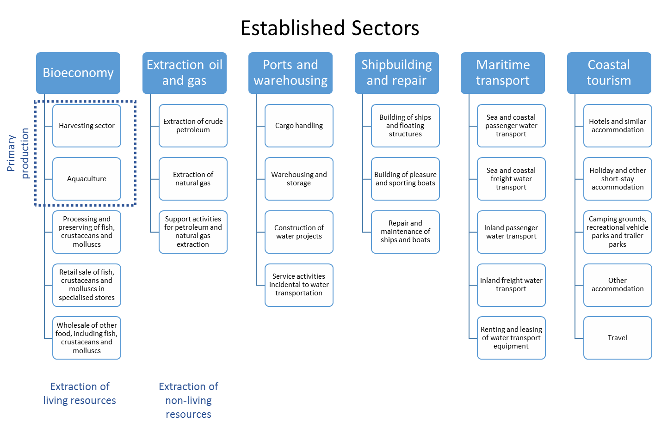

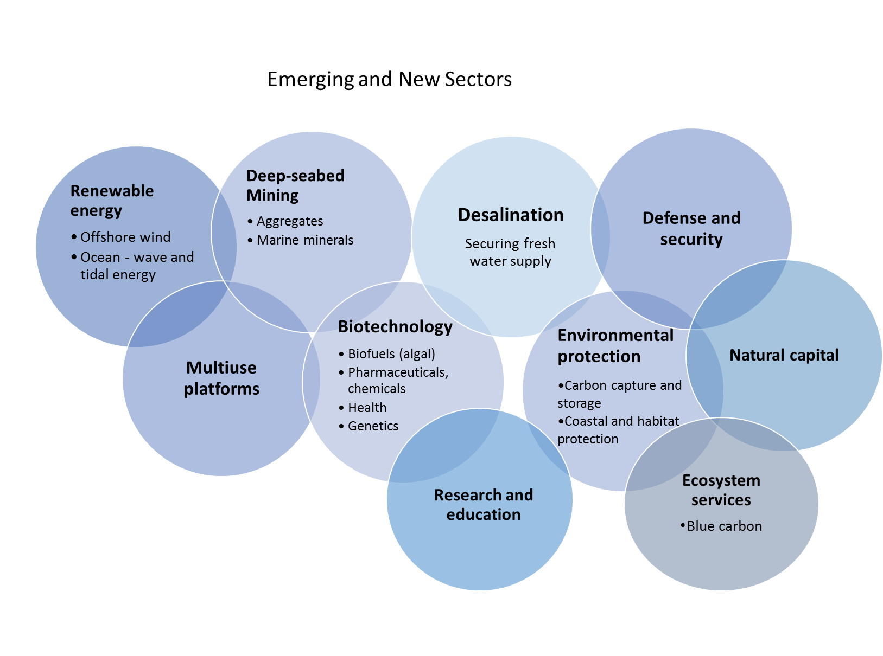

DIRECT IMPACT OF THE BLUE ECONOMY

The blue economy sectors of the EU covered in the present report employed directly around 3.48 million persons in 2016, a modest 1% increase compared to 2008 (3.45 million persons employed). Wages and salaries amounted to €41.0 billion, a 19 % increase on 2008 (€34.6 billion). Blue economy based wages and salaries have grown steadily since reaching a low in 2011, while employment has remained relatively stable, translating into higher average wages.

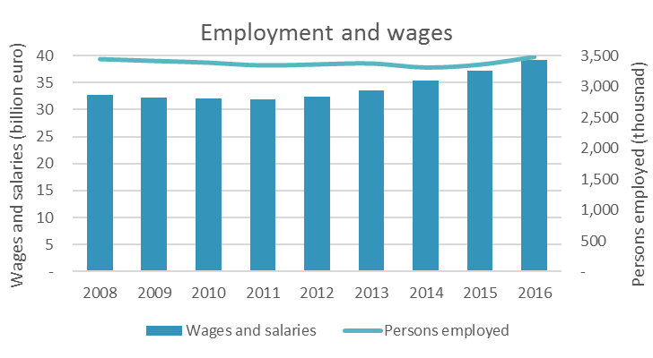

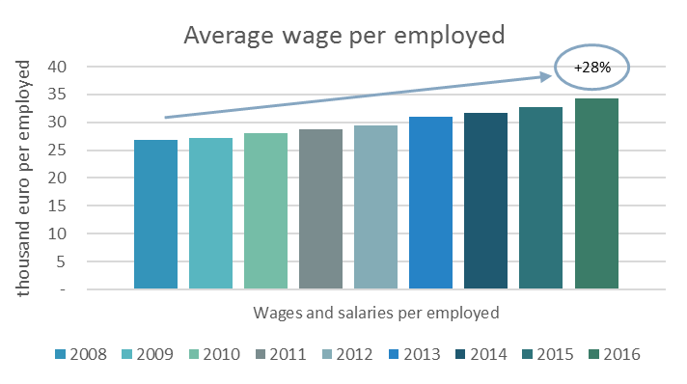

GVA generated by the blue economy sectors covered in the present report amounted to EUR 174.2 billion in 2016, a 4% increase compared to 2008. While gross profit at EUR95.1 billion, saw a 1% decrease on 2008 (EUR96.4 billion). Total turnover was around EUR 566.2 billion, a 1% increase over 2008.

The evolution over the 8 years covered reflects quite well the economic evolution of the whole of the EU economy. All the economic indicators reach and or exceed its pre-crisis levels. The net investment to GVA in particular reflects a sharp change in trend which implies a very significant improvement in economic expectations in the relevant sectors.

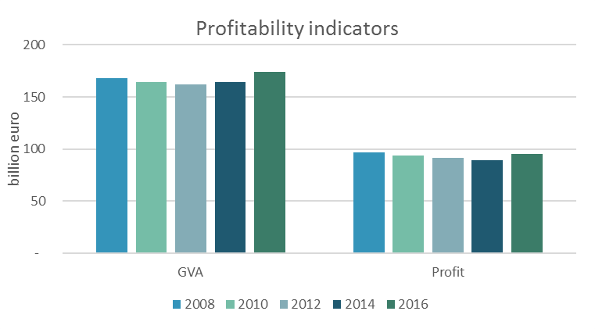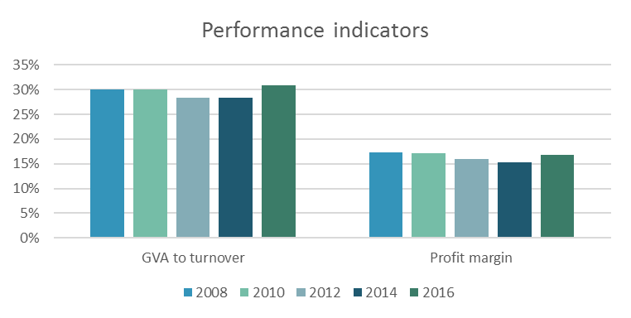

CONTRIBUITION OF THE BLUE ECONOMY

In 2016, the blue economy as covered in the present report amounted to about 1.3% of the EU28 GVA and just over 0.5% of the employment. Whereas the share over total employment remained stable over the period analysed period (2008-2016), the share of the BE over GDP decreased until 2015, but in 2016 had not yet reached its pre-crisis levels. This could be due to fact that some of the sectors covered, e.g. ports, maritime transport and shipbuilding were hit hard by the crisis. It could also be that other sectors beyond the Blue Economy recovered at a faster pace or that land based emerging sectors are gaining importance faster than their maritime counterparts. For example, energy production is cheaper on land and the lower the prices of energy from these sources competes with established or additional blue economy sectors (oil extraction, wind energy, deep sea mining).

Actually, omitting the Maritime extraction of Oil & gas sector, the evolution of the blue economy based GVA and employment follow trends much closer to these of the EU GDP.

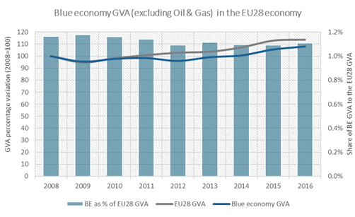

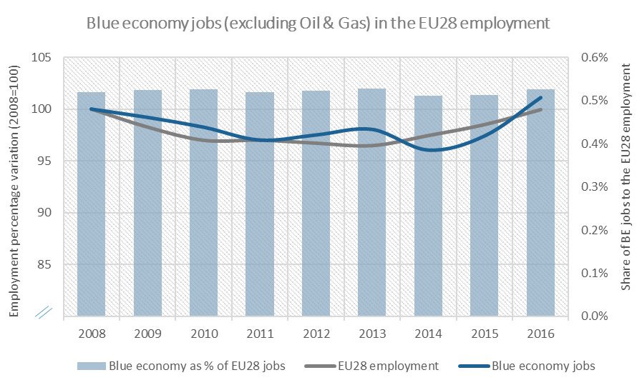

Looking at the sector covered, as stated above, there are significant differences between them in terms of performance. Some sectors perform better than others do: for example, the growth of the bioeconomy sector has outperformed that of the EU28 GDP since at least 2008. This covers the fisheries sector which seems to follow a path relatively independent from that of the economy in general. The positive evolution of the performance of the fisheries sector since 2008 is related to the increased efforts under the CFP to fish at sustainable levels. Available data shows a positive link between sustainable fishing and positive performance. Fishing at sustainable levels reaches a high number of species in the North Sea, the Baltic and the North East Atlantic.

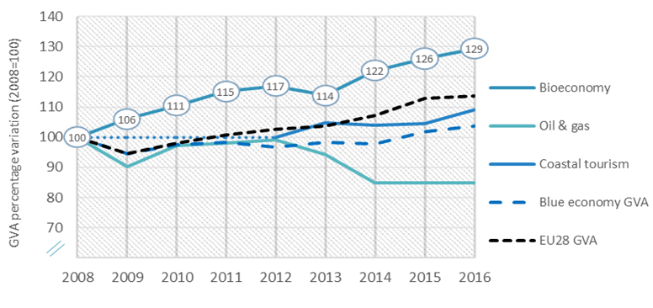

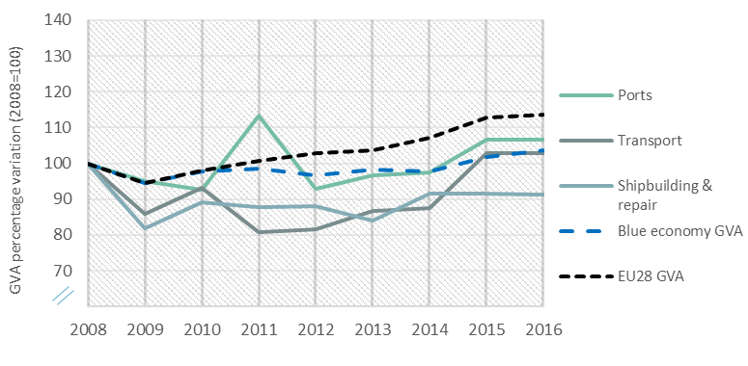

CONTRIBUTION TO NATIONAL ECONOMIES



All Member States below the 1.3% are situated in the north-eastern part of the Union and where the only ones not being landlocked are the Baltic Member States. Only one, Slovenia is Mediterranean. In contrast, four of the five Member States with the highest shares are in situated in the Mediterranean sea-basin. Also in the Iberian Peninsula the blue economy has a shared well above the EU average. The percentage for the UK is above the average but relatively modest.

Compared to 2008, the share of the Blue Economy decreased in Croatia, Denmark, Malta, Cyprus, United Kingdom, Finland and Germany. It increased, in Greece, Bulgaria, Estonia, Netherlands, Portugal, Spain and Belgium.

In terms of employment, Spain generates a fifth of the total EU28 blue economy based jobs (almost 691 000), a figure that has increased since 2008. Italy has moved to second place, with 390 000 jobs in the blue economy while the UK has slipped into third place, followed by Greece. Most likely, most of these jobs are related to tourism. These four Member States generate 52% of the total blue economy jobs, a percentage that jumps to 67% when France and Germany and included. In absolute terms, the five largest EU economies are among the 6 largest countries in terms of jobs.

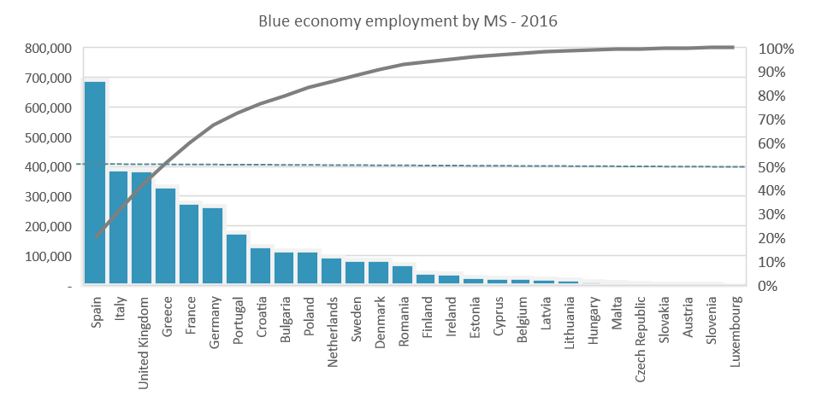

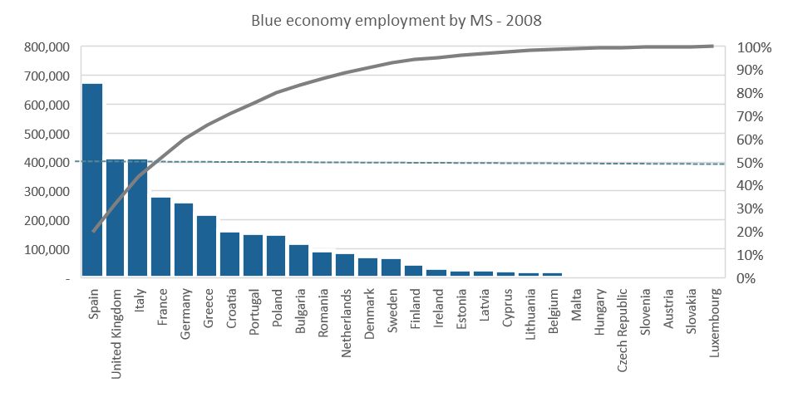

The UK, largely due to the developed offshore oil and gas sector, accounts for almost a third of the total amount spent on blue economy wages and salaries; a figure which increased significantly since 2008. Together with Germany and Italy, these three Member States contribute to 54% of the blue wages and salaries in the EU28.

Also as regards, GVA, the UK leads in generating blue economy based GVA (22% of the total) and gross profit (24%) and is the top invester (32%). Together with Spain, Italy, Germany and France, the UK accounted for 66% of the blue GVA in 2016. Denmark, the Netherlands and Greece add a further 17.2%.

The UK with Spain, Italy and Demark accounted for 56% of the profit generated in 2016. Germany fell from second poition in 2008 to fifth in 2016.

SECTORS OF THE BLUE ECONOMY

The blue economy sectors are not by any means equivalent to each other. At 61% in 2016, up from 59% in 2008, coastal tourism accounts for the largest share of employment corresponding to the sectors covered by the present report. The contribution of that sector to the Blue Economy as covered by the present report in terms of GVA and gross profits, while higher than in 2008, is significantly lower (40% and 42% respectively) than that to employment.

In contrast, the extraction of non-living marine resources sector, i.e., oil & gas, which represents less than 2% of the employment, generated 15% of the GVA and 20% of the gross profits in 2016 even if down from 18% and 26% respectively in 2008). It is clear then that each of these sectors has very different levels of labour productivity but also that their contribution to the resilience of coastal areas –measured in terms of jobs- varies very much.

The offshore oil and gas is a highly capitalised sector that requires few employees per unit of output and that is very much concentrated in very few geographical areas. In contrast, the coastal tourism sector is a labour intensive activity, particularly during the high season, which is widespread all along the EU coastline.

Regarding the other sectors covered, the bioeconomy sector is growing since 2008. This is very much the case of the fisheries catching sector, where growth is compatible with increasingly sustainable exploitation of stocks. In shipbuilding most of the value added is from upstream and downstream activities. That means that beyond its specific contribution, multiplier effects on income and jobs are important in many sectors of the Blue Economy. These multiplier effects are quite significant also in the catching sector. One of the side effects of the restructuring of the EU fishing fleet has been, according to the sector that the reduction of the fishing fleet has resulted in parallel reductions in activities ancillary to fishing and in income and job losses beyond these in the catching sector.

Comparing 2016 with 2008, it appears that the bioeconomy and coastal tourisms on the one hand and the shipbuilding & repair and oil and gas have followed opposite evolutions during the crisis. It looks as if the first two act as buffers to compensate loses of jobs but also GVA and gross profits in industrial sectors.

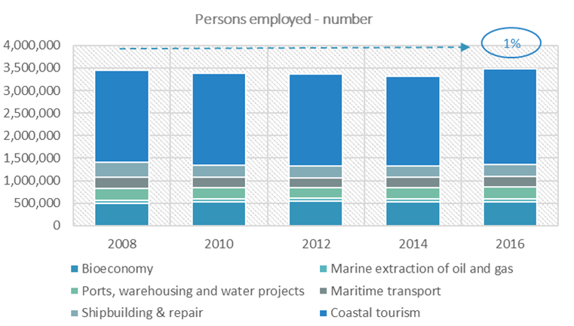

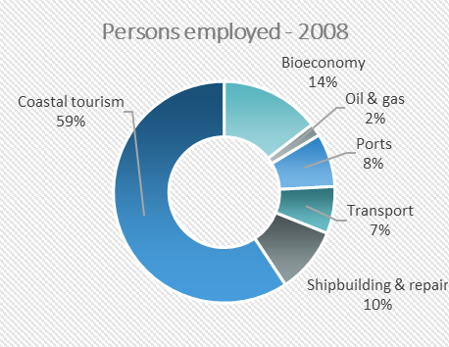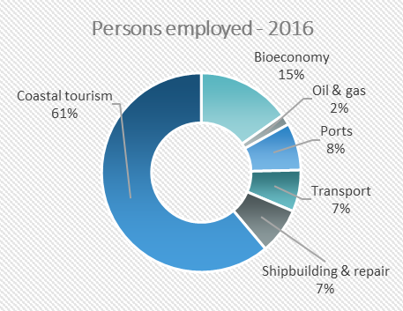

BLUE ECONOMY EMERGING SECTORS

The following section provides an account of the socio economic data of what are categorised as emerging sectors within the blue economy. Although some of these may have been around longer than others, they are emerging in that they have not nearly achieved their full potential. The first part will cover renewable energy and will mainly focus on off-shore wind energy and ocean energy (i.e. tidal and wave energy), followed by blue bio technology, desalination and finally deep-sea mining.

It is worth noting that in being emerging sectors the consistent collection of socio-economic data has proven difficult. With the exception of off-shore wind energy and to a lesser extent wave and tidal energy, the lack of data is the main challenge faced in the drafting of this report. Previous studies undertaken by the OECD and the European Commission already point out that more should be done to improve data collection and quality. This having been said, the data available does shows interesting trends and great potential.

Off-shore wind: Perhaps the most well-established of the emerging sectors and the one for which more reliable and accurate data is available. On-shore wind farms have been around for many years and are booming industry. Off-shore wind energy seems to be headed in the same direction. European investment in the sector has increased in recent years, as has employment, which the OECD believes will be at 170,000 by 2020 and double that by 2030.It is worth noting that most of the activity within the industry took place in Europe, which indeed is responsible for 91% of global GW off-shore wind capacity.

Ocean energy: Renewable energies need not only encompass offshore wind but various forms of ocean energy too. In the section below the report will focus mainly on both wave and tidal energy. Currently both are being further development and so much is being investment in research. In fact, The JRC estimates that employment in Europe for this sector currently stands at 1800-2050m of which 1450 would be in research and development. Moreover, JRC data shows that the EU is an important actor in this sector and hosts half of the world's tidal energy developers and 60% of the wave developers.

Blue biotechnology: has various application of different types it has had an impact in the healthcare and pharmaceutical sectors by creating new medication and vaccines for a wide range of diseases (e.g. multiple sclerosis (MS)), In agriculture, livestock, veterinary products, and aquaculture it has helped produce vaccines to as well as improving animal feed. In industrial processes and manufacturing, has led to the use of enzymes in the production of detergents, pulp and paper, textiles, and biomass, Finally, in energy production, as blue biotechnology can produce large amounts of oil through micro-algal. In terms of socio-economic data it is still challenging to find consistent accurate information. Most of it comes from the private sector, can are not necessarily being collected regularly and following strict criteria. However, the OECD estimated the sector to be a USD 2.8 billion in 2010, and is projected to increase to around USD 4.6 billion by 2017 at a global level. Data provided by the industry claims that the EU algae biomass sector currently employs 14.000 people and has a value of EUR 1.69 billion, which includes research and development, equipment production and jobs in the larger supply chain which depend on output from the algae sector.

Desalination: Desalination plants can be found across the globe with the largest one being located in Saudi Arabia. Some EU MS have too started investing in this sector and the biggest plant at EU level can be found in Almeria, Southern Spain. Although still emerging, this can indeed prove to be a key sector, if we consider that some countries and cities are already experiencing water shortages. In the case of desalination data is practically non-existent. This does not necessarily mean that the sector does not have potential and is not beginning to thrive, but there does not seem to be a well-established process of data collection for it.

Deep-sea mining: Lack of data is a problem also in this emerging sector, alongside lack of knowledge. The former, as highlighted previously in other sectors is due to the fact that information is not being collected in a regular and consistent manner. The latter is due to the fact that although exploration projects are underway, no actual deep-sea mining project has taken place, thereby making it difficult to fully assess its socio economic potential, however what seems clear is the potential for negative environmental impacts of the sector.

**PART 2: RESULTS OF EMFF SUPPORT TO THE BLUE ECONOMY 2014-2020**

**EXAMPLE 1: AQUACULTURE - FACTS, FIGURES, PROJECTS**

Market data for Europe show a 4% growth in volume and an 8% growth in value between 2014 and 2015. This is an indication that our continuous work with Member State authorities to remove barriers for growth is yielding first results, after a long period of stagnation.  Although still at a low level compared to Asia and with growth rates still lagging behind, the European aquaculture sector generated in 2015 more value than ever before.

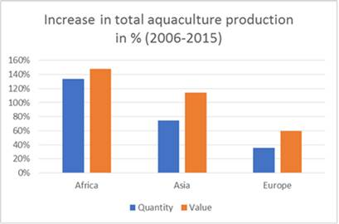

In addition to working with national authorities through the Open Method of Coordination, the Commission directly supports innovative aquaculture initiatives in Europe through two strands (in addition to support via shared management).  The projects funded are addressing the full cycle of challenges that the aquaculture industry faces: from education and acceptance to space conflicts, from better feed to business set-up.

**European Maritime and Fisheries Fund (EMFF) – in direct management**

[BBMBC](https://ec.europa.eu/easme/en/blue-biotechnology-master-blue-career) (education: Master related to aquaculture)

[BlueSmart](https://ec.europa.eu/easme/en/blue-education-sustainable-management-aquatic-resources) (education: Master related to aquaculture)

[Entrefish](https://ec.europa.eu/easme/en/sustainable-entrepreneurship-stronger-skills-and-new-employment-fishery-s-and-aquaculture-s-smes) (education: Master related to aquaculture)

[FAIMMAC](https://ec.europa.eu/easme/en/fishery-and-aquaculture-integrated-management-model-along-adriatic-coasts) (promoting the eco-friendly production of flat oyster in Italy), see also <https://www.facebook.com/FAIMMAC/>

[Amalia](https://ec.europa.eu/easme/en/algae-market-lab-ideas-adding-value-marine-invasive-seaweeds-iberian-northwest) (aquaculture feed)

[INvertebrateIT](https://ec.europa.eu/easme/en/disruptive-and-forward-looking-opportunities-competitive-and-sustainable-aquaculture) (production of insects for aquaculture feed via the use of organic waste)

**Research Framework Programmes (FP7 and Horizon 2020)**

[OCEANFISH](http://cordis.europa.eu/result/rcn/203874_en.html) takes advantage of ocean currents to enable fish farming further out to sea.

[TARGETFISH](http://cordis.europa.eu/result/rcn/203871_en.html) works towards keeping the fish in these farms disease-free by developing vaccines with an effective means of delivery

[ARRAINA](http://cordis.europa.eu/result/rcn/166136_en.html) explores plant based feed for farmed fish to reduce pressure on marine resources

[IDREEM](http://cordis.europa.eu/result/rcn/155950_en.html) seeks to improve the integrated production of the European aquaculture sector for reduced waste and increased competitiveness.

Under shared management within the EMFF, Member States may use much larger amounts, up to 1.2 bn euro until 2020.  A particularly interesting and growing activity are **projects in local communities (FLAGs)**:

**Duckweed for fish feed -** Kainnu Koillismaa FLAG, Finland

A fish farm teamed up with the local FLAG and a LEADER LAG to take advantage of nutrients dissolved in water on fish farms by cultivating duckweed (*Lemna minor*) as an aquatic crop in the ponds. The duckweed removes unwanted substances from the water and is harvested and used as protein-rich feed. This project promotes the use of domestic feed ingredients and environmentally-friendly fish farming while being cost-effective.

**Biodegradable meshes for mussel cultivation -** Ria de Arousa FLAG, Spain

With the help of FLAG funding, a local company has been able to put in place a biodegradable mesh for their mussel cultivation. Using this completely environmentally-friendly mesh, their organic mussel production contributes to solving important problems in the mussel-growing sector by improving the environmental impact of the manufactured products. The project has also opened up a new line of production in the company.

**Tomatofish -** Mecklenburgische Seenplatte-Müritz FLAG, Germany

A local fish farm company has developed an innovative way to grow fish and tomatoes together in one integrated system: the aquaponics system. This energy- and water-efficient method while the fish waste provides an organic food source for plants which, in return, naturally filter the water. The project was put in place in collaboration with the Leibniz-Institute of Freshwater Ecology and Inland Fisheries, IGB Berlin. It is open to visitors and promotes this technology for a wider-spread use in similar inland territories.

**Cultivating microalgae for oil extraction -** Costa da Morte FLAG, Spain

Thanks to the FLAG’s financial support, a young producer has set up a start-up company to cultivate microalgae on land specifically for oil extraction. The oil, high in omega-3, will then be used as a pharmaceutical-grade and standardized nutrient and as raw material for human consumption. The project envisages an annual production of 4 000kg of microalgae.

**Combining functionality with recreational activities -** Braila FLAG, Romania

With FLAG funding, an aquaculture farm has acquired all the necessary equipment (kitchen, bar, utensils, furniture, etc.) to set up a restaurant. A pontoon was also built in proximity to Lake Blasova’s shore using over 100 m2 of floating modules with an anchoring system and a bridge. This pontoon unites the functionality of the restaurant with specific fishing and recreational activities happening on the lake.

**From crushed shells to 3D printing -** North Sardinia FLAG, Italy

The initial phase of the project was reusing crushed shells as a mineral supplement for poultry and for soil fertilization. Local high school students and teachers have taken the project even further by using crushed shells for 3D printing. This method uses a mixture of resins to produce any items such as jewellery, watch cases, eyeglass frames, tiles, worktops or other. The FLAG works with the project promoters on the business plan, marketing, equipment acquisition etc. to develop the start-up.

**Reconnecting the land and the sea -** West FLAG, Ireland

Facilitated and funded by the FLAG, a group of shellfish farmers, shellfish exporters, inshore fishermen, and marine heritage enthusiasts have formed a community-based organisation to improve the quality of life, environment, economy and maritime heritage around its bay area. Together they work to reconnect the local community with the bay’s activities, organizing demonstrations and tasting events as well as a workshop to plan the rejuvenation of the native oyster. Promotional material and a website are also being developed.

**Detecting toxic marine microalgae -** Pyrénées-Méditerranée FLAG, France

The local oyster farm situated in a lagoon in the Mediterranean Sea is regularly affected by toxic phytoplankton contamination which leads to economic losses during the critical season around Christmas. In order to prevent this, the farm has teamed up with a research institute to develop an innovative solution to detect toxic marine microalgae and anticipate the toxic proliferation especially during the high oyster season.

**Fish farm activities for the entire community -** Our Krajna and Paluki FLAG, Poland

To ensure a better integration of the fisheries sector within the community, the FLAG has been working closely with the largest carp producer in its region to encourage local fish consumption and improve environmental awareness. In cooperation with the fish farm and other actors, the FLAG has organised a series of activities including fish farming demonstrations and carp filleting shows, bird camps and cross-country running and geocaching which has helped the farm take on a more active role in the community activities while increasing direct sales.

**Community sea gardens -** Djursland FLAG, Denmark

As fishing activities declined in their local harbour, a voluntary association was created to set up a sustainable sea garden near the port for local community members to grow shellfish and seaweed on a small-scale. A dynamic network of about 80 gardeners has taken root, bringing new life into the harbour. They mainly grow mussels, but also seaweed and oysters, contributing to a cleaner marine environment. The local FLAG supported the project idea, though it was ultimately funded through other sources.

**EXAMPLE 2: MARITIME SPATIAL PLANNING IN THE BLACK SEA**

[MARSPLAN](http://marsplan.ro/en/), the first project to bring Romanian and Bulgarian authorities and institutes together to work on Maritime Spatial Planning in the Black Sea, is approaching the finish line.

In the past two and a half years MARSPLAN has produced a [report on the institutional and legislative framework](http://marsplan.ro/en/results/institutional-and-legislative-framework.html) for maritime spatial planning in the Black sea, a [detailed analysis](http://marsplan.ro/en/results/msp-studies.html) of the Bulgarian and Romanian maritime areas, several [case studies](http://marsplan.ro/en/results/case-study.html), a [common methodology](http://marsplan.ro/en/results/defining-common-methodology.html) for analysis and a c[ommon strategic framework](http://marsplan.ro/en/results/common-strategic-framework-for-msp.html) for MSP with sectorial, environmental and geological maps as well development scenarios. Importantly, through intense cooperation the project also delivered a draft [maritime spatial plan for the Mangalia – Shabla](http://marsplan.ro/en/results/maritime-spatial-plan-for-the-cross-border-area-mangalia-shabla.html) area on the Bulgarian-Romanian border.

MARSPLAN started in the summer of 2015 to support the implementation of the EU [legislation](http://eur-lex.europa.eu/legal-content/EN/TXT/?uri=uriserv:OJ.L_.2014.257.01.0135.01.ENG) on [maritime spatial planning](https://ec.europa.eu/maritimeaffairs/policy/maritime_spatial_planning_en) in Romania and Bulgaria, but also to create a strategic vision for the whole Black Sea area. Funded through the EMFF annual work programme of 2014, it received an EU contribution of 1.6 million euro.

The European Commission will formally approve the project’s results after its official closure in February. But it is safe to say that by gathering together the public authorities that coordinate land and sea transport, environmental protection and coastal management in both countries, MARSPLAN has laid a solid foundation on which they can both establish their own national plans and build a common vision for border areas.

Riding on the MARSPLAN momentum and as a next step, we envisage reaching out to the other Black Sea countries in the course of the year to extend the effort to the rest of the basin and promote the principles of environmentally and economically sound maritime spatial planning in the whole of the Black Sea.

**EXAMPLE 3: NAUTICAL ROUTES FOR EUROPE – FIVE NEW TOURISM IDEAS LAUNCHED TO MAKE EUROPE A DESTINATION OF EXCELLENCE**

European tourists, and particularly sailors, boaters and water sports practitioners are in for a treat: soon they will be able to choose from another series of attractive and unique formulas designed to let people discover the continent's tremendous maritime heritage, from marine archaeology to wind, from history to sport, from fish to food and wine.

After the success of the first few projects on underwater cultural heritage (such as the UCRCA project, the NIRD project and the ATAS project ), and in-keeping with the European Year of Cultural Heritage, the European Union is now financing a series of new initiatives designed to give visitors an all-round experience and kindle the European tourism industry.

The Tuna Route celebrates the importance of the iconic Bluefin Tuna in the Western Mediterranean by bringing together science, conservation, culture, gastronomy and aquaculture. A service of charters will connect destinations and activities throughout the route and games will inform consumers on the full range of labelled products.

The Meltemi Route will create at least four sailing itineraries focused on water sports and nautical tourism in the North-East Aegean Sea. It will enable people to sail in the wake of the Meltemi wind and touch upon otherwise unreachable, totally unspoiled spots along the magnificent coasts of Greece and Turkey.

The WAOH Route aims to develop the first European sustainable diving route along 5000 km of Atlantic coastline, from the South of Portugal and Spain to the North of Ireland and the UK.ChannelSail creates a nautical route from English Cornwall to French Cornouaille to rediscover, through historical and modern sailing activities, the Celtic heritage common to both these Channel regions.

From Greece to Magna Graecia will design experiential sailing cruises between Greece and Italy and complement them with rich offer of cultural and scientific experiences like exploring the seabed, learning about the gastronomic traditions across the Ionian Sea and trying sports such as kite-surfing, diving or fishing.

These projects are being financed through the European Maritime and Fisheries Fund with total budget of about 1.5 million euros. They will promote off-season tourism and thus extend the opening times of businesses; they will attract travellers to new, lesser known areas, thus reducing pressures (environmental and social) at traditional destinations; and they will above all promote the shared values of the various European destinations and encourage a responsible and sustainable behaviour on the part of travellers – all core principles of the EU's Strategy for Coastal and Maritime Tourism.

**EXAMPLE 4: EUMOFA COUNTRY PROFILES**

Up-to-date profiles and data about aquaculture and fisheries in all EU 28 Member States

Through the EUMOFA EU Market Observatory for Fisheries and Aquaculture – two core sectors of the Blue Economy – the latest data about the aquaculture and fisheries industry is provide in each of the EU's 28 Member States. This is useful information for all who what to inform themselves about those sectors in the country they live in or in a country they are visiting!

|  |  |  |  |  |  |  |  |  |  |  |  |  |  |
| --- | --- | --- | --- | --- | --- | --- | --- | --- | --- | --- | --- | --- | --- |
| |  |  |  |  |  |  |  |  |  |  |  |  |  | | --- | --- | --- | --- | --- | --- | --- | --- | --- | --- | --- | --- | --- | | |  | | --- | |  | |  | | |  |  |  |  |  | | --- | --- | --- | --- | --- | | |  |  |  |  | | --- | --- | --- | --- | |  | |  |  | | --- | --- | | |  | | --- | | **New country profiles are now online** on [**www.eumofa.eu**](https://eumofa.us12.list-manage.com/track/click?u=8f50ddacc29d98ce55398bbd0&id=7d0dae69ac&e=97f75aad4c)  **EUMOFA has launched the new country profiles, aiming to offer a unique and detailed snapshot of each stage of the fisheries and aquaculture supply chain of each EU country.** | | | | | |  |  | | --- | --- | | |  | | --- | | [Austria](https://eumofa.us12.list-manage.com/track/click?u=8f50ddacc29d98ce55398bbd0&id=879e883973&e=97f75aad4c) [Belgium](https://eumofa.us12.list-manage.com/track/click?u=8f50ddacc29d98ce55398bbd0&id=7611c72c36&e=97f75aad4c) [Bulgaria](https://eumofa.us12.list-manage.com/track/click?u=8f50ddacc29d98ce55398bbd0&id=59ca890c55&e=97f75aad4c) [Croatia](https://eumofa.us12.list-manage.com/track/click?u=8f50ddacc29d98ce55398bbd0&id=a2f7e137c3&e=97f75aad4c) [Cyprus](https://eumofa.us12.list-manage.com/track/click?u=8f50ddacc29d98ce55398bbd0&id=79703f3988&e=97f75aad4c) [Czech Republic](https://eumofa.us12.list-manage.com/track/click?u=8f50ddacc29d98ce55398bbd0&id=8ccc1b8481&e=97f75aad4c) [Denmark](https://eumofa.us12.list-manage.com/track/click?u=8f50ddacc29d98ce55398bbd0&id=76c8962d71&e=97f75aad4c) [Estonia](https://eumofa.us12.list-manage.com/track/click?u=8f50ddacc29d98ce55398bbd0&id=c67112b432&e=97f75aad4c) [Finland](https://eumofa.us12.list-manage.com/track/click?u=8f50ddacc29d98ce55398bbd0&id=7436c3222a&e=97f75aad4c) [France](https://eumofa.us12.list-manage.com/track/click?u=8f50ddacc29d98ce55398bbd0&id=6357aacf5f&e=97f75aad4c) [Germany](https://eumofa.us12.list-manage.com/track/click?u=8f50ddacc29d98ce55398bbd0&id=158e44e96c&e=97f75aad4c) [Greece](https://eumofa.us12.list-manage.com/track/click?u=8f50ddacc29d98ce55398bbd0&id=1f8389542b&e=97f75aad4c) [Hungary](https://eumofa.us12.list-manage.com/track/click?u=8f50ddacc29d98ce55398bbd0&id=3f00b58519&e=97f75aad4c) [Ireland](https://eumofa.us12.list-manage.com/track/click?u=8f50ddacc29d98ce55398bbd0&id=e305f2d7ff&e=97f75aad4c) [Italy](https://eumofa.us12.list-manage.com/track/click?u=8f50ddacc29d98ce55398bbd0&id=01036e3935&e=97f75aad4c) [Latvia](https://eumofa.us12.list-manage.com/track/click?u=8f50ddacc29d98ce55398bbd0&id=57f78effc8&e=97f75aad4c) [Lithuania](https://eumofa.us12.list-manage.com/track/click?u=8f50ddacc29d98ce55398bbd0&id=2daf2b59c4&e=97f75aad4c) [Luxembourg](https://eumofa.us12.list-manage.com/track/click?u=8f50ddacc29d98ce55398bbd0&id=2b6112102f&e=97f75aad4c) [Malta](https://eumofa.us12.list-manage.com/track/click?u=8f50ddacc29d98ce55398bbd0&id=9c177c7d58&e=97f75aad4c) [Netherlands](https://eumofa.us12.list-manage.com/track/click?u=8f50ddacc29d98ce55398bbd0&id=10ab76b5da&e=97f75aad4c) [Poland](https://eumofa.us12.list-manage.com/track/click?u=8f50ddacc29d98ce55398bbd0&id=202bd0028e&e=97f75aad4c) [Portugal](https://eumofa.us12.list-manage.com/track/click?u=8f50ddacc29d98ce55398bbd0&id=3b6da6bb52&e=97f75aad4c) [Romania](https://eumofa.us12.list-manage.com/track/click?u=8f50ddacc29d98ce55398bbd0&id=83d46e43ab&e=97f75aad4c) [Slovakia](https://eumofa.us12.list-manage.com/track/click?u=8f50ddacc29d98ce55398bbd0&id=350fb1c2a0&e=97f75aad4c) [Spain](https://eumofa.us12.list-manage.com/track/click?u=8f50ddacc29d98ce55398bbd0&id=f6cf86f013&e=97f75aad4c) [Sweden](https://eumofa.us12.list-manage.com/track/click?u=8f50ddacc29d98ce55398bbd0&id=9dbee446f6&e=97f75aad4c) [Slovenia](https://eumofa.us12.list-manage.com/track/click?u=8f50ddacc29d98ce55398bbd0&id=48855b3eaa&e=97f75aad4c) [United Kingdom](https://eumofa.us12.list-manage.com/track/click?u=8f50ddacc29d98ce55398bbd0&id=13b948d580&e=97f75aad4c) | | | | |  | | |

# Features in fisheries and maritime policies post-2020

**FEATURES IN FISHERIES AND MARITIME POLICIES POST-2020**

|  |  |  |
| --- | --- | --- |
| *Specific objective* | *Retained features* | *Discarded features* |
| SO 1:1 Sustainable, competitive and inclusive fisheries | A targeted model introducing a new feature compared to the current period. Fleet adaptation measures will remain necessary as regards certain fleet segments or certain sea basins (e.g. Mediterranean, consequences of Brexit). However, such support needs to be tightly linked to specific conservation objectives (especially as regional multiannual management plans enter into effect) and to a more effective fleet management by Member States.  Modernisation of the fleet with regard to innovation, health and safety, energy efficiency and investments on board improving the quality of products.  Maintaining higher co-financing rates and allow higher aid intensity for investments in outermost regions compared to the mainland. | To focus future funding exclusively on supporting the implementation of the landing obligation and the discard ban and completely exclude all fleet measures. |
| SO 1:2 Sustainable and competitive SSCF | Higher intervention rates  Differentiated areas of support (e.g. certain operations only for small-scale operators)  Differentiated forms of support (e.g. access to grants only for small-scale operators and only financial instruments for other beneficiaries) | Earmarked support for small-scale operators |
| SO 1:3 Implementation of the CFP (fisheries control, data) | Continue financial support for fisheries control and link it with the revision of the Control regulation.  Reinforce the link to maritime surveillance  Strengthen the collection and processing of marine data in synergy with EMODNET and the MSFD. | Merging support for control and maritime surveillance. |
| SO 1:4 Conservation of marine ecosystems | Continue support for biodiversity protection, including support to the management, restoration and monitoring of Natura 2000 sites and other MPAs, to promote more selective fishing gear, to avoid accidental by-catch of species (marine mammals and seabirds) to continue addressing the issue of collection of marine litter and to support aquaculture providing environmental services.  Develop cross-cutting indicators for all EU funds for Natura 2000, building on and adapting existing indicators developed under the EMFF. |  |
| SO 2:1 Sustainable, innovative and competitive aquaculture | Target support to productive and innovative investments to growth. Support should be provided through financial instruments.  Support on compensatory measures for less profitable aquaculture activities  Grants for enabling conditions for aquaculture - including stock insurance schemes - could be considered as well in addition to covering aquaculture more prominently in local development strategies (CLLD) as an important area for diversification, jobs and growth. | To provide grants for investments  To exclude inland aquaculture  To let other funding instruments take care of supporting investments in aquaculture |
| SO 2:2 Market organisation | Financial support for the organisation of the sector and its structure through producer organisations (POs) | Discontinue market support |
| SO 2:3 Quality and sustainability of products | Keep the support but provide it only through financial instruments for all including for SMEs. | Discontinue support for processing  Provide support through financial instruments for all but SMEs who could still get grants |
| SO 3:1 Enabling an innovative, sustainable and knowledge-based blue economy | Focus on providing funding for enabling conditions to facilitate innovation and market development in the blue economy by addressing market failures for the sustainable development of economic activities, safeguard ecosystems and reinforce security at sea. It also includes enhancing marine and scientific knowledge (e.g. EMODNET and MSFD).  Outermost regions would be encouraged to draw up maritime sustainable development strategies. | Focus future funding almost entirely on maritime policy and blue growth and only keep a minor part for data, control and the CLLD-approach. The problem here is that available funding would still not be to enough to provide sufficient funding for unlocking the potential of the maritime economy while key objectives of the CFP would risk not to be delivered.  Fund maritime policy through other funding instruments |
| SO 3:2 Prosperous blue coastal and inland communities | Broaden the scope of the approach to include maritime policy/blue growth.  Further strengthen the role of the FLAGs is to introduce a new feature by aligning with the principles of the EAFRD and ensuring that a meaningful share of the post-2020 funding is delivered through CLLD. | Continue as during 2014-2020 with the same coverage and roughly the same level of funding.  Ring-fence the CLLD allocation |
| SO 4:1 International ocean governance | Continue support for international and regional organizations (RFMOs, RSCs)  Broaden scope of support for international ocean governance through ; development of ocean partnerships with key partners; building capacity for better ocean governance, conservation and restoration of marine biodiversity and sustainable blue economies with key partners, promote MSP worldwide and strengthening; international ocean research and data.  Include support needed to effectively implement the external part of the EU policy to fight against IUU fishing in the form of technical assistance to third countries to implement international obligations (ex. revision of legal frameworks, MCS capacity trainings, correct implementation of the EU catch certification scheme) and operational maintenance/update/development of the IT tool for the EU IUU catch certification scheme. | Continue as during 2014-2020 |
| SO 4:2 Maritime surveillance and coastguards cooperation | To promote, in line with the EUMSS Action Plan, enhanced international cooperation on maritime security (including on the fight against IUU), integrated maritime surveillance (particularly CISE), capability development and research & innovation, risk management and assessment as well as dedicated education and training activities in the field of maritime security.  Include support for interagency cooperation on coast guard functions, established following the revision of the mandates of the EFCA, EMSA and FRONTEX | Continue as during 2014-2020 |

# CLLD implementation under the EFF and the EMFF

**(1) Fisheries CLLD in the programming period 2007-2013**

Axis 4 of the European Fisheries Fund (EFF) was used by 312 Fisheries Local Action Groups (FLAGs) from 21 Member States (MS). It had a budget of 522 M€ (EFF contribution, 11.5% of total EFF budget). FLAGs covered an area of over 850 000 square km and a population of over 28 000 000 (based on data from 270 FLAGs for which such information is available).

Information collected by the FARNET support unit (FSU) indicates that FLAGs in 2007-2013 period supported **over 11.000 projects**. The graph below illustrates the purposes of projects (based on a sample of FLAGs from 15 MS, Cap Gemini study of 2014):

Adding value, creating jobs and promoting innovation

Supporting diversification

Enhancing and capitalising on environmental assets

Social wellbeing and cultural heritage

Strengthening the role of fisheries communities in local development

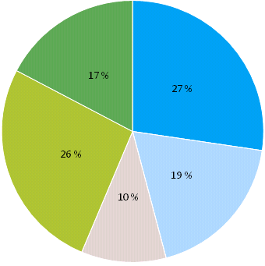

According to a FLAG survey carried out by FSU in 2016, projects supported by EFF in 151 FLAGs which responded to the survey (almost 50% of the total number of FLAGs) helped to **create nearly 3900 jobs** and **maintain a further 4500**, and to create **1050 new businesses**. Approximately **2700** projects have specifically targeted the **small-scale coastal fisheries** sector.

**(2) Fisheries CLLD in the period 2014-2020**

In 2014-2020, Union Priority 4 of the EMFF is implemented by 20 Member States who, by the end of 2017, had selected 368 FLAGs. Complete data is not yet available, but 228 FLAGs cover an area of nearly 250 000 square km and a population of nearly 24 000 000.

These FLAGs have at their disposal a total budget of 522 M€ (EMFF contribution, ca. 12% of the EMFF[83]), plus ca. 170 M€ of national/regional public funding. The average total public funding per FLAG by Member State (in M€) is presented below:

According to information collected by FSU, 170 FLAGs for which such data is already available have **mobilised over 8500 stakeholders** (members of the FLAG partnerships), of which over **2300** represented the **fisheries and aquaculture** sectors.

By the end of December 2017, **1317 projects** had been selected for implementation and approved by the relevant authority:

In nine MS, FLAGs also have access to other ESI funds to implement their local strategy. The graph below shows how many FLAGs in those countries use which combination of funds:

# FLAG support to small scale coastal fisheries

* **Objective & Methodology**

The FARNET Support unit carried out a study to assess the level of support channeled through the Fisheries Local Action Groups (FLAGs) towards Small Scale Coastal Fisheries (SSCF) as no data was systematically collected on this topic. The study consisted in a survey addressed to all FLAGs in existence in the 2007-2013 programming period as well as in 4 case studies on 4 FLAGs which harbored significant SSCF. The definition of Small Scale Coastal Fisheries used was based regulation 508/2014 but adapted to account specifically for inland fisheries and on foot fishing/shellfish gathering.

* **Importance of SSCF in FLAG Areas**

There is a clear tendency for FLAGs to be located in areas with strong SSCF presence: 50 % of surveyed FLAGs report SSCF to represent 80 to 100% of the fisheries sector locally. There is a strong but not systematic relationship between the importance of SSCF locally and the budget devoted by FLAGs to support SSCF.

* **FLAG Projects 2007-2013 (EFF)**

An estimated 2682 projects were targeted at small scale coastal fisheries in the period 2007-2013 accounting for around 23% of FLAG projects. The share of projects targeting SSCF jumps to around 40% if inland areas without commercial fishing are taken out of the population. In other words, those FLAGs where SSCF was potentially present devoted around 40 % of their projects to support that segment of the fleet. Areas with important inland commercial fishing activities (Finland, Estonia) were heavily supported by FLAGs.

* **Financial Support 2007-2013 (EFF)**

The level of total public support (EFF and national co-financing) channeled through the FLAGs in support of SSCF for the period 2007-2013 can be estimated was about EUR 140 million (of which around EUR 90 million EFF and 50 million national co-financing). This represents close to 20% of the total public money available to the FLAGs in the period 2007/2013.

The share of the budget devoted to SSCF increases to close to 30 % of total public expenditure if inland areas without commercial fishing are taken out of the population. In other words, those FLAGs where SSCF was potentially present devoted around 30 % of their budget to support that segment of the fleet.

* **Project Size and Types of Projects (EFF)**

The average size of SSCF projects supported by FLAGs amounts to around EUR 41 000. This is below the average project size of around EUR 62 000. SSCF projects are therefore generally smaller than other types of projects financed by Axis 4. The two more popular categories of projects are those linked with product promotion and support to diversification of activities outside fisheries. Supporting forms of diversification within the sector itself and supportto small scale infrastructure and working conditions come not far behind. The types of project supported vary very much per Member State.

* **Non-Financial Support**

90 % of FLAG surveyed provided non-financial type of support to SSCF. Support to access funding from other programmes and support to foster collaboration with other stakeholders were the two most common non-financial types of support FLAG provide to SSCF.

* **Planned Financial Support 2014-2020 (EMFF)**

Financial support to SSCF was expected to increase in the current period with several elements pointing in the same direction. An estimate of EUR 210 million was proposed but should be treated with caution as it represents a 13% increase in the level of support compared to the period 2007-2013. In absolute terms, this represents an increase of around EUR 70 million.

# Financial Instruments using EMFF – 2014-2020 Programming Period

Three Member States have started or intend to start using EMFF in Financial Instruments.

***Estonia:***

There are three FI products supported through the EMFF OP: two for the fish processing sector and one for the aquaculture sector:

* Growth loan (processing) fund: EUR 3.2 m; started in 2017; Loaned: approx. EUR 300 000 (5 beneficiaries)
* Long – term investment loan( processing): EUR 4m; started in 2017; Loaned: EUR 500 000 (2 beneficiaries)
* Investment loan for aquaculture development: EUR 4m; available from June 2017 (no loans to date)

2018 will be the first year for the Estonia authorities to report on this.

***Spain:***

The EIB is to be the fund manager for a fund of funds (FoF) to promote new investments in fishery, aquaculture, fishery transformation industry and the commercialization of the products. According to the Operational Programme under EMFF approved for Spain, a total amount of EUR 57m is available for the Instrument (42.75m EMFF, 14.25m national) -of which 25m is earmarked for Galicia.

Following discussions with MAPAMA (Ministerio de Agricultura y Pesca, Alimentación y Medio Ambiente) and the EIB, it has been decided to establish a funded loan instrument. This is also considered the most appropriate instrument in view of the amount of the FoF. EMFF and national contribution will represent 50% of the loans provided to final beneficiaries, the remainder being co-financed by the selected financial intermediaries with own funds. An EIB funding (potentially under EFSI) of the commercial banks’ contribution is envisaged once the participating commercial banks have been selected. The Fund is due to be launched in June 2018.

***Italy:***

The MA is currently working to setup a financial instrument. In particular, the MA has contracted a feasibility study to find out what kind of instruments will be best to address market failure and stakeholders expectations.

On 23 January 2017 MA entrusted the Department of Economics and Law of the University of Cassino and Southern Lazio to carry the ex-ante evaluation. Activities are now being finalised and the MA expects to be able to launch the financial instruments in 2018.

# Outermost Regions and the EMFF

In the current programming period (2014-2020), structural support is available to Outermost Regions (OR) operators involved in fishery and aquaculture with the same types of measures as in the mainland. However, given that fishing activities in the outermost regions of the Union are facing difficulties, in particular because of their remoteness and special climatic conditions, the EMFF take into account the particular constraints of such regions, recognised in Article 349 TFEU.

The recognition of the specific characteristics of ORs lies in a higher rate of support for most of these measures (increase by 35 percentage points of aid intensity), except for engine replacement for which the aid intensity remains the same that in the mainland (30%). In the other hand, it was considered necessary to continue to provide support in order to offset the additional costs for the fishing, farming, processing and marketing of certain fishery and aquaculture products from the ORs of the Union, so that the compensation contributes to the retaining of the economic viability of operators from those regions.

Support to ORs under the EMFF is composed of **two very separate envelopes**:

* The first consists of the **regular** structural measures
* The second includes ring-fenced amounts to **compensate** ORs producers (catch, aquaculture, processing and marketing sectors) for the difference of costs between ORs and mainland.

The latter is a novelty of the EMFF, as it was previously managed directly by the Commission under a self-standing regulation.

Regular structural measures in the OR are the same as for other parts of the EU, except that the co-funding rates are higher. The maximum aid intensity (share of public funding in the total costs) for the other EMFF measures in the ORs - at 85% - is 35pp higher than for other regions[84].

Compensation for additional costs allows Member States to allocate close to EUR 200 million to their OR operators. This amount is ring fenced for the whole of the 2014-2020 programming period as follows: Azores and Madeira (EUR 45.2 million, EUR 6.4 million per year), Canary Islands (EUR 60.9 million, EUR 8.7 million per year), French outermost regions (EUR 86.5 million, EUR 12.3 million per year). This represents an increase in overall total amounts of almost 50% for PT and ES ORs, and 150% for FR ORs. The geographic coverage was extended to all FR ORs (Mayotte, Martinique, Guadeloupe et Saint Martin, not previously covered). The EU co-financing rate for the compensation regime remains at 100%.

# Summary of the State of Play of the CFP

Over the past few years there has been significant progress in implementing the 2013 CFP reform, in particular in the following areas:

*1) Meeting the MSY objective*

According to the latest assessment from the Scientific, Technical and Economic Committee for Fisheries (STECF), based on 2015 data, 39 of 66 stocks assessed in the North-East Atlantic were exploited within FMSY (equating to 59 %, up from 52 % in the previous year). Median fishing mortality has now stabilised at around 1.0. In 2017, the number of total allowable catches (TACs) set in line with MSY advice increased to 44, representing 61 % of all catches in the North-East Atlantic.

Progress towards fishing stocks at levels consistent with FMSY has continued. In all TAC regions the rate of fishing above FMSY has decreased considerably. Fishing compared to FMSY was at 99 % in 2015 (down from 158 % in 2003 and 129 % in 2008). Overall, overexploitation has declined drastically across all areas (with the exception of the Mediterranean and the Black Sea).

*2) Rebuilding stocks*

Both ICES and the STECF provide information on spawning stock biomass trends for the North-East Atlantic and STECF also for the Mediterranean.

The analysis shows that average biomass in the North-East Atlantic was 35 % higher in 2015 than in 2003. The percentage of stocks within safe biological limits is also increasing in this area. In 2015, 68 % of stocks were classified as being within safe biological limits. A less pronounced upward trend is apparent for data-poor stocks. By contrast, in the Mediterranean Sea average biomass declined by 20 % from 2003 until 2014.

*3) Shaping multiannual plans in line with the reformed CFP*

After the adoption of the Baltic plan in 2016, the Commission proposed multiannual plans for demersal fish stocks in the North Sea and for small pelagics in the Adriatic. Whereas a political agreement was reached for the North Sea MAP in late 2017, progress in reaching agreement on the Adriatic MAP is slow. The slow progress in adopting MAPs led to a situation in 2017 in which the first generation of discard plans were set to expire without the appropriate provisions in place in the MAPs. This led to an adjustment of the Basic Regulation to allow for a new set of discard plans.

*4) Decentralising governance*

CFP governance has clearly shifted to a more decentralised governance, including multiannual plans and delegated acts adopted through regionalisation.

*5) Commitments for the Mediterranean and Black Sea*

Important political agreements to achieve environmental, economic and social sustainability have been reached – in the Mediterranean Sea through the Medfish4Ever Ministerial declaration, and in the Black Sea through the Bucharest Declaration.

However, despite this progress, further efforts are needed in particular:

* 1. to bring down the **high levels of overfishing in the Mediterranean** (with 90% of the stocks overfished and the 2 stocks of anchovy and sardines in the Adriatic likely to collapse in the near future),
  2. **to reduce the number of individual stocks exploited above FMSY in the North-East Atlantic** and
  3. **to implement the landing obligation.**

In addition, in 2017 the Commission proposed *a prohibition of eels fishing.* Whereas it was initially foreseen to postpone prohibition of eels fishing in December 2018, it was finally decided at December Council to ban fishing for eel of an overall length of 12 cm or more in EU waters of ICES areas, including the Baltic Sea, for a consecutive three-month period to be determined by each Member State between 1 September 2018 and 31 January 2019- when eels are migrating. In addition, the Member States will be required to strengthen national management plans in order to protect eels in the inland waters.

# Contribution on International Ocean Governance to the EMFF post-2020 impact assessment

Oceans play a cross-cutting and central role for human well-being. They provide vital services to people and the planet including food, nutrition, climate regulation, oxygen production and hold a strong potential for economic growth. However, the oceans' capacities to provide these services are strongly impaired to date for example by pollution, ocean warming and acidification, over-exploitation of marine resources, illegal and criminal activities. The situation is expected to aggravate with climate change and further growth of the world population. A transformation towards better conservation and sustainable use of oceans is urgently needed. Challenges to ocean sustainability in light of their essential role for sustainable development are increasingly in the focus of major policy discussions and processes.

* The UN recognized the need for ocean sustainability by adopting a dedicated goal for oceans as part of the 2030 Agenda (SDG14) in 2015 and organising the first UN High Level conference on oceans in June 2017. The call for action adopted at the conference confirmed the urgent need for action and implementation of SDG 14.
* The G7 summit in 2015 adopted an action plan to combat marine litter, which was echoed by a statement at the G20 in 2017.
* The OECD report on the "Ocean Economy in 2030" recognized the strong potential of the ocean to boost economic growth while highlighting the need to tackle existing challenges to ocean health and sustainability and ensuring further growth in respect of ecosystem boundaries.
* Growing recognition of the oceans double role vis a vis climate change in being subject to climate change effects and mitigating its impacts in the process under the Paris agreement as reflected in the discussions and outcome of the COP23 in Bonn, November 2017.
* The Our Ocean Conference organised by the EU on 5 and 6 October 2017 in Malta, spurring more than 400 commitments from 112 countries and by other public and private actors around the world reached over €6 billion focusing to strengthen the fight against marine pollution, enlarge protected areas, reinforce security of the oceans, foster blue economy initiatives and sustainable fisheries and intensify the EU efforts against climate change.
* The urgent need to act for ocean sustainability and the need for further dedicated research in this regard has also been confirmed by the report of the high-level group chaired by Pascal Lamy to maximise the impact of R&I programmes which specifically mentions "keeping our oceans clean and productive" as one the global societal challenges of our time.

Delivering ocean sustainability and tackling the underlying challenges to it, while facilitating economic development requires an ocean governance framework fit for purpose. There is general consensus that the current system for ocean governance is highly fragmented and incomplete and its efficiency limited by lack of implementation and coordination, illegal activities inadequate engagement of all relevant actors and stakeholders, knowledge gaps and a partly ill-suited monitoring and advisory system.

The EC jointly with the EEAS therefore adopted an agenda to strengthen international ocean governance (IOG) in November 2016 to ensure that oceans are safe, secure, and clean and sustainability managed. The IOG agenda for the future of our oceans is a major building block in the EU's response to the 2030 Agenda, particularly the ocean goal, SDG14. It specifies 50 actions in 15 categories under three strands of work:

1) Improving the international ocean governance framework

2) Reducing pressures on oceans and seas and creating the conditions for a sustainable blue economy

3) Strengthening international ocean research and data

Some examples of the actions and the related rationale are as follows:

* Important instruments for oceans governance, such as the **FAO Port State Measures Agreement** to Prevent, Deter and Eliminate Illegal, Unreported and Unregulated Fishing, need to be, ratified and be effectively implemented.
* Regional Fisheries Management Organisations (RFMOs) are the key international organisations for the **conservation and sustainable use of marine resources, including straddling and highly migratory fish stocks**. In line of this, it is therefore important to increase participation in relevant international instruments particularly the UN Fish Stocks Agreement.
* Overfishing and overcapacity of fleets harm the sustainable management of fish stocks. We need to urgently address **harmful fisheries subsidies**. (Following the Ministerial Conference 10-13 December 2017, in Buenos Aires failure to agree a draft text on subsidy prohibitions relating to (IUU) fishing and overfished stocks, even more).
* We need to protect biodiversity. We need to meet the agreed target to conserve at least 10 per cent of coastal and marine areas in the coming three years. We will also need the UN to convene the Intergovernmental Conference next year to negotiate an **implementing Agreement under the United Nations Convention on the Law of the Sea (UNCLOS) on marine biodiversity beyond national jurisdiction**, which can enable the establishment and management of marine protected areas in the high seas.
* We need to overcome our current fragmented approach: we need to improve **cooperation and coordination** between international bodies that carry responsibility for ocean management.
* Developing countries need support to build their capacity to **develop a sustainable ocean economy**.
* Building on the universal application of the UNCLOS, maritime multilateralism and the rule of law at sea, including the importance of cooperation should be promoted for the benefit of global **maritime security**.
* Oceans are important regulators for our climate. It is therefore key that the Paris Agreement is implemented with an ambitious strategy and targets set by countries to **reduce greenhouse gases**. Meanwhile, we all need to take measures and support those in need to deal with the consequences of ocean warming, sea-level rise and acidification.
* Marine pollution, particularly from land-based activities and from plastics, needs to be tackled – a circular economy based on the "three Rs": Reduce, Reuse and Recycle, is to be promoted to rethink waste management: from production to consumption, so that **waste leakage** into the environment is minimised.
* New technologies need to be developed and embraced to further advance our knowledge and understanding of the oceans. Global marine research and science partnerships need to be facilitated across the globe spanning a **worldwide marine data network** open to all.

A full list of the 50 actions specified to deliver these work strands is provided in the annex. As indicated in the list, several of these actions aim to be achieved by 2020 or earlier. However, it is important to note that several of these like the UNGA decision to start the negotiation of an intergovernmental Instrument under UNCLOS on the conservation and sustainable use of marine biodiversity in areas beyond national jurisdiction (BBNJ) are just the beginning and will require follow-up actions. Others marked as "ongoing" will have to be continued beyond 2020. Finally, with the global discourse on oceans developing, new ones will emerge.[85]

The EU plays a major role in International Ocean Governance with being a member in almost all relevant global and regional fora and numerous bilateral relations with key ocean players. Furthermore, European business & industry is engaged in many maritime activities which are not limited to the EU waters, e.g. fisheries, transport, cruise industry, seabed mining, biotech, ocean energy. This brings high responsibility and the need for ensuring a level playing field for competitiveness.

The IOG agenda facilitates the EU to use its position and interests to take a leading role in shaping and advancing ocean governance in the international context to ensure an adequate and enforceable ocean governance framework.

**Risk of non-delivery**

Not delivering on International Ocean Governance will not only threaten the EU's economic, environmental and security interests in relation to oceans, seas and marine resources but also undermine the EU's role as a key ocean player and question its stated commitment to the delivery of key global processes like the Agenda 2030, the Paris Agreement, the UN process on establishing a legally binding instrument for BBNJ or the WTO negotiations on fisheries subsidies to name just a few.

List of Actions

International Ocean Governance: an agenda for the future of our oceans

|  |  |
| --- | --- |
| **Action** | **Timing** |
| 1. **Filling the gaps in the international ocean governance framework** | |
| **1.1.** Work with Member States and international partners for adoption, ratification and implementation of ocean governance instruments.  FAO Port State Measures Agreement:  - Inception meeting  - Adoption of Article 21 Trust Fund at FAO Committee of Fisheries | Ongoing  2017  2018 |
| **1.2.** UNGA decision to hold an intergovernmental conference for the negotiation of an intergovernmental Instrument under UNCLOS on the conservation and sustainable use of marine biodiversity in areas beyond national jurisdiction (BBNJ) based on the recommendations by the BBNJ Preparatory Committee in 2016 and 2017. | 2017 |
| **1.3.** Support international efforts for the protection of marine biodiversity in relevant international institutions | Ongoing |
| **1.4.** Produce guidance on the exploration and exploitation of natural resources on the seabed in areas under national jurisdiction | By 2018 |
| **1.5.** Pursue regional initiatives for sustainable development and/or safety and security in sea basins outside the EU. | Ongoing |
| 1. **Promoting regional fisheries management and cooperation in key ocean areas to fill regional governance gaps** | |
| **2.1.**.Support a multilateral agreement or RFMO to prevent unregulated high seas fisheries in the Central Arctic Ocean | 2017-2018 |
| **2.2.** Support the upgrading of the Fishery Committee for the Eastern Central Atlantic and the Western Central Atlantic Fishery Commission.  CECAF: availability of a study on cost and benefits of different options for the status of CECAF  WECAFC decision in on way forward | By 2020  2017  2018 |
| **2.3.** Support regional fisheries bodies and initiatives in improving cooperation between countries on issues such as IUU fishing.  Establishment of IUU procedures in all RFMOs, their harmonisation and mutual recognition of IUU listings in all relevant RFMOs  General Fisheries Commission for the Mediterranean (GFCM): development of a holistic regional plan of action to fight IUU fishing. | Ongoing  By 2020.  2017 |
| **2.4.** Promote improvements to the functioning of existing regional fisheries management bodies including regular performance reviews.  Second performance reviews in all RFMOs to which the EU is party [for IATTC the first performance review] | By 2020 |
| 1. **Improving coordination and cooperation between international organisations and launching Ocean Partnerships for ocean management** | |
| **3.1.** Support better cooperation and coordination between global and regional organisations with a mandate related to the oceans, including through new or existing frameworks.  UNEA 2 Oceans and Seas  RFMO coordination mechanism established | Ongoing  As of 2016-progress review by December 2017  2020 |
| **3.2.** Support better coordination between RFMOs and regional seas conventions (RSCs) and cooperation with global organisations.  Priority under EU HELCOM presidency  ICCAT-OSPAR cooperation agreement | Progress review by December 2017  Progress review by June 2018  2018 |
| **3.3.** Support global efforts for the protection of marine biodiversity such as:   * the priority actions adopted by the 12th meeting of the Conference of the Parties to the CBD on marine and coastal biodiversity * decisions identifying Ecologically and Biologically Significant Marine Areas (EBSAs) | Regular review by CBD COPs |
| **3.4.** Ensure the effective implementation of decisions taken for the protection of marine species at the CITES CoP 16 and 17 | Regular review by CITES COPs |
| **3.5.** Support strengthening UN‑Oceans, in the context of the upcoming review of its mandate | 2017 |
| **3.6.** Propose to develop ocean partnerships with key players. | As of 2017 |
| 1. **Capacity Building** | |
| **4.1.** Promote and build capacity for better ocean governance and sustainable blue economies with EU partners – in particular in the Pacific ocean, in the Indian Ocean and in Western Africa. | Ongoing/As of 2016 |
| **4.2.** Engage in maritime security capacity‑building with other countries and regional organisations –notably in the Gulf of Guinea and in the Indian Ocean. | 2017 |
| **4.3.** Support the development of a robust, evidence-based Blue Economy Development Framework. | As of 2017 |
| **4.4.** Identify ways to improve ocean governance through the implementation of the SDGs, including capacity building in focus areas, such as the Gulf of Guinea~~,~~ South-East Asia. | As of 2017-2030 |
| **4.5.** Promote technical cooperation in collaboration with the IMO aimed at bolstering implementation and enforcement of IMO instruments. | 2018 |
| **4.6.** Support capacity building towards a blue economy in the Mediterranean, in the context of the Union for the Mediterranean and other organisations, including the Barcelona Convention | 2017-2018 |
| 1. **Ensuring the safety and security of seas and oceans** | |
| **5.1.** Build on the EUMSS to reduce and eliminate maritime security threats and risks | 2017 |
| **5.2.** Enhance the exchange of cross-sectoral maritime surveillance information between Member States, and with non EU countries. | 2018-2020 |
| **5.3.** Assess how to facilitate the interoperability of maritime surveillance environments, such as the CISE. | 2018-2020 |
| **5.4.** Launch a pilot project to monitor illegal fishing worldwide, and explore possibilities for expanding monitoring to other sectors. | As of 2017 |
| 1. **Implementing the COP21 Agreement and mitigating the harmful impact of climate change on oceans, coastlines and ecosystems** | |
| **6.1.** Step up work with international partners on joint action to protect and restore marine and coastal ecosystems. | As of 2017 |
| **6.2.** Launch international public‑private partnerships aimed at restoring, adapting or developing ‘green/blue infrastructure’. | By 2020 |
| **6.3.** Promote the inclusion of ocean‑related action in national follow-up to the commitments under the Paris Agreement.  Present state of play in the Global Stock take exercise as laid down in the Paris Agreement. | As of 2017  2018 |
| **6.4.** Propose international action to follow up on the consequences inter alia of ocean warming, sea‑level rise and acidification. | 2018 |
| 1. **Fighting illegal fishing and strengthening the sustainable management of ocean food resources globally** | |
| **7.1.** Improving current systems and supporting Member States in ensuring efficient controls through the development of electronic tools on IUU. | As of 2018 |
| **7.2.** Strengthen cooperation on IUU with third countries through   * capacity‑building and partnership with EFCA. * Use of available EU development funding to support action on IUU. * Addressing IUU-related challenges such as forced labour and other forms of work that violate human rights | As of 2017 |
| **7.3.** Cooperate with non-EU countries through bilateral dialogues and formal processes (pre-identification, identification and listing) under the IUU Regulation. | Ongoing |
| **7.4.** Promote multilateral action on IUU, including:   * the creation of a global fleet register; Termination of Phase I * the allocation of a unique vessel identifier (IMO number) to commercial fishing vessels; Application of IMO numbers in all RFMOs for vessels above 100 GT * the adoption of guidelines to develop and implement catch documentation schemes (global catch certificate). | 2018  By 2018  2017 |
| **7.5.** Strengthen the role of Interpol in the fight against IUU fishing | Ongoing |
| **7.6.** Strengthen supervision of the EU's external fishing fleet wherever it operates, in line with the proposed regulation on sustainable management. | (FAR adoption by EP and Council in 2017) |
| 1. **Banning harmful fisheries subsidies** | |
| **8.1.** Engage in multilateral negotiations in the WTO to ban, by 2020, subsidies that contribute to overcapacity, overfishing and IUU fishing.  Decision at WTO Ministerial Conference | October 2016  2017 |
| 1. **Fighting marine litter and the sea of plastic** | |
| **9.1.** Propose action on Marine Litter:   * a strategy on plastics, addressing marine litter * address sea‑based sources of marine litter, through the revision of the Port Reception Facilities Directive and, if necessary, additional action relating to fishing activities and aquaculture. * Contribute to the assessment of governance strategies and approaches to combating marine plastic litter and microplastics, as requested by the UN Environment Assembly. * provide financial support, to improve capacity to collect marine litter and the availability of data on litter concentrations in seas around the EU. * propose to strengthen the institutional framework through better coordination of international efforts, the G7 plan to combat marine litter, and the global partnership on marine litter. * promote marine litter action plans focusing on i.a. RSCs around Europe. | 2017  2017-2019  2017  2017-2020  Ongoing  Progress review by December 2017 |
| 1. **Promoting maritime spatial planning at global level** | |
| **10.1.** Launch work towards proposals for international guidelines on MSP | 2017 |
| 1. **Achieving the global target of conserving 10% of marine and coastal areas and promoting the effective management of MPAs** | |
| **11.1.** Promote the exchange of best practices and support efforts towards coherent networks of MPAs. | Ongoing |
| **11.2.** Promote coordinated action on MPAs:   * regional and international cooperation to develop long-term, sustainable financing mechanisms, for MPAs * Complete an MPA twinning project on best practices and capacity building in the Atlantic from Europe to Africa, North and South America * Provide funding under Horizon2020 and LIFE for marine research essential for the establishment of marine protected areas and liaise with international partners | Ongoing  2016-2017  Ongoing |
| 1. **A coherent EU strategy on ocean observation, data and marine accounting** | |
| **12.1.** Propose a coherent ocean observation in line with the G7 Tsukuba Communiqué. | 2018 |
| **12.2.** Present proposal to align EMODnet with other international marine data collection efforts | 2018 |
| **12.3.** Significantly strengthen the integrated system for natural capital and ecosystem services accounting (Commission, EEA and international partners). | As of 2017 |
| 1. **Strengthening investment in ‘blue’ science and innovation** | |
| **13.1.** Set up a ‘blue‑science cloud pilot’ | 2018 |
| **13.2.** Work with G7 partners to advance the new G7 ‘Future of the Oceans’ initiative on research and observation of the oceans and seas. | 2017 |
| 1. **International ocean research, innovation and science partnerships** | |
| **14.1.** Develop marine research and science partnerships with key partners, including in the context of global alliances such as the Belmont Forum or the Group on Earth Observations | Ongoing |
| **14.2.** Strengthen work on an All‑Atlantic Ocean Research Alliance | 2017 |
| **14.3.** Advance work to include southern Mediterranean countries in the BLUEMED initiative | 2017 |
| **14.4.** Strengthen science, research and innovation involvement in the Black Sea under the Black Sea Synergy. | 2017-2018 |
| 1. **Working with stakeholders** | |
| **15.1.** Set up an EU international oceans stakeholder forum | October 2017 |

# Results of the Simplification Survey

|  |  |
| --- | --- |
|  | EUROPEAN COMMISSION  DIRECTORATE-GENERAL FOR MARITIME AFFAIRS AND FISHERIES |

Brussels, 5 August, 2015

**Report**

**on the results of the survey on simplification in the EMFF**

1. **Introduction**

The new regulatory framework as agreed by the co-legislators by May 2014 has been to establish rules that simplify the legal framework, enhance the principle of proportionality and reduce administrative burden both for beneficiaries and for Member States managing the funds. In addition to the general provisions on the reduction of administrative burden and the application of the principle of proportionality, the regulatory framework comprises several concrete simplification measures. Besides simplification which is directly achieved by specific provisions, the new regulatory framework establishes some simplification options which the Member States can decide to implement.

In June 2015, when out of the 27 beneficiary Member States[86] 24 countries have already formally submitted their operational programmes, DG MARE launched a questionnaire on simplification to map up the take-up of those simplification options provided by the legislative framework, to have an overview on what Member States are planning to do to simplify access to and implementation of funds by beneficiaries and to better understand eventual obstacles they face during this exercise.

This report provides a concise summary and analysis of the replies of Member States to the questionnaire.

1. **Participation in the survey**

The questionnaire was launched via the Commission's EUSurvey application on 22 May 2015 with a 3-week deadline that has been extended once until 26 June 2015 to have a better coverage of Member States.

By that final deadline, altogether 18 completed questionnaires were submitted by the following Member States: BE, CZ, DK, DE, IE, FR, HR, CY, LV, LT, HU, MT, NL, PT, RO, SI, SK and UK.

Although, the Member States completed the questionnaire represent only 47.65% in terms of the EMFF national allocations under shared management, they cover 62.8% of the population of the EU and more than half of the European Union from fisheries and aquaculture policy point of view:

* in terms of fisheries fleet capacity (53.46% considering engine power and 55.24% considering vessel tonnage);
* in terms of aquaculture production (51.55% considering the volume of production and 58.7% considering the value of production).

1. **Part I - General behaviour towards simplification**

Member States consider the importance of simplification of access to and implementation of the EMFF quite high (on an average 4.3 and 4.5 on a scale from 0 to 5). There is a slight difference in favour of the implementation that is considered more important. We may assume that this could be explained by the regulatory framework itself: the relatively detailed requirements for Member States concerning information and publicity to the potential beneficiaries as well as the guidance to beneficiaries elaborated by the Commission in accordance with Article 13 of the CPR already provided substantial information for the effective access to the ESI Funds. The realistic self-assessment of Member States demonstrates that although the competent authorities at the national level made already efforts for simplification, nevertheless, still there is room for improvement. There was only one Member State (HU) that evaluated its own performance higher than the importance of simplification.

1. **Part II – Simplification options specific to the EMFF**

The EMFF Regulation provides for options for simplification that are very specific for the fund and their implementation is subject to a political choice by the national level competent authorities.

* 1. **Accelerated procedure for operations not exceeding 4,000 EUR in certain measures**

Articles 27 and 49 of the EMFF Regulation on advisory services in fisheries and aquaculture respectively allow for the establishment of an accelerated selection procedure for operation where support from the EMFF remains below 4,000 EUR. Given the small size of the operation in terms of financing, the accelerated procedure could be coupled with a more limited volume of the content of the applications. The take-up of these provisions could be beneficial particularly for small beneficiaries (eg. natural persons or SMEs).

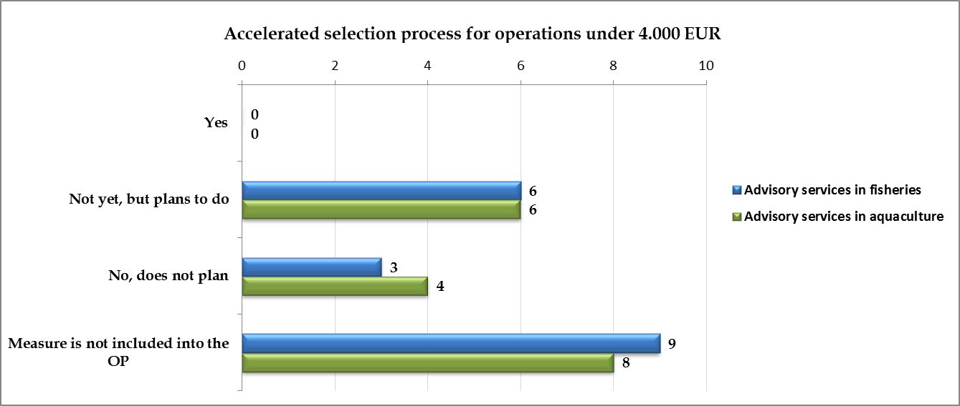

In fisheries, two third of the Member States (FR, HR, IE, LT, PT, RO) that included this measure into their operational programme made the choice to establish such accelerated procedures. In aquaculture this ratio is 60% (CY, FR, HR, IE, PT, RO). However, in the current phase of implementation none of them actually established those procedures, therefore we do not have information yet about the potential extent of simplification within this measure.

* 1. **Advance payment to beneficiaries in certain measures**

Articles 62 and 66 of the EMFF Regulation allows for the Member States to provide advance payment to the beneficiaries of these measures up to 50% of the public support. This could increase the liquidity of the beneficiary and thus facilitate the implementation of respective operations on the ground.

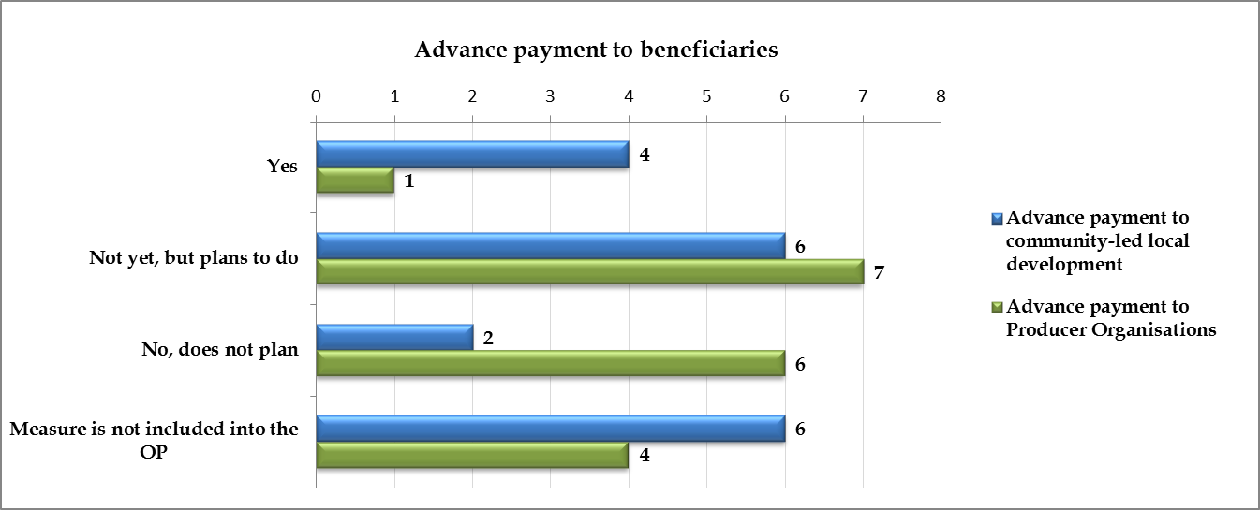

In case of community-led local development (Article 62 of the EMFF), the advance payment should not be more than 50% of public support to running cost and animation. So, this indicates that the objective of providing advance payment is clearly the facilitation of the launch of implementation of such operations. The need for that is also justified by the statistics: 83% of the replying Member States (CY, DK, FR, HR, IE, LT, LV, PT, RO, SI) will provide this advance payment to their beneficiaries.

In case of preparation and implementation of Production and Marketing Plans (PMPs), support to Producer Organisations (POs) is obligatory in accordance with the policy legislation, and advance payment could help overcoming the gap between the delayed launch of implementation of the EMFF programmes and the continuous activities of the POs. Despite the difficulties, only 57% of the Member States that included this measure into their operational programme (DK, FR, HR, IE, LT, PT, RO, UK) decided to provide advance payment to the Producer Organisations.

There are several Member States (DK, FR, LV, SI) that have already put in place provisions at national level to provide the advance payment.

* 1. **Special rules of calculation of supporting compensation of mollusc farmers allowing for companies with less than three years of activity (article 55.2)**

The EMFF may support compensation to mollusc farmers for the temporary suspension of harvesting of farmed molluscs, where such suspension occurs for public health reasons. However, one of the conditions of such support is that the threshold of the loss resulting from the suspension of the harvest should be calculated on the basis of the average turnover of the business over the three calendar years preceding the year in which the suspension was introduced. This implies that only those aquaculture farms could be eligible that have at least 3 years of record of functioning. However, the EMFF Regulation allows for the Member State to establish special calculation rules in respect of companies with less than three years of activity. This would enable the access to financing also for relatively newly established companies.

While the use of this measure is relatively low (72% of replying Member States do not finance this measure from the EMFF), only 40% of the Member States (HR, FR) which included this measure into their operational programme opted for establishing this special calculation and ensuring access to funding for a wider range of aquaculture companies.

* 1. **For the purposes of aquaculture stock insurance, establishment of criteria in advance on the basis of which the formal recognition of the occurrence of circumstances listed shall be deemed to be granted (article 57.3)**

The EMFF may contribute to an aquaculture stock insurance covering economic losses of aquaculture farmers in case of unforeseen natural disasters or adverse climatic events, changes in water quality or diseases. The occurrence of such events should be formally recognised by the responsible authorities of the Member State. Nevertheless, the Member State may establish the criteria in advance on the basis of which formal recognition is deemed to be provided. This arrangement could substantially accelerate the granting of such financing for beneficiaries who are anyway in a difficult situation.

Only one third of the replying Member States (FR, HR, IE, LT, PT, RO) included this measure into their operational programme, and out of those half of them (FR, IE, RO) will put in practice this option for simplification.

1. **Part III – Application of Simplified Cost Options (SCO)**

One of the key features for simplification in the 2014-2020 is that based on the previous experiences in cohesion policy the possibility of using the Simplified Cos Options (SCOs) has been extended to the EMFF as well. Without the risk of increasing the error rate, SCOs could substantially accelerate reimbursement procedures while they reduce the administrative burden of the beneficiary, for instance in relation to the retention of documents.

Despite all of those advantages, only slightly more than 50 % of the replying Member States plan to use the SCOs in the context of the EMFF.

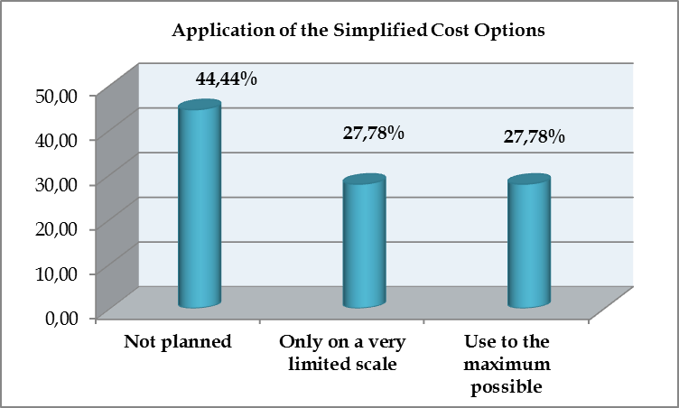

Among those Member States who do not plan to establish SCOs at all (BE, CY, CZ, HU, LT, LV, PT, SK) or will establish those only on a very limited scale (DE, FR, NL, RO, SI) – alleged obstacles or difficulties that could justify their position were as follows:

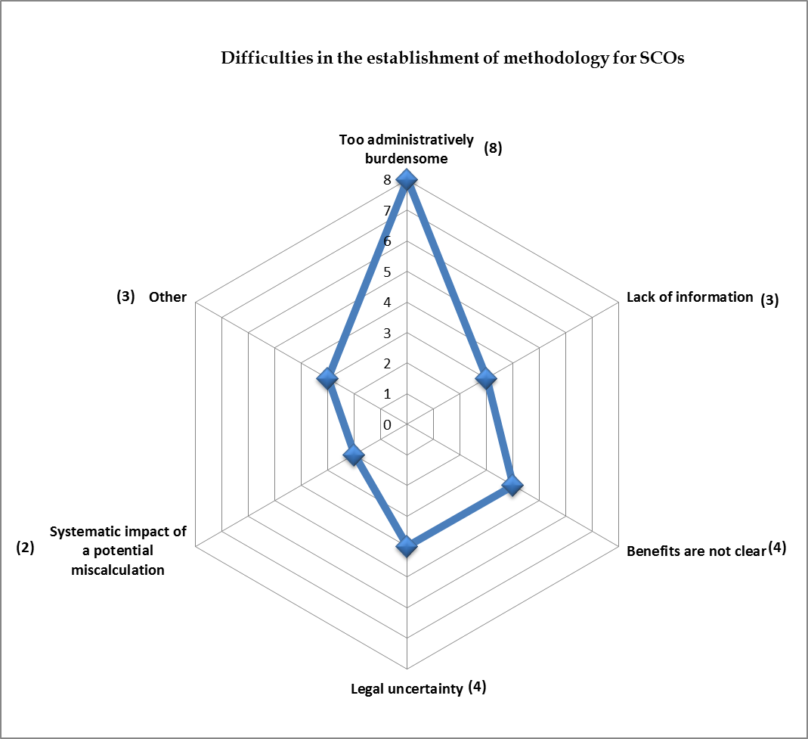

(The numbers following the indication of a particular difficulty indicate the number of MS that referred to it, whereas multiple replies were possible.)

While we believe that there needs to be a critical mass in place for the effective use of the SCOs, there seems to be no correlation between the policy choice made in relation to the use of the SCOs and the relative share of allocation within the EMFF.

Article 67(1)(b)-(d) of the CPR defines the different types of SCOs available in the context of the EMFF. Member States that want to fully exploit the potential of SCOs (DK, HR, IE, MT, UK) or to use them at least on a limited scale, made the following choices as regards the different types of SCOs:

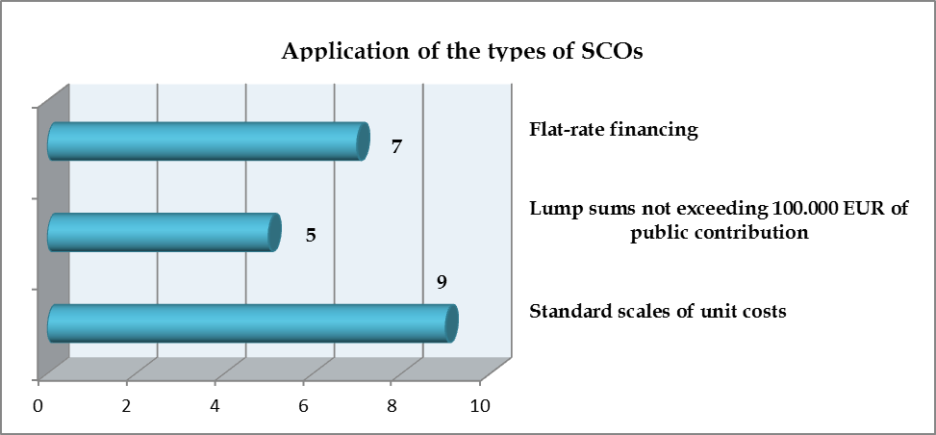

While the expectations towards SCOs are high, none of the Member States has previous experiences with SCOs in the period of 2007-2013 and only one of them (NL) has already established the methodology. In the remaining 9 Member States the elaboration of methodologies is in progress.

Article 67 of the CPR allows for different methodologies along which lump sums or standard scales of unit cost (SSUC) may be established. The choices for different options by Member States are as follows (multiple replies were allowed):

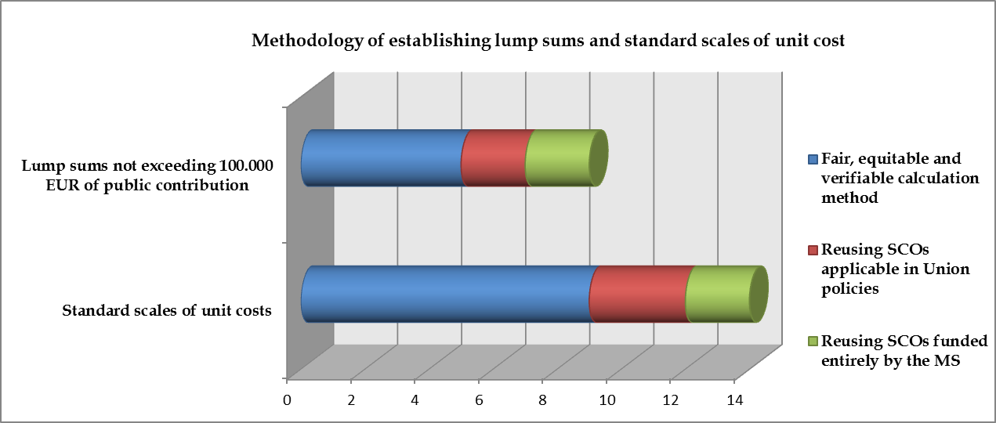

For both, lump sums and SSUC, the majority of the Member States (55% for lump sums, 64% for SSUC) decided to apply the fair, equitable and verifiable calculation method. Reusing SCOs applicable in other Union policies or those funded entirely by the Member State itself were not so popular. This might be probably due to the lack of knowledge of SCOs in other policies or the lack of SCOs financed entirely from national resources.

As regards flat rates, Article 68 of the CPR provides for different methods of flat rates for financing indirect costs. Out of those methodologies

* 4 Member States (DK, IE, MT, UK) will use the flat rate of up to 25% of eligible direct costs pursuant to paragraph (1)(a) of Article 68 of the CPR; and
* 4 Member States (DE, HR, IE, NL) will apply the flat rate up to 15% of eligible direct staff costs pursuant to paragraph (1)(b) of Article 68 of the CPR.

As regards the intervention logic within the EMFF, establishment of SCOs will benefit the following Union priorities and measures the most:

* at the level of Union priorities:
  + the highest ratio of application of SCOs (70% of Member States using SCOs) is for the Union priority on "Fostering environmentally sustainable, resource efficient, innovative, competitive and knowledge based aquaculture".
  + More than half (60%) of the Member States that wish to make use of the SCOs, will apply them for the Union priorities on "Promoting environmentally sustainable, resource efficient, innovative, competitive and knowledge based fisheries" and "Fostering the implementation of the CFP";
  + In case of the Union priority on "Fostering the implementation of the Integrated Maritime Policy" as well as for technical assistance, the use of SCOs shows the lowest rate (3 out of 10 Member States);
* at the level of measures:
  + the use of SCOs among the measures is fairly balanced, there is no measure that would be particularly preferred in the context of the SCOs. For each measures, on an average 2-3 Member States will apply SCOs. The only exceptions from this general observation are the two measures in Union priority 3 ("Fostering the implementation of the CFP"): Data collection and Control and enforcement. Here, more than half (6 out of 10) of the Member States wish to establish SCOs.

There seems to be only a very limited differentiation in the use of SCOs when considering the beneficiaries of such schemes:

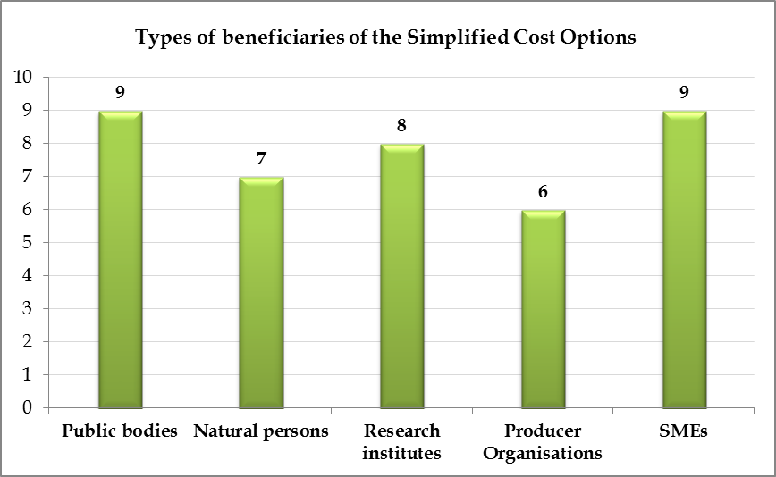

In the 10 Member States that plans to put in practice SCOs in the context of the EMFF, the biggest beneficiaries of such schemes seem to be SMEs and public bodies, while surprisingly natural persons (fishermen) are granted with this possibility on a somewhat lower scale.

1. **Part IV – E-cohesion**

In cohesion policy, all communication between the beneficiaries and the competent authorities taking part in the implementation of the Funds is carried out by means of electronic data exchange systems (this provision is labelled as "e-cohesion"). Member States should establish the necessary technical environment and enable such communication by the end of 2015.

In case of the EMFF, the provisions concerning "e-cohesion" do not apply. Nevertheless, several Member States plan to apply or introduce it for the period 2014-2020 on a voluntary basis. Only about 11% of the replying Member States indicated not making use of the benefits of such a paperless management and communication system.

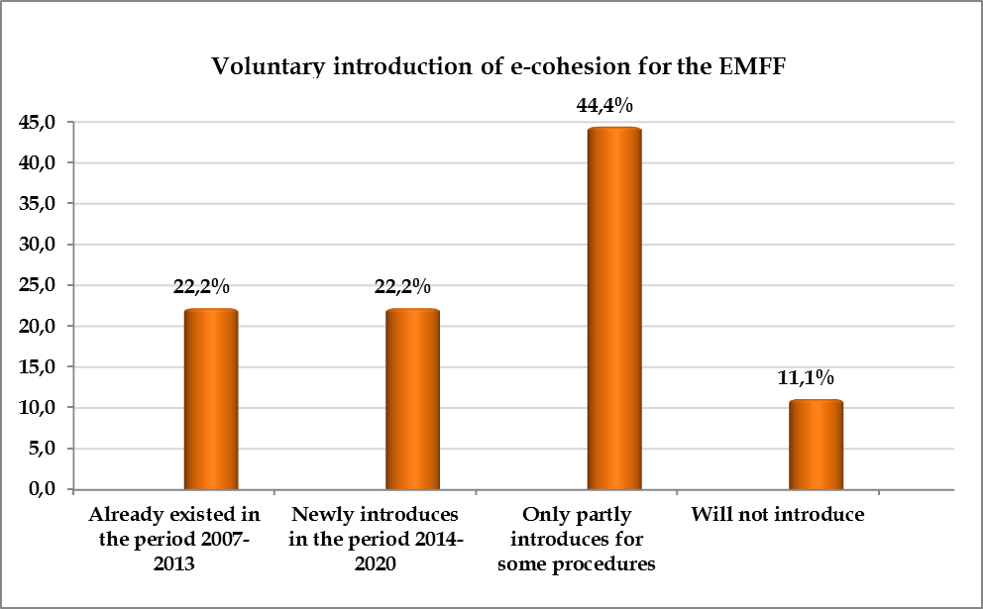

Around one fifth of the Member States (CZ, FR, LV, MT) already had in place this data exchange system in the previous period and the same amount of Member States (IE, NL, SI, UK) will newly establish fully fledged data exchange system for the purposes of the EMFF. Almost half of the Member States (BE, CY, DK, HR, HU, LT, PT, SK) will only apply paperless communication system only partly (in most of the cases only for the project application and appraisal process).

Member States (DE and RO) that decided not to establish such information systems referred to either their federal system of public administration (DE) as an obstacle or the lack of financial resources (RO).

1. **Part V – Statistics on procedures**

The survey also aimed at collecting certain baseline data of administrative burden on different types of beneficiaries in certain procedures at the national level or lower. Due to the very early stage of implementation of EMFF programmes, these data are mostly based on experiences in the 2007-2013 period.

The ***average volume of project applications*** vary between 15 and 35 pages, but within this range clearly SMEs need to prepare the most extensive documentation for accessing funds. The average volume of project application by SMEs is 33.5% more than for natural persons that are in the most advantageous situation, but also 17% more compared to Producer Organisations that are in the second worst position. While the SMEs are in a clearly disadvantaged situation, for the other types of beneficiaries the volume of applications is more balanced.

These averages, nevertheless, cover wide ranges of replies. Most of the replies placed the average volume of application between 10 and 50 pages, for each type of beneficiaries there was at least one Member State where the average volume of a project application is over 100 pages.

A similar tendency can be observed as regards the ***average period of time needed for the appraisal of the applications*** (ie. from the moment of submission of project application until the decision is made by the Managing Authority).

SMEs need to wait for the longest period of time to receive information on the official decision of the Managing Authority on their project applications. On an average, project appraisal for operations where the beneficiary is a SME takes 16.5% longer than in case of natural persons, 13.4% longer than in case of Producer Organisations and 10% longer than in case of public beneficiaries.

Within the limits set by the averages, most of the member States assumed the average time period needed for the appraisal of project applications between 15 and 90 working days. Nevertheless, in case of public bodies and Producer Organisations, there are two member States where this procedure takes more than 120 working days. In one Member State the same refer to SMEs as well.

The relative position of the different types of beneficiaries is only slightly different in case of ***reimbursement to beneficiaries*** (ie. observing the average length of period of time from submission of a payment claim by the beneficiary to the actual payment to the same beneficiary).

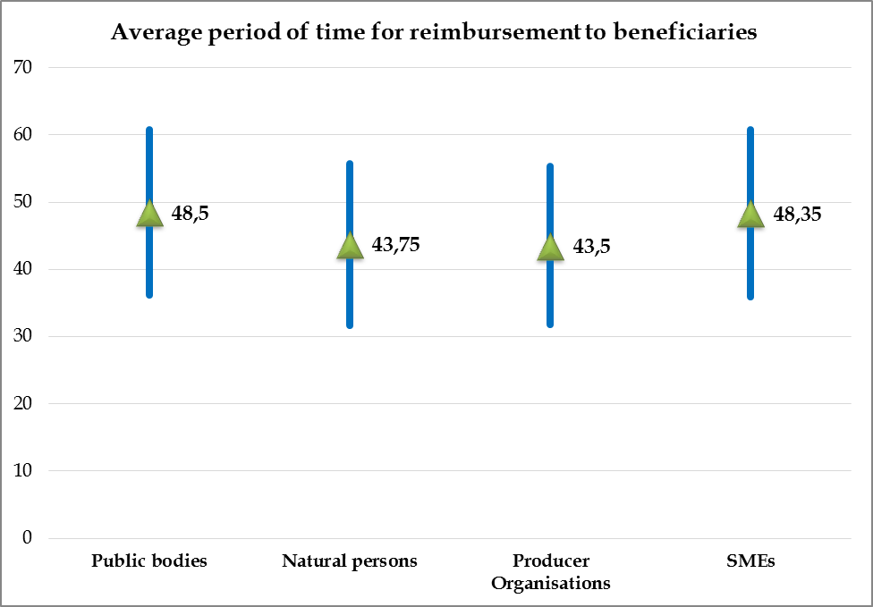

Here, public bodies and SMEs share the most disadvantaged situation of having longest average period of time (appr. 48.5 working days) waiting for their costs to be reimbursed. Nevertheless, this is still substantially less than the legal obligation set by the Common Provisions Regulation for the 2014-2020 period.

Article 132(1) of the CPR sets out that the Managing Authority should ensure that the beneficiary receives the total amount of eligible public expenditure no later than 90 days from the date of submission of the payment claim by the beneficiary.

Seven Member States (CZ, DK, HR, LV, MT, NL, UK) representing almost 40% of those who replied to the questionnaire apply – on a voluntary basis – a shorter deadline for payments to beneficiaries. These shorter deadlines vary from 15 days (MT) to 60 working days (HR), but more than one Member State applies the deadline of 30 days as well as of 60 days.

1. **Other initiatives and proposals of Member States**

The questionnaire allowed the Member States to present any further initiative they will take during the 2014-2020 period to simplify access to and implementation of the EMFF for beneficiaries as well as to share with the Commission any further areas where there is a legal obstacle at EU level that hinders the simplification at national or regional level.

Nevertheless, only very few Member States (DE, FR, NL, PT and UK) used this opportunity. Only two Member States (UK) indicated that they have own initiatives for simplification beyond the options provided by the legislative framework. These own initiatives include:

* in the application process beneficiaries are not required to submit any documentation that is already registered anywhere in the public administration;
* accelerated procedures in the appraisal of applications by the means of
  + expression of interest only;
  + panel assessment for operations above 100,000 EUR.
* the establishment and functioning of an intuitive e-system (including contact details and helpdesk) that allows for tailoring of questions.

Among the obstacles hindering the simplification for beneficiaries the followings were mentioned:

* Ambiguities and complexity in the EMFF Regulation may lead to problems of accountability;
* in general, the origin of complexity and administrative burden for beneficiaries lies in the increased obligations of competent authorities implementing the EMFF (ie. the Managing Authorities, the Certifying Authority and the Audit Authority). A typical example for this general problem was identified as follows:
  + the amount of storage and provision of data linked to the implementation of the EMFF has substantially increased that will also increase the complexity of application forms.
* lengthy procedure of the adoption of the OPs, that is hindering the implementation of measures, particularly those which finance a continuous activity (eg. control and enforcement, data collection). Here the shift from direct management to shared management was not as smooth as it was expected and therefore resulted in temporary scarcity of financial resources.

None of the replying Member States mentioned legal obstacles in other EU-level legislative acts that would hinder the simplification of access and implementation by beneficiaries.

1. **conclusions**

Member States clearly articulated the need for simplification for access to but moreover for the implementation of the EMFF.

In general, we can establish that specific options for simplification provided by the legislative framework of the EMFF were well received by the Member States, the ratio of implementation of each of the options exceeds the 50%, and in some of the cases it is over 80%.

Simplified Cost Options are new elements in the 2014-2020 period in the context of the EMFF. Member States well understood the potential for simplification in these options and more than half of them wishes to establish them covering all measures and all types of beneficiaries in the EMFF.

Despite the fact that "e-cohesion" is not obligatory for the EMFF, the rate of putting into practice the simplification option of a paperless programme management system is surprisingly high.

Examination of administrative burden on different types of beneficiaries demonstrates a clearly disadvantaged situation for SMEs in terms of the volume of project applications, the average length of period of time for project appraisal as well as for reimbursement of costs.

Proposals of Member States for further fields of simplification that could be explored related mainly to the extensive reporting obligations of competent authorities that are usually passed on to beneficiaries as well. Nevertheless, none of the replying Member States mentioned any legal obstacle in EU-level legislative acts that would hinder the simplification of access and implementation by beneficiaries and thus would necessitate an initiative from the Commission.

# How the EMFF contributes to the climate change (Presentation – mainstreaming of Climate Action into EU policies and funds)

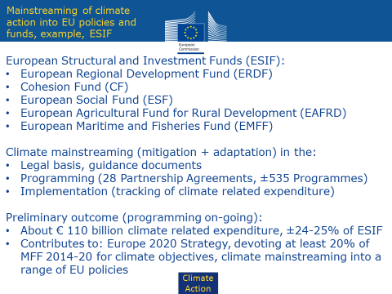

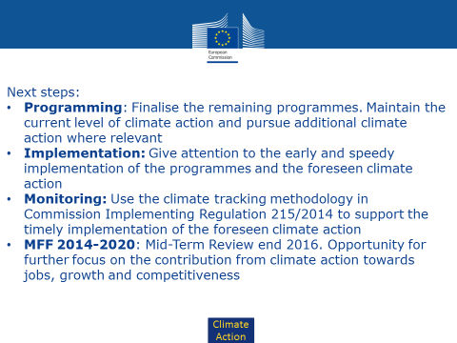

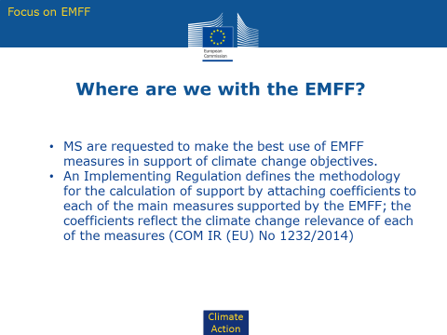

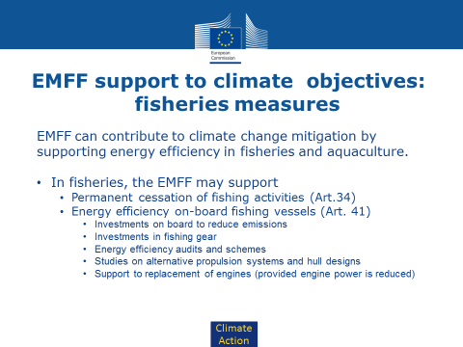

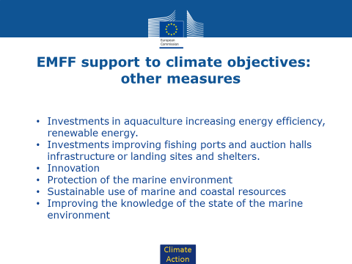

# How the EMFF supports the environmental objectives (Presentation)

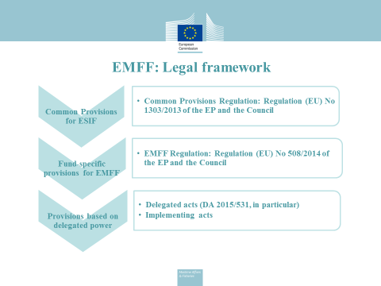

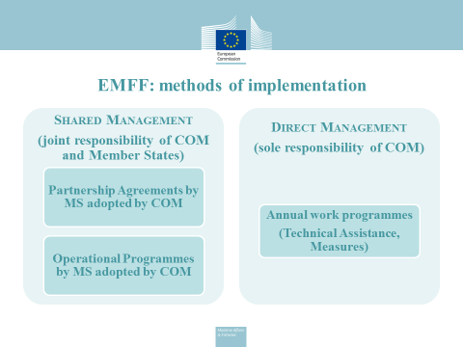

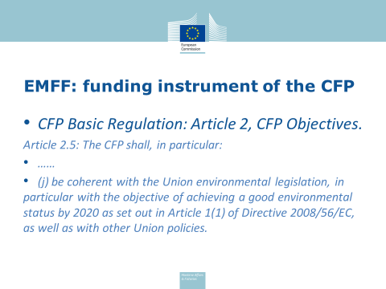

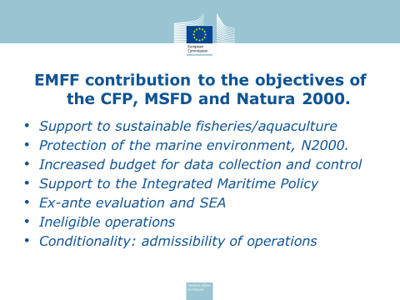

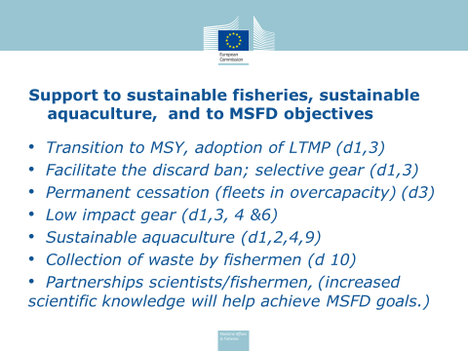

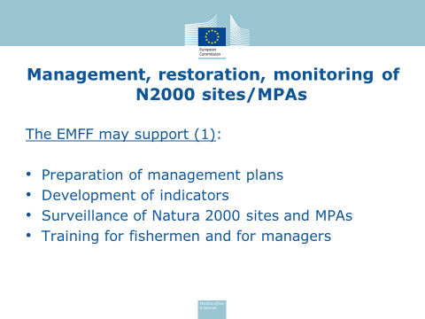

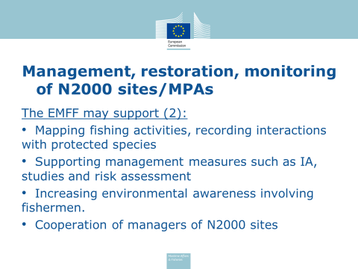

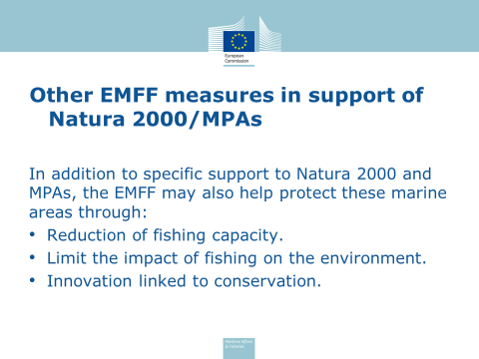

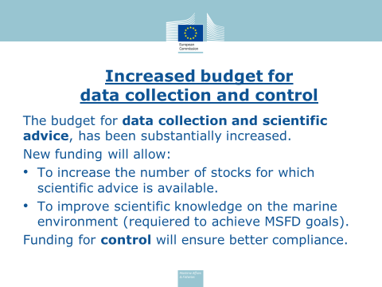

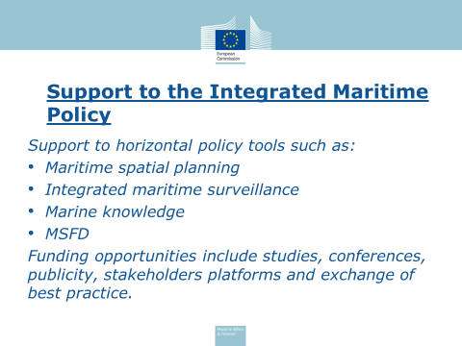

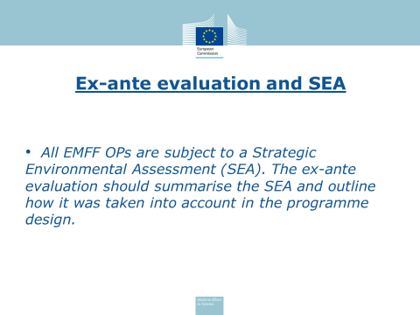

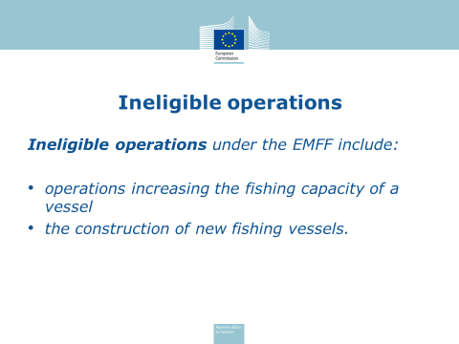

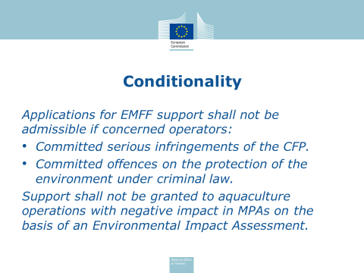

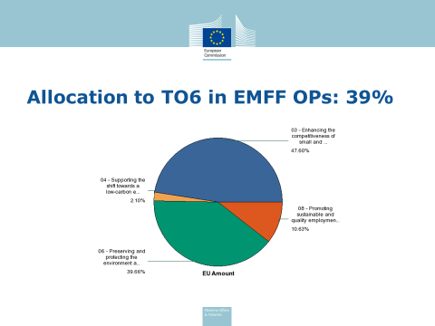

# Market policy - post 2020 perspectives

The Common Organisation of the Markets (CMO), one of the pillars of the CFP, will still be in force after 2020. The EMFF provides financing for actions of the CMO Regulation: creation of professional organisations (Art. 15), preparation and implementation of production and marketing plans (PMPs) (Art 28(6)), storage mechanism (Art. 30), and Market intelligence (Art 42). Other actions related to marketing and processing that are financed under the EMFF have a link with the CMO Regulation, although not explicitly mentioned therein.

Given the overall stability in the legal framework, the objectives of EMFF UP5 do not require a revision but priorities could be reassessed. Public support must be kept for the organisation of the sector and its structure through the creation and support to POs, given their key contribution to the objectives of the CFP, the expenditure incurred to meet their legal obligations (from the CMO) and the existence of market failures. To note also that the need to maintain the current support to POs remains a priority for the EP[87]. And the present situation of high profitability which could plead against such support has a strong cyclical dimension (cheap fuel, ageing of the fleet, difficult generational renewal) and should therefore not override the arguments presented.

Organisation of the sector (only public support):

Economic importance of POs as they strengthen the bargaining power of producers and improve the functioning of the supply chain, and political importance in their contribution to the cohesion and prosperity of coastal communities (maintenance of a large network of (small) producing entities). This can only be achieved through their empowerment and adequate public funding to support their activities.

POs are key actors of the CFP for promoting and achieving sustainable fisheries and aquaculture activities: their primary objective is the implementation of the CFP and they represent the vast majority of the landings and of the species under quota. However, an excessive focus on conservation and/or lack of expertise in the market dimension weakens their capacity to fully deliver on the market dimension of the CMO objectives: this is reflected in the quasi-absence of inter-branch organisations, and their poor functioning. Public support should tackle these shortcomings.

Therefore, support to the creation and restructuring of professional organisations[88] (incl. transnational) and the restructuring of collective organisations into POs should be maintained.

Support to PMPs (only public support)

PMPs are "contracts" between POs and their MS. They are an innovative, effective and flexible tool to support an increasingly market-based approach in fleet management and allow POs to act in the public interest. Support to the POs through PMPs is necessary to correct certain market failures: monopsony (necessity to increase producers' bargaining power vis-à-vis the processing industry or retailers), common-pool resource (possible collective management of quotas by POs), externalities (political importance of coastal communities and environmental harm), and makes a decisive contribution to ensuring the sustainability and fair standard of living for EU fishermen and aquaculture farmers, and by extension for the coastal communities[89]. Provision of public support is both an incentive and a compensation to properly achieve these missions. The level of public supportshould be proportional to the ambition of the PMP and conditioned to achieving their objectives[90]. Repayable forms of support should be an option. It can be maintained below the current thresholds (no indication that this is a limiting factor). The case of small POs should be addressed specifically.

Support to marketing measures (PP)

The CMO has objectives that pertain to the market performance overall: a diverse supply to consumers, the valorisation of products' characteristics (origin, production), and the redistribution of added value along the supply chain. Public support to pursue these objectives is needed to avoid that economic interests alone drive the market. For example, a handful of species account for the almost totality of consumption in the EU. This limits the diversity of supply to the consumer and puts pressure on the most economically interesting stocks, creating conservation problems. On the contrary, underutilised species have difficulties to enter the market. The challenge is to disentangle the public interest of an action from the private (economic) interest of the operator in the chain. So it will be needed to identify the type of actions that can be delegated to private operators and under which conditions[91]. MS should be allowed to implement any measure they consider relevant (no "no-go areas).

Support to processing (only through financial instruments)

Although the processing sector is a major business and represents thousands of jobs, support should be primarily provided to all operators (including SMEs) only through financial instruments rather than direct grants, and limited to operations which consist in innovative processes or methods, support to the processing of unwanted catches and of co-products (with an emphasis on circular economy[92]).

Support to storage aid (no-go area)

The temporary application of the storage aid mechanism under the EMFF aimed at ensuring a smooth transition towards the PMPs and it should not be reintroduced, even if certain stakeholders will request it. The creation of a rapid crisis mechanism that would allow MS to reallocate funding from other priorities in the case of unforeseeable market disruptions (e.g. Russian ban) could nonetheless be considered (safety net to be strictly defined for situations that cannot be catered for by standard measures).

Support to market intelligence (Public support – direct management – same level of support)

The Commission, with the contribution of MS, must deliver on Market Intelligence[93]. The market intelligence provided by the observatory (EUMOFA) at EU level cannot be undertaken by the sector: conflictual interests and fragmentation of the market would lead to information asymmetry. So Market Intelligence needs to be provided at EU level and complement MS' work in that regard. EUMOFA's services are considered useful and deliver on the Commission's obligation. There is a continuous increase in use by stakeholders and it supports policy making (inter alia on the basis of ad-hoc reports and analysis to prepare regulatory or operational outputs). EUMOFA's services will be expended to provide additional analysis of past and future trends to further increase quality of support to policy orientation and informed management decisions. Sufficient resources should also be granted to support complementary measures: Eurobarometer surveys, information system on commercial designations of FAPs and other ad-hoc initiatives.

# EU fish market – presentation

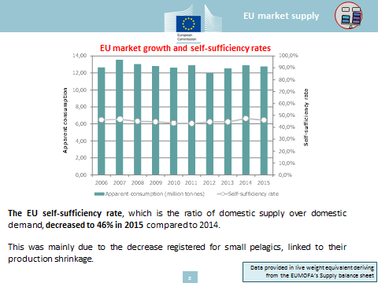

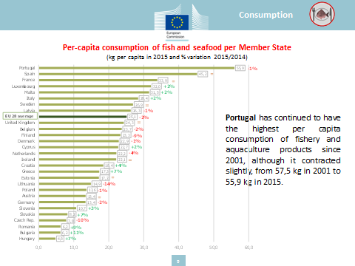

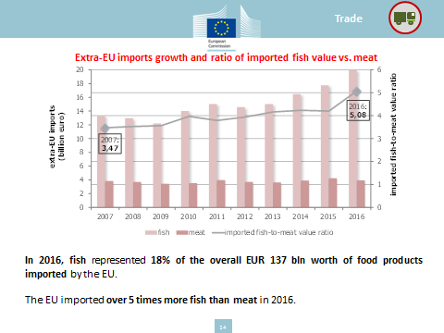

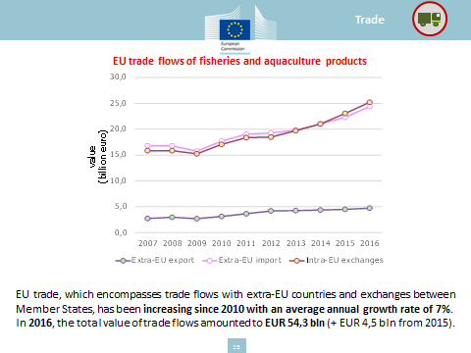

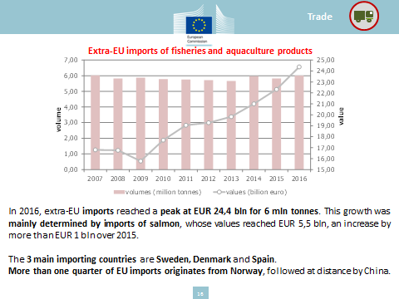

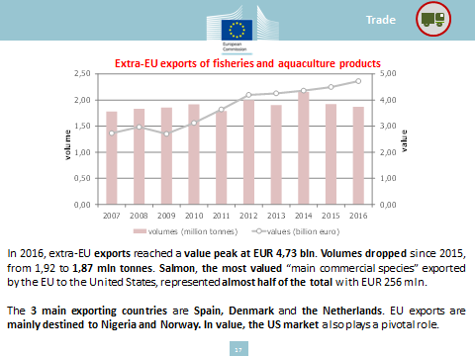

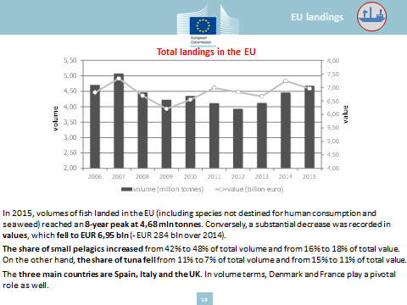

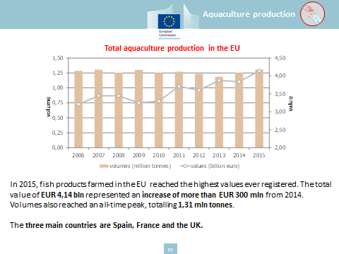

# Establishment of the Stakeholder Forum for International Ocean Governance (IOG Forum): Relation between IOG Agenda and SDG14

|  |  |  |
| --- | --- | --- |
| **Pillar** | **Strategic Actions** | **SDG 14 relevance** |
| Improving the international ocean governance framework | Filling gaps in the international framework | SDG14/ SDG14.c |
| Promoting regional fisheries management and cooperation in key ocean areas to fill regional ocean governance gaps | SDG14.4 |
| Improving coordination and cooperation between international organisations and launching ocean partnerships | SDG 14/ SDG14.c |
| Capacity Building | SDG 14/ SDG14.a |
| Ensuring the safety and security of seas and oceans | SDG14 |
| Reducing pressure on oceans and seas and creating the conditions for a sustainable blue economy | Implementing the COP21 Agreement and mitigating the impact of climate change on oceans, coastlines and ecosystems | SDG14.3 |
| Fighting illegal fishing and strengthening the sustainable management of ocean food resources globally | SDG14.4 |
| Banning harmful fisheries subsidies | SDG14.6 |
| Fighting marine litter and the ‘sea of plastic’ | SDG14.1 |
| Promoting maritime spatial planning (MSP) at global level | SDG 14/ 14.2 |
| Achieving the global target of conserving 10% of marine and coastal areas and promoting the effective management of MPAs | SDG14.5 |
| Strengthening international ocean research and data | Coherent EU strategy on ocean observation, data and marine accounting | SDG14 |
| Strengthening investment in ‘blue’ science and innovation | SDG14 |
| International ocean research, innovation and science partnerships | SDG14 |

# New Fisheries Local Action Groups Project Examples[94]

**1/** [Boosting a seaweed business on the Irish offshore Islands](https://webgate.ec.europa.eu/fpfis/cms/farnet2/on-the-ground/good-practice/short-stories/boosting-seaweed-business-irish-offshore-islands_en) (West FLAG, Ireland)

West FLAG supports business development among some of the most marginalised and remote communities in the country, including offshore islands and native Irish speaking communities where a seaweed company has grown from one to four employees.

**2/** [Crushed shells and 3D printing](https://webgate.ec.europa.eu/fpfis/cms/farnet2/on-the-ground/good-practice/short-stories/crushed-shells-and-3d-printing_en) (North Sardinia FLAG, Italy)

In Olbia, the northern area of Sardinia, the shells of mussels are no longer considered waste. With the help of the FLAG, local students and teachers are using crushed shells to create useful objects of all sorts, from moulds created by 3D printing.

**3/** [Detecting toxic microalgae](https://webgate.ec.europa.eu/fpfis/cms/farnet2/on-the-ground/good-practice/short-stories/detecting-toxic-microalgae_en) (Mediterranean Pyrenees FLAG, France)

Oyster farms on the Leucate lagoon are regularly affected by toxic phytoplankton, leading to economic losses. In search of a solution, shellfish farmers teamed up with a biotech start-up to test a new, quick and easy way to detect toxic marine microalgae and anticipate its proliferation.

**4/** [Bisset's Fish Van](https://webgate.ec.europa.eu/fpfis/cms/farnet2/on-the-ground/good-practice/projects/bissets-fish-van_en) (East Lothian, UK)

Local fish delivered fresh to the doorstep as fisherman boosts the family business through direct sales from FLAG funded van.

# Overview of the financial EMFF Implementation

|  |  |  |  |  |  |
| --- | --- | --- | --- | --- | --- |
| **EMFF Financial Plan (section 8.2 of the OP)** | | | | | |
| **EU 27** | **Total public contribution**  **(EUR)** | **EMFF contribution**  **(EUR)** | **National contribution** | **EMFF %** | **National %** |
| EU 27 | 7.983.485.404 | 5.749.331.600 | 2.234.153.804 | 72.02% | 27.98% |

|  |  |  |  |
| --- | --- | --- | --- |
| **EMFF contribution per Union Priority** | | | |
| **Union Priority**  **(UP)** | **Union Priority Name** | **Total Contribution** | **%** |
| 1 | Promoting environmentally sustainable, resource efficient, innovative, competitive and knowledge based fisheries | 1,552,778,803 | 27% |
| 2 | Fostering environmentally sustainable, resource efficient, innovative, competitive and knowledge based aquaculture | 1,198,667,887 | 20.8% |
| 3 | Fostering the implementation of the CFP | 1,100,000,000 | 19.1% |
| 4 | Increasing employment and territorial cohesion | 524,816,451 | 9.1% |
| 5 | Fostering marketing and processing | 1,010,418,274 | 17.6% |
| 6 | Fostering the implementation of the Integrated Maritime Policy | 71,055,600 | 1.2% |
| 7 | Technical assistance | 291,594,585 | 5.1% |

|  |  |  |
| --- | --- | --- |
| **Total EMFF allocation per Member State** | | |
| **Member State** | **Programme** | **Total allocation** |
| AT | 2014AT14MFOP001 | **6.965.000** |
| BE | 2014BE14MFOP001 | **41.746.051** |
| BG | 2014BG14MFOP001 | **88.066.622** |
| CY | 2014CY14MFOP001 | **39.715.209** |
| CZ | 2014CZ14MFOP001 | **31.108.015** |
| DE | 2014DE14MFOP001 | **219.596.276** |
| DK | 2014DK14MFOP001 | **208.355.420** |
| EE | 2014EE14MFOP001 | **100.970.418** |
| ES | 2014ES14MFOP001 | **1.161.620.889** |
| FI | 2014FI14MFOP001 | **74.393.168** |
| FR | 2014FR14MFOP001 | **587.980.173** |
| GR | 2014GR14MFOP001 | **388.777.914** |
| HR | 2014HR14MFOP001 | **252.643.138** |
| HU | 2014HU14MFOP001 | **39.096.293** |
| IE | 2014IE14MFOP001 | **147.601.979** |
| IT | 2014IT14MFOP001 | **537.262.559** |
| LT | 2014LT14MFOP001 | **63.432.222** |
| LV | 2014LV14MFOP001 | **139.833.742** |
| MT | 2014MT14MFOP001 | **22.627.422** |
| NL | 2014NL14MFOP001 | **101.523.244** |
| PL | 2014PL14MFOP001 | **531.219.456** |
| PT | 2014PT14MFOP001 | **392.485.464** |
| RO | 2014RO14MFOP001 | **168.421.371** |
| SE | 2014SE14MFOP001 | **120.156.004** |
| SI | 2014SI14MFOP001 | **24.809.114** |
| SK | 2014SK14MFOP001 | **15.785.000** |
| UK | 2014UK14MFOP001 | **243.139.437** |
|  | **27** | **5.749.331.600** |

|  |  |  |  |  |  |
| --- | --- | --- | --- | --- | --- |
| **Payment claims per accounting period** | | | | | |
| **Accounting Period** | **Cost Claim - Total Amount (€)** | **Cost claim vs**  **Total EMFF** | **Cost Claim - Paid Amount (€)** | **Paid vs Total EMFF** | **Cost Claim - Withheld Amount (€)** |
| 01/07/2015 - 30/06/2016 | 9.937.955,08 | 0,17% | 8.944.159,57 | 0,16% | 0,00 |
| 01/07/2016 - 30/06/2017 | 84.744.834,71 | 1,47% | 76.270.351,21 | 1,33% | 8.474.483,50 |
| 01/07/2017 - 30/06/2018 | 145.246.905,54 | 2,53% | 117.683.797,39 | 2,05% | 14.261.108,68 |
| **Total** | **239.929.695,33** | **4,17%** | **202.898.308,17** | **3,53%** | **22.735.592,18** |

|  |  |  |  |  |  |
| --- | --- | --- | --- | --- | --- |
| **Payment claims per Member State and for all accounting periods** | | | | | |
| **Member State** | **Cost Claim - Total Amount (€)** | **Cost claim vs**  **Total EMFF** | **Cost Claim - Paid Amount (€)** | **Paid vs Total EMFF** | **Cost Claim - Withheld Amount (€)** |
| AT | 470.432,63 |  | 423.389,37 |  | 38.113,42 |
| BE | 2.677.876,12 |  | 2.410.088,51 |  | 267.787,61 |
| BG | 0.00 |  | 0.00 |  | 0.00 |
| CY | 1.826.803,99 |  | 1.644.123,59 |  | 24.680,40 |
| CZ | 1.720.589,27 |  | 1.548.530,34 |  | 172.058,93 |
| DE | 23.184.215.90 |  | 20.865.794,31 |  | 2.318.421,59 |
| DK | 29.331.535,15 |  | 26.398.381,63 |  | 2.933.153,52 |
| EE | 13.953.076,27 |  | 8.573.093,81 |  | 1.292.199,52 |
| ES | 12.686.093,57 |  | 11.417.484,21 |  | 1.268.609,36 |
| FI | 11.109.917,50 |  | 9.998.925,75 |  | 642,932.75 |
| FR | 28.230.864,95 |  | 19.204.321,32 |  | 2.823.086,50 |
| GR | 788.987,79 |  | 309.602,40 |  | 78.889,78 |
| HR | 0.00 |  | 0.00 |  | 0.00 |
| IE | 21.218.763,11 |  | 16.724.649,82 |  | 1.858.294,42 |
| LT | 6.069.930,92 |  | 5.462.937,83 |  | 606.993,09 |
| LV | 15.497.194,50 |  | 13.947.475,04 |  | 1.294.020,91 |
| MT | 583.793,48 |  | 525.414,13 |  | 58.379,35 |
| NL | 934.218,57 |  | 840.796,71 |  | 93.421,86 |
| PT | 28.742.488,56 |  | 25.868.239,70 |  | 2.874.248,86 |
| RO | 12.237.474,84 |  | 11.013.727,36 |  | 1.223.747,48 |
| SE | 2.549.061,15 |  | 2.294.155,03 |  | 254.906,12 |
| SI | 668.031,63 |  | 523.585,43 |  | 66.803,16 |
| SK | 0.00 |  | 0.00 |  | 0.00 |
| UK | 25.448.435.,43 |  | 22.903.591,88 |  | 2.544.843,55 |
|  | **239.929.695,33** | **4,17%** | **202.898.308,17** | **3,53%** | **22.735.592,18** |

1. European fisheries and maritime policies are crucial in delivering the priorities set out in the Rome Declaration
2. The blue economy includes fisheries and aquaculture, tourism, shipping, ocean energy, blue biotechnology, seabed mining, etc.
3. Further references provided in Annex 4
4. COM(2018) 98 final, Brussels, 14.2.2018
5. Reflection paper on the future of EU finances, European Commission, COM(2017) 358 of 28 June 2017
6. <https://ec.europa.eu/commission/priorities/democratic-change/future-europe/eu-budget-future_en>
7. Fishing was initially funded under the European Agriculture Guidance and Guarantee Fund (EAGGF). In 1993 a separate fund was established (FIFG), the Financial Instrument for Fisheries Guidance.
8. SWD(2017) 276 final of 13.07.2017
9. Ex-post evaluation of the European Fisheries Fund (2007-2013), Final report, November 2016. A more complete account of the EFF ex-post evaluation is provided in Annex 3. Full report: <https://publications.europa.eu/en/publication-detail/-/publication/f0ab224d-f34c-11e6-8a35-01aa75ed71a1>
10. Small Scale Coastal Fleet comprises fishing vessels less than 12 metres not using towed fishing gear
11. Commission Communication on 'A stronger and renewed strategic partnership with the EU's outermost regions', COM (2017)623 final, Strasbourg, 24.10.2017. The Communication is based on wide exchanges with representatives of the outermost regions including the 4th Outermost Regions Forum held in Brussels on 30-31 March 2017. <http://ec.europa.eu/regional_policy/en/information/publications/communications/2017/un-partenariat-privilegie-renouvele-et-renforce-avec-les-regions-ultraperipheriques>
12. Regulation (EU) No 1255/2011 of the European Parliament and of the Council of 30 November 2011 establishing a Programme to support the further development of an Integrated Maritime Policy
13. 2008/56/EC
14. COM(2012) 713 final, Brussels, 30.11.2012
15. COM(2013) 279 final, Brussels, 13.5.2013
16. Directive 2014/89/EU of 23 July 2014 establishing a framework for maritime spatial planning
17. Of which EUR 5.750 million in shared management and EUR 647 million in direct management.
18. Respectively EUR 5.750 million for shared and EUR 647 million for direct management.
19. In addition to the fund-specific ExAC, there are also ExAC set out in the CPR applicable to all ESIF
20. Support for permanent cessation was terminated on 31/12/2017
21. An overview of support to the local development of coastal areas through CLLD is provided in Annex 4.2.
22. By January 2018 interim claims submitted represented only around 4% of planned EMFF assistance for the current period.
23. The N+3 automatic decommitment risk.
24. Infosys data from 2017
25. Landing obligation, final report. FAME, February 2018
26. A full account of the stakeholder consultations is provided in Annex 2.
27. Opinion of the Committee on Fisheries on the next MFF (2017/2052(INI))
28. Within the meaning of the CMO Regulation (Reg.1379/2013)
29. Mainly in new fishing vessels and investments on board, privately financed
30. Prices of marine diesel halved in the period 2014-2016
31. 2017 Annual Economic Report on the EU Fishing Fleet, STECF 17-12, JRC 2017
32. For all 76 TACs with MSY advice the Commission proposed TACs in line with or slightly below MSY 2018. The Council adopted 53 TACs in line with MSY (29 in Western waters plus one in the deep sea, 17 North Sea, 7 Baltic Sea), compared to 44 in 2016.
33. Delivering on the MSY targets, the landing obligation and the discard ban contributes to three of the 11 Descriptors of Good Environmental Status in the MFSD (D1 (biodiversity), D3 (commercial fish), D4 (marine food webs). In addition, fishing has implications for a fourth one, sea-floor integrity (D6, impacted by bottom fishing). This points to the need to bring the implementation of the CFP, the Maritime Spatial Planning Directive and the MSFD closer together. Continued support for reducing incidental catches of protected species and for management measures related to Natura 2000 sites and other MPAs also contributes to addressing this challenge.
34. Belgium, Bulgaria, Croatia, Cyprus, Denmark, France, Germany, Ireland, Italy, Malta, Portugal, Romania, Slovenia, Spain and the United Kingdom.
35. 2017 Annual Economic Report on the EU Fishing Fleet, STECF 17-12, JRC 2017
36. Study on the economic importance of activities ancillary to fishing in the EU, March 2016
37. Approximately 8% of the catching sector workforce is made up of non-locals (other Member State nationals or third country nationals)
38. Study on the employment of non-local labour in the fisheries sector, MRAG Ltd, Coffey and AND International, June 2016
39. <http://ec.europa.eu/environment/marine/eu-coast-and-marine-policy/marine-strategy-framework-directive/index_en.htm>  
    <http://eur-lex.europa.eu/legal-content/EN/TXT/?uri=CELEX:32008L0056>
40. <http://ec.europa.eu/environment/nature/legislation/fitness_check/docs/nature_fitness_check.pdf>
41. <https://www.eca.europa.eu/Lists/ECADocuments/SR17_1/SR_NATURA_2000_EN.pdf>
42. <http://ec.europa.eu/environment/nature/legislation/fitness_check/action_plan/communication_en.pdf> 
43. <http://www.europarl.europa.eu/sides/getDoc.do?type=TA&language=EN&reference=P8-TA-2017-0441>
44. <http://www.consilium.europa.eu/en/press/press-releases/2017/06/19/conclusions-eu-action-plan-nature/>
45. Study on Realising the potential of the Outermost Regions for sustainable Blue Growth, COGEA srl, in partnership with AND International, Fundación AZTI and Poseidon Aquatic Resources Management Ltd, September – 2017
46. The total compensation regime amounts to EUR 192.5 million for 2014-2020, +/- 9% of the EMFF allocation to the three concerned Member States The financial envelope for compensation plans are ring-fenced for the whole of the 2014-2020 programming period as follows: Azores and Madeira (EUR 45.2 million, EUR 6.4 million/ per year), Canary Islands (EUR 60.9 million, EUR 8.7 million/per year), French outermost regions (EUR 86.5 million, EUR 12.3 million/per year). This represents an increase in overall total amounts of almost 50% for PT and ES ORs, and 150% for FR ORs. Geographic coverage was extended to all FR ORs (Mayotte, Martinique, Guadeloupe and Saint Martin, previously not covered).
47. Following data from EUMOFA in 2015 fish products farmed in the EU reached the highest values ever registered. The total value of EUR 4.14 billion represented an increase of more than EUR 300 million or 8% from the previous year. Volumes also reached an all-time peak, totalling EUR 1.31 million tonnes, an increase of 54.4 tonnes or 4% above the 2014 volumes. Around 95% of total EU aquaculture production is represented by 10 species. Compared to 2006, the most significant changes recorded in 2015 were in value terms. Salmon, now accounts for almost 1/4 of the total; oyster moved up from ranking 6th to 4th; eel value contracted by 40%.
48. Directive 2014/89/EU of the European Parliament and of the Council of 23 July 2014 establishing a framework for maritime spatial planning
49. Cross-border MSP projects are listed here: https://ec.europa.eu/maritimeaffairs/policy/maritime_spatial_planning_en
50. Further details provided in Annex 4.14
51. Starting with Axis 4 under the EFF and continuing with CLLD under the EMFF
52. While during the 2007-2013 period 57% of FLAGs stated they would spend more than 30 % of their budget on projects targeting SSCF, the share increases to 71% in the 2014-2020 period as stated in the Ad-hoc expert report providing information on present and future EMFF support to Small-Scale Coastal Fisheries through FLAGs, FARNET, 2017
53. The EU plays an active role in the WTO’s negotiations on disciplining fisheries subsidies contributing to overcapacity, overfishing and IUU as requested by SDG 14.6. In this respect the EU made proposals to discipline capacity-enhancing proposals, including the prohibition of construction aid.
54. Special Eurobarometer 464b: European's attitudes towards security, December 2017
55. (OR. en), 17002/14, Brussels, 16 December 2014
56. Permanent cessation, extraordinary cessation, start-up support and engine replacement
57. A monopsony is a market situation in which there is only one buyer. A oligopsony is a state of the market in which only a small number of buyers exists for a product.
58. (OR. en), 17002/14, Brussels, 16 December 2014
59. Article 92 in the draft Common Provisions Regulation
60. Shared management in the current EMFF is primarily implemented through grants, albeit with an increasing amount implemented through financial instruments. A novelty introduced in the EMFF is that in the case of investments in processing of fishery and aquaculture products support to enterprises other than SMEs is only granted though financial instruments. Specific EMFF financial instruments intend to invest nearly EUR 80 million compared to EUR 63.5 million in the previous programming period. Although to date no substantial reporting by Member States is available, operational knowledge indicates that there is progress on the ground, that ex-ante assessments have been finalised and decisions on whether and how to proceed have continued during 2017.
61. As many as 75% of respondents in our stakeholder consultation were in favour of increasing the use and allocations for financial instruments post 2020.
62. The main difference between repayable assistance and grants lies in the repayable character of the assistance as opposed to the non-reimbursable character of a grant. On the other hand the repayable assistance also differs from financial instruments, notably loans which contain an unconditional obligation to repay.
63. During the 2014-2020, following a survey on simplification launched by DG MARE in 2015 and followed-up in 2017 by an additional survey, less than 50% of replying Member States reported they planned to use SCOs within the EMFF. The main reason for not using SCOs was that it was considered too administratively burdensome. The preferred SCO was standard scales of unit costs followed by flat-rate financing. Member States mostly planned to use SCOs for support to sustainable aquaculture and for data collection and control. Further results of this survey are presented in Annex 4.8.
64. The funding according to management mode is 90% in shared management and 10% in direct management.
65. The current dual mode provides for continuity and the possibility to benefit from already gained experience much in the line with what stakeholders ask for. As part of the ESI Funds, most of the future funding would continue to be implemented in shared management. The purpose is to support adaptive processes in a specific sector, investments in businesses and preservation of environmental resources, funding should be as close as possible to local and national realities and complementary to national policies and funding.
66. Article 107 of the EMFF Regulation requires the establishment of a Common Monitoring and Evaluation System (CMES) for the operations co-financed by the EMFF under shared management. A more complete account of the system is provided in Annex 3.
67. A complete list of indicators used during the 2014-2020 period is provided in Annex 3.3
68. The Infosys reporting system is established through Art 97.1 (a) of the EMFF Regulation. In order to limit the administrative burden for MAs, the system uses information which is already available in the Member States.
69. This was not the case during the 2014-2020 period when the methodological guidance came late at a time when many operational programmes had already been approved)
70. https://stecf.jrc.ec.europa.eu/reports/dcf-dcr
71. http://www.eumofa.eu/sources-of-data
72. Option 1: decrease by 15% (baseline); Option 2: decrease by 30%; Option 3: constant of slightly increased budget.
73. SWD (2017) 276
74. Council Regulation (EC) No 1198/2006 of 27 July 2006 of the European Fisheries Fund and Commission Regulation (EC) No 498/2007 of 26 March 2007 laying down detailed rules for the implementation of Council Regulation (EC) No 1198/2006 on the European Fisheries Fund.
75. This date was established by Commission Delegated Act (EU) 2015/895, adopted on the basis of Article 129 of the EMFF Regulation 508/2014.
76. The Financial Instrument for Fisheries Guidance (FIFG) was created in 1993 as the specific financial instrument dedicated to fisheries structural policy. First established through Regulation (EC) No 2080/93, the FIFG became the structural pillar of the CFP.
77. For the 2007-2013 period, Luxembourg did not receive funding from the EFF, while Croatia only had an OP adopted in 2013.
78. It is a common practice to "overbook" the commitment since it may happen that some operations are not carried through.
79. Please note this figure must be used carefully since it is based on the amounts declared by the MS at the end of March 2017, which have not yet been verified by the Commission, nor audited.
80. https://ec.europa.eu/fisheries/documentation/studies/axis-4_en. These figures were confirmed by a survey undertaken by the FARNET Support Unit in 2016.
81. http://ec.europa.eu/fisheries/documentation/studies/cessation_en
82. However, the ex-post evaluators underlined the fact that technical assistance was not properly documented and monitored; this limits the value of these conclusions.
83. adjusted to be comparable with 2007-2013 data, i.e. without UP3 and UP6
84. This applies to all eligible measures (e.g. support for young fishermen, investments on board in health and safety, investments in fishing ports, support for control and enforcement and for data collection) with the exception of engine replacement (30%).
85. DG MARE will present a progress report in 2018 and initiate a process for planning the next, "post-2020" IOG Agenda phase.
86. One Member State, Luxembourg decided not to be a beneficiary of the EMFF and informed the European Commission on this decision in a letter.
87. Cf. Committee on Fisheries' (draft) opinion to Committee on Budgets on the next MFF (Preparing the Parliament’s position on the MFF post-2020).
88. Within the meaning of the CMO Regulation
89. Although an indirect benefit, one may wonder how much it would cost to achieve it through other public policies
90. Art 28(1) of the CMO regulation
91. In case of a "measures-based" instrument the current conditions of art. 68 should be thoroughly reviewed.
92. I.e. support to the reduction of food loss and waste, facilitate the reutilisation of co-products resulting from primary processing for food purposes; to note that 'by-products' are products not destined to human consumption (bones, skin, etc.) and therefore Art. 69(1)(d) is not sufficient as currently drafted
93. Art. 42 of the CMO Regulation
94. CLLD examples can be found on the Good practices page of the FARNET website: https://webgate.ec.europa.eu/fpfis/cms/farnet2/on-the-ground/good-practice_en