

**List of abbreviations**

|  |  |
| --- | --- |
| AA | Association Agreement |
| CIS | Commonwealth of Independent States |
| CPI | Consumer price index |
| DCFTA | Deep and Comprehensive Free Trade Area |
| EC | European Community |
| ECF | Extended Credit Facility |
| EEU | Eurasia Economic Union |
| EFF | Extended Fund Facility |
| EFTA | European Free Trade Association |
| EIB | European Investment Bank |
| ENP | European neighbourhood policy |
| ENI | European neighbourhood instrument |
| EU | European Union |
| EUR | Euro |
| FATF | Financial Action Task Force |
| FDI | Foreign direct investment |
| FSAP | Financial sector assessment programme |
| GAFTA | Greater Arabic Free Trade Area |
| GCC | Gulf Cooperation Council |
| GDP | Gross domestic product |
| IMF | International Monetary Fund |
| MFA | Macro-financial assistance |
| MoU | Memorandum of understanding |
| OECD | Organisation for Economic Cooperation and Development |
| OJ | Official Journal of the European Union |
| PFM | Public finance management |
| PPP | Public‑private partnership |
| SBA | Stand-By Arrangement |
| SDR | Special drawing rights |
| SOE | State-owned enterprise |
| SREP | Supervisory review and evaluation process |
| USD | United States dollar |
| TFEU | Treaty on the Functioning of the European Union |
| VAT | Value added tax |
| WTO | World Trade Organisation |
| y-o-y | year-on-year |

**Contents**

Introduction 3

Background analysis of beneficiaries of macro-financial assistance 4

1. Georgia 4

1.1. Macroeconomic performance 4

1.2. Structural reforms 5

1.3. Implementation of macro-financial assistance 6

2. Jordan 8

2.1. Macroeconomic performance 8

2.2. Structural reforms 9

2.3. Implementation of macro-financial assistance 10

3. Moldova 12

3.1. Macroeconomic performance 12

3.2. Structural reforms 13

3.3. Implementation of macro-financial assistance 14

4. Tunisia 17

4.1. Macroeconomic performance 17

4.2. Structural reforms 18

4.3. Implementation of macro-financial assistance 19

5. Ukraine 22

5.1. Macroeconomic performance 22

5.2. Structural reforms 24

5.3. Implementation of macro-financial assistance 25

Annexes 27

Annex 1: Selected macroeconomic indicators by country 27

Annex 2: MFA operations by date of decision, 1990-2017 29

Annex 2A: Status of effective disbursements by date of decision at end-December 2017 30

Annex 2B: Status of effective disbursements by region at end-December 2017 36

Annex 3: MFA amounts authorised by year, 2005-2017 (EUR million) 42

Annex 4: MFA amounts disbursed by year, 2005-2017 (EUR million) 43

# Introduction

This staff working document complements the Commission’s report to the European Parliament and the Council on the implementation of macro-financial assistance (MFA) to third countries in 2017.

Over 2017, five countries benefited from macro-financial assistance, notably Georgia, Moldova and Ukraine in the Eastern Neighbourhood, and Jordan and Tunisia in the Southern Neighbourhood. For each beneficiary country, the report provides more detailed information on: (i) their macroeconomic and financial situation; (ii) progress in accomplishing their structural reforms agenda; and (iii) implementation of MFA operations in those countries.

The annexes include overview tables on the effective disbursements of MFA operations since 1990 by date of adoption of the decisions and by region, as well as tables on MFA commitment and payment amounts in 2005‑2017, by year and by region.

# Background analysis of beneficiaries of macro-financial assistance [1]

1. **Georgia**

## Macroeconomic performance

The macroeconomic outlook for Georgia remains vulnerable. The economy faces risks due to external imbalances (notably, a large current account deficit and significant external debt) and international reserves that are below the adequate level.

Georgia’s GDP increased by 4.8 % between January and November 2017 and is expected to have grown by more than 4 % for the whole of 2017, driven by a recovery in both external and domestic demand and by an increase in investment. A similar level of GDP growth is forecast for 2018. Last year’s faster-than-expected economic growth follows 2 years of deceleration due to external shocks, notably the economic slowdown in the region.

Over-performance on the back of faster-than-expected economic growth is expected to have allowed a reduction of the general government fiscal deficit to 3.5 % of GDP in 2017, compared to 4.1 % in 2016. The deficit is forecast to slightly decrease further in 2018. Georgia’s public debt is expected to have decreased in 2017, to around 42 % of GDP (compared to 45 % in 2016) and is likely to remain at a similar level in 2018.

Annual consumer price inflation has been above the central bank’s target of 4 % for most of this year, following an increase in excise duties on tobacco, fuel and motor vehicles in January 2017. To ease inflationary pressures, the central bank raised its refinancing rate three times in 2017 from 6.5 % to: 6.75 % in January, 7 % in May and 7.25 % in December.

On the exchange rate of the lari against the US dollar, the Georgian currency depreciated by 22 % in 2014-2016, moving from 1.77 in 2014 to 2.27 in 2016. In 2017, the lari was broadly stable against the US dollar. However, the overall trend belies substantial intra-annual volatility: the lari appreciated against the dollar by around 12 % from the beginning of 2017 until mid-August and lost this gain in the following 4 months. This exchange rate volatility, coupled with the still high dollarisation (68 % of deposits and 58 % of loans were denominated in US dollars as of November 2017), makes Georgia’s financial sector vulnerable to exchange rate risk.

Georgia’s balance of payment position remains vulnerable due to a large current account deficit (around 10 % expected in both 2017 and 2018) and high external debt (107 % expected in 2017 and 106 % in 2018). The inflows of foreign direct investment (FDI) were lower than expected in 2017 (around 9 % of GDP) due to the fact that some large investment projects are nearing completion. Georgia’s international reserves have been broadly stable in absolute terms since 2011, totalling USD 3.0 billion at end-2017 (about 3 months of import cover), but reserve needs have been increasing and are currently below the level the IMF estimates is adequate.

## Structural reforms

Key to Georgia’s structural reform agenda is the government’s Four-Point Reform Plan which focuses on improving the business environment, education and public administration and boosting investment in infrastructure. The Georgian authorities intend to complement these structural reforms with fiscal reforms and a strengthening of the financial sector.

The first leg of the Reform Plan is to improve the business environment. For this, the Georgian authorities plan to reform the insolvency law, ensure an adequate restructuring framework for viable businesses and introduce International Financial Reporting Standards (IFRS) for financial reporting by corporations. The Georgian authorities also plan to continue the land reform by extending the application of a special rule which simplifies the land registration process. By simplifying land transactions and making it easier to use land as collateral for borrowing, the land reform should contribute to rural development and make agricultural production more efficient.

The second leg of the Reform Plan is educational reform. The Georgian authorities plan to improve the education system by setting curriculum standards and introducing vocational training and adult learning. This reform should help to address the skills mismatch, which is one of the main structural weaknesses of the Georgian economy and contributes to high unemployment.

The third leg of the Reform Plan is to make public administration more efficient. This will notably involve containing the wage bill and administrative expenses, better targeting subsidies and social assistance programmes and introducing a one-stop shop for all government services. These changes are expected to further improve the business environment (in addition to the measures under the dedicated first point of the reform plan) and create fiscal space for investment.

The fourth leg of the Reform Plan covers investment in infrastructure (highways, ports, airports and railways). Additional and better infrastructure is expected to help Georgia utilise its potential as a transit country between Europe and Asia, support the development of the growing tourism sector and in this way create new economic opportunities for its population.

The Georgian authorities intend to complement structural reforms with fiscal reforms. Aside from reorienting expenditure under the Four-Point Reform Plan (reducing current expenditure and increasing capital expenditure), the Georgian authorities plan to improve the management of fiscal risks stemming from public-private partnerships (PPPs) and state-owned enterprises (SOEs). The Parliament of Georgia is expected to adopt a law in 2018 on PPPs, which will establish reporting and monitoring government exposure in PPPs and cap such government exposure. For SOEs, the Georgian authorities have expanded the analysis of contingent liabilities associated with such enterprises, as part of the Fiscal Risk Statement accompanying the 2018 budget. The Georgian authorities also plan to tighten budget lending, e.g. to SOEs, by requiring a reasonable expectation of commercial returns on new operations.

In the financial sector, the Georgian authorities plan to introduce a deposit guarantee scheme in 2018 and to improve regulatory, supervisory and resolution frameworks for banks. In April 2017, the Georgian Parliament approved legislative amendments that invalidate the effects of a 2014 law establishing a new financial supervision agency. In this way, the Georgian authorities have reaffirmed the independence of the National Bank of Georgia, reverting to the original legal framework in which the responsibility for financial supervision is assigned to the Bank, as recommended by the international financial institutions and the EU.

The issue of high dollarisation continues to be addressed by introducing liquidity coverage ratio limits, with preferential treatment of liabilities denominated in the national currency. On the supply side, the Georgian authorities also plan to develop the country’s capital markets in lari, notably by starting to publish the calendar of government bond issuances to develop a benchmark, upgrading the trading infrastructure of the Georgian Stock Exchange and introducing derivatives. On the demand side, the Georgian authorities introduced a second (funded) pillar of the pension system with effect from January 2018, which is also intended to create demand for long-term financial instruments denominated in the national currency. In addition, the Georgian authorities plan to introduce mandatory third-party vehicle insurance in 2018 to support the development of the insurance sector.

The national reform agenda is also supported by MFA conditionality. For example, the conditions for the 2015-2017 MFA operation helped to improve public finance management in Georgia by protecting the operational independence of the State Audit Office. The proposed further MFA is likely to be conditional on making further improvements in public finance management, the financial sector, social and labour market policies, the business environment, trade and the promotion of exports.

## Implementation of macro-financial assistance

The first and second MFA operations for Georgia were pledged at the International Donors’ Conference in Brussels in October 2008, following Georgia’s military conflict with Russia in August 2008. The first operation of EUR 46 million, fully in the form of grants, was implemented in 2009-2010.

The second operation of EUR 46 million, half in grants and half in loans, was implemented in 2015-2017. In 2016, Georgia met all policy conditions attached to the 2015-2017 MFA operation (i.e. strengthen public finance management, the social safety net, the financial sector, as well as trade and competition policies). However, the final disbursement could only be made in May 2017, once the new IMF programme (2017-2020) had been agreed in April 2017.

In June 2017, Georgia requested further MFA from the EU. In September 2017, the Commission submitted to the European Parliament and the Council a proposal for up to EUR 45 million in further MFA (EUR 35 million in the form of loans and EUR 10 million in the form of grants). The European Parliament and the Council adopted the Decision in April 2018. If all relevant measures are fulfilled, the assistance to Georgia could be disbursed in two instalments in 2018.

The proposed new MFA operation will help Georgia cover part of the residual external financing needs for 2017-2020 and in so doing reduce the economy’s short-term balance of payments and fiscal vulnerabilities. As previously noted, the new MFA operation will also support Georgia’s national reform agenda by making the MFA conditional on the implementation of certain policies.

|  |
| --- |
| **Status of economic reform — Georgia** |
| **1. Price liberalisation**  Prices are largely free. |
| **2. Trade regime**  Georgia (WTO member since 2000) has a liberal trade policy, with no quantitative restrictions on imports or exports. In June 2014, it signed an Association Agreement with the EU, including a deep and comprehensive free trade area (DCFTA) agreement, which entered into force in September 2014. |
| **3. Exchange rate regime**  There is a floating exchange rate for the lari, with limited official intervention by the National Bank of Georgia. There are no restrictions on current international transactions, in accordance with Article VIII of the IMF’s Articles of Agreement. |
| **4. Foreign direct investment**  Georgia has a liberal regime for FDI and unlimited repatriation of capital and profits. FDI has increased substantially in the past few years, from 5.1 % of GDP in 2013 to an estimated 9 % of GDP in 2017. |
| **5. Monetary policy**  The Central Bank’s main monetary policy objective is price stability. The Bank is currently applying an inflation-targeting regime, with a target of 4 % for 2017. The effectiveness of monetary policy is significantly constrained by the high level of dollarisation: in November 2017, 58 % of loans and 68 % of deposits were denominated in US dollars. |
| **6. Public finances and taxation**  The public finance management system is essentially sound and transparent, although further reforms are needed in areas such as public investment management. Public revenues are constrained by the Constitution (Article 94), while the budget deficit, public debt and public spending are capped by the Liberty Act, in force since January 2014, at 3 %, 60 % and 30 % of GDP respectively. |
| **7. Privatisation and enterprise restructuring**  Most state-owned enterprises (SOEs) have been privatised, with their number falling from around 1 300 in 2009 to around 140 in 2017. The remaining SOEs account for around 7 % of GDP by revenue and expenditure, and 17 % of GDP by liabilities. The ongoing privatisations mainly concern loss-making SOEs. |
| **8. Financial sector**  Georgia’s financial sector is small and dominated by banks, which hold more than 90 % of the total financial sector assets. However, banking sector credit to the economy is only around 50 % of GDP. The sector is concentrated, with the two largest banks, out of 16 in total, holding around two thirds of the assets. Georgia’s banking sector has a low-risk profile and has generally remained resilient, reporting sufficient capital and liquidity. In November 2017, the liquidity coverage ratio was 136 % (compared to 119 % in 2016), and the capital adequacy ratio was around 15.4 % (in line with the average level in 2014-2016). |

2. **Jordan**

## Macroeconomic performance

The continuation of the Syrian crisis in 2017, through its effects on trade, tourism and investor confidence, put a drag on growth and weighed on Jordan’s external and fiscal position. GDP increased modestly by 2.2 % in 2017 compared to a 2 % increase in 2016. However, it remains insufficient to contain unemployment, which grew from 15.3 % in 2016 and 18.2 %[2] in the first quarter of 2017 to 18.5 % in the third quarter of 2017.

Headline consumer price inflation rose to 3.3 % year-on-year in the first 8 months of 2017. This reflected higher global food prices and the one-off impact of the fiscal measures that the authorities took in early 2017 accounting for 1.5 % of GDP (increases in excise tax and in goods and services tax).

The progress with fiscal consolidation in recent years, though partly owing to low oil prices, continued in 2017. The overall fiscal deficit, which includes transfers to NEPCO (the electricity company) and WAJ (the water authority of Jordan) and grants, shrank from 3.2 % of GDP in 2016 to 2.6 % of GDP in 2017. This outcome was supported by the fiscal measures of 1.5 % of GDP mentioned above. Despite the progress, the fiscal position remains dependent on foreign grants. These amounted to 2.9 % of GDP in 2017, down from 3.3 % of GDP in 2015. Jordan’s gross public debt increased to 95.3 % of GDP at the end of 2017 from 95.1 % of GDP at the end of 2016. Around 40.7 % of GDP was external public debt.

On the back of improved travel receipts and remittance inflows, the current account deficit narrowed slightly in 2017 to 8.4 % of GDP from 9.7 % of GDP in 2016. However, it remains at high levels and is dependent on foreign grants (11.7 % of GDP in 2017 excluding grants), which indicates the vulnerability of the external position.

During 2017, the Central Bank of Jordan increased the re-discount rate in four steps to reach 5 % in December 2017. The Bank had left the rate unchanged at 3.75 % since July 2015. This decision to raise the rate was motivated by the jump in inflation (to 3.8 % year-on-year between January and March 2017), the decision of the US Federal Reserve to increase benchmark rates from 0.75 % in March 2017 to 1.5 % in December 2017 (in three steps) and the 10.8 % fall in Jordan’s foreign currency reserves between December 2016 and April 2017.

In December 2017, gross foreign currency reserves (including gold) stood at USD 14.3 billion, equivalent to around 7.9 months of next year’s imports. Given the vulnerability of the external position, the elevated risks from regional conflicts, the exchange rate peg and exposure to oil price shocks, the current level of reserves should be preserved or increased to help the country withstand possible shocks stemming from the factors mentioned above.

## Structural reforms

The authorities continued to implement an ambitious structural reform agenda to correct macroeconomic imbalances and generate more inclusive and sustainable growth. The reform agenda draws mainly from ‘Jordan 2025’ — a 10‑year economic blueprint published in May 2015 — and from programmes agreed with international donors (in particular, the IMF and the World Bank) and the EU (in the context of the Partnership Priorities and the Jordan Compact agreed in July 2016 and which include the MFA-II).

In May 2017, the authorities announced the Jordan economic growth plan, which comprises a comprehensive set of reforms and investment projects to preserve macroeconomic stability and revitalise growth. They also announced the adoption of the national strategy for human resources development, which outlines a 10-year plan to improve elementary education, higher education, technical education and vocational training.

Fiscal consolidation was underpinned by the fiscal measures of 1.5 % of GDP (increases in excise tax and in goods and services tax) mentioned above.

For MFA-II induced structural reforms, in June 2017 the authorities adopted an updated version of their medium-term public debt strategy, re-organised the Public Debt Directorate and took measures to increase transparency and publish trade information on public debt management to help develop a domestic bond market.

The government also adopted and published an updated action plan for reducing water sector losses and awarded contracts for projects that improve energy efficiency in the water sector.

Also in June 2017, the government completed the withdrawal of the Audit Bureau from an additional 20 internal control units. These units are now ready and certified by the Audit Bureau to handle pre-audit independently without the Audit Bureau’s involvement.

Substantial progress was achieved in establishing an operational National Unified Registry, with the signature in 2017 of the related contract which would allow the project (financed by the Deauville Partnership’s Transition Fund) to be completed by end-2018.

The authorities launched a new household expenditure and income survey as part of their efforts to produce updated poverty indicators (for the first time since 2010) that will allow them to improve the targeting of social policies.

There was visible progress in making it easier to hire Syrian refugees. The authorities issued 36 790 work permits in 2016 and 36 125 work permits in 2017. At the end of 2017, there were 233 Syrian refugees employed in the industrial zones under the agreement to relax the rules of origin. This was out of the total workforce of 697 persons working in the 10 factories granted a licence to export to the EU under this scheme. Until the end of 2017, two of the companies participating in the scheme exported products to the EU worth a total of EUR 1.6 million. Syrian refugees also gained access to vocational training programmes of the Jordanian Ministry of Labour.

Unfortunately, by the end of 2017, little or no progress was identified in: i) amending the Audit Bureau Law to make the Bureau more independent; ii) submitting to the Jordanian Parliament a new more progressive Income Tax Law with a lower exemption threshold; iii) reducing tax exemptions in the general sales tax (GST); and iv) establishing an independent system for appeals in the case of public procurement.

## Implementation of macro-financial assistance

As regional instability deepened, with negative repercussions for the economy, the Jordanian authorities requested a second MFA programme on 3 March 2016. In line with the EUR 2.4 billion the Commission pledged at the ‘Supporting Syria and the Region’ conference in London on 4 February 2016, the Commission adopted a proposal on 29 June 2016 for a decision on a second MFA operation to Jordan worth EUR 200 million in loans. The new MFA programme, which was approved on 14 December 2016, follows the successful implementation of the first MFA operation of EUR 180 million in loans, which was fully disbursed in 2015.

Following the signature of the MoU and the loan facility agreement of the MFA-II on 19 September 2017, the Commission released the first instalment of EUR 100 million on 25 October 2017. A mission to review compliance with the conditions of the second instalment took place in Amman in early December 2017.

Compliance was achieved for 7 of the 11 MFA conditions to: (i) improve public debt management and enhance the capacity of the Public Debt Directorate; (ii) enable the withdrawal of the Audit Bureau from pre-audit activities; (iii) prepare the set-up of the national unified registry for better targeting of social policies; (iv) conduct a survey to produce updated poverty indicators; (v) create job opportunities for around 75 000 Syrian refugees (including around 233 in the special economic zones designated by the rules of origin agreement); (vi) provide vocational training to Syrian refugees; and (vii) restore the financial viability of the water sector by implementing an action plan to increase revenues and reduce losses (including by promoting energy efficiency in pumping stations).

By the end of 2017, little or no progress was identified for the other 4 MFA conditions to i) amend the Audit Bureau Law to make the Bureau more independent; (ii) submit to the Jordanian Parliament a new more progressive Income Tax Law with a lower exemption threshold; (iii) reduce tax exemptions in the general sales tax (GST); and (iv) establish an independent system for appeals in the case of public procurement. In light of this, the mission concluded that the disbursement of the second instalment was not yet possible.

Delays have also been observed in implementing the three-year programme that is supported by the USD 723 million Extended Fund Facility arrangement, and which was approved by the IMF in August 2016. The first IMF programme review (initially planned for December 2016) was only approved by the IMF Board in June 2017, while the second programme review (initially planned for September 2017) was not conducted in 2017 because of delays in complying with tax reforms.

The Jordanian authorities committed to work further to comply with the MFA-II conditions and with the conditions of the Extended Fund Facility in order to successfully complete the second review of the MFA-II and IMF programmes as early as possible in 2018.

The European Parliament, the Council and the Commission adopted a joint declaration in light of the decision approving the second MFA operation. The declaration committed the Commission to submit, if appropriate, a new proposal for extending and increasing MFA to Jordan, on condition that the second MFA was successfully completed, the usual preconditions were met for this type of assistance and there was an updated assessment by the Commission of Jordan’s external financing needs.

|  |
| --- |
| **Status of economic reform — Jordan** |
| **1. Price liberalisation**  Prices are largely free, but there are oligopolistic conditions in several sectors. Fuel subsidies have been eliminated since November 2012. Electricity tariffs and prices for some basic foodstuffs are still subject to administrative controls. The government adopted an automatic adjustment of electricity tariffs based on fuel prices and abolished subsidies on flour. |
| **2. Trade regime**  Jordan has a relatively liberal trade regime. It joined the WTO in 2000 and ratified an Association Agreement with the EU in 2002. It is also one of the EU’s partner countries that could potentially benefit from a DCFTA agreement. It is a member of both the Greater Arabic Free Trade Area (GAFTA) and the Agadir Agreement and has also concluded FTAs with the United States, Turkey, Syria, the European Free Trade Association (EFTA) and Singapore. On 19 July 2016, the EU approved a 10-year significant relaxation of rules of origin for a wide range of industrial products produced in 18 selected special economic zones, provided that each company uses a minimum percentage of Syrian refugee labour in the production. |
| **3. Exchange rate regime**  Since October 1995, the dinar has been pegged to the US dollar. |
| **4. Foreign direct investment**  Jordan is largely open to foreign investment. It signed the OECD’s Declaration on International Investment and Multinational Enterprises in 2013. However, there are still significant land ownership restrictions, minimum capital requirements and restrictions on foreign investment in certain sectors, such as the wholesale and retail trade. |
| **5. Monetary policy**  The Central Bank of Jordan has become more independent. Its main monetary policy tools are the certificates of deposit, through which it influences retail interest rates in the banking system. The Central Bank has developed a credible track record of ensuring price stability, maintaining exchange rate stability and promoting growth. |
| **6. Public finances and taxation**  Between 2007 and 2016, Jordan’s tax-to-GDP ratio dropped from 20.4 % to 16.6 %, reflecting structural weaknesses in the taxation system such as the high exemption threshold in income tax and the granting of widespread tax exemptions. There is scope for improving public debt management, including by developing the domestic bond market. The public procurement system is fragmented and is not in line with international standards. |
| **7. Privatisation and enterprise restructuring**  Privatisation started in 1986 in the aftermath of an economic crisis and has made significant progress since then. Nevertheless, direct state ownership in certain sectors such as mining and public utilities remains significant. |
| **8. Financial sector**  The financial sector is relatively well developed and dominated by banks, which are generally profitable and well capitalised. Banks have already started implementing Basel III. However, the narrow and shallow institutional investors’ base restricts the development of domestic capital markets. The Central Bank will develop a financial inclusion strategy to increase access to and the use and quality of financial services. |

3. **Moldova**

## Macroeconomic performance

Economic performance is expected to remain solid over the medium term, with steady growth, moderate inflation and a gradual narrowing of the current account deficit. Moldova experienced a period of relative stability in 2016 and 2017, as it continued to recover from the banking crisis. Economic growth was at 4.3 % in 2016 and is estimated to have moderated to 3.5 % in 2017, supported by recovery of investment and strong growth in domestic trade and construction. Accommodative fiscal policy (in particular public investments) and remittances are expected to further sustain economic growth in the range of 3.5 %-4.0 % in 2018-2020.

Annual inflation peaked at 9.6 % in 2015 in the aftermath of the banking crisis. It decreased to 6.4 % in 2016 as a result of restrictive monetary policy measures. Due to the effects of adjusting utilities tariffs and the impact of changes in excise duties, annual inflation is expected to remain at 6.5 % in 2017. Over the medium term, inflation is expected to remain anchored at 5 % — the inflation target of Moldova’s central bank.

Between 2014 and 2016, the government experienced substantial fiscal pressures due to lower budget revenues resulting from the weaker economic activity and the interruption of budget support from international institutions. With the resumption of economic growth and budget support from international institutions, the overall budget deficit is projected to increase from 2.1 % of GDP in 2016 to 3.1 % of GDP in 2017. However, the expected fiscal deficit for 2017 is narrower than initially projected, following better-than-expected revenue performance and delays in spending. Revenue over-performance is largely due to higher-than-expected trade activity, higher average wage growth and the payoffs from tax and customs reforms. Under-execution of spending relates to delays in implementing road transportation projects, the reorganisation of ministries and uncertainty over external financing. In agreement with the IMF programme, the overall budget deficit for 2018 is targeted at 3.3 % of GDP.

Moldova’s total external debt is projected to reach 86.7 % of GDP by end-2017, down from 97.2 % of GDP at end-2016. The reduction largely reflects the strong appreciation of the nominal exchange rate in 2017 (by an estimated 11.3 %) amid renewed capital inflows. At 63.3 % of GDP, private external debt, primarily comprising trade credits and FDI-related loans, is relatively high for a low-income country. Public and publicly guaranteed external debt is held mainly by multilateral and bilateral donors and is mostly medium and long term and on concessional terms.

According to IMF projections, the current account deficit is to have widened in 2017 to 6.3 % of GDP from 4.6 % in 2016. The current account is projected to narrow in 2018 to 5.4 % and then gradually decline to about 5.0 % in the medium term. The deterioration in 2017 reflects rapid growth in non-energy imports which outpaced strong growth in exports. Remittances are to have picked up slightly in 2017 but remain well below 2014 levels.

As a result of the crisis in the financial sector, international reserves fell by 35 % between September 2014 and February 2015, to USD 1.7 billion. Following the stabilisation and recovery of the foreign exchange market in the second half of 2016, the country’s central bank had built up USD 2.1 billion in foreign reserves by December 2016. By November 2017, foreign exchange reserves had further increased to USD 2.7 billion, representing an estimated 5.2 months of projected imports.

## Structural reforms

Following the Council Conclusions of February 2016, the Moldovan authorities adopted several legislative initiatives related to the priority reform areas identified in the Conclusions.

In March 2017, the EU-Moldova Association Council reaffirmed its commitment to the process of political association and economic integration and took stock of the progress in implementing the EU-Moldova Association Agreement.

On 26 February 2018, the Foreign Affairs Council adopted Council Conclusions highlighting that it is crucial that the reforms started in 2016 be implemented to bring tangible and visible benefits to the people of Moldova.

Moldova is expected to continue with its overall reform process in line with the commitments made under the Association Agreement and the revised Association Agenda, which sets out 13 key priorities for reform actions for 2017-2019, should serve as practical guidance.

Renewed efforts should be urgently dedicated to a more decisive fight against corruption accompanied by a thorough reform of the judiciary. A functioning, impartial and accountable justice system, a proven track record of convictions for corruption (especially high-level corruption) and respect of the rule of law are key to restoring the people’s trust.

The Moldovan authorities should ensure that there is a thorough, impartial and comprehensive investigation into the cases of massive banking fraud that were uncovered in 2014. This must be done to recover the misappropriated funds and to bring all those responsible to justice, regardless of their current political affiliation.

The appointment of the leadership of the new anti-corruption institutions and the adoption of the anti-money laundering law are welcomed. For the ongoing reforms, it will be crucial to: i) continue strengthening the capacities of the anti-corruption bodies; ii) set up a functioning and effective mechanism for freezing, confiscating, managing and recovering assets; iii) ensure a functioning system for declaring and verifying assets; iv) step up efforts to build a track record in the fight against corruption (especially high-level corruption); and v) underpin the independence of the anti-corruption institutions. It is also important to swiftly set up an autonomous office in charge of preventing and fighting money laundering and developing and approving mechanisms to sanction violations of the anti-money laundering regime, and identify and freeze the suspicious transactions.

Moldova undertook reforms to improve corporate governance in the financial sector and strengthen the independence and supervisory powers of the National Bank. These reforms helped to restore economic and financial stability and were key in the conclusion and successful implementation of an agreement with the IMF. Moldova should continue to pursue reforms in order to address the significant remaining challenges, notably by strengthening weak governance, fighting against corruption, improving the business environment and lifting potential growth.

Moldova should step up its reform efforts to implement and enforce the DCFTA, including by ensuring that the relevant institutions have more administrative capacity and greater independence, and that the protection of intellectual property rights, including geographical indications, is more strictly enforced.

It is also important to have more competition and greater transparency in the energy sector. This includes ensuring that the energy regulator has the institutional and financial capacity to continue reforming the energy market. Moldova should complete the energy sector reform in line with the EU Third Energy Package, in particular when it comes to unbundling gas and electricity transmission and distribution.

## Implementation of macro-financial assistance

The Moldovan government requested MFA from the EU in August 2015 and reiterated this request in March 2016. On 13 January 2017, the Commission proposed up to EUR 100 million in MFA to Moldova. Of this amount, EUR 60 million would be in the form of loans and EUR 40 million in the form of grants. This proposal was made in light of the political and economic developments since 2014. It was based on an updated assessment of the country’s external financing needs, the size of the IMF programme, burden-sharing considerations and the room of manoeuvre in the EU budget.

Including a grant is consistent with the methodology for determining the use of grants and loans in EU MFA. This methodology was endorsed by the Economic and Financial Committee in January 2011 and mentioned in the Joint Declaration that the European Parliament and the Council adopted together with the decision providing further macro-financial assistance to Georgia[3]. The Commission’s proposal took into account the following criteria:

1. Moldova is a lower middle-income country with a relatively low per capita income level;
2. while Moldova’s public debt dynamics are judged to be sustainable by the IMF, Moldova’s public debt ratios have significantly increased following the banking crisis and the depreciation of the leu;
3. Moldova is eligible for concessional financing from both the IMF’s Poverty Reduction and Growth Trust and the World Bank’s International Development Association.

On 13 September 2017, the European Parliament and Council signed the decision to extend the MFA to Moldova. After publication in the Official Journal (on 20 September), the decision entered into force on 23 September. On 20 November 2017, the Commission adopted the decision to approve the MoU on the MFA operation to Moldova. EU Member States gave a favourable opinion on the MoU on 13 November 2017. The Memorandum with the Moldovan authorities was signed in Brussels on 24 November 2017. The MoU and related documents (loan facility agreement, grant agreement) entered into force in January 2018.

On 5-9 February, the Commission visited Chisinau to assess compliance with the MFA MoU conditions for the disbursement of the first instalment. The release of the first instalment of MFA of EUR 30 million (of which EUR 20 million in loans and EUR 10 million in grants) would be decided after assessing whether the economic policy conditions and political preconditions of the MoU had been fulfilled.

The 28 policy conditions of the MoU focus on five areas of reform: public sector governance, governance and supervision of the financial sector, fight against corruption and money laundering, energy sector reforms and improving the business climate and implementation of the DCFTA.

More specifically, as part of efforts to strengthen the business and investment climate, the government will take steps to reduce the administrative burden of starting and operating a business and will adopt a new Customs Service Law and new Customs Code, both of which should help improve international trade. The authorities are also committed to strengthening the rule of law and increasing the effectiveness and independence of the judiciary system.

Furthermore, a substantial number of policy measures in this MoU are aimed at the fight against corruption and money laundering. In this context, the Moldovan Parliament will adopt the new Law on the Prevention of Money Laundering. The authorities will also strengthen the operational capacities of the agencies in charge of the fight against corruption and money laundering, in particular the National Integrity Authority, the Office for the Prevention and fight against Money Laundering and the new Criminal Asset Recovery Office.

Finally, the authorities will pursue implementation of the asset recovery strategy for the funds fraudulently transferred from Banca de Economii, Unibank and Banca Sociala.

In sum, the programme of policy measures in the proposed MoU has been carefully designed to support a job-creating and socially-friendly reform strategy. In addition, the EU’s MFA, as part of a substantial international assistance package, will provide Moldova with the financial relief it needs and facilitate a softer, more gradual adjustment of the economy.

|  |
| --- |
| **Status of economic reform — Republic Of Moldova** |
| **1.** **Price liberalisation**  Most prices are free, but regulated prices continue to exist for electricity, natural gas, water and sanitation, housing and medical services and rail and urban passenger transport. |
| **2. Trade regime**  Moldova (a WTO member since 2001) has a liberal trade regime. The EU and the Republic of Moldova have developed a close trading relationship over the years. This led to the conclusion of an Association Agreement, including a DCFTA, which was signed on 27 June 2014 and entered fully into force on 1 July 2016. |
| **3. Exchange rate regime**  Moldova’s vulnerability to external shocks requires it to have a flexible exchange rate arrangement that serves as an efficient absorber of such shocks. In this context, the National Bank of Moldova follows flexible exchange rate policies and intervenes on the market to smooth sporadic volatility. |
| **4. Foreign direct investment**  There are no controls on inward investment. Net FDI inflows are projected to remain moderate, averaging USD 106 million per year in 2017-2019. |
| **5. Monetary policy**  As part of the medium-term monetary policy strategy adopted in December 2010, the central bank targets inflation of 5 % annually (measured by the consumer price index), with a possible deviation of ± 1.5 percentage points. This is considered to be optimal for the growth and development of Moldova’s economy over the medium term. |
| **6. Public finances and taxation**  The Moldovan government is planning to publish its first Fiscal Risk Statement in 2018. The Moldovan government is also streamlining the fiscal responsibility framework. Revenue measures include increasing the excise rates on tobacco, petroleum and alcoholic products and expanding the wealth tax base. The 2018 budget is planned to have aggregate revenue of MDL 56.9 billion or 35.6 % of GDP. Total expenditure is planned at MDL 61.7 billion or 38.5 % of GDP. The budget deficit for 2018 is targeted at 3.3 % of GDP. |
| **7. Privatisation and enterprise restructuring**  Moldova has gradually sought to privatise state-owned assets and enterprises. In 2017, stakes in a dairy producer, glass container manufacture, carpets manufacturer, agricultural company and a number of properties were successfully privatised. Privatisation programmes under preparation include offering stakes in a number of companies in the areas of food processing, hospitality, road repair and maintenance and construction. Privatisation of Vestmoldtransgaz is underway. Vestmoldtransgaz is a natural gas transport company operating the Iasi (Romania) — Ungheni (Moldova) pipeline and implementing the construction project of the Ungheni-Chisinau pipeline. |
| **8. Financial sector**  Financial sector reform is one of the key challenges for Moldova. The agenda of financial sector reform has a number of inter-connected but separate strands. These include: (i) completing the liquidation of the three banks involved in the 2014 bank fraud and pursuing investigations; (ii) dealing with the governance or solvency problems in the three banks put under special supervision by the central bank in June 2015; (iii) strengthening the regulatory and supervisory framework, also part of Moldova’s regulatory convergence commitments under its Association Agreement with the EU; (iv) strengthening the regulatory framework and oversight of non-financial institutions, particularly in the insurance sector. |

4. **Tunisia**

## Macroeconomic performance

In 2017, Tunisia’s GDP grew by 1.9 %, signalling a moderate recovery from 2016 (+ 1.1 % compared to the initial IMF target of +2.5 %) and 2015, when the two terrorist attacks of that year hit the Tunisian economy and growth reached only 0.8 %. Two economic sectors, tourism and phosphate production (two of the main export sectors heavily affected by, respectively, the terrorist attacks of 2015 and the renewed outburst of social unrest in 2016), considerably improved their performance in 2017.

Unemployment remained high overall (15.3 % at the end of 2017) and even more so for university graduates (about 30 %) and particularly women (over 40 %).

Inflation averaged 5.2 %, reaching 6.4 % at the end of the year (up from 3.7% and 4.2%, respectively, in 2016). This was the result of rebounding consumption (+2.4 %) combined with the depreciation of the Tunisian dinar. In response to rising inflation, the Central Bank of Tunisia tightened its monetary policy in the spring of 2017 and raised the official interest rate by 75 bps, to 5 %.

On public finances, the deficit reached a level of around 6 % of GDP at the end of 2017 (against the 5.4 % target, and slightly up from 5.9 % at the end of 2016), with public debt at 70 % of GDP (up from 62 % in 2016). On the expenditure side, the wage bill continued to absorb, in relative terms, the largest share of resources (nearly half of total public expenditure, and about 14 % of GDP)

The wage bill, at over 14 % of GDP, is a long-standing issue for Tunisia’s public finances. To gradually reduce it, the government agreed to freeze public salaries in 2017 and cap recruitment at 3 000 new employees in 2018. It is also implementing a programme of early retirement (adopted in June 2017 and to become effective this year, with a total of 6 400 applications so far) and is about to launch a programme of voluntary resignation from public sector jobs (adopted in January 2018 and expected to concern 10 000 to 15 000 civil servants).

Expenditures in 2017 were also considerably pushed up by debt service costs. At end-November, these debt service costs reached the historically high level of TND 6.67 billion (about EUR 2.25 billion), 39 % higher than in November 2016, and are expected to amount to TND 7.1 billion in 2017 overall (EUR 2.4 billion). One of the reasons for this was the maturity of several external loans at the same time (i.e. a total of about EUR 690 million in loans from Qatar, Japan and the IMF),

The balance of payments situation remained vulnerable in 2017, although there were some signs of recovery.

The trade account continued to deteriorate in 2017 in particular as a result of increasing energy imports, which make up two thirds of Tunisia’s total imports, and of the depreciation of the dinar. Overall, imports grew faster than exports, and the cover rate hovered around 70 % throughout the year. The trade deficit grew by 23.7 % from 2016, reaching 14.7 % of GDP in November 2017. To curb imports, the Tunisian government first introduced a series of general import-restrictive measures in May 2017, and then in October the Central Bank rationed credit for the import of a list of 220 goods. Moreover, given the widening trade deficit with Turkey, a 90 % tariff top-up has been applied to Turkish imports. The increase in tourist arrivals in 2017 determined a +17.7 % rise in tourism revenues (in TND) compared to 2016. Inflows of remittances (in TND) in November 2017 were 13.9 % higher than a year earlier. The exchange effect played a considerable role in both cases: the increase in tourism revenues and remittances expressed in euros amounted to about 2 % and 0.3 % respectively. The current account deficit reached the overall level of 10 % of GDP in 2017, up from 9 % of GDP in 2016.

Foreign direct investment (FDI) grew by 8.4 % from 2016 (+16.2 % in the industrial sectors, and -0.9 % in hydrocarbons) and remained stable at around 2 % of GDP in 2017.

Tunisia’s external debt reached almost 77 % of GDP at the end of 2017. Most of this debt is publicly contracted (about 50 % of GDP). The external deficit fell by almost 70 % in absolute terms (from TND 1.943 million to TND 597 million) between October 2016 and October 2017, mainly due to the mobilisation of external resources (including the two MFA operations) and the inflow of foreign direct investment.

On the exchange rate, between end-2016 and end-2017, the Tunisian dinar depreciated against the USD (by 6.3 %) and the EUR (by 17.6 %). Since the beginning of 2011, the Tunisian dinar has depreciated by 42 % against the USD and by 35 % against the EUR. The currency’s depreciation and the rise in imports have contributed to the depletion of international reserves, which amounted to TND 13 billion (about EUR 4.4 billion) and 90 days of imports at the end of 2017.

The sources the government used to cover its financing needs in 2017 included: (i) the roll-over of a USD 500 million debt repayment to Qatar and an additional new USD 500 million loan from the country; (ii) USD 320 million from the IMF; (iii) USD 500 million from the World Bank; (iv) EUR 120 million from the African Development Bank; and (v) EUR 300 million from EU MFA operations (EUR 100 million from MFA-I, and EUR 200 from MFA-II). In February 2017, Tunisia also issued EUR 850 million in Eurobonds, with a maturity of 7 years and a 5.75 % yield.

## Structural reforms

Tunisia’s economy faces a number of challenges, which the country’s national unity government has pledged to address through a comprehensive programme of structural reforms. Although the structure of the economy is quite diversified sector-wise, economic activities are mostly concentrated in coastal areas. This translates into a large social and economic gap with the regions of the interior. The predominance of the public sector as an employer is at the root of the extremely high wage bill, and to some degree, of the skills mismatch and high unemployment rate among young people. A high degree of administrative bureaucracy, which discourages private investment, and the widespread informality of business activities are also detrimental to tax collection and conducive to public finance constraints.

Throughout 2017, the process of reform continued, although it was hindered, to a certain degree, by the resignation of certain ministers and the consequent government reshuffle in September.

In February 2017, Tunisia’s Council of Ministers adopted a comprehensive strategy to reform the civil service, with the twofold objective of reducing the wage bill (in the short term) and improving the overall management of human resources in the public sector (in the medium-long term). A dedicated office for the implementation of the reform ('*Unité de gestion par objectifs'*) has been created within the Presidency of the Tunisian government to define how the strategy’s various pillars will be implemented.

On fiscal policy, the 2017 Budget Law continued on the path of the tax reform strategy initiated in 2016, namely by cutting VAT exemptions and introducing a corporate income tax ‘top-up rate’ of 7.5 %.

On the business environment, following the adoption of the new Investment Law in September 2016, a number of implementing decrees were adopted in March 2017. These concern: i) the establishment of an office for the implementation of the law (*‘Unité de gestion par objectifs’*); ii) the creationof the Higher Council on Investment, the Tunisian Investment Agency and the Tunisian Investment Fund; and iii) the setting up of financial incentives for investments in priority sectors and geographical areas.

As for social and employment policy, in August 2017, the Ministry of Vocational Training and Employment issued a decree launching the new programme ‘*Contrat Dignité*’ to help bring long-term unemployed young people into the labour market.

Negotiations between the EU and Tunisia on a Euro-Mediterranean Aviation Agreement were completed on 11 December 2017 with the signature of the Memorandum of Consultations which will accompany the Agreement.

Despite this progress, the pace of reform is still moderate and also concerns some measures that are linked to the implementation of MFA-II.

## Implementation of macro-financial assistance

Following the Tunisian Parliament’s ratification of the legal documents on 4 March 2015, the first MFA operation for Tunisia[4] (MFA-I) was launched for an amount of EUR 300 million. The operation ended on 20 July 2017. The assistance was disbursed in three equal instalments of EUR 100 million. The first instalment, disbursed in May 2015, was conditional on good progress under the IMF’s stand-by arrangement. The Commission disbursed the second instalment of the assistance in December 2015 after the conditions in the MoU had been satisfied and the sixth review of the IMF programme had been successfully completed on 30 September 2015. Disbursement of the third and final instalment of EUR 100 million took place on 20 July 2017, following the IMF Board’s approval of the first review of the Extended Fund Facility programme on 12 June, and the Commission’s positive assessment of all relevant MoU conditions but one, for which a waiver was granted. The waived condition referred to the Tunisian legislative work leading to the negotiations for an Agreement on Conformity Assessment and Acceptance of Industrial Products with the EU.

In February 2016, following a request from Tunisia, the Commission submitted a proposal to the European Parliament and the Council to grant a second MFA operation to Tunisia (MFA-II) for a maximum of EUR 500 million, in the form of medium-term loans. The legislative decision on this new operation was adopted in July 2016[5] and the draft MoU was agreed on with the Tunisian authorities in December. The MoU and the loan facility agreement were signed on 27 April 2017. Following the Tunisian Parliament’s ratification on 28 July 2017, the MoU entered into force on 11 August 2017.

The second and third instalments of MFA-II are conditional on:

* improving public finance management;
* reforming the tax system to increase tax collection while improving tax equity;
* strengthening and better targeting the social safety net;
* strengthening the banking system;
* promoting investment and supporting the recovery of the tourism sector;
* implementing active labour market policies to reduce Tunisia’s high unemployment rate.

The first instalment of EUR 200 million was disbursed on 25 October 2017 and was only conditional on good progress under the IMF’s Extended Fund Facility. The second and third instalments, amounting to EUR 150 million each, are to be disbursed in the course of 2018.

The implementation of MoU conditions tied to the disbursement of the second instalment was assessed as mostly satisfactory during the Commission’s inspection in January 2018. One condition, related to the Tunisian Parliament’s adoption of a new law on the country’s Court of Auditors, still remains to be fulfilled. If this condition is fulfilled by the spring and the IMF Board approves the second programme review, the second MFA-II instalment may be disbursed before the summer.

Finally, the Joint Communication of 29 September 2016 of the HRVP and the Commission to the European Parliament and the Council envisaged the possibility of granting further macro-financial assistance to Tunisia, if appropriate, on the basis of an assessment of the country’s economic and financial needs.

|  |
| --- |
| **Status of economic reform — Tunisia** |
| **1. Price liberalisation**  Most prices are free, but regulated prices exist for fuel, electricity, transport and food products. An automatic price-adjustment mechanism for fuel prices was meant to be gradually adopted starting in 2017; however, the process was only partly initiated with a one-off cut in fuel subsidies in July 2017 and the adoption of a formula at the end of 2017 which did not take into account the recent increase in oil prices. |
| **2. Trade regime**  Tunisia joined the WTO in 1995 and was the first Mediterranean country to sign an Association Agreement with the EU in 1995. Tariff dismantling under the Agreement was completed in 2008. In April 2016, negotiations started for an EU-Tunisia DCFTA. In the course of 2017, in response to the deterioration of the trade and current account deficit, the Tunisian government introduced a number of measures aimed at curbing imports. |
| **3. Exchange rate regime**  The Central Bank of Tunisia changed its operational framework for exchange rate policy in 2012 to make rates more flexible. The Tunisian dinar is fully convertible for current account transactions but there are still limitations on its convertibility for capital account transactions. |
| **4. Foreign direct investment**  Since 1972, FDI has benefited from incentives for exporting enterprises. The new Investment Law adopted in 2016 and its implementing decrees aim to foster investments (both foreign and local) through a progressive liberalisation of the market and by establishing fiscal and financial incentives for new investments in a number of sectors. The gap between corporate tax rates applying to the off-shore and on-shore regimes has recently been reduced. |
| **5. Monetary policy**  The Central Bank is independent and its mandate is to ensure price stability. Since the revolution, the government has undertaken a review of the relevant legislation to strengthen the Bank’s independence and good governance. A new law adopted in April 2016 is set to strengthen the central bank’s governance and establish its function as a lender of last resort. |
| **6. Public finances and taxation**  Central government expenditure made up over 30 % of GDP in 2017. About half of this was expenditure on salaries. Transfers and subsidies, of which the bulk is energy and food, represented almost 6 % of GDP. The subsidy system, the civil service and the tax system are undergoing protracted reform. |
| **7. Privatisation and enterprise restructuring**  Privatisation almost ground to a halt following the 2011 revolution, partly because it is associated with questionable practices and processes under the previous administration. The repossession and sale of assets belonging to the previous ruling elite are ongoing. |
| **8. Financial sector**  The country’s three largest public banks, which represent 40 % of total banking system assets, are hampered by weak lending practices, governance issues and excessive exposure to the tourism sector. This has increased vulnerabilities in the sector. A 2012 IMF/World Bank assessment warned that the banking system had recapitalisation needs of around 2 % of GDP; the recapitalisation carried out in 2015 amounted to 1 %. Given the negative impact of the 2015 terrorist attacks on the tourism sector, additional financing needs for these banks are likely to arise in the short to medium term. A new banking law, including aspects such as a banking resolution mechanism, prudential regulations and improved governance and bank bankruptcy provisions, was adopted in May 2016. |

5. **Ukraine**

## Macroeconomic performance

Ukraine was affected by a particularly deep recession in 2014 and 2015, where real GDP contracted by 6.6 % and 9.8 % respectively. While reflecting Ukraine’s long-standing macroeconomic and structural weaknesses, the economic crisis was largely driven by the loss in confidence and the damage to production capacity resulting from the conflict provoked by Russia’s destabilising actions in the East of the country. The combination of a strong policy response and a large-scale international support package helped the economy return to growth in 2016 (2.4 %). The recovery continued into 2017, when GDP growth accelerated to 2.5 %, despite the negative impact of a cargo blockage introduced in March 2017 in the non-government-controlled areas. The expansion of economic activity in 2017 was mainly driven by investment and household consumption, on the back of wage growth and exchange rate stabilisation.

Despite the economic crisis, Ukraine’s public finances have been consolidated over the past 3 years: the overall fiscal deficit, including the deficit of the oil and gas company Naftogaz, was reduced from 10 % of GDP in 2014 to only 1.6 % in 2017 (compared with a 2.7 % ceiling set by the authorities). The better-than-expected fiscal outcome in 2017 reflected robust tax collection, rising dividend payments from state-owned enterprises and some one-off factors such as the confiscation of frozen assets of former President Yanukovych (totalling 1 % of GDP). In another positive development, quasi-fiscal deficits, associated with the recapitalisation of state-owned companies and banks, have been significantly reduced, notably due to the elimination of the operating deficit of Naftogaz. Such fiscal consolidation, coupled with relative exchange rate stability since 2016, has also helped reduce the general government debt at 71.6 % of GDP at end-2017 from around 80 % a year earlier.

The 2018 budget envisages a fiscal deficit of 2.4 % of GDP (in line with the 2.5 % ceiling in the IMF programme) and is based on assumptions of 3 % real GDP growth and 9 % consumer price inflation. The disinflation trend that prevailed from spring 2015 (60.9 % in April 2015) to mid-2016 (6.9 % in June 2016) has been gradually reversed. The pick-up in inflation in 2017 (13.7 % in December) has been driven by growing production costs and consumer demand (notably resulting from wage hikes), as well as rising raw food prices (due to the frost in early 2017 which damaged crops) and fuel prices. Growing inflationary pressure has led the central bank to raise its policy interest rate from 12.5 % in October 2017 to 14.5 % in December 2017.

With respect to the external sector, Ukraine’s current account deficit gradually widened to 1.9 % of GDP in 2017 (after 1.4 % of GDP in 2016), following the sharp downward adjustment induced by the economic crisis (from 9 % of GDP in 2013 to a surplus of 1.8 % in 2015). The widening of the current account deficit in the past 2 years mainly reflects the recovery in investment imports (in line with growing business confidence) as well as robust domestic consumption. Private capital inflows have also increased, especially as a result of a USD 3 billion Eurobond placement by the government in September 2017. The support from Ukraine’s multilateral and bilateral partners, coupled with current account adjustment and a gradual return of private financial flows, helped Ukraine replenish its international reserves to USD 18.8 billion at end-2017, despite weakness in FDI.

Despite the improvement of Ukraine’s economic situation since 2015, a number of vulnerabilities remain. Reserves remain below IMF adequacy standards, notably in a context of high external indebtedness. Additionally, the unstable domestic political environment and a continued threat of intensification of tensions in the eastern part of the country are downside risks that could weigh on the still timid recovery. Moreover, being a commodity exporter (agricultural products and metals accounted for 70 % of Ukraine’s merchandise exports in 2017), Ukraine remains particularly vulnerable to worsening terms of trade. In fact, the global plunge of commodity prices was a key contributing factor in the balance of payments crises which Ukraine experienced in 2009 and 2014-2015.

Ukraine’s high external indebtedness constitutes another source of vulnerability. Despite steep deleveraging by the corporate and banking sectors since the 2014 crisis, gross external debt amounted to USD 116.6 billion at the end of 2017 (around 106 % of GDP), including USD 46.7 billion of short-term maturities. While this debt relates predominantly to the private sector and does not represent as such a direct liability for the state, part of it is related to state-owned companies (sometimes guaranteed by the state) and thus amounts to a contingent liability for the authorities. The amount of direct state-owned external debt maturing in the following year has significantly declined with the crisis, as the authorities resorted to long-term lending from international financial institutions and rescheduled some USD 15 billion of bonded debt (both directly owned and guaranteed) with its November 2015 debt operation. However, payment obligations under the restructured bonds resume in 2019.

While Ukraine has managed to replenish its gross international reserves over the last 3 years, the process has been slower than initially planned by the IMF. With USD 18.8 billion at end-2017, reserves remain below their pre-crisis level and the level foreseen in the IMF programme (USD 22.3 billion by end-2017). Reserves could come under renewed pressure in 2018-2019, when the country is expected to make more than USD 12 billion in payments (interest and principal) on sovereign and quasi-sovereign external debt. This peak in debt repayments comes at the time of the presidential and parliamentary elections in 2019. In this context, the further replenishment of Ukraine’s international reserves seems necessary, and the EU’s additional MFA could usefully support this effort, both directly (through its disbursements) and indirectly (as a catalyst for private capital inflows and instilling confidence in the local currency).

Continued support from the IMF and Ukraine’s international partners, including the EU, therefore remains essential. Since the onset of the crisis, the USD 17.5 billion Extended Fund Facility programme for Ukraine approved by the IMF in March 2015 has been complemented by substantial support from Ukraine’s bilateral partners, including the EU. Other international financial institutions such as the World Bank, the EBRD and the EIB have also significantly scaled up their activity to support the country’s economic transition. However, as Ukraine’s economy remains fragile and exposed to a number of vulnerabilities, the IMF estimates that the country will face additional external financing needs in 2018 and early 2019. In this context, the Commission received a request from the Ukrainian authorities for additional EU MFA in November 2017.

## Structural reforms

With the political transition in 2014, Ukraine embarked on an ambitious and wide-ranging reform programme. This programme was supported by large-scale financial and technical assistance provided by multilateral and bilateral partners. However, following the initial strong impulse for reform in 2014-2015, progress became uneven in 2016-2017. This had an impact not only on the pace of economic recovery but also on the implementation of the financial support programmes for the country. The main obstacles to a faster implementation of reforms are the complex domestic political environment, the lack of political will to implement ambitious reforms in sectors such as the fight against corruption, and the strong opposition by vested interests which continue to exert a strong influence on policy-making in the country.

In April 2017, the Ukrainian government approved a mid-term priority action plan to 2020, which outlines the main reform areas the authorities plan to pursue in the next few years. It consists of five pillars: (i) economic growth; (ii) effective governance; (iii) human capital development; (iv) rule of law and the fight against corruption; and (v) security and defence. Despite the unpropitious external environment and significant internal challenges, Ukraine managed to push through reforms in a variety of sectors, notably as part of the policy programmes attached to IMF assistance and MFA.

For public finance management, the authorities strengthened the external audit function and improved transparency in public procurement, which resulted in substantial fiscal savings for the state. Fiscal governance was strengthened by introducing measures to improve tax compliance and by launching mid-term budgetary planning.

Governance reforms resulted in the set-up of new anti-corruption institutions in 2015-2016, with one of them, the National Anti-Corruption Bureau, already playing a critical role in investigating corruption offences. In September 2016, the authorities also launched an electronic platform for the submission of asset declarations by senior public officials. However, the National Agency for the Prevention of Corruption, which is in charge of verifying these declarations to identify possible cases of corruption offences, currently remains unable to conduct this function in an efficient manner, as it has not yet introduced a mechanism for automatic verification.

A judiciary reform introduced in 2016 saw the election of a new Supreme Court in 2017 and the launch of competitive selection procedures for judges at lower instance courts. A major reform of public administration was launched in mid-2016. It is expected to depoliticise and professionalise the civil service and improve its effectiveness. While important measures were launched to improve the corporate governance and transparency of state-owned companies, the government’s privatisation efforts have not yielded any results yet.

The energy sector also witnessed comprehensive reforms: i) the independence of the market regulator was strengthened with the adoption of a law in September 2016; ii) a new law on electricity was adopted in April 2017 to increase competition in the sector; and iii) major steps were taken to improve energy efficiency. Strong progress was made in reforming the gas sector, although the strategy approved for the unbundling of Naftogaz has not been fully implemented yet. Household gas tariffs were increased considerably to better reflect market levels, while utility subsidies were raised to compensate poorer households for the tariff hike.

Other major reforms included deregulation, making the competition authority more efficient and decentralisation, which has already resulted in positive fiscal implications. In the social sphere, the authorities launched major pension, education and healthcare reforms. In the banking sector, the focus was on cleaning up the segment from unviable players and recapitalising the remaining banks to stabilise the system and pave the way for recovery in credit activity.

## Implementation of macro-financial assistance

In January 2015, the Commission proposed a new MFA operation (the third since 2014) consisting of loans of up to EUR 1.8 billion, to be made available in three equal instalments of EUR 600 million. This was done because of Ukraine’s rapidly deteriorating economic situation and weak balance‑of‑payments position resulting from the armed conflict in the eastern part of the country. The co-legislators adopted the Commission proposal in April 2015. In July 2015, the first instalment of EUR 600 million was disbursed to Ukraine.

Although the second instalment of EUR 600 million was initially planned to be released in autumn 2015, the disbursement was delayed due to Ukraine’s weak implementation of a number of reforms attached to this instalment. The Commission eventually disbursed the instalment in April 2017, following additional steps by the Ukrainian authorities to address outstanding issues, which enabled the Commission to make a positive assessment of Ukraine’s overall implementation of the agreed policy programme.

A third instalment of EUR 600 million was available to Ukraine under this MFA programme. It was also dependent on the implementation of a number of measures. Ukraine fulfilled 17 of the 21 policy commitments attached to this disbursement, including reforms in public finance management, public administration, the energy sector and the judiciary. However, Ukraine had not implemented several measures when the validity period of the MFA expired. These included two measures to fight corruption, with the introduction of a mechanism to verify asset declarations submitted by public officials. As a result, the third instalment of MFA was cancelled on 18 January 2018.

In November 2017, Ukraine requested additional MFA from the EU to cover its external financing gap and support the authorities’ reform agenda. Following an assessment of this request, the Commission submitted a proposal to the European Parliament and the Council for further MFA to Ukraine on 9 March 2018. The Commission is proposing up to EUR 1 billion in the form of loans. According to the current tentative plan, the European Parliament and the Council could adopt the Decision in June 2018, and a memorandum of understanding — listing specific policy conditions for MFA — could be signed shortly after that. The MFA to Ukraine is expected to be disbursed in two instalments — one in 2018 and one in early 2019.

|  |
| --- |
| **Status of economic reform — Ukraine** |
| 1. **Price liberalisation**   While most prices are determined freely, regulated prices remain for utilities (particularly gas and electricity) and public transport. |
| 1. **Trade regime**   Ukraine joined the WTO in May 2008. The EU-Ukraine Association Agreement entered into force on 1 September 2017; the provisions on the Deep and Comprehensive Free Trade Area (DCFTA) had been provisionally applied since January 2016. |
| 1. **Exchange rate regime**   Following the decision to abandon the currency peg in February 2014, Ukraine’s central bank has implemented a managed float regime. In 2017, the central bank continued to ease the various administrative measures that were introduced to contain the currency crises from 2014 and early 2015. The central bank intervenes regularly on the foreign exchange market to reduce exchange rate volatility and replenish its reserves. |
| 1. **Foreign direct investment**   Some restrictions on FDI-related flows exist, such as a ban on the purchase of agricultural land. Capital controls that affect foreign investment activity persist, despite their gradual elimination. |
| 1. **Monetary policy**   The central bank’s primary objective is to achieve and maintain price stability under an inflation targeting framework. The pick-up in inflation in late 2016 and 2017 (from +6.9 % in June 2016 to +13.7 % in December 2017) drove the central bank to gradually raise its benchmark interest rate from 12.5 % in October 2017 to 14.5 in December 2017. The inflation target for end-2018 is 6 % plus/minus 2 percentage points. |
| 1. **Public finances and taxation**   General government expenditures remain high. However, measures are being implemented to streamline outlays and improve control over them. On the revenue side, the tax base has been gradually widened, and Naftogaz’s operational deficit has been eliminated. Risks for the sustainability of public finances stem from the high financing needs of the pension system (an issue that will not be entirely solved by the recently adopted pension reform) and the still narrow tax base. |
| 1. **Privatisation and enterprise restructuring**   Despite ambitious privatisation plans, no major sales of state assets took place in 2017. A law on privatisation was adopted in January 2018, in line with requirements under Ukraine’s IMF programme. |
| 1. **Financial sector**   The authorities continued implementing ambitious measures coordinated with the IMF to strengthen confidence in the system, including by improving supervision, ensuring the recapitalisation of commercial banks and resolving related party lending. Following the nationalisation in December 2016 of the largest commercial bank, PrivatBank, Ukraine’s banking sector is now dominated by state-owned banks, which represented 56 % of net assets and 62 % of retail deposits in July 2017. |

# Annexes

## Annex 1: Selected macroeconomic indicators by country

MFA complements and is conditional on the existence of an adjustment and reform programme agreed with the International Monetary Fund (IMF). To facilitate comparability, this section thus quotes the latest IMF data available for the selected macroeconomic indicators.[6]











## Annex 2: MFA operations by date of decision, 1990-2017



## Annex 2A: Status of effective disbursements by date of decision at end-December 2017













## Annex 2B: Status of effective disbursements by region at end-December 2017

 







## Annex 3: MFA amounts authorised by year, 2005-2017 (EUR million)



**Chart 3A: MFA amounts authorised by year, 2005-2017 (EUR million)**

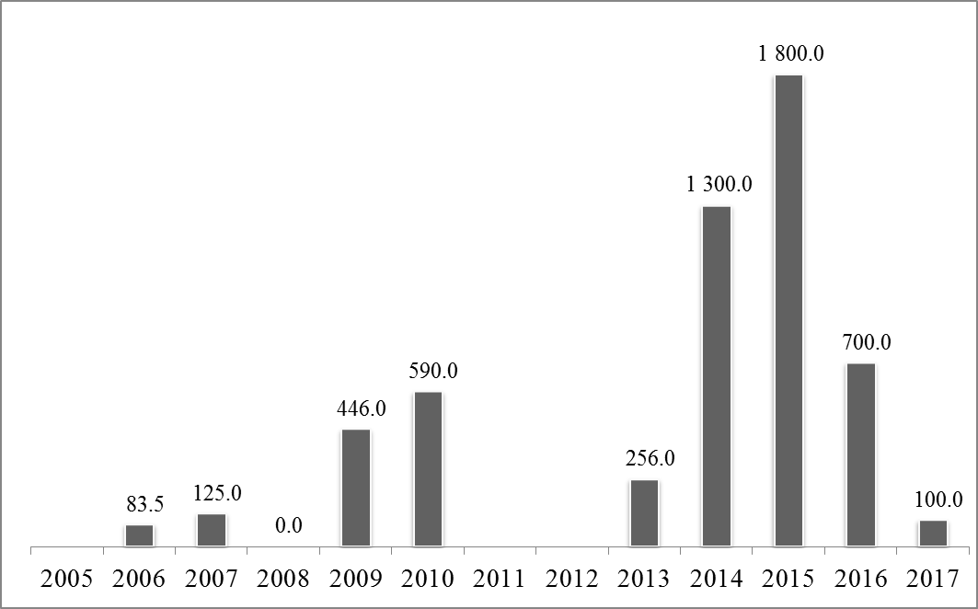

**Chart 3B: MFA amounts authorised by region, 2005-2017 (%)**

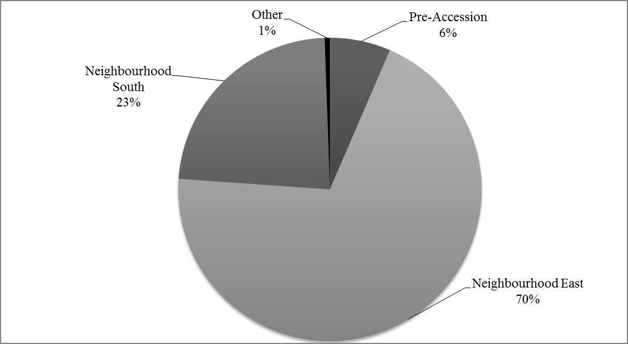

## Annex 4: MFA amounts disbursed by year, 2005-2017 (EUR million)



**Chart 4A: MFA amounts disbursed by year, 2005-2017 (EUR million)**

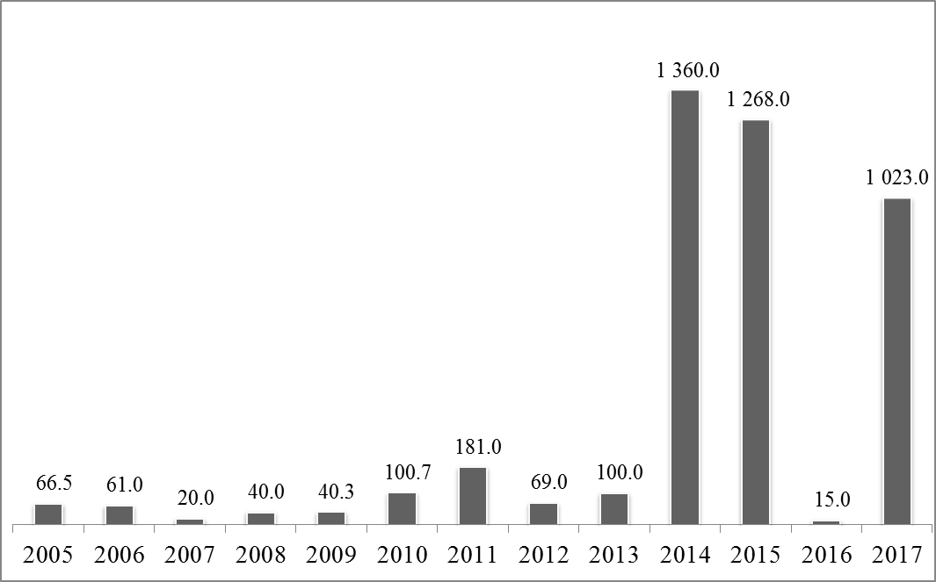

**Chart 4B: MFA amounts disbursed by region, 2005-2017 (%)**

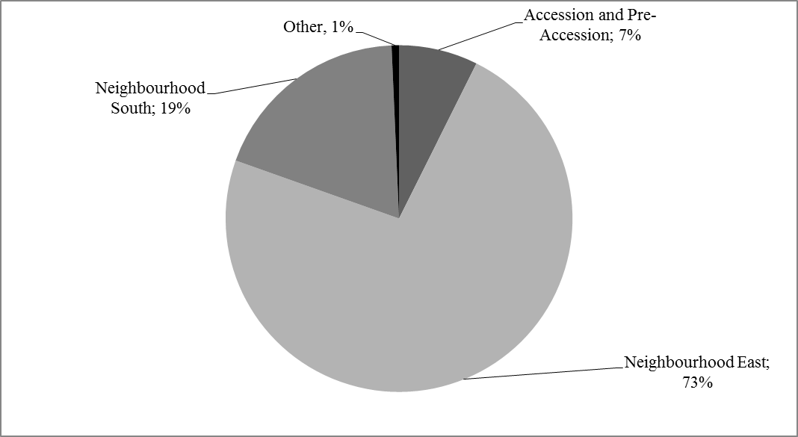

1. This section quotes statistics supplied by national authorities and other relevant sources.
2. This figure reflects a new methodology used by the Jordanian Department of Statistics (DoS) for measuring unemployment following recommendations by the International Labour Organisation (ILO). Therefore, it may not be fully comparable to the figures cited for 2016 and earlier years.
3. OJ L 218, 14.8.2013, p. 18.
4. Decision No 534/2014/EU of the European Parliament and of the Council of 15 May 2014 providing macro-financial assistance to the Republic of Tunisia (OJ L 151, 21.5.2013).
5. Decision No 1112/2016/EU of the European Parliament and of the Council of 6 July 2016 providing further macro-financial assistance to Tunisia (OJ L186, 9.7.2016).
6. These may vary from the statistics quoted in the country-analysis section of this document.