

REPORT FROM THE COMMISSION TO THE EUROPEAN PARLIAMENT AND THE COUNCIL

concerning the implementation and the results of the Pericles 2020 programme for the protection of the euro against counterfeiting in 2017

1. **General**

The ''Pericles 2020'' programme (hereafter ''the Programme") is an exchange, assistance and training programme for the protection of the euro against counterfeiting. It replaces the Pericles programme that was established in 2001 and ran during the period 2002-2013. The Programme was established by **Regulation (EU) No 331/2014 of the European Parliament and of the Council of 11 March 2014**[1]**. Its application was extended to the non-participating Member States by Council Regulation (EU) 2015/768 of 11 May 2015**[2]. Regulation (EU) No 331/2014 establishes the duration of the Programme until 31 December 2020. Article 13(3) of **the Regulation** requires the Commission to provide annual information on the results of the Programme to the European Parliament and to the Council. This Annual Report responds to that requirement in relation to the year 2017.

1. **Annual Work Programme 2017**
   1. **Implementation of the Annual Work Programme in 2017**

The annual budget for the implementation of the Programme for the year 2017 was set at EUR 1 047 500 and was financed from the budget line 01. 020400 of the general budget of the European Union for 2017. A total of **1 047 477,62** was committed in 2017. The Programme is implemented through co-financed actions (grants) originating from the competent authorities of the Member States and through ''Commission actions'', organised directly by the Commission.

The implementation of the Programme reflected the commitment of Member States and the Commission to protect the euro against counterfeiting. Discussions of the multi-annual strategy at the meetings of the Euro Counterfeiting Experts Group (ECEG) made it possible to commit 99.99% of the overall budget in 2017.Taking into account the quality and quantity of grant applications received in 2017, it was necessary to transfer *EUR* 152 000 from "Commission actions" to grants. In 2017, the Programme funded 13 projects in total[3]. Altogether, 10 grants were succesfully awarded from applications originating from the competent authorities of the Member States. An increase from 9 grants in 2016. Furthermore, 3 Commission actions were funded, compared to 4 Commission actions in the previous year. 4 actions were implemented in 2017, while 9 actions are being/will be implemented in 2018 and later.

**Chart I and Chart II: Type of action financed and Number of actions per Member State (actions committed to in 2017, see annex I)[4]**

Applicants to the Programme in 2017 represent six Member States, namely Italy, Spain, Romania, Croatia, Portugal and Austria. To an extent, this reflects the fact that the countries most affected by euro counterfeiting are more frequent users of Pericles funds. In addition, Portugal, Austria and Romania are first-time applicants to the Programme.

The actions for which commitments were made in 2017 consist of 6 seminars/conferences, 2 technical trainings, 4 staff exchanges, and 1 purchase of equipment. The actions take place[5] both inside and outside the EU depending on the specific needs to protect the euro against counterfeiting. Since its inception, the Programme has consolidated its regional approach by implementing actions involving particularly sensitive regions of the world. Of specific focus are Latin America (3 actions organised by Spain and 1 Commission action), and South-East Europe (1 action each organised by Italy, Romania and Croatia).

Charts III and IV give a breakdown of the origin and professional background of participants to the Programme:

**Chart III and Chart IV: Origin of participants and Professional background of participants[6] (actions committed to in 2017, see annex I)[7]**

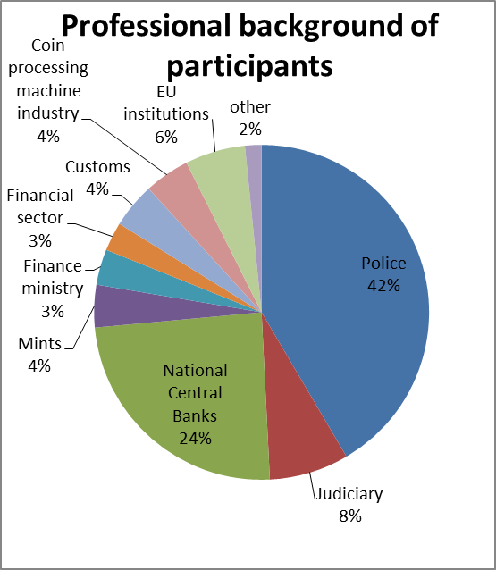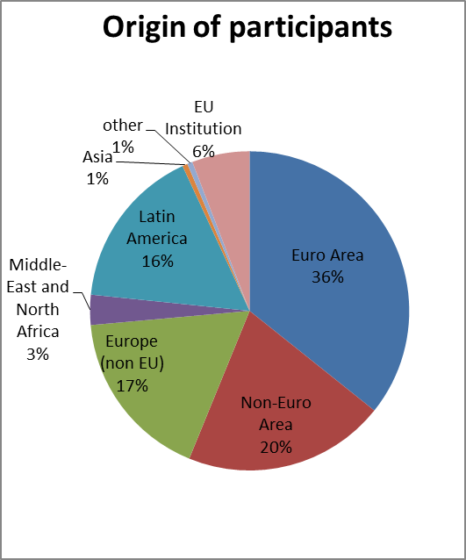

An estimated number of 756 experts participate in actions for which commitments were made in 2017.

In terms of origin, participants come from 57 countries. The majority of trainees (73%) are European participants: 36% come from the euro area Member States, while non-EU countries in Europe represents 17% and Non-Euro Area Member States 20%; 16% of trainees are from Latin America, a significant decrease compared to the previous year[8]. Finally, 3% come from the Middle East and North Africa and 1% from Asia.

With respect to the professional background of participants, members from police forces represent 42% of the total. That prominent presence is due to the fact that police authorities represent the front line in the fight against euro counterfeiting, and police staff includes both investigators and technicians.

However, the implementation of the Programme in 2017 demonstrates a continuing positive trend towards an increasing differentiation and diversification of the professional backgrounds of participants over the years. Indeed, for the second year in a row, police authorities do not represent the absolute majority of participants in 2017. Other categories of participants account for 58% of the total, a slight decrease from 63% in the previous year. The substantial participation of central banks has remained nearly constant with (24%)[9] and there is a continuing high participation of members of the judiciary (8%)[10]. Of particular note is the significant participation of mints (4%), customs (4%), ministries of finance (3% and financial institutions (3%), reflecting a full range of professional backgrounds of the participants. Finally, the implementation of the Commission action ''first meeting of the Platform 1210'' results in a high participation of representatives from the coin processing machine (CPM) industry (4%) for the second year in a row, which affirms the private sector as a significant stakeholder in the fight against counterfeiting.

As a result, the implementation of the Programme meets the transnational and multidisciplinary dimensions of the Programme required under Regulation (EU) No 331/2014.

* 1. **Overview of actions under the Annual Work Programme 2017**

A comprehensive overview of Pericles actions under the 2017 Annual Work Programme can be found in Annex I. The following actions can be highlighted:

*Regional international cooperation*

The Programme has succeeded to maintain and further strengthen strong regional international cooperation in 2017:

* Four actions took/will take place in Latin America, bringing together experts from a large number of Latin American countries including Argentina, Brazil, Colombia, Costa Rica, Chile, Ecuador, El Salvador, Guatemala, Honduras, Mexico, Nicaragua, Panama, Paraguay, Peru, Dominican Republic and Uruguay;
* Four actions took/will take place in South Eastern Europe, maintaining strong cooperation in this region.

*Internet/darknet*

Several actions committed in 2017 addressed the threat posed by the internet/darknet in the fight against counterfeiting, focussing on the effectiveness of investigation techniques and the need for a coordinated response to the threat:

* The co-funded 'ICIT – Darknet Investigation – Protection of the Euro' conference, organised by the Austrian Ministry of the Interior (BMI), will take place in Vienna in October 2018;
* Furthermore, both the UCAMP[11]-organised conference 'A Community Strategy to Protect the Euro in the Mediterranean Area' as well as the BIBE[12]-organised conference 'Curso de Formación sobre Falsificación de Moneda para Expertos de Paises Iberoamericanos' and the Bank of Croatia-organised '3rd conference: Balkan network for euro protection' treated this topic.

*How to apply workshop*

In March 2018, the Commission organised the 'Pericles 2020 how to apply workshop' as a Commission action, responding both to the requests of several Competent National Authorities in the meetings of the Euro Counterfeiting Experts Group (ECEG) as well as to the recommendation of the Mid-Term evaluation of the programme[13] to encourage greater participation of Competent National Authorities. The workshop was geared towards the desk officers in charge of preparing grant applications, to explain step-by-step the application procedure, the financial guidelines and all supporting documents.

*New Competent National Authority applicants*

The 2017 commitments also reflect a further diversification of Member States' competent national authorities applying for the Programme; the Romanian police, Austrian police and Portuguese police are first-time applicants for Pericles funds. This is in line with the recommendation of the Mid-Term evaluation of the programme to encourage greater participation of Competent National Authorities to the programme.

1. **Implementation of actions in 2017 that were committed to under previous budgets of the Programme**

2017 saw the implementation of 10 actions that were committed to under previous budgets of the Programme[14]. Of those actions, 6 originated from the competent national authorities of Member States - namely France, Spain, Germany, Croatia and Italy - while 4 actions were initiated by the Commission. The actions consisted of 4 seminars, 2 technical trainings, 2 staff exchanges, 1 purchase of equipment and a study. Particular focus regions and topics were South-Eastern Europe, China, and Latin America, as well as the darknet and the authentication of euro coins.

Of particular note is the EU China platform meeting/seminar on the protection of currencies against counterfeiting that was held in November 2017 in Brussels, Belgium. The meeting involved participation of the relevant Chinese authorities involved in the fight against currency counterfeiting, the EU Institutions as well as representatives from Member States particularly affected by euro counterfeiting. The action was successful in establishing a platform of cooperation on the protection of the euro between relevant European Institutions and Chinese authorities, and treated topics such as the exchange of best practices on the dismantling and identification of illegal printshops and mints, the distribution of counterfeits on the internet/darknet, the channels for the exchange of operational information and European and Chinese legal frameworks for the protection of currencies against counterfeiting.

1. **Conclusion and way forward**

The ''Pericles 2020'' programme continues to be an important and efficient tool in the fight against counterfeiting. This is underscored by the fact that the available budget for 2017 was fully committed. The Programme forms the basis for the support of studies, maintaining and developing cooperation, and exchanging best practices among all actors involved in the fight against euro counterfeiting.

The Commission constantly disseminates the results of the actions supported under the Programme to the experts of the Euro Counterfeit Experts Group (ECEG). In 2017, 3 ECEG meetings took place. The Programme shows a high degree of consistency and complementarity with other relevant programmes and actions at Union level because it is dedicated exclusively to and focuses on preventing and fighting a specific form of organised crime, namely euro counterfeiting. This is true for DG NEAR’s ***Technical Assistance and Information Exchange (TAIEX)*** instrument, most often used in support of accession negotiations, and DG HOME's Internal Security Fund - Police[15], which covers the prevention and combating of crime in general.

Furthermore, a mid-term evaluation of the Programme was carried out by an independent contractor on the basis of Art 13(4) of Regulation (EU) No 331/2014. The independent evaluation concludes that all findings converge towards an unambiguously positive overall assessment regarding its EU added value, coherence, relevance, effectiveness, sustainability and efficiency. The Commission adopted Communication COM(2017) 741 to the European Parliament and to the Council on the results of the Mid-Term Evaluation of the programme on 6 December 2017[16], in which it shares the conclusion that the Programme should continue until its natural expiry in 2020, supports the continuation of the Programme beyond 2020 given its EU added value, its long-term impact and sustainability, and concurs with the assessment of the Evaluation on the continuation of the Programme as a standalone programme beyond 2020[17].

Based on the results of the implementation of the Programme and the continuous analysis of emerging threats discussed in the ECEG, the priorities for 2018 are the following[18]:

* Supporting activities aimed at improving cooperation among those Member States which are particularly affected by the production and distribution of counterfeits;
* Fostering cooperation with authorities of those third countries where there is suspicion of or evidence for counterfeit euro production;
* Maintaining an efficient framework for the protection of the euro in South Eastern Europe;
* Topical developments: technical developments within the coin processing machines (CPM) industry, the distribution of counterfeits and high quality components on the internet and improving security features of euro coins.

1. Regulation (EU) No 331/2014 of the European Parliament and of the Council establishing an exchange, assistance and training programme for the protection of the euro against counterfeiting (the 'Pericles 2020' programme) (OJ L 103, 5.4.2014, p. 1). That Regulation repealed Council Decisions 2001/923/EC, 2006/75/EC, and 2006/849/EC.
2. Council Regulation (EU) 2015/768 of 11 May 2015 extending to the non-participating Member States the application of Regulation (EU) No 331/2014 of the European Parliament and of the Council establishing an exchange, assistance and training programme for the protection of the euro against counterfeiting (the ‘Pericles 2020’ programme) (OJ L 121, 14.5.2015, p. 1).
3. A comprehensive overview of Pericles actions committed to in 2017 can be found in Annex I.
4. All data concerns both actions implemented in 2017 and actions that are being/will be implemented beyond 2017.
5. Some actions are still being implemented in 2018.
6. The other category includes, inter alia, Interpol, staff from national ministries and representations, and staff of academic institutions.
7. All data concerns both actions implemented in 2017 and actions that are being/will be implemented beyond 2017.
8. This is a decrease from 26% during 2016 Pericles implementation, COM(2017) 345 final.
9. This is a small increase from 23% during 2016 Pericles implementation.
10. This is a slight decrease from 11% during 2016 Pericles implementation.
11. Ufficio Centrale Antifrode dei Mezzi di Pagamento.
12. Brigada de Investigacion del Banco de Espana.
13. Communication COM(2017) 741 final - Communication from the Commission to the Council and the European Parliament on the mid-term evaluation of the Programme for exchange, assistance and training for the protection of the euro against counterfeiting ('Pericles 2020' Programme), 6 December 2017.
14. A comprehensive overview of Pericles actions committed to under previous budgets of the Pericles 2020 programme but implemented in 2017 can be found in Annex II.
15. Regulation (EU) No 513/2014 of the European Parliament and of the Council of 16 April 2014 establishing, as part of the Internal Security Fund, the instrument for financial support for police cooperation, preventing and combating crime, and crisis management and repealing Council Decision 2007/125/JHA (OJ L 150, 20.5.2014, p. 93).
16. Communication COM(2017) 741 final - Communication from the Commission to the Council and the European Parliament on the mid-term evaluation of the Programme for exchange, assistance and training for the protection of the euro against counterfeiting ('Pericles 2020' Programme), 6 December 2017.
17. In the meantime, the Commission has adopted a proposal to continue the programme beyond 2020, COM (2018) 369 and COM (2018) 371
18. The priorities of the Programme for 2018 are an essential part of the Annual Work Programme, which is annexed to Commission Decision C(2018) 470 final of 30 January 2018 concerning the adoption of the work programme for 2018 of the Pericles 2020 programme.