

**Annex A – List of Technical Studies in support of good implementation**

* [A best practice based approach to National Contact Point websites: feasibility study](https://ec.europa.eu/health/sites/health/files/cross_border_care/docs/pwc_national_contact_points_website_en.pdf)

**Objective:** To develop recommendations on what information should be provided by NCPs in order to enable patients to exercise their rights to cross-border healthcare in practice.

* [Impact of information on patients' choice within the context of the Directive 2011/24/EU](https://ec.europa.eu/health/sites/health/files/cross_border_care/docs/cbhc_information_patientschoice_en.pdf)

**Objective:** To evaluate – using a behavioural approach – the impact of information provision on patients' choices to exercise their rights to be treated abroad.

* [The Evaluative Study on the Cross-border Healthcare Directive](https://ec.europa.eu/health/sites/health/files/cross_border_care/docs/2015_evaluative_study_frep_en.pdf)

**Objective:** To lay the groundwork for a research methodology for assessing information provision to patients.

* [Literature-based approach to defining the concept of healthcare which requires "highly specialised and cost-intensive medical infrastructure or medical equipment"](https://ec.europa.eu/health/sites/health/files/cross_border_care/docs/ecorys_frep_en.pdf)

**Objective:** To assess how the concept of healthcare requiring highly specialised and cost-intensive medical infrastructure or equipment can be defined.

* [Study on better cross-border cooperation for high-cost capital investments in health](https://ec.europa.eu/health/sites/health/files/cross_border_care/docs/hci_frep_en.pdf)

**Objective:** To select candidate devices (cost-intensive and highly specialised medical equipment) where cross-border resource pooling may be recommendable in view of efficiency gains.

* [Study on cross-border health services: potential obstacles for healthcare providers](https://ec.europa.eu/health/sites/health/files/cross_border_care/docs/potentialobstacles_cbhcprovision_frep_en.pdf)

**Objective:** To analyse the legal, administrative and other requirements by country which may constitute barriers to health providers wishing to offer their services in another Member State.

* [Patients' Rights in the European Union – Mapping Exercise](https://ec.europa.eu/health/sites/health/files/cross_border_care/docs/2018_mapping_patientsrights_frep_en.pdf)

**Objective:** To provide a comparative overview of patients' rights currently in place in EU Member States, Norway and Iceland.

* [Study on cross-border cooperation](https://ec.europa.eu/health/sites/health/files/cross_border_care/docs/2018_crossbordercooperation_frep_en.pdf)

**Objective:** To map EU-funded projects in the period 2007-2017 in 28 EU Member States, EEA countries and Switzerland and to provide insight into potential future challenges and opportunities for cooperation in healthcare for the period up to 2030, as well as to present successful business cases for cross-border collaboration.

* [Study on information provision to patients](https://ec.europa.eu/health/cross_border_care/key_documents_en)

**Objective:** To train NCPs into good practices and structure their cooperation, drawing on a thorough assessment of the state of play of information provision.

**Annex B**

**Flow Map 1: Patient Mobility with Prior Authorisation in Europe in 2015-2017**

**Country of affiliation[1] Country of treatment[2]**

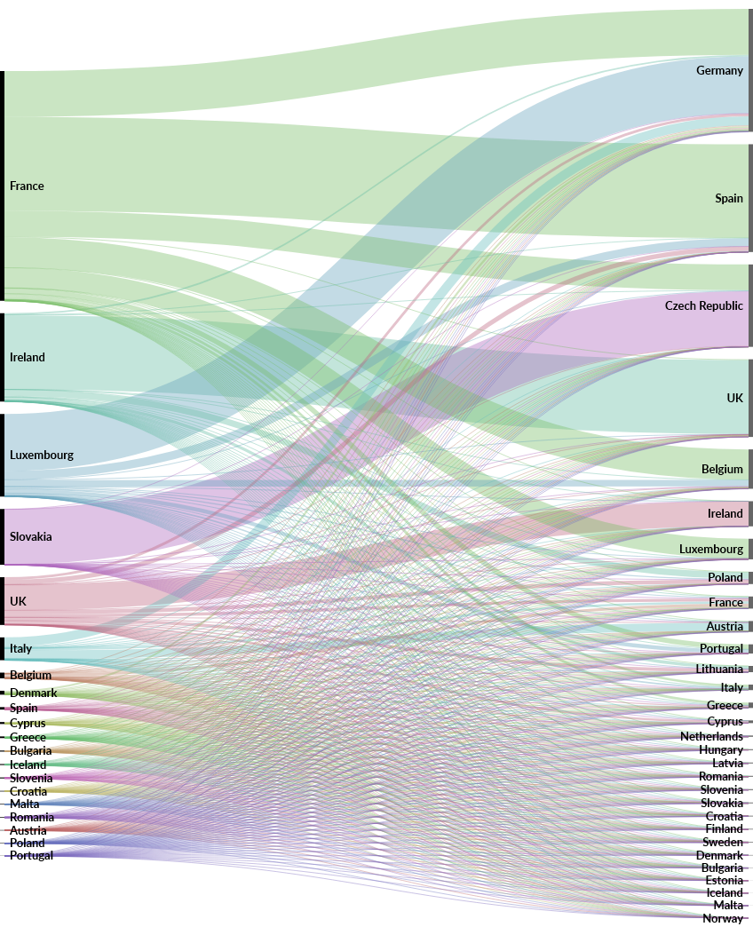

**Flow Map 2: Patient Mobility Not Requiring Prior Authorisation in Europe in 2015-2017**

**Country of affiliation**[3] **Country of treatment**[4]

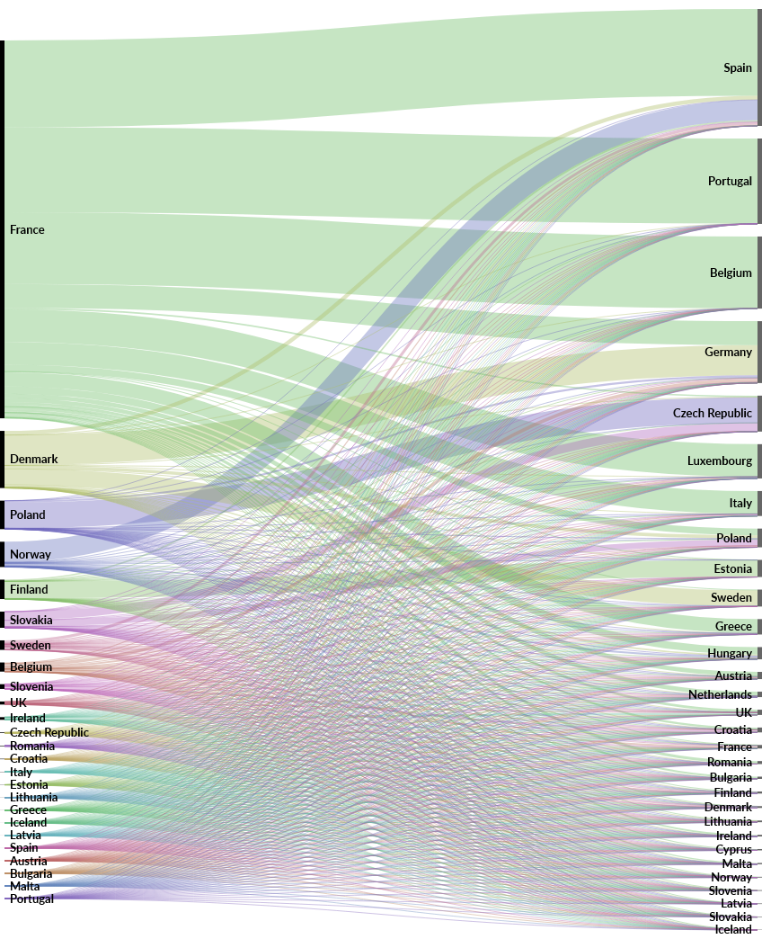

1. Order from top to bottom: France, Ireland, Luxembourg, Slovakia, UK, Italy, Belgium, Denmark, Spain, Cyprus, Greece, Bulgaria, Iceland, Slovenia, Croatia, Malta, Romania, Austria, Poland, Portugal
2. Order from top to bottom: Germany, Spain, Czech Republic, UK, Belgium, Ireland, Luxembourg, Poland, France, Austria, Portugal, Lithuania, Italy, Greece, Cyprus, Netherlands, Hungary, Latvia, Romania, Slovenia, Slovakia, Croatia, Finland, Sweden, Denmark, Bulgaria, Estonia, Iceland, Malta, Norway
3. Order from top to bottom: France, Denmark, Poland, Norway, Finland, Slovakia, Sweden, Belgium, Slovenia, UK, Ireland, Czech Republic, Romania, Croatia, Italy, Estonia, Lithuania, Greece, Iceland, Latvia, Spain, Austria, Bulgaria, Malta, Portugal
4. Order from top to bottom: Spain, Portugal, Belgium, Germany, Czech Republic, Luxembourg, Italy, Poland, Estonia, Sweden, Greece, Hungary, Austria, Netherlands, UK, Croatia, France, Romania, Bulgaria, Finland, Denmark, Lithuania, Ireland, Cyprus, Malta, Norway, Slovenia, Latvia, Slovakia, Iceland