

Appendix 4

**TACHOnet specifications**

1. Scope and purpose
   1. This appendix sets out the terms and conditions regarding the connection of AETR Contracting Parties to TACHOnet through eDelivery.
   2. Contracting Parties connecting to TACHOnet through eDelivery shall abide by the provisions laid down in this Appendix.
2. Definitions
   * + 1. ‘Contracting party’ or ‘party’ means any Contracting party to the AETR;
       2. ‘eDelivery’ means the service developed by the European Commission making possible to transmit data between third parties by electronic means, providing evidence relating to the handling of the transmitted data, including proof of sending and receiving the data, and protecting transmitted data against the risk of any unauthorised alteration;
       3. ‘TACHOnet’ means the system for the electronic exchange of information on driver cards between contracting parties referred to in Article 31(2) of Regulation (EU) No 165/2014;
       4. ‘Central hub’ means the information system enabling the routing of TACHOnet messages between requesting and responding parties;
       5. ‘Requesting party’ means the contracting party emitting a TACHOnet request or a notification, which is then routed to the appropriate responding party by the central hub;
       6. ‘Responding party’ means the contracting party to whom the TACHOnet request or notification is addressed;
       7. ‘Card issuing authority’ or ‘CIA’ means the entity empowered by a contracting party for the issuing and management of tachograph cards.
3. General responsibilities
   1. Neither contracting party may conclude agreements for the access to TACHOnet on behalf of another party or in any other way represent the other contracting party on the basis of this Appendix. Neither contracting party acts as the other contracting party’s subcontractor in the operations referred to in this Appendix.
   2. The contracting parties shall provide access to their national register on driver cards through TACHOnet, in the way and with the level of service set out in Sub-appendix 4.6.
   3. The contracting parties shall notify each other without delay if they observe disturbances or errors within their domain of responsibility, which may endanger the fulfilling of the normal operation of TACHOnet.
   4. Each party shall designate contact persons for TACHOnet to the AETR Secretariat. Any change in contact points must be provided to the AETR Secretariat in writing.
4. Tests for connection to TACHOnet
   1. The connection of a contracting party to TACHOnet shall be established after the successful completion of the connection, integration and performance tests in accordance with the instructions and under the supervision of the European Commission.
   2. In case of failure of the preliminary tests, the European Commission may temporarily put on hold the testing phase. The tests shall resume once the contracting party has communicated to the European Commission the adoption of the necessary technical improvements at national level, allowing the successful performance of the preliminary tests.
   3. The maximum duration of the preliminary tests shall be six months.
5. Trust architecture
   1. Confidentiality, integrity and non-repudiation of the TACHOnet messages shall be ensured by the TACHOnet trust architecture.
   2. The TACHOnet trust architecture shall be based on a public key infrastructure (PKI) service set up by the European Commission, whose requirements are laid down in Sub-appendices 4.8 and 4.9.
   3. The following entities shall intervene in the TACHOnet trust architecture:

(a) Certification Authority, responsible for the generation of the digital certificates to be delivered by the Registration Authority to the national authorities of the contracting parties (via trusted couriers appointed by them), as well as for setting up the technical infrastructure regarding the issuance, revocation and renewal of digital certificates.

(b) Domain Owner, responsible for the operation of the central hub referred to in Sub-appendix 4.1 and for the validation and coordination of the TACHOnet trust architecture.

(c) Registration Authority, responsible for registering and approving the requests of issuance, revocation and renewal of digital certificates, and for verifying the identity of the trusted couriers.

(d) Trusted Courier, is the person appointed by the national authorities, responsible for handing the public key to the Registration Authority and for getting the corresponding certificate being generated by the Certification Authority.

(e) National authority from the contracting party, which shall:

(i) generate the private keys and the corresponding public keys to be included in the certificates to be generated by the Certification Authority;

(ii) request the digital certificates to the Certification Authority;

(iii) appoint the Trusted Courier.

* 1. The Certification Authority and the Registration Authority shall be appointed by the European Commission.
  2. Any contracting party connecting to TACHOnet must request the issuance of a digital certificate in accordance with Sub-appendix 4.9, in order to sign and encrypt a TACHOnet message.
  3. A certificate may be revoked in accordance with Sub-appendix 4.9.

1. Data protection and confidentiality
   1. The parties, in compliance with data protection laws at international and national level, and in particular with the Convention for the Protection of Individuals with regard to Automatic Processing of Personal Data, shall adopt all necessary technical and organisational measures to guarantee the security of the TACHOnet data and prevent the alteration or loss of, or unauthorised processing of or access to such data (in particular the authenticity, data confidentiality, traceability, integrity, availability and non-repudiation and security of the messages).
   2. Each party shall protect its own national systems against illicit use, malicious code, viruses, computer intrusions, infringements and illegal tampering of data and other comparable actions by third parties. The parties agrees to use commercially reasonable efforts to avoid the transmission of any viruses, time bombs, worms or similar items or any computer programming routines that may interfere with other Party’s computer systems.
2. Costs
   1. The contracting parties shall bear their own development and operation costs in conjunction to their own data systems and procedures as required to fulfil the obligations according to this Appendix.
   2. The services specified in Sub-appendix 4.1, provided by the central hub, are free of charge.
3. Subcontracting
   1. The parties may subcontract any of the services for which they are responsible under this Appendix.
   2. Such subcontracting does not relieve the party from the responsibility pursuant to this Appendix, including the responsibility for the appropriate level of service in accordance with Sub-appendix 4.6.

Sub-appendix 4.1

**General aspects of TACHOnet**

1. General description

TACHOnet is an electronic system for the exchange of information on driver cards between AETR contracting parties. TACHOnet routes the requests for information from the requesting parties to the responding parties, as well as the replies from the latter to the former. Contracting parties being part of TACHOnet must connect their national registers on driver cards to the system.

1. Architecture

TACHOnet messaging system shall be composed of the following parts:

* 1. A central hub, which shall be able to receive a request from the requesting party, validate it and process it by forwarding it to the responding parties. The central hub shall wait for each responding party to answer, consolidate all the answers and forward the consolidated response to the requesting Party.
  2. National systems of the parties, which shall be fitted with an interface capable of both sending requests to the central hub and receiving the corresponding replies. National systems may use propriety or commercial software to transmit and receive messages from the central hub.

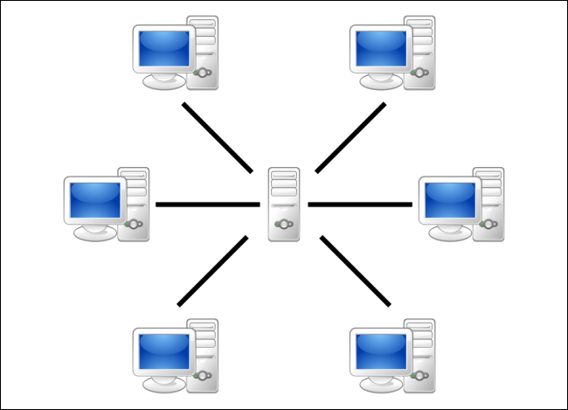

1. Management
   1. The central hub shall be managed by the European Commission, which shall be responsible for the technical operation and maintenance of the central hub.
   2. The central hub shall not store data for a period exceeding six months, other than the logging and statistical data set out in Sub-appendix 4.7.
   3. The central hub shall not provide access to personal data, except for authorized European Commission personnel, when necessary for the purpose of monitoring, maintenance and troubleshooting.
   4. Each contracting party shall be responsible for:
      1. The setup and management of their national systems, including the interface with the central hub.
      2. The installation and maintenance of their national system, both hardware and software, whether proprietary or commercial.
      3. The correct interoperability of their national system with the central hub, including the management of error messages received from the central hub.
      4. Taking all the measures to ensure the confidentiality, integrity and availability of the information.
      5. The operation of the national systems in accordance with the service levels set out in Sub-appendix 4.6.

Sub-appendix 4.2

**Functionalities of TACHOnet**

1. The following functionalities shall be provided through TACHOnet messaging system:
   1. Check Issued Cards (CIC): allows the requesting party to send a Check Issued Cards Request to one or all responding parties, in order to determine if a card applicant already possesses a driver card issued by the responding parties. The responding parties shall reply to the request by sending a Check Issued Cards Response.
   2. Check Card Status (CCS): allows the requesting party to ask the responding party about the details of a card issued by the latter by sending a Check Card Status Request. The responding party shall reply to the request by sending a Check Card Status Response.
   3. Modify Card Status (MCS): allows the requesting party to notify the responding party, through a Modify Card Status Request, that the status of a card issued by the latter has changed. The responding party shall reply with a Modify Card Status Acknowledgement.
   4. Issued Card Driving License (ICDL): allows the requesting party to notify the responding party, through an Issued Card Driving Licence Request, that a card has been issued by the former against a driving licence issued by the latter. The responding party shall reply with an Issued Card Driving Licence Response.
2. Other message types deemed suitable for the efficient functioning of TACHOnet shall be included, for instance error notifications.
3. National systems shall recognize the card statuses listed in Table 1, when using any of the functionalities described in point 1. However, parties are not required to implement an administrative procedure that makes use of all of the listed statuses.
4. When a party receives a response or notification giving a status that is not used in its administrative procedures, the national system shall translate the status on the received message to the appropriate value in that procedure. The message shall not be rejected by the responding party, as long as the status in the message is listed in Table 1.
5. The card status listed in Table 1 shall not be used to determine if a driver card is valid for driving. When a party queries the register of the card issuing national authority via the CCS functionality, the response shall contain the dedicated field ‘valid for driving’. The national administrative procedures shall be such that CCS responses always contain the appropriate ‘valid for driving’ value.

Table 1

**Card statuses**

| **Card Status** | **Definition** |
| --- | --- |
| Application | The CIA has received an application to issue a driver card. This information has been registered and stored in the database with the generated search keys. |
| Approved | The CIA has approved the application for the tachograph card. |
| Rejected | The CIA did not approve the application. |
| Personalised | The tachograph card has been personalised. |
| Dispatched | The National Authority has dispatched the driver card to the relevant driver or delivering agency. |
| Handed Over | The National Authority has handed over the driver card to the relevant driver. |
| Confiscated | The driver card has been taken from the driver by the competent authority. |
| Suspended | The driver card has been taken temporarily from the driver. |
| Withdrawn | The CIA has decided to withdraw the driver card. The card has been permanently invalidated. |
| Surrendered | The tachograph card has been returned to the CIA, and declared no longer needed. |
| Lost | The tachograph card has been declared lost to the CIA. |
| Stolen | The tachograph card has been reported stolen to the CIA. A stolen card is considered lost. |
| Malfunctioning | The tachograph card has been reported as malfunctioning to the CIA. |
| Expired | The period of validity of the tachograph card has expired. |
| Replaced | The tachograph card, which has been reported lost, stolen or malfunctioning, has been replaced by a new card. The data on the new card is the same, with the exception of the card number replacement index, which has been increased by one. |
| Renewed | The tachograph card has been renewed because of a change of administrative data or the validity period coming to an end. The card number of the new card is the same, with the exception of the card number renewal index, which has been increased by one. |
| In Exchange | The CIA that issued a driver card has received a notification that the procedure to exchange that card for a driver card issued by the CIA of another Party has started. |
| Exchanged | The CIA that issued a driver card has received a notification that the procedure to exchange that card for a driver card issued by the CIA of another Party has completed. |

Sub-appendix 4.3

**Message provisions of TACHOnet**

1. General technical requirements
   1. The central hub shall provide both synchronous and asynchronous interfaces for the exchange of messages. Parties may choose the most suitable technology to interface with their own applications.
   2. All messages exchanged between the central hub and the national systems must be UTF-8 encoded.
   3. National systems shall be capable of receiving and processing messages containing Greek or Cyrillic characters.
2. XML messages structure and Schema definition (XSD)
   1. The general structure of XML messages shall follow the format defined by the XSD schemas installed in the central hub.
   2. The central hub and the national systems shall transmit and receive messages that conform to the message XSD schema.
   3. National systems shall be capable of sending, receiving and processing all messages corresponding to any of the functionalities set out in Sub-appendix 4.2.
   4. The XML messages shall include at least the minimum requirements laid down in Table 2.

Table 2

**Minimum requirements for the content of the XML messages**

| **Common Header** | | **Mandatory** |
| --- | --- | --- |
| Version | The official version of the XML specifications will be specified through the namespace defined in the message XSD and in the *version* attribute of the Header element of any XML message. The version number (‘n.m’) will be defined as fixed value in every release of the XML Schema Definition file (xsd). | Yes |
| Test Identifier | Optional id for testing. The originator of the test will populate the id and all participants in the workflow will forward / return the same id. In production it should be ignored and will not be used if it is supplied. | No |
| Technical Identifier | A UUID uniquely identifying each individual message. The sender generates a UUID and populates this attribute. This data is not used in any business capacity. | Yes |
| Workflow Identifier | The workflowId is a UUID and should be generated by the requesting party. This id is then used in all messages to correlate the workflow. | Yes |
| Sent At | The date and time (UTC) that the message was sent. | Yes |
| Timeout | This is an optional date and time (in UTC format) attribute. This value will be set only by the central hub for forwarded requests. This will inform the responding party of the time when the request will be timed out. This value is not required in MS2TCN_<x>_Req and all response messages. It is optional so that the same header definition can be used for all message types regardless of whether or not the timeoutValue attribute is required. | No |
| From | The ISO 3166-1 Alpha 2 code of the party sending the message or ‘EU’. | Yes |
| To | The ISO 3166-1 Alpha 2 code of the party to which the message is being sent or ‘EU’. | Yes |

Sub-appendix 4.4

**Transliteration and NYSIIS (New York State Identification and Intelligence System) Services**

1. The NYSIIS algorithm implemented in the central hub shall be used to encode the names of all the drivers in the national register.
2. When searching for a card via the CIC functionality the NYSIIS keys shall be used as the primary search mechanism.
3. Additionally, parties may employ a custom algorithm to return additional results.
4. The search results shall indicate the search mechanism which was used to find a record, either NYSIIS or custom.
5. If a party chooses to record ICDL notifications then the NYSIIS keys contained in the notification shall be recorded as part of the ICDL data. When searching the ICDL data the party shall use the NYSIIS keys of the applicant’s name.

Sub-appendix 4.5

**Security requirements**

1. HTTPS shall be used for the exchange of messages between the central hub and the national systems.
2. National systems shall use the digital certificates referred to in Sub-appendices 4.8 and 4.9 for the purposes of securing the transmission of messages between the national system and the central hub.
3. National systems shall implement, as a minimum, certificates using the SHA-2 (SHA-256) signature hash algorithm and a 2048 bit public key length.

Sub-appendix 4.6

**Service levels**

1. National systems shall fulfil the following minimum level of service:
   1. They shall be available 24 hours a day, 7 days a week.
   2. Their availability shall be monitored by a heartbeat message issued from the central hub.
   3. Their availability rate shall be 98%, according to the following table (the figures have been rounded to the nearest convenient unit):

|  |  |  |  |
| --- | --- | --- | --- |
| An availability of | means an unavailability of | | |
| Daily | Monthly | Yearly |
| 98% | 0.5 hours | 15 hours | 7.5 days |

Parties are encouraged to respect the daily availability rate, however it is recognised that certain necessary activities, such as system maintenance, require a down time of more than 30 minutes. However, the monthly and yearly availability rates remain mandatory.

* 1. They shall respond to a minimum of 98% of the requests forwarded to them in one calendar month.
  2. They shall respond to requests within 10 seconds.
  3. The global request timeout (time within which the requestor may wait for a response) shall not exceed 20 seconds.
  4. They shall be able to service a request rate of 6 messages per second.
  5. National systems may not send requests to the TACHOnet hub at a rate exceeding 2 requests per second.
  6. Every national system shall be able to cope with potential technical problems of the central hub or national systems in other parties. These include, but are not limited to:

(a) loss of connection to the central hub;

(b) no response to a request;

(c) receipt of responses after message timeout;

(d) receipt of unsolicited messages;

(e) receipt of invalid messages.

1. The central hub shall:
   1. feature an availability rate of 98%;
   2. provide to national systems notification of any errors, either via the response message or via a dedicated error message. The national systems, in turn, shall receive these dedicated error messages and have an escalation workflow in place to take any appropriate action to rectify the notified error.
2. Maintenance

Parties shall notify other parties and the European Commission of any routine maintenance activities via the web application, at least one week before the beginning of those activities if technically possible.

Sub-appendix 4.7

**Logging and Statistics of the data collected at the central hub**

1. In order to ensure privacy, the data for statistical purposes shall be anonymous. Data identifying a specific card, driver or driver licence shall not be available for statistical purposes.
2. Logging information shall keep track of all transactions for monitoring and debugging purposes, and allow the generation of statistics about these transactions.
3. Personal data shall not be retained in the logs for more than 6 months. Statistical information shall be retained indefinitely.
4. The statistical data used for reporting shall include:

(a) the requesting party;

(b) the responding party;

(c) the type of message;

(d) the status code of the response;

(e) the date and time of the messages;

(f) the response time.

Sub-appendix 4.8

**General provisions regarding digital keys and certificates for TACHOnet**

1. The Directorate General for Informatics of the European Commission (DIGIT) shall make available a PKI service[1] (referred to as “CEF PKI service”) to the AETR Contracting Parties connecting to TACHOnet (henceforth the national authorities) through eDelivery.
2. The procedure for request and revocation of digital certificates, as well as the detailed terms and conditions for its usage, are defined in the Appendix
3. Usage of certificates:
   1. Once the certificate is issued, the national authority[2], shall use the certificate only in the context of TACHOnet. The certificate can be used to:

(a) authenticate the origin of data;

(b) encrypt data;

(c) ensure detection of integrity breaches of data.

* 1. Any usage not explicitly authorised as part of the permitted usages of the certificate is prohibited.

1. Contracting parties shall:

(a) protect their private key against unauthorized use;

(b) refrain from transferring or revealing their private key to third parties, even as representatives;

(c) ensure confidentiality, integrity, and availability of the private keys generated, stored and used for TACHOnet;

(d) refrain from continued use of the private key following expiry of the validity period or revocation of the certificate, other than to view encrypted data (e.g., decrypting e-mails). Expired keys shall be either destroyed or retained in a manner preventing its use;

(e) provide the Registration Authority with the identification of those authorised representatives who are authorized to request revocation of certificates issued to the organisation (revocation requests shall include a revocation request password and details about the events that lead to revocation);

(f) prevent misuse of the private key by requesting the revocation of the associated public key certificate in case of compromise of the private key or of the private key activation data;

(g) be responsible and hold the obligation of requesting revocation of certificate under circumstances identified in the certification policies (CP) and certification practices statement (CPS) of the Certification Authority;

(h) notify the Registration Authority without delay of loss, theft, or potential compromise of any AETR keys used in the context of TACHOnet.

1. Liabilities

Without prejudice of the liability of the European Commission in contravention of any requirements laid down in applicable national law or with respect to liability for matters which may not be excluded under that law, the European Commission shall not be responsible or liable with regard to:

(a) the content of the certificate which lies exclusively with the certificate owner. It shall be the responsibility of the certificate owner to check the accuracy of the certificate content;

(b) the use of the certificate by its owner.

Sub-appendix 4.9

**Description of** **the PKI service for TACHOnet**

1. Introduction

A PKI (Public Key Infrastructure) is a set of roles, policies, procedures and systems needed to create, manage, distribute, and revoke digital certificates[3]. The CEF PKI service of eDelivery enables issuance and management of digital certificates used to ensure confidentiality, integrity and non-repudiation of the information exchanged between Access Points (AP).

The PKI service of eDelivery is based on the Trust Center Services TeleSec Shared Business CA (Certification Authority) for which the Certificate Policy (CP) / Certification Practices Statement (CPS) of TeleSec Shared-Business-CA of T-Systems International GmbH[4] apply.

The PKI service issues certificates that are suitable for securing various business processes within and outside of companies, organisations, public authorities and institutions that require a medium security level to prove the authenticity, integrity and trustworthiness of the end-entity.

1. Certificate Request Process
   1. Roles and responsibilities
      1. ‘Organisation’ or ‘national authority’ requesting the certificate
         1. The national authority shall request the certificates in the context of the TACHOnet project.
         2. The national authority shall:
         3. request the certificates from the CEF PKI service;
         4. generate the private keys and the corresponding public keys to be included in the certificates issued by the Certification Authority;
         5. download the certificate when approved;
         6. sign and send back to the Registration Authority:

the contact persons and trusted couriers identification form,

the signed individual Power of Attorney[5].

* + 1. Trusted Courier
       1. The national authority shall appoint a Trusted Courier.
       2. The trusted Courier shall:
       3. hand over the public key to the Registration Authority during a face-to-face identification and registration process;
       4. get the corresponding certificate from the Registration Authority.
    2. Domain Owner
       1. DG MOVE shall be the Domain Owner.
       2. The Domain Owner shall:
       3. validate and coordinate the TACHOnet network and the TACHOnet trust architecture, including the validation of the procedures for the issuance of the certificates;
       4. operate the TACHOnet central hub and coordinate the activity of the parties regarding the functioning of TACHOnet;
       5. perform, along with national authorities, the tests of connection to TACHOnet.
    3. Registration Authority
       1. The Joint Research Centre (JRC) shall be the Registration Authority.
       2. The Registration Authority shall be responsible for verifying the identity of the trusted courier, for registering and approving the requests of issuance, revocation and renewal of digital certificates.
       3. The registration authority shall:
       4. assign the unique identifier to the national authority;
       5. authenticate the identity of the national authority, its contact points and trusted couriers;
       6. communicate with the CEF Support regarding the authenticity of the national authority, its contact points and trusted couriers;
       7. inform the national authority about the approval or rejection of certificate.
    4. Certification Authority
       1. The Certification Authority shall be responsible for the provision of the technical infrastructure for the request, issuing and revocation of digital certificates.
       2. The Certification Authority shall:
       3. provide for the technical infrastructure for certificate requests by national authorities;
       4. validate or reject certificate request;
       5. communicate with the Registration Authority for the identity verification of the requesting organisation, when required.
  1. Certificate issuance
     1. The certificate issuance shall be carried out in accordance with the following sequential steps, represented in figure 1:
        1. **Step 1:** Trusted courier identification;
        2. **Step 2:** Certificate request creation;
        3. **Step 3**: Registration at RA;
        4. **Step 4:** Certificate generation;
        5. **Step 5:** Certificate publication;
        6. **Step 6:** Certificate acceptance.

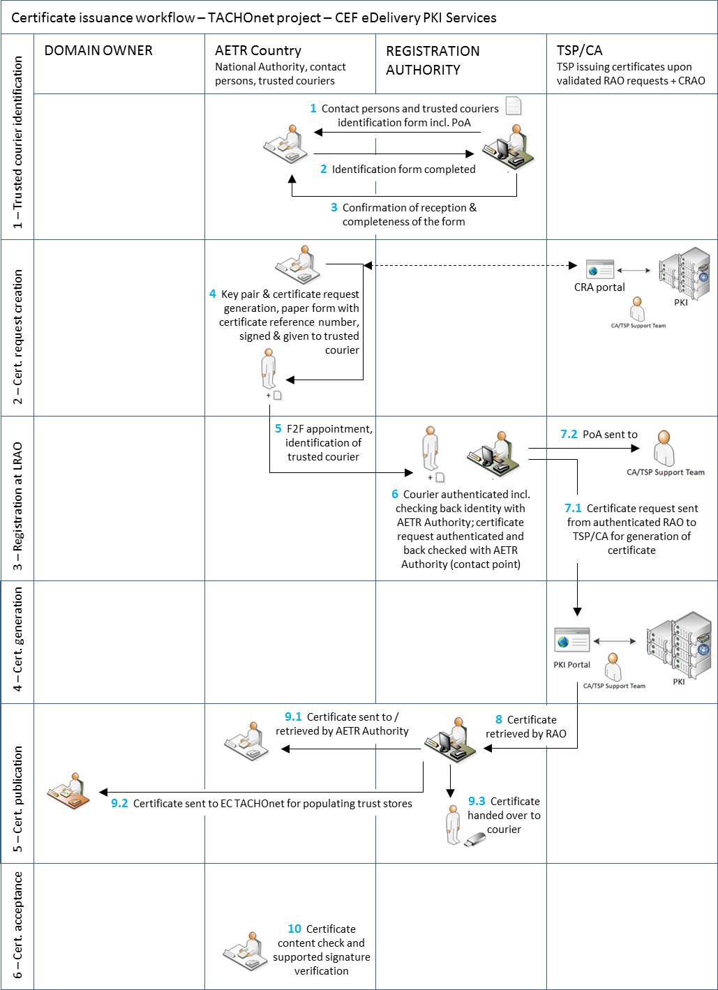

Figure 1 - Certificate issuance workflow

* + 1. Step 1: Trusted Courier identification

The following process shall be carried out for the Trusted Courier identification:

* + - 1. The Registration Authority shall send to the national authority the contact persons and trusted couriers’ identification form[6]. This form shall also include a power of attorney (PoA) that the organisation (AETR Authority) shall sign.
      2. The national authority shall send back the completed form and signed PoA to the Registration Authority.
      3. The Registration Authority shall acknowledge the good reception and completeness of the form.
      4. The Registration Authority shall provide an updated copy of the list of contact persons and trusted couriers to the domain owner.
    1. Step 2: Certificate request creation
       1. The request and the retrieval of the certificate shall be done on the same computer and with the same browser.
       2. The following process shall be carried out for the certificate request creation:
       3. The Organisation shall navigate to the user web interface to request the certificate via the URL <https://sbca.telesec.de/sbca/ee/login/displayLogin.html?locale=en>: , and shall enter the username ‘**sbca/CEF_eDelivery.europa.eu’** and the password ‘**digit.333**’

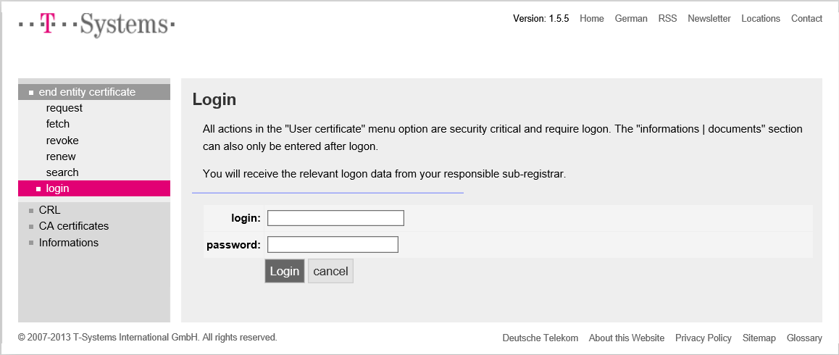

Figure 2

* + - 1. The Organisation shall click on ‘request’ on the left side of the panel and shall select ‘CEF_TACHOnet’ in the dropdown list.

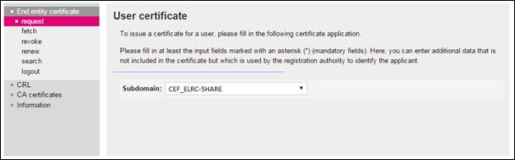

Figure 3

* + - 1. The Organisation shall populate the certificate request form lied down in figure 4 with the information in Table 3, clicking on 'Next (soft-PSE)' to finish the process.

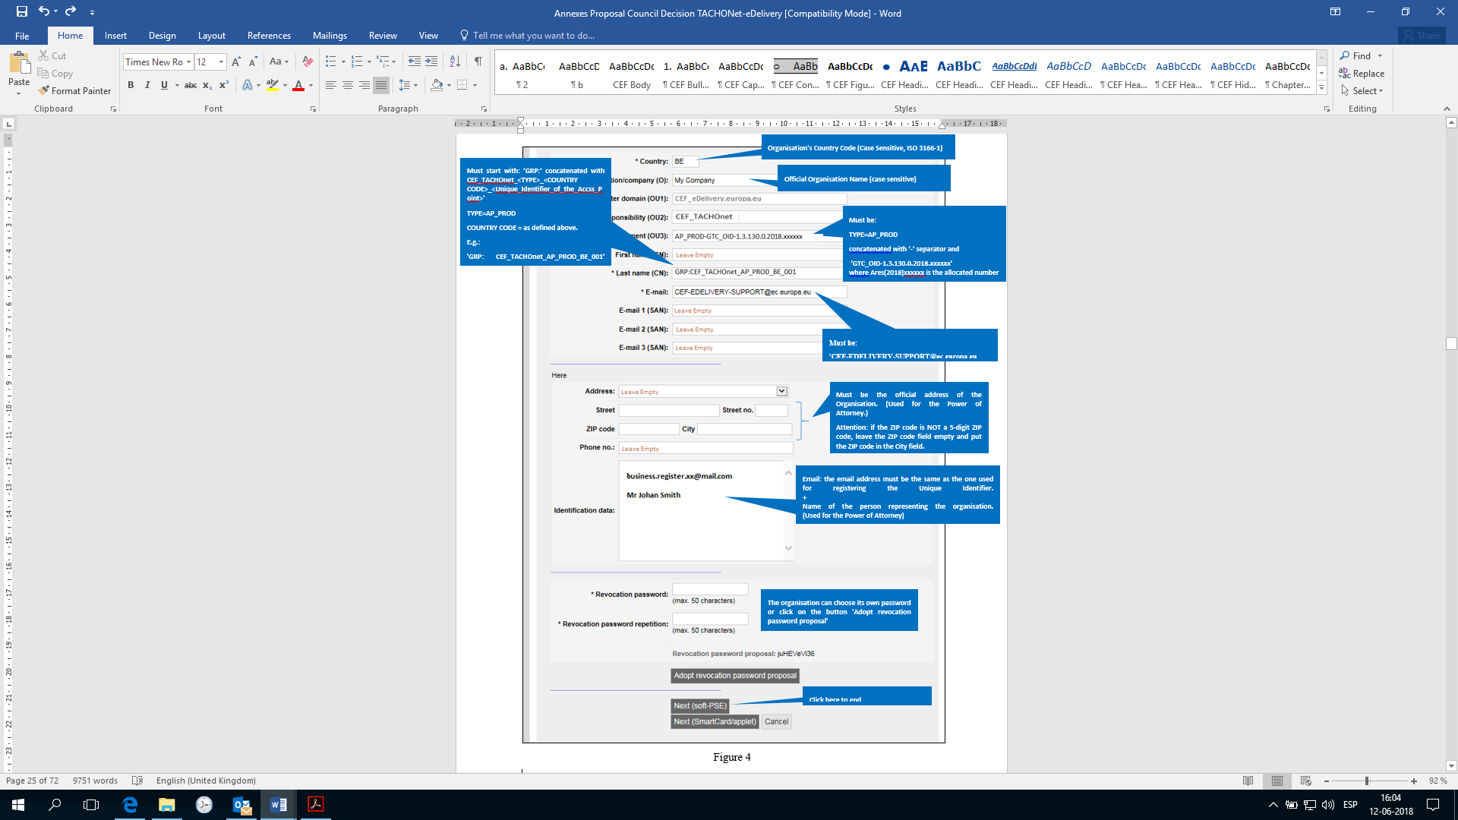

Figure 4

|  |  |
| --- | --- |
| Requested Fields | Description |
| Country | **C=Country Code**, location of certificate owner, verified using a public directory;  Constraints: 2 characters, in accordance to ISO 3166-1, alpha-2, Case Sensitive; Examples: DE, BE, NL,  Specific cases: UK (for Great-Britain), EL (for Greece) |
| Organisation/Company (O) | **O=Organization name of the certificate owner** |
| Master domain (OU1) | **OU=CEF_eDelivery.europa.eu** |
| Area of responsibility (OU2) | **OU=CEF_TACHOnet** |
| Department (OU3) | Mandatory value per "AREA OF RESPONSIBILITY"  The content must be checked using a positive list (white list) when the certificate is requested. If the information does not correspond to the list, the request is prevented.  Format: **OU=<TYPE>-<GTC_NUMBER>**  Where "<TYPE>" is replaced by AP_PROD: Access Point in Production environment.  And where <GTC_NUMBER> is **GTC_OID-1.3.130.0.2018.xxxxxx**,where Ares(2018)xxxxxx is the GTC number for the TACHOnet project.  e.g.:  AP_PROD**-**GTC_OID-1.3.130.0.2018.xxxxxx |
| First name (CN) | Must be Empty |
| Last name (CN) | Must start with "GRP:", followed by a common name.  Format:  **CN=GRP:<AREA OF RESPONSIBILITY>_<TYPE>_<COUNTRY CODE>_<UNIQUE IDENTIFIER>**  e.g.:  GRP:CEF_TACHOnet_AP_PROD_BE_001 |
| E-mail | **E=**[**CEF-EDELIVERY-SUPPORT@ec.europa.eu**](mailto:CEF-EDELIVERY-SUPPORT@ec.europa.eu) |
| E-mail 1 (SAN) | Must be Empty |
| E-mail 2 (SAN) | Must be Empty |
| E-mail 3 (SAN) | Must be Empty |
| Address | Must be Empty |
| Street | Must be the official address of the Organisation of the Certificate Owner. (Used for the Power of Attorney.) |
| Street no. | Must be the official address of the Organisation of the Certificate Owner. (Used for the Power of Attorney.) |
| Zip Code | Must be the official address of the Organisation of the Certificate Owner. (Used for the Power of Attorney.)  **Attention**: if the ZIP code is NOT a 5-digit ZIP code, leave the ZIP code field empty and put the ZIP code in the City field. |
| City | Must be the official address of the Organisation of the Certificate Owner. (Used for the Power of Attorney.)  **Attention**: if the ZIP code is NOT a 5-digit ZIP code, leave the ZIP code field empty and put the ZIP code in the City field. |
| Phone no | Must be Empty |
| Identification data | The email address must be the same as the one used for registering the Unique Identifier. + Must be the name of the person representing the organisation. (Used for the Power of Attorney)  + **Commercial Register No** (only mandatory for private organisations)  **Entered at the Local Court of** (only required for German and Austrian private organisations) |
| Revocation password | Mandatory field chosen by the requestor |
| Revocation password repetition | Mandatory field chosen by the requestor repeated |

Table 3. Complete details of each requested field

* + - 1. The selected key length shall be 2048(High Grade).

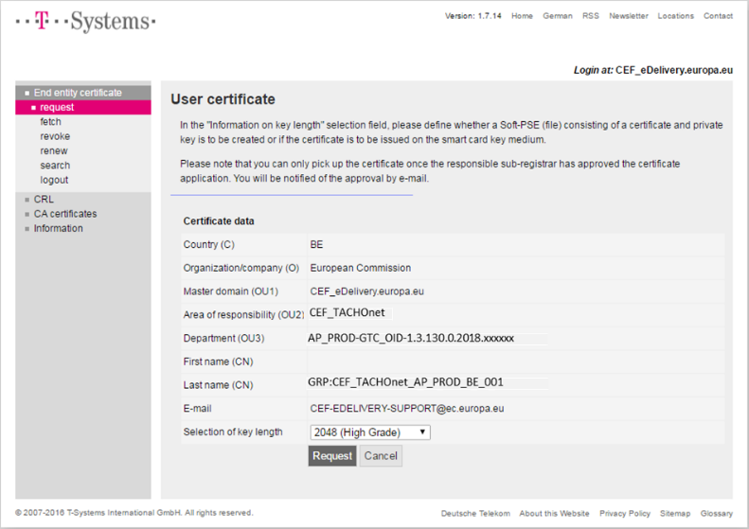

Figure 5

* + - 1. The Organisation shall record the reference number to retrieve the certificate.



Figure 6

* + - 1. The CEF Support Team shall check for new requests of certificates and verifiy if the information in the certificate request is valid, i.e. that it conforms to the naming convention specified in Appendix 5.1 Certificate Naming Convention.
      2. The CEF Support Team shall verify that the information entered in the request is in a valid format.
      3. When either check from points 5 or 6 above fails, the CEF Support Team shall send an email to the email address provided in the “Identification data” of the request form, with the Domain Owner in cc, in which the Organisation is requested to start the process again. The failed certificate request shall be cancelled.
      4. The CEF Support Team shall send an email to the Registration Authority about the validity of the request. The email shall include:

the name of the Organisation, available in the field “Organisation (O)” of the certificate request;

the certificate data including the name of the AP for which the certificate is to be issued, available in the field “Last Name (CN)” of the certificate request;

the certificate reference number;

the address of the Organisation, its email and the name of the person representing it.

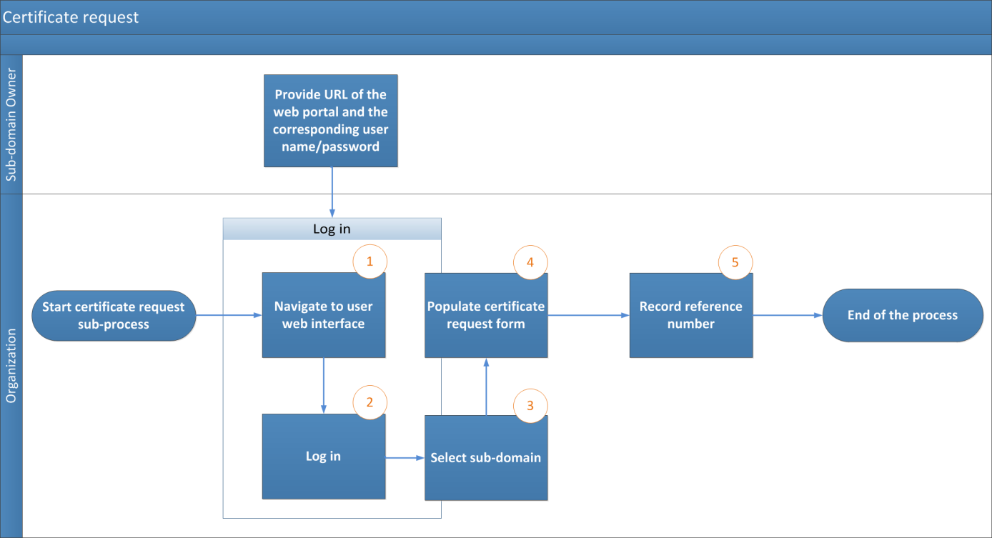

Figure 7 – Certificate request process

* + 1. Step 3: Registration at Registration Authority (Certificate approval)
       1. The Trusted Courier or contact point shall make an appointment with the Registration Authority via email exchange, identifying the Trusted Courier who will proceed to the face-to-face meeting.
       2. The Organisation shall prepare the documentary package consisting in:
       3. the filled-in and signed power of attorney;
       4. a copy of the valid passport of the trusted courier who will perform the face-to-face. This copy must be signed by one of the step 1 identified Organisation points of contact;
       5. the certificate request paper form signed by one of the points of contact of the Organisation.
       6. The Registration Authority shall receive the Trusted Courier after identity screening at the building reception. The Registration Authority shall conduct the face-to-face registration of the certificate request by:
       7. identifying and authenticating the Trusted Courier;
       8. verifying the trusted courier physical appearance against the passport presented by the Trusted Courier;
       9. verifying the validity of the passport presented by the Trusted Courier;
       10. verifying the validated passport presented by the trusted courier against the copy of the valid passport of the trusted courier signed by one of the identified points of contact of the Organisation. Signature is authenticated against the original “trusted courier and contact points identification form”;
       11. verifying the filled-in and signed power of attorney;
       12. verifying certificate request paper form and its signature against the original “trusted courier and contact points identification form”;
       13. calling the signatory contact point to double check the identity of the trusted courier and the content of the certificate request.
       14. The Registration Authority shall confirm to the CEF Support Team that the national authority is indeed authorized to operate the components for which it is asking the certificates and that the corresponding face-to-face registration process was successful. The confirmation shall be sent using a "CommiSign" certificate secure email, attaching a scanned copy of the authenticated face-to-face documentary package and of the signed process check list carried out by the Registration Authority.
       15. If the Registration Authority confirms the validity of the request, the process shall carry on as set out in 2.2.4.6 and 2.2.4.7. Otherwise the certificate issuance shall be rejected and the Organisation shall be informed.
       16. The CEF Support Team shall approve the certificate request and shall notify the Registration Authority the approval of the certificate.
       17. The Registration Authority shall notify the Organisation that the certificate can be retrieved via the user portal.

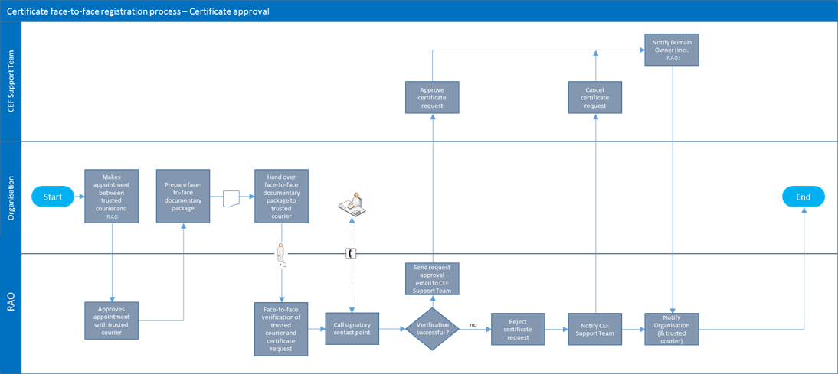

Figure 8 - Certificate approval

* + 1. Step 4: Certificate generation

Upon approval of the certificate request, the certificate shall be generated.

* + 1. Step 5: Certificate publication and retrieval
       1. Following approval of the certificate request, the Registration Authority shall retrieve the certificate and hand over a copy to the Trusted Courier.
       2. The Organisation shall receive the notification from the Registration Authority that the certificates can be retrieved.
       3. The Organisation shall navigate to the user portal at <https://sbca.telesec.de/sbca/ee/login/displayLogin.html?locale=en> and shall log in with the username "**sbca/CEF_eDelivery.europa.eu**" and the password "**digit.333**".

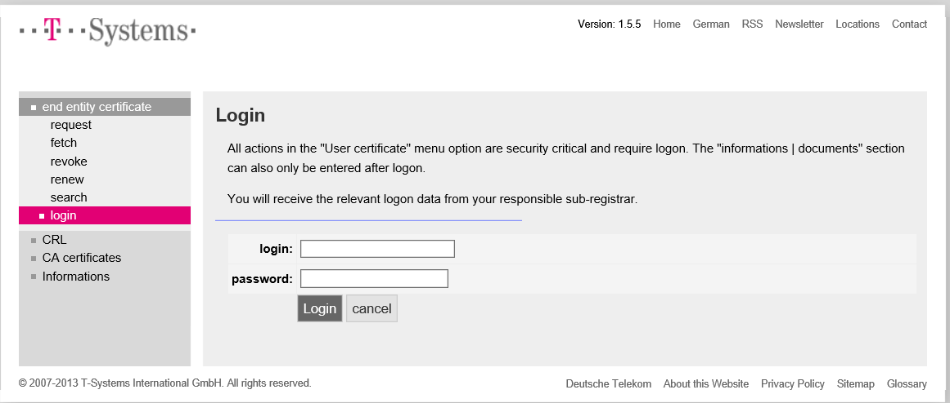

Figure 9

* + - 1. The Organisation shall click on the “fetch” button on the left-hand side and shall provide the reference number recorded during the certificate request process;

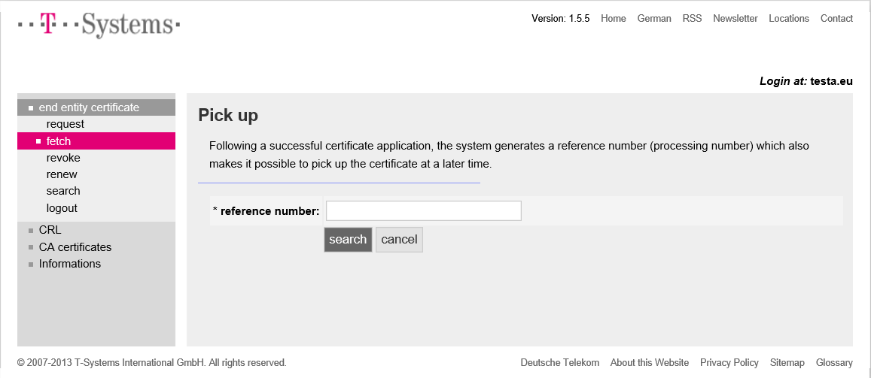

Figure 10

* + - 1. The Organisation shall install the certificates by clicking on the install button;

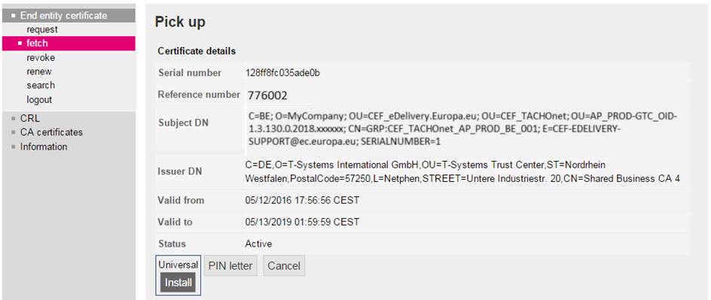

Figure 11

* + - 1. The certificate shall be installed on the Access Point. As this is implementation-specific, the Organisation shall refer to its Access Point provider to obtain the description of this process.
      2. The following steps are needed for the certificate installation on the Access Point:
      3. export the private key and the certificate,
      4. create the keystore and the truststore,
      5. install the keystore and the truststore on the access point.

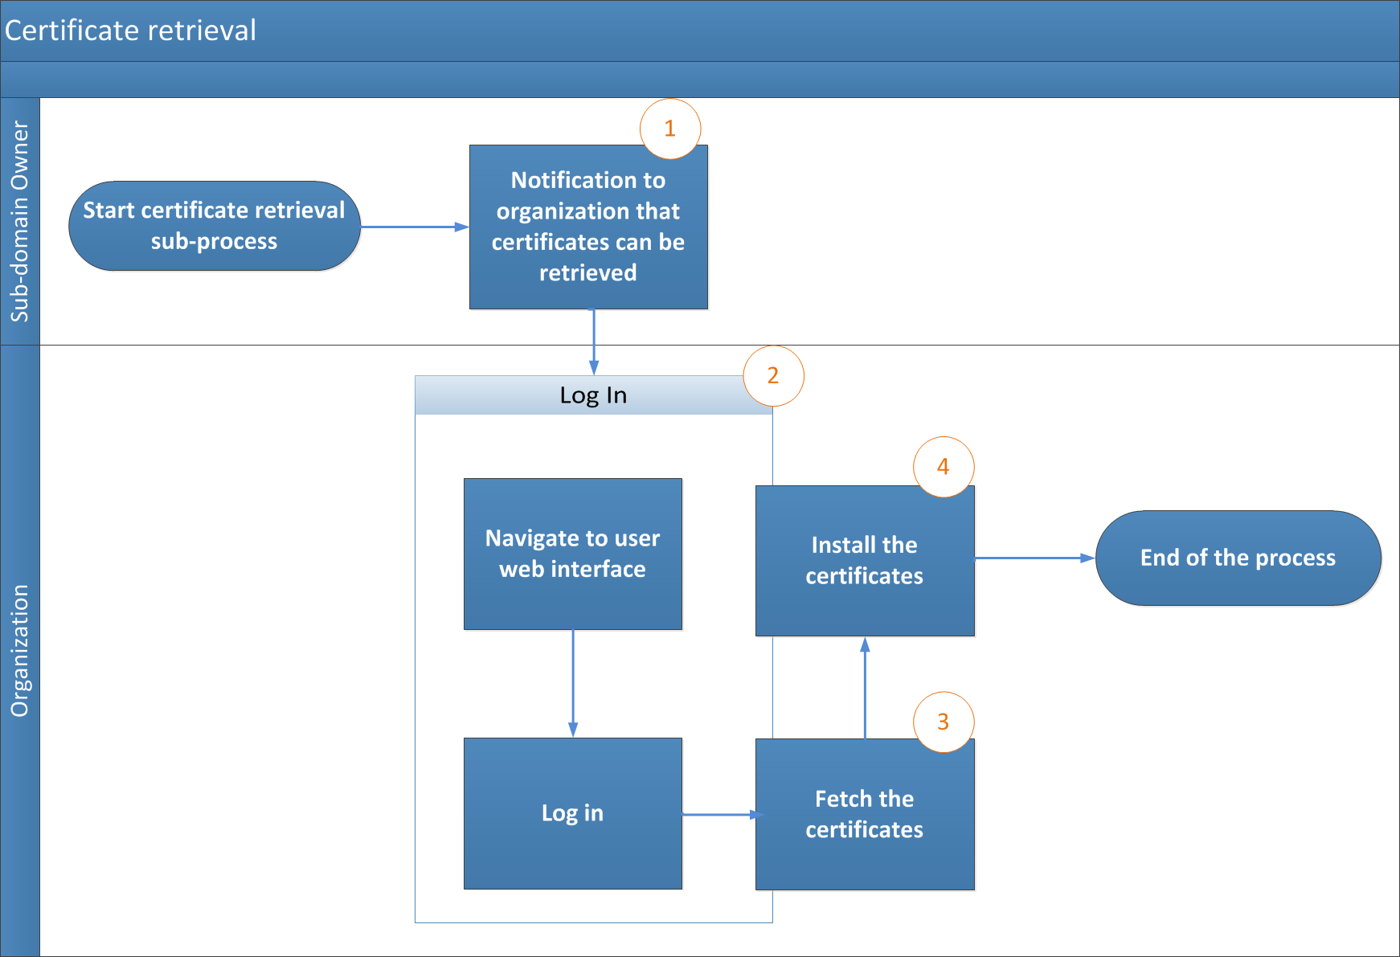

Figure 12 - Certificate retrieval

1. Certificate revocation process
   1. The Organization shall submit a revocation request through the user web portal;
   2. The CEF Support Team shall execute the certificate revocation.



Figure 13 - Certificate revocation

1. General Terms and conditions of the CEF PKI service
   1. Context

In its capacity as Solution Provider of the eDelivery Building Block of the Connecting Europe Facility, DIGIT shall make available a PKI service[7] (‘CEF PKI service’) to the AETR Contracting Parties. The CEF PKI service shall be used by national authorities (‘end-Users’) participating in TACHOnet.

DIGIT is a PKI tenant within the TeleSec Shared-Business-CA solution (‘SBCA’) operated in the Trust Center of the Group unit T-Systems International GmbH (‘T-Systems’[8]). DIGIT plays the role of Master Registrar of the 'CEF_eDelivery.europa.eu' domain of the SBCA. In this role, DIGIT creates sub-domains within the 'CEF_eDelivery.europa.eu' domain for each project using the CEF PKI service.

This document provides details on the terms and conditions of theTACHOnet sub-domain. DIGIT plays the role of sub-Registrar of this sub-domain. In this capacity, it issues, revokes and renews the certificates of this project.

* 1. Disclaimer on liability

The European Commission accepts no responsibility or liability whatsoever with regard to the content of the certificate which lies exclusively with the certificate owner. It is the responsibility of the certificate owner to check the accuracy of the certificate content.

The European Commission accepts no responsibility or liability whatsoever with regard to the use of the certificate by its owner being a third legal entity outside the European Commission.

This disclaimer is not intended to limit the liability of the European Commission in contravention of any requirements laid down in applicable national law or to exclude its liability for matters which may not be excluded under that law.

* 1. Authorised /prohibited uses of certificates
     1. Permitted usage of certificates

Once the certificate is issued, the certificate owner[9] shall use the certificate only in the context of TACHOnet. Within this context, the certificate can be used to:

* authenticate the origin of data;
* encrypt data;
* ensure detection of integrity breaches of data.
  + 1. Prohibited usage of certificates

Any usage not explicitly authorised as part of the permitted usages of the certificate is prohibited.

* 1. Additional obligations of the certificate owner

The detailed terms and conditions of the SBCA are defined by T-Systems in the Certificate Policy (CP)/Certification Practice Statement (CPS) of the SBCA service[10]. This document includes security specifications and guidelines regarding technical and organizational aspects and describes the activities of the Trust Centre operator in the roles of Certification Authority (CA) and Registration Authority (RA) as well as the Registration Authority’s (RA) delegated third party.

Only entities authorised to participate TACHOnet can request a certificate.

Regarding certificate acceptance, clause 4.4.1 of the SBCA Certificate Policy and Certification Practice Statement (‘CP/CPS’) applies, furthermore the terms of use and provisions described in the present document are deemed accepted by the organization to which the certificate is issued (“O=”) when first used.

Regarding publication of the certificate, clause 2.2 of the SBCA CP/CPS applies.

All certificate owners shall comply with the following requirements:

* + 1. protect their private key against unauthorized use;
    2. refrain from transferring or revealing their private key to third parties, even as representatives.
    3. refrain from continued use of the private key following expiry of the validity period or revocation of the certificate, other than to view encrypted data (e.g., decrypting e-mails).
    4. the certificate owner is responsible for copying or forwarding the key to the end entity or entities.
    5. the certificate owner must obligate the end entity/all end entities to comply with the present terms and conditions, including the SBCA CP/CPS, when dealing with the private key.
    6. The certificate owner must provide the identification of those authorised representatives who are authorized to request revocation of certificates issued to the organisation with the details of events that lead to revocation and the revocation password.
    7. for certificates associated to groups of persons and functions and/or legal persons, after a person leaves the group of end entities (e.g. termination of the employment relationship), the certificate owner must prevent misuse of the private key by revoking the certificate.
    8. The certificate owner is responsible and shall request revocation of the certificate under the circumstances referred to in clause 4.9.1 of the SBCA CP/CPS.

Regarding renewal or rekey of certificates, clause 4.6 or 4.7 of the SBCA CP/CPS applies.

Regarding amendment of certificate, clause 4.8 of the SBCA CP/CPS applies.

Regarding certificate revocation, clause 4.9 of the SBCA CP/CPS applies.

1. Contact persons and trusted couriers identification form (sample)

|  |  |  |  |  |  |  |  |  |  |  |  |  |  |  |  |  |  |  |  |  |  |  |  |  |  |  |  |  |  |  |
| --- | --- | --- | --- | --- | --- | --- | --- | --- | --- | --- | --- | --- | --- | --- | --- | --- | --- | --- | --- | --- | --- | --- | --- | --- | --- | --- | --- | --- | --- | --- |
| **I,** *[name and address of the organisation representative]***, certifies that the following information are to be used in the context of the request, generation and retrieval of public key digital certificates for TACHOnet access points supporting the confidentiality, integrity and non-repudiation of the TACHOnet messages:**  Contact person information**:**   |  |  | | --- | --- | | **Contact person #1** | **Contact person #2** | | Name: | Name: | | First names: | First names: | | Mobile phone: | Mobile phone: | | Telephone: | Telephone: | | Email: | Email: | | Specimen handwritten signature: | Specimen handwritten signature: |   Trusted courier information**:**   |  |  | | --- | --- | | **Trusted courier #1** | **Trusted courier #2** | | Name: | Name: | | First names: | First names: | | Mobile phone: | Mobile phone: | | Email: | Email: | | Passport issuing country: | Passport issuing country: | | Passport number: | Passport number: | | Passport validity end date: | Passport validity end date: |   **Place, date, company stamp or seal of the Organisation:**  **Signature of the authorised representative:** |

1. Documents
   1. Individual Power of Attorney (sample)

A sample of the individual Power of Attorney that must be signed and presented by the trusted courier during face-to-face registration at RAO can be found here:



* 1. Certificate request paper form (sample)

A sample of the certificate request paper form that must be signed and presented by the trusted courier during face-to-face registration at RAO can be found here:

1. Glossary

The key terms used in this Sub-appendix are defined in the CEF Definitions section on the CEF Digital Single Web Portal:

<https://ec.europa.eu/cefdigital/wiki/display/CEFDIGITAL/CEF+Definitions>

The key acronyms used in this Component Offering Description are defined in the CEF Glossary on the CEF Digital Single Web Portal:

<https://ec.europa.eu/cefdigital/wiki/pages/viewpage.action?spaceKey=CEFDIGITAL&title=CEF+Glossary>

1. A PKI (Public Key Infrastructure) is a set of roles, policies, procedures and systems needed to create, manage, distribute, and revoke digital certificates.
2. Identified by the “O=” attribute value in the Subject Distinguished Name of the issued certificate
3. <https://en.wikipedia.org/wiki/Public_key_infrastructure>
4. The latest version of the CP and CPS can be downloaded on <https://www.telesec.de/en/sbca-en/support/download-area/>
5. A power of attorney is a legal document by which the Organisation empowers and authorises the European Commission represented by the identified official responsible for the CEF PKI service the power to request the generation of a certificate on its behalf from the T-Systems International GmbH TeleSec Shared Business CA. See also point 6.
6. See point 5
7. A PKI (Public Key Infrastructure) is a set of roles, policies, procedures and systems needed to create, manage, distribute, and revoke digital certificates.
8. The trusted role of the Trust Center operator, located in the T-Systems Trust Center, also performs the task of internal registration authority.
9. Identified by the “O=” attribute value in the Subject Distinguished Name of the issued certificate
10. The latest version of the T-Systems SBCA CP/CPS is available from <https://www.telesec.de/en/sbca-en/support/download-area/>.