

**Introduction**

In 2017, the European Commission continued to deliver on its strong commitment to increased transparency and accountability. One of the means by which it seeks to do that is to foster the effective exercise of the right of access to documents[1] held by the EU institutions. This right is enshrined in Article 42 of the Charter of Fundamental Rights of the EU, Article 15(3) of the Treaty on the Functioning of the EU and Regulation (EC) No 1049/2001 regarding public access to European Parliament, Council and Commission documents[2].

**Broader Transparency Agenda**

The European Commission has taken several important steps to increase the transparency of its law-making and policy implementation processes, including in its contacts with stakeholders and lobbyists.

In 2017, the European Commission continued to deliver on its Better Regulation Agenda, which aims at getting the European Union to work better and more transparently, with a strong focus on acting in a simpler way and only where it matters for citizens. Since 2017, the Commission's Regulatory Fitness and Performance programme (REFIT) has been seeking to identify opportunities for simplification and the reduction of unnecessary costs every time the European Commission proposes to revise existing law. The initiatives that result from this work are included each year in the Commission’s work programme and can be monitored in the REFIT Scoreboard.

Within REFIT, the European Commission focuses particularly on those areas where business and other stakeholders see excessive costs and burdens. For this purpose, the European Commission has created an online portal where everybody can make suggestions, and takes advice from a high level expert group, the REFIT Platform. Since its creation, the REFIT Platform has adopted 58 opinions, drawing on over 280 public suggestions on how to make EU laws more effective and efficient.

In April 2016, the three institutions agreed on the Interinstitutional Agreement on Better Law-making. During 2017, work continued between the institutions on the concept for the future Joint Legislative Database envisaged in the agreement. This having been agreed, work is now underway to define the detailed specifications and begin developing the future tool, which will be a user-friendly portal, aimed at the general public, providing simple access to information on ongoing legislative processes, presented in a timeline format and providing links to more detailed sources.

In December 2017, the new online Interinstitutional Register of Delegated Acts was launched[3]. It is a joint tool of the European Commission, the European Parliament and the Council of the European Union, giving access to the whole lifecycle of delegated acts, from their planning by the European Commission to their publication in the Official Journal. It thereby increases the transparency of the process of preparing, adopting and scrutinising delegated acts and serves as a one-stop shop for stakeholders interested in this type of acts.

In 2017, the European Commission further improved the register of expert groups, in particular by adding a new dedicated section on group meetings, which displays the documents in a more ordered and user-friendly way. Furthermore, synergies between the register of expert groups and the Transparency Register were enhanced, by ensuring the automatic transfer of data concerning the membership of expert groups.

In parallel, the Transparency Register has continued to grow steadily, and currently contains over 11,000 entries, with 2,430 new entities joining during the course of 2017[4], all signed up to a common Code of Conduct. The Transparency Register today is one of the biggest of its kind in the world.

A new, innovative IT solution was developed and implemented to improve the overall data quality and improve user experience. Moreover, as of December 2017, the Transparency Register automatically provides information about the Commission expert groups[5] to which registrants have been appointed, retrieved from the Register of Commission expert groups and other similar entities[6].

In the context of the European Commission proposal for a new Interinstitutional Agreement on a mandatory Transparency Register[7], the European Parliament adopted its negotiating mandate on 15 June 2017[8] and the Council of the European Union adopted its mandate on 6 December 2017[9]. Two interinstitutional orientation meetings took place under the Estonian Presidency of the Council of the European Union on 6 September 2017 and 12 December 2017. Political representatives from the three institutions agreed that negotiations on a mandatory EU Transparency Register would start in early 2018. Following preparatory meetings at technical level, the first political meeting took place on 16 April 2018.

Transparency regarding ethics of Commissioners and former Commissioners is ensured through a dedicated Europa webpage[10].

On the occasion of his 2017 State of the Union annual speech, President Juncker announced a new Code of Conduct for Members of the Commission[11]. The modernised rules set new standards for ethical rules in Europe. The new Code of Conduct continues President Juncker's push for greater transparency since the beginning of his mandate and extends the ʻcooling-offʼ period from 18 months to two years for former Commissioners, and to three years for the President of the European Commission. The modernisation goes further by setting clearer rules and higher ethical standards as well as introducing greater transparency in a number of areas. The new Code entered into force on 1 February 2018.

On 12 September 2017, with regard to proactive transparency, the European Commission decided[12], in light of the many requests received for access to documents on Commissioners’ mission expenses, to publish, every two months, an overview of mission expenses per Member. The regular overviews cover all missions undertaken unless publication of this information would undermine the protection of the public interest as regards public security, defence and military matters, international relations or the financial, monetary or economic policy of the Union or a Member State. The first overviews were published at the end of February 2018.

As part of the European Commission's commitment to transparency made in the EU's new trade strategy ʻTrade for Allʼ, the European Commission published negotiating texts and the latest round reports related to the EU's existing trade agreements and ongoing trade negotiations with non-EU countries on a dedicated website[13].

The European Commission has also decided to adopt a general approach to transparency and to ensure the maximum level of openness during the negotiating process with the United Kingdom under Article 50 of the Treaty on European Union. This was also highlighted in its Communication on the state of progress of the negotiations with the United Kingdom under Article 50 of the Treaty on European Union, where the European Commission confirmed that ʻthe negotiations have been carried out with unprecedented transparencyʼ. In 2017, the European Commission proactively published many relevant documents on a dedicated website, such as draft negotiation positions for particular negotiation topics, EU position papers, agendas for the negotiation rounds, EU/UK joint technical notes, the Joint Report on progress during phase 1 of the negotiations and the draft Withdrawal Agreement.

**Access to documents**

Within the broader transparency agenda, the right of access to documents features as a prominent part of the European Commission's commitment to transparency. In addition to providing access to documents in its possession, following specific requests received under Regulation (EC) No 1049/2001, the European Commission also proactively published, in a user friendly way, a wide range of information and documents, both in its various public registers and on its webpages.

This report is drawn up pursuant to Article 17(1) of Regulation (EC) No 1049/2001. It provides an overview of how the European Commission applied the access to documents rules in 2017. The report is based on statistical data, which are summarised in Annex[14]. The statistics reflect the number of applications received in 2017 and the replies provided to them. They do not reflect the number of documents requested or (partially) disclosed, which were far more numerous.

Whereas applicants may ask for access to a single document, they more frequently request access to a multitude of documents, or even to entire files concerning a specific subject or procedure. The statistics show the importance of the right of access to documents as part of the European Commission's overall transparency policy. The requested documents were fully or partially disclosed in 82% of the 6,255 cases at the initial stage, and wider or even full access was granted in 46.9% of the 299 cases reviewed at the confirmatory stage.

**Resources**

In the European Commission, the treatment of initial access to documents requests is handled on a decentralised basis by the various Commission Directorates-General and services. Each Directorate-General and service has designated at least one legal expert, acting as ‘access to documents coordinator’, for this task. Depending on the size of the service and the number of requests received, these members of staff are usually assisted by a few administrative and support staff. The coordinator coordinates the draft replies with the units responsible for the underlying policy areas.

Confirmatory requests are dealt with by the Secretariat-General, so as to ensure an independent administrative review of the reply given at the initial stage. Ten   
full-time equivalent posts are set aside in the Secretariat-General for this task, made up of case handlers and administrative staff. In addition to their responsibility for reviewing initial replies, they provide horizontal guidance, training and advice to all   
Directorates-General and services of the European Commission on the application of Regulation (EC) No 1049/2001. They also manage the Commission-wide IT system for handling initial and confirmatory requests for access to documents, which is currently being modernised. The steadily rising number of new applications for access to documents since the entry into force of Regulation (EC) No 1049/2001 and the need for increased transparency in this area highlight the need to allocate sufficient human and IT resources to the European Commission in order to ensure the efficient handling of access to documents requests and achieve the best outcomes for citizens.

1. **Registers and Internet Sites**

In 2017, 18,825 new documents were added to the register of Commission documents[15] (see Annex – Table 1), falling within the C, COM, JOIN, OJ, PV, SEC or SWD category[16]. No sensitive documents[17] falling within those categories were created or received by the European Commission in 2017*.*

In 2017, the ‘Access to Documents’ website on *Europa*[18] recorded a decrease in the number of visitors (12,618 in comparison to 15,496 in 2016) and in the number of the pages viewed (16,876 in comparison to 23,290 in 2016, see Annex – Table 2).

Both platforms have become important search tools enabling citizens to participate more closely and actively in the European Commission's decision-making process and policy on access to documents.

**2. Cooperation with other Institutions subject to Regulation (EC) No 1049/2001**

In 2017, the European Parliament, the Council of the European Union and the European Commission continued to hold regular technical meetings, at administrative level, in order to share experiences, develop best practices and ensure the consistent application of Regulation (EC) No 1049/2001.

**3. Analysis of the Applications for Access**

3.1. The number of applications

In 2017, the number of **initial applications** increased by almost 3% (6,255 compared to 6,077 in 2016). The number of initial replies based on Regulation (EC) No 1049/2001 decreased by around 6% (from 7,137 in 2016 to 6,704 in 2017)[19].

As regards **confirmatory applications** requesting a review, by the European Commission, of initial replies fully or partially refusing access, their number slightly increased by 1% (299 in 2017 in comparison to 295 in 2016), continuing the steadily upward trend since 2016. The number of confirmatory replies based on Regulation 1049/2001 increased significantly by 15 %, from 219 in 2016 to 258 in 2017.

The number of confirmatory applications dealt with in 2017 was higher yet, as in some cases, requests from one single applicant were regrouped and dealt with by a single reply (see Annex – Table 5).

3.2. Proportion of applications per European Commission Directorate-General/Service (Annex – Table 10)

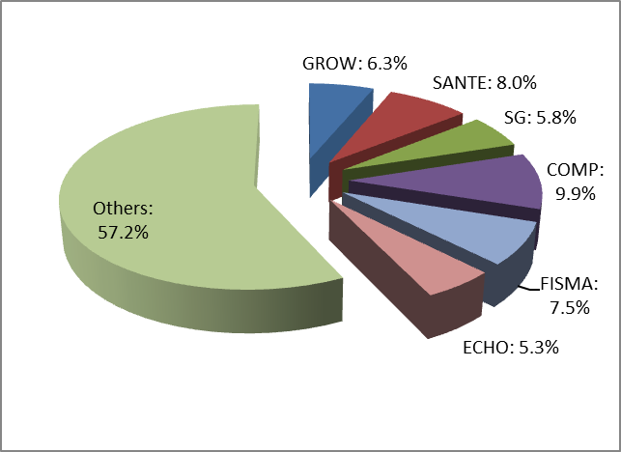The Directorate-General for Competition received the highest proportion of **initial applications** (9.9% in comparison to 7.2% in 2016), whilst the Directorate-General for Health and Food Safety occupied the second rank, with a small decrease from 8.0% in 2016 to 7.9% in 2017. Initial applications for documents held by the Directorate-General for Financial Stability, Financial Services and Capital Markets Union increased from 5.6% to 7.5% in 2017, putting it in third place.

The Directorate-General for Internal Market, Industry, Entrepreneurship and SMEs (6.3%), the Secretariat-General (5.8%) and the Directorate-General for Humanitarian aid and civil protection (5.3%) were the only other DGs receiving more than 5% of all initial applications each. The remaining European Commission departments each accounted for 4% or less of all initial applications.

As regards **confirmatory applications** received by the Secretariat-General, the highest proportion related to initial replies provided by the Directorate-General for Competition (20.1% in 2017, compared to 15.9% in 2016). It was followed by the Directorate-General for Internal Market, Industry, Entrepreneurship and SMEs (8.0%, compared to 5.86% in 2016). The third place was shared by the Directorate-General for Health and Food Safety and the Directorate-General for Communication Networks, Content and Technology, both representing 6.0% of initial replies (compared to, respectively, 10.2% and 2.7% in 2016).

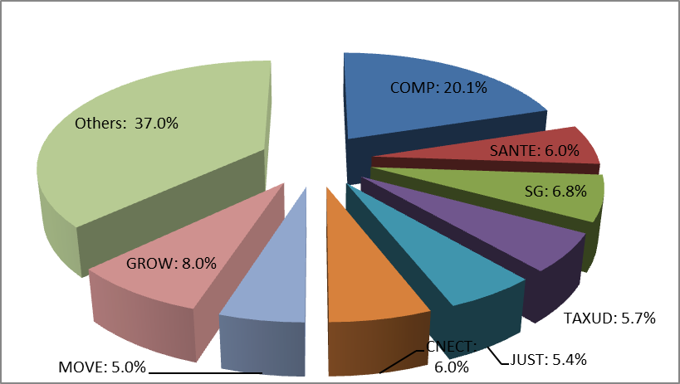

The initial replies of three other European Commission departments formed the subject of more than 5% of all confirmatory applications each (the Directorate-General for Taxation and Custom Union, the Directorate-General for Justice and Consumers and the Directorate-General for Mobility and Transport). The initial replies provided by the remaining European Commission departments accounted for less than 5% of requests for a confirmatory review each.

3.3. The social and occupational profile of applicants[20] (Annex – Table 8)

Most **initial applications** in 2017 continued to originate from citizens. These accounted for 37.4% of all applications (compared to 38.3% in 2016). The second place was occupied by academic institutions and think tanks (21.6% in 2017 in comparison to 16.0% in 2016). Companies and legal professionals were the third most active category, accounting respectively for 13.6% and 13.2%% of initial applications (in comparison with respectively 9.7% and 13.5% in 2016).

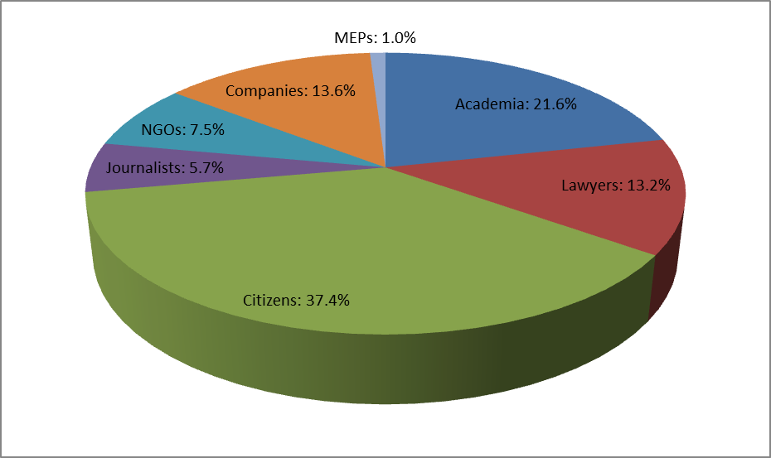

The fourth place was occupied by civil society (NGOs) (7.5%, compared to 11.9% in 2016), followed by journalists (5.7%, compared to 5.9% in 2016) and Members of the European Parliament (1.0% in 2017, compared to 4.8% in 2016).

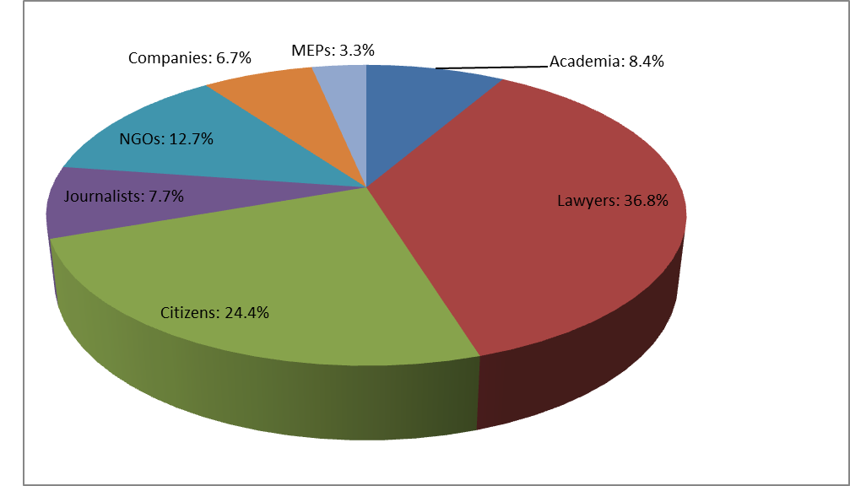Most **confirmatory applications** in 2017 originated from legal professionals. These accounted for almost 37% of all applications (36.8%, compared to 26.4% in 2016). Citizens, with 24.4% of all applications (in comparison to 30.2% in 2016) were the second-most active category of applicants.

They were followed by civil society (NGOs), accounting for 12.7% of applications (24.8% in 2016). Academic institutions and think tanks occupied the fourth place at 8.4% (4.4% in 2016), journalists came in fifth at 7.7% of applications (8.1% in 2016) and companies sixth at 6.7% (3.1% in 2016).

3.4. The geographical origin of applicants (Annex – Table 9)

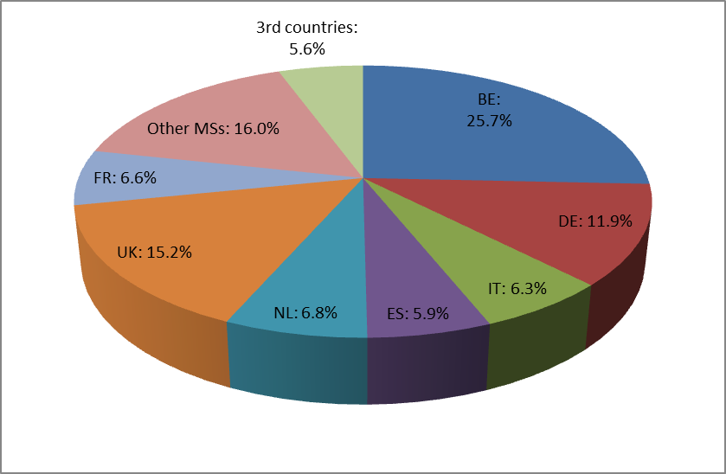Regarding the geographical breakdown of **initial applications**, the largest proportion of initial applications continued to originate from applicants residing or based in Belgium (25.7%, compared to 27.2% in 2016), followed by the United Kingdom (a significant increase, from 10.0% in 2016 to 15.2% in 2017) and Germany (11.9%, compared to 12.6% in 2016). The Netherlands, France, Italy and Spain followed, representing more than 5% of all applications each. The applications originating from the remaining 21 Member States accounted for less than 3% per Member State.

The right of access to documents also continued to be exercised by applicants residing or having registered office in third countries, as their initial applications accounted for 5.62% of all initial applications (4.1% in 2016).

Regarding the geographical breakdown of **confirmatory applications**, the largest proportion by far originated from applicants within Belgium (29.4%, compared to 33.2% in 2016), followed by Germany (14.4%, compared to 13.2% in 2016). The United Kingdom (8.7%), Spain (8.4%), Italy (6.4%) and France (6.0%) were the only other Member States from where more than 5% of applications originated.

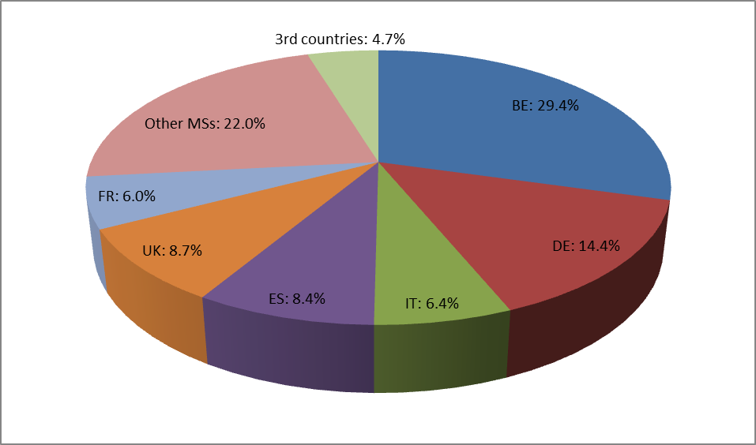

Applications originating from the remaining 21 Member States accounted for 3%, or less, each. Finally, applications from applicants residing or having their registered office in third countries accounted for 4.7% of all applications (compared to 3,7% in 2016).

**4. Application of Exceptions to the Right of Access**

4.1. Types of access provided

In 2017, full or partial access to documents was given in more than 82% of cases at the **initial stage** (82.0% in comparison to 81.3% in 2016). Full access continued to be given in almost 62% of all cases. This constitutes a slight increase in comparison with the previous year (60.9%).

The percentage of partially positive replies was stable (20.2% in 2017 compared to 20.4% in 2016). A slightly lower percentage (17.98%) of applications were fully rejected compared to 2016 (18.7%) – see Annex (Table 4).

In 2017, almost every second initial reply challenged by a confirmatory application was (fully or partially) reversed at **confirmatory stage** (46.9% in 2017 compared to 52% in 2016). The number of confirmatory applications giving rise to a fully positive reply was slightly higher (5.4%) than in 2016 (5.0%) – see Annex (Table 6).

In 41.5% of cases, wider (though not full) access was granted than at initial level (a decrease compared to 47.3% in 2016). At confirmatory level, the initial full refusal was confirmed in 53.1% of cases (compared to 47.9% in 2016).

4.2. Invoked exceptions to the right of access (Annex – Table 7)

The protection of privacy and the integrity of the individual continued to be the main reason for (full or partial) refusal of access at the **initial stage**, remaining constant at 31.3%. As in previous years, a large part of the partial refusals was due to the need, flowing from the applicable data protection legislation, to redact the names of   
non-senior staff members or third-party representatives appearing in the documents.

The second most invoked exception was the protection of the purpose of inspections, investigations and audits (17.6 in 2017 compared to 16.2% in 2016). The exception aimed at protecting commercial interests, occupying the third place, was invoked more frequently than in 2016 (16.8% in 2017 compared to 13.7% in 2016).

The relative use of the exception protecting the decision-making process of the institution slightly decreased (16.3% in 2017, compared to 18.8% in 2016). The exception protecting the public interest as regards public security, which increased the most significantly in 2016, decreased and occupied the fifth place (5.4% in 2017, compared to 7.3% in 2016).

At **confirmatory stage**, the most frequently invoked, main ground for confirming a (full or partial) refusal of access was the protection of the purpose of inspections, investigations and audits, representing a 57% increase in comparison to the previous year (35.1% in 2017, in comparison to 20.3% in 2016). In the second place was the exception protecting privacy and the integrity of the individual (26.2%, compared to 28.3% in 2016). The exception protecting commercial interests was invoked less frequently (13.3% in 2017, compared to 15.9% in 2016), putting it in the third place.

The fourth and the fifth rank were occupied, respectively, by the exceptions protecting the decision-making process of the institution (11.9%, compared to 20.3% in 2016), and the public interest as regards the financial, monetary or economic policy of EU or a Member State (4.7%, compared to 2.8% in 2016).

**5. Complaints to the European Ombudsman**

In 2017, the European Ombudsman closed 25 complaints about the European Commission's handling of requests for access to documents[21]. Six of these were closed with further or critical remarks[22]. By way of comparison, in 2016 the European Ombudsman closed a lower number (21) of complaints, but a similar number (six) with further or critical remarks[23].

In 2017, the European Ombudsman opened 25 new inquiries where access to documents was either the main or a subsidiary part of the complaint (a significant increase in comparison to 2016, when 12 new inquiries were opened, reflecting the increased importance given by the European Ombudsman to that area of activity).

**6. Judicial Review**

In 2017, the EU Courts have delivered important new case law that will influence the European Commission's practice under Regulation (EC) No 1049/2001.

6.1. The Court of Justice

The Court of Justice handed down eight judgments on appeal where the European Commission was a party to the proceedings.

In the *Saint Gobain Glass v European Commission* Case[24], regarding access to the documents from the Member States on environmental information, in particular on emission quotas, the Court ruled that the concept of ‘decision-making process’ referred to in the ‘decision-making process’ exception of Article 4(3) of Regulation (EC) No 1049/2001 relates to the confidentiality of the proceedings of public authorities, without covering the entire administrative procedure that led to the decision.

Further, it stated that the strict interpretation of Article 4(3) in light of Article 6(1) of Regulation (EC) No 1367/2006 (Aarhus Convention) also implies that the internal nature of documents or a risk of external pressure are not sufficient to demonstrate serious harm.

In two judgments, the Court further clarified the extent to which documents forming part of ongoing administrative or judicial proceedings can fall under a general presumption of non-disclosure.

In its *French Republic v Carl Schlyter* judgment[25], the Court of Justice defined, for the first time, the notion of ‘investigation’ in the third indent of Article 4(2) of Regulation (EC) No 1049/2001. It stated that the requirement of transparency underlying Directive (EU) No 2015/1535 (former Directive 98/34/EC) applies also to detailed opinions issued by the European Commission or Member States as a matter of principle. This principle normally applies also to comments issued by the latter. No general presumption of  
non-disclosure can apply to documents held by the European Commission in the context of notification procedures according to these Directives. Instead, the documents should be identified and assessed individually.

The Court held in its *Sweden and Spirlea v European Commission* judgment[26] that documents relating to an infringement procedure during the pre-litigation stage of an inquiry carried out as part of an EU Pilot procedure, may be covered by the general presumption of confidentiality according to Article 4(2), third indent of Regulation (EC) No 1049/2001.

In its *European Commission v Patrick Breyer* judgment[27], the Court of Justice concluded that the written pleadings of the parties participating in procedures of the EU Courts are not excluded from the application of Regulation (EC) No 1049/2001. The fact that the European Commission received the written pleadings through the Court itself does not have any impact on the application of Regulation (EC) No 1049/2001, as the European Commission holds the documents.

In *Typke v European Commission*[28], the Court confirmed that the right of access to documents of the institutions applies only to existing documents in the possession of the institution concerned and that Regulation (EC) No 1049/2001 may not be relied upon to oblige an institution to create a document that does not exist. It follows that an application for access that would require the European Commission to create a new document, even if that document were based on information already appearing in existing documents held by it, falls outside the framework of Regulation (EC) No 1049/2001.

6.2. The General Court

The General Court handed down 14 judgments related to the right of access to documents where the Commission was a party to the proceedings.

In four cases, the General Court ruled that the action for the annulment of the European Commission decision was inadmissible[29]. In one case, the appeal did not result in a judgment[30].

In five cases, the General Court dismissed the applicant's action for annulment of the European Commission's confirmatory decision on access to documents, by confirming the European Commission's position[31]. In two cases, the General Court (partially) annulled the European Commission decision[32].

At a general level, as regards **wide-scope requests**, the General Court confirmed that the institution can refuse access if carrying out an individual assessment would represent a disproportionate administrative burden and if the applicant refuses to cooperate in finding a fair solution. The institution does not have to justify why it did not consider options other than the refusal, nor does the institution, in such cases, have to release the documents that it had already examined individually as part of the administrative burden assessment.

**Regarding commercial interests**, the General Court ruled that documents submitted under Regulation concerning the Registration, Evaluation, Authorisation and Restriction of chemicals, establishing a European Chemicals Agency, (EC) No 1907/2006 do not automatically fall under a general presumption of refusal of access. The fact that a document may be protected by an intellectual property right flowing from sectorial legislation does not automatically imply that the document is to be considered a business secret. The release of documents reflecting exposure levels to dangerous chemical substances can in some cases be considered justified by an overriding public interest[33].

Concerning the **purpose of investigations**, the General Court confirmed the general presumption of non-accessibility of documents pertaining to a State aid file. It also specified that the reasoning in a confirmatory decision may not consist of a mere reference to the reasoning in other (annexed) documents, even if the latter may be used to back up specific parts of it[34].

The General Court also re-confirmed that, despite the protection of human health and the environment being of public interest, general considerations relating to the principle of transparency and the right of the public to be informed of the work of the institutions cannot justify the disclosure of documents relating to the pre-litigation stage of infringement procedures[35].

Furthermore, the General Court confirmed its position taken in earlier rulings that an EU institution, when assessing a request for access to documents held by it, may take into account more than one of the grounds for refusal set out in Article 4 of Regulation (EC) No 1049/2001. In this particular case, relating to an investigation, it took the view that disclosure of the requested documents would be liable to undermine both the protection of the commercial interests of the undertakings involved and the protection of the purpose of the related investigation[36].

As regards documents having a relevant link with a judicial dispute at EU level, the General Court confirmed that the exceptions of the **protection of court proceedings** and the **protection of investigations** do not apply where the documents at issue are not drawn up in the context of specific court proceedings, and the opening of the pre-litigation stage of an infringement action against a Member State is not reasonably foreseeable. A mention of future proceedings in the context of potential infringement action is not enough. Similarly, the exception of the purpose of investigations does not apply where the procedure under Directive (EU) No 2015/1535 (former Directive 98/34/EC) is closed without any follow up action from the European Commission because, under such circumstances, the commencement of an infringement action remains purely hypothetical[37].

In the same judgment, the General Court confirmed that, before refusing access to a document originating from a Member State, the institution must make sure that the Member State has based its objection on one of the substantive exceptions in Article 4(1) to (3), and the reasons submitted by the latter do exist and are referred to in its own decision.

As regards referrals by Member States to the European Commission under Article 5, second paragraph of Regulation (EC) No 1049/2001, of requests for access to documents received under national law, the General Court ruled that the institution is not competent to accept such referrals for documents that do not originate from the institution, regardless of whether it holds such documents[38].

In 2017, the General Court did not hand down any judgments related to the right of access to documents on appeal against a decision of the Civil Service Tribunal where the European Commission was a party to the proceedings.

6.3. Pending Court cases

In 2017, 15 new cases were brought before the General Court against European Commission decisions under Regulation (EC) No 1049/2001[39]. In addition, one new appeal was brought before the Court of Justice against a judgment of the General Court where the European Commission was a party to the proceedings[40].

**7. Conclusions**

In 2017, the European Commission continued to deliver on its commitment to increase transparency, both under Regulation (EC) No 1049/2001 and in the framework of its broader transparency agenda. The European Commission's proactive publications help to enhance the quality and quantity of information and documents disseminated to the general public via its websites.

This was reflected in, amongst other things, its progressive implementation of the Better Regulation Agenda; its policy concerning ‘revolving doors’; its proposal for an Interinstitutional Agreement on a mandatory Transparency Register; and also in various initiatives aimed at increasing pro-active transparency. These included: the systematic publication of information on the meetings of its political leaders and senior officials with stakeholders; the publication of relevant documents on the ongoing withdrawal negotiations with the United Kingdom; the launch of the new online Interinstitutional Register of Delegated Acts; and the regular publication of mission expenses of individual Commissioners.

The European Commission also continued to publish pro-actively, in a user-friendly way, a wide range of information and documents on its various legislative and non-legislative activities.

The right to access documents upon request, as provided for in the Charter of Fundamental Rights of the European Union, the European Union Treaties and   
Regulation (EC) No 1049/2001, continued to be an important instrument through which the European Commission delivers on its transparency commitment.

Although the number of confirmatory applications increased only slightly (299 in 2017 in comparison to 295 in 2016), the number of requests for access to documents at the initial stage increased significantly, from 6077 in 2016 to 6255 in 2017. At the same time, the complexity of applications increased as well. This demonstrates that EU citizens and other beneficiaries are making active use of their right of access to documents held by the European Commission.

The European Commission remains by far the EU institution handling the largest number of requests for access to documents. The high disclosure rate of documents following numerous access requests has resulted in a large number of documents being made available. In parallel, the European Commission continued to publish large amounts of documentation and information in 2017 on the European Commission's numerous webpages and in its various public registers, covering all areas of European Union activity.

1. Beneficiaries of the right of access to documents are EU citizens and persons residing or having their registered office in a Member State. In addition, citizens and legal persons of third countries not residing or having their registered office in a Member State also enjoy that right.
2. Official Journal L 145, 31.5.2001, p. 43 (hereinafter referred to as ‘Regulation 1049/2001ʼ).
3. <http://europa.eu/rapid/press-release_IP-17-5221_en.htm>
4. Counting only entities that were registered and active on 31.12.2017.
5. This refers to individuals appointed to represent a common interest shared by stakeholders in a particular policy area, who do not represent an individual stakeholder, but a policy orientation common to different stakeholder organisations (ʻType B membersʼ) and to organisations in the broad sense of the word, including companies, associations, non-governmental organisations, trade unions, universities, research institutes, law firms and consultancies (ʻType C membersʼ), as laid down in Commission Decision C(2016) 3301 of 30.5.2016.
6. <http://ec.europa.eu/transparency/regexpert/>
7. <http://ec.europa.eu/transparency/regdoc/rep/1/2016/EN/1-2016-627-EN-F1-1.PDF>
8. <http://www.europarl.europa.eu/resources/library/media/20170622RES78125/20170622RES78125.pdf>
9. <http://www.consilium.europa.eu/en/press/press-releases/2017/12/06/transparency-register-council-agrees-mandate-for-negotiations/>
10. <https://ec.europa.eu/info/about-european-commission/service-standards-and-principles/codes-conduct/ethics-and-integrity-eu-commissioners_en>
11. Commission Decision C(2018)700 of 31.1.2018 on a Code of Conduct for the Members of the European Commission.
12. Commission Decision C(2017)6200 of 12.9.2017 on a Code of Conduct for the Members of the European Commission.
13. <http://trade.ec.europa.eu/doclib/press/index.cfm?id=1395>
14. Unless otherwise indicated, the statistics presented in this Report are based on figures extracted from the European Commission IT applications on 13 March 2018. Percentages in the narrative part of the Report are rounded to the closest decimal.
15. A similar number as in 2016 (18,523).
16. C: Autonomous acts of the Commission; COM: Commission legislative proposals and other documents communicated to other institutions, with their preparatory papers; JOIN: Commission and High Representative Joint Acts; OJ: Agendas of Commission meetings; PV: Minutes of Commission meetings; SEC: Commission documents which cannot be classified in any of the other series; SWD: Commission staff working documents.
17. For the purposes of Regulation 1049/2001, sensitive documents are documents classified as ‘top secret’, ‘secret’ or ‘confidential’ (see Article 9(1) of Regulation 1049/2001).
18. Access to documents: <http://ec.europa.eu/transparency/access_documents/index_en.htm>.
19. This number also includes replies where the European Commission confirmed that it does not hold any documents requested. In such a situation, applicants have the right to contest the non-existence of documents under Regulation (EC) No 1049/2001 before the General Court.
20. In their application, the applicants can (but are not required to) indicate their social/occupational profile (i.e. choose one of the seven given categories). For statistical purposes, the profile of ‘citizens‘ covers the applicants who indicated their profile as ‘citizens’ together with the applicants who did not indicate their social/economical profile (i.e. did not choose any of the seven categories).
21. The statistics concern the European Ombudsman cases for all European Commission departments except the European Anti-Fraud Office.
22. The four cases with remarks: 682/2014/JF, 351/2016/OV, 5/2016/OI, 7/2016/PL. 21 cases were closed without any remark/further action.
23. The six cases with further/critical remark: 2012/0803/TN, 2013/369/TN, 2014/0852/LP, 2014/1871/JN, 2014/2063/PMC, and 2015/437/OMB. Three cases were closed with suggestions for improvement and 12 cases were closed without any further action.
24. Judgment of 13 July 2017 in *Saint Gobain Glass v European Commission*, C-60/15 P, EU:C:2017:540.
25. Judgment of 7 September 2017 in *French Republic v Carl Schlyter,* C-331/15 P, EU:C:2017:639*.* 
26. Judgment of 11 May 2017 in *Sweden and Spirlea v European Commission*, C-562/14 P, EU:C:2017:356.
27. Judgment of 18 July 2017 in *European Commission* *v* *Patrick Breyer*, C-213/15 P, EU:C:2017:563.
28. Judgment of 11 January 2017 in *Typke v European Commission*, C-491/15 P, EU:C:2017:5.
29. Order of 7 June 2017 in *De Masi v European Commisison*, T-11/16, EU:T:2017:385; order of 4 May 2017 in *De Masi v European Commission,* T-341/16, EU:T:2017:301; order of 19 July 2017 in *De Masi v European Commission*, T-423/16, EU:T:2017:546; order of 5 July 2017 in *Europen Environmental Bureau v European Commission,* T-448/15, EU:T:2017:503.
30. Order of 14 December 2017 in *Rogesa v European Commission,* T-475/17, EU:T:2017:919.
31. Judgment of 23 January 2017 in *Association Justice & Environment, z.s. v European Commission*, T-727/15, EU:T:2017:18; judgment of 28 March 2017 in *Deutsche Telekom AG v European Commission,* T-210/15, EU:T:2017:224; judgment of 5 April 2017 in *French Republic v European Commission,* T-344/15, EU;T:2017:250; judgment of 7 September 2017 in *AlzChem AG v European Commission,* T-451/15, EU:T:2017:588; judgment of 18 May 2017 in *Verschuur v European Commission,* T-877/16, EU:T:2017:353.
32. Judgment of 28 April 2017 in *Gameart sp.z o.o. v European Commission*, T-264/15, EU:T:2017:290; judgment of 27 April 2017 in *Germanwings GmbH v European Commission*, T-375/15, EU:T:2017:289.
33. Judgment of 13 January 2017 in *Deza v European Chemical Agency,* T-189/14, EU:T:2017:4.
34. Judgment of 27 April 2017 in *Germanwings GmbH v European Commission*, T-375/15, EU:T:2017:289.
35. Judgment of 23 January 2017 in *Association Justice & Environment, z.s. v European Commission*,   
    T-727/15, EU:T:2017:18.
36. Judgment of 28 March 2017 in *Deutsche Telekom AG v Commission,* T-210/15, EU:T:2017:224.
37. Judgment of 5 April 2017 in *French Republic v European Commission*, T-344/15, EU:T:2017:250.
38. Judgment of 28 April 2017 in *Gameart sp.z o.o. v European Commission,* T-264/15, EU:T:2017:290.
39. Pending Court cases: *Izba Gospodarcza Producentów i Operatorów Urządzeń Rozrywkowych v European Commission*, T-750/17; *ViaSat v European Commission,* T-734/17; *Evropaïki Dynamiki v European Commission,* T-730/17; *Commune de Fessenheim e.a. v European Commission,* T-726/17; *ClientEarth v European Commission,* T-677/17; *Viasat v European Commission,* T-649/17; *Rogesa v European Commission,* T-475/17; *Arca Capital Bohemia v European Commission,* T-441/17; *Arca Capital Bohemia v European Commission,* T-440/17; *Campbell v European Commission,* T-312/17; *RE v European Commission,* T-257/17; *CBA Spielapparate- und Restaurantbetriebs v European Commission,* T-168/17; *Sumner v European Commission*, T-152/17; *Hércules Club de Fútbol v European Commission,* T-134/17; *Chambre de commerce et d'industrie métropolitaine Bretagne-ouest (port de Brest) v European Commission,* T-39/17.
40. Case *AlzChem AG v European Commission*, C-666/17 P.