Contents
1 Introduction 3
1.1 The context and structure 3
1.2 The Union competition rules - Articles 101 and 102 TFEU 3
1.3 The scope of the Union competition rules in the agricultural sector according to the TFEU 5
1.4 Competition derogations in Regulation (EU) 1308/2013 5
1.5 Derogations from Article 101 TFEU according to general competition rules 6
2 The application of Union competition rules as set out in the CMO 7
2.1 Description of various producer cooperations 7
2.2 General CMO Provisions concerning recognised producer organisations 8
2.3 Article 209 CMO – farmers and farmers' associations 10
2.4 Article 210 CMO – Agreements by Interbranch Organisations 11
2.5 Sector specific rules in the CMO 14
2.5.1 Article 160 CMO – Producer organisations in the fruit and vegetables sector 14
2.5.2 Supply management rules for certain sectors 17
2.5.2.1 Article 150 CMO - Supply management of cheese with protected PDO/PGI 17
2.5.2.2 Article 162 CMO – Olive oil, tobacco - Co-ordination of supply and marketing of the produce 18
2.5.2.3 Article 167 CMO - Supply management of wine 18
2.5.2.4 Article 172 CMO - Supply management ham with a PDO/PGI 20
2.5.3 Article 125 – Sugar, Agreements within the trade and value sharing mechanism 20
2.5.4 Contractual negotiations by producer organisations in various sectors 22
2.5.4.1 Article 169, 170 and 171 CMO – Olive oil, beef&veal and certain arable crops (repealed by the Omnibus Regulation) 23
2.5.4.2 Article 149 CMO - Collective negotiation in the milk and milk products sector (in force) 27
2.6 Crisis situations 28
2.6.1 Articles 222 CMO as applied during the milk market crisis 28
2.6.2 Article 33 CMO – Crisis measures in operational programmes in the fruit and vegetables sector 29
2.7 Exemptions under individual assessment according to Article 101 (3) TFEU 32
3 Investigations by competition authorities in the agricultural sector 32
3.1 Nearly 170 antitrust investigations in 2012-2017 33
3.2 Main product categories investigated 33
3.3 Entities subject to investigations 35
3.4 Main sources of investigations 36
3.5 Types of complainants 37
3.6 Types of infringements investigated 38
3.7 Outcomes of investigations 40
3.8 Types of infringements found 43
4 Consultations received by European competition authorities 47
4.1 More than 40 consultations 47
4.2 Main source of consultations 49
4.3 Main types of consultations 49
5 Monitoring and related activities 51
5.1 Number of monitoring and related activities 51
5.2 Main types of monitoring and related activities 51
6 Court cases 56

Introduction

The context and structure
- Under Article 225(d) of Regulation (EU) No 1308/2013 ('CMO') the Commission shall present to the European Parliament and the Council, by 31 December 2017, a report on the application of the competition rules to the agricultural sector, in particular on the operation of Articles 209, 210 and 169, 170 and 171 CMO.
- The report and this Staff Working Document are based on input from national competition authorities ('NCAs') and the Commission concerning investigations, consultations and monitoring activities, Member States and private organisations to the Commission, studies of the European Commission on producer organisations in the olive oil, arable crops and beef&veal sector (2017) and on interbranch organisations (2016).
- 'Agricultural sector' covers the products listed in Article 1 (2) and Annex I CMO. In parallel, competition authorities have carried out investigations and other activities regarding food products that are not agricultural products. The report does not cover these latter investigations/activities.
- The report covers the period from 1 January 2014 to mid-2017, as far as derogations from the competition rules in the CMO are concerned and from 1 January 2012 to mid-2017 for the description of antitrust investigations.
- This Staff Working Document is divided into three main parts.
- In the first part, it describes the EU competition rules and in particular the scope of the Union competition rules in the agricultural sector according to the TFEU.
- In the second part, it describes the case investigations, consultations and monitoring activities of European competition authorities from 1 January 2012 to mid-2017 ('the Period').
- The third part provides background on the application of the Union competition rules as set out in the CMO Regulation.
- The Annex provides an overview of the number of recognised producer organisations and associations of producer organisations in different sectors.

The Union competition rules - Articles 101 and 102 TFEU
- Article 101 of the Treaty on the Functioning of the European Union (TFEU) and Article 102 TFEU address the behaviour of undertakings under the competition rules. While Article 101 TFEU addresses agreements between undertakings, Article 102 TFEU deals with the abuse of a dominant position of an undertaking.
- Article 101(1) TFEU prohibits agreements between two or more independent market operators which restrict competition within the internal market. It is important to note that joint sales, joint production and supply management measures of competitors are normally considered restrictions of competition covered by Article 101 (1) TFEU. A competitor can be 'actual' or potential. An actual competitor is active on the same relevant market. A competitor is a potential one if, while not actually active on the relevant market, is likely to enter it when it becomes attractive to do so. The definition of the relevant market in terms of product and geographic market is subject to an assessment in each individual case.
- Agreements covered by Article 101 (1) TFEU can be horizontal, i.e. concluded between actual or potential competitors on the same level of the chain (e.g. farmers) or vertical, if concluded between actors operating on different levels of the chain (e.g. farmers agree with processors).
- Under Article 101(3) TFEU, Article 101(1) may be declared inapplicable if the agreement
  - contributes to improving the production or distribution of goods or to promoting technical or economic progress,
  - while allowing consumers a fair share of the resulting benefit,

while it does not

  - impose on the undertakings concerned restrictions which are not indispensable to the attainment of these objectives and
  - afford such undertakings the possibility of eliminating competition in respect of a substantial part of the products in question.

- Article 102 TFEU prohibits market operators holding a dominant position on a given market to abuse that position, e.g. by charging unfair prices or by limiting output. The Commission's Guidance on the application of Article 102 TFEU contains a description of how the market power of an undertaking should be assessed, stating that market shares provide a first indication, but that the assessment will take place in light of the relevant market conditions.
- For the purposes of the CMO Regulation, Article 208 CMO states that 'dominant position means a position of economic strength enjoyed by an undertaking which enables it to prevent effective competition being maintained in the relevant market by giving it the power to behave to an appreciable extent independently of its competitors, customers and ultimately of consumers.'

The scope of the Union competition rules in the agricultural sector according to the TFEU
- Under Article 42 TFEU, the Union competition rules apply to production of and trade in agricultural products only to the extent determined by the European Parliament and the Council, within the framework of Article 43(2) TFEU and taking into account the objectives of Article 39 TFEU.
- The priority of the objectives of common agricultural policy as set out in Article 39 TFEU over the objectives of competition law have recently been confirmed in the Court's 'Endives' judgment which relies on long standing case law. At the same time, the Court recalled that the maintenance of effective competition is one of the objectives of the common agricultural policy and the common organisation of markets.
- Article 39 TFEU lists the objectives of the common agricultural policy:
- to assure the availability of supplies,
- to increase agricultural productivity by promoting technical progress and by ensuring the rational development of agricultural production and the optimum utilisation of the factors of production,
- to stabilise markets and
- to ensure that supplies reach consumers at reasonable prices, and
- to ensure that the agricultural community achieves a fair standard of living, in particular by increasing the individual earnings of persons engaged in agriculture.

Competition derogations in Regulation (EU) 1308/2013
- With Article 206 of Regulation (EU) 1308/2013 (CMO), the European Parliament and the Council have decided that the competition rules apply to agriculture, save as otherwise provided for in this Regulation.
- The CMO contains certain derogations from the application of Article 101(1) TFEU either generally for all sectors or specifically for certain agricultural sectors only. Some derogations apply in any market situation whilst others may be applied only in times of crisis. In some cases the measures can be taken or triggered by 'recognised' producer organisations ('POs') only whilst others apply to all farmers and their associations, with or without recognition as a PO. Special rules also apply to recognised interbranch organisations (´IBOs´). The CMO was amended as of 1 January 2018. The 'Omnibus Regulation' introduced a horizontal competition derogation for recognised POs and APOs in all agricultural sectors, as far as certain activities (such as joint sales) of recognised POs and APOs are concerned (Article 152 CMO was amended). The existing sectoral derogations for recognised POs and APOs in the olive oil, beef and veal and arable crops sector (Articles 169-171 CMO) have consequently been repealed.
- The CMO does not contain any explicit derogation from the application of Article 102 TFEU.
- The determination whether a derogation from competition law applies is to be made on a case by case basis and should be assessed by the party relying on an exception ('self-assessment'). It is also for this party to prove that the conditions for the application of an exemption are met.
- The CMO, with the exception of notifications pursuant to Article 210 CMO, does not foresee a notification of agreements, decisions or concerted practices closed by a Commission decision that would establish whether the conditions for application of the exemption are met.
- Article 210 CMO provides for a voluntary notification system for agreements and decisions of recognised interbranch organisations. Under certain conditions the agreements of such recognised interbranch organisations might derogate from Article 101 (1) TFEU (for details, see paragraph (48)).

Derogations from Article 101 TFEU according to general competition rules
- As already mentioned above, Article 101 (1) TFEU is not applicable, if the conditions of Article 101 (3) TFEU are fulfilled. In this regard, the Commission's Guidelines on horizontal co-operation agreements describe various forms of horizontal cooperation (see footnote 3), including information exchanges, production and purchase agreements, which might be relevant for the cooperation of agricultural producers or other operators in the food supply chain.
- Certain activities, for which it can be assumed with sufficient certainty that they satisfy the conditions of Article 101 (3) TFEU are 'block exempted' by way of Regulation. This is the case for specialisation agreements, which also cover joint production agreements between competitors. Subject to a 20% market share threshold (on the relevant market), parties which jointly produce products, may under certain conditions be allowed to sell these products according to Article 2, 3 and 4 of the Specialisation Block Exemption Regulation.
- This is relevant for the agricultural sector, as it gives e.g. agricultural producers a possibility to market those products, which they process together. In practice, the provision will in particular apply to those agricultural cooperatives, which engage in processing. However, in sectors where such processing typically does not take place, e.g. for eggs, the sale of live animals or fresh fruit and vegetables, the Block Exemption Regulation will not be relevant.

The application of Union competition rules as set out in the CMO
- As many of the derogations from the application of Article 101(1) TFEU refer to specific entities, such as recognised producer organisations, interbranch organisations or farmers' associations, this section will give an overview of the main characteristics of the different cooperation forms which agricultural producers might engage in.

Description of various producer cooperations
Producer organisations (POs): Producers can cooperate among themselves (horizontal cooperation). POs vary in terms of number and size of their members and also regarding the degree of cooperation, e.g. for the types and numbers of products covered, the size of the geographical area in which the PO operates and the kind and number of activities which the PO carries out for its producer members. Some POs are recognised by Member States under Articles 152 and 154 CMO. The CMO does not define what constitutes a PO, but it lists – for the purpose of the national recognition process – certain criteria which a PO needs to meet to be recognised. Such a condition is in particular that the PO is constituted and controlled by producers in a specific sector listed in Article 1 (2) CMO.

Associations of producer organisations (APOs): Associations of recognised producer organisations are entities formed by recognised POs. APOs can also be recognised by Member States. They may carry out any of the activities or functions of POs according to Article 156 CMO.

Interbranch organisations (IBOs): Producers can also work together with other operators in the food supply chain in interbranch organisations, which constitute vertical cooperation between the production sector and at least one other level of the food supply chain such as processors or distribution, including retail. Member States can recognise such interbranch organisation based on Articles 157 and 158 CMO. The CMO lists certain recognition criteria which the interbranch organisation has to meet to be recognised. These requirements are in particular that an IBO is constituted in a specific sector listed in Article 1 (2) CMO and pursue a specific aim listed in Article 157 (1) CMO, which is e.g. improving knowledge and transparency and the market by publishing aggregated data e.g. on production costs, price indices, etc., drawing up contract models or carrying out research e.g. with a view to improving production, processing and marketing or promoting more sustainable or environmentally sound production methods.

Farmer cooperatives: Producers may organise themselves in the form of farmers' cooperatives, which are generally formed by the members, controlled by them for their benefit and may often encompass downstream activities, such as processing. The European Court of Justice recognised the benefits of cooperatives in the agriculture sector and confirmed that their creation does not of its own constitute an infringement of Union competition rules. A cooperative, a common legal form used in particular in Northern Europe, is not the only legal form of PO – other legal forms exist and their activities and extent of integration of producer cooperation vary. The CMO does not contain any special rules for cooperatives, although certain provisions dealing with farmers' associations, such as Article 209 CMO would also cover cooperatives. As farmer cooperative is only a special form of a PO, it can ask for recognition in the same manner as any other PO.

Farmers' associations: Some of the provisions in the CMO refer to farmers' associations, a term which is not defined, but would cover a cooperation of farmers, irrespective of whether this cooperation is recognised as a PO. This term is associated with farmers' cooperatives, but not limited to them only.

General CMO Provisions concerning recognised producer organisations
- Until 1 January 2018, Article 152 CMO listed as objectives of recognised POs important tasks such as concentration of supply, placing of products on the market or production planning. Article 152 CMO did not stipulate any explicit derogation from the competition rules when POs engage in such activities.
- While this report is limited to the period mentioned in paragraph 4, two recent developments should be mentioned.
- Firstly on 14 November 2017 the European Court of Justice answered a preliminary ruling request from the Cour de cassation in France in the 'Endives' case. In 2012, the French Competition Authority had imposed sanctions on practices of POs, APOs and other entities regarding the endive production and marketing sector. The French competition authority had fined various organisations and companies for anti-competitive agreements, in essence on price concertation, volume coordination of endives as well as the exchange of commercially sensitive information.
- Secondly, as of 1 January 2018, Article 152 CMO, as amended by the Omnibus Regulation, provides for an explicit derogation from Article 101(1) TFEU for recognised POs/APOs. Recognised POs/APOs must integrate an activity such as transportation or promotion etc. in order to be recognised. To rely on the derogation from Article 101(1) TFEU, the PO/APO must genuinely exercise the integrated activities; concentrate supply and place products of its members on the market. If those conditions are met, the PO/APO may plan production, place products of its members on the market and engage in contractual negotiations (joint sales) on behalf of its members.
- In the Endives judgment, the Court made a distinction between agreements between recognised POs/APOs or with unrecognised entities on the one hand and behaviour taking place within a recognised PO/APO on the other. The Court stated that to agreements between POs/APOS and other non-recognised entities the competition rules apply.
- The Court acknowledged that a PO or an APO may, in order to achieve the objectives of the common market organisation, have recourse to means different from those which govern normal market operations and, in particular, to certain forms of coordination and concertation between agricultural producers. Under strict conditions as specified in the judgment, the competition rules thus may not apply to practices of producer members within a recognised POs or recognised APOs, provided that the entity is duly recognised by the Member State and the practices are actually and strictly necessary for and proportionate to the pursuit of the objectives assigned to the PO or APO concerned.
- The practices of producers, to which Article 101(1) TFEU may not apply subject to this necessity and proportionality test, concerned coordination of quantities, exchange of information and a certain form of coordination of the pricing policy. However, the Court clarified that collective fixing of minimum sale prices within a PO, which does not allow its members, who sell a part of their production outside the PO, to sell at a price below a minimum price, may not pass the proportionality test. The Court refers in this context to the already low level of competition in the markets for agricultural products resulting from in particular the possibility given to producers to create POs. To such behaviour, the competition rules do apply.
- Given that this non-application of the competition rules focused on recognised POs and APOs and taken into account that also some other CMO provisions explicitly refer to such recognised POs and APOs, the Annex at the end of this document presents an overview of the number of POs and APOs currently recognised in the European Union. This overview on recognised POs and APOs refers to Article 152 CMO applicable before its amendment as of 1 January 2018 by the Omnibus Regulation (i.e. it was not mandatory for these POs/APOs to exercise any activity on behalf of their members in order to be recognised).
- However, the Commission has thus far received limited data, as the recognition is done by Member States. The notification by Member States under Article 154(4)(d) CMO only concerns recognitions, refusal or withdrawal of recognitions taken during the previous year and does not require Member States to report the total number of recognised POs/APOs.
- As a first step to establish the recognised entities, the Commission requested the Member States in April 2017 to provide information on the number of recognised POs and to indicate the activities that these entities carry out.
- The Commission also launched a study on producer organisations, based on a pilot project of the European Parliament, which will entail an analysis of the best ways for producer organisations to be formed, carry out their activities and be supported, inter alia based on this data. The study should inter alia establish an inventory of recognised POs and APOs as well as a survey of unrecognised producer cooperations, taking as a starting point the results from the Commission's questionnaire to Member States (see the Annex for data on producer organisations).
- The Annex includes information on the fruit and vegetables sector (which has the highest number of recognised POs/APOs), the milk and milk products sector and all other agricultural sectors, in which POs/APOs are recognised. In these other sectors, the highest number of recognised entities can be found in the wine, cereals, meat and olive oil sector.

Article 209 CMO – farmers and farmers' associations
- Article 209 CMO, which has existed with similar wording since 1962, is a general derogation from Article 101 (1) TFEU for farmers and their associations. Article 209 1st subparagraph stipulates that Article 101(1) TFEU shall not apply to the agreements, decisions and practices referred to in Article 206 CMO necessary for the attainment of the objectives set out in Article 39 TFEU. The Court of Justice held that for its application all the five CAP objectives mentioned in Article 39 TFEU must be fulfilled, when the producer organisation adopts measures not foreseen by the CMO for the common organisation of the market.
- Article 209 2nd subparagraph of the CMO stipulates that Article 101(1) TFEU shall not apply to agreements, decisions and concerted practices of all farmers and their associations, such as cooperatives, as well as recognised POs and their associations that concern production or sale of agricultural products or the use of joint facilities for the storage, treatment or processing of agriculture products. The agreements shall not i) jeopardise the objectives of Article 39 TFEU, ii) entail an obligation to charge an identical price and iii) exclude competition.
- Article 209 only applies to farmers and their associations, including recognised POs/APOs. It does not apply to associations which also involve other operators of the food supply chain. In a decision, the Commission found that the organisations involving pure processors or trade organisations cannot rely on this provision.
- Currently, the Commission has no information on how often farmers and farmers associations rely on this article. It has been rarely referred to in competition cases.
- The national competition authority ("NCA") in the Netherlands dealt with the predecessor article to Article 209 CMO – Article 176 of Regulation 1234/2007 - in two investigations: In 2012, the NCA in the Netherlands fined five agricultural producer organisations and three wholesalers for exchanging information on prices, on how much they each would produce and their market shares in order to reduce the quantity of bell peppers in the market, thereby increasing the prices of bell peppers. The NCA concluded that the derogation in Article 176 of Regulation (EU) 1234/2007 did not apply since 1) the parties were not part of a national market organisation, 2) the parties did not demonstrate that minimum price agreements are necessary to achieve CAP objectives and 3) the agreements entailed charging identical prices.
- Also in 2012, the NCA in the Netherlands fined a group of agricultural producers, wholesalers and processors for an agreement that limited the production of silverskin onions. The parties to the agreement also shared price information in order to align prices and obtain the highest possible price level. In order to support the agreement they bought several competing onion producers that after the acquisition would no longer produce silverskin onions. The parties argued that the agreement could be covered by the derogation, because it was needed to increase the productivity and yield of the production as well as to obtain reasonable prices. However, the NCA found that the derogation did not apply since 1) the parties were not part of a national market organisation, 2) the yearly output quotas were intended to raise prices above the competitive level and the agreement did not contribute to ensuring that supplies reach consumers at reasonable prices and 3) the agreements entailed charging identical prices.
- With the changes in the Omnibus regulation as of 1 January 2018, under Article 209(2) CMO parties have the option to ask an opinion from the Commission on the compatibility of their agreements with the objectives set out in Article 39 TFEU.

Article 210 CMO – Agreements by Interbranch Organisations
- Pursuant to Article 210 CMO recognised interbranch organisations (IBOs) need to notify their agreements and practices to the Commission to benefit from an exemption from Article 101(1) TFEU. As IBOs potentially represent all levels of the supply chain, they should – as reflected in the catalogue of objectives in Article 157(1) of the CMO – deal with general supply chain issues and address topics which may contribute to greater supply chain efficiency.
- Where the Commission after examination of the agreement does not find the agreement to be incompatible with Union rules within 2 months after having received full notification, Article 101(1) TFEU does not apply to such agreement. This applies if the following conditions are fulfilled:
- The IBO must be recognised by the Member State according to Article 157(1) CMO.
- The agreement must be notified to the Commission.
- The agreements cannot be put into effect before or during the Commission examination of the agreement.
- The agreement may not:

- lead to market partitioning within the Union,
- affect the sound operation of the market organisation,
- create distortions of competition, which are not essential to achieving CAP objectives pursued by the interbranch organisation activity,
- entail price or quota fixing,
- create discrimination or eliminate competition in respect of a substantial proportion of the product in question.
- Article 210 CMO only applies to such agreements of IBOs which have not yet been implemented. This results from Article 210 (3) CMO, which stipulates that such agreements may not be put into effect before the lapse of the two months period of investigation for the Commission, referred to under Article 210 (2) 1st subparagraph, b) CMO.
- Where the Commissions finds that the agreements notified are incompatible with the Union rules, it shall set out its findings in a decision without applying the procedure referred to in Article 229 (2) or (3) CMO. In case that the Commission does not intend to adopt a decision finding incompatibility, it will inform the notifying party accordingly. For the purposes of notification, the Commission has given details on the notification and the functional mailbox established for notification purposes on the website of DG Agriculture and rural development.
- In January 2015, the Commission did not object to an agreement of the Centre National Interprofessionnel de l'Economie Laitière (CNIEL) which established price grids for certain milk characteristics. Given that the milk price depends on its composition and quality, the regional organisations of CNIEL publish values for various technical milk specifications based on different parameters of milk (e.g. fat content, origin of the milk based on type of cattle, criteria for health and hygiene) which lead to bonuses or penalties in relation to the base price. Milk farmers and buyers may on a voluntary basis refer in their contracts to the published grids to agree on a premium or penalty in relation to the basic milk price.
- In June 2017, the Commission did not object to the agreement of the French interbranch organisation Comité national interprofessionnel de la pomme de terre (CNIPT) establishing a price indicator for potatoes. The price indicator is based on aggregated data on how farmers in the past have been remunerated for certain potato varieties. Publishing this information aims at increasing the knowledge of the supply chain. Potato farmers and buyers may on a voluntary basis refer to the published price indicator in their individual contracts.
There are currently 128 recognised IBOs in the European Union in nine Member States, with the vast majority of these IBOs in France and Spain. IBO are also present in the Netherlands (9), Greece (7), Hungary (6), Italy (3), Portugal (5), Romania (5) and Germany (1). Most of the interbranch organisations operate in the wine and fruit and vegetables sector.
Figure 1: Recognised Interbranch organisations in the European Union
(data July 2017)

Figure 2: Recognised Interbranch Organisations per Member State (data mid 2017)

Sector specific rules in the CMO
- According to sector specific provisions in the CMO, POs, APOs and IBOs are entitled to apply certain measures, which otherwise might be considered restrictions of competition under Article 101(1) TFEU. Such measures are typically supply management measures, sometimes also crisis prevention measures, by which POs and APOs e.g. regulate volumes of production or sell products of the producer members. This section will describe the sector specific rules and provide information to which extent these provisions have been used.

Article 160 CMO – Producer organisations in the fruit and vegetables sector
- Article 160 CMO requires producer members to market their entire production concerned through the PO (the producer members’ ‘delivery obligation’). Subject to the necessity and proportionality test recalled by the European Court of Justice in the Endives case, the PO may be allowed to sell the quantities on behalf of their members (Article 160 (3) CMO) and carry out other activities (e.g. planning of volumes, exchange of commercially sensitive information). Article 160 CMO states that the PO and associations of POs in the fruit and vegetables sector shall be deemed to be acting in the name of and on behalf of their members in economic matters within their terms of reference.
- According to Article 11 of Commission Delegated Regulation (EU) 2017/891, the main activity of POs in the fruit and vegetables sector relates to the concentration of supply and the placing on the market of the products of their members for which they are recognised. Placing on the market includes among others the decision on the product to be sold, the way of selling and unless the sale is by means of an auction, the negotiation of its quantity and price. If the PO does not comply with these requirements a Member State may ultimately withdraw its recognition for the PO, and recover Union financial assistance that the PO received.
- According to Article 12 of Commission Delegated Regulation (EU) 2017/891 the percentage of produce that any producer member markets outside the PO shall not exceed 25%, in volume or in value. Member States may set a lower percentage and, subject to conditions, a higher percentage. Only POs which fulfill all recognition criteria and which implement the operational funds and the operational programmes in line with the existing rules are allowed to market produce on behalf of their members.
- The annual reporting from Member States shows that in 2016 there were 1,763 POs in the EU and 60 APOs in the fruit and vegetable sector, which corresponds to an organisation rate of 47% in the EU. There is a great divergence among the organisation depending on the Member State. There are no recognised POs in Slovenia, Estonia or Luxembourg. POs in Poland, Bulgaria or Latvia started only recently to use the Union fruit and vegetables aid scheme i.e. to benefit from Union support. In some cases, this is due to low production. In others, it is because the producer group (PG) scheme is currently being used and it is expected that the PO scheme is put in place at a later stage or has only marginally started to function.
- In 2016 321 668 producers in the fruit and vegetable sector were members of recognised POs, APOs or PGs. The table below provides an overview for each Member State.

Table 1: Organisation rate and marketable production of POs/APOs in the Fruit and Vegetable Sector 2016

2016 | Total value of fruit and vegetables production by Member State (EUR Million) (1) | Total value of fruit and vegetables production marketed by POs or APOs (EUR Million) (2) | Organisation rate (POs or APOs) by Member State (2)/(1) | Number of POs* | Number of APOs* | Number of PGs*
Belgique/België | 1,288 | 1,112 | 86% | 14 | 3 | 0
Bulgaria | 299 | 2 | 1% | 8 | 0 | 12
Česká republika | 145 | 90 | 62% | 19 | 0 | 2
Danmark | 264 | 147 | 56% | 2 | 0 | 0
Deutschland | 3,551 | 1,440 | 41% | 31 | 0 | 0
Elláda | 2,977 | 318 | 11% | 126 | 1 | 0
España | 13,186 | 8,070 | 61% | 568 | 7 | 0
Estonia | 29 | 0 | 0% | 0 | 0 | 0
France | 6,228 | 3,117 | 50% | 228 | 27 | 2
Hrvatska | 128 | 2 | 2% | 3 | 0 | 0
Ireland | 279 | 202 | 72% | 2 | 0 | 3
Italia | 10,513 | 6,852 | 65% | 304 | 13 | 0
Kypros | 106 | 23 | 22% | 9 | 0 | 0
Latvia | 65 | 20 | 31% | 3 | 0 | 2
Lithuania | 84 | 0 | 0% | 0 | 0 | 0
Luxembourg | 6 | 0 | 0% | 0 | 0 | 0
Magyarország | 870 | 150 | 17% | 55 | 7 | 4
Malta | 41 | 0 | 0% | 0 | 0 | 2
Nederland | 3,304 | 1,675 | 51% | 13 | 0 | 0
Österreich | 394 | 220 | 56% | 11 | 0 | 0
Polska | 3,510 | 617 | 18% | 239 | 1 | 57
Portugal | 1,588 | 400 | 25% | 62 | 0 | 0
Romania | 2,793 | 30 | 1% | 19 | 0 | 7
Slovenija | 156 | 0 | 0% | 0 | 0 | 0
Slovensko | 137 | 35 | 25% | 5 | 0 | 0
Suomi/Finland | 433 | 75 | 17% | 4 | 0 | 0
Sverige | 314 | 152 | 49% | 5 | 0 | 17
United Kingdom | 2,525 | 1,029 | 41% | 33 | 1 | 0
TOTAL EU | 55,213 | 25,779 | 47% | 1,763 | 60 | 108
Source: EC-AGRI-G2 - Elaboration from data transmitted by the Member States (Annual report 2016 provisional) except (1) Economic Accounts of Agriculture-Eurostat
*recognised at 31/12 of the year concerned

Supply management rules for certain sectors

Article 150 CMO - Supply management of cheese with protected PDO/PGI
- Member States may, under certain conditions and for a limited period of time, lay down binding rules to regulate the supply of cheeses with a protected designation of origin (PDO) or protected geographical indications (PGI), upon request of a PO, an interbranch organisation (IBO) or a group of operators dealing which PDO or PGI products within the meaning of Article 3 (2) of Regulation (EU) 1151/2012 (PDO/PGI group). This measure shall be aimed at adapting the supply of that cheese to demand, at ensuring the value added and quality of PDO/PGI cheeses, which are particularly important for vulnerable rural regions and shall meet other conditions set out in Article 150(4) CMO. These conditions provide inter alia for a prohibition of price fixing and that the measures taken must not render unavailable an excessive production of the product concerned that otherwise would have been available.
- Two Member States have adopted rules on the supply management for PDO/PGI cheese. The two Member States assess positively the effectiveness of this instrument as regards the proper adjustment of supply to demand, price stabilisation and protection of production in disadvantaged areas. The corresponding notifications are published on the Commission website.
Table 2: Supply management notifications by Member States

Supply management PDO PGI cheese
France |  | Italy
Comté | For campaigns 2015/2016 to 2017/2018 | Asiago | Campaign 2017-2019
Beaufort | Campaigns 1.4.2017-31.3.2018 | Grana Padano | Campaign  2017- 2019
Reblochon | For campaigns 2015/2016 to 2017/2018 | Parmigiano Reggiano | Campaign 2017-2019
Gruyère | For campaigns 2015/2016 to 2017/2018 | Pecorino Romano | Three years as of March 2016
Morbier | Campaign 2017
Abondance | Campaign 2017/2018
Emmenthal de Savoie | Campaign 2017/2018
Tomme de Savoie | Campaign 2017/2018

Article 162 CMO – Olive oil, tobacco - Co-ordination of supply and marketing of the produce
- According to Article 162 CMO, recognised interbranch organisations in the olive oil and table olives sector and in the tobacco sector may have as their objectives also the concentration and co-ordination of supply and marketing of the produce of their members, the adaptation of production and joint processing to the requirements of the markets, improving the product, and promotion of the rationalisation and improvement of production and processing.
- The Commission does not have any information on the use of this provision.

Article 167 CMO - Supply management of wine
- Producer Member States may, under certain conditions, lay down marketing rules to regulate supply, in particular by decisions of recognised interbranch organisations, in order to improve and stabilise the operation of the common market in wines.
- France has notified the Commission of having made use of this possibility, in the years 2014-2016. The below table summarizes the notifications received under Article 167(3) CMO.

Table 3: Notification by Member States of market stabilisation measures in the wine sector
Decision | Topic | Decision and publication in the Official Journal (JORF) | Publication in the Bulletin Officiel (BO)
Year 2016
Arrêté relatif aux volumes complémentaires individuels pour certaines appellations d'origine contrôlées pour la récolte 2015 | Volume complémentaire individuel | Arrêté du 19/04/16 publié au JORF du 29/04/16 | -
Arrêté relatif aux volumes substituables individuels pour certaines appellations d'origine contrôlées pour la récolte 2015 | Volume substituable individuel | Arrêté du 19/04/16 publié au JORF du 29/04/16 | -
Arrêté relatif à la liste des vins à indication géographique protégée pour lesquels un volume complémentaire individuel peut être constitué | Volume complémentaire individuel | Arrêté du 16/06/16 publié au JORF du 29/06/16 | -
Arrêté relatif à la fixation d'un volume complémentaire au titre de ta récolte 2015 pour certains vins à indication Géographique protégée | Volume complémentaire individuel | Arrêté du 16/06/16 publié au JORF du 29/06/16 | -
Décret modifiant le décret fixant la liste des vins rouges tranquilles et des vins blancs tranquilles bénéficiant d'une appellation d'origine protégée pour lesquels un volume complémentaire individuel peut être constitué | Volume complémentaire individuel | Décret du 07/10/16 publié au JORF du 09/10/16 | -
Mise en œuvre d'une décision du Conseil interprofessionnel du vin de Champagne (CIVC) | Sortie de la réserve au cours des campagnes 2016-2017, 2017-2018 et 2018-2019 | Arrêté du 06/04/16 publié au JORF du 16/04/16 | BO du 06/04/16
Mise en œuvre d'une décision du Bureau interprofessionnel des vins de Bourgogne (BIVB) | Mise en réserve de Crémant de la récolte 2015 | Arrêté du 14/06/16 publié au JORF du 24/06/16 | BO du 30/06/16
Mise en œuvre d'une décision du Conseil interprofessionnel du vin de Champagne (CIVC) | Mise en réserve d'une partie de la récolte 2015 et sortie de la réserve au cours de la campagne 2015-2016 | Avis du 18/10/16 publié au JORF du 26/10/16 | BO du 03/11/16
Mise en œuvre d'une décision du Comité national du Pineau des Charentes (CNPC) | Réserve interprofessionnelle d'une partie de (a production de la campagne 2015-2016 | Arreté du 10/10/16 publié au JORF du 29l\0i\6 | BO du 03/11/16
Year 2015
Décret fixant la liste des vins tranquilles à AOP pour lesquels un VCI peut être constitué | Volume complémentaire individuel | Décret du 9/10/15 publié au JORF du 11/10/15 | -
Décret modifiant le décret du 9/10/15 fixant ia liste des vins tranquilles à AOP pour lesquels un VCI peut être constitué | Volume complémentaire individuel | Décret du 4/12/15 publié au JORF du 6/12/15 | -
Décret relatif au VCI pour les vins rouges tranquilles bénéficiant d'une appellation d'origine contrôlée | Volume complémentaire individuel | Décret du 25/08/15 publié au JORF du 27/08/15 | -
Bureau interprofessionnel des vins de Bourgogne (BIVB) | Mise en réserve de Crémant de la récolte 2014 | Arrêté du 26/03/15 publié au JORF du 03/04/15 | BO du 09/04/15
Comité national du Pineau des Charentes (CNPC) | Réserve interprofessionnelle d'une partie de la production de la campagne 2015*2016 | Arrêté du 07/09/15 publié au JORF du 16/09/15 | BO du 17/09/15
Conseil interprofessionnel du vin de Champagne (CIVC) | Mise en réserve d’une partie de la récolte 2015 et sortie de la réserve au cours de ia campagne 2015-2016 | Arreté du 27/10/15 publié au JORF du 07/11/15 | BO du 19/11/15
Year 2014
Decret portant experimentation du VCI pour certain appellations | Volume complémentaire individuel | Décret du 13/10/14 publié au JORF du 15/10/14 | non concerné
Conseil interprofessionnel du vin de Champagne (CIVC) | Mise en réserve d’une partie de la récolte | arrêté du 26/09/14 publié au JORF du 11/10/14 | BO du 16/10/14

- Spain has notified the adoption of the Real Decreto 774/2014 on the application of Article 167 of Regulation (EU) No 1308/2013. The Decreto sets the basis for the implementation of this provision when necessary and it also lays down a specific rule for application in the marketing year 2013/2014. This campaign was marked by a significant increase in wine production in certain areas of Spanish production, which led to unduly high surpluses in the market, creating tensions and problems of capacity in the wineries for the next marketing year. This called for the implementation of a marketing rule.
- The Commission has not received any notification from the other producer Member States.

Article 172 CMO - Supply management ham with a PDO/PGI
- As for cheese (see above section 2.5.2.1), Member States are allowed, for a limited period of time, to lay down binding rules for the regulation of the supply of ham benefiting from a PDO/PGI upon request of a PO, an IBO or a PDO/PGI group. This measure is aimed at ensuring the added value, and to maintain the quality of, in particular, cured ham benefitting from a PDO/PGI. The measures must respect the conditions of Article 150 (4) CMO, which in particular prohibit price fixing and which stipulate that excess production which would otherwise have been available, should not be rendered unavailable by the measure.
- Only one Member State has thus far adopted rules for the regulation of the supply of ham. Italy adopted supply management measures concerning 'Prosciutto di San Daniele'. The measure was adopted in 18 May 2015 and was valid until 31 December 2017.

Article 125 – Sugar, Agreements within the trade and value sharing mechanism
- On 30 September 2017, the sugar quota ended. Articles 125 and 126 CMO covering terms for buying sugar beet and sugar cane, including pre-sowing delivery contracts continue to apply after the end of the sugar quota regime.
- Article 125 CMO provides that the terms for buying sugar beet and sugar cane shall be governed by written agreements within the trade ("AWT"). AWTs are horizontal/vertical contractual arrangements between beet growers and sugar undertakings, which are under the conditions of the CMO, not subject to the competition rules. AWT are defined as an agreement, concluded, prior to the conclusion of a delivery contract, between undertakings or an undertakings' organisation recognised by the Member State concerned, or a group of undertakings' organisations on the one hand and a sellers' association recognised by a Member State concerned or a group of such sellers' organisations on the other.
- Annex X to the CMO names the elements which the parties to an AWT may agree upon. This concerns e.g. the minimum sugar content, conditions on delivery, including in relation to pulp and rules on price adaptation for pluri-annual contracts.
- Commission Delegated Regulation (EU) 2016/1166 of 17 May 2016 amending Annex X to Regulation (EU) No 1308/2013 of the European Parliament and of the Council as regards purchase terms for beet in the sugar sector as from 1 October 2017, contains a value sharing clause, which allows the parties to agree to share value and losses between them. This clause reads: 'A sugar undertaking and the beet sellers concerned may agree on value sharing clauses, including market bonuses and losses, determining how any evolution of relevant market prices of sugar or other commodity markets is to be allocated between them'.
- The rationale of the value sharing mechanism is to enable beet growers and sugar undertakings to secure their supplies on pre-defined purchase terms with certainty of sharing the profits and costs throughout the supply chain to the benefit of the beet growers. The benefit of value sharing also transmits the price signals in the market directly to the growers. The value sharing can be whatever parties decide among themselves, and thus can also include formulas on sharing market bonuses and losses e.g. based on the sales price of the processed product sugar. However, when negotiating value sharing, the parties cannot engage in price fixing (for the beet or the sugar price).
- The value sharing clause is optional. As it should only be agreed between one undertaking (i.e. no cooperation of several undertakings) and its suppliers at the same time, AWT at the national level can only be concluded with a national value sharing clause if there is only one undertaking in that Member State.
- Finally, in the absence of a reference price, the value sharing formula can make a link to the evolution of other relevant market prices or commodities. The table below shows that the majority of AWTs, for which information is available, a value sharing mechanism is used and linked to the sales price of sugar.
- Based on a recent survey of December 2017 conducted by the Comité europeén des Fabricants de Sucre (CEFS) among its members, the vast majority of beet sugar producing companies, namely 36 out of 42, have concluded AWTs. Out of the remaining six companies, two are cooperatives.
- A total of 22 of such agreements have been concluded. Four of the agreements are national and cover 18 undertakings. 11 of the 22 agreements cover the marketing years 2017/2018, while 11 run for several years or for an unlimited period.
- Of the 42 active sugar undertakings, 30 make use of the value sharing mechanism. 3 private undertakings do not use the mechanism. Another 5 undertakings are organised in cooperative form and engage in profit sharing. For 4 undertakings, no information is available. The 30 undertakings and 5 cooperatives which use value or profit sharing present 96% of the former total EU beet sugar production quota.
Figure 3: Use of value sharing mechanisms in delivery contracts or AWT by undertakings, 2017

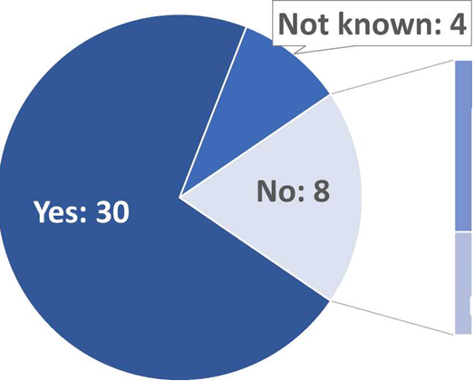
of which coops: 5, which use profit sharing instead
of which private: 3

- The value sharing mechanism can be implemented in different ways. Normally the sugar sales price is used as a reference, but sometimes the price of ethanol or both of sugar/ethanol is used. Sometimes reference is made to an independent reporting system, such as the monthly sugar price as published by the EU price reporting system. A small number of private sugar companies link value sharing to the profitability of the company.
- As to antitrust investigations, in 2013 the NCA in Poland investigated a complaint from sugar beet growers about an alleged abuse of dominance by a sugar processor. According to the complaint, the processor had abused its dominant position by stipulating in the supply contract that growers could only use seeds purchased from the sugar processor for sowing sugar beets. The processor argued that the requirement should be exempted from competition law pursuant to Regulation (EC) No 707/2008 of 24 July 2008, Annex II point XII.3d. This derogation allows the AWTs to include "rules on the choice and supply of seeds of the varieties of beet to be produced". The NCA closed the case during the preliminary proceedings after having found that there were no indications that the seed requirements were exploitative since the growers could obtain a fair commercial margin and that the Regulation allowed the AWT to include seed specifications.

Contractual negotiations by producer organisations in various sectors
- Until 1 January 2018, the CMO provided for four sectors possibilities for recognised POs to engage in contractual negotiations for the sale of the respective products of their members. These were derogations from the Union competition rules. The derogations concerned the sectors of olive oil, beef/veal and certain arable crops (Article 169-171 CMO) and milk and milk products (Article 149 CMO). All measures had in common that the possibility of selling the products jointly via a PO should strengthen the bargaining position of farmers in relation to their downstream partners, but the conditions and the activities carried out under these provisions were different.
- In the milk sector, the possibility to conduct contractual negotiations was introduced in 2012 with the Milk package, Article 149 CMO. That possibility of contractual negotiations is subject to a market share threshold, but no further conditions in the form of the generation of efficiencies have to be fulfilled to engage in such negotiations. In the three other sectors, however, the provisions provided for a market share threshold and the need that the producer organisation integrates efficiency enhancing activities for its members. The producer organisation is also obliged to place the products of its members on the market.
- The Omnibus Regulation amended Article 152 CMO from 1 January 2018 and stipulates that recognised POs and APOs can engage in contractual negotiations in all sectors. Consequently, it also repealed Articles 169-171 of the CMO Regulation for the olive oil, beef/veal and certain arable crops sector as of that date. The sector specific derogation for milk in Article 149 CMO was not repealed.
- In the following all four derogations will be described.

Article 169, 170 and 171 CMO – Olive oil, beef&veal and certain arable crops (repealed by the Omnibus Regulation)
- Articles 169-171 of the CMO Regulation contained the efficiency based derogations from competition rules in the olive oil, arable crops, and beef and veal sectors. While these derogations have been repealed, they do form part of the reporting obligation under Article 225 d) CMO, but they continue legally to be relevant for those activities, which took place before the amendments of the Omnibus Regulation entered into force on 1 January 2018. If a recognised PO/an APO carried out contractual negotiations on behalf of its members (i.e. jointly sells the production of its members), it had to, in order to benefit from the derogation, carry out an additional activit(ies). These additional activities must generate significant efficiencies. The provisions at hand contained a non-exhaustive list of such activities. The rationale of these derogations was to compensate the anti-competitive effects of contractual negotiations by other, efficiency enhancing activities. This contributes to the real integration of these entities, to their increased bargaining power and ultimately to the improved competitiveness.
- The conditions of the derogation included requirements of formal recognition by Member States and notification of the production volumes covered by the derogations. In order to facilitate the application of the derogations, the Commission adopted the Guidelines on the application of the derogations in 2015.

- As a condition for contractual negotiations to take place, the PO should effectively concentrate supply and place the products of its members on the market.

- Further, the PO should integrate one or more activities of its producer members and this activity should be likely to generate significant efficiencies to ensure that the PO activity contributes to the fulfilment of the CAP objectives as set out in Article 39 TFEU.

- The derogation is only applicable if the PO's market share stays below a certain threshold, in the case of olive oil the volume of olive oil production covered by such negotiations must not exceed 20 % of the total relevant market. For the beef/veal and certain arable crops sector, the threshold is based on national production: For a particular PO and each product covered by those articles, the quantity of the product covered by such negotiations must not exceed 15 % of the total national production of that product.

- Moreover, to benefit from the competition derogation, the PO must notify the competent authority in the Member State in which it operates and provide it with the volume of the product covered by the negotiations, Article 169, 170, 171 (2) (g) CMO. No PO notified such volumes. Therefore no PO has been able to rely on the derogation from the competition rules provided by these articles.
- The Member State is in turn obliged to inform the Commission. Since the entry into force of Regulation (EU) No 1308/2013, no Member State has notified the use of this possibility in its territory in any of the above mentioned sectors. From 2014-mid 2017 neither the NCAs nor the European Commission investigated any cases in which Articles 169-171 CMO were assessed.
- In 2017 the Commission launched a 'Study on Producer Organisations and their activities in the olive oil, beef and veal, arable crops sectors'. The study finds that the total number of recognised and unrecognised POs and APOs to be over 1 400 entities in the olive oil sector; over 800 in the beef and veal sector, and around 1 600 in the arable crops sector. In these sectors there are overall five times more unrecognised POs/APOs than those formally recognised by Member States under EU legislation.

Table 4: POs and APOs in the 28 Member States, 2017

 | Number of recognised PO | Estimate of the number of non/recognised* PO | Number of recognised APO | Estimate of the number of non/recognised APO*
Olive oil | 252 | 1161><1181 | 8 | 0><10
Beef and veal | 178 | 609><644 | 2 | 17><27
Arable Crops | 189 | 1364><1414 | 3 | 19><29
Total | 619 | 3134><3239 | 13 | 26><66
Recognised POs are producer organizations recognised under the Article 154 CMO Regulation; recognised APOs are associations of producers organizations recognised under Article 156 CMO Regulation

- The study, based on a sample of 203 POs and 23 APOS, reveals that the main motivating factors for farmers to set up a PO or an APO are (i) to improve access to markets due to an increased volume, (ii) to improve the position of the members in negotiations with buyers, (iii) to reduce costs for members, and (iv) improve the position of members in negotiations with suppliers.
- According to the study, most producers did not encounter many barriers to establish the PO or APO. POs considered that lack of support from the government, difficulty to organise support from sector organisations, and lack of good examples of successful cooperation within the sectors were sometimes a barrier to the establishment of the organisation.
- Furthermore, according to the study the main benefits for members in a PO/an APO are (i) improved market access and price stability, (ii) reduced costs and economies of scale.
- The results also show that not all POs and APOs carry out contractual negotiations and other commercialisation-related activities (involving, in addition to contractual negotiations, also commercialisation strategies and planning of quantities). Only two-third of POs and APOs carry out contractual negotiations and other commercialisation-related activities. More than 90% of the entities that carry out these commercialisation-related activities also carry out at least one of the efficiency-enhancing activities required by Articles 169-171 of the CMO Regulation. The most common efficiency-enhancing activities are quality control, distribution/transport, and procurement of inputs. According to the study, most POs carry out these latter, efficiency-enhancing activities because they consider them to improve their position in negotiations with buyers and secondly because they reduce the costs of the members. Ensuring compliance with competition rules was found to be the least important reason for organisations carrying out these activities.
- Most organisations covered by the study state that their activities are at least to some extent contributing to the CAP objectives. 60% of the POs consider that their activities contribute to the CAP objective of increasing agricultural productivity. Around 50% of POs consider that their activities contribute to a fairly good extent to the CAP objectives of ensuring availability of supply, ensuring a fair standard of living for farmers, and stabilising markets. 40% of the organisations perceive that their activities contribute to reasonable consumer prices to at least a fairly good extent. APOs have a slightly different view, namely that their activities contribute to increasing productivity relatively more to stabilising markets, and to a fair standard of living for farmers, and to a lesser extent to availability of supply and reasonable consumer prices.
- The study provides useful information about the relevance and benefits of the recognition process for POs:
  - Most POs have not been able to rely on the derogation from the competition rules because most POs did not ask for recognition. As explained above the study finds that there are five times more unrecognised POs/APOs than formally recognised POs/APOs. The study provides information about the reasons of the POs for seeking or not seeking recognition.
  - Around half of the unrecognised POs and APOs stated that they were not aware of the possibility of recognition under the CMO Regulation.
  - The other half of the unrecognised POs and APOs stated that they were aware of the possibility of recognition under the CMO Regulation. About three fourth of them perceive that there are potential benefits of being recognised.
  - Virtually all of recognised POs and APOs see additional benefits of the recognition.
  - POs that are aware of the possibility to get formally recognised under the CMO Regulation state that the recognition may provide the following benefits to a fairly good or to a large extent: financial support of investments, services and plans (about 70%); credibility towards other actors in the supply chain (about 60%); better access to extension services (about 60%); and legal security (about 60%). Benefiting from the derogation from competition rules (whose pre-requisite was the recognition) is least often indicated to be an important benefit of recognition to a fairly good or to a large extent (about 35%).
  - POs that are aware of the possibility to be formally recognised, but do not get recognised, consider that the most relevant reason for not applying for recognition is that the benefits are unclear (about three quarters considered that this is an important or very important). Equally often, organisations stated that the lack of good examples was a reason for not applying. The thresholds for recognition were important or very important reasons for two thirds of the organisations. Other reasons included the complexity of the application process, the increased supervision or the amount of information requested by the Competent Authorities.
  - About two thirds of formally recognised POs/APOs or those that have applied for recognition (i.e. those effectively went through the recognition process) consider that the complexity of the application process and the amount of information requested are fairly important, important or very important barriers for recognition.

Article 149 CMO - Collective negotiation in the milk and milk products sector (in force)
- Recognised POs in the milk and milk products sector (Articles 152(3) and 161 CMO) may negotiate contract terms collectively on behalf of their farmers, including the price of raw milk (Article 149 CMO).
- Article 149 CMO however does not require that the PO concentrates supply and places the products on the market. Further, it also does not require that the milk PO integrates activities which are likely to generate significant efficiencies. In the milk and milk product sector POs are allowed to carry out so-called 'bargaining activities' for their members, i.e. to negotiate a sales price for their members' products, without itself acting as an economic operator that integrates other members' activities beyond the mere selling activity.
- The volume of milk over which a PO can negotiate is limited to 3.5% of the EU production and to 33% of the national production of the Member State(s) concerned. For Member States with a production of less than 500 000 tonnes, this limit is set at 45% of national production. The limits allow negotiations between POs and dairy processors of approximately the same size while maintaining effective competition on the dairy market.
The implementation of this provision was described in the Commission reports to the European Parliament and to the Council in 2014 and 2016.
- Nine Member States reported deliveries of raw milk in 2016 under contracts collectively negotiated (six in 2014 and 2015). The collectively negotiated volume amounted to 22.8 million tonnes, corresponding to some 15% of total milk deliveries in the EU in 2016.
- No intervention of the competition authorities has been reported thus far against exclusion of competition or serious damage to SME processors of raw milk due to these collective negotiations.

Table 5: Contractual negotiations in the milk sector 2015 and 2016

Member State | Volume collectively negotiated (x1000 t) | Approximate  share of MS deliveries | Volume collectively negotiated (x1000 t) | Approximate  share of MS deliveries
 | 2015 |  | 2016
Belgium | - | - | 1 495 | 39%
Bulgaria | 5,6 | 1,10% | 3,94 | 0,8%
Czech Republic | 497 | 17% | 1 314 | 44%
Germany | 13 253 | 42% | 11 681 | 37%
Spain | 621 | 9% | 716 | 10%
France | 5 171 | 20% | 5 893 | 24%
Croatia | - | - | 0,49 | 0,1%
Italy | - | - | 95 | 0,8%
United Kingdom | 820 | 5% | 1 599 | 11%

Crisis situations

Articles 222 CMO as applied during the milk market crisis
- Article 222 CMO allows the Commission to adopt implementing acts to the effect that Article 101(1) TFEU is not to apply to agreements and decisions of recognised producer organisations, their associations and recognised interbranch organisations in any of the sectors of Article 1(2) CMO during periods of severe market imbalance, provided that these agreements do not undermine the proper functioning of the internal market, strictly aim at sector stabilisation and fall under one or more of the categories of actions listed in Article 222 CMO.
- Commission Implementing Regulation 2016/559, based on Article 222 CMO, authorised recognised POs, their associations and recognised interbranch organisations in the milk sector to plan production for a period of 6 months. That period was extended for a further six months by Commission Implementing Regulation 2016/1615, until 12 April 2017.
- Given that the milk sector is predominantly characterised by cooperative structures, it was considered to be appropriate to extend that authorisation to cooperatives formed by milk producers. In order to address the situation in the milk and milk products market effectively, the measure covered other forms of farmers' cooperation that have been established by milk producers under national law and active in the milk and milk products sector. Commission Delegated Regulation that put in place this extension was based on Article 219(1) CMO which allows the Commission to adopt delegated acts in order to react efficiently and effectively against threats of market disturbances.
- No notification has been received from any Member States of agreements or decisions covered by Commission Implementing Regulation 2016/559 and Commission Delegated Regulation (EU) 2016/558.
- In 2016, an NCA received a request for consultation from a Dairy Producer Organisation concerning whether it would be compatible with competition law to publicly make a statement to its members encouraging them to reduce their production of raw milk. The NCA informally concluded that such a statement could potentially be problematic and any communication on that regard should be followed up by an encouragement and a call for the members to observe and act according to the Regulation adopted by the European Commission pursuant to Article 222 CMO.

Article 33 CMO – Crisis measures in operational programmes in the fruit and vegetables sector
- In the fruit and vegetables sector, POs/APOs are, pursuant to Article 33 CMO, entitled to take certain measures in the framework of the operational programmes. The measures under these programmes may include production planning, measures to maintain product quality, research, but also measures to prevent and manage crisis. Some of these measures, such as production planning and certain crisis measures such as market withdrawal may have an impact on the volume of products supplied to the market. EU provides financial assistance to the POs/APOs' operational programmes.

Table 6: Total expenditure on the operational programmes of POs/APOs and EU, by measures (2016)
 | Planning of production | Product quality | Marketing improve-ment | Research and Experimental production | Training | Crisis prevention and  management | Environmental actions | Other actions
EU financial assistance and PO contribution | 398.551.853 | 428.851.321 | 368.302.477 | 11.021.994 | 30.931.268 | 89.960.339 | 241.332.308 | 35.354.944
Share measure of total expenditure | 25% | 27% | 23% | 1% | 2% | 6% | 15% | 2%
Source EC AGRI G2 Extraction from data submitted by MS (Annual report 2015, provisional data)
- The EU financial assistance to the operational programmes also covers crisis prevention and management measures. As can be seen from the below table, these measures include different actions. There are preventive actions such as harvest insurance as well as crisis management measures, which may have an impact on volumes supplied to the market, namely market withdrawals, green harvesting and non-harvesting of fruit and vegetables.
Table 7: EU financial assistance to crisis prevention measures of POs/APOs (2016)
Crisis prevention and management measures 2016 | Amount of the EU financial assistance (€) | %
Promotion and communication activities | 10.989.328 | 23%
Training actions and exchanges of best practices | 187.752 | 0%
Harvest insurance | 9.812.787 | 21%
Support for the administrative costs of setting up mutual funds | 196.591 | 0%
Investment making the management of the volumes placed on the market more efficient | 1.080.896 | 2%
Replanting of orchards where that is necessary following mandatory grubbing up for health and phytosanitary reasons | 192.290 | 0%
Market withdrawals | 22.205.324 | 47%
Green-and non-harvesting | 2.900.040 | 6%
Total crisis prevention and management measures | 47.565.009 | 100%

- The amount of EU financial assistance provided to crisis prevention and management measures under Article 33 CMO was marginal. In 2015, EU financing for these measures of around EUR 50 million constituted only 6% of the total EU financial assistance to POs/APOs operational funds (total amount of EUR 740 862 571). The weight in volume is even less significant. In 2015 POs/APOs withdrawals amounted to 79 531 t. PO/APO market around 50 million t per year (50% of the total F&V production in the EU). Market withdrawals represent less than 1% of the total volume marketed by POs/APOs.
- POs/APOs contributed to the crisis prevention and management measures EUR 29. 133 741 of their funds. Taken together, in 2016, the EU and POs/APOs spent a total of EUR 76 698 750 for crisis prevention and management measures. The table below gives an overview how many POs implemented crisis management measures in 2016.
Table 8: Implementation of crisis management measures by POs (APOS) (2016)
2016 | Number of POs implementing crisis prevention and management measures | Total number of PO by MS | Share
Belgique/België | 11 | 14 | 79%
Bulgaria | 0 | 8 | 0%
Česká republika | 17 | 19 | 89%
Danmark | 1 | 2 | 50%
Deutschland | 15 | 31 | 48%
Elláda | 3 | 126 | 2%
España | 190 | 568 | 33%
Estonia | 0 | 0 | 0%
France | 220 | 228 | 96%
Hrvatska | 0 | 3 | 0%
Ireland | 0 | 2 | 0%
Italia | 160 | 304 | 53%
Kypros | 1 | 9 | 11%
Latvia | 0 | 3 | 0%
Lithuania | 0 | 0 | 0%
Luxembourg | 0 | 0 | 0%
Magyarország | 13 | 55 | 24%
Malta | 0 | 0 | 0%
Nederland | 10 | 13 | 77%
Österreich | 2 | 11 | 18%
Polska | 5 | 239 | 2%
Portugal | 21 | 62 | 34%
Romania | 1 | 19 | 5%
Slovenija | 0 | 0 | 0%
Slovensko | 3 | 5 | 60%
Suomi/Finland | 0 | 4 | 0%
Sverige | 3 | 5 | 60%
United Kingdom | 9 | 33 | 27%
Total EU | 685 | 1763 | 39%

Exemptions under individual assessment according to Article 101 (3) TFEU
- Agreements reached between independent producers e.g. on quantities and sales can be exempted Article 101(3) TFEU, if the conditions described in paragraph 13 are met.
- In 2013, the NCA in France fined five pork slaughterers for agreeing on quantities of pork meat to be bought from farmers producing live pigs. The aim was to lower the prices paid to farmers. The NCA also fined an association of meat slaughterers for sending price instructions to its members. Further, seven slaughterhouses, an association of slaughterers and an auction market buyer federation were fined for collectively agreeing on a base price to be paid to farmers. Concerning the last infringement, the parties argued that their agreement could be exempted under Article 101(3) TFEU. The NCA concluded that even if the parties could demonstrate that fixing a base price contributed to improving the meat production, the other conditions were not demonstrated because a fixed base price did not promote economic progress and the practice did not allow consumers a fair share of any resulting benefit.
- In 2013, the NCA in Latvia assessed under national competition law the cooperation between two dairy cooperatives, which intended to build and manage a factory for processing raw milk together. The cooperation included an agreement on raw milk prices. The NCA found that the price agreement was a necessary and inevitable component of the cooperation and that the agreement's effects in terms of the efficiency, which would arise from collective raw milk sales and processing, likely could compensate for the potential negative effect on competition. On this basis the NCA concluded that the exemption under national competition law applied to the agreement and closed the investigation without a decision.

Investigations by competition authorities in the agricultural sector
- This Section describes the antitrust investigations of the European competition authorities in the agricultural sector from 1 January 2012 to mid-2017 ('the Period'). This part of the report has been prepared within the European Competition Network ('ECN') in close collaboration with the NCAs concerning their enforcement and related activities in the agricultural sector.
- This Section provides an overview of (1) the number of antitrust investigations per authority, (2) the product categories investigated, (3) the main sources of investigations (4) the entities subject to investigations, (5) the type of complainants, (6) the type of infringement investigated, (7) the legislation applied, (7) the outcomes of investigations, (8) the types of infringements found and (9) the entities subject to decisions detecting an infringement.

Nearly 170 antitrust investigations in 2012-2017
- In the Period, European competition authorities have concluded about 126 investigations and were still as of mid-2017 running about 41 investigations, leading to a total of 167 investigations. This number does not take into account all the investigations opened to address potential problems regarding non-agricultural products in the food supply chain in the Period.
Table 9: Investigations by competition authorities in the Period 01/2012 -06/2017 (closed investigations and pending proceedings)
Authority | Number of investigations
Austria | 24
Belgium | 3
Bulgaria | 4
Cyprus | 9
Croatia | 1
Czech Republic | 1
Denmark | 22
Estonia | 1
Finland | 4
France | 7
Germany | 8
Greece | 21
Hungary | 1
Ireland | 8
Latvia | 2
Lithuania | 1
Netherlands | 4
Poland | 8
Portugal | 1
Romania | 1
Spain | 8
Slovakia | 1
Sweden | 5
European Commission | 22

Main product categories investigated
- The investigations undertaken by European competition authorities have covered a wide range of agricultural products. Table 10 classifies the investigations according to the main agricultural product categories concerned.

Table 10: Main products subject to scrutiny in antitrust actions
in the Period 01/2012-06/2017

Main Agricultural Product | Number of investigations | RawProducts | Processed  Products | Both:  raw and processed products
Milk and dairy | 60 | 20 | 31 | 8
Meat in general | 30 | 17 | 9 | 5
Fruit & Vegetables | 23 | 17 | 4 | 2
Oilseeds, oils and fats | 8 | - | 7 | 1
Sugar | 8 | 1 | 6 | 1
Cereals | 17 | 2 | 14 | -
Rice | 4 | 2 | 2 | -
Other | 25 | 11 | 6 | 1
TOTAL | 175 | 70 | 79 | 18

- European competition authorities investigated mostly the following agricultural product categories: (1) milk and dairy, (2) meat in general, (3) fruit and vegetables and (4) cereals. A number of investigations also took place in the categories of (5) oilseeds, oils and fats, (6) sugar and (7) rice.
Figure 4: Categories of agricultural products investigated by competition authorities

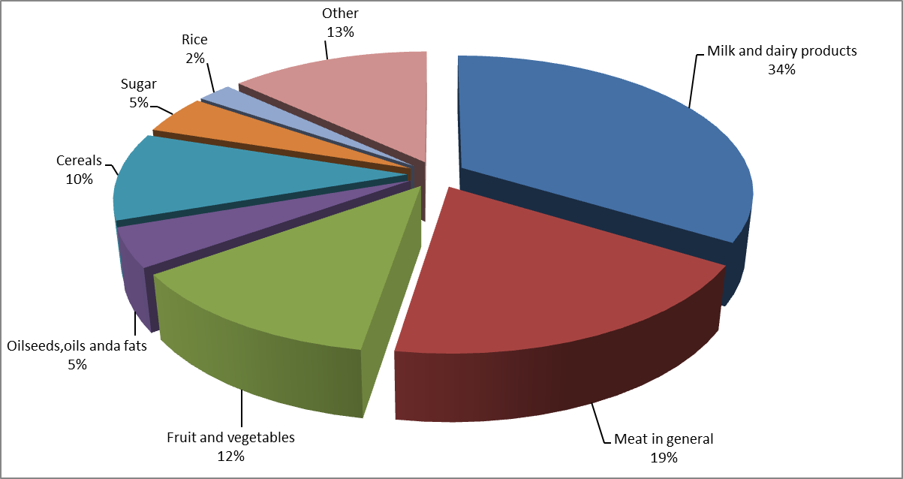

- The infringements detected by the European competition authorities which resulted in a prohibition decision and a fine concern a variety of agricultural products, including: milk and dairy products (26%), fruit and vegetables (22%), meat in general (16%), oilseeds, oil and fats (10%), others products, e.g. natural vinegar, wine, cereals, wine, cotton, sugar (26%).
- All cases of abusive conduct by dominant operators detected by European competition authorities concern the milk and dairy sector.

Entities subject to investigations
- The entities subject to investigations conducted by European competition authorities are: processors (36%), retailers (15%), other types of associations (11%), agricultural producers, (9%), wholesalers (9%), agricultural producer organisations (9%), general associations of farmers (9%), others (7%), associations of producer organisations (4%). The entities that most frequently are the subject of complaints from agricultural producers are agricultural producers.
- The entities subject to decisions where European competition authorities found an infringement of competition rules and fined the entities are: processors (39%), retailers (26%), wholesalers (12%), other types of associations (7%), agricultural producers (5%), agricultural producers organisations (4%), others (4%), associations of producers organisations (3%).

Figure 5: Entities concerned by 'infringement decisions with fines'

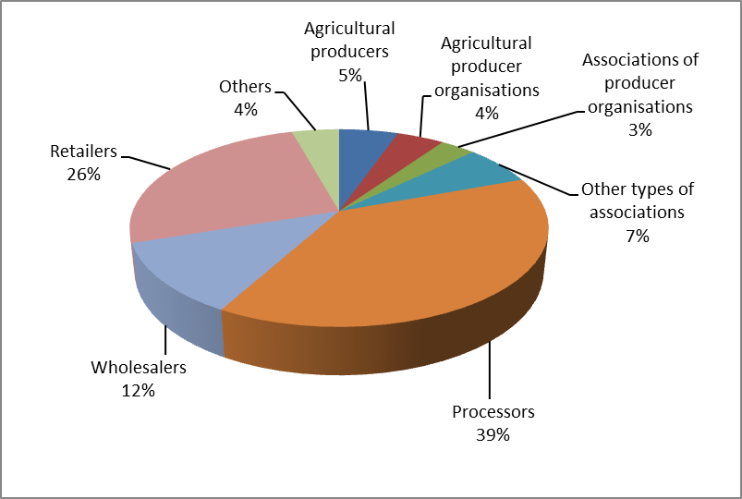
- Processors are the entities most frequently represented in the investigations. For example, in 2014 the NCA in Germany fined the three major German sugar processors for forming a 'territorial cartel' which meant that they would limit their sales of sugar in Germany to their respective home sales areas. They also agreed on prices and quantities to be sold. The aim was to get the highest possible prices. In two other cases for instance, in 2012 and 2013 the NCAs in France and Germany respectively fined 17 and 22 large flour mills for jointly agreeing on sales prices, the quantities they would sell and which customers each mill would limit their sales to. In another example, in an ex officio case from 2012 the NCA in Greece fined the processors (private companies, cooperatives and an association of processors) of poultry meat for jointly i.a. fixing the selling prices of their products and preventing imports of chickens.

Main sources of investigations
- The figure below shows the origins of the antitrust investigations covered by this Staff Working Document. European competition authorities opened slightly over half of their investigations following complaints (from suppliers, competitors or customers). The authorities opened the other proceedings ex officio, meaning that the authorities opened the proceedings on their own initiative after having become aware of potential anti-competitive practices through various ways, such as the press or by evidence gathered when investigating other cases.

Figure 6: Reasons for opening antitrust investigations in the Period 01/2012-06/2017

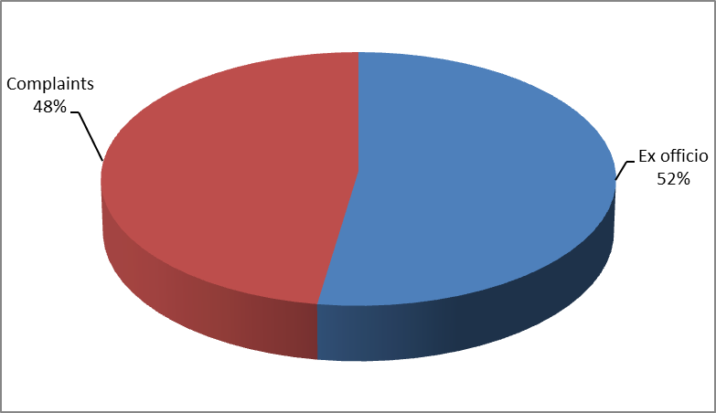

Types of complainants
- The complainants are varied and the complaints have essentially come from: agricultural producers (23%), processors (19%), others (15%), agricultural producer organisations (13%), individual persons (7%), wholesalers (5%), retailers (5%), other types of associations (5%), agricultural associations of producer organisations (3%), local authorities (3%), general associations of farmers (2%).
- The figures above show that agricultural producers alone or in a partnership of their choosing, are the most important source of complaints. As shown in paragraph (138), in most cases investigations did not lead to findings of infringements: they did so only in about one fourth of the investigations covered in this report. The proportion is lower for investigations triggered by complaints of agricultural producers: out of 25 investigations opened in the Period following complaints lodged by agricultural producers, only 4 investigations led to the adoption of a decision finding an infringement. One possible explanation for this is that agricultural producers often make their complaints public at the time they submit them to competition authorities and thereby undermine the chances that the authorities can collect evidence of infringements, where such infringements exist.
- European competition authorities have nevertheless identified several practices that were directly detrimental to farmers. For instance, in 2015, the NCA in Spain fined buyers who had agreed to pay lower prices to farmers for raw milk who had allocated farmers between themselves. The NCA in France fined buyers of live pigs because they had agreed on quantities they planned to purchase with a view to reducing the price for the animals. They also intervened to allow to relax exclusivity conditions imposed by dominant cooperatives on farmers: in those cases, competition authorities enabled farmers to supply several processing cooperatives with raw milk (in Sweden) and sugar beets (in France), thereby widening options for producers to obtain higher prices and allowing them to increase their output (for example for beets at the time of removal of quotas).
- The NCA in Cyprus investigated a complaint from a farmer concerning an association of dairy producer organisations' clauses with their members that prevent farmers from supplying to other dairies. The complainant argued that the obligation to exclusively supply his entire production to the producer organisation, the ban on supplying raw milk to third parties, a general ban on farmers carrying out competing activities and sanctioning its members for exceeding the production cap constituted an abuse of dominance. The farmer decided to withdraw his complaint and as a result the NCA has opened an ex officio investigation into the matter and is currently investigating the case. In 2018, the NCA in Germany closed its investigation against Germany's largest dairy into the duration of the notice periods for the supply contracts between milk producers and dairies. In an interim report published in March 2017, the NCA found that along with other special market conditions such as exclusive supply obligations and ex-post pricing, the prevailing notice periods could lead to a foreclosure of the market to the detriment of the farmers. In its interim report, the NCA suggested several changes to the conditions of delivery, including shorter notice periods. After a discussion of the findings in the market and some changes in market conditions, such as a large number of termination notices due to the last milk market crisis and modifications of the conditions of delivery by the investigated dairy, the NCA closed its case and is now monitoring whether these developments will effectively improve competition in the market.
- The type of product categories for which agricultural producers filed complaints are: milk and dairy (36% of the complaints), meat in general (28% of the complaints), fruit and vegetables (16% of the complaints), eggs (4% of the complaints), wine (4% of the complaints), rice (4% of the complaints), cereals (4% of the complaints), cotton (4% of the complaints).
- The types of infringement alleged by individual agricultural producers are: abusive conduct by dominant operators (40% of the complaints), vertical agreements between entities operating at different levels of the production (32% of the complaints), horizontal agreements between two or more actual or potential competitors (28% of the complaints).

Types of infringements investigated
- European competition authorities have investigated vertical agreements (38% of investigations in the Period), i.e. agreements between entities operating at different levels of the production. For example, in a number of cases competition authorities investigated agreements between processors and retailers establishing a minimum retail price. This was the case in Slovakia for one case concerning dairy products and in Bulgaria for three cases concerning sunflower oil. The NCA in Austria concluded 23 investigations into agreements between processors and retailers on minimum retail prices on dairy, meat and flour products. In other cases, competition authorities concluded that it would seem unlikely to find an infringement and therefore closed the investigation. For example, the NCA in Croatia initiated an investigation concerning an agreement between the representatives of the milk producers and milk processors, concerning the calculation of the purchase price of milk. The NCA took the position that the negotiations and arrangements for milk purchase prices were not considered as prohibited agreements according to competition rules.
- European competition authorities have investigated horizontal agreements, i.e. agreements between two or more actual or potential competitors (38% of the investigations in the Period). For example, competition authorities investigated agreements between producers fixing the price of an agricultural product. In some cases, the agreement could be effectively proven: for instance, the NCA in Cyprus found that an agricultural association of producer organisations infringed competition rules by concluding with its farmers, members of the association, distribution agreements for raw cow milk which included specific terms for determining the price of raw milk. In other cases, competition authorities concluded that it would seem unlikely to find an infringement and therefore closed the investigation. For example the NCA in Poland closed its investigation due to lack of evidence that simultaneous and relatively fast price changes (namely reduction) of industrial apples purchased by processors were not the result of a price-fixing agreement.
- Competition authorities have also investigated in some cases agreements that were both vertical and horizontal because they involved several levels of the chain and they involved at each level several, if not all, competitors. This was particularly the case for agreements reached in a given Member State that aimed at raising prices and, in order to maintain higher prices, aimed at preventing imports from other Member States. For instance, the European Commission investigated agreements that national associations of agricultural producers publicly reported that they had reached with national associations of processors and national associations of retailers in France. The agreements aimed at raising prices of some dairy and meat products and excluding supplies of producers from other Member States by committing the retailers to source 100% of the relevant products in France. The Commission intervention ensured that French supermarket shelves were not reserved for French products, thus preventing a damaging cycle of retaliations, blocking imports from outside their own Member States, for all farmers and the cases have been closed. In 2015-2016, the European Commission looked into other similar initiatives in Austria, Belgium, Germany and Italy in the milk sector that would block certain imports from producers in other Member States or favour domestic production to the detriment of imports. The NCA in Hungary investigated a similar case concerning watermelons in Hungary.
- Collective agreements limiting imports appear to be a new practice that developed in the period. It was found not only in the "vertical and horizontal" agreements presented in the preceding paragraph but also in horizontal agreements between processors: for instance the NCA in France fined seventeen flour mills in France and Germany for agreeing to limit imports between France and Germany and the NCA in Greece fined domestic processors (private companies, cooperatives and an association of processors) of fresh and frozen poultry meat for preventing imports of live chickens in order to maintain higher prices. Collective agreements limiting imports run counter to the basic EU principle enforced through competition law that all producers of agricultural products should have a fair access to the whole European Internal market and not be discriminated on the basis of their nationality.
- Competition authorities have further investigated potential abusive conduct by dominant operators (24% of the investigations in the Period). These abuses mainly involved strategies to foreclose competitors, such as exclusivity obligations, minimum purchasing obligations, refusals to supply and some exploitative abuses, such as unjustified contractual obligations. On many occasions, the competition authority concluded that that it was unlikely to find an infringement because of a lack of evidence and therefore closed the investigation. For example, the NCA in Sweden has closed an investigation due to lack of evidence that a dominant company was paying retailers not to sell the products of competitors. In other cases, NCAs have found that dominant companies abused their dominant positions, for instance by refusing to supply their products to certain customers or by excluding smaller competitors of customers by selling at artificially low prices below cost that such competitors cannot compete with.
- All cases where competition authorities found that an operator had abused its dominant position concern the milk and dairy sector (i.e. 4 cases in 2012, 2013 and 2014, see paragraph (140)).
Figure 7: Main types of infringements investigated in the Period 01/2012-06/2017
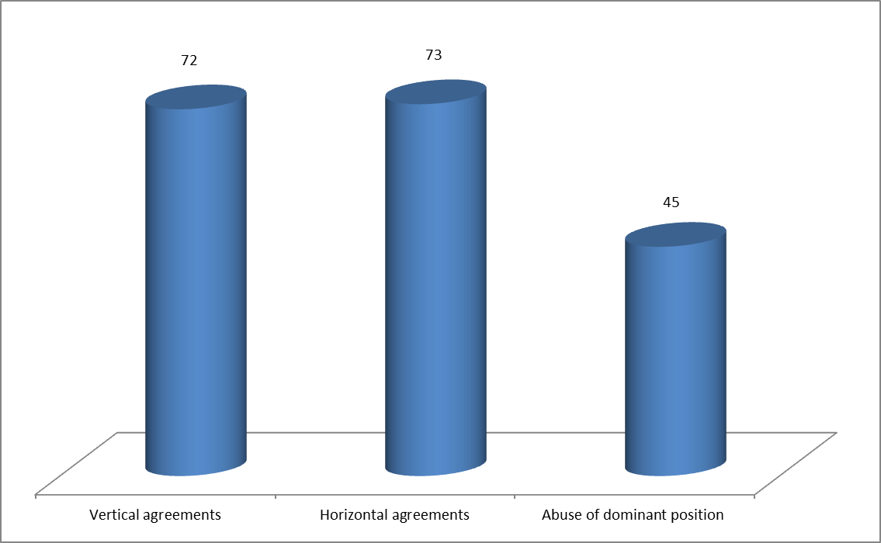

Outcomes of investigations
- The antitrust investigations in the agricultural sector that were concluded during the Period led to four different types of outcomes:
  - infringement decisions with fines, i.e. the competition authorities found an infringement and required the entity concerned to stop the infringement and to pay a pecuniary penalty (about half of the concluded cases);
  - infringement decisions without fines, i.e. the competition authorities found an infringement and required the entity concerned to stop the infringement without paying a pecuniary penalty(a few of the concluded cases);
  - commitment decisions, i.e. the competition authorities did not decide whether there was an infringement and adopted a decision that makes legally binding the commitment offered by the entity under investigation, thereby removing any potential concerns (a few of the concluded cases);
  - closures without decision, i.e. investigations of competition authorities led to a closure of the proceedings during a preliminary phase of the investigation due to lack of evidence, because disproportionate efforts were necessary to meet the requisite burden of proof or because of the need to set priorities (about half of the concluded cases). Many of these closures concern the rejections of complaints.
- Overall, most of the investigations conducted by competition authorities led to a closure of the proceedings because of a lack of evidence or because disproportionate efforts were necessary to meet the requisite burden of proof or because of the need to set priorities in the light of the many matters they have to investigate and the limited available resources.
Example of a commitment decision
In 2017, in an investigation initiated by a complaint, the NCA in France expressed concerns that a sugar processor´s procurement contracts with sugar beet farmers could foreclose the sugar beet procurement market. In response to the NCA's concerns the sugar processor committed to amend its articles of association to limit the delivery obligation to the processor, to limit the duration of the contracts, to reduce an advance notice period from twelve to three months and to give its mangers training in competition law. The NCA concluded that these commitments will open up the procurement contracts and allow sugar beet growers to benefit from greater freedom to choose which processor to supply.

Example of an infringement decision without fines

In 2017, the NCA in Sweden adopted an infringement decision in an ex officio case without applying a fine. The infringement detected was a breach of commitments made in a previous investigation concerning the milk and dairy sector. As a result, the NCA decided to repeal the decision to make the commitments binding with the effect that the NCA may reopen the original investigations.

Examples of investigations closed without finding an infringement
In 2013, the NCA in Latvia closed an investigation based on a complaint without finding an infringement due to lack of evidence concerning possible information exchange and customer allocation between the largest flour millers in Latvia.
In 2013, the NCA in Hungary closed an ex officio investigation against a number of supermarkets, an association of Hungarian watermelon producers and an inter-branch organisation for fruits and vegetables concerning an alleged anticompetitive agreement. Allegedly the parties had agreed on prices for watermelons and that they would not distribute (or only at a higher price) imported watermelons. After the initiation of proceedings, Hungary adopted a new law which generally exempts the agricultural sector from the general prohibition of the Hungarian competition act. The Hungarian NCA subsequently closed the case and issued a statement saying that the new law gives rise to serious concerns as it causes legal uncertainty in the evaluation of cartel activities concerning agricultural products. The law was ultimately repealed in 2015 following an infringement proceeding by the Commission.
In 2014, the NCA in Poland closed two ex officio investigations concerning whether the fall in prices of rapeseed and cereals from farmers was the result of an anticompetitive agreement between rapeseed and cereal wholesale buyers. The NCA analysis showed that the decrease in buying prices was related to the market situation and the investigations were closed without finding an infringement.
In 2015, the European Commission concluded an ex officio investigation into an agreement between one retailer and the main national federation of vegetable growers in France. The agreement aimed to restrict the majority of the retailer's procurement of certain seasonal vegetables, excluding vegetable producers from other Member States. The agreement was the first of its kind, was only limited to one retailer (Carrefour) and was immediately renounced after the Commission initiated its investigation. The European Commission closed the investigation without a finding of an infringement.

In 2016, the NCA in Ireland closed an investigation based on a complaint from a retailer into whether a trade association of milk farmers had entered into an agreement in order to raise the price of milk. The investigation was closed without a decision due to lack of evidence.
In 2016, the NCA in Romania concluded an ex officio investigation concerning a possible agreement between eleven cereal wholesalers and an association of cereal traders that allegedly had set the price to be paid to cereal producers. The case was closed due to lack of evidence.
In 2016, the NCA in Sweden concluded an investigation based on a complaint into whether a dairy cooperative's rebates to retailers could be an abuse of a dominant position as they prevented competing dairies from also selling to the same retailers. The NCA also investigated alleged payments from the dairy cooperative to retailers that were allegedly meant to ensure that no other competing dairy products were sold by the retailers. The case was closed due to lack of evidence.

Figure 8: Results of the investigations conducted by the competition authorities in the Period
01/2012-06/2017

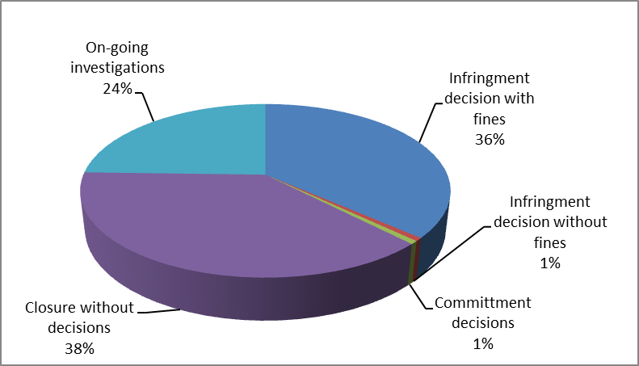

Types of infringements found
- The figure below shows the types of infringements found by competition authorities. They can be classified as follows: agreements on price (46%), agreements on output (13%), information exchange on output, market shares and customers (13%), agreements on market shares (10%), information exchange on price (10%), abuses of dominant position, involving strategies to foreclose competitors, such as predatory prices, exclusionary rebates, excessive and unfair prices (8%). In a number of cases, the competition authorities found that there were several infringements at the same time. The boxes below provide examples of infringements and combinations of infringements.

Figure 9: Main types of infringements detected by competition authorities in the Period
01/2012-06/2017

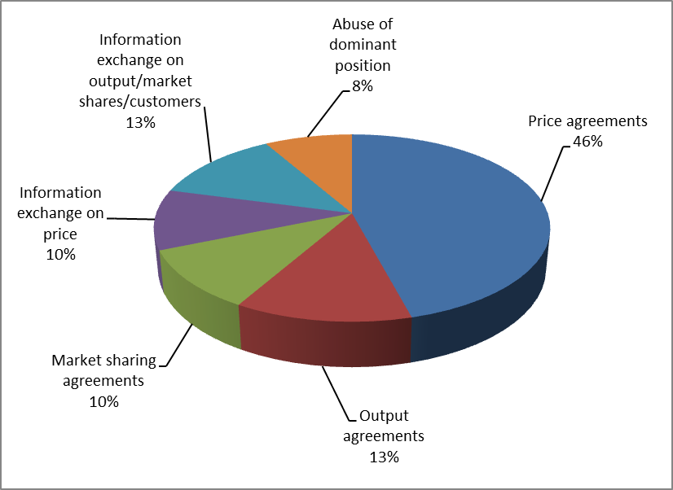

Examples of decisions finding vertical agreement on prices
In 2013, the NCA in Bulgaria found in three separate ex officio investigations that processors and wholesalers had agreed on fixing a minimum price at which the wholesaler could sell the processors' refined sunflower oil.
In 2013 and 2014 the NCA in Austria concluded 23 separate ex officio investigations in cases where processors and retailers had agreed on the final sales price of agricultural products (dairy, meat and flour products) to consumers. In all these cases fines have been imposed by the Cartel Court upon the NCA’s application.

Example of a decision finding a horizontal agreement on prices
In 2015, in an investigation based on a complaint, the NCA in the Czech Republic fined 7 competing producers of live chicken (private companies as well as cooperatives) for agreeing on sales prices of chicken for slaughtering.

Example of a decision finding an agreement on quantities to be bought and prices to farmers
In 2013, in an investigation based on a complaint, the NCA in France fined five pork slaughterers agreeing on quantities of pork meat to be bought with the aim of lowering the prices paid to farmers producing live pigs. The NCA also fined an association of slaughterers for sending pricing instructions to its members. The NCA further fined seven slaughterhouses, an association of slaughterers and an auction market buyer federation for setting together, when the market was down, a unique price for their purchases from farmers.
Example of a decision finding an agreement on prices, customer allocation and market sharing
In 2014, in an ex officio investigation, the NCA in Germany fined twenty-two milling companies, the association of German mills and their representatives for their involvement in a cartel on the sale of flour. The milling companies involved had agreed on prices offered to customers, which customers each company would sell to and the volumes that the companies would supply to all customers. The agreements applied to all forms of flour sales, i.e. to industrial customers (such as e.g. processors of bakery products and bakery chains), artisan bakers and the direct sale of flour in small packages (max. 1 kg packets) to food retailers.
Example of a decision finding an exchange of information on price, output and market sharing
In 2012, the NCA in the Netherlands fined five agricultural producer organisations and three wholesalers for exchanging information on prices, on how much they each would produce and their market shares in order to reduce the quantity of bell peppers in the market, thereby increasing the prices of bell peppers.
Examples of decisions finding an agreement prices, market sharing and preventing imports

In 2012, in an ex officio investigation, the NCA in France fined seventeen flour mills for agreeing to limit imports between France and Germany. Specifically, they agreed on a maximum quantity that would be imported and agreed not to market their products in each other's countries. The millers were also fined for agreeing on a certain price for sales to their customers. To maintain a certain price level the millers had also agreed to limit their production of flour and agreed on which customers each of them would and should sell to.

In 2012, in an ex officio investigation, the NCA in Greece fined the processors (private companies, cooperatives and an association of processors) of fresh and frozen poultry meat for fixing the selling prices of their products to the next level of the production/distribution chain (namely their prices to wholesalers, super-markets, butchers, rotisseries) and for market sharing, especially with regard to safeguarding the existing allocation of clients, as a means to facilitate enforcement of the price-fixing agreement. The association of processors was also separately fined for limiting production by controlling and preventing imports of live chickens in order to maintain higher prices.
Example of a decision finding an agreement on output and an information exchange on price
In 2012, in an ex officio investigation, the NCA in the Netherlands fined a group of agricultural producers, wholesalers and processors for an agreement that limited the production of silverskin onions. Further, the parties to the agreement shared information on their prices in order to align their prices and obtain the highest possible price level. The NCA also found that in order to support this agreement the parties bought several competing onion producers that after the acquisition would no longer produce silverskin onions.
Example of a decision finding an information exchange on output and prices
In 2012, in an ex officio investigation, the NCA in the Netherlands fined producers, wholesalers, processors and retailers for agreeing to limit output and exchange information on prices of first year onion sets for the purpose of creating scarcity in the market and increasing the price.
Example of a decision finding a horizontal agreement on price, volumes, information exchange and bid-rigging
In 2015, the NCA in France in an ex officio investigation fined 11 processors of fresh dairy products (yoghurts, fromage frais, cottage cheese and milk based desserts) for exchanging sensitive information and agreeing on volumes and any price rises on products to be sold under retailers' own brand labels (also so-called private labels). The processors also coordinated who should win tenders launched by major retailers.
Example of a decision finding an agreement on price and market sharing in the sugar sector
In 2014, the NCA in Germany fined the three major German sugar processors for forming a "territorial cartel" which meant that they would limit their sales of sugar in Germany to their respective home sales areas. Sugar was exported to other countries rather than sold to customers in their competitors' sales areas. They also agreed on prices and how much they would sell. The aim of the agreements was to achieve the highest possible prices for sugar.
Examples of decisions finding an abuse of a dominant position
In 2012, in an investigation initiated by a complaint, the NCA in Finland proposed a fine on a milk processor for abusing its dominant position by selling fresh milk at artificially low prices. The NCA found evidence that the motivation for low prices was to outmatch all other processors, including small dairies and dairies from other Member States, so that the dominant processor eventually would be the only milk processor in the market - allowing it then to raise the prices again. This behaviour is called "predatory pricing".
In 2013 the NCA in Cyprus, in an investigation based on a complaint regarding raw milk supply, fined an association of cattle producer organisations. The NCA found that the association's prices were so high that they implied a refusal to supply a milk processor. Given the dominant size of the producer organisation the manufacturer processor had very limited possibilities of getting raw milk anywhere else.
In 2014 the NCA in Cyprus in an ex officio investigation, fined the same association of cattle producer organisations for setting too high and unfair prices for raw milk (the association was simultaneously fined for anti-competitive agreements).
In 2014, in an ex officio investigation, the NCA in France fined a dairy processor (i.e. yogurt and fresh cheese products) for abusing its dominant position by developing a practice of denigration against its competitor's products.
The NCA in Cyprus is also currently investigating a complaint from a dairy on whether an association of dairy producer organisations has abused a dominant position in the raw milk and cheese sector. The association has allegedly imposed unfair trading practices by way of arbitrary and unilateral variations in the price and quantities delivered of raw milk, refused to supply and margin squeeze. A statement of objections has been issued and the investigation is on-going.

Consultations received by European competition authorities
- This Section provides a description of the consultations that the NCAs have received and dealt with from the Member States (e.g. ministries, regional or local governments) and private entities (e.g. consumers farmers, companies) from 1 January 2012 to mid-2017 on the application of the competition rules to the agricultural sector
- This Section provides an overview of (1) the number of consultations received, (2) the product categories subject to consultations, (3) the main sources of consultations (4) the type of consultations received, (5) the number of monitoring and related activities conducted, (6) the product categories subject to monitoring and related activities, (7) the main type of monitoring and related activities conducted.

More than 40 consultations
- In the Period, NCAs received 46 consultations for advice concerning the application of competition rules to the agricultural sector.
Table 11: Consultations conducted by NCAs in the Period 01/2012-06/2017
Authority | Number of consultations
Austria | 1
Cyprus | 1
Denmark | 3
Finland | 2
France | 3
Italy | 3
Latvia | 4
Lithuania | 9
Netherlands | 3
Romania | 10
Slovenia | 1
Spain | 4
United Kingdom | 2
Total | 46

- The scope and the focus of the consultations provided by the NCAs in the agricultural sector varied but they mainly focused on specific agricultural products, such as milk and dairy (35%), cereals (11%), fruit and vegetables (7%) oilseeds, oils and fats (7%), meat in general (4%) and eggs (2%). 35% were consultations on agricultural issues in general (e.g. sustainability initiatives or strengthening farmers) or other products.

Figure 10: Number of categories of products subject to consultations received by NCAs in the Period 01/2012-06/2017

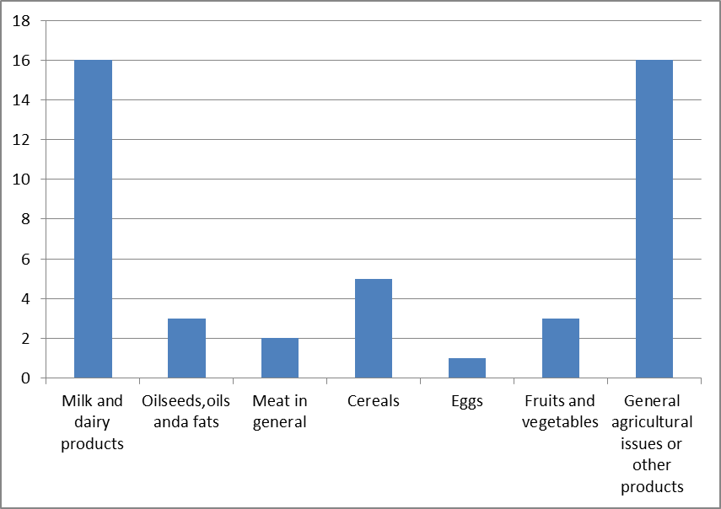

Main source of consultations
- The following entities have consulted the NCAs: (1) Governments (namely, Ministries of Agricultural and Rural Development, Ministries of Economic Affairs, Departments for Liaison with Parliament); (2) Parliaments (namely, Committees for Agriculture); (3) producers; (4) producer organisations; (5) associations of producer organisations; (6) other types of associations; (7) interbranch organisations and (8) processors.
Figure 11
Sources of consultations during the Period 01/2012-06/2017

Main types of consultations
- The consultations received and dealt with by the NCAs were of three main kinds: (1) consultations concerning new legislative proposals concerning the agricultural sector, in which the NCAs have been asked to advise on effect of such new proposal on competition; (2) consultations from national governments with the purpose of obtaining guidance on envisaged measures in the agricultural sector; (3) requests for consultations from operators in the agricultural markets, including farmers, in which NCAs e.g. have been asked to provide guidance concerning envisaged activities in the sector. The consultations from operators in the market are often confidential.

Examples of consultations concerning legislation
In 2015, the NCA in Romania received a consultation from their national government concerning the amendment of the law on marketing of foodstuff (including in particular eggs, fruit and vegetables and milk and dairy products), regarding i.e. the obligation for retailers to make special areas in the shops available for Romanian food producers. The NCA stated that in their opinion the legislative initiative would lead to discrimination and a restriction of competition.
In 2015, the NCA in Cyprus provided input to a public consultation initiated by the Cypriot Ministry of Agriculture, Rural Development and Environment on the draft laws regarding the contractual negotiations in the milk and milk products sector and the recognition of producer organisation of agricultural products.
In 2016, the NCA in Italy received a consultation from their national government concerning draft legislation on the establishment of an entity in charge of price collection in the supply chain concerning agricultural products. The NCA concluded that any price benchmarks should not become an instrument to coordinate future prices and recommended safeguards in this regard.
In 2016, the NCA in Romania received a consultation from their national government concerning draft legislation introducing an obligation for traders of food to purchase meat, eggs, vegetables, fruits, dairy and bakery products in the proportion of at least 51% from Romanian producers. The NCA stated that in their opinion this measure could be considered discriminatory and lead to partitioning of the internal market.
Examples of consultations from the national government and the operators in the milk sector
In 2016 and 2017, the NCA in Lithuania received several consultations concerning milk from the national Ministry of Agriculture, milk processors and associations of milk processors. The consultations concerned the application of competition rules to a publication of the raw milk price of the Ministry's website. The NCA concluded that in case such prices might be of highly strategic importance and that publication could increase transparency to a degree that could prevent competition on prices. The NCA advised the Ministry to assess the information and instead publish historic information on prices and only in a form through which the processor that had paid a given price could not be identified.
In 2015, the NCA in Austria discussed and provided input to the parliamentary committee for agriculture concerning milk and dairy products and in particular the supply management for stabilising Austrian and European milk markets, possible measures after the end of the milk quota and how the sector could co-operate with the tourism industry to consolidate agricultural production.

Monitoring and related activities

Number of monitoring and related activities
- This Section provides a description of the monitoring and related activities, which includes sector enquiries or reports regarding any agricultural product; monitoring exercises into agricultural products; and market advocacy work of another type that the European competition authorities have conducted and/or issued from 1 January 2012 to mid-2017.
- In the Period, NCAs conducted 53 monitoring and related activities concerning the application of competition rules to the agricultural sector.

Table 12: Monitoring and related activities conducted by NCAs in the Period 01/2012-06/2017
National Competition Authority | Number of monitoring and related activities
Bulgaria | 2
Cyprus | 1
Denmark | 1
Finland | 2
Greece | 1
Hungary | 7
Italy | 6
Latvia | 3
Lithuania | 1
Netherlands | 5
Poland | 5
Romania | 1
Slovakia | 2
Spain | 12
Sweden | 1
United Kingdom | 3
Total | 53

- The scope and the focus of the monitoring and related activities conducted by the NCAs in the agricultural sector have focused on specific agricultural products, such as milk and dairy (39%), oilseeds, oils and fats (10%), meat in general (10%), cereals (4%), fruit and vegetables (6%), sugar (2%) and other products (29%), including, wine, eggs, rice and agricultural products considered as a whole.

Main types of monitoring and related activities
- NCAs conducted several types of monitoring and related activities by: (1) sector enquiries, (2) advocacy work, (3) reports, (4) monitoring, and (5) policy work.

Figure 12: Types of monitoring and related activities in the Period 01/2012-06/2017

Examples of sectoral inquiries
In 2012, The NCA in Bulgaria published a sectoral inquiry which analyses the sharp increase in prices of oilseed sunflower and sunflower oil in August –October 2010. The NCA analysed price data of the oil-yielding sunflower seed in the entire chain and observed that discrepancies existed between price changes at the level of production on the one hand and processing on the other. The NCA found that the discrepancy may partly be due to the structural weakness at different levels of the chain. The NCA subsequently opened an investigation into vertical agreements in the sector. See above in para (140) for the outcome.
In 2013, the NCA in Finland published a study on the position of farmers in the food supply chain. Based on questionnaires sent to operators in various levels of the food supply chain in the meat, fish farming and open air and greenhouse cultivation sectors, the NCA found that the balance of power in the chain could be evened out by increased cooperation between primary producers. The NCA concluded that a large-scale relaxation of the application of competition rules in the agricultural sector would not be a sustainable solution and that the competition legislation already allowed cooperation between farmers by way of agreements that improve market performance and as well as pass on some of the resulting benefit to the consumer.
In 2013, the NCA in Greece published a sectoral inquiry concerning the functioning of the fruit and vegetables supply chain. The NCA analysed the pricing for certain products and in particular if and why there would be any remarkable differences between the prices charged at different levels of the chain. The NCA found that the production of fruit and vegetables has been gradually shrinking over the last 20 years and that the wholesale level of trade is not organized and remains fragmented. The NCA's econometric analysis of the price transmission mechanisms in the sectors showed significant asymmetries with regard to the responses to positive and negative price changes along the supply chain of fruits and vegetables. These asymmetries are expressed both in terms of the speed of the change-transmission, as well as in terms of the extent and permanent character of adaptation to other levels. Overall, the econometric analysis of the price transmission mechanism confirms the relatively weak position of agricultural producers and the relatively strong position of the wholesalers along the supply chain of fruits and vegetables.The inquiry suggested structural reforms, e.g. removing regulatory barriers to competition, reinforcing the producer organisations and consolidating the supply chain.
In 2015, the NCA in Lithuania published a sectoral enquiry concerning price changes and the functioning of the supply chains for raw milk and dairy products. The inquiry was meant to identify potential problems and provide market participants with recommendations based on best practices in the EU. The NCA found that a stronger negotiation power and a bigger quantity of produced milk may increase the efficiency of milk producers. The NCA also found that the most effective way of increasing farmers' sales is for farmers to cooperate or form producer organisations. This would allow farmers to ensure long-term agreements downstream, build up immunity from market fluctuations and boost export opportunities.
In 2016, the NCA in Italy published a sector inquiry on the impact of the end of the milk quota regime, in reaction to complaints from farmers concerning low prices for raw milk and excessive concentration of value in the other levels of the milk supply chain. The NCA assessed the contractual dynamics for sale of raw milk from farmers, the mechanisms for price transmission along the chain, the behaviour of the buyers during contractual negotiations and the level of competition throughout the milk supply chain. The sector inquiry did not reveal any critical competition issues in the price transmission mechanisms in the supply chain. The NCA found that the most significant way the milk farmers could increase their profits would be by establishing producer organisations whereby they could obtain more bargaining strength for selling raw milk and generate cost savings by cooperating on e.g. transport, organisation of production.
In 2016 the NCA in Slovakia began a sector inquiry concerning meat, fruit and vegetables, cereals eggs and milk and dairy products. The inquiry was initiated as a result of the general discontentment of farmers and wholesalers with market conditions in the agriculture and food sector in Slovakia. The inquiry is still ongoing and will assess the problems and to which extent the NCA can intervene.
In 2016, the NCA in Poland completed a sectoral inquiry into the pork meat supply chain. The NCA analysed the supply structure of the markets, production of meat by retail chains and the causes of the crisis in the Polish pig breeding industry.

Examples of advocacy works
In 2013-2015, the NCA in The Netherlands presented an example of a competition analysis of an agreement, including presumed sustainability agreements. Following growing concerns among stakeholders about environment, pollution and animal welfare, parties within the sectors of breeding, slaughter trade and retail of chicken and chicken meat, wanted to stop breeding of chicken at the lowest legal welfare limit. Their goal was creating a higher level of sustainability within this particular food channel. As part of the NCA's assessment, a consumer panel inquiry was carried out, in order to establish consumer preferences as well as the existence and degree of consumers' willingness to pay for these reported advantages. While the consumer inquiry showed that consumers care about animal welfare, they were not inclined to pay the extra costs needed for the reported animal welfare measures. Consumers reportedly sensed a misbalance between the measures and the accompanying costs. Therefore the NCA found that this particular sustainability agreement did not fulfil the criteria under national and EU law and could not be exempted from competition rules. In addition to the NCA's Vision Document from 2014 which explains to what degree sustainability initiatives of businesses can be compatible with competition law, the NCA has subsequently in 2016 published basic principles for when the NCA will intervene against sustainability agreements.
In 2015, the NCA in Italy provided guidance to farmers and producer organisations concerning milk and Protected Designation of Origin (PDO or DOP in Italian) dairy products. The NCA found that in order to ensure compliance with national and EU competition law, the maximum compliance of the DPO scheme production plans under EU legislation must be ensured. This includes in particular an assessment of an undertakings' decision to limit output in order to match supply and demand, that rules that do not hinder more efficient undertakings are introduced and that a restriction of competition should be proportionate to the purpose of ensuring market stability and quality of the products.
In 2015, the NCA in Hungary provided input to the initiative of the Ministry of Agriculture concerning national rules for the minimum production quantity required for the establishment of producer organisations and associations of producer organisations in the milk and dairy sector. The NCA found that the proposed minimum threshold was too high compared to other EU Member States, where there as a result are more producer organisations. The NCA proposed a significantly lower threshold and simplifying the rules so that the status of small producers could be improved. The NCA's opinion was not taken into consideration.
In 2016, the NCA in Hungary took part in the initiative of the Ministry of Agriculture for making binding the decision of interbranch organisation about monthly reporting requirements of producers and traders to the interbranch organisation on quantity of production and on average buying prices of raw milk.

Examples of reports
In 2012, the NCA in Spain published a report analysing a legislative package to improve the functioning of the food supply chain for the Spanish Ministry of Agriculture. The package was aimed at achieving a better balance in the trading relationships in the food supply chain. In the report, the NCA warned on the questionable necessity and proportionality of the aim and measures in the legislative package. Following the report, some provisions were abandoned by the legislator.
In 2014, the NCA in the Netherlands published a report concerning the relationship between food prices at various levels in the chain. The NCA, for this purpose, commissioned an investigation into pricing of basic food. The purpose of the investigation was to obtain an insight into the development of the relationship between food prices in the various link of the food supply chain. The investigation further explained price patterns that may indicate a lack of competition.

In 2016, the NCA in Spain published a report analysing draft legislation aimed at introducing more transparency in the different commercial relations within the cow milk sector and which imposes that price and quantity information on the previous month's sales must be sent to the producers. In the report, the NCA e.g. found that the level of transparency went beyond what was necessary and that there may be other instruments that better could tackle the difference in negotiation power among the operators in the sector like e.g. promoting cooperatives and internationalisation of the sector.

Examples of monitoring
In 2015, the NCA in Romania published its monitoring analysis of the price changes for milk, dairy, eggs and chicken meat products at producer level and the retail level. The analysis was initiated after a legislative change on a VAT reduction. The NCA found that both in the modern and traditional trade, the shelf sales price of the products was reduced as a result of the VAT change and the reduction of VAT was transferred to consumers. Also, the change in VAT led to an increase in sales in the overall market, largely in hypermarkets and discounter.
In 2016 the NCA in Latvia published its monitoring activities concerning the milk and dairy sector. The NCA analysed the dynamics of the purchasing prices of raw milk and the factors affecting prices. The NCA found no evidence of anticompetitive behaviour, but rather that overproduction, the import restrictions from Russia as well as the end of the milk quotas had led to low prices and increased market power of dairies. The NCA also found that relatively low efficiency of farmers, the number of many small farms and the fact that the farmers were not integrated with the processing sector effectively prevented them from increasing their market power.
In 2017, the NCA in Latvia published its analysis of the increase in raw milk prices in 2016. The NCA found that the increase in raw milk prices was temporary and not due to anticompetitive behaviour in the sector.

Example of policy work
In 2012 and on an ongoing basis, the NCA in the United Kingdom liaises with the government on European considerations of competition law derogations in the agricultural sector. In 2012-2013, the NCA for example provided views on initial possible compromise amendments concerning the CAP proposals and the derogation under the CMO Regulation.

Court cases
- In the Period, the European Commission is aware of the existence of 22 Court cases concerning agricultural products. All these cases related to an appeal by the parties subject to decisions issued by NCAs, either contesting the amount of fines imposed or the existence of the illegal conduct itself.
- The European Commission is not informed of Court cases in which parties sought a direct application of European competition rules without a prior investigation by a competition authority.
Example of a court case
In 2013, the Spanish Court of First Instance (Audiencia Nacional) in Spain dismissed the actions of the companies subject to a decision by the Spanish NCA. The court ruled inter alia that an NCA decision fining two associations for making price recommendations to their members was not a violation of the associations' right to freedom of speech.

ANNEX
Table 13: Recognised POs and APOs in the Fruit and Vegetables sector 2016

MS CODE | COUNTRY | POs | APOs
AT | Austria | 11 | 0
BE | Belgium | 14 | 3
BG | Bulgaria | 8 | 0
CY | Cyprus | 9 | 0
CZ | Czech Republic | 19 | 0
DE | Germany | 31 | 0
DK | Denmark | 2 | 0
EE | Estonia | 0 | 0
ES | Spain | 568 | 7
FI | Finland | 4 | 0
FR | France | 228 | 27
GR | Greece | 126 | 1
HR | Croatia | 3 | 0
HU | Hungary | 55 | 7
IE | Ireland | 2 | 0
IT | Italy | 304 | 13
LT | Lithuania | 0 | 0
LU | Luxemburg | 0
LV | Latvia | 3 | 0
MT | Malta | 0 | 0
NL | Netherlands | 13 | 0
PL | Poland | 239 | 1
PT | Portugal | 62 | 0
RO | Romania | 19 | 0
SE | Sweden | 5 | 0
SI | Slovenia | 0 | 0
SK | Slovakia | 5 | 0
UK | United Kingdom | 33 | 1
EU | Total EU Ms | 1763 | 60

Fruits and Vegetable by 2016

Table 14: Recognised POs/APOS in the milk and milk products sector 2016

MS CODE | COUNTRY | POs | APOs
AT | Austria | 0 | 0
BE | Belgium | 4 | 0
BG | Bulgaria | 2 | 0
CY | Cyprus | 0 | 0
CZ | Czech Republic | 10 | 0
DE | Germany | 158 | 3
DK | Denmark | 0 | 0
EE | Estonia | 0 | 0
ES | Spain | 8 | 0
FI | Finland | 0 | 0
FR | France | 63 | 3
GR | Greece | 1 | 0
HR | Croatia | 3 | 0
HU | Hungary | 5 | 0
IE | Ireland | 0 | 0
IT | Italy | 51 | 1
LT | Lithuania
LU | Luxemburg | 0 | 0
LV | Latvia | 0 | 0
MT | Malta | 0 | 0
NL | Netherlands | 0 | 0
PL | Poland | 0 | 0
PT | Portugal | 4 | 0
RO | Romania | 0 | 0
SE | Sweden | 0 | 0
SI | Slovenia | 1 | 0
SK | Slovakia | 0 | 0
UK | United Kingdom | 2 | 0
EU | TOTAL EU MS | 312 | 7

Table 15: Recognised POs/APOS in other agricultural sectors, 2016

MS CODE | COUNTRY | POs | APOs
AT | Austria | 15 | 0
BE | Belgium | 3 | 0
BG | Bulgaria | 7 | 0
CY | Cyprus | 0 | 0
CZ | Czech Republic | 3 | 0
DE | Germany | 494 | 6
DK | Denmark | 0 | 0
EE | Estonia | 0 | 0
ES | Spain | 3 | 0
FI | Finland | 0 | 0
FR | France | 430 | 0
GR | Greece | 97 | 3
HR | Croatia | 4 | 0
HU | Hungary | 0 | 0
IE | Ireland | 0 | 0
IT | Italy | 222 | 5
LT | Lithuania | - | -
LU | Luxemburg | 0 | 0
LV | Latvia | 1 | 0
MT | Malta | 1 | 0
NL | Netherlands | 1 | 0
PL | Poland | 0 | 0
PT | Portugal | 53 | 0
RO | Romania | 0 | 0
SE | Sweden | 0 | 0
SI | Slovenia | 0 | 0
SK | Slovakia | 0 | 0
UK | United Kingdom | 0 | 0
EU | TOTAL EU MS | 1334 | 14

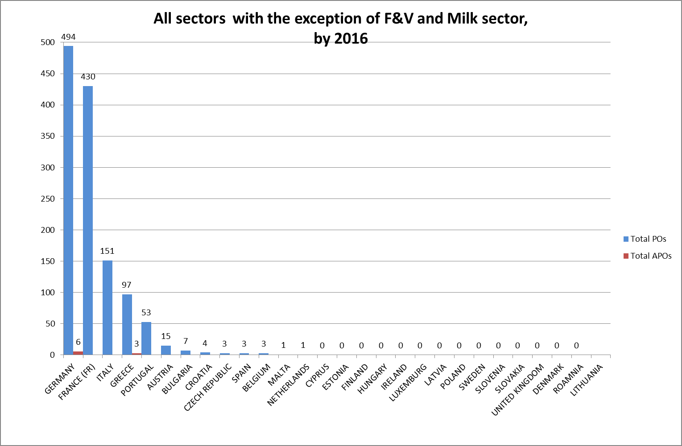

Table 16: POs/APOS in meat, olive oil, cereals and wine

SECTOR | POs | APOs
Meat | 497 | 3
Olive oil | 252 | 8
Cereals | 170 | 2
Wine | 216

Regulation (EU) 1308/2013 of the European Parliament and of the Council of 17 December 2013 establishing a common organisation of the markets in agriculture, OJ L 347 of 20.12.2013,p. 671.
For the period 2004-2011 see report on competition law enforcement and market monitoring activities by the European competition authorities in the food sector.
See further in the Guidelines on the applicability of Article 101 of the Treaty of the Functioning of the European Union to horizontal co-operation agreements, OJ C 11 of 14.1. 2011.
See Guidance on the Commission's enforcement priorities in applying Article 82 of the EC Treaty to abusive exclusionary conduct by dominant undertakings, OJ C 45 of 24.2.2009, p.7.
Judgment of 14 November 2017, APVE and Others, C‑671/15,EU:C:2017:860, paragraph 37. See also judgment of 29 October 1980, Maizena, 139/79, EU:C:1980:250, paragraph 23, judgment of 5 October 1994, Germany v. Council, C-280/93, EU:C:1994: 367, paragraph 61, judgement of 19 September 2013, Panellionios Szdesmos Viomichanion Metapoiisis Paknou, C-373/11, EU: C: 201: 567, paragraph 39.
Judgement of 9 September 2003, Milk Marque and National Farmers' Union, C-137/00, EU:C:2003:429, paragraph 57, judgment of 14 November 2017, APVE and Others, C‑671/15,EU:C:2017:860, paragraph 37 and 48.
Article 206, 1st subparagraph CMO reads: 'Save as otherwise provided in this Regulation, and in accordance with Article 42 TFEU, Articles 101 to 106 TFEU and the implementing provisions thereto shall, subject to Articles 207 to 210 of this Regulation, apply to all agreements, decisions and practices referred to in Article 101(1) and Article 102 TFEU which relate to the production of, or trade in, agricultural products.'
Regulation (EU) 2017/2393 of the European Parliament and of the Council of 13 December 2017 amending Regulations (EU) No 1305/2013 on support for rural development by the European Agricultural Fund for Rural Development (EAFRD), (EU) No 1306/2013 on the financing, management and monitoring of the common agricultural policy, (EU) No 1307/2013 establishing rules for direct payments to farmers under support schemes within the framework of the common agricultural policy, (EU) No 1308/2013 establishing a common organisation of the markets in agricultural products and (EU) No 652/2014 laying down provisions for the management of expenditure relating to the food chain, animal health and animal welfare, and relating to plant health and plant reproductive material (OJ 2017 L350, p. 15) ("Omnibus Regulation").
Repealed from 1 January 2018 by the Omnibus Regulation.Regulation (EU) 2017/2393, see fn. 8.
Article 209(2) CMO, second subparagraph.
Guidelines on the applicability of Article 101 TFEU to horizontal co-operation agreements, OJ C 11 of 14.1.2011.
Commission Regulation (EU) No 1218/2010 of 14 December 2010 on the application of Article 101(3) of the Treaty on the Functioning of the European Union to certain categories of specialisation agreements, OJ L 335, 18.12.2010.
For a distinction of different types of agricultural cooperatives, see the Commission's study on https://ec.europa.eu/agriculture/sites/agriculture/files/external-studies/2012/support-farmers-coop/fulltext_en.pdf.
See Memo of DG COMP for the Agricultural Markets Task Force, p 6/7, https://ec.europa.eu/agriculture/sites/agriculture/files/agri-markets-task-force/2016-06-28/memo.pdf.
Study 'Support for Farmers' cooperatives', Bijman a.o, p. 110, https://ec.europa.eu/agriculture/sites/agriculture/files/external-studies/2012/support-farmers-coop/fulltext_en.pdf.
Judgment in Oude Luttikhuis, C-399/93, EU:C:1995:434, paragraphs 10-16.
Omnibus Regulation, OJ L 350 of 29.12.2017, p. 15, cited above fn.8.
Judgment in Case C-671/15 APVE and Others, see fn5. The questions of interpretation posed to the Court concerned provisions of Regulation 1234/2007 which has been repealed and replaced by Regulation 1308/2013.
Judgment C-671/15, see fn. 5, paragraph 43.
https://ec.europa.eu/agriculture/calls-for-tender/280414-2017_en.
Regulation No 17: First Regulation implementing Articles 85 and 86 of the Treaty, OJ 13, 21.2.1963, p. 204.
See e.g. judgment of the General Court, Case T-217/03 and T-245/03, FNCBV, EU:T:2006:391, paragraph 199, upheld on appeal by the Court of Justice in Joined Cases C-101/07 P and C-110/07 P, FNCBV, EU:C:2008:741.
Commission Decision of 26.11.1986 relating to a proceeding under Article 85 of the EEC Treaty (IV/31.204 - MELDOC). OJ 1986 L 348, p. 50.
Details on IBOs and the notification procedure, https://ec.europa.eu/agriculture/producer-interbranch-organisations/interbranch-organisations_en.
https://ec.europa.eu/agriculture/producer-interbranch-organisations/interbranch-organisations_en.
https://ec.europa.eu/agriculture/sites/agriculture/files/producer-interbranch-organisations/documents/recognised_ibos_2017_en.pdf.
Judgment C-671/15, see fn.18.
Article 59 of Regulation (EU) 2017/891 (OJ L 138, 25.5.2017, p. 4) – Article 114 of the former regulation, Regulation (EU) No 543/2011 (OJ L 157, 15.6.2011, p. 1).
Regulation (EU) 2017/891, Article 12. The current provisions replace Article 26a of Commission Implementing Regulation (EU) No 543/2011, where this derogation was limited to 10%, but Member States could set a higher percentage.
Articles 59 seq of Regulation (EU).
Latest available data from Member States' annual reports.
The ‘organisation rate’ is the proportion (%) of the total value of the EU’s or Member States’ F&V production that is marketed by POs or APOs.
Producer groups are an earlier stage of producer cooperation before cooperation within a PO. It would be expected that after finishing plan implementation, PGs receive recognition as a PO and start the implementation of an operational programme. PG recognition and recognition plans implementation are now covered by Regulation (EU) No 1305/2013 (art 27). The recognition plans under Regulation EU No 1234/2007 were approved last time in 2013. As they can last up to 5 years, the last year of implementation under 1st pillar – Regulation EU No 1234/2007 - will be 2018. Until 31.12.18, there are still plans which co-exist under both pillars.
Regulation (EU) No 1151/2012 of the European Parliament and of the Council of 21 November 2012 on quality schemes for agricultural products and foodstuffs, OJ L 343 of 14.12.2012, p.1.
https://ec.europa.eu/agriculture/milk/milk-package_en.
For the PDO/PGI group, see above paragraph (60).
Delivery contract: Contract concluded between a seller and an undertaking for the delivery of beet for the manufacture of sugar, CMO Annex II, Part II, Section A, point 5.
CMO Annex II, Part II, Section A, point 6 CMO.
OJ 2016 L 193, p. 17.
This clause resembles, but is not identical to the so-called profit sharing clause which applied under the quota regime in Annex XI, point (j) and which read that 'any difference between the reference threshold and the actual selling price of sugar is to be allocated between the sugar undertaking and beet sellers'.
CEFS is the European association of sugar processors. It has made a survey on the use of the value sharing mechanism among its members in November 2017.
See annex II, Part I, Section A, 6 (b) CMO which states that in the absence of an agreement between the parties, the law on cooperatives and on companies is considered a AWT as far as they govern the delivery of sugar beet by the shareholders or members of a company or cooperative.
For more details, https://ec.europa.eu/agriculture/milk/milk-package_en.
Guidelines on the application of the specific rules set out in Articles 169, 170 and 171 of the CMO Regulation for the olive oil, beef and veal and arable crops sectors, OJ C 431, 22.12.2015, p. 1.
http://ec.europa.eu/competition/publications/reports/kd0218732enn.pdf
See paragraph (91).
Cf. Article 39 TFEU.
https://ec.europa.eu/agriculture/sites/agriculture/files/milk/milk-package/com-2014-354_en_0.pdf
https://ec.europa.eu/agriculture/sites/agriculture/files/milk/milk-package/com-2016-724_en.pdf
Commission Implementing Regulation (EU) 2016/559 of 11 April 2016 authorising agreements and decisions on the planning of production in the milk and milk products sector (OJ 2016 L 96, p. 20).
Commission Implementing Regulation (EU) 2016/1615 of 8 September 2016 amending Implementing Regulation (EU) 2016/559 as regards the period in which agreements and decisions on the planning of production in the milk and milk products sector are authorised (OJ 2016 L 242, p. 17).
Commission Delegated Regulation (EU) 2016/558 of 11 April 2016 authorising agreements and decisions of cooperatives and other forms of producer organisations in the milk and milk products sector on the planning of production.
The consultation and therefore NCA in question is confidential.
This document covers only measures available to POs/APOS under the operational programmes based on Article 33 CMO. The table does not cover Union financial assistance for crisis management under Article 219 CMO, such as measures under Delegated Regulation (EU) 2016/921.
Some POs have not implemented these measures, because the measures were not provided in the operational programme.
'European competition authorities' covers both the European Commission and EU national competition authorities.
The numbers of main agricultural product investigated does not match with the total number of investigations or the total number of raw, processed and both raw and processed products, because some investigations cover more than one product.
The notion of raw covers raw plant products, raw milk as well as live animals.
In contrast, competition authorities did not identify such agreements in the period 2004-2011 covered by the report on competition law enforcement and market monitoring activities by the European competition authorities in the food sector.
The total number of investigations conducted by the competition authorities and the number of main type of infringements detected do not match because some investigations may cover more than one type of infringement (for instance a vertical and horizontal agreement).
Latest available data from Member States' annual reports following MS reporting obligation in Regulation 543/2011.
Annual reporting by MS according to Commission Implementing Regulation (EU) No 511/2012 of 15 June 2012 on notifications concerning producer and interbranch organisations and contractual negotiations and relations provided for in Council Regulation (EC) No 1234/2007 in the milk and milk products sector, OJ L 156 of 16.6.2012, 39.
Data provided by MS as a response to the information request of the Commission of April 2017. However, two MS did not provide any information. For Italy the information is incomplete, as the data is gathered on a regional level and not all regions had replied at the time of reporting.
Based on preliminary figures from request of the Commission to Member States and study DG COMP.

