

REPORT FROM THE COMMISSION TO THE EUROPEAN PARLIAMENT AND THE COUNCIL

The application of the Union competition rules to the agricultural sector

# Introduction

1. Under Article 225(d) of Regulation (EU) No 1308/2013 ('CMO')[1] the Commission shall present to the European Parliament and the Council, by 31 December 2017,   
   a report on the application of the competition rules to the agricultural sector,   
   in particular on the operation of Articles 209, 210 and 169, 170 and 171 CMO.
2. This report is based on input from national competition authorities ('NCAs'), Member States and private organisations to the Commission, studies of the European Commission on producer organisations in the olive oil, arable crops and beef &veal sector (2017) and on interbranch organisations (2016).
3. 'Agricultural sector' covers the products listed in Article 1 (2) and Annex I CMO.
4. The report covers the period from 1 January 2014 to mid-2017, as far as derogations from the competition rules in the CMO are concerned and from 1 January 2012 to mid-2017 for the description of antitrust investigations ('the Period').[2]   
   The Commission Staff Working document provides additional information on the derogations and the antitrust investigations.

## The Union competition rules

1. **Article 101 Treaty on the Functioning of the European Union** (TFEU) prohibits agreements between two or more independent market operators which restrict competition. These cover in particular price fixing arrangements, which remove incentives to improve production and are serious infringements. Under Article 101(3) TFEU agreements are exempted from the prohibition in Article 101(1) if they generate objective economic benefits that outweigh the negative effects of   
   a restriction of competition, e.g. by contributing to improving the production or distribution of goods, while allowing consumers a fair share of the resulting benefit. The restriction must also be indispensable and competition must not be eliminated. Operators assess themselves whether the conditions of Article 101 TFEU are fulfilled.[3]
2. The agricultural sector can also benefit from exemptions under general competition rules, e.g. the so-called Specialisation Block Exemption Regulation (SBER).[4]   
   If parties produce or process products jointly and the parties' combined market shares do not exceed 20% of the relevant market for the processed products,   
   the SBER allows joint sales of such products. This is relevant e.g. for cooperatives, which often engage in processing activities.
3. **Article 102 TFEU** prohibits firms holding a dominant position on a given market to abuse that position, e.g. by charging unfair prices or by limiting output.
   1. **The application of the EU competition rules to the agricultural sector**
4. The TFEU grants a special status to the agricultural sector. Under Article 42 TFEU, the Union competition rules apply to production of and trade in agricultural products only to the extent determined by the European Parliament and the Council, within the framework of Article 43(2) TFEU and taking into account the five objectives of Article 39 TFEU. The objectives are increasing productivity, achieving a fair living standard of the agricultural community, market stabilisation, assuring availability of supplies and ensuring reasonable consumer prices. The European Court of Justice recognises the precedence of the common agricultural policy over the objectives of the Treaty in the field of competition.[5] It acknowledges that the maintenance of effective competition is one of the objectives of the common agricultural policy and common organisation of markets.[6]

# derogations from Article 101(1) TFEU

1. The Union competition rules apply to the production of and trade in agricultural products, unless the CMO states otherwise (Article 206 CMO). The CMO contains derogations from the application of Article 101 TFEU, which either apply to all or some agricultural sectors or deal with specific situations.
2. The below graph describes the framework of competition rules and derogations before 1 January 2018. [7]

**Graph 1**

**Competition rules before 01.01.2018**

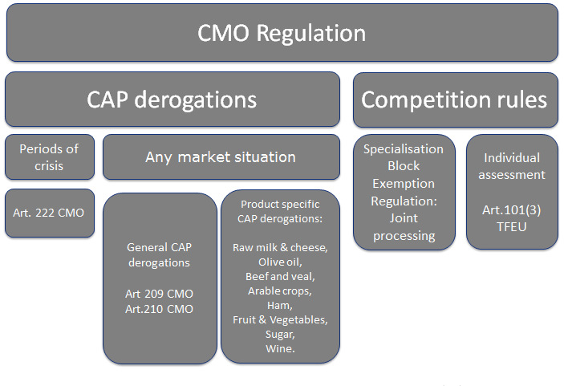

1. Many of these derogations apply to the work of recognised producer organisations (PO), whose activities are described in Article 152 CMO; others apply to farmers and farmers' associations (Article 209) and Article 210 CMO applies to vertical cooperation in the supply chain by recognised interbranch organisations.
2. As regards specifically the fruit &vegetables sector, concerning the activities of a PO Article 160 CMO requires producer members to market their entire production concerned through the PO. Under Article 11 of Commission Delegated Regulation (EU) 2017/891[8], the main activity of POs in the fruit &vegetables sector relates to the concentration of supply and the placing on the market of the products of their members. In a recent case concerning fruit & vegetables POs, the European Court of Justice stated that, subject to conditions, Article 101 TFEU may not apply to certain activities (e.g. planning of volumes, adoption of a pricing policy) of such POs.[9] Annual reports of Member States show that POs/ APOs marketed around 50% of the total fruit & vegetables output in the EU in 2015.
3. The recognition of POs and APOs is granted by the Member States. Currently,   
   there are more than 1700 recognised POs and 60 APOs in the EU in the fruit &vegetables sector. This is due to EU co-financing for the operational programmes being allocated to recognised POs. In the milk sector there are about 300 recognised POs and 7 APOs. There are around 1200 recognised POs and nine APOs in the other sectors, mainly for meat, olive oil and cereals. [10]
4. While this report is limited to the period mentioned in paragraph 4, **two recent developments** should be mentioned.
5. Firstly, the European Court of Justice decided in the Endives judgment[11] that practices such as coordination of volume and pricing policies as well as exchanges of commercially sensitive information between producer organisations (POs) and their associations (APOs) are prohibited under Article 101 TFEU. The Court also found that, under certain conditions, Article 101 TFEU may not apply within recognised POs and associations of producer organisations (APOs) to such activities carried out by a given PO/APO. The practices at hand must in particular be **strictly necessary** for and **proportionate** to carrying out the objectives assigned to the PO/APOs by EU legislation.
6. Secondly, as of 1 January 2018, Article 152 CMO, as amended by the Omnibus Regulation, provides for a derogation from Article 101 TFEU for **recognised POs/APOs.** To rely on the derogation, the PO/APO must integrate at least one activity of the producer members (e.g. transport, storage), genuinely exercise the activity, concentrate supply and place products of their members on the market.

## General competition derogations in the CMO

### Article 209 CMO

1. Article 209 (1) 2nd paragraph CMO, which has existed with similar wording since 1962, is a general derogation from Article 101 (1) TFEU for farmers working together. The agreements **shall not** (i) jeopardise the objectives of Article 39 TFEU, (ii) entail an obligation to charge an identical price and (iii) exclude competition.   
   As farmers assess the applicability of the derogation to the agreement themselves without informing the Members States or the Commission, the Commission has no data on how often farmers relied on this derogation. In competition investigations, parties rarely referred to Article 209 CMO.
2. The competition authority in the **Netherlands** dealt with the predecessor article to Article 209 CMO – Article 176 of Regulation 1234/2007 - in two investigations.   
   In one of these, in 2012, the National Competition Authority ("NCA") fined a group of agricultural producers, wholesalers and processors for an agreement that limited the production of silver-skin onions. The parties to the agreement also shared price information in order to align prices and obtain the highest possible price level.   
   In order to support the agreement they bought several competing onion producers that after the acquisition would no longer produce silver-skin onions. The parties argued that the agreement could be covered by the derogation, because it was needed to increase the productivity and yield of the production as well as to obtain reasonable prices. The NCA found that the derogation did not apply since 1) the parties were not part of a national market organisation, 2) the yearly output quotas were intended to raise prices above the competitive level and the agreement did not contribute to ensuring that supplies reach consumers at reasonable prices and 3) the agreements entailed charging identical prices.

### Article 210 CMO – Agreements by Interbranch Organisations (IBO)

1. Under Article 210 CMO, recognised IBOs can rely on a derogation from Article 101(1) TFEU. They must notify their agreements to the Commission and if the Commission does not find them incompatible with Union rules within 2 months after having received full notification, Article 101(1) TFEU does not apply. The agreement may not entail price or quota fixing or lead to market partitioning or create other competition distortions. The Commission has received **two notifications** from IBOsunder this article.
2. In January 2015, the Commission did not object to an agreement of the *Centre National Interprofessionnel de l'Economie Laitière (CNIEL)* which established price grids for certain milk characteristics. As the milk price depends on its composition and quality, the regional organisations of CNIEL publish values for various technical milk specifications based on different parameters of milk (e.g. fat content, origin of the milk based on type of cattle, criteria for health and hygiene) which lead to bonuses or penalties in relation to the base price. Milk farmers and buyers may on a voluntary basis refer in their contracts to the published grids to agree on a premium or penalty in relation to the basic milk price.
3. In June 2017, the Commission did not object to the agreement of the French interbranch organisation *Comité national interprofessionnel de la pomme de terre (CNIPT)* establishing a price indicator for potatoes. The price indicator is based on aggregated data of how farmers in the past have been remunerated for certain potato varieties. Publishing this information aims at increasing the knowledge of the supply chain. Potato farmers and buyers may on a voluntary basis refer to the published price indicator in their individual contracts.
4. There are currently **128 recognised interbranch organisations** in nine Member States of the European Union, with the vast majority of these IBOs in France and Spain (65, respectively 27 IBO). Most of the interbranch organisations operate in the wine and fruit and vegetables sector.[12]

## Sector specific derogations in the CMO

### Contractual negotiations

1. During the period covered by this report, in four sectors - *olive oil, beef/veal and certain arable crops and milk and milk products* - the CMO provided the possibility for the POs to negotiate supply contracts for the sale of the respective products of their members. The measures had in common the strengthening the bargaining position of farmers in relation to their downstream partners, but the conditions and activities authorised under these provisions differ.
2. Since 2012, under Article 149 CMO in the **milk sector**, recognised POs, subject to quantitative limitations, can engage in contractual negotiations without being required to concentrate supply and place products of their members on the market or to integrate an efficiency enhancing activity of their producers. A PO can negotiate   
   a price for the delivery of raw milk to processors. The implementation of this provision was described in Commission reports of 2014 and 2016.[13] Nine Member States reported deliveries of raw milk in 2016 under contracts collectively negotiated. The volume collectively negotiated amounted to 22.8 million tonnes, corresponding to 15% of total milk deliveries in the EU in 2016. The sector specific derogation for milk in Article 149 CMO is still applicable.
3. Since 2014, Articles 169, 170 and 171 CMO allowed joint sales and sales-related activities of agricultural products in the sectors of **olive oil, beef and veal, and arable crops** by producers through recognised POs. Subject to quantitative limitations, the PO may negotiate supply contracts, provided that it concentrates supply and places the products of its members on the market. It further needs to integrate at least one activity of its producer members, which should be likely to generate significant efficiencies. In 2015, the Commission adopted Guidelines on the application of these provisions.[14] The provisions have been repealed as of 1 January 2018 by Regulation (EU) 2017/2393. While the derogations concerning olive oil, beef/veal and certain arable crops have been repealed, they continue legally to be relevant for those activities, which took place before the amendments of the Omnibus Regulation entered into force on 1 January 2018.
4. In order to benefit from the derogation for these three sectors, the PO must provide the competent authority of its Member State with the volume of the product covered by the negotiations. The Member State must inform the Commission. Since the entry into force of the CMO, the Commission has not received any such notifications.
5. In 2017 the Commission launched a study on Producer Organisations and their activities in the three sectors. The **results** show that there are many more   
   non-recognised POs/APOs than recognised POs/APOs. The total number of recognised and non-recognised POs and APOs is around 1 400 entities in the olive oil sector; around 800 in the beef and veal sector and around 1 600 in the arable crops sector.
6. The **results** also show that about two-third of POs and APOs carry out contractual negotiations and, that virtually all those POs and APOs who do so also carry out at least one of the efficiency-enhancing activities required by Articles 169-171 of   
   the CMO Regulation, the most common efficiency-enhancing activities being quality control, distribution/transport and procurement of inputs. POs carry out these efficiency-enhancing activities first and foremost because they consider that these activities improve their position in negotiations with buyers. No PO has fulfilled all administrative requirements (recognition and notification of volumes negotiated)   
   to benefit from the derogation.

### Other sector derogations, including crisis measures

1. Articles 150 and 172 CMO allow POs to agree **to adapt supply to demand** and ensure value added and quality of certain products. For the supply of **PDO/PGI cheeses[15]**, ***France*** has applied supply management for **eight** and ***Italy* for four cheeses** under application of Article 150 CMO. A similar possibility for the supply of PDO/PGI ham has so far only been used by **Italy,** Article 172 CMO. For **wine**, ***France* (17 cases) and *Spain* (1 case)** notified the Commission of having laid down marketing rules for supply regulation in accordance with Article 167 CMO**.**
2. In the **sugar sector**, Commission Delegated Regulation (EU) 2016/1166[16] allows sugar processors and sugar beet growers to agree to share value and losses between them, subject to certain conditions. The value sharing clause is optional and should only be agreed between one sugar processor (i.e. no cooperation of several processors) and beet growers at the same time. Parties cannot fix prices for beet.   
   The value sharing is widely used, i.e. in 35 out of the 42 agreements within the trade[17], for which the Commission obtained information.
3. Article 33 CMO provides for the possibility of **producer organisations in the fruit and vegetables sector to implement various measures under operational programmes, *inter alia* production planning and crisis measures**. These measures are co-financed by the EU. In 2015, the EU financial assistance for crisis measures accounted for EUR 50 million.
4. In a situation of severe market imbalance, Article 222 CMO allows **agreements of recognised POs/APOs and IBOs** in all agricultural sectors for a limited period of six months, which can be prolonged once. Such crisis measures to e.g. withdraw products from the market have been authorised by the Commission during the milk crisis from April 2016 to April 2017. The Commission has not received any information that this authorisation has been used.

## Article 101(3) TFEU

1. Agreements reached between independent producers e.g. on quantities and sales can be exempted under Article 101(3) TFEU, if the conditions described in paragraph 5 above are met.
2. In 2013 the **NCA in Latvia,** in an ex officio investigation, assessed a joint processing agreement by two dairy cooperatives that included raw milk price fixing under national competition law (equivalent to Article 101 (3) TFEU). The NCA found that the agreement could be exempted, as all the conditions were met.
3. In 2013, the **NCA in France** initiated an investigation based on a complaint and fined five pig slaughterers for agreeing on quantities of pork meat to be bought from farmers producing live pigs. The aim was to lower the prices paid to farmers.   
   The NCA also fined an association of slaughterers for sending price instructions to its members. Further, seven slaughterhouses, an association of slaughterers and   
   an auction market buyer federation were fined for collectively agreeing on a base price to be paid to farmers. Concerning the last infringement, the parties argued that their agreement could be exempted under Article 101(3) TFEU. The NCA concluded that even if the parties could demonstrate that fixing a base price contributed to improving the meat production, the other conditions were not fulfilled because   
   a fixed base price did not promote economic progress and the practice did not allow consumers to enjoy a fair share of any resulting benefit.

# Investigations by competition authorities in the agricultural sector

1. In the period from 1 January 2012 to mid-2017 ('the Period'), European competition authorities[18] have concluded about **126 investigations** with about **41 investigations** still ongoing, leading to a total of **167 investigations**. The highest number of investigations was carried out by the NCAs in **Austria** (24), **Denmark** (22), **Greece** (21) and by the **European Commission** (22).

## Main product categories investigated

1. The competition authorities' investigations cover a wide range of agricultural products, but the following product categories were investigated most frequently: **milk and dairy** (34%), **meat** (19%), **fruit and vegetables** (12%) and **cereals** (10%). A number of investigations also took place in the categories of **oilseeds, oils and fats** (5%), **sugar** (5%) and **rice** (2%).
2. The infringements detected by the competition authorities which resulted in   
   a financial penalty concern a variety of agricultural products, including: **milk and dairy products (26%), fruit and vegetables (22%), meat in general (16%), oilseeds, oil and fats (10%), others products, e.g. natural vinegar, wine, cereals, wine, cotton, sugar (26%)**.

## Entities subject to investigations

1. The entities subject to investigations conducted by competition authorities are: **processors (36%)**, **retailers (15%)**, **other types of associations (11%)**, **agricultural producers, (9%)**, **wholesalers (9%)**, **agricultural producer organisations (9%)**, **general associations of farmers (9%)**, **others (7%)**, **associations of producer organisations (4%)**.
2. The entities subject to decisions where competition authorities found an infringement of competition rules are: **processors (39%), retailers (26%), wholesalers (12%), other types of associations (7%), agricultural producers (5%), agricultural producers organisations (4%), others (4%), associations of producers organisations (3%).**
3. Processors are the entities most frequently represented in the investigations.   
   For example, in 2014 the NCA in **Germany** fined the three major German sugar processors for forming a 'territorial cartel' which meant that they would limit their sales of sugar in Germany to their respective home sales areas. They also agreed on prices and quantities to be sold. The aim was to obtain the highest possible prices.   
   In two other ex-officio cases for instance, in 2012 and 2013 the NCAs in **France** and **Germany** respectively fined 17 and 22 large flour mills for jointly agreeing on sales prices, the quantities they would sell and which customers each mill would limit their sales to. In another example, in an ex-officio case from 2012 the NCA in **Greece** fined the processors (private companies, cooperatives and an association of processors) of poultry meat for jointly i.a. fixing the selling prices of their products and preventing imports of chickens.

## Main sources of investigations

1. As to the **origins of the investigations**, competition authorities opened the majority of the investigations following **complaints** (from suppliers, competitors or customers). The authorities opened other proceedings on their own initiative after becoming aware of potential anti-competitive practices through market information.

## Types of complainants

1. The complainants are varied and essentially include: **agricultural producers** (**23%**), **processors** (**19%**), **others** (**15%**), **agricultural producer organisations** (**13%**), **individual persons** (**7%**), **wholesalers** (**5%**), **retailers** (**5%**), **other types of associations** (**5%**), **agricultural associations of producer organisations** (**3%**), **local authorities** (**3%**), **general associations of farmers** (**2%**).
2. This shows that agricultural producers alone or in a partnership are the most important source of complaints. Investigations only led to findings of infringements in about one fourth of the investigations covered by this report. This proportion is lower for investigations triggered by complaints of agricultural producers: out of   
   **25 investigations** opened in the Period following complaints lodged by agricultural producers, only **4 investigations** led to the adoption of a decision finding   
   an infringement. Agricultural producers often make their complaints public at   
   the time they submit them to competition authorities and thereby undermine   
   the chances that the authorities can collect evidence of possible infringements.
3. Competition authorities have nevertheless identified several practices that were directly detrimental to farmers. For example, on the basis of a complaint the **NCA in Spain** fined buyers who agreed to pay lower prices to farmers for raw milk and who allocated farmers between themselves. In another example, on the basis of   
   a complaint, the **NCA in France** fined buyers of live pigs because they had agreed on the quantities they planned to purchase from farmers with a view to reducing   
   the price for the animals. NCAs for instance also intervened to relax the exclusivity conditions imposed by dominant cooperatives on farmers. In those cases, competition authorities enabled farmers to supply several processing cooperatives with raw milk (in Sweden) and sugar beet (in France), thereby widening options for producers to obtain higher prices and allowing them to increase their output   
   (for example for sugar beets at the time of removal of quotas).

## Outcomes of investigations

1. The antitrust investigations in the agricultural sector that were closed during the Period led to four different types of outcomes:
   1. **infringement decisions with fines**, i.e. the competition authorities required an entity to stop the infringement and to pay a pecuniary penalty (about half of the concluded cases);
   2. **infringement decisions without fines**, i.e. the competition authorities required an entity to stop the infringement without a pecuniary penalty   
      (a few of the concluded cases);
   3. **commitment decisions**, i.e. the competition authorities did not decide whether there was an infringement and adopted a decision that makes the commitment offered by the entity under investigation legally binding, thereby removing any potential concerns (a few of the concluded cases) ;
   4. **closures without decision,** i.e. closure of the proceedings by the competition authorities during a preliminary phase of the investigation due to lack of evidence (among these investigations the rejections of complaints must be taken into account), because disproportionate efforts were necessary to meet the requisite burden of proof or because of the need to set priorities(about half of the concluded cases)**.**

## Types of infringements investigated

**Figure 1**

**Numbers of main types of infringements investigated in the Period 01/2012-06/2017[19]**

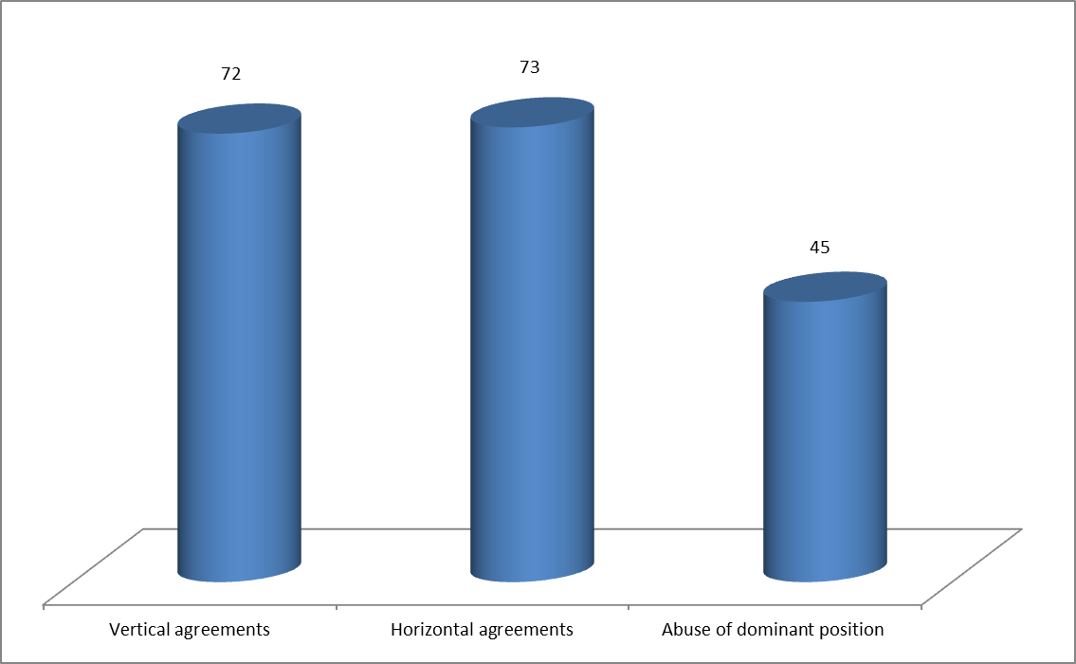

1. European competition authorities have investigated **vertical agreements** (**38%** of investigations in the Period), i.e. agreements between entities operating on different levels of the production. For example, NCAs investigated agreements between processors and retailers establishing a minimum retail price e.g. in in **Slovakia** for one case concerning dairy products and in **Bulgaria** for three cases concerning sunflower oil. The NCA in **Austria** concluded 23 investigations into agreements between processors and retailers on minimum retail prices on dairy, meat and flour products. In some other cases, competition authorities concluded that an infringement was unlikely and therefore closed the investigation. For example,   
   the NCA in **Croatia** initiated an investigation based on a complaint concerning an agreement between the representatives of the milk producers and milk processors, concerning the calculation of the purchase price of milk. The NCA found that the negotiations and arrangements for milk purchase prices were not considered problematic under competition rules.
2. European competition authorities have investigated **horizontal agreements**,   
   i.e. agreements between two or more actual or potential competitors (**38%**),   
   e.g. agreements between producers fixing the price of an agricultural product.   
   For example, in an ex-officio investigation, the NCA in **Cyprus** found that   
   an agricultural association of producer organisations infringed competition rules by concluding with its farmers, members of the association, distribution agreements for raw cow milk which included specific terms for determining the price of raw milk. In other cases, competition authorities concluded that an infringement was unlikely and therefore closed the investigation. For example, the NCA in **Poland** closed its investigation into a complaint due to lack of evidence that simultaneous and relatively fast price changes (namely reduction) of industrial apples purchased by processors resulted from a price-fixing agreement.
3. Competition authorities have also investigated agreements that were **both vertical and horizontal** because they involved several levels of the supply chain and they involved at each level several, if not all, competitors. For example, in 2015   
   the **European Commission** ex officio looked into agreements that national associations of agricultural producers publicly reported to have reached with national associations of processors and national associations of retailers in **France**.   
   The agreements aimed at raising prices of some dairy and meat products and excluding supplies of producers from other Member States by committing the retailers to source 100% of the relevant products in France. The Commission intervention ensured that French supermarket shelves were not reserved for French products, thus preventing a damaging cycle of retaliations for all farmers in the Internal Market and the cases have been closed. Several NCAs investigated similar agreements.
4. Competition authorities have further investigated potential **abusive conduct by dominant operators** (**24%**). These abuses mainly involved strategies to foreclose competitors, such as exclusivity obligations, minimum purchasing obligations, refusals to supply and so-called exploitative abuses, such as unjustified contractual obligations. In some cases, NCAs have found that dominant companies abused their dominant positions, for instance by refusing to supply their products to certain customers. In one example, in 2012, based on a complaint the NCA in **Finland** proposed a fine on a dairy cooperative for abusing its dominant position by selling fresh milk at artificially low prices. The NCA found that the cooperative's motivation for low prices was to evict all other processors from the market, including small dairies, so the dominant processor would become the only milk processor in the market - allowing it then to raise the prices again.
5. All cases of abusive conduct by dominant operators detected by competition authorities concern the milk and dairy sector.
6. Sometimes, the cases were closed due to lack of evidence. For example, the NCA in **Sweden** closed an investigation due to lack of evidence concerning a complaint that a dominant company was paying retailers not to sell the products of competitors.

## Types of infringements found

1. The types of infringement detected by the competition authorities can be classified as follows: **agreements on price** (**46%**), **agreements on output** (**13%**), **information exchange on output, market shares and customers** (**13%**), **market sharing agreement** (**10%**), **information exchange on price** (**10%**), **abuses of dominant position**, involving strategies to foreclose competitors, such as predatory prices, exclusionary rebates, excessive and unfair prices (**8%**). In a number of cases, the competition authorities found that there were several infringements at the same time.

**Figure 2**

**Main types of infringements detected by competition authorities in   
the Period**

**01/2012-06/2017**

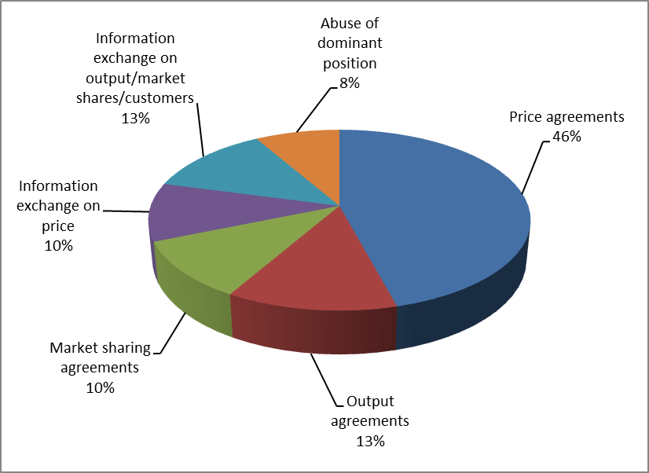

## Consultations and monitoring activities

1. Further, competition authorities provide advice on the application of competition rules. In the Period, NCAs have received 46 such **consultations for advice** in   
   the agricultural sector. Consultation requests come from operators, but also from authorities e.g. on the subject of new legislation.
2. An important work of the NCAs also consists in monitoring activities. In the Period, NCAs have conducted 53 **monitoring and related activities** concerning the application of competition rules to the agricultural sector. Such work typically includes sector investigations, adoption of reports and advocacy work.

1. Regulation (EU) 1308/2013 of the European Parliament and of the Council of 17 December 2013 establishing a common organisation of the markets in agriculture, OJ L 347 of 20.12.2013, p. 671.
2. For the period 2004-2011 see [report on competition law enforcement and market monitoring activities by the European competition authorities in the food sector](http://ec.europa.eu/competition/ecn/food_report_en.pdf).
3. For guidance, European Commission’s 2004 guidelines on the application of Article 81(3) EC   
   (now Article 101 (3) TFEU).
4. Commission Regulation 1218/2010 of 14.12.2010 on the application of Article 101 (3) TFEU to certain categories of specialisation agreements, OJ L 335/43 of 18.12.2010.
5. Judgment of 29 October 1980, *Maizena*, 139/79, EU:C:1980:250, paragraph 23, Judgment of 5 October 1994, *Germany v. Council*, C-280/93, EU:C:1994: 367, paragraph 61, Judgement of 19 September 2013, *Panellionios Szdesmos Viomichanion Metapoiisis Paknou,* C-373/11, EU: C: 201: 567, paragraph 39, and most recently recalled in Judgment of 14 November 2017, *APVE and Others,*   
   C‑671/15,EU:C:2017:860, paragraph 37.
6. Judgement of 9 September 2003, *Milk Marque and National Farmers' Union,* C-137/00, ECLI:EU:C:2003:429, paragraph 57, Judgment of 14 November 2017, *APVE and Others,*   
   C‑671/15,EU:C:2017:860, paragraph 37 and 48.
7. Regulation (EU) 2017/2393 of the European Parliament and of the Council of 13 December 2017 amending Regulations (EU) No 1305/2013 on support for rural development by the European Agricultural Fund for Rural Development (EAFRD), (EU) No 1306/2013 on the financing, management and monitoring of the common agricultural policy, (EU) No 1307/2013 establishing rules for direct payments to farmers under support schemes within the framework of the common agricultural policy, (EU) No 1308/2013 establishing a common organisation of the markets in agricultural products and (EU) No 652/2014 laying down provisions for the management of expenditure relating to the food chain, animal health and animal welfare, and relating to plant health and plant reproductive material   
   (OJ 2017 L350, p. 15) "Omnibus Regulation" amended 152 CMO to contain an explicit competition derogation for PO/APOs in all sectors.
8. OJ L 138 of 25.5.2017, p.4.
9. See paragraph 15 below.
10. Data for 2016, The data is based on Member State reporting for the fruit and vegetables sector and for the milk sector. For the other sectors, data are preliminary figures based on Member States' answers to Commission's request of April 2017.
11. Judgment of 14 November 2017, *APVE and Others,* C‑671/15,EU:C:2017:860, paragraph 43 seq.   
    The case concerned provisions of Regulation (EU) 1234/2007.
12. Annual reports by Member States and Arcadia/LEI Wageningen study.
13. https://ec.europa.eu/agriculture/milk/milk-package_en.
14. Commissions Notice, OJ C 431 of 22.12.2015, p. 1.
15. PDO is 'Protected designation of origin' and PGI 'Protected geographical indications'.
16. Commission Delegated Regulation (EU) 2016/1166 of 17 May 2016 as regards purchase terms for beet in the sugar sector as from 1 October 2017.
17. These are agreements between beet growers or their organisation and sugar processors or their organisations to be concluded prior to an individual delivery contract, Article 125 CMO.
18. 'Competition authorities' covers both the European Commission and EU national competition authorities.
19. The total number of investigations conducted by the competition authorities and the number of main type of infringements detected do not match because some investigations cover more than one type of infringement (for instance a vertical and horizontal agreement).