

Country fact sheet: Germany

# 1. Total greenhouse gas emissions

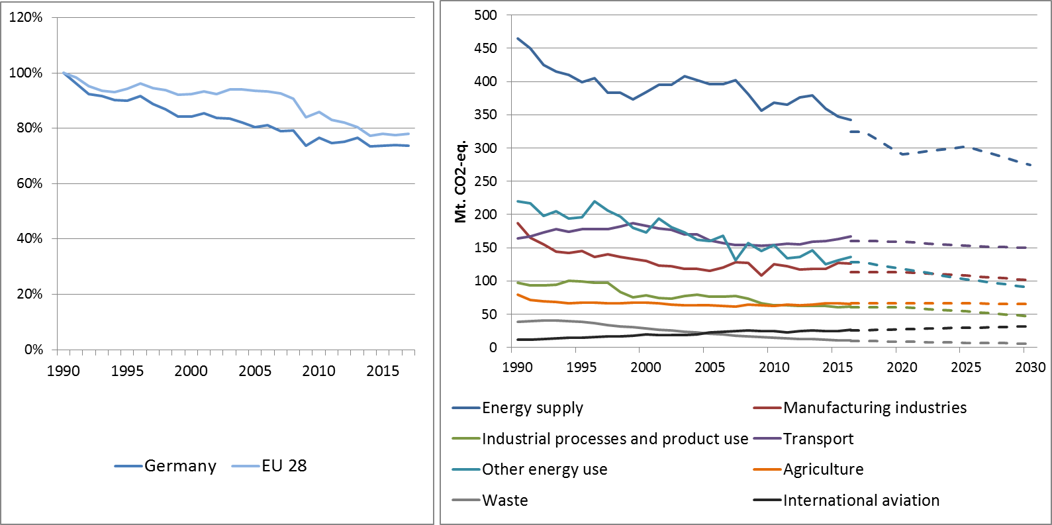

Figure 1: Left hand side: Total greenhouse gas emissions[1] 1990-2017 (index 1990 = 100 %). Right hand side: Total greenhouse gas emissions by sector[2] – historical emissions 1990-2016, projections 2017-2030 (Mt CO2-eq.).

**Figure 2: Share of emissions covered by the ETS and the ESD (2016).[3]**

# 2. ETS emissions

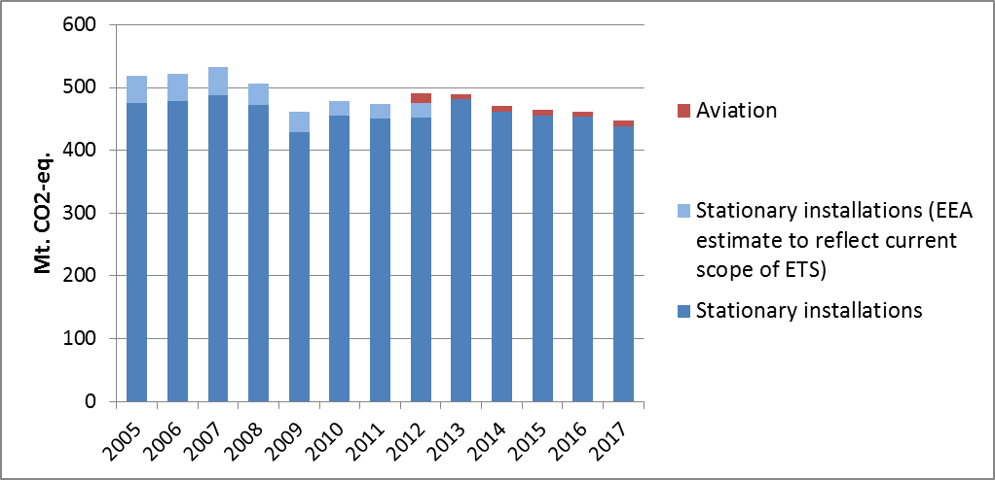

Figure 3: ETS emissions (Mt CO2-eq.).[4]

# 3. Emissions in Effort Sharing sectors

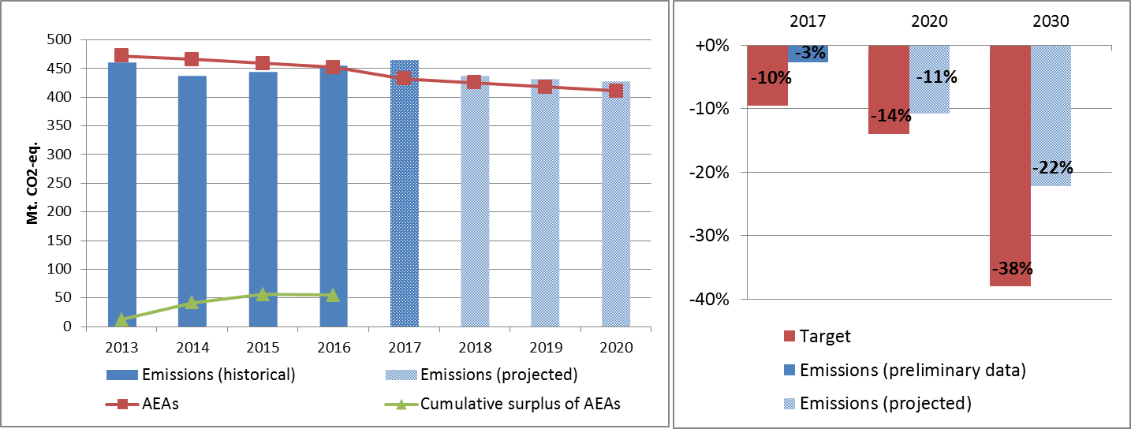

Figure 4: Left hand side: Emissions, annual emission allocations (AEAs) and accumulated surplus/ deficit of AEAs under the Effort Sharing Decision 2013-2020 (Mt CO2-eq.). Right hand side: Emissions and targets under the Effort Sharing Decision/ Effort Sharing Regulation 2017, 2020 and 2030 as percentage change from 2005.

# 4. Land use, land use change and forestry

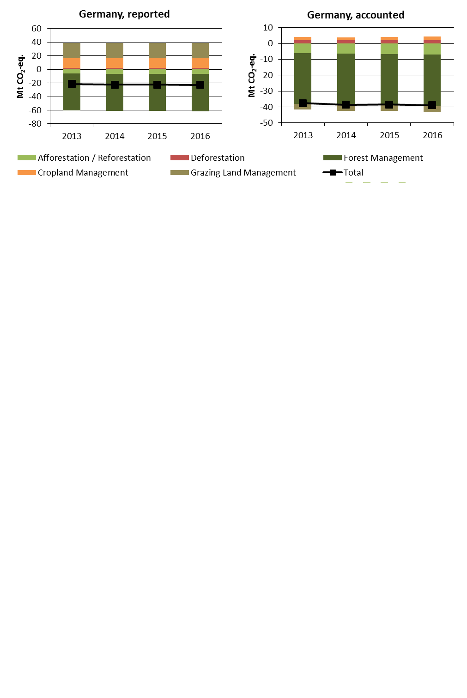

Figure 5: Reported and accounted emissions and removals from LULUCF (Mt CO2-eq.)[5]

Reported quantities under the Kyoto Protocol for Germany show net removals of, on average, -22.4 Mt CO2-eq for the period 2013 to 2016. In this regard Germany contributes with 5.8% to the annual average sink of -384.4 Mt CO2-eq of the EU-28. Accounting for the same period depicts net credits of, on average, -38.7 Mt CO2-eq, which corresponds to 33.2% of the EU-28 accounted sink of -115.7 Mt CO2-eq. Reported net removals and accounted net credits show slight increases. Germany elected to report and account for Cropland Management as one of seven EU Member States and for Grazing Land Management as one of six EU Member States.

Country fact sheet: Greece

# 1. Total greenhouse gas emissions

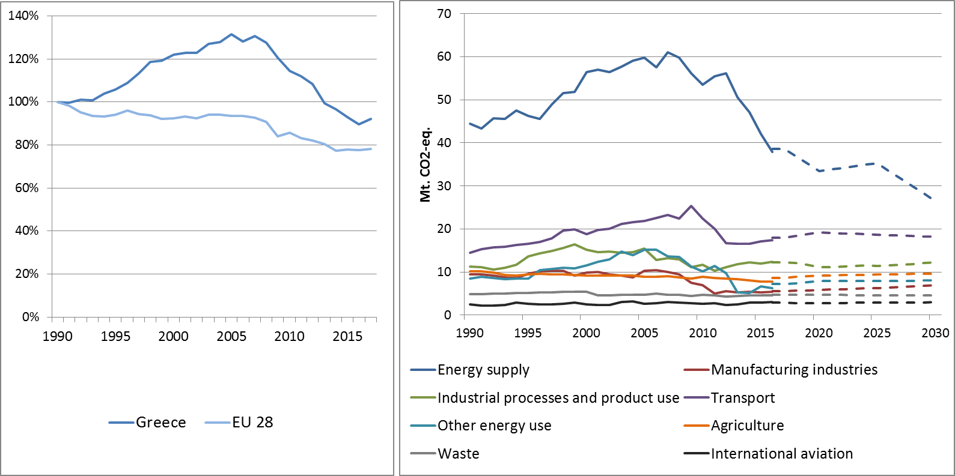

Figure 1: Left hand side: Total greenhouse gas emissions[6] 1990-2017 (index 1990 = 100 %). Right hand side: Total greenhouse gas emissions by sector[7] – historical emissions 1990-2016, projections 2017-2030 (Mt CO2-eq.).

**Figure 2: Share of emissions covered by the ETS and the ESD (2016).[8]**

# 2. ETS emissions

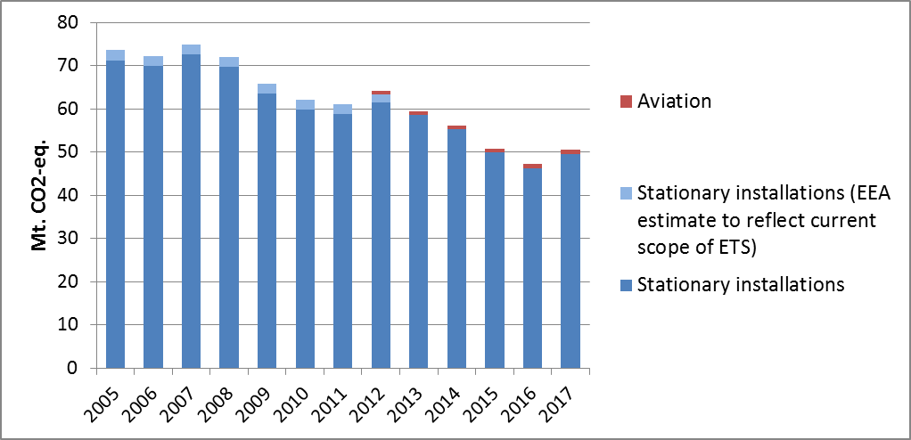

Figure 3: ETS emissions (Mt CO2-eq.).[9]

# 3. Emissions in Effort Sharing sectors

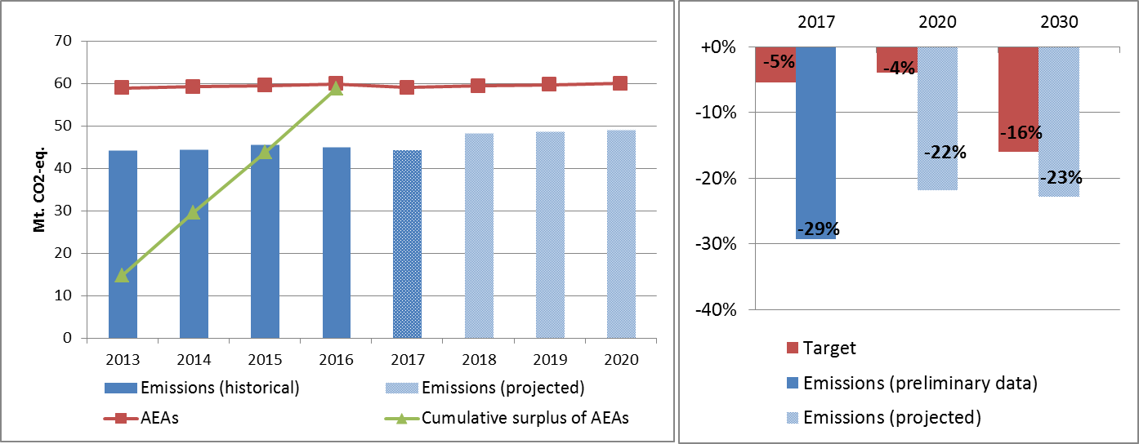

Figure 4: Left hand side: Emissions, annual emission allocations (AEAs) and accumulated surplus/ deficit of AEAs under the Effort Sharing Decision 2013-2020 (Mt CO2-eq.). Right hand side: Emissions and targets under the Effort Sharing Decision/ Effort Sharing Regulation 2017, 2020 and 2030 as percentage change from 2005.

# 4. Land use, land use change and forestry

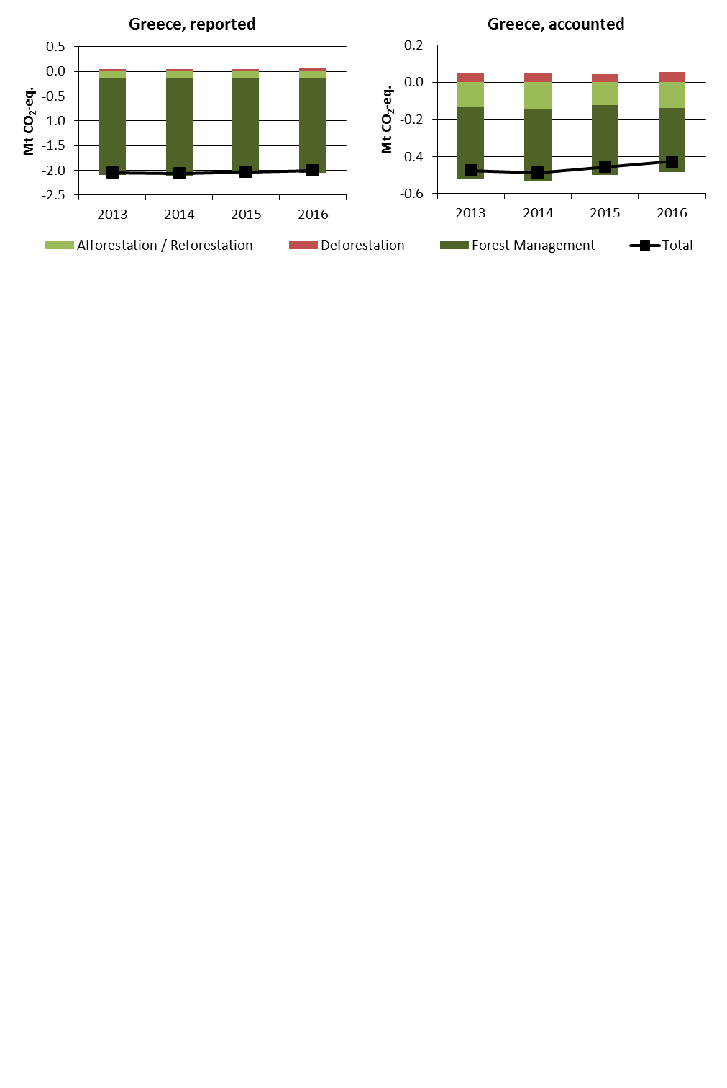

Figure 5: Reported and accounted emissions and removals from LULUCF (Mt CO2-eq.)[10]

Reported quantities under the Kyoto Protocol for Greece show net removals of, on average, -2.0 Mt CO2-eq for the period 2013 to 2016. In this regard Greece contributes with 0.5% to the annual average sink of -384.4 Mt CO2-eq of the EU-28. Accounting for the same period depicts net credits of, on average, -0.5 Mt CO2-eq, which corresponds to 0.4% of the EU-28 accounted sink of -115.7 Mt CO2-eq. Reported net removals are nearly unchanged over the four-year period, while accounted net credits show a decrease since 2014.

Country fact sheet: Hungary

# 1. Total greenhouse gas emissions

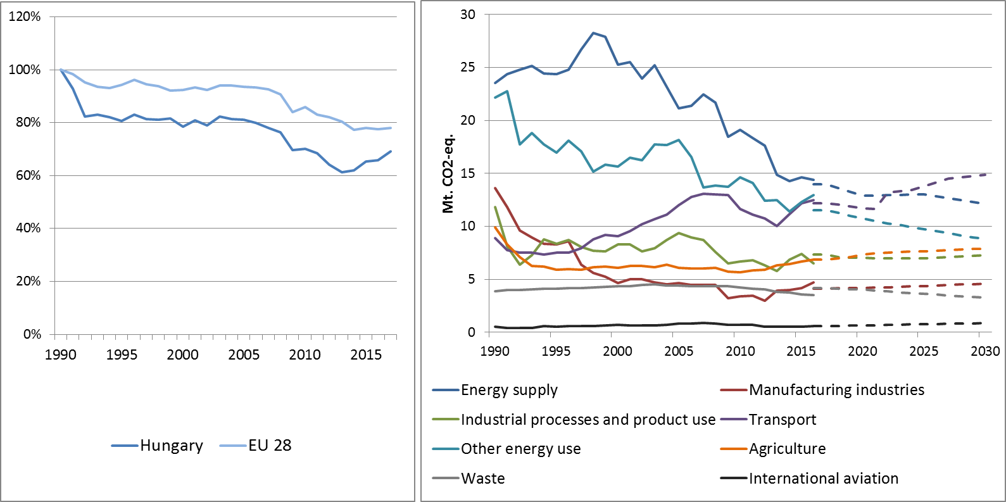

Figure 1: Left hand side: Total greenhouse gas emissions[11] 1990-2017 (index 1990 = 100 %). Right hand side: Total greenhouse gas emissions by sector[12] – historical emissions 1990-2016, projections 2017-2030 (Mt CO2-eq.).

**Figure 2: Share of emissions covered by the ETS and the ESD (2016).[13]**

# 2. ETS emissions

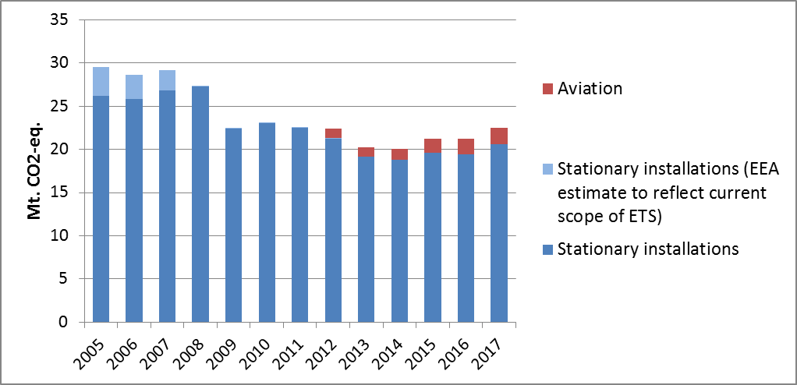

Figure 3: ETS emissions (Mt CO2-eq.).[14]

# 3. Emissions in Effort Sharing sectors

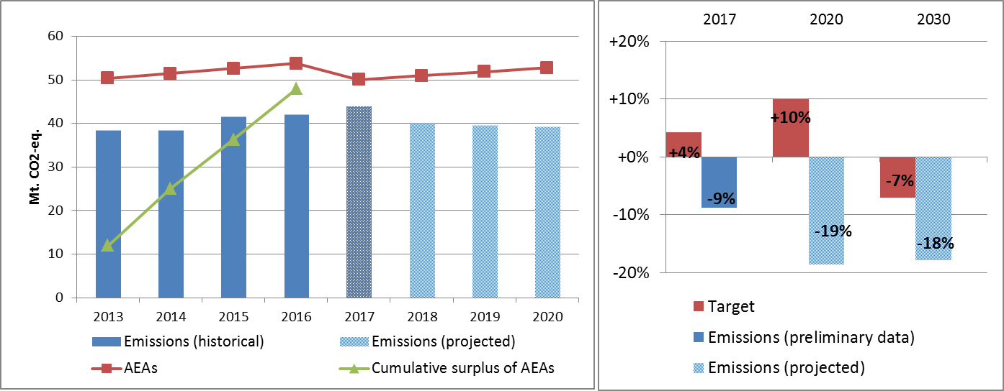

Figure 4: Left hand side: Emissions, annual emission allocations (AEAs) and accumulated surplus/ deficit of AEAs under the Effort Sharing Decision 2013-2020 (Mt CO2-eq.). Right hand side: Emissions and targets under the Effort Sharing Decision/ Effort Sharing Regulation 2017, 2020 and 2030 as percentage change from 2005.

# 4. Land use, land use change and forestry

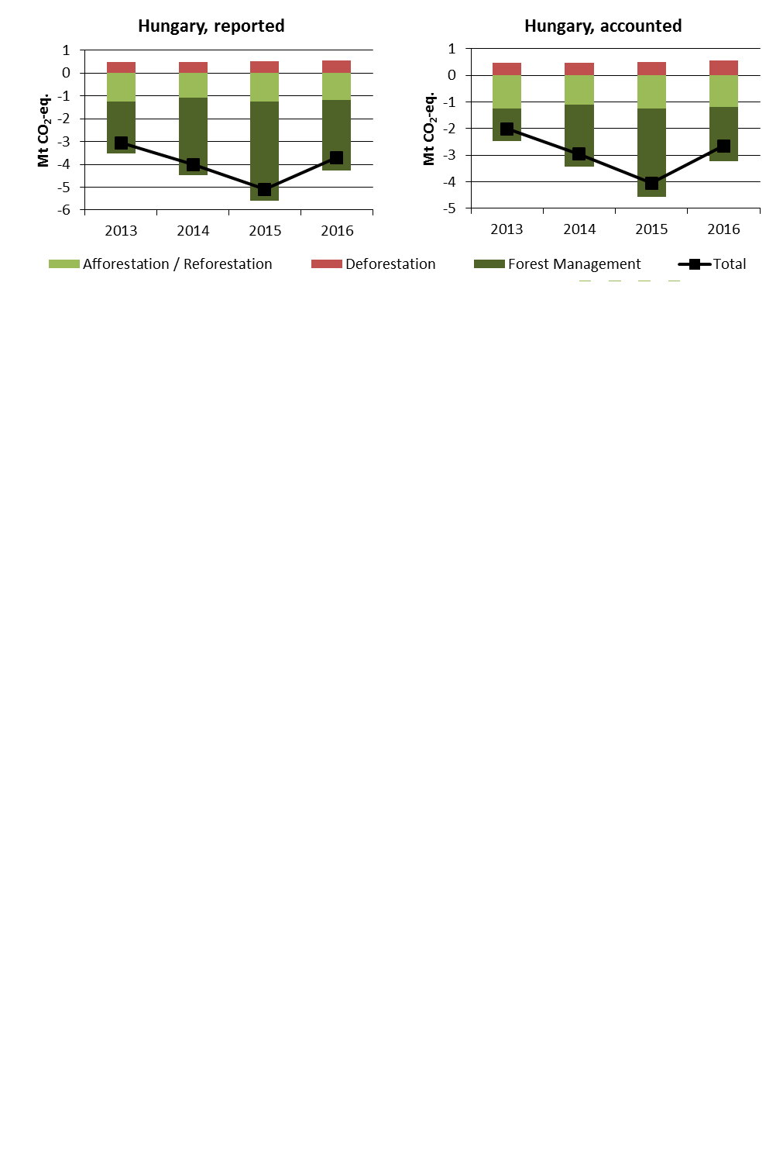

Figure 5: Reported and accounted emissions and removals from LULUCF (Mt CO2-eq.)[15]

Reported quantities under the Kyoto Protocol for Hungary show net removals of, on average, -4.0 Mt CO2-eq for the period 2013 to 2016. In this regard Hungary contributes with 1.0% to the annual average sink of -384.4 Mt CO2-eq of the EU-28. Accounting for the same period depicts net credits of, on average, -2.9 Mt CO2-eq, which corresponds to 2.5% of the EU-28 accounted sink of -115.7 Mt CO2-eq. Reported net removals and accounted net credits show an increase between 2013 and 2015 and a sharp decrease for 2016.

Country fact sheet: Ireland

# 1. Total greenhouse gas emissions

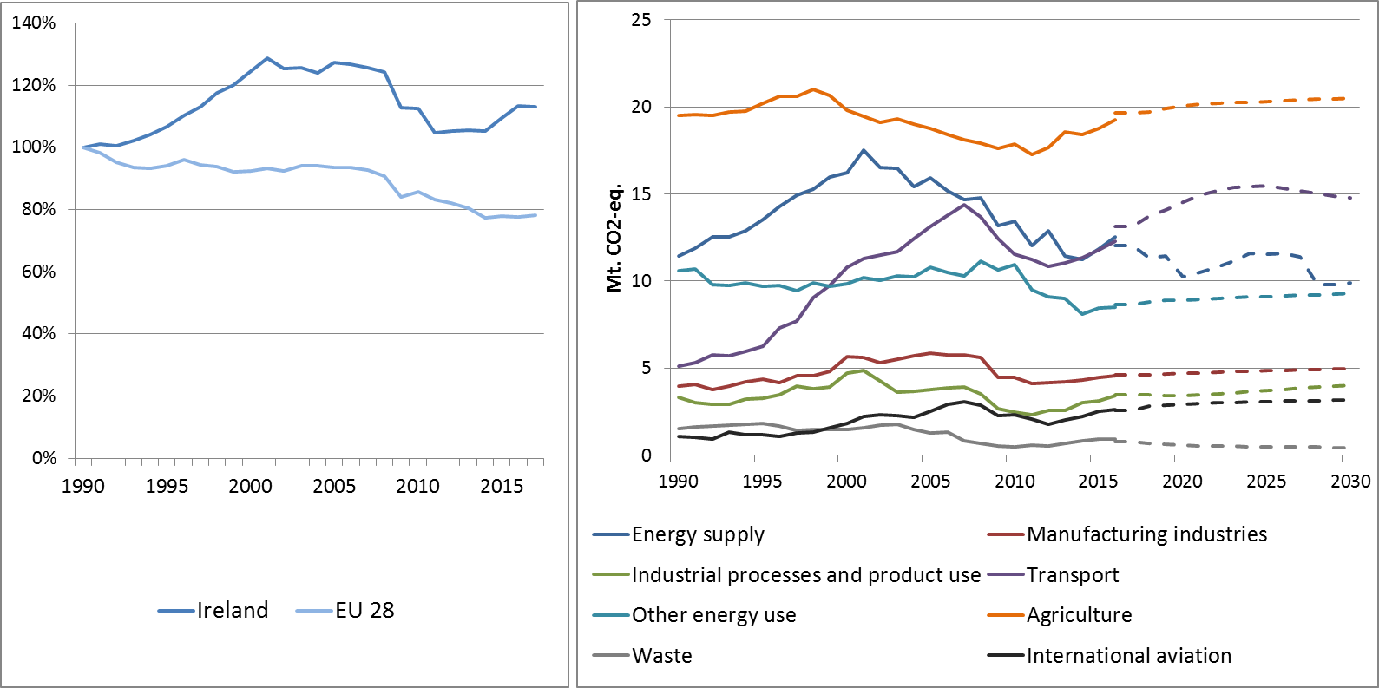

Figure 1: Left hand side: Total greenhouse gas emissions[16] 1990-2017 (index 1990 = 100 %). Right hand side: Total greenhouse gas emissions by sector[17] – historical emissions 1990-2016, projections 2017-2030 (Mt CO2-eq.).

Figure 2: Share of emissions covered by the ETS and the ESD (2016).[18]

# 2. ETS emissions

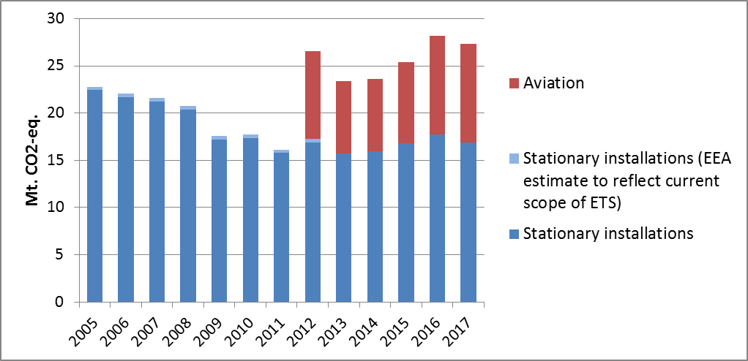

Figure 3: ETS emissions (Mt CO2-eq.).[19]

# 3. Emissions in Effort Sharing sectors

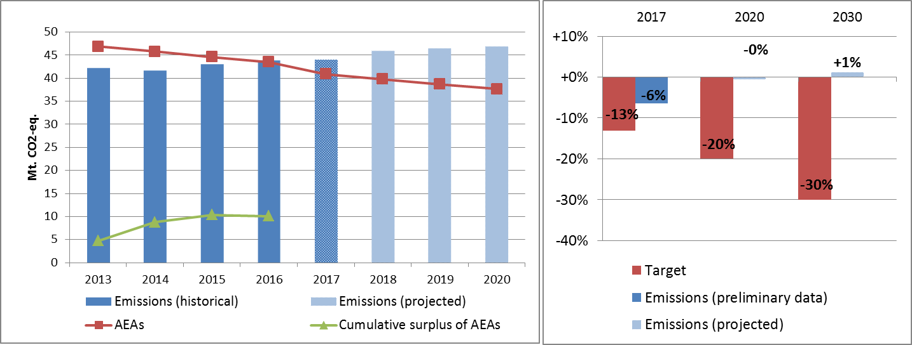

Figure 4: Left hand side: Emissions, annual emission allocations (AEAs) and accumulated surplus/ deficit of AEAs under the Effort Sharing Decision 2013-2020 (Mt CO2-eq.). Right hand side: Emissions and targets under the Effort Sharing Decision/ Effort Sharing Regulation 2017, 2020 and 2030 as percentage change from 2005.

# 4. Land use, land use change and forestry

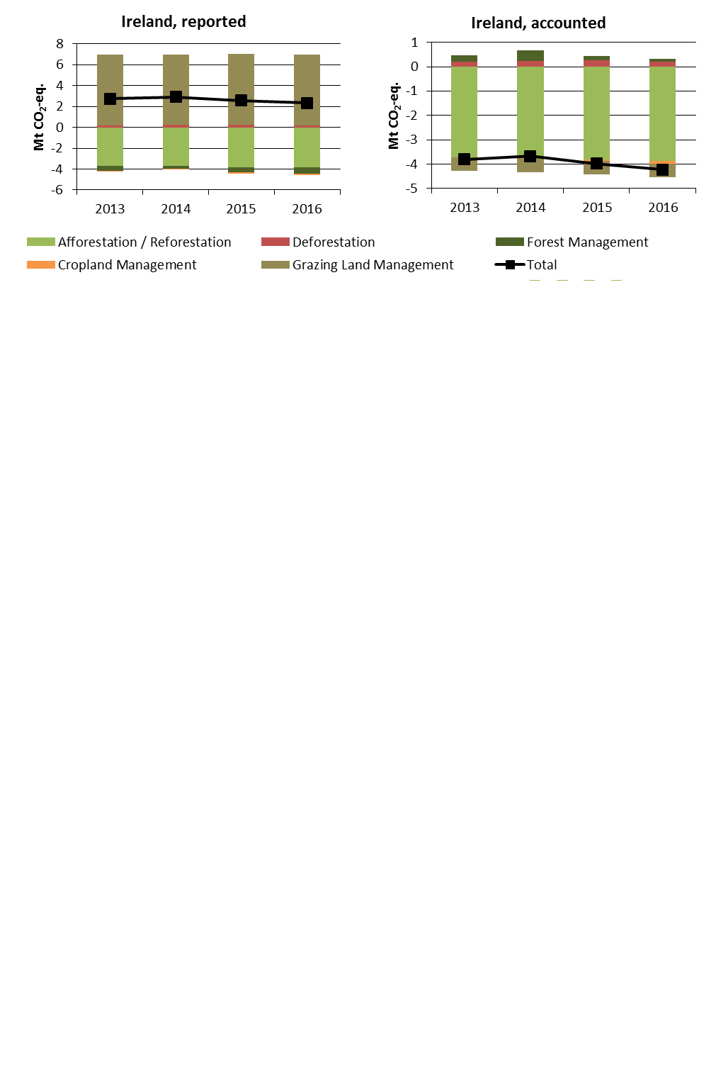

Figure 5: Reported and accounted emissions and removals from LULUCF (Mt CO2-eq.)[20]

Reported quantities under the Kyoto Protocol for Ireland show net emissions of, on average, 2.6 Mt CO2-eq for the period 2013 to 2016. In this regard Ireland contributes negatively with -0.7% to the annual average sink of -384.4 Mt CO2-eq of the EU-28. Ireland is one of two EU Member States which show net emissions in this preliminary exercise. Accounting for the same period depicts net credits of, on average, -3.9 Mt CO2-eq, which corresponds to 3.4% of the EU-28 accounted sink of -115.7 Mt CO2-eq. Reported net emissions are highest for 2014 and decreased thereafter. This pattern is more accentuated with lowest accounted net credits for 2014 and increasing thereafter. Ireland elected to report and account for Cropland Management as one of seven EU Member States and for Grazing Land Management as one of six EU Member States.

Country fact sheet: Italy

# 1. Total greenhouse gas emissions

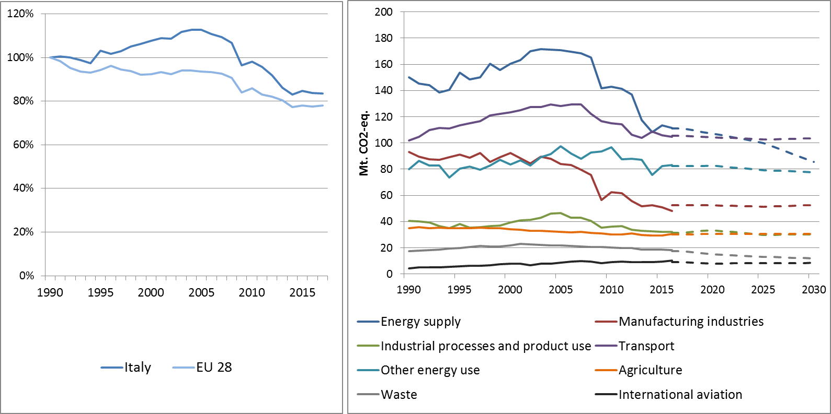

Figure 1: Left hand side: Total greenhouse gas emissions[21] 1990-2017 (index 1990 = 100 %). Right hand side: Total greenhouse gas emissions by sector[22] – historical emissions 1990-2016, projections 2017-2030 (Mt CO2-eq.).

**Figure 2: Share of emissions covered by the ETS and the ESD (2016).[23]**

# 2. ETS emissions

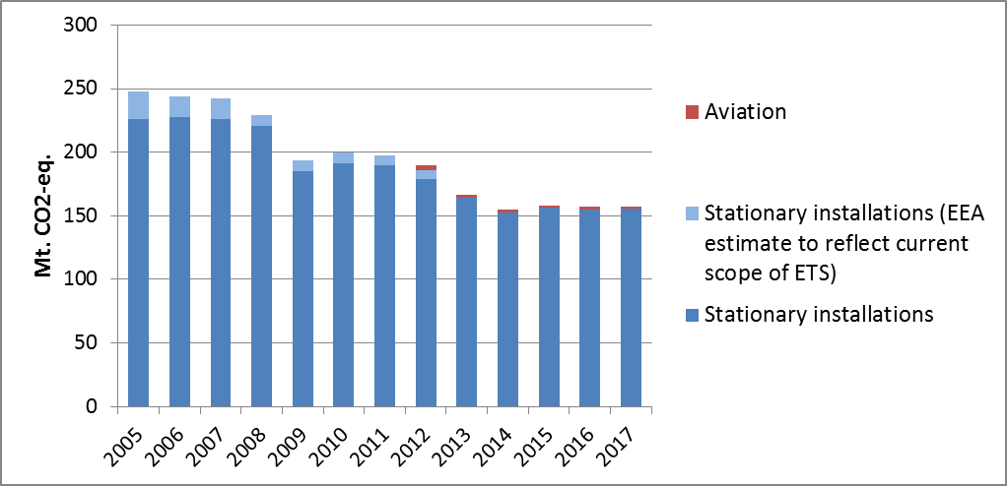

Figure 3: ETS emissions (Mt CO2-eq.).[24]

# 3. Emissions in Effort Sharing sectors

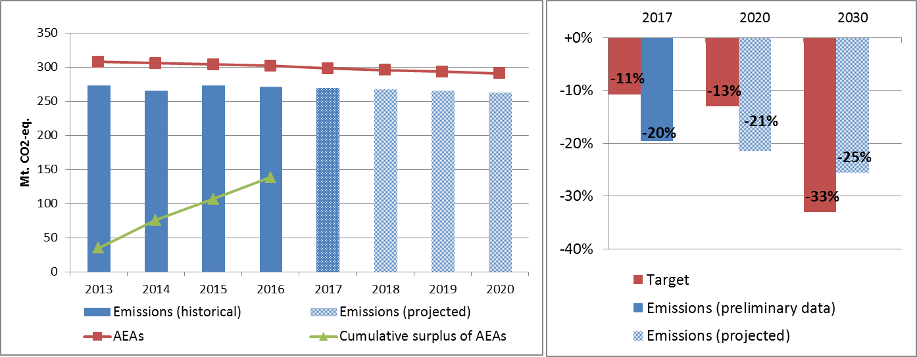

Figure 4: Left hand side: Emissions, annual emission allocations (AEAs) and accumulated surplus/ deficit of AEAs under the Effort Sharing Decision 2013-2020 (Mt CO2-eq.). Right hand side: Emissions and targets under the Effort Sharing Decision/ Effort Sharing Regulation 2017, 2020 and 2030 as percentage change from 2005.

# 4. Land use, land use change and forestry

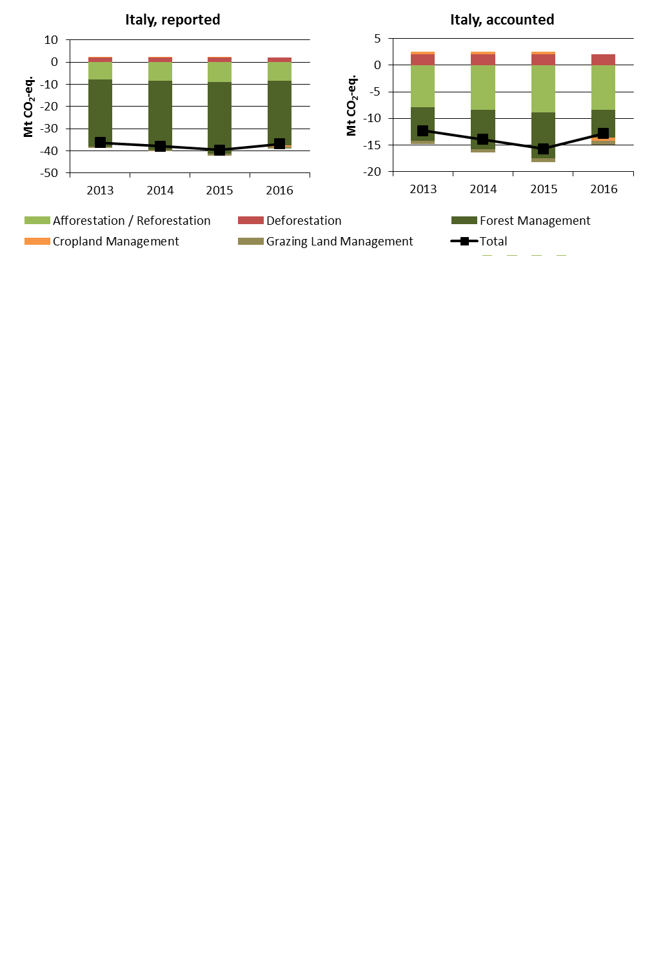

Figure 5: Reported and accounted emissions and removals from LULUCF (Mt CO2-eq.)[25]

Reported quantities under the Kyoto Protocol for Italy show net removals of, on average, -37.7 Mt CO2-eq for the period 2013 to 2016. In this regard Italy contributes with 9.8% to the annual average sink of -384.4 Mt CO2-eq of the EU-28. Accounting for the same period depicts net credits of, on average, -13.7 Mt CO2-eq, which corresponds to 11.8% of the EU-28 accounted sink of -115.7 Mt CO2-eq. Reported net removals and accounted net credits show increases between 2013 and 2015 followed by a decrease for 2016. Italy elected to report and account for Cropland Management as one of seven EU Member States and Grazing Land Management as one of six EU Member States.

Country fact sheet: Latvia

# 1. Total greenhouse gas emissions

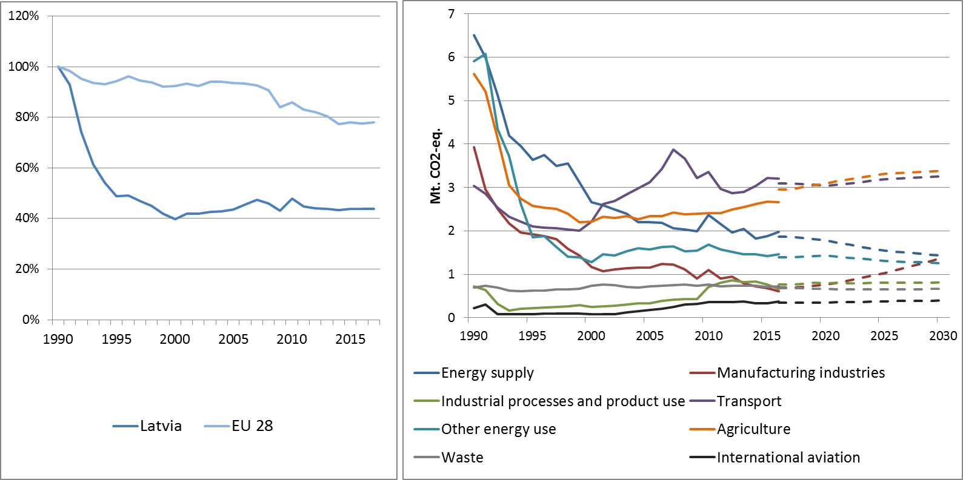

Figure 1: Left hand side: Total greenhouse gas emissions[26] 1990-2017 (index 1990 = 100 %). Right hand side: Total greenhouse gas emissions by sector[27] – historical emissions 1990-2016, projections 2017-2030 (Mt CO2-eq.).

**Figure 2: Share of emissions covered by the ETS and the ESD (2016).[28]**

# 2. ETS emissions

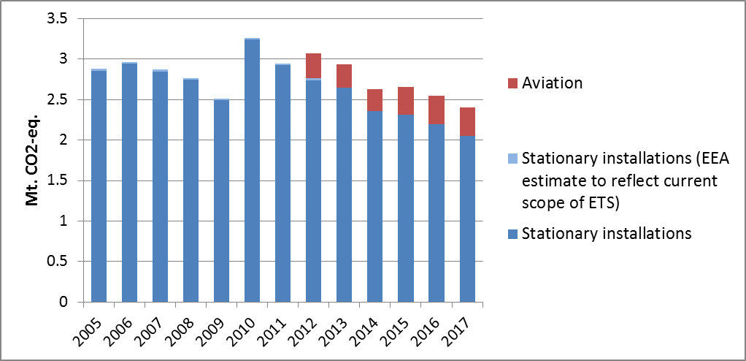

Figure 3: ETS emissions (Mt CO2-eq.).[29]

# 3. Emissions in Effort Sharing sectors

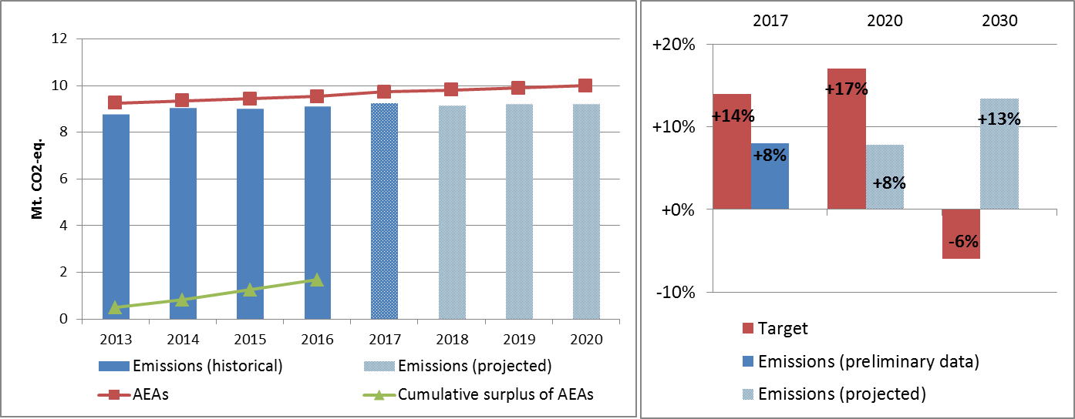

Figure 4: Left hand side: Emissions, annual emission allocations (AEAs) and accumulated surplus/ deficit of AEAs under the Effort Sharing Decision 2013-2020 (Mt CO2-eq.). Right hand side: Emissions and targets under the Effort Sharing Decision/ Effort Sharing Regulation 2017, 2020 and 2030 as percentage change from 2005.

# 4. Land use, land use change and forestry

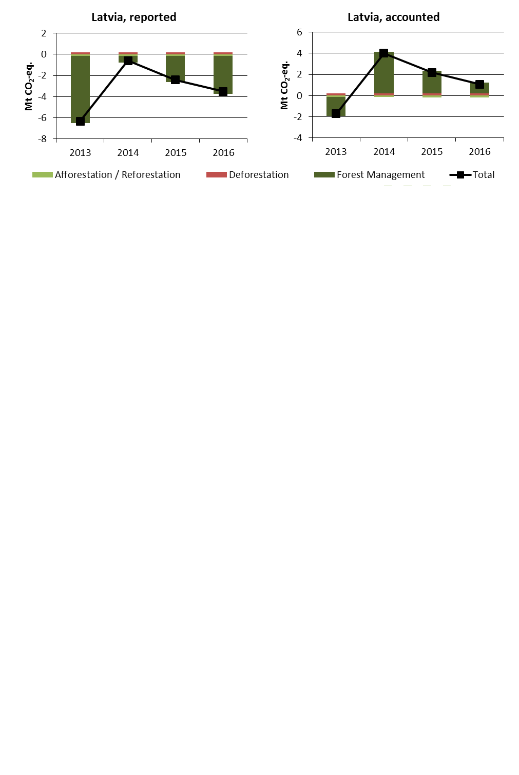

Figure 5: Reported and accounted emissions and removals from LULUCF (Mt CO2-eq.)[30]

Reported quantities under the Kyoto Protocol for Latvia show net removals of, on average, -3.2 Mt CO2-eq for the period 2013 to 2016. In this regard Latvia contributes with 0.8% to the annual average sink of -384.4 Mt CO2-eq of the EU-28. Accounting for the same period depicts net debits of, on average, 1.4 Mt CO2-eq, which corresponds to a negative contribution of -1.2% of the EU-28 accounted sink of -115.7 Mt CO2-eq. Latvia is one of six EU Member States which show net debits in this preliminary accounting exercise. Reported net removals decrease sharply from 2013 to 2014 and increase thereafter. Accounting quantities show a similar pattern for which net credits for 2013 convert into substantial net debits for 2014 which decrease over the following years.

1. National total, including international aviation.
2. The sectors in the figure correspond to the following IPCC sectors: Energy supply: 1A1, 1B and 1C. Manufacturing industries: 1A2. Industrial processes and product use: 2. Transport: 1A3. Other energy use: 1A4, 1A5 and 6. Agriculture: 3. Waste: 5. International aviation: memo item.
3. Excluding international aviation, CO2 from domestic aviation and NF3.
4. The scope of ETS was extended from 2013. To reflect the current scope of ETS, estimates made by EEA are included in the figures from 2005 to 2012. The estimates cover only emissions from stationary installations.
5. The differences between reported and accounted emissions from LULUCF under the Kyoto Protocol are described in part 1b.
6. National total, including international aviation.
7. The sectors in the figure correspond to the following IPCC sectors: Energy supply: 1A1, 1B and 1C. Manufacturing industries: 1A2. Industrial processes and product use: 2. Transport: 1A3. Other energy use: 1A4, 1A5 and 6. Agriculture: 3. Waste: 5. International aviation: memo item.
8. Excluding international aviation, CO2 from domestic aviation and NF3.
9. The scope of ETS was extended from 2013. To reflect the current scope of ETS, estimates made by EEA are included in the figures from 2005 to 2012. The estimates cover only emissions from stationary installations.
10. The differences between reported and accounted emissions from LULUCF under the Kyoto Protocol are described in part 1b.
11. National total, including international aviation.
12. The sectors in the figure correspond to the following IPCC sectors: Energy supply: 1A1, 1B and 1C. Manufacturing industries: 1A2. Industrial processes and product use: 2. Transport: 1A3. Other energy use: 1A4, 1A5 and 6. Agriculture: 3. Waste: 5. International aviation: memo item.
13. Excluding international aviation, CO2 from domestic aviation and NF3.
14. The scope of ETS was extended from 2013. To reflect the current scope of ETS, estimates made by EEA are included in the figures from 2005 to 2012. The estimates cover only emissions from stationary installations.
15. The differences between reported and accounted emissions from LULUCF under the Kyoto Protocol are described in part 1b.
16. National total, including international aviation.
17. The sectors in the figure correspond to the following IPCC sectors: Energy supply: 1A1, 1B and 1C. Manufacturing industries: 1A2. Industrial processes and product use: 2. Transport: 1A3. Other energy use: 1A4, 1A5 and 6. Agriculture: 3. Waste: 5. International aviation: memo item.
18. Excluding international aviation, CO2 from domestic aviation and NF3.
19. The scope of ETS was extended from 2013. To reflect the current scope of ETS, estimates made by EEA are included in the figures from 2005 to 2012. The estimates cover only emissions from stationary installations.
20. The differences between reported and accounted emissions from LULUCF under the Kyoto Protocol are described in part 1b.
21. National total, including international aviation.
22. The sectors in the figure correspond to the following IPCC sectors: Energy supply: 1A1, 1B and 1C. Manufacturing industries: 1A2. Industrial processes and product use: 2. Transport: 1A3. Other energy use: 1A4, 1A5 and 6. Agriculture: 3. Waste: 5. International aviation: memo item.
23. Excluding international aviation, CO2 from domestic aviation and NF3.
24. The scope of ETS was extended from 2013. To reflect the current scope of ETS, estimates made by EEA are included in the figures from 2005 to 2012. The estimates cover only emissions from stationary installations.
25. The differences between reported and accounted emissions from LULUCF under the Kyoto Protocol are described in part 1b.
26. National total, including international aviation.
27. The sectors in the figure correspond to the following IPCC sectors: Energy supply: 1A1, 1B and 1C. Manufacturing industries: 1A2. Industrial processes and product use: 2. Transport: 1A3. Other energy use: 1A4, 1A5 and 6. Agriculture: 3. Waste: 5. International aviation: memo item.
28. Excluding international aviation, CO2 from domestic aviation and NF3.
29. The scope of ETS was extended from 2013. To reflect the current scope of ETS, estimates made by EEA are included in the figures from 2005 to 2012. The estimates cover only emissions from stationary installations.
30. The differences between reported and accounted emissions from LULUCF under the Kyoto Protocol are described in part 1b.