

Country fact sheet: Romania

# 1. Total greenhouse gas emissions

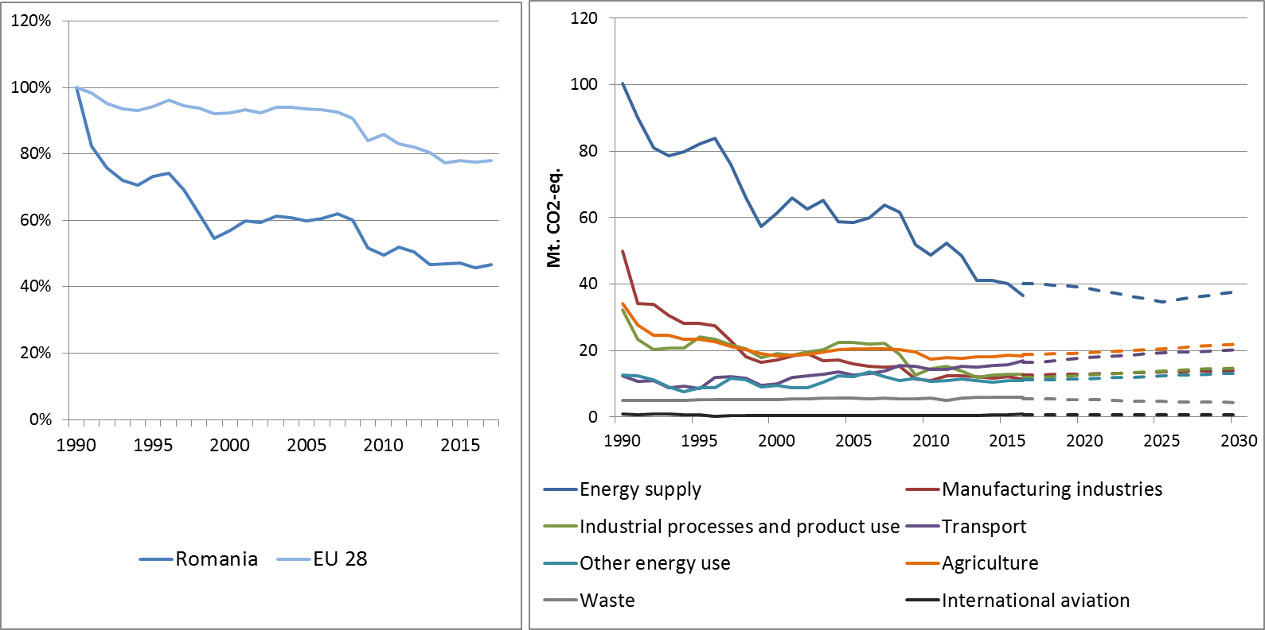

Figure 1: Left hand side: Total greenhouse gas emissions[1] 1990-2017 (index 1990 = 100 %). Right hand side: Total greenhouse gas emissions by sector[2] – historical emissions 1990-2016, projections 2017-2030 (Mt CO2-eq.).

**Figure 2: Share of emissions covered by the ETS and the ESD (2016).[3]**

# 2. ETS emissions

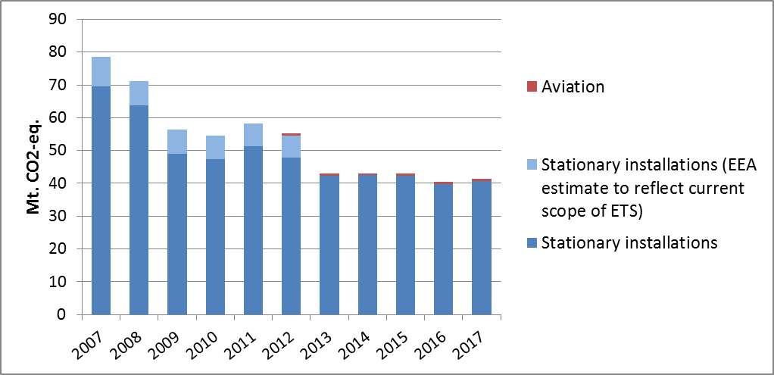

Figure 3: ETS emissions (Mt CO2-eq.).[4]

# 3. Emissions in Effort Sharing sectors

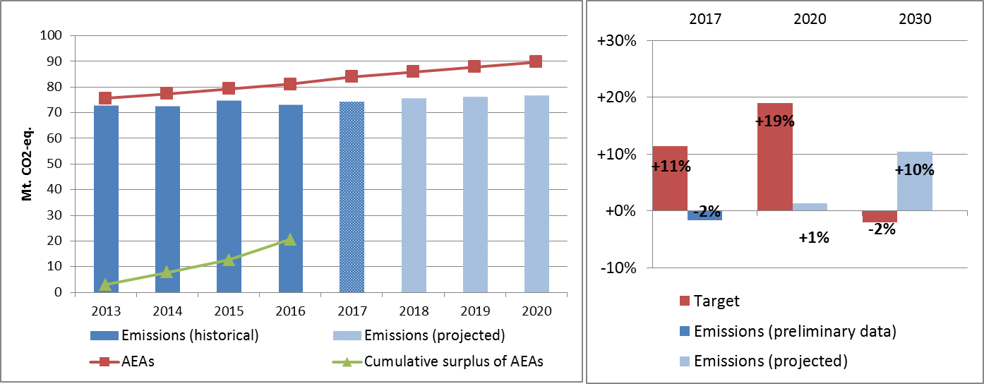

Figure 4: Left hand side: Emissions, annual emission allocations (AEAs) and accumulated surplus/ deficit of AEAs under the Effort Sharing Decision 2013-2020 (Mt CO2-eq.). Right hand side: Emissions and targets under the Effort Sharing Decision/ Effort Sharing Regulation 2017, 2020 and 2030 as percentage change from 2005.

# 4. Land use, land use change and forestry

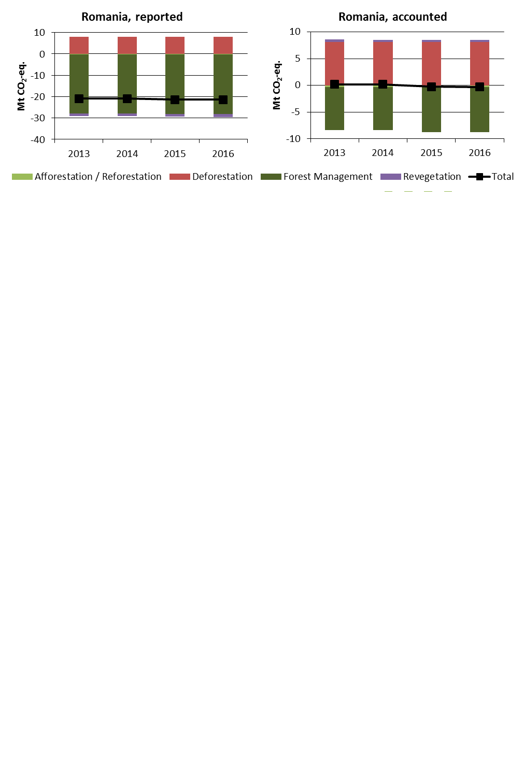

Figure 5: Reported and accounted emissions and removals from LULUCF (Mt CO2-eq.)[5]

Reported quantities under the Kyoto Protocol for Romania show net removals of, on average, -21.2 Mt CO2-eq for the period 2013 to 2016. In this regard Romania contributes with 5.5% to the annual average sink of -384.4 Mt CO2-eq of the EU-28. Accounting for the same period depicts net credits of, on average, -0.03 Mt CO2-eq, which corresponds to 0.03% of the EU-28 accounted sink of -115.7 Mt CO2-eq. Reported net removals show a small increasing trend. The same pattern is indicated for accounting quantities transitioning from small net debits to small net credits. Romania is the only EU Member State which elected to report and account for Revegetation.

Country fact sheet: Slovakia

# 1. Total greenhouse gas emissions

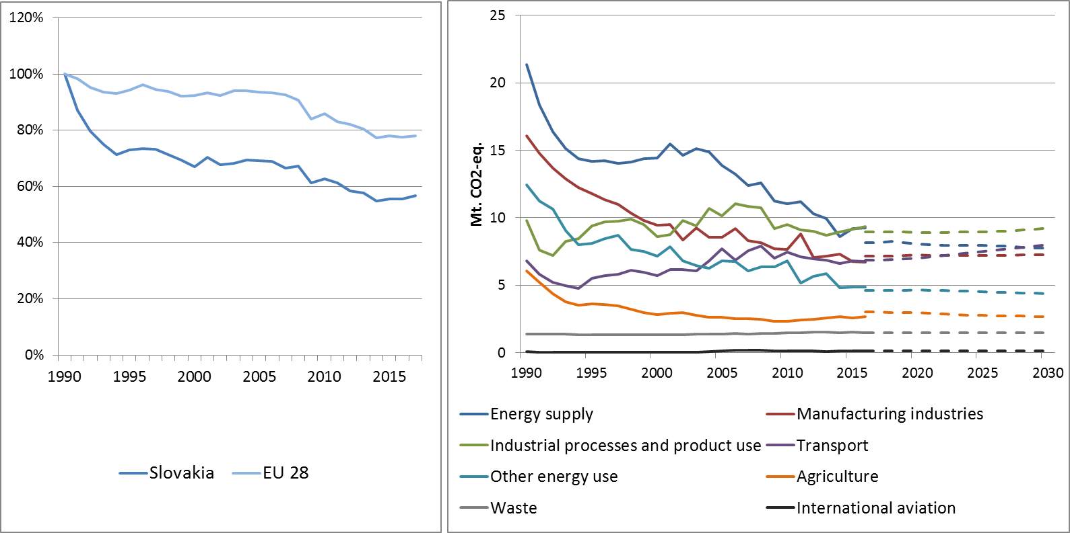

Figure 1: Left hand side: Total greenhouse gas emissions[6] 1990-2017 (index 1990 = 100 %). Right hand side: Total greenhouse gas emissions by sector[7] – historical emissions 1990-2016, projections 2017-2030 (Mt CO2-eq.).

**Figure 2: Share of emissions covered by the ETS and the ESD (2016).[8]**

# 2. ETS emissions

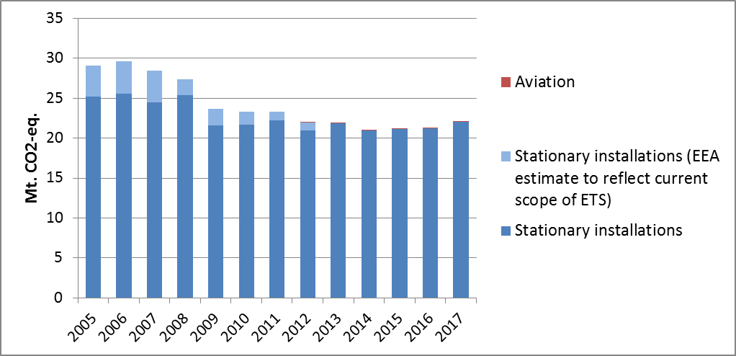

Figure 3: ETS emissions (Mt CO2-eq.).[9]

# 3. Emissions in Effort Sharing sectors

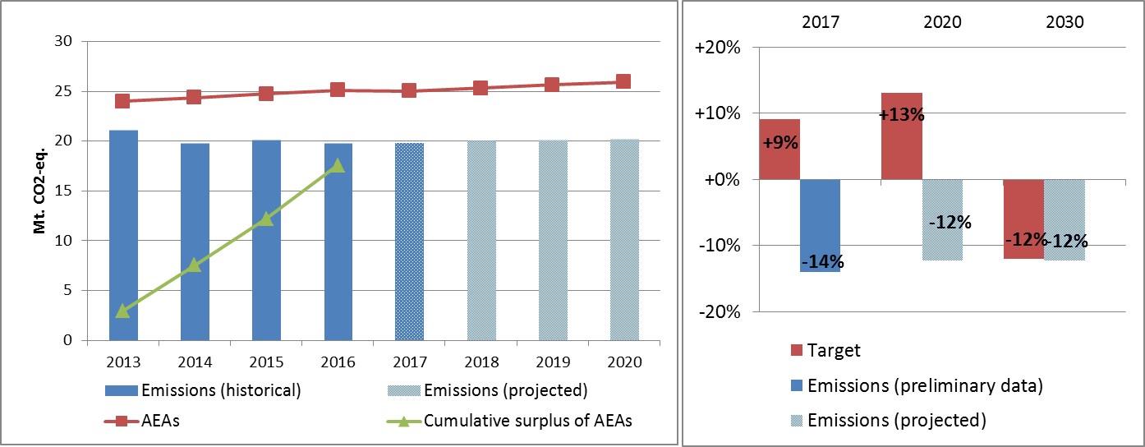

Figure 4: Left hand side: Emissions, annual emission allocations (AEAs) and accumulated surplus/ deficit of AEAs under the Effort Sharing Decision 2013-2020 (Mt CO2-eq.). Right hand side: Emissions and targets under the Effort Sharing Decision/ Effort Sharing Regulation 2017, 2020 and 2030 as percentage change from 2005.

# 4. Land use, land use change and forestry

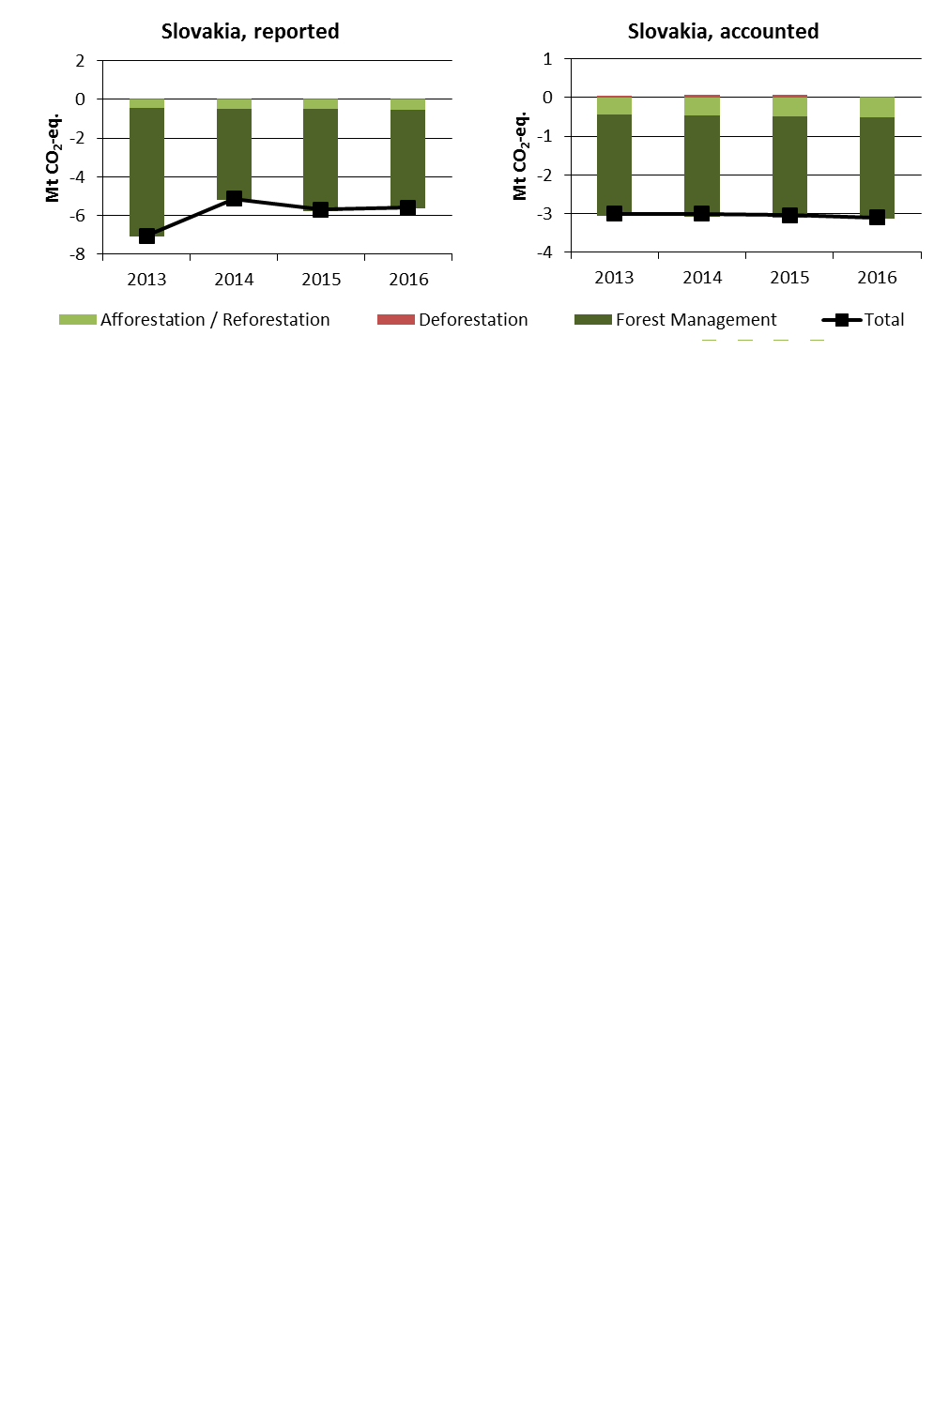

Figure 5: Reported and accounted emissions and removals from LULUCF (Mt CO2-eq.)[10]

Reported quantities under the Kyoto Protocol for Slovakia show net removals of, on average, -5.9 Mt CO2-eq for the period 2013 to 2016. In this regard Slovakia contributes with 1.5% to the annual average sink of -384.4 Mt CO2-eq of the EU-28. Accounting for the same period depicts net credits of, on average, -3.0 Mt CO2-eq, which corresponds to 2.6% of the EU-28 accounted sink of -115.7 Mt CO2-eq. Reported net removals depict a decrease between 2013 and 2014 followed by a minor increase, while accounted net credits show a very small increase over the four-year period. In this preliminary simulated accounting exercise potential credits by Forest Management of, on average, -3.1 Mt CO2-eq per year are capped to -2.6 Mt CO2-eq per year. Slovakia is one of eight EU Member States which exceed the cap of 3.5% from emissions of the base year (1990).

Country fact sheet: Slovenia

# 1. Total greenhouse gas emissions

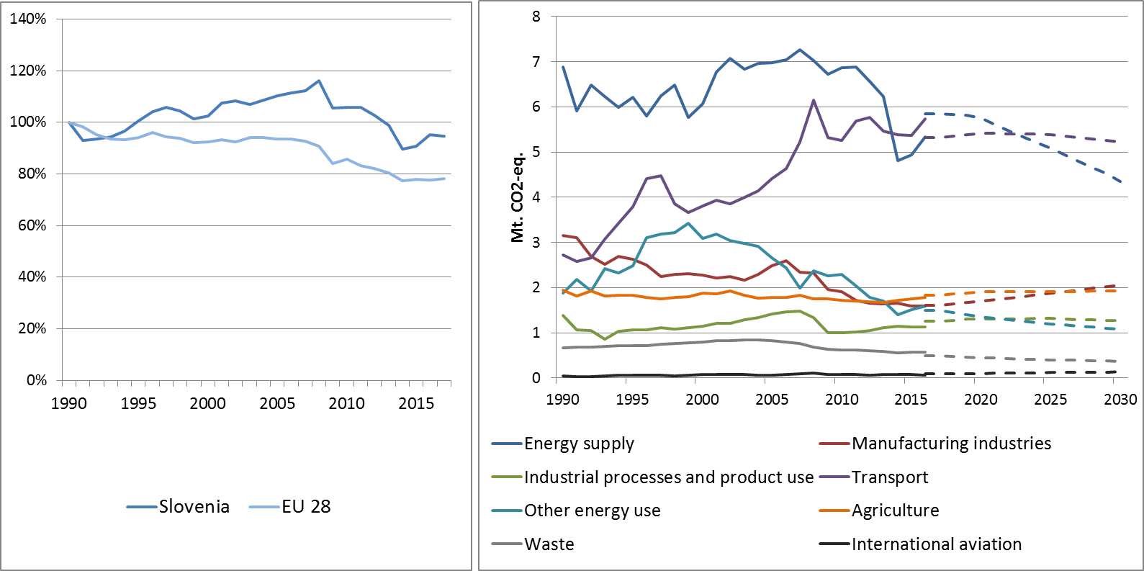

Figure 1: Left hand side: Total greenhouse gas emissions[11] 1990-2017 (index 1990 = 100 %). Right hand side: Total greenhouse gas emissions by sector[12] – historical emissions 1990-2016, projections 2017-2030 (Mt CO2-eq.).

**Figure 2: Share of emissions covered by the ETS and the ESD (2016).[13]**

# 2. ETS emissions

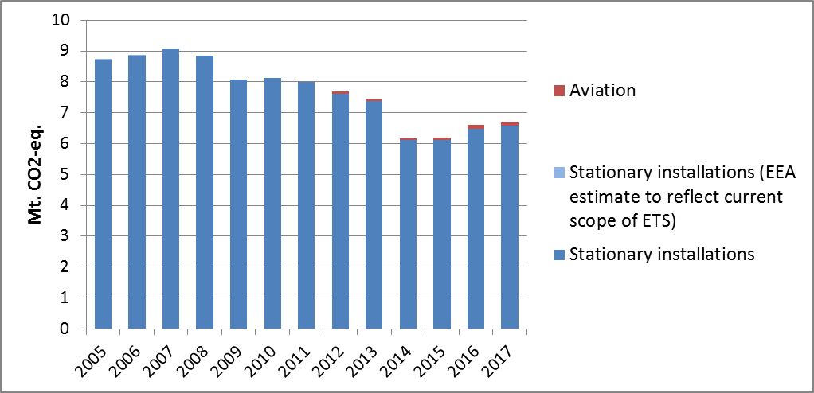

Figure 3: ETS emissions (Mt CO2-eq.).[14]

# 3. Emissions in Effort Sharing sectors

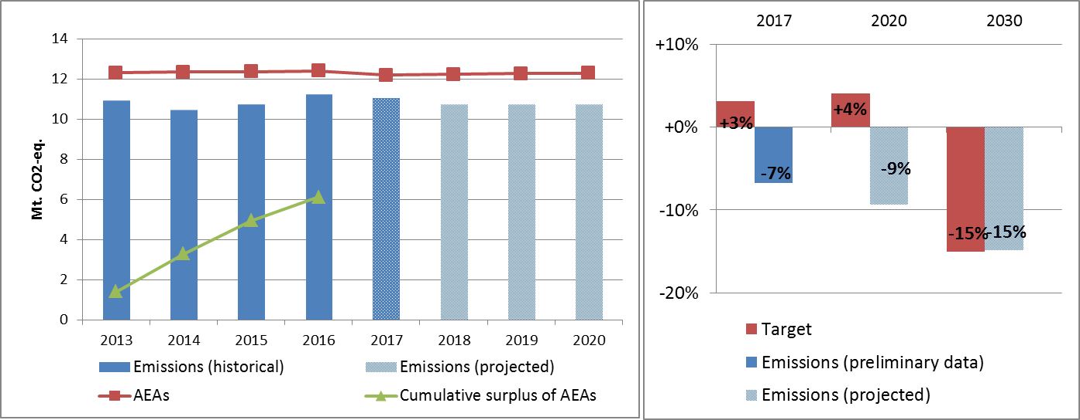

Figure 4: Left hand side: Emissions, annual emission allocations (AEAs) and accumulated surplus/ deficit of AEAs under the Effort Sharing Decision 2013-2020 (Mt CO2-eq.). Right hand side: Emissions and targets under the Effort Sharing Decision/ Effort Sharing Regulation 2017, 2020 and 2030 as percentage change from 2005.

# 4. Land use, land use change and forestry

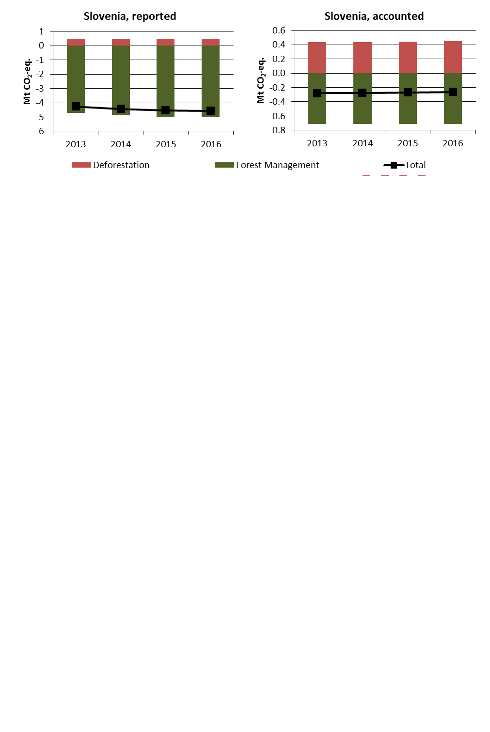

Figure 5: Reported and accounted emissions and removals from LULUCF (Mt CO2-eq.)[15]

Reported quantities under the Kyoto Protocol for Slovenia show net removals of, on average, -4.5 Mt CO2-eq for the period 2013 to 2016. In this regard Slovenia contributes with 1.2% to the annual average sink of -384.4 Mt CO2-eq of the EU-28. Accounting for the same period depicts net credits of, on average, -0.3 Mt CO2-eq, which corresponds to 0.2% of the EU-28 accounted sink of -115.7 Mt CO2-eq. Reported net removals depict a small increase over the four-year period, while accounted net credits remain nearly unchanged. Slovenia is the only EU Member State which does not provide quantities to report and account for Afforestation/Reforestation. In this preliminary simulated accounting exercise potential credits by Forest Management of, on average, -1.7 Mt CO2-eq per year are capped to -0.7 Mt CO2-eq per year. Slovenia is one of eight EU Member States which exceed the cap of 3.5% from emissions of the base year (1986).

Country fact sheet: Spain

# 1. Total greenhouse gas emissions

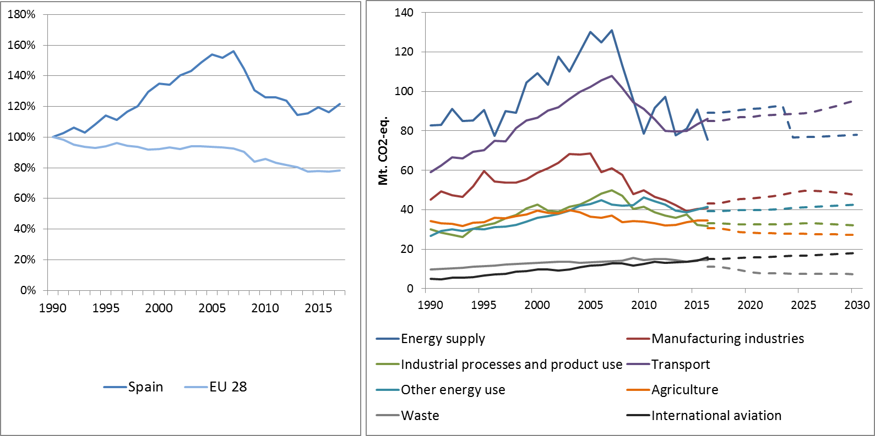

Figure 1: Left hand side: Total greenhouse gas emissions[16] 1990-2017 (index 1990 = 100 %). Right hand side: Total greenhouse gas emissions by sector[17] – historical emissions 1990-2016, projections 2017-2030 (Mt CO2-eq.).

**Figure 2: Share of emissions covered by the ETS and the ESD (2016).[18]**

# 2. ETS emissions

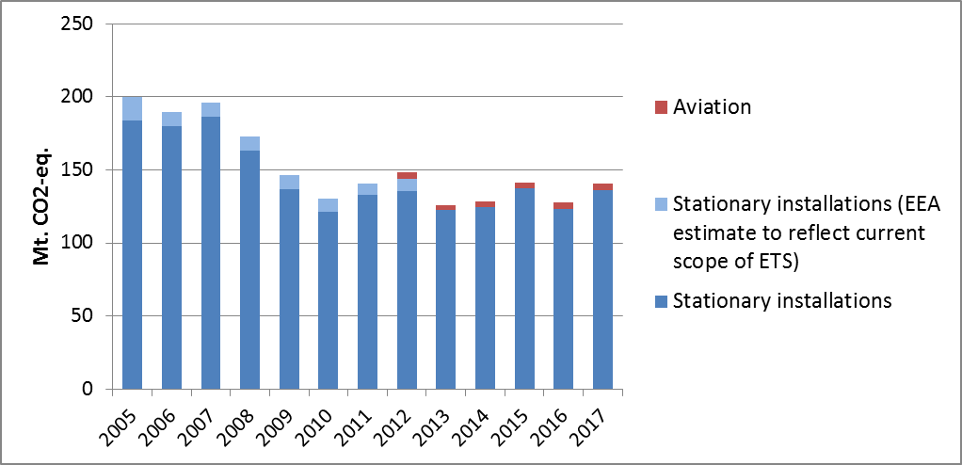

Figure 3: ETS emissions (Mt CO2-eq.).[19]

# 3. Emissions in Effort Sharing sectors

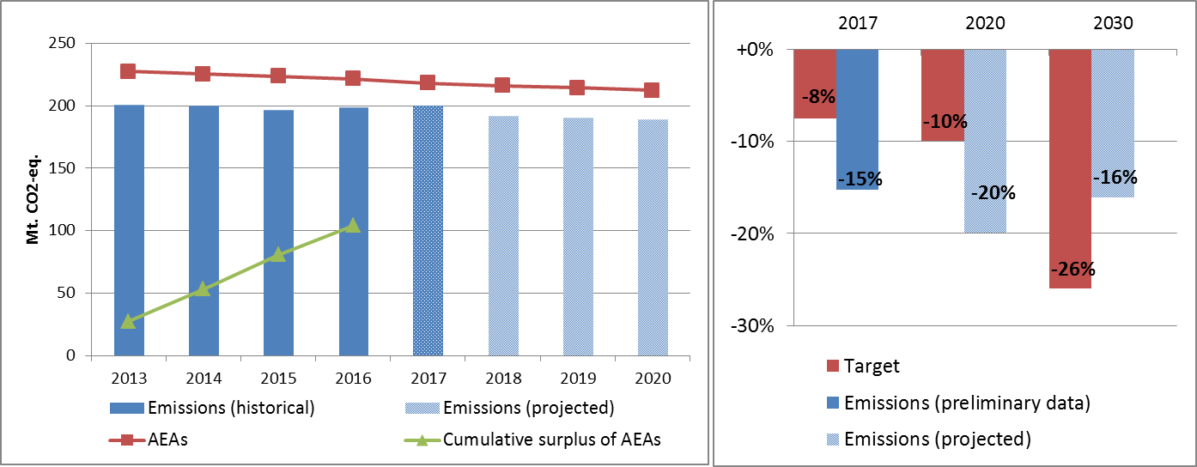

Figure 4: Left hand side: Emissions, annual emission allocations (AEAs) and accumulated surplus/ deficit of AEAs under the Effort Sharing Decision 2013-2020 (Mt CO2-eq.). Right hand side: Emissions and targets under the Effort Sharing Decision/ Effort Sharing Regulation 2017, 2020 and 2030 as percentage change from 2005.

# 4. Land use, land use change and forestry

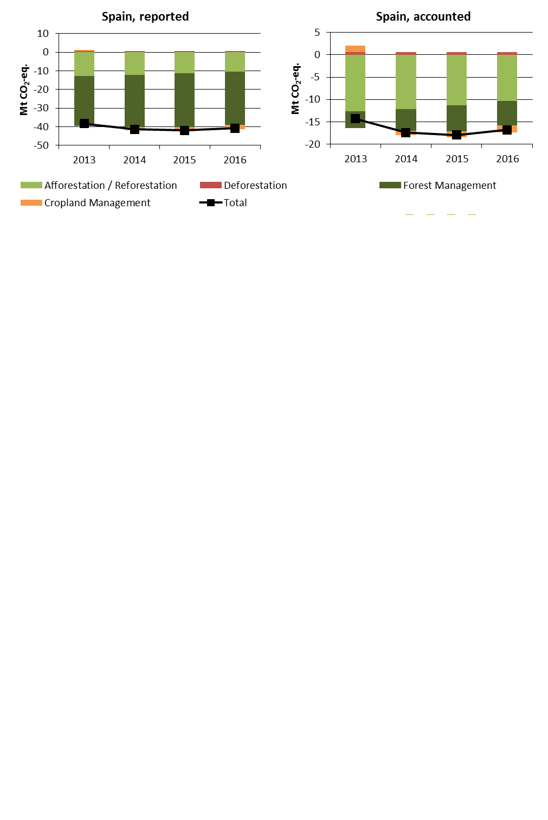

Figure 5: Reported and accounted emissions and removals from LULUCF (Mt CO2-eq.)[20]

Reported quantities under the Kyoto Protocol for Spain show net removals of, on average, -40.5 Mt CO2-eq for the period 2013 to 2016. In this regard Spain contributes with 10.5% to the annual average sink of -384.4 Mt CO2-eq of the EU-28. Accounting for the same period depicts net credits of, on average, -16.6 Mt CO2-eq, which corresponds to 14.3% of the EU-28 accounted sink of -115.7 Mt CO2-eq. Reported net removals show an increase which levels off and slightly decreases for 2016. This pattern is more accentuated for accounted net credits. Spain is one of seven EU Member States which elected to report and account for Cropland Management.

Country fact sheet: Sweden

# 1. Total greenhouse gas emissions

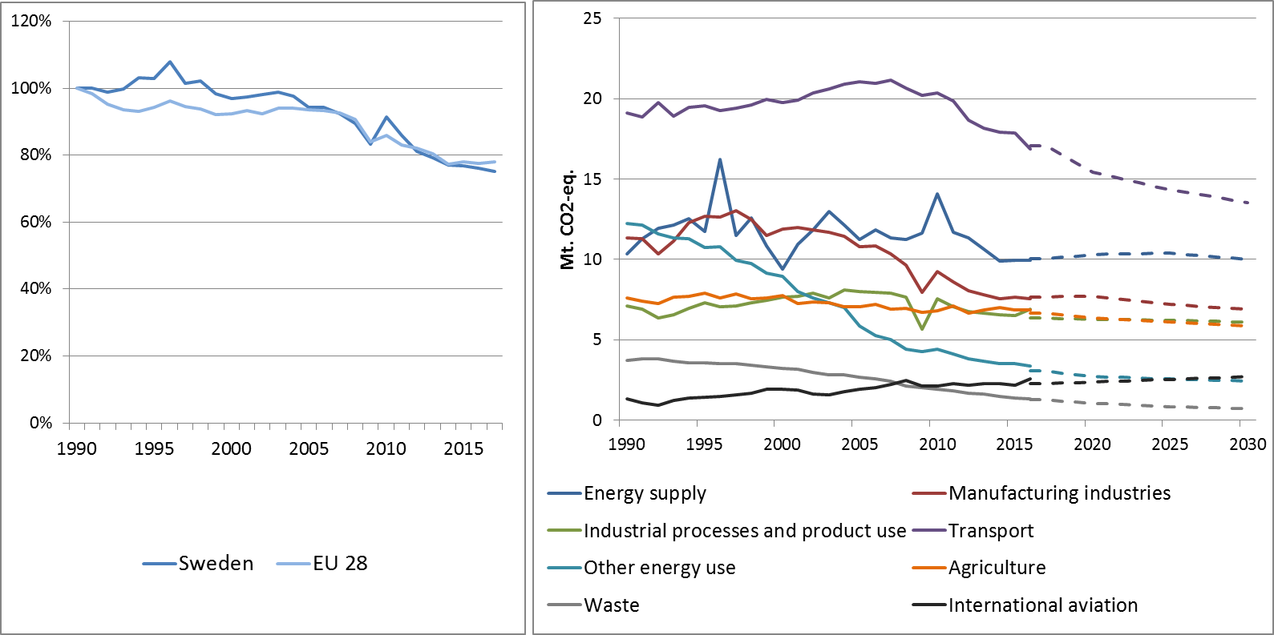

Figure 1: Left hand side: Total greenhouse gas emissions[21] 1990-2017 (index 1990 = 100 %). Right hand side: Total greenhouse gas emissions by sector[22] – historical emissions 1990-2016, projections 2017-2030 (Mt CO2-eq.).

**Figure 2: Share of emissions covered by the ETS and the ESD (2016).[23]**

# 2. ETS emissions

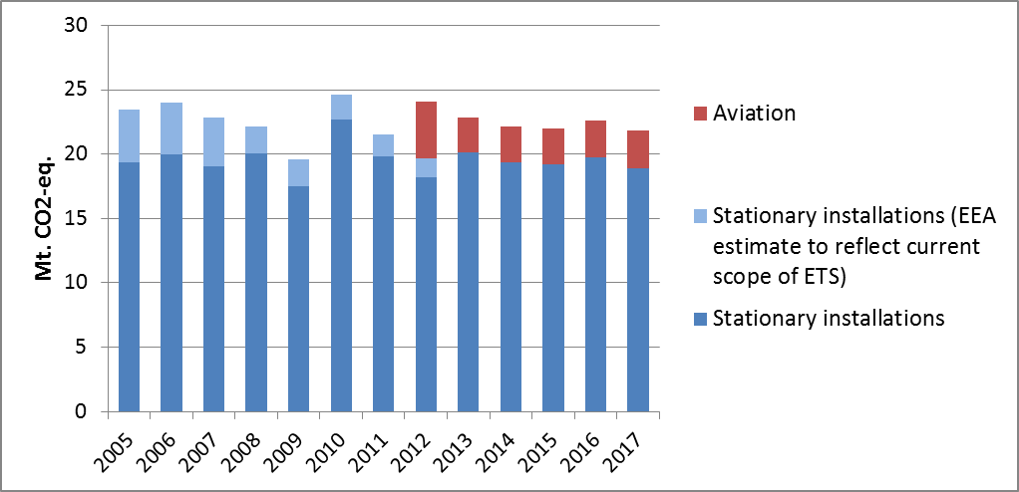

Figure 3: ETS emissions (Mt CO2-eq.).[24]

# 3. Emissions in Effort Sharing sectors

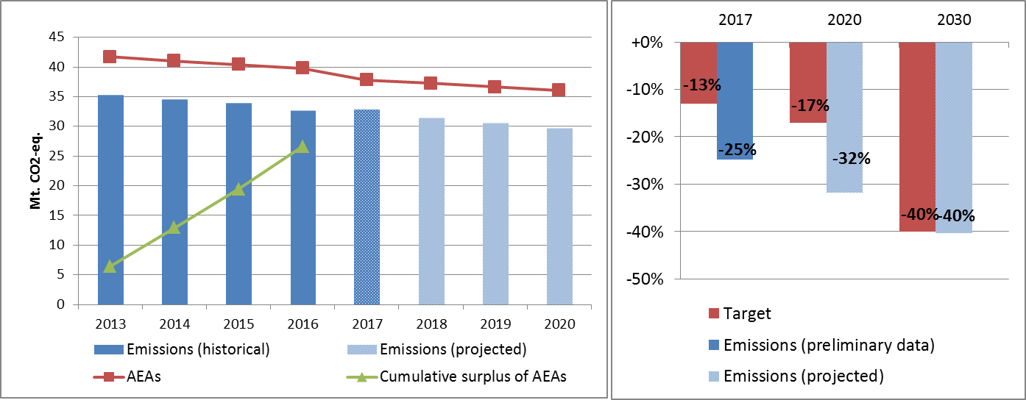

Figure 4: Left hand side: Emissions, annual emission allocations (AEAs) and accumulated surplus/ deficit of AEAs under the Effort Sharing Decision 2013-2020 (Mt CO2-eq.). Right hand side: Emissions and targets under the Effort Sharing Decision/ Effort Sharing Regulation 2017, 2020 and 2030 as percentage change from 2005.[25]

# 4. Land use, land use change and forestry

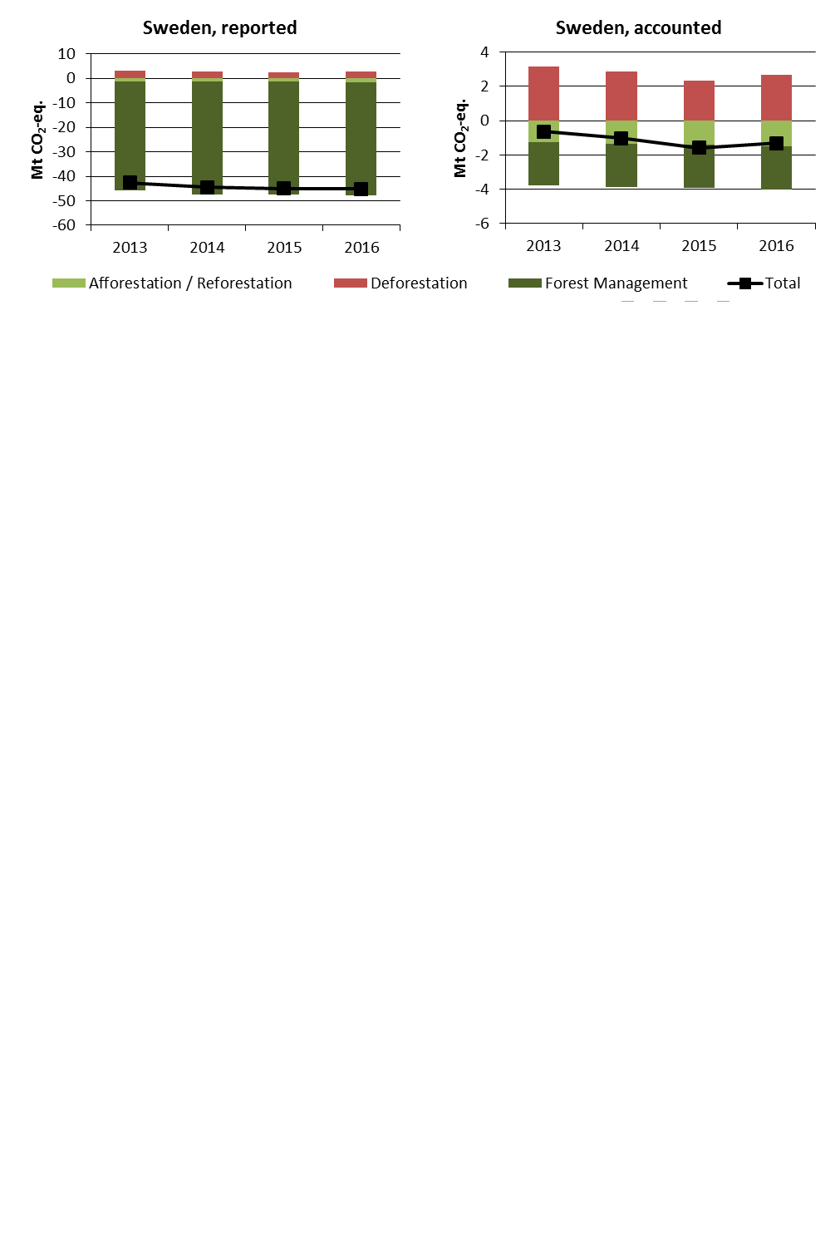

Figure 5: Reported and accounted emissions and removals from LULUCF (Mt CO2-eq.)[26]

Reported quantities under the Kyoto Protocol for Sweden show net removals of, on average, -44.3 Mt CO2-eq for the period 2013 to 2016. In this regard Sweden contributes with 11.5% to the annual average sink of -384.4 Mt CO2-eq of the EU-28. Accounting for the same period depicts net credits of, on average, -1.1 Mt CO2-eq, which corresponds to 1.0% of the EU-28 accounted sink of -115.7 Mt CO2-eq. Reported net removals depict a small increase over the four-year period, while accounted net credits increase between 2013 and 2015 and slightly decrease for 2016. In this preliminary simulated accounting exercise potential credits by Forest Management of, on average, -13.5 Mt CO2-eq per year are capped to -2.5 Mt CO2-eq per year. Sweden is one of eight EU Member States which exceed the cap of 3.5% from emissions of the base year (1990).

Country fact sheet: United Kingdom

# 1. Total greenhouse gas emissions

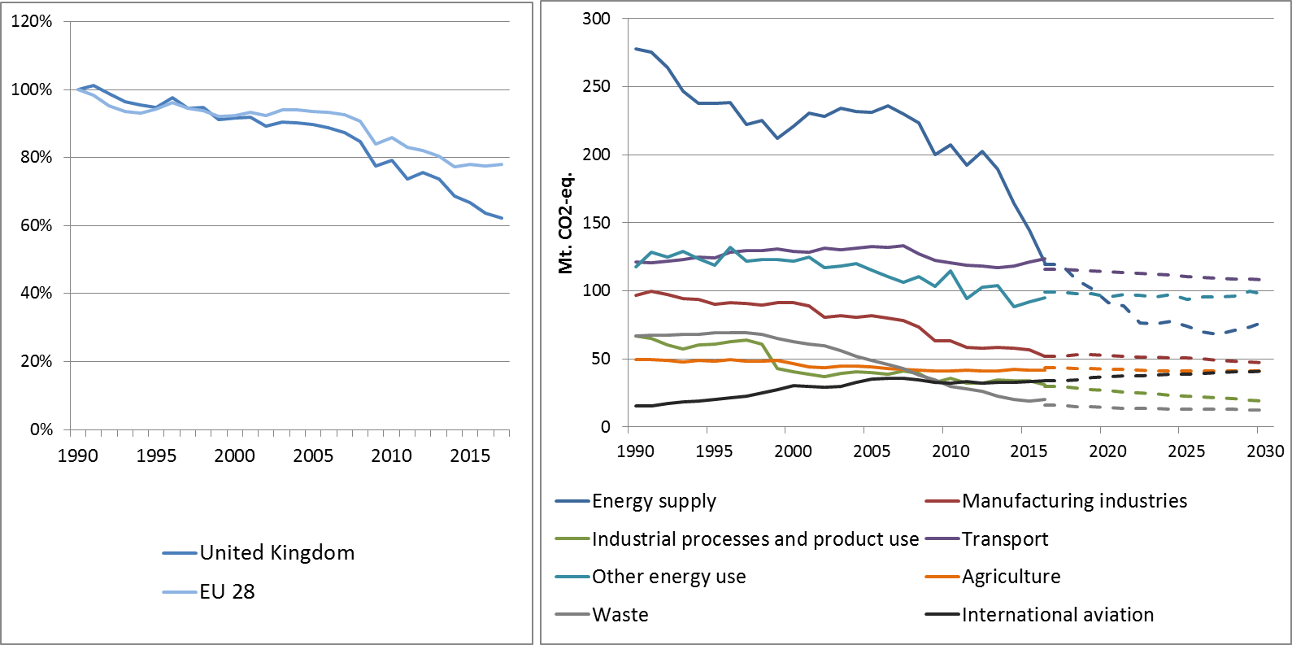

Figure 1: Left hand side: Total greenhouse gas emissions[27] 1990-2017 (index 1990 = 100 %). Right hand side: Total greenhouse gas emissions by sector[28] – historical emissions 1990-2016, projections 2017-2030 (Mt CO2-eq.).

**Figure 2: Share of emissions covered by the ETS and the ESD (2016).[29]**

# 2. ETS emissions

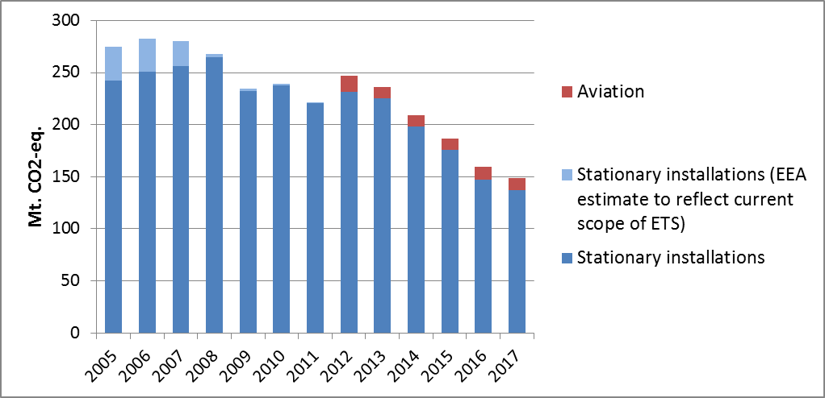

Figure 3: ETS emissions (Mt CO2-eq.).[30]

# 3. Emissions in Effort Sharing sectors

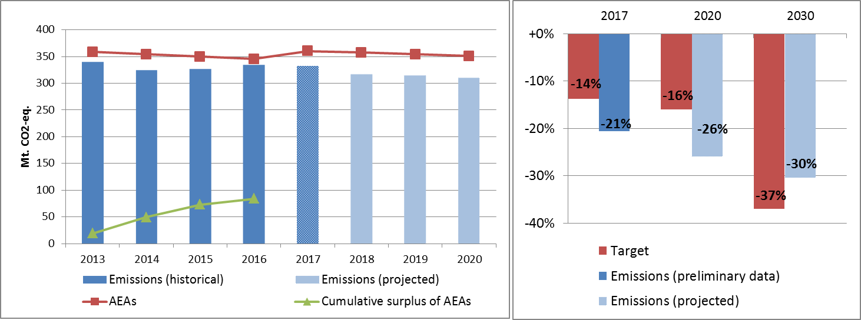

Figure 4: Left hand side: Emissions, annual emission allocations (AEAs) and accumulated surplus/ deficit of AEAs under the Effort Sharing Decision 2013-2020 (Mt CO2-eq.). Right hand side: Emissions and targets under the Effort Sharing Decision/ Effort Sharing Regulation 2017, 2020 and 2030 as percentage change from 2005.

# 4. Land use, land use change and forestry

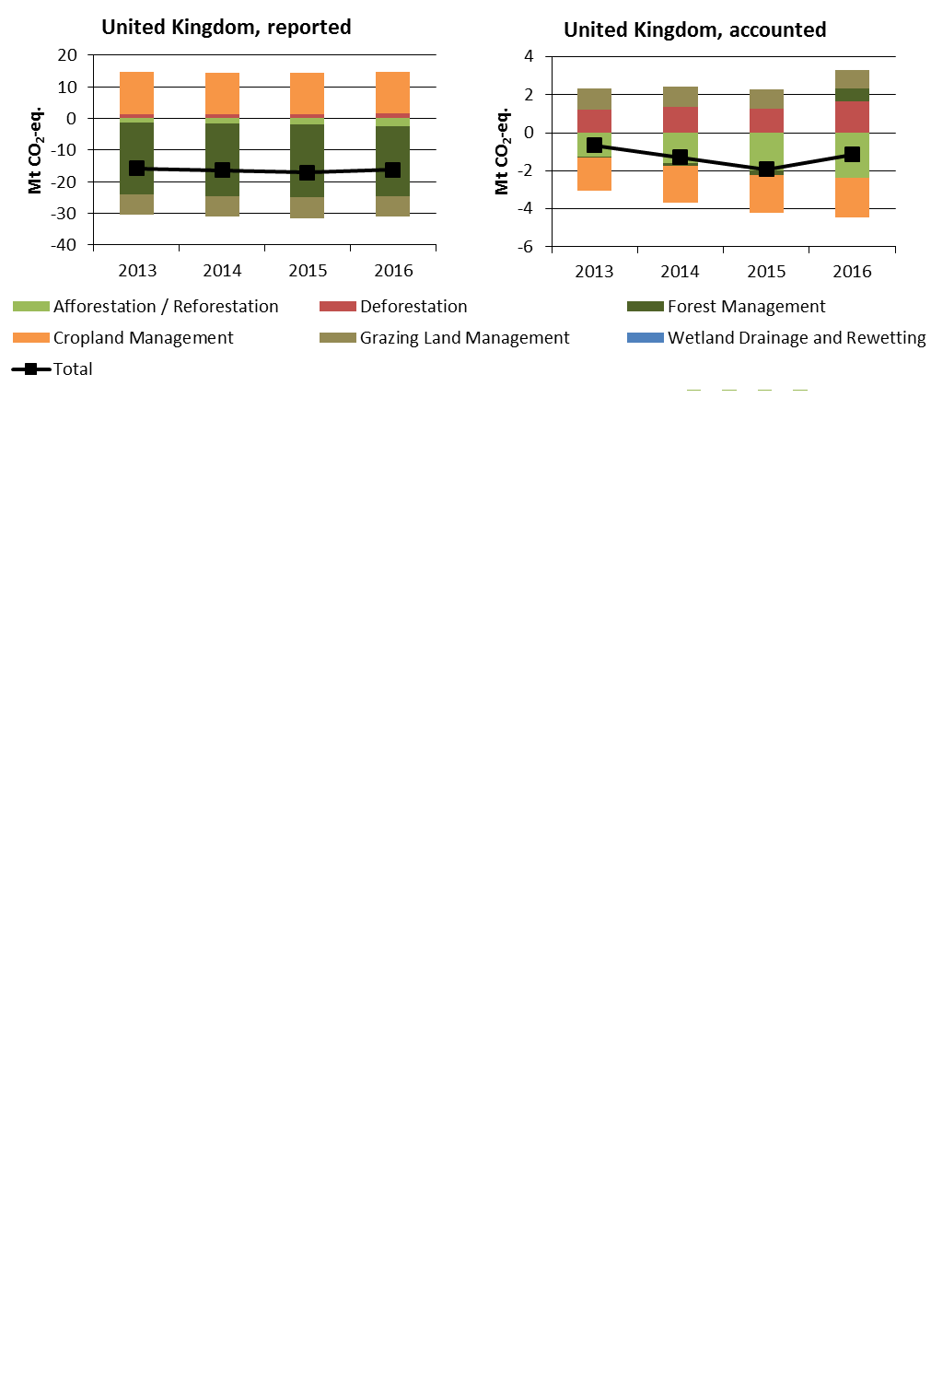

Figure 5: Reported and accounted emissions and removals from LULUCF (Mt CO2-eq.)[31]

Reported quantities under the Kyoto Protocol for the United Kingdom show net removals of, on average, -16.4 Mt CO2-eq for the period 2013 to 2016. In this regard United Kingdom contributes with 4.3% to the annual average sink of -384.4 Mt CO2-eq of the EU-28. Accounting for the same period depicts net credits of, on average, -1.3 Mt CO2-eq, which corresponds to 1.1% of the EU-28 accounted sink of -115.7 Mt CO2-eq. Reported net removals are nearly unchanged, while accounted net credits increase between 2013 and 2015 and drop notably for 2016. The United Kingdom elected to report and account for Cropland Management as one of seven EU Member States and for Grazing Land Management as one of six EU Member States. The United Kingdom is the only EU Member State that elected to report and account for Wetland Drainage and Rewetting but has so far not provided any data.

Data sources for country fact sheets

Figure 1: Annual European Union greenhouse gas inventory 1990–2016 (EEA greenhouse gas data viewer: <https://www.eea.europa.eu/data-and-maps/data/data-viewers/greenhouse-gases-viewer> ). *Proxy GHG emission estimates for 2017Approximated EU greenhouse gas inventory 2017* (European Environment Agency)*.* Member States national projections, reviewed by the European Environment Agency.

Figure 2: Verified ETS emissions abstracted from European Union Transaction Log 20.07.2018 (EEA ETS data viewer: <https://www.eea.europa.eu/data-and-maps/dashboards/emissions-trading-viewer-1>). ESD data from European Commission: *Commission Implementing Decision (EU) on greenhouse gas emissions for each Member State for the year 2016 covered by Decision No 406/2009/EC of the European Parliament and of the Council* (forthcoming).

Figure 3: abstract from European Union Transaction Log 20.07.2018 (EEA ETS data viewer: <https://www.eea.europa.eu/data-and-maps/dashboards/emissions-trading-viewer-1> ).

Figure 4: European Commission: *Commission Implementing Decision (EU) on greenhouse gas emissions for each Member State for the year 2016 covered by Decision No 406/2009/EC of the European Parliament and of the Council* (forthcoming). *Proxy GHG emission estimates for 2017Approximated EU greenhouse gas inventory 2017* (European Environment Agency)*.* Member States national projections, reviewed by the European Environment Agency.

Figure 5: European Commission based on data accounted and reported by Member States under the Kyoto Protocol.

Part 1B: Explanatory text on land use land use change and forestry – reported and accounted emissions under the Kyoto protocol

The figures presented in the country fact sheets provide reported emissions and removals and accounted debits and credits by applying the accounting rules for the Land Use Land Use Change and Forestry (LULUCF) of the second commitment period of the Kyoto Protocol. Reported data for mandatory and elected activities were collected from the EU Member States by the European Environmental Agency and underwent a simulated accounting process developed by the Joint Research Centre (JRC) together with DG CLIMA. The following country-sheets show the result for each of the 28 EU Member States and the total of the EU-28 for the period 2013-2016.

Almost all Member States reported emissions and removals for mandatory activities Afforestation/Reforestation, Deforestation and Forest Management; one EU Member State did not provide any activities and another no data for Afforestation/Reforestation. Elected Activities for Cropland Management were provided by seven EU Member States, for Grazing Land Management by six EU Member States and for Revegetation by one EU Member State. No data for Wetland Drainage and Rewetting were provided although one EU Member State has elected to do so.

The quantities and tendencies between reported emissions and removals and accounted debits and credits may differ notably. Reported data represent what the "atmosphere sees" according the rules of the Kyoto Protocol. Accounting represents a means to evaluate policies and to raise ambition for more action in terms of reducing emissions and increasing removals. Note that debits and credits from accounting are preliminary and simulated, because definitive accounts can only be computed after the end of the commitment period (December 2020) with inventories becoming available by March 2022. “Preliminary” refers to the fact that reported emissions and removals for each category and year may still change, including for the base year (1990 for most Member States). This may mostly affect preliminary accounts following the net-net accounting rule for Cropland Management, Grazing Land Management and Revegetation while patterns for activities Afforestation/Reforestation and Deforestation with gross-net accounting should remain rather similar. Accounting for Forest Management uses the forest management reference level and most current technical corrections. Forest Management credits are capped and presented as yearly averages when the total Forest Management credits from 2013 to 2016 exceed the simulated cap over the 4-year period. There are several Members States with Forest Management accounts very close to the cap threshold, either showing specific tendencies to become capped or might not to be capped anymore in the future, which may have significant effects on the total accounted quantities for that Member State and the EU-28.

1. National total, including international aviation.
2. The sectors in the figure correspond to the following IPCC sectors: Energy supply: 1A1, 1B and 1C. Manufacturing industries: 1A2. Industrial processes and product use: 2. Transport: 1A3. Other energy use: 1A4, 1A5 and 6. Agriculture: 3. Waste: 5. International aviation: memo item.
3. Excluding international aviation, CO2 from domestic aviation and NF3.
4. The scope of ETS was extended from 2013. To reflect the current scope of ETS, estimates made by EEA are included in the figures from 2007 to 2012. The estimates cover only emissions from stationary installations. Romania joined the ETS in 2007.
5. The differences between reported and accounted emissions from LULUCF under the Kyoto Protocol are described in part 1b.
6. National total, including international aviation.
7. The sectors in the figure correspond to the following IPCC sectors: Energy supply: 1A1, 1B and 1C. Manufacturing industries: 1A2. Industrial processes and product use: 2. Transport: 1A3. Other energy use: 1A4, 1A5 and 6. Agriculture: 3. Waste: 5. International aviation: memo item.
8. Excluding international aviation, CO2 from domestic aviation and NF3.
9. The scope of ETS was extended from 2013. To reflect the current scope of ETS, estimates made by EEA are included in the figures from 2005 to 2012. The estimates cover only emissions from stationary installations.
10. The differences between reported and accounted emissions from LULUCF under the Kyoto Protocol are described in part 1b.
11. National total, including international aviation.
12. The sectors in the figure correspond to the following IPCC sectors: Energy supply: 1A1, 1B and 1C. Manufacturing industries: 1A2. Industrial processes and product use: 2. Transport: 1A3. Other energy use: 1A4, 1A5 and 6. Agriculture: 3. Waste: 5. International aviation: memo item.
13. Excluding international aviation, CO2 from domestic aviation and NF3.
14. The scope of ETS was extended from 2013. To reflect the current scope of ETS, estimates made by EEA are included in the figures from 2005 to 2012. The estimates cover only emissions from stationary installations.
15. The differences between reported and accounted emissions from LULUCF under the Kyoto Protocol are described in part 1b.
16. National total, including international aviation.
17. The sectors in the figure correspond to the following IPCC sectors: Energy supply: 1A1, 1B and 1C. Manufacturing industries: 1A2. Industrial processes and product use: 2. Transport: 1A3. Other energy use: 1A4, 1A5 and 6. Agriculture: 3. Waste: 5. International aviation: memo item.
18. Excluding international aviation, CO2 from domestic aviation and NF3.
19. The scope of ETS was extended from 2013. To reflect the current scope of ETS, estimates made by EEA are included in the figures from 2005 to 2012. The estimates cover only emissions from stationary installations.
20. The differences between reported and accounted emissions from LULUCF under the Kyoto Protocol are described in part 1b.
21. National total, including international aviation.
22. The sectors in the figure correspond to the following IPCC sectors: Energy supply: 1A1, 1B and 1C. Manufacturing industries: 1A2. Industrial processes and product use: 2. Transport: 1A3. Other energy use: 1A4, 1A5 and 6. Agriculture: 3. Waste: 5. International aviation: memo item.
23. Excluding international aviation, CO2 from domestic aviation and NF3.
24. The scope of ETS was extended from 2013. To reflect the current scope of ETS, estimates made by EEA are included in the figures from 2005 to 2012. The estimates cover only emissions from stationary installations.
25. Sweden has cancelled its surplus of AEAs to enhance the environmental integrity of the system as a whole.
26. The differences between reported and accounted emissions from LULUCF under the Kyoto Protocol are described in part 1b.
27. National total, including international aviation.
28. The sectors in the figure correspond to the following IPCC sectors: Energy supply: 1A1, 1B and 1C. Manufacturing industries: 1A2. Industrial processes and product use: 2. Transport: 1A3. Other energy use: 1A4, 1A5 and 6. Agriculture: 3. Waste: 5. International aviation: memo item.
29. Excluding international aviation, CO2 from domestic aviation and NF3.
30. The scope of ETS was extended from 2013. To reflect the current scope of ETS, estimates made by EEA are included in the figures from 2005 to 2012. The estimates cover only emissions from stationary installations.
31. The differences between reported and accounted emissions from LULUCF under the Kyoto Protocol are described in part 1b.