

Country fact sheet: Czech Republic

# 1. Total greenhouse gas emissions

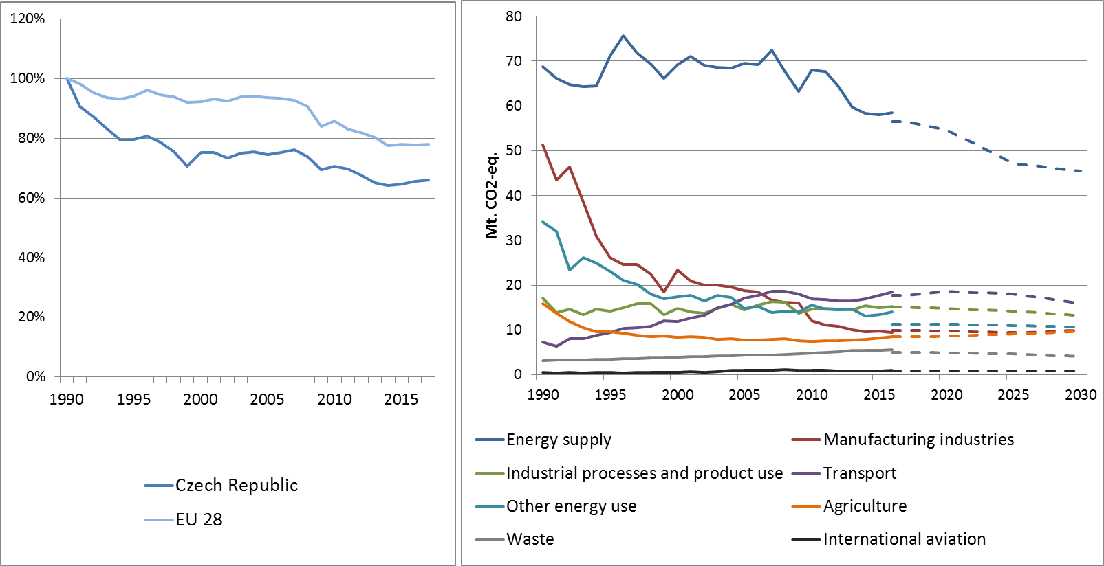

Figure 1: Left hand side: Total greenhouse gas emissions[1] 1990-2017 (index 1990 = 100 %). Right hand side: Total greenhouse gas emissions by sector[2] – historical emissions 1990-2016, projections 2017-2030 (Mt CO2-eq.).

**Figure 2: Share of emissions covered by the ETS and the ESD (2016).[3]**

# 2. ETS emissions

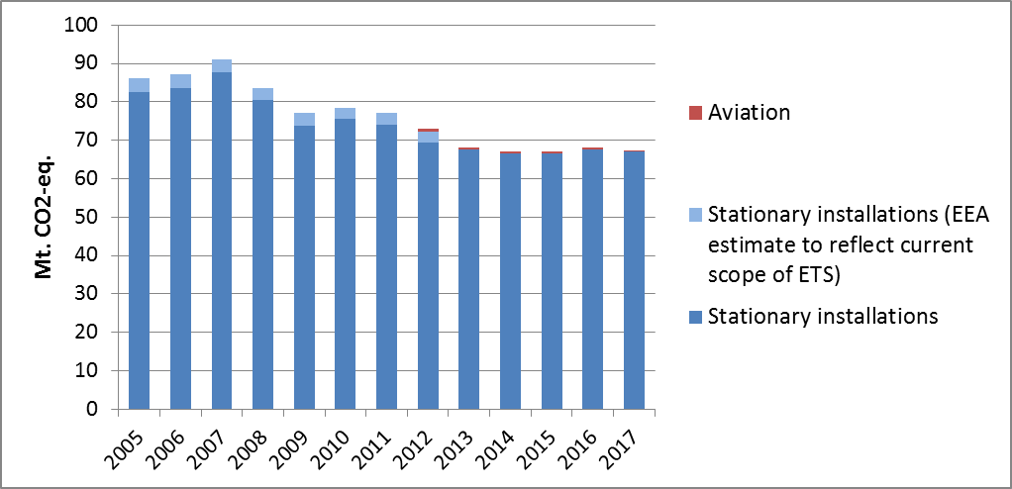**Figure 3: ETS emissions (Mt CO2-eq.).[4]**

# 3. Emissions in Effort Sharing sectors

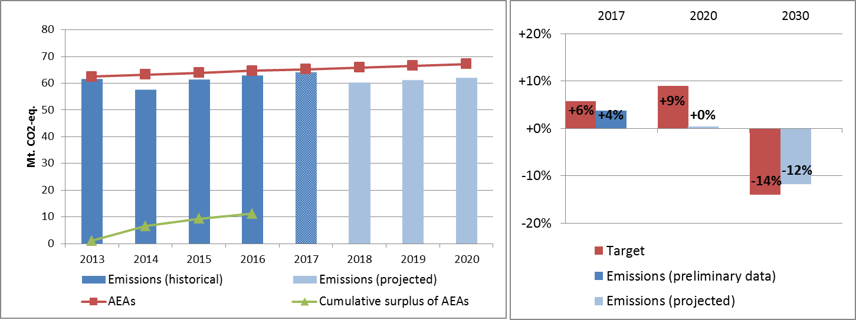

Figure 4: Left hand side: Emissions, annual emission allocations (AEAs) and accumulated surplus/ deficit of AEAs under the Effort Sharing Decision 2013-2020 (Mt CO2-eq.). Right hand side: Emissions and targets under the Effort Sharing Decision/ Effort Sharing Regulation 2017, 2020 and 2030 as percentage change from 2005.

# 4. Land use, land use change and forestry

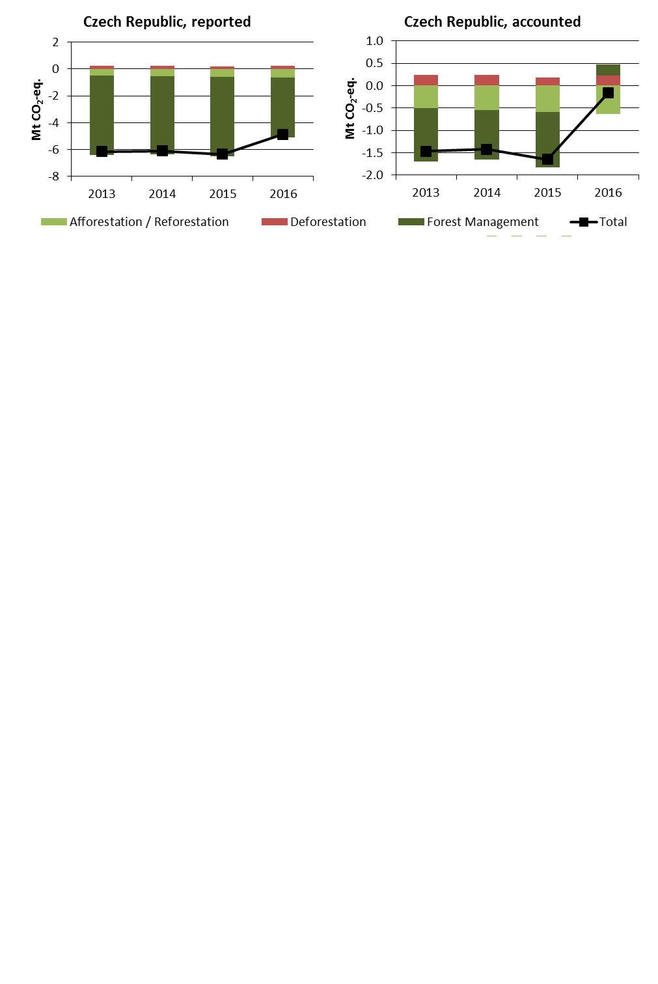

Figure 5: Reported and accounted emissions and removals from LULUCF (Mt CO2-eq.)[5]

Reported quantities under the Kyoto Protocol for the Czech Republic show net removals of, on average, -5.9 Mt CO2-eq for the period 2013 to 2016. In this regard the Czech Republic contributes with 1.5% to the annual average sink of -384.4 Mt CO2-eq of the EU-28. Accounting for the same period depicts net credits of, on average, -1.2 Mt CO2-eq, which corresponds to 1.0% of the EU-28 accounted sink of -115.7 Mt CO2-eq. Reported net removals are rather similar between 2013 and 2015 and decrease markedly for 2016. This pattern is accentuated with accounted net credits being highest for 2015 and a sharp decrease to nearly zero for 2016.

Country fact sheet: Denmark

# 1. Total greenhouse gas emissions

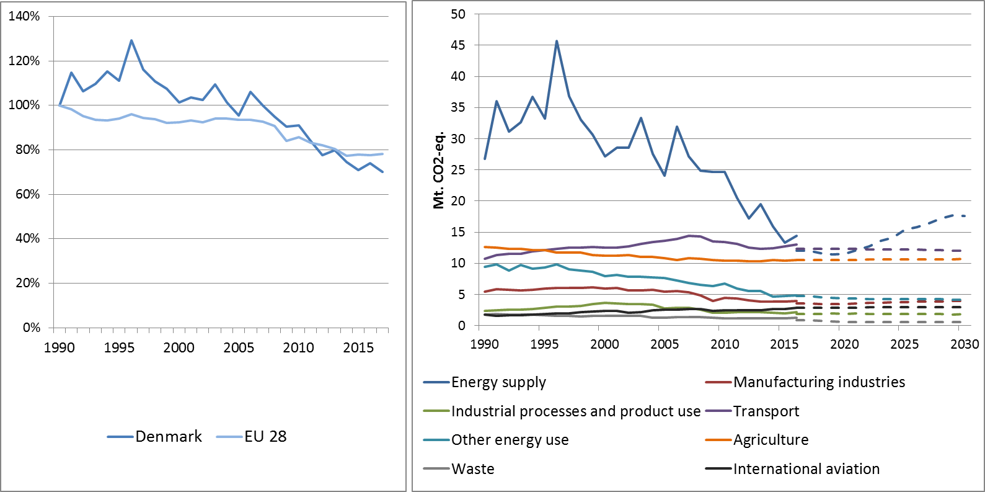

**Figure 1: Left hand side: Total greenhouse gas emissions[6] 1990-2017 (index 1990 = 100 %). Right hand side: Total greenhouse gas emissions by sector[7] – historical emissions 1990-2016, projections 2017-2030 (Mt CO2-eq.).**

**Figure 2: Share of emissions covered by the ETS and the ESD (2016).[8]**

# 2. ETS emissions

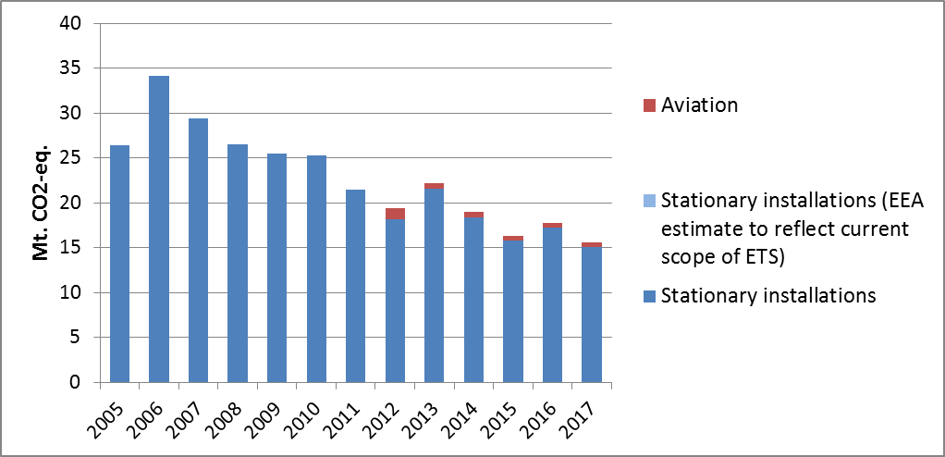

Figure 3: ETS emissions (Mt CO2-eq.).[9]

# 3. Emissions in Effort Sharing sectors

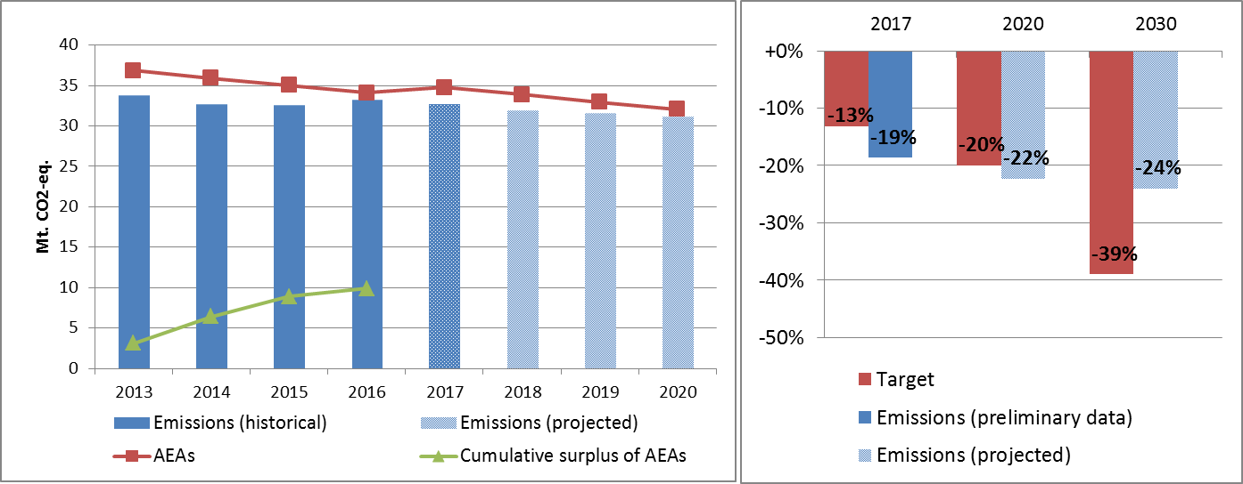

Figure 4: Left hand side: Emissions, annual emission allocations (AEAs) and accumulated surplus/ deficit of AEAs under the Effort Sharing Decision 2013-2020 (Mt CO2-eq.). Right hand side: Emissions and targets under the Effort Sharing Decision/ Effort Sharing Regulation 2017, 2020 and 2030 as percentage change from 2005.

# 4. Land use, land use change and forestry

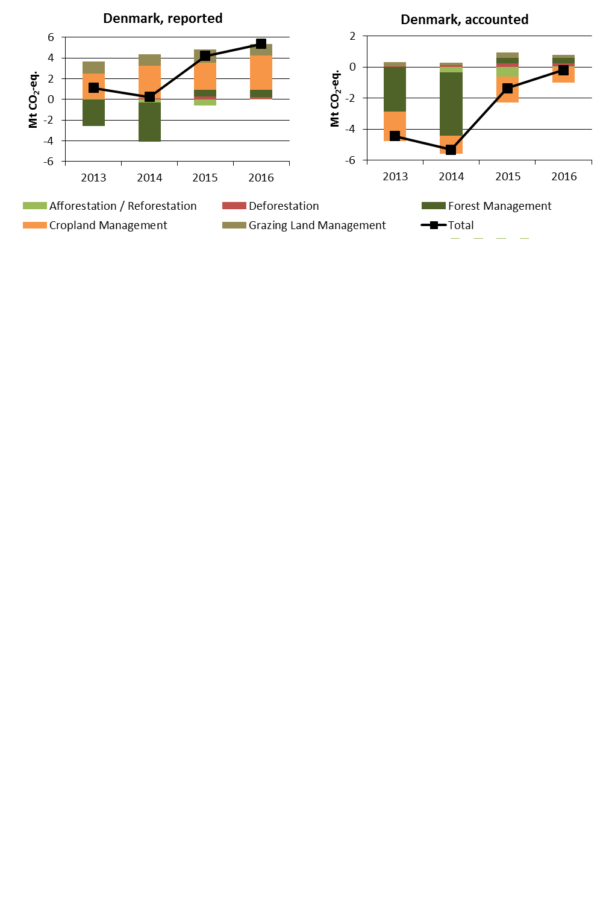

Figure 5: Reported and accounted emissions and removals from LULUCF (Mt CO2-eq.)[10]

Reported quantities under the Kyoto Protocol for Denmark show net emissions of, on average, 2.7 Mt CO2-eq for the period 2013 to 2016. In this regard Denmark contributes negatively with -0.7% to the annual average sink of -384.4 Mt CO2-eq of the EU-28. Denmark is one of two EU Member States which show net emissions in this preliminary exercise. Accounting for the same period depicts net credits of, on average, -2.8 Mt CO2-eq, which corresponds to 2.4% of the EU-28 accounted sink of -115.7 Mt CO2-eq. Reported net emissions are lowest for 2014 and increase markedly in the following years, which is similar to accounted net credits being highest for 2014 and decreasing thereafter. Denmark elected to report and account for Cropland Management as one of seven EU Member States and for Grazing Land Management as one of six EU Member States.

Country fact sheet: Estonia

# 1. Total greenhouse gas emissions

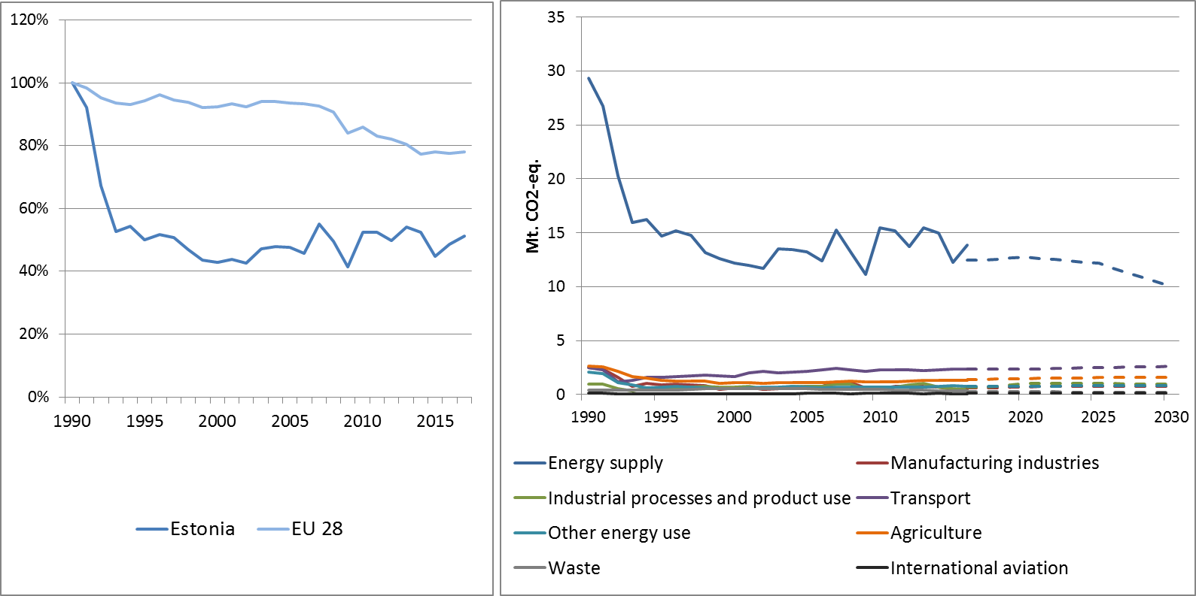

**Figure 1: Left hand side: Total greenhouse gas emissions[11] 1990-2017 (index 1990 = 100 %). Right hand side: Total greenhouse gas emissions by sector[12] – historical emissions 1990-2016, projections 2017-2030 (Mt CO2-eq.).**

**Figure 2: Share of emissions covered by the ETS and the ESD (2016).[13]**

# 2. ETS emissions

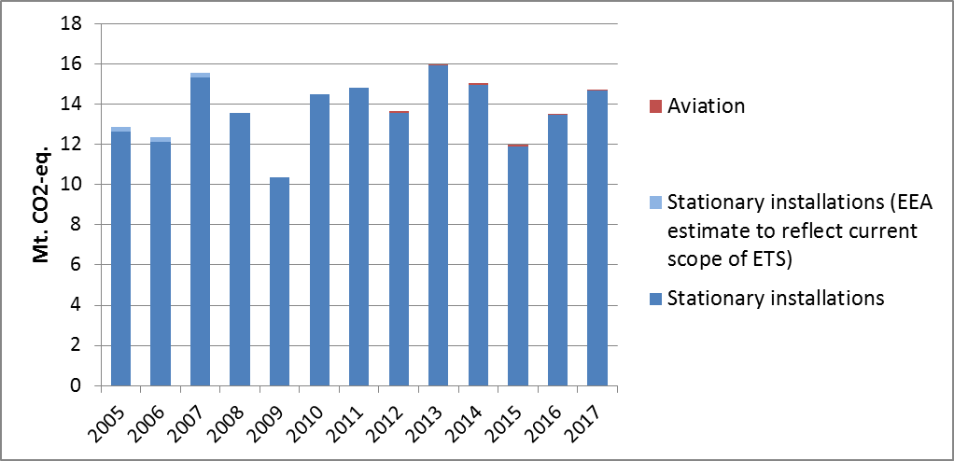

Figure 3: ETS emissions (Mt CO2-eq.).[14]

# 3. Emissions in Effort Sharing sectors

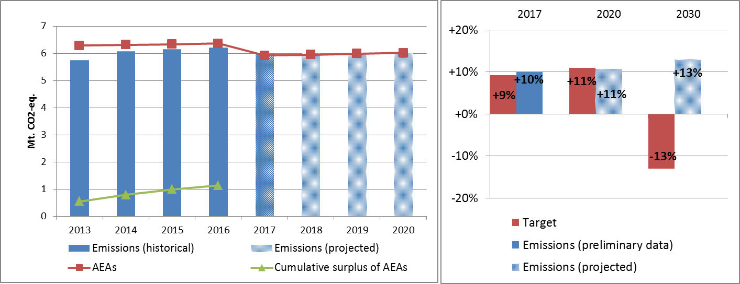

Figure 4: Left hand side: Emissions, annual emission allocations (AEAs) and accumulated surplus/ deficit of AEAs under the Effort Sharing Decision 2013-2020 (Mt CO2-eq.). Right hand side: Emissions and targets under the Effort Sharing Decision/ Effort Sharing Regulation 2017, 2020 and 2030 as percentage change from 2005.

# 4. Land use, land use change and forestry

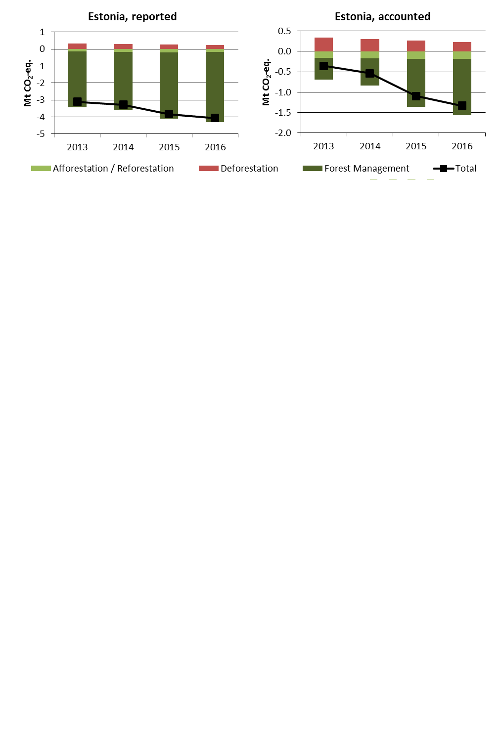

Figure 5: Reported and accounted emissions and removals from LULUCF (Mt CO2-eq.)[15]

Reported quantities under the Kyoto Protocol for Estonia show net removals of, on average, -3.6 Mt CO2-eq for the period 2013 to 2016. In this regard Estonia contributes with 0.9% to the annual average sink of -384.4 Mt CO2-eq of the EU-28. Accounting for the same period depicts net credits of, on average, -0.8 Mt CO2-eq, which corresponds to 0.7% of the EU-28 accounted sink of -115.7 Mt CO2-eq. Reported net removals and accounted net credits show a continuous increase.

Country fact sheet: Finland

# 1. Total greenhouse gas emissions

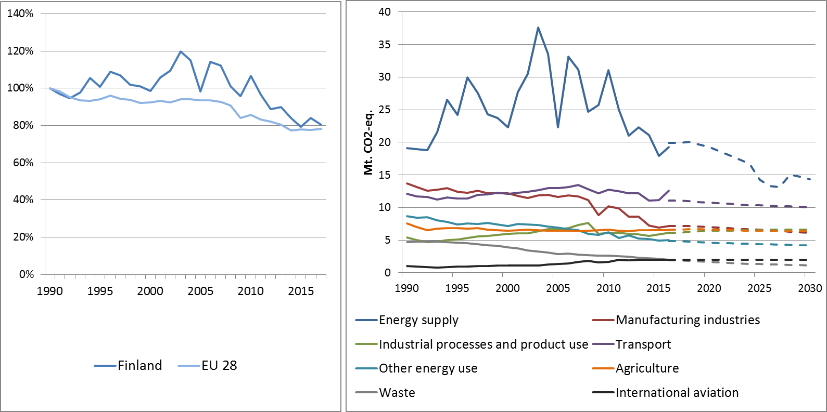

Figure 1: Left hand side: Total greenhouse gas emissions[16] 1990-2017 (index 1990 = 100 %). Right hand side: Total greenhouse gas emissions by sector[17] – historical emissions 1990-2016, projections 2017-2030 (Mt CO2-eq.).

**Figure 2: Share of emissions covered by the ETS and the ESD (2016).[18]**

# 2. ETS emissions

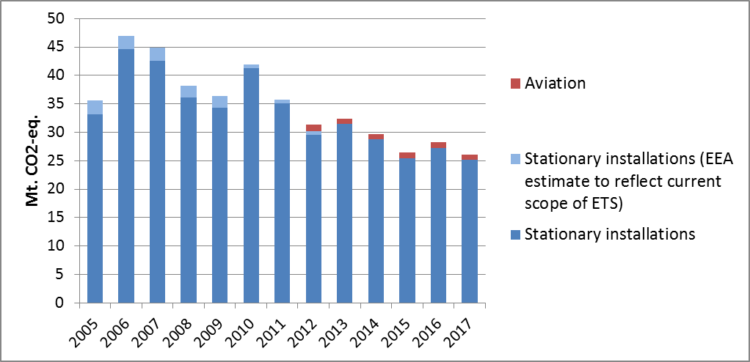

Figure 3: ETS emissions (Mt CO2-eq.).[19]

# 3. Emissions in Effort Sharing sectors

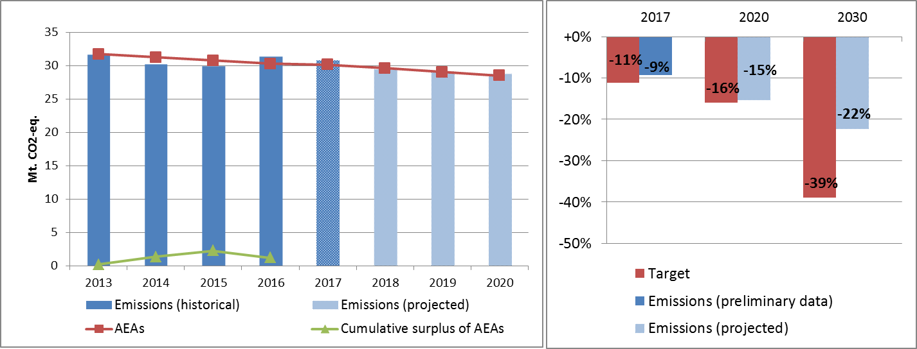

Figure 4: Left hand side: Emissions, annual emission allocations (AEAs) and accumulated surplus/ deficit of AEAs under the Effort Sharing Decision 2013-2020 (Mt CO2-eq.). Right hand side: Emissions and targets under the Effort Sharing Decision/ Effort Sharing Regulation 2017, 2020 and 2030 as percentage change from 2005.

# 4. Land use, land use change and forestry

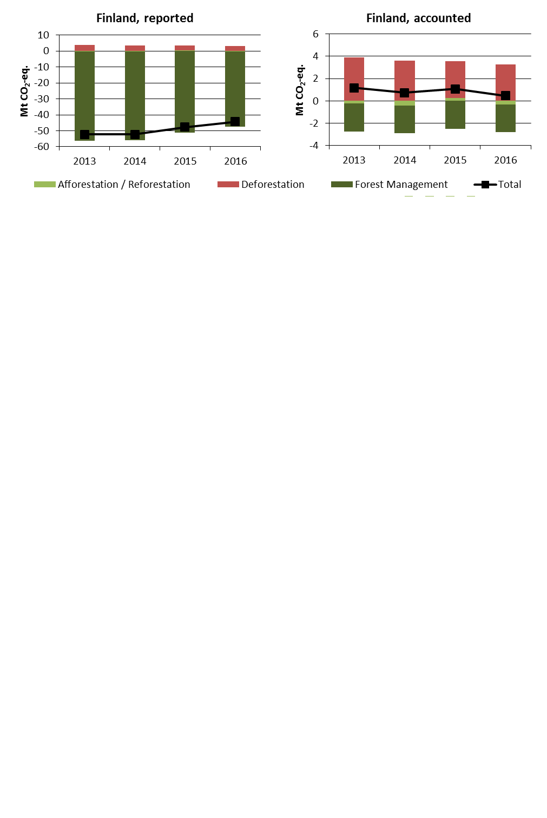

Figure 5: Reported and accounted emissions and removals from LULUCF (Mt CO2-eq.)[20]

Reported quantities under the Kyoto Protocol for Finland show net removals of, on average, -49.2 Mt CO2-eq for the period 2013 to 2016. In this regard Finland contributes with 12.8% to the annual average sink of -384.4 Mt CO2-eq of the EU-28. Accounting for the same period depicts net debits of, on average, 0.8 Mt CO2-eq, which corresponds to a negative contribution of -0.7% of the EU-28 accounted sink of -115.7 Mt CO2-eq. Finland is one of six EU Member States which show net debits in this preliminary accounting exercise. Reported net removals decrease since 2014, while accounted net debits show a decreasing trend over the four-year period. In this preliminary simulated accounting exercise potential credits by Forest Management of, on average, -17.5 Mt CO2-eq per year are capped to -2.5 Mt CO2-eq per year. Finland is one of eight EU Member States which exceed the cap of 3.5% from emissions of the base year (1990).

Country fact sheet: France

# 1. Total greenhouse gas emissions

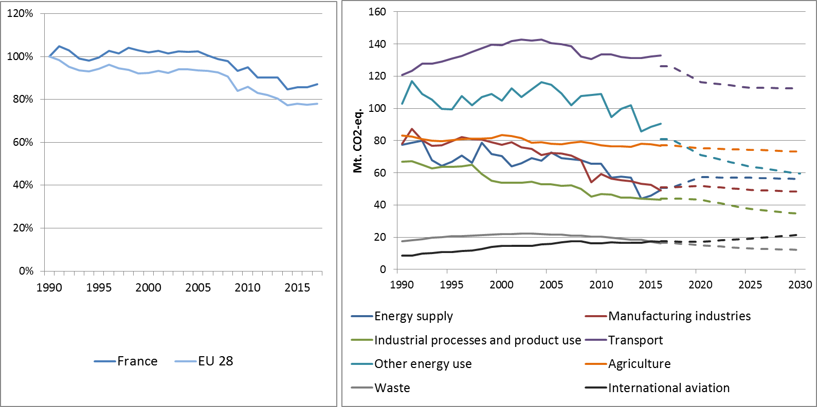

Figure 1: Left hand side: Total greenhouse gas emissions[21] 1990-2017 (index 1990 = 100 %). Right hand side: Total greenhouse gas emissions by sector[22] – historical emissions 1990-2016, projections 2017-2030 (Mt CO2-eq.).

**Figure 2: Share of emissions covered by the ETS and the ESD (2016).[23]**

# 2. ETS emissions

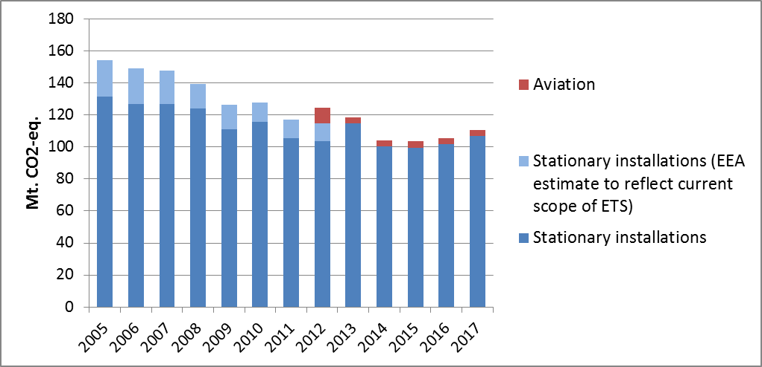

Figure 3: ETS emissions (Mt CO2-eq.).[24]

# 3. Emissions in Effort Sharing sectors

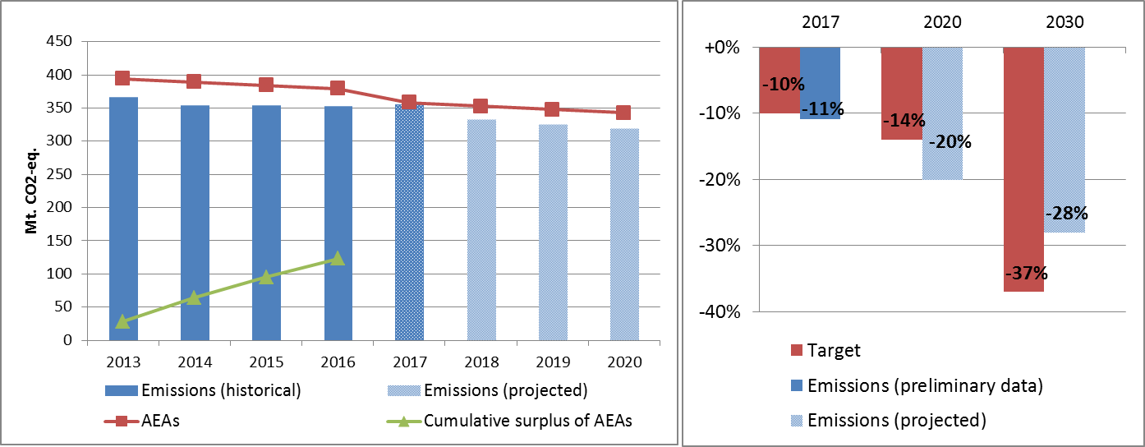

Figure 4: Left hand side: Emissions, annual emission allocations (AEAs) and accumulated surplus/ deficit of AEAs under the Effort Sharing Decision 2013-2020 (Mt CO2-eq.). Right hand side: Emissions and targets under the Effort Sharing Decision/ Effort Sharing Regulation 2017, 2020 and 2030 as percentage change from 2005.

# 4. Land use, land use change and forestry

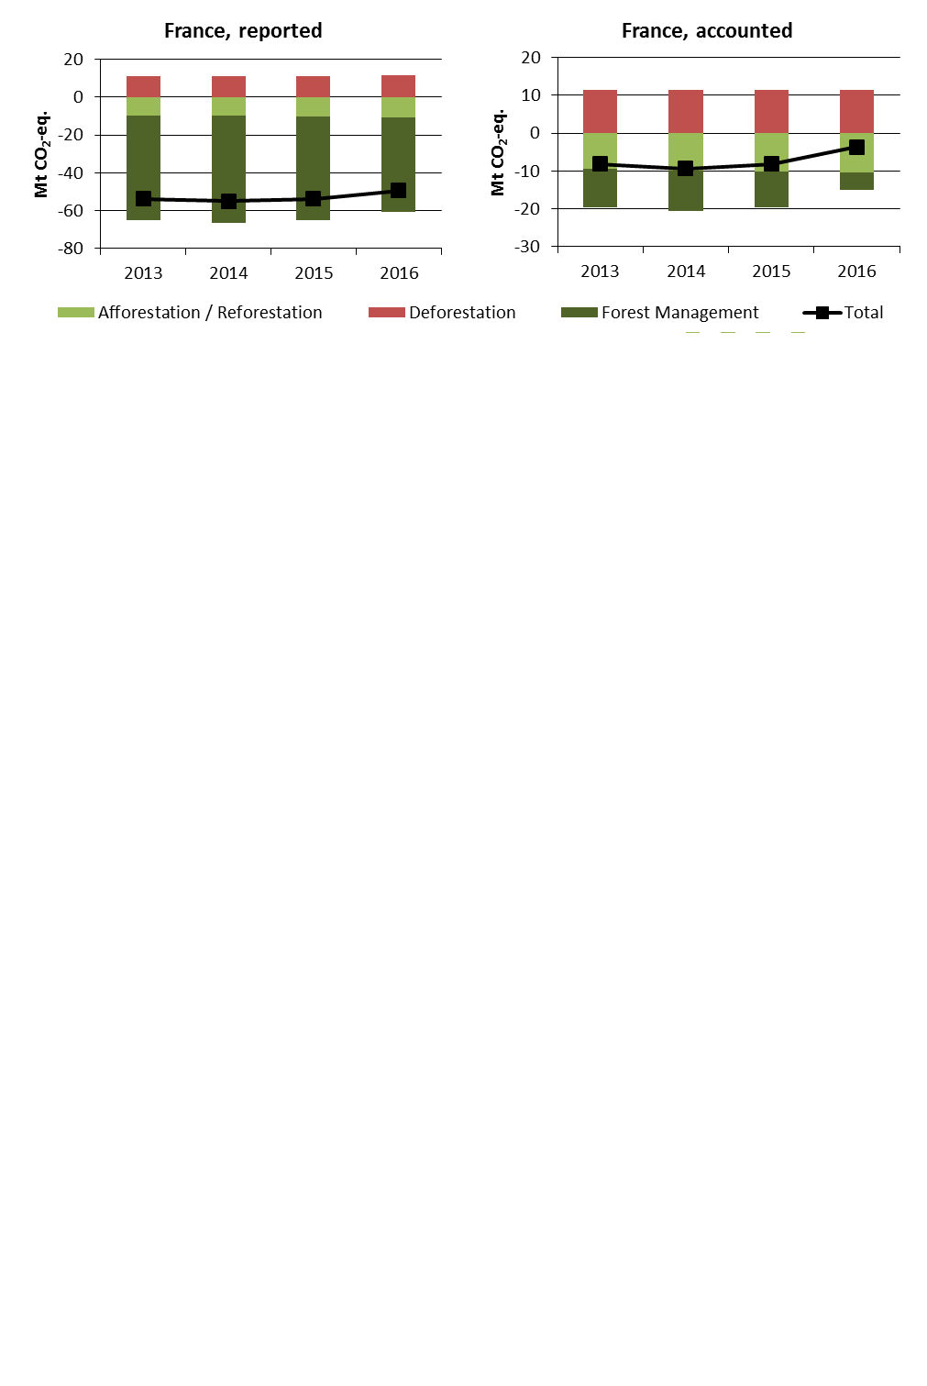

Figure 5: Reported and accounted emissions and removals from LULUCF (Mt CO2-eq.)[25]

Reported quantities under the Kyoto Protocol for France show net removals of, on average, -53.0 Mt CO2-eq for the period 2013 to 2016. In this regard France contributes with 13.8% to the annual average sink of -384.4 Mt CO2-eq of the EU-28. Accounting for the same period depicts net credits of, on average, -7.3 Mt CO2-eq, which corresponds to 6.4% of the EU-28 accounted sink of -115.7 Mt CO2-eq. Reported net removals and accounted net credits show a decreasing trend since 2014.

1. National total, including international aviation.
2. The sectors in the figure correspond to the following IPCC sectors: Energy supply: 1A1, 1B and 1C. Manufacturing industries: 1A2. Industrial processes and product use: 2. Transport: 1A3. Other energy use: 1A4, 1A5 and 6. Agriculture: 3. Waste: 5. International aviation: memo item.
3. Excluding international aviation, CO2 from domestic aviation and NF3.
4. The scope of ETS was extended from 2013. To reflect the current scope of ETS, estimates made by EEA are included in the figures from 2005 to 2012. The estimates cover only emissions from stationary installations.
5. The differences between reported and accounted emissions from LULUCF under the Kyoto Protocol are described in part 1b.
6. National total, including international aviation.
7. The sectors in the figure correspond to the following IPCC sectors: Energy supply: 1A1, 1B and 1C. Manufacturing industries: 1A2. Industrial processes and product use: 2. Transport: 1A3. Other energy use: 1A4, 1A5 and 6. Agriculture: 3. Waste: 5. International aviation: memo item.
8. Excluding international aviation, CO2 from domestic aviation and NF3.
9. The scope of ETS was extended from 2013. To reflect the current scope of ETS, estimates made by EEA are included in the figures from 2005 to 2012. The estimates cover only emissions from stationary installations.
10. The differences between reported and accounted emissions from LULUCF under the Kyoto Protocol are described in part 1b.
11. National total, including international aviation.
12. The sectors in the figure correspond to the following IPCC sectors: Energy supply: 1A1, 1B and 1C. Manufacturing industries: 1A2. Industrial processes and product use: 2. Transport: 1A3. Other energy use: 1A4, 1A5 and 6. Agriculture: 3. Waste: 5. International aviation: memo item.
13. Excluding international aviation, CO2 from domestic aviation and NF3.
14. The scope of ETS was extended from 2013. To reflect the current scope of ETS, estimates made by EEA are included in the figures from 2005 to 2012. The estimates cover only emissions from stationary installations.
15. The differences between reported and accounted emissions from LULUCF under the Kyoto Protocol are described in part 1b.
16. National total, including international aviation.
17. The sectors in the figure correspond to the following IPCC sectors: Energy supply: 1A1, 1B and 1C. Manufacturing industries: 1A2. Industrial processes and product use: 2. Transport: 1A3. Other energy use: 1A4, 1A5 and 6. Agriculture: 3. Waste: 5. International aviation: memo item.
18. Excluding international aviation, CO2 from domestic aviation and NF3.
19. The scope of ETS was extended from 2013. To reflect the current scope of ETS, estimates made by EEA are included in the figures from 2005 to 2012. The estimates cover only emissions from stationary installations.
20. The differences between reported and accounted emissions from LULUCF under the Kyoto Protocol are described in part 1b.
21. National total, including international aviation.
22. The sectors in the figure correspond to the following IPCC sectors: Energy supply: 1A1, 1B and 1C. Manufacturing industries: 1A2. Industrial processes and product use: 2. Transport: 1A3. Other energy use: 1A4, 1A5 and 6. Agriculture: 3. Waste: 5. International aviation: memo item.
23. Excluding international aviation, CO2 from domestic aviation and NF3.
24. The scope of ETS was extended from 2013. To reflect the current scope of ETS, estimates made by EEA are included in the figures from 2005 to 2012. The estimates cover only emissions from stationary installations.
25. The differences between reported and accounted emissions from LULUCF under the Kyoto Protocol are described in part 1b.