

Contents

*Part 1: Country fact sheets* 3

Country fact sheet: Austria 4

Country fact sheet: Belgium 7

Country fact sheet: Bulgaria 10

Country fact sheet: Croatia 13

Country fact sheet: Cyprus 16

Country fact sheet: Czech Republic 19

Country fact sheet: Denmark 22

Country fact sheet: Estonia 25

Country fact sheet: Finland 28

Country fact sheet: France 31

Country fact sheet: Germany 34

Country fact sheet: Greece 37

Country fact sheet: Hungary 40

Country fact sheet: Ireland 43

Country fact sheet: Italy 46

Country fact sheet: Latvia 49

Country fact sheet: Lithuania 52

Country fact sheet: Luxembourg 55

Country fact sheet: Malta 58

Country fact sheet: Netherlands 61

Country fact sheet: Poland 64

Country fact sheet: Portugal 67

Country fact sheet: Romania 70

Country fact sheet: Slovakia 73

Country fact sheet: Slovenia 76

Country fact sheet: Spain 79

Country fact sheet: Sweden 82

Country fact sheet: United Kingdom 85

Data sources for country fact sheets 88

Part 1B: Explanatory text on land use land use change and forestry – reported and accounted emissions under the Kyoto protocol 89

*Part 2: Other technical information* 90

1. Overview of EU climate targets 91

2. Greenhouse gas emissions covered by the Kyoto Protocol and the EU Climate and Energy package 95

3. EU greenhouse gas emissions by sector 96

4. Greenhouse gas intensity in the EU and its Member States 98

5. Greenhouse gas emissions per capita in the EU and its Member States 99

6. EU ETS emissions 100

7. Emissions covered by the effort-sharing legislation 101

8. Use of revenues from auctioning of ETS allowances 107

## 

## *Part 1: Country fact sheets*

Country fact sheet: Austria

# 1. Total greenhouse gas emissions

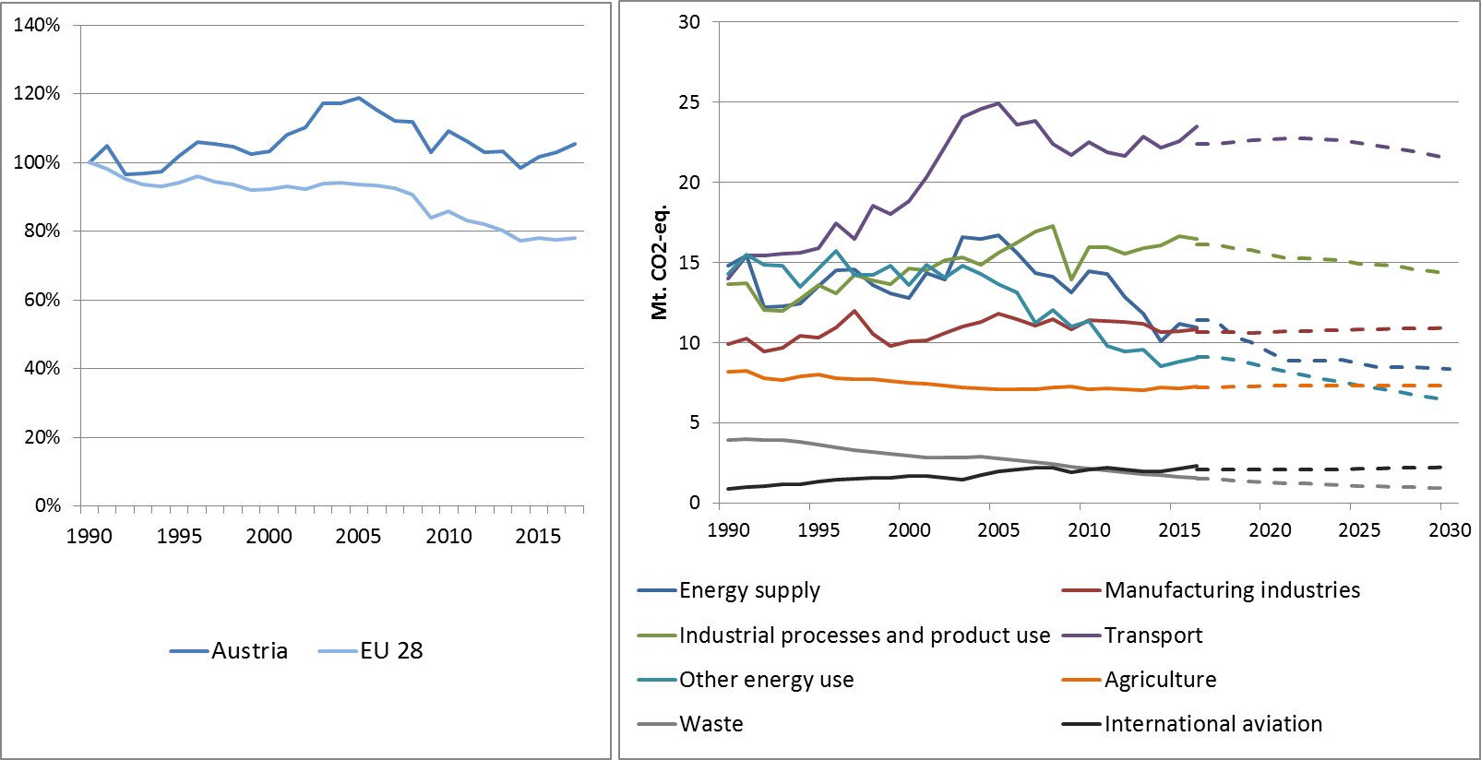

Figure 1: Left hand side: Total greenhouse gas emissions[1] 1990-2017 (index 1990 = 100 %). Right hand side: Total greenhouse gas emissions by sector[2] – historical emissions 1990-2016, projections 2017-2030 (Mt CO2-eq.).

Figure 2: Share of emissions covered by the ETS and the ESD (2016).[3]

# 4. ETS emissions

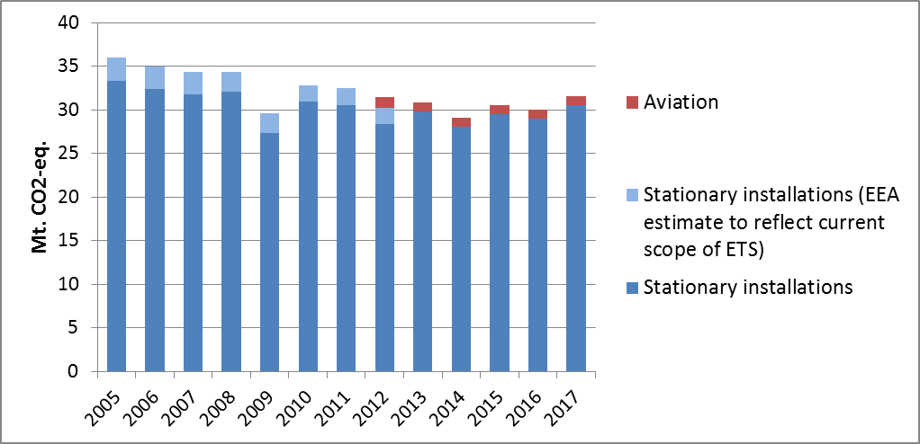

Figure 3: ETS emissions (Mt CO2-eq.).[4]

# 3. Emissions in Effort Sharing sectors

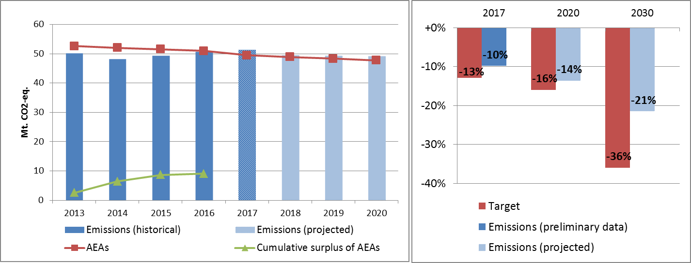

Figure 4: Left hand side: Emissions, annual emission allocations (AEAs) and accumulated surplus/ deficit of AEAs under the Effort Sharing Decision 2013-2020 (Mt CO2-eq.). Right hand side: Emissions and targets under the Effort Sharing Decision/ Effort Sharing Regulation 2017, 2020 and 2030 as percentage change from 2005.

# 4. Land use, land use change and forestry

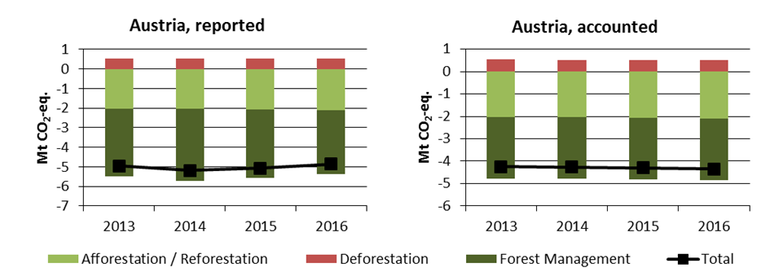

Figure 5: Reported and accounted emissions and removals from LULUCF (Mt CO2-eq.)[5]

Reported quantities under the Kyoto Protocol for Austria show net removals of, on average, -5.0 Mt CO2-eq for the period 2013 to 2016. In this regard Austria contributes with 1.3% to the annual average sink of -384.4 Mt CO2-eq of the EU-28. Accounting for the same period depicts net credits of, on average, -4.3 Mt CO2-eq, which corresponds to 3.7% of the EU-28 accounted sink of -115.7 Mt CO2-eq. Reported net removals are highest for 2014 and decreased slightly over the following years, while accounted net credits show no notable trend. In this preliminary simulated accounting exercise potential credits by Forest Management of, on average, -2.8 Mt CO2-eq per year are capped to -2.7 Mt CO2-eq per year. Austria is one of eight EU Member States which exceed the cap of 3.5% from emissions of the base year (1990).

Country fact sheet: Belgium

# 1. Total greenhouse gas emissions

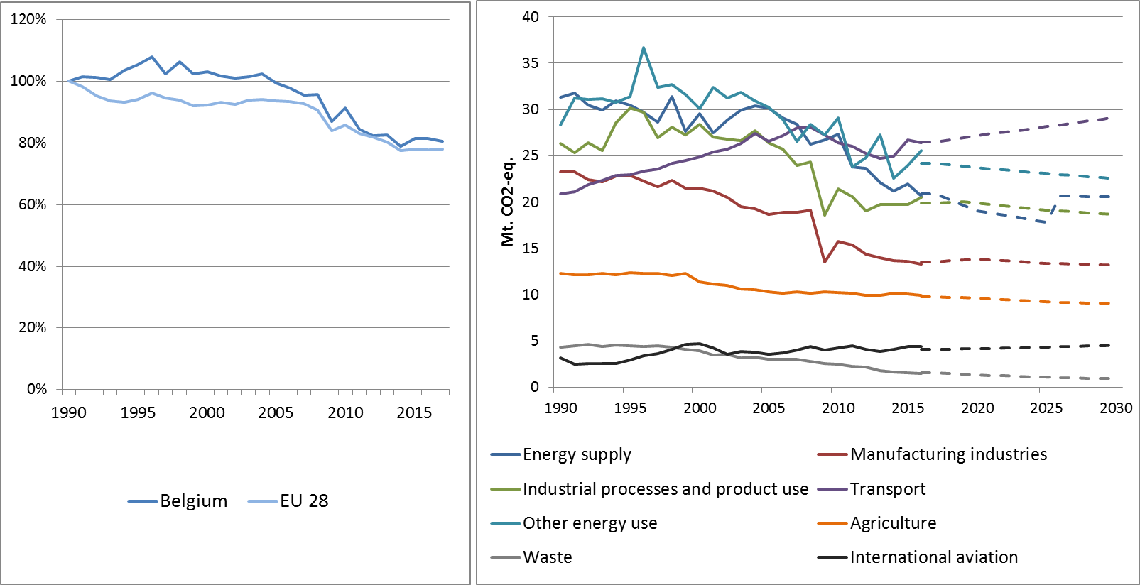

Figure 1: Left hand side: Total greenhouse gas emissions[6] 1990-2017 (index 1990 = 100 %). Right hand side: Total greenhouse gas emissions by sector[7] – historical emissions 1990-2016, projections 2017-2030 (Mt CO2-eq.).

**Figure 2: Share of emissions covered by the ETS and the ESD (2016).[8]**

# 4. ETS emissions

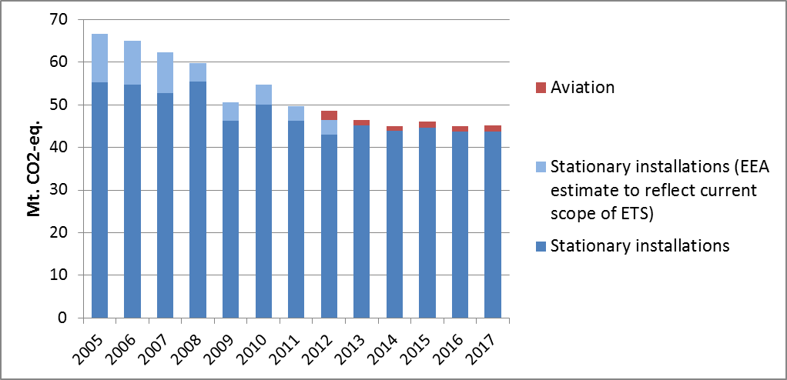

Figure 3: ETS emissions (Mt CO2-eq.).[9]

# 3. Emissions in Effort Sharing sectors

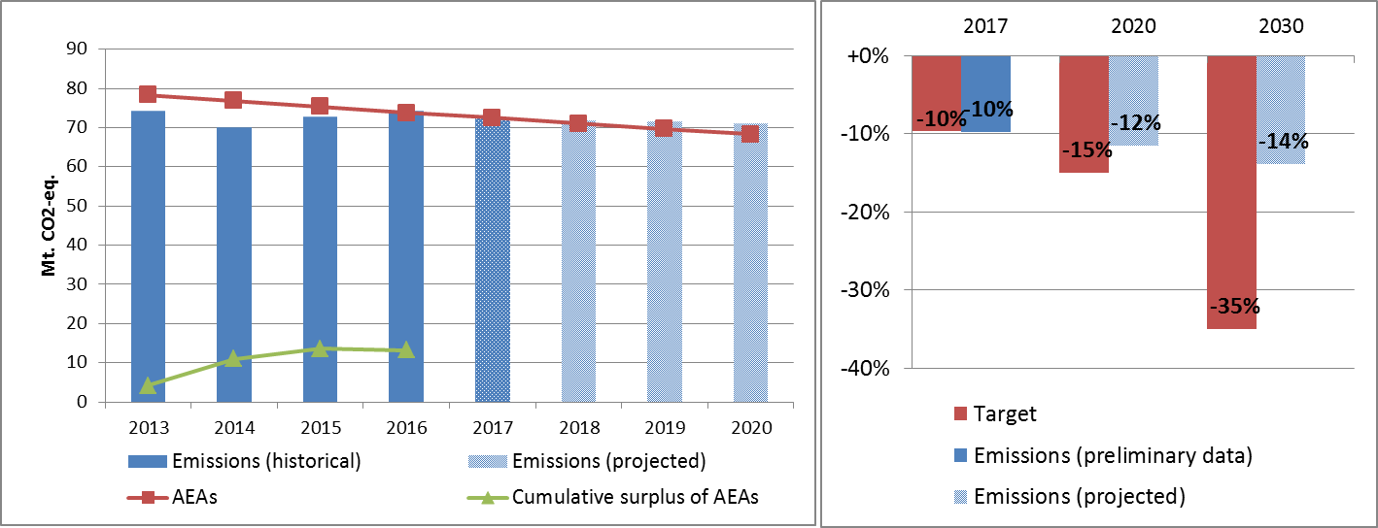

Figure 4: Left hand side: Emissions, annual emission allocations (AEAs) and accumulated surplus/ deficit of AEAs under the Effort Sharing Decision 2013-2020 (Mt CO2-eq.). Right hand side: Emissions and targets under the Effort Sharing Decision/ Effort Sharing Regulation 2017, 2020 and 2030 as percentage change from 2005.

# 4. Land use, land use change and forestry

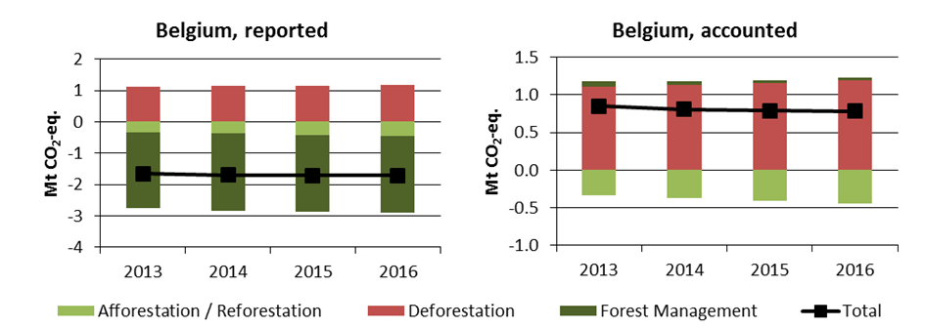

Figure 5: Reported and accounted emissions and removals from LULUCF (Mt CO2-eq.)[10]

Reported quantities under the Kyoto Protocol for Belgium show net removals of, on average, -1.7 Mt CO2-eq for the period 2013 to 2016. In this regard Belgium contributes with 0.4% to the annual average sink of -384.4 Mt CO2-eq of the EU-28. Accounting for the same period depicts net debits of, on average, 0.8 Mt CO2-eq, which corresponds to a negative contribution of -0.7% of the EU-28 accounted sink of -115.7 Mt CO2-eq. Belgium is one of six EU Member States which show net debits in this preliminary accounting exercise. Reported net removals show no notable trend, while accounted net debits depict slight decreases.

Country fact sheet: Bulgaria

# 1. Total greenhouse gas emissions

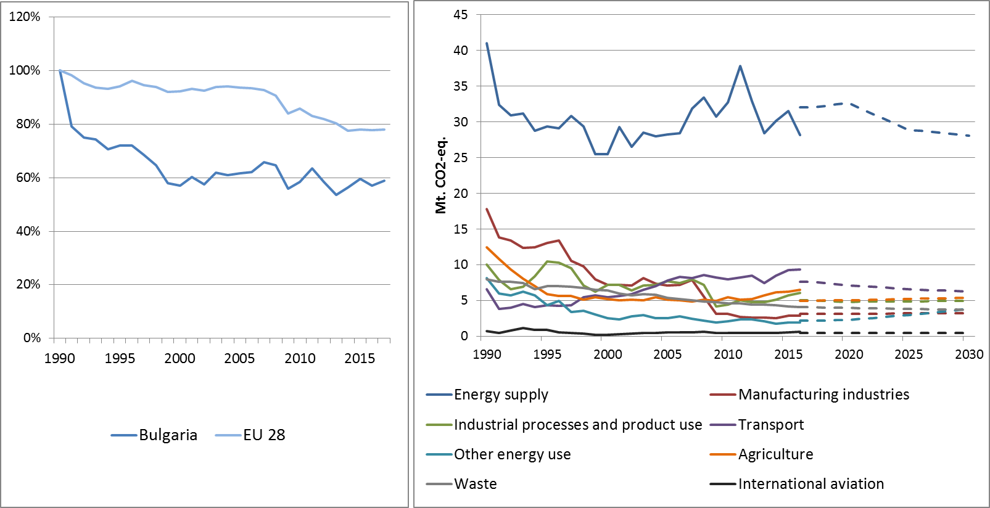

Figure 1: Left hand side: Total greenhouse gas emissions[11] 1990-2017 (index 1990 = 100 %). Right hand side: Total greenhouse gas emissions by sector[12] – historical emissions 1990-2016, projections 2017-2030 (Mt CO2-eq.).

**Figure 2: Share of emissions covered by the ETS and the ESD (2016).[13]**

# 2. ETS emissions

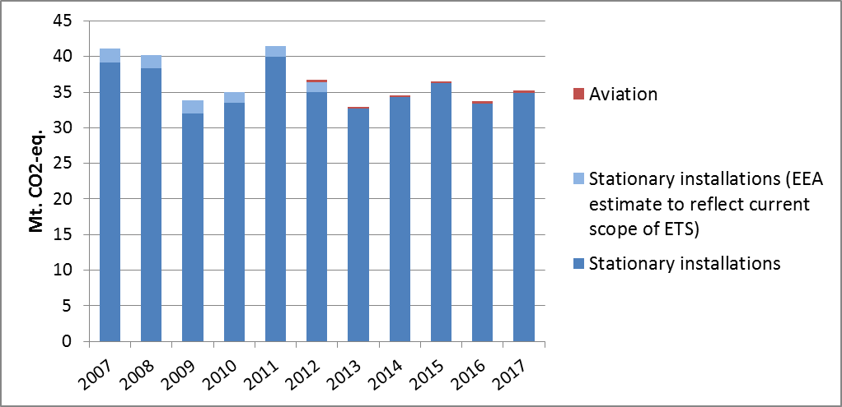

Figure 3: ETS emissions (Mt CO2-eq.).[14]

# 3. Emissions in Effort Sharing sectors

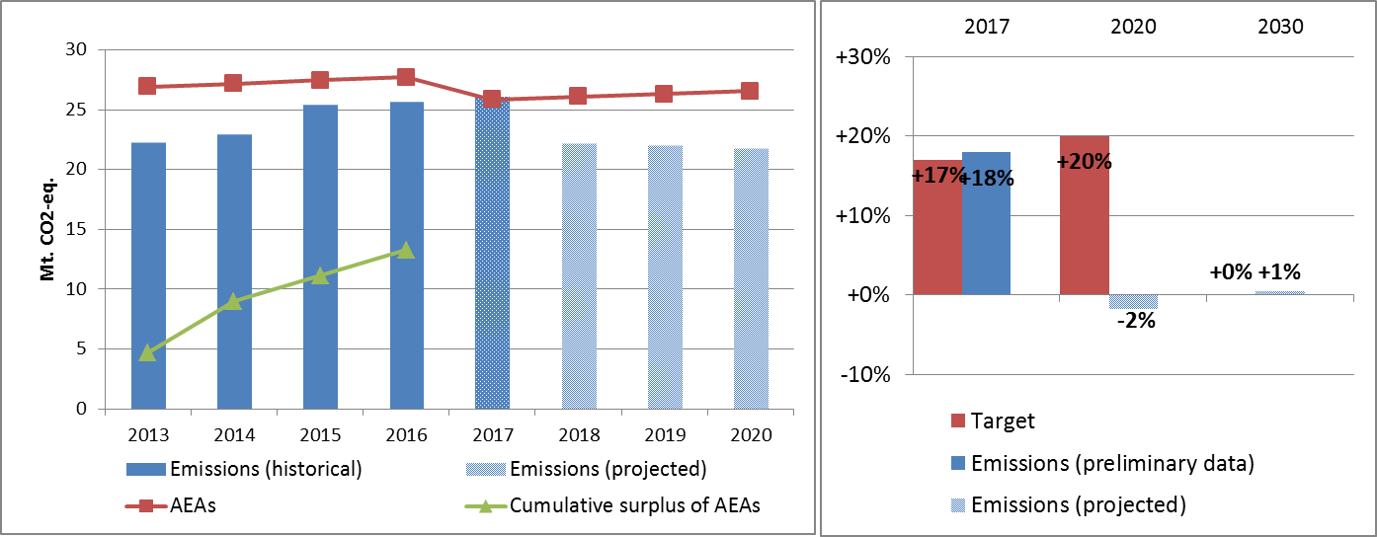

Figure 4: Left hand side: Emissions, annual emission allocations (AEAs) and accumulated surplus/ deficit of AEAs under the Effort Sharing Decision 2013-2020 (Mt CO2-eq.). Right hand side: Emissions and targets under the Effort Sharing Decision/ Effort Sharing Regulation 2017, 2020 and 2030 as percentage change from 2005.

# 4. Land use, land use change and forestry

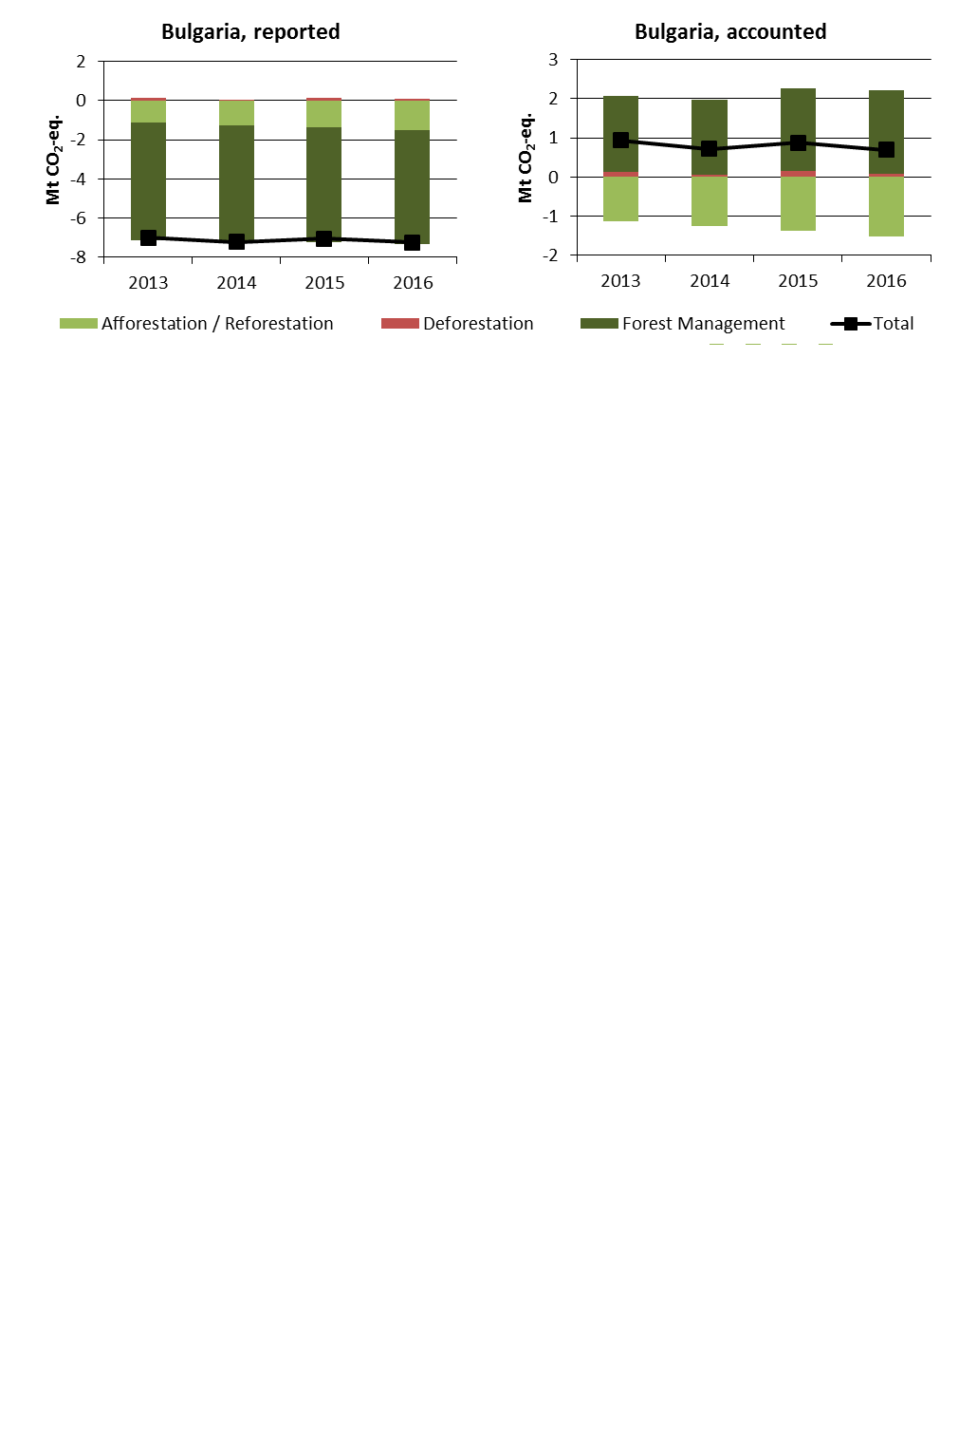

Figure 5: Reported and accounted emissions and removals from LULUCF (Mt CO2-eq.)[15]

Reported quantities under the Kyoto Protocol for Bulgaria show net removals of, on average, -7.1 Mt CO2-eq for the period 2013 to 2016. In this regard Bulgaria contributes with 1.9% to the annual average sink of -384.4 Mt CO2-eq of the EU-28. Accounting for the same period depicts net debits of, on average, 0.8 Mt CO2-eq, which corresponds to a negative contribution of -0.7% of the EU-28 accounted sink of -115.7 Mt CO2-eq. Bulgaria is one of six EU Member States which show net debits in this preliminary accounting exercise. Reported net removals show minor variations with no trend, while accounted net debits depict the same variation with slight decreasing tendencies.

Country fact sheet: Croatia

# 1. Total greenhouse gas emissions

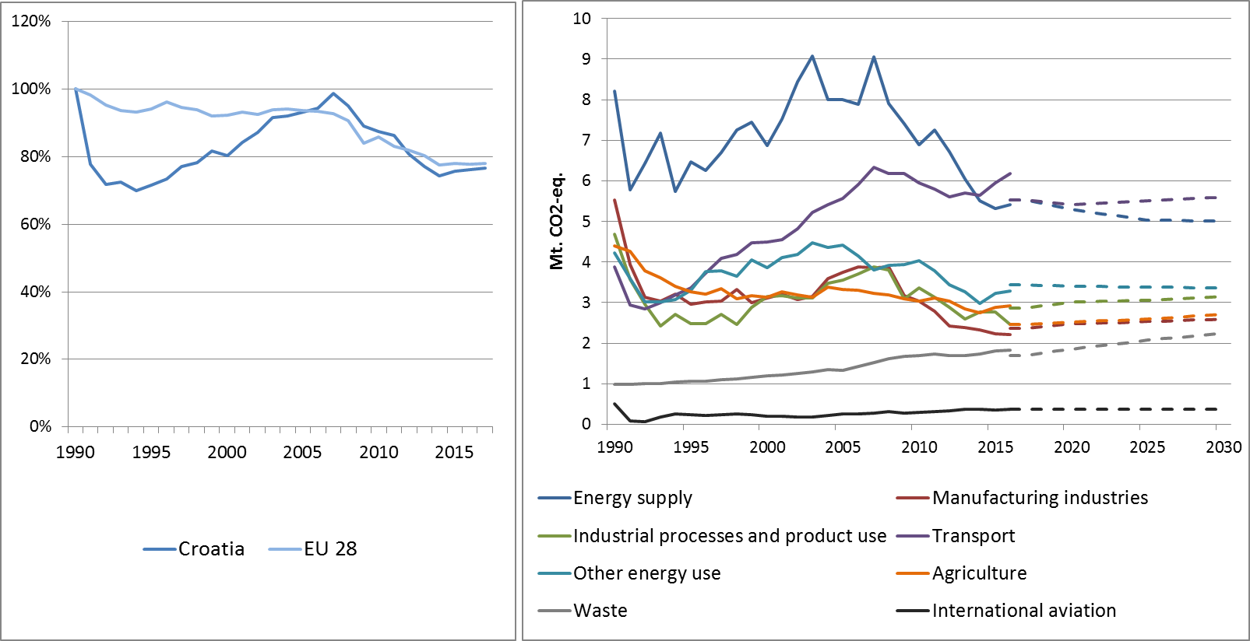

Figure 1: Left hand side: Total greenhouse gas emissions[16] 1990-2017 (index 1990 = 100 %). Right hand side: Total greenhouse gas emissions by sector[17] – historical emissions 1990-2016, projections 2017-2030 (Mt CO2-eq.).

Figure 2: Share of emissions covered by the ETS and the ESD (2016).[18]

# 2. ETS emissions

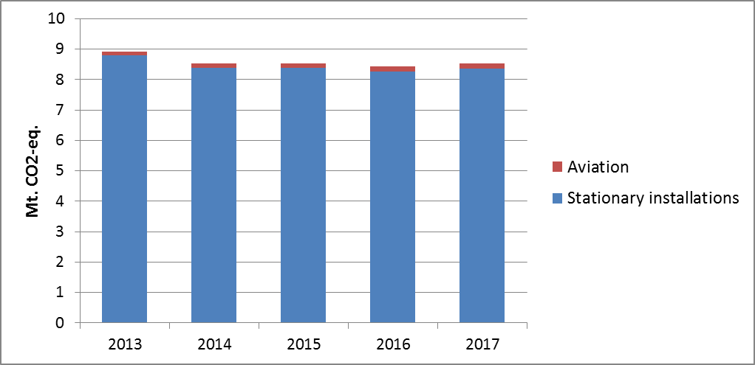

Figure 3: ETS emissions (Mt CO2-eq.).[19]

# 3. Emissions in Effort Sharing sectors

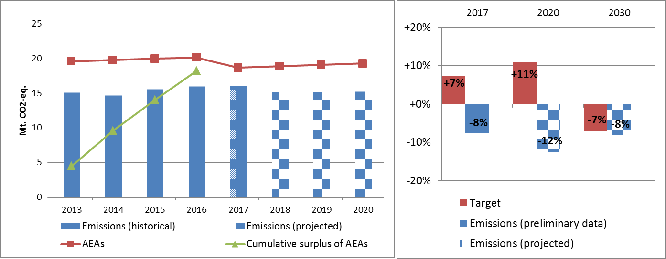

Figure 4: Left hand side: Emissions, annual emission allocations (AEAs) and accumulated surplus/ deficit of AEAs under the Effort Sharing Decision 2013-2020 (Mt CO2-eq.). Right hand side: Emissions and targets under the Effort Sharing Decision/ Effort Sharing Regulation 2017, 2020 and 2030 as percentage change from 2005.

# 4. Land use, land use change and forestry

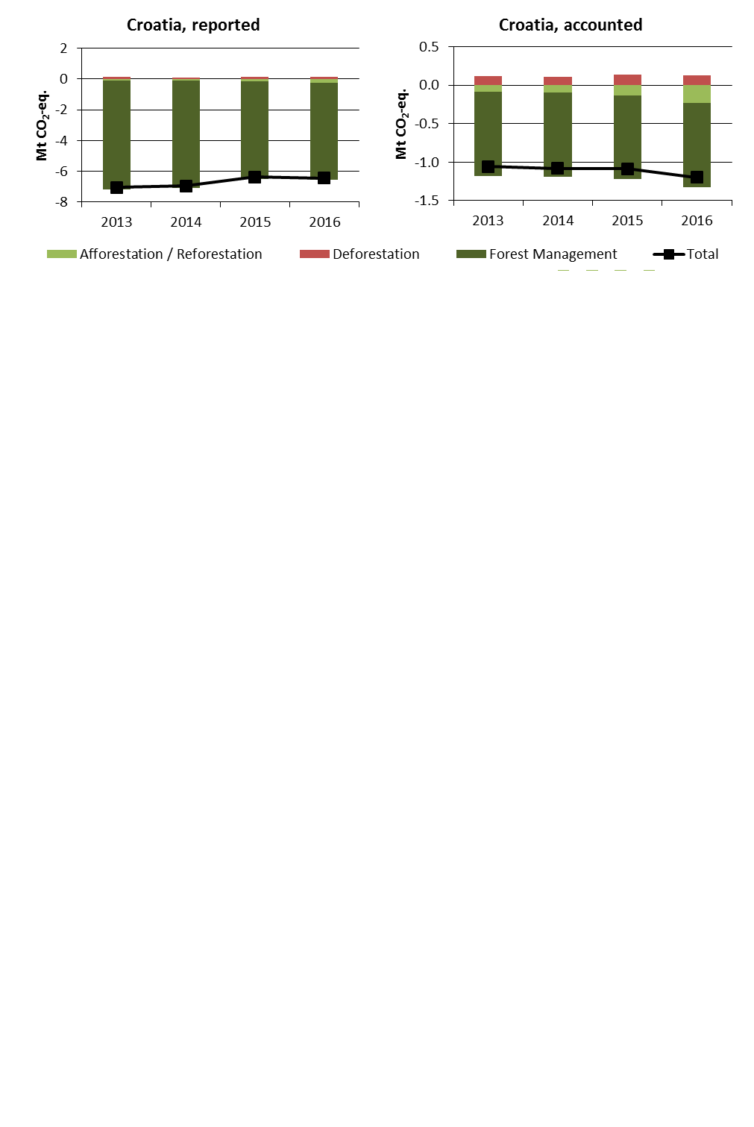

Figure 5: Reported and accounted emissions and removals from LULUCF (Mt CO2-eq.)[20]

Reported quantities under the Kyoto Protocol for Croatia show net removals of, on average, -6.7 Mt CO2-eq for the period 2013 to 2016. In this regard Croatia contributes with 1.7% to the annual average sink of -384.4 Mt CO2-eq of the EU-28. Accounting for the same period depicts net credits of, on average, -1.1 Mt CO2-eq, which corresponds to 1.0% of the EU-28 accounted sink of -115.7 Mt CO2-eq. Reported net removals show a decrease between 2014 and 2015, while accounted net credits reveal an increase for 2016. In this preliminary simulated accounting exercise potential credits by Forest Management of, on average, -1.3 Mt CO2-eq per year are capped to -1.1 Mt CO2-eq per year. Croatia is one of eight EU Member States which exceed the cap of 3.5% from emissions of the base year (1990).

Country fact sheet: Cyprus

# 1. Total greenhouse gas emissions

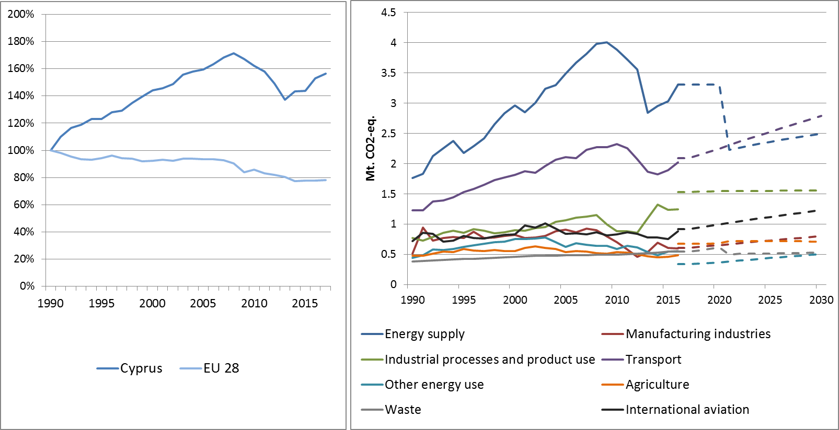

**Figure 1: Left hand side: Total greenhouse gas emissions[21] 1990-2017 (index 1990 = 100 %). Right hand side: Total greenhouse gas emissions by sector[22] – historical emissions 1990-2016, projections 2017-2030 (Mt CO2-eq.).**

**Figure 2: Share of emissions covered by the ETS and the ESD (2016).[23]**

# 2. ETS emissions

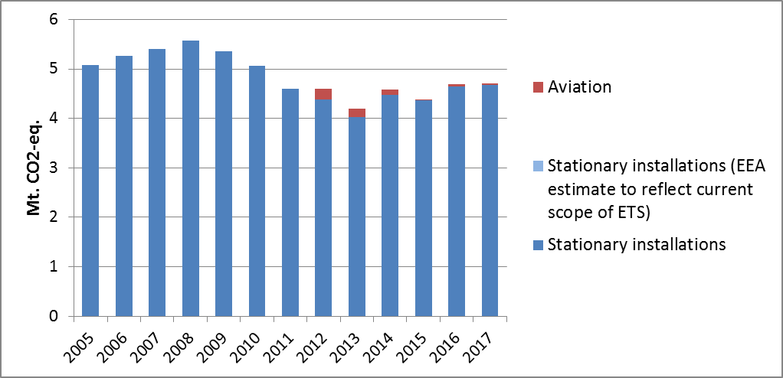

Figure 3: ETS emissions (Mt CO2-eq.).[24]

# 3. Emissions in Effort Sharing sectors

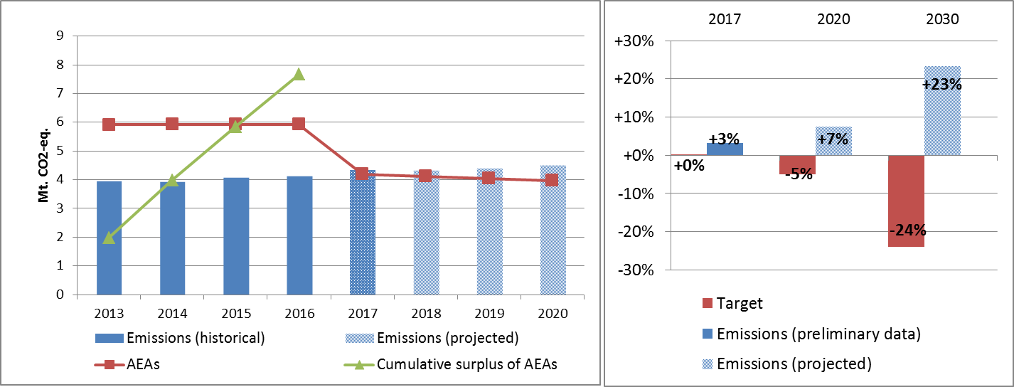

Figure 4: Left hand side: Emissions, annual emission allocations (AEAs) and accumulated surplus/ deficit of AEAs under the Effort Sharing Decision 2013-2020 (Mt CO2-eq.). Right hand side: Emissions and targets under the Effort Sharing Decision/ Effort Sharing Regulation 2017, 2020 and 2030 as percentage change from 2005.

# 4. Land use, land use change and forestry

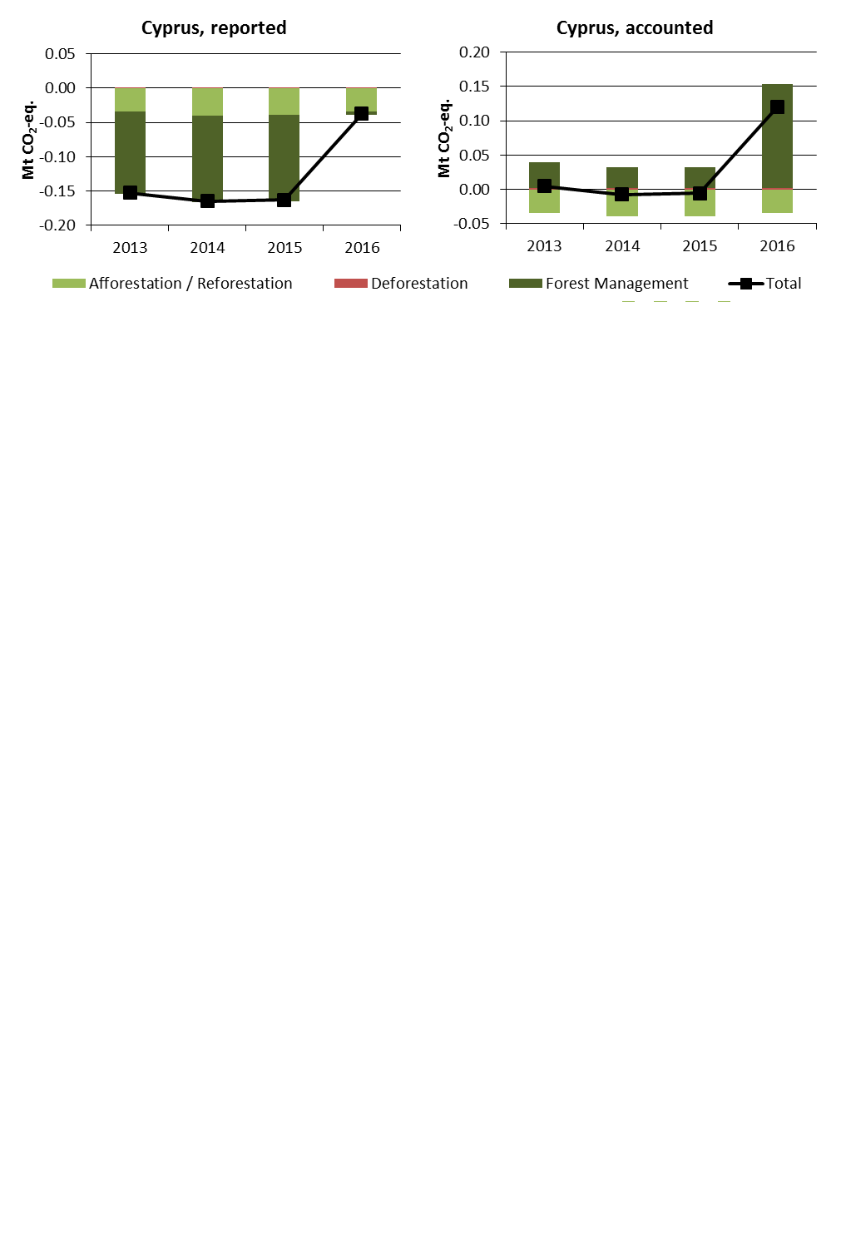

Figure 5: Reported and accounted emissions and removals from LULUCF (Mt CO2-eq.)[25]

Reported quantities under the Kyoto Protocol for Cyprus show net removals of, on average, -0.13 Mt CO2-eq for the period 2013 to 2016. In this regard Cyprus contributes with 0.03% to the annual average sink of -384.4 Mt CO2-eq of the EU-28. Accounting for the same period depicts net debits of, on average, 0.03 Mt CO2-eq, which corresponds to a negative contribution of -0.02% of the EU-28 accounted sink of -115.7 Mt CO2-eq. Cyprus is one of six EU Member States which show net debits in this preliminary accounting exercise. Reported net removals were highly similar for 2013 to 2015 but decrease markedly for 2016. This pattern is replicated for accounted quantities with a net zero or very small net credits from 2013 to 2015 and net debits for 2016.

1. National total, including international aviation.
2. The sectors in the figure correspond to the following IPCC sectors: Energy supply: 1A1, 1B and 1C. Manufacturing industries: 1A2. Industrial processes and product use: 2. Transport: 1A3. Other energy use: 1A4, 1A5 and 6. Agriculture: 3. Waste: 5. International aviation: memo item.
3. Excluding international aviation, CO2 from domestic aviation and NF3.
4. The scope of ETS was extended from 2013. To reflect the current scope of ETS, estimates made by EEA are included in the figures from 2005 to 2012. The estimates cover only emissions from stationary installations.
5. The differences between reported and accounted emissions from LULUCF under the Kyoto Protocol are described in part 1b.
6. National total, including international aviation.
7. The sectors in the figure correspond to the following IPCC sectors: Energy supply: 1A1, 1B and 1C. Manufacturing industries: 1A2. Industrial processes and product use: 2. Transport: 1A3. Other energy use: 1A4, 1A5 and 6. Agriculture: 3. Waste: 5. International aviation: memo item.
8. Excluding international aviation, CO2 from domestic aviation and NF3.
9. The scope of ETS was extended from 2013. To reflect the current scope of ETS, estimates made by EEA are included in the figures from 2005 to 2012. The estimates cover only emissions from stationary installations.
10. The differences between reported and accounted emissions from LULUCF under the Kyoto Protocol are described in part 1b.
11. National total, including international aviation.
12. The sectors in the figure correspond to the following IPCC sectors: Energy supply: 1A1, 1B and 1C. Manufacturing industries: 1A2. Industrial processes and product use: 2. Transport: 1A3. Other energy use: 1A4, 1A5 and 6. Agriculture: 3. Waste: 5. International aviation: memo item.
13. Excluding international aviation, CO2 from domestic aviation and NF3.
14. The scope of ETS was extended from 2013. To reflect the current scope of ETS, estimates made by EEA are included in the figures from 2007 to 2012. The estimates cover only emissions from stationary installations. Bulgaria joined the EU ETS in 2007.
15. The differences between reported and accounted emissions from LULUCF under the Kyoto Protocol are described in part 1b.
16. National total, including international aviation.
17. The sectors in the figure correspond to the following IPCC sectors: Energy supply: 1A1, 1B and 1C. Manufacturing industries: 1A2. Industrial processes and product use: 2. Transport: 1A3. Other energy use: 1A4, 1A5 and 6. Agriculture: 3. Waste: 5. International aviation: memo item.
18. Excluding international aviation, CO2 from domestic aviation and NF3.
19. Croatia joined the ETS in 2013.
20. The differences between reported and accounted emissions from LULUCF under the Kyoto Protocol are described in part 1b.
21. National total, including international aviation.
22. The sectors in the figure correspond to the following IPCC sectors: Energy supply: 1A1, 1B and 1C. Manufacturing industries: 1A2. Industrial processes and product use: 2. Transport: 1A3. Other energy use: 1A4, 1A5 and 6. Agriculture: 3. Waste: 5. International aviation: memo item.
23. Excluding international aviation, CO2 from domestic aviation and NF3.
24. The scope of ETS was extended from 2013. To reflect the current scope of ETS, estimates made by EEA are included in the figures from 2005 to 2012. The estimates cover only emissions from stationary installations.
25. The differences between reported and accounted emissions from LULUCF under the Kyoto Protocol are described in part 1b.