

Country fact sheet: Lithuania

# 1. Total greenhouse gas emissions

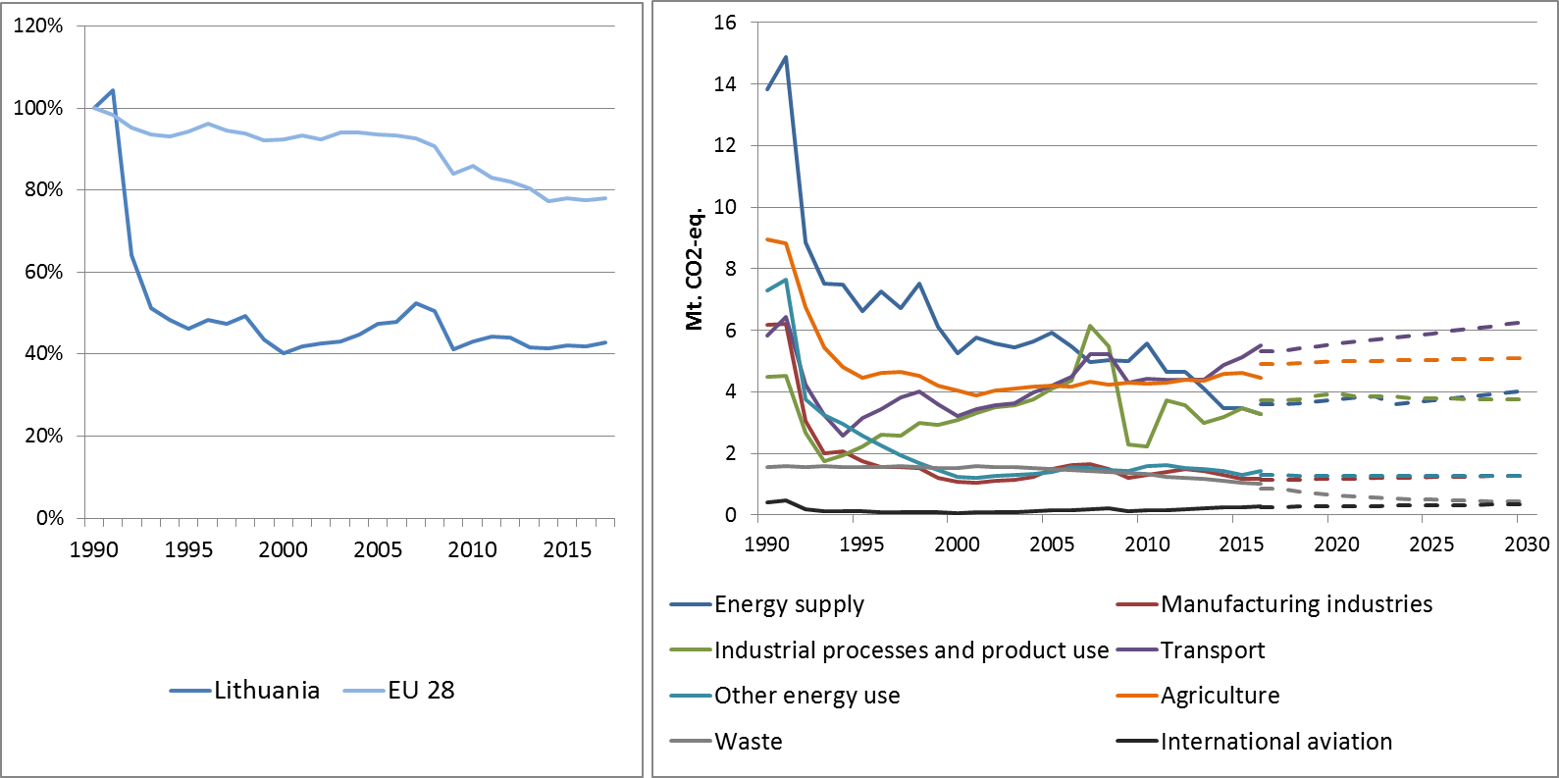

Figure 1: Left hand side: Total greenhouse gas emissions[1] 1990-2017 (index 1990 = 100 %). Right hand side: Total greenhouse gas emissions by sector[2] – historical emissions 1990-2016, projections 2017-2030 (Mt CO2-eq.).

**Figure 2: Share of emissions covered by the ETS and the ESD (2016).[3]**

# 2. ETS emissions

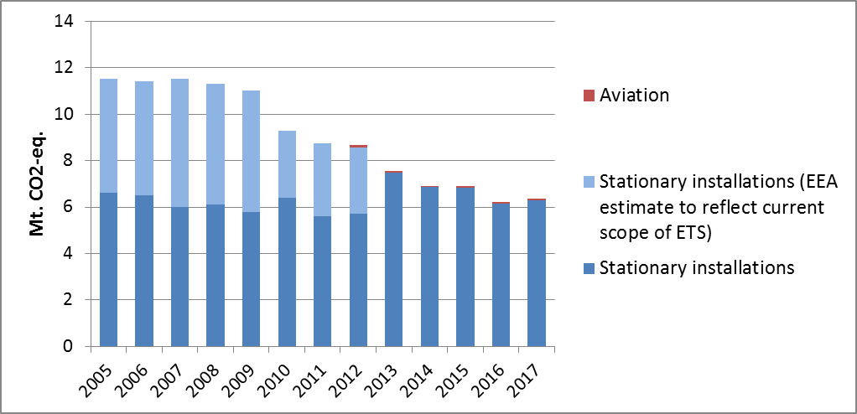

Figure 3: ETS emissions (Mt CO2-eq.).[4]

# 3. Emissions in Effort Sharing sectors

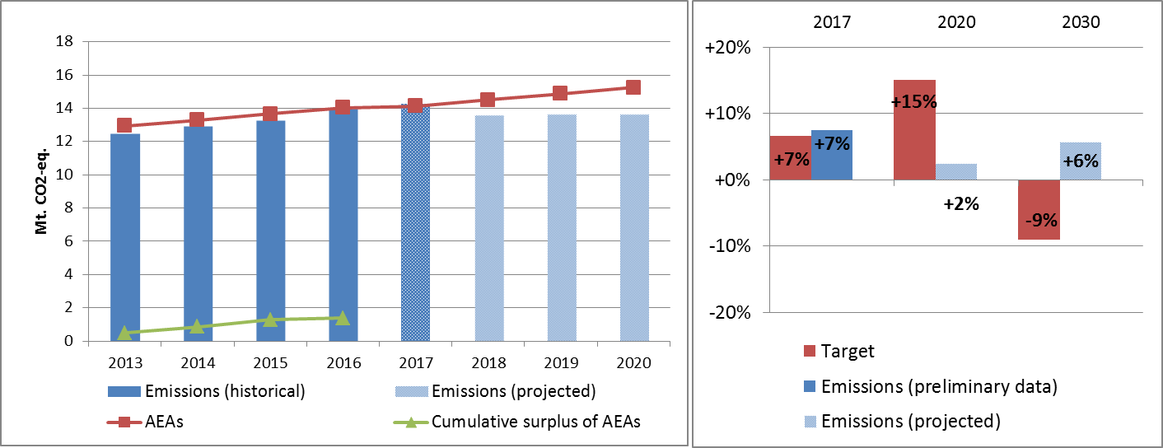

Figure 4: Left hand side: Emissions, annual emission allocations (AEAs) and accumulated surplus/ deficit of AEAs under the Effort Sharing Decision 2013-2020 (Mt CO2-eq.). Right hand side: Emissions and targets under the Effort Sharing Decision/ Effort Sharing Regulation 2017, 2020 and 2030 as percentage change from 2005.

# 4. Land use, land use change and forestry

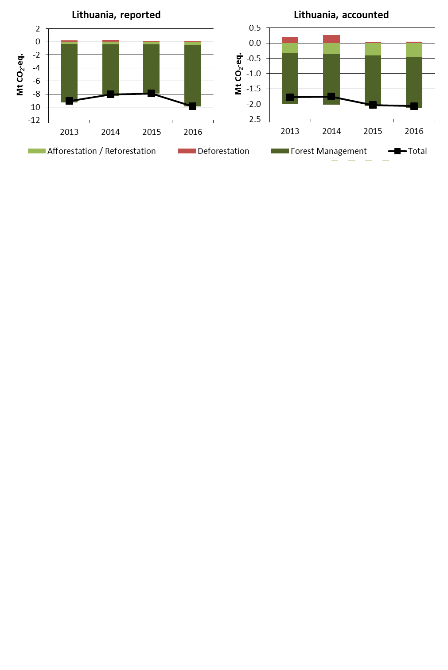

Figure 5: Reported and accounted emissions and removals from LULUCF (Mt CO2-eq.)[5]

Reported quantities under the Kyoto Protocol for Lithuania show net removals of, on average, -8.7 Mt CO2-eq for the period 2013 to 2016. In this regard Lithuania contributes with 2.3% to the annual average sink of -384.4 Mt CO2-eq of the EU-28. Accounting for the same period depicts net credits of, on average, -1.9 Mt CO2-eq, which corresponds to 1.7% of the EU-28 accounted sink of -115.7 Mt CO2-eq. Reported net removals decrease between 2013 and 2015 and markedly increase for 2016 while accounted net credits show an increasing trend. In this preliminary simulated accounting exercise potential credits by Forest Management of, on average, -3.0 Mt CO2-eq per year are capped to -1.7 Mt CO2-eq per year. Lithuania is one of eight EU Member States which exceed the cap of 3.5% from emissions of the base year (1990).

Country fact sheet: Luxembourg

# 1. Total greenhouse gas emissions

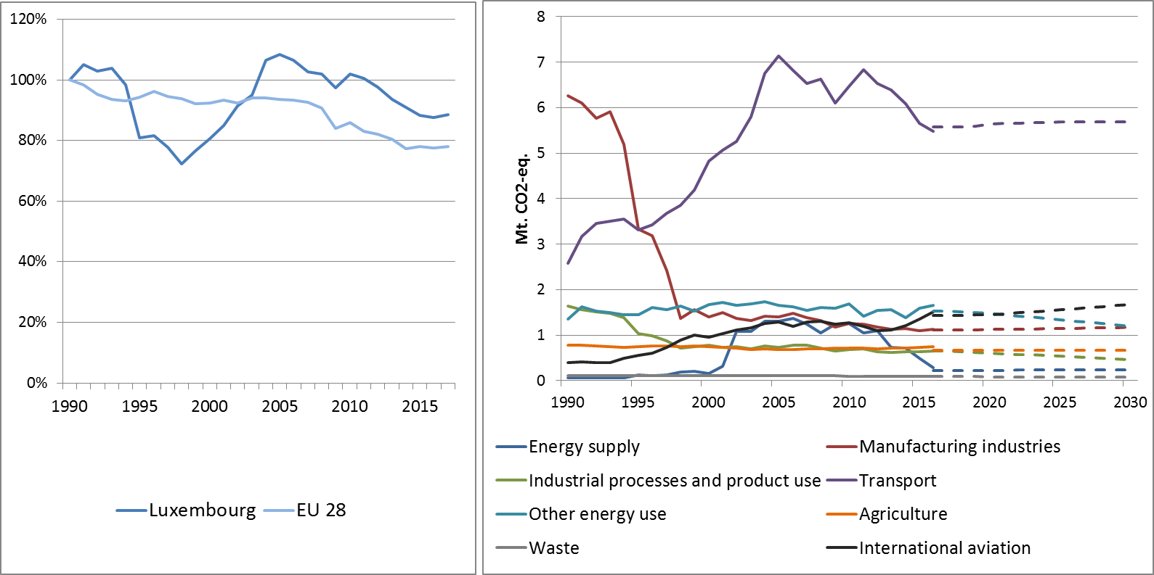

Figure 1: Left hand side: Total greenhouse gas emissions[6] 1990-2017 (index 1990 = 100 %). Right hand side: Total greenhouse gas emissions by sector[7] – historical emissions 1990-2016, projections 2017-2030 (Mt CO2-eq.).

**Figure 2: Share of emissions covered by the ETS and the ESD (2016).[8]**

# 2. ETS emissions

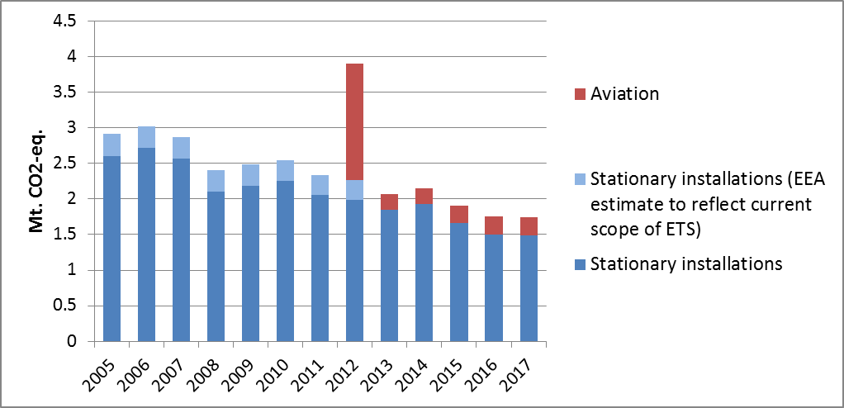

**Figure 3: ETS emissions (Mt CO2-eq.).[9]**

# 3. Emissions in Effort Sharing sectors

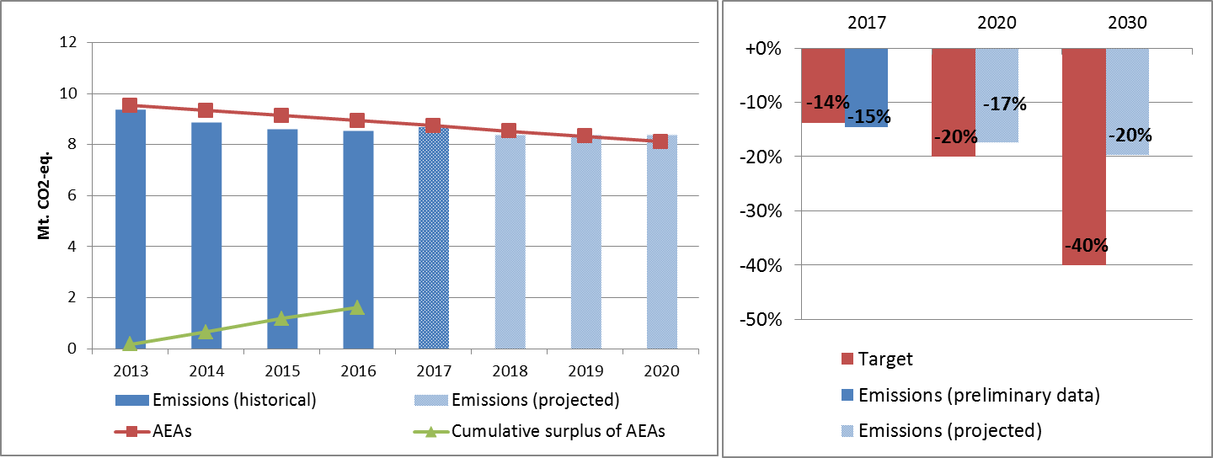

Figure 4: Left hand side: Emissions, annual emission allocations (AEAs) and accumulated surplus/ deficit of AEAs under the Effort Sharing Decision 2013-2020 (Mt CO2-eq.). Right hand side: Emissions and targets under the Effort Sharing Decision/ Effort Sharing Regulation 2017, 2020 and 2030 as percentage change from 2005.

# 4. Land use, land use change and forestry

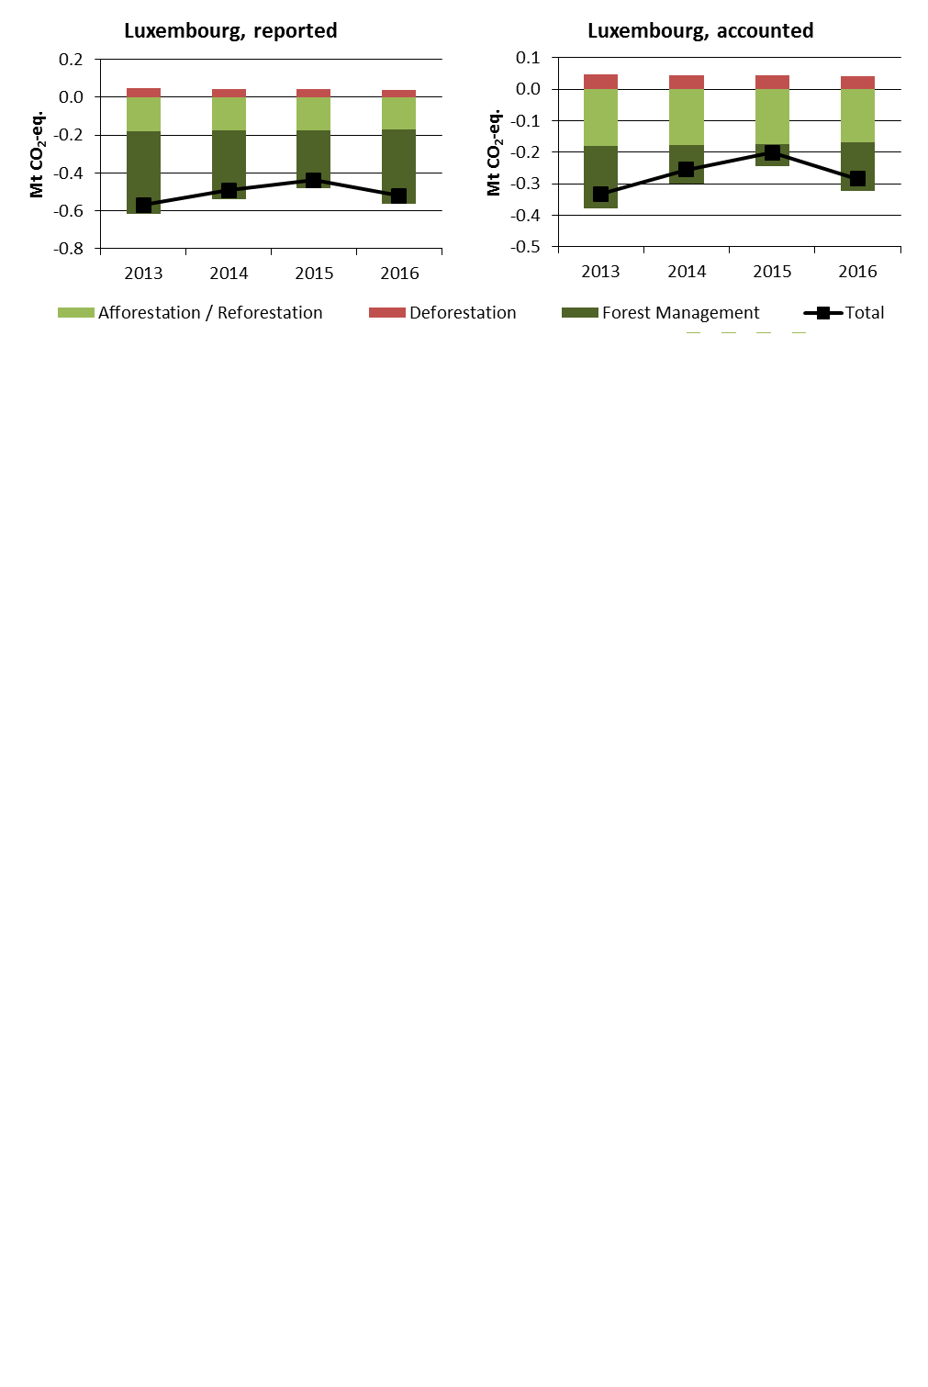

Figure 5: Reported and accounted emissions and removals from LULUCF (Mt CO2-eq.)[10]

Reported quantities under the Kyoto Protocol for Luxembourg show net removals of, on average, -0.5 Mt CO2-eq for the period 2013 to 2016. In this regard Luxembourg contributes with 0.13% to the annual average sink of -384.4 Mt CO2-eq of the EU-28. Accounting for the same period depicts net credits of, on average, -0.3 Mt CO2-eq, which corresponds to 0.2% of the EU-28 accounted sink of -115.7 Mt CO2-eq. Reported net removals and accounted net credits decrease between 2013 and 2015 and markedly increase for 2016.

Country fact sheet: Malta

# 1. Total greenhouse gas emissions

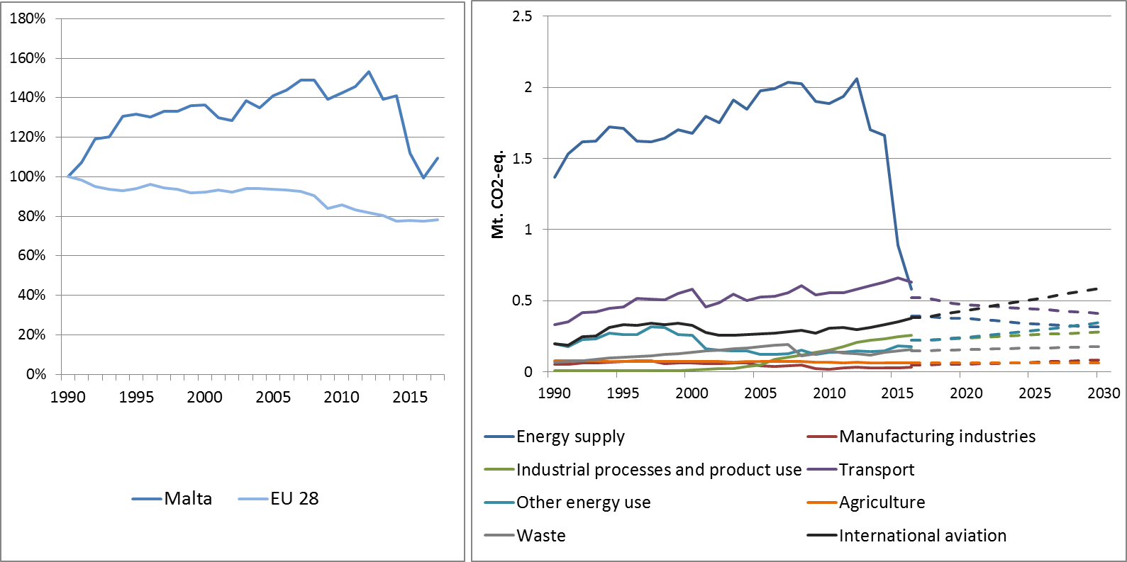

Figure 1: Left hand side: Total greenhouse gas emissions[11] 1990-2017 (index 1990 = 100 %). Right hand side: Total greenhouse gas emissions by sector[12] – historical emissions 1990-2016, projections 2017-2030 (Mt CO2-eq.).

**Figure 2: Share of emissions covered by the ETS and the ESD (2016).[13]**

# 2. ETS emissions

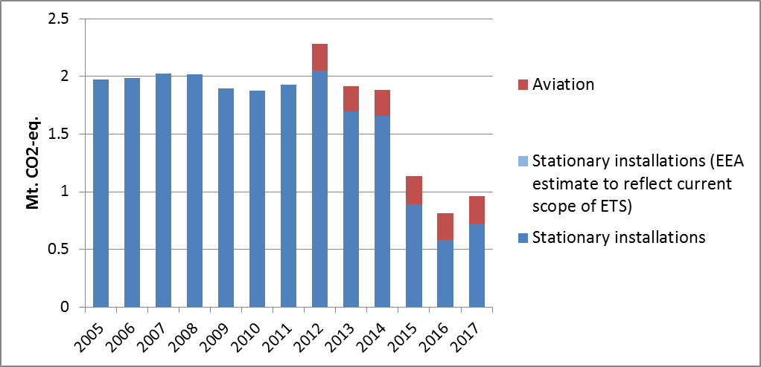

**Figure 3: ETS emissions (Mt CO2-eq.).[14]**

# 3. Emissions in Effort Sharing sectors

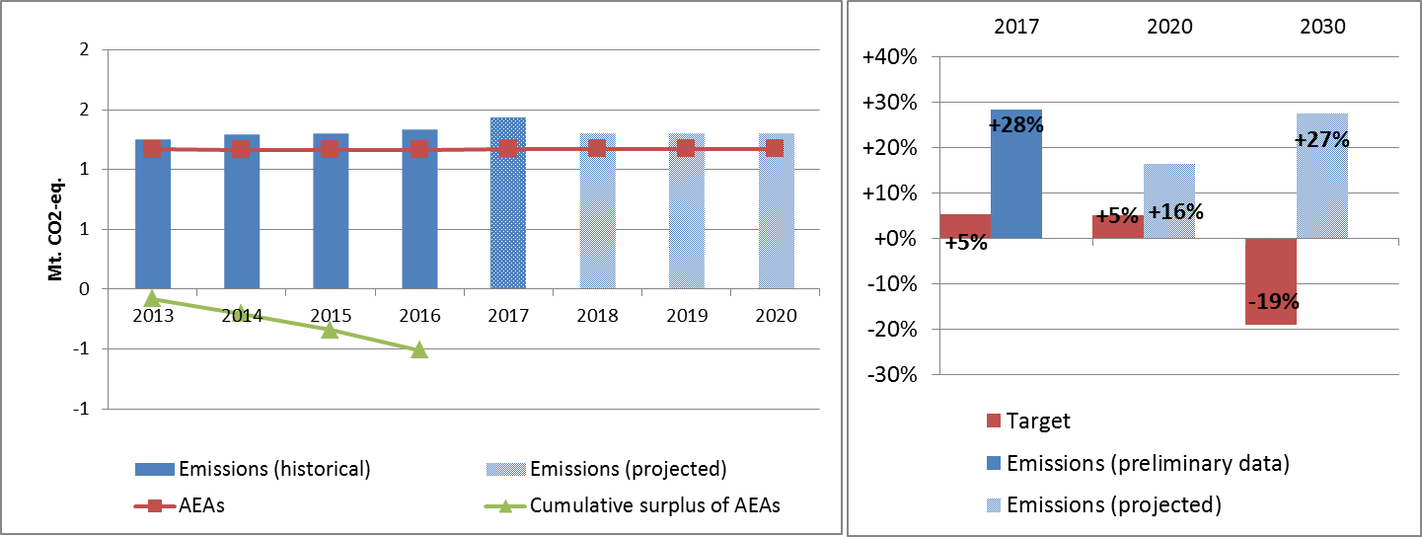

Figure 4: Left hand side: Emissions, annual emission allocations (AEAs) and accumulated surplus/ deficit of AEAs under the Effort Sharing Decision 2013-2020 (Mt CO2-eq.). Right hand side: Emissions and targets under the Effort Sharing Decision/ Effort Sharing Regulation 2017, 2020 and 2030 as percentage change from 2005.[15]

# 4. Land use, land use change and forestry

Malta is the only EU Member State with no reported and accounted quantities under the Kyoto Protocol second commitment period.

Country fact sheet: Netherlands

# 1. Total greenhouse gas emissions

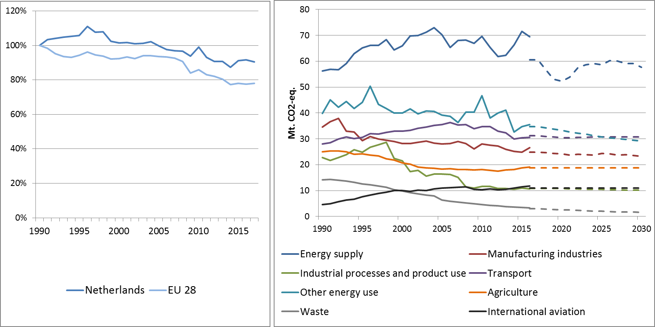

Figure 1: Left hand side: Total greenhouse gas emissions[16] 1990-2017 (index 1990 = 100 %). Right hand side: Total greenhouse gas emissions by sector[17] – historical emissions 1990-2016, projections 2017-2030 (Mt CO2-eq.).

**Figure 2: Share of emissions covered by the ETS and the ESD (2016).[18]**

# 2. ETS emissions

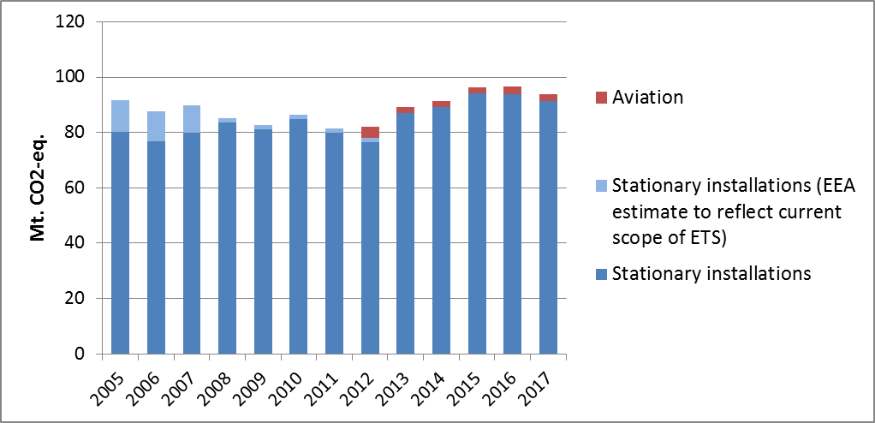

Figure 3: ETS emissions (Mt CO2-eq.).[19]

# 3. Emissions in Effort Sharing sectors

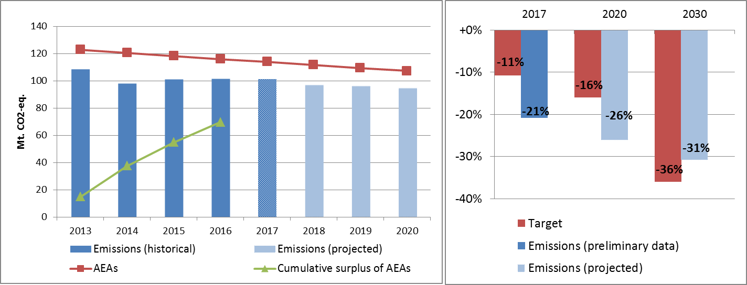

Figure 4: Left hand side: Emissions, annual emission allocations (AEAs) and accumulated surplus/ deficit of AEAs under the Effort Sharing Decision 2013-2020 (Mt CO2-eq.). Right hand side: Emissions and targets under the Effort Sharing Decision/ Effort Sharing Regulation 2017, 2020 and 2030 as percentage change from 2005.

# 4. Land use, land use change and forestry

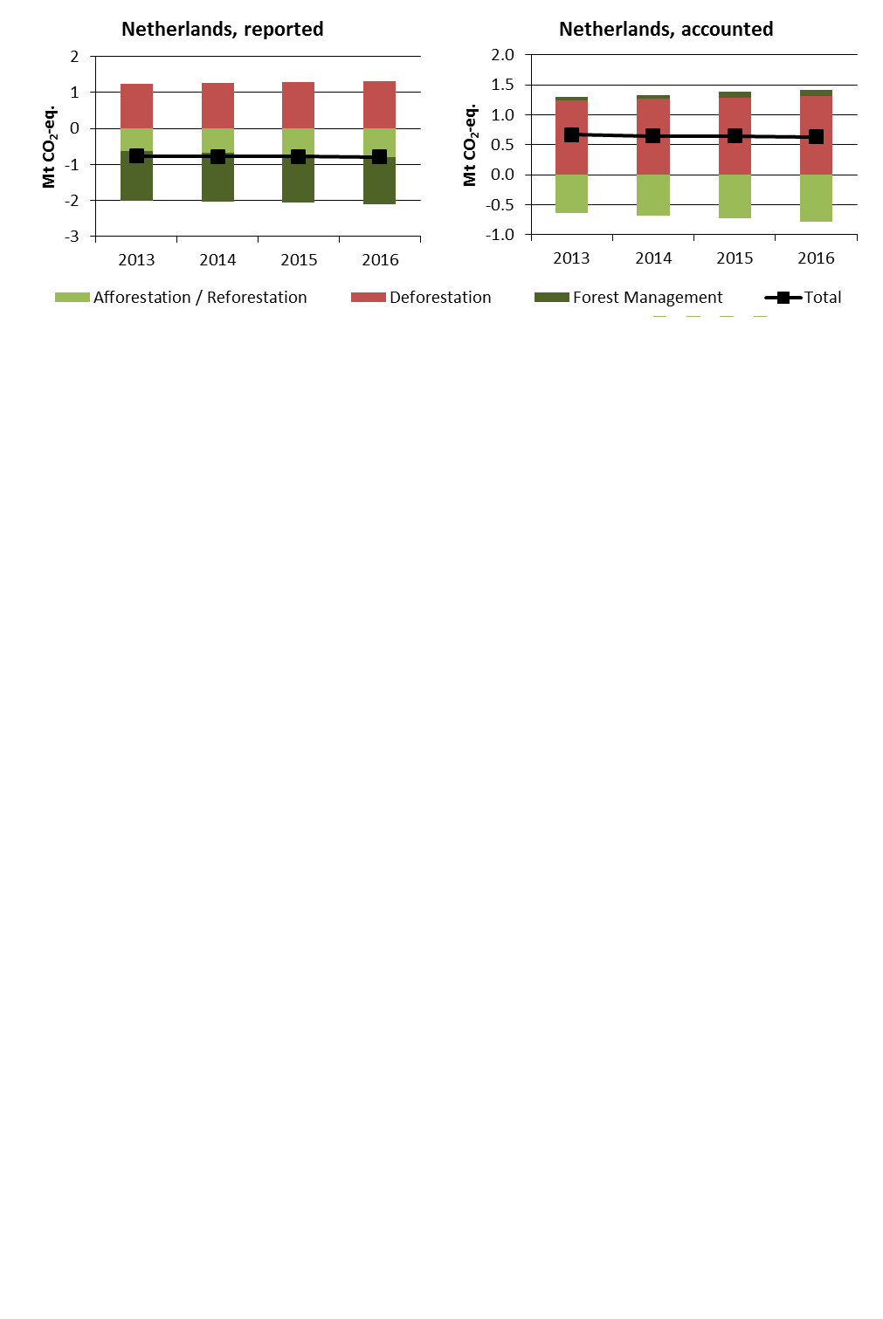

Figure 5: Reported and accounted emissions and removals from LULUCF (Mt CO2-eq.)[20]

Reported quantities under the Kyoto Protocol for the Netherlands show net removals of, on average, -0.8 Mt CO2-eq for the period 2013 to 2016. In this regard the Netherlands contribute with 0.2% to the annual average sink of -384.4 Mt CO2-eq of the EU-28. Accounting for the same period depicts net debits of, on average, 0.7 Mt CO2-eq, which corresponds to a negative contribution of -0.6% of the EU-28 accounted sink of -115.7 Mt CO2-eq. The Netherlands is one of six EU Member States which show net debits in this preliminary accounting exercise. Reported net removals increase and accounted net debits show nearly no change over the four-year period.

Country fact sheet: Poland

# 1. Total greenhouse gas emissions

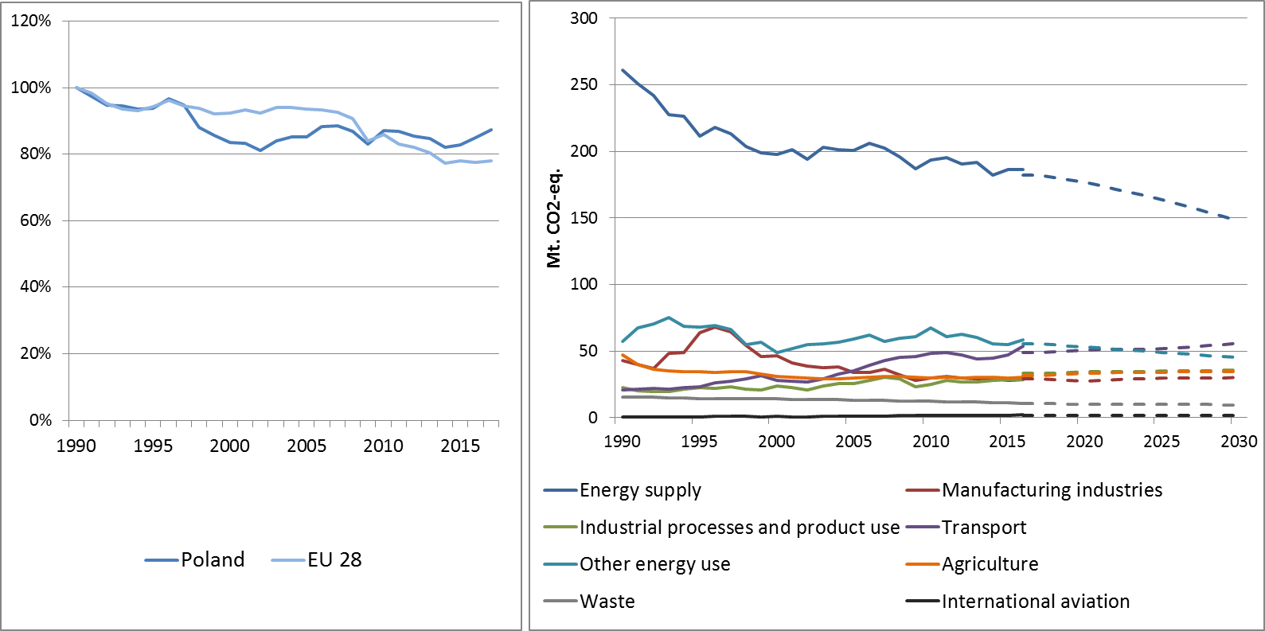

Figure 1: Left hand side: Total greenhouse gas emissions[21] 1990-2017 (index 1990 = 100 %). Right hand side: Total greenhouse gas emissions by sector[22] – historical emissions 1990-2016, projections 2017-2030 (Mt CO2-eq.).

**Figure 2: Share of emissions covered by the ETS and the ESD (2016).[23]**

# 2. ETS emissions

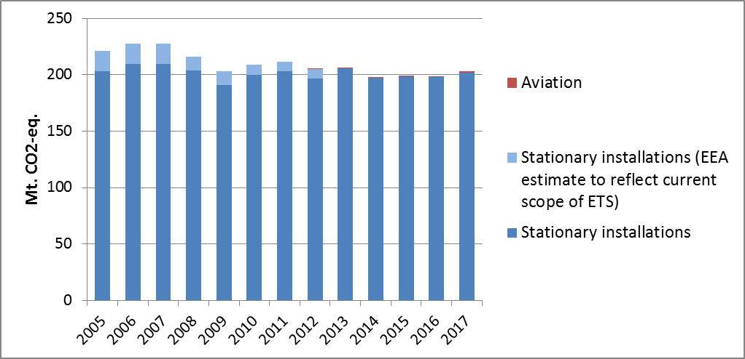

Figure 3: ETS emissions (Mt CO2-eq.).[24]

# 3. Emissions in Effort Sharing sectors

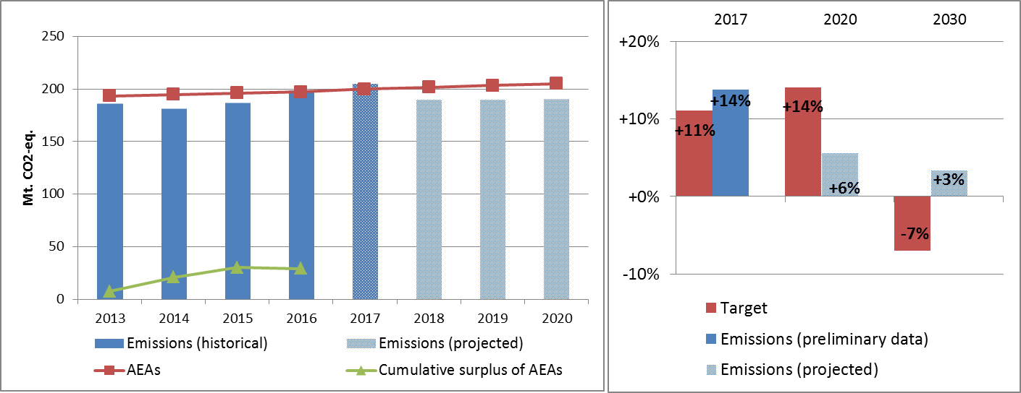

Figure 4: Left hand side: Emissions, annual emission allocations (AEAs) and accumulated surplus/ deficit of AEAs under the Effort Sharing Decision 2013-2020 (Mt CO2-eq.). Right hand side: Emissions and targets under the Effort Sharing Decision/ Effort Sharing Regulation 2017, 2020 and 2030 as percentage change from 2005.

# 4. Land use, land use change and forestry

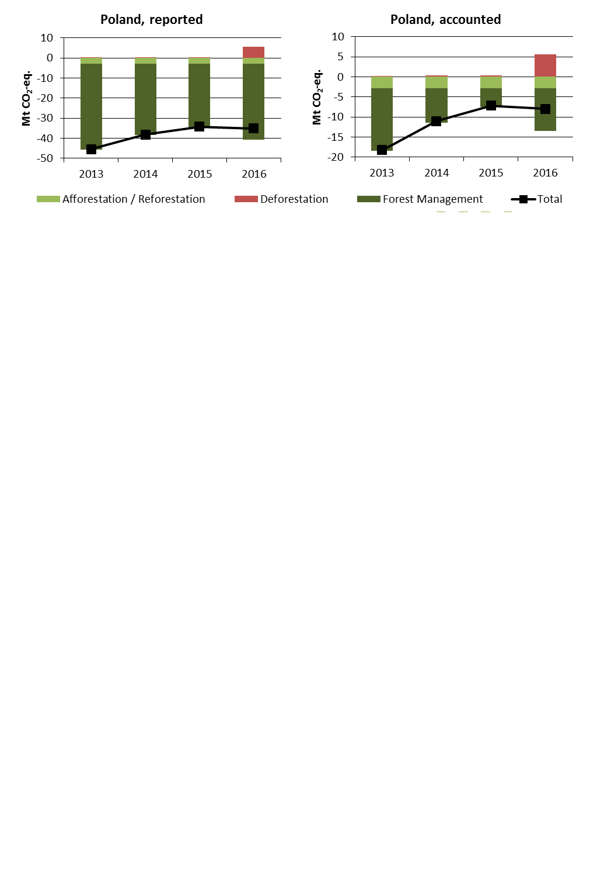

Figure 5: Reported and accounted emissions and removals from LULUCF (Mt CO2-eq.)[25]

Reported quantities under the Kyoto Protocol for Poland show net removals of, on average, -38.3 Mt CO2-eq for the period 2013 to 2016. In this regard Poland contributes with 10.0% to the annual average sink of -384.4 Mt CO2-eq of the EU-28. Accounting for the same period depicts net credits of, on average, -11.1 Mt CO2-eq, which corresponds to 9.6% of the EU-28 accounted sink of -115.7 Mt CO2-eq. Reported net removals and accounted net credits decrease between 2013 and 2015 and slightly increase for 2016.

Country fact sheet: Portugal

# 1. Total greenhouse gas emissions

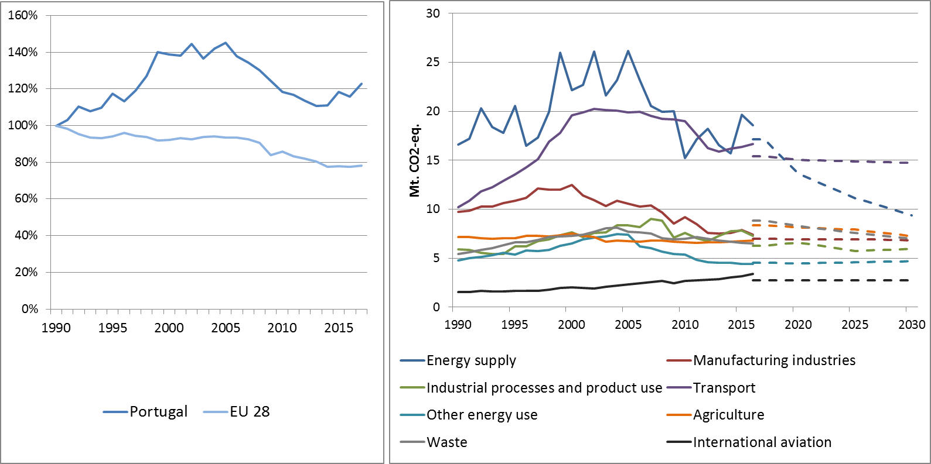

Figure 1: Left hand side: Total greenhouse gas emissions[26] 1990-2017 (index 1990 = 100 %). Right hand side: Total greenhouse gas emissions by sector[27] – historical emissions 1990-2016, projections 2017-2030 (Mt CO2-eq.).

**Figure 2: Share of emissions covered by the ETS and the ESD (2016).[28]**

# 2. ETS emissions

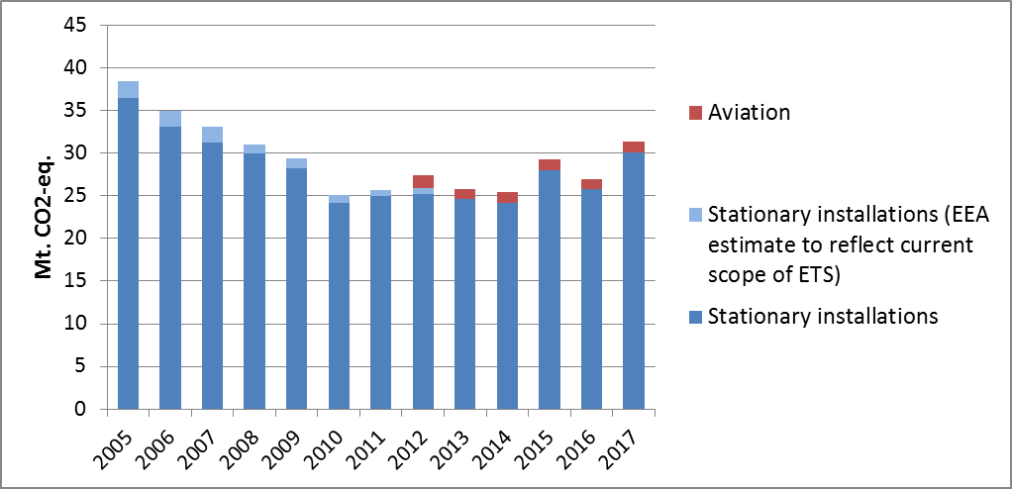

Figure 3: ETS emissions (Mt CO2-eq.).[29]

# 3. Emissions in Effort Sharing sectors

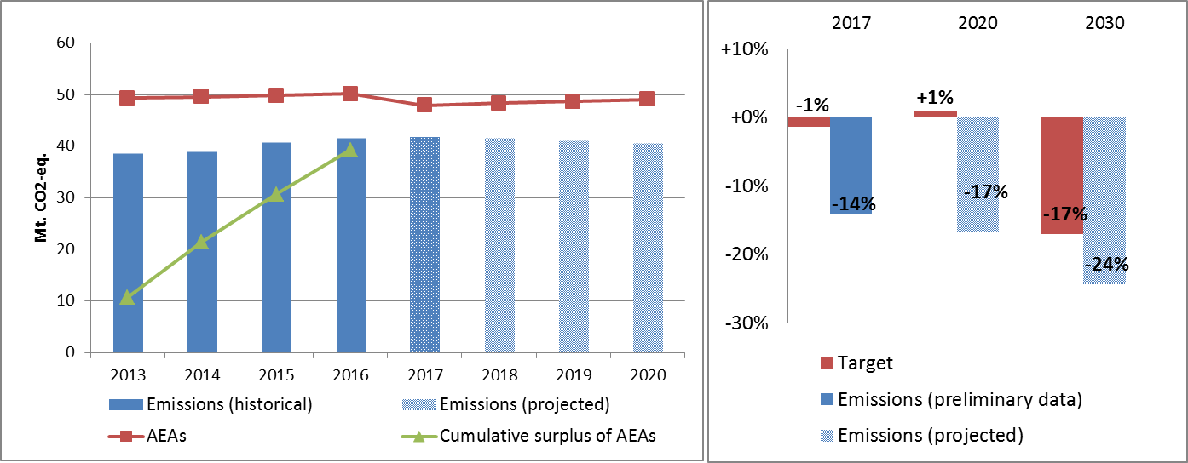

Figure 4: Left hand side: Emissions, annual emission allocations (AEAs) and accumulated surplus/ deficit of AEAs under the Effort Sharing Decision 2013-2020 (Mt CO2-eq.). Right hand side: Emissions and targets under the Effort Sharing Decision/ Effort Sharing Regulation 2017, 2020 and 2030 as percentage change from 2005.

# 4. Land use, land use change and forestry

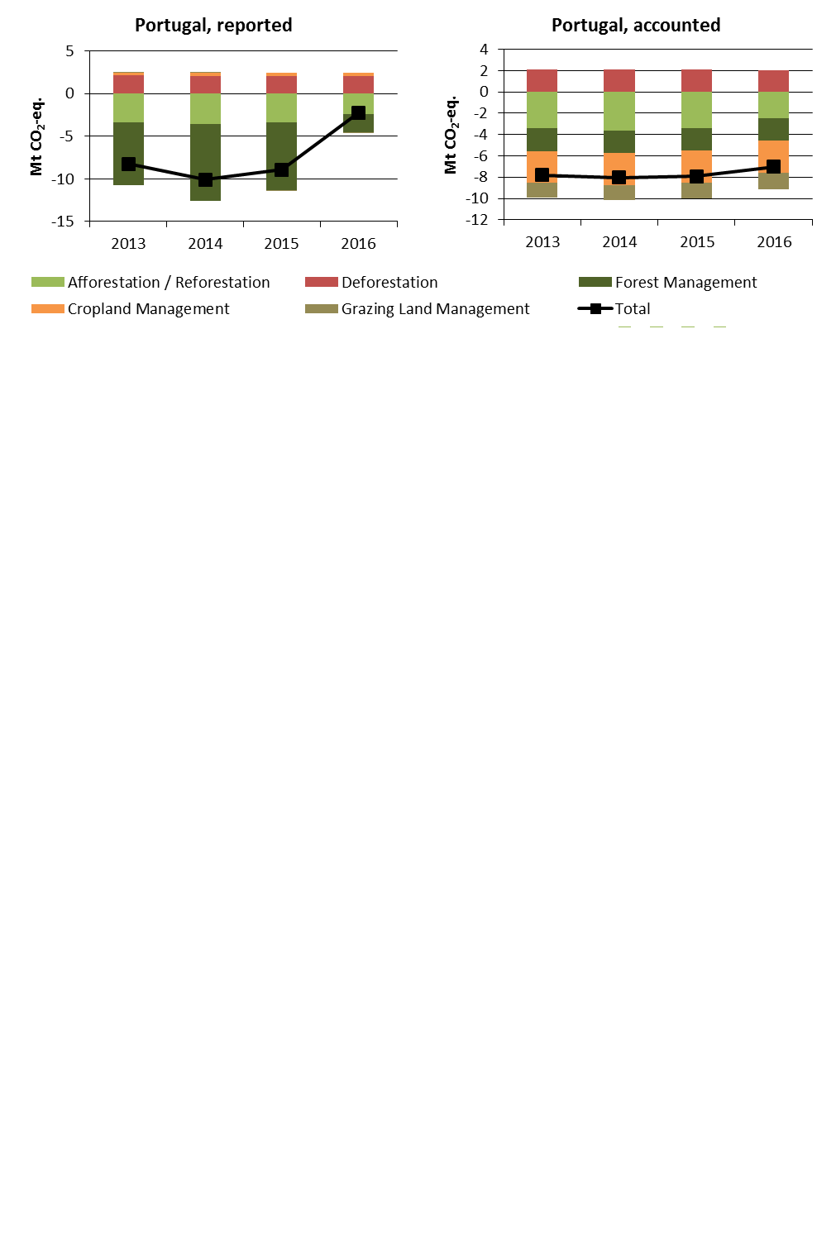

Figure 5: Reported and accounted emissions and removals from LULUCF (Mt CO2-eq.)[30]

Reported quantities under the Kyoto Protocol for Portugal show net removals of, on average, -7.4 Mt CO2-eq for the period 2013 to 2016. In this regard Portugal contributes with 1.9% to the annual average sink of -384.4 Mt CO2-eq of the EU-28. Accounting for the same period depicts net credits of, on average, -7.7 Mt CO2-eq, which corresponds to 6.7% of the EU-28 accounted sink of -115.7 Mt CO2-eq. Reported net removals are highest for 2014 and decrease substantially thereafter, while accounted net credits only show a minor decrease for 2016. Portugal elected to report and account for Cropland Management as one of seven EU Member States and for Grazing Land Management as one of six EU Member States. In this preliminary simulated accounting exercise potential credits by Forest Management of, on average, -3.0 Mt CO2-eq per year are capped to -2.1 Mt CO2-eq per year. Portugal is one of eight EU Member States which exceed the cap of 3.5% from emissions of the base year (1990).

1. National total, including international aviation.
2. The sectors in the figure correspond to the following IPCC sectors: Energy supply: 1A1, 1B and 1C. Manufacturing industries: 1A2. Industrial processes and product use: 2. Transport: 1A3. Other energy use: 1A4, 1A5 and 6. Agriculture: 3. Waste: 5. International aviation: memo item.
3. Excluding international aviation, CO2 from domestic aviation and NF3.
4. The scope of ETS was extended from 2013. To reflect the current scope of ETS, estimates made by EEA are included in the figures from 2005 to 2012. The estimates cover only emissions from stationary installations.
5. The differences between reported and accounted emissions from LULUCF under the Kyoto Protocol are described in part 1b.
6. National total, including international aviation.
7. The sectors in the figure correspond to the following IPCC sectors: Energy supply: 1A1, 1B and 1C. Manufacturing industries: 1A2. Industrial processes and product use: 2. Transport: 1A3. Other energy use: 1A4, 1A5 and 6. Agriculture: 3. Waste: 5. International aviation: memo item.
8. Excluding international aviation, CO2 from domestic aviation and NF3.
9. The scope of ETS was extended from 2013. To reflect the current scope of ETS, estimates made by EEA are included in the figures from 2005 to 2012. The estimates cover only emissions from stationary installations.
10. The differences between reported and accounted emissions from LULUCF under the Kyoto Protocol are described in part 1b.
11. National total, including international aviation.
12. The sectors in the figure correspond to the following IPCC sectors: Energy supply: 1A1, 1B and 1C. Manufacturing industries: 1A2. Industrial processes and product use: 2. Transport: 1A3. Other energy use: 1A4, 1A5 and 6. Agriculture: 3. Waste: 5. International aviation: memo item.
13. Excluding international aviation, CO2 from domestic aviation and NF3.
14. The scope of ETS was extended from 2013. To reflect the current scope of ETS, estimates made by EEA are included in the figures from 2005 to 2012. The estimates cover only emissions from stationary installations.
15. Malta has covered its deficit of AEAs by purchasing AEAs from Bulgaria.
16. National total, including international aviation.
17. The sectors in the figure correspond to the following IPCC sectors: Energy supply: 1A1, 1B and 1C. Manufacturing industries: 1A2. Industrial processes and product use: 2. Transport: 1A3. Other energy use: 1A4, 1A5 and 6. Agriculture: 3. Waste: 5. International aviation: memo item.
18. Excluding international aviation, CO2 from domestic aviation and NF3.
19. The scope of ETS was extended from 2013. To reflect the current scope of ETS, estimates made by EEA are included in the figures from 2005 to 2012. The estimates cover only emissions from stationary installations.
20. The differences between reported and accounted emissions from LULUCF under the Kyoto Protocol are described in part 1b.
21. National total, including international aviation.
22. The sectors in the figure correspond to the following IPCC sectors: Energy supply: 1A1, 1B and 1C. Manufacturing industries: 1A2. Industrial processes and product use: 2. Transport: 1A3. Other energy use: 1A4, 1A5 and 6. Agriculture: 3. Waste: 5. International aviation: memo item.
23. Excluding international aviation, CO2 from domestic aviation and NF3.
24. The scope of ETS was extended from 2013. To reflect the current scope of ETS, estimates made by EEA are included in the figures from 2005 to 2012. The estimates cover only emissions from stationary installations.
25. The differences between reported and accounted emissions from LULUCF under the Kyoto Protocol are described in part 1b.
26. National total, including international aviation.
27. The sectors in the figure correspond to the following IPCC sectors: Energy supply: 1A1, 1B and 1C. Manufacturing industries: 1A2. Industrial processes and product use: 2. Transport: 1A3. Other energy use: 1A4, 1A5 and 6. Agriculture: 3. Waste: 5. International aviation: memo item.
28. Excluding international aviation, CO2 from domestic aviation and NF3.
29. The scope of ETS was extended from 2013. To reflect the current scope of ETS, estimates made by EEA are included in the figures from 2005 to 2012. The estimates cover only emissions from stationary installations.
30. The differences between reported and accounted emissions from LULUCF under the Kyoto Protocol are described in part 1b.