

**TABLE OF CONTENTS**

FOREWORD 2

KEY MESSAGES 3

1. OVERVIEW OF LABOUR MARKET AND SOCIAL TRENDS AND CHALLENGES IN THE EUROPEAN UNION 12

1.1 Labour market trends 12

1.2 Social trends 17

2. SNAPSHOTS FROM THE SOCIAL SCOREBOARD 21

2.1 The scoreboard explained 21

2.2 Evidence from the social scoreboard 23

3. EMPLOYMENT AND SOCIAL REFORMS – MEMBER STATES PERFORMANCE AND ACTION 30

3.1 Guideline 5: Boosting demand for labour 30

3.1.1 Key indicators 31

3.1.2 Policy response 45

3.2. Guideline 6: Enhancing labour supply and improving access to employment, skills and competences 51

3.2.1 Key indicators 51

3.2.2 Policy response 78

3.3. Guideline 7: Enhancing the functioning of labour markets and the effectiveness of social dialogue 91

3.3.1 Key indicators 91

3.3.2 Policy response 116

3.4. Guideline 8: Promoting equal opportunities for all, fostering social inclusion and combatting poverty 130

3.4.1 Key indicators 130

3.4.2 Policy response 151

ANNEXES 158

# FOREWORD

The Joint Employment Report (JER) by the European Commission and the Council is mandated by Article 148 of the Treaty on the Functioning of the European Union (TFEU). The initial proposal for this report by the European Commission is part of the Autumn package, which includes the Annual Growth Survey launching the European Semester cycle. The Joint Employment Report provides an annual overview of key employment and social developments in Europe as well as Member States' reform actions, in line with the Guidelines for the Employment Policies of the Member States[1]. The reporting on these reforms follows the structure of the Guidelines: boosting demand for labour (Guideline 5), enhancing labour supply and improving access to employment, skills and competences (Guideline 6), enhancing the functioning of labour markets and the effectiveness of social dialogue (Guideline 7), and promoting equal opportunities for all, fostering social inclusion and combatting poverty (Guideline 8).

In addition, the Joint Employment Report monitors Member States' performance in relation to the Social Scoreboard set up in the context of the European Pillar of Social Rights. The Pillar was established as an inter-institutional Proclamation by the European Parliament, the Council and the Commission on 17 November 2017. It identifies principles and rights in three areas: i) equal opportunities and access to the labour market, ii) fair working conditions, and iii) social protection and inclusion. Monitoring of progress in these areas is underpinned by a detailed analysis of the Social Scoreboard accompanying the Pillar.

The Joint Employment Report is structured as follows: an introductory chapter (Chapter 1) reports on main labour market and social trends in the European Union, to set the scene. Chapter 2 presents the main results from the analysis of the social scoreboard associated to the European Pillar of Social Rights. Chapter 3 provides a detailed cross-country description of key indicators (including from the social scoreboard) and policies implemented by Member States to address the Guidelines for Employment Policies.

# KEY MESSAGES

***Europe is making progress regarding the Social Scoreboard accompanying the European Pillar of Social Rights.*** *In a context of improving labour markets and declining poverty, 13 out of the 14 headline indicators of the Social Scoreboard recorded an improvement over the last year, on average. Still, the economic recovery is not yet benefitting all citizens and countries in the same manner. Challenges with regard to specific principles of the Pillar are identified for a majority of Member States. The current economic upswing provides an opportunity for stepping up reforms aiming at improving the inclusiveness, resilience and fairness of labour markets and social protection systems, thus fostering convergence towards better living and working conditions in the EU. However, there are also downside risks to the recovery, which make it urgent for Member States to seize this opportunity.*

***Strong job creation continues, with employment reaching a record level in the EU.*** *In the second quarter of 2018, 239 million persons were in employment in the EU, 14 million more than the lowest level reached in mid-2013, at the peak of the crisis. The employment rate of people aged 20-64 rose to 73.2% in the same period: with the current trend, the EU is well on track to reach the Europe 2020 target of a 75% employment rate in 2020. Employment growth in 2017 and the first two quarters of 2018 was spread among all main demographic groups, with the largest increases recorded by older workers (55-64) as in previous years. Yet, substantial disparities in employment rates across the EU suggest that there is room for further improvement, notably for those Member States that are still far from attaining their national Europe 2020 targets.*

***Unemployment has returned to its pre-crisis level, but remains high in a number of Member States****. Thanks to the steady labour market recovery, the unemployment rate kept declining in 2017, to reach 6.9% in the second quarter of 2018. It now stands at the lowest level in ten years, more than 4 pps below the 2013 peak. In the euro area, the unemployment rate at 8.3% in Q2-2018 remains one percentage point higher than the lowest level registered in 2008. Unemployment rates are still particularly high in Greece, Spain, Italy, Croatia and Cyprus.*

***Employment gains continue to be more prominent in terms of employed persons than of hours worked.*** *The volume of total hours worked in the EU kept increasing in 2017 – though more slowly than total employment – and is not yet back to the 2008 level. A high number of involuntary part-time workers (i.e. workers who are in part-time but would like to work more), still 1.3 million above 2008, also suggests that there is remaining slack in the labour market. The decreasing number of hours worked per person is nonetheless part of a structural trend that started in the early 2000s.*

***Household incomes continue rising in almost all Member States.*** *Supporting the process of upward convergence, real per capita disposable household income grew more strongly in the Member States that most recently joined the Union. While these developments were mostly driven by favourable economic conditions, they benefitted also from reforms leading to improvements in the adequacy of social benefits, including minimum income schemes. Yet, in a number of countries the real gross disposable income per capita remains significantly below the pre-crisis levels. Household incomes grew more slowly than GDP, highlighting that income gains from the recovery have reached households only to some extent – thus raising questions about the inclusiveness of recent growth.*

***On the back of robust economic and labour market recovery, the share of people******at-risk-of poverty or social exclusion decreased******markedly in 2017.*** *More than 5 million people exited from poverty or social exclusion, the largest decline since the recovery started. This change was driven mainly by decreasing numbers of people experiencing severe material deprivation and/or living in very-low work intensity households (since their respective peaks, these indicators dropped by respectively 15 and 8 million). The total number of people at risk of poverty or social exclusion, at 113 million people or 22.5% of total population in 2017, is now below pre-crisis levels. Estimates indicate that this trend is set to continue into the next year. Still, there remains a long way to reach the Europe 2020 poverty and social exclusion reduction target.* *The risk of poverty or social exclusion remains a challenge particularly for children, people with disabilities and people with a migrant background.*

***Real wage growth slowed down in 2017, but has picked up in 2018.*** *Overall, wage growth remains below what could be expected given the positive labour market and economic performance. The modest wage dynamics over the past years can be explained by weak productivity growth, still low inflation expectations and remaining reserves in the labour market. In real terms, average wages still lag behind pre-crisis levels in many Member States and their growth remained, in 2017, below productivity growth. This is in line with a long-term trend: in the EU, between 2000 and 2017, real value added per person employed grew by 15.6%, while real compensation per employee grew by only 11.2%. Despite these developments, there is evidence that convergence in labour income levels is taking place although large differences remain between and within Member States.*

***Wage setting frameworks (including minimum wages) are starting to react to the improvement in labour market conditions****. In particular, statutory minimum wages were increased in several countries, with the involvement of social partners. This development is important in view of the persisting high rates of in-work poverty in a number of Member States, which also require action in the areas of tax design and benefits adequacy. Against this background, it is important that the adjustment in minimum wage levels follows transparent and predictable rules, taking into account their impact on competitiveness, job creation and in-work poverty.*

***In a context of sustained job creation, some groups still face difficulties in reaping the benefits of the recovery****. Job growth in 2017 has been mainly driven by women, older workers and high-skilled people. On the other hand, the employment rate of low-skilled workers is still below pre-crisis levels and remains almost 30 pps lower than that of high-skilled workers. Though increasing, the employment rate of young people is lower than in 2008 (by 2.7 pps). On a positive note, the share of young people neither in employment, education or training at 10.9% is now back to pre-crisis levels. People with a migrant background face employability challenges: the employment rate gap between native and non-EU born workers stood at 10 pps in 2017 (up from 4.5 pps in 2008). This gap is especially pronounced among migrant women. Finally, people with disabilities tend to participate less in the labour market; the potential to use their talents remains largely untapped.*

***Participation of women in the labour market continues to grow at a fast pace.*** *The employment rate of women stood at 66.5% in 2017, almost 5 pps higher than in 2008.**Still, the employment rate gender gap remains substantial, with considerable disparities across Member States. Though women are generally better qualified than men in terms of educational attainment level, the gender pay gap is high and only gradually declining. Women are over-represented in lower-paid sectors and occupations and work more frequently in underqualified jobs compared to their skills level. The impact of parenthood and caring responsibilities remains the main driver of lower employment rates, with underdeveloped services being a major impediment to stay in or return to employment. Furthermore, informal carers, the majority of whom are women, are more at risk of experiencing poverty and financial dependency, with career interruptions often translating into lower pension entitlements. A number of Member States are taking action to provide affordable and equal access to quality childcare and long-term care services, but important challenges remain. A more balanced distribution of paid family-related leaves between women and men would be beneficial in some cases. A few Member States are adapting their tax and benefits systems to remove disincentives to work for second earners. Concrete actions to tackle the gender pay gap are in place only in a limited number of countries.*

***The employment rate of older workers increased substantially over the last decade****. For the age group 55-64 it rose from 45.5% in 2008 to 57.1% in 2017. Older workers were relatively more shielded from the recession and their employment rate kept increasing during the crisis, to then become an important driver of job recovery. The rising duration of working lives is explained by a number of factors, including increases in statutory retirement age, better access to care services, availability of flexible working arrangements and active ageing strategies. Several Member States are further promoting labour market participation of older workers, including by supporting flexible transitions into retirement and providing financial incentives both for employers and employees.*

***The labour market situation of young people continues to improve, but youth unemployment remains high in a number of Member States.*** *While steadily declining and back to the 2008 level, the youth unemployment rate (age group 15-24) presents large differences across countries and very high rates in some of them. A still considerable part of the young people is economically inactive. Overall in the EU, almost 6 million people aged 15-24 were neither in employment, education or training (NEET) in 2017. If prolonged over time, detachment of young people from the labour market can have negative consequences for potential growth as well as negative effects for the individuals concerned, such as the depreciation of skills and a higher risk of poverty and social exclusion later in life. Actions taken by Member States in line with the Council Recommendation establishing the Youth Guarantee are key drivers for improvement.*

***Ensuring access to quality and inclusive education and training enables younger generations to become engaged and active citizens, helping them integrate into the labour market and society.*** *Europe is progressing towards reaching the 2020 headline target on early school leaving rate of 10%, and has almost reached the target of 40% on tertiary education attainment. Still, large differences persist across Member States and among population groups (for instance, between men and women and between native- and non-EU born people). The high shares of low achievers in basic skills, and the strong correlation of educational outcomes with socio-economic status and labour market outcomes are a matter of concern. Member States are undertaking steps to improve their education systems, notably to further reduce drop-out rates, foster equal access and improve educational outcomes among disadvantaged learners. More (and more efficient) investment in education and training systems is a priority in some Member States. Improving the quality of higher education and its labour market relevance is also high on the agendas of Member States, especially in the context of rising tertiary education attainment rates.*

***Technological changes and related transformations in labour markets crucially require upskilling and reskilling of the working age population.*** *Having a labour market relevant qualification is increasingly important for workers to adapt to a rapidly changing environment.**In the EU, the ratio between low-qualified adults and the number of jobs requiring a low qualification level is, on average, three to one. Yet, low skilled and older people are significantly less likely to participate in adult learning programmes than the average. Significant gaps remain in terms of digital skills: more than 40% of adults in the EU do not have basic digital skills, with peaks of 70% in some Member States. This implies that a significant part of the population cannot access a large variety of services, with negative impacts on inclusion and productivity.*

***Member States are adapting their skills development systems and are developing strategies to improve labour market relevance of training, with a view to facilitating learners’ transitions into and within the labour market.*** *This includes**making skills and qualifications easier to be understood and recognised throughout Europe and taking into account learning outside institutional contexts. Vocational education and training systems are being reviewed and updated, with the goal of improving their labour market relevance and promoting access, but challenges remain in these domains. The provision of incentives to disadvantaged groups to participate in adult learning, together with proper guidance and the provision of financial support to companies for training their staff are important policy levers to achieve better outcomes. Member States continue to increase the offer of learning and qualification opportunities to low-skilled adults, in line with the Upskilling Pathways initiative. Promoting development of digital skills occupies an important place among Member States’ education and skills priorities.*

***The incidence of atypical forms of work is roughly stable at EU level, but high labour market segmentation remains an issue for a number of Member States.*** *The share of total employees on a temporary contract did not change significantly over recent years, hovering around 14% on average. Globally, more than half of temporary employees are "involuntary", reaching 70% or more in 12 Member States. In several countries, the combination of high shares of temporary contracts and low transition rates towards permanent contracts is symptomatic of labour market duality. This is a matter of concern as atypical workers experience lower job quality and higher in-work poverty risks. In addition, around one quarter of all self-employed workers in the EU can be classified as "vulnerable" or "concealed". Also, survey results seem to suggest that the proportion of people earning more than half of their income from platform work may now have reached around 2% (2017) and is expected to increase, which underlines the importance of increased policy focus on this development. Reforms in the area of employment protection legislation are taking place in some Member States, with the aim to achieve a better balance between flexibility and security and avoid segmentation. These include, in some cases, stricter conditions for using temporary contracts, or larger scope for collective bargaining to define their framework. Regulation on new forms of work, including platform workers and own-account workers, has been initiated in a few Member States.*

***Unemployment benefits of adequate amount, reasonable duration, accessible to all workers and accompanied by effective activation measures are key to support jobseekers during transitions.*** *The design of these systems varies to a considerable extent from one Member States to another, across all dimensions. Recent reforms in this domain have mostly focused on strengthening activation requirements for jobseekers receiving benefits, for instance by reinforcing job search obligations and conditions to accept a new job. Concerns remain about the coverage of atypical workers, who often do not have full access to the system, and the absence of coverage for the self-employed – issues highlighted in the Commission's proposal for a Council recommendation on access to social protection for workers and the self-employed.*

***Effective active labour market policies and Public Employment Services are crucial to ensure well-functioning and inclusive labour markets.*** *Active labour market policies improve labour market matching and increase the chances of job seekers to find a new job. Their role is especially important to foster the integration of the long-term unemployed. Public Employment Services are the main institutions in charge of supporting job search efforts of the unemployed and referring them to activation measures. Yet, participation and investment in active labour market policies differs significantly across the EU. Similarly, the effectiveness of Public Employment Services in providing job search support is heterogeneous across and, sometimes, within Member States. While important measures are being taken in a majority of Member States, with a focus on the provision of individualised services, several Member States have scope to reinforce their active labour market policies systems. Member States made progress on implementing the Council recommendation on the integration of long-term unemployed, with further action needed to foster cooperation across different actors and on improving outreach towards inactive people. Public Employment Services are continuing their reform agenda, in the framework of the European PES Network. While some Member States took further measures to promote the integration of migrants into the labour market (with a focus in particular on refugees), systematic approaches are lacking and there is a need to invest more into upskilling and recognition of skill and qualifications, efficient labour market policies and support by Public Employment Services.*

***For the first time since the crisis income inequality in the EU decreased slightly in 2017,*** *driven by faster increases in the incomes of lower income households. This suggests that the recovery begins to reach the most vulnerable. Available estimates indicate that this positive trend will continue in a majority of Member States. Still, in 2017 the richest 20% of the population had a disposable income that was 5.1 times higher than that of the poorest 20% in the EU (from 5.2 in 2016), with large variation across Member States. Income inequality is above pre-crisis levels in some countries, often linked to unequal opportunities in access to education, training and social protection, and correlated to poor labour market outcomes. Some Member States are undertaking inequality-reducing policies, notably in the design of minimum wage setting and tax and benefit systems. To break the transmission of inequalities across generations, Member States can take further action in different areas, such as by fostering equal opportunities in education and training, ensuring access to quality healthcare and other services, promoting gender equality and addressing regional disparities.*

***The measured impact of social transfers (excluding pensions) on poverty reduction continued to decline in 2017.*** *This is in line with reduced automatic stabiliser effects in a phase of economic expansion, though large variations remain among Member States. The poverty-reducing impact of social transfers fell mostly in long-standing members of the EU, while it increased in countries that joined more recently (suggesting that convergence is taking place). The overall outcome depends on improved labour market conditions (and related changes in the characteristics of those at risk of poverty)* *as well as* *changes in benefits adequacy and coverage, including the fact that benefits sometimes lag behind generally increasing incomes. The adequacy of minimum income benefits varies significantly among Member States, as shown by the results of the related benchmarking exercise.*

***Member States continue taking measures to modernise social protection systems, strengthening coverage and adequacy of benefits and services.*** *Steps are being taken to improve access to social protection, notably for non-standard workers and the self-employed who continue to face significant gaps. Some innovations are also being introduced with regard to new forms of work. Work on improving adequacy of benefits continues, though in some cases there have been delays. A number of Member States are improving their minimum income schemes by combining adequate levels of support with access to enabling goods and services, and with incentives to (re)integrate into the labour market, in an active inclusion approach. Some Member States are enhancing integrated delivery of services (such as social assistance, employment and other social services). In a context where housing-related expenditures amount to a significant share of many households’ incomes and the evolution in the number of homeless is not improving, some Member States have undertaken reforms to improve access to housing, either through the provision of incentives or via preventative measures.*

***Demographic change and rising life expectancy present the pension, healthcare and long-term care systems with a clear need to adapt.*** *The demand for long-term care and healthcare is growing and the needs are changing as populations age. Over the next five decades, the number of Europeans aged 80+ is set to double. By 2050, there will be only two persons in active age (15-64) for one person over 65 year old, compared to three today; the ratio is already on the decrease. Therefore, while measures to improve financial sustainability are still high on many Member States’ agendas, ensuring pension adequacy gains in importance.**The income replacement and poverty prevention capacity of pensions varies significantly among Member States. Member States are increasingly taking steps to safeguard pension adequacy through minimum guarantees and indexation of benefits, promote flexible retirement, tailor pension accrual conditions to diverse categories of workers and enhance the role of supplementary pensions.*

***Improving access to quality healthcare and long-term care, together with increasing their effectiveness, is a guiding principle for reforms in Member States.*** *For some Europeans, costs and waiting times remain important barriers for the accessibility of healthcare. Thus, in a number of Member States reforms of healthcare systems focus on improving their effectiveness by better coordination and a stronger role assigned to primary care and prevention. Measures are taken to improve training and working conditions of health workers. In the area of long-term care, most care is still provided by family members, given the lack of comprehensive schemes to cover the need for old age care in the majority of Member States. Current reforms intend to combine a system of support for informal and family carers by public institutions and a network of community and institutional services, with attention to sustainability in the face of demographic challenges.*

***A well-functioning social dialogue is a key element of the European social market economy.*** *It helps strengthening social cohesion and reducing conflicts in the society, to the mutual benefit of workers, employers and governments. The involvement of social partners in the preparation of reforms can improve their design and implementation, increase ownership among citizens and eventually lead to better socio-economic outcomes. However, the degree and impact of social partners' involvement varies considerably among Member States and is weak in several cases. While there is no one-size-fits-all model for social dialogue practices, in some Member States there is clear scope for improving the capacity of social partners and providing them with an adequate framework for predictable and timely consultation including in all key stages of the European semester. Similarly, using the experience of civil society organisations can play and plays an important role to ensure that reforms are designed and implemented effectively. Yet, the degree of engagement with societal stakeholders varies significantly among Member States, with insufficient capacity to actively participate in the policy debate being an issue in some of them.*

# 1. OVERVIEW OF LABOUR MARKET AND SOCIAL TRENDS AND CHALLENGES IN THE EUROPEAN UNION

This section presents an overview of labour market and social trends and challenges in the European Union, providing a detailed analytical account of major employment and social policy areas.

### 1.1 Labour market trends

**Labour market conditions continue to improve, with employment reaching a record level in the EU.** On the back of strong economic growth (2.4%), the number of people in employment in the EU increased by 1.6% in 2017, the largest annual increase rate since the start of the recovery. Total employment kept increasing in the first two quarters of 2018, to reach 238.9 million[2] – about 3.2 million jobs more than one year ago, and the highest level ever reached in the EU. Since employment started recovering in mid-2013, more than 14 million additional jobs were created.

**The employment rate (of people aged 20-64) is on a steady rise, getting closer to the Europe 2020 target.** It increased slightly faster than in 2016, by 1.1 percentage point to 72.2% in 2017 and continued rising in the first two quarters of 2018, up to 73.2% (Figure 1). If the positive trend continues at the current pace, the EU would be well placed to reach its Europe 2020 target of a 75% employment rate. The situation continues to improve also in the euro area, where the employment rate reached its highest level at 71.9% in Q2-2018. These positive developments are supported by a continuing upward trend in labour market participation. In Q2-2018, the activity rate (15-64) achieved a record high at 73.8% (73.5% in the euro area). The activity rate in the EU has been increasing at a constant pace, even during the crisis, closing the gap with the United States. In 2017, older workers and women continued to drive the increase in labour force participation.

**The unemployment rate is now back to its pre-crisis level.** Thanks to the steady job creation trend, the unemployment rate kept falling, down to 6.9% in Q2-2018 – a level not recorded in the EU since Q2-2008 and more than 4 pps below the 2013 peak. The improvement is less substantial in the euro area, where the unemployment rate, at 8.3% in Q2-2018, remains one percentage point higher than the lowest level recorded in 2008. These positive trends are associated with a continuing decrease in the long-term unemployment rate (i.e. share of the unemployed for at least one year within the active population), which dropped in the EU by 0.5 pps year-on-year to 3% in Q2-2018 (3.9% in the euro area). Though unemployment (including long-term) decreased across all Member States over the last year, a significant dispersion of unemployment rates persists (as shown in Section 3.1.1), with some countries still far from their pre-crisis minimum levels.

Figure 1: Employment and unemployment rates in the EU and euro area

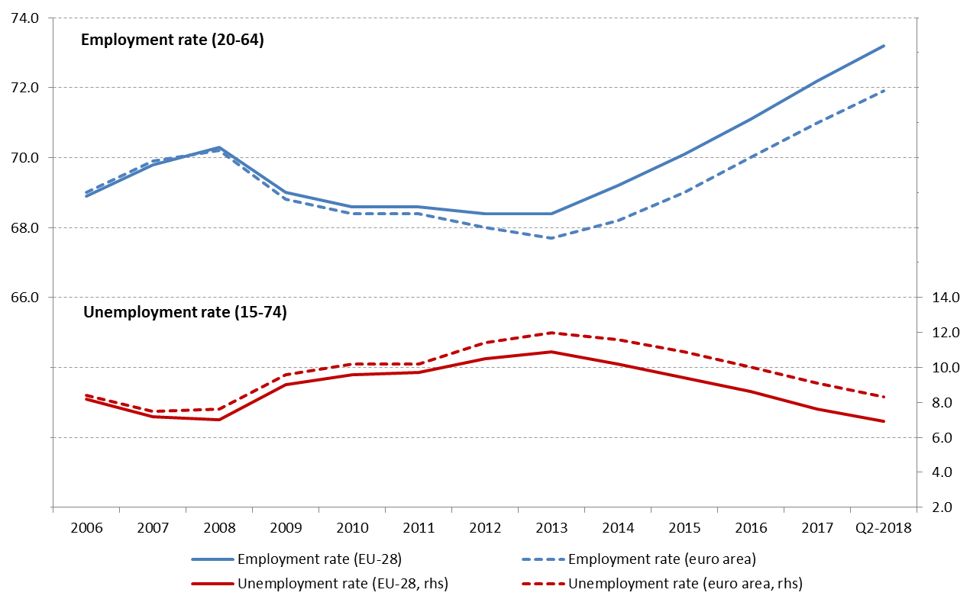

Source: Eurostat, LFS. Note: seasonally adjusted figures for Q2-2018.

**Youth unemployment also continues to decrease quickly,** dropping by 1.8 pps year-on-year to 15.2% in Q2-2018 (16.9% in the euro area). This level corresponds to the minimum reached just before the crisis (Q2-2008) and is now almost 9 pps below the 2013 peak. Still, youth unemployment remains high in some Member States, with rates above 30% in Spain, Italy and Greece (see Section 3.2.1). Continuing improvements are recorded in terms of people aged 15-24 who are neither in employment, nor in education or training (NEET), whose rate declined by 0.6 pps to 10.9% in 2017, a similar level as in 2008.

**The decrease in youth unemployment is mirrored by a parallel increase in the educational attainment of youth:** the rate of early leavers from education and training (aged 18-24), which has been steadily declining over the last decade, with the latest decrease (by 0.1 pps) reached 10.6% in 2017. This is very close to the Europe 2020 target of 10%, though there is room for further reduction[3]. Tertiary educational attainment for those aged 30 to 34 continued increasing steadily, reaching 39.9% in 2017 – almost reaching the Europe 2020 target of 40%.

**The recovery continues to be more prominent in terms of employed persons than of hours worked.** The volume of total hours worked in the EU increased by 1.2% in 2017, continuing the positive trend started in 2015. Nonetheless, this increase remains below that of total employment (which rose by 1.6%, see above), and implies that the number of hours worked per capita decreased. Total hours worked are not yet back to their 2008 peak level. This evidence points to remaining slack in the labour market, as also signalled by other indicators. In 2017, there were almost 9 million involuntary part-time workers in the EU (i.e. workers who are in part-time but would like to work more), declining from a peak of 10.3 million in 2013, but still 1.3 million above the level of 2008. In a longer-term perspective, the moderate dynamics of working hours is part of a structural shift, linked to a growing incidence of part-time work over the last 15 years and changing preferences of workers as concerns working time arrangements. As a result, the number of hours worked per person is on a gradually declining trend since 2000[4].

**Employment gains were spread among all the main demographic groups in 2017.** As in previous years, older workers (55-64) recorded the largest increase (Figure 2): the number of employed persons in this group rose by 4.3% in 2017, pushing the employment rate up to 57.1%, the highest ever (almost 12 pps higher than in 2008). The number of young people (15-24) in employment increased slightly faster than in 2016 (1.6% vs. 1.3%). Yet, the youth employment rate has not fully recovered from the crisis, as at 34.7% in 2017 it remains 2.7 pps below the 2008 level. Nevertheless, in view of a stable activity rate (at 41.7% in 2017 vs. 41.6% in 2016) the employment gains translated into a continuing decrease in unemployment for this age group. Employment increased slightly faster among women than among men in 2017 (1.5% vs. 1.3%). Yet the employment gender gap remains almost unchanged at 11.5 pps, 0.1 pps below 2016 (though significantly lower than the pre-crisis value of 15 pps in 2008). Although increasing by 1.7 pps at 63% in 2017, the employment rate of non-EU born people aged 20-64 remains 10 pps lower than that of native-born. The gap is higher for women (around 14 pps).

Figure 2: Employment rates and employment growth across different groups in the EU

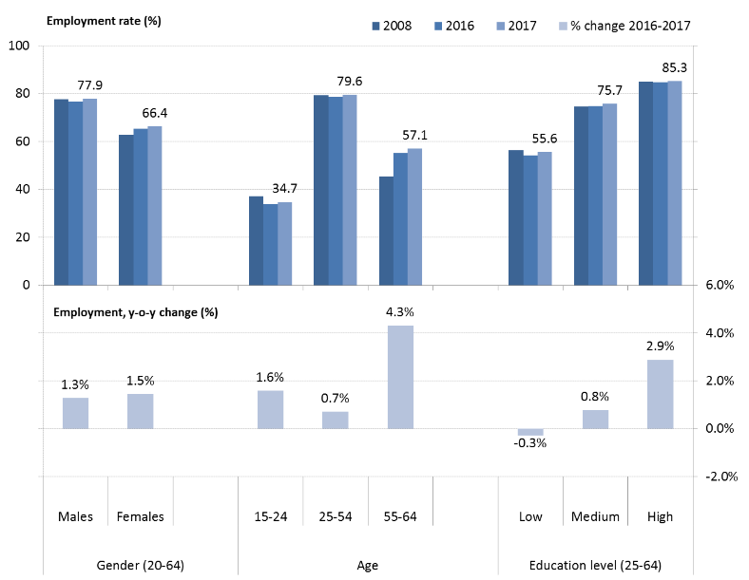

Source: Eurostat, LFS.

**The recovery keeps increasing the number of high skilled workers in the economy.** The number of people with higher education in employment increased by 2.9% in 2017 (age group 25-64), while a moderate increase of 0.8% was recorded among medium-skilled workers (i.e. those with upper secondary education). On the contrary, the number of low-skilled workers (i.e. with lower secondary education or below) dropped by 0.4%. Since the overall population of low-skilled workers aged 25-64 is on the decline (by 2.7% compared to 2016) – as part of a trend reflecting population ageing and higher educational attainment among younger generations – this group's employment rate actually increased from 54.3% in 2016 to 55.6% in 2017. The gap between employment rates of low- and high-skilled workers slightly decreased from 30.5 pps in 2016 to 29.7 pps in 2017, but remains very high and indicative of the room for action to increase the employability of people with low education level. Detailed trends by Member States are provided in the following sections of the report.

**Temporary employment, as a proportion of total employment, remained almost stable in 2017, while part-time employment decreased marginally.** Following a similar trend as in recent years, the recovery is fostering job creation in both permanent and temporary contracts, which rose respectively by around 2.7 million and 0.8 million in 2017 (corresponding to percentage increases by 1.7% and 2.9%). Nonetheless, as a proportion of total employment, the share of temporary employees remained almost stable, slightly increasing by 0.1 pps to 14.3% (age group 15-64). For a second year in a row, the proportion of part-time workers (age group 15-64) decreased marginally (by 0.1% to 19.4% in 2017), remaining almost 2 pps above the 2008 level. On the upside, as also mentioned above, the share of involuntary part-time workers is decreasing significantly (from 21.1% in 2016 to 19.8% in 2017) though remaining substantial. Self-employment (15-64) over total employment continued a slow decline, down to 13.7% in 2017 (from 14.0% in 2016 and 14.4% in 2013).

**In terms of sectoral developments, employment continued to shift towards services.** In line with the trend of recent years, the largest number of jobs was created in services[5] (2.8 million additional persons in employment in 2017, or +1.6% compared to 2016; based on national accounts). From 2008 to 2017, the share of employment in services in the EU increased continuously from 70.1% to 73.9%. With an increase by 2%, construction recorded the largest increase in employment since the recession, consolidating the recovery started in 2015; however, the number of employed persons is still almost 15% lower than in 2008. Industry also showed a solid expansion (by 1.5%, the highest rate since 2007). Finally, after a long series of declines, employment in agriculture slightly increased by 0.3% in 2017.

### 1.2 Social trends

**The number of persons at risk of poverty or social exclusion (AROPE****[6])****[7] has substantially declined in 2017 and is now below pre-crisis levels.** The declining trend in this indicator continued for a fifth consecutive year in 2017, falling to 113 million persons (or 22.5% of the total population) in line with the recovery in employment and the increase in disposable income. As a result, in 2017 there were 5 million fewer persons at risk of poverty or social exclusion in the EU than before the crisis (in 2008), while the decline from the peak in 2012 amounts to nearly 11 million. However, given the setback of the crisis, the Europe 2020 headline target (20 million fewer people at risk of poverty or social exclusion compared to 2008) remains far from reach. The current overall decline in the indicator is driven by all its three sub-components, though to a different extent (see below and Figure 3).

Figure 3: Percentage of population at-risk-of-poverty or social exclusion (AROPE) and subcomponents (2005-2017).

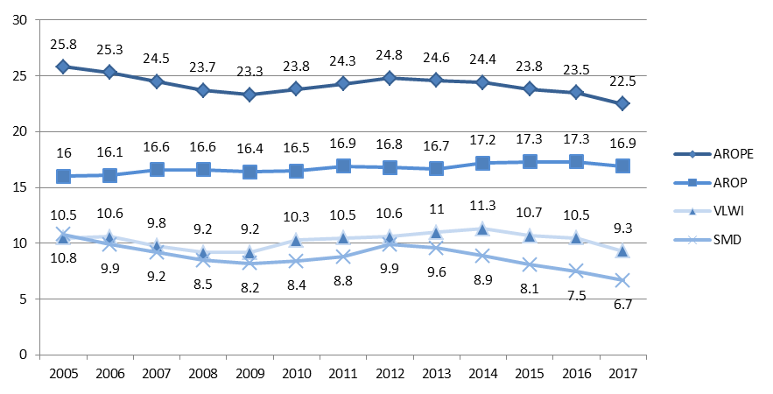

Source: Eurostat, SILC. Note: the legend is explained in footnote 6.

**A sharp fall in the number of persons suffering from severe material deprivation (SMD) brings the figures to its lowest level in recent history, reflecting rising standards of living.** Over 3 million people were relieved of severe material deprivation in the year to 2017, bringing the overall number of persons affected down to 34.8 million or 6.9% of the EU population (0.6 pps less than in 2017 and below 2008). This decline represents a significant improvement for a fifth year in a row, reflecting an improving material situation of households. In spite of these positive developments, a large variation between Member States persists (see section 3.4).

**The record increase in employment rates has contributed to reducing the number of persons living in quasi-jobless households** by 3.7 million in 2017. As a share of the population aged 0-59, this corresponds to a decrease from 10.5% in 2016 to 9.3% in 2017 – below 10% for the first time since 2009. Yet, both the rate and the number of people affected remain above pre-crisis levels.

**The percentage of the population at risk of poverty has shown its first decline since the crisis.** Following an increase in the number of people at risk of poverty until 2014, this indicator had stabilised in the following two years. In 2017 the rate fell by 0.4 pps to 16.9%, or nearly 2 million people – marking the first year after the crisis in which the incomes of poor households have risen faster than median incomes. The latest data from Eurostat flash estimates[8] suggest that this decline in poverty rates is set to continue. However, the at risk-of-poverty rate for persons living in households with very low work intensity has increased for a fourth consecutive year, and is now at a record-high 62.3%. This points to persistent gaps in the adequacy of social benefits in several countries and has been identified as a trend to watch by the Social Protection Committee[9].

**In spite of the overall decline in the share of people at risk of poverty, in-work poverty remains high.** In 2017, 9.6% of the working population had household income below 60% of the national median, a figure that was unchanged from 2016, and which remains well above the 2008 figure of 8.5%. The increases to date have affected both part-time and full-time workers, although the former remain at substantially higher risk of poverty (15.8% as against 8.0%). The trend has affected in particular younger workers (aged under 30 years) who face a higher and increasing risk vis-à-vis workers aged 30 years and over.In-work poverty has been identified as a trend to watch by the Social Protection Committee both from a short- and long-term perspective[10].

**Poverty figures for the most vulnerable people indicate modest improvements, reversing previous trends.** The poverty gap, which measures how far away from the poverty line those at risk of poverty are, fell in 2017. It decreased modestly from 25% to 24.7%, yet remaining well ahead of pre-crisis levels. This suggests that the relative income position of the most vulnerable is slightly improving. For the unemployed, the poverty risk declined for the first time since the crisis, yet at 48% it remains near record-high levels.

**Despite overall improvements, the risk of poverty or social exclusion facing children remains high.** The AROPE rate for children (aged 0-17) continues to decline, falling from 26.4% to 24.5% in 2017, well below the pre-crisis level. However, 62.9% of the children of low-skilled parents remain at risk of poverty or social exclusion, against only 9% for the children of high-skilled parents. For the children of non-EU born people, the proportion of those at risk of poverty or social exclusion has been rising throughout the post-crisis period, reaching 34.5% in 2017, more than twice the rate facing the children of native-born parents. A key driver of child poverty is the growth in the number of single parent households, whose share has increased from 4.4% of the EU population in 2011 to 4.8% in 2016 (but fell to 4.3% in 2017). The at-risk-of-poverty rate for children from single parent households is twice the average for children overall, a gap that continues to widen.

**Household incomes continue to grow, but at a slower rate than the economy as a whole.** While the gross disposable income of households (GDHI) rose for a fourth year in a row to 2017, and is now well ahead of the 2008 level, the annual increase still lags behind GDP growth (GDHI grew under 1% for the year to 2017, while real GDP per capita rose by 2.2% in the same period). This highlights that households' income gains are lagging behind overall income growth in the economy. As shown in Section 3.4, gross disposable household income per capita, in real terms, remains below pre-crisis levels in a number of Member States.

**Increases in income inequality in post-crisis years have begun to reverse in 2017, though not compensating yet for past increases.** On average, the richest 20% of households in Member States have an income that exceeds that of the poorest 20% of households by over five times. The S80/S20 ratio rose from 5.0 to 5.2 between 2008 and 2016, also driven by poor labour market conditions and stagnating incomes, especially in the lowest part of the distribution. In 2017, this ratio has begun to decline, back to 5.1 on average in the EU. The latest Eurostat flash estimates suggest the decline is set to continue.

# 2. SNAPSHOTS FROM THE SOCIAL SCOREBOARD

The European Pillar of Social Rights, established as an inter-institutional Proclamation by the European Parliament, the Council and the Commission on 17 November 2017, sets out a number of key principles and rights to support fair and well-functioning labour markets and welfare systems. It is designed as a compass for a renewed process of convergence among Member States towards better socio-economic conditions.

The European Pillar of Social Rights is accompanied by a social scoreboard to monitor performances and track trends across Member States[11]. The scoreboard provides a number of indicators (headline and secondary) to screen the employment and social performance of Member States on selected indicators along three broad dimensions, identified in the context of the Pillar: (i) equal opportunities and access to the labour market, (ii) dynamic labour markets and fair working conditions, and (iii) public support / social protection and inclusion. Since the 2018 edition, the Joint Employment Report integrates the social scoreboard, whose results (as concerns headline indicators) are summarised in this Chapter. The analysis is placed in the broader reform context presented in Chapter 3.

### 2.1 The scoreboard explained

**The social scoreboard is a central tool for monitoring performance in the employment and social domains, and convergence towards better living and working conditions**. In particular, it helps monitoring the situation of Member States on measurable dimensions of the Pillar, complementing the existing monitoring tools, in particular the Employment Performance Monitor and the Social Protection Performance Monitor[12]. It notably includes 14 headline indicators that assess employment and social trends at large[13]:

* *Equal opportunities and access to the labour market:*
  + Share of early leavers from education and training, age 18-24
  + Gender gap in employment rate, age 20-64
  + Income inequality measured as quintile share ratio - S80/S20
  + At-risk-of-poverty or social exclusion rate (AROPE)
  + Young people neither in employment nor in education or training (NEET rate), age 15-24
* *Dynamic labour markets and fair working conditions:*
  + Employment rate, age 20-64
  + Unemployment rate, age 15-74
  + Long-term unemployment rate, age 15-74
  + Gross disposable income of households in real terms, per capita[14]
  + Net earnings of a full-time single worker without children earning an average wage[15]
* *Public support / Social protection and inclusion:*
* Impact of social transfers (other than pensions) on poverty reduction[16]
* Children aged less than 3 years in formal childcare
* Self-reported unmet need for medical care
* Share of population with basic overall digital skills or above.

**Headline indicators are analysed using a common methodology agreed by the Employment Committee and the Social Protection Committee** (see Annex 3 for details). This methodologyevaluates the situation and developments in Member States by looking at levels and yearly changes[17] of each of the headline indicators included in the social scoreboard.Levels and changes are classified according to their distance from the respective (unweighted) EU averages. Member States' performances on levels and changes are then combined (by using a predefined matrix) so that each Member State is assigned to one out of seven categories ("best performers", "better than average", "good but to monitor", "on average/neutral", "weak but improving", "to watch" and "critical situations"). On this basis, Table 1 provides a summary of the readings of the scoreboard according to the latest figures available for each indicator.

**A careful and non-mechanical reading of the table is warranted.** For this purpose, a detailed analysis of the fourteen indicators, including longer-term trends and additional indicators, when relevant, is presented in Chapter 3. In addition, the forthcoming country reports will provide an in-depth analysis of all "critical situations" and additional socio-economic and policy background to better qualify country-specific challenges in the context of the European Semester. Together with further analysis included in the Employment Performance Monitor and the Social Protection Performance Monitor, this will provide an analytical basis for the subsequent Commission proposals for Country Specific Recommendations where appropriate.

### 2.2 Evidence from the social scoreboard

**The analysis of the Scoreboard points to a continuing recovery in the labour market and social situation for the EU as a whole[18].** On average for the EU[19], 13 out of 14 headline indicators recorded an improvement over the last available year (i.e. 2017 or 2016 depending on data availability), with only one (impact of social transfers on poverty reduction) slightly deteriorating, though in line with a reduced impact of automatic stabilisers in a phase of economic expansion. The most significant progress was recorded in (overall and long-term) unemployment rates, which decreased in all Member States in 2017, with only one "critical situation" highlighted. Developments in the employment rate and the at-risk-of-poverty or social exclusion rate were also positive across the board, as the large majority of Member States recorded an improvement compared to the previous year.

**Most Member States face challenges on at least one headline indicator, but the overall count has reduced compared to last year.** Considering the three more problematic classifications altogether, i.e. "critical situation", "to watch" and "weak but improving", most Member States are flagged at least once – with the exception of Germany, Finland, France, the Netherlands and Sweden. Considering "critical situations" only (i.e. indicators whose level is much worse than average, and either not improving sufficiently fast or deteriorating further), the number of flagged Member States decreased from 14 in the 2018 Joint Employment Report (with a smaller set of indicators) to 13 in the current exercise (Estonia, Malta and Portugal have left this group, while Hungary and Latvia have joined it). The count of challenges points to an improvement across the board. Across the 14 domains assessed, overall 117 "critical situation", "to watch" or "weak but improving" cases are identified, i.e. about 31% of the total number of assessments (compared to 33% in the 2018 JER); of these, 39 are "critical situations", corresponding to 10% of all assessments (compared to 13% in the 2018 JER)[20].

Looking at the three broad dimensions covered by the scoreboard, similarly to the 2018 Joint Employment Report, problematic flags appear more frequently in the area of **"public support/social protection and inclusion"**, with an average of 9.3 cases (of which 3.5 "critical situations") per indicator. The **impact of social transfers on poverty reduction** appears as the most challenging indicator, with flags for 11 Member States (of which 5 in the bottom category).

The dimensions of **"equal opportunities and access to the labour market"** and "**dynamic labour markets and fair working conditions"** follow, with an average of 8.6 and 7.4 flagged cases per indicator respectively (3.2 and 1.8 "critical situations" each). In the first domain, the most flagged indicator is **early leavers from education and training** (10 times). In the latter, **net earnings of a full-time single worker** **without children** **earning an average wage** appears as the indicator with most numerous challenges (12 flags).

**As for the last year, the situation of Member States and the severity of the respective challenges vary widely.** Greece, Romania and Italy still present "critical", "to watch", or "weak but improving" assessments on ten or more indicators – of which "critical situations" flagged respectively for 7, 4 and 6 indicators (see Table 1). For these countries, challenges are spread uniformly across the three domains (still, "better than average" performances are flagged once for Greece and Italy, respectively on the early school leavers rate and self-reported unmet needs for medical care, and twice for Romania, on the unemployment rate and the growth of gross disposable household income per capita). In terms of overall count, Croatia and Spain (9 challenges each), Bulgaria (8 challenges), Cyprus, Latvia and Portugal (6 challenges each) follow. By contrast, Netherlands is a "best performer" or "better than average" on 11 headline indicators, followed by Czech Republic and Sweden (10 indicators each), Austria, Germany and Slovenia (8 indicators each).

When looking at **equal opportunities and access to the labour market,** the largest improvements were recorded, on average, in terms of at-risk-of-poverty or social exclusion and NEET rates, while progress has been more muted as concerns early school leaving, gender employment gap and income inequality (however, the latter indicator shows the first decrease in the post-crisis period). When looking by indicator:

* Spain, Italy and Romania face a "critical situation" when it comes to early leavers from education and training, compared to Croatia, Ireland, Poland and Slovenia as the "best performers";
* Greece, Italy, and Romania score critical on the gender employment gap, compared to Finland, Lithuania and Sweden as "best performers";
* Bulgaria, Spain, Latvia and Lithuania face a "critical situation" in terms of income inequality compared to the best performance of the Czech Republic, Finland, Slovenia and Slovakia;
* The situation as concerns the at-risk-of-poverty or social exclusion rate is critical in Bulgaria and Greece, compared to the Czech Republic and Finland as "best performers";
* Cyprus, Croatia, Greece and Italy face a "critical situation" when looking at NEETs while Austria, Czech Republic, Germany, the Netherlands, Slovenia and Sweden perform the best.

Turning to **dynamic labour markets and fair working conditions in the EU,** on average the situation improved over the last year across all indicators, notably employment and unemployment rates (both overall and long-term), gross disposable household income (GDHI) per capita and net earnings of a full-time single worker without children earning an average wage. When looking by indicator:

* Croatia, Greece, Italy and Spain face a "critical situation" when it comes to their employment rate, compared to the Czech Republic, Estonia, Germany, the Netherlands, Sweden and the UK as the "best performers";
* No country scores critical on the unemployment rate (Cyprus, Croatia, Greece and Spain are marked "weak but improving", while Italy is "to watch"); on the other hand, the Czech Republic scores as "best performer";
* Italy scores critical on the long-term unemployment rate (no "best performers" identified through the methodology, while 14 countries are "better than average")
* The growth in per capita GDHI is seen as a "critical situation" in Greece and Cyprus, compared to Bulgaria and Poland as "best performers";
* The situation on net earnings of a full-time single worker without children earning an average wage is assessed as critical for Hungary and Slovakia, while Austria, Germany, Luxembourg, the Netherlands and the United Kingdom are the "best performers".

As regards **public support and social protection and inclusion,** the situation has improved over the last year in terms of childcare availability, self-reported unmet need for medical care and digital skills but it worsened in terms of the impact of social transfers on poverty reduction, as mentioned above. When looking by indicator:

* Bulgaria, Greece, Italy, Latvia and Romania face a "critical situation" when it comes to the ability of their social transfers to reduce the risk of poverty. This compares to Denmark, Finland, Hungary and Sweden as the "best performers";
* Bulgaria, the Czech Republic, Greece, Poland and Slovakia score critical on the participation of children aged less than 3 to formal childcare, compared to France, Luxembourg, the Netherlands and Portugal as "best performers";
* Latvia faces a "critical situation" in terms of self-reported unmet need for medical care (no "best performers" identified through the methodology, while 12 countries are "better than average");
* Bulgaria, Croatia and Romania face a "critical situation" when looking at levels of digital skills, while Finland, Luxembourg, the Netherlands and Sweden perform the best.

**Table 1.** **Summary of headline indicators of the Social Scoreboard**



Note: On 26 October 2018: income quintile ratio, AROPE, impact of social transfers on poverty reduction and self-reported need for medical care not available for IE and UK; GDHI per capita growth not available for HR and MT; net earnings of a full-time single worker without children earning the average wage not available for CY; individuals' level of digital skills not available for IT. Breaks in series and other statistical flags are reported in Annexes 1 and 2.

|  |
| --- |
| ***Box 1. Benchmarking - state of play***  The importance of benchmarking as a tool to support structural reforms and foster upward convergence in the employment and social fields was recognised by the Five Presidents' Report of June 2015[21] and further underlined in the Reflection Paper on EMU deepening of May 2017[22]. The Communication of 26 April 2017 establishing a European Pillar of Social Rights[23] identified benchmarking as a key vehicle to support the implementation of the Pillar within the European Semester. Since then, benchmarking exercises have been developed and discussed with Member States in several areas.  In particular, the Employment Committee (EMCO) and the Social Protection Committee (SPC) have agreed on a common approach in three steps: (1) identification of key challenges and a set of high level outcome indicators relevant for the policy area under consideration; (2) performance indicators which allow for benchmarking the performance; (3) the identification of policy levers, which are accompanied by general principles for policy guidance and, when available, by specific indicators. At this stage, reference values for policy levers are not set, as the aim is to allow for comparisons across Member States.  The benchmarking framework on unemployment benefits and active labour market policies was used for the first time in the 2018 European Semester. In this context, a comparative analysis of specific design features and performance of unemployment benefit systems, notably as concerns eligibility and adequacy aspects, was included in the 2018 Joint Employment Report and Country Reports. Following the endorsement by the Employment Committee (EMCO), elements of the framework related to the activation component of unemployment benefit schemes (e.g. availability-to-work conditions attached to receiving unemployment benefits) and to labour market services in support of job seekers are now integrated in the European Semester 2019 and are presented in this report.  Upon endorsement by the Social Protection Committee (SPC), the European Semester 2019 also sees a full integration of the benchmarking framework on minimum income benefits, covering adequacy, coverage and activation components of minimum income schemes, including as concerns their relation with in-kind services (healthcare, education and housing). Finally, this Semester cycle benefits, for the first time, from the results of the benchmarking framework on adult skills and learning, which was agreed with the Employment Committee in October 2018. Work is currently ongoing within relevant Committees on possible additional benchmarking frameworks, such as on pension adequacy, to be utilised in future Semester cycles. |

# 3. EMPLOYMENT AND SOCIAL REFORMS – MEMBER STATES PERFORMANCE AND ACTION

This section presents an overview of recent key employment and social indicators and measures taken by the Member States in priority areas identified by the EU employment guidelines[24], as adopted by the Council in 2018. For each guideline, recent developments on a selection of key indicators are presented, as well as policy measures taken by Member States. As concerns the latter, the section draws on Member States’ National Reform Programmes 2018 and European Commission sources[25]. If not specified otherwise, only policy measures implemented after June 2017 are presented in the report. An in-depth analysis of recent labour market developments can be found in the Labour Market and Wage Developments 2018 report[26] and the Employment and Social Developments in Europe Review 2018.[27]

### **3.1** **Guideline 5: Boosting demand for labour**

This section looks at the implementation of the employment guideline no. 5, which recommends Member States to create conditions promoting labour demand and job creation. It first presents an overview of unemployment and employment rates by Member State, complementing the analysis at EU level made in Chapter 1, to highlight the relevance of the job creation challenge across countries. It then looks at self-employment dynamics, as a proxy for entrepreneurship and as a source of employment growth per se (aspects of self-employment related to new forms of work are discussed in Chapter 3.3). Finally, it investigates wage and tax wedge developments as key macroeconomic determinants of hiring decisions. Section 3.1.2 reports on policy measures implemented by Member States in these areas to promote labour demand, including hiring subsidies.

### 3.1.1 Key indicators

**The decline in unemployment accelerated in 2017.** For the first time after the crisis, the unemployment rate decreased in all EU Member States. A quicker-than-average drop occurred notably in some Member States suffering from very high unemployment rates – Greece, Spain, Croatia, Portugal, all experiencing a reduction by 2 pps or more – pointing to a clear convergence trend[28] towards lower unemployment levels. Nonetheless, a strong decrease occurred also in some low-unemployment countries – by more than 1 pp in the Czech Republic, the Netherlands, and Poland. As evident from Figure 4 (which looks jointly at levels and changes according to the agreed methodology for assessing headline indicators of the social scoreboard[29]), the dispersion of unemployment rates remained substantial in 2017, with values ranging from around 3% in the Czech Republic to 21.5% in Greece. The unemployment rate also remains high in Italy, with only limited improvements compared to 2016. In spite of the steady decrease since 2013, in many Member States the unemployment rate remains much higher than in 2008 (Figure 5) – especially in Croatia, Greece, Cyprus, Italy and Spain. On the contrary, in Germany, Hungary and Poland the unemployment rate in 2017 was more than 2 pps lower than before the crisis.

Figure 4: Unemployment rate (15-74) and yearly change (Social Scoreboard headline indicator)

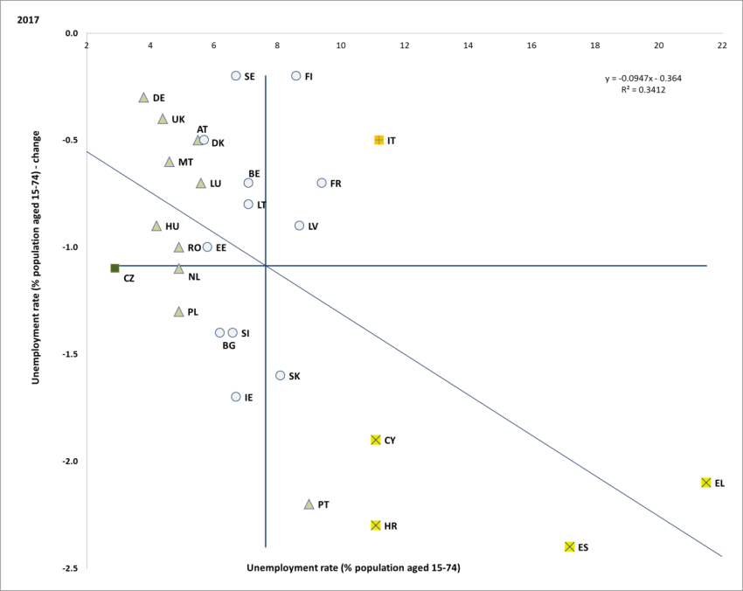

Source: Eurostat, LFS. Period: 2017 levels and yearly changes with respect to 2016. Note: Axes are centred on the unweighted EU average. The legend is presented in the Annex.

Figure 5: Unemployment rate (15-74), multiannual comparison

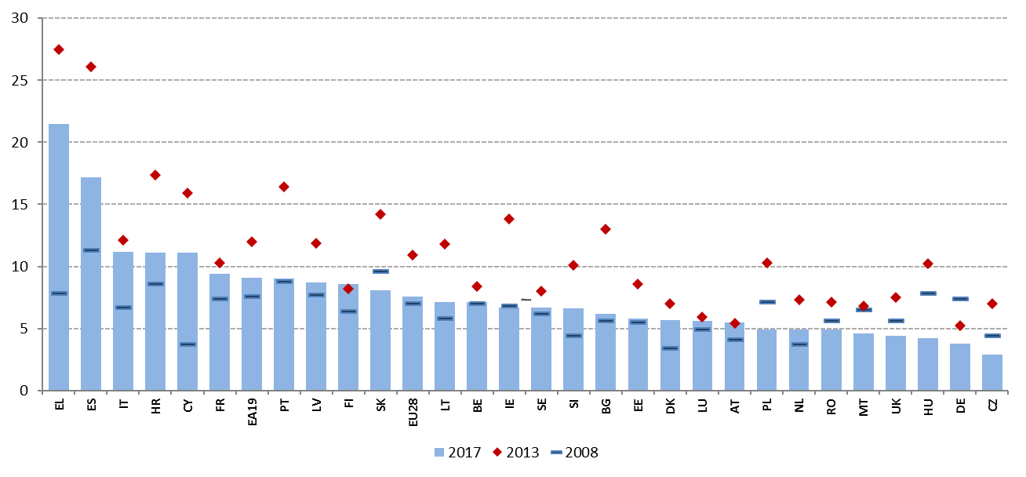

Source: Eurostat, LFS.

**While employment rates registered strong increases, significant disparities remain.** All Member States recorded increases, with the exception of Denmark[30] (a 0.5 pp decrease, though from a very high level). As shown in Figure 6, employment rates are only partially converging: Member States characterised by lower employment rates tend to experience a somewhat faster growth than average – but the situation remains scattered. Employment rates (age group 20-64) diverge widely, ranging from 57.8% in Greece to 81.8% in Sweden in 2017. At the lower end, the employment rate remains much below the EU average in some of the countries most hardly hit by the crisis, namely Greece, Croatia, Italy and Spain (flagged as "critical situations"). Nine countries are already above the 75% target, while the six best performers (Sweden, Germany, Estonia, the Czech Republic, the United Kingdom and the Netherlands are all close to or above 78%).

Figure 6: Employment rate (20-64) and yearly change (Social Scoreboard headline indicator)

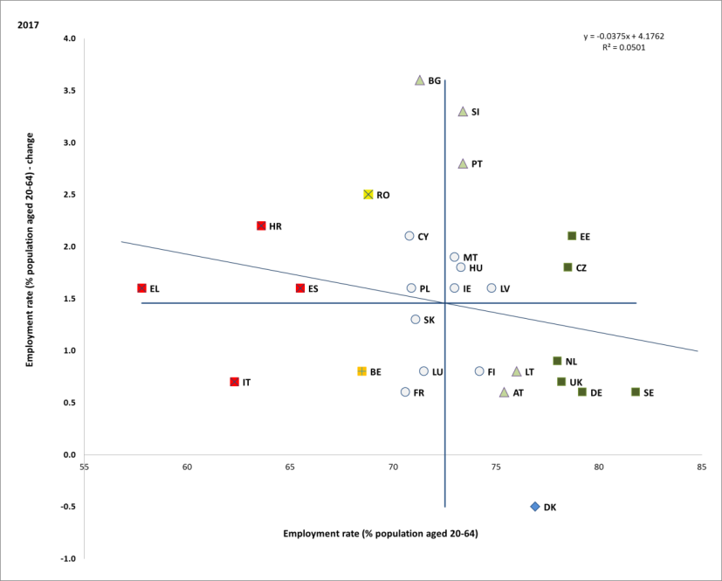

Source: Eurostat, LFS. Period: 2017 levels and yearly changes with respect to 2016. Note: Axes are centred on the unweighted EU average. The legend is presented in the Annex.

**Average employment rates in the EU have been constantly rising since 2013 and are now well above the pre-crisis peak.** Hungary and Malta, who had the lowest employment rates in the EU in in 2008, have experienced the highest long run increases (+11.8 pps and +13.8 pps respectively in 2017) and are now slightly above the EU average. However, disparities are still high. In particular, similarly as for unemployment rates, employment rates remain below 2008 levels in those countries most affected by the crisis, such as Greece, Italy, Croatia, Spain, Cyprus and Ireland (Figure 7).

Figure 7: Employment rate (20-64), multiannual comparison

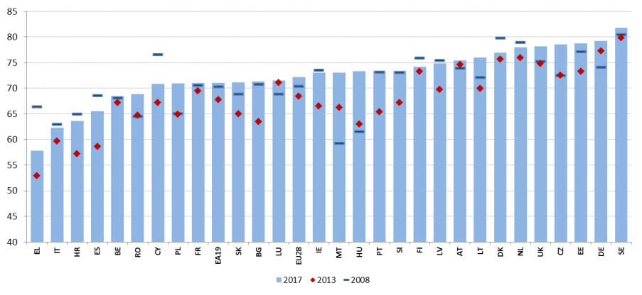

Source: Eurostat, LFS.

**The sustained job growth did not affect the long-term declining trend in self-employment.** In absolute numbers, self-employment fell by 0.5% in 2017 (after a slight increase in 2016[31]). It continued to decline also in relative terms, representing 13.7% of total employment in 2017 (down from 14.0% in 2016 and 14.4% in 2013). The share of self-employed men over the total men employed, at 17.2%, remains much higher than for women (9.7%). Trends in self-employment are less negative if the primary sector and manufacturing are excluded. In particular, self-employment has steadily increased over the last ten years in most of the sectors related to services.

**Overall figures are the result of diverging developments across Member States, sectors and sub-groups.** However the trends in self-employed do not seem linked to performance in employment at Member State or sectoral level. In terms of age and education groups, developments reflect to a large extent the changing composition of the workforce: self-employment kept falling for people aged 15-49 while it increased markedly for people aged 50-64 and 65 and over (+1.2% and +4.0%, respectively). The level of education is also an important factor, as in 2017 the number of self-employed decreased by 3.2% for people with up to lower secondary education and increased by 1% for people with tertiary education. Finally, an increase in the number of self-employed born outside the EU is recorded. Aspects related to self-employment as an atypical form of work are discussed in detail in Chapter 3.3.

**Wage growth remains moderate in most Member States.** Nominal wage growth in the EU has remained subdued during the recovery, but started picking up in 2017, with compensation per employee increasing by 2.1%. Differences across countries are considerable, with wages growing generally faster in Member States with lower levels and in those that are not members of the euro area. The increase in nominal compensation per employee was the highest in Romania (16.0%), Lithuania (9.1%), Hungary (7.9%), Latvia (7.9%) and Bulgaria (7.5%), pointing to wage convergence between Eastern and Western Europe. At the low end, nominal wages declined in Finland (-1.1%) and Croatia (-1.1%) and remained flat in Spain, Italy and Greece.

**In real terms, wage growth slowed down in 2017 compared to 2016.** In the EU, real consumption wages (i.e. wages adjusted for the change in consumer prices) grew by 0.5% in 2017, down from 1.2% in 2016. In the euro area, real wages almost stagnated (+0.2%). A decline was recorded in eight countries: Spain, Italy, Greece, Croatia, Portugal, the Netherlands, Austria and Finland. The slowdown compared to 2016 was partly due to the increase in consumer prices, which was not matched by the rise in compensations. However, even when looking at real production wages (adjusted for the GDP deflator), the picture is almost unchanged, with real wage growth increasing only slightly in the EU in 2017 (by 0.7%) and a decline registered in ten countries (Figure 8).

Figure 8: Real compensation per employee, HICP and GDP deflator, 2017 annual % change

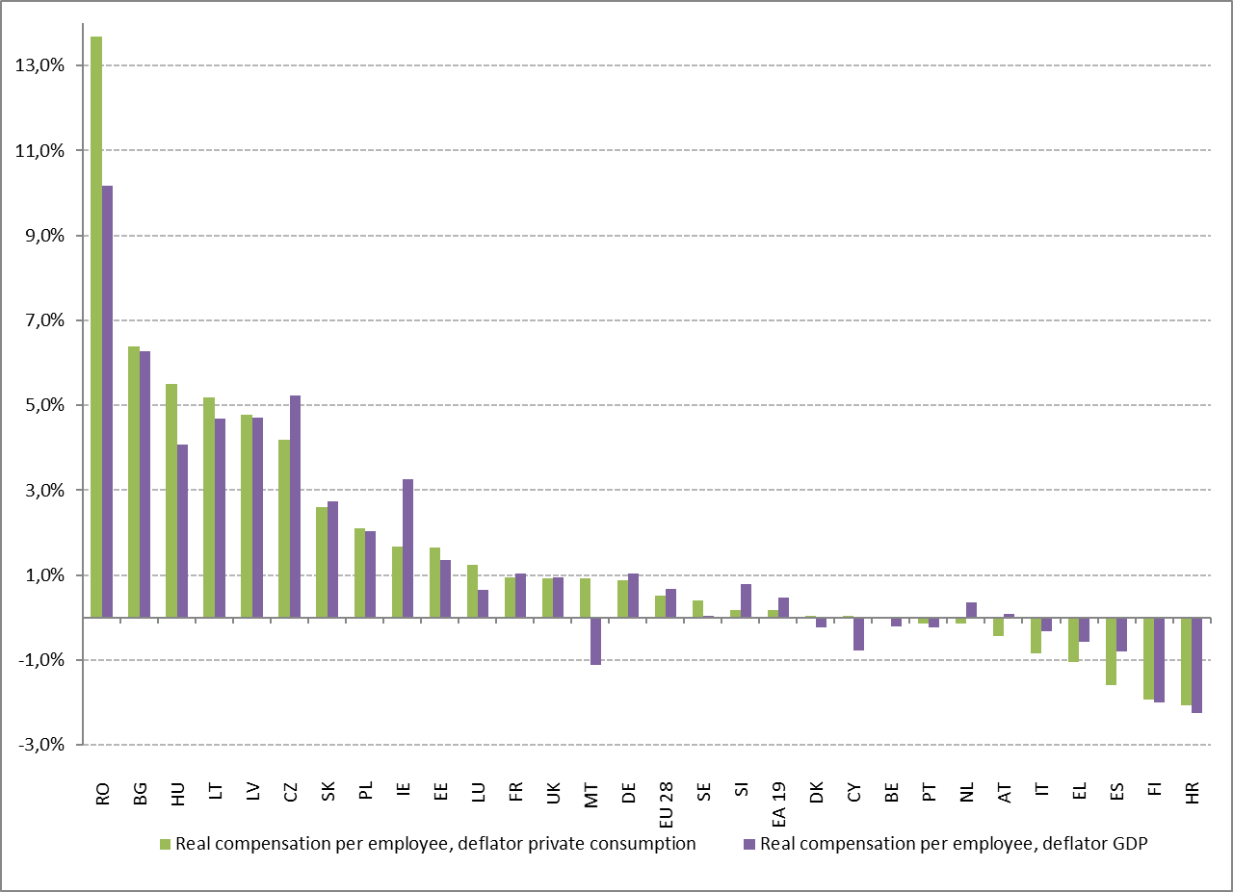

Source: European Commission, AMECO database.

**In 2017, real wage growth stood below productivity growth in most Member States.** This trend is also confirmed over a three-year period (Figure 9) and in a longer-term perspective (Figure 10). In nine countries (Belgium, Cyprus, Croatia, Finland, Greece, Italy, the Netherlands, Portugal and Spain), real wage growth was negative over the period 2015-2017. Also over the longer term (2000-2017), real wage developments have been trailing behind productivity on average. In Portugal and Italy, wages are still below 2000 levels in real terms. The recent trend is opposite for most of the central and eastern Member States, where, over the last three years, real wage growth (deflated with GDP deflator) exceeded productivity growth, partially as a result of the catching-up process towards higher income countries. In 2017, the largest excess growth of real wages over productivity growth was observed in the Baltic Member States, Bulgaria, and Slovakia.

Figure 9: Real compensation per employee and productivity, average growth rates 2015-2016-2017

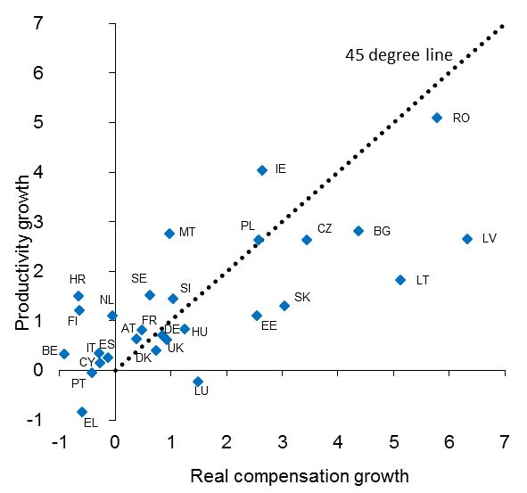

***Source:*** Eurostat, National Accounts (own calculations, from Labour Market and Wage Developments in Europe, annual review 2018).

**Figure 10: Wage and productivity developments, 2000-2017 average % changes**

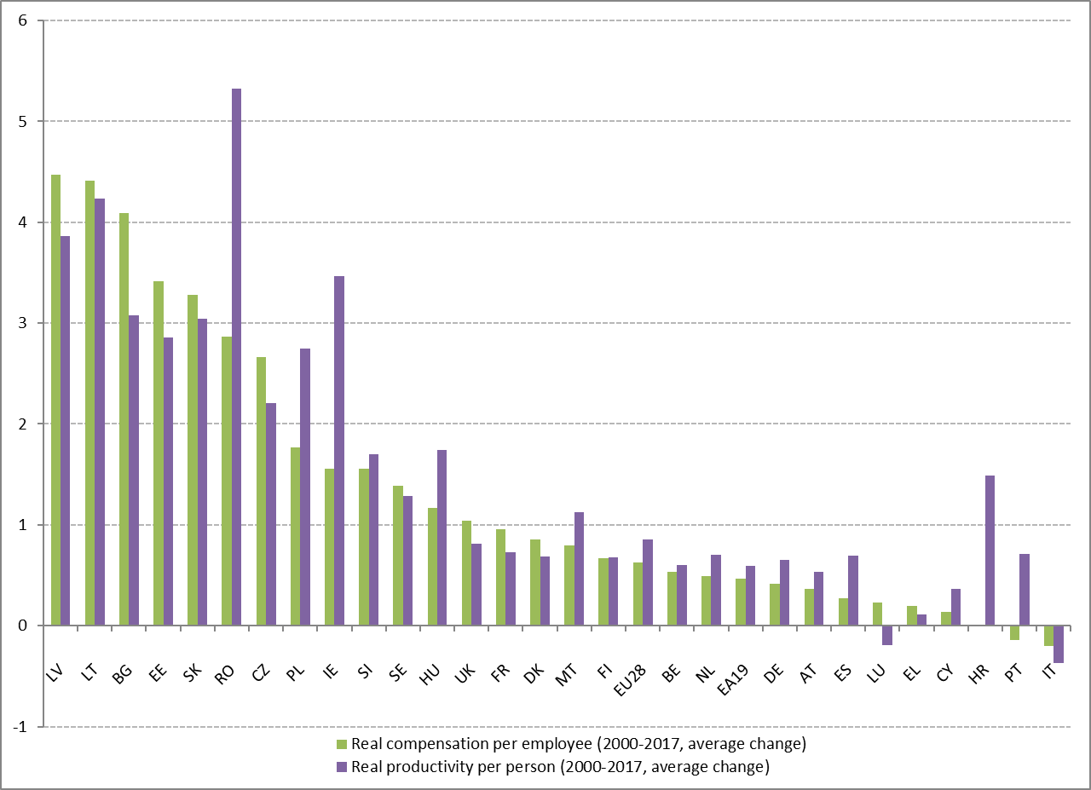

Source: Eurostat, National Accounts (own calculations).

**Wage growth remains below what could be expected on the basis of current unemployment levels.** In the recovery, wage growth has been moderate overall, and has not appeared to react to the fall in unemployment rate as in previous economic cycles. This phenomenon has been called the apparent "flattening" of the wage Phillips curve, i.e. the relationship between wage growth and unemployment. As shown for the euro area in Figure 11**,** it suggests that wages have become less responsive to the overall unemployment rate in the economy.

**Figure 11: Phillips curve for the euro area: growth rate of compensation per employee, 2000-2017**

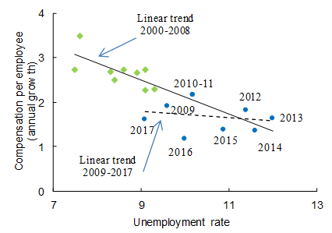

Source: DG ECFIN AMECO database and Eurostat, LFS (own calculations, from Labour Market and Wage Developments in Europe, annual review 2018)

**Moderate nominal wage growth during the recovery can be explained by low inflation, low productivity growth, the effect of some labour market reforms and remaining reserves in the labour market.** A significant part of the moderation in nominal wages can be explained by low inflation (1.5% on average during the recovery, between 2010 and 2017, compared to 2.2% in 2000-2007). Meanwhile, real productivity growth increased somewhat (0.7% on average over 2010-2017 as compared to 0.4% pre-crisis) but was coupled with a significantly higher unemployment rate (11.7% in the post-crisis period as compared to 8.7% pre-crisis). Overall, recent estimations suggest that inflation, productivity and labour market reserves explain much of the recent wage moderation (IMF 2017[32]; European Commission 2018[33]). Latent labour market reserves, notably an increased share of underemployed part-time workers, may contribute to wage moderation in some Member States with low unemployment rate.

**Net earnings are converging in Europe, with fast growth in Central and Eastern Europe and slow growth in Western and Southern Europe, especially in those countries most affected by the crisis.** Convergence in labour income levels is key to ensure that anyone in the EU achieves a decent standard of living, as advocated by the European Pillar of Social Rights. Evidence shows that this convergence process is taking place, albeit at a slow pace, as large discrepancies still remain across Member States. Taking as a reference a single earner without children earning the average wage level, over a three-year period (2013-2016) net earnings[34] increased the most in some countries characterised by the lowest levels. For this reason, Bulgaria, Romania, Latvia, Lithuania and Estonia are classified as “weak but improving”. Slovakia and Hungary, while having also experienced higher than average increases, are marked as "critical situations" in view of slower progress. At the other end of the spectrum, growth in net earnings was moderate (ranging from 0.7% to 2.1%) in all the "best performers" (Luxembourg, the United Kingdom, the Netherlands, Germany and Austria). Net earnings decreased or did not grow in Portugal, Greece and Belgium.

Figure 12: Net earnings and yearly change – average over three years (Social Scoreboard headline indicator)

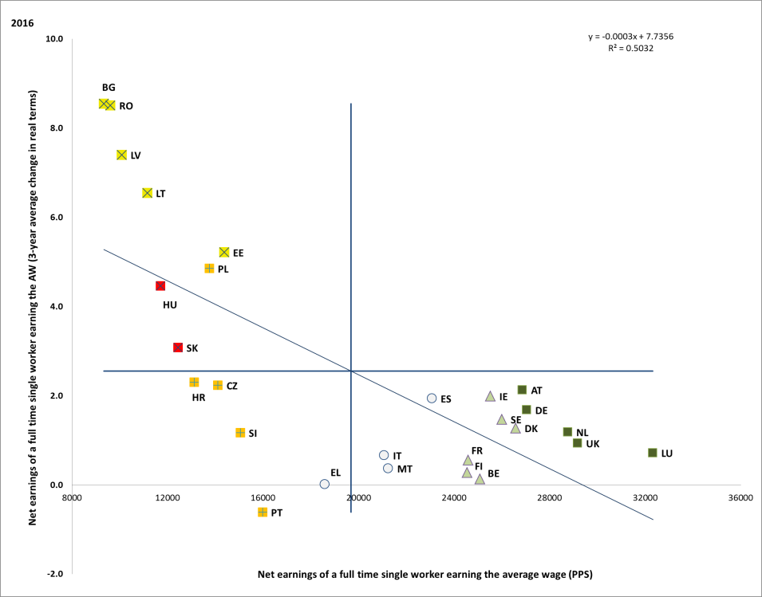

Source: OECD (own calculations). Period: 2016 levels (3-year average) and average yearly changes 2013-2016. Note: Axes are centred on the unweighted EU average. The legend is presented in the Annex. Member States marked with an asterisk are those where nominal unit labour cost (NULC) exceeded the threshold set by the Macroeconomic Imbalances Procedure (MIP). The MIP scoreboard indicator is the percentage change over three years of NULC. The threshold is 9% for the euro area countries and 12% for the non-euro area countries. Data not available for Cyprus.

**In-work poverty remains well above pre-crisis levels and is only slowly declining**. The share of persons who, while being at work, have an equivalised disposable income below the risk-of-poverty threshold rose from 8.6% in 2008, to 9.0% in 2013 and to 9.6% in 2017. The highest level was recorded in Romania (17.4%), followed by Luxembourg, Spain, Greece and Italy – all above 12%. At the other end of the spectrum, the in-work poverty rate is below 5% in Finland, the Czech Republic and Ireland. In-work poverty kept increasing in several Member States in 2017, including (by more than 0.5 pps) in Hungary, Italy, Latvia, Slovenia, Belgium and the Netherlands (see also Chapter 3.4).

Figure 13: In-work at-risk-of-poverty rate, multiannual comparison

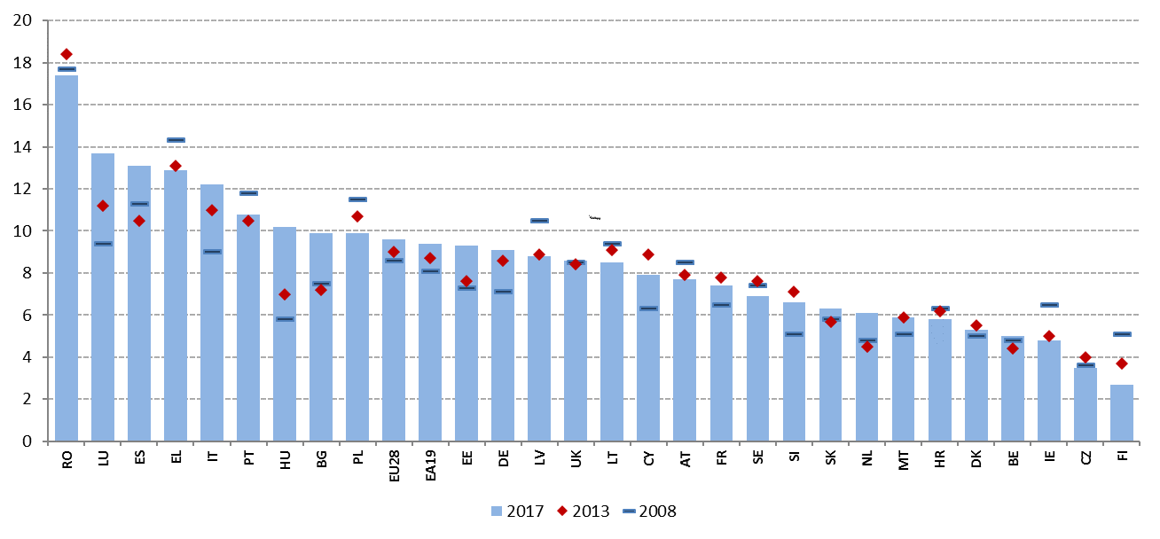

Source: Eurostat. Note: for HR, 2010 instead of 2008 data. For IE and UK, 2016 instead of 2017 data.

**Wage dispersion seems broadly stable in Europe.** Wage growth, especially at the bottom of the wage scale, plays an important role in reducing income inequalities and in-work poverty. Dispersion of gross earnings, measured as the ratio between the fifth and first decile (D5/D1), ranged in 2016 from 1.43 in Finland to 1.90 in the Czech Republic. Wage setting institutions can have an impact on wage dispersion. In particular, stronger collective bargaining tends to be associated with a lower earnings inequality (European Commission, 2018[35]). Collective bargaining coverage varies widely across Europe, reflecting different national traditions and institutions. In 2015, the percentage of employees with the right to bargain ranged from 98% in Austria to 7.1% in Lithuania.

**In most Member States, statutory minimum wages set a lower bound to the wage distribution**. Minimum wages may increase labour market participation of certain groups and support aggregate demand by increasing the income of low-wage earning families, which have a higher propensity to consume. At the same time, minimum wages increase the cost of hiring low-wage workers, thereby potentially harming the employment opportunities of groups typically earning low wages (e.g. young and low-skilled workers), depending on the structure of the economy and the macroeconomic situation. Statutory minimum wages set at a national level exist in most Member States, with the exception of Austria, Cyprus, Denmark, Finland, Italy and Sweden. For international comparison, the absolute level of the minimum wage is not a very useful measure because it does not take into account cross-country differences in labour productivity and prices. It is therefore more useful to look at the minimum wage relative to a country's average or median wage. Figure 14 shows the minimum wage as a percentage of the median wage in EU Member States, as calculated by the OECD. The highest minimum wages, as a ratio to the median, are found in France, Slovenia, Portugal, Romania, and Luxemburg. The lowest levels are observed in the Spain, Czech Republic, Estonia, the Netherlands, and Ireland. As the potential impact on both employment and living conditions is higher when a large share of the workforce is covered by the minimum wage, this indicator should also be taken into account in the discussion of policy options at national level. Targeted measures to reduce in-work poverty, such as in-work benefits, should also be considered.

**Figure 14: Minimum wages as proportion of the median and average earnings of full-time workers (2017)**

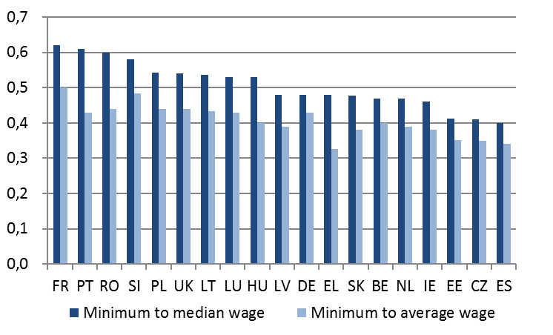

Source: OECD. Notes: AT, CY, DK, FI, IT and SE do not have a statutory national minimum wage. For BG, HR and MT no information is provided by the OECD. Eurostat data indicates that, in 2017, the monthly minimum wage as a proportion of the mean value of monthly wages was 47.8% in BG, 40.6% in HR and 43.6% in MT (Industry, Construction and Services; not comparable to OECD figures).

**The tax burden on labour in Europe has gradually decreased in recent years, but significant differences remain across Member States.** In 2017, the tax wedge for a single worker earning the average wage ranged from less than 30% in Ireland and Malta to around 50% in Belgium, Germany, Hungary, Italy, France and Austria. For lower income workers (defined as those earning 67% of the average wage), the tax wedge ranged from around 20% in Malta and Ireland to more than 45% in Belgium, Hungary and Germany. Different country patterns emerge with respect to the progressivity of tax rates and the redistributive effect of the tax system (see section 3.4). In 2017, the most significant reductions in the tax wedge for single workers earning the average wage occurred in Hungary (-2.1 pps), Luxembourg (-1.8 pps) and Finland (-1.2 pps), while the largest increase was in Bulgaria (+0.6 pps). Between 2013 and 2017 the non-weighted average tax wedge decreased by 0.5 pps in the EU (and by 0.8 pps for low-income workers, with important reductions in Italy, Hungary, France, Belgium, Romania and the Netherlands). Over the same period, there has been some convergence in the level of the tax wedge, with the difference between the highest and lowest tax wedge at average wage level decreasing by 2.1 pps, and by 2.9 pps for lower income workers. This is principally due to large reductions in some of the countries experiencing the highest rates (Belgium, Austria, Hungary, as well as Italy and France, but limited to lower income workers). Large reductions in the tax wedge were also seen in Romania and the Netherlands. Increases in the tax wedge over the same period were less pronounced, but affected particularly lower income workers in the Czech Republic, Slovenia and Portugal[36].

Figure 15: Tax wedge on labour, level in 2017 and change 2013/2017

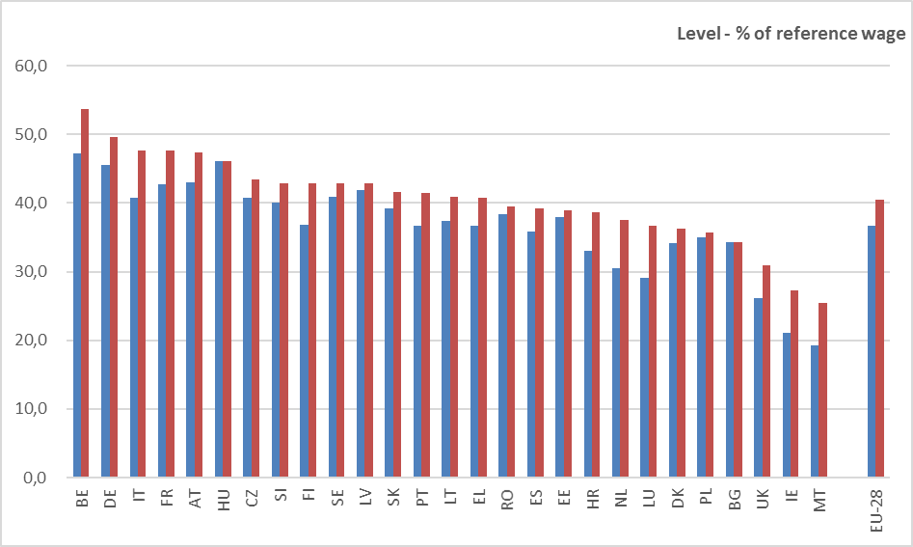

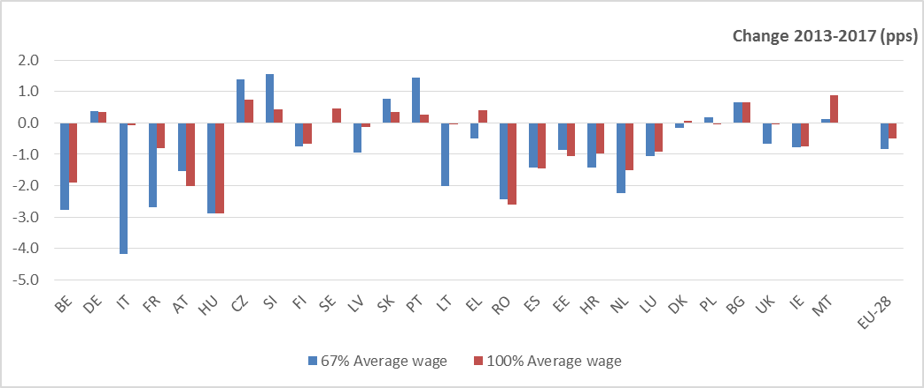

Source: Tax and benefits database, European Commission/OECD. Note: data are for single earner households (no children). No recent data available for Cyprus. Data updated on 11 April 2018.

### 3.1.2 Policy response

**Several Member States resorted to employment subsidies for job creation, although some scaling down is occurring as labour market conditions improve.** Most measures in this area target specific groups facing labour market integration problems (e.g. youth, older people, long-term unemployed, migrants, etc.) and consist of financial incentives to employers for hiring targeted workers.Targeted hiring subsidies were introduced or confirmed by several Member States (more details to be found in section 3.2). A few countries also adopted hiring subsidies for a wider public, i.e. without or with looser eligibility conditions, usually with the aim of promoting open-ended employment. In Greece, additional cycles of public works were launched in 2017 in 51 municipalities and new programmes are under preparation; furthermore, a new programme of public works in forest fire protection was launched in May 2018. In October 2017, Greece also adopted a programme subsidising wages of workers under contracts for provision of independent services in case they are hired as employees. Finally, a programme of subsidies to businesses for the employment of 15,000 unemployed people aged 30-49 was recently launched. In France, subsidised contracts declined further in 2018 from 310,000 to 200,000 and are now limited to the most vulnerable people in the non-profit sector, including young people and the long-term unemployed. As of 2018, existing schemes of subsidised contracts were reviewed and renamed *Parcours Emploi Compétence*, increasing their counselling and training dimension. In this context, a targeted hiring premium called *Emplois francs* for hiring jobseekers from most deprived urban areas (*Quartiers politique de la ville)* is being tested since April 2018 in ten areas, with no other condition than being a jobseeker resident in the area. Moreover, in the context of the new Poverty Plan, additional measures for labour market integration of people with social and employment difficulties (*Insertion par l’activité économique*) have been decided. Italy introduced a structural reduction of contributions for employers hiring young people or long-term unemployed in Southern regions on a permanent basis or under apprenticeships. Portugal put in place a set of financial incentives to permanent hiring, in the form of partial exemptions of social security contributions for certain vulnerable groups (young people, long-term unemployed, older people). In Hungary, the ESF contributes to enhancing the employment potential of social enterprises through incentives and subsidies for job creation.

**Some Member States are taking action to promote entrepreneurship and start-ups.** In Greece, subsidies are granted for a first-time hiring of employees by young self-employed or enterprises run by young people. In Latvia, a new law sets the main principles and working arrangements of social enterprises. Support to approximately 200 social enterprises will be provided. Moreover, the turnover threshold for payers of the microenterprise tax has been reduced from EUR 100,000 to EUR 40,000, keeping a single rate of 15% of which 80% is diverted towards state insurance mandatory contributions. In Hungary, since autumn 2017, a loan facility (that can be combined with several other grant instruments) is available to support individuals to become entrepreneurs or to social enterprises to promote the expansion of their market activities. In Poland, the government has adopted a draft law to reduce social security contributions for small business owners, so-called small ZUS contributions. In Slovakia, new legislation has been adopted on the conditions for the public support to social economy and social enterprises. In Finland, as of 2018, it is possible to receive the unemployment benefit in the form of a grant for starting-up a new business and while working as a part-time entrepreneur. Moreover, discussions are ongoing on how to make easier for the unemployed to set up companies. Steps have also been taken in many Member States to make sure that self-employed enjoy adequate social rights (see section 3.3 on labour market segmentation).

**Some Member States reduced labour costs by decreasing the tax wedge, often targeting the lowest incomes**. The tax wedge was tackled mainly for low-income earners, through reforms focused on personal income taxation, often by increasing tax allowances (i.e. the tax-free amount of income) or introducing progressivity in the overall system. For instance, a major reform was adopted in Lithuania, amending the Law on Personal Income Tax (PIT), introducing progressivity instead of the previous flat rate and increasing the tax-exempt amount of income. Similarly, in Latvia a major tax reform includes the replacement of a flat 23% personal income tax rate with a progressive system. Non-taxable allowances were also increased. Estonia also introduced non-taxable allowances. The Netherlands announced a PIT reform to be implemented over the course of 2019 and 2020. This includes a reduction in the number of tax brackets from four to two, alongside an increase in the general tax credit and the earned income tax credit. The reform is expected to reduce the overall tax burden on labour, in particular at middle to higher income levels. In Romania, the flat PIT rate was reduced from 16% to 10% from 2018, alongside major changes to the design of social security contributions. Portugal introduced PIT reforms intended to reduce the tax burden on low to middle income earners; including an increase in the number of tax brackets. Other Member States introduced reforms with a narrower scope. For instance, in Malta, an income tax rebate on employment income between EUR 40 and EUR 68 for people earning less than EUR 60,000 per year was adopted. The United Kingdom increased the personal allowance to £11,850 (about EUR 13,400) per year and the threshold for the higher rate from £45,000 (about EUR 50,850) to £46,350 (about EUR 52,400). In Denmark, the 2018 tax agreement strengthens the incentive to work full-time, in particular targeting unemployed and part time workers. In Cyprus, The Child Benefit Law was modified to increase the eligible income threshold by EUR 5,000 for every additional child after the first two.

**Some Member States also intervened on the tax wedge through reduction in social security contributions**. In France, the transformation of the tax credit for employment and competitiveness into a direct reduction of social security contributions on wages up to 2.5 times the minimum wage is to be implemented in 2019 (complemented by strengthened reduction for lower wages, postponed to October 2019). In Croatia, the base on which the employer contribution for social security is calculated was cut by 50 % for those workers that have been employed for a period of more than 12 months on the minimum wage. Belgium adopted a reduction of social security contribution for some types of shift work in the construction sector. More generally, the profit participation scheme in the private sector has been replaced by a new premium (an amount or a percentage of the salary), which cannot exceed 30% of the total gross salary. The employer is exempt from social contributions on these premiums, while the employee should pay a solidarity contribution of 13.07%.

**Wage setting frameworks have been the object of major reforms over the past years**. In Greece, after the exit from the ESM Programme in August 2018, two collective bargaining principles, suspended in 2011, are reintroduced: the possibility to administratively extend sectoral agreements to non-signatory parties and the favourability principle (in case of conflicting collective agreements, e.g. sector and firm level, the more favourable for the worker prevails). In Croatia, the draft proposal for the Act on Wages in Civil Service determined the framework for the payment class system and payment grades, as well as for assessing work efficiency. France, building on previous reforms, further defined the perimeter of each level of collective bargaining. In the future, sector level bargaining will prevail over national labour law for setting framework and conditions of use of fixed-term, project-based contracts and trial period (see also Chapter 3.3). Agreement at company-level can be less favourable than at branch-level, with the exception of 13 defined areas of bargaining, including sectorial minimum wages, while branch-level agreements apply if no agreement is reached at company-level. Moreover, majority agreements at company-level to preserve employment (*accords de competitivité*) are now extended beyond working time conditions and also include remuneration, also allowing companies to dismiss employees that refuse such agreements on real and serious grounds. In Italy, in March 2018 an agreement among the main trade unions and the employers' organisation paved the way for a strengthening of collective bargaining, by defining criteria for measuring representativeness of social partners’ associations. In Cyprus, a new agreement on the Cost of Living Adjustment index came into force in 2018, leading to limited increases in wages and defining criteria on the frequency and nature of periodical adjustments. In Latvia, new conditions for overtime pay are being set, with the involvement of social partners, jointly with negotiations on sectoral minimum wages. In Portugal, a set of measures has been agreed with social partners (and are now being discussed in Parliament) to improve the scope of collective bargaining. In particular, "banks of hours" would not be agreed on an individual basis anymore, but as part of collective bargaining or group agreements, to be reached after worker’s consultation (see also Chapter 3.3). In Spain, social partners reached in June 2018 a preliminary wage agreement for 2018, with a general 2 % wage increase (slightly above the expected inflation rate), plus another 1 % depending on the results, productivity and absenteeism rates of the firm/ sector. Romania made wage bargaining compulsory for all companies. Ireland introduced the possibility for collective bargaining for certain categories of self-employed, Slovakia reintroduced the extension of higher level collective agreements under specific conditions to the non-participating employers without their consent.

**As labour market conditions improve, minimum wages have been increased in several countries, while steps are also taken to make minimum wage setting frameworks more predictable**. Statutory minimum wages increased in all of the countries where changes took place between 2017 and 2018, with the exception of Germany, Greece, Luxembourg and Belgium, where there was a decline in real terms[37]. In recent years, expert groups have been involved in minimum wage-setting in a growing number of countries, including Germany and Ireland. Malta will set up such a group in 2018 and a possible involvement of experts is discussed in Bulgaria and Romania. Estonia adopted a EUR 30 increase of minimum wage in 2018 to reach EUR 500, while anchoring the formula for future increases to official forecasts of labour productivity and economic growth. Ireland increased the National Minimum Wage by 30 cent to EUR 9.55 per hour, following the advice of Low Pay Commission, which also took into account competitiveness development and the impact on employment. In Spain, a law (agreed with the social partners) increased the minimum wage in 2018 by 4% compared to 2017 and further increases have been proposed for 2019. In Croatia, besides increasing the minimum wage level and reducing the health insurance contributions paid by employers, a new regulation stipulates that additional earnings (from overtime work, night work or work during holidays) shall be excluded from the definition of minimum wage. Latvia introduced a minimum wage increase to EUR 430 per month, up from EUR 380, as of 2018. In Hungary, the minimum wage was raised by 8% to HUF 138,000, approximately EUR 440, in 2018 (+12% for skilled workers). In Slovakia, as of 1 January 2019, the minimum wage will be increased to 520 EUR, up from EUR 480. The United Kingdom raised the national living wage (to £7.83 per hour, about EUR 6.9) in April 2018, as well as the national minimum wage for young workers. The minimum wage for young workers was also increased in the Netherlands, while Germany introduced a minimum wage for temporary agency workers. Finally, Bulgaria adopted the Law on the Ratification of ILO Convention 131, with a view to achieve a consensus with the social partners on the development of a transparent mechanism for setting the minimum wage.

### **Guideline 6: Enhancing labour supply and improving access to employment, skills and competences**

This section looks at the implementation of the employment guideline no. 6, which recommends to Member States to create conditions to promote labour supply, skills and competences. It presents indicators about educational and training attainment, outcomes and impact on skills development and the employability of the workforce. It then goes through labour market outcomes for various groups underrepresented in the labour market (e.g. young people, older workers, women, people with a migrant background and people with disabilities). Section 3.2.2 reports on policy measures of Member States in these areas and measures targeted at those groups.

### 3.2.1 Key indicators

**The share of early leavers from education and training has continued to decrease over the years, although the downward trend has slowed down recently and large differences persist among the Member States.** Overall, the average early school leaving rate in the EU decreased from 14.7% in 2008 to 11.9% in 2013 and further to 10.6% in 2017. The situation has remained almost stable in comparison with the previous year, when the EU average was 10.7%. Eighteen Member States have reached the EU target value (< 10%), with Germany (10.1%), the United Kingdom (10.6%) and Estonia (10.8%) very close to meeting it. A certain degree of convergence among Member States in terms of recent trends is visible in 2017 (Figure 16), with significant decrease in the early school leaver rates (by more than 1 pp) in Portugal, Malta and Bulgaria (all flagged "weak but improving") but also some major increases in Slovakia (+1.9 pps), Luxembourg (+1.8 pps), Denmark[38] (+1.6 pps) and Cyprus (+1 pp). According to the social scoreboard classification, in spite of some improvement the situation remains "critical" in Spain (18.3%) and Romania (18.1%) as well as in Italy (14%) where the rate has slightly increased.

**Figure 16: Early leavers from education and training (% of population aged 18-24) and yearly change (Social Scoreboard headline indicator)**

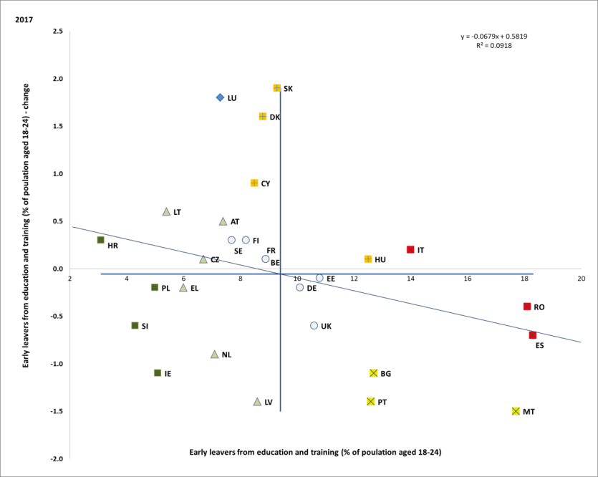

Source: Eurostat. Period: 2017 levels and yearly changes with respect to 2016. Note: Axes are centred on the unweighted EU average. The legend is presented in the Annex.

**Remarkable long-term improvements have been registered in most EU Member States, especially in those previously showing particularly high shares of early school leavers**. From 2008 to 2017, both Ireland and Greece have been able to significantly reduce their early school leaver rates, by 6.6 and 8.4 pps respectively, and they are currently well below the EU target value. At the same time, Spain (18.3%) and Portugal (12.6%) have drastically reduced their early school leaver rates by 13.4 and 22.3 pps respectively since 2008, although they have not reached the target yet. Among countries with high levels of early school leaver rate, only Romania does not show any major development across the years while Slovakia experienced a sizeable increase of 3.3 pps, although it still remains below the EU headline target in 2017 (Figure 17).

**Figure 17: Early leavers from education and training, 2008-2017 (%)**

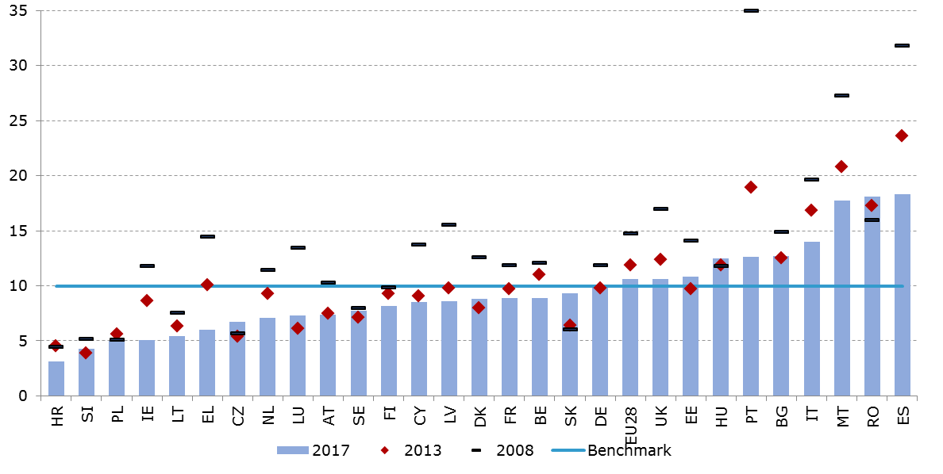

Source: Eurostat, online data code: [edat_lfse_14].

**There are still important differences in terms of early school leaving rates between men and women and between native-born and non-EU born people.** While on average in the EU 8.9% young women left school early in 2017, the ratio for men was 12.1%. This gender gap is particularly pronounced in Denmark, Luxembourg, Italy, Portugal, Malta, Estonia, Latvia, and Spain (more than 5 pps), with Bulgaria, Hungary and Slovakia being the only Member States where there are lower early school leaver rates for men than for women. At the same time, the early school leaving rates are much higher among non EU-born than among native-born pupils. In 2017, the EU average among the native-born was 9.6%; however for the non-EU born it was twice as high. The early school leaver rates of non EU-born are particularly low in Ireland, Luxembourg and the Netherlands – all well below the 10% benchmark – while they are extremely high in Spain (31.9%) and Italy (30.1%).

**After several years of steady progress, the share of low achievers[39] in basic skills among 15 year-olds is on the rise**. The 2015 OECD Programme for International Student Assessments (PISA) shows that on average in the EU the share of pupils who perform below the baseline level is around 20%, with 19.7% in reading, 22.2% in mathematics and 20.6% in science. Compared to the previous PISA round in 2012[40], the situation has worsened in all three domains: by 1.9 pps in reading, 0.1 pp in mathematics, and 4 pps in science. Low-achievers deserve additional support because they are those more at risk of future unemployment and social exclusion later on in life. In 2015, the percentage of students with low achievement in mathematics in the EU was 22.2%, with striking differences among Member States. Whereas Estonia, Finland, Denmark and Ireland featured less than 15% of low achievers in mathematics, Cyprus, Bulgaria, Romania, Greece and Croatia struggled with more than 30% of students who failed to reach basic proficiency levels in mathematics (Figure 18).

**Figure 18: Percentage of low achieving students in mathematics, 2015**

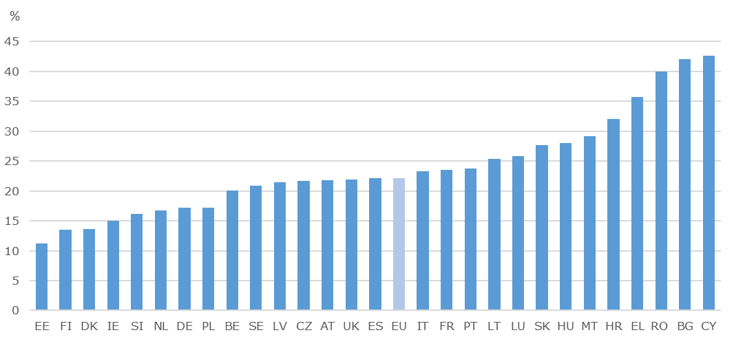

Source: OECD. Note: Countries are ordered by low to high share of low achievers in mathematics. EU weighted average calculated by DG EAC.

**Educational outcomes are strongly influenced by students’ socio-economic status and migrant background.** Students with lower socio-economic status or with a migrant background are overrepresented among the group of low achievers and struggle to obtain baseline proficiency in all three domains. A closer look at those students who reached the baseline levels of proficiency in all three domains against unfavourable situations shows that the performance gap between native and foreign born students is of 23 pps on average in the EU, with native students performing better in all the Member States, except for Malta (as shown in Figure 19). Very significant differences are registered in Finland, Sweden, Austria, Germany and France (between 35 and 40 pps), while the performance gap is below 15 pps in Cyprus, the United Kingdom and Portugal. Low educational outcomes and inequalities linked to socio-economic background represent major obstacles to human capital improvement, with potential knock-on effects on skills levels.

**Roma inclusion in education remains a challenge,** due to several factors, including school segregation, non-inclusive teaching and barriers induced by severe poverty or housing segregation. Notwithstanding efforts to increase participation rates and reduce drop-out, significant issues remain in promoting ethnically-mixed schools and desegregation measures. To be noted also that a significant number of Roma children in Hungary, Bulgaria, Romania, and Slovak Republic live in deep poverty without access to basic public utilities.

**Figure 19: Percentage of students attaining baseline proficiency by migrant background, 2015**

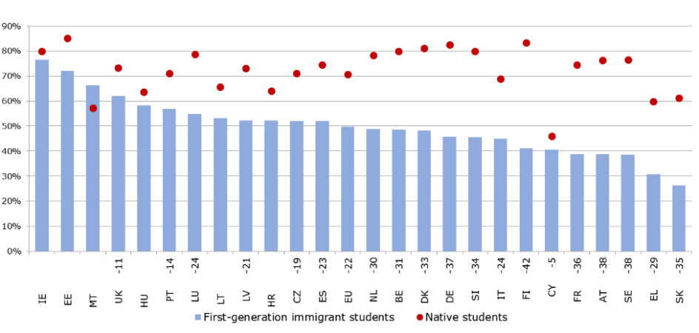

Source: OECD (2018): The Resilience of Students with an Immigrant Background: Factors that Shape Well-Being, Figure 3.7.

Notes: Statistically significant differences are shown next to country/economy name. Only countries with valid values for immigrant students are shown. For the EU average, this number refers only to the subset of countries/economies with valid information on both groups of students. Students who attain baseline academic proficiency are students who reach at least PISA proficiency level two in all three PISA core subjects – math, reading and science. Countries and economies are ranked in descending order of the percentage of first-generation immigrant students reaching baseline levels of proficiency in PISA core domains.

**The proportion of 30-34 year olds who successfully complete tertiary education continues to increase in the EU and the 40% headline target has almost been reached.** In the EU, 39.9% of the 30-34 year-old population held a tertiary degree in 2017, as a result of a gradual increase over the last years. Tertiary educational attainment rose in most of the Member States between 2014 and 2017. Only in Croatia, Hungary and, to a lesser extent, Spain and Finland, the proportion of the population with a tertiary qualification decreased over the same period. By contrast, there was a remarkable growth of 7.4, 6.5 and 6 pps in Slovakia, Greece and Czech Republic, respectively. Among the countries that have tertiary attainment rates below 40%, only Romania, Italy and Croatia have not reached 30% (Figure 20). Overall, 15 out of the 28 Member States have met their respective national targets in 2017.

**Figure 20: Tertiary educational attainment, 2008, 2013, 2017 and EU2020 target**

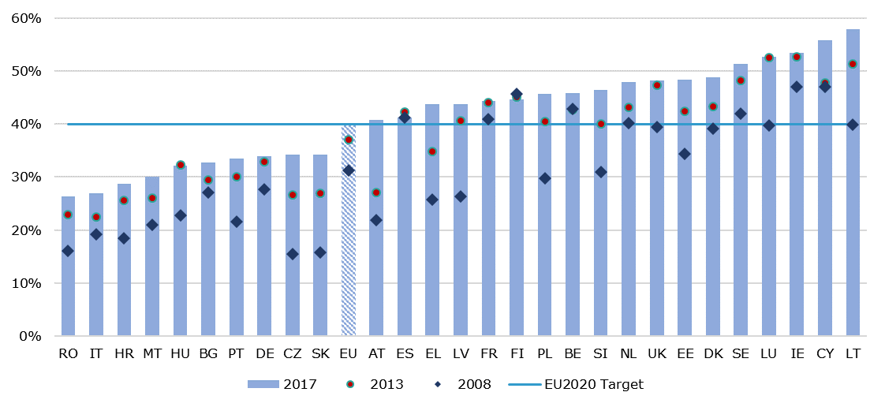

Source: Eurostat, LFS [edat_lfse_03]. The indicators cover the share of the total population aged 30-34 having successfully completed tertiary education (ISCED 5-8). Break in series in 2014 due to the introduction of the new ISCED classification; 2017 data for LU are unreliable because of the small sample size.

**Women show a higher tertiary attainment rate than men and important gaps exist between native and non-EU born people**. In 2017, 44.9% of women aged 30-34 year old held a higher education qualification, against a 34.9% of men. This gap has increased over the past 15 years and is particularly significant in Latvia, Lithuania, and Slovenia, where the tertiary attainment of women is more than 20 pps higher than that of men. At the same time, in almost all Member States the share of people born within the country or within the EU is higher than the share of those born outside the EU. On average this gap amounts to about 5.5 pps, pointing to persistent challenges in terms of equity, access and the social dimension of higher education.

**About one third of young adults in the EU hold a VET-related qualification.** In 2016, 33% of young adults within the age group 30-34 acquired an upper-secondary qualification of a vocational orientation. As shown in Figure 21, this share was more than 40% in countries such as Slovakia, Hungary, Austria, Romania, Germany, Czech Republic and Croatia, whose model of transitions from education to employment is strongly rooted in the vocational education system. On the contrary, the share was comparatively lower (less than 20%) in countries whose model is more centred around tertiary education (e.g. Lithuania, Sweden, Cyprus and Ireland) or with overall comparatively lower diffusion of direct labour market relevant qualifications (e.g. Malta, Portugal, Spain, Luxembourg and Greece).

**Figure 21: Education to employment: transition pathways and systems, 2016**

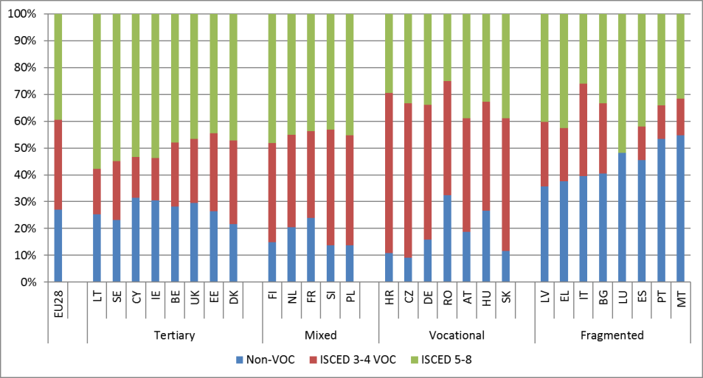

Source: Eurostat, LFS. Online data code: [lfso_16feduc].

Note: Non-VOC qualifications includes qualifications at ISCED levels 0-2 or a medium-level qualification (ISCED 3-4) of a general orientation; ISCED 3-4 VOC are qualifications at a medium (ISCED 3-4) level with a vocational orientation; ISCED 5-8 includes a high level of education qualifications

**Not everyone gets an equal chance to acquire the skills and qualifications that are valuable in the labour market.** In some countries, more than half of the young people aged 30-34 report not to have a qualification – be it vocational or academic – clearly linked to the labour market. This has an impact in terms of integration in the labour market. For example (as shown in Figure 22, while those with VET and higher education qualifications achieve employment rates around or above 80%, less than 70% of those with an upper-secondary diploma of a general orientation are in employment after the age of 25. Those without an upper-secondary diploma are even more disadvantaged, with less than 60% in employment after age of 25.

**Having a labour market relevant qualification – be it academic or vocational – is increasingly important to adapt to a rapidly changing economy and to address the demand for high skills.** The employment rate of recent graduates with a tertiary degree in 2017 was 84.9% and was 0.9 pps higher than the overall employment rate of working-age adults with the same educational attainment. Only in a few Member States (Italy, Greece, Croatia, Cyprus, Slovenia and Spain), recent tertiary graduates are still disadvantaged, although the situation in all those countries has improved, with the exception of Croatia. Not far behind, the employment rate of recent graduates with a medium-level vocational qualification was 76.6%, 5.7 pps higher than the overall employment rate of the working-age adults with medium-level educational attainment, pointing to an employment premium for recent VET graduates. Conversely, the employment rate of those with only a medium level general qualification was 64.1%. Young adults who only had a low-level qualification were further disadvantaged in the labour market with an employment rate of 56.4% in 2017.

**Figure 22: Employment rate of recent graduates by educational attainment level, 2017**

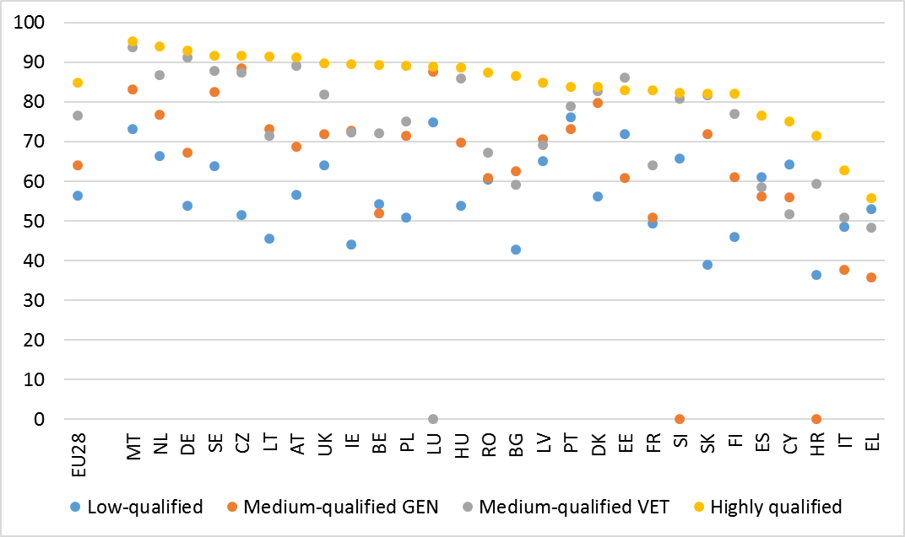

Source: Eurostat LFS. Note: young adults aged 20-34. Data for low-qualified include all young adults not enrolled in education or training no matter how long ago they completed their education. Data for medium and highly qualified include only individuals who have graduated 1-3 years before the survey.

**One way to improve labour market outcomes of young people is to provide them with opportunities to gain exposure to real working environment** – through either company-based work-based learning or apprenticeships, which are linked to the curriculum of their programme. Those with such an experience during their studies are able to find a job more easily and may even have the possibility to apply for more advanced positions. However, as shown in Figure 23, less than 50% of those holding a VET qualification report to have received such experience during their studies. An even smaller proportion had a more significant work-based learning experience through an apprenticeship. The largest proportion of VET students having access to work-based learning (more than 90%) can be found in Hungary, the Netherlands, Finland and Sweden.

**Figure 23: Access to work-based learning and apprenticeships in VET, 2016**

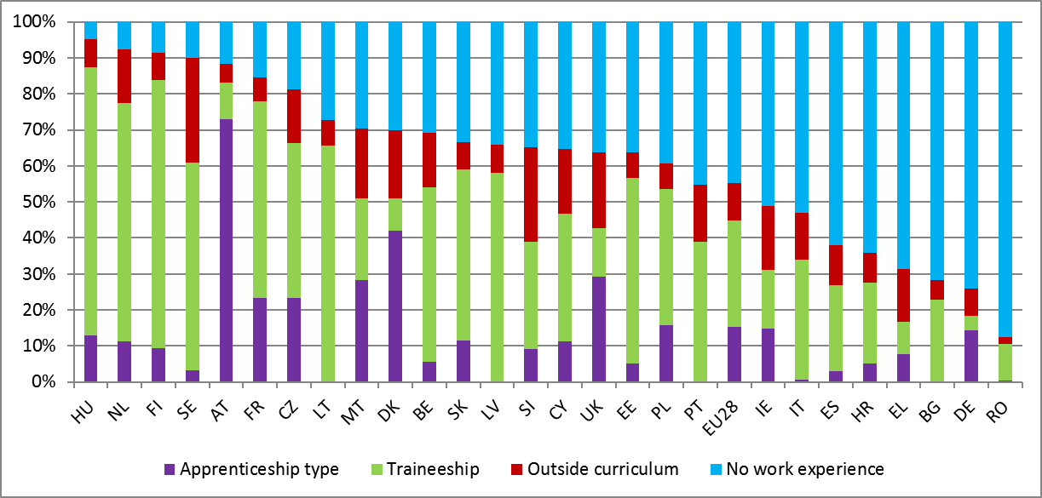

Source: Eurostat, LFS. Online data code: [lfso_16feduc]. Notes: young adults aged 15-34 with a vocational qualification at upper-secondary or post-secondary non-tertiary level. LU data is not available. Data for ‘Apprenticeship’ in BG, LV, LT and PT is not available. Data for DE might not be representative due to a large number of non-response.

**Low qualified adults are also often at a significant disadvantage in the labour market compared to their peers who have stayed in education longer.** In the EU, the ratio between low-qualified adults and the number of jobs requiring low levels of qualification is on average 3 to 1 (Table 2). In other words, there are three times more low-qualified adults compared to the jobs that require an only low level of qualification. The issue seems more pressing in countries like Malta, Portugal, Greece, Italy and Spain with a ratio higher than 4. This may eventually result in weaker labour market attachment, higher incidences of precarious work, high unemployment and in the risk to drift-away from the labour market altogether.

**Table 2: Number of low-qualified adults and low-qualified jobs in the EU.**

|  |  |  |  |
| --- | --- | --- | --- |
|  | **Total low qualified adults 25-64 (ths)** | **Total elementary jobs (ths)** | **Ratio** |
| EU28 | 61,353.0 | 20,210.6 | 3.0 |
| Malta | 125.8 | 17.6 | 7.1 |
| Portugal | 2,897.3 | 490.0 | 5.9 |
| Greece | 1,583.2 | 268.0 | 5.9 |
| Italy | 12,834.9 | 2,517.8 | 5.1 |
| Spain | 10,654.1 | 2,409.0 | 4.4 |
| Sweden | 751.0 | 231.1 | 3.2 |
| Romania | 2,417.4 | 776.4 | 3.1 |
| Belgium | 1,386.0 | 449.6 | 3.1 |
| Croatia | 366.5 | 119.4 | 3.1 |
| France | 7,200.6 | 2,692.9 | 2.7 |
| Luxembourg | 64.8 | 24.6 | 2.6 |
| Netherlands | 1,902.2 | 742.0 | 2.6 |
| United Kingdom | 6,744.3 | 2,641.3 | 2.6 |
| Ireland | 443.0 | 176.3 | 2.5 |
| Finland | 329.0 | 148.3 | 2.2 |
| Austria | 728.4 | 337.3 | 2.2 |
| Slovenia | 140.7 | 67.5 | 2.1 |
| Bulgaria | 677.2 | 333.0 | 2.0 |
| Germany | 6,116.8 | 3,154.2 | 1.9 |
| Hungary | 857.9 | 460.4 | 1.9 |
| Denmark | 527.3 | 302.3 | 1.7 |
| Cyprus | 88.1 | 53.5 | 1.6 |
| Estonia | 80.4 | 51.5 | 1.6 |
| Poland | 1,617.0 | 1,041.6 | 1.6 |
| Czech Republic | 367.2 | 266.3 | 1.4 |
| Slovakia | 272.2 | 217.3 | 1.3 |
| Latvia | 100.7 | 106.7 | 0.9 |
| Lithuania | 79.4 | 115.1 | 0.7 |

Source: Eurostat, LFS, 2017.

**Low skilled and older people are less likely to participate in adult learning programmes.** In 2017, the rate of participation in adult learning in the EU for low qualified and older people has been twice lower than the overall participation rate of 10.9% (Figure 24). Even the unemployed, who should be a particularly relevant target group for re-skilling, are less likely than an average employee to participate in learning. This trend is also visible in countries where the overall participation in adult learning is close or above the EU average.

**Figure 24: Participation in adult learning by demographic groups**

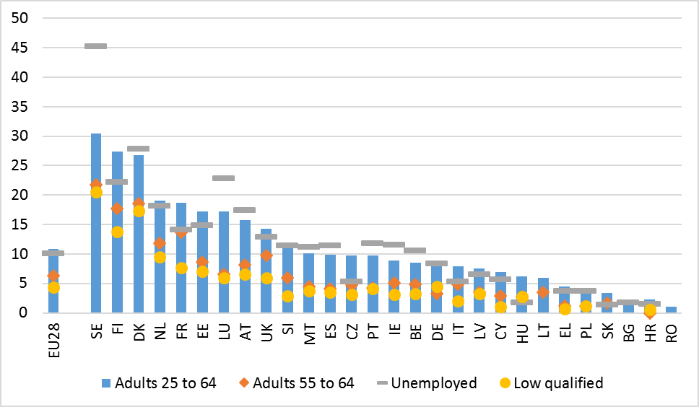

Source: EU LFS, 2017

**The level of digital skills is not growing fast and the persisting gap between top and low performers points to a two speed digital Europe**. On average in the EU 57% of population aged 16-64 had at least basic digital skills in 2017. Low digital skills may have an impact on productivity and growth potential, but also on social exclusion for a significant part of the population, in view of the changing modalities for fruition of services and the impact of technology on the world of work. The level is particularly low in Bulgaria, Romania and Croatia ("critical situations"). In six other countries (Greece, Poland, Portugal, Latvia, Ireland, and Hungary, all flagged "to watch") it is comparatively higher (around 50%) but still low in comparison to the average. The best performances can be found in Luxembourg, the Netherlands, Sweden and Finland with rates above 75%.

**Figure 25: Share of population with basic overall digital skills or above and yearly change (Social Scoreboard headline indicator)**

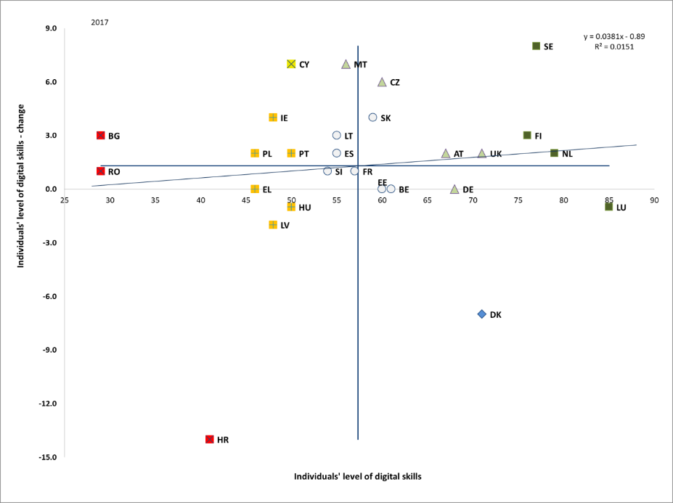

Source: Eurostat. Period: 2017 levels and yearly changes with respect to 2016. Note: Axes are centred on the unweighted EU average. The legend is presented in the Annex. Data for IT not available.

**The provision of guidance about learning opportunities can effectively stimulate individual demand for and participation in learning**.The benchmarking framework on adult skills and learning[41] has identified the provision of guidance on learning opportunities as a key policy lever to encourage participation of adults in learning. According to the latest (2016) data on access to guidance services for learning, as provided by the Adult Education Survey,[42] there is a strong positive relationship between the share of adults (aged 25-64) receiving guidance and the share of those eventually participating in learning.[43] While public guidance services represent a common policy tool in most Member States, their coverage in terms of outreach varies considerably from one country to the other. Notably, as shown in Figure 26, in 2016 the share of adults who received free of charge information or advice on learning opportunities from institutions or organisations during the last 12 months ranged from 1.5% in Romania to nearly 56% in Sweden (EU average: 24.3%). In countries like Bulgaria, Greece, Lithuania, and Italy, less than 10% of adults benefitted from this type of free of charge services, whereas participation in learning is also relatively low over the same reference period (29% against an EU average of 43%). On the other hand, in Sweden, Austria the Netherlands, Luxembourg and Denmark, more than 40% of adults received guidance on learning opportunities. This can be considered one of the determinants of the relatively high adult learning participation rate registered in these countries (57% against an EU average of 43%).

Figure 26. Share of adults receiving guidance on adult learning opportunities, 2016

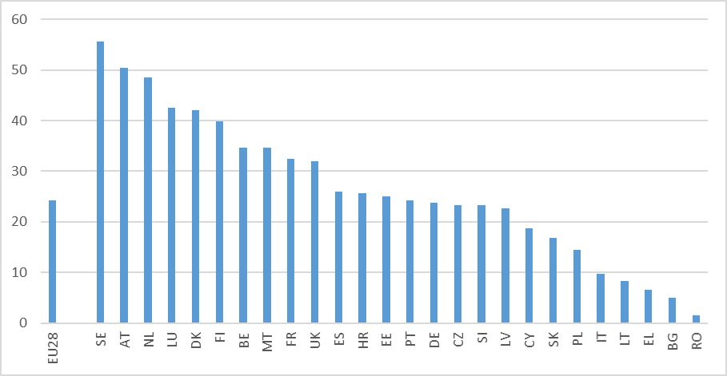

Source**:** Eurostat,Adult Education Survey. Data correspond to 2016. Data for Ireland and Hungary are missing.

**Training measures to engage disadvantaged persons are particularly relevant.** They may take various forms, including for example formal or non-formal vocational training or basic skills development programmes.[44] Low-qualified and unemployed adults face particular challenges in terms of accessing learning. According to LFS data, in 2017 the share of unemployed adults who participated in any training activity during the last four weeks before the survey (as part of all unemployed adults) ranges from almost 1.5% in Slovakia to nearly 45% in Sweden (EU average: 10.1%) (Figure 27). Apart from Slovakia, in countries like Croatia, Hungary, Bulgaria, Poland, Greece, Italy, the Czech Republic, Cyprus, Latvia and Germany, less than 10% of unemployed adults participate in learning. On the other hand, in Denmark, Luxembourg and Finland the share of participants exceeds 20%. Looking at the share of low-qualified[45] adults who participated in any training activity during the last four weeks before the survey (as a share of all low-qualified adults) significant discrepancies across Member States also emerge (Figure 28). Less than 1% of low-qualified adults participate in learning in Cyprus, Greece and Croatia, while more than 10% do so in Sweden, Denmark and Finland (EU average: 4.3%).

Figure 27. Share of unemployed adults participating in learning (as a share of all unemployed adults), 2017

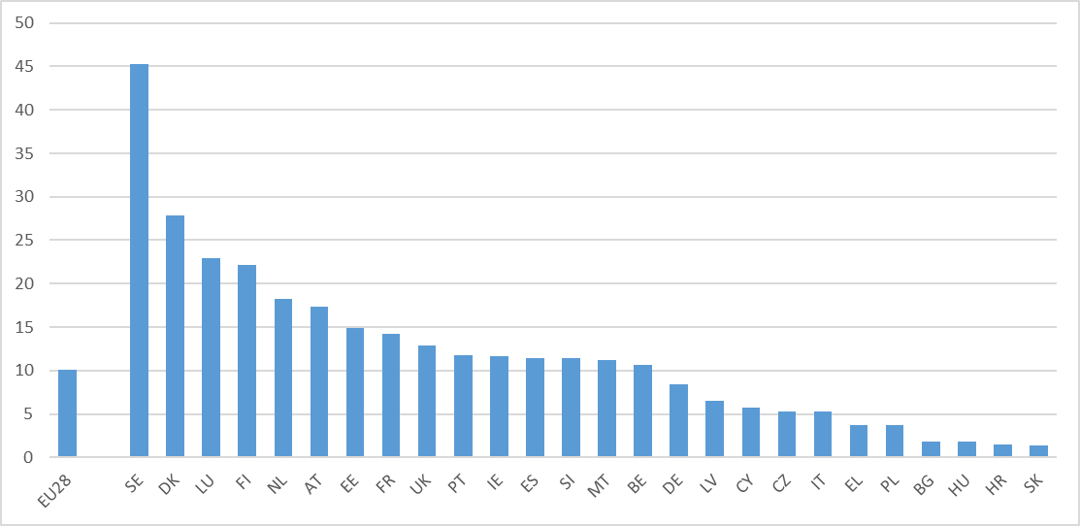

Source: EU Labour Force Survey. Data correspond to 2017. Data for LT and RO are missing.

Figure 28. Share of low-qualified adults participating in learning (as part of all low-qualified adults), 2017

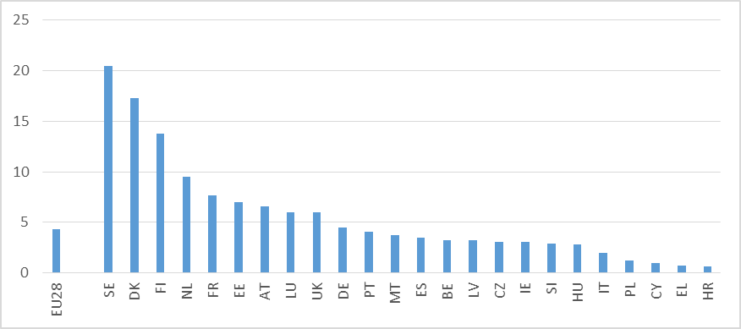

Source: EU Labour Force Survey. Data correspond to 2017. Data for RO, BG, LT, SK are not available.

**The provision of financial incentives to employers can encourage their investment in staff training.** Employers in most cases are the ones providing or financing adult learning for their staff, as they sponsor more than two-thirds of all adults participating in job-related training. Despite low overall coverage, public financing to employers is a common policy tool in Member States. Incentives can broadly take the form of tax incentives (tax credits or tax allowances), direct subsidies for training (including EU support) or levy-based financing schemes (training funds). There is also evidence that direct subsidies to enterprises (e.g. in the form of grants) can be more effective in steering employee participation in learning, as compared to the other forms of financial incentives. The appropriate targeting of financial support for training is important, for example, by focusing on enterprises that face financial and capacity constraints, notably SMEs, in order to avoid deadweight effects (financing investment that would have taken place anyway). Indeed, evidence shows that the coverage, rather than the volume of financial support, has a strong positive link with participation of adults in learning. According to latest (2015) data on financial support from Continuous Vocational Training Survey,[46] the share of companies which report to have received any type of public co-financing for training activities during the last 12 months (reflecting the coverage of financial support) range from 0.1% in Romania to nearly 64% in Spain (Figure 29). Apart from Romania, also in Portugal, Slovakia and Bulgaria the share of companies that receive such type of financial support is lower than 1%. Conversely, in Cyprus, Belgium, France and Spain, this share exceeds 20%.

Figure 29. Financial support for training provided to companies, 2015

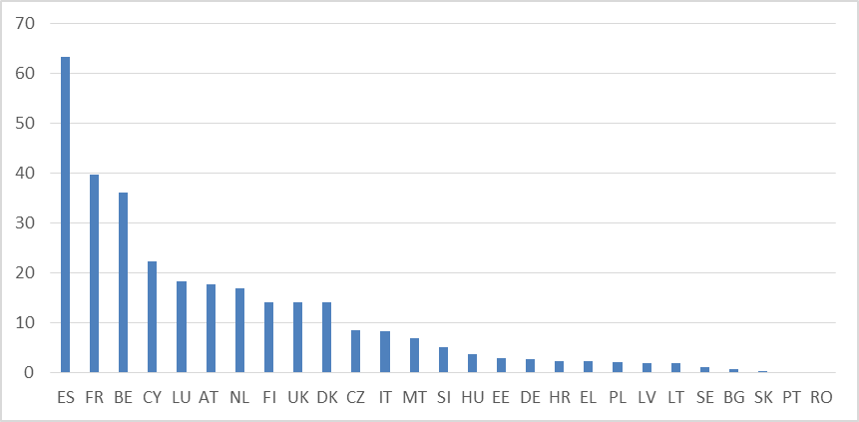

Source: Eurostat, Continuous Vocational Training Survey. Data correspond to 2015 and show the share of enterprises with 10 and more persons employed that report to have received public financial support for training provision during the reference year (2015). Data for Ireland are missing.

**The labour market situation of young people continues to improve, in line with the strengthening of the macroeconomic environment.** In the EU, the youth unemployment rate decreased from a peak of 23.7% in 2013 to 16.8% in 2017. However, it is still higher than it was in 2008 and remains above 30% in some Member States (Italy, Spain and Greece). Dispersion in youth unemployment rate is decreasing over time (see Figure 30), with higher reductions seen in countries with higher levels, although with some exceptions (Italy, France, Belgium) where the decline is rather slow. At the other end of the spectrum, remarkable reductions have been achieved in the Czech Republic, Hungary, Slovenia, Bulgaria, Ireland and Poland, which were well below the EU average in 2017. Young men and women experience similar levels and trends in unemployment rates (16.1% for women and 17.4% for men in 2017). The employment recovery does not always lead to quality job creation, as young people are more often employed under non-standard and precarious types of contracts, including temporary jobs, involuntary part-time work and low-paid jobs. In 2017, 43.9% of young workers (up from 42.2% in 2013) worked under a temporary contract (compared to 12.2% of workers aged 25-54) – more than 7 out of 10 in Slovenia and Spain.

**Figure 30: Youth unemployment rate (15-24), multiannual comparison**

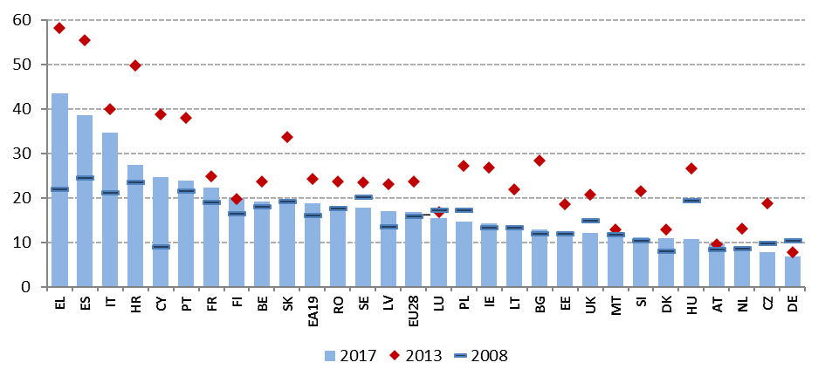

Source: Eurostat, LFS.

**In addition to those working or seeking a job, a considerable part of young people aged 15-24 are economically inactive.** In total in the EU, in 2017 almost 6 million people aged 15-24 were neither in employment, education or training (NEET). This amounts to 10.9% of population in that age class, down from a peak of 13.2% in 2012 and back to the level of 2008 (10.9%). This reduction was due mostly to unemployed NEETs moving into work. As shown in Figure 31, NEET rates above 15% are still recorded in several countries (Italy, Cyprus, Bulgaria, Croatia, Greece and Romania). The number of NEETs is increasing in Denmark[47], Luxembourg, Estonia and, more worryingly, in the two countries with the highest rates (Cyprus and Italy, both "critical situations"). For this reason, convergence is only limited, as suggested by the slightly negative slope of the regression line. On a more positive tone, remarkable reductions are observed in Bulgaria and Romania ("weak but improving"), starting from high levels.

**Figure 31: NEET rate (15-24) and yearly change (Social Scoreboard headline indicator).**

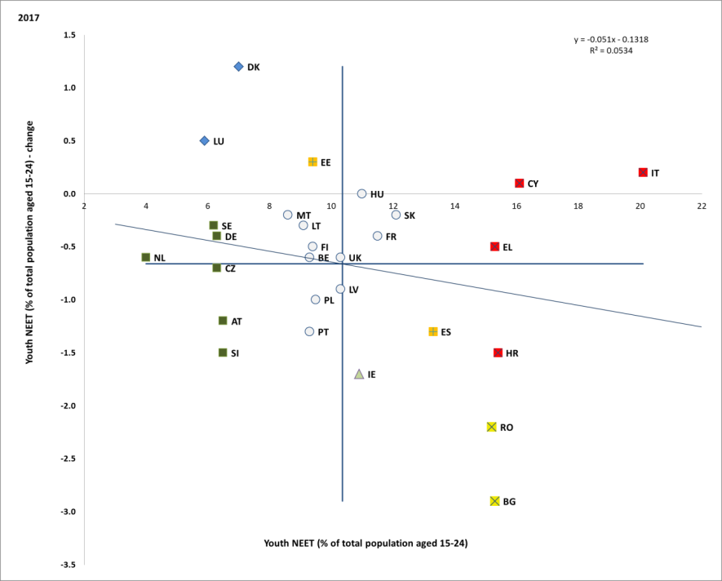

Source: Eurostat. Period: 2017 levels and yearly changes with respect to 2016. Note: Axes are centred on the unweighted EU average. The legend is presented in the Annex.

**Following the reduction in youth unemployment, the majority of NEETs are inactive, but** **with substantial differences among Member States.** Inactivity rates are particularly high in Bulgaria, Romania and Italy, while unemployment is predominant in Spain, Croatia and Greece. Having only low-level education has been identified as the main risk factor for being NEET[48]. Among female NEETs, inactivity is more frequent than unemployment, while the opposite holds for men.

**Employment rate of older workers has grown substantially over the last decade.** Older workers (aged 55-64) have weathered the crisis relatively better than other age groups and have driven most of the job creation during the recovery, with almost 7 million additional people in employment between Q2-2013 and Q2-2018. More generally, as already shown in Section 1, the age group 55-64 is a very important driver of the overall increase in employment rates over the last ten years. In 2017, the employment rate of people aged 55-64 rose to 55.3%, 1.8 percentage points higher than in previous year, and the steady increase is projected to continue against the background of demographic change. Employment rates of older workers vary widely across Member States, ranging from 76.4% in Sweden to 38.3% in Greece, with rates below or close to 50% also recorded in Spain, Belgium, Poland and Malta. The employment rate of women aged 55-64 is growing faster than for men and stood at 50.9% in 2016.

**Since 2008, the average duration of working life increased in almost all Member States,** with major increases (by more than two years) in Estonia, Lithuania, the Czech Republic, Malta, Hungary, Poland and Luxembourg. The gender gap in the duration of working lives is declining but still significant, with women participating in the labour market on average 4.9 years less than men (33.4 vs 38.3 years in 2017). This average is the result of major variations across Member States and is driven by multiple factors, such as insufficient access to care services as well as lower pensionable ages for women in some Member States.

**Figure 32: Average duration of working life, 2008-2017 comparison**

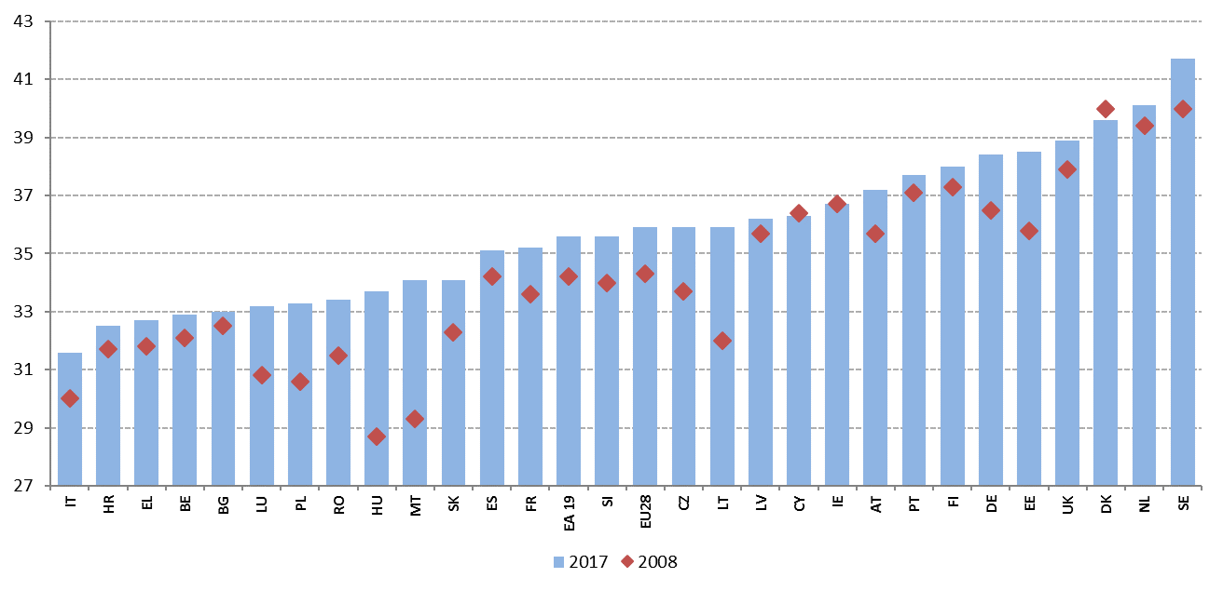

Source: Eurostat, LFS.

**In 2017, the employment rate of women continued its steady increase.** It reached 66.5%, compared to 65.3% a year before. The employment rate of women improved in all Member States, with the exception of Denmark (where it is nonetheless very high). It ranges between 79.9% in Sweden and 48.0% in Greece, with low rates (below 60%) also recorded in Spain, Malta, Croatia and Italy. Despite progress, in all Member States women continue to be less represented in the labour market compared to men. The gender gap in employment – a headline indicator of the Social Scoreboard – remains high at 11.5 percentage points. In a context of little variation compared to last year, convergence among Member States is limited. Italy, Greece, and Romania are flagged as "critical situations", while Malta, which still experiences the highest gender employment gap, saw a notable improvement in 2017. Significant increases (by 1 pp or more) were registered in Latvia, Hungary and Croatia, even if in these Member States employment rate increased for both sexes, but much faster for men than for women. Latvia, together with Lithuania, Finland and Sweden, remain the best performers on the gender employment gap.

**Figure 33: Gender employment gap and yearly change (Social Scoreboard headline indicator)**

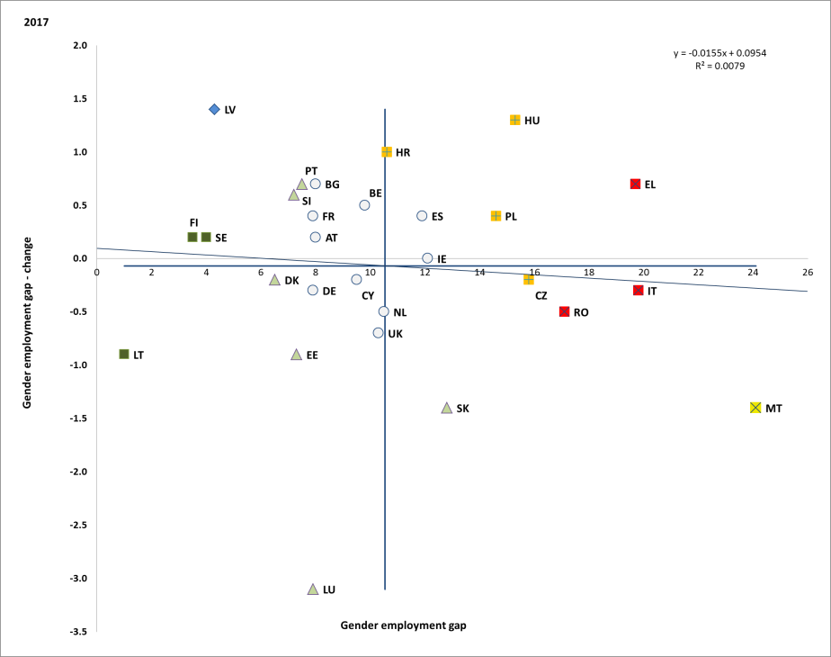

Source: Eurostat, LFS. Period: 2017 levels and yearly changes with respect to 2016. Note: Axes are centred on the unweighted EU average. The legend is presented in the Annex.

**The gender employment gap is bigger in terms of full-time equivalents, as women register higher rates of part-time work.** The average gender gap in part-time employment decreased only slightly compared to 2016 and stood at 23 pps in 2017.Overall, 31.1% of women in the EU worked part-time in 2017 compared to 8.2% of men. However, there are large differences across Member States. While the share of women working part-time remains traditionally low in most of the Eastern European Member States (below 10% in Bulgaria, Croatia, Lithuania, Hungary, Poland, Romania and Latvia), it has reached 74.1% in the Netherlands (22.6% for men), 49.9% in Austria (10.5% for men) and 46.8% in Germany (9.3% for men). Availability of part-time work is an important factor for keeping women attached to the labour market, notably when they have children. However, long periods of reduced working hours may fuel gender gaps in wages and pensions, as part-time is usually also associated with lower hourly earnings and lower social security contributions. Even if declining, 22.5% of female part-time employment was involuntary in 2017.

**In addition to lower employment rates, women also tend to suffer from a significant pay gap.** In spite of women being generally better qualified than men[49], the gender pay gap remains stable at 16.2%[50] in 2016, with only a small decline compared to 2013 (16.8%).Women tend to be over-represented in lower paid sectors and occupations and frequently work in underqualified jobs compared to their skills. Still, part of the pay gap remains even if netting out factors such as differences in experience, level of education, type of contract, and so on. Differences across countries are considerable. The gender pay gap remains above 20% in Estonia, the Czech Republic, Germany, the United Kingdom and Austria, while the smallest values (slightly above 5%) are registered in Romania, Italy and Luxembourg. Since 2013, the situation has considerably improved in Estonia, Hungary and Spain, while the gender pay gap has increased by more than 2 pps in Portugal and Lithuania. The gender pay gap frequently translates into a pension gap between women and men, which stood at around 37.2 % in 2016 (decreasing by 1.1 pps compared to 2015). The gender pension gap was the highest in Cyprus, the Netherlands and Malta (above 44%), while the smallest gaps (below 10%) were registered in Estonia, Denmark and Slovakia.

**Figure 34: Unadjusted gender pay gap in 2013 and 2016**

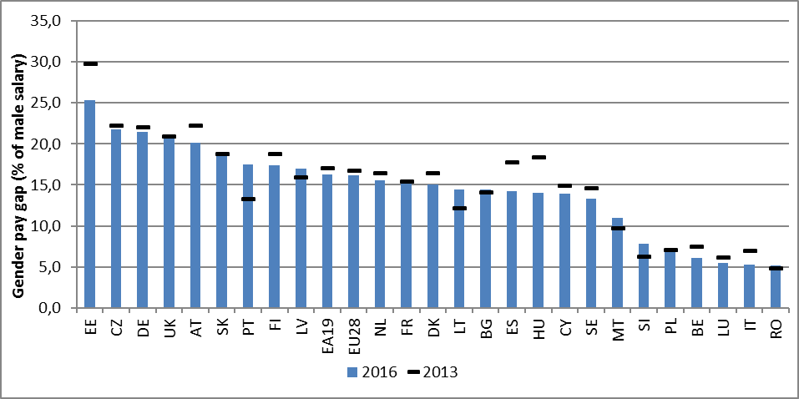

Source: Eurostat. Note: the unadjusted Gender Pay Gap (GPG) is measured as the difference between average gross hourly earnings of male and female paid employees as a percentage of average gross hourly earnings of male paid employees. No recent data available for Croatia, Greece and Ireland.

**Gaps in employment tend to be wider for women with caring responsibilities.** For instance, parenthood is one of the main factors hampering women's full participation in the labour market. In all Member States, the gender employment gap widens substantially when parenthood is taken into account. On average in 2017, the employment rate of women (20-49 years old) with a child under the age of 6 was 9.2 pps lower than for women without children. In the Czech Republic, Hungary and Slovakia the negative impact of parenthood is particularly high (over 40 pps), while the impact is positive – but smaller than for men – in Portugal, Luxembourg, Sweden and Croatia. Conversely, parenthood has a positive impact on the labour market participation of men in all EU Member States (+12.4 pps on average).

**Figure 35: Employment impact of parenthood for men and women (age 20-49) in 2017**

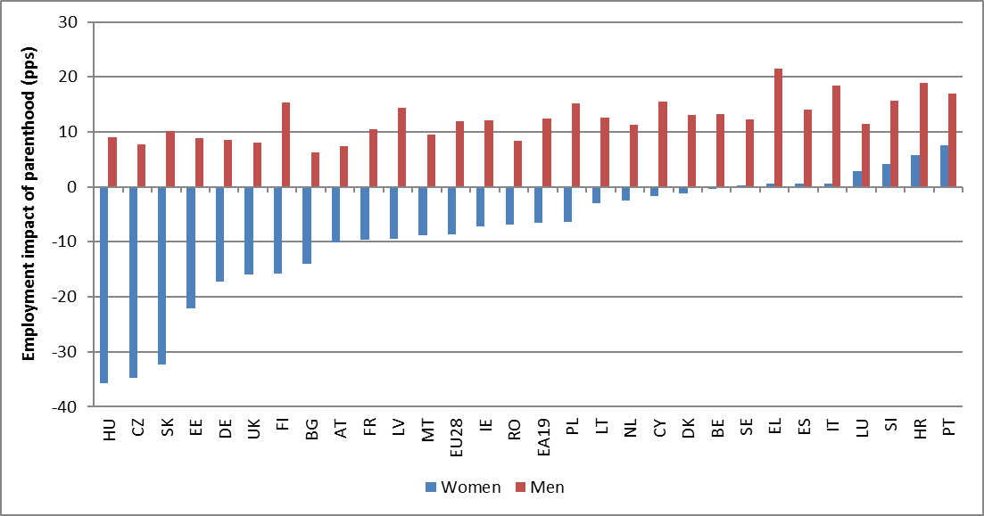

Source: Eurostat. Note: the employment impact of parenthood is measured as the difference (in pps) of the employment rate of women (men) with at least one child under the age of 6 and the employment rate of women (men) with no children.

**Unequal access to quality and affordable childcare and long-term care services contributes to the negative effect of parenthood on the employment of women.** As shown by the Social Scoreboard headline indicator on participation in formal childcare, in 2016 around 33% of children aged 0 to 3 were enrolled in formal childcare. This means that the Barcelona target on the availability of (high quality and affordable) childcare facilities for children in this age group has been nominally reached. However, major differences persist among countries. While in Denmark the enrolment rate stood at 70% and in Portugal, Luxembourg, Sweden and the Netherlands at around 50%, in Slovakia, the Czech Republic, Poland and Greece it was well below 10% (the latter countries, together with Bulgaria, are flagged as "critical situations"). In these Member States, lack of formal childcare arrangements also translates into poor labour market outcomes for women (in all of them the gender employment gap is above the EU average and parenthood has a negative impact on employment rates). In 2017, 21.6% of women with caring responsibilities in the EU were inactive or worked part-time due to a lack of childcare and long-term care services. In Greece, Spain, Croatia and Cyprus this share was well above 50%, reaching a record high in Romania and Latvia (above 89%).

**Figure 36: Children in formal childcare 0-3 and yearly change (Social Scoreboard headline indicator)**

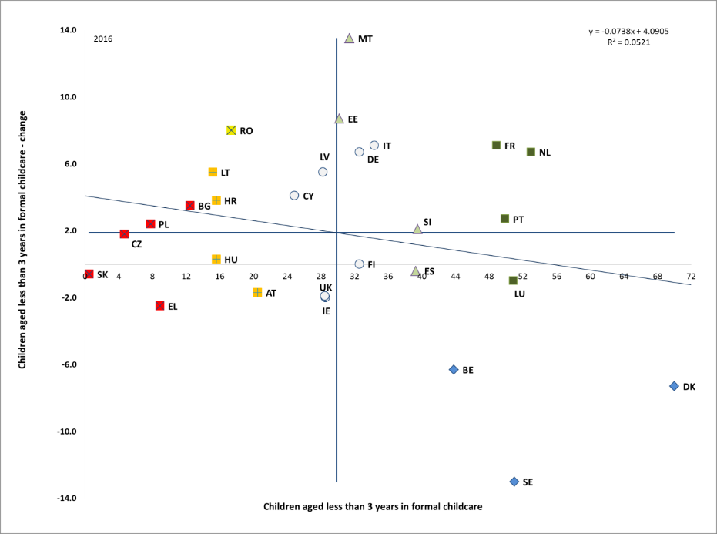

Source: Eurostat, EU-SILC. Period: 2017 levels and yearly changes with respect to 2016. Note: Axes are centred on the unweighted EU average. The legend is presented in the Annex.

**The provision of formal accessible, high-quality and sustainable long-term care services remains a challenge in several Member States.** The underdevelopment of long-term care services can be a major impediment for women to stay in employment, as informal care is often the only option for many families. Demographic change is going to aggravate this challenge, as the number of dependent elderly people is estimated to rise by 13 million between 2016 and 2070[51]. Furthermore**,** informal carers, the majority of whom are women, are more at risk of experiencing poverty and financial dependency, especially when forced to reduce their working hours or withdraw from employment to care for their relatives, thus lowering their income and pension entitlements.

**Women also tend to face strong financial disincentives when entering the labour market or wanting to work more**. In particular, when income tax is levied on household income rather than on individual income, non-working partners and second earners (often women) can face high financial disincentives to participate in the labour market or to work more hours. Other features of the tax and benefit system may also discourage labour supply, including family-based, dependent spouse and transferable deductions. In 2016, the inactivity trap for the second income earner was particularly high in Denmark, Germany, Belgium and France, while the low wage trap was high in Belgium, Germany and Luxembourg[52]. Large costs of care facilities increase inactivity traps, acting as disincentives to take up jobs or increase working hours.

**People with a migrant background benefit only partially from the general improvement in labour market conditions**. Whereas non-EU born people make up an increasing share of population in the EU (7.2% in 2017, up from 6.6% in 2014), they are less likely to be in employment than native born. In 2017, 63% of non-EU born people of working-age (20-64) were in employment, a much lower level than before the crisis (66.2% in 2008). The employment gap between the two groups stood at 10 pps in 2017, slightly better than in 2016 (10.5 pps), but much worse than in 2008 (4.5 pps). In some Member States (Finland, Sweden, the Netherlands and Belgium) this gap was around or close to 20 percentage points in 2017. The situation is even more challenging for non-EU born women. Their employment rate stood at 54.1% in 2017, with a gap of 13.6% with respect to native women. Moreover, when in employment, non-EU born people are more likely to be affected by in-work poverty than native-born.

**Figure 37: Employment rate of non-EU born people, multiannual comparison**

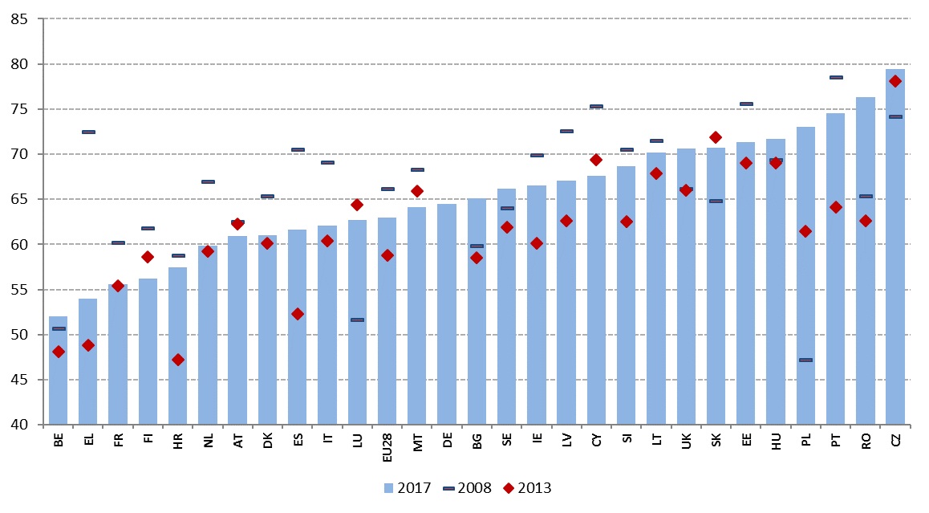

Source: Eurostat. Note: no data available for Germany for 2008 and 2013.

**Figure 38: Employment rate by country of birth, ages 20-64, 2017**

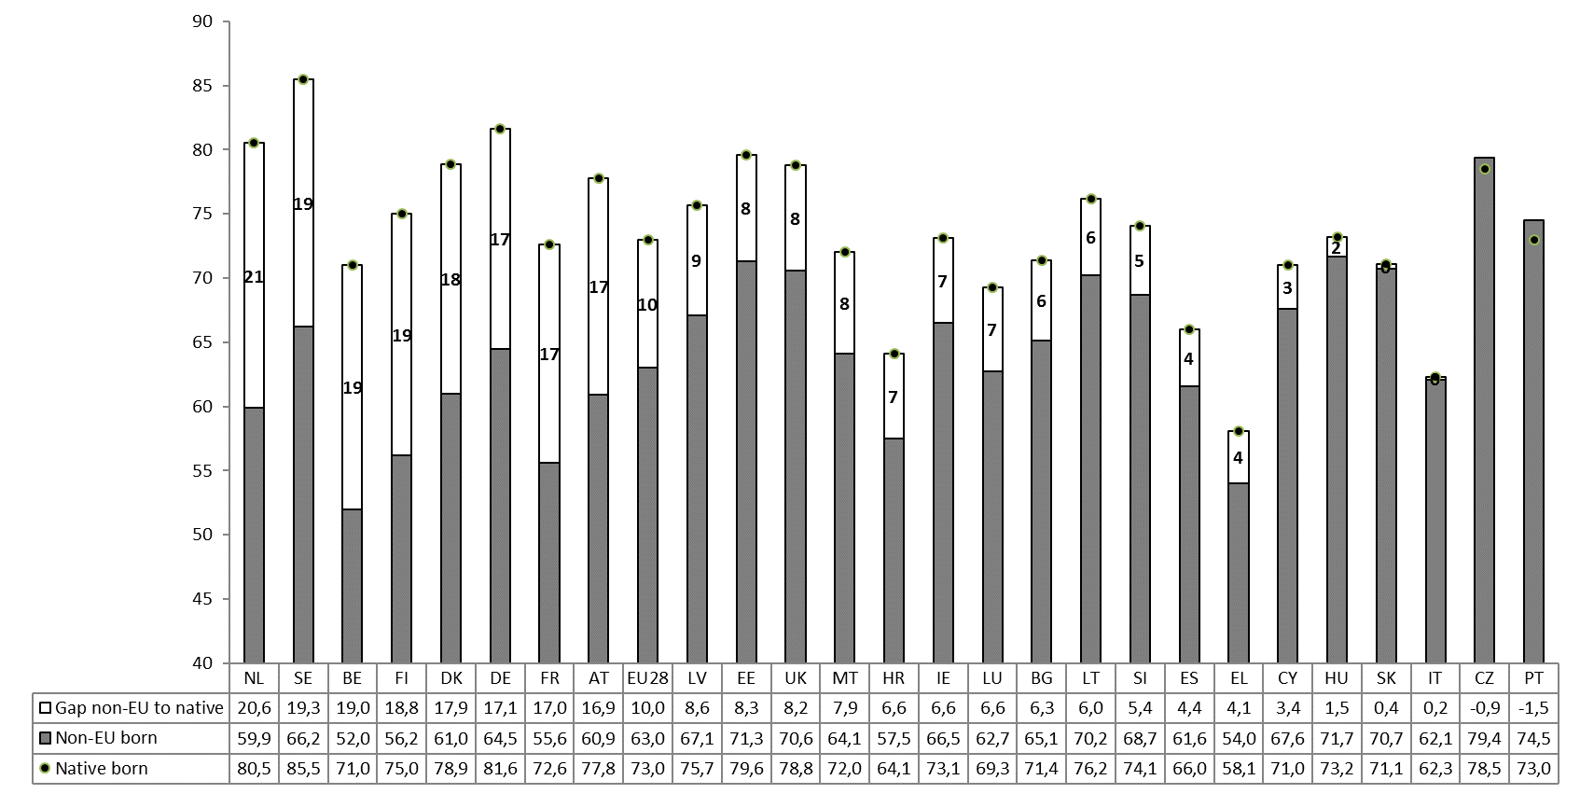

Source: Eurostat.

**Challenges faced by people with a migrant background have a tendency to be passed on over generations**. The share of people with a migrant background is increasing, especially among young people[53], and there is evidence that native born people with foreign born parents have lower employment rates than those with native background[54]. In turn this contributes to higher unemployment rates among some groups of disadvantaged young people. Labour market outcomes also differ markedly by reason of migration[55]. However, while the lower employment rates of migrants are partly driven by a higher share of persons with low level of education, a rising level of education[56] does not translate into better employment outcomes and there is a significant under-use of migrants' skills and qualifications[57].

**The employment rate gap experienced by persons with disabilities indicates an untapped potential to use their talents.** In the EU in 2016, the employment gap[58] between persons with disabilities and those without was large, with a 48.1% employment rate for persons with disabilities versus 73.9% for those without. There is, however, a substantial variation in the gap between Member States[59], varying from 14.7 pps (Italy) to over 45 pps (Ireland). In addition, only 59.7% of persons with disabilities in the EU are economically active, compared to 82.2% of those without disabilities, suggesting that significant barriers exist for persons with disabilities in accessing the labour market[60]. Countries with similar activity rates for persons without disabilities can have greatly different activity rates for persons with disabilities. The quality of work is also an important issue, as in 2016 persons with disabilities in the EU were more likely to face in-work poverty than the general population.[61] In terms of gender, the employment rate of women with disabilities (45.9%) was only slightly lower than that of men with disabilities (50.6%), and the gap was reversed in some Member States. Looking at the overall quality of life perceived by people with disabilities, Eurofound[62] finds that the extent to which they feel left out of society varies considerably depending on whether they are employed or not. Those who have a job far less often report feeling left out of society than long-term unemployed respondents or those who are unable to work because of their disability.

### 3.2.2 Policy response

**Comprehensive strategies that focus on the root causes of early school leaving are required to reduce dropout rates, prevent social exclusion and help the transition of young people to the labour market**. Many Member States have recently introduced measures to reduce the number of early school leavers, from policies for language support for students with a different mother tongue, to education and career guidance in schools, or measures to support early leavers to re-enter the education and training system. For instance, in Bulgaria, the 'Your class' project funds additional pedagogical support for students at risk of dropping out, such as language training, additional classes to overcome learning gaps or extra-curricular activities to increase students' motivation. Sweden financially supports schools according to pupils' socio-economic background, in order to promote a balanced social composition and to prevent early school leaving. In Spain, the Proeducar plan fosters policies that enhance the quality and equity of the education system and support second chance programmes.

**Ensuring access to affordable and high quality education, as well as supporting teachers’ continuous professional development, is crucial to improve pupils’ educational outcomes.** Ireland’s Action Plan for Education focuses on promoting and encouraging quality, excellence and innovation, meeting critical skills gaps, leading in key enabling technologies and championing inclusion. A recent secondary education reform in Luxembourg aims at adapting education to students' needs, giving schools more autonomy to organise the curriculum according to the profile they opt for, diversifying the language offer and introducing three-year plans for school development covering aspects such as guidance, study success, after-school activities, psycho-social assistance and improving digital skills. In Croatia**,** the School for Life initiative introduces new curricula based on the learning outcomes approach, which shifts the classroom focus to the pupils’ experience, recognizes the importance of teacher preparation and introduces cross-subject teaching of key competences, such as entrepreneurship, learning to learn or citizenship education. 'Co-operation for the Best School possible' ('Samverkan för bästa skola') is Sweden's initiative to tackle inequalities. It provides tailor-made support that is practice-oriented and is accompanied by teachers' professional development in schools that face the most severe challenges in providing high quality teaching and where a high proportion of pupils do not complete their education. Cyprusis implementing a new professional learning framework for teachers to upscale their continuous training and has started to upgrade the pre-school curriculum based on success and adequacy indicators. In Lithuania, the new Teacher Training Regulation defines quality requirements for study programmes and teacher internships; it also specifies possibilities for teacher training and professional development, and establishes criteria for national teacher training centres.

**Effective enforcement of legislative changes for Roma inclusion in education remains important.** In Bulgaria the measures currently in place for Roma students include scholarships and extracurricular activities, additional Bulgarian language classes and activities with parents. In July 2017, Hungary amended its Equal Treatment and Public Education Acts to ensure prohibition of segregation. Also, schools with low achievement, high drop-out rate and high risk of segregation have been selected in 2017 to receive training and complex development support to implement differentiated teaching methods. Antisegregation officers and working groups are being set up in educational districts. In Romania, the responsibilities of school inspectorates and of the quality assurance agency (ARACIP) to monitor segregation were expanded. The revised Action Plan for integrating Roma approved by the Slovak government in February 2017 is being implemented but results remain to be seen. The Slovak Republic adopted a 10 year National Education Development Plan which should also address the aspects of inclusiveness and quality of education, also for Roma children.

**Boosting the quality of higher education is key, especially in the context of continuously rising tertiary education attainment rates.** The Commission Communication on a renewed EU agenda for higher education of 2017[63] stresses the importance of measures aimed to broaden participation in higher education, increase completion rates, equip students with skills and competences relevant to the world of work or improve the efficiency of the higher education funding system. Several Member States have announced reforms in line with those principles. France has recently adopted a law to support students’ success in higher education, notably through increased guidance for entry, support all along the studies, and publication of expected competences prior to entry for different study areas. Austria and the Czech Republic recently introduced new funding systems for higher education to foster diversification and quality. In Poland, the recently adopted Act on research, science and higher education ("Ustawa 2.0") represents a major modernisation effort that aims to increase quality in the higher education sector. Portugal introduced measures to increase higher education enrolment, such as bolstering the social support mechanisms to students from disadvantaged backgrounds through a significant increase in scholarships, a social scheme for payment of tuition fees in multiple instalments, and the implementation of a redefined programme "+Superior", to promote and support enrolment in less densely populated and lower demand regions.

**Member States continue to make skills and qualifications easier to understand throughout Europe.** All Member states have national qualifications frameworks organised around the principle of learning outcomes. Almost all (27) have put their qualification levels in relation with the European Qualifications Framework, and 19 indicate the EQF level on their qualifications, making them clearer and better comparable (Belgium, the Czech Republic, Denmark, Germany, Estonia, Greece, France, Ireland, Italy, Latvia, Lithuania, Luxembourg, Hungary, Malta, the Netherlands, Austria, Portugal, Slovenia and the United Kingdom).

**More and more Member States take into account learning outside institutional education and training**. In 15 countries a coordination mechanism has been set up to promote exchange and consistency in validation efforts across education and training sectors, the labour market and the third sector (Belgium, Denmark, France, Greece, Ireland, Italy, Latvia, Malta, the Netherlands, Poland, Portugal, Romania, Slovakia, Spain, Sweden). Links between national qualification frameworks (NQF) and validation are intensifying in most countries. Validation can lead to any qualification included in the framework in 11 countries (Belgium, France, Ireland, Latvia, Malta, the Netherlands, Poland, Portugal, Romania, the United kingdom) and to credit towards a qualification in further four (Denmark, Estonia, Spain, Slovenia).

**Member States are moving towards a comprehensive strategic approach to skills governance.** In 2016, as part of the Skills Agenda package, the Council adopted a Recommendation on Upskilling Pathways aiming to help responding to skills gaps, inequality and emerging labour market needs requiring ever higher levels of skills. Through Upskilling Pathways, policy makers would design and implement policies specifically tailored to the needs of low-skilled adults. Several Member states have been working towards national skills strategies, supported by the Commission in cooperation with the OECD (Spain, Italy, Portugal, Slovenia and more recently, Belgium/Flanders). After completing the diagnostic phase and identifying the main skills challenges, Italy and Slovenia are carrying out the action phase of the process. Portugal has completed both the diagnostic and action phase and launched its action plan in May of this year. Latvia and Poland will embark on their Skills Strategy projects later in 2018.

**Further steps are being taken to promote and facilitate access and participation in VET.** Luxembourg has modified its legislation regarding the support and development of life-long learning with the aim to improve effectiveness of spending through the co-financing of vocational life-long learning. France committed additional funds to vocational training and apprenticeship via the so-called Plan d'Investissement Competence (PIC), implying almost a 10% average annual increase in public spending on vocational training and apprenticeship. Malta’s "Get Qualified" scheme aims at improving financial support for students wishing to pursue vocational training.

**Member States are adapting their systems of vocational education and training with a goal of improving their labour market relevance.** Slovenia has introduced an annex to a certificate, which provides detailed, uniform and internationally comparable information to employers on vocational qualifications. In the framework of the Technical Education Reform the United Kingdom has announced the introduction of T-levels – technical qualifications that 16- to 19-year-olds will be able to take as an alternative to A-levels, the main school leaving qualification. Greece expanded its apprenticeship support for the upper-secondary vocational school graduates that gives access to EQF level 5 qualifications and aims at facilitating transition to the labour market. Croatia has amended the Vocational Education Act that provides for development and design of new vocational curricula for acquiring vocational qualifications as required by the labour market; it also establishes a better quality assurance system and regional competency centres. In Cyprus, the government has introduced measures aiming at improving the quality of vocational education and the acquisition of skills and competences required by the labour market through, in particular, promoting the cooperation between VET providers and industry regarding practical trainings (via industrial placement). In Finland, the VET reform measures aim further at developing apprenticeship training and facilitating flexible paths to learning and a practical approach to obtaining a qualification.

**Several Member States adopted different measures promoting the development of digital skills.** An EU funded project “Education for Tomorrow” is being launched in Bulgaria to help open the education to digital technologies and to introduce innovative teaching methods as well as to increase motivation to learn and overcome difficulties in learning content. UK rolls out the National Retraining Scheme where it will use an additional GBP 30 million (EUR 34 million) for particular digital skills needs. Spain adopted a digital skills training programme for Young Professionals offering the unemployed young people from the National Youth Guarantee System training oriented to the digital industry and new business models. Malta set up a sub-committee in its National Skills Council to carry out research and make recommendations to address digital skills mismatches.

**Further improving youth employment and supporting young people’s transition between education and the labour market remains an important priority**. In 2017, more than 5 million young people registered in the Youth Guarantee and 3.5 million took up an offer of employment, continued education, a traineeship or an apprenticeship and close to half of young people were still in employment, education or training 6 months after leaving the Youth Guarantee registry. However, in many Member States the estimated proportion of NEETs registered with the scheme throughout the year is still below 50%. In a context where young people’s labour market performance has significantly improved, policy measures underpinning the Youth Guarantee’s delivery are becoming more targeted.

**Member States are stepping up their outreach efforts, making services more accessible** **to young people and ensuring a better identification of those in need.** In Finland, the one-stop guidance centres for youth (Ohjaamo, originally operating under ESF funding) were made permanent and will receive extensive financial support, aiming to reach a total of 10,000 young people. Youth Employment Agencies are being rolled out across Germany. Cyprus has launched an outreach project supported by the Ministry of Education in cooperation with the Ministry of Labour and the Cyprus Youth Board, aiming to reach out to 4,000 inactive NEETs and to provide them with activation support through counselling and tailor made training. In Croatia,a NEET mapping system is in place since November 2017, which aims to identify non-registered NEETs and their characteristics to better target measures to this group.

**New measures were also introduced to better support young people facing multiple disadvantages, including through better cooperation between employment, social and education services.** In Austria, youth coaching helps keep young people in the education and training system as long as possible, or alternatively reintegrate them into the system. In Ireland, the Youth Employment Support Scheme was announced in 2018. It offers work placements to young jobseekers who are long-term unemployed or face significant barriers to employment. Participants learn basic work and social skills in a supportive environment while receiving a weekly payment equivalent to the net minimum wage.

**Member States continue supporting labour market demand through employment and entrepreneurship incentives, mainly in the form of targeted wage and recruitment subsidies**. In March 2018, Belgium adopted a new law to support new “Starter Jobs”, which has not yet entered into force, making the employment of inexperienced young people between 18 and 21 years less costly without reducing their net pay. Spain launched a new wage subsidy programme for 10,000 unemployed 18-29 years old, with emphasis on higher education graduates (6,000 places). A longer subsidy period is granted for the recruitment of long-term unemployed and minimum income beneficiaries. Spain also adopted a reduction in the social security contributions during 3 years for firms that transform training contracts into open-ended and new wage subsidies for a first-time hiring by young entrepreneurs (up to 35 years). A longer subsidy period is foreseen for young unemployed (up to 29 years). Italy offers an array of incentives linked to social security contributions, such as reduced contribution during three years for private companies hiring youth under an open-ended contract or total exoneration during three years for employers hiring young people on open-ended contracts after a traineeship or a dual VET programme and for employers hiring young people enrolled in the Youth Guarantee programme. Romania is planning to increase the employment subsidy for hiring young NEETs and young graduates from 1.125 lei/month (about EUR 245) to 2.250 lei/month (about EUR 490).

**An important focus on upskilling and re-skilling young people through active labour market policies is present in several Member States.** In Croatia, the Ministry of Labour and Pension System and the Managing Board of the Croatian Employment Service adopted a new package of active labour market measures with additional emphasis on training and workplace training, including for youth. Since 2017, Spain has implemented a Digital skills training programme for Young Professionals, offering unemployed young people from the National Youth Guarantee System training oriented to the digital industry and new business models.

**Member States have also continued** **adapting their traineeship legislation to the Quality Framework for Traineeships[64] and further developed financial incentives for traineeships.** In Lithuania, a new Law on Employment, which came into force on 1 July 2017, makes a distinction between two types of traineeship, namely "voluntary practice" (Article 10) and “Advanced Training” (Article 39), and sets a clearer framework for unpaid and paid traineeships. In Spain, the 2018 budget law includes a financial allocation to launch a Youth Guarantee training bonus (*bono de formacion garantia juvenil*), a financial support of EUR 430 during a maximum of 18 months for young people hired on training and apprenticeship contracts. In July 2018, Romania adopted a traineeship law supporting people above 16 years old. The law makes it compulsory for employers to offer a monthly payment of minimum 50% of the gross minimum wage, for a maximum of 720 hours (within 6 months). A bonus will be offered for hiring trainees at the end of their traineeship.

***Box 2. Making full use of the European Social Fund (ESF)***

With a budget of EUR 86.4 billion for 2014-2020, the European Social Fund (ESF) is one the key EU instruments to support addressing the challenges identified in the country-specific recommendations (CSRs). The operational programmes directly contribute to promoting sustainable and quality employment, promoting social inclusion, investing in education and training and enhancing institutional capacity building.

One of the key policy priorities is youth employment, tackled through both the ESF own resources and the Youth Employment Initiative (YEI). The budget of the YEI has been increased in 2017 to EUR 8.9 billion, covering the full 2014-2020 programming period. The YEI specifically targets young people who are not in employment, education or training (NEET), concentrated on the EU regions with the highest youth unemployment rates in 2012.

Over 15 million participants have benefitted from ESF and YEI support between 2014 and 2017, including almost 3 million long-term unemployed (17%). Young people below 25 years of age (42% of total participants) and low-skilled people with primary or lower secondary education (44% of total participants) are key target groups of these interventions. Implementation, which showed a sharp acceleration in 2017, should continue steadily in the coming years.

Over 2.4 million young NEET have been supported by the YEI between 2014 and 2017, out of which:

- 1.5 million young people have completed the YEI supported intervention;

- 780,000 young people were in education/training, gaining a qualification, or in employment, including self-employment, upon leaving;

- 550,000 young people received an offer of employment, continued education, apprenticeship or traineeship upon leaving;

On 30 May 2018, the European Commission adopted a proposal for the 2021-2027 European Social Fund Plus (ESF+). The ESF+ will allow within the broader framework of the Structural and Investment Funds to focus support more on challenges identified in the European Semester. In this context, ESF+ will merge the:

• European Social Fund (ESF) and the Youth Employment Initiative (YEI),

• Fund for European Aid to the Most Deprived (FEAD),

• EU Programme for Employment and Social Innovation, and

• EU Health Programme.

The ESF+ Regulation will aim to ensure that resources under the shared management strand focus on the key challenges identified, in particular it will:

• Support the principles of the European pillar of social rights and the implementation of recommendations under the European Semester;

• Continue to provide support to young people with a minimum allocation for Member States with high youth unemployment rates;

• Foster social inclusion with a minimum share of 25%;

• Support Union actions for social innovation, mobility and health;

• Support long-term integration of third-country nationals, in complementarity with the Asylum and Migration Fund (AMF);

• Be made simpler to reduce the administrative burden on national authorities or organisations benefiting from ESF+ measures.

**Several Member States continue their efforts to promote labour market participation of older workers**. In Denmark, the pension agreement strengthens the incentives for older workers to stay longer on the labour market. A series of initiatives increases the degree of flexibility in the pension system, including higher financial incentives to postpone retirement and to establish private pension schemes. Greece adopted a programme of subsidies to public sector and local enterprises, entities and organizations to employ 10,000 long-term unemployed aged 55-67. In Malta, retired pensioners, who are less than 65 years of age and are self-employed or work part-time, will be able to pay the national insurance contribution pro-rata at a 15 per cent rate instead of the full rate. Slovenia introduced a subsidy aimed at permanent employment of persons older than 58 years, with priority for unemployment benefit- and cash social assistance beneficiaries. The subsidy amounts to EUR 11,000 and is payed to the employer in two parts (half at the recruitment and half after the 18th monthly salary). Moreover, a project was started to provide comprehensive support to companies for an active ageing of the workforce. Both measures are co-financed by the ESF. Finally, in line with the Active Ageing Strategy, in March 2018 the governmental council for active ageing and intergenerational cooperation was established, consisting of ministers and representatives of professional institutions, NGOs and economy.

**Many Member States continue efforts in the area of childcare and long-term care services to remove obstacles to employment of women.** In June 2018,Germany adopted a programme "Childcare financing" supporting the expansion of childcare places for very young children in order to increase the number of women working full-time. The programme, with a budget of EUR 3.28 billion, aims at providing additional 100,000 childcare places. Ireland has put forward the early childhood education scheme for children in pre-school age. As of September 2018, children are able to start attending childcare system at the age of 2 years and 8 months and continue until they reach the compulsory school age. Also Greece has extended the obligatory pre-school education from 1 to 2 years and has provided 15 million EUR for additional 10,000 childcare places. Some Member States have taken steps to improve the affordability of childcare. In Spain, the Law on the Personal Income Tax has been modified in order to enable a deduction of childcare expenses for children up to 3 years of age. Finland lowered fees for early childhood education for low-income and middle-income families. According to estimates, this will make approximately 6,700 families eligible for free early childhood education and care. Ireland announced a single affordable childcare scheme which would provide financial support for pre-school and school childcare. Bulgaria adopted measures aiming at providing more long-term care facilities for the elderly and persons with disabilities. Some Member States also took measures in favour of paid informal care. The Czech Republic adopted a law on special leave for carers (paid leave up to three months for informal carers of family dependants). Ireland plans to extend the parental leave entitlement to 26 weeks (6 months) in respect of each child. If passed, the additional 8 weeks provided for under the legislation will be made available to those parents who have already availed of the existing 18 week entitlement. Finally, Estonia introduced 5 additional carers' leave days (remunerated at the minimum wage).

**A balanced distribution of paid leave between women and men can be particularly beneficial in fostering women’s employment after having children.** To this end, Spain adopted a new law extending the right of fathers to paid paternity leave from 4 to 5 weeks. Czech Republic introduced one week of paid paternity leave. Slovenia has reduced the length of paternity leave from 90 to 30 days but has significantly increased the amount of paternity allowance to 100% of wages. In the Netherlands, the draft bill extending the length of paternity leave from 2 to 5 days and granting additional 5 weeks of leave for parents has been sent to the Parliament. Estonia plans to make the parental leave scheme more flexible to allow for both parents to take the leave simultaneously.

**Some Member States are adapting their tax and benefits systems to remove disincentives to work for second earners.** Denmark adopted the 2018 tax agreement strengthening the incentives to work full-time, notably for the unemployed and part-time workers. Spain modified the 2018 budget law to introduce a Personal Income Tax deduction for a dependent partner with low income. Latvia extended the coverage on non-taxable income to non-working spouses taking care of a child up to 3 years old or at least 3 children up to 18 years old.

**Only a limited number of Member States took steps to address the gender pay gap.** Sweden established a new agencyfor work environment that will collect and disseminate information on the work environment policies, including on gender segregation in occupations. Estonia plans to increase pay transparency in the public sector and will develop an IT tool to analyse wage differences between men and women. France announced a set of 10 measures to foster closing the gender pay gap. In August 2018, Portugal introduced measures to promote equal remuneration among women and men who perform equal work or work of equal value. These entail an annual report on general and sectorial information about gender differences in remuneration, and an assessment per company, profession and level of qualifications. Specific actions from the labour inspectorate and sanctions against employers based on the grounds of discriminatory treatment are envisaged.

**Many Member States are taking action to promote integration of people with a migrant background through strategic plans, funding, legislation and innovative measures**. In Finland, new models for funding integration were introduced, speeding up the integration process, and allowing migrants to combine education and work in a flexible way. In Malta, the Migrant Integration Strategy & Action Plan (Vision 2020) as a framework for understanding successful integration was launched in December 2017. In Belgium, the integration programme of the German-speaking Community became mandatory for foreign nationals who are above 18 years of age, are registered at a municipality as of January 2018 and have a residence permit valid for at least three months. In Austria, two new integration laws came into effect in the summer of 2017 as part of a larger effort to promote integration. The Integration Act requires refugees and persons with subsidiary protection status to sign an “integration statement” and to participate in integration courses. With effect from 1st January 2018, the Federal Asylum Law was adapted, entitling beneficiaries of subsidiary protection and asylum seekers to integration support, provided that granting of international protection seems very likely.

**Promoting the integration of migrants in the labour market is a priority in many Member States.**In Belgium, the Flemish Public Employment Service (VDAB) implemented its Action Plan for 2017 entitled ‘Integration through work’. Sweden adopted new measures to facilitate the integration of newly arrived migrants, in particular to the labour market via, inter alia, the provision of targeted education and training. The Swedish Agency for Economic and Regional Growth facilitates contacts and networking between foreign-born women, in particular newly arrived women, and employers. In Estonia, an information campaign was launched to encourage second and third generations’ access to employment in the public sector. A pilot mentoring programme was also launched to facilitate third-country nationals’ access to the labour market.

**Promoting access to education and training can be a key driver for the integration in the labour market and in society at large**. In Sweden, under the education and training obligation, all newly arrived immigrants from third countries who benefit from the Public Employment Service's Introduction Programme and are considered in need of education or training to get a job can apply for education and training paths. In Estonia, an online platform for immigrants to learn Estonian was further developed in 2017. In Finland, reforms in basic and vocational education aimed to enhance the development of migrants’ linguistic capabilities. In addition, a legislative amendment was adopted to provide literacy for migrants in adult education provision. Croatia improved its system of recognition of qualifications for beneficiaries of international protection and allowed them to finish education started in the country of origin, free of charge. In Germany, measures were implemented to help third-country nationals to integrate into the labour market via recognition of their occupational and educational qualifications, as well as their non-formal skills.

**Member states are also taking specific measures for refugees and asylum seekers.** In Belgium, structural cooperation has been agreed between the Federal Agency for the reception of asylum seekers (Fedasil) and the Walloon Public Employment Agency (Forem), mainly to facilitate access to employment for asylum seekers. In Estonia, the Unemployment Insurance Agency extended a project ‘My First Job in Estonia’ under the Youth Guarantee scheme, co-financed by the European Social Fund for beneficiaries of international protection. In Luxembourg, the Employment Agency set up a service for the integration of beneficiaries of international protection in the labour market. In the Netherlands, a programme for beneficiaries of international protection and native-born with a migrant background was launched to improve access to employment. France launched the “pathway for 1,000 refugees” initiative, which offers 1,000 beneficiaries of international protection with an eight-month integration pathway including accommodation, language learning and certified vocational training.

**Several Member States are promoting the employment of persons with disabilities.** Since September 2017, the Greek government has been subsidising the employment of persons with disabilities and the adaptation of workplaces in the local government and private companies. In a similar vein, Sweden has raised the cap for subsidising the employment of persons with disabilities. Poland is implementing a European Social Fund-financed project to reduce barriers to employment of persons with disabilities. Bulgaria is investing on training to increase the employability of persons with disabilities ("training and employment"), with priority to those with more severe disabilities. France adopted the *Liberté de Choisir son Avenir Professionnel* law ("Freedom to Choose one's Professional Future"), aiming to promote the employment of persons with disabilities. This law includes a scaling up of socio-medical approaches to aid in job searches, a move of the requirement to have 6% of recruitment from people with disabilities from the work unit to the company level and the introduction a compulsory company declaration (from January 2020) on measures taken to integrate workers with a disability. In Portugal a new social benefit granted to people with a disability above 60% aims to encourage them to continue working or to look for a job (currently, people with disabilities are not entitled to receive disability benefits if they receive any form of remuneration). Malta is introducing a new budgetary measure that will allow people with disability to keep their disability pension in full when working/when they get a job.

### **Guideline 7: Enhancing the functioning of labour markets and the effectiveness of social dialogue**

This section looks at the implementation of the employment guideline no. 7, which recommends Member States to enhance the functioning of the labour market and the effectiveness of social dialogue. This includes balancing flexibility and security in labour market policies, preventing labour market segmentation and fostering transitions towards open-ended forms of employment, ensuring effective active labour market policies and public employment services, providing adequate unemployment benefits that do not disincentivise a prompt return to employment, and promoting the mobility of workers and learners. In addition, the guideline recommends Member States to ensure the timely and meaningful involvement of the social partners in the design and implementation of policies, including through support for increased capacity of the social partners. The chapter starts by shortly introducing key indicators pointing at challenges in this area, notably on segmentation between permanent and temporary jobs (and related job quality issues), participation into active labour market policies and PES, functioning of unemployment benefits (through an update of the benchmarking exercise presented in 2018) and the extend of workers' and learners' mobility. Section 3.3.2 finally reports on policy measures from Member States in these areas.

### 3.3.1 Key indicators

**Though roughly stable at EU level, labour market segmentation represents an issue for a number of Member States.** Segmentation is the situation where (at least) two “segments” of workers characterised by different rights, entitlements and/or working conditions coexist in the labour market. Especially if associated with limited possibilities to move from atypical to permanent jobs, it may hamper the functioning and fairness of labour markets. A highshare of temporary workers can be a rough indicator of labour market segmentation in a Member State. At EU level (Figure 39) the proportion of temporary contracts over total employees did not change significantly over recent years, hovering around 14% on average over the last ten years. However, some Member States experience much higher levels: this is the case in particular of Spain, Poland, Portugal, the Netherlands and Croatia, which all recorded rates above 20% in 2017; followed by other six member states (Slovenia, France, Sweden, Finland, Italy and Cyprus) in the range between 15% and 20%. Some of these countries went through significant increases between 2008 and 2017, notably Croatia (by 8 pps), Slovakia (by 5 pps), the Netherlands (by around 4 pps) and Italy (by 2 pps). A significant increase was also recorded by Denmark (from 8.5% in 2008 to 12.9% in 2017). A peculiar case is Spain, where the share of temporary contracts contracted significantly during the crisis (from 29.2% in 2008 to 23.2% in 2013) to increase again with the recovery (up to 26.8% in 2017).

**Figure 39: Share of temporary workers over total employees (15-64).**

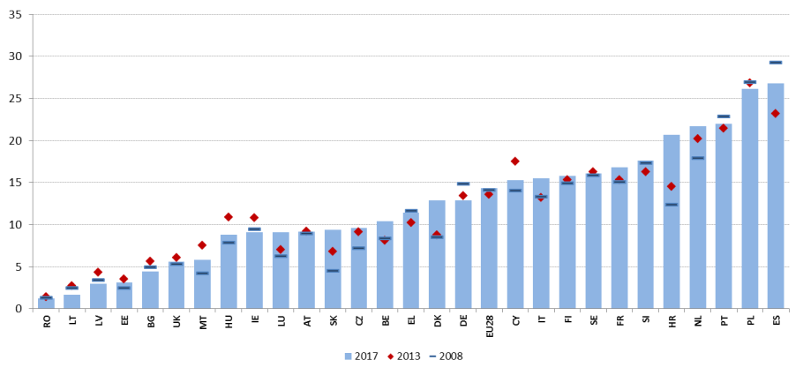

Source: Eurostat, LFS.

**Temporary contracts may act as stepping stones towards permanent jobs, but often represent "dead ends".** Figure 40 shows the transition rates from temporary to permanent contracts (averaged over three years to minimise the impact of short-term fluctuations) plotted against the share of temporary contracts over total employees. On average, 24% workers with a temporary contract move to a permanent contract during the following year. However, in a number of Member States the yearly transition rate is significantly lower than the EU average. This is the case, in particular, of Spain, France, Poland and Italy, which combine a low transition rate (around 11% for the former two countries, 20% for Italy and 22% for Poland) with a high share of temporary contracts, pointing to segmentation. Transition rates are comparatively higher in Member States with a low proportion of fixed-term contracts. Conversely, in the countries with a high share of fixed-term contract, workers tend to be stuck in temporary jobs. Notable exceptions are represented by Sweden and Slovenia that, in spite of having high shares of temporary workers, present transition rates close or above 40%.

**Figure 40: Share of temporary workers over total employees 15-64 (2017) and transition rate to permanent jobs, 3-years average (2016).**

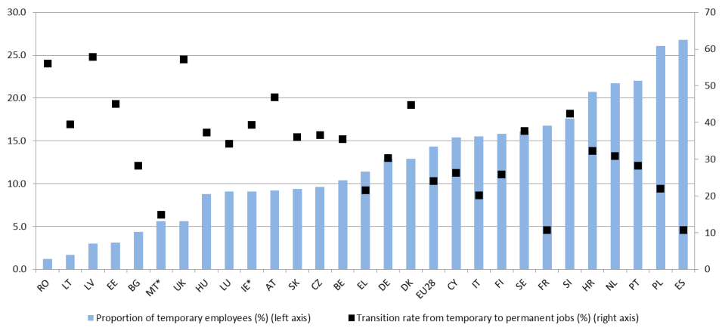

Source: Eurostat, LFS, SILC.

Note: the transition rate for IE and MT refers to 2015.

**In the EU, the majority of temporary workers are on a fixed-term contract because they cannot find a permanent job.** The proportion of "involuntary" temporary workers is an additional indication of segmentation in the labour market; around 54% of all temporary workers aged 15-64 in the EU are in this situation (2 pps more than in 2008), but the share is above 70% in 12 Member States. In this perspective, the situation of Member States like Portugal, Croatia and Spain – which combine a high share of temporary workers with a percentage of "involuntariness" higher than 80% – is especially challenging (Figure 41). The situation of Cyprus also needs some monitoring: even if the share of temporary employees is only slightly above the EU average, 91.9% of them are in this situation because they could not find a permanent job. Younger workers are normally more willing to accept temporary jobs; as shown in Figure 41, when the 25-64 age group is considered, the share of involuntary temporary workers is higher in all Member States. Interestingly, the gap between 15-64 and 25-64 age groups is lowest where the share of involuntary temporary workers is highest, indicating that in more segmented labour markets also younger workers have a strict preference for open-ended contracts. The share of older workers (aged 55-64) on involuntary temporary contracts has increased substantially with the crisis, from 51.9% in 2008 to 60.6% in 2017.

**Figure 41: Involuntary temporary workers as a share of total temporary employees, 2017.**

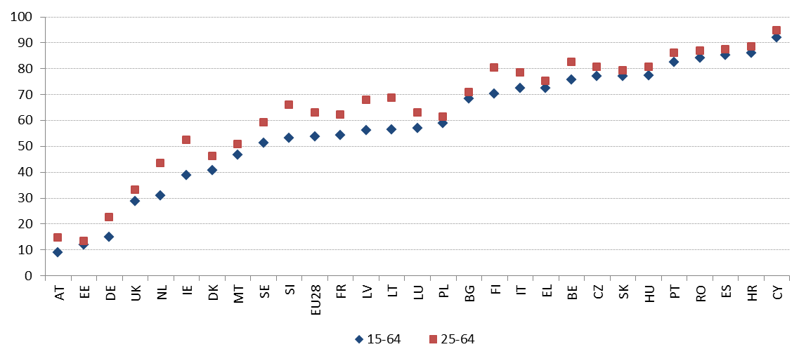

Source: Eurostat, LFS.

**A high proportion of self-employed workers may also be a sign of labour market segmentation.** While self-employment is normally voluntary, it may conceal dependent employment relationships (so-called 'bogus' self-employment). In addition, often social security systems are not adapted to include the self-employed (this issue is discussed in Chapter 3.4). The degree of autonomy of self-employed workers cannot be measured with comparable Eurostat statistics across Member States[65]. However, some proxy information can be obtained by looking at the share of self-employed without employees ('own account workers') over total employment – when high, it could signal the need for further country-specific assessment. The ranking shows Greece (22.3%), Romania (15.3%) and Italy (15.1%) on top in 2017, followed by Poland, Czech Republic, Slovakia, the United Kingdom and the Netherlands with rates above 11% (Figure 42). At the lower end, Denmark, Germany, Sweden and Hungary show rates below or close to 5%. Since 2008 the share of own account workers has remained stable on average in the EU, but significant increases were recorded in some countries, notably in the Netherlands (from 8.4% in 2008 to 11.5% in 2017) and in the United Kingdom (from 9.8% to 11.8%). On the contrary, it has decreased markedly in Croatia (from 11.7% to 5.7%) and Portugal (from 13.5% to 8.9%). According to Eurofound[66], in 2015 around one quarter of all self-employed workers in the EU could be classified as "vulnerable" or "concealed"[67], with substantial differences among Member States. These workers are characterised by economic dependence, low levels of autonomy and financial vulnerability; therefore, ‘bogus self-employed’ are most likely to be found in these groups. Figure 43 shows the distribution of self-employed workers in these two categories as a share of total employment, by Member State.

**Figure 42: Self-employed without employees as percentage of total employment.**

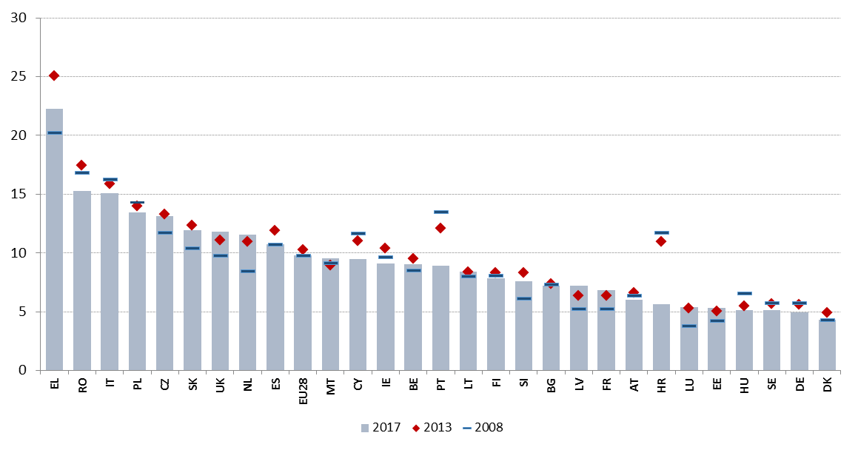

Source: Eurostat, LFS – own calculations.

**Figure 43: "Vulnerable" and "concealed" self-employed workers as a proportion of total employment.**

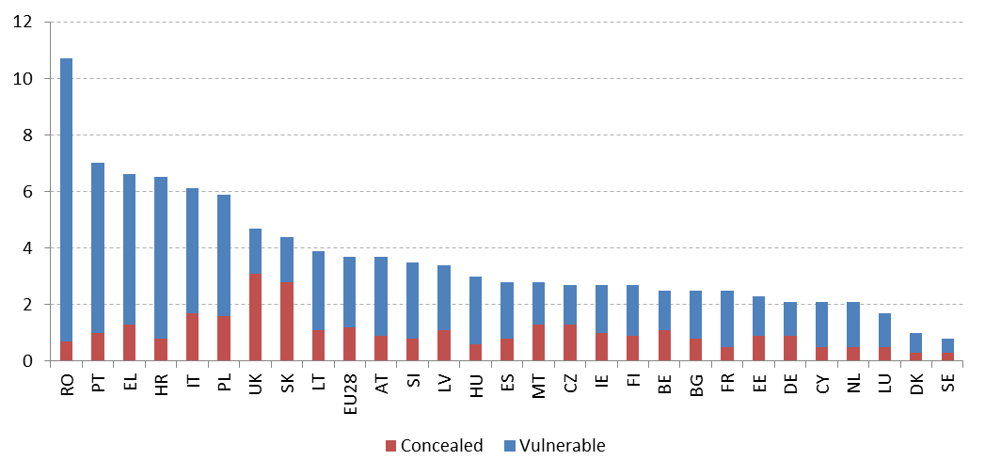

Source: Eurofound (2017) – based on sixth European Working Conditions Survey (2015).

**"Platform work", though currently limited to small parts of the workforce, may have a significant impact on working conditions and patterns.** Recently, the European Commission's COLLEEM online survey[68] investigated the utilisation of online platforms among frequent internet users aged 16-74 in 14 EU countries, providing some initial tentative evidence on the situation of platform workers. According to European Commission (2018)[69], based on the survey results, the proportion of people earning more than half of their income from platform work hovered slightly above 2% in 2017, with the highest levels recorded in United Kingdom (4.3%) and the Netherlands (2.9%). Around half of those for whom platform work is the main activity regard themselves as fully or partly self-employed, although a significant share (38%) see themselves as employees. This suggests that many platform workers may not be covered by social protection – an issue which is complicated by the fact that often their employment status is not clear for regulatory purposes.

**Temporary workers experience lower job quality, over a number of different dimensions.** The sixth European Working Conditions Survey (2015) provides information on a number of key dimensions of job quality. Based on this survey, Eurofound[70] has computed seven job quality indexes (concerning respectively physical environment; social environment; work intensity; skills and discretion; working time quality; prospects; and earnings). Looking at differences in the scores for six of the seven job quality indices[71] (Table 3) workers on short-term temporary contracts score below average in four of them, of which *prospects* (including job security and career advancement) and *skills and discretion* (which includes, for instance, access to training and decision autonomy) are the most challenging. On the other hand, as regards the social environment, they have a slightly higher score than the average. Longer-term temporary contracts show a similar pattern, but their job quality scores are closer to the average; in addition, they find themselves in less favourable *social environments* compared to the average. Differences remain after statistically controlling for factors such as individual or job-related characteristics (Figure 44). Workers on temporary contracts are also more than three times as likely to be at risk of poverty as those in permanent employment (16.3% of temporary workers, versus 5.8% of permanent workers in 2017); a gap which has been growing steadily since the crisis.

**Table 3: Job quality scores by employment status (2015)**

Source: Eurofound computation on EWCS 2015. Green marks “better than average”, red “worse than average”. The shade of the colour indicates the deviation from the average (darker shades have more distance to average).

**Figure 44: Effects of employment status on specific aspects of job quality, controlling for individual and job-related characteristics (2015)**

****Source: Eurofound computation on EWCS, 2015

Note: The colours represent the relative association between each job quality indicator and the employment status as compared to the reference group of employees with indefinite contracts. Results stem from multi-level regressions controlling for individual characteristics, occupation, sector and others.

Effective active labour market policies (ALMPs) are a key component of well-functioning labour markets. They increase the opportunities of job-seekers to find a new job and improve labour market matching. The main challenge that ALMPs seek to address is unemployment, notably long-term unemployment (i.e. of duration longer than one year). Evidence shows that the longer the spell a job-seeker spends in unemployment, the higher is the risk of skills depreciation, discouragement and overall detachment from the labour market. Therefore, long-term unemployment is both an indicator of the effectiveness of ALMPs and a measure of the challenge faced by a country in terms of activation of its unemployed population[72]. Figure 45 shows the long-term unemployment rate (i.e. the ratio between the number of people unemployed for more than one year and the active population) in 2017 and its change compared to 2016. As also mentioned in Chapter 1, long-term unemployment has been reducing in all Member States in 2017, on the back of the labour market recovery. In spite of a broadly converging trend (as highlighted by the negative slope of the regression line) there remain significant discrepancies across Member States, with rates ranging in 2017 from 1% in Czech Republic to 15.6% in Greece. Together with Spain (which shows a rate of 7.7%), Greece is flagged as "weak but improving", as it combines a much higher than average level with a fast rate of reduction over the last year. Italy, which recorded a comparatively lower long-term unemployment rate (6.5%), is flagged as a "critical situation", in consideration of its limited improvement in 2017 compared to the previous year. The situation of Slovakia is considered "to watch" with a rate of 5.1%. Among the countries marked as "better than average", it is worth mentioning Cyprus, Portugal and Croatia, which are classified in this group because of their performance on the yearly change, pointing to a significant improvement in 2017 (the level being close but still above the EU average).

**Figure 45: Long-term unemployment rate (Social Scoreboard headline indicator)**

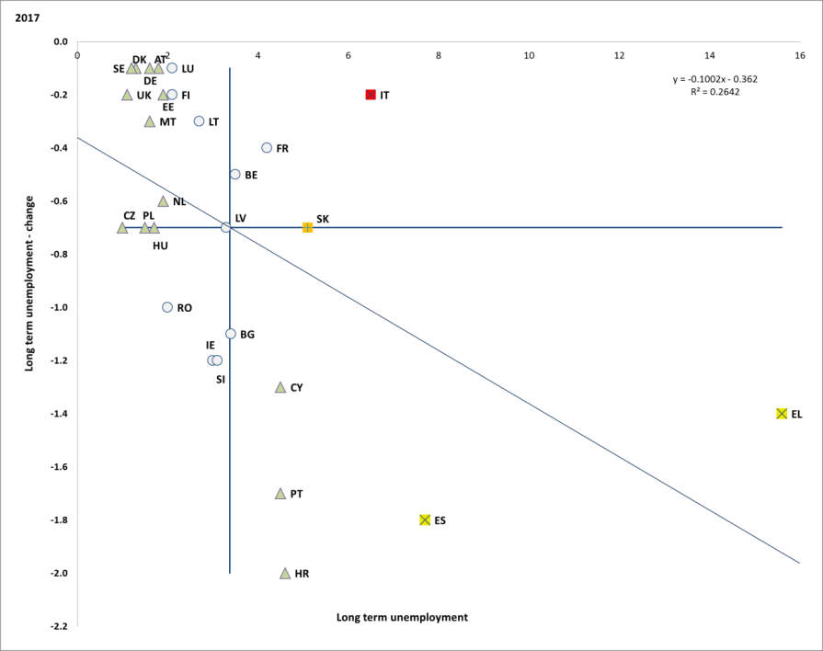

Source: Eurostat, LFS. Period: 2017 levels and yearly changes with respect to 2016. Note: Axes are centred on the unweighted EU average. The legend is presented in the Annex.

In most Member States, the long-term unemployment rate has not recovered yet to pre-crisis levels. The improvement with respect to 2013 (reference as peak year of the crisis) has been especially relevant (by more than 4 pps) in Croatia, Spain, Slovakia, Portugal, Ireland and Bulgaria. Still, in few Member States the long-term unemployment rate in 2017 is equal or higher than in 2013, notably for France (same rate), Austria (+0.5 pps), Finland (+0.4 pps) and Luxembourg (+0.3 pps). In addition, for 21 Member States the long-term unemployment rate remains higher than in 2008, the largest gaps being recorded for Greece (+11.9 pps), Spain (+5.7 pps), Cyprus (+4 pps) and Italy (+3.5 pps). This is an indication of the intensity of the recession suffered by these countries in past years, and the impact it keeps showing on labour market outcomes – but, at the same time, of the challenges faced by the public employment services and active labour market policies systems, which in many cases were put under severe stress by the suddenly increasing number of job-seekers.

Figure 46: Long-term unemployment as a percentage of active population

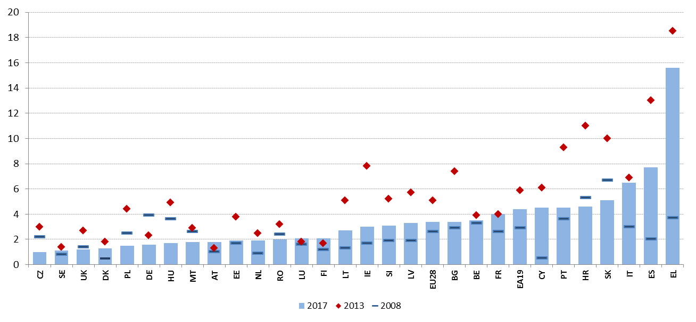

Source: Eurostat, LFS.

**Participation in active labour market policies still differs significantly across the EU.** Active labour market policies (ALMPs) represent one of the cornerstones in ensuring effective labour market transitions and high performing labour markets. Together with an effective lifelong learning infrastructure, ALMPs constitute the actual support (and security) dimension of a well-balanced flexicurity set-up, which is recognised as a factor improving labour market performance. In this light, disparities among Member States in participation to activation measures are striking. On the one hand, there is a large group of Member States (Greece, Romania, Bulgaria, Latvia, Slovenia, Croatia, Cyprus and Malta) where less than 10% of those wanting to work participated in ALMPs in 2016. Moreover, this share in most cases has decreased in recent years. On the other hand, there is another group of countries recording participation rates beyond 40% (Sweden, France, Denmark, Hungary, Luxembourg and Belgium); for this group of countries the trend is generally positive or constant since 2013. This seems to indicate that convergence is not taking place on this policy indicator[73]. In most countries, participation rates have dropped after the crisis (with the notable exceptions of Belgium, Hungary, Sweden, Czech Republic and Estonia) indicating that the increase in the number of people looking for a job has not been followed by a proportional increase in participation to ALMPs.

Figure 47: Participants in ALMPs per 100 persons wanting to work

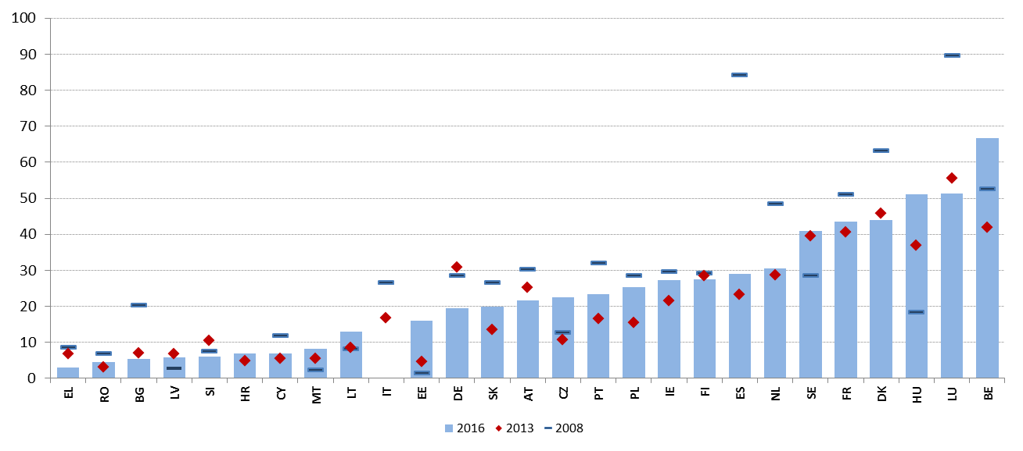

Source: Eurostat, LMP database and LFS. No recent data available for UK; no figures for 2016 for IT.

**Total investment in active labour market policies also seems to diverge greatly among Member States.** If the share of long-term unemployed is a rough approximation for the effectiveness of active labour market policies, this divergence is a matter of concern as well. Although spending on labour market services and measures to some extent is related to the unemployment and competitiveness situation in a given Member State, the figures illustrate large differences in the commitment to building effective systems for active labour market policies. The spending on labour market services and measures varies from 1.5% of GDP to less than 0.1% in some of the less committed Member States (Figure 48). Moreover, the Member States with the lowest investments in ALMPs also tend to be those where a significant part of the ALMP system is co-financed by the ESF and where the long-term sustainability of the system is in question.

Figure 48: Spending on labour market services and measures (2016) and share of long-term unemployed (2017)

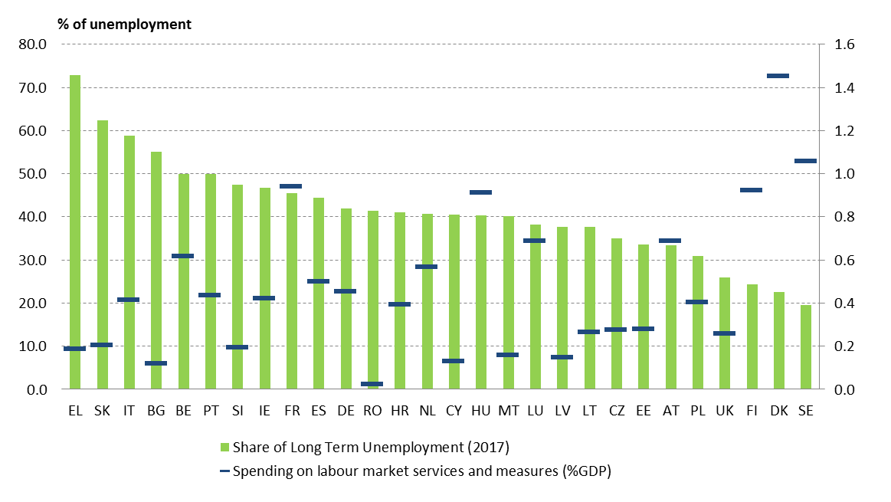

**Public Employment Services (PES) are the main labour market institutions in charge of job search support and referral of job-seekers to activation measures.** Although structured differently in each country, all PES aim at matching supply and demand in the labour market by providing services to both registered unemployed and employers. In particular, they are in charge for profiling clients, providing them counselling and individualised support, referring them to training and activation measures, and (in many countries) paying unemployment and/or welfare benefits.

**Nonetheless, the effectiveness of Public Employment Services in providing job search support is unequal among Member States,** depending inter alia on their capacity, quality of services offered and coordination with other actors. Such discrepancies reflect, in many cases, the use of PES made by unemployed people for job search (beyond formal registration requirements, which are generally necessary to access unemployment and other welfare benefits). Figure 49 shows the share of unemployed people using public employment services for job search. The values do not differ significantly from those published in the 2018 Joint Employment Report. At the bottom of the distribution, Spain, Italy and Romania show the lowest shares in 2017 (less than 30%), followed by the Netherlands, the United Kingdom and Portugal (with a share between 30% and 40%). Conversely, in Member States such as Lithuania, Slovakia, the Czech Republic, Austria, Slovenia, Germany and Greece, the share of unemployed people who declare using Public Employment Services to search for a job is above 70%. On average, the use of PES by unemployed has constantly decreased since the onset of the crisis, dropping from 58.1% in 2008 to 45.2% in 2017 (1 pp less than in 2016). Nonetheless, an opposite trend is recorded in few Member States, with notable increases in Latvia and Cyprus (by more than 30 pps), Estonia and Greece (by around 15 pps), Romania and Slovenia (by around 9 pps). In some of these countries, though, increased rates may be due to stronger obligations to register in order to access benefits. Figure 50 provides a hint to the use made of selected alternative job search methods by unemployed people, including private employment offices, direct applications to employers and informal methods such as asking friends, relatives and trade unions. While it is difficult to find general patterns, it appears that in Member States where usage of public employment services is low, informal methods are the most frequently used.

Figure 49: Share of unemployed people using public employment services for job search

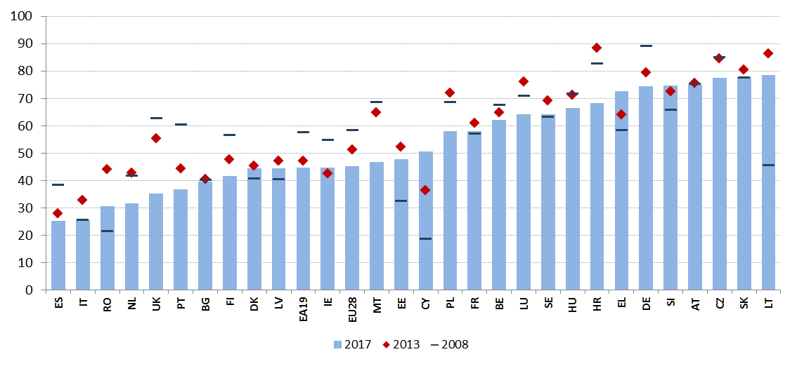

Source: Eurostat, LFS.

Figure 50: Share of unemployed people using selected job search methods (2017)

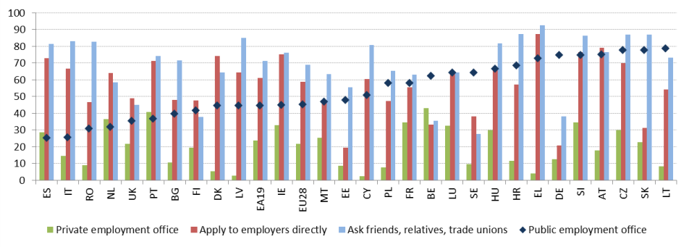

Source: Eurostat, LFS.

**The provision of adequate unemployment benefits of reasonable duration, accessible to all workers and accompanied by effective active labour market policies is key to support jobseekers during transitions in the labour market.** The 2018 Joint Employment Report presented an extensive comparative analysis of the main design features of unemployment benefit systems across the EU, based on the results of the benchmarking exercise of unemployment benefits and ALMPs conducted within the Employment Committee (EMCO). The analysis, which looked into a number of performance and policy lever indicators (for year 2016 or 2017 depending on data availability) remains overall valid, in view of the limited policy changes occurred during the reference period for this report (for details on the reforms taken by Member States in this domain, see Section 3.3.2; for a long-term overview of reforms by Member States, see European Commission, 2018[74]). This section provides an update of the exercise, notably of policy lever indicators. Furthermore, it looks into the additional indicators of strictness of job-search requirements for unemployed jobseekers which have been agreed by the Employment Committee in 2018.

**The share of short-term unemployed people[75] covered by unemployment benefits amounts to around one third, on average.** This share slightly decreased in the aftermath of the crisis (from 34.4% in 2008 to 32.7% in 2017), remaining stable over the most recent years. However, significant differences across countries persist (Figure 51). These differences depend on the policy design of the unemployment benefits systems (notably on eligibility conditions, maximum duration, strictness of job search requirements, overlaps with other social protection schemes) as well as on the cyclical position of different countries. In a long term perspective, between 2008 and 2017 the largest increases in coverage were recorded in Latvia (by almost 16 pps), Italy (10 pps) and France (9 pps). On the other hand, the largest drops were recorded in Hungary (-15 pps), Luxembourg (-12 pps), Croatia and Germany (-10 pps). The latter, however, still shows the highest coverage rate (62.8%) – followed by Finland, Austria, Belgium and France with rates above 50%. On the contrary, the lowest coverage can be observed in Malta, Croatia, Poland, Romania and Bulgaria, with rates significantly below 15% and no sign of improvement.

Figure 51: coverage of unemployment benefits for the short-term unemployed

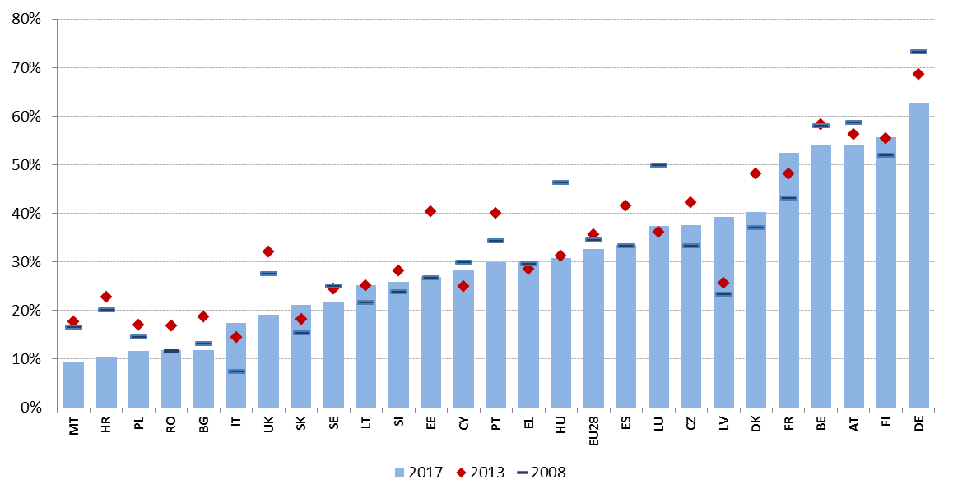

Source: computation on Eurostat, LFS data. Note: data not available for IE and NL.

**There have been no major changes between 2016 and 2018 in the design of unemployment benefits in Member States.** To be entitled to unemployment benefits, unemployed people are generally required to have a minimum work record and/or have paid insurance contributions during a period of time. As shown in Figure 52, this minimum period ranges from less than 20 weeks in France and Italy to a year (52 weeks) or more in Poland, Romania and Slovakia. Almost no variations are recorded between 2016 and 2018, with three exceptions. In the case of Austria, an insurance record of 52 weeks within the last 24 months is still required for first-time applications. However, for subsequent applications, this period has been reduced to 28 weeks. In Bulgaria, the length of the required qualifying period has increased from 9 months of insurance during the 15 months prior to unemployment, to at least 12 months of insurance during the 18 months before unemployment. A similar reduction has taken place in Latvia where the requirement increased from having paid at least 9 months of contributions in the 12 months prior to unemployment to having paid at least 12 months of insurance in the 16 months prior to unemployment. As concerns the maximum duration of benefits (Figure 53), there has been no change between 2017 and 2018. Belgium remains at the higher end with unlimited benefit duration – which should be seen in the context of the absence of an unemployment assistance scheme. On the opposite side are Hungary and Malta. The maximum duration continues to be shorter than the contribution periods in most Member States; only in four they are equal (France, Netherlands, Greece, Luxembourg) and in three cases higher (Finland, Denmark, Belgium). As concerns level and adequacy of unemployment benefits Member States also present significant disparities.Net replacement rates for a low-wage worker with a short work history (1 year) range from less than 20% of previous (net) earnings in Hungary to around 90% in Luxembourg (Figure 54). The comparison between the net replacement rates at the 2nd and the 12th month of the unemployment spell shows the effect of either the expiration of the benefits (with individuals falling into other schemes, such as unemployment or social assistance), or the reduction in benefit generosity over time[76].

Figure 52: Length of the required qualifying period, 2016 and 2018 (in weeks)

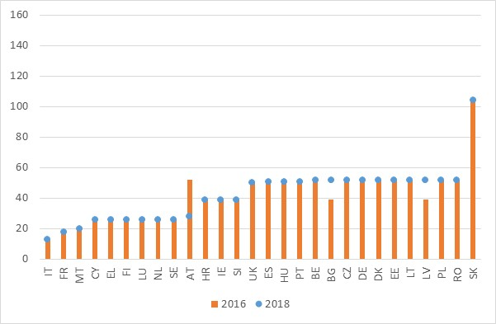

Source: MISSOC (Mutual Information System on Social Protection) database, and national legislation. Note: In Malta (2018), the minimum qualifying criteria are 50 weeks of paid contributions of which at least 20 paid or credited in the previous 2 calendar years; in Ireland (2016 and 2018), at least 104 weekly contributions must have been paid since the person first started work.

Figure 53: Maximum duration of benefits with a 1-year work record, 2017, and 2018

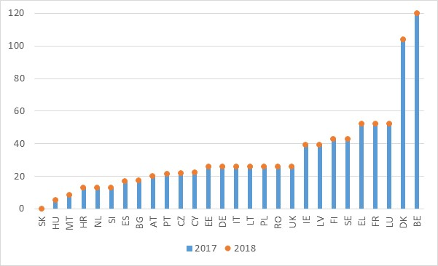

Source: MISSOC (Mutual Information System on Social Protection) database and national legislation (January 2017 and January 2018). Note: in Belgium there is no limit on the duration of benefits. In Cyprus, weeks are calculated on the basis of 6 working days per week. In Ireland, benefit is paid for 39 weeks (234 days) only for people with 260 or more weekly PRSI contributions paid. In Slovakia, a person with a one-year record cannot qualify for unemployment benefits (at least 2 years of unemployment insurance contributions during the last 3 years are required. In Poland, duration varies depending on the level of the unemployment rate of the region relative to the national average.

Figure 54: Net replacement rate of unemployment benefits at 67% of the average wage, at the 2nd and 12th month of unemployment (2018)

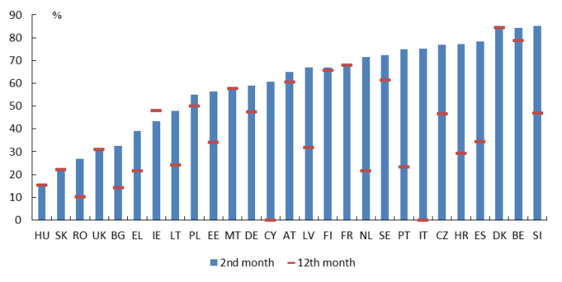

Source: European Commission based on OECD Tax-Benefit Model. Note: The indicator is calculated for the case of a single person without children with a short work history (1 year) and aged 20. Further methodological details in footnote 76.

**Member States have developed several strategies to activate recipients of unemployment benefits.** The adopted policy instruments follow the principle of mutual obligation. In particular, recipients of unemployment benefits are required to engage in job-search activities; at the same time, public authorities have to support them in their job search and in overcoming the obstacles that may prevent them from regaining employment while monitoring their compliance with availability-to-work conditions (and implementing sanctions when needed). The principle of early intervention and tailor-made services to unemployed jobseekers has also been widely embraced by Member States with the aim of shortening unemployment spells, fostering quality matches and preventing long-term unemployment and discouragement. Indeed, mandatory requirements for Public Employment Services to provide certain types of early support for jobseekers (profiling, design of individual action plans, personalised counselling) exist in most Member States.

**There is a large diversity in the strictness of availability-to-work conditions and job-search requirements[77] attached to unemployment benefits.** Figure 55 shows the severity of availability requirements and suitable work criteria for unemployment benefits recipients. They appear to be the strictest in Poland, Denmark, Malta and Croatia, while they are the least strict in Belgium, Lithuania, Bulgaria, Cyprus, Finland and Spain. Figure 56 shows a great variation in the strictness of job-search and monitoring requirements. In particular, stricter requirements exist in Malta, the United Kingdom and Luxembourg, while the least strict are observed in Cyprus, Greece and Poland. Finally, Figure 57 also shows a large diversity in the severity of sanctions applied when unemployment benefits recipients do not comply with availability and job-search requirements. Sanctions appear to be the strictest in Slovenia, Romania, Luxembourg, Greece, Croatia and Portugal, while they are the least strict in Austria, Hungary, Cyprus, Ireland, Denmark and Germany (in some cases however this goes along with a short duration of benefits). Malta, Croatia and Estonia appear to have more stringent provisions in all dimensions. Yet, several Member States display a combination of stringent provisions for certain components and less stringent for others. For instance, Denmark has the second most stringent provisions for availability requirements and suitable work criteria, but one of the least strict for benefit sanctions. These different approaches provide an insight on how national systems tackle the issue of moral hazard inherent to unemployment insurance benefits. For instance, more strict job-search and availability requirements are expected to encourage higher job-search efforts and faster acceptance of job offers, thus counterbalancing the possible financial disincentives created by unemployment benefit systems and reducing unemployment duration. At the same time, overly stringent requirements may have counterproductive effects, for instance as concerns a reduction in the coverage of benefits or a detriment in the quality of matches, which may not be long-lasting (with more people falling back into unemployment more frequently).

Figure 55: Availability requirements and suitable work criteria, 2017

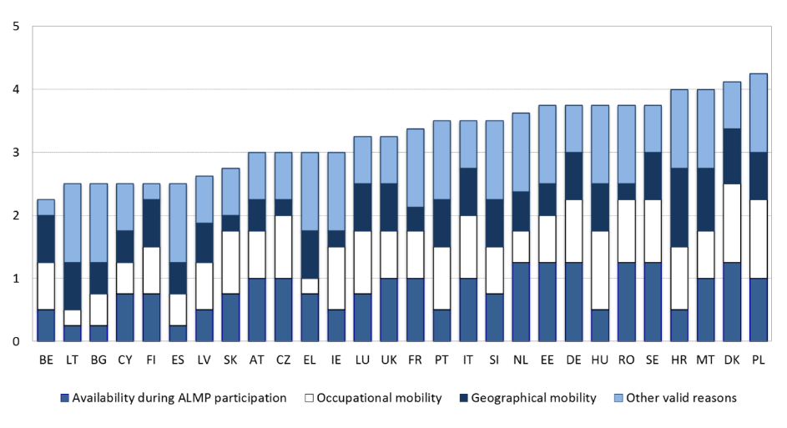

Source: OECD. Note: Scored from 1 (most lenient) to 5 (most strict).

**Figure 56: Job-search and monitoring requirements, 2017**

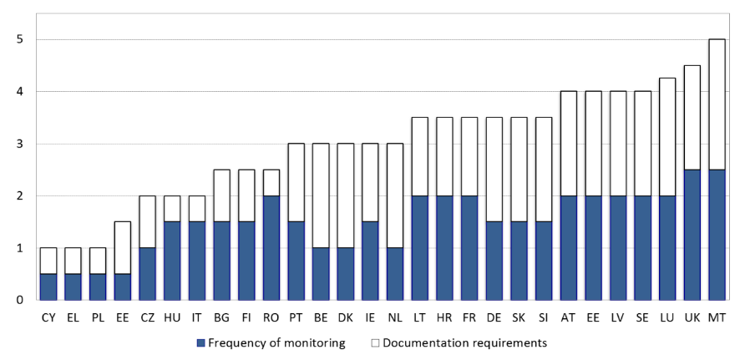

Source: OECD. Note: Scored from 1 (most lenient) to 5 (most strict).

**Figure 57: Strictness of benefits sanctions, 2017**

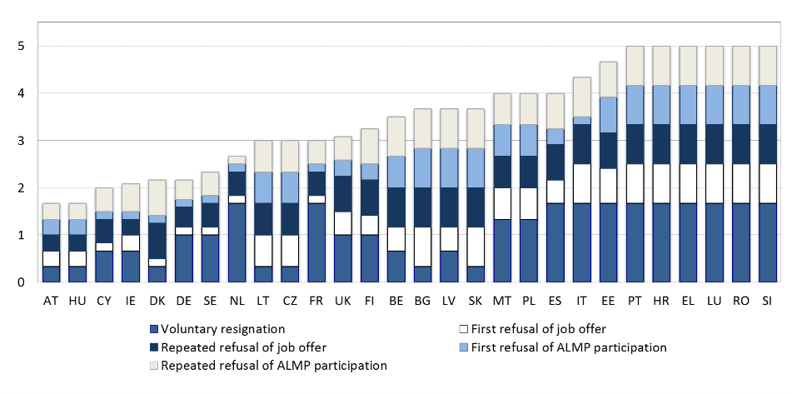

Source: OECD. Note: Scored from 1 (most lenient) to 5 (most strict)

**Tackling barriers to mobility of workers and learners can enhance employability and skills development, helping exploiting the full potential of the European labour market.** In 2017, there were roughly 12.4 million EU citizens of working age (20-64) living in another country than their country of citizenship[78]. This number has increased by 5% compared to 2016, at a similar pace as it had increased in the previous years. Germany and the United Kingdom were the main countries of residence in 2017, hosting respectively 3 million and 2.6 million people, followed by Spain (1.4 million), Italy (1.2 million) and France (around 1 million). While Germany and the United Kingdom show an upward trend going back to 2015, Italy and France show a more moderate (and lower than average) growth. On the contrary, Spain had an absolute lower number of EU28 movers, with a 1% decrease compared to 2016. This continues a (slowing) downward trend observed since 2014. The main countries of origin remain unchanged from 2016, with Romanian, Polish, Portuguese, Italian and Bulgarian nationals constituting the largest groups at EU level. Together their numbers reach around 6.6 million people, more than half of the total EU-28 movers in the EU. In proportion to the population, the highest outflows are recorded in Lithuania, Romania and Latvia; a rising trend could be observed in Lithuania, Romaina, Latvia, Estonia and Croatia. The main countries of origin and countries of destination remain unchanged when focusing on economically active citizens (i.e. employed persons and jobseekers).

**Studying abroad is beneficial for skills development and better future labour market prospects**. Mobile students contribute to knowledge development, stronger cultural awareness, technology upgrading and capacity building in their country when they return home after studying abroad. Moreover, students’ exchanges between countries enhance opportunities for collaboration between academic institutions, contributing to the European goal of opening up and modernising education systems. Yet only small shares of Europeans are mobile graduates. In 2016, only 10.7 % of higher education graduates originating from EU Member States were mobile; 3.1 % were degree mobile and graduated in a different country from that in which they got their diploma, while 7.6 % had a credit mobility stay and spent a temporary study period or/and work placement abroad. The Member States with the highest shares of outward mobile graduates are Luxembourg (84.4%), the Netherlands (23.2%), and Finland (19.5%). Other four EU Member States have student mobility rates above 15 % (Germany, France, Cyprus and Lithuania). Mobility patterns between countries are explained by several factors, such as geographical proximity, language ties or the availability of English language programmes in non-English speaking countries. The teaching quality of universities and their reputation also represent strong attracting factors.

**Social dialogue, whether bipartite or tripartite, is a key element of the European social market economy.** It enables promoting agreements and policy measures that balance the interests of both sides of industry. Effective social dialogue finds solutions which are acceptable to the involved partners, and thus reduces conflicts in the society and strengthens social cohesion. An important element for such dialogue is the mutual respect and trust between the partners, which comes along with the experience of previous good cooperation and the value added of such negotiated results. To allow for such negotiations, the social partners need to be independent of each other and of the government (autonomy of social partners). Hence, social dialogue is to the advantage of workers, employers and governments. The ‘New Start for Social Dialogue’ initiative launched in March 2015, the Council conclusions and the Quadripartite Statement signed by the European social partners, the Commission and the Netherlands Presidency on behalf of the Council on ‘A new start for a strong social dialogue’, both adopted in June 2016, call on the Member States to closely involve social partners in the design and implementation of relevant reforms and policies, in line with national practices. The European Pillar of Social Rights and the new Employment Guideline 7 restate that social dialogue is a core value of the European Union.

**The European Union faces a diversity of national social dialogue systems.** These differences are mainly related to divergent institutional frameworks and operational capacities of social partner organisations, contributing to important differentials in the quality of social dialogue. While there is no one-size-fits-all model, timely and meaningful involvement of social partners in policy design and implementation, including by providing support for increased capacity of social partners, should be considered as a common denominator for well performing and effective tripartite social dialogue systems,. The latter is equally true for bipartite social dialogue.

**The capacity of social partners plays an important role in shaping the social dialogue**. Social partners' membership figures provide some indication of their capacity to represent the respective collective interests of either side of industry (Figure 58). The larger their membership and the more representative, the stronger their voice and mandate arguably is. Still, these figures do not provide a full picture. For instance, in certain Member States with low measured union density (e.g. France), trade unions may enjoy fairly broad support also from non-members (see Eurobarometer data on trust in unions) and have a strong capacity to participate in policy developments. In most Member States, union density has been in decline since the 1980s, with employer density somewhat more stable. Beyond aggregate membership figures, representation structure – more or less fragmented – may also impact the capacity of social partners, especially when fragmented representation is weakly coordinated.

Figure 58: Trade union density rate

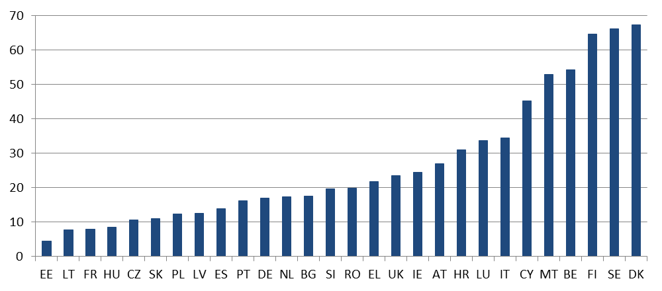

Source: OECD and ICTWSS database (the source containing more recent data per MS was used). Note: calculated as a share of employees that are trade union members. Data years: 2017 for SE, 2016 for AT, CZ, DK,FI, DE, HU, IE, IT, LT, NL, UK; 2015 for BE, EE, FR, LV, LU, PT, SK, SI, ES; 2014 for PL; 2013 for CY, EL; 2012 for HR, MT, BG and RO. The data on employer density for a number of Member States have been updated less frequently in the recent years; therefore, it is not presented in a chart.

**The capacity building measures are supported by the European Structural and Investment Funds in a number of Member States**. Financial support has been allocated, among others, in Bulgaria, Cyprus, Czechia, Greece, France, Lithuania, Latvia, Poland, Slovakia and Portugal. In Portugal, the European Social Fund (ESF) supports the institutional capacity building of social partners in view of their important role in the modernization of labour market institutions, including the management and implementation of active labour market policies and vocational education and training. In Latvia, the ESF supports strengthening of the bipartite social dialogue. The goal of the projects is to develop a legal framework to facilitate social dialogue in different sectors. Yet, there is room for improving the take up of available EU funding in several Member States in order to increase the capacity of social partners.

**The changing world of work offer new opportunities for social partner organisations but also poses new threats.** Already now, workers under different contractual arrangements show very different representation patterns. In particular, employees with permanent contracts are affiliated to a trade union to a significantly higher degree than workers on fixed-term contracts. In addition, most of the newer forms of employment suffer from a lack of representation. Research from the Netherlands suggests that these developments may impact the outcome of collective bargaining, with lower wage increases in sectors with many independent workers (and lower membership) compared to other sectors[79]. At the same time, enterprises in the expanding service sector are less likely to be members of employer organisations than those in industry. In recent years, social partners' organisations have taken initiatives to attract new members, or strengthen the voice of certain underrepresented groups (youth and platform workers) through targeted strategies and recruitment efforts and creating specific structures within the organisation[80].

**In the EU, the representativeness of social partner organisations is typically assessed using two different principles**. On the one hand, some countries rely principally on "legal conformity", meaning a certain number of legal requirements regulate the representativeness of social partners and specify the preconditions for participation in collective bargaining and binding collective agreements (e.g. elections and density or membership on the union side, and employee coverage or employer membership density of the employer side). On the other hand, other Member States rely on the principle of "mutual recognition" which involves self-regulation by the social partners. Finally, a number of countries employ a mix of these two principles. In practice, a lack of transparency can make it difficult to univocally gauge the representativeness of various organisations[81].

**The European Semester dedicates increasing attention to social dialogue.** In 2017, a first fully-fledged multilateral surveillance exercise on the involvement of social partners in reforms and policies was held in the Employment Committee, institutionally underpinned by the Employment Guidelines, with 14 Member States reviewed and country-specific conclusions. National social partner representatives were present and provided their view on the state of play. Whereas the functioning of social dialogue is specific to each country, the review revealed some challenges common to several of the reviewed Member States. These include capacity issues among the social partners and the need for more predictable, meaningful and timely consultation of social partners covering different phases of reforms. The conclusions of the multilateral surveillance exercise together with further analysis included in the country reports finally translated into a strong emphasis on the role of social dialogue in the country-specific recommendations, proposed by the Commission in May and adopted by the Council in July 2018. For two Member States (Hungary and Romania) recommendations explicitly call for an improvement of social dialogue, while for several other Member States the role of social partners, including in some cases existing challenges, is recalled in the recitals. In some cases there is scope for improving the capacity of social partners and providing them with an adequate framework for predictable and timely consultation on policy making and notably reforms, including in all key stages of the European Semester.

**The consultation of civil society organisations also plays an important role to ensure that reforms are designed and implemented effectively.** As highlighted in the revised Employment Guidelines adopted in July 2018, Member States should take into account the experience of civil society organisations on employment and social issues, where relevant and building on existing national practices. For their involvement to be fruitful in the identification of policy challenges and remedies, it is important that the dialogue is inspired to the principles of openness, pluralism and transparency. Preliminary evidence[82] suggests that the degree of engagement of civil society stakeholders varies significantly among Member States, as regards both the European Semester and more generally the consultation on planned reforms. Consultation with stakeholders may be challenging in countries where civil society is less organised: in particular, insufficient capacity to actively engage in the policy debate may be an issue in some Member States.

### 

### 3.3.2 Policy response

**Reforms in the area of employment protection legislation are taking place in some Member States, with the aim to achieve a better balance between flexibility and security and avoid segmentation.** France, as part of a broader reform of labour law, introduced in January 2018 a compulsory seniority and age-based reference for compensation of employees in case of unlawful dismissals on economic grounds, aiming at increasing coherence of the amounts related to similar cases and to facilitate the resolution of litigation at the conciliation stage. To compensate, severance pay in case of economically justified dismissals will be increased by 25%. In addition, companies can implement through a majority agreement the "Rupture Conventionnelle Collective" (RCC) i.e. a mutually-agreed resignation procedure in exchange of a compensation for the employee (which cannot be inferior to individual severance pay), after negotiation with trade unions. The use of this mechanism has to be validated by public authorities, notably to avoid abuses. The timespan for starting a lawsuit to contest a dismissal (except in cases of harassment and discrimination) was reduced from 2 to 1 year. Moreover, in December 2017 collective bargaining rules were reviewed to restrain the scope of assessment of financial difficulties justifying collective dismissal; the assessment for assessing economic difficulties for a company is now restricted to the national territory, away from worldwide scope, giving more leeway to companies to justify collective dismissals. In Belgium, the notice periods were shortened in 2018 during the beginning period of each new employment contract (from 2 to 1 week during the first 3 months, from 4 to 3 weeks the fourth month). In Croatia, an Amendment to the Labour Act has reintroduced in 2017 the possibility for the employer, abolished in 2014, to bring a claim to court in order to override the works council’s refusal to give consent to the dismissal of protected employees (e.g. employees who are members of the works council, disabled employees, older employees, etc.). In Italy, workers' compensation in case of unfair dismissals was recently increased.

**A number of Member States are further planning measures in this domain, which may be adopted in the near future.** In the Netherlands, a (draft) package of comprehensive measures was submitted to public consultation in April 2018, with the intention to achieve a better balance in employment protection law. The package includes the introduction of an additional ground (so-called "accumulation ground") for dismissal of employees with a permanent contract; the possible extension of the probation period for permanent contracts (from 2 to 5 months); the extension of the duration period of successive temporary contracts to 3 years (instead of only 2 years as previously); and the possibility to differentiate unemployment contributions with respect to the type of contract. In Finland, the government is preparing an amendment to the Employment Contracts Act, aimed at easing the criteria for individual redundancy in businesses employing 10 people or less. The objective is to lower the threshold for hiring new employees. This would be combined with easier hiring on fixed-term contracts of young unemployed people (below 30 years old). The draft proposal was circulated for comments in summer 2018. Based on the comments the government revised the size from enterprises employing 20 people to those employing 10 people. The amendment has received so far mixed appraisals in view of the broad scope of both measures, which is considered by some not targeted enough.

**As concerns temporary contracts, some Member States are acting to establish stricter conditions for their use (in order to prevent abuses) or allow more freedom to collective bargaining in negotiating their framework.** In the Czech Republic, several measures aimed to prevent abuses of temporary work agencies have become operational in July 2017; these include stricter sanctions for the responsible representative of a temporary work agency that lost its licence due to breaches of obligations. In Slovenia, amendments to the Labour Inspections Act aim to prevent illegal use of atypical forms of work, including work on the basis of civil law contracts, and to sanction those employers who do not pay wages in due time. In particular, when an inspector establishes that work is unlawfully performed on the basis of a civil law contract, the employer is mandated to offer the worker an adequate employment contract within three days. France enabled sector level bargaining to prevail over national labour law for setting framework of use of fixed-term and temporary contracts (see Chapter 3.1). Agreements at company-level can be less favourable than branch-level ones, by removing the capacity to set “lockdown clauses” for the latter. In Portugal, a comprehensive package of measures to tackle labour market segmentation was agreed with social partners in June 2018 (the package is expected to be legislated by the end of 2018). Changes include: reduction of the maximum duration of fixed-term contracts from three to two years (including renewals), with a total duration of renewals not exceeding the duration of the initial period; reduction of the maximum duration of undetermined contracts ("contratos de trabalho a termo incerto") from six to four years; limiting the scope of justifications for use of temporary contracts for younger workers and the long-term unemployed. At the same time, the probationary period will be increased to 180 days for first time contracts as well as for newly hired long-term unemployed. The tripartite agreement also calls for taxing excessive labour turnover, whereby the definition of excessive (by sector) is to be defined under regulatory decree, with the involvement of social partners. Finally, Greece plans to increase the protection of workers performing contracted work. For the first time, an integrated system of rules will be introduced establishing mutual and joint liability of the contracting entity, the contractor and the subcontractor for workers in the performance of the contracted work. This broadens the protection of workers' rights as concerns wages, insurance contributions, redundancy payments and compensation in the event of an accident at work. In Italy, the maximum duration of temporary contracts was reduced from 36 to 24 months. The maximum number of extensions was reduced from 5 to 4 and, after the 12th month, extensions are allowed only if new justifying reasons are formally provided. The law also increased additional social security contribution paid by employers for the renewal of temporary contracts by 0.5 pp. Finally, the quota of employees under temporary contracts has been increased from 20% to 30% of total employees, but it now also includes agency workers.

**Some innovations are being introduced as concerns new forms of work, including platform workers and own account workers.** In France, the voluntary adoption of a social charter by on-line platforms towards independent workers was introduced. This charter should consist of a set of principles applying to independent workers registered in on-line platforms, including a participation of the platforms to work accidents insurance and the compulsory financing by the platforms of training applying to independent workers. In Belgium the use of "flexi-jobs" (that already existed in the HORECA sector) has been extended to other sectors, notably retail; pensioners and any worker having a contract for at least four fifths of a full time may apply for a flexijob. Revenues from flexi-jobs are not subject to taxation and social security contribution on the employee side, while the employer pays reduced social contributions. In Spain, the 2017 reform of the Law on Autonomous Workers seeks to improve the job quality of self-employed, including social protection and safety at work. The new measures extend from 6 to 12 months the 50 EUR social security contribution flat rate, and introduce a higher degree of flexibility in deciding the amounts. The reform also makes pension payments compatible with free-lance work, promotes work-life balance and better access to training. In Ireland, the Employment Bill 2017 addresses a number of areas of the current employment legislation as concerns low-paid, more vulnerable employees. The purpose of the Bill is to ensure that employees are better informed about the nature of their employment arrangements (and their core terms) at an early stage – a new offence is being created for non-provision by the employer of core terms within a specified period. In addition, zero hours contracts are prohibited in most circumstances; a “banded hours” provision is introduced so that employees on low-hour contracts who consistently work extra hours than provided for in their contracts, are entitled to be placed in a band of hours that better reflects the reality; an enhanced minimum payment is introduced for employees who are called in to work for a period but actually did not provide work. In Portugal, the planned introduction of "Contrato Geracao" includes two strands: the introduction of financial support to companies that hire simultaneously a young unemployed person (or a young person looking for a first job) and an older long-term unemployed person; and support to youth employment combined with a partial retirement of an older worker.

**Some Member States have taken measures in the area of organisation of working time, not always with a view to greater adaptability.** In Belgium, a number of obligations regarding part-time work were modernised and simplified in 2017, notably reducing formalities in the determination of fixed or variable work schedules, the notification and the surveillance of deviations. In addition, the legal framework for "career saving" became applicable as from February 2018. Provided there is an agreement at sectoral or enterprise level, it allows employees to save some “leave time” for accumulation and use at a later stage. Finally, the procedure to introduce night work and Sunday work in the context of e-commerce has been simplified. In France, the remit of *accords de competitivité* ("competitiveness agreements") has been extended (see Chapter 3.1). As part of the tripartite agreement with social partners on the reform of labour law, Portugal plans to eliminate the individual "bank of hours" and the collective ones based on individual agreements. The agreements already in force will expire one year at most after the implementation of the new rules. The new agreements will be made under collective bargaining or group agreements, to be reached after worker’s consultation. The measure specifies daily hours' limits, rates of approval by workers and use of the most favourable treatment principle.

**Several Member States have adopted measures to prevent the use of undeclared work, improve safety at work and/or strengthen labour inspectorates.** In Bulgaria, since the end of 2017, an amendment to the Law on Public Procurement regulates the removal of a participant in a public procurement procedure, when in the previous three-year period a penalty was imposed for the use of undeclared work. This requirement also applies to subcontractors, which are mainly small and micro enterprises (often in the construction sector). Information campaigns are also carried out to raise the awareness of the risk groups about the disadvantages related to envelope wages, notably in terms of lower social security contributions. Greece has completed in 2018 the automatic exchange of information between the databases of various ministries and labour market institutions, as well as the police. In addition, the system of fines imposed on employers who have not declared a dependent worker was reviewed, with a substantial reduction if the employer recruits the undeclared worker with a full-time contract within 10 days from the inspection (the measure aims at incentivising the transformation of undeclared into formal work). In Spain, the 2018-2020 Strategic Plan, agreed with the autonomous communities and in consultation with social partners, aims at strengthening the labour inspectorates’ capacity and at structuring its actions in a concrete and measurable manner. It also pays attention to the challenges arising from the new forms of work, working conditions and non-discrimination in the job place. In Estonia, an amendment of the Occupational Health and Work Safety Act, adopted in May 2018 improves protection against health hazards in the workplace and ensures that safety instructions and the provision of first aid training are adapted to the specificities of the company. As mentioned above, Slovenia is taking action to prevent illegal use of atypical forms of work. In addition, the Labour Inspectorate is given extra powers to investigate cases of non-payment of wages (one of the most frequent violations since 2009). In Cyprus a review of the system of labour inspections will be promoted in order to improve their effectiveness and efficiency to combat undeclared work. This would include increased fines and the introduction of an electronic declaration of commencement of employment. In addition, a new bill providing for the creation of a Centralized Labour Inspectorate has been forwarded for approval during the next months. In Portugal, a recruitment process of labour inspectors and the opening of new competitions are ongoing. Moreover, with a view to discourage undeclared or sub-declared work, Portugal plans to extend the maximum duration of very short-term contracts from 15 to 35 days (with a maximum annual duration of 70 days with the same employer). Transparency in the use of temporary agency work will be reinforced, making information of worker mandatory about the reason behind the termination of a contract between the user firm and the temporary work agency.

**Relatively few policy measures have been taken by Member States to reinforce their ALMP systems despite of persistent challenges.** Greece is implementing a new system of ALMP delivery aiming at increasing the effectiveness of activating policies through improved profiling and matching activities. A better targeting of ALMPs remains crucial for achieving better outcomes of these reforms and so far a pilot for over 2000 unemployed has been launched at one local employment office. Cyprus has launched the pilot phase of a newly developed monitoring and evaluation system for active labour market policies enabling to improve the effectiveness of labour market measures. This will allow policy makers to better design and revise on-going labour market programmes. In Spain, a broad strategic framework for the coordination of the National Employment System has been developed. This measure sets out the organisational framework for all actions implemented within the Spanish National Employment System during 2017-2020 and serves as a basis for designing and managing of active labour market policies, training actions and many other strategies of regional public employment services and sets the framework for defining principles, targets, instruments and financial resources.

**Member States are still prioritising the provision of more individual services**. Estonia is extending the scope of ALMPs to certain employed persons to prevent unemployment. The target group includes people working under service contracts or authorisation agreement and those earning national average wage. Stable levels of PES expenditure on ALMPs as well as human resources are supposed to address persisting challenges. Hungary has taken further steps to address the challenges of the Public Work Scheme by implementing programmes which enhance the transition from these programmes to the primary labour market. A job-creation programme qualifies the employment of a person in public works as a category of primary support while two other programmes provides either recruitment incentives or bonuses or establish a mentoring for people coming from the Public Work schemes in order to facilitate their integration into the primary labour market.

**Measures to improve the training components of ALMPS are also still being promoted**. In Croatia a new package of nine active labour market measures has been adopted. In the new package more focus is placed on training and workplace training, especially for youth, older workers and long-term unemployed. Self-employment subsidies will be more stimulated as well. In addition, subsidies will be given to employers support the employment of workers in the age category 50+. France continues to invest in vocational training and apprenticeship, through the *Plan d’Investissement dans les compétences* ("Investment in Competences Plan", see chapter 3.2). The objective is to provide qualifying training to 1 million unemployed with low levels of qualification and to 800 000 young NEETs partly through preparation to apprenticeships.

**Public Employment Services (PES) are following their reform agenda, aiming to increase the institutional capacity in times of decreasing unemployment.** To this end,PES are increasingly benefitting from their involvement in the "Benchlearning project" conducted in the framework of the European Network of Public Employment Services. Since 2015 Benchlearning supports PES in developing awareness of strengths as well as areas for further improvement aiming at better service delivery to PES customers. As the number of registered jobseekers steadily fell over the past years Public Employment Services are requested to strategically reallocate their resources according to the customers' needs. Certain target groups such as the long-term-unemployed and an increasing number of older workers continue to require intensive support as most PES are facing an aging client base. Lithuania is modifying the work of PES, optimising the resources with the aim to improve the work with the clients and reduce the caseload from more than 400 cases to fewer than 300 per case handler. In Cyprus they pursue the Enhancement and Modernization of PES 2014-2020 by implementing reform measures for the strengthening of its Public Employment Services. Recently additional 20 counsellors/advisors have been recruited in order to be able to address their current mandate more effectively and efficiently, in implementing the Youth Guarantee and the Council Recommendation on the integration of the long-term unemployed in the labour market. Additional measures which include training of employment counsellors, training of PES officers, enhancement of the PES Candidate Placement System (CPS) and the creation of an IT platform, improvement of services to both job-seekers and employers. Spain has taken steps to improve the public employment and working conditions 2018. The Ministry and the social partners signed a document committing them to promote measures for civil servants to recover their purchasing power and improve their working conditions. This measure precedes an agreement in April 2017 to reduce the overall share of temporary contracts in the Public Sector down to 8 % in 2020 through recruitment competitions for permanent posts (some 250,000). In Greece the process of PES re-engineering has continued throughout 2017-2018 to improve the functioning of Public Employment Services. A new profiling methodology was piloted in autumn 2017 and started being rolled-out in 2018. A new skill assessment tool is under development. The recruitment of additional employment counsellors started in the first semester of 2018 should lead to an almost doubling of the counsellors' workforce by the end of 2018. Finally, Austria has taken steps to evaluate and design a more effective management of the Public Employment Services, notably by reviewing and revising all PES instruments for efficient and effective reintegration into the labour market. Job-specific training and qualifications in cooperation with employers are being prioritised together with increased employment incentives.

**PES are requested to intensify their cooperation with employers and local authorities in order to better meet the requirements of tighter labour markets.** On that account PES are developing comprehensive employer engagement strategies, defining different approaches as to employer segmentation and organisation of employer services. Most Public Employment Services have set up central coordination levels of employer services though they also do provide services for employers at regional and local level. Additionally, PES ought to define common minimum standards of service delivery to employers including measuring satisfaction. In Italy and Spain, the central PES agencies, respectively ANPAL and SEPE, are facilitating mutual learning activities between the regions in order to exchange on good practise allowing improving the services to employers. In Lithuania, the PES plans to create a model on municipality-PES cooperation on common provision of measures to activate the recipients of social assistance. This model will have to be complemented by an implementation plan.

**Member States have continued to implement the Council recommendation on long-term unemployment[83].** A 2018 self-assessment of Member States showed globally, compared to 2016, a 15% increase in scores, with most important progress reached in Member States with less advanced systems. More specifically, on the registration of the unemployed, countries have adopted different approaches and incentives to encourage registration.  The most effective are those where registration is linked to entitlement to some forms of benefits or services.  However, there is still room for improvements in the outreach towards the inactive in several Member States (e.g. Bulgaria, Estonia and Romania). There are also multiple approaches to the provision of a single point of contact for services: some countries have tried to integrate all services into one point (e.g. Finland, Germany and Ireland), others have a “bridge point” linking different institutions or authorities (e.g. Cyprus and the Netherlands).  Effective co-ordination between social and employment authorities and services is still a challenge in many Member States (e.g. Croatia, Greece, Hungary, Latvia, Romania and Spain); often complicated by challenges linked to data protection and resources. While there are measures planned to enhance this, implementation on the ground is yet to take-off. Job Integration Agreements in some form or another are established in almost all Member States but some elements are missing, in particular the in-depth (re)assessments when required. Some Member States (e.g. the Czech Republic, Greece and Slovakia) are yet to move towards a more targeted/individualised case-management approach dedicated to the long-term unemployed. There are a lot of different activities carried out under the heading of engagement with employers.  Agreements with social partners are generally in place, though these do not always translate to the local level.  Some Member States (e.g. Greece, Portugal, Slovenia and Sweden) are dedicating PES staff to working with employers: this seems a good approach; nevertheless, improvements, notably in the form of more strategic partnerships and approaches, are still required in some Member States (e.g. Croatia, France and Italy).

**Member States are providing more individualised support to long-term unemployed and better integrated services**. In Bulgaria, Job Integration Agreements are now signed between the long-term unemployed person and the labour office, including proposals for specific employment services and referral to services provided by other institutions. Since January 2018, Family and Labour Counselling and Mobile joint teams of Employment Agency and Social Assistance Agency staff provide comprehensive and integrated services to unemployed persons in remote areas. In Romania, a pilot is underway aiming to create integrated teams to address several challenges at the same time: social, educational and medical, also in partnership with the PES.The project will pilot this approach in 139 of the most disadvantaged communities selected based on the poverty maps and the criteria agreed upon by the Government. A scale-up is envisaged later on. Slovenia adopted a 2017-2020 social activation programmes aiming at encouraging social and labour market inclusion of the 12 500 most-hard-to-employ and vulnerable people. The aim is to provide these persons with competences that will bring them closer to the labour market inclusion. In Ireland, the voluntary scheme YESS ("Youth Employment Support Scheme") is aimed at young jobseekers who are long-term unemployed or who face significant barriers to gaining employment. YESS aims to provide an opportunity to learn basic work and social skills in a supportive environment while on a work placement. The standard duration for the work experience placements will be three months although there will be an option to extend that to six or nine months following a review of progress by a departmental caseworker.

**Subsidies and incentives have become a common policy measure for integrating long-term unemployed into the labour market.** Cyprus has launched a programme about providing incentives for hiring unemployed individuals in the private sector. The subsidy is granted only for the first 6 months of employment. Through the scheme 946 enterprises benefited and about 2,472 participants gained employment*.* In Luxembourg, new measures aim at creating subsidised permanent jobs for long-term unemployed that match the new needs of employers and targets 30+ long-term unemployed and the scheme has a specific provision for people older than 50 enabling a total refund of wage labour costs until retirement. On the other hand, in the light of the improving labour market situation, France has reduced the volume of its subsidised job schemes (see also Section 3.1.2). In Austria, measures have been taken aiming at reducing long-term unemployment by tightening sanctions, strengthening constraints on unemployed to accept job offers even by longer commuting distances up to 2.5 hours per day and combining unemployment benefit and social assistance. Generally, the aim is to create stronger incentives by unemployed to take up a job offer and reduce unemployment and increase effectiveness of labour market policy. Sweden introduced "Introduction jobs", targeting long-term unemployed or newly arrived immigrants that can be flexibly combined with education and training. The wage subsidy for introduction jobs is capped at a gross salary of SEK 20,000 per month (about EUR 1950), with a limit of 80%. Subsidies in Slovenia are aimed at the permanent employment of persons older than 58 years until they fulfil the conditions for retirement. Priority inclusion is foreseen for unemployment benefit- and cash social assistance beneficiaries. The subsidy amounts to EUR 11 000 and is payed to the employer in two parts (half at the employment and half after 18th salary).

**Cooperation with the private sector continues to enhance transitions to the primary labour market.** Entry agreements are being tested in Sweden enabling long-term unemployed, with a particular focus on foreign-born women, to gain employment from an employer covered by a collective agreement on entry agreements. Such agreements are based on a proposal from the social partners and aim at building a new model for getting more people into the labour market and to ease future skills supply for employers, also through Swedish courses and other short-term training programmes. In Malta, the Community Work Scheme that places long-term unemployed people in work is being revised to ensure those at risk of becoming detached from the labour market are formally employed and active.

**Recent reforms in the domain of unemployment benefits have mostly focused on strengthening activation requirements.** In Finland, since January 2018, unemployed jobseekers are only eligible for the full amount of unemployment benefits if they also get some paid work income or take part in services improving their employment prospects (with some thresholds). If a jobseeker fails to show the required activity during the 65-day monitoring period, the unemployment benefit paid for the following 65 days is reduced by 4.65%. Furthermore, the government is preparing legislation that would require unemployed jobseekers to apply for one job per week or face a cut in their unemployment benefits. The proposal is currently under consultation with social partners, but both employees' and employers' sides have expressed reservations on it, as it may lead the employee to prepare applications without the intention of being hired. In Slovenia, since October 2017 dismissed workers are obliged to report to the employment service already within the notice period in case the employment contract has been terminated for business reasons or reasons of incompetence. Failure to do this will result in the first three months of unemployment in lower unemployment benefits (60% rather than 80%) of the reference salary. In addition, low-skilled persons whose professions are not in high demand are allowed to keep receiving 20% of their unemployment benefit for a maximum of 12 months when they find a job. France, as part of the Law *Liberté de Choisir son Avenir Professionnel* ("Freedom to Choose one's Professional Future"), will apply a stricter control on job search, counterbalanced by increased tailor-made accompanying measures. Professional branches are invited to negotiate agreements so as to foster more sustainable forms of work, but if collective bargaining fails, the government can intervene. People receiving unemployment benefit will also be allowed to run a part-time activity, under more restrictive conditions. Moreover, the unemployment benefit, previously exclusively financed by social security contributions, is supplemented by an increase on the broader tax "CSG-Contribution sociale généralisée". Starting from 1 January 2019, unemployment insurance negotiations will be framed by the government, which will determine the overall financial envelope to respect and the targets to meet. Access to benefit would also be granted to independent workers and to employees who resign, under certain conditions. Spain plans to introduce a "Universal Social Card" with the aim to gather information on social benefits received by all individuals as well as any potential situations giving the right to social benefits (e.g. dependency, disability, unemployment or large families). It is expected to improve the coordination between administrations, increase the effectiveness of social benefits and, ultimately, help to detect vulnerable situations. The design and development of the Universal Social Card system finished at the end of 2017, with approval expected by Q4-2018.

**As parts of the ongoing reforms, eligibility conditions to unemployment benefits have been modified in some cases, often making them stricter.** Bulgaria has increased in 2018 the minimum unemployment benefit from BGN 7.2 (approximately EUR 3.7) to BGN 9 (EUR 4.6) per day, with a maximum of BGN 74.3 (EUR 38). At the same time, the eligibility requirements have been tightened – the insured person must have worked for at least 15 months during the 18 months, and not 9 months of the last 15, as it was before. This tightening is likely to affect younger workers and persons who are more likely to have interrupted careers – notably seasonal workers and workers on precarious jobs. Going in a different direction, Portugal has reduced the guarantee period for access to the initial unemployment benefit upon expiration of a fixed-term contract, from 180 to 120 days. In Austria, a package of measures is planned to reduce long-term unemployment by tightening the rules concerning mobility of unemployment benefit recipients (accepting job offers even by longer commuting distances up to 2.5 hours per day), abolishing the prolongation of the UB entitlement due to sickness (except in-patient stay) and restricting the duration of marginal employment during receipt of UB. Generally, the aim is to create stronger incentives for unemployed to take up a job offer and reduce unemployment and increase effectiveness of labour market policy.

**Some Member States took action to promote workers' and learners' mobility (internal and external), with the aim to enhance employability and improve skills development, and/or attract foreign workers in sectors showing labour shortages.** In 2018, Finland has introduced measures to support regional mobility and commuting of unemployed jobseekers, including the provision of mobility allowances (now also available for part-time work with working hours less than 18 hours a week, work-related training) and targeted information on economic support for mobility. A higher mobility allowance can be provided in case of exceptionally long commuting distances. Social partners were consulted on the reform. In Latvia, mobility support measures for unemployed people were expanded in 2018 to include also the capital (Riga, previously excluded). The measure covers regional mobility for people who take up a job offer in other regions, but also those who are enrolled in some ALMP measures, including Youth Guarantee, subsidized employment and vocational training measures. Support measures aimed at attracting medical practitioners (doctors and nurses) for work in regions outside Riga started in December 2017. Moreover, a list of 237 high-skilled professions, where at the moment there is a significant shortage of labour force and which could attract third-country nationals, was approved in Latvia. Some preferential conditions are applied to employees wishing to receive an EU Blue Card in those cases. In Poland, the creation of the National Agency for Academic Exchange in 2017 is expected to facilitate the internationalisation of Polish universities through the pro-quality support of academic mobility. In Bulgaria, a simplified Blue Card authorization procedure for third-country nationals has been approved to overcome the identified shortage of qualified specialists in the field of information and communication technologies, engineers in industrial production and others relevant fields. The modifications will allow as well the issuance of the Blue Card for a period of up to 4 years, when in the past it was issued for a term of one year. In Estonia, an amendment of the "Aliens’ Act" exempts top-level specialists from immigration quota and extend the maximum term of short-term employment to 12 months, while leaving the immigration quota unchanged.

**The involvement of national social partners in the design and implementation of employment and social reforms and policies varies across Member States.** The quality and form of this involvement reflects the diversity of national institutional frameworks and social dialogue practices, with a marked lack of timely and or meaningful dialogue in a number of Member States. At the same time, during the last 18 months social partners have been involved in the design of relevant policy reforms in several Member States[84]. New legislation and measures concerning the functioning of labour market have been discussed or agreed for instance in Bulgaria, Croatia, Denmark, Finland, the Netherlands, Portugal and Sweden (integration of migrants). As also shown in Section 3.1, social partners have negotiated reforms of wage setting framework in a number of countries. In Estonia, the government decided to restore regular tripartite meetings with social partners, which were interrupted since 2002. Negotiations related to the setting or increase of minimum wages have taken place for instance in Bulgaria, Estonia, Poland, Portugal and Spain. Social partners took part in the discussion of reforms of social protection and/or unemployment benefit in Croatia, France, Finland, Germany, Portugal and Slovenia, among others. Education and VET policies, as well as training, apprenticeshipand life-long learning reforms and new policies have been discussed with the participation of social partners in the Czech Republic, Denmark, France, Latvia, the Netherlands and Poland.

### **Guideline 8: Promoting equal opportunities for all, fostering social inclusion and combatting poverty**

This section looks at the implementation of the employment guideline no. 8, which recommends to Member States to modernise their social protection systems, in order to promote equal opportunities, combat poverty and social exclusion. It first presents an overview of the social situation in Member States by key indicators, including disposable income, inequality, poverty and social inclusion, pension adequacy, access to housing, access to healthcare and long-term care. Section 3.4.2 reports on policy measures from Member States in the areas of social protection systems, including minimum income schemes, family benefits, housing policies, pensions, long-term care, healthcare and inclusion of people with disabilities.

### 3.4.1 Key indicators

**Household incomes kept rising in almost all EU countries in 2016[85].** Real disposable household income (GDHI) per capita[86] rose for all Member States with the exception of Greece, where it registered a small decrease. In general, improvements have been the fastest in countries which have more recently joined the EU, such as Bulgaria, Poland, Romania and Lithuania, and slower for longer-standing Member States such as Austria, Italy, France, Belgium, Luxembourg, while even negative for Greece and the United Kingdom. This reflects ongoing convergence, with Bulgaria and Poland currently being the best performers in this regard. In a number of countries, real GDHI per capita remains significantly below the pre-crisis levels. This is notably the case for Greece and Cyprus, where the levels in 2016 were, respectively, at around 69% and 82% of the levels recorded in 2008 (both countries are flagged as "critical situations"). In Italy, Ireland, Spain, Austria, Belgium, Portugal ("to watch" countries) and Slovenia ("on average") real GDHI per capita was in the range between 90% and 100% of the 2008 value. In all these countries but Slovenia the growth rate in 2016 lagged behind the (unweighted) EU average or was even negative in the case of Greece.

**Figure 59: Real GDHI per capita, index 2008 = 100 and yearly change (Social Scoreboard headline indicator)**

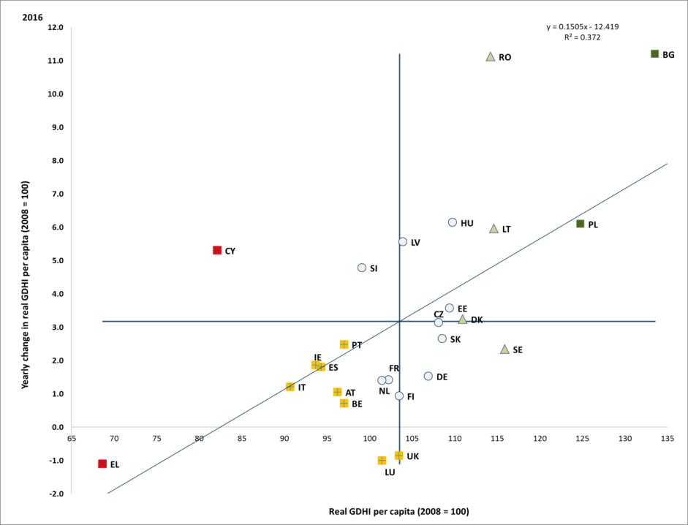

Source: Eurostat, National Accounts [nasq_10_nf_tr and namq_10_gdp], own calculations. Period: 2016 levels and yearly changes with respect to 2015. Note: Axes are centred on the unweighted EU average. The legend is presented in the Annex. Data for HR and MT not available on 26 October 2018.

**A majority of countries experienced a further significant improvement in the share of people at risk of poverty or social exclusion (AROPE) in 2017[87].** The effects of the economic recovery have become visible with falling risks of poverty or social exclusion now apparent in all but a handful of Member States (also see Section 1.2). Improvements are particularly apparent in Romania, Cyprus, and Poland, for which AROPE fell by more than 2%. By contrast, for Denmark, the Netherlands and Austria, AROPE rates registered a modest increase on the year, albeit from a low level. The situation remains "critical" in Bulgaria and Greece, in view of still very high levels but only moderate decrease over the last year. The negative correlation between trends and levels (see Figure 60) suggests ongoing convergence across Member States. Among the different age groups, young people aged 18-24 are most at risk of poverty or social exclusion with a rate of 29.1%. This indicator registered improvements in a majority of Member States, reflecting falling youth unemployment.

Figure 60: Percentage of the population at risk of poverty or social exclusion, 2017 and change from previous year (Social Scoreboard headline indicator)

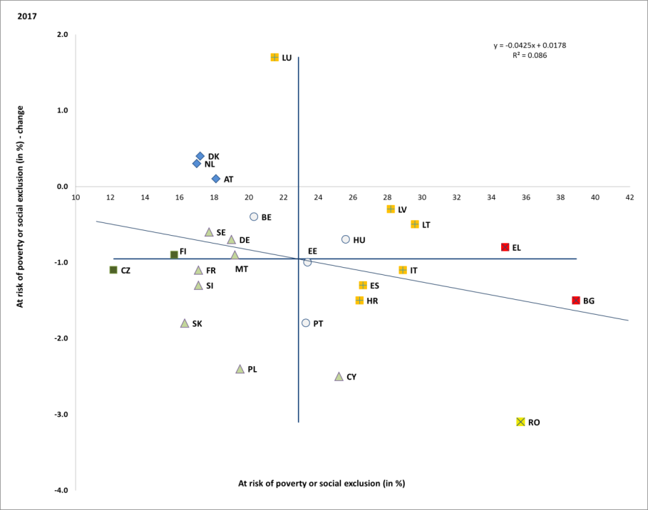

Source: Eurostat, SILC. Period: 2017 levels and yearly changes with respect to 2016. Note: axes are centred on the unweighted EU average. The legend is presented in the Annex. Data for IE and UK not available at 26 October 2018.

**While declining, the AROPE rate for children (aged 0-17) remains well above the figure for the general population in most Member States.** In 2017, it decreased in all Member States for which it is above the EU average (24.5%). Yet it remains particularly high in Romania (41.7%), Bulgaria (41.6%) and Greece (36.2%). By contrast, in some Member States with below-average levels of child poverty, the trend has been much flatter, largely reflecting the position of migrant children. This is the case in Austria, Belgium, France and Sweden. In the 25-54 age bracket the rate declined by 1 pp to 21.9%. People aged 55 and over remain the group least likely to be affected by poverty or exclusion with a rate of 20.5%.

**People with a migrant background experience a significantly higher risk of poverty or social exclusion.** In 2017, the AROPE rate was more than twice as high among non-EU born than among natives (41% compared to 20.7%). This gap was particularly large in Belgium (37.1 pps), Sweden (29.6 pps) and Denmark (25.8 pps) but was smallest in Poland (4.6 pps), Portugal (6.8 pps) and the Czech Republic (7.8 pps).

Figure 61: Sub-indicators of the at-risk-of-poverty or social exclusion rate

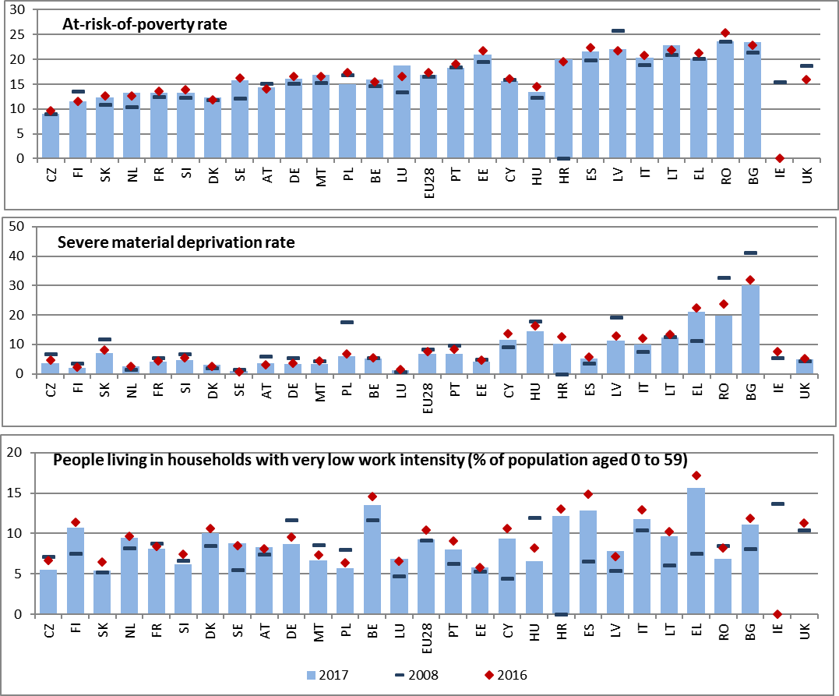

Source: Eurostat, SILC. Note: Indicators are ranked by AROPE in 2017. Data for IE and UK not available for 2017 on 26 October 2018. EU27 values used for 2008 (data for HR not available).

**The share of the EU population at risk of poverty fell in 2017 in a majority of Member States, after three years of stability**. The biggest decreases were recorded in (Poland -2.3 pps), Romania (1.7 pps) and Hungary (-1.1 pps). On the contrary, the indicator increased in Luxembourg (+2.2 pps), Lithuania (+1.0), Bulgaria (+0.5) and the Netherlands (+0.5). In all but six Member States, the share of people at risk of poverty remains higher in 2017 than in the pre-crisis period (2008) (Figure 61). Eurostat flash estimates point to further declines in AROP in Greece, Romania, and Portugal, and to an increase in the United Kingdom.

**The rate of severe material deprivation reached its lowest level so far.** Almost all Member States experienced a decline in 2017. Romania was the country with the largest annual reduction by 4.1 pp. A significant variation remains among Member States, with Finland and the Netherlands having severe material deprivation (SMD) rates of less than 3%, while at the other end of the spectrum Bulgaria with a rate of 30%, followed by Greece (21.1%) and Romania (19.4%). A slightly higher share of women (6.9%) experiences severe material deprivation compared to men (6.4%). A decrease took place across all age groups, with young people 18-24 still being most likely to experience SMD (7.9%), followed by children aged 0-17 (7.2%), the prime age population (25-54) (6.7%) and the elderly; i.e., over 65 (6.3%).

**The share of people living in quasi-jobless households further decreased.** In 20 Member States, the proportion of the population aged 0-59 living in households where adults work less than 20% of the potential has decreased in 2017. However, despite the improvements, only 9 Member States have shares below pre-crisis levels. The biggest year-on-year reductions were registered in Spain (-2.1 pps), Greece (-1.6 pps) and Romania (-1.3 pps). At the same time, the poverty risk facing those who live in quasi-jobless households continues to increase in a majority of Member States, reaching 79.9% in Slovakia, 78.2% in Lithuania and 77.8% in Latvia.

**Reducing the rate of in-work poverty remains a challenge.** As also shown in Section 3.1, in spite of an overall reduction in at-risk-of-poverty rate, the share of people at risk of in-work poverty remained stable in 2017. More than one in ten people in employment were at risk of poverty in seven Member States. Though declining, the rate of in-work poverty was highest in Romania, (17.4% in 2017, down from 19.7% in 2014) where precarious self-employment remains a key driver. High rates were also recorded in Luxembourg (13.7%) and Spain (13.1%), where a key driver was the poverty risk facing employees with temporary contracts. On the other hand, three countries had in-work poverty rates below 5% (Finland, Czech Republic, and Ireland).

**The depth of poverty has declined for the first time since 2008, yet remains high compared to pre-crisis levels.** The relative at-risk-of-poverty gap, which measures the average distance from the poverty threshold for those at risk of poverty[88], has been on an increasing trend in most Member States in the post-crisis period. Yet in the year to 2017, the figure fell for 11 Member States, and remained broadly stable for 5, decreasing on average from 26.2% to 25.4%. The change was driven by improvements in the depth of poverty for the working age population and especially for children. The rate remains high (above 30%) in particular in Romania, Spain, Bulgaria and Greece. By contrast, the depth of poverty facing those age 65 and over remained stable. Improvements were strongest for Italy, Hungary and Romania.

**People with disabilities are significantly more likely to live at risk of poverty or social exclusion than those without disabilities.** In 2016, 30.1% of persons with disabilities in the EU were at risk of poverty or social exclusion, compared to 20.9% of people without disabilities,[89] corresponding to a gap of 9.2 percentage points. This gap is more pronounced for working-age people (16-64) with 37.6% of people with disabilities in this group at risk of poverty or social exclusion in 2016, compared to 21% of persons with disabilities over the age of 65.[90] The severity of disability is a very important explanatory factor, with 36.1% of those with a severe disability aged 16 or over in the EU in 2015 at risk of poverty or social exclusion, compared to 27.4% of those with a moderate disability and 20.8% without disabilities.

**Income inequality declined slightly in 2017, for the first time since the crisis.** The share of income of the richest 20% compared to that of the poorest 20% fell in a majority of Member States (Figure 62), although most of them still had income quintile share ratios in 2017 above the levels of 2008. In 2017, the highest levels of income inequality, with S80/S20 ratios above 6, were recorded in Latvia, Estonia, Lithuania and Bulgaria (all "critical situations", with a significant increase in the latter country). Though presenting still high levels, significant decreases occurred in Romania, Greece and Italy ("weak but improving"). The improvements were driven by faster increases in the incomes of poorer households relative to the median in 10 Member States, suggesting the recovery was beginning to reach the most vulnerable.

Figure 62: Income quintile share ratio and yearly change (Social Scoreboard headline indicator)

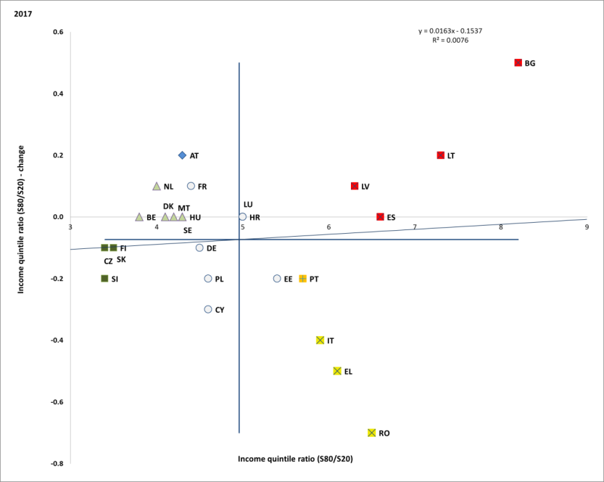

Source: Eurostat, SILC. Period: 2017 levels and yearly changes with respect to 2016. Note: Axes are centred on the unweighted EU average. The legend is presented in the Annex. Data for IE and UK not available at 26 October 2018.

**Social protection expenditure continued to increase in all Member States, while large differences persist between them[91].** In real terms, expenditure on social protection rose in all Member States from 2014 to 2015[92]. However, as a percentage of GDP, social protection spending increased in only 7 countries while it fell in 16. This was mainly driven by a lower proportion of spending on unemployment benefits, in line with improving labour market conditions. By contrast, spending as a percentage of GDP on sickness and health increased in 10 countries, and decreased in 12. Social protection spending as a percentage of GDP was overall highest in France (31.9%), Denmark (31.1%) and Finland (31.1%).On the other hand, it amounted to less than 15% of GDP in Lithuania (14.8%), Latvia (14.7%), and Romania (14.3%).

**The impact of social transfers on reducing poverty has fallen modestly, in line with a reduced effect of automatic stabilisers in a phase of economic expansion.** However, considerable variation persists among Member States (Figure 63).Social transfers excluding pensions reduced poverty risk by 32.4% in 2017, as against 33.2% in 2016, a continuation of a trend marked by improved labour market conditions and accordingly more dynamic labour income increases than social transfers. The size of the poverty reducing impact of transfers varies considerably across Member States, and many countries with the highest poverty risk also have the weakest impact of social transfers (Greece, Romania, Italy, Bulgaria and Latvia).

Figure 63: Impact of social transfers (other than pensions) on poverty reduction and yearly change (Social Scoreboard headline indicator)

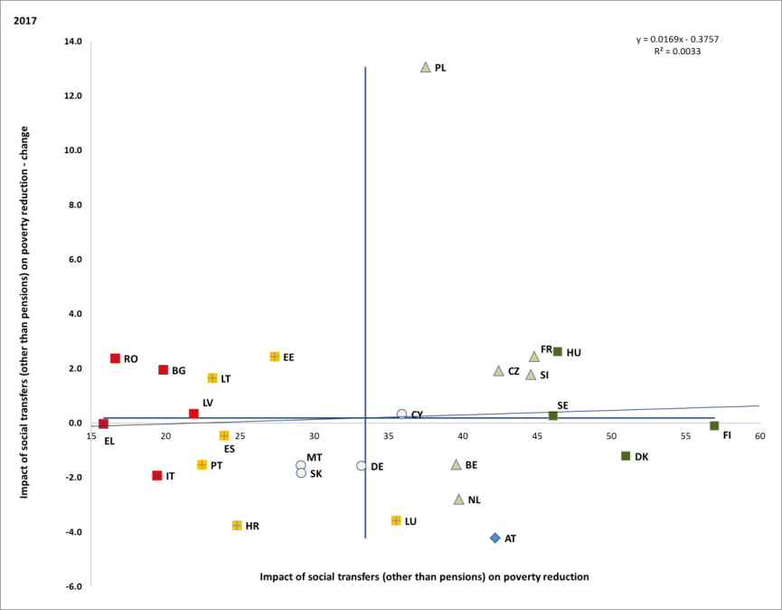

Source: Eurostat, SILC. Period: 2017 levels and yearly changes with respect to 2016. Note: Axes are centred on the unweighted EU average. The legend is presented in the Annex. Data for IE and UK not available at 26 October 2018.

**Self-employed and non-standard workers endure greater economic uncertainty with limited access to social protection[93].** In 2017, the self-employed did not have access to unemployment protection in eleven countries, mandatory sickness protection in three countries, and protection against accidents at work and occupational injury in ten countries.[94] Non-standard workers usually have the same formal coverage by most social benefit schemes as those on standard contracts, though often this does not hold for certain categories of workers (e.g. casual and seasonal workers, on-call workers, and those on temporary agency contracts, civil law contracts or zero-hour contracts are often excluded from membership in the relevant schemes). Overall, obstacles faced by non-standard workers and the self-employed in relation to effective coverage, meaning the ability to build up and take up adequate entitlements in case of need, have been identified for at least twenty-four Member States[95] (minimum qualifying periods, waiting times, lack of transferability of social protection rights).

**Preserving and transferring accumulated entitlements to another scheme following professional transitions remains difficult.** As the world of work changes, this flexibility is becoming more important and a lack of transferability may impede labour market dynamism and matching. For workers moving between sectors or employment forms, a lack of regulation makes transfers difficult in at least four Member States, while extremely high cost and different rules governing different schemes create have also been identified as a barrier to these transitions in several Member States. Finally, the lack of transparent information about social security rights stops people from taking informed decisions in many countries. While generic information about social protection schemes is available in all but five Member States, personalised information is only available in about half of them (e.g. simulation on pensions is available in Germany, France, Spain, United Kingdom and Poland).

**Minimum income schemes should combine an adequate level of support** **with access to enabling goods and services and incentives to (re)integrate into the labour market for those who can work,** as underlined in theEuropean Pillar of Social Rights**.** Thecomparative analysis of specific design features of minimum income schemes and their interplay with the provision of other benefits and activation support measures can provide useful insight regarding their performance. The analysis in the following paragraphs draws from the benchmarking exercise of minimum income benefits conducted in 2017-18 in the Social Protection Committee.[96] This benchmarking framework focuses on minimum income benefits for the working age population with working ability not in employment and not entitled, nor eligible or having exhausted entitlements to social insurance benefits.

**The adequacy of minimum income benefits varies significantly between Member States**. The adequacy of minimum income benefits can be measured by comparing the income of beneficiaries with the national poverty threshold (as an indication of the poverty alleviation effect of schemes) and with the income of beneficiaries to the income of a low-wage earner[97] (to provide an indication of the activation dimension and potential disincentive effects of the schemes). Both indicators provide similar results as concerns the adequacy of minimum income in Member States in 2016[98] (Figure 64). Looking at the case of single-person households, in 2016 adequacy was the highest in the Netherlands, Ireland, Denmark and Luxembourg. In these Member States the level of benefits exceeded 80% of the national poverty threshold level (set at 60% of the national median equivalised disposable income after social transfers). In the case of the Netherlands in particular, the level of the benefit represented 106% of the poverty threshold, actually lifting recipients out of poverty. At the lower end, the adequacy of minimum income in Bulgaria, Romania, Hungary, Slovakia, and Lithuania is below 40% of the poverty threshold or one third of the income of a low-wage earner in 2016.

Figure 64: Net income of minimum income recipients as % of at-risk-of-poverty threshold (smoothed over three years) and of the income of a low wage earner (2016)

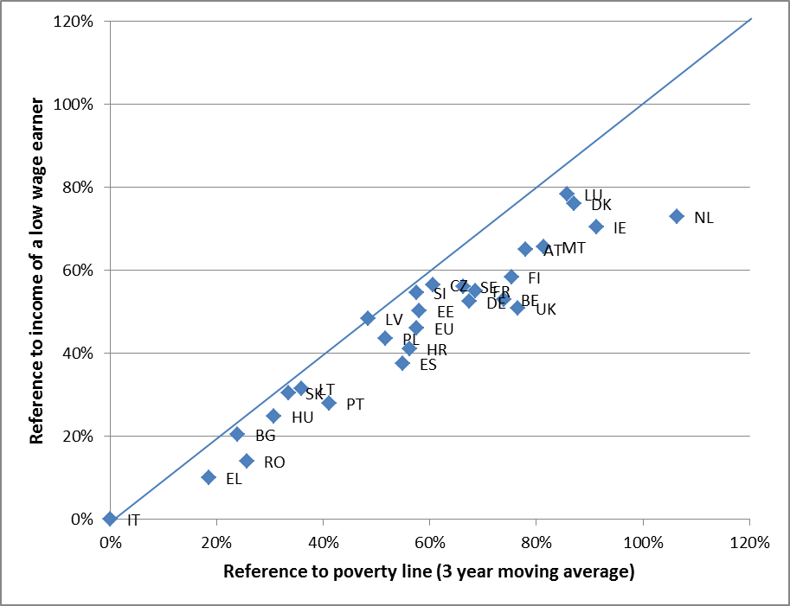

Source: Eurostat, OECD. Note: Information is not available for CY. Information about IT and EL does not include the newly introduced minimum income schemes in 2017. Latest available information about poverty thresholds in IE, HR, and UK is for 2015 income year.

**The adequacy of minimum income benefits impacts, in particular, the depth of poverty among recipients.** The relative at-risk-of-poverty gap[99] for the working age population (16-64) decreases marginally for the first time in 2017, in line with the overall indicator, but remains well above pre-crisis levels. The gap is significantly larger in the case of persons aged 18 to 59 living in quasi-jobless households (Figure 65). EU SILC 2016 data shows that the depth of poverty was highest among people from (quasi-)jobless households in Lithuania, Bulgaria, Latvia, Italy, and Romania (over 50%). By contrast, the smallest gap was observed in Finland, the Netherlands, and Ireland (under 20%). The poverty gap for persons living in quasi-jobless households tends to point to weaknesses in of the adequacy and coverage of benefit systems (as also noted in the 2018 SPC annual report).

**Figure 65: Relative at-risk-of-poverty gap for persons 18-59 from quasi-jobless households (2016)**

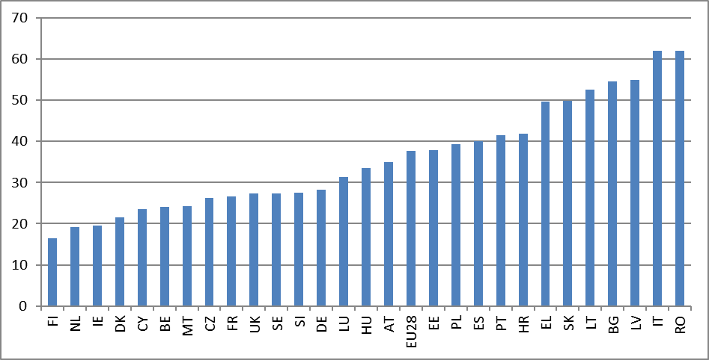 Source: Eurostat, SILC.

**All Member States make use of means testing together with other eligibility requirements for minimum income schemes.** Stricter eligibility requirements imply lower coverage[100] and vice versa.Means-testing is the most commonly used way to target those living in poverty[101]. Means-testing conditions generally assess the resources (be it income, assets, real estate or movable property) of all household members and not just of direct claimants. In most Member States the threshold used in the means test is the maximum level of benefit provided (and the actual support amounts to the difference between the maximum level of the benefit and a person's or household's income), while several Member States also disregard part of people's earnings, which positively affects the coverage of schemes and contributes to reducing in-work poverty. Other eligibility requirements, such as those regarding residence, also affect the coverage of schemes (as this can reduce coverage for people experiencing within-country mobility or homelessness).

**Minimum income recipients have greater difficulty in accessing various in-kind services**. Access to services(as measured by the unmet needs for medical care, the housing cost overburden, and the non-participation in training related to professional activity[102]) is an essential component of integrated active inclusion strategies. In 2016, the access to these services for people aged 18-59 at risk of poverty living in quasi-jobless households was generally lower than that of people of the same age group not at risk of poverty nor living in quasi-jobless households. Looking at performance across services, Finland, Hungary and the United Kingdom are the only Member States where the gap in access to services is below the EU average in 2016 in all three areas. By contrast, the gaps in access appear above the EU average across all three areas examined in Greece and Latvia. In detail, the largest gaps in unmet needs for medical care are experienced in Latvia (14.8 pps) and Greece (34.1 pps), while the lowest ones were in Denmark, Spain, the Netherlands and the UK (less than 1 pp.). In the area of housing, the largest gaps in the housing cost overburden rate were observed in Denmark, Greece, Austria, and Italy (over 50 pp), while the smallest gaps were in Malta, Cyprus, Ireland, and Finland (under 20 pp)[103]. In the domain of adult learning, in 2016 Sweden and Denmark experienced negative gaps, showing better access for people at risk of poverty from very low intensity households, and in Malta and the UK there was no gap. The largest gaps observed were in Latvia, Spain, and Lithuania (over 16 pp).

**Access to housing of good quality has been improving since 2008, but in some countries a significant proportion of population reports that it encounters quality problems with their dwelling.** In the EU, 13.1% of the population reports living in a dwelling with a leaking roof, damp walls, floors or foundation, or rot in window frames or floor in 2017. This is 2.3 pps less than in 2016[104]. This component of housing deprivation[105] is a particular issue in 5 Member States (Cyprus, Portugal, Hungary, Latvia and Slovenia) where over 20% of the population reports that it encounters this quality problem with their dwelling. In 2017, Romania experienced a considerable improvement, with the proportion of the population reporting not having a bath, or a shower, nor indoor flushing toilet in their household declining, yet at a considerable 27.2%. In Latvia, Bulgaria and Lithuania not having a bath or a shower in the dwelling and not having an indoor flushing toilet for the sole use of the household is an issue for around 10% of the population.

**The share of household disposable income spent in housing-related expenditures remains significant in a number of Member States**. When housing costs are taken into account, 156 million people are at risk of poverty, as against 85 million before housing costs are taken into account. This condition is particularly draining for households with lower income. In 2017, 10.2% of households in the EU spent over 40% of their disposable income on housing costs, but this share increases to 37.8% when considering households at risk of poverty. Despite a slight improvement compared to previous years, the housing cost overburden rate remains the highest in Greece, at 39.6% in 2017. Bulgaria, Denmark and Germany are, after Greece, the Member States with highest rates of population experiencing housing cost overburden (over 15% of the population in each). The effect is particularly notable in Denmark and Germany, where the share of people at risk of poverty is below the EU average before housing costs, but above the EU average when housing costs are taken into account. By contrast, in Estonia, Ireland, Finland, Cyprus and Malta less than 5% of the population live in households overburdened by housing-related expenditure. In most countries, tenants who rent at market price are considerably more overburdened by housing related costs than owners with a mortgage or a loan (EU average of 25.1% for tenants paying market rent, compared to around 5% for owners).

**Rising rents represent an increasing burden on the poor in some Member States.** In 2016, in 7 countries (Ireland, Estonia, Lithuania, Slovenia, Hungary, Austria and Poland) rents calculated in real terms have increased by more than 5% since 2015. High rents can compound the risk of poverty or social exclusion, particularly in countries such as Slovenia, Ireland, Austria and Lithuania where the poverty risk facing tenants is significantly greater than for those who own their homes. National figures may also hide challenges at the level of particular cities.

**The recent evolution of the homelessness indicates that the situation is not improving.** Estimates of the number of homeless are not comparable country by country, due to a lack of official sources and different methodologies for counting the homeless. Available data only allow monitoring the evolution of the issue over time (using, in most cases, 2017 or 2016 as a most recent year). They nonetheless indicate that homelessness has recently increased in all of the 25 covered Member States except in Finland, where the situation has improved[106].

**Pension income provides older people with a relative protection against poverty risk.** At the EU level, the at-risk-of-poverty (AROP) rate for older people is lower than for people of working age (14.6% compared to 16.7% in 2017). Over the last decade, this relation has been reversed compared to the pre-crisis period, partially explained by the fact that the crisis reduced average household disposable real income levels, especially among the working-age population across almost all European countries while pensions remained more resilient. However, severe material deprivation also decreased among older people (from 7.4% in 2008 to 6.3% in 2017), indicating that the decrease in poverty and social exclusion was not just a relative effect.

**Figure 66: Percentage of population aged 65 and above at-risk-of-poverty or social exclusion relative to the EU average, 2017**

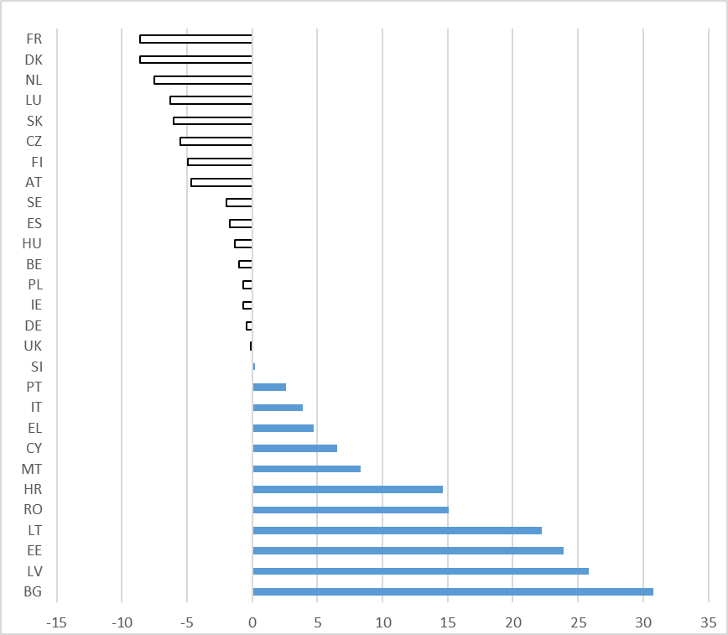

Source: Eurostat, EU-SILC. Notes: data are standardised (EU28=0). Data for IE, UK are for 2016.

**The risk of poverty and social exclusion risk among older people has been steadily decreasing for most Member States.** Overall 148,000 fewer people aged 65 or older were at risk of poverty or social exclusion in 2017 compared to pre-crisis levels (2008). The headline improvement masks marked differences between the Member States, with substantial decreases in old age poverty or social exclusion risk in Cyprus (-24.7 percentage points since 2008), Bulgaria (-16.6 pps), Romania (-16.2 pps) and Latvia (-14.9 pps), while there were increases in Luxembourg (+6.4 pps) and Germany (+2.2 pps).

**However, of particular concern is the situation of older women,** as one in five women aged 65 or over is at risk of poverty or social exclusion in the EU. In 2017, the AROPE rate for women ranged from around 10 percent in Denmark, France and the Netherlands to over 50 percent in Bulgaria, and over 40 percent in the Baltic States. The highest gender differences in the AROPE rate are observed in Lithuania (19.9 pps), Estonia (19.7 pps), followed by Latvia (16.6 pps) and Bulgaria (16.2 pps).Older women have lower incomes than older men: in 2016, the median income for older women was 6 percentage points lower than for men in the EU relative to younger people of the same gender (90% for women and 96% for men).Thus, not only do women have lower incomes during their working lives, but they also have a lower income when in retirement, which contributes to gender inequalities in old-age income.

**On average across the EU, people aged 65 and over have slightly lower incomes than younger age groups.** The median disposable income of those aged 65 and above was 92 percent of the younger population's income in 2017. The total relative median income ratio was below 75 percent in five countries (Denmark, Malta, Lithuania, Latvia and Estonia) and below 80 percent in a further four (Belgium, Sweden, Cyprus and the Czech Republic). In contrast, older men in nine Member States (Luxembourg, Greece, France, Spain, Hungary, Italy, Austria, Poland and Romania) and older women in two Member States (Luxembourg and Greece) enjoyed a higher median income than those aged below 65 in 2017.

**While, on average, pensions amount to more than half of late-career work income, the income replacement capacity of pensions varies significantly among Member States.** In 2017, the aggregate replacement ratio[107] (ARR) averaged 59 percent in the EU, with significant cross-country differences. The ratio ranged from above 80 percent in Luxembourg to less than 40 percent in Ireland, Bulgaria and Croatia[108].

**In a context of rising life expectancies, pensions need to adapt; working lives start later and become longer while people live longer overall.** In addition to poverty reduction and income replacement, the third relevant dimension of pension adequacy is the duration of retirement. The ratio between time spent in retirement and time spent working presently averages 51% in the EU. Figure 67 provides an overview of average life time spent before working, in work and after retirements in Member States (drawing on an estimate of the start of employment/entry into labour market, an estimate of the average exit age from the labour market, and life expectancy at age 60).

**Figure 67: Life time spent under different activity statuses, 2017**

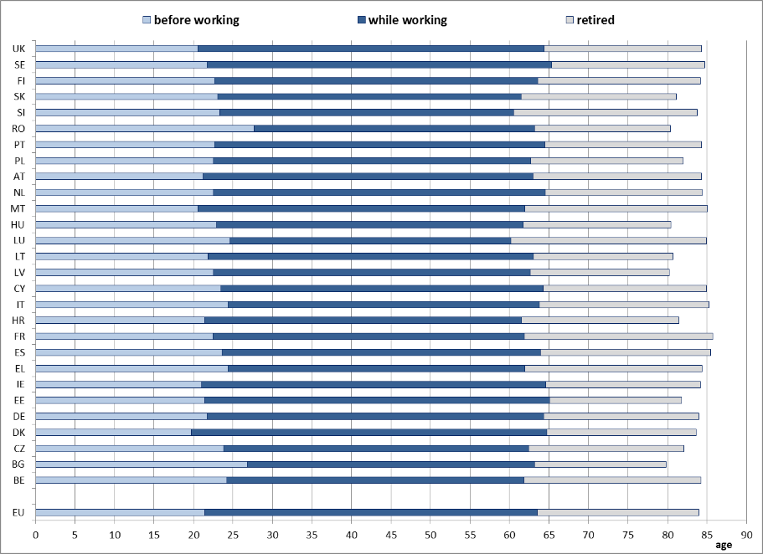

Source: Ageing Report 2018 for labour market entry and exit ages; Eurostat for life expectancy projections. Note: ‘while working’ means between labour market entry and exit ages.

**People in non-standard or self-employment often face less favourable conditions for accessing and accruing pension rights than those in open-ended, full-time job contracts.** SHARE survey data[109] allow measuring the impact of self-employment on retirement income and living standards by comparing the situation of retired self-employed people[110] and of retired employees in most Member States.[111]The retired self-employed report lower incomes than retired employees in almost all countries covered. The highest income gaps can be observed in Luxembourg, Denmark and France, and in nine countries the gap exceeds 20 percent. Only in Hungary and Estonia do the retired self-employed enjoy slightly higher incomes than retired employees (see Figure 68 below). The income gap, together with higher income inequality,[112] leads to substantially higher levels of poverty risk for retired self-employed, around twice that of retired employees on average. The retired self-employed have lower pensions than retired employees in every country observed and, despite higher asset-to-income rations, are more exposed to financial hardship in old age. The financial distress index, which measures the difficulty in making ends meet on a scale of 1 to 4, averages 2.3 for the retired self-employed and 2.1 for retired employees in the Member States surveyed[113].

**Figure 68: Relative difference in the median equivalised disposable income between retired employees and retired self-employed, 2017, %**

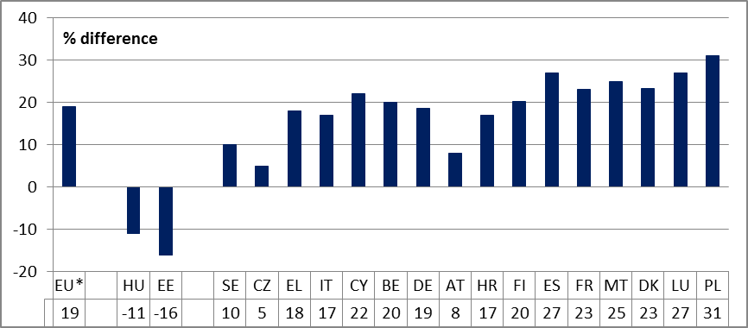

Source: SHARE. Notes: EU* does not include IE, NL and UK. Sample sizes in BG, LV, LT, PT, RO, SI and SK do not allow a distinction to be drawn between retirees.

**Figure 69: Self-reported unmet needs for medical care (Social Scoreboard headline indicator)**

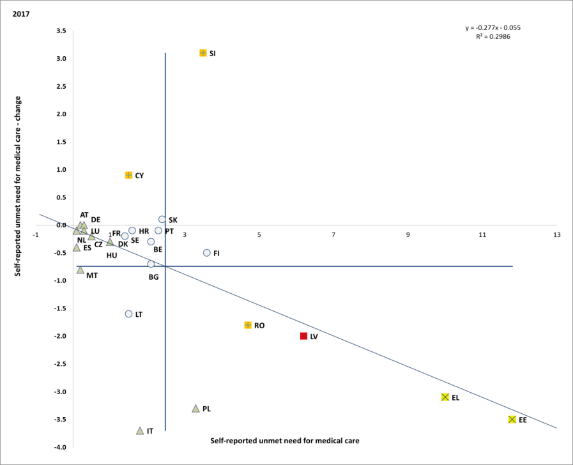

Source: Eurostat, SILC. Period: 2017 levels and yearly changes with respect to 2016. Note: Axes are centred on the unweighted EU average. The legend is presented in the Annex. Data for IE and UK not available at 26 October 2018.

**There are signs of convergence in the share of the population reporting perceived unmet needs for medical care**[114]. Reversing a previous tendency, a weak negative correlation has emerged between level and changes in unmet needs for medical care, with those countries where unmet needs are highest showing the most positive trend (see Figure 69). In some Member States, costs and waiting time remain important barriers for the accessibility of healthcare. Nonetheless, the proportion of the EU population facing self-reported unmet needs for medical care due to either too high costs, too long waiting time or travelling distance, on average decreased in 2017 to 1.6%. The share of the people impacted still exceeded 5% in Estonia and Greece (above 10%) and Latvia. Increases to 2017 were recorded only for Slovenia, Cyprus and Slovakia.

**Activity status may also play an important role in explaining problematic access to medical care in some countries.** Although the majority of countries do not show significant differences according to activity status, in some of them unemployed people (and to a lesser extent pensioners) may encounter higher difficulties in accessing healthcare (see Figure 70). Even in countries where the percentage of unmet needs among the entire population is below the EU average, figures suggest that the unemployed may face difficulties accessing medical care (e.g. Belgium, France, Italy, and Hungary).

**Figure 70: self-reported unmet needs for medical examination according to activity status (2016)**

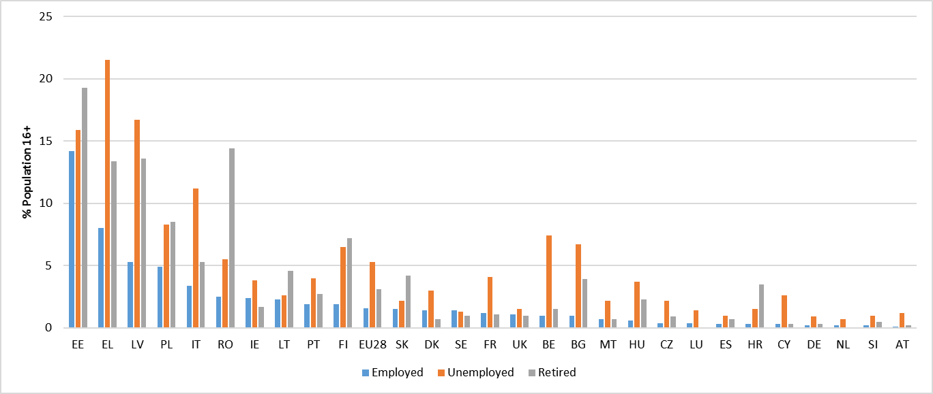

Source: Eurostat [hlth_silc_13].

**The healthy life years (at the age of 65) increased further in the EU for men to 9.8 years and for women to 10.1 years.** While the highest number of healthy life years at 65 can be expected in Sweden, Malta and Ireland (about 12 years for both gender), the healthy life expectancy is particularly low in Latvia, Slovakia and Croatia (around 5 years).

**Healthcare is financed through different schemes, while the relative importance of each scheme varies among Member States.** In 2016, out-of-pocket payments[115], i.e. household expenditure for health (including medical goods) not reimbursed by any scheme or paid as cost-sharing with an organised scheme, measured as a share of current health expenditure is above 30% in Bulgaria, Greece, Cyprus, Latvia and Lithuania (Figure 71).

**Figure 71: Healthcare expenditure by financing source, 2016**

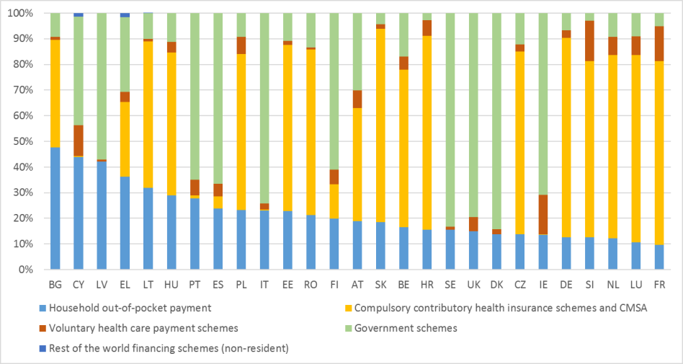

Source: Eurostat [hlth_sha11_hf]. Notes: data are collected according to Commission Regulation (EC) 2015/359 as regards statistics on healthcare expenditure and financing (System of Health Accounts 2011 manual).

**The need for Long Term Care (LTC) is growing as the population in the EU ages**. Over the next six decades (by 2070), the number of Europeans aged 80+ is set to double and the old-age dependency ratio (people aged 65+ relative to those aged 15-64) is projected to jump from 29.6% in 2016 to 51.2% in 2070[116] (the EU would go from 3.3 to only 2 working-age people for every person aged 65+). The risk of becoming dependent is higher towards older age, when people are more likely to become frail (60% people aged 75-84 and 70% aged 85+ report a disability).

**A significant rise in LTC needs is projected.**  LTC is the fastest-rising social expenditure compared to health and pensions. The EU public expenditure on LTC is projected to increase from 1.6% to 2.7% of GDP between 2016 and 2070, with marked variations across the EU (see Figure 72).

**Figure 72: Projected public expenditure on LTC as % of GDP, in 2016 and 2070**

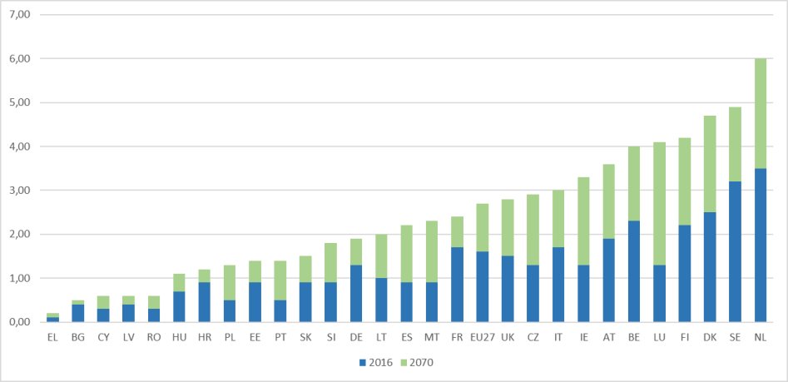

Source: based on data from the 2018 Ageing Report. Note: AWG reference scenario

**Long-term care sustainability will also be challenging for those Member States which now rely heavily on informal care.** The pool of informal carers is shrinking due to changing family patterns (fewer children, family members living further apart), with increasing female employment and the increase in the retirement age. Informal care also entails important costs for the economy, as informal carers reduce or leave formal employment, and thus pay little or nothing in taxes and contributions. There are also challenges in recruiting and retaining carers. The sector is affected by the prevalence of part-time work and temporary contracts, which reduces its attractiveness.

### 3.4.2 Policy response

**Reforms in several Member States aim to strengthen the active inclusion approach.** Some Member States are enhancing integrated delivery of services (such as social assistance, employment and other social services) in particular by undertaking a person-centred approach aimed at addressing complex needs of the most vulnerable people. In Bulgaria,the implementation of the Employment and Social Assistance Centres providing integrated and mobile services[117] is ongoing. By February 2018, 73 such centres, established with the support of the ESF were operational[118] and provided employment and social assistance services. As of 2018 the centres offer Job Integration Agreement for the long-term unemployed linking the long-term unemployed with specific employment services and referrals to services provided by other institutions. In Ireland, the *Action Plan* *for Jobless Households* extends activation services to people who are not working, but are not defined as unemployed on the traditional measures. It focuses in particular on improving employment rates of households with children – both the traditional ‘nuclear’ family and the lone parent family and people with disabilities. In Finland, the one-stop guidance centres for youth ("Ohjaamo"), originally operating under ESF funding, have been made a permanent measure and is being expanded with the psychosocial support network. In Greece the Community Centres, serving as one-stop-shops for social services at municipal level started opening in 2017. The Centres are supporting the implementation of the Social Solidarity Income scheme (SSI), connecting the beneficiaries to complementary social services. By February 2018, 203 out of the 240 planned centres were operational. Additionally, more and more municipalities across the EU provide integrated social services focusing on complex needs of the vulnerable groups (e.g. single entry points in Athens or health promotion services in Essen). These operations were supported by the ESF.

**Modernisation and increases in adequacy of some benefits continue in several Member States, though in some cases there have been delays**. In Lithuania, the state-supported income, as well as family-related benefits, have been increased in 2018. In Bulgaria, a 15% increase in the minimum income in 2018 follows a 9-year freeze. In continuity with the multiannual plan to fight poverty established in 2013, in France the minimum income (*Revenu de solidarité active – RSA socle)* has undergone a 1.6% increase in September 2017 followed by a 1% increase in April 2018. These increases are the last of a series that enabled an increase of the minimum income relative to inflation and are complemented by a renewed focus on activation of beneficiaries (*‘Garantie d’activité’*), as part of the recently announced anti-poverty plan. However, in Romania, the planned consolidation of existing social benefits has been postponed to April 2019, while in Croatia the implementation of the new Social Welfare Act will not come into effect until December 2019. Latvia's planned Minimum Income Improvement Plan (submitted in May 2018 and to take effect in 2020) has not yet been adopted by the Government. A draft law in Luxembourg seeks to reorganize the Guaranteed Minimum Income (RMG) mechanism, with the aim to reduce the high inactivity traps generated by the current scheme and address the problems of housing cost overburden and insufficient income for one-parent households.

**The coverage of social protection increases in several Member States.** Belgium adopted a law removing limitations on the access to enterprise pension's schemes for young persons and short-term contracts. Other countries plan to introduce or have adopted measures in favour of self-employed or small-business owners. These measures include reduced contributions below a certain threshold (Latvia, Poland), the coverage of independent workers in the unemployment scheme (France), or the possibility to include independent workers in a work accident insurance via a social charter of on-line platforms (France, see also Section 3.3.2).

**Measures aimed at tackling income inequality and in-work poverty address both tax design and benefit adequacy**. In addition to minimum wage setting, a number of inequality-reducing policies related to the tax-benefit system can help alleviate in-work poverty. In Lithuania, a reform of the flat tax income regime was adopted in June of 2018, introducing a progressive, two-band structure which should help reduce income inequality. In Latvia, the introduction of progressive personal income tax is accompanied by non-taxable allowances of the personal income tax and for dependants. A proposed reform by the Czech Republic to revamp the Personal Income tax system should add a further degree of progressivity, in particular through adding a new tax rate of 23% for higher incomes.

**Some Member States have taken measures specifically targeting child poverty.** In Spain, the 2018 national budget allocates EUR 100 million to fight severe poverty with a particular attention to families with children. Lithuania’s Law on Benefits for Children introduces a universal child benefit system. Furthermore, a child benefit to families raising and/or fostering three and more children shall be paid disregarding the family income. A supplement to the state benefit for families with two or more children has been introduced in Latvia. Greece has adopted a reform of child benefits system, replacing the former two benefits (the "unified child benefit" and "large family benefit") with a single means-tested child benefit. This reform aimed to improve targeting and increase equity among supported children.

**Social inclusion measures for persons with disabilities have been undertaken in order to complement employment policies and prevent suffering due to poverty.** To improve efficiency and ensure that people receive the benefits they are entitled to, Spain has implemented a test phase of the Universal Social Card, which allows the gathering of information on all the benefits that a person receives in one place, as well as indicating which other benefits they may be entitled to. For 2018, the work ability allowance for those who are unable to work or whose ability is limited has been raised in Estonia. In 2017, Malta implemented a further reform to disability pensions, whereby a three-tier payment system was introduced, with those unable to work due to disability set to receive steadily increasing sums per month until their pension reaches the equivalent of the minimum wage. A 2016 Polish government Act provides a grant of 4000 złoty (approximately EUR 940) to the parents of a severely disabled child in its first year of life. In Portugal, a new Independent Living Support Model (MAVI) was adopted in 2017, funded through the ESF, whereby every person with an incapacity score of 60% or above is entitled to 40 hours support per week from a dedicated support worker, aiding them with personal care, health, nutrition, travel, higher education, vocational training, cultural activities, sports, job search, participation in society and citizenship activities. Additionally in 2017, the Portuguese government brought together three disability benefits – the disability allowance, the social invalidity pension and the invalidity pension – into one benefit, the Social Benefit for Inclusion. Romania has switched to using the Social Reference Indicator to calculate disability benefit, instead of the Consumer Price Index, which resulted in a rise in benefit for adults with disability.

**A number of Member States have undertaken reforms in the field of access to housing.** Denmark has adopted an action plan to fight homelessness, based on strengthening of preventive measures and improving the guidance on how to exit homelessness. Greece has introduced a new means-tested housing benefit intended for low-income families living in rented dwellings and those paying a mortgage. Spain has adopted a national plan which includes aiding the low-income families to pay the rent and prevent eviction, financial aid for young people buying houses in sparsely populated areas and aid to renovate housing for special vulnerable groups. The Swedish government has allocated additional funds to support non-profit organisations to combat homelessness among young adults.

**The dynamic of pension reforms is shifting towards addressing the adequacy challenges.** While measures to improve financial sustainability are still high on many Member States’ pension agendas, this process has been coupled with measures recalibrating the scope of the pension mix to respond to some key labour market and pension system challenges: safeguarding pension adequacy, combining work with pensions, and tailoring pensionable rights to specific categories of workers.

**Some Member States continue to focus on rebalancing pension duration with life expectancy.** For instance, the 2017 reform in the Czech Republic capped the ongoing increase of pensionable age at 65, to be reached in 2030, to be linked to life expectancy afterwards, although further legislation will be required to enact the link. Other countries are increasing career-length requirements. In Lithuania, for example, the length of the contributory period will gradually increase, from 30 years in 2017 to 35 years by 2027. In contrast, Poland reintroduced lower, differentiated pensionable ages for men and women (65 and 60 years, respectively) as of October 2017. This triggered a sharp increase in pension take-up, the newly granted pensions for women being much lower on average than for men.[119]

**More pension reform measures are aimed at reducing poverty** (e.g. minimum guarantees) and **improving income maintenance** (e.g. favourable indexation, enhancing the role of supplementary pensions). Latvia, Malta and Romania have raised the non-taxable minima, which should benefit the recipients of lower pensions. Minimum pensions were increased in Bulgaria, Poland and Romania, where a significant 30% raise was granted in 2017. Other measures, such as additional safeguards for pensioners with long careers, were introduced; e.g. Austria in 2017 raised the minimum pension from EUR 883 to EUR 1000 per month for people with at least 30 years of contributions.[120]

**Improving the effectiveness of healthcare by better coordination and giving a stronger role to primary care has become a guiding principle in a number of Member States.** In Estonia, current plans for health centres and hospital networks seek to create multi-disciplinary teams, to redefine the roles of family physicians vis-à-vis specialists and to improve training. Ireland is stepping up capital investment with, inter alia, the creation of Primary Care Centres across the country. Bulgaria and France presented in the autumn 2018 fundamental reform proposals for the health system, including more efficient hospital care and a better integration of care. In Slovakia, efforts to strengthen the weak gatekeeping role of general practitioners and avoid unnecessary referrals to specialist physicians are continuing. In Latvia, the transforming primary care practices into larger health centres with 3-6 family doctors, at least two nurses, and potentially including specialists in the team is ongoing, so are reforms to re-configure inpatient services in hospitals. In Croatia, the functional integration of hospitals (still in the pilot phase) and improved primary care should improve quality of services, bring savings and financial stability as well as increase the level of safety and patients' satisfaction. In Austria, 75 centres based on multi-professional teams will be opened by 2021.

**Measures are being taken to improve the training and working conditions of health workers.** In Italy, competencies of general practitioners, specialists and nurses have been combined to provide care in the community. Also Hungary and Sweden have a major focus on bolstering skills supply in the healthcare sector and improving working conditions and salaries. In Romania, as of March 1st 2018, gross salaries of doctors and nurses, gross salaries, were increased considerably (by 70%-172%). In Latvia, the government plans substantial (almost threefold) increases of health professionals’ wages by 2023. Support measures aimed at attracting medical practitioners and nurses to work in peri-urban or rural are on the way in Latvia, Poland, Portugal and Romania.

**Specific measures to improve the access to healthcare include the reduction of out-of-pocket payments**, specifically co-payments, in some Member States. An example is Cyprus, which adopted in 2017 a major reform to, inter alia, provide universal access to healthcare by 2020. In Estonia, the additional reimbursement of costs of prescription pharmaceuticals was widened as of 2018. In Lithuania, a number of measures were undertaken in 2017 to curb out-of-pocket payments on medicines and increase the transparency of pharmaceutical policy. They included a reduction of VAT on expensive medicines and caps put on the difference between the prices at which medicines are offered in pharmacies and their reference prices, promotion of generics and the rational use of medicines.

**Some Member States aim at a holistic approach for long-term care.** Bulgaria has adopted an action plan for the implementation of the National Long Term Care Strategy which includes the strengthening of the institutional framework for provision and development of integrated social services. Poland has designed a social policy for older dependent people based on a system of support for informal carers by public institutions and on a network of community and institutional services.

**To increase the pool of carers, Member States are proposing different policy options.** The Czech Republic adopted a special leave (paid up to three months) for informal carers of family dependants. Estonia provides a possibility to have 5 additional paid carers' leave days for employed carers (relative, spouse, registered partner or carer) per calendar year. In Germany, the education and training of nurses is being reformed in order to establish a common curriculum and training for nurses in health care, paediatric care and long-term care, and reduce labour shortage.

# ANNEXES

**Annex 1. Social scoreboard headline indicators, levels**



Source: Eurostat.

Note: EUnw and EAnw refer to the non-weighted averages for EU and the euro area.

Flags – b: break in time series; e: estimated; p: provisional; u: low reliability (small number of observations).

**Annex 1 (continued). Social scoreboard headline indicators, levels**



Source: Eurostat, OECD.

Note: EUnw and EAnw refer to the non-weighted averages for EU and the euro area. Real GDHI per capita is measured using 'unadjusted income' (i.e. without including social transfers in kind) and without correction for purchasing power standards. Net earnings of a full time single workers earning the average wage should be read and interpreted in conjunction with other indicators, such as the in-work poverty rate, the ratio between the fifth and the first decile of the wage distribution (D5/D1) and other relevant EPM/SPPM and JAF indicators. For this indicator 3-year averages are used to smooth out short-term fluctuations.

Flags – b: break in time series; e: estimated; p: provisional; u: low reliability (small number of observations).

**Annex 1 (continued). Social scoreboard headline indicators, levels**



Source: Eurostat.

Note: EUnw and EAnw refer to the non-weighted averages for EU and the euro area.

Flags – b: break in time series; e: estimated; p: provisional; u: low reliability (small number of observations).

**Annex 2. Social scoreboard headline indicators, changes and distance to EU**



Source: Eurostat.

Note: EUnw and EAnw refer to the non-weighted averages for EU and the euro area. On 26th October 2018, statistical significance estimates for changes of LFS and SILC-based indicators are not available.

Flags – b: break in time series; e: estimated; p: provisional; u: low reliability (small number of observations).

**Annex 2 (continued). Social scoreboard headline indicators, changes and distance to EU**



Source: Eurostat, OECD.

Note: EUnw and EAnw refer to the non-weighted averages for EU and the euro area. Real GDHI per capita is measured using 'unadjusted income' (i.e. without including social transfers in kind) and without correction for purchasing power standards. Net earnings of a full time single workers earning the average wage should be read and interpreted in conjunction with other indicators, such as the in-work poverty rate, the ratio between the fifth and the first decile of the wage distribution (D5/D1) and other relevant EPM/SPPM and JAF indicators. For this indicator, the distance to the EU average is expressed in purchasing power standards (PPS) while the changes are expressed in real terms in national currency; 3-year averages are used for both levels and changes to smooth out short-term fluctuations. On 26th October 2018, statistical significance estimates for changes of LFS and SILC-based indicators are not available.

Flags – b: break in time series; e: estimated; p: provisional; u: low reliability (small number of observations).

**Annex 2 (continued). Social scoreboard headline indicators, changes and distance to EU**



Source: Eurostat.

Note: EUnw and EAnw refer to the non-weighted averages for EU and the euro area.

Flags – b: break in time series; e: estimated; p: provisional; u: low reliability (small number of observations). On 26th October 2018, statistical significance estimates for changes of LFS and SILC-based indicators are not available.

**Annex 3. Methodological note on the identification of trends and levels in the scoreboard**

In mid-2015 the European Commission, the Employment Committee and the Social Protection Committee agreed on a methodology for assessing Member States' performance on the scoreboard of key employment and social indicators. As part of the agreement, the methodology aimed at providing, for each indicator, a measure of the relative standing of each Member State within the distribution of the indicator values (scores) of the EU. The methodology is applied jointly to year-levels (levels) as well as to one-year changes (changes), thus enabling a holistic assessment of MS performance[121].

In 2017 the Commission in agreement with the Employment Committee and the Social Protection Committee has decided to apply the methodology to the social scoreboard accompanying the European Pillar of Social Rights.

For each indicator, levels and changes are converted to standard scores (also known as z-scores) to apply the same metric to all the indicators. This is achieved by standardising raw values of both levels and changes according to the formula:

$${z-score for MS}_{X}= \frac{\left[{MS}_{X} indicator -average \left(MS indicator\right)\right]}{standard deviation (MS indicator)}$$

Then the distributions of scores (separately for levels and changes) are analised. This approach enables expressing for each Member State its raw indicator value in terms of how many standard deviations it deviates from the (unweighted) average. The performance of each MS is assessed and classified on the basis of the resulting z-scores against a set of pre-defined thresholds, set as standard deviation multiples.

The most important issue within this approach is setting cut-off points. Given that no parametric assumption can be made about the distribution of the observed raw values[122], it is common to use a “rule of thumb” in selecting the thresholds. According to the analysis of the key indicators used in the scoreboard, it was agreed to consider:

1. Any score below -1 as a very good performance
2. Any score between -1 and -0.5 as a good performance
3. Any score between -0.5 and 0.5 as a neutral performance
4. Any score between 0.5 and 1 as a bad performance
5. Any score higher than 1 as a very bad performance[123]

Table 4: Z-scores threshold values

|  |  |  |  |  |  |
| --- | --- | --- | --- | --- | --- |
|  | z-scores threshold values | | | | |
| -1.0 | - 0.5 | 0 | 0.5 | 1.0 |
| *(lower than)* | *(lower than)* | *(between)* | *(Higher than)* | *(Higher than)* |
| **Assessment** | | | | |
| Levels | Very Low | Low | On average | High | Very High |
|  |  |  |  |  |  |
| Changes | Much lower than average | Lower than average | On average | Higher than average | Much higher than average |

By combining the evaluation of levels and changes it is then possible to classify the overall performance of a country according to each indicator within one of the following seven categories. The colour coding is reflected in the respective figures in the body of the report.

The tables below provide the classification based on z-scores for those indicators for which a low value is assessed as a good performance (e.g. unemployment rate, AROPE, etc).

|  |  |  |
| --- | --- | --- |
| **Best performers** | scoring less than -1.0 in levels and less than 1.0 in changes | Member States with levels much better than the EU average and with the situation improving or not deteriorating much faster than the EU average |
| **Better than average** | scoring between -1.0 and -0.5 in levels and less than 1 in changes or scoring between -0.5 and 0.5 in levels and less than -1.0 in changes | Member States with levels better than the EU average and with the situation improving or not deteriorating much faster than the EU average |
| **Good but to monitor** | scoring less than -0.5 in levels and more than 1.0 in changes, *and* presenting a change higher than zero[124] | Member States with levels better or much better than the EU average but with the situation deteriorating much faster than the EU average |
| **On average / neutral** | scoring between -0.5 and 0.5 in levels and between -1.0 and 1.0 in changes | Member States with levels on average and with the situation not improving nor deteriorating much faster than the EU average |
| **Weak but improving** | scoring more than 0.5 in levels and less than -1.0 in changes | Member States with levels worse or much worse than the EU average but with the situation improving much faster than the EU average |
| **To watch** | scoring between 0.5 and 1.0 in levels and more than -1.0 in changes or scoring between -0.5 and 0.5 in levels and more than 1.0 in changes (*and* presenting a change higher than zero[125]) | This category groups two different cases: i) Member States with levels worse than the EU average and with the situation deteriorating or not improving sufficiently fast; ii) Member States with levels in line with the EU average but with the situation deteriorating much faster than the EU average |
| **Critical situations** | scoring more than 1.0 in levels and more than -1.0 in changes | Member States with levels much worse than the EU average and with the situation deteriorating or not improving sufficiently fast |



The tables below provide the classification based on z-scores for those indicators for which a high value is assessed as a good performance (e.g. employment rate, participation into childcare, etc).

|  |  |  |
| --- | --- | --- |
| **Best performers** | scoring more than 1.0 in levels and more than -1.0 in changes | Member States with levels much better than the EU average and with the situation improving or not deteriorating much faster than the EU average |
| **Better than average** | scoring between 1.0 and 0.5 in levels and more than -1.0 in changes or scoring between -0.5 and 0.5 in levels and more than 1.0 in changes | Member States with levels better than the EU average and with the situation improving or not deteriorating much faster than the EU average |
| **Good but to monitor** | scoring more than 0.5 in levels and less than -1.0 in changes, *and* presenting a change lower than zero[126] | Member States with levels better or much better than the EU average but with the situation deteriorating much faster than the EU average |
| **On average / neutral** | scoring between -0.5 and 0.5 in levels and between -1.0 and 1.0 in changes | Member States with levels on average and with the situation not improving nor deteriorating much faster than the EU average |
| **Weak but improving** | scoring less than -0.5 in levels and more than 1.0 in changes | Member States with levels worse or much worse than the EU average but with the situation improving much faster than the EU average |
| **To watch** | scoring between -0.5 and -1.0 in levels and less than 1.0 in changes or scoring between -0.5 and 0.5 in levels and less than -1.0 in changes (*and* presenting a change lower than zero[127]) | This category groups two different cases: i) Member States with levels worse than the EU average and with the situation deteriorating or not improving sufficiently fast; ii) Member States with levels in line with the EU average but with the situation deteriorating much faster than the EU average |
| **Critical situations** | scoring less than 1.0 in levels and less than 1.0 in changes | Member States with levels much worse than the EU average and with the situation deteriorating or not improving sufficiently fast |



***Cut-off points summary table***

|  |  |  |  |  |  |  |
| --- | --- | --- | --- | --- | --- | --- |
|  |  | **Very low** | **Low** | **On average** | **High** | **Very high** |
| **Early leavers from education and training**  **(% of poulation aged 18-24)** | Levels | less than 5.4% | less than 7.4% | between 7.4% and 11.4% | more than 11.4% | more than 13.4% |
| Changes | less than -1.0 pps | less than -0.5pps | between -0.5pps and 0.4pps | more than 0.4pps | more than 0.8pps |
| **Gender employment gap (pps)** | Levels | less than 5.2pps | less than 7.8pps | between 7.8pps and 13.2pps | more than 13.2pps | more than 15.9pps |
| Changes | less than -1.0pps | less than -0.5pps | between -0.5pps and 0.4pps | more than 0.4pps | more than 0.9pps |
| **Income quintile ratio (S80/S20)** | Levels | less than 3.7 | less than 4.3 | between 4.3 and 5.6 | more than 5.6 | more than 6.2 |
| Changes | less than -0.3 | less than -0.2 | between -0.2 and 0.0 | more than 0.0 | more than 0.2 |
| **At risk of poverty or social exclusion (%)** | Levels | less than 16.1% | less than 19.5% | between 19.5% and 26.3% | more than 26.3% | more than 29.7% |
| Changes | less than -1.9pps | less than -1.4pps | between -1.4pps and -0.5pps | more than -0.5pps | more than 0.0pps |
| **Youth NEET (% of total population aged 15-24)** | Levels | less than 6.5% | less than 8.4% | between 8.4% and 12.3% | more than 12.3% | more than 14.2% |
| Changes | less than -1.5pps | less than -1.1pps | between -1.1pps and -0.2pps | more than -0.2pps | more than 0.2pps |
| **Employment rate (% population aged 20-64)** | Levels | less than 67.0% | less than 69.8% | between 69.8% and 75.3% | more than 75.3% | more than 78.0% |
| Changes | less than 0.5pps | less than 1.0pps | between 1.0pps and 1.9pps | more than 1.9pps | more than 2.4pps |
| **Unemployment rate (% active population aged 15-74)** | Levels | less than 3.6% | less than 5.6% | between 5.6% and 9.6% | more than 9.6% | more than 11.7% |
| Changes | less than -1.7pps | less than -1.4pps | between -1.4pps and -0.8pps | more than -0.8pps | more than -0.4pps |
| **Long-term unemployment rate (% active population aged 15-74)** | Levels | less than 0.5% | less than 1.9% | between 1.9% and 4.8% | more than 4.8% | more than 6.3% |
| Changes | less than -1.3pps | less than -1.0pps | between -1.0pps and -0.4pps | more than -0.4pps | more than -0.1pps |
| **Real GDHI per capita (2008 = 100)** | Levels | less than 90.7 | less than 97.1 | between 97.1% and 110.0 | more than 110.0 | more than 116.4 |
| Changes | less than 0.0pps | less than 1.6pps | between 1.6pps and 4.8pps | more than 4.8pps | more than 6.3pps |
| **Net earnings of a full time single worker earning the average wage (levels in PPS, changes in national currency in real terms)** | Levels | less than 12,559 | less than 16,115 | between 16,115 and 23,228 | more than 23,228 | more than 26,784 |
| Changes | less than -0.1% | less than 1.2% | between 1.2% and 3.9% | more than 3.9% | more than 5.2% |
| **Impact of social transfers (other than pensions) on poverty reduction (%)** | Levels | less than 22.0% | less than 27.7% | between 27.7% and 39.2% | more than 39.2% | more than 44.2% |
| Changes | less than -3.1pps | less than -1.5pps | between -1.5pps and 1.9pps | more than 1.9pps | more than 3.5pps |
| **Children aged less than 3 years in formal childcare (%)** | Levels | less than 12.8% | less than 21.4% | between 21.4% and 38.4% | more than 38.4% | more than 46.9% |
| Changes | less than -3.6pps | less than -0.9pps | between -0.9pps and 4.6pps | more than 4.6pps | more than 7.4pps |
| **Self-reported unmet need for medical care (%)** | Levels | less than 0.4% | less than 1.0% | between 1.0% and 3.9% | more than 3.9% | more than 5.4% |
| Changes | less than -2.2pps | less than -1.5pps | between -1.5pps and 0.0pps | more than 0.0pps | more than 0.7pps |
| **Individuals who have basic or above basic overall digital skills (% of population aged 16-74)** | Levels | less than 43.4% | less than 50.4% | between 50.4% and 64.3% | more than 64.3% | more than 71.3% |
| Changes | less than -3.0pps | less than -0.9pps | between -0.9pps and 3.5pps | more than 3.5pps | more than 5.6pps |

**Annex 4: Summary overview of the ‘employment trends to watch’ and number of Member States with deterioration or improvement as identified by the 2018 Employment Performance Monitor (EPM).**

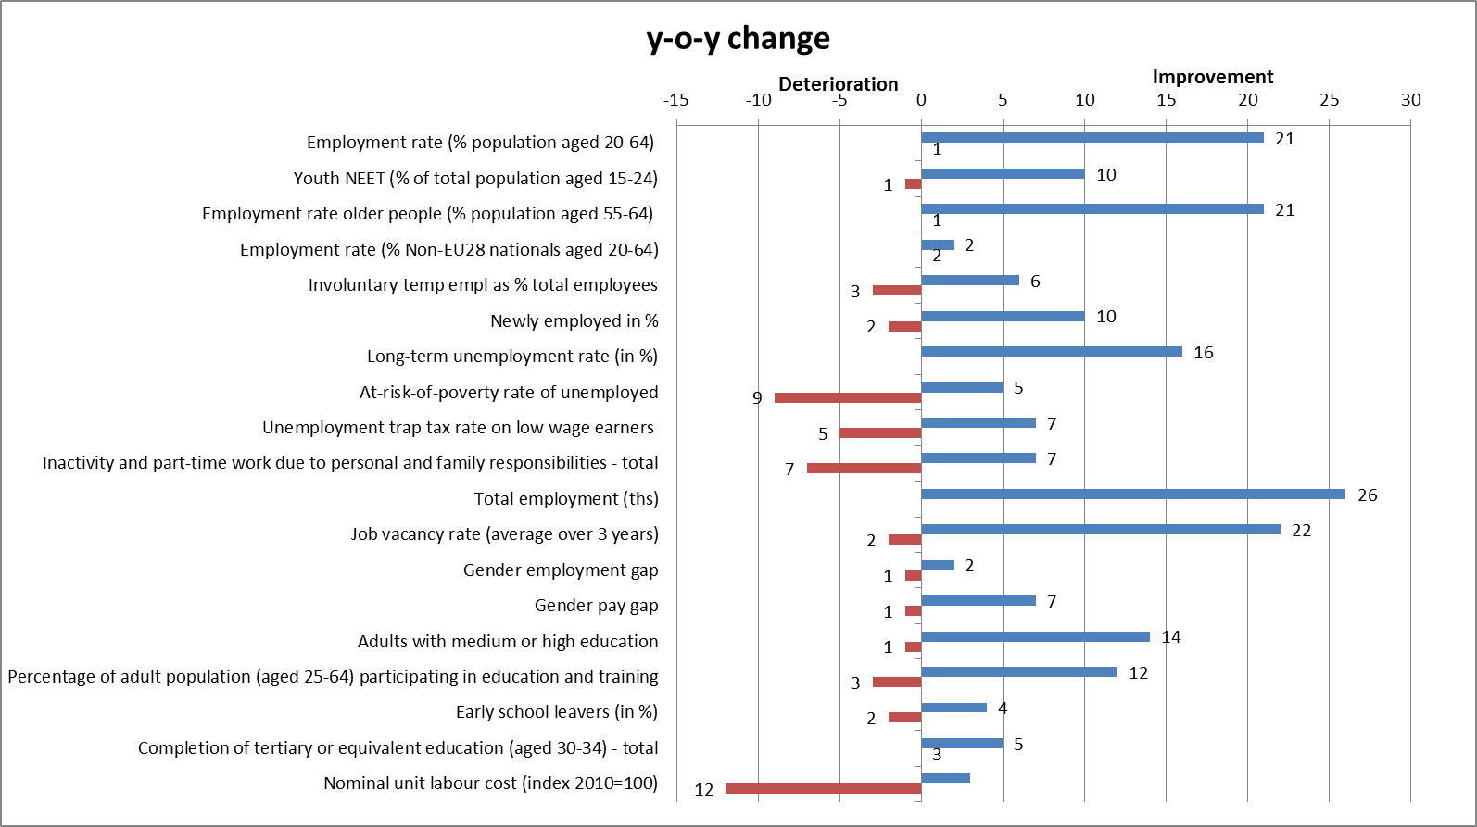

Note: 2016-2017 changes, except 2015-2016 for at-risk-of poverty rate of unemployed, unemployment trap and gender pay gap.

**Annex 5: Summary overview of the ‘social trends to watch’ and number of Member States with deterioration or improvement over 2015-2016 as identified by the August 2018 update of the Social Protection Performance Monitor.**

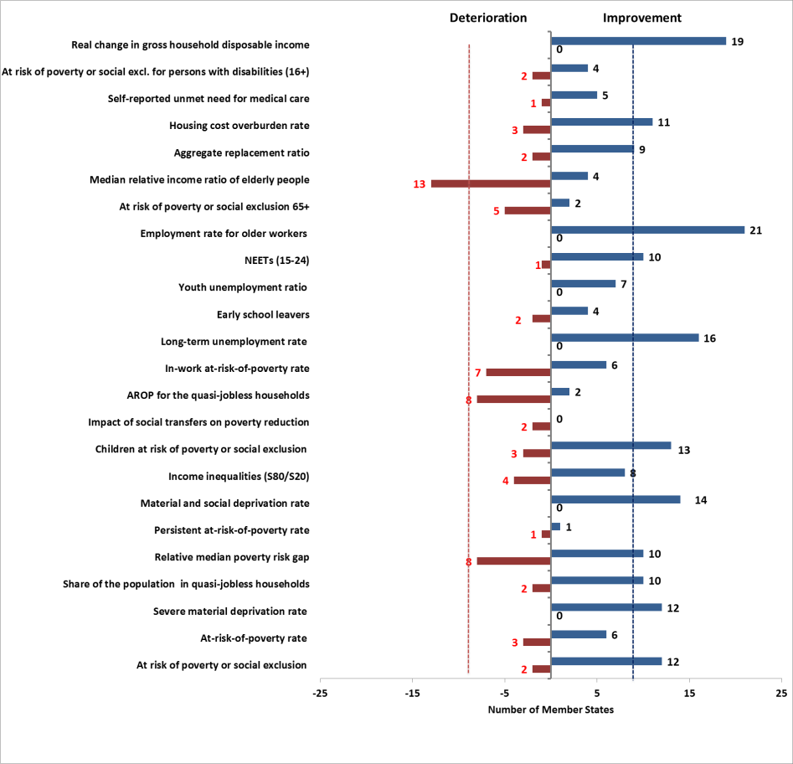

Note: for EU-SILC based indicators the indicated changes for 2015-2016 generally actually refer to 2014-2015 for income and household work intensity indicators, and similarly for unmet needs for medical care. For LFS-based indicators (LTU rate, early school leavers, youth unemployment ratio, NEETs (15-24), ER (55-64)) and severe material deprivation (not yet final for 2017 for several MS in August 2018) the changes refer to the period 2016-2017.

1. Revised Employment Guidelines have been adopted by the Council of the European Union in July 2018, aligning the guidelines to the European Pillar of Social Rights (Council Decision (EU) 2018/1215 of 16 July 2018 on guidelines for the employment policies of the Member States).
2. Total employment figures come from National Accounts (domestic concept), other figures from Labour Force Survey data. Seasonally adjusted quarterly figures are used throughout this section.
3. In the Communication "Strengthening European Identity through Education and Culture" of 14 November 2017 (COM(2017) 673 final) the Commission indicates the ambition to reduce the benchmark for early school leaving to 5% by 2025.
4. More details in European Commission (2018), "Employment and Social Developments in Europe. Annual Review 2018".
5. Within services, the largest percentage increase was recorded in "information and communication" activities, followed by "professional, scientific and technical activities; administrative and support service activities" (respectively by 3.4% and 2.9% in 2017). On the contrary, "financial and insurance services" recorded a drop by 0.7%.
6. People at risk of poverty or social exclusion (AROPE) are people who are at risk of poverty (AROP) and/or experiencing severe material deprivation (SMD) and/or living in households with very low work intensity (VLWI).

   People at risk of poverty are people living in a household whose equivalised disposable income is below 60% of the national equivalised median income (this indicator is therefore an income poverty indicator).

   People are severely materially deprived if they live in a household unable to afford at least four of the following items: 1) pay rent/mortgage/ utility bills on time; 2) keep home adequately warm; 3) meet unexpected expenses; 4) eat meat, fish or a protein equivalent every second day; 5) one week annual holiday away from home; 6) have access to a car for private use; 7) have a washing machine; 8) have a colour TV; and 9) have a telephone.

   People living in households with very low work intensity (i.e. (quasi-)jobless households) are people aged 0-59 living in a household where working-age adults (18-59) worked less than 20% of their total work potential during the past year.
7. The income statistics of EU SILC refer to the previous income year, with the exception of United Kingdom (survey year) and Ireland (income of 12 months preceding the survey).
8. EU-SILC data refer in most Member States to incomes recorded in the previous year (i.e. 2016 incomes for SILC 2017, see also footnote 7). Flash estimate statistics published by Eurostat indicate that improvements in the at-risk-of-poverty indicator (as well as the S80/S20 ratio) are also expected in most Member States for incomes recorded in 2017 (i.e. for indicators published in 2018).
9. 2018 SPC annual report.
10. 2018 SPC annual report.
11. SWD(2017) 200 final, accompanying the Communication COM(2017) 250 final of 26 April 2017.
12. The Employment Performance Monitor (EPM) and the Social Protection Performance Monitor (SPPM) are yearly reports prepared respectively by the Employment Committee and the Social Protection Committee. They identify trends to watch, key employment and social challenges in Member States, and monitor progress towards the Europe 2020 employment and poverty reduction targets.
13. In the 2018 Joint Employment Report, upon request of the Employment Committee and the Social Protection Committee (and their Indicator Sub-Groups), two headline indicators in the domain of "dynamic labour markets and fair working conditions" ("participants in active labour market policies per 100 persons wanting to work" and "compensation of employees per hour worked, in euro") were not included in the overview table and not presented as Scoreboard headline indicators in subsequent analysis, due to technical concerns. Following discussions, in September 2018 the Committees have agreed replacing these indicators with alternative ones (respectively "long-term unemployment rate" and "net earnings of a full-time single worker without children earning an average wage"). These indicators, which are related in particular to the Pillar principles on "Active support to employment" and "Wages", will be used in the analysis of the current Joint Employment Report.
14. As demanded by the Committees, this indicator is measured using 'unadjusted income' (i.e. without including social transfers in kind) and dropping reference to the use of purchasing power standards (PPS) units.
15. Levels of this indicator are expressed in purchasing power standards (PPS) while changes are expressed in national currency in real terms. To smooth out short-term fluctuations, 3-year averages are used for both levels and changes. This indicator should be read and interpreted in conjunction with other indicators, such as the in-work poverty rate, the ratio between the fifth and the first decile of the wage distribution (D5/D1) and other relevant EPM/SPPM and JAF indicators.
16. This is measured as the difference, among total population, between the share of people at risk of poverty rate before and after social transfers.
17. With the exception of the Gross Disposable Household Income, which is measured as an index number (2008=100, thus reflecting a change compared to pre-crisis) and changes in the latest year; and net earnings of a full-time single worker without children earning an average wage, for which three-years averages are used, in agreement with the Employment Committee and the Social Protection Committee.
18. The cut-off date for the extraction of social scoreboard headline indicators is 26th October 2018. An update will be provided in the final version of the Joint Employment Report for adoption by the EPSCO Council.
19. This evidence refers to weighted EU averages, except for the indicator "Net earnings of a full-time single worker without children earning an average wage" for which unweighted average is used.
20. The improving trend is confirmed if the two new indicators ("long-term unemployment rate" and "net earnings of a full-time single worker without children earning an average wage") are excluded from the count to allow a comparison on the same set of indicators. In this case, the overall percentage of "critical situations", "to watch" or "weak but improving" cases among total assessments is still 31%, while the percentage of "critical situations" slightly increases to 11%.
21. *Completing Europe's Economic and Monetary Union*, Report by Jean-Claude Juncker, in close cooperation with Donald Tusk, Jeroen Dijsselbloem, Mario Draghi and Martin Schulz, 22 June 2015.
22. COM(2017) 291 final.
23. COM(2017) 250 final.
24. Council Decision (EU) 2018/1215 of 16 July 2018 on guidelines for the employment policies of the Member States.
25. Including LABREF database, available at http://ec.europa.eu/social/main.jsp?catId=1143&intPageId=3193.
26. European Commission (2018). Labour Market and Wage Developments in Europe. Annual review 2018. Luxembourg: Publications Office of the European Union. Available at: http://ec.europa.eu/social/main.jsp?catId=738&langId=en&pubId=8139&furtherPubs=yes
27. European Commission (2018). Employment and Social Developments in Europe. Annual Review 2018. Luxembourg: Publications Office of the European Union. Available at: http://ec.europa.eu/social/main.jsp?catId=738&langId=en&pubId=8110&furtherPubs=yes
28. When looking at social scoreboard figures according to the common methodology, the report uses the concept of convergence in levels, or "beta-convergence". This refers to the situation where indicators in worse-performing countries improve faster than in best performing ones. It can be assessed by looking at the slope of the regression line in the scatterplot of levels against changes.
29. See Chapter 2 and Annex 2 for details.
30. This decrease should be interpreted with caution as employment statistics for Denmark present a break in series in 2017 and 2016 (see also Annexes 1 and 2). A break in series is also flagged for Belgium in 2017.
31. Eurostat, LFS.
32. IMF (2017), World Economic Outlook, October 2017.
33. European Commission (2018). Labour Market and Wage Developments in Europe. Annual review 2018. Luxembourg: Publications Office of the European Union.
34. Net earnings levels are measured in purchasing power standards (PPS) to allow a meaningful comparison across Member States. The changes are measured in national currency and in real terms. This indicator should be read and interpreted in conjunction with other indicators, such as the in-work poverty rate, the ratio between the fifth and the first decile of the wage distribution (D5/D1) and other relevant EPM/SPPM and JAF indicators.
35. European Commission (2018). Labour Market and Wage Developments in Europe. Annual review 2018. Luxembourg: Publications Office of the European Union.
36. More information on recent trends including on different income groups can be found in: Tax Policies in the European Union – 2018 Survey, European Commission, DG TAXUD.
37. Eurofound (2018) Statutory minimum wages 2018.
38. This increase should be interpreted with caution as Denmark presents a break in series in 2017 and 2016 (see also Annexes 1 and 2). Breaks in series are also flagged for Belgium and Malta in 2017.
39. PISA defines “low achievers” as those 15-year-old students who in basic skills score below the baseline level of proficiency that is required to participate fully in modern society (i.e. level 2).
40. The OECD's Programme for International Student Assessment (PISA) survey of basic competences of 15 year-old is conducted every three years.
41. DG EMPL worked with Member States (in consultation with DG EAC) to develop a comprehensive framework for benchmarking adult skills and adult learning systems in the EU, from a cross-country perspective. The framework is based on a three-step approach endorsed by EMCO and SPC in June 2017. In a first step, broad key challenges in the field of adult skills and learning are discussed and a set of high-level outcome indicators is identified (employment rates, productivity and skills mismatch). In a second step, a set of performance indicators is identified, including the share of adults with medium and high skills, participation of adults in learning, digital skills, and the share of jobs requiring medium and high skills. For the third step, a thematic approach is followed to identify key policy levers that are effective in improving performance of adult skills and learning systems: the provision of guidance on learning opportunities; initiatives aimed to engage disadvantaged groups to learning, such as the unemployed and the low-qualified; and measures to support/incentivise enterprises in training their staff. The latter indicators are presented in this section.
42. Data cover the range of services (such as the provision of information, assessment, career management skills, orientation and advice) to assist learners and/or potential learners to make choices relating to education and training possibilities.
43. European Commission (2015), An in-depth analysis of adult learning policies and their effectiveness in Europe.
44. See, for example, ESRI (2012) ‘Literacy, Numeracy and Activation among the Unemployed’; Shaw, N., Armistead, C. (2002) ‘Evaluation of the Union Learning Fund Year 4’, London: Department for Education and Skills; Casey, H. et al (2006) ‘You wouldn’t expect a maths teacher to teach plastering: Embedding literacy, language and numeracy in post-16 vocational programmes – the impact on learning and achievement’, NRDC.
45. Low-qualified are defined here as persons with at most lower secondary educational attainment (ISCED levels 0-2).
46. Data are part of the European statistics on Lifelong Learning and cover all three types of financial incentives, namely direct subsidies for training, tax incentives and receipts from levy-based training funds. Among others, the survey provides data on enterprises' receipts from collective, mutual or other training funds and any other financial support acquired from the public sector for the provision of continuing vocational training.
47. This increase should be interpreted with caution as Denmark presents a break in series in 2017 and 2016 (see also Annexes 1 and 2). Breaks in series are also flagged for Belgium, Ireland and Malta in 2017.
48. Eurofound (2016), 'Exploring the Diversity of NEETs'. Luxembourg: Publications Office of the European Union.
49. In 2017, 44.9% of women aged 30-34 in the EU had tertiary education compared to 34.9% of men (see also earlier in this Section); in all Member States, the tertiary education attainment rate is higher for women than for men.
50. The reference Social Scoreboard indicator is the unadjusted gender pay gap (i.e. not adjusted according to individual characteristics that may explain part of the earnings difference), which should give an overall picture of gender inequalities in terms of pay. Research shows that most of the gap persists even when differences in educational attainment, occupational choice, working hours and other observable attributes are taken into account (e.g. http://ec.europa.eu/justice/gender-equality/files/gender_pay_gap/2016_factors_gpg_en.pdf).
51. European Commission (2018), "Ageing Report 2018", European Economy Institutional Paper 079.
52. The inactivity trap for the second earner measures the marginal effective tax rate on labour income from a second member of a couple moving from social assistance to work. The low wage trap is calculated for couple without children where a second earner increases earnings from 33% to 67% of the average wage and where the principal earner earns 100% of the average wage.
53. In the EU, in 2014, around 20% of people aged 15-29 had a migrant background – either foreign-born or native born with at least one foreign born parent. Source: Eurostat.
54. OECD (2017), Catching Up? Intergenerational Mobility and Children of Immigrants.
55. The employment rate of non-EU born people is higher for those arrived for study or employment reasons (71% in 2014, even higher than for natives) and lower for those arrived for family reasons and for refugees. Migrants for family reasons were in 2014 the biggest share among non-EU born people (52%). Their employment rate was 53% in 2014, lower than among refugees (56%).
56. In terms of educational attainment, third-country nationals (aged 25-54) were more likely to have a low level of education in 2017 (43.6%) compared to host-country nationals (21.2%), and less likely to have reached tertiary education (respectively 26.3% and 31.6%).
57. The gap in the employment rate among non-EU born and native-born is the most pronounced among those with tertiary education, highlighting that migrants face lower returns on their education compared to natives (see also Employment and Social Developments in Europe 2015). In 2017, around 42% of third-country nationals with high level of education were over-qualified: i.e. working but in low or medium-skilled occupations, compared to around 20% among host-country nationals. However, the gap between the two groups did reduce over the last few years, from 25 pps in 2012 to 20 pps in 2017.
58. Data come from EU-SILC 2015 analysed by the Academic Network of European Disability Experts (ANED).
59. The prevalence of disability also differs among Member States to a considerable extent.
60. ibid
61. EU-SILC (2017) In-work at-risk-of-poverty rate by level of activity limitation, sex and age (hlth_dpe050)
62. Eurofound (2018), The social and employment situation of people with disabilities, Publications Office of the European Union, Luxembourg, forthcoming.
63. COM(2017) 247 final
64. Council Recommendation of 10 March 2014 on a Quality Framework for Traineeships, 2014/C 88/01.
65. A forthcoming ad-hoc Eurostat LFS module on self-employment, whose results are expected in 2019, will help shedding light on the issue.
66. Eurofound (2017), Exploring self-employment in the European Union, Publications Office of the European Union, Luxembourg.
67. Based on 2015 data from the sixth European Working Conditions Survey (EWCS) five distinct clusters of self-employed are identified (‘employers’, ‘stable own-account workers’, ‘small traders and farmers’, ‘vulnerable’ and ‘concealed’). The clusters are the outcome of a statistical model (latent class analysis) controlling for variables for economic dependence (e.g. number of clients, ease of finding new customers), operational dependence (e.g. able to take time off on short notice) and entrepreneurialism (e.g. having multiple establishments, reason to become self-employed). More details in Eurofound (2017), ibid.
68. The COLLEEM ("Collaborative Economy and Employment") survey is an online panel survey on digital platforms commissioned by DG EMPL and coordinated by the JRC. It was conducted in 14 European Member States: DE, ES, FI, FR, HR, HU, IT, LT, NL, PT, RO, SE, SK and UK. The survey was conducted in June 2017. See Pesole et al., (2018).
69. European Commission (2018). Employment and Social Developments in Europe. Annual Review 2018. Luxembourg: Publications Office of the European Union.
70. Eurofound (2018), “Does employment Status matter for job quality?", forthcoming.
71. The seventh dimension, i.e. earnings, is excluded because of low reliability.
72. For these reasons, the long-term unemployment rate has been agreed by the Employment Committee as a headline social scoreboard indicator to monitor active support to employment.
73. Nonetheless, this indicator should be interpreted with caution, as it only measures participation to (and not effectiveness of) labour market policies, and for a number of countries it presents statistical reliability issues, related to the data collection process.
74. European Commission (2018). Labour Market and Wage Developments in Europe. Annual review 2018. Luxembourg: Publications Office of the European Union.
75. Those who have been unemployed for less than one year.
76. The OECD models used for this indicator have been refined since adoption of the 2018 Joint Employment Report in Council, in particular for AT, DK, EE, FI, DE, ES, IE, IT, UK.
77. These policy indicators were developed by the OECD using data collected via comprehensive expert surveys. They provide information about legal (i.e. de jure) conditions, but not about its effective implementation (which can vary between countries with the same rules).These indicators cannot be interpreted in a simplistic manner, as it is not possible to identify an 'optimal' degree of strictness for job-search and availability requirements.
78. This number refers to "long-term" EU-28 movers of working age, living in EU-28, based on Eurostat demography statistics. For details, see European Commission (forthcoming), 2018 Annual Report on Intra-EU Labour Mobility, Directorate-General for Employment, Social Affairs and Inclusion.
79. DNB (2018), "DNBulletin: Flexibilisering arbeidsmarkt gaat gepaard met daling arbeidsinkomensquote", published on 1st February 2018.
80. See Chapters 5 in Employment and Social Developments in Europe, 2018 and 2017 editions.
81. Eurofound (2016), 'The concept of representativeness at national, international and European level'.
82. As collected, for instance, during the seminar "The Social Pillar and European Semester as tools for delivering social Europe – a reflection with civil society", held on 2 October 2018 in Brussels.
83. This paragraph is based on the conclusions of the EMCO Thematic Review on the implementation of the Council Recommendation on the integration of the long-term unemployed in the labour market of 3rd October 2018. An in-depth evaluation is underway and will be published in early 2019, together with a report to the Council.
84. A detailed analysis of involvement of social partners in recent reforms can be found in Eurofound (2019), “Social dialogue practices within the context of the EU Semester”, forthcoming.
85. On 26th October 2018 data for 2017 are available only for 18 Member States. An update will be provided in the final version of the Joint Employment Report.
86. GDHI is measured using 'unadjusted income' (i.e. without including social transfers in kind), in real terms. Data not available for HR, and MT on 26th October 2018.
87. See Chapter 1.2 for definitions of at-risk-of-poverty or social exclusion and its components. Note: the income statistics of EU SILC refer to the previous income year. Therefore, 2017 EU SILC figures for AROP, S80/S20, etc. refer to the 2016 income year.
88. The relative median at-risk-of-poverty gap is calculated as the difference between the median equivalised total net income of persons below the at-risk-of-poverty threshold and the at-risk-of-poverty threshold, expressed as a percentage of the at-risk-of-poverty threshold (60% of the national median equivalised income).
89. EU-SILC (2017), people at risk of poverty or social exclusion by level of activity limitation, sex and age [hlth_dpe010].
90. ibid.
91. Based on ESSPROS data. No 2015 data available for PL.
92. See also European Commission (2018), Employment and Social Developments in Europe. Annual Review 2018. Luxembourg: Publications Office of the European Union.
93. This topic is partly addressed also in Section 3.3.
94. Evidence in this paragraph and the following is based on European Commission, SWD(2018) 70 final – "Impact Assessment Accompanying the Proposal for a Council recommendation on access to social protection for workers and the self-employed".
95. AT, BE, BG, CZ, DE, DK, EE, EL, ES, FI, FR, HU, HR, IT, LU, MT, NL, PL, PT, SE, SI, RO, SK and UK.
96. Approved by the SPC in June 2018.
97. A 'low-wage earner' is defined in the benchmarking framework as somebody earning 50% of the average national gross wage.
98. The indicators are based on the latest available information in the OECD Tax-benefit model. Information is not available for CY. Information about IT and EL does not include the newly introduced minimum income schemes and they have not been included in this analysis.
99. See Footnote 88 for a definition of the relative at-risk-of-poverty gap.
100. Number of persons who meet the eligibility requirements and could potentially benefit from a scheme.
101. This differs from the theoretical concept of 'universal basic income', where a certain level of income is provided to every citizen, regardless of their situation. For more information please see European Commission (2018), Employment and Social Developments in Europe, Annual Review 2018, p. 142.
102. From the 2016 EU SILC ad-hoc module on access to services. Reasons taken into account for the purpose of the benchmarking: 'no suitable courses or programmes available' and 'cannot afford it'.
103. A more comprehensive discussion of the issue of unmet medical care needs and access to housing are presented below in this section.
104. Data in this paragraph is sourced from EU-SILC.
105. The housing deprivation rate is a measure of poor amenities in a dwelling and is calculated by referring to those households experiencing at least one of the following: (i) a leaking roof, (ii) no bath, nor shower in the dwelling, (iii) no indoor toilet, (iv) a dwelling considered too dark.
106. Data compiled by FEANTSA, the federation of national civil society organisations working with the homeless in Europe. See FEANTSA (2018), Third overview of housing exclusion in Europe.
107. Ratio of the median individual gross pensions of 65-74 relative to the median individual gross earnings of 50-59.
108. Data for Croatia and Ireland are for 2016.
109. Survey of Health, Ageing and Retirement in Europe. Data source: SHARE wave 7, 2017.
110. For the purposes of this comparison, ‘retired self-employed’ are defined as retirees who have spent 50% or more of their working careers as self-employed.
111. The Survey of Health, Ageing and Retirement in Europe (SHARE) is a multidisciplinary and cross-national panel database of micro data on health, socio-economic status and social and family networks of more than 120,000 individuals aged 50 or older (more than 297,000 interviews). SHARE covers 27 European countries.SHARE wave 7 survey excluded IE, NL and UK. In some Member States, sample sizes do not allow for a comparison.
112. The S80/S20 ratio is one third higher among retired self-employed than among retired employees.
113. EU-28 except IE, NL and UK.
114. Self-reported unmet needs for medical care concern a person's subjective assessment of whether he or she needed examination or treatment for a specific type of health care, but did not have it or did not seek it because of the following three reasons: ‘Financial reasons’, ‘Waiting list’ and ‘Too far to travel’. The problems that people report in obtaining care when they are ill often reflect significant barriers to care.
115. Out-of-pocket spending refers to direct payments for goods and services from the household primary income or savings, where the payment is made by the user at the time of the purchased of goods or the use of the services either without any reimbursement or as cost-sharing with an organised scheme.
116. Ageing Report 2018, European Commission.
117. Joint teams of Social Assistance and Employment Agency offer comprehensive integrated services to unemployed people in remote areas of Bulgaria.
118. Supported by the ESF.
119. European Commission and the Social Protection Committee (2018). The 2018 Pension Adequacy Report: current and future income adequacy in old age in the EU.
120. Ibid.
121. With the exception of the new indicator "net earnings of a full-time single worker without children earning an average wage" for which 3-year averages are used for both levels and changes to smooth out short-term fluctuations.
122. Both normality and T-shaped distribution tests were carried out resulting in the rejection of any distributional hypothesis.
123. In case of normality, chosen cut-off points roughly corresponds to 15 %, 30%, 50%, 70% and 85% of cumulative distribution.
124. The latter condition prevents a Member State presenting "low" or "very low" level to be flagged as "deteriorating" when showing a change "much higher than average", but still improving.
125. The latter condition prevents a Member State presenting an "on average" level to be flagged as "to watch" when showing a change "much higher than average", but still improving.
126. The latter condition prevents a Member State presenting "high" or "very high" level to be flagged as "deteriorating" when showing a change "much lower than average", but still improving.
127. The latter condition prevents a Member State presenting an "on average" level to be flagged as "to watch" when showing a change "much lower than average", but still improving.