

**1. Introduction**

The EU framework for national Roma integration strategies up to 2020[1] is the first EU initiative targeting Roma that included a follow-up mechanism. Its main objectives are to tackle socioeconomic exclusion of and discrimination against Roma by promoting equal access to education, employment, health and housing. It invited Member States to design national Roma integration strategies (NRIS)[2] and nominate national Roma contact points (NRCP) to coordinate the planning, implementation and monitoring of these strategies with a view to meeting EU Roma integration goals. For each Roma integration goal, the EU framework listed a set of measures that Member States could take. In enlargement countries[3] a fifth goal, access to civic documentation was added, and the EU aims to improve delivery of pre-accession assistance, strengthen involvement of civil society and enhance monitoring.

*Box 1: EU Roma integration goals*

1. Ensure that all Roma children complete at least primary school

2. Cut the employment gap between Roma and the rest of the population

3. Cut the gap in health status

4. Cut the gap in access to housing and public utilities

An evaluation covering the 2011-2017 period was carried out in response to the Council Conclusions on ‘Accelerating the Process of Roma Integration.’[4] This report sums up the findings of the open public consultation (OPC), the results of the evaluation, and the main lessons learnt from the evaluation. The accompanying staff working document annexed to this Report contains the full evaluation.

**2. Public consultation**

The consultation enquired about the causes of exclusion, ways and actors to tackle them, and the priorities for action. It collected opinions on achievements, challenges and progress regarding both policy development and the situation of Roma in education, employment, health, housing and regarding discrimination/antigypsyism[5]. The findings cover perception of stakeholders such as National Roma Contact points, civil society organizations and individuals from Member States and enlargement countries.

An overwhelming majority of the 240 respondents think that the **situation of Roma** is worse than that of non-Roma in the five fields, particularly regarding discrimination, in employment and housing. Most also think that public interventions are needed both by EU institutions and national authorities in all these areas to improve the situation.

In terms of change since 2011 most people see an improvement in education. While many see improvement in health, opinions regarding employment are divided. Regarding both housing and discrimination those who believe the situation is worsening outnumber those who see improvement.

*Chart 1: Perceived changes in the situation of Roma since 2011*

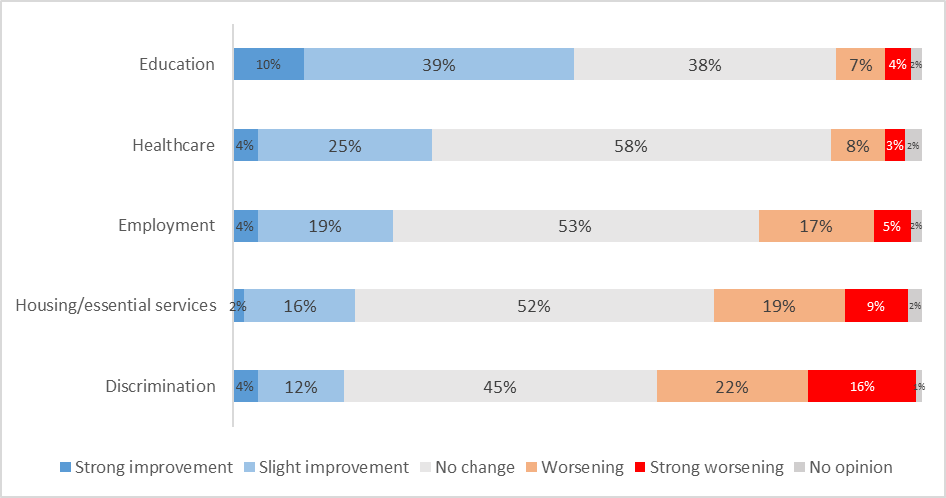

*OPC*

Regarding **policy development** at EU level most progress is seen in education and in fighting discrimination. Also for health and employment more people see improvement rather than deterioration. Regarding housing negative opinions outnumber positive ones. On policy development at the national level the balance tilts towards the positive for education and healthcare, and to the negative for employment, discrimination and especially housing.

Replies suggest that successful Roma integration strategies at both European and national level need to be comprehensive, covering at least the **key fields of the EU framework** as well as **fighting antigypsyism**. From a list of 20 possible priority areas[6] education emerged as a clear priority (67 % at European and 76 % at national level), followed by employment (49 % at European and 57 % at national level), while more than one third of respondents at both European and national levels selected the fight against discrimination and antigypsyism, as well as access to housing and healthcare as priorities.

The need for a comprehensive approach is also suggested by the finding that there are multiple causes of exclusion that integration strategies must address simultaneously. These include primarily discrimination and antigypsyism, limited political commitment, lack of Roma participation, limited capacities of institutions and insufficient funding.

According to 60 % of the respondents national, regional and local authorities need EU-support to improve the situation of Roma. Stakeholders see a stronger role for the EU than for national authorities in monitoring and enforcing European non-discrimination and anti-racism legislation and in making the development and implementation of ambitious Roma inclusion policies a condition for access to funding. National authorities are expected to play a bigger role in measures fighting antigypsyism (such as community building between Roma and non-Roma, non-discrimination and Roma inclusion training for public officials, or making Roma history and culture part of school curricula) and in increasing Roma participation (political participation, national fora of cooperation, capacity building, involvement in policy development and monitoring).

Achievements (putting Roma inclusion high on the policy agenda, EU funding, recognition of antigypsyism as a specific form of intolerance) are linked to the EU, rather than the national level. Regarding challenges to the framework and NRIS, the overarching challenge highlighted by most stakeholders participating at the public consultations is the lack of effective mainstreaming (i.e. sensitivity of mainstream public policies to Roma needs).

**3. Results by evaluation criterion**

The evaluation assessed five basic criteria (relevance, coherence, effectiveness, efficiency, and the EU added value) and three additional ones (equity, coordination, sustainability). The additional criteria are reviewed below linked to the basic evaluation criteria to which they are most closely connected (equity under relevance, coordination under effectiveness, and sustainability under EU added value).

***3.1. Relevance***

The analysis of relevance looks at whether the objectives set were appropriate to the needs at the time and continue to be relevant today. **Relevance is assessed as overall positive with limitations**. The evaluation confirmed the priority areas as key to Roma inclusion and they continue to be valid today.

The evaluation also identified **shortcomings** in the initial design of the framework:

* While relevant, the goal in the area of education (that all Roma children complete at least primary education) was not ambitious.
* Fighting discrimination was a general objective, a cross-cutting theme without a specific non-discrimination goal. Action targeting antigypsyism was found to be insufficient, although the framework identified measures tackling discrimination in each policy area and subsequent EU policy documents recognised antigypsyism as a specific form of intolerance,[7] as well as steps at EU and national level to fight discrimination, racism and xenophobia in line with EU legislation[8].
* While the framework highlighted diversity under the broad umbrella term of Roma[9], it proved to have limited capacity to deal with diversity within the Roma population. It did not pay sufficient attention to targeting specific groups among Roma, addressing the gender dimension or multiple discrimination (**equity**).

To respect Member State competences the EU framework provides flexibility for the adaptation of its objectives and selection of target groups to specific national contexts. This flexibility implies that the framework’s relevance hinges closely on the appropriateness and ambition of the objectives and measures set out in NRIS. While such an approach has the potential to strengthen the relevance of actions, the evaluation found that overall it contributed to fragmented implementation reducing effectiveness.

***3.2. Effectiveness***

The analysis of effectiveness considers the extent to which the framework has made progress so far towards its objectives, both in terms of Roma integration goals and the setting up of instruments and structures for Roma integration at EU and national level (**coordination**).

**Effectiveness in progress towards Roma integration goals is assessed as overall limited** with significant differences across areas and countries[10]. Education is found as the area with most progress (improvements in early school-leaving, early childhood education and compulsory schooling, but deterioration in segregation). The self-perceivedhealth status of Roma has improved but medical coverage continues to be limited. No improvement has been observed in access to employment, and the share of young Roma not in employment, education or training (NEET) has even increased. The housing situation remains difficult. Some progress has been observed in respect to the general objective of fighting poverty. Antigypsyism and hate crime continue to be a matter of high concern, despite evidence of some reduction in discrimination experiences of Roma when accessing services in some areas.

*Chart 2: 2011-2016 changes in the situation of Roma in the policy areas, poverty; Discrimination by area and antigypsyism*

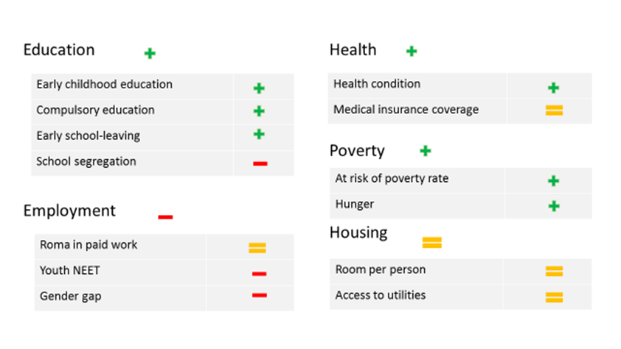

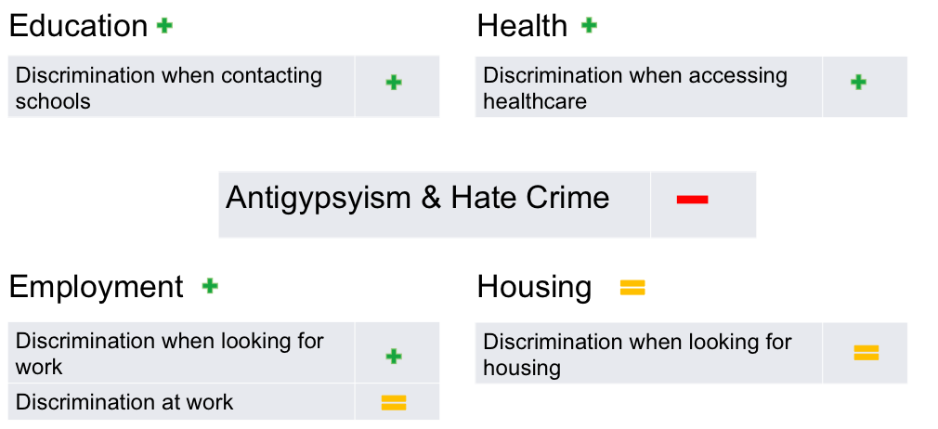

*FRA 2011, 2016, 2017*

**Effectiveness in terms of coordination** **is assessed as positive at EU level and limited at national level.** According to the evaluation findings, the framework succeeded in setting up or strengthening instruments and governance structures and building cooperation among and capacity of actors working on Roma inclusion. The framework further improved stakeholder cooperation at EU and national level, but participation does not yet sufficiently impact policy-making and service design. At national level, the framework led to the development of instruments – national Roma strategies, Contact Points (NRCP) and platforms – but the alignment of NRIS with Roma integration goals is incomplete. According to the evaluation findings, although the establishment of NRCP has led to improvements in cooperation among public administration entities and between public administration and other stakeholders, several NRCP still lack institutional weight, resources and capacity.

***3.3. Coherence***

The analysis of coherence examines how well the EU framework works together with other EU and national instruments. **Coherence has been assessed as positive at EU level and limited at national level.**

The evaluation shows that at EU level progress has been made in mobilising policy, funding and legal instruments for Roma inclusion. This is particularly the case for the Europe 2020 strategy (through synergies between Europe 2020 targets and Roma integration goals and country-specific recommendations on Roma) and European Structural and Investment Funds (ESIF 2014-2020: Roma-specific investment priority[11] and ex ante conditionality). Moreover, a link between Europe 2020 and ESIF was created: Member States that received country-specific recommendations on Roma were to include the Roma-specific investment priority and use ESIF for inclusive policy reform. This in turn triggered the applicability of the Roma-related thematic ex-ante conditionality and its fulfilment criteria, closely linked to the framework’s objectives.

The evaluation suggests that the framework also succeeded in mainstreaming Roma inclusion goals into areas such as enlargement[12], Urban Agenda[13], EU anti-trafficking policies[14] or proposals such as the recast Drinking Water Directive[15]. However, the evaluation notes that Roma are not explicitly referred to in the Youth Guarantee or the European Pillar of Social Rights. The EU framework and EU legal instruments are highly complementary in terms of aims and scope. The enforcement of EU legislation by the Commission strengthens the framework’s policy objectives, while the monitoring NRIS implementation informs the Commission on the state of play of the EU legislation.

The evaluation found that the framework contributed to mainstreaming Roma integration into legal, policy and financial instruments at national level to a more limited extent. Most NRIS do not connect well with public policies. A major obstacle is NRCPs' limited influence on the design, implementation and decision-making processes of mainstream policies.

***3.4. Efficiency***

The analysis of efficiency assesses the relationship between the resources used in an intervention and the changes generated. The evaluation focused on the efficiency of monitoring and reporting and attempted to assess the costs and benefits in the context of the EU framework and NRIS.

**On monitoring and reporting systems efficiency has been assessed as limited.** Monitoring instruments developed gradually. The 2013 Council Recommendation introduced comprehensive reporting by Member States, albeit only from 2016.[16] This reporting, in line with Member States’ commitments primarily focuses on integration measures, rather than outcome and result indicators that would allow the overall effectiveness of the interventions to be measured. The evaluation finds that the online reporting tool provided by the Commission for reporting from the national to the European level is a positive step towards policy learning and transparency, but still has weaknesses to be addressed (*See Section 4.5.).* Independent monitoring has been ensured through FRA and IPA-funded surveys making possible monitoring progress over time. Since 2017 the Commission has piloted a project to monitor the implementation of NRIS by coordinated civil society coalitions[17].

**The evaluation states that costs and benefits could not be conclusively quantified, evaluated and attributed to the framework**. While costs are short-term, the majority of the potential benefits are long-term and cannot be realised until 2020. In the long term, progress made in education, employment, housing and health would not only reduce poverty among Roma, but also bring fiscal benefits such as contributions to the government budget or impact on the use of public goods and services (reduction in the take-up of social benefits). The integration of Roma could positively impact the labour market (improved efficiency through diminished labour and skill shortages) and the economy, including GDP.

***3.5. EU added value***

The analysis of EU added value looks for changes triggered by the framework over and above what could reasonably have been expected from stakeholders alone or from no action at all. **EU added value has been assessed as positive.** The evaluation observes that the EU action has provided added value to national Roma policies and their implementation through political, governance and financial dimensions.

*Box 2: EU added value*

**Political**

* Roma inclusion high on the EU and national agendas
* Attention to Roma issues even in countries with smaller Roma populations

**Governance**

* Development of structures for Roma inclusion
* Stability thanks to the multiannual character of EU action
* Policy guidance, monitoring and reporting framework for accountability and transparency
* Opportunities for mutual exchange and cooperation
* Comprehensive approach

**Financial**

* ESIF and IPA support to implement NRIS

The evaluation finds that without the EU framework, Roma issues would receive less attention in the EU policy agenda. In some countries NRIS may cease to exist; in others they may be weakened further reducing political commitment to Roma inclusion. The ending of the framework would result in less and looser monitoring and reporting. Some current national policies and targeted structures would stop or become less operational and more symbolic. **More time is needed to consolidate working structures, ensure sustainability and the long-term impact of policies,** according to the evaluation. It is essential that NRIS guided by a common framework are continued and improved. While the initial phase has achieved some tangible, albeit insufficient results, the evaluation submits that the overall process be strengthened and become better focused, with an emphasis on improved political commitment, the introduction of specific measurable targets and rigorous monitoring, and more effective implementation supported by sufficient funding and participatory governance systems.

**4. Evaluation: conclusions and lessons learnt**

The evaluation showed that the framework has been key for the development of and EU and national instruments and structures aiming to promote Roma inclusion, but the ambition of "putting an end to the exclusion of Roma" has not been achieved. Both, the evaluation findings and the earlier annual assessments[18] carried by the Commission on the implementation of the NRIS point to the key priorities to be addressed; these include the need for better mainstreaming, clear focus on fighting antigypsyism, improving partnership and Roma participation, addressing diversity among Roma (with focus on Roma women, youth and children) and better target setting, data collection and reporting to promote policy learning.[19]

4. 1. Combining effective mainstreaming and Roma targeting to ensure sustainability

According to the findings of the evaluation, the EU framework and NRIS should be mobilised more effectively to ensure that Roma needs are reflected in mainstream policies.Inclusion of Roma happens when mainstream policies are responsive to their specific needs. Most current policies aimed at Roma inclusion lack a systemic perspective. The evaluation finds that **national authorities should follow a twin strategy of making mainstream services** **inclusive and providing targeted programmes towards the most vulnerable.** NRIS should detail how to further include Roma in education, employment, health and housing policies and what explicit measures will be developed to overcome specific disadvantages and ensure effective equal access in the different areas. To this end Member States should make full use of the investment priority on integrating marginalised communities such as Roma and other relevant investment priorities.

In relation to this point, for the post-2020 ESIF regulations the Commission proposed to strengthen the link between NRIS and EU funding, maintaining a specific objective on socio-economic integration of marginalised communities such as Roma and allowing funds to be used only if they are linked to strengthened thematic enabling conditions which include requirements for NRIS[20]:

* measures to accelerate Roma integration, and prevent and eliminate segregation;
* taking into account the gender dimension and situation of young Roma;
* setting baselines, measurable milestones and targets;
* arrangements for monitoring, evaluation and review;
* arrangements for mainstreaming Roma inclusion at regional and local levels;
* arrangements for ensuring that the design, implementation, monitoring and review of NRIS are conducted in close cooperation with Roma civil society and all other relevant stakeholders, including those at the regional and local levels.

Roma inclusion is also among the thematic priorities for future assistance to the enlargement region under IPA III..

Also at EU level, the evaluation suggests that consistency between the framework and other policies should be strengthened. Linking policy priorities (both promoting inclusive structural reform under the Semester and enlargement policy, and targeted policies under NRIS) to EU funding should be stepped up. The Commission could for example explore further possibilities to condition funding on the fight against discrimination and antigypsyism, and fully exploit **synergies between Roma integration goals and of key EU and international policy efforts**, such as the European Pillar of Social Rights and the UN 2030 Agenda on Sustainable Development is another mechanism to be considered to be used to the full.

***4.2. Increased focus on fighting discrimination and antigypsyism***

The evaluation found that the lack of a specific non-discrimination goal and targeted strategies and action to fight antigypsyism were among the key weaknesses. While discrimination and social exclusion reinforce each other, any Roma can be exposed to discrimination, but not all are socially excluded.

Some efforts to rectify this weakness have already been made: Antigypsyism is monitored under the Racial Equality Directive[21] and the Council Framework Decision on combating racism and xenophobia[22]; monitoring hate speech online covers antigypsyism and has involved Roma NGOs[23] ; the fight against discrimination and antigypsyism were prioritised in calls under the Rights, Citizenship and Equality programme, under the Roma Civil Monitor project, in stakeholder discussions, such as the European Platform for Roma Inclusion or the High Level Group on combatting racism and xenophobia[24] and in the FRA’s research work[25].

The evaluation suggests that **Member States should be encouraged to implement more measures tackling discrimination and antigypsyism,** e.g.according to the evaluation**,** NRIS should include targeted measures aimed at preventing and countering bias motivated hate crime, hate speech and stigmatisation caused by antigypsyism (such as updating education curricula, inter-ethnic community building, trainings sensitising employers, educational, health and housing authorities, as well as police, prosecutors and judges). Systematic efforts are needed to prevent EU funds from supporting discriminatory practices. Mutual learning and cooperation between public authorities, civil society, the media and equality bodies should cover monitoring and fighting antigypsyism. NRCP should involve equality bodies when drawing up action plans on fighting antigypsyism, racism and discrimination under NRIS.

The evaluation puts forward that fighting discrimination and antigypsyism should be a separate priority area of the framework with a specificnon-discrimination goal alongside the four Roma integration goals**.** At the same time, it should also remain a cross-cutting priority with specific objectives in each of the four policy areas. **A clearer focus on fighting antigypsyism and discrimination should complement, not replace the inclusion approach.** This could both strengthen the enforcement of anti-discrimination and hate crime legislation and increase effectiveness of social inclusion policies.

***4.3. Partnership***

The evaluation found that governance mechanisms are in place at the EU and national level, but their function is still limited. In general, NRIS do not connect effectively to mainstream policies, as they do not involve key sectors and stakeholders in a consistent way. Civil society participation at all stages of European multilevel governance has been fostered. However Roma still have only limited opportunities to participate effectively in political life and in all stages of the policy process. Strengthening the framework and NRIS requires empowerment and capacity building of Roma, civil society, national authorities, in particular NRCP and local governments.

**To ensure Roma empowerment and participation** dedicated measures needs to be encouraged to strengthen the Roma voice in the policy process. These include:

* political participation through community action;
* promoting Roma participation in professions in which they are underrepresented;
* promoting good practices for cooperation between Roma and non-Roma;
* supporting Roma engagement with local authorities and civil society.

Gender equality needs to be taken into account when promoting more effective Roma engagement at all levels.

The evaluationshows that **empowerment and capacity building of Roma and pro-Roma civil society** is crucial not only in providing social services to Roma, but also in policy development and as independent watchdogs. Continued and coordinated civil involvement in monitoring implementation should be ensured. Their involvement in the designing, implementing and monitoring mainstream policies should also be supported at the national level, to ensure that policies reach out to Roma. To this end synergies and cooperation between Roma and mainstream NGOs needs to be supported.

**NRCP should be strengthened** in terms of mandate, institutional capacity, human resources and budget. They have to become efficient advocates of mainstreaming Roma inclusion into all relevant policy areas and engage key departments at national level. To this end they should:

* ensure a permanent dialogue with all departments relevant for Roma inclusion;
* work in close alignment with managing authorities;
* work with regional and local actors;
* involve all relevant actors in overseeing NRIS and relevant policies for Roma inclusion and anti-discrimination;
* strengthen the system of consultation and dialogue with Roma civil society and their involvement in monitoring, evaluating and reporting on implementation.

**Local governments** often do not possess sufficient resources and expertise when it comes to fighting discrimination and promoting social inclusion. EU funds should be used to a larger extent to build local capacities and promote the development, implementation and monitoring of local strategies. Engaging Roma communities in initiatives targeting them and building their capacity to take the leadership in such projects improves the effectiveness and efficiency of EU funds for Roma inclusion and contributes to empowering the people usually referred to as “target group”.[26]

***4.4. Addressing diversity among Roma***

The evaluation found that the EU framework had limited capacity to deal with diversity among Roma. The **gender dimension** was found to be weak, with only some NRIS taking into account the specific vulnerabilities of women. A **child-sensitive approach** would have required more comprehensive strategies tackling children’s needs simultaneously in education, health and housing policies as well as in child protection. Fighting trafficking in human beings with child sensitivity and addressing the gender dimension is still a need. Multiple and intersectional discrimination is rarely addressed.

Although a key trigger for the launch of the EU framework has been intra-EU mobility after enlargement, the framework and most NRIS lack consideration of the needs of EU-mobile Roma, non-EU nationals or stateless Roma. Addressing these needs would require explicit measures and human rights-based practices.

The evaluation shows that NRIS should better reflect the needs of specific groups and the diversity of conditions across the Roma population. NRIS should include explicit targets and indicators to tackle the specific needs of vulnerable groups in each of the key areas. The target group among Roma of key inclusion measures should be specified in NRIS while taking into account the Citizens’ Rights Directive.[27]

***4.5. Target setting, data collection, monitoring and reporting to enable policy learning***

According to the evaluation, complementing the four priority areas with a focus on fighting discrimination and antigypsyism as both a cross-cutting requirement and a separate area and specifying a **portfolio of individually adaptable Roma integration objectives with accompanying targets and indicators** would improve the framework’s effectiveness and relevance. Country-specific targets could be selected from a detailed list of optional targets and indicators per area (differentiated targets in a common framework). Governments should update their objectives and prioritise according to their national circumstances on the basis of data. Having a flexible yet standardised set of objectives and targets can help to take better account of the diversity in the Roma population. A flexible indicator framework would allow NRIS to adapt the shared set of targets to national priorities and improve the quality of NRIS in several ways:

* The objectives of NRIS need to be specified and disaggregated, including nationally adapted targets for sub-sectors.
* The objectives should identify specific, quantified and time-bound targets in each area detailed according to country situations.
* Targets should be set in absolute terms in order to reflect improvement in the situation of Roma, as well as relative terms in relation to the general population in order to reduce gaps.
* Gender inequalities and group specific needs should be present in the targets.
* NRIS should define reporting on its respective targets and pay attention to interconnections across targets in key areas.

The evaluation shows that **data collection, monitoring and reporting systems should be strengthened.** Lack of reliable data disaggregated by ethnicity and lack of transparency and accountability mechanisms are key challenges that make the process of monitoring difficult and unreliable. This makes it difficult to measure progress. The NRIS monitoring and reporting system should provide information at policy and programme level, information on explicit targeted actions and actions to promote more inclusive mainstream policies. Data availability and disaggregation should be improved to ensure appropriate data exists to monitor implementation, achievements and efficiency. Data collection, reporting and analysis to track progress should be developed using FRA's support and technical assistance to national authorities[28] in order to facilitate evidence-based policy learning. Qualitative data should be used to contextualise quantitative indicators and better understand the specific factors contributing to the success or failure of individual interventions.

Improved national reporting coordinated by NRCP and involvement of civil society in monitoring can contribute to the systematisation of knowledge and the documentation of existing experiences, which can strengthen mutual learning and policy transfer.

***4.6. Increase ambition on progress during the pre-accession phase***

The evaluation included also pre-accession countries and the findings shows the importance of ambitious objectives on Roma integration in the pre-accession phase. Therefore, promoting equal access to education, employment, health and housing has been included as part of the enlargement process. All enlargement countries adopted an NRIS, nominated NRCPs and implemented an annual reporting system similar to Member States. Even if progress has been achieved, much remains to be done on the challenges identified above.

**5. Conclusions**

Roma exclusion and discrimination has existed for centuries. Overcoming it requires long-term commitments and a comprehensive approach. Structural changes need time and real impact may not be seen for at least a generation.

The evaluation of the EU framework for national Roma integration strategies up to 2020 has shown that the EU framework is the beginning of a process that, despite many limitations and taking into account the massive task involved, has shown positive results and an initial change in trends. However the evaluation also suggests that further steps could be taken to come closer to achieve the objectives. .

Annex 1

*Table 1 Summary of assessment by evaluation criterion*

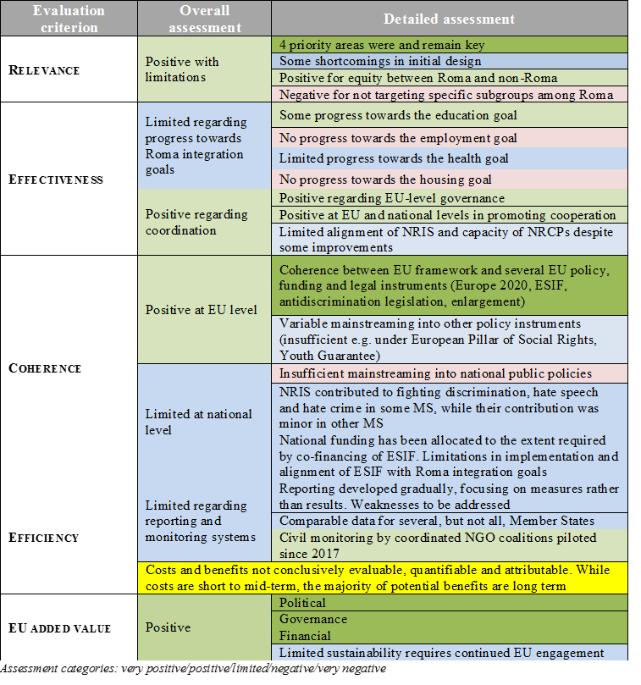

1. COM(2011) 173 final
2. NRIS also stands for integrated sets of policy measures.
3. Enlargement countries include Albania, Bosnia and Herzegovina, former Yugoslav Republic of Macedonia, Kosovo*, Montenegro, Serbia and Turkey.

   * This designation is without prejudice to positions on status, and is in line with UNSCR 1244/1999 and the ICJ Opinion on the Kosovo declaration of independence.
4. EPSCO, 8/12/2016**.**
5. <https://ec.europa.eu/info/consultations/public-consultation-evaluation-eu-framework-national-roma-integration-strategies-2020_en>.
6. Access to education, employment, health care, housing and essential services, documentation; promoting Roma culture and arts, teaching of Romani language, teaching of Roma history; fighting discrimination, addressing antigypsyism, Roma empowerment, specific measures for Roma children, women, youth; poverty reduction; capacity building for national, regional and local authorities, for civil society; coordination and cooperation of stakeholders; funding; monitoring and evaluation.
7. The Council of Europe (ECRI) defines antigypsyism as a ‘specific form of racism, an ideology founded on racial superiority, a form of dehumanisation and institutional racism nurtured by historical discrimination, which is expressed, among others, by violence, hate speech, exploitation, stigmatisation and the most blatant kind of discrimination.’ COM(2017) 458 final, 2008/913/JHA.
8. Council Directive 2000/43/EC of 29 June 2000 implementing the principle of equal treatment between persons irrespective of racial or ethnic origin and Council Framework Decision 2008/913/JHA of 28 November 2008 on combating certain forms and expressions of racism and xenophobia by means of criminal law.
9. The term ‘Roma’ is used in line with the terminology of European institutions and international organisations to refer to a number of different groups (such as Roma, Sinti, Kale, Gypsies, Romanichels, Boyash, Ashkali, Egyptians, Yenish, Dom, Lom, Rom, Abdal) and also includes Travellers, without denying these groups’ special characteristics.
10. Roma integration indicators scoreboard, SWD (2017) 286 final/2 accompanying COM (2017) 458 final.
11. For the 2014-2020 period €1.5 bio were made available to 12 Member States under ESF investment priority 9(ii) ‘Integration of marginalised communities such as the Roma’.
12. Roma integration was fully mainstreamed into enlargement negotiations. It was included in enlargement key priorities, visa liberalisation road map, negotiations on chapter 23 "Judiciary and Fundamental rights", IPA assistance. Progress was assessed in annual Commission reports.
13. Eurocities2017:Roma in Cities in Europe. Brussels. <http://nws.eurocities.eu/MediaShell/media/Mapping_of_the_situation_of_Roma_in_cities_FINAL_REPORT.pdf> .
14. See deliverables under the 2012-2016 EU strategy on eradicating trafficking in human beings, where the situation of Roma and their particular vulnerability and risk of being trafficked are referred to, This is in line with the comprehensive EU anti-trafficking legal (Directive 2011/36/EU) and related EU policy framework, including the Commission Communication reporting on the follow up to the EU Strategy towards the eradication of trafficking in human beings and identifying further concrete actions (COM(2017)728final).
15. COM(2017) 753 final.
16. 2017 in the enlargement region
17. <https://cps.ceu.edu/roma-civil-monitor> A similar process is also funded by IPA.
18. COM/2017/0458 final, COM/2016/0424 final, COM/2015/0299 final, COM/2014/0209 final, COM/2013/0454 final
19. See Annex for a table with a summary of assessment by evaluation criterion.
20. <https://ec.europa.eu/commission/publications/investing-people_en> for Commission ESF+ proposal of 30/05/ 2018; <https://ec.europa.eu/commission/publications/regional-development-and-cohesion_en> for Commission CPR proposal of 29/05/ 2018.
21. Council Directive 2000/43/EC of 29 June 2000 implementing the principle of equal treatment between persons irrespective of racial or ethnic origin, OJ L 180, 19.7.2000, p. 22–26.
22. Council Framework Decision 2008/913/JHA of 28 November 2008 on combating certain forms and expressions of racism and xenophobia by means of criminal law; OJ L 328, 6.12.2008, p. 55–58.
23. <http://ec.europa.eu/newsroom/just/item-detail.cfm?item_id=54300>
24. <http://ec.europa.eu/newsroom/just/item-detail.cfm?&item_id=51025>
25. FRA 2018, A persisting concern: anti-Gypsyism as a barrier to Roma inclusion.
26. The ROMACT programme and FRA’s Local engagement in Roma inclusion (LERI) project are examples of how participatory action methods can facilitate local partnerships and build cohesion at local level. <http://coe-romact.org/>; <http://fra.europa.eu/en/project/2015/local-engagement-roma-inclusion-leri-multi-annual-roma-programme>
27. 2004/38/EC
28. applies also to candidates countries with observer status