

**Contents**

**Section 1: Statistics on the calls for proposals**

**1.** **Call for proposal AGRI-SIMPLE-2016** 2

**2.** **Calls for proposal AGRI-MULTI-2016** 9

**3.** **Call for proposal AGRI-SIMPLE-2017** 13

**4.** **Call for proposal AGRI-MULTI-2017** 19

**5.** **CALL FOR PROPOSAL AGRI-SIMPLE-2018** 24

**6.** **CALL FOR PROPOSAL AGRI-MULTI-2018** 30

**7.** **Evaluation of the proposals for promotion programmes** 35

Section 2: Statistics and details on Commission’s own initiaves

**1.** **High Level Mission to Colombia and Mexico, 7-12 February 2016** 36

**2.** **High Level Mission to China and Japan, 16-22 April 2016** 38

**3.** **High Level Mission to Vietnam, Singapore and Indonesia, 2-9 November 2016** 40

**4.** **High Level Mission to Canada, 30 April – 3 May 2017** 42

**5.** **EU Pavilion at SIAL Canada in Toronto, 2-4 May 2017** 43

**6.** **High Level Mission to Saudi Arabia and Iran, 7-13 November 2017** 44

**7.** **EU Pavilion at SIAL Middle East, 12-14 December 2017** 47

**8.** **SPS Seminar Korea, 20-21 March 2018** 49

**9.** **High Level Mission to China. 14-19 May 2018** 51

**10.** **EU pavilion at SIAL China, 16-18 May 2018** 52

**Section 3: Details on technical support**

**1.** **Objectives and target audience** 54

**2.** **EU agri-food promotion portal** 54

**3.** **Events** 60

**4.** **Information and promotion campaigns** 61

**COMMISSION STAFF WORKING DOCUMENT**

***Accompanying the document***

**REPORT FROM THE COMMISSION TO THE EUROPEAN PARLIAMENT AND THE COUNCIL**

**Interim Report in accordance with Article 26(1) of Regulation (EU) No 1144/2014 of the European Parliament and of the Council of 22 October 2014 on information provision and promotion measures concerning agricultural products implemented in the internal market and in third countries and repealing Council Regulation (EC) No 3/2008**

Section 1: Statistics on the calls for proposals

1. **Call for proposal AGRI-SIMPLE-2016**
   1. **Submission statistics**

**Number of proposals by topic, requested grant and comparison with the available budget**

|  |  |  |  |  |
| --- | --- | --- | --- | --- |
| **Topic** | **Number of proposals** | **Requested grant (EUR)** | **Available budget (EUR)** | **Requested/available** |
| SIMPLE-01-2016 – Union quality schemes | 33 | 28.936.430 | 10.050.000 | 288% |
| SIMPLE-02-2016 – Merits of Union agricultural products | 36 | 46.503.300 | 6.700.000 | 694% |
| SIMPLE-03-2016 -promotion on milk/dairy, pig meat products or a combination of those two | 23 | 44.421.614 | 12.350.000 | 360% |
| SIMPLE-04-2016 -promotion in China, Japan, South Korea and Taiwan | 19 | 31.645.859 | 11.725.000 | 270% |
| SIMPLE-05-2016 -promotion in USA and Canada | 27 | 35.565.457 | 11.725.000 | 303% |
| SIMPLE-06-2016 -promotion in Central and South America and the Carribbean | 2 | 1.021.981 | 7.035.000 | 15% |
| SIMPLE-07-2016 -promotion in South East Asia | 6 | 6.625.481 | 7.035.000 | 94% |
| SIMPLE-08-2016 -promotion in Africa and the Middle East | 9 | 12.411.296 | 4.690.000 | 265% |
| SIMPLE-09-2016 -promotion in other third countries | 9 | 9.479.369 | 4.690.000 | 202% |
| SIMPLE-10-2016 -promotion of milk/dairy products, pig meat products or a combination of those two targeting any third country | 35 | 93.860.125 | 21.000.000 | 447% |
| **Total call AGRI-SIMPLE-2016** | **199** | **310.470.913** | **97.000.000** | **320%** |

**Number of proposals by Member State**

|  |  |
| --- | --- |
| **Member state** | **Number of proposals** |
| Austria | 3 |
| Belgium | 13 |
| Bulgaria | 3 |
| Cyprus | 1 |
| Czech Republic | 1 |
| Germany | 2 |
| Denmark | 3 |
| Estonia | 1 |
| Greece | 41 |
| Spain | 22 |
| Finland | 2 |
| France | 17 |
| Croatia | 2 |
| Hungary | 1 |
| Ireland | 5 |
| Italy | 45 |
| Lithuania | 9 |
| Latvia | 3 |
| Netherlands | 4 |
| Poland | 4 |
| Portugal | 3 |
| Romania | 1 |
| Slovenia | 7 |
| Slovakia | 1 |
| United Kingdom | 5 |
| **Total** | **199** |

**Number of submissions by type of proposing organisation**

|  |  |
| --- | --- |
| **Type of proposing organisation\*** | **Number** |
| EU level trade or inter trade organisation | 0 |
| Agri-food sector body | 51 |
| Producer association | 98 |
| MS level trade or inter trade organisation | 148 |
| **Total n° of applicants** | **297** |
| * - based on declarations made by applicants | |

**Information on or promotion of quality schemes\***

|  |  |  |
| --- | --- | --- |
|  | **SIMPLE internal market** | **SIMPLE third countries** |
| **EU quality schemes** | 43 | 50 |
| **Organic production method** | 14 | 17 |
| **Outermost regions** | 16 | 3 |
| **National quality schemes** | 15 | 13 |

* - based on declarations made by applicants; same proposal can promote more than one quality scheme

**Proposals by product sector**

|  |  |  |  |
| --- | --- | --- | --- |
| **Product sector** | **Number of proposals** | **Requested budget (EUR)** | **Share of total requested budget (EUR)** |
| Fresh and processed fruit and vegetables | 42 | 60.881.350 | 19.6% |
| Meat | 30 | 51.843.533 | 16.7% |
| Dairy products | 29 | 70.932.421 | 22.8% |
| Other eligible products | 8 | 7.530.212 | 2.4% |
| Wine, cider and vinegar | 7 | 2.509.772 | 0.8% |
| Beer | 6 | 4.055.981 | 1.3% |
| Cereals | 3 | 1.412.912 | 0.5% |
| Horticultural products | 3 | 2.717.886 | 0.9% |
| Spirits, liqueurs and vermouth | 3 | 3.292.734 | 1.1% |
| Bread, pastry, cakes, confectionery, biscuits and other baker's wares | 2 | 1.788.508 | 0.6% |
| Olive oil | 2 | 3.715.119 | 1.2% |
| Beverages made from plant extracts | 1 | 2.530.671 | 0.8% |
| Eggs | 1 | 709.047 | 0.2% |
| Fishery and aquaculture products | 1 | 734.505 | 0.2% |
| Honey and beekeeping products | 1 | 279.245 | 0.1% |
| Sugar | 1 | 575.960 | 0.2% |
| Mixed products | 59 | 94.961.058 | 30.6% |
| of which baskets with wine | 32 | 35.698.283 | 11.5% |
| **Total** | **199** | **310.470.913** | **100%** |

**1.2 Statistics on accepted proposals**

**Evaluation outcome**

|  |  |  |
| --- | --- | --- |
|  | **SIMPLE call** | |
| **Status of proposal** | **Number of proposals** | **%** |
| Accepted | 60 | 30% |
| Reserve list | 19 | 10% |
| Rejected - no budget | 26 | 13% |
| Rejected - below threshold | 52 | 26% |
| Ineligible | 42 | 21% |
| **TOTAL** | **199** | **100%** |

**Number of proposals by call and topic, requested grant and consumption of indicative budget per topic**

|  |  |  |  |  |
| --- | --- | --- | --- | --- |
| **Topic** | **Number of proposals** | **Requested grant (EUR)** | **Indicative budget (EUR)** | **Share of indicative budget spent** |
| SIMPLE-01-2016 | 8 | 5.953.197 | 10.050.000 | 59% |
| SIMPLE-02-2016 | 6 | 9.901.855 | 6.700.000 | 148% |
| SIMPLE-03-2016 | 10 | 11.073.863 | 12.350.000 | 90% |
| SIMPLE-04-2016 | 6 | 11.252.044 | 11.725.000 | 96% |
| SIMPLE-05-2016 | 9 | 18.557.750 | 11.725.000 | 158% |
| SIMPLE-06-2016 | 1 | 963.331 | 7.035.000 | 14% |
| SIMPLE-07-2016 | 4 | 4.868.055 | 7.035.000 | 69% |
| SIMPLE-08-2016 | 4 | 7.732.315 | 4.690.000 | 165% |
| SIMPLE-09-2016 | 4 | 4.202.627 | 4.690.000 | 90% |
| SIMPLE-10-2016 | 8 | 19.727.078 | 21.000.000 | 94% |
| **Total call AGRI-SIMPLE-2016** | **60** | **94.232.114** | **97.000.000** | **97%** |

**Approved proposals by Member State**

|  |  |  |  |
| --- | --- | --- | --- |
| **Member state** | **Number of approved proposals** | **Amount of co-financing (EUR)** | **Share of total co-financing (EUR)** |
| AT | 2 | 4.200.000 | 4.5% |
| BE | 5 | 5.863.211 | 6.2% |
| DE | 1 | 1.974.890 | 2.1% |
| DK | 2 | 2.071.709 | 2.2% |
| ES | 6 | 10.248.583 | 10.9% |
| FR | 8 | 9.075.352 | 9.6% |
| EL | 8 | 16.384.710 | 17.4% |
| HR | 1 | 3.316.510 | 3.5% |
| IE | 1 | 3.008.565 | 3.2% |
| IT | 10 | 23.593.771 | 25.0% |
| LT | 6 | 4.984.236 | 5.3% |
| LV | 1 | 2.761.304 | 2.9% |
| NL | 1 | 1.599.280 | 1.7% |
| PL | 1 | 2.040.320 | 2.2% |
| PT | 1 | 731.175 | 0.8% |
| SI | 6 | 2.378.498 | 2.5% |
| **TOTAL** | **60** | **94.232.114** | **100.0%** |

**Approved proposals by product sector**

|  |  |  |  |
| --- | --- | --- | --- |
| **Product sector** | **Number of**  **proposals** | **Approved budget** | **Share of total budget approved** |
| Fresh and processed fruit and vegetables | 14 | 28.336.915 | 30.1% |
| Meat | 12 | 16.114.331 | 17.1% |
| Dairy products | 7 | 13.968.287 | 14.8% |
| Other eligible products (honey. vinegar. beverages made from plant extracts) | 3 | 3.829.002 | 4.1% |
| Beer | 5 | 2.453.566 | 2.6% |
| Cereals | 2 | 985.597 | 1.0% |
| Spirits, liqueurs and vermouth | 3 | 3.292.734 | 3.5% |
| Olive oil | 1 | 3.222.639 | 3.4% |
| Mixed products | 13 | 22.029.044 | 23.4% |
| of which baskets with wine | 5 | 7.957.878 | 8.4% |
| **Total** | **60** | **94.232.114** | **100.0%** |

1. **Calls for proposal AGRI-MULTI-2016**

**2.1 Submission statistics**

**Number of proposals, requested grant and comparison with the available budget**

|  |  |  |  |  |
| --- | --- | --- | --- | --- |
| **Topic** | **Number of proposals** | **Requested grant** | **Available budget** | **Requested/available** |
| **Total call AGRI-MULTI-2016** - multi programmes implemented on the internal market or in third countries | 27 | 116.102.232 | 14.300.000 | 812% |

**Member State of the coordinator**

|  |  |
| --- | --- |
| **Coordinator member state** | **Number of proposals** |
| Belgium | 2 |
| Bulgaria | 2 |
| France | 7 |
| Germany | 1 |
| Greece | 3 |
| Italy | 3 |
| Lithuania | 1 |
| Netherlands | 2 |
| Spain | 5 |
| United Kingdom | 1 |
| **Total** | **27** |

**Number of submissions by type of proposing organisation**

|  |  |
| --- | --- |
| **Type of proposing organisation\*** | **Number** |
| EU level trade or inter trade organisation | 5 |
| Agri-food sector body | 6 |
| Producer association | 16 |
| MS level trade or inter trade organisation | 46 |
| **Total n° of applicants** | **73** |
| * - based on declarations made by applicants | |

**Information on or promotion of quality schemes**

|  |  |
| --- | --- |
|  | **MULTI call** |
| **EU quality schemes** | 8 |
| **Organic production method** | 4 |
| **Outermost regions** | 1 |
| **National quality schemes** | 0 |

* - based on declarations made by applicants

**Target countries**

|  |  |  |
| --- | --- | --- |
|  | **Number of proposals** | **%** |
| Internal market | 20 | 74% |
| Third countries | 7 | 26% |
| **Total** | **27** | **100%** |

**Proposals by product sector**

|  |  |  |  |
| --- | --- | --- | --- |
| **Product sector** | **N° of proposals** | **Requested budget** | **Share of total requested budget** |
| Horticultural products | 5 | 7.823.072 | 6.7% |
| Mixed products | 5 | 18.429.905 | 15.9% |
| Fresh and processed fruit and vegetables | 4 | 27.072.624 | 23.3% |
| Olive oil | 4 | 4.886.846 | 4.2% |
| Wine | 3 | 7.506.894 | 6.5% |
| Dairy products | 2 | 24.900.000 | 21.4% |
| Meat products | 2 | 15.228.502 | 13.1% |
| Bread | 1 | 5.460.000 | 4.7% |
| Other eligible products | 1 | 4.794.388 | 4.1% |
| **Total** | **27** | **116.102.232** | **100.0%** |

**2.2 Statistics on accepted proposals**

**Evaluation outcome**

|  |  |  |  |
| --- | --- | --- | --- |
|  | **MULTI call** | | |
| **Status of proposal** | **Number of proposals** | **%** |
| Accepted | 6* | 22% |
| Reserve list | 1 | 4% |
| Rejected - no budget | 0 | 0% |
| Rejected - below threshold | 16 | 59% |
| Ineligible | 4 | 15% |
| **TOTAL** | **27** | **100%** |

* after addition budget has been allocated

**Number of proposals, requested grant and consumption of indicative budget\***

|  |  |  |  |  |
| --- | --- | --- | --- | --- |
| **Topic** | **Number of proposals** | **Requested grant** | **Indicative budget** | **Share of indicative budget spent** |
| **Total call AGRI-MULTI-2016** | 6 | 16.827.217 | 14.300.000 | 118% |

* after addition budget has been allocated

**Details on accepted proposals\***

|  |  |  |  |  |  |
| --- | --- | --- | --- | --- | --- |
| **Applicants’ member states** | **Number of approved proposals** | **Product sector** | **Target countries** | **Amount of co-financing (EUR)** | **Share of total co-financing (EUR)** |
| BE+NL | 1 | Fruit (fresh or dried) | DE | 1.322.400 | 7.9% |
| FR+ES+PT | 1 | Outermost regions logo | BE, FR, DE, PL, PT, ES | 2.700.000 | 16.0% |
| DE | 1 | Cut flowers and plants, bulbs roots and live plants | FR, DE, PL, SE | 1.399.478 | 8.3% |
| IT+ES | 1 | Olive oil | US, JP | 568.282 | 3.4% |
| ES+FR | 1 | Wine. cider and vinegar | US, CA | 2.400.000 | 14.3% |
| UK+DK | 1 | Organic products | UK, DK | 8.437.056 | 50.1% |
| **Grand Total** | **6** |  |  | **16.827.217** | **100.0%** |

* after addition budget has been allocated

1. **Call for proposal AGRI-SIMPLE-2017**

**3.1 Submission statistics\***

**Number of proposals by topic, requested grant and comparison with the available budget**

|  |  |  |  |  |
| --- | --- | --- | --- | --- |
| **Topic** | **N° of proposals** | **Requested grant (EUR)** | **Indicative budget (EUR)** | **Requested / available** |
| SIMPLE-01-2017 -Union quality schemes | 45 | 64.907.025 | 12.375.000 | 525% |
| SIMPLE-02-2017 -merits of Union agricultural products | 43 | 80.636.570 | 10.125.000 | 796% |
| SIMPLE-03-2017 -promotion in China, Japan, South Korea, Taiwan, South East Asia or India | 26 | 46.580.231 | 14.750.000 | 316% |
| SIMPLE-04-2017 -promotion in USA, Canada or Mexico | 19 | 30.627.547 | 11.600.000 | 264% |
| SIMPLE-05-2017 -promotion in Africa, Middle East, Iran or Turkey | 16 | 27.752.872 | 8.450.000 | 328% |
| SIMPLE-06-2017 -promotion in other third countries | 11 | 11.158.681 | 11.600.000 | 96% |
| SIMPLE-07-2017 - promotion of milk/dairy products, pig meat products or a combination of those two targeting any third country | 24 | 39.591.211 | 12.600.000 | 314% |
| SIMPLE-08-2017 -promotion of beef products targeting any third country | 5 | 5.179.988 | 4.000.000 | 129% |
| **Total** | **189** | **306.434.124** | **85.500.000** | **358%** |

* Submission statistics do not take into account 1 incomplete proposal received after the submission deadline via email; they also do not take into account changes in requested grant and topics selected by the applicants that were confirmed during the evaluation.

**Number of proposals and requested grant by Member State**

|  |  |  |  |
| --- | --- | --- | --- |
| **Member State** | **Number of proposals** | **Requested grant (EUR)** | **%** |
| AT | 2 | 4.200.000 | 1.4% |
| BE | 10 | 12.513.855 | 4.1% |
| BG | 8 | 18.453.415 | 6.0% |
| CY | 2 | 2.342.968 | 0.8% |
| CZ | 2 | 3.917.021 | 1.3% |
| DE | 7 | 7.296.788 | 2.4% |
| DK | 1 | 577.601 | 0.2% |
| EL | 30 | 64.763.709 | 21.1% |
| ES | 16 | 31.663.997 | 10.3% |
| FR | 23 | 32.179.549 | 10.5% |
| HR | 2 | 3.454.490 | 1.1% |
| HU | 2 | 407.600 | 0.1% |
| IE | 2 | 4.149.037 | 1.4% |
| IT | 36 | 53.391.032 | 17.4% |
| LT | 10 | 15.923.818 | 5.2% |
| LV | 5 | 6.235.588 | 2.0% |
| NL | 5 | 8.300.969 | 2.7% |
| PL | 8 | 14.541.191 | 4.7% |
| PT | 8 | 5.825.043 | 1.9% |
| RO | 1 | 1.145.175 | 0.4% |
| SE | 1 | 1.407.560 | 0.5% |
| SI | 1 | 391.391 | 0.1% |
| UK | 7 | 13.352.329 | 4.4% |
| **Total** | **189** | **306.434.124** | **100.0%** |

**Number of submissions by type of proposing organization**

|  |  |
| --- | --- |
| **Type of proposing organization\*** | **Number** |
| Agri-food sector body | 44 |
| Producer organisation or association of producer organisations | 95 |
| Trade or inter-trade organisation | 95 |
| Trade or inter-trade organisation of the Union | 0 |
| **Total n° of applicants** | **234** |
| * - based on declarations made by applicants | |

**Information on or promotion of quality schemes**

|  |  |  |
| --- | --- | --- |
| **Quality scheme\*** | **Internal market** | **Third countries** |
| **EU quality schemes** | 47 | 42 |
| **Organic production method** | 13 | 13 |
| **Outermost regions** | 6 | 5 |
| **National quality schemes** | 15 | 9 |

* - based on declarations made by applicants; a programme can promote more than one quality scheme

**Proposals by product sector**

|  |  |  |
| --- | --- | --- |
| **Product group** | **Number of proposals** | **Request grant** |
| Basket of products | 62 | 107.213.864 |
| Fresh or processed fruit and vegetables | 35 | 55.778.806 |
| Dairy products | 26 | 48.184.166 |
| Meat and meat preparations | 27 | 40.150.875 |
| - Bovine | 6 | 6.689.811 |
| - Pork | 5 | 9.332.740 |
| - Poultry | 3 | 5.174.475 |
| - Sheep and goat | 2 | 984.025 |
| - Meat preparations | 5 | 8.840.002 |
| - Baskets | 6 | 9.129.822 |
| Olive oil | 12 | 28.639.448 |
| Wine, cider and vinegar | 10 | 4.471.357 |
| Other eligible products | 4 | 4.732.970 |
| Cereals | 2 | 4.985.250 |
| Spirits, liqueurs and vermouth | 2 | 3.611.535 |
| Eggs | 2 | 3.305.190 |
| Bread, pastry, cake, confectionery. biscuits and other baker's wares | 2 | 2.200.918 |
| Beer | 2 | 1.245.056 |
| Vegetable oils other than olive oils | 2 | 435.071 |
| Cut flowers and plant, bulbs roots and live plants | 1 | 1.479.618 |
| **Total** | **189** | **306.434.124** |

**3.2 Statistics on accepted proposals**

**Evaluation outcome**

|  |  |  |
| --- | --- | --- |
| **Status of proposal** | **Number of proposals** | **Share of all proposals** |
| Accepted | 52 | 28% |
| Reserve list | 9 | 5% |
| Rejected - below threshold | 101 | 53% |
| Ineligible/inadmissible | 27 | 14% |
| **TOTAL** | **189** | **100%** |

**Number of successful proposals by topic, requested grant and consumption of indicative budget per topic\***

|  |  |  |  |  |
| --- | --- | --- | --- | --- |
| **Topic** | **Number of proposals** | **Requested grant (EUR)** | **Indicative budget (EUR)** | **Share of indicative budget spent** |
| SIMPLE-01-2017 | 11* | 16.690.765 | 12.375.000 | 135% |
| SIMPLE-02-2017 | 10 | 20.136.116 | 10.125.000 | 199% |
| SIMPLE-03-2017 | 3 | 9.415.941 | 14.750.000 | 64% |
| SIMPLE-04-2017 | 7 | 13.284.743 | 11.600.000 | 115% |
| SIMPLE-05-2017 | 5 | 5.228.960 | 8.450.000 | 62% |
| SIMPLE-06-2017 | 3 | 1.984.691 | 11.600.000 | 17% |
| SIMPLE-07-2017** | 10 | 18.053.351 | 17.100.000 | 106% |
| SIMPLE-08-2017 | 4 | 5.167.988 | 4.000.000 | 129% |
| **Total** | **53\*** | **89.962.556** | **90.000.000** | **100%** |

* Grant agreement for the proposal 779621 – PiaveDOP has not been signed thus allowing to grant the first two programme proposals from the reserve list in Annex II to Commission Implementing Decision C(2017) 6934, namely 779464-4EU and 779549- E4QUALITY.

** with addition of the “crisis” budget of 4.500.000 EUR

**Approved proposals by Member State\***

|  |  |  |  |
| --- | --- | --- | --- |
| **Member state** | **N° of approved proposals** | **Amount of co-financing (EUR)** | **Share of total co-financing (EUR)** |
| Belgium | 4 | 3.376.588 | 3.8% |
| Germany | 2 | 2.102.813 | 2.3% |
| Greece | 4 | 7.634.216 | 8.5% |
| Spain | 10 | 25.536.966 | 28.4% |
| France | 17 | 31.559.954 | 35.1% |
| Hungary | 1 | 240.000 | 0.3% |
| Ireland | 1 | 1.417.500 | 1.6% |
| Italy | 4* | 5.086.852 | 5.7% |
| Lithuania | 2 | 3.032.308 | 3.4% |
| Latvia | 1 | 1.012.747 | 1.1% |
| Netherlands | 2 | 3.065.418 | 3.4% |
| Poland | 1 | 1.904.266 | 2.1% |
| Romania | 1 | 1.145.175 | 1.3% |
| Slovenia | 1 | 391.391 | 0.4% |
| UK | 2 | 2.456.362 | 2.7% |
| **TOTAL** | **53** | **89.962.556** | **100%** |

* Grant agreement for the proposal 779621 – PiaveDOP has not been signed thus allowing to grant the first two programme proposals from the reserve list in Annex II to Commission Implementing Decision C(2017) 6934, namely 779464-4EU and 779549- E4QUALITY.

**Approved proposals by product sector\***

|  |  |  |  |
| --- | --- | --- | --- |
| **Product sector** | **N° of proposals** | **Approved budget (EUR)** | **Share of total approved budget (EUR)** |
| Dairy products | 9 | 19.867.868 | 22.1% |
| Basket of products | 10 | 20.802.904 | 23.1% |
| Olive oil | 3 | 14.806.959 | 16.5% |
| Fruit and vegetables | 8 | 11.769.921 | 13.1% |
| Bovine meat | 5 | 6.216.933 | 6.9% |
| Meat preparations | 3 | 5.342.642 | 5.9% |
| Meat preparations; pork meat | 2 | 2.121.320 | 2.4% |
| Spirits, liqueurs and vermouth | 1 | 1.533.760 | 1.7% |
| Other eligible products | 2 | 1.218.357 | 1.4% |
| Cereals; other eligible products | 3 | 1.169.550 | 1.3% |
| Fruit juice | 1 | 1.053.868 | 1.2% |
| Bovine meat; sheep and goat meat | 1 | 1.022.810 | 1.1% |
| Bread, pastry, cakes, confectionery, biscuits and other baker's wares; chocolate and derived products | 1 | 1.012.747 | 1.1% |
| Sheep and goat meat | 1 | 800.000 | 0.9% |
| Meat preparations; poultry meat | 1 | 642.175 | 0.7% |
| Vegetable oils other than olive oils | 1 | 391.391 | 0.4% |
| Wine, cider and vinegar | 1 | 189.351 | 0.2% |
| **Total** | **53** | **89.962.556** | **100%** |

* Grant agreement for the proposal 779621 – PiaveDOP has not been signed thus allowing to grant the first two programme proposals from the reserve list in Annex II to Commission Implementing Decision C(2017) 6934, namely 779464-4EU and 779549- E4QUALITY.

1. **Call for proposal AGRI-MULTI-2017**

**4.1 Submission statistics**

**Number of proposals, requested grant and comparison with the available budget**

|  |  |  |  |  |
| --- | --- | --- | --- | --- |
| **Topic\*** | **Number of proposals** | **Requested grant (EUR)** | **Available budget (EUR)** | **Requested/available** |
| MULTI-A-2017 - increasing the awareness of Union sustainable agriculture on the internal market | 11 | 29.542.753 | 15.050.000 | 196% |
| MULTI-B-2017 -Union quality schemes - internal market or third countries | 8 | 37.031.135 | 15.050.000 | 246% |
| MULTI-C-2017 -merits of Union agricultural products - internal market or third countries | 16 | 65.575.874 | 12.900.000 | 508% |
| **Total call** | **35** | **132.149.762** | **43.000.000** | **307%** |

**Member State of the coordinator**

|  |  |
| --- | --- |
| **Coordinator member state** | **Number of proposals** |
| Belgium | 4 |
| Bulgaria | 1 |
| Germany | 2 |
| Denmark | 1 |
| Greece | 4 |
| Spain | 2 |
| France | 12 |
| Italy | 4 |
| Latvia | 1 |
| Netherlands | 3 |
| Zambia - ineligible | 1 |
| **Total** | **35** |

**Number of submissions by type of proposing organisation**

|  |  |
| --- | --- |
| **Type of proposing organisation\*** | **Number** |
| EU level trade or inter trade organisation | 8 |
| Agri-food sector body | 11 |
| Producer association | 3 |
| MS level trade or inter trade organisation | 23 |
| **Total n° of applicants** | **45** |
| * - based on declarations made by applicants | |

**Information on or promotion of quality schemes**

|  |  |
| --- | --- |
|  | **MULTI call** |
| **EU quality schemes** | 9 |
| **Organic production method** | 4 |
| **Outermost regions** | 2 |
| **National quality schemes** | 2 |

* - based on declarations made by applicants

**Target countries**

|  |  |  |
| --- | --- | --- |
|  | **Number of proposals** | **%** |
| Internal market | 29 | 83 % |
| Third countries | 6 | 17 % |
| **Total** | **35** | **100%** |

**Proposals by product sector**

|  |  |  |  |
| --- | --- | --- | --- |
| **Product sector** | **Number of proposals** | **Requested budget (EUR)** | **Share of total requested budget** |
| Basket of products | 5 | 26.292.209 | 20% |
| Sheep and goat meat (fresh, chilled and frozen) | 3 | 21.908.122 | 17% |
| Dairy products | 5 | 20.124.185 | 15% |
| Fruit and vegetables | 5 | 19.474.203 | 15% |
| Bovine meat (fresh, chilled and frozen) | 2 | 7.378.512 | 6% |
| Cut flowers and plants. bulbs roots and live plants | 5 | 7.237.408 | 5% |
| Wine, cider and vinegar | 1 | 6.415.365 | 5% |
| Bread, pastry, cakes, confectionery, biscuits and other baker's wares | 1 | 5.400.000 | 4% |
| Beer | 2 | 5.394.113 | 4% |
| Other eligible products | 3 | 4.887.616 | 4% |
| Spirits, liqueurs and vermouth | 1 | 2.700.320 | 2% |
| Pork meat (fresh, chilled and frozen) | 1 | 2.537.108 | 2% |
| Preparations of vegetables, fruit or nuts (incl. table olives) | 1 | 2.400.602 | 2% |
| **TOTAL** | **35** | **132.149.762** | **100%** |

**4.2 Statistics on accepted proposals**

**Evaluation outcome**

|  |  |  |
| --- | --- | --- |
| **Status of proposal** | **Number of proposals** | **%** |
| Accepted | 9 | 26% |
| Reserve list | 8 | 23% |
| Rejected - below threshold | 9 | 26% |
| Ineligible | 9 | 26% |
| **TOTAL** | **35** | **100%** |

**Number of accepted proposals*, requested grant and consumption of indicative budget**

|  |  |  |  |  |
| --- | --- | --- | --- | --- |
| **Topic** | **Number of proposals** | **Requested grant (EUR)** | **Indicative budget (EUR)** | **Share of indicative budget spent** |
| MULTI-A | 3 | 10.042.389 | 15.050.000 | 67% |
| MULTI-B | 3 | 13.788.240 | 15.050.000 | 92% |
| MULTI-C | 4* | 21.553.169 | 12.900.000 | 167% |
| **Total** | 10* | 45.383.798 | 43.000.000 | 106% |

* it includes additional proposal ID 779465 from the reserve list after addition budget has been allocated

**Accepted proposals* by origin of beneficiaries, product/sector, target markets and requested grant**

|  |  |  |  |  |  |
| --- | --- | --- | --- | --- | --- |
| **Topic** | **Coordinator’s MS** | **Partners’ MS** | **Product sector** | **Target countries** | **Requested grant (EUR)** |
| **A** | FR | DK+BE+IE+FR+NL+UK | Dairy products (excl. Cheese) | DK+BE+IE+FR+NL+UK | 2.880.000 |
| ES | HU | Sheep and goat meat (fresh, chilled and frozen) | ES+HU | 5.460.000 |
| BE |  | Cut flowers and plants, bulbs roots and live plants | BE+BG+DE+DK+FR+ NL+UK | 1.702.389 |
| **B** | FR | IT | Vegetables (fresh, chilled and dried) excluding sweetcorn; Fruit (fresh or dried); | DE+FR+IT | 4.428.000 |
| FR | NL | Cheese; Dairy products (excl. Cheese) | DE+FR+NL | 6.959.638 |
| EL | BG+RO | Preparations of vegetables, fruit or nuts (incl. table olives); | UAE+KW+ SA | 2.400.602 |
| **C** | NL | BE | Bread, pastry, cakes, confectionery, biscuits and other baker's wares | BE+NL | 5.400.000 |
| FR | HU+FR | Fruit (fresh or dried); Vegetables (fresh, chilled and dried) excluding sweetcorn; | FR+HU | 4.073.221 |
| FR | IE+UK | Sheep and goat meat (fresh, chilled and frozen) | DE+FR+IE+UK | 8.224.061 |
| ES | ES+PT | Rabbit meat | ES+PT | 3.855.887 |
| **TOTAL** |  |  |  |  | **45.383.798** |

* it includes additional proposal ID 779465 from the reserve list after addition budget has been allocated

1. **CALL FOR PROPOSAL AGRI-SIMPLE-2018**

**5.1 Submission statistics**

**Number of proposals, requested grant and comparison with the available budget**

|  |  |  |  |  |
| --- | --- | --- | --- | --- |
| **Topic** | **Number of proposals** | **Requested grant** | **Available budget** | **Requested/**  **available** |
| Simple-01-2018. Union quality schemes | 28 | 36.236.292 | 11.000.000 | 329.4% |
| Simple-02-2018. AGRI methods & products | 32 | 37.948.272 | 7.000.000 | 542.1% |
| Simple-03-2018. Sheep & goat meat | 3 | 4.083.829 | 2.000.000 | 204.2% |
| Simple-04-2018. China, Japan, Asia | 29 | 52.072.195 | 26.250.000 | 198.4% |
| Simple-05-2018. Can, USA,  Mex, Colombia | 21 | 43.700.209 | 22.500.000 | 194.2% |
| Simple-06-2018. Other geographical areas | 33 | 41.486.225 | 26.250.000 | 158.0% |
| **Total call AGRI-SIMPLE-2018** | **146** | **215.527.021** | **95.000.000** | **226.9%** |

**Proposals by Member State**

|  |  |  |  |  |
| --- | --- | --- | --- | --- |
| **Member state** | **Number of programmes** | **Total budget** | **Requested grant** | **Share of total requested budget** |
| Belgium | 8 | 11.730.558 | 8.736.750 | 4.1% |
| Bulgaria | 3 | 10.010.444 | 7.643.908 | 3.5% |
| Czech Republic | 3 | 6.531.624 | 4.665.729 | 2.2% |
| Germany* | 7 | 7.519.549 | 4.187.032 | 1.9% |
| Denmark | 1 | 4.755.088 | 3.804.070 | 1.8% |
| Greece | 22 | 43.292.622 | 34.129.259 | 15.8% |
| Spain | 14 | 28.825.845 | 20.605.748 | 9.6% |
| Finland | 2 | 4.385.818 | 3.370.997 | 1.6% |
| France | 20 | 34.662.169 | 26.982.843 | 12.5% |
| Ireland | 6 | 12.490.424 | 9.512.037 | 4.4% |
| Italy | 31 | 73.611.947 | 56.338.119 | 26.1% |
| Lithuania | 5 | 8.987.573 | 6.861.712 | 3.2% |
| Latvia | 1 | 937.445 | 749.956 | 0.3% |
| Netherlands | 1 | 1.199.979 | 839.986 | 0.4% |
| Poland | 9 | 20.396.211 | 15.868.643 | 7.4% |
| Portugal | 5 | 5.450.870 | 4.150.600 | 1.9% |
| Romania | 2 | 2.768.261 | 2.214.609 | 1.0% |
| Slovenia | 5 | 3.207.675 | 2.245.372 | 1.0% |
| UK | 1 | 3.742.359 | 2.619.652 | 1.2% |
| **Total call AGRI-SIMPLE-2018** | **146** | **284.506.464** | **215.527.021** | **100.0%** |

* 5 were submitted by an applicant from a non-EU country

**Number of submissions by type of proposing organisation**

|  |  |
| --- | --- |
| **Type of proposing organisation\*** | **Number** |
| Agri-food sector body | 38 |
| Producer association | 67 |
| MS level trade or inter trade organisation | 78 |
| **Total n° of applicants** | **183** |
| * - based on declarations made by applicants | |

**Information on or promotion of quality schemes**

|  |  |
| --- | --- |
|  | **Number of proposals** |
| **EU quality schemes** | 65 |
| **Organic production method** | 24 |
| **Outermost regions** | 7 |
| **National quality schemes** | 15 |

* - based on declarations made by applicants

**Proposals by product sector**

|  |  |  |  |
| --- | --- | --- | --- |
| **Product sector** | **Number of proposals** | **Requested Grant** | **Share of total requested grant** |
| Basket of products | 41 | 60.425.699 | 28% |
| Fresh or processed fruit and vegetables | 36 | 57.500.750 | 27% |
| **Meat and meat preparations** | **24** | **37.343.922** | **17%** |
| Bovine | 5 | 4.128.322 | 2% |
| Basket of meat products | 4 | 6.875.442 | 3% |
| Meat preparations | 4 | 4.544.620 | 2% |
| Poultry | 4 | 5.949.831 | 3% |
| Sheep and goat | 4 | 6.703.481 | 3% |
| Pork | 3 | 9.142.227 | 4% |
| Dairy products | 20 | 29.791.922 | 14% |
| Olive oil | 6 | 11.850.469 | 5% |
| Honey and beekeeping products | 5 | 2.459.760 | 1% |
| Wine. cider and vinegar | 4 | 5.122.133 | 2% |
| Other eligible products | 3 | 3.031.664 | 1% |
| Cereals | 2 | 5.410.250 | 3% |
| Cut flowers and plants. bulbs roots and live plants | 1 | 280.000 | 0% |
| Spirits. liqueurs and vermouth | 1 | 489.468 | 0% |
| Beer | 1 | 544.254 | 0% |
| Fisheries | 1 | 554.400 | 0% |
| Bread. pastry. cakes. confectionery. biscuits and other baker's wares | 1 | 722.331 | 0% |
| **Total call AGRI-SIMPLE-2018** | **146** | **215.527.021** | **100%** |

**5.2 Evaluation statistics[1]**

**Evaluation outcome**

|  |  |  |
| --- | --- | --- |
|  | **AGRI-SIMPLE-2018** | |
| **Status of proposal** | **n°** | **%** |
| Accepted | 58 | 39.7% |
| Reserve list | 9 | 6.2% |
| Rejected – no money | 25 | 17.1% |
| Rejected - below threshold | 38 | 26.0% |
| Ineligible | 16 | 11.0% |
| **TOTAL** | **146** | **100.0%** |

**Number of proposals, requested grant and consumption of indicative budget**

|  |  |  |  |  |
| --- | --- | --- | --- | --- |
| **Topic** | **Number of proposals** | **Total grant** | **Indicative budget by topic** | **Share of indicative budget spent** |
| SIMPLE-01-2018 -Union quality schemes | 8 | 13.384.497 | 11.000.000 | 122% |
| SIMPLE-02-2018 -merits of Union agricultural products | 7 | 6.403.194 | 7.000.000 | 91% |
| SIMPLE-03-2018 -sustainable sheep/goat meat production | 1 | 1.810.526 | 2.000.000 | 91% |
| SIMPLE-04-2018 –promotion in China, Japan, South Korea, Taiwan, South East Asia or Southern Asia | 13 | 27.870.725 | 26.250.000 | 106% |
| SIMPLE-05-2018 -promotion in Canada, USA, Mexico or Colombia | 12 | 22.715.290 | 22.500.000 | 101% |
| SIMPLE-06-2018 -promotion in other third countries | 17 | 24.958.927 | 26.250.000 | 95% |
| **Total call AGRI-SIMPLE-2018** | **58** | **97.143.160** | **95.000.000** | **102%** |

**Accepted proposals by Member State**

|  |  |  |  |
| --- | --- | --- | --- |
| **Member state of the coordinator** | **Number of programmes** | **Total grant amount** | **Share of total grant amount** |
| Belgium | 3 | 3.466.480 | 3.6% |
| Bulgaria | 1 | 1.580.261 | 1.6% |
| Czech Republic | 1 | 742.000 | 0.8% |
| Denmark | 1 | 3.804.070 | 3.9% |
| Greece | 7 | 12.474.716 | 12.8% |
| Spain | 6 | 11.392.098 | 11.7% |
| France | 11 | 13.451.886 | 13.8% |
| Ireland | 1 | 3.158.417 | 3.3% |
| Italy | 18 | 34.399.016 | 35.4% |
| Lithuania | 2 | 1.758.051 | 1.8% |
| Netherlands | 1 | 839.986 | 0.9% |
| Poland | 4 | 8.531.209 | 8.8% |
| Portugal | 1 | 795.707 | 0.8% |
| Romania | 1 | 749.264 | 0.8% |
| **Total call AGRI-SIMPLE-2018** | **58** | **97.143.160** | **100.00%** |

**Number of applicants in accepted proposals by type of proposing organisation**

|  |  |
| --- | --- |
| **Type of proposing organisation\*** | **Number** |
| Agri-food sector body | 12 |
| Producer association | 24 |
| MS level trade or inter trade organization | 34 |
| **Total n° of applicants** | **70** |
| * - based on declarations made by applicants | |

**Accepted proposals informing on or promoting quality schemes**

|  |  |
| --- | --- |
|  | **MULTI call** |
| **EU quality schemes** | 23 |
| **Organic production method** | 8 |
| **Outermost regions** | 1 |
| **National quality schemes** | 5 |

* - based on declarations made by applicants

**Target countries of accepted proposals**

|  |  |  |  |  |
| --- | --- | --- | --- | --- |
|  | **Number of proposals** | **Co-financing budget** | **% of total number of proposals** | **% of total co-financing budget** |
| Internal market | 16 | 21.598.217 | 27.6% | 22.2% |
| Third countries | 42 | 75.544.943 | 72.4% | 77.8% |
| **Total** | **58** | **97.143.160** | **100%** | **100%** |

**Accepted proposals by product sector**

|  |  |  |  |
| --- | --- | --- | --- |
| **Product sector** | **Number of proposals** | **Requested budget** | **Share of total requested budget** |
| Fruit and vegetables | 17 | 30.273.221 | 31.2% |
| Fruit (fresh or dried) | 7 | 12.695.989 | 13.1% |
| Preparations of vegetables, fruit or nuts (incl. table olives) | 4 | 9.053.434 | 9.3% |
| Fruit (fresh or dried), Vegetables (fresh, chilled and dried) excluding sweetcorn, Preparations of vegetables, fruit or nuts (incl. table olives) | 4 | 7.088.199 | 7.3% |
| Vegetables (fresh, chilled and dried) excluding sweetcorn | 1 | 749.264 | 0.8% |
| Fruit (fresh or dried), Vegetables (fresh, chilled and dried) excluding sweetcorn | 1 | 686.335 | 0.7% |
|  |  |  |  |
| Meat and meat preparations | 12 | 22.027.405 | 22.7% |
| Pork meat | 2 | 6.150.708 | 6.3% |
| Bovine meat and Pork meat | 1 | 3.158.417 | 3.3% |
| Meat preparations | 2 | 2.748.179 | 2.8% |
| Sheep and goat meat | 1 | 1.810.526 | 1.9% |
| Poultry meat | 2 | 1.799.000 | 1.9% |
| Pork meat, Meat preparations | 1 | 828.735 | 0.9% |
| Pork meat, Poultry meat, Meat preparations | 1 | 480.893 | 0.5% |
| Bovine meat | 1 | 433.507 | 0.4% |
| Cheese and dairy products | 13 | 18.907.782 | 19.5% |
| Basket of products | 10 | 18.696.851 | 19.2% |
| Olive oil | 1 | 4.090.977 | 4.2% |
| Other eligible products | 2 | 2.763.982 | 2.8% |
| Cereals | 1 | 2.520.000 | 2.6% |
| Wine, cider and vinegar | 2 | 1.758.051 | 1.8% |
| Bread, pastry, cakes, confectionery, biscuits and other baker's wares | 1 | 722.331 | 0.7% |
| **Total** | **58** | **97.143.160** | **100.0%** |

1. **CALL FOR PROPOSAL AGRI-MULTI-2018**

**6.1 Submission statistics**

**Number of proposals, requested grant and comparison with the available budget**

|  |  |  |  |  |
| --- | --- | --- | --- | --- |
| **Topic** | **Number of proposals** | **Requested grant** | **Available budget\*** | **Requested/available** |
| MULTI-A-2018 - sustainable sheep/goat meat production | 1 | 3.863.253 | 4.000.000 | 96.6% |
| MULTI-B-2018 - fruits and vegetables in the context of proper dietary practices | 6 | 9.788.118 | 8.000.000 | 122.4% |
| MULTI-C-2018 - Union quality schemes or merits of Union agricultural products | 16 | 57.111.851 | 30.000.000 | 190.4% |
| MULTI-D-2018 - promotion in any third country(ies) | 13 | 39.272.090 | 37.100.000 | 105.9% |
| **Total call** | **36** | **110.035.312** | **79.100.000** | **139.1%** |

* Topic D includes 5 million EUR top-up from the unspent crisis budget

**Member State of the coordinator**

|  |  |
| --- | --- |
| **Member state of coordinator** | **Number of programmes** |
| Belgium | 4 |
| Bulgaria | 4 |
| Cyprus | 1 |
| Germany | 1 |
| Denmark | 1 |
| Greece | 7 |
| Spain | 2 |
| France | 4 |
| Ireland | 1 |
| Italy | 7 |
| Lithuania | 1 |
| Netherlands | 1 |
| Portugal | 1 |
| Romania | 1 |
| **Total** | **36** |

**Number of submissions by type of proposing organisation**

|  |  |
| --- | --- |
| **Type of proposing organisation\*** | **Number** |
| EU level trade or inter trade organisation | 7 |
| Agri-food sector body | 17 |
| Producer association | 30 |
| MS level trade or inter trade organisation | 49 |
| **Total n° of applicants** | **103** |
| * - based on declarations made by applicants | |

**Information on or promotion of quality schemes**

|  |  |
| --- | --- |
|  | **MULTI call** |
| **EU quality schemes** | 11 |
| **Organic production method** | 7 |
| **Outermost regions** | 1 |
| **National quality schemes** | 2 |

* - based on declarations made by applicants

**Target countries**

|  |  |  |
| --- | --- | --- |
|  | **N° of proposals** | **%** |
| Internal market | 23 | 63.9% |
| Third countries | 13 | 36.1% |
| **Total** | **36** | **100%** |

**Proposals by product sector**

|  |  |  |  |
| --- | --- | --- | --- |
| **Product sector** | **N° of proposals** | **Requested budget** | **Share of total requested budget** |
| Fresh or processed fruit and vegetables | 12 | 23.349.463 | 21% |
| Basket of products | 10 | 33.386.856 | 30% |
| Wine, cider and vinegar | 6 | 22.995.603 | 21% |
| Dairy products (excl. Cheese) | 3 | 15.949.654 | 14% |
| Bovine meat (fresh. chilled and frozen) | 2 | 6.686.217 | 6% |
| Spirits. liqueurs and vermouth | 1 | 1.164.640 | 1% |
| Olive oil | 1 | 3.954.459 | 4% |
| Pork meat (fresh. chilled and frozen) | 1 | 2.548.420 | 2% |
| **Total** | **36** | **110.035.312** | **100%** |

**6.1 Statistics on evaluated proposals[2]**

**Evaluation outcome**

|  |  |  |
| --- | --- | --- |
|  | **MULTI call** | |
| **Status of proposal** | **Number of proposals** | **%** |
| Accepted | 21 | 58.3% |
| Reserve list | 0 | 0.0% |
| Rejected - below threshold | 11 | 30.6% |
| Ineligible | 4 | 11.1% |
| **TOTAL** | **36** | **100.0%** |

**Number of proposals, requested grant and consumption of indicative budget**

|  |  |  |  |  |
| --- | --- | --- | --- | --- |
| **Topic** | **Number of proposals** | **Requested grant** | **Indicative budget** | **Share of indicative budget spent** |
| **MULTI-A** | 0 | 0 | 4.000.000 | 0.0% |
| **MULTI-B** | 5 | 9.788.098 | 8.000.000 | 122.4% |
| **MULTI-C** | 10 | 44.747.494 | 30.000.000 | 149.2% |
| **MULTI-D** | **6** | 21.001.858 | 37.100.000 | 56.6% |
| **Total call** | **21** | **75.537.451** | **79.100.000** | **95.5%** |

**Accepted proposals by origin of beneficiaries, product/sector, target markets and requested grant**

|  |  |  |  |  |  |  |
| --- | --- | --- | --- | --- | --- | --- |
| **Topic B** | **Coordinator MS** | **Partners MS** | | **Product sector** | **Target countries** | **Requested Grant (EUR)** |
| BE | FR | | Fresh F&V | France, Belgium, Italy, Poland, Germany | 1.015.961 |
| DE | AT | | Fresh F&V | Germany, Austria | 2.368.844 |
| CY | EL+BG+RO | | Fresh F&V | Czech Republic, Germany, Poland | 3.747.478 |
| BE | DE | | Fresh F&V | Belgium, Germany | 1.232.244 |
| EL | EL+CY | | Fresh F&V | Greece, Germany, Poland | 1.423.570 |
| **Topic C** | DK | SE | Pork meat | | Denmark, Sweden | 2.548.420 |
| FR | DK+FR+IE | Cheese | | Denmark, France, Ireland | 3.740.000 |
| LT | EE | Cheese, Dairy products (excl. Cheese), Spirits, liqueurs and vermouth | | Estonia, Latvia, Lithuania, Germany, Poland | 2.055.193 |
| FR | BE+DK+FR+IE+NL | Dairy products (excl. Cheese) | | Belgium, Denmark, France, Ireland, Netherlands | 9.900.000 |
| BE | FR+ES | F&V | | Belgium, France, Germany, Greece, Poland, Spain | 3.839.834 |
| IT | NL | Organic products | | France, Germany, Italy | 6.415.404 |
| PT | IT | Wine | | Denmark, Germany, Portugal, France | 2.796.367 |
| FR | IT+BE+NL | Bovine meat | | Belgium, France, Italy | 5.995.475 |
| IT | FR | Olive oil | | France, Germany, Italy | 3.954.458 |
| EL | IT+EL | Wine, cheese | | Germany, France, Italy, Greece | 3.502.341 |
|  |  |  | |  | 44.747.494 |
| BG | CY | Cheese | | Brazil, Japan, United States | 2.309.654 |
| **Topic D** | FR | DE | Wine | | United States | 7.881.360 |
| IT | PL | Organic products | | Thailand, United States, Indonesia, Singapore, Vietnam | 1.811.682 |
| ES | FR | Wine | | China, Hong Kong, Taiwan, S. Korea, Japan, Singapore | 2.880.000 |
| IT | EL | Wine | | Canada, Russian Federation, Japan | 4.639.093 |
| EL | BG | Wine | | Belarus, Brazil, China | 1.480.067 |

1. **Evaluation of the proposals for promotion programmes**

Proposals that are submitted following the publication of the calls for proposals have to be firstly checked for their compliance with the admissibility, eligibility, exclusion and selection criteria set out in the annual work programme/call.

For the evaluation of proposals, experts are selected in a way to ensure a high level of skills. experience and knowledge in the areas of the call (including project management. marketing. communication. internationalisation and evaluation of results in relation to the agri-food sector) while ensuring absence of conflict of interest. Special attention is given to achieving a balanced composition in terms of skills, experience, knowledge, geographical diversity and gender.

The evaluation was made against the award criteria set out in the annual work programme/call.

Each proposal was evaluated against the award criteria, independently by (at least) 3 experts.

The experts prepared an individual evaluation report (IER) with comments and scores for each criterion.

For each proposal, the individual experts then formed a consensus group in order to reach a common view and agree on comments and scores (in a consensus report).

Finally, the panels are convened for each topic of the call to examine and compare the consensus reports to check the consistency of their scores and comments and — in case of equal scores — to agree on a priority order.

The ‘above-threshold proposals’ (i.e. proposals that passed both the individual and overall thresholds) are ranked by the experts in order of their overall score in their panel ranked list.

Based on the expert ranking and the budgetary constraints the Agency has drawn up call ranked lists.

The Agency did not deviate from the panel ranked list(s) nor did the Commission in case of selection of simple programme.

Section 2: Statistics and details on Commission’s own initiatives

1. **High Level Mission to Colombia and Mexico, 7-12 February 2016**

**High-level missions are part of a series of Economic Diplomacy activities envisaged to facilitate market access for European agri-food products. They typically include a political part dedicated to political meetings of the Commissioner and a business part with activities for business delegates representing European exporters.**

Participants to the missions are recruited via calls for applications which are published for each high-level mission via different channels:

* official invitations to the European Parliament's Committee on Agriculture.
* the Member States and their Ministries of Agriculture.
* the major professional organisations.
* the Civil Dialogue Group on Quality and Promotion.
* DG AGRI website and social media.
* and since 2017 also via the EU Representations in the Member States; the National Promotion Bodies. and CHAFEA’s website.

The selection is based on several criteria particularly geographical balance among the Member States; sectorial balance taking into account the products potential for the target country market; balance between SMEs and bigger companies; national and European umbrella organisations.

42 business representatives (out of a 58 applications) from 14 Member States accompanied Commissioner Hogan in this mission.

**Participation per Member State:**

|  |  |
| --- | --- |
| EU umbrella organisations | 3 |
| Belgium | 3 |
| Bulgaria | 1 |
| Denmark | 1 |
| Finland | 1 |
| France | 2 |
| Germany | 4 |
| Greece | 1 |
| Ireland | 2 |
| Italy | 3 |
| Spain | 10 |
| Poland | 2 |
| Portugal | 2 |
| UK | 2 |
| Netherlands | 1 |

|  |  |
| --- | --- |
| **Participation per Sector:** |  |
| Alcoholic beverages | 8 |
| General | 2 |
| Dairy | 6 |
| Fruit and Veg | 3 |
| Meat | 15 |
| Cereals and Potato starch | 2 |
| Confectionary | 2 |

**Political deliverables of the mission included:**

* Market access issues;
* Good communication channel established between Colombian authorities and the EU in different issues: organics, SPS, rural development etc.; negotiations were launched on the organics agreement;
* Awareness about the EU and the Trade Agreement increased;
* GI friendly partner in the region

**Elements of business delegation programme:**

* Networking dinner with Commissioner
* Introductory seminar for European producers about Colombian market
* Business seminars on EU products for local buyers, retailers and distributors
* B2B meetings
* Retail visits in Colombia: Carulla. Jumbo. Exito
* Networking dinner with the EU MS Embassies and representatives of the Mexican authorities
* Business Seminar on Mexican market
* Retail visits in Mexico: Chedraui. La Europea Plaza Carso. Liverpool. La Bottega Culinaria. Condesa.

**High Level Mission to Colombia and Mexico – evaluation highlights**

* 92% of business delegates were satisfied with the mission
* 72% of business delegates indicated a possibility for their business to grow as a result of the mission.

1. **High Level Mission to China and Japan, 16-22 April 2016**

45 business delegates (out of 151 applications) from 15 Member States took part in this mission.

**Participation per Member State:**

|  |  |
| --- | --- |
| EU umbrella organisations | 7 |
| Belgium | 5 |
| Bulgaria | 1 |
| Denmark | 1 |
| Finland | 1 |
| France | 7 |
| Germany | 4 |
| Greece | 1 |
| Ireland | 3 |
| Italy | 11 |
| Spain | 9 |
| Poland | 5 |
| Portugal | 5 |
| Sweden | 2 |
| UK | 3 |
| Netherlands | 1 |

|  |  |
| --- | --- |
| **Participation per Sector:** |  |
| Meat (pork/beef/poultry) | 20 |
| Alcoholic beverages | 14 |
| Dairy | 10 |
| F&V and Olive Oil | 3 |
| General | 10 |
| Cereals | 3 |
| Other (animal fat/genetic material) | 3 |

**The mission delivered the following results:**

* SPS and market access: restrictions connected to Schmallenberg virus lifted for 4 Member States and some administrative progress on BSE;
* GI negotiations: a successful round took place in November. Next one was in February 2017;
* Organics: agreed to revisit current positions and a meeting took place between the CNCA and DG AGRI in July 2016;
* Cooperation in agriculture research: DG Plewa attended the Food Security and Safety Summit in China in November;
* Young farmers: a cooperation project agreed to be launched.

**Regarding the mission in Japan (Tokyo. Yokohama). the results of the vising include:**

* several SPS barriers were tackled or advanced upon: end of beef ban due to BSE (beyond the lift of the ban on Italian beef);
* Japan agreed to harmonise with widely recognised international standards in the field of food and wine additives;
* recognition of the regionalisation principle in the area of animal diseases;
* Strong political message was delivered regarding EU ambition for EU-Japan FTA and EU readiness to conclude the FTA as soon as possible.

**Elements of the business delegation programme:**

* Handbooks on the Chinese and Japanese markets
* Working meetings with Commissioner Hogan
* Workshop organised by the EU Chamber of Commerce in China
* Seminar on Green Agriculture and Sustainable Trade
* Business seminar on European products for Chinese businesses
* Site visits in China: organic farm, GI production sites, Chongming Ecological Agricultural Science and Innovation Center
* Launch of the “European Restaurant Week” in China
* Retail visits in China: Sanyuanqiao Best Collections, Carrefour, Metro, Jenny Lou
* Introductory seminar on Japanese market
* Launch of the “Tastes of Europe – Restaurant Week” In Japan
* Business seminar on EU products
* B2B meetings
* Retail visits in Japan: Takashimaya. Metro, Motomachi Union Supermarket
* Site visits in Japan: in and around port of Yokohama.

**High Level Mission to China and Japan – evaluation highlights**

* 91% of business delegates satisfied with participation
* 75% expected their business to grow as a result of the mission
* One year after the mission 81% of business delegates confirmed that contacts established during the mission facilitated their business and 44% of them concluded new business deals for a total sales value of over 75 million EUR a year.

1. **High Level Mission to Vietnam, Singapore and Indonesia, 2-9 November 2016**

The visit to Vietnam was organised in the wake of the EU-Vietnam Free Trade Agreement. concluded on 2 December 2015. The Commissioner focused his diplomatic efforts on swift implementation of the FTA in order to maximise the opportunities it offered, while emphasising the importance of removing SPS barriers to trade. Good political contacts were made during the visit with progress expected on SPS issues.

Similarly, the visit in Indonesia followed the launching of the negotiations on the EU-Indonesia Free Trade Agreement amid expectations for much higher trade flows. The Commissioner raised issues of GI protection and TBT and SPS barriers, including progress on “single entity” status for the EU, access to the port of Jakarta as well as discussions on BSE status.

52 business representatives (out of 82 applications) from 16 Member States participated in this mission.

**Participation per Member State:**

|  |  |
| --- | --- |
| EU umbrella organisations | 7 |
| Belgium | 1 |
| Bulgaria | 2 |
| Denmark | 1 |
| Finland | 2 |
| France | 3 |
| Germany | 3 |
| Greece | 1 |
| Hungary | 1 |
| Ireland | 2 |
| Italy | 7 |
| Spain | 7 |
| Poland | 4 |
| Portugal | 3 |
| Romania | 1 |
| UK | 3 |
| Netherlands | 3 |

**Participation per Sector:**

|  |  |
| --- | --- |
| Meat (pork/beef/poultry) | 21 |
| Dairy | 9 |
| F&V and Olive oil | 7 |
| Alcoholic beverages | 6 |
| General | 4 |
| Cereals | 4 |

**The mission featured a number of new elements:**

* Introductory briefing meeting organised in Brussels ahead of departure
* Business delegation visited one country – Singapore – without the Commissioner
* Mission was linked to a major international trade event (SIAL Interfood Indonesia)
* Programme of activities benefited from cooperation with Member States and co-financed promotion programmes
* Working breakfasts with the Commissioner were organised for different categories of products.
* Programme of business delegation activities featured different elements organised according to the objectives of the mission.

1. **To improve market knowledge:**

* Market Entry Handbooks
* Introductory seminars including with Vietnamese Minister of Agriculture on the FTA
* Retail visits: Lottemart, Occident Mart, AEON Mall, ANNAM Gourmet market (in Vietnam), Fairprice Finest, La Petitie Boutique, Quartier, Sheng Siong (Singapore), Carrefour (Indonesia)
* Information sessions per different sectors and product categories
* Networking activities

1. 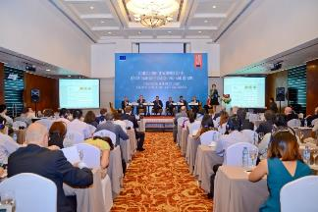**To organise business contacts on the spot:**

* B2B meetings
* Business fora for local buyers
* Press conferences
* Visit to SIAL Indonesia

1. **To allow for interaction with the Commissioner. Commission and Member States officials:**

* Breakfasts, debriefing and other networking opportunities with Commissioner
* Participation in the event “Ballade en France”.

**High Level Mission to Vietnam, Singapore and Indonesia – evaluation highlights**

* Average satisfaction rate among business delegates at 96%
* One in four business delegate closed business deals as an immediate result of the mission
* One year after the mission 89% of the business delegates confirmed that contacts established during the mission facilitated their business and 53% concluded business deals.

1. **High Level Mission to Canada, 30 April – 3 May 2017**

High Level Mission to China was organised to coincide with the beginning or provisional application of the CETA agreement as well as the SIAL Canada fair in Toronto where the EU was designated the Region of Honour. Commissioner’s political programme was organised in parallel to the activities of the business delegation.

**The objectives of business delegation activities were to:**

* Increase market knowledge. notably by providing insights into the regulatory framework and consumer preferences;
* Provide local business contacts.

A 60-strong business delegation (out of 156 applications) came from 22 Member States. featuring 57% delegates who joined Commission’s missions for the first time.   
  
**Participation per Member State:**

|  |  |
| --- | --- |
| EU umbrella organisations | 5 |
| Austria | 3 |
| Belgium | 5 |
| Bulgaria | 1 |
| Cyprus | 1 |
| Denmark | 1 |
| Finland | 1 |
| France | 4 |
| Germany | 1 |
| Greece | 2 |
| Hungary | 4 |
| Ireland | 3 |
| Italy | 8 |
| Latvia | 1 |
| Lithuania | 3 |
| Netherlands | 1 |
| Poland | 3 |
| Portugal | 1 |
| Romania | 1 |
| Slovak Republic | 1 |
| Slovenia | 1 |
| Spain | 6 |
| Sweden | 1 |
| United Kingdom | 2 |

**Participation per Sector**:

|  |  |
| --- | --- |
| Alcoholic beverages | 17 |
| Confectionary + genera | 14 |
| Dairy | 12 |
| Fruit and Veg | 8 |
| Meat | 9 |

**Activities organised for the business delegates:**

* Networking dinner
* Business forum
* B2B meetings
* Participation in the opening of EU pavilion at SIAL Canada, visit of the fair
* Session on CETA
* Retail visits to Loblaws, Metro, Pusateri’s
* Site visits to the LCBO, Ontario Food Terminal, St. Lawrence Market, Food Starters, Food Innovation & Research Centre.

**High Level Mission to Canada – evaluation highlights**

* 59% overall satisfaction rate among business delegates
* Highest rated activities by business delegates: retail visits, business forum, introductory seminar
* 56% of business delegates expected their business to grow as a result of the mission.

1. **EU Pavilion at SIAL Canada in Toronto, 2-4 May 2017**

Commission organised EU pavilion at SIAL Canada in Toronto in order to profit from the Region of Honour status granted to the EU by fair organisers in 2017 as well as to emphasise the trade opportunities opened by the CETA agreement.

**The pavilion was organised in order to:**

* Promote and raise the profile of Union agricultural production methods, quality schemes and high quality and safety standards in particular in the context of CETA.
* Promote EU products through common activities (permanent / non-permanent ones) all day long for 3 days.
* Achieve good media coverage and exposure of EU products.

**Priority topics of pavilion communication included:**

* CETA agreement
* 'Safe Food for Canadians' (new Canadian regulation to be implemented in 2017 implies that importers have a license for importation)
* PDO/PGI/TSG: Stress value and message of the origin
* In addition: Organic / sustainable agriculture

Product categories exhibited at the EU pavilion: Wine, Spirits, Beer, Fresh and Processed meat, Olive Oil, Fresh fruits and vegetables, Processed fruits and vegetables, Dairy products, Processed cereals, Bread, Pastry, Cakes, Biscuits and other bakery products, Chocolate and derived products, Confectionary, Honey, Gums resins and plant extracts, Cotton, Living plants, products with Geographical Indications.

**List of activities and features of the EU pavilion:**

* Display and tasting of a selection of GI and organic products. combined with informative session moderated by and expert in each category. At least 10 products from 10 different Member States were represented in each category of products.
* Interactive screen directing visitors to Member States’ pavilions. EU companies and EU co-financed programmes, informing of benefits of CETA, providing information on GI products and presenting promotion campaigns running in Canada.
* SIAL opening by the Commissioner
* Open general information session on CETA
* Session and quiz on GIs
* Presentation of EU co-financed promotion campaigns
* EU-Canadian products pairing
* Cooking shows and classes with local chef
* Mixologist contest
* Press interviews with EU business delegates.

1. **High Level Mission to Saudi Arabia and Iran, 7-13 November 2017**

Organised within the framework of EU economic diplomacy, the high-level mission to Saudi Arabia and Iran had two parallel aspects: bilateral meetings of the Commissioner with relevant national authorities and accompanying business delegation activities. Objectives of this mission included discussions on market access, establishment or enhancement of business relations as well as improved understanding of the markets.

44 business delegates joined Commissioner in Saudi Arabia, 42 in Iran, mostly overlapping and coming in total from 19 Member States (169 applications from 23 Member States).

**Participation per Member State:**

|  |  |
| --- | --- |
| EU umbrella organisations | 6 |
| Austria | 2 |
| Belgium | 3 |
| Bulgaria | 3 |
| Denmark | 2 |
| Finland | 3 |
| France | 8 |
| Greece | 2 |
| Hungary | 1 |
| Ireland | 3 |
| Italy | 5 |
| Spain | 5 |
| Lithuania | 4 |
| Poland | 3 |
| Portugal | 3 |
| Romania | 1 |
| Netherlands | 3 |

|  |  |
| --- | --- |
| **Participation per Sector:** |  |
| General | 9 |
| Dairy & Baby Milk | 11 |
| Fruit and Veg | 9 |
| Beef. Lamb &Genetic Material | 10 |
| Poultry & Eggs | 3 |
| Cereals & Seeds | 7 |
| Olive oil. Sauces and Condiments | 3 |
| Bakery & Confectionery | 3 |
| Fodder & Feed | 4 |

In order to assist business delegates in valuable market intelligence, the Commission procured Market Entry Handbooks for both visited countries and organised preparatory briefing meeting ahead of the mission.

**Elements of business delegation programme in Saudi Arabia:**

* Business Event "Doing business in Saudi Arabia: Agri-Food sector"
* Press conference
* Individual B2B meetings
* Participation in SFDA conference on food safety
* Official dinner
* Retail visits (to selected supermarkets, shopping malls), European Food Festival
* Field visits (to selected local agri-food companies)
* Breakfasts with Commissioner.

**Elements of business delegation programme in Iran:**

* Exclusive expert presentation on financial transactions with Iran
* EU-Iran Agri-Food Business Forum
* Individual B2B meetings
* Press conference
* Official dinner
* Retail visits (to selected supermarkets. wholesalers. bazaars)
* Field visits (to selected local agri-food companies)
* Breakfasts and debriefing with Commissioner

**Evaluation by business delegates**







**High level mission to Saudi Arabia and Iran – Evaluation highlights:**

54 Business delegates participated in more than 300 B2B meetings and more than 400 attendees of business seminars.

1. **EU Pavilion at SIAL Middle East, 12-14 December 2017**

EU pavilion of 160 m2 was organised at SIAL Middle East in Abu Dhabi. UAE on 12-14 December 2017. This activity belonged in a follow up to Commissioner’s visit to Saudi Arabia and Iran and served a purpose of communicating about key characteristics of EU agri-food products to regional mainly business audience: sustainability, quality, diversity, safety, taste and traceability.

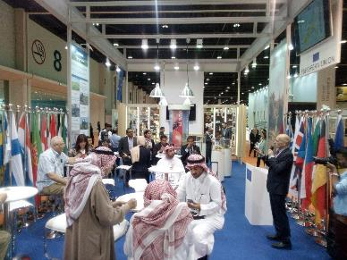The EU pavilion had solely communication and informative function. with no explicit B2B element which was typically covered by EU Member States and private stands. EU companies and promotion programmes exhibiting at the fair.

Pavilion’s activities featured permanent display of selected EU quality food and beverage products from most Member States, scheduled info session on EU food safety and quality policy coupled with tasting of samples made from EU food products by an acknowledged chef Donnchadh Geraghty from Ireland as well as a permanent info desk.

**Food product categories exhibited at the pavilion included:**

* Fruits, vegetables and nuts
* Meat: Beef and poultry
* Dairy and cheese
* Chocolates and confectionery
* Olive oil
* Preparations of cereals, flour, starch or milk
* Pastry processed products
* Food preparations for infant use.

The fair in general attracted relatively low number of visitors in 2017 and as a result it is estimated that EU pavilion was visited by approx. 520 visitors including 160 who participated in the cooking shows and info sessions.

**EU pavilion at SIAL Middle East** – **evaluation highlights**

* 69% of pavilion visitors interested in buying or consuming European products
* Quality was identified as the main driving element behind EU products’ popularity (53%); 21% valued their taste and visual appeal.

1. **SPS Seminar Korea, 20-21 March 2018**

“EU Agri-Foods SPS Seminar” was organised in Four Seasons Hotel. Seoul. South Korea on 20-21 March 2018 as the first SPS Promotion Seminar under EU Promotion policy. SPS Promotion seminars respond to a need for dissemination of EU high safety and quality standards in third countries having highest export growth potential. This includes promoting key elements of the EU Common Agriculture Policy such as EU quality schemes for agricultural products. EU organic production or sustainable production systems for EU agri-food products including in particular EU ‘from farm to fork’ Sanitary and Phytosanitary (SPS) regime. Specifically for Korea, the Seminar aimed to capitalise on opportunities for agri-food products opened by the EU-Korea Free Trade Agreement.

**Issues covered in presentations:**

* Overview of EU food safety regulations
* Animal identification and traceability in the EU
* International standards for safe trade of animal products
* Food information to consumers in the EU
* EU policy on GIs and organics
* Challenges and opportunities on the Korean market
* The EU phytosanitary system (F&V) and the EU pesticides management system
* Regionalisation for plant diseases
* The EU management system for pesticides, residues and chemicals
* Enforcement of EU SPS legislation: controls, audits, inspections.

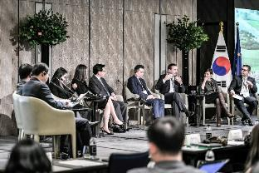The seminar agenda included a Round Table "*The Korean market. Food Safety and Quality standards: benefits and challenges".* The aim of this round table was double: to wrap up and insist on the most important political aspects seen during the lectures (trade irritants with Korea) and to provide to stakeholders other than the Korean official services a chance to have a say. The core of the discussions consisted of identifying elements which may constitute challenges to EU exporters trying to enter the Korean market along with possible solutions. The Round Table was held facing the public and counted with speakers including EU MS trade attachés, EU exporter's representatives, Korean Importers Association, chambers of commerce, Wine and Spirit Importers Association, Fruits Importers Association, private companies, legal firms etc.

Attractive products display was another magnet for target audiences.   
It provided a presentation of food and beverage products from majority of EU MS including products provided directly by MS representatives and their contacts in Korea featuring the following product categories:

* Beverages: mineral water, juice, wine and spirits;
* Confectionery and Chocolate
* Dairy and cheese;
* Fish (processed);
* Nuts and olives;
* Olive oil, balsamic vinegar, sauces and dips;
* Pastry cooked products: biscuits and waffles;
* Preparations of cereals.

The cooking show was a major attraction of the seminar and served as the right complement to the expert sessions. It featured presentations and serving of signature dishes prepared by resident chefs from Austria and Korea as well as hired chef from Italy and a celebrity Korean chef Jae-Hoon Lee. The show generated enormous interest as well as a suitable environment for B2B relations.

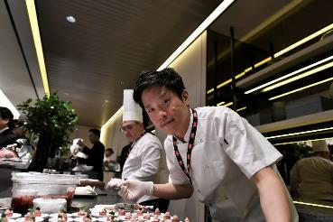

**“EU Agri-Foods SPS Seminar” – evaluation highlights:**

* **147 participants** over 2 days
* **>70%** of participants had increased their overall knowledge on the European Union and EU food safety standards
* **>50%** of participants had increased their knowledge on EU quality policy on GIs, organics and safe EU exports to Korea
* **<40%** of participants had increased their knowledge of the EU’s plant health standards of the EU’s phytosanitary system and of the EU’s pesticides management system
* **All participants** had increased their knowledge of the EU’s GI products following the Seminar
* **64%** found the quality of the speakers to be good, while **36%** found it very good
* **91%** of participants overall satisfied with the reception, cooking shows and product display
* 16 Korean media outlets covered the event
* 19 articles about the seminar published in Korean press and media
* 6 social media influencers and bloggers participated.

1. **High Level Mission to China. 14-19 May 2018**

High Level Mission to China featured events organised in Shanghai and its immediate neighbourhood as well as in Shenzhen. The largest mission organised within Promotion policy’s own initiative activities. It gathered 65 business delegates from 24 Member States (more than 170 applications) representing the following categories of products:

* 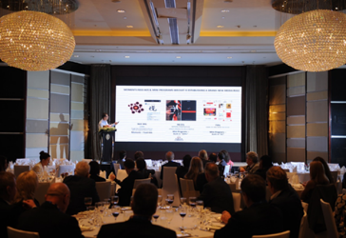Dairy
* Alcoholic Beverages
* Meats & Meat products (Pork; Beef; Poultry)
* Fruits & Vegetables
* Confectionary
* Olive oil

Programme for business delegates was organised in parallel to Commissioner Hogan’s agenda of political meetings.

**The objectives of activities offered to business delegates were to:**

* improve the delegates’ knowledge about Chinese market, its consumers and trends;
* provide networking opportunities with Chinese business people as well as Member States commercial representatives;
* enhance the visibility of European agri-food companies on the Chinese market.

**Events organised for the business delegates included:**

* preparatory briefing meeting in Brussels, including presentation of a dedicated Market Entry Handbook
* 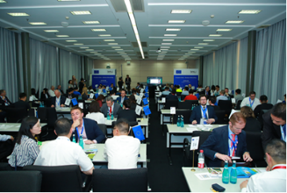internal briefing meeting and networking dinner
* targeted seminar on the Chinese market with presentations from the EU Chamber of Commerce in China, EU SME Centre, China Policy, RCS, Carrefour, EU IPR Helpdesk, Eibens, Publicis Communications
* info desks from EU SME Centre, EU IPR Helpdesk, EU Chamber of Commerce in China
* Sectoral workshops on market access, key SPS issues, future consumption and consumer trends
* Business dinner
* Working breakfasts with Commissioner
* Participation in the opening of EU pavilion at SIAL China and visit of the fair
* B2B matchmaking at SIAL China
* Debriefing from political meetings of the Commissioner
* Retail visits to Metro, Hema supermarkets
* Site visits in Shanghai to Bright Dairy & Food. Carrefour Food Safety Lab, Free Trade Zone, Yumi Research Center
* E-commerce workshop in Shenzhen
* Networking business dinner with local businesses
* Site visits in Shenzhen to the logistics centre, High Green Market

**High level mission to China – evaluation highlights**

* 86% general satisfaction rate among business delegates
* 76% of business delegates expect their business to grow in China as a result of this mission
* The most useful events as rated by business delegates: meetings/interaction with the Commissioner, business seminar, retail visits.

1. **EU pavilion at SIAL China, 16-18 May 2018**

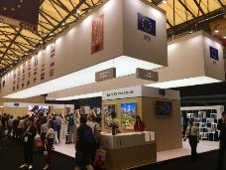EU pavilion at SIAL China in Shanghai was organised on 16-18 May 2018 to coincide with Commissioner Hogan’s high level mission to China with business delegation. A 168 m2 pavilion was designed with an objective of communicating key characteristics of EU agricultural food and beverage products: food safety, tradition, nutritious value and traceability, with a special focus given to GI products on the occasion of ongoing negotiations of the EU-China GI agreement. The EU was also designated as Region of Honour of SIAL China 2018.

**Animations and activities in the pavilion included:**

* Official opening ceremony
* Product display
* Tasting area
* Cooking show & policy
* 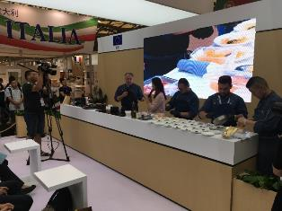information sessions
* Infopoint
* Panel discussion session hosted by  
  SIAL: “Geographical Indication  
  labels – promising high quality and tradition”.

Tasting area was organised into tasting stations with the following product categories: meat, cheese, fruit and vegetables, beer, wine and confectionery. In total, 33 250 samples of quality EU food and beverage products were served during three days of the fair.

Member States contributed selected products both to the tasting stations as well as to product display while it was ensured that products from across the EU are equally represented.

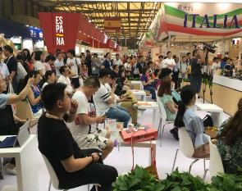The EU pavilion was envisaged to provide additional visibility for the EU at the fair under “Enjoy It’s from Europe” signature while indirectly representing Member States European companies and promotion programmes and reinforcing their status and messaging with the visiting business people and public.

Cooking shows were delivered by Michelin-star German chef operating in Shanghai. accompanied with a commentary by a local moderator and policy officer from the Commission explaining about safety and quality aspects of EU products used for the preparation of the dishes.

**EU pavilion at SIAL China – evaluation highlights**

* 12 cooking and information sessions
* 588 participants in total
* 88.5% participants satisfied
* 85% learned about EU added value for food safety, 71% about health quality of EU foods
* 81% interested in buying EU foods

**Section 3: Details on technical support**

1. **Objectives and target audience**

Technical support services are part of the measures on the initiative of the Commission foreseen by the reformed promotion of agricultural products policy. The objectives of these services are defined in the Regulation (EU) No1144/2014, Article 9:

"2. The Commission shall develop technical support services, in particular with a view to:

(a) encouraging awareness of different markets, including by means of exploratory  
 business meetings;

(b) maintaining a dynamic professional network around information and promotion  
 policy, including providing advice to the sector with regard to the threat of imitation  
 and counterfeit products in third countries; and

(c) improving knowledge of Union rules concerning programme development and  
 implementation."

Subsequently, Chafea and European Commission developed the services presented below targeting the following audiences:

1. National and/or European organisations of producers representing different agricultural  
 product sectors (e.g. dairy, meat, fruit and vegetables, wine etc.)

2. SMEs exporting within the EU and to third countries

3. National authorities (such as ministries of agriculture and paying agencies)

4. Organisations providing support for internationalisation of SMEs

1. **EU agri-food promotion portal**

Based on the input from the stakeholders, the portal was created available at the following web address: <https://ec.europa.eu/chafea/agri/>. It includes market information, information concerning the available funding opportunities, news and events as well as tools supporting the potential applicants for EU funding in their proposal preparation as well as assisting exporters in their export activity. The portal contains an interactive map with information concerning all adopted programmes since 2014 including target markets and budget information.

Please see below the home page of the portal:

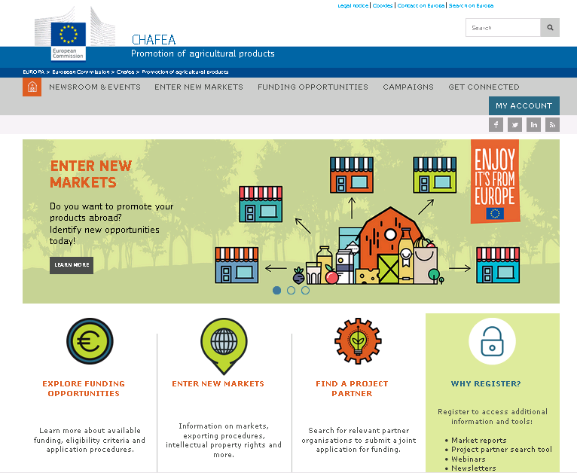

Information regarding the portal statistics can be found in the technical support services section of the report.

Please find below examples of the specific tools offered as part of the portal:

**Market entry handbooks**

Market entry handbooks constitute a tailor-made analysis of the third country markets with identified opportunities for the EU agri-food products. The countries covered by the reports correspond to those where business delegations visits were organised as well as to the priority countries identified each year in the Annual Work Programme. Examples can be found below. There are currently eight market entry handbooks available on the portal with six additional in the preparation.

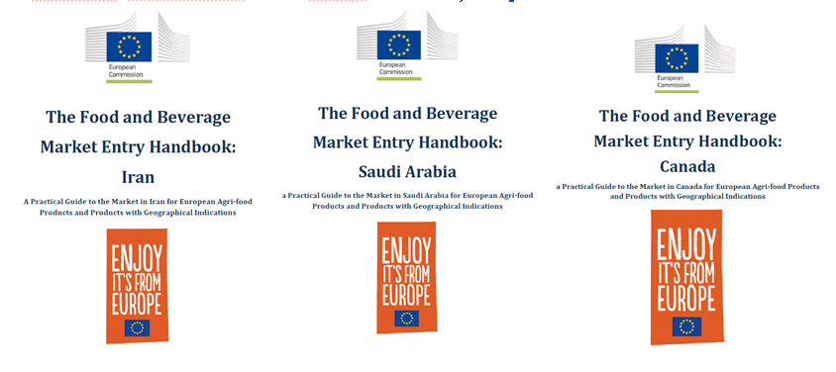

Highlights:

* tailor-made proprietary market reports.
* export opportunities identified per sector.
* advice on the market entry conditions, distribution channels and marketing channels.
* cultural aspects including the DOs and DON'Ts.
* part of the briefing of the business delegation.

**Find partners tool**

In order to facilitate contacts between different organisations eligible for funding as well as stimulate applications for the MULTI call, a specific tool was developed on the portal. It gives the applicants the opportunity to fill in their organisation's profile and define parameters of the desired profile of the partner organisation.



Highlights:

* tool tailored to the specificities of the promotion policy.
* facilitates contacts between organisations from different regions and Member States.

**Eligibility checker**

This tool was created in order to help the applicants navigate through the eligibility criteria and ultimately reduce the number of ineligible proposals.

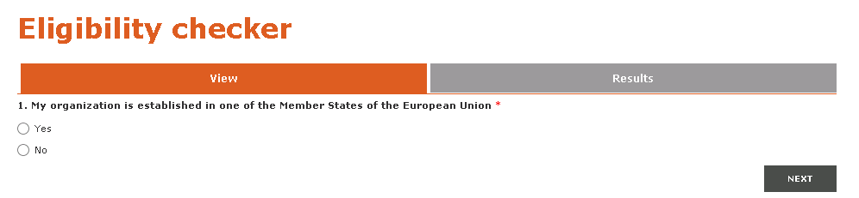

**Campaign visual creator**

Another area which is problematic for the applicants and beneficiaries of the EU funding concerns the rules on visuals. It is however very important that the rules are being adhered to. This tool, as well as other documents available on the portal, allow the applicants and beneficiaries upload their visual and make a simulation how their marketing material may look like, which is at the same time visually appealing and following the rules in place.

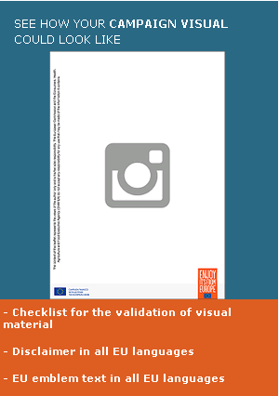

**Frequently Asked Questions**

As a complement to call documents, such as the call texts, guide for applicants and helpdesk, a series of Frequently Asked Questions was developed. It is updated every year and includes weekly updates during the call submission period. It is searchable which facilitates its use.

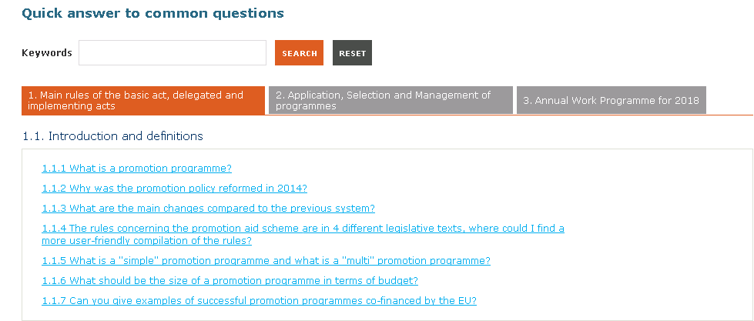

**Interactive map of EU-funded campaigns**

Interactive map serves as the repository of all campaigns adopted since 2014 and allows for the search by different parameters. e.g. proposing country, target country, product sector. It provides links to the actual campaign websites and increases the transparency by featuring the campaign budget, including the share of the EU funding.

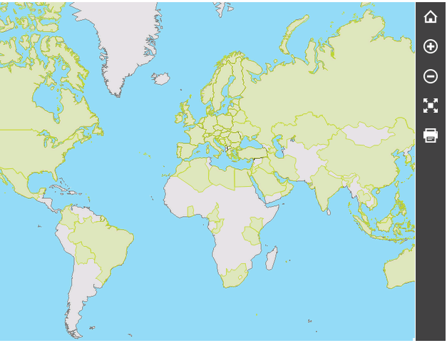

**Webinars**

In order improve the quality of the proposals, each year the weak areas are identified and complemented by the applicants' feedback. Based on this information, tailor-made webinars are organised together with the experts in the field. The target audience constitutes of the potential applicants for EU funding as well as the EU exporters in general.

There are currently six webinars available on the portal and further four in preparation. Examples of the webinars can be found below. Statistics can be found in the part of the report dedicated to technical services.

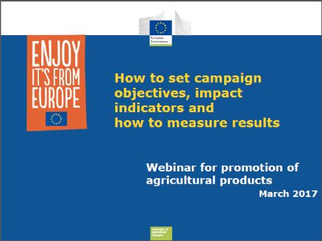

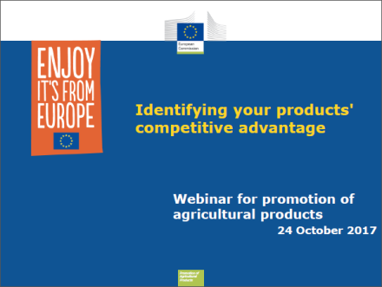

1. **Events**

**Info days**

Info days on calls for proposals are organised every year following the publication of the calls for proposals. They include presentations of the calls as well as statistics of previous calls, information concerning the eligibility and support tools available. They also feature presentations of the EU-funded programmes by the beneficiaries in order to share best practices. One general info day takes place in Brussels.

The objective is to increase awareness of the funding opportunities as well as to increase the knowledge of the rules applicable to the calls for proposals.

In collaboration with the Member States, Chafea and European Commission participate in the national info days where possible attended by a native speaker.

Statistics can be found in the technical support services part of the report.

**Highlights:**

* relevant audience (agri-food stakeholders);
* more in-depth information concerning the calls;
* opportunity to ask questions;
* web streaming for higher outreach;
* examples of best practices.

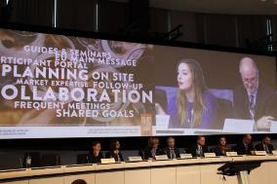

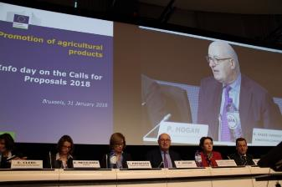

**Presentations of EU funding opportunities and match-making**

In 2018, Chafea and European Commission organised for the first time the presentation of the EU-funding and the match-making event during one of the biggest European food trade fairs – SIAL in Paris on 23 October.

The exact registration figures were not yet known at the time of writing this report.

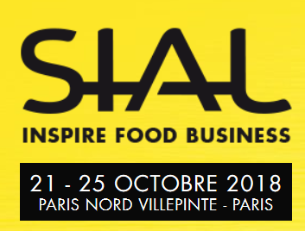

**Highlights:**

* organising the event at the place where over 7000 agri-food exhibitors and over 15000 visitors can be found;
* opportunity to enlarge the audience;
* opportunity to increase the number of new applicants.

1. **Information and promotion campaigns**

In order to increase the awareness of the available funding opportunities under the promotion policy as well as enlarge the pool of "new" applicants, Chafea and European Commission organised a direct mailing campaign sent out to a thousand potential applicants. As a secondary objective, the campaign was aiming to raise awareness of the support tools available to the potential applicants and exporters.

The open rate varied between 20 and 35% which is considered a good result for the direct marketing campaign.

Examples of visuals can be found below.

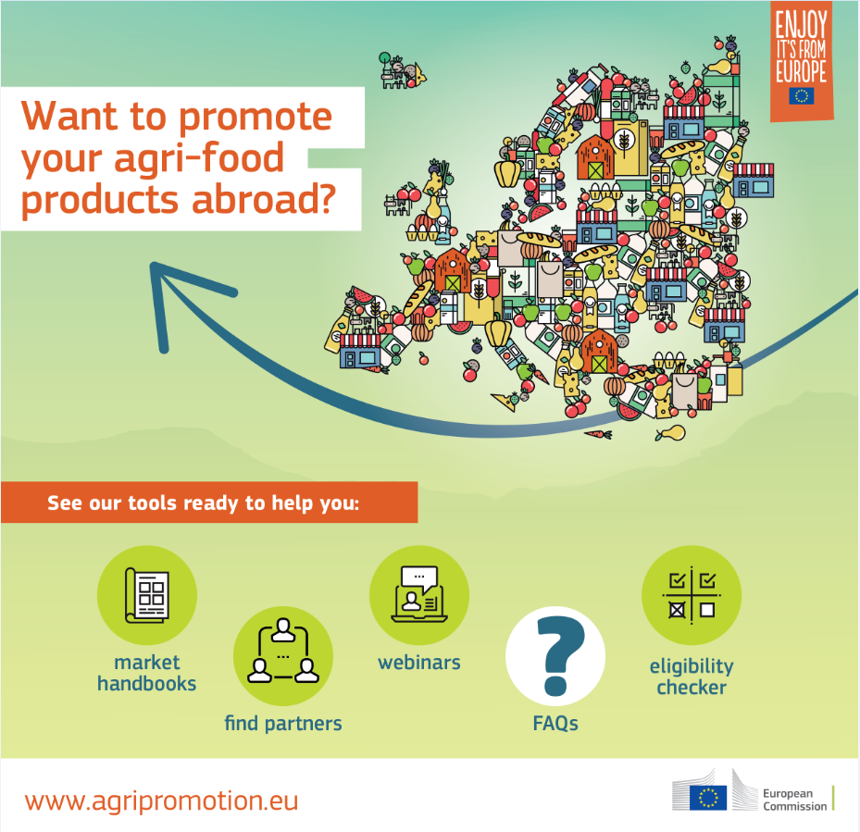

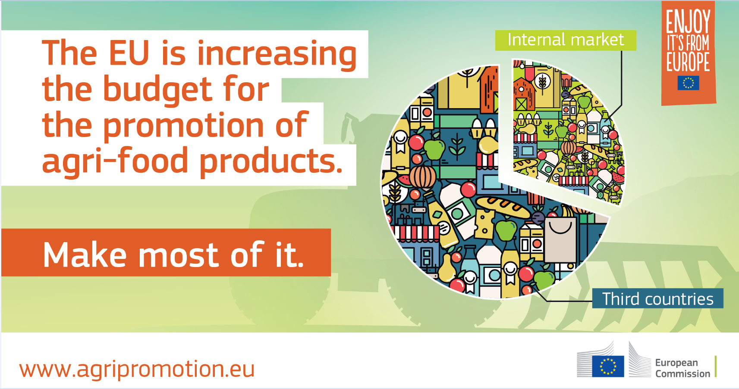

1. The statistics for the 2018 programmes show the result of evaluation, the grant agreements are yet to be signed
2. The statistics for the 2018 programmes show the result of evaluation, the grant agreements are yet to be signed