

**Promoting the international role of the euro in the field of energy**

**1. Introduction**

The EU is the world's largest energy importer, with the Union's annual energy import bill averaging EUR 300 billion in the last 5 years. The majority of our energy imports are priced and paid for in US dollars, the currency predominantly used in the international trade of commodities.

According to the estimates of the European Securities and Markets Authority (ESMA) [1], in the European Economic Area (EEA) alone and for 2016 (latest available year), the annual traded volumes of energy commodities exceed EUR 40 trillion. This is more than the double of the EU GDP and more than 100 times greater than the value of the EU's energy import bill. More than 93% of the traded volumes go to crude oil where currently all contracts are dollar-denominated; the same applies for coal which accounts for slightly more than 1%. The US dollar is also used in gas (2.7% of the energy traded volume) but to a lesser extent and with decreasing importance, at least within the EEA. Finally, in power and emissions (slightly less than 2.3% of the energy traded volumes), the US dollar is practically not used and the majority of trade is based on euro- or pound- denominated contracts.

The dominance of the US dollar in EU energy trade stems from historical reasons with the dollar being the reserve currency of the world rather than from the role of the US as an energy supplier. While the US is gradually becoming an important energy supplier of the EU, its share from the EU import bill remains modest for the time being: in 2017 it was about 2%. The main energy suppliers of the EU are Russia, Norway, the Middle East and Africa.

The euro is a stable, reliable and globally recognized currency widely accepted for international payments. Yet, its use as a medium of exchange for commodity transactions and operations along the entire value chain, from exploration and production through subsequent shipping and insurance to final discharge and consumption remains limited, with the exception of gas where it is gaining some ground.

The dominant role of the US dollar has important implications on European companies. First, energy transactions are exposing them to an exchange rate risk which they have to manage in the financial market[2]. Second, the predominance of trades based on US dollars means that recent unilateral actions by third country jurisdictions, together with declining support for international rules based governance and trade can impede or at least make energy trade more difficult. Hence, a growing role of the euro will support the EU energy policy objectives through lowering transaction costs and risks, increasing access to reliable finance and strengthening the EU's autonomy thus reducing risk of disruption of energy supplies due to third-party actions. It will offer a stronger alternative for payments helping companies operate in a stable and predictable environment in full compliance with the rules-based international trading system.

**2. Historical background**

Since the middle of the 19th century, which marked the beginning of the modern age of the petroleum industry, the value of crude oil has been assessed under different pricing systems. From the late 1920s, a system of posted prices in US dollars controlled by a cartel of transnational oil companies allowed for a high level of price stability until the 1970s. By then, an OPEC-administered pricing system, also denominated in US dollars, became the predominant mechanism, essentially replacing one cartel-based structure by another. This was a period of strong price instability related to such underlying events as an oil embargo (in 1967), two oil shocks (in 1973 and in 1979) and a period of oil glut (early 1980s). By mid-1980s, this system collapsed and was replaced by the current market-linked pricing system.

**3. Current situation**

Like most commodities, energy products are typically traded globally, mostly in US dollars. Additional costs such as transportation and insurance are also usually quoted in US dollars.

*Oil*

Crude oil is currently the most actively traded global commodity. Market participants trade it on a great variety of market platforms are trading it continuously across all continents. The combined daily transactions turnover is assessed to be several magnitudes above the world consumption of oil. Crude oil has become the leading benchmark not only for all energy products but also for the entire investment class of primary commodities.

The current market-based oil trade system developed bottom-up, without specific government intervention. It is built on a structure for dated (physical) and derivative (paper) trading and uses a variety of contracts (spot, forward, futures, swaps, options etc.) to establish the current and future value of crude oil, providing market participants with tools to manage risk exposure.

Crude oil comes in more than 600 different grades, characterised by different physical and chemical properties (density, sulphur content, acidity etc.) and originating from different regions of the world. The physical and derivative markets typically use standardised contracts which refer to benchmark grades such as Brent, West Texas Intermediate (WTI), Dubai or Urals. All remaining crude grades are priced against the benchmarks, using a formula that reflects the quality of the grade. Brent and WTI are the most actively traded benchmark grades, with Brent alone accounting for an estimated 60% of global oil trade. All these benchmarks are denominated in US dollars, including Brent[3] which is the main benchmark used in Europe. As oil is easy to transport and transport costs are relatively low, price differences across the different regions of the world are limited.

Major oil companies and price reporting agencies developed the first price benchmarks for the physical market in the late 1980s. They used the US dollar as the underlying currency to facilitate global transactions and comparisons across different crude grades.

Price reporting agencies (PRAs), such as Platts, Argus, ICIS Heren and OPIS, are privately owned publishers and information providers, which report oil prices transacted in physical and some derivative oil markets, and give an informed assessment of oil price levels at distinct points in time. They use a variety of methods to assess prices, ranging from expert-based judgement to sophisticated analytical algorithms. PRAs publish their price discovery methodologies[4] in line with the transparency principles developed by the International Organisation of Securities Commission[5].

Crude oil contracts are traded on organised exchanges and the over-the-counter (OTC) markets. Derivative contracts traded on stock exchanges (forwards, futures, options, swaps, etc.) are used to conclude transactions based on standard conditions. For oil, they normally use the physical barrel of a reference grade as an underlying asset. For example, Brent Crude futures contracts are traded at the Intercontinental Exchange (ICE)[6] while WTI futures contracts are traded on the New York Mercantile Exchange (NYMEX).[7]

The dominance of the US dollar in the oil trade is to some extent linked to the fact that the national currencies of several oil producing countries (including Bahrain, Oman, Qatar, Saudi Arabia and the United Arab Emirates) are pegged to the dollar which eliminates exchange-rate risks for them. Moreover, futures exchanges such as the ICE and NYMEX tend to favour the US dollar and British pound in transactions.

There have been attempts to challenge the US dollar as the default currency for oil trade but faced various obstacles. Most recently, China launched crude oil futures contracts priced in yuan on the Shanghai International Energy Exchange[8].

*Gas*

Gas is more difficult and expensive to transport and, as a result, markets are more regional than in the case of oil and there are no globally used and accepted price benchmarks. That said, the progressive development of liquefied natural gas (LNG) markets means that regional markets are better connected and in recent years, particularly from 2015, one can see an increasing convergence of regional prices.

Extra-EU imports are typically priced in US dollars. Import prices are often linked to oil (product) prices but there is a clear trend of a diminishing role of oil-indexation in Europe and a shift to the use hub prices: on average, on European gas imports, the share of oil-indexation in price formation decreased from more than 80% in 2005 to 34% in 2017.[9] However, significant differences exist across regions: the share of oil-indexation is quite limited in north-western European Member States while it is more important in central and eastern, Scandinavian and Baltic Member States and in particular in southern Member States.

Hubs are liquid wholesale gas markets with a large number of buyers and sellers and contracts are denominated in national currency. The two most liquid gas hubs in the EU are the Dutch TTF and the UK NBP, with prices denominated in euros and British pounds, respectively. There are also attempts to establish gas hubs in Asia.

The pricing of EU gas imports from Norway are now predominantly based on European hub prices, i.e. they are priced in euros or pounds. However, most imports from other suppliers remain denominated in US dollars.

*Coal*

Like oil, steam and coking coal are also traded in the global market.[10] Price differences are basically explained by the (relatively low) transportation costs. China has a dominant role in the market: it is the biggest producer, the biggest consumer and the biggest importer of coal in the world. Yet, international transactions in the global market are typically performed in US dollars. Important price benchmarks include CIF ARA (Europe), Richards Bay (South Africa) and Newcastle (Australia); all are denominated in US dollars.

*Nuclear*

The annual value of trade in uranium and related fuel manufacturing services (conversion, enrichment and fabrication) for the production of nuclear energy in the EU is approximately EUR 2.5 billion, of which nearly EUR 1.7 billion are imports. 50% of the nearly 100 contracts are quoted in US dollars and the remainder in euro.

While 80% of uranium is imported from Australia, Canada, Kazakhstan, Niger and Russia, the vast majority of the related fuel manufacturing services are provided by Russia.

**4. Initiatives to develop the international role of the euro in the field of energy**

*Wider use of the euro in international agreements and non-binding instruments related to energy*

The Commission and the Member States should promote the larger use of the euro in relations with third countries in the field of energy, including in contracts within the framework of bilateral and multilateral international agreements or non-binding instruments such as memoranda of understanding.

Energy relations between Member States and third countries are frequently underpinned by intergovernmental agreements (IGAs). Member States have notified more than 120 such agreements, many of which relate to the purchase of oil and gas[11]. Such agreements provide political support and legal certainty to European companies negotiating more detailed commercial contracts with energy suppliers in third countries.

To ensure that intergovernmental agreements in the field of energy comply with EU law, in 2016 the Commission put forward a legislative proposal to make intergovernmental agreements on gas and oil subject to prior (ex-ante) scrutiny by the Commission. The revised Intergovernmental Agreement Decision[12] entered into force in 2017; it allows the Commission to assess draft agreements and, in case of doubts about the compatibility with EU law, to issue its opinion. Before signing the intergovernmental agreement, the Member State concerned has to take utmost account of the Commission's opinion. This way the Commission can ensure that no energy deal jeopardises the security of supply in an EU country, or hampers the functioning of the EU's energy market.

The objective of the Intergovernmental Agreement Decision is to ensure the functioning of the internal energy market and enhance the security of energy supply in the EU. The increasing use of the euro in energy transactions can reinforce the EU's economic and energy sovereignty and thereby its security of supply. The Commission's will therefore assess draft agreements and non-binding instruments related to energy and systematically draw the attention of Member States to include a model clause related to the use of euro as a default currency for energy transactions to be carried out under the agreement.

*Promoting the wider use of the euro in energy-related transactions*

In the framework of the Oil Stocks Directive[13], the Member States are obliged to maintain emergency stocks of crude oil and/or petroleum products equal to at least 90 days of net imports or 61 days of consumption, whichever is higher. Stocks must be readily available so that in the event of a crisis they can be allocated quickly to where they are most needed. To satisfy the stockholding obligation Member States rely on Central Stockholding Entities and obligated economic operators to acquire, maintain, manage and sell emergency oil stocks and specific stocks, including tickets.

To promote and facilitate the wider use of euro in energy transactions Member States should encourage those economic operators to widen the share of euro-based contracts in the activities described above.

Another initiative could be an **emergence of a euro-denominated reference oil contract** that is transparent and traded on the physical oil market. It could be used as an underlying asset for financial contracts, such as derivatives, that provide the necessary risk management tools to market participants. Such a contract is not available today but if/once in place, it could provide the right incentives for the take-up of the euro in international energy transactions (for oil as well as for gas, in the cases where pricing of transactions remains linked to oil).

The introduction of a euro-based contract for the physical crude oil market will not require a fundamental change in the way transactions are conducted. As the current market-linked price system has remained relatively stable, changes introduced would require broad acceptance from market participants.[14] Therefore, they should be involved in the development of design features of such a contract.

Such a euro-denominated contract could be established using a **production-based approach**. It could be related to crudes from existing production fields within the EEA, in a similar way to the established global reference contracts such as Brent, WTI, Dubai, Urals. However, developing an entirely new crude grade basket based on production fields, which are depleting, would arguably be very challenging considering the need for a wide market acceptance.

Alternatively, a euro-denominated contract could be based on a **consumption-based approach**. The contract could be fixed to match the physical properties (gravity, sulphur content and others) of the average or typical barrel in the EU crude oil import basket. Although EU's demand for oil and petroleum products will decrease in time, the challenge seems less immediate than for the production-based option.

Facilitating market acceptance would require enforceability of the contract, including beyond EU borders.

Lessons could be drawn from previous attempts to develop a non-USD based contract.[15]

Central Stockholding Entities and obligated economic operators under the Oil Stocks Directive could be among the early adopters of such a euro-based contract.

The situation for the gas markets has already evolved compared to the oil market. Following market liberalization, a number of gas trading hubs has developed in Europe, where gas products denominated in euros are traded.

As mentioned above, the number of gas supply contracts of EU importers relying on hub-pricing has significantly increased over the years. However, EU gas supply contracts relying on oil-indexation are generally denominated in US dollars and the same applies for a significant number of hybrid contracts[16]. The issue is similar for both pipeline gas as well as LNG.

Promoting the conditions for a wider use of hub pricing indexation within contracts and increasing the attractiveness of EU gas trading hubs appear as key elements to further increase the share of gas contracts denominated in euros.

In more detail, an increase in the share of gas contracts denominated in euros could be achieved as the result of the following initiatives:

* the promotion of increase of liquidity for gas hubs in the EU, with hub prices denominated in euro;
* a greater choice in terms of trading products offered on these hubs, including derivatives for the hedging of positions;[17]
* the introduction of incentives aimed at fostering the renegotiation of gas long-term contracts (LTCs) as to incorporate hub-based pricing indexation systems in place of pure oil-based or hybrid indexation systems;
* the use of euro-denominated price benchmarks for oil by oil price-reporting agencies;
* the promotion of the use of the euro as companies' functional currency along the gas value chain, from upstream activities to final sales.[18]

The Commission has already dealt with some of these issues in the context of the enforcement of EU competition rules in the energy sector. In the Gazprom case, one of the Commission's competition concerns was that Gazprom may have been able to charge higher prices in five Member States (Bulgaria, Estonia, Latvia, Lithuania and Poland). The commitments proposed by Gazprom and made binding by the Commission[19] ensure that Gazprom will propose to its relevant customers contract amendments aimed at ensuring that the prices under their supply contracts reflect the price level in competitive western European gas markets, especially at liquid gas hubs.

As far as nuclear contracts are concerned, there is already a certain acceptance of euro-based contracts. More specifically around 50% of them are already quoted in euro reaching 80% for uranium enrichment services. Market acceptance and enforceability would be facilitated by the existing Euratom Treaty provisions requiring the Euratom Supply Agency to co-sign the supply contracts and being notified of services contracts.

*Promoting the wider use of the euro in financial markets related to energy*

European companies providing financial services could play a role in promoting the wider use of the euro in financial transactions and project investments.

For example, companies providing financial services and traders active on energy markets (especially targeting market makers) should be encouraged to develop euro-denominated derivative products using euro based references in physical trade. This especially refers to the oil and petroleum products market where the acceptance of euro on the derivatives market should accompany the development of physical contracts. Such euro derivatives products would offer the necessary and attractive tools for investors to hedge their risks. At the same time, it is important that development of derivatives markets remains commensurate to the size of the physical market.

On the investment side, an option would be to ensure that energy project promoters have access to deep and liquid euro-denominated capital markets that could help them raise the necessary funding with an affordable transaction cost. The synergies with the Capital Markets Union are explained in detail in the Communication COM(2018)796 *"Towards a stronger international role of the euro"*.

**ANNEX - EU energy imports**

The EU is a net importer of energy: in 2016, the import dependency[20] stood at 53.6%. This means that the EU needs to import just over half of the energy it consumes. Import dependency is particularly high in case of fossil fuels: in 2016, it was 87.4% for crude oil and natural gas liquids (NGL), 70.4% for natural gas and 40.2% for solid fuels (from which 61.2% for hard coal). EU energy import dependency seems to have stabilised in recent years: since 2005, it has been fluctuating between 52% and 55%.

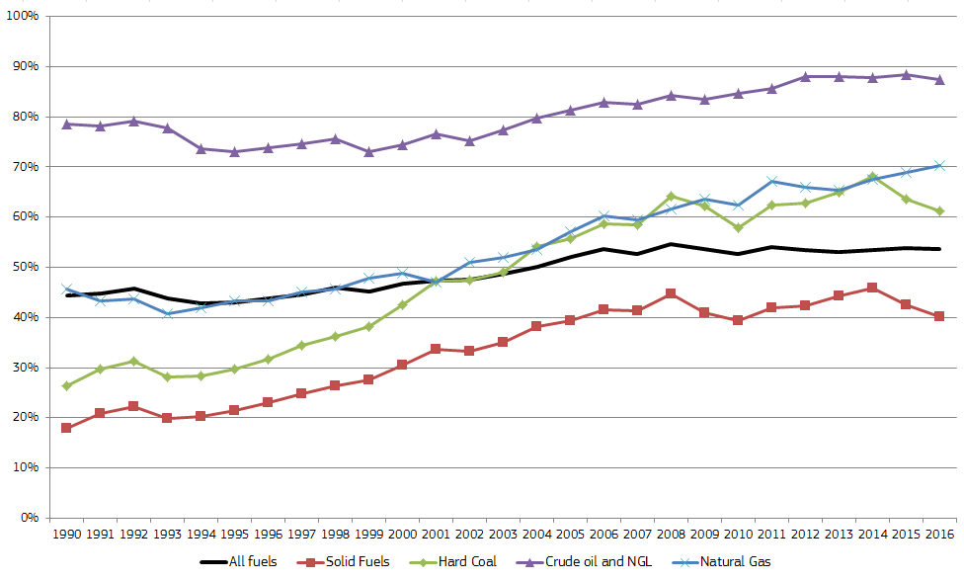

**Figure 1 - EU import dependency by fuel**

Source: Eurostat

The high import dependency poses significant challenges in terms of energy security and the diversification of suppliers and supply routes but, in addition, it also means that the EU is facing an important energy import bill. In 2013, the EU's estimated import bill (covering crude oil, natural gas and hard coal) reached EUR 400 billion, equivalent to 3.0% of EU GDP. In 2013-2016, falling energy prices allowed the import bill to decrease significantly, although the weakening of the euro has partly offset this effect. In 3 years, the import bill has almost halved. Energy prices increased in 2017, resulting in a growing import bill, but still well below the 2013 level: in 2017, the estimated import bill amounted to EUR 266 billion, equivalent to 1.7% of EU GDP.

Crude oil is by far the main component of the import bill, making up 68% of the total in 2017. The share of gas and hard coal was 28% and 4%, respectively.

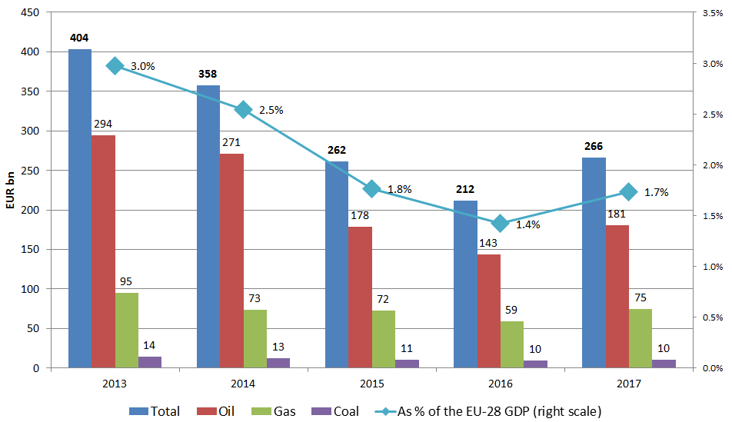

**Figure 2 - The estimated EU import bill**

Source: DG Energy calculation

In case of oil, Russia is the main supplier of the EU, covering about 30% of total extra-EU imports, followed by Norway (12%). Countries of the Middle East and Africa have a combined share of about 40%. In 2017, the share of the US from EU crude oil imports was 2%.

Russia has an even higher share from extra-EU gas imports, reaching 43% in 2017, followed by Norway (34%). Pipeline imports from North Africa amount to about 10%, with the rest (about 14% in 2017) covered by LNG coming from various suppliers around the world. In 2017, 4% of the LNG imports, i.e. about 0.5% of total gas imports arrived from the US.

The main coal suppliers of the EU are Russia, Colombia, Australia and the US. In 2016, the US covered 14% of EU hard coal imports.

80% of uranium is supplied by 5 big producing countries (Australia, Canada, Kazakhstan, Niger and Russia), while 40% of the conversion services are provided by Russia, Canada and USA and 30% of enrichment by Russia.

1. <https://www.esma.europa.eu/sites/default/files/library/esma70-156-165_opinion_on_market_size_calculation._corrected.pdf>
2. E.g. by hedging
3. The Brent Crude is extracted from the North Sea and is currently comprised by the following blends: Brent, Forties, Oseberg and Ekofisk.
4. For example, details of the crude oil price methodology used by Platts are presented at <https://www.spglobal.com/platts/plattscontent/_assets/_files/en/our-methodology/methodology-specifications/crude-oil-methodology.pdf>..
5. <http://www.iosco.org/library/pubdocs/pdf/IOSCOPD391.pdf>
6. Contract specifications are available at <https://www.theice.com/products/219/Brent-Crude-Futures> .
7. Contract specifications are available at https://www.cmegroup.com/trading/why-futures/welcome-to-nymex-wti-light-sweet-crude-oil-futures.html.
8. Contract specifications are available at http://www.ine.cn/en/products/oil/standard/index_2.html.
9. Source: Wholesale Gas Price Survey 2018, International Gas Union
10. Lignite and brown coal are typically not traded internationally
11. 124 intergovernmental agreements have been notified by Member States to the Commission between 2012 and 2016 under Decision No 994/2012/EU
12. Decision (EU) 2017/684 of the European Parliament and of the Council of 5 April 2017 on establishing an information exchange mechanism with regard to intergovernmental agreements and non-binding instruments between Member States and third countries in the field of energy, and repealing Decision No 994/2012/EU
13. Council Directive 2009/119/EC of 14 September 2009 imposing an obligation on Member States to maintain minimum stocks of crude oil and/or petroleum products, <https://publications.europa.eu/en/publication-detail/-/publication/b4c7129d-b59e-4679-89ac-1781ef8ac502/language-en>
14. The adding of a fifth crude oil grade in the Brent basket is a recent example how changes tend to occur incrementally.
15. For example, Chinese capital controls, large storage costs and design issues with the delivery window were quoted as some of the factors impeding the yuan-denominated oil futures contracts at the Shanghai International Energy Exchange to gain ground.
16. By hybrid contracts we mean contract relying on indexation systems based both on oil and hub prices.
17. For instance, some LNG contracts have moved away from dollars to be denominated in other currencies when the price under the contract relied on a hub indexation mechanisms based on a liquid hubs.
18. Even when their gas supply contracts rely - exclusively (e.g. Baltic countries) or partially (e.g. Slovakia) - on oil-indexation, EU gas importers do not seem to be opposed to denominate their gas supply contracts in Euros as soon as this fits in their value chain.
19. Commission's decision C(2018)3106 final of 24 May 2018 relating to a proceeding under Article 102 of the TFEU and Article 54 of the EEA Agreement.
20. Import dependency is calculated as net imports divided by gross inland consumption.