

# INTRODUCTION

This report presents the implementation of the 2015 annual work programme (2015 AWP), under the third Health Programme 2014-2020 established by Regulation (EU) No 282/2014 of the European Parliament and of the Council of 11 March 2014[1].

Under Article 13 of the Regulation, the Commission must report to the Health Programme Committee on the implementation of all actions funded under the Programme and also to the European Parliament and the Council. This report meets the latter requirement. It provides detailed information on the 2015 budget and how it was committed. It also takes account of the amendment to the 2015 AWP to channel funding towards those Member States under particular migratory pressure that require support in their response to the related health challenges.

The Commission Staff Working Document accompanying this Report sets out a number of examples of the key actions co-funded under the second[2] and third Health Programmes, for which final results became available in 2015. It also gives examples of actions funded under the 2015 work programme in supportive fields such as evaluation and dissemination. The report also provides tables with an overview of all co-funded activities and contracts.

The 2015 AWP focused on innovation in health and healthcare, with two related action streams (health technology and migrants’ health) highlighted in this report. The Commission decided to amend the 2015 AWP[3] in response to the high influx of migrants in clear need of international protection and the need to provide financial support to organisations able to support Member States in addressing this emergency situation.

The Commission ensures that the implementation of the third Health Programme is closely monitored and that results are publicised more widely. It also continues to encourage all Member States and other countries involved in the Programme to participate and continues to seek synergies with other EU funding programmes.

TABLE OF CONTENTS

INTRODUCTION 1

ACTIONS OF THE YEAR — SPECIFIC THEMATIC FOCUS OF 2015: 3

BUDGET IMPLEMENTATION 5

1. Budget 5

2. Objectives, priorities and financing mechanisms in 2015 7

3. Implementation of the operational budget by financing mechanism 9

4. Beneficiaries 11

OTHER MAIN FEATURES 11

# THEMES AND ACTIONS FOR 2015:

The priority health topic for the 2015 AWP was ‘*health technology assessment (HTA) and innovation*’. This was addressed through several actions funded by different financing mechanisms and signed in the first quarter of 2016, most of them for 3 years, meaning that they will run until the end of 2018 and in some cases until 2020. They are:

* the new joint action on HTA, representing the highest ever EU contribution (EUR 11 999 798.74) to a single aspect of health policy under the third Health Programme;
* two projects and a joint action on integrated care (total EU contribution EUR 6 837 798.31); and,
* the preparatory work for the establishment of the European Reference Networks (EUR 381 372.23).

Background: The new joint action on HTA is the scientific and technical component of EU cooperation in this area. It was launched in June 2016 and will run until 2020. It includes government appointed organisations (from EU countries, EU accession countries, EEA and EFTA countries), and a large number of relevant regional agencies and not-for-profit organisations that produce or contribute to HTA in Europe.

Goal: The objective is to support voluntary scientific and technical level between HTA bodies. This cooperation should provide input for the development of a model for joint work to be continued after EU funding under the Health Programme ends.

Means: There is a strong focus on the joint production of health technology assessments and early dialogues on the results and how to apply them in national settings. The early dialogues, particularly the parallel consultations, have become highly valued by companies seeking early advice. As of May 2018, 29 requests for early dialogues have been received by the joint action partners. HTA also assesses other aspects of health technology, for example its cost implications for the patient and its impact on the organisation of healthcare systems in the delivery of care and administration of treatment. It is therefore a multidisciplinary process that systematically reviews the medical, economic, organisational, social and ethical issues related to the use of a health technology.

Background: On integrated care, one co-funded project brings together innovative European healthcare regions, industry and academia in a partnership that has the potential to transform ‘cure and care’ delivery services. The project includes both a pilot project phase and scaled-up, routine care practice. The project involves 13 partners from six EU countries (Denmark, Germany, Greece, Netherlands, Spain and United Kingdom).

Goal: The overall objective is to identify, transfer and scale up existing and operational care coordination and good tele-health practices, with the aim of reaching 75 000 care recipients or patients across regions and programmes in multiple European countries. The project is expected to deliver two major benefits:

* a strong basis for successful twinning and coaching that facilitates shared learning;
* practical support for scaling up good practices that promote active and healthy ageing and the participation of older people in the community.

This combined with a joint action, should contribute substantially to improving the organisation and implementation of integrated care concepts across the EU.

Additional actions in response to the migration crisis in the summer of 2015 and following the subsequent amendment to the 2015 AWP, are:

* four projects on migrants’ and refugees’ health (EUR 6 239 154)
* one direct grant to the International Office of Migration (IOM) (EUR 1 000 000).

These aimed to *‘support Member States under particular migratory pressure in their response to health related challenges, with a view to provide concrete support to organisations active in the field and help address the public health impact in the most affected EU Member States*’[4].

Background: One project, led by the Andalusian School of Public Health, brought together partners from seven countries (Belgium, Denmark, Italy, the Netherlands, Poland, Slovakia and Spain).

Goal: to support Member States in establishing or strengthening a health sector coordination mechanism for a coherent and consolidated national and cross-country response to address the health-related issues of arriving migrants (refugees, asylum seekers and other migrant populations) while preventing and addressing possible communicable diseases and cross border health threats. This was achieved through an assessment of the coordination mechanism in place and by improving coordination and health professionals' capacities and skills.

Background: Another project involved eight partners to support health authorities in 11 Member States.

Goal: The project focused on health assessments of incoming migrants via a common instrument allowing Member States to detect and assess potential threats, distribute health promotion materials and raise awareness among stakeholders.

The detailed overview of all actions funded under the 2015 is provided in the Commission Staff Working Document accompanying this report.

# BUDGET IMPLEMENTATION

1. Budget

The overall budget for the third Health Programme 2014-2020 is EUR 449.4 million. This includes EUR 30 million for the functioning of the Consumer, Health, Food and Agriculture Executive Agency (Chafea) which the Commission has mandated to manage the Health Programme 2014-2020. Chafea has been providing the Commission with technical, scientific and administrative assistance in implementing the Health Programme since 2005[5]. It organises annual calls for proposals, coordinates the evaluation of submissions, negotiates, signs and manages related grant agreements, and disseminates the results of actions. It is also responsible for many procurement procedures.

The budget set out in the work plan for the 2015 AWP[6] was EUR 59 750 000, broken down as follows:

* operational expenditure: EUR 54 041 000, corresponding to the third programme for EU action in the field of health (2014-2020) budget line 17 03 01 (‘*Encouraging innovation in health, increasing the sustainability of health systems and protecting Union citizens from serious cross-border health threats’*);
* administrative expenditure: EUR 1 500 000, corresponding to the support expenditure for the third Programme for EU action in the field of health (2014-2020) budget line 17 01 04 02.

The total operational budget was EUR 55 629 805 and the total administrative budget was EUR 1 551 822, 66. This included EFTA/EEA credits and recovery credits from previous budget years.

In 2015, Chafea executed EUR 47 967 105.24 of the operational budget, while the European Commission’s Directorate-General for Health and Food Safety (DG SANTE) executed EUR 6 810 913.51, covering procurement, direct grants and other measures, amounting to a total of EUR 54 778 018.75.

2. Objectives, priorities and financing mechanisms in 2015

In 2015, the total operational budget was divided among the four specific programme objectives as follows.

1. **Health promotion:** ***EUR 15 669 170.92 (29 % of the operational budget in 2015)*** for promoting health, preventing diseases and fostering supportive environments for healthy lifestyles taking into account the ‘health in all policies’ principle.
2. **Health threats**: ***EUR 5 016 028.59 (9 % of the operational budget in 2015)*** for protecting EU citizens from serious cross-border health threats.
3. **Health systems**: ***EUR 25 106 924.35 (46 % of the operational budget in 2015)*** for contributing to innovative, efficient and sustainable health systems.
4. **Better and safer healthcare**: ***EUR 6 127 923.17 (11 % of the operational budget in 2015)*** for helping EU citizens access better and safer healthcare.

The specific call to ‘*support Member States under particular migratory pressure in their response to health related challenges*’ was a horizontal action related to Objectives 1 (health promotion) and 2 (health threats). The corresponding amount of EUR 7 234 199.58 (13 % of the operational budget in 2015) was divided evenly between Objective 1 and Objective 2 and resulted to the calculations above.

In addition, **horizontal activities (IT, communication)** amounted to ***EUR 2 857 971.72 (5 % of the operational budget in 2015).***

**Figure 1: Operational budget by third Health Programme objective in 2015**

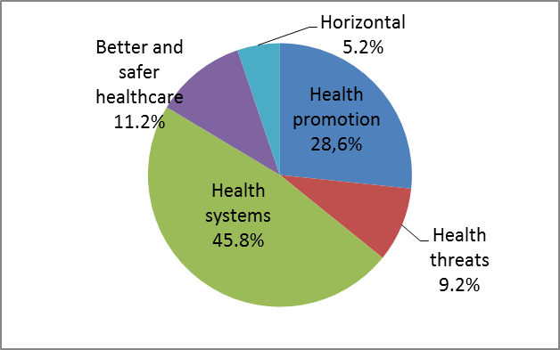

The figure below provides information on the Health Programme credits invested as EU contribution under the different thematic priorities in year 2015.

**Figure 2: Operational budget by thematic priority in 2015**

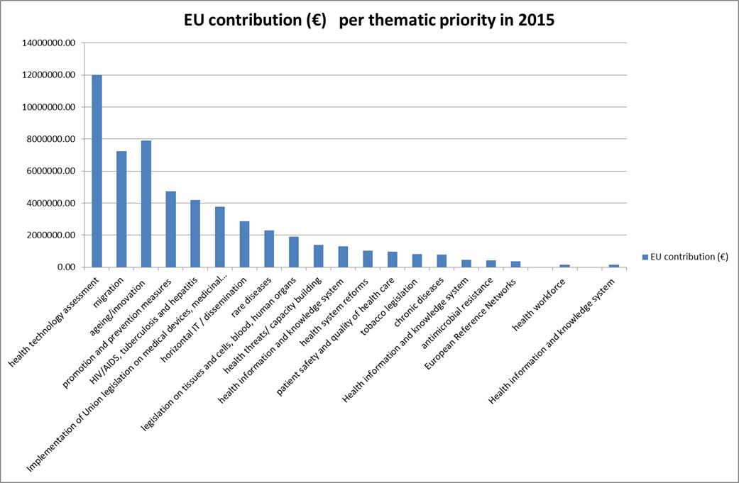

The Programme is implemented through a wide range of funding instruments. These are:

* actions co-financed with Member State authorities (joint actions);
* project grants;
* operating grants in support of non-governmental organisations;
* direct agreements with international organisations;
* public procurement;
* other actions, such as the scientific committees, administrative agreements with the Joint Research Centre and grants for Council presidency conferences.

Competitive selection and award procedures were used to select initiatives for funding. However, they are not used for joint actions, direct grant agreements and conferences organised by Council presidencies because in those cases competitive procedures are either not allowed under the specific rules or are not used in practice, for example, due to a monopoly situation.

Administrative credits covered expenditure for studies, meetings of experts, information and publication costs, and technical and administrative assistance for IT systems.

3. Implementation of the operational budget by financing mechanism

|  |  |  |
| --- | --- | --- |
| **Type of financing mechanism** | **Implementation (EUR) Commitments** | **Share of mechanism in total implemented budget (commitments)** |
| **Calls for proposals:** |  |  |
| Project grants | 14 944 000.04 | 27.3 % |
| Operating grants | 5 005 520.00 | 9.1 % |
| **Grants for joint actions** | **17 791 725.60** | **32.5 %** |
| **Conference grants to the Member States holding the presidency of the EU** | **120 434.90** | **0.2 %** |
| **Direct grant agreements** |  |  |
| ***Managed by CHAFEA*** | **3 715 000.00** | **6.8 %** |
| ***Managed by DG SANTE*** | **120 747.29** | **0.2 %** |
| **Procurement (service contracts)** |  |  |
| ***Managed by CHAFEA*** | 5 890 424.70 | 10.8 % |
| ***Managed by DG SANTE*** | 5 744 988.82 | 10.5 % |
| **Other actions** |  |  |
| ***Managed by CHAFEA*** | 500 000.00 | 0.9 % |
| ***Managed by DG SANTE*** | 945 177.40 | 1.7 % |
| **Budget implemented in 2015** | **54 778 018.75** | 100 % |
| **Total available budget** | **55 629 805.00** |  |
| **Credits not used[7]** |  |  |
| ***by CHAFEA*** | 218 478.65 |  |
| ***by DG SANTE*** | 633 307.60 |  |

4. Beneficiaries

In 2015, more than 200[8] different grant agreements and service contracts were signed with various beneficiaries and service providers, ranging from governmental and non-governmental organisations to academic institutions and private companies. The category ‘other’ includes beneficiaries such as healthcare providers and international organisations. Figure 3 provides an overview of the different groups of beneficiaries.

**Figure 3: Types of beneficiaries of the third Health Programme in 2015**

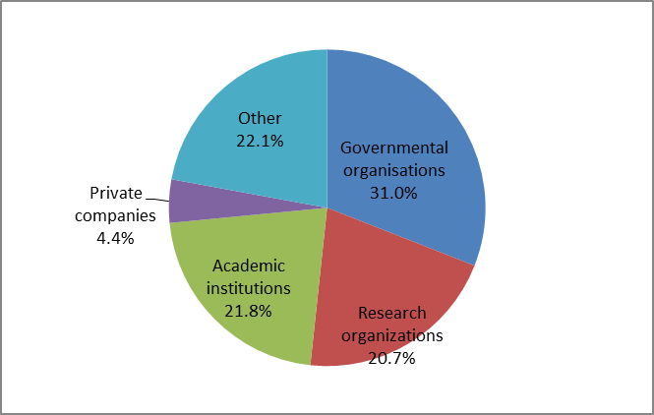

# 

# OTHER MAIN FEATURES

2015 was the second year of the third Health Programme that was seriously affected by the pressure caused by the unprecedented influx of refugees entering Europe. This situation tested the Programme’s flexibility to quickly adapt to new policy needs, as well as Chafea’s ability to respond accordingly and implement decisions related to the AWP. Chafea launched the related direct grants and call for proposals for projects in record time and was able to sign the selected grant agreements within less than 3 months of the 2015 AWP amendment.

This was helped by simplified administrative procedures introduced in 2014 as well as the participant portal for online submissions and the online evaluation and electronic signature of the grant agreements. Despite the minor hurdles in the system, this reduced the time taken to sign the grants.

The number of participants involved in joint actions continued to be relatively high, as was the case for the second Health Programme and first year of the third Health Programme. In 2015, there were between 10 and 45 partners (beneficiaries) per joint action. This high number was a challenge for the Programme’s overall management and coordination, as all partners had to sign the grant agreement.

Following the recommendations of the ex post evaluation of the second Health Programme 2008-2014[9] and mid-term evaluation of the third Health Programme[10], Chafea invested significant resources in information and dissemination activities, in close collaboration with DG SANTE and the Health Programme’s network of National Focal Points. It organised several workshops, helped organise major national and international conferences, and organised stand-alone events in collaboration with national authorities in Member States. A more detailed description of the dissemination activities in 2015 is provided in the Commission Staff Working Document accompanying this report.

Building on the processes and tools developed under the third Health Programme, electronic monitoring and reporting has been introduced to save time on both sides. As a result, both the beneficiary and Chafea have become paperless, especially in the case of grants. The CORDA[11] system, implemented by the common support centre of the EU research and innovation programme, centralises the data collected for all co-funded actions managed by Chafea and monitored using H2020 electronic tools. It is the key source of information, providing feedback on whether the Programme’s objectives and priorities have been met and on the types of actions and organisations that have been co-funded.

Further improvements are to be introduced in the coming years, including an improved electronic monitoring and reporting system and better and more targeted dissemination. In addition, efforts will continue to increase the participation of organisations and institutions from countries which, until now, have been under-represented among the beneficiaries.

The identification of key priority areas for each year of the Programme has shown the added value of ensuring continuity between the annual work programmes. It has improved the overall coherence and consistency of the third Health Programme and supported the use of the deliverables and results of previous funding rounds.

1. OJ L 86, 21.3.2014, p. 1.
2. OJ L 301, 20.11.2007, p. 3.
3. <https://ec.europa.eu/health/sites/health/files/programme/docs/wp2015_amendment_en.pdf>
4. The call for proposals was launched in October 2015.
5. Decision 2004/858/EC of 15 December 2004 (OJ L 369, 16.12.2005, p. 73) amended by Decision 2008/544/EC of 20 June 2008 (OJ L 173, 3.7.2008, p. 27). Since December 2014 **Chafea** has replaced the Executive Agency for Health and Consumers (EAHC) under [Commission Implementing Decision 2014/927/EU](https://eur-lex.europa.eu/legal-content/EN/TXT/PDF/?uri=CELEX:32014D0927&from=EN)
6. [Commission Decision C(2015) 3594 of 2 June 2015](https://ec.europa.eu/health/sites/health/files/programme/docs/wp2015_en.pdf) (see at: <https://ec.europa.eu/health/sites/health/files/programmes/docs/wp2015_en.pdf> .
7. Pre-accession credits were not yet used, leading to differences between amounts in the award decision and the actual amounts.
8. This excludes contracts signed with individual experts e.g. those on the scientific committees.
9. COM(2016) 243 final of 10.5.2016.
10. COM(2017) 586 final of 11.10.2017.
11. CORDA is the Common Research Data Warehouse, i.e. the place of storage of all the information on EU-funded projects and their results. Started as the reference data base for EU funded research, stretching back to 1990, it now includes the actions co-funded by the 3rd health programme which are managed through the H2020 tools.