

INTERIM REPORT FROM THE COMMISSION TO THE EUROPEAN PARLIAMENT AND TO THE COUNCIL

on the application of Annex XI to the Staff Regulations and Article 66a thereof

# Introduction

Article 15(4) of Annex XI to the Staff Regulations as last amended in 2013[1] provides that at the end of 2018, the Commission shall submit an interim report to the European Parliament and the Council on the application of Annex XI and of Article 66a of the Staff Regulations.

This interim report implements the aforementioned provision by describing the process and outcome of the implementation of the rules for updating remuneration and pensions under Annex XI to the Staff Regulations (hereinafter the "Method") as well as the solidarity levy under Article 66a for the period 2014-2018.

# Basic objectives and principles of the Method adopted in 2013

The provisions[2] of the current Method for updating remuneration and pensions were adopted as part of the reform of the EU Staff Regulations in 2013. They apply from 1 January 2014 until at least 31 December 2023.

The proper functioning of the Method is based on the two underlying principles that have been reconfirmed in 2013:

* The principle of parallelism of the evolution of purchasing power of EU staff and national officials in central governments (Article 65 and Annex XI SR); and
* The principle of equality of purchasing power among EU staff in different duty stations (Article 64 and Annex XI SR).

### Principle of parallelism

The principle of parallel developmentof purchasing power means that the purchasing power of officials of the EU follows, both upwards and downwards, the evolution of the average purchasing power of civil servants in national central government.

Therefore, under Article 65(1) of the Staff Regulations the update of remuneration and pensions reflects the annual evolution between 1 July of the previous year and 1 July of the current year[3] of:

* The real salaries of civil servants in the central governments in a sample of 11 Member States[4] representing at least 75% of the EU Gross Domestic Product. For each of these Member States, the yearly change in real salaries is calculated net of inflation and is called the Specific Indicator. The *Global Specific Indicator* (GSI) is the average of all specific indicators weighted by GDP.
* The annual inflation in Brussels and Luxembourg (in the same proportion as the distribution of the EU staff between the two cities). This element is called *Joint Index*.

The GSI and the Joint Index are multiplied to calculate the value of the update. The value of the update is expressed as a percentage that is applied across-the-board to the net remuneration and pensions of all EU staff with effect on 1 July[5].

It is in that context important to point out that the Method does not allow "double counting" of inflation, but guarantees the parallel evolution of salaries of the EU staff and the national civil servants, net of inflation. To this end, the GSI is first calculated net of inflation in the sample of 11 Member States, and only as a second step it is combined with the Joint Index.

Detailed information on the evolution of the GSI and of the Joint Index is provided respectively in parts 3 and 4.

### Specific derogations to the principle of parallelism decided in 2013: the salary freeze and the solidarity levy

The Method was agreed in 2013 as the result of negotiations involving EU institutions, their administrations and representatives of their staff.

In accordance with Article 336 TFEU, the ordinary legislative procedure for amending the Staff Regulations involved the Commission with its right of initiative and the European Parliament and the Council as co-legislators, after consultation of the other institutions concerned and their administrations, in particular the Court of Justice and the Court of Auditors. Prior to the Commission’s proposal, extensive consultation of the representatives of staff of all institutions took place. During the ordinary legislative procedure, the Council as well implemented its procedure for consultation of staff representatives.

To take account of the particularly difficult economic and social context in the Union in that period and following the conclusions of the European Council adopted in February 2013, as part of the reform it was also decided:

* That the update of remuneration and pensions of all staff of the Union institutions, other bodies and agencies through the Method would be suspended in 2013 and 2014 (see part 3.4.1 on the two-year salary freeze), and
* That the potential advantages for officials and other servants of the European Union of the application of the Method would be balanced by the reintroduction as of 1 January 2014 of the system of a solidarity levy deducted from EU staff salaries at an increased rate (see part 3.4.2 on the solidarity levy).

### General derogations to the principle of parallelism: moderation and exception clauses

By derogation to the general principle of parallelism of purchasing power evolution, a moderation clause limits high increases in purchasing power as well as any high loss in purchasing power for a given year. If the calculated increase in purchasing power (GSI) exceeds 2% or if the purchasing power decreases by more than 2%, then the change in purchasing power for EU staff is limited to 2%. The part of the gain or loss in purchasing power exceeding 2% is applied nine months later, from 1 April of the following year.

The exception clause limits the gain in purchasing power of EU staff when there is a downturn in the EU economy. If there is a forecast decrease in the EU GDP and there is a gain in purchasing power measured by the specific indicator, then depending on the magnitude of the GDP decrease, a part of the gain in purchasing power is postponed to the following year according to the table below:

|  |  |  |
| --- | --- | --- |
| Gross Domestic Product | Consequences in terms of split of the global specific indicator | Date of payment of the second part |
| [-0,1 % ; -1 %] | 33 % ; 67 % | 1 April of year n + 1 |
| [-1 % ; -3 %] | 0 %; 100 % | 1 April of year n + 1 |
| below -3 % | 0 % | - |

If the EU GDP decreased by more than 3%, then the gain in the purchasing power due to the Method is granted when the EU economy recovers, i.e. when the gross domestic product of the EU reaches the pre-downturn level (recovery clause).

If the final data delivered by the Commission on the EU GDP is different from the forecast to the extent that it affects the consequences how the crisis clause was applied, then the necessary corrections, including retroactive adjustments, either positive or negative, are made[6].

### Principle of equality of purchasing power among EU staff – correction coefficients

The correction coefficient puts into practice the general principle of equal treatment, which in this particular case corresponds to the equality of purchasing power between all staff of the EU institutions, bodies and agencies regardless of their place of employment.

Whereas the same salary grids and basic amounts apply to all EU staff, correction coefficients apply to staff serving in posts outside Brussels and Luxembourg, who should neither suffer financially from higher living costs in their duty stations or benefit from lower living costs.

Hence the correction coefficient operates as a percentage adjustment to the salary to compensate the difference (positive or negative) in the cost of living in each duty station. The correction coefficient is applied according to the following formula:

**Correction coefficient**

(= Economic parity / Exchange rate)

**Salary in duty station**   
(in euros for euro-countries)

**Exchange rate**   
(=1 for euro-countries)

**Salary in Brussels**   
(in euros)

=

X

X

Correction coefficients are updated at least once a year with effect on 1 July[7]. The detailed evolution of correction coefficients during the reference period is provided in part 5.

## Legal framework for the yearly implementation of the Method adopted in 2013

### Procedure for the implementation of the Method – workflow of the update

Article 65 of the Staff Regulations provides that the annual update of remuneration and pensions shall take place before the end of the year in the light of a report on statistical data prepared by Eurostat. It continues indicating that the amounts and weightings (correction coefficients) referred to in Article 64 and Article 65(1) shall be understood as amounts and weightings the value of which at a given point in time is subject to update "without intervention of another legal act". The Commission shall publish the updated amounts and weightings within two weeks after the update in the C series of the *Official Journal of the European Union* for information purposes.

Furthermore, Annex XI to the Staff Regulations lays down detailed rules regarding the calculation of the update and the role of Eurostat and national statistical institutes in monitoring the quality of the basic data and the applied statistical methods.

The combined reading of the above provisions, as confirmed in the recitals of Regulation No 1023/2013, indicates that the update is defined as an "automatic" or "mechanical" event, which occurs without any decision-making process among the EU institutions and is based on a strictly defined methodology for processing of the relevant statistical data as regards to the calculation of the amounts and the weightings.

In terms of procedure, the Commission has defined internally an administrative workflow, involving a number of Commission services, to ensure the proper implementation of the update once the underlying statistical data is calculated and transmitted by Eurostat. The main objectives of the workflow are to put in place the necessary controls and quality checks to ensure the necessary budgetary coordination and the timely information by the Commission to the EU institutions, bodies and agencies.

Since 2014, this workflow has been applied smoothly by the Commission services. It significantly facilitated the successful technical implementation of the Method. As a result, all due payments and recoveries that resulted from the 2014-18 updates and affected the remuneration and pensions of the staff in the EU institutions and agencies were executed within the statutory timeframe.

### A set of strict reporting obligations

While the yearly implementation of the update does not necessitate the adoption of any legal act, the co-legislators provided for strict reporting obligations:

* Under Article 65(1) of the Staff Regulations, every year the Commission shall transmit a report[8] to the European Parliament and the Council on data pertaining to the budgetary impact of remuneration and pensions of Union officials,
* Under Article 15 of Annex XI to the Staff Regulations the present interim report to the European Parliament and the Council on the application of Annex XI and of Article 66a of the Staff Regulations shall be submitted in 2018,
* Also under Article 15 of Annex XI to the Staff Regulations, before 31 March 2022 the Commission shall submit a report to the European Parliament and the Council assessing whether, in particular, the evolution of purchasing power of remuneration and pensions of Union officials is in accordance with the changes in the purchasing power of salaries in national civil services in central governments. On the basis of that report, if appropriate, the Commission shall submit a proposal to amend Annex XI as well as Article 66a of the Staff Regulations on the basis of Article 336 of the Treaty on the Functioning of the European Union.

# Specific indicators

The Specific Indicators measure changes in the purchasing power of civil servants in central governments of Member States.

## Specific indicator trends for individual Member States

Calculations and figures relating to specific indicators are based on data supplied and validated by the responsible statistical authorities in the Member States. To this end, a yearly remuneration questionnaire has been developed and updated over time. A set of country-specific methodology manuals and assessment reports is also being made public to raise the level of transparency[9].

TABLE 1 summarises the available data for each Member State for the period 2014-2018 together with a simple arithmetic average value for the period. TABLE 2 shows the same data, re-expressed as a cumulative index (2012=100).

## Trend of the Global Specific Indicator as defined in the 2013 Method

Under the Method adopted in 2013, the GSI is computed as of 2015 using a sample of eleven reference Member States (weighted by GDP): Belgium, Germany, Spain, France, Italy, Luxembourg, Netherlands, Austria, Poland, Sweden and the United Kingdom.

Annual and cumulative data by Member State of the applicable sample

TABLE 3 shows the time series of the specific indicators for the applicable sample of eleven Member States since 2015, together with a simple arithmetic mean value for the period. TABLE 4 shows the same data, re-expressed as a cumulative index (2014=100).

Global specific indicator for the applicable sample

The cumulative impact of the GSI since 2015 is illustrated in GRAPH 5. This corresponds to the evolution of purchasing power of civil servants in the sample of 11 Member States over the period (weighted by GDP expressed in Purchasing Power Standards). In accordance with the principle of parallelism (see part 2.1.1), the purchasing power of EU staff followed the same evolution.

GRAPH 6 shows the time series since 2015 of the global specific indicator, together with the Joint Index and the consequent annual update for EU staff.

TABLE 7 presents these time series data, re-expressed as a cumulative index over the period. The global specific indicator, computed as a simple average for the four-year period, is 100.5; the cumulative impact to July 2014 (2014=100) is 102.1. The average annual inflation in accordance with the Joint Index for Brussels and Luxembourg over this period was 101.5; the cumulative impact is 105.9. The average annual update to remuneration and pensions was 102.2; the cumulative impact is 109.2.

## The Global Specific Indicator as defined under previous Methods

Using a sample of Member States to calculate the GSI has not always been the approach chosen by the legislator. Prior to 2004, the GSI was calculated by reference to the statistical data for all Member States (e.g. 15 Member States in 2003).

Furthermore, during the negotiations leading to the 2004 reform, the Council decided to refer to a sample of 8 reference Member States. This decision was motivated by a retrospective data analysis suggesting that developments in that sample would reflect closely the average evolution in all Member States. However, it is to be noted that a subsequent analysis showed that the actual evolution of purchasing power in the selected sample after 2004 was lower than the average for all Member States.

In 2013, the co-legislator maintained the principle of a sample of Member States while increasing its size from 8 to 11.

With the sample of 8 Member States applicable under the previous Method (2004-2013), the simple average of the yearly GSI for the period 2015-2018 would be 100.7 and the cumulative impact (2014=100) would be 102.5.

With all 28 Member States the simple average of the yearly GSI for the period 2015-2018 would be 101.4 and the cumulative impact (2014=100) would be 105.4.

## Departure from the general principle of parallelism

### The suspension of salary updates for two years (2013-2014)

As part of the reform of the Staff Regulations in 2013, the European Council called for the adjustment of remuneration and pensions of all staff of the Union institutions through the Method to be suspended for two years. Thus no update of remuneration and pensions took place in 2013 and 2014[10] and therefore no General Specific Indicator could have been calculated for the same period according to the clear text of the Staff Regulations.

While the suspension of the update discontinued the application of the principle of parallelism for the period 2013-2014, the correction coefficients continued to be updated to ensure equality of purchasing power between the different places of employment.

### The impact of the EU solidarity levy

The solidarity levy is a deduction from the remuneration of EU staff that was re-introduced at an increased rate on 1 January 2014. The rate of the solidarity levy, which is applied to the base defined in Article 66a(3) of the Staff Regulations, is 6%. It is increased to 7% for staff in grade AD 15, step 2, and above.

In the draft 2019 budget[11], revenues from the solidarity levy are expected to reach EUR 93 million. GRAPH 8 shows the evolution of these revenues since 2012.

### Application of the moderation and exception clauses

Between 2015 and 2018, Eurostat duly verified the figures of the updates against the criteria for the moderation and exception clauses as set out in Articles 10 and 11 of Annex XI to the Staff Regulations.

The General Specific Indicator did not exceed an upper limit of +2% or a lower limit of -2% (see GRAPH 5). Therefore the moderation clause did not apply.

The annual EU GDP growth forecast available at the time of each yearly Eurostat report was positive. Therefore the exception clause under Article 11(1) of Annex XI to the Staff Regulations did not apply.

The final data on annual EU GDP growth was positive. Therefore no correction was made under Article 11(2) of Annex XI to the Staff Regulations.

# The Joint Index

The Joint Index measures changes in the cost of living in Belgium and Luxembourg for EU officials according to the distribution of staff serving in these two Member States, based on the Harmonised Indices of Consumer Prices (HICP) in the case of Belgium and the Consumer Prices Index (CPI) in the case of Luxembourg, in accordance with Article 1 of Annex XI to the Staff Regulations.

Due to the specific consumption weights used for aggregating the Joint Index[12], there may be limited differences between its evolution and the evolution pattern of the HICP for Belgium and the CPI for Luxembourg[13] for a given year.

GRAPH 9 shows the Joint Index time series (annual increase June-June by reference to previous year), together with comparable information for Belgian HICP and Luxembourg CPI.

The average Joint Index over the period from 2015 to 2018 has been 101.5. The cumulative index for the whole period to June 2018 (base June 2014 = 100) is 105.9.

By comparison, the average HICP in Belgium over the period was 101.7 and the cumulative total for the period was 107.0. The average CPI in Luxembourg over the period was 100.8 and the cumulative total for the period was 103.0.

# Correction coefficients

In accordance with Article 64 of the Staff Regulations, the remuneration of officials serving in places of employment outside Brussels and Luxembourg is expressed in euro and adjusted by a correction coefficient for their location which is set above, below or equal to 100%. The objective of correction coefficients is to ensure that purchasing power in a given place of employment reflects the equivalent situation in Brussels.

Correction coefficients are mathematical factors which, when applied to a monetary amount expressed in euro, together with the official exchange rate to the euro (e.g. for a particular duty station city), identify the economic parity. The latter is a statistical value reflecting the cost-of-living difference (e.g. between the duty station city and Brussels) and it corresponds to the average ratio of prices. It thus reflects the amount in national currency in a particular location which is needed to purchase the equivalent basket of goods and services in Brussels with one euro.

The methodology for calculating correction coefficients is defined and regularly improved by Eurostat in cooperation with the national statistical institutes. For the period into consideration it is worth mentioning the following developments:

* Implementation of a more developed methodology for comparing healthcare and education costs across Member States,
* An increasing number of organisations willing to cooperate with Eurostat[14] and to use the data issued by Eurostat for different purposes (e.g. the United Nations recently decided to use the data on correction coefficients to adjust the salaries of their staff working in the EU based on the cost of living).

## Trends of correction coefficients

TABLE 10 shows correction coefficient values for individual duty stations in the EU[15] for the period 2013-2018[16].

From this table it is apparent that the correction coefficients for different locations have followed different trends over time. In 19 locations they have decreased over the period, whilst 12 locations have experienced increases.

It is to be noted that since the entry into force of the amended Annex XI to the Staff Regulations a new procedure for creating or withdrawing correction coefficients has been in force, in accordance with Article 9 thereof[17]. During the period 2014-2018 no formal request has been submitted to the Commission and the list of applicable correction coefficients has remained stable.

## Issues faced by the Commission with regard to correction coefficients

### 

### Perception of correction coefficients as impacting negatively purchasing power and attractiveness of the EU public service

The correction coefficients are often mistakenly perceived as the driver of the decrease of purchasing power of EU staff and the Commission administration is often asked about the role of correction coefficients and the methodology used for computing them. Such questions are raised by stakeholders, including staff, staff representatives, host state representatives etc. This issue arises in particular in cases involving staff whose place of employment is subject to a correction coefficient below 100, particularly when this specific coefficient is subject to downward updates.

Correction coefficients only aim at maintaining over time the equivalence of purchasing power between staff posted in different Member States and the staff posted in Brussels. Conversely, the correction coefficients do not aim at maintaining purchasing power at a given level. Hence, as the purchasing power of staff in Brussels decreased (reduction by 10.5% between 2004 and 2018) the purchasing power of staff in all places of employment decreased in the same proportion.

At the same time, the above perception of correction coefficients remains an issue related to attractiveness of the EU civil service in some Member States. In that regard, a number of EU agencies reported to the Commission a visible negative impact on their capacity to recruit and retain highly-qualified and geographically balanced staff.

### Lack of consideration for expenses made outside the place of employment

The existing methodology as developed by Eurostat in cooperation with national statistical institutes is based on the assumption that staff member's expenditure is entirely incurred in the place of employment. This simplification has been subject to some questions as it may be seen as not fully reflecting the overall consumption patterns of staff members, which also comprises expenditure outside the place of employment. Eurostat and national statistical institutes have initiated discussions on the possibility to update the statistical methodology of correction coefficient calculation in order to take into account expenditure incurred outside the place of employment.

### Cost of living in Luxembourg

On the occasion of the last Staff Regulations reform, the co-legislators maintained the long-lasting legislative solution that no correction coefficient shall be applicable to the remuneration of staff in Brussels and Luxembourg, having regard to the special referential role of those places of employment as principal and original seats of most of the institutions. At the same time, the co-legislators decided to take due account of inflation in Luxembourg by creating the Joint Index (see part 4).

This legislative solution has been subject to criticism by some staff members whose place of employment is Luxembourg, who have argued that it does not properly reflect alleged differences in the cost of living between Brussels and Luxembourg. Recently, staff members referred to the introduction of a specific correction coefficient for Luxembourg by the European Free Trade Association, which has its own staff rules.

The absence of a correction coefficient in Luxembourg under the EU Staff Regulations was also subject to several challenges before the EU Courts. Based on the latest judgment rendered by the EU General Court in October 2018, this legislative solution is confirmed[18] as long as the Staff Regulations as amended in 2013 remain into force.

# Conclusions

Since its introduction in 2014 Annex XI to the Staff Regulations and Article 66a thereof have been successfully implemented by the Commission. The Method for update of remuneration and pensions set therein by the European Parliament and the Council have proved its efficiency and effectiveness over the five annual cycles of its implementation (2014-2018). The Method has achieved its objectives while putting aside the inter-institutional tensions and court cases known from the past.

In particular, the following conclusions may be drawn based on the implementation of the Annex XI to the Staff Regulations and Article 66a for the period 2014-2018:

1. In 2013 and 2014, salaries and pensions of EU officials were “frozen” in nominal terms. This came on top of limited salary adjustments in 2012 (0.8%) and no salary adjustment in 2011.
2. As of 1 January 2014, a solidarity levy was reintroduced at an increased rate. This effort of solidarity translated into an increased contribution of EU officials to the general EU budget in the aftermaths of the economic crisis. This contribution has been growing throughout the period even as the economic and social situation of the Union significantly improved.
3. Since 2015, national civil servants of 11 reference Member States have seen the purchasing power of their salaries increase by 2.1%. As a result of the application of the principle of parallelism inherent to the Method, since 2015 the purchasing power of EU officials increased in parallel with that of national civil servants in those 11 reference Member States. The use of data for all EU28 Member States though would have produced different figures (+ 5.4%).
4. Following an initial phase of a higher-than-average increase of the figure of the update in 2015 and 2016 that could be described as a “catch-up” effect in the Member States after the economic and social crisis, the following yearly exercises in 2017 and 2018 have resulted into moderate nominal salary increases.
5. In net terms in 2018, the Method resulted into a decrease of the purchasing power of EU staff by 0.4%.
6. As the Method contains an automatic annual update and automatic crisis clauses, it effectively remedied the difficulties in the implementation of the previous methods. At the same time, the Method remained constantly scrutinised by the European Parliament and the Council via the annual reports delivered by the Commission.
7. The Method also successfully stood legal scrutiny before the European Courts in the few individual cases brought against it. It also avoided social tensions as no major strikes took place in the Institutions during that period.
8. When it comes to the full implementation of the principle of equality of purchasing power among EU staff in different places of employment via the system of correction coefficients, few issues have been identified to be closely followed during the next implementation period.

ANNEX









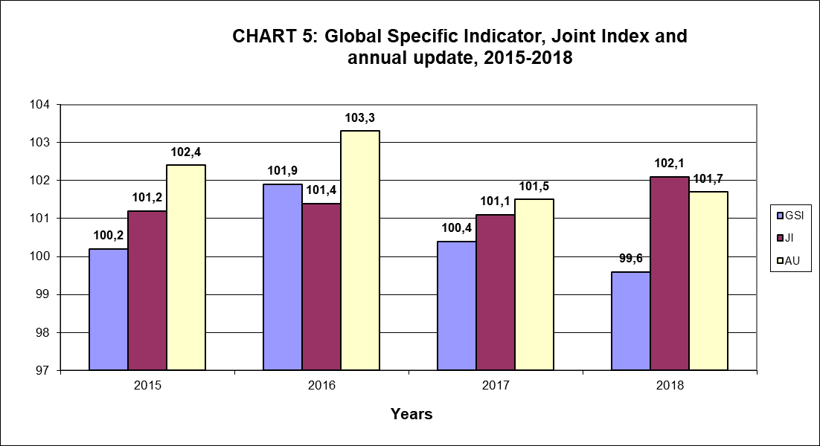

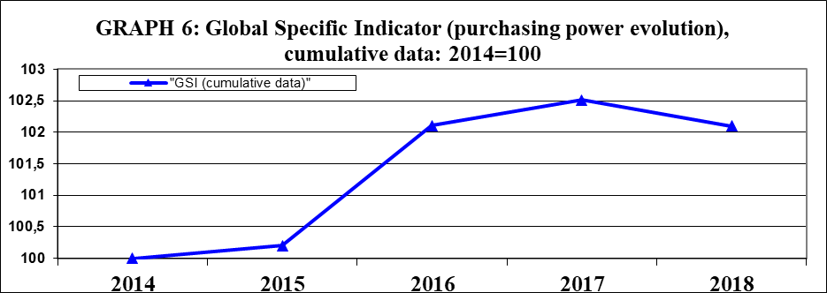



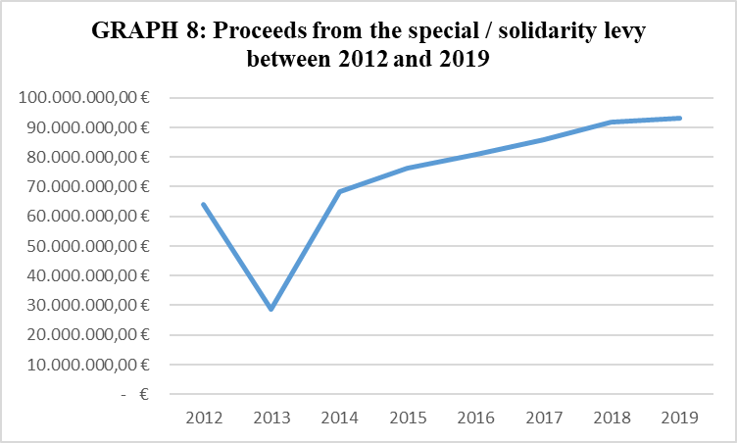

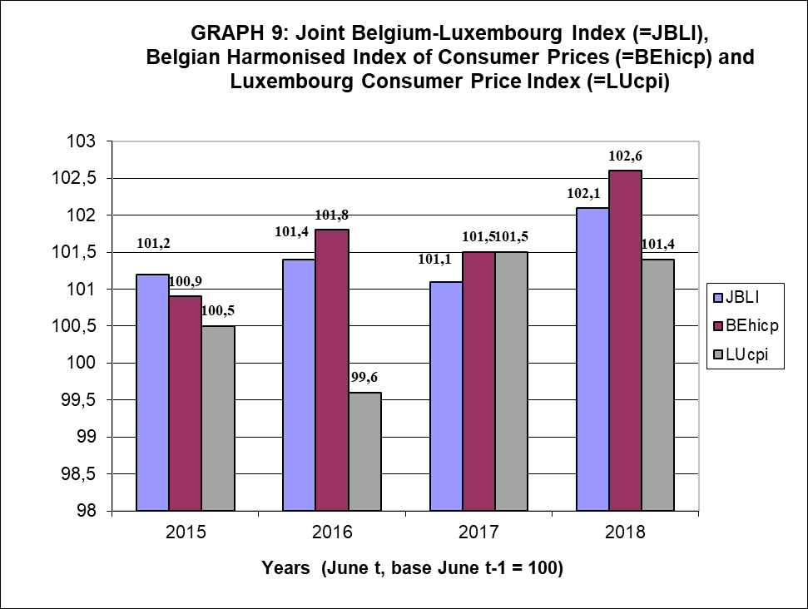



1. Regulation (EU, Euratom) No 1023/2013 of the European Parliament and of the Council of 22 October 2013.
2. These are mainly Articles 64, 65 and 65a of the Staff Regulations and Annex XI thereto.
3. The methodology is based on the comparison of a snapshot of a national remuneration system of a Member State in the month of July of the current year with the equivalent snapshot in the same Member State in the month of July of the previous year.
4. Belgium, Germany, Spain, France, Italy, Luxembourg, the Netherlands, Austria, Poland, Sweden and the United Kingdom.
5. To account for substantial changes in the cost of living in Brussels and Luxembourg, an intermediate update may take place as of 1 January, in accordance with Articles 4 to 7 of Annex XI to the Staff Regulations. The sensitivity threshold referred to in these provisions was not reached in Brussels and Luxembourg since the entry into force of the 2013 Method.
6. The Working Group on Articles 64 and 65 of the Staff Regulations decided that the "final data" delivered by the Commission on the EU GDP for a given year would be interpreted as the data available by 30 September of the following year. This clarification was deemed to be necessary since GDP data can often be revised many years after the reference year.
7. An intermediate update may take place with effect on 1 January in the event of a substantial change in the cost of living between June and December.
8. COM(2015) 597 final, COM(2016) 717 final, COM(2017) 699 final.
9. The general methodology manual for calculating Specific Indicators is available on Eurostat’s website. In addition, 13 country-specific assessments have already published as of late 2018 and work is ongoing with other national authorities to increase the number of published assessments (see the following link: <https://ec.europa.eu/eurostat/web/civil-servants-remuneration/specific-indicators/country-assessments>).
10. Pursuant to Article 65(4) of the Staff Regulations.
11. COM(2018) 300.
12. As compared with the regular weights used for price statistics, the main difference for aggregating the Joint Index is the use of weights for rents that include owner-occupiers (instead of considering only tenants).
13. Values shown are for the overall aggregate index; actual calculations are done from detailed level.
14. For instance, the “family budget surveys” conducted to define consumption weights have been fully harmonised with the Coordinated Organisations (e.g. OECD, Council of Europe) and the United Nations.
15. In accordance with Articles 12 and 13 of Annex to the Staff Regulations, specific weightings (correction coefficients) may also apply to the remuneration of staff posted outside the EU. The updated value of these weightings is annexed to the yearly reports adopted by the Commission on data pertaining to the budgetary impact of the updates. A specific methodology has been developed by Eurostat in cooperation with national statistical authorities.
16. TABLE 12 presents only the correction coefficients resulting from the successive annual updates. Intermediate updates taking effect on 1 January are not presented.
17. This procedure involves notably the adoption by the Commission of a delegated act following a formal request submitted by the appropriate authorities of the Member States concerned, the administration of an institution of the Union or the representatives of officials of the Union in a given place of employment.
18. In the Judgment of the General Court (Eighth Chamber) of 4 October 2018 in case T-546/16 *Marina Tataram v European Commission*, the application was dismissed as inadmissible.