

EN

**REPORT FROM THE COMMISSION TO THE EUROPEAN PARLIAMENT AND THE COUNCIL**

**on the implementation of Regulation (EC) No 428/2009 setting up a Community regime for the control of exports, transfer, brokering and transit of dual-use items**

**1. Introduction**

Article 23(3) of Regulation (EC) No 428/2009 ("the Regulation") calls for the Commission to submit an annual report to the European Parliament on the activities, examinations and consultations of the Dual-Use Coordination Group (DUCG). Furthermore, the Commission Communication (COM(2014)244) recognises that the publication of reports and non-sensitive control information could be critical steps to enhance transparency and improve operators' compliance and their capacity to implement controls. This report, prepared by the Commission with input from Member States' in the DUCG[1], provides information on the implementation of the Regulation in 2017, and includes aggregated export control data for 2016.

**2. Evolution of the policy & regulatory framework**

**2.1. Export control policy review**

Further to the adoption on 28 September 2016 of a Commission proposal for a modernisation of EU export controls[2], the legislative process has started in 2017 as the European Parliament and the Council examined the proposal. In particular, the European Parliament's Committee on International Trade (INTA) held a first exchange of views on the subject on 28 February 2017, followed by a public hearing on 21 March 2017 and a technical briefing on 4 May 2017. INTA adopted a report on the legislative proposal on 21 November 2017, including 101 amendments demonstrating the Parliament's broad support for more harmonised and effective controls, adapting the EU export control system to new threats associated with cybersurveillance items and taking into consideration human rights as part of the overall thrust for more responsible value-based trade and a "Europe that protects".

For its part, the Commission conducted a series of targeted consultations and outreach to key industry and civil society stakeholders in the course of 2017. In particular, an Export Control Forum was organised on 19 December 2017, jointly with the Estonian Presidency of the Council of the EU, to exchange views with industry and civil society stakeholders[3].

**2.2. Amendments to Regulation (EC) No 428/2009**

The Regulation was amended once over the reporting period. Commission Delegated Regulation (EU) No 2017/2268[4] of 26 September 2017 updated the EU Control List in Annex I to the Regulation, and incorporated modifications agreed at the multilateral export control regimes in 2016.

The 2017 EU control list thus incorporates approximately 170 amendments, most of which stem from the Wassenaar Arrangement (WA) and the Missile Technology Control Regime (MTCR). WA amendments concern, in particular, a significant restructuring of Category 5 Part 2 "Information security" into a more positive list of strategically important items in entry 5A002.a., and an amendment to the control of technology for lasers. MTCR changes concern in particular amendments to controls on ‘Ultra High Temperature Ceramics’ and flow-forming machines, the introduction of new controls on gel propellant rocket systems and gel propellant tanks, as well as aerothermodynamic test facilities. Other changes concern e.g. the introduction of 2 sub-controls for plasma torches and electron beam guns, and the removal of control on the dengue virus.  A "Comprehensive Change Note" was published as guidance providing an overview of all technical changes to the 2017 EU Dual-Use Control List[5]. Annexes II and IV of the Regulation were also updated in line with the amendments to Annex I. The updated and consolidated EU Control List became applicable on 16 December 2017, thereby allowing the EU to adhere to its international commitments with regard to export controls and helping EU exporters where control parameters were relaxed.

**2.3. National implementing measures**

The Regulation is binding in its entirety and directly applicable in all Member States, but foresees that Member States take certain measures for the implementation of specific provisions, and that information on those measures should be published in the Official Journal of the European Union. As no new measures were introduced by Member States in 2017, the Information Note of 20 August 2016[6] remained valid in 2017, providing an overview of measures taken by Member States including, inter alia, the extension of brokering and transit controls, the extension of controls to non-listed items for reasons of public security and human rights consideration, the introduction of national general export authorisations, the application of intra-EU transfer controls for non-listed items, as well as information relating to competent authorities.

**3. Activities of the Dual-Use Coordination Group**

Article 23 of the Regulation sets up a Dual-Use Coordination Group (DUCG) bringing together experts from the Commission and Member States to examine any issue concerning the application of export controls with a view to practically improving their consistency and effectiveness throughout the EU. The DUCG held 6 meetings over the reporting period, thus providing a forum for consultations on a number of topical issues concerning the implementation of the Regulation.

**3.1. Consultations on implementation issues - general information exchange.**

The DUCG conducted ***general information exchanges in support of the modernisation of EU export controls***, in particular regarding the implementation of catch-all controls and transit controls, as well as on the validity of licences. Furthermore, the DUCG supported the organisation of a "Peer Visit / Export Control Retreat" in Malta on 11-12 May 2017 to informally exchange views at technical and conceptual level on key issues related to the modernisation of EU export controls.

The DUCG also conducted a regular general ***exchange of information regarding the implementation of national measures***; in the absence of any new national measure in 2017, the DUCG did not prepare an Information Note for publication in the Official Journal.

The DUCG reviewed the methodology and approach for data exchange, and conducted a ***licensing data collection exercise*** on 2016 data in order to enhance information exchange between MS and to increase public transparency on EU dual-use export controls (EU 2016 aggregated data was used in the preparation of this annual export control report).

The DUCG supervised the activity of the "Surveillance technology expert group" ("STEG"). The STEG held two meetings in 2017 and monitored relevant technology and policy developments, reviewed licensing and denials trends and provided expertise in support of the legislative process for the modernisation of EU export controls and in relation to technical discussions in the Wassenaar multilateral export control regime. In consideration of the debate regarding the control of cyber-surveillance items, the DUCG conducted an ***exchange of information on the application of controls on cyber-surveillance items*** in 2016. The data shows an increasing but limited number of licences (139 licences in 2016). In the same period, 17 denials were issued for cyber-surveillance items[7].

The DUCG was informed of EU actions to support SMEs, clusters and regions in developing dual-use projects (e.g. COSME programme).

**3.2. Technical exchange of information - implementation issues**

* ***Support to the preparation of updates to the EU control list***

The DUCG was consulted and supported the preparation of a Commission Delegated Regulation updating the EU Control List in Annex I to Regulation (EC) No 428/2009. National experts, as well as observers from the European Parliament, attended a special session of the DUCG on 23 May 2017 and gave presentations highlighting the most important changes to the control list. Commission Delegated Regulation (EU) 2017/2268 was adopted on 26 September 2017 and published on 15 December 2017[8].

* ***Technical information exchange on specific implementation issues***

The DUCG held technical exchanges of information on specific control issues such as the *application of* *controls under Art. 22.10* of Regulation (EC) 428/2009, in an attempt to identify implementation challenges and to collect information on national experience and practices and on industry awareness.

The DUCG also held a technical exchange of information on possible *alignments between the EU dual-use control text and the control texts in the multilateral regimes* (on the Nuclear General Note and the Nuclear Software Note).

**3.3. EU Guidelines on Dual-Use Export Controls**

In light of the results of the 2016 Survey on AEO-ICP convergence, the DUCG decided to set up a Technical Expert Group (TEG) to develop guidelines for industry compliance (TEG on "Internal Compliance Programmes"). The TEG held four meetings and consulted industry representatives in the course of its work. The progress of this Technical Expert Group was presented to the DUCG on 9 November 2017 and to stakeholders on the occasion of the Export Control Forum on 19 December 2017.

**3.4. Electronic exchange of information between competent authorities**

The DUCG continued to support the further development of the Dual-use e-System (DUeS), a secure and encrypted electronic system hosted by the Commission, to support enhanced exchange of information between export control authorities and the Commission. In the course of 2017, the DUCG agreed on specific improvements to DUeS and developed new functionalities enabling the online management of access and contacts in national administrations, and supporting 'Article 11 consultations' e.g. when the goods are located in a Member State other than the one in which the application has been made. Other updates were made e.g. regarding legal references for the reporting of denials under Iran sanctions and to reflect the 2016 update of the EU control list under Commission Delegated Regulation (EU) No 2017/2268.

The DUCG also continued discussions regarding the development of an "electronic licensing platform", and set up a Technical Expert Group to support the e-licensing feasibility study conducted by the Commission in the course of 2017. The feasibility study for the development of an "electronic licensing platform" to be used by competent authorities on a voluntary basis was presented to stakeholders on the occasion of the Export Control Forum on 19 December 2017.

**3.5. EU Dual-use Pool of Experts**

In 2017, the EU Dual-use Pool of Experts operated by Commission’s Joint Research Centre (JRC) and experts made available by Member States continued to provide support to competent authorities requesting advice to support the assessment of specific licensing cases. In total, 9 technical advices on commodity classification were provided to 6 competent authorities over the reporting period.

**3.6. Export control enforcement**

The DUCG exchanged information on certain specific attempts at the circumvention of controls. For its part, the Commission released a new version of the 'correlation table'[9] linking customs codes with dual-use classifications and continued inclusion of export control parameters into the EU's online customs tariff database (TARIC).

**3.7. Capacity building**

In 2017, the Commission’s JRC continued the series of technical seminars in collaboration with the US Department of Energy, and held the 10th seminar on 23-24 May 2017 at the World Customs Organization's headquarters in Brussels, Belgium. The event was attended by licensing officers and technical experts from comptetent authorities, as well as exporters, academia and research organisations. Themes explored included challenges related to implementing catch all controls and challenges related to linking customs codes and export control lists.

Based on a concept note prepared by the Commission's Joint Research Centre (JRC), the DUCG explored plans for the development of an EU 'Inreach' training curriculum for licensing and custom officials and initiated preparations for a first seminar to be held in 2018.

**3.8 Transparency and dialogue with industry and academia**

The DUCG supported the organisation of an "Export Control Forum" on 19 December 2017 in Brussels with industry associations, dual-use companies, academia and civil society organisations to discuss the implementation of EU export controls and the legislative process for a modernisation of EU export controls[10]. The Commission and competent authorities organised or participated in over 160 outreach events in 2017.

The DUCG also prepared documentation to support exporters' implementation of the regulations. In particular, a "Comprehensive Change Note" summarises, for information purposes, the control text changes to the EU control list introduced under Commission Delegated Regulation (EU) No 2017/2268.

**4. EU export controls – Key Data**

It is difficult to get reliable information on overall dual-use exports (including non-listed dual-use items) as there is no correspondingly defined economic sector. However the Commission and Member States collect data that allow for approximate estimates of exports of dual-use goods based, on the one hand, on specific licensing data collected by competent authorities and, on the other hand, on statistics for customs commodities which include dual-use goods. 2016 export data estimates are presented below. To be noted, estimates presented hereafter do not include services and intangible technology transfers associated with the trade in dual-use goods.

**4.1. EU dual-use trade: items and destinations**

In 2017, the Regulation primarily applied to the export of about 1841 dual-use "items" listed in Annex I (the "EU Control List") and classified in 10 categories (Figure 1). These dual-use items relate to circa 1000 customs commodities, including chemicals, metals and non-metallic mineral products, computers, electronic and optical products, electrical equipment, machinery, vehicles and transport equipment etc. and typically fall at the high–tech end of this large, mixed commodity area.



*Figure 1: Number of dual-use items listed in Categories of Annex I further to the adoption of Regulation (EU) 2017/2268, compared to Regulation (EU) No 2016/1969.*

Statistical estimates of the relative importance of dual-use trade indicate that dual-use exports represent about 2.6% of EU total exports (intra and extra-EU), within a broad ‘dual-use export domain’[11] of customs commodities (Figure 2).

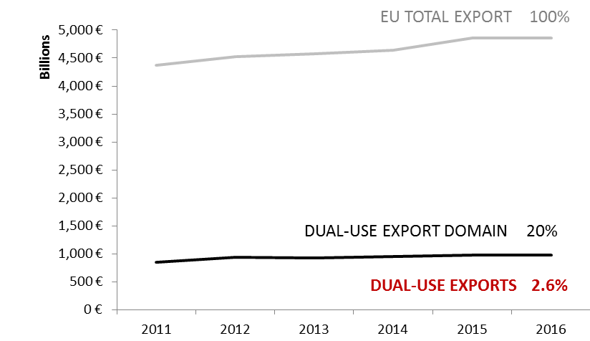

*Figure 2: Statistical estimates of dual-use intra and extra-EU exports.*

Statistical estimates also show the main dual-use export destinations and indicate that a large part of the these exports are directed towards 'EU001 countries' benefiting from Union general export authorisations (EUGEAs). The destination countries reflect the EU export market structure in the relevant commodities as well as trade facilitation under EUGEAs (Figure 2, 3 and 4)[12].



*Figure 3: EU dual-use export estimates: top 25 export destination countries and their sub-regions in 2016.*



*Figure 4: EU dual-use export estimates: destination countries by world regions and sub-regions in 2016.*

**4.2. EU dual-use trade control: Applications, licences, denials**

The DUCG has exchanged licensing data and information, in order to improve the understanding of export controls and their economic effect. Some data collected for the reporting period is reported below; it should be noted however that not all Member States collect all data. The information provided below thus represents approximate estimates of aggregate quantities and values within the limits of the data made available by Member States.

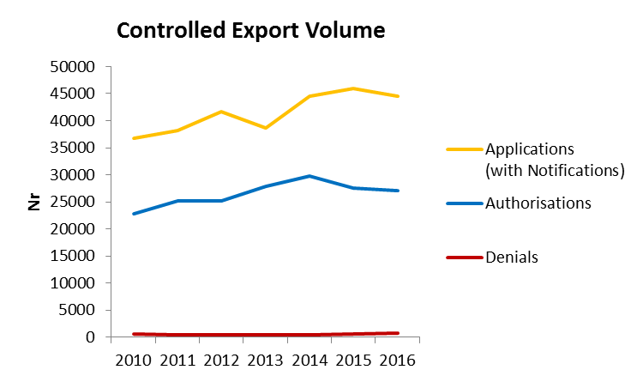

*Figure 5: Volume (number) of authorisations and denials in 2010-2016[13].*

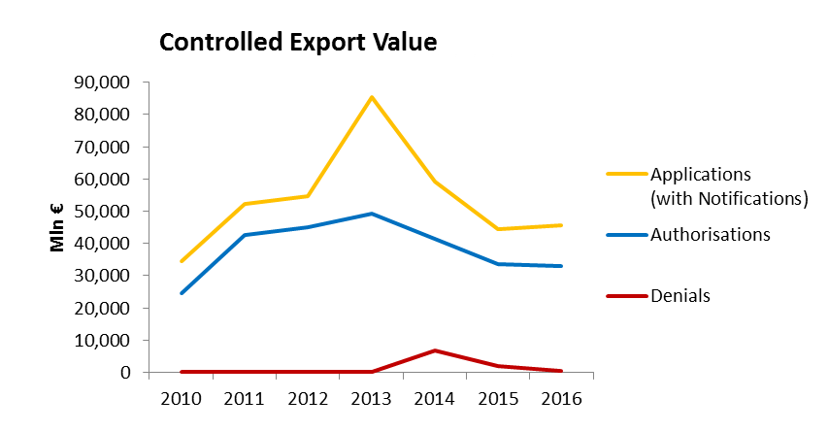

*Figure 6: Value (mln EUR) of authorisations and denials in 2010-2016.*

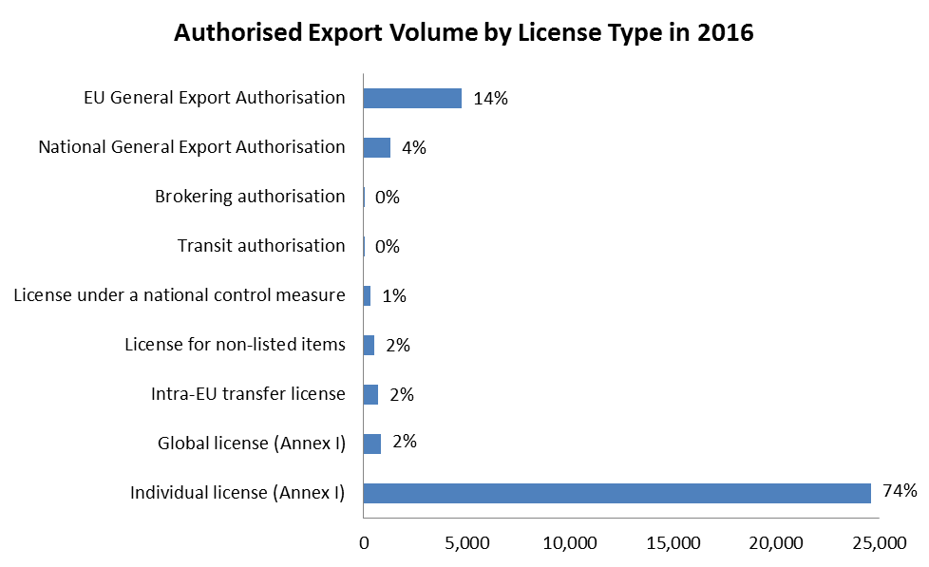

*Figure 7: Volume (number) of authorisations per category in 2016.*

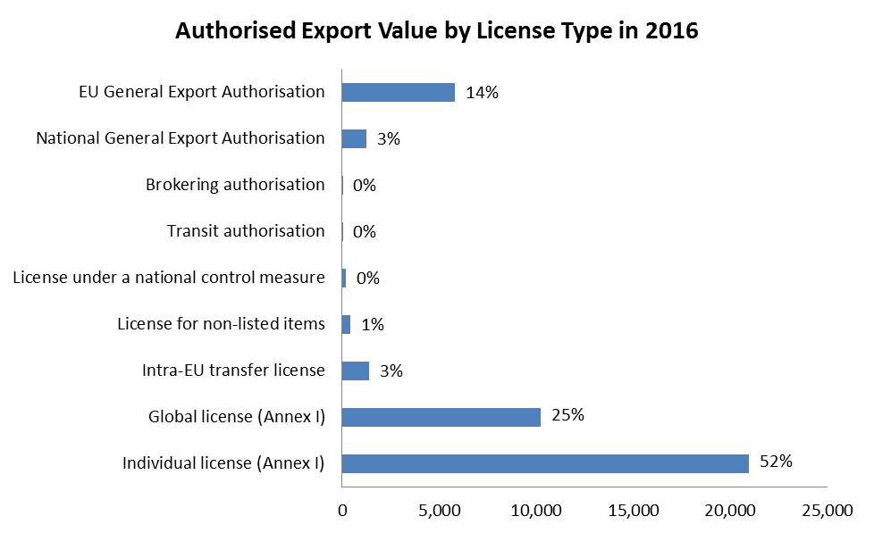

*Figure 8: Value (mln EUR) of authorisations per type in 2016.*

The total value[14] of applications reached EUR 45.7 bn and controlled dual-use exports thus represented 2.6% of total extra-EU exports. Authorised dual-use trade amounted to EUR 33.1 bn, representing 1.9% of total extra-EU exports, with a majority of transactions authorised under individual licenses (approx. 25.000 single licenses issued in 2016) and global licenses (by their value). Only a small portion of exports were actually denied: approx. 690 denials were issued in 2016, representing about 1.1% of the value of controlled dual-use exports in that year, and 0.03% of total extra-EU exports.

1. Some MS competent authorities also publicly report on trade in dual-use items.
2. COM(2016)616. The proposal for a regulation is available at <http://eur-lex.europa.eu/legal-content/EN/TXT/?qid=1476175365847&uri=CELEX:52016PC0616>
3. The report of the Forum is available at:

   <http://trade.ec.europa.eu/doclib/docs/2017/december/tradoc_156503.pdf>
4. OJ L 334, 15.12.2017.
5. The Summary Note is available at: http://trade.ec.europa.eu/doclib/docs/2017/october/tradoc_156133.pdf.
6. Official Journal of the European Union C 304, 20.8.2016, p. 3.
7. 13 denials were issued in 2016 for mobile telecommunications interception or jamming equipment, 1 for decoding software for mobile communications, 2 for Internet Protocol (IP) network communications surveillance systems and 1 for intrusion software.
8. OJ L 334, 15.12.2017, p. 1.
9. <http://trade.ec.europa.eu/doclib/docs/2017/march/tradoc_155445.xlsx>
10. <http://trade.ec.europa.eu/doclib/docs/2017/december/tradoc_156503.pdf>
11. The statistical methodology developed by the Commission's Joint Research Centre makes use of a correlation table, developed by DG TAXUD, between dual-use classification numbers and customs codes and of Eurostat’s COMEXT data, as well as of licensing data. The notion of *dual-use export domain* refers to a large mixed commodity area, which includes dual-use items. Trade in dual-use items takes place *within* this commodity area, but is not identical to it, since by far, not all of the commodities within the *dual-use export domain* are really dual-use.
12. "Stores and provisions extra" are defined as delivery of ships' and aircraft's stores. ”Miscellaneous –countries not specified extra” includes countries and territories not specified within the framework of trade with third countries (i.e., these codes are usually used for goods delivered for offshore installations).
13. In Figures 5 and 6, "Applications" data include all applications for licenses, including notifications under general authorisations, thus providing an indication of "controlled exports", i.e. the value of extra-EU exports subject to an authorisation process. In cases where no application data is available, the charts make use of authorisation data as estimate for application data. "Authorisations" data refers to dual-use exports authorised under individual and global licences. It should be noted that applications do not necessarily correspond to the sum of authorisations and denials, as a number of applications may be cancelled and some applications may not be finalised within the same year. "Denial" refers to the volume and value of denied exports.
14. This figure includes value for licence applications and notifications under General Export Authorisations.