

1. **INTRODUCTION**

In an increasing globalized world, the differences in taxation systems may affect negatively to tax revenue collection, as businesses are able to shift profits across borders and taxpayers can earn income from abroad without being taxed, when taxpayers are not compliant in all countries involved. This has led to the development of various cooperation mechanisms among tax authorities, referred as ‘administrative cooperation in direct taxation’.

Within the EU, Council Directive on administrative cooperation in the field of direct taxation 2011/16/EU (the Directive or DAC) is a key element in cooperation between Member States. It supports Member States by giving a new improved framework for commonly structured working methods and electronic tools since 2013, on the basis of experiences in mutual assistance since 1977.

Access to information on the incomes earned and the assets held abroad by resident taxpayers is of great importance for tax authorities. Accordingly, the exchange of information on taxpayers engaged in cross-border activities is as an essential component of an effective administrative cooperation and is one of the forms of cooperation covered in the DAC. The exchange of information involves a bilateral information flow between competent tax authorities in two countries and concerns foreseeably relevant data related to a variety of taxes, applicable to both natural and legal persons.

Three forms of information exchange are foreseen in the DAC, namely: (i) the exchange of information on request (EOIR), which refers to information concerning specific persons or transactions expressed by the requesting country; (ii) the spontaneous exchange of information (SEOI), which refers to the unsystematic flows of information deemed to be of interest for the receiving country; and (iii) the automatic exchange of information (AEOI), which refers to the exchange of predefined tax data, using predefined formats and at predetermined times, without prior request from another country.

The AEOI is the subject of this report. It differs from the other forms of information exchange because of its mandatory nature and broader scope.

Member States agreed mandatory AEOI to start as of mid-2015 for tax information concerning tax residents in other Member States, for five categories of income and capital (DAC1). In 2014, Member States agreed to update the Directive to implement in the EU the Common Reporting Standard developed by the Organisation for Economic Co-operation and Development (OECD), introducing automatic exchange of financial account information (DAC2). In 2015, a further amendment introduced AEOI for tax rulings and advance pricing agreements (DAC3). AEOI was further expanded in 2016 and 2017.[1]

This report is based on Article 8b (2) of the Directive which requires the Commission to submit, before 1 January 2019, a report providing an overview and assessment of AEOI under DAC1, DAC2 and DAC3. It describes the main key findings about the implementation of AEOI, its costs and benefits, as well as actions taken by Member States to make use of the information received.

The report has been drafted mainly on the basis of information gathered from Member States’ tax authorities via an annual survey and annually collected sets of statistical data.[2] It covers the period from 2015 until mid-2018 as regards DAC1, and from 2017 until mid-2018 as regards DAC2 and DAC3.

It must be noted that at the time of preparing this report, the Commission is conducting a comprehensive evaluation of DAC[3]covering, in addition to AEOI, also all other forms of administrative cooperation.

1. **DAC1**

DAC1 requires Member States to automatically exchange information that is available on five categories of income and capital: income from employment, director’s fees, life insurance products, pensions, and ownership of and income from immovable property.[4]

This information has to be sent at least once a year to the Member State of taxpayer’s residence. The first exchanges of this data took place in June 2015, regarding the taxable period 2014. Using a step-by-step approach, Member States were expected to send information for at least three income or capital categories out the five described in Article 8(1) of the Directive by 2017.

This report covers information from Member States concerning the following years: 2015, 2016 and 2017.

**2.1 Main features in DAC1 information exchanges**

Up until June 2017, **Member States exchanged information concerning nearly 16 million taxpayers, related to incomes and capital amounting to over EUR 120 billion**. Most information concerned income from employment and pensions, which represent over 80 % of the taxpayers and 95 % of the total value.

|  |  |
| --- | --- |
| **Number of Taxpayers (million)** | **Value of Information Exchanged (€ million)** |
| * Partial | * Partial |

Figure *1*. *Evolution of DAC1 Exchanges by Message Year*

**The volume of information exchanged has grown over time, with a twofold increase between 2015 and 2016**. Data on information exchanges concerning the first half of 2017 suggests that the increasing trend continued. This is also confirmed by amount reports, which can be extracted from the secured exchange channel that Member States use for bilateral exchanges: there is a positive trend also in 2017 in the exchanged data amounts.

|  |  |
| --- | --- |
| **Sending Countries** | **Receiving Countries** |
| **Number of Taxpayers (million)** | |
|  |  |

*Figure 2. Top 10 of Sending and Receiving Countries – Files sent in 2016*

The **exchange patterns are mostly consistent with intra-EU migration patterns**. Emigration countries are net receivers of information. In particular, Poland receives information on 14 times more taxpayers (equalling 19 times the amount) than it sends information about. The opposite applies in net immigration countries, such as Luxembourg which sends information on five times as many taxpayers as it receives information on, and on over thirty times the value. Other net receivers include Spain and Portugal, whilst Germany and Denmark are net senders.

Not surprisingly, **large EU countries such as France, Germany, Italy, and the UK are among both the top senders and the top receivers**, even though the profile is somehow different in terms of income categories. For instance, in terms of taxpayers concerned, France and Germany are by far the largest senders for employment and pension income, while a substantial share of the information they receive concerns immovable property. The situation is exactly the opposite for Italy, Spain and Portugal: a large share of the information they send concern immovable property, while they receive information concerning mostly pensions.

An overview of bilateral interactions shows a high degree of concentration, with different patterns depending on whether the number of taxpayers or the value of the information exchanged are considered. **In terms of number of taxpayers, France and Germany are the main sending countries.** The bulk of exchanges take place along two axes, the one connecting Germany and France with Spain and Portugal, and the one linking Germany and Italy, with two additional significant flows between France and Italy and the Netherlands and Poland.

**The situation is different when the euro amounts of information exchanged is considered**. The three largest flows, accounting for more than EUR 9 billion, originate from Luxembourg towards Belgium, France and Germany. This is supplemented by a significant flow from France to Portugal, which is the one to have a clear link with the exchange of information in terms of number of taxpayers.

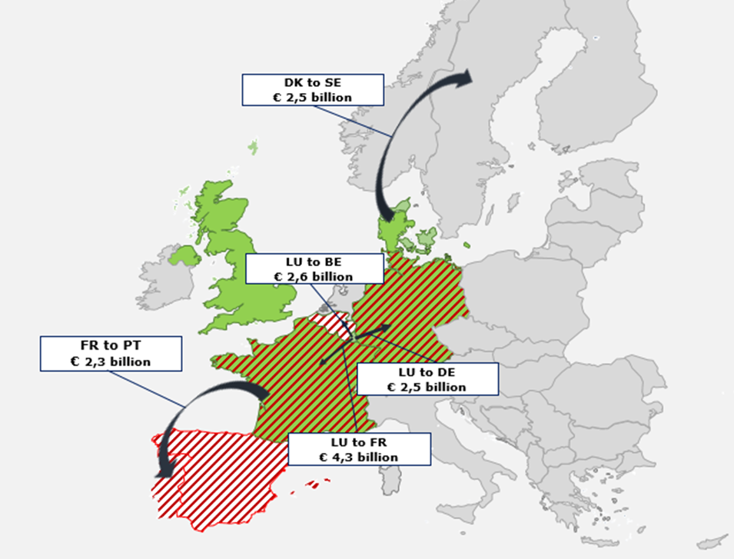

*Figure 3. Main Bilateral Flows/Value of Information Exchanged/Year 2016*

**Availability of information**

On the basis of DAC1, Member States only have to share the information they have available in their national tax databases. No additional data collection compared to what tax administrations collect for internal tax purposes is required.

**In 2017 eight Member States had information available for all five categories of income and capital covered in DAC1**, and another nine had information available for all categories except for life insurance products. Only one country, Cyprus, had information available for only one category of income (pensions). The remaining ten could exchange information on three income categories. This availability has evolved only marginally in the three years surveyed. Only Czech Republic, Estonia, Finland and Italy have increased the number of income categories since 2015.

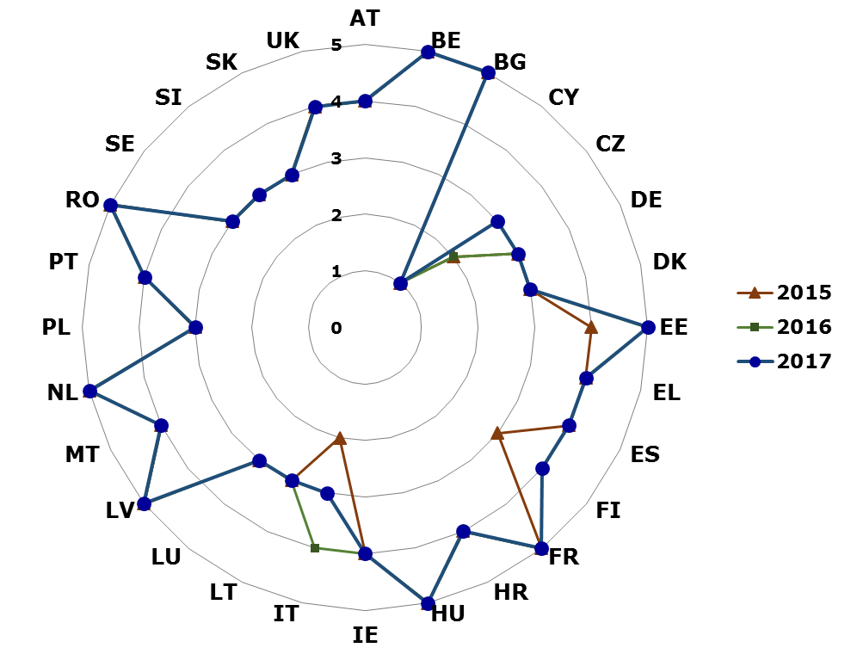

*Figure 4. Number of categories of DAC1 for which information is available 2015 - 2017*

For tax administrations, to work for having new information available for AEOI can be time-consuming and costly. For example, Ireland reported that gathering information on life insurance products would require significant resources and time for the necessary laws and IT systems to be in place. Malta pointed out that collecting additional information would impose a significant burden on economic operators.

Some evidence however suggests that increasing the availability of information does not always require the collection of additional information. Availability can be expanded by improving the accessibility of existing information. In 2015, Czech Republic reordered its national tax databases to provide information on income from property and in 2016 Finland was able to start sending property income information by integrating different existing databases.

**Availability of identification elements - Taxpayer Identification Number (TIN)**

The inclusion of identification elements in the data sent is essential for Member States to be able to associate the information they receive with national taxpayers databases. The name of the taxpayer and the TIN issued by the receiving country are regarded as the most useful identification elements in case of automatic matching. **The systematic inclusion of information of the TIN of the taxpayer would allow to bypass several problems connected to the use of the name for the identification**, such as misspelling or translation/transliterations, as well as homonymies.

However, only two countries, Ireland and Lithuania, actually included in the information exchanged the TIN issued by the recipient country, for all taxpayers concerned. Estonia did so for nearly 60% of the taxpayers.

In no less than 15 cases, the information sent did not include the TIN of the recipient country for any of the taxpayers on which information was shared. Since these cases include the largest senders, overall **only 2 % of the taxpayers on which information was exchanged were associated with a TIN issued by the recipient country**. Therefore, the identification of taxpayers is in practice based on information about their birth date and name in free or structured format.

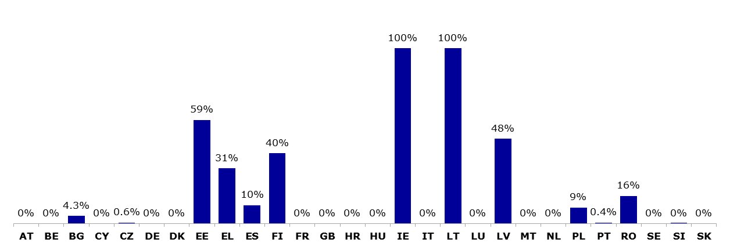

*Figure 5. Share of taxpayers/parties for which the TIN of the recipient country was included by sending Member State (all message years, weighted average)*

**Time gap between tax year of the income and sending date**

Member States have the obligation to share DAC1 information within six months following the end of the tax year of the Member State during which the information became available. In practice there could be a delay of up to eighteen months from the end of the tax year.

Overall, since the start of DAC1 exchanges, **tax information was sent on average twelve months after the end of the tax year they refer to, but there are significant differences between Member States**.

The time required has reduced over time, and there are no major differences between the different income categories. The proportion of exchanges sent within six months increased from 31 % for data regarding tax year 2014, to 45 % for those concerning tax year 2015.

No correlation was found between the time taken to exchange information and the type of income and capital, the number of files sent, the number of taxpayers or the overall value concerned. Furthermore, while ten Member States send all messages at the same time, the others tend to send the messages over several months.

**Treatment and use of the received information**

The first effort for using the received data is to open the file and start processing it. **Member States tend to open the files within one year of receipt**. In 2017, depending on the type of income, 23 Member States reported opening the files received during the year of reception. As of 2017, only three Member States (Bulgaria, Malta, and Slovakia) appear not to have worked with the files received neither during the year they received them, nor in the following years.

Normally, the first step is to match the information received to an identified taxpayer record. Information about an unidentified taxpayer is not as easily usable. Matching allows linking the information received from other countries with the relevant taxpayers’ files.

The share of taxpayers data automatically exchanged under DAC1 which was identified and successfully matched with national databases varies depending on the types of income and capital. In the case of Member States for which matching results were available for 2017, the matching rates averaged at about 90 % for income from employment and pensions, were in the 75 % - 80 % range for directors' fees and ownership of and income from immovable property and averaged a modest 59 % for life insurance products. Almost 90 % of matching is done automatically or semi-automatically. The share of manual matching has declined overtime.

**Risk assessment and personal income tax assessment[5] are the most common uses of the information reported in all three years.** The overall trend seems to be an increased and more intensive use of the information received. There are no major differences in the use made of information under the various income categories, with the exception of life insurance products, which are systematically less used than the other income types.

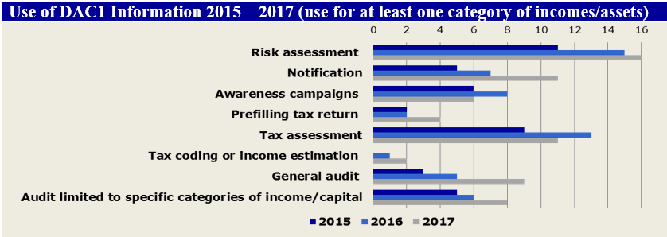

*Figure 6. Use of DAC1 information*

1. **DAC2**

Under the DAC2 Member States are required to automatically exchange financial account information, i.e. end-of-year account balance on a reportable account, as well as dividends, interests, gross proceeds and other investment income paid to that account during a year. This information is provided to Member States' tax authorities by financial institutions, which have to perform certain due diligence procedures aimed at identifying reportable financial accounts and then report the required information. The DAC2 implements within the EU the Common Reporting Standard (CRS) developed by OECD and broadly applied at international level.

The information is sent annually within nine months following the end of the calendar year or other appropriate reporting period to which the information relates. The first exchanges took place in September 2017.

The information available for this report refers to the half year period from mid-September 2017 through March 2018. Therefore, **no real trends in the information flows can be identified, nor can any reliable analysis be made on the possible use of the data**. Finally, Austria began to fully apply DAC2 only in 2018.

**Main features in DAC2 information exchanges**

**Member States exchanged information concerning a total of some 8.7 million accounts, and financial income** about **end-of-year account balances** amounting to **EUR 2,919 billion in total**. However, so far the exchanges have concerned only the existing ‘high value accounts’[6] and the ‘new accounts’ opened in the last months of 2016. The number of accounts is therefore expected to increase once the full reporting scope of DAC2 is implemented.

**The other financial information exchanged appears to refer primarily to gross proceeds** which account for EUR 3,466 billion.[7] In contrast, dividends are valued at EUR 21.2 billion, interest at EUR 19.0 billion, and other payments at EUR 61.8 billion.

|  |  |
| --- | --- |
| **Sending Countries** | **Receiving Countries** |
| **Number of Accounts (million)** | |
|  |  |
| **Overall Amount (€ billion)** | |
|  |  |

*Figure 7. Top 10 Senders and Receivers of DAC2 Information*

**The network of bilateral exchanges is centered on Luxembourg and, to a much smaller extent, Ireland**. Outgoing flows of financial information are dominated by Luxembourg, with 17 % of the accounts and nearly 80 % of the amounts reported. Ireland is also an important sending country, coming fourth in the ranking in terms of both number of accounts and total amount reported.

**Regarding incoming information, there are differences depending upon the variable taken into consideration**. In terms of number of accounts, the ranking broadly reflects the size of Member States’ economies, with Germany, Italy, France and the UK accounting for half of the total. In contrast, when looking at the value reported, the ranking is led by Belgium, Sweden and the UK, which cumulatively account for 63 % of the total value.

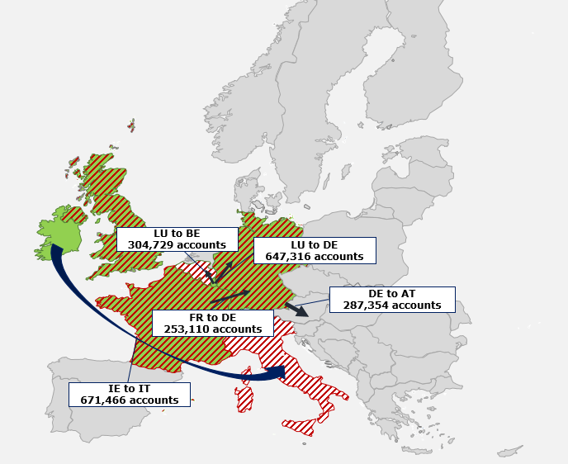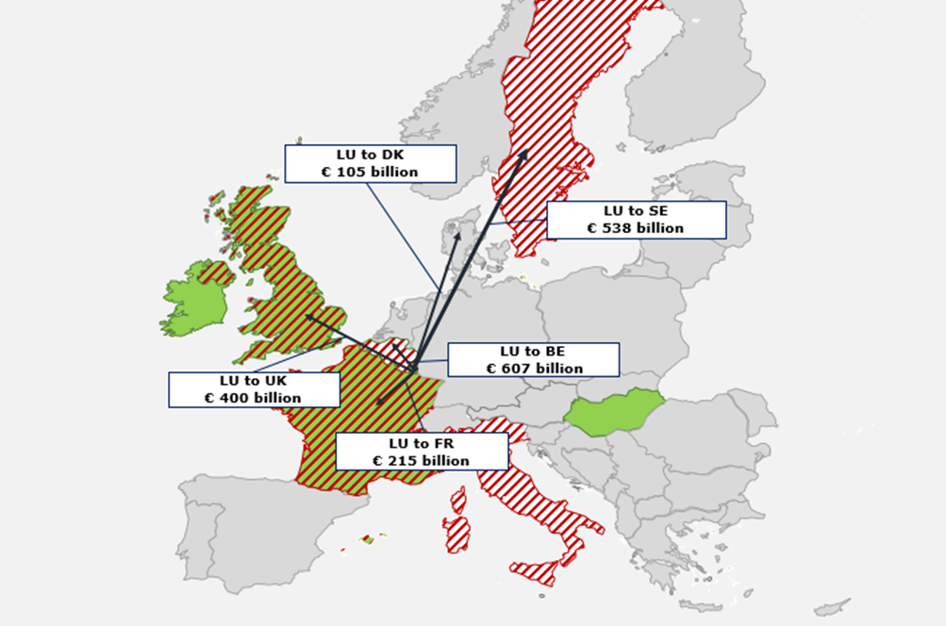

*Figure 8. Main Bilateral Flows – Number of Accounts (left) and Value of Information Exchanged (right)*

**Availability and timeliness of information**

The availability of information and question of timeliness is not relevant for DAC2 as there is no ‘availability clause’ nor potentially long timeline for exchanging the information received by tax authorities from their financial institutions. In the case of DAC2, there are much more TINs included in the data than with DAC1. Overall, some 70 % of the accounts whose holders are natural persons are associated with at least one TIN of account holders, and 73 % of the accounts whose holders are legal persons, are associated with an organization identification number. This relates to the liabilities of a financial institution or bank to know their clients.

**Treatment and use of the received information**

During the first year of DAC2 exchanges, only three states, Bulgaria, Slovakia and Malta, reported not having opened the files received. Italy and Sweden, reported having made an initial selection on the files received using a combination of threshold and other criteria, while all other Member States have worked directly with the whole dataset.

**Information on matching rates and methods (fully or partially automatic or manual) is available only for some Member States.** Most Member States use automated matching. Only a few rely on less efficient manual procedures. In terms of results, seven Member States were able to successfully match 80 % or more of the information received, whereas another two successfully matched 75 % of the data. Results are lower for other Member States. Estonia reports the lowest overall matching rate (37 %).

**Risk assessment is reported as the most common use of DAC2 information, followed by tax assessment**. Numerous Member States also reported using the information for awareness campaigns and for notification to taxpayer to generate disclosure.

As the first exchanges took place in September 2017, **DAC2 information has not been used as much as DAC1 information in 2017**. Nine states reported not using the information received via DAC2. Of them five, Bulgaria, Germany, Luxembourg, Malta, and Slovakia, also did not use the information received under DAC1 in the same year. Italy, a scarce user of DAC1 information, reported using DAC2 data, even if only for awareness campaigns.

1. **DAC3**

DAC3 AEOI requires sharing information on advance cross-border tax rulings (ATR) and advance pricing arrangements (APA) issued to a person or group of persons, other than natural persons. The sharing is carried out via entry into a central database accessible to all Member States.

**DAC3 resulted in a major increase in the transparency of information on advance tax rulings and advance pricing arrangements.** Almost 18,000 rulings were recorded in the central directory in 2017 compared to hardly any being spontaneously exchanged in the years up to 2015. However, it is too early to report on how this additional information has been used.

1. **COSTS AND BENEFITS**

The costs incurred by Member States are mainly related to the development and maintenance of the IT systems which are used to exchange information automatically. Most of the costs occur at the time when the IT systems are developed, while recurring costs are much lower.

On the basis of the available data, the overall implementation costs of AEOI provisions appear to be approximately EUR 112 million for the period 2012-2017. Costs varied depending on the system as reported in the sections below.

**DAC1**

The total costs incurred by Member States for implementing AEOI under DAC1 were EUR 69 million. The costs show major differences between Member States and between years. This can be explained by the differences in sophistication in the IT systems used for AEOI and in the procurement methods (e.g. outsourcing vs in-house development). The costs might be higher also for the reason that solutions for the use of information (e.g. matching tools) have been included in the development work from the start.

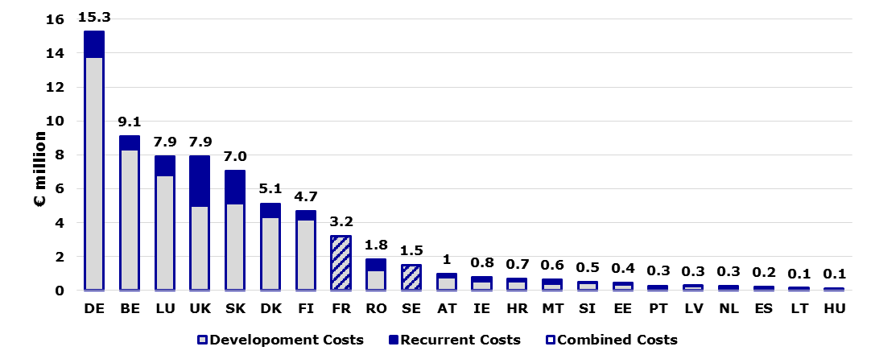

*Figure 9. DAC1 Costs up to 2017 (22 Member States) (EUR million)*

**DAC2**

The total costs incurred by Member States for implementing AEOI under DAC2 were EUR 45.4 million. As DAC2 provisions are based on the OECD’s Common Reporting Standard (CRS), the IT systems used for collection of data under DAC2 and CRS, as well as for the exchanges are largely comparable. Therefore, it is difficult to distinguish DAC2 from CRS costs and costs reported byMember States may overestimate the costs attributable to DAC2 only.

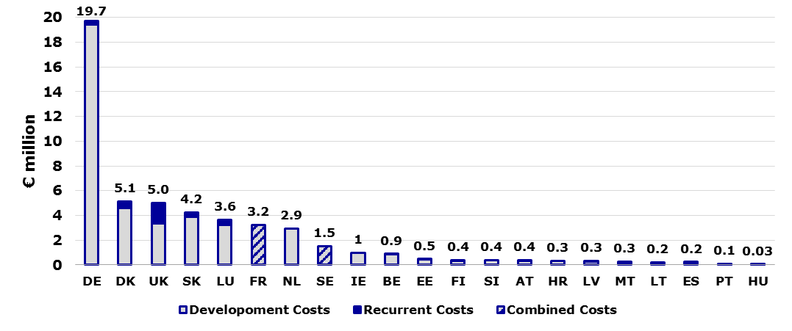

*Figure 10. DAC2 Costs up to 2017 (21 Member States) (EUR million)*

As in the case of DAC1, there are significant differences in DAC2 costs among Member States.

In addition to the Member States, in the case of DAC2 also financial institutions had to bear costs to adapt their IT systems. While a precise figure of these costs is not available, on the basis of available evidence costs borne by financial institutions appear higher than those incurred by Member States. One-off costs estimates for financial institutions in Austria, France, Germany, Luxembourg and UK given by stakeholders total around EUR 340 million while yearly costs are estimated at EUR 120 million.

No quantitative estimates are available for the administrative burden incurred by taxpayers having to comply with DAC2 reporting obligations. For DAC2, the actual reporting bodies towards tax authorities are not the taxpayers but the financial institutions maintaining the reportable accounts.

**DAC3**

The total costs incurred by Member States for implementing AEOI under DAC3 were EUR 2.1 million. The significantly lower amount compared with DAC1 or DAC2 is due to the following:

* DAC3 information is not exchanged on a bilateral basis, but the relevant information is uploaded in a Central Directory managed by the Commission;
* the number of ‘pieces of information’ to be shared is much smaller than in the case of DAC1 and DAC2;
* less complex systems and procedures needed to be put in place by Member States.

Despite lower costs there remain significant differences between Member States.

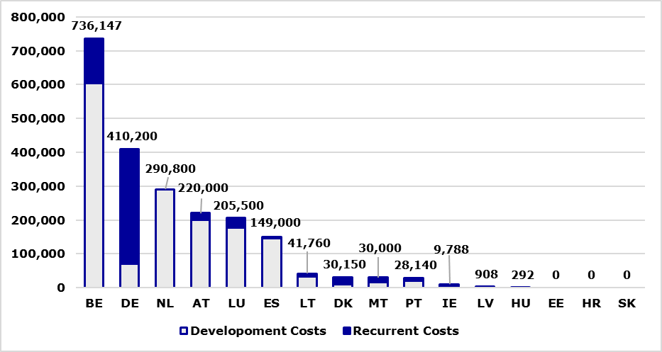

*Figure 11. DAC3 Costs up to 2017 (16 Member States) (EUR)*

**Benefits of AEOI between competent tax authorities**

The key benefit of AEOI lies in providing tax administrations with information which is useful to counter cross-border tax fraud, evasion and avoidance. There is a high risk to non-intentional and intentional non-compliance of income or assets, which are not nationally reported by third parties, such as employers and banks. As the foreign-source income and assets are reported in country of residence only by the taxpayer, it could be presumed to be a risk area in respect of compliance[8].

However, when it comes to quantify the benefits of AEOI in terms of **additional tax revenues**, the Member States have repeatedly explained how difficult it is to define the direct monetary benefit of tax data received from abroad, which is at its best only part of the information used for assessing additional taxes, or may not lead to any additional tax revenues at all. It can be said that **tax correctness** is already a valuable benefit to reach via mandatory AEOI, but that does not necessarily mean additional tax revenues. Additionally, as part of the whole set of information concerning certain taxpayer, the data coming automatically from abroad has its role to provide the **full profile of a risky or a compliant taxpayer**. Finally, another important benefit is certainly the **deterrent effect** for taxpayers due to the expected increasing use of information exchanged.

Using information received by other Member States via automatic exchanges, some Member States have been able to identify under-reporting of income by some taxpayers.

As regards the benefits in terms of increased tax compliance, five Member States (Belgium, Estonia, Finland, Poland and Slovenia) have been able to calculate the monetary benefits resulting from the use of DAC1 information.

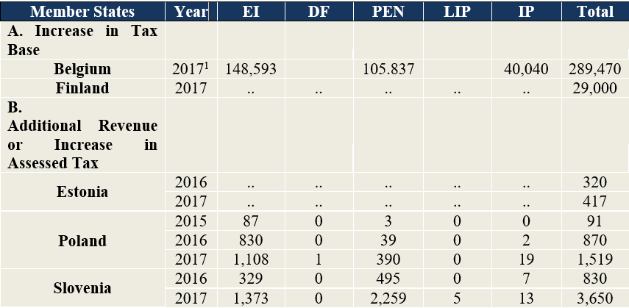

*Table 12: Incremental Tax Revenue from DAC1-related Actions (EUR ‘000)*

For Estonia, Poland and Slovenia data are available for more than one year. It emerges that benefits increase overtime. This may be explained by tax authorities progressively making a better use of the information exchanged. For Belgium, Poland and Slovenia, which provided information per category of DAC1 information, practically all benefits derive from the compliance use of DAC1 information on employment income and pensions, i.e. controlling if the taxpayers have been reporting these foreign income. In the case of Belgium and Finland, benefits are described as an increase in the tax base. Actual additional revenues collected are not known but they are likely a fraction of overall increase of the tax base. For Belgium, Estonia, Finland and Slovenia benefits reported are higher than reported costs[9]. For example, Belgium has reported DAC1 costs of EUR 9,100,000 and additional (unreported) income of EUR 289,470,000 in tax base. If the tax imposed on these additional income would be 10 % it would mean EUR 28,947,000 in added tax revenues. In the case of DAC2 and DAC3, no information is available on benefits from the compliance use of information received due to the short time between this report and the first DAC2 and DAC3 exchanges in 2017.

Moving to the question of benefits in terms of deterrence, estimates show that the CRS (which has been implemented in the EU via the DAC2) has had a significant deterrent effect. According to the Global Forum, the CSR led to voluntary disclosures and investigations which brought close to EUR 85 billion in additional tax revenue[10]. But, this figure covers the full scope of CRS and not only intra-EU exchanges under DAC2. Despite the difficulties of distinguishing between DAC2 and CRS benefits (and costs) it should be noted that even a very small share of that amount, for example EUR 1 billion would far outweigh the reported costs for tax authorities.

1. **CONCLUSIONS AND** **WAY FORWARD**

Three key conclusions emerge from this report.

First, Member States have recognised that the tax information received via AEOI can be used in different ways. The tax authorities mainly use the information for risk assessment and personal income tax assessment. However, several Member States still make very limited if any use of the information they receive.

Second, AEOI has required significant development investments by Member States, and even if the recurring costs are lower, there are annual costs to maintain the exchange activities. As regards the benefits of AEOI, it appears that the main benefits lie in the increased tax compliance and in the deterrent effect for taxpayers. However, it is very difficult to quantify the benefits of AEOI in terms of additional tax revenues.

Third, often Member States send information which do not include all necessary identification elements which would permit an automated matching of this information with the one available nationally. As a way forward, two main areas of improvement are identified:

**Improve quality of information**

Member States would improve EU-wide compliance and ensure a level playing field for both nationally and cross-border active taxpayers, if AEOI is used more effectively. Using mass of information effectively requires two main actions:

• Member States should review the quality of the information they collect before they send it.

• Member States receiving the information should give timely and constructive feedback to those sending it, so that AEOI quality can raise overtime. Member States should provide feedback also to the entities (e.g. financial institutions) which supply information for AEOI.

**Make better use of data received via AEOI**

Full use of the AEOI information requires strategic focus at the level of Member States, and agreeing on some common key indicators for benefits and assessment methods:

• Member States should develop a common methodology to estimate the benefits of AEOI reliably and comprehensively.

• Member States should ensure AEOI information is part of the tax risk management cycle and that it is used more for awareness campaign to improve voluntary compliance as well as for audits, combining all AEOI flows together as well as information obtained nationally and received via other means of administrative cooperation (e.g. simultaneous controls, presences in other tax administrations during enquiries and through exchange of information on request and spontaneously).

• Member States should share knowledge of best practices for full and efficient use of the data, for example by using advanced analytics techniques, such as data mining.

The EU Fiscalis programme for tax cooperation[11] can provide support for both improving AEOI data quality and making sure information exchanged is used efficiently and effectively to create a fairer tax system for the benefit of Europe and its citizens.

1. For more information see webpages of DG TAXUD on administrative cooperation.
2. Commission implementing regulation (EU) 2018/99 on the format of the yearly assessment and statistical data.
3. Roadmap of the evaluation: <https://ec.europa.eu/info/law/better-regulation/initiatives/ares-2018-1068597_en>
4. In this report, the following acronyms are used for DAC1 AEOI: employment income (EI); pensions (PEN); life insurance products (LIP); income or ownership of immovable property (IP); directors’ fees (DF).
5. DAC1 information, independently of the income type, is mostly used in the area of personal income tax. Other areas for which DAC1 information is relatively more commonly used include company tax and recovery purposes.
6. The term “High Value Account” refers to an account opened before 1.1.2016 with an aggregate balance or value that exceeds, as of 31 December 2015, or 31 December of any subsequent year, an amount that corresponds to USD 1 000 000.
7. It is worth noting that this value is strongly influenced by statistical data about gross proceeds information sent from the UK to France for a value over EUR 1,254 billion, and from France to the UK for a value of 1,320 billion.
8. See the report on Tax Gap to the Committee on Finance and U.S. Senate prepared by the United States Government Accountability Office (GAO).
9. Costs for Poland are not available.
10. Global Forum March 2018 Progress report to Ministers of Finance, p. 13.

    <http://www.oecd.org/tax/transparency/about-the-global-forum/g20/>
11. Proposal of 8 June 2018 for a Regulation establishing the 'Fiscalis' programme for cooperation in the field of taxation as part of the Multiannual Financial Framework (MFF) for the years 2021-2027:

    <https://eur-lex.europa.eu/legal-content/EN/TXT/?qid=1529053629679&uri=CELEX:52018PC0443>