

REPORT FROM THE COMMISSION TO THE EUROPEAN PARLIAMENT AND THE COUNCIL

on recent developments as regards euro coins

# Section 1. Introduction

The arrival of the euro as the single European currency was a major step forward in European integration. Euro cash is a dominant means of payment, with euro coins playing an important role. Citizens and retailers use coins in daily transactions to make payments or give change.

Though euro coins are issued at national level, it is the Council that standardises their denominations and technical specifications.[1] Since the introduction of euro notes and coins on 1 January 2002, euro area countries have collectively issued nearly 127 billion euro coins, valued at a total of about €28bn. The euro coinage, covering eight denominations ranging from one euro cent to two euros[2], has remained unchanged ever since.

The usefulness of the two smallest denominations (one and two euro cents) has been a matter of debate since they were introduced. The main aspects of this debate are these coins’ high production and handling costs compared to their face value, the high loss rate of these coins, and the falling purchasing power of these two small denominations more than 16 years after the introduction of euro notes and coins.[3]

The Commission carried out an impact assessment[4] on the issuance of one- and two- euro cent coins in preparation of its Communication of 2013.[5] This impact assessment was presented as a staff working document accompanying the Communication.[6] It highlighted four possible scenarios, ranging from no change to taking the coins out of circulation and introducing rounding rules.[7] In subsequent discussions, a majority of Member States were in favour of continuing to issue one- and two-euro cent coins, while examining possible ways of cutting production costs without altering the coins’ appearance and parameters.

This new report follows recital 7 of Regulation (EU) No 651/2012 on the issuance of euro coins (OJ L 201, 27.7.2012, p. 135), which foresees that “*The use of different denominations of euro coins and euro banknotes, as currently devised, should be periodically and carefully examined by the competent institutions against the criteria of cost and public acceptability*”. It also updates the findings of the 2013 Communication.

In section 2, the report takes stock[8] of the use of one- and two-euro cent coins and their evolving perception.[9] It also puts forward possible policy options for further discussion.[10] An extensive stakeholder consultation has been held recently on the issues associated with these coins, as announced in the roadmap that initiated this report.[11] The stakeholders consulted and the results of the consultations are described in part I of the Annex to this report. The policy options for these coins presented in this report are derived from this consultation.

Section 3 takes a look at the latest developments on the security features of coins. It is vital that citizens and retailers have confidence in euro coins of any denomination if the latter are to remain an efficient and attractive means of payment. The total number of counterfeit euro coins (50 euro cents, one euro and two euros) detected in circulation and reported has always been relatively stable.[12] While coin production technology to make coins even more secure has progressed, and automatic coin authentication is well established as a way to detect counterfeiting[13], the quality of some counterfeits has improved too.

Section 4 concludes by setting out intended tips following up the main findings of this report.

# Section 2. One- and two-euro cent coins: developments and debate following the Commission communication from 2013

## 2.1 Using one- and two-euro cent coins for payment

One- and two-euro cent coins are needed to buy goods or services whose total cost does not end in zero or five euro cents (i.e. the price of a single purchase or the sum of all purchases is not a round figure), and where cash payment is expected or is the dominant means of payment. Generally speaking, this is the case for relatively small purchases[14] of food and durable products in supermarkets, at bakeries and smaller retailers and for loose goods purchased by weight, volume, etc. on weekly markets or at the butchers’ or filling stations. Expenditure in supermarkets and smaller shops still accounts for a large share of consumers’ subsistence budget. However, most consumer goods do not fall into this category anymore, as single-item prices are higher and therefore usually rounded off[15] and/or because payments are made by non-cash means. Where cash payments involve the use of one- and two-euro cent coins, these denominations are mostly used to give change (‘one-way use’). Typically, consumers receive one- and two-euro cent coins more than they spend them.

## 2.2. Changes in the issuance of one- and two-euro cent coins

The issuance of one- and two-euro cent coins has continuously increased since 2002, and the issuance rate is growing faster than for the other euro coin denominations. In fact, statistically every citizen of the euro area now owns 181 of these coins, whereas at the moment of the Commission Communication of 2013 every citizen owned 145 coins. Nowadays, nearly half of all euro coins issued are one- and two-euro cent coins.

|  |  |  |  |
| --- | --- | --- | --- |
| Year | All euro coins  (billions) | All one- and two-euro cent coins  (billions) | Percentage of one- and two-euro cent coins (of all coins issued in the euro area) |
| December 2002 | **40** | **14** | **35 %** |
| End of 2004 | **54** | **21** | **39 %** |
| End of 2007 | **73** | **31** | **42 %** |
| End of 2012 | **102** | **47** | **46 %** |
| End of 2017 | **126** | **61** | **48 %** |

(Source: European Central Bank, all figures rounded)

The rate of one- and two-euro cent coins returning to the national central banks is the lowest of all denominations. One-way use, low return to national central banks and a steady increase in the issuance of one- and two-euro cent coins corroborate the assumption that these denominations are not circulating efficiently among economic operators, but are mostly hoarded or get lost.

## 2.3 Costs of 'one-way use' and high issuance of one- and two-euro cent coins

Euro coins are legal tender,[16] and providing the public with legal tender comes at a cost. The costs entailed by one- and two-euro coins relate to blank production, as well as minting, issuance, handling and circulation or recirculation of these denominations. Lost coins also cause environmental costs.[17] As there is no effective incentive for recirculating these denominations, more and more one- and two-euro cent coins are being issued, pushing up overall costs further.

In general, seigniorage income from issuing one-euro cent coins is negative, given that procurement costs alone already exceed the face value of the coin.[18] Fiscally speaking, issuing this denomination is a loss-making activity for Member States. During the stakeholder consultation in 2017[19], most euro area countries reported that the procurement cost of two-euro cent coins still lies below their face value.

**2.4 How Member States react to increasing costs and issuance of one- and two-euro cent coins**

Member States have tackled costs and demand in different ways.

One possibility is rounding up or down to the nearest five euro cents when making a cash payment. The final sum of purchases ending in one, two, six or seven euro cents is rounded down, whereas a sum ending in three, four, eight or nine euro cents is rounded up. For example, for a final sum of purchase of €3.58 or €3.62 the amount of €3.60 is due in cash, whilst for the sums €3.63 or €3.67 the amount of €3.65 would have to be paid cash. Such rounding implies losing or gaining at most two euro cents at the final rounding, with gains and losses evening out over time. This therefore effectively reduces the usage of one- and two-euro cent coins.

An increasing number of countries follow this approach: since 2002, it has been mandatory to round the final purchase sum at cash payment in Finland to the nearest five euro cents; in 2004, rounding became standard practice in the Netherlands; in 2014, Belgium introduced a law providing for voluntary rounding, followed by Ireland in 2015; in 2017, Italy passed a law making rounding mandatory and stopped minting one- and two-cent euro coins. However, rounding has not yet become habitual in either Belgium or Italy.

Some Member States swap various euro coin denominations against one-euro cent coins from other EU countries’ coin stocks at face value to mitigate the production or procurement costs of this denomination.

**2.5 Retailers' response to costs arising from one- and two-euro cent coins**

Retailers (including supermarkets) naturally have to adapt to consumers’ payment habits and preferences. Retailers play a pivotal role, as they are the main players initiating one-way use by giving one- and two-euro cent coins as change. This is expected to last as long as there is no rounding and costs arising from the use of these denominations continue to be borne by customers.

In some cases, procuring new one- and two-euro cent coins from a commercial bank via the national central bank can cost retailers less than providing coins in circulation from professional cash handlers, as the second option involves higher handling costs. Even if commercial banks charge for withdrawing new one- and two-euro cent coins, retailers often pay less for new coins than what they would have to pay if ordering coins from professional cash handlers.[20] As a result, new coins are issued, while coin stocks keep accumulating at the level of professional cash handlers.

**2.6 What the public thinks of one- and two-euro cent coins**

Since 2014, the Commission has been conducting yearly public opinion polls on these coins.[21] The vast majority of people in the euro area favour abolishing these denominations, as shown by responses to the survey question below. There is little change in this large majority over the years.

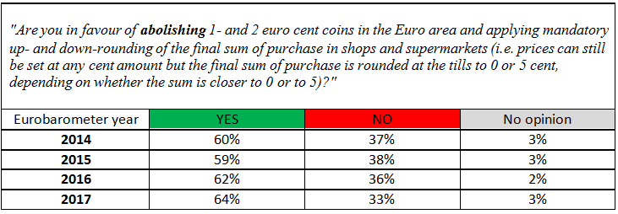

Looking at the results by euro area country today, none of them displays any longer an absolute majority in favour of keeping these two denominations.

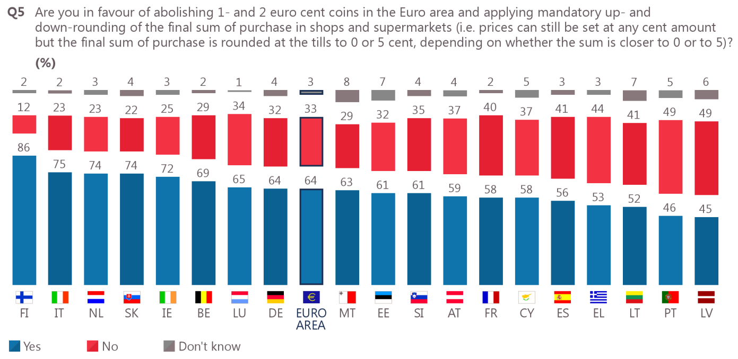

(Source: Eurobarometer 2017)

**2.7 Concerns that rounding to the nearest five cents would raise consumer prices and inflation**

Another important issue in the debate on whether to discontinue one- and two-euro cent coins is inflation and perceived inflation. Rounding the final sum might lead consumers to expect systematic upward rounding or outright price increases in future. This concern actually holds if rounding affects goods that are frequently purchased and typically paid for in cash, and could thus influence inflation expectations (‘perceived inflation’). However, abolishing one- and two-euro cent coins and applying rounding rules are not expected to significantly affect price stability because:

* Lower costs for cash handling could allow retailers to lower prices.
* If rounding were introduced, there would be no change in the way in which inflation is measured, using the Harmonised Index of Consumer Prices (HICP)[22], or in the measurement of private consumption. There would thus be no ‘new figures’. The statistical authorities would continue to use the quoted prices (i.e. non-rounded prices), with no systematic bias in summation, when calculating price indices.
* Discontinuing one- and two-cent coins could provide an opportunity for producers and retailers to change a broader set of individual quoted prices at the same time. This could then lead to some increase in the general price level and - at least as a one-off phenomenon - to higher inflation. However, price transparency, consumer awareness and competition in the retail sector can be expected to limit such risk. According to one stakeholder, one can neither rule out the possibility that the final sum of purchase might actually be rounded down in general in the medium term, as a result of competitive behaviour.[23]
* The experience of countries that limit the use of one- and two-euro cent coins for cash payments, such as Finland, the Netherlands or Ireland, confirms that the practice of rounding cash payments has had no measurable impact on consumer price inflation, as measured by the HICP or the private consumption deflator.

**2.8 Examination of the issuance of one- and two-euro cent coins against the criteria of cost and public acceptability**

Applying the criteria of costs and public acceptability of one- and two-euro cent coins shows the following picture:

1. Owing to their diminished purchasing power, one- and two-euro cent coins are predominantly used one-way, which leads to hoarding and loss of coins.
2. Governments issuing these coins make a loss on them, with negative seigniorage (at least for the one-euro cent coin).
3. The costs of coin handling is expensive compared with the face value of these coins. Retailers pay up to one euro for a coin roll of 50 one-euro cent coins.
4. Among the general public, there is a stable majority in favour of discontinuing one- and two-euro cent coins, as reflected by the data in the table above.
5. The reduction of production costs has limits[24]. In a context of positive inflation, it generates only temporary effects until production costs exceed face value again and it fails to address the other challenges posed by one- and two-euro cent coins: hoarding and loss will continue.

Discontinuing these coins would be a possibility to address the disadvantages and challenges related to their use as highlighted above. However, further analysis of the ramifications of any possible discontinuation is warranted. It is understood that Member States may issue euro coins subject to approval by the ECB of the volume of issuance.[25]Regulation (EU) No 651/2012, on the other hand contains binding rules for the issuance of euro coins to prevent different practices among Member States and to achieve a sufficiently integrated framework for the single currency.[26]

The following two sub-sections discuss the pros and cons of both the withdrawal and the phasing out of these coins.

*2.8.1 Pros and cons of the withdrawal of coins and the swift loss of legal tender status*

Should the Member States decide to withdraw these coins, their issuance would stop and they would lose their status as legal tender for payments fairly quickly, possibly with the right to redeem them at central banks even after loss of such status. Mandatory rounding of the final sum of purchase to the nearest five euro cents at cash payment would be needed throughout the euro area, to make sure that the same rule applies in the same way to the entire area.[27] The coins would have to be actively withdrawn from circulation.

This would imply:

* immediate cost-savings: no more production or issuance costs, and no negative seigniorage;
* no more handling costs for one- and two-euro cent coins;
* rapid response to the citizens’ preferences.

The downside would be the one-off costs of withdrawal. Further analysis would be necessary to obtain an estimation.[28]

*2.8.2 Pros and cons of the phasing out of coins and the non immediate loss of legal tender status*

Should the Member States decide to phase out these coins, their issuance would also stop, while the legal tender status would be withdrawn only later. Stopping the production and issuance of these coins would have a similar effect to the first scenario. However, they would remain in circulation but disappearing little by little, as large numbers of coins continue to be lost and no new ones are issued. The legal tender of the coins for payment could be withdrawn at the earliest when the circulation of the coins becomes purely residual, possibly with the right for redeem at Central Banks even after the legal tender ended. This measure would have to be accompanied by mandatory rounding as soon as the coins cease to be issued, as in the first scenario.

This would imply:

* no withdrawalcosts;
* one- and two-euro cent coins would continue to be used to make payments for longer.

Compared to their withdrawal, this would imply:

* fewer economic benefits, given continued handling costs for the one- and two-euro cent coins in circulation until their numbers dwindle;
* retailers would have to continue to cater for processing one- and two-euro cent coins, albeit much less so, due to the rounding up;
* less immediate response to the wishes of most people in the Member States concerned.

# Section 3. Protecting euro coins against counterfeiting: enhancing security features of euro coins to keep coins a trusted means of payment

The EU has a developed a legal framework in place and fosters cooperation with Member States and national authorities to ensure that euro cash is trusted and cash circulation is secure and efficient. Rules (including provisions under criminal law) are in place to protect euro coins against counterfeiting and to authenticate them. These are complemented by legal provisions on reproduction and on medals and tokens, to make sure that only genuine coins are fit for circulation and used in the cash circuit.[29]

The number of counterfeit euro coins (50 euro cents, one euro, two euros) detected in circulation and reported is relatively stable, with an annual average of about 150,000 counterfeits (representing a nominal value of about 240,000 euros).

Number of counterfeited euro coins detected, per denomination   
(Source: European Technical and Scientific Centre)

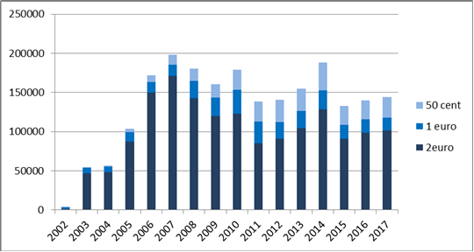

At the same time, the total volume of coins in circulation has continued to increase from 40 billion in 2002 to 125 billion by the end of 2017. As a result, the ratio of detected counterfeits has significantly dropped over time, from one for every 70,000 genuine coins in 2007 to one for every 120,000 in 2017 (again taking into account only the 50 euro cents, one euro, two euros).

Citizens pay little attention to coins’ appearance and security features. A large proportion of coins are kept in wallets and tills as small change, never once undergoing a professional authenticity check.

The technical specifications and features of all euro coin denominations date from the mid-1990s, while both production technology and the ‘quality’ of some counterfeits detected have moved on.

Counterfeits of poor visual quality but with good electromagnetic properties can enter the market through vending and ticket machines. Some machines may not immediately recognise sophisticated counterfeits, and the number of counterfeits in circulation is likely to be higher than the number detected.

The euro area must continue its efforts to protect euro coins against counterfeiting, to keep them secure and trusted. It has not yet considered upgrading euro coins with new security features. The European Central Bank has started issuing a new series of banknotes with advanced security features. It may be time to start considering the need for the upgrading of our euro coins too.

# Section 4. Conclusions

|  |
| --- |
| This report describes the use of the one- and two-euro cent coins. It provides Member States a basis to explore the most appropriate way forward regarding these two denominations at euro area level. |
| In terms of protection and security priorities, the Commission will continue cooperation with Member States to further improve detection of counterfeits; under the Pericles Programme[30] and its successor under the upcoming Multiannual Financial Framework[31]; will continue to financially support Member States’ competent authorities in conducting coin security-related research and development; will explore which new appropriate security features could be developed for use in high-denomination euro coins (one- and two-euro coins); will pursue discussions in the competent fora on how coins with new security features could be issued and first-generation coins be withdrawn over time, without disrupting the smooth circulation of the other euro coins and the well-established cash circuit. | |

1. Article 128 (2) of the Treaty on the Functioning of the European Union.
2. Article 1 and Annex 1 of Council Regulation (EU) No 729/2014 (OJ L 194, 2.7.2014, p. 1).
3. Between January 2002 and the beginning of 2018 consumer prices rose by 28%, as measured by the cumulative harmonised index of consumer prices (source: Eurostat). A consumer good priced at €0.78 in 2002 costs €1 today; a consumer good on sale for €1 in 2002 sells for €1.28 in 2018.
4. Article 2 of Regulation (EU) No 651/2012 on the issuance of euro coins (OJ L 201, 27.7.2012, p. 135) requires the Commission to assess the continued issuance of one- and two-euro cent coins through an impact assessment, which must include, notably, a cost-benefit analysis, and which must take account of these coins’ real production costs, set against their value and benefits.
5. Communication from the Commission to the European Parliament and the Council: Issues related to the continued issuance of the one- and two-euro cent coins, COM(2013)281 final (https://eur-lex.europa.eu/legal-content/EN/TXT/?uri=celex%3A52013DC0281).
6. SWD/2013/0175 final (https://eur-lex.europa.eu/legal-content/EN/TXT/?uri=CELEX:52013SC0175)
7. The four scenarios presented were: (1) ‘status quo scenario’: continued issue under today's conditions, without changing the legal or material context; (2) ‘issuance at reduced cost scenario’: issue at reduced cost by changing coins’ material composition or improving the efficiency of coin production, or both; (3) ‘quick withdrawal scenario’: abolition and withdrawal of the one- and two-euro cent coins within a short timeframe, and introduction of rounding rules; (4) ‘fading out scenario’: stopping the issue of one- and two-euro cent coins, and introduction of rounding rules. While no further coins would be issued and binding rounding rules would apply under this scenario as well, existing coins would remain legal tender. One- and two-euro cent coins could still be used, but only for payment to the rounded final sum. Since no new coins would be issued, these coins would be expected to disappear gradually from circulation, given the high loss rate and the fact that they are not convenient means of payment.
8. As part of its regular review referred to in Recital 7 of the Regulation (EU) No 651/2012 on the issuance of euro coins (OJ L 201, 27.7.2012, p. 135.
9. See Annex Part 2.
10. As for the 2013 communication, no evidence emerged from the analysis and discussions held to differentiate between one-euro cent and two-euro cent coins in terms of policy options. There was no empirical evidence, nor were there any economic and social considerations to point at such differentiation.
11. <https://ec.europa.eu/info/law/better-regulation/initiatives/ares-2017-3071370_en>
12. An average of about 150 000 counterfeits are detected in circulation annually, most of which are fake two-euro coins.
13. Credit institutions and professional cash handlers have to authenticate euro coins while using certified coin processing machines in line with Regulation (EU) No 1210/2010, OJ L 339, 22.12.2010, p. 1. Unfit coins (e.g. damaged coins) must be withdrawn. Member States must also make sure that counterfeits are detected and handed over to law enforcement authorities; see Regulation (EU) No 1338/2001, as amended, OJ L 181, 4.7.2001, p. 6.
14. The average value of a cash transaction in the euro area is now €12.38, though payment habits differ between Member States; see ECB Occasional Paper Series No 201, November 2017: ‘The use of cash by households in the euro area’, p. 20.
15. Such goods include clothing, shoes, electronic devices, fixtures and furniture. Increasingly, ‘away from home’ consumption (such as beverages, snacks, print media, tickets or visits to restaurants) comes with round prices.
16. Article 11 of Regulation (EC) No 974/98 on the introduction of the euro, OJ L 139, 11.5.1998, p. 1.
17. One- and two-euro cent coins are copper-plated steel coins. Abandoned coins typically end up in public land, in household waste or in incineration plants.
18. From a survey carried out in 2017, only three Member States (of the nine that replied) reported that procurement costs of one-cent coins had fallen below their nominal value. As regards two-euro cent coins, six out of nine reported that acquisition costs had fallen below nominal value.
19. See Annex, Part 1 Chapter C.1.
20. Some retailers reported that a coin roll containing 50 one-euro cent coins can cost up to 50 cents, to be added to the face value of the coins in the roll.
21. Flash Eurobarometer reports on the euro area: FL 405, FL 429, FL 446 and FL 458: <http://ec.europa.eu/commfrontoffice/publicopinion/index.cfm/Survey/index#p=1&instruments=FLASH>
22. In the euro area, HICP measures the change over time in the prices of consumer goods and services acquired, used or paid for by euro area households. HICP uses a single agreed methodology, to make data from different countries readily comparable.
23. EHI Retail Institute/Deutsche Bundesbank, Coins Study: Impact assessment of rounding in the retail sector (2015), p. 51.
24. Member States agreed new manufacture standards for one- and two-euro cent coins, to produce them more cost-efficiently without changing their appearance, while continuing to abide by the technical specifications set out in Council Regulation (EU) No 729/2014. The new standards apply to production rolled out in 2017. Coins produced in accordance with old standards can be used in parallel.
25. See Article 128 (2) TFEU.
26. See recital 2 of Regulation (EU) No 651/2012 of the European Parliament and of the Council of 4 July 2012 on the issuance of euro coins. This regulation is based on article 133 TFEU.
27. In its opinion on a draft Belgian law providing for voluntary rounding of payments denominated in euros, the ECB (CON/2014/6, item 2.4) pointed out that ‘with a view to preserving the unity and integrity of the single monetary area, the ECB therefore recommends that any rounding rules are established in a harmonised manner at Union, rather than national, level.’ This was repeated in ECB Opinion CON/2018/41 of 4 September 2018.
28. These costs are difficult to estimate because they will depend on the attitude of citizens in each Member State and their eagerness to effectively return the denominations withdrawn. Previous experiences from change-overs to the euro indicate that such costs would be limited, in particular concerning very low denominations, where existing high rates of loss already point towards a lack of discipline in caring about the value represented by these coins.
29. See overview of the relevant EU legal acts at: <https://ec.europa.eu/info/about-european-commission/euro/euro-coins-and-notes/euro-coins/legislation-euro-coins_en>
30. Regulation (EU) No 331/2014 on ‘Pericles 2020’ programme, OJ L 103, 5.4.2014, p. 1.
31. COM(2018) 369 final and COM(2018) 371 final.