

Malta 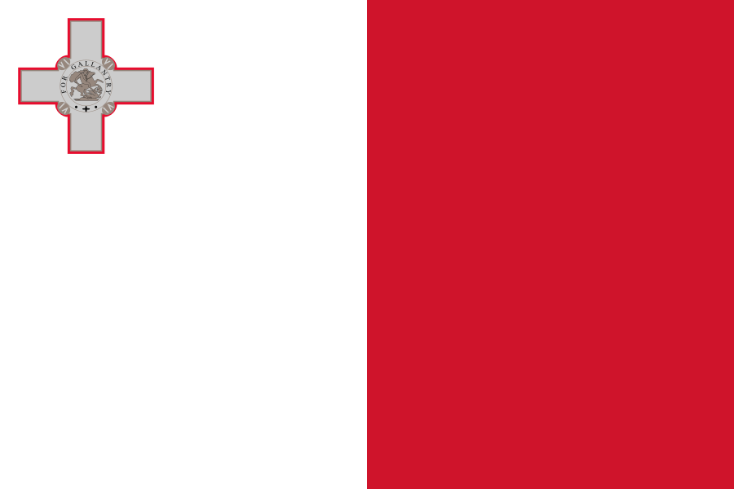

## Prices

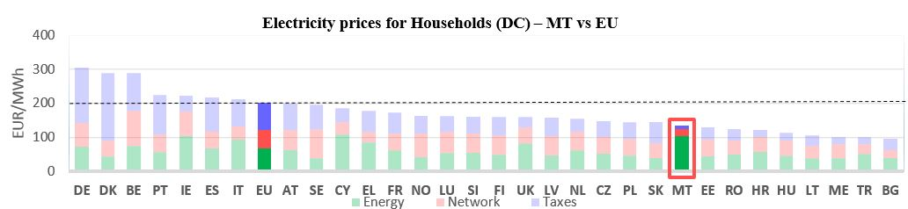see footnote**[1]**

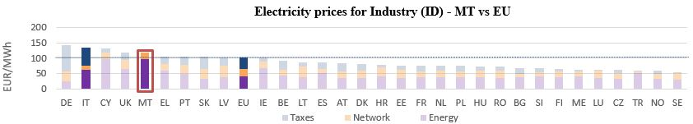



See footnote [2]

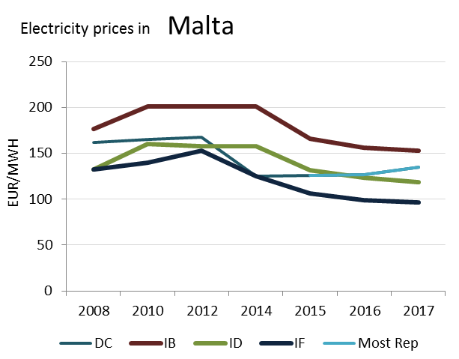

(DC)

**Prices**

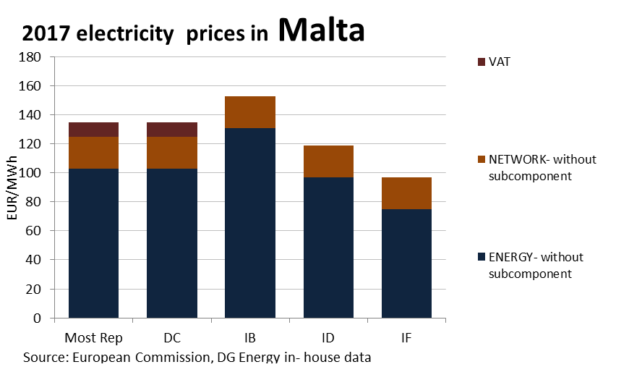

**Price regulation**

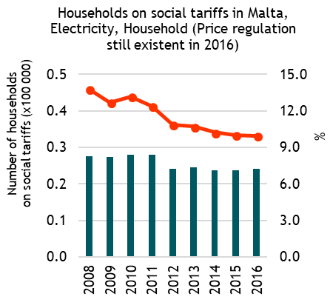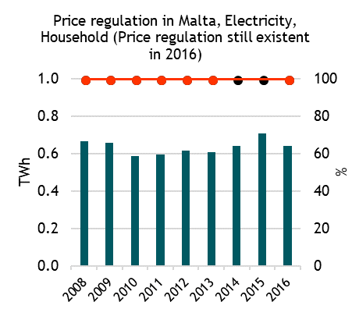

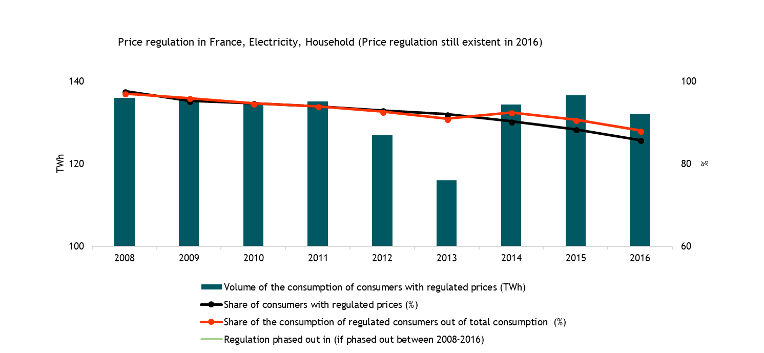

**Oil products prices**

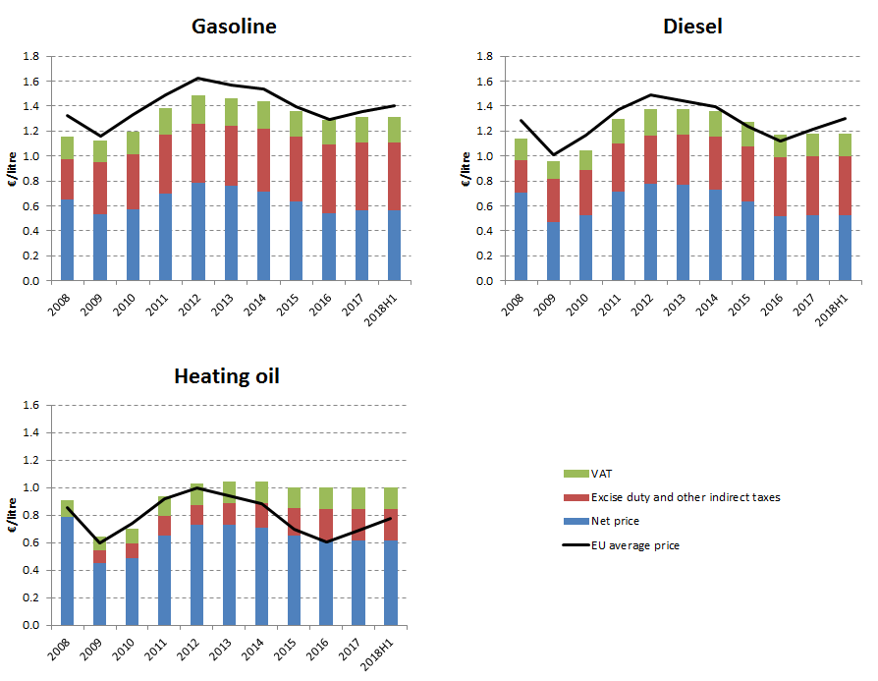

**Energy costs shares in total production costs**

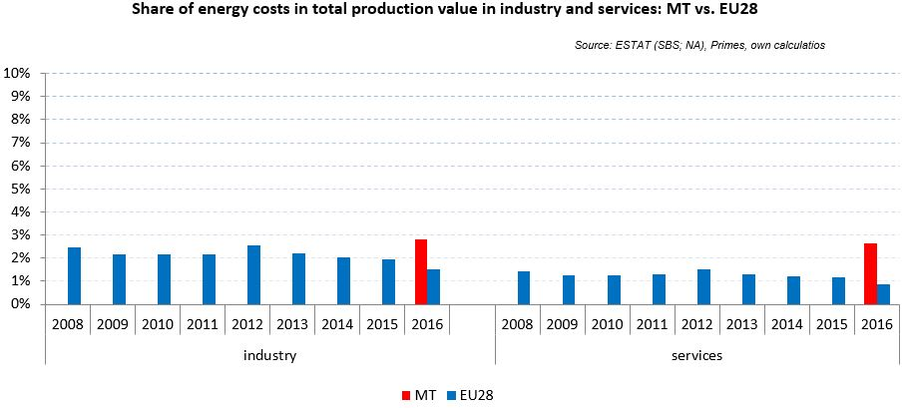

*Eurostat SBS data not available due to confidentiality issues*

Notes: Data for Malta (prior to 2016), Poland (prior to 2015), Slovenia (prior to 2012) and Greece (prior to 2008) is not available. Data for Denmark, Sweden and the United Kingdom for 2016 was missing by the time of extraction

## Financial support interventions

Netherlands 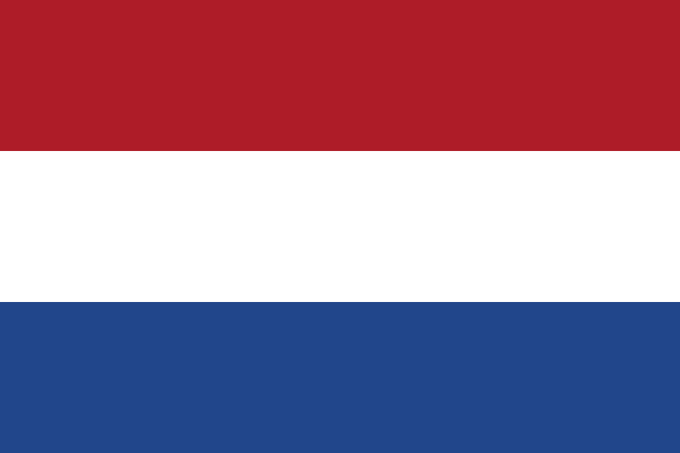

## Prices

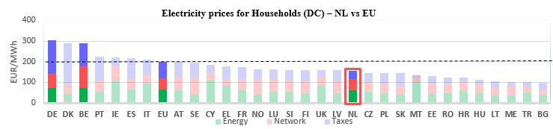

see footnote**[3]**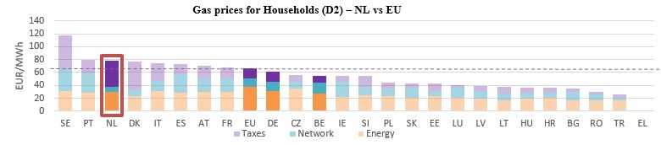

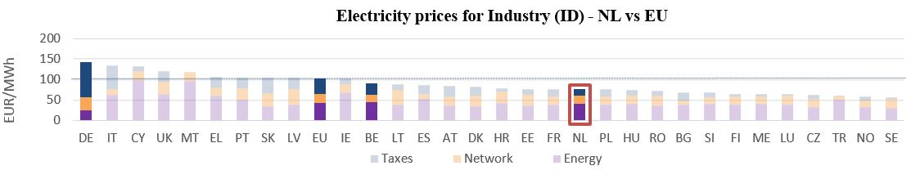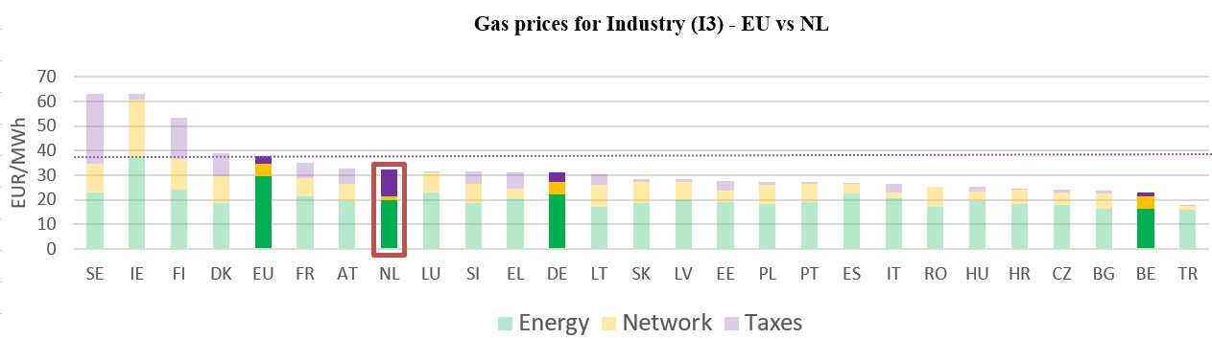

**Gas prices for Industry (I3) – NL vs EU**

See footnote [4]

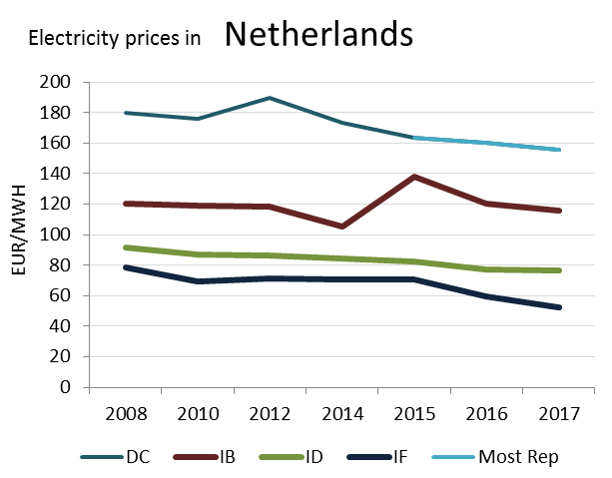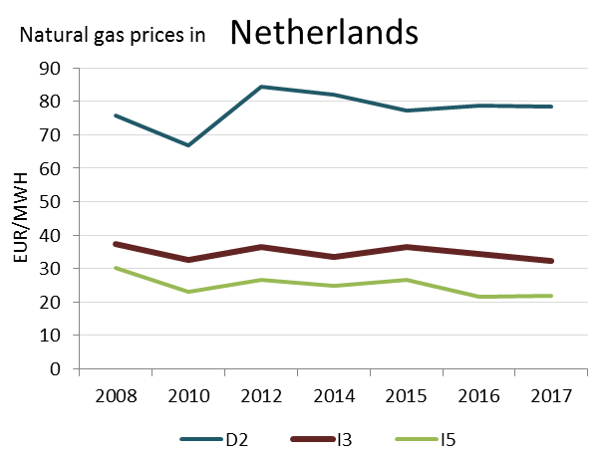

(DC)

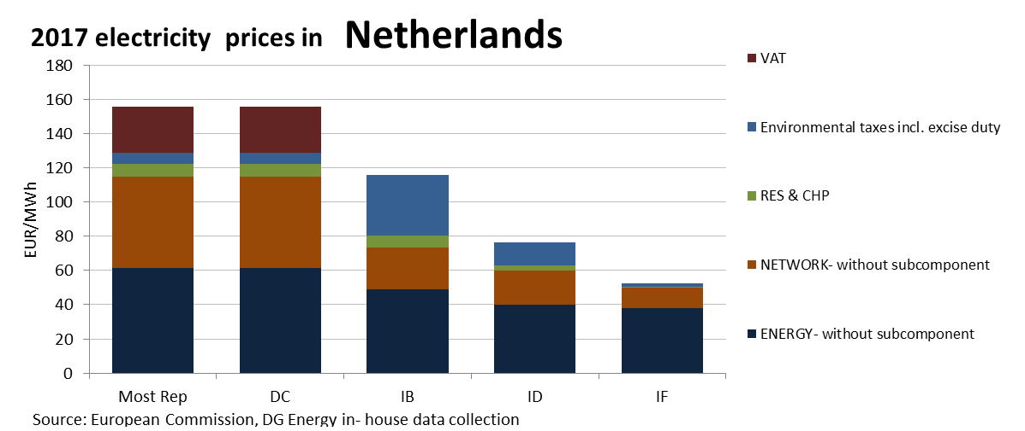

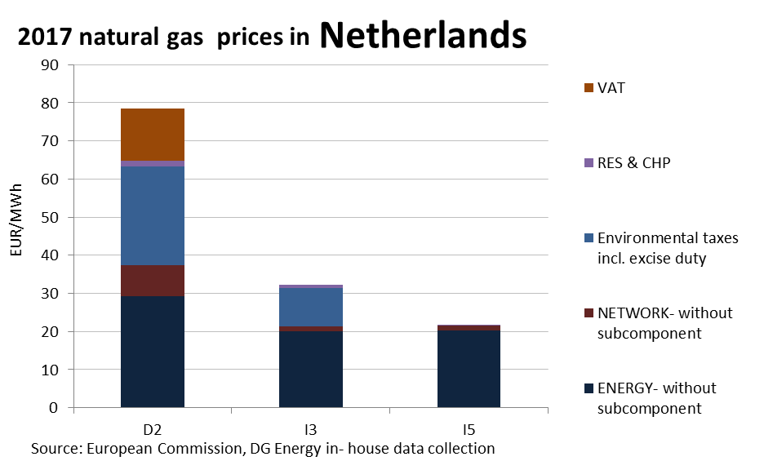

**Prices**

This country liberalised prices before 2008.

No social tariffs identified.

**Oil products prices**

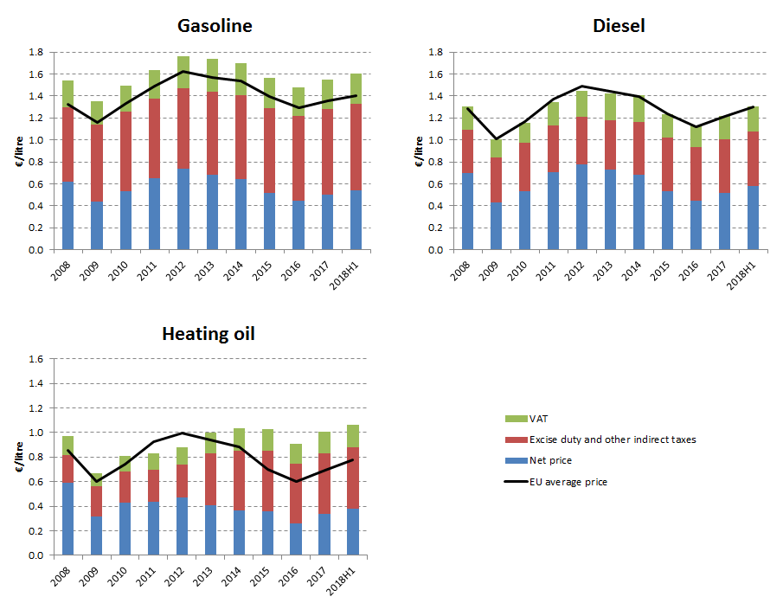

**Energy costs shares in total production costs**

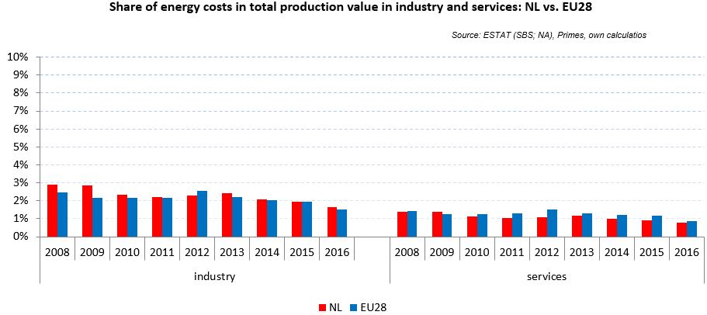

Notes: Data for Malta (prior to 2016), Poland (prior to 2015), Slovenia (prior to 2012) and Greece (prior to 2008) is not available. Data for Denmark, Sweden and the United Kingdom for 2016 was missing by the time of extraction

## Financial support interventions

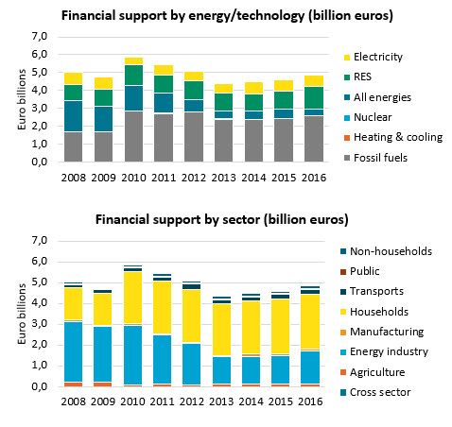

Poland 

## Prices

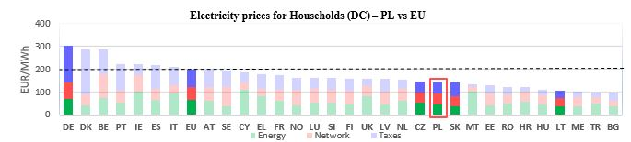

**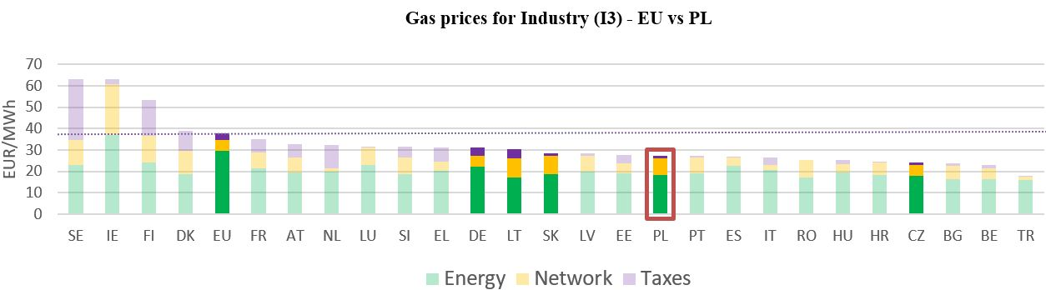****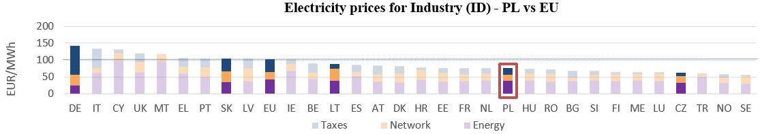**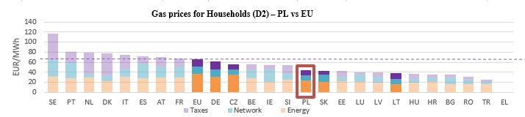see footnote[5]

**Gas prices for Industry (I3) – PL vs EU**

See footnote [6]

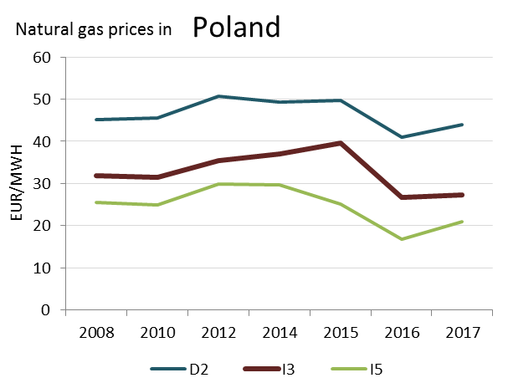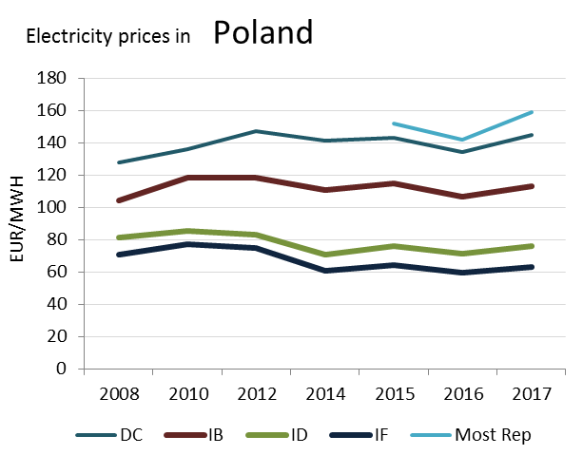

**Prices**



(DB)

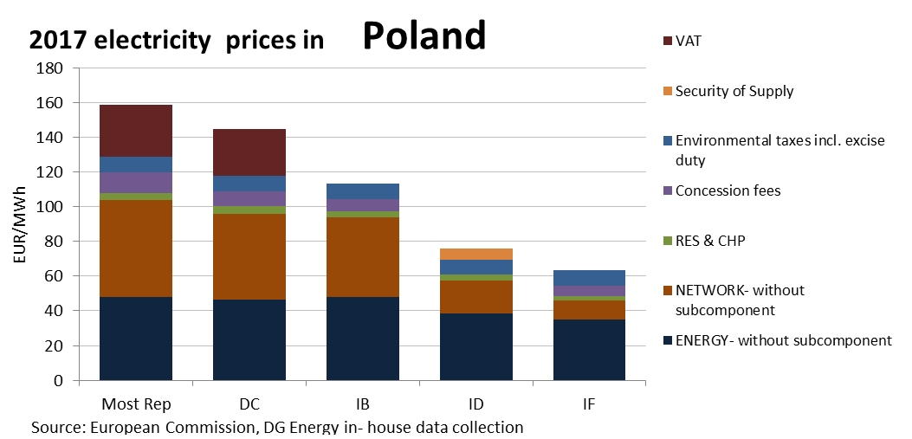

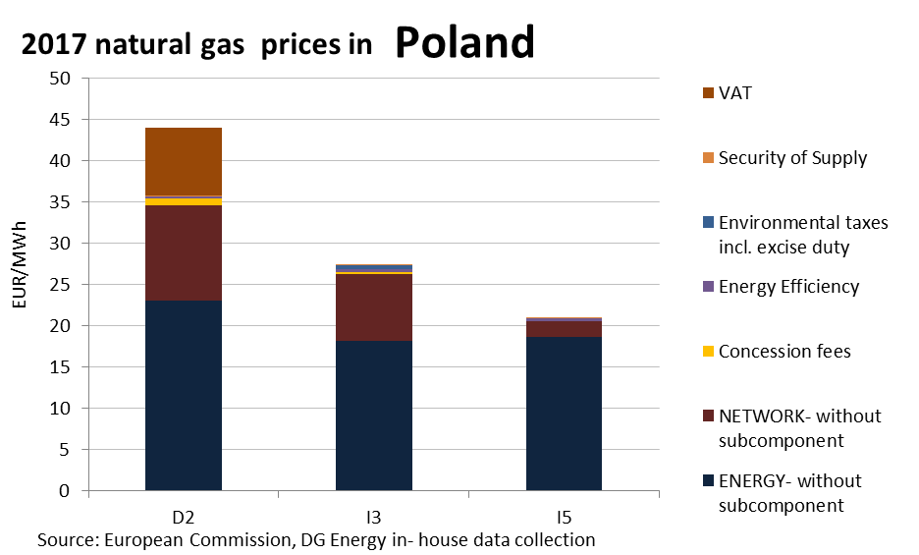

**Price regulation**

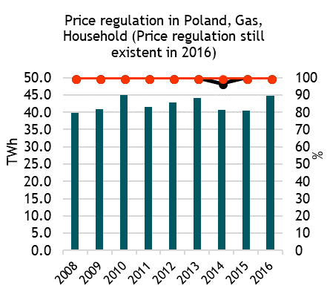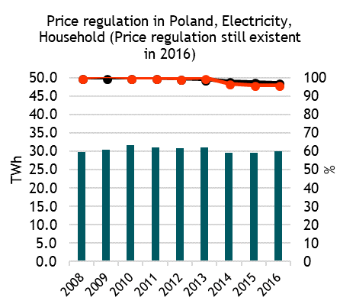



**Oil products prices**

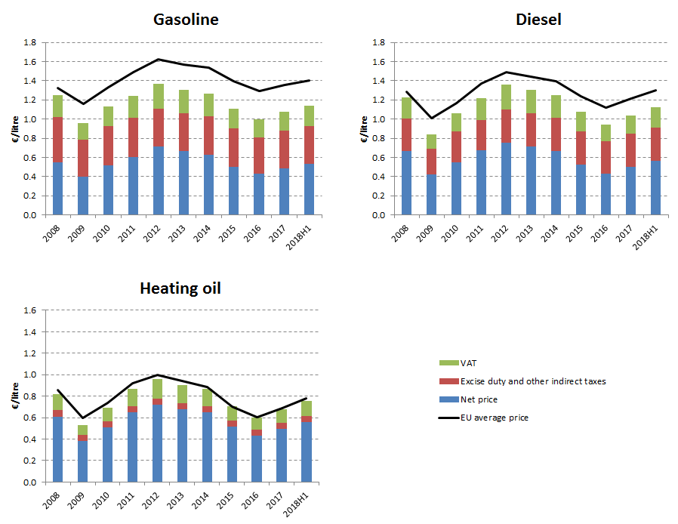

**Energy costs shares in total production costs**

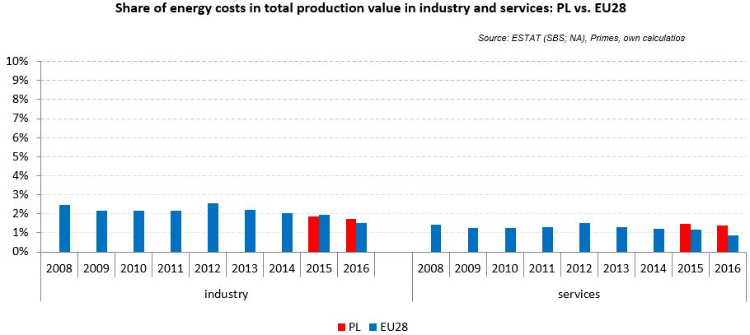

Notes: Data for Malta (prior to 2016), Poland (prior to 2015), Slovenia (prior to 2012) and Greece (prior to 2008) is not available. Data for Denmark, Sweden and the United Kingdom for 2016 was missing by the time of extraction

## Financial support interventions

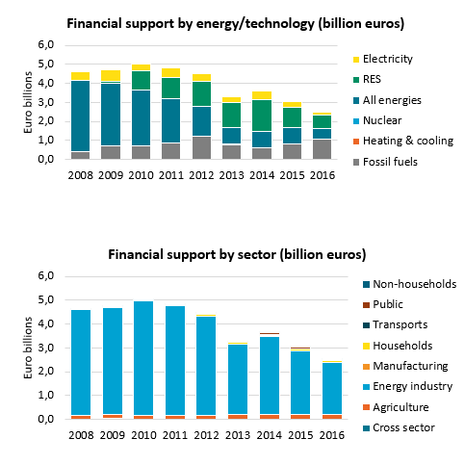

Portugal 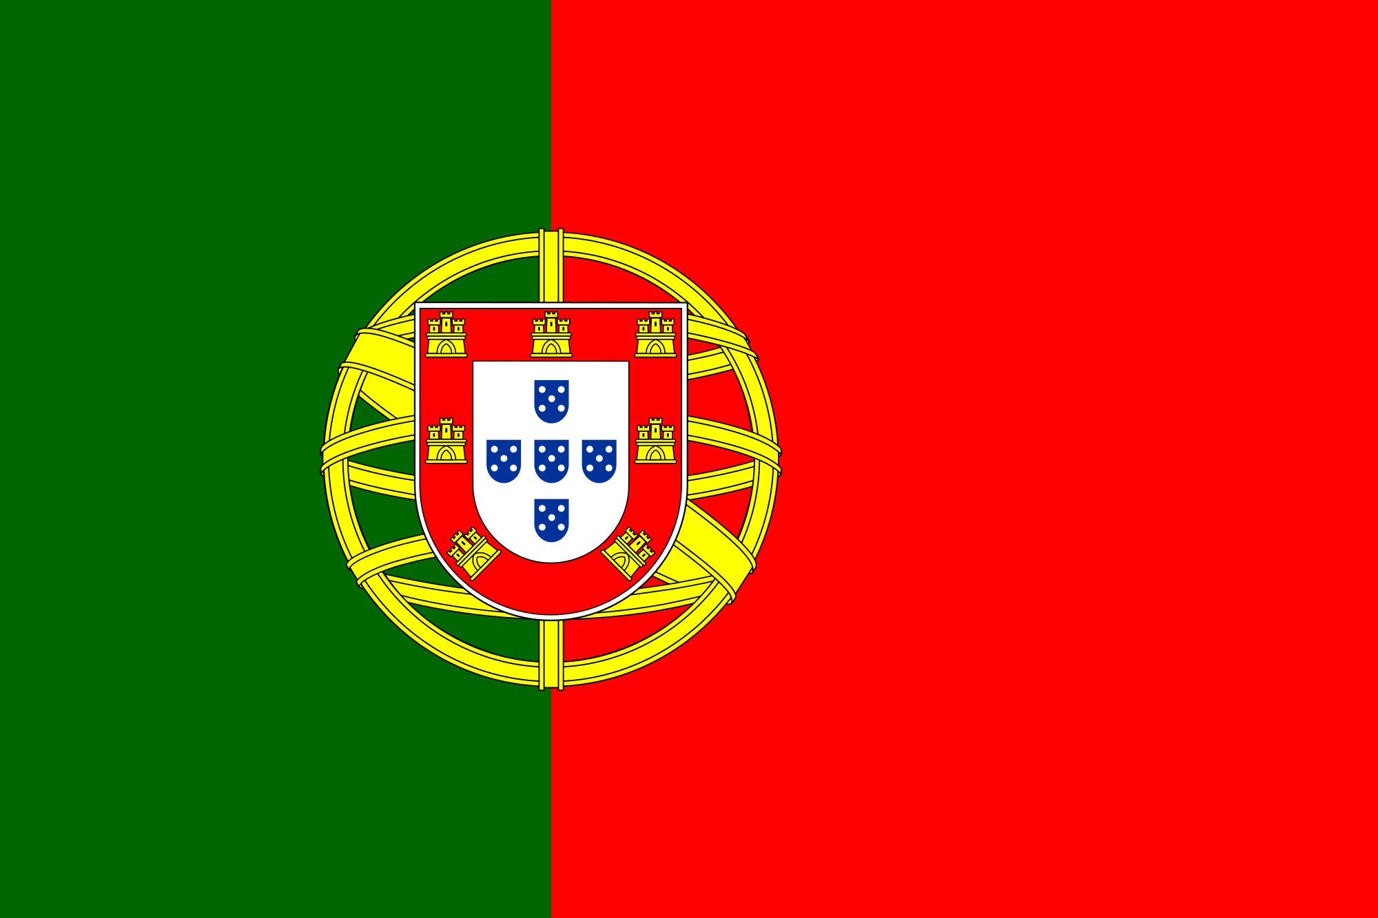

## Prices

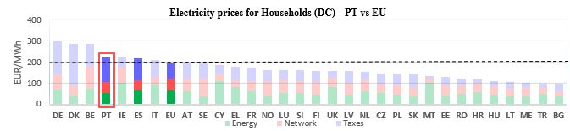[7]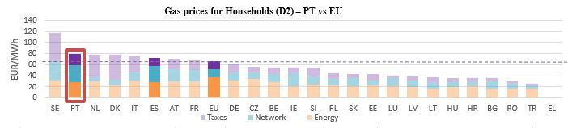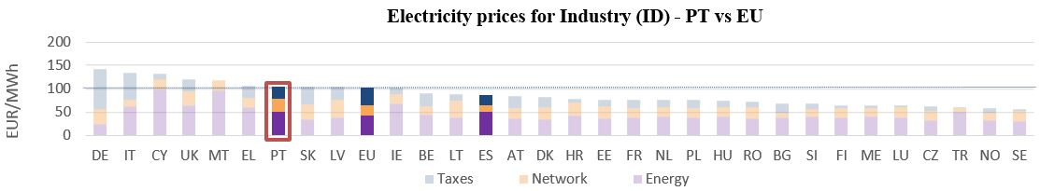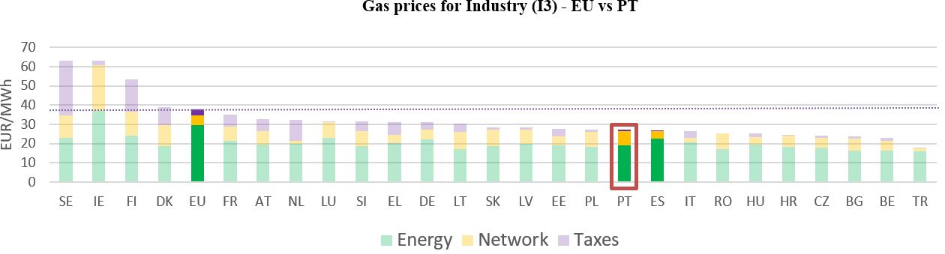

**Gas prices for Industry (I3) – PT vs EU**

See footnote



See footnote

[8]

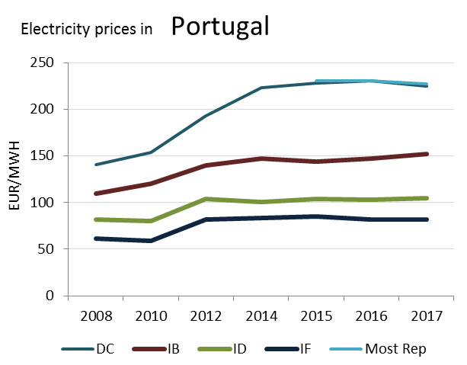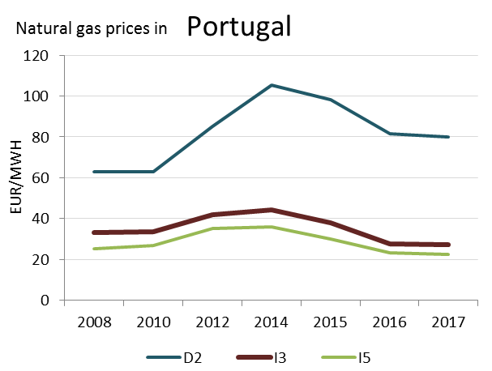

(DC)

**Prices**

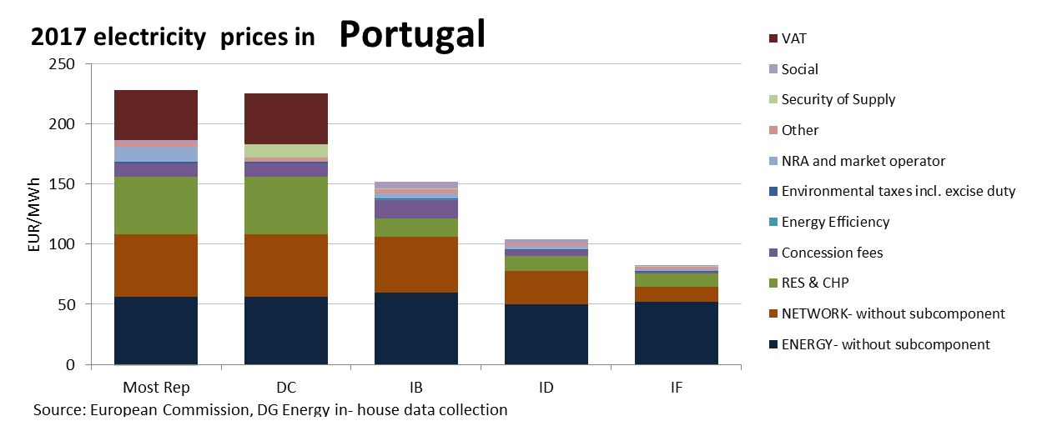

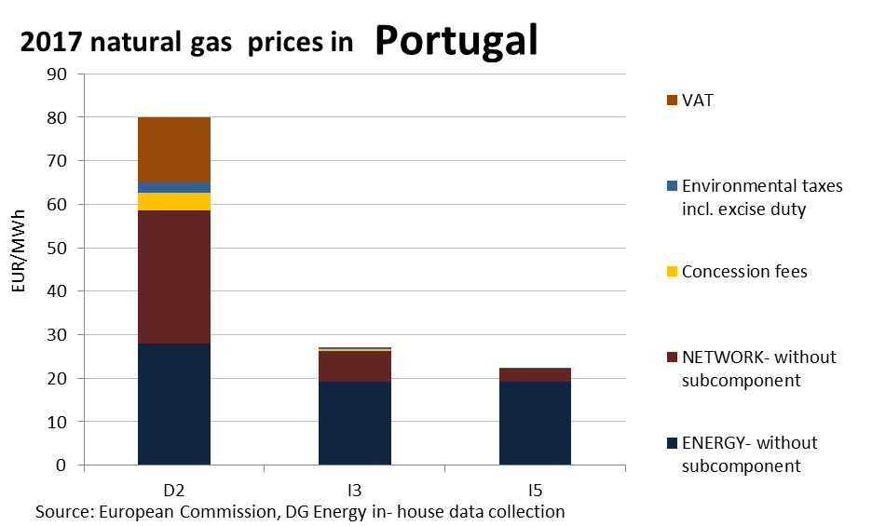

**Price regulation**

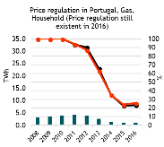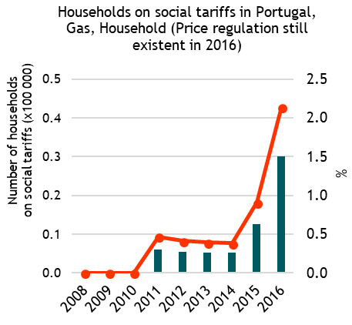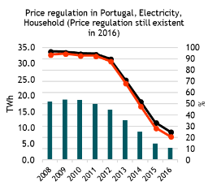

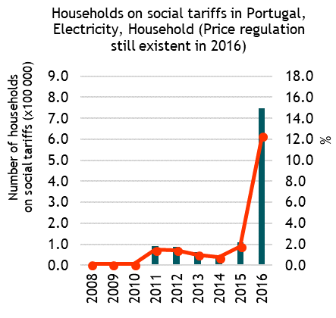

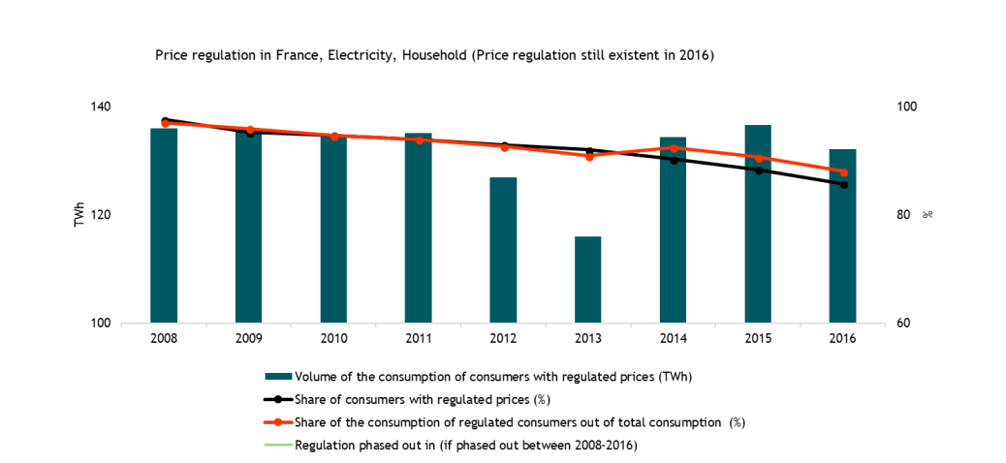

**Oil products prices**

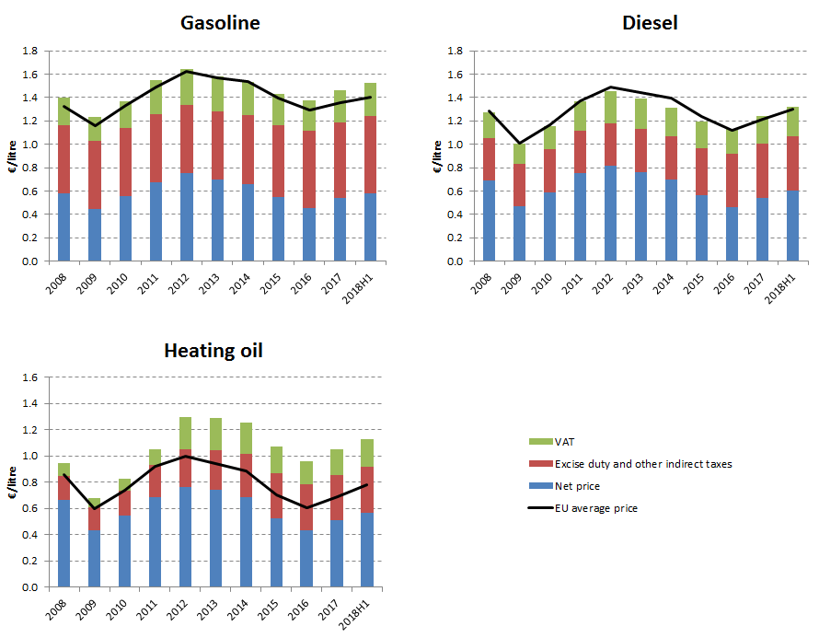

**Energy costs shares in total production costs**

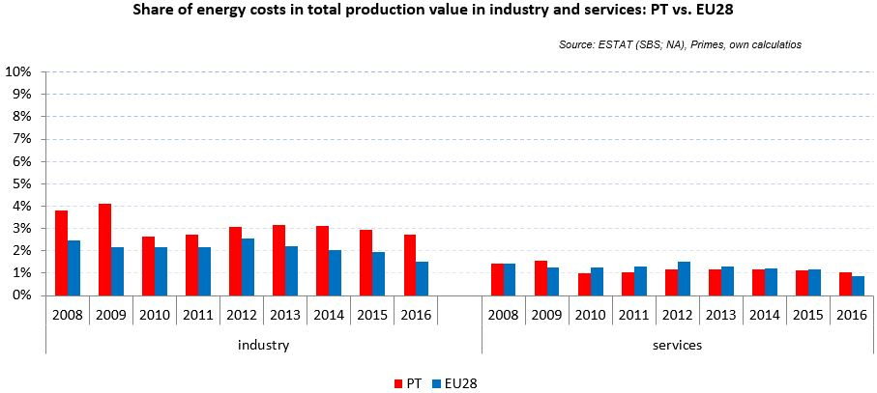

Notes: Data for Malta (prior to 2016), Poland (prior to 2015), Slovenia (prior to 2012) and Greece (prior to 2008) is not available. Data for Denmark, Sweden and the United Kingdom for 2016 was missing by the time of extraction

## Financial support interventions

Romania

## Prices

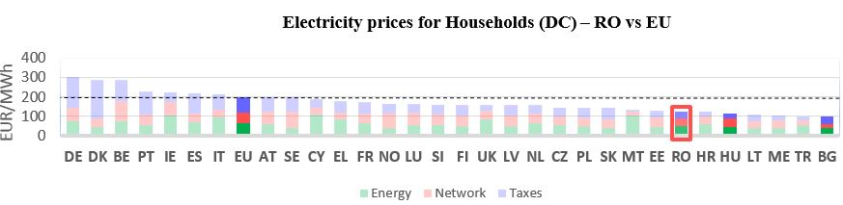see footnote[9]

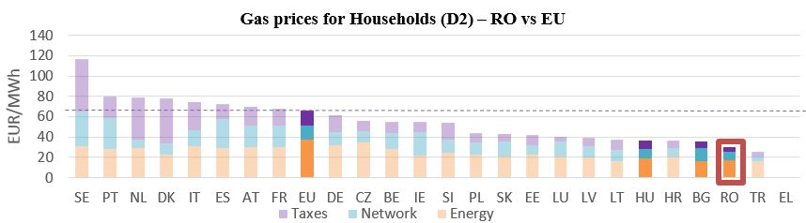

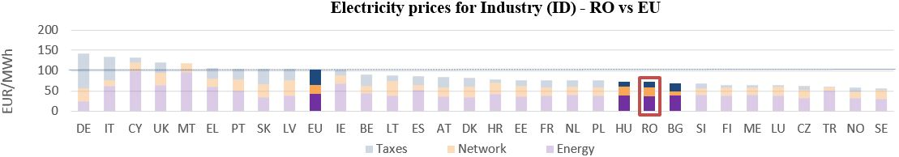

**Gas prices for Industry (I3) – RO vs EU**

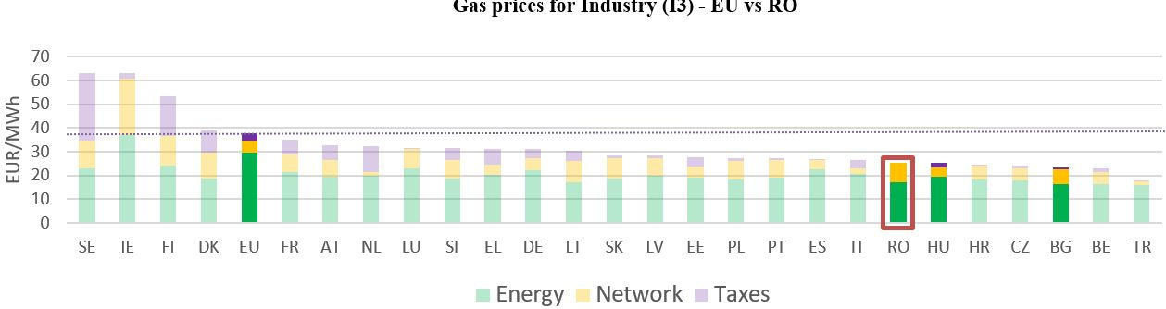



See footnote [10]

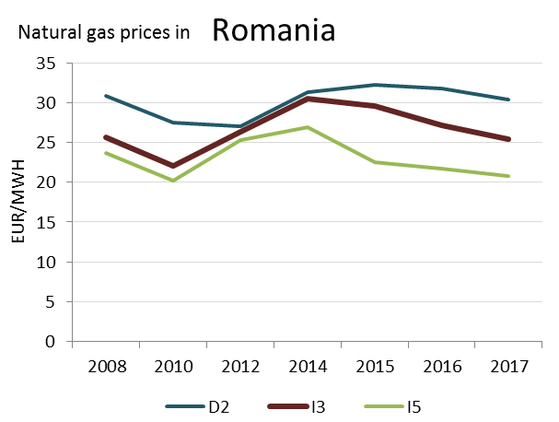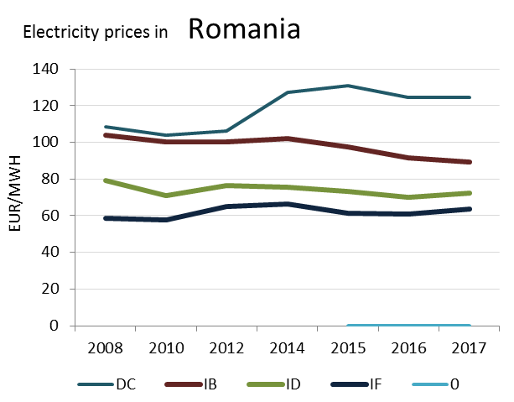

**Prices**

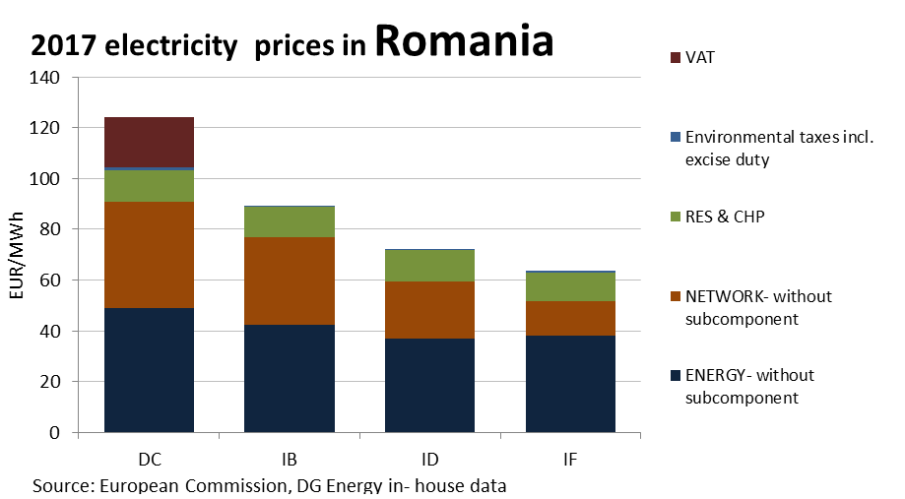

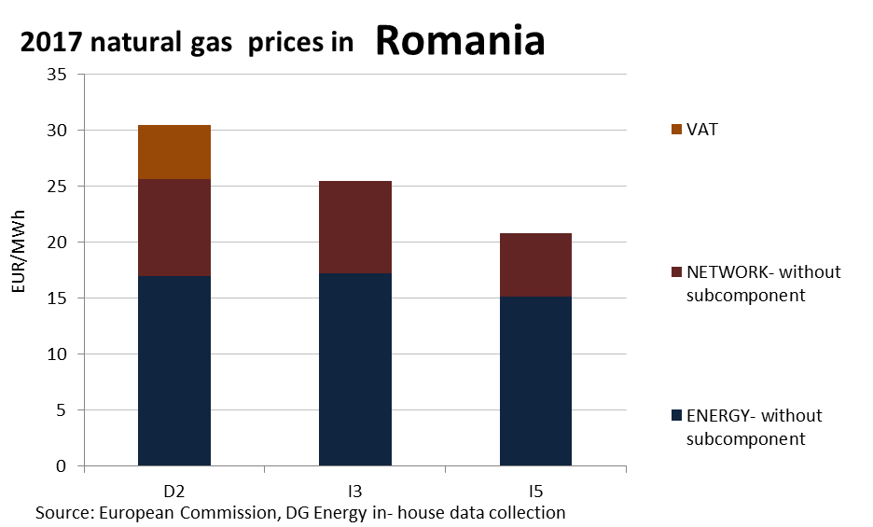

**Price regulation**

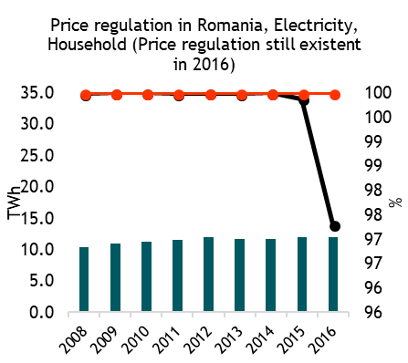

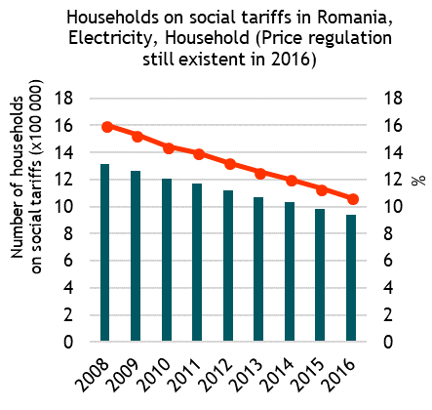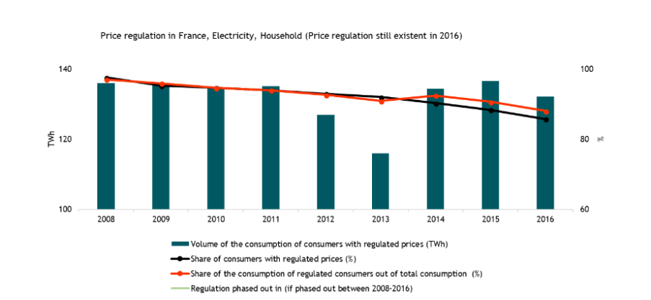

**Oil products prices**

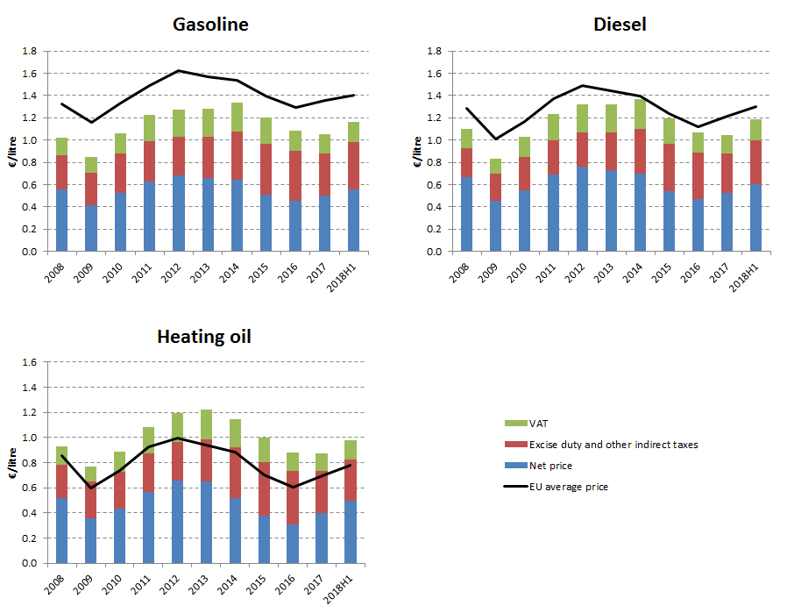

**Energy costs shares in total production costs**

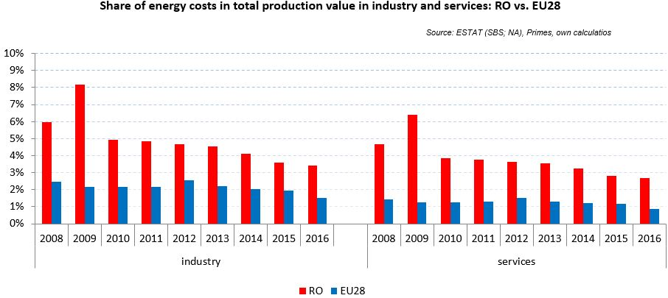

Notes: Data for Malta (prior to 2016), Poland (prior to 2015), Slovenia (prior to 2012) and Greece (prior to 2008) is not available. Data for Denmark, Sweden and the United Kingdom for 2016 was missing by the time of extraction

## Financial support interventions

Slovakia

## Prices

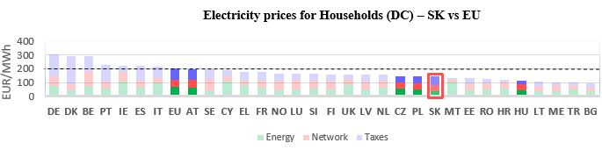**[11]**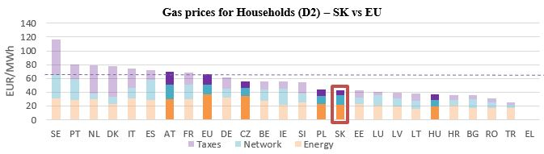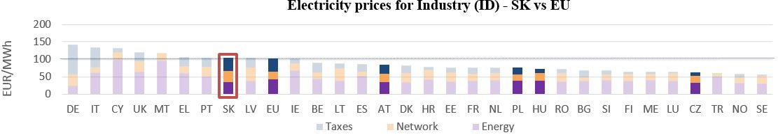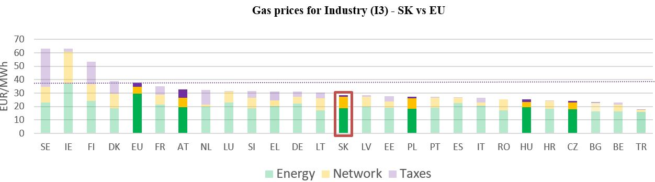

See footnote

See footnote [12]

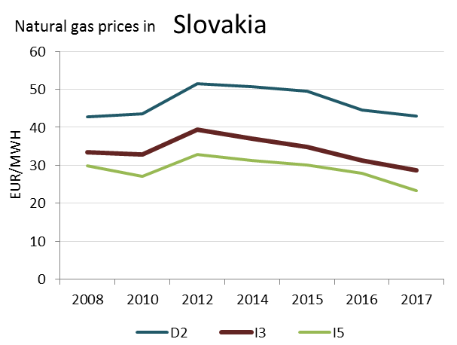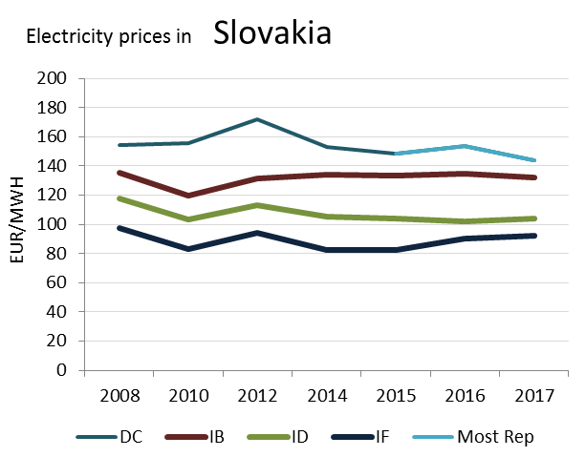

(DC)

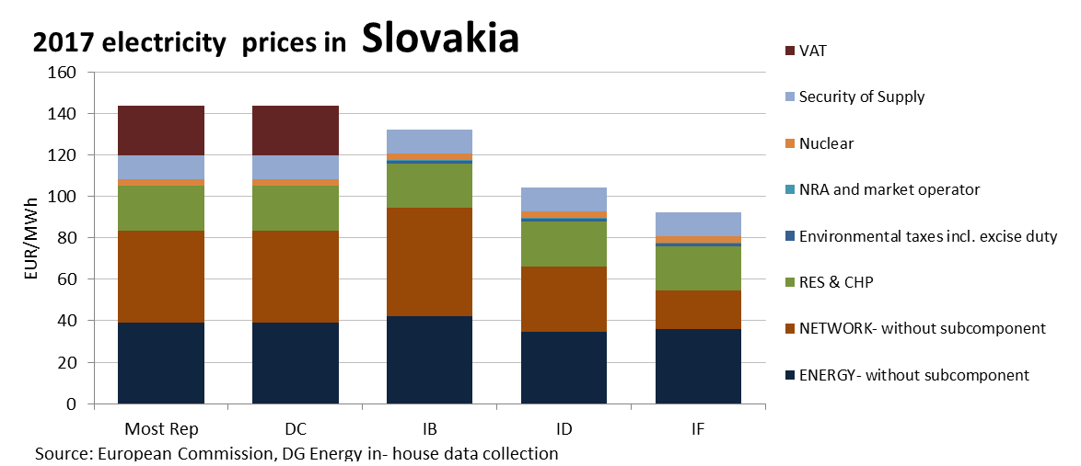

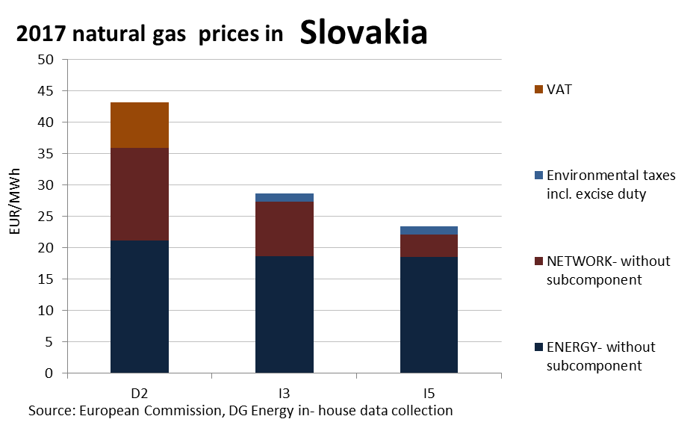

**Prices**

**Price regulation**

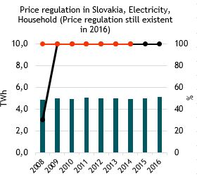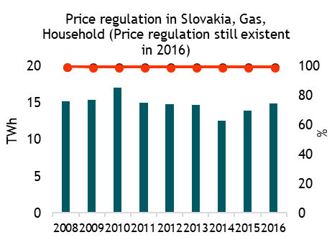

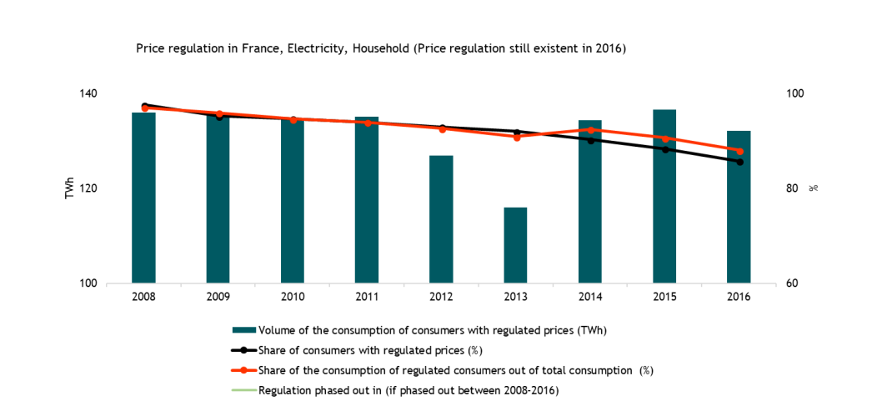

**Oil products prices**

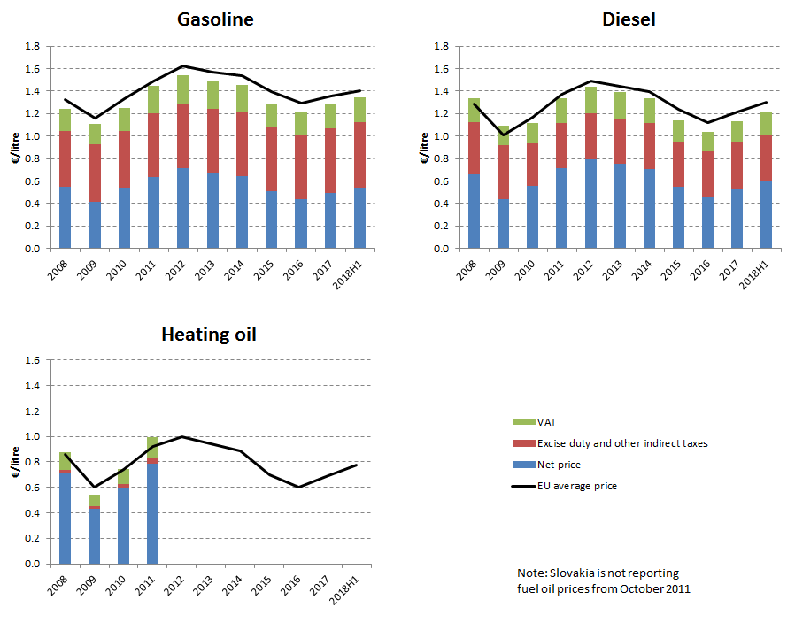

**Energy costs shares in total production costs**

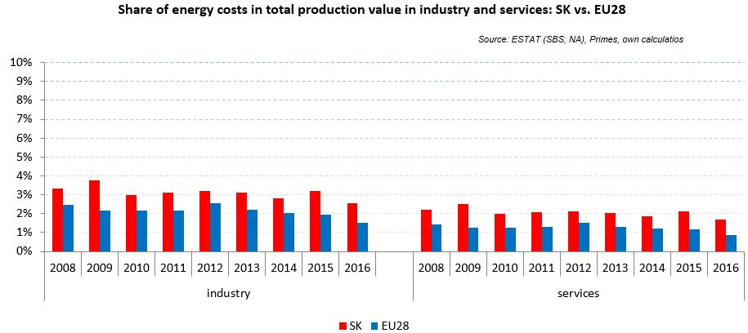

Notes: Data for Malta (prior to 2016), Poland (prior to 2015), Slovenia (prior to 2012) and Greece (prior to 2008) is not available. Data for Denmark, Sweden and the United Kingdom for 2016 was missing by the time of extraction

## Financial support interventions

Slovenia 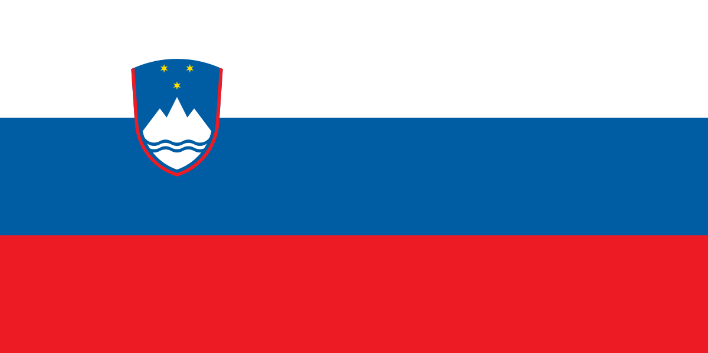

## Prices

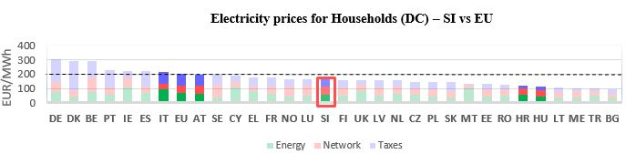[13]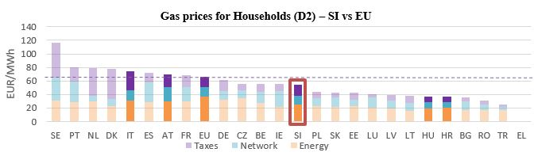

See footnote

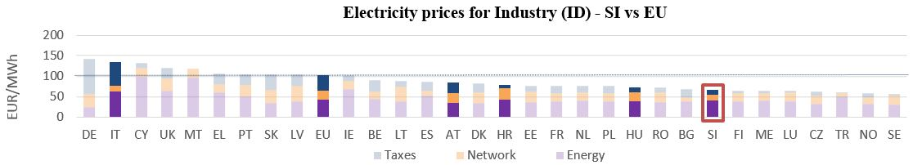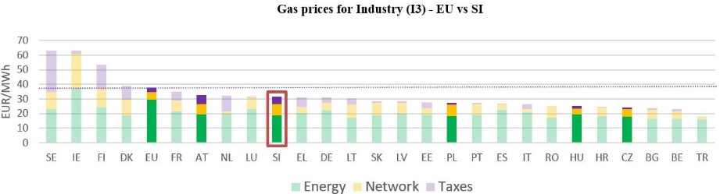

**Gas prices for Industry (I3) – SI vs EU**



See footnote [14]

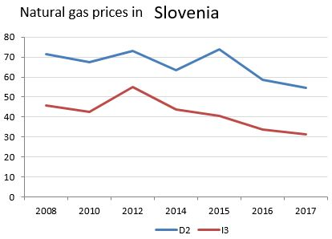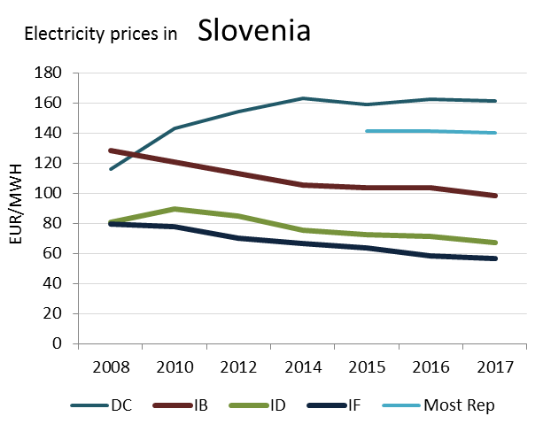

(DD)

**2017 electricity prices in Slovenia Prices**

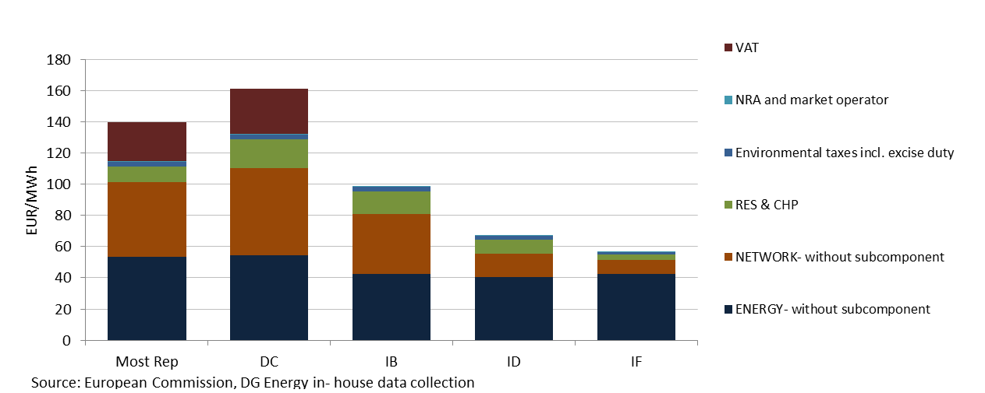

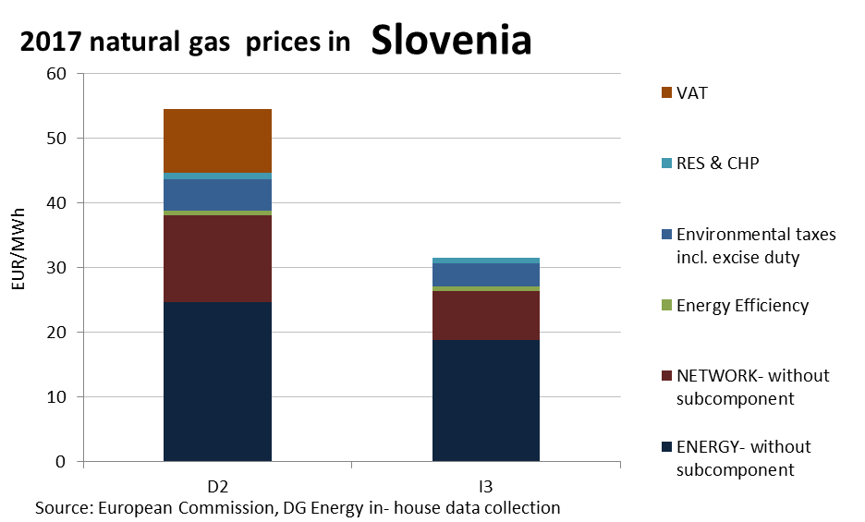

This country liberalised prices before 2008.

No social tariffs identified.

**Oil products prices**

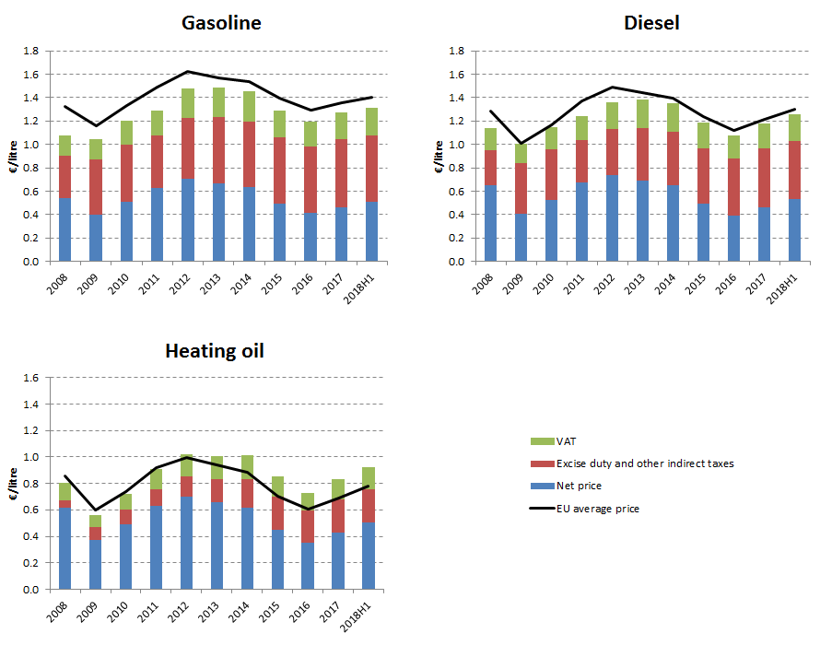

**Energy costs shares in total production costs**

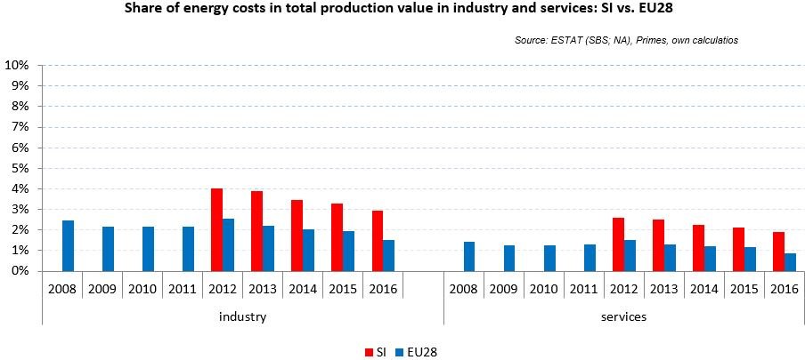

Notes: Data for Malta (prior to 2016), Poland (prior to 2015), Slovenia (prior to 2012) and Greece (prior to 2008) is not available. Data for Denmark, Sweden and the United Kingdom for 2016 was missing by the time of extraction

## Financial support interventions

**Spain** 

## Prices[15]

See footnote

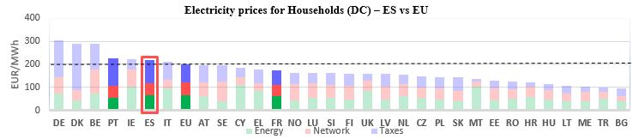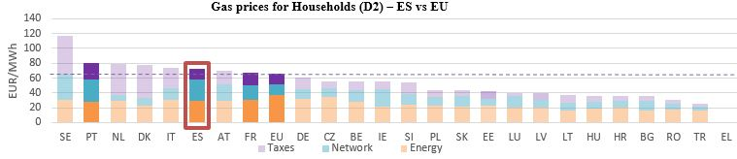

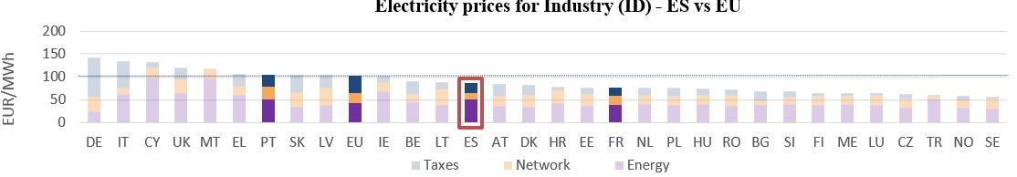

**Gas prices for Industry (I3) – ES vs EU**

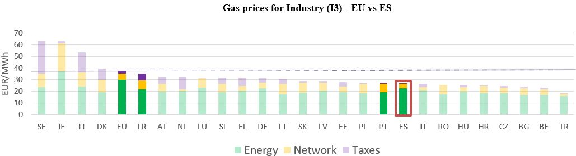



See footnote [16]

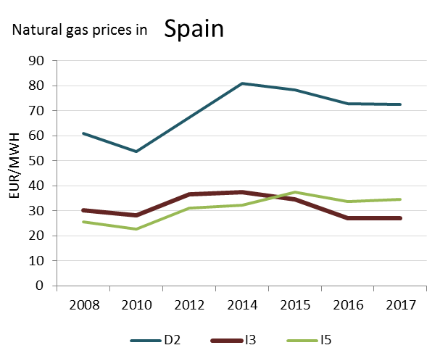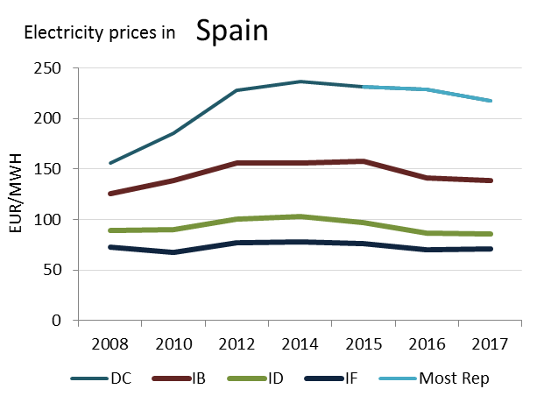

(DC)

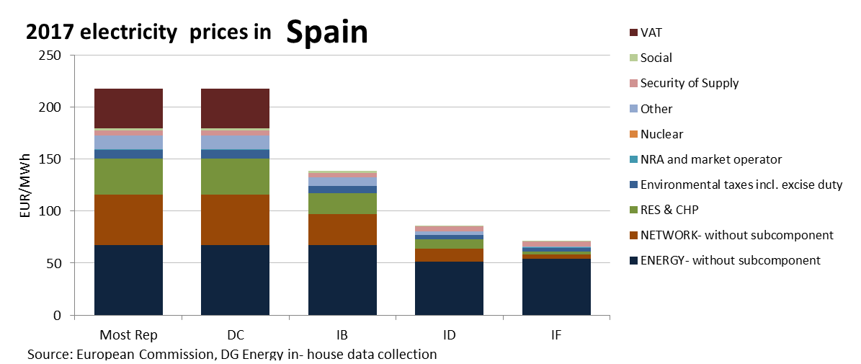

**Prices**

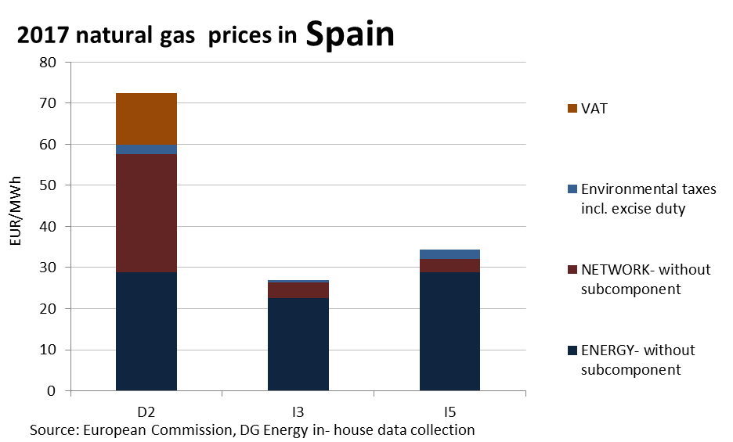

**Price regulation**

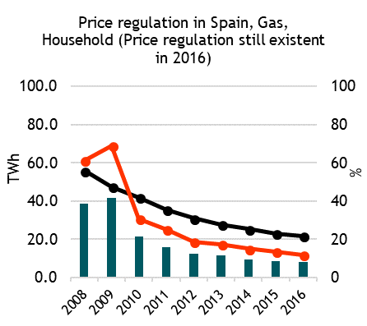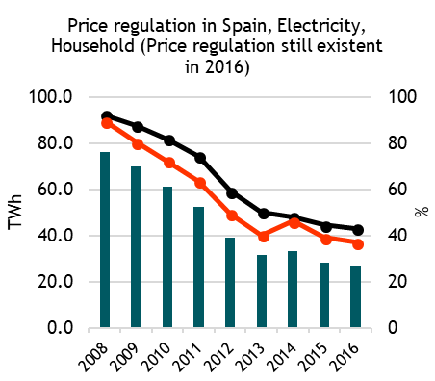

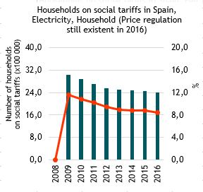

**Oil products prices**

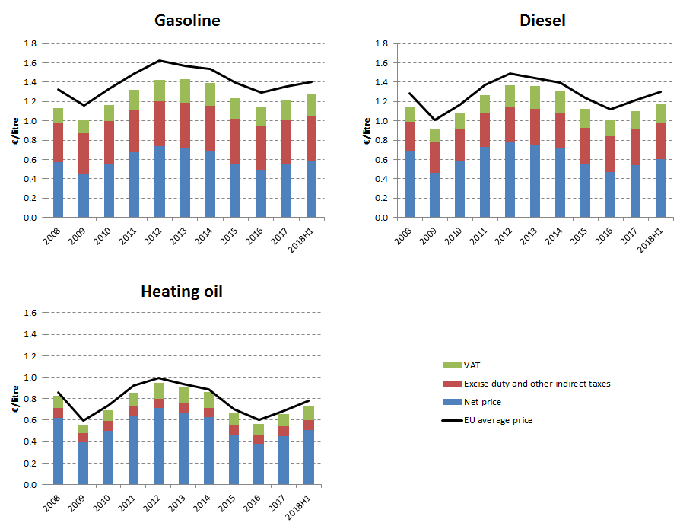

**Energy costs shares in total production costs**

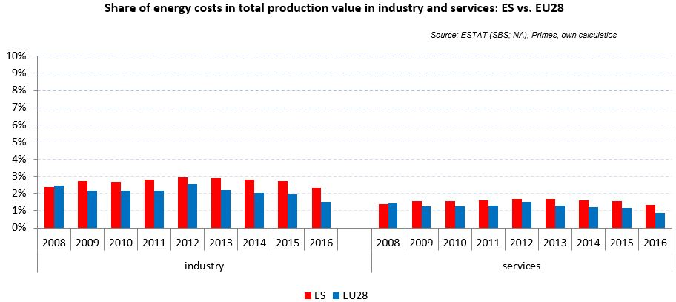

Notes: Data for Malta (prior to 2016), Poland (prior to 2015), Slovenia (prior to 2012) and Greece (prior to 2008) is not available. Data for Denmark, Sweden and the United Kingdom for 2016 was missing by the time of extraction

## Financial support interventions

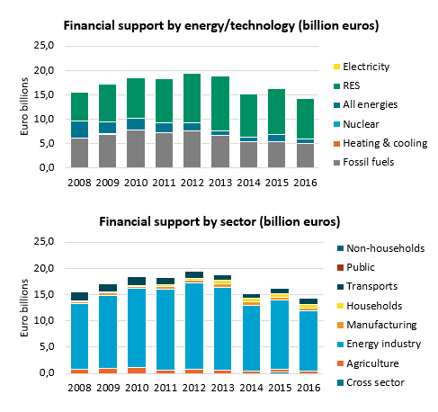

1. Neighbour countries and EU 28. No gas household prices available for Greece for 2017.
2. Annual electricity consumption: DB 1 - 2.5 MWh, DC 2.5 - 5 MWh, DD 5 - 15 MWh, DE above 15 MWh, IB 20-500 MWh, ID 2000-20000 MWh, IF 70000-150000 MWh. Annual Gas consumption: D2 20-200 GJ, I3 10000-100000 GJ, I5 1 mil - 4 mil GJ.
3. Neighbour countries and EU 28. No gas household prices available for Greece for 2017.
4. Annual electricity consumption: DB 1 - 2.5 MWh, DC 2.5 - 5 MWh, DD 5 - 15 MWh, DE above 15 MWh, IB 20-500 MWh, ID 2000-20000 MWh, IF 70000-150000 MWh. Annual Gas consumption: D2 20-200 GJ, I3 10000-100000 GJ, I5 1 mil - 4 mil GJ.
5. Neighbour countries and EU 28. No gas household prices available for Greece for 2017.
6. Annual electricity consumption: DB 1 - 2.5 MWh, DC 2.5 - 5 MWh, DD 5 - 15 MWh, DE above 15 MWh, IB 20-500 MWh, ID 2000-20000 MWh, IF 70000-150000 MWh. Annual Gas consumption: D2 20-200 GJ, I3 10000-100000 GJ, I5 1 mil - 4 mil GJ.
7. Neighbour countries and EU 28. No gas household prices available for Greece for 2017.
8. Annual electricity consumption: DB 1 - 2.5 MWh, DC 2.5 - 5 MWh, DD 5 - 15 MWh, DE above 15 MWh, IB 20-500 MWh, ID 2000-20000 MWh, IF 70000-150000 MWh. Annual Gas consumption: D2 20-200 GJ, I3 10000-100000 GJ, I5 1 mil - 4 mil GJ.
9. Neighbour countries and EU 28. No gas household prices available for Greece for 2017.
10. Annual electricity consumption: DB 1 - 2.5 MWh, DC 2.5 - 5 MWh, DD 5 - 15 MWh, DE above 15 MWh, IB 20-500 MWh, ID 2000-20000 MWh, IF 70000-150000 MWh. Annual Gas consumption: D2 20-200 GJ, I3 10000-100000 GJ, I5 1 mil - 4 mil GJ.
11. Neighbour countries and EU 28. No gas household prices available for Greece for 2017.
12. Annual electricity consumption: DB 1 - 2.5 MWh, DC 2.5 - 5 MWh, DD 5 - 15 MWh, DE above 15 MWh, IB 20-500 MWh, ID 2000-20000 MWh, IF 70000-150000 MWh. Annual Gas consumption: D2 20-200 GJ, I3 10000-100000 GJ, I5 1 mil - 4 mil GJ.
13. Neighbour countries and EU 28. No gas household prices available for Greece for 2017.
14. Annual electricity consumption: DB 1 - 2.5 MWh, DC 2.5 - 5 MWh, DD 5 - 15 MWh, DE above 15 MWh, IB 20-500 MWh, ID 2000-20000 MWh, IF 70000-150000 MWh. Annual Gas consumption: D2 20-200 GJ, I3 10000-100000 GJ, I5 1 mil - 4 mil GJ.
15. Neighbour countries and EU 28. No gas household prices available for Greece for 2017.
16. Annual electricity consumption: DB 1 - 2.5 MWh, DC 2.5 - 5 MWh, DD 5 - 15 MWh, DE above 15 MWh, IB 20-500 MWh, ID 2000-20000 MWh, IF 70000-150000 MWh. Annual Gas consumption: D2 20-200 GJ, I3 10000-100000 GJ, I5 1 mil - 4 mil GJ.