

# ANNEX 2 – FACTORS DRIVING ENERGY COSTS IN MANUFACTURING IN THE EU SECTORS

This annex contains the results of the energy costs decomposition analysis of the various sectors analysed between 2010 and 2015 in the Staff Working Document (see section 6.4).

The decomposition of energy costs is following the formula below:

$$∆Energy Costs=\left(real\right) output effect+\left(real\right) energy intensity effect+price effect+residual$$

Where

* **(real) Output effect:** the effect of changes in real production (GVA),
* **(real) Energy intensity effect:** the effect of changes in energy per unit of real output (GVA) over time due to energy efficiency measures, behavioural changes and industry structural change;
* **Price effects:** the effect of changes in coal, gas and electricity prices.
* The **residual,** whichincludes the effect of unexplained data discrepancy with Eurostat SBS data on 'purchases of energy'.

Be aware that the residual can be rather significant in some specific cases for which the results of the analysis should be taken with precaution.

List of figures

Figure 1: Fruit and vegetables 93

Figure 2: Grain mill and starch products 93

Figure 3: Manufacture of beverages 93

Figure 4: Textiles 94

Figure 5: Wood 94

Figure 6: Pulp, paper and paperboard manufacture 94

Figure 7: Paper and paperboard articles 95

Figure 8: Refineries 95

Figure 9: Man-made fibres 95

Figure 10: Pharmaceutical products 96

Figure 11: Plastics 96

Figure 12: Glass 96

Figure 13: Refractory products 97

Figure 14: Clay building materials 97

Figure 15: Ceramics 97

Figure 16: Cement 98

Figure 17: Stone 98

Figure 18: Basic iron and steel 98

Figure 19: Aluminium 99

Figure 20: Casting of Metals 99

Figure 21: Fabricated metal products 99

Figure 22: Electrical equipment 100

Figure 23: Machinery and equipment 100

Figure 24: Computer and electronic products 100

Figure 25: Motor vehicles and trailers 101

Figure 26: Transport equipment 101

Figure 27: Other Manufacturing 101

Figure 28: Machinery repair and installation 102

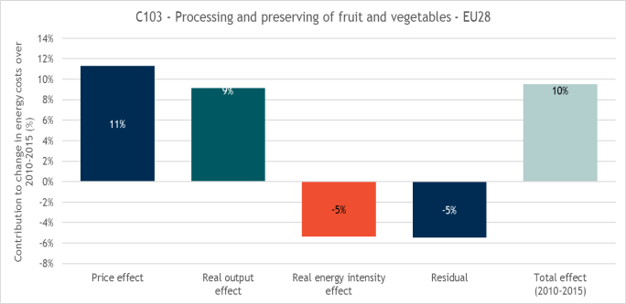

Figure 1: Fruit and vegetables

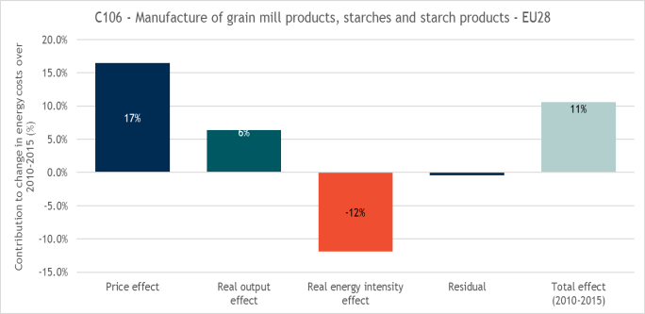

Figure 2: Grain mill and starch products

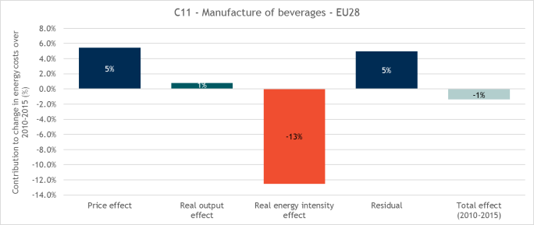

Figure 3: Manufacture of beverages

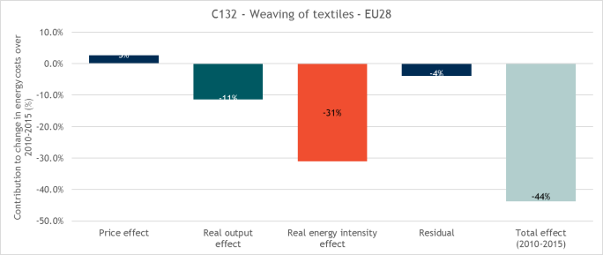

Figure 4: Textiles

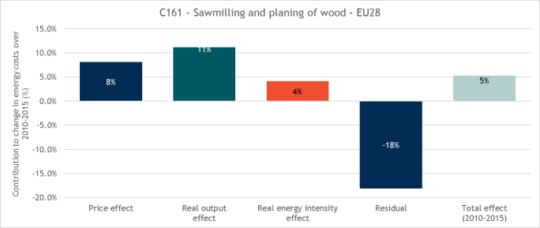

Figure 5: Wood

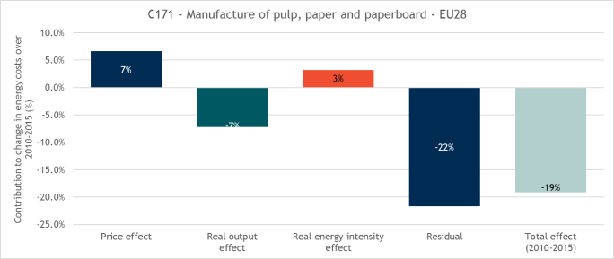

Figure 6: Pulp, paper and paperboard manufacture

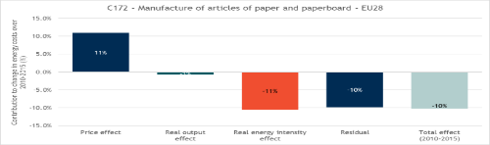

Figure 7: Paper and paperboard articles

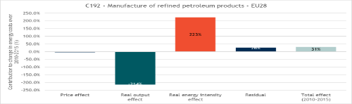

Figure 8: Refineries

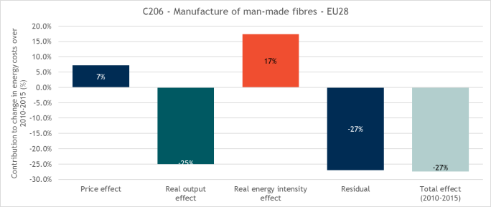

Figure 9: Man-made fibres

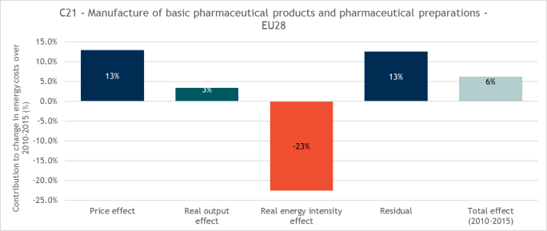

Figure 10: Pharmaceutical products

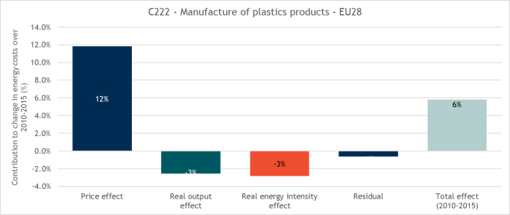

Figure 11: Plastics

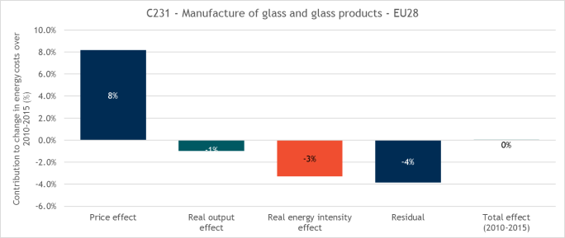

Figure 12: Glass

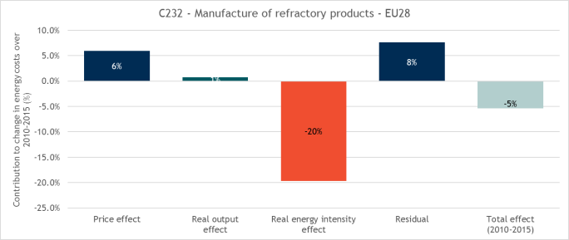

Figure 13: Refractory products

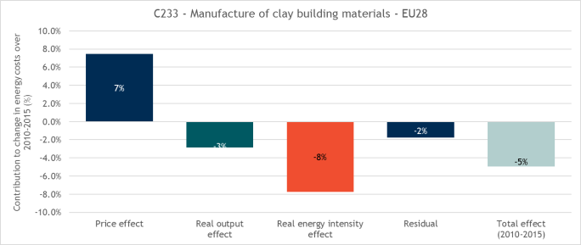

Figure 14: Clay building materials

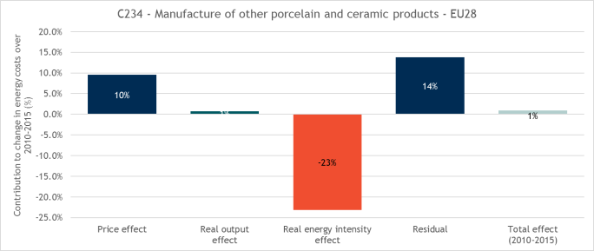

Figure 15: Ceramics

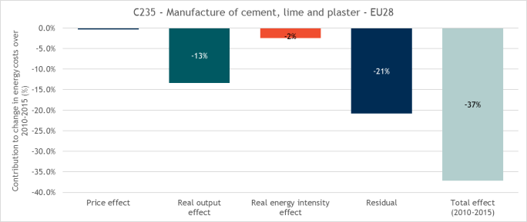

Figure 16: Cement

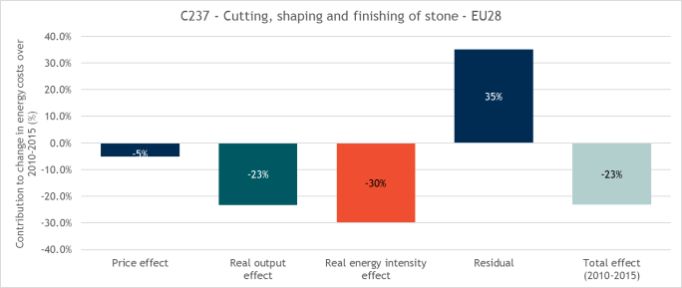

Figure 17: Stone

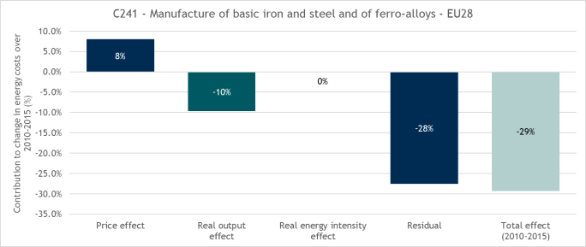

Figure 18: Basic iron and steel

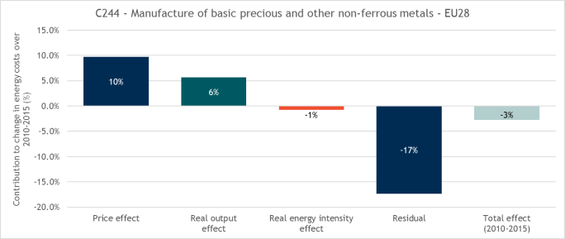

Figure 19: Aluminium

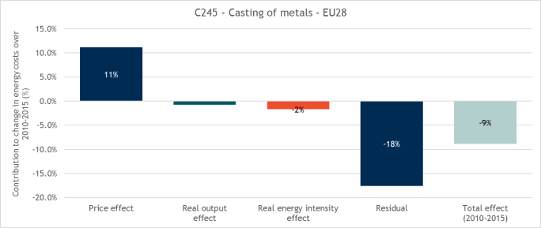

Figure 20: Casting of Metals

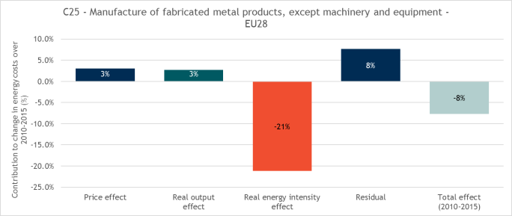

Figure 21: Fabricated metal products

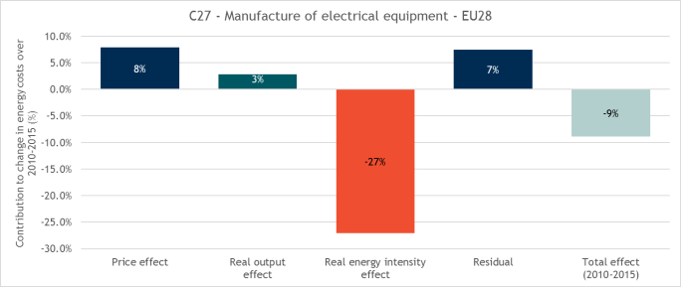

Figure 22: Electrical equipment

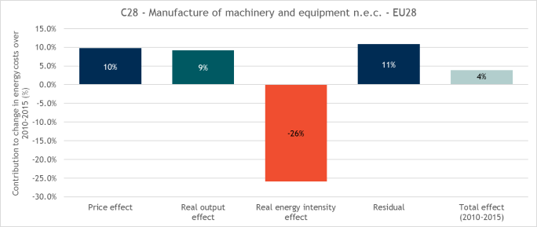

Figure 23: Machinery and equipment

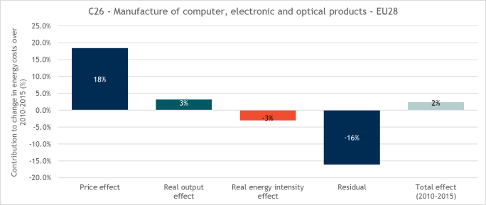

Figure 24: Computer and electronic products

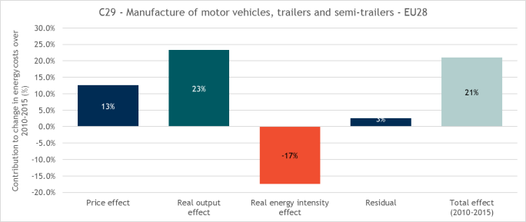

Figure 25: Motor vehicles and trailers

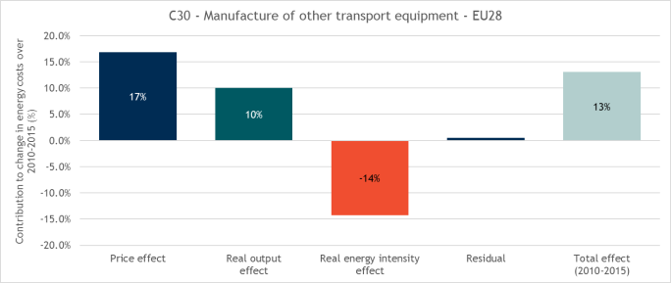

Figure 26: Transport equipment

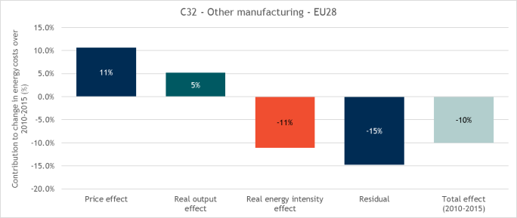

Figure 27: Other Manufacturing

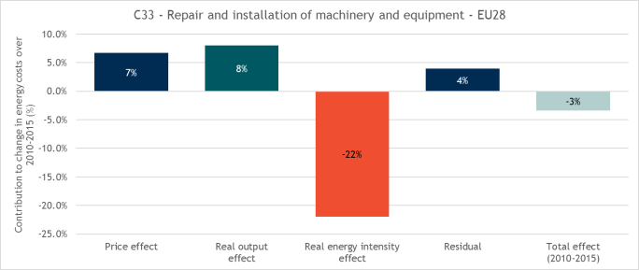

Figure 28: Machinery repair and installation