

Contents

Introduction 10

1 Electricity prices 13

1.1 Wholesale electricity prices 13

1.1.1 Evolution of wholesale electricity prices 14

1.1.2 Factors impacting the evolution of wholesale prices 18

1.1.3 International comparisons 23

1.2 Retail Electricity Prices 26

1.2.1 Household Electricity Prices 30

1.2.2 Industrial Electricity Prices 38

1.2.3 Small vs. Large Industrial Electricity Prices 44

1.2.4 International comparisons 51

2 Gas prices 54

2.1 Wholesale gas prices 54

2.1.1 Evolution of wholesale gas prices 55

2.1.2 Factors impacting the evolution of wholesale gas prices 60

2.1.3 International comparison 64

2.2 Retail gas prices 68

2.2.1 Household Natural Gas Prices 70

2.2.2 Industrial Natural Gas Prices 73

2.2.3 International comparisons 76

3 Oil and oil product prices 79

3.1 Crude oil prices 79

3.2 Wholesale prices of oil products 81

3.3 Retail prices of oil products 82

3.3.1 Methodology 84

3.3.2 General findings 84

3.3.3 Gasoline 87

3.3.4 Diesel 90

3.3.5 Heating oil 94

3.3.6 Gasoline vs diesel 97

3.3.7 International comparison 103

4 The EU energy bill 107

4.1 Introduction 107

4.2 Methodology 108

4.3 Drivers 110

4.4 Import bill calculation 114

5 Household energy expenditure and energy poverty 117

5.1 Energy products in household budgets 118

5.1.1 Energy expenditure (excluding transport) in households with low income 118

5.1.2 Energy expenditure (excluding transport) in households with middle income 120

5.1.3 Energy expenditures in the transport sector 123

6 Industry energy costs 125

6.1 Energy costs and competitiveness at macroeconomic level 128

6.1.1 Competitiveness drivers: EU vs G20 129

6.1.2 Impact of energy on the economy's competitiveness 139

6.2 Energy costs for industry 146

6.3 Exploring energy intensities 159

6.4 Energy costs drivers 163

6.4.1 Drivers of energy costs (Purchases of energy) 163

6.4.2 Impact of energy costs on Total Production Costs 168

6.4.3 Drivers of the energy costs as a share of production costs 169

6.5 International comparisons 171

6.5.1 Energy costs vs other G20 countries 172

6.5.2 Energy intensity of EU sectors vs other G20 174

6.5.3 Industrial electricity prices: EU vs G20 countries 177

6.5.4 Industrial gas prices: EU vs G20 countries 184

6.6 Case studies of selected Energy Intensive Industries 193

6.6.1 Scope and samples 193

6.6.2 Cross-Sectorial comparisons 195

6.6.3 Prices across Member States 199

6.6.4 Overview of results of specific case studies 208

7 Energy subsidies 211

7.1 Subsidies in the energy sector 216

7.1.1 Fossil fuel subsidies in the energy sector 217

7.1.2 Renewables 218

7.1.3 Nuclear 219

7.1.4 Other specific subsidies 221

7.2 Subsides beyond the energy sector 224

7.2.1 Fossil fuels subsidies beyond the energy sector 224

7.2.2 Sectors receiving subsidies beyond the energy industry 225

7.3 Impact of subsidies on energy prices for consumers 227

7.4 International comparisons of fossil fuel subsidies 231

8 The role of energy for government revenues and inflation 233

8.1 Government revenues from the energy sector 233

8.1.1 Energy taxes 233

8.1.2 Excise duties 237

8.1.3 Value added tax (VAT) 241

8.1.4 Tax revenues from oil products 242

9 Prices and costs and future investments 245

9.1 Introduction and definitions 246

9.2 Drivers of electricity costs and prices 247

9.2.1 Renewable costs are declining 247

9.2.2 Fossil fuel prices and carbon price 249

9.2.2.1 Gas price 249

9.2.2.2 Coal price 250

9.2.2.3 Oil price 250

9.2.3 Carbon price 251

9.3 Need for new capacities 252

9.3.1 Evolution of electricity demand 252

9.3.1.1 Age structure of fossil fuel fired power plants 254

9.4 Electricity prices vs costs up to 2030 in the EU 257

9.5 Investment in power production assets 258

10 Price regulation 263

10.1 Impact of price regulation on competition, prices, quality of services and investments 264

10.2 Price regulation in household gas and electricity markets 266

10.2.1 Share of households under regulated prices 267

10.2.2 Share of consumers under social tariffs 270

10.3 Impact of regulated prices on household retail markets 272

10.3.1 Impact on competition and consumer engagement 272

10.3.2 Market concentration 279

10.3.3 Impact on prices and costs 282

10.3.4 Impact on consumer perception 290

10.4 Impact of regulated prices on non-household retail markets 292

10.5 Impact of regulated prices on tariff deficits and investments 297

10.6 Dynamic pricing 298

10.6.1 Objective, methodological approach and assumptions 298

10.6.2 Preliminary results 301

10.6.3 Robustness of results and further research 307

**List of Figures**

Figure 1 - Evolution of monthly average wholesale day-ahead baseload electricity prices in Europe, showing the European Power Benchmark and the range of minimum and maximum prices across the markets 14

Figure 2 - Evolution of wholesale electricity prices in Europe since 2016 15

Figure 3 - Regional market prices in the North-Western Europe coupled area 16

Figure 4 - The Central Eastern Europe average wholesale price and the EPB benchmark 17

Figure 5 - Regional market prices in Italy and South Eastern Europe 18

Figure 6 - Electricity consumption and economic growth 19

Figure 7 - Electricity generation mix in the EU-28 (actual power generation) 19

Figure 8 - Monthly electricity generation in the EU and the share of some generation sources in the EU electricity mix 20

Figure 9 - Monthly coal, natural gas and carbon price indexes, compared to the 2008 average price and the share of renewable energy (right hand scale) 21

Figure 10 - Net electricity flow position compared to domestic electricity generation in the European power regions 22

Figure 11 - Comparison of wholesale electricity prices in the EU with global trade partners 24

Figure 12 - Comparison of wholesale electricity prices in the EU with global trade partners 24

Figure 13 - Evolution and composition of the EU household price (DC). MR = Most representative 29

Figure 14 - Household rices in 2017 (most rep.) 31

Figure 15 - Composition of hosehold prices in 2017 (most rep.) 32

Figure 16 - Breakdown of household prices (DC) 33

Figure 17 - Composition of taxes in 2017 (Most rep.) 33

Figure 18 - Taxes, ees, levies and charges for EU households (DC) 37

Figure 19 - Evolution and composition of the EU industrial price (ID) 38

Figure 20 - Industrial (ID) electricity prices in 2017 39

Figure 21 - Composition of industrial (ID) electricity prices in 2017 39

Figure 22 - Breakdown of EU prices in 2017 (ID) 40

Figure 23 - Composition of taxes in 2017 (ID) 41

Figure 24 - Taxes, levies, fees and charges of industrial electricity prices 43

Figure 25 - Evolution of small (IB) and large (IF) industrial electricity prices 44

Figure 26 - Composition of small (IB) and large (IF) industrial electricity prices 45

Figure 27- Composition of small (IB) and large (IF) industrial prices in 2017. First 16 countries alphabetically. 46

Figure 28 - Composition of small (IB) and large (IF) industrial prices in 2017. Last 15 countries alphabetically. 47

Figure 29 - Composition of taxes on prices for small (IB) and large (IF) industrial electricity prices (2008-2017) 47

Figure 30 - Composition of taxes on prices for small (IB) and large (IF) industrial electricity consumers in 2017 47

Figure 31 - RES support costs for electricity consumers (DC=Household, IB=small, ID=median, IF=large) 48

Figure 32 - RES support in 2017 by consumer type and country. First 13 countries alphabetically 49

Figure 33 - RES support in 2017 by consumer type and country. Last 13 countries alphabetically 49

Figure 34 - Difference between household retail electricity prices and electricity wholesale prices 2008-2018, EUR2017/MWh 51

Figure 35 - Difference between industrial retail electricity prices and electricity wholesale prices, EU28 and other G20 countries, 2008-2018, EUR2017/MWh 52

Figure 36 - Selected wholesale gas prices in Europe 55

Figure 37 - The difference between the Platts North West Europe Gas Contract Indicator (GCI) and the Dutch hub price (TTF) 55

Figure 38 - Price formation in Europe 56

Figure 39 - Daily day-ahead prices at selected gas hubs from 2008 to mid-2018 57

Figure 40 - The monthly average price of oil (Brent) and oil-indexed gas contracts (Platts GCI) 59

Figure 41 - Daily spot prices of oil (Brent) and gas (at the Dutch TTF hub) 60

Figure 42 - Daily change of spot prices of oil (Brent) and gas (at the Dutch TTF hub) 60

Figure 43 - The monthly average price of oil (Brent) and gas (at the Dutch TTF hub), measured in EUR/MWh 61

Figure 44 - Monthly average gas price at the Dutch TTF hub and heating degree days in the Netherlands 62

Figure 45 - Daily gas price at the Dutch TTF hub and average daily temperature in the Netherlands from the beginning of 2013 to mid-2018 62

Figure 46 - Comparison of European, US and Japanese wholesale gas prices 63

Figure 47 - The ratio of European, US and Japanese wholesale gas prices 64

Figure 48 - Gas wholesale prices in the EU (weighted average), China, Japan and the US 65

Figure 49 - Gas wholesale prices in the EU (weighted average) and selected markets 66

Figure 50 - Composition of the EU household gas price (DC) 70

Figure 51 - Household gas prices in 2017 70

Figure 52 - Composition of household gas prices in 2017 71

Figure 53 - Composition of EU taxes on household gas prices 72

Figure 54 - Composition of EU prices for small (I3) and large (I5) industrial gas consumers 73

Figure 55 - Median (I3) and large (I5) industrial gas prices in 2017 74

Figure 56 - Composition of median (I3) and large (I5) industrial gas prices in 2017 74

Figure 57 - Composition of EU gas prices for median (I3) and large (I5) consumers 75

Figure 58 - Composition of taxes for median (I3) and large (I5) industrial gas consumers 75

Figure 59 - Difference between household retail natural gas prices and wholesale prices, EU28 and trading partners 76

Figure 60 - Difference between industrial retail natural gas prices and wholesale prices, EU28 and trading partners 77

Figure 61 - The Brent crude oil price from 2008 to mid-2018 79

Figure 62 - Crude oil (Brent) and European wholesale gasoline, diesel and heating oil prices from 2008 to mid-2018 80

Figure 63 - Crack spreads of gasoline, diesel and heating oil from 2008 to mid-2018 81

Figure 64 - Average retail price of oil products in the EU 84

Figure 65 - Average excise duty rates for oil products in the EU 85

Figure 66 - Average retail price of oil products in the EU, without taxes 85

Figure 67 - The retail price of gasoline in the EU 86

Figure 68 - The retail price of gasoline in the EU, without taxes 87

Figure 69 - The exercise duty rate of gasoline in the EU 88

Figure 70 - Average retail price of gasoline in the EU by price component 88

Figure 71 - Average retail price of gasoline in the first half of 2018 by Member State and price component 89

Figure 72 - The retail price of diesel in the EU 90

Figure 73 - The retail price of diesel in the EU, without taxes 90

Figure 74 - The exercise duty rate of diesel in the EU 91

Figure 75 - Average retail price of diesel in the EU by price component 92

Figure 76 - Average retail price of diesel in the first half of 2018 by Member State and price component 92

Figure 77 - The retail price of heating oil in the EU 93

Figure 78 - The retail price of heating oil in the EU, without taxes 94

Figure 79 - The exercise duty rate of heating oil in the EU 95

Figure 80 - Average retail price of heating oil in the EU by price component 95

Figure 81 - Average retail price of heating oil in the first half of 2018 by Member State and price component 96

Figure 82 - Average retail price of gasoline and diesel in the EU 97

Figure 83 - Average retail price of gasoline and diesel in the EU, without taxes 98

Figure 84 - Average excise duty rates for gasoline and diesel in the EU 98

Figure 85 - The difference between the average excise duty rate on gasoline and diesel 99

Figure 86 - Excise duty rates in individual Member States in 2008 and the first half of 2018 100

Figure 87 - the change of the difference between the gasoline and diesel excise duty rates between 2008 and the first half of 2018 101

Figure 88 - Excise duty rates for motor fuels in Belgium 101

Figure 89 - International comparison of retail gasoline prices 102

Figure 90 - International comparison of retail gasoline prices 103

Figure 91 - International comparison of retail diesel prices 103

Figure 92 - International comparison of retail diesel prices 104

Figure 93 - EU import dependency by fuel 107

Figure 94 - EU net imports of energy in 2016 (mtoe) 108

Figure 95 - EU net imports 110

Figure 96 - Comparison of European oil, gas and coal prices 111

Figure 97 - The USD/EUR exchange rate since 2013 112

Figure 98 - The estimated EU import bill 115

Figure 99 - Expenditures on household energy products for the poorest households in the EU Member States), and the share of energy in the total household consumption expenditure 118

Figure 100 - Expenditures on household energy products for the lower-middle income households in the EU Member States, and the share of energy in the total household consumption expenditure 119

Figure 101 - Expenditures on household energy products for households with middle income in the EU Member States, and the share of energy in the total household consumption expenditure 120

Figure 102 - The ratio of homes being not adequately warm for households being below the 60% of the median income and the share of energy products within the total expenditure for households in the third decile (lower-middle income) 121

Figure 103 - Expenditures on transport energy products for the poorest households in the EU Member States, and the share of transport energy in the total household consumption expenditure 122

Figure 104 - Expenditures on transport energy products for households with middle income in the EU Member States, and the share of transport energy in the total household consumption expenditure 123

Figure 105 - Overall competitiveness in EU and non-EU G20 129

Figure 106 - Results for selected favourable factors of competitiveness 133

Figure 107 - Results for selected unfavourable factors of competitiveness 134

Figure 108 - Overall productivity in the EU and G20 135

Figure 109 - Productivity and Efficiency of EU and non-EU G20 136

Figure 110 - Labour productivity in industry in EU and G20 137

Figure 111 - Labor productivity in Services in EU and G20 137

Figure 112 - User satisfaction on Energy infrastructure in EU and G20 138

Figure 113 - Elecriticity prices for industry in the EU and G20 in 2017 139

Figure 114 - Real Unit Energy Cost - manufacturing excluding refining 140

Figure 115 - Contribution to growth of RUEC by Real Prices and Energy Intensity 140

Figure 116 - Evolution of energy costs shares in production value 141

Figure 117 - Evolution of energy costs shars in production value for Manufacturing 142

Figure 118 - Breakdown of the energy consumption per energy carrier, EU, 2008-2015 averages 150

Figure 119 - Average energy cost shares per sector – based on available data points, split by energy carrier, 2008-2015 averages 150

Figure 120 - Energy costs shares in total production costs in manufacturing sectors, 2008-2015 153

Figure 121 - Energy costs shares in total production costs in non-manufacturing sectors 154

Figure 122 - Gross Operating Surplus in manufacturing sectors (average 2008-2015) 156

Figure 123 - Gross Operating Surplus in manufacturing in the EU and Member States, 2008-2015 157

Figure 124 - Energy intensity (consumption/value added in nominal terms) for the most energy intensive manufacturing sectors (average of available countries) 159

Figure 125 - Energy intensity (consumption/value added in nominal terms) for other manufacturing sectors (average of available countries) 160

Figure 126 - Energy intensity (consumption/value added in nominal terms) for non- manufacturing sectors (average of available countries) 161

Figure 127 - Drivers of energy costs (absolute changes) 164

Figure 128 - Drivers of change in energy costs in EU manufacturing sectors over 2010-2015 (%) 165

Figure 129 - Classification of sectors by comparing the dynamics of energy costs dynamics vs productions costs 170

Figure 130 - International comparision of energy costs shares for selected energy intensive sectors 171

Figure 131 - Energy costs shares in production value for the most energy intensive sectors in manufacturing, 2008-2015 172

Figure 132 - Energy costs shares in production value for other manufacturing sectors, 2008-2015 172

Figure 133 - Energy intensity international comparisons for the most energy intensive manufacturing sectors 174

Figure 134 - Energy intensity international comparisons for other manufacturing sectors 175

Figure 135 – Retail electricity prices for industry: EU vs China, Japan & US, 2008-2018 176

Figure 136 - Retail electricity prices for industry: EU vs other G20, 2007-2018 177

Figure 137 – Retail electricity indexes prices for industry: EU vs Argentina, Australia & India, 2008-2018 178

Figure 138 - Range of retail electricity prices for industry in the EU 181

Figure 139 - Box plot of EU28 industrial retail electricity prices 2008-2017 181

Figure 140 - EU28 industrial retail electricity prices 2008-2017, individual Member States lines visible, outliers named 182

Figure 141 - Retail gas prices for industry: EU vs China, Japan and the US, 2008-2018 183

Figure 142 - Retail gas prices for industry: EU vs other non-EU G20 countries, 2008-2018 184

Figure 143 - Retail gas indexes prices for industry: EU vs AU and MX, 2008-2018 185

Figure 144 - Max-min range of retail gas prices for industry in the EU, 2008-2018 188

Figure 145 - Box plot of industrial gas prices, 2008-2017 188

Figure 146 - EU28 industrial retail natural gas prices 2008-2017, individual Member States lines visible, outliers named 189

Figure 147 - Average industry electricity (left) and gas (right) prices in the EU and among the top 15 EU trade partners (current prices) 190

Figure 148 - Impact on EU industry unit costs in a counterfactual scenario where EU energy prices over 2007-2016 are comparable to energy prices faced by the EU’s main trading partners 191

Figure 149 - Impact on EU industry prices in a counterfactual scenario where EU energy prices over 2007-2016 are comparable to energy prices faced by the EU’s main trading partners 191

Figure 150 - Plant electricity consumption and average electricity prices by sector, 2016 (185 observations) 194

Figure 151 - Average electricity prices by consumption level, 2008 – 2017 (2008: 120 observations; 2009: 73; 2010: 141; 2011: 86; 2012: 154; 2013: 161; 2014: 161; 2015: 158; 2016: 185; 2017: 182) 195

Figure 152 - Plant electricity consumption and average electricity costs by sector, 2016 (185 observations) 196

Figure 153 - Plant natural gas consumption and average natural gas prices by sector, 2016 (165 observations) 197

Figure 154 - Average natural gas prices by consumption level, 2008 – 2017 (2008: 110 observations; 2009: 74; 2010: 129; 2011: 81; 2012: 137; 2013: 145; 2014: 149; 2015: 147; 2016: 165; 2017: 163) 198

Figure 155 - Structure of average electricity prices in the surveyed plants in the NWE region (France, Germany, the Netherlands and the UK) in absolute terms (€/MWh), 2008 – 2017 201

Figure 156 - Structure of average electricity prices in the surveyed plants in the SE region (Portugal, Italy, Spain and Greece) in absolute terms (€/MWh), 2008 – 2017 202

Figure 157 - Structure of average electricity prices in the surveyed plants in the CEE region (Poland and Bulgaria) in absolute terms (€/MWh), 2008 – 2017 203

Figure 158 - Structure of average natural gas prices in the surveyed plants in the NWE region (France, Germany, the Netherlands and the UK) in absolute terms (€/MWh), 2008 – 2017 204

Figure 159 - Structure of average natural gas prices in the surveyed plants in the SE region (Portugal, Italy and Spain) in absolute terms (€/MWh), 2008 – 2017 205

Figure 160 - Structure of average natural gas prices in the surveyed plants in the CEE region (Poland and Bulgaria) in absolute terms (€/MWh), 2008 – 2017 206

Figure 161 – Financial support by sector in the EU-28 (expressed in €2017bn) 213

Figure 162 – Financial support by energy group (expressed in €2017bn) 214

Figure 163 – Financial support in 2016 by energy source and EU Member States (expressed in €2017bn and as the percentage of Gross Domestic Product - GDP) 215

Figure 164 – Subsidies in the energy sector, by generation technology 216

Figure 165 – Subsidies to fossil fuels in the energy sector, by generation technology 217

Figure 166 – Support to renewable energy sources in the EU Member States 218

Figure 167 – Nuclear R&D support in the EU Member States 219

Figure 168 – Support to nuclear decommissioning in some EU Member States 220

Figure 169 – Free emission allowances allotted to stationary installations, to the aviation sector, and the evolution of the carbon price in the ETS system 221

Figure 170 – Capacity payment support in some EU Member States 222

Figure 171 – Financial support to interruptible load schemes in some EU Member States 223

Figure 172 – Fossil fuel subsidies in different sectors in the EU 224

Figure 173 – Subsidies to oil and petroleum products in different sectors in the EU 224

Figure 174 – Distribution of support among energy sources in 2016 in the EU 226

Figure 175 – Retail electricity prices, recoverable taxes and tax relieves paid by large industrial (energy intensive) and median level electricity customers in some EU Member States in 2016 227

Figure 176 – Retail gas prices, recoverable taxes and tax relieves paid by large industrial (energy intensive) and median level gas customers in some EU Member States in 2016 228

Figure 177 - Retail electricity prices, recoverable taxes and tax relieves paid by households in some EU Member States in 2016 229

Figure 178 - Retail gas prices, recoverable taxes and tax relieves paid by households in some EU Member States in 2016 229

Figure 179 - The impact of loans and grants for energy efficiency measures and/or other investments on EU28 household and industry energy consumption between 2008 and 2015 230

Figure 180 – Fossil fuel subsidies in the world and in the EU 231

Figure 181 - Energy taxes in the EU-28 233

Figure 182 - Energy taxes as a percentage of tax revenue and of GDP in 2016 234

Figure 183 - Energy taxes by economic activity 234

Figure 184 – Average energy tax for 1 toe of gross inland energy consumption in the EU-28 235

Figure 185 – Average energy tax for 1 toe of gross inland energy consumption in 2016 236

Figure 186 - Excise duty revenues from energy consumption 237

Figure 187 - Exercise duty revenues from energy consumption, adjusted for inflation (in 2015 euros) 238

Figure 188 - The share of excise duty revenues by energy product 239

Figure 189 - The share of excise duty revenues by energy product, 2017 239

Figure 190 - The average standard VAT rate in the EU 240

Figure 191 - Estimated tax revenue from gasoline, diesel and heating oil 242

Figure 192- Ratio between volume traded annually on day-ahead market and electricity final 246

Figure 193 - Evolution of investment costs of renewables 246

Figure 194 - Expected development of investment costs of renewable energy technologies in the long term under different scenarions (lines) and uncertain factors (range): example of solar and wind (left: utility scale photovoltaics, right: offshore wind turbines) 247

Figure 195 - Monthly gas import price 248

Figure 196 - Monthly coal import price 249

Figure 197 - Daily oil price (Brent) 250

Figure 198 - Daily ETS price 250

Figure 199 - Daily ETS price in 2018 251

Figure 200 - Final electricity consumption in the EU28, historical data and projections. 252

Figure 201 - EU 2015 Installed gas capacity by age [MW] 253

Figure 202 - EU 2015 installed coal capacity 254

Figure 203 - EU 2015 installed oil capacity 254

Figure 204 - additions and retirement of gas power plants. 255

Figure 205 - additions and retirement of coal power plants. 255

Figure 206 - additions and retirement of oil power plants. 256

Figure 207 - EU28: electricity prices and cost 257

Figure 208 - New power generation capacity - PRIMES projections. 258

Figure 209 - New power generation investments - PRIMES projections. 258

Figure 210 - Household price regulation in EU Member States in 2016 266

Figure 211 - Share of consumers under regulated prices in EU Member States in 2016 267

Figure 212 - Evolution in the share of households under regulated prices 268

Figure 213 - Share of households under social tariffs in EU Member States 269

Figure 214 - Evolution in the share of households under social tariffs in EU Member States 270

Figure 215 - Number of active suppliers per 100,000 citizens in 2016 272

Figure 216 - Evolution in the number of active suppliers per 100,000 citizens in 2016 274

Figure 217 - Annual switching rates in 2016 275

Figure 218 - Evolution in annual switching rates 276

Figure 219 - Type of electricity and gas contracts available and offers per supplier 278

Figure 220 - Market share of the 3 largest suppliers 279

Figure 221 - Evolution in market concentration 280

Figure 222 - Prices for electricity (2016) and gas (2015) on household markets 281

Figure 223 - Evolution in prices for electricity (2016) and gas (2015) on household markets 282

Figure 224 - Energy component mark-ups 284

Figure 225 - Evolution in energy component mark-ups 285

Figure 226 - Energy expenditure as share of disposable income 286

Figure 227 - Energy poverty 287

Figure 228 - Evolution of energy poverty 288

Figure 229 - Consumer perception of the market in 2015 290

Figure 230 - Non-household price regulation from a geographical perspective 291

Figure 231 - Share of non-household consumption under regulated prices 292

Figure 232 - Energy and supply component for electricity (2016) and gas (2015) on the non-household consumer market 293

Figure 233 - Energy and supply component for electricity (2016) and gas (2015) on the non-household consumer market 294

Figure 234 - Energy and supply component for electricity (2016) and gas (2015) on the non-household consumer market 295

Figure 235 - Potential savings for households from switching to dynamic pricing in selected Member States ; by consumption band 302

Figure 236 - Elements to understand consumer behaviour and agregation for analysis 305

Figure 237 - Potential savings from switching to DPC with alternative mark-ups in Italy 307

**List of Tables**

Table 1 - Key figures on the evolution and drivers of retail electricity prices 26

Table 2 - Composition of small (IB) and large (IF) industrial prices 44

Table 3 - The ratio of European, US and Japanese wholesale gas prices 64

Table 4 - Key figures on the evolution and drivers of retail gas prices 68

Table 5 - Estimated average gas import prices by supplier (€/MWh) 109

Table 6 - EU crude oil import bill in 2013-2017 113

Table 7 - EU gas import bill in 2013-2017 113

Table 8 - EU hard coal import bill in 2013-2017 114

Table 9 - Coverage of manufacturing sectors 146

Table 10 - Coverage of other sectors, excluding manufacturing 147

Table 11 - Energy costs shares in total production costs for manufacturing and non-manufacturing, 2008-2015 151

Table 12- Drivers of total production costs in manufacturing sectors 167

Table 13 - Changes in energy costs and total production costs by sector 168

Table 14 - Changes in retail industrial electricity prices compared to EU prices, constant 2017 EUR/MWh 179

Table 15 - Factors in observed industrial retail electricity price changes per country, nominal prices, per MWh 180

Table 16 - Changes in the industry retail natural gas price differential compared to EU prices, constant 2017 euros per MWh 186

Table 17 - Factors in observed industrial retail natural gas price changes per country, nominal prices, per MWh 187

Table 18 - Size and EU representativeness of the samples in the bottom-up analysis 193

Table 19 - Key plant level results from the case studies (2016) – EU values 207

Table 20 - Overview of tariff deficits in Member States between 2008-2016 296

Table 21 - Composition of user group for estimating the DPC 303

Table 22 - Estimated average annual savings per Band, EUR, 2016 303

Table 23 - Estimated average annual savings per Band, share of energy supply component, 2016 304

Table 24 - Estimated number of consumers losing out from the switch to DPC 304

Introduction

The European's Commission *Clean energy for all Europeans* package adopted in November 2016[1] included capital energy policy initiatives to roll out the Energy Union and set strengthened foundations to meet the EU's climate and energy targets and its international commitment under the Paris Agreement. The (previous) 2016 energy prices and costs report was part of that package and provided evidence assessing and underpinning the need for various European energy policy actions.

Two years after, most of the initiatives of that package have already been agreed between Parliament and Council and will start to be implemented soon. In November 2018, the European Commission has just presented the *Long-term EU strategy for the reduction of greenhouse gas emissions in accordance with the Paris Agreement[2].* In a similar vein as in 2016, the 2018 edition of the energy prices and costs report comes at a timely moment and contributes to assess energy policies on the basis of the new evidence coming from the analysis of energy costs, prices and support interventions. The evidence of the report highlights the important role of international fossil fuel prices in driving energy prices in the EU making the case for pursuing our efforts to decarbonise our energy system. Data also shows the impact of dollar-denominated international energy prices on our energy bill, underpinning our efforts to reduce dependence on fossil fuels and highlighting the benefits of pricing the transactions of energy products in euros to reduce the uncertainty brought by exchange rate volatility[3].

The first part of the report (Part I – Energy Prices, comprising Chapters 1, 2 and 3) looks at the developments on wholesale and retail energy prices for electricity, gas and oil products between 2008 and 2017-18. On retail prices, the European Commission has again conducted an *ad hoc* data collection of the cost elements making up retail prices. The report presents the most detailed available breakdown of these elements affecting prices, in particular the various taxes and levies, and provides an insight on the evolution, composition and drivers of retail prices. International comparisons of the prices for petroleum, gas and electricity products are also presented in the chapters of Part I.

The impact of the energy costs on the economy, the industry and households is addressed in the second part of the report (Part II – Energy costs). Chapter 4 on the import bill assesses the developments in the EU energy bill and the reasons behind them. Chapter 5 looks at impact of energy prices and costs on energy poverty including an assessment of the energy expenditure shares by income level. Finally, Chapter 6 analyses the impact of energy costs on the (cost) -competitiveness of the European industry. The analysis includes an assessment of the costs for whole industry and services sectors and for 45 specific manufacturing and non-manufacturing sectors, including energy intensive industries. Their energy costs shares, energy intensities and energy prices are examined and, to the extent possible by the available data, compared with those in the third countries. The chapter presents a combination of results coming from studies using highly aggregated statistical data and sectorial data collected at plan level. Part II is complemented by Annex 1, which presents case studies for a number of sectors/subsectors of energy intensive industries, and by Annex 2, which includes sectorial decomposition analyses of energy costs.

Government interventions and revenues from energy products are addressed in Part III of the report. Chapter 7 presents the result of the analysis of the data collected on support interventions across member states (more than 1400 types of interventions) from 2008-2017. This constitutes the most updated and detailed inventory of energy subsidies of the EU Member States. The impact of these subsidies on the prices and costs for consumers and industry, particularly energy intensive sectors, is also estimated using a combination of analytical and econometric techniques (that distinguish the impact on prices at wholesale and retail level). Chapter 8 also assesses the nature and importance of energy tax revenues in government's budgets.

Part IV of the report (Chapter 9), looks forward, and assesses the relation between future expected prices and costs in the electricity market and how this can affect the incentives for investment in the different energy technologies in the 2030 horizon. It analyses the various underlying factors driving the price-cost relation together with expected developments on future demand which is significantly influenced by our policy decisions.

Finally, Part V looks at the impact of regulation on prices. Chapter 10 assesses in detail the impact of price regulation on the existence of competitive prices, quality of service and the propensity to invest between 2008 and 2016. It looks at how price regulation/de-regulation affects Member States by analysing indicators on various groups of Member States, those which with have been fully liberalised prices (prior or during the period of study) versus those which are in transition to price deregulation (less than 50% of the market is with price regulation) and those which still have significant part of their market (more than 50%) with price regulation. Finally, on the basis of data collected from Member States, section 10.2 of the chapter includes estimates of the benefits from switching from regulated prices to fully liberalised dynamic price contracts.

Country-factsheets with energy prices and costs key indicators are included in Annex 3.

**PART I**

**ENERGY PRICES**

# Electricity prices

## Wholesale electricity prices

* Over the last ten years wholesale electricity prices showed a significant volatility in Europe, reaching their peak in 2008 and their lows in early 2016. Since spring 2016, when the European Power Benchmark (EPB) index, in parallel with many wholesale electricity market prices, fell to ten year lows and reached 30 €/MWh, there was a general price recovery and by August 2018 the EPB went up to 60€/MWh.
* Price convergence across the European regional wholesale markets varies over time. Wholesale electricity prices tended to diverge more in general price spike periods (e.g.: in 2008 or in early 2017), or when low prices could be observed in some local markets (e.g.: periods of abundant hydro power generation in the Nordics).
* Different regional markets in Europe face different prices, owing to differences in local generation mixes and interconnection capacities.
* EU and national level policies resulted in increasing wind and solar generation in many European countries. Integration of renewable generations sources to the grid and investments in infrastructure capacities are indispensable to accomplish a properly working internal electricity market in the EU. Market couplings now cover the majority of EU wholesale markets, enabling more efficient cross-border trade and better convergence of prices between neighbouring markets.
* Several factors impacting wholesale electricity prices can be identified both on the demand side and on the supply side of the electricity market. Since 2008 GDP in the EU-28 was up by 10%, while at the same time electricity consumption decreased by 6%, pointing to less electricity intensity of the EU economy. On the supply side there were fundamental changes in the EU electricity generation mix since 2008: the share of fossil fuels decreased while the share of renewable energies practically doubled, reaching an estimated 38% in April 2018.
* The price of coal and natural gas has an important role in shaping electricity generation costs, as coal-fired and gas-fired generation ensures the marginal generation costs on the electricity market. Coal and gas prices peaked in 2008; then fell sharply in 2009. After a recovery, between 2012 and 2016 they decreased again, whereas in the last two year they rebounded. After being at low levels for several years, emission allowance prices tripled between mid-2017 and mid-2018, starting to impact again wholesale electricity prices. Wholesale electricity prices showed a strong co-movement with fossil fuel prices.
* In international comparison, which is useful for analysing the competitiveness of electricity intensive industries, wholesale electricity prices in the EU were higher than in the US, Canada, Australia and Russia during most of the time in the last ten years, however, they were lower than prices in China, Japan, Mexico, Turkey, Brazil and Indonesia. Electricity price differentials between the EU and its trading partners do not give in all cases a comprehensive explanation for competitiveness of products manufactured by energy intensive industries, other factors of competitiveness need to be taken into consideration.

### Evolution of wholesale electricity prices

Over the last decade, wholesale electricity prices in the European markets showed significant volatility. In 2008, as all energy commodity prices reached their top, wholesale electricity prices also peaked. Subsequently during 2009, in parallel with the economic crisis the wholesale electricity prices fell back. Between 2010 and 2012 a solid price recovery took place, however, in the following four years a downward trend could be witnessed, and in early 2016 wholesale electricity prices fell to a decade low in many European markets. Compared to these lows, wholesale electricity prices increased until mid-2018 again.

The next chart **(Figure 1)** shows the evolution of the European Power Benchmark (EPB) and the range of minimum and maximum wholesale electricity prices in each month between 2008 and 2018. EPB is an index computed as the weighted average of the day-ahead prices of the most liquid wholesale electricity markets, serving as a general European benchmark,. In different periods convergence across European markets reached a different degree; in the periods of general price spikes (e.g.: in 2008 or in early 2017) prices became more divergent, however, very low prices in some national markets (e.g.: Nordic markets during summertime, a high level of hydro power generation, or markets with high share of variable renewable penetration) can also lead to significant price differentials across Europe.

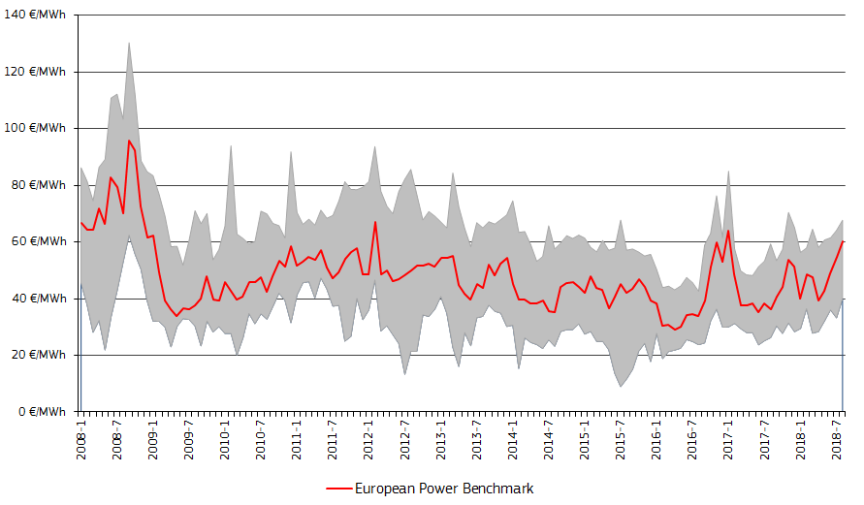

Figure 1 - Evolution of monthly average wholesale day-ahead baseload electricity prices in Europe, showing the European Power Benchmark and the range of minimum and maximum prices across the markets

Source: Platts, European power markets

Zooming on the market developments of the last two years (since the publication of the 2016 edition of the *Energy Prices and Costs in the EU* report), , we can see that in the second half of 2016 wholesale electricity prices started to increase, owing to higher electricity generation costs in parallel with increasing coal and gas prices (see **Figure 2)**. This increase was reinforced at the beginning of 2017 as an ongoing cold weather, coupled with lower than usual nuclear electricity generation in some Western European countries (mainly France and Belgium), resulted in high wholesale electricity prices. At the end of 2017 safety inspections also reduced the availability of nuclear fleet in the same markets. All-in-all, since spring 2016, when the EPB index was around 30 €/MWh, a measurable wholesale price increase could be observed by August 2018, as the benchmark was above 60 €/MWh in that month.

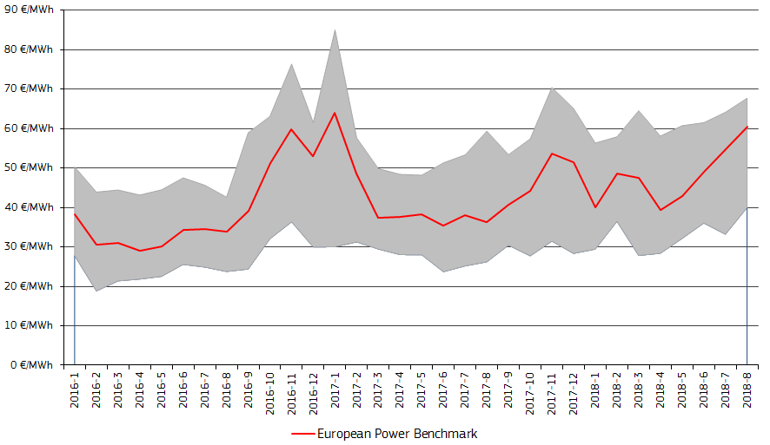

Figure 2 - Evolution of wholesale electricity prices in Europe since 2016

Source: Platts, European power markets

As it was already mentioned, there might be significant differentials in wholesale electricity prices across Europe in some periods, thus it is worth taking a look at the price evolution of the regional markets.

**Figure 3** shows the regional wholesale electricity prices in the North Western Europe (NWE) market coupling area, including Central Western Europe (Germany, France, Austria and the Benelux), the UK, the Nordic markets (Norway, Sweden, Denmark, Finland and the Baltic States) and Iberian market (Spain and Portugal). Nordic markets had normally the lowest wholesale price across Europe over the last two years, owing to the important role of hydro power generation and increasing of wind and solar. In Central Western Europe (CWE), where prices were also lower than the EPB during most of this time period, increasing renewable penetration and the important role of nuclear power resulted in competitive electricity generation costs.

In the Iberian region prices significantly impacted by hydro reserves and generation; from mid-2016 to the beginning of 2018 a dry period resulted in lower than usual hydro power generation that increased the wholesale price level above the EPB. During most of the time in 2016-2018 the highest wholesale prices could be observed in the UK; owing to significant electricity import needs of the country and the climate change levy that directly impacts the UK wholesale electricity price.

Although the NWE region is the largest flow based market coupled area in Europe, significant differences in wholesale prices exists across its different regions. This suggests further integration of all electricity generation sources (especially variable renewables like wind and solar) and further investment in infrastructure (e.g.: interconnection capacities) could help to diminishes cross-market price differentials.

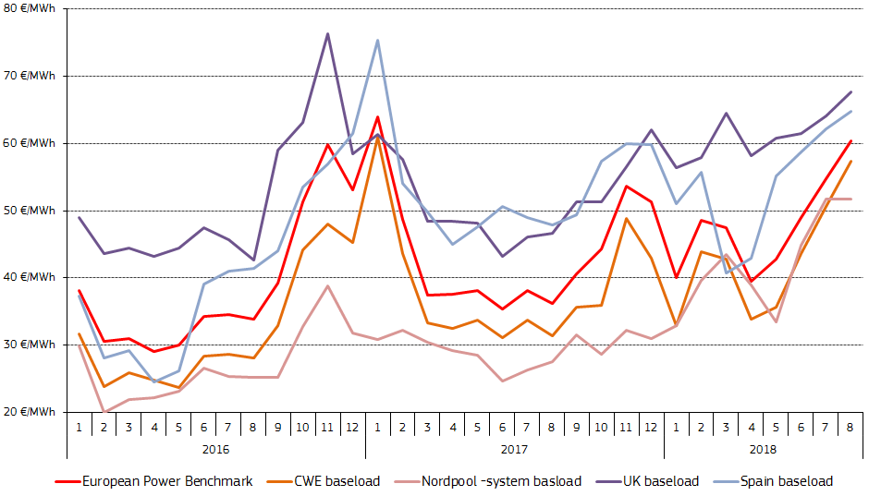

Figure 3 - Regional market prices in the North-Western Europe coupled area

Source: Platts, European power markets

In the Central and Eastern Europe region (CEE – Poland, Czech Republic, Slovakia, Hungary, Romania, Croatia and Slovenia) prices behaved similarly to the European benchmark between 2016 to (August) 2018 (see **Figure 4**). Besides abundant fossil fuel (mainly coal and lignite) and nuclear power generation in the region as a whole, market prices in the Central Eastern Europe are impacted by electricity imports from Central and Western Europe and the Balkans, where hydro generation is important. At the end of 2016 and 2017, when nuclear availability in the CWE region was low due to the aforementioned reasons, prices in the CEE region were lower than in Western Europe.

In the CEE region four national markets (Czech Republic, Slovakia, Hungary and Romania) are coupled and wholesale electricity prices are well aligned in the majority of trading hours. Poland is price coupled with Sweden (and thus with the NWE region). Croatia and Slovenia are not coupled with the rest of the CEE region.

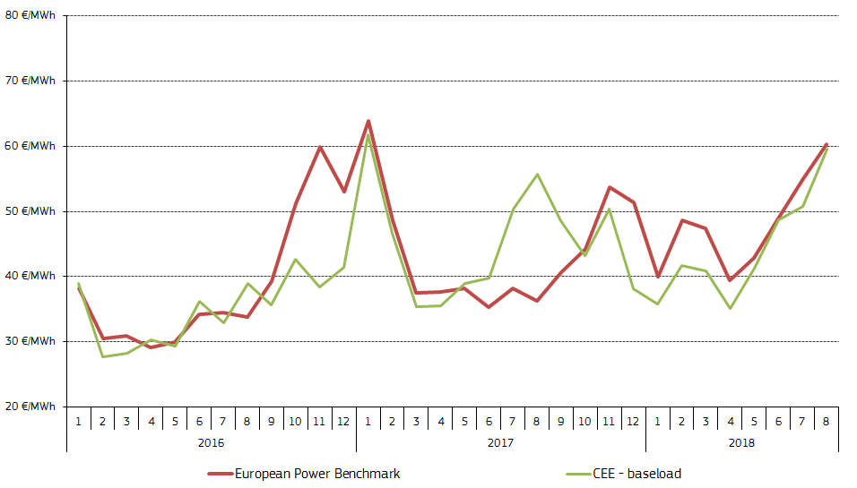

Figure 4 - The Central Eastern Europe average wholesale price and the EPB benchmark

Source: Platts, European power markets

In Italy and Greece wholesale electricity prices between 2016 and 2018 so far were usually higher than the EPB benchmark (**Figure 5**). Italy has traditionally been a net electricity importer, as the cost of import (mainly from the CWE region) is competitive to the domestic, primarily gas-fired power generation. During the summer period renewable generation picks up in Italy and imports are lower. Greece is also traditionally net electricity importer, the country's domestic production is largely based on domestic lignite and gas fired generation. Imports from the Balkans are competitive against domestic generation.

Bulgarian wholesale prices were however lower than European prices between 2016 and 2018 so far, owing to favourable costs of domestic electricity generation (largely based on solid fuels and nuclear). Bulgaria is normally a net electricity exporter, but in some periods (e.g.: the cold snap in January 2017) exports were banned[4]

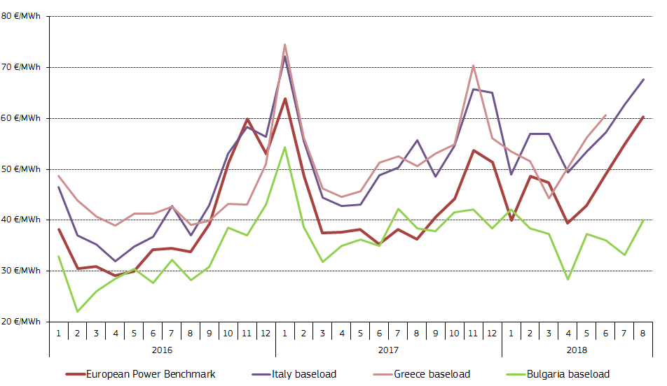

Figure 5 - Regional market prices in Italy and South Eastern Europe

Source: Platts, European power markets

### Factors impacting the evolution of wholesale prices

Wholesale electricity prices are determined by market forces. In this section we look at demand side and supply side factors that explain their evolution.

On the demand side of the electricity market, residential electricity consumption is determined by needs for various purposes, for example lighting, heating and using household appliances. For businesses, the consumption of electricity is mainly determined by the level of economic activity, which can be measured by the evolution of the Gross Domestic Product (GDP).

The next chart (**Figure 6**) shows that electricity consumption in the EU has strong seasonality (see blue dashed line in **Figure 6**). During wintertime the industrial activity and the lighting and heating needs of households are higher than in summertime, all this resulting in higher electricity consumption during the winter period.

In order to assess the relation between electricity consumption and economic activity we need to compare their trends. The seasonality of electricity consumption can be mostly eliminated by applying a four-quarter moving average (red line), which can then be compared to the evolution of the overall economic activity. In the second quarter of 2018 GDP in the EU was up by more than 10% compared to 2008; (after the crisis in 2008-2009 the recovery took several years) at the same time electricity consumption was down by 6%. This decoupling of the GDP trend from the electricity consumption shows a decreasing electricity intensity of economic activity over the last ten years.

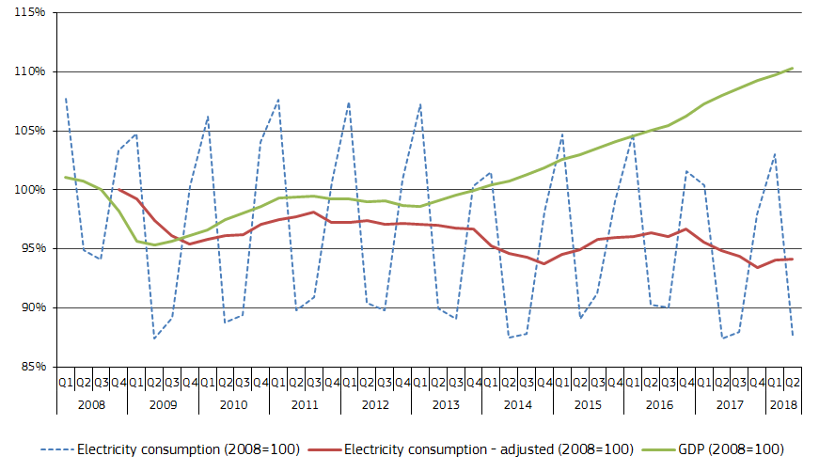

Figure 6 - Electricity consumption and economic growth

Source: Eurostat

On the supply side of the wholesale electricity market, it is the electricity generation mix, the marginal costs of the generation technologies and the electricity imports, as competing alternative that determine the overall generation costs and electricity prices. The next chart (**Figure 7**) shows the changes in the shares of the generation technologies in the EU electricity mix between 2008 and the first quarter of 2018. The share of fossil fuel generation (lignite, coal, gas and oil) decreased significantly (from 54% in 2008 to 37% in 2017 and to 34% in January-August 2018). At the same time the share of renewables (including wind, solar, hydro and biomass) increased from 17% to 33%. The share of nuclear remained practically constant, showing minor changes from one year to another.

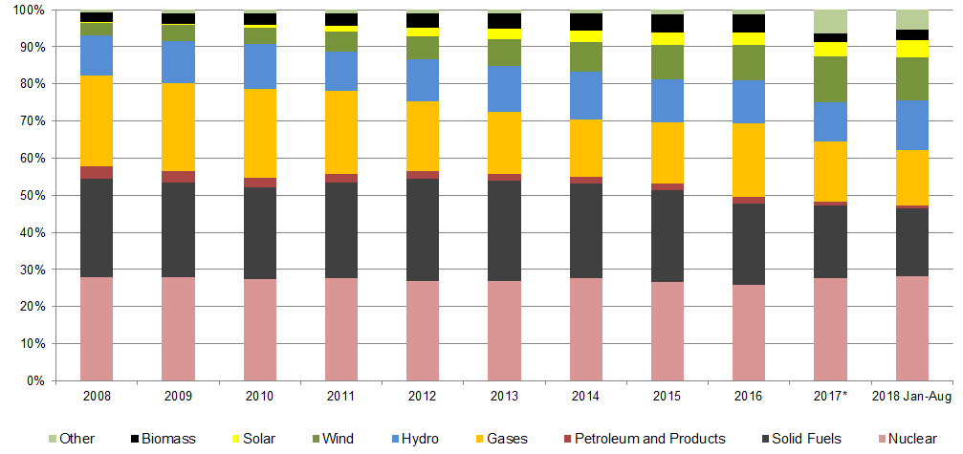

Figure 7 - Electricity generation mix in the EU-28 (actual power generation)

Source: Eurostat and ENTSO-E. *2017 and 2018 Jan-Aug data are not fully comparable with earlier periods, as a part of biomass generation seems to be reported under 'Other'

Within renewables, the share of hydro power remained constant over time (although the hydro share can vary on the short term depending on weather conditions, namely the amount of precipitation).

The increase in the share of renewables within the EU electricity generation mix was largely owing to wind power, whose share went up from 3.5% to 12% between 2008 and 2017 (in some periods, for example in December 2017 the share of wind was almost 17%).

The amount of generated electricity from the main sources and their share in the total generation can also be seen in **Figure 8**, Nuclear energy had an important but slightly decreasing share over the last two-three years in the EU. Its variability is small and mainly due to maintenance cycles. Both wind and solar power had an intra-annual seasonality in the EU over the last few years: while the share of solar increased during summertime, the share of wind generation was the highest in the stormy wintry period. In April 2018 the combined share of wind and solar was 19% in the EU electricity generation mix. Biomass had a relatively stable share over time. Hydro availability strongly depended on weather and the amount of precipitation. Both coal and gas had higher share in winter periods, however, coal, as baseload technology had a smaller seasonality than natural gas.

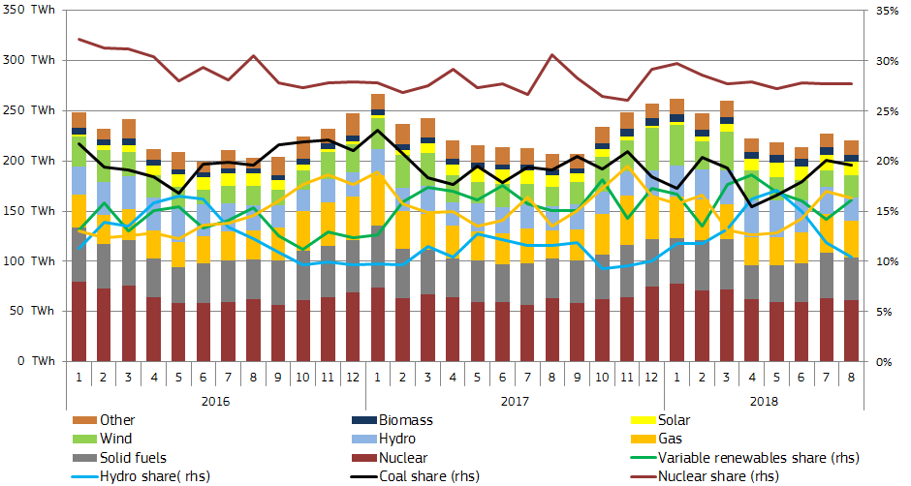

Figure 8 - Monthly electricity generation in the EU and the share of some generation sources in the EU electricity mix

Source: ENTSO-E

Besides the generation mix the marginal cost of each generation technology impacts the supply of electricity on the wholesale market. Generation technologies like wind, solar, hydro have very low or negligible marginal generation costs. Nuclear and biomass also have low marginal costs, whereas coal, gas and oil fired generation have higher marginal generation costs, so these latter normally set the marginal cost on the market; they are on the higher end of the electricity supply curve (the so-called merit order curve). Variable renewables (wind, solar) and other low marginal cost technologies can impact the total electricity supply by shifting the merit order curve towards the right (more generation at the same cost level) and thus result in lower equilibrium price assuming the same electricity demand curve.

**Figure 9** shows the monthly coal, gas and emission allowance (carbon) prices, compared to the average of 2008, and the share of renewable sources in the EU electricity generation mix. Both coal and gas prices, after reaching a peak in 2008, fell back amid of the economic crisis in 2009, and recovered in 2010-2011. After 2012 both coal and gas prices started to decrease and in the first half of 2016 they reached the lowest since the crisis year of 2009. In 2016-2018 they rebounded from these low levels. If looking at the evolution of wholesale electricity prices (see **Figure 1**) there is a high degree of correlation between fossil fuel prices and the wholesale electricity market. However, increasing share of renewables (between 2008 and 2018 the share of renewables practically doubled in the EU generation mix) had a downward impact on the wholesale market. A recent study estimates conducted by the EC (*Trinomics et altri, 2018*) that one percentage point increase in the share of renewables in Germany results in a decrease of the wholesale electricity price by 0.5 €/MWh.

Carbon prices showed a sharp decrease between 2008 and spring 2013, as they went down by 80% (in June 2008 the average carbon price peaked at 28 €/MtCO2e, while in April 2013 it was below 4 €/MtCO2e). Since then until mid-2017 they showed only minor variations, not being able to significantly impact competition between coal, gas and renewables, and not being effective in driving investments towards the decarbonisation of the European electricity sector. However, as market players anticipated that regulatory changes in the so-called Market Stability Reserve of the EU Emission Trading System might reduce the oversupply of allowances in the carbon market – a measure to enter into force as of January 2019 – the price of emission allowances doubled between mid-2017 and mid-2018, reaching 21 €/MtCO2e[5] by the end of August 2018, which was the highest since October 2008.

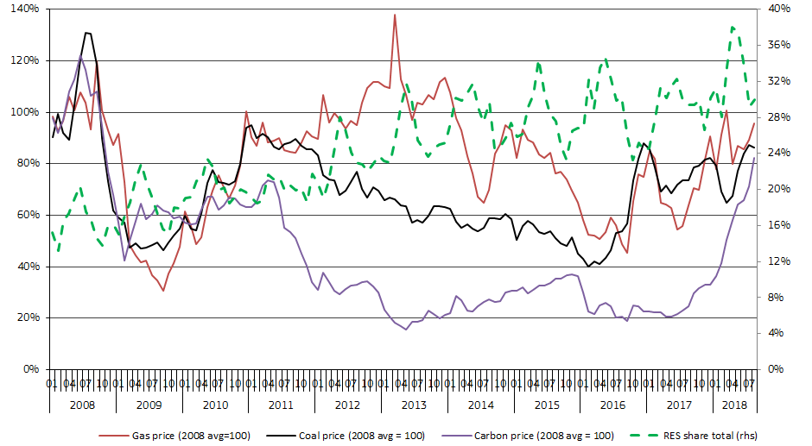

Figure 9 - Monthly coal, natural gas and carbon price indexes, compared to the 2008 average price and the share of renewable energy (right hand scale)

Source: ENTSO-E

National and EU level policies played a role on incentivising the increase of the share of variable renewable technologies. EU Member States have to fulfil their 2020 renewable objectives, for which different instruments, such as feed-in-tariffs, feed-in-premiums, renewable quota obligations, etc. have been implemented. Increasing renewable capacities and less reliance on fossil fuels, in parallel with moderate growth in demand for power, have led to overall overcapacities in many European electricity markets, resulting in a downward pressure on wholesale electricity prices.

Furthermore, as the integration of the European wholesale electricity markets moves forward, the importance of cross-border electricity trade increases and market-based instruments, such as the aforementioned coupling of neighbouring markets have been implemented, contributing to more efficient cross-border electricity trade, and generally better convergence of wholesale electricity prices. EU policies aim at achieving a better market integration through improving market liquidity, cross border trade and better integration of variable renewable generation sources to the power grid.

At EU level electricity imports do not have significant influence on wholesale market prices as extra-EU electricity imports are negligible compared to the bloc's total consumption. However, looking at individual power regions (see **Figure 10)** the situation is different, as some regions (e.g.: the Baltic states and Italy) might have significant import needs on the top of their domestic production to satisfy all consumption needs. Other regions, such as Central and Western Europe, the Nordic region or South Eastern Europe recently, produce more electricity than their domestic needs, therefore they are net exporter. As electricity normally flows from low priced areas to higher priced ones, net exporter regions have lower wholesale prices as net importers.

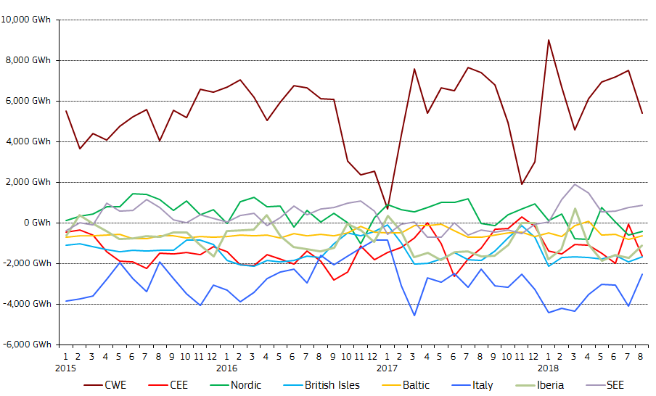

Figure 10 - Net electricity flow position compared to domestic electricity generation in the European power regions

Source: ENTSO-E

### International comparisons

Comparing the European electricity benchmark wholesale price index (EBP) with the wholesale prices in the most important trading partners of the EU can provide a useful analysis on how energy costs differentials can impact the competitiveness of European energy intensive industries with a high trade exposure. Electricity costs are only one factor of international competitiveness and other aspects (such as business environment, labour costs, etc.) are also important. A more detailed analysis of the impact of prices on competitiveness can be found in chapter 6.

**Figure 11** shows that, since 2008, wholesale electricity prices in the US have been for most of the time lower than in the EU, with the EU-US price ratio reaching the magnitude of 2 sometimes. In contrast, prices in Japan showed a huge increase after the Fukushima nuclear incident in March 2011, and as nuclear capacities were put offline, and the increasing reliance on gas fired generation resulted in Japanese prices being 3-4 times as the EU average between 2012 and 2014. Since 2016, as nuclear capacities were gradually put back in operation, the wholesale price gap between Japan and the EU decreased.

In China the wholesale electricity prices have been constantly higher by several magnitudes (2-3) than in the EU, implying that competitiveness problems of some energy intensive industries (e.g.: steel sector) vis-à-vis China do not actually stem from electricity prices.

**Figure 12** shows some further examples on wholesale prices of important EU trade partners. In Canada wholesale prices were one of the lowest over the last ten years among countries presented below. In Australia, based on competitive domestic coal fired generation, wholesale prices were also lower than in the EU (however in the summer period in 2017 there were some price spikes). In Russia wholesale electricity prices were also lower than in the EU.

On the other hand, prices in Mexico and Turkey, albeit following a decreasing trend, were higher than the European benchmark. Prices in Indonesia were comparable with the EPB between 2009 and 2013, however, the price gap with Europe has widened since and at the end of 2017 local wholesale electricity prices were twice as high as in Europe. Among all analysed countries wholesale electricity prices were the highest in Brazil.



Figure 11 - Comparison of wholesale electricity prices in the EU with global trade partners

Source: Trinomics et atri study (2018)



Figure 12 - Comparison of wholesale electricity prices in the EU with global trade partners

Source: Trinomics et altri study (2018)

## Retail Electricity Prices

**Main findings**

The last two years brought major departures from decade long trends in the evolution, composition and drivers of electricity prices:

* The EU household price decreased for the first time. This means that from 2016 to 2017 prices fell for all consumer analysed types.
* The decade long trend of taxes and network charges driving household prices up also came to an end. Taxes kept increasing for all industrial consumer types, albeit these increases were smaller than the decreases in energy components, leading to falling prices.
* Progress towards the completion of the single energy market continued. This is reflected by the fact that national energy components are gradually converging: they became 15% less spread out since 2008. For industrial consumers even total prices converged by 8%, as such prices are less impacted by varying national taxation.[6]
* The energy component, which consists mostly of wholesale prices, remained on a steadily decreasing trajectory due to EU policies, such as market coupling and increased interconnection capacities. The energy component diminished both in absolute and relative terms. In other words the only part of the price which is set by market forces is contracting while the share of the regulated part is growing, reaching 40% EU- wide.
* Wholesale prices have been increasing since the spring of 2016. This development has not yet factored in to the energy component of retail prices. Similarly, decreasing wholesale prices in the period 2012 to 2016 were not fully passed on to retail prices.
* Electricity prices remained heavily impacted by policy support costs and fiscal instruments, albeit to a varying degree across Member States.
* The cost of supporting renewable energy also started to fall for households after a decade of steep increases. This is remarkable as the share of renewables in the EU's generation mix kept growing. RES support costs decreased in the last reporting year by 1% for households, but increased by 7% for medium industrial and by 17% for large industrial consumers. RES levies ranged from 1 to 73 EUR/MWh across reporting countries.
* Excise duty rates range from 5 to 122 EUR/MWh, while VAT rates spread from 6% to 27% displaying a highly differentiated picture of energy taxation across the EU.
* The EU household electricity price grew annually by 2.1% since 2008 and reached 195[7] EUR/MWh in 2017. The EU medium industrial electricity price grew at the annual rate of 1% and averaged at 103 EUR/MWh in 2017. The EU price for large industrial consumers even experienced a decrease of 0.3% annually and reached 80 EUR/MWh by 2017, down from 83 EUR/MWh in 2008.

**Methodological framework**

Table 1 - Key figures on the evolution and drivers of retail electricity prices

|  |  |  |  |  |  |  |  |  |  |
| --- | --- | --- | --- | --- | --- | --- | --- | --- | --- |
| Consumer type | Household (DC) | | | Industrial (ID) | | | Large Industrial (IF) | | |
| Component | Annual growth | Share 2017 | ∆ Share | Annual growth | Share 2017 | ∆ Share | Annual growth | Share 2017 | ∆ Share |
| Energy | -1.5% | 33% | - 12 p.p. | - 4.7 % | 40% | - 28 p.p. | - 4.8% | 49% | -25 p.p. |
| Network | +2.5% | 27% | + 1 p.p. | + 3.5% | 22% | + 5 p.p. | + 2.7% | 17% | + 4 p.p. |
| Taxes | + 6.1% | 40% | + 11 p.p. | +12.3% | 38% | + 23 p.p. | + 11% | 34% | +21 p.p. |
| Total | 2.10% |  |  | + 1% |  |  | - 0.3% |  |  |

Source: DG ENER in-house data collection

**Aim and scope of the chapter**

The following chapter analyses retail electricity prices. It takes an in- depth look at the evolution, composition and drivers of prices paid by final consumers on EU as well as on national level in 30 European countries from 2008 to 2017.

The analysis serves as an objective, evidence based tool to determine how the composition of retail prices changed over time, how did various policies and fiscal instruments impact prices and which elements contribute the most to increasing or decreasing prices. The data collection designed and conducted specifically for the purpose of this report, introduces a high level of harmonization and transparency. This allows for the comparison of price developments over time and across countries.

**A Decade of Data**

The chapter is based on an in-house data collection by the Directorate General for Energy of the European Commission (DG Energy). Data for this in-house survey was provided by the competent authority of each reporting country, in most cases the statistical office, ministry or regulator representing the country in the European Statistical System. Data was provided by 26 EU Member States and 3 non-member countries, Montenegro, Norway and Turkey.

Greece and the United Kingdom provided no data. Figures for these countries are substituted by Commission estimates.

**Structure along Eurostat legislation**

The chapter is structured along different consumer types of the two energy products. Consumer types are defined by Eurostat methodology under Regulation (EU) 2016/1952 of the European Parliament and of the Council of 26 October 2016 on European statistics on natural gas and electricity prices. It differentiates household and industrial consumers[8], whereas both consumer types are further broken down into consumption bands. Consumption bands cover different volume ranges of annual consumption. Different bands are applied to electricity and natural gas.

The chapter commences by examining the most representative household electricity price on EU level and in each reporting country. Next, the chapter looks at electricity prices paid by industrial consumers. It differentiates between 3 levels of industrial consumption in order to provide the best possible picture of a diverse group of consumers, ranging from small businesses to manufacturing industries consuming large amounts of energy. The chapter first examines prices paid by industrial consumers with a median volume of consumption. This consumer band is often used to describe economy- wide industrial price developments. The analysis is completed by a comparison of prices paid by consumers of small versus large volumes of electricity.

General observations that hold for all bands are presented only under the section of household prices and are not repeated in each section.

**Harmonized methodology for comparable results**

Total prices provide no information on the drivers of price developments. To facilitate a more focussed identification of price increase drivers, total prices are further decomposed into three main components. The components Energy, Network and Taxes disaggregate the total price along the value chain. DG Energy further disaggregates taxes into 10 sub-components. These were designed to showcase national characteristics based on harmonized sub-components to the fullest extent possible, while minimizing the number of elements designated as "other". The same components and sub-components are applied to both electricity and natural gas.

DG Energy provided extensive guidance to the reporting national authorities to ensure that elements are assigned to components and sub-components in a harmonized manner across all countries.

All EU figures are weighted averages of EU Member States only. It is to be noted that the number of countries included in each EU average changes according to energy product and consumption band. For example, there are no consumers in the largest electricity bands.

**Data cooperation**

DG Energy would like to thank for the cooperation of national authorities from 29 countries who provided essential data for the retail prices sections of the report:

|  |  |  |
| --- | --- | --- |
| **Country** | **Organization** | **Expert** |
| Austria | E- Control | Esther Steiner |
| Belgium | Belgian Ministry of Economic Affairs | Marc Vos |
| Bulgaria | National Statistical Institute of Bulgaria | Iveta Minkova |
| Ivanka Tzvetkova |
| Cyprus | Electricity Authority of Cyprus | Marios Skordellis |
| Czech Rep. | Czech Statistical Office |  |
| Germany | BDEW Bundesverband der Energie- und Wasserwirtschaft e.V. | Christian Bantle |
| Denmark | Danish Energy Agency | Ali A. Zarnaghi |
| Estonia | Statistics Estonia |  |
| Spain | Ministerio para la Transición Ecológica |  |
| Finland | Statistics Finland | Marianne Rautelin |
| France | Ministère de la Transition écologique et solidaire | Pascal Levy |
| Croatia | Croatian Bureau of Statistics | Mirjana Petanjek |
| Željka O. Kelebuh |
| Hungary | Hungarian Energy and Public Utility Regulatory Authority |  |
| Ireland | Sustainable Energy Authority of Ireland | Mary Holland  Martin Howley |
| Italy | Italian Regulatory Authority for Energy, Networks and Environment | Gabriella Antonel |
| Lithuania | Statistics Lithuania | Virginija Jasionienė |
| Luxembourg | Institut national de la statistique et des études économiques du Grand-Duché de Luxembourg | Olivier Thunus |
| Latvia | Central Statistical Bureau of Latvia | Anna Paturska |
| Malta | National Statistics Office of Malta | Ronald Tanti |
| Netherlands | Statistics Netherlands | Eva Witteman |
| Poland | Polish Energy Market Agency | Krzysztof Dziedzina |
| Portugal | Direccao Geral de Energia e Geologia | Elisa Oliveira |
| Romania | Romanian National Institute of Statistics | Michaela Chirculescu |
| Sweden | Statistics Sweden | Viktor Ahlberg |
| Slovenia | Statistical Office of the Republic of Slovenia | Marko Pavlič |
| Slovakia | Statistical Office of the Slovak Republic |  |
| Norway | Statistics Norway | Thomas Aanensen |
| Montenegro | Statistical Office of Montenegro | Suzana Gojcaj |
| Turkey | Turkish Statistical Institute | Mehmet Gedik |

### Household Electricity Prices

The following section analyses prices paid by household electricity consumers. It examines weighted EU averages and the most representative band in each country. "Most representative" is defined as the consumption band accounting for the largest share in total household consumption, in other words the price for which the most electricity was sold. It is irrespective of the number of consumers in the band. Due to data availability restrictions, weighted EU averages are built uniformly from the consumption band defined by Eurostat terminology as DC, covering annual consumption of 2500 to 5000 kWh. For 2017 a "Most representative" weighted average is also presented.

**Evolution of household electricity prices**

Total prices grew at 2% annual rate from 2008 to 2017. In absolute terms the EU price grew from 166 to 200 EUR/MWh in the same period. When considering the most representative band in each country, instead of uniformly considering the consumption band DC, the EU average falls slightly lower, at 196 EUR/MWh. Prices grew faster than inflation, which averaged at 1.2% annually during the same period.

In 2017 the EU price fell for the first time by 3%. This is a significant departure from almost a decade of continuous increases. The decreasing EU average is however to be interpreted with caution. From 2016 to 2017 prices of the most representative bands actually increased in 13 reporting countries. Prior to 2016 the direction of developments on EU level, were mostly the same as the direction of developments in the majority of reporting countries. Since 2016, we can observe more divergent developments.

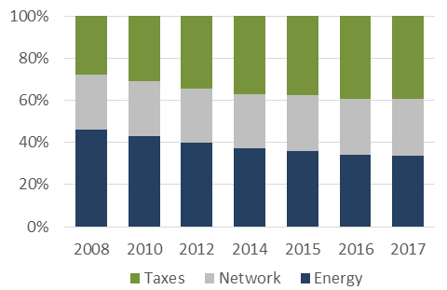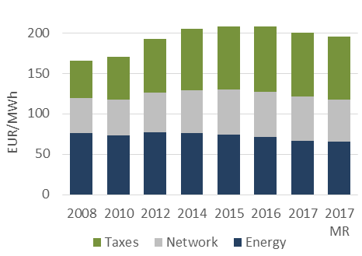

Figure 13 - Evolution and composition of the EU household price (DC). MR = Most representative

Source: DG ENER in-house data collection

**Composition of household electricity prices**

Over time the composition of prices changed significantly. The share of the energy component in the total price decreased by 13 percentage points from 46% to 33% in 2017. In the beginning of the observation period, the energy component was the largest of the three components in all reporting countries.

In absolute terms, the energy component decreased on average at an annual rate of 1.5% and reached 67 EUR/MWh in 2017. The contraction of the energy component can be linked to EU energy policies: increased competition resulting from market coupling and the growth of power generation capacity with low operating costs, such as wind and solar power, in addition to existing nuclear and hydro power. On national level 11 Member States reported actually higher energy components in 2017 than in 2016. In these countries wholesale prices either increased or their fall has not translated into a reduction of the energy component. Such results may imply that price competition in a number of retail markets is weak, allowing suppliers to avoid passing on wholesale price reductions to final consumers.

The share of the network component remained almost constant at about quarter of the price from 2008 to 2017. In absolute terms the network component grew at the annual rate of 2.5% and reached 54 EUR/MWh in 2017.

The share of the taxes component grew by 12 percentage points. It accounted for 28% of the weighted average EU price in 2008 and for 40% in 2017, meaning that it was the largest of the three components. In absolute terms, taxes grew at the annual rate of 6% and reached almost 80 EUR/MWh in 2017. The section "Composition of taxes, levies, fees and charges" analyses in detail which specific policies and fiscal instruments were driving this increase.

Box – Definition of most representative band

Household electricity consumption is broken down into 5 bands. The most representative band is defined as the one of these five bands with the highest share in total consumption. In other words, the price for which the most electricity was sold.

The 2016 edition of the Energy Prices and Costs series as well as all regular Eurostat press releases uniformly analyse consumption band DC for each country. In many of our reporting countries however only a smaller portion of consumption falls into DC. Household consumption varies highly across countries. It is determined by several factors including household size, climatic conditions (availability of sunlight and consequent lighting needs, heating and cooling needs), GDP (number and size of electric appliances on one hand and the efficiency of these appliance son the other hand), and prevalence of electrification in the transport and heating sectors. In northern countries consumption is typically above DC while in southern countries typically below.

To analyse prices that are truly representative, DG Energy introduced the possibility of reporting the price of the most representative band in each country. This feature of the in-house data collection serves the purpose of better catering to needs of Member States. One third of the countries made use of this possibility. It is important to note that if a country did not provide data for the most representative band, it was automatically assumed that DC is such. Typical consumption falls in the following ranges in the reporting countries.

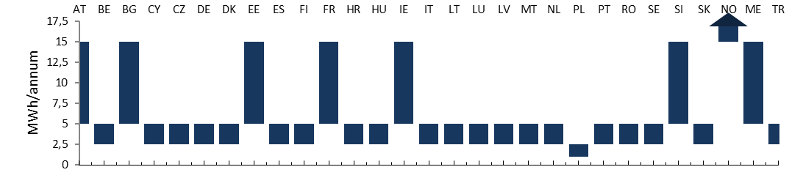Source: DG ENER in-house data collection

**Drivers of Household Electricity Prices**

2017 brought a significant departure from the decade long trend of increasing prices: the EU household electricity price fell for the first time. Between 2008 and 2016 the price was steadily increasing, driven by the combined impact of network charges and taxes – both components steadily growing until 2016. At the same time, smaller decreases in the initially large energy component slightly moderated the growth of the total price. Since 2017 both network charges and taxes have been decreasing on average, in addition to the energy component that has been contracting throughout the whole period. Decreases in all three components led to an overall price reduction.

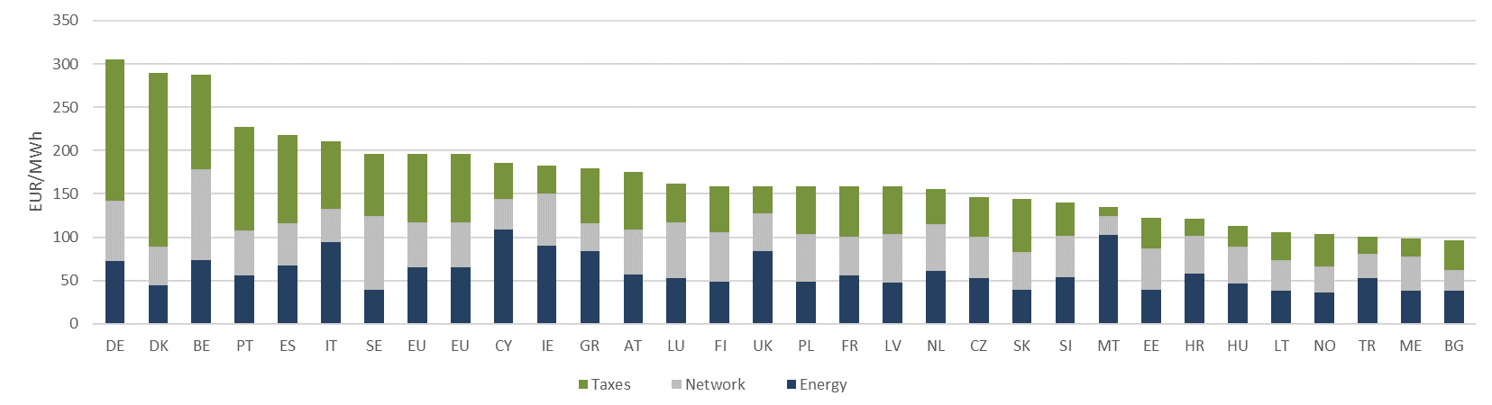

Figure 14 - Household rices in 2017 (most rep.)

Source: DG ENER in-house data collection

In 2017 Germany reported the highest price of 305 EUR/MWh, overtaking Denmark with a price of 289 EUR/MWh. Denmark reported the highest price from 2008 to 2017. Bulgaria reported the lowest price of 97 EUR/MWh among all EU and non- EU countries. The ratio of the largest to smallest price across the EU decreased by 4% over the last decade, indicating progress towards the completion of the internal energy market. In 2017 the largest price was 3.1 times of the smallest.

Denmark and Germany reported the highest tax components of almost 200 and 166 EUR/MWh respectively. In Germany this tax component consists of a number of elements. Support to renewable energy is the largest of those elements (45%), followed by excise duties and concession fees (each 13%). In Denmark the tax component consists mostly of excise duty (61%) and to a much lesser extent of support to renewable energy (10%). The three countries (BE, DE, DK) that reported the largest total prices also reported the highest tax components, indicating a strong correlation between overall price levels and taxation.

Belgium reported the largest network component of 105 EUR/MWh which is double that of the EU average (52 EUR/MWh), followed by Sweden with a network component of 85 EUR/MWh.

The largest energy components were reported by the islands of Cyprus and Malta. Relatively high energy components result from the characteristics of non- interconnected island systems: limited economies of scale, higher proportion of costs to ensure security of supply and the lack of gas and electricity interconnections. Limited land availability and resulting expensive land occupation fees might also contribute to higher energy components.

Italy and Ireland reported the highest energy components among interconnected countries. In Italy, it results mostly from the prominent and increasing role of natural gas in the country's generation mix. There is no nuclear generation in Italy and coal plays a very limited role. Production from renewable sources decreased by 3.3% in 2016, mostly due to a significant drop in hydroelectric production, resulting from reduced availability of water resources. As hydro generation decreased by 3.3 TWh and gas fired generation grew by 7 TWh, the latter's share increased to almost half (47%) of the country's gross electricity production. At the same time, wholesale prices of gas also returned to growth. These developments are reflected in the energy component.

In Ireland, much like in the case of isolated island systems, the lack of interconnections is contributing to a higher energy component. The level of interconnection in Ireland is relatively low, at below 5% of all installed capacity or at 6.6% of dispatchable generation. The share of natural gas is also a contributing factor in Ireland: at 50% the highest in Europe. Natural gas is mostly the price setting, marginal plant of the merit order and as such, relatively expensive.

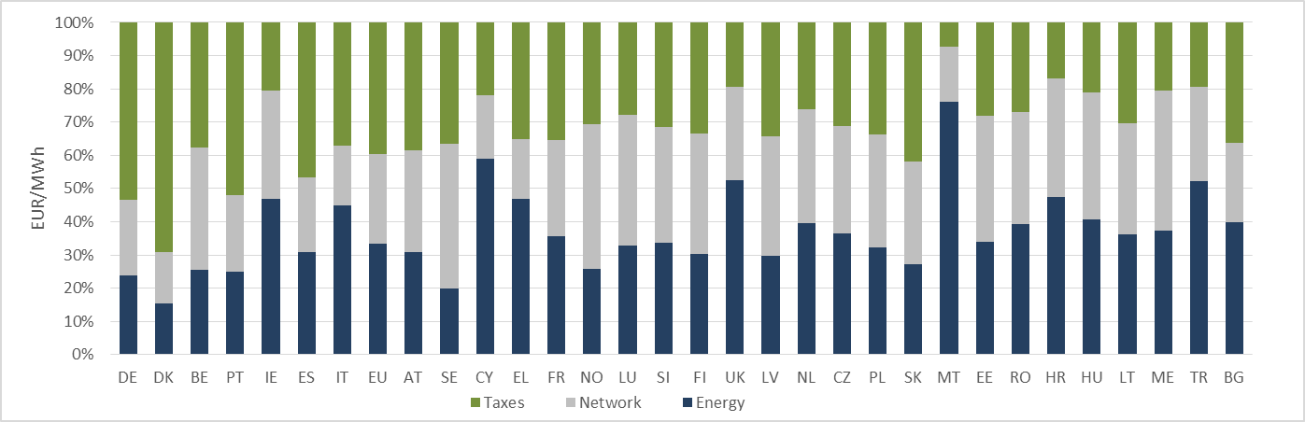

Figure 15 - Composition of hosehold prices in 2017 (most rep.)

Source: DG ENER in-house data collection

**Box – European Commission efforts to increase interconnection capacities**

As we saw above, interconnections – or more precisely the lack thereof – is a key contributing factor to high energy components. The socioeconomic value of electricity interconnectors comes from their ability of reducing costs by increasing the efficiency of the electricity systems and in parallel improving security of supply and facilitating the cost effective integration of the growing share of renewables.

The framework for the trans-European energy networks (TEN-E) and the Projects of Common Interest (PCIs) are the main tools of the EU energy policy to increase the physical electricity exchange capacity between Member States. The PCIs aim particularly to better connect the peripheral regions such as for example the Iberian Peninsula with the rest of Europe or to integrate rapidly growing share of renewables from remote generation areas such as the Northern Seas. On the current third Union list, there are 110 PCIs in electricity, which benefit from a streamlined permit granting procedures, improved regulatory conditions and under certain conditions are eligible for funding through the Connecting Europe Facility.

In addition, the 10% electricity interconnection target by 2020 has provided political momentum to advance key cross-border projects. As a result, seventeen Member States have already reached the target and seven more are on the path to reaching the target by 2020 through the completion of PCIs currently under construction.

In November 2017, the Commission proposed to operationalise the 15% interconnection target by 2030 through a set of additional and more specific thresholds which serve as indicators of the urgency of the action needed. The new thresholds reflect the three headline goals of European energy policy: increasing competitiveness through market integration and better prices, guaranteeing security of supply and achieving the climate targets through increased use of renewable sources. In total, approximately 22 electricity infrastructure PCIs have been completed or will be in operation by the end of 2018. Another 31 important projects are scheduled to be completed around 2020.

**Composition of taxes, levies, fees and charges**

In order to better understand how specific policies and fiscal instruments impact taxation levels- which in turn impact total prices- taxes and levies are broken down into 10 sub-components. These sub-components were designed to showcase national characteristics to the fullest extent possible, while minimizing the number of elements designated as "other". DG Energy provided extensive guidance to reporting authorities to ensure that the wide range of tax elements that exist across the countries are assigned to sub-components in a harmonized manner.

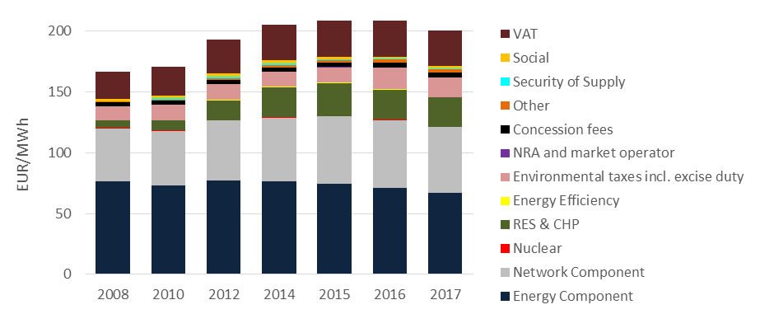It is important to note that we consider only policy support costs that directly impact retail prices. Also, not every tax sub-component exists in each Member State. The following graph displays EU averages.

Figure 16 - Breakdown of household prices (DC)

Source: DG ENER in-house data collection

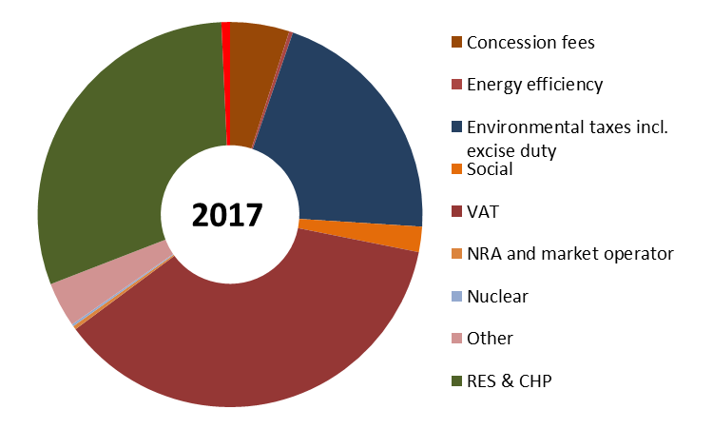

Figure 17 - Composition of taxes in 2017 (Most rep.)

Source: DG ENER in-house data collection

**Value Added Tax**

VAT is imposed on household electricity prices in all reporting countries. The EU VAT Directive explicitly allows Member States to apply reduced rates to electricity. As a result, VAT rates range from 6% in the United Kingdom to 27% in Hungary. As the largest sub-component, VAT accounted for 37% of the tax component and 17% of the total price. VAT is an ad valorem tax, its absolute value is based on the value of all other elements in the price. Even if VAT rates remain unchanged but other elements increase, the absolute amount of VAT increases. The average amount of VAT paid by households across the EU was 29 EUR/MWh in 2017, an increase of 31% since 2008.

**Environmental taxes incl. excise duty (Non- Earmarked Taxes)**

The sub-component includes any manifestation of excise duty, environmental, greenhouse gas emission, transmission and distribution taxes. Their common characteristic is that normally revenues from these taxes are not earmarked to energy, climate or environment related policies. In other words, revenues flow into the central state budget regardless of the name of the tax. Minimum excise duty levels on energy products are harmonised on the EU level and are defined by the Council Directive 2003/96/EC22. The sub-component excludes VAT.

Non- earmarked taxes grew from 11 to 16 EUR/MWh by 2017. They made up 21% of the taxes component and 8% of the total price, representing the third largest sub-component after VAT and RES&CHP. This reflects an annual growth rate of 1%, significantly lower than for industrial consumers.

**Renewable Energy and Combined Heat and Power**

This sub-component includes any support to renewable energy (RES) and combined heat and power generation (CHP). Explicit RES & CHP support costs are presented for 25 EU Member States and Montenegro. In Finland and Malta the renewable energy support scheme is not financed through an explicit levy on consumer bills but from the central state budget. France has been following the same example since 2016.In Hungary household electricity consumers, unlike their industrial counterparts, are exempted from the RES levy (a value of 0 is reported). Therefore in these 4 countries the direct cost to households is zero. It is important to note that consumers still pay for the support of renewable energy, albeit in an implicit way. Data for the United Kingdom is estimated and includes support to energy efficiency. In several countries renewable energy is supported also from sources additional to taxes on consumer bills.

The average EU household paid 24 EUR/MWh for RES&CHP support in 2017. This figure equals 30% of the taxes component and 12% of the total EU price. The sub-component experienced a fast increase from 2008 to 2015 as it grew annually by 15%. An important departure from this trend is to be observed in 2016 when the cost of RES&CHP support on EU level started to fall. A 2% decrease is remarkable especially as the share of renewable energy in the EU's energy mix grew by 16% from 2015 to 2016. These developments mean not only that the average EU household pays less but also that the lower cost enables more renewable energy.

Box - The French energy taxation and support to RES

France recently overhauled its energy taxation. Until 31 December 2015 a Public Service Obligation was levied on electricity (CSPE) and natural gas (CSPG) bills. The PSO consisted of three main elements: support to renewable energy, support to vulnerable consumers and national tariff equalization[9]. All three PSO elements are accounted for separately in our report and the latter two are classified as social levies. The RES support levy ranged from 2 EUR/MWh for large industrial consumers to 11 EUR/MWh for households.[10] The RES element of the PSO on natural gas bills specifically supported bio-methane. At the same time, a separate consumption tax was applied to both electricity (TICFE) and gas (TICGN). Rates of this tax on electricity rates ranged from 1.5 EUR/MWh for large industrial consumers to 12 EUR/MWh for households.[11]

From 1 January 2016 the explicit RES levy, as well as both other PSO elements were discontinued. Vulnerable consumers and national tariff equalization are financed through the general budget. The dedicated budget line "Public service of energy" also includes smaller elements of the discontinued PSO such as, support to combined heat and power and CDC (Caisse des dépôts et consignation, the French National Promotional Bank) management fees. Until 2017 RES was supported through a transitory system.

In 2017 the electricity consumption tax (TICFE) increased to 9 EUR/MWh for large industrial consumers and to 31[12] EUR/MWh for households. The natural gas consumption tax increased to about 5 EUR/MWh for households and median industrial consumers, while large industrial consumers remained exempted. Revenues from these taxes feed into the general budget and do not support any specific policies.

From 2017 onwards, renewable energy is supported through the revenues of two fossil fuel taxes. TICPE, which is applied to the end use of petroleum products and TICC, which is applied to coal consumption, including coal used to generate electricity. Consequently, the financing of renewable energy is no longer directly connected to electricity or natural gas bills. This is reflected in our data: From 2017 onwards the RES sub-component is zero.

**CSPE: Contribution au service public de l'électricité. Discontinued PSO.**

**CSPG: Contribution au service public du gaz. Discontinued PSO.**

**TICFE: Taxe intérieure sur la consommation finale d’électricité. Current consumption tax on electricity.**

**TICGN: Taxe intérieure sur la consommation de gaz naturel. Current consumption tax on gas.**

**TICPE: Taxe Intérieure sur les Produits Énergétiques. Fossil fuel tax on petroleum products.**

**TICC: Taxe Intérieure sur la Consommation de Charbon. Fossil fuel tax on coal.**

**Social Charges**

Social charges include support to vulnerable consumers, social tariffs, last resort supplier, national tariff equalization, pension funds and support to sectorial employment policies. They were the second most important energy policy relevant charges across the EU in terms of the cost to consumers as well as in terms of the number of countries applying them[13]. Still, the impact of social charges remained limited. They made up 3% of the taxes component and 0.8% of the total price. They grew at the annual rate of 3% and reached 2.15 EUR/MWh in 2017. More telling is the number of countries that applied explicit social charges: it grew from 6 in 2008 to 9 in 2017. In Bulgaria and Portugal in certain years between 2015 and 2017 the sub-component was negative as rebates were effective, which decreased total prices in these countries. The United Kingdom's Warm Home Discount is a redistributive levy. All households pay towards this levy via their gas and electricity bills. All the revenues collected are recycled back as £140 annual rebates on the electricity bills of eligible low-income and vulnerable households. As such, the net effect of the policy on average dual fuel (gas and electricity) bills is £0. The underlying report however reflects the gross cost, as the rebate applies only to smaller a subset of households.

**Security of Supply**

Security of supply related levies were imposed by 9 Member States in 2017, up from 6 in 2008. The impact of security of supply related charges remained limited, at below 1% of the EU price.

**Concession Fees**

Concession fees, in most cases for the occupation of public land, accounted for 2% of the EU price and 4% of the taxes component. Such fees, averaging at 3.7 EUR/MWh, were imposed by 5 Member States (AT, BE, DE, PL, PT) on household electricity prices. The presence of concession fees in the EU average is due to a higher fee of 20.5 EUR/MWh in Germany.

**Other energy policy relevant charges**

The explicit impact of other energy policy relevant charges remained limited. Cost elements imposed to support energy efficiency, the nuclear sector or the national regulatory agency, each made up less than 1% of the average EU price. Charges for the financing of the National Regulatory Agency or a market operator are levied in 6 Member States (BE, CZ, PT, SK, SI, ES). Nuclear sector levies are imposed by 4 Member States (BE, IT, SK, ES). The nuclear sub-component includes only levies that directly impact retail prices by supporting the sector. Taxes paid by generators of nuclear energy - imposed on the wholesale level - are therefore not considered. Support to energy efficiency measures is explicitly levied in 4 Member States (BE, IT, SI, UK[14]). The residual sub-component "other" includes a limited number of elements such as, deficit annuities in Spain, public television fee in Turkey or R&D in Denmark.

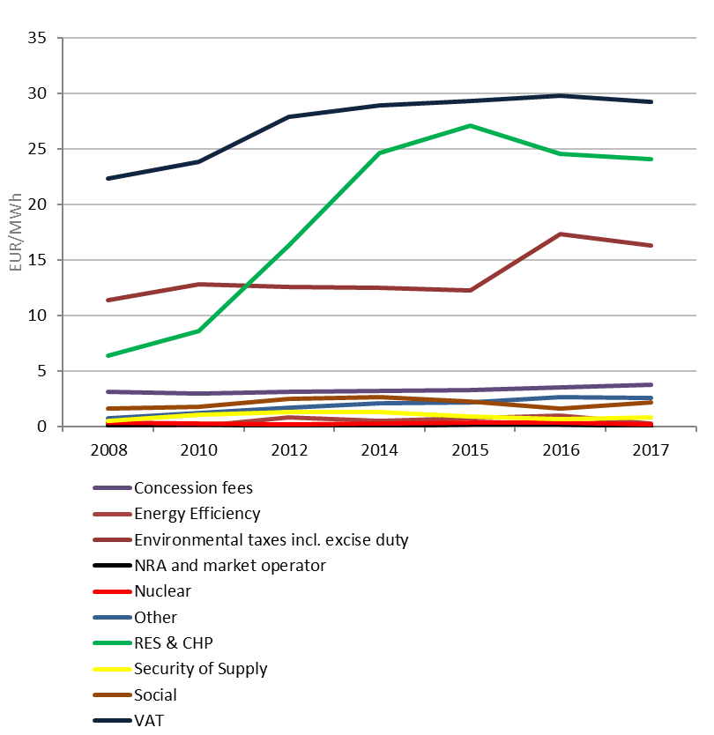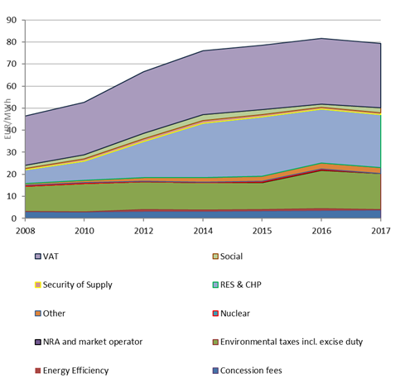

Figure 18 - Taxes, fees, levies and charges for EU households (DC)

Source: DG ENER in-house data collection

### Industrial Electricity Prices

The following section analyses prices paid by non- household electricity consumers on EU and national levels. It examines prices of the Eurostat band ID, covering annual consumption of 2000 to 20 000 MWh. This band is often considered as the best indicator of economy wide non- household prices. It can be considered industrial as far as it might include prices paid by other non-household sectors, such as services, agriculture, fisheries and transport.[15]

**Box - The role of households and industry in our energy consumption**

Households account for about 22% of our energy consumption[16]. This has not changed significantly over the last decade as the share of household consumption fluctuates close to this figure. Improvements in energy efficient appliances however slowly dampen these fluctuations that no longer reach as high as around 2010.

Industries accounted for 25% of the EU’s energy consumption in 2016, reflecting a 3 percentage point decrease since 2008, the beginning of the economic and financial crisis that dampened industrial production and thus energy consumption.

**Evolution of Industrial Electricity Prices**

Total prices grew at 1% annual rate from 2008 to 2017. In absolute terms the EU price grew from 94 to 103 EUR/MWh. This growth was slightly higher than inflation for industrial prices, which averaged at 0.5% annually during the same period.[17]

The evolution of the EU industrial (ID) price conceals two distinct periods. From 2008 to 2014 it steadily grew by 2% annually. Since 2015 it has been decreasing by 1% annually These EU figures are made up of relatively homogenous national developments, as ID prices grew only in one third of the reporting countries from 2016 to 2017.

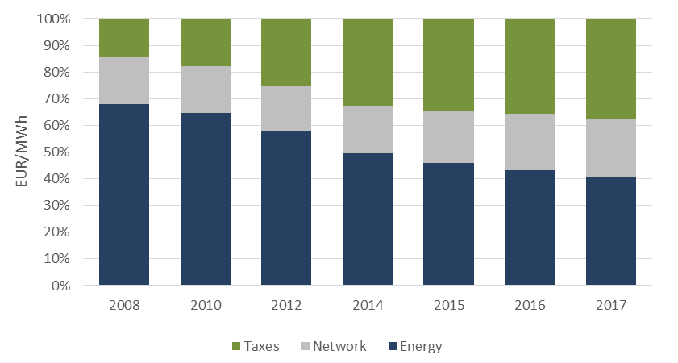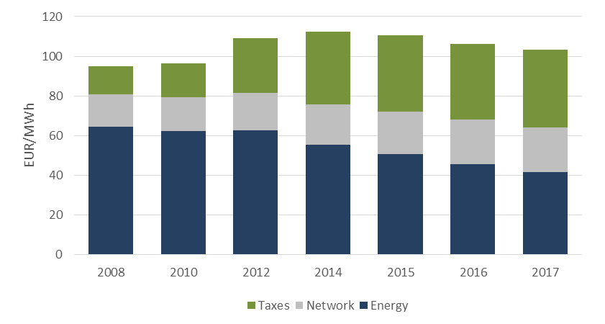

Figure 19 - Evolution and composition of the EU industrial price (ID)

Source: DG ENER in-house data collection

**Composition of Industrial Electricity Prices**

Over time, the composition of the EU industrial price changed even more significantly than the composition of the household price. The share of the energy component in the total price decreased by 28 percentage points from 68% to 40% in 2017. Still, unlike in the case of households, the energy component of industrial electricity prices remained the largest of the three components by a small margin. Its share in the total price was 2 p.p. higher than the share of taxes. In absolute terms, the energy component decreased at the annual rate of 5% and reached 41 EUR/MWh in 2017. The contraction of the energy component reflects falling wholesale prices which make up most of the component and can be linked to EU energy policies: increased competition resulting from market coupling and the growth of power generation capacity with low operating costs (such as wind and solar power, in addition to existing nuclear and hydro power). On country level, 9 countries reported actually higher energy components in 2017 than in 2016. In these countries wholesale prices either increased or their fall has not translated into a reduction of the energy component. Such results may imply that price competition in a number of retail markets is weak, allowing suppliers to avoid passing on wholesale price reductions to final consumers.

The share of the network component increased by 5p.p. from 17% to 22% in 2017. In absolute terms the network component grew at the annual rate of 4% and reached 22 EUR/MWh.

The share of the taxes component grew by 23 percentage points, taking over most part of the falling share of the energy component. It accounted for 15% of the EU price in 2008 and for 38% in 2017. In absolute terms, taxes grew at the annual rate of 12% and reached 39 EUR/MWh in 2017.

In 2017 Germany reported the highest medium industrial price (142 EUR/MWh), followed by Italy (133 EUR/MWh) and Cyprus. Germany and Italy reported also the highest taxes across the EU, while in Cyprus a high energy component results in overall higher prices,[18] In Germany RES support costs made up 80% of all taxes while excise duties accounted for an additional 18%. The composition of Italian taxes is similar to those of Germany, with RES accounting for four-fifths of all taxes. Sweden reported the lowest price of 55 EUR/MWh among all EU and non- EU countries.

For medium industrial consumers, Latvia, Lithuania, Germany and Slovakia reported the highest network components (in descending order) ranging from 36 to 31 EUR/MWh. Belgium, where network charges for household consumers are double that of the EU average, reported the 6th smallest network component for industrial consumers (18 EUR/MWh).

The largest energy components were reported by the islands of Cyprus and Malta, followed by Ireland and the United Kingdom.

Figure 20 - Industrial (ID) electricity prices in 2017

Source: DG ENER in-house data collection

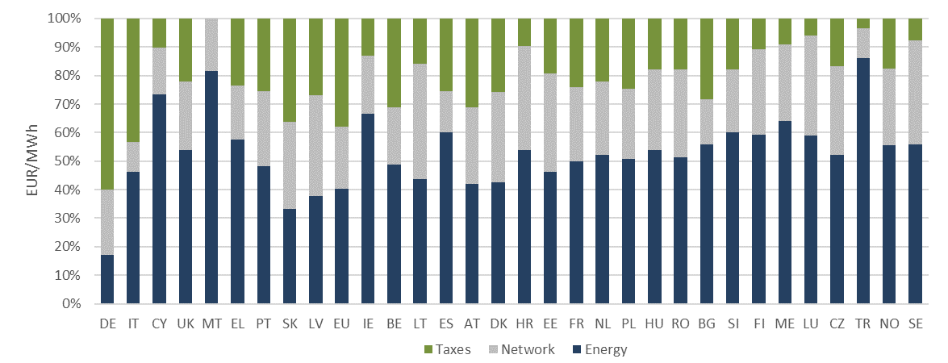

Figure 21 - Composition of industrial (ID) electricity prices in 2017

Source: DG ENER in-house data collection

The previous graphs present medium consumption figures in each country. Several countries grant tax reductions to energy intensive industries. As energy intensity is not based on consumption volume, but on the share of energy related costs in total production, this median band can include enterprises that benefit from such reduced tax rates.

**Drivers of Industrial Electricity Prices**

The EU industrial price grew continuously from 2008 to 2015. This increase was driven by the combined impact of network charges and taxes, as both components were steadily increasing. At the same time, smaller decreases in the initially large energy component moderated the growth of total prices. A departure from this trend is to be observed in 2015 when the total EU price fell for the first time. This can be attributed entirely to the accelerated reduction of the energy component as the other two components kept increasing. From 2016 to 2017 the average industrial price further decreased from 106 to 103 EUR/MWh.

It is to be underlined that EU averages conceal divergent national developments. Total prices increased in one third of the reporting countries from 2016 to 2017. The energy component actually increased in 9 countries. On the national level network charges increased in 14 countries and taxes grew in 16 of the 28 EU Member States[19].

**Composition of taxes, levies, fees and charges**

The following section considers only policy support costs that directly impact retail prices.

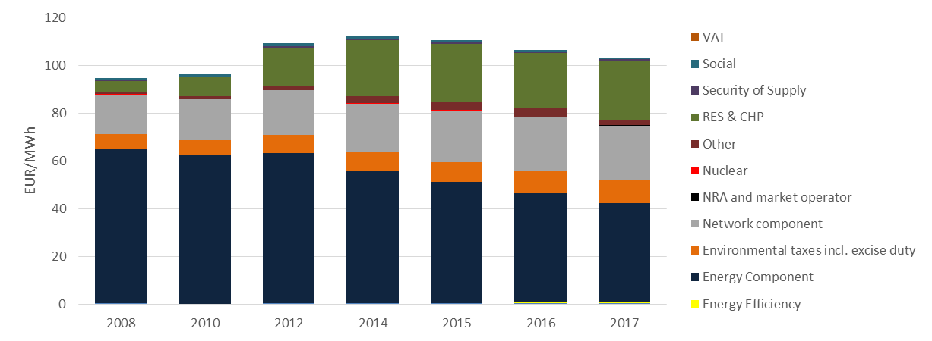

Figure 22 - Breakdown of EU prices in 2017 (ID)

Source: DG ENER in-house data collection

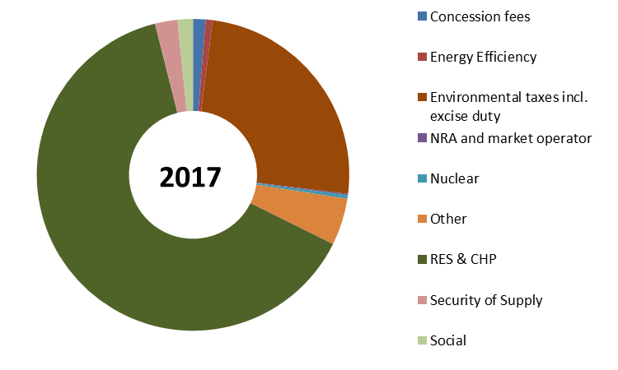

Figure 23 - Composition of taxes in 2017 (ID)

Source: DG ENER in-house data collection

**Value Added Tax**

VAT is recoverable for most industrial consumers in all reporting countries. Therefore this report analyses industrial prices excluding VAT. Other recoverable taxes are also excluded prom the price we report.

**Environmental Taxes incl. excise duty (non- earmarked taxes)**

Non- earmarked taxes grew from 6 EUR/MWh to 11 EUR/MWh in 2017. This reflects an annual growth rate of 3%, the third highest among the 10 different categories of taxes. Non- earmarked taxes made up 25% of the taxes component and 9% of the total price, representing the second largest sub-component after RES&CHP.

**Renewable energy and Combined Heat and Power**

This sub-component includes any support to renewable energy and combined heat and power generation. Explicit RES & CHP support costs are presented for 25 EU countries and Montenegro. In Finland and Malta the renewable energy support scheme is not financed from a levy on electricity consumption but from the central state budget. France has been following the same example since 2016. Therefore in these 3 countries the explicit cost of supporting renewable energy is zero for industrial consumers. It is important to note that consumers still pay for the support of renewable energy, albeit indirectly. In Hungary industrial consumers are subject to a RES levy while households are exempted. Data for the United Kingdom is estimated and includes support to energy efficiency. In several countries renewable energy is supported also from sources in addition to levies on electricity consumption.

RES & CHP accounted for 25 EUR/MWh in 2017 (up from 23.2 EUR/MWh in 201). This figure equals 64% of the taxes component and 24% of the total EU price. These relative shares are almost twice of the household figures. This is due to the fact that VAT, which accounts for a high share of household taxes, is recoverable for industrial consumers.

**Social charges**

Social charges include support to vulnerable consumers, social tariffs, last resort supplier, national tariff equalization, pension funds and support to sectorial employment policies. The impact of social charges on industrial prices diminished over time, as they decreased from 0.9 EUR/MWh to 0.6 EUR/MWH in 2017. They made up 2% of the taxes component and 0.6% of the total price (slightly less than for household consumers) in 2017.

**Security of supply**

Security of supply related levies were imposed by 10 countries in 2017, up from 6 in 2008. The impact of security of supply related charges remained limited, at below 1% of the EU price.

**Concession fees**

Concession fees for industrial consumers were much smaller than for their household counterparts. As a result, the impact of such fees remained insignificant (below half a percent of the total price).

**Other energy policy relevant charges**

The explicit impact of other energy policy relevant charges also remained limited. Cost elements imposed to support energy efficiency, the nuclear sector and national regulatory agency made up less than 1% of the average EU price. Charges for the financing of the National Regulatory Agency or a market operator are levied in 6 Member States (BE, ME, PT, SK, SI, ES). Nuclear sector levies are imposed by 4 Member States (BE, IT, SK, ES). The nuclear sub-component includes only levies that directly impact retail prices by supporting the sector. Taxes paid by generators of nuclear energy - imposed on the wholesale level - are therefore not included. Support to energy efficiency measures is explicitly levied in 4 Member States (BE, IT, SI, UK[20]). The residual sub-component "other" includes a limited number of elements such as, deficit annuities in Spain, public television fee in Turkey or R&D in Denmark.

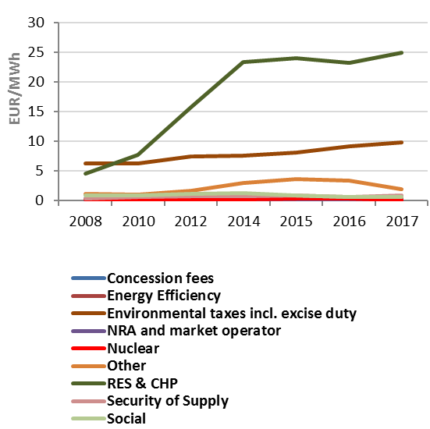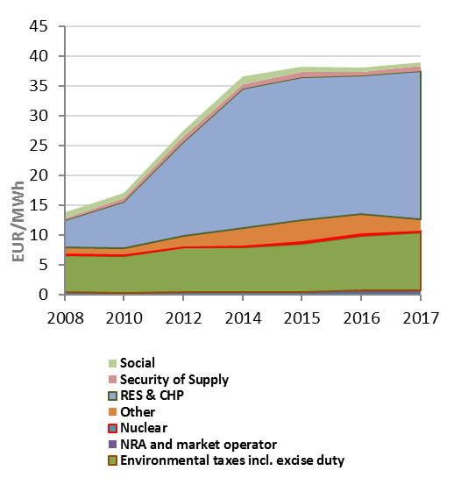

Figure 24 - Taxes, levies, fees and charges of industrial electricity prices

Source: DG ENER in-house data collection

### Small vs. Large Industrial Electricity Prices

The following section compares prices paid by two types of non- household consumers: consumers with small volume of annual consumption (20 to 500 MWh defined as band IB) and consumers with large volume of annual consumption (70 000 to 150 000 MWh defined as IF). Band IB typically includes small enterprises and services. Band IF includes large industrial consumers such as the chemicals, metals and construction materials industries. Band IF covers many energy intensive industries, however not all of them. Energy intensity is not defined based on consumption volume but on the relative importance of energy costs in total production costs. As a result, an enterprise that consumes small amount of electricity can still be energy intensive. The opposite holds as well. There are enterprises consuming large amounts of electricity that are not considered energy intensive. An example is the automobile industry. Band IF is therefore a mixed band that covers prices paid by energy intensive and non-energy intensive industries. This is reflected in our data: large consumers pay lower taxes due to partial exemptions from levies according to the Energy and Environment State Aid Guidelines (EEAG). These partial exemptions apply to some, not all IF consumers.

Data for IB was reported by 26 EU member States (except the United Kingdom and Greece), Montenegro, Norway and Turkey. Data for the UK and Greece was estimated by DG Energy. IF data was reported by 25 EU Member States and Turkey. Data for the UK and Greece was also estimated by DG Energy for this band. In Luxembourg IF data is confidential (there are less than three consumers in the band).

**Evolution of Small vs. Large Industrial Electricity Prices**

Total prices grew at annual rate of 1.8% for IB consumers. IF prices experienced a different evolution as they fell slowly, by 0.3% a year. In absolute terms the IB price grew from 121 to 143 EUR/MWh and the IF price fell from 83 to 80 EUR/MWh. Inflation averaged at annual 0.5% during the same period.[21] The above figures cover the period 2008 to 2017, by 2015 year-on-year prices were falling for both consumer types. The EU averages conceal relatively homogenous evolutions across the reporting countries as IB and IF prices increased in 9 and 11 countries respectively from 2016 to 2017.

In 2017 Germany reported the highest (192 EUR/MWh) IB price while Sweden reported the smallest (78 EUR/MWh) across the EU. Both Norway and Turkey reported prices lower than any EU Member State. Cyprus reported the highest price for large industrial consumers (117 EUR/MWh) followed by Germany (114 EUR/MWh) and the United Kingdom (113 EUR/MWh). Also Sweden reported the smallest price for IF (40 EUR/MWh). Over the last decade the ratio of the largest to smallest price evolved differently for the two consumer types. For IB consumers the ratio decreased by 13% and the largest price was 2.7 times of the smallest. For IF consumers the ratio increased by 18% to 4.7.

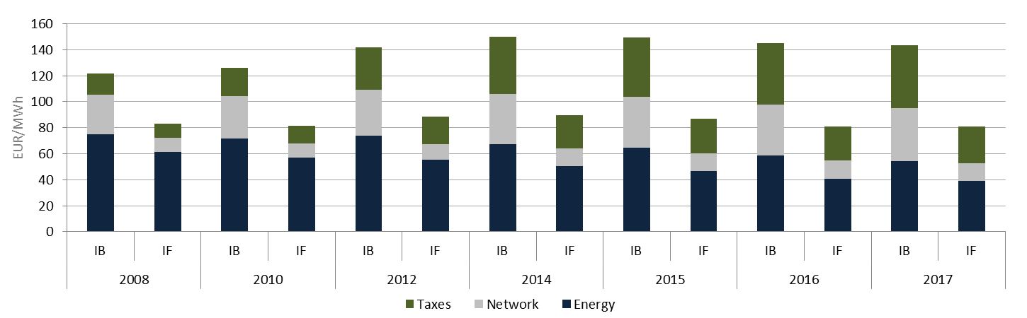

Figure 25 - Evolution of small (IB) and large (IF) industrial electricity prices

Source: DG ENER in-house data collection

**Composition of Small vs. Large Industrial Electricity Prices**

Albeit the two bands reflect prices for quite different consumer types, the composition of prices evolved in a notably similar fashion. For both consumer types the energy component lost about 25 p.p. of its share in the total price. Also for both consumer types taxes took over most of the decreasing share of the energy component, as they experienced around 20 p.p. increase. A smaller increase in the share of network charges accounted for the remaining changes.

Table 2 - Composition of small (IB) and large (IF) industrial prices

|  |  |  |  |  |  |  |
| --- | --- | --- | --- | --- | --- | --- |
|  | IB | | IF | | IB | IF |
|  | 2008 | 2017 | 2008 | 2017 | Change (p.p., 2008-2017) | |
| Energy | 62% | 38% | 74% | 49% | -24% | -25% |
| Network | 25% | 28% | 13% | 17% | 3% | 4% |
| Taxes | 13% | 34% | 13% | 34% | 20% | 21% |

Source: DG ENER in-house data collection

In absolute terms, the energy component decreased at an annual rate of 3.5-5% for the two consumer types. By 2017 it reached 54 and 39 EUR/MWh for IB and IF consumers respectively. The contraction of the energy component reflects falling wholesale prices, which make up most of the component

In absolute terms the network component grew at the annual rate of 2.7% (IB) and 3.3% (IF) for the two consumer types. For IB consumers the network component grew from 30 to 40 EUR/MWh from 208 to 2017. The IF network component grew from 10 to 13 EUR/MWh during the same period.

In 2008 taxes made up 34% of the total price for both consumer types. In absolute terms they grew from 16 to 48 EUR/MWh for IB consumers and from 10 to 27 EUR/MWh for IF consumers. Taxes grew 2 p.p. faster for large consumers (by 13% annually).

In 2017 the total IB price was 143 EUR/MWh, 62 EUR higher than the IF price. The reason for this difference lies in all three components. Some IF consumers are auto producers, who generate their own electricity or have over the counter, long term power purchase agreements which are reflected by lower energy components in our data (54 vs. 39 EUR/MWh). IF consumers are often connected directly to the high voltage transmission grid and therefore do not need to pay for using the distribution grid. This reduces the network component in our data set (40 vs. 13 EUR/MWh). Lastly, for IB consumers taxes at 48 EUR/MWh were 17 EUR higher than for IF consumers. The difference stems mostly from partial reductions in RES levies, according to the State Aid Guidelines and from reduced excise duty rates according to the Energy Tax Directive.

As all three components are proportionally smaller, taxes made up the exact same share of the total price for both consumers types: 34%. While relative shares for the two consumer types were equal, as we saw above, large consumers pay lower taxes. Reduced taxes reflect efforts to safeguard the competitiveness of EU industries. These reductions, which cannot exceed 85% of the applicable RES levy, qualify as aid compatible with the internal market. Reductions are partial, therefore no consumer is completely exempted. Qualifying industries are energy intensive, meaning that they face higher share of energy costs in their production (around 10% compared to 3% cross- industry average). Furthermore, due to the trade intensity of the goods they produce, they are exposed to competition with producers outside of the EU, who are not subject to comparable climate legislation. As a result of reductions in the applicable RES levies, not only the share of taxes in the total price is equal for the two consumer types, but also the subset of taxes supporting renewable energy. From 2008 to 2016 the share of RES support in the total price was equal in each year for IB and IF consumers. A difference appears only in 2017 when the RES levy for IB consumers was 20% of the total price, compared to 23% for IF consumers.

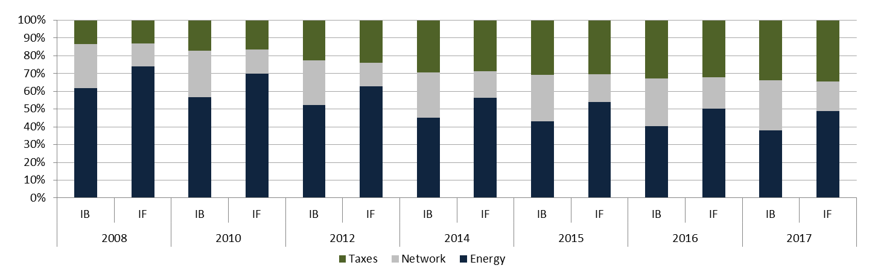

Figure 26 - Composition of small (IB) and large (IF) industrial electricity prices

Source: DG ENER in-house data collection

**Drivers of Small vs. Large Industrial Electricity Prices**

Both for small and large industrial consumers we observe the continuation of the trends of the last decade, with one exemption. The energy component continued to fall, taxes continued to increase. Both unbroken trends since 2008. The network component continued to slightly increase for IB consumers but fell for the first time for IF consumers from 2016 to 2017. This development represents the only new trend, however an important change lies in the speed of increases and decreases of the three components. We observe falling total prices for both consumer types since 2015, while the evolution of the three components mostly didn’t change direction. Falling total prices result from the fact that the energy component kept decreasing at the same speed (4-7% year-on-year) while the increase of network charges and taxes slowed down to around 2% compared to double digit growth rates in the early years of our observation period. Since 2015 the decrease of the energy component was no longer only mitigating increases of the two other components but overtook them, resulting in overall falling prices both for small and large industrial consumers.

These EU level figures conceal relatively homogenous developments on national level. For IF consumers total prices increased in 9 countries and the energy component increased in 10 countries from 2016 to 2017. For IF consumers both total prices and the energy component increased in 11 countries. The list of countries where total prices increased and where the energy component increased is not identical but notably similar. This indicates, as also noted above, that in most countries the evolution of the network and taxes components slowed down so much that the overall price evolution is now set by the energy component.

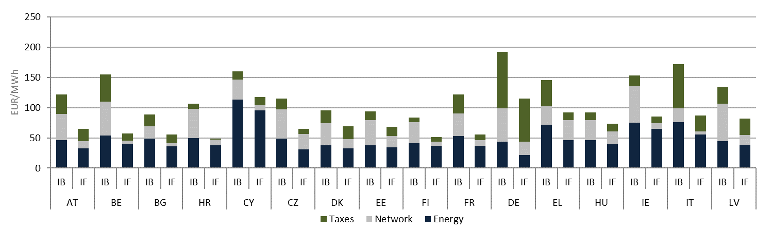

Figure 27- Composition of small (IB) and large (IF) industrial prices in 2017. First 16 countries alphabetically.

Source: DG ENER in-house data collection

In 2017 Germany reported the highest small industrial price of 192 EUR/MWh followed by Italy (172).

In Germany and Italy taxes are made up mostly of RES support (above 70% in both countries) and excise duty (17%), complemented with smaller elements, such as concession fees in Germany.

In 2017 Latvia, Ireland and Belgium reported the highest network components of 62, 59 and 56 EUR/MWh respectively for small industrial consumers (IB). While the lists of countries with highest level for taxation for small and large industrial consumers are very similar, we observe a difference in terms of network charges. For large industrial consumers the United Kingdom, the Czech Republic, Malta and Germany reported the highest network components in descending order. Belgium, where network charges for household consumers are double that of the EU average, reported the 3rd smallest network component in the EU for large industrial consumers.

The energy component was the highest in the same countries as in the case of household and medium industrial consumers. For further explanation, please consult the corresponding section of the chapter on household prices.

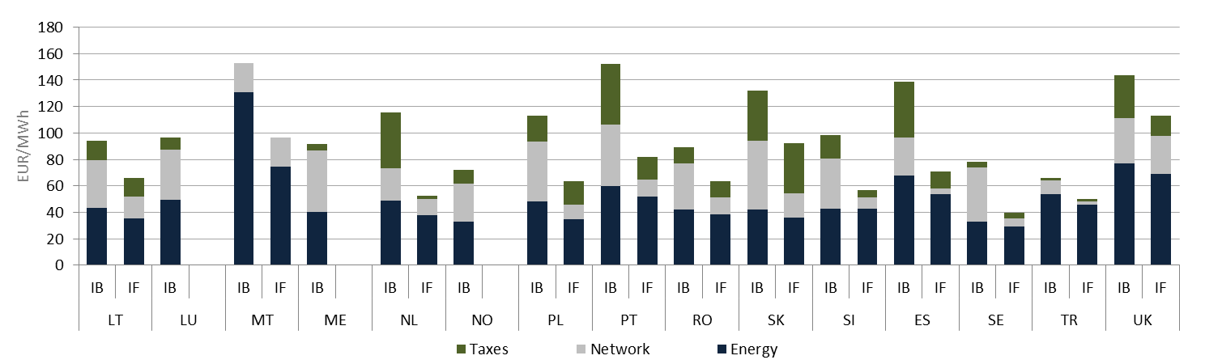

Figure 28 - Composition of small (IB) and large (IF) industrial prices in 2017. Last 15 countries alphabetically.

Source: DG ENER in-house data collection

**Composition of taxes, levies, fees and charges**

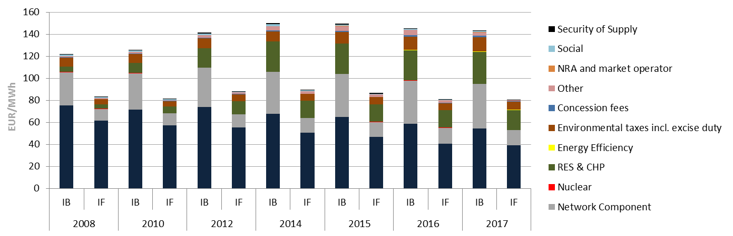

Figure 29 - Composition of taxes on prices for small (IB) and large (IF) industrial electricity prices   
(2008-2017)

Source: DG ENER in-house data collection

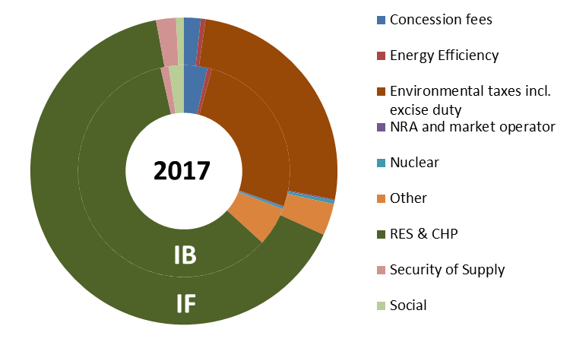

Figure 30 - Composition of taxes on prices for small (IB) and large (IF) industrial electricity consumers   
in 2017

Source: DG ENER in-house data collection

**Value Added Tax**

VAT is recoverable for most industrial consumers in all reporting countries. Therefore the analyses in this section focus on industrial prices excluding VAT. Other recoverable taxes are also excluded prom the price we report.

**Other non- earmarked taxes**

Non- earmarked taxes for small industrial consumers grew from 7 to 12 EUR/MWh by 2017. This reflects an annual growth rate of 2.4%, the third highest among the 10 different categories of taxes. Non- earmarked taxes made up 26% of the taxes component and 8% of the total IB price. For large industrial consumers, non- earmarked taxes grew even faster, at the annual rate of 3%, albeit from an initially lower level. They averaged at 7 EUR/MWh across the EU in 2017.

**Renewable energy and Combined Heat and Power**

This sub-component includes any support to renewable energy and combined heat and power generation. Explicit RES & CHP support costs were reported by 25 EU countries. In Finland and Malta, the renewable energy support scheme is not financed from a levy on electricity consumption but from the central state budget. France has been following the same example since 2016. Therefore in these 3 countries the cost of supporting renewable energy through electricity bills is zero. It is important to note that consumers still pay for the support of renewable energy, albeit in an implicit way. Data for the United Kingdom is estimated and includes support to energy efficiency.

RES& CHP support cost were 29 and 18 EUR/MWh for small and large consumers respectively in 2017. RES support made up 59% of all taxes and 20% of the total price for small industrial consumers. The same shares for large industrial consumers were slightly higher at 65% (of taxes) and 22% (of the total price). The RES sub-component grew at the annual rate of 16% and 18% for IB and IF respectively. These growth rates covering the period 2008 to 2017, conceal volatile sub- periods: after strong initial growth from 2008 to 2012 we observe almost stagnation from 2014 to 2016 for both consumer types. From 2016 to 2017 the cost of RES support grew again slightly faster.

The following graphs display the cost of supporting renewable energy for different consumer types. They reflect the extent to which Member States make use of the above described exemptions and reductions regulated by the State Aid Guidelines. Of the 26 countries that reported RES support costs for both consumer types, burden sharing is equal in 6. In 3 (HR, HU, IT) households pay less than small and medium industrial consumers (albeit more than large industrial consumers). In 17 countries the levy is degressive, it decreases as the consumption increases.

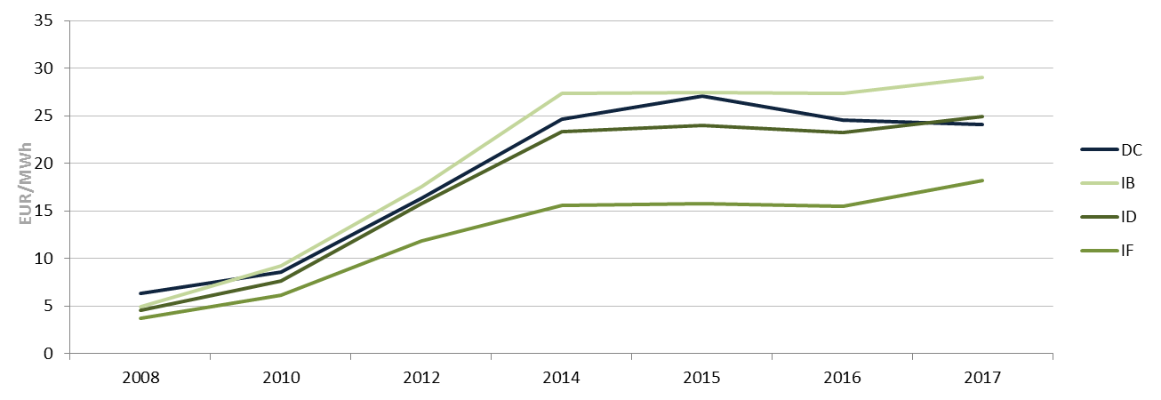

Figure 31 - RES support costs for electricity consumers (DC=Household, IB=small, ID=median, IF=large)

Source: DG ENER in-house data collection

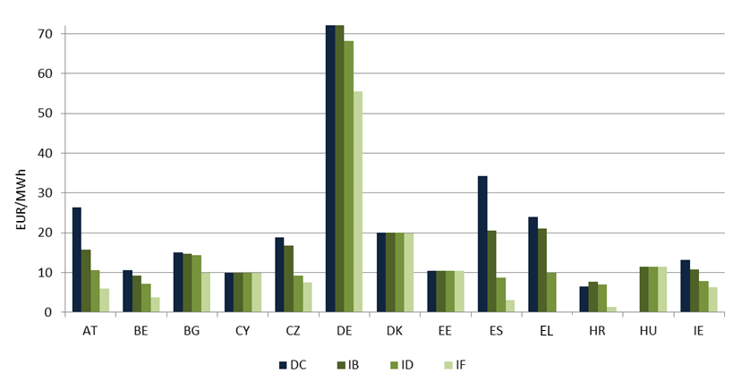

Figure 32 - RES support in 2017 by consumer type and country. First 13 countries alphabetically

Source: DG ENER in-house data collection

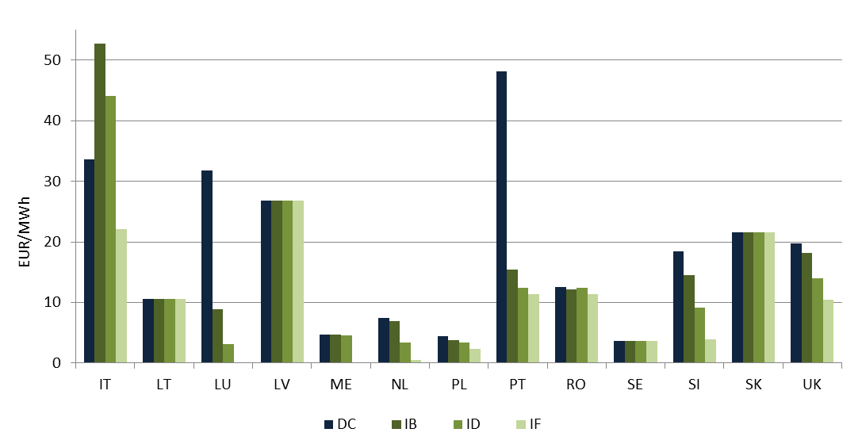

Figure 33 - RES support in 2017 by consumer type and country. Last 13 countries alphabetically

Source: DG ENER in-house data collection

The share of all other policy support costs, including energy efficiency, security of supply and nuclear sector policies, remained below 1% of the total price.

### International comparisons

Component level data (energy, network, taxes) is not available for countries outside of the European Statistical System, which encompasses the 28 EU Member States, 4 EFTA members, 9 Energy Community contracting parties of the western- Balkans and Turkey. Consequently Turkey is the only G20 trading partner of the EU for which component level data is available.

Component level data enables the identification of price drivers. As this data is not available for G20 trading partners, the difference between wholesale and retail prices can serve as a proxy. The difference consists of network charges, taxes, levies as well as of the costs and profit margins of supply companies. Consequently, the difference includes elements from all three components. The non- regulated, supply related costs account for only a small share of the total difference in most countries.

We observe that the difference between wholesale and retail prices, therefore the impact of the regulated part, is larger in the EU than in its G20 trading partners. This holds for both electricity and natural gas and both households and industry. On average across the EU the non- regulated part of the [price has been contracting since 2008 while the regulated part kept growing until recently. At the same time we observe that retail prices are below wholesale prices in some trading partner countries, indicating that prices are subsidized and regulated at low levels. Consumers pay less than the actual cost of their energy use.

Electricity wholesale prices in the EU are often comparable to those in G20 countries. This however does not translate to retail prices as such are on average higher in the EU than in all G20 trading partners. This is a result of various taxes and levies that provide revenue to treasuries through excise taxes and finance policies, such as renewable energy and energy efficiency. These contributions result in higher prices but also allowed the EU to be a global driving force in combatting climate change and a leader in the development and deployment of sustainable energy technologies.

**Household Electricity Prices**

The EU28 average difference between household retail prices and wholesale prices has increased from around 100 EUR/MWh in 2008 to more than 160 EUR/MWh in 2017.

The difference in the US is lower than in the EU28 at around 80-90 EUR/MW, albeit it has been increasing since 2008. The same analysis using the wholesale proxy for China shows a negative outcome of 30-40 EUR/MWh, this highlights that household consumers in China are not paying the full cost of their electricity use. The difference in Japan varied considerably over the observation period, with the Fukushima effect on wholesale prices likely to have played an important role in the 2011 peak. For the other G20 countries the differences are significantly lower than for the EU28 average. In Mexico (MX), Indonesia (ID) and Russia (RF) the difference is small, indicating that retail prices are regulated and kept at low levels in these countries. In Canada (CA), Turkey (TR) and Brazil (BR) the difference is greater, but still significantly smaller than for the EU28 average.





Figure 34 - Difference between household retail electricity prices and electricity wholesale prices 2008-2018, EUR2017/MWh

Source: Trinomics et altri study

**Industrial Electricity Prices**

The EU28 average difference between household retail prices and wholesale prices has increased from around 30 EUR/MWh in 2008 to around 70 EUR/MWh in 2017. The difference in the US is lower than in the EU28 at around 15-40 EUR/MWh, albeit it has been slowly increasing since 2008. The difference in Japan is in the same order of magnitude as the EU28 average and US levels, but has varied considerably over the period, with the annual frequency of the data playing a role, and the Fukushima effect on wholesale prices likely to have played an important role in the 2011 peak. The same analysis using the wholesale proxy for China shows virtually no difference, likely due to the proxy being similar to the industrial price, it is an interesting contrast to household prices, pointing towards energy policy priorities and price interventions in favour of households rather than industry.

For the rest of the G20 countries the difference compared to the EU28 average is typically lower, although the difference in Canada (CA) has generally been similar to the EU. We can observe a small divergence in Mexican (ME) and Russian (RF) prices which remained mostly constant over time, while the difference in the EU increased. In Turkey (TR) the difference in prices was often negative highlighting that retail prices are regulated at levels below the cost of supplying electricity.

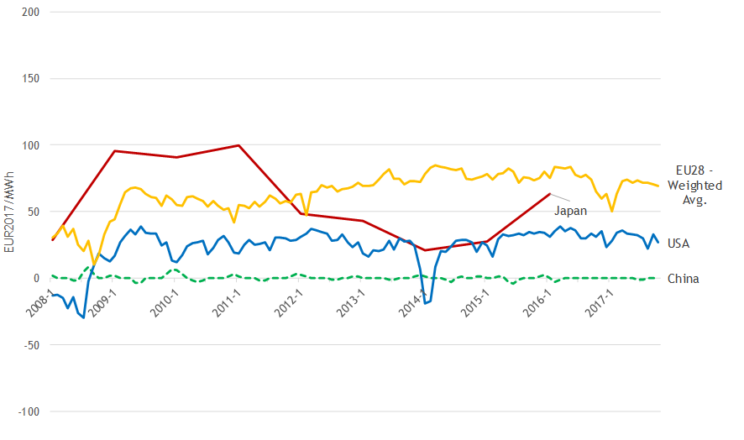

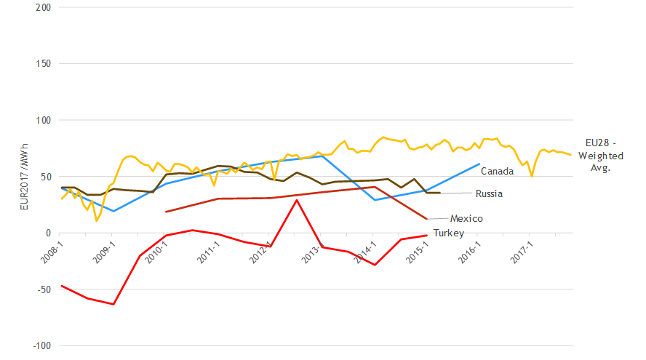

Figure 35 - Difference between industrial retail electricity prices and electricity wholesale prices, EU28 and other G20 countries, 2008-2018, EUR2017/MWh

Source: Trinomics et altri study

# Gas prices

## Wholesale gas prices

**Main findings**

* European wholesale gas prices plummeted in the wake of the 2008-2009 financial crises but recovered by 2011-2013, helped by the economic recovery and the Fukushima accident which increased global LNG demand. This was followed by a period of declining prices as low oil prices and increasing global LNG supplies, coupled with weak demand put pressure on European gas prices. After bottoming out in 2016, wholesale gas prices have been on the rise, driven by the economic recovery, rising gas demand (both in Europe and globally) and increasing oil and coal prices.
* European wholesale prices move in a rather wide range, with regional price differences driven mainly by the level of competition: in general, markets with higher levels of competition show a lower price level than markets with only one supply source. Since 2015, falling oil prices, the decreasing role of oil-indexation and, in some cases the diversification of supply sources contributed to converging wholesale prices in Europe.
* Among the different pricing mechanism, oil-indexation is losing ground in the European market but continue to play an important role in certain regions, in particular in the Mediterranean, in Southeast Europe and the Baltics. On the other hand, hub prices gained significant ground in Central Europe: wholesale prices in this region are more and more aligned with Northwest European hub prices, rather than with oil-indexed prices.
* From time to time, daily prices can show extreme volatility, typically when cold snaps sharply increase demand while supply is limited by infrastructure constraints or other factors. Two such extreme periods occurred during the 2017-2018 winter, leading to unprecedented prices at certain gas hubs. On both occasions, rising prices provided the right signal to market participants and gas supplies were not interrupted but the extent of the price rise seems to point toward the inflexibility of demand.
* While oil-indexed prices have a diminishing role in the European market, European wholesale gas prices continue to be closely aligned with the oil price, reflecting the close relationship between the gas market and the wider energy complex. There is a strong correlation between oil and gas prices in the long term but during shorter periods the price trend of the two commodities can diverge. Compared to oil, the price of gas is more exposed to seasonality.
* EU gas demand shows a strong seasonality which is reflected in the development of wholesale gas prices: prices tend to be higher when temperatures are low. Periods of extremely cold temperatures often trigger price peaks.
* In international comparison, European wholesale gas prices are well above those in major gas producing countries (Canada, Russia, US) but in general lower than in other G20 economies, especially those which solely or largely rely on LNG imports (e.g. China, Japan, Korea). International prices have converged since 2015 which means that the absolute value of the regional differences decreased but, nevertheless, these differences proved persistent.

### Evolution of wholesale gas prices

Gas prices, similarly to the price of most other commodities, peaked in 2008, driven by robust global economic growth and rising demand from emerging markets, particularly China. In the wake of the economic crisis, prices sharply decreased: in less than one year, European gas hub prices fell by around 70%. Prices gradually recovered between 2009 and 2013, helped by the economic recovery and the Fukushima accident which increased global LNG demand. In March 2013, hub prices exceeded the record levels reached in 2008.

In 2013-2016, wholesale gas prices were on a declining trajectory and, by 2016, European wholesale gas prices fell to the lowest levels since 2009. In this period, low oil prices and increasing global LNG supplies, coupled with weak demand put pressure on European gas prices.

Wholesale gas prices have bottomed out in 2016 and have been on the rise since then, driven by the economic recovery, rising gas demand (both in Europe and globally) and increasing oil and coal prices. Hub prices have nearly doubled since 2016 and, at the same time, they have been exhibiting strong seasonal volatility.

The Commission follows the development of a number of wholesale gas prices across the EU, including prices at trading hubs, estimated border prices calculated based on customs data and other prices reported by commercial data providers or other sources. Wholesale prices move in a rather broad band: in 2008-2014, the average difference between the highest and lowest price was close to 20 EUR/MWh. From 2015, prices have perceivably converged, with the widths of the band narrowing to around 10 EUR/MWh in 2015-2017. In case of extreme events (cold spells and/or supply disruptions) affecting specific regions, e.g. in the first quarter of 2018, the price band can become much wider.

Hub prices, especially those in the liquid Northwest European markets have been near to the lower border of the price range for most of the last decade, as demonstrated in **Figure 36** by the price at the Dutch (TTF) and the UK (NBP) hubs. Oil-indexed prices, on the other hand, have been typically closer to the upper border of the price band for most of the period, as indicated by the development of the Platts North West Europe Gas Contract Indicator (GCI), a theoretical index showing what a gas price linked 100% to oil would be.

Regional price differences are largely explained by the different pricing mechanisms and the different levels of competition. In general, markets with higher levels of competition show a lower price level than markets with only one supply source. Lower oil prices, the decreasing role of oil-indexation and, in some cases, new supply sources (e.g. LNG in Lithuania and Poland) contributed to converging wholesale prices in Europe in 2015-2017.

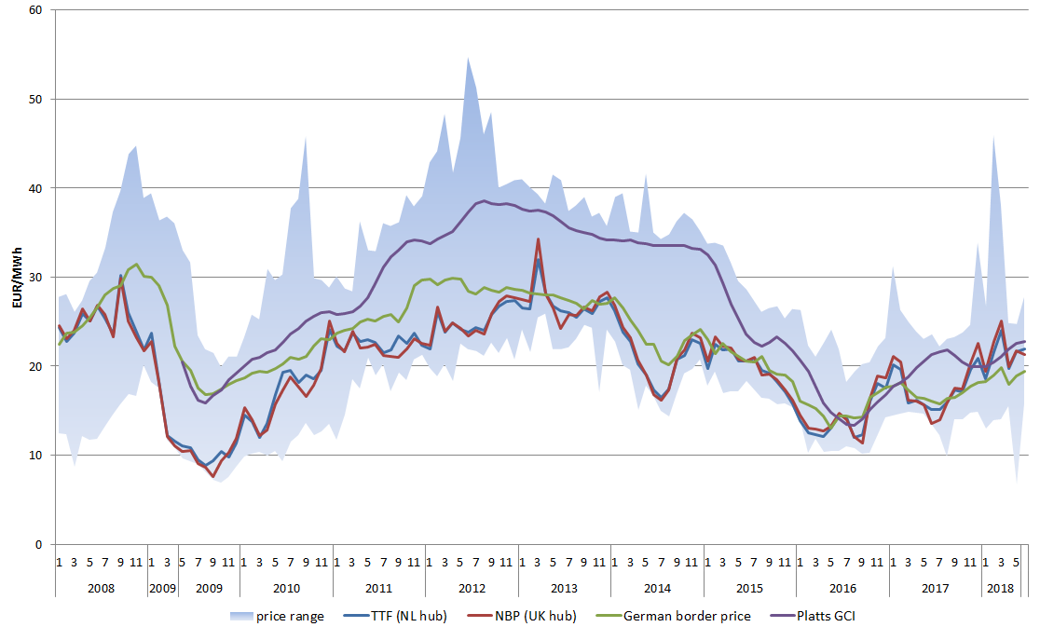

Figure 36 - Selected wholesale gas prices in Europe

Source: Platts, BAFA, Eurostat Comext

The difference between GCI and the price at the Dutch hub (TTF) averaged around 10 EUR/MWh in 2011-2014. In the wake of the oil price fall in 2014-2015, oil-indexed gas prices have significantly decreased, facilitating the convergence of European wholesale gas prices. In certain periods, oil-indexed prices were actually lower than the price at the most liquid gas hubs in Northwest Europe. This was the case during most of the 2016-2017 winter and in March 2018 when hub prices grew driven by high seasonal demand and supply disruptions.

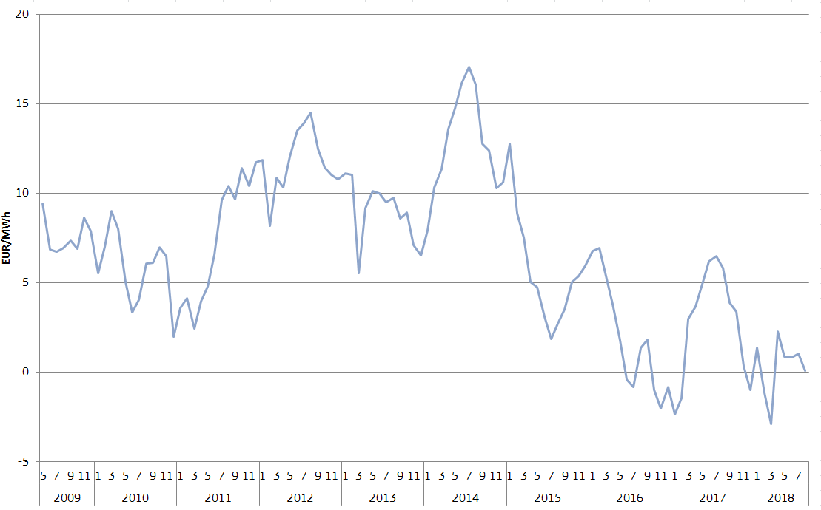

Figure 37 - The difference between the Platts North West Europe Gas Contract Indicator (GCI) and the Dutch hub price (TTF)

Source: Platts

Over the period, there has been a trend of moving from oil-indexed prices towards hub pricing. After years of a declining trend, the share of oil-indexation in Europe seems to have stabilised around 30% in 2014-2016 but there are significant regional differences.

The development of the German border price (a weighted average gas import price for the country) on **Figure 36** clearly demonstrates the trend of moving towards hub pricing: while in 2009 it was very close to the Platts GCI index, it gradually approximated the Dutch and UK hub prices, showing that the pricing of German imports, including those coming from Russia, is increasingly based on hub prices, rather than oil-indexation. As **Figure 38** shows, such a trend could be observed also in the countries of Central Europe (e.g. Czech Republic, Hungary, Slovakia) where wholesale prices are more and more aligned with Northwest European hub prices, rather than with oil-indexed prices. On the other hand, oil-indexation continued to have an important role in the Mediterranean, in Southeast Europe and the Baltics.

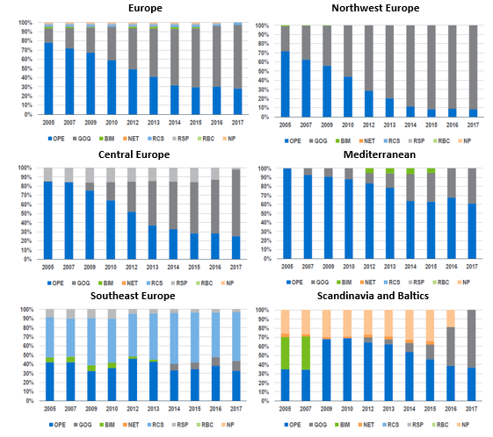

Figure 38 - Price formation in Europe

Source: IGU Wholesale Gas Price Survey, 2018 Edition

Northwest Europe: Belgium, Denmark, France, Germany, Ireland, Netherlands, UK

Central Europe: Austria, Czech Republic, Hungary, Poland, Slovakia, Switzerland

Mediterranean: Greece, Italy, Portugal, Spain, Turkey

Southeast Europe: Bosnia, Bulgaria, Croatia, FYROM, Romania, Serbia, Slovenia

Scandinavia & Baltics: Estonia, Finland, Latvia, Lithuania, Norway, Sweden

OPE: oil price escalation, GOG: gas-on-gas competition; BIM: bilateral monopoly, NET: netback from final product, RCS: regulated cost of service, RSP: regulated social and political, RBC: regulated below cost, NP: no price

The monthly average prices depicted in **Figure 36** often hide a high degree of daily volatility. For short periods, daily prices can reach exceptionally high levels, typically when cold naps sharply increase demand while supply is limited by infrastructure constraints or other factors. **Figure 39** shows that two such extreme periods occurred during the 2017-2018 winter, leading to unprecedented prices at certain gas hubs.

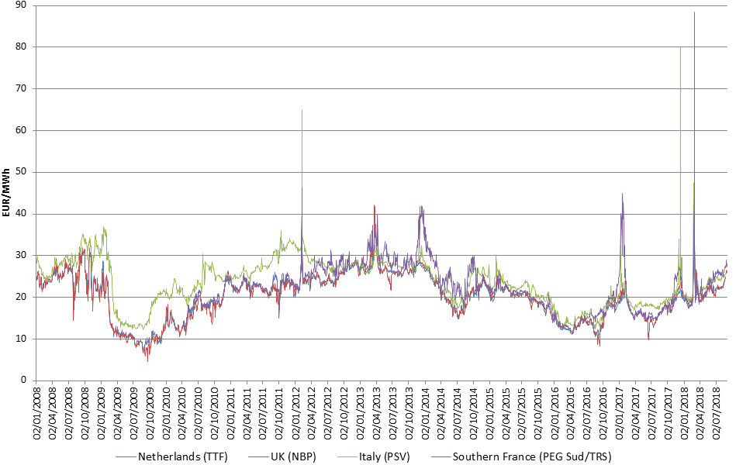

Figure 39 - Daily day-ahead prices at selected gas hubs from 2008 to mid-2018

Source: Platts

On 12 December 2017, an explosion at the Baumgarten facility in Austria cut Russian supplies to the country. In Austria, domestic supplies were secured from increased storage withdrawals. The accident also cut all Russian imports to Italy, the main source of supply to the country. In Italy, the supply-demand balance was rather tight already before the incident, because of strong winter demand and reduced import capacity through Switzerland. In the wake of the disruption, the Italian day-ahead price settled at a record 80 EUR/MWh on 12 December, up from 23.7 EUR/MWh the day before. The price spike allowed demand to fall and alternative supplies to grow. Italy has a number of import sources and, within hours, pipeline imports were ratcheted up on all supply routes, with the biggest additional volumes coming from Switzerland and Algeria. To a lesser extent, Libyan supplies also increased. In addition, LNG send-out from the Adriatic LNG facility was also stepped up. Growing imports were not sufficient to replace the missing volumes; increased withdrawals for domestic storages had to fill the gap. A longer-lasting disruption would have also attracted additional LNG cargoes. However, the outage was resolved in less than a day, with gas flows from Russia resuming before midnight and prices quickly receding to previous levels.

More or less at the same time, amid strong seasonal demand, supplies in Northwest Europe were constrained by the unplanned outage of the Forties pipeline system in the UK North Sea and a 2-day loss of output from Norway’s Troll field. The outage of the Forties pipeline lasted from 11 to 30 December 2017 and triggered a reduction of UK gas production by 30-40 million cubic meters a day. As a result, UK prices also soared, reaching the highest level in nearly three years and incentivising additional imports. On 12 December, the NBP settled at 26.1 EUR/MWh, 3.9 EUR/MWh above the TTF and the premium remained around 2 EUR/MWh between 13 and 20 December. Increasing imports through the Interconnector (from Belgium) and the BBL pipeline (from the Netherlands) were instrumental in replacing missing volumes and, after 20 December, rising temperatures also contributed to the easing of the market tightness. On the other hand, the price signal was not strong enough to boost LNG imports.

During a late-winter cold snap in late February/early March 2018, temperatures dropped around 10oC below the seasonal average in most of Europe, causing a significant price spike. The cold spell triggered record gas consumption in a number of Member States and tightened the supply-demand balance in Europe. The cold spell arrived at a time when gas storage levels were already rather low (especially in Northwest Europe), increasing the impact on day-ahead prices. Hub prices in Western Europe reached unprecedented levels, with TTF and NBP closing at 79.0 Euro/MWh and 88.4 Euro/MWh, respectively on 1 March 2018. Storage withdrawals typically tail off in February but this was not the case in 2018. Skyrocketing spot prices provided a boost to withdrawals which was a key source of gas supply during the cold spell. On 28 February, withdrawals in the EU reached 11.4 TWh (nearly 1.1 bcm), the highest daily rate on record. On the other hand, the price spike did not last long enough to attract additional LNG supplies: LNG imports remained below 2017 levels in both February and March 2018.

On both occasions, rising prices provided the right signal to market participants and gas supplies were not interrupted but the extent of the price rise seems to point toward the inflexibility of demand.

**Figure 39** also depicts the price in Southern France which, on certain occasions, well exceeds the price in the Northern part of the country. Northern France has access to the diverse supply sources available in Northwest Europe and, as a result, the price is typically very close to the price at the Dutch TTF hub. Southern France, however, is largely relying on the LNG terminals on its Mediterranean coast; constraints on the north-south link within France mean that prices can be quite divergent. For example, the premium of PEG Sud/TRS over PEG Nord reached a record 23.0 EUR/MWh on 20 January 2017 when high seasonal demand coupled with low LNG imports and the persistent capacity restrictions on the north-south link caused supply tightness in the Southern part of the country. In this period, LNG supplies from Algeria, France's main LNG supplier, were hindered by technical issues. Under such circumstances, prices had to increase substantially and for a sustained period in order to attract LNG cargoes from the high-priced Asian market. By early February, milder weather and additional LNG cargoes allowed the situation to ease and the premium of TRS over PEG Nord has practically disappeared. Ongoing infrastructure upgrade projects will help to debottleneck the north-south link; once these are completed, such big price differences are not likely to occur any more.

### Factors impacting the evolution of wholesale gas prices

The development of wholesale gas prices is influenced by a number of factors. In this section we look into the impact of two important variables, the oil price and the weather.

There is a persistent strong correlation between oil and gas prices. By definition, this is the case for oil-indexed prices, as shown by **Figure 40** which depicts the movement of the Brent oil price and the Platts North West Europe Gas Contract Indicator (GCI), a theoretical index showing what a gas price linked 100% to oil would be. Typically there is a 6-9 month time lag in the pricing formulas used which means that oil-indexed gas prices react to changes in the oil price with a delay. For example, Brent started its steep fall in mid-2014 but this was reflected in the development of oil-indexed prices only from the beginning of 2015.

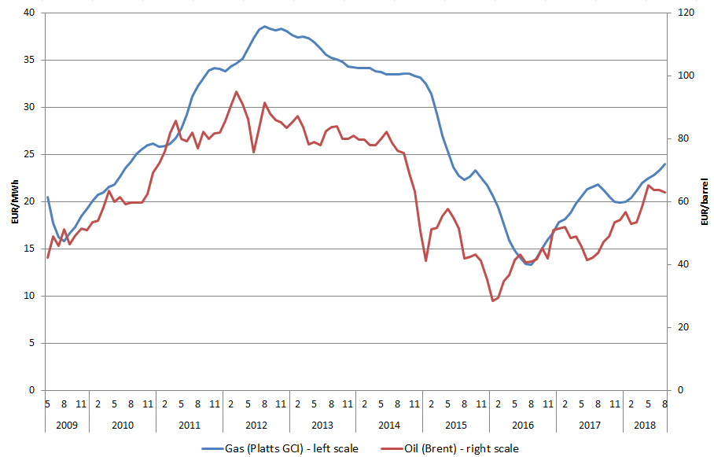

Figure 40 - The monthly average price of oil (Brent) and oil-indexed gas contracts (Platts GCI)

Source: Platts

The observation of a strong correlation between oil and gas prices also holds for European gas hub prices, as shown in **Figure 41** through the example of the Dutch TTF, Europe's most liquid hub. While oil-indexed prices have a diminishing role in the European market (see section 2.1.1), hub prices continue to be closely aligned with the oil price, reflecting the close relationship between the gas market and the wider energy complex.

Looking at the last decade, this correlation is apparent in the long term but in shorter periods the price trend of the two communities can diverge. For example, in the second half of 2014, when oil prices started to fall steeply, gas hub prices moved in the opposite direction. Also, the price of gas is more exposed to seasonality, as demonstrated lately by the distinct peaks during the 2016-2017 and the 2017-2018 winters.

In certain cases there seems to be a time gap between changes in oil and gas hub prices: in 2008-2009, TTF plunged a couple of months later than Brent while in 2014 the fall of TTF preceded the collapse of the oil price.

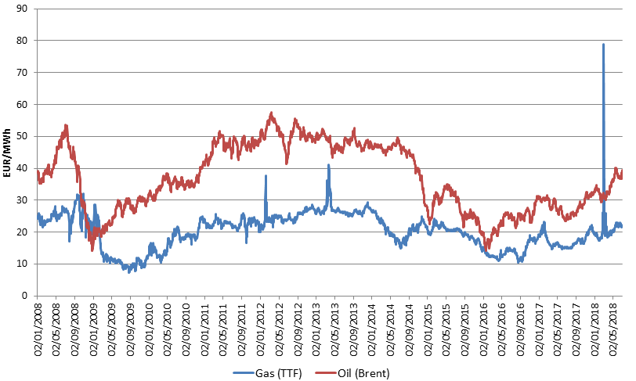

Figure 41 - Daily spot prices of oil (Brent) and gas (at the Dutch TTF hub)

Source: Platts

**Figure 42** depicts daily changes of Brent and TTF. Dots represent individual days, showing the change of oil price (on the horizontal axis) and the gas price (on the vertical axis) compared to the previous day, expressed in percentage. While oil and gas prices do not necessarily change in the same direction every day, there is a weak positive correlation, particularly the increasing oil prices often coincide with increasing gas prices.

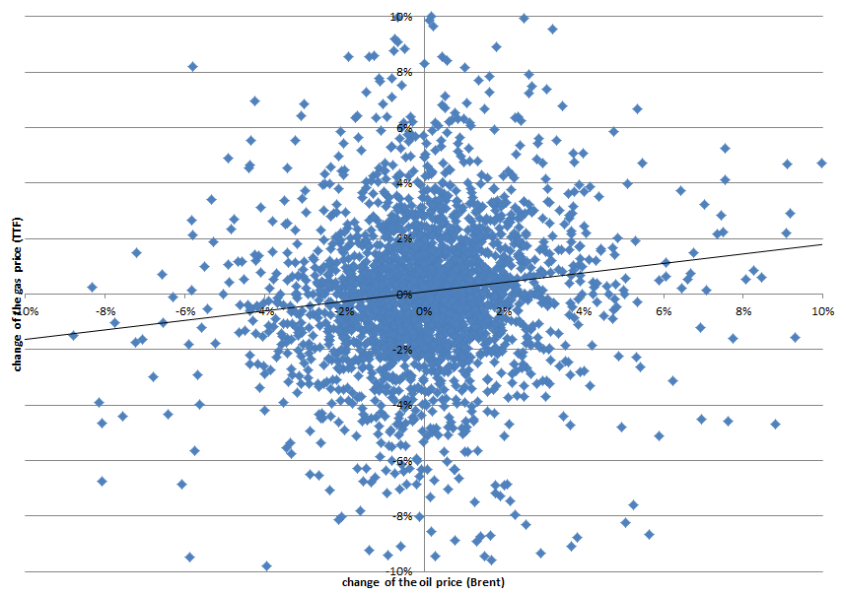

Figure 42 - Daily change of spot prices of oil (Brent) and gas (at the Dutch TTF hub)

Source: Platts

Measured in energy content, oil has traditionally been more expensive than natural gas. This was the case in the last decade, except for a short period at the end of 2008 and the beginning of 2009 when European gas hub prices followed the plunge of oil price with some delay. Between the beginning of 2008 and mid-2018, the price of Brent (measured in EUR/MWh) was on average 86% higher than the price of gas at the TTF hub. This ratio has gradually decreased over the period, meaning that the relative price of gas compared to oil increased. In the last three and a half years, the average "premium" of oil over gas was 58%.

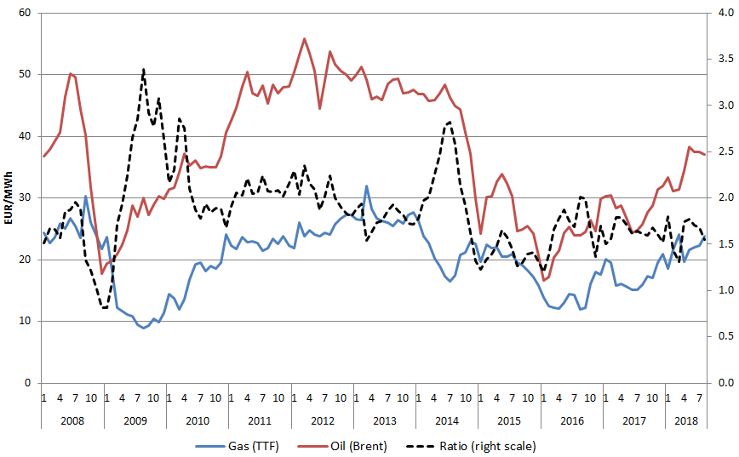

Figure 43 - The monthly average price of oil (Brent) and gas (at the Dutch TTF hub), measured in EUR/MWh

Source: Platts

Note: a conversion rate of 1.7 MWh/barrel was used for Brent

EU gas demand shows a strong seasonality, reflecting the fact that a large proportion of gas is used for space heating. According to 2016 data, the residential sector covered 27% of the gross inland consumption of gas in the EU; this is very close to the share of transformation input (gas used mainly in power stations and district heating plants) which was 33%.[22] Depending on temperatures, the level of gas consumption can be rather volatile during the winter months which can obviously have an impact on the price of gas.

Accordingly, one would expect a seasonality in prices reflecting the seasonality of demand, with lower temperatures associated with higher prices. Looking at the Netherlands, this is indeed the case in several years (in particular 2009, 2014, 2016 and 2017) with lower prices in summer and higher prices in winter. On the other hand, there are years when such a trend cannot be observed, indicating that gas prices are also impacted by other factors. But in general, periods of extremely cold temperatures (e.g. January 2009, January 2010, December 2010, January 2012, January 2017) trigger smaller or larger price peaks. Cold spells at the end of winter, when gas stocks are largely depleted (e.g. March 2013 and March 2018), can induce exceptionally high prices.

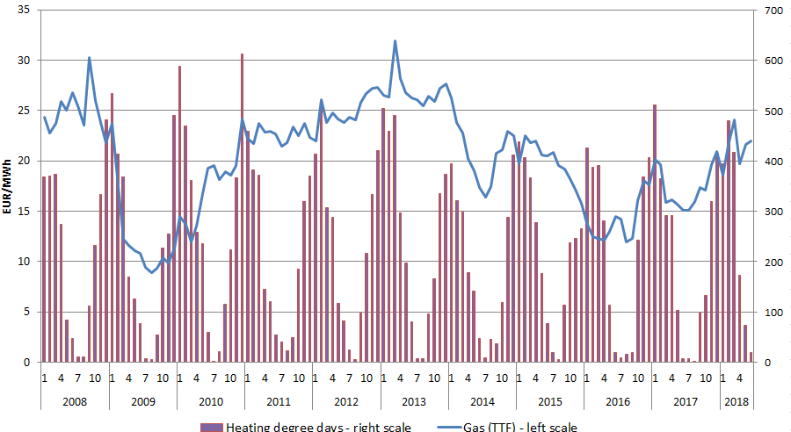

Figure 44 - Monthly average gas price at the Dutch TTF hub and heating degree days in the Netherlands

Source: Platts, Eurostat

On **Figure 45**, dots represent individual days, showing the daily average temperature in the Netherlands (on the horizontal axis) and the gas price at the TTF hub (on the vertical axis). The linear trendline confirms the negative correlation between temperatures and prices. It is also clearly visible that exceptionally high prices occur on days with low temperatures. Since 2013, the TTF price never exceeded 30 EUR/MWh on days with an average temperature of more than 4oC. The highest price was observed on 1 March 2018 when temperatures were 9oC below the seasonal average.

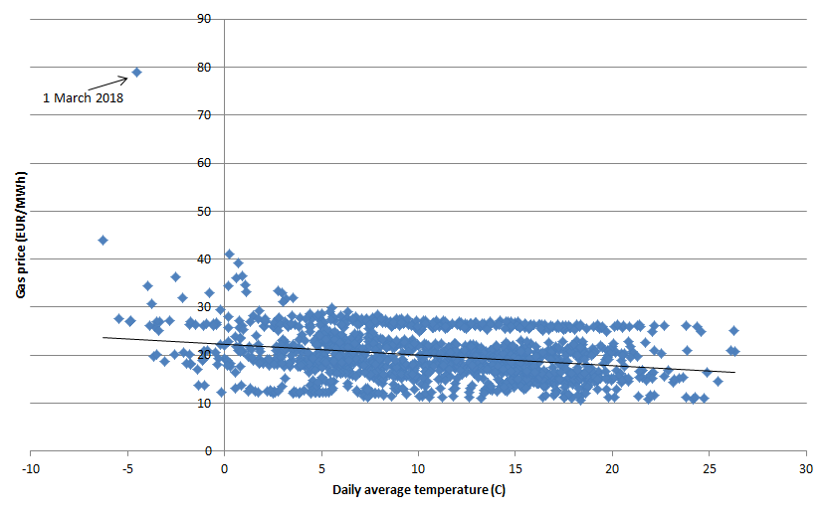

Figure 45 - Daily gas price at the Dutch TTF hub and average daily temperature in the Netherlands from the beginning of 2013 to mid-2018

Source: Platts, Thomson Reuters/Point Carbon

*Note: only weekdays are depicted*

### International comparison

Comparing European gas wholesale prices with those in the EU's major trading partners provides an insight into how energy costs can impact the international competitiveness of energy intensive industries which are exposed to global trade.

After the 2011 Fukushima accident and the start of the US shale gas revolution, the three main regional benchmarks depicted in **Figure 46** had significantly diverged and price differences remained large through 2011-2014. Since the second half of 2014, there has been a convergence of international prices. Japanese LNG prices significantly decreased, facilitated by weak demand in Asia and the increasing global LNG supplies, and compounded by the fall of oil prices. These factors also contributed to the decrease of prices in Europe, thereby lowering the premium above the persistently low gas wholesale price in the US.

In the second quarter of 2017, the convergence among the key international gas prices reached the greatest level since the Fukushima accident. However, the trend of converging regional prices was interrupted during the last two winters (2016-2017 and 2017-2018) when Asian prices showed a steep rise due to strong seasonal demand. European and US prices also increased but to a lesser extent, resulting in a widening gap between regional benchmarks.

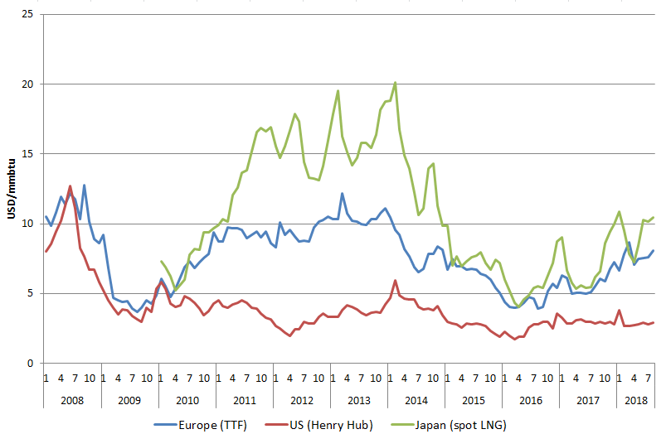

Figure 46 - Comparison of European, US and Japanese wholesale gas prices

Source: Platts, Thomson Reuters

There has been a slow convergence between US and European prices in 2012-2016, with the ratio of European and US prices dropping below 1.5 in the third quarter of 2016. Since then, however, European prices increased while US prices remained rather stable, leading to a diverging trend. European prices remain stubbornly high compared to those in the US: in 2017, the TTF price was on average almost two times higher than the US Henry Hub benchmark.

For most of 2011-2014, Japanese spot LNG prices were 40 to 100% higher than the Dutch TTF benchmark. In the last few years, during the summer months, the gap between European and Japanese prices has almost disappeared. However, during the winter months, driven by the strong seasonal demand in Asia, Japanese prices rise substantially and as a result show a distinctive premium over Europe. In 2017, the Japanese spot LNG price was on average 20% higher than the price at the Dutch TTF hub but in January 2018 the mark-up was well above this level, reaching 64%. In March, when TTF surged due to a late-winter cold spell, the Japanese spot LNG price was exceptionally lower than the Dutch benchmark.

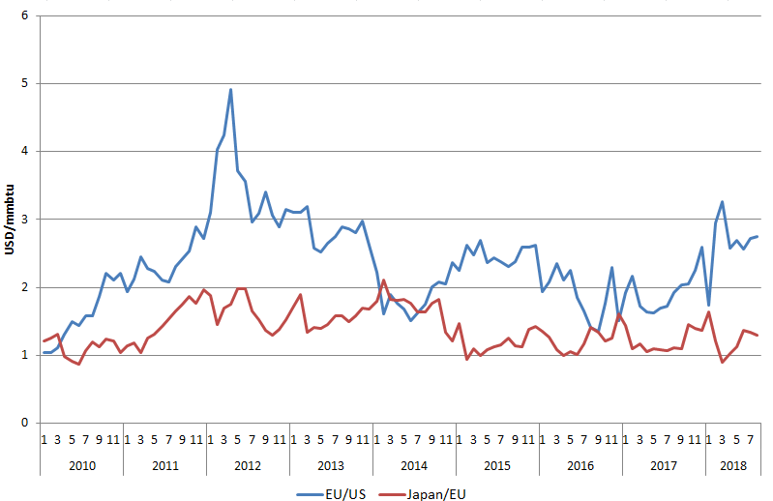

Figure 47 - The ratio of European, US and Japanese wholesale gas prices

Source: Platts, Thomson Reuters

Table 3 - The ratio of European, US and Japanese wholesale gas prices



Source: Platts, Thomson Reuters – The 2018 values refer to the period of January-August 2018

The study prepared by Trinomics[23] provides a more comprehensive international comparison of gas wholesale prices, covering most G20 economies, with the findings shown in **Figure 48** and **Figure 49**. Prices are expressed in constant (2017) euros. In case of the EU, a weighted average of national wholesale prices was calculated and depicted.

The analysis reveals a very large dispersion of prices in 2011-2011, followed by a noticeable convergence from 2015. Part of the gas wholesale prices is indexed to oil prices and hence the price convergence was largely driven by the lowering of the crude oil price.

Major gas producing countries, including Canada, Russia and the US have the lowest gas wholesale prices in the G20. This was also the case in Australia until 2016 but then domestic supply shortages triggered a significant price rise.

Apart from the producing countries, wholesale prices in the G20 countries tend to be higher than the EU average, often showing a high degree of volatility.

Chinese wholesale prices follow a similar trend to the Japanese price but in 2011-2014, after the Fukushima accident, the absolute level of the price remained somewhat lower, probably because – unlike Japan– China is not fully reliant on LNG (the country also has indigenous production and pipeline imports from a couple of sources). In addition, Chinese prices exhibit less seasonality.

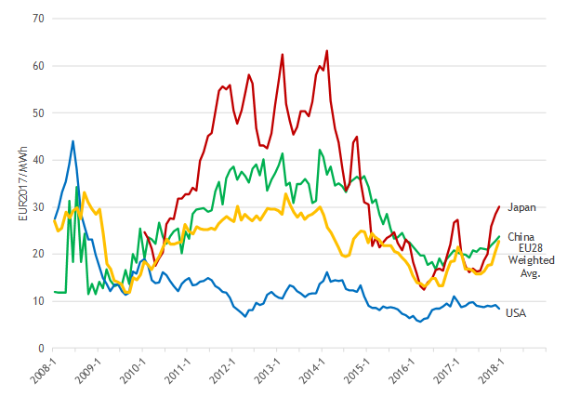

Figure 48 - Gas wholesale prices in the EU (weighted average), China, Japan and the US

Source: Platts, Thomson Reuters, Knoema (World Gas Intelligence; World Bank), World Bank Commodities Price Data (The Pink Sheet).

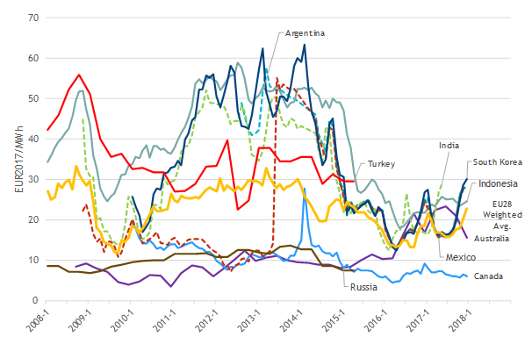

Figure 49 - Gas wholesale prices in the EU (weighted average) and selected markets

Source: Platts, Thomson Reuters, Knoema (World Gas Intelligence; World Bank), World Bank Commodities Price Data (The Pink Sheet).

## Retail gas prices

**Main findings**

* Progress towards the completion of the single gas market continued. This is reflected by the fact that national energy components are gradually converging: they became 20%[24] less spread out over the last decade.
* Natural gas prices remained largely determined by the international wholesale price of the commodity and followed its evolution with a slight time lag. Consequently, the energy component - containing wholesale prices- retained its positions as the largest of the three components for all consumer types, with shares ranging from 50 to 80%.
* In absolute terms the energy component increased by half a percent annually for households but decreased at a faster pace for industrial consumers (by 1.75% annually[25]).
* Network charges continued to be on divergent trajectories for different gas consumer types. They increased annually by 4% for households and 5% medium industrial consumers but decreased by 1.6% annually for large industrial consumers.
* The impact of taxation on natural gas prices remained limited. Taxes made up 26% of household bills (compared to 40% for electricity) and only 10% of large industrial gas bills.
* The composition of taxes on natural gas bills also differs significantly from their electricity counterparts. Almost 90% of imposed additions are fiscal instruments generating revenue for the state budget and only a small portion are levies supporting specific policies. Non- harmonized taxes (other than VAT and excise duty) are more common compared to electricity bills.
* Support to renewable energy has played an insignificant role in gas price developments. By 2017 only 3 countries imposed a RES levy on gas.
* The EU household gas prices grew by 2.5% annually since 2008 and reached 60 EUR/MWh in 2017. Industrial gas prices evolved in the opposite direction as prices for both small and large consumers contracted over the same period and reached 29 EUR/MWH and 22 EUR/MWh respectively.

Table 4 - Key figures on the evolution and drivers of retail gas prices

|  |  |  |  |  |  |  |  |  |  |
| --- | --- | --- | --- | --- | --- | --- | --- | --- | --- |
| Consumer type | Household (D2) | | | Industrial (I3) | | | Large Industrial (I5) | | |
| Component | Annual growth | Share 2017 | ∆ Share | Annual growth | Share 2017 | ∆ Share | Annual growth | Share 2017 | ∆ Share |
| Energy | 0.5% | 49% | - 10 p.p. | -2% | 69% | - 14 p.p. | - 1.5% | 81% | - 4 p.p. |
| Network | + 4.1 % | 24% | + 3 p.p. | + 4.8 % | 18% | + 7 p.p. | - 1.6% | 8% | 0 |
| Taxes | + 5.8 % | 26% | + 7 p.p. | + 10% | 13% | +7 p.p. | + 5% | 11% | +4 p.p. |
| Total | + 2.5 % |  |  | - 0.4% |  |  | - 1% |  |  |

Source: DG ENER in-house data collection

**Scope of the chapter**

According to Regulation (EU) 2016/1952 the report analyses prices of natural gas sold to consumers who purchase gas for their own use. Therefore prices paid by consumers who purchase gas for electricity generation in power plants or for non-energy purposes (e.g. for use in the chemicals industry) are excluded.

Box - The role of electricity and natural gas in our energy consumption

This chapter analyses consumer prices of electricity and natural gas. What is the role of these two energy products in our economy and everyday lives? Electricity accounts for 22% of our energy consumption[26] across the whole economy. This share remained remarkably constant over the last decade as a combined result of progressive electrification and increasing energy efficiency at the same time. The share of electricity varies considerably across reporting countries. It ranges from 13% in Lithuania to 34% in Sweden. The highest shares of electricity in final energy consumption are recorded by 2 non- EU member countries: Montenegro and Norway with 34% and 51% respectively.

The high share of electricity in Norway's energy mix results from the abundance of available hydro power resources. About 96% of electricity in Norway is produced from hydro power and most of it is consumed domestically. Relatively low cost and low carbon electricity helped Norway to develop a large power intensive industry. The availability of hydro electricity also impacts household energy consumption: electric heating sector is more wide spread than in other EEA countries. In Montenegro the dominant role of electricity results partially from the fact that there is no natural gas consumption in the country. On the other hand, different end uses of electricity, such as space cooling or electro intensive industries are prevalent.

Natural gas accounted for the exact same share on average across the EU as electricity, namely 22%. The share of natural gas in our final energy consumption has also not changed over the last 10 years. The use of natural gas differs even more across countries than the use of electricity. No gas is used on the islands of Cyprus and Malta. This is reflected in our data. The share of natural gas in final energy consumption of households is the lowest in Sweden at 1 %, closely followed by Finland and Norway with 2% share in both countries. The relative importance of natural gas is the highest in Hungary at 31%, followed by Italy and the United Kingdom with 29% share in both countries. Our analysis of national energy components reflects on the high shares of natural gas in the energy mix of these countries.

Electricity and natural gas together account for less than half of our energy consumption. The rest is covered mainly by liquid fuels for transport and heating as well as biomass.

### Household Natural Gas Prices

Household gas prices were reported by 23 EU Member States and Turkey. Natural gas is not used on the islands of Malta and Cyprus and in Montenegro. Regulation (EU) 2016/1952 lays down that reporting countries, where natural gas accounts only for an insignificant share of final energy consumption, are exempt from the obligation of providing price data. According to this Finland, where the share of household consumption of gas in final energy consumption is below 1.5%, is not reporting such data. Figures for Greece and the United Kingdom are estimates by DG energy as these two countries have not reported the breakdown of gas prices. No household gas data or estimates are available for Greece after 2015.

The following chapter analyses gas prices paid by household consumers whose annual consumption falls in the range of 20 to 200 GJ. This consumption band is defined by Eurostat as D2. It is the most representative consumption band in all but one reporting country.

**Evolution Household Gas Prices**

**Total prices grew at 2.5% annual rate from 2008 to 2017. In absolute terms the EU price grew from 48 EUR/MWh to 60 EUR/MWh.** This growth is faster than inflation, which averaged at 1.2% annually during the same period. The overall increase recorded throughout the period 2008 to 2017 however conceals two distinct periods. Prices steadily grew from 2008 to 2014 but have been increasing ever since. The EU average price peaked at 69 EUR/MWh in 2014 and decreased to 60 EUR/MWh by 2017. **This EU average conceals relatively homogenous developments on national level as prices increased only in 10 countries in the last reporting year. In 2017 Romania reported the smallest and Sweden the largest price. The ratio of the largest to smallest price increased by 6% to around 4:1 over the last decade.**

**Composition of Household Gas Prices**

**Over time, the composition of prices changed albeit less significantly than in the case of electricity. In 2017 the energy component, which mainly consists of wholesale prices, still made up almost half of the price even after its share decreased by 10 percentage points from 59% to 49% by 2017.**

**In absolute terms, the energy component decreased at an annual rate of 0.5% and reached 29 EUR/MWh in 2017. This collides with developments on the national level, as the energy component increased in only 6 reporting countries from 2016 to 2017.**

**The share of the network component increased slightly from 21% to 24% of the total price. In absolute terms the network component grew at the annual rate of 4% and reached 14 EUR/MWh by 2017.**

**The share of the taxes component grew by almost 7 percentage points and reached 26% in 2017. In absolute terms, taxes grew at the annual rate of 6% and reached almost 15 EUR/MWh by 2017.**

**The impact of taxes was smaller on household gas prices than on their electricity counterparts as the energy component, driven mainly by international commodity prices, remained the dominant component.**

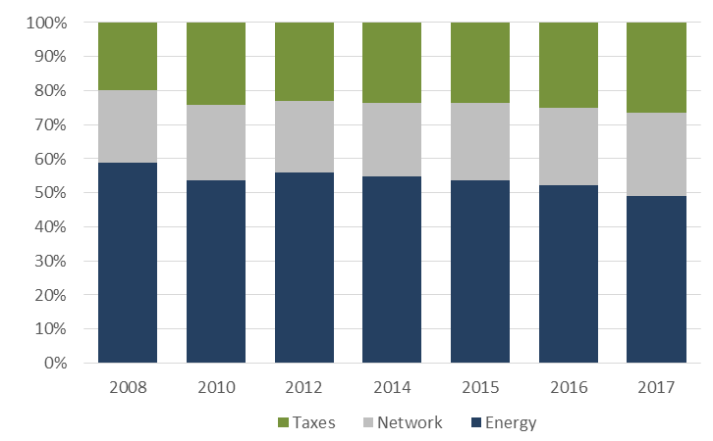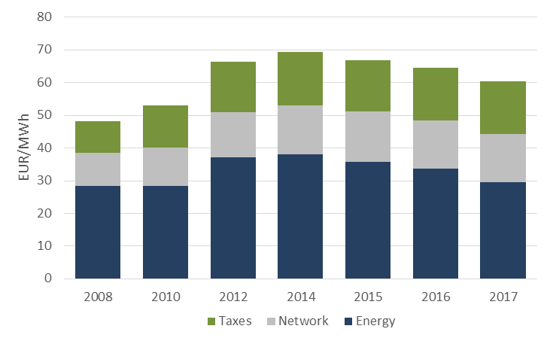

Figure 50 - Composition of the EU household gas price (DC)

Source: DG ENER in-house data collection

**Drivers of Household Gas Prices**

**The EU natural gas price for household consumers peaked in 2014 and has been decreasing ever since. The trend results from a steady decline of the energy component, continued smaller increases in the network component and a volatile evolution of taxes. 2017 was the first year when all three components contracted, leading to the largest year-on-year fall of the total price in our observation period.**

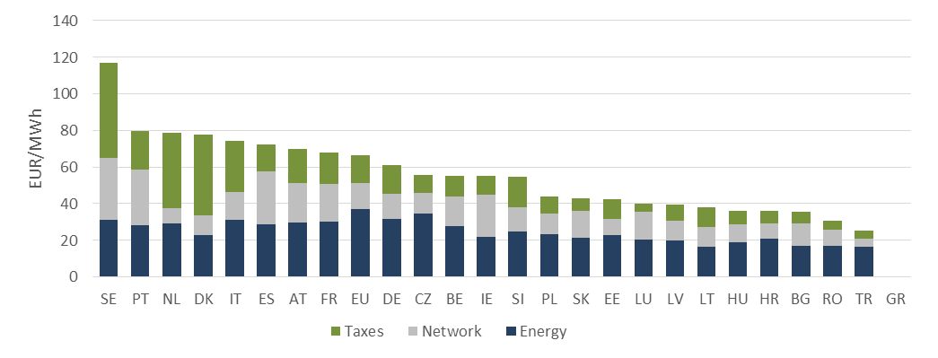

Figure 51 - Household gas prices in 2017

Source: DG ENER in-house data collection

Sweden's high gas prices stem from a carbon tax, which aims to curb greenhouse gas emissions. This holds both for households and industrial consumers. The tax was introduced as early as 1991 on all fossil fuels in proportion to their carbon content. Combustion of sustainable biofuels doesn't result in a net increase of carbon in the atmosphere and hence are not subject to the carbon tax.

Relatively high gas prices in Portugal result from a combination of factors, namely the very low unit consumption of households (mild climate), a modern network resulting in higher access tariffs (Portugal’s natural gas industry is only 20 years old), and a higher tax burden than in most other Member States. Additionally, natural gas has a CCGT backup role in Portugal, complementing the relevant, non-dispatchable and renewable-based electricity production. This balancing role led to access tariff volatility, affecting price convergence with other EU countries. This is reflected in our data: in other countries high prices typically stem from high taxes. In Portugal the network component of 30 EUR/MWh is more than double that of the EU average (13 EUR/MWh).

In the Netherlands relatively high prices stem also from taxation. 41 EUR/MWh taxes account for more than half of the total price and are significantly above the 13 EUR/MWh EU average. This tax policy aims to prevent gas field earthquakes at extraction sites through reducing demand. The Netherlands has significant gas resources in the Groningen area, located in north of the country. The extraction of these resources causes seismic activity which in turn causes significant damage to local businesses and homes.

90% of taxes imposed on natural gas bills across all reporting countries, including those in Sweden and the Netherlands, are non- earmarked taxes. Revenues from these taxes feed into the general budget and do not directly support energy or climate policies.

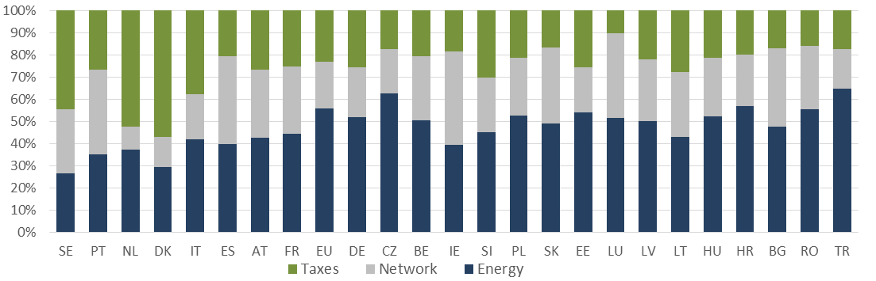

Figure 52 - Composition of household gas prices in 2017

Source: DG ENER in-house data collection

**Composition of taxes, levies, fees and charges**

**Natural gas prices remained** less impacted by taxation than their electricity counterparts. Taxes made up 26% of the total price compared to 41% of household electricity prices. The number and composition of taxes imposed on household gas prices also significantly differs from electricity taxation. While Member States add dozens of different policy support costs to electricity prices, the variety of taxes on gas prices is much more limited.

Taxation of household gas prices is dominated by excise duties. Such are imposed according to the Energy Tax Directive from 2003. Excise duties accounted for 40% of all taxes, twice as much as in the case of electricity (20%). Renewable energy support costs, which make up 30% of all taxes on electricity prices, have almost no impact on household gas prices as they account for less than a percent of the total price. Their 0.5% share almost equals the share of social charges and energy efficiency (both below half a percent share). In the case of electricity household prices RES support cost exceed energy efficiency related charges by a factor of 100. While until 2016 all but 3 Member States levied explicit RES support costs on household electricity prices, only 5 did so on household gas prices.

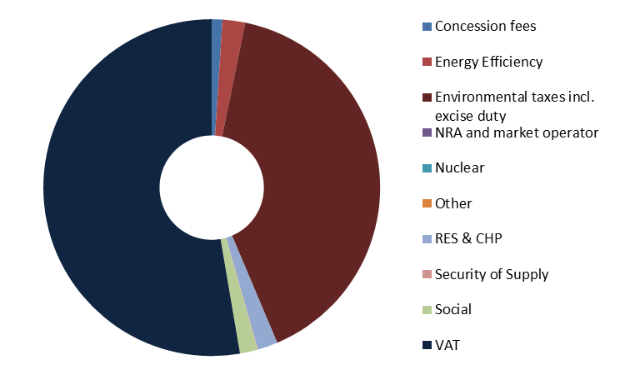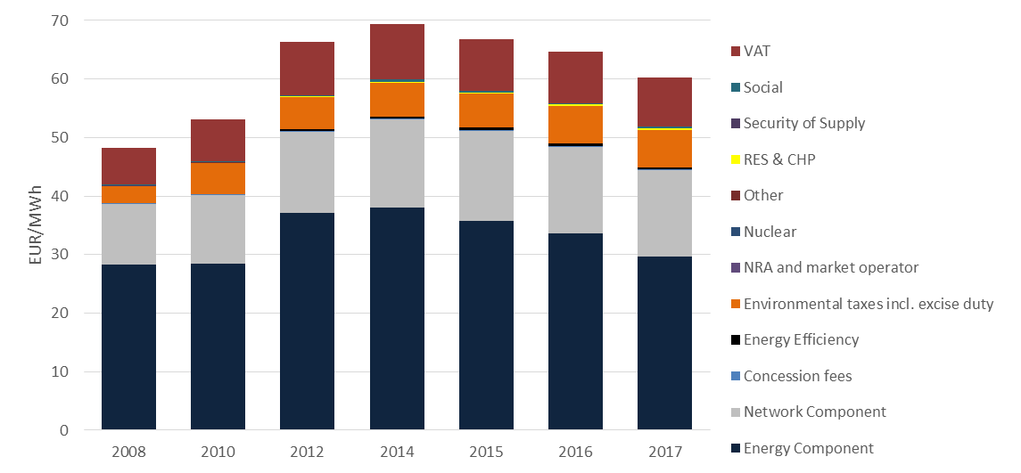

Figure 53 - Composition of EU taxes on household gas prices

Source: DG ENER in-house data collection

### Industrial Natural Gas Prices

The following chapter compares gas prices paid by industrial consumers with medium versus large annual consumption. Medium industrial consumption is defined as band I3 covering annual consumption volumes between 10 000 and 100 000 GJ. Large consumption is defined as band I5 covering annual consumption between 1 million and 4 million GJ. Median industrial (I3) prices were reported by 24 EU Member States and Turkey. The breakdown of gas prices was not reported by Greece and the United Kingdom. Large industrial prices (I5) were reported by 19 EU Member States and Turkey (in other countries there are either no consumers in this consumption band or data is confidential). Figures for the United Kingdom are Commission estimates both for I3 and I5 prices.

**Evolution Industrial Gas Prices**

**The observation period 2008 to 2017 conceals two distinct periods for both consumer types: Prices grew from 2008 to 2012 and have been on a decreasing trajectory ever since. Looking at the whole of the last decade, the median industrial price decreased at the annual rate of 0.4%. The large industrial price contracted even faster, by 1% annually. Inflation during the same period averaged at 0.5%**[27]**. In absolute terms the I3 price fell from 30 to 29 EUR/MWh by 2017. The I5 price decreased from 25 to 23 EUR/MWh. In 2017 Belgium reported the smallest I3 price and Sweden the largest. The ratio of the largest to smallest price across the EU increased by 22% since 2008 and reached almost 3:1 by 2017. The largest price for I5 consumers was also reported by Sweden, the smallest by Romania with a ratio of 3:1 in 2017. This ration decreased by 17% over the last decade. The convergence indicates progress towards the completion of the internal energy market.**

**Composition of Industrial Gas Prices**

**Over time the composition of industrial gas prices also changed, albeit to a different extent for the two consumer types. In 2008, the first year of our observation period, the energy component accounted for 82% of small and 85% of large industrial prices. The international price of the commodity, complemented by the commercial costs of suppliers, made up most of the final consumer price. The impact of network costs and taxes was limited. The share of the energy component decreased to 68% for small and to 81% for large industrial consumers by 2017. The 13 percentage point decrease in the composition of the I3 price is more significant than the smaller change in the I5 price. In I3 prices, the diminishing share of the energy component was taken over equally by network charges, which grew by almost 5% annually and taxes, which grew by 10% annually. Taxes increased at a higher speed, albeit from an initially lower level, reaching 4 EUR/MWh by 2017. As a result, both components grew in absolute terms by about 2 EUR/MWh in the period 2008-2017. The share of the network and taxes components grew by 6.6% and 7.7% respectively.**

**The composition of I5 prices changed less significantly as the energy component maintained its dominance accounting for over four-fifths of the price, even as it decreased in absolute terms from 21 to 18 EUR/MWh by 2017. The network component also decreased in absolute terms: large industrial consumers payed 20 Eurocents/MWh less in 2017 than they did in 2008. These network developments hold uniquely for I5 consumers among all analysed electricity and gas bands. As the share of both the energy and network components decreased, the relative weight of taxes grew from 6% to 11%, and reached 2.5 EUR/MWH in absolute terms.**

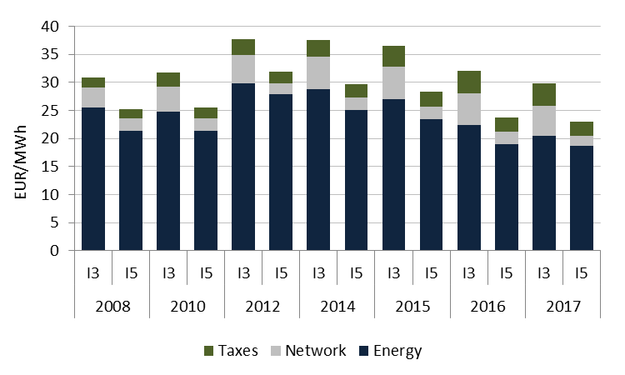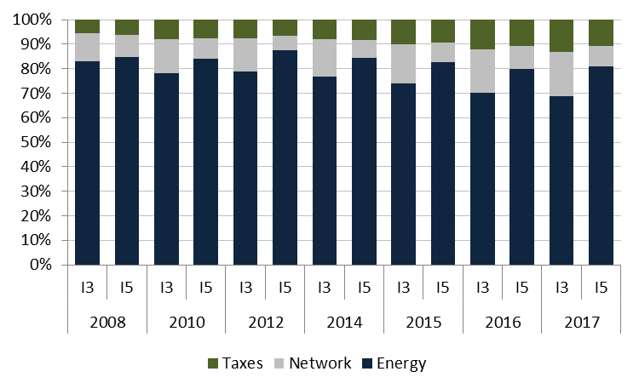

Figure 54 - Composition of EU prices for small (I3) and large (I5) industrial gas consumers

Source: DG ENER in-house data collection

**Drivers of Industrial Gas Prices**

Industrial gas prices remained dominated by the energy component, which mainly consists of the commodity price. Consequently, consumer prices followed the developments on international gas markets, albeit with a slight time lag. Between 2008 and 2010 the large energy component slightly decreased, while the initially small tax component grew by 25% for I3 consumers. From 2010 to 2012 international commodity prices gradually recovered. As a result, I3 and I5 consumer prices grew by 18% and 25% respectively. Since 2012, both prices have been on a downward trajectory. Decreases are driven by falling energy components complemented by moderate decreases in network components since 2015.

The evolution of the three components for the two consumer types (small and large industrial gas) is fairly similar. One difference is to be observed in the evolution of taxes: for small industrial gas consumers taxes kept increasing throughout the whole observation period while they started to decrease for large consumers in 2015. Price decreases are driven by the continued contraction of the energy component, in the last year accompanied by contractions in all three components for small industrial consumers.

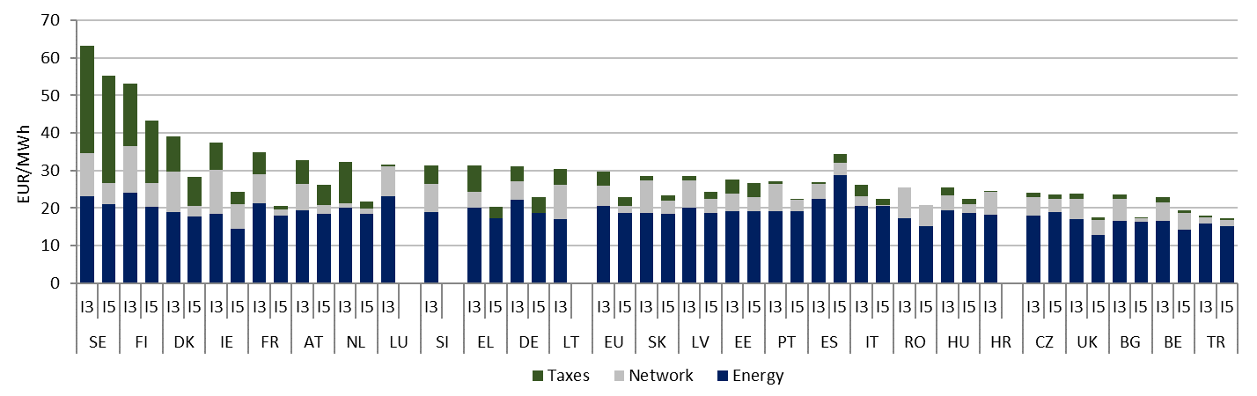

Figure 55 - Median (I3) and large (I5) industrial gas prices in 2017[28]

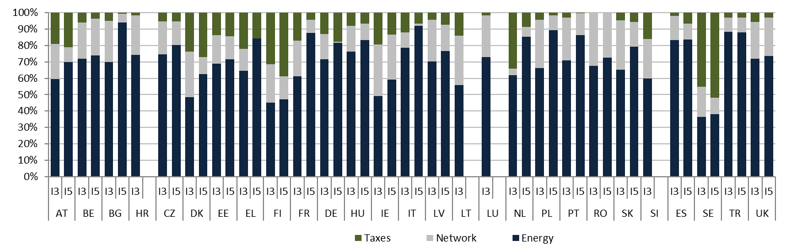

Figure 56 - Composition of median (I3) and large (I5) industrial gas prices in 2017[29]

**Composition of taxes, levies, fees and charges**

**Gas prices are generally less impacted by policy support costs and fiscal instruments than electricity prices. Also, industrial consumers benefit from exemptions and reduced tax rates in most countries. As a result, taxes accounted for only 13% and 10% of the total price for medium and large consumers respectively. In comparison, taxes made up 26% of the household gas price and 40% of the household electricity price.**

**Taxes imposed on industrial gas prices consist mostly of excise duty and other non- earmarked taxes that do not support any specific policies (shown as environmental taxes incl. excise duty on our graphs). Non- earmarked taxes made up 89% and 86% of total prices for median and large consumers respectively. The impact of renewable energy support costs remained limited at 4% and 5% of all taxes. 3 countries imposed a levy on median industrial gas prices to support renewable energy and only 1 of all reporting countries (Italy) did so for large industrial consumers.**

**Several countries however impose taxes that are both non-earmarked and non-harmonized. These taxes are non- earmarked as their revenues do not support any specific policy and non- harmonized, as their minimum levels are not regulated on EU level (minimum levels of excise duty and VAT are set by the Energy Tax Directive of 2003). Imposing non-harmonized taxes on gas prices is more common across the EU than imposing such taxes on electricity prices**

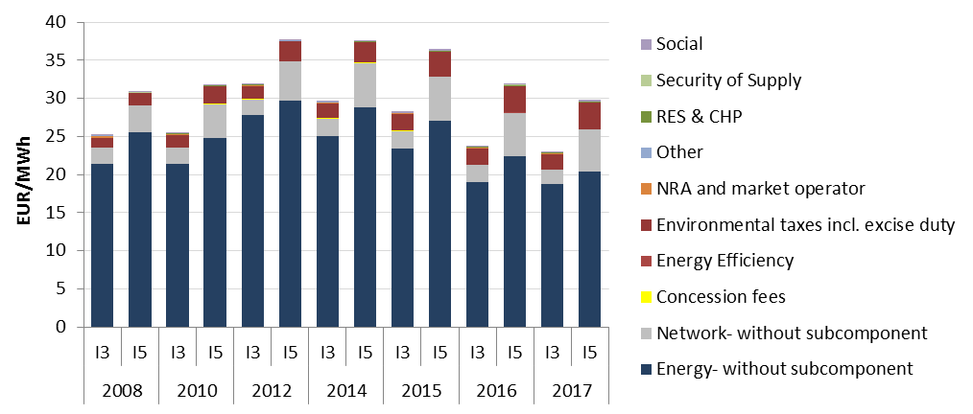

Figure 57 - Composition of EU gas prices for median (I3) and large (I5) consumers

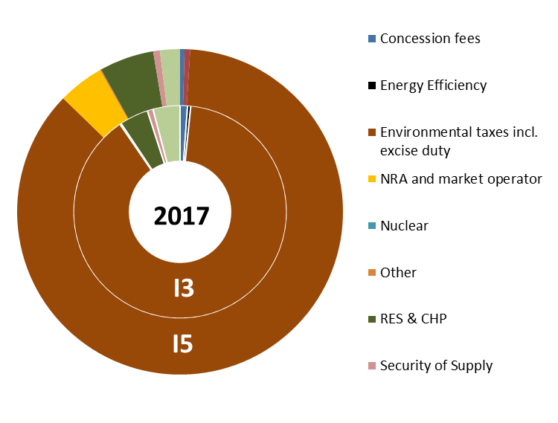

Figure 58 - Composition of taxes for median (I3) and large (I5) industrial gas consumers

### International comparisons

For a detailed explanation on the purpose and methodology of this analysis, please consult the international comparison section of the electricity chapter.

**Household Natural Gas Prices**

The EU28 average difference between retail and wholesale prices increased from 30 EUR/MWh in 2008 to 40 EUR/MWh in 2017. The difference in the US is lower, at around 20 EUR/MWh and experienced only a small increase since 2008. The small difference however allows for important conclusions in terms of the role of the components. As US wholesale prices have declined significantly, the share of the other components in the total price must have increased.

The difference in Japan has declined over the period from more than 120 EUR/MWh to around 80 EUR/MWh but remains around twice as high as EU average levels. The price difference in China fluctuates between low and negative levels (+/- 10 EUR/MWh) indicating that Chinese households don’t pay the full cost of their natural gas use. For all other G20 countries) the difference is lower than the EU28 average. In Mexico (MX) and Turkey (TR) there is only a very small difference, indicating that prices are regulated at low levels. The difference in Russia, Canada and Brazil is also lower, in the range of 20 EUR/MWh . Only in South Korea is the difference closer to the EU level. In Argentina the prices difference is negative, highlighting indicating that households pay subsidized prices that do not cover the full costs of their natural gas use.

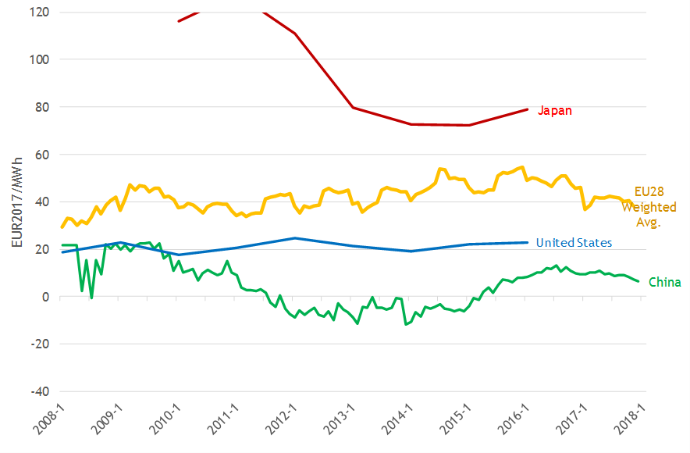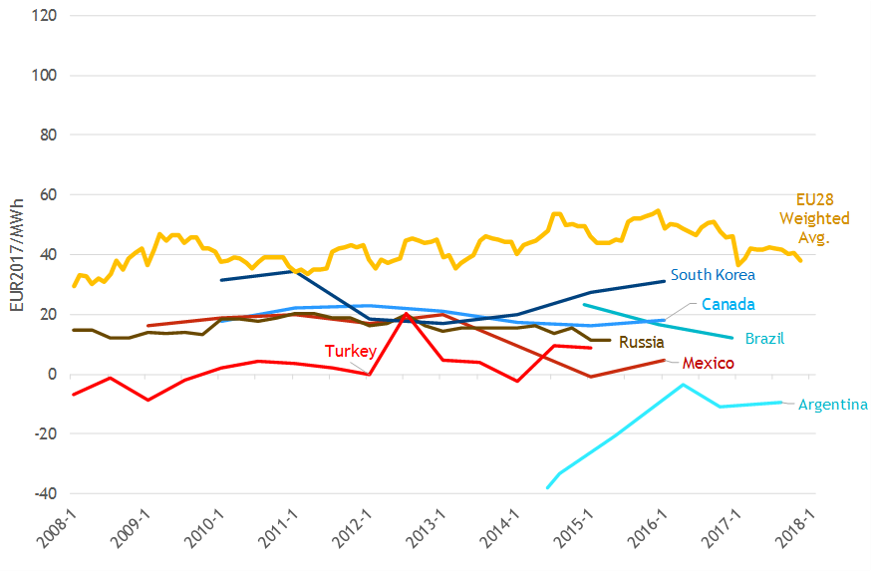

Figure 59 - Difference between household retail natural gas prices and wholesale prices, EU28 and trading partners

Source: Trinomics et altri study

**Industrial Natural Gas Prices**

The EU28 average difference between industrial retail and wholesale remained at 5 EUR/MWh between 2008 and 2017. The difference in the US is slightly lower than in the EU28 difference in Japan has been greater than EU, but has substantially converged since 2011. The price difference in China has been greater than in the EU and finished the period at around 15 EUR/MWh. In both Japan and China this reflects both wholesale and retail prices that are similar or higher than in the EU.

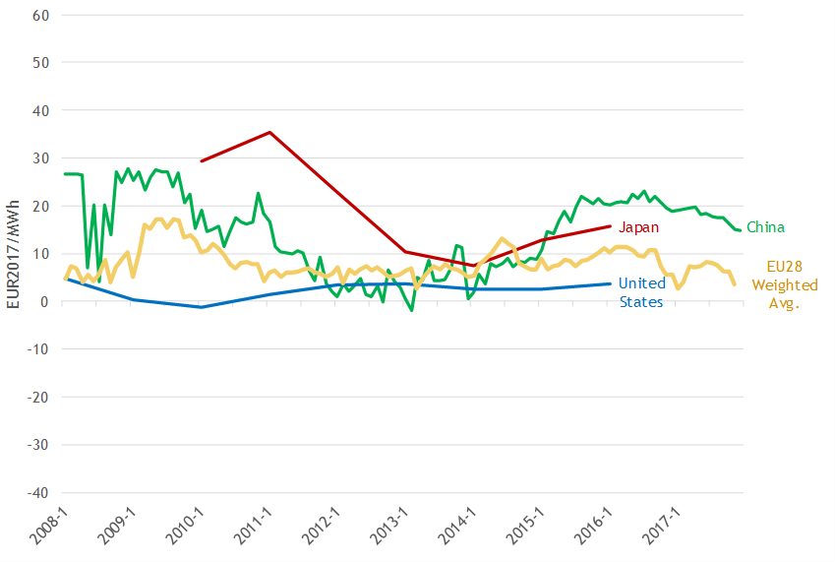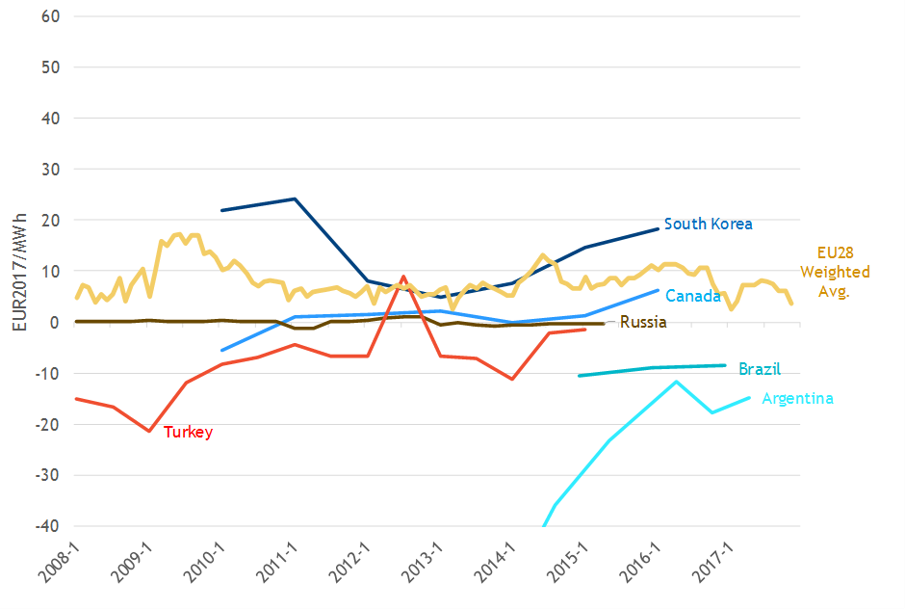

Figure 60 - Difference between industrial retail natural gas prices and wholesale prices, EU28 and trading partners

1. COM(2016) 860
2. COM(2018) 773
3. COM(2018) 796
4. <https://ec.europa.eu/energy/sites/ener/files/documents/platts_report_final_version_rrr.pdf>
5. At the end of November 2018 the was around 19 €/MtCO2e
6. Simple averages of the analysed bands.
7. Weighted average “Most representative” price.
8. 'Industrial' consumers are currently referred to in Eurostat statistics as 'Non-households' consumers
9. National tariff equalization enables consumers on isolated island energy systems to pay prices similar to those on mainland France.
10. Graphs in the body of the report as well as in the French graphical country profile display a RES levy of around 18 EUR/MWh for households and 3.4 EUR/MWh for large industrial consumers in 2015. This is due to a late data revision request by the French Ministry of Ecology, Sustainable Development and Energy that could no longer be reflected on our graphs. This box contains the updated data.
11. Combined excise duty and local tax
12. Combined excise duty and local tax
13. VAT and non- earmarked taxes are not considered energy policy relevant as their revenues not necessary support energy or climate policies.
14. Data is available for the United Kingdom until 2015.
15. According to Directive 2008/92/EC of the European Parliament and of the Council: Industrial end-user may include other non-residential users.
16. Final Energy Consumption in 2016, ESTAT: nrg_110a
17. Eurostat Producer Price Index,  [(sts_inppd_a)](http://ec.europa.eu/eurostat/product?code=sts_inppd_m&language=en&mode=view)
18. For more information on factors determining the energy component and on non- interconnected island systems, please consult the corresponding section of the household electricity chapter.
19. No 2016 data available for Greece and the United Kingdom.
20. Data is available for the United Kingdom until 2015. From 2016 onwards Commission estimates are used as substitutes.
21. Eurostat Producer Price Index (sts_inpp_ma)
22. Source: Eurostat (http://ec.europa.eu/eurostat/web/energy/data/energy-balances)
23. Energy prices, costs and subsidies and their impact on Industry and Households (2018) by Trinomics et altri (2018)
24. Average of the 3 analysed natural gas consumption bands (D2,I3,I5).
25. Average of the two analysed industrial bands (I3,I5).
26. Final Energy Consumption in 2016, ESTAT: nrg_110a
27. Eurostat Producer Price Index (sts_inpp_a)
28. Energy Component for Greece includes also network charges
29. Energy Component for Greece includes also network charges