

List of Country sheets

Austria 107

Prices 107

Financial support interventions 110

Belgium 111

Prices 111

Financial support interventions 114

Bulgaria 115

Prices 115

Financial support interventions 118

Croatia 119

Prices 119

Financial support interventions 122

Cyprus 123

Prices 123

Financial support interventions 126

Czech Republic 127

Prices 127

Financial support interventions 130

Denmark 131

Prices 131

Financial support interventions 134

Estonia 135

Prices 135

Financial support interventions 138

Finland 139

Prices 139

Financial support interventions 142

France 143

Prices 143

Financial support interventions 146

Germany 147

Prices 147

Financial support interventions 150

Greece 151

Prices 151

Financial support interventions 154

Hungary 155

Prices 155

Financial support interventions 158

Ireland 159

Prices 159

Financial support interventions 162

Italy 163

Prices 163

Financial support interventions 166

Latvia 167

Prices 167

Financial support interventions 170

Lithuania 171

Prices 171

Financial support interventions 174

Luxembourg 175

Prices 175

Financial support interventions 178

Malta 179

Prices 179

Financial support interventions 182

Netherlands 183

Prices 183

Financial support interventions 186

Poland 187

Prices 187

Financial support interventions 190

Portugal 191

Prices 191

Financial support interventions 194

Romania 195

Prices 195

Financial support interventions 198

Slovakia 199

Prices 199

Financial support interventions 202

Slovenia 203

Prices 203

Financial support interventions 206

Spain 207

Prices 207

Financial support interventions 210

Sweden 211

Prices 211

Financial support interventions 214

United Kingdom 215

Prices 215

Financial support interventions 217

Norway 218

Prices 218

Financial support interventions 220

Montenegro 221

Prices 221

Turkey 223

Prices 223

Content

This annex contains country *energy prices and costs* factsheets of the 28 EU Member States, Norway, Montenegro and Turkey. Where available, each factsheet displays information about the level of electricity, gas and oil prices in 2017 as well as about the main components of such prices, including a detailed breakdown of the taxes and levies charged to gas and electricity prices. Information about the presence of price regulation and social tariffs in each country are also included in the price section of the factsheet.

The factsheets also contain an account of the relative importance of energy costs in production costs for industry and services for the EU Member States over 2008-2016. Finally, financial support interventions to energy products across countries are also presented with a breakdown indicating the economic sectors and energy technologies that receive that support.

**Details**

The purpose of annex 3 is to provide an overview of gas and electricity prices and costs for each country analysed.

In the first page, electricity and gas prices in 2017 are shown at national level in comparison with their respective neighbour countries and the EU average. Electricity and Gas prices for Households are shown first, followed by electricity and gas prices for Industry. Then the evolution of electricity and gas prices from 2008 to 2017 is presented.

In the second page, the amount of the taxes and levies included in electricity and natural gas prices across consumption bands in 2017 are listed for each country analysed. The state of play of price regulation is then presented for EU Member States. Some have already liberalised prices before 2008 and not even social tariffs were identified. For some others, the factsheet shows the relative importance of price regulation and social tariffs for households for electricity and gas (shares of consumers/consumption under price regulation and social tariffs).

In the third page, oil prices (in €/litre) are presented, showing the evolution for gasoline, diesel and heating oil prices at national level from 2008 to the first half of 2018 and compared to the EU average. VAT and other indirect taxes affecting the country's total prices are also displayed. Subsequently, energy costs shares in total production value costs for industry and services from 2008 to 2016 are shown and compared to the EU average.

The last page of each factsheet (usually page 4) includes (where available) the country's financial support interventions to energy products from 2008 to 2016. First, it shows the financial support by energy technology (electricity, renewable energy sources, heating and cooling sector, fossil fuels and all other energies) and then by the economic sectors the received the support (households, non-households, public, transport, manufacturing, energy industry, agriculture and cross sectors).

Methodology

In order to understand the price codes used for the graphs in the country sheets, please refer to the table below. Each code corresponds to a specific product (electricity or natural gas), which is related to the household or industry sectors and to a level of annual consumption.

|  |  |  |  |  |
| --- | --- | --- | --- | --- |
| Code | Product | Type | Annual consumption | Description |
| DC | Electricity | Household | 2.5 - 5 MWh | median |
| IB | Electricity | Industry | 20-500 MWh | small |
| ID | Electricity | Industry | 2000-20000 MWh | median |
| IF | Electricity | Industry | 70000-150000 MWh | large |
| D2 | Natural Gas | Household | 20-200 GJ | median |
| I3 | Natural Gas | Industry | 10000-100000 GJ | median |
| I5 | Natural Gas | Industry | 1 mil - 4 mil GJ | large |

The "Most representative" band for household consumers is defined as the consumption band accounting for the largest share in total household consumption. It is thus the band with the highest volume of electricity irrespectively of the number of consumers in the band. The most representative bands are shown for the Member States that requested so in the context of the data collection of prices undertaken by the EC for the purposes of this report. For the others only the 'DC band' is shown.

**Most representative bands by Member State**

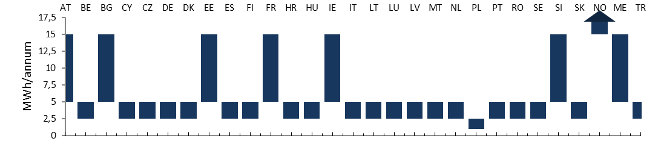

Austria 

## Prices

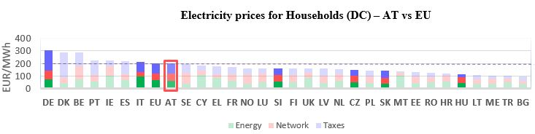

See footnote [1]

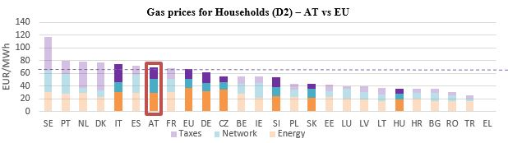

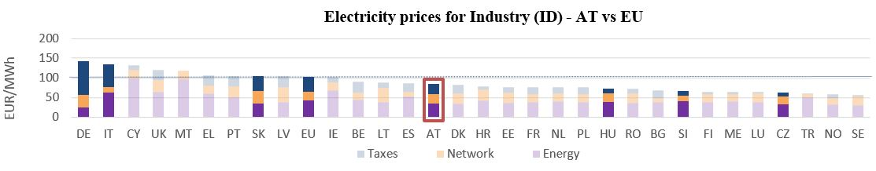

**Gas prices for Industry (I3) – AT vs EU**

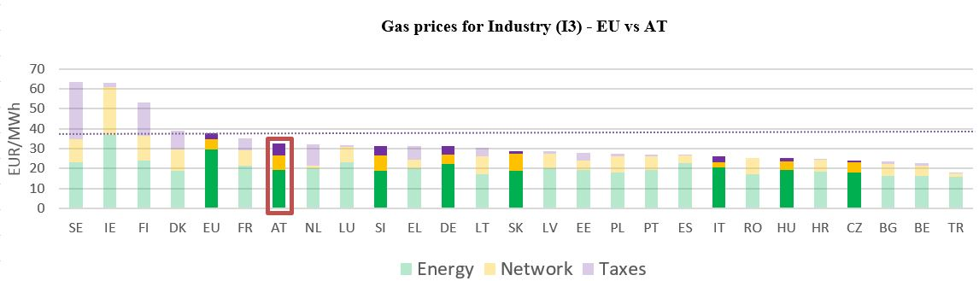

See footnote [2]

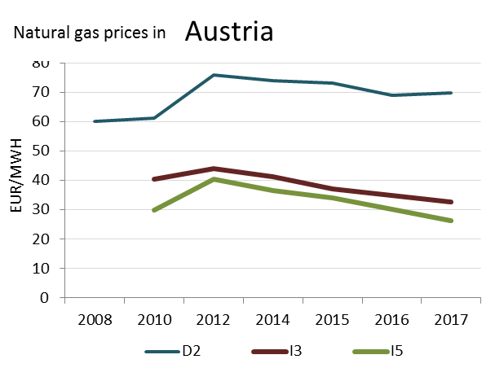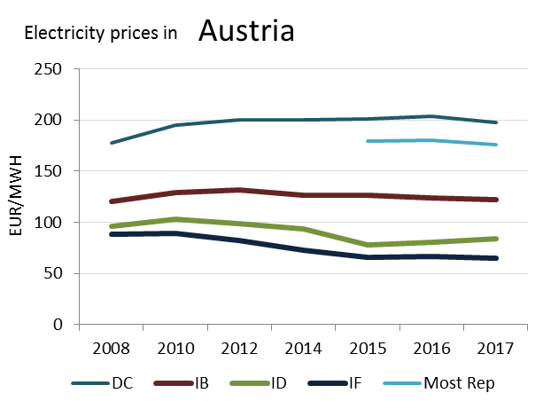

(DD)

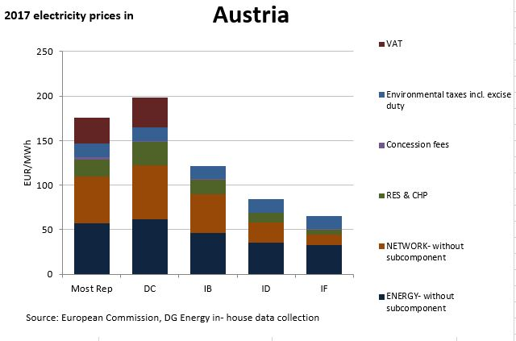

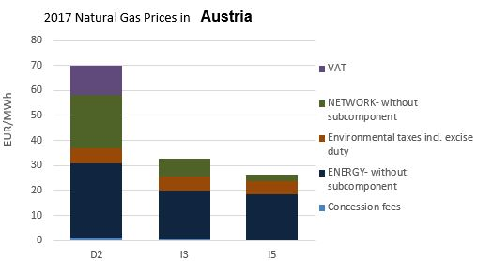

**Oil prices**

This country liberalised prices before 2008.

No social tariffs identified.

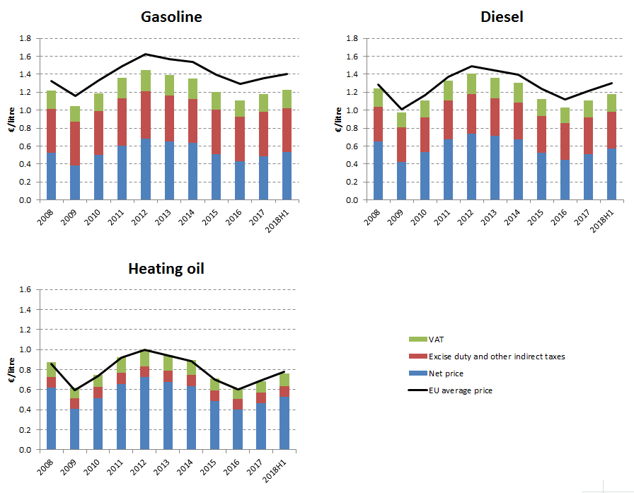

**Energy costs shares in total production costs**

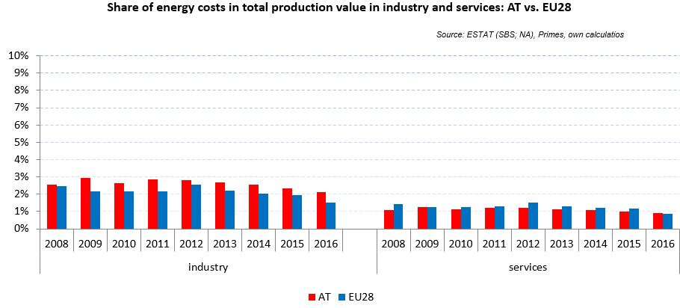

Notes: Data for Malta (prior to 2016), Poland (prior to 2015), Slovenia (prior to 2012) and Greece (prior to 2008) is not available. Data for Denmark, Sweden and the United Kingdom for 2016 was missing by the time of extraction

## Financial support interventions

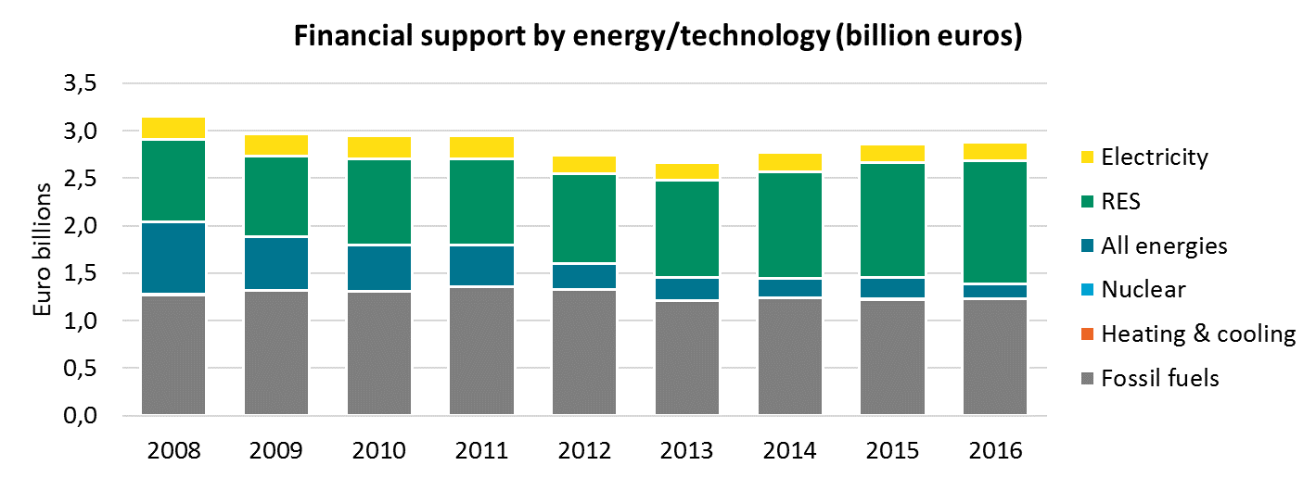

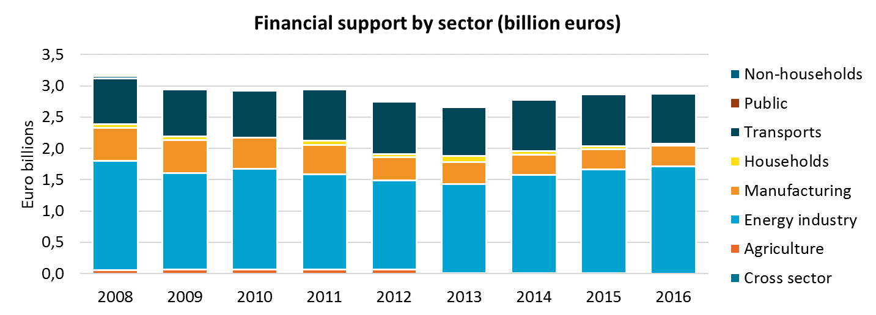

Belgium 

## Prices

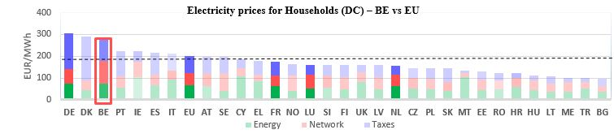

See footnote **[3]**

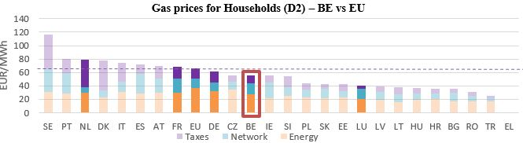

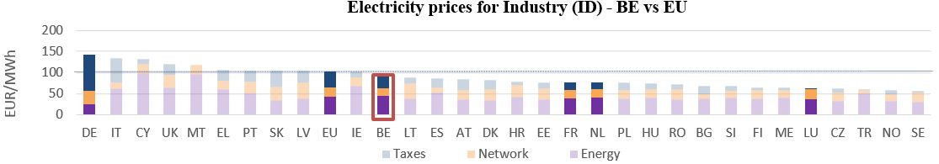

**Gas prices for Industry (I3) – BE vs EU**

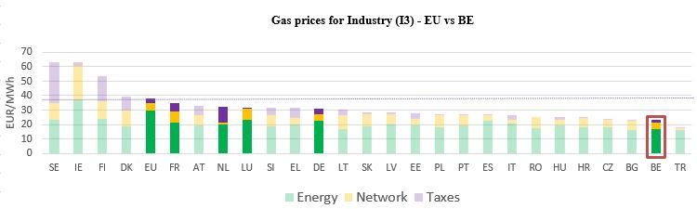



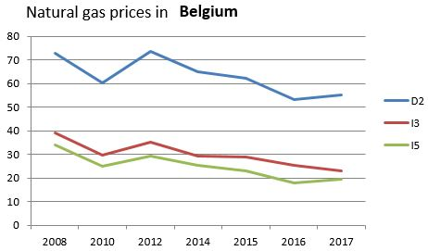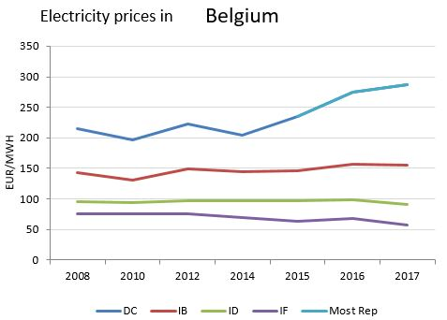 See footnote [4]

(DC)

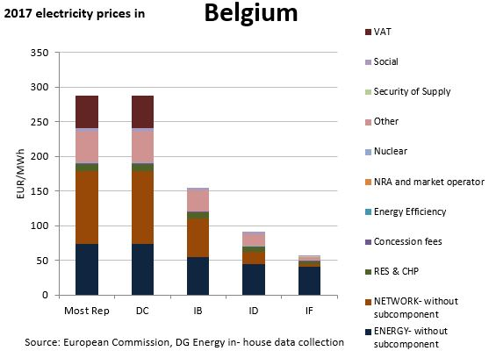

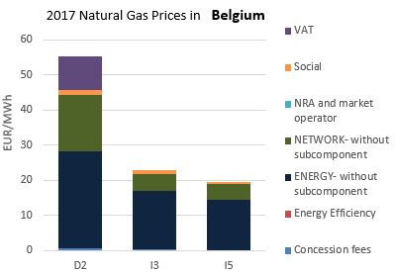

**Price regulation**

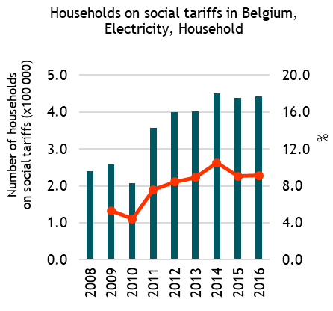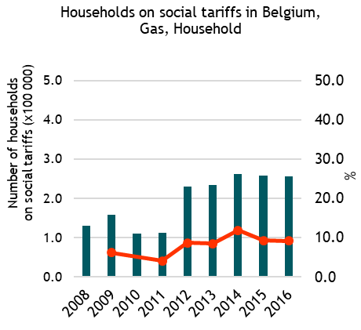

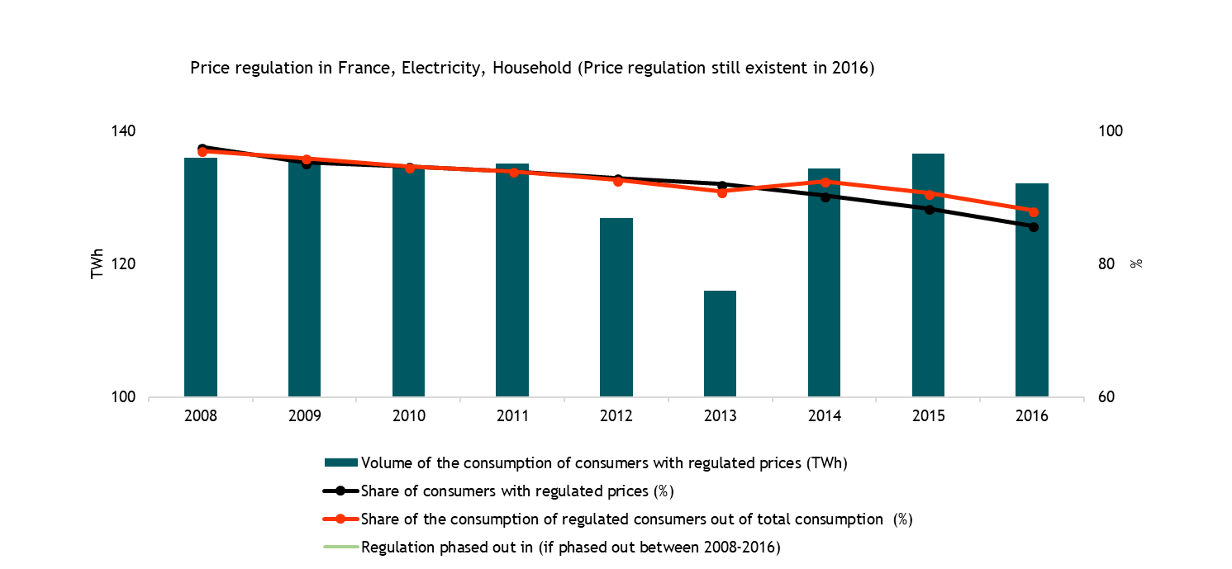

**Oil products prices**

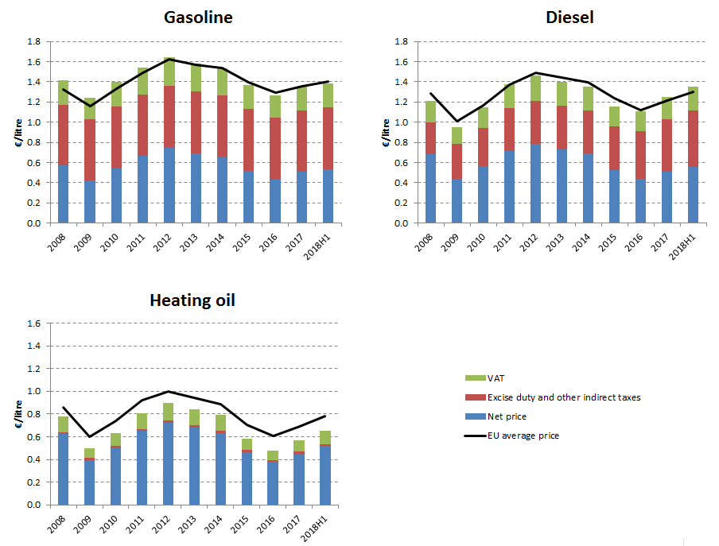

**Energy costs shares in total production costs**

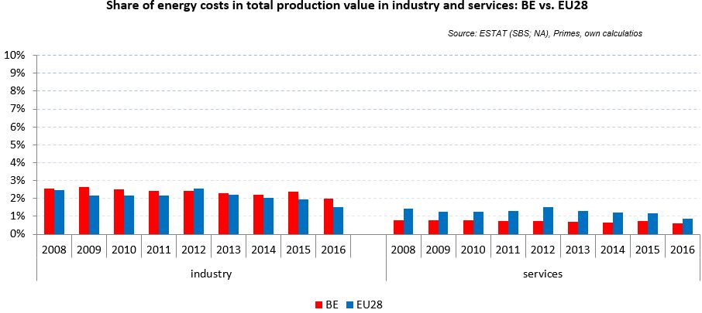

Notes: Data for Malta (prior to 2016), Poland (prior to 2015), Slovenia (prior to 2012) and Greece (prior to 2008) is not available. Data for Denmark, Sweden and the United Kingdom for 2016 was missing by the time of extraction

## Financial support interventions

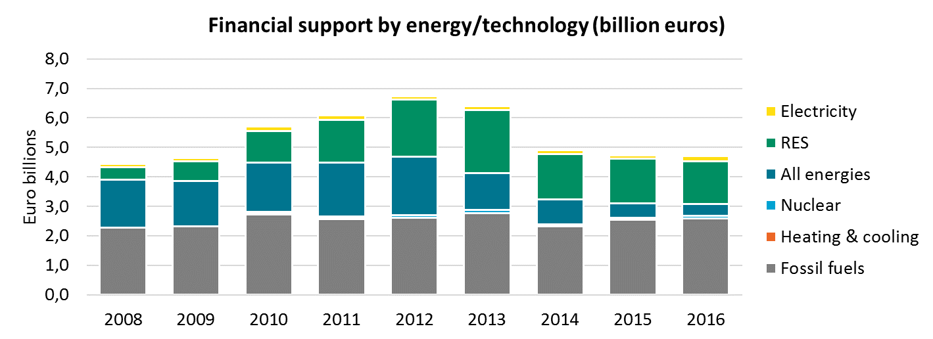

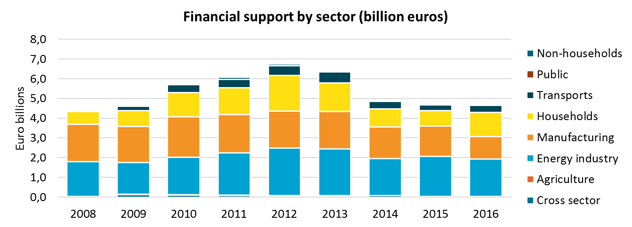

Bulgaria 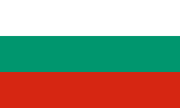

## Prices

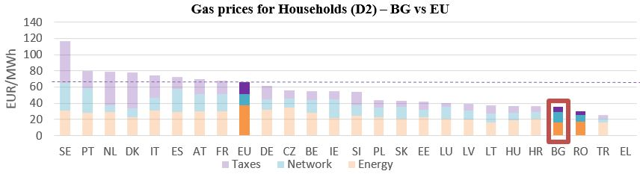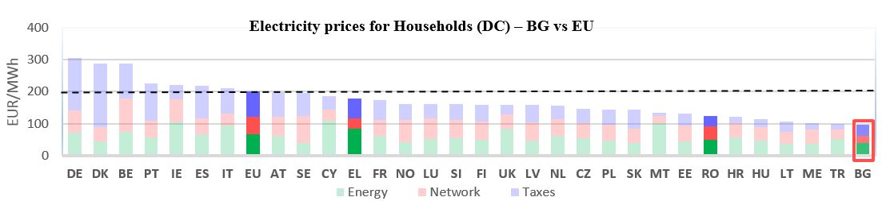 See footnote[5]

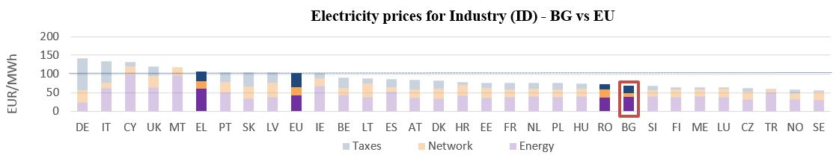

**Gas prices for Industry (I3) – BG vs EU**

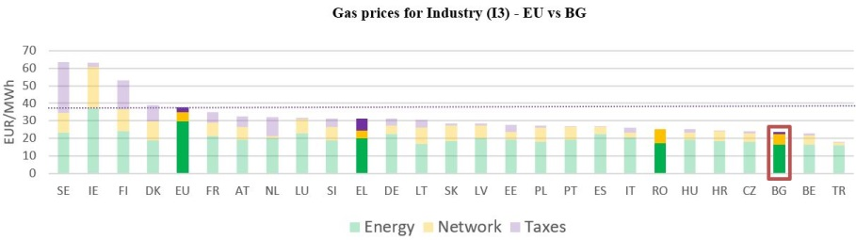

See footnote [6]



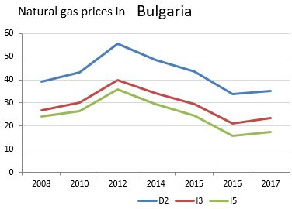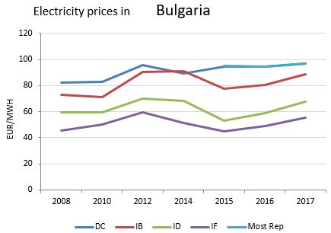

(DD)

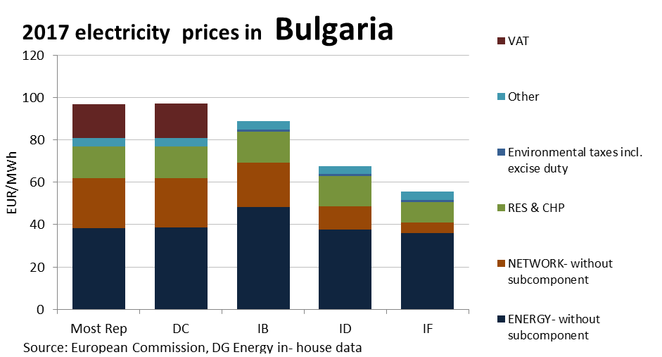

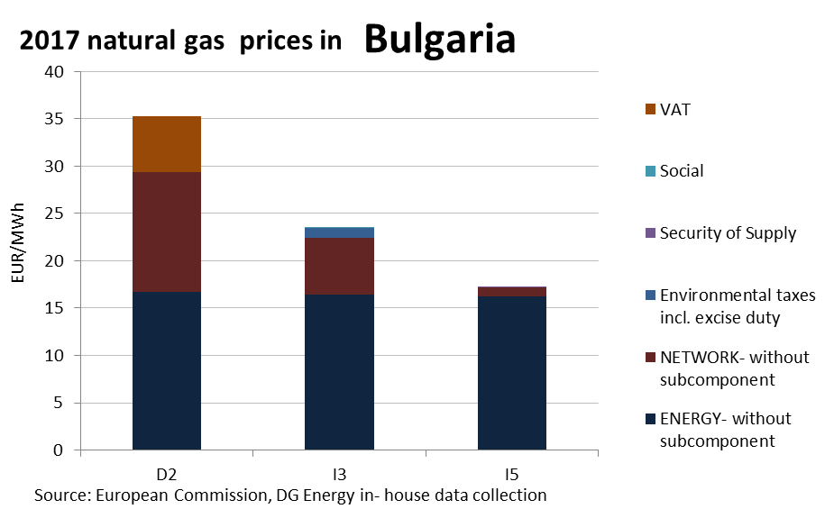

Price regulation was still existent in 2016

**Oil products prices**

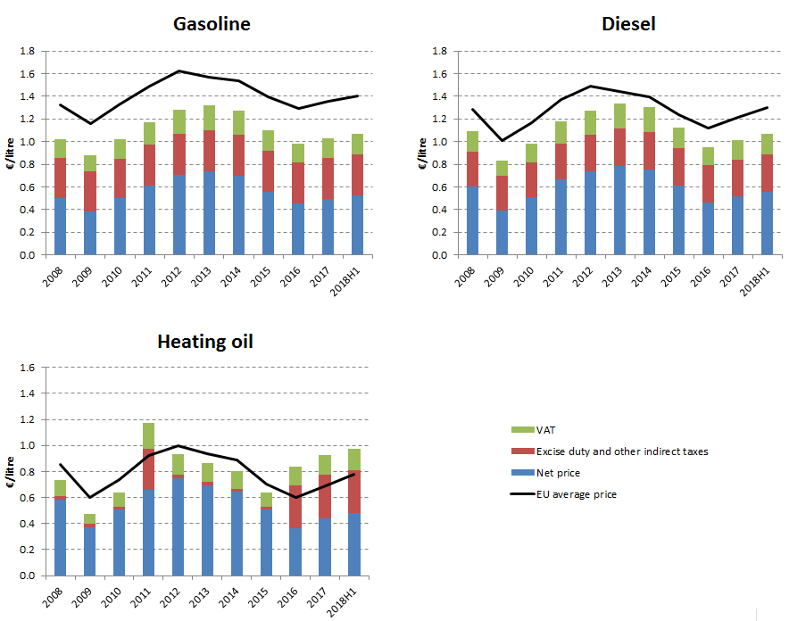

**Energy costs shares in total production costs**

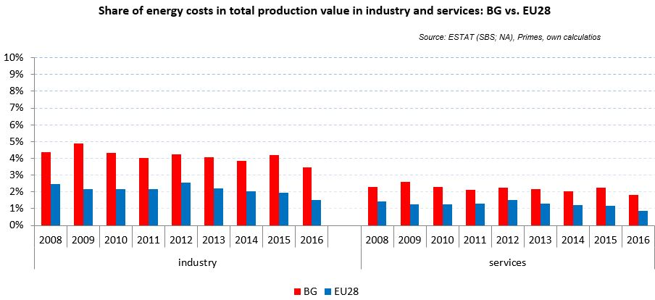

Notes: Data for Malta (prior to 2016), Poland (prior to 2015), Slovenia (prior to 2012) and Greece (prior to 2008) is not available. Data for Denmark, Sweden and the United Kingdom for 2016 was missing by the time of extraction

## Financial support interventions

Croatia 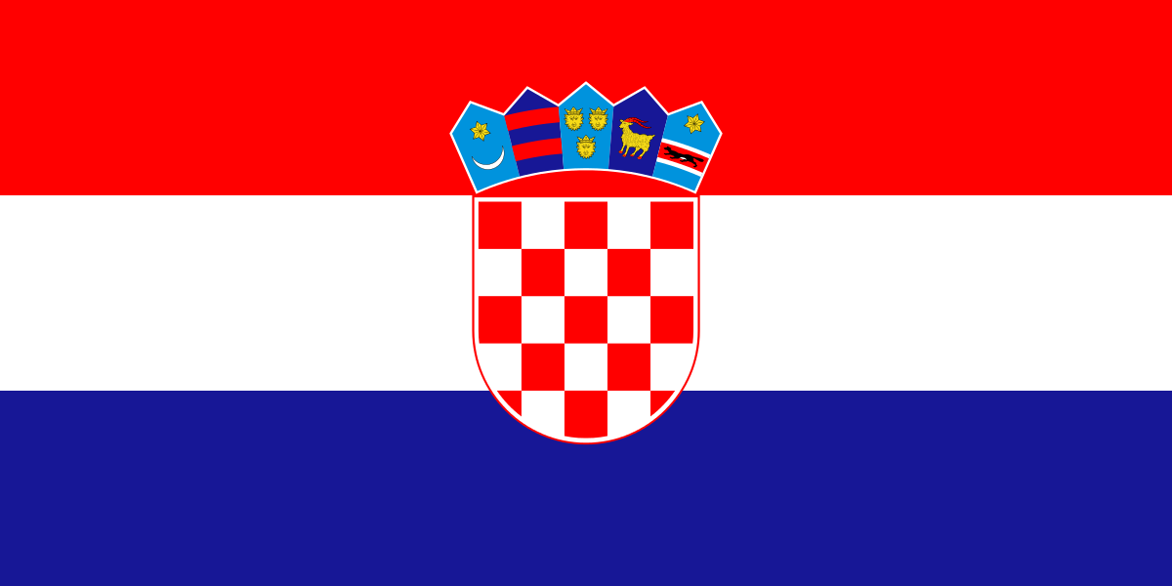

## Prices

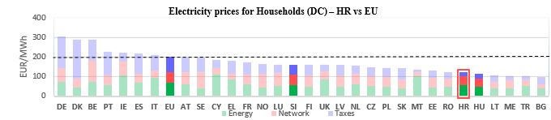

See footnote[7]

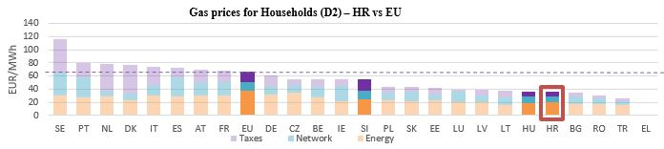

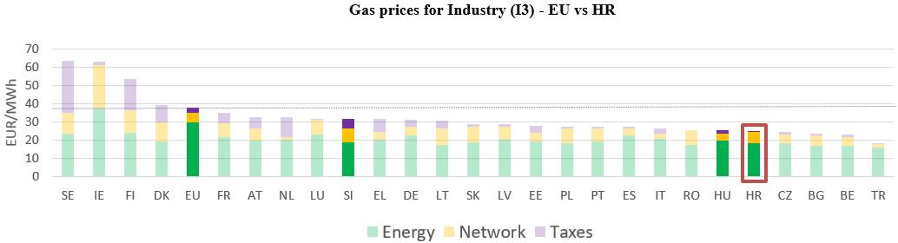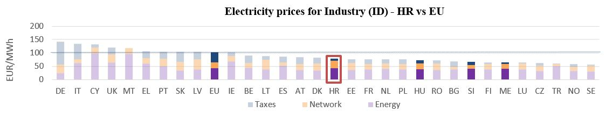

**Gas prices for Industry (I3) – HR vs EU**



 See footnote [8]

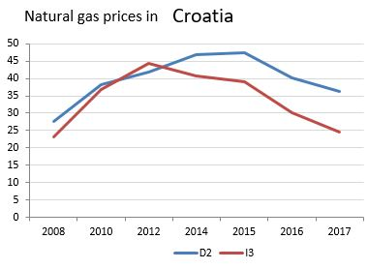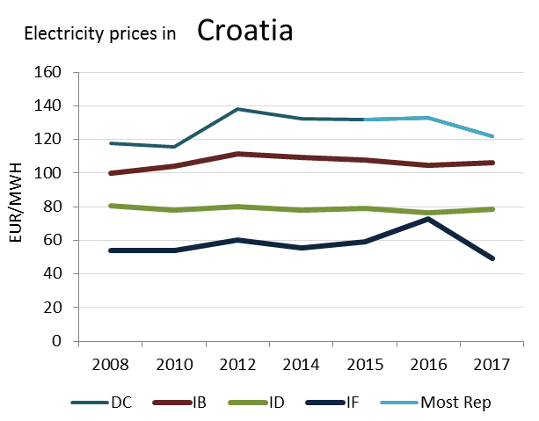

(DC)

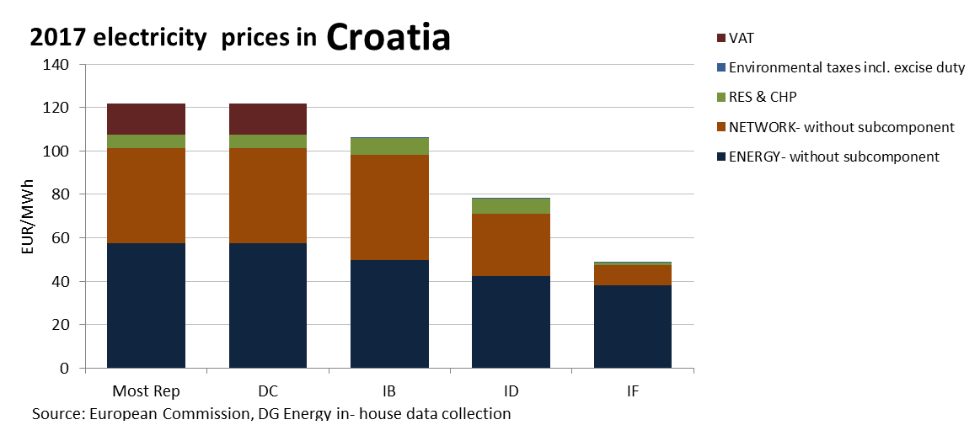

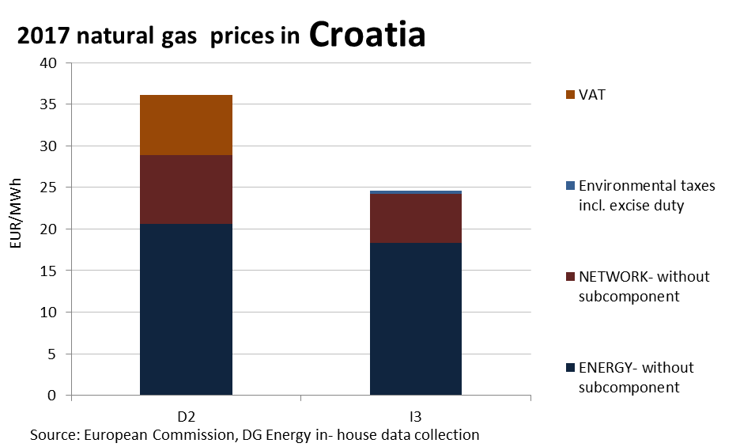

**Price regulation**

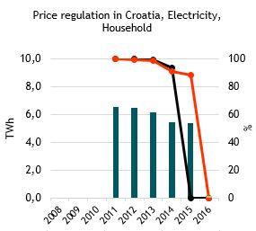



**Oil product prices**

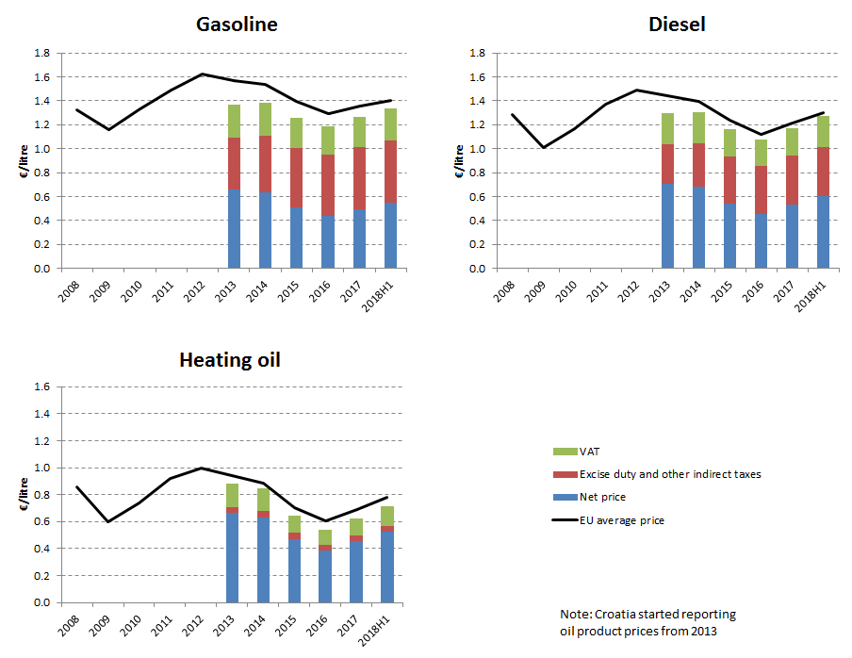

**Energy costs shares in total production costs**

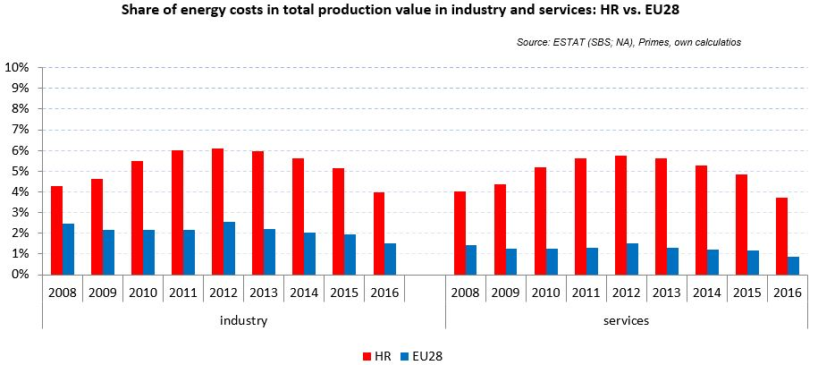

Notes: Data for Malta (prior to 2016), Poland (prior to 2015), Slovenia (prior to 2012) and Greece (prior to 2008) is not available. Data for Denmark, Sweden and the United Kingdom for 2016 was missing by the time of extraction

## Financial support interventions

Cyprus 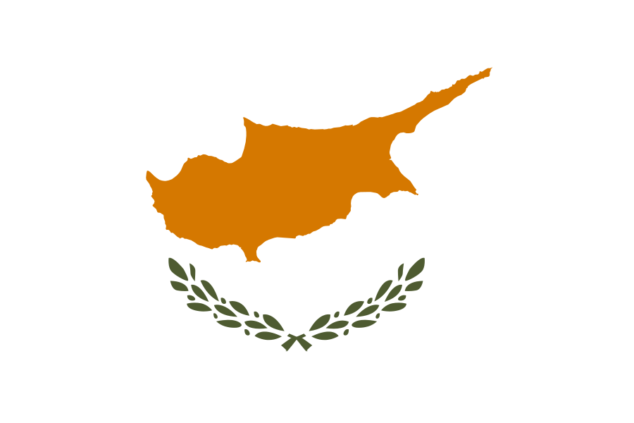

## Prices

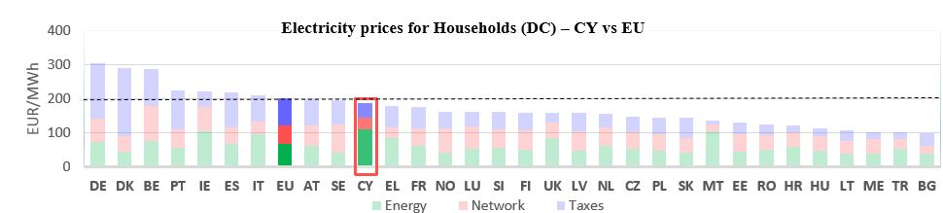 See footnote[9]

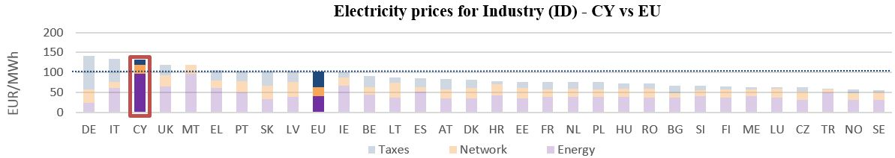



See footnote [10]

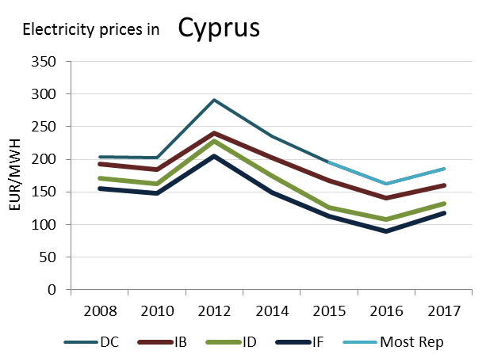

(DC)

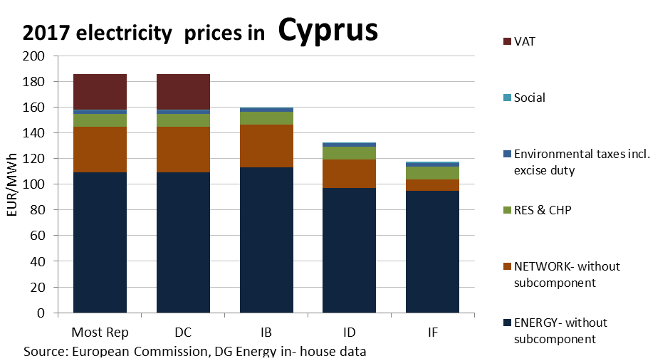

**Price regulation**

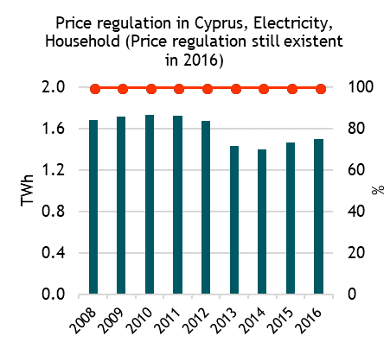

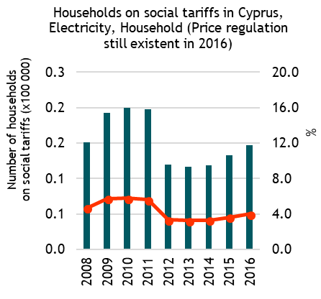



**Oil products prices**

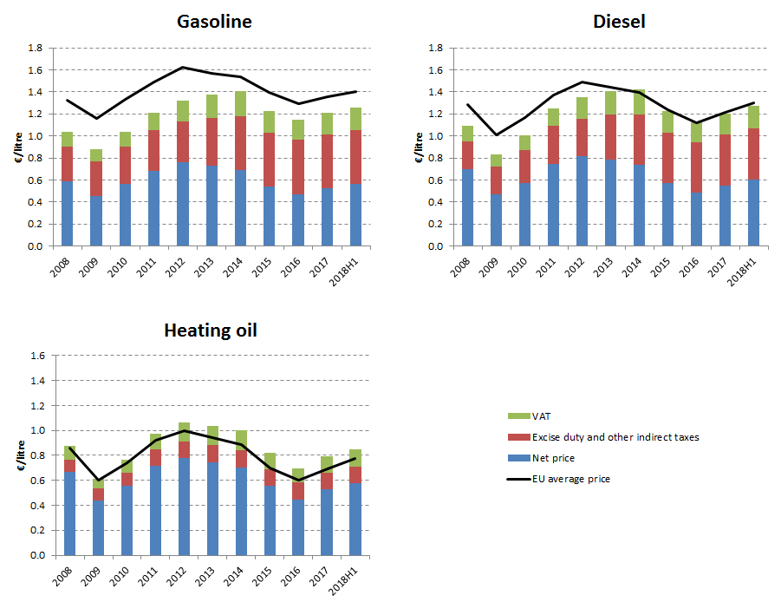

**Energy costs shares in total production costs**

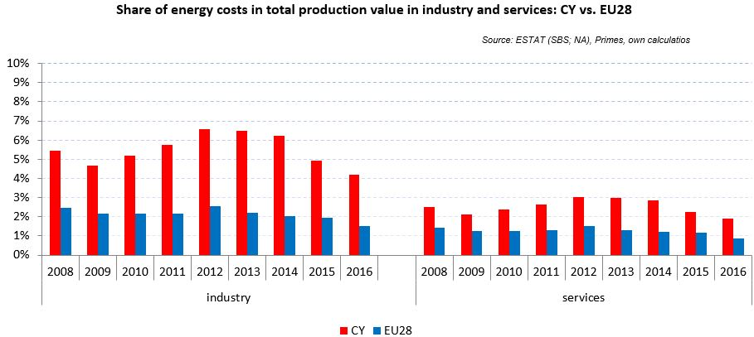

Notes: Data for Malta (prior to 2016), Poland (prior to 2015), Slovenia (prior to 2012) and Greece (prior to 2008) is not available. Data for Denmark, Sweden and the United Kingdom for 2016 was missing by the time of extraction

## Financial support interventions

Czech Republic  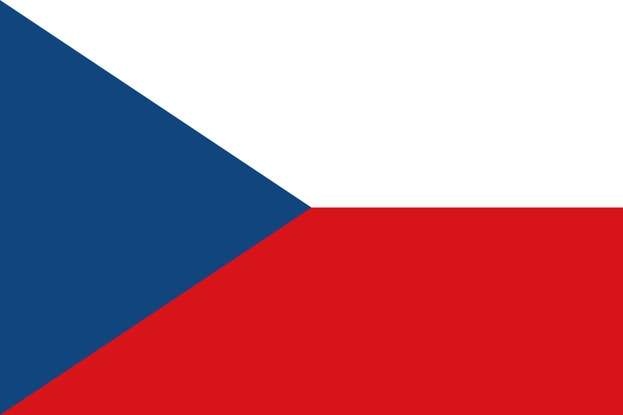

## Prices

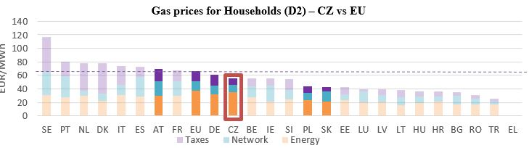 See footnote [11]

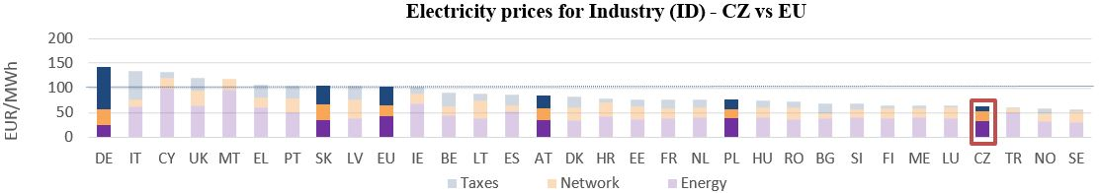

**Gas prices for Industry (I3) - CZ vs EU**

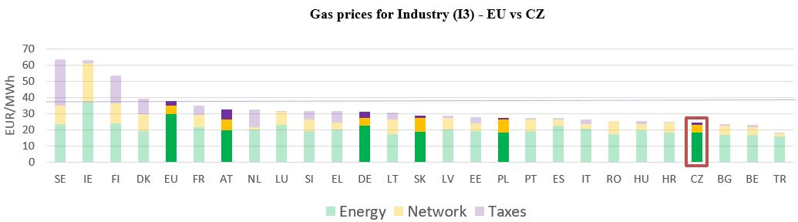

See footnote [12]

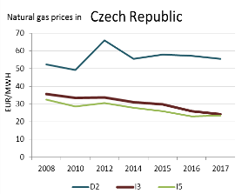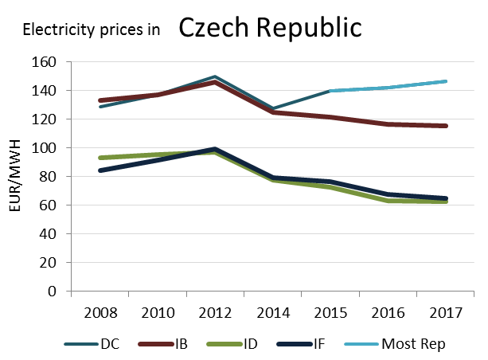

(DC)

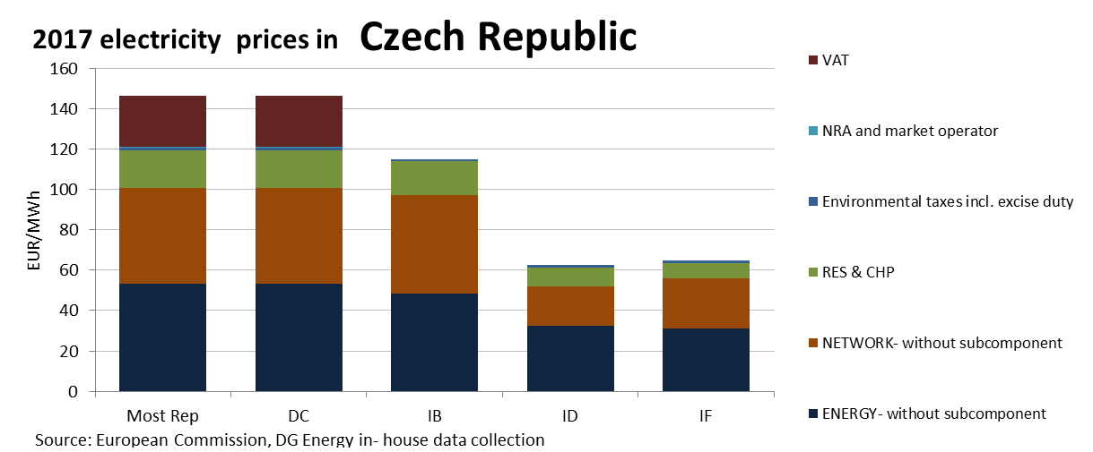

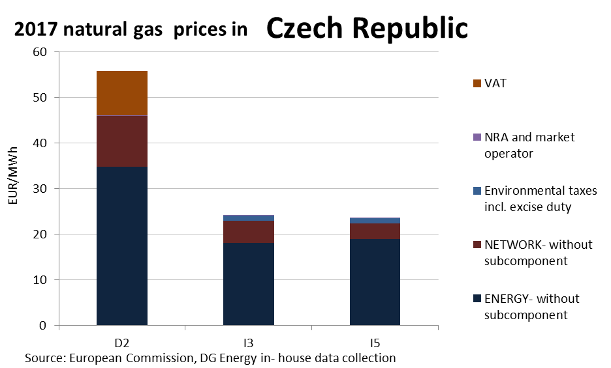

This country liberalised prices before 2008.

No social tariffs identified.

**Oil products prices**

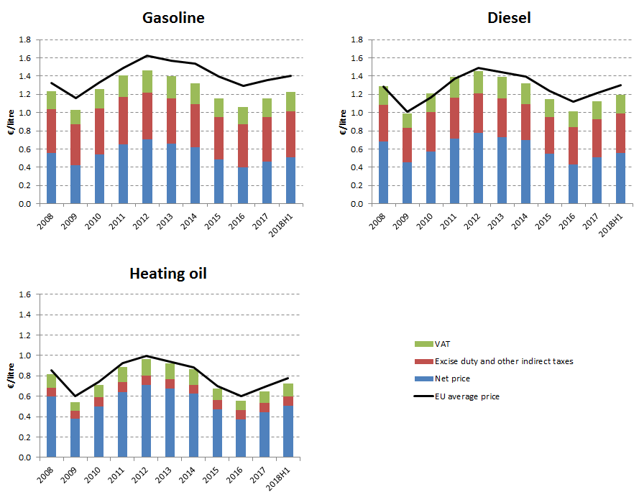

**Energy costs shares in total production costs**

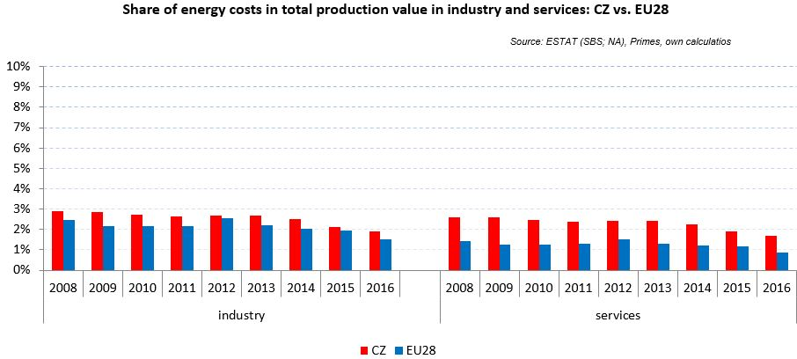

Notes: Data for Malta (prior to 2016), Poland (prior to 2015), Slovenia (prior to 2012) and Greece (prior to 2008) is not available. Data for Denmark, Sweden and the United Kingdom for 2016 was missing by the time of extraction

## Financial support interventions

Denmark 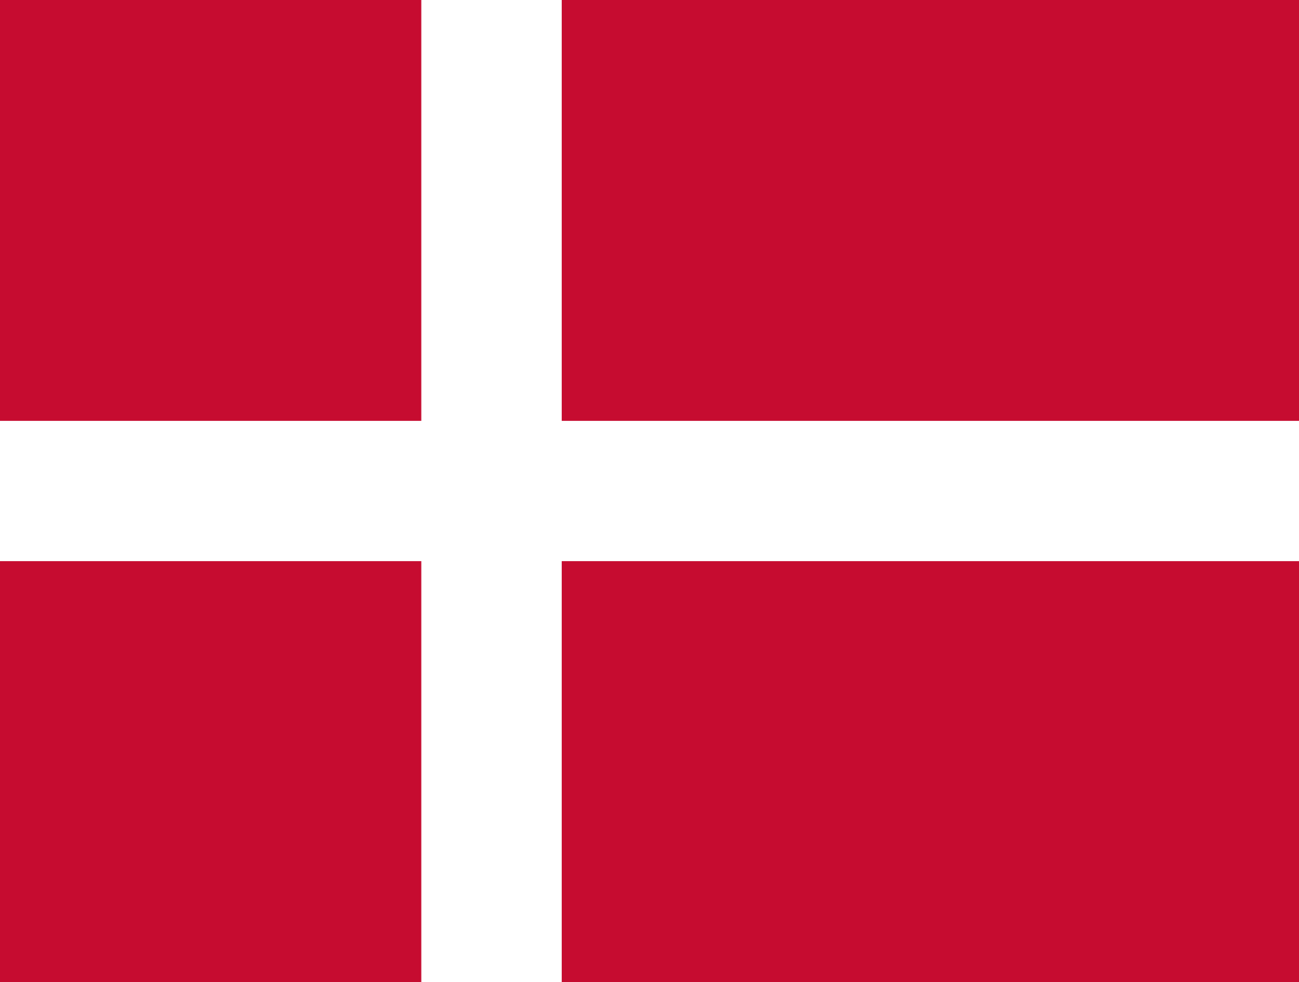

## Prices

See footnote[13]

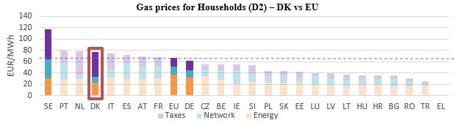

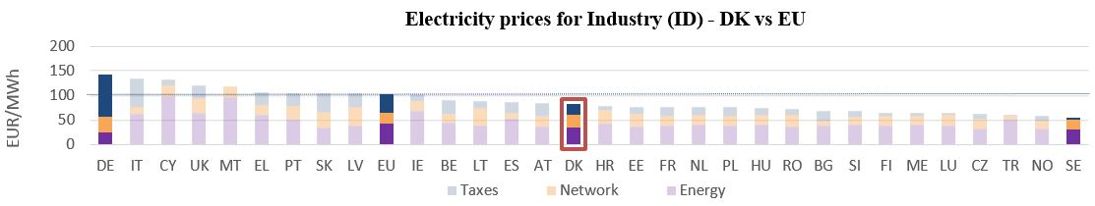

**Gas prices for Industry (I3) - DK vs EU**

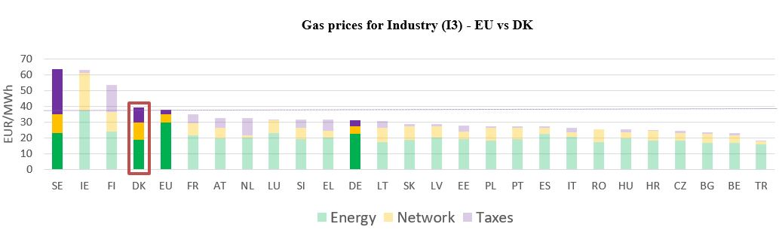

See footnote [14]

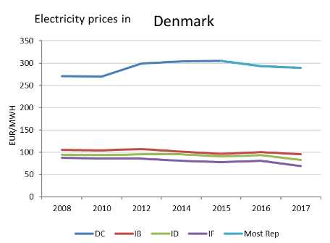

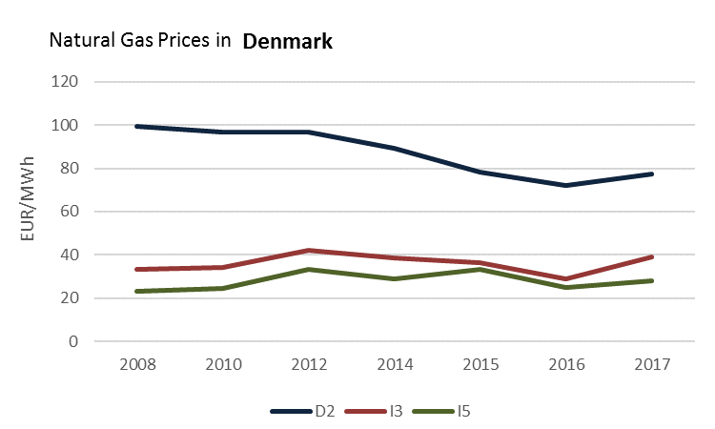

(DC)

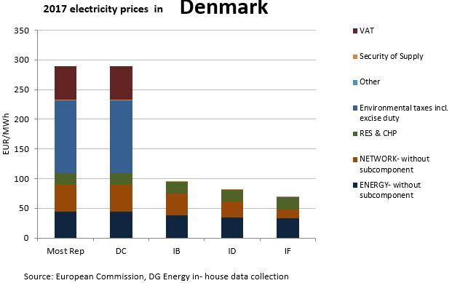

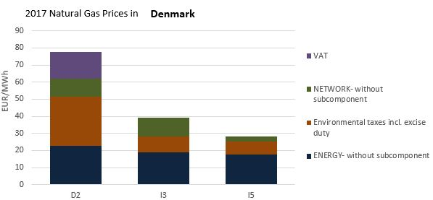

**Price regulation**

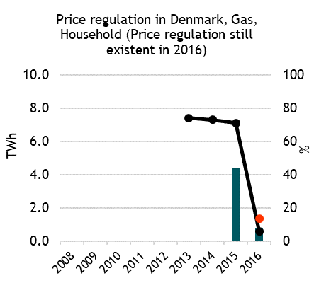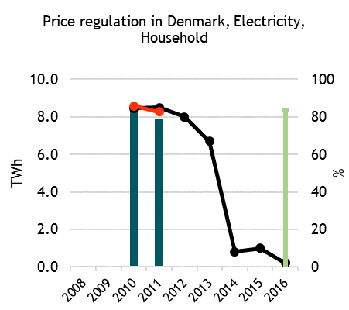



**Oil products prices**

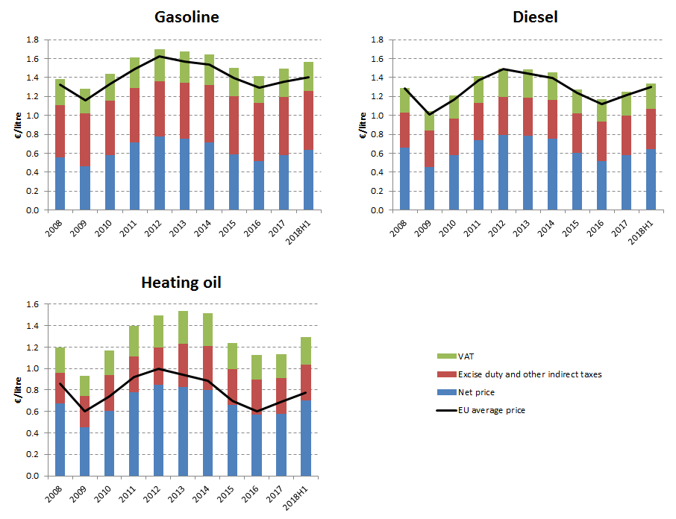

**Energy costs shares in total production costs**

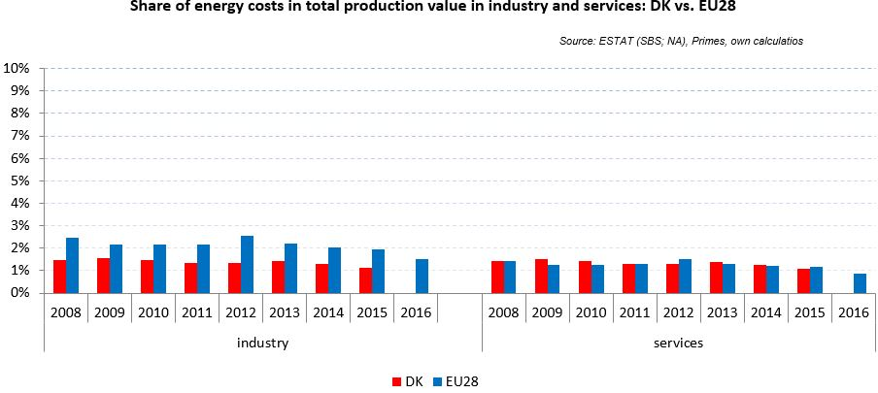

Notes: Data for Malta (prior to 2016), Poland (prior to 2015), Slovenia (prior to 2012) and Greece (prior to 2008) is not available. Data for Denmark, Sweden and the United Kingdom for 2016 was missing by the time of extraction

## Financial support interventions

Estonia 

## Prices

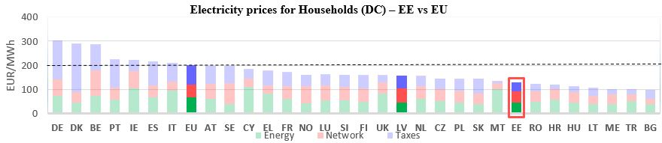 See footnote [15]

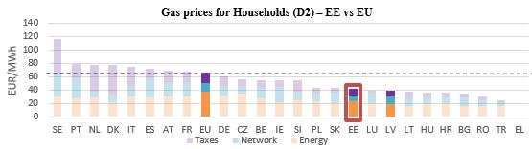

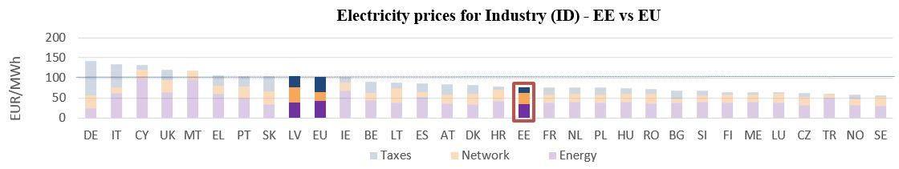

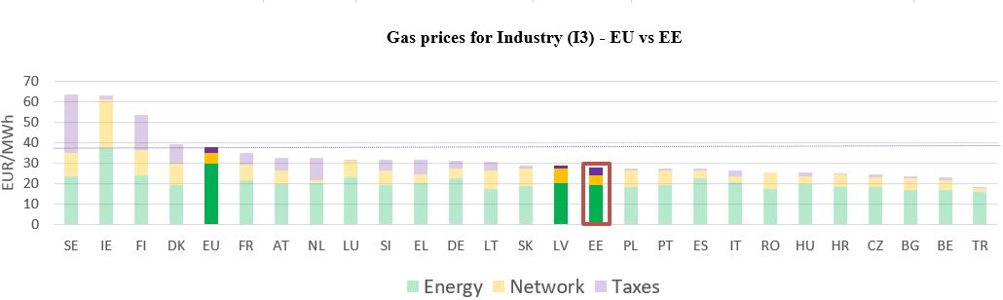

**Gas prices for Industry (I3) – EE vs EU**

See footnote [16]

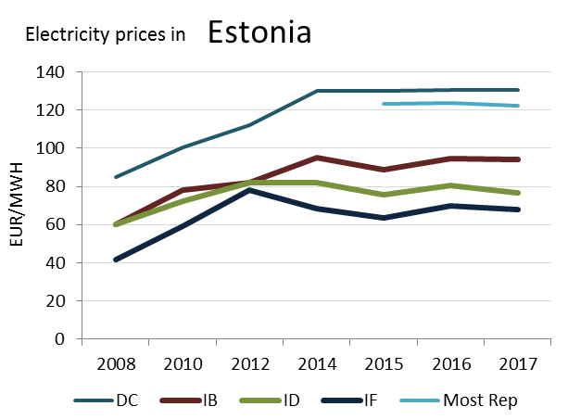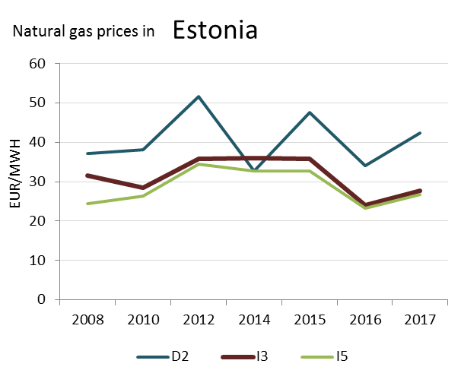

(DD)

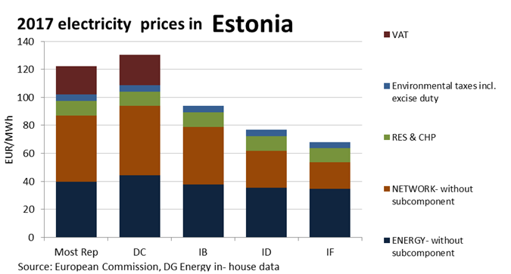

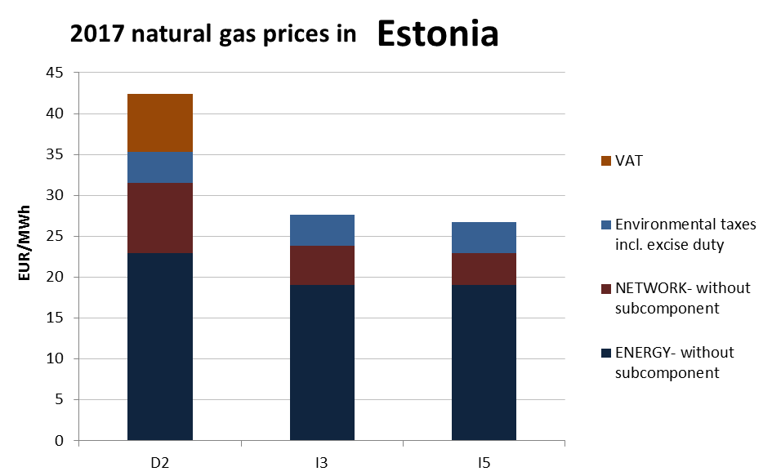

**Price regulation**

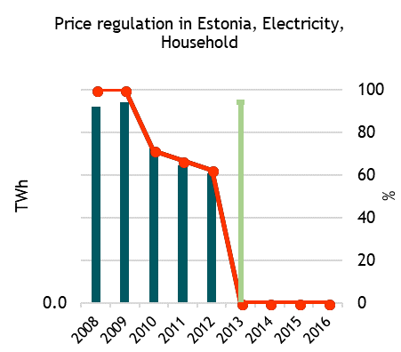



**Oil prices**

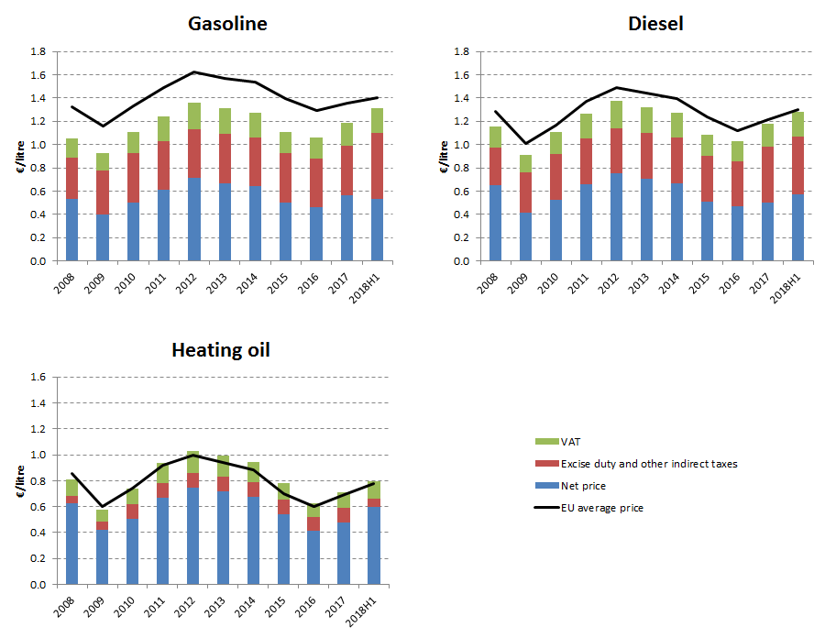

**Energy costs shares in total production costs**

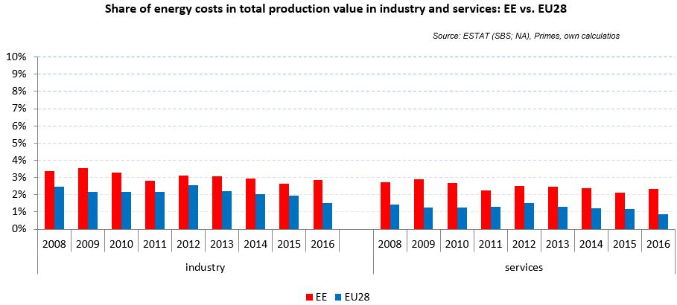

Notes: Data for Malta (prior to 2016), Poland (prior to 2015), Slovenia (prior to 2012) and Greece (prior to 2008) is not available. Data for Denmark, Sweden and the United Kingdom for 2016 was missing by the time of extraction

## Financial support interventions

Finland 

## Prices

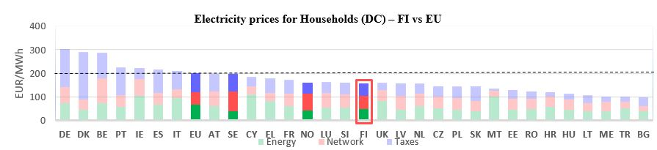 See footnote[17]

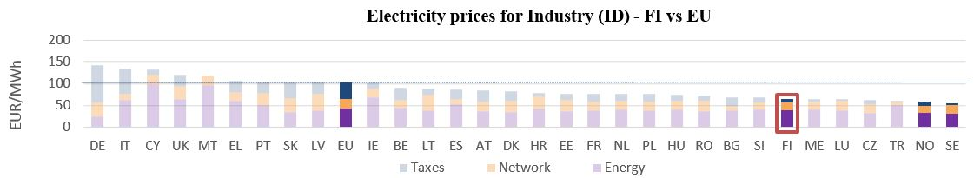

**Gas prices for Industry (I3) – FI vs EU**

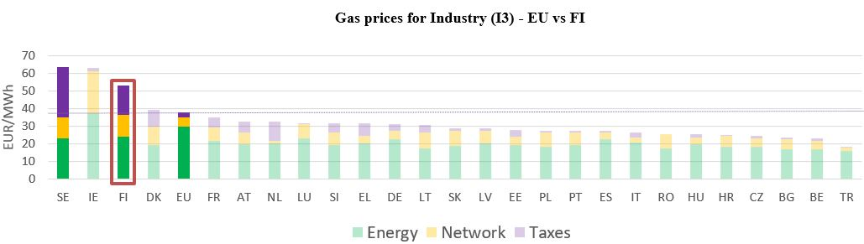



See footnote [18]

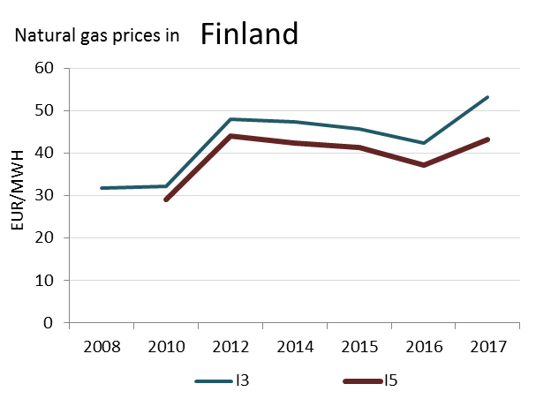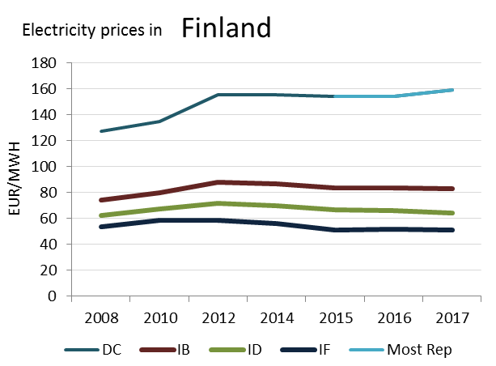

(DC)

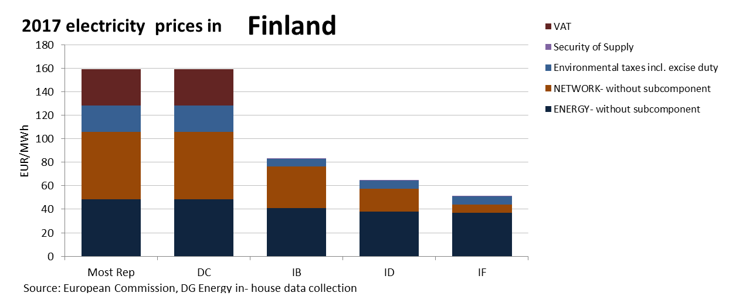

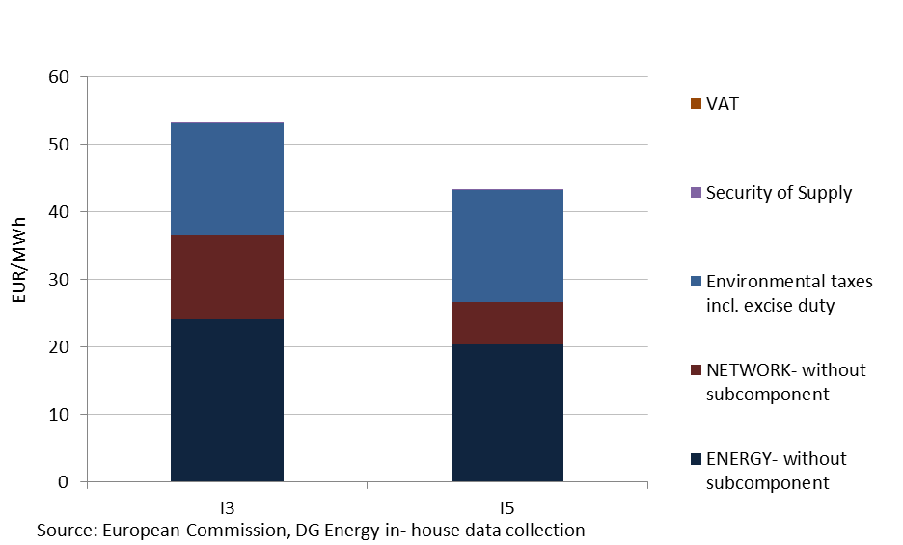

This country liberalised prices before 2008.

No social tariffs identified*.*

**2017 Natural gas prices in Finland**

**Oil products prices**

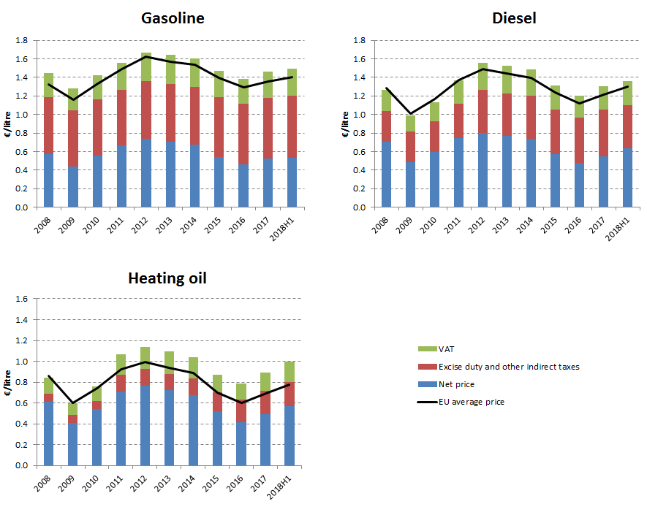

**Energy costs shares in total production costs**

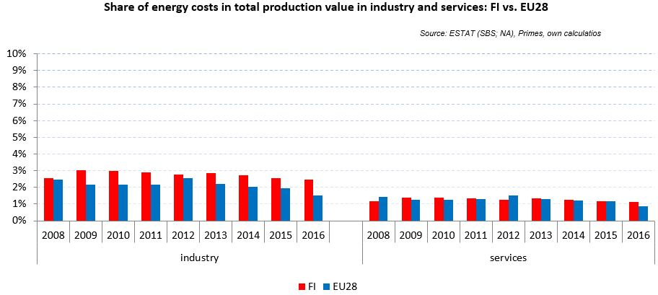

Notes: Data for Malta (prior to 2016), Poland (prior to 2015), Slovenia (prior to 2012) and Greece (prior to 2008) is not available. Data for Denmark, Sweden and the United Kingdom for 2016 was missing by the time of extraction

## Financial support interventions

1. Neighbour countries and EU 28. No gas household prices available for Greece for 2017.
2. Annual electricity consumption: DB 1 - 2.5 MWh, DC 2.5 - 5 MWh, DD 5 - 15 MWh, DE above 15 MWh, IB 20-500 MWh, ID 2000-20000 MWh, IF 70000-150000 MWh. Annual Gas consumption: D2 20-200 GJ, I3 10000-100000 GJ, I5 1 mil - 4 mil GJ.
3. Neighbour countries and EU 28. No gas household prices available for Greece for 2017
4. Annual electricity consumption: DB 1 - 2.5 MWh, DC 2.5 - 5 MWh, DD 5 - 15 MWh, DE above 15 MWh, IB 20-500 MWh, ID 2000-20000 MWh, IF 70000-150000 MWh. Annual Gas consumption: D2 20-200 GJ, I3 10000-100000 GJ, I5 1 mil - 4 mil GJ.
5. Neighbour countries and EU 28. No gas household prices available for Greece for 2017.
6. Annual electricity consumption: DB 1 - 2.5 MWh, DC 2.5 - 5 MWh, DD 5 - 15 MWh, DE above 15 MWh, IB 20-500 MWh, ID 2000-20000 MWh, IF 70000-150000 MWh. Annual Gas consumption: D2 20-200 GJ, I3 10000-100000 GJ, I5 1 mil - 4 mil GJ.
7. Neighbour countries and EU 28. No gas household prices available for Greece for 2017.
8. Annual electricity consumption: DB 1 - 2.5 MWh, DC 2.5 - 5 MWh, DD 5 - 15 MWh, DE above 15 MWh, IB 20-500 MWh, ID 2000-20000 MWh, IF 70000-150000 MWh. Annual Gas consumption: D2 20-200 GJ, I3 10000-100000 GJ, I5 1 mil - 4 mil GJ.
9. Neighbour countries and EU 28. No gas household prices available for Greece for 2017.
10. Annual electricity consumption: DB 1 - 2.5 MWh, DC 2.5 - 5 MWh, DD 5 - 15 MWh, DE above 15 MWh, IB 20-500 MWh, ID 2000-20000 MWh, IF 70000-150000 MWh. Annual Gas consumption: D2 20-200 GJ, I3 10000-100000 GJ, I5 1 mil - 4 mil GJ.
11. Neighbour countries and EU 28. No gas household prices available for Greece for 2017.
12. Annual electricity consumption: DB 1 - 2.5 MWh, DC 2.5 - 5 MWh, DD 5 - 15 MWh, DE above 15 MWh, IB 20-500 MWh, ID 2000-20000 MWh, IF 70000-150000 MWh. Annual Gas consumption: D2 20-200 GJ, I3 10000-100000 GJ, I5 1 mil - 4 mil GJ.
13. Neighbour countries and EU 28. No gas household prices available for Greece for 2017.
14. Annual electricity consumption: DB 1 - 2.5 MWh, DC 2.5 - 5 MWh, DD 5 - 15 MWh, DE above 15 MWh, IB 20-500 MWh, ID 2000-20000 MWh, IF 70000-150000 MWh. Annual Gas consumption: D2 20-200 GJ, I3 10000-100000 GJ, I5 1 mil - 4 mil GJ.
15. Neighbour countries and EU 28. No gas household prices available for Greece for 2017.
16. Annual electricity consumption: DB 1 - 2.5 MWh, DC 2.5 - 5 MWh, DD 5 - 15 MWh, DE above 15 MWh, IB 20-500 MWh, ID 2000-20000 MWh, IF 70000-150000 MWh. Annual Gas consumption: D2 20-200 GJ, I3 10000-100000 GJ, I5 1 mil - 4 mil GJ.
17. Neighbour countries and EU 28. No gas household prices available for Greece for 2017.
18. Annual electricity consumption: DB 1 - 2.5 MWh, DC 2.5 - 5 MWh, DD 5 - 15 MWh, DE above 15 MWh, IB 20-500 MWh, ID 2000-20000 MWh, IF 70000-150000 MWh. Annual Gas consumption: D2 20-200 GJ, I3 10000-100000 GJ, I5 1 mil - 4 mil GJ.