

# Industry energy costs

**Introduction**

The chapter mainly looks at the impact of energy prices and energy costs on the cost-competitiveness of selected European industrial sectors. In the following pages we first look at the context of the general competitiveness of the EU and the importance of energy costs for the overall industry and services. Energy costs are then mapped across several manufacturing, services and agricultural sectors. Emphasis is put in analysing energy intensive sectors which by nature are sensitive to energy costs fluctuations. The evolution of energy costs in the various sectors are assessed as well as the factors driving these costs like changes on energy prices, output and energy intensity. Finally the available international data is used to establish international comparisons of energy costs with third countries.

**Main findings**

Onthe overall impact of energy on the EU competitiveness

* Energy plays a relatively modest role in the formation of the gross value added in the economy. On EU level, its share is estimated at around 2% of the total production value of manufacturing and around 1% of the combined group of industry and services in 2016.
* The economic performance and the overall competitiveness of the EU Member States has remained stable compared to that of our main trading partners.
* The macroeconomic effects of the wide variations of the global energy commodity prices (oil, gas and coal) in recent years are yet to unravel. It seems that up to 2017 the impact on the overall competitiveness of the EU economy was limited and the real unit energy costs of large industrial subsectors remained stable.
* Yet, energy is at the very fabric of almost all products and services used in everyday life. In addition, several important manufacturing sectors (see section 6.2) also rely on energy as the biggest or the most critical factor of production.

Energy costs shares

* Energy costs shares in production costs fell for the vast majority of the sectors studied between 2008 and 2015, with the most significant declines appearing in some of the most energy intensive sectors.
* Energy costs for the selected manufacturing sectors accounted for around 1-10% of total (operational) production costs. For some sectors of the most energy intensive sectors energy costs accounted for more than 10% of production costs in at least one year like for *paper*, *clay building materials*, *iron and steel* and *cement* (on the latter sector the energy costs share was consistently above 10%).
* Amongst the less energy intensive manufacturing sectors studied, energy costs are typically 1-3% of operational (production) costs. For *computers and electronics*, *motor vehicles* and *other transport equipment* costs do not reach 1% of total production costs
* Amongst the non-manufacturing sectors studied, energy cost shares are comparable to or higher to those in the highly energy intensive manufacturing sectors for *land transport*, *air transport*, *mining of metal ores*, e*lectricity-gas* and o*ther mining*. It is notable that energy cost shares in *waste management* and *accommodation and restaurants* are 3-5%, while negligible in *construction* and *trade*.

Drivers of energy costs for industry

* The aggregated energy costs of the sectors studied at EU level fell by 8% over 2010-2015. The decomposition analysis shows that this was the result of increasing prices of energy (that induced +7% increase in energy costs), reduced energy intensity (-4% in energy costs) and almost close to zero impact from changes in output. Due to data limitations, a large part of the decrease in energy costs over the period could not be specifically identified and is behind the important reduction in energy costs over the period (the residual explains -10% of reduction in energy costs). The low quality of the energy consumption data may have prompted an underestimation on the reduction of energy intensity, which could come from the intense industry restructuring that follows economic crises and international competitive pressures in energy intensive sectors.
* Energy costs have a zero or negative impact on the Total Production Costs in the vast majority of manufacturing sectors analysed over the period of study.
* Energy costs shares in total production costs have fallen among nearly all the manufacturing sectors over the period of study (27 out of 30 sectors). Although half of the sectors experienced increases in energy costs, these costs have not increased by as much as other non-energy costs of production resulting in lower energy costs shares. For most of the less energy-intensity industries, the energy costs share fell by -*0.1pp to -0.6pp* while for the more energy intensive sectors, reductions were larger, between *-5.8pp and -1.5pp.*

Energy intensity

* Energy intensity (energy consumption/GVA) varies considerably across the sectors studied in accordance to the various production processes (the highest values are displayed in *steel*, *cement*, *refineries*, *paper and basic chemicals,* in manufacturing, and *land transport*, *electricity-gas,* in non-manufacturing*,*)
* Energy intensity fell in most of the highly energy intensive sectors in *manufacturing*, including *steel*, *refineries* and *paper.* There were, however, manufacturing sectors in which energy intensity increased (i.e. *cement,* *grain products*, *sawmills* and *chemicals*).In *non-manufacturing,* energy intensity decreased in sectors like *land transport* and *other mining* although increasedin *electricity-gas* and *agriculture.* Energy intensityremained overall decreased or remained relatively stable in the less energy intensive sectors (manufacturing and non-manufacturing)

International comparisons

* Energy costs shares in production costs in the EU are usually higher than in Asian partners (Japan, South Korea). EU costs shares are in most of the cases comparable to those in the US sectors, with the exception of sectors like *non-ferrous metals (aluminium)* or *steel*, which display lower energy costs shares in the US.

* Energy intensity (proxy of energy efficiency)[1] in the sectors studied is systematically lower in the EU than those in China and Turkey. Energy intensity in the EU sectors is comparable to those in the US, although with a considerable variation per sector (EU sectors being more energy efficient (less energy intensive) in *beverages*, *glass*, *fabricated metal products*; and the less energy efficient (more energy intensive) in *chemicals*, *man-made fibres* and *computers and electronics*).
* EU industrial prices for electricity are lower or comparable to Asian countries (lower than Japan, comparable to China) and higher than US prices (US prices are half the EU levels). Most other G20 countries (Canada, India, Russia, Mexico, South Korea, Saudi Arabia, and Turkey) also have lower prices than in the EU. Only Brazil has higher prices.
* Industrial prices for electricity increased over the period (from 100 EUR/MWh in 2008 to 110 EUR/MWh in 2017). The price gap with the US and China (which was favourable for these two countries) has widened, slightly with the US and more significantly with China (where prices have declined since 2011). The gap with Japan (which was favourable for the EU) has shrunk as prices have converged in 2015-2016 to EU levels. Prices South Korea are increasing and converging to EU levels, whilst prices in Mexico (already below cost) are decreasing since 2014.
* Industrial gas prices in the EU are overall lower than those in Asia (Japan, South Korea, China) but higher than the rest of G20, particularly gas producers (e.g. US, Canada, Russia, Brazil display price levels around half of those in the EU).
* EU industrial gas prices have declined in nominal and real terms between 2008-2017 (to reach below 25 EUR/MWh in 2016) but prices declined even further in most of the other G20 countries. The price gap deteriorated with regard to the US and Canada (where prices reached 10 EUR/MWh in 2016) and Japan and South Korea (where after peaking around 2014 prices decreased to get closer to EU prices). Conversely, price gaps with China, Russia, Mexico and Australia improved for the EU as prices in these countries remained roughly constant at the end of period or increased.
* Inflation and exchange rate changes played a significant role in the evolution of nominal prices. High inflation pushed up prices in countries like Brazil and Indonesia while in Russia and Turkey the inflationary effects were mitigated or offset by exchange rates depreciations. Exchange rate appreciations pushed up Chinese and US prices.

## Energy costs and competitiveness at macroeconomic level

To properly asses the cost-competitiveness of the various industrial sectors it is important to know more about the international competitiveness context of the EU. Competitiveness is a complex matter which depends not only on prices and costs (cost competitiveness) but also on aspects like the quality of the products produced and the institutional background (economy stability, legal certainty, etc.). All these different factors are weighed by investors and producers when taking decisions on where (in which country) to produce or invest.

This introductory section provides an overview of the competitiveness context of the EU and precedes the more detailed analyses on the sectorial competitiveness (section 6.2). In this section we first assess how the EU competitiveness is placed internationally by looking at international competitiveness indexes. Second, we assess the overall impact of energy costs in the cost competitiveness of the EU and its Member States. We do so by calculating the shares of energy costs in the total production value of the whole industry and services sectors in each Member State.

**Defining competitiveness and the factors affecting it**

The competitive positions of companies, industries and economies are impacted by a set of factors that go beyond prices, costs and factor productivity. The country risk, the political stability, the regulatory environment, the presence or absence of barriers to trade and investment and taxation policy (among others) are weighing heavily on economic decisions to invest or do business in a given area of the world.

The purpose of the current and the next section of the chapter is to position the energy-related aspects as a subset of the complex group of interdependent factors that impact competitiveness, productivity and economic decisions to invest. Seen from the macro-economic perspective, the importance of the energy compound might appear modest when compared to total production value. Yet, as energy is at the very fabric of almost all products and services used in everyday life its role is crucial for the entire economy.

Several international institutes and organisations have developed methodologies combining hard statistical data and surveys of experts' opinions to measure the factors that influence the competitiveness of a given economy.

The *Global Competitiveness Indicator* of the World Economic Forum (WEF) [2], the *World Competitiveness Scoreboard* of the International Institute for Management Development (IMD)[3] and the *Economic Freedom of the World Index* of Fraser Institute (FI)[4] are using similar bottom-up approaches to measure economic performance and assess the competitive position of a country. A wide range of parameters are first collected and quantified, to be later regrouped in main themes which will then feed into global, composite indices. A methodological note at the end of section 6.1.2 presents the structure, the parameters and the factors of competitiveness used in the global indices of WEF, IMD and FI.

WEF defines[5] the competitiveness on a national level as "*the set of institutions, policies, and factors that determine the level of productivity of an economy, which in turn sets the level of prosperity that the country can earn*"

### Competitiveness drivers: EU vs G20

From 2008 to 2018, the EU economy has followed a pathway that is broadly comparable to that of its main trading partners, proxied here as the non-EU group of G20 countries[6]. Starting from 2014, the EU economy as a whole was actually improving its overall competitiveness and performance, as shown by the aggregate indices in **Figure 105**.

The focus of this section is on general trends that are driving competitiveness; as such the use and comparison of groups of countries to track evolution is justified. It should nevertheless be pointed out that the EU and the non-EU G20 are far from being homogenous groups. They are rather composed of countries that are at undergoing different stages of their economic development. Caution should be used when general conclusions are applied to specific countries of the two groups. The charts that follow try to capture group diversity by reporting data for averages and dispersion (outliers and middle quartiles).

|  |  |
| --- | --- |
|  |  |
|  |  |
|  |  |

Figure 105 - Overall competitiveness in EU and non-EU G20

This finding on gradual improvement of competitiveness of the EU holds when the economic performance of the two groups is measured by **actual score** or by the **ranking position** of the countries that are being analysed.

**Figure 106** and **Figure 107** report on a set of components and factors of competitiveness where EU Member States and the non-EU G20 countries show a relative divergence in terms of performance. Those factors could also explain possible differences of the level of macroeconomic competitiveness of the two groups of countries.

The indices of WEF, IMD and FI produce similar results indicating that the EU group seems to enjoy a clear competitive advantage over the non-EU G20 group in the following areas: **international trade[7]; freedom to trade internationally[8]; prices[9]; public finance[10]; institutional framework[11]; sound money[12]; business legislation[13]; infrastructure – including electricity supply; security; health and primary education and ICT use**. On the other hand, the relatively **small size of EU economies** (taken separately), **the employment and flexibility of the labour market and fiscal policies** seem to be pushing down the economic performance of the EU group compared to the group of non-EU G20 countries.

|  |  |
| --- | --- |
|  |  |
|  |  |
|  |  |
|  |  |
|  |  |
|  |  |
|  |  |
|  |  |
|  |  |
|  |  |
|  |  |

Figure 106 - Results for selected favourable factors of competitiveness

|  |  |
| --- | --- |
|  |  |
|  |  |
|  |  |
|  | vz |

Figure 107 - Results for selected unfavourable factors of competitiveness

The recent improvement of EU economic performance is also confirmed by the European Commission reports on Single Market Integration and Competitiveness[14].

In terms of overall productivity, the majority of EU MS are competing with the high-income members of the non-EU G20 group, as shown in **Figure 108**.

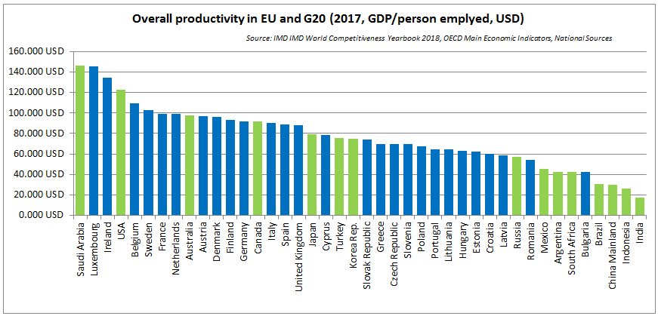

Figure 108 - Overall productivity in the EU and G20

Notes:

1. Overall productivity is defined as the ratio of GDP over employment; employment data are estimates and are provisional for the most recent period;

2. Data for Malta is not available

Over the recent years, the dispersion of productivity and efficiency rates across G20 economies has increased, with high income countries enjoying stronger growth rates than the low-income and less diversified economies of the non-EU G20. Whereas the group of EU countries perform better over the group on non-EU G20 (see **Figure 109**), the 2016 Single Market Integration and Competitiveness report mentioned above, as well as its 2015 version, point out that many EU Member States face a generalised fall in productivity growth rates and that productivity gaps are accumulating with respect to high income G20 countries. Reforms enhancing the labour and total factor productivity of European companies at both national and EU level are further discussed in separate reports of the European Commission[15].

|  |  |
| --- | --- |
|  |  |
|  |  |

Figure 109 - Productivity and Efficiency of EU and non-EU G20

Whereas the underlying trends driving productivity remain the same, the productivity spread across high- and low- income countries is less pronounced when the monetary value used is switched from US Dollars to Purchasing Power Parities[16]. This is confirmed both for the industrial and services sectors, as shown in **Figure 110** and **Figure 111.**

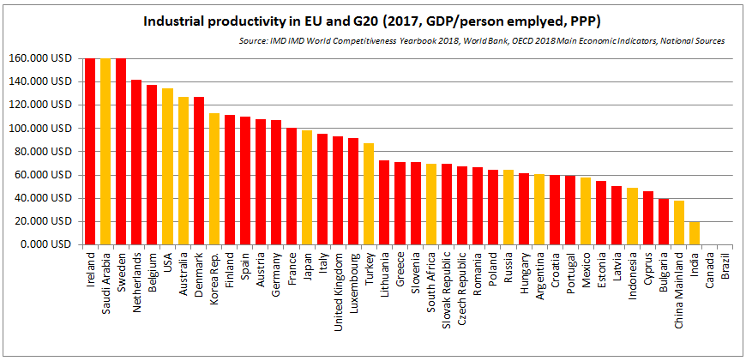

Figure 110 - Labour productivity in industry in EU and G20

Notes:

1. Industrial productivity is defined as the ratio of related GDP (PPP) per person employed in industry; employment data are estimates and are provisional for the most recent period

2. Data for Canada and Brazil is not available

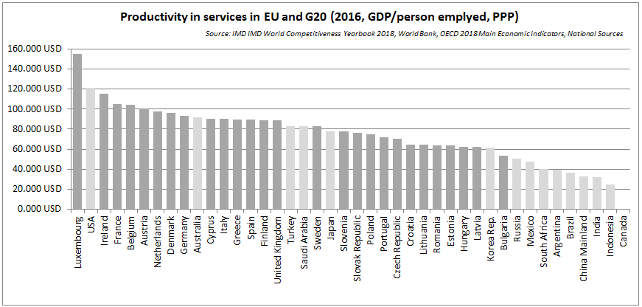

Figure 111 - Labor productivity in Services in EU and G20

Notes:

1. Productivity in services is defined as the ratio of related GDP (PPP) per person employed in services; employment data are estimates and are provisional for the most recent period

2. Data for Canada and Brazil is not available

### Impact of energy on the economy's competitiveness

**Figure 112** reports on the results from the user satisfaction survey on the adequacy and efficiency of energy infrastructure. As a group, EU clearly outperforms the non-EU G20 countries, as EU users of energy grids tend to be more satisfied on average with the overall operation, reliability and quality of service of dispatching of energy than their counterparts from G20 countries.

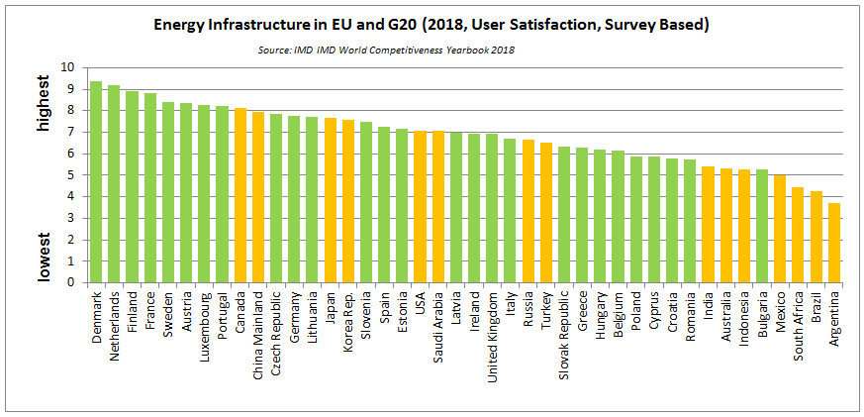

Figure 112 - User satisfaction on Energy infrastructure in EU and G20

Looking at recent prices for electricity for industrial users, both the EU and the non-EU G20 country groups appear as quite dispersed. Within non-EU G20, and compared to prices from 10 years ago, Mexico and Turkey register decreases in the range of 10% - 20% whereas the highest increases were recorded in Indonesia and Korea, both above 30%, as shown on **Figure 113**. **Section 6.5.3** provides a comprehensive international comparison on the evolution industrial prices, using a richer data sources.

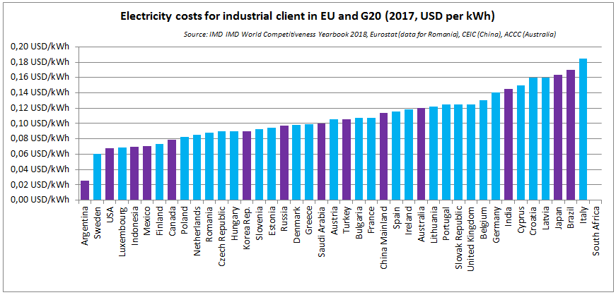

Figure 113 - Elecriticity prices for industry in the EU and G20 in 2017

Notes:

1. Prices refer to the simple average of the domestic monthly reference with tax for electricity for industry; data may be different

2. US prices are net of taxes;

3. Data for India is for 2013, data for Saudi Arabia is for 2014 data for South Africa is not available

Assessing the importance of energy as a production factor on the global macroeconomic level, and comparing the performance of EU countries against its main trading partners is not straightforward, with serious data availability and methodological issues.

In terms of the **absolute value of energy costs**, a report[17] from the European Commission estimated that the EU manufacturing sector had some of the lowest **Real Unit Energy Costs** **(RUEC) [18]** together with Japan and the US. While the USA is constantly performing better than the EU, looking at updated data[19], Japan has recently decoupled from the EU and increased its RUEC, mainly on the back of rising energy prices. China and Russia, on the other hand, score worse than the EU on a permanent basis (see **Figure 114**).

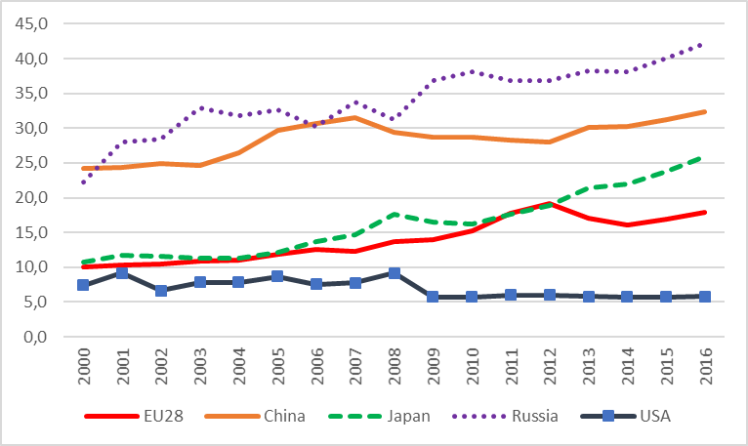

Figure 114 - Real Unit Energy Cost - manufacturing excluding refining

Source: DG JRC (own calculations based on WIOD) and DG ECFIN

The Real Unit Energy Costs of the EU has remained broadly stable over the last 5 years. However, a slight increase was recorded recently, especially due to higher energy prices. To a large extent these were offset by decreasing energy intensity of the European manufacturing sectors (**Figure 115**).

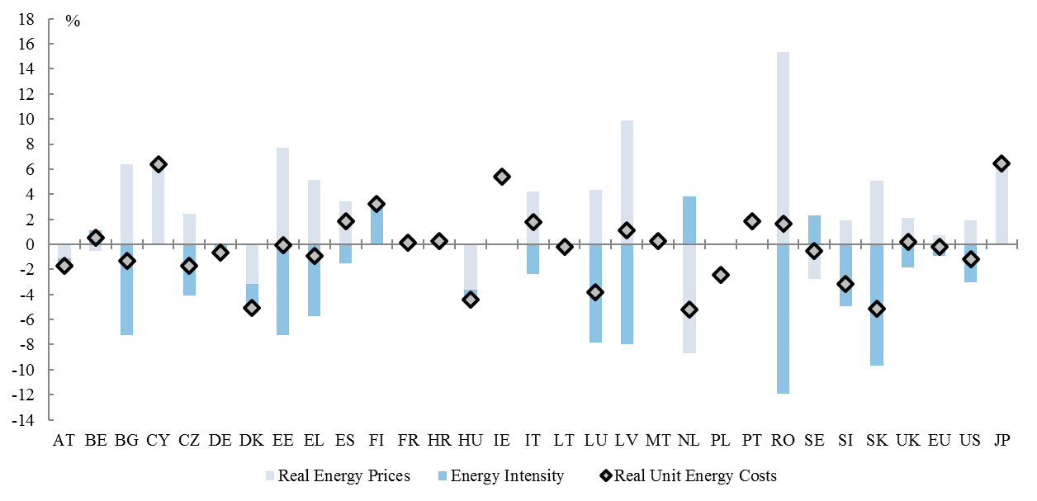

Figure 115 - Contribution to growth of RUEC by Real Prices and Energy Intensity

Source: DG JRC (own calculations based on WIOD) and DG ECFIN

The improvements of the EU industry in terms of energy intensity have helped to offset the increase in real energy prices. Compared to its world peers, EU manufacturers have developed best-of-class industrial processes in terms of energy efficiency and have continued to steadily improve their energy intensity levels.

The **relative share of energy in total factor production costs** can be proxied by the share of energy products in total production value, as reported by the Structural Business Statistics (SBS) tables in Eurostat. This approach has **several important limitations**, listed in the Box at the end of this section, but remains the only viable one in terms of harmonised and publically available data.

**Figure 116** shows the evolution of the share of energy-related costs in total production value in the broad classes of industry and services[20]. On EU level, and for the last decade of observed data, this share has decreased from 1.5-1.7% to around 1.0%-1.3%.

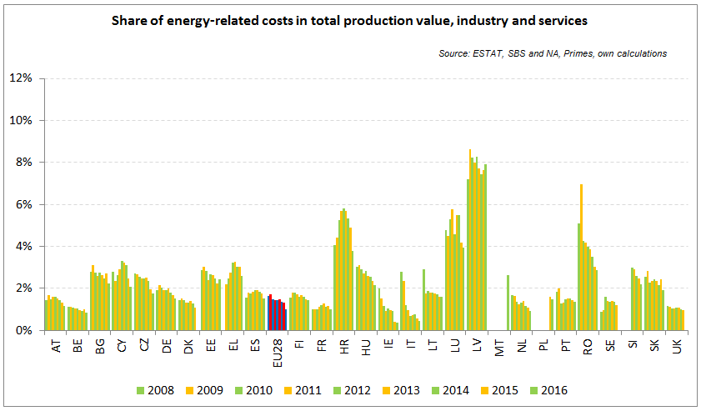

Figure 116 - Evolution of energy costs shares in production value

Notes:

1. Data for Malta (prior to 2016), Poland (prior to 2015), Slovenia (prior to 2012) and Greece (prior to 2008) is not available. Data for Denmark, Sweden and the United Kingdom for 2016 was missing by the time of extraction

**Figure 117** represents the share of energy-related costs for the manufacturing sector and across the EU Member States. Throughout the 2008-2016 period, and where data is available, the energy share has gradually decreased for the majority of Member States. On EU level, it went from 2.2%-2.5% at the beginning of the period to 1.5%-2.0% at the end. Member States with relatively smaller size would typically present a higher and more oscillating share than average; probably pointing to the fact that these economies have a relatively less diversified portfolio of manufacturing industries centred mainly on more energy-intensive sectors.

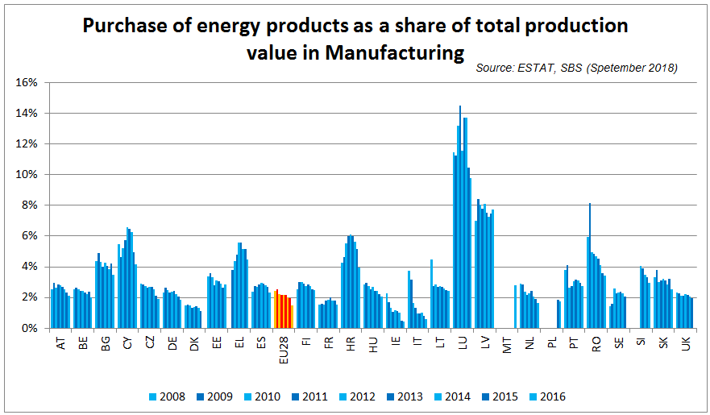

Figure 117 - Evolution of energy costs shars in production value for Manufacturing

Notes:

1. Data for Malta (prior to 2016), Poland (prior to 2015), Slovenia (prior to 2012) and Greece (prior to 2008) is not available. Data for Denmark, Sweden and the United Kingdom for 2016 was missing by the time of extraction

**Box- Data limitations**

|  |
| --- |
| * There is no one-on-one mapping between the economic indicators of SBS and the profit and loss account of real companies; * Capital expenditure (CAPEX) is difficult to collect in SBS, forcing the estimation of the energy component to rely solely on operating expenditure (OPEX); as a result the provided estimation is not assessing the long term investment and cannot determine the relative share of investment in improved energy performance tools over the total stock of investment; * The purchases of energy product data is available only for NACE Rev. 2 sections B (Mining and quarrying), C (Manufacturing), D (Electricity, gas, steam and air conditioning supply) and E (Water supply, sewerage, waste management and remediation activities). It is not available for important industrial such as Section F (Construction) and energy intensive sections such as H (Transportation and storage). More importantly, it is not available for all services sectors. According to the 2015 Commission report on single market integration and competitiveness, the relative share of the services sector in the 2014 Total Value Added in the EU 28 stood at almost 75%, as opposed to 15% for Manufacturing. * Based on the definition of the Commission Regulation (EC) No 250/2009, the structural business statistics (SBS) code "20 11 0 Purchases of energy products" includes only energy products which are purchased to be used as a fuel. Energy products purchased as a raw material or for resale without transformation (such as crude oil) are excluded. |

**Methodological note**

**Structure, parameters and factors of competitiveness in WEF, IMD and FI indices**

|  |  |  |
| --- | --- | --- |
|  |  |  |

## Energy costs for industry

**Sources, scope and methodology**

The following sections of this chapter mainly rely on findings from studies commissioned by the European Commission to external consultants. The main source for this chapter is the study on *'Energy prices, costs and subsidies and their impact on industry and households'* by Trinomics et altri[21] (2018), onwards *study by Trinomics*, which provides data and analyses on a wide range of manufacturing sectors and other relevant economic sectors (30 manufacturing sectors, including 15 energy intensive industries *plus* 14 sectors from agriculture, extractive and services). The study on *'Composition and drivers of Energy: case studies in selected Energy Intensive Industries'* by CEPS and Ecofys (2018)[22], onwards the *study by CEPS*, is the other main source for this chapter and focuses on case studies of 8 energy intensive subsectors.

The **methodology** of both studies is different but complementary. The *study by Trinomics et altri* follows a *top-down approach* using highly aggregated statistical data in particular for non-manufacturing sectors (30 manufacturing sectors at NACE 3 level, 7 non-manufacturing level at NACE 2 level and 7 other non-manufacturing at NACE level 1). Statistical data and estimates based on that data are used to understand the role of energy prices and costs in the competitiveness of these sectors. The CEPS study follows a *bottom-up* approach. CEPS calculations are based on direct collection of price and costs data at plant level via a questionnaire which allows analysing samples of varying representativeness.

These two approaches are complementary and provide a broader vision of the energy prices and energy costs paid by European industries. Highly aggregated data (used in a top down approach) usually is easily available in official statistics with well-established methodologies that cover long-time spans that makes it good for identifying long term trends. But aggregated information within one sector contains individual companies which may have rather heterogeneous industrial processes and products. Plant data or highly disaggregated data (used in bottom up approach) can be better for identifying targeted sub-groups of individuals and therefore represent better the analysed characteristics of these groups. But plant data is however scarce, normally based on ad-hoc methodologies which make comparisons of each studies or sources difficult and most importantly the actual effectiveness of the data sample for describing the targeted sub-groups of individuals depends critically on how large and how well the sample represents that group of individuals (something which is difficult to achieve).

**Approach for the selection of sectors**

The study commissioned by the European Commission to *Trinomics et altri* analysed energy costs and other indicators across 44 sectors of different levels of aggregation. Sectors were selected by looking at three aspects:

* *Importance of energy costs for the sector* usually *proxied* by the energy cost per production value, calculated by dividing purchases of energy by the total production value of each sector[23];
* *Economic importance of the sector* proxied by the share of sectoral value added in GDP of the country and by the assessment of the general economic or strategic relevance of the sector;
* *The trade exposure of the sector* which was proxied by the trade intensity of the sector which was calculated by dividing the sum of imports and exports of a product to and from the EU in total, by the size of the market which is represented by the sum of production value and imports.

The selection resulted in 30 manufacturing sectors[24]. The first 15 sectors are the most intensive energy sectors and were already the object of a study in the 2016 energy prices and costs report (shaded sectors in **Table 9**). In addition to those sectors, 15 more manufacturing sectors were selected in order to be able to *map* energy costs in manufacturing (non-shaded sectors in **Table 9**). The mapping of energy costs was completed by selecting the other non-manufacturing sectors.

Table 9 - Coverage of manufacturing sectors

|  |  |  |  |
| --- | --- | --- | --- |
| Coverage of Manufacturing | | | |
| *Study by Trinomics et altri* | | *Study by CEPS et altri* | |
| Sector | Level of aggregation (NACE code) | Sector | Level of aggregation (NACE code) |
| **Grain mill** and starch products | C106 |  |  |
| Weaving of **textiles** | C132 |  |  |
| Sawmilling and planing of **wood** | C161 |  |  |
| **Pulp, paper** and paperboard | C171 |  |  |
| **Refined petroleum products** | C192 | **Refineries** | C1920 |
| **Basic chemicals and fertilisers** | C201 | **Nitrogen fertilisers** | C2015* |
| **Man-made fibres** | C206 |  |  |
| **Glass** and glass products | C231 | **Packaging glass** | C2313* |
| **Glass tableware** | C2313* |
| **Refractory** products | C232 |  |  |
| **Clay building** materials | C233 | **Wall and floor tiles** | C2331 |
| **Bricks and roof tiles** | C2332 |
| **Porcelain and ceramic** products | C234 |  |  |
| **Cement**, lime and plaster | C235 |  |  |
| Cutting **stone** | C237 |  |  |
| Basic **iron and steel** and of ferro-alloys | C241 | **Iron and steel** | C2410 |
| **Non-ferrous metals** | C244 | **Aluminium** | C2442 |
| **Fruit** **and vegetables** | C103 |  |  |
| **Articles of paper** and paperboard | C172 |  |  |
| **Plastics** products | C222 |  |  |
| **Abrasive products** and non-metallic mineral products n.e.c. | C239 |  |  |
| **Casting of metals** | C245 |  |  |
| **Beverages** | C11 |  |  |
| **Basic pharmaceutical** products | C21 |  |  |
| **Fabricated metal products** (except machinery) | C25 |  |  |
| **Computer, electronic** and optical products | C26 |  |  |
| Electrical equipment | C27 |  |  |
| **Machinery** and equipment n.e.c. | C28- |  |  |
| **Motor vehicles**, trailers and semi-trailers | C29 |  |  |
| **Other transport equipment** | C30- |  |  |
| **Other manufacturing** | C32 |  |  |
| **Repair, installation of machinery** | C33 |  |  |

* The sector analysed is a subsector of the NACE code mentioned.

Source: European Commission Services

Note: Shaded Sectors are those most intensive

Table 10 - Coverage of other sectors, excluding manufacturing

|  |  |
| --- | --- |
| Coverage of other agriculture, mining, construction and services  *Study by Trinomics et altri* | |
| Sector | Level of aggregation (NACE code) |
| **Agriculture, forestry and fishing** | A |
| **Extraction of crude petroleum and natural gas** | B06 |
| **Mining** of **metal ores** | B07 |
| **Other mining and quarrying** | B08 |
| **Electricity, gas,** steam and air-conditioning supply | D35 |
| **Water supply**, sewerage, water management and remediation activities | E38 |
| **Construction** | F |
| Wholesale and retail **trade** | G |
| **Land Transport** | H49 |
| **Air Transport** | H51 |
| **Accommodation** and food service activities | I |
| **Information and communication** | J |
| **Professional**, scientific and technical **activities** | M |
| **Administrative** and support service **activities** | N |

Source: European Commission Services

**Energy costs shares**

This section focuses in assessing the cost-competitiveness of the various industrial sectors. The share of energy costs in the total production cost is a good indicator of the impact that energy costs can have on the price competitiveness of the various industrial sectors. Using Eurostat SBS as the main data source, energy cost shares are calculated by dividing the purchases of energy by total production costs, where total production costs are equal to total purchases of goods and services (including energy)[25] plus personnel costs.

Before looking at the results we should bear in mind that the heterogeneity of the energy intensity of the industries aggregated in each sector makes that the results for the total sector usually underestimates the impact of energy costs on the industrial segments with the highest energy intensity. This is particularly true for sectors like chemicals, cement, non-ferrous metals, steel and paper which include companies producing high energy intensive primary products alongside companies producing low energy intensive secondary products. It is also important to be aware that the consumption of self-generated energy is not captured by the indicator analysed (energy costs shares using SBS data) and that self-consumption is not uncommon in the industrial segments with a high energy intensity. This is why the analysis in this section is complemented by a more exhaustive analysis of all the factors affecting the energy costs (self-consumption of self-generated energy, exemptions to energy taxes, etc.) at a more disaggregated level (NACE 4) on the basis of the results of the CEPS study[26] (see 6.6.4 and Annex 1)

**Results on energy costs shares**

and **Figure 120** (see below) look at the main developments on energy costs shares the selected manufacturing sectors in the period 2008-2015 showing that:

* Energy costs for the selected manufacturing sectors typically accounted for around 1-10% of total (operational) production costs, although for some sectors the costs significantly exceed 10% (e.g. *Cement, lime and plaster* and *Clay building materials*)
* Amongst the 15 most energy intensive manufacturing sectors energy costs accounted for more than 10% of production costs in at least one year in the *pulp and paper*, *clay building materials*, *iron and steel* and in particular, the *cement, lime and plaster* sectors.
* Amongst the 15 less energy intensive manufacturing sectors energy costs are typically 1-3% of operational (production) costs. For *computers and electronics*, *motor vehicles* and *other transport equipment* costs do not reach 1% of total production costs
* Over the period 2008-2015, energy cost shares have fallen in almost every sector (except for the *refineries* sector) The largest declines in cost share were observed in the most energy intensive sectors like *cement, lime and plaster* (-7%). *clay building materials* (-4%), *pulp and paper* (-4%), *glass* (-1.7%) and *iron and steel* (-1.7%). Other sectors with smaller declines nevertheless see proportionally significant decreases like in *non-ferrous metals*, *textiles* and *pharmaceutical products*.
* While the overall trend is for decline in energy cost shares across all sectors over the full period there are few exceptions (although more frequent in the second part of the period, 2011-2015) such as the *refractory products*, *clay building materials*, *abrasive products*, *fabricated metal products* and *computer and electronics* for which the cost shares increased by approximately 1-3%.

An account of the available data from MS to estimate the sector's energy cost share in production costs can be found in Annex D of the study by Trinomics et altri study (2018).

**Box - Energy costs and the sector's fuel mix**

Energy costs are determined by the price of energy products and the quantities of consumed for each product. Prices usually show high volatility while energy consumption volumes tend to more stable (as it depends on factors like the consumption patterns, the economic situation and energy efficiency). This makes that prices changes explain most of the changes in energy costs in the short term. The consumption fuel mix is thus very relevant for energy costs as it determines how much will be affected the energy costs by price changes in each energy product. It is also important to note that the sector's fuel mix tends to be rather stable (as it depend inter alia on the fuel requirements of the specific production process and the availability of the energy product (e.g. gas is not always available) which usually limit fuel switching)

**Figure 118** displays the average importance of fuels in terms of energy consumption by sector and **Figure 119** shows the importance of fuels in terms of their energy costs shares in total energy costs related to each sector.

These figures show that electricity and gas (this varies across sectors) are generally the most important energy products in terms of consumption. Electricity is the energy product having the biggest impact on energy costs shares (e.g. > 80% for *Pharmaceuticals*, *non-ferrous metals* and *computers and electronics)*. This can be explained by its relatively high price compared to the other fuels. Natural gas has a major impact on the energy costs in *glass*, *beverages* and *steel*. Oil and coal have a relatively small impact on energy costs even when consumption is high. Oil costs are relevant for *refineries,* *cement* and *chemicals* while coal costs are for *steel*, *abrasive products,* *cement* and *casting of metals*. “Other energies”, in particular biomass, represent an important consumption share in some sectors like *sawmills* (>80% of consumption), *man-made fibres* (57%), *stone* (38%) and *paper* (29%) and can thus significantly impact their energy costs.

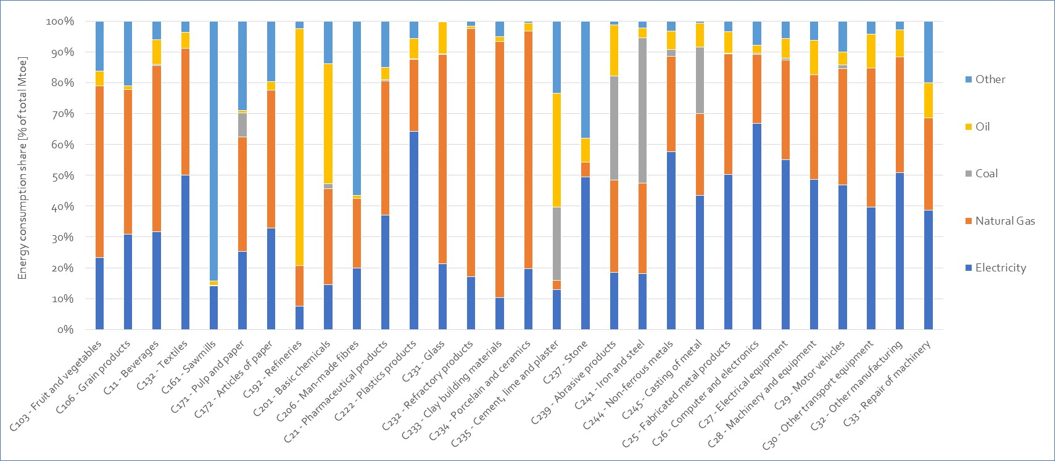

Figure 118 - Breakdown of the energy consumption per energy carrier, EU, 2008-2015 averages

Source: Trinomics et altri study

Note: “other” combines biomass and heat energy consumption

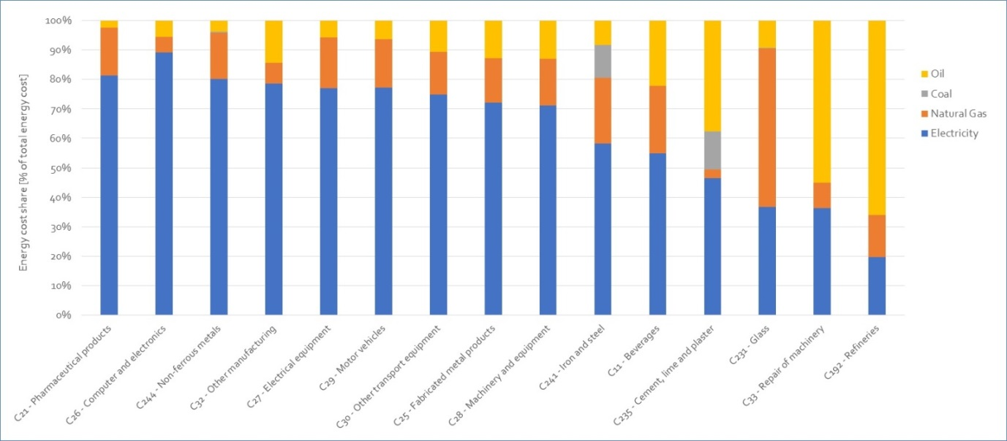

Figure 119 - Average energy cost shares per sector – based on available data points, split by energy carrier, 2008-2015 averages

Source: Trinomics et altri study

Table 11 - Energy costs shares in total production costs for manufacturing and non-manufacturing, 2008-2015

|  |  |  |  |  |  |  |  |  |  |  |  |  |  |  |  |  |  |  |
| --- | --- | --- | --- | --- | --- | --- | --- | --- | --- | --- | --- | --- | --- | --- | --- | --- | --- | --- |
|  | **2008** | **2009** | **2010** | **2011** | **2012** | **2013** | **2014** | **2015** | **Changes 2008-2015** | **Changes 2008-2011** | **Changes 2011-2015** | **Level 2015** | **Average** | **Max. level** | **Low. level** | | **Diff max-low level** | |
| **Section C** | | | | | | | | | | | | | | | |  | |  | |
| C103 - Fruit and vegetables | 3,6% | 3,5% | 2,8% | 2,8% | 3,0% | 2,8% | 2,9% | 2,5% | -1,1% | -0,8% | -0,3% | 2,5% | 3,0% | 3,6% | 2,5% | | 1,1% | |
| C106 - Grain products | 3,8% | 3,8% | 3,3% | 3,1% | 3,3% | 3,1% | 3,3% | 3,0% | -0,8% | -0,6% | -0,1% | 3,0% | 3,3% | 3,8% | 3,0% | | 0,8% | |
| C132 - Textiles | 4,3% | 6,4% | 3,6% | 2,5% | 2,7% | 2,4% | 2,3% | 2,1% | -2,2% | -1,8% | -0,4% | 2,1% | 3,3% | 6,4% | 2,1% | | 4,3% | |
| C161 - Sawmills | 3,7% | 4,1% | 3,6% | 4,1% | 3,7% | 3,6% | 3,4% | 3,1% | -0,6% | 0,4% | -1,0% | 3,1% | 3,7% | 4,1% | 3,1% | | 1,0% | |
| C171 - Pulp and paper | 12,2% | 13,0% | 11,1% | 11,2% | 10,7% | 9,9% | 9,1% | 8,4% | -3,9% | -1,1% | -2,8% | 8,4% | 10,7% | 13,0% | 8,4% | | 4,6% | |
| C172 - Articles of paper | 3,6% | 3,7% | 3,1% | 2,8% | 3,0% | 3,0% | 2,7% | 2,5% | -1,0% | -0,8% | -0,3% | 2,5% | 3,0% | 3,7% | 2,5% | | 1,2% | |
| C192 - Refineries | 3,2% | 2,4% | 2,5% | 2,0% | 2,8% | 3,1% | 3,1% | 3,7% | 0,6% | -1,2% | 1,7% | 3,7% | 2,8% | 3,7% | 2,0% | | 1,7% | |
| C201 - Basic chemicals | 7,1% | 7,7% | 6,8% | 7,0% | 6,7% | 6,7% | 6,1% | 5,7% | -1,4% | -0,1% | -1,3% | 5,7% | 6,7% | 7,7% | 5,7% | | 2,0% | |
| C206 - Man-made fibres | 8,6% | 12,4% | 7,8% | 7,1% | 6,7% | 8,5% | 6,5% | 6,2% | -2,4% | -1,6% | -0,9% | 6,2% | 8,0% | 12,4% | 6,2% | | 6,2% | |
| C222 - Plastics products | 3,5% | 3,5% | 2,9% | 2,9% | 2,8% | 2,9% | 2,7% | 2,6% | -0,9% | -0,6% | -0,3% | 2,6% | 3,0% | 3,5% | 2,6% | | 0,9% | |
| C231 - Glass | 9,8% | 10,1% | 8,9% | 9,1% | 10,3% | 10,1% | 9,3% | 8,2% | -1,7% | -0,7% | -0,9% | 8,2% | 9,5% | 10,3% | 8,2% | | 2,1% | |
| C232 - Refractory products | 6,9% | 6,5% | 6,2% | 5,9% | 6,5% | 6,6% | 5,8% | 6,1% | -0,8% | -1,0% | 0,1% | 6,1% | 6,3% | 6,9% | 5,8% | | 1,1% | |
| C233 - Clay building materials | 15,4% | 14,1% | 11,8% | 11,0% | 12,4% | 12,4% | 11,3% | 11,1% | -4,3% | -4,4% | 0,1% | 11,1% | 12,4% | 15,4% | 11,0% | | 4,4% | |
| C234 - Porcelain and ceramics | 6,0% | 5,7% | 4,8% | 5,0% | 5,3% | 5,4% | 5,0% | 4,3% | -1,7% | -1,0% | -0,8% | 4,3% | 5,2% | 6,0% | 4,3% | | 1,7% | |
| C235 - Cement, lime and plaster | 22,1% | 22,9% | 22,1% | 23,5% | 21,4% | 21,8% | 20,9% | 16,3% | -5,8% | 1,5% | -7,3% | 16,3% | 21,4% | 23,5% | 16,3% | | 7,3% | |
| C237 - Stone | 4,8% | 4,4% | 3,3% | 3,4% | 2,6% | 4,3% | 3,1% | 3,2% | -1,5% | -1,4% | -0,1% | 3,2% | 3,6% | 4,8% | 2,6% | | 2,1% | |
| C239 - Abrasive products | 5,8% | 5,3% | 4,9% | 4,9% | 5,0% | 5,2% | 4,8% | 5,1% | -0,7% | -0,9% | 0,1% | 5,1% | 5,1% | 5,8% | 4,8% | | 1,0% | |
| C241 - Iron and steel | 9,2% | 11,9% | 9,5% | 7,7% | 8,5% | 8,5% | 7,3% | 7,5% | -1,7% | -1,4% | -0,3% | 7,5% | 8,8% | 11,9% | 7,3% | | 4,6% | |
| C244 - Non-ferrous metals | 4,6% | 6,0% | 4,2% | 4,0% | 3,9% | 4,0% | 3,6% | 3,5% | -1,1% | -0,5% | -0,6% | 3,5% | 4,2% | 6,0% | 3,5% | | 2,5% | |
| C245 - Casting of metal | 6,4% | 7,1% | 6,0% | 5,2% | 5,4% | 5,5% | 5,3% | 4,9% | -1,4% | -1,1% | -0,3% | 4,9% | 5,7% | 7,1% | 4,9% | | 2,2% | |
|  |  |  |  |  |  |  |  |  |  |  |  |  |  |  |  | |  | |
|  | **2008** | **2009** | **2010** | **2011** | **2012** | **2013** | **2014** | **2015** | **Changes 2008-2015** | **Changes 2008-2011** | **Changes 2011-2015** | **Level 2015** | **Average** | **Max. level** | **Low. level** | | **Diff max-low level** | |
| C11 - Beverages | 2,6% | 2,6% | 2,6% | 2,7% | 2,6% | 2,6% | 2,5% | 2,4% | -0,2% | 0,1% | -0,2% | 2,4% | 2,6% | 2,7% | 2,4% | | 0,2% | |
| C21 - Pharmaceutical products | 2,8% | 1,7% | 1,2% | 1,2% | 1,3% | 1,3% | 1,2% | 1,1% | -1,7% | -1,6% | -0,1% | 1,1% | 1,5% | 2,8% | 1,1% | | 1,7% | |
| C25 - Fabricated metal products | 2,2% | 2,4% | 2,3% | 1,9% | 2,0% | 2,1% | 2,1% | 1,9% | -0,2% | -0,3% | 0,0% | 1,9% | 2,1% | 2,4% | 1,9% | | 0,5% | |
| C26 - Computer and electronics | 0,9% | 0,9% | 0,7% | 0,8% | 0,8% | 0,8% | 0,8% | 0,8% | -0,2% | -0,2% | 0,0% | 0,8% | 0,8% | 0,9% | 0,7% | | 0,2% | |
| C27 - Electrical equipment | 1,1% | 1,3% | 1,0% | 1,0% | 1,0% | 1,0% | 1,1% | 0,9% | -0,3% | -0,2% | -0,1% | 0,9% | 1,0% | 1,3% | 0,9% | | 0,5% | |
| C28 - Machinery and equipment | 1,1% | 1,2% | 1,0% | 0,9% | 0,9% | 1,0% | 0,9% | 0,8% | -0,3% | -0,2% | -0,1% | 0,8% | 1,0% | 1,2% | 0,8% | | 0,4% | |
| C29 - Motor vehicles | 1,0% | 1,0% | 0,8% | 0,8% | 0,8% | 0,8% | 0,7% | 0,7% | -0,3% | -0,2% | -0,1% | 0,7% | 0,8% | 1,0% | 0,7% | | 0,3% | |
| C30 - Other transport equipment | 1,1% | 1,0% | 0,9% | 0,8% | 0,8% | 0,9% | 0,7% | 0,8% | -0,3% | -0,3% | -0,1% | 0,8% | 0,9% | 1,1% | 0,7% | | 0,4% | |
| C32 - Other manufacturing | 1,3% | 1,4% | 1,3% | 1,1% | 1,1% | 1,1% | 1,1% | 1,0% | -0,3% | -0,2% | -0,1% | 1,0% | 1,2% | 1,4% | 1,0% | | 0,4% | |
| C33 - Repair of machinery | 1,3% | 1,2% | 1,1% | 1,1% | 1,1% | 1,2% | 1,1% | 0,9% | -0,4% | -0,2% | -0,2% | 0,9% | 1,1% | 1,3% | 0,9% | | 0,4% | |
| **Other sections** | | | | | | | | | | | | | | | |  | |  | |
| B - Mining and quarrying | 3,4% | 2,9% | 2,9% | 2,7% | 2,8% | 2,8% | 2,7% | 3,1% | -0,3% | -0,8% | 0,5% | 3,1% | 2,9% | 3,4% | 2,7% | | 0,8% | |
| B06 - Oil and gas | 1,6% | 0,6% | 0,6% | 0,5% | 0,6% | 0,7% | 0,7% | 0,7% | -0,9% | -1,1% | 0,2% | 0,7% | 0,7% | 1,6% | 0,5% | | 1,1% | |
| B07 - Mining of metal ores | 15,8% | 16,6% | 19,7% | 20,8% | 19,6% | 19,4% | 17,7% | 18,4% | 2,6% | 5,0% | -2,4% | 18,4% | 18,5% | 20,8% | 15,8% | | 5,0% | |
| B08 - Other mining | 10,3% | 9,8% | 10,4% | 10,4% | 10,9% | 10,2% | 9,6% | 9,4% | -0,9% | 0,1% | -1,0% | 9,4% | 10,1% | 10,9% | 9,4% | | 1,5% | |
| D35 - Electricity, gas and steam | 17,0% | 16,8% | 16,9% | 16,4% | 14,3% | 12,3% | 11,4% | 11,5% | -5,5% | -0,6% | -4,9% | 11,5% | 14,6% | 17,0% | 11,4% | | 5,6% | |
| E38 - Waste management | 4,0% | 3,0% | 3,1% | 3,5% | 4,2% | 4,3% | 4,8% | 4,3% | 0,3% | -0,5% | 0,8% | 4,3% | 3,9% | 4,8% | 3,0% | | 1,8% | |
| F - Construction | 1,5% | 1,5% | 1,5% | 1,7% | 1,7% | 1,7% | 1,6% | 1,4% | 0,0% | 0,2% | -0,3% | 1,4% | 1,6% | 1,7% | 1,4% | | 0,3% | |
| G - Wholesale and retail trade | 0,7% | 0,8% | 0,7% | 0,6% | 0,7% | 0,6% | 0,6% | 0,6% | -0,1% | 0,0% | 0,0% | 0,6% | 0,7% | 0,8% | 0,6% | | 0,2% | |
| H49 - Land transport | 36,3% | 31,0% | 33,2% | 40,6% | 37,0% | 34,4% | 32,1% | 27,0% | -9,3% | 4,3% | -13,6% | 27,0% | 33,9% | 40,6% | 27,0% | | 13,6% | |
| H51 - Air transport | 19,5% | 16,7% | 21,6% | 20,1% | 23,3% | 20,0% | 24,4% | 20,2% | 0,7% | 0,6% | 0,1% | 20,2% | 20,7% | 24,4% | 16,7% | | 7,8% | |
| I - Accomodation and restaurants | 3,9% | 4,2% | 4,7% | 4,2% | 4,5% | 4,3% | 3,7% | 3,9% | 0,0% | 0,3% | -0,3% | 3,9% | 4,2% | 4,7% | 3,7% | | 1,1% | |

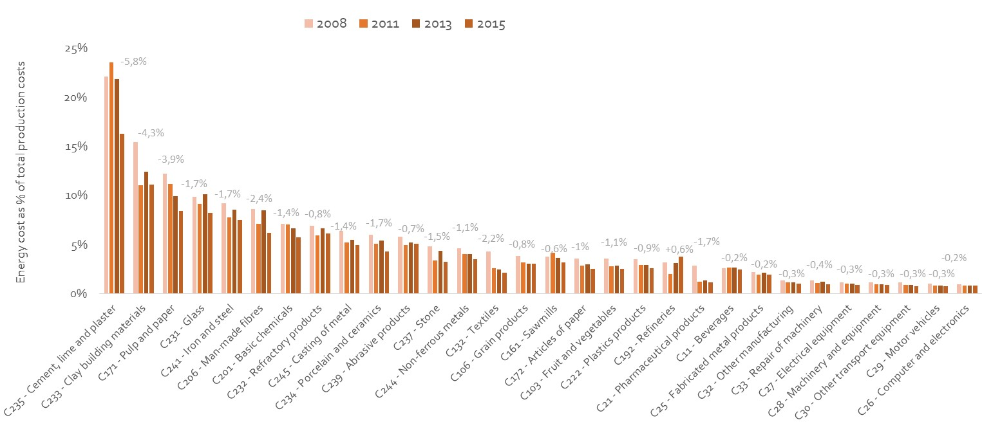

Figure 120 - Energy costs shares in total production costs in manufacturing sectors, 2008-2015

Source: Trinomics et altri study

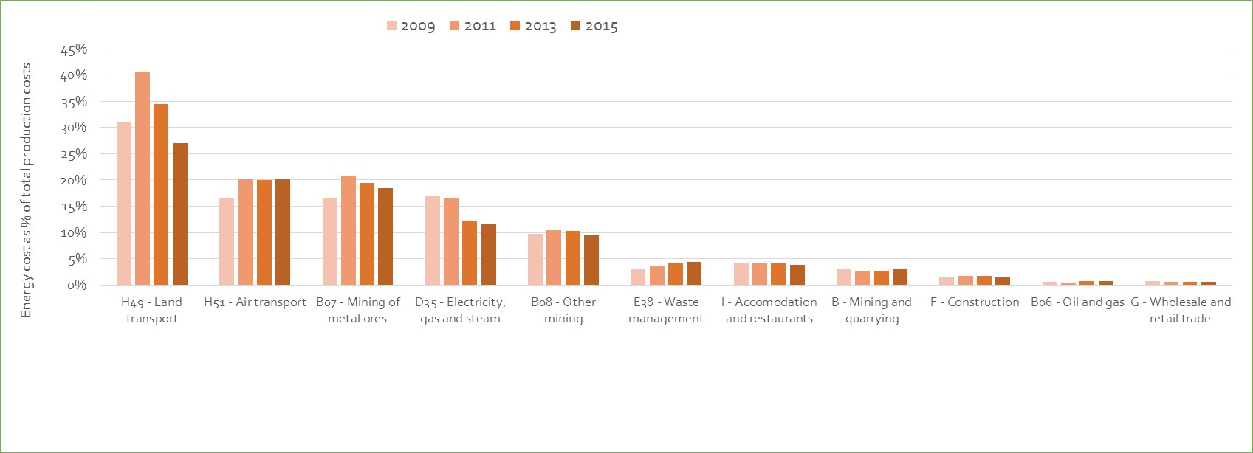

Figure 121 - Energy costs shares in total production costs in non-manufacturing sectors

Source: Trinomics et altri study

Amongst the non-manufacturing sectors for which data was available energy cost shares are particularly high in 5 sectors, being comparable to or higher than cost shares in the most energy intensive manufacturing sectors. These 5 sectors are H49 Land transport (H49), Air transport (H51), Mining of metal ores (B07), Electricity, gas and steam (D36) and other mining (B08). Clearly fuel costs are important drivers of costs in the transport and electricity and gas sectors, whilst mining is also an energy intensive activity. It is notable that energy cost shares in Waste management (E38) and Accommodation and restaurants (I) also have cost shares of 3-5%, which is comparable to many of the energy intensive manufacturing sectors. Energy cost shares are negligible in the construction (F) and Wholesale and retail (G) sectors.

**Box - Energy costs for refineries**

In sectors like refineries (also chemicals) the impact of energy products on production costs goes beyond the purchases of electricity and gas from external energy suppliers. In refineries energy products are also used as feedstocks (e.g. crude oil) in the industrial process. Moreover, some energy products are also self-produced and self-consumed in the industrial process. Energy costs have thus a key relevance for refineries.

Estimating the importance of all energy costs for the refinery sector is complex due to the limited or confidential data. The 'purchases of energy' from Eurostat statistics (SBS) represented on average bit less than 3% of the production costs over the last years (Trinomics et altri, 2018). However, the SBS 'purchases of energy' does not include crude oil expenses. These crude oil expenses were estimated to account for more than 80% of the production costs of refineries (CEPS and Ecofys, 2018).

Finally, refineries also consume petroleum products, refinery gas and petroleum coke for its own use. Such products are self-consumed. The estimation of the monetary amounts from self-generated and self-consumed products (Trinomics et altri) signals that these amounts would represent a small share of total energy costs (few percentage points) which would tend to be smaller where products of the prices are lower (particularly as regards gas).

**Results on Gross Operating Surpluses shares**

Profit margins together with production costs make up the final sales price. Profits therefore play an important role in the cost-competitiveness of firms in the short term (when setting prices). But profits are also relevant for the competitiveness in the long term as they are necessary to attract and enable investment.

It is thus interesting to analyse the trends on Gross operating surplus[27] (GOS, a proxy for profits) for the sectors studied (see the two graphs below in **Figure 122)** shows the average GOS share in production costs for the manufacturing sectors between 2008 and 2015. For most of those sectors, the share was between 5-15%, higher for sectors like *pharmaceuticals*; *cement, beverages* and particularly lower for *steel* (only 3.2% and even negative in one year, in 2009).

The GOS shares in production costs increased and decreased across for some sectors alike. The proportionally higher increases were in *textiles* (+94%), *casting of metal*, *paper*, *porcelain* and *ceramics* (all the latter around 50%). The most significant declines were in *steel* (-57%) and *refineries*, *cement*, and *motor vehicles* (all the latter around minus 30%).



Figure 122 - Gross Operating Surplus in manufacturing sectors (average 2008-2015)

Source: Trinomics et altri study

Note: Average of for the sector based on the MS for which total production cost and GOS data available for all years

For the EU as a whole (see **Figure 123**), GOS shares in production costs oscillated in the range of 11-13%/year between 2008 and 2015, with significant differences between Member States. Poland, the UK and Ireland have the highest surpluses (over 16%) and are closely followed by Greece, Cyprus, Bulgaria and Romania. The lowest surpluses are found in France, Italy, Belgium and Sweden.



Figure 123 - Gross Operating Surplus in manufacturing in the EU and Member States, 2008-2015

Source: Trinomics et altri study

## Exploring energy intensities

*Energy intensity* is the result of dividing the energy consumption by the Gross Value Added (GVA). Although is not is not a direct measure of energy efficiency of production (which could be measured by dividing the energy consumption by the volume of production) it is used as proxy of it. This is because comparable production volume data is not easily available. In any case, when using energy intensity as proxy for energy efficiency one should bear in mind that the energy intensity is subject to the factors that change the value added of the production, i.e. there are price effects (which are common and volatile and that can be due to various reasons like demand changes, monetary issues, etc.) that affect the value added and are not related to changes in the volume of production.

**Figure 124**, **Figure 125** and **Figure 126** (see next page/s) display the energy intensity of selected sectors in the period 2008-2015 showing that:

* Energy intensity varies considerably across sectors in accordance to the various production processes (*steel* and *cement* (>2 toe/1000 Euros) and *refineries* and *paper* (> 1 toe/1000 thousand Euros) display the highest values).
* Energy intensity decreased in most of the energy intensive sectors like *steel* (-1,9%/year since 2009), *refineries* and *paper* although it increased in *cement* (by around 3.1%/year since 2009), *grain products*, *sawmills* and *chemicals*. For the rest it remained relatively similar levels.
* Energy intensity was particularly volatile for *refineries,* *steel* and *man-made fibres* probably reflecting price affecting the value added of production.
* There were also proportionally significant decreases in the less energy intensive manufacturing sectors like in *textiles*, *stone*, *articles of paper*, *motor vehicles* (although for these sectors the indicator lies at a rather low level, i.e. between 0.3 and 0.1 toe/1000euros)
* Energy intensity also decreased in non-manufacturing sectors with the highest energy intensity (e.g. *land transport*, *electricity-gas*, *other mining* and *agriculture*) and remained relatively stable for the less energy intensive sectors.

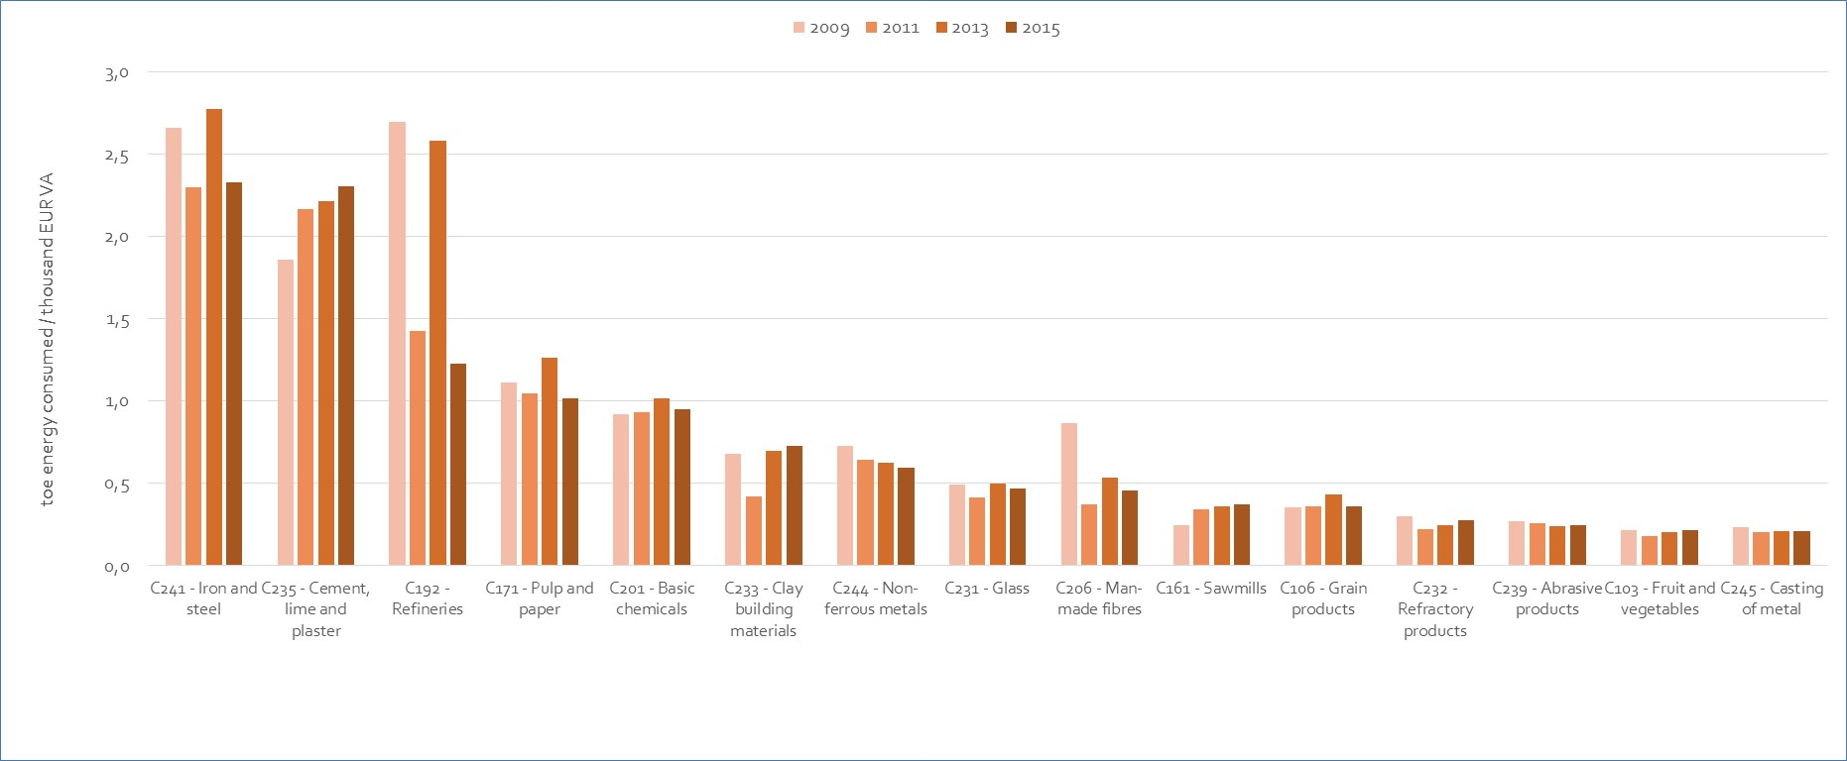

Figure 124 - Energy intensity (consumption/value added in nominal terms) for the most energy intensive manufacturing sectors (average of available countries)[28]

Source: Trinomics et altri study

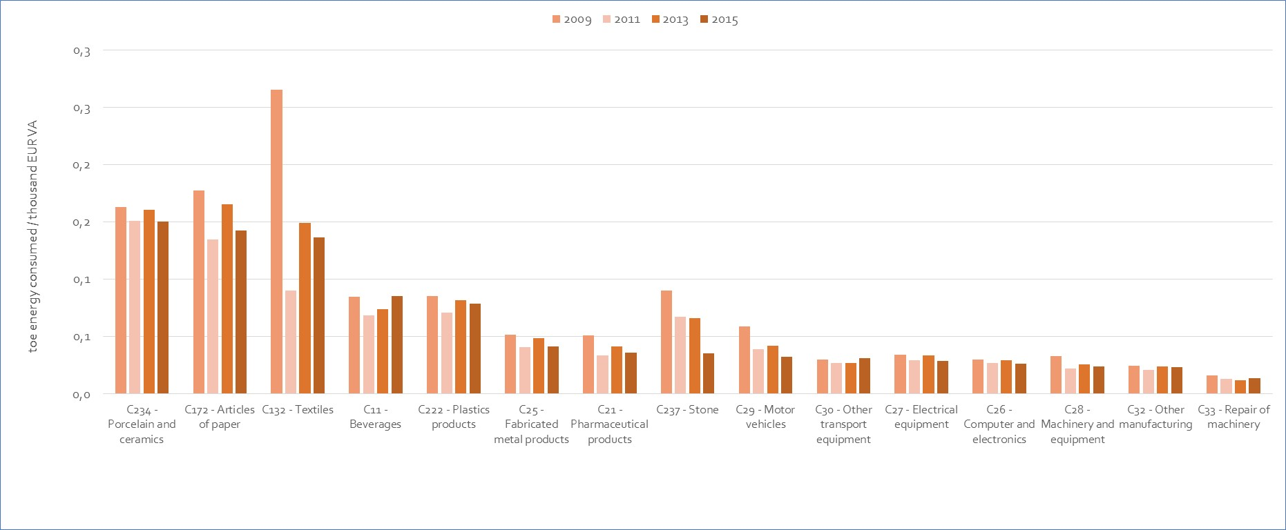

Figure 125 - Energy intensity (consumption/value added in nominal terms) for other manufacturing sectors (average of available countries)[29]

Source: Trinomics et altri study

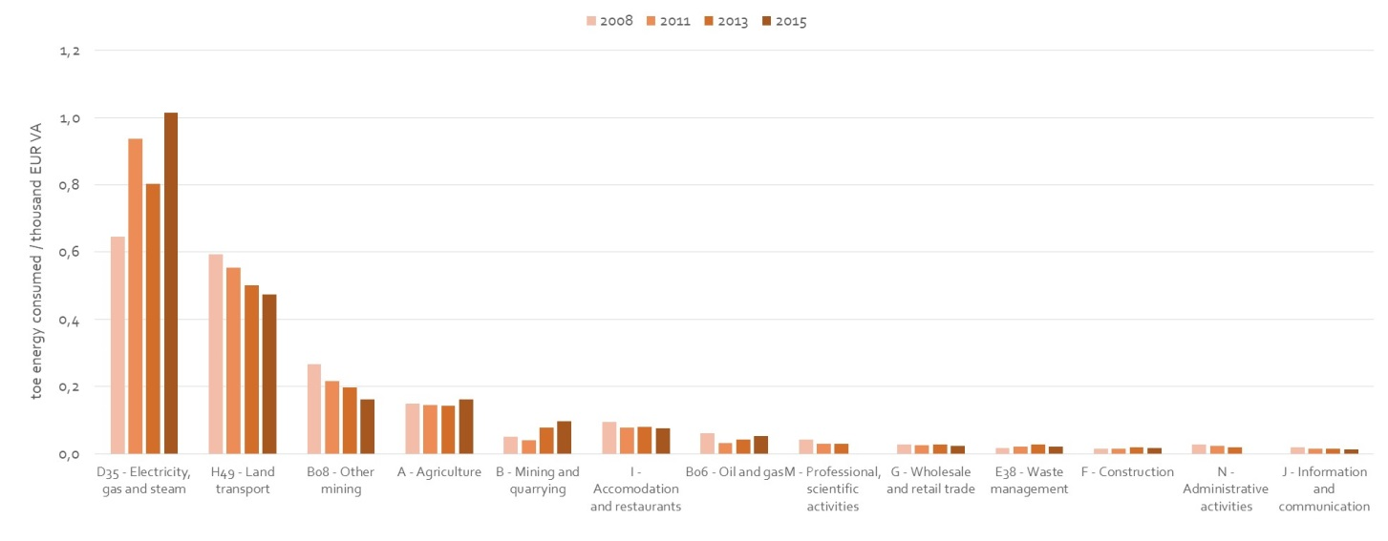

Figure 126 - Energy intensity (consumption/value added in nominal terms) for non- manufacturing sectors (average of available countries)[30]

Source: Trinomics et altri study

## Energy costs drivers

Changes in energy costs over time can be the result of several factors. In this section we estimate how changes on energy prices, output and energy intensity impact energy costs. The section relies on the main findings of the decomposition analyses undertaken in the *Trinomics et altri* study which assesses the extent to which these three factors affected the energy costs of selected energy-intensive sectors over 2010-2015.

The decomposition was carried out using the *Log Mean Divisia Index (LMDI)* which shows for a given percentage change in energy costs over the period, the extent to which this change is attributable to changes in each driver over the same period. To make that analysis it was necessary to estimate the prices and the consumption by sector. The purchases of energy resulting from multiplying the estimated prices and consumption were not always similar to the results from historical data coming from 'purchases of energy' collected in Eurostat. A residual (the difference between the two) was therefore introduced in the analysis to take into account for these data discrepancies and ensure a coherent approach in the analysis of the energy costs in this document[31].

The ratio between energy costs and total production costs is also a good indicator of the impact on total costs and competitiveness of a sector. In this section after the analysis of the factors driving the real energy costs (numerator of the ratio) we also look at the factors that drive the production costs (denominator) so we can also assess the actual evolution of the *ratio*.

### Drivers of energy costs (Purchases of energy)

Using the LMDI decomposition, the key drivers of energy costs can be identified.

$Energy costs= Output\left(constant\right)×\frac{Energy}{Output \left(constant\right)} × Price of energy$

The analysis in this section aims to use LMDI decomposition to explain the behaviour of the energy costs observed as energy purchases of energy from SBS data. Thus, a residual is introduced in the analysis to account for the difference between estimated energy costs and the SBS data for energy purchases of energy. For the purposes of this analysis, the change in energy costs over time is defined as follows:

$$∆Energy Costs=\left(real\right) output effect+\left(real\right) energy intensity effect+price effect+residual$$

Where

* **Output effect:** the effect of changes in real production (GVA),
* **(Real) Energy intensity effect:** the effect of changes in energy per unit of real output (GVA) over time due to energy efficiency measures, behavioural changes and industry structural change;
* **Price effects:** the effect of changes in coal, gas and electricity prices.
* The **residual,** whichincludes the effect of unexplained data discrepancy with Eurostat SBS data on 'purchases of energy'.

**Box – Interpretation of results**

The interpretation of some of these effects is complex in some cases and may deserve some additional explanations.

The unexplained **residual** likely arises from missing data, in particular, on energy consumption. In these cases, data gaps were filled using sectoral energy-intensity figures for those countries where data is available. In some cases, that meant relying on trends of very few countries (Germany and few others) to predict the wider sectoral trends at the EU28 level. Therefore it is possible that the residual is partly reflecting some energy intensity effects that were impossible to identify from the limited energy consumption data available. Industry restructuring is indeed typical in periods following economic crises and intense international competition as the one suffered for some of the analysed energy intensive industries in the period under study. On the other hand, the residual was calculated as the difference from the Eurostat SBS data in order to ensure a coherent analysis in this section in line with the analysis on the previous sections of the chapter. However Eurostat SBS data could also present some inconsistencies as it is based on surveys which might also be partially incomplete.

The interpretation of the **price effect** is more complex that it seems and also deserves further explanations. The price effect captures the effect of changes in weighted-average energy prices on energy costs faced by firms. The prices used are nominal and exclude all recoverable tax and levies (such as VAT). The price effects are estimated by combining (fixed) estimates of the energy mix at a sectoral level and estimates of energy prices (by fuel) over the period 2010-2015. Energy price for each sector and fuel is estimated by using the Eurostat production price band in which most industrial production would fall into[32]. Therefore the price effect does not capture the behaviour of other fuel prices (price of biomass or heat) which are assumed to behave in line with the weighted average from coal, gas and electricity prices. Finally, price for each industry sector at the EU28 level, the Member State level prices are weighted by the total value of production (by Member State). Thus, the EU28 level results for each industry sector reflect a double-weighting of price: (i) (fixed) fuel shares used to derive a representative weighted-average fuel price for each industry and each Member State (ii) (dynamic) Member State production shares used to weight the Member State -level price effects, to derive an EU average price effect for each industry sector. The latter means that prices changes can be due to changes on the production structure of the sector at EU level (shifts of production across MS) which results on changes on the weights used for calculating the prices.

**Results of the analysis of energy cost drivers at EU level**

At aggregate level across all the manufacturing sectors analysed, the change of energy costs over the period 2010-2015 fell by 8%. This was the result of the following combined effects:

* energy price increases contributed to an increase of 7% in energy costs;
* real output changes had an impact close to zero on energy costs;
* lower energy-intensity contributed to energy savings that reduced energy costs by 4%.
* The residual (unidentifiable factors) drove energy costs down by 10%



Figure 127 - Drivers of energy costs (absolute changes)

Source: Trinomics et altri

**Results of the analysis energy costs drivers by sectors**

**Figure 128** summarises the analysis of the impact of energy cost drivers by sectors. It shows that the magnitude of the various effects across sectors is very diverse. The value of the residual also varies significantly across sectors signalling which sectors have the most robust estimates of the effects. A more detailed analysis by sector can be found in Annex 2.



Figure 128 - Drivers of change in energy costs in EU manufacturing sectors over 2010-2015 (%)

NB: Industry sectors are ordered according to energy intensity

The **price effect** was positive across almost all industry sectors analysed contributing to a 5%-10% increase in current energy costs over the period 2010-2015. The price effect mainly reflects increases in prices of electricity, which accounts for the largest share of energy consumption for many of the sectors studied. Gas is also important for many energy-intensive industries but gas prices remained roughly stable over the period.

The price effect were modest (contributed a 0-5% increase in energy costs) in sectors like *Beverages (C11); Weaving of textiles (C132); Cement (C235), Fabricated metal products, except machinery and equipment (C25); Basic chemicals (C201).* In these sectors, the low price effect is largely because production took place in Member States where energy price rises were more modest and/or production shifted to Member States where energy prices are lower[33]. The decline on oil prices over the period also contributed to bring down the price effect in oil intensive sectors like *Basic chemicals (C201)[34]* and particularly C*ement (C235)*. The largest price effect was estimated in *Computer, electronic and optical products (C26)* which relies on electricity very importantly (80% of the sector's energy costs) and is prominently located in Member States which experienced significant electricity price rises over 2010-2015[35].

The **real output effect** was negative for most of the more energy-intensive industry sectors and positive for most of the less energy-intensive industry sectors, reflecting that for high energy-intensity industry sectors reductions in energy costs are closely linked to lower economic activity. The sectors (and Member States) that saw the largest falls in real output over 2010-2015 include *Basic chemicals (C201)* in France; *Man-made fibres (C206)* in the UK, the Netherlands, Belgium and Spain; *Cement (C235)* in Spain, Italy and Greece; *Cutting stone (C237)* in Italy and Spain.

The largest positive output effects appeared in sectors which are less affected by energy price increases like the *Motor vehicles (C29)* and *Other transport equipment (C30)*, where rises in real output[36] contributed to a 23% and 10% increase in energy costs, respectively.

**Energy-intensity** **effects** suggest that, in most cases, the energy intensity of manufacturing industries fell over the period. These results have however to be taken with precaution as, in many cases, they are reliant on data (or estimations) from very few countries[37]. The negative energy intensity effect can represent improvements in energy efficiency (due to behavioural change or investments in more energy efficient processes in response to higher prices or policies[38]) but also structural changes within sectors (as there can be considerable heterogeneity at the level of aggregation studied, i.e. NACE 3-digit level)[39]. It is interesting to see that reduction in (real) energy intensity appeared systematically among the ‘less energy-intensive’ sectors while it was not always the case for the 'most energy-intensive sectors'. This however might be due to the fact that data for the most energy-intensive industry sectors was sparser.

### Impact of energy costs on Total Production Costs

Based on Eurostat SBS data for energy purchases and total production costs, this section assesses the results of the decomposition of total production costs in order to assess the extent to which total production costs were driven by changes in energy costs.

$$Total production costs= Energy costs+ Other costs of production$$

$$∆Total production costs =∆Energy costs+ ∆Other costs of production$$

The result of the analysis by *Trinomics et altri* estimates that, at aggregated level, energy costs had a close to zero impact on increasing total production costs over the period of study (2010-2015).

At sector level, the impact of changes in energy costs on total production costs was more diverse (See Table 12), ranging from -8% to +1%. In almost all cases the impact of energy costs was smaller than other cost drivers. Energy costs drove significant reductions in total costs of production in *Cement (-8%), Basic iron and steel (-3%), Paper (-2%), Man-made fibres (-2%), Clay building materials (-1%), Basic chemicals (-1%), Casting of metals (-1%)* and *Cutting of stone (-1%). Cement* was the only sector in which energy costs explained more than half of the reduction in total production costs, with energy costs falling primarily due to reductions in output. Among the less energy intensive sectors,energy costs (mainly driven by efficiency improvements, structural change and lower real output) had a negative impact on production costs only for *Weaving of textiles (-2%)*.

Table 12- Drivers of total production costs in manufacturing sectors

| Code | Description | Main energy carrier used by sector | Energy cost effect | Other cost effect | Total effect |
| --- | --- | --- | --- | --- | --- |
| ***High energy-intensity sectors*** | | | | | |
| C235 | Manufacture of cement, lime and plaster | Oil | -8% | -7% | -15% |
| C233 | Manufacture of clay building materials | Natural Gas | -1% | 2% | 1% |
| C171 | Manufacture of pulp, paper and paperboard | Natural Gas | -2% | 9% | 7% |
| C231 | Manufacture of glass and glass products | Natural Gas | 0% | 9% | 9% |
| C241 | Manufacture of basic iron and steel and of ferro-alloys | Natural Gas | -3% | -8% | -10% |
| C206 | Manufacture of man-made fibres | Natural Gas | -2% | -7% | -9% |
| C232 | Manufacture of refractory products | Natural Gas | 0% | -3% | -3% |
| C201 | Manufacture of basic chemicals, fertilisers and nitrogen compounds, plastics and synthetic rubber in primary forms | Natural Gas | -1% | 7% | 7% |
| C239 | Manufacture of abrasive products and non-metallic mineral products n.e.c. | Natural Gas | 1% | 10% | 11% |
| C245 | Casting of metals | Electricity | -1% | 11% | 11% |
| C234 | Manufacture of other porcelain and ceramic products | Natural Gas | 0% | 14% | 14% |
| C192 | Manufacture of refined petroleum products | Oil (chemical feedstock); Natural Gas (energy input) | 1% | -15% | -14% |
| C244 | Manufacture of basic precious and other non-ferrous metals | Electricity | 0% | 17% | 17% |
| C237 | Cutting, shaping and finishing of stone | Electricity | -1% | -20% | -21% |
| C161 | Sawmilling and planing of wood | Electricity | 0% | 22% | 22% |
| ***Lower energy-intensity sectors*** | | | | | |
| C106 | Manufacture of grain mill products, starches and starch products | Natural Gas | 0% | 23% | 23% |
| C222 | Manufacture of plastics products | Electricity | 0% | 18% | 18% |
| C172 | Manufacture of articles of paper and paperboard | Natural Gas | 0% | 11% | 11% |
| C103 | Processing and preserving of fruit and vegetables | Natural Gas | 0% | 25% | 26% |
| C11 | Manufacture of beverages | Natural Gas | 0% | 6% | 6% |
| C132 | Weaving of textiles | Electricity | -2% | -2% | -3% |
| C25 | Manufacture of fabricated metal products, except machinery and equipment | Electricity | 0% | 9% | 9% |
| C21 | Manufacture of basic pharmaceutical products and pharmaceutical preparations | Natural Gas | 0% | 17% | 17% |
| C32 | Other manufacturing | Electricity | 0% | 15% | 15% |
| C33 | Repair and installation of machinery and equipment | Electricity | 0% | 14% | 14% |
| C27 | Manufacture of electrical equipment | Electricity | 0% | 10% | 9% |
| C28 | Manufacture of machinery and equipment n.e.c. | Electricity | 0% | 22% | 22% |
| C26 | Manufacture of computer, electronic and optical products | Electricity | 0% | -6% | -5% |
| C30 | Manufacture of other transport equipment | Natural Gas | 0% | 28% | 28% |
| C29 | Manufacture of motor vehicles, trailers and semi-trailers | Electricity | 0% | 42% | 42% |

Source: Trinomics et altri study

### Drivers of the energy costs as a share of production costs

The energy costs shares in total production costs ($\frac{Energy costs}{Total production costs}$) is a useful measure for assessing energy cost impacts. It is therefore interesting to see how this ratio has been affected by the dynamics in energy costs (the numerator of the ratio) and total production costs (the denominator).

Table 13 - Changes in energy costs and total production costs by sector

| Code | Description | Main energy carrier used by sector | Change in energy costs (%) | Change in total production costs (%) | Percentage point change in ratio of energy costs in total costs |
| --- | --- | --- | --- | --- | --- |
| ***High energy-intensity sectors*** | | | | | |
| C235 | Manufacture of cement, lime and plaster | Oil | -37% | -15% | -5.8 pp |
| C233 | Manufacture of clay building materials | Natural Gas | -5% | 1% | -0.7 pp |
| C171 | Manufacture of pulp, paper and paperboard | Natural Gas | -19% | 7% | -2.7 pp |
| C231 | Manufacture of glass and glass products | Natural Gas | 0% | 9% | -0.7 pp |
| C241 | Manufacture of basic iron and steel and of ferro-alloys | Natural Gas | -29% | -10% | -2.0 pp |
| C206 | Manufacture of man-made fibres | Natural Gas | -27% | -9% | -1.6 pp |
| C232 | Manufacture of refractory products | Natural Gas | -5% | -3% | -0.2 pp |
| C201 | Manufacture of basic chemicals, fertilisers and nitrogen compounds, plastics and synthetic rubber in primary forms | Natural Gas | -11% | 7% | -1.1 pp |
| C239 | Manufacture of abrasive products and non-metallic mineral products n.e.c. | Natural Gas | 15% | 11% | +0.2 pp |
| C245 | Casting of metals | Electricity | -9% | 11% | -1.1 pp |
| C234 | Manufacture of other porcelain and ceramic products | Natural Gas | 1% | 14% | -0.6 pp |
| C192 | Manufacture of refined petroleum products | Oil (chemical feedstock); Natural Gas (energy input) | 31% | -14% | 1.3 pp |
| C244 | Manufacture of basic precious and other non-ferrous metals | Electricity | -3% | 17% | -0.7 pp |
| C237 | Cutting, shaping and finishing of stone | Electricity | -23% | -21% | -0.1 pp |
| C161 | Sawmilling and planing of wood | Electricity | 5% | 22% | -0.5 pp |
| ***Lower energy-intensity sectors*** | | | | | |
| C106 | Manufacture of grain mill products, starches and starch products | Natural Gas | 11% | 23% | -0.3 pp |
| C222 | Manufacture of plastics products | Electricity | 6% | 18% | -0.3 pp |
| C172 | Manufacture of articles of paper and paperboard | Natural Gas | -10% | 11% | -0.6 pp |
| C103 | Processing and preserving of fruit and vegetables | Natural Gas | 10% | 26% | -0.4 pp |
| C11 | Manufacture of beverages | Natural Gas | -1% | 6% | -0.2 pp |
| C132 | Weaving of textiles | Electricity | -44% | -3% | -1.5 pp |
| C25 | Manufacture of fabricated metal products, except machinery and equipment | Electricity | -8% | 9% | -0.4 pp |
| C21 | Manufacture of basic pharmaceutical products and pharmaceutical preparations | Natural Gas | 6% | 17% | -0.1 pp |
| C32 | Other manufacturing | Electricity | -10% | 15% | -0.3 pp |
| C33 | Repair and installation of machinery and equipment | Electricity | -3% | 14% | -0.2 pp |
| C27 | Manufacture of electrical equipment | Electricity | -9% | 9% | -0.2 pp |
| C28 | Manufacture of machinery and equipment n.e.c. | Electricity | 4% | 22% | -0.1 pp |
| C26 | Manufacture of computer, electronic and optical products | Electricity | 2% | -5% | +0.1 pp |
| C30 | Manufacture of other transport equipment | Natural Gas | 13% | 28% | -0.1 pp |
| C29 | Manufacture of motor vehicles, trailers and semi-trailers | Electricity | 21% | 42% | -0.1 pp |

Source: Trinomics et altri study

Note: Energy costs are taken from the ‘Purchases of Energy Products’ data (from Eurostat SBS). Other costs comprise ‘personnel costs’ and ‘costs of goods and services, net of energy costs', calculated from the Eurostat SBS data. Results are rounded to the nearest percentage point and cases where the energy cost effect and the other cost effect do not sum to the total effect are due to rounding.

**Table 13** shows that the energy costs shares in total production costs have fallen among nearly all sectors over the period of study. There was a wide variation in changes in energy costs (the numerator) over the period, with around half of the sectors experiencing increases in energy costs and the other half experiencing decreases. This means that, even though energy costs have increased among some sectors, they have not increased by as much as other non-energy costs of production resulting in lower energy costs shares. For most of the less energy-intensity industries, the ratio of energy costs in total production costs fell by -0.1pp to -0.6pp. For the more energy intensive sectors, there were typically larger reductions in the ratio of energy costs to total production costs, particularly in *Cement (-5.8pp), Paper (-2.7pp), Basic iron and steel (-2 pp), Man-made fibres (-1.6pp) and Weaving of textiles (-1.5pp).*

**Figure 129**shows thatthe only sector in which energy costs increased at a faster rate than other non-energy costs of production over the period were *Computer products, abrasive non-metallic products* and *refinery products*.

|  | Reduction in energy costs over 2010-2015 | Increase in energy costs over 2010-2015 |
| --- | --- | --- |
| **Energy costs grew at a slower rate than non-energy costs of production** | * Fabricated metal products (C25) * Repair and installation of machinery (C33) * Cutting and shaping stone (C237) * Weaving of textiles (C132) * Beverages (C11) * Refractory products (C232) * Cement, lime and plaster (C235 * Clay building materials (C233) * Electrical equipment (C27) * Other manufacturing (C32) * Paper and paperboard (C172) * Pulp, paper and paperboard (C171) * Glass (C231) * Iron and steel (C241) * Basic and non-ferrous metals (C244) * Chemicals (C201) * Man-made fibres (C206) * Casting of metals (C245) | * Other transport equipment (C30) * Fruit and vegetables (C103) * Plastics products (C222) * Grain mill products, starches (C106) * Motor vehicles (C29) * Sawmilling and planing of wood (C161) * Machinery and equipment n.e.c. (C28) * Pharmaceutical products (C21) * Other porcelain and ceramic (C234) |
| **Energy costs grew at a faster rate than non-energy costs of production** | - | * Computer, electronic and optical C26) * Abrasive non-mettalic minerals(C239) * Refined petroleum products (C192) |

Figure 129 - Classification of sectors by comparing the dynamics of energy costs dynamics vs productions costs

Source: Trinomics et altri study

## International comparisons

International competitiveness is a relative matter. We need to compare the energy costs to the EU trading partner to assess what is their actual impact on the cost-competiveness of our industry. The same applies to the energy efficiency indicators which can influence the relative energy consumption and therefore the energy costs. Finally, prices of energy products should also be compared as they are usually the main drivers of the energy costs. While data on international prices is relatively robust, the data available for energy costs and energy efficiency is rather limited and the results of the latter should be taken with certain caution.

The chapter compares retail industrial prices for the EU industry with those in G20 Members. It relies on the results of the *Trinomics et altri* study. It focuses on the international comparisons of prices for electricity and gas, which are the most relevant for energy costs in most of manufacturing. International comparisons on oil products prices can be also found in **section 3.3.7** as they are also relevant for the energy costs in some specific manufacturing sectors and non-manufacturing sectors.

### Energy costs vs other G20 countries

In this section the energy costs of EU sectors are compared to those in main EU trading partners in order to assess the competitiveness of EU sectors. Unfortunately, as noted in the previous sections, specific data on energy cost shares is relatively limited across the main non-EU G20 partners.

**Figure 130** shows a comparison of energy costs shares in production costs for the sectors and countries for which equivalent energy cost and production cost data were found.



Figure 130 - International comparision of energy costs shares for selected energy intensive sectors

Source: Trinomics et altri study

The data for the available sectors show that EU shares in production costs are comparable to those of the US except for *steel* and *non-ferrous metals*. As to Japan, costs shares are higher in the EU energy costs shares in the 3 sectors for which data was available. These results are in line with those found in the 2016 energy prices and costs report where comparisons could be made for a larger number of sectors and were pointing to higher energy costs shares in energy intensive industries in the EU compared to Japan and similar energy costs shares in the EU and the US, with the exception of sectors subjected to higher international competitive pressure, for which EU cost shares were lower.

By using production value rather than production costs as the basis of the comparison the international analysis can be expanded to include South Korea and other sectors (See **Figure 131** and **Figure 132**). It is important to bear in mind that comparing energy costs to production value is not the same as comparing to production costs. Production value includes profits and this variable is much more volatile and also depends of other factors than production costs.



Figure 131 - Energy costs shares in production value for the most energy intensive sectors in manufacturing, 2008-2015

Source: Trinomics et altri study



Figure 132 - Energy costs shares in production value for other manufacturing sectors, 2008-2015

Source: Trinomics et altri study

When we look at the energy costs shares in production value we observe that in most cases the EU shares continue to be higher than in those Japan although in some cases EU shares become comparable or even lower (i.e. for *computer and electronics*; *cement* and *refineries*). The EU energy cost shares were also higher than those in South Korea for almost all the sectors (particularly much higher than in *sawmills* and *transport equipment*; and with the only exception of *clay building materials*).

As to Norway, the result of the comparison is mixed. For some sectors the energy cost shares are much lower than in the EU (*Grain*, *Glass*, *Refractory Products*) while for some other they are much higher (paper, chemicals, steel and non-ferrous metals).

EU energy cost shares were in general lower in the EU than those of Turkey with the exceptions of few sectors (*fruit and* *vegetables*, *chemicals*, abrasive *products*, *non-ferrous metals* and *repair of machinery*.

Some observations can be drawn on some of the sectors. For *Grain products,* the EU average energy cost share is higher than in the US (where production is highly mechanised) and Norway; it is however similar to that in Turkey. For s*awmills* costs in the EU are a little lower than those in the US on average, but higher than in the other countries. For *Glass,* theEU cost shares are lower than in the US and Turkey, but higher than in Norway. For *steel* and *non-ferrous metals* the EU energy cost shares are lower than in Norway and comparable to those in Turkey, but higher than those in the US and Japan (and, for non-ferrous metals, particularly much higher than in South Korea).

### Energy intensity of EU sectors vs other G20

Energy efficiency can also be factor for international competitiveness (the more energy efficient a firm is, the lower its relative consumption and energy costs). By comparing energy intensities across one can have an indication of the different energy efficiency in these compared sectors and countries. This complements the understanding of the role of energy cost shares. One should also be aware that the international data on energy intensity is rather limited (with often only one or two other international comparators available) and that these results should not be generalised.

**Figure 133** and **Figure 134** display the trends in energy intensity on the available sectors and countries. Although it is difficult to draw any general conclusions it can be observed that that:

* Energy intensities in the EU compared to those in the US show considerable variation per sector for which data is available, with the EU being less energy intensive in *beverages*, *glass*, *fabricated metal products*, and the US being less energy intensive in *chemicals*, *Man-made fibres* and *computers and electronics*.
* The EU is less energy intensive than China in every sector for which data is available (except for *refineries* for which the EU have the highest energy intensity of the countries for which data was available).
* The EU sectors are also systematically less energy intensive that those in Turkey (note that the data set was the most complete)

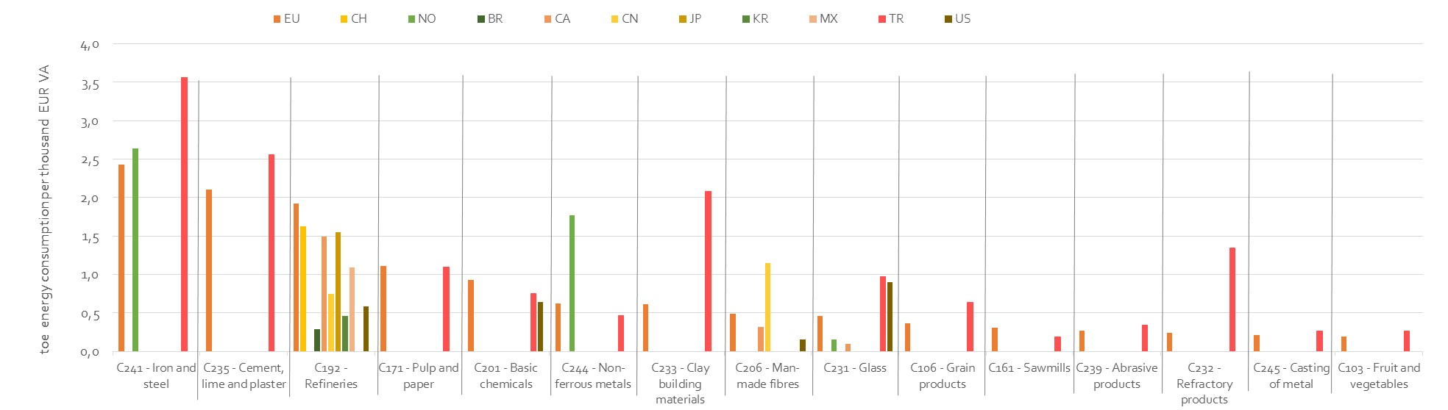

Figure 133 - Energy intensity international comparisons for the most energy intensive manufacturing sectors

Source: Trinomics et altri study

Note: data limited for available sectors and countries

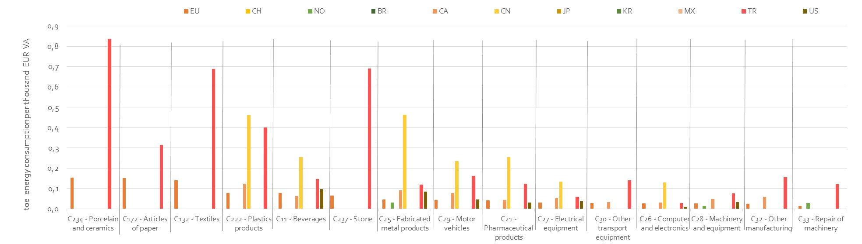

Figure 134 - Energy intensity international comparisons for other manufacturing sectors

Source: Trinomics et altri study

Note: data limited for available sectors and countries

### Industrial electricity prices: EU vs G20 countries

This section compares retail industrial prices for electricity in the EU industry with those in G20 Members. It relies on the results of the *Trinomics et altri* study. International comparisons of electricity prices are very relevant for an assessment of cost competitiveness of sectors. Indeed electricity is the energy carrier which most often has the highest potential to impact the energy costs differential between energy intensive sectors in manufacturing.

Retail electricity prices for industry have relatively complete datasets. The price data covers EU28 and G20 countries from 2008-2018. EU28 prices are based on consumption band assumptions (mainly Eurostat consumption band ID) while data for non-EU G20 countries is normally based on the average of the countries (not based on consumption bands). The price data is however widely comparable (i.e. comparability checks were undertaken can be found in the study by *Trinomics et altri*). Finally, prices are exclusive of VAT and recoverable taxes and levies but include (non-recoverable) excise taxes and levies.

The main conclusions that can be drawn from this data are:

* EU28 average prices increased from around 100 EUR/MWh in 2008 to 120 EUR/MWh by 2013-2014, but since then prices have slowly declined to around 110 EUR/MWh.
* US prices are around half the EU average levels and have not changed significantly between 2008 and 2018.(See **Figure 135)**
* Prices in Japan were higher than the EU28 average but have declined since 2012 and converged in 2015-2016 to a broadly similar level .(See **Figure 135**)
* Prices in China began at a comparable level to EU prices but have declined since 2011 and thus diverged from EU levels. (See **Figure 135**)



Figure 135 – Retail electricity prices for industry: EU vs China, Japan & US, 2008-2018

Sources: Eurostat, CEIC and IEA

* Most other G20 countries (Canada, India, Russia, Mexico, South Korea, Saudi Arabia, and Turkey) also have lower prices than the EU average. Only Brazil has higher prices. Prices in South Korea are lower but increasing and converging to EU levels, whilst prices in Mexico (already below cost) are diverging as they have significantly decreased since 2014. (See **Figure 136**)



Figure 136 - Retail electricity prices for industry: EU vs other G20, 2007-2018

Sources: Eurostat, CEIC, IEA, ERRA

For Argentina, Australia, India there is only information from price indices (and not absolute price data). The evolution of the indices indicate that EU average prices have increased by around 10% since 2008 (+1.1%/year) while real price indices declined in India and particularly in Argentina. The Australian price index has increased in real terms by more than 60% over the period. – See **Figure 137**



Figure 137 – Retail electricity indexes prices for industry: EU vs Argentina, Australia & India, 2008-2018

Sources: Eurostat, CEIC and IEA

* Price differentials (in real prices 2017) did not evolve favourably for the EU in most of the cases as EU prices increased (by 10%) while prices decreased in most of the G-20 countries (with the exception of Indonesia and South Korea). As a result of this divergent evolution, the price gap with the US and China (which was already favourable for these two countries at the start of the period analysed) has widened slightly. The gap with Japan (which was favourable for the EU) has shrunk. The price gap with the EU increased for most of the other G-20 countries, or in the case of Brazil, prices that were initially higher converged towards EU levels. Only the price gap with South Korea evolved favourably for the EU (while the gap with Indonesia remained roughly stable) – See Table 14

Table 14 - Changes in retail industrial electricity prices compared to EU prices, constant 2017 EUR/MWh

|  |  |  |  |  |  |  |  |  |
| --- | --- | --- | --- | --- | --- | --- | --- | --- |
| **Country** | **Start price [EUR2017]** | **End price [EUR2017]** | **Change EUR** | **Change %** | **Start Gap [EUR]** | **End Gap [EUR]** | **Difference [EUR]** | **Impact for EU** |
| EU28 | **101.33** | **112.05** | 10.72 | 10.6% |  |  |  |  |
| Argentina |  |  |  |  |  |  |  |  |
| Australia |  |  |  |  |  |  |  |  |
| Brazil | **151.51** | **144.48** | -7.03 | -4.6% | 50.18 | 32.43 | -17.75 | Negative |
| Canada | **71.53** | **70.66** | -0.87 | -1.2% | -29.80 | -41.39 | -11.59 | Negative |
| China | **109.83** | **99.65** | -10.18 | -9.3% | 8.50 | -12.40 | -20.90 | Negative |
| India |  |  |  |  |  |  |  |  |
| Indonesia | **65.01** | **71.30** | 6.29 | 9.7% | -36.32 | -40.75 | -4.43 | Negative |
| Japan | **140.15** | **134.58** | -5.57 | -4.0% | 38.82 | 22.53 | -16.29 | Negative |
| Mexico | **127.10** | **63.20** | -63.90 | -50.3% | 25.77 | -48.85 | -74.62 | Negative |
| Russia | **64.00** | **56.33** | -7.67 | -12.0% | -37.33 | -55.72 | -18.39 | Negative |
| Saudi Arabia | **47.25** | **43.60** | -3.66 | -7.7% | -54.08 | -68.46 | -14.38 | Negative |
| South Africa |  |  |  |  |  |  |  |  |
| South Korea | **62.94** | **85.82** | 22.88 | 36.3% | -38.39 | -26.23 | 12.16 | Positive |
| Turkey | **70.21** | **56.80** | -13.41 | -19.1% | -31.12 | -55.25 | -24.13 | Negative |
| USA | **63.85** | **58.71** | -5.14 | -8.1% | -37.48 | -53.34 | -15.86 | Negative |

Source: Trinomics et altri study.

Note: a positive impact for the EU is recorded if the price gap has improved over time, e.g. that if a country had lower prices initially the gap is now smaller or prices are higher than the EU average, or if a country had higher prices and that the gap has increased. A negative impact is recorded if a country had lower prices than the EU, and that the gap has now increased, or if the country had higher prices than the EU but this gap has narrowed or the country now has lower prices.

* The analysis of the drivers of international prices (see Table 15) shows that monetary effects (inflation and exchange rate changes) played a very significant role in the evolution of nominal prices. High inflation played a key role in pushing up prices in countries like Brazil and Indonesia. In Russia and Turkey the effects of high inflation were mitigated or offset by exchange rates depreciations. Exchange rate appreciations also played a role in pushing up Chinese and US prices. EU prices increased by around 12% in real terms between 2008 and 2017 (1.3%/year). In contrast, real prices declined in Brazil, Mexico, China, the US and Saudi Arabia. However, national prices increased in real terms in the remainder of the G20 in a comparable or higher magnitude.

Table 15 - Factors in observed industrial retail electricity price changes per country, nominal prices, per MWh

|  |  |  |  |  |  |  |  |  |  |  |  |  |
| --- | --- | --- | --- | --- | --- | --- | --- | --- | --- | --- | --- | --- |
| **Country** | **Start date** | **End date** | **Nominal Start price EUR** | **Change due to inflation [EUR]** | **Change due to price change in national currency [EUR]** | **Exchange rate effect [EUR]** | **Total change [EUR]** | **Nominal End price EUR** | **Change due to inflation [%]** | **Change due to real price change in national currency [%]** | **Exchange rate effect [%]** | **Total change [%]** |
| EU28 | 2008-1 | 2017-11 | **92.80** | 8.20 | 11.05 | 0.00 | **19.25** | **112.05** | 8.8% | 11.9% | 0.0% | **20.7%** |
| Argentina | No data |  |  |  |  |  |  |  |  |  |  |  |
| Australia | No data |  |  |  |  |  |  |  |  |  |  |  |
| Brazil | 2008-12 | 2016-12 | **111.68** | 71.01 | -15.02 | -14.87 | **41.12** | **152.80** | 63.6% | -13.4% | -13.3% | **36.8%** |
| Canada | 2008-1 | 2016-1 | **48.18** | 4.02 | 23.20 | -2.86 | **24.36** | **72.55** | 8.3% | 48.2% | -5.9% | **50.6%** |
| China | 2008-1 | 2017-12 | **62.87** | 14.43 | -5.98 | 26.03 | **34.48** | **97.34** | 23.0% | -9.5% | 41.4% | **54.8%** |
| India | No data |  |  |  |  |  |  |  |  |  |  |  |
| Indonesia | 2008-12 | 2016-12 | **40.72** | 18.18 | 9.96 | 5.56 | **33.70** | **74.41** | 44.6% | 24.5% | 13.7% | **82.8%** |
| Japan | 2008-1 | 2016-1 | **94.40** | -1.15 | 18.50 | 26.44 | **43.79** | **138.19** | -1.2% | 19.6% | 28.0% | **46.4%** |
| Mexico | 2008-1 | 2016-1 | **85.61** | 26.29 | -32.71 | -14.30 | **-20.72** | **64.89** | 30.7% | -38.2% | -16.7% | **-24.2%** |
| Russia | 2008-1 | 2015-4 | **43.11** | 30.16 | 17.35 | -33.08 | **14.43** | **57.54** | 70.0% | 40.2% | -76.7% | **33.5%** |
| Saudi Arabia | 2009-1 | 2015-4 | **35.65** | 6.78 | -3.78 | 5.89 | **8.89** | **44.53** | 19.0% | -10.6% | 16.5% | **24.9%** |
| South Africa | No data |  |  |  |  |  |  |  |  |  |  |  |
| South Korea | 2008-1 | 2016-1 | **42.40** | 6.35 | 34.28 | 5.09 | **45.72** | **88.12** | 15.0% | 80.9% | 12.0% | **107.8%** |
| Turkey | 2008-1 | 2017-7 | **64.30** | 42.27 | 27.94 | -77.71 | **-7.50** | **56.80** | 65.7% | 43.5% | -120.9% | **-11.7%** |
| USA | 2008-1 | 2017-12 | **43.01** | 5.65 | -3.61 | 10.97 | **13.01** | **56.02** | 13.1% | -8.4% | 25.5% | **30.2%** |

Source: Trinomics et altri.study

Explanation: this table shows the different components of the observed nominal price change, decomposed into inflation, price change and exchange rate effects. By summing the components between the Nominal start price EUR and Total change [EUR] the total change can be calculated, this corresponds to the difference between the Nominal Start price EUR and the Nominal End price EUR.

Note: this table presents nominal prices, differences can be observed with the previous table which used constant prices, the start prices differ due to application of the currency deflator for the constant price calculation, whilst the end prices differ due to small differences in the conversions used in the two calculations, this latter difference is typically less than +/- 5% of the price.

**Note on the range and dispersion of industrial electricity prices in the EU**

The industrial electricity prices in the EU Member States have spanned a range of 50-270 EUR/MWh between 2008 and 2018 (see figure below looking at the maximum and minimum prices registered in MS between 2008–2018)

. 

Figure 138 - Range of retail electricity prices for industry in the EU

Source: Eurostat

This wide range does not necessary mean that there huge differences in prices between the Member States .It reflects steady price differential between Member States (ie Members with consistently higher or lower prices than the EU average) but also temporary price divergences (e.g. price spikes) in some countries. The dispersion of EU prices can be better assessed by the Box plot figure below (in which the square shows the range of the prices of the 25% of the MS being above the average and 25% of the MS being below the average price (ie 50 of the sample))



Figure 139 - Box plot of EU28 industrial retail electricity prices 2008-2017

Source: Trinomics et altri study

The figure below allows for identifying the MS which are close to the maximum and minimum range as well as those with significant and steady deviations from the average.



Figure 140 - EU28 industrial retail electricity prices 2008-2017, individual Member States lines visible, outliers named

Source Trinomics et altri study

### Industrial gas prices: EU vs G20 countries

Retail gas prices for industry also have relatively complete datasets, the following figures present gas price data for the EU28 and G20 countries from 2007-2018. Prices are excluding VAT and all recoverable taxes and levies. From the analysis of the data one can conclude that:

* EU prices were in the range of 25-40 EUR/MWh but since 2016 they have declined to a level below 25 EUR/MWh (marking a fall of around 20-25% over the 2008-2017).
* Industry gas prices in the **US** (and **Canada**) are considerably lower than the EU average, having been around the same in 2008 (around 30 EUR/MWh), they have declined considerably more to reach around 10 EUR/MWh in 2016. Prices in **China** have stayed around 40 EUR/MWh throughout the period. Prices in **Japan** prices increased between 2009 and 2014 (diverging from the EU average) but since (2015-16) decreased to get close to EU prices. – See **Figure 141**



Figure 141 - Retail gas prices for industry: EU vs China, Japan and the US, 2008-2018

Sources: Eurostat, CEIC

* Prices in **Turkey** display similar, but slightly lower, levels and trends to the EU average. Prices in **South Korea** more closely mirror the price trends in Japan, diverging between 2009-2014, then converging between 2015-16. Prices in **Brazil** and **Russia** are around half the EU levels, comparable to prices in the US (and Canada). Prices in **Argentina** are the lowest of all, held artificially low by policy (they have started to increase since 2015). – See **Figure 142**



Figure 142 - Retail gas prices for industry: EU vs other non-EU G20 countries, 2008-2018

Sources: Eurostat, CEIC, ERRA, IEA

NB. Information for Australia and Mexico comes only from price indices (no absolute prices). It shows that whilst EU average prices have declined by around 20-25% since 2008, in contrast prices in national currency in Mexico have remained around the same in real terms, whilst prices in Australia have increased by around 50% in real terms (4.6% annual average increases) - See **Figure 143**



Figure 143 - Retail gas indexes prices for industry: EU vs AU and MX, 2008-2018

Source: Trinomics et altri study

* Price differential (in 2017 euros) did not evolve favourably for the EU with regard to half of the countries (particularly the US and Canada) in which prices fell more than the EU average. The price gap with Russia evolved positively for the EU as Russian prices increased slightly. The price gap with China, Mexico and Australia have also evolved favourably for the EU as prices in these countries at the end of period have were roughly comparable to those in 2008 or increased. (see **Table 16**)

Table 16 - Changes in the industry retail natural gas price differential compared to EU prices, constant 2017 euros per MWh

|  |  |  |  |  |  |  |  |  |
| --- | --- | --- | --- | --- | --- | --- | --- | --- |
| **Country** | **Start price [EUR2017]** | **End price [EUR2017]** | **Change EUR** | **Change %** | **Start Gap [EUR]** | **End Gap [EUR]** | **Difference [EUR]** | **Impact for EU** |
| EU28 | **31.74** | **23.97** | -7.77 | -24.5% |  |  |  |  |
| Argentina | **3.16** | **2.17** | -0.99 | -31.3% | -28.58 | -21.80 | 6.78 | Positive |
| Australia |  |  |  |  |  |  |  |  |
| Brazil | **28.17** | **15.93** | -12.24 | -43.5% | -3.57 | -8.04 | -4.47 | Negative |
| Canada | **30.55** | **12.38** | -18.18 | -59.5% | -1.19 | -11.60 | -10.41 | Negative |
| China | **38.51** | **38.47** | -0.04 | -0.1% | 6.77 | 14.50 | 7.73 | Positive |
| India |  |  |  |  |  |  |  |  |
| Indonesia |  |  |  |  |  |  |  |  |
| Japan | **48.67** | **34.09** | -14.59 | -30.0% | 16.93 | 10.12 | -6.82 | Negative |
| Mexico | **37.57** | **37.57** | 0.00 | 0.0% | 5.82 | 13.59 | 7.77 | Positive |
| Russia | **8.58** | **7.12** | -1.46 | -17.0% | -23.16 | -16.85 | 6.31 | Positive |
| Saudi Arabia |  |  |  |  |  |  |  |  |
| South Africa |  |  |  |  |  |  |  |  |
| South Korea | **47.14** | **36.72** | -10.42 | -22.1% | 15.40 | 12.74 | -2.65 | Negative |
| Turkey | **27.08** | **16.60** | -10.48 | -38.7% | -4.66 | -7.37 | -2.71 | Negative |
| USA | **32.21** | **10.41** | -21.80 | -67.7% | 0.47 | -13.56 | -14.03 | Negative |

Source: Trinomics et altri study

Note: a positive impact for the EU is recorded if the price gap has improved over time, e.g. that if a country had lower prices initially the gap is now smaller or prices are higher than the EU average, or if a country had higher prices and that the gap has increased. A negative impact is recorded if a country had lower prices than the EU, and that the gap has now increased, or if the country had higher prices than the EU but this gap has narrowed or the country now has lower prices.

* The analysis of the factors driving price differential (see **Table 17**) shows that EU nominal prices in Euros decreased by 18% over the period 2008 to 2017 (-2% per year). Of the other G20 countries, nominal prices in national currency only decreased in the US and Canada, increasing in all others and by particularly high amounts in Argentina, Russia and Turkey. When taking exchange and inflation effects into account we find that in real terms in national prices that the EU decrease was around 26% (-3.3% per year), but that real decreases were experienced not only in the US and Canada, but also in Argentina, Brazil, Japan, Russia and Turkey. This difference being explained in Argentina, Russia and Turkey by high inflation and exchange rate effects. In Brazil high inflation was the most important explanatory factor, whilst in Japan the changes were only small.
* In terms of the differentials in real national price changes the EU experienced negative differentials with Argentina, Brazil, Canada, Russia, Turkey and the US; and positive differentials with China, Japan, Mexico and South Korea. In the 3 Asian countries it is likely driven by differences in supply, with these being much more reliant on LNG shipments, with this reflected in wholesale prices. This highlights the fact that whilst EU prices have declined in both nominal and real terms over this period that, outside Asia and Mexico, prices in the rest of the G20 have decreased even further.

Table 17 - Factors in observed industrial retail natural gas price changes per country, nominal prices, per MWh

|  |  |  |  |  |  |  |  |  |  |  |  |  |
| --- | --- | --- | --- | --- | --- | --- | --- | --- | --- | --- | --- | --- |
| **Country** | **Start date** | **End date** | **Nominal Start price EUR** | **Change due to inflation [EUR]** | **Change due to price change in national currency [EUR]** | **Exchange rate effect [EUR]** | **Total change [EUR]** | **Nominal End price EUR** | **Change due to inflation [%]** | **Change due to real price change in national currency [%]** | **Exchange rate effect [%]** | **Total change [%]** |
| EU28 | 2008-1 | 2017-11 | **29.07** | 2.57 | -7.67 | 0.00 | **-5.10** | **23.97** | 8.8% | -26.4% | 0.0% | **-17.5%** |
| Argentina | 2008-9 | 2017-12 | **1.49** | 3.76 | 4.01 | -7.41 | **0.36** | **1.85** | 252.2% | 269.0% | -497.0% | **24.1%** |
| Australia | No data |  |  |  |  |  |  |  |  |  |  |  |
| Brazil | 2008-12 | 2016-12 | **15.75** | 10.02 | -9.35 | -1.46 | **-0.79** | **14.97** | 63.6% | -59.4% | -9.3% | **-5.0%** |
| Canada | 2008-1 | 2016-1 | **20.58** | 1.72 | -9.09 | -0.50 | **-7.87** | **12.71** | 8.4% | -44.2% | -2.4% | **-38.2%** |
| China | 2008-1 | 2017-12 | **22.04** | 5.06 | 0.43 | 10.05 | **15.54** | **37.58** | 23.0% | 2.0% | 45.6% | **70.5%** |
| India | No data |  |  |  |  |  |  |  |  |  |  |  |
| Indonesia | No data |  |  |  |  |  |  |  |  |  |  |  |
| Japan | 2009-1 | 2016-1 | **36.72** | -0.23 | 1.01 | -2.51 | **-1.73** | **35.00** | -0.6% | 2.8% | -6.8% | **-4.7%** |
| Mexico | 2008-1 | 2008-1 | **25.30** | 0.00 | 0.00 | 0.00 | **0.00** | **25.30** | 0.0% | 0.0% | 0.0% | **0.0%** |
| Russia | 2008-1 | 2015-4 | **5.78** | 4.04 | 1.63 | -4.18 | **1.49** | **7.27** | 69.9% | 28.2% | -72.3% | **25.8%** |
| Saudi Arabia | No data |  |  |  |  |  |  |  |  |  |  |  |
| South Africa | No data |  |  |  |  |  |  |  |  |  |  |  |
| South Korea | 2008-1 | 2016-1 | **31.75** | 4.76 | -0.99 | 2.18 | **5.95** | **37.70** | 15.0% | -3.1% | 6.9% | **18.7%** |
| Turkey | 2008-1 | 2017-7 | **24.80** | 16.30 | -1.79 | -22.71 | **-8.20** | **16.60** | 65.7% | -7.2% | -91.6% | **-33.1%** |
| USA | 2008-1 | 2016-1 | **21.69** | 2.57 | -16.38 | 2.80 | **-11.01** | **10.69** | 11.8% | -75.5% | 12.9% | **-50.8%** |

Source: Trinomics et altri study (2018)

**Note on the range and dispersion of retail gas prices for industry in the EU**

The max-min range of gas prices in the EU Member States was roughly between 15-50 EUR/MWh. The dispersion in gas is thus much lower than for electricity with most of the countries being much closer to the average price.



Figure 144 - Max-min range of retail gas prices for industry in the EU, 2008-2018

Sources: Eurostat



Figure 145 - Box plot of industrial gas prices, 2008-2017

Source: Trinomics et altri study

Note: the square represents the range of the prices for the 25% of countries above and below the average (50% of the sample)

The figure below allows for identifying the MS which are close to the maximum and minimum range as well as those with significant and steady deviations from the average.



Figure 146 - EU28 industrial retail natural gas prices 2008-2017, individual Member States lines visible, outliers named

Source: Trinomics et altri study

**Note on the estimation of the price effect on the EU international competitiveness**

The previous sections of this chapter show that energy prices in the EU were in many cases higher than in trading partners over the period of study. This could have had some negative impact on the cost competitiveness of the EU industry. It is interesting to complement the analysis in this chapter by an assessment of the impact of price differences on the competitiveness of some EU energy intensive sectors (at NACE 2 level) over the period 2008-2016.

This is done in the *Trinomics et altri* study through an ex-post analysis where a counterfactual scenario is developed in which gas and electricity prices in the EU are aligned with the lower prices faced by the EU’s main trading partners. This counterfactual scenario is then compared to historical data to assess the impact on the competitiveness of some EU sectors, i.e. how much lower the energy costs and prices of these sectors would have been if they had paid the lower energy prices available in the EU trading partners.

To assess the hypothetical scenario the E3ME (a comprehensive macro-econometric model) was used[40]. The energy prices (excluding VAT) were taken from Eurostat and IEA. For the counterfactual scenario, the weighted average energy prices (by total trade) from the 15 top EU-trading countries over the period 2008-2016[41] was calculated.

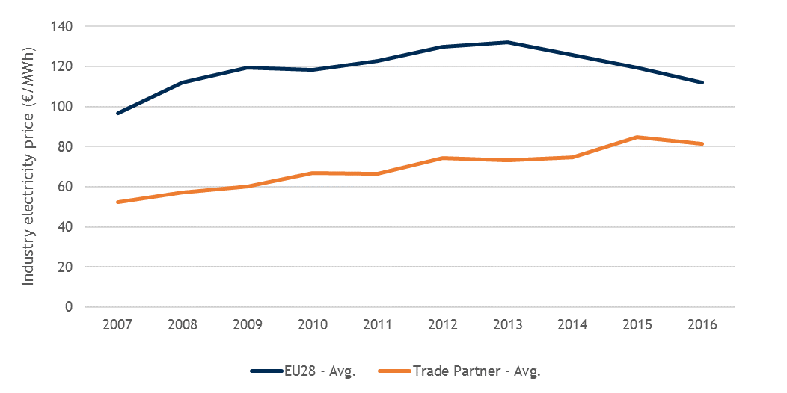 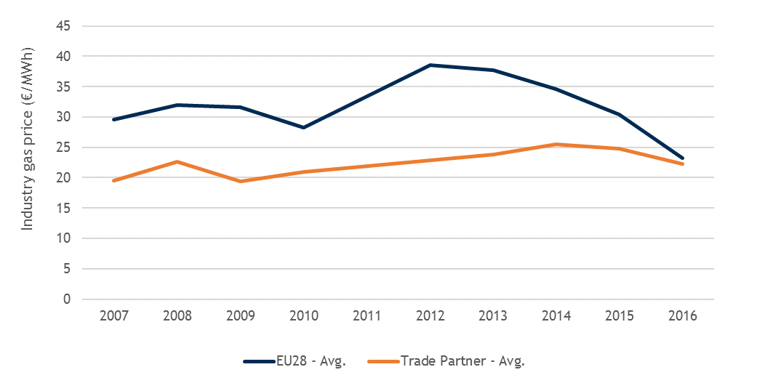

Figure 147 - Average industry electricity (left) and gas (right) prices in the EU and among the top 15 EU trade partners (current prices)

Source: Trinomics et altri study

The figures below show how industry unit costs would have evolved in the EU sectors analysed over 2008-2016 (had industry gas and electricity prices matched the lower prices faced by the EU’s main trading partners).In most sectors, unit costs[42] would have been around 0.5-1.0% lower but much lower (2.0-2.5%) in the most energy intensive industries like Basic metals or non-metallic minerals lower (See Figure). Prices of goods manufactured would have been between 0.2% and 0.8% lower over.

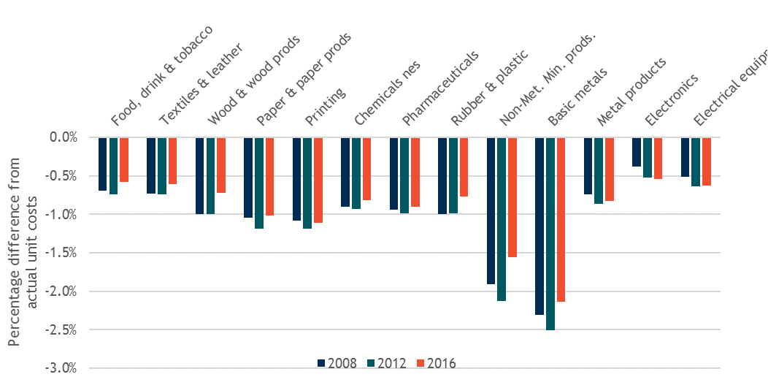

Figure 148 - Impact on EU industry unit costs in a counterfactual scenario where EU energy prices over 2007-2016 are comparable to energy prices faced by the EU’s main trading partners

Source: Trinomics et altri study

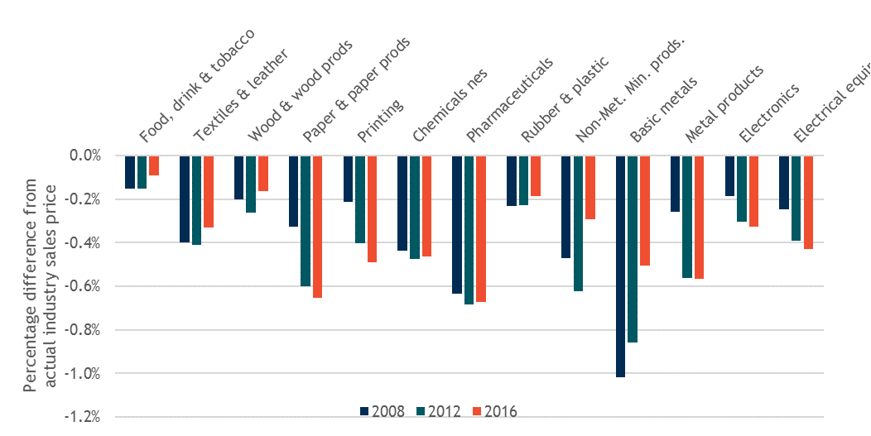

Figure 149 - Impact on EU industry prices in a counterfactual scenario where EU energy prices over 2007-2016 are comparable to energy prices faced by the EU’s main trading partners

Source: Trinomics et altri study

## Case studies of selected Energy Intensive Industries

Previous sections and chapters have analysed energy prices and costs for industry from highly aggregated statistical information (top-down approach). In this section, we look at energy prices and costs[43] in some selected energy intensive industries at a more disaggregated level and the role they can play in their competitiveness, based on primary data collected from individual companies (bottom-up approach). This bottom-up approach aims at completing the analysis by addressing the specificities of (sub-)sectors where energy costs are most relevant and may significantly affect their competitiveness and which effect may not be fully captured at aggregated level.

The results presented here are based on the study carried out for the European Commission by CEPS and Ecofys[44]. Primary data, including energy bills, were collected at plant level via a dedicated questionnaire.

### Scope and samples

The bottom-up analysis covers the entire EU over a 10-year period going from 2008 to 2017. It focusses on the following sectors: bricks and roof tiles, wall and floor tiles, glass tableware, packaging glass, primary aluminium, secondary aluminium, downstream aluminium industry, electric arc furnace steelmaking (referred to as EAF steel), blast furnace-basic oxygen furnace steelmaking (referred to as BOF steel), nitrogen fertilisers and refineries.

The selection of these sectors ensures wide coverage of key features of EU energy intensive industries. The sectors covered include in particular:

* Natural gas-intensive sectors (e.g. bricks and roof tiles, packaging glass) and electricity-intensive sectors (e.g. primary aluminium, EAF steel);
* Sectors purchasing additional energy carriers, including coking coal (e.g. BOF steel) and crude oil (e.g. refineries);
* Sectors concentrated in a limited number of Member States (e.g. wall and floor tiles, primary aluminium) and sectors geographically dispersed in Europe (e.g. packaging glass, secondary and downstream aluminium);
* Sectors dominated by large companies (e.g. primary aluminium, glass tableware) and sectors including many SMEs (e.g. bricks and roof tiles, wall and floor tiles);
* Net importer sectors (e.g. primary, secondary and downstream aluminium, EAF and BOF steel), net exporter sectors (e.g. wall and floor tiles, glass tableware) and sectors that are relatively less exposed to international competition (e.g. bricks and tiles, packaging glass).

For each sector, data were collected on a sample of ‘typical’ plants across the EU, which reflect the average features of EU plants operating in that sector[45]. Table 18 shows the sample composition for each sector[46] as well as its representativeness at EU level (share of the sample in the EU turnover or production capacity). The full sample includes 194 plants from 11 sectors spread over three aggregated EU regions[47]. EU representativeness of the samples for 2016 observations ranges from 11% for wall and floor tiles to above 90% in the case of glass tableware.

Table 18 - Size and EU representativeness of the samples in the bottom-up analysis

|  |  |  |  |  |  |
| --- | --- | --- | --- | --- | --- |
|  | **Number of plants by geographical region(1)** | | | | **Representativeness in 2016(2)** |
| **Sector** | **Central-Eastern Europe** | **North-Western Europe** | **Southern Europe** | **Total** | **Share of turnover (T) or production capacity (C)** |
| Bricks and roof tiles | 11 | 36 | 11 | **58** | 11% (T) |
| Wall and floor tiles | 8 | 4 | 10 | **22** | 12% (T) |
| Glass tableware | 2 | 4 | 6 | **12** | 92% (T) |
| Packaging glass | 8 | 8 | 8 | **24** | 17% (T) |
| Aluminium primary | 1 | 5 | 4 | **10** | 60% (T) |
| Aluminium secondary | 2 | 1 | 6 | **9** | n.a.(3) |
| Aluminium downstream | 1 | 4 | 3 | **8** | 13% (T) |
| Steel EAF | 3 | 13 | 2 | **18** | 14% (C) |
| Steel BOF | 3 | 4 | 0 | **7** | 26% (C) |
| Nitrogen fertilisers | 4 | 1 | 3 | **8** | 17% (C) |
| Refineries | 1 | 8 | 4 | **13** | 19% (C) |
| **TOTAL** | **44** | **88** | **57** | **189** | **-** |

Source: CEPS/Ecofys

(1) **Central-Eastern Europe:** Bulgaria, Croatia, Czech Republic, Estonia, Hungary, Latvia, Lithuania, Poland, Romania, Slovak Republic, Slovenia; **North-Western Europe:** Austria, Belgium, Denmark, Finland, France, Germany, Ireland, Luxembourg, the Netherlands, Sweden, the UK; **Southern Europe:** Cyprus, Greece, Italy, Malta, Portugal, Spain.

(2) Estimates of the representativeness vary from year to year due to turnover/production capacity variation both in the sample and the sector as well as potential missing observations in the sample for a given year. For illustrative purpose, figures are shown for 2016 (figures with similar orders of magnitude can be observed for the other years).

(3) Due to data unavailability at this level of sectoral disaggregation the representativeness could not be computed.

### Cross-Sectorial comparisons

**Electricity prices and costs**

We can observe across sectors a straightforward relationship between increased electricity consumption levels and decreased average prices (**Figure 150**). At the lower range of electricity consumption (2016 figures), we can find the bricks and tiles industry, with a median electricity consumption of around 6 GWh/year per plant, which pays on average 84 EUR/MWh, while in the upper range the primary aluminium industry, with a median consumption of around 2.3 TWh/year per plant (almost 400 times higher than for bricks and tiles), pays 39 EUR/MWh on average. The sector which pays the highest electricity prices is wall and floor tiles with a price of 99 EUR/MWh on average, which is around 150% more expensive than the price paid by primary aluminium.

The average electricity prices are associated in most sectors with high price spreads (the most extreme case being refineries), which reflect the high variability of conditions in different Member States.



Figure 150 - Plant electricity consumption and average electricity prices by sector, 2016 (185 observations)

Source: CEPS/Ecofys.

**Figure 151** presents the average electricity prices of plants grouped by 4 electricity consumption bands, irrespective of the sector:

* 1-10 GWh (35% of sampled plants), mostly equivalent to electricity band IC or ID;
* 10-100 GWh (37% of sampled plants), mostly equivalent to electricity band ID or IE;
* 100-1,000 GWh (21% of sampled plants), mostly equivalent to electricity band IF or IG;
* 1,000-10,000 GWh (7% of sampled plants), equivalent to electricity band IG.

The negative correlation between consumption and average prices of electricity appears quite robust over the period (lower bands pay a higher price and upper bands pay a lower price). In general, electricity prices peaked in 2011 for the two upper bands (100-10,000 GWh) and in 2012 for the two lower bands (1-100 GWh) and have been decreasing since then in all four consumption bands.



Figure 151 - Average electricity prices by consumption level, 2008 – 2017 (2008: 120 observations; 2009: 73; 2010: 141; 2011: 86; 2012: 154; 2013: 161; 2014: 161; 2015: 158; 2016: 185; 2017: 182)

Source: CEPS/Ecofys.

The trend of lower prices for industries that have plants with high electricity needs can be explained by various reasons:

1. Some larger consumers may negotiate more favourable supply price conditions through the wholesale market or through striking better deals with providers in exchange for the amount of power they purchase and their load consumption profile.
2. Larger consumers from energy-intensive sectors may be granted exemptions from certain taxes and levies, or be provided with lower prices in Member States with regulated prices.
3. Some industries, in particular the primary aluminium industry, run a flat profile process from day to night, hence benefit from lower electricity prices (base load prices).

With accounting for reimbursements[48], payments for flexibility schemes and revenues from self-generated electricity sold to the grid, **Figure 152** shows electricity costs vs. electricity consumption at plant level by sector. We observe for costs the same trends as before for prices, but since some plants either receive reimbursements, payments and/or self-produce electricity, electricity costs are generally lower than electricity prices. The difference between prices and costs varies both across sectors and years (full details can be found in the CEPS and Ecofys study). Across sectors, the difference tends to be larger in 2016 and 2017 in comparison with previous years, but it remains moderate in any case. For instance in 2016, costs were between 0% (downstream aluminium) and 11% (wall and floor tiles) lower than prices (**Figure 152** compared to **Figure 150**).

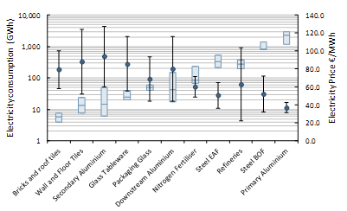

Figure 152 - Plant electricity consumption and average electricity costs by sector, 2016 (185 observations)

Source: CEPS/Ecofys.

**Natural gas prices and costs**

A correlation between natural gas consumption and the natural gas price paid by plants can be seen, but is much less significant when compared with the analysis on electricity prices (**Figure 153**). In 2016, nitrogen fertiliser plants (the most natural gas intensive plants in the analysis) had a median natural gas consumption of 4,5 TWh and paid for it 19 EUR/MWh on average, while plants from the bricks and roof tiles industry (the least natural gas intensive plants in the analysis) had a median natural gas consumption of 51 GWh (almost 100 times less than nitrogen fertilisers) and paid for it 25 EUR/MWh on average. The sector which pays the lowest natural gas prices is BOF steel with a price of 17 EUR/MWh on average. The maximum natural gas price differential (the highest natural gas price paid compared to the lowest in relative terms) observed in the sampled energy intensive industries is around +46%, which is still significant, but the price range is much lower than in the case of electricity (maximum price differential: +152%).

The lower variation in natural gas prices both within (price spreads) and across sectors compared to electricity prices can be explained by the fact that:

1. The proportion of taxes, levies and network costs is relatively small in the total natural gas price. Consequently, there is less opportunity for governments to adapt prices through discounts and exemptions.
2. Natural gas costs heavily depend on international prices set by natural gas producing countries. Since EU Member States are mostly net importers of natural gas, there is little room for price negotiation. By contrast, electricity prices depend on the generation mix within that Member State and the surrounding Member States, so are more country and region specific.



Figure 153 - Plant natural gas consumption and average natural gas prices by sector, 2016 (165 observations)

Source: CEPS/Ecofys.

As in the case of electricity, plants can be grouped, regardless of the sector, by natural gas consumption bands. **Figure 154** shows the average natural gas prices for 3 natural gas consumption bands:

* 10-100 GWh (42% of sampled plants), mostly equivalent to natural gas band I3 or I4;
* 100-1,000 GWh (44% of sampled plants), mostly equivalent to natural gas band I4 or I5;
* 1,000-10,000 GWh (11% of sampled plants), mostly equivalent to natural gas band I6.

The impact of natural gas consumption levels on average natural gas prices (negative correlation) is robust over years but less pronounced than for electricity. In general, natural gas prices peaked in 2012 for the two upper bands (100-10,000 GWh) and in 2013 for the lowest band (10-100 GWh) and have been decreasing since then. However, we can note that natural gas prices increased again in 2017 for the highest band (1,000-10,000 GWh).



Figure 154 - Average natural gas prices by consumption level, 2008 – 2017 (2008: 110 observations; 2009: 74; 2010: 129; 2011: 81; 2012: 137; 2013: 145; 2014: 149; 2015: 147; 2016: 165; 2017: 163)

Source: CEPS/Ecofys.

Unlike electricity, in the case of natural gas, reimbursements, payments for flexibility schemes or revenues from self-generated natural gas do no play any significant role. As a result, natural gas costs are similar to natural gas prices and are then not shown here.

### Prices across Member States

**General remarks**

Based on the data collected in the CEPS and Ecofys study, average energy prices (electricity and natural gas) faced by energy intensive sectors in some specific Member States can be calculated by pulling together all the sampled plants in a given Member State, regardless of the sectors. Due to confidentiality reasons, only Member States with reliable data available from at least three independent companies have been included in this part of the analysis[49].

It is important to keep in mind that the samples at Member State level are relatively small and have not been designed to be representative of those Member States[50]. For a given Member State, some energy intensive sectors may be over-represented while some others may be under-represented. In particular, a Member State with mostly large plants in the sample, associated with larger energy consumption, may tend to exhibit lower energy prices, but these prices might not be representative for all plants within that Member State. In the same way, a Member State with mostly small plants in the sample, associated with lower energy consumption, may show higher energy prices, but again these prices might not be representative for all plants within that Member State. Results should therefore be taken with caution and not interpreted as national average prices for energy intensive industries but rather as average prices faced by the energy intensive companies included in the samples.

**Electricity prices**

**Figure 155, Figure 156** and **Figure 157** show the average electricity prices and its main components (energy, network, RES support/levies and other non-recoverable taxes/levies) for energy intensive sectors in Member States of the NWE region (France, Germany, the Netherlands and the UK), SE region (Portugal, Italy, Spain and Greece) and CEE region (Poland and Bulgaria), respectively.

In most Member States, average electricity prices for energy intensive sectors increased on the period 2008-2012 and have started to decline since 2012-2013. This can be seen in France, Germany, the Netherlands, Greece, Spain and Bulgaria. In some cases, the peak in electricity prices came later, for example in 2014 in Poland and in 2015 in the UK. However, average electricity prices have started to increase again in 2016 or 2017 in a number of these Member States (e.g. France, Germany, the Netherlands, Spain and Poland).

Plants in Germany, the UK, Italy and Bulgaria experience noticeably higher electricity prices compared to other Member States included in the analysis. This is generally the result of higher non-recoverable taxes and levies including RES levies and network costs.

The levels and relative shares of the different price components for energy intensive sectors vary significantly between Member States. The most pronounced differences are observed in the regulatory components, i.e. network costs, RES support/levies and other non-recoverable taxes/levies. These differences can be attributed to:

* The considerable variation of exemptions for electricity-intensive sectors, including the scope, rules (*ex ante* vs. *ex post* exemptions[51]) and magnitude, between Member States;
* The variation of visibility of price components in bills from one Member State to another (For example, RES levies are sometimes not visible in the bill, though existing, and may then be accounted for in another component by the respondents. This is particularly the case for the plants in the Netherlands, Portugal and Spain, which report very little or no RES levies but these costs have likely been included in network costs or in other non-recoverable taxes/levies);
* The different overall network costs and RES support payments within Member States, which depend on the way in which renewables and the network grid are funded, the extent of renewable deployment and the level of grid upgrades.

**Natural gas prices**

**Figure 158, Figure 159** and **Figure 160** show the average natural gas prices and its main components (energy, network and non-recoverable taxes/levies) for energy intensive sectors in Member States of the NWE region (France, Germany, the Netherlands and the UK), SE region (Portugal, Italy and Spain) and CEE region (Poland and Bulgaria), respectively.

Average natural gas prices for energy intensive sectors showed a peak in 2012/13 and since then have been decreasing in all Member States, with much lower prices in more recent years. Between 2013 and 2017, natural gas prices declined by around 1/3 in all countries (except in Germany where the reduction is 20%).

Plants in the NWE region appear to benefit from lower natural gas prices compared to plants in the SE and CEE regions. This is mostly attributable to lower wholesale natural gas prices, but also to lower network costs.

Plants in Portugal, Bulgaria, Italy and Spain experience the highest natural gas prices. Although this is largely due to higher wholesale natural gas prices, these Member States (with the exception of Spain) also have higher network costs.

Overall, we observe less variation in natural gas prices across Member States compared to electricity prices. This is due to less leverage from governments to adapt natural gas prices through intervening with regards to taxes and levies (the proportion of non-recoverable taxes/levies is relatively small in the total natural gas price compared to electricity), as well as the fact that there are no differences in generation costs.

Figure 155 - Structure of average electricity prices in the surveyed plants in the NWE region (France, Germany, the Netherlands and the UK) in absolute terms (€/MWh), 2008 – 2017

Source: CEPS/Ecofys.

Note: The data presented on the graph are the average prices faced by the surveyed plants but are not representative of national prices. Direct comparisons between two Member States should be avoided.

Figure 156 - Structure of average electricity prices in the surveyed plants in the SE region (Portugal, Italy, Spain and Greece) in absolute terms (€/MWh), 2008 – 2017

Source: CEPS/Ecofys.

Note: The data presented on the graph are the average prices faced by the surveyed plants but are not representative of national prices. Direct comparisons between two Member States should be avoided.

Figure 157 - Structure of average electricity prices in the surveyed plants in the CEE region (Poland and Bulgaria) in absolute terms (€/MWh), 2008 – 2017

Source: CEPS/Ecofys.

Note: The data presented on the graph are the average prices faced by the surveyed plants but are not representative of national prices. Direct comparisons between two Member States should be avoided.

Figure 158 - Structure of average natural gas prices in the surveyed plants in the NWE region (France, Germany, the Netherlands and the UK) in absolute terms (€/MWh), 2008 – 2017

Source: CEPS/Ecofys.

Note: The data presented on the graph are the average prices faced by the surveyed plants but are not representative of national prices. Direct comparisons between two Member States should be avoided.

Figure 159 - Structure of average natural gas prices in the surveyed plants in the SE region (Portugal, Italy and Spain) in absolute terms (€/MWh), 2008 – 2017

Source: CEPS/Ecofys.

Note: The data presented on the graph are the average prices faced by the surveyed plants but are not representative of national prices. Direct comparisons between two Member States should be avoided.

Figure 160 - Structure of average natural gas prices in the surveyed plants in the CEE region (Poland and Bulgaria) in absolute terms (€/MWh), 2008 – 2017

Source: CEPS/Ecofys.

Note: The data presented on the graph are the average prices faced by the surveyed plants but are not representative of national prices. Direct comparisons between two Member States should be avoided.

### Overview of results of specific case studies

For each sector analysed, energy prices and costs and information on their main drivers were collected and main features of production cost structures and international competitiveness were reviewed. The details of the analysis by sector are presented in **Annex 1**. Note that technical descriptions of production processes and technologies in each sector and detailed trade analyses are not part of this report but can be found in the CEPS and Ecofys study[52].

Key findings for typical plants in Europe of the sectors analysed are summarised in **Table 19**.

Table 19 - Key plant level results from the case studies (2016) – EU values

|  |  |  |  |  |  |  |  |
| --- | --- | --- | --- | --- | --- | --- | --- |
| **Sector** | Median electricity consumption (GWh) | Average electricity price(1) (€/MWh) | Average electricity costs(1) (€/MWh) | Median natural gas consumption (GWh) | Average natural gas price(1) (€/MWh) | Main energy carriers used(2) | Share of total energy costs in total production costs(3) (%) |
| Bricks and roof tiles | 5.9 | 86.3 | 79.3 | 51.3 | 25.1 | Natural gas | 19.0 |
| Wall and floor tiles | 13.5 | 99.2 | 88.1 | 146.4 | 24.1 | Natural gas | 15.6 |
| Glass tableware | 25.2 | 92.4 | 85.8 | 150.3 | 23.8 | Natural gas, electricity | 13.7 |
| Packaging glass | 49.0 | 75.4 | 68.9 | 266.5 | 22.3 | Natural gas | 19.6 |
| Primary aluminium | 2267.1 | 39.4 | 37.0 | 199.8 | 20.9 | Electricity | 42.9 |
| Secondary aluminium | 14.9 | 97.6 | 93.9 | 82.8 | 24.4 | Natural gas, electricity | 14.0 |
| Downstream aluminium | 42.4 | 80.0 | 80.0 | 97.4 | 24.7 | Electricity | 1.9 |
| Steel EAF | 330.7 | 53.7 | 50.6 | 209.8 | 19.2 | Electricity | 12.3 |
| Steel BOF | 817.5 | 57.6 | 52.1 | 1,499.1 | 17.2 | Coking coal/coke | 4.4(4) |
| Nitrogen fertilisers | 86.0 | 66.5 | 60.3 | 4,464.7 | 18.8 | Natural gas | 58.7 |
| Refineries | 277.4 | 69.0 | 62.9 | 1,596.9 | 20.3 | Crude oil | 84.4 |

(1) Electricity and natural gas costs take account of reimbursements, self-production and flexibility schemes, while electricity and natural gas prices do not. As natural gas costs appear to be similar to natural gas prices, they are not shown in the table.

(2) Energy carriers include all energy raw materials, either used for energy (energy sources) or non-energy (feedstocks) purpose.

(3) Total energy costs include only electricity and natural gas costs; in the case of refineries, the costs of other fuels including feedstocks (crude oil, fuel oil, petroleum coke and refinery gases) are also included. Total production costs include all costs (both OPEX and CAPEX) directly relating to the production process.

(4) This share refers to the costs of electricity and natural gas only. The costs of coking coal and coke are not included.

The mix of energy carriers used (i.e. the proportion of electricity, natural gas, etc.) varies hugely from sector to sector and even within sectors. The analysis shows that the situation in terms of energy consumption and costs is rather diverse across sectors and even within sectors (e.g. primary, secondary and downstream aluminium producers, or EAF steel vs. BOF steel). In some cases (e.g. refineries), energy feedstocks can also play a major role in energy costs. The range observed for the share of total energy costs in total production costs is very broad in the sectors looked at. In 2016, it went from 2% in downstream aluminium industry to 84% in refineries. Overall, the case studies show that energy costs play a significant role in determining the production costs in most sectors analysed and directly affect their competitiveness. Nevertheless, other non-energy production costs are also very relevant to take into account when analysing the drivers of the sector competitiveness.

1. Data available across sectors and countries is rather limited
2. World Economic Forum; Global Competitiveness Report 2017-2018. The Global Competitiveness Indicator of the World Economic Forum (WEF) <https://www.weforum.org/reports/the-global-competitiveness-report-2017-2018>
3. The World Competitiveness Scoreboard of the International Institute for Management Development (IMD), <https://www.imd.org/wcc/world-competitiveness-center-rankings/world-competitiveness-ranking-2018/>
4. Economic Freedom of the World indicator, Fraser institute, <https://www.fraserinstitute.org/studies/economic-freedom>
5. World Economic Forum; Global Competitiveness Report 2017-2018, p. ix.
6. The non-EU countries members of the G20 are Argentina, Australia, Brazil, Canada, China, India, Indonesia, Japan, Mexico, Russia, Saudi Arabia, South Africa, South Korea, Turkey and the United States.
7. Metrics measuring country performance of international trade include elements from the current account balance, balance of trade, exports and imports of goods and services, etc.
8. Metrics measuring country's freedom to trade internationally include: tariffs, regulatory trade barriers, black market exchange rates and controls of movement of capital and people.
9. Metrics measuring country performance of prices include: consumer price indices, cost of living, rents, food costs and gasoline prices
10. Metrics measuring country performance of public finance include: government budget surplus/deficit, total government debt, management of public finances, tax evasion, pension funding, general government expenditure, etc.
11. Metrics measuring country performance of institutional framework include: interest rate, credit rating, central bank policy; foreign currency reserves, legal and regulatory framework, adaptability of government policy, transparency, bureaucracy, bribery and corruption, rule of law, etc.
12. Metrics measuring country performance in terms of sound money include: money growth, inflation, freedom to own foreign currency bank accounts, etc.
13. Metrics measuring country performance of business legislation include: tariff barriers, protectionism, public sector contracts, state ownership of enterprises, ease of doing business, start-up days, etc.
14. Report on Single Market Integration and Competitiveness in the EU and its Member States, 2016 DG GROW,

    <https://ec.europa.eu/growth/content/single-market-integration-and-competitiveness-eu-and-its-member-states-2016_en>
15. These include the European Competitiveness Report, 2014 DG GROW <http://ec.europa.eu/growth/industry/competitiveness/reports/eu-competitiveness-report/index_en.htm>

    and the Member States' Competitiveness Report, 2014 DG GROW <http://ec.europa.eu/growth/industry/competitiveness/reports/ms-competitiveness-report/index_en.htm>
16. Purchasing Power Parities (PPP) are the currency exchange rates that equalize the purchasing power of different currencies. This means that a given sum of money, when converted into different currencies using the PPP exchange rate, will buy the same basket of goods. PPP are currency conversion rates that eliminate the differences in price level across countries.
17. Energy Economic Developments in Europe, 2014, DG ECFIN, <http://ec.europa.eu/economy_finance/publications/european_economy/2014/pdf/ee1_en.pdf>
18. The Real Unit Energy Cost (RUEC) is defined as the ratio of energy costs in current prices over value added in current prices. RUEC can be represented as the product of real energy price and energy intensity.
19. Corsatea, T. D., Lindner, S., Rueda-Cantuche, J. M., Velázquez, A., Amores, A.F. and Neuwahl, F. (2018 – to be published) World Input-Output Database (WIOD) Energy and Emission Accounts. Update 2000-2016. JRC Technical Reports. Publications Office of the European Union, Luxembourg.
20. Industry defined as the combination of Sections B (Mining and quarrying), C (Manufacturing), D (Electricity, gas, steam and air conditioning supply) and E (Water supply, sewerage, waste management and remediation activities) of NACE Rev. 2, the Statistical classification of economic activities. Services defined as the grouping of NACE Rev. 2 sections A (Agriculture, forestry and fishing), G (Wholesale and retail trade; repair of motor vehicles and motorcycles), H (Transportation and storage), I(Accommodation and food service activities), J(Information and communication), K(Financial and insurance activities), L(Real estate activities), M(Professional, scientific and technical activities) and N(Administrative and support service activities).
21. Consortium is made up by Trinomics B.V. in association with Enerdata, Cambridge Econometrics and Ludwig Bölkow systemtechnik.
22. Consortium composed by CEPS and Ecofys
23. Due to a lack of energy cost data at EU level for divisions A and G to S, indicator 1) could not be calculated. For these divisions the importance of energy costs was estimated by assessing the energy intensity level (energy consumption/value added) instead.
24. Methodological details of the selection criteria can be found in the *Trinomics et altri* study.
25. Total purchases of goods and services represents the value of all goods and services purchased during the accounting period for resale or consumption in the production process, excluding capital goods (the consumption of which is registered as consumption of fixed capital). This therefore, includes the costs of materials that enter directly into the goods produced (raw materials, intermediary products, components), non-capitalised small tools and equipment and the value of ancillary materials. Service costs, such as repairs and maintenance, transport and logistics, communication, insurance, legal and accountancy fees, are also included in this total.
26. Study on Composition and Drivers of Energy Prices and Costs: Case Studies in Selected Energy Intensive Industries, CEPS and Ecofys, 2018
27. Gross operating surplus presented are the result of subtracting personnel costs from value added using Eurostat SBS statistics
28. The energy intensity change includes both change due to energy efficiency of production and change due to price effects
29. The energy intensity change includes both change due to energy efficiency of production and change due to price effects
30. The energy intensity change includes both change due to energy efficiency of production and change due to price effects
31. Energy price data was based on the prices from the consumption band from Eurostat relevant for each sector; energy consumption data came from the ODYSEE/MURE database and national data sources; gross output data from the Eurostat SBS. The difference between the estimated purchases of energy and the ‘Purchases of Energy Products’ data from the Eurostat SBS was attributed to a residual term, which captures data discrepancies which include *inter alia* the effect of fuel switching over the period (as the decomposition calculations assume fixed fuel shares over 2010-2015).
32. Allocating industry sectors specified at the NACE 3-digit level to energy consumption bands specified by gross annual energy consumption is not straightforward; for many industries there is variation in total energy consumption at the plant level, so it is highly likely that different manufacturing plants will face different energy prices, even if they belong to the same industry sector and are located in the same Member State. For the decomposition analysis we are interested in changes in energy prices (and costs) over time, and so the mapping from industry sector to consumption band does not have a large bearing on the results in so far as the energy consumption bands reflect similar energy price trends over time. For example, at the EU28 level, electricity prices excluding recoverable taxes and levies increased by between 13% and18% in bands IA to IE over the period 2010-2015.
33. In the case of *Manufacture of beverages (C11)*, for example, growth in output was highest in France (a country with relatively low industry electricity prices), while declines in output occurred in Denmark and Greece (countries with higher electricity prices).
34. In Basic Chemicals (201), the benefits of lower oil prices were outweighed by the effect of increases in production in countries with relatively high industry electricity prices (Germany and Belgium) and reduced production in France, where industry electricity prices are below the EU average.
35. Germany, France and the UK account for around 2/3 of the total value of production in the sector. The estimated electricity prices (excluding recoverable taxes) faced by the sector were estimated to have risen over the period in Germany (22%), France (32%) and the UK (58%).
36. Gross output in these sectors increased most noticeably in Germany and the UK, which each experienced annual growth in constant price output of over 3% pa.
37. From around five countries, where both energy consumption and gross output data is available, and used to proxy trends in energy-intensity at the EU level. In addition the unexplained residual component captures changes in energy intensity due to fuel switching and could also be partly capturing other energy intensity effects.
38. Policies such as the carbon price, energy efficiency loans and grants, energy audit or energy management systems and a package of other measures that have been offered to energy-intensive industry sectors can incentivise energy efficient investments and reduce energy cost pressures.
39. Steel production in the EU uses either the Basic Oxygen Furnace (BOF) or Electric Arc Furnace (EAF) process. While both production processes are energy-intensive, the energy requirements are very different. The main energy costs to the BOF process is coking coal, while electricity is the primary energy cost for the EAF process. Changes to the structure of the steel manufacturing sector therefore could substantially affect energy intensity and energy costs
40. As a macro-econometric model, E3ME uses an extensive historical database and is well placed to carry out ex-post economic analysis. E3ME is built around an input-output structure with a detailed representation of industry interdependencies. The input-output framework in E3ME shows, for each industry sector in each EU Member State, the cost of energy relative to total production costs. The input-output framework thus reflects industry-specific exposure to competitiveness risks from international variation in energy costs. The E3ME model also includes a series of price equations (estimated for each sector and country) which reflect different cost pass-through rates among sectors and reflect how energy costs ultimately affect prices of the goods and services produced. Import and export prices and bilateral trade equations are also estimated in each sector and country. Detailed information about E3ME is available in the Trinomics et altri study.
41. A trade-weighted average electricity price is used for the counterfactual scenario. Trade weights applied are as follows: USA (24%); China (22%); Switzerland (10%); Russia (8%); Turkey (6%); Norway (5%); Japan (5%); South Korea (4%); India (3%); Brazil (3%); Canada (3%); Saudi Arabia (2%); Mexico (2%); Singapore (2%); United Arab Emirates (2%).
42. I.e. the sum of material costs, energy costs and labour costs
43. All energy prices and costs in this section are in nominal terms (no price deflator is applied). Both prices and costs are expressed in unit terms. Energy prices are computed as total price paid to purchase energy (net of recoverable taxes, such as VAT, and of any ex ante exemption, such as RES levy exemption) divided by total amount of energy purchased. Unlike prices, energy costs take also account for reimbursements (ex post exemption), payments for flexibility schemes and self-generation of energy.
44. CEPS and Ecofys (2018). Study on composition and drivers of energy prices and costs: case studies in selected energy intensive industries – 2018.
45. The construction of a 'statistically representative' plant sample per sector was not feasible due to the constraints of the study. Instead, a sample of typical plants with a broad geographical coverage and which represents at least 10% of the sectoral turnover or production capacity was built for each sector. Result findings were further cross-checked through stakeholder consultation and secondary data validation.
46. For a given indicator, due to some inconsistent or missing data, the actual sample size may be lower than the numbers indicated in Table 16 and, as such, will be mentioned in the relevant tables/figures.
47. Sectorial results had to be aggregated at a regional level to respect confidentiality. See Table 16 for the details of the EU aggregated regions.
48. By nature, reimbursements are received with a delay (often the following year or even after). As it was not possible to trace them back with the associated consumption, they were accounted for in the year they are actually received. In general, reimbursements deducted in the costs are due to previous years' tax payments.
49. Note that any year with less than three independent observations are always omitted.
50. We refer the reader to the CEPS and Ecofys study for the details of the samples by Member State.
51. It should be remembered that prices, unlike costs, do not account for ex post exemptions (reimbursement).
52. CEPS and Ecofys (2018). Study on composition and drivers of energy prices and costs: case studies in selected energy intensive industries – 2018.