

**France** 

## Prices

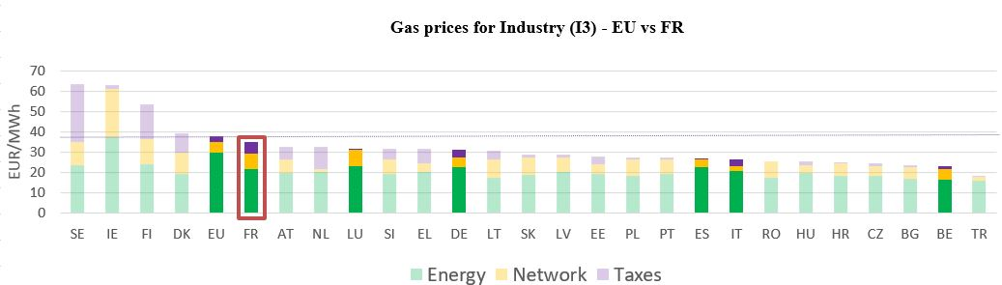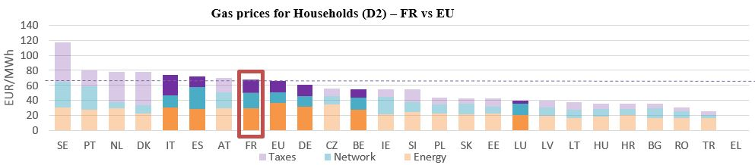See footnote [1]

**Gas prices for Industry (I3) – FR vs EU**

See footnote [2]

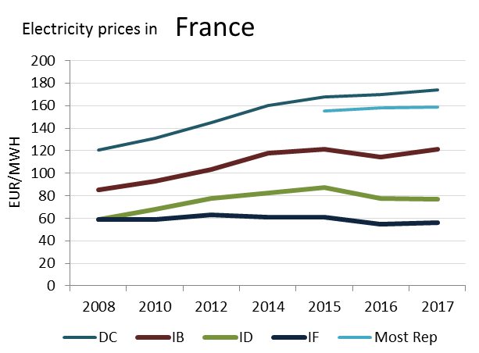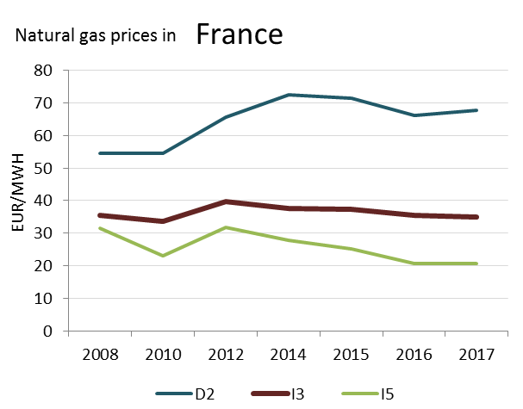

(DD)

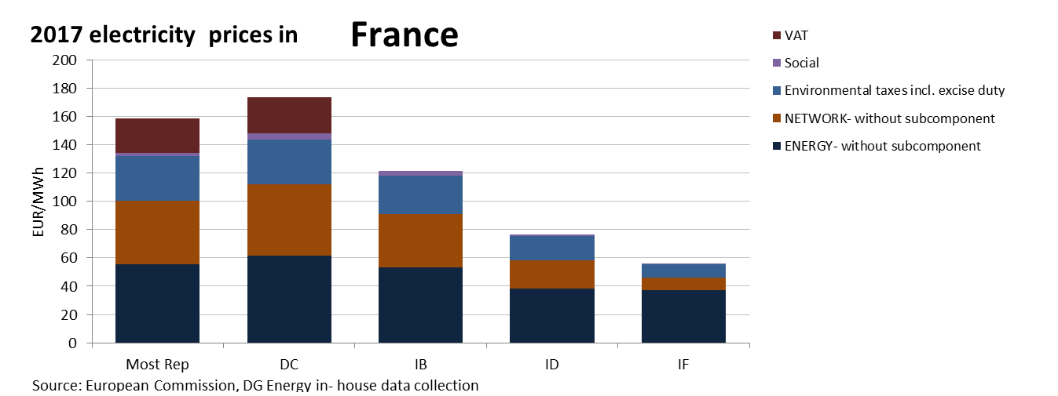

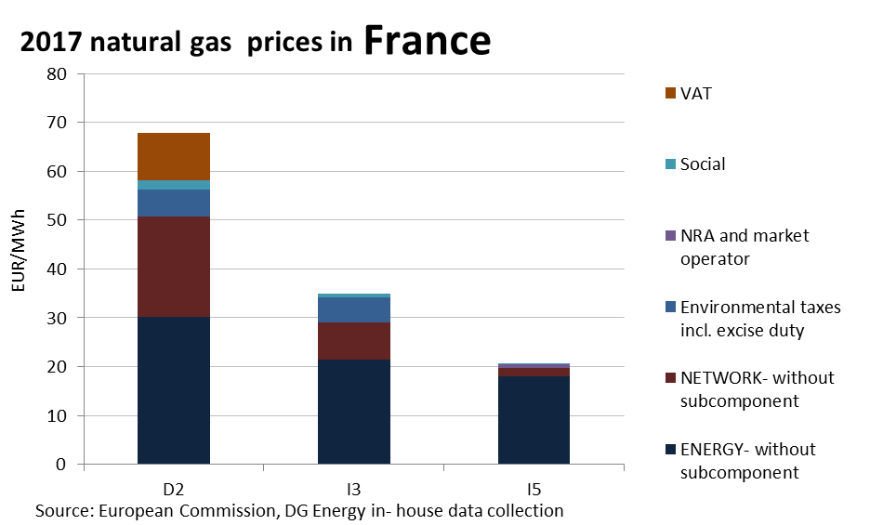

**Price regulation**

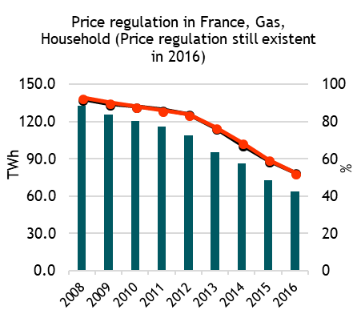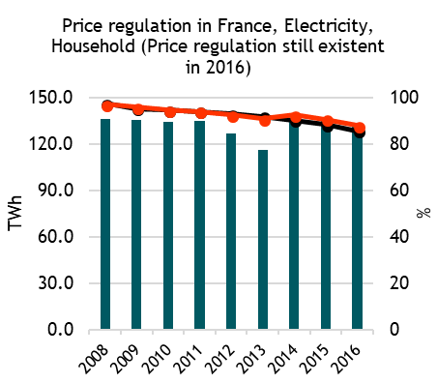

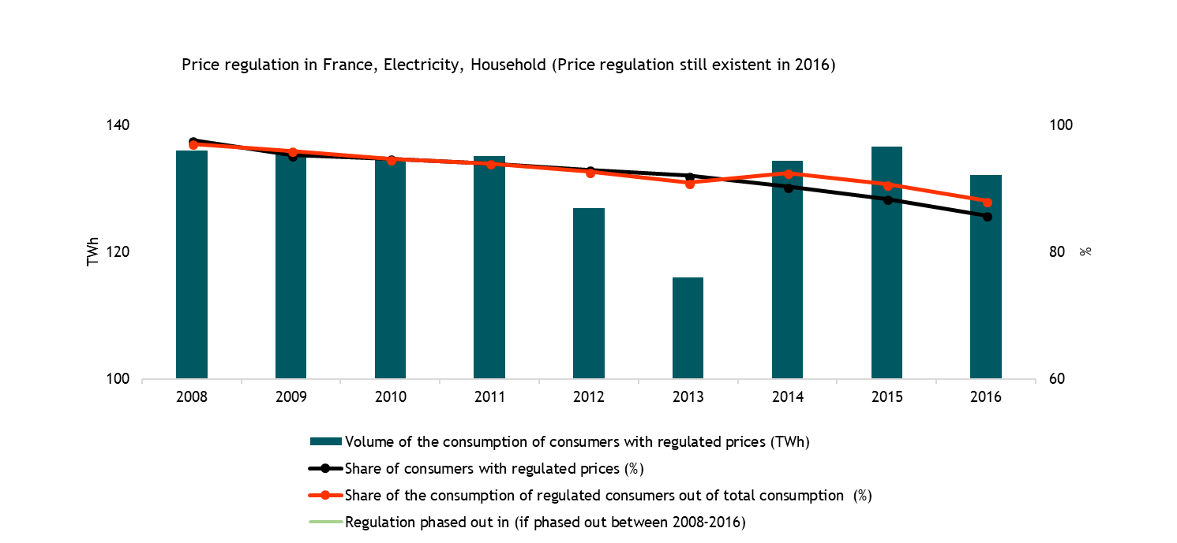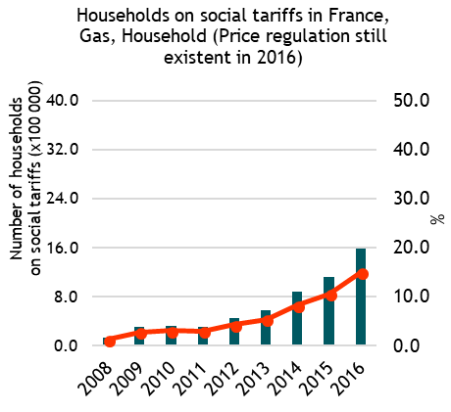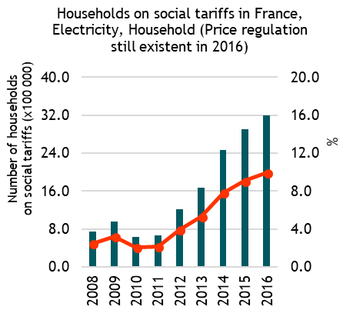

**Oil product prices**

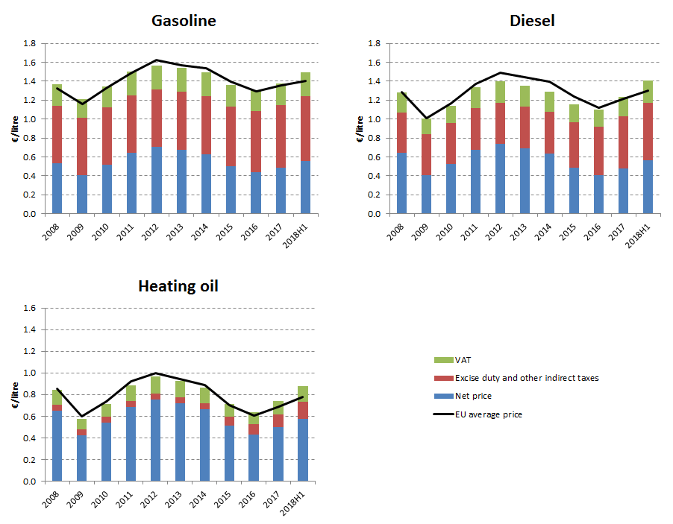

**Energy costs shares in total production costs**

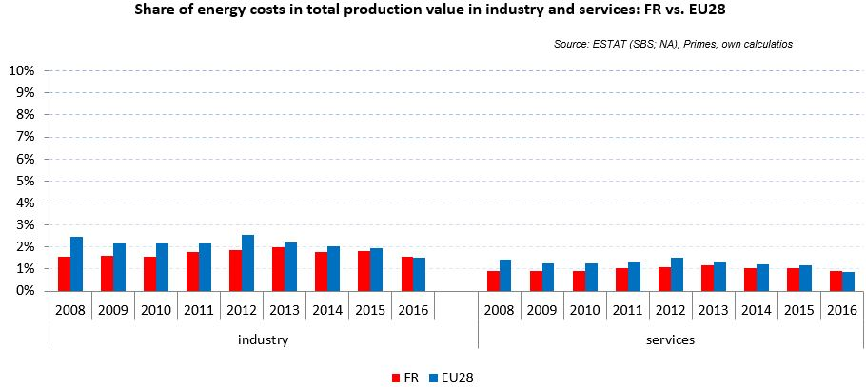

Notes: Data for Malta (prior to 2016), Poland (prior to 2015), Slovenia (prior to 2012) and Greece (prior to 2008) is not available. Data for Denmark, Sweden and the United Kingdom for 2016 was missing by the time of extraction

## Financial support interventions

**Germany**  

## Prices

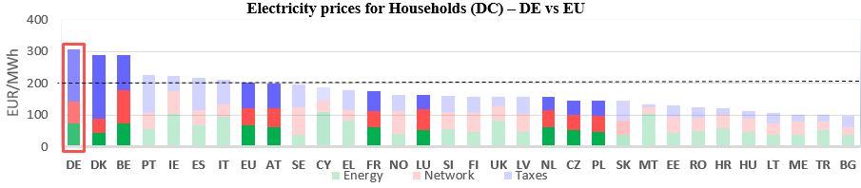 see footnote[3]

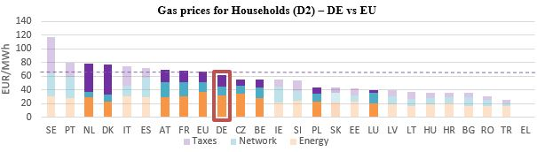

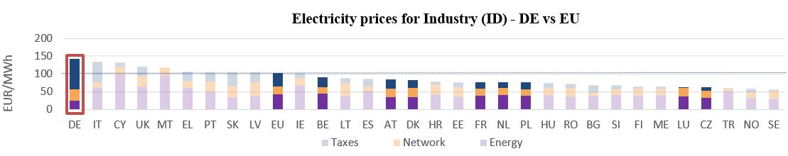

**Gas prices for Industry (I3) – DE vs EU**

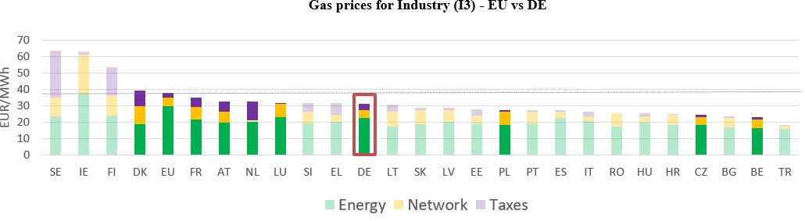

See footnote [4]

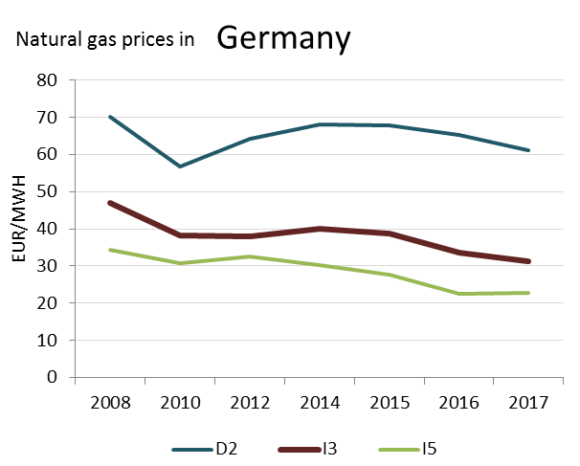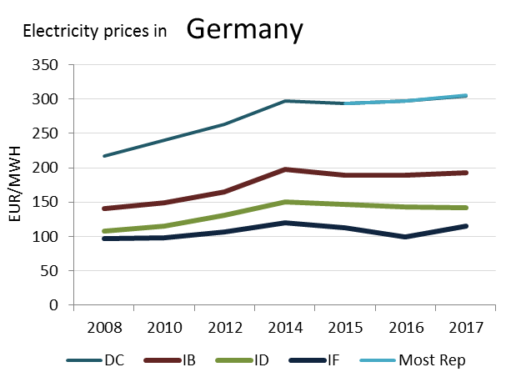

(DC)

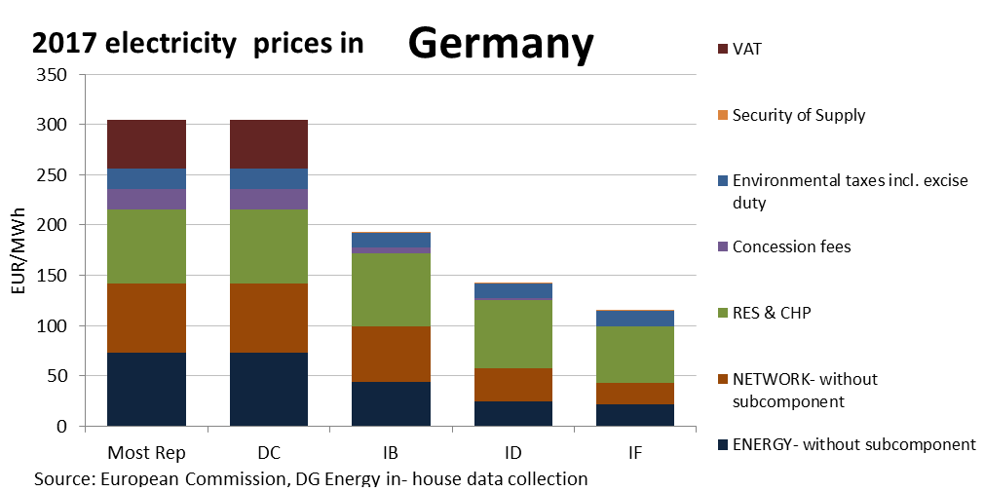 **Prices**

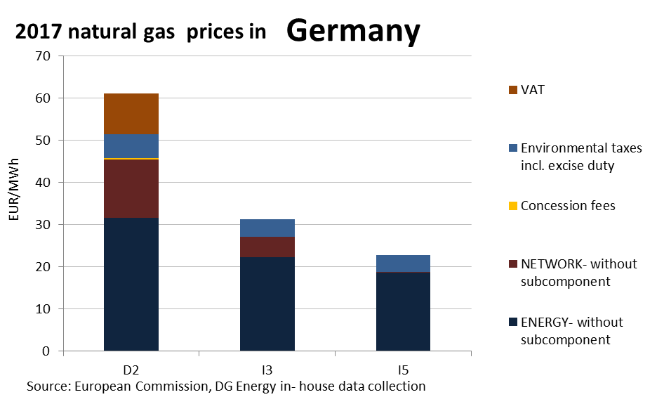

This country liberalised prices before 2008.

No social tariffs identified.

**Oil products prices**

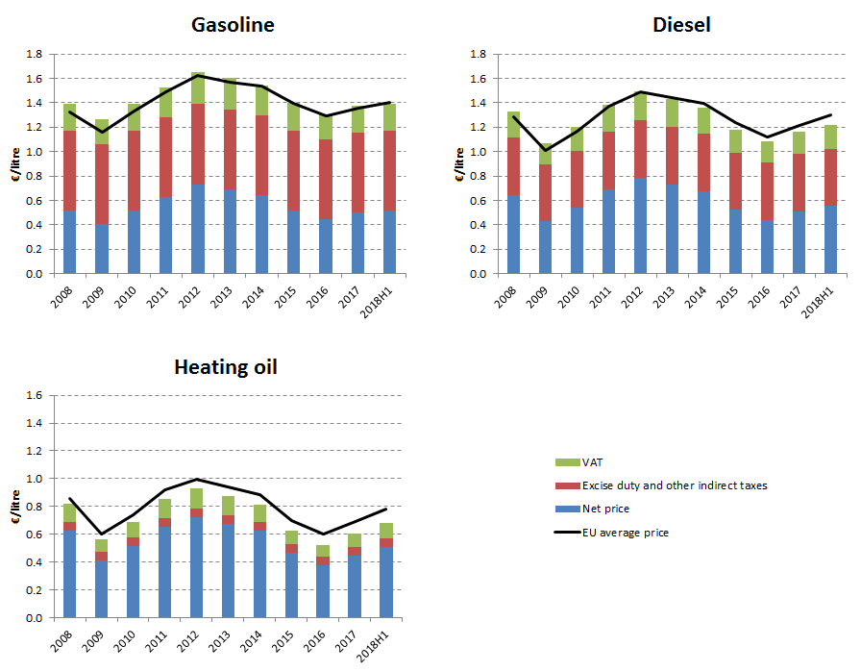

**Energy costs shares in total production costs**

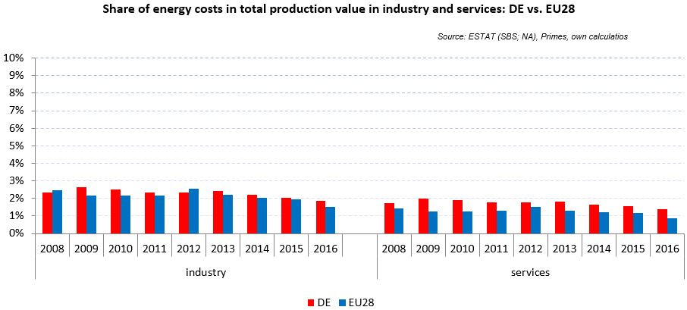

Notes: Data for Malta (prior to 2016), Poland (prior to 2015), Slovenia (prior to 2012) and Greece (prior to 2008) is not available. Data for Denmark, Sweden and the United Kingdom for 2016 was missing by the time of extraction

## Financial support interventions

Greece 

## Prices

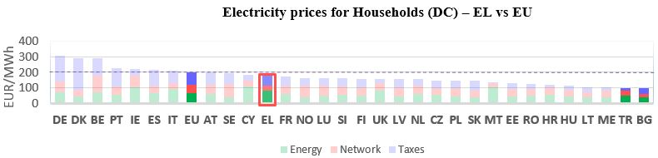 See footnote[5]

**Gas prices for Households (ID) – EL vs EU**

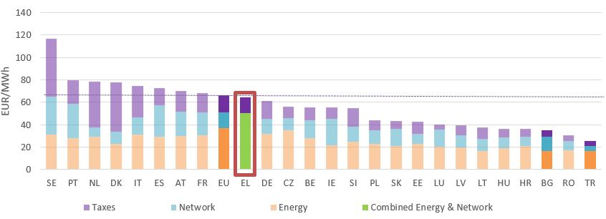

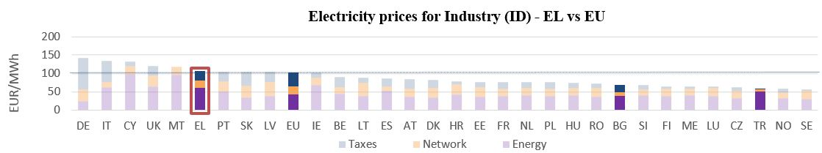

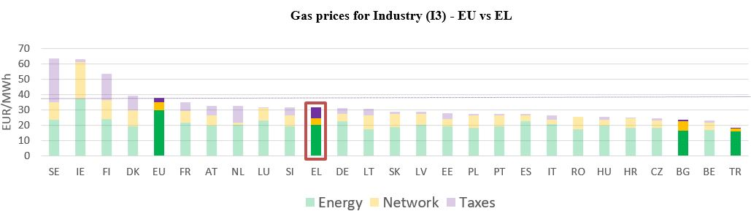

**Gas prices for Industry (I3) – EL vs EU**



See footnote [6]

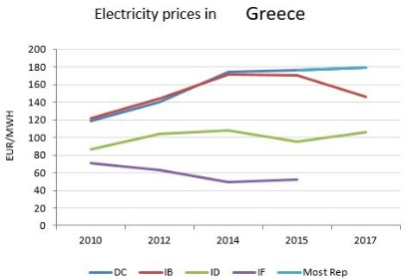

**Price regulation**

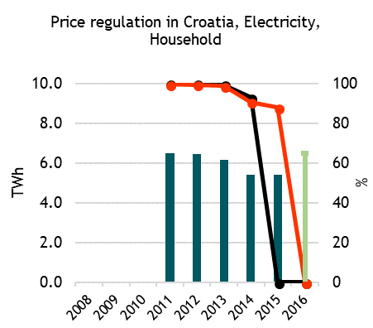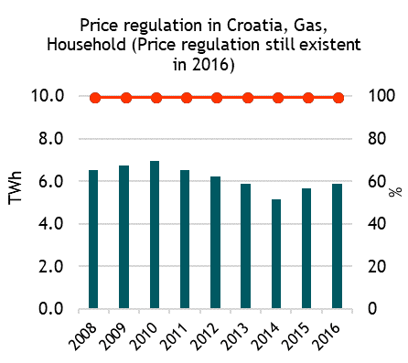



No data available for 2017 electricity and natural gas prices

**Oil products prices**

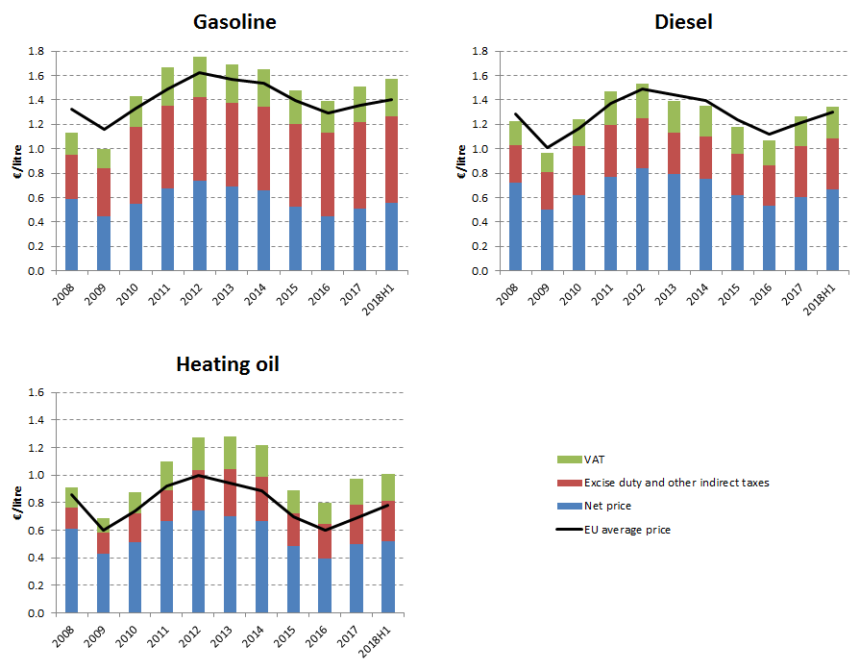

**Energy costs shares in total production costs**

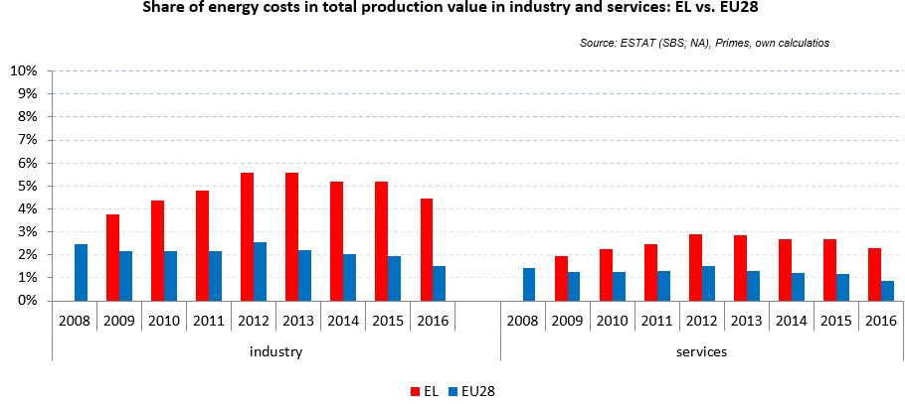

Notes: Data for Malta (prior to 2016), Poland (prior to 2015), Slovenia (prior to 2012) and Greece (prior to 2008) is not available. Data for Denmark, Sweden and the United Kingdom for 2016 was missing by the time of extraction

## Financial support interventions

Hungary Prices

## Prices

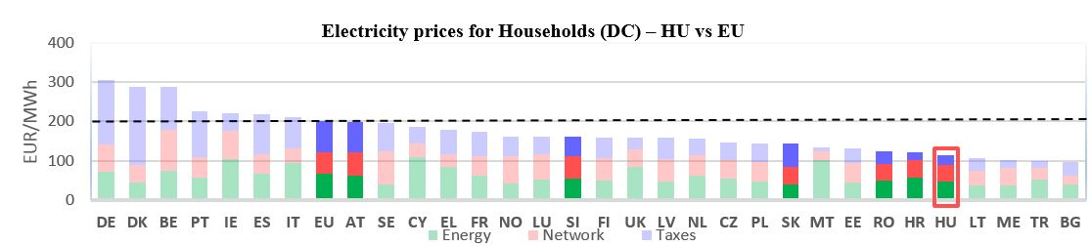See footnote[7]

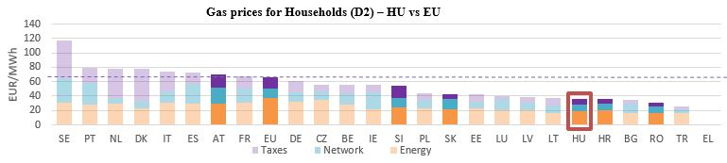

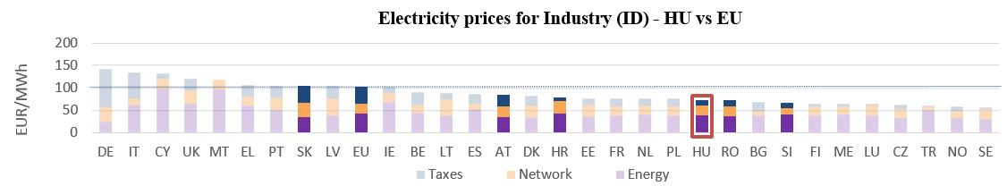

**Gas prices for Industry (I3) – HU vs EU**

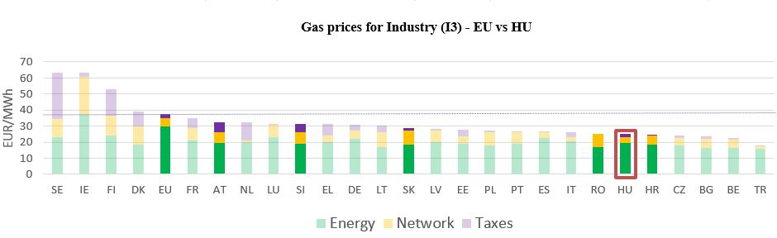

See footnote [8]

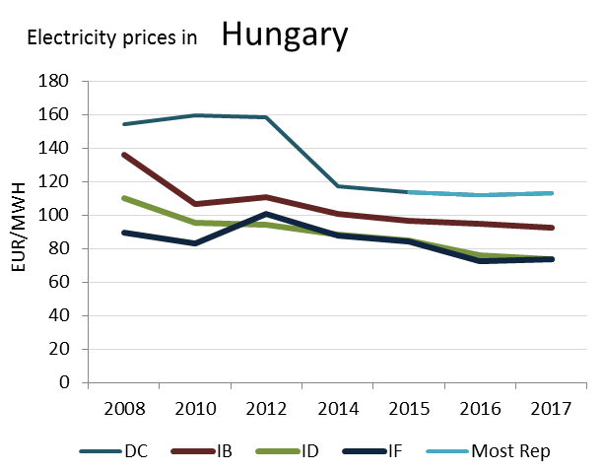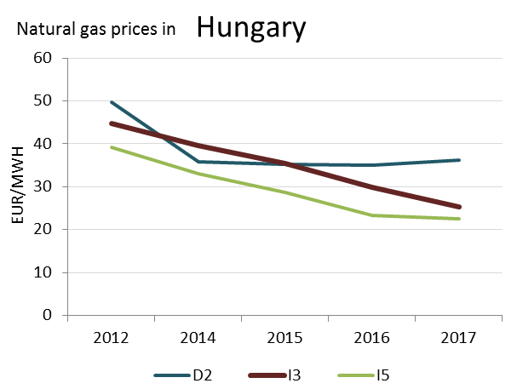

(DC)

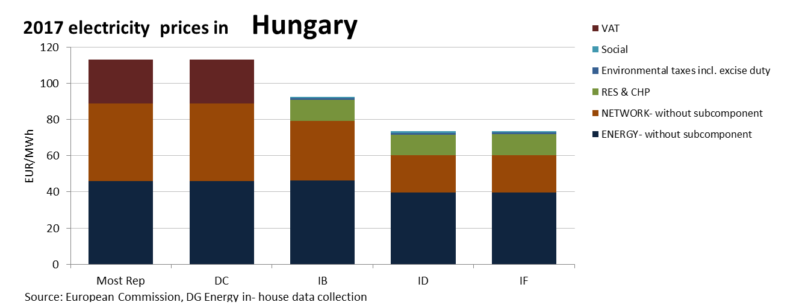 **Prices**

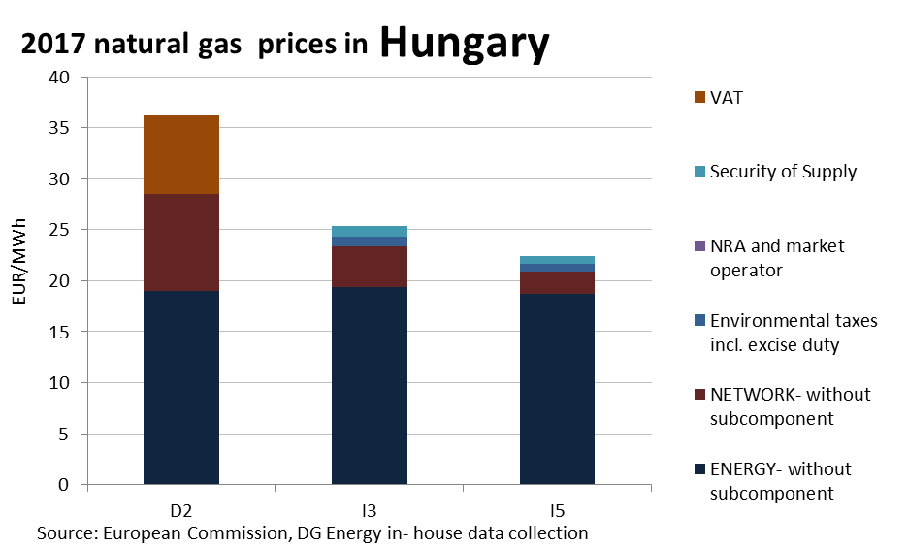

**Price regulation**

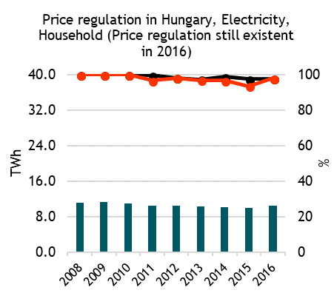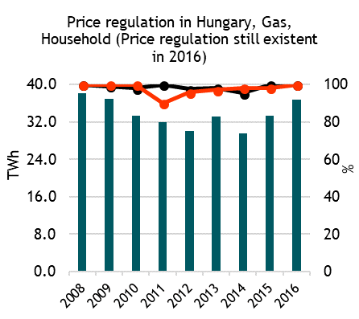

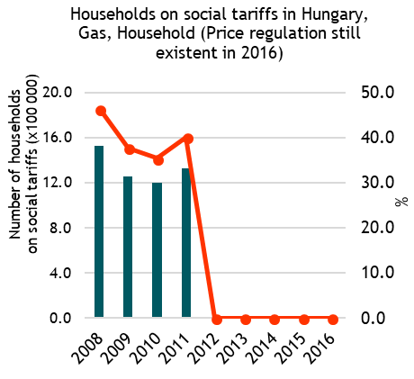



**Oil product prices**

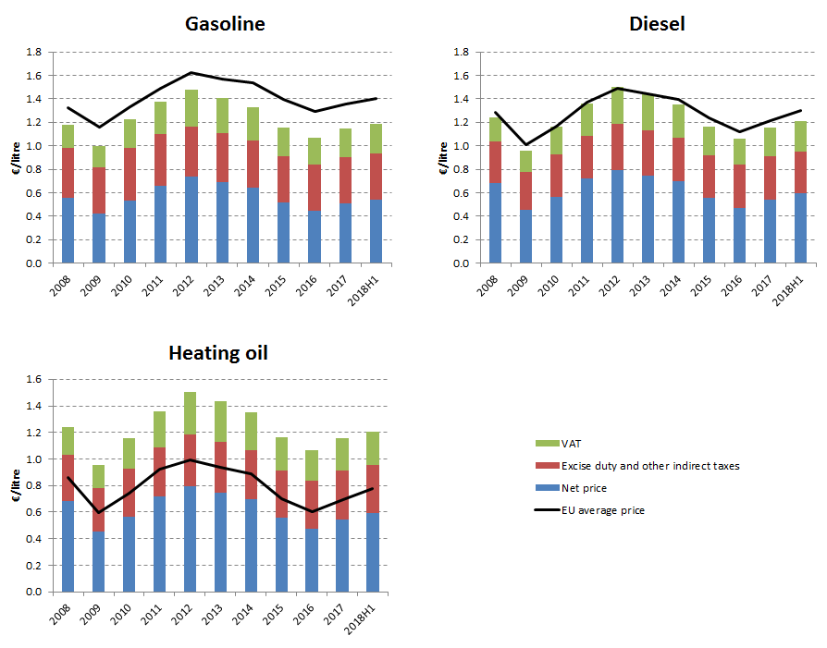

**Energy costs shares in total production costs**

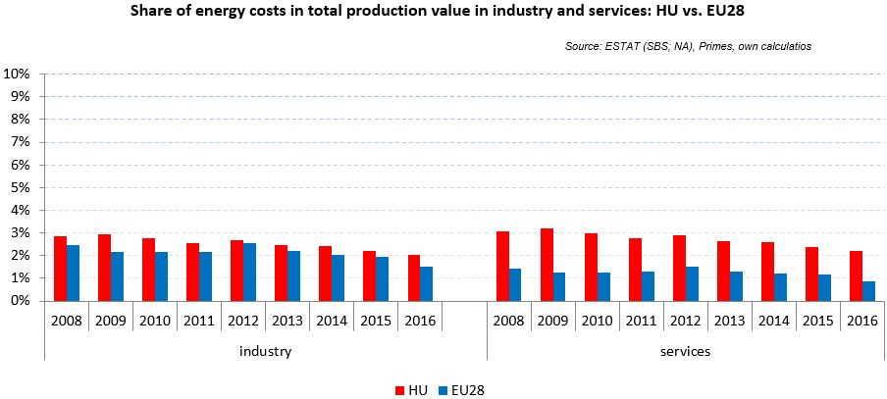

Notes: Data for Malta (prior to 2016), Poland (prior to 2015), Slovenia (prior to 2012) and Greece (prior to 2008) is not available. Data for Denmark, Sweden and the United Kingdom for 2016 was missing by the time of extraction

## Financial support interventions

Ireland

## see footnote[9]Prices

## 

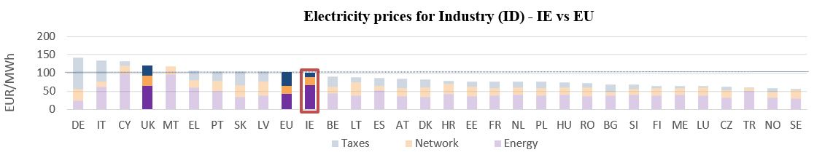

**Gas prices for Industry (I3) – IE vs EU**

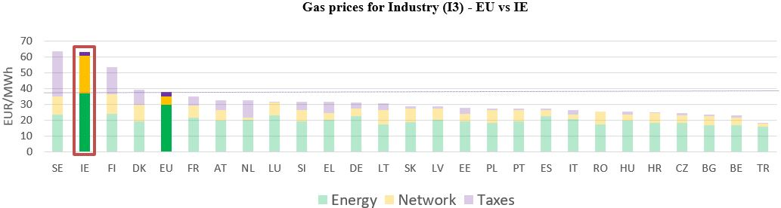



See footnote [10]

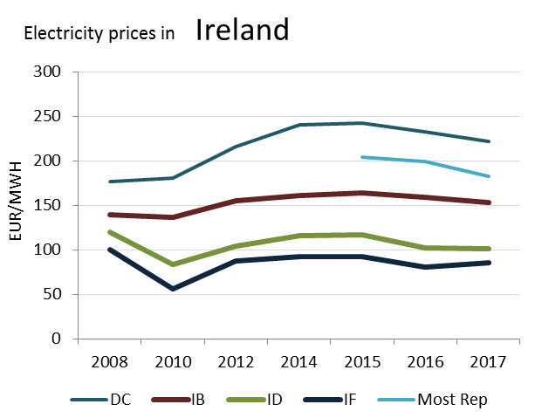

(DD)

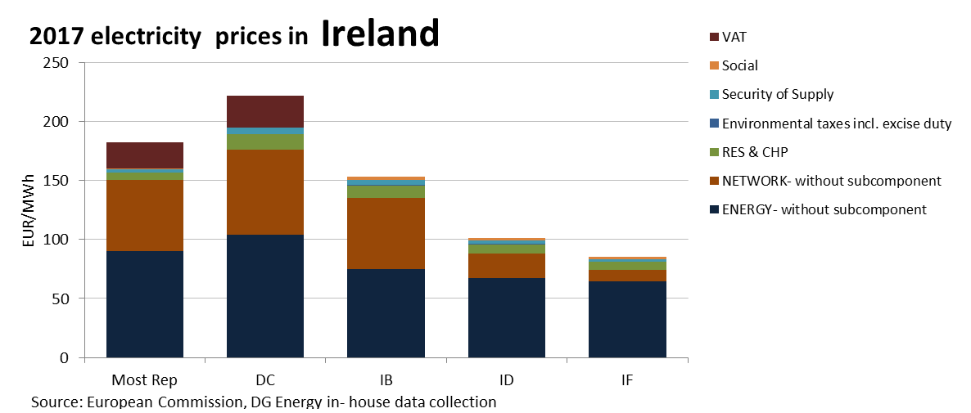

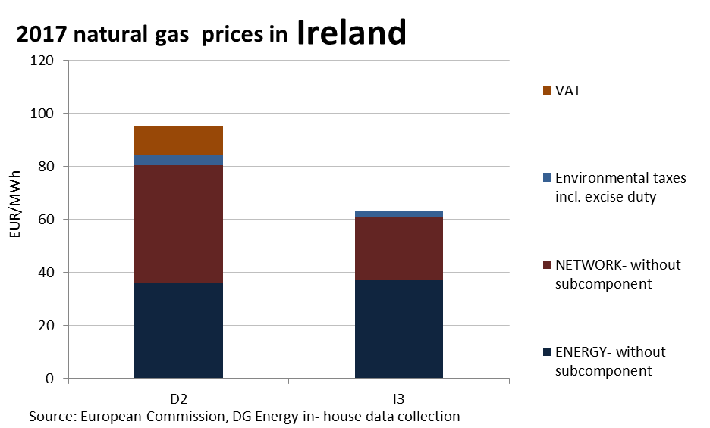

**Price regulation**

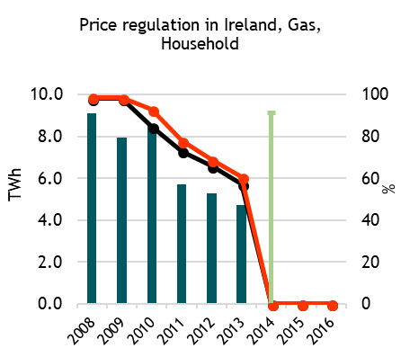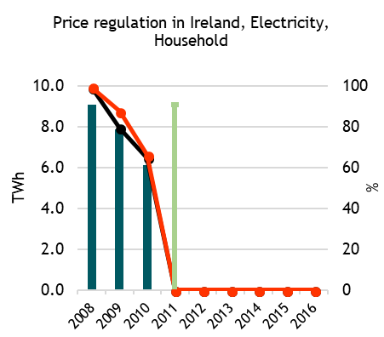



**Oil products prices**

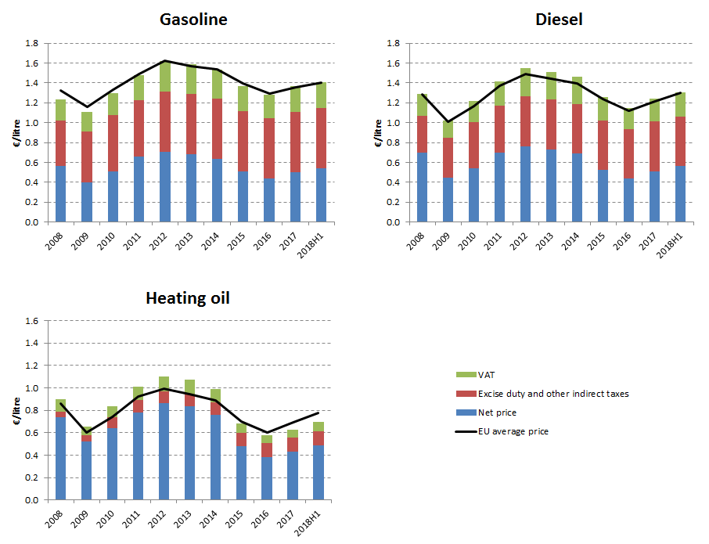

**Energy costs shares in total production costs**

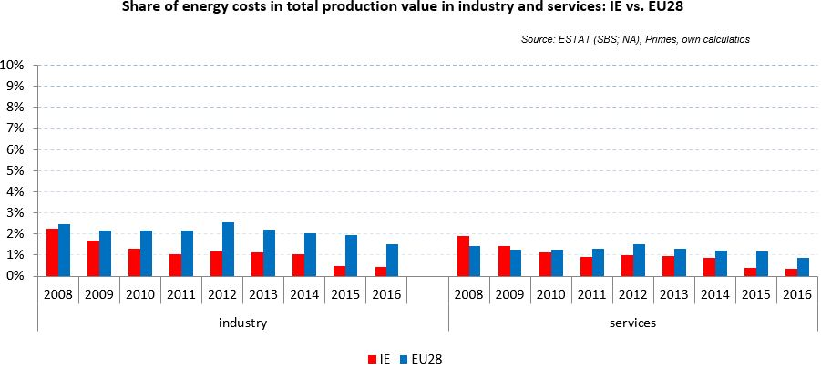

Notes: Data for Malta (prior to 2016), Poland (prior to 2015), Slovenia (prior to 2012) and Greece (prior to 2008) is not available. Data for Denmerk, Sweden and the United Kingdom for 2016 was missing by the time of extraction

## Financial support interventions

Italy 

## Prices

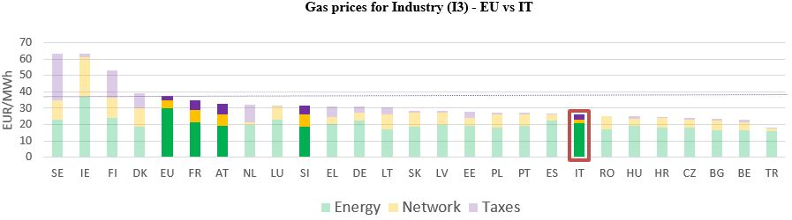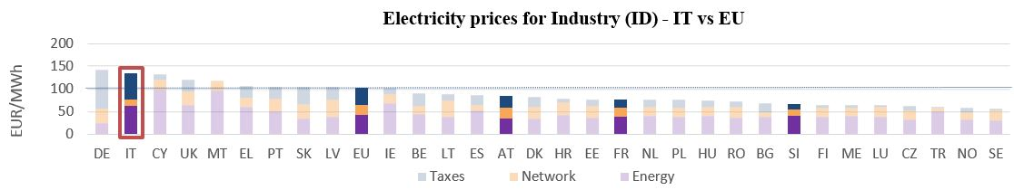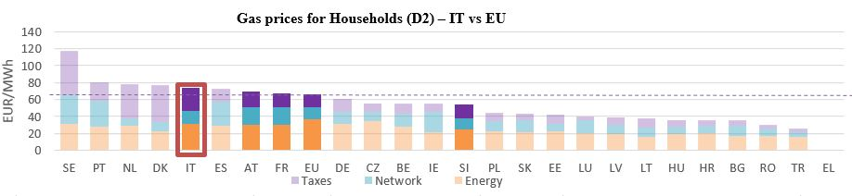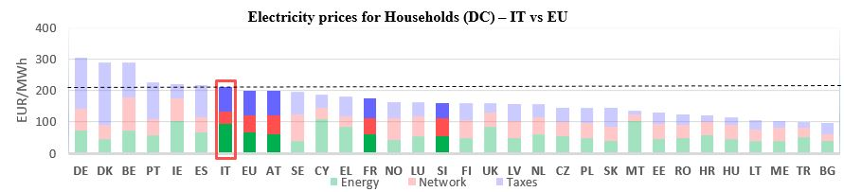see footnote[11]

**Gas prices for Industry (I3) – IT vs EU**

See footnote [12]

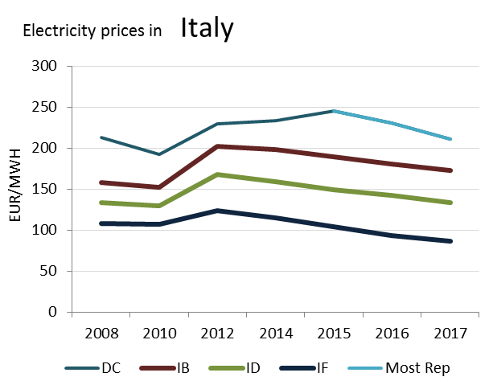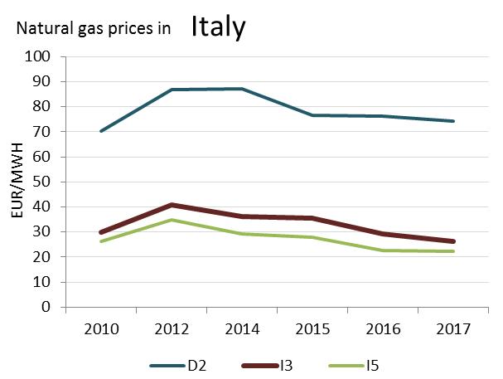

(DC)

**2017 electricity prices in Italy**

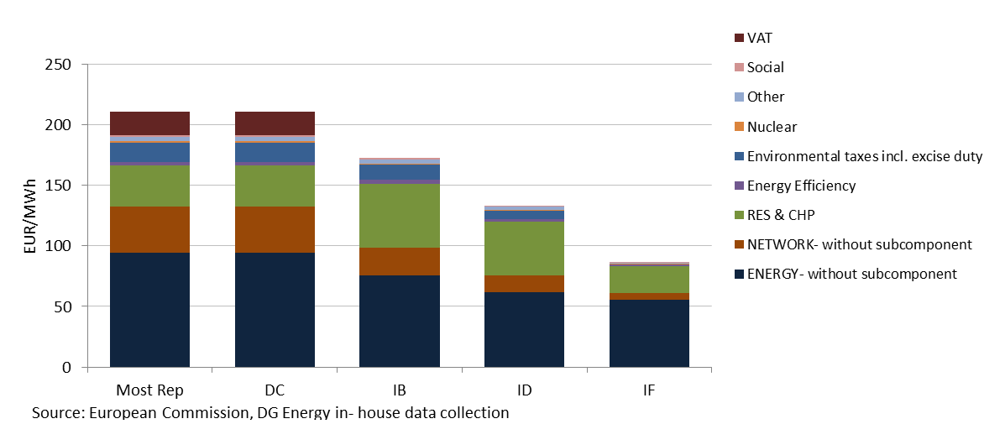

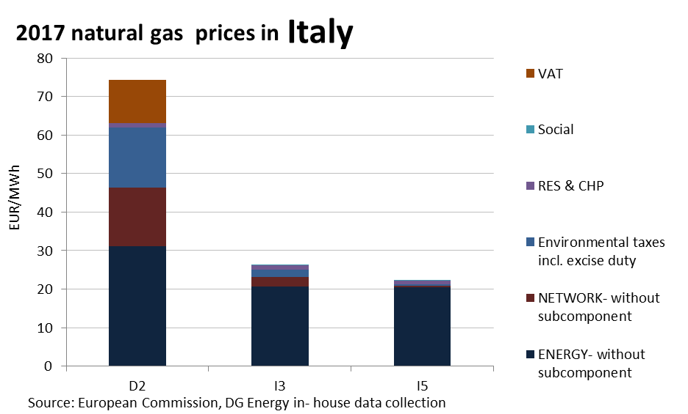

**Price regulation**

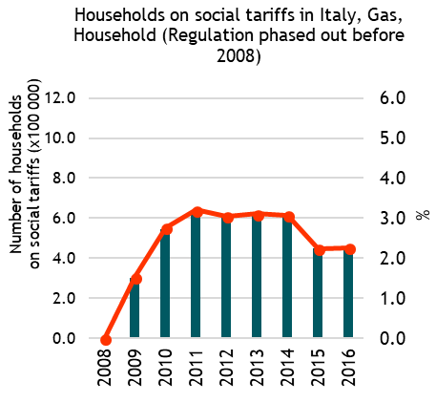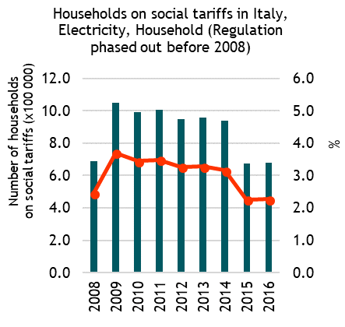



**Oil products prices**

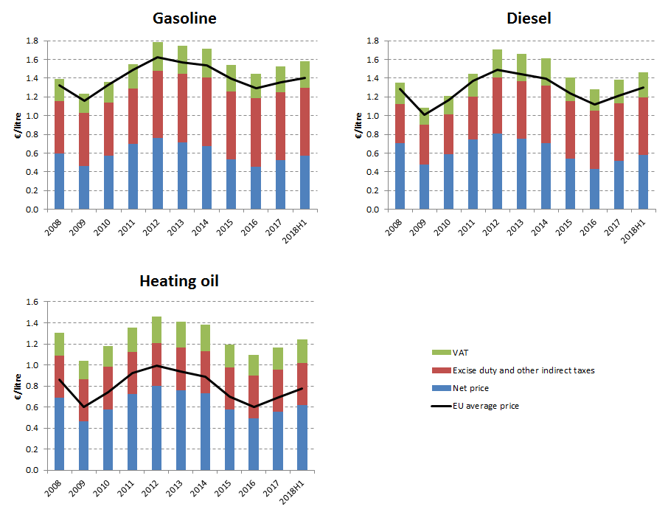

**Energy costs shares in total production costs**

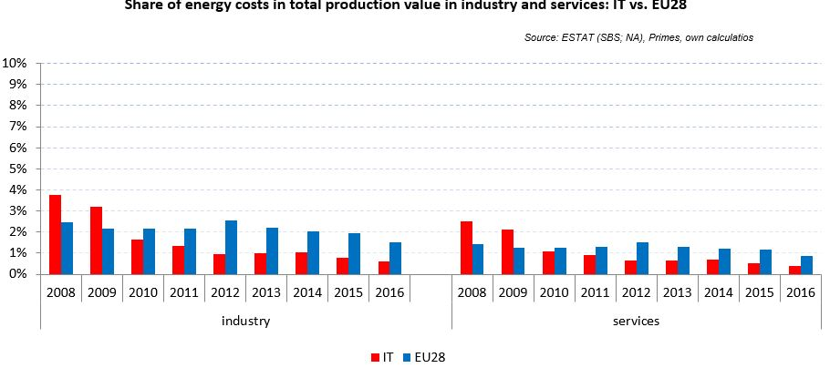

Notes: Data for Malta (prior to 2016), Poland (prior to 2015), Slovenia (prior to 2012) and Greece (prior to 2008) is not available. Data for Denmark, Sweden and the United Kingdom for 2016 was missing by the time of extraction

## Financial support interventions

Latvia 

## Prices

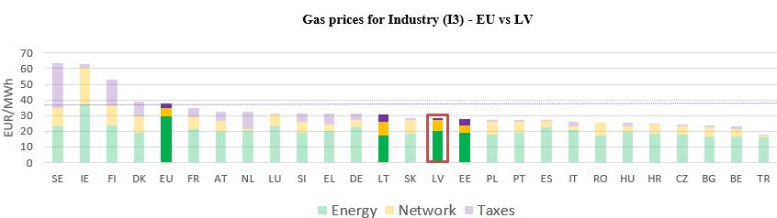See footnote[13]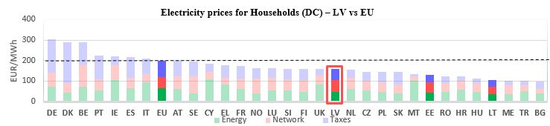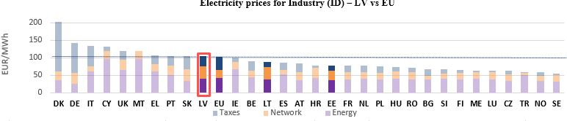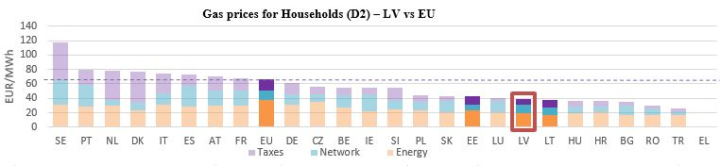

**Electricity prices for Industry (I3) – LV vs EU**

**Gas prices for Industry (I3) – LV vs EU**

See footnote **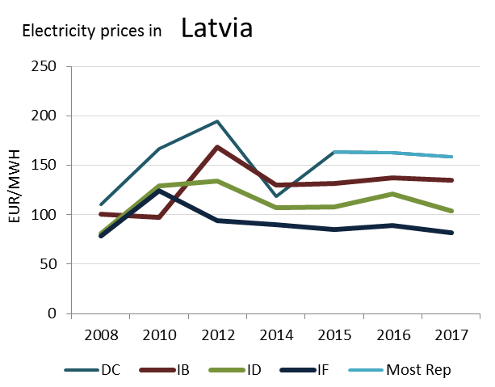******[14]

(DC)

(DC)

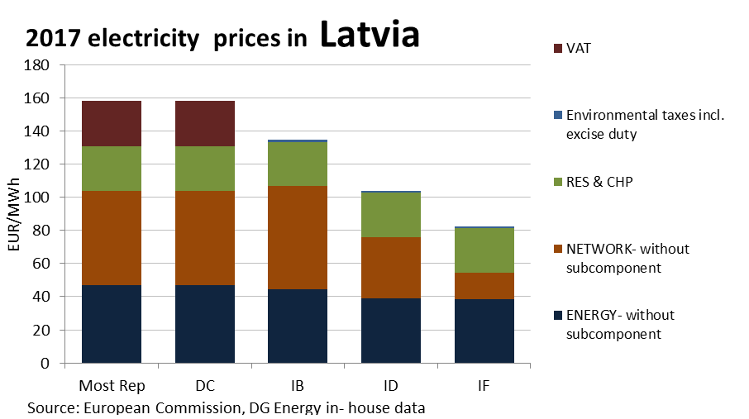

**Prices**

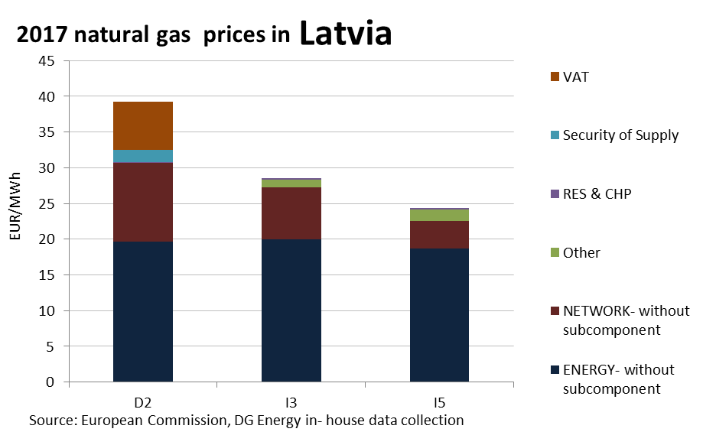

**Price regulation**

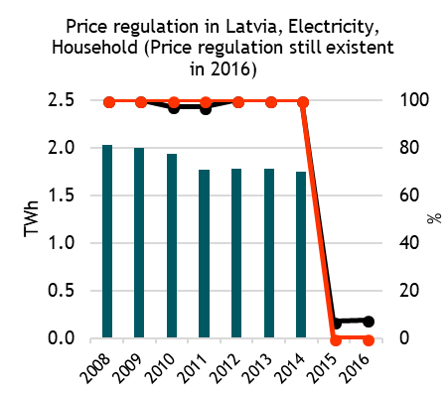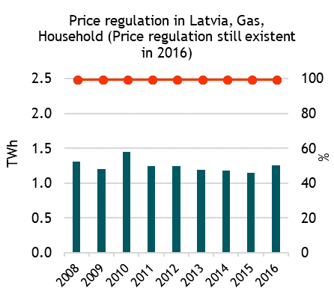

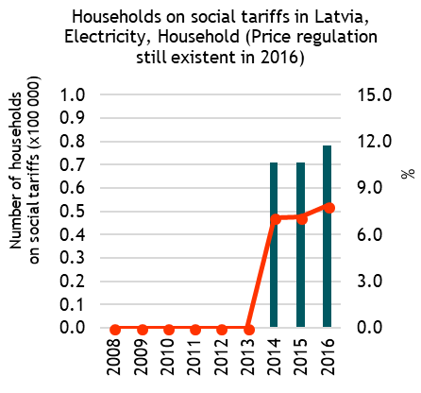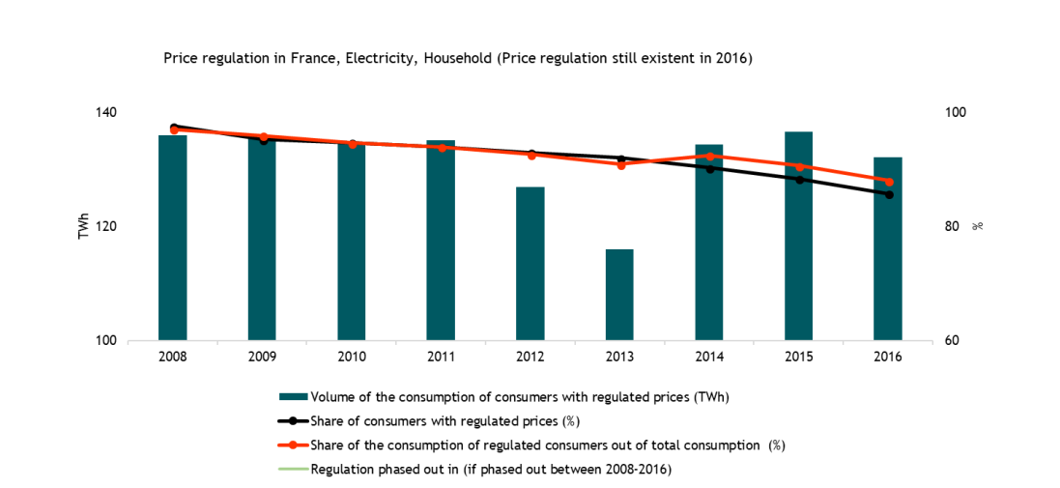

**Oil products prices**

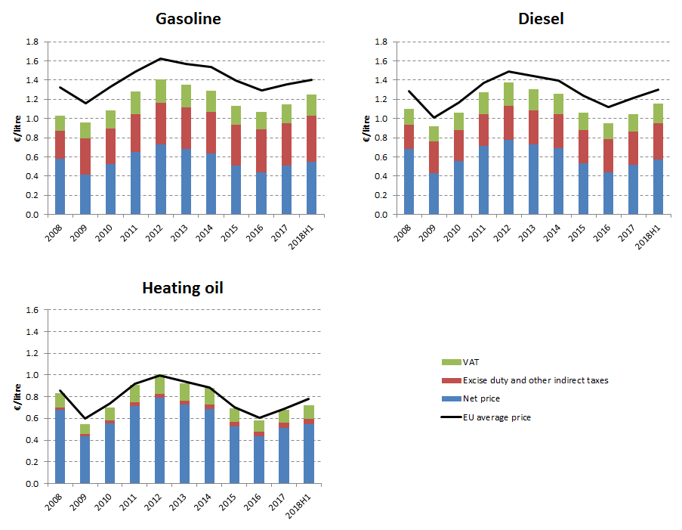

**Energy costs shares in total production costs**

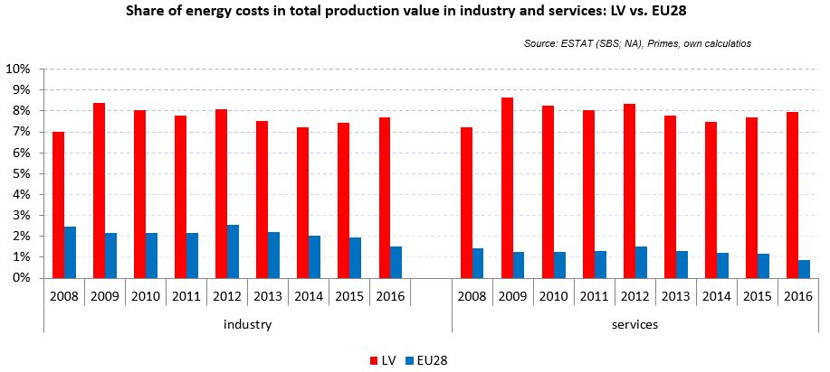

Notes: Data for Malta (prior to 2016), Poland (prior to 2015), Slovenia (prior to 2012) and Greece (prior to 2008) is not available. Data for Denmark, Sweden and the United Kingdom for 2016 was missing by the time of extraction

## Financial support interventions

Lithuania 

## Prices

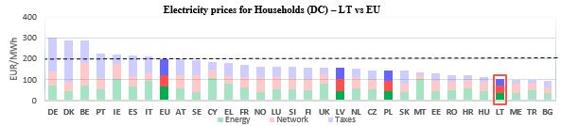see footnote[15]

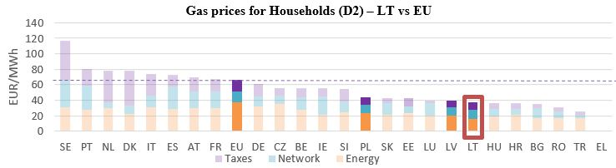

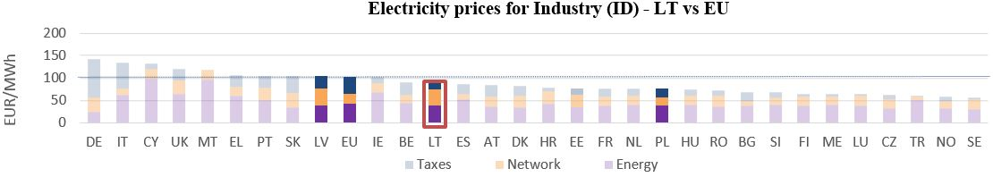

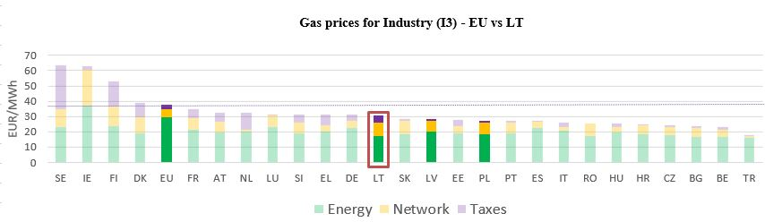

**Gas prices for Industry (I3) – LT vs EU**

See footnote [16]

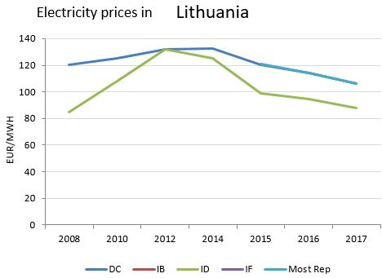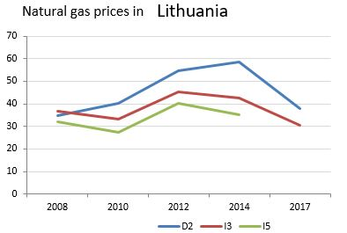

(DC)

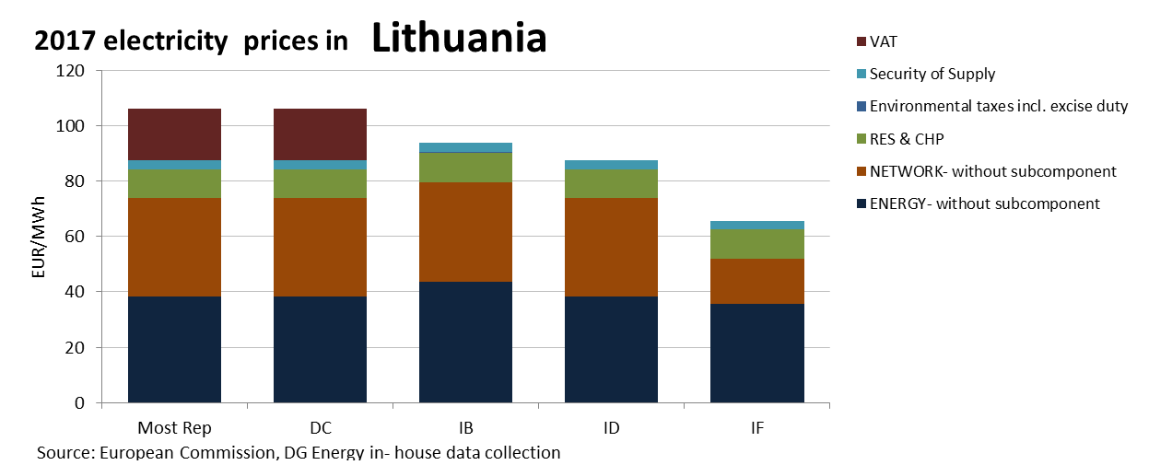

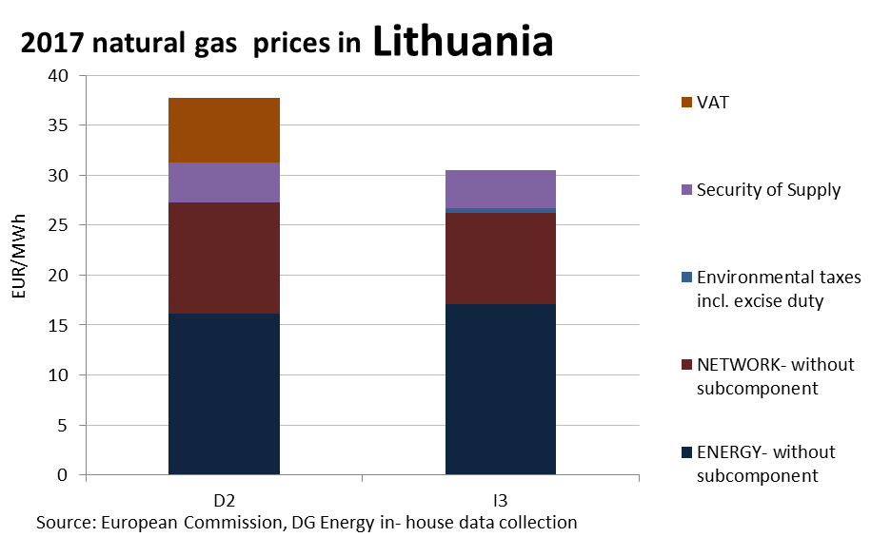

**Price regulation**

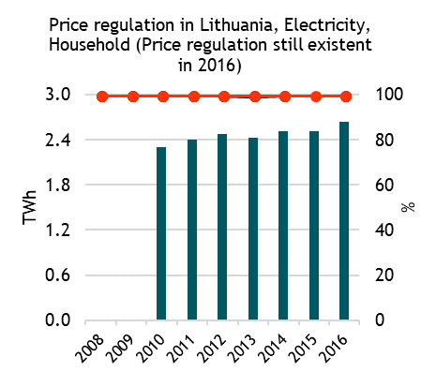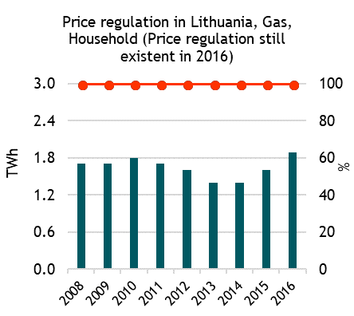



**Oil products prices**

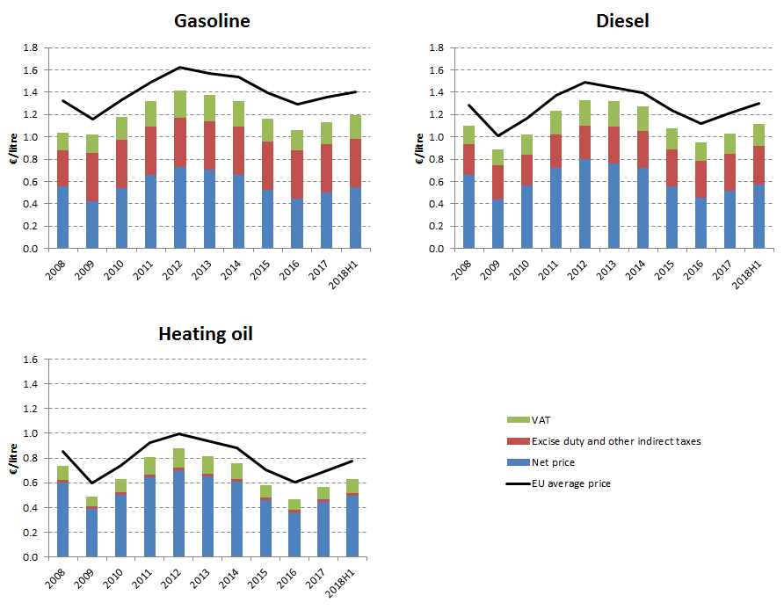

**Energy costs shares in total production costs**

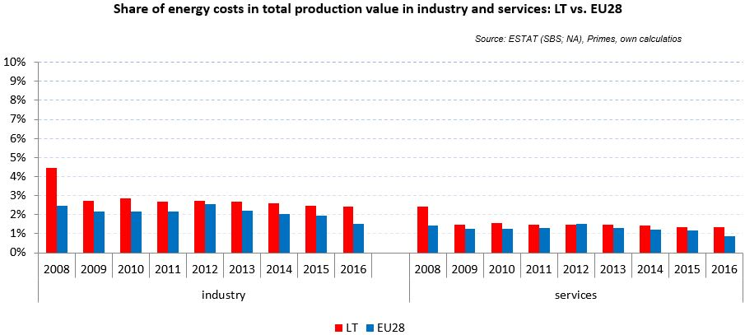

Notes: Data for Malta (prior to 2016), Poland (prior to 2015), Slovenia (prior to 2012) and Greece (prior to 2008) is not available. Data for Denmark, Sweden and the United Kingdom for 2016 was missing by the time of extraction

## Financial support interventions

Luxembourg 

## Prices

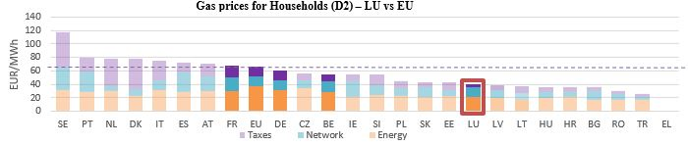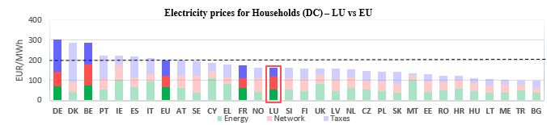see footnote[17]

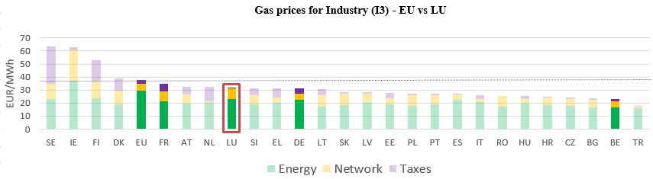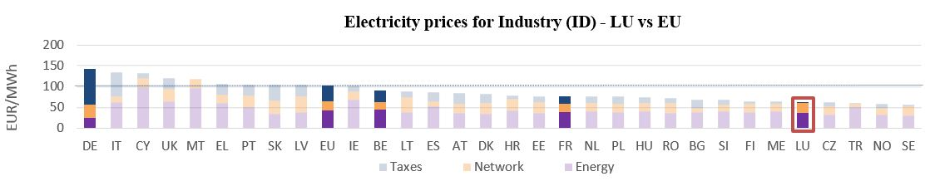

**Gas prices for Industry (I3) – LU vs EU**

See footnote [18]

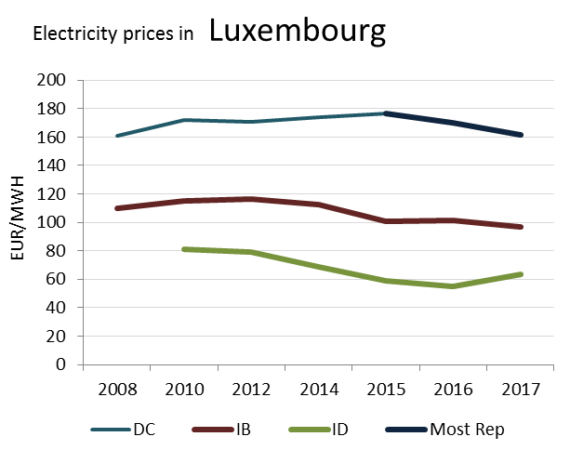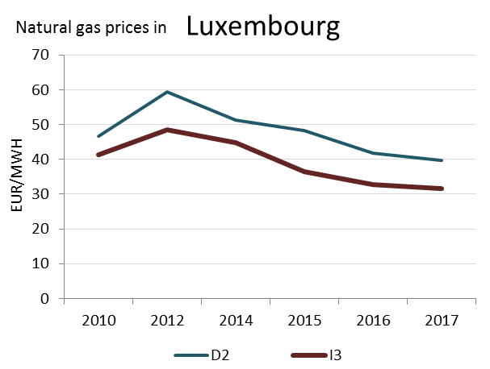

(DC)

**Prices**

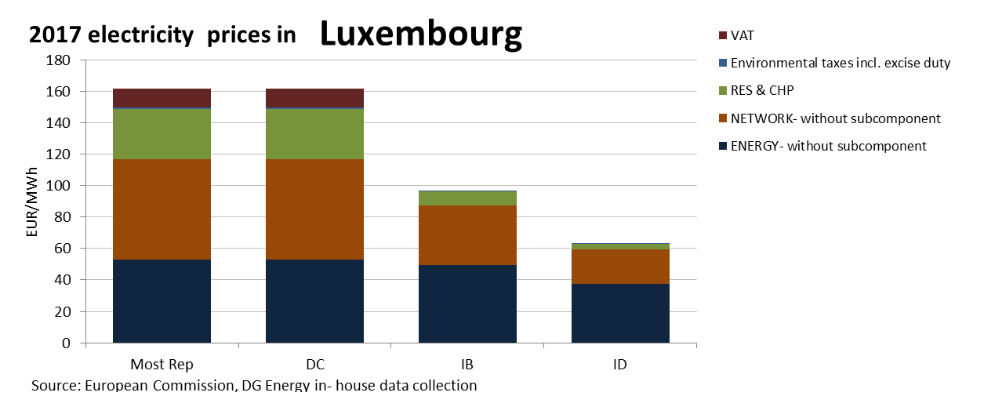

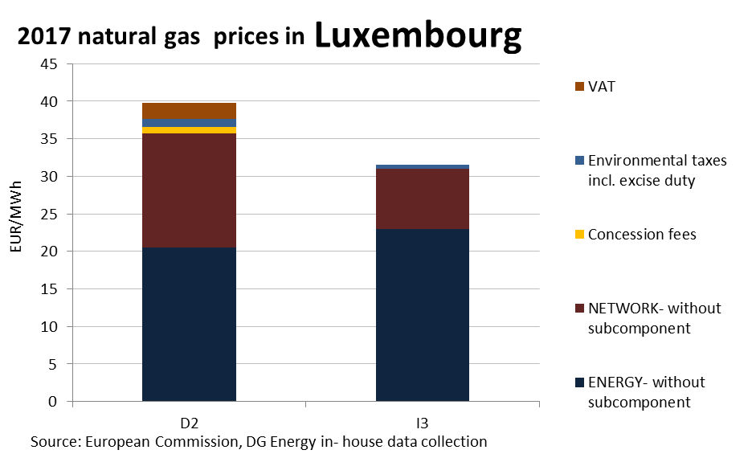

This country liberalised prices before 2008.

No social tariffs identified.

**Oil products prices**

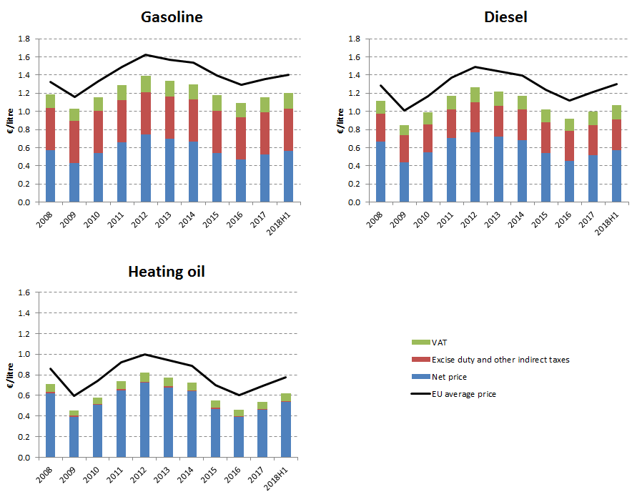

**Energy costs shares in total production costs**

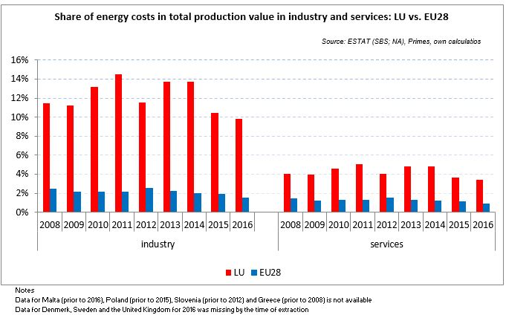

## Financial support interventions

1. Neighbour countries and EU 28. No gas household prices available for Greece for 2017.
2. Annual electricity consumption: DB 1 - 2.5 MWh, DC 2.5 - 5 MWh, DD 5 - 15 MWh, DE above 15 MWh, IB 20-500 MWh, ID 2000-20000 MWh, IF 70000-150000 MWh. Annual Gas consumption: D2 20-200 GJ, I3 10000-100000 GJ, I5 1 mil - 4 mil GJ.
3. Neighbour countries and EU 28. No gas household prices available for Greece for 2017.
4. Annual electricity consumption: DB 1 - 2.5 MWh, DC 2.5 - 5 MWh, DD 5 - 15 MWh, DE above 15 MWh, IB 20-500 MWh, ID 2000-20000 MWh, IF 70000-150000 MWh. Annual Gas consumption: D2 20-200 GJ, I3 10000-100000 GJ, I5 1 mil - 4 mil GJ.
5. Neighbour countries and EU 28. Please note that gas household prices available for Greece refer to 2015 (2017 not available).
6. Annual electricity consumption: DB 1 - 2.5 MWh, DC 2.5 - 5 MWh, DD 5 - 15 MWh, DE above 15 MWh, IB 20-500 MWh, ID 2000-20000 MWh, IF 70000-150000 MWh. Annual Gas consumption: D2 20-200 GJ, I3 10000-100000 GJ, I5 1 mil - 4 mil GJ.
7. Neighbour countries and EU 28. No gas household prices available for Greece for 2017.
8. Annual electricity consumption: DB 1 - 2.5 MWh, DC 2.5 - 5 MWh, DD 5 - 15 MWh, DE above 15 MWh, IB 20-500 MWh, ID 2000-20000 MWh, IF 70000-150000 MWh. Annual Gas consumption: D2 20-200 GJ, I3 10000-100000 GJ, I5 1 mil - 4 mil GJ.
9. Neighbour countries and EU 28. No gas household prices available for Greece for 2017.
10. Annual electricity consumption: DB 1 - 2.5 MWh, DC 2.5 - 5 MWh, DD 5 - 15 MWh, DE above 15 MWh, IB 20-500 MWh, ID 2000-20000 MWh, IF 70000-150000 MWh. Annual Gas consumption: D2 20-200 GJ, I3 10000-100000 GJ, I5 1 mil - 4 mil GJ.
11. Neighbour countries and EU 28. No gas household prices available for Greece for 2017.
12. Annual electricity consumption: DB 1 - 2.5 MWh, DC 2.5 - 5 MWh, DD 5 - 15 MWh, DE above 15 MWh, IB 20-500 MWh, ID 2000-20000 MWh, IF 70000-150000 MWh. Annual Gas consumption: D2 20-200 GJ, I3 10000-100000 GJ, I5 1 mil - 4 mil GJ.
13. Neighbour countries and EU 28. No gas household prices available for Greece for 2017.
14. Annual electricity consumption: DB 1 - 2.5 MWh, DC 2.5 - 5 MWh, DD 5 - 15 MWh, DE above 15 MWh, IB 20-500 MWh, ID 2000-20000 MWh, IF 70000-150000 MWh. Annual Gas consumption: D2 20-200 GJ, I3 10000-100000 GJ, I5 1 mil - 4 mil GJ.
15. Neighbour countries and EU 28. No gas household prices available for Greece for 2017.
16. Annual electricity consumption: DB 1 - 2.5 MWh, DC 2.5 - 5 MWh, DD 5 - 15 MWh, DE above 15 MWh, IB 20-500 MWh, ID 2000-20000 MWh, IF 70000-150000 MWh. Annual Gas consumption: D2 20-200 GJ, I3 10000-100000 GJ, I5 1 mil - 4 mil GJ.
17. Neighbour countries and EU 28. No gas household prices available for Greece for 2017.
18. Annual electricity consumption: DB 1 - 2.5 MWh, DC 2.5 - 5 MWh, DD 5 - 15 MWh, DE above 15 MWh, IB 20-500 MWh, ID 2000-20000 MWh, IF 70000-150000 MWh. Annual Gas consumption: D2 20-200 GJ, I3 10000-100000 GJ, I5 1 mil - 4 mil GJ.