

**PART III**

**Energy subsidies and government revenues from energy products**

# Energy subsidies

**Main findings**

* In order to fulfil its energy and climate objectives, and to comply with international commitments on phasing out subsidies to fossil fuels, the European Commission and its Member States aim to better monitor fossil fuel subsidies. Fossil fuel subsidies are encouraging wasteful energy consumption and put an obstacle to green investments.
* Based on the previous study on energy costs and subsidies in 2014[1], this report extends the scope of the analysis beyond the energy sector, looking at energy related subsidies in sectors such as transport, agriculture, energy intensive industries, residential sector, etc.
* In 2016 energy-related subsidies in the EU amounted to €169 bn, up from €148 bn in 2008. The largest part of this amount was absorbed by the energy sector (€102 bn in 2016), the residential sector (€24bn), energy intensive manufacturing industry (€18 bn) and transport (€13 bn).
* Between 2008 and 2016 a threefold increase could be observed for renewable subsidies (mainly wind and solar electricity generation), up from €25 bn to €76bn. Over the same period subsidies in the form of free emission allowances fell from €41bn to €4 bn, in parallel with decreasing carbon prices and less eligible sectors for receiving free ETS allowances, such as most of the electricity generation sector.
* Subsidies to fossil fuels remained overall stable between 2008 and 2016 (€54-55 bn, however, in 2012 they reached €60 bn). Subsidies did not decrease in spite of the EU international commitments to phase fossil fuels out in the medium term. As to the sectors, in the transport sector a slight increase could be observed over this period (from €10 bn to 12 bn), while in the other sectors, subsidies decreased or remained stable. In 2016 the energy sector represented €16 bn of the total fossil fuel subsidies, followed by transport (€12 bn) and the manufacturing and household sectors (both €8.5 bn). Within the total fossil fuel support, €28 bn could be attributed to petroleum products, €13 bn to natural gas and €7 bn to coal and lignite in 2016 in the EU, while more than €7 bn could not be allocated to given fossil technologies (multiple sources).
* The importance and nature of subsidies to different energy products can vary across economic sectors. In the energy sector most of the subsidies are linked to the production of energy while in other sectors subsidies are related to energy consumption. In the energy sector more than two thirds of the total subsidies were related to renewables (solar, wind, biomass, hydro) in 2016. In the agriculture and transport sectors 90% of the subsidy amount could be linked to fossil fuels, predominantly petroleum products. In the case of energy intensive industries almost half of all subsidies could be linked to fossil fuels and around 35% to electricity. In the case of the residential sector electricity and gas both had a significant share.
* Energy subsidies had a measurable impact on the wholesale electricity market over the last decade, as they increased the installed renewable capacities and higher renewable generation had a lowering impact on the wholesale price level. Our analysis shows that one percent increase in the share or variable renewable sources resulted in a wholesale price decreasing by 0.5 €/MWh between 2008 and 2016. In some Member States the competitiveness of energy intensive industries is protected by exemption from energy and climate policy tax measures.
* In the case of households subsidies to energy efficiency investments can substantially lower electricity and gas bills, having an impact on the overall energy demand and energy market prices.
* According to the latest available international comparisons (2015 data), subsidies to fossil fuels have an even bigger importance outside the EU. Subsidies to petroleum products, which account for the largest share within fossil fuels, strongly correlate with the evolution of crude oil prices, especially in those countries, where consumption is subsidised by retail price caps. In the EU petroleum consumption is rather subsidised through excise duty and tax exemptions, being independent from crude oil prices.

**Overview of energy subsidies in the EU**

The production and system costs of different types of energy can be difficult to assess and are not easy to compare. In competitive markets, prices can be taken to reflect costs. However, the energy sector is marked by often low levels of competition, an extensively regulated asset base, externalities and other market failures and significant public intervention through regulation and subsidies. Observed prices are therefore rarely an accurate reflection of costs. Where the price signal is impaired the efficiency of producers is hidden and the size and nature of subsidies and cross-subsidisation between different types of power generation is not transparent. The complex interplay of direct, indirect, financial, or regulatory support measures adds to the lack of clarity.

In order to better understand the nature of government interventions affecting the EU internal energy market, first it is needed to collect information on a uniform basis in all EU countries. Definition and measurement of government interventions and subsidies can follow different approaches, however, in order to ensure comparability a common methodological base is needed. The first attempt to quantify energy subsidies in the EU was made in a Commission study on energy costs and subsidies in 2014. This study aimed at collecting data on electricity and heat generation costs, in parallel with external costs and setting up an inventory in government interventions in the energy sector. However, for further policy needs the sectorial coverage of this first study needs to be extended, as important economic sectors where energy-related subsidies are applicable (e.g.: transport, agriculture, energy intensive industries, etc.) were not covered in the 2014 study.

Both in the EU and at international fora the issue of fossil fuel subsidies gained much attention over the last years. The Commission's "Clean Energy for all Europeans" package (November 2016) 'is stepping up EU's action in removing inefficient fossil fuel subsidies in line with international commitments under G7 and G20 and in the Paris Agreement. The remaining but still significant public support for oil, coal and other carbon-intensive fuels continues to distort the energy market, creates economic inefficiency and inhibits investment in the clean energy transition and innovation. The Market Design Reform is intended to remove priority dispatch for coal, gas and peat and will limit the need for capacity mechanisms which often relied on coal.

The Commission will also establish regular monitoring of fossil fuel subsidies in the EU. The Commission is carrying out a REFIT evaluation of EU framework for energy taxation in order to define possible next steps also in the context of the efforts to remove fossil fuel subsidies. Member States' integrated national energy and climate plans should enable them to identify the investments needed for the clean energy transition. Member States should also use these plans to monitor the phase-out of fossil fuel subsidies.

Since the September 2009 Pittsburgh summit, G-20 countries have recurrently expressed their commitment to 'phase out and rationalise over the medium term inefficient fossil fuel subsidies while providing targeted support for the poorest - also noting that 'inefficient fossil fuel subsidies encourage wasteful consumption, reduce our energy security, impede investment in clean energy sources and undermine efforts to deal with the threat of climate change'.

The 2016 G7 Declaration stated that group's commitment to "the elimination of inefficient fossil fuel subsidies and encourage all countries to do so by 2025". Inefficient fossil fuel subsidies (IFFS) that encourage wasteful consumption distort energy markets, impede investment in clean energy sources, place a strain on public budgets, and incentivise unsustainable infrastructure investments.

Taking into account the data needs of ongoing policy initiatives and giving a first guidance to Member States who will have the obligation (every two years as of 2023) to report on fossil fuel subsidies, a new chapter on measuring subsidies in the EU has been put in the 2018 energy prices and costs report. Compared to the 2014 subsidy report, the scope of analysis has been extended beyond the energy sector to transport, agriculture and energy intensive industries, which led to a significant increase of the number of total interventions. The time horizon of the new data collection now covers the period of 2008-2016, whereas the latest data in the 2014 subsidy study were of 2012. Reporting systems in most of the EU Member States underwent significant developments over the last few years, filling in the data gaps we faced during the preparation of the study in 2014.

In this report we follow the definition of OECD on energy related government interventions, according to which subsidy is 'any measure that keeps prices for consumers below market levels, or for producers above market levels, or that reduces costs for consumers or producers'. The study is following a bottom-up approach, collecting data on individual measures and then aggregating them for each economic sector, energy carrier, country, subsidy type, etc. As minimum requirement, all state aid decisions in the energy sector, notified to the European Commission, were considered as subsidies. However, the subsidy definition used in this report is a broader concept than state aid cases. Items such as regulated prices and all tax reductions are considered subsidies irrespective of having been qualified as state aid. Therefore, the amount of total subsidies is higher than that of state aid notifications.

Looking at the results of the study prepared by Trinomics et al. on energy prices and costs, we can see that the total amount of subsidies to the energy sector, representing the largest part of energy related subsidies, has been significantly upwardly revised compared to the 2014 study on energy costs and subsidies[2] (for 2012 the 2014 study gave a number of €99 bn, whereas the current study estimates the 2012 subsidy value for €147 bn for the energy sector – if everything on **Figure 161** except transport and agriculture are included). The difference mainly stems from aforementioned better quality of data reporting from the Member States.

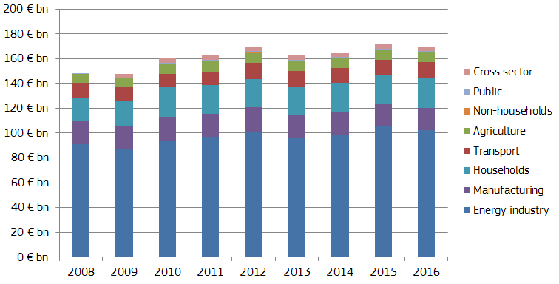

Figure 161 – Financial support by sector[3] in the EU-28 (expressed[4] in €2017bn)[5]

Source: DG ENER, data from Trinomics et altri study (2018)[6]

Besides the energy sector, significant subsidies occurred in the residential sector (€24 bn in 2016), owing to preferential energy prices (e.g.: lower VAT rates), in some countries and support for energy savings and efficiency measures. In the case of manufacturing industries subsidies, amounting to €18bn in 2016, occurred mainly for ensuring competitiveness of European energy intensive industries at global level, exempting certain sectors from energy taxes and other policy levies (e.g.: renewable generation support). The transport sector was the fourth largest regarding subsidy volumes (€13 bn in 2016), primarily owing to fuel subsidies (e.g.: reduction or exemption from excise duties). In the agriculture subsidies (€8 bn in the same period) could be linked to fuel tax reductions or exemptions.

As both **Figure 161** and **Figure 162** show, amount of subsidies in the EU-28 showed an increasing trend between 2008 and 2016. Subsidies to renewable energy tripled in this time period, however, in the last few years the increase slowed down. At the same time, subsidies to fossil fuels remained stable (€54-55 bn). On **Figure 162** “All” gathers all interventions that either cover all energy sources, for instance the measures supporting energy efficiency and Free emission allowances (ETS), as well as all the measures combining energy sources classified in more than two different groups of energy, for instance a measure supporting CHP fuel with coal, natural gas and biomass. Primarily owing to a significant decrease in emission allowances support (from €41 bn to €4 bn between 2008 and 2016), the share of this "All" category fell significantly. Support to the electricity sector and to nuclear did not change too much over time.

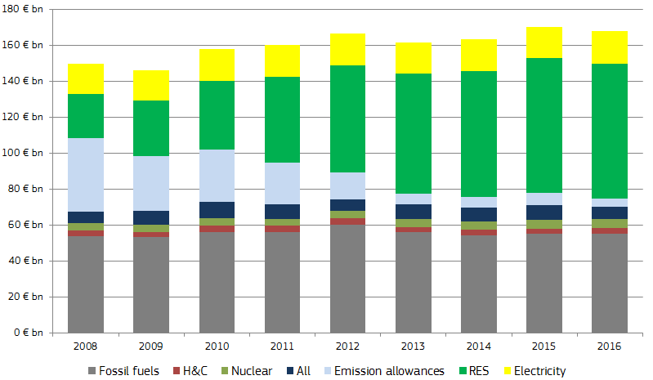

Figure 162 – Financial support by energy group (expressed in €2017bn)

Source: DG ENER, data from Trinomics et altri study (2018)

**Figure 163** shows the financial support in each Member state in 2016 by energy source. Germany spent the most on renewable energy support in this year (€27 bn), while the United Kingdom spent the most on fossil fuel support (€12 bn). Germany, Italy, France and Spain spent more on subsidising renewable energies than on fossil fuels. As percentage of Gross Domestic Product (GDP) Bulgaria spent the most on energy subsidies (2.7%), while Luxembourg spent the lowest share (0.3%). In the EU as whole, energy subsidies amounted to 1.1% of the GDP in 2016[7].

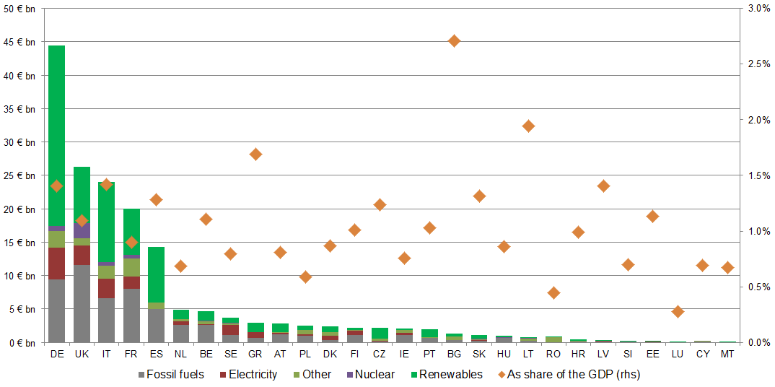

Figure 163 – Financial support in 2016 by energy source and EU Member States (expressed in €2017bn and as the percentage of Gross Domestic Product - GDP)

Source: DG ENER, data from Trinomics et altri study (2018)

## Subsidies in the energy sector

The energy sector has been the largest recipient of subsidies related to energy products. As Figure 164 shows, subsidies in the energy sector were relatively stable as of 2011, reaching around €100 bn in each year in the EU-28. However, the structure of subsidies significantly changed between 2008 and 2016. The most visible change was relating to emission allowances, as in parallel with the decrease in carbon price between 2008 and 2013 and owing to the third phase of the ETS system, putting an end to the eligibility of the electricity sector to free emission allowances, support to emission allowances shrunk by several magnitudes (from €41 bn in 2008 to €4 bn in 2016).

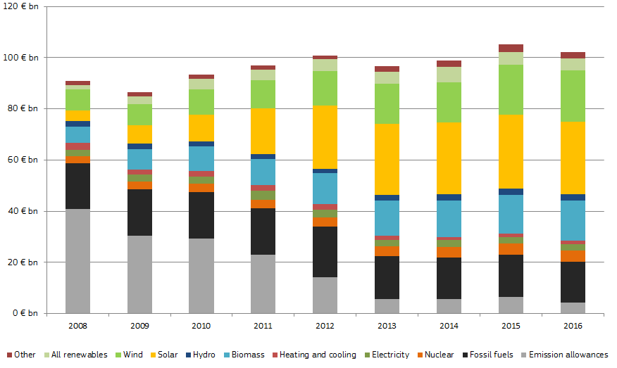

Figure 164 – Subsidies in the energy sector, by generation technology

Source: DG ENER, data from Trinomics et altri study (2018)

On the other hand, subsidies to renewable energy sources (biomass, hydro, wind and solar) rose from €23 bn to €71 bn between 2008 and 2016. The biggest rise could be observed between 2008 and 2013; since then only a moderate increase could be observed.

### Fossil fuel subsidies in the energy sector

Fossil fuel subsidies in the energy sector were fairly stable between 2008 and 2011, averaging around €18 bn in each year. After a peak of €20 bn measured in 2012, in 2013 the amount of total fossil fuel subsidies in the EU energy sector fell back to €17 bn and it slowly decreased until 2016, falling below16 bn.

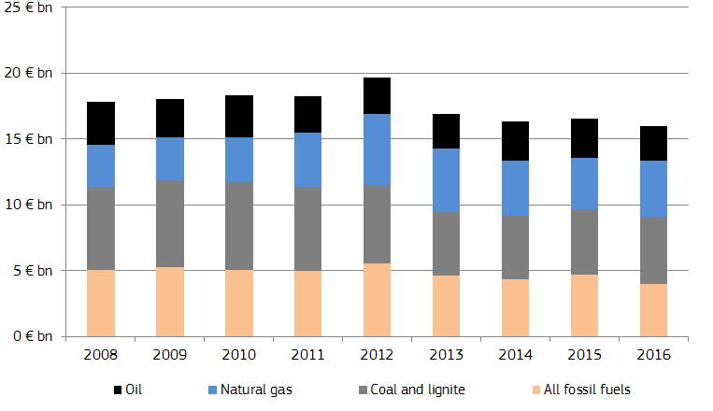

Figure 165 – Subsidies to fossil fuels in the energy sector, by generation technology

Source: DG ENER, data from Trinomics et altri study (2018)

When we compare these figures with those in the previous study on subsidies (Ecofys, 2014), we observe that the share of fossil fuels is now higher and the coal and gas shares are lower. The subsidies not linked to any specific technology, being the principal reason of higher subsidy numbers compared to the last study, mainly comprises of subsidy types related to combined power and heat generation, infrastructure, mine decommissioning and in some cases R&D expenditures.

### Renewables

The rapid increase in subsidies to renewable technologies over the years 2008 to 2012, especially for wind and solar power generation, slowed down since 2013. This was owing to several factors: Most important, the costs of generation (especially for solar PVs) significantly decreased over the last decade, resulting in reduction of Feed-in-Tariffs (FiT) and Feed-in-Premiums (FiP). Several Member States (for instance Spain since 2012, Italy in 2014 for PV, etc.) ended support in the case of new contracts. New regulations have also been introduced (the so-called concept of “development corridor”) in order to control the development of the installed capacities. On the other hand, the fall in wholesale electricity prices between 2012 and 2016 in Europe (see Chapter 1.1 on wholesale electricity markets) has driven the amount of subsidies upward by increasing the difference between the wholesale price and the fixed price from FiT contracts.

Between 2008 and 2016 the biggest increase in subsidies among renewables could be observed for solar technologies (from €4 bn to €28 bn), implying a six-fold increase. At the same time support for wind energy rose from €8 bn to €20bn. However, it is important to recall that the increase in the share of renewable sources within the EU power generation mix was predominantly owing to the increase in the share of wind, as its share went up from 3.5% to 12% between 2008 and 2017 (see Chapter 1.1 on wholesale electricity prices). At the same time the share of solar remains lower (less than 4% in 2017 on average across Member States). Renewable support schemes in the past decade contributed to a higher increase in wind penetration than for solar energy.

Looking at the two most widespread renewable support instruments, FiTs and FiPs, we can say that FiTs had a much bigger role between 2008 and 2016 (increasing from €18 bn to €50bn in this period) than renewable supports under FiP regimes (increasing from €1bn to €6.4 bn).

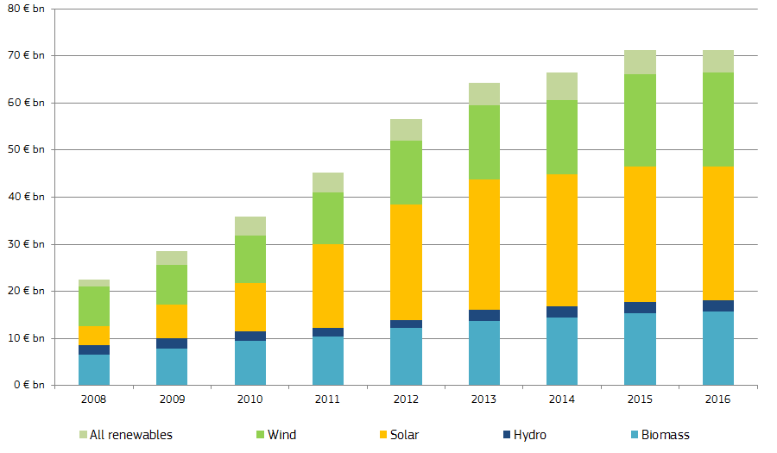

Figure 166 – Support to renewable energy sources in the EU Member States

Source: DG ENER, data from Trinomics et altri study (2018)

### Nuclear

In the nuclear sector the main subsidy instrument is the research and development support. This is applicable on both national and European level, as **Figure 167** shows. Not surprisingly the biggest amount of support has been spent in France on nuclear related R&D activities between 2008 and 2016, given the country's significant nuclear generation capacities and industry. Besides France significant amounts were spent in Germany, UK, Czech Republic and Belgium over the last few years. The total amount of support spent on nuclear R&D has been slightly above €1 bn in each year since 2012.

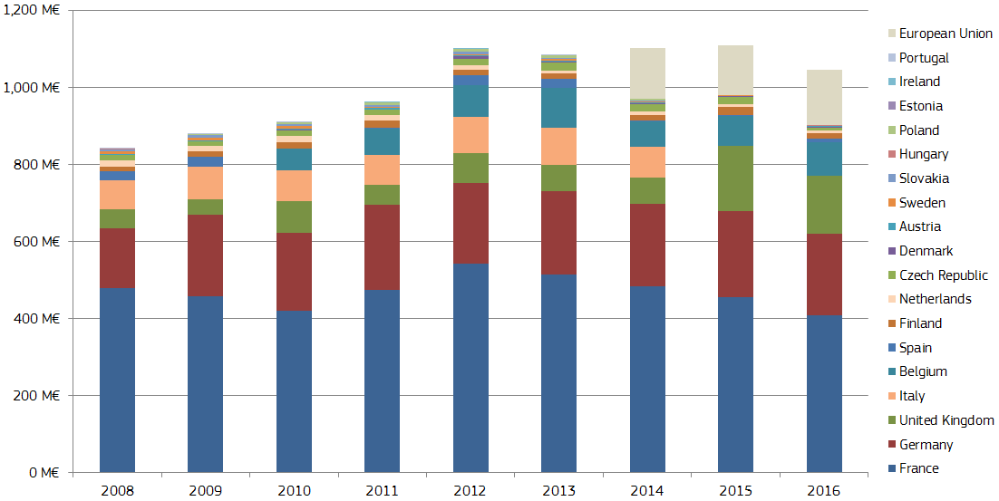

Figure 167 – Nuclear R&D support in the EU Member States

Source: DG ENER, data from Trinomics et altri study (2018)

Subsidies from EU funds on nuclear research activities also appeared as of 2014, as the EU plans to spend €1.6 bn on the nuclear research programme Euratom under the Horizon 2020 programme in the 2014-2020 period.

The next chart (**Figure 168**) shows the financial support to nuclear decommissioning[8] in some EU Member States. In 2016 the nuclear sector received the biggest decommissioning support in the UK, amounting to €2.2 bn. However, in this country nuclear energy is also used for non-energy market (i.e.: military) purposes which is not easy to identify as a separate item, implying that the actual support could be lower. In Italy nuclear decommissioning also received a significant support in 2016 (€ 560), while in Lithuania the financial support was related to the decommissioning of the former Ignalia power plant.

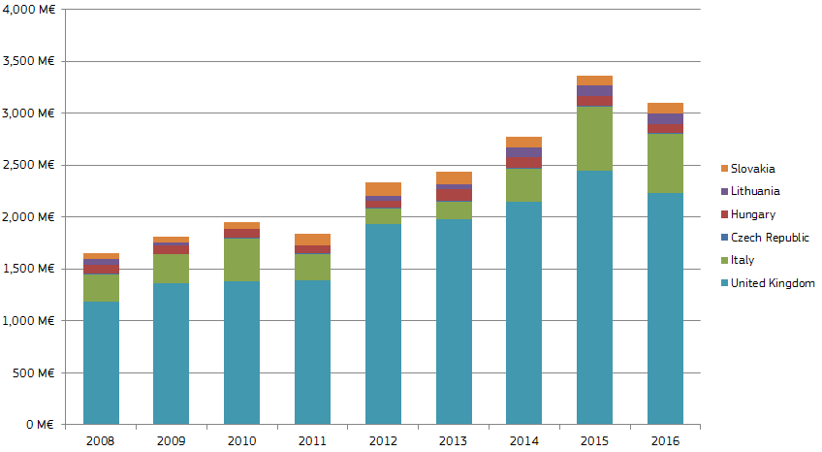

Figure 168 – Support to nuclear decommissioning in some EU Member States

On the top of support to decommissioning, in some countries (e.g.: France, Sweden and Romania) another € 200 million was spent on stranded assets and issues (e.g.: nuclear safety) financed by public national funds.

Financial support for nuclear third party liability may exist (as liability of nuclear operators is limited in most EU Member States and as the financial securities to be provided by operators for the coverage of the risk do not match the potential costs resulting from a severe nuclear accident) but, cannot be estimated at this stage. The reasons for this include the fact that there is neither a sufficiently developed nor harmonised approach by EU Member States on how the insurance, private and financial markets could provide for increased coverage in this field. The European Commission is investigating this specific topic further in separate studies.

Finally, State aid cases decisions may serve to identify other subsidies to nuclear generation[9]

### Other specific subsidies

After looking at the most important generation technologies there are some specific subsidies relating to the energy sector that should be presented in this subchapter.

As the next chart (**Figure** **169)** shows, there were significant changes in 2013, as the power sector was no longer eligible for free emission allowances under Phase-III of the ETS system, and the manufacturing sector's free allowances have also been reduced. In parallel, carbon prices on the market fell significantly, from 19.4 €/tCO2e in 2008 to 5.2 €/tCO2e.in 2016. In consequence, total financial support to free emission allowances dropped from €41 bn to €4 bn between 2008 and 2016. Although the aviation sector is also eligible for free allowances, the magnitude of support cannot be compared to the sectors with stationary installations.

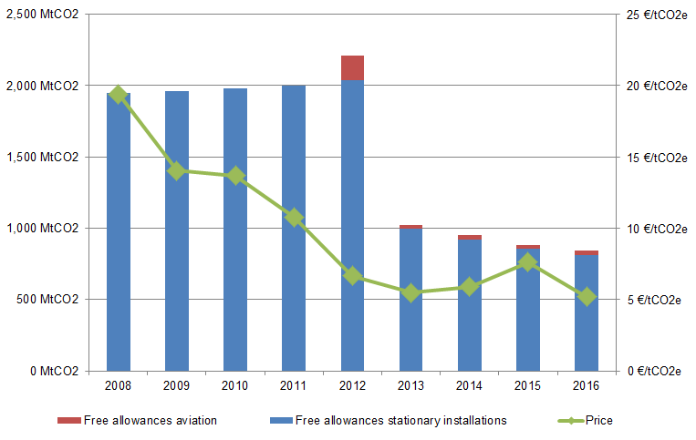

Figure 169 – Free emission allowances allotted to stationary installations, to the aviation sector, and the evolution of the carbon price in the ETS system[10]

Source: DG ENER, data from Trinomics et altri study (2018)

Capacity markets make an important policy issue in European energy policy as introduction of such instrument is always subject to an a priori inquiry from the European Commission whether the planned instrument is compatible with the EU State aid guidelines. Capacity payments are compatible with the EU internal electricity market rules; however, they should not lead to any distortion in the neighbouring markets. Capacity markets are also important from decarbonisation perspective, as in most cases they cover fossil fuel (coal or gas) generation technologies used as strategic or balancing reserves.

**Figure 170** shows the capacity payments in some EU Member states (where capacity markets could be identified in the period of 2008-2016). Capacity payments in the EU as whole varied between €1 bn and €2.1 bn over this period, with the biggest payment amounts observed in Ireland, Spain and Greece. In 2015 a new capacity mechanism, aiming at keeping brown coal (lignite) power plants in the strategic reserve but normally out of operation, was introduced in Germany as well. In other countries, such as Sweden, Finland and Belgium, capacity payments only amounted to few millions of euros, and this instrument plays only a marginal role in the given country's electricity generation (primarily during high demand periods, such as colder winter days).

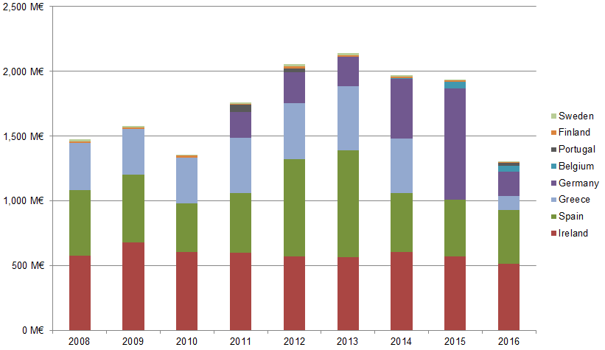

Figure 170 – Capacity payment support in some EU Member States

Source: DG ENER, data from Trinomics et altri study (2018)

Demand response instruments, as an alternative or complementary measure to balancing on the electricity market, have an increasing importance on European electricity markets. **Figure 171** shows how they impact subsidies in the electricity markets in Member States with available data.

In Spain, Italy and Portugal the annual amount of interruptible load scheme related subsidy can reach several hundreds of million euros. In Spain the interruptibility service is a tool managed by the Transmission System Operator (TSO) to reduce load of certain consumers in case the system needs it to keep the system balanced. This service is provided by big industrial consumers. In Italy the TSO contracts annual capacity of demand-side response (DSR) from energy-intensive industries with electricity consumption usually higher than 7 GWh.

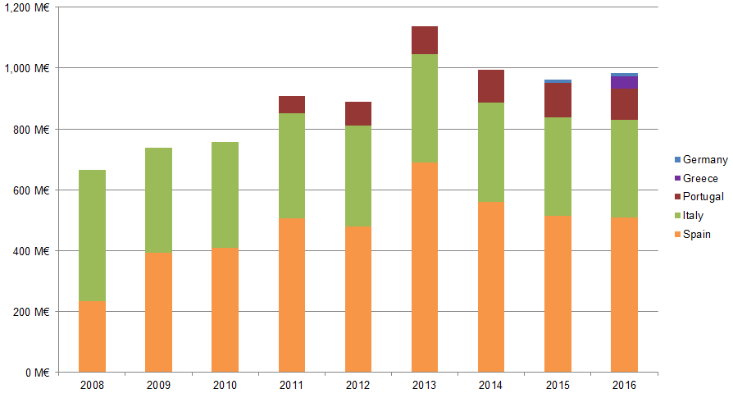

Figure 171 – Financial support to interruptible load schemes in some EU Member States

Source: DG ENER, data from Trinomics et altri study (2018)

## Subsides beyond the energy sector

The energy sectors accounts for the majority of energy subsidies but energy subsidies beyond the energy sector are also significant. This section first focuses on fossil fuels subsides not given to the energy industry. Then the distribution of these subsidies across the non-energy sectors (namely, Households, Manufacturing, Transport and Agriculture) is analysed

### Fossil fuels subsidies beyond the energy sector

Between 2008 and 2016 subsidies to fossil fuels remained stable in the EU-28, and reached around €54-55 bn in both 2008 and 2016. However, in 2012 support to fossil fuels peaked above €60 bn. Within this, subsidies to petroleum products increased from €26 bn to €28 bn, that could mainly be observed in the transport sector, as both **Figure 172** and **Figure 173** show. On the other hand, subsidies to coal and lignite, natural gas, and other fossil fuels remained stable or decreased between 2008 and 2016.

These subsidy figures do not include excise duties differences between petrol and diesel fuels. The scope of this study does not cover subsidies across different fuels, as subsidy calculations are not based on energy content. However, several countries consider the difference in the excise duty rates as tax expenditure and include it in their annual budget / finance law reports.

This is the case of Denmark (€0.2bn in 2016), Italy (€5bn in 2016) and Sweden (€0.9bn in 2016). Most of the Member States, however, do not currently consider the excise duty rate difference between diesel and gasoline as tax expenditure. This is another reason why this measure has been excluded of our study. Few other Member States have released official estimations of their potential tax losses. This is at least the case for France (€6.9bn in 2011) and Germany (€8bn in 2015).

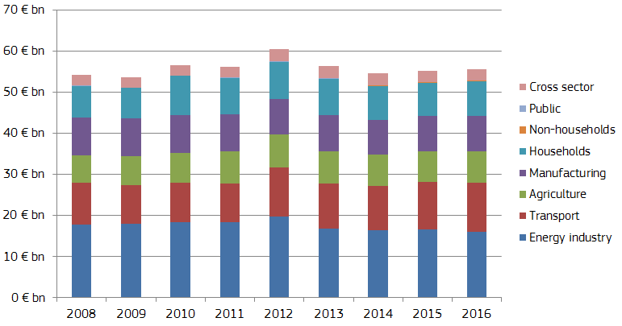

Figure 172 – Fossil fuel subsidies in different sectors in the EU

Source: DG ENER, data from Trinomics et altri study (2018)

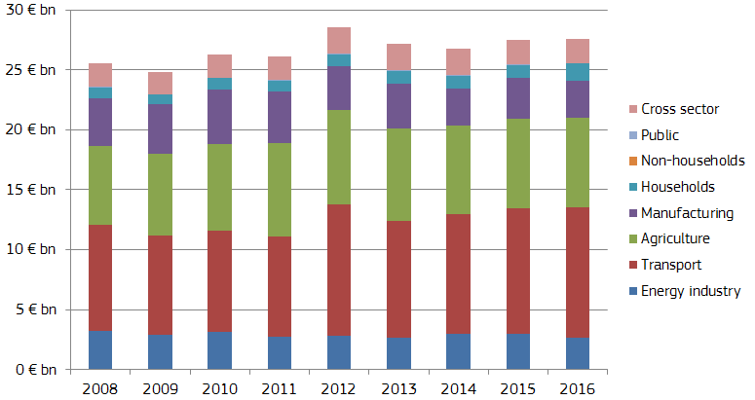

Figure 173 – Subsidies to oil and petroleum products in different sectors in the EU

Source: DG ENER, data from Trinomics et altri study (2018)

### Sectors receiving subsidies beyond the energy industry

It is worth taking a look at the other non-energy sectors (**Figure 174**) consuming energy and receiving energy-related subsidies.

In the case of *Household*s, receiving €24 bn of subsidies in 2016, the largest part of subsidies was assigned to Electricity (€8.2 bn), followed by natural gas (€7 bn). The third largest category was other subsidies (€3.7 bn) in 2016 and heating and cooling also received €1.8 bn as subsidy. Most of these subsidies for households covered fuel payments for given types of households, energy savings measures, investments for refurbishment of housing to enhance energy efficiency, price support measures or reduced taxes for household energy consumption. Consumption of electricity is also subsidised, for example in some countries households electricity consumption falls under a preferential VAT rate, or face reduced excise taxes. Households also received subsidies through regulated electricity and natural gas prices. The uptake of renewable energy generation by households is also subsidised in many Member States.

*Manufacturing industry* (mainly the energy intensive industries) received €18 bn in the form of energy related subsidies in 2016. Around 35% of the total support in the sector could be assigned to electricity consumption (€6.4 bn in 2016). In the case of large energy consumers (energy intensive industries) the preservation of the international competitiveness for their products is ensured by preferential electricity tariffs or exemptions/reductions from energy taxes, costs of carbon emission and other climate policy measures (renewables levies or carbon taxes). Subsidies to petroleum products (€3 bn in 2016) could also be observed, mainly in the chemical industries and in the form of exemption from excise duties. The remaining part of subsidies in the energy sector could be assigned to general fossil fuel measures (€ 3bn), coal and lignite (1.8 bn).

The *Transport* sector received €13 bn energy-related subsidies in 2016. More than 80% of that support (around €11 bn) could be linked to oil and petroleum products, mainly in the form of preferential tax and excise duty rates (exemptions or partial refund) for transport vehicles consuming petroleum products. Support to natural gas used in road transport amounted to €1 bn and support for the use of electricity in rail transport was € 600 million. Subsidy in the form of free emission allowances to air transport amounted to €4.4 bn in 2012 but decreased to only €158 million in 2016. This is because the EU has decided to lmit the EU ETS to intra-EEA flights in light of ICAO Resolution of 2016[11]. Support to biofuels use in road transport (biofuel blending) through reduced excise taxes amounted to around 700 million euros in 2016.

In 2016 the total support to *Agriculture* amounted to €8 bn. The overall majority (96% in 2016) of the total support could be attributed to the consumption of petroleum products. This mainly covered support to fuel consumption (reduced tax rates, exemptions from excise taxes or refunds). Renewables also received support, mainly to support investments in energy efficiency. There were some individual cases when natural gas and electricity consumption in the agricultural sector received subsidies (e.g.: heating of greenhouses) under conditions to invest in energy efficiency.

As miscellaneous category, '*Cross sector'* includes mainly general energy measures, aiming at energy savings or investments in more energy efficient products, or other measures directly not attributable to one single sector or generation technology.

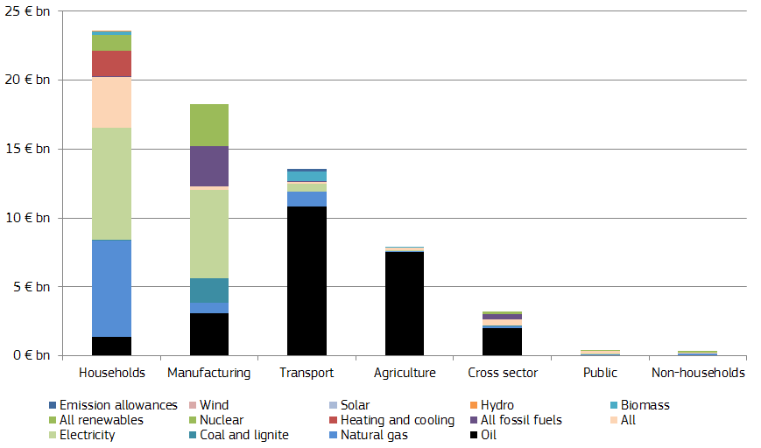

Figure 174 – Distribution of support among energy sources in 2016 in the EU

Source: DG ENER, data from Trinomics et altri study (2018)

## Impact of subsidies on energy prices for consumers

Beyond setting up an inventory of subsidies, it is essential to analyse their impact on the energy markets. In this subchapter we are looking at how different types of subsidies impact wholesale and retail electricity and gas prices for different types of consumers (energy intensive industries, medium-sized industrial energy consumers and households).

Subsidies can impact wholesale electricity prices, as for example higher penetration of renewable energy sources in the electricity mix, as it can be seen in Chapter 1.1, will lead to lower prices in the market. Electricity production subsidies, such as Feed-in-Tariff and/or investment grants, are likely to have affected the electricity generation mix. Through these impacts on the electricity generation mix, the electricity production subsidies could have had subsequent (indirect) impacts on wholesale electricity prices, due to the merit order effect.

For many countries in the EU, if support for renewables did not exist, less renewables capacity would have been installed over the past ten years: these emerging technologies would not have initially been able to compete with other generation technologies, due to the large initial investment cost required and relatively high levelised costs of electricity generation

The underlying study on energy prices and costs showed that one percent increase in the share renewable energy sources in the generation mix will drive down the wholesale price by 0.5 €/MWh in Germany, but elsewhere in the EU we have similar (or slightly lower) expectations. As modelling results show, without subsidies to production of renewable energies in Germany, the share of wind and solar together would be 8% lower in the country's electricity mix, implying that wholesale electricity prices decreased by 4 €/MWh in the consequence of subsidies to renewables.

On the other hand, wholesale gas prices, predominantly determined by import sources, are not significantly impacted by any subsidies in the EU. Due to the high import dependency, the marginal price of gas in the EU is determined by supply and demand interactions in international energy markets.

The energy prices and costs study in the EU provides some analysis on how tax relieves, grants for energy efficiency and energy demand moderation and subsidies to energy production can impact retail electricity and gas prices paid by industrial and household customers.

In the case of industrial customers it is worth comparing large consumers (energy intensive industries) and consumers with medium energy consumption. As **Figure 175** shows, energy intensive industries receive measurable subsidies in the form of tax relieves in Germany, Sweden and Finland, while in other countries and in non-energy intensive industries the support is not so significant. It is important to recall that these subsidies serve as compensation for non-recoverable taxes and levies.

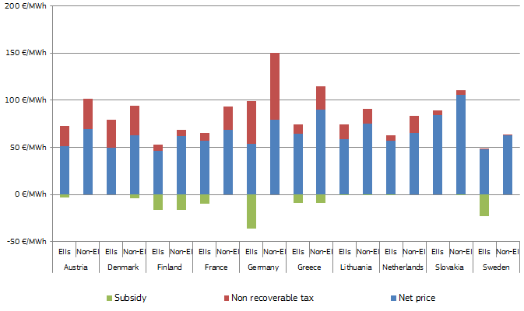

Figure 175 – Retail electricity prices, recoverable taxes and tax relieves paid by large industrial (energy intensive) and median level electricity customers in some EU Member States in 2016[12]

Source: DG ENER, data from Trinomics et altri study (2018)

In the case of natural gas, energy intensive (large consumer) industries received significant tax relieves in Austria, Finland, and some support can be observed in the UK. However, in the case of natural gas the role of taxes and levies (non-recoverable) aiming at fulfilling energy and climate policy objectives is less important than in the case of electricity.

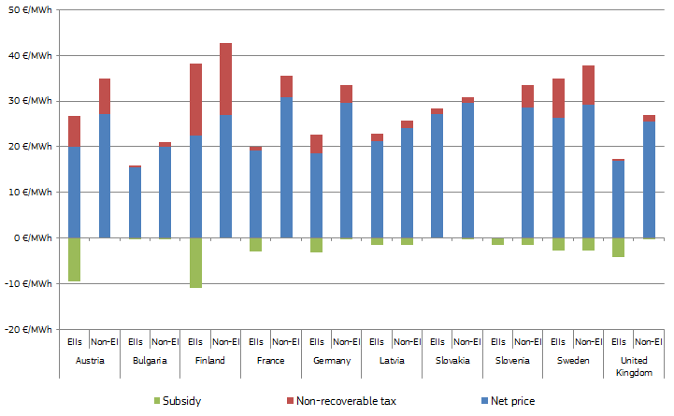

Figure 176 – Retail gas prices, recoverable taxes and tax relieves paid by large industrial (energy intensive) and median level gas customers in some EU Member States in 2016

Source: DG ENER, data from Trinomics et altri study (2018)

In households, one of the main motivations for VAT and other tax exemptions is to reduce incidence of fuel poverty, particularly where the housing stock is inefficient and of poor quality in thermal insulation, or where there is a high share of rented accommodation. **Figure 177** and **Figure 178** show the impact of tax relief for household electricity and gas prices.

The impact of energy tax relief policies on household electricity prices was the largest in the UK, where households face a reduced VAT rate of 5% for electricity and gas (compared to a standard VAT rate of 20%). Households in Latvia and Lithuania also face reduced VAT rates for heat energy, while in Denmark, there is an income tax allowance, ‘the green check’, to compensate for increased energy and environment costs imposed on consumers.

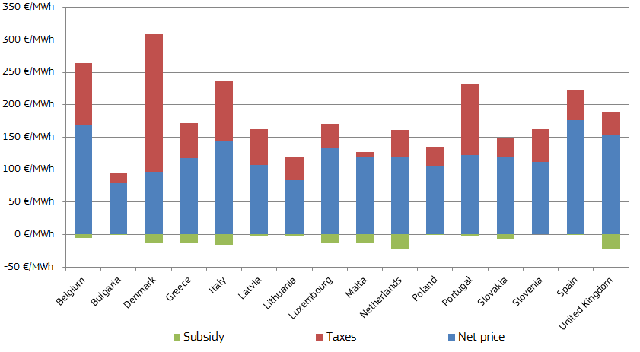

Figure 177 - Retail electricity prices, recoverable taxes and tax relieves paid by households in some EU Member States in 2016

Source: DG ENER, data from Trinomics et altri study (2018)

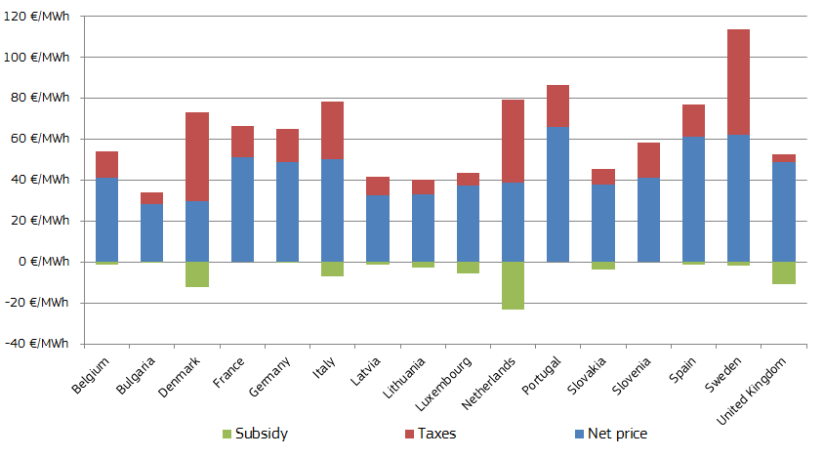

Figure 178 - Retail gas prices, recoverable taxes and tax relieves paid by households in some EU Member States in 2016

Source: DG ENER, data from Trinomics et altri study (2018)

*Energy loans and grants* do not have a direct impact on gas and electricity prices but do affect gas and electricity demand and, through their impact on total energy consumption, affect energy costs faced by final users. Three types of loans and grants were identified in the energy prices and costs study:

The *energy savings grants and loans* are targeted to improve energy efficiency and reduce energy consumption.

The *energy demand subsidies* reimburse consumers’ energy costs and typically comprise a lump sum payment for certain energy consumers.

The *investment subsidies* include grants for energy efficiency improvements, CHP, micro-generation and other energy investments. **Figure 179** shows the impact of these measures on electricity and gas consumption.

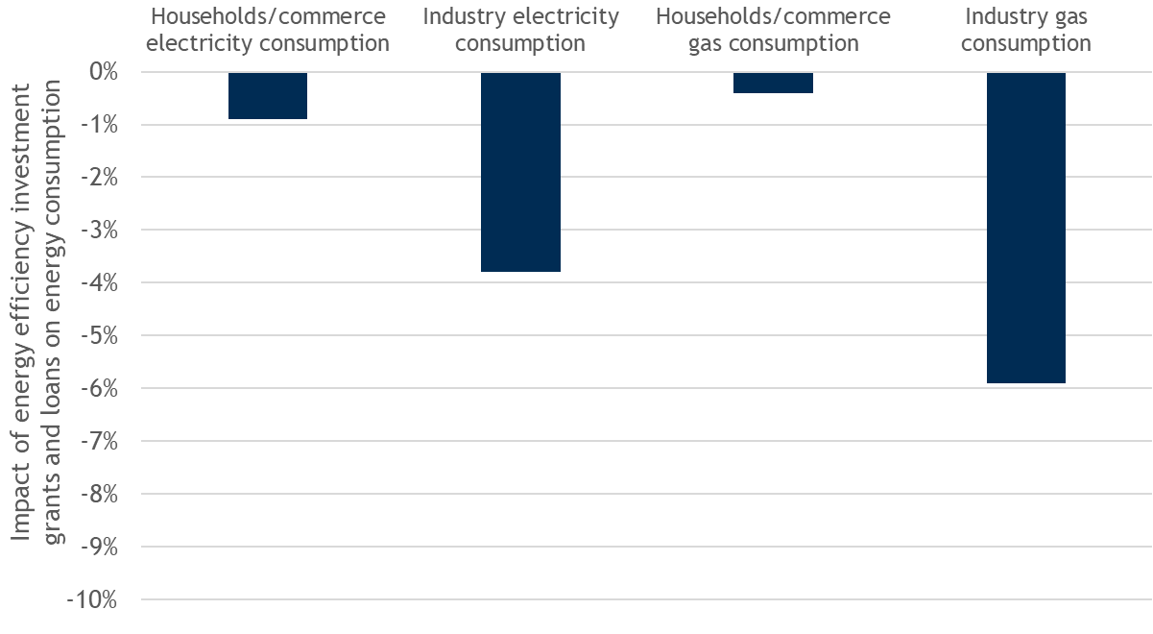

Figure 179 - The impact of loans and grants for energy efficiency measures and/or other investments on EU28 household and industry energy consumption between 2008 and 2015

Source: DG ENER, data from Trinomics et altri study (2018)

The largest impact of these support instruments could be observed in the case of industrial gas consumption and household electricity consumption, decreasing respectively by 6 and 4% between 2008 and 2015. Industrial gas consumption decreased by 40% in Latvia and by 28% in Estonia, while industrial electricity consumption fell by 38% in the Czech Republic in this period.

## International comparisons of fossil fuel subsidies

At the beginning of this chapter the global initiatives on rolling back fossil fuel subsidies have been mentioned, alongside with the efforts in the EU. Although different institutions, such as the IMF, OECD, IEA, etc. use different definitions, methodology and data sources for measuring fossil fuel subsidies, often resulting in numbers being barely comparable, it is always useful to put the results of the energy prices and costs study in global comparison. Over the last few years OECD and IEA tried to merge the results of their data collection, covering 76 countries around the world. The study on energy prices and costs follows a similar methodology to that of the OECD, setting up a subsidy inventory using a bottom-up approach.

As **Figure 180** shows, the estimated global amount of fossil fuel subsidies showed an increase between 2010 and 2012, and then fell back significantly until 2015. This was mainly due to the decrease in subsidies to petroleum products, the largest share of fossil fuel support.

At global level the amount of support for fossil fuels followed closely the price evolution of crude oil and petroleum products. In many countries in the world consumption of petroleum products for final customers (e.g.: residential customers) are subsidised, using below-cost end-user prices. In the period of high oil prices, the subsidies will increase automatically if the end-user prices are to be maintained, while in parallel with decrease oil and petroleum product prices it falls back. However, over the last few years many policy measures were taken around the world (e.g.: Mexico, Middle East countries) in order to reduce such type of subsidies.

In contrast, subsidies to petroleum products in the EU countries do not show close correlation with oil prices, as most of these subsidies can be linked to tax and fixed amount of excise duty reductions and exemptions, being independent from petroleum product prices. Subsidy to natural gas showed proportionally a similar evolution to crude oil products, in parallel with high fossil fuel prices in 2012 gas subsidies also went up, however, given the different magnitudes, the amounts seem to be more stable over time on **Figure 180**. Subsidy to coal showed a high degree of stability both in the EU and on global scale.

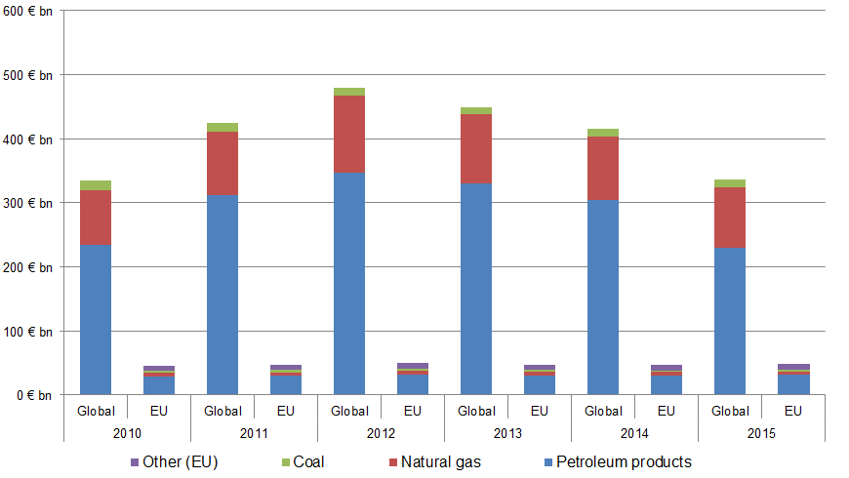

Figure 180 – Fossil fuel subsidies in the world and in the EU

Source: IEA-OECD common database (OECD companion to the Inventory of Support Measure for Fossil fuels, 2018), converted to euro and the study on Energy prices and costs in the EU

The aforementioned international institutions (IMF, IEA, OECD) have done several studies, aiming at quantifying fossil fuel subsidies over the past few years, however, since the publication of the last Energy prices and costs report at the end of 2016 no new results have been made available that cover regions beyond Europe. Nevertheless, these international institutions (especially OECD) are active in collecting data on subsidies and any updates will be taken into account at international comparisons in the next edition of this report.

# The role of energy for government revenues and inflation

## Government revenues from the energy sector

**Main findings**

* In 2016, energy taxes collected by EU Member States amounted to EUR 280.4 billion, equivalent to 1.88% of EU GDP. As a percentage of GDP and total tax revenue, energy tax revenue has been rather stable since the 2008 economic crisis.
* In individual Member States, the role of energy taxes in government revenues and GDP shows a significant variety: Member States with a lower GDP/capita typically have a higher share of energy taxes from both total tax revenue and from GDP.
* The energy tax revenue per 1 tonne of oil equivalent of gross inland energy consumption was EUR 171 in 2016. In real terms, this average calculated tax rate increased by 20.5% between 2010 and 2016, more than offsetting the fall of energy consumption in this period.
* Excise duties constitute the largest part of energy taxes, amounting to around EUR 244 billion in 2017. When adjusted for inflation, excise duty revenues have been rather stable in 2011-2014 but increased by 2-3%/year in 2015-2017.
* Oil products continue to dominate excise duty revenues, with a share consistently above 80%, although this share has slightly decreased over the last decade, at the benefit of gas and electricity. In 2017, the share of petroleum products was more than 50% in all Member States and more than 90% in 19 Member States.
* For the main oil products, the nominal excise duty revenue is gradually growing, driven by increasing excise duty rates and, in the last few years, rising consumption. In 2013-2015, growing excise duty revenues were offset by lower VAT revenue driven by falling oil and oil product prices. As a result, the nominal tax revenue from petroleum products has been relatively stable but in real terms the tax revenue decreased.

### Energy taxes

Taxes and duties imposed on energy products are an important source of government revenue in EU Member States. In 2016, energy taxes[13] collected by EU Member States amounted to 280.4 billion euros. This was equivalent to 1.88% of EU GDP and 4.70% of total revenues from taxes and social contributions (including imputed social contributions).

While nominal energy tax revenues increased by 27% between 2009 and 2016 (on average by 3.5%/year), as a percentage of GDP and tax revenue they remained relatively stable, showing only a marginal increase in this period.

According to the estimations of the Commission's Taxation and Customs Union Directorate-General, around 70% of energy tax revenues come from transport fuels.[14]

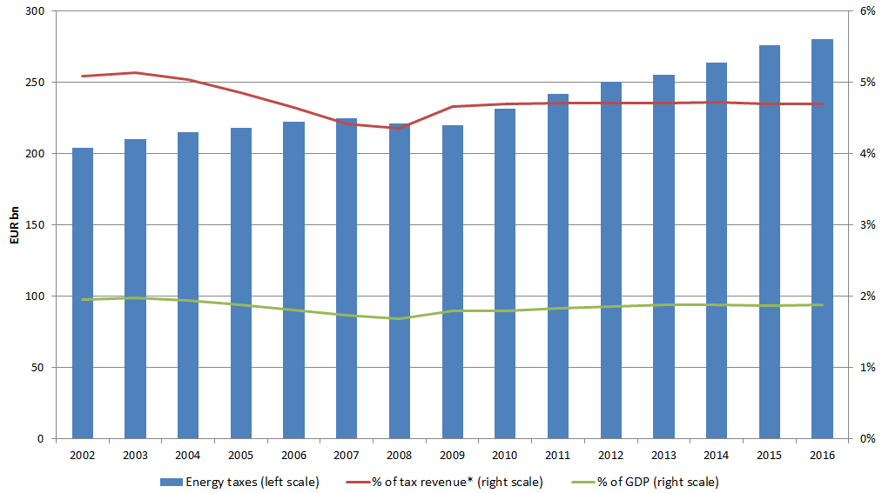

Figure 181 - Energy taxes in the EU-28

Source: Eurostat (data series env_ac_tax)

*percentage of total revenues from taxes and social contributions (including imputed social contributions)

Looking at individual Member States, the role of energy taxes in government revenues shows a significant variety: in 2016, energy taxes in Latvia made up 9.85% of total revenues from taxes and social contributions (including imputed social contributions) while this share was only 3.03% in Belgium. When compared to the GDP, energy tax revenue was highest in Slovenia (3.28%) and lowest in Ireland (1.12%). Typically, Member States with a lower GDP/capita have a higher share of energy taxes from both total tax revenue and from GDP.

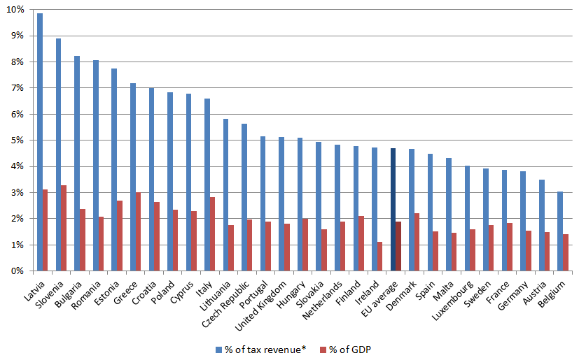

Figure 182 - Energy taxes as a percentage of tax revenue and of GDP in 2016

Source: Eurostat (data series env_ac_tax)

*percentage of total revenues from taxes and social contributions (including imputed social contributions)

Households are the main contributors to energy tax revenues: in 2015, they payed 46% of total energy taxes. This represents a small decrease compared to 2009 when this share reached 50%. From economic activities, transportation, manufacturing and other services were the three sectors paying the largest amount of energy taxes in 2015, with 12%, 11% and 10% of total energy taxes, respectively.

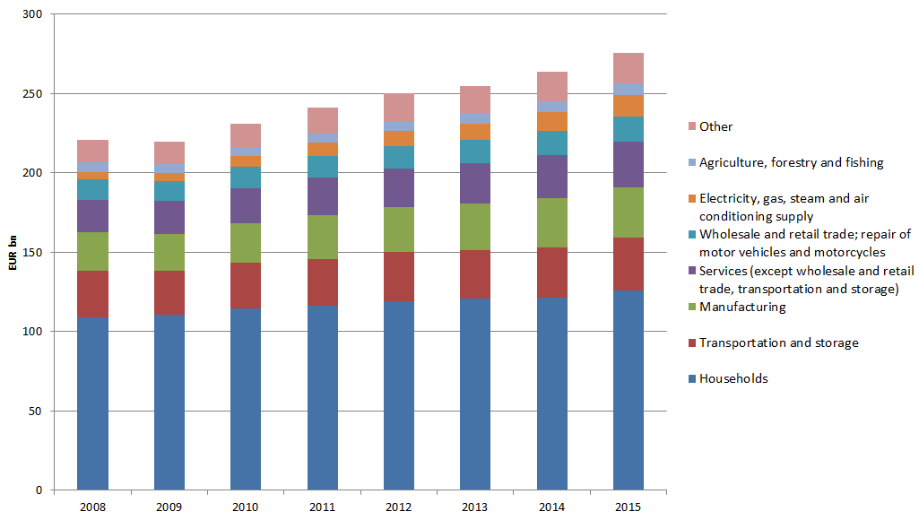

Figure 183 - Energy taxes by economic activity

Source: Eurostat (data series env_ac_taxind2)

The underlying tax base of energy taxes declined in the last decade: the EU's gross inland energy consumption decreased by 12.6% between 2006 and 2014, followed by a slight increase in 2015 (+1.3%) and 2016 (+0.7%). This decline was more than offset by the increase of the average calculated tax rate which increased from EUR 121 per 1 tonne of oil equivalent (toe) of gross inland energy consumption in 2006 to EUR 171/toe in 2016.

When allowing for inflation, the average calculated tax rate decreased between 2002 and 2010 (with a dip in 2008) but increased afterwards. Between 2010 and 2016, the real tax burden increased by 20.5% (by 3.2%/year), from EUR 142/toe to EUR 170/toe (both measured in 2015 euros).

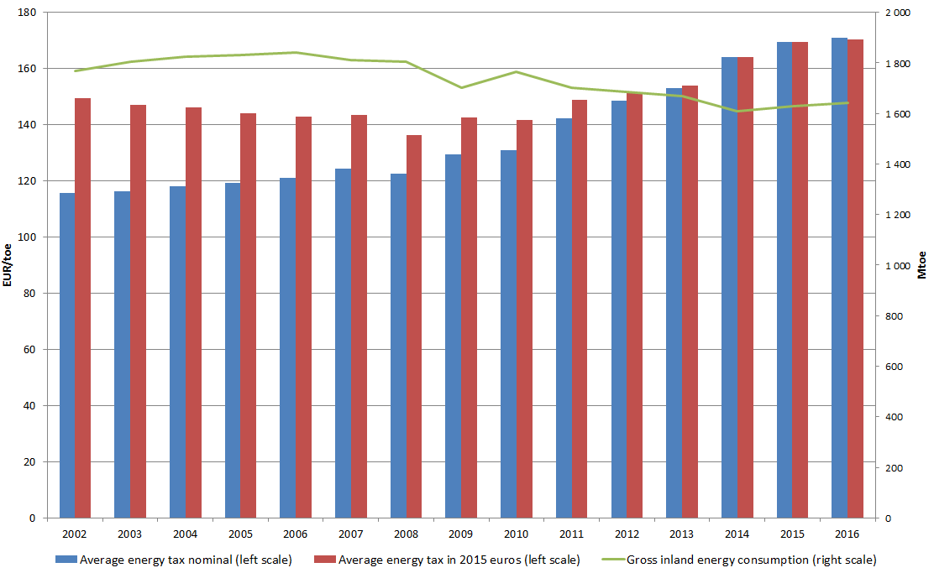

Figure 184 – Average energy tax for 1 toe of gross inland energy consumption in the EU-28

Source: DG Energy calculation based on Eurostat data (data series env_ac_tax, nrg_100a and prc_hicp_aind)

On average, the energy tax revenue per 1 toe of gross inland energy consumption was EUR 171 in 2016, but there was a huge variation across Member States, from EUR 63 in Bulgaria to EUR 352 in Denmark. Member States with higher GDP and a higher share of oil in the energy mix tend to have higher energy taxes per 1 toe of gross inland energy consumption.

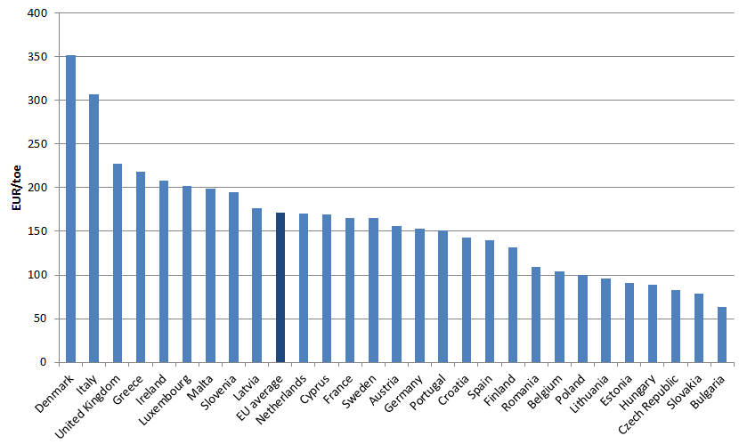

Figure 185 – Average energy tax for 1 toe of gross inland energy consumption in 2016

Source: DG Energy calculation based on Eurostat data (data series env_ac_tax and nrg_100a)

### Excise duties

Excise duties constitute the largest part of energy taxes.

Excise duties are indirect taxes imposed on the sale or use of specific products, typically alcohol, tobacco and energy products. All revenue from excise duties goes to the budgets of Member States. Excise duties are set in absolute values, i.e. as a fixed amount per quantity of the product (e.g. per litre/kg/GJ/MWh). Accordingly, assuming that the rates don't change, the revenue will depend on the consumption of the specific product. In contrast, price changes should not impact revenues (at least not directly).

Current EU rules for taxing energy products are laid down in Council Directive 2003/96/EC174[15] (the Energy Tax Directive), which entered into force on 1 January 2004. The Directive covers petroleum products (gasoline, gasoil, kerosene, LPG, heavy fuel oil), natural gas, coal, coke and electricity. In addition to establishing a common EU framework for taxing energy products, the Directive sets minimum excise duty rates.

The Commission's Taxation and Customs Union Directorate-General (TAXUD) regularly publishes the excise duty rates applicable in EU Member States[16] and the revenue from excise duties[17].

As far as revenues are concerned, the latest available data relate to 2017.[18] According to these data, excise duty revenues amounted to EUR 244 billion in 2017. From 2009, total revenue shows an increasing trend.

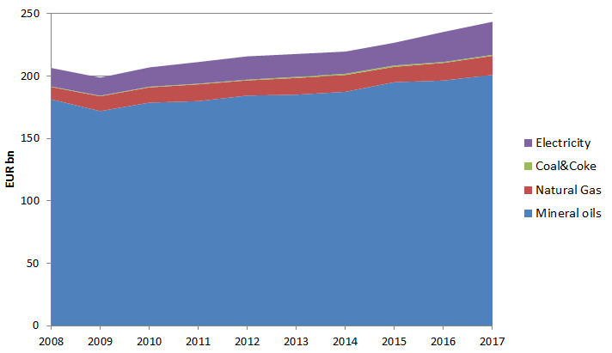

Figure 186 - Excise duty revenues from energy consumption

Source: DG Taxation and Customs Union

If adjusted for inflation, excise duty revenues have slightly decreased between 2008 and 2014: measured in 2015 euros, they amounted to EUR 230 billion in 2008 and EUR 220 billion in 2014. In the last here years (2015-2017), however, real revenues increased by 3.4%, 3.5% and 1.9%, respectively.

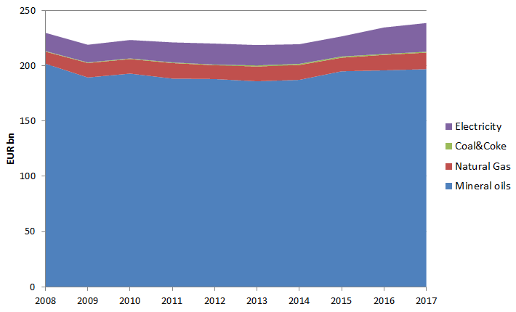

Figure 187 - Exercise duty revenues from energy consumption, adjusted for inflation (in 2015 euros)

Source: DG Taxation and Customs Union, adjusted by HICP

In 2017, oil products were the main source of excise duty revenue, covering 82.5% of all excise duty revenue from energy products. The rest was shared by electricity (10.9%), gas (6.3%) and coal (0.3%).

The share of oil products from total revenues decreased from 87.8% in 2008 to 82.5% in 2017 mainly at the benefit of gas and electricity.

Between 2008 and 2017, revenues from taxes on oil products increased by 10.8%, on gas by 55.3%, on electricity by 78.3% and on coal by 93.7%. In this 9-year period, inflation measured by the Harmonised Index of Consumer Prices (HICP) was 13.5%.

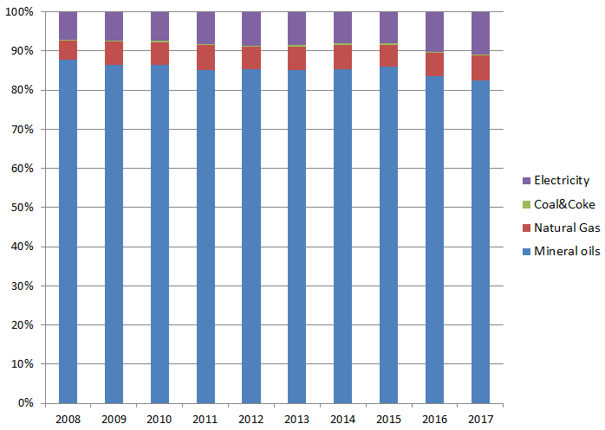

Figure 188 - The share of excise duty revenues by energy product

Source: DG Taxation and Customs Union

Oil products make up more than 60% of the excise duty revenue in all Member States except Denmark; in 19 Member States they make up more than 90%.

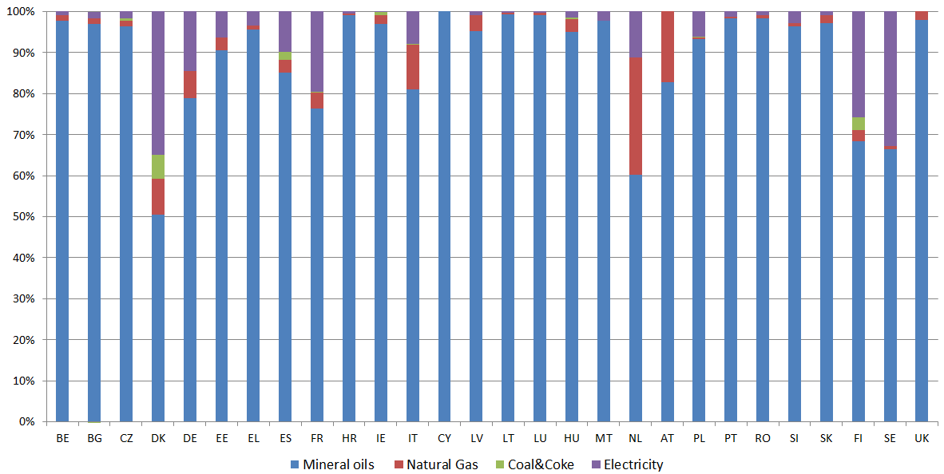

Figure 189 - The share of excise duty revenues by energy product, 2017

Source: DG Taxation and Customs Union

### Value added tax (VAT)

VAT imposed on energy products is another important source of government revenue. However, unlike for excise duties, there is no publicly available data for VAT revenues from energy products.

The VAT is a general consumption tax assessed on the value added to goods and services. It applies to practically all goods and services (including energy products) that are bought and sold for use or consumption in the EU. The VAT is borne ultimately by the final consumer; companies can reclaim the VAT they pay on the products and services they use as an input. VAT is charged as a percentage of the price which means that an increase of the price will entail an increase in the tax revenue and vice versa.

The VAT Directive (2006/112/EC)[19] requires that the standard VAT rate must be at least 15% and Member States can apply one or two reduced rates of at least 5% but only to goods or services listed in Annex III of the Directive (energy products are not in the list). In addition, there are multiple exceptions to the basic rules (usually with conditions/deadlines), including

* possibility of reduced rates for goods and services other than those listed in the directive (e.g. Article 102 allows the use of reduced rate to the supply of natural gas, electricity and district heating, "provided that no risk of distortion of competition thereby arises”);
* several country-specific exceptions, including the permission to use “super reduced” rates under 5% (including zero rates) for certain (including energy) products.

The EU-28 average standard VAT rate increased by 2 percentage points between 2008 and 2015 but has been rather stable since then: it was 21.5% in 2016 and 2017 and also at the start of 2018. Hungary has the highest VAT standard rate (27 %), followed by Croatia, Denmark and Sweden (all 25%). Luxembourg (17%) and Malta (18%) apply the lowest standard rate.

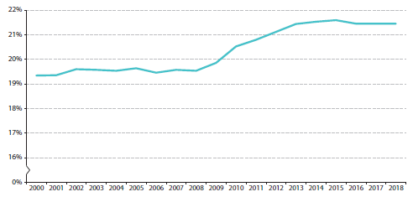

Figure 190 - The average standard VAT rate in the EU

Source: DG Taxation and Customs Union

About half of the Member States use reduced VAT rates for certain energy products, mainly gas, electricity, district heating, firewood and heating oil. Of course, this has an impact on household retail prices and partly explains the price differences across Member States. For example, the applicable VAT rate for gas and electricity ranges from 5% to 27%. DG TAXUD regularly publishes the VAT rates applied by Member States for different product groups/services.[20]

As a follow-up of the Action Plan on VAT[21], the Commission adopted a number of legislative proposals related to the VAT system with the objective of working towards the completion of a single EU VAT area. On 18 January 2018, a proposal was adopted to introduce more flexibility for Member States to change the VAT rates they apply to different products. According to the proposal, the current list of goods and services to which reduced rates can be applied would be abolished and replaced by a new "negative" list to which the standard rate of 15% or above would always be applied. The proposed "negative list" contains most oil products, requiring the application of the standard rate. On the other hand, Member States would continue to be able to apply a reduced rate for electricity, gas, LPG, district heating and firewood.[22]

### Tax revenues from oil products

Oil products, especially motor fuels, are the main source of tax revenue from the energy sector for government budgets. Data from the Weekly Oil Bulletin[23] allows a more detailed analysis of tax revenues from petroleum products, including an estimation of VAT revenues (assuming that no VAT is reclaimed).

Our analysis covers the three main petroleum products sold in the retail sector: gasoline (Euro-super 95), diesel (automotive gas oil) and heating oil (heating gas oil). For most Member States, the analysis covers the years 2005-2017, except Bulgaria (2008-2017), Croatia (2013-2017) and Romania (2008-2017).

For each year and each Member State, an average price was calculated as an arithmetic average of the weekly prices. The EU average price was then calculated as the weighted average of these. In the absence of 2017 annual consumption figures, for 2017 we used the 2016 consumption data as the weight.

Based on the development of consumption, consumer prices and their components, we estimated the tax revenues collected by Member States. It is important to underline that most enterprises can reclaim the VAT they pay, so the calculated VAT revenue is a theoretical maximum; the actual VAT revenue collected by Member States must be significantly lower.

The estimated revenue from excise duties shows an increasing trend between 2005 and 2017. Although the combined consumption of the three product groups decreased between 2008 and 2014, this was largely offset by the increase of the average excise duty rates. If adjusted for inflation, however, excise duty revenues slightly decreased in this period. Supported by the low oil prices and the economic recovery, fuel consumption increased in 2015-2016, giving a boost to excise duty revenues.

As the VAT is an ad valorem tax, the estimated (theoretical) VAT revenue is fluctuating in line with the net price. Accordingly, it decreased from 97.5 billion euros in 2012 to 76.7 billion euros in 2016 (a decrease of 21%). In the same period, the estimated excise duty revenue increased from 180.3 billion euros to 192.6 billion euros (an increase of 7%). In line with rising fuel prices, estimated VAT revenues increased in 2017 while the estimated excise duty revenue was practically unchanged compared to 2016.

Assuming that roughly half of the VAT is reclaimed (i.e. the actual VAT revenue is half of the theoretical value depicted on the below graph), the increase of excise duty more or less offset the decrease of the VAT revenue in 2012-2016, resulting in a relatively stable tax revenue from petroleum products. When adjusted for inflation, this means the value of the tax revenue has slightly decreased.

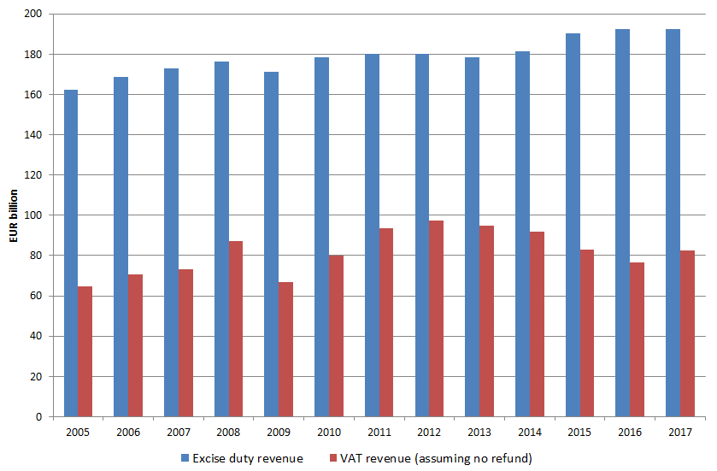

Figure 191 - Estimated tax revenue from gasoline, diesel and heating oil

Source: DG Energy calculation

**PART IV**

**Prices and Costs**

**and**

**Future Investments**

# Prices and costs and future investments

**Main Messages**

* Future electricity production costs are projected to follow diverging trends: higher cost components for fossil fuel power plants (import prices, carbon price), lower for renewables, notably for solar and wind (decreasing investment cost, higher capacity factor) (section 9.2.1).
* In a context of a slowly increasing demand for electricity, and an ageing fossil fuel fleet, the projected range for future electricity prices is similar to the range of costs of mature RES technologies. This means that, beyond market prices, less (or even zero) public support would be needed for enabling investments in the most mature RES technologies (section 9.3).
* The future range of prices is projected below the cost ranges for the fossil fuel technologies. Future electricity prices are expected not be encouraging additional investments in new fossil fuels capacity, which is expected to steadily decline driven are old plants are decommissioned (sections 9.4 and 9.5).

## Introduction and definitions

Very significant investments in the electricity market will be needed to enable the transition into a low carbon energy system over the coming decades. There will be even more important needs in the future in the light of the expected increasing electrification of our energy system.

In this chapter we look at the impact that prices can have on triggering investments in electricity markets. Prices need to cover total production costs to generate profits. Without the existence of current or expected market profits it will be difficult that investments are undertaken. When market profits are not sufficient government can intervene and offer public support to make investments possible if they consider those investments beneficial for the society.

In this section we look forward, up to 2030, and we assess to which extent current and future market prices are expected to be encouraging the additional investments in the various electricity technologies. In our analysis we also look at the main factors that can drive future electricity prices like the future carbon price and the prices of fossil fuels (oil, coal and gas) which are directly or indirectly relevant for producing electricity.

We compare in this section observed electricity prices, expected electricity prices in 2030 and expected electricity production costs in 2030 in the EU.

* Historical electricity prices considered in the analysis are the hourly day-ahead prices[24] observed in different power markets in the EU28.
* Expected hourly electricity prices in 2030 computed[25] as the hourly marginal cost of production.
* Production costs are expressed as levelised cost of electricity (LCOE), which include fixed costs per produced kWh (investment, amortization) and variable costs per produced kWh (fuel cost including losses, CO2 emission costs, O&M). The LCOE per technology type thus depends on the projected load factor. Costs are shown both for new investments and for the overall power mix.

Prices and costs per markets are averages, weighted over electricity produced, of prices and costs per Member State belonging to the market.

Volumes traded on day-ahead markets have been increasing over time, and were equivalent to around 50% of the total consumption of electricity in 2016 (**Figure 192**). In some European regional market like Nord Pool or the Iberian Peninsula this ratio is close to 100%. This reflects the growing importance of these markets for the electricity system.

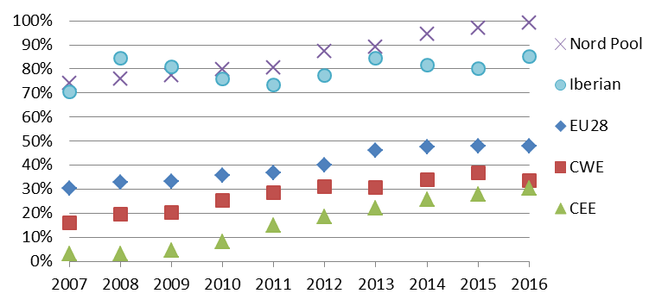

Figure 192- Ratio between volume traded annually on day-ahead market and electricity final

Source: Eurostat, Platts, European power exchanges

## Drivers of electricity costs and prices

### Renewable costs are declining

Wind and solar production costs have experienced decreases over the last decade (**Figure** **193**). PV in particular has seen a sharp decrease of costs since the early 2010s. Wind has also gone through investment cost decrease, albeit at a lower pace than solar PV, but also is undergoing improvement of the load factors, which ultimately leads to a decrease of the production cost.

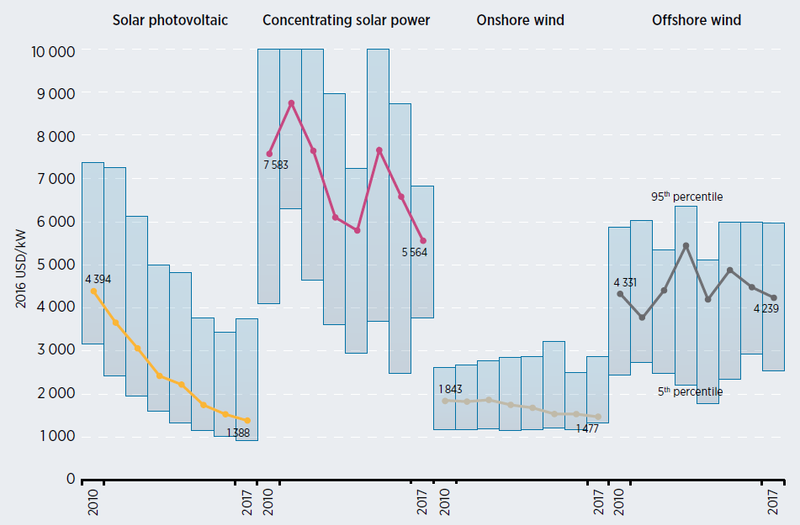

Figure 193 - Evolution of investment costs of renewables

Source: IRENA (2018)[26]

Note: Global data (expressed in USD), the thick lines represent the weighted average.

These improvements are expected to continue in the coming decades, including for offshore wind, further improving the future competitiveness of renewables (**Figure 194**) at EU and global level, and thus creating market opportunities outside the EU for European manufacturers[27].

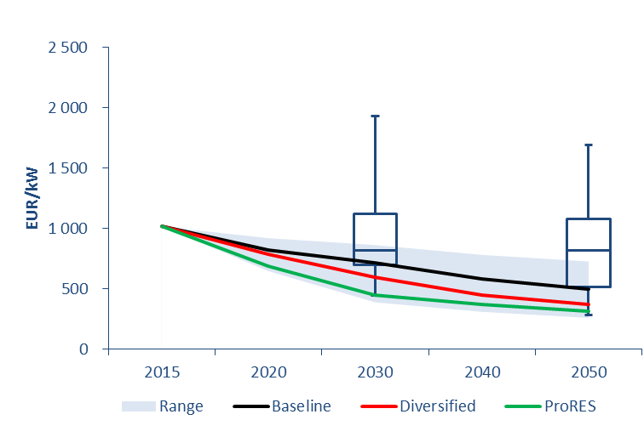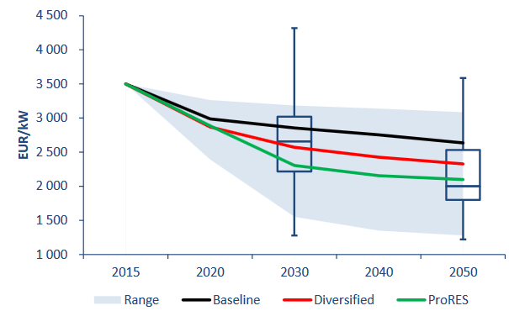

Figure 194 - Expected development of investment costs of renewable energy technologies in the long term under different scenarions (lines) and uncertain factors (range): example of solar and wind (left: utility scale photovoltaics, right: offshore wind turbines)

Source: JRC (2018)[28]

### Fossil fuel prices and carbon price

Fossil fuel prices are expected to rise by 2030 compared to 2015, as underlined in most international energy outlooks (IEA WEO 2017[29] and WEO 2018[30], JRC GECO 2017[31], EIA IEO 2018[32]), due to cheap resource becoming scarcer and in particular to the oil production moving progressively towards heavier and more expensive oil types. The projections underpinning this analysis are consistent with this assumption. They have been elaborated for the Long Term Strategy Baseline scenario.

### Gas price

Gas is an important contributor to the European power system, with 20% of the total electricity production in 2016[33].

Gas import price has been slightly decreasing over the last 10 years, but has been increasing slightly in 2018. It is expected to keep rising by 2030 to about 35 €/kWh (partially driven by the expected increase of oil price – see 9.2.2.3.). This is consistent with, for instance, IEA WEO2017131, which sees natural gas import price 75% higher than the price observed in 2016, and 5% higher than the price observed in 2010.



Figure 195 - Monthly gas import price

Source: 2008-2017: BAFA, 2018: UK NBP, 2030: European Commission (LTS Baseline)

Note 1: the box plots show the minimum observed in a given period (lower whisker), the first quartile (lower bar), the median (black line), the third quartile (upper bar) and the maximum (upper whisker).

Note 2: historical prices are in current €, 2030 point is in €2013

Note 3: “2018” covers January-September

### Coal price

Coal still represents a sizeable share of the power production of the EU, around 22% in 2016, although steadily decreasing (39% in 1990, 25% in 2010135).

The coal import price has been declining over the last 10 years, but is on the rise in 2018. It is expected to keep rising by 2030, reaching on average the highest levels observed over 2008-2018.



Figure 196 - Monthly coal import price

Source: PLATTS (Coal CIF ARA spot) for 2008-2018, 2030: European Commission (LTS Baseline)

Note 1: historical prices are in current €, 2030 point is in €2013

Note 2: “2018” covers January-September

### Oil price

Oil is a marginal fuel in the power system (2% of the total production135, 10 times less than gas or coal), but oil price will still play a role since it will influence the evolution of the gas price.

While the average oil price has been fairly stable over the periods observed 2008-2012, then 2013-2017 and 2008), **Figure 197** shows a great variability. Oil price is expected to get close to 95 €/bl by 2030, in line with the general trends projected by most long-term oil market outlooks (for instance, IEA WEO2017108 sees the international oil price reaching $(2016) 94 /bl in 2030, more than twice higher the low point reached in 2016, and 10% higher than the high values observed in 2010).



Figure 197 - Daily oil price (Brent)

Source: Historical Brent oil price from EIA (2018 until 09/10/2018)[34], $-€ exchange rate from ECB[35]; 2030: European Commission (LTS Baseline)

Note: historical prices are in current €, 2030 point is in €2013

### Carbon price

After having reached low levels in 2013-2017, the carbon price is clearly on an upwards trend in 2018 (see **Figure 198** and **Figure 199**), and is likely to increase further in the coming years due to the strengthening of the ETS targets and to the policy instruments (like the Market Stability Reserve) recently put in place to support the market[36]. The LTS Baseline value is 28 €(2013)/tCO2 in 2030, which will affect fossil-fuel based electricity production.



Figure 198 - Daily ETS price

Source: EEX EUA; 2030: European Commission (LTS Baseline)

Note: historical prices are in current €, 2030 point is in €2013

Note 2: “2018” include the daily prices from 01/01/2018 until 16/10/2018



Figure 199 - Daily ETS price in 2018

Note: last point is 16/10/2018.

## Need for new capacities

The need for new power generation capacity in the next decade will depend on demand for electricity and on the energy and climate policies of the European Union. Energy policy will directly affect electricity demand, through on the one hand stronger energy efficiency and on the other hand expected electrification of transport, heating & cooling as well as, to some extent, industry. Policy targets will also affect the type of technologies that are deployed with different requirements for the system, including storage and more flexible demand side response.

### Evolution of electricity demand

After a stabilisation since 2008, electricity demand is expected to increase slowly by 2030, up to 3000 TWh. In order to understand drivers of energy consumption, the European Commission uses, among other tools, projections from energy system models. **Figure 200** shows projections for final electricity consumption calculated for different projection exercises.

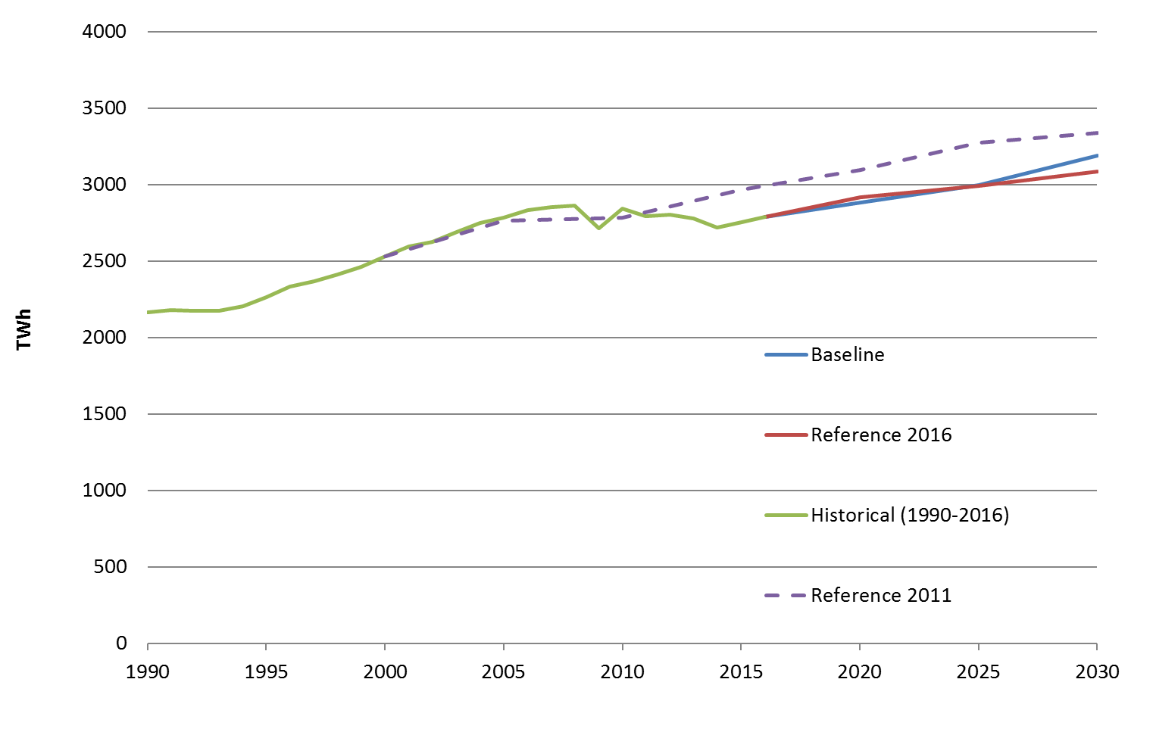

Figure 200 - Final electricity consumption in the EU28, historical data and projections.

Source: historical from Eurostat ([nrg_105a](http://appsso.eurostat.ec.europa.eu/nui/submitViewTableAction.do)), projections by European Commission, DG ENERGY.

With the economic recovery, electricity consumption in the European Union is set to moderately increase remaining close to its 2005 peak. Several macroeconomic trends are contributing to the moderate prospects for electricity demand. First, the European recession precipitated a restructuring of the Union's economy towards less energy-intensive activities. Second, the energy efficiency policy of the Union is promoting efficiency standards and mobilising investments in energy conservation. These policies have a considerable impact on electricity demand: According to IEA[37], energy efficiency measures reduced the growth of electricity demand in IEA member countries from an expected 1.3% per year to the observed 0.2% per year.

Finally, the aging population and the projected moderate economic growth cap energy demand while markets for several energy-intensive products show signs of saturation. These trends are contrasted by a shift from fossil fuels to electricity driven by climate policies (with low cost of renewables technologies, electrification becomes an effective mean to decarbonise the economy).

All these trends combined will have important consequences on the volume of investments in energy assets. Investments in conventional fossil fuel technologies will be effected to a greater extent.

The projections realised before 2010, on the other hand, pointed to a continued growth of electricity consumption as it can be seen in **Figure 200.** Following the great recession of 2009, the later scenarios were updated with the latest available macroeconomic projections[38] and calibrated to the latest statistical data. The new projections show an almost flat demand for electricity, only marginally increasing in 2030 compared to the 2005 peak.

Up to 2030, the upward trend is fairly similar in the Reference 2016 scenario and in the LTS Baseline, which takes into account the agreed new targets on energy efficiency (at least 32%) and renewables (at least 32.5%) for 2030. The economic trends described above result in reduced electricity demand compared to past projections (e.g., the projections in the 2011 Reference scenario also shown in **Figure 200**). After 2025, the electrification of the economy starts having a noticeable impact on electricity demand.

### Age structure of fossil fuel fired power plants

To understand the impact the developments shown in the previous sections will have on energy assets investments, it is necessary to analyse the age profile on the power plants operating in the Union. It is possible to extract the approximate age profile of power plants by fuel type from data sets such as the Platts WEPP database and the PRIMES database. **Figure 201** shows the installed gas capacity by age in the EU in 2015 from these two datasets.

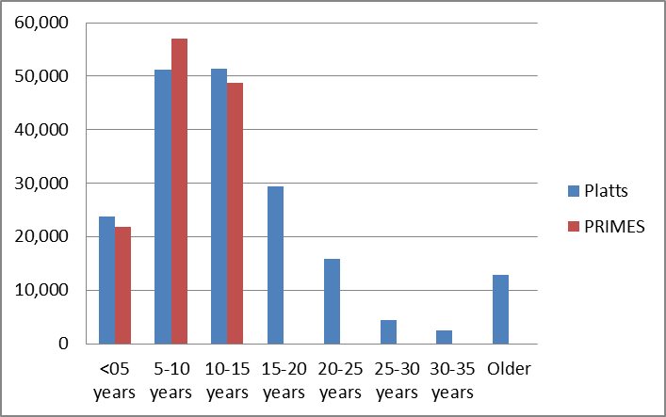

Figure 201 - EU 2015 Installed gas capacity by age [MW]

Source: Platts and PRIMES databases.

**Figure 202** and **Figure 203** show the same bar plot for coal and oil generation capacity from the Platts database. While gas capacity is dominated by younger power plants, the age distribution of coal and oil power plants in dominated by older installation relative to the expected lifespan. For consistency with the assumption used for the PRIMES projections, the expected lifetime of fossil fuels power plants is assumed to be 30 years, 40 year and 35 years for gas, coal and oil, respectively.

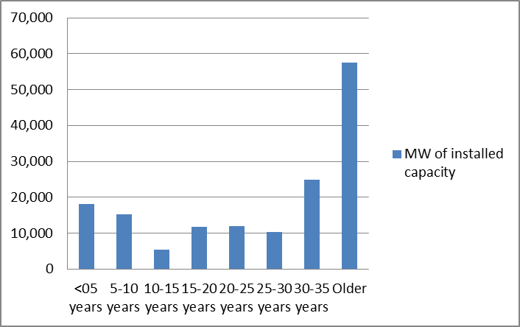

Figure 202: EU 2015 installed coal capacity

Source: Platts

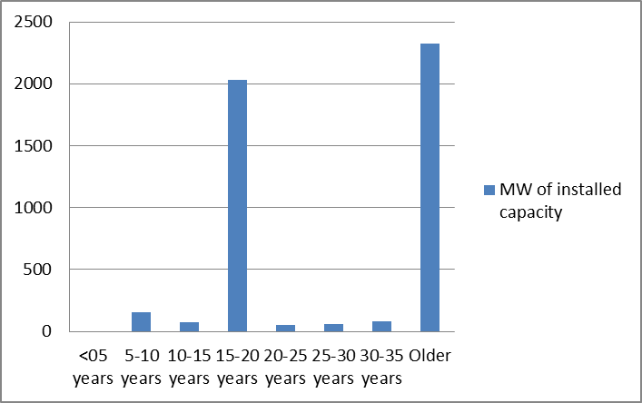

Figure 203 - EU 2015 installed oil capacity

Source: Platts

The differences between the age profiles of the different technologies can be explained by the pattern of investments over the last decade. **Figure 204**, **Figure 205** and **Figure 206** show the year-by-year retirements and additions of gas, coal and oil power plants respectively. All charts refer to the EU and are taken from the Platts power plants database. The years between 2007 and 2013 have seen a particularly high deployment of gas power plants. Gas power plants additions are greater than retirements even in later years and for every year in the data series. For coal and oil plants, on the other hand, retirements have been greater than addition for the last several years. This resulted in a higher share of older power plants for coal and oil as shown in **Figure 201**, **Figure 202** and **Figure 203**.

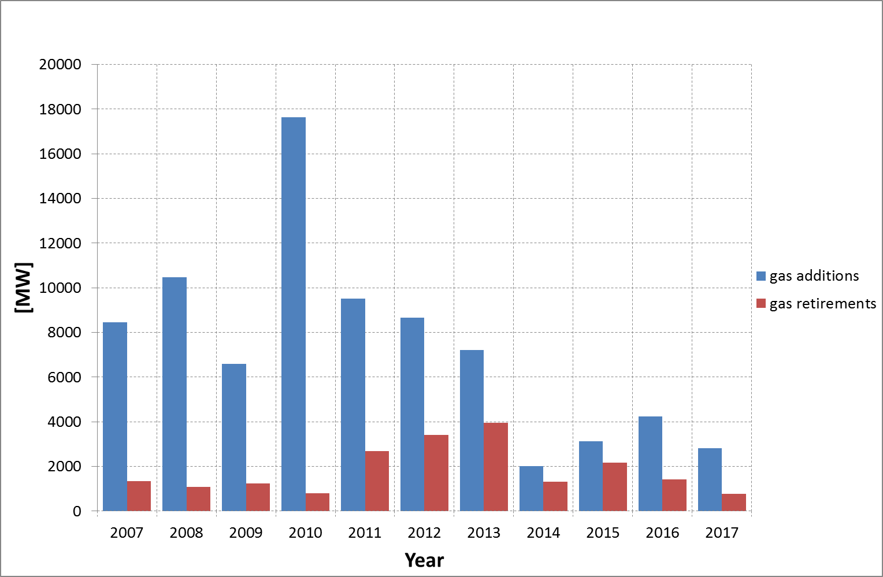

Figure 204 - additions and retirement of gas power plants.

Source: Platts

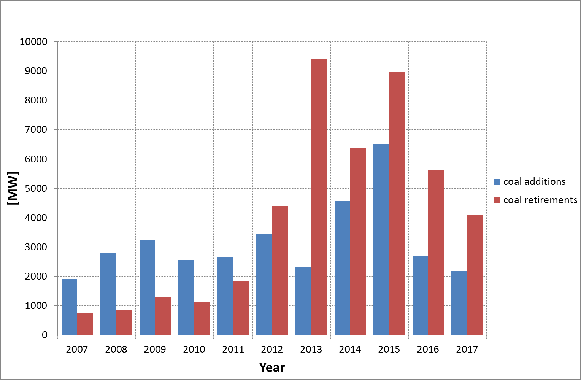

Figure 205 - additions and retirement of coal power plants.

Source: Platts

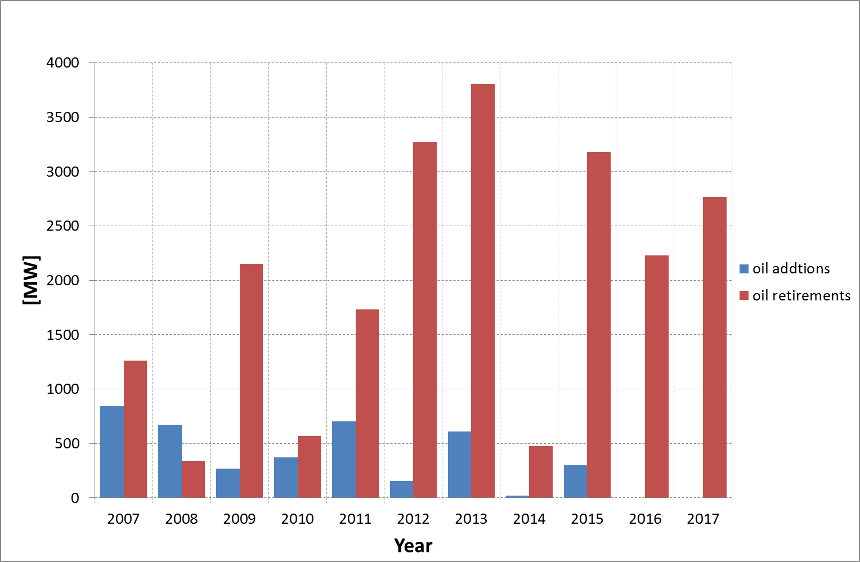

Figure 206 - additions and retirement of oil power plants.

Source: Platts

## Electricity prices vs costs up to 2030 in the EU

Electricity prices[39] have decreased slightly over the past 10 years, with a fairly highly dispersion of daily prices. The average prices are expected to go higher by 2030, with even larger dispersion upwards.

**Figure 207** shows that increasing prices[40] would cover the production costs[41] of the most mature renewables (wind, hydro, solar)[42] *installed* in 2030. On the other hand, the expected production cost of installed fossil-fuel based and biomass plants would tend to be higher than average expected prices due to rising fossil fuel import prices, rising carbon price, and also to decreasing load factor. Fossil fuel plants are expected to come into play in the market when there will be higher prices than usual (unexpected lower supply due to low supply by renewables and higher demand). In the medium-term this should partially compensate for the lower utilisation rate.

While the financing of *new* gas, oil and nuclear capacities would be more uncertain, investments in new capacities of hydro, wind and solar would increasingly be supported by the market prices. This also means that less additional public support, beyond market prices, would be needed for encouraging investments in these most needed technologies for the transition to a low carbon electricity system.



Figure 207 - EU28: electricity prices and cost

Source: Left graph: 2008-2018: Platts, 2030: METIS model; Right graph: PRIMES model.

Note 1: the box plots show the minimum observed in a given period (lower whisker), the first quartile (lower bar), the median (black line), the third quartile (upper bar) and the maximum (upper whisker).

Note 2: for visualisation purposes the left graph has been capped to 200 €/MWh.[43]

Note 3: costs for storage and additional interconnections are not accounted for in this Figure.

Note 4: historical prices are in current euros, values for 2030 are in 2013 euros. Prices and costs are averaged over the EU28 and per technology category (e.g. “wind”).

Note 5: “2018” includes daily prices from 01/01/2018 until 16/10/2018

## Investment in power production assets

In order to meet its renewable energy and emission reduction targets, the European Union will have to invest considerable amounts in power production assets and in renewable energy technologies in particular. The European Commission used the PRIMES energy model system to produce projections of the future capacity needs. **Figure 208** shows a comparison between the projected capacity addition for selected fossil fuels and renewables technologies (in MW for 5 years periods). **Figure 209** shows a similar chart for investments in billion € for five years periods. While renewables investments are set to expand considerably, the prospects for fossil fuels in power generation are limited. As coal is phased out, gas confirms its role as a transition fuel. However, as discussed in section 9.3.1.1, the fleet of gas power plants is relatively young. With the common assumption of a 30 years lifetime, a significant share of the gas plants operating today will still be in operation in 2030. Investments in new gas generation until 2030 will be only a fraction than in the previous decade. (In particular, the higher electricity demand due to electrification is to a large extent satisfied by more ambitious renewable targets.) According to PRIMES projection approximately 40 GW of new gas-fired capacity will be installed in the EU up to 2030.

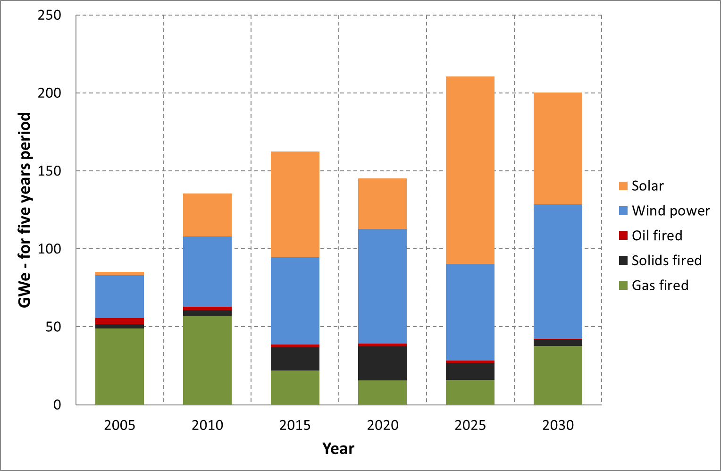

Figure 208 - New power generation capacity - PRIMES projections.

Source: PRIMES

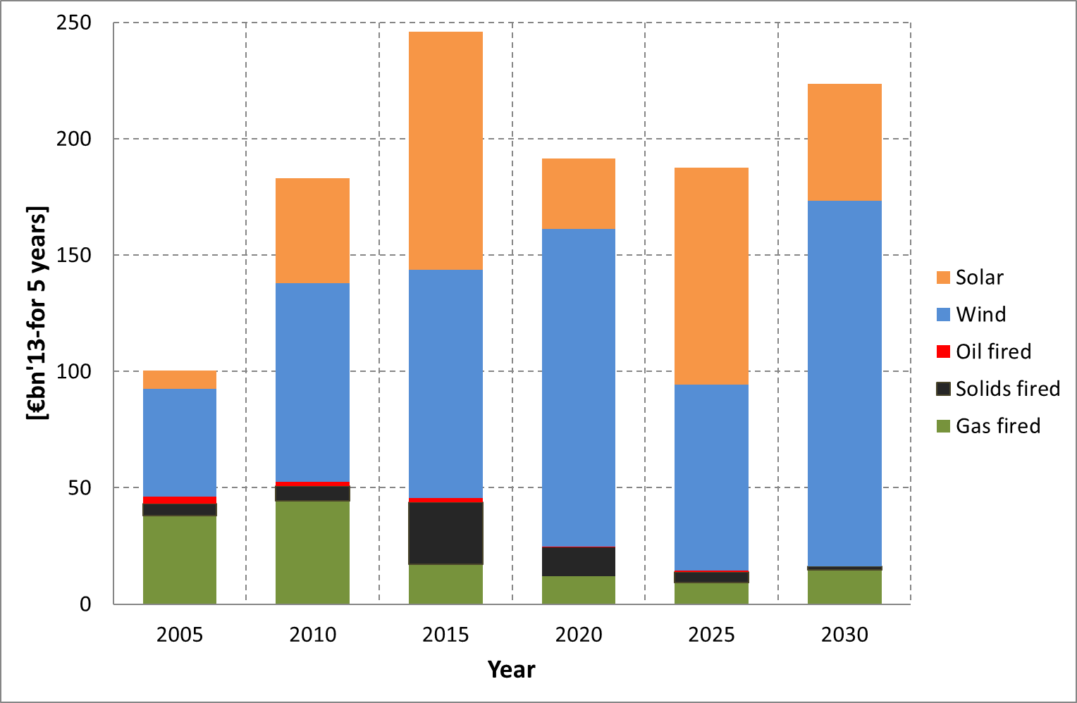

Figure 209 - New power generation investments - PRIMES projections.

Source: PRIMES

It should be pointed out that new investments depend strongly on the assumed lifetimes (and, hence, retirement rates) of fossil fuel power plants. In particular, the future of gas is tied to the phasing out of coal. Ten member states have stated their intention to eliminate coal in power generation or have already done so. These policies have not been taken into account in the projections shown above. Phasing out coal at a faster pace than projected by PRIMES could substantially increase the need for investments in new gas power plants[44].

1. <https://ec.europa.eu/energy/sites/ener/files/documents/ECOFYS%202014%20Subsidies%20and%20costs%20of%20EU%20energy_11_Nov.pdf>
2. <https://ec.europa.eu/energy/sites/ener/files/documents/ECOFYS%202014%20Subsidies%20and%20costs%20of%20EU%20energy_11_Nov.pdf>
3. Definition for the specific sectors:

   Public institutions: Amounts inventories are mainly dedicated to public building retrofits and public lighting programme.

   Non-households: All types of actors (public and private companies, public institutions, local authorities, religious institutions, associations, NGOs) involved in any economic sector, except the households that are the only actors not eligible to this instruments.

   Cross sector: All economic sectors and actors are eligible, i.e. public and private companies, public institutions, local authorities, religious institutions, associations, NGOs and/or households involved in any economic sector
4. Unless otherwise stated, in this chapter subsidy amounts are expressed in €2017 bn and referring to the EU
5. State aid notified to the Commission amounted to € 56 billion in 2016. The difference with the ca. €102 bn of aid is explained by subsidies which do not fall under the category of State aid like price regulation, general tax reductions, support to infrastructure, etc.
6. Unless otherwise stated, in this chapter the data source is the study on Energy prices and costs in the EU for all charts
7. The ratio Subsidies/GDP depends on the various factors impacting GDP
8. In the case of some reactors decommissioning was driven by political decisions so that the “financial support” is a compensation for the operator not being able to accumulate sufficient funds for decommissioning
9. Decisions on State aid: insurance cost (SA.46602), cost of waste management (SA.45296).
10. Assuming the continuation of the slightly decreasing trend between 2013 and 2016 in the amount of free allowances, and bearing in mind that in January-October 2018 the average CO2 price rose to 14.9 €/tCO2e , measurably up from 5.2 in 2016 and 5.9 in 2017, the financial support to free emission allowances might have significantly increased in 2018, compared to the 2016 support (€4 bn).
11. The 2016 ICAO General Assembly Resolution sets out the objective and key design elements of the global scheme, as well as a roadmap for the completion of the work on implementing modalities. In June 2018, ICAO endorsed the Standard and Recommended Practises (SARP) detailing the Carbon Offsetting Scheme for International Aviation due to start for its voluntary phase in 2021. The Carbon Offsetting and Reduction Scheme for International Aviation (CORSIA) aims to stabilise CO2 emissions at 2020 levels by requiring airlines to offset the growth of their emissions after 2020. As of 29 June 2018, 73 States, representing 75.96% of international aviation activity, intend to voluntarily participate in CORSIA from its outset. In accordance with the EU ETS Directive, the Commission will then assess the key features of CORSIA and consider ways to implement CORSIA in Union law, taking into account the Union economy-wide greenhouse gas emission reduction commitment for 2030.
12. The charts on retail electricity and gas prices for energy intensive industries, business customers with medium annual electricity and gas consumption and households show how subsidies (green bar) lowered the overall retail price the customer actually paid in 2016.Otherwise said, prices without the impact of subsidies would have been greater by the amount the green bars symbolise.
13. Energy-related environmental taxes as defined in "Environmental taxes – A statistical guide" (http://ec.europa.eu/eurostat/documents/3859598/5936129/KS-GQ-13-005-EN.PDF/706eda9f-93a8-44ab-900c-ba8c2557ddb0?version=1.0); this category includes taxes imposed on energy production and on energy products used for both transport and stationary purposes, as well as on greenhouse gases but does not include VAT imposed on energy products
14. Taxation Trends in the European Union (2018);

    <https://ec.europa.eu/taxation_customs/sites/taxation/files/taxation_trends_report_2018.pdf>
15. <http://eur-lex.europa.eu/LexUriServ/LexUriServ.do?uri=OJ:L:2003:283:0051:0070:EN:PDF>
16. <https://ec.europa.eu/taxation_customs/sites/taxation/files/resources/documents/taxation/excise_duties/energy_products/rates/excise_duties-part_ii_energy_products_en.pdf>
17. <https://ec.europa.eu/taxation_customs/sites/taxation/files/resources/documents/taxation/excise_duties/energy_products/rates/excise_duties_energy_products_en.pdf> (at the time of writing the report, this document included revenue data for the period 2008-2017)
18. 2017 figures were not available for the UK; therefore, for this country, 2016 figures were used instead.
19. <https://eur-lex.europa.eu/LexUriServ/LexUriServ.do?uri=OJ:L:2006:347:0001:0118:en:PDF>
20. <https://ec.europa.eu/taxation_customs/sites/taxation/files/resources/documents/taxation/vat/how_vat_works/rates/vat_rates_en.pdf>
21. <https://ec.europa.eu/taxation_customs/sites/taxation/files/com_2016_148_en.pdf>
22. <http://europa.eu/rapid/press-release_IP-18-185_en.htm>
23. <https://ec.europa.eu/energy/en/statistics/weekly-oil-bulletin>
24. day-ahead wholesale daily average baseload contracts
25. Using the METIS model, see: <https://ec.europa.eu/energy/en/data-analysis/energy-modelling/metis>
26. IRENA (2018), Renewable Power Generation Costs in 2017, International Renewable Energy Agency, Abu Dhabi
27. JRC (2017), Magagna, D., Shortall, R., Telsnig, T., Uihlein, A. and Vazquez Hernandez, C., Supply chain of renewable energy technologies in Europe - An analysis for wind, geothermal and ocean energy, EUR28831 EN, Publications Office of the European Union, Luxembourg, 2017, ISBN 978-92-79-74281-1,

    doi:10.2760/271949, JRC108106

    <http://publications.jrc.ec.europa.eu/repository/bitstream/JRC108106/kjna28831enn.pdf>
28. JRC (2018), Tsiropoulos I,Tarvydas, D, Zucker, A, Cost development of low carbon energy technologies – Scenario - based cost trajectories to 2050, 2017 Edition, EUR 29034 EN, Publications Office of the

    European Union, Luxembourg, 2018, ISBN 978-92-79-77479-9, doi: 10.2760/490059, JRC109894
29. <https://www.iea.org/weo2017/>
30. [https://webstore.iea.org/world-energy-outlook-2018, not published at the time of this analysis](https://webstore.iea.org/world-energy-outlook-2018,%20not%20published%20at%20the%20time%20of%20this%20analysis)
31. <https://ec.europa.eu/jrc/en/geco>
32. <https://www.eia.gov/outlooks/ieo/>
33. <https://ec.europa.eu/energy/en/data-analysis/country>
34. <https://www.eia.gov/dnav/pet/pet_pri_spt_s1_d.htm> (retrieved 31/07/2018)
35. [https://www.ecb.europa.eu/stats/policy_and_exchange_rates/euro_reference_exchange_rates/html/eurofxref-graph-usd.en.html#](https://www.ecb.europa.eu/stats/policy_and_exchange_rates/euro_reference_exchange_rates/html/eurofxref-graph-usd.en.html) (retrieved 31/07/2018)
36. <https://ec.europa.eu/clima/policies/ets_en>
37. IEA 2018, World Energy Outlook 2018
38. Macroeconomic projections were taken from the 2015 Ageing Report of the European Commission (DG ECFIN).
39. Day-ahead wholesale prices
40. The Figure shows the distribution of daily prices as observed over 2008-2018 and as projected for 2030.
41. Expressed as the levelised cost of electricity production (LCOEs)
42. More estimates on future LCOEs can be found in e.g.: Ram, M. et al. (2018). A comparative analysis of electricity generation costs from renewable, fossil fuel and nuclear sources in G20 countries for the period 2015-2030. Journal of Cleaner Production Volume 199, 20 October 2018, Pages 687-704

    <https://doi.org/10.1016/j.jclepro.2018.07.159>
43. Projections of spot prices are uncertain and actual prices will depend on a number of factors difficult to predict, including the weather conditions or unforeseeable events affecting the grid.
44. For instance, this would be in line with the gas consumption projections from WEO2018