

Sweden 

## Prices

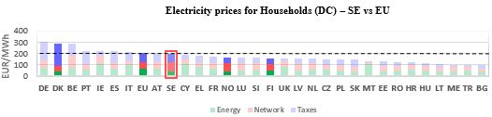[1]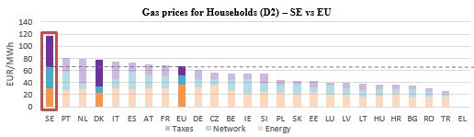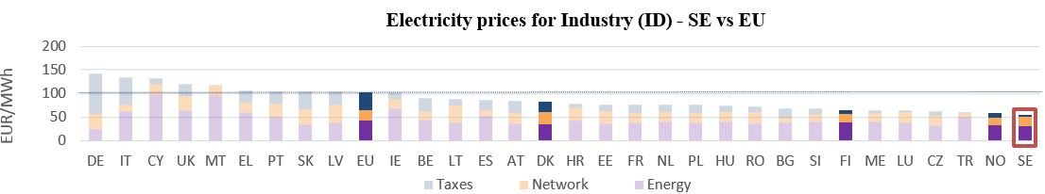

See footnote

**Gas prices for Industry (I3) – SI vs EU**

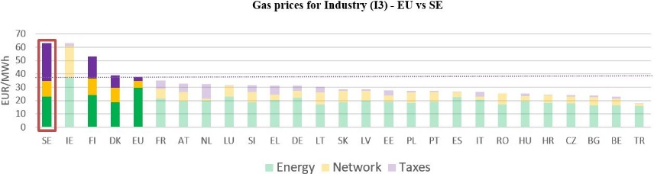

See footnote [2]

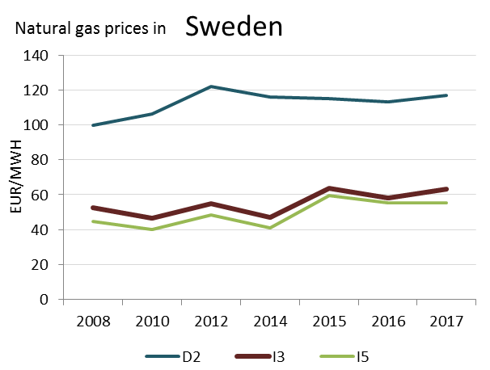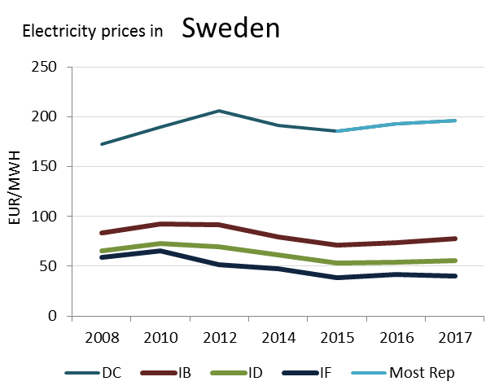

(DC)

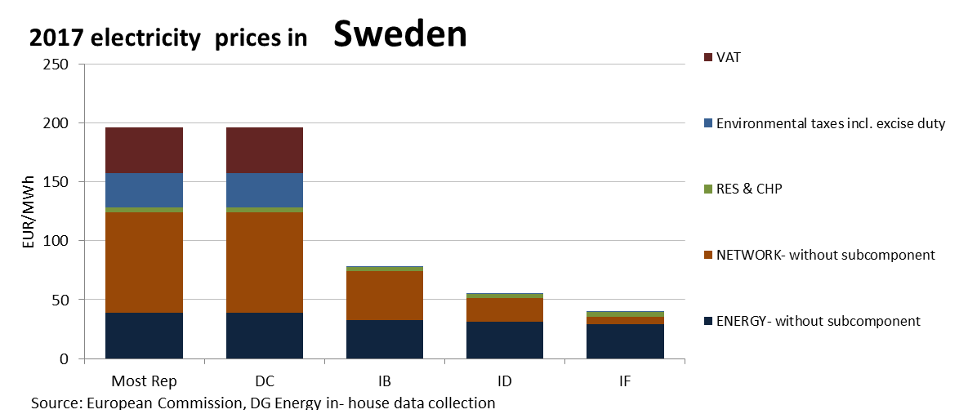 **Prices**

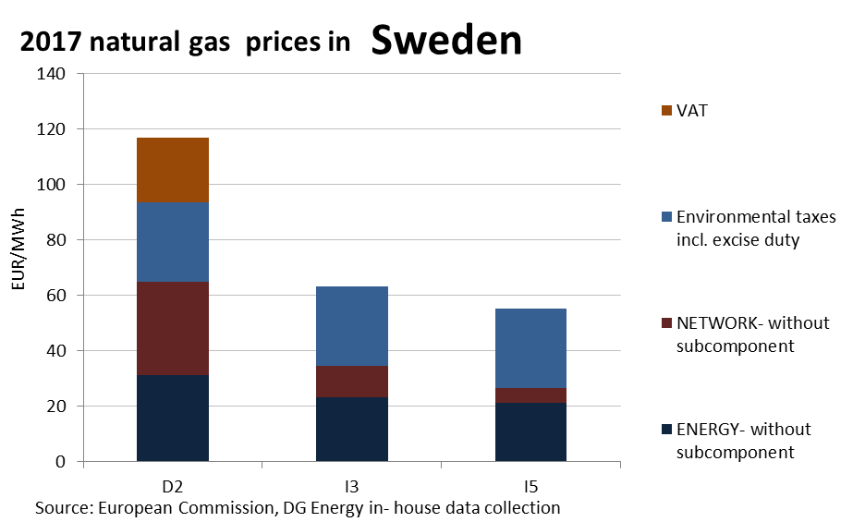

**Price regulation**

This country liberalised prices before 2008.

No social tariffs identified.

**Oil products prices**

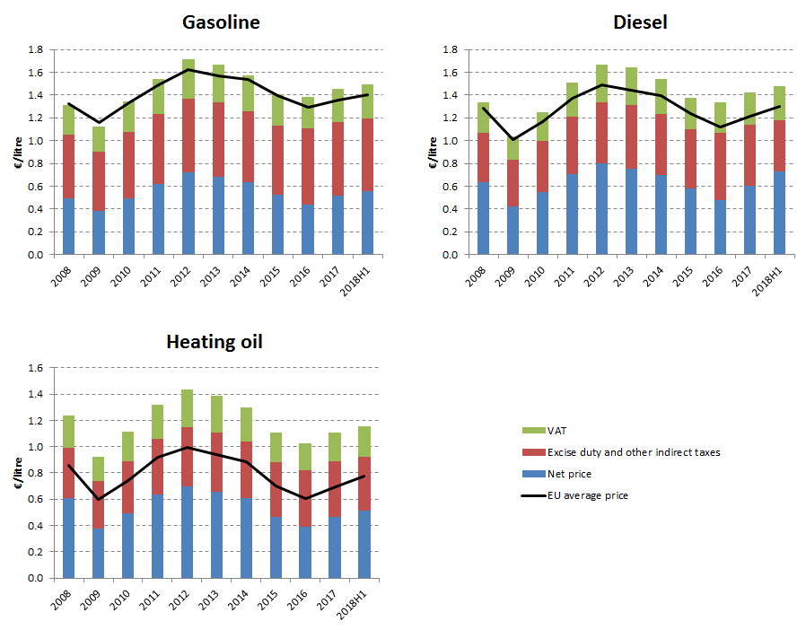

**Energy costs shares in total production costs**

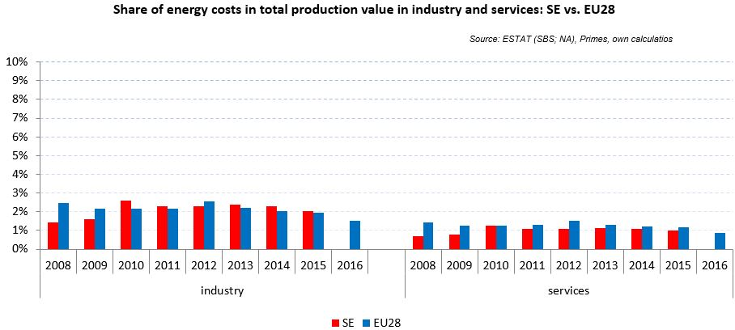

Notes: Data for Malta (prior to 2016), Poland (prior to 2015), Slovenia (prior to 2012) and Greece (prior to 2008) is not available. Data for Denmark, Sweden and the United Kingdom for 2016 was missing by the time of extraction

## Financial support interventions

United Kingdom 

## Prices

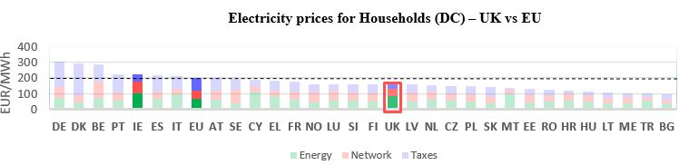see footnote[3]

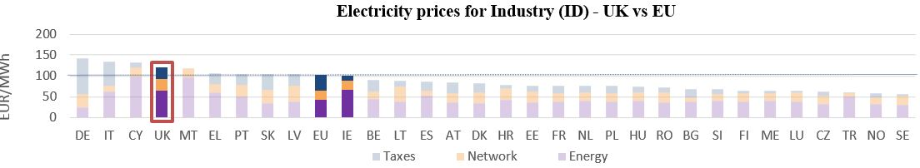



See footnote [4]

No data available for electricity and natural gas prices

This country liberalised prices before 2008.

No social tariffs identified.

**Oil products prices**

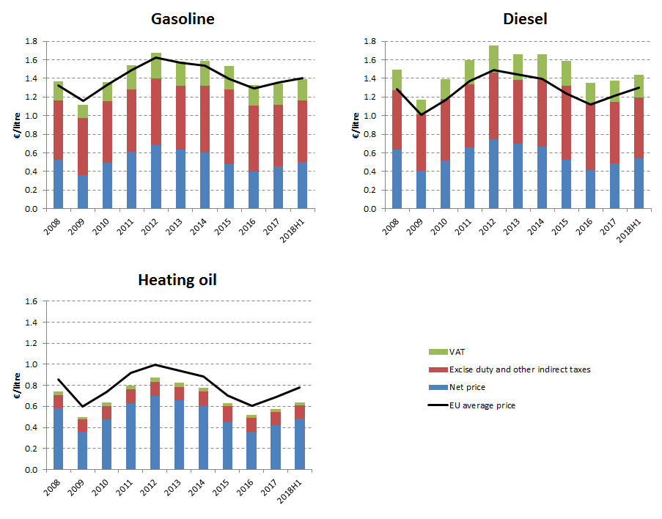

**Energy costs shares in total production costs**

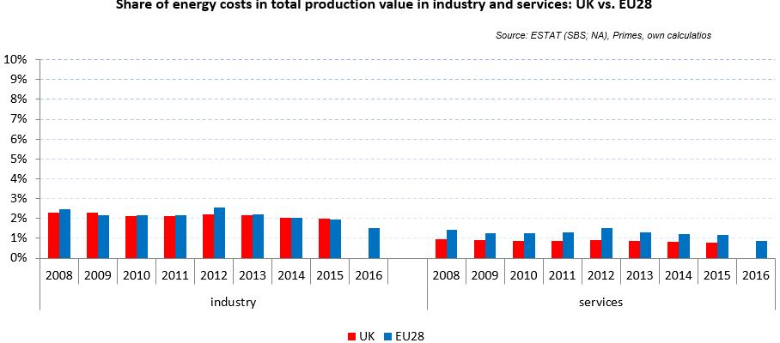

Notes: Data for Malta (prior to 2016), Poland (prior to 2015), Slovenia (prior to 2012) and Greece (prior to 2008) is not available. Data for Denmark, Sweden and the United Kingdom for 2016 was missing by the time of extraction

## Financial support interventions

**Norway** 

## Prices

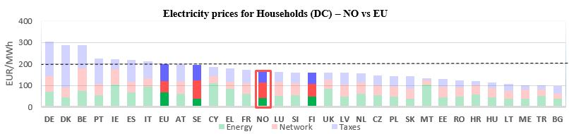see footnote[5]

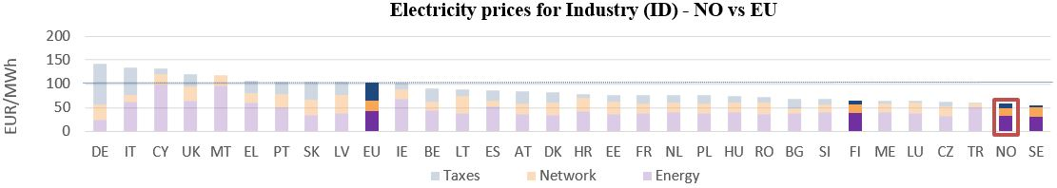

See footnote [6]

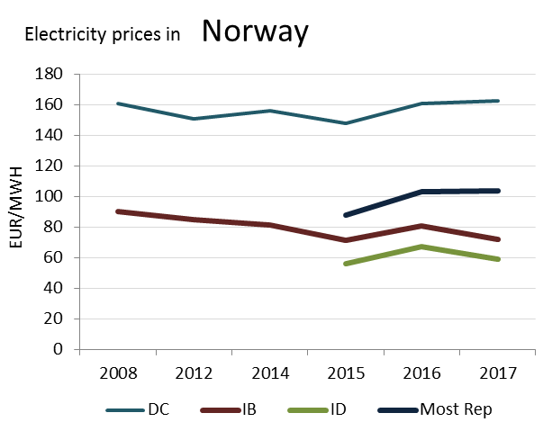

(DE)

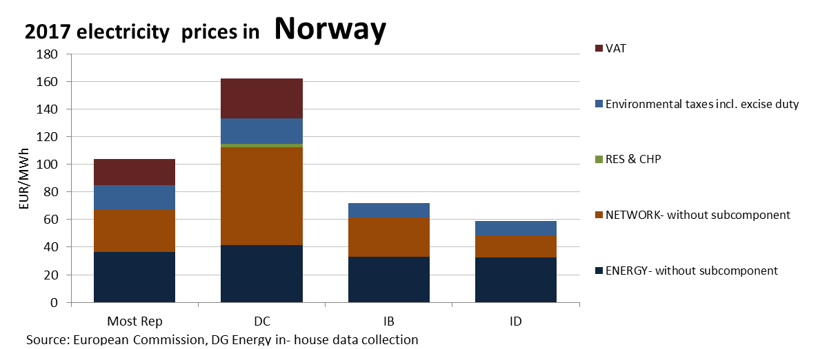

Oil product prices and Energy costs shares are not available for this country

## Financial support interventions

[7]

Montenegro  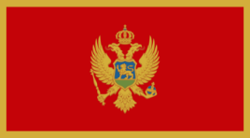

## Prices

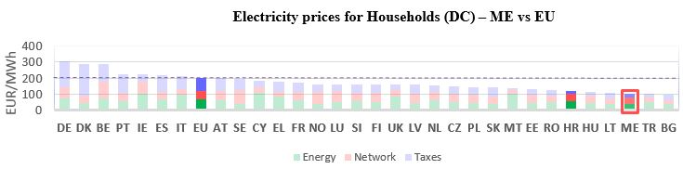see footnote[8]

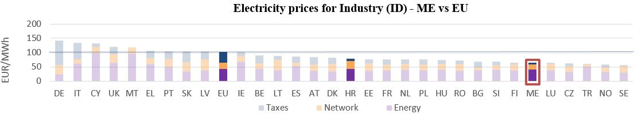

See footnote [9]

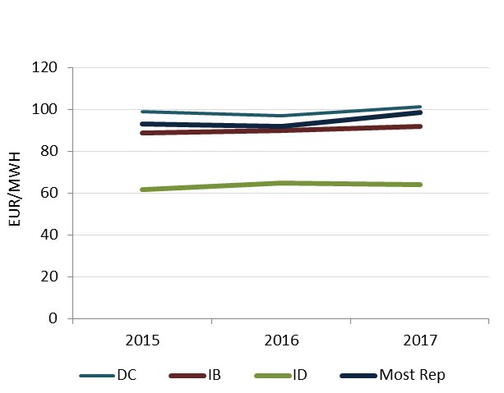

(DD)

**2017 electricity prices in Montenegro**

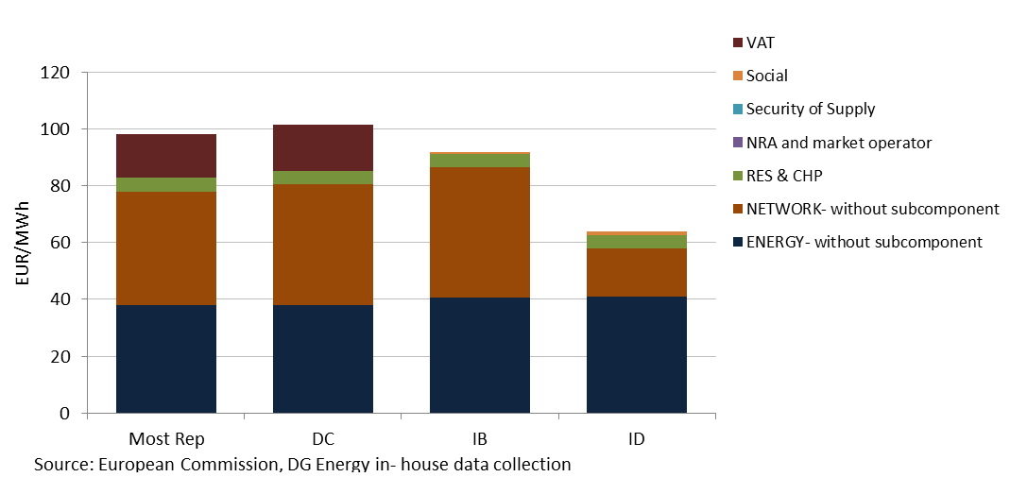

Oil product prices and Energy costs shares are not available for this country

Turkey  

## Prices

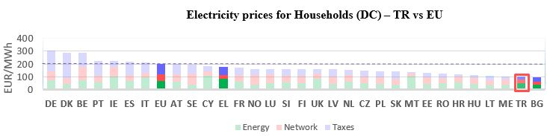[10]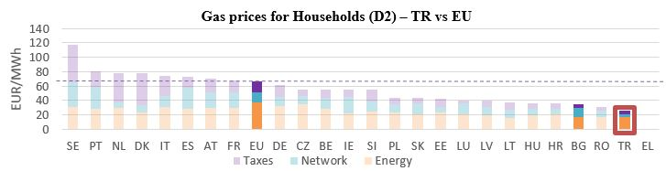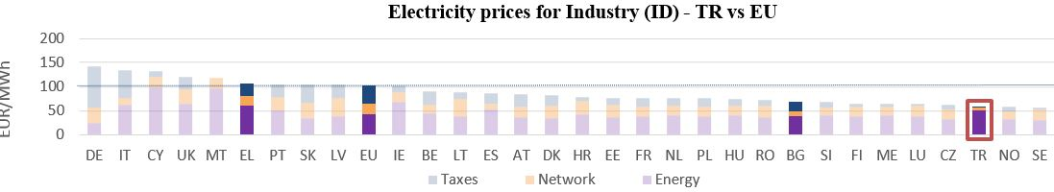

See footnote

**Gas prices for Industry (I3) – TR vs EU**

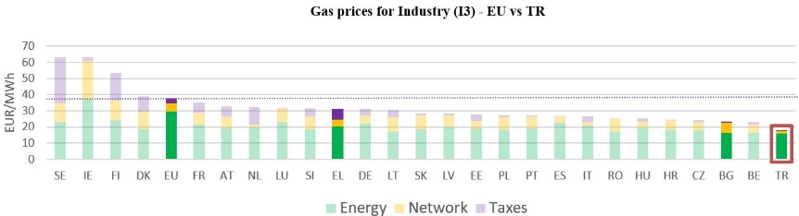

See footnote [11]

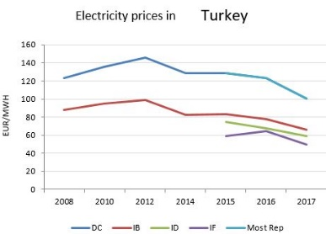

(DC)

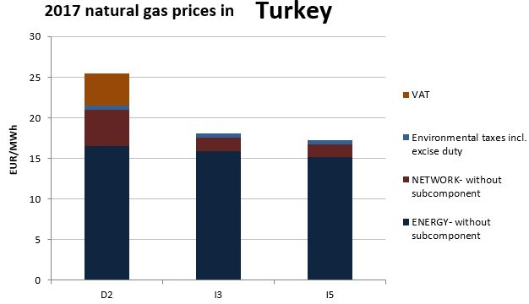

Oil product prices and Energy costs shares are not available for this country

1. Neighbour countries and EU 28. No gas household prices available for Greece for 2017.
2. Annual electricity consumption: DB 1 - 2.5 MWh, DC 2.5 - 5 MWh, DD 5 - 15 MWh, DE above 15 MWh, IB 20-500 MWh, ID 2000-20000 MWh, IF 70000-150000 MWh. Annual Gas consumption: D2 20-200 GJ, I3 10000-100000 GJ, I5 1 mil - 4 mil GJ.
3. Neighbour countries and EU 28. No gas household prices available for Greece for 2017.
4. Annual electricity consumption: DB 1 - 2.5 MWh, DC 2.5 - 5 MWh, DD 5 - 15 MWh, DE above 15 MWh, IB 20-500 MWh, ID 2000-20000 MWh, IF 70000-150000 MWh. Annual Gas consumption: D2 20-200 GJ, I3 10000-100000 GJ, I5 1 mil - 4 mil GJ.
5. Neighbour countries and EU 28. No gas household prices available for Greece for 2017.
6. Annual electricity consumption: DB 1 - 2.5 MWh, DC 2.5 - 5 MWh, DD 5 - 15 MWh, DE above 15 MWh, IB 20-500 MWh, ID 2000-20000 MWh, IF 70000-150000 MWh. Annual Gas consumption: D2 20-200 GJ, I3 10000-100000 GJ, I5 1 mil - 4 mil GJ.
7. Only fossil fuels data available
8. Neighbour countries and EU 28. No gas household prices available for Greece for 2017.
9. Annual electricity consumption: DB 1 - 2.5 MWh, DC 2.5 - 5 MWh, DD 5 - 15 MWh, DE above 15 MWh, IB 20-500 MWh, ID 2000-20000 MWh, IF 70000-150000 MWh. Annual Gas consumption: D2 20-200 GJ, I3 10000-100000 GJ, I5 1 mil - 4 mil GJ.
10. Neighbour countries and EU 28. No gas household prices available for Greece for 2017.
11. Annual electricity consumption: DB 1 - 2.5 MWh, DC 2.5 - 5 MWh, DD 5 - 15 MWh, DE above 15 MWh, IB 20-500 MWh, ID 2000-20000 MWh, IF 70000-150000 MWh. Annual Gas consumption: D2 20-200 GJ, I3 10000-100000 GJ, I5 1 mil - 4 mil GJ.