

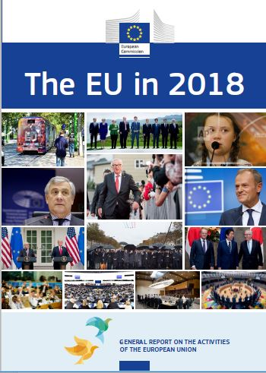

**On the cover**

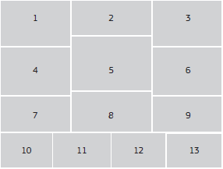

1. A tram emblazoned with the InvestEU campaign image. InvestEU is the final part of this Commission’s Investment Plan for Europe, which bypassed its investment target of €315 billion in July 2018. (© European Union)

2. Council President Donald Tusk, British Prime Minister Theresa May, German Chancellor Angela Merkel, US President Donald Trump, Canadian Prime Minister Justin Trudeau, French President Emmanuel Macron, Japanese Prime Minister Shinzō Abe, Italian Prime Minister Giuseppe Conte and Commission President Jean-Claude Juncker pose for a group photo during the G7 summit in Quebec, Canada, 8 June 2018. (© European Union)

3. Climate activist Greta Thunberg speaking at the United Nations COP24 Climate Change Conference in Katowice, Poland, 4 December 2018. (© Associated Press)

4. Antonio Tajani, President of the European Parliament. (© European Union)

5. Jean-Claude Juncker, President of the European Commission. (© European Union)

6. Donald Tusk, President of the European Council. (© European Union)

7. Commission President Jean-Claude Juncker and US President Donald Trump at a press conference on EU–US trade relations at the White House, Washington, United States, 25 July 2018. (© European Union)

8. World leaders gather during the ceremony marking the First World War armistice centenary, Paris, France, 11 November 2018. (© European Union)

9. Council President Donald Tusk, Japanese Prime Minister Shinzō Abe and Commission President Jean-Claude Juncker after the signing of two landmark agreements between the EU and Japan, Tokyo, Japan, 17 July 2018. (© European Union)

10. The European Economic and Social Committee hosts the first European Citizens’ Panel, which was convened to prepare a public consultation on the Future of Europe. A group of 96 European citizens from 27 Member States worked together to draft a 12-question online consultation, Brussels, Belgium, 5-6 May 2018. (© European Union)

11. MEPs during a plenary session of the European Parliament, Strasbourg, France. (© European Union)

12. A meeting of the College of Commissioners, Brussels, Belgium. (© European Union)

13. A European Council Summit, Brussels, Belgium. (© European Union)

The EU in 2018

GENERAL REPORT ON THE ACTIVITIES OF THE EUROPEAN UNION

Published in accordance with Article 249(2) of the Treaty on the Functioning of the European Union

**An interactive version of this publication, containing links to online content, is available in PDF, EPUB and HTML format:**

europa.eu/general-report/en

**The EU in 2018 — General Report on the Activities of the European Union**

European Commission

Directorate-General for Communication

Editorial Service & Targeted Outreach

1049 Brussels

BELGIUM

*The EU in 2018 — General Report on the Activities of the European Union* was adopted by the European Commission on 00 February 2018 under reference number COM(201x)xxxx

|  |  |  |  |  |
| --- | --- | --- | --- | --- |
| Print | ISBN 978-92-79-97095-5 | ISSN 1608-7321 | doi: 10.2775/30693 | NA-AD-19-001-EN-C |
| PDF | ISBN 978-92-79-97071-9 | ISSN 1977-3374 | doi: 10.2775/356350 | NA-AD-19-001-EN-N |
| EPUB | ISBN 978-92-79-97102-0 | ISSN 1977-3374 | doi: 10.2775/5330 | NA-AD-19-001-EN-E |
| HTML | | ISSN 1977-3374 | doi: 10.2775/183858 | NA-AD-19-001-EN-Q |

Luxembourg: Publications Office of the European Union, 2019

© European Union, 2019

Reuse is authorised provided the source is acknowledged.

The reuse policy of European Commission documents is regulated by Decision 2011/833/EU (OJ L 330, 14.12.2011, p. 39).

For any use or reproduction of photos or other material that is not under the copyright of the European Union, permission must be sought directly from the copyright holders.

CREDITS

All photos © European Union unless otherwise stated.

Cover: Copyrights as stated on the inside cover.

Foreword

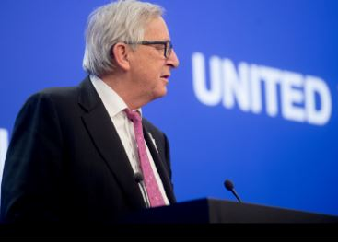

European Commission President Jean-Claude Juncker.

In 2018 we celebrated what it is to be European. The European Year of Cultural Heritage brought to life Europe's rich diversity and celebrated the principles that unite us: the values that we share, the peace and freedom that were so hard won, the rule of law and the respect for human rights and human dignity that can never be taken for granted.

There were reminders throughout the year of just how much was sacrificed for these values and rights. We commemorated together the centenary of the end of the First World War, which cost the lives of so many millions. We celebrated together the 100th anniversary of several of our Member States who claimed their freedom at the end of the war. We remembered together the 70th anniversary of the Universal Declaration of Human Rights. And we honoured together the 50th anniversary of the Prague Spring.

All of this reminds us how far we have come but also how much we must remain vigilant in the fight for freedom and democracy. And it brought into sharp focus the responsibility of our generation to leave a stronger, more united and more democratic Europe to our children. This has been the driving force of the European Commission over the last year, as we continue to deliver on the things that matter the most. The results speak for themselves.

The European economy is firmly back on its feet and continues to grow. More Europeans are in work than ever before, with 239 million people currently in work. 12 million of those jobs have been created since the start of this Commission. Youth unemployment is at its lowest since 2008, although still too high. And investment is back, thanks to the €370 billion worth of investments triggered by the Juncker Plan.

The European Single Market, at 25 years old, goes from strength to strength. Many barriers have been removed but more can be done. We have made everyday life easier for Europeans — from movie and music subscriptions that travel with you across the EU, to better protection for holidaymakers and ending discrimination for online shoppers.

Our trade agreement with Canada is already showing positive results and we can expect the same from the deal we signed with Japan in July. Almost 74 000 EU companies are already exporting to Japan — selling everything from biscuits to fireplaces — and providing jobs to more than 600 000 Europeans.

The new Africa–Europe Alliance for Sustainable Investment and Jobs that I announced in September during my State of the Union address will take the EU’s partnership with Africa to the next level. It would help create up to 10 million jobs in Africa in the next five years alone.

We continue to make the EU a safer place to live and work. We have taken action to remove the means for terrorists to commit their crimes and are tackling terrorist content online. New rules are helping law enforcement officers to better trace criminal networks and we are bolstering our defences against cyber-attacks. We are protecting Europeans online thanks to new data protection rules that came into effect in May. And we are helping to make the planet safer by making our roads safer and our air cleaner. Europe once again led the way in December in Katowice when the world agreed on a new rulebook to implement the Paris Agreement on fighting climate change.

Our migration policy is working. The numbers of people arriving has fallen dramatically; EU operations have helped rescue 690 000 people at sea since 2015 and we are taking our responsibility for helping refugees, both inside and outside our Union. At the same time, we are better protecting our border and have proposed to further strengthen the European Border and Coast Guard with an additional 10 000 European border guards by 2020. We are fighting the root causes of irregular migration with partners across the world, while working to open legal pathways to the EU to attract highly skilled workers from other parts of the world.

As we look to the year ahead, we see a year of democracy and debate. The European elections in May will be, after the Indian general election, the second largest elections anywhere in the world in 2019. People of all ages across Europe are making their voices heard as never before, and it is the duty of parliamentarians, governments and policymakers to engage as never before.

This is why I made debate and dialogue a top priority for this Commission, because Europe belongs to us all, and every European should be able to shape the future of our Union. I was honoured to take part in the 1 000th Citizens’ Dialogue in Freiburg, Germany in October and I look forward to seeing the debate continue across our Union throughout the year.

The main message from this debate is that Europeans expect their Union to deliver for them. They do not care about proposals but about how actual laws improve their lives. This will be our driving force until the very last day of our mandate. There is still a lot more work to do: all the proposals and initiatives on our 10 priorities that we announced in 2014 are on the table. Our focus is firmly on delivering them.

This will be the best message for Europeans to take to the polls. And it will be the best symbol for leaders to take to the informal Summit in Sibiu on 9 May 2019. It will be a time to set the priorities for the new Union of 27 for the next five years and to back up that ambition by agreeing in principle on a long-term EU budget that will deliver on the promises that have been made.

Sibiu, the elections and all of 2019 will be decisive for our Union in many ways. It is an opportunity for us to build solid foundations for the future, to show that Europe is listening to its citizens, and to deliver on the things that matter the most.

This is our duty to those who sacrificed so much for us. And it is our responsibility to all of those that will follow.

[signature]

Jean-Claude Juncker

Chapter 1

A new boost for jobs, growth and investment

‘My first priority as Commission President will be to strengthen Europe’s competitiveness and to stimulate investment for the purpose of job creation.’

Jean-Claude Juncker, political guidelines, 15 July 2014

Europe’s economy performed well in 2018 and looks set to keep growing. After nearly 6 years of continuous growth, Member States are also showing an increasing degree of economic convergence, which benefits people in all parts of the EU. The Commission has delivered on the promise to get more people into work. Investment has almost returned to pre-crisis levels and the state of public finances in terms of debt and deficit levels has improved significantly.

The gross domestic product of the euro area and the wider EU were both expected to increase by 2.1 % in 2018, with every country in the EU expected to see its economy grow.

More Europeans were in work than ever before, with 12.4 million new jobs created since 2014, unemployment dropping to 6.8 %, and youth unemployment back to its 2008 level. The Investment Plan for Europe has mobilised over €370 billion in investment across Europe since 2015, significantly more than targeted. As a result, the European Fund for Strategic Investments is expected to support an estimated 1.4 million new jobs by 2020 while the EU’s gross domestic product will be boosted by an estimated 1.3 %.

Household incomes continued to rise while public debt levels fell. In 2018 government deficits in the EU were expected to fall to 0.6 % of gross domestic product, down from 6.2 % in 2009, and the ratio of government debt to gross domestic product was expected to fall to 81.4 % from 88.3 % in 2014. Inflation is steady at 1.7 %.

In 2018 European banks continued to get stronger, less encumbered by bad loans, and better prepared to withstand potential economic shocks.

However, despite all these positive developments, it needs to be underlined that the outlook for the global economy has deteriorated amidst trade tensions and geopolitical uncertainties, and the risks to the European economy have increased.

The Investment Plan for Europe

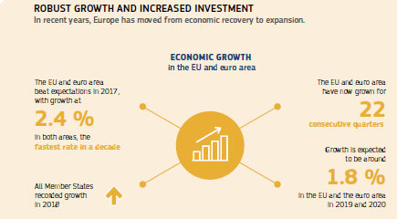

In 2015 the European Commission, together with the European Investment Bank Group, launched the Investment Plan for Europe, with the European Fund for Strategic Investments at its core. This was a new and innovative approach to funding. The Fund was created with an initial €21 billion of risk-bearing capacity from the EU and the European Investment Bank Group, which in turn attracts other sources of private funding in particular. Given its undisputed success, the Fund was further improved in 2018, extended until the end of 2020 and its investment target raised from €315 billion to at least €500 billion. New rules also make it easier to combine financing from the Fund with the European Structural and Investment Funds and other sources of EU financing.

The EU’s commitment to boosting jobs, growth and investment yielded tangible results in 2018. The Investment Plan has exceeded its original target and expectations and has now mobilised over €370 billion in investment across Europe since 2015, two thirds of which come from private sources. Thanks to the backing of the European Fund for Strategic Investments, 856 000 small and medium-sized businesses are set to benefit from improved access to finance. Estimates show that the Fund has already supported more than 750 000 jobs, while 1.4 million new jobs are set to be created by 2020. The Investment Plan has already increased EU gross domestic product by 0.6 %, a figure set to reach 1.3 % by 2020.

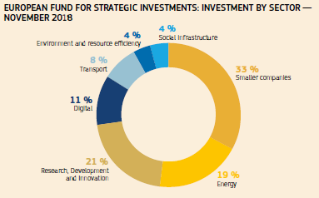

Since its launch, the Investment Plan has helped finance the rollout of high-speed broadband internet to 15 million households, renovate or build half a million affordable homes and improved healthcare services for 30 million Europeans. It has supplied 7.4 million households with renewable energy and improved rail and urban infrastructure for the 95 million passengers who use it every year. [All Member States are benefiting](https://ec.europa.eu/commission/priorities/jobs-growth-and-investment/investment-plan-europe-juncker-plan/investment-plan-results_en), especially those that were hardest hit by the crisis.

The success of the Investment Plan has been supported by the [European Investment Advisory Hub](http://eiah.eib.org/), which provides tailored support to hundreds of project promoters, and the [European Investment Project Portal](https://ec.europa.eu/eipp/desktop/en/index.html?2nd-language=en), which provides an easily accessible pipeline of mature projects for potential investors.

Economic and fiscal policy

Economic growth and job creation in Europe are also supported by the EU’s economic and fiscal governance rules. Economic policy coordination in the EU is organised annually in a cycle known as [the European Semester](https://ec.europa.eu/info/business-economy-euro/economic-and-fiscal-policy-coordination/eu-economic-governance-monitoring-prevention-correction/european-semester_en). It is launched towards the end of each year with, among other things, the publication of the [Annual Growth Survey](https://ec.europa.eu/info/sites/info/files/file_import/2019-european-semester-annual-growth-survey_en_1.pdf) and a proposal for a recommendation on the economic policy of the euro area. In March 2018 the European Commission published Country Reports analysing the economic and social challenges facing each Member State, apart from Greece, which was still benefiting from a stability support programme.

For the first time, the [Country Reports](https://ec.europa.eu/info/publications/2018-european-semester-country-reports_en) put a special emphasis on the priorities of the [European Pillar of Social Rights](https://ec.europa.eu/commission/priorities/deeper-and-fairer-economic-and-monetary-union/european-pillar-social-rights_en), adopted in November 2017. In 2018 particular attention was paid to analysing challenges related to the skills of the workforce and how national social safety nets operate. Overall, the reports showed that Member States had achieved at least ‘some progress’ on more than two thirds of the policy recommendations made last year.

Since the European Semester cycle of policy coordination began in 2011, Member States have made most progress in financial services and in fiscal policy and fiscal governance. Significant progress has also been made in addressing access to finance, in employment protection legislation and frameworks for labour contracts.

In May the Commission made policy recommendations to each Member State based on its analysis in the Country Reports. These ‘country-specific recommendations’ focused on strengthening the foundations for sustainable and inclusive growth in the long term. The Commission called on Member States to take advantage of the positive economic environment to pursue structural reforms that improve the business environment and conditions for investment, especially through product and service market reforms, supporting innovation, improving small and medium-sized enterprises’ access to finance and fighting corruption.

Member States were also advised to strengthen their economic resilience to long-term challenges, such as demographic trends, migration and climate change.

The Commission also recommended that countries carry out reforms that prepare their workforces for the future, including future forms of work and increasing digitalisation; reduce income inequalities; and create employment opportunities, particularly for young people.

To support Member States in their reforms, the Commission also proposed the creation of a Reform Support Programme, currently being discussed by the European Parliament and Member States, to support priority reforms with an overall budget of €25 billion and provide financial as well as technical support and advice.

In May the Commission also concluded its review of the guidance it issued on the EU’s fiscal rules in 2015. According to the review, the Commission’s guidance on flexibility has helped to strike the right balance between ensuring prudent fiscal policy and stabilising the economy. Estimates suggest that this approach helped boost EU gross domestic product by 0.8 % over the last four years and resulted in the creation of 1.5 million jobs.

The aggregate deficit level in the euro area was expected to fall to 0.6 % of gross domestic product in 2018, down from a peak of 6.2 % of gross domestic product in 2009. The debt-to-gross domestic product ratio is expected to fall from 91.8 % in 2014 to 86.9 % in 2018.

The European Commission also took a number of steps under [the Stability and Growth Pact](https://ec.europa.eu/info/business-economy-euro/economic-and-fiscal-policy-coordination/eu-economic-governance-monitoring-prevention-correction/stability-and-growth-pact_en) in May. This included recommending that the [Excessive Deficit Procedure be closed](https://ec.europa.eu/info/business-economy-euro/economic-and-fiscal-policy-coordination/eu-economic-governance-monitoring-prevention-correction/stability-and-growth-pact/corrective-arm-excessive-deficit-procedure/ongoing-excessive-deficit-procedures/france_en#closed-procedure) for France. With France out of the procedure, the only Member State subject to the enforcement procedures of the EU’s fiscal rules in 2018 was Spain. This compares with as many as 24 countries in 2011. After many difficult years, Greece successfully concluded its stability support programme, with its place at the heart of the euro area and European Union secured.

The European Commission also continued to provide post-programme support to those countries that benefited from financial assistance during the crisis: Ireland, Spain, Cyprus, Portugal and Romania.

In March 2018, the [European Fiscal Board](https://ec.europa.eu/info/business-economy-euro/economic-and-fiscal-policy-coordination/european-fiscal-board-efb_en), an independent advisory body of the European Commission, issued a [statement](https://ec.europa.eu/info/publications/relocation-danish-economic-council-away-copenhagen-area_en) expressing concerns about the planned relocation of the independent Danish Fiscal Council away from the Copenhagen area. In June 2018, the Board urged Member States, especially those with high levels of public debt, to take advantage of the positive economic environment to strengthen public finances. In October 2018, the Board published its [second Annual report](https://ec.europa.eu/info/publications/2018-annual-report-european-fiscal-board_en). This included a review of how the Stability and Growth Pact, the commonly agreed rules of fiscal policymaking, had been implemented in the 2017 assessment cycle, complemented with suggestions on how to simplify the Pact and to make it more effective.

The European Commission’s [Annual Growth Survey](https://ec.europa.eu/info/sites/info/files/file_import/2019-european-semester-annual-growth-survey_en_1.pdf), published in November, found that Europe’s economy is set to continue expanding in 2019. Employment has already risen to a record level of 239 million people and unemployment has fallen back to pre-crisis levels (6.8 %), helping more than 10 million people out of poverty or social exclusion. The growth of the economy, however, is not benefiting all citizens and countries in the same manner and remains vulnerable to global instability and medium to long-term challenges.

Completing the Capital Markets Union

The [Capital Markets Union](https://ec.europa.eu/info/business-economy-euro/growth-and-investment/capital-markets-union_en) is one of the Commission’s main priorities. It complements the Banking Union, the strengthening of the Economic and Monetary Union and the international role of the euro. The Capital Markets Union is also complementary to the Investment Plan for Europe in strengthening Europe’s economy and stimulating investments to create jobs. It aims to mobilise and channel capital to all businesses in the EU, particularly small and medium-sized enterprises that need resources to expand and thrive.

In May the Commission proposed new rules to give small and medium-sized enterprises better access to financing through public markets. This initiative should help EU companies to tap into market-based funding more easily and cheaply so that they can expand. Other proposals will boost the cross-border market for investment funds, promote the EU market for covered bonds as a source of long-term finance and ensure greater certainty for investors in cross-border transactions of securities and claims. At the moment there is no legal certainty as to which national law applies when determining who owns a claim after it has been assigned in a cross-border case. The proposed new rules clarify under which law such disputes are resolved. It is now up to the European Parliament and the Council to turn these and other proposals into law as rapidly as possible, to make the Capital Markets Union a reality.

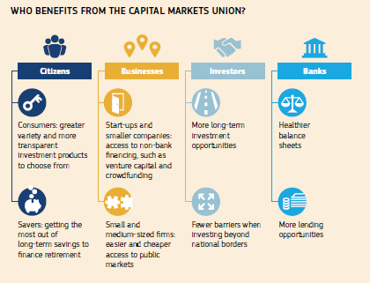

The Commission and the European Investment Fund (part of the European Investment Bank Group) have also launched a pan-European Fund-of-Funds Programme for venture capital based on a call for expression of interest. Backed by EU funding of €410 million, the six participating funds aim to raise up to €2.1 billion of public and private investment. In turn, this should trigger an estimated €6.5 billion of new investment in innovative start-up and scale-up companies across Europe, doubling the amount of venture capital currently available in Europe. The limited and unevenly developed EU venture capital markets are consistently mentioned as a factor holding back the innovation and expansion of EU companies.

In June new rules were also adopted by the Commission [to stimulate insurers’ investments in simple, transparent and standardised securitisation](http://europa.eu/rapid/press-release_MEX-18-4026_en.htm). This securitisation is an important channel for diversifying funding sources and enabling a broader distribution of risk across financial market participants. These rules complement already agreed rules [to stimulate insurers’ investments in simple, transparent and standardised securitisation](http://europa.eu/rapid/press-release_MEX-18-4026_en.htm).

At the end of 2018, the Parliament and the Council reached a political agreement on the core elements of the pan-European personal pension product, a voluntary scheme for saving for retirement for citizens, including in a cross-border context. The personal pension product will offer additional retirement investment opportunities for citizens who so wish, complementing existing public and occupational pension systems.

Promoting undistorted competition to support growth and investment

The EU’s competition policy ensures that companies are welcome to invest in and do business in the Single Market, as long as they adhere to EU competition rules. In 2018 the Commission continued to enforce competition rules for the benefit of households and businesses, ensuring a level playing field and a wider choice and better prices for consumers.

In December new rules and tools were adopted to enable national competition authorities to enforce EU antitrust rules even more effectively*.*

During the year, the Commission took 393 merger decisions, 10 antitrust decisions, 4 cartel decisions and 219 State aid decisions, generating significant benefits for EU consumers and supporting growth. In total, the Commission imposed fines of over €6.3 billion on companies found to be in breach of EU competition rules and ordered the Member States concerned to recover an estimated €1 billion in unlawful and incompatible aid from beneficiary undertakings. 91 % of State aid cases were dealt with under simplified rules through the General Block Exemption Regulation, meaning that State aid can be granted at local, regional and national level without any involvement at all from the Commission.

Sustainable growth to create jobs and help the environment

As part of broader efforts to improve the sustainability of Europe's economy, in January the Commission [adopted](http://europa.eu/rapid/press-release_IP-18-5_en.htm) a new Strategy for Plastics aimed at transforming the way we design, produce, use and recycle plastics. Under the new plans, all plastic packaging on the EU market would have to be recyclable or reusable by 2030, consumption of single-use plastics would be reduced, and the intentional use of microplastics would be restricted.

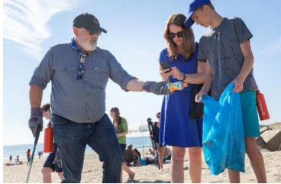

Frans Timmermans, First Vice-President of the European Commission, takes part in a beach clean-up initiative with young scouts in The Hague, the Netherlands, 23 July 2018.

A legislative proposal was made in May to tackle marine litter at its source by targeting the ten plastic products that most often end up in the oceans, as well as lost and abandoned fishing gear. In December the European Parliament and the Council reached a provisional political agreement on the new EU Directive on Single-use Plastics, the most ambitious legal instrument at global level addressing marine litter. It envisages different measures to apply to different product categories. Where alternatives are easily available and affordable, single-use plastic products such as plastic cutlery, plates, or straws, products made of oxo-degradable plastic and food and beverage containers made of expanded polystyrene will be banned from the market. For other products, the focus is on limiting their use through a national reduction in consumption; on design and labelling requirements; and waste management/clean-up obligations for producers.

Also in May, the Council [adopted](http://europa.eu/rapid/press-release_IP-18-3846_en.htm) new rules on waste to make the EU the global leader in waste management and recycling. Member States will now be required to recycle at least 55 % of their municipal waste by 2025, 60 % by 2030 and 65 % by 2035. Other approved measures included a 10 % cap on landfill by 2035, mandatory separate collection of biowaste, and stricter schemes to make producers pay for the collection of key recyclables.

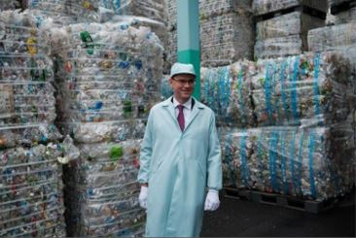

Commission Vice-President Jyrki Katainen, at a recycling plant for PET bottles in Tokyo, Japan, 23 October 2018.

Following an EU-wide pledging campaign as part of the European Plastics Strategy, in November the European Commission provided a preliminary assessment that shows that EU industry is significantly committed to recycling plastics — at least 10 million tonnes of recycled plastics could be supplied by 2025 if the pledges are fully delivered. However, on the demand side, only five million tonnes are expected so far, demonstrating that more will be needed to achieve the objective of a well-functioning EU recycled plastics market.

Work also continued on improving the sustainable, ‘circular’ management of water resources and on making drinking water safer for all Europeans. In February the Commission [proposed](http://europa.eu/rapid/press-release_IP-18-429_en.htm) a revision of the Drinking Water Directive to upgrade drinking water standards, improve access to water for all and help consumers to find reliable information about its supply. The proposal was also a response to the first-ever successful European Citizens’ Initiative, ‘Right2Water’, which received the support of 1.6 million people. The aim is to encourage consumers to choose tap water over bottled water and thereby save money, reduce plastic waste entering our rivers and seas, and lower greenhouse gas emissions.

In spring 2018 the Commission also put forward proposals on sustainable finance, aiming to ensure that the financial sector plays its role in the green transition by investing in a more sustainable way.

The blue economy

The ‘blue economy’ includes all rule-based, sustainable economic activities related to our oceans, seas or coastal areas — from fisheries, shipbuilding and tourism to ocean energy and blue biotechnology. In 2018 the Commission published its first Annual report on this fast-growing economic sector, which is set to double in size globally by 2030. The report highlights that the blue economy generates more than €560 billion a year in turnover, employs more than 3.5 million people and is a fast-growing sector in many countries. Spain accounts for one fifth of total employment in the sector, followed by Italy, the United Kingdom and Greece. Combined, these four Member States account for more than half of jobs related to the blue economy.

Regional and urban policy

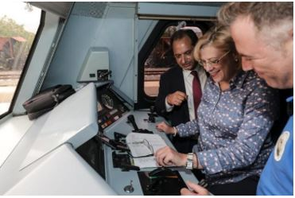

Commissioner Corina Creţu during her visit to Lamia, Greece, 4 October 2018.

Regions and cities can play a powerful role in supporting growth, jobs and investment. In 2018 the EU continued to invest in policies to strengthen competitiveness and job creation, promote social inclusion and support small and medium-sized enterprises in regional and local contexts. Several initiatives and strategies were implemented to spur growth and innovation on a larger scale, including a new set of actions in 2018 to further help Europe’s regions invest in their niche areas of competitive strength, known as ‘[smart specialisation](https://ec.europa.eu/commission/news/smart-specialisation-european-regions-2017-jul-18_en)’.

These actions include continued support to the lagging regions initiative and the implementation of a new initiative targeting regions in industrial transition. In this framework, pilot actions in 2018 in 10 regions and two Member States will receive expert advice and financial support from the European Regional Development Fund and the European Observatory for Clusters and Industrial Change.

The Commission has also selected five cohesion policy programmes to take part in a new pilot action on improving administrative capacity. Programmes in Greece, Poland, Spain, Croatia and Bulgaria are receiving tailored support to improve how they operate. The European Investment Bank’s Advisory Hub carried out a study on investment platforms in the outermost regions to help improve their access to the Investment Plan. In addition, task forces have been set up on energy in Réunion and on waste management in the Canary Islands, and Horizon 2020 is funding a project to foster research excellence in all outermost regions.

Connecting Europe

The [Connecting Europe Facility](https://ec.europa.eu/inea/en/connecting-europe-facility) blending call, combining grants with financing from the European Fund for Strategic Investments, the European Investment Bank, national promotional banks or private-sector investors, resulted in the selection of 35 projects in the field of safe, clean and intelligent mobility that will receive €405 million in grants. Another call for proposals, worth €290 million supported projects aimed at developing [the Single European Sky](https://ec.europa.eu/transport/modes/air/ses_en) and European aviation. Some €9.5 million under the Single European Sky ATM Research Joint Undertaking (SESAR) will finance a range of U-space drone demonstrations, focusing on the safe and secure integration of drones into the aviation system.

Helping small and medium-sized enterprises find funding, new partners and new markets

Small businesses are the backbone of the EU’s economy. Every year the EU supports small businesses with various types of financing and advice services. In recent years, the EU has made great progress in improving access to finance for small businesses in Europe. The EU has already helped provide more than €20.3 billion of financing to around 381 000 small businesses under [COSME](https://ec.europa.eu/growth/smes/cosme_en), the EU’s programme for the competitiveness of small and medium-sized enterprises complemented by the European Fund for Strategic Investments.

Boosting research, innovation and technology

Scientific excellence and breakthrough innovation

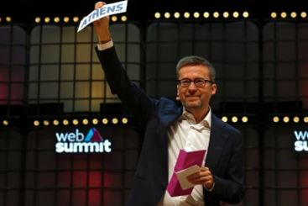

Commissioner Carlos Moedas announces Athens as the winning city of the European Capital of Innovation award at the Web Summit in Lisbon, Portugal, 6 November 2018.

During the year, Horizon 2020 launched calls for proposals and other actions worth a total of €10 billion to support research and innovation. Examples include a new call for proposals to invest almost €200 million in developing next-generation batteries that will help drive the transition towards a decarbonised society; almost €1 billion to connect economic and environmental gains in support of the EU’s Circular Economy package; and some €200 million to look into the root causes of irregular migration and feed into the European Agenda on Migration.

In addition, to stimulate public–private cooperation in financing clean energy innovation, an agreement signed with the Gates Foundation in autumn 2018 established a €100 million fund targeting EU innovators and companies with the potential to achieve significant and lasting reductions in greenhouse gas emissions.

The [European Open Science Cloud](https://ec.europa.eu/research/openscience/index.cfm?pg=open-science-cloud), a virtual environment to store, share and reuse data across disciplines and borders, was officially launched in 2018, enabling an estimated 1.7 million researchers and 70 million professionals to access a growing volume of open data.

The EU in space

Building on the 2016 [Space Strategy for Europe](http://europa.eu/rapid/press-release_IP-16-3530_en.htm), the EU continued to develop the space infrastructure that underpins the economy and so much of our daily lives. In June 2018, the Commission proposed a €16 billion Space Programme that would further enhance the EU’s leadership in space.

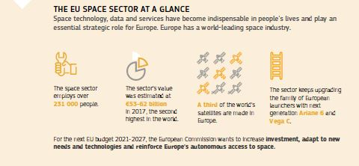

The [Copernicus](http://copernicus.eu/) Programme is the biggest provider of Earth observation data in the world, helping address diverse challenges, such as natural disasters and climate change. The launch of the [seventh Copernicus satellite](http://copernicus.eu/news/copernicus-sentinel-3-in-orbit) in 2018 has improved our ability to monitor oceans, land and the atmosphere. The Copernicus [Data and Information Access Services](https://ec.europa.eu/docsroom/documents/30162), also launched in 2018, allow innovative start-ups and other users to access, process and download data easily and without having to invest in expensive data storage and processing facilities.

[Galileo](http://ec.europa.eu/growth/sectors/space/galileo_en), the EU’s satellite navigation programme, provides precise positioning, navigation and timing services and can be used by the latest generation of smartphones resulting in greater accuracy than previous GPS-only systems. With [four new satellites launched](http://europa.eu/rapid/press-release_IP-18-4603_en.htm) in 2018 (named after children who won a drawing competition), Galileo’s performance has improved and it has moved closer to becoming a fully independent, autonomous satellite positioning system, attracting 500 million users worldwide. Galileo’s signals are used by traffic and railway management, aircraft navigation, banking and farming, and they pave the way for autonomous cars.

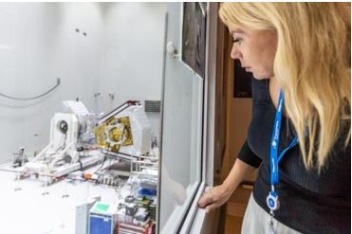

Commissioner Elżbieta Bieńkowska visits the European Spaceport in Kourou, French Guiana, ahead of the Galileo satellite launch, 25 July 2018.

In November the US Federal Communications Commission decided to grant a licence waiver for Galileo signal reception in the United States. This means that citizens and businesses in the US will be able to benefit from Galileo’s state-of-the-art satellite navigation signals — be it for connected cars, smart watches, farming or aircraft navigation.

Galileo’s accuracy is a major factor in the effectiveness of the eCall system, which helps to locate a car in case of emergency. eCall has been mandatory in all new types of cars in the EU since 31 March 2018 and helps to cut emergency services response time by up to 60 %. In December the Commission adopted new measures to help locate people in emergency situations more accurately thanks to Galileo’s signals, making rescue efforts more effective. Under the new rules, all smartphones sold in the EU will be able to send the precise location of the person who calls the 112 emergency number to the emergency services taking the call.

Because access to space is strategically important, the EU aims to reinforce its autonomy in this area. In 2018 a competition was launched to award [€10 million](https://ec.europa.eu/research/eic/index.cfm?pg=prizes_space) to the most commercially viable solution offering dedicated low-cost launch services for light satellites. The InnovFin Space Equity Pilot initiative brings together around €110 million in funding to stimulate investment in the space sector, by increasing the amount of risk capital available for SMEs and midcaps.

European Defence Technology

In 2018 the European Union invested €40 million towards the funding of collaborative research in innovative defence technologies and products under the preparatory action on defence research.

In July the EU adopted the new European Defence Industrial Development Programme to provide the European defence industry with financial support during the development phase of new products and technologies in areas selected at European level. It foresees a budget of €500 million during 2019 and 2020 to co-finance collaborative defence capability development projects.

Investing in people

In 2018 the EU adopted a Recommendation on a framework for quality and effective apprenticeships. It contains criteria to promote ensuring good learning and working conditions for apprentices throughout the EU.

In April the EU simplified and modernised the [Europass CV](https://ec.europa.eu/epale/en/content/europass-framework-revised-make-skills-and-qualifications-more-visible-eu), which will help people to present their skills and qualifications in a more visible and understandable way right across the Single Market. It will also enable policymakers to better anticipate labour market needs and trends.

Reforms to education and training systems are a high priority in most Member States and featured prominently in the 2018 European Semester. Twenty Member States received a country-specific recommendation in the area of education and training.

Effective education and training systems are of critical importance to provide young people with the knowledge, competences and skills to find fulfilling work and become independent, engaged citizens. They also play a crucial role in giving workers the opportunity to upgrade their skills to cope with changing working methods and the needs of the labour market and help increase productivity and growth.

To advance its work on building a [European Education Area](https://ec.europa.eu/education/initiatives/european-education-area_en) by 2025, in the first half of 2018, the Commission presented six concrete policy measures. In May 2018 the Council adopted Recommendations on [Key Competences for Lifelong Learning](https://eur-lex.europa.eu/legal-content/EN/TXT/?qid=1527150680700&uri=CONSIL:ST_9009_2018_INIT) to help more people acquire the core set of skills necessary to live and work in the 21st century and on promoting [common values, inclusive education and the European dimension of teaching](https://eur-lex.europa.eu/legal-content/EN/TXT/?qid=1541673953899&uri=CELEX:32018H0607(01)). In November 2018 it adopted measures on the automatic [mutual recognition](https://eur-lex.europa.eu/legal-content/EN/TXT/HTML/?uri=CELEX:32018H1210(01)&from=EN) of qualifications and the outcomes of learning periods abroad. Discussions continue on early childhood education and care and the teaching and learning of languages. Implementation of an action plan to improve the digital skills of EU citizens and the use of new technologies in teaching and learning is also ongoing.

Connecting people

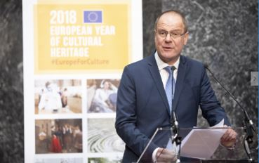

Commissioner Tibor Navracsics speaking at a forum on the International Dimension of the European Year of Cultural Heritage, Brussels, Belgium, 23 April 2018.

Europe celebrated the [European Year of Cultural Heritage](https://europa.eu/cultural-heritage/european-year-cultural-heritage_en) in 2018, encouraging more people to discover and engage with Europe’s rich and diverse cultural heritage, and to reinforce a sense of belonging to a common European space. Over 7.5 million people took part in more than 13 000 events organised across 37 countries. To ensure that the European Year has a lasting impact beyond 2018, on 7 December the Commission presented [60 actions](http://europa.eu/rapid/press-release_IP-18-6661_en.htm) related to the promotion and protection of cultural heritage in the longer term.

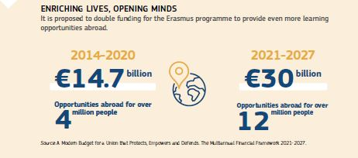

In 2018, with a budget of more than €2.7 billion, the [Erasmus+ programme for education, training, youth and sport](http://ec.europa.eu/programmes/erasmus-plus/node_en) enabled around 600 000 young people and 190 000 members of staff from educational institutions and youth organisations to participate in learning activities. In March the Commission added an online version to its mobility actions with the launch of [Erasmus+ Virtual Exchange](https://europa.eu/youth/erasmusvirtual), a project to promote intercultural dialogue and improve the skills of at least 25 000 young people through digital learning tools. In May the Commission proposed to double Erasmus funding to €30 billion in the next long-term budget 2021-2027, tripling the number of people it could support.

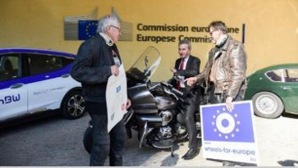

Commissioner Günther Oettinger (centre) welcomes members of the ‘Wheels for Europe’ initiative, a group of motorcyclists and classic car drivers promoting the European idea by touring around Europe, Brussels, Belgium, 11 October 2018.

DiscoverEU

Between July and October 2018 around 15 000 young people had the opportunity to explore Europe with a [DiscoverEU](https://ec.europa.eu/commission/news/discovereu-travel-passes-explore-eu-summer-2018-jun-11_en) travel pass. This new initiative enabled them to better understand Europe’s diversity, enjoy its cultural richness, make new friends and get a sense of their European identity. In November young people had another opportunity to apply for free tickets to travel in 2019. The Commission has proposed to greatly expand the scheme post-2020.

The European Solidarity Corps

In October the [European Solidarity Corps](https://europa.eu/youth/solidarity_en) got a boost when the EU adopted a self-standing [legal base](https://eur-lex.europa.eu/legal-content/EN/TXT/?uri=CELEX:32018R1475) for this initiative and it received a budget for the next 3 years. By the end of December, almost 100 000 young people had registered and 11 000 had engaged in solidarity activities across Europe. In June, the Commission proposed a new programme for the European Solidarity Corps beyond 2020, with a budget of €1.26 billion to broaden the opportunities it offers. This would allow at least 350 000 young Europeans to support communities in need through volunteering (including support to humanitarian aid operations in non-EU countries), traineeships and job placements between 2021 and 2027.

Protecting people’s health and helping the economy

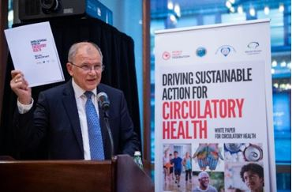

Commissioner Vytenis Andriukaitis speaks at the World Heart Federation launch of the White Paper on Circulatory Health during the 73rd UN General Assembly in New York, USA, 25 September 2018.

In December 2018 European Health Ministers adopted the [Recommendation](https://ec.europa.eu/health/vaccination/overview_en) proposed by the Commission to strengthen EU cooperation in the fight against diseases that can be prevented by vaccines. The recommendation focuses on three main pillars: tackling reluctance to vaccinate and improving vaccination coverage; sustainable vaccination policies in the EU; and EU coordination and the contribution to global health.

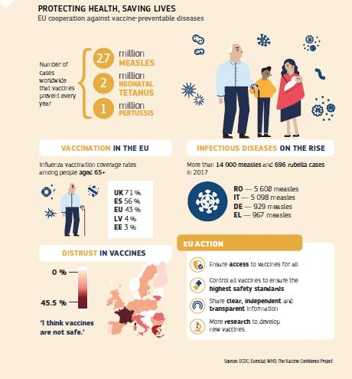

The [Health at a Glance: Europe 2018](https://ec.europa.eu/health/state/glance_en) report, published in November by the Commission and the Organisation for Economic Cooperation and Development, calls for improving mental health and preventing mental illnesses that not only have social consequences but are also estimated to cost more than 4 % of gross domestic product across the EU. The report also shows that the steady increase of life expectancy has slowed down and that large gaps across and within countries persist, notably leaving people with a low level of education behind. It also calls for the addressing of risk factors like smoking, alcohol and obesity, reducing premature mortality, ensuring universal access to care, and strengthening the resilience of health systems. With the report, the Commission kicked off the second State of Health in the EU knowledge cycle, which analyses and shares comparative data and insights into health and health systems in the EU and supports health authorities in their evidence-based policymaking.

The 2-year ‘State of Health’ cycle was prepared by the European Commission in close cooperation with the Organisation for Economic Cooperation and Development and the European Observatory on Health Systems and Policies.

The EU continued to aim at protecting health and safety at work with a [proposal](https://eur-lex.europa.eu/legal-content/EN/TXT/?qid=1532427883252&uri=CELEX:52018PC0171)to limit workers’ exposure to five more cancer-causing chemicals. This is aimed at strengthening protection for over 1 million workers in Europe.

In an effort to protect bees and pollinators, further restrictions were adopted on the use of three [neonicotinoids](https://ec.europa.eu/food/plant/pesticides/approval_active_substances/approval_renewal/neonicotinoids_en), which are active substances chemically similar to nicotine used in plant protection products. A complete ban on using these products outdoors entered into force in December 2018 and their use indoors was limited to permanent greenhouses. This was complemented by the first-ever EU initiative to address the decline of wild pollinating insects.

An EU budget focused on results

The 2018 EU budget focused on delivering on Europe’s priorities by stimulating job creation, especially for young people, and by boosting growth and strategic investments. It also continued to support efforts to tackle migration and security challenges, both inside and outside the EU.

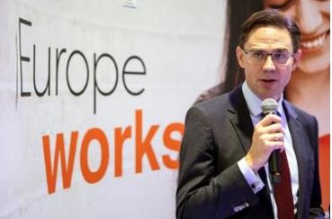

Commission Vice-President Jyrki Katainen at a fair dedicated to projects financed by the European Fund for Strategic Investments, Brussels, Belgium, 26 October 2018.

Nearly half of the funds committed (€77.5 billion) went towards strengthening the European economy, job creation and increasing the global competitiveness of companies, researchers and universities. EU funding supported agriculture and rural areas (common agricultural policy), regions (European Regional Development Fund, European Social Fund, Cohesion Fund), research and innovation (Horizon 2020), small and medium-sized enterprises (Competitiveness of Enterprises and Small and Medium-sized Enterprises), education, training and youth (Erasmus+), transport and digital infrastructure (Connecting Europe Facility).

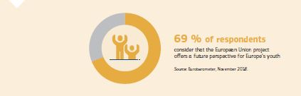

The Youth Employment Initiative addressed the challenge of youth unemployment by committing €350 million to provide young people with support and better opportunities to find jobs. An additional €2 billion was provided in 2018 for the European Fund for Strategic Investment to further pursue the successful mobilisation of private investments in strategic European projects. €59.2 billion contributed to promoting sustainable growth through support for farmers, fisheries, climate and biodiversity.

The EU’s long-term budget 2021-2027

In May, following months of consultations with Member States and European citizens, the Commission presented its proposal for the 2021-2027 long-term budget.

This was followed by a complete set of proposals for sectoral programmes and funds. This proposal for a long-term budget is the translation into budgetary figures of the EU’s objectives for the coming decade, as agreed by EU leaders in February 2018. The proposed budget combines new instruments with modernised programmes to deliver efficiently on the EU’s priorities. It provides the means to find appropriate answers to major challenges including youth unemployment, migration, security and technological and digital transformation. The proposals include a simplified budget that forges a stronger link with the political priorities (see also the dedicated chapter on ‘The future long-term budget of the EU’).

InvestEU

Given the success of the Investment Plan for Europe, the European Commission proposed that all the EU’s financing programmes in the next long-term budget (2021-2027) should follow the same model. The many financing programmes currently offered by the EU would be brought under one roof: the [InvestEU Programme](https://ec.europa.eu/commission/publications/investeu-programme_en). Like the Investment Plan, the InvestEU Programme would consist of a fund, an advisory hub and an investment portal. The InvestEU Fund would have a €38 billion guarantee from the EU budget to support strategically important projects across the EU in sectors such as sustainable infrastructure; research, innovation and digitisation; small and medium-sized companies; and social investment and skills. It is estimated that the Fund would trigger over €650 billion in additional investment over seven years.

Boosting research, innovation and technology

The Commission also plans to boost investment in research to keep Europe at the forefront of global research and innovation, with a proposed budget of €100 billion for research and innovation between 2021 and 2027 under the new Horizon Europe Programme. The Commission has proposed that the EU invest [€16 billion](http://ec.europa.eu/growth/content/eu-budget-%E2%82%AC16-billion-space-programme-boost-eu-space-leadership-beyond-2020_en) under the EU Space Programme to help develop its leadership in space. The Commission proposes a budget of €13 billion for the European Defence Fund. This will place the EU among the top four defence research and technology investors in Europe.

Agriculture and the maritime economy for growth

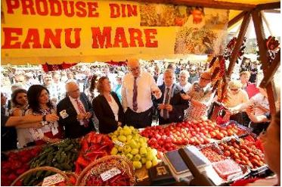

Commissioner Phil Hogan visits the Harvest Festival in Cluj-Napoca, Romania, 14 September 2018.

The Commission has proposed to maintain strong support for EU farming and rural areas by allocating €365 billion to the common agricultural policy for the period 2021-2027. [The common agricultural policy proposals](https://ec.europa.eu/info/food-farming-fisheries/key-policies/common-agricultural-policy/future-cap_en)focus on the simplification and modernisation of the policy to keep it fit for the future. In addition to the traditional objectives of farm income, food security and environmental protection, the plans also address new societal demands such as safe, nutritious and sustainable food, combating food waste and animal welfare. The plans also propose a new partnership between the EU and its Member States. In the future, while the elements needed to achieve the EU’s common objectives and the smooth functioning of the Single Market will be defined at EU level, Member States will be able to choose and design policy measures to suit the needs of their farmers and rural areas.

The Commission has also proposed a new €6.14 billion [European Maritime and Fisheries Fund](https://ec.europa.eu/easme/en/european-maritime-and-fisheries-fund) to strengthen support for the maritime economy, while promoting simplification and a stronger focus on results. The Fund will enable investment in new maritime markets, technologies and services such as ocean energy and marine biotechnology. Coastal communities will receive more support and the Fund will also continue to support the European fisheries sector, with a particular focus on helping small-scale fisheries.

The future of cohesion policy

With a budget of €373 billion proposed by the Commission, the [proposals for cohesion policy funds](http://europa.eu/rapid/press-release_IP-18-3885_en.htm) focus on modernising Europe’s economy, making it smarter, greener and more connected, and moving to a low-carbon economy. Rules would also be simplified, with one set of rules covering seven funds, and procedures made more flexible.

Investing in people

The Commission has proposed to further strengthen the Union’s social dimension through a new and improved European Social Fund. The new ESF+ would amount to €101.2 billion, a significantly higher share of the overall Cohesion budget than is the case at present. It would give more visibility and impact to social investment. In particular, the combination of ESF+, Erasmus and European Solidarity Corps potentially more than doubles the funds dedicated to supporting young people, compared to the current financial framework. While the European Globalisation Adjustment Fund would be revamped, its scope would be widened and its ceiling increased to €225 million per year compared to €170 million per year in the current period.

Chapter 2

A connected Digital Single Market

‘I believe that we must make much better use of the great opportunities offered by digital technologies, which know no borders.’

Jean-Claude Juncker, political guidelines, 15 July 2014

2018 was another successful year for Europe’s [Digital Single Market Strategy](https://ec.europa.eu/digital-single-market/en/policies/shaping-digital-single-market), which is well on its way.

In 2018 agreement was reached on 23 legislative proposals and seven are still under negotiation. The Commission proposed new initiatives on supercomputing, ehealth, disinformation, public sector information, the transparency of online platforms, artificial intelligence and blockchain. The Commission also proposed investment in digital transformation and new measures to support media freedom, pluralism and literacy.

In September President Juncker announced proposals to strengthen the EU’s cybersecurity capabilities and in December, an agreement was reached on the Cybersecurity Act proposed by the Commission in 2017. This reinforces the mandate of the EU Agency for Cybersecurity and establishes an EU framework for cybersecurity certification, boosting the security of online services and consumer devices.

Progress was made on legislation to facilitate access to content online and e-commerce and on proposals to modernise EU copyright rules, e-privacy and digital contracts, giving consumers and businesses clear rights. Measures covering audiovisual media services, free flow of data and the Single Digital Gateway were agreed. In December the new European Electronic Communications Code entered into force, providing an updated regulatory framework for electronic communications to encourage investment in very high-capacity networks and protect users in the digital age.

Since 1 April 2018, Europeans have been able to access the online content they subscribe to at home, wherever they are in the EU, and their personal data is protected by the new General Data Protection Regulation which came into effect in May.

The EU continued to fight anti-competitive behaviour in the digital field, fining Qualcomm for abusing its market dominance in certain chipsets and Google for illegal practices related to the Android operating system.

To ensure a continuously stronger Digital Single Market and to keep the EU at the forefront of [digital transformation](https://ec.europa.eu/digital-single-market/en/news/eu-budget-future-digital-transformation), the Commission proposed a new €9.2 billion Digital Europe Programme as part of the EU’s next long-term budget.

Delivering on the Digital Single Market

Of the 30 legislative initiatives presented by the European Commission since 2015, 23 have been agreed between the European Parliament, the Council of the European Union and the European Commission. There remain seven Commission proposals on the table that the European Parliament and the Council need to approve to further build the Digital Single Market.

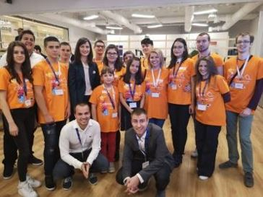

Commissioner Mariya Gabriel participating in EU Code Week, Brussels, Belgium, 15 October 2018.

Several major digital initiatives came into force in 2018. January saw the launch of the EU-wide awareness campaign [#SaferInternet4EU](https://ec.europa.eu/digital-single-market/en/news/saferinternet4eu-campaign-0) on online safety, media literacy and cyber-hygiene. In September, the EU legislation on electronic identification (eIDAS Regulation) entered into force. In October, Member States implemented rules that facilitate access to printed material in formats adapted for people with visual impairment or other disability, and in December new rules came into force banning unjustified geo-blocking in online sales within the Single Market.

Films and music without frontiers

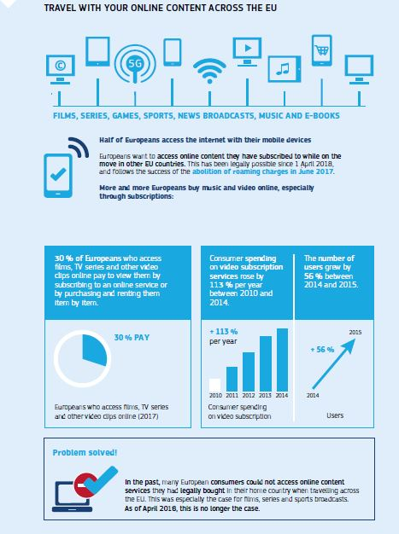

Since April 2018, thanks to new portabilityrules, Europeans have been able to access the online content (audiovisual and music) they have subscribed to at home, wherever they are in the EU. In May, the Commission announced the creation of an [online directory of European films](https://ec.europa.eu/digital-single-market/en/news/online-directory-european-films) to increase the visibility of European cinema. [A prototype](http://europa.eu/rapid/press-release_IP-18-6134_en.htm) was released in October.

In June 2018 theEuropean Parliament, Council and Commission reached a political agreement on revised rules for a fairer regulatory environment for the entire audiovisual sector, including on-demand services and video-sharing platforms. The rules promote European audiovisual productions and guarantee the independence of audiovisual regulators.

Safer and easier online shopping

The [new Regulation](http://europa.eu/rapid/press-release_MEMO-17-5246_en.htm) on cross-border parcel delivery services, important for e-commerce, entered into force in May. High prices for cross-border parcel delivery are an obstacle for consumers and retailers, especially small and medium-sized companies, who want to buy and sell online across the EU.

Boosting trust online and building the Digital Single Market

The rules on electronic identification for electronic transactions in the internal market have entered into force offering Europeans a new freedom: to rely on a notified electronic identification means to securely access digital services provided everywhere across Europe ranging from enrolling in a foreign university, accessing electronic health records, registering a company and filing tax returns online to digitally opening a bank account.

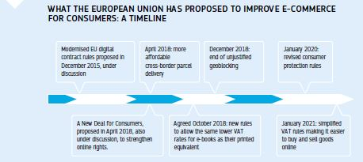

New rules have been in place since December 2018 banning unjustified geo-blocking and other forms of discrimination based on a customer’s nationality, place of residence or place of establishment. They allow people and businesses to access websites from other Member States and to access the same goods and services as local customers. The Commission also presented an interim report on the effects of the abolition of retail roaming surcharges that entered into force in 2017.

Unlocking the full potential of the EU’s data economy

Breaking down barriers will help the value of the EU’s data economy to double between 2015 and 2020 from 1.9 % to 4 % of gross domestic product. it is forecast that 10.4 million people will be employed in the EU data economy by 2020. Removing existing data localisation requirements will drive down the costs of data services and provide businesses with greater flexibility in organising their data management and data analytics, while expanding their use and choice of providers.

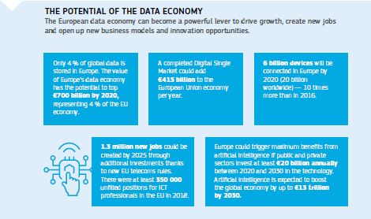

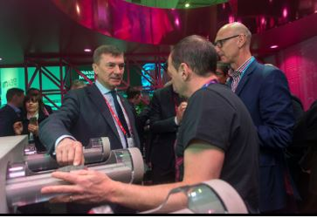

Commission Vice-President Andrus Ansip visits an exhibition stand during the Mobile World Congress in Barcelona, Spain, 27 February 2018.

Artificial intelligence

Artificial intelligence is already part of our everyday lives — from helping doctors make faster and more accurate medical diagnoses to assisting farmers in using fewer pesticides on crops. It also helps public administrations to provide tailor-made responses to citizens and to reduce the number of traffic accidents. Artificial intelligence can also help fight climate change or anticipate threats.

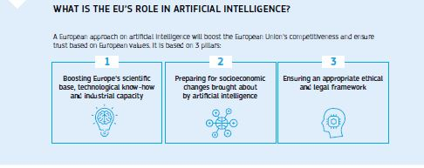

In April the Commission proposed a European approach to increase public and private investment in artificial intelligence, prepare for related socioeconomic changes, and ensure that an appropriate ethical and legal framework is developed to cover liability issues around these new technologies. The approach aims to maximise the impact of investment at EU and national levels, encourage cooperation, exchange best practice and define the way forward together to ensure the EU’s global competitiveness in this sector.

In June the Commission appointed the High-Level Expert Group on Artificial Intelligence and launched the [European AI Alliance](https://ec.europa.eu/digital-single-market/en/european-ai-alliance), an online multi-stakeholder community open to anyone with an interest in artificial intelligence.

In December, as a follow-up to the April Communication, and in close collaboration with Member States, the Commission proposed a [coordinated plan](http://europa.eu/rapid/press-release_IP-18-6689_en.htm) to boost the development and use of artificial intelligence ‘made in Europe’. The [plan](http://europa.eu/rapid/press-release_MEMO-18-6690_en.htm) aims to ensure complementarity and synergies between national and EU-level actions to maximise impact and spread the benefits of artificial intelligence across Europe. The plan proposed joint actions in four key areas: increasing investment, making more data available, fostering talent and ensuring trust. It also provides a strategic framework for national artificial intelligence strategies. EU countries are encouraged to develop their national artificial intelligence strategies by mid 2019, building on the work done at European level.

In parallel, the Commission [awarded](https://ec.europa.eu/digital-single-market/en/news/commission-awards-eu66000000-new-robotics-and-artificial-intelligence-projects) €66 million to robotics projects that will help digitise small and medium-sized companies across the EU.

In December an independent group of 52 experts drafted [ethics guidelines](https://ec.europa.eu/digital-single-market/news-redirect/641027) for the development and use of artificial intelligence which are open to consultation through the AI Alliance and will be finalised in 2019. The group will also present policy recommendations in Spring 2019.

Building a world-class supercomputer infrastructure in Europe

In January 2018 the Commission unveiled plans to establish a European High Performance Computing Joint Undertaking. This new legal and funding structure will pool EU and national resources to build supercomputing and data infrastructure and support research and innovation in this area, with the aim of making Europe one of the top three supercomputing powers in the world. In September Member States backed the Commission’s proposal, and the Joint Undertaking began operations in November. It will build and deploy this infrastructure across Europe (with financing proposed from the next EU long-term budget) to improve data-processing capacities for research and industry, and support innovation in supercomputing technologies, hardware and software. There will be benefits for many areas, from healthcare and renewable energy to car safety and cybersecurity.

Better access to and reusability of data

In April the Commission proposed to extend the Public Sector Information directive to data held by public undertakings and limit charges for the reuse of their data. The aim is also to facilitate the reusability of research data resulting from public funding, and oblige Member States to develop open access policies. The new rules require, where applicable, technical solutions to provide real-time access to data.

In April, as part of the 3rd Data Package, the Commission made a [new set of recommendations](https://ec.europa.eu/info/news/new-commission-guidance-supports-eu-member-states-transition-open-science-2018-apr-25_en) to address technological changes on access to and preservation of scientific information. They offer guidance on implementing open access policies in line with open science objectives, research data and data management, the creation of a [European Open Science Cloud](https://ec.europa.eu/research/openscience/index.cfm?pg=open-science-cloud), and text and data mining. The recommendations also addressed incentives and the development of relevant skills for researchers to practise open science.

Free flow of non-personal data

In December [new rules](https://ec.europa.eu/digital-single-market/en/news/free-flow-non-personal-data) that will allow non-personal data to be stored and processed everywhere in the EU without unjustified restrictions came into force. The new rules remove barriers hindering the free flow of data, and will boost Europe’s economy by generating an estimated growth of up to 4 % gross domestic product by 2020. Member States should have to communicate to the Commission any remaining or planned data localisation restrictions, which are allowed only in limited specific situations on grounds of public security in compliance with the principle of proportionality. Public authorities will be able to access data for scrutiny and supervisory control wherever it is stored or processed in the EU. The rules will also encourage the creation of codes of conduct for cloud services to facilitate switching between cloud service providers under clear deadlines.

Keeping up with blockchain

The Commission launched the [EU Blockchain Observatory and Forum](https://www.eublockchainforum.eu/) in February with the support of the European Parliament. It will monitor developments and promote the role of European stakeholders in ‘blockchain’, technologies that store blocks of information which are distributed across the digital network.

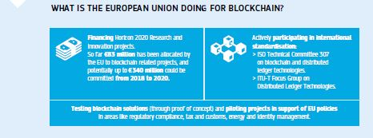

.eu top-level domain name

In December agreement was reached on new rules governing the .eu top-level domain name, which was created in 2002 to make it easier for European businesses and citizens to participate in e-commerce and to boost the online Single Market. The review aims for a future-proof, flexible and transparent internet governance system, with stakeholders fully involved. One of the main innovations proposed is to allow EU citizens to register .eu domain names, wherever they live.

eHealth

In April the [Commission announced its ambitions on the digital transformation of health and care](http://europa.eu/rapid/press-release_IP-18-3364_en.htm). The Commission will support EU cooperation in three priority areas: citizens’ secure access to their health data, including across borders; personalised medicine and disease prevention through shared European data; and citizen empowerment with digital tools and person-centred care. As a first deliverable, several pioneering Member States will start exchanging ePrescriptions and digital Patient Summaries from early 2019. Meanwhile, by November 2018, 19 European countrieshadsigned a declaration to provide cross-border access to their [genomic information](https://ec.europa.eu/digital-single-market/en/news/eu-countries-will-cooperate-linking-genomic-databases-across-borders).

Connectivity and digital entrepreneurship

In January the Commission adopted its Digital Education Action Plan, which aims to ensure that all EU citizens benefit equally from the opportunities available online, at home, in school and in the workplace. Initiatives include supporting schools with high-speed broadband connections, scaling up a new self-assessment tool for schools on the use of technology for teaching and learning (Selfie) and the #SaferInternet4EU public awareness campaign. The campaign was launched on Safer Internet Day (6 February) to raise awareness of children’s safety online and tackles issues including cyberbullying, fake news, sexting, harmful content, critical thinking, media literacy and digital skills, and good practice in cyber safety.

The EU’s [WiFi4EU](https://www.wifi4eu.eu/#/home) initiative to bring public Wi-Fi hotspots to communities across Europe took a major step forward in November with the publication of its first call for proposals. The budget of the WiFi4EU scheme is €120 million between 2018 and 2020. It will support the installation of Wi-Fi equipment in public spaces such as parks, squares, public buildings, libraries, health centres and museums.

Investing in broadband

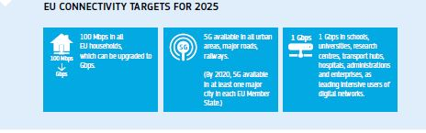

In June the European Parliament and the Council reached a [political agreement](http://europa.eu/rapid/press-release_IP-18-4070_en.htm) to update the EU’s telecoms rules. The new European Electronic Communications Code will boost investments in very high-capacity networks across the EU, including in remote and rural areas. The agreement on the Code included setting a time frame for Member States to allow the use (by 2020) of key radio frequency bands needed for the [development of 5G services](https://ec.europa.eu/digital-single-market/en/news/more-and-better-internet-connectivity-requires-investments-high-speed-and-quality-networks). The Code entered into force in December. The European Commission also presented a [toolkit](https://ec.europa.eu/digital-single-market/en/news/european-commission-joins-forces-help-bringing-more-broadband-rural-areas) to bring more broadband to remote and rural areas, where only 40 % of people have fast internet access compared to 76 % in the EU as a whole.

[Digital Opportunity Traineeships](https://ec.europa.eu/digital-single-market/en/news/apply-one-6000-digital-opportunity-traineeships-cybersecurity-big-data-quantum-techn)

This EU-funded [training initiative](https://ec.europa.eu/digital-single-market/en/digital-opportunity-traineeships-boosting-digital-skills-job) will help companies fill vacancies with candidates with digital skills. In April the Commission launched a pilot project financed by Horizon 2020 and managed by Erasmus+ for 6 000 internships in cybersecurity, big data, quantum technology, machine learning and digital marketing.

Women in Digital

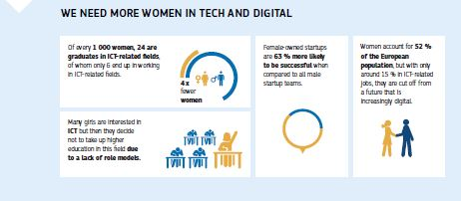

Recognising that the gender digital gap has enormous social and economic implications, the Commission raised awareness of the importance of women’s empowerment in our digital society by developing the Women in Digital Strategy. Its goal is to help unlock the full contribution that women can make to the digital economy by combating stereotypes in the media and promoting role models; promoting digital skills and education for women; and facilitating women’s participation in digital entrepreneurship and innovation.

International cooperation

In February the Commission adopted the Western Balkans Strategy, which launched six flagship initiatives, including one designed to help the EU’s six western Balkan partners make a success of the digital transition. The Digital Agenda for the Western Balkans was launched in June to bring the benefits of the digital transformation to the citizens of the region. It sets out an approach to lower roaming charges, invest in broadband connectivity, increase cybersecurity, trust and the digitisation of industry, strengthen the digital economy, and boost research and innovation.

In the context of the new Africa–Europe Alliance for Sustainable Jobs and Growth, the EU–African Union Digital Economy Task Force met for the first time in December and will issue recommendations by June 2019 on how to develop the Pan-African Digital Market connected to the EU’s Digital Single Market.

A fair digital ecosystem

Ensuring fair competition in the online economy

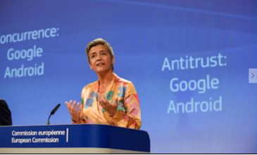

Commissioner Margrethe Vestager giving a press conference on the European Commission’s antitrust case against Google, Brussels, Belgium, 18 July 2018.

In January the Commission fined Qualcomm €997 million for abusing its market dominance in Long-Term Evolution baseband chipsets, which enable smartphones and tablets to connect to cellular networks and comply with the 4G Long-Term Evolution (LTE) standard. The Commission also cleared, subject to conditions, the proposed acquisition of NXP by Qualcomm, two of the leading players in the semiconductor industry. In the media sector, the Commission cleared Comcast’s acquisition of Sky in June. In the telecommunications sector, the Commission approved the acquisition of UPC Austria by T-Mobile Austria in July.

In July the [Commission fined Google €4.34 billion](http://europa.eu/rapid/press-release_IP-18-4581_en.htm) for breaching EU antitrust rules by imposing illegal restrictions on Android device manufacturers and mobile network operators to cement its dominant position in general internet search. The [Commission fined](http://europa.eu/rapid/press-release_IP-18-4601_en.htm), in four separate decisions, consumer electronics manufacturers Asus, Denon & Marantz, Philips and Pioneer a total of over €111 million for imposing fixed or minimum resale prices on their online retailers in breach of EU competition rules.

In December the [Commission fined Guess](http://europa.eu/rapid/press-release_IP-18-6844_en.htm) just under €40 million for restricting retailers from online advertising and selling cross-border to consumers in other Member States (geo-blocking), in breach of EU competition rules.

In September the Commission approved the [proposed acquisition of Shazam](http://europa.eu/rapid/press-release_IP-18-5662_en.htm), a leading music recognition application, by Apple, which operates Apple Music, the second largest music streaming service in Europe. In November the Commission approved the proposed acquisition of parts of Fox by Disney, both US-based global media companies. The decision is conditional on full compliance with commitments offered by Disney to address the Commission’s competition concerns. Also in November, the Commission approved the [proposed acquisition of Tele2 NL](http://europa.eu/rapid/press-release_IP-18-6588_en.htm) by T-Mobile NL. The Commission’s investigation concluded that the proposed transaction was unlikely to significantly impact the level of service or prices paid by Dutch mobile telecoms customers.

The Commission also adopted the first State aid decisions in relation to very high capacity networks for broadband, allowing Member States to support such networks, in particular, in specific target areas within Austria, Germany and the Netherlands.

Digital Taxation

In March the Commission proposed a reform of the EU’s corporate tax rules for digital activities. The new measures also ensure that digital businesses pay fair taxes in the EU by making tax rules fit for the recent expansion in the digital economy.

Promoting the digitisation of financial services

In March the Commission adopted an [Action Plan](https://ec.europa.eu/info/publications/180308-action-plan-fintech_en) on technology-enabled innovation in financial services (FinTech) to help the financial sector to make use of rapid advances in areas such as blockchain, artificial intelligence and cloud services. It seeks to make markets safer and easier to access, for the benefit of consumers, investors, banks and new market players alike. As a first major deliverable, the Commission proposed new rules to help crowdfunding platforms grow across the EU’s Single Market to improve access to funding, especially for start-ups and other small businesses. The rules will allow these platforms to apply for an EU label and offer their services across the EU, while investors will be protected by rules on information disclosure, governance, risk management and a coherent approach to supervision.

Fairness and transparency for users of online intermediation services

In April the Commission adopted a [proposal for a regulation](http://europa.eu/rapid/press-release_IP-18-3372_en.htm) to promote fairness and transparency for business users of online platforms. It addresses harmful trading practices arising from unequal business relations between platforms and business users who depend on them to offer their goods and services to consumers in the EU. A newly created [Observatory](https://ec.europa.eu/digital-single-market/en/expert-group-eu-observatory-online-platform-economy), supported by a group of independent experts, will closely monitor the online platform economy and will advise the Commission on the need for future initiatives.

Building stronger cybersecurity and making the internet safer

The Directive on Security of Network and Information Systems became applicable in May 2018. It is is the first EU-wide legally binding set of rules on cybersecurity and establishes a framework to ensure a high common level of security of network and information systems across the EU.

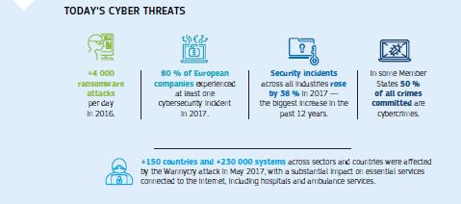

The Commission has proposed the creation of a [European Cybersecurity Industrial, Technology and Research Competence Centre and a Network](https://ec.europa.eu/digital-single-market/en/european-cybersecurity-industrial-technology-and-research-competence-centre) of National Coordination Centres. The aim is to help the EU maintain and develop the cybersecurity technological and industrial capacities necessary to secure its [Digital Single Market](https://ec.europa.eu/digital-single-market/digital-single-market). The network will engage in the development of new cybersecurity capabilities and broader cybersecurity competence-building in the Member States. The proposal should help the EU and Member States take a proactive, longer-term and strategic perspective to cybersecurity industrial policy.

Fighting online disinformation

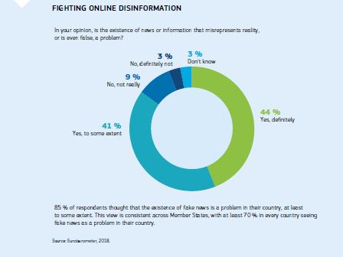

In April the Commission proposed a [first set of measures to tackle disinformation online](http://europa.eu/rapid/press-release_IP-18-3370_en.htm). This includes developing an EU-wide Code of Practice on Disinformation that was published in September, to be implemented by the signatories, among them large online platforms, ahead of the European elections in 2019. It also includes support for an independent network of fact-checkers, and promoting quality journalism and media literacy. The Facebook/Cambridge Analytica revelations demonstrated that personal data can be exploited in electoral contexts, as well as the impact it is having on the resilience of democratic processes. In September President Juncker announced [measures](http://europa.eu/rapid/press-release_IP-18-5681_en.htm) for securing free and fair elections and an EU-wide Code of Practice on [disinformation](https://ec.europa.eu/digital-single-market/en/news/factsheet-tackling-online-disinformation). The Commission then asked representatives of online platforms and advertisers to [commit](https://ec.europa.eu/digital-single-market/en/news/roadmaps-implement-code-practice-disinformation) to this code.

In December the Commission and the High Representative adopted an [Action Plan on Disinformation](https://eeas.europa.eu/headquarters/headquarters-homepage/54866/action-plan-against-disinformation_en) that builds on the April Communication and the work of the East Strategic Communication Task Force of the European External Action Service, which was established in 2015 when the European Council first recognised the threat of Russian disinformation campaigns.

The Action Plan against disinformation focuses on four key areas to effectively build up the EU-wide capabilities to tackle disinformation: (a) improved detection, analysis and exposure of disinformation; (b) stronger cooperation between the Institutions and the Members States; (c) mobilisation of the private sector to address disinformation; (d) raising awareness and empowering citizens. Also in the context of the upcoming European elections, a Rapid Alert System will be set up by March 2019 between the EU institutions and Member States.

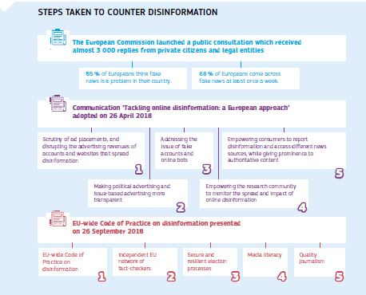

The EU’s long-term budget 2021-2027

To ensure the European Union remains at the cutting edge of [digital transformation](https://ec.europa.eu/digital-single-market/en/news/eu-budget-future-digital-transformation), the Commission has proposed a new Digital Europe programme with a budget of €9.2 billion (2021 to 2027). The programme will include funds to support five specific areas: high performance computing; artificial intelligence; cybersecurity and trust; digital skills; anddigital transformation and interoperability. The digital part of the Connecting Europe Facility will reinforce Europe’s broadband infrastructure (including 5G) to connect communities across the EU (€3 billion). Other funds, such as InvestEU and those for regional development and cohesion policy, will complement these investments in digital strategy.

Horizon Europe will fund digital research and innovation in industry (€15 billion) and other areas such as security, health, mobility, energy and the environment. Creative Europe will fund the Media Programme and additional measures to support media freedom, media pluralism and media literacy (€1.2 billion).

Chapter 3

A resilient Energy Union with a forward-looking climate change policy

‘I want to reform and reorganise Europe’s energy policy into a new European Energy Union. […] We need to strengthen the share of renewable energies on our continent. […] A binding 30 % objective for energy efficiency by 2030 is to me the minimum if we want to be credible and forward-looking. […] This is not only a matter of a responsible climate change policy. It is, at the same time, an industrial policy imperative.’

Jean-Claude Juncker, political guidelines, 15 July 2014

The EU’s vision to create a European Energy Union and place Europe at the forefront of energy efficiency, clean and renewable energy production and the fight against climate change is becoming a reality. EU climate and energy policies are accelerating public and private investment in innovation and modernisation, creating green jobs, and enabling all citizens to benefit from the transition to a modern and clean economy.

The EU has shown that the world can count on Europe for climate leadership. It is the first major economy to translate its promises under the Paris Agreement on climate change into binding laws. At the UN Climate Conference in Katowice in December, the EU played an instrumental role in making the Paris Agreement operational, with the adoption of a clear rulebook that will turn it into climate action at all levels worldwide.

With the Commission presenting its vision for a prosperous, modern, competitive and climate-neutral economy by 2050, the EU further demonstrated its commitment to ambitious climate action that goes hand in hand with economic modernisation and a better quality of life.

In 2018 the EU continued to take action to meet its commitments. It set ambitious new renewable energy and energy efficiency targets, while new [rules](https://ec.europa.eu/energy/en/topics/energy-efficiency/buildings) and sources of investment came into force to make buildings more energy efficient. A robust governance system based on national energy and climate plans was agreed, as well as new rules for making the EU’s electricity market work better. All this will underpin the Energy Union and ensure its objectives are achieved.

Good progress was made on strong rules to decarbonise and modernise the transport sector, while the agreement on synchronising the Baltic States’ electricity grid with the continental European network is a major milestone in creating a more connected and better integrated EU energy market.

A strategic vision for a climate-neutral Europe by 2050

In Europe, as elsewhere, the impact of climate change has become hard to ignore. Temperature rise in Europe is already higher than the global average. While 2018 was a particularly bad year for droughts, we have had extreme heatwaves in 4 of the last 5 years. In summer 2018 temperatures in the Arctic Circle were 5 °C higher than normal, while central Europe was so dry that the Rhine was too shallow in places for inland navigation. Adapting to our changing climate is inevitable and we need to move from a logic of progressively reducing emissions to a goal of near-zero greenhouse gas emissions.

The Intergovernmental Panel on Climate Change confirmed that urgent acceleration of global climate action is needed. The world will have to go to net zero greenhouse gas emissions by around 2070 to limit temperature increase to 1.5 °C. To show global leadership and reap the benefits of first mover advantage, the EU would have to achieve greenhouse gas neutrality by 2050, as proposed in the EU long-term strategy.

At the same time, the last 2 years have marked a watershed in Europe’s response to climate change, with intensive work at EU level to adopt climate and energy legislation to trigger a shift in our energy system towards a low-carbon economy. With the legislation in place, the EU is focused on taking the necessary steps to safeguard everyone’s future.

Responding to the invitations from the European Parliament and the European Council, in November 2018 the Commission proposed a strategic long-term vision for a prosperous, modern, competitive and climate neutral economy by 2050: [A Clean Planet for All](https://ec.europa.eu/clima/news/commission-calls-climate-neutral-europe-2050_en).

The strategy aimed to set the direction of travel of EU climate and energy policy and to frame what the EU considers as its long-term contribution to the aims of the Paris climate agreement to keep the temperature increase to well below 2 °C and pursue efforts to keep it under 1.5 °C. The EU will do this by investing in realistic technological solutions, empowering citizens and aligning action in key areas such as industrial policy, finance, or research, while ensuring social fairness for a just transition so that no European is left behind. With this plan, the EU aims to become the world’s first major economy to go climate neutral by 2050.

The mandate for action comes from EU citizens. According to a Eurobarometer poll published in November 2018, 93 % of European citizens believe that climate change is caused by human activity and 85 % agree that fighting climate change and using energy more efficiently can create economic growth and jobs in Europe.

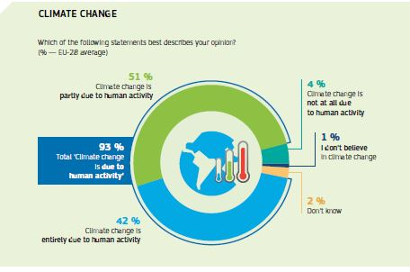

In preparing its vision, the Commission brought together a wide range of stakeholders and held a [public consultation](https://ec.europa.eu/info/news/public-consultation-strategy-long-term-eu-greenhouse-gas-emissions-reduction-2018-jul-17_en) that fed into its deliberations. The adoption of the vision kicks off a broad debate involving decision makers, stakeholders and citizens on how the EU can contribute to the long-term goals of the Paris Agreement and how the required transformation can be achieved.

In December 2018 the European Council invited Member States to work on the Commission’s strategy in order to provide guidance on the overall direction and political priorities in the first semester of 2019. This would enable the European Union to submit a long-term strategy by 2020 in line with the Paris Agreement.

Working internationally on global climate action

Shortly after the adoption of the long-term strategy, and 3 years after the Paris Agreement, the EU went to the [UN Climate Conference (COP24)](https://ec.europa.eu/clima/news/un-climate-talks-eu-plays-instrumental-role-making-paris-agreement-operational_en) in Katowice, Poland, in December with two main objectives. Firstly, to complete a robust and comprehensive rulebook for making the Paris Agreement operational, and second, to take stock of collective progress towards its long-term goals.

Discussions in Katowice concluded with the adoption of a clear rulebook to make the Paris Agreement work in practice across the world, with the EU playing an instrumental role in the outcome. It worked with allies from both developed and developing countries, showing that multilateralism and international cooperation are the most effective way to tackle this global challenge.

The rulebook will enable the parties to the Paris Agreement to implement, track and progressively enhance their contributions to tackling climate change, in order to meet the Agreement’s long-term goals.

Governments and stakeholders at COP24 also took stock of progress in view of the temperature goals of the Paris Agreement and considered how to promote more ambitious climate action now and in their next round of national climate commitments. This is expected to create a positive political momentum and trigger a global conversation around long-term strategies and the need to accelerate action.

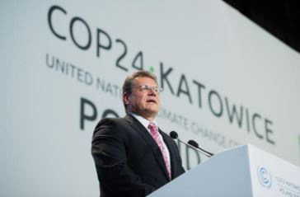

Commission Vice-President Maroš Šefčovič at COP24, Katowice, Poland, 3 December 2018.

Throughout 2018 the EU played a key role in high-level events to bolster global climate action. The EU hosted the [second Ministerial on Climate Action](https://ec.europa.eu/clima/news/commissioner-arias-cañete-co-convenes-global-ministerial-meeting-brussels_en) in Brussels together with Canada and China, bringing together representatives of 36 governments from many of the world’s largest economies. Ministers stressed the importance of multilateralism and confirmed that the Paris Agreement is irreversible and non-negotiable. The EU and China reaffirmed their commitment to climate action at the [China–EU Summit](https://ec.europa.eu/clima/news/eu-and-china-step-cooperation-climate-change-and-clean-energy_en) in July and agreed to enhance cooperation on emissions trading. The EU also stepped up cooperation on carbon markets with [California](https://ec.europa.eu/clima/news/eu-and-california-step-cooperation-carbon-markets_en) and [New Zealand](https://ec.europa.eu/clima/news/eu-and-new-zealand-strengthen-cooperation-emissions-trading-systems_en).

The EU demonstrated its global leadership by ratifying an [agreement](https://ec.europa.eu/clima/news/eu-ratifies-kigali-amendment-montreal-protocol_en) to phase-down hydrofluorocarbons, dangerous climate-warming gases commonly used in heating and cooling equipment. Global implementation of the agreement, which entered into force on 1 January 2019, will make a significant contribution to the Paris Agreement objective.

In 2018 the EU also contributed to securing two important climate deals in the shipping and aviation sectors. In April the International Maritime Organizationagreed to set a clear [greenhouse gas emission reduction objective](https://ec.europa.eu/transport/modes/maritime/news/2018-04-13-imo-agreement-co2_en) of at least 50 % by 2050, compared to 2008 levels, with a view to phasing out the greenhouse gas emissions of the sector as soon as possible this century. In June the International Civil Aviation Organizationendorsed the [standard](https://ec.europa.eu/transport/modes/air/news/2018-06-29-endorsement-icao-standard_en) for the first ever global scheme to tackle CO2 emissions in the aviation sector. The agreement sets the rules needed for airlines to monitor, report and verify their emissions from 2019.

The EU remains strongly committed to supporting climate action in developing countries. The EU, its Member States and the European Investment Bank continue to be the largest provider of public climate finance, together contributing €20.4 billion to developing countries in 2017.

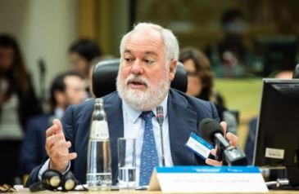

Commissioner Miguel Arias Cañete at the high-level event ‘Climate, Security and Peace: the Time for Action’, Brussels, Belgium, 22 June 2018.

Completing a modern and ambitious Energy Union

Transforming Europe’s energy systems is essential to tackling climate change. That means changing the way we produce and use energy. This is why the EU is building a low-carbon economy in which consumers will have a better choice of energy supply, access to reliable energy price comparisons and the possibility to produce and sell their own electricity.

The clean energy package

The agreement on [all legislative proposals](http://europa.eu/rapid/press-release_IP-18-6870_en.htm) in the [Clean Energy for All Europeans](https://ec.europa.eu/energy/en/news/commission-proposes-new-rules-consumer-centred-clean-energy-transition) package in 2018 puts in place a modern regulatory framework for the clean energy transition, delivering on the EU’s objective to become a global leader in renewables and to put energy efficiency first.

This includes a new energy efficiency target for the EU for 2030 of at least 32.5 %, and a new target of at least 32 % for renewables in the EU’s energy mix, with a clause for an upwards revision for both by 2023.These new targets reflect the EU’s high level of ambition, as well as the pace of change of new technologies and reduced costs through economies of scale. Together, they will deliver total greenhouse gas emission reductions of around 45 % by 2030, surpassing the EU’s commitment under the Paris Agreement to reduce emissions by at least 40 % by 2030 compared to 1990.

New European rules that entered into force in July will contribute to these goals by tapping into the huge potential for efficiency gains in the building sector, the largest single energy consumer in Europe. This will create a clear path towards a low and zero-emission building stock by 2050.

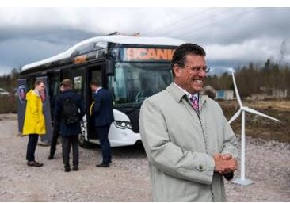

Commission Vice-President Maroš Šefčovič visits the building of a lithium-ion battery factory in Västerås, Sweden, 27 April 2018.

As well as making buildings smarter and saving money, the new rules will also create jobs in the renovation and construction sector.

Energy efficiency improvements will also help combat energy poverty by reducing bills in older buildings, which are in most urgent need of renovation. As part of its efforts to address energy poverty across EU countries, the Commission launched the [EU Energy Poverty Observatory](https://www.energypoverty.eu/) in January. It will improve the measuring, monitoring and sharing of knowledge and best practice on energy poverty.

[Legislation](https://ec.europa.eu/energy/en/new-governance-deliver-objectives-energy-union) aimed at equipping Member States and the EU to govern the Energy Union came into force in December. It will ensure that the 2030 energy and climate targets and climate adaptation goals are achieved by setting out a political process defining how EU countries and the Commission work together.

New rules for making the EU’s electricity market work better were also politically agreed in December. They will create more competition and will allow consumers to participate more actively in the market and play their part in the clean energy transition. Agreements were also reached on measures to ensure European citizens are better protected against critical electricity supply shortages, and on the strengthening of the role of the Agency for the Cooperation of Energy Regulators.

Other energy efficiency actions during 2018 included a ban on the sale of inefficient halogen light bulbs from 1 September, saving EU consumers money on their energy bills and helping to reduce greenhouse gas emissions.

Energy security and solidarity

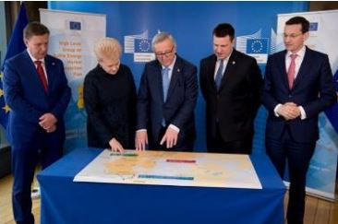

Jean-Claude Juncker, President of the European Commission (centre), receives Māris Kučinskis, Latvian Prime Minister, Dalia Grybauskaitė, President of Lithuania, Jüri Ratas, Estonian Prime Minister, and Mateusz Morawiecki, Polish Prime Minister, Brussels, Belgium, 22 March 2018.

Security of energy supply for EU consumers is an integral part of the [Energy Union Strategy](https://ec.europa.eu/energy/en/topics/energy-strategy-and-energy-union/building-energy-union). As part of the effort to strengthen security of supply in the Baltic States, the President of the Commission and the leaders of Lithuania, Latvia, Estonia and Poland [reached an agreement](http://europa.eu/rapid/press-release_IP-18-4284_en.htm) on synchronising the Baltic States’ electricity grid with the continental European network by 2025. Full integration of the Baltic States’ grids with the rest of Europe is a priority for the Energy Union and will be a major contribution to the unity and energy security of the EU.

EU citizens will get a wider range of choice and more secure supplies through competition and diversification of energy sources. Some examples of progress in this area include a joint commitment to implement the [gas interconnector between Bulgaria and Serbia](https://ec.europa.eu/info/news/eu-investment-gas-interconnection-between-bulgaria-and-serbia-enhance-energy-security-region-2018-may-17_en), which was signed in May. The gas pipeline will not only provide a new supply route to Serbia, but also to other parts of the south-east European region.

In June the Prime Ministers of Bulgaria and Greece [signed a political statement](https://ec.europa.eu/info/news/important-impetus-integration-energy-markets-south-east-europe-prime-ministers-issue-statement-support-greece-bulgaria-gas-interconnector-2018-jun-29_en) supporting the construction of a gas interconnector between the two countries. Other important projects linking Member States include the [gas interconnectors](https://ec.europa.eu/info/news/eu-invests-clean-gas-interconnections-2018-may-25_en) between Denmark and Poland and Poland and Lithuania.

European solidarity on energy was underlined at the [Lisbon Summit](https://ec.europa.eu/info/news/second-energy-interconnection-summit-lisbon-declaration-signed-2018-jul-27_en) in July when the leaders of Portugal, France and Spain agreed on steps to strengthen the integration of the Iberian Peninsula into the European energy market. The Commission is supporting the construction of the necessary infrastructure, with a record investment of €578 million for the power line crossing the Bay of Biscay, the largest [Connecting Europe Facility](https://ec.europa.eu/inea/en/connecting-europe-facility/cef-energy) investment ever awarded to an energy infrastructure project.

In May the Commission imposed [binding obligations on the Russian company Gazprom](http://europa.eu/rapid/press-release_IP-18-3921_en.htm) to enable and guarantee the free flow of gas at competitive prices in central and eastern European gas markets.

In 2018 the EU invested €48.4 million in eight electricity, gas and smart-grid infrastructure projects through the Connecting Europe [Facility](https://ec.europa.eu/inea/en/connecting-europe-facility/cef-energy/cef-energy-projects-and-actions). Over 50 % of the planned allocations for sustainable energy and transport projects for 2014-2020 (around €32 billion) have already been made to projects on the ground. The EU is actively supporting many regions in developing strategies and implementing concrete actions through the Commission’s [pilot actions](http://europa.eu/rapid/press-release_IP-17-5167_en.htm) on [regions in industrial transition](http://europa.eu/rapid/press-release_IP-17-5167_en.htm) and in the [coal and carbon intensive regions in transition initiative](https://ec.europa.eu/commission/sites/beta-political/files/support-action-coal-carbon-intensive-regions_en.pdf). The [Investment Plan for Europe](https://ec.europa.eu/commission/sites/beta-political/files/energy-sector-factsheet-297x210-july18_en.pdf) continued in 2018 to help European citizens get their energy from renewable sources, bringing the total of households helped by the Plan to 7.4 million. In December the [Commission fined Bulgarian Energy Holding](http://europa.eu/rapid/press-release_IP-18-6846_en.htm), its gas supply subsidiary Bulgargaz and its gas infrastructure subsidiary Bulgartransgaz (the BEH group) €77 million for blocking competitors’ access to key gas infrastructure in Bulgaria, in breach of EU antitrust rules.

In 2018 the EU approved six electricity capacity mechanisms in Belgium, France, Germany, Greece, Italy and Poland, designed to guarantee sufficient electricity supply in the medium and long term.

In international developments, the Commission held a series of high-level meetings in Iran, with the aim of strengthening energy cooperation between both partners. Against thechallenging background of the withdrawal of the US from theJoint Comprehensive Plan of Action on nuclear power in Iran, the Commission insisted that the lifting of sanctions was an essential part of the nuclear deal.

In July President Juncker visited US President Donald Trump at the White House, where they agreed to strengthen EU–US strategic energy cooperation. They agreed in particular to work together to increase [EU imports of liquefied natural gas](http://europa.eu/rapid/press-release_IP-18-4920_en.htm) from the United States to improve the diversification and security of energy supplies.

Decarbonising the economy

Action to reduce emissions is an investment in the prosperity and sustainability of the European economy. The EU is already on track to exceed its 2020 greenhouse gas emissions reduction target of 20 %. Emissions fell by 22 % between 1990 and 2017, while the EU economy grew by 58 % over the same period.

The legislative framework to achieve the EU’s Paris pledge is already in place. The economy-wide target for 2030 has been translated into specific targets for the EU Emissions Trading System and for the sectors outside its scope, such as transport, buildings, waste and agriculture.

In May the legislators adopted binding annual greenhouse gas emission reduction [targets](https://ec.europa.eu/clima/news/member-states-emission-reduction-targets-2021-2030-adopted_en) for EU Member States for the period from 2021 to 2030 for the non-Emissions Trading System sectors, which account for almost 60 % of the EU’s total domestic emissions. In addition, EU legislation [was adopted](https://ec.europa.eu/clima/news/regulation-land-use-land-use-change-and-forestry-2030-climate-and-energy-framework-adopted_en) to regulate emissions and absorptions from land use.

The EU Emissions Trading System has been [revised](https://ec.europa.eu/clima/policies/ets/revision_en) for the period after 2020. This reform will increase the pace of emissions cuts, continue to address the risk of carbon leakage, and help energy-intensive industrial sectors and the power sector meet the innovation and investment challenges of the transition to a low-carbon economy. Market developments since the revised legislation was adopted are seen as a sign of growing confidence in the crucial role of the carbon market in delivering on the EU’s climate ambition and are driving technological change.

In May the Commission presented the remaining [set of actions](http://europa.eu/rapid/press-release_IP-18-3708_en.htm) to modernise Europe’s transport sector (see also Chapter 4), including the first ever [CO2 emissions standards](https://ec.europa.eu/clima/policies/transport/vehicles/heavy_en) for heavy-duty vehicles. Under the proposal, average CO2 emissions from new trucks would have to be 15 % lower in 2025 than in 2019, with an indicative reduction target of at least 30 % proposed for 2030. These targets will allow transport companies — mainly SMEs — to make significant savings thanks to lower fuel consumption. In December, the European Parliament and the Council reached a political agreement on strong rules to decarbonise and modernise the light-duty vehicles sector. They provisionally agreed on new CO2 emission standards for cars and vans in the EU for the period after 2020. Emissions from new cars will have to be 37.5 % lower and from new vans 31 % lower in 2030 compared to 2021. This will accelerate the transition to clean mobility, preparing for climate neutrality in the second half of the century. It will help deliver on the EU’s commitments under the Paris Ageement, while also improving air quality for all Europeans.

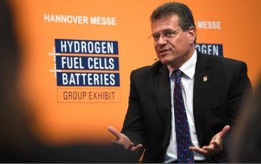

Commission Vice-President Maroš Šefčovič participating in a discussion at the Hannover Messe, Hannover, Germany, 23 April 2018.

Other measures include a comprehensive action plan for batteries that will help create a competitive and sustainable battery ‘ecosystem’ in Europe. Batteries will be as essential to the automotive industry of the 21st century as the combustion engine was in the 20th century. One year after the European Commission launched [the European Battery Alliance](https://ec.europa.eu/growth/industry/policy/european-battery-alliance_en) there has been [major progress](http://europa.eu/rapid/press-release_IP-18-6114_en.htm) in establishing battery manufacturing in Europe, with the first pilot production facilities already underway. The European Commission also proposed new tyre labelling, which could help European households save up to €125 per car per year by using the most efficient tyres to reduce fuel costs.

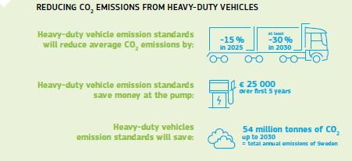

Fighting air pollution

In May 2018 the EU took decisive [action to protect citizens from air pollution](https://ec.europa.eu/commission/commissioners/2014-2019/vella/announcements/commissioner-vellas-press-conference-europe-protects-clean-air-all_en), outlining support [measures](http://ec.europa.eu/environment/air/pdf/clean_air_for_all.pdf) to help Member States meet their targets. These include stepping up cooperation with Member States through Clean Air Dialogues and using EU funding to support measures to improve air quality.

In addition, the Commission referred France, Germany, Hungary, Italy, Romania and the United Kingdom to the Court of Justice of the European Union. This was for failure to respect air quality limit values and for failing to take appropriate measures to keep exceedance periods as short as possible.

In September new [emission tests](https://ec.europa.eu/growth/content/clean-mobility-new-emissions-tests-become-mandatory-all-new-cars-1-september-2018_en) became mandatory for all new cars before they can be sold, registered and driven on European roads. The new tests will ensure more reliable emissions (results in real driving conditions) and help rebuild confidence in the performance of new cars. From January 2019, independent parties, including the Commission, will be able to perform officially recognised tests through accredited laboratories and technical services to test emission levels during a vehicle’s lifetime (see also Chapter 4).

In September the Commission opened an [in-depth investigation](http://europa.eu/rapid/press-release_IP-18-5822_en.htm) to assess whether BMW, Daimler and VW (Volkswagen, Audi, Porsche) colluded, in breach of EU antitrust rules, to avoid competition on the development and roll-out of technology to clean the emissions of petrol and diesel passenger cars.

In 2018 the Commission approved a number of support measures accompanying the move towards low-emission transport. These State aid schemes, notified by Germany and Portugal, concerned support for the purchase of low-emission vehicles, construction of the necessary charging infrastructure and the retrofitting of older diesel buses.

Adapting to the impacts of climate change

In addition to measures to cut emissions, the EU continued to take action to prepare for and adapt to the inevitable impacts of climate change. Today, 25 Member States have an Adaptation Strategy, and climate adaptation has been integrated into EU funding instruments and into initiatives such as the Covenant of Mayors on Climate and Energy, which celebrated its 10th anniversary in 2018. The [report](https://ec.europa.eu/clima/news/europe-ready-climate-impacts-commission-evaluates-its-strategy_en) on the implementation of the EU Adaptation Strategy published in November, highlights these and other successes but also outlines actions needed to reduce Europe’s vulnerability to climate impacts within and outside its borders.

Sustainable finance

[](https://europa.eu/!Nj43hg)

Making our money work for the planet — investing sustainably.

Around €180 billion of additional investments a year would be needed to achieve the EU’s 2030 climate and energy objectives. Based on the recommendations of the High-Level Expert Group on sustainable finance, the Commission launched an [Action Plan On Sustainable Finance](http://europa.eu/rapid/press-release_IP-18-1404_en.htm) and followed up with legislative proposals in May 2018. A proposed amendment to create a new category of benchmarks comprising low-carbon and positive carbon impact benchmarks, and a proposal for a regulation on disclosures relating to sustainable investments and sustainability risks are advancing in the legislative process. The Commission has also proposed to gradually create a unified classification system (‘taxonomy’) on what can be considered an environmentally sustainable economic activity. Once adopted, these rules will give financial market operators a strong incentive to invest in a more sustainable way and ensure transparency so that institutional as well as retail investors are in a position to make informed choices for their investments.

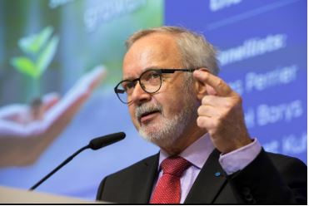

Werner Hoyer, President of the European Investment Bank, speaking at the High-Level Conference on Financing Sustainable Growth, Brussels, Belgium, 22 March 2018.

Another important development came in October, when the Commission and Breakthrough Energy, led by Bill Gates, [launched a new €100 million investment fund](http://europa.eu/rapid/press-release_IP-18-6125_en.htm), Breakthrough Energy Europe, to help innovative European companies develop and bring new clean energy technologies to the market. In addition, the European Commission approved an [investment package of €243 million from the EU budget](https://ec.europa.eu/clima/news/life-programme-member-states-benefit-quarter-billion-euros-investments-environment-nature-and_en) for projects under the LIFE Programme supporting nature, the environment and quality of life, in Europe’s transition to a more sustainable and low-carbon future.

The EU’s long-term budget 2021-2027

To help achieve the EU’s climate goals, the Commission has proposed that at least 25 % of the next long-term EU budget (2021-2027) should contribute to climate objectives. It proposes to strengthen the LIFE Programme, one of the spearheads of EU environmental and climate funding, with a 60 % increasein funding.

In the field of energy, [€8.7 billion](http://europa.eu/rapid/press-release_IP-18-4029_en.htm) would support investments in European energy infrastructure networks over the 7-year period to help complete a sustainable and climate-resilient Energy Union and support the clean energy transition. A further €6.07 billion would be allocated to the international project to construct and operate an experimental facility for testing the viability of fusion as a clean and sustainable source of energy. In addition, the Commission [proposes](http://europa.eu/rapid/press-release_IP-18-3985_en.htm) to increase the EU’s ambitions on environmental care and climate action with 40 % of the common agricultural policy’s overall budget expected to contribute to climate action.

Investing in breakthrough technologies is a prerequisite for reaching the EU’s climate targets. Under the revised [EU Emission Trading System Directive](https://eur-lex.europa.eu/legal-content/EN/TXT/?uri=uriserv:OJ.L_.2018.076.01.0003.01.ENG), an Innovation Fund will work in synergy with Horizon Europe, InvestEU and the other EU programmes under the long-term budget. On top of the EU budget, a Modernisation Fund will provide additional funding for 10 Member States in central and eastern Europe for the modernisation and decarbonisation of their energy systems. In the proposal for a new LIFE Programme, the European Commission proposed €5.45 billion for projects supporting the environment and climate action, an increase of €1.95 billion.

The future long-term budget of the EU

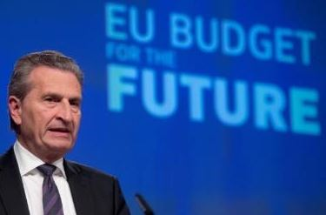

Commissioner Günther Oettinger talks at an event on the long-term budget plans of the European Commission, 2 May 2018.

In May 2018 the European Commission presented its proposal for the future long-term budget of the EU, covering the 2021-2027 period. This proposal is the result of an open and inclusive process that has received inputs from the European Parliament, the Member States, beneficiaries of EU funding and other stakeholders. It aims to focus on the current and future challenges facing the EU, and to provide the resources for a Europe that protects, empowers and defends.

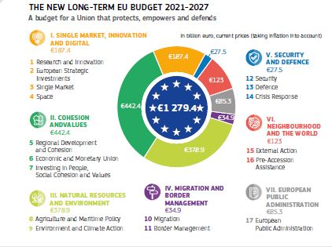

The proposed budget amounts to €1 135 billion in commitments (in 2018 prices) over 7 years, equivalent to 1.11 % of the EU-27’s gross national income. The proposed legislative package also modernises and simplifies the current overall financing system of the EU budget, simplifying some existing elements, like the Value Added Tax-based own resource, and introducing a basket of new own resources linked to the EU’s political priorities.

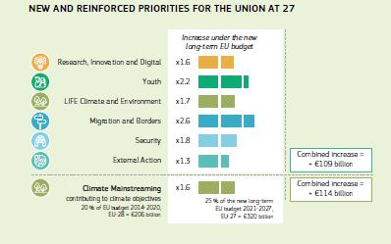

The proposal focuses on areas where the EU budget can make the biggest difference by providing European added value. In particular, it increases the current level of funding for key areas where a coordinated approach can deliver more effectively than a national one: research and innovation, digital transformation, young people, security and external borders management, and EU external action. In order to bridge the gap in the EU budget left by the United Kingdom’s withdrawal from the EU, savings and improved efficiency are also put forward in the new proposal. While moderate cuts are inevitable, the common agricultural policy and the cohesion policy will be modernised to ensure that they can deliver with less and contribute to the new priorities.

The proposed long-term budget also takes significant steps to simplify EU funding procedures, allowing potential beneficiaries to access available opportunities more easily. The Commission has proposed to:

— reduce the number of programmes to 37, down from 58 under the current framework;

— simplify the rules for EU funding, cutting red tape and making it easier to submit an application;

— add synergies and complementarity of funding, in order to avoid duplications; and

— build on the existing flexibility instruments and crisis management tools to make the EU budget more responsive in a fast-changing world.

The new proposal also introduces a strengthened link between EU funding and the rule of law, which is an essential precondition for sound financial management. A new proposed mechanism will allow the European Union to suspend, reduce or restrict access to EU funding in a manner proportionate to the nature, gravity and scope of the rule of law deficiencies.

Following the Commission’s proposal, the Member States in the European Council will discuss and decide on the future long-term budget of the EU with the consent of the European Parliament. A timely approval will be important to provide for a seamless transition between the current and the next long-term budget, ensuring predictability and stability.

Chapter 4

A deeper and fairer internal market with a strengthened industrial base

‘Our internal market is Europe’s best asset in times of increasing globalisation. I therefore want the next Commission to build on the strength of our Single Market and to fully exploit its potential in all its dimensions.’

Jean-Claude Juncker, political guidelines, 15 July 2014

In 2018 we celebrated 25 years of the internal market, also known as the Single Market. It is one of the largest markets in the world, where people, goods, services and money can move freely.

Thanks to the Single Market, Europeans can in principle buy what they want, where they want and benefit from greater choice and lower prices. European businesses — big and small — can expand their customer base and trade products and services more easily across the EU.

Citizens have seen the end of roaming charges, gained a full set of passenger rights and enjoy greater consumer protection on and offline. We live in a fairer and more social Europe where people can expect better living and working standards. However, more remains to be done in this area.

Efforts to improve the functioning of the Single Market continue on a daily basis — from creating a Single EU Value Added Tax area and combating tax evasion and fraud to ensuring the cars we drive are safer and cleaner.

Developments in 2018 include important milestones towards a fair internal market with the adoption of new rules on equal pay for equal work in the same place and to ensure professionals can provide their services across the Union more easily. The EU also agreed to create a Single Digital Gateway to make it easier for citizens and businesses to manage their paperwork online.

The Customs Union, which celebrated its 50th anniversary in July, continues to be a cornerstone of the Single Market. It keeps EU borders safe and protects citizens from prohibited and dangerous goods while safeguarding the financial interests of the EU and supporting a smooth flow of legitimate trade.

Making the Single Market work better for people and businesses

In 2018 the EU continued to remove barriers to the free movement of goods and services, and shared best practices to support the development of the retail sector.

In November 2018 the Commission [adopted a Communication](http://europa.eu/rapid/press-release_IP-18-6490_en.htm) that presented a fresh assessment of the situation in the Single Market and called on Member States to renew their political commitment to it. To exploit its full potential in the digital era and ensure the sustainable growth of our economy, the Single Market needs to function properly and evolve in a rapidly changing world. Today, however, deeper integration requires more political courage than 25 years ago and greater efforts to close the gap between rhetoric and delivery. The Communication highlights three main areas where further efforts are needed to deepen and strengthen the Single Market. Firstly, the Commission calls on Member States to be vigilant in implementing, applying and enforcing EU rules and to refrain from erecting new barriers. Secondly, it calls on the European Parliament and the Council to adopt all the legislation that has been proposed to ensure the proper functioning of the Single Market. Thirdly, it highlights the significant potential for further economic integration in the areas of services, products, taxation and network industries, which will require political courage and determination.

The Commission also presented Communications on the [EU Investment Plan](http://europa.eu/rapid/press-release_IP-18-6484_en.htm) and on [European harmonised standards](http://europa.eu/rapid/press-release_IP-18-6491_en.htm). These demonstrate how the Commission’s initiatives contribute to improving people’s daily lives, help businesses to thrive, maintain Europe as an attractive investment destination and boost Europe’s values, standing and influence in the world.

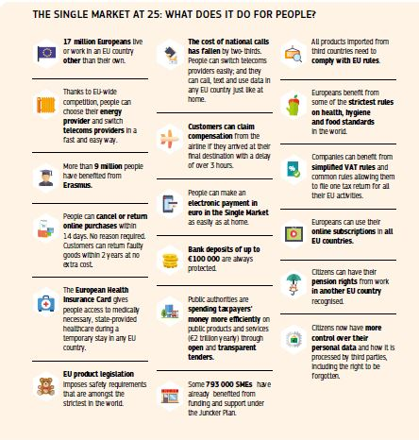

The EU agreed new [rules](https://eur-lex.europa.eu/eli/dir/2018/958/oj) to ensure that national regulations do not create unnecessary obstacles to the free movement of professionals across the EU. This will help the 50 million people, or 22 % of the European labour force, who work in regulated professions that require specific qualifications, such as engineers, lawyers and architects. From 2020, EU Member States will have to thoroughly assess the costs and benefits of planned legislation by carrying out a test to ensure they are proportionate and justified*.*

The [European Professional Card](https://europa.eu/youreurope/citizens/work/professional-qualifications/european-professional-card/index_en.htm), which has been available since January 2016, is making it easier for qualified professionals to provide services across the EU. The 2018 [evaluation](https://ec.europa.eu/growth/content/digital-procedures-driving-eu-single-market_en) shows that the card, which currently covers general care nurses, pharmacists, physiotherapists, real estate agents and mountain guides, is providing added value compared to traditional recognition processes.

The EU also looked at restrictions in the retail sector, which employs almost 9 % of Europe’s workforce in over 3.6 million companies. With the rapid development of e-commerce and multi-channel retailing, the sector is undergoing a dramatic transformation. In April the Commissionpublished a set of [best practices](http://europa.eu/rapid/press-release_IP-18-3377_en.htm) to create a more open, integrated and competitive retail sector, including new approaches to revitalise city centres. The Commission encouraged Member States to make sure current regulations are non-discriminatory, justified and proportionate. A [guide](https://publications.europa.eu/en/publication-detail/-/publication/d606c517-4445-11e8-a9f4-01aa75ed71a1/language-en) to revitalising and modernising the small retail sector gives practical suggestions on how to meet the challenges of the future.

To improve fairness in the food supply chain and strengthen the position of farmers and small businesses, the Commission [proposed](http://europa.eu/rapid/press-release_IP-18-2702_en.htm) to ban the most damaging unfair trade practices.

In December the European Parliament, the Council and the Commission reached a [political agreement](http://europa.eu/rapid/press-release_IP-18-6790_en.htm) on a new set of rules that will ensure protection of 100 % of EU farmers and of most smaller and medium-sized agri-food companies against practices contrary to good faith and fair dealing.

To ensure that Single Market rules are being properly applied, the Commission also initiated a number of infringement procedures against Member States, including in the area of recognition of professional qualifications, public procurement and the retail sector.

Towards fair labour mobility and safer working conditions

[](https://europa.eu/!Ww67Hn)

Celebrating 50 years of free movement and 60 years of social security coordination in the EU.

In 2018 we celebrated the 50th anniversary of the founding regulations on freedom of movement for workers. Today, some 17 million Europeans live or work in a different EU country, almost twice as many as 10 years ago.

The Commission has proposed the creation of a [European Labour Authority](https://eur-lex.europa.eu/legal-content/EN/TXT/?qid=1532427961822&uri=CELEX:52018PC0131) to inform citizens and businesses about opportunities to live, work or operate in another EU country, to strengthen cooperation between EU countries to enforce the rules fairly and effectively and to mediate solutions in cases of cross-border disputes. This new body should be established in 2019, and complements the proposal to improve the rules that coordinate social security systems, which have been protecting citizens for 60 years. Both proposals are being negotiated in the European Parliament and the Council.

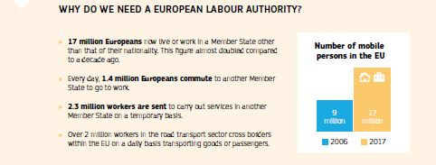

Striking a balance between free movement of services and equal treatment of workers is at the heart of [new rules](https://eur-lex.europa.eu/legal-content/EN/TXT/?qid=1532427470248&uri=CELEX:32018L0957) to protect the rights of those who are sent by their employer to work temporarily in another Member State. This will ensure equal pay for equal work in the same place, creating a level playing field between foreign and local companies in the host country.

The digital single gateway: a one-stop shop for online paperwork

In 2018 the [Regulation](https://eur-lex.europa.eu/legal-content/EN/TXT/?uri=uriserv:OJ.L_.2018.295.01.0001.01.ENG&toc=OJ:L:2018:295:TOC) to create a single digital gateway was adopted to make it easier for people and companies in the EU to manage their paperwork online. In the future, any administrative procedure currently available online for users in one EU country will be accessible to users from other EU Member States in an EU language that is understandable for cross-border users. Twenty-one key procedures, including requests for a birth certificate or to register a car, will be available online. The system will also reduce cross-border red tape by introducing the ‘once-only’ principle, requiring authorities to reuse information already provided by citizens and businesses and could save companies over €11 billion.

A strong and innovative industrial base

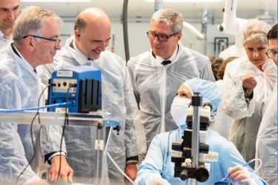

Commissioner Pierre Moscovici (second from left) on a tour of the CERTEM microelectronics research centre in Tours, France, 15 May 2018.

A strong and competitive industrial base is crucial for the future of Europe’s economy. The EU’s renewed industrial policy strategy aims to empower European industry and European citizens to reap the opportunities of industrial transformation, digitalisation and decarbonisation.

The 2018 EU Industry Day showed that Europe is in a good starting position. The EU once more demonstrated its leadership in the transition to clean and sustainable energy with the launch of the first [Clean Energy Industrial Forum](https://ec.europa.eu/energy/en/events/clean-energy-industrial-forum-renewables), which centred around three industry-led initiatives on [batteries, renewables and construction](https://ec.europa.eu/info/events/eu-industry-day_en).

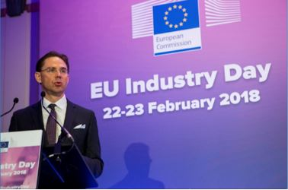

Commission Vice-President Jyrki Katainen speaking at the Second European Industry Day in Brussels, Belgium, 22 February 2018.

The EU launched the €10 million [Prize on Innovative batteries for eVehicles](https://ec.europa.eu/research/eic/index.cfm?pg=prizes_batteries) and hosted the first meeting of Industry 2030 — a group of 20 experts who will help shape the vision for the future of European industry with recommendations in summer 2019.

The EU’s innovation performance continues to improve, but the 2018 [European Innovation Scoreboard](https://ec.europa.eu/growth/industry/innovation/facts-figures/scoreboards_en) showed further efforts are needed to ensure Europe’s global competitiveness. There was a positive trend in the majority of EU countries — most notably in Malta, the Netherlands and Spain, with Sweden remaining the EU innovation leader. The EU is catching up with key competitors such as Canada, Japan and the United States. But closing this innovation gap and maintaining the lead over China will require a concerted effort to exploit Europe’s innovation potential.

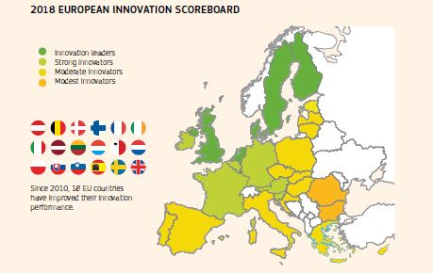

Europe needs to seize opportunities arising from the rapid development of technologies. As well as supporting the modernisation of EU industry with initiatives such as [measures on artificial intelligence](http://europa.eu/rapid/press-release_IP-18-3362_en.htm) and a strategy on [connected and automated driving](http://europa.eu/rapid/attachment/IP-18-3708/en/Factsheet%20Connected%20and%20Automated%20Mobility%20%20For%20a%20competitive%20Europe.pdf), the EU also evaluated existing rules on machinery and liability are fit for purpose. This showed that they are fit for emerging digital technologies and innovative products.

Taxation made simpler and more fraud-proof

A smooth-functioning Single Market needs fair and efficient tax rules. With this in mind, the Commission has presented 22 proposals in the area of tax since November 2014.

In May 2018, EU Finance Ministers adopted [rules](http://europa.eu/rapid/press-release_IP-18-1841_en.htm) aimed at boosting transparency to prevent aggressive cross-border tax planning. From July 2020, tax intermediaries such as tax advisors, accountants, banks and lawyers who provide their clients with complex cross-border financial schemes that could help avoid tax will be obliged to report these structures to their tax authorities.

The Commission is undertaking the most far-reaching VAT reform for a quarter of a century. In October 2017 it proposed the main principles for the creation of a single EU VAT area to help shut down the estimated €50 billion in cross-border VAT fraud currently affecting national budgets annually in EU Member States. In May 2018 the Commission presented the [detailed technical measures](http://europa.eu/rapid/press-release_IP-18-3834_en.htm) in view of implementing the main principles for the taxation of trade between EU countries.

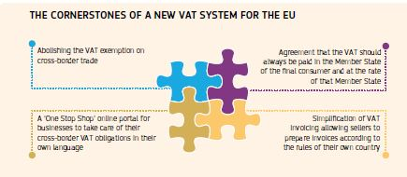

In October the Commission welcomed the adoption by EU countries of new tools to close loopholes in the EU’s VAT system. With entry into force in November 2018, EU countries will be able to exchange more information and cooperate more closely in the fight against criminal organisations.

Celebrating 50 years of the Customs Union

2018 marked the 50th anniversary of the Customs Union. The EU’s Single Market, which allows any business established in the EU to sell its goods and invest throughout the EU without any internal borders, would be impossible without the tariff-free environment provided by the Customs Union.

The role and responsibilities of Member States’ customs authorities have grown over the last 50 years. In July, following the First Biennial Report on Progress in Developing the EU Customs Union and its Governance, EU Member States signed the [Charter of the Customs Administrations of the EU](https://ec.europa.eu/taxation_customs/charter_en). This confirms the principles of protecting society, facilitating trade and acting as one, for now and the future.

Better financial services

Under current rules, there is no difference for euro area residents or businesses if they carry out euro transactions in their own country or with another euro area Member State. The EU wants Europeans in non-euro area countries to have the same conditions when making [cross-border payments](https://ec.europa.eu/info/business-economy-euro/banking-and-finance/consumer-finance-and-payments/payment-services/single-euro-payments-area-sepa_en#rules-on-charges-for-cross-border-payments-in-euro) in the euro area. In December the European Parliament, the Council and the Commission reached a political agreement on the [proposal](http://europa.eu/rapid/press-release_IP-18-2423_en.htm), which will mean cheap euro transfers everywhere in the EU and fairer currency conversions for consumers.

The May proposal on new [EU rules on motor insurance](http://europa.eu/rapid/press-release_IP-18-3731_en.htm) aims to better protect victims of car accidents and improve the rights of insurance policyholders. The new rules will ensure that victims of car accidents receive the full compensation they are due, even if the insurer is insolvent.

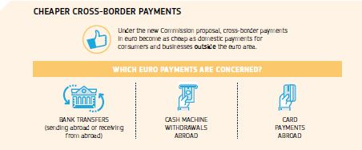

Greater consumer protection on insurance products

EU consumers have greater clarity with the entry into application of [new rules](https://ec.europa.eu/info/business-economy-euro/banking-and-finance/insurance-and-pensions/insurance-distribution_en) on the distribution of insurance products in October. This will strengthen consumer protection by reinforcing the rules on the way insurance products are sold. The enhanced rules are expected to benefit policyholders, as well as insurance companies and providers.

Ensuring a level playing field in the Single Market

The Commission’s job as a competition authority in the area of merger control is to make sure that people in the EU are not denied the benefits of competition, such as lower prices, greater consumer choice and greater product innovation.

In 2018 the Commission approved [Bayer’s acquisition of Monsanto](http://europa.eu/rapid/press-release_IP-18-2282_en.htm), subject to conditions. The parties agreed to resolve all the identified competition concerns, in particular the consequences this merger would have for innovation in the future, with an extensive package of remedies including divesting the relevant research and development assets.

The Commission also actively pursues and heavily fines cartels. Under the Commission’s leniency programme, companies can provide insider evidence in return for fines reductions. In 2018, the Commission fined [eight producers of capacitors](http://europa.eu/rapid/press-release_IP-18-2281_en.htm) (used in smart phones and other appliances) €254 million for participating, together with an immunity applicant, in a cartel. The Commission also [fined](http://europa.eu/rapid/press-release_IP-18-962_en.htm) four maritime car carriers €395 million and, in three separate cartel settlements, fined car parts suppliers €151 million.

The role of EU State aid control is to ensure that EU countries do not give selected companies better tax treatment than others. In June the Commission found that [Luxembourg allowed two Engie group companies](http://europa.eu/rapid/press-release_IP-18-4228_en.htm) to avoid paying taxes on almost all their profits. Luxembourg must now recover around €120 million in unpaid tax. In October the Commission concluded that Slovakia’s €125 million [investment aid to Jaguar Land Rover](http://europa.eu/rapid/press-release_IP-18-6023_en.htm) is in line with EU State aid rules. The aid will contribute to the development of the region of Nitra, without unduly distorting competition in the Single Market.

In December the Commission approved €1.75 billion of State aid for the support of €6 billion of private-sector investment in research, development and innovation in the area of microelectronics, which is one of the Key Enabling Technologies for the European economy. This Important Project of Common European Interest will be carried out by about 30 companies in four Member States in collaboration with research organisations and universities, with important spillover effects on other companies throughout the EU.

In December the Commission established that Gibraltar’s corporate tax exemption regime for interest and royalties, as well as five tax rulings, are illegal under EU State aid rules. The beneficiaries now have to return unpaid taxes of around €100 million to Gibraltar.

Towards safe, clean and connected mobility

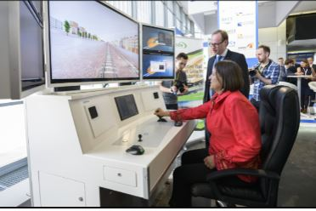

Commissioner Violeta Bulc participates in the TEN-T Days conference on European mobility, connectivity and transport in Ljubljana, Slovenia, 26 April 2018.

The EU is moving towards clean and sustainable mobility to protect our health and environment and boost the competitiveness of EU industry.

In 2018 the EU finalised the overhaul of the process to ensure car manufacturers comply strictly with all EU safety, environmental and production requirements. The reform was [proposed](http://europa.eu/rapid/press-release_IP-16-167_en.htm) in the wake of the ‘Dieselgate’ scandal and complements the EU’s wider work for a clean, sustainable and competitive car sector. The [new rules](https://eur-lex.europa.eu/legal-content/EN/TXT/?uri=uriserv%3AOJ.L_.2018.151.01.0001.01.ENG), which will apply from 2020, will significantly raise the quality level and independence of vehicle testing, increase checks on cars that are already on the EU market, and strengthen the overall system with European oversight.

As part of the ‘Europe on the Move’ initiative, the EU put forward the final [set of measures](http://europa.eu/rapid/press-release_IP-18-3708_en.htm) aimed at modernising Europe’s transport system to allow all Europeans to benefit from safer traffic, less polluting vehicles and more advanced technological solutions.

The reform of [vehicle safety rules](http://europa.eu/rapid/attachment/IP-18-3708/en/Factsheet%20Safe%20Mobility%20%20A%20Europe%20that%20protects.pdf)vehicle safety rules foresees that all new vehicle models placed on the market will be required to have the latest advanced safety technology, such as emergency braking and intelligent speed assistance. This goes hand in hand with efforts to make road infrastructure safer. These proposals are now under final consideration by Member States and the European Parliament.

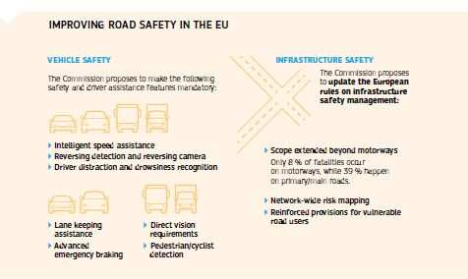

The risks posed by unsafe road infrastructure will also be systematically addressed, including the risks to vulnerable road users like cyclists and pedestrians. The proposals will help Member States in their efforts to improve road safety, and in particular help those with poorer road safety performance to catch up with better performers.

Moving towards [connected and automated cars](http://europa.eu/rapid/attachment/IP-18-3708/en/Factsheet%20Connected%20and%20Automated%20Mobility%20%20For%20a%20competitive%20Europe.pdf) can make mobility safer, cleaner, more inclusive and more efficient. The 2018 strategy aims to ensure that key technologies and infrastructures are developed in the EU and that they are safe.

Ending seasonal time changes

In response to the request by the European Parliament and the concerns of a growing number of citizens and Member States, the Commission launched a [public consultation on summertime arrangements](https://ec.europa.eu/info/consultations/2018-summertime-arrangements_en) in July. Approximately 4.6 million responses were received, the highest number ever for a public consultation. This found that 84 % of respondents were in favour of ending seasonal clock changes. The original reason why Member States introduced these arrangements in the 1970s (mainly to save energy) have become much less relevant as new techniques to reduce energy consumption have become available.

The existing EU legislation harmonised the rules on time changes across all Member States, in order to prevent disruption of the Single Market. With the same objective in mind, the Commission presented a proposal in September to end seasonal clock changes. This called on Member States to make their choices as regards their standard time (which falls under national competence) in a coordinated way, regardless of whether they want their future permanent standard time to coincide with their present summertime or remain unchanged (current ‘winter time’). This proposal is now with the Council and the European Parliament.

Protecting intellectual property rights and fighting counterfeiting

In a world where EU companies are increasingly competing on innovation, creativity and quality, protecting intellectual rights is a powerful tool for growing the competitiveness of all companies, including small and medium-sized enterprises.

To help Europe’s pharmaceutical companies tap into fast-growing global markets and promote jobs, growth and investments in the EU, the Commission [proposed an adjustment](http://europa.eu/rapid/press-release_IP-18-3907_en.htm) to intellectual property rules to make EU-based pharmaceutical companies more competitive in global markets.

The advertising sector joined forces to fight counterfeiting and piracy by signing [a voluntary agreement](https://ec.europa.eu/growth/industry/intellectual-property/enforcement/memorandum-of-understanding-online-advertising-ipr_en) to reduce the advertisement revenues of websites and mobile apps infringing copyright or disseminating counterfeits.

New EU rules protecting [trade secrets](https://ec.europa.eu/growth/industry/intellectual-property/trade-secrets_en) came into force in June. The changes will discourage unfair competition and encourage collaborative innovation and the sharing of valuable know-how to make the EU a stronger and more competitive economic region.

Modern and sustainable public procurement

Every year, over 250 000 public authorities in the EU spend around €2 trillion — 14 % of EU gross domestic product – on the purchase of services, works and supplies. In 2018, the Commission followed up on its [strategy](http://europa.eu/rapid/press-release_IP-17-3543_en.htm) to get better value for taxpayers’ money and contribute to a more innovative, sustainable, inclusive and competitive economy. It published [guidance](https://ec.europa.eu/docsroom/documents/29261) to encourage public buyers to use procurement as a tool to stimulate innovation and shared a [recommendation](http://eur-lex.europa.eu/legal-content/EN/TXT/?uri=uriserv:OJ.L_.2018.102.01.0087.01.ENG&toc=OJ:L:2018:102:TOC) for national authorities to support SMEs and make it easier for them to take part in defence procurement contracts. Separate [guidance](http://ec.europa.eu/regional_policy/en/information/publications/guidelines/2018/public-procurement-guidance-for-practitioners-2018) helps to avoid the most common errors in projects co-financed by the European Structural and Investment Funds.

The EU’s long-term budget 2021-2027

In June 2018 the Commission proposed a new dedicated €4 billion [programme](http://europa.eu/rapid/press-release_IP-18-4049_en.htm) to empower and protect consumers and enable Europe’s small and medium-sized enterprises to take full advantage of a well-functioning Single Market. The new programme will strengthen the governance of the Single Market, support business competitiveness and promote human, animal and plant health and animal welfare.

Chapter 5

A deeper and fairer Economic and Monetary Union

‘Over the next five years, I want to continue with the reform of our Economic and Monetary Union to preserve the stability of our single currency and to enhance the convergence of economic, fiscal and labour market policies between the Member States that share the single currency.’

Jean-Claude Juncker, political guidelines, 15 July 2014

On 1 January 2019 Europe celebrated the 20th anniversary of the euro. Since its launch, the euro has been the second most used reserve currency in the world. Today, 60 countries link their currencies to the euro in one way or another. And soon the euro area will represent 85 % of the overall gross domestic product of the entire European Union.

Despite the difficulties of recent years, public support for the euro and Economic and Monetary Union in Europe remains at a record high.

The EU has taken important steps towards a deeper and fairer Economic and Monetary Union and towards completed Banking and Capital Markets Unions.

Financial stability has been considerably reinforced in the euro area and throughout the EU since the outbreak of the financial crises. Today, banks are much better capitalised. The ratio of non-performing loans has almost halved since 2014 and are approaching pre-crisis levels. Still, to harness the full potential of the euro, more needs to be done.

At the Euro Summit in December, EU leaders took further steps to deepen the EMU by backing plans for a common backstop to the Single Resolution Fund, endorsing reform of the European Stability Mechanism. They also called for the development of a budgetary instrument to support economic convergence and competitiveness in the euro area and future euro area Member States, based on the proposals made by the Commission in the context of the next long-term budget.

Also in December, the Commission presented ideas for the strengthening of the international role of the euro in an increasingly complex and multi-polar world and to better reflect Europe’s economic, political and financial weight.

Completing the Banking Union

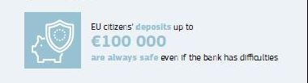

The completion of the [Banking Union](https://ec.europa.eu/info/business-economy-euro/banking-and-finance/banking-union_en) is a major step in deepening the EU’s Economic and Monetary Union. Since 2014, risk reduction has continued at a sustained pace in the EU financial sector and should pave the way for further risk-sharing through a [European Deposit Insurance Scheme](https://ec.europa.eu/info/business-economy-euro/banking-and-finance/banking-union/european-deposit-insurance-scheme_en). The European Commission proposed in 2015 a euro area-wide scheme to complement existing national deposit guarantee schemes. EU legislation already ensures that all deposits up to €100 000 are protected in case of a bank failure. Through a single fund, the scheme would provide a stronger and more uniform degree of insurance cover in the euro area.

In regard to the backstop to the Single Resolution Fund for the Banking Union, EU leaders agreed on its modalities in December. The backstop will be provided by the European Stability Mechanism and reinforces confidence in the EU banking system. It will be activated as a last-resort insurance in the event of major bank resolution cases.

Banking sector risks have been significantly reduced in the EU in recent years. Banks under the supervision of the European Central Bank have raised €234 billion of additional capital since 2014 and have much larger liquidity buffers. New rules were agreed in December 2018, further strengthening banks’ resilience and the possibility for banks to exit the market without costs for taxpayers.

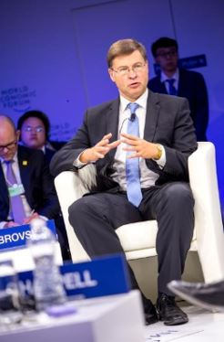

Commission Vice-President Valdis Dombrovskis at the Summer Davos Conference, Tianjin, China, 19 September 2018.

In addition, the proportion of non-performing loans — where a borrower is unable or unwilling to repay a bank loan — has decreased significantly, including in Member States where this was particularly high. In November an EU-wide stress test of the European banking sector coordinated by the European Banking Authority showed that Europe’s banks had become more resilient to macroeconomic shocks. The test covered 48 of Europe’s largest banks, including 33 directly supervised by the European Central Bank accounting for about 70 % of euro area banking assets.

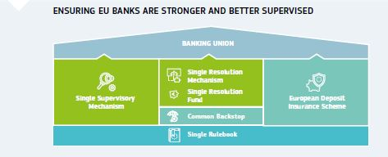

In March 2018, the Commission presented legislation to address the remaining stocks of non-performing loans and prevent their possible build-up in the future, and on the creation of an enabling framework for Sovereign Bond-Backed Securities, allowing for wider diversification of banks’ portfolios of sovereign bonds. Progress was made on the proposals regarding non-performing loans with agreement being found on one key element in particular: ensuring sufficient loss coverage by banks for future non-performing loans. Work is still ongoing on two other elements: enabling accelerated out-of-court enforcement of loans secured by collateral, and further developing secondary markets for non-performing loans where banks can sell such loans to credit servicers and investors.

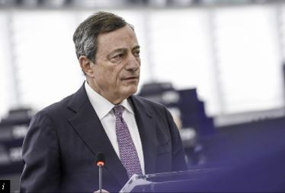

Mario Draghi, President of the European Central Bank, discussing the European Central Bank Annual Report for 2016 at the plenary session of the European Parliament, Strasbourg, France, 5 February 2018.

Member States’ progress towards adoption of the euro

May saw the release of the European Commission’s biannual assessment of certain Member States’ readiness to adopt the euro as their currency. The [Convergence Report](http://europa.eu/rapid/press-release_MEMO-18-3827_en.htm)forms the basis for the Council of the European Union’s decision on whether a Member State fulfils the conditions for joining the euro area. The report, which is issued in parallel with a separate assessment conducted by the European Central Bank, covers the seven Member States that are committed to adopting the euro but have not yet done so, namely Bulgaria, Czechia, Croatia, Hungary, Poland, Romania and Sweden.

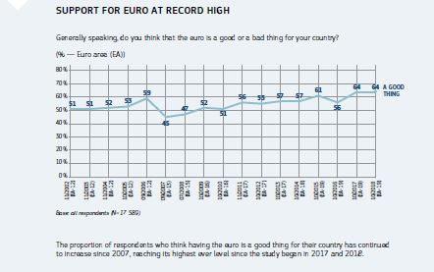

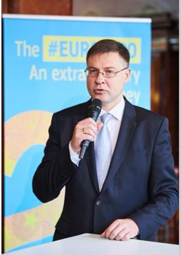

Commission Vice-President Valdis Dombrovskis at an event to celebrate the first 20 years of the euro, Brussels, Belgium, 3 December 2018.

While all seven Member States generally display considerable nominal convergence, the report found that none of them currently meet all the formal conditions for participating in the common currency. While Bulgaria and Croatia fulfil all of the convergence criteria, except for the exchange rate criterion, the report found that only Croatia’s legislation was fully compatible with the rules of the Economic and Monetary Union.

The review of other factors found that the non-euro area Member States are generally well integrated economically and financially in the EU. However, some still experience macroeconomic vulnerabilities and/or face challenges related to their business environment and institutional framework which may pose risks to the sustainability of the convergence process.

The Commission is committed to support Member States that are preparing for joining the euro area. Through a dedicated work stream in its Structural Reform Support Programme, upon request the Commission will provide targeted support to Member States who wish to adopt the euro. Achieving convergence and building robust economic structures is crucial for the prosperity of the EU as a whole and the smooth functioning of the euro.

Greater social fairness in the Economic and Monetary Union

The [European Pillar of Social Rights](https://ec.europa.eu/commission/priorities/deeper-and-fairer-economic-and-monetary-union/european-pillar-social-rights_en) sets out essential principles for well-functioning and fair labour markets and welfare systems. While a strong focus on employment and social performance is particularly important to increase the resilience and deepen Economic and Monetary Union, delivering the European Pillar of Social Rights is a shared political commitment and responsibility at Union level and at Member State level within their respective competence.

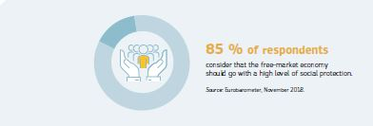

A strong social dimension is an essential part of Economic and Monetary Union. The European Pillar of Social Rights was jointly proclaimed by the European Parliament, the Council and the Commission in November 2017. It serves as a compass for tackling new social challenges to ensure modern, inclusive and competitive societies.

While today’s more flexible working arrangements provide new job opportunities, especially for young people, they can give rise to economic uncertainty and inequalities. In line with the principles of the Pillar of Social Rights, the Commission wants to make sure that all people have a fair chance of pursuing a full working life, enjoy decent working conditions, and have sufficient social protection, regardless of the type of employment contract they have.

Alongside the proposal for the actual Pillar, in 2017 and 2018 the European Commission proposed specific initiatives to put it into practice.

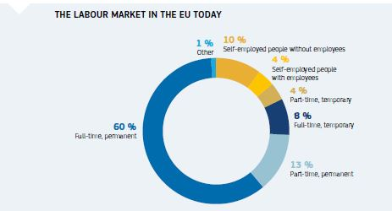

For instance, in March the Commission proposed a [Social Fairness Package](http://europa.eu/rapid/press-release_IP-18-1624_en.htm) which includes proposals for a European Labour Authority to ensure that EU rules on fair labour mobility are enforced in a fair, simple and effective way (see also Chapter 4).

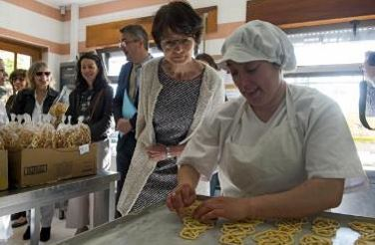

Commissioner Marianne Thyssen during a visit to Aveiro, Portugal at the Social Action Centre of the Municipality of Ílhavo (CASCI), an EU-funded project that offers social assistance and job opportunities to people at risk of social exclusion, including people with disabilities, 26 April 2018.

The Social Fairness Package also included a proposal for [a Council Recommendation on access to social protection for workers and the self-employed](https://eur-lex.europa.eu/legal-content/EN/ALL/?uri=COM:2018:132:FIN). Ministers concluded a political agreement on this proposal in December. The Recommendation aims to support people in non-standard forms of employment and self-employment who, due to their employment status, are not sufficiently covered by social security schemes and are therefore exposed to higher economic uncertainty.

The Recommendation covers social security schemes for unemployment, sickness and healthcare, maternity/paternity leave, accidents at work and occupational diseases, invalidity, and old age. The goal is to encourage EU countries to ensure that all non-standard workers and the self-employed can join and contribute to social security schemes, closing formal coverage gaps. It also aims to allow them to build up and take up adequate social benefits as members of a scheme and increase transparency regarding social security systems and rights.

Balancing work and family life

The Commission put forward a [proposal for a new directive on work–life balance for parents and carers](http://europa.eu/rapid/press-release_IP-17-1006_en.htm) in 2017. As one of the key deliverables of the European Pillar of Social Rights, this initiative sets a number of new or higher minimum standards for paternity, parental and carer’s leave and flexible working arrangements. Negotiations between the European Parliament and Council are ongoing. They reached a provisional agreement in December.

Transparent and predictable working conditions

In June 2018, Member States reached an agreement on the Commission’s [proposal for a directive on transparent and predictable working conditions](http://europa.eu/rapid/press-release_IP-17-5285_en.htm). The proposal aims to ensure that in a modern and flexible labour market, all workers in the EU are fully informed in writing on the basic conditions of their employment relationship, and sets out new rights for all workers, including those in non-standard forms of employment. Negotiations between the European Parliament and the Council were ongoing at the end of 2018.

Tackling employment and social challenges

The European Pillar of Social Rights played a guiding role in the 2018 cycle of economic policy coordination, known as the European Semester. As a result, there was an even greater emphasis on employment and social challenges in the recommendations issued to Member States. A new social scoreboard was put forward in the draft Joint Employment Report. It tracks trends and performances across EU countries in three areas related to the Pillar’s 20 principles: equal opportunities and access to labour market; fair working conditions; and social protection and inclusion.

Against the background of a positive economic outlook, the 2018 country-specific recommendations seek to promote a forward-looking approach, focusing on building the basis for sustainable, inclusive and long-term growth. Engagement at all levels, including with social partners and civil society, will be crucial to achieve this goal. The recommendations were adopted by the Council in July.

Supporting reforms in Member States

While Europe’s economy has strengthened and is on a steady growth path, further structural reforms are needed to make our economies more stable, inclusive, productive and resilient.

To support these reform efforts, in 2015, the Commission created the Structural Reform Support Service, which helps Member States prepare, design and implement reforms. The support is given purely on demand and is tailor-made for the Member State.

Demand for the service has far outstripped expectation. To date, the Service has engaged, through the Structural Reform Support Programme and other sources, in almost 500 technical support projects in 25 EU Member States. This means, for example, assisting Member States in reforming education and healthcare systems, modernising public financial management, reforming tax administrations, increasing the efficiency of public administrations and judicial systems, developing digital economy, creating business-friendly environments and improving access to finance.

For example, the Ministry of Justice in Croatia received support in its efforts to improve the country’s court management to underpin an effective judicial system and respect for the rule of law. The Commission is also supporting Slovakia in its efforts to make the health system more effective and efficient, and Latvia in implementing its mid-term tax strategy. Support has also been provided to Bulgaria to help create a more business-friendly environment and to the Baltic states to help improve the functioning of capital markets in the region.

With growing demand from Member States, in December 2017 the Commission proposed to increase the funding of the Structural Reform Support Programme. The proposal was approved by the European Parliament and the Council in 2018, bringing the total budget of the Programme to €222.8 million up to 2020. This will enable the EU to respond to the high demand for support from Member States.

Fair competition

Over the last decade, EU State aid control in the banking sector has made a vital contribution to restoring the health of the EU banking sector by requiring banks to restructure and clean up their balance sheets as a condition to receiving State support. The Commission also helped to tackle remaining legacy problems at EU banks.

In Cyprus, the Commission approved State aid to finance the orderly market exit of Cyprus Cooperative Bank, including the sale of some parts to Hellenic Bank and the removal of €6 billion of non-performing loans. This was coupled with binding commitments by Cyprus to reform the judicial framework, helping to tackle non-performing loan issues going forward and to reduce costs for taxpayers. In Italy, as part of its restructuring plan, Banca Monte dei Paschi successfully disposed of €24.6 billion in bad loans via the aid-free Italian guarantee scheme ‘GACS’, set up in 2016. From January to September 2018, nine more market-conform GACS transactions took place, removing in total a further €14.4 billion in bad loans from the Italian banking system.

The Commission also positively concluded an investigation into the aid that Nova Ljubljanska Banka in Slovenia received in 2013 by accepting measures proposed by Slovenia ensuring that it will become a viable player in Slovenia’s banking market.

In 2018 the Commission approved the sale of HSH Nordbank in Germany to private investors without any further aid. Indeed, most of the banks that were supported by taxpayers during the crisis in the interest of financial stability are now exiting their State aid procedure and have become attractive again for private market participants.

State aid control in the banking sector will continue its independent role in ensuring a fair and competitive financial sector, in close coordination with the bank resolution framework of the Banking Union.

Strengthening the international role of the euro

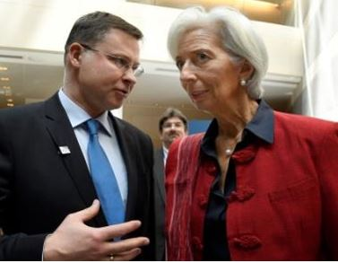

Commission Vice-President Valdis Dombrovskis and Christine Lagarde, Managing Director of the International Monetary Fund, at the Spring Meetings of the World Bank and IMF, Washington, USA, 21 April 2018.

In his State of the Union address in September, European Commission President Jean-Claude Juncker announced plans to introduce further initiatives to strengthen the international role of the euro. The Commission’s proposals, announced in December, are part of Europe’s commitment to an open, multilateral and rules-based global economy and have the potential to bring tangible benefits to European citizens and businesses, including lower trading costs, more choice, better access to financing, greater autonomy and a more resilient global financial system. The core of the proposals revolves around initiatives to enhance the attractiveness of the euro as a global currency by improving the resilience of Europe’s economy and the depth, liquidity and efficiency of its financial markets, notably by completing the Capital Markets Union. The proposals also call for greater use of the euro in strategic sectors such as energy, raw materials and transport, and for a more unified representation of the euro area in the international arena.

The EU’s long-term budget 2021-2027

In May 2018 the European Commission put forward two proposals that demonstrate how the EU’s next long-term budget (2021-2027) could contribute to stability, convergence and cohesion in the euro area and the EU while boosting economic performance and resilience.

The proposed Reform Support Programme will support priority reforms in all EU Member States, with an overall budget of €25 billion. It comprises three elements: a Reform Delivery Tool, to provide financial support for reforms, a Technical Support Instrument, to offer and share technical expertise; and a Convergence Facility, to help Member States on their way to joining the euro. The Programme would enable the EU to respond to the high demand from Member States for support in preparing, designing and implementing growth-enhancing reforms.

The proposal for a European Investment Stabilisation Function will help stabilise public investment levels and facilitate rapid economic recovery in cases of significant economic shocks in Member States of the euro area and those participating in the European Exchange Rate Mechanism.