

Chapter 6

A balanced and progressive trade policy to harness globalisation

‘European trade policy means making the most of opportunities with like-minded partners across the world. It also means working to improve and shape the global rules-based system so that it continues to deliver peace, prosperity and progress.’

Jean-Claude Juncker, Keynote speech ‘Transatlantic relations at a crossroads’, 25 July 2018

The EU reaffirmed its position as a trade power in 2018, continuing to be one of the world’s most open economies and pursuing an ambitious trade negotiations agenda which aims to open markets and create a level playing field for EU firms around the globe. The EU has concluded trade agreements with 71 countries around the world, accounting for 40 % of the world’s gross domestic product. The European economy depends on trade: every €1 billion in exports supports 14 000 jobs in Europe. Openness combined with high standards remains the best way to make globalisation work for all Europeans.

With 36 million EU jobs depending on exports, 80 % of imports used as input for EU goods or services, and 90 % of global growth in the coming decades expected to come from outside the EU, open trade is more important than ever for the EU.

The EU is committed to a rules-based multilateral trading system as the basis for prosperity. It continues to play a leading role in the World Trade Organization and has proposed ideas for reforming it. When others break international trade rules or engage in unfair trading practices, the EU defends European businesses, workers and citizens.

In 2018, the EU defended its interests in the face of protectionist tendencies and growing barriers to trade. Stronger and more effective trade defence rules came into force. The EU also began the process of setting up a new framework for screening strategic investments from outside the EU.

The EU reached a new agreement on trade with Mexico, signed a trade deal with Japan, and continued talks with Mercosur. The EU also made good progress in other trade negotiations, including with Chile, and launched talks for trade agreements with Australia and New Zealand.

A balanced and progressive trade policy

In recent years, international trade has faced mounting challenges, with renewed doubts about the effects of globalisation, questions about the purpose and value of trade agreements, and resurging protectionism. In response, the EU redoubled its efforts to defend the rules-based system of international trade underpinned by the World Trade Organization in 2018, working closely with trading partners with a view to modernising international trade rules.

The EU continued to play a leading role in the World Trade Organization. It reiterated its strong commitment to the organisation and its continued support for finding solutions to important issues in the global multilateral trading system. In September 2018, the EU put forward a concept paper on the reform of the organisation. It highlighted the need to update the rulebook on subsidies and forced technology transfers, which are at the heart of growing trade tensions, as well as to improve transparency in the organisation. It also stressed the need to unblock the appointments of Appellate Body members so that the organisation’s system for resolving conflicts is upheld.

Trade policy must also be effective, transparent and based on values. The fundamentals of the [2015 Trade For All Strategy](http://ec.europa.eu/trade/policy/in-focus/new-trade-strategy/) continued to guide the approach taken in 2018: openness combined with high standards remains the most appropriate way to make globalisation work for all Europeans.

The EU continued its efforts to negotiate new trade deals, update existing agreements and to ensure that business, workers and consumers can reap the benefits of trade agreements.

Progress was also made on legislation for the EU’s proposed framework to screen foreign direct investment on grounds of security and public order. This aims to ensure that foreign investment remains a major source of growth in the EU while simultaneously protecting the EU’s essential interests. In November the Council and the European Parliament reached a political agreement on the final shape of the framework. The Parliament is to vote on the agreement in February 2019 and the Council is due to adopt the Regulation soon after. The Regulation is expected to enter into force in April 2019.

Through its Market Access Strategy, the EU tackles market access barriers around the globe, while remaining committed to balanced, rules-based and responsible trade.

A Europe that protects

Europe is an open continent, but not a naïve one. The EU stands up for its values and interests. Its trade policy robustly defends European businesses and workers when others break global trade rules or engage in unfair trading practices.

When diplomatic interventions fail, the EU does not hesitate to use the World Trade Organization’s dispute settlement mechanism to enforce its rights and get the full benefits of membership for European businesses, workers and farmers. In 2018 the EU launched procedures against China relating to technology transfer, and against the United States on its measures on imports of steel and aluminium. Dispute procedures bring results: in 2018 Russia stopped imposing anti-dumping duties on light commercial vehicles from Germany and Italy.

In line with World Trade Organization rules and EU legislation, the EU opened 10 new investigations into, and imposed seven new trade defence measures against, unfair trade practices. Among the measures it imposed were anti-dumping duties on steel from China so that its export price reflected a fair market value. The EU also opened 17 new review investigations and renewed seven existing measures for another 5 years.

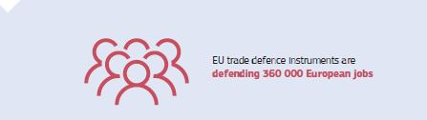

In July the EU imposed provisional safeguard measures on imports of 23 categories of steel products. Those measures aim at addressing the potential trade diversion of steel from other countries to the EU arising from additional tariffs imposed by the United States.

The EU also protects EU industries when third countries open trade defence investigations (anti-dumping, countervailing or safeguard investigations) against EU exports. Examples include the proceedings launched by the United States (steel and aluminium, solar panels, olives), Turkey (tyres) or Israel (cocoa spread).

In June 2018 the EU’s modernised anti-dumping and anti-subsidy legislation entered into force. Along with the December 2017 changes to the rules on the calculation of the dumping margin where state intervention distorts prices and costs, this modernised legislation is the first major revamp of the EU’s trade defence instruments since the establishment of the WTO in 1994. The new regulations adapt the EU’s trade defence instruments to the challenges of the global economy. They are more effective, more transparent and easier for companies to use, and enable the EU to impose higher duties on dumped products.

Patents are essential to the EU economy and international trade as incentives for innovation, while access to standards is important for technological development. The relationship between patents and standards is a priority to the EU. In October, the EU set up a group of 15 experts on Standard Essential Patents. These patents are part of standardised technology and the group provides the European Commission with expertise and advice on how to improve their licencing. It held its first meeting on 12 November.

European exporters continue to face barriers to trade around the world. In June the European Commission’s Annual Report on Trade and Investment Barriers showed that in 2017, European exporters faced 396 barriers in over 57 countries, a big rise on 2016. The report showed that the European Commission’s Market Access Strategy had removed 45 obstacles affecting EU exports worth €8.2 billion — more than twice the number removed in 2016.

The EU continues to take a clear stand on goods used for capital punishment and torture. In September the Alliance for Torture-Free Trade, which the EU co-launched in 2017, met at the United Nations General Assembly. Delegations from a further six countries, including Australia and New Zealand, joined the Alliance and members agreed to take measures to restrict and stop trade in goods used for capital punishment and torture and to work towards a binding United Nations resolution.

A Europe that takes the lead

The trade agreements that the EU has negotiated or is negotiating aim to ensure that trade works for everyone. These agreements help the EU to export Europe’s high standards for food safety, workers’ rights, the environment and consumer rights far beyond Europe’s borders.

The EU played a leading role in United Nations discussions on reforming how investors can settle disputes with countries. In 2018 the EU pursued its efforts to establish a multilateral court for settling such disputes, a major innovation in global governance.

In June EU Trade Commissioner Cecilia Malmström presented the Belgian city of Ghent with the first EU Fair and Ethical Trade City Award, which recognises local initiatives to encourage fair and ethical trading practices.

The EU–Mexico Trade Agreement

In April the EU and Mexico concluded the negotiations on a new trade deal. Almost all trade in goods between the EU and Mexico will be duty-free, including agricultural products. Simpler customs procedures will benefit EU industry and agriculture.

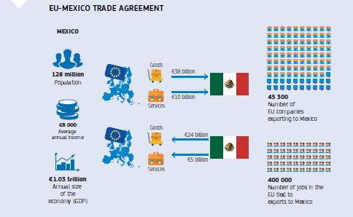

The agreement sets the highest standards of labour, safety, environmental and consumer protection. It refers explicitly to the precautionary principle, which allows policymakers to act to protect human, animal or plant health, or the environment, in the face of a perceived risk and at a level they consider appropriate, even when scientific analysis is not conclusive.

The agreement includes a commitment to implement the Paris climate agreement. It also safeguards EU Member States’ right to organise public services how they want.

It is the first EU trade agreement to tackle corruption, such as bribery and money laundering, in the private and public sectors.

The agreement places European and Mexican firms on an equal footing when bidding for government contracts in each other’s public procurement markets. The new deal also protects intellectual property rights and prevents copies of 340 traditional EU regional food and drink products from being sold in Mexico.

The agreement opens up trade in services, such as financial services, transport, e-commerce, and telecommunications, and ambitious competition and subsidy provisions will help level the playing field and boost market access.

The trade deal also improves investment conditions and includes the EU’s new investment court system, ensuring transparency and governments’ right to regulate in the public interest. The EU and Mexico agreed to work towards setting up a Multilateral Investment Court.

The Economic Partnership Agreement with Japan

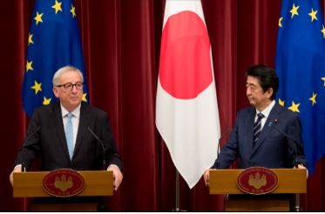

Jean-Claude Juncker, President of the European Commission, attends the EU–Japan summit alongside Shinzō Abe, Prime Minister of Japan, in Tokyo, Japan, 17 July 2018.

At the EU–Japan summit in Tokyo in July, Commission President Jean-Claude Juncker, Council President Donald Tusk and Japanese Prime Minister Shinzō Abe signed the EU–Japan Economic Partnership Agreement, the largest and most important bilateral trade deal ever concluded by the EU.

Japan and the EU share a strong commitment to democracy, the protection of human rights, free and open trade, multilateralism and a rules-based international order. Japan is a long-standing strategic partner of the EU and an important ally on the international scene.

When it enters into force on 1 February 2019, the Economic Partnership Agreement will create an open trading zone covering 635 million people and almost one third of the world’s total gross domestic product. It will remove trade barriers and contribute to the EU and Japan jointly shaping global trade rules.

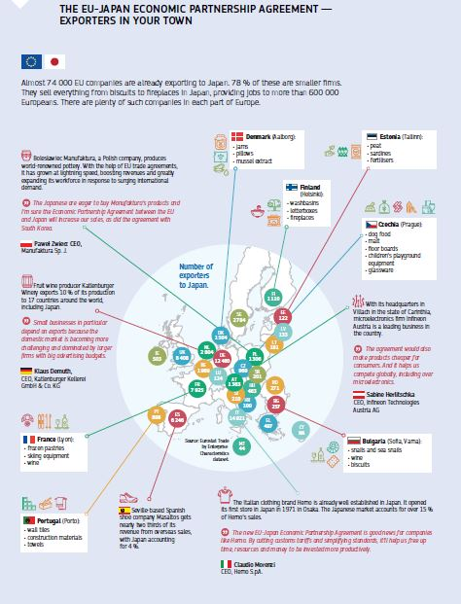

The Agreement will remove nearly all the €1 billion in duties paid every year by EU companies exporting to Japan as well as a number of long-standing regulatory barriers, for example on EU car exports. It will increase EU exports and create [new opportunities for European companies](http://trade.ec.europa.eu/doclib/docs/2017/july/tradoc_155694.pdf) to the benefit of citizens. It will expand opportunities, namely for key EU agricultural exports, and protect the name of more than 200 traditional food and drink products in the Japanese market. The Agreement will make it easier for EU firms to provide services in Japan. Provisions on competition and subsidies will help level the playing field. The Agreement also includes a chapter on small and medium-sized enterprises. It provides for contact points and targeted information for smaller businesses, which is particularly relevant since four out of five current exporters to Japan are small firms.

The Agreement sets the highest standards of labour, safety, environmental and consumer protection, and fully safeguards public services. It has a dedicated chapter on sustainable development and is the first EU trade agreement to include a specific commitment to comply with the Paris Agreement on climate change.

In 2018, the EU continued negotiations with Japan on investment protection standards and dispute resolution, holding three meetings.

The Comprehensive Economic and Trade Agreement with Canada

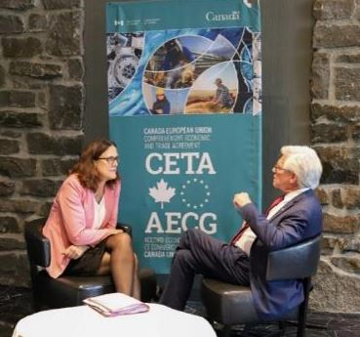

Commissioner Cecilia Malmström meets with Jim Carr, Canadian Minister of International Trade Diversification, on the first anniversary of the Comprehensive Economic and Trade Agreement, Montreal, Canada, 26 September 2018.

On 21 September 2018 the provisional application of the EU’s [Comprehensive Economic and Trade Agreement](http://ec.europa.eu/trade/policy/in-focus/ceta/) with Canada celebrated its first anniversary.

The trade deal has the potential to save EU businesses over €500 million a year previously paid in Canadian tariffs on their exports. Almost 99 % of these savings started from day one.

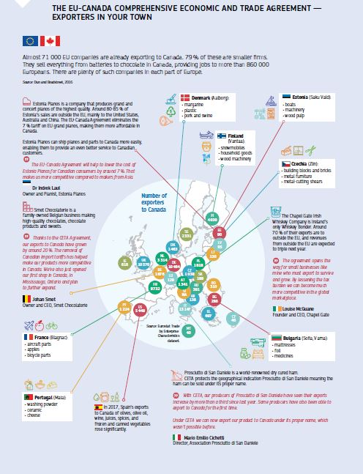

All businesses can save time and money thanks to easier procedures. EU consumers can also benefit from wider choice and lower prices.

A transparent and inclusive negotiating process

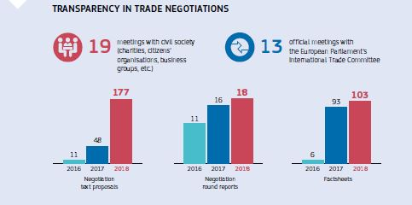

Transparency and engagement with the public remained essential ingredients in trade policy in 2018 to ensure democracy, public trust and accountability. This must exist before, during and after negotiations, as well as when agreements are implemented.

The European Commission continued to publish reports of negotiating rounds, position papers and proposals for texts in trade agreements under negotiation. It also published extensive additional material on the EU’s trade agreement with Mexico. In 2018, the European Commission published its second comprehensive Annual Report assessing the implementation of the EU’s trade agreements. This enabled stakeholders, civil society and other EU institutions to scrutinise how the EU is implementing the agreements. It also provides lessons for ongoing and future trade negotiations.

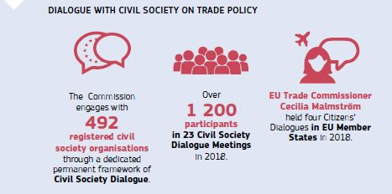

In February the new advisory group on EU trade negotiations held its first of six meetings. Composed of 28 organisations representing businesses, trade unions, consumers and environmental bodies, the group aims to foster dialogue and gather views from a wide range of stakeholders.

United States

The focus with the United States has been on addressing issues of common interest. In June, the US imposed tariffs on EU steel and aluminium exports. The EU considered them unjustified and illegal and had no option but to introduce rebalancing measures on US exports. Meeting in July, European Commission President Jean-Claude Juncker and US President Donald Trump agreed to establish an Executive Working Group to facilitate trade and develop a positive transatlantic trade agenda. The Group aims to identify ways to intensify regulatory cooperation, eliminate tariffs on industrial goods (apart from vehicles), facilitate trade in soybeans, increase trade in liquefied natural gas to reinforce energy security, and reform the World Trade Organization.

Four political-level meetings have been held since the Group was set up, with discussions focusing on regulatory issues. There have already been positive results. On liquefied natural gas, EU firms have signed several long-term contracts with US companies and new EU infrastructure and terminal projects are underway. The US has agreed to relax its licensing requirement for exporting liquefied natural gas to the EU. On soybeans, US exporters have roughly doubled their share on the EU market. While this work continues, both sides agreed not to introduce new tariffs on their trade.

China

The EU had a successful summit with China in 2018. It also held three rounds of talks for an investment agreement with China; the first market access offers were exchanged in the margins of the Summit. Two rounds of negotiations took place on an agreement to protect the names of traditional food and drink products. China has agreed to work with the EU on reform of the World Trade Organization to help the organisation meet its current challenges.

Other negotiations

The EU has trade agreements with 70 partners covering 40 % of the world’s gross domestic product. With a view to opening up new markets for European exports, the EU launched new trade negotiations and made good progress in ongoing talks.

Southern and eastern neighbourhood

In the southern neighbourhood, trade ministers and representatives from 43 Union for the Mediterranean countries met in March for the first time since 2010 to give a new impetus to the regional trade and investment agenda. They endorsed action plans on enhanced cooperation in a range of sectors and on the fight against piracy and counterfeiting.

Progress towards a Deep and Comprehensive Free Trade Area with Tunisia was achieved with two rounds of negotiations in 2018.

In June, the European Commission and the Gulf Cooperation Council held the second meeting of the EU–GCC Trade and Investment Dialogue.

In the eastern neighbourhood, the EU concentrated on implementing its agreements for deep and comprehensive free trade areas with Georgia, Moldova and Ukraine.

Latin America

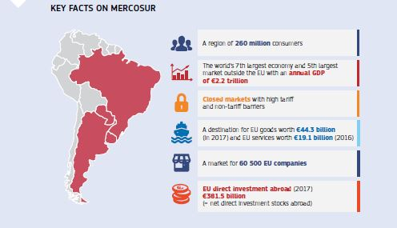

Talks with Mercosur (Argentina, Brazil, Paraguay and Uruguay) continued in 2018. The negotiations aim to integrate two important regional markets, cut tariffs, increase business opportunities in the Mercosur region, widen consumer choice, cut red tape, boost growth and competitiveness, promote shared values like sustainable development and create jobs.

The EU held three rounds of negotiations with Chile to update the 2002 EU–Chile Trade Agreement. The EU has proposed including pilot provisions on trade and gender.

In April the EU concluded negotiations to modernise its trade agreement with Mexico.

Asia and Australasia

On 19 October the EU signed trade and investment agreements with Singapore. In October the Commission sent the trade and investment agreements negotiated with Vietnam to the Council for its approval and to the European Parliament for its consent. The EU held three rounds of trade talks with Indonesia. The negotiations aim to increase trade and direct investment between the EU and Indonesia. The objective is to reach an agreement similar to those agreed with Singapore and with Vietnam.



Commissioner Karmenu Vella meets with Siti Nurbaya Bakar, Indonesia’s Minister of Environment and Forestry, at the 8th EU–Indonesia Business Dialogue in Jakarta, Indonesia, 25 October 2018.

In June the EU launched negotiations for trade agreements with Australia and New Zealand.

In 2018 the EU held two rounds of talks with each country and the EU published proposals covering 18 negotiating areas.

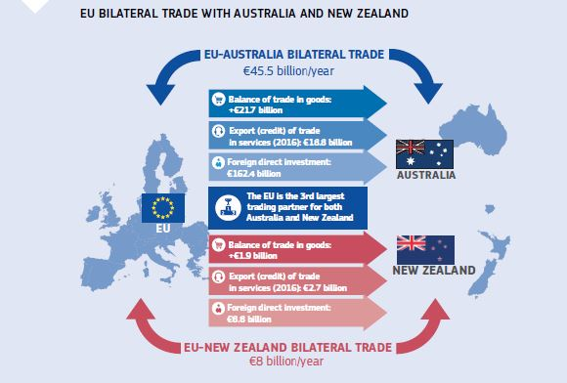

Africa, Caribbean and Pacific countries

In August, Gambia became the 14th West African country to sign the region-to-region Economic Partnership Agreement with the EU. In September, Mauritania became the 15th (with only Nigeria’s signature still missing). On 6 December, the Council approved Samoa’s accession to the Economic Partnership Agreement with Pacific countries. Economic Partnership Agreements are trade and development agreements negotiated between the EU and African, Caribbean and Pacific countries and regions. They are currently being put into practice with some 30 African, Caribbean and Pacific countries. These agreements can be seen as building blocks towards a future continent-to-continent free trade area, one of the aims of the new Africa–Europe Alliance for Sustainable Investment and Jobs, which also supports African efforts towards a continental free trade area.

The Year in Pictures

|  |  |
| --- | --- |
| 01 | Council President Donald Tusk, Commission President Jean-Claude Juncker and Bulgarian Prime Minister Boyko Borissov attend the opening ceremony for the Bulgarian Council Presidency, Sofia, Bulgaria, 11 January 2018. |
| The European Year of Cultural Heritage was launched on 31 January 2018. The campaign poster used to promote the Year features the diversity and varied forms of cultural heritage that exist throughout Europe. | 02 |
| 03 | The EU-28 Heads of State or Government gathered for the Spring European Council Roundtable, focusing on economic affairs, including trade and taxation, Brussels, Belgium, 22 March 2018. |
| A poster for one of the five short films commissioned for the EU and Me campaign, directed by famous European film-makers, on the various rights people enjoy in the EU. The campaign won Gold at the Cannes Lions Festival. The campaign was launched on 9 May 2018. | 04 |
| 05 | The launch event of the #PassOnPlastic Pledge featured Plasticus, a plastic whale made from the same amount of plastic that ends up in the ocean every second, Brussels, Belgium, 15 May 2018. |
| French President Emmanuel Macron, UK Prime Minister Theresa May and German Chancellor Angela Merkel take a walk across the Lovers’ Bridge during the EU–Western Balkans Summit, Sofia, Bulgaria, 17 May 2018. | 06 |
| 07 | A minute of silence is held for Nicole Fontaine, former President of the European Parliament (1999 to 2002), following her death in May, Strasbourg, France, 28 May 2018. |
| Council President Donald Tusk, UK Prime Minister Theresa May, German Chancellor Angela Merkel, US President Donald Trump, Canadian Prime Minister Justin Trudeau, French President Emmanuel Macron, Japanese Prime Minister Shinzō Abe, Italian Prime Minister Giuseppe Conte and Commission President Jean-Claude Juncker attend the G7 Summit in Quebec, Canada, 8 June 2018. | 08 |
| 09 | Simone Veil, former MEP and first female President of the European Parliament, received French national honours and was interred in the Panthéon, only the fifth woman to receive this honour, Paris, France, 1 July 2018. |
| Unemployment in the EU fell to its lowest level since 2008, while the EU employment rate reached its highest ever peak according to Eurostat statistics released on 2 July 2018. | 10 |
| 11 | Commission President Jean-Claude Juncker and Chinese Premier Li Keqiang at the EU–China Summit, Beijing, China, 16 July 2018. |
| Council President Donald Tusk, Japanese Prime Minister Shinzō Abe and Commission President Jean-Claude Juncker attend the EU–Japan Summit following the signing of a landmark EU–Japan Free Trade Agreement, Tokyo, Japan, 17 July 2018. | 12 |
| 13 | A man connects his electric car to a public charging pole, part of the City-zen smart city project in Amsterdam, the Netherlands, which received funding from the EU’s Horizon 2020 programme. This funding forms part of President Juncker’s Investment Plan for Europe, which surpassed its original €315 billion target for investment on 18 July 2018. |
| European cheeses on sale in Wellington, New Zealand. The EU and New Zealand launched talks for a comprehensive and ambitious trade agreement on 21 July 2018. | 14 |
| 15 | Danish firefighters coordinate their response to Swedish wildfires during summer 2018, as part of the EU’s Civil Protection Mechanism, which pools resources for Member States in times of need, Kårböle, Sweden, 22 July 2018. |
| The Galileo satellite launch in Kourou, French Guiana, propelled the EU’s Space Programme to new heights. Over 10 % of the EU’s gross domestic product is already dependent on space-related services, 25 July 2018. | 16 |
| 17 | Commission President Jean-Claude Juncker and US President Donald Trump attend a press conference following their meeting on the road to reducing tariffs and other trade barriers between the EU and the United States, Washington, United States, 25 July 2018. |
| New €100 and €200 banknotes featuring updated security features were unveiled by the European Central Bank — strengthening the anti-counterfeiting capabilities of the euro and completing the Europa series of banknotes, Frankfurt, Germany, 17 September 2018. | 18 |
| 19-2 | Austrian Chancellor Sebastian Kurz, Council President Donald Tusk and Commission President Jean-Claude Juncker at the podium during an informal meeting of EU Heads of State or Government to discuss internal security and migration, Salzburg, Austria, 20 September 2018. |
| Commission President Jean-Claude Juncker takes part in the 1 000th Citizens’ Dialogue, Freiburg, Germany, 1 October 2018. | 20 |
| 21 | The Commission’s Chief Negotiator for the withdrawal of the United Kingdom from the EU, Michel Barnier and UK Prime Minister, Theresa May meet for negotiations on the UK’s departure from the European Union, Brussels, Belgium, 18 October 2018. |
| Unveiling ceremony of the portrait of the murdered journalist Daphne Caruana Galizia, in the presence of Parliament President Antonio Tajani and family members of Ms Caruana Galizia, Strasbourg, France, 23 October 2018. | 22 |
| 23 | The #EUprotects campaign was launched on 25 October 2018. It showcases everyday heroes from across Europe and beyond under the common slogan ‘Together we protect’. |
| 25 | Géraldine Maitreyi Gupta is one of tens of thousands of young Europeans to have volunteered for the European Solidarity Corps. The Corps received the ‘Innovation in Politics’ Prize for ‘Civilisation’, awarded by the Innovation in Politics Institute in Vienna, Austria, on 17 November 2018. |
| The European Commission’s Berlaymont building is lit up in orange in continued support of the UN’s ‘Orange the world’ campaign to end violence against women, Brussels, Belgium, 24 November 2018. | 26 |
| 27 | Commission President Jean-Claude Juncker delivers a speech at the G20 Summit focused on international trade and tax systems, Buenos Aires, Argentina, 30 November 2018. |
| The ‘#EUROat20’ launch event celebrating the first 20 years of the single currency, Brussels, Belgium, 3 December 2018. | 28 |
| 29 | EU-funded scientist Gérard Mourou receives his Nobel Prize from King Carl XVI Gustaf of Sweden. Mr Mourou was among the 2018 Nobel Prize laureates in Physics in 2018, alongside Arthur Ashkin and Donna Strickland, for helping to revolutionise laser physics. Mr Mourou’s research infrastructure project was previously awarded €500 000 from the EU’s Seventh Framework Programme for Research. Stockholm, Sweden, 10 December 2018. |
| Europe once again led the way on environmental protection in Katowice, Poland, when the world agreed on a new rulebook to implement the Paris Agreement on fighting climate change, 15 December 2018. | 30 |
| 31 | A sign reading ‘Strasbourg stronger than hate’ is displayed at a tolerance march in Kleber Square, Strasbourg, France, after a gunman’s attack on a Christmas market near the square, 16 December 2018. |
| President of Rwanda Paul Kagame, Austrian Chancellor Sebastian Kurz, Chairperson of the African Union Commission Moussa Faki Mahamat and Commission President Jean-Claude Juncker attend the High Level Forum Africa–Europe on digital cooperation, Vienna, Austria, 18 December 2018. | 32 |

Chapter 7

An area of justice and fundamental rights based on mutual trust

‘Our European Union is more than a big common market. It is also a Union of shared values, which are spelled out in the Treaties and in the Charter of Fundamental Rights. Citizens expect their governments to provide justice, protection and fairness with full respect for fundamental rights and the rule of law. This also requires joint European action, based on our shared values.’

Jean-Claude Juncker, political guidelines, 15 July 2014

The remaining foundations of the Security Union were laid in 2018 with a new set of proposals to deny terrorists and criminals the means to commit their crimes. This included measures to facilitate cross-border access to electronic evidence and access to financial information for law-enforcement authorities, measures to prevent document fraud and the use of false identities, and new rules on the freezing and confiscation of criminal assets. The EU also stepped up the fight against terrorism and terrorist content online.

In May a new era in data protection dawned across the EU with new rules providing a stronger and more consistent personal data protection framework for people, businesses and administrations.

The EU continued to work to improve the effectiveness of national justice systems and to promote and uphold the respect of the rule of law. To further strengthen fundamental rights, the Commission proposed EU-wide standards for the protection of whistle-blowers, strengthened equality bodies, and also worked on the Gender Pay Gap Action Plan and the European Disability Strategy.

In September 2018 the Commission adopted a package of measures to help ensure free, fair and secure elections, as part of the preparations for the European elections in 2019. A preliminary agreement was expected between Parliament and Council in January 2019.

The Commission adopted a New Deal for Consumers, thereby strengthening consumer rights, in the digital sphere and a European system of collective redress when groups of consumers have suffered harm.

Tackling terrorism and crime in Europe

The EU continued to implement its 2017 Action Plan on the protection of public spaces, backed up by over €100 million of funding. The implementation of the October 2017 [Action Plan](https://ec.europa.eu/home-affairs/sites/homeaffairs/files/what-we-do/policies/european-agenda-security/20171018_action_plan_to_enhance_preparedness_against_chemical_biological_radiological_and_nuclear_security_risks_en.pdf) on enhancing preparedness against chemical, biological, radiological and nuclear risks accelerated following the incidents in Salisbury and Amesbury in the United Kingdom.

Three crucial directives to strengthen the fight against terrorism and serious crime also became applicable in 2018 including the EU Passenger Name Record Directive (PNR), the Directive on combating terrorism and the Directive on the control of the acquisition and possession of weapons.

The Commission made proposals in April to cut off terrorist financing by strengthening access to financial information. These would allow law-enforcement authorities timely access to the financial information necessary to investigate serious crimes. The new rules promote better cooperation between national law-enforcement authorities and national financial intelligence units, as well as with Europol. The proposal is currently being discussed between the European Parliament and Council, who aim to adopt it before the European elections in May 2019.

In September the Commission proposed new rules to have terrorist content taken off the web within 1 hour. The proposal clarifies the roles of the national authorities and the hosting service providers while also establishing robust safeguards that ensure the respect of fundamental rights such as the freedom of speech and the creation of a legally binding duty of care.

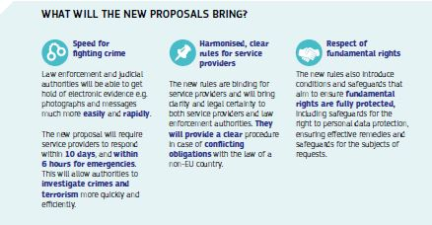

The Commission also launched an initiative inviting the European Council to amend Article 86 of the Treaty so as to enable the legislator to extend the competence of the European Public Prosecutor’s Office to fight cross-border terrorism across all Member States. A reinforced European Public Prosecutor’s Office, acting at EU level, would address the current shortcomings in the fight against terrorism and establish a common Union approach against terrorism — encompassing all steps, i.e. from investigating and prosecuting to bringing terrorist crimes to justice.

Criminals and terrorists use text messages, emails and apps to communicate. Over half of all criminal investigations today now include cross-border requests to obtain electronic evidence held by service providers based in other countries. However, almost two thirds of these crimes cannot be properly investigated or prosecuted because of the difficulties investigators face in accessing such evidence in a timely manner. To address this issue, in April the Commission proposed new rules for judicial and law-enforcement authorities to get easier access to this evidence wherever it is stored in the Union. In December the Council adopted its negotiating position on the proposed Regulation, and will start negotiations with the European Parliament as soon as the Parliament adopts its negotiating position.

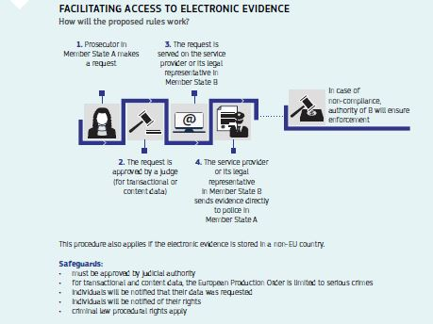

A new regulation on the freezing and confiscation of assets across borders was adopted on 14 November. The new rules will facilitate cross-border recovery of criminal assets, lead to more efficient freezing and confiscation of illicit funds, and protect the victims’ rights to compensation.

The EU agreed to improve the legal framework of the European Criminal Records Information System, closing a gap in the system and helping Member States to identify third-country nationals with criminal convictions. This legislation will create a centralised system to identify EU countries from which detailed conviction information from national registers can be quickly obtained.

More effective legislation against money laundering

[New anti-money laundering rules](https://ec.europa.eu/info/sites/info/files/diagram_aml_2018.07_ok.pdf) in force since July 2018 prevent EU financial systems from being used for money laundering or funding terrorists. In October 2018, the EU agreed on strengthened criminal law measures to counter money laundering. A new Directive will harmonise offences and sanctions for money laundering, ensuring that dangerous criminals and terrorists face equally severe penalties for their crimes across the whole EU. A [strengthened policy](https://ec.europa.eu/info/sites/info/files/swd_2018_362_f1_staff_working_paper_en_v2_p1_984066.pdf) for identifying third-country jurisdictions with strategic deficiencies in their anti-money laundering and countering financing of terrorism regimes has been enforced, based on a methodology published by the Commission in June.

Despite the fact that the EU anti-money laundering framework is solid, recent cases involving EU banks clearly indicate that there is room for improvement, notably when it comes to cross-border cooperation between competent authorities. In September, the Commission presented a [proposal](https://ec.europa.eu/commission/sites/beta-political/files/soteu2018-supervisory-authorities-regulation-646_en.pdf) to strengthen supervision of EU financial institutions to better address money laundering and terrorist financing threats, in particular through reinforcing the mandate of the European Banking Authority to act on money laundering supervision of the financial sector. The proposal is being discussed between the European Parliament and Council, with the aim of adopting it before the European elections in May 2019.

In addition, in April the Commission presented a proposal to facilitate the use of financial and other information for the prevention and combat of serious crime. This proposal will enhance the cooperation between Financial Intelligence Units and law enforcement authorities as well as Financial Intelligence Units between them.

Finally, the Commission adopted a Delegated Regulation adopting the regulatory technical standards on the criteria for the appointment of central contact points for electronic money issuers and payment service providers and with rules on their functions.

Civil justice

Improving judicial cooperation

In May, the Commission [adopted](http://europa.eu/rapid/press-release_IP-18-3991_en.htm) two proposals on the modernisation and digitalisation of judicial cooperation in relation to the service of documents and the taking of evidence, which aim to make access to civil justice cheaper, more efficient and more accessible to citizens and businesses. These proposals are currently being negotiated in the Council and European Parliament.

In December, the Council and the European Parliament reached an agreement in trilogues on the proposed rules on [insolvency proceedings](http://ec.europa.eu/information_society/newsroom/image/document/2016-48/proposal_40046.pdf) to set up restructuring systems and give entrepreneurs a second chance. This initiative, which will be formally adopted in 2019, will increase the opportunities for viable companies in financial difficulties to restructure early on to prevent bankruptcy and avoid laying off staff. It will also ensure that honest entrepreneurs get a second chance at doing business after a bankruptcy.

In December 2018 the Council reached a political agreement on the proposed update of the ‘Brussels IIa Regulation’ to update the rules that protect children in cross-border family disputes and to speed up proceedings.

Company law and access to company information

In April the Commission proposed [new rules](https://ec.europa.eu/info/publications/company-law-package_en) concerning the use of digital tools and processes in company law and cross-border conversions, mergers and divisions. The aim is to enable companies to use digital tools in interactions with public authorities on company law issues and to provide a harmonised procedure for companies that restructure or relocate within the Single Market, while bringing more legal clarity and safeguards for employees, shareholders and creditors. The negotiations in the European Parliament and in the Council progressed well in 2018 according to an ambitious timetable that aims for adoption during the current legislature.

The [Business Registers Interconnection System](https://e-justice.europa.eu/content_find_a_company-489-en.do), which makes it easier to find company information in the EU, was widely used in 2018, with over 372 000 searches for company information and over 241 000 requests for company details in the first 17 months since going live.

Stronger protection of personal data

The [General Data Protection Regulation](https://ec.europa.eu/commission/priorities/justice-and-fundamental-rights/data-protection/2018-reform-eu-data-protection-rules_en), in force since May 2018, creates a stronger and more consistent data protection framework for people, businesses and administrations across the EU. In January the Commission issued guidance explaining the main innovations and opportunities brought by the new Regulation.

New data protection rules for EU institutions, bodies, offices and agencies came into force on 11 December 2018.

The proposed e-privacy rules aim to provide a high level of privacy protection for users of electronic communication services and a level playing field for all market players. The new rules ensure a strong and coherent framework for data processing and bring the existing rules, which date from 2002, into line with the General Data Protection Regulation to uphold citizens’ rights to personal data protection.

Data flows are important for both business and law enforcement. By determining that a country outside the EU ensures an adequate level of data protection, adequacy decisions allow personal data to flow freely between the EU and the country in question for business reasons and/or allow law enforcement authorities to exchange data when needed, while ensuring the continuity of protection.

In July the EU and Japan concluded their talks on reciprocal adequacy for commercial purposes. In parallel, there are ongoing talks between the EU and the South Korea on adequacy for commercial purposes which are expected to be completed in early 2019.



Giovanni Buttarelli, European Data Potection Supervisor, meeting with Indian Ambassador Gaitri Issar Kumar, Brussels, Belgium, 30 August 2018.

Fundamental rights and judicial systems

Improving the effectiveness of justice systems and upholding the rule of law

Effective justice systems are crucial for the application of EU law and for investment. In 2018 the Commission used the [EU Justice Scoreboard](https://ec.europa.eu/info/strategy/justice-and-fundamental-rights/effective-justice/eu-justice-scoreboard_en) and [the European Semester](https://ec.europa.eu/info/business-economy-euro/economic-and-fiscal-policy-coordination/eu-economic-governance-monitoring-prevention-correction/european-semester_en) to encourage Member States to improve the independence, quality and efficiency of their justice systems. The Council issued recommendations on this issue to Croatia, Italy, Cyprus, Portugal and Slovakia in July.

In September the Commission [referred](http://europa.eu/rapid/press-release_IP-18-5830_en.htm) Poland to the Court of Justice of the European Union due to the violations of the principle of judicial independence created by the new Polish Law to lower the retirement age for Supreme Court judges. The [Court of Justice](https://curia.europa.eu/jcms/upload/docs/application/pdf/2018-12/cp180204en.pdf) issued interim measures granting all the Commission’s requests until the Court has rendered a final judgment.

In the context of the new long-term EU budget, the Commission [proposed a Regulation](https://eur-lex.europa.eu/legal-content/EN/TXT/?uri=COM%3A2018%3A324%3AFIN) on the protection of the Union’s budget in case of deficiencies regarding the rule of law in the Member States.

Protecting rights and fighting discrimination

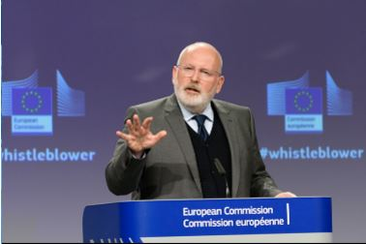

Frans Timmermans, First Vice-President of the European Commission, presents the Commission proposal on the protection of whistleblowers, Brussels, Belgium, 23 April 2018.

In April the Commission proposed EU-wide standards for the protection of whistleblowers who report breaches of EU rules that can cause serious harm to the public interest. This will improve the detection, investigation and sanctioning of breaches of EU law and would safeguard the right to freedom of expression and media freedom.

The 2017 Report on the Application of the EU Charter of Fundamental Rights highlighted the pressing challenges in making fundamental rights a reality in people’s lives. These range from improved responses to hate crime, hate speech and violence against women to the promotion of the European Pillar of Social Rights. The report also highlights the important role of a free and vibrant civil society and of independent courts.

In July the Commission addressed a letter of formal notice to Hungary regarding its law criminalising activities in support of asylum and residence applications, also to ensure the respect of EU rules on free movement of people and the provisions of the EU Charter of Fundamental Rights.

Fighting hate crime and hate speech online and offline

The EU’s Code of Conduct on countering illegal hate speech online continued to show results. According to the third evaluation of the Code published in January 2018, further progress was made in swiftly reviewing and removing racist and xenophobic hate speech online.

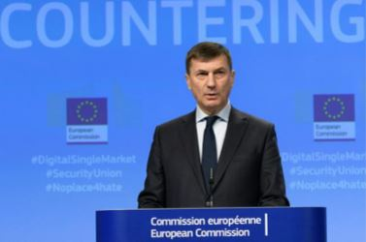

Commission Vice-President Andrus Ansip at a press conference on tackling illegal online content, Brussels, Belgium, 1 March 2018.

IT companies removed on average 70 % of the content notified to them and met the target of reviewing the majority of notifications within 24 hours, reaching an average of more than 81 %. The Code has become an industry standard in the fight against illegal hate speech: Snapchat, Instagram, Google+ and Dailymotion announced their participation in 2018.

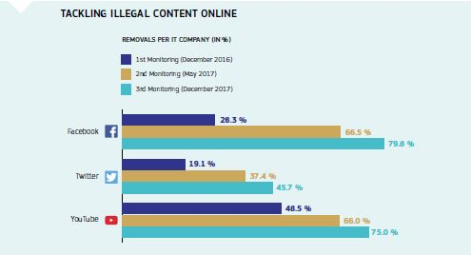

Non-discrimination and equality

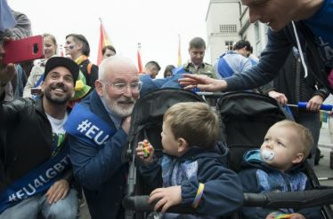

Frans Timmermans, First Vice-President of the European Commission, participates in the official opening of the Belgian Pride Festival, Brussels, Belgium, 19 May 2018.

Member States are obliged to have at least one organisation — an equality body — established in their country to analyse and monitor discrimination, as well as to promote and protect equal treatment of everyone living there. In June the Commission recommended a [set of measures](http://europa.eu/rapid/press-release_IP-18-4000_en.htm) for Member States to ensure that equality bodies effectively protect citizens and fight discrimination.

One of the achievements of the European Disability Strategy is the Commission proposal for a [European Accessibility Act](http://ec.europa.eu/social/main.jsp?catId=1202) to improve accessibility to everyday products and services, such as mobile phones, computers, e-books, e-commerce and banking services. This will have a positive impact on the lives of millions of Europeans and will make it easier and more attractive for businesses to create and sell accessible products and services. A provisional agreement was reached in November 2018 and final adoption of the proposal by the European Parliament is expected by April 2019.

The EU continued to promote diversity by supporting the growing movement of Diversity Charters that provide support in diversity management for 9 000 organisations across Europe, covering 15 million employees. It also continued to implement its [List of Actions](https://ec.europa.eu/info/policies/justice-and-fundamental-rights/combatting-discrimination/lesbian-gay-bi-trans-and-intersex-equality/list-actions-advance-lgbti-equality_en) to advance LGBTI equality by monitoring legislation, funding projects and raising awareness.

In January the Commission published an in-depth evaluation of the EU framework for National Roma Integration Strategies 2011-2020. The EU actively promoted Roma culture during [EU Roma Week](https://www.coe.int/fr/web/youth-roma/-/eu-roma-week-2018) in April and commemorated the Roma Holocaust.

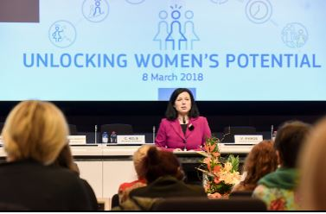

Commissioner Vĕra Jourová at the conference ‘Unlocking Women’s Potential’, in Brussels, Belgium, 8 March 2018 (International Women’s Day).

On average, women still [earn 16 % less than men](http://ec.europa.eu/eurostat/documents/2995521/8718272/3-07032018-BP-EN.pdf/fb402341-e7fd-42b8-a7cc-4e33587d79aa) in the EU. To tackle the gender pay gap, the Commission began implementing an [action plan](http://ec.europa.eu/newsroom/just/item-detail.cfm?item_id=607452) to achieve equal pay between men and women, with measurable progress expected by 2020.

The EU concluded the accession to the Council of Europe’s Istanbul Convention on combating and preventing violence against women and domestic violence. This is a major step towards a more comprehensive legal framework at the EU-level to end gender-based violence.

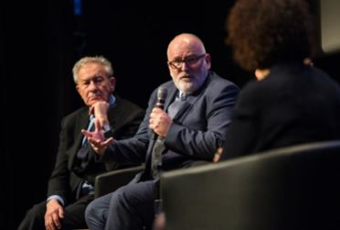

Frans Timmermans, First Vice-President of the European Commission (right) and historian Simon Schama (left) participate in a debate organised in the framework of the International Holocaust Remembrance Day by the Commission in cooperation with the European Jewish Congress and the United States Holocaust Memorial Museum, Brussels, Belgium, 24 January 2018.

European Union citizenship

Consular protection

Consular protection rules, which clarify an EU citizen’s rights to assistance from the embassies of other EU Member States in a country outside the EU, entered into application in May 2018. An information campaign on consular protection targeted at young European travellers was launched in August 2018.

In May the Commission proposed improvements to the rules on EU Emergency Travel Documents in order to make the document more secure and streamline the applicable procedures. The proposal was endorsed by the Parliament’s Committee on Civil Liberties, Justice and Home Affairs and is currently being negotiated within the Council.

Identity cards

In April the Commission proposed improvements to the security features of EU citizens’ identity cards, residence documents and non-EU family members’ residence cards. The proposed rules upgrade the security features and will thereby make it easier for EU citizens to exercise their free movement rights. The Parliament and the Council have decided to enter into negotiations on the proposal.

Elections

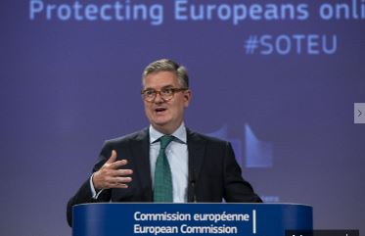

Commissioner Julian King speaking at a press conference on new measures to secure free and fair elections and countering terrorism online and offline, Brussels, Belgium, 13 September 2018.

In the wake of the Facebook/Cambridge Analytica scandal, as well as the increased risks posed to elections through disinformation campaigns, cyber-attacks and hybrid threats, securing free and fair elections to the European Parliament in 2019 has become a priority for the Commission.

In order to meet these challenges, in September 2018 the Commission adopted a [package of measures](https://ec.europa.eu/commission/sites/beta-political/files/soteu2018-factsheet-free-fair-elections_en.pdf) to support Member State authorities and other relevant stakeholders in their joint efforts to ensure free and fair elections.

The package outlined a set of concrete measures, including enhanced cooperation through the establishment of elections cooperation networks (both at national and EU level); guidance on the application of data protection rules in the electoral context; greater transparency in paid online political advertisements and communication; strengthened cybersecurity; diligent enforcement of existing electoral rules to include the online context; awareness raising; and the application of appropriate sanctions for exploiting the misuse of personal data in order to deliberately influence the outcome of the European elections.

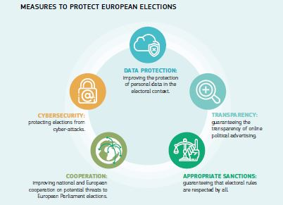

Protecting consumers

In April the Commission proposed a [New Deal for Consumers](http://europa.eu/rapid/press-release_IP-18-3041_en.htm) to ensure that consumers fully benefit from their EU rights. The new rules propose aEuropean system of collective redress when groups of consumers have suffered harm, with proper safeguards so there can be no misuse. At the same time, those rules should provide Member States’ consumer authoritieswith stronger sanctioning powers against traders that breach them. In December the European Parliament adopted its position on the part of the New Deal that concerns collective redress and planned to adopt its position on the rest in January 2019.

The new rules also aim to adapt consumer rights to the new technologies. Thus, for instance, when searching on onlinemarketplaces and platforms,consumers will be clearly informed if a trader is paying for a search result. Online marketplaces will also have to inform consumers about the main algorithms determining the ranking of the results and who the consumer is buying from.

The Commission continued to work against misleading commercial practices, such as those involving the marketing of products as being identical when in fact their composition or characteristics are significantly different, including by proposing to clarify the applicable EU law within the New Deal for Consumers initiative. In addition, the Commission released a common [testing methodology](https://ec.europa.eu/jrc/en/page/eu-harmonised-methodology-testing-food-products-180814) developed with industry, which is currently being implemented in an EU-wide testing campaign.

Under [new package travel rules](https://ec.europa.eu/info/sites/info/files/factsheet_package_holidays_2018.06_en_web.pdf) in force since July, travellers will receive clear information on whether they are being offered a package with full protection or a linked travel arrangement with more limited protection. Travellers will also benefit from stronger rights, for instance in relation to cancellations, or where the organiser increases the price by more than 8 %.

Resolving complaints out of court

The [alternative dispute resolution](https://ec.europa.eu/info/live-work-travel-eu/consumers/resolve-your-consumer-complaint/alternative-dispute-resolution-consumers_en) procedure ensures that when something goes wrong with a consumer purchase, affordable and impartial dispute resolution is available to assist consumers and traders. In 2018 quality-certified dispute resolution bodies spread to all EU Member States.

Joint actions to protect consumers

The Commission was involved in a [number of joint actions](https://ec.europa.eu/info/live-work-travel-eu/consumers/enforcement-consumer-protection/coordinated-actions_en) with national bodies to enforce consumer protection rules in 2018. Following the ‘dieselgate’ emission scandal, Volkswagen committed to continue the repairs free of charge until the end of 2020. In July the rate of repair reached 80 % of affected cars. Another joint action involving Facebook, Twitter and Google+ resulted in improved terms of service for more than 250 million social media users in the EU. In 2018, action began against AirBnB to improve the transparency of their pricing and bring their terms of service into line with EU standards.

Stopping dangerous products from reaching consumers

[](https://europa.eu/!QD94rx)

The Safety Gate rapid alert system enables quick exchange of information about dangerous non-food products posing a risk to the health and safety of consumers.

[The Rapid Alert System for Dangerous Non-Food Products](https://ec.europa.eu/consumers/consumers_safety/safety_products/rapex/alerts/repository/content/pages/rapex/index_en.htm) allows for a quick exchange of information on dangerous products found on the market and on the measures taken to prevent them from reaching consumers, particularly children. In 2018, 2 257 dangerous products were circulated among the 31 European national authorities participating in the system.

In June, four online marketplaces: Alibaba (for AliExpress); Amazon; eBay; and Rakuten France signed a ‘[Product Safety Pledge](http://europa.eu/rapid/press-release_IP-18-4247_en.htm)’ and committed to, among others, removing dangerous products found by national surveillance authorities on their websites within 2 working days.

The 2017 [Annual Report of the Rapid Alert System for Food and Feed](https://ec.europa.eu/food/sites/food/files/safety/docs/rasff_annual_report_2017.pdf) shows that 3 832 original notifications of possible food or feed risks were reported in 2017, with 942 classified as ‘alerts’ raising serious health concerns.

rescEU

While the existing Union Civil Protection Mechanism provides a sound basis for a coordinated Europe-wide response to natural and man-made disasters, the 2018 forest fire season demonstrated yet again the need to improve and strengthen it. The total burned area in Europe was over 130 000 hectares in 2018 and the risk of fires is expected to further increase due to climate change. In 2018, Greece, Sweden, Latvia and Portugal activated the Union Civil Protection Mechanism to respond to forest fires. Fires represented the biggest share (35 %) of requests for EU assistance.

In December 2018 the European Parliament and the Council provisionally agreed on the Commission proposal to strengthen the existing Mechanism. This proposal will boost investment in disaster prevention and preparedness, encourage the pooling of assistance within the European Civil Protection Pool, as well as to create a reserve of additional civil protection capacities at EU level to respond to disasters (the so-called rescEU). rescEU capacities will include firefighting planes and helicopters and, based on risk analysis, can be extended to other capacities. The three institutions are committed to concluding formal adoption and the entry into force is set to take place in the first half of 2019.

The EU’s long-term budget 2021-2027

As part of the long-term EU budget for the period 2021-2027, the Commission has proposed the creation of a Justice, Rights and Values Fund with a proposed budget of €947 million for the 7-year period. The Fund will focus on people and entities which contribute to the EU’s common values, rights and rich diversity.

Chapter 8

Towards a new policy on migration

‘We cannot continue to squabble to find ad-hoc solutions each time a new ship arrives. Temporary solidarity is not good enough. We need lasting solidarity — today and forever more.’

Jean-Claude Juncker, State of the Union address, 12 September 2018

In 2018, the European Union’s comprehensive approach on migration continued to deliver on all fronts: deeper cooperation with partner countries; better-managed external borders; and more effective and operational tools to protect our borders and manage migration inside the European Union in a spirit of solidarity and responsibility. Work on the [European Agenda on Migration](https://ec.europa.eu/home-affairs/what-we-do/policies/european-agenda-migration/proposal-implementation-package_en) made a positive contribution to replacing unsafe and uncontrolled migration with safe, orderly and regular migration. Following the peak in arrivals to the European Union in 2015, flows are now back to below pre-crisis levels.

The Commission presented new proposals in September to further strengthen the European Border and Coast Guard with a standing corps of 10 000 operational staff; to establish a stronger mandate for an EU Agency for Asylum so that, together, they are able to deploy joint EU migration management teams in all situations and offer full operational support to Member States. Also in September, the Commission proposed a targeted revision of the Return Directive to put in place more effective and simplified return procedures.

Following 2 years of intense work, five of seven proposals to improve our current asylum system have come close to adoption in 2018. Legal migration channels to the European Union increased for people in need of international protection, and since 2015, resettlement programmes have offered safe and legal pathways to almost 44 000 people.

In its December progress report on the European Agenda on Migration, the Commission reiterated its recommendation to step up efforts to better manage labour migration, based on the needs of our economies.

The European Agenda on Migration

Throughout 2018, the Commission presented regular progress reports on the implementation of the European Agenda on Migration, looking at the measures taken to stabilise the flows and better manage the EU’s external borders. The reports looked at the EU efforts to address the root causes of migration, provide support to front-line Member States and neighbouring countries facing strong migratory pressure, protect migrants on their journeys, return and readmission, and progress on legal pathways such as resettlement.

In its December 2018 report, the Commission noted that the EU’s comprehensive approach on migration has delivered on all fronts: irregular arrivals are down to pre-crisis levels, deeper cooperation with partner countries has been achieved; external borders are better managed; and there are more effective tools to manage migration inside the EU. The report concluded that work needs to continue at all levels, both outside and within the EU.

Border protection and tacking irregular flows

Border management

Negotiations continued in 2018 on the Commission’s 2017 proposal to update the Schengen Borders Code in recognition of the need to guarantee our citizens’ security while preserving their freedom of movement. The objective is to adapt the rules for the reintroduction of temporary internal border controls to current needs and introduce stronger procedural safeguards so that border controls at internal borders remain a measure of last resort.

In its December Communication on Migration, the Commission called for the full restoration of Schengen as an area without temporary internal border controls, built on the foundations of a properly-functioning Common European Asylum System.

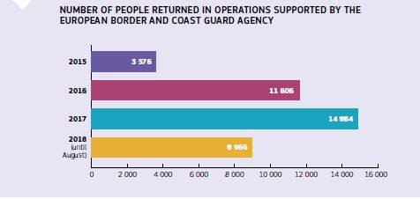

The [European Border and Coast Guard Agency](https://frontex.europa.eu/) supported national border guards with on average around 1 350 deployed experts along all migratory routes in 2018. In June, Member States called for the Agency’s supportive role to be further strengthened, including cooperation with countries outside the EU, increased resources and an enhanced mandate.

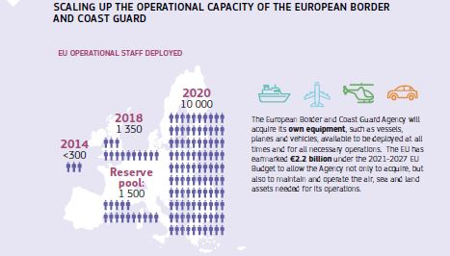

In response, in September the Commission proposed to strengthen the Agency with a standing corps of 10 000 operational staff by 2020. The members of the standing corps will have executive powers and their own equipment to intervene wherever needed along the EU’s external borders as well as in non-EU countries. The proposal also ensures that Member States retain their sovereignty over operations carried out at their borders. By the end of 2018, the Member States in the Council had agreed on some elements of the Commission proposal (provisions on return and cooperation with third countries) and discussions on all elements continue.

The EU continued negotiations with western Balkan countries on operational cooperation agreements on border management that would enable the European Border and Coast Guard to provide assistance and deploy its staff when necessary. In October, the EU signed such an agreement with Albania, and agreements were initialled with the former Yugoslav Republic of Macedonia (July) and Serbia (September). Negotiations with Montenegro and Bosnia-Herzegovina have also concluded successfully.

Information systems on security and border management

In October 2018, the Regulation establishing a European Travel Information and Authorisation System (ETIAS) entered into force. The new system will establish pre-travel screening for security and migration risks of travellers benefiting from visa-free access to the Schengen area, paving the way for it to become operational by the end of 2021.

After the entry into force of the new law in December 2017, the Commission started work on the implementation of a new entry/exit system for the Schengen area. The system will reinforce controls at the EU’s external borders by registering entry, exit and refusal of entry information of third-country nationals crossing the external borders of the Schengen area. It is expected to become operational by the end of 2020.

Strengthening the Schengen Information System

The Schengen Information System supports external border control and law enforcement cooperation in the Schengen countries. New rules to reinforce the system entered into force in December 2018. The changes includenew alerts on return decisions and better enforcement of entry bans, an obligation to include alerts linked to terrorism, stronger provisions on missing children and people in need. It also includes stronger data protection rules, more efficient use of fingerprints, palm prints and facial images to identify persons, and easier access for EU Agencies.

Interoperability

In December 2017 the Commission proposed new legislation on the interoperability of information systems to ensure that border guards, immigration officers and law enforcement have access to the information they need when they need it. By the end of 2018, the European Parliament and Member States had made important progress, paving the way for adoption in the first quarter of 2019.

Return and readmission

With EU support, the International Organisation for Migration assisted 16 463 people to voluntarily return home from Libya in 2018 alone. The EU continues to work with the African Union, the United Nations and the Libyan authorities to stop the systematic detention of migrants, including children. Over 2 700 refugees were released from detention thanks to these efforts.

In September, the Commission proposed a targeted review of the Return Directive that, in combination with the proposal for a new European Border and Coast Guard Regulation strengthens the Agency’s mandate on returns, will improve the effectiveness of the EU return policy, while continuing to ensure the respect of the fundamental rights of migrants.

In order to speed up return procedures and prevent absconding and irregular secondary movements, the proposal introduces the application of simplified return procedures at the external border to people whose asylum applications were refused. The proposal introduces an obligation to immediately issue return decisions to rejected asylum seekers, closing a procedural gap that hitherto facilitated absconding, and requires irregular migrants to cooperate during the procedures regarding their identification. In addition, it harmonises the rules for ordering the detention of irregular migrants for the purpose of their removal, including by setting a maximum period of detention of no less than three months and by ensuring the possibility to detain migrants who pose public order or security risks. Finally, Member States would be required to establish national programmes to assist irregular migrants willing to return voluntarily.

Protecting those in need

Asylum reform

The European Union remains true to its fundamental values by providing protection to those in need, with a total of 164 055 asylum seekers granted protection in the first nine months of 2018. Two years of intensive work resulted in significant progress on the Commission’s 2016 proposals to reform the Common European Asylum System, with five of the Commission’s seven proposals ready for adoption: the [Qualification Regulation](https://ec.europa.eu/home-affairs/sites/homeaffairs/files/what-we-do/policies/european-agenda-migration/20181204_managing-migration-factsheet-1-qualification-regulation_en.pdf), [Reception Conditions Directive](https://ec.europa.eu/home-affairs/sites/homeaffairs/files/what-we-do/policies/european-agenda-migration/20181204_managing-migration-factsheet-2-reception-conditions-directive_en.pdf), the [European Asylum Agency Regulation](https://ec.europa.eu/home-affairs/sites/homeaffairs/files/what-we-do/policies/european-agenda-migration/20181204_managing-migration-factsheet-3-eu-agency-for-asylum_en.pdf), the [Eurodac Regulation](https://ec.europa.eu/home-affairs/sites/homeaffairs/files/what-we-do/policies/european-agenda-migration/20181204_managing-migration-factsheet-4-eurodac-regulation_en.pdf) and the [Union Resettlement Framework Regulation](https://ec.europa.eu/home-affairs/sites/homeaffairs/files/what-we-do/policies/european-agenda-migration/20181204_managing-migration-factsheet-5-union-resettlement-framework_en.pdf). Although part of a broader reform, each individual proposal has a clear benefit on its own and swift adoption of each one would make a clear difference on the ground.

Important progress was also made on the [Asylum Procedure Regulation](https://ec.europa.eu/home-affairs/sites/homeaffairs/files/what-we-do/policies/european-agenda-migration/20181204_managing-migration-factsheet-6-asylum-procedure-regulation_en.pdf) and the Dublin Regulation, indispensable elements of a future-proof asylum system. On the request of Member States, temporary arrangements anticipating the core elements of a future Dublin Regulation could be set up to serve as a bridge until the new Dublin regulation enters into force. In addition, and in order to facilitate a compromise, the Commission proposed in September to further expand the EU Asylum Agency’s mandate, tools and budget (€321 million for 2019-2020) to provide more comprehensive assistance to Member States throughout the international protection procedure when requested. Together with the European Border and Coast Guard Agency, joint EU migration management teams will support Member States when and where needed in tasks such as identification and registration of asylum seekers, preparation of decisions on applications for international protection and operational assistance.

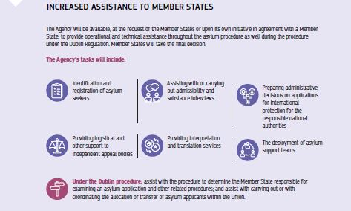

‘Hotspots’ and support for Greece, Italy and Spain

To support the Greek authorities as well as international organisations and non-governmental organisations managing the refugee and humanitarian crisis in Greece, the Commission has allocated over €816.4 million in Emergency Assistance since the beginning of 2015. The emergency funding comes on top of the €613.5 million already allocated to Greece under the national programmes for 2014-2020. At the end of the year, the Commission delegated management of €252 million to international organisations operating in Greece, including Unicef and the United Nations Refugee Agency (UNHCR). In addition, the Commission provides permanent structural support to the Greek authorities with a permanent presence on all hotspot islands.

As regards Italy, over €35.5 million has been allocated in 2018 bringing the total amount of emergency assistance made available to Italy since 2014 to €224.9 million. The emergency assistance allocation complements over €724 million in EU support to Italy’s national programmes under the Asylum, Migration and Integration Fund and Internal Security Fund for the period 2014-2020.

In July, in view of increased arrivals, Spain was allocated €36.01 million in emergency assistance to improve the reception capacity for arrivals at its southern coast and in Ceuta and Melilla, as well as to help increase returns. The emergency funding awarded to Spain comes on top of €737.5 million allocated to Spain for migration, border and security management under national programmes for the period 2014-2020.

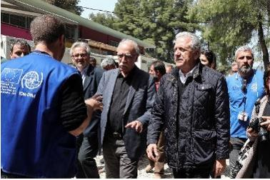

Commissioner Dimitris Avramopoulos (right) visits a refugee camp with Dimitris Vitsas, Greek Minister for Migration, in Ritsona, Greece, 12 April 2018.

Migrants arriving at hotspots in Italy and Greece were properly identified, registered, fingerprinted and their data checked against relevant security databases. In its December progress report on the European Agenda on Migration, the Commission noted that the situation in Greece has improved, but that more needs to be done by the Greek authorities to improve reception conditions, accelerate the processing of asylum applications and increase returns.

Most EU Member States continued to help alleviate the pressure on Greece and Italy by relocating eligible applicants from these countries, which are on the frontline of migration flows.

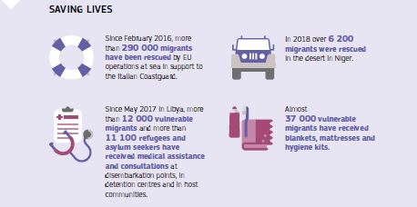

The EU–Turkey Statement

[The 2016 EU–Turkey Statement](http://www.consilium.europa.eu/en/press/press-releases/2016/03/18/eu-turkey-statement/) remained of paramount importance in reducing irregular and dangerous crossings to the Greek islands from the Turkish mainland, in saving lives at sea, and in promoting the resettlement of Syrians in need of international protection.

Turkey made outstanding efforts to provide shelter and support to more than 3.5 million registered Syrian refugees, and the EU has demonstrated its commitment to support Turkey in this challenge. The Facility for Refugees in Turkey continues to support the needs of refugees and host communities in Turkey, in close cooperation with the Turkish authorities. The Facility helped over 1.3 million refugees, through monthly cash transfers, education for 500 000 children and healthcare for hundreds of thousands of people with €1.9 billion distributed. The EU also began to mobilise the second tranche of €3 billion of financial support.

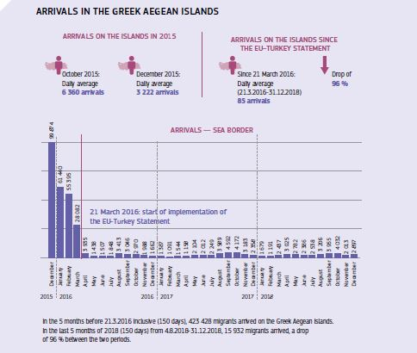

Financial support for the efficient management of migration

The Commission supports national efforts to improve migration and border management with significant funding. The [Asylum, Migration and Integration Fund](https://ec.europa.eu/home-affairs/financing/fundings/migration-asylum-borders/asylum-migration-integration-fund_en), with €576 million, the [Internal Security Fund (Borders and Visa),](https://ec.europa.eu/home-affairs/financing/fundings/security-and-safeguarding-liberties/internal-security-fund-borders_en) with €567 million, and the [Internal Security Fund (Police)](https://ec.europa.eu/home-affairs/financing/fundings/security-and-safeguarding-liberties/internal-security-fund-police_en), with €92.7 million, continued to support capacity building in 2018, providing humanitarian and healthcare assistance and helping to develop operational cooperation. For the period 2014-2020, the Union’s support for national efforts in the fields of migration and security is estimated at €5.5 billion for the Asylum, Migration and Integration Fund, and at €2.9 billion for the Internal Security Fund (excluding agencies).

In December 2018 the European Parliament and the Council amended the rules of the Asylum, Migration and Integration Fund to enable Member States to continue using funding previously committed to the Union’s emergency relocation scheme, which ended successfully in 2017. The change will allow Member States to use the remaining funds to continue relocating or resettling applicants or beneficiaries of international protection, as well as addressing other migration-related needs within the scope of the Fund.

Managing migration and saving lives at sea

Operation Themis, together with other EU Joint Operations and naval missions, continued to support Italy in addressing irregular immigration across the central Mediterranean. Overall, these operations have contributed to the rescue of over 690 000 people at sea.

Moreover, the EU continued to disrupt criminal smuggling networks in the central Mediterranean and the Aegean with the help of the Turkish authorities and NATO. Cooperation to tackle migrant smuggling and human trafficking networks was enhanced with partners in the Sahel in line with the [Declaration](http://europa.eu/rapid/press-release_STATEMENT-18-2067_en.htm) adopted in Niamey (Niger) in March.

In line with the 2015 [Action Plan against Migrant Smuggling](https://ec.europa.eu/anti-trafficking/sites/antitrafficking/files/eu_action_plan_against_migrant_smuggling_en.pdf), in May 2018 the Commission proposed a revision of the legislation that organises the way in which [Member States, the EU and Union Agency Immigration Liaison Officers work together](http://www.europarl.europa.eu/RegData/etudes/BRIE/2018/621810/EPRS_BRI(2018)621810_EN.pdf). This revision aims to ensure better cooperation and coordination among the European staff deployed in third countries to work on migration. Negotiations between the European Parliament and the Council are expected to begin in early 2019 so the new rules can enter into force by the end of May 2019.

In December the European Council approved measures with a law enforcement focus to step up the fight against crime networks that smuggle migrants. The concrete actions draw on an enhanced inter-agency approach both at EU and national level, making the best use of synergies between the tools available and maximising use of the EU’s external assets. Key objectives include increasing the operational and analytical capacities of the European Migrant Smuggling Centre; enhancing the capacity to tackle online communication between smugglers; developing partnerships with third countries; and sharing information on criminal networks.

Enhancing safe and legal pathways to Europe

Developing orderly legal pathways for people in need of protection and creating channels for labour migration is an integral part of the EU’s comprehensive approach to migration. It goes hand in hand with a firm policy on tackling irregular flows of migrants and ensuring stronger border protection, streamlined asylum procedures and more effective returns. In his State of the Union address in September, President Juncker reiterated the Commission’s call to open up more legal pathways.

Resettlement

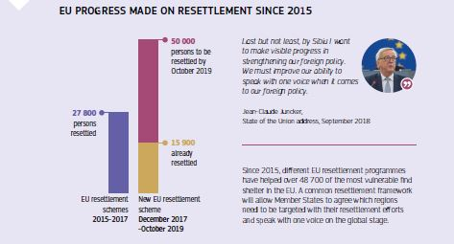

EU resettlement initiatives have shown that legal and safe channels can replace unsafe and irregular migration for people in need of international protection. Since 2015, different EU resettlement programmes have helped over 48 700 of the most vulnerable find shelter in the EU. This includes almost 21 000 individuals, whom Member States resettled in 2018 as part of a common pledge to resettle more than 50 000 people in need of protection by the end of October 2019 — the largest EU resettlement scheme to date.

Encouraging needs-based migration

The Commission has also made proposals to create more attractive pathways for needs-based labour migration. A new EU Blue Card scheme that brings real added value compared with the current Blue Card in line with the Commission’s 2016 proposal, is an essential component to creating an attractive and more competitive economy. By the end of the year, the EU’s work to implement pilot projects on legal migration with key African partners had also advanced considerably. With €20 million earmarked, several projects are expected to begin in 2019. They will replace irregular migration with safe, orderly and well-managed legal migration.

Integration

Early and effective integration is key to making migration a benefit for both migrants and the economy and cohesion of European society. The European Union continued to implement the 2016 [Action Plan on the integration of third-country nationals](https://ec.europa.eu/home-affairs/sites/homeaffairs/files/what-we-do/policies/european-agenda-migration/proposal-implementation-package/docs/20160607/communication_action_plan_integration_third-country_nationals_en.pdf) adopted on 7 June. This provides a comprehensive framework to support Member States’ efforts in developing and strengthening their integration policies through financial support and best-practice guidance. The Commission promoted a multi-stakeholders’ approach to enhance integration of migrants into the labour market and provided support to integration actors on the ground, including local and regional authorities and non-governmental organisations.

At the European Migration Forum in March, over 200 stakeholders shared examples of successful labour market integration of migrants.

Visa policy

Nationals of some non-EU countries are required to hold a visa when travelling to the [Schengen area](https://ec.europa.eu/home-affairs/what-we-do/policies/borders-and-visas/schengen). The EU has established a common visa policy for short stays in the Schengen area based on a common list of countries whose citizens must have a visa when crossing the external borders, and a list of countries whose citizens are exempt from that requirement. In 2017 (the latest figures available), the 26 Schengen States issued 14.6 million short-stay visas.

In March the Commission proposed to reform the common visa policy to adapt the rules to evolving security concerns, challenges linked to migration and new opportunities offered by technological developments. The objective of the proposed changes to the Visa Code is to facilitate visa procedures for legitimate travellers whilst strengthening security and mitigating irregular migration risks. By the end of 2018 both the European Parliament and the Council had adopted their respective mandates for the interinstitutional negotiations. Discussions between the co-legislators were ongoing, with the aim to conclude negotiations in early 2019.

In May the Commission proposed to upgrade the Visa Information System, to better respond to evolving security and migratory challenges and improve the EU’s external border management. The proposed changes will allow for more thorough background checks on visa applicants and close security and information gaps notably as regards long-term residence documents issued by Member States. It will enable full interoperability with other EU-wide databases. Discussions in the European Parliament and Council were ongoing at the end of 2018, with the aim to conclude negotiations in early 2019.

Negotiations on EU visa facilitation agreements with Belarus, China and Tunisia continued in 2018. On visa liberalisation, the Commission confirmed in July that Kosovo (this designation is without prejudice to positions on status, and is in line with UNSCR 1244/1999 and the ICJ Opinion on the Kosovo declaration of independence) met all the criteria for visa-free travel to the Schengen area.

The European Commission published a Communication on Visa Reciprocity in December 2018, describing the state of play and way forward as regards the situation of non-reciprocity with the United States as the only remaining such case. Nationals of Bulgaria, Croatia, Cyprus, Poland and Romania still need a visa to travel to the United States. The Communication took stock of progress towards achieving visa reciprocity, namely the progress of these Member States in fulfilling the necessary requirements set by the United States’ legislation.

The EU’s long-term budget 2021-2027

In June 2018, the Commission proposed the architecture of the dedicated funding instruments on migration and border management. Together with the allocations for the relevant agencies, the proposed resources are €34.9 billion, almost tripling the current envelope of €13 billion (including agencies). The proposals for the Asylum and Migration Fund and the Border Management and Visa Instrument, as part of the Integrated Border Management Fund, foresee a flexibility mechanism to allocate resources according to the evolution of challenges, needs and priorities.

Chapter 9

A Stronger global actor

‘I want our Union to become a stronger global actor … and I want us to dedicate further efforts to defence matters’

Jean-Claude Juncker, State of the Union address, 13 September 2017

As the global situation becomes less stable, and the role of international institutions continues to come under scrutiny, the EU is using its diplomatic, political, and economic power as a security provider to promote international peace and security.

The EU firmly believes that multilateral diplomacy leads to peaceful solutions to pressing international issues. The EU has shown leadership, creativity and reliability in supporting the Iran nuclear deal, the Paris climate change agreement, the United Nations’ Sustainable Development Goals, new trade agreements with strong social safeguards and cooperation with the African Union and working with the United Nations. The EU also remained the largest provider of official development assistance in 2018.

Our neighbourhood and enlargement policies supported stability and focused on building closer relations between the European Union and its neighbours.

European security and defence was a priority in 2018 with the EU taking decisive steps to increase its role as a global security provider to complement its economic power. The proposed expansion of the European Defence Fund is an example of this, as is the adoption of 34 defence projects in the framework of the Permanent Structured Cooperation, and a new European Peace Facility for defence cooperation between countries.

In 2018 the EU consolidated its position as the world’s biggest donor of humanitarian aid, giving over €1 billion. The EU’s humanitarian aid worldwide provided life-saving support from natural disasters and man-made conflicts around the globe.

The European Union’s neighbourhood

The Eastern neighbourhood

The Eastern Partnership Summit of 2017 reconfirmed clear commitment to the Partnership by the EU and its partners: Armenia, Azerbaijan, Belarus, Georgia, Moldova and Ukraine. In 2018 the focus has been on reforms in areas such as the economy, stronger governance, stronger connectivity and stronger society.



Commissioner Johannes Hahn and Georgian Prime Minister Mamuka Bakhtadze at the opening of the First Eastern Partnership European School in Tbilisi, Georgia, 4 September 2018.

2018 marked the fourth year of unprecedented close relations between the EU and Ukraine with a productive [Summit](https://www.consilium.europa.eu/en/meetings/international-summit/2018/07/09/ukraine/) in July, which underlined the continuation of intensive support from the EU for the country’s reform programme. The EU remains Ukraine’s biggest trading partner and its most important source of assistance, which in 2018 focused on employment skills such as vocational education and training reform, and the Energy Efficiency Fund.

The relationship between the EU and Georgia, framed by an already ambitious Association Agreement, became even closer in 2018. In November President Jean-Claude Juncker and other members of the European Commission welcomed members of the Government of Georgia, led by Prime Minister Mamuka Bakhtadze for a meeting in the Berlaymont building in Brussels. The EU and Georgia agreed to more than 25 concrete actions across three focus areas: economy, trade and connectivity; education, research and innovation; justice and internal security. These actions will advance cooperation and deliver tangible benefits for Georgian citizens.

Russia

In terms of the EU’s relations with Russia, respect for international law remains paramount. The EU’s policy towards Russia is guided by the following principles: full support for the independence, sovereignty and territorial integrity of Ukraine within its internationally recognised borders; full implementation of the Minsk agreements (a package of measures to bring lasting peace to Ukraine, signed by the representatives of Ukraine, Russia and the separatists from the Donetsk People’s Republic and Luhansk People’s Republic); strengthening relations with our eastern partners; strengthening EU resilience; the need for selective engagement with Russia, and willingness to support Russian civil society. In 2018, the EU engaged with Russia on security challenges such as Iran and Syria. The EU reconfirmed its policy of non-recognition of the illegal annexation of Crimea. The EU has expressed its utmost concern regarding the escalation at the Kerch Straits and the Azov Sea and Russia’s violations of international law.

The European Union’s southern neighbourhood

In 2018, the EU continued to work with its partner countries in the southern neighbourhood to promote sustainable stability, security and growth in a wide range of areas, notably based on the new European Neighbourhood Policy Partnership Priorities with Algeria, Egypt, Jordan and Lebanon. Political priorities for 2018-2020 were concluded with Tunisia in May. The EU supports socioeconomic development, good governance, human rights, security and the root causes of irregular migration in all countries in the region.

The EU also worked actively to partner with international financial institutions and the private sector, through its European External Investment Plan and the creation of the European Fund for Sustainable Development, which includes a financial guarantee to help reduce risk for investments, modelled on the EU’s internal Investment Plan. The Plan supports the mobilisation of private-sector investments in small and medium-sized companies, female entrepreneurship, energy and digital infrastructure and many other areas, in order to contribute to local development. The Plan also includes technical assistance to reinforce local institutions and fight against corruption. In 2018, Egypt, Jordan, Morocco and Lebanon joined Algeria, Israel and Tunisia in the Partnership for Research and Innovation in the Mediterranean Area (PRIMA). PRIMA will fund research and investment to improve sustainable agriculture and access to water in a region affected by climate change and population growth. The EU continued to foster regional cooperation through the Union for the Mediterranean and the League of Arab States.

The western Balkans and the enlargement process

In 2018, the EU significantly enhanced its relations with the western Balkans. In February, the European Commission published the [Western Balkans Strategy](https://ec.europa.eu/commission/news/strategy-western-balkans-2018-feb-06_en) for a credible enlargement perspective for and enhanced EU engagement with the region. This strategy reconfirms the perspective of EU membership as a key driver for reforms and modernisation in the western Balkans. It put forward a comprehensive Action Plan of 57 actions for the period 2018-2020 based on six flagship initiatives (rule of law, security and migration, socioeconomic development, connectivity, digital agenda, and reconciliation and good neighbourly relations). Its implementation is under way with most actions launched and some completed in 2018.

The [Summit in Sofia](https://www.consilium.europa.eu/en/meetings/international-summit/2018/05/17/) in May attended by President Juncker reaffirmed this perspective. He said: ‘This summit has allowed us to forge even closer links with our friends from the western Balkans who, step by step, each day come a little bit closer to the European Union — each at its own pace and merits. Being anchored in the European Union means sharing values and principles, including respect for the rule of law, independence of the judiciary and freedom of expression — because the European Union is first of all a community of values and law.’

The EU also launched agriculture and rural development support programmes in Albania, Montenegro and Serbia and these continue to operate in the former Yugoslav Republic of Macedonia. They contribute to food safety and quality and make rural livelihoods more attractive.

In 2018 Montenegro and Serbia continued their EU accession negotiations. Their overall pace depends on progress on rule of law and in the case of Serbia, also on the normalisation of relations with Kosovo (This designation is without prejudice to positions on status, and is in line with UNSCR 1244/1999 and the ICJ Opinion on the Kosovo declaration of independence). The EU welcomed a bilateral agreement between Greece and the former Yugoslav Republic of Macedonia on the issue of the name of the latter country, and encourages its ratification. Following intensive reform efforts in Albania and the former Yugoslav Republic of Macedonia, supported by the EU, the Commission recommended the opening of accession negotiations with both countries. The EU continued to support reforms in Bosnia and Herzegovina and Kosovo.

Turkey

Relations between the EU and Turkey continued to be challenged by the further deterioration of the rule of law, fundamental rights and the independence of the judiciary in Turkey. Accession negotiations have therefore effectively come to a standstill and no further work took place on the modernisation of the EU–Turkey Customs Union. Nonetheless, the political dialogue has continued and cooperation at a technical level has continued in those areas of strong mutual interest, such as migration, security, trade, energy, transport and the environment.

Africa–Europe relations

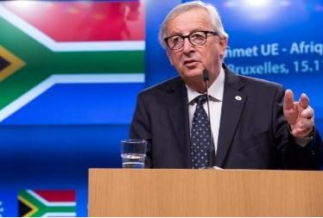

Commission President Jean-Claude Juncker addresses the EU–South Africa Summit, Brussels, Belgium, 15 November 2018.

The new [Africa–Europe Alliance for Sustainable Investment and Jobs](https://ec.europa.eu/commission/sites/beta-political/files/soteu2018-factsheet-africa-europe_en.pdf) launched in September 2018 aims to take the EU’s partnership with Africa to the next level. The initiative will help improve job creation in Africa by supporting education and skills, boosting trade and mobilising investment in strategic economic sectors. Speaking at the [State of the Union address](https://ec.europa.eu/commission/sites/beta-political/files/soteu2018-speech_en_0.pdf) in 2018, President Juncker said: ‘This Alliance — as we envision it — would help create up to 10 million jobs in Africa in the next 5 years alone. We want to create a framework that brings more private investment to Africa. We are not starting from scratch: our External Investment Plan, launched two years ago, will mobilise over €44 billion in both the public and private investment. Alone, the projects already in the pipeline will unlock €24 billion.’

This partnership between the EU and Africa as a partnership between equals was reinforced at a [High-Level Forum in Vienna](https://ec.europa.eu/commission/news/president-juncker-high-level-forum-africa-europe-2018-dec-18_en) in December which focused on innovation, investment and job creation, education and supporting business and trade. Within three months, the Africa–Europe Alliance was already delivering on its first projects.

Some of the initiatives launched in Vienna included an EU guarantee ([NASIRA Risk-Sharing Facility](https://ec.europa.eu/europeaid/news-and-events/eu-external-investment-plan-commission-and-fmo-sign-first-guarantee-agreement-unlock_en)), the first of its kind under the EU External Investment Plan, which will use **€75 million** of EU funds to leverage up to **€750 million of investments for entrepreneurs in Sub-Saharan Africa and the EU’s southern neighbourhood**. This is expected to create 800 000 jobs and benefit those who usually struggle to access affordable loans, such as small and medium-sized enterprises, internally displaced people, refugees, returnees, women and young people. In terms of educational exchanges, the EU is well on track to deliver on its 2020 target of 35 000 exchanges.

In 2018 alone, the European Union has committed over **€540 million** to support business and investment climate reforms, significantly exceeding the Africa–Europe Alliance’s commitment to increase EU support up to €300-350 million per year for 2018-2020.

The European Union is committed to support the creation of an **African Continental Free Trade Area**, and has in particular announced **€50 million** of support towards that goal. A first step was taken in December with a [€3 million programme signed with the United Nations Economic Commission for Africa](https://ec.europa.eu/europeaid/news-and-events/africa-europe-alliance-eu-supports-african-continental-free-trade-area-eu50-million_en) to develop national implementation strategies for the continental free trade area.

A key aspect of the Africa–Europe Alliance is the collaboration in joint task forces set up at the Vienna meeting on rural Africa, [digital economy](https://ec.europa.eu/europeaid/news-and-events/european-union-african-union-digital-economy-task-force_en), transport **and energy.**

[The European External Investment Plan](https://ec.europa.eu/commission/eu-external-investment-plan/external-investment-plan-progress-so-far_en) is also delivering: the EU supports investment projects in northern and sub-Saharan Africa through its regional investment platforms and has supported investment programmes in key sectors such as renewable energy, sustainable agriculture, urban infrastructure, connectivity and digitalisation. Dialogue between the private sectors in Africa and Europe is also being scaled up through the Sustainable Business for Africa platform. **Public–private dialogues** to promote Sustainable Business for Africa have been established in the following African countries: Côte d’Ivoire; Ethiopia; Morocco; Nigeria; South Africa; Tanzania; Tunisia and Uganda.

Similar dialogues in 25 additional African countries are currently being prepared. This will help to boost decent job creation, in particular for young people and women. The dialogues were launched in Abidjan during the [EU–Africa Business Forum](https://ec.europa.eu/commission/commissioners/2014-2019/ansip/announcements/opening-statement-vice-president-ansip-high-level-panel-digital-economy-eu-africa-business-forum_en) in November 2017. As part of this engagement, President Juncker visited Tunisia in October 2018.

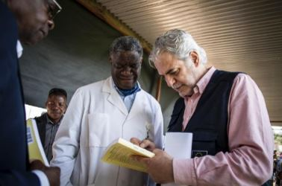

Commissioner Christos Stylianides meets with Denis Mukwege, Nobel Prize winner and founder of Panzi Hospital, during his visit to Bukavu, Democratic Republic of Congo, 24 March 2018.

The EU has continued to build a real partnership of equals with Africa. Examples of enhanced EU cooperation with Africa on peace and security issues include the G5 Sahel Joint Force, the [African Union–European Union Memorandum of Understanding on Peace, Security and Governance](https://www.africa-eu-partnership.org/en/stay-informed/news/eu-and-african-union-commissions-step-their-cooperation-support-young-people-jobs), and the EU’s support to security and reconciliation in the Horn of Africa. While humanitarian aid, development cooperation and support to peace and security continue to be important areas of cooperation, the EU has substantially reinforced its economic partnership with Africa. Today the EU and Africa work together as partners in new areas such as research and innovation, and in strategic economic sectors such as agriculture, digitalisation, transport and energy.

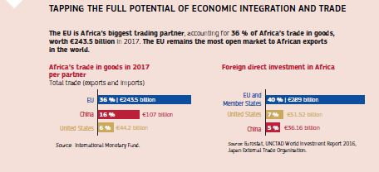

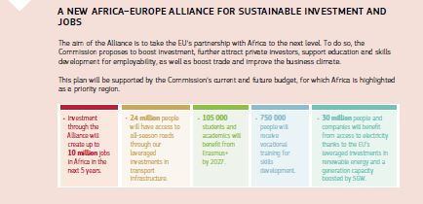

North America and Latin America

A strong and well-functioning transatlantic partnership with the United States remains a crucial element for Europe’s security and prosperity. The EU remains committed to the strategic partnership with the United States, based on shared values and interests, and a willingness to play a responsible role in world affairs to our mutual benefit. The EU has worked closely over the past year with the US administration and Congress where there are common objectives (the western Balkans, Ukraine, Russia, North Korea, counterterrorism, cybersecurity and defence *—* including NATO). The EU has stood up for its values, principles and interests when challenged.

In July, following a meeting between Presidents Juncker and Trump, the EU and the US issued a joint statement pledging cooperation to work together toward zero tariffs, zero non-tariff barriers, and zero subsidies on non-auto industrial goods. They agreed to work to reduce barriers and increase trade in services, chemicals, pharmaceuticals, medical products and soybeans. The two parties also agreed to strengthen strategic cooperation on energy.

The EU has strengthened its relationship with Canada with the Strategic Partnership Agreement. The EU and Canada continue to cooperate closely on areas such as security, defence and gender issues.

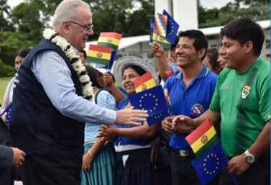

Commissioner Neven Mimica during a visit to the Chapare Region of Bolivia, 4 May 2018.

EU cooperation with Latin America and the Caribbean focused on modernising association agreements with Mercosur, Mexico and Chile. An agreement with Havana in 2018 ushered in a new era in EU–Cuba cooperation. The EU continues to support the implementation of the peace agreement in Colombia.

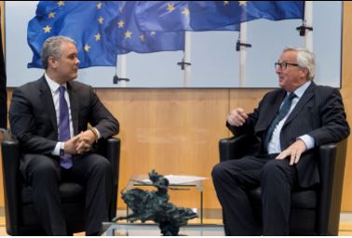

Jean-Claude Juncker, President of the European Commission, receives Iván Duque Márquez, President of Colombia, in Brussels, Belgium, 24 October 2018.

Asia and the Pacific



Federica Mogherini, High Representative/Commission Vice-President, during a visit to South Korea at the truce village of Panmunjom in the demilitarised zone separating the two Koreas, 5 August 2018.

In 2018 the EU strengthened economic diplomacy and scaled up its security role in Asia, which included working to reduce tensions on the Korean peninsula. The EU worked on a [Strategy on connecting Europe and Asia](http://europa.eu/rapid/press-release_IP-18-5803_en.htm), with the fight against climate change and regional cooperation at its heart. To develop relations to their full potential, the EU adopted a new Strategy on India and ratified the EU–Philippines Partnership and Cooperation Agreement. The EU and Thailand launched a labour dialogue to promote decent labour conditions.

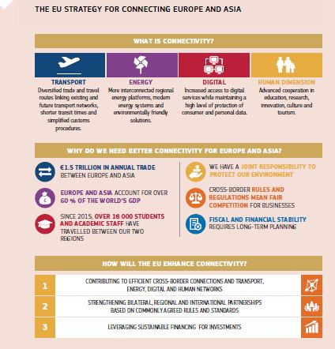

The EU continued to engage with China on issues such as climate change and common security interests, such as the Iran nuclear deal, Afghanistan and the Korean peninsula. At the same time, the EU ensured greater reciprocity in economic relations, science and technology. The EU engaged with China on infrastructure, worked to align investment with EU strategic networks and promoting transparency, economic and social sustainability. The EU encouraged closer cooperation on the Sustainable Development Goals, conflict resolution, international rules and respect for human rights.

The 2018 [EU-China Tourism Year](https://ecty2018.org/) provided a unique opportunity to increase visitor flows and investments on both sides. It aimed to promote lesser-known destinations, improve travel and tourism experiences, and provide opportunities to increase economic cooperation. Over 150 initiatives and events took place during the year.

The 12th Asia–Europe Meeting summit was held in Brussels on 18-19 October 2018, bringing together leaders of 51 European and Asian countries, EU representatives, and the Secretary-General of the Association of Southeast Asian Nations.

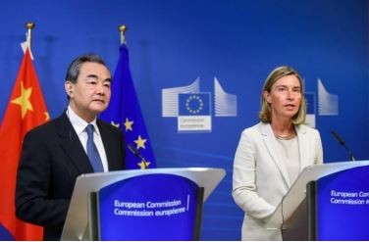

Federica Mogherini, High Representative/Commission Vice-President, with Wang Yi, State Councillor and Chinese Minister for Foreign Affairs, at a press conference for the EU–China High Level Strategic Dialogue meeting, Brussels, Belgium, 1 June 2018.

The Middle East

The EU continued to actively respond to the ongoing crisis and conflicts in the region. It notably helped the stabilisation process through its support for the UN-led peace processes in Syria and in Yemen, for the process of stabilisation in Iraq, and for the search for a two-state solution to the Israeli-Palestinian conflict.

Syria

The conference on ‘Supporting the Future of Syria and the Region’ in April 2018, allowed the international community to renew and strengthen the political, humanitarian and financial commitment to the Syrian people. The EU adopted the [EU Strategy for Iraq](http://www.consilium.europa.eu/en/press/press-releases/2018/01/22/iraq-eu-adopts-new-strategy/) to support the country’s recovery from the fight against Da’esh.

Yemen

In Yemen, the EU continued to support the UN-led process and the UN Special Envoy Martin Griffiths, as well as support the crisis-affected population.

Israel, the occupied Palestinian territory and the Middle East peace process

The EU continued its firm support for the resolution of the Israeli-Palestinian conflict and for a two-state solution. It appointed a new EU Special Representative for the Middle East Peace Process, Susanna Terstal. The EU also agreed an additional €40 million in support for a United Nations Relief and Works Agency for Palestine Refugees in the Near East for the education of 500 000 Palestinian refugee children, healthcare for more than 3.5 million patients and assistance to over 250 000 vulnerable Palestinian refugees, bringing the contribution in 2018 to €146 million.

Iran

In 2018, the EU stayed the course on the Iran nuclear deal, continuing to support its implementation as a cornerstone of the global non-proliferation regime and a key security interest for the EU, the region and the world. The EU deeply regretted the US withdrawal and its re-imposition of sanctions. The [EU encouraged Iran to continue the full implementation of its nuclear-related commitments](https://eeas.europa.eu/delegations/iran_en), which has been confirmed by a number of reports from the International Atomic Energy Agency. In parallel, the EU continued to develop relations with Iran, most notably in the areas of trade and investment, energy, environment, education, research, civil nuclear cooperation, humanitarian aid and human rights. The EU also actively engaged Iran on issues of concern, such as regional issues, ballistic missiles and human rights, to encourage restraint and constructive engagement in the region.

Security and defence

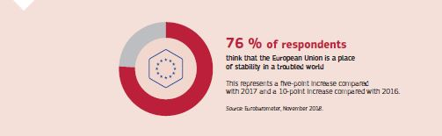

Given the unpredictable times we face, Europe needs to take greater responsibility for its own internal and external security. European defence is essential not only for Europe’s own security but more widely in the pursuit of global peace and security.

In March, a first grant agreement under the Preparatory Action for Defence Research was signed for €35 million for [Ocean 2020](http://ec.europa.eu/growth/content/european-defence-fund-continues-deliver-another-important-grant-key-research-project_en), the first cross-European military research project. In parallel, under the Permanent Structured Cooperation on Defence that the Council decided to establish in December 2017, substantial progress was made and 34 multinational defence collaborative projects were launched throughout the year, including on military training and exercises, military capabilities on land, air and sea, and the ever more important area of cyber defence. A defence initiative on improving military mobility was launched with an EU Action Plan in March 2018. In July, the EU established the European Defence Industrial Development for 2019-2020 Programme and proposed a [€13 billion European Defence Fund](http://europa.eu/rapid/press-release_IP-18-4121_en.htm) for the next long-term EU budget (2021 to 2027) to increase the EU’s role as a security and defence provider.

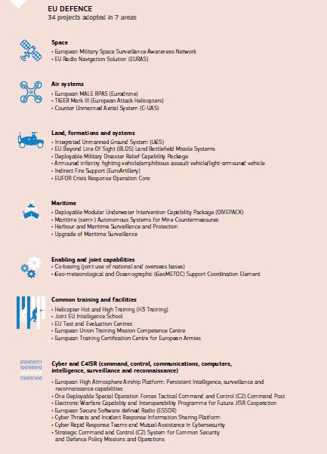

In 2018, the EU conducted six military and 10 civilian Common Security and Defence Policy missions and operations outside its borders. Whether in Afghanistan, the Sahel or Iraq, building strong, resilient and inclusive state institutions requires investment in the development of professional police, judges, doctors and school administration, as well as a reliable and democratically controlled army. In June, the EU therefore also proposed a [European Peace Facility](https://eeas.europa.eu/headquarters/headquarters-homepage/46285/european-peace-facility-eu-budget-fund-build-peace-and-strengthen-international-security_en) making it easier to fund its Common Security and Defence Policy missions and operations and to support Europe’s partners. In November, EU ministers also adopted a Civilian Common Security and Defence Policy Compact that is intended to lead to a more capable, more effective and more joined up civilian Common Security and Defence Policy.

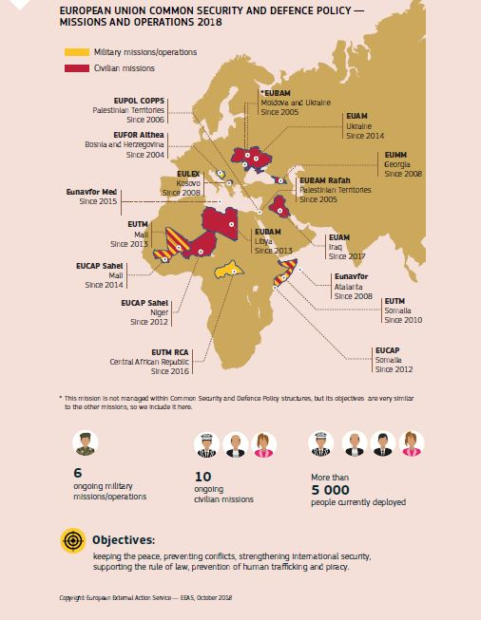

Military missions are just one element in the EU’s toolbox of instruments to tackle today’s challenging security environment. In 2018, Member States acknowledged the crucial role of civilian Common Security and Defence Policy missions in addressing security challenges, including organised crime, terrorism and hybrid threats. They decided further to strengthen the civilian dimension of Common Security and Defence Policy through a Civilian Compact.

Preventing and countering terrorism and violent extremism

Counterterrorism and preventing violent extremism have been top EU priorities over the past year, in line with the UN Global Counterterrorism Strategy and the Plan of Action to Prevent Violent Extremism. The EU has strengthened dedicated counterterrorism dialogues with the western Balkans, Turkey and the Middle East and North Africa countries as well as key international organisations.

Migration

The EU continues to work with Member States and international partners to save lives, provide protection, offer safe and legal pathways and tackle the root causes of migration. It has stepped up the fight against criminal networks that often take advantage of people’s despair and engage in people smuggling and trafficking. The United Nations Global Compact for Migration and Global Compact for Refugees were both adopted in 2018.

The EU’s work has contributed to: the safe return home of over 33 000 migrants stranded in Libya; an 80 % reduction in the number of arrivals via the central Mediterranean route; and the establishment of an evacuation channel in Niger for those in need of international protection. Since November 2017, 2 105 vulnerable refugees and asylum seekers have been evacuated.  The EU Emergency Trust Fund for Africa continued to tackle the root causes of instability, forced displacement and irregular migration and to help manage migration.

Responding to humanitarian crises and emergencies

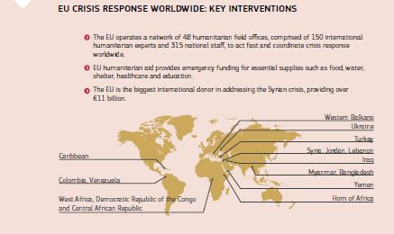

The conflict in Syria has led to unspeakable misery for millions of people. Since the beginning of hostilities in 2011, the EU has provided life-saving support to civilians in Syria and in its neighbouring countries. Its humanitarian aid projects in Syria, Jordan, Lebanon, Egypt and Turkey amounted to €311 million in 2018.

International conflicts can only be solved through a strong multilateral system and almost half of the EU’s humanitarian aid funding in 2018 went to UN organisations — most notably the World Food Programme, the two UN agencies for refugees and migration, Unicef and the World Health Organisation. In 2018, education projects became central to the EU’s humanitarian aid response and amounted to €100 million.

In 2018 the European Union activated its civil protection mechanism on 10 occasions to respond to sudden onset disasters in Latin America, Africa and Asia. When a series of earthquakes and a tsunami struck Indonesia in late September, for example, the European Commission coordinated the delivery of shelter, power modules and water purification from eight different EU Member States.

Human rights

The EU continued to defend and promote [human rights](https://eeas.europa.eu/topics/human-rights-democracy_en) especially at a time when respect for these rights is being eroded in many parts of the world. The 70th anniversary of the Universal Declaration of Human Rights was strongly supported by the EU. The ‘Good Human Rights Stories’ launched at the UN General Assembly brought together an alliance of countries and highlighted examples of positive human rights practices.

Equality between women and men is one of the fundamental values of the EU and a priority for its European and international policies. The EU supports the United Nations Women, Peace and Security agenda. It is also working on implementing the action plan set out in the working document on ‘Gender equality and women’s empowerment: transforming the lives of girls and women through EU external relations, 2016-2020’.

In 2018 [Electoral Observation Missions](https://eeas.europa.eu/topics/election-observation-missions-eueoms_en) went to Gambia, Kosovo, Lebanon, Tunisia and Honduras.

EU sanctions

[Sanctions](https://eeas.europa.eu/topics/sanctions-policy/423/sanctions-policy_en), often called ‘restrictive measures’, are one of the EU’s tools to promote the objectives of the common foreign and security policy: peace, democracy, and the respect for the rule of law, human rights and international law. They are always part of a wider, comprehensive policy approach involving political dialogue and complementary efforts. EU sanctions are not punitive, but designed to bring about a change in policy or activity by the target country, entities or individuals. A map of EU sanctions can be found [here](https://ec.europa.eu/fpi/what-we-do/sanctions_en).

Working with international partners

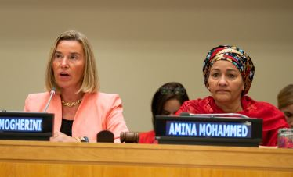

Federica Mogherini, High Representative/Commission Vice-President, and Amina Mohammed, Deputy Secretary-General of the United Nations, attend a launch event of the Latin America Programme during the 73rd session of the UN General Assembly, New York, USA, 27 September 2018.

The EU must take strategic responsibility to act alone when necessary and with partners whenever possible. This is why the EU strengthened its cooperation with other international partners, such as NATO and the United Nations.

The United Nations

The EU believes in a rules-based international order with the [United Nations](https://eeas.europa.eu/delegations/un-new-york/33807/eu-un_en) at its heart for a stable and secure world. At the UN General Assembly in 2018, the EU delegation (led by President Donald Tusk and President Jean-Claude Juncker) agreed a renewed strategic partnership with the UN, including a commitment to enhance development cooperation. The EU supported the reforms proposed by UN Secretary-General António Guterres to make the UN fit for purpose in the 21st century. Cooperation on peace and security intensified, notably in the Central African Republic, Mali, Sahel, Libya and Somalia.

A stronger EU–NATO partnership

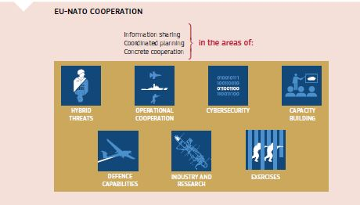

The cooperation between the EU and NATO constitutes an integral pillar of the EU’s work in strengthening European security and defence, as part of the implementation of the EU Global Strategy.

Altogether, 74 concrete actions are currently being implemented in various areas, with the third progress reports issued in 2018 highlighting rapid progress and added value in EU–NATO cooperation. Furthermore, the EU and NATO conducted a coordinated and parallel exercise to improve and enhance the EU’s ability to respond to a complex crisis of a hybrid nature and to further develop interaction between both organisations in situational awareness, cyber-crisis response, and strategic communication in crisis situations.

The European Union in the G7 and G20

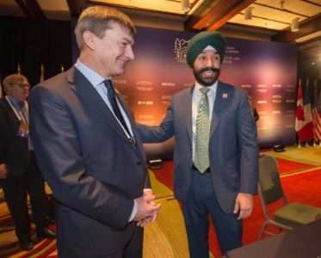

Commission Vice-President Andrus Ansip discusses with Navdeep Bains, Canadian Minister for Innovation, Science and Economic Development, at the meeting of G7 Ministers for Employment and Innovation on ‘Preparing for jobs of the future’, Montreal, Canada, 28 March 2018.

The European Union is a full member of the G7 and G20. In these fora, the EU fights to preserve the rules-based international order, which is currently under great strain, in terms of trade, security, climate change and human rights. Meeting in Canada in June, G7 leaders committed in [a declaration](https://www.consilium.europa.eu/en/press/press-releases/2018/06/09/the-charlevoix-g7-summit-communique/) to fight trade protectionism and to modernise the World Trade Organization, and urged Russia to end its actions undermining democracies and its support of the Syrian regime. They also called for the denuclearisation of the Korean peninsula and of Iran. G7 leaders vowed to work together to achieve inclusive growth and gender equality, and the EU reaffirmed is strong commitment to implementing the Paris Climate Agreement. At the G20 meeting in Buenos Aires, leaders issued a [declaration](https://www.consilium.europa.eu/media/37247/buenos_aires_leaders_declaration.pdf) focusing on building consensus for fair and sustainable development. G20 leaders renewed their commitment to work together to improve a rules-based international order and supported the necessary reform of the WTO to improve its functioning.

The EU’s long-term budget 2021-2027

The EU is the world’s biggest donor of development assistance, the first trading partner and the first foreign investor for almost every country in the world. The EU will increase the money it spends on development and humanitarian aid in the long-term budget for 2021 to 2027. [As a Union promoting peace, stability and exporting its values and rules](https://ec.europa.eu/commission/sites/beta-political/files/budget-proposals-neighbourhood-world-may-2018_en.pdf), it is faced with many challenges as well as opportunities in an increasingly complex and connected world. Prosperity and peace in the EU’s neighbourhood has a positive impact on the EU’s own prosperity. For the next long-term budget, the Commission proposes to increase investment in external actions by 26 % to €123 billion, along with a major restructuring of the EU’s external action instruments to provide better coherence, build on cooperation effectiveness, simplify processes and use economies of scale. The year also saw the launch of the [European Defence Fund](http://europa.eu/rapid/press-release_IP-17-1508_en.htm) to help countries spend taxpayers’ money more efficiently, reduce duplications in spending, and get better value for money. The Fund will coordinate and amplify national investments in defence research and developing defence equipment and technology. It has two main strands: (i) research; and (ii) development. Research could typically cover electronics, metamaterials, encrypted software and robotics, while development could cover defence equipment and technology such as developing drone technology or satellite communications to reduce costs.

Security threats know no borders and are becoming increasingly international. The complex nature of these challenges is such that no Member State can or should be made to meet them on its own. The EU budget must support Member States in their responsibilities and efforts to keep Europeans safe. The EU budget for security and defence according to the Commission’s proposals to Council and Parliament will amount to some €19.5 billion (€13 billion for the European Defence Fund plus €6.5 billion for military mobility under the Connecting Europe Facility). In addition, according to the High Representative’s proposal to the Council with support of the Commission, a further €10.5 billion will be made available outside the EU budget for the European Peace Facility. Overall expenditure on security and defence for 2021-2027 should therefore exceed €30 billion.

Chapter 10

A Union of democratic change

‘A European Commission under my leadership will be committed to fulfilling the special partnership with the European Parliament. […] I am also committed to enhanced transparency when it comes to contact with stakeholders and lobbyists.’

Jean-Claude Juncker, political guidelines, 15 July 2014

In his 2014 political guidelines for the next European Commission, Commission President Jean-Claude Juncker committed to ‘work to re-gain citizens’ trust in the European project’. To fulfil this aim, the Juncker Commission has worked since day one to make the EU more democratic, by opening up the policymaking process to citizens’ input, boosting transparency and embedding Better Regulation principles at the heart of the Commission’s work.

2018 continued to build on previous achievements by presenting new future-oriented initiatives. In February, the Commission presented practical measures to EU leaders to improve the connection to citizens at the next European elections and make the EU work more efficiently. Citizens’ Dialogues went from strength to strength, with the 1 000th Dialogue taking place in Freiburg, Germany, in October with President Juncker, and wide-ranging debates on the Future of Europe.

Many of these Citizens’ Dialogues discussed the Future of Europe, a debate that gathered pace in 2018 with discussions online and in Parliaments, cities and regions across the Union in the run-up to the decisions that the Union is expected to take at the Sibiu Summit in May 2019.

The Commission gave its views on the selection process for the next Commission President, the composition of the future European Parliament and Commission and the functioning of a double-hatted President for the Commission and European Council.

The European Parliament and the Council reached agreement in February on new [rules for funding European political parties](http://www.consilium.europa.eu/en/press/press-releases/2018/04/26/european-political-parties-revised-funding-rules-adopted/) and in December on the reform of the European Citizens’ Initiative, which includes more information and help for organisers, making it easier for citizens to prepare an initiative. And in May the Commission presented its proposal for the future long-term budget of the Union, launching a process with the other European institutions to ensure that the EU will have the resources to meet the Union’s ambitions and face current and future challenges.

The future of Europe

In the 2016 State of the Union address, President Juncker kick-started the reflection process on the future of Europe, and of the EU at 27. EU leaders adopted two important Declarations on the path ahead: at Bratislava in September 2016, and Rome in March 2017 and in parallel, the Commission, together with the European Parliament and the Member States, invited citizens to contribute to the debate on the future of Europe by participating in Citizens’ Dialogues and through [online consultations drafted by citizens themselves](https://ec.europa.eu/commission/future-europe/consultation-future-europe_en).

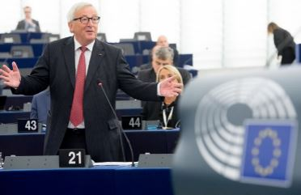

Jean-Claude Juncker, President of the European Commission, speaking at the plenary session of the European Parliament on the debate on the future of Europe, Strasbourg, France, 23 October 2018.

In March 2017 the European Commission published a White Paper on the Future of Europe, offering five scenarios for how the Union could evolve. This was followed by a series of five reflection papers on the issues that will most affect the EU’s future. President Juncker proposed a Roadmap for a More United, Stronger and More Democratic Union in his 2017 State of the Union address.

Building on this, national leaders agreed on a Leaders’ Agenda—a list of the most pressing issues and challenges for which solutions should be found, ahead of the European elections in May 2019. Substantial progress has been made so far, with the Commission adopting all proposals that were requested by EU leaders in Bratislava and Rome, making ambitious proposals in the areas of migration, Economic and Monetary Union, institutional issues, taxation in the digital economy, digital issues, research and innovation, education and culture.

In February 2018 the Commission proposed a package of options to make the EU work more efficiently including by confirming and improving the system of lead candidates for President of the European Commission (‘Spitzenkandidaten’). It also called for the links between European political parties and their national and regional member parties to be more transparent, so that voters can easily see how their vote translates into decisions in Europe. To ensure the European elections are free and fair, in September 2018 the Commission presented additional specific measures which aim to protect our democratic processes from manipulation by third countries or private interests, such as by exploiting illegally obtained personal data.

In September 2018 leaders agreed on measures relating to internal security, while in December they agreed on measures relating to the Economic and Monetary Union.

The road to Sibiu

In the Roadmap for a More United, Stronger and More Democratic Union, President Juncker proposed a special leaders’ meeting in Sibiu, Romania, to discuss strategic issues on the future of the Union. The informal leaders’ meeting will take place on 9 May 2019, where national leaders should be able to send a message of hope, unity and determination, and recall our shared values. It will also be an opportunity to mark the culmination of the process of reflection on the future of Europe with a renewed commitment to an EU that delivers on the issues that really matter to people. On this occasion — 6 weeks after the United Kingdom is due to leave the EU and 2 weeks before the European Parliament elections — leaders are expected to reflect on a new Strategic Agenda that will set priorities and guide the work of the European Union over the next 5 years.

In the 2018 State of the Union address, President Juncker repeated the commitment to deliver a more united, stronger and more democratic Europe. On the ‘Road to Sibiu’ there are a number of milestones and key initiatives to deliver on the Commission’s 10 political priorities, as well as the complementary forward-looking proposals. There are three priorities for the three EU institutions making all of this a reality — the European Parliament, Council and Commission.

* Delivering what was agreed and promised — adoption of the legislative proposals still pending.
* Overcoming important outstanding challenges — including completing work in the area of migration; reinforcing the Economic and Monetary Union and addressing increasing tensions in the global trading system.
* Giving the European Union a perspective for the future. It is with this in mind that, in May, the Commission tabled its proposal for the next long-term budget of the Union of 27 Member States (2021 to 2027). To enable the Union to be an effective and sovereign global actor, the Commission proposed in September greater use of qualified majority voting in certain areas of EU common foreign and security policy. Initiatives to give a perspective to the future of the Union also include a further reinforcement of mechanisms to protect and defend the rule of law in all Member States.

The EU agenda in 2019 will be marked by three words: delivery, destiny and democracy.

Delivery is the Commission’s and President Juncker’s main focus right until the very last day in office. All the proposals based on the 10 Priorities of the Juncker Commission are now on the table, but around 241 proposals still need to be adopted in the next few months. The College will be working flat out to ensure that as many as possible of these proposals are formally adopted by the co-legislators to make a real difference in people’s lives.

2019 will be the year when Europe must take its destiny into its own hands, as President Juncker called for in his last State of the Union speech. On 9 May in Sibiu, Romania, the 27 leaders will usher in a new dawn with a very special summit that will pave the way for a stronger, more united and more democratic Europe.

Just 2 weeks after Sibiu, Europeans will take part in the second largest election anywhere in the world — second only to the Indian general election. Democracy and European elections will be a chance for people to have their say on the kind of Union they want and for all parties from across the spectrum to put forward their ideas for the future.

The European Parliament

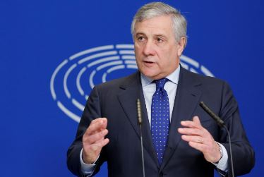

Antonio Tajani, President of the European Parliament, speaks during a press conference about the withdrawal of the United Kingdom from the EU in the European Parliament, Strasbourg, France, 15 November 2018.

The European Parliament tackled a wide range of policy issues in 2018, adopting legislation to prevent money laundering and terrorist financing, to make sure Member States know who is crossing the external borders, to set up a new Solidarity Corps to help young people to volunteer or work in projects in their own country or abroad, to encourage the development of an environmentally sustainable ‘circular’ economy and to reduce greenhouse gas emissions. It also approved a modernisation of Europe’s tools to tackle unfair trading practices by countries around the world and legislation to make fairer and more effective the rules on workers who are posted to work in another EU country than their own.

The European Council

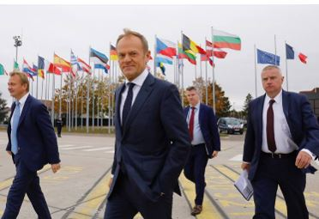

Donald Tusk, President of the European Council, at the European Parliament in Strasbourg, France, 24 October 2018.

The European Council held an informal meeting in February to discuss institutional issues encompassing the composition of the European Parliament, transnational lists, and appointments including the *Spitzenkandidaten* for the post of President of the European Commission. In addition, leaders held a debate on the political priorities of the EU’s next long-term budget (2021-2027).

The March European Council focused on the economy (in particular the Single Market Strategies), trade, social issues, and preparations for the May EU–Western Balkans Summit. In the context of the Leaders’ Agenda, discussions also took place on digital taxation and foreign relations. The European Council (in its Article 50 configuration of 27 Member States) adopted guidelines on the future relationship with the United Kingdom. At the Euro Summit, leaders held an exchange of views on all elements of the Economic and Monetary Union, except for the Banking Union and the European Stability Mechanism.

EU leaders met in Sofia, Bulgaria in May for the EU–Western Balkans Summit. Prior to the summit, leaders held a working dinner in the context of the Leaders’ Agenda where the discussion was dedicated to digital issues, and research and innovation.

In June the main topic discussed by leaders was migration. Security and defence, the EU’s next long-term budget (2021-2027), trade, the European Semester, digital taxation, and innovation and digital Europe also featured on the agenda. At the Euro Summit, leaders discussed the completion of the Banking Union and the future role of the European Stability Mechanism. The European Council (meeting as the 27 Member States in the Article 50 formation) reviewed the state of progress in negotiations on the withdrawal of the United Kingdom from the EU, noting the lack of substantial progress since the March European Council on the draft Withdrawal Agreement as well as on future relations.

At an informal meeting in Salzburg in September, leaders addressed the Article 50 negotiations, in addition to internal security under the Leaders’ Agenda. They also took stock of the implementation of the June European Council conclusions on migration.

In October leaders came back to internal security and migration as a follow-up to September’s informal meeting. Under external relations, leaders addressed EU–Africa relations, the EU–Arab League Summit scheduled for February 2019, the 2030 Agenda for Sustainable Development and preparations for the United Nations Climate Change Conference in Katowice, Poland. Leaders also held discussions on Article 50 negotiations and on issues related to the Economic and Monetary Union.

In November an extraordinary European Council (Article 50) meeting was held to allow EU-27 leaders to endorse the draft Withdrawal Agreement and approve the Political Declaration setting out the framework for the future relationship between the EU and the United Kingdom.

In December the European Council discussed the next long-term budget, migration, the Single Market, climate change, security and defence, disinformation, the fight against racism and xenophobia, Citizens’ Dialogues and Citizens’ Consultations, and Preparations for the Strategic Agenda. Under external relations, leaders addressed preparations for the EU–Arab League Summit, Russia, and the EU–Japan Economic Partnership Agreement. A European Council (Article 50) meeting also took place, as well as a Euro Summit where the main issues discussed were a budgetary instrument for convergence and competitiveness for the euro area, and the strengthening of the international role of the euro.

The Council of the European Union

Bulgaria and Austria held the rotating Presidency of the Council of the European Union in 2018. During the first half of the year, Bulgaria focused on migration, security, digital economy, the western Balkans, and economic and social cohesion. In the second half of 2018, the Austrian Presidency focused on migration, internal security, subsidiarity and digitalisation.

The European Economic and Social Committee and the European Committee of the Regions

In 2018 the European Economic and Social Committee was actively involved in discussions on the EU’s next long-term budget 2021-2027, holding a plenary debate in September with the participation of Commissioner Günther Oettinger, responsible for budget and resources, and in the debate on the European Citizens’ Initiative. In May the Committee held a commemorative plenary session to celebrate its 60th anniversary and hosted the annual Civil Society Days, which focused on citizenship, democracy and culture in a digitalised Europe.

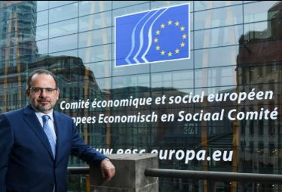

Luca Jahier was elected President of the European Economic and Social Committee in April 2018.

In the first half of 2018, the European Committee of the Regions was engaged in the work of the Task Force on Subsidiarity, Proportionality and ‘Doing Less More Efficiently’ contributing on the issues that are important to local and regional authorities. The Committee continued with the series of town-hall events and Citizens’ Dialogues on the future of Europe, culminating in the adoption of the [opinion on the future of Europe](http://dm.cor.europa.eu/CoRDocumentSearch/Pages/opinionsresults.aspx?k=(dossiername:CIVEX-VI)(rapporteur:LAMBERTZ)(documentlanguage:EN)), and with reinforcing the Cohesion Alliance — a coalition of those who believe that EU cohesion policy must continue to be a pillar of the EU’s future. The Committee also hosted the ninth European Conference on Public Communication in November, dedicated to Campaigning for Europe in preparation for the European elections in 2019.

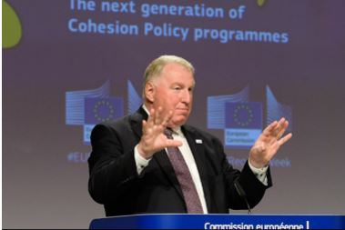

Karl-Heinz Lambertz, President of the Committee of the Regions, presenting the European Week of Regions and Cities 2018 and the next generation of Cohesion Policy Programmes, Brussels, Belgium, 8 October 2018.

Completing the Better Regulation Agenda

Commission Work Programme 2019

In October the European Commission presented its Work Programme for 2019. This set out three main priorities for the year ahead: reaching swift agreement with co-legislators on pending legislative proposals to deliver on the 10 political priorities; adopting a limited number of new initiatives to address outstanding challenges; and, as part of the roadmap to the Sibiu Summit on 9 May 2019, presenting several initiatives with the perspective of a future Union of 27 Member States, reinforcing the foundations for a strong, united and sovereign Europe. New initiatives cover areas such as migration, reinforcing Economic and Monetary Union, reducing tensions in the global trade system, tackling challenges to the rule of law and finalising the agreement for the United Kingdom’s withdrawal from the EU.

The Task Force on Subsidiarity, Proportionality and ‘Doing Less More Efficiently’

The Task Force on [Subsidiarity, Proportionality and ‘Doing Less More Efficiently](https://ec.europa.eu/commission/priorities/democratic-change/better-regulation/task-force-subsidiarity-proportionality-and-doing-less-more-efficiently_en)’ was established in 2017 to make recommendations on how to better apply the principles of subsidiarity and proportionality; identify policy areas where work could be re-delegated or definitely returned to EU countries; and find ways to better involve regional and local authorities in EU policymaking and delivery. It was chaired by Frans Timmermans, First Vice-President of the Commission, and included representatives of national parliaments and of the Committee of the Regions. The European Parliament was also invited to nominate representatives, but decided not to do so.

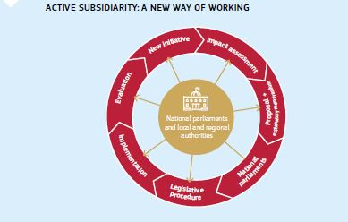

On 10 July the Task Force issued its [final report](http://europa.eu/rapid/press-release_IP-18-4393_en.htm). It concludes that a new way of working on subsidiarity and proportionality is needed to allow local and regional authorities and national parliaments to make a more effective contribution to EU policymaking and in the design of new legislation. The proposed new approach would see subsidiarity and proportionality being assessed more consistently by all levels of government, on the basis of a ‘model grid’ — comparable to a subsidiarity and proportionality checklist. The Task Force did not identify any competences or policy areas that should be re-delegated definitively, in whole or in part, to the Member States.

In response to the report of the Task Force, the Commission published the communication ‘[The Principles of subsidiarity and proportionality: Strengthening their role in EU policymaking](https://ec.europa.eu/info/publications/communication-principles-subsidiarity-and-proportionality-strengthening-their-role-eu-policymaking_en)’ on 23 October. The Commission intends to implement many of the actions in the Communication as part of the ongoing exercise taking stock of its better regulation agenda, and will report on this in the spring of 2019.

Working to simplify legislation

In line with the commitment taken in the Interinstitutional Agreement on Better Law-Making, in November the Commission presented an Annual Survey of the Union’s efforts to simplify legislation, to avoid overregulation and reduce regulatory burdens undertaken in 2018. This work is carried out within the Regulatory Fitness and Performance Programme that aims to identify opportunities to simplify legislation and reduce unnecessary costs. Every time the Commission proposes to revise existing law, it checks whether it can be simplified and any unnecessary costs removed. The survey finds that, under the Regulatory Fitness and Performance (REFIT) Programme, the current Commission has delivered more than 150 initiatives focused on simplifying legislation and reducing burdens. A recent example is a proposal to amend the current VAT rules where compliance costs for small businesses are expected to be reduced by €11.9 billion per year to €56.1 billion per year, an 18 % reduction compared to the present situation.

This endeavour is supported by the REFIT platform (composed of a Stakeholders and Government group) that has issued 31 opinions in 2018 year recommending the Commission to take actions in areas that are particularly burdensome to citizens and business.

Other major simplification initiatives were undertaken in 2018 in the context of the EU’s next long-term budget (2021-2027). The new programmes will make it easier for beneficiaries to apply and benefit from EU funding opportunities.

The Interinstitutional Agreement on Better Law-Making

In 2016 and 2017 the European Parliament, the Council and the European Commission agreed on two Joint Declarations on the EU’s legislative priorities. They highlighted 89 initiatives for which priority treatment in the legislative process was needed. This represents a common commitment by the three institutions to ensure substantial progress and, where possible, delivery before the European elections in May 2019.

By the first half of 2018, the European Commission had adopted all the initiatives announced in the Joint Declarations on legislative priorities. Of the 89 initiatives in the Joint Declaration, by the end of 2018, 61 had been politically agreed or formally adopted by the European Parliament and the Council. Of the 28 initiatives still on the table, seven are well on track to be agreed by May 2019. The remaining 21 initiatives can still be agreed by May 2019 if there is strong political will from the co-legislators.

The Interinstitutional Agreement on Better Law-Making brought about more transparency, accountability and legal clarity to the existing system of implementing acts (comitology) and delegated acts. In 2018 the European Commission continued negotiations with Parliament and Council on criteria for the choice between implementing and delegated acts and on aligning existing legislation to the system introduced by the Lisbon Treaty — both follow commitments under the Interinstitutional Agreement on Better Law-Making. Negotiations are also ongoing on further improvements to the comitology system. All of these negotiations aim at increasing legal stability and reducing controversy in legislative negotiations. The new [Register of delegated acts](https://webgate.ec.europa.eu/regdel/#/home), the first truly interinstitutional law-making tool, went online on 12 December 2017.

Monitoring the application of EU law

The effective application of the law is essential to guarantee that citizens and businesses enjoy the benefits of EU law. Any rule, no matter how carefully drafted and prepared, is only as effective as its implementation. The Commission therefore pays attention not only to proposing new legislation, but also to ensuring that it is properly applied and enforced.

The [Annual Report for 2017](http://europa.eu/rapid/press-release_IP-18-4295_en.htm), published on 12 July 2018, shows a slight decrease (by 5.91 %) of open infringement cases against Member States compared to the previous year. The policy areas in which most infringement cases were opened in 2017 were mobility and transport, environment and financial stability, services and capital markets.

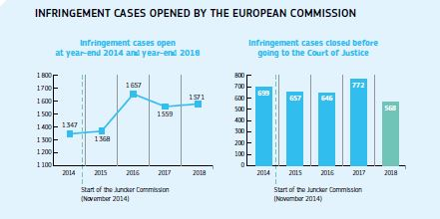

Giving citizens a say in EU law-making

As part of the Commission Better Regulation Agenda, the central consultation website ‘[Have Your Say](https://ec.europa.eu/info/law/better-regulation/have-your-say_en)’ was improved to make it easier for the general public to follow and to contribute to its law-making process.

Since the launch of the website in 2016, the number of yearly visits has constantly increased, reaching almost 500 000 for 2018. In order to take stock of its ‘better regulation’ approach, and assess how well the various better regulation tools work in practice and contribute to achieving its objectives, the Commission launched a [public consultation](https://ec.europa.eu/info/consultations/public-consultation-stocktaking-commissions-better-regulation-approach_en?pk_source=twitter&pk_medium=social_media_organic&pk_campaign=br_stocktaking_opc) from 17 July until 23 October. All citizens, organisations and public authorities with an interest or experience in EU policymaking were welcome to contribute. More than 600 contributions were collected across all Member States. These were thoroughly looked into and analysed together with the input from targeted consultations of EU institutions and bodies. The exercise will be finalised in the first half of 2019.

Ensuring the rule of law

Abiding by the rule of law is a fundamental element of democracy and of respect for fundamental rights. But it is also an essential guarantee of the functioning of the European Union — as a Single Market, as an area where laws are applied uniformly and the budget is properly spent, and as an area where Member States and their citizens can work together in a spirit of mutual trust towards our common objectives.

The greatest risk when the rule of law is disregarded is that of eroding mutual trust: refusing to play by the rules of the EU Treaties directly affects the very basis of solidarity, cohesion and the mutual recognition of national decisions.

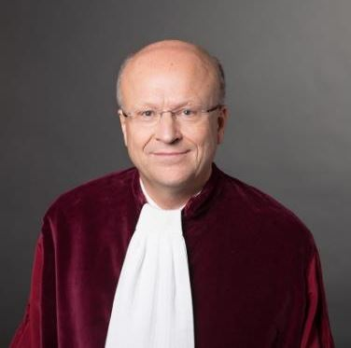

On 9 October 2018 Koen Lenaerts was re-elected by the Members of the Court of Justice of the European Union to serve as President of the Court until 6 October 2021.

In 2018, the Commission continued to address challenges to the rule of law in a few Member States, notably Hungary and Poland. In this context, the Commission had to resort to the use of infringement procedures and, in the case of Poland, of the provisions of Article 7 of the Treaty on European Union.

The Commission has also continued to work together with Bulgaria and Romania in the context of the Cooperation and Verification Mechanism.

A major innovation in the proposed long-term budget is the strengthened link between EU funding and the rule of law. Respect for the rule of law is an essential precondition for sound financial management and effective EU funding. The Commission is therefore proposing a new mechanism to protect the EU budget from financial risks linked to generalised deficiencies regarding the rule of law in the Member States. The new proposed tools would allow the Union to suspend, reduce or restrict access to EU funding in a manner proportionate to the nature, gravity and scope of the rule of law deficiencies.

Transparency and accountability

The Joint Transparency Register

Contacts with stakeholders and civil society are an integral part of the work of the EU institutions. At the same time, transparency and accountability are essential to maintain the trust of European citizens in the legitimacy of the political, legislative and administrative processes in the Union. Transparency of interest representation is especially important in order to allow citizens to follow the activities and potential influence of those seeking to influence the EU law-making process. This is why the Commission has tabled a proposal to upgrade the current Transparency Register by a new Interinstitutional Agreement of mandatory nature covering the European Parliament, the Commission and, for the first time, the Council of the European Union. Negotiations on this dossier with the other institutions are ongoing.

A new Code of Conduct for the Members of the Commission

The European Commission adopted the new [Code of Conduct for the Members of the European Commission](http://europa.eu/rapid/press-release_IP-18-504_en.htm) on 31 January. Some of the novelties include extending the notification period for post-mandate activities to 2 years (3 years as regards the President), stricter rules to the financial interests of Commissioners, better prevention of conflicts of interest and enhanced transparency (for example, regarding the twice-monthly publication of Commissioners’ mission expenses). Also in the spirit of transparency and accountability, and as provided for by the new Code of Conduct, the Commission will publish annual reports on its application.

Access to documents

In October the Commission adopted its 2017 Report on Access to Documents. The report shows that the number of initial requests for access to documents submitted under Regulation (EC) No 1049/2001 on public access to documents increased by almost 3 % (from 6 077 requests in 2016 to 6 255 in 2017) and the number of confirmatory requests by 1 % (from 295 in 2016 to 299 in 2017). The European Commission remains by far the EU institution handling the largest number of requests for access to documents.

This demonstrates that EU citizens and other beneficiaries are making active use of their right to access documents held by the European Commission. The requested documents were fully or partially disclosed in more than 82 % of cases at the initial stage. Wider or even full access was granted in 46 % of the cases reviewed at the confirmatory stage. In parallel, the Commission continued to publish proactively large amounts of documentation and information on its webpages and in its various public registers, covering all areas of EU activity.

Control of the EU budget

A control framework and a performance framework are in place to provide reasonable assurance that EU funds are paid in accordance with the relevant rules and there is continuous work to ensure that measures are taken to prevent, detect and correct errors, increasing the focus on achieving results.

In April 2018, following a positive recommendation from the Council, the European Parliament gave its final approval to the way the Commission implemented the EU budget in 2016. The annual discharge procedure allows the Parliament and the Council to hold the Commission politically accountable for the implementation of the budget and to keep the management of taxpayers’ money under democratic control.

In July the Commission presented its Integrated Financial Reporting Package on the 2017 EU budget, which puts together all the available information on the implementation, performance, results, sound financial management and protection of the EU budget. The reports demonstrated that the EU budget delivered results in line with the Commission’s priorities and was implemented properly.

In 2018 the Commission achieved substantial progress towards the establishment of the European Public Prosecutor’s Office, which will have competence to investigate and prosecute criminal offences affecting the EU budget in the 22 participating Member States, and is expected to be operational by the end of 2020.

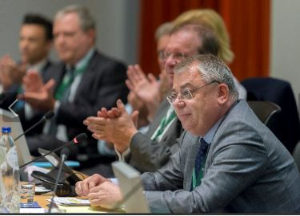

Klaus-Heiner Lehne, President of the European Court of Auditors, at the Global Audit Leadership Forum, Luxembourg, 26 April 2018.

In October, for the eleventh year in a row, the European Court of Auditors issued a clean bill of health on the EU’s annual accounts, finding them to be true and fair. Moreover, the Court detected fewer errors across the areas of spending than reported in the previous 4 years. For more than half of the EU’s spending, the error rate did not even reach the level considered by the Court to be material. No errors were found on the revenue side of the budget.

National parliaments

The 2017 Annual Reports on Subsidiarity and Proportionality and on the Commission’s relations with national parliaments were both published on 23 October, together with a Communication from the Commission on the principles of subsidiarity and proportionality.

A total of 570 opinions from national parliaments were received during 2018, including 37 reasoned opinions submitted under the Subsidiarity Control Mechanism arguing that legislative acts presented by the Commission did not comply with the subsidiarity principle. The Commission continued its intensive political dialogue with national parliaments. In particular, Commissioners met with national parliaments 140 times over the course of the year, either during visits to Member States or when parliamentarians visited Brussels. Members of the Commission also attended a variety of inter-parliamentary meetings and other events at which they engaged with national parliamentarians.

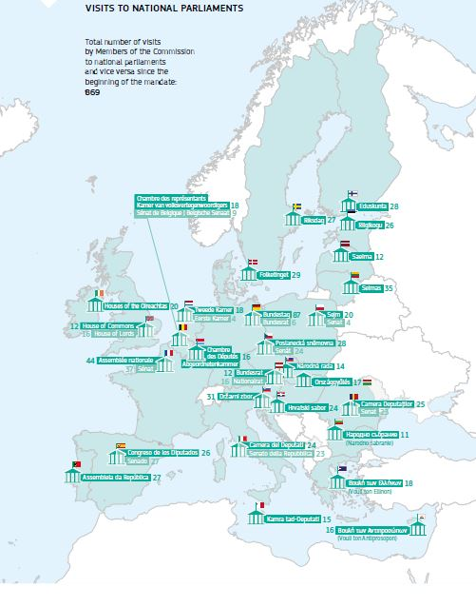

The European Ombudsman

The European Ombudsman’s inquiries into alleged maladministration in the institutions and bodies of the European Union covered matters relating, among others, to the Code of Conduct for Members of the Commission, and in particular to post-mandate activities, the appointment of Commission special advisors, and the transparency of international negotiations. Specific topics such as issues relating to calls for tenders, contracts, late payments, individual staff matters and access to documents were also addressed. In 2018, over 97 % of all 229 decisions and recommendations issued by the European Ombudsman were closed without any finding of maladministration.

The European Citizens’ Initiative

The Commission registered seven new Citizens’ Initiatives in 2018.

The [second 3-year report on the application of the European Citizens’ Initiative Regulation](http://europa.eu/rapid/press-release_IP-18-2563_en.htm) was published on 28 March 2018, presenting the state-of-play on the instrument; i.e. main problems stakeholders are confronted with, but also improvements already introduced or proposed by the Commission in its proposal for a new Regulation adopted on 13 September 2017.

On the occasion of the [European Citizens’ Initiative Day 2018](https://www.eesc.europa.eu/en/agenda/our-events/events/eci-day-2018-working-together), organised on 10 April by the European Economic and Social Committee, the Commission launched a 3-year communication campaign on the European Citizens’ Initiative. This consisted mainly of social media campaigns based on short videos, as well as events in Member States targeting potential multipliers.

On 22 May a [European Citizens’ Initiative Forum](https://collab.ec.europa.eu/wiki/eci/) was also launched. The Forum is an online collaborative platform, which supports citizens interested in starting an initiative or who are already coordinating an initiative by showcasing best practices, by helping with finding partners in other countries or by providing independent advice by experts.

On 12 December, a political agreement was reached with the European Parliament and the Council on the reform of the European Citizens’ Initiative, based on the Commission proposal adopted in 2017*.*

Citizens’ Dialogues and Citizens’ Consultations

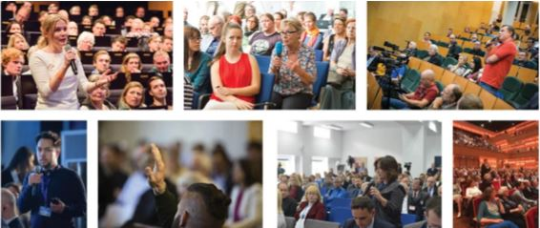

Citizens’ Dialogues

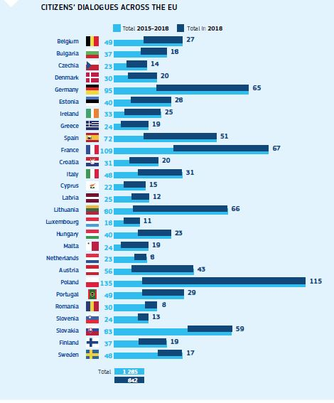

Since 2015, almost 1 300 Citizens’ Dialogues have taken place in over 400 towns and cities across the EU. The number of dialogues increased significantly following the publication of the White Paper on the Future of Europe in 2017. To maintain the momentum, in February 2018 the Commission announced its intention to reach a target of 1 000 Citizens’ Dialogues.

On 1 October 2018, President Juncker and Mr Winfried Kretschmann, Minister-President of Baden-Württemberg, debated with citizens at the 1000th Citizens’ Dialogue since the beginning of the Commission’s mandate, in Freiburg, Germany.

In 2018, 833 Citizens’ Dialogues took place in 27 Member States, bringing together more than 70 000 people. Since 2015, over 160 000 people have discussed the issues that matter most to them with the President and Vice-Presidents of the Commission, Commissioners, EU officials, members of the European Parliament and national politicians. The impact can already be seen in the work of the Commission and the other institutions. For instance, the Commission’s proposals for a new long-term budget, and the subsequent discussions amongst the co-legislators, reflect the priorities and ambitions that citizens expressed during the White Paper debates.

The European Commission is developing new formats of Citizens’ Dialogues, including cross-border events with citizens from two or three Member States, live Citizens’ Dialogues with users of social media platforms, citizens’ workshops in which citizens discuss topics all day followed by a dialogue, and new partnerships with the other institutions and Member States.

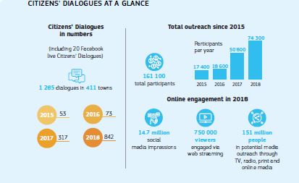

The first transnational dialogues took place in border cities in 2018 with citizens from Malta and Italy, Germany and the Netherlands, and Germany and Poland. The European Parliament and Commission co-organised a joint Citizens’ Dialogue in Bled, Slovenia, in April 2018. Members of the European Parliament Franc Bogovič and Tibor Szanyi, and Commissioners Violeta Bulc and Phil Hogan, represented the institutions. The public discussed issues including rural development and smart villages, connectivity and the common agricultural policy.

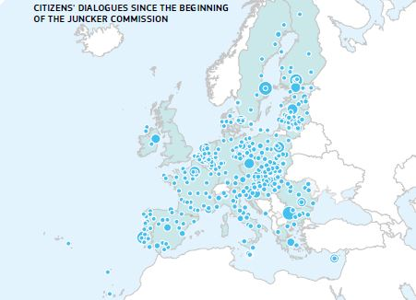

Debate on the future of Europe

The debate on the future of Europe intensified in 2018. The ultimate aim of the debate is to hear all views and ideas, from right across Europe, and every voice counts. This is why the European Commission has focused on reaching out in different ways and partnering with all other institutions and Member States that want to take part. The call has been answered by many. The European Parliament launched a series of high-profile debates on the future of Europe with Heads of State or Government, and the European Committee of the Regions took the debate to Europe’s regions, cities and municipalities through the [Reflecting on Europe](https://cor.europa.eu/en/engage/Pages/Reflecting-on-Europe.aspx) campaign.

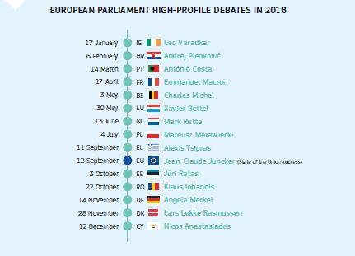

Following initiatives by French President Emmanuel Macron and other leaders, 27 Member States agreed in March on a joint framework on citizens’ consultations with citizens on the future of Europe, building on the experience of the European Commission.

To support the process, in May 2018 the European Commission partnered with the European Economic and Social Committee in a unique exercise in participative democracy. A Citizens’ Panel of 96 people from 27 Member States was selected by an independent polling agency to reflect the diversity of socioeconomic backgrounds and opinions towards the EU. Over two days in May they discussed and designed a set of questions to put to Europeans.

This questionnaire was the basis for an [online consultation](https://ec.europa.eu/commission/future-europe/consultation-future-europe_en), asking all Europeans what direction they want the Union to take in the future. More than 76 000 contributions were received by the end of 2018. Most of these contain qualitative comments and ideas in addition to the ‘closed’ questions that focus on some of the key issues for the future of Europe.

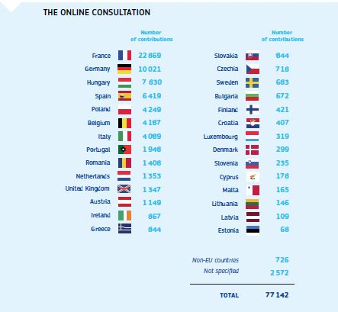

The online consultation was complemented by a Special Eurobarometer [survey on the future of Europe](https://data.europa.eu/euodp/lv/data/dataset/S2217_90_2_479_ENG) conducted between 24 October and 7 November with a representative sample of 27 339 EU citizens.

Citizens’ expectations

Despite the diversity of their formats and participants, the dialogues tend to converge around certain recurring topics. On the whole, participants tend to perceive the European Union positively. They see Europe as the key to solving problems. There are also concerns and frustrations. The question of who should do what is often brought up. Citizens tend to think that key challenges can be tackled more efficiently by combined action at the European and national levels. They tend to be largely in favour of more harmonisation at the European level, for example for the environment and food safety. But most also expect and ask for reforms to make the Union more efficient and more transparent.

More information on the content and results of the Citizens’ Dialogues and debates on the future of Europe can be found in the [Progress Report on Citizens’ Dialogues and Citizens’ Consultations](https://ec.europa.eu/commission/progress-reports-citizens-dialogues-and-consultations_en) that the Commission presented to the European Council on 11 December 2018.

The withdrawal of the United Kingdom from the European Union

In a referendum held on 23 June 2016 the people of the United Kingdom voted to leave the European Union by a margin of 52 % to 48 %. On 29 March 2017 the United Kingdom formally notified the European Council of its intention to leave the European Union and the European Atomic Energy Community (Euratom). This triggered the procedure set out in Article 50 of the Treaty on European Union for a Member State to withdraw from the Union, beginning a 2-year countdown to withdrawal.

The negotiation process

The European Commission was [appointed](http://europa.eu/rapid/press-release_IP-17-1405_en.htm) to negotiate a Withdrawal Agreement with the UK. During these negotiations, the member representing the withdrawing Member State does not participate in the European Council (Article 50) or the Council (Article 50). The Commission [appointed](http://europa.eu/rapid/press-release_IP-16-2652_en.htm) Michel Barnier to represent the Commission as Chief Negotiator. A Task Force under Mr Barnier’s leadership was [set up](http://ec.europa.eu/transparency/regdoc/rep/10061/2016/EN/10061-2016-2181-EN-F1-1.PDF) to prepare and conduct the negotiations with the United Kingdom under Article 50 of the Treaty on European Union.

On 29 April 2017 the European Council (Article 50) adopted [guidelines](http://www.consilium.europa.eu/en/press/press-releases/2017/04/29/euco-brexit-guidelines/) for the negotiations with the EU’s positions and principles. On 22 May 2017, the Council (Article 50) adopted a [decision](http://data.consilium.europa.eu/doc/document/XT-21016-2017-INIT/en/pdf) authorising the opening of negotiations with the UK and the first set of [negotiating directives](https://www.consilium.europa.eu/media/21766/directives-for-the-negotiation-xt21016-ad01re02en17.pdf). These provided for a clear structure and a united EU approach to the negotiations.

The European Parliament also set out the [key principles and conditions](http://www.europarl.europa.eu/news/en/press-room/20170329IPR69054/red-lines-on-brexit-negotiations) for its approval of the Withdrawal Agreement.

Formal negotiations began on 19 June 2017, following the UK general election. On 8 December 2017 the EU and the UK published a [joint report](https://ec.europa.eu/commission/sites/beta-political/files/joint_report.pdf)on the areas of agreement between both sides on key withdrawal issues, namely on citizens’ rights, the financial settlement and the need for a backstop solution to avoid a hard border between Ireland and Northern Ireland. Subsequently, on 15 December 2017 the European Council (Article 50) confirmed that ‘sufficient progress’ had been made to move to the second phase of negotiations and adopted [guidelines](http://www.consilium.europa.eu/en/press/press-releases/2017/12/15/european-council-art-50-guidelines-for-brexit-negotiations/) on possible transitional arrangements and the future relationship.

On 29 January 2018 the Council (Article 50) adopted a [decision](http://www.consilium.europa.eu/media/32507/xt21004en18.pdf) authorising negotiations on transitional arrangements and [negotiating directives](http://www.consilium.europa.eu/media/32504/xt21004-ad01re02en18.pdf). On 6 February 2018 the Commission published its [proposal on transitional arrangements](https://ec.europa.eu/commission/publications/position-paper-transitional-arrangements-withdrawal-agreement_en). On 19 March 2018, the EU and UK negotiators took another decisive step by reaching an agreement on the [draft Withdrawal Agreement](https://ec.europa.eu/commission/publications/draft-agreement-withdrawal-united-kingdom-great-britain-and-northern-ireland-european-union-and-european-atomic-energy-community-0_en), which translated the progress achieved during the first phase of negotiations into legal terms. It also included a legal text on the transition period.

On 23 March 2018 the European Council (Article 50) adopted [guidelines](http://www.consilium.europa.eu/en/press/press-releases/2018/03/23/european-council-art-50-guidelines-on-the-framework-for-the-future-eu-uk-relationship-23-march-2018/) on the framework for a future EU–UK relationship.

On 19 June 2018 the negotiators of the EU and the UK published a [joint statement](https://ec.europa.eu/commission/publications/joint-statement-negotiators-european-union-and-united-kingdom-government-progress-negotiations-under-article-50-teu-united-kingdoms-orderly-withdrawal-european-union_en), outlining further progress in the negotiations on the Withdrawal Agreement.

The European Councils (Article 50) of [29 June](https://www.consilium.europa.eu/media/35966/29-euco-art50-conclusions-en.pdf) and [17 October 2018](https://www.consilium.europa.eu/en/meetings/european-council/2018/10/17/art50/) reviewed the state of negotiations and reaffirmed the strong unity of the 27 Member States and the single negotiation structure that was in place.

After 17 months of intensive negotiations, on 14 November 2018 the Commission and UK negotiators agreed on [the Withdrawal Agreement](https://eur-lex.europa.eu/legal-content/EN/TXT/?qid=1545062994126&uri=CELEX:52018PC0833) on the terms of the UK’s orderly withdrawal from the EU and on 22 November they agreed [the Political Declaration](https://ec.europa.eu/commission/publications/political-declaration-setting-out-framework-future-relationship-between-european-union-and-united-kingdom_en)setting out the framework for the future EU–UK relationship. On [25 November 2018](https://www.consilium.europa.eu/en/press/press-releases/2018/11/25/european-council-art-50-conclusions-25-november-2018/) the European Council (Article 50) formally endorsed the Withdrawal Agreement and approved the Political Declaration.

The Withdrawal Agreement and Political Declaration on the framework of the future relationship

The Withdrawal Agreement fully respects the European Council guidelines, which set the objective to create legal certainty and preserve Union interests where Brexit creates uncertainty.

This concerned most notably citizens’ rights, the financial settlement, the avoidance of a hard border on the island of Ireland, and a strong governance system preserving the role of the Court of Justice of the European Union for the interpretation of Union law. The agreement settles a range of other separation issuesin order to provide legal certainty for citizens, stakeholders and business.

The Agreement also foreseesa transition period until the end of 2020, which can be extended once, for up to 1 or 2 years**,** to be agreed jointly by the EU and the United Kingdom. During that transition period, the EU will treat the United Kingdom as if it were a Member State, except for participation in institutions and decision-making.

The Withdrawal Agreement also includes three protocols: a protocol on Ireland and Northern Ireland that provides for a legally operative backstop to ensure that there will be no hard border between Ireland and Northern Ireland, unless and until a subsequent agreement realises that objective; a protocol on the Sovereign Base Areas in Cyprus, protecting the interests of Cypriots who live and work in these Areas; and a protocol on Gibraltar, which provides for close cooperation between Spain and the United Kingdom with respect to the implementation of citizens’ rights provisions in the Withdrawal Agreement, and concerns administrative cooperation between competent authorities in a number of policy areas.

The Withdrawal Agreement is accompanied by a Political Declaration setting out the framework for the future EU–UK relationship (in line with Article 50 of the Treaty, which stipulates that the Withdrawal Agreement should take account of the framework of the future relationship).

The Political Declaration defines the parameters for an ambitious and deep economic and security partnership. It covers more areas than any of the EU’s existing partnerships with other third countries: goods, services, digital, mobility, transport, energy, internal security, foreign policy, security, defenceand many more.

Next steps

Before it can enter into force, the Withdrawal Agreement needs to be ratified by the UK, according to its own constitutional arrangements. The ratification on the side of the United Kingdom is currently uncertain.

On the EU side, the Commission, the European Parliament and the Council (Article 50) have started to take the necessary steps to ensure that the agreement can enter into force on 30 March 2019. On 5 December 2018 the Commission adopted proposals for Council decisions on [the signing](https://ec.europa.eu/commission/publications/proposal-council-decision-signing-agreement-withdrawal-united-kingdom-great-britain-and-northern-ireland-european-union-and-european-atomic-energy-community_en) and on [the conclusion](https://ec.europa.eu/commission/publications/proposal-council-decision-conclusion-agreement-withdrawal-united-kingdom-great-britain-and-northern-ireland-european-union-and-european-atomic-energy-community_en) of the Withdrawal Agreement.

Agreements governing the future relationship with the UK will be negotiated and concluded in accordance with Article 218 of the Treaty on the Functioning of the European Union, once the UK will no longer be a Member State.Both parties committed to use their best endeavours to have these agreements concluded as soon as possible after the UK’s withdrawal from the EU, with a view to ensuring that they can enter into force by the end of 2020.

The EU has been negotiating with the United Kingdom with the unequivocal objective of achieving an orderly withdrawal of the United Kingdom from the EU through an agreed and ratified Withdrawal Agreement. This notwithstanding, the Commission has been clear that irrespective of whether there is a Withdrawal Agreement in place in time for withdrawal or not, the United Kingdom’s choice to leave the European Union will cause significant disruption. The 23 March 2018 European Council (Article 50) called upon ‘the Commission, the High Representative of the Union for Foreign Affairs and Security Policy and the Member States to continue the work on preparedness at all levels for the consequences of the UK withdrawal, taking into account all possible outcomes’. With this in mind, the Commission has consistently not only called on European citizens, businesses and Member States to prepare for all possible scenarios, but also put every effort into its own preparedness work.

In its first two Communications preparing for the withdrawal of the United Kingdom from the EU of 19 July and 13 November respectively, the Commission defined the scope of this preparedness and contingency work, the principles underpinning it and described the action taken so far. In the November Communication, the Commission gave a state of play on the progress on its eight legislative proposals that were already on the table of the co-legislators, and announced 18 new preparedness measures. An essential action was the publication, during 2018, of 83 Preparedness Notices, setting out the legal consequences of the withdrawal across a wide array of areas. As part of this preparedness effort, the Commission has been in contact with numerous stakeholders and businesses to explain its work and, not least, to encourage them to prepare for all possible scenarios, assess relevant risks and plan their response in order to mitigate them.

The European Council (Article 50) of 13 December 2018 called for work on preparedness for the consequences of the United Kingdom’s withdrawal to be intensified at all levels and for all possible outcomes. Responding to this call, on 19 December 2018 the Commission adopted a third Communication and 14 legislative contingency measures, covering a limited number of areas where the Commission has concluded that a ‘no-deal’ scenario would create major disruption for citizens and businesses in the EU-27. These areas include, amongst others, financial services, air transport, customs, and climate policy. These measures are unilateral and limited in time, aim for damage limitation and can only mitigate the most severe consequences of a withdrawal without an agreement.

**Getting in touch with the EU**

**ONLINE**

Information in all the official languages of the European Union is available on the Europa website:

<https://europa.eu/european-union/index_en>

**IN PERSON**

All over Europe there are hundreds of local EU information centres.

You can find the address of the centre nearest you at:

<https://europa.eu/european-union/contact_en>

**ON THE PHONE OR BY EMAIL**

Europe Direct is a service which answers your questions about the European Union.

You can contact this service by freephone: 00 800 6 7 8 9 10 11 (certain mobile telephone operators do not allow access to 00 800 numbers or may charge for these calls), or by payphone from outside the EU: +32 22999696, or by email via

<https://europa.eu/european-union/contact_en>

**FIND PUBLICATIONS ABOUT EUROPE**

You can download or order free and priced EU publications from:

<https://publications.europa.eu/publications>

**EUROPEAN COMMISSION REPRESENTATIONS**

The European Commission has offices (representations) in all the Member States of the European Union:

<https://ec.europa.eu/info/contact/local-offices-eu-member-countries_en>

**EUROPEAN PARLIAMENT INFORMATION OFFICES**

The European Parliament has an information office in every Member State of the European Union:

<http://www.europarl.europa.eu/atyourservice/en/information_offices.html>

**EUROPEAN UNION DELEGATIONS**

The European Union also has delegations in other parts of the world:

<https://eeas.europa.eu/headquarters/headquarters-homepage/area/geo_en>