

Table of contents

1. Introduction 5

2. Background to the intervention 6

3. Implementation / state of Play 16

4. Method 23

5. Analysis and answers to the evaluation questions 25

5.1. Relevance 25

5.2. Coherence and complementarity 31

5.4. Efficiency 41

5.5. EU added value 45

5.6. Sustainability 46

6. Conclusions 47

6.1. Relevance 48

6.2. Coherence 48

6.3. Effectiveness 49

6.4. Efficiency 50

6.5. EU added value 51

6.6. Sustainability 51

6.7. Lessons learned from the evaluation 52

Annex 1: Procedural information 55

Annex 2: Intervention Logic of the ESI actions 60

Annex 3: Stakeholder consultation 61

Annex 4: List of evaluation questions 64

Annex 5: Results of the Open Public Consultation 66

Annex 6: Overview of ESI funded actions per partner and areas of intervention 68

Annex 7: Methods and analytical models 69

**Glossary**

|  |  |
| --- | --- |
| ***Term or acronym*** | ***Meaning or definition*** |
| AMIF | Asylum, Migration and Integration Fund |
| ASB | Arbeiter-Samariter-Bund - The Workers' Samaritan Federation |
| DG ECHO | Directorate-General for Civil Protection and Humanitarian Aid Operations |
| DG HOME | Directorate-General for Migration and Home Affairs |
| DG REGIO | Directorate-General for Regional and Urban Policy |
| DRC | The Danish Refugee Council |
| EMAS | Emergency Assistance Grant Scheme |
| ERDF | The European Regional Development Fund |
| ESF | The European Social Fund |
| ESI | Emergency Support Instrument |
| ESOP | Emergency Support Operational Priorities |
| ESTIA | Support to Integration & Accommodation |
| EUSF | The European Union Solidarity Fund |
| FAFA | Financial and Administrative Framework Agreement |
| FCE | Final consumption expenditure |
| FEAD | The Fund for European Aid to the Most Deprived |
| FPA | Framework Partnership Agreement |
| IFRC | The International Federation of Red Cross and Red Crescent Societies |
| IRC | The International Rescue Committee |
| IO | International Organisation |
| IOM | International Organization for Migration |
| ISF | Internal Security Fund |
| MoMP | Ministry of Migration Policy |
| MPCT | Multipurpose Cash Transfer |
| MSF | Médecins Sans Frontières |
| NFI | Non-Food Items |
| NGOs | Non-governmental organisations |
| NRC | Norwegian Refugee Council |
| SRSS | Structural Support Service |
| STC | Save the Children |
| TDH | Terre des Hommes |
| UAMs | Unaccompanied Minors |
| UCPM | The Union Civil Protection Mechanism |
| UNHCR | United Nations High Commissioner for Refugees |
| VAT | Value-Added Taxes |

# Introduction

## Purpose of the evaluation

This Staff Working Document presents the results of the evaluation of the operation of Council Regulation (EU) 2016/369 on the provision of emergency support within the Union[1] (hereafter 'the Regulation'), implemented by the European Commission’s Directorate-General for European Civil Protection and Humanitarian Aid Operations (DG ECHO). The Regulation was adopted and simultaneously activated on 16 March 2016 for a period of three years to provide a rapid response to the humanitarian needs arising from the influx of refugees and migrants into the Union. While the Regulation does not establish it explicitly, *de facto* it creates a financial instrument, referred to in this document as ‘Emergency Support Instrument’ (ESI).

Article 8(1) of the Regulation, provides that a report shall be presented by the Commission to the Council twelve months after the activation of the ESI. A report fulfilling this requirement was submitted to the Council on 15 March 2017[2].

Furthermore, in accordance with Article 8(2) of the Regulation, the Commission is required to submit *“an evaluation of the operation of the Regulation to the Council by the end of the current activation in March 2019 and to put forward suggestions for the future of the Regulation, and where appropriate, proposals to amend or terminate it*”.The evaluation has also been carried out in accordance with Article 30(4) of the Financial Regulation[3].

The purpose of the evaluation is therefore to assess the implementation and performance of the actions funded by ESI and implemented in Greece, since 16 March 2016, and hence to examine the extent to which the Regulation is fit-for-purpose, based on the experience gained from the implementation of such actions. The evaluation consequently seeks to identify any gaps, as well as strengths and weaknesses, of the current legislative framework and in the operational response.

The evaluation is mainly based on an external study[4] that was carried out between July and October 2018, which builds on an internal evaluation exercise carried by the Commission, and it provides the most important source of evidence for this document.

## Scope of the evaluation

As set out in the Evaluation Roadmap[5], the scope of the evaluation covers the actions implemented by ESI in Greece since its activation (from 16 March 2016 up to 15 October 2018) looking at the following criteria established in the Commission's Better Regulation guidelines[6]: (i) relevance, (ii) effectiveness, (iii) efficiency, (iv) coherence, (v) EU added value. Given the particular nature of the intervention under ESI, the evaluation will also consider a further criterion, namely sustainability.

# Background to the intervention

## Description of the intervention and its objectives

**Background: a humanitarian emergency within the EU**

In 2015 and during the first months of 2016, close to 1.4 million persons in need of international protection and migrants made their way to the EU via the Eastern and Central Mediterranean route[7]. This movement has been considered the "largest movement of displaced people through European borders since World War Two"[8]. This flow of migrants and refugees affected the capacity of countries along the migratory routes to cope with humanitarian and protection needs.

In 2015, 850 000 people crossed from Turkey to Greece through the Aegean and Dodecanese sea, mainly Syrians (59%), Afghans (24%) and Iraqis (8%), but also from other countries, such as Iran, Pakistan, North and Central Africa. These events unfolded at a time when Greece was struggling with the effects of an unprecedented economic and financial crisis.

In November 2015, the former Yugoslav Republic of Macedonia (FYROM) announced that only Syrians, Iraqis and Afghans would be allowed to cross, creating tensions at the border with migrants and refugees from other nationalities. Circumstances changed drastically as of mid-February 2016 with the progressive establishement of border restrictions along the Western Balkans route, leading to an effective closure of the route at the beginning of March 2016.

As a result, more than 60 000 people became stranded in Greece, with around 8,500 people at Idomeni alone (a Greek village of about 150 inhabitants located close to the north border with the Republic of North Macedonia ). The situation shifted from Greece being a transit country to becoming a host country.

This put a huge strain on the already limited resources of the national authorities to respond to this humanitarian emergency. For instance, Greece did not have a dedicated department dealing with migration issues (i.e. the Ministry of Migration Policy (MoMP) was established in October 2016)[9] and faced a limited coordination amongst the different ministries with competences in that area.[10] The capacity to provide accommodation to the newcomers proved to be insufficient, with several important gaps in the availability and access to services for asylum seekers. Water and sanitation facilities were insufficient. The humanitarian situation was exacerbated by limited access to legal aid and translation services to asylum seekers, or of humanitarian and social protection to vulnerable groups, such as women, children and unaccompanied minors.

Figure 1 and 2 below present a timeline, as developed in the support study, on the different relevant stages that unfolded in Greece between 2015 and 2018. Overall, both provide a summary of the sequence of events and situation in Greece, the available resources at the time, as well as the policies and measures undertaken at EU level to help the Greek authorities address the emergency.

1. Timeline of events between 2015 and 2016

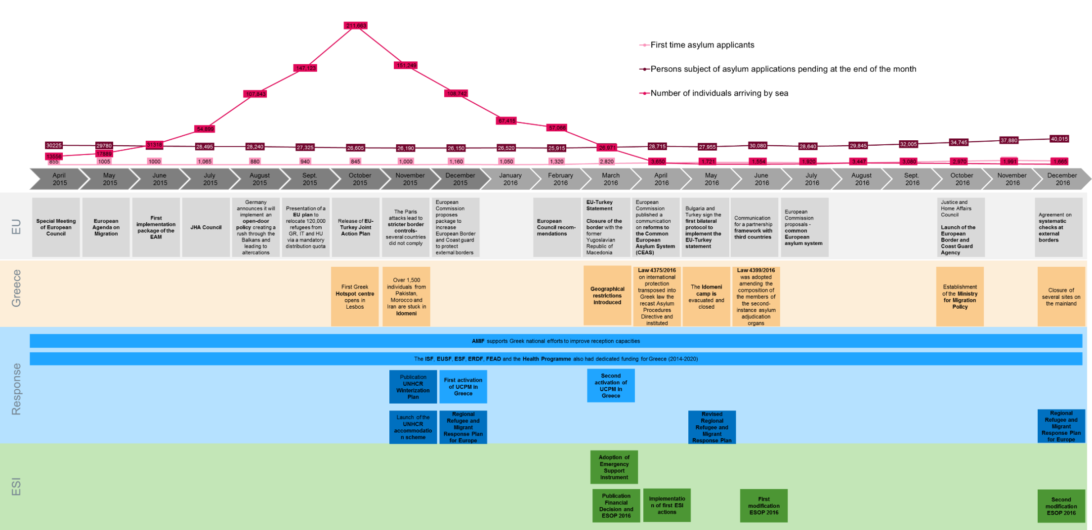

1. Timeline of events between 2017 and 2018

This figure represents the timeline of events in 2017 and 2018, showing ESI’s intevention in relation to other EU instruments and political events at national and European levels.

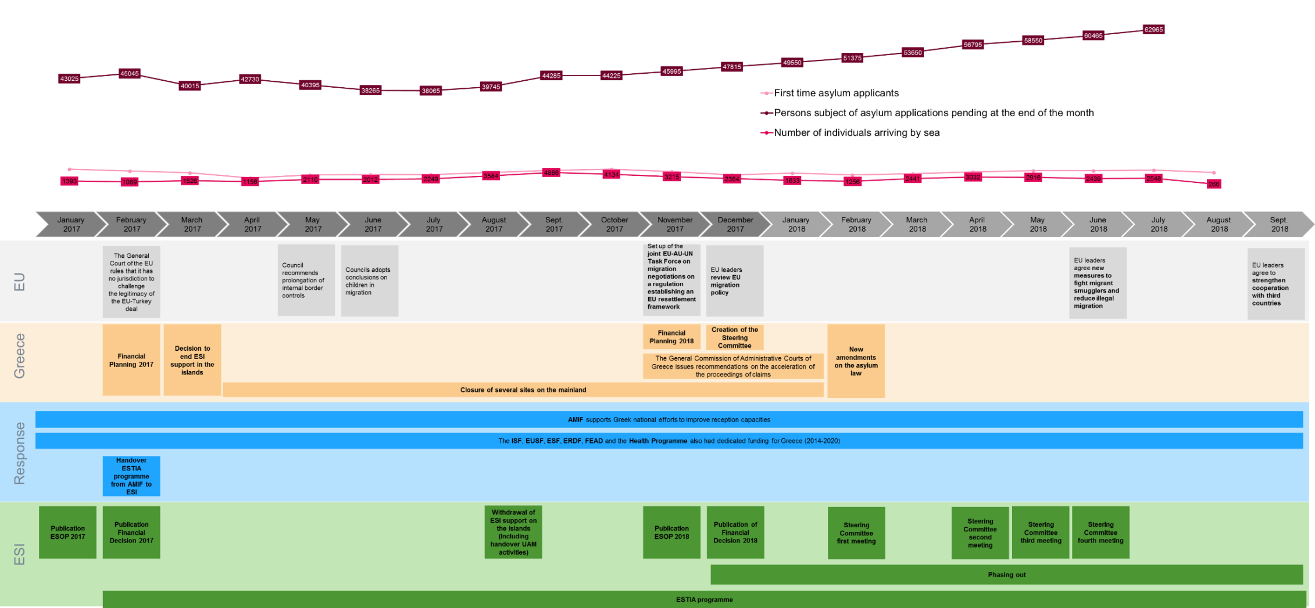

**The need for a new instrument to provide emergency support within the EU**

The EU has well-established financial instruments in place to assist Member States in responding to different types of internal challenges and to express solidarity with disaster-stricken regions. These include for example: the Union Civil Protection Mechanism (UCPM)[11]; the Asylum, Migration and Integration Fund (AMIF)[12]; the Internal Security Fund (ISF)[13]; and the European Union Solidarity Fund (EUSF)[14], the European Social Fund (ESF)[15], the European Regional Development Fund (ERDF)[16], the Fund for European Aid to the Most Deprived (FEAD)[17] and the Health Programme[18]. However, as most of these intruments rely on shared or indirect management implementation modalities[19], none of them is fully suitable to address wide-ranging humanitarian needs resulting from disasters of exceptional scale and impact, which consequently overwhelm the existing national capacities of Member States. Thus, at the peak of the refugee crisis in Greece, there was no EU instrument available that allowed for the direct implementation of operations through humanitarian partners.

While Council Regulation (EC) No 1257/96 on humanitarian aid[20] allows the European Union to provide assistance, relief and protection to people affected by natural or man-made disasters and similar emergencies in third countries, its scope does not include the EU. Therefore, while the Commission is able to draw rapidly on the humanitarian capacities and expertise of more than 200 UN partners, international organisations and non-governmental organisations outside of the EU, there was no legal basis to do so within the EU at the beginning of 2016.

Consequently, as a response to the increased number of arrivals in the summer of 2015, and in support to the Greek authorities, several national and international NGOs and groups of volunteers had already started to provide assistance to refugees and migrants arriving in Greece. However, administrative and operational modalities of the available EU instruments made it difficult for humanitarian actors to be funded[21]. In particular, the AMIF National Programme, where the majority of resources would have been available, was not ready to fund at that moment any National or International NGOs, nor International Organization, who could provide crucial support to the national response in an EU Member State.[22]

In this context, on 19 February 2016 the European Council called the Commission to 'put in place the capacity for the EU to provide humanitarian assistance internally, in cooperation with organisations such as the United Nations High Commissioner for Refugees (UNHCR), to support countries facing large numbers of refugees and migrants, building on the experience of the EU Humanitarian Aid and Civil Protection department'.[23]

On 2 March 2016, the Commission adopted its Proposal for a Council Regulation on the provision of emergency support within the Union[24], subsequently the Council Regulation (EU) 2016/369 was adopted by the Council[25] on 15 March 2016[26] and pursuant to Article 9(2) it was activated for a period of three years for the management of the humanitarian impact of the refugee and migration crisis within the EU. As a result, the Commission had an instrument that could potentially finance its humanitarian partners to directly implement actions within the EU and consequently boost Member States’ capacity and support the expertise available for the humanitarian response to the the crisis.

**Objectives and Scope of Council Regulation (EU) 2016/369**

The general objective of the ESI, as stated in Article 3(1) of the Regulation, is to "provide needs-based emergency response, complementing the response of the affected Member States, aimed at preserving life, preventing and alleviating human suffering, and maintaining human dignity…". According to Art 3(3) the emergency support provided under the Regulation must be granted and implemented in compliance with the fundamental humanitarian principles of humanity, neutrality, impartiality and independence.

According to Article 3(2) of the Regulation, emergency support may include any of the humanitarian actions eligible for Union financing pursuant to Article 2, 3 and 4 of Regulation (EC) No 1257/96, and may therefore encompass assistance, relief and, where necessary, protection operations to save and preserve life in disasters or in their immediate aftermath.

The Regulation builds upon the know-how of the Commissionin the field of humanitarian assistance - acquired through EU funded actions implemented in third countries - and sets out the framework within which emergency support may be provided, namely when the following preconditions are met:

* In the event of an ongoing or potential natural or man-made disaster;
* Where the exceptional scale and impact of the disaster is such that it gives rise to severe wide-ranging humanitarian consequences in one or more Member States; and
* In exceptional circumstances where no other instrument available to Member States and to the Union is sufficient.

Concerning its geographical scope, emergency support may be provided in the territory of the EU Member States affected by the above conditions, and in the event of such a disaster, the Council, based on a Commission proposal, would decide whether or not to activate the emergency support and the duration of its activation.

In terms of implementation, the actions funded by ESI shall be carried out by the Commission or by humanitarian partners selected by the Commission, including non-governmental organisations, specialised services of the Member States or international agencies and organisations having the requisite expertise, which have concluded a Framework Partnership Agreement (FPA) with the Commission or fall in the scope of the Financial and Administrative Framework Agreement (FAFA).

According to Article 1(2) of the Regulation, emergency support provided under ESI is in support of, and complementary to, the actions of the affected Member State; therefore close cooperation and consultation shall be maintained with the affected Member State – a stronger coordination requirement than is imposed on humanitarian operations outside the EU. In addition, synergies and complementarity must be sought with other Union instruments under which some form of emergency assistance may be offered. In the case of humanitarian actions in Greece, this would primarily relate to voluntary in-kind contributions provided under the UCPM and emergency assistance under AMIF and ISF.

**The activation of the emergency support for the refugee and migration crisis**

Following the Council’s decision to activate the ESI for a three-year period, a Financing Decision[27] was adopted on 15 April 2016 for the first year of actions funded by ESI. The latter specified the maximum EU contribution for emergency support actions and defined the specific objectives of actions funded by ESI in Greece and in any other affected Member State. Two consecutive Financing Decisions followed for the 2017[28] and 2018[29] implementation periods, in which the same objectives were maintained, mainly:

* To meet the basic needs of refugees and migrants in the Union through the provision of multi-sectorial support. The multi-sectorial response included the following sectors of intervention: 1) food assistance; 2) distribution of non-food items; 3) provision of shelter; 4) healthcare, including psychosocial support; 5) water, sanitation and hygiene (WASH); 6) protection services; and 7) educational services appropriate to the emergency context;
* To provide technical assistance to the extent required for the management of emergency support.

The programming of ESI was defined annually in the Emergency Support Operational Priorities document (ESOPs).[30] Each ESOP served as guidance for the humanitarian organisations to prepare their proposals for actions to be implemented in Greece. The funding was allocated to the selected partners, following technical assessments undertaken by the Commission experts.

All the humanitarian partners selected to implement ESI’s actions in Greece were humanitarian organisations with whom the Commission had a signed Framework Partnership Agreement (FPA). These are hereafter referred to in this document as *Commission’s partners*.

The detailed **intervention logic** of the ESI is provided in Annex 2, where the scope, overall objective and activities of the Instrument are presented and linked. The rationale for ESI’s intervention was based on the overall assumption that no other EU/ national instrument was ready to provide the emergency support needed, at least not adequately to the nature and scale of the needs, and that a ‘no action’ approach would have had severe negative consequences not only on Greece but on the EU as a whole. The rationale for the activation in Greece was related to different factors, including the high number of arrivals, the closure of the Western Balkan borders and the fact that Greece shifted from being a transit country to a host country, while it was already previously presenting insufficient national capacity to address the basic needs of the newly arrived. In terms of inputs, the maximum EU contribution allocated to the ESI, EUR 650 million, was meant to be spread over the three years of the instrument's activation. Given that the ESI focused on ‘life-saving’ emergency support, it was therefore assumed that the allocation and selection of the Commission’s partners and their actions, together with the Commission’s experience on delivering humanitarian support, would contribute to the provision of swift response. In this regard, the support study has confirmed that indeed no other EU/ national instrument was able to deliver emergency support at this scale and speed, and that the ESI’s implementation period has allowed for the immediate delivery of a response.

Regarding the main activities to be implemented and undertaken by the ESI, the main assumptions were based on the fact that Commission’s partners with appropriate expertise, were available on the ground, or ready to be quickly deployed, to provide a response which was timely and, more importantly, based on needs assessments. Overall, a total of 29 actions were implemented by 18 Commission’s partners. The support study confirmed that the implemented actions prioritised the sectors in which support was the most urgently needed, and that these also included coordination with national authorities, other EU instruments, Commission’s partners, local implementing partners and other organisations involved. Furthermore, the support study indicated that in terms of outputs the actions implemented by ESI reached a cumulative total of over 146 thousand persons by early 2018, mainly through activities related to protection, shelter and settlement, food security and livelihoods, education, health, coordination, WASH and multi-purpose cash transfers (MPCT) for basic needs assistance. With the caveat that within this cumulative figure, beneficiaries might be counted twice, and there were nevertheless some challenges faced at the initial stage of the ESI activation with regard to the coordination with and between national authorities, which are further developed in section 5.

In terms of outcomes, actions funded by ESI were expected to address the most urgent needs in terms of food, shelter and healthcare and to overall improve access to different services, including accommodation protection measures and education for children. At the same time, actions funded by ESI would aim to be complementary to actions implemented by national authorities and civil society actors, while providing capacity- building, and paving the way for a successful handover of the ESI-funded response to other instruments. As a result, the assistance to and protection needs of the final beneficiaries would have been met to the extent possible, and their dignity restored. Regarding the successful handover, the support study identified shortcomings in this regard, including the full development of a clear exit strategy to support a successful handover to national authorities and ensure sustainability of actions. It must however be noted that many actions funded by ESI were still on-going at the time the support study was undertaken. Therefore, most of the exit strategies were still under development, and as a result it was too early to assess their success and sustainability of exit strategies. Nevertheless, several measures have also been undertaken specifically in order to enhance the short- and longer-term sustainability of actions funded by ESI: these are further described in section 5.

Finally, with regard to the expected impacts, the ESI was expected to prevent and alleviate human suffering as a result of the emergency, and restore and maintain dignity of the affected populations. In addition, actions funded by ESI were also expected to – indirectly- support the Member State’s integration policy and measures, for example by creating the pre-conditions for integration for beneficiaries. The main assumptions on this related to the availability of a national integration framework/ strategy in the host society and the implementation of such measures and framework by the authorities. In this regard, the support study highlighted the absence of a well-developed national integration strategy, which consequently affected the extent to which beneficiaries can make a smooth transition from receiving emergency support to starting their integration into the new host society. The Commission however considers that while these challenges could indeed affect the final expected impact regarding the integration of beneficiaries, these are nevertheless considered to be part of the situational context, and not part of the nature of the ESI as an instrument. These challenges are described in section 5.

## Baseline and points of comparison.

The ESI was set up as a generic instrument (i.e. to address the humanitarian consequences of any natural or man-made disaster in the EU), not as a specific tool to deal with humanitarian consequences of the migration and refugee crisis. Due to the immediate need to provide a rapid response, no impact assessment or in-depth stakeholder consultation took place prior to the creation of the ESI (i.e. back in 2016).

In order to address the absence of a baseline to implement the first EU emergency support intervention within the EU, the Commission carried out a broad consultation at different levels to develop a needs assessment. The latter involved not only the different relevant Commission services active in regard to the migration crisis, but also a wide range of stakeholders, including humanitarian partners and other donors.

The United Nations’ Regional Refugee and Migrant Response Plan for Europe, launched in January 2016[31], was key to build points of comparison and the responsible organisations (i.e. International Organization for Migration (IOM) and United Nations High Commissioner for Refugees (UNHCR)) were widely consulted throughout the process. This plan identified the main needs and provided a quantification of financial resources needed per sector and per year. The 2016 response was divided in seven sectors namely protection, education, site management support, health and nutrition, food security, shelter/ NFIs items and WASH, thus covering all the sectors with the highest reported needs.[32] The 2017 response targeted the same sectors but taking into consideration the new contextual developments and emerging needs. Similarly the 2018 response followed up on actions covering the main sectors identified throughout 2017; however, in 2018 the need to plan and prepare for the hand-over of actions funded by ESI to the national authorities was introduced. A description of the evolution of the identified needs and priorities is further described in section 3.

Other sources of information were considered in the support study as point of comparison. However, it must be emphasised that Greece’s situation in 2015/2016 was unprecedented. Greece was already facing many challenges as a transit country of migrants and refugees, paired with a deep economic crisis. After becoming a host country with an increased number of arrivals, the national authorities had to deal not only with the most urgent humanitarian needs of the new arrivals, but also with the medium and long-term needs of those who were now stranded and therefore remaining in Greece. Greece therefore faced the need to significantly and urgently increase its reception capacity, to move from temporary accommodation to more long-term housing, as well as to address the health, education and protection needs of refugee and migrant children and the eventual integration of the beneficiaries, for example into the labour market and public services for the adults.

Overall, the situation of refugees and migrants in Greece in March 2016- hence before the activation of ESI- and their main needs can be summarised as follows[33]:

|  |
| --- |
| * There was insufficient accommodation capacity and a lack of basic humanitarian services (i.e. food, water and sanitation facilities). * While some facilities were reported to be adequate for short-term accommodation, there was a lack of long-term accommodation facilities. * The vast majority of the camps were located outside urban areas, often far from service providers and with difficult access to public transport.[34] * In a number of camps, there was no official management of the site leading to a lack of registration of refugees and migrants.[35] * There was a lack of special shelters for vulnerable people including unaccompanied minors, elderly, victims of sexual and gender based violence (SGBV) and individuals suffering from serious mental health disorders. * The lack of security in the camps was highlighted by national and international NGOs. Violent incidents, including SGBV were reported in several sites.[36] * The lack of systematic provision of information to refugees and migrants on their rights and obligations was also observed by some NGOs on the ground. * In the islands, there was a significant lack of accommodation capacity and refugees and migrants were sleeping in tents unsuitable for the winter. Access to food and water was also reported to be insufficient[37] |

# Implementation / state of Play

This section provides a brief overview of the actions funded by ESI over the 2016-2018 period.

Following its activation in Greece, a total of EUR 700 million was intially set as the maximum contribution of the EU for the provision of emergency support to Greece for ESI’s three-year activation period (2016-2019). The 2016 Financing Decision initially provided for a maximum contribution of EUR 300 million, however the budgetary authority ultimately allocated EUR 250 million. Both the 2017 and the 2018 Financing Decisions set the maximum contribution of the Union at EUR 200 million for each year respectively, bringing the overall total to EUR 650 million.

These funds were allocated to deal with the fluctuating number of people in need of protection in Greece. In addition, support was to be provided to a Member State already severely affected by the impact of the economic crisis, where significant unmet humanitarian needs were present in the sectors of food assistance, shelter, healthcare, water, sanitation, hygiene (WASH), non-food items (NFIs), education and protection.

However, shortly after the adoption of the Regulation, the situation on the Eastern Mediterranean route significantly changed. Following the adoption of the EU-Turkey Statement of 18 March 2016[38], irregular crossings from Turkey to Greece decreased sharply (from 1,800 daily arrivals in early 2016 to 73 daily arrivals after the Statement)[39]. Despite seasonal peaks and a surge of arrivals by land at the border with Turkey since late 2017, the average daily arrivals in 2017 and 2018 have nevertheless ranged between 100 and 135 persons per day.

**Actions implemented under the ESI and geographical coverage**

Within the three-year activation period ESI has funded 29 operational actions implemented by 18 Commission’s partners amounting to EUR 644.5 million[40] (as shown in Figure 1 below). The actions included activities in the field of provision of shelter, site management, cash assistance, food aid, distribution of non-food items, protection, education, health services, including psychosocial support. An overview (table) of the actions funded by ESI, by funding and Commission’s partners is provided in Annex 6.

1. ESI contribution to operational actions implemented in Greece

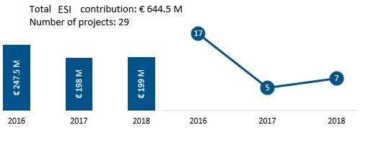

At the beginning of the activation, in March 2016, while ESI was mainly funding actions on the Greek mainland (hereafter referred to as ‘mainland’), specific unmet needs on the islands were also targeted. This was the case for emergency accommodation capacity during winter (including hotel places and rub-halls), complementary food distribution, protection and some education in emergency activities. Most of the needs on the islands, where the so-called “hotspots”[41] were located, were targeted by other EU funding instruments such as AMIF and ISF.

However, in 2017 under the agreement with the Greek authorities and in view of the phasing out of the ESI in 2019 and the need to prepare a handover, it was decided that ESI would be active in the mainland only, with the exception of the cash and rental accommodation schemes on the islands.

**Evolution of programmatic priorities**

During 2016, the humanitarian and emergency situation in Greece was characterised by several changes in terms of population movement. From a high number of arrivals reported at the end of 2015 and beginning of 2016 and closed borders along the Balkan’s route, which prompted a wide-ranging and multi-sectoral emergency assistance to meet basic needs of people in transit, the situation changed after the EU-Turkey Statement, which resulted in a sharp reduction in the number of arrivals.

ESI activation focused on providing support to meet the basic needs of the people stranded in Greece. Before ESI activation, living conditions in existing accommodation facilities were assessed as sub-standard with needs remaining high in terms of food, non-food items, protection, medical care, WASH, non-formal education, shelter/accommodation (including winterisation) and unaccompanied minors (UAMs) . It is against this scenario, and following an agreement on the priorities between the Commission and the relevant national authorities, that the first tranche of EUR 247.5 million was allocated in 2016 for emergency support actions to address the aforementioned sectors. As a result, most beneficiaries of actions funded by ESI (hereafter ‘beneficiaries’) were accommodated in 40 formal and informal sites/camps on the mainland and in two sites on the islands (Karatepe and Souda).

While the initial 2016 ESI budget allocation was made in emergency mode and in the absence of an agreed governmental response plan, in early 2017 the Commission services (Structural Support Service (SRSS), DG HOME and DG ECHO) and the national authorities (Ministry of Migration Policy (MoMP), Ministry of Economy and Ministry of Defence in particular) agreed on the operational priorities and on a strategic response plan for 2017. The discussions resulted in the first Financial Plan presented by the national authorities in February 2017. Overall, the Financial Plan provided the main elements of the approach to be implemented during the given year, the main needs and areas to be covered (as indicated and requested by the national authorities), an indicative budget breakdown per relevant actor and per EU funding instrument, as well as the Guiding Principles for all the actions funded in Greece.

The subsequent 2017 ESI funding allocation amounted to EUR 198 million and was made in line with the priorities established in the Financial Plan 2017, which included a gradual transition of beneficiaries from sites to urban rental accommodation, and an increased focus on multi-purpose cash transfers (MPCT). The combination of rental accommodation and MPCT resulted in the programme called Emergency Support to Integration & Accommodation (ESTIA), which is the flagship programme of ESI. The response plan also included a handover of activities to the national authorities, mainly those actions providing shelter for UAMs and all actions carried out on islands (with the exception of partial cash transfers and rental accommodation schemes) with the support of the AMIF National Programme as of August 2017.

The third and last allocation of ESI funding amounted to EUR 199 million. Its accompanying 2018 Financial Plan reflected the need to plan and prepare for the handover of actions funded by ESI to the national authorities, and namely of the ESTIA programme which absorbed the majority of the 2018 ESI funds (EUR 167.5 million) to provide 27 000 accommodation places and cash assistance to more than 65 000 asylum seekers. The transition of actions to the national authorities was also planned in other sectors, with health assistance in sites already starting as of July 2018.

Overall, the actions implemented by ESI evolved along and in parallel with the needs and the changing situation in Greece i.e. from an initial emergency phase in which the short term needs of refugees/migrants needed to be covered and the administrative capacities needed to be developed and reinforced (e.g. creation of the Ministry of Migration Policy); to a second phase of joint planning with the national authorities, where the humanitarian response was consolidated, for example by reducing the number of partners and interventions and by initiating the handover phase; and finally, to a last implementation phase where by the end of 2018/beginning of 2019 all actions funded by ESI would be completed, and the most important building blocks would be handed over to other sources of EU funding, with the ultimate aim being the handover of actions to the national authorities. For instance on 20 December 2018 agreements were signed for the two main programmes funded by the Emergency Support Instrument (ESTIA and Site Management Support for the mainland), that ensure funding from AMIF Emergency Assistance as of January 2019.

Figure 4 below provides an overview of the evolution of priorities and activities according to the different ESOPs developed throughout 2016 -2018.

1. Three-year ESOPs evolution overview.

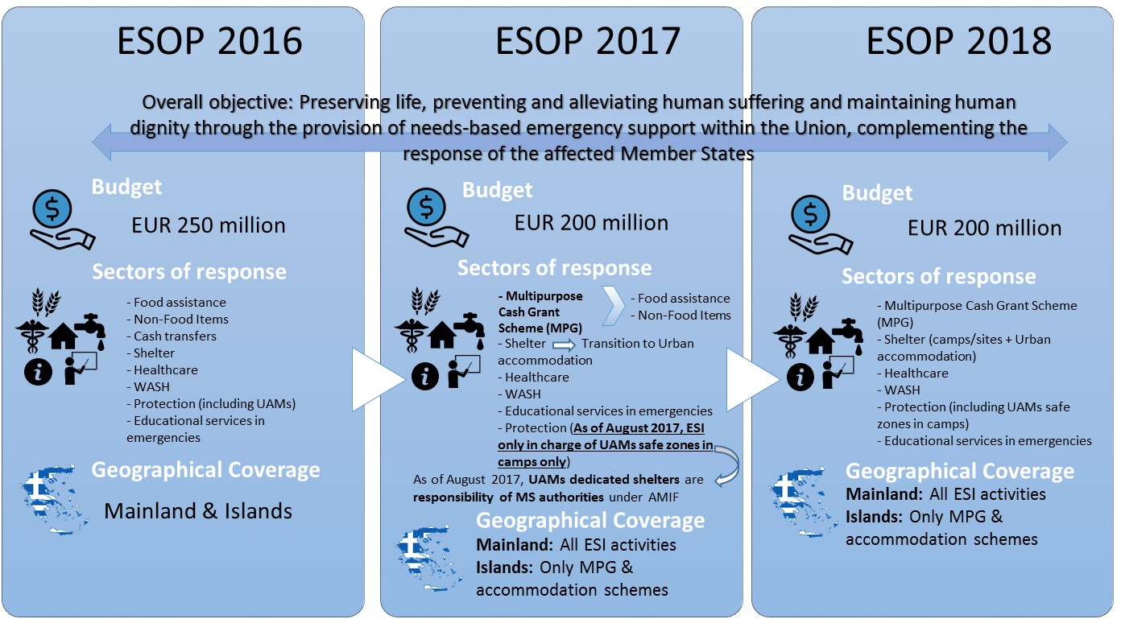

***NB****: The maximum contribution of each ESOPs budget includes the budget allocation for the provision of the Commission’s technical assistance for the management actions funded by ESI.*

The following sub-sections below provide the implementation and state of play of the actions funded by ESI according to the specific priorities and sectors.

1. ESI Funding per sector (as of 31/12/2018)

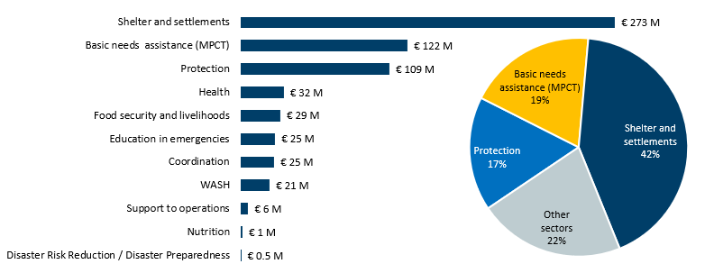

# *Accommodation*

The Commission allocated EUR 300 million (representing the highest share of ESI funding and taking into account the following sectors: shelter & settlements, WASH and support to operations) to its Commission’s partners (i.e. UNHCR, IOM, IRC, IFRC, ASB, DRC, NRC, CARE, OXFAM and TDH[42]) to provide accomodation and shelter support for all beneficiaires in Greece. Accomodation included both categories: places in sites and rental accommodation scheme (apartments). It is important to note that at the time of activation, insufficient shelters were available to house refugees and migrants and most sites had to be set up from scratch, which made the initial actions costly. Moreover, on top of the funding granted to actions in the area of shelter and accommodation, ESI also funded actions that aimed at providing and maintaining WASH facilities in accommodation places. A total of EUR 21 million from the ESI budget was used to fund WASH actions during the period 2016-2018 (see Figure 5). Out of the total allocation under accomodation, over EUR 116 million were allocated to Commission’s partners to build sites/camps and assist in their management, including coordination, care, maintenance and community mobilization. This has allowed the creation of some 20 000 places in permanent camps and some 10 000 to 15 000 temporary emergency accommodation places all over mainland[43].

As part of the 2017 Financial Plan, the national authorities decided for a gradual transition of beneficiaries from temporary reception facilities (sites) to urban rental accommodation. Internally, the European Commission services decided that the AMIF-funded rental accommodation scheme would be handed over to ESI, changing its main purpose from being a functional tool of the relocation policy, to a vulnerability-based reception system. UNHCR was identified as the most suitable framework partner to run such an action, labelled as the “ESTIA programme”. Over EUR 184 million were allocated to the ESTIA accommodation programme to provide up to 52 000 rental accommodation places between 2017 and 2018 (up to 25 000 in 2017 and up to 27 000 in 2018).

# *Multipurpose Cash Scheme*

The Commission allocated EUR 122 million to multi-purpose cash assistance for beneficiaires in Greece throughout the 2017-2018 period, representing the second highest share of ESIs funding[44]. At the beginning of the implementation, all assistance had been provided in kind (food rations, non-food items) by several actors funded under different instruments.

As of July 2016 and in agreement with the national authorities, ESI started funding actions to build up a multi-purpose cash scheme in Greece via several Commission’s partners. The aim of this first phase was to build up the coverage of multi-purpose cash assistance and the operational capacity of partners. By the end of 2016, with the addition of a UNHCR-implemented cash project, the total cash assistance provided to beneficiares in Greece increased, replacing in-kind distribution of relief items except food aid. By February 2017, over 35 000 people living in 55 locations in the mainland and on the islands, as well as in two urban locations, had received cash assistance, which was provided through pre-paid cards. The monthly cash assistance scheme is only covering basic needs and is geographically restricted to Greece. By injecting cash into the local economy, it impacts economic recovery in the host country and supports increasing the self-reliance of its beneficiaries. Major progress was achieved in 2017 through the establishment of a single delivery cash-based assistance: by December 2017, 37 600 people living in 92 locations in mainland and on the Greek islands have received cash assistance. From April 2017 to October 2018, 90 351 eligible individuals have received cash assistance in Greece at least once[45].

# *Protection*

The protection sectorwas the third largest funded by the ESI. The Commission allocated EUR 108 million for protection related activities in Greece, both in sites and in urban contexts in complementarity to the rental accommodation scheme. Funded actions included the provision of psycho-social support, child-friendly spaces, case management systems, family tracing and care for UAMs. Two-thirds of children residing in camps benefited from child-friendly spaces, where children could regain a sense of normality, and the ones more at risk can get specialised support. Ten safe zones with a total capacity for 300 UAMs were available in ten sites on the mainland. Other actions included protection of women (including from Sex and Gender Based Violence), elderly and disabled persons, legal support to refugees and migrants, as well as to ensure that refugees and migrants were well informed on their status and rights. It is estimated that a cumulative total of over 200 000 persons benefitted from protection services for the whole ESI activation period, with the caveat that estimation on the number of beneficiaries reached is strongly limited by the fact that there could be a significant share of double counting- this is further explained in section 5.3.

# *Delivery of health services*

EUR 31.5 million, representing the fourth largest share of ESI’s funding, were allocated to provide primary health care, specialised healthcare (including mental health), psycho-social support and referral to hospital for people located in camps, both on mainland and islands, as well as referral and translation support in the urban context of Athens. An average of over 10 000 primary health care consultations were provided every month by Commission’s partners (i.e. IFRC, ASB, MDM-BE and MDM-GR[46]). Vaccination for children was provided, including for those attending schools. Around 1 000 mental health consultations took place every month, a service much needed due to the traumatic experiences of most beneficiaires. In 2018 health Commission’s partners handed over health care in sites to the Ministry of Health structures under the DG HOME funded "Philos programme".

# *Unaccompanied Minors (UAMs)*

Between April 2016 and July 2017, ESI continued to scale up its financial support for the provision of adequate accommodation and accompanying care services for UAMs stranded in Greece. By July 2017, ESI was providing financial support to cover the management of approximately 1 000 places for UAMs in dedicated shelters in Greece, for a total amount of EUR 22.8 million. As previously mentioned, from August 2017, the responsibility for the provision of financial support to continue the management of these shelters was transferred to the national authorities, under AMIF funding of the National Programme. ESI continued to provide financial support to run ten temporary safe zones of UAMs in camps. Safe zones provide short-term, temporary accommodation and a full range of care services for UAMs, pending the availability of more adequate accommodation place in dedicated UAMs shelters.

# *Education*

Since April 2016, ESI provided over EUR 25 million in support of access to formal and non-formal education, representing the fifth largest share of ESI’s funding by sector. Actions under formal education included transport by school buses between camps and local schools throughout the academic year, and supporting the implementation of the Ministry of Education's strategy to ensure access and integration of refugee children in the formal education system via afternoon bridging classes (DYEP programme). All refugee sites across the mainland were incorporated into this strategy. In addition, ESI also funded actions, mainly through UNICEF, to support the work of the Ministry of Education and coordinating organisations working with refugees to enrol children living in urban areas into the local school, and to provide training to local school teachers in multicultural schoolroom management skills. By June 2018, 8 000 refugee and migrant 5-17 year old children were enrolled in primary and secondary education.

Funding was also allocated to Commission’s partners to provide non-formal education to children and adults residing in refugee camps and urban areas across Greece. Activities provided included basic maths and literacy lessons, and classes in Greek and English and mother tongue language. Around 9 000 children have benefited from these activities.

# *Other measures*

As further complementary measures, over EUR 53 million were allocated to ensure the delivery of food, nutritional services for children, distribution of non-food items (blankets, clothing, rain ponchos, hats, gloves, etc) and coordination activities such as organisation of working groups and production of information material.

Three Commission humanitarian field experts were redeployed to monitor and coordinate the actions funded by ESI in Greece. The presence of these experts was crucial to support the Commission’s partners in their work and to liaise with the national authorities. All in all, the 29 actions were monitored through at least 65 field missions. In addition, some of the Commission’s global thematic experts (e.g. on cash, health services, protection and gender issues) were also sent to Greece over twelve times to provide strategic orientations policy in their areas of expertise.

Overall, while it is too early to assess the impact of the actions funded by ESI in the mid and long-term run, in the Commission’s view – based on the available qualitative and quantitative data- ESI’s actions have significantly contributed to meeting the needs of the target population during the period concerned, complementing crucially the related actions of the Greek authorities and civil society organisations.

# Method

## Short description of methodology

This Staff Working Document builds on an independent evaluation conducted by an external contractor, as well as on an internal evaluation exercise developed by the Commission on the actions carried out by the ESI. The internal evaluation exercise was undertaken from January 2018 to February 2018, in view of the possibility of ESI being included in the future post 2020 Multiannual Financial Framework (MFF) and in view of the Better Regulation Guidelines. Given the timing of the internal evaluation exercise, the latter focused on assessing the Instrument as a whole, i.e. without fully assessing in detail the design and results of ESI's funded actions, as many of these were still ongoing. Different research methods and tools were used by the internal evaluation, including literature and document review, as well as a stakeholder consultation involving all relevant actors (See Annex 3). In order to complement the preliminary findings of the internal evaluation, an external evaluation was launched. The latter identified and targeted the gaps of the internal evaluation (i.e. the mapping and analysis of the ESI’s implemented actions and their available results) and complemented its preliminary findings, by further assessing the actions implemented as part of the operational response.

The external evaluation (hereafter ‘support study’) was carried out between July 2018 and October 2018. The methodology used by the both the support study and the Commission’s internal evaluation are coherent with the guidelines provided in the Terms of Reference (ToR), as adopted by the Inter-service Steering Group (ISG) and as indicated in the Evaluation Roadmap. The results of the internal evaluation exercise, which complement the support study, were added and are presented as a single evaluation exercise by the support study.

A desk review was used to inform the support study, which provided the answers to the evaluation questions identified by the Commission in the ToR and was based on a detailed evaluation framework developed for this evaluation, which was informed by all data sources and research tools put in place during the evaluation.

The support study also made use of complementary research methods to ensure a robust assessment of the findings, and hence the reliability and validity of the evidence and to verify and triangulate the different sources of the evaluation results, as well as to address potential bias and to ensure objectivity.

For example, in addition to a stakeholder consultation, the variety of data sources and research tools included documentary and literature review, as presented below:

* A large literature review, including:
  + A set of 166 documents (i.e. legislation, regulatory documents, the Emergency Support Operational Priorities (ESOPs), Financial Decisions and Plans, project portfolio analysis, proposals, monitoring reports, amongst others):
  + 35 publicly available documents to capture information gathered by third parties, such as UNHCR, IOM and other Commission services. In addition, databases from UNHCR, IOM and the Greek authorities were explored and used for this analysis.
* The mapping of the 29 actions funded by ESI, including their proposal assessment, as well as rejected proposals.

The stakeholder consultation covered a wide range of relevant actors involved in actions funded by ESI in order to capture their views and inputs and it was composed of the following activities:

* A total of 73 key informant interviews[47] (with EU officials, Greek authorities, ESI’s Commission’s partners and local implementing partners)
* Two different online surveys:
  + The first one targeting the Commission’s partners and their local implementing partners who have carried out actions in Greece and;
  + The second one consisted of a mini mobile survey of main beneficiaries.
* Ten focus groups with beneficiaries;
* Three field missions to Greece which included interviews and project visits.

An overview of the stakeholders reached and consulted is provided in Annex 3.

An open public consultation (OPC) was also carried out for three months (January 2018 – March 2018), for which 153 respondents from all over Europe provided feedback on EU funds in the area of security, including amongst other issues, the provision of humanitarian support at large scale for emergency situations. An analysis of the relevant replies is provided in Annex 5.

## Limitations and robustness of findings

Several actions funded by ESI were still ongoing at the time the support study was carried out. Thus the unavailability of some final project reports was a limitation. Mitigation measures were therefore undertaken and all available primary data for all actions funded by ESI that could be collected was analysed. The stakeholder strategy therefore focused on carefully identifying and reaching a strategic sample of stakeholders aimed at targeting those that have had a significant involvement in actions funded by ESI, provided valuable findings. Furthermore, it was also too early to assess the successful handover of ESI actions to the national authorities or the implementation of activities with other sources of EU funding such as AMIF/EMAS. At the time of developing this report, grant agreements with UNHCR and IOM were signed by the Commission (DG HOME) to ensure the continuation of EU funding for the ESTIA programme and site management support actions – following the end of ESIs three year activation period - and before the actions are handed over to the authorities.

The lack of quantitative data was another limitation, particularly to inform the efficiency criteria. This is also related to the fact that there has not been any other operation providing emergency humanitarian support at the same scale and within the EU that could be used for potential comparison. Therefore, the external evaluator developed a series of indicators to assess the cost-effectiveness of the ESI in Greece. The indicators compared different costs in relation to actions funded by ESI, with the costs of other EU interventions in Egypt, Jordan, Lebanon and Turkey (see section 5.4). In addition, emphasis on qualitative data, particularly on the stakeholder consultation findings was placed in order to triangulate the findings and provide valid conclusions.

Finally, it should be highlighted that the findings provided by the support study and this document are mainly based on the sole case study on the activation of ESI in Greece. The implementation of ESI actions was influenced by the specific context of one single Member State, therefore, the extent to which this evaluation was able to assess the instrument’s broader adequacy for emergency situations elsewhere in the EU is somehow limited to such single case study.

# Analysis and answers to the evaluation questions

The support study was based on 17 evaluation questions (as shown in annex 4) and organised around the five main evaluation criteria presented in the European Commission's Better Regulation Guidelines, complemented by the criterion of sustainability. The findings are presented in this section according to each criterion.

## Relevance

# *Relevance of the regulation as a tool to provide emergency support within the Union*

The ESI was relevant and necessary to provide the capacity to address wide-ranging humanitarian needs within the Union resulting from natural or man-made disasters, within just the general limitation of assessing the Regulation’s broader relevance on the basis of a single case study. The conclusion of the support study underlined the swift activation time of ESI, the ability to mobilise a large proportion of funding and hence a swifter implementation of the actions (through an established framework of Commission’s partners on the ground) and the diversity of such actions. Furthermore, there was a general agreement among stakeholders that the Commission’s contribution through the ESI activation was in line with its mandate and relevant to an emergency response within the EU.

The document review and the consultation with stakeholders showed that ESI was the most relevant tool to deliver an emergency response of such nature and scale within the EU. In Greece, ESI supported a Member State for which the refugee and migration influx added critical challenges to their national system already struggling with a difficult socio-economic and employment situation, in addition to the emerging and urgent humanitarian needs of the new arrivals. Survey results of Commission’s partners and their local implementing partners, confirmed this finding as the vast majority of respondents (80%) considered the use of the ESI was relevant to respond to the humanitarian needs spurred by the sudden influx of refugees and migrants into the EU.

1. Relevance of the ESI to respond to emerging humanitarian needs in Greece, and in the EU

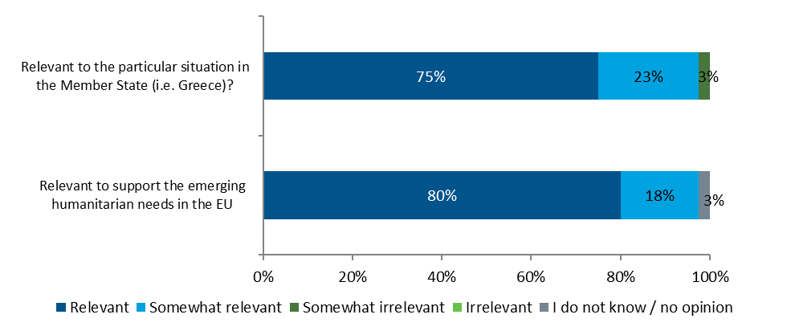

Source: DG ECHO. 2018. Survey of framework partners and local implementing partners. N=38

Some of the main distinguishing factors of the ESI were its rapid response time, i.e. the speed with which the ESI was activated and actions launched on the ground once the situation was deemed an emergency; the Commission’s implementation method and longstanding experience in humanitarian emergencies i.e. through the humanitarian Commission’s partners; as well as the breadth of actions it was able to fund. This allowed to commit funds directly to the Commission’s partners, already present in Greece (which in result collaborated with local implementing partners already operating on the ground), as opposed to through national/ regional authorities. Although different EU funding instruments were available for Greece (e.g. the EUSAF, AMIF, ISF, FEAD), the document review and other research tools showed that none of these specifically fully targeted the evolving large scale humanitarian needs (See section 5.2). More importantly, such funds primarily relied on the administrative and operational capacities of a Greek government, who was under severe stress in financial and economic terms.[48]

The swift proposal, adoption and activation of ESI meant that there was a quick response to the humanitarian consequences of the emergency. Evidence shows that, following the quick agreement by the Council on the Regulation, ESI was operational in a very short time period. Overall, it took 19 days to activate and within the subsequent three weeks the first Commission’s partners’ contracts were signed and funding released.

# *Relevance of the ESI intervention when considering Greece’s particular situation and needs; and the correct assumption of such needs*

ESI was also a relevant tool for an emergency such as the one faced by Greece. The ESI intervention was appropriate and valuable considering the situation in Greece, which was, at the time, characterised by an overwhelmed national capacity to respond and address in a timely manner the scale of the needs on the ground. The national authorities were facing a multitude of national challenges. The nature of these were not only ongoing economic and related to institutional reforms, but also related to the asylum system and procedure. The evidence collected by the support study further concluded that both the sudden increase in the number of asylum seekers and migrants paired with institutional and administrative challenges faced by the national authorities, made ESI intervention indispensable.

The Member State’s limited capacity was underscored by the support study, which found that although other EU funding instruments were available, Greece was facing issues regarding the rapid implementation and financial absorption of these funds (mostly AMIF National Programme). Research conducted by the support study and based on Key Informant Interviews compared the response to the refugee emergency in Greece (using ESI), Bulgaria and Italy (using EMAS)[49]. It was found that the response in Bulgaria was slower and less flexible than the response in Greece, particularly because of the different regulatory framework of the instrument, paired with the complex public procurement procedures, including the development of specification of the needs. For example, in Bulgaria, the general procurement process takes six months on average. Therefore, the process between the identification of the ‘need’ to intervene and the delivery of goods or services to the beneficiaries, typically, can take up to one year, which in practice means that the length of the procedures is a significantly long period to provide an emergency response.

Also, the majority of the Commission’s partners and implementing partners surveyed (75%) in the context of the evaluation indicated that ESI had been a relevant tool to respond to the situation in Greece. Out of these respondents, 53% agreed that the specific objectives of ESI were relevant, or at least somewhat relevant, to the needs in Greece, with 63% of them considering the objectives to be relevant to the specific needs of the target group identified (see Figure 6 above).

Given the emergency of the situation and the need for a rapid response, at the initial stage of the activation, a rapid needs assessment was undertaken, which consisted of mapping the existing EU funds, to minimise duplication and increase the relevance of ESI within the context of Greece, as well as needs assessment undertaken in the field[50] based on a broad dialogue with relevant stakeholders at all levels.[51]

Subsequently, and as described in Section 3, each yearly ESOP undertook a needs assessment, and the priorities of each ESOP evolved according to the changing situation and needs in Greece during the implementation period[52]. As underlined by the support study, each of the ESOPs was based on robust needs and risk assessments conducted jointly by the Commission services, national authorities and Commission’s partners. In addition, specific needs assessments were conducted for all actions funded by ESI. For example, while at the central level, the Commission conducted needs assessments mainly through field missions and dialogue with relevant stakeholders, at the governmental and the local level, each of the Commission’s partners had to undertake and provide a needs assessment for each of their proposed actions. Therefore, each of the ESOPs contained a clear analysis of needs as well as a risk assessment, identifying potential constraints and limitations, to be taken into consideration when implementing actions on the ground. The support study also indicated that while at the beginning of the activation, the Commission’s partners considered that the development process of the initial needs assessments was unclear, the process considerably improved in the subsequent years, by providing better clarity on the process and links between such assessments and funding allocations.

Thus, in agreement and cooperation with the Greek authorities, the Commission prioritised the sectors of shelter, food, health and protection[53]. As shown in section 3, given that the needs were multi-faceted, these had to be addressed from various angles, hence by a multi-sectoral approach. The actions funded by ESI were therefore implemented through a multi-sectoral response, although priorities were formulated in a way to also address niche support if relevant. Thanks to years of expertise of humanitarian activity outside of the EU, the Commission has defined policy guidelines[54] for each main humanitarian sector to ensure high quality and coherence of the funded actions. Overall, the Commission’s partners involved in the ESIs response have not only adhered to these standards and practices, but have been often active contributors to the definition of policies, as the Commission involves its humanitarian partners in the definition of policies through extensive consultation. In this sense, the Commission considered that the direct implementation of ESI actions through its experienced humanitarian partners was relevant, as it allowed the Commission to ensure adherence to its own humanitarian standards and good practices. The guidelines were applied to the same extent for the current ESI activation as for actions in third countries[55]. They were referred to in the ESOPs, were taken into account in the selection of projects, and were used as a reference for project monitoring[56].

Concerning ESI funding, this was consistent over the intervention period and the mapping of actions funded by ESI showed that all main sectors were overall well covered, with accommodation, food assistance and protection identified recurrently as top needs. The support study however underlined that a few needs identified on the ground during the implementation, in particular those of specific vulnerable groups and of beneficiaries on the islands could have benefited from more support. The former mainly related to mental health services, interpretation and cultural mediation services. While these areas were identified in the 2017 & 2018 ESOPs, the Commission’s partners did not propose enough actions for funding to cover these specific needs. The absence of proposals for actions was due either to the lack of national capacity in the Member State, and/or to the lack of sufficient resources of partners to provide for specific services. Regarding the needs on the islands, it was agreed in 2017, in cooperation with the national authorities, that the EU instruments AMIF/EMAS would cover the services in the “hotspots”.

Unavoidable challenges were nevertheless present. One of them was the constantly changing situation on the ground which hindered the accurate assessment of needs, capacities and number of beneficiaries to be targeted. In this regard, the constant and close monitoring undertaken by the Commission field experts played a key role to better assess the response and the adaptation to the changing conditions on the ground. Although the evaluation found there were slight discrepancies between UNHCR data on people of concern compared to the numbers of beneficiaries reached by actions funded by ESI, the findings also showed that the ESI-targeted beneficiaries aligned well with the needs assessments carried out throughout the actions and UNHCR data. Nevertheless, during ESI’s activation it has been difficult to determine the exact number of persons of concern given the type of emergency and the constantly fluctuating number of arrivals/departures to and from Greece.

# *Flexibility of the legal framework to appropriately adapt the operational response to: the changing conditions and needs in the Member State concerned; and to the changing conditions on the ground*

The ESI legal framework was found to be appropriate and flexible for such an operational response in Greece, given the nature of the emergency and the ever-changing needs on the ground. This flexibility can be attributed to the framework (design and implementation) but also to the working method of ESI, where actions were regulated by the agreements between the Commission and its partners, with the former providing more flexibility[57].

It must be further emphasised that the Regulation was not designed to specifically respond to a migration crisis, and thus it could potentially be used for different type of emergencies within the European Union (please see section 2). The Regulation therefore provides for a wider scope to ensure the necessary flexibility to adapt to the national and operational context.

Overall, there was a general agreement by all stakeholders consulted (Commission, national authorities, Commission’s partners and implementing partners) that ESI's legal framework allowed for a rapid and flexible response, just as it is the case for emergencies in third countries. Such adaptability was evidenced by the reallocation of funding, modification requests and contingency planning developed over the course of ESI’s activation. The set of rules governing the ESI actions allows for the introduction of modifications in case of changed circumstances. Yet, some elements of the actions needed prior Commission’s approval in order for these to take effect or be implemented (e.g. the funding amount , the duration of the action, the results to be achieved); other were considered as non-essential changes and therefore these could be unilaterally modified by the Commission’s partner. For instance, a partner has the flexibility to make transfers between different budget headings in their budget.

ESI partners made use of this flexibility, particularly at the beginning of the operations in 2016. The first 17 contracts signed in 2016 in the first months of the activation saw 58 amendments. This mirrored the difficulties of operational planning in the year 2016. In the following two years, once the initial response had been deployed, the operational environment was better known and the response could be better structured, the number of amendments dropped to eight in 2017 and thirteen in 2018.

The Commission considers that the legal framework of the ESI is in principle applicable to other Member States facing a similar crisis, provided that the Council activates the use of the instrument. The support study nevertheless highlighted that there is room for improvement in the case of a future activation, in terms of better mapping the capacities of local actors such as municipalities and civil society organisations, preferably before an ESI intervention or at least at an early stage thereof. Indeed some local partners considered that they had been insufficiently consulted at the very early stage of the activation. Additionally the study called for a clearer division of responsibilities between the various stakeholders involved in an ESI activation, for example by early identification (i.e. at an early stage of ESI intervention) of the key actors and their roles (at EU, national and local level) to reinforce the sustainability of an intervention in the long run and in view of improving the coordination and cooperation between all the actors involved. It must however be noted that operating in crises situations does not always allow for such a degree of forward planning, in particular as the ESI operates by definition in a Member State that is overwhelmed.

# *Extent to which ESI working method (i.e. channelling aid through humanitarian partners) was relevant to address the humanitarian needs that resulted from the refugee and migration crisis*

Channelling the actions through the Commission’s partners has ensured a timely and tailored response to the emerging humanitarian needs of the beneficiaries targeted in Greece. Moreover, it allowed the Commission to fund organisations which were not eligible or available through other instruments. International NGOs for instance, which played an important role in the response, were not funded directly by the Commission through other instruments. This method was relevant, as it allowed the NGOs to take swift action to address the most urgent humanitarian needs, given the limited capacities of the national authorities as well as that of the local and civil society organisations, to respond to the situation at the beginning of ESI’s activation. It must be underlined that the capacity of the national authorities was overwhelmed at the beginning of 2016. The Member State had to deal with an influx of refugees and migrants that was unprecedented. Special measures had been taken to cope with the situation such as using the armed forces to create shelter and provide services, but there was nevertheless a lack of sufficient humanitarian capacity and expertise in the country, which had not been prepared for such an exceptional situation. Thus the immediate provision of expertise and funding was the most viable solution to respond to the emergency situation and to allow the national authorities to strengthen their structures and to gradually increase the capacity of national entities including civil society organisations.

This was corroborated by 91% of the Commission’s partners surveyed, who considered ESI’s working method to be relevant or somewhat relevant to address needs, with none deeming it irrelevant. Opinions on the possibility of working directly with Member State authorities were divided, with 48% of respondents indicating it would have been relevant or somewhat relevant to implement ESI’s actions through the Member State authorities, while 43% considered it would be somewhat irrelevant or irrelevant. However, it must be highlighted that the legal basis of ESI does not allow for its actions to be directly implemented by the Member State authorities, yet close cooperation with the affected Member State is a requirement (see section 5.2 below). This is consistent with the fact that emergency support is to be provided by the ESI when a Member State’s capacity to respond to the humanitarian consequences of a crisis is limited and/or overwhelmed- as was the case of Greece. In addition, at the time ESI was activated, Greece was also under an institutional restructuring process, including the creation of the Ministry of Migration Policy, established by mid- 2016.

The support study also underscored some issues regarding the involvement of local organisations. These were mainly identified at the initial activation phase, although local implementing partners considered that they could have been better involved to provide a better understanding of the local context and needs. The context and situation in Greece must be again noted in this regard, as there was no Greek organisation which had signed a framework partnership agreement with the Commission before the beginning of 2016, and thus it was not possible to directly fund Greek civil society organisations through ESI. This issue was addressed and the involvement of Greek civil society organisations gradually increased, on the one hand as leading Commission’s partners increasingly collaborated with local organisations on the ground for the implementation of the actions, and on the other hand when selection criteria for Commission’s partners eligible to receive emergency support funding were adapted in 2017 in order to allow local Greek organisations to become ESI FPA partners. At the end of 2018, Greek FPA partners and local implementing partners played a key role in the management of the response and are expected to continue doing so, provided other sources of funding such as the AMIF national programme will be accessible.

## Coherence and complementarity

# *Extent to which the ESI actions adhered to the humanitarian principles*

The actions funded by ESI were implemented in respect of the humanitarian principles of neutrality, humanity, impartiality and independence, as required by Article 3 of Council Regulation (EU) 2016/369. This was validated by the support study findings, which showed that the Commission assessed both at the proposal stage and during the consistent monitoring of the activities, the adherence of the proposed actions, their design and implementation to the humanitarian principles.

The majority of stakeholders consulted (Commission, national authorities, Commission’s partners and implementing partners) highlighted that no discrimination among the beneficiaries of ESI actions has been found. On the contrary, every person who was seeking asylum in Greece was eligible for ESI funded assistance. Furthermore, the Commission’s partners implementing ESI actions all had a solid track record of applying the humanitarian principles, as they have undergone a robust certification[58]. Finally, both exit strategies and handover arrangements to the national and local authorities (including municipalities) included capacity-building activities with explicit reference to the humanitarian principles. However, the implementation on the ground continued to be affected by fluctuating numbers of beneficiaries, security challenges and the lack of accommodation facilities, which was progressively tackled through establishment of new camps/sites.

Despite the challenges faced and the complex situation involving partners, beneficiaries and national authorities, ESI proved to be a relevant and flexible instrument to deal with this exceptional situation in an EU Member State. The majority of the stakeholders consulted (i.e. Commission, national authorities and Commission’s partners) considered that actions funded by ESI respected the fundamental humanitarian principles. However, the support study underlined that some of the Commission’s partners perceived some challenges while applying the principles of independence and neutrality. This issue was mainly related to the requests and decisions made by the national authorities on the delivery of humanitarian aid – including for example the location and establishment of camps/sites. While the selection of sites, in particular of temporary facilities, was considered sometimes as unsatisfactory (since the camps/sites were located in remote places or needed to be developed) at least at the beginning of the activation, balanced decisions had to be made between the need for shelter and meeting national standards. Such decisions however, together with their assessment, had to be done in cooperation by the national authorities and negotiated with local authorities both for practical purposes and given the legal requirement for such coordination in the ESI Regulation.

In addition, it should be noted that working in an EU Member State is inevitably different from working outside the EU. Within the EU, and according to the principle of loyal cooperation, the Commission has an obligation to cooperate and coordinate with the Member State concerned, also in accordance with Article 3 (4) of the ESI Regulation (a more stringent requirement than the one applicable in third countries). At the beginning of the activation, this particular obligation presented a challenge for humanitarian partners, in particular NGOs, which typically limit their interaction with governmental authorities in third countries to a minimum. In the case of Greece this was different. The national authorities (i.e. later the Ministry of Migration Policy) were at all times in the lead of the response, even if their necessary legislative framework and sufficient capacities were not fully developed at the beginning of the crisis but gradually developed throughout ESI’s activation. Greece, as an EU Member State, took the necessary decisions to shape the national response in the medium and long-term, also in view of taking over the ESI operations by 2019. Some partners interpreted this as a limitation of their operational independence, an issue also raised in the support study. In the Commission’s view this was not the case, as the actions developed by ESI were in full respect of the humanitarian principles (as also proven by the evidence provided in the support study), therefore the limitation raised by the partners was eventually a matter of diverging views on certain aspects of the response.

At the same time, the Regulation explicitly states that close cooperation and consultation with the affected Member State has to be ensured. Given that the ESI was a new instrument, through which emergency humanitarian-style support has been provided for the first time in the EU, the Commission’s partners faced a different situation and context. They also had to learn how to work in a new context and with the national authorities of an EU Member State, and *vice versa*. The cooperation and collaboration of all the actors involved was nevertheless substantially improved during the implementation of actions funded by ESI. In this regard, stakeholders consulted (i.e. national authorities, Commission’s partners) highlighted the Commission’s coordinating role (particularly DG ECHO with regards to ESI-funded actions) to achieve an effective working method between all the relevant donors and organisations involved at EU and national level. In addition, the Commission (DG ECHO in particular for ESI-funded actions) played a key role in mediating between the traditional humanitarian actors positions and those of the national authorities which were driven, by nature, by strategic imperatives for example for what concerns the locations of camps (a scattered location of small camps has prevailed in order to better distribute the burden between different regions of the country).

In the opinion of some of the Commission’s partners consulted, the limited intervention on the islands could be perceived as compromising the principle of humanity. In this regard, it must be noted that both ESI and AMIF funding for actions in the islands was available and implemented throughout the period of the support study. However, attempts to significantly increase reception capacity on the islands were unsuccessful. For instance EUR 3 million for UNHCR from the ESI budget were committed for the creation of an additional reception facility on the island of Chios. As no agreement on the location for the facility was reached, the latter was never built. As of 2017, ESI’s main focus would therefore primarily concentrate on providing assistance on the mainland in order to create the necessary capacity for the decongestion of the islands, which was the best strategy to cope with the low but continuous influx. This agreement is reflected in the Financial Plans for 2017 and 2018 which present the responsibilities of the various EU instruments as regards the financing of activities in relation to the refugee and migration crisis. This division of tasks was appropriate to guarantee coordination and ensure complementary, EMAS funding were already scaling up the response on the islands, where the migration hotspots were concentrated. As of 2017, there was a clear need to boost the response in the mainland by creating sufficient hosting capacity to facilitate the transfers from the islands and, as a consequence, to alleviate the pressure on islands.

# *Extent to which the ESI is complementary to other related EU and/ or national instruments and overlaps identified*

Article 6 of the Regulation provides that the ESI funded interventions must seek synergies and complementarities with other EU Instruments. In this regard, ESI has overall achieved a high level of coherence with other relevant EU instruments and it did not have any evident overlaps with other EU instruments that could deliver assistance to Greece.

When analysing the extent to which these EU instruments either overlap or complement the ESI, the following differences are noted: the instruments of Humanitarian Aid (Council Regulation 1257/96) and the UCPM (Decision No 1313/2013/EU) have guiding principles that are very similar to ESI (provision of relief to most affected by cases of man-made and/or natural disasters). Nevertheless, the geographical scope of the former is different, as the Humanitarian Aid Regulation foresees a geographical limitation: assistance can be provided *outside* the Union only. On the other hand, the UCPM is mainly limited to in-kind assistance and/ or human resources (teams of experts) and it depends on Member States' voluntary contributions to the affected country. Assistance has to be requested by the affected country and delivered by specialised Member State agencies. In the case of Greece, the Mechanism was activated twice in 2015 and 2016 with over 200 000 in-kind donations of relief items and equipment from over 20 other EU Member States. By the time the emergency support Regulation was proposed by the Commission, it was clear that the UCPM had reached its limits and further substantial assistance, in terms of further capacity to provide additional humanitarian assistance for the mid and/or long term, could have not been provided by other Member States, who in many cases were also hosting a high number of refugees and migrants.

The EUSF (Council Regulation 2012/2002) targets natural disasters only, thus excluding man-made ones, under which category falls the flow of refugees and migrants experienced in Greece since 2015, and for which the ESI was activated in March 2016. The FEAD (Regulation (EU) 223/2014) focuses on reducing poverty in the Member States. The third EU Health Programme (2014-2020) also supported actions to address the migrant health issues in Greece, amongst other countries.

Finally, AMIF (Regulation (EU) No 516/2014) and the ISF (Regulation EU 513/2014 and Regulation EU 515/2014) do not particularly focus on the provision of humanitarian aid, emergency relief or poverty-reduction assistance. Instead, AMIF's goal is to support the management of migration flows and to strengthen a common European approach to asylum and immigration, mostly through support to the development of structures, systems and organisational capacities. The ISF on the other hand aims to enhance security within the EU by both strengthening police cooperation and combating crime, as well as supporting integrated border management and a common visa policy. The support study underlined that while some stakeholders (Commission and Commission’s partners) raised similarities with other EU funding instruments, it is mainly EMAS the instrument which presents more similarities. In fact,the mandate of EMAS is defined as providing additional emergency support to address urgent and specific needs arising, inter alia, also from “heavy migratory pressure in one or more Member States characterised by a large and disproportionate inflow of third-country nationals, which places significant and urgent demands on their reception and detention facilities, asylum systems and procedures”.

Overall the complementary with EMAS has been guaranteed thanks to:

* The timing: when EMAS was used to assist vulnerable refugees and migrants in Greece, ESI was not yet available.
* The channels: a significant proportion of the EMAS funding in the 2015-2017 period went directly to the national authorities and to international organisations, while ESI funding went also to NGOs and the Red Cross family organisations, partners which are not eligible under AMIF EMAS[59].
* The division of responsibilities: DG ECHO primarily concentrating on the provision of emergency assistance on the mainland of Greece and DG HOME providing assistance through the National Programmes and EMAS in the island territories, where the migration hotspots were located.

Furthermore, partner organisations on the ground ensured the complementarity of the actions with the local authorities and with other international organisations by demonstrating at action proposals stage to have a full knowledge of the context and of the response already ongoing on the ground. Proposals have been rejected by the Commission where a risk of overlap existed. Monthly updates have been requested to the partner organisations, which allowed the Commission to map the actions by sector and to continue checking any possible overlap and to guarantee constant coordination.

Moreover, a series of coordination mechanisms between the relevant Commission services and national authorities were established to ensure coherence between the ESI and other EU funding instruments. The main result of the effective coordination between all relevant actors is reflected in the Financial Plans, where the main needs and areas to be covered by ESI, as indicated and requested by the national authorities, including an indicative budget breakdown per relevant actor and per EU funding instrument were provided. As of 2018, a Steering Committee was also established with the involvement of relevant Commission Services and the National Authorities (i.e. Ministry of Migration Policy, Ministry of Economy, Ministry of Labour, Ministry of Education etc.). Furthermore, strict and regular monitoring of the Commission field experts, together with the coordinating role of the SRSS, also highlighted by many stakeholders consulted, facilitated the complementarities between the various EU Instruments.

Overall coordination was provided by the SRSS at the institutional level. The Commission (through DG ECHO) organised regular coordination meetings with the national authorities and different Ministries, such as the Ministry of Economy and the newly established MoMP as well as regular meetings with humanitarian organisations.

The coordination at the Commission level also involved regular (firstly weekly later monthly) coordination meetings between DG ECHO and DG HOME at different levels of hierarchy as well as exchanges with other DGs for the provision of social services (funded by ESIF) –DG EMPL and DG REGIO in particular.

Finally, no overlaps were encountered with national instruments, as there were no available national instruments that could possibly target and address the scale of the humanitarian needs on the ground. This was firmly corroborated by all the stakeholders consulted, including the national authorities.

Overall, it can therefore be concluded that ESI interventions inside the EU require a high degree of complementarity and coordination with the existing EU funding mechanisms and the authorities of the affected Member State. A balance has to be found to ensure that the experience and expectations from the humanitarian partners are channelled through the appropriate channels and delivered in a principled, yet effective way.

## Effectiveness

# *Extent to which the Regulation objectives have been achieved, in particular as regards meeting the humanitarian needs of refugees and migrants in the different sectors of intervention*

The identified humanitarian needs of refugees and migrants in Greece were met and/or their situation improved, when compared to the starting point in 2016, as a result of ESI’s actions. There was an evident upgrade of people’s living conditions in terms of shelter, WASH, immediate living conditions and their access to cash assistance (replacing in-kind assistance). For a detailed list of achievements per sector, please see section 3 above (implementation/state of play). The support study evidence shows that most of the actions funded by ESI addressed the identified humanitarian needs, achieved and surpassed their output targets[60] with many reaching a higher number of beneficiaries than planned. In summary, the support study provides an analysis of three different aspects related to ESI actions:

* Result indicators of the ESI actions: All the sectors, except for the WASH activities, have on average surpassed the targets set in terms of the number of services to be provided, number of sites to be built/ conditions improved or the number of support mechanisms to be implemented. In 86% of the indicators (266 out of 308) the targets set were achieved or exceeded, and around 60% of such achievements related to the beneficiary level targets.
* Outcomes and improvement of the beneficiaries’ situation: achievements are mixed. The absolute majority of outcome indicators set in the ESI actions related to the improvement of the beneficiaries’ situation. The achievement of outcome indicators set at the project level has been positive, but less so in comparison to the result indicators.
* Number of beneficiaries reached: Overall, the support study states that all ESI actions have reached a higher number of beneficiaries than originally planned, and with a very wide coverage of needs and managing to improve their living conditions if compared to the starting point in 2016. For instance, it is estimated that the ESTIA multi-purpose cash transfer programme cumulatively had around 104 000 beneficiaries compared to the estimated 114 000- 143 000 people in need in Greece in the 2017-2018 period. The overachievement of targets however could be linked to the overly cautious initial estimations, alternatively to the fluctuations in the number of people arriving in Greece requiring assistance, or potential double counting in the number of beneficiaries. Due to the multi-sectorial nature of actions funded by ESI, and to the way project templates are structured, it is not possible to obtain a number of unique beneficiaries supported by the ESI funding. The analysis of the average number of beneficiaries reached per action per gender shows that 60% of reached beneficiaries were women and 40% men on average. Women remained consistently in the majority amongst the ESI beneficiaries in 2016, 2017 and 2018. Comparing the latter with UNHCR data on people in need of assistance in Greece (1) shows a different profile, as amongst the overall number of people in need, 60% were men and 40% women. This means that the ESI reached more women than in the overall target population, which is positive as women tend to be more vulnerable in the emergency situations.

1. Cumulative numbers of people in need of assistance in Greece, by age and sex, 2017 and 2018

|  |  |  |  |  |  |
| --- | --- | --- | --- | --- | --- |
|  | Number | % |  | Number | % |
| Adults | 66,583 | 60% | men | 65,909 | 59% |
| Children | 44,311 | 40% | women | 44,985 | 41% |
| Total | 110,894 | 100% | total | 110,894 | 100% |

Source: UNHCR. Population data – UNHCR estimates based on enrolment. Cumulative number of unique people in need for years 2017 and 2018.

In addition, there was a broad agreement between the stakeholders consulted (i.e. Commission, national authorities, Commission’s partners and implementing partners) that the identified and targeted humanitarian needs in the different sectors of intervention were met by the actions funded by ESI in a timely manner.

On the other hand, the beneficiaries’ satisfaction varied across the services provided by ESI’s actions, as pointed out by the support study, particularly regarding cash assistance. Beneficiaries’ feedback collected by the support study in September 2018[61] (Figure 7 below), and through other means of verification such as partners-implemented surveys, indicates that with the support of ESI some of their needs were met to a certain degree of satisfaction.

On average, across the services received, 50% of beneficiaries surveyed in the evaluation were either very happy or happy with the services received. However, to be noted is the varying degree of satisfaction with the different types of support received, with high approval ratings for services in the education, protection assistance and shelter/ accommodation. Half of the respondents who received healthcare were satisfied with the support provided while around one third of the respondents were not happy with the health assistance received. In the shelter sector, in general, those who were happy with the support received and those who believed that their needs had not been covered were relatively equally distributed (47% and 42% respectively).

Only a third of the beneficiaries were happy with the food services they received. Cash services seem to have satisfied few beneficiaries, with about half of the participants not being happy with the programme and considering that the support received did not respond to their needs. Only a third of the cash beneficiaries perceived that their needs were covered with the support received. Mainly beneficiaries complained that the amounts received were not sufficient.

This finding appears in line with the trends observe in other Commission-funded cash actions in third countries, and somehow expected as a result to such a direct question, however the results of the beneficiaries’ survey contradict the feedback provided by ESI partners and the results of monitoring missions undertaken by DG ECHO.

It is important to underline that the cash amounts distributed were established as a contribution to the beneficiaries’ family basket, and not meant to fully substitute a family’s income, as the question of the mini survey undertaken by the support study seems to suggest. Furthermore, the amount provided corresponds to the amount given to vulnerable Greek families by the social protection system and that the Minimum Expenditure Basket was agreed between members of the Cash Working Group in Greece and the Greek Government. Additionally, in order to pursue an objective of sustainability, and allow a possible handover/takeover of the cash assistance at the end of ESI operations, the Commission and the Greek Government decided to align the cash transfers, so as to equal the amounts provided by the Social Solidarity Income to the Greek citizens, and to also avoid inequalities between the beneficiaries and the Greek citizens. The results of the survey may however indicate that the amounts are too low and it is a matter that may require further analysis.

1. Does the support you receive (good and services) responds to your needs and (if relevant) the needs of your family/ (difference of views between respondents on the mainland and the islands)

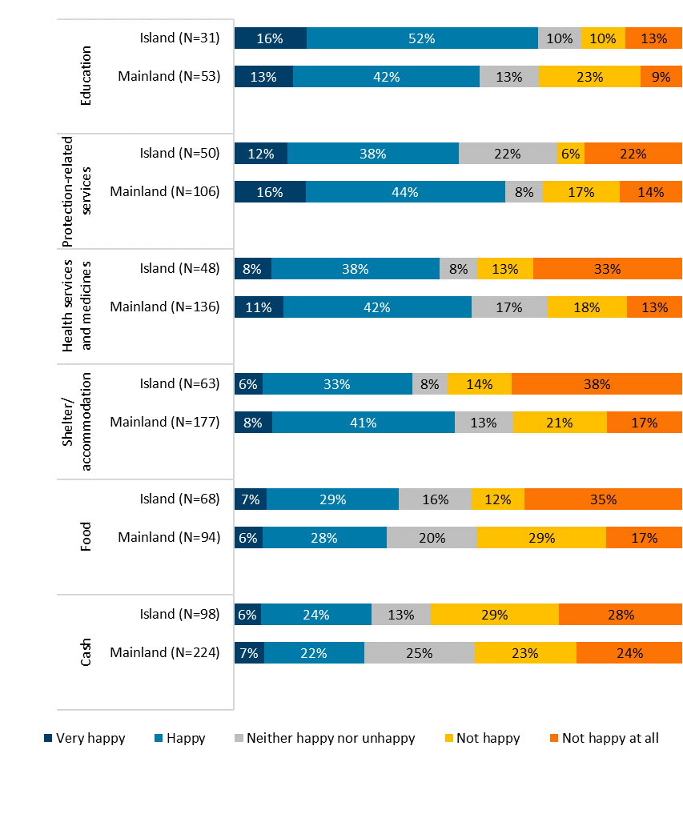

# *Enabling or hampering factors influencing the achievement of the objectives*

As described above in section 3 (“evolution of programmatic priorities”) the ESOPs were constantly updated and adapted to the evolving needs and established priorities. The support study concluded that the flexibility of ESI was one of the main enabling factors for the achievement of the objectives. It allowed to adapt the ongoing actions to the changing conditions on the ground, which amongst others included the fluctuating numbers of beneficiaries. In addition, the swift and holistic approach of the actions funded by ESI to address the needs of beneficiaries and their engagement in the delivery of assistance were also highlighted as enabling factors. The clearest example of such a flexibility approach is represented by the choice to support the systemic shift from in-camp to urban accommodation policy and from in-kind assistance to cash.

A number of challenges were also identified, both at the strategic and operational level, which influenced the achievement of the objectives. According to the support study, more than half of Commission’s partners and implementing partners (58%) indicated having encountered challenges while implementing their ESI-funded actions in Greece. This is corroborated by the analysis of the project final documentation (Single Forms) where the framework partners identified having faced challenges affecting the implementation of the ESI actions in 22 out of 29 actions. The most frequently mentioned challenge, across the various sources of evidence, relates to:

* At the strategic level: **absence of a plan and/or strategy** at an early point of the crisis by the national authorities to respond to the large influx of refugees and migrants into the country. There were also limited adequate resources and experience in emergency assistance and asylum issues by the national authorities, to steer the activities in a consistent manner. This has improved as the ESI implementation progressed, especially with the establishment of a single Ministry responsible for migration matters, which did provide the necessary guidance as of 2017.
* At a more operational level:
  + Framework partners faced a situation of **poor and fluctuating data on the beneficiaries** and the nature of their needs, which made it difficult to plan the individual project actions. This has somewhat improved over time as the migration situation has stabilised and better data emerged from the national authorities and UNHCR.
  + National authorities were considered to insufficiently manage the **security** in the various mainland sites. Over time, the situation was addressed and has improved.
  + Several **procedural and administrative obstacles** were encountered, including delays in obtaining permits to access locations and start planned actions, legislative and administrative challenges as procedures did not always permit the swift action that is needed in an emergency context, which in turn led to delays in the provision of services by the ESI actions. Examples given included challenges in determining site locations and the numbers of refugees and migrants per site, with changing plans causing delays and changes in the implementation of actions.

However, as actions funded by ESI matured, the positive effects of developing constructive relationships between the national authorities in Greece, local NGOs, local authorities and other partners at the local level was also stressed by the support study. The cooperation with the Greek municipalities played a key role for the activities implemented by ESI, in particular as part of the ESTIA programme.

# *Extent to which the Actions funded by ESI’ implementation method (i.e. channelling aid through humanitarian partners) allows to effectively address the humanitarian needs that arose as a result of the refugee and migration crisis within the EU*

Channelling the actions through the Commission’s partners allowed ESI to timely and effectively fulfil the humanitarian needs of the targeted beneficiaries (see section 5.1.4). Overall, the working method was pertinent and effective when considering the numerous challenges faced by both the national authorities and the local civil society organisations to provide a rapid, coordinated and effective response to the emergency.

This view was also shared by the Commission’s partners and implementing partners as most of them (90%) agreed that channelling ESI’s actions through humanitarian partners was effective or somewhat effective. Only 35% consider that it would have been effective or somewhat effective doing it through the Member State authorities.

1. Share of respondents that considered having ESI’s actions implemented by Member State authorities vs. Commission’s partners would allow for a good, timely and effective response

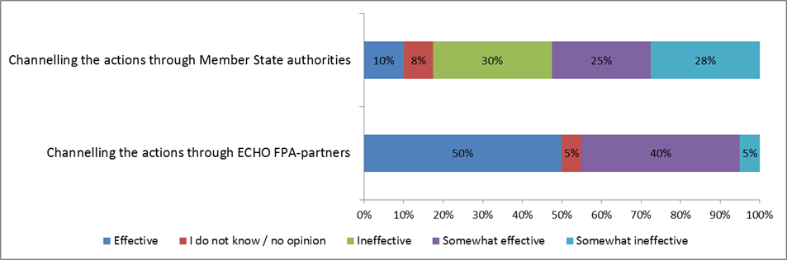

The support study findings also showed that the close presence and extensive follow-up by the Commission experts in the field, was instrumental in the effectiveness of ESI overall.

# *Extent to which the Actions funded by ESI followed the EU visibility criteria as set out by the Communication and Visibility Manual for European Union-funded Humanitarian Aid Actions*

ESI funded actions provided a clear communications and visibility plan to ensure the relevant activities met the EU visibility Criteria for EU funded Humanitarian Aid actions. With the activation of ESI in March 2016, communicating the impact of EU actions in Greece towards EU taxpayers, beneficiaries, local communities and stakeholders became essential. Commission’s partners overall adhered to the communication and visibility requirements, while the Commission provided continuous guidance and monitoring, leading to significant progress throughout ESI activation.

This was corroborated by the actions mapping done by the support study, which found that while the visibility of ESI funded actions varied, overall Commission’s partners applied the visibility guidelines extensively, with many of the partners going beyond the mandatory visibility requirements. Although some issues were encountered during the first months of actions funded by ESI as underscored by the support study, these mainly related to security concerns (especially shortly after the EU-Turkey Statement). The visibility however gradually improved over time. As shown by Figure 5 below, 95% of the surveyed partners reported both being aware of the Commission’s visibility requirements and having managed to implement these under the actions funded by ESI, 15% of respondents reported having faced obstacles while doing so, whereas most of them (80%) stated that they did not face any obstacles.

1. Share of awareness on the Commission’s visibility requirements, their implementation and obstacles

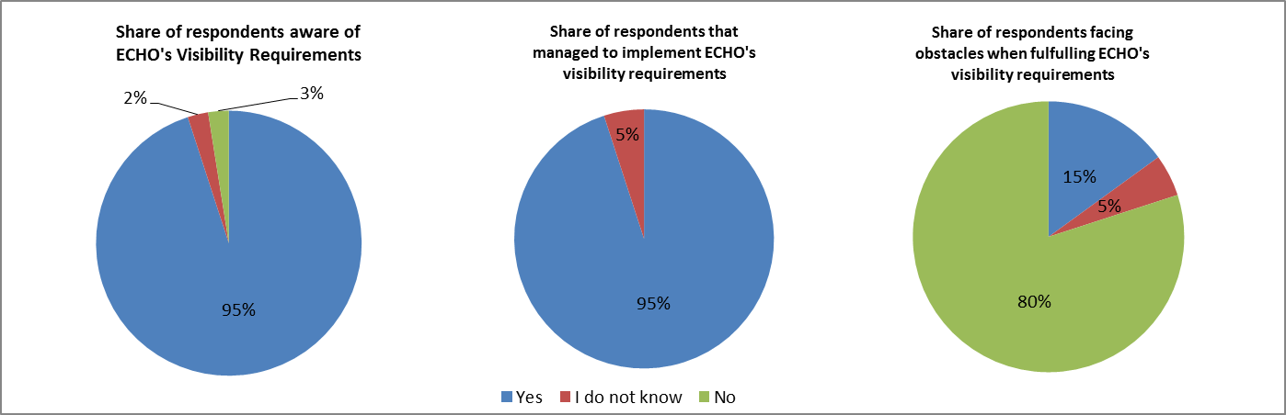

## Efficiency

# *Extent to which the Actions funded by ESI were implemented in a timely and cost-effective way, taking account of the specific conditions of the emergency operations in Greece? - And What factors affected the efficiency of the response and to what extent?*

Overall the actions funded by ESI are considered to be cost-effective and the budget allocation was appropriate to meet the humanitarian needs. Furthermore, the efficiency the actions overall improved over time. For example, while in 2016, ESI’s focus was to primarily respond to the emergency in a timely manner, concentrating on lifesaving activities, in 2017 and 2018, the Commission adopted a different approach to the crisis to avoid gaps and overlaps and consolidated the response by reducing the number of partners. As a result, the 2017 ESOP promoted the “one partner per sector and per site” strategy avoiding duplication of activities. Similarly to findings of the effectiveness of the actions, the support study underlined that the flexibility of ESI also contributed to improve the efficiency of actions funded by ESI, by allowing the Commission’s partners to adapt to the changing needs on the ground. For example, evidence on the flexibility has shown that modification requests allowed the Commission’s partners to adapt the actions to evolving needs, in particular for 2016 contracts. The majority of partners have requested modifications during the implementation of their actions. In 60% of the cases these concerned an adaptation of the strategic operations, such as upgrading the container sites, adapting the food offer based on the needs of the beneficiaries, scaling up of winter kits distribution or increasing the legal aid provision to beneficiaries. The Commission’s partners also requested adaptations to the timing and budget of their actions. The flexibility in modifying and extending the duration of the ESI actions is a welcome element that was raised by most of the partners as improving the cost-effectiveness of the response.

The assessment provided by the support study was mostly based on qualitative indicators and stakeholder views, mainly given the fact that ESI is a relatively new EU support instrument and it has only been activated, for the first time in Greece. Hence, there is no basis for comparison with previous EU interventions in any other Member State. The support study however tried to provide quantitative evidence by developing a series of indicators to look at the cost-effectiveness of similar crises targeted by EU humanitarian aid actions, however implemented in third-countries, such as Egypt, Jordan, Lebanon, and Turkey. Through this exercise different levels of economic development were taken into consideration by weighing the costs using final consumption expenditure (FCE) per capita and GDP per capita.

The support study developed three indicators to assess the costs effectiveness of ESI:

* The first indicator compared the cost per beneficiary of ESI in Greece with the cost per beneficiary of other Commission (DG ECHO) interventions in Egypt, Jordan, Lebanon and Turkey. The costs in the group of countries of reference was then indexed to the consumer price level of Greece (using the FCE).
* The second indicator provided a comparison of the alpha ratio across the countries and indicated the share of the cash and in-kind modalities that is directly transferred to the beneficiaries. A higher alpha ratio indicated better cost-effectiveness.
* The third indicator, finally compared the average share of specific costs per project in Greece and in the other countries, with a higher share of specific cost indicating a better efficiency of the actions.

As a result of such exercise, the support study concluded that the average cost of implementation per beneficiary of the emergency support activities in Greece was lower than in the other countries (EUR 792 vs EUR 1 375) once the prices were adjusted to the Greek prices level (FCE). The analysis however showed different level of cost-efficiency depending on the different sectors, hence suggesting that while a high cost-efficiency was found in some sectors (e.g. health services, basic needs assistance (e.g. MPCT) and Food Security and Livelihoods (FSL)), more efficiency could have been achieved in other sectors (e.g. protection and accommodation services). This first basis for comparison, however should be interpreted with caution as other factors such as the country taxes, the price of the goods bought on international market, exchange rates and import taxes, etc. were not considered. Beyond the current exercise of evaluating the activation of the ESI for Greece, some of the calculations done in this context could usefully serve as an input to further work on assessing cost-effectiveness.

1. Average cost per beneficiary, per sector, 2016 - 2018

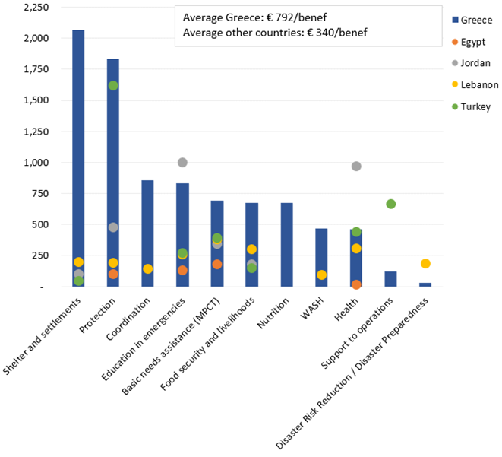

The support study findings overall showed that actions funded by ESI were proportionally less efficient in 2016 due to higher support costs to initiate all the activities in Greece (set up of camps/sites etc.) however the efficiency improved in the subsequent years. This is consistent with the situation in Greece at the beginning of the activation, as the Member State had not seen a previous and major presence of humanitarian actors, and the Commission’s partners first had to establish a presence on the ground.

In addition, an indication of the efforts made to improve the efficiency of the actions, is reflected in the Commission’s application of strict monitoring requirements on ESI actions. For instance, UNHCR was required to conduct monthly certification of refugees and migrants, something which is not needed as part of humanitarian responses elsewhere. This specific requirement overall helped to keep track of the extent to which targets were being met within the available budget. Throughout the project cycle the Commission (DG ECHO) undertook regular site visits to monitor the implementation of the ESI actions, including close scrutiny of ongoing activities and making recommendations to improve efficiency. This was also reflected in some of the actions’ modification requests whereby specific suggestions were made to improve the efficiency of the activities and ensure that lessons learned from previous visits/ actions were taken into consideration. In addition, Commission’s field experts played a key role in following the implementation of technical solutions on the ground and in proposing more cost-effective alternatives where and whenever necessary. For instance, on several occasions expensive technical solutions were revised by the Commission’s experts to reduce the costs.

Coordination was also key to ensure efficiency. The support study’s stakeholder consultation findings show that one effort to ensure cost-effectiveness was the UNHCR-led inter-agency coordination mechanism, with all relevant humanitarian organisations, as it allowed to better coordinate activities implemented by different organisations and avoid overlaps, as well as for both the best practices and ‘know-how’ exchange.

In addition, the support study findings also identified other measures that the Commission’s partners and local implementing partners put in place to ensure and/or maximise the cost-effectiveness of their ESIs actions (see also Figure 11). The main measures included:

* Cooperation with the private sector. For instance, the private sector was involved through civil engineering and architectural studies.
* The use of innovative method and new technologies. For instance, Mercy Corps developed an App called ‘refugee.info’ which gave beneficiaries access to a range of services in their desired language.
* Partner monitoring systems, including the use of efficiency-related indicators.
* Community based participatory approaches to allow beneficiaries to support themselves and their peers.

1. Measures implemented by framework partners and local implementing partners to maximise the cost-effectiveness of actions funded by ESI

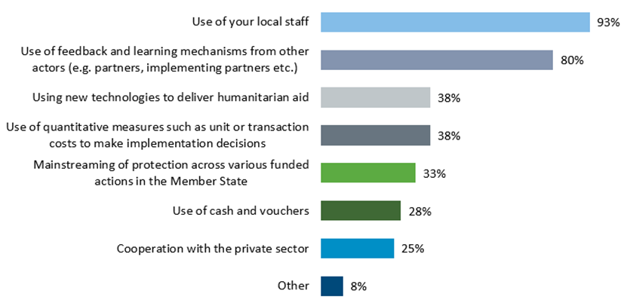

Regarding the factors that affected the efficiency of actions funded by ESI, these were both of external and internal nature. The external factors, as by the document review and the stakeholders consulted, included the overall overwhelmed national capacity and lack of a well-defined national strategy in 2016 to respond to the influx of migrants and refugees, paired with the limited infrastructure and services to deal with refugees and asylum seekers, as well as the national requirements and standards set by the national authorities regarding the setting up of sites/camps, which increased the building, administration, transportation and logistical costs. Some examples provided by the support study related to the dispersion of camps/sites, their capacity, the use of private land or private buildings, the national standards requests on specific model of containers, the last-minute closure of camps already set-up, among others. Furthermore, the costs of operating in Greece were higher when compared to EU interventions in third countries, as ESI had to adhere to EU and national legal frameworks and procedures. Challenges identified were particularly related to the Member State’s specific context and legal framework, such as a high level of taxation and social security obligations resulting from Greek labour law, lack of sufficient provision of public services close to sites which lead to additional transportation costs, amongst others.

On the other hand, internal factors affecting the efficiency, were also identified by the support study. It should be however noted that the Commission mitigated such challenges by requesting its partners to undertake certain measures to improve the efficiency of their actions. These included for example: the progressive reduction of expatriate staff and instead increase the employment of local staff and volunteers, (including migrant volunteers), grassroots movements; the creation of partnerships with local NGOs (a total of 69 different implementing partners participated in ESI’s actions, 25 local NGOs and 10 local authorities); strict monitoring of ESI’s actions to boost cost-effective alternatives (e.g. UNHCR monthly certification of refugees and migrants in ESTIA).

Finally, coordination between the relevant actors (including partners, local organisations and local authorities, such as municipalities) was also key to ensure the efficiency of actions funded by ESI. Such coordination clearly improved in 2017 and 2018.

## EU added value

# *The EU added value of the ESI activation in Greece - What is the specific EU added value Actions funded by ESI and working methods in Greece?*

ESI demonstrated a clear EU added value given that its actions could not have been implemented by any other national instrument and/or actor - as there was no national equivalent instrument available that could have successfully addressed the needs, nor did the concerned Member State have the capacity to address the scale of the resulting humanitarian crisis.

Although other EU funding instruments and tools were active in Greece (e.g. AMIF/ EMAS), overall during its three year activation, ESI addressed a clear gap in the provision of humanitarian emergency support, as it provided a timely support, for large-scale actions to address the basic needs of beneficiaries in an emergency context, by channelling the response through certified humanitarian partners, which could not have been funded directly by other EU instruments and thus providing a holistic response. As shown by Figure 12 below, the vast majority of the Commission’s partners and implementing partners (78%) considered that the emergent needs - resulting from the sudden influx of refugees and migrants into Greece- would have not been met without the activation of ESI.

1. Share of respondents that considered actions could not have been implemented without ESI and/or the needs could not have been met in Greece without ESI

|  |  |
| --- | --- |
| **Share of respondents who considered that actions could/could not have been implemented by the concerned Member State** | **Share of respondents who consider that the emerging needs in Greece could/could not have been met without ESI's activation** |
|  |  |

The main specific characteristics, as also highlighted by the support study, that boosted the added value of actions funded by ESI were notably: ESI's focus on humanitarian support; the flexibility of the instrument to adapt to evolving needs; the fast response by which ESI was activated and the actions then implemented; the expertise of Commission’s partners and consequently the transfer of knowledge and the capacity building component included in all ESI’s actions (for both local organisations and national authorities);as well as the Commission’s expertise and technical assistance on the ground. ESI replicated the Commission’s successful and unique *modus operandi* of deploying humanitarian field experts to Greece (by DG ECHO). The three Commission Greek-speaking field experts deployed to Greece were the interface between the Commission, the Greek authorities and the partners. Thanks to their long-standing expertise in managing and monitoring the implementation of humanitarian operations in the field, they were able to address implementation challenges directly, which improved coordination and speeded up implementation.

## Sustainability

# *Extent to which the ESI actions can continue after the end of the three-year activation on the basis of national funding, and relying on the national programmes under AMIF and ISF, or other sources of funding (such as EUSF, ESF, ERDF and FEAD)*

The ESI activation is due to end in March 2019, thus at the time the support study was undertaken actions funded by ESI were still ongoing. Similarly, while some of ESI’s actions were handed over to the national authorities (e.g. shelters for UAMs, primary healthcare) the transition process is still ongoing.

Although sustainability and exit strategy are not one of the main objectives, and not formally referred to in the ESI Regulation, the support study nevertheless showed that the Commission did undertake a number of measures to ensure that partners considered sustainability of their actions throughout the ESI activation period. As of 2017 the Commission consolidated the ESI operations by reducing the number of partners and streamlining sectoral interventions. For example, the 2018 ESOP did consider and referred to the sustainability and exit strategies. In addition, the Commission has continued to stress the sustainability of the actions as part of the coordination mechanisms (involving other Commission services and national authorities). The analysis of actions funded by ESI also showed that Commission’s partners considered sustainability in the design of their actions. The latter particularly focused through the collaboration with local implementing partners, training and capacity building of local authorities and organisations, and capacity building of beneficiaries.

While overall, it is therefore too early to assess the long-term sustainability of ESI’s actions, the following actions have nevertheless taken place to enhance the short- and longer-term sustainability the actions:

* EU funding has been ensured for the continuation of the actions, mainly through AMIF/EMAS, and the Commission has been working to ensure a smooth handover of the actions between its services. On 20 December 2018 the Commission (DG HOME) signed grants with UNHCR and IOM to continue the financing of the ESTIA programme and the site management support in 2019. Moreover, the ESTIA programme was set up in a way to facilitate handover to other funding sources and the national authorities.
* A better and matured coordination has resulted from the implementation of actions funded by ESI between Commission services, national and local authorities Commission’s partners and local organisations. Cooperation with local authorities included the municipalities, which was a key cooperation factor for ESI’s activities, in particular under the ESTIA programme. Monthly meetings of a steering committee chaired by DG HOME with the participation of the Greek authorities, UNHCR and IOM monitor progress in handing over responsibilities to the Greek authorities.
* As explained in section 5.5 above, there has been an embedded transfer of knowledge and capacity building through actions funded by ESI, provided to both local organisations and national authorities.

Positive examples highlighted by the support study also included: the use of a transitional period for the successful handover of activities as part of actions funded by ESI exit strategies and improved pre-conditions for the integration into the host society of beneficiaries being granted an international protection or humanitarian status. All these elements play a key factor for the sustainability and continuance of the actions.

It should also be noted that additional support, outside the scope of ESI, has been provided in parallel by the Commission to the national authorities, with a twofold aim: on the one hand to move from a crisis/emergency mode (following three-year activation of ESI) towards a more stable approach to manage the refugee and migrant influx; and on the other hand, to strengthen the national administrative and operational capacity (mainly that of the Reception and Identification Service (RIS) and the Department for the Protection of Asylum Seekers (DPAS) under the Ministry of Migration Policy (MoMP)) to enable them to provide accommodation and basic services to asylum seekers and refugees. This support goes hand in hand with the view and aim to ensure the sustainability of the actions implemented by ESI in Greece.

The challenges regarding sustainability raised by the stakeholders consulted in order to ensure the sustainability of actions funded by ESI, remained the lack of a well-defined national strategy, including specific sectoral strategies, to continue to respond to the needs, as well as the limited implementation by the national authorities of integration measures. In the Commission’s view, these challenges are part of the situational context of Greece and are considered as ‘external’ since they are not embedded in the nature of the ESI and/or its Regulation. The Commission nevertheless continues to work on the handover of the operations with all relevant actors.

# Conclusions

The objective of the evaluation of Council Regulation 2016/369 of 15 March 2016 on the provision of emergency support within the Union, was to assess, on the basis of its first activation, whether it was suitable to support EU Member States in the humanitarian response to an overwhelming emergency. The evaluation did not assess wider implications of the aid provided given the urgent nature of the needs addressed and their evolving nature.

The evaluation found that Council regulation 2016/369 allowed the Commission to rapidly react to an emergency in a Member State that was overwhelmed by the crisis, by mobilising the support of humanitarian partners and possibly Member States’ specialised agencies through EU funding. The results of this evaluation and the support study indicate that the legislative framework is suitable and flexible enough to support a Member State and express European solidarity by building on the humanitarian expertise of the European Commission.

The evaluation indicates that none of the challenges encountered were a direct consequence of the legislative framework of ESI. At the same time the support study and the Commission’s evaluation confirmed that a humanitarian intervention in a Member State poses challenges of an operational nature. However, in the Commission’s experience, some of the challenges are also encountered in non-EU interventions. In the case of Greece, some of them can be explained by the fact that the Regulation was new and hence activated for the first time, while others related to the need of better coordination and planning. As these challenges may occur in future activations, in particular as the Regulation is aimed to be activated for a Member State that would be overwhelmed by a crisis, in future activations it will be therefore necessary to address such challenges, as early as possible, at the outset of the activation and in close cooperation with the affected Member State.

Based on the findings of the support study, the Commission’s overall conclusion is that the Emergency Support Regulation is a suitable tool to address large-scale humanitarian emergencies within the European Union. The activation of the Regulation and the actions implemented as a result of the activation in Greece have achieved its objectives, and ESI has therefore allowed Greece to address the emergency humanitarian needs which it faced as a result of the refugee and migration crisis. The activation of ESI will cease in March 2019, thus there is an on-going and well-advanced transition of the activities to national authorities, but ESI remains a valid EU emergency support instrument in the future.

## Relevance

The evidence provided shows that the intervention of ESI has been both relevant to respond to the migration and refugee crisis in the EU, and particularly relevant to address its consequences in Greece, as it provided the much-needed additional capacity for the affected Member State to swiftly respond to the particular scale of the emerging humanitarian needs. The vast majority of the stakeholders consulted agreed that ESI’s working method has also proven to be relevant for the implementation of humanitarian actions, allowing international organisations and NGOs to provide a fast and effective response to the crisis, and at the same time support the Member State’s national authorities to address the humanitarian needs. As a result of the lessons learnt throughout this first and so far only activation of ESI in the EU, there is nevertheless room for improvement in the case of a future activation, such as, ensuring a faster involvement of the local organisations already active in the field, and avoiding duplication and/or decentralisation of activities. On the other hand, ESI’s legislative framework has allowed the actions to evolve and adapt according to the changing needs of the crisis, hence showing the flexibility of the instrument. The flexibility demonstrated by ESI and its legal framework, shows that, in principle, ESI is applicable to other Member States and other type of emergencies.

## Coherence

Internalcoherence of ESI and its implemented actions is deemed satisfactory. The evidence provided by the support study shows that ESI has complemented the actions undertaken both by the national authorities, as well as by other EU instruments and no major overlaps were encountered during the implementation of actions funded by ESI. Overall, while some coordination challenges were faced at the early stage of the ESI’s activation, the coordination mechanism established between the different Commission services (SRSS, DG HOME and DG ECHO), Commission’s partners and national authorities matured and improved over the activation period and was a key factor to avoid overlaps. In particular, the coordination role of the Commission between all relevant actors and the adoption and implementation of the Financial Plans, were considered as a key achievement that positively contributed to the coordination of the EU response to the refugee crisis.

External coherence was also satisfactory, as actions funded by ESI were designed and implemented in compliance with the four humanitarian principles of humanity, neutrality, independence and impartiality. The Commission consistently monitored the implementation of the actions ensuring their adherence to the humanitarian principles. All actions were implemented by experienced humanitarian organisations, which fully adhere to the principles. In some cases there were divergent views on the design of the response, and it was not always possible for the Commission to fully reconcile the positions of humanitarian partners with those of the Greek authorities. But every effort was made to find viable solutions. In the Commission’s view these challenges and decisions did not jeopardise the operational independence of humanitarian partners.

## Effectiveness

Both the qualitative and quantitative evidence showed that actions funded by ESI were overall effective and have addressed the identified humanitarian needs. The vast majority of the stakeholders consulted considered ESI as an effective instrument, which reached its objectives in providing immediate and speedy relief to the targeted beneficiaries. More importantly, the situation of the latter improved when compared to the starting point in 2016. This was linked to the fact that ESI’s working method (i.e. channelling the implementation of actions through Commission’s partners) also proved to be effective in order to provide a fast and flexible response. In addition, one of the key factors for the success of ESI actions, as pointed out by the support study findings, was the regular monitoring activities by the Commission field experts, ensuring that the needs were effectively covered.

Furthermore, most of ESI’s actions fully achieved their outputs and reached a higher number of beneficiaries than planned. The overachievement of targets however could be linked to the cautious initial estimations, or alternatively to the fluctuations in the number of people arriving in Greece requiring assistance. Overall, actions funded by ESI have positively contributed to preserving lives, preventing and alleviating human suffering, as well as improving dignity of life of the targeted affected people. By December 2018, the ESI-supported actions were able to address several sectorial needs of the target population in the mainland, with the provision of accommodation, multi-purpose cash transfers, water, sanitation, hygiene services, health and protection and education.

As an example, the flagship initiative ESTIA programme managed to provide housing to over 50 000 people, as well as pre-paid cash cards to more than 65 000 refugees and migrants. The cooperation developed with local authorities, in particular with municipalities, played a key role to reach the main objectives of the programme. Similarly, the Site Management Support provided by ESI-funded partners allowed to build-up the reception capacity in the mainland in a more structured, dignified and regulated way, with the creation of some 20 000 places in permanent camps and some 10 000 to 15 000 temporary emergency accommodation places all over mainland.

The consultation with the final beneficiaries however shows that, although generally speaking their level of satisfaction regarding the assistance provided by actions funded by ESI is positive, the results were mixed, as their degree of satisfaction varied across the services received. Most notably beneficiaries were less satisfied regarding the amount of the cash assistance provided by ESI’s actions. It must be however noted that the amount established for the cash support provided by ESI was agreed between members of the Cash Working Group in Greece and the Greek authorities. Furthermore, the amount corresponds to the amount provided by the Social Solidarity Income to the Greek citizens. While the results of the survey may indicate that the amounts are too low, in the Commission’s view this is a matter that may require further analysis.

While there were no major obstacles to the effectiveness of actions funded by ESI in Greece, the support study underscored some challenges such as the overwhelmed national capacity at the beginning of the crisis, as well as the limited strategy and coordination of authorities at the early stage of the activation. In the Commission’s opinion, such challenges are nevertheless perceived as ‘external’ challenges/factors, as these are not directly embedded in the nature or legislative framework of ESI, but linked to the situational context of the Member State. These include for example: at the strategic level, the volatile situation in Greece at the time of ESI’s activation, coupled with feeble coordination between national authorities and resulting from the lack of a well-defined national strategic approach in 2016 to manage the refugee and migration crisis. In this regard, to ensure the effectiveness of the actions, a close cooperation and coordination between all the relevant actors was deemed essential in ESI’s intervention in Greece. Overall, the close cooperation between the relevant Commission services, national authorities and Commission’s partners was fundamental to facilitate coordination between all actors involved (in addition to the establishment of a Steering Committee between the Commission Services and the national authorities). The involvement of the national authorities and local organisations was likewise identified by the support study as a success factor.

At the operational level, challenges were encountered regarding the fluctuating data on the number of beneficiaries. This was however counterbalanced by the flexibility of the ESI to adapt its actions to the changing needs on the ground, paired to the close monitoring undertaken by the Commission field experts on the ground. Finally, the visibility requirements of EU actions were overall achieved and no major issues were encountered, as Commission’s partners generally adhered and managed to fulfil these.

## Efficiency

Based on the evidence provided by the support study the efficiency of the actions funded by ESI was adequate and it improved over the years. The allocation of ESI’s budget was timely and effective and the budget allocation under the Financial Decisions reflected the targeted needs and provided a flexible time framework.

While Commission’s partners did not face major obstacles to ensure the rationalisation of actions funded by ESI, the cost-effectiveness was also influenced by the same ‘external’ factors aforementioned, i.e. due to the situational context of Greece, (e.g. the limited national capacity, strategy and coordination between the national authorities). These challenges, as highlighted by the support study, were also associated to the following issues: the limited infrastructure and services to welcome the high – and fluctuating- number of refugees and migrants, the national authorities’ approach to disperse the camps/sites around the country and the national standards to be met by the services provided. As a result, the findings of the support study showed that ESI’s actions were proportionally less efficient in 2016 due to higher support costs to initiate all the activities in Greece (set up of camps/sites etc.). This is consistent with the situation in Greece at the beginning of ESI’s activation, as the Member State had not seen major presence of humanitarian actors before, and the Commission’s partners first had to establish several of their actions from scratch. Nevertheless, the cost-efficiency improved over the activation period and benefited from the flexibility of the instrument to adapt and/or adjust its actions according to the changing needs.

Internal factors, on the other hand, were also encountered, such as the high presence of expatriate staff. These factors were however mitigated by the Commission by requesting its partners to undertake certain measures to improve the efficiency of their actions. For example, encouraging partners to increase the employment of local staff and volunteers, the creation of partnerships with local NGOs, strict monitoring of actions funded by ESI to boost cost-effective alternatives etc.

While comparing ESI’s intervention in Greece to humanitarian response in third countries, adjustments to contextual factors must be carried out. Thus, the comparison done by the support study to similar interventions in Egypt, Jordan, Lebanon and Turkey showed that the average cost of implementation of certain emergency support activities in Greece was overall lower. However, the analysis shows different levels of efficiency across the different sectors. Commission’s partners nevertheless endeavoured to adopt economies of scale in the design and implementation of the actions funded by ESI and thus increasing ESI's efficiency over time.

## EU added value

The intervention of ESI provided a concrete EU added value to address the crisis, given that there was no available national instrument to respond to the crisis in the affected Member State. Similarly, the actions funded by ESI could not have been implemented by any other EU instrument - at least not with a similar scale and/or within the similar timeframe. Consequently, ESI’s intervention in Greece addressed the emerging humanitarian needs that could not have been met by neither national nor other EU instruments.

Four main characteristics of ESI boosted the EU added value of its actions: 1) the flexibility of the instrument to adapt to evolving needs, 2) the fast response of the intervention, 3) the adhered “know-how” and expertise on humanitarian actions provided by ESI’s response throughout the Commission’s partners and services, including the Commission field experts (DG ECHO) presence on the ground and 4) the rapid mobilisation of NGOs that could not be funded by any other EU instrument.

Moreover, the EU added value also comprised the transfer of knowledge that ESI funded actions have provided to the local organisations and to the government actors as a result of its intervention. The support study nonetheless suggests that the EU added value could be further boosted by the early involvement of local non-governmental organisations, in the case of a future ESI activation.

## Sustainability

In terms of the sustainability of the actions funded by ESI, given that the latter were still ongoing at the time the support study was carried out and these will end by March 2019 (as stipulated by the Regulation), it was too early for the support study to assess this specific criterion fully. Nevertheless, although the sustainability of the actions was not one of the primary objectives of the Regulation, the preliminary findings show that all Commission’s partners considered sustainability in the design and implementation of their actions. Similarly, sustainability and exit strategies were reflected in the ESOP 2018 annual strategy.

The experience of the Commission with *nexus* approaches[62] in humanitarian responses overall points to many challenges in ensuring the sustainability of the emergency operations implemented in the field. These are mainly due to the limitations encountered in the country concerned, such as national capacity, both at financial and infrastructure level, as well as that of their civil structures and organisations. Moreover, in most of the cases, one of the main challenges is the absence of other funding instruments to ensure the continuation or takeover of such operations.

In the case of Greece, the three-year activation period of ESI has marked considerable progress on services provided to refugees and migrants. At present, the sustainability of the actions funded by ESI has been ensured mainly by: safeguarding the EU funding for the continuation of the actions through other EU Instruments (AMIF/EMAS grant agreements for 2019 were signed with UNHCR, IOM, and UNICEF on 20 December 2018); by enhancing the coordination between all relevant actors, i.e. Commission services, national and local authorities (including municipalities), partners and local organisations as a result of ESI’s actions and; by the embedded transfer of knowledge and capacity building to both local organisations and national authorities. The additional actions funded through other EU instruments, for example under the SRSS, to reinforce the national capacity of the authorities, also complement the sustainability element of the actions implemented by ESI in Greece. Such actions and results provide interesting lessons learned for nexus approaches elsewhere.

The Commission has overall continued ensuring the smooth handover of ESI’s actions and to put emphasis on the need for close cooperation and coordination between the relevant actors, considered essential to guarantee the sustainability of the actions.

## Lessons learned from the evaluation

Both the support study and the Commission’s evaluation point to the fact that the activation and implementation of ESI funded actions in Greece has been overall successful. The establishment and activation of ESI was relevant given the overwhelming humanitarian consequences in the Member State concerned at the time of the activation, in order to swiftly and effectively address a situation of such scale. The Instrument’s working method and its legal framework have allowed for a flexible, fast response implemented through experienced humanitarian organisations, who have collaborated with both the national authorities and local organisations, in return providing them with capacity building and transfer of knowledge to enhance the sustainability of the actions. Close cooperation between the relevant Commission services, the national authorities and Commission’s partners, as well as the constant monitoring undertaken by the Commission in the field, have proven to be key for the efficient and effective implementation of the actions. Overall, consultations at all levels showed that stakeholders considered the ESI activation and actions relevant and effective to target the humanitarian needs on the ground and these have also reached.

However, it has to be acknowledged that both the support study and the evaluation have important limitations. The legal obligation to report back to the Council at the end of the activation meant that research for the support study and this evaluation started only two years after the activation of the Regulation and long before the final outcomes of the ESI operations could be assessed. Many final reports were still outstanding at the time this report has been drafted and will only become available later in 2019. While the handover of activities to other EU funding sources has taken place, medium-term sustainability and efficiency will have to be assessed on the basis of costs incurred which will only be known in 2019. Thus, the assessment of the suitability and performance of the instrument will need to be further complemented in light of the final results.

As ESI is a new instrument, which has been activated for the first time, there are consequently areas for improvement in case the need for a future activation arises. As evidenced by the findings of the support study, as well as by the Commission’s evaluation, the following issues would need to be considered:

1. **The activation of ESI should be accompanied by an obligation to develop an organisational framework outlining roles and responsibilities, tailored to each country of activation**

The support study and the Commission’s own data and qualitative assessment indicates that the legal framework is appropriate for the tasks described, despite a number of external challenges. Nevertheless, in order to ensure a clear division of roles and a good coordination between all relevant actors involved, since the very early stage of the activation, ESI should be accompanied by an obligation to develop, an organisational framework outlining capacities, roles and responsibilities of all actors involved and tailored to each country of activation.

1. **ESI should include an explicit requirement for the development of an overall exit strategy, as well as specific exit strategies by sector and at action level**

While the 2018 ESOP did consider and referred to the sustainability and exit strategies of ESIs actions and the support study further confirmed that Commission’s partners did undertake a number of measures to ensure the sustainability of their actions- and even though it was too early for the support study and this evaluation to assess the sustainability of the actions, the Commission considers that in order to address any foreseen challenges regarding the sustainability of ESI’s actions, in the case of a future activation, the Commission and the affected Member State should set up operational strategies and ensure the availability of follow-up funding. These two elements would enhance the chances of a successful exit strategy.

1. **Further synergies with other funding mechanisms to complement emergency activities with longer-term actions should be sought systematically as part of any future activation**

At the early stages of the ESI’s activation, some challenges were encountered regarding the cooperation and coordination between relevant actors. These coordination mechanisms nevertheless, matured and improved throughout the activation period. And while no clear overlaps or duplications were identified between national and/or EU instruments- also thanks to the close coordination between the main stakeholders, the mapping of funding and joint planning- it is considered that for any possible future activation, further complementarities and synergies could however be sought to provide a more holistic response. Thus, to ensure and improve the impact of ESI-funded activities, as well as to avoid any potential duplication of efforts, further synergies with other funding mechanisms to complement emergency activities with longer-term actions should continue to be sought systematically as part of any future activation.

1. **Local partners should be more systematically involved in future ESI activations**

As showed by the evaluation, some of the local implementing partners and Commission’s partners stressed that a better mapping and use of the local organisations could have benefited the ESI’s activation at an early stage. Thus, for a better contextual understanding in the Member State concerned, local partners already active in the country of activation should be identified, at an early stage of the activation, and more systematically involved, potentially as implementing partners.

1. **In any future activation, ESI should continue to aim for cost-effectiveness among the different sectors targeted and by seeking further economies of scale.**

The evaluation showed that the cost-effectiveness of the activities varied amongst the different sectors under which ESI’s activities were implemented. And while overall this evaluation found that the efficiency of the actions funded by ESI was adequate and it improved over the years, there would be always room for improvement and thus the ESI should continuously aim for the cost-effectiveness of its actions.

In the case of Greece, one of the key factors that positively influenced and ultimately improved the cost-effectiveness of the implemented actions, was the close monitoring on the situation on the ground. As explained by this evaluation, the latter was regularly undertaken by the Commissions field experts. Thus the Commission considers that in any future ESI activation, and whenever relevant, the Commission should continue ensuring the presence and support of its humanitarian experts in the field, whose presence on the ground ensures the operational coordination and technical support necessary for the success of its operations.

Based on the findings of the evaluation as presented in this document and according to Article 8 of the Regulation, as the next step, the Commission will present a report to the Council concerning the future of the Regulation and, where appropriate, proposals to amend or terminate it.

# Annex 1: Procedural information

1. **Lead DG, Decide Planning/CWP references**

European Civil Protection and Humanitarian Aid Operations (ECHO)

1. **Planning Reference**

PLAN/2017/1561

1. **Organisation and timing**

The support study was supervised by an Interservice Steering Group (ISG), with members from DG BUDG, DG EMPL, DG HOME, DG NEAR, DG REGIO, DG SANTE, SG and DG ECHO. In total, two meetings were held with the ISG during the overall process of the support study.

Timetable

* 1st meeting of ISG (ToR): 16 October 2017
* Start of evaluation contract: 6 July 2018
* Launch of OPC: 10 January 2018
* Close of OPC: 9 March 2018
* ISG meeting on draft Final Report: 11 October 2018
* Publication of external report: <https://ec.europa.eu/echo/funding-evaluations/evaluations/thematic-evaluations_en>

1. **Exceptions to the better regulation guidelines**

The Better Regulation Guidelines were applied in full.

1. **Consultation of the RSB**

The present section provides an overview of the information and evidence that has been further incorporated to the Staff Working Document, following the consultation of the Regulatory Scrutiny Board (RSB) by which recommendations were provided for the improvement of the document.

**Background**

Following the inclusion of the Evaluation of the Emergency Support Instrument (ESI) in the 2018 Business Plan of the RSB, the ESI’s external evaluation was submitted together with a draft Commission Staff Working Document (SWD) to the RSB. On 16 January 2019, the RSB provided a positive (second) opinion to the Commission regarding the Staff working Document. The RSB’s main considerations and how they were addressed are presented in the following table:

| **No.** | **Point raised by RSB** | **Comment** | **Section of SWD** |
| --- | --- | --- | --- |
| 1.a | To what extent the approach to humanitarian aid was guided by existing Commission guidelines | The Commission’s sector guidelines were applied to the same extent for ESI as for actions in third countries. They are based on good practice, which ensures quality of implemented actions. They are referred to in the ESOPs, are taken into account in the selection of projects to be funded, and are used as a reference for project monitoring. | Sub-section 5.1.2 (para. 6) amended.  Annex 1 amended. |
| 1.b | Whether the guidelines need to be adapted for emergency support within the European Union | The sector guidelines are designed to fit all emergency contexts, and focus on the delivery of emergency services to targeted people. Thus, they must be flexible to the context where the emergency response is delivered. To be kept in mind is that the ESI implementing partners are the same as for EU emergency response in third countries, which contributes to ensuring a proper interpretation for and application to the specific context. | Explanatory footnote added to section 5.1.2 |
| 2. | The comparison with EU humanitarian activities in third countries uses some ambiguous language | The comparison concerns cost-effectiveness. Ambiguity eliminated. | Sub-section 6.4 (para. 4) rephrased |
| 3.a | Whether all numbers and targets reached correspond to the delivery of qualitative outcomes | Numbers and targets reached refer to the most vulnerable people as identified by the needs assessments and specified in the ESOPs. The quality of the response is the focus of the project selection process and monitoring, which ensure that projects are specified and deliver according to standards and good practice as expressed by the sector guidelines. | Explanatory footnote added in sub-section 5.3.1. As for ensuring quality of actions, see flowchart of Annex 1. |
| 3.b | What do these numbers mean in view of the evolving needs? | The relevance of targets was ensured by a continuous revision of needs assessments, which were taken into account for the annual ESOPs. | This is explained under sub-section 5.1.2 (para. 5) |
| 3.c | An analysis of some critical dimensions such as security could yield more lessons for addressing future emergency situations | There are two possible interpretations of this point:   1. Security in the camps. At the baseline (before ESI activation) there were reports of lack of security in the camps, which was mitigated by protection activities under the ESI. However, to be kept in mind is that enforcement of security measures addressing violence is the competence of the Member State concerned. 2. The ESI was included in the Open Public Consultation for the security cluster, as it addresses the refugee crisis in the EU. However, the ESI (a) focuses on emergency aid based on the humanitarian principles, and (b) addresses disasters that overwhelm the capacity of an EU Member State. Thus, security issues are outside the scope of the ESI (and are within the mandate of DG HOME), and refer specifically to the current activation rather than the overall instrument. | Concerning baseline, see sub-section 2.2 (bullet list) |
| 4. | The report could improve readability of the timelines of events and of the intervention logic | The text of the two charts is small, and it should be ensured that the reader can get a quick overview. The chart for the intervention logic is provided in annex. However, the main components and logic are explained in a more digestible format in the main document. | Intervention logic: Subsection 2.1 (end)  Timeline: Main milestones are provided before the detailed chart (sub-section 2.1). |

Concerning points 1.a), 3.a); 3.b), the flowchart below is provided for clarification. Particularly, it shows how the (policy) sector guidelines are linked to the different steps of the process for emergency aid under the ESI. Moreover; it illustrates how needs assessments relate to the humanitarian principles and how they are linked to the priority setting of the ESOPs.

**Safeguards for spending EU funds and ensure quality under the ESI**



1. **Evidence, sources and quality**

The evaluation relies entirely on an external evaluation carried out by ICF Consulting Services Ltd, which included the use of a series of research tools specifically developed and tailored for the purpose of capturing the views and input of all relevant stakeholders of the activities funded by ESI and providing triangulated conclusions. These research tools included:

* A large literature review, including:
  + A set of 166 documents regarding regulatory documents, Operational Priorities (ESOPs), Financial decisions and plans, DG ECHO mission reports, audit reports, meeting minutes, communication and visibility plans and beneficiary surveys and:
  + 35 publicly available documents to capture information gathered by third parties such as UNHCR, IOM and other Commissions services. In addition, databases from UNHCR, IOM and the Greek authorities were explored and used for this analysis.
* The mapping of 29 ESI funded actions and the proposal assessment of the funded actions as well as those actions rejected.
* 73 key informant interviews conducted at different stages of the evaluation and involving one to two interviewees per interviewing session;
* Three field missions to Greece. The missions included interviews, ten focus groups and project visits.
* One online survey targeting the Commission’s partners and local implementing partners
* One mini-mobile survey targeting final beneficiaries of the ESTIA programme (hence focusing on the accommodation and cash component)
* An Open Public Consultation (OPC) on the Commission’s website from January to March 2018; and

Overall, the evaluation results are considered as valid, as most findings are confirmed by multiple sources of evidence.

# Annex 2: Intervention Logic of the ESI actions

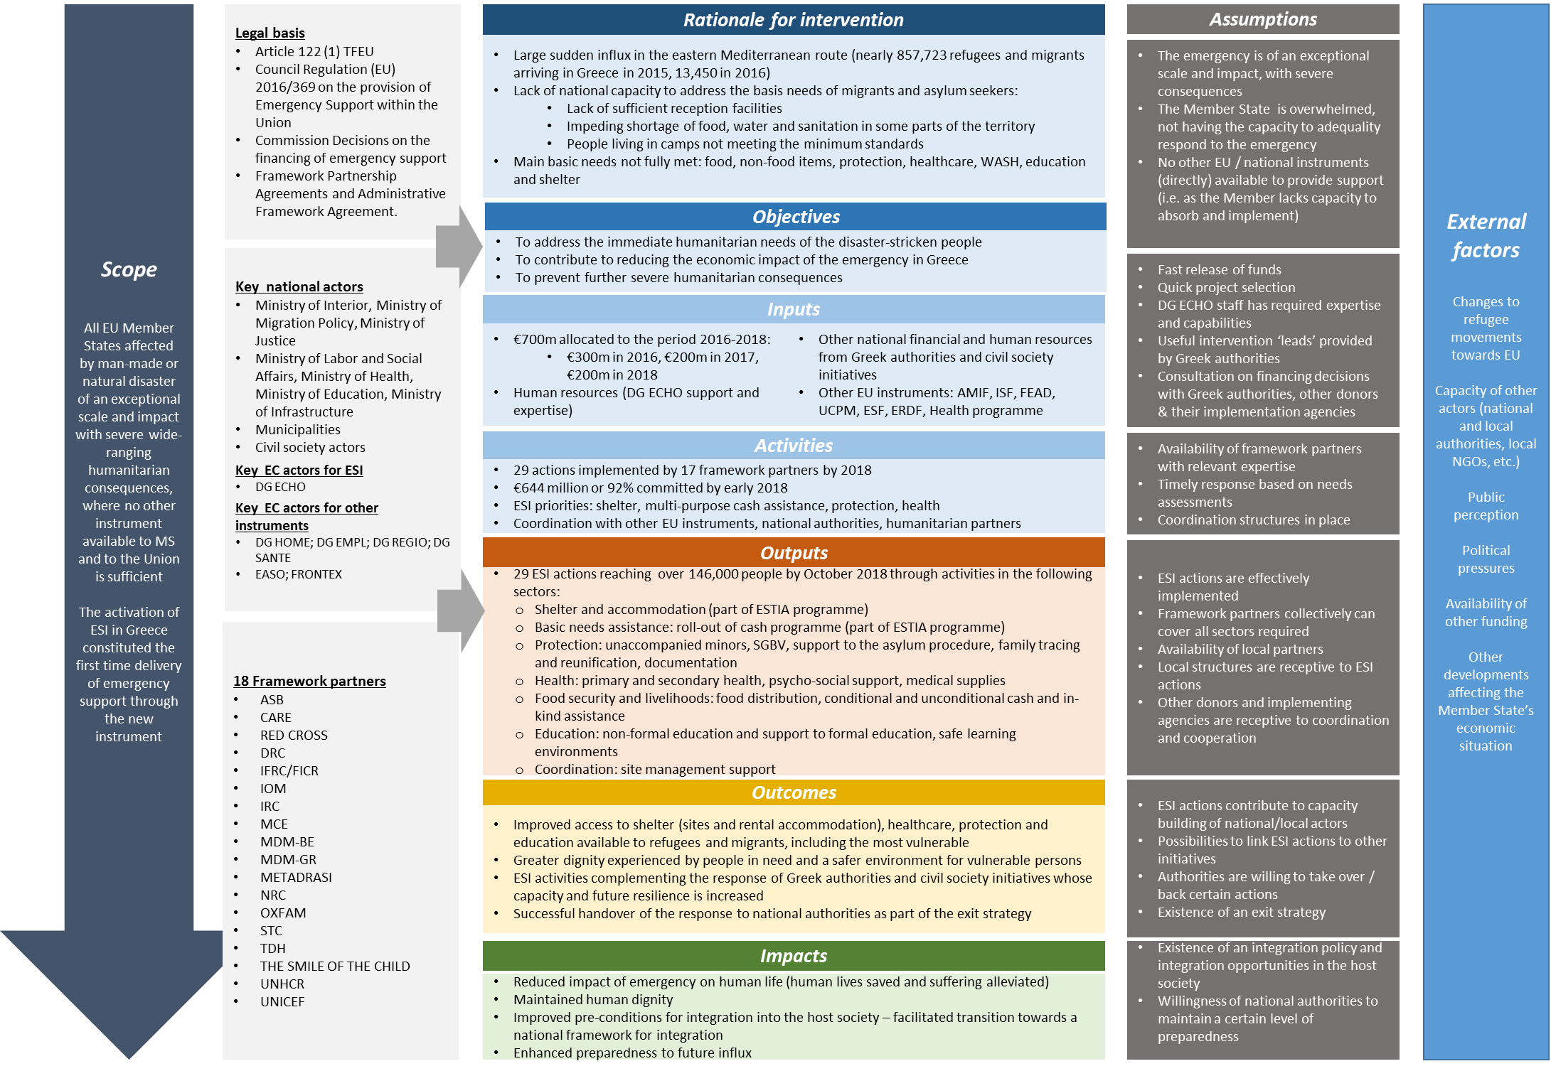

***NB***: *Following the submission of the support study, the ESI committed the 100% of its budget, amounting to EUR 643 600 000.*

# Annex 3: Stakeholder consultation

**Objective and scope of the stakeholder consultation**

The objective of the stakeholder consultation was to provide all relevant stakeholders with the opportunity of expressing their views on the main topics of the evaluation.

The consultation, which was developed through a number of different methods, covered the following topics:

* The **relevanc**e of ESI’s as a tool for emergency response within the EU, both in terms of its legal framework and implemented operations, its working method, as well as the relevance of its intervention in Greece, according to the evolving humanitarian needs and context.
* The **coherence and complementarity** of ESI to other EU and/or national instruments, as well as its adherence to the humanitarian principles.
* The **effectiveness** of the actions implemented by ESI in achieving or contributing to the Regulation objectives and to meet the humanitarian needs targeted; the effectiveness of its working method and any factors contributing or hampering the former.
* The **efficiency** of the ESI’s implemented actions;
* The **EU added value** of the intervention of ESI in Greece, including that of its implemented operations and working method;
* The **sustainability** of ESI’s actions and the extent to which they could continue after the end of the three-year activation of the ESI, through other funding sources.

**Stakeholder mapping**

Stakeholders were identified through a literature review and exchanges with the Commission. These include the following groups, also reflected in Figure A1.1 below:

* **EU officials**: this group of stakeholders relate to EU officials involved in the design and implementation of the ESI or in other support mechanisms implemented on the ground. Their consultation aimed to understand the coherence of ESI’s actions with other EU instruments. These included: DG ECHO officials, DG HOME officials, DG SG officials and representatives of the Structural Reform Support Service (SRSS).
* **National authorities**: these included Greek national authorities that had a major influence on the implementation of ESI actions in the country. A selected number of public authorities at national, regional and local level were consulted to gather their views on ESI intervention.
* **Commission’s partners and their local implementing partners**: these included the selected humanitarian organisations, INGOs and NGOs that had implemented ESI’s actions on the ground. As one the main type of stakeholders to be consulted, the partners and their implementing partners were selected on the basis of the number of actions implemented and the amount of funding received.
* **Civil Society Organisations:** these included non-governmental organisations (NGOs), universities and research organisations, media representatives, social partners, professional associations and other organisations that played an important role in undertaking complementary function in areas such as good governance advocacy. Their consultation aimed at understanding the context, as well as the relevance, effectiveness and added value of ESI’s actions.
* **Beneficiaries:** these are at the centre ESIs actions and included the target population but also actors that have indirectly benefited from actions funded by ESI such as the wider community. Their consultation aimed at understanding how ESI’s intervention helped and met their needs.
* **Other actors**: these included other (humanitarian) actors who did not receive ESI funding but were present in the country and pursuing humanitarian activities. The consultation with this type of stakeholders aimed at understanding how coordination on the ground worked and their perspectives on ESI’s effectiveness and added value.
* **Private sector:** these are those that played an increasing role in emergency response working for or in coordination with humanitarian actors, for example those private entities providing goods and services such as personnel, equipment or logistics services (e.g. Cash Based Interventions (CBIs)). Their consultation aimed at exploring how ESI’s actions engaged with them while retaining its independent character and how partnerships worked in practice.

*Figure A1.1: ESI’s evaluation stakeholder mapping*

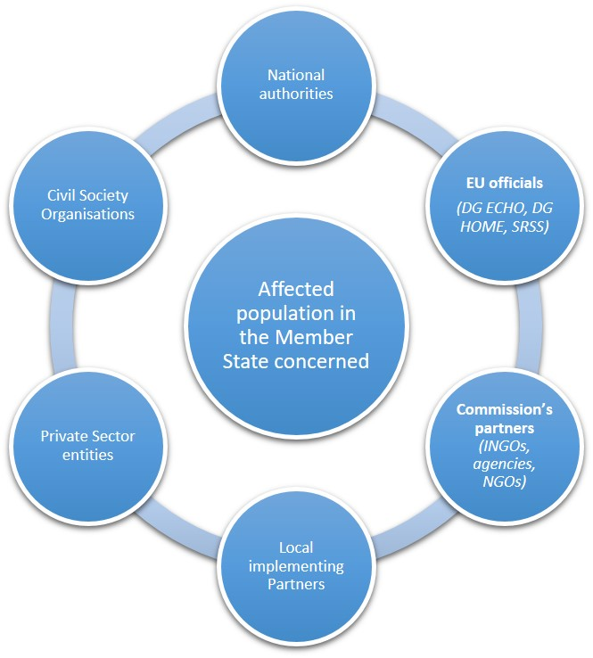

**Methods and tools**

The topics and consultation tools were tailored for each stakeholder group. The specific methods and tools to gather information from the different stakeholders were chosen on the basis of their role and diversity, as well as their influence, impact, awareness and accessibility. A key principle of the consultation was to strike an adequate balance between representativeness of stakeholders and gathering the relevant insights to answer the evaluation questions. The table below provides an overview of the methods that were used to consult each stakeholder group:

*Table A1.1 Overview of the different tools used according to type of stakeholder*

|  |  |  |  |  |  |  |  |  |  |  |  |
| --- | --- | --- | --- | --- | --- | --- | --- | --- | --- | --- | --- |
|  |  | **Research tools** | | | | **Evaluation criteria** | | | | | |
|  | Key informant Interviews | Online Survey | Mobile survey | Fieldwork interviews | Fieldwork focus groups | Relevance | Coherence & complementarity | EU Added Value | Effectiveness | Efficiency | Sustainability |
| Beneficiaries |  |  | ✓ |  | ✓ | ✓ |  |  | ✓ |  |  |
| EU officials | ✓ |  |  | ✓ |  | ✓ | ✓ | ✓ | ✓ | ✓ | ✓ |
| National Authorities | ✓ |  |  | ✓ |  | ✓ | ✓ | ✓ | ✓ | ✓ | ✓ |
| Framework partners | ✓ | ✓ |  | ✓ |  | ✓ | ✓ | ✓ | ✓ | ✓ | ✓ |
| Local implementing partners | ✓ | ✓ |  | ✓ |  | ✓ | ✓ | ✓ | ✓ | ✓ | ✓ |
| Civil Society Organisations | ✓ |  |  | ✓* |  | ✓ | ✓ | ✓ |  |  |  |
| Private sector | ✓ |  |  | ✓* |  |  |  |  | ✓ | ✓ |  |
| Other humanitarian actors |  |  |  | ✓* |  | ✓ | ✓ | ✓ | ✓ | ✓ | ✓ |

*Note: * The external evaluation team reached out to different members this stakeholder group, however some or none of them responded to the requests to discuss this evaluation.*

# Annex 4: List of evaluation questions

1. **Relevance**

* **EQ1** To what extent is the Emergency Support Instrument fit-for-purpose as a tool for emergency response within the Union?
* **EQ2** To what extent was the ESI intervention appropriate when considering Greece's particular situation and needs (e.g. type of needs, assessment of capacities, number of beneficiaries)?
* **EQ3.** To what extent has the legal framework demonstrated to be flexible enough to appropriately adapt the operational response to the changing conditions and needs in the Member State concerned?
* **EQ4.** To what extent is the method of working (channelling aid through humanitarian partners) relevant for addressing the humanitarian consequences of the refugee and migration crisis within the EU?
* **EQ5.** To what extent were the assumptions of ESI’s intervention in Greece correct (type of needs, assessment of capacities and number of beneficiaries)?
* **EQ6.** To what extent has the legal framework shown to be flexible enough to allow for appropriately adapting the operational response to the changing conditions on the ground? Is the Instrument’s flexibility applicable in any given Member State?

1. **Coherence and complementarity**

* **EQ7.** To what extent has the ESI intervention adhered to the humanitarian principles (humanity, neutrality, impartiality and independence)? When assessing the implemented operations**?**
* **EQ8.** To what extent is the Emergency Support Instrument complementary to other related EU instruments, and are there any overlaps?

1. **Effectiveness**

* **EQ9.** To what extent have the objectives of the Regulation and the specific objectives of the activation been achieved, in particular as regards meeting the humanitarian needs of refugees and migrants in the different sectors of intervention?
* **EQ10.** Were there any particular factors influencing the achievement of these objectives?
* **EQ11.** To what extent did actions funded by ESI’ implementation method (i.e. channelling aid through humanitarian partners) allow to effectively address the humanitarian needs?
* **EQ12.**  To what extent have the ESI-funded operations achieved EU visibility as set out by the Communication and Visibility Manual for European Union-funded Humanitarian Aid Actions?

1. **Efficiency**

* **EQ13.** To what extent were the actions funded by ESI implemented in a timely and cost-effective way, taking account of the specific conditions of the emergency operations in Greece?
* **EQ14.** What factors affected the cost-effectiveness of the response and to what extent?

1. **EU added value**

* **EQ15.** What was the EU added value of the ESI activation in Greece?
* **EQ16.** What is the specific EU added value of the ESI’s operations and their working method in Greece?

1. **Sustainability**

* **EQ17.** To what extent can actions currently funded under the ESI continue after the end of the three-year activation on the basis of national funding, and relying on the national programmes under AMIF and ISF, or other sources of funding such as EUSF, ESF, ERDF and FEAD??

# Annex 5: Results of the Open Public Consultation

An open public consultation (OPC) on EU funds in the area of security was carried out for three months (January 2018 – March 2018) The aim was to collect the views of all interested parties on the EU budget in view of the next generation of financial programmes for the post-2020 Multiannual Financial Framework. The topics of the consultation included: Borders and security, Fraud prevention, Humanitarian aid and civil protection, Business and industry, Digital economy and society, Economy, finance and the euro, Energy, Research and innovation- and Transport[63]. Hence, the Emergency Support Instrument was also covered by this consultation.

A total of 153 respondents from all over Europe (of which 114 were organisations and 39 individuals) provided feedback on EU funds in the area of security, including amongst other issues, the provision of humanitarian support at large scale for emergency situations. As part of the consultation, the following relevant questions on the emergency support were addressed to the general public and the figures show the results.

Firstly, respondents were asked to indicate their experience with one or more funds or programmes. As shown in Figure 1 below, respondents seem to be most familiar with the Internal Security Fund for police (40.5%) whereas only 6.5% of the respondents were familiar with the Emergency Support instrument. The low awareness/experience of the instrument might a linked to the fact that the latter was only introduced in March 2016.

Figure 1: *Experience of respondents with programmes/funds*

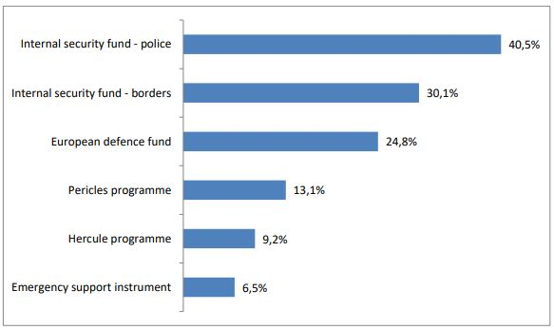

*Source: Factual summary of the public consultation on the EU long-term*

In addition, respondents were asked which challenge(s) respondents considered important and how successful the current EU programmes/funds are at addressing these challenges. Figure 2, shows that 68.6% of the respondents considered the provision of humanitarian support in large-scale emergency situations as important or rather important, while 25.5% considered that the challenge has been fully or fairly well addressed.

Figure 2: *Importance of policy challenges and how well current programmes/funds address them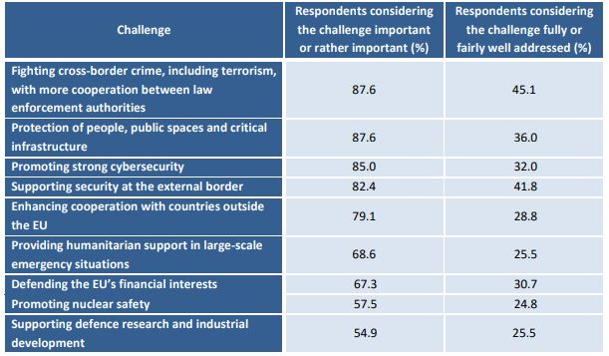*

*Source: Factual summary of the public consultation on the EU long-term*

Regarding the EU added value that the current EU programmes/funds provide compared to those the Member State could achieve at national, regional and local level, 68.0% of respondents considered that the EU programmes/funds do add value to a large or fairly large extent compared to what Member States could achieve on their own. While 34 respondents (22.2%) considered that the current programmes/funds add value to some extent only, and three respondents (2%) considered them not to add any value at all.

When enquiring respondents to provide their opinion regarding the obstacles that prevent the current EU programmes and fund to meet their objectives, the results showed that 71.9% of respondents considered "Complex procedures leading to a high administrative burden and delays" the most important obstacle preventing current programmes/funds from successfully achieving their objectives. The latter obstacle was followed by the "lack of flexibility to react to unforeseen circumstances or new priorities" which was considered by 56.2% of respondents consider a challenge to a large or fairly large extent.

Finally, preliminary steps were identified by the consultation for respondents to provide their views on which of these could help reduce the administrative burdens the current programmes/funds pose to beneficiaries. Results showed that "fewer, clearer and simpler rules" was the most preferred option- as chosen by 78.4% of respondents considering this at least to a fairly large extent) while "simpler application and reporting procedures" was also considered by 73.2% of respondents.

# Annex 6: Overview of ESI funded actions per partner and areas of intervention

(As of 31/12/2018)

|  |  |  |
| --- | --- | --- |
| **Partner** | **Contract Amount in Euro** | **Areas of intervention** |
| OXFAM-NL (NOVIB) | 13 500 000 | Multi-sectorial assistance in Epirus region |
| STC-UK | 9 651 000 | Child protection, education in emergencies |
| DRC-DK | 48 404 000 | Site management, protection, food aid, shelter |
| IRC-UK | 30 780 000 | Cash assistance, site management, WASH |
| UNHCR-CH | 369 170 000 | Cash programme, accommodation scheme, multi-sectorial response, coordination |
| MDM-BE | 13 550 000 | Health |
| ASB-DE | 18 625 000 | Shelter |
| FICR-CH | 23 000 000 | Multi-sectorial response, cash, health |
| NRC-NO | 16 400 000 | Food assistance (Chios), shelter, basic services in Chios |
| IOM-CH | 56 400 000 | Camp management activities, shelter, transport, UAM |
| CARE-DE | 3 726 000 | Protection activities |
| MCE-UK | 6 567 782 | Cash assistance |
| UNICEF-US | 22 796 218 | Education, UAM, child protection activities |
| TDH-CH | 5 830 000 | Education, UAM, child protection activities |
| MDM-EL | 900 000 | Mental health for urban caseload |
| METADRASI | 1 500 000 | Interpretation services to facilitate access to healthcare system, protection activities, education |
| SPANISH RC | 2 000 000 | Health, protection activities |
| Smile of the Child | 800 000 | Protection activities |
| **TOTAL** | **643 600 000** |  |

# Annex 7: Methods and analytical models

**A. Research framework**

A variety of data sources were used to build a rich and comprehensive evidence base for this evaluation covering a wide range of stakeholders. Overall, approximately 200 documents were reviewed and 73 interviews were undertaken. Direct engagement with beneficiaries took place through ten focus groups, nine interviews and a mini mobile survey (Figure 13).

1. Overview of the approach to the evaluation

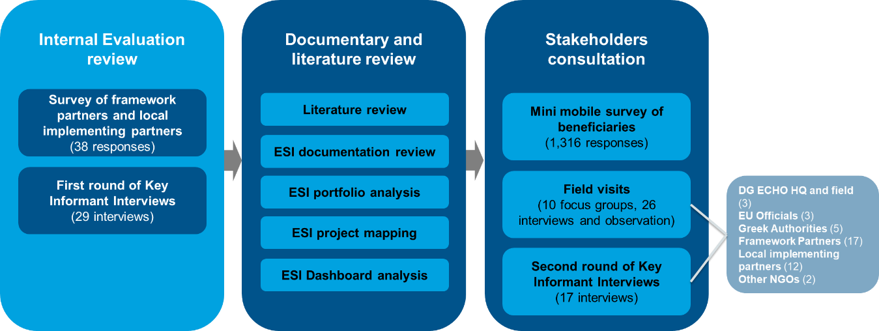

*Source: ICF. 2018.*

1. Internal evaluation review and gap analysis

As part of an internal exercise, the Commission conducted an internal evaluation of the ESI Regulation covering the period 2016-2017. As a first step, the external evaluation team reviewed the internal evaluation including the main findings reported in the draft report and underpinning data and information.

2. Documentary and literature review

As part of the desk review, the evaluation team looked at a range of secondary sources of evidence.

* **Literature review**: 35 publicly available documents were reviewed to capture information gathered by third parties such as the United Nations High Commissioner for Refugees (UNHCR), the International Organization for Migration (IOM) and other Commissions services. In addition, databases from UNHCR, IOM and the Greek authorities were explored and used for this analysis.
* **ESI documentation review**: 166 documents were reviewed as part of this evaluation, these include regulatory documents, Operational Priorities (ESOPs), Financial Decisions and plans, DG ECHO mission reports, audit reports, meeting minutes, communication and visibility plans, and beneficiary surveys.
* **ESI portfolio analysis:** data extracted from DG ECHO EVA and HOPE databases[64] were analysed to create a series of tables and charts that are presented throughout this report. The analysis focused on elements such as Resilience marker, Gender/Age marker, beneficiaries, sectors, transfer modalities, project duration, location, and costs.
* **ESI project mapping:** all 29 ESI actions were reviewed through a mapping of information extracted from DG ECHO SingleForms[65] and operation sheet (FichOps)[66].
* **ESI Dashboard analysis**: decisions and reasons for proposals’ approval or refusal were analysed and a typology of actions accepted or rejected was created.

3. Stakeholder consultation

As part of the consultation stage a mini mobile survey, field visits and Key Informant Interviews were undertaken in parallel to engage with a maximum of stakeholders.

* **Mini mobile survey of beneficiaries:** a survey focusing on the ESI support and more specifically on Cash and Accommodation under the Support to Integration & Accommodation (ESTIA) programme, was created in English and translated into French, Arabic, Farsi and Kurmanji to cover the majority of the beneficiaries (81%).[67] The survey link was sent to 10,901 households (i.e. head of the household) of the ESTIA programmes covering the five languages of the survey through UNHCR,[68] 6,803 households received it (63%) and 1,788 responded to the survey. After cleaning the data and removing duplicates, 1,316 responses were considered valid representing a response rate of 19%. In addition, one focus group and four beneficiary interviews were conducted to gather additional qualitative information on Cash;
* **Field visits**: two field visits were conducted with a specific thematic and evaluative focus. The first visit, called “*The handover of the ESI health projects to National Authorities*” focused on the transition of the health activities from DG ECHO to the national authorities, which is primarily linked to the evaluation criteria of coherence and sustainability. The second visit, called “*ESI accommodation projects under the ESTIA programme – working with local NGOs and municipalities*” focused on the accommodation component of the ESTIA programme, and the evaluation criteria of relevance, effectiveness, efficiency and sustainability. For each field visit, the external evaluation team engaged with a wide range of stakeholders (26 interviews were undertaken), including beneficiaries (five focus groups and five interviews were conducted)[69] and visited several sites. In addition, four focus groups were conducted with 23 children to discuss the education component of ESI’s operations.
* **Key Informant Interviews**: 17 additional interviews were organised to complement the interviews conducted as part of the internal evaluation and the field visits. Interviews were conducted with EU officials, Greek authorities, framework partners and local implementing partners. In the present report, these will be referred to as *Second round of Key Informant Interviews*.

4. Validity of findings

Complementary research methods were used to enhance the reliability and validity of the data collected and to provide the basis for cross-verification, corroboration and triangulation of the evaluation results. The vested interests of different stakeholder groups were taken into account to address potential bias and to ensure objectivity. However, as with any evaluation, there were limitations to the methodologies applied, which are summarised in Table 2 below. Given these methodological caveats and limitations, caution was exercised when interpreting data and producing findings.

1. Limitations to methodologies applied

| Tasks | Issues encountered | Steps taken |
| --- | --- | --- |
| ESI documentation | Incomplete financial information.  Lack of clarity on whether the information relates to DG ECHO or DG HOME.  Uneven provision of detail in the different reports.  No clear structure of documents (e.g. meeting minutes, mission reports). | Additional information requested directly to DG ECHO, DG HOME and framework partners.  Information mapped into excel templates to allow for comparison.  Data used with caution and triangulated with other data sources (interviews, field visits). |
| Portfolio analysis | Limitations with beneficiary data (i.e. double counting).  Incomplete information for projects where the final report is not yet available. | Several other external sources were used to corroborate the data (UNHCR, Greek Asylum services).  The quantitative analysis was supported by qualitative information from other data sources (interviews, field visits). |
| Project mapping | Inconsistencies in type and amount of information available in partner reports.  Data mainly at output-level, less at outcome level.  Limited data to inform cost-effectiveness and efficiency assessments. | Data used with caution and triangulated with other data sources (interviews, field visits).  Quantitative information corroborated with Portfolio analysis. |
| Mini mobile survey | Coverage based on the languages spoken and availability of contact details.  Overrepresentation of men.  Several beneficiaries completed the survey more than once.  Number of valid responses vary greatly by question. | Focus groups with women were conducted while in the field to capture women’s perspective on cash.  Duplicates were removed.  The base taken for analysis is the number of respondents to each question, therefore it varies greatly between questions. |
| Field visits | Few sites visited, as the camps are scattered throughout Greece.  As framework partners were no longer active in the sites visited, they had limited control over the organisation of the site visits including focus groups. | Sites that were not visited were discussed during the interviews with framework partners and local implementing partners. Information was triangulated with project documentation and literature review.  In sites, the team requested the support of the ESI SMS partners to organise the focus groups. |
| Key Informant Interviews | Diversity of interviewees consulted (DG ECHO, framework partners, local implementing partners, National Authorities etc.) with more or less informed knowledge of the ESI interventions and some vested interests. | Specific topic guides were developed for the different stakeholder’s groups consulted. During the analysis, the information collected was contextualised; the differences in the contexts and views were factored in. Data was cross-checked with other data sources. |

**B. Efficiency analysis**

**The use of the final consumption expenditure and GDP per capita to compare ESI with DG ECHO actions in other countries**

As it was the first time the ESI was activated in Europe, no comparison could be made with other Member States. Nonetheless, four third countries were selected as a reference to assess the cost-effectiveness of ESI, namely Egypt, Jordan, Lebanon, and Turkey. These countries all welcomed large numbers of refugees from the Middle East and faced some similar challenges as those encountered in Greece. The different levels of economic development were taken into consideration through final consumption expenditure (FCE) per capita and GDP per capita. Figure 14 indicates that the average price level of the four countries equals merely 32% of Greece’s level (Greece representing 100%). In other words, consumption of similar goods in Greece is nearly three times more expensive than in other countries. In the same vein, the average GDP per capita of the four countries equals 30% of Greece’s GDP per capita. This supports the assumption that the wage level in Greece is roughly three times higher than the averages in other countries.

1. Final consumption expenditure and GDP per capita (average from 2015 to 2017)

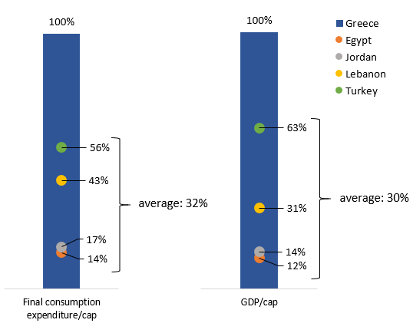

*Source: ICF. 2018. World Bank database. Indicators: (1) Households and NPISHs final consumption expenditure per capita (constant 2010 US$), (2) GDP per capita (constant 2010 US$), available at:* <https://data.worldbank.org/>*, extracted on 26/09/2018*

*Note: this graph represents the share of the final consumption expenditure per capita and GDP per capita of Egypt, Jordan, Lebanon and Turkey, as a share of the final consumption expenditure per capita and GDP per capita of Greece.*

The average cost of implementation of the emergency support activities in Greece is EUR 813 per beneficiary while it costs on average EUR 379 per beneficiary in other countries. However, once the prices are adjusted to the Greek price level (FCE), the average cost per beneficiary in the other countries is EUR 1 375 per beneficiary (Figure 15). The adjusted price is on average three times the original prices of consumption in the countries of reference. Although it provides a base for comparison, this should be interpreted with caution; the rate might be biased as many other factors affect the costs such as the country taxes, the price of the goods bought on international market, exchange rates and import taxes, etc.

1. Average cost per beneficiary, per sector, 2016 - 2018

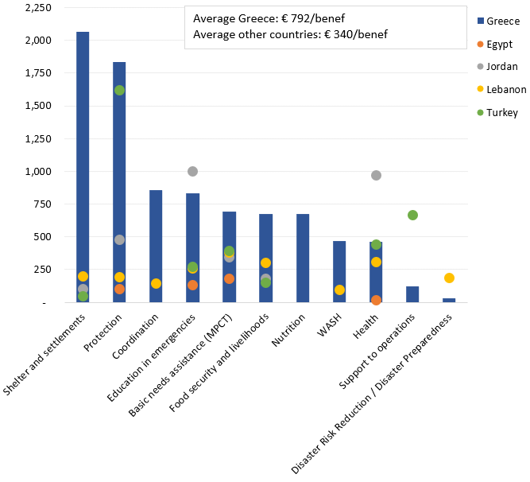

*Source: ICF. 2018. Data extracted from HOPE/EVA databases on 15.10.2018. Note: Some sectors were not covered in all five countries.*

**Quantitative indicators used to assess the cost-effectiveness of the ESI in Greece**

* The first indicator compares the **cost per beneficiary** of the ESI in Greece with the cost per beneficiary of other DG ECHO interventions in Egypt, Jordan, Lebanon and Turkey. The costs in the group of countries of reference is then indexed to the consumer price level of Greece (using the FCE). Although not perfectly accurate, this gives an indication of the cost-effectiveness of the actions based on similar modus operandi (i.e. DG ECHO through framework partners) with the same objective (i.e. save life) for similar target groups (i.e. refugees).
* The second indicator compares the **average share of specific costs per project** in Greece and in the other countries, with a higher share of specific cost indicating a better efficiency of the actions.
* And lastly, the **alpha ratio** of the Basic needs assistance (e.g. MPCT) sector indicates the share of the cash that is directly transferred to the beneficiaries. A higher alpha ratio indicating a better cost-effectiveness.

**Methodology of the calculation of the cost per beneficiary**

**Data sources**

Two datasets have been used to calculate the cost per beneficiary indicator: the “Transfer Modalities” and the “Beneficiaries” datasets extracted from the HOPE dashboard. The table below shows the variables that have been used for the calculations and the source of each variable.

The indicators used from the “Transfer Modalities” are:

* **Result Direct Specific Cost**: as given in the single form “*Estimated incurred total amount”*. In theory, this should represent the amount of cost directly transferred to the implementation of the result.[70] For example:
  + Project of sensitisation in refugee camps:
    - Result 1: sensitisation of heath matters to the refugees (Health).
    - Result 2: installation of sanitation equipment (WASH).

The cost for the running of the local office, the transport of the staff to the refugee camps are seen as common direct support costs. The cost of the sanitation equipment is a direct cost of result 2.

* **Contract Amount Signed by Partner:** The initial ECHO contribution to the total costs of the project.
* Result Contract Amount Signed by Partner: Initial ECHO contribution to each result
* **Result Individual Beneficiaries**: the number of beneficiaries, both individual beneficiaries and beneficiaries reached through households, at result level.

From the “Beneficiaries” dataset we have only extracted the **total cost,** which represent the total cost of the project.

**Methodology**

To estimate the cost per beneficiary for each result, the total cost of each result was divided by the number of individuals reached. However, the **total cost per result**, which was not available in the datasets, was estimated by the weight of ECHO’s contribution to each result. Which was also equal to the weight of each Result Direct Specific Cost. Hence, the total cost of each results includes the direct support costs common to all results and the indirect costs.

**Analysis of the share of direct specific costs**

**Data sources**

The two same datasets have been used to calculate the share of direct support cost and direct specific costs: the “Transfer Modality” dataset and the “Beneficiaries” extracted from HOPE.

The indicators used are:

* **Total cost**: The total cost of the project
* **Total cost per result**: Total cost of each result (including the indirect common costs and other indirect costs).
* **Contract amount signed by partner**: amount of ECHO contribution to the total cost of the project
* **Result contract amount signed by partner:** amount of ECHO contribution per result
* **Result Direct Specific Cost:** the “net” cost of each result, this excludes the indirect costs and the common direct cost of implementation

**Methodology**

In theory, the sum of the “result direct specific costs” (the pure or net costs of the results) should give an indication of the amount of money used to implement the action (directly transferred to beneficiaries).

Hence, the difference between the total cost of the project (a) and the sum of “direct specific cost” (d) should give a relatively good estimation of the “direct support costs” as described in section 10.2 of the Single Form. Note that Section 10.2 was introduced in late 2017 only.

The share of direct support costs (e) is hence equal to the estimated total direct support costs divided by the total cost.

**Analysis of the Alpha ratio**

The alpha ratio is the transfer value divided by the total costs. In other words, it represents the share of the total costs that is directly transferred to the beneficiaries in the form of cash, voucher or in kind.

**Sources**

The two same datasets have been used to calculate the alpha ratio: the “Transfer Modality” dataset and the “Beneficiaries” extracted from HOPE.

The indicators used are

* **TM name:** gives the types of transfer modality used per result
* **TM Direct Specific Cost:** the direct specific cost incurred to each transfer modality type
* **Total cost per result**: Total cost of each result (including the indirect common costs and other indirect costs).
* The database of the transfer modality gives an additional disaggregation of each result per transfer modality type. For instance, the table below shows a project that implemented two results in different sectors. The two results used cash as a transfer modality. However, the full amount of the costs was not given in cash, a share of it was used for other purpose and is referred as “no transfer”.

|  |  |  |  |  |  |
| --- | --- | --- | --- | --- | --- |
| **Result number** | **Sector** | **Total costs per result** | **TM Name** | **TM Direct Specific Cost** |  |
| 1 | Nutrition | 622,120 | cash | 11,912 | a |
| 1 | Nutrition | 622,120 | In kind | 32,696 | b |
| 1 | Nutrition | 622,120 | No transfer | 483,386 | c |
| 2 | WASH | 528,140 | cash | 14,714 | d |
| 2 | WASH | 528,140 | No transfer | 433,773 | e |

**Methodology**

As a first step, we have summed up for each result, the values of the TM direct specific cost that are given either in cash, in voucher of in kind (a+b for result 1, c alone for result 2). This gives the total value of the transfer, per result. Then, to obtain the alpha ratio, we have divided the value of the transfer by the total cost per result: (a+b)/c and d/e. This gives the share of the total cost that has been directly transferred to beneficiaries in the form of cash, in kind or vouchers.

**C. Analytical framework**

| **Evaluation Criterion** | **Internal/External/Both** | **Evaluation Question** | **Judgement criterion** | **Indicators** | **Quant/Qual** |
| --- | --- | --- | --- | --- | --- |
| **Relevance** | Internal | EQ1. To what extent is the Emergency Support Instrument (ESI) relevant as a tool for emergency response within the Union? | JC1.1 The ESI is necessary to provide the capacity for the Union to address wide-ranging humanitarian needs resulting from natural or manmade disasters. | Description of ESI, its objectives, characteristics, etc. | Qualitative |
| Evidence of ESI (instrument) being developed based on assessments of the context and needs | Qualitative |
| Perceptions/opinions of relevant stakeholders regarding the relevance of the instrument | Qualitative |
| Internal | EQ2. To what extent was the ESI intervention appropriate when considering Greece's particular situation and needs (e.g. type of needs, assessment of capacities, number of beneficiaries)? | JC2.1 The intervention under the instrument was appropriate for the MS situation, as the latter had already exhausted all available capacity/resources. | Description of the crisis and context | Qualitative |
| Needs identified by DG ECHO (ESOPs) vs needs identified by other actors (HOME, UN, NGO, authorities) in their respective needs assessment | Qualitative |
| Evidence of ESI (legal framework, ESOPs) being based on an assessment of capacity and gaps in response (i.e. existing instrument) | Qualitative |
| Perception of relevant stakeholders on the national capacity to respond to the crisis | Qualitative |
| JC2.2 The ESI actions were appropriate and took into account the emerging needs in the Member State (Greece) and targeted the relevant beneficiaries | Evidence of ESI actions being based on an assessment of existing national and EU initiatives and gaps in response | Qualitative |
| Evidence of ESI actions being based on assessments of the country's context and needs | Qualitative |
| Number of beneficiaries targeted by the actions/partners vs. an estimate of number of people/beneficiaries in need | Quantitative |
| Perceptions/opinions of relevant stakeholders regarding the relevance of ESI actions vs their needs assessment in EL | Qualitative |
| JC2.3 Partners' needs assessments have correctly analysed the needs of the target beneficiaries. | Data on beneficiaries to be presented by sector/need and location | Quantitative |
| Type and level of needs identified by partners vs needs identified by other actors in their respective needs assessment | Quantitative |
| Evidence of quality (e.g., level of involvement of key stakeholders and final beneficiaries, robust methods being used, etc.)and comprehensiveness (e.g. inclusion of sectors, vulnerable groups, gender, etc.) of ESI actions' needs assessments | Qualitative |
| JC2.4 Budget allocations have taken account of the partners' needs assessments | Absolute amount and share of ECHO budget allocated to ESI (instrument) compared to total funding allocated to the refugee and migration influx | Quantitative |
| Description of DG ECHO mechanism for funding allocation | Qualitative |
| Evidence that DG ECHO’s budget size was commensurate to ESI objectives and expected outcomes | Qualitative |
| Evidence that DG ECHO’s budget allocations considered the actions of other donors | Qualitative |
| Evidence that the action selection and funding allocation was based on needs | Qualitative |
| Internal | EQ3. To what extent has the legal framework demonstrated to be flexible enough to appropriately adapt the operational response to the changing conditions and needs in the Member State concerned? | JC3.1 ESI's legal framework allowed for the optimal implementation of the actions, and remained relevant throughout the changing conditions and needs in the Member State | Evolution of the needs overtime | Qualitative |
| Changes in ECHO strategy over the period (ESOPs, Financial Decisions, Financial plans) | Qualitative |
| Perceptions/opinions of relevant stakeholders regarding the relevance of the ESI vs their needs assessment in EL | Qualitative |
| Perceptions/opinions of relevant stakeholders regarding the flexibility of the ESI and if such flexibility allowed the instrument to remain relevant despite EL changing needs | Qualitative |
| JC3.2 The ESI implemented actions were relevant to the ESI objectives | Perception of stakeholders indicating that the ESI actions were relevant and coherent with ESI objectives | Qualitative |
| Evidence of coherence between ESOPs and ESI actions | Qualitative |
| Both | EQ4. To what extent is the method of working (channelling aid through humanitarian partners) relevant to address the humanitarian consequences of the refugee and migration crisis within the EU? | JC4.1 Channelling the actions through the FPA has ensured a timely and tailored response to the emerging humanitarian needs of the targeted beneficiaries | Description of ECHO working method in the context of Greece | Qualitative |
| Perception of stakeholders on the relevance of the working method | Qualitative |
| Reasons why some partners/potential partners did not apply for funding under ESI | Qualitative |
| Perception of stakeholders on the relevance of the partner selection | Qualitative |
| Both | EQ5. To what extent were the assumptions of the ESI intervention in Greece correct (type of needs, assessment of capacities and number of beneficiaries)? | JC5.1 The majority of the assumptions at the start of the ESI operations at the operational level leading to funding the individual projects were correct: the type and scale of needs, the assessment of capacities (of the national authorities and the implementing partners – framework and local) and the anticipated number of beneficiaries were assessed mostly appropriately | Type and scale of needs in different sectors | Quantitative |
| Estimates of number of people with different types of need (WASH, food, shelter, etc.) | Quantitative |
| Estimates of number of beneficiaries in need by type of beneficiary, location | Quantitative |
| The assumptions based on the baseline situation in early 2016 correctly anticipated the developments in 2016, 2017 and 2018 in relation to the Greek authorities’ capacities to provide humanitarian aid | Qualitative |
| Opinions of relevant stakeholders on the degree of the correctness of the main assumptions for ESI intervention in Greece | Qualitative |
| JC5.2 At the project level, the target beneficiaries outlined in the Single Forms align with other (official, high quality) needs assessments | Number of beneficiaries targeted by DG ECHO partners by type of beneficiary / type of need / location as listed in Single Forms | Quantitative |
| Number of beneficiaries and needs identified by other actors | Quantitative |
| JC5.3 Projects provided a clear definition of the target group, their level of vulnerability, and a rationale for targeting the population | Rating of the quality of the needs assessments by the evaluation team | Qualitative |
| Number of ESI actions including a vulnerability assessment | Quantitative |
| JC5.4 The needs identified in the majority of ESI projects align appropriately with the needs described by beneficiaries | Alignment of needs assessment with needs identified elsewhere | Qualitative |
| Alignment of needs with needs reported by beneficiaries | Qualitative |
| JC5.5 The emergency support provided in the majority of the ESI projects was appropriate to the particular context, gaps in support and needs identified | Evidence that needs assessments informed the decision to activate ESI as well as funding decisions | Qualitative |
| Opinions of relevant stakeholders on the relevance of the ESI actions in relation to needs, gaps and context | Qualitative |
| Both | EQ6. To what extent has the legal framework shown to be flexible enough to allow for appropriately adapting the operational response to the changing conditions on the ground? Is the Instrument’s flexibility applicable in any given Member State? | JC6.1 The ESI legal framework has shown sufficient flexibility to enable the ESI funded projects to respond to the changing conditions | Evolution of the ESI funded activities compared to the evolution of the needs of the beneficiaries on the ground and of the Greek authorities’ capacities to respond | Quantitative |
| The changes experienced by ESI actions (both at strategic and operational levels) and the influence of legal framework on such changes (as well as other factors) | Qualitative |
| JC6.2 The features allowing the flexibility of the ESI instrument were maximised by DG ECHO, partners and national authorities in Greece across the projects examined (i.e. quick response time, low administrative burden) | Number of modification request submitted by partners | Quantitative |
| Evidence that the partners' modifications were based on evolving needs | Qualitative |
| Opinions of relevant stakeholders on the degree of flexibility provided by the legal framework | Qualitative |
| JC6.3 The flexibility of the ESI instrument allows it to be easily adapted to other Member States | Opinions of relevant stakeholders on the extent of application of ESI in other Member States | Qualitative |
| JC6.4 Individual ESI project approaches are easily transferred to other Member States | Opinions of relevant stakeholders on the extent of application of the activities funded under ESI in other Member States | Qualitative |
| **Coherence and comple-mentarity** | Both | EQ7. To what extent have the ESI projects adhered to the humanitarian principles (humanity, neutrality, impartiality and independence)? | JC7.1 The ESIs funded actions match (or do not contradict) the humanitarian principles | ESI regulation and DG ECHO policy framework regarding principles and policy on Humanitarian Principles | Qualitative |
| Key informant perspectives on coherence between the ESI actions implemented and the humanitarian principles | Qualitative |
| JC7.2 At proposal stage, the actions have been designed to adhere to the humanitarian principles and the selection of actions identified and addressed any possible concerns beforehand | References to / coverage of the principles in the action design (Single Forms) and the documentation of DG ECHO’s | Quantitative |
| JC7.3 In the implementation phase, any tensions between humanitarian principles and practicalities of delivering ESI funded activities were successfully resolved | Evidence of tensions identified and how they have been resolved | Qualitative |
| EQ8. To what extent is the Emergency Support Instrument complementary to other related EU instruments , and are there any overlaps? | JC8.1 The actions funded through the ESI could not have been implemented by any other EU or national instrument | Number of actions linked (or covering) ESIs specific objectives – as described in the Single Forms | Quantitative |
| Perceptions/opinion of relevant stakeholders on the complementarity of ESI actions | Qualitative |
| JC8.2 The funded actions do not overlap with actions implemented/funded under other EU or national instruments. | Perceptions/opinion of relevant stakeholders - the (non-existing) overlaps between ESIs actions and other EU and/or national instruments | Qualitative |
| Evidence of duplication in the actions managed by DG ECHO and those managed by other EU and international actors | Qualitative |
| JC8.3 The implementation of ESI actions had not had any direct negative consequence on actions implemented through other EU and national instruments | Perceptions/opinion of relevant stakeholders on potential negative consequences of ESI activation in Greece | Qualitative |
| JC8.4 ESIs budget allocation also considered the funding provided by other EU and/or national instruments. | Break down of the funding sources | Quantitative |
| Evidence of coordination with EU and national actors for the allocation of funding | Qualitative |
| Perceptions/opinion of relevant stakeholders on the ESI funding allocation | Qualitative |
| JC8.5 Coordination mechanisms have been established to coordinate the intervention/ operations between the main actors. i.e. DG ECHO, partners and national authorities | Evidence of coordination mechanisms at the EU, national and local and thematic levels | Qualitative |
| Perception of relevant stakeholders on the coordination and how it could have been improved | Qualitative |
| **Effective-ness** | Both | EQ9. To what extent have the objectives of the Regulation, and the specific objectives of the activation been achieved, in particular as regards meeting the humanitarian needs of refugees and migrants in the different sectors of intervention? | JC9.1 Following the ESI activation the identified humanitarian needs of refugees and migrants were met, and/or these improved as a result of the ESI actions. | Main outcomes and results indicators of the actions | Qualitative |
| Estimate of total number of refugees and migrants in need of humanitarian assistance (according the relevant sectors). | Quantitative |
| Data on beneficiaries to be presented by sector/need and location | Quantitative |
| Number of beneficiaries targeted vs number of beneficiaries reached | Quantitative |
| Perceptions/opinion of relevant stakeholders on the achievement of ESI | Qualitative |
| JC9.2 ESI projects were implemented as planned on the ground | Perceptions/opinion of relevant stakeholders on the implementation of ESI actions | Qualitative |
| JC9.3 ESI projects met / improved the identified humanitarian needs of refugees and migrants | Outcomes and impacts of ESI actions as reported by implementing partners, beneficiaries and external observers | Quantitative |
| Opinions of relevant stakeholders (including beneficiaries) on the funded actions’ contribution to addressing needs | Qualitative |
| JC9.4 Success factors were maximised by DG ECHO, DG ECHO partners and national authorities across the majority of ESI projects | Description of the key stakeholder cooperation mechanisms developed for the implementation of ESI actions (refer to EQ8) | Qualitative |
| Opinions of the relevant stakeholders on the level and success of cooperation between stakeholders at different levels | Qualitative |
| Typology of critical success factors | Qualitative |
| JC9.5 Appropriate technical and other support and monitoring was provided by DG ECHO to the majority of ESI projects | Description of components of DG ECHO’s technical and other support delivered to the ESI actions | Qualitative |
| Description of the components of monitoring and evaluation arrangements across the ESI actions | Qualitative |
| Perception of relevant stakeholders on DG ECHO technical support and monitoring practices | Qualitative |
| JC9.6 Actions provided a clear Communications and visibility plan to ensure the relevant activities met the EU visibility Criteria for EU funded Humanitarian Aid actions. | Number of Communication Plans developed (number of communication plans submitted by partners) | Quantitative |
| Number and type of communication activities implemented by sector | Quantitative |
| Information / Description on the communication plans meeting the EU visibility requirements | Quantitative |
| Measures taken to avoid confusion between DG ECHO and other EU instrument | Qualitative |
| Perception of relevant stakeholders on DG ECHO visibility | Qualitative |
| EQ10. Were there any particular factors influencing the achievement of these objectives? | JC10.1 Obstacles to the effectiveness of ESI activities have been addressed appropriately and effectively across the majority of ESI projects | Evidence of obstacles to effectiveness identified by partners and DG ECHO in their reports | Qualitative |
| Perceptions/opinion of relevant stakeholders enabling or hampering factors regarding the achievement of the ESI objectives and/or action results | Qualitative |
| EQ11. To what extent did ESI-funded actions implementation method (i.e. channelling aid through humanitarian partners) allow to effectively address the humanitarian needs | JC11.1 Channelling the actions through framework partners allowed the ESI projects to timely and effectively fulfil the humanitarian needs of the targeted beneficiaries | Number of DG ECHO framework partners which had a presence / could operate in Greece in 2016 | Quantitative |
| Share of framework partners which proposed ESI actions following the activation of ESI in Greece | Quantitative |
| Number of local implementing partner used by ESI actions | Quantitative |
| ESI budget at the instrument level and at individual action level was implemented as planned | Qualitative |
| Opinions of relevant stakeholders on the effectiveness of the ESI implementation method | Qualitative |
| JC11.2 Comparison with the emergency support under AMIF (including EMAS) in Italy shows a slower and less flexible response compared to ESI projects in Greece | Response time and flexibility of the emergency support under AMIF in Italy and Bulgaria | Qualitative |
| Opinions of relevant stakeholders (DG HOME) on AMIF / EMAS implementation vs ESI | Qualitative |
| JC11.3 The change of the implementation selection of framework partners was effective in ensuring the right selection of partners to implement the ESI actions | Opinions of relevant stakeholders on the changes in the partner selection criteria | Qualitative |
| EQ12. To what extent have the ESI-funded operations achieved EU visibility as set out by the Communication and Visibility Manual for European Union-funded Humanitarian Aid Actions? | JC12.1 The visibility of ESI funded operations is high in Greece | Evidence of the type and volume of ESI activities implemented supporting the visibility objective | Quantitative |
| Evidence of the level of awareness of DG ECHO activities within Greece (amongst national stakeholders and final beneficiaries) | Qualitative |
| Obstacles to visibility | Qualitative |
| JC12.2 The Manual is used extensively by FPAs in ESI funded activities | Number of actions reporting the implementation of visibility activities and the use of the Manual | Quantitative |
| Evidence of effective use of the communication and visibility manual within DG ECHO funded actions | Qualitative |
| **Efficiency** | Both | EQ13. To what extent were the ESI-funded actions implemented in a timely and cost-effective way, taking account of the specific conditions of the emergency operations in Greece? | JC13.1 DG ECHO’s response was timely and flexible | Information on the budget planning and timelines, for example as described by the ESOPs | Qualitative |
| Evidence of flexibility mechanism being in place to adapt to the changing needs (in terms of strategy implementation and funding) | Qualitative |
| Perception of relevant stakeholders on the timeliness of DG ECHO funding | Qualitative |
| JC13.2 The allocated budget was proportionate to the targets set | Rationale of the selection of actions- how the selection considered the available budget, vs the budget requested and timeliness | Qualitative |
| Rationale of the partners' design of their action's budgets and timelines- including the selection of implementing partners | Qualitative |
| Perception of relevant stakeholders on the budget allocated to Greece | Qualitative |
| JC13.3 ESIs financial decisions and ESOPs were designed according to the specific needs and time constraints | Info on the ESI funding process and development of the financial planning | Qualitative |
| JC13.4 Humanitarian actions funded by DG ECHO were cost-effective | Quantitative evidence that actions funded by DG ECHO were cost effective (e.g. cost per beneficiary, alpha-ratio) | Quantitative |
| Qualitative evidence that actions funded by DG ECHO were cost effective | Qualitative |
| Evidence that partners have a good understanding of factors affecting the cost-effectiveness of their actions, and take these into account during design and implementation stage | Qualitative |
| Evidence of key actions undertaken to ensure cost-effectiveness | Qualitative |
| Evidence that largest indirect cost drivers were well managed | Qualitative |
| JC13.5 DG ECHO promoted, developed and implemented cost effective approaches in ESI projects | Evidence of DG ECHO supporting innovative solutions and best practices to improve cost effectiveness of its funded actions | Qualitative |
| Evidence of DG ECHO cooperating and coordinating with the national and local authorities to improve the cost effectiveness of its funded actions | Qualitative |
| Evidence of DG ECHO cooperating and coordinating with other organisations and the private sector to improve the cost effectiveness of its funded actions | Qualitative |
| JC13.6 DG ECHO balanced cost in relation to making strategic choices about its portfolio of assistance | Evidence of DG ECHO promoting best practices driving cost effectiveness, e.g. multi sectoral approaches, consortium, transfer modalities, using local partners etc. | Qualitative |
| JC13.7 DG ECHO took appropriate actions to ensure cost-effectiveness throughout the project cycle | Evidence of DG ECHO considering cost-effectiveness when preparing the ESOPs and when discussing the requests put in by the Greek authorities | Qualitative |
| Evidence of DG ECHO considering economy, efficiency and cost-effectiveness in selecting partner proposals and negotiating contracts (prior to the action) | Qualitative |
| Evidence of DG ECHO monitoring efficiency and cost-effectiveness of partners and taking appropriate actions to ensure cost-effectiveness throughout the action cycle (during implementation of the action) | Qualitative |
| Evidence that lessons learned were considered throughout the action cycle and good practice being shared and taken into account to drive efficiency | Qualitative |
| EQ14 What factors affected the cost-effectiveness of the response and to what extent? | JC14.1 No major impediments were encountered while ensuring the cost-effectiveness of the actions | Underspending reported or found in any of the ESI actions | Quantitative |
| Any factors influencing the efficiency of the ESI actions | Qualitative |
| **EU Added Value** | Internal | EQ15. What was the EU added value of the ESIs activation in Greece? | JC15.1 The ESI has a clear EU added value when compared to existing national instruments | Perceptions/opinion of relevant stakeholders on the added value of ESI compared to other instrument activated in Greece | Qualitative |
| JC15.2 The actions funded through the ESI could not have been implemented by any other national actor | Perceptions/opinion of relevant stakeholders | Qualitative |
| JC15.3 Certain characteristics of the ESI make it distinctive to any other available national instruments | Perceptions/opinion of relevant stakeholders on specific characteristics differentiating ESI from other instruments | Qualitative |
| External | EQ16. What is the specific EU added value of the ESI’s operations and their working method in Greece? | JC16.1 Actions financed by the ESI on the ground have a clear added value compared to actions financed by other EU instruments and/or other relevant donors | ESI funding in Greece compared to other EU / donor funding to address the problem | Quantitative |
| Perception of key stakeholders on the added value of the activities implemented through ESI | Qualitative |
| Perceptions of key informants on factors hindering the maximisation of EU added value | Qualitative |
| JC16.2 The actions funded through the ESI could not have been implemented by any other national actor | Evidence of results that could not have been achieved without a coordinated effort at the EU level | Qualitative |
| Perceptions of key informants on whether other instruments could have achieved the same results | Qualitative |
| JC16.3 The instrument had specific characteristics which distinguished it from other EU support mechanisms | Analysis of the typology of characteristics distinguishing ESI from other relevant interventions (especially voluntary in-kind contributions provided under the UCPM and emergency assistance under AMIF and ISF) | Qualitative |
| Perceptions of key informants on specific aspects contributing to the EU added value | Qualitative |
| **Sustain-ability** | External | EQ17. To what extent can actions currently funded under the ESI continue after the end of the three-year activation on the basis of national funding, and relying on the national programmes under AMIF and ISF, or other sources of funding such as EUSF, ESF, ERDF and FEAD? | JC17.1 The majority of ESI projects have built in the sustainability considerations into the project design and implementation | Evidence that partners are systematically considering sustainability issues in the ESI actions (i.e. exit strategy) | Qualitative |
| Evidence of exit strategies | Qualitative |
| JC17.2 Where relevant, the majority of ESI funded actions are handed appropriately over to the relevant EU /Greek authorities | Evidence of handover of ESI activities | Qualitative |
| Evidence of success factors leading to increased sustainability at the action level | Qualitative |
| Factors challenging sustainability/handover of activities | Qualitative |
| JC17.3 Key factors leading to sustainability have been maximised across the majority of ESI projects | Analysis of the typology of measures and approaches to increase sustainability | Qualitative |
| JC 17.4 Specific actions have been taken on the ground to ensure a nexus between ESI funding and other EU funds (e.g. AMIF, ESF, etc., see also Coherence EQ) | Evidence of building capacity at national and/ or local level; local community engagement and participation | Qualitative |

1. OJ L 70, 16.3.2016, p. 1–6.
2. Report from the Commission to the Council on the implementation of Regulation (EU) 2016/369 on the provision of emergency support within the Union, of 15 March 2017- COM(2017) 131 final
3. Which stipulates that all programmes or activities where the resources mobilised exceed EUR 5 million, must be the subject of an interim and/or ex post evaluation in order to verify that they were consistent with the objectives set. OJ L 298 of 26.10.2012.
4. Evaluation of the operation of Regulation (EU) 2016/369 on the provision of emergency support in the Union (ICF Consulting Services Ltd): <https://ec.europa.eu/echo/funding-evaluations/evaluations/thematic-evaluations_en>
5. The published Roadmap of the evaluation can be consulted at: <https://ec.europa.eu/info/law/better-regulation/initiatives/ares-2017-4710263_en>
6. The better regulation guidelines set out the principles that the European Commission follows when preparing new initiatives and proposals and when managing and evaluating existing legislation, and can be consulted at <https://ec.europa.eu/info/law/law-making-process/planning-and-proposing-law/better-regulation-why-and-how/better-regulation-guidelines-and-toolbox_en>
7. Data provided by IOM, available at <http://migration.iom.int/europe/>.
8. [UNHCR Regional Refugee and Migrant Response Plan for Europe, 2016.](http://reporting.unhcr.org/sites/default/files/RRMRP%20Europe%20Jan.-Dec%202016%20-%20Revision%20May%202016.pdf)
9. European parliament. 2017. International protection in Greece Background information for the LIBE Committee delegation to Greece 22-25 May 2017. Available at: <https://www.ecoi.net/en/file/local/1401618/1226_1497249698_ipol-stu-2017-583145-en.pdf>.
10. OCHA. 2016. Greece: “Europe’s lack of political will creating serious suffering for thousands of migrants in Greece” – UN rights expert. Available at: <https://www.ohchr.org/EN/NewsEvents/Pages/DisplayNews.aspx?NewsID=19976&LangID=E>
11. Decision No 1313/2013/EU of the European Parliament and of the Council of 17 December 2013 on a Union Civil Protection Mechanism he Union Civil Protection Mechanism (OJ L 347, 20.12.2013, p. 924).
12. Regulation (EU) No 516/2014 of the European Parliament and the Council of 16 April 2014 establishing the Asylum, Migration and Integration Fund, amending Council Decision 2008/381/EC and repealing Decisions No 573/2007/EC and No 575/2007/EC of the European Parliament and of the Council and Council Decision 2007/435/EC (OJ L 150, 20.05.2014, p.168).
13. Regulation (EU) No 513/2014 of the European Parliament and of the Council of 16 April 2014 establishing, as part of the Internal Security Fund, the instrument for financial support for police cooperation, preventing and combating crime, and crisis management and repealing Council Decision 2007/125/JHA (OJ L 150, 20.5.2014, p. 93) and Regulation (EU) No 515/2014 of the European Parliament and of the Council of 16 April 2014 establishing, as part of the Internal Security Fund, the instrument for financial support for external borders and visa and repealing Decision No 574/2007/EC (OJ L 150, 20.5.2014, p. 143).
14. Council Regulation (EC) No 2012/2002 of 11 November 2002 establishing the European Union Solidarity Fund (OJ L 311, 14.11.2002, p.3).
15. Council Regulation (EU) No 1304/2013 of 17 December 2013 on the European Social Fund (OJ L 347, 20.12.2013, p. 470–486)
16. Regulation (EU) No 1304/2013 of the European Parliament and of the Council of 17 December 2013 on the European Social Fund and repealing Council Regulation (EC) No 1081/2006 (OJ L 347, 20.12.2013, p. 470–48).
17. Regulation (EU) No 223/2014 of the European Parliament and of the Council of 11 March 2014 on the Fund for European Aid to the Most Deprived (OJ L 72, 12.3.2014, p. 1–41).
18. Regulation (EU) No 282/2014 of the European Parliament and of the Council of 11 March 2014 on the establishment of a third Programme for the Union's action in the field of health (2014-2020) and repealing Decision No 1350/2007/EC.
19. There are different ways to implement the EU budget, depending on the variable level of implication of the European Commission in its implementation. In direct management, the Commission is in charge of all EU budget implementation tasks, which are performed directly by its departments either at headquarters or in the EU delegations or through European executive agencies. In indirect management the Commission entrusts budget implementation tasks to partner countries (or to bodies designated by them), international organisations or development agencies of EU Member States. In shared management the Commission delegates implementation tasks to the EU Member States. For more info see: <https://ec.europa.eu/europeaid/funding/about-funding-and-procedures/how-do-we-offer-funding_en>
20. OJ L 163, 2.7.1996, p. 1.
21. Under the AMIF emergency assistance component EMAS, the basic act for AMIF and ISF do not limit funding to particular entities. It has been a policy choice to introduce in the annual work programme (AWP) the principle that eligible applicant organisations can only be Member States, International organisations and EU agencies.
22. Stefania Kalogeraki. 2018. Volunteering for Refugees and Asylum Seekers in Greece. Available at: <https://link.springer.com/chapter/10.1007/978-3-319-73335-7_7>
23. European Council Conclusions [EUCO 1/16, Brussels, 18-19 February 2016](http://www.consilium.europa.eu/en/meetings/european-council/2016/02/EUCO-Conclusions_pdf/).
24. COM (2016) 115 final, Brussels, 2.03.2016.
25. <https://www.consilium.europa.eu/en/press/press-releases/2016/03/15/refugee-crisis-emergency-support/>
26. OJ L 70, 16.3.2016, p. 1
27. C (2016) 2214 final, Brussels, 15.04.2016
28. C (2017) 763 final, Brussels, 14.02.2017
29. C (2017) 8295 final, Brussels, 12.12.2017
30. ESOPs and Financing Decisions are published in [ECHO website.](http://ec.europa.eu/echo/funding-evaluations/funding-emergency-support_en)
31. The Regional Refugee and Migrant Response Plan, launched by the Office of the United Nations High Commissioner for Refugees (UNHCR), the International Organization for Migration (IOM) and 72 other partners, aimed to play a key role in ensuring more efficient operations and a better coordinated response to the migration challenges. Available at: [UNHCR Regional Refugee and Migrant Response Plan for Europe, January 2016](http://www.refworld.org/docid/56a9e5134.html)
32. UNHCR. 2016. Regional refugee and migrant response plan for Europe January to December 2016. Available at: <http://reporting.unhcr.org/sites/default/files/RRMRP%20Europe%20Jan.-Dec%202016%20-%20Revision%20May%202016.pdf>
33. Amnesty International. 2016. Greece: Chaos erupts at Idomeni border as Balkans route shut down. Available at: [htpps://www.amnesty.org/en/press-releases/2016/02/idomeni-border-crisis/](https://www.amnesty.org/en/press-releases/2016/02/idomeni-border-crisis/)
34. <https://reliefweb.int/sites/reliefweb.int/files/resources/62216.pdf>
35. ECRE. Greece. Conditions in reception facilities. Available at: <http://www.asylumineurope.org/reports/country/greece/reception-conditions/housing/conditions-reception-facilities>
36. ECRE. Greece. Conditions in reception facilities. Available at: <http://www.asylumineurope.org/reports/country/greece/reception-conditions/housing/conditions-reception-facilities>
37. ECRE. Conditions in reception facilities. Available at: <http://www.asylumineurope.org/reports/country/greece/reception-conditions/housing/conditions-reception-facilities>
38. See http://www.consilium.europa.eu/en/press/press-releases/2016/03/07-eu-turkey-meeting-statement/
39. Based on figures available until 22.09.2017 according to data provided by Greek authorities to the Commission.
40. While EUR 650 million was set as the maximum EU contribution for ESI actions, the EUR 644.5 million represent the funding provided for the implementation of *operational* actions, while the remaining budget has been allocated to cover the Commission’s technical assistance for the management of the support provided by ESI. As established in the Financing Decisions, in 2016 and 2017 a total of 1% of the total maximum contribution was allocated each year for technical assistance, whereas in 2018 0.5% of the budget was allocated to technical assistance.
41. “The 'hotspot approach' was presented by the Commission as part of the European Agenda on Migration of April 2015, when record numbers of refugees, asylum-seekers and other migrants flocked to the EU. The 'hotspots' – first reception facilities – aim to better coordinate EU agencies' and national authorities' efforts at the external borders of the EU, on initial reception, identification, registration and fingerprinting of asylum-seekers and migrants. Currently, only Greece and Italy host hotspots”. Source: [European Parliament Briefing on the State of Play of Hotspots at EU External borders.](http://www.europarl.europa.eu/RegData/etudes/BRIE/2018/623563/EPRS_BRI(2018)623563_EN.pdf)
42. United Nations High Commissioner for Refugees (UNHCR), International Organisation for Migration (IOM), the International Federation of Red Cross and Red Crescent Societies (IFRC), the International Rescue Committee (IRC), the Danish Refugee Council (DRC), Arbeiter-Samariter-Bund (ASB), Save the Children (STC), Norwegian Refugee Council (NRC), Care International (CARE), and Terre des Hommes (TDH).
43. Greek Council for Refugees – types of accommodation, available at http://www.asylumineurope.org/reports/country/greece/reception-conditions/housing/types-accommodation
44. The multipurpose cash scheme was introduced in April 2017 and fully implemented nationwide in May 2017. The total allocation (between 2017-2018) amounts to EUR 122 million. Before the scheme was introduced, a total of EUR 22 million was allocated to different activities involving cash transfers in 2016.
45. Source: UNHCR data, <https://data2.unhcr.org/en/documents/download/66253>
46. Arbeiter-Samariter-Bund (ASB), the International Federation of Red Cross and Red Crescent Societies (IFRC) and Médecins du Monde (MDM).
47. 43 key informant interviews were undertaken by the external evaluators, while 30 interviews were undertaken as a part of the internal evaluation exercise done by the Commission.
48. European Commission (EU) 2 March 2016. Proposal for a Council Regulation on the provision of Emergency support within the Union
49. While findings are reported for Bulgaria, the support study does not mention any remarkable findings related to the relevance for Italy.
50. The initial assessments took into account the Emergency Response Coordination Centre (ERCC) needs assessments, the results provided by the early Commission reports undertaken on the refugee crisis in Greece, and the needs assessment and priorities provided by DG ECHO partners active in the Member State. Overall, the evaluation findings showed that a preliminary needs assessment on Greece was actually undertaken in early February 2016 by the ERCC following the activation of the EU Civil Protection Mechanism in Greece.
51. Thus, ESI initial needs assessment considered those assessments undertaken and provided by several Commission’s partners active in Greece, such as: Action Aid, Caritas, Christian Aid, DRC, IOM, IRC, MDM, MSF, NRC, Oxfam, REACH, Red Cross Movement, Save the Children, Solidarities International, UNHCR, UNICEF, as well as the Greek authorities and the European Commission.
52. See further flowchart of Annex 1 “Safeguards for spending EU funds and ensure quality under the ESI”
53. See further flowchart of Annex 1 “Safeguards for spending EU funds and ensure quality under the ESI”
54. A repository of DG ECHO’s humanitarian policies is available at :<https://ec.europa.eu/echo/what/humanitarian-aid_en> - by sector [Aid efficiency](http://ec.europa.eu/echo/what-we-do/humanitarian-aid/aid-efficiency_en), [Capacity building](http://ec.europa.eu/echo/what-we-do/humanitarian-aid/capacity-building_en), [Cash-based assistance](http://ec.europa.eu/echo/what/humanitarian-aid/cash-and-vouchers_en), [Disaster risk reduction](http://ec.europa.eu/echo/what/humanitarian-aid/risk-reduction_en), [Education in emergencies](http://ec.europa.eu/echo/what/humanitarian-aid/education-emergencies_en), [Food assistance](http://ec.europa.eu/echo/what/humanitarian-aid/food-assistance_en), [Gender- and age-sensitive aid](http://ec.europa.eu/echo/what/humanitarian-aid/gender-sensitive-aid_en), [Health](http://ec.europa.eu/echo/what/humanitarian-aid/health_en), [Humanitarian air services](http://ec.europa.eu/echo/what/humanitarian-aid/humanitarian-air-services_en), [Needs assessments](http://ec.europa.eu/echo/what/humanitarian-aid/needs-assessments_en), [Nutrition](http://ec.europa.eu/echo/what/humanitarian-aid/nutrition_en), [Protection](http://ec.europa.eu/echo/what/humanitarian-aid/protection_en), [Resilience](http://ec.europa.eu/echo/what/humanitarian-aid/resilience_en), [Shelter and settlements](http://ec.europa.eu/echo/what/humanitarian-aid/emergency-shelter_en), [Social protection](http://ec.europa.eu/echo/what/humanitarian-aid/social-protection_en), [Water, sanitation and hygiene](http://ec.europa.eu/echo/what/humanitarian-aid/water-sanitation-hygiene_en).
55. The sector guidelines are designed to fit all emergency contexts, and focus on the delivery of emergency services to targeted people. Thus, they must be flexible to the context where the emergency response is delivered. To be kept in mind is that the ESI implementing partners are the same as for EU emergency response in third countries, which contributes to ensuring a proper interpretation for and application to the specific context.
56. See further flowchart of Annex 1 “Safeguards for spending EU funds and ensure quality under the ESI”
57. See further flowchart of Annex 1 “Safeguards for spending EU funds and ensure quality under the ESI”
58. NGOs can apply for the signature of Framework Partnership Agreement for humanitarian aid and emergency support if they comply with the criteria established under the Humanitarian Aid Regulation, the Financial Regulation and on the basis of its Rules of Application. The selection criteria consist of a number of eligibility and suitability criteria. The full set of criteria, the applied benchmarks, the application form and the supporting documentation are available at <http://dgecho-partners-helpdesk.eu/_media/become_a_partner/fpa_application_questionnaire_for_website_en_13_02_2015.pdf>
59. Under the emergency assistance component EMAS, the basic act for AMIF and ISF do not limit funding to particular entities. It has been a policy choice to introduce in the annual work programme (AWP) the principle that eligible applicant organisations can only be Member States, International organisations and EU agencies.
60. Targets refer to the most vulnerable people as identified by the needs assessments and specified in the ESOPs. The quality of the response is the focus of the project selection process and monitoring, which ensure that projects are specified and deliver according to standards and good practice as expressed by the sector guidelines.
61. The survey link was sent to 10,901 households (i.e. to the head of the household) of the ESTIA programmes covering the five languages of the survey through UNHCR, 6,803 households received it (63%) and 1,788 responded to the survey. After cleaning the data and removing duplicates, 1,316 responses were considered valid representing a response rate of 19%.
62. The humanitarian-development *nexus* approach predicates that poverty, conflict, fragility and forced displacement are deeply interlinked and must be addressed in a coherent and comprehensive way. In May 2017 the Council adopted conclusion on the operationalization of the nexus approach. See <https://www.consilium.europa.eu/media/24010/nexus-st09383en17.pdf>
63. More information is available at: <https://ec.europa.eu/info/consultations/public-consultation-eu-funds-area-security_en>
64. EVA and HOPE are DG ECHO interactive dashboards that provide information about each action financed by a contract signed by the partner.
65. Main instrument of Framework Partnership Agreement used by framework partners to submit requests, modification requests, interim reports and final reports.
66. Communication and recording tool that captures the main aspects of the operational analysis and follow-up made by Field Experts, Desk Officers, Desk Assistants and Financial Officers on the humanitarian actions all along the action’s cycle.
67. UNHCR. 2018. Data on languages spoken.
68. A sample of 10,901 cases were contacted by UNHCR out of 25,000 registered cases. The sample was selected on the basis of the availability of the contact details and the language spoken.
69. Two focus groups and three interviews with beneficiaries were conducted as part of the accommodation case study and three focus groups and one interview with beneficiaries were conducted as part of the health case study.
70. This was confirmed by emails exchanged with colleagues from DG ECHO analytics. However, some financial statements extracted from the Dashboard shows that it’s not always the case. For instance, the financial statement of the project ECHO/CHD/BUD/2014/91002 shows that support costs common to all results are included in the direct costs of the actions.