

Table of Contents

1. Subject, purpose and scope of the evaluation 2

2. Context and objectives of the European contribution to ITER 4

3. Implementation, progress and state of play 9

Developments in the construction and management of the ITER project in 2014-2017 9

New Project Baseline based on Staged Approach 9

Euratom expenditure related to ITER 10

Progress of Euratom contributions to ITER under the 2016 Baseline 13

BA projects' progress and schedule 16

4. Evaluation of results achieved to date - methodology and tools in accordance with Better Regulation principles 17

Limitations of the evaluation 18

5. Analysis and answers to the evaluation questions 18

Relevance 19

Effectiveness 20

EU Added Value 22

Efficiency 22

Coherence 24

6. Conclusions 25

Annex 1: Procedural information concerning the process of preparing the evaluation 26

Annex 2: Methods used in preparing the evaluation 27

Evaluation questions of the supporting study 27

Methodological approach 28

Data collection 28

Evaluation matrix 30

Aggregation of analysis 40

List of abbreviations

BA Broader Approach

DA Domestic Agency

F4E Fusion for Energy

GB Governing Board of F4E

GVA Gross Value Added

IO ITER Organization

ILO Industrial Liaison Officers

PA Procurement Arrangement

# 1. Subject, purpose and scope of the evaluation

The ITER project is a unique case of international scientific collaboration between seven Parties representing 80% of the world’s GDP. It has the purpose of exploring the feasibility of using fusion as an energy source for peaceful purposes. Following the signature of the ITER Agreement in 2006 between seven international partners, of which Euratom (represented by the European Commission) is one[1], in March 2007 the Council of the European Union adopted Decision 2007/198/Euratom establishing the European Joint Undertaking for ITER and the Development of Fusion Energy (F4E)[2]. F4E's primary function is to discharge Euratom's obligations regarding the ITER project and to carry out other ITER-related activities. F4E's members are Euratom, Euratom's Member States[3], and Switzerland.

The Council Decision establishing F4E requires the preparation of a mid-term progress report on the implementation of the aforementioned Decision, setting out the results of the use of the Euratom contribution in the multiannual financial period 2014-2020[4]. Section 3 of the present document addresses this requirement.

Notwithstanding the specific provisions for the preparation of the mid-term progress report in the aforementioned Decision, it was deemed important, especially in the context of the preparations for the Multiannual Financial Framework 2021-2027, to carry out also a mid-term evaluation of European participation in the ITER project through F4E, following the usual standards for mid-term evaluations under the Better Regulation principles[5]. The present document presents also the results of such a mid-term evaluation.

The temporal and material scope of the analysis in this report covers the period 2014 (since the start of the current financing period) up to 2017 and focuses on the European contribution to ITER while it also touches on other, related activities of F4E.

The preliminary findings of this evaluation informed the Commission’s proposal for the 2021-2027 Multiannual Financial Framework (MFF), and the outcomes will feed into the related negotiations with the European Parliament and the Council of the European Union. More generally, the findings of this evaluation provide valuable input for possible improvements in the current financing period or things to consider for the next financing period.

This report draws on a supporting study prepared in late 2017 and early 2018 by an external consultant[6]. Its scope covered the period 2014-2017, and focused on the European contribution to ITER through F4E. Moreover, the report draws on two other studies by external consultants: one for the preparation of the impact assessment/ex-ante evaluation on EU funding and participation in ITER and the Broader Approach (BA) activities under the next MFF[7], which considered the different options for the future EU contribution to the project in terms of finance and management; and a "Value for Money" study[8], which analysed the impact on the EU industry due to EU investment in the ITER project over the period 2008-2017, and modelled the future impact of further investment. These three studies in turn drew on other reviews of F4E and of the ITER Organisation (IO) conducted over the past several years. Annex 1 presents a complete list of supporting documents that are referred to in this evaluation.

# 2. Context and objectives of the European contribution to ITER

In accordance with the ITER Agreement and the implementing provisions agreed between the ITER Parties, the ITER project aims to construct and operate an experimental fusion reactor which will be used to explore and demonstrate the scientific and technological feasibility of sustained fusion power generation. The project is implemented by the ITER Organization (IO) set up under the ITER Agreement as an international organization. The ITER project is expected to culminate with a set of experiments (so-called Deuterium-Tritium Plasma) that will achieve a positive net fusion energy balance[9]. These results can pave the way to the construction of a demonstration power plant (DEMO), whose goal would be to demonstrate fusion in the context of a working power plant.

Several designs for fusion reactors have been considered in fusion science, but the design generally accepted as the most feasible and realistic is the tokamak[10]. Figure 1 shows a cross-section of ITER’s tokamak design with labels describing its main components and systems.

Under the terms of the ITER Agreement, each Party is committed to providing two types of contribution to the project: in-kind and in-cash. In-cash contributions are paid directly to IO and used for its operations and activities, which include the design and specification of the project components as well as the overall assembly, installation and operation of the device. The in-kind contributions take the form of the components of the tokamak and its ancillary and support systems; they are procured and built by the Parties and delivered to the ITER site in Cadarache, France. Figure 2 shows a simplified schema of the ITER tokamak, indicating which Parties are responsible for the key in-kind contributions.

The Parties exercise the governance of the ITER project and supervise IO primarily through the ITER Council, in which all Parties are represented and which meets twice a year. The ITER Council has overall authority over and responsibility for the project; it is supported by its subordinated/advisory bodies.

In accordance with the ITER Agreement, each Party is required to set up a Domestic Agency (DA) that is responsible for the delivery to IO of both types of contribution on behalf of the Party. F4E is the EU's Domestic Agency. The governance of F4E is exercised by F4E's members through F4E Governing Board and its bodies.

Figure 3 illustrates ITER’s governance structure with a focus on the European perspective. It covers the governance structure of both the ITER Organization and F4E, indicating also their interdependence.

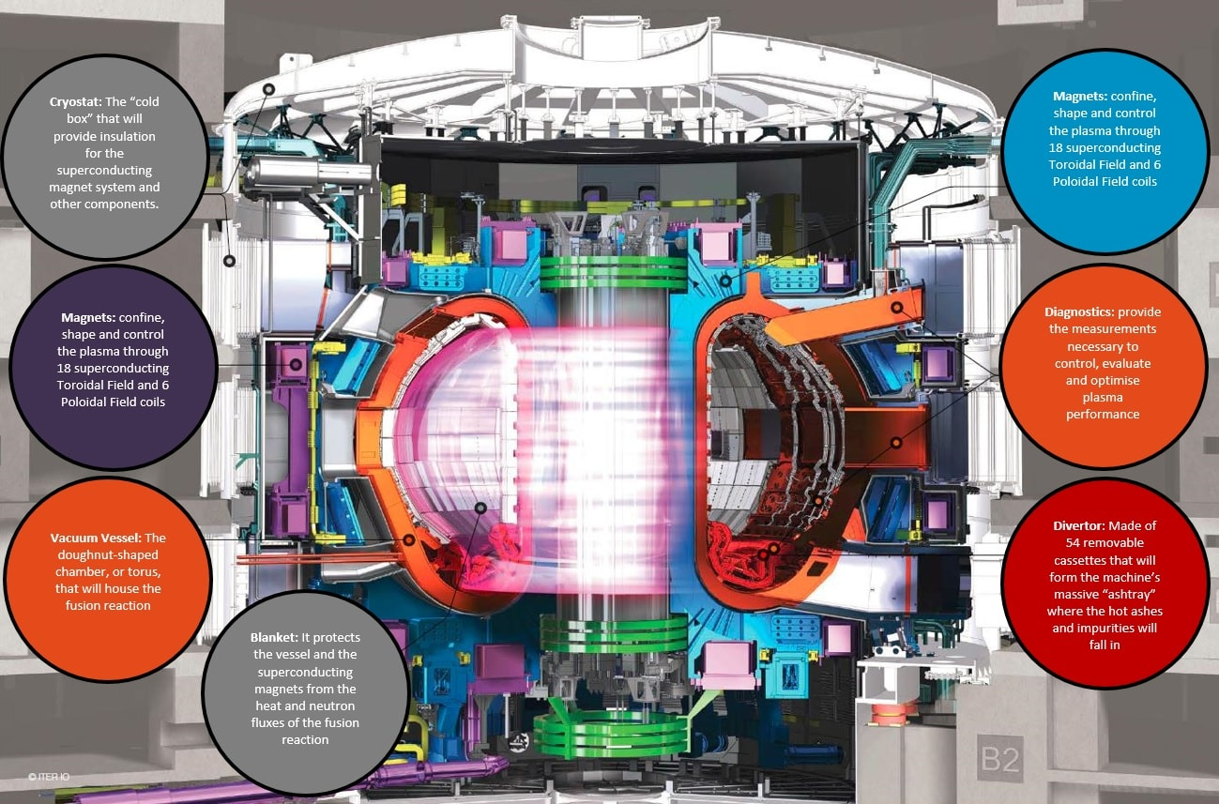

Figure 1: Cross-section of the ITER tokamak, with labels briefly explaining the functions of the main systems. Source: F4E 2016 Highlight report. Copyright: IO

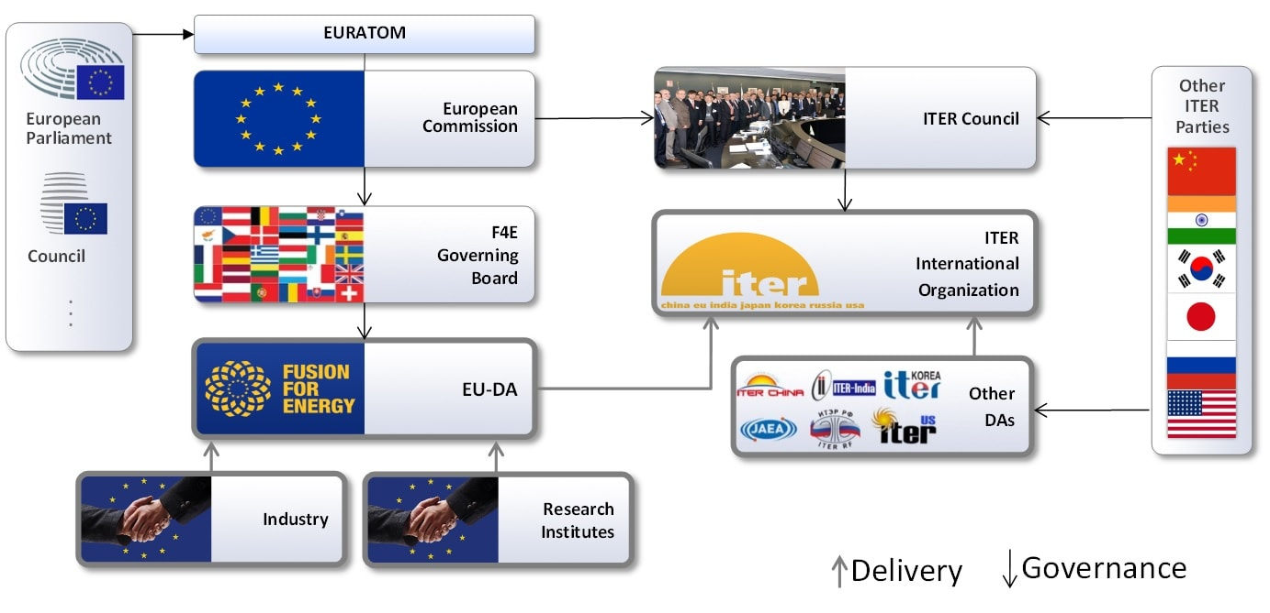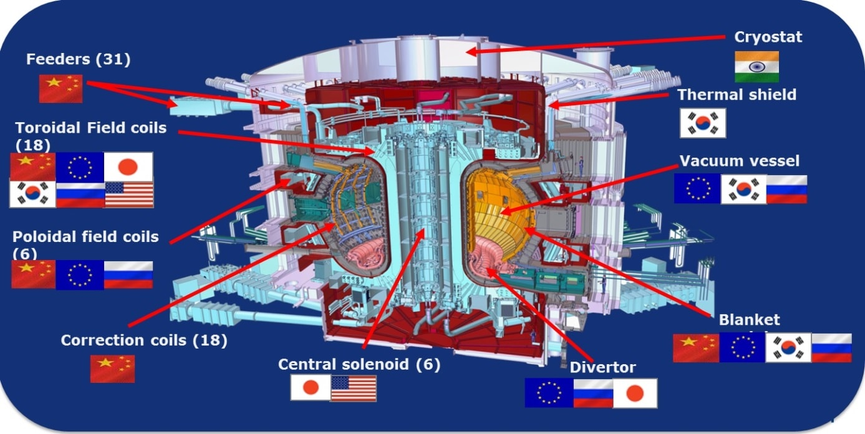

Figure 3: Diagram of the governance structure of the ITER project. Source: F4E

Figure 2: Diagram of the tokamak showing broadly which Parties are responsible for which components of the machine.

In the context of the negotiations of the ITER Agreement, a separate but related bilateral agreement between the EU and Japan was signed in 2005. This agreement, called "Broader Approach" (BA), facilitates cooperation between the two Parties on three fusion-related projects located in Japan[11], intended to support the development and realisation of ITER and the preparations for DEMO. The majority (approx. 90%) of resources that the EU contributes to BA projects are in the form of voluntarily provided in-kind components by several Members of F4E[12]; therefore, the in-cash contribution that is sent to BA through F4E is very small compared to its in-cash and in-kind contributions to ITER.

In accordance with all the above, F4E has three statutory tasks:

(a) to provide the contribution of the European Atomic Energy Community (Euratom) to the ITER International Fusion Energy Organisation;

(b) to provide the contribution of Euratom to Broader Approach Activities with Japan for the rapid realisation of fusion energy;

(c) to prepare and coordinate a programme of activities in preparation for the construction of a demonstration fusion reactor and related facilities including the International Fusion Materials Irradiation Facility (IFMIF).

At present, the main focus of F4E's activities is on (a) and (b). Its work on DEMO is currently mostly carried out through its collaboration with the European Consortium for the Development of Fusion Energy (EUROfusion)[13], which conducts significant research activities, partly funded by F4E grants, on topics of relevance for the DEMO preparation [14]. All F4E actions are underpinned by scientific support from EUROfusion funded by the Euratom Research and Training Programme.

Figure 4 below presents the intervention logic of F4E's implementation of the EU's contribution to ITER and of the associated activities related to BA and DEMO. A positive outcome of ITER will represent an important signal towards the confirmation of fusion as a new and sustainable source of energy that will help mitigate climate change, contribute to energy security, improve the environmental performance of the energy sector and boost EU’s innovation and competitiveness. ITER's success will depend on the Parties to the ITER Agreement remaining committed and providing their support (in kind and cash contributions).

The next section of the report documents a number of positive developments in the execution of the ITER project that were achieved in recent years. Despite this progress and the significant improvements in the project's execution and governance, there remain important risks related to design and assembly that still require full attention by the management and stakeholders to be addressed adequately, including by proper provisioning for contingencies in cost and schedule

Brexit does not affect the EU commitment to ITER.

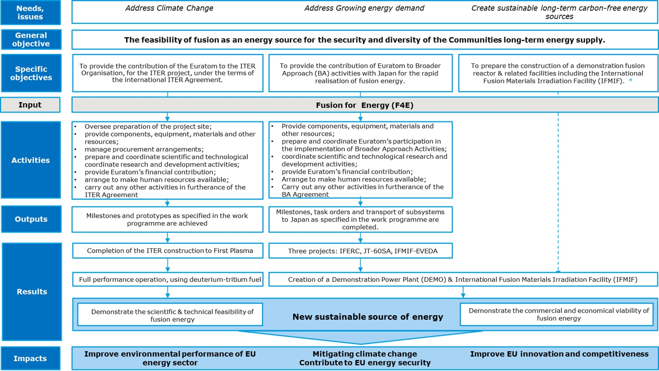

Figure 4: The intervention logic of F4E. Source: Evaluation supporting study

# 3. Implementation, progress and state of play

## Developments in the construction and management of the ITER project in 2014-2017

ITER’s construction by F4E began in Cadarache in 2009 and was expected to last ten years. Following the revelation of multiple weaknesses and shortcomings in 2013 (by an internal assessment of the ITER project[15] and a review of F4E[16]), the project baseline adopted in 2010 was no longer considered realistic. One of the key drivers of the delays and extra costs was the immaturity and resulting frequent changes of the design of project components due to the complexity and first-of-a-kind nature of the project. The expected delivery dates of some in-kind contributions had been delayed by up to 45 months relative to their planned dates in the ITER schedule of 2010. The need for turning the project around became evident.

Accordingly, the IO and F4E initiated large-scale changes at all levels, including changes in the top managements of both organizations. The new managements adopted Action Plans in 2015 to address the situation. Furthermore, the new Director-General of the IO appointed by the ITER Council in March 2015 took actions to implement rigorous project management techniques (including schedule and cost control, risk management, and design freezing) and established a Reserve Fund[17] to cover cost increases due to late changes of technical specifications. In F4E, actions included a closer focus on risk management, more flexibility in the implementing regulations for contract management, and deeper integration and communication between F4E, IO, and the other DA's. Its Governing Board (GB) also appointed a new Director for F4E.

## New Project Baseline based on Staged Approach

In April 2016, the new baseline[18] was reviewed by an independent committee[19], and the 2025 First Plasma milestone was confirmed as the earliest technically feasible date. It was noted that setting this as the target date to achieve First Plasma omits any kind of contingency, assuming that all risks can be mitigated. The lack of a contingency in the baseline is unusual in a project as large and complicated as ITER, and this adds a level of uncertainty to the overall management[20]. The reviewers also recommended a "*Staged Approach*". Taking into account the positive recommendations of this review, the ITER Council endorsed ad referendum the new ITER baseline in November 2016[21].

The *Staged Approach* is one of the most crucial parts of the management turnaround. It splits the construction and assembly of the machine into four stages, each of which builds towards a key goal. This culminates in the final goal of the fourth stage: full Deuterium-Tritium (D-T) operation[22]. During each stage of the project, only activities that are critical to achieving that stage's goal are carried out. This plan takes into account the financial constraints of the ITER Parties by limiting the in-cash contributions and postponing in-kind contributions that are not necessary for the project's current stage. It also reduces risks by testing the machine and the existing components after each stage is complete, allowing any issues to be identified and addressed before moving on. The project is currently in its first stage, with its key goal being First Plasma. In order to achieve First Plasma in 2025 as scheduled, F4E has adopted a strategy called “*Straight Road to First Plasma*” which prioritises components that are essential to this milestone. The staged approach is illustrated in Figure 5 below.

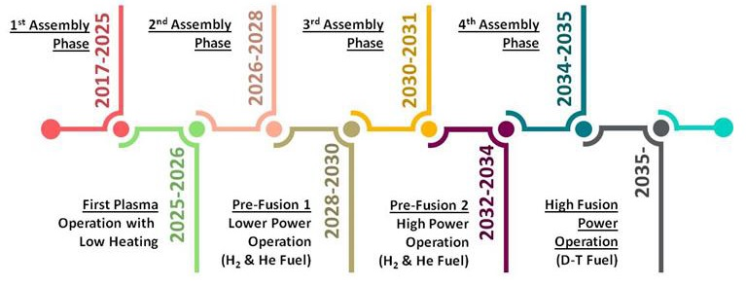

Figure 5: Diagram of the Staged Approach and its primary milestones.

Following the approval of the 2016 baseline, F4E set the new timetable and recalculated the estimated cost of F4E’s contribution until the achievement of the First Plasma milestone in 2025. The expected funding required from F4E for the construction phase between 2021 and 2025 is of EUR 5.5 billion in current values[23]. Europe’s total estimated contribution to the revised baseline of the project based on the staged approach is presented in Table 1 below.

Table 1: Summary table of Euratom’s commitment appropriations to ITER up to First Plasma (FP), from FP to Deuterium-Tritium (D-T), and total after 2020. Units are current values in EUR billion.

Source: Communication COM(2017) 319 - EU contribution to a reformed ITER project

|  | To FP | From FP to DT | | Total after 2020 |
| --- | --- | --- | --- | --- |
|  | **2021-2025** | **2026-2027** | **2028-2035** |
| F4E total cash to IO | 1.5 | 0.7 | 1.6 | 3.8 |
| F4E in-kind contribution | 3.1 | 0.8 | 0.7 | 4.6 |
| F4E administration | 0.3 | 0.1 | 0.6 | 1.0 |
| F4E other activities | 0.5 | 0.2 | 0.1 | 0.8 |
| EC project administration | 0.05 | 0.02 | 0.08 | 0.15 |
| Total | 5.5 | 1.8 | 3.1 | 10.4 |

## Euratom expenditure related to ITER

The funding for European participation in ITER and for related activities (BA, DEMO) is channelled through F4E as the Euratom Domestic Agency for ITER. The operating revenues of F4E include mainly the Euratom contribution; the ITER Host State (France) contribution; and the Membership contributions. The contribution from Euratom constitutes the main source of revenue for F4E. Since the establishment of F4E, as of 31 December 2017, F4E has received a total of EUR 5 055 million in commitment appropriations and EUR 3 328 million in payment appropriations (both in current values) from Euratom contributions. A chart with a running total of commitment and payment appropriations is presented in Figure 6. These appropriations include those that assign funds to BA activities; however, since the vast majority of value that the EU diverts to BA comes in the form of voluntary in-kind contributions, these appropriations are very small compared to those for ITER. Overall, this diagram demonstrates the recently improved and good budgetary performance both in terms of commitments and payments, notwithstanding the observations made in regular audits and independent reviews of the project[24].

Figure 6: Cumulative sums of commitment appropriations and payment appropriations (current values in EUR million). Source: F4E draft Annual and Multiannual Programme years 2019-2023, produced in the evaluation supporting study

The vast majority of F4E's expenditure is accrued in relation to Procurement Arrangements (PAs). These are contracts, created and defined by IO, each of which represents specific work to be performed and delivered to IO by a DA. PAs can represent the construction of components, services, administration, or any other work that needs to be performed to contribute to the ITER project, but the bulk of them concern the development and construction of components for the tokamak as in-kind contributions. Following the signature of a PA with IO, F4E tenders and signs contracts with suppliers of the requisite deliverables.

As of November 2017, F4E had signed contracts corresponding to 87% of all the in-kind contributions due to IO from the EU side. The amount of money that this represents is shown by Figure 7 below.

Although the contracts signed represent a value of almost EUR 4 billion, this is not the amount of money that has been paid by F4E. Money committed at the beginning of a PA will often be paid through instalments, with the bulk of the money being paid at the end. Up to May 2017, about EUR 2.25 billion has been paid for the in-kind contributions to ITER[25]. This money has gone to hundreds of different contractors and many more sub-contractors inside and outside the EU, and has produced growth and employment in the EU economy. These benefits will be quantified in Section 5.

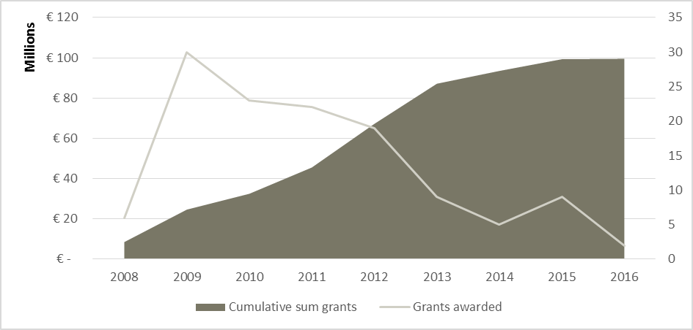

Figure 8: The cumulative number of grants awarded by F4E from 2008 to January 2017 and their cumulative value in EUR. Source: Data from F4E, produced in the evaluation supporting study

Figure 7: The cumulative number of contracts awarded by F4E from 2008 to May 2017 and their cumulative value in EUR. Source: Data from F4E, produced in the evaluation supporting study

Besides contracts, part of F4E's operating expenditure is constituted by grants. These take the form of contributions to Research and Development related to F4E activities. Figure 8 shows the cumulative amount of grants awarded by F4E and their value in euros.

To date, entities in at least 20 Member States have benefitted from contracts with F4E for the delivery of in-kind contributions to ITER and from grants for supporting research and development actions. As France is the host country of the project, French contractors and sub-contractors receive the highest proportion of contracts and sub-contracts. However, this benefit is balanced by the fact that during the construction phase, 20% of the European contribution to the project is funded by France and 80% by Euratom – a significantly higher amount than the other Member States. F4E is making efforts, in line with the request from the Council of the EU and the European Parliament, to address the differences in the level of participation of industry in Member States, including by increased information on procurements and grant opportunities.

## Progress of Euratom contributions to ITER under the 2016 Baseline

When complete, the ITER complex will entail thirty-nine buildings, structures and areas, including the Tokamak Complex with the ITER machine itself. In November 2017, the milestone of 50% completion of the total physical construction activities needed to reach First Plasma was achieved[26].

The physical progress of the project can be monitored by milestones. Each year, at one of its biannual meetings, the ITER Council approves a set of milestones for the purposes of performance tracking and reporting to the ITER Council. The milestones pertaining to European contributions are also monitored by the F4E Governing Board (GB). The milestones cover all areas of the project, from procurement to construction. Table 2 shows the status at the end of 2017 of all milestones that were due up to that point. All milestones due by the end of 2017 have been achieved[27].

|  |
| --- |
| Table 2: A summary of milestones due by the end of December 2017.  Source: F4E Summary Report on Progress for EU ITER Council and Governing Board Milestones – end of December 2017 |
|  |

Another way to measure the completion of the project is using ITER credits. The “credits” system was introduced to facilitate tracking of contributions[28]. When a PA is created by IO, internal milestones are defined to mark the progress of its execution. Some of these milestones have ITER credits (also called ITER Units of Account, or IUA) associated with them which are released by IO to the DA on achievement.

Obtaining all the credits for a PA means that the DA has achieved all milestones and therefore fully discharged its obligations for that PA. It is important to note that ITER credits do not correspond to the actual cost of the work done or component produced, but rather the nominal value of the PA as agreed between IO and its members (the ITER Parties)[29]. Therefore, the ITER credits that a DA has received from IO correspond to the work that has been carried out and the milestones that have been achieved. Credits are not earned for in-cash contributions and the administrative expenditure of the DA.

Figure 9 and Figure 10 show the progress of ITER credits compared to the baseline over the periods 2014-2017 and 2010-2017 respectively. It can be seen that the credits achieved follow the baseline quite closely, notwithstanding a small delay in 2017

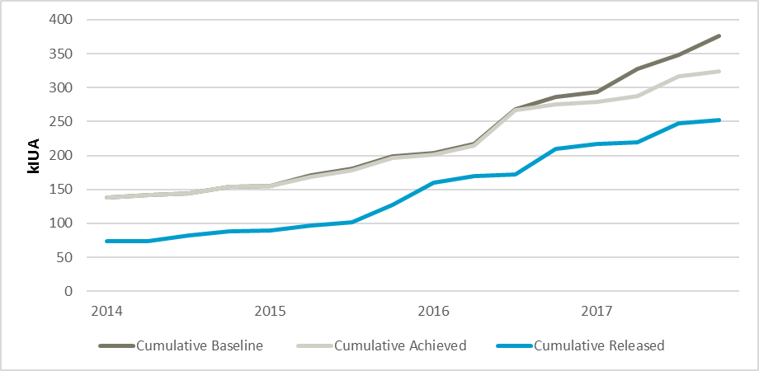

Figure 9: Cumulative achieved and released credits compared to the current baseline over the period 2014-2017. Source: Data from F4E, produced in the evaluation supporting study

As of late 2017, 35% of the total European credits for in-kind contributions have been achieved. The progress that has been made between 2014 and 2017 is shown in Table 3, and these data are presented in Figure 11 as a percentage of the total credits for each action.

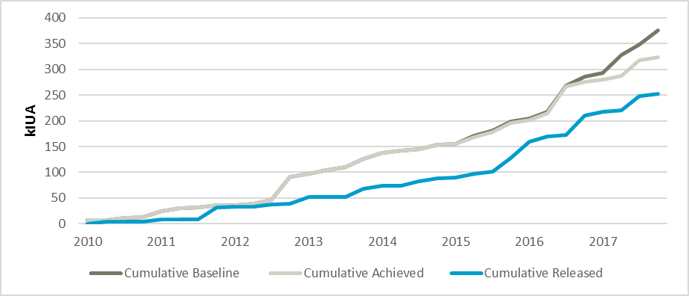

Figure 10: Cumulative achieved and released credits compared to the current baseline over the period 2010-2017. Source: Data from F4E, produced in the evaluation supporting study

Table 3: Progress of actions (categories of work) in terms of achieved credits in 2013 and 2017.

Source: Data from F4E draft Annual and Multiannual Programme years 2019-2023.

| Action | Achieved as of 1/1/2014 (kIUA) | Achieved as of 30/11/2017 (kIUA) | Forecast for total credits (kIUA)[30] |
| --- | --- | --- | --- |
| Site and Buildings and Power Supplies | 53.50 | 181.94 | 516.10 |
| Magnets | 13.19 | 85.74 | 185.84 |
| Vacuum Vessel | 0 | 30.08 | 89.56 |
| Cryoplant and Fuel Cycle | 0 | 22.86 | 57.39 |
| Neutral Beam and EC Power Supplies  and Sources | 1.86 | 19.63 | 103.95 |
| In Vessel - Divertor | 0 | 1.92 | 22.24 |
| Remote Handling | 0 | 1.80 | 39.73 |
| Antenna and Plasma Engineering | 0 | 0.50 | 27.41 |
| Diagnostics | 0 | 0.02 | 29.67 |
| In Vessel - Blanket | 0 | 0 | 44.85 |

Figure 11: Graph illustrating the progress of actions as a percentage in credits

Source: Data from F4E draft Annual and Multiannual Programme years 2019-2023

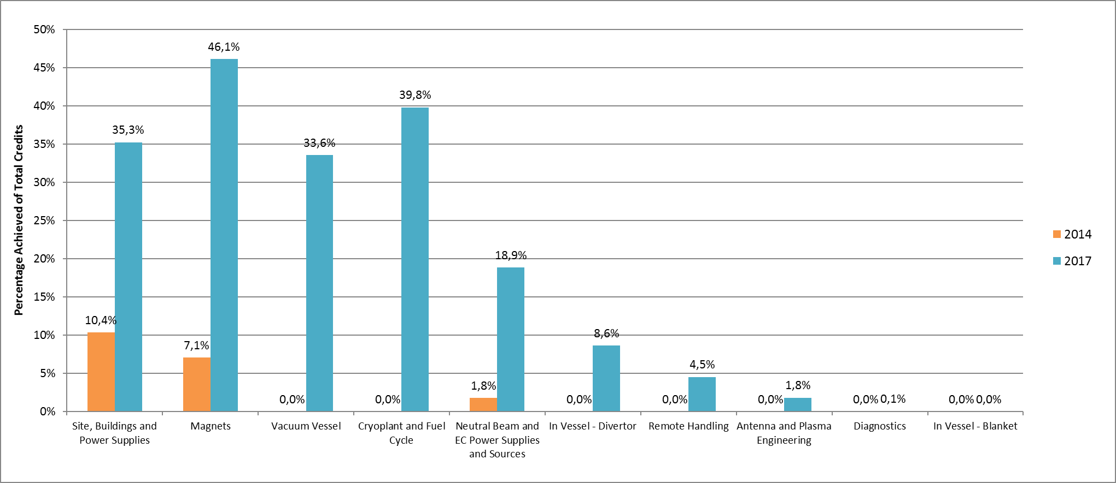

## BA projects' progress and schedule

The resources provided by the EU for the implementation of BA activities are largely (approx. 90%) provided voluntarily by several Members of F4E (Belgium, France, Germany, Italy, Spain and, in the past, Switzerland). Therefore, the in-cash contribution from the EU for these projects is very small compared to F4E’s expenditures on ITER.

Like in ITER construction, in-kind contributions to BA projects are formalised using PAs and their values are measured in credits. The BA credits are called Broader Approach Units of Account (BAUA). The complete scope of work covered by the BA Agreement has a value of 1 000 000 BAUA[31], 500 000 of which are provided by Euratom and 500 000 by Japan.

The three projects all aim to be completed within the current MFF (before the end of 2020). As of the end of June 2016, the EU had been awarded 73% of its total commitment for JT-60SA, 82% for IFMIF/EVEDA, and 97% for IFERC[32].

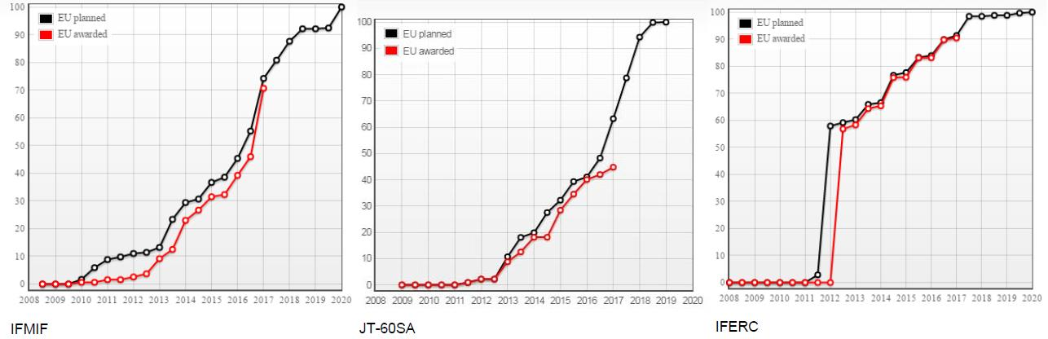Figure 12 below shows the awarded credits for each project as a percentage of the amount planned to be awarded. The average percentage is above 88%.

Figure 12: Ratio of credit awarded under the BA Agreement to credit planned.

Source: F4E 2016 Final Accounts, produced in the evaluation’s supporting study

# 4. Evaluation of results achieved to date - methodology and tools in accordance with Better Regulation principles

The implementation of European participation in ITER and Broader Approach through F4E activities, the results of which are presented in the previous Section in accordance with the requirements of Article 5b of Decision of the Council of the EU establishing F4E, has been analysed in accordance with the principles of Better Regulation.

The results of the analysis are presented in the ensuing section and are structured around five evaluation criteria: Relevance, Effectiveness, EU Added Value, Efficiency, and Coherence. Annex 2 details the methodology of the evaluation supporting study including the related evaluation matrix.

In a mid-term evaluation, it is customary to assess the effects produced by the intervention against a baseline. This baseline is often a description of how the current situation would have evolved in the absence of the intervention. The ITER project is a special case because of its long duration and its status as a scientific experiment linked to an international agreement. Furthermore, the total impact of ITER is hard to quantify – its existence produces not only economic benefits but also new Intellectual Property and spin-offs. The Value for Money study includes ten case studies of companies that have worked with ITER and developed “spin off” products for exploitation outside fusion (such as the broader energy sector, aviation and hi-tech instruments). A baseline scenario would exclude these new innovations, but it is difficult to tell what their impacts will be.

However, it is possible to define baselines within certain constraints. For quantitative analysis, the Value for Money study focuses only on the EU economy and takes two baselines. The first is a “no ITER spending” scenario where the money that has been spent through F4E’s budget is not spent at all; ITER’s impact relative to this scenario is called the *gross impact*. The second is a scenario where instead of being spent on ITER, the same amount of money was spent in other sectors of the EU economy in proportion to their respective size. Impact relative to this scenario is called the *net impact*. This is further elaborated on in the “Efficiency” part of Section 5 (Analysis).

## Limitations of the evaluation

This evaluation concerns the European contribution to ITER. However, even when one considers only its ITER-related activities, F4E is only one cog in the large, complex machine that is the ITER project. It is therefore difficult to evaluate F4E's performance using ITER's progress as a metric, because the project's progress depends on many organisations of which F4E is only one. F4E's BA-related activities are simpler to analyse as there are only two Parties (Euratom and Japan), but it must be kept in mind that the results seen in the construction and operation of the facilities are not solely under the control of F4E or the EU.

Furthermore, it is stipulated in the ITER Agreement that as the Host Party, Euratom may not withdraw from the project. This renders some areas of evaluation, such as the value of continued EU involvement, hypothetical. However, the answers to these questions are still valuable as they justify and support other areas of evaluation.

Some of the studies from which this evaluation draws use historical data to predict ITER's economic impact in various future scenarios. The act of forecasting and projecting necessarily implies making certain assumptions on the evolution of the geopolitical landscape over the period of projection.

In the supporting study to this evaluation, some findings are based on the responses to an online survey that was distributed to members of the GB and Industrial Liaison Officers (ILOs). Their populations are 60 and 22 respectively, and their response rates were not very high – 45% and 36% respectively. Due to this small sample size, the results cannot be interpreted as accurately representing the views of the ILOs and GB members; furthermore, there may be a self-selection bias in the sample. Nevertheless, the results can provide some useful indications.

# 5. Analysis and answers to the evaluation questions

This section presents the findings of the mid-term evaluation of the European contribution to ITER addressing whether this is still relevant given the current needs. It goes on judging how effective and efficient has been the European participation in ITER examining also its EU added value. Last but not least this section examines how coherent is Euratom’s participation in ITER with other EU interventions/policies.

## Relevance

1. On 28 November 2018, the European Commission adopted a strategic long-term vision for a prosperous, modern, competitive and climate neutral economy by 2050 – A Clean Planet for all[33]. The strategy shows how Europe can lead the way to climate neutrality by investing into realistic technological solutions, empowering citizens, and aligning action in key areas such as industrial policy, finance, or research – while ensuring social fairness for a just transition. The analysis accompanying this document acknowledges that fusion is a potential new power generation technology that would not produce greenhouse gases and uses fuels available in abundance and recognizes ITER as one of the major global initiatives that is the European Union’s main contribution to fusion research. Fusion energy could bring important benefits. Fusion fuels (deuterium and tritium) are widely available and nearly inexhaustible. The fusion power plant does not inherently present particular safety risks: less than a gram of fuel makes up the plasma, which rapidly extinguishes itself in case of any unplanned event. Deuterium-tritium reactions release neutrons which will activate wall materials. The resulting radioactive by-products are short-lived. The **benefits of fusion power** as a carbon-free, sustainable energy source to complement renewables are persuasive arguments in favour of fusion.
2. Unlike renewable energy sources, which are generally at a stage in their development where they can produce energy for commercial use, fusion is still a **nascent technology** that requires further research before it can do the same. ITER holds a unique place in the fusion energy research landscape. It is the key facility for the implementation of the European research roadmap to the realisation of fusion energy. The roadmap forms the basis for the programmes of EUROfusion and Fusion for Energy and provides a clear and structured way forward to commercial electricity from fusion.
3. As a collaboration between seven Parties collectively representing 80% of the world’s GDP, ITER stands out as by far the largest and most ambitious fusion experiment currently being constructed. The project is crucial to prove feasibility of fusion; therefore, the outcomes of ITER experiments should be considered as highly relevant to the EU's future energy needs. F4E's second and third objectives, concerning the European contribution to BA and DEMO, are also related to this goal. Although fusion as a technology is not yet developed enough to serve the EU's energy needs now, because of its potential, its development is crucial to the post-2050 energy landscape.
4. In a project such as ITER, where components produced in separate countries by different contractors have to work together in perfect harmony, **design changes** are inevitably very difficult and costly. Following the 2013 assessment design changes by the IO were discouraged and early freezing of designs encouraged. These measures, although highly beneficial from a project management perspective, create a situation where the design cannot easily incorporate new technological advances or improvements on its specification. However, within these restrictions, there is limited space to change the design, for example in the design of smaller components. Among staff and stakeholders at IO and F4E, GB members and ILOs, most agreed that F4E adapts adequately to technological and scientific advances, and none pointed out a major technological or scientific achievement that should have been considered by F4E but was not.
5. From the perspective of EU's energy-related international commitments, ITER is relevant to EU's commitments under the **Paris Agreement** and the **Sustainable Development Goals (usually referred to as Agenda 2030)**, both adopted in 2015 within the framework of the United Nations. To be achieved by the end of the century, the objectives of the Paris Agreement concern limiting global warming, increasing the ability to adapt to climate change, and moving towards low greenhouse gas emissions. To achieve these objectives, it is indisputably necessary to phase out fossil fuel usage in favour of more climate-friendly alternatives. Although fusion energy as a viable commercial energy source is a long-term goal not expected to produce electricity before 2050, the timeframe for these targets is also long-term. Therefore, as a low-carbon alternative to fossil fuels and complement to renewable energy, fusion energy research, and by extension the ITER project, is very much in line with the EU's obligations and commitments under the Paris Agreement.
6. Unlike the Paris Agreement, the **Sustainable Development Goals** concern not only energy and climate but a broad range of social and economic development issues. There are 17 global goals to be achieved by 2030, concerning areas such as poverty, education, hunger, sanitation, gender equality, and climate change. Despite its long term nature, ITER is in line with these goals.

## Effectiveness

1. As explained in the intervention logic (Figure 4), the three tasks of F4E can be considered F4E's specific objectives. The extent to which these objectives have been achieved so far was evaluated in some detail in sections 2 and 3; the BA projects are progressing largely as planned, the DEMO preparation projects are (with the exception of the IFMIF part under the BA Agreement) not being discharged by F4E until First Plasma has been achieved, and although ITER has suffered serious delays and cost overruns in the past, it is now **steadily progressing in accordance with the schedule and budget** under the new 2016 baseline. Figures 9 and Figure 10 illustrate the extent to which the ITER project is on schedule in terms of credits achieved and released.
2. The date for First Plasma includes no **contingency** provision for unscheduled developments and risk-events which however cannot be reasonably excluded, particularly in projects of comparable complexity. To ensure schedule reliability, a reasonable contingency should be considered. As stated in the recent Commission Communication on ITER[34]., in line with existing experience with large international projects of similar complexity and maturity, the Commission estimates that a contingency of up to 24 months in terms of schedule and 10-20% in terms of budget appears appropriate.
3. In terms of the improvement in **project culture and management** since the management turnaround in 2015, although three years is a very short time to see large-scale improvement in a project of this magnitude, there are some indications of progress. In the latest annual assessment of F4E[35], it was stated that F4E “appears to be on track and is positioned to make the transition to a non-emergency steady state”[36]. However, both that assessment and interviews conducted in support of the evaluation highlight that significant progress remains to be made, notably regarding contract management and procurement practices. The procurement regulations of F4E were not designed for an international experimental science project. To remedy this, F4E engages actively with the industry and research communities to promote participation in calls for tenders and calls for proposals. This includes cooperation with the network of Industrial Liaison Officers (ILOs) and the European Fusion Laboratory Liaison Officers (EFLO) Network. This also includes communication and information initiatives to raise awareness and capability.
4. Furthermore, a **supervision strategy** was recently adopted by the responsible Commission services[37] with two facets: first, ensuring, through EC participation in F4E’s governance structure, that F4E’s scope, budget and schedule are fit for purpose and adhered to; and second, exercising direct supervision over the use of F4E’s budget and monitoring its operational performance. In parallel, through Euratom’s chairmanship of ITER’s Management Advisory Committee (MAC) in 2016 and 2017, measures were taken to improve MAC’s efficiency through timely delivery of the appropriate information before the meetings and reorganisation of MAC’s agendas. Other governing bodies of ITER underwent similar changes, and contacts were also reinforced between the Commission, the IO, and F4E at all hierarchical levels. In October 2017, MAC members carried out a self-assessment, where all Members acknowledged visible improvements in the effectiveness of the Committee’s governance.
5. One of the most critical issues for the construction of ITER now is the proper execution of **assembly and installation**, taking into account that ITER, as a first of a kind project, involves multiple organizations and, as a result, a complex configuration definition and change management process. To meet this end, it was deemed pertinent to review the ITER’s strategy for assembly and installation, focusing on the several changes and improvements that have been made in the past few years, such as the adoption of the staged approach for finalising the assembly of key components, the placement of a CMA (Construction Manager-as-Agent) contract and the implementation of a new configuration management plan (CMP). In view of the above, the ITER Council, at its twenty-first meeting (IC-21) held in November 2017, decided to carry out in 2018 an in-depth independent review on ITER’s configuration, assembly and installation strategy for the critical path to First Plasma.
6. The planning, design and construction of ITER facilitates new cutting-edge **research and innovation** both within and outside the field of fusion. In fact, an F4E contract is regarded as a stepping stone towards realising longer term benefits. Firms judge that working on ITER bolsters their reputation as a leading high-tech company. More than a third of firms have developed new cutting-edge technologies as a result of their work on ITER. The potential for spin-offs partially already realised, is very significant and could produce myriad benefits for the EU and the other ITER Parties. Spin-offs may generate an extra 10,900 jobs between 2018 and 2030 and an increase in gross value added of € 2,248 million over this period[38].
7. The Value for Money study found that over the period 2008-2017, compared to no spending, F4E spending on ITER has produced **34 000 job years** and almost **EUR 4.8 billion** in Gross Value Added (GVA). There is also high potential for spin-off technology, as ITER is at the cutting edge of fusion research and many of its components are the first of their kind. In the same study, several case studies were identified where companies’ participation in ITER had enabled the development of spin-offs and innovation, often transferable to other sectors.
8. As described under “Coherence” below, the ITER project contributes to the achievement of many of the **EU's internal and international goals and objectives**; some, like the Paris Agreement, are very high-profile and well-known to the general public..

## EU Added Value

1. When the contributions of the other Parties are taken into account, as well as the resources that will be required after 2020, the cost of ITER is substantial. The project also requires significant technical expertise and a large number of skilled manufacturers to design and build the components and bid for contracts in a fair and competitive way. In short, constructing a fusion device like ITER requires sustained scientific, managerial and financial commitment on a scale that would be unrealistic for any one country to undertake. Therefore, it can only be achieved through **collaboration** both between Member States and globally. In a global collaborative project, the EU is indispensable in order to promote the interests of European countries on the same footing as other global powers.
2. Exercising **governance at EU level** avoids the even more complex governance structure that would arise if participation in the project was done at Member State level. In a similar way, procuring the European contribution through F4E avoids the potential complexity of each Member State having its own procurement rules and processes.

## Efficiency

1. The EU's contribution to the construction of ITER will total in the region of EUR 6.6 billion by 2020 (2008 values), in line with the cap established by the Council of the EU in 2010. Most of F4E’s budget is spent through procurements; its administrative expenditure represented 6% (in terms of commitment appropriations) and 9% (in terms of payment appropriations) of the total expenditure of F4E over the period 2014-2017. This proportion of administrative expenditure is similar to other large projects[39]. Therefore, the main influence on F4E’s cost-efficiency is that of its **procurement practices**. Over time F4E’s procurement strategy has evolved from placing large contracts on a fixed-price basis to placing smaller contracts with more variable characteristics. For each contract, a call for tender is published on F4E's Industry Portal[40]. As an EU Joint Undertaking, F4E is bound to follow EU public tender procedures as set out in F4E’s Financial Regulation[41]. According to the latter, participation in public tendering procedures should be open on equal terms to all tenders from EU Member States and third countries that have a special agreement with the EU regarding public procurement. In the case of F4E’s Financial Regulation; participation is restricted to the Members of F4E (the EU Member States and Switzerland) with some exceptions. This system is intended to avoid monopolies and encourage competitive tendering, which lowers the cost of contracts in a transparent and open manner, taking into account the requirements of sound management of public funds.
2. Over time, F4E has made concerted efforts to improve its **control and monitoring** practices. For example, the Integrated Reporting System (IRS) was implemented in 2017. It allows all F4E staff to access computer-generated reports using live data direct from F4E's intranet. The automation of the report generation is a more efficient system than human-generated reports, and although the IRS requires some setup and maintenance, interviewees from F4E reported that the administrative burden is reasonable. One of the key elements of F4E’s control and monitoring strategy, is the Integrated Management System (IMS). The IMS consists of a set of Key Performance Indicators (KPIs). Their functions are to quantify progress and provide easily-monitored variables that indicate the status of the project. At the end of each year F4E produces a comparison of the planned indicators and the achieved ones. In the annual assessment of F4E for 2014, it was stated that “the assessors recognise the value of the IMS and consider it a complex, robust system for an efficient and effective management and recommend its systematic implementation”.
3. A recent report by the Commission's Internal Audit Service flagged three very important actions of a previous **audit** that were significantly delayed at the beginning of 2018. On the meantime, F4E has progressed and intends to complete these actions by end 2018. The improvement of the financial performance of F4E has been confirmed in annual discharge procedures by the European Parliament, based on the annual review of its accounts by the European Court of Auditors that has consistently confirmed their regularity and conformity. Discharge has been granted to the 2016 accounts of F4E. The discharge procedure for the 2017 annual accounts is ongoing. The European Court of Auditors (ECA) had preliminary observations related to the provision for the decommissioning costs and to issues regarding internal control including recruitment processes.
4. The Value for Money study found that compared to an appropriate “alternative investment” scenario, the **net impact** of ITER spending on GVA in Europe totals EUR 132 million, and on employment 5 800 job years.

## Coherence

1. First published in 2012 by the EFDA[42], the **EUROfusion roadmap** outlines the pragmatic approach and the practical steps involved in achieving fusion electricity on the commercial power grid. ITER is the key facility of the roadmap and is highlighted as an integral part of the EU’s overall fusion strategy. Accordingly, most of financial resources for fusion research coming from the Euratom Research and Training Programme are dedicated to preparations for ITER exploitation.
2. The **Euratom Research and Training Programme**[43]**, complementing Horizon 2020,** supports nuclear research and training activities with an emphasis on nuclear safety, radiation protection and the development of fusion energy. In order to achieve the latter, the Programme calls for a “shift from pure, academic research to scientific questions of designing, building and operating future facilities such as ITER”. In this way, alongside existing fusion projects such as JET and future reactors such as DEMO, the ITER project is a cornerstone of the Euratom Research and Training Programme and hence relevant to the flagship Horizon 2020 programme.
3. The **European Commission's** **political priorities** for the period 2014-2019 include two relevant to ITER: “Jobs, growth and investment”, and “Energy Union and Climate”. The former includes an objective of steering EU funds towards “jobs, growth and competitiveness”. Even at its present stage, several years before the beginning of its operational phase, the Value for Money study estimates that the ITER project has produced growth in GVA and employment across Europe. The “Energy Union and Climate” political priority is highly relevant to ITER across many of its dimensions, such as diversifying Europe's sources of energy, decarbonising the energy economy, and prioritising research and innovation in low-carbon and clean energy technologies.
4. The ongoing European **Strategic Energy Technology Plan** (SET-Plan) aims to accelerate the development and deployment of low-carbon technologies. While it focuses on developing renewable energy technology in order to meet the EU's short- and medium-term energy targets, it does highlight fusion technology as a “high-potential attractive long-term low-carbon energy solution” and cites ITER as one of the most important industrial research projects in the world, that aims to demonstrate the feasibility of fusion power and show that it can work without negative impacts[44].

# 6. Conclusions

The present document fulfils the legal requirement for a mid-term progress report, but also includes the findings of a mid-term evaluation in accordance with Better Regulation principles. The evaluation is focused on the European contribution to ITER in 2014-2017 and shows that although the ITER project has suffered significant delays and cost overruns since its inception, the management turnaround implemented from 2015 onwards has had a positive effect. Within its current baseline (scope, cost, and schedule) adopted in 2016, ITER is on track in terms of schedule and budget. The BA projects are also progressing well within their own baselines. The obligations to DEMO preparation are for the most part being discharged by EUROfusion until ITER's first phase is complete in 2025.

However, the construction and management of ITER are still in the improvement process; in such a long-term project, it will be important to monitor whether the positive effects of the management turnaround continue and whether the supervision and monitoring of F4E by the European Commission improves in accordance with the new Commission’s supervision strategy.

ITER remains an important part of EU energy and innovation policies and, its potential role in the decarbonisation of the energy landscape post-2050 is very significant. This investment aligns with other EU goals regarding growth, and there has already been significant growth in GVA and employment due to investment in ITER.

Being the Host Party of such an important project, both as a major scientific project and an international collaboration on an unprecedented scale, the ITER project places the EU at the forefront of fusion research, and various European initiatives cite ITER as an example of the EU investing in future energy solutions.

# Annex 1: Procedural information concerning the process of preparing the evaluation

1. **Lead DG**

DG Energy (ENER)

1. **Organisation and timing**

This evaluation has been steered by DG Energy since April 2018 under the scrutiny of an inter-service group (ISG) consisting of representatives of SG, BUDG, RTD[45].

During 2018, ISG meetings took place on 10 January, 22 February, 19 March, 2 May, 18 June, and 6 November.

The ISG was consulted on the draft report on 25 October.

**Exceptions to the Better Regulation guidelines**

None

1. **Sources of evidence**

The following is a list of all documents that this study drew on in its analysis:

* The Council Decision that set up F4E and defined its objectives: “Establishing the European Joint Undertaking for ITER and the Development of Fusion Energy and conferring advantages upon it”, 27 March 2007
* F4E Annual Reports
* For background information regarding private procurement regulation: David Metzger, “The Rules of Engagement: Private Sector Procurement and the Common Law”, April 2012
* The “Energy Roadmap 2050”, published in 2012
* Ernst and Young, Published by the European Parliament, “Potential for Reorganisation within the ITER Project to Improve Cost-effectiveness”, 15 May 2013
* William Madia and Associates, “Final report of the 2013 ITER Management Assessment”, 18 October 2013
* The “Strategic Energy Technology (SET) Plan”, published 12 December 2017
* 6th Annual Assessment of F4E, Report to the Governing Board
* Trinomics, “Study on the impact of the ITER activities in the EU”, May 2018 (commonly referred to as the “Value for Money” study)
* Ramboll, “The European Contribution to ITER: Achievements and Challenges”, May 2018
* Trinomics, “Supporting Analysis for an Impact Assessment on the Future Funding of EU Participation in ITER Project and Broader Approach (BA) Activities under the next MFF”, May 2018

# Annex 2: Methods used in preparing the evaluation

To collect evidence and produce analysis to support this evaluation, an external consultant (Ramboll) was commissioned in 2017. The consultant carried out all tasks as required under the scrutiny of an inter-service group (ISG) and the steer of DG Energy. Primary data were mainly collected from 21 December 2017 to 29 January 2018.

## Evaluation questions of the supporting study

In the Terms of Reference of this study, 21 evaluation questions were identified to be answered in the report. These evaluation questions are as follows:

1. To what extent have the objectives of European participation to ITER as stated in Article 1(2) of F4E's Statutes been achieved so far?
2. What have been the quantitative and qualitative effects on growth, jobs, innovation, enterprises and SMEs linked to the European contribution to ITER?
3. Do the observed effects address the objectives of the European contribution to ITER?
4. To what extent did the recent management reorganisations at ITER and F4E impact the performance of the European contribution to ITER?
5. Analysis of the Performance Framework
6. To what extent has the European contribution to ITER (in kind and in cash) been cost effective?
7. To what extent are the costs of the European contribution to ITER (administrative and operational) justified?
8. What factors influenced the efficiency with which the achievements observed were attained?
9. To what extent are the costs associated with the European contribution to ITER under the new baseline proportionate to the benefits (direct and indirect ones) generated?
10. How timely and efficient is the process for reporting and monitoring?
11. How well do the (original) objectives mentioned in F4E's Statutes (still) correspond to the needs and policies of the EU?
12. How has the development of the new project baseline contributed to sustaining the project's relevance?
13. What improvements to the relevance of the project have been brought through the turnaround in IO and F4E since 2015?
14. To what extent are the objectives of ITER relevant to the needs of EU and its policies?
15. Does the European contribution to ITER adapt adequately to technological or scientific advances?
16. To what extent is the European contribution to ITER coherent with other Commission initiatives?
17. To what extent is European participation in ITER coherent with the wider EU policy (Energy, Research, Climate, Environment)?
18. To what extent is the European contribution to ITER coherent with international obligations?
19. What is the additional value of EU intervention (Euratom participation in ITER) compared to what could have been achieved by Members States at national level?
20. To what extent do the issues addressed by Euratom's participation in ITER project continue to require action at EU level?
21. To what extent can we observe changes in the perception of Euratom's participation in ITER (positive or negative) by the targeted stakeholders and by the general public?

## Methodological approach

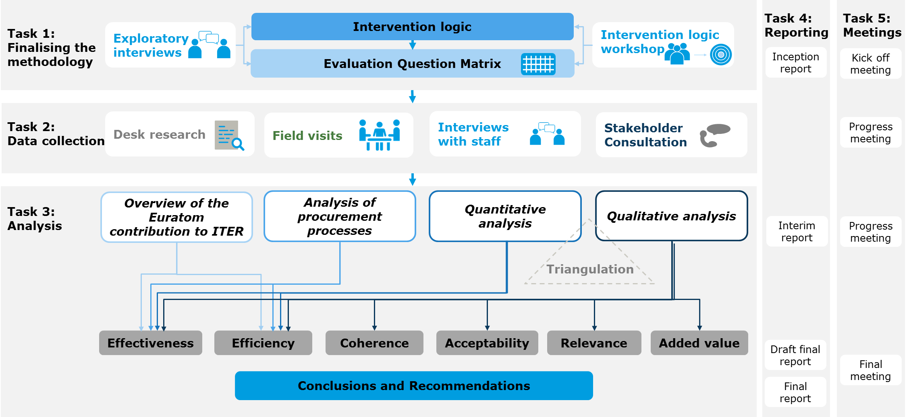Figure 13 below visually represents the methodology that was followed by the evaluation consultant. The work was structured through five tasks that fed into each other in order to deliver the data collection and analysis in the evaluation.

Figure 13: Overview of the methodological approach to the preparation of the supporting study.

Source: Evaluation supporting study

## Data collection

In order to answer these questions, the consultant used three methods of data collection: desk research, in-depth interviews, and a survey.

*Desk research*

Desk research is a central method to collect information for the purposes of evaluation. The desk research involved the systematic assessment and organisation of information pre-existing to the study. Documentation was categorised according to the evaluation matrix below.

A wide range of documents of different types were consulted; policy and legal documents, documents internal to F4E and ITER operations, reports, academic literature, and data and documents not available to the public supplied by IO and F4E.

*Stakeholder consultation*

Two main methods were used to consult stakeholders: semi-structured interviews with three different groups of stakeholders (F4E staff, IO staff, and other external stakeholders), and a survey among all members of the F4E Governing Board (GB) and the Industrial Liaison Officers (ILOs)[46]. In the analysis, the data sources have been triangulated to generate findings.

A total of 34 in-depth interviews were conducted with different types of stakeholders, as summarised in table 4 below. Each interview lasted for about one hour and was of a semi-structured nature. The interviews followed an interview guide, adapted for the type of stakeholder[47], yet allowed for exploration of topics outside the guide if considered relevant.

Table 4: Number of interviewees per stakeholder group. Source: Evaluation supporting study

| **Stakeholder group** | **Conducted interviews** |
| --- | --- |
| IO | 9 |
| F4E | 12 |
| Other | 13 |
| **Total** | **34** |

The semi-structured nature of the interviews and the time-limit of one hour meant that the interviewer prioritised questions most relevant to the knowledge of the interviewee. As a result, the extent of the responses to the questions in the interview-guide varies between the interviewees. Relying on different groups of stakeholders helps uncover institutional biases and the triangulation of the interview notes has been done in the analysis by comparing results from the different groups.

The evaluation team interviewed staff at Fusion for Energy (F4E) in Barcelona, Spain on 15 and 16 February 2018, and IO in Saint Paul-lez-Durance, France on 06 March 2018, to increase understanding of the Euratom contribution to ITER, fill data gaps and gather feedback on latest developments and progress. Due to the small number of stakeholders having knowledge on the European contribution to ITER, but also in order to avoid overlap with other studies conducted in parallel, the stakeholder consultation focussed on a restricted number of semi-structured phone interviews.

A survey was conducted among member of the F4E Industrial Liaison Officer (ILO) network and the members of the F4E Governing Board. The response rate for the online survey was 45% for the General Board (GB) members and 36% for the Industrial Liaison Officers (ILO), which is not very high considering their small populations (60 and 22, respectively) and the high commitment that could be expected from then. This implies that there may be self-selection biases in the sample. For example, it may be that more committed GB members and ILOs responded to the survey, and that these members are more likely to respond in a certain way.

The results of the survey can therefore not be statistically generalised to the GB and ILO populations. That is, the results do not lend themselves to the identification of their associated margin of error. Thus, as calculating the margin of error could be misleading, it was not calculated for the responses to the survey.

Notably, the biases outlined above do not impact on the value of the results of the survey. Although they should be kept in mind upon interpretation of the survey results, the results still give an indication of the opinion of GB members and ILOs on the European contribution to ITER.

## Evaluation matrix

The following table presents the evaluation matrix applied to the study, as set out in its inception report[48]. The matrix sets out the consultant’s interpretation of the evaluation questions and ensures that there is a clear link between the evaluation questions addressed, the indicators and the methodology proposed. It also makes clear references to the sources of information and the analytical methods used.

| Questions | Indicators/Descriptors | Judgement criteria | Data sources | Analytical approach |
| --- | --- | --- | --- | --- |
| EQ1: To what extent have the objectives of European participation to ITER as stated in Article 1(2) of F4E's Statutes been achieved so far? | * Objectives of European participation to ITER as stated in Article 1(2) of F4E's Statutes * Activities achieved in relation to the objectives stated in Article 1(2) * Independent bodies/experts’ assessment of progress made in relation to the objectives stated in Article 1(2) * Stakeholder’s assessment/opinion about progress on the objectives stated in Article 1(2) | * Activities are achieved according to (yearly) targets set in the work programmes * Independent bodies/experts assess progress positively * A majority of stakeholders agree that the objectives are met | Desk research  Survey / interviews with stakeholders | Quantitative and qualitative assessment  Triangulation of sources |
| EQ2: What have been the quantitative and qualitative effects on growth, jobs, innovation, enterprises and SMEs linked to the European contribution to ITER? | Output indicators:   * Number of contracts and grants awarded * Value of contracts and grants awarded * Geographical spread of value/number of contracts and grants awarded * Etc.   Effect of the European contribution to ITER on:   * growth, * jobs, * innovation, * enterprises and SMEs | The implemented procedures are in line with competition rules and encourage European industries and guarantee that the best use of the industrial and research potential and capabilities are met  The European contribution to ITER is found to have a positive effect:   * growth, * jobs, * innovation, * enterprises and SMEs | Desk research  Study on the impact of the ITER project activities in the EU | Review of procurement and grant award procedures  Quantitative and qualitative assessment  Triangulation of sources |
| EQ3: Do the observed effects address the objectives of the European contribution to ITER? | * Objectives of the European contribution to ITER * Outcomes indicators: (no. of collaboration agreements, no. of scientific papers in collaboration, no. of research papers, no. of SMEs involved in contracts as well as values of these contracts) * Extent to which the outcomes of the F4E’s activities lead to collaboration, innovation and competition and the participation of SMEs in the procurement procedures | The observed effects are found to address the objectives of the European contribution to ITER. | Desk research  Study on the impact of the ITER project activities in the EU  Field visits and interviews with ITER/F4E management and staff (including interviews with the procurement and grant officers).  Interviews with grant and procurement beneficiaries | Quantitative and qualitative assessment  Triangulation of sources |
| EQ4: To what extent did the recent management reorganisations at ITER and F4E impact the performance of the European contribution to ITER? | * F4E and ITER organisations and management  1. decision processes and tools, including procurement 2. organisation structure, 3. internal and external communication 4. changes within above mentioned areas (previous vs now)  * Use of procedures and control systems implemented by ITER & F4E in order to transfer contribution “in-cash” to IO in a correct way (no. of procedures, no. of control mechanisms, no. of staff/management using procedures and control mechanisms, time consumption for each procedure and control mechanism, ) * Use of Procurement Procedures (time consumption, no. of people involved, existence of evaluation model, geographical spread, existence of control mechanism, usage of control mechanism) * Use of grant procedures (time consumption, no. of people involved, existence of evaluation model, geographical spread, existence of control mechanism, usage of control mechanism) * Monitoring and implementation of contracts (monitoring systems, usage of system, planning of implementation, execution of implementation) * Coordination procedures for the implementation of other activities (existence of procedures, usage of these procedures | The change the recent management reorganisations at ITER and F4E are found to have had an impact on the implementation and results of the European contribution  The implemented procedures lead to the timely and on budget provision of in-kind and in-cash contributions | Desk research  Field visits and interviews with ITER/F4E management and staff (including interviews with the procurement and grant officers).  Interviews with grant and procurement beneficiaries (will give answers on innovation and enterprises) | Review of procurement and grant award processes and procedures  Quantitative and qualitative assessment  Triangulation of sources |
| EQ5: Analysis of the Performance Framework | * Indicators/KPIs   Project schedule  Estimate to project completion  Current development backlog  Labour costs spent per month  Current resource allocation   * Milestones   Percentage of Milestones Missed - Identifying when and why milestones are missed   * Estimated Cost at Completion/EAC   Cost Variance - Keeping accurate records related to cost variance will provide a detailed profile of which teams and processes are most efficient   * Earned Value Management/EVM)   **Planned value** (PV): The approved budget for the work scheduled to be completed by a specified date; also referred to as the budgeted cost of work scheduled (BCWS). The total PV of a task is equal to the task’s budget at completion (BAC) — the total amount budgeted for the task.  **Earned value** (EV): The approved budget for the work actually completed by the specified date; also referred to as the budgeted cost of work performed (BCWP).  **Actual cost** (AC): The costs actually incurred for the work completed by the specified date; also referred to as the actual cost of work performed (ACWP).  **Schedule variance** (SV) = Earned value (EV) – Planned value (PV)  **Cost variance** (CV) = Earned value (EV) – Actual cost (AC)  **Schedule performance index** (SPI) = Earned value (EV) / Planned value (PV)  **Cost performance index** (CPI) = Earned value (EV) / Actual cost (AC) | n/a | Desk research  Field visits and interviews with ITER/F4E management and staff. | Quantitative and qualitative assessment  Triangulation of sources |
| EQ6: To what extent has the European contribution to ITER (in kind and in cash) been cost effective? | Extent to which the outputs of the European contribution to ITER:   * were produced with agreed costs. Cost comparison in accordance with Signed Contracts and budgeted costs today. * could have been produced at a lower cost. Competitive tenders in terms of costs/unit. Pre-requisites are equal with or better than final conditions. * could have been produced alternatively at a lower cost. Other tenderers. Other grant beneficiaries. | * The actual costs are consistent with the initial estimates and deviations are justified * The benefits are found to exceed the costs * The costs are lower than alternative means of attaining the same benefits. | Desk research  Field visits and interviews with ITER/F4E management and staff.  Targeted stakeholder consultation | Quantitative and qualitative assessment  Triangulation of sources |
| EQ7: To what extent are the costs of the European contribution to ITER (administrative and operational) justified? | * Amount and share of administrative and operational costs * Planned costs versus current costs and reasons for deviation * Comparison of share of administrative and operational costs of similar large complex projects. | * The administrative and operational costs are found to be proportionate to the scope of the project and deviations are found to be justified. * Costs are lower than for similar large complex projects | Desk research  Field visits and interviews with ITER/F4E management and staff.  Targeted stakeholder consultation | Quantitative and qualitative assessment  Triangulation of sources |
| EQ8: What factors influenced the efficiency with which the achievements observed were attained? | * Factors identified on the basis of desk research and interviews * Factors will be investigated such as: change in legislation, safety regulations, technical requirements, standards and specifications etc. | * n/a | Desk research  Field visits and interviews with ITER/F4E management and staff  Targeted stakeholder consultation | Quantitative and qualitative assessment  Triangulation of sources |
| EQ9: To what extent are the costs associated with the European contribution to ITER under the new baseline proportionate to the benefits (direct and indirect ones) generated? | * These costs will be judged against the previous results from questions (especially EQ5). * Factors identified on the basis of desk research and explorative interviews. | * The benefits are found to be proportionate to the benefits (direct and indirect). | Desk research  Field visits and interviews with ITER/F4E management and staff.  Targeted stakeholder consultation | Quantitative and qualitative assessment  Triangulation of sources |
| EQ10: How timely and efficient is the process for reporting and monitoring? | * Extend to which reporting and monitoring deadlines are met * Extend to which reporting and monitoring results are available when needed * Administrative burden: Number of staff / Amount of time / costs allocated to reporting obligations | * Deadlines are systematically met * Results are available when needed (for meetings, planning etc.) * The administrative burden is found to be proportionate to the scope of the project | Desk research  Field visits and interviews with ITER/F4E management and staff.  Targeted stakeholder consultation | Quantitative and qualitative assessment  Triangulation of sources |
| EQ11: How well do the (original) objectives mentioned in F4E's Statutes (still) correspond to the needs and policies of the EU? | * Objectives of ITER mentioned in F4E’s statutes * Main current needs and policies (in the area of energy in the EU, as well as other relevant areas) * Stakeholders’ views on the continued relevance of the F4E objectives | * The objectives of F4E match the identified current needs and policies of the EU * A majority of stakeholders agrees that the objectives are relevant to the needs and policies of the EU | Policy and legislative documents  Targeted stakeholder consultation  Open public consultation | Qualitative assessment  Triangulation of sources |
| EQ12: How has the development of the new project baseline contributed to sustaining the project's relevance? | * Expected/observed effect of the new project baseline on the project’s relevance * Expected effect of the new project baseline (schedule) on relevance with respect to global trends (e.g. climate change, uptake of renewable energy) | * The new project baseline is found to have a positive effect on the project’s relevance | Policy documents (e.g. Commission communication and SWD on the new baseline)  Operational documents  Field visits and interviews with F4E and ITER management and staff  Targeted stakeholder consultation | Qualitative assessment  Triangulation of sources |
| EQ13: What improvements to the relevance of the project have been brought through the turnaround in ITER Organisation and F4E since 2015? | * Expected/observed effect of the turnaround in ITER Organisation and F4E since 2015 on the project’s relevance | * The turnaround in ITER Organisation and F4E is found to have a positive effect on the project’s relevance | Policy documents (e.g. Commission communication and SWD on the new baseline)  Operational documents  Field visits and interviews with F4E and ITER management and staff  Stakeholder consultation (including procurement and grant beneficiaries) | Qualitative assessment  Triangulation of sources |
| EQ14: To what extent are the objectives of ITER relevant to the needs of EU and its policies? | * Objectives of ITER (other than those mentioned in F4E’s statutes) * Main current needs and policies (in the area of energy in the EU, as well as other relevant areas) * Stakeholders’ views on the continued relevance of the ITER project objectives for the EU | * The objectives of ITER match the identified current needs and policies of the EU * A majority of stakeholders agrees that the objectives are relevant to the needs and policies of the EU | Policy and legislative documents  Targeted stakeholder consultation  Open public consultation | Qualitative assessment  Triangulation of sources |
| EQ15: Does the European contribution to ITER adapt adequately to technological or scientific advances? | * Current technological and scientific advances * Evidence of the adaption of the scientific and technological research and development activities coordinated by F4E to technological and scientific advances * (Lack of) evidence of a gap between the outputs/results of the European contribution to ITER and current technological and scientific advances | * The technological research and development activities coordinated by F4E are found to address technological and scientific advances * The outputs/results of the European contribution to ITER are found to match current technological and scientific advances | Policy documents (e.g. Commission communication and SWD on the new baseline)  Operational documents  Field visits and interviews with F4E and ITER management and staff  Targeted stakeholder consultation | Qualitative assessment  Triangulation of sources |
| EQ16: To what extent is the European contribution to ITER coherent with other Commission initiatives? | * Other related Commission initiatives:   a) contributing initiatives such as the Roadmap to Fusion Electricity, EUROfusion, Euratom Research and Training Programme, Strategic Energy Technology (SET) Plan and Strategic Transport Research and Innovation Agenda (STRIA)  b) initiatives with a potentially contradictable focus such us support of renewable energies and energy efficiency, decentralisation of power sources   * The extent to which overlaps, gaps, contradictions or discrepancies exist with other Commission initiatives | * Absence of evidence of overlaps, gaps, contradictions or discrepancies with other Commission initiatives | Policy and legal documents that are the basis for the studied Commission initiatives  Targeted stakeholder consultation (with relevant Commission’s DGs) | Qualitative assessment  Triangulation of sources |
| EQ17: To what extent is European participation in ITER coherent with the wider EU policy (Energy, Research, Climate, Environment)? | * Other related wider EU policies * The extent to which overlaps, gaps, contradictions or discrepancies exist with wider EU policy | * Absence of evidence of overlaps, gaps, contradictions or discrepancies with wider EU policy | Policy and legal documents that are the basis for the studied wider EU policy  Targeted stakeholder consultation (with relevant Commission’s DGs) | Qualitative assessment  Triangulation of sources |
| EQ18: To what extent is the European contribution to ITER coherent with international obligations? | * The extent to which overlaps, gaps, contradictions or discrepancies exist with international obligations | * Absence of evidence of overlaps, gaps, contradictions or discrepancies with international obligations | Policy and legal documents that are the basis for the studied international obligations  Targeted stakeholder consultation | Qualitative assessment  Triangulation of sources |
| EQ19: What is the additional value of EU intervention (Euratom participation in ITER) compared to what could have been achieved by Members States at national level? | * Extent to which additional value has resulted from the EU intervention compared to what could reasonably have been achieved at national level * Extent to which the governance and management structure (and related costs) of the ITER organisation is simpler or more complex due to the EU intervention compared to a structure in which each MS is a single party * Oher sources of additional value that has resulted from the EU intervention | * A majority of stakeholders recognise the EU added value of the Euratom participation in ITER in terms of higher achievements * A majority of stakeholders in the IO recognise the EU added value of the Euratom participation in ITER in terms of lower complexity * Other sources of added value are identified | Targeted stakeholder consultation | Qualitative assessment  Triangulation of sources |
| EQ20: To what extent do the issues addressed by Euratom's participation in ITER project continue to require action at EU level? | * Extent to which stakeholders agree that the issues addressed by Euratom's participation in ITER project continue to require resources and action at EU level * Extent to which Member States are (un)likely to continue contributing to ITER in the absence of EU coordination via F4E | * A majority of stakeholders agree that continued action at EU level is needed * A majority of Member State representative confirm they would not continue to invest in ITER in the absence of F4E | Targeted stakeholder consultation | Qualitative assessment  Triangulation of sources |
| EQ21: To what extent can we observe changes in the perception of Euratom's participation in ITER (positive or negative) by the targeted stakeholders and by the general public? | * Extent to which there is change in the perception of ITER among the targeted stakeholders * Extent to which we can observe changes in the perception of the intervention by civil society organisations that were opposed to the Euratom's participation in ITER | * There is evidence of how the perception of ITER has changed * There is evidence that the perception of civil society organisations has changed | Quick scan of international press  Targeted stakeholder consultation  Open public consultation | Qualitative assessment  Triangulation of sources |

## Aggregation of analysis

Although the evaluation supporting study was the main source of analysis for the present evaluation, much was drawn from many other sources, notably two recent studies.

The study on “the impact of the ITER activities in the EU”, also known as the “Value for Money” study, compiles a database of all commitments and payments made by F4E to facilitate Europe’s in-kind contributions to ITER and BA. The E3ME economic model[49] is used to analyse the growth in GVA and employment in the EU due to these payments. The model is then used to predict the growth that will be produced over the period 2018-2030, both compared to a scenario where the money is not spent elsewhere and an “alternative investment” scenario.

A second study, "Supporting Analysis for an Impact Assessment on the Future Funding of EU Participation in ITER Project and Broader Approach (BA) Activities under the next MFF", analyses various funding options for the ITER project post-2020 and their projected effects on growth in the EU.

In addition to these sources, input was also drawn from primary sources such as F4E's annual and monthly reports, and other independent assessments such of that of William Madia and Associates and Ernst and Young, both in 2013. The full list of sources that were used to support the analysis in the evaluation can be found in Annex 1.

1. Euratom (the European Atomic Energy Community) participates as an entity legally distinct from the EU but with the same membership. Switzerland participates in Euratom’s programmes as an “Associated State”. The other Parties to the ITER Agreement are Russia, United States, China, Korea, Japan, and India.
2. Eurlex link: <https://eur-lex.europa.eu/legal-content/EN/TXT/?uri=CELEX:32007D0198>
3. Euratom's Member States are the 28 Member States of the European Union. Switzerland participates in Euratom’s programmes as an "Associated State"
4. Article 5b of the Statutes of F4E states: “The Commission shall submit to the European Parliament and to the Council, by 31 December 2017, at the latest, a progress report on the implementation of this Decision on the basis of information provided by the Joint Undertaking. That report shall set out the results of the use of the Euratom contribution referred to in Article 4(3) as regards commitments and expenditure”.
5. Commission Staff Working Document on Better Regulation Guidelines (SWD(2017)350)
6. Entitled "The European Contribution to ITER: Achievements and Challenges", the report analyses literature provided by F4E, the results of a survey distributed among the members of the Governing Board (GB) and Industrial Liaison Officers (ILOs), and interviews with three different groups of stakeholders. The study was conducted by an external consultancy, Ramboll.
7. Trinomics, "Supporting Analysis for an Impact Assessment on the Future Funding of EU Participation in ITER Project and Broader Approach (BA) Activities under the next MFF", May 2018.
8. Trinomics, “Study on the impact of the ITER activities in the EU”, May 2018.
9. Previous tokamaks such as the Joint European Torus (JET) have achieved fusion, but none so far have created a plasma that produces more fusion energy than the thermal energy put into it. ITER is expected to achieve a net energy gain through its size and more sophisticated first-of-a-kind technology.
10. A tokamak is a device that uses magnetic fields to confine plasma in a chamber in the shape of a torus. It was invented in the 1950's in the Soviet Union.
11. The three Broader Approach projects are:

    The Satellite Tokamak Programme (STP) JT-60SA, a project to upgrade an existing tokamak located in Naka, Japan.

    The International Fusion Materials Irradiation Facility – Engineering Validation and Engineering Design Activities (IFMIF/EVEDA), a facility for fusion materials testing.

    The International Fusion Energy Research Centre (IFERC): it carries out several projects including joint work on pre-conceptual DEMO design, testing and development of materials for tritium breeder blankets (tritium is one of the fuels of the fusion reaction), and the preparation of hardware and software for the Remote Experimentation Centre in Rokkasho, Japan.
12. Belgium, France, Germany, Italy, Spain and, up to 2010, Switzerland.
13. EUROfusion is the umbrella organisation of Europe's fusion research laboratories, founded in 2014. It supports and funds research activities on behalf of Euratom, and is funded in part by the Euratom Research and Training Programme.
14. One important exception to this is the IFMIF facility in Japan, the EU contribution to which is discharged by F4E.
15. William Madia and Associates, "Final report of the 2013 ITER Management Assessment", 18 October 2013
16. Ernst and Young, Published by the European Parliament, "Potential for Reorganisation within the ITER Project to Improve Cost-effectiveness", 15 May 2013
17. The Reserve Fund is designed to discourage changes of specification by IO, as any costs incurred by changing the design of a procurement after it has been frozen must be paid from this fund.
18. A baseline comprises the scope, cost, and schedule of a project.
19. ITER Council Review Group (ICRG), “ITER Council Working Group on the Independent Review of the Updated Long-Term Schedule and Human Resources - Report”, 15 April 2016. The report can be found at <http://www.firefusionpower.org/ITER_ICRG_Report_2016.pdf>
20. This issue is further elaborated in section 5 of this report.
21. Source: ITER Organisation https://www.iter.org/newsline/-/2588
22. Several types of fusion have been achieved on Earth, but the most suitable for ITER uses two isotopes of hydrogen as its reactants: deuterium and tritium. In the reaction, one deuterium molecule and one tritium molecule fuse and create a helium molecule and a neutron with high kinetic energy.
23. This contribution comes from the EU budget, France, and F4E’s Members.
24. See point xix in Section 5 of the present report.
25. Trinomics, "Study on the impact of the ITER project activities in the EU", May 2018
26. Source: ITER Organisation https://www.iter.org/newsline/-/2877
27. Milestones GB08/IC24 and GB09/IC25 were originally due by the end of 2017. However, in line with the revised construction strategy (RCS) approved at the ITER Council in June 2018, the completion date for some milestones has been revised since the RCS organises the work in a different way, while keeping the First Plasma date in 2025. This effectively removes the delay on the two milestones which are now subject to another schedule under which they are not yet due.
28. In many construction projects, measuring progress is relatively straightforward – one measures the money spent and the work done so far as a percentage of the whole. However, ITER is a complex, international project, where many contributions come in-kind and several currencies are involved in the procurement of components. The credits system simplifies the situation somewhat, and as such the amount of credits awarded is a useful metric.
29. For an indicative idea of an IUA's value, in 2008, the ITER Council approved an exchange rate of 1 IUA equalling EUR 1 498.16.
30. Forecast credit value includes credits for not yet signed PAs. In this case values are only indicative as negotiations will be carried out prior to PA signature to finalise them
31. As of 5 May 2005, 1 BAUA is equivalent to EUR 678
32. As with the percentages under the previous sub-heading, these represent the credits awarded as a percentage of the total credit value of the contracts
33. COM(2018)773
34. COM(2017)319 and the accompanying Staff Working Document SWD(2017)232
35. Every year, the F4E Governing Board appoints a panel of independent experts to produce an Annual Assessment of F4E. Each Assessment has general terms of reference, which are constant year-to-year, and specific terms of reference, which change every year and provide the assessors with specific areas to focus on.
36. 6th Annual Assessment of F4E, Report to the Governing Board
37. “Commission Supervision Strategy of F4E”, 22 September 2017
38. Trinomics, “Study on the impact of the ITER activities in the EU”, May 2018
39. In the Value for Money study, the proportional administrative expenditure of the ITER project was compared to that of Norra Länken, a Swedish motorway project of similar size, and was found to be similar.
40. The Industry Portal is a website designed to facilitate the participation of European companies in ITER. F4E publishes its calls for tender on the Portal, as well as detailed information about its procurement practices and how to get involved.
41. “Financial Regulation of the Joint Undertaking”, which entered into force on 1/1/2016, except titles on Procurements, Grants and Prizes, which entered into force on 1/6/2016
42. The European Fusion Development Agreement (EFDA), was a consortium of fusion research institutes across the EU and Switzerland, and the predecessor to EUROfusion.
43. <https://ec.europa.eu/programmes/horizon2020/en/h2020-section/euratom>
44. "The Strategic Energy Technology (SET) Plan", published 12 December 2017
45. Invitation to participate in the ISG: (Ares(2017)5482573)
46. Industrial Liaison Officers (ILOs) are a network of representatives from different European countries that together with F4E to raise awareness regarding funding schemes and ways to get involved in the ITER project
47. In other words, an adapted interview guide was created for representatives from: IO, F4E, ILO, GB, BA, scientific community, and the European Parliament
48. “The European Contribution to ITER: Achievements and Challenges – Inception Report”, Ramboll, January 2018
49. E3ME is a computer-based model of the world’s energy systems, economies and environment. It was developed by Cambridge Econometrics as part of the European Commission’s research framework programmes and is widely used by large organisations for the purposes of ex-ante and ex-post analysis <https://www.camecon.com/how/e3me-model/>