

Table of contents

Executive summary 3

1. Introduction 4

1.1. What is EURES? 4

1.1.1. EURES services to jobseekers and employers 5

1.1.2. Two pillars: the EURES Job Mobility Portal and the human network 5

1.1.3. The organisation of the EURES network 6

1.2. The 2016 Regulation 6

1.2.1. Why a reform of the Regulation? 6

1.2.2. Main elements and timeline of the reform 6

2. Main activities of the EURES network: January 2016 - June 2018 7

2.1. Activities in EURES member countries 7

2.1.1. General support services for workers and employers 7

2.1.2. Specific support services 8

2.1.3. Resources and governance 11

2.2. Horizontal support activities from the European Coordination Office (ECO) 13

2.2.1. Coordination and governance support 13

2.2.2. Operation and development of the EURES Portal and related IT services 13

2.2.3. Training and professional development 14

2.2.4. Helpdesk 14

2.2.5. Networking, exchange of best practice and mutual learning 14

2.2.6. Information and communication activities 15

2.2.7. Analysis of geographic and occupational mobility 15

2.2.8. Development of an appropriate cooperation and clearance structure for apprenticeships and traineeships 16

2.2.9. Financial resources 16

3. Implementation of the Regulation in the Member States 17

3.1. Composition of the network and organisational matters 17

3.1.1. Regulation requirements 17

3.1.2. Implementation 17

3.1.3. Challenges 18

3.2. Governance and interaction with organisations outside the EURES network 18

3.2.1. Regulation requirements 18

3.2.2. Implementation 18

3.2.3. Challenges 19

3.3. Broadening the network 19

3.3.1. Regulation requirements 19

3.3.2. Implementation 19

3.3.3. Challenges 20

3.4. Job vacancies and CV exchanges 20

3.4.1. Regulation requirements 20

3.4.2. Implementation 20

3.4.3. Challenges 20

3.5. Support services 21

3.5.1. Regulation requirements 21

3.5.2. Implementation 21

3.5.3. Challenges 22

3.6. Information exchange, programming and performance measurement 22

3.6.1. Regulation requirements 22

3.6.2. Implementation 22

3.6.3. Challenges 23

4. Implementation of the Regulation by the European Commission 23

4.1.1. Regulation requirements 23

4.1.2. Implementation 24

4.1.3. Challenges 24

5. Conclusions and recommendations 24

5.1. Conclusions 24

5.2. Recommendations for Member States for the next reporting period 25

5.3. Actions to be taken forward by the European Commission 26

**Annex – Relevant figures** 28

|  |
| --- |
| Executive summary This **Activity Report** provides an overview of the activities carried out by the **EURES network** between **January 2016 and June 2018 as well as a description of the state of play of the application of the EURES Regulation** (EU) 2016/589 **by July 2018** as provided for in Article 33 of this Regulation**.** The EURES network consists of employment service providers and other partner organisations across EU and EEA Member States and Switzerland aiming at strengthening their intra-labour mobility and achieving an integrated European labour market.  The **main features** of the EURES network are twofold. Thousands of jobseekers and employers across Europe benefit from the **placement and** **matching services** through the EURES network every day. Trained EURES staff offer **support services and guidance** on working conditions in other European countries in order to facilitate jobseekers’ and employers’ choices.  EURES activities overseen by the National Coordination Offices (NCOs) include targeted mobility schemes (TMS), with the aim to address specific labour surpluses and shortages. EURES also assists frontier workers and employers under the umbrella of cross-border partnerships and other activities in cross-border regions.  At the regulatory level, the **implementation of the EURES Regulation**, which entered into force in 2016, has been completed in most areas. The NCOs have been nominated, the Public Employment Services (PES) appointed as Members of the national EURES networks, and admission systems for new Members and Partners have been set up. On the IT side, the implementation of the transparent exchange of job vacancies and CVs between national databases and EURES is a major achievement in facilitating job matches at the European level. The [EURES Portal,](https://eures.europa.eu) managed by the European Coordination Office (ECO), holds 3 million job offers daily and over 400,000 CVs ready for matching. The introduction of the European classification of skills, qualifications and occupations (ESCO) will further contribute to a better digital job matching and targeted placements across borders. In addition, the governance of the network has been reinforced through new monitoring and performance tools.  The **main challenges** for the EURES network remain to complete the implementation of the CV and job vacancy exchange with all Member States. The admission of new Members and Partners, which will allow the broadening of the EURES network, and include private employment actors, has only just started at the end of the reporting period. Building synergies with complementing initiatives such as EUROPASS2 and the Single Digital Gateway and streamlining cooperation also remain important areas for further development. Better integrating EURES mobility schemes and cross-border partnerships within the general strategy of the network, in particular via more systematic information exchanges between EURES Members and Partners, will create additional network effects.  The **way forward** for the EURES network lies in the functioning of EURES as a dynamic network with an increased number of actors, activities and services and enhanced communication, including on social media. The transition to a new data exchange system for job vacancies and CVs is well on its way to evolve into a full- fledged matching system and placement tool. The EURES network builds on a strong cooperation between PES, and other EURES Members and Partners who regularly meet to exchange best practices at mutual learning events. The support provided by ECO, through the identification of synergies and overlaps of EURES activities with other European initiatives and the guidance and network facilitation, in particular through the EURES portal, are key to a further integration of the EURES network.  In the medium term, EURES coordination activities will be the responsibility of the European Labour Authority (ELA), proposed by the Commission in March 2018 and provisionally agreed by the European Parliament and Council in February 2019. This will be achieved through a formal transfer to the ELA of the EURES European Coordination Office (ECO). Under the responsibility of ELA, ECO will strengthen EURES role in the promotion of fair mobility conditions. It will benefit from a comprehensive operational structure dedicated to EU labour mobility and from specialised expertise in different areas which may provide ideas on further challenges to be addressed or innovative policy approaches and tools. In turn, ECO will contribute to the functioning of the Authority through its expertise, network, and tools. |

# Introduction

## What is EURES?

EURES is a **cooperative network** between the European Commission and Members and Partners, such as Public Employment Services (PES), in all the EU countries and Iceland, Liechtenstein, Norway and Switzerland (hereafter: ‘EURES member countries’). Since its launch in 1994, EURES has helped people benefit from one of the core principles of the European Union: the **free movement of workers**. EURES provides a unique range of information and employment services to jobseekers and employers interested in pursuing employment opportunities or in recruiting jobseekers throughout Europe[1].

In 2016, the **new EURES Regulation (EU) 2016/589** came into force with the aim of creating a bigger and stronger network of European employment services, both public and private, in order to deliver a more efficient exchange of labour market information across borders in support of job placements across the EU/EEA area[2].

### EURES services to jobseekers and employers

|  |
| --- |
| * Helping jobseekers to **find jobs** and employers to **find candidates** acrossEurope; * **Matching** job vacancies and CVs on the EURES Job Mobility Portal; * **Information, guidance** and other labour mobility support services for workers and employers; * **Post-recruitment assistance**; * Access to information on aspects of **living and working conditions** such as taxation, pensions, health insurance and social security in EURES member countries; * Specific support services for frontier workers and employers in **cross-border regions**; * Support to specific groups in the context of EURES-related **targeted mobility schemes**; * Promotion of **opportunities for young people** *inter alia* via **Drop'pin@EURES**; * Support for dynamic recruitment events through the **European Online Job Days** **(EOJD)** platform. |

### Two pillars: the EURES Job Mobility Portal and the human network

EURES forms an essential part of the labour market support structure that the EU has developed over past decades to improve its social and economic performance. The network focuses on the provision of **information** and **guidance for matching and placement** to those interested in working in other EURES member countries, and to employers who are interested in recruiting employees from other EURES member countries. It delivers its services through two main complementary channels – the EURES Portal and the EURES staff network across Europe.

#### The EURES Job Mobility Portal

EURES is regularly among the five most visited websites of the europa.eu domain. In 2017 alone, the EURES website received a total of 14,880,000 visits and 48,350,000 views. On any given day, about 3 **million jobs** and close to **400,000** **jobseeker CVs[3]** areavailableon the EURES Job Mobility Portal. These numbers have steadily increased over the reporting period in all categories. From June 2017 to June 2018, there has been an increase in registration on the EURES Portal of 30% for employers and 20% for jobseekers.

The EURES Portal delivers a **free of charge self-service** for jobseekers and employers who register to find a job or a candidate. Both employers and jobseekers can set up accounts allowing them to use the search and match functions on the portal, to create and store search profiles, and to receive email alerts.

#### The EURES human network

A network of over **1,000 EURES staff[4]** from the **32 EURES member countries,** delivers tailored career and recruitment advice, support for job search and hiring, and information on relevant rules such as social security and tax arrangements in other EURES member countries, as well as post-recruitment assistance, for instance language courses.

### The organisation of the EURES network

Each EURES member country designates a **National Coordination Office** (NCO), which is generally linked to either the PES or the Ministry of Labour. The Directorate General for Employment, Social Affairs and Inclusion of the European Commission (DG EMPL) hosts the **European Coordination Office** (ECO), which provides horizontal support to NCOs. Together, the NCOs and ECO constitute the **European Coordination Group** (ECG) of the EURES network.

EURES Members and Partners are the organisations performing operational activities within the EURES network. In the EURES network, Members must carry out all of the following tasks while Partners need to carry out at least one:

* Contributing to the pool of job vacancies by transmitting data to the EURES Portal and IT platform;
* Contributing to the pool of jobseeker profiles by transmitting data to the EURES Portal and IT platform;
* Providing support services directly to jobseekers and employers.

## The 2016 Regulation

### Why a reform of the Regulation?

Since the initial Commission decision establishing EURES[5], the network has undergone continued reform to adapt to the ever-changing labour market. The new EURES Regulation (2016/589) provides the foundations for the **strengthening of the network** by enhancing the accessibility of job vacancies, laying the ground for the exchange of CVs between Member and Partner organisations and the EURES Portal and providing improved support for jobseekers and employers seeking cross-border opportunities.

The objective of the new Regulation is to **enhance transparency** through an increase in the number of jobs advertised on the EURES Portal, improve the **online matching** of job vacancies and CVs, provide a **minimum agreed package of services** for jobseekers and employers and extend the **range of digital employment services** on the EURES Portal.

### Main elements and timeline of the reform

The new Regulation, which came into force on 12 May 2016, is supported by six implementing decisions[6] ensuring a uniform implementation across Member States. The first steps of the implementation were the appointment of the NCOs and the PES as EURES Members, as well as the establishment of the ECG in 2016.

The Regulation set 13 May 2018 as the deadline for EURES member countries to roll-out the **uniform exchange system** in order to be able to **share all[7] job offers** – including apprenticeships and traineeships – which are available from the PES and other EURES Member organisations on the EURES Portal as well as **CVs**, provided that jobseekers have agreed to the transmission of their personal data. The same deadline applied to the setting up of **admission systems** in EURES member countries allowing organisations such as private employment services or third-sector organisations to join the EURES network as Members or Partners. Finally, the Regulation requires that **reports on the activities of the network** are prepared in 2018 and 2020 and an ex-post evaluation is submitted in 2021.

# Main activities of the EURES network: January 2016 - June 2018

## Activities in EURES member countries

### General support services for workers and employers

#### Matching and placement activities

All EURES member countries provide information and support regarding labour mobility in Europe for jobseekers and employers and organise recruitment events, with an increased cooperation between EURES offices.

EURES staff offer jobseekers assistance in drawing up their CVs and job applications and help employers to draft job requirements and vacancies. To deliver this service, EURES advisers across the network have been in contact with 696,514 jobseekers and 111,636 employers in 2017[8]. According to information received by EURES staff, their activities resulted in around 30,000 placements across the EURES network in 2016[9]. Thanks to the data collection provision in the EURES Regulation (Art. 32), a more precise reporting will be possible in the future.

Matching events are organised to bring together employers and jobseekers and facilitate recruitment across borders. **EURES staff from destination countries** are generally invited to provide job offers and information on living and working conditions. As an additional support service for employers, EURES staff can **screen CVs** in orderto pre-select candidates with the appropriate skill-set for interviews e.g. at ‘job dating’ events.

A specific format of matching events is the **European Job Days**, gathering employers and jobseekers from several EURES member countries **both online and on site**. Seventeen countries were involved in the 24 events organised in 2017, which nearly 21,500 jobseekers and over 1,100 companies attended, offering well over 10,000 jobs. Sixteen such events took place in the first half of 2018.

Special attention is paid to **linking EURES activities to labour market needs** in order to address priority sectoral and skills needs. Guided by the rationale of tackling mobility hurdles in the context of EU/EEA labour market integration, some EURES recruitment events **target** the needs and possibilities in **specific sectors**, particularly when there is a recognised occupational shortage in a potential receiving country and a surplus of workers in another. The sectors where the largest number of countries experience matching and placement needs are tourism and hospitality[10] – both areas where foreign language skills are of particular importance. Other sectors where high levels of matching are conducted through EURES include transport, health, construction, engineering and ICT and seasonal jobs in agriculture.

#### Information and guidance

Relevant labour market information is accessible through the EURES Portal, with EURES member countries regularly **updating general information** on their labour markets and living and working conditions in 26 languages. In addition, at least fourteen countries also have their own **EURES national website** where jobseekers and employers can find the labour mobility information they seek, some of it being translated in several languages.

Examples of information and guidance activities for jobseekers and employers provided by the EURES network include factsheets and digital solutions on the national EURES websites on the labour, health, administrative or tax-related arrangements in the destination country. NCOs also organise **workshops**, for example to teach jobseekers how to present a CV to employers in specific countries. Similarly, support from EURES advisers to employers typically relates to drafting job vacancy descriptions in order to attract workers with appropriate skills from abroad.

### Specific support services

#### Support services in cross-border regions

Under the new EURES Regulation, EURES Members and Partners engaging in Cross-border Partnerships (CBPs) or other cooperation and service structures (including with organisations outside the EURES network) provide information as well as placement and recruitment services tailored to the specific requirements and circumstances of frontier workers and employers in cross-border regions[11].

These CBPs can apply for financial support in annual calls under the EaSI programme[12]. EaSI support is also available for the establishment of new CBPs or for the implementation of innovative new measures. In 2016, **12 CBPs** were supported through an EaSI grant from the previous year. In 2017 and 2018, **9 CBPs** offered support services and placements in the border regions, based on EaSI grants awarded in the previous year.

Support services in EURES cross-border regions consist of multilingual information services and job offers. These services are delivered through physical and increasingly virtual **one-stop-shop** solutions. The information provided relates to issues such as social security coordination, provisions for daily commuting, the recognition of qualifications and taxation. Placement and recruitment activities have resulted in close to 4,400 jobseekers finding a cross-border job following an individual contact with EURES-related services in 2016 and 2017[13].

#### Post-recruitment assistance

Post-recruitment assistance aims to ensure the **best possible integration of mobile workers** into their new positions. While most EURES member countries focus on providing information to workers and employers prior to signing an employment contract, a number of them also organise post-recruitment activities. For example, EURES Italy operates a **follow-up database** to ensure that placements fully respect applicable labour standards. Almost 7,000 requests from workers to assess their case were handled in 2016[14].

#### Support to youth – apprenticeships and traineeships

Various activities and programmes developed within the EURES network focus specifically on **youth**. In the European Council conclusions of June 2012[15], Member States and the Commission were invited to further develop the EURES portal and, to examine the possibility of extending it to apprenticeships and traineeships. To that end, apprenticeships and traineeships are now covered under the EURES Regulation insofar as successful applicants are subject to an employment relationship. Offers of such apprenticeships and traineeships are already included in the exchange of job vacancies on the EURES portal with 6,567 apprenticeship offers and 1,859 traineeship offers available at the end of the reporting period[16].

In addition, companies and organisations can directly showcase the youth opportunities they have on offer through a self-service in the **Drop’pin@EURES** section of the EURES Portal. A total of 2,092 opportunities from 501 companies are currently on offer in 32 fields of activity running from engineering to personal skills and development[17]. ECO is in the process of further facilitating the collection and display of apprenticeship and traineeship offers on the portal. The development of tailor-made specifications will make it easier for stakeholders to flag their own offers and to search for those of others. This new feature is expected to be implemented in 2019.

#### EURES-related targeted mobility schemes

EURES also aims to reach **specific groups of jobseekers** and help fill **vacancies in specific sectors**. To that end, EURES activities can be complementary to, or integrated with, EU financed **targeted mobility schemes** (TMS) financed under the EU Programme for **Employment and Social Innovation** (EaSI) which seek to test innovative ways of supporting cross-border job mobility or tackle the needs of specific target groups.

**Your first EURES Job (YfEJ)** offers support to young people up to the age of 35 in a European-wide search for a job, traineeship or apprenticeship, and to employers seeking young people with appropriate skills across EURES member countries. Between 2016 and mid-2018, **four countries** (France, Germany, Italy and Sweden) have led Your first EURES Job projects.Reports indicate firstly that the typical job finder is between 23 and 26 years old and has completed higher education or is still in education and secondly that over half (52%) of job finders were unemployed at the time of placement. Over 80% of those who found a job in another country through the scheme had already worked in their country of residence, while only 28 % of them had worked abroad. Employers include both large companies and SMEs.

The most important **countries of departure** over the period were Italy, Ireland, France and Spain. The main **receiving countries** **and sectors** are Germany for human health and social work; the United Kingdom for education and France for ICT placements[18]. While over **3,000 placements were made**, only 15% to 26% of the initial placement targets for the different programmes were achieved between 2016 and the first half of 2017[19]. Nevertheless, almost 1,200 placements for jobs, traineeships and apprenticeships were secured in the second half of 2017 alone[20], indicating a stronger uptake of the scheme. Most young people who participated in the scheme have been employed on a regular work contract and only a small number took up apprenticeships or traineeships*.*

**Reactivate** is an intra-EU job mobility scheme for workers aged 35 and more, facing difficulties in finding a job or training opportunity in their country of residence and willing to move to another country. As with Your first EURES Job,jobseekers can apply for various forms of financial support through the Reactivate employment service. Currently, employment services in four countries have taken the lead in Reactivate projects: **Italy, France, Poland** and **Sweden**, with partners in **13 countries**. Despite a slow initial take-up, the scheme has long-term potential given that the employment rates of older EU workers currently working in a Member State other than the one in which they were born are similar to that of employees of the same age working in their country of birth[21].

The **European Solidarity Corps** also has a labour mobility dimension aiming to create opportunities for young people to develop their skills and increase their future labour market prospects via a job or a traineeship abroad. Two projects are currently running under this scheme: a French-led consortium aiming for 1,000 job and traineeship placements, and an Italian-led one aiming for 400 placements by September 2018.

The table below provides an overview of the targeted mobility schemes, indicating their funding sources, target populations, and the countries which are actively participating in the schemes.

Overview of EURES-related mobility schemes

|  |  |  |
| --- | --- | --- |
| **Mobility scheme** | **Target group** | **Lead employment services** |
| Cross-border partnerships (CBPs) | Jobseekers and employers in border regions | AT, BE, CH, CZ, DE, DK, ES, FR, HR, IT, IE, PT, FR, HU, LU, NL, PL, SE, SI, SK, UK |
| Your first EURES Job | Jobseekers aged 18-35 years / companies with skills needs | Lead employment services: DE, FR, IT, SE  Partners in: BG, HR, CY, PT, RO, SI, ES, DK, FI, IE, LU, NO[22] |
| European Solidarity Corps | Youth aged 18-30 | Lead employment services: FR, IT |
| Reactivate | Jobseekers aged 35 or older / employers in need of qualified workforce | Lead employment services in: IT, FR, SE, PL  Partners in: DE, EL, ES, NL, IT, FI, IE, LU, PT, RO, SI, BE, CY |

### Resources and governance

#### Human resources

**EURES staff**[23] work in the national or regional PES or in other EURES Member or Partner organisations. Theyprovide specialised advice, guidance and assistance to jobseekers and employers. The distribution by country of the total number of EURES staff[24] roughly **reflects the size of national labour markets**, ranging from 178 advisers in Germany, 92 in Spain and 55 in Poland to 20 in Bulgaria, 15 in the Netherlands, 7 in Cyprus and 3 in Estonia.

#### Financial resources

The financial resources available to the network differ significantly from one country to another. Staff costs represent the major share of the national funding. However, it is difficult to identify exact amounts as EURES services mainly have been part of the service offer of the Public Employment Services. In most cases, the **European Social Fund** (ESF) complements national funding, in relation to recruitment, advice and guidance services at national and cross-border level. The Commission does not have any information on the amounts allocated for EURES activities under ESF for the programming period 2014-2020. Given the shared management nature of the Fund, the information available at EU level is limited to what has been agreed in the ESF Regulation[25] and in particular in the Implementing Regulation (EU) No 215/2014 that lays out the categories of intervention.

Horizontal activities organised by ECO are funded through the EURES axis of EaSI[26], which also accounts for a share of the operational costs of EURES service providers in Norway and Iceland. Specific services such as customised assistance under targeted mobility schemes are also funded under EaSI. A breakdown of the financial resources available under EaSI for EURES during the reporting period is presented in section 2.2.9 below.

#### IT infrastructure

All Member States have adapted or are in the process of adapting their IT infrastructure to allow for the extended transmission of job vacancies and CVs to the EURES Portal as part of the implementation of the 2016 Regulation.

In addition, many of them have launched national initiatives aimed at improving the delivery of online services. For instance, some NCOs have adopted a **digital by default** approach in the delivery of EURES services (United Kingdom) and increased theuse of technology to attract, recruit and match candidates by providing **e-learning classes** on job search on the EURES national homepage (Denmark). A **EURES app** allowing employers to find cross-border workers in Belgium and the Netherlands more easily is being developed [27](EURES Scheldemond). Other examples of innovative approaches to service deliveryinclude the development of a **website dedicated to young people** in Belgium[28]; close **cooperation with the IT part of the YfEj** programme in Cyprus; the introduction of an **online checklist** for PES advisers on EURES procedures in Croatia; and the roll-out of 38 online services in France and webinars as a cost-efficient way to provide ‘live’ information without geographical constraints.

#### Governance and stakeholder cooperation

NCOs carry out a significant share of their activities in cooperation with a **wide range of stakeholders at local, regional, national and cross-border levels**. These include social partners, other European networks, career guidance services, chambers of commerce, and authorities in charge of social security and taxation. It can be noted that the closer the cooperation with actors on the ground, the more successful jointly organised activities are as they lead to a greater number of successful matches between jobseekers and employers.

#### Communication in EURES member countries

A share of the EURES communication budget is used to **support EURES member countries’ communication activities**, including funding to promote EURES’ visual identity, provide advice on social media matters or support video production and events. Awareness raising and communication activities target different audiences across the EURES network. Some NCOs implement information campaigns of a general nature (Estonia), others target specific sectors (Iceland), while others focus on young people (Netherlands). **Social media and targeted campaigns** are increasingly used to promote EURES activities alongside the PES websites, for instance in Belgium, Cyprus, Estonia, Norway, Spain and Sweden. EURES Members’ social media accounts gather around 120,000 followers[29].

**Information material** for employers and jobseekers is tailored, targeted and available in different languages. In 2017, some 330,000 copies of EURES-related material were requested by the EURES Network, while the external EURES newsletter has reached nearly 700,000 subscribers. Innovative communication activities include an **information day on a train** travelling between the Netherlands and Germany organised by the regional Cross-border Partnership, the promotion of cross-border mobility at an open-air music festival and the broadcast of a **weekly radio programme** on EURES and a TV programme on labour mobility in Italy.

#### Monitoring and evaluation of activities

The new EURES Regulation sets a result-oriented approach to the activities of the EURES network. The **programming cycle** has been the main monitoring tool for yearly activity over the period. Within this frame, each NCO has reported on the outputs and outcomes of their national EURES network in a yearly National Activity Report against the objectives set out in their National Work Programme (previously named Activity Plan). In addition, **monthly EURES adviser reports** monitor EURES services to jobseekers and employers and the EURES **Performance Measurement System (PMS)** measures the performance and the activities of the EURES network in a consistent manner. As of 2018, it will be used to monitor the programming of EURES activities according to an agreed set of indicators[30].

## Horizontal support activities from the European Coordination Office (ECO)

### Coordination and governance support

ECO organises the work of the European Coordination Group. It chairs its **meetings**, which are convened at regular intervals to present and discuss recent developments and news across the network, and to share best practices and the state of play on the implementation process of the Regulation and interoperability of IT systems. ECO also supervises and facilitates the different stages of the programming cycle and coordinates NCOs’ planning, commenting and reporting tasks.

### Operation and development of the EURES Portal and related IT services

ECO operates the EURES Job Mobility Portal. It has also **set up a new system and procedures**, defined in close cooperation with Member States, to ensure the exchange of job vacancies and CVs. A set of standards for the format of job vacancies and CVs based on international industry HR Open standards have been adopted in 2017. ECO has offered specific default implementation modules to Member States, thus easing substantially the implementation effort to take part in the new exchange system. The transition to the new system on the EURES Portal took place in the first half of 2018. Monitoring and assistance mechanisms in relation to technical readiness and data quality have been set up.

### Training and professional development

ECO provides a common training programme and professional development for the staff of the EURES Members and Partners. This includes the implementation of a renewed training programme for EURES; the launch of the **EURES Academy** in 2016, which encompasses all training activities under the EURES Regulation with the goal of providing EURES staff with the necessary tools, competences and skills for developing placement and recruitment activities. Significant interest in EU level training has been reported by the national EURES networks[31].

At national level, EURES Members and Partners train their staff in order to ensure a basic common level of knowledge on EURES. New staff receive **pre-training** in various formats (e.g. classroom, online, on the job or with self-learning tools)at national level in order to better grasp the objectives, tools and strategies of the network from a national perspective. This national level training is prepared by NCOs on the basis of the indicative guidelines, tools and helpdesk provided by the EURES Training Team.

### Helpdesk

ECO provides a helpdesk function for all users of the EURES Portal and its services (i.e. jobseekers, employers, staff of the EURES Members and Partners, NCOs and guest visitors). This includes replies to all enquires relating to the services provided on the EURES Portal, including the Extranet section, and the services provided on the European Job Days platform. Enquiries can be put forward through the Portal web form, a free phone number, an online chat or Skype. In 2017, the EURES helpdesk processed around 20,000 user enquiries.

### Networking, exchange of best practice and mutual learning

ECO facilitates networking, mutual learning and the exchange of best practices within the EURES network. Apart from the regular meetings of the ECG and other expert groups, a number of specific **mutual learning events** have been organised over the period. Their purpose is to exchange ideas and best practices among NCOs and enhance cooperation within the network. For instance, a mutual learning event on the design and implementation of admission systems for EURES Members and Partners and an event with external experts on best practices in automated matching tools were held in 2018. Moreover, a new version of the **EURES Extranet** became operational in early 2018. Its objective is to support and encourage collaboration and the exchange of information across the EURES network through interactive work spaces and fora.

### Information and communication activities

ECO supports information and communication activities within the EURES network to foster EURES awareness, in line with the EURES communication strategy for 2015-2020. It prepares targeted **guidance documents** for EURES member countries’ multiannual national communication plans, while a **pool of national communication experts** has been established to share and promote best practices. In addition, ECO runs the European Online Job Days platform and supports and hosts the organisation of over 30 job days and recruitment events (online, onsite or both) per year.

The **EURES social media** accounts count over 260,000 followers on Facebook, more than 36,000 on Twitter and 28,000 on LinkedIn. The EURES YouTube channel has been reorganised to reflect the different target groups and provide a clearer video overview. In 2017, the first EURES social media campaign took place. The **#YourCareerMove** campaign was intended to raise awareness of the range of EURES services and to promote cooperation within the network. The campaign generated an estimated 10 million impressions, 440 quiz participants created a EURES profile during the campaign (which represents a conversion rate that is 4 to 5 times higher than the social media average) and 85% of NCOs were satisfied with the campaign’s promotional tools. This campaign has been shortlisted for the Digital Communications Awards 2018 in the “Institutions” category.

Since 2016, ECO has published 216 news articles on the EURES portal and 114 articles on the EURES Extranet portal. The EURES portal articles showcase **success stories** of jobseekers and employers engaging with EURES, **recruitment trends** or **job hunting and recruitment tips**. **Drop’pin@EURES publications** have been updated and a **Practitioner’s Guide to EURES** has been developed, with the aim to explain the changes brought by the new EURES Regulation. In addition, ECO has compiled a new leaflet and trifold for the Reactivate scheme.

ECO has also developed infographics, a EURES **style guide**, and updated graphic guidelines and the EOJD manual for event organisers. The **EURES News and Information Bureau (ENIB)** has adopted a new content strategy to facilitate the planning and alignment of its publications with social media activities. Monthly topics were defined and regular updates and reminders sent, while communications material are made available for the whole EURES network in the communication workspace of the new Extranet.

### Analysis of geographic and occupational mobility

Every year, the Commission publishes a report on labour mobility containing key information on flows and patterns in the Union and EFTA countries, with a particular focus on the labour market situation of mobile workers and the gender dimension[32]. Based on this information, an analysis of labour market shortages and surpluses and their causes in the EURES member countries has been produced annually since 2017[33].

### Development of an appropriate cooperation and clearance structure for apprenticeships and traineeships

The matching and placing of candidates from other countries into apprenticeship and traineeship offers is complex and resource-intensive given the significant differences in institutional settings between EURES member countries. ECO contributes to developing a **common understanding** and appropriate **support services** by providing a set of minimum data quality requirements and information on apprenticeships and internships on the EURES Portal. In particular, ECO is currently developing, together with the Member States, recommendations for host organisations on the process from the publication of the offer until the end of the apprenticeship or traineeship, including the transmission of the offer and the interaction of EURES Members and Partners with organisations publishing the offers. These recommendations, once agreed upon, will be published on the EURES Portal.

### Financial resources

The EURES axis of the EaSI programme provides the financing of the horizontal support activities, such as the development and maintenance of the EURES Job Mobility portal, the common training programme, communication, analytical and network activities, Your first EURES Job and cross border partnerships.

The table below shows an indicative breakdown of the resources actually committed following procurement and grant award procedures[34]:

|  |  |  |  |
| --- | --- | --- | --- |
| **Main Activities** | **2016** | **2017** | **Half of 2018** |
| 1. Job Mobility Portal | 3.600.000 | 4.270.000 | 2.280.000 |
| 1. Help desk | 300.000 | 350.000 | 250.000 |
| 1. Translations | 500.000 | 500.000 | 543.500 |
| 1. Common Training programme | 1.600.000 | 1.800.000. | 875.000 |
| 1. Network meetings | 100.000 | 140.000 | 125.000 |
| 1. Support to the network activities | 2.800.000 | 2.800.000 | 1.225.000 |
| 1. Your first EURES job | 9.900.100 | 3.000.000 | 7.054.000 |
| 1. Cross border partnerships | 3.900.000 | 3.400.000 | 3.226.090,5 |

# Implementation of the Regulation in the Member States

This section describes the state of play of the application **in the Member States** of the EURES Regulation as required by the second subparagraph of Article 33 of that Regulation. The analysis is based on replies received from the NCOs on a survey and compliance checklist and other information available to the Commission. The table at the top of each sub-section provides a summary view of the compliance checklist on the implementation of the Regulation. When data on (sub-)actions are reported, the table presents an aggregate outcome of the actions. When data for all sub-actions are reported, the lowest value is presented. When no data are reported for some sub-actions, the action is presented as partially completed.



*Data are reported as not available by the NCO or no data were reported.

## Composition of the network and organisational matters

### Regulation requirements

Member States have to inform ECO about their **designated NCO**. The **Public Employment Service** holds a **special status as a Member** in each Member States. A set of **minimum criteria[35]** outlines the **obligations PES** need to fulfil for their role **as EURES Members**. In order to comply with the requirement, PES can outsource, delegate or conclude specific agreements with organisations under their responsibility. Organisations which have been part of the national EURES networks since before the entry into force of the 2016 Regulation may remain Partners during a **transitional period** before having to re-apply to become Member or Partners of the EURES network. NCO shall inform ECO of the composition of their network during the transition period.

### Implementation

All Member States have designated their NCO and representatives for the European Coordination Group, and informed ECO hereof. Responsibilities for the PES and **changes to the network** stemming from the new EURES Regulation have been **communicated** to the relevant authorities and partner organisations in all Member States. As a result, some of the NCOs have changed their **staff structure** and in some cases the EURES network has undergone a change with, for example, regional PES offices becoming Members and, together with the NCO, forming the national EURES network. As required, NCOs have informed ECO of these changes to the national EURES networks and to the structure of the NCO via the EURES helpdesk. **EURES services to jobseekers and employers**, both online and offline, are provided through the PES. In a number of Member States, EURES services are fully integrated into the national PES services.

### Challenges

Member States report that, while **the number of tasks for which the NCO is responsible have grown** with the implementation of the Regulation, this has not always been followed by an increase in **staff or budget allocations**. In particular, one-person NCOs in smaller Member States report that they are faced with a heavy **administrative burden and reporting duties** under the new EURES Regulation. In particular, the **broadening of the EURES network in order to admit Members and Partners** is expected to have a significant impact on the management needs of the NCOs. As the network is expanding, so are the tasks for NCOs to manage and coordinate so that new Members and Partners are connected to the common IT platform, fulfil their monitoring and reporting requirements and the quality of data (jobvacancies and CVs) shared on the EURES portal is ensured.

## Governance and interaction with organisations outside the EURES network

### Regulation requirements

The **core organisations of the EURES network** in the Member States are the PES and other EURES Members and Partners. However, the functioning of the network requires **cooperation** with numerous other organisations. The Regulation specifies as one of NCOs’ responsibilities the promotion of **collaboration with relevant stakeholders** in the context of EURES network. National EURES networks are also required to cooperate with other **EU information and advisory services** **and networks**. In addition, NCOs should facilitate regular dialogues for the EURES network with the **social partners**, in line with national law and practice. In view of **providing access to information** to jobseekers and employers on taxation, issues related to work contracts, pensions, health insurance, social security and active labour market measures, the NCOs also need to establish contacts with **competent authorities** at national level.

### Implementation

The first stakeholder group are national level authorities, as well as social partners in many Member States. Information about EURES is typically shared through regular meetings and coordination sessions. Other stakeholder organisations who are active in the field of European labour mobility, such as EU information and advisory services, also **receive information** on EURES and are **regularly invited to attend or co-organise EURES events**. Several Member States have completed their **stakeholder mapping** of organisations currently outside the EURES network, while others are still working on it. In the future, some of these organisations may be invited to become Members or Partners. The mapping also shows where the network can be strengthened through partnerships, for example with providers of apprenticeships and traineeships, for which arrangements that are currently lacking in several countries.

### Challenges

No specific challenges were reported by the Member States in relation to this set of requirements.

## Broadening the network

### Regulation requirements

To **join the EURES network as a new Member or Partner**, organisations can be admitted through national **admission systems** to be put in place by each Member State, based on the minimum criteria set out in the EURES Regulation. Member States may add national admission criteria, to maintain control over the accreditation of new Members and Partners in line with national requirements as well as the Regulation. Pursuant to the EURES Regulation and the related implementing decision, all Member States should have put in place such an admission system, including for the monitoring of the compliance of Member and Partners, and notified ECO[36]. Prior to the implementation of the admission system to broaden the network in May 2018, a **transition period** was provided for in the Regulation. This has allowed the EURES networks to continue their cooperation with partner organisations, such as cross-border partners, while preparing for the requirements for Members and Partners under the new EURES Regulation.

### Implementation

All but one Member State have indicated that they have prepared, or put in place, an admission system, but only a third of them had officially notified ECO about their respective systems by July 2018. In a number of Member States, prospective Members and Partners are invited to join meetings and workshops on EURES’ activities and how to become a Member or Partner, while other Member States have launched communication strategies to reach out to potential Members and Partners, informing them about the EURES network. No new Members or Partners had been admitted by July 2018, but several NCOs have announced that they were in the process of assessing applications or had published **calls for applications.**

Member States will monitor the compliance of their Members and Partners with the Regulation and have either set up **appropriate systems**, or are preparing a mechanism to do so. Compliance includes reporting data and sharing information with the NCO, which in turn reports to ECO.

### Challenges

Almost half of the Member States state that they face **delays in the national legislative procedure for putting in place an admission system.** . Moreover, a consequence of broadening the EURES network is that the NCOs need to manage a **larger network**, to ensure the connection and interoperability of Members and Partners with the common IT platform, and to safeguard the quality of data and information shared and reported within the network and on the EURES portal.

## Job vacancies and CV exchanges

### Regulation requirements

The transparent **exchange of job vacancies, job applications, and CVs**, is one of the key features of the new EURES Regulation. The Regulation requires all EURES Members and Partners to **transfer** their **publicly available job vacancies to the EURES portal** and prepare for the exchange of apprenticeship and traineeship data. Member States are also expected to share information on national practices and data issues. All data exchanges must take place through a **single coordinated channel**. **Technical standards** should be applied by all for the functioning of automated matching. Member States should also monitor applications by EURES Members and Partners and ensure the visibility of EURES at national level.

### Implementation

Member States have made the necessary adjustments for the implementation of the Single Coordinated Channel. While most Member States have met the May 2018 deadline for the **exchange of job vacancies**, more time appears to be needed regarding CV exchanges[37]. **Apprenticeships and traineeships** with a professional component are transferred to the EURES portal in most Member States, together with other jobvacancies. Several Member States are working to improve their apprenticeship and traineeship offerings through EURES, by reaching out to providers and setting up a system for the collection of vacancies.

With a view to developing an automated **matching tool** through the EURES portal, the **European classification for skills, competences and occupations (ESCO)** is being progressively implemented in the EURES network by all Member States. At the time of the drafting of this Report, an analysis of the national classification systems was completed or ongoing in most Member States, showing gaps in compliance with ESCO.

### Challenges

The **exchange of CVs** is still a ‘work in progress’ in most Member States. Only one Member State was ready by the July 2018 deadline with the expectation that a few others will be able to join by the end of 2018. Technical changes to adapt IT systems to the single coordinated channel are still needed. Another challenge is the **outdated IT infrastructure** in some regions which is unable to handle activities that should be part of the integrated coordination mechanisms. A lack of human, financial or IT resources are the most frequently quoted reasons for delays in the implementation of planned IT-related activities at national level. Finally, a few Member States have expressed concern for the protection and safety of personal data when exchanging jobvacancies and CVs on the EURES portal. This has been addressed by ECO.

## Support services

### Regulation requirements

Member States are required to ensure the **continuity** of EURES services through their national PES, provide **information** and **assistance** to jobseekers and employers with their registration on the EURES portal and to **monitor applications** of future Members and Partners. Support services should also be provided in **cross-border regions** and Member States are expected to **mainstream mobility support** in their national active labour market policies.

### Implementation

Almost all Member States report that they ensure **continuity in providing support services** for jobseekers and employers. **Information on EURES** is available through all the PES websites and national EURES portals, where applicable. As one of the support services of EURES, **guidance and support for jobseekers and employers** to register on the EURES portal is provided. In Croatia, this is further supported by tutorial videos showing how to use the EURES portal. More detailed information is generally available online, in particular regarding **targeted mobility schemes**. A number of Member States consider that information on the EURES portal and PES website should be made more easily accessible in a few clicks.

Support services also extend to **cross-border regions**. In 17 Member States, the identification of organisations which can provide support services in cross-border regions, including job-searches, is completed or in progress. However, in order to comply with the Regulation, some Member States need to improve the support provided for finding a job abroad, including opening up Active Labour Market Policies to include job-search assistance for finding jobs abroad and allowing non-nationals to use the service.

In each Member State, **EURES case handling staff have full access to the EURES portal**, including job vacancies and CVs**,** after NCO validation. They also receive information and guidance documents on handling procedures, with a specific focus on the issue of CV data protection, which one Member State reports will be included in the training of EURES advisers.

### Challenges

No specific challenges were reported by the Member States in relation to this set of requirements.

## Information exchange, programming and performance measurement

### Regulation requirements

**Information exchange** within the EURES network on activities, strategies and events is the baseline for **cooperation within and across countries**, and with the European Commission. Coordination across the EURES network is supported by information exchanges between the relevant staff and bodies within each Member State and appropriate internal cooperation agreements. Specific **coordination mechanisms** for each national context are in place to collect and report the information required by the Regulation to the NCO.

### Implementation

In several Member States, a **template or online tool** has been developed so that all parties involved can fulfil their reporting duties more easily. Importantly, coordination efforts have led to an intensification of cooperation between EURES staff and PES employer services in several Member States. In terms of coordination with regard to what has to be delivered for the Regulation, **regular events and joint meetings** have been organised with all relevant national level stakeholders, including business forums and employer events. To bring more expertise to the network, partners are brought on board by the PES, e.g. on apprenticeships and traineeships, in some Member States.

The areas where Member States undertake efforts to establish information exchanges extend to **labour market shortages and surpluses in national and sectoral labour markets** - and is now addressed by 22 Member States. As a result of this data collection, most Member States are contributing to a joint labour market analysis for EURES, as well as improving the programming of activities and targeted cooperation across countries.

The overall performance of EURES is measured through the **PMS**, for which ECO has created a reporting tool that is shared with all NCOs. In view of diligent reporting, several Member States have set up their own national data collection procedures. In addition, the Regulation requires NCOs to report discrepancies between the number of jobvacancies transferred to the EURES portal and the number of jobvacancies publicly available to the PES, as well as to Members and Partners, along with any difference between the number of jobvacancies transferred to the EURES portal and the total number of national level jobvacancies. In the latter case, a number of countries report that they do not to have access to jobvacancy data at national level, because it is not collected.

In relation to the **programming** cycle, improving the peer review exercise and templates where Member States can view and comment on each other’s work programme for the upcoming year, is expected to greatly improve cooperation across the network.

### Challenges

Member States report **issues with data collection and reporting** for both the PMS and the programming cycle, and suggest points for improvement. Overall, the streamlining of all data collection methods is thought to lighten the burden of reporting for the NCOs. While a number of Member States do not currently encounter any difficulties, others find the reporting obligations challenging. For instance, not all Member States currently have access to the data needed to report on every indicator of the PMS. It is thought that an **online reporting tool** allowing automated data extractions linked to the PES system would limit the errors that occur through manual reporting. **Further guidance** on how to use and compare the various data sources, such as Eurostat, PES data, national statistics, data extracted from IT systems, and reports from other countries, is also needed to improve the quality of data reporting.

An important challenge to get a full view on EURES performance is the **collection of data on job placements** through the EURES network[38]. Until 2017, the number of placements were reported by EURES advisers on a voluntary basis (about 50-60% of all reporting). In addition, EURES advisers are not systematically informed of placements by jobseekers or employers.

# Implementation of the Regulation by the European Commission

This section provides an overview of the state of play of the application **at EU level** of the EURES Regulation as required by the second subparagraph of Article 33 of that Regulation, as summarised in the compliance checklist presented below.

### Regulation requirements

|  |  |
| --- | --- |
| **Areas of ECO activities** | **Status** |
| Provision of horizontal support activities for the benefit of the EURES network | V |
| *Preparation for the application of the EURES Regulation* | V |
| *Facilitation of networking, mutual learning and exchange of best practices (Article 8)* | V |
| *Information and communication activities regarding the EURES network (Articles 1 – 8)* | ΔΔ |
| *Provision of training programme for the NCOs EURES members/partners (Article 8)* | V |
| *Support to broadening the network and the admission systems (Articles 3 – 7 – 11)* | V |
| Programming cycle and exchange of labour market information including joint analysis | V |
| Development and operation of EURES Portal (including helpdesk function) and interoperability platform (including for apprenticeships and traineeships) | Δ |
| Measuring performance and monitoring progress | V |
| Management and dialogue at EU level | V |

### Implementation

ECO has completed all preparatory and accompanying activities relating to the new EURES Regulation and provided **implementation guidance** to EURES organisations at the national level, e.g. in terms of training, mutual learning events etc. It has carried out all necessary activities for the setting up of the new **data exchange system**.

It is on track to further **improve the utility and features of the EURES Extranet** and to dedicate resources to delivering network facilitation through events and workshops as well as with the development of EURES communication tools.

In terms of **staff training** activities, ECO has fully launched its EURES Academy as well as external stakeholder and central training programs.

For the setting-up of the EURES monitoring cycle, the **formalisation of reporting templates** and **joint analyses** has been accomplished. In that respect, ECO is still working on a coherent approach towards labour market information for the purpose of EURES. The PMS has been fully installed and will deliver operational results in the reporting year 2018. The roll-out of the evaluation and monitoring methods of the PMS remains to be completed.

Finally, ECO has completed its project to provide a **centralised helpdesk** on the EURES Portal.

### Challenges

With regards to a long-term framework for mutual learning and information exchange on EURES Members and Partners’ admission procedures, ECO acknowledges that this remains a ‘work in progress’.

# Conclusions and recommendations

## Conclusions

The ambitious reform of EURES set out in the EURES Regulation, which came into force on 12 May 2016, is reaching completion as the deadline for implementation passed in May 2018. The implementation process has taken place in a challenging environment impacted by a number of external factors such as changes in the financial support available for national activities and new data protection requirements. Nevertheless, most of the obligations, both at European and national level, have been fulfilled or are well on track for being fulfilled. The following list shows some examples of the accomplishments made in the reporting period:

* The full legal framework has been put in place with the adoption of the six implementing decisions under the EURES Regulation;
* All Member States have nominated a NCO and appointed PES as EURES Members;
* EURES is already starting to act as a more dynamic network with an increased number of actors, activities and services and enhanced communication, including on social media;
* The transition to a new data exchange system for job vacancies and CVs following the definition of new formats and standards is well under way;
* EURES has taken up its role as a centre of expertise on labour market mobility and a laboratory for innovative mobility projects (targeted mobility schemes);
* The EURES portal continues to be an effective European placement tool;
* The new monitoring and reporting provisions in the Regulation are implemented and will allow more complete and consistent reporting on EURES activities, including on placements in the future

There are, however, still a number of challenges to be tackled both in a short and in a long term perspective. To make the extension of the network to new Members and Partners a reality, all Member States must put in place effective and transparent admission systems and share information about admitted organisations across the network. The system for the exchange of job vacancies and CVs must be fully implemented by all Member States while ensuring that all relevant job vacancies and CVs are sent to the EURES Portal timely and meeting common quality standards. In a longer term perspective, it will also be necessary to ensure appropriate synergies with similar or complementing initiatives such as Europass2 and the Single Digital Gateway.

These challenges will be dealt with together with the setting up of the European Labour Authority (ELA), proposed by the Commission in March 2018 and provisionally agreed by the European Parliament and Council in February 2019. In the medium term, EURES coordination activities will indeed be the responsibility of the ELA which should reach its full capacity by 2024. This will be achieved through a formal transfer to the ELA of the EURES European Coordination Office (ECO).

Under the responsibility of ELA, ECO will strengthen EURES role in the promotion of fair mobility conditions. It will benefit from a comprehensive operational structure dedicated to EU labour mobility and from specialised expertise in different areas which may provide ideas on further challenges to be addressed or innovative policy approaches and tools. In turn, ECO will contribute to the functioning of the Authority through its expertise, network, and tools.

This transfer will have no impact on how the network operates on the ground.

## Recommendations for Member States for the next reporting period

The current priority concerns of the Member States for the next reporting period are **financing schemes**, **dialogue** and **cooperation**, **digital activities**, **information exchange** and **monitoring and evaluation methods**.

For the functioning of the EURES network and the reform as launched in 2016, it is of high importance that **Member States provide all necessary human and ICT resources to NCOs** to fulfil their tasks, as well as all NCO comply with the **transposition and implementation periods** as stipulated by the Regulation while **meeting the agreed submission dates** of reporting, monitoring and other common exercises of the network.

A **review and better integration of EURES-related mobility schemes by the Member States**, both in terms of the finance mechanism and the programming and joint reporting would be beneficial to the entire EURES network and improve the perception of EURES staff who undertake administrative tasks. Moreover, the **identification of labour shortages and surpluses in other EURES member countries** is an important way to support the development of joint recruitment activities within the network. Improvements are possible through the streamlining of activities and enhanced cooperation between countries with complementary shortages and surpluses of workers.

Some NCOs have indicated that they, under current arrangements, **cannot fully guarantee the quality of CVs and job vacancies** that are transmitted by new EURES Members and Partners. Therefore NCOs should adapt their national IT systems more quickly and agree on certain quality standards in order to **improve data transfer** in the light of all EU data protection requirements. Member States should also exploit the full potential of the EURES-related data to improve and complement their national services, e.g. through a more **extensive use of EURES APIs**.

The **broadening of the EURES network** needs to be fostered by NCOs adopting appropriate admission systems and establishing a common code of conduct in order to increase the current spectrum of EURES Members and Partners. In addition, Member States should **strengthen the cooperation** within the EURES network (e.g. with other NCOs, CBPs, targeted mobility schemes) and continue reaching out to a broad spectrum of EURES stakeholders such as social partners, training and education providers, and other EU information and service networks.

Member States are encouraged **to make full use tools and guidelines on public relations and outreach** provided by the European level and to mainstream their internal and external communication activities on EURES.

## Actions to be taken forward by the European Commission

The **complete roll-out and subsequent analysis of the Performance Measurement System**  and the development of further **advanced features on the EURES Portal** will be key areas of action for ECO during the next reporting period. ECO should continue providing **guidance and advice** to Member States for the implementation of the Regulation requirements and discuss the means by which solutions can be found for Member States’ specific situations or administrative arrangements. This could entail the provision of more **user-friendly** electronic versions of the EURES Extranet and reporting templates. The latter could for instance include pre-defined fields and drop-down list sections based on PMS indicators. This would ensure consistency and reduce the administrative burden for NCOs, while facilitating the extraction and analysis of data.

The **alignment of admission systems and delivery of guidance material** should be maintained as a priority for ECO during the forthcoming reporting period. NCOs stress their **appreciation of the cooperation with ECO**, especially in drafting common documents and mutual learning events and call for a continuation of these good practices. However, ECO is expected to provide more support to NCOs in raising the profile of the EURES brand among jobseekers and employers at national level. This could be achieved by the re-establishment of the **Information and Communication working group** for NCOs to exchange best practices. Another point of development is **synergies** and the reduction of overlaps with other Commission initiatives and EU networks in related fields, in particular EUROPASS2 and the Single Digital Gateway.

The **integration of cross-border activities** and **systematic information on activities** in the framework of CBPs would be useful for the exchange of best practices and labour market analyses in border regions. Overall, there is still a **lack of systematic information exchange** on several aspects of CBP operations, which is being addressed through the development of CBP fiches. Guidelines on how best to include CBPs in the EURES network and in the PMS would significantly enhance the quality of monitoring and data exchanges.

**Annex – Relevant figures**

Figure 1 – Number of EURES advisers per 100,000 working age (20-64) residents in 2017

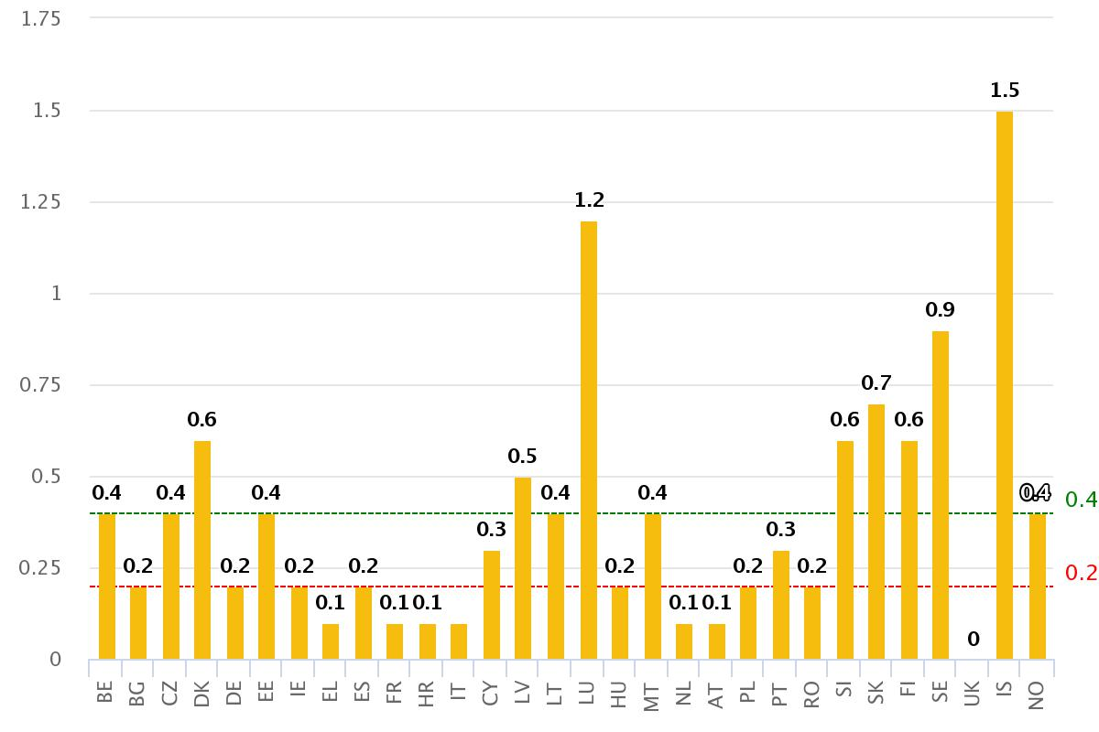

*Source: EURES Portal – Single Market Scoreboard 2017*

Figure 2 – Number of EURES advisers and similar staff at EU level in 2017

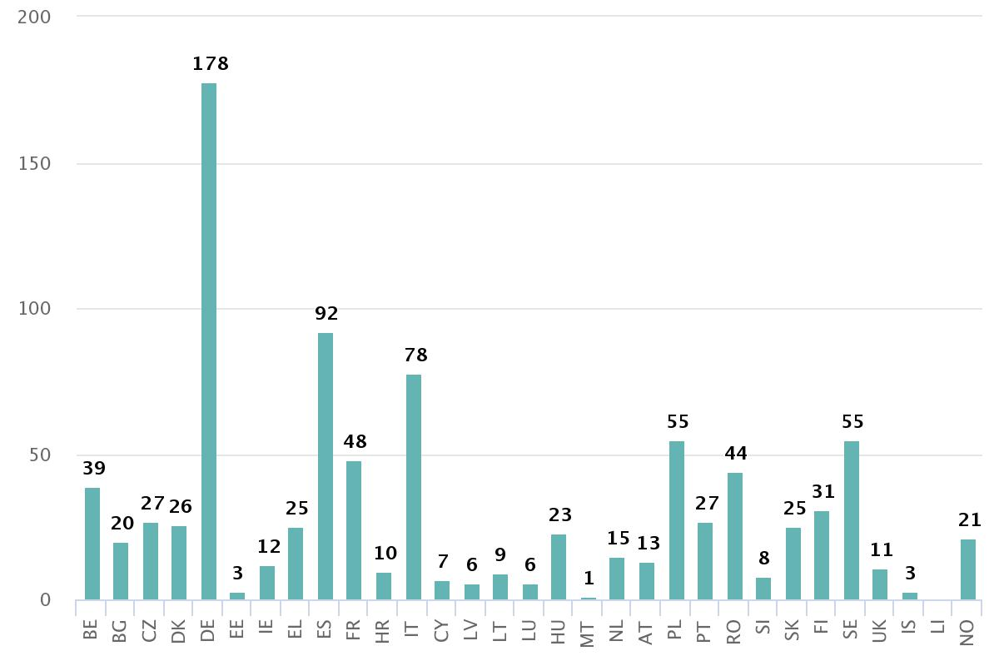

*Source: ECO – Single Market Scoreboard 2017*

Table 1 – Jobseekers registered on EURES portal

|  |  |
| --- | --- |
| *EURES country of residence* | *Jobseekers self-registered on the EURES portal (first semester 2018)* |
| AT | 2,937* |
| BE | 6,628 |
| BG | 8,028 |
| CY | 1,372* |
| CZ | 3,958* |
| DE | 12,453 |
| DK | 1,491* |
| EE | 1,549* |
| EL | 1,342 |
| ES | 60,846 |
| FI | 5,257 |
| FR | 17,510 |
| HR | 14,858 |
| HU | 6,776 |
| IE | 2,043* |
| IS | 401* |
| IT | 71,476 |
| LI | 4* |
| LT | 2,688* |
| LU | 703* |
| LV | 1,649* |
| MT | 685* |
| NL | 4,750 |
| NO | 2,113* |
| PL | 14,663 |
| PT | 17,250 |
| RO | 17,159 |
| SE | 3,959* |
| SI | 4,156* |
| SK | 1,279* |
| UK | 8,532 |

*Source: EURES Performance Measurement System report, first semester 2018 and EURES portal (if followed by “*)*

Figure 3 – Main sending countries (with outflows or nationals of more than 50,000) and changes compared to 2014

|  |  |
| --- | --- |
| ***Country of residence*** | ***Outflow of nationals***  ***(main sending countries)*** |
| RO | 157 (+11%) |
| PL | 123 (-16%) |
| UK | 105 (-9%) |
| DE | 79 (-6%) |
| IT | 75 (+14%) |
| ES | 69 (+19%) |

*Source: 2017 Annual Report on intra-EU Labour Mobility*

Figure 4 – Composition of intra-EU mobility by different types, EU-28 citizens in the EU-28, 2016

| ***Type of mobility*** | ***Extent*** |
| --- | --- |
| **‘Long-term’ EU-28 movers of working age** (20-64 years) living in EU-28 (Eurostat demography figures) | 11.8 million |
| *(as share of the total working-age population in the EU-28[39])* | *3.9%* |
| EU-28 movers of working age living in EU-28** (EU-LFS figures) | 11 million |
| …of which **active EU-28 movers** (employed or looking for work) | 9.1 million |
| *(as share of the total labour force in the EU-28)* | *4%* |
| **Cross-border workers** (20-64 years) | 1.4 million |
| *(as share of the total employed in the EU-28)* | *0.6%* |
| **Number of postings[40]** (of employed and self-employed), (no. of PDs A1) | 2.3 million |
| **Annual return mobility** (20-64 years) (2015) | 614,453 |
| *(as share of EU-28 nationals leaving their country of origin in 2014)* | *55%* |

*Source: 2017 Annual Report on intra-EU Labour Mobility*

Figure 5 – Employment of recent EU-28 movers and nationals by sector, EU-28 aggregate level, 2016

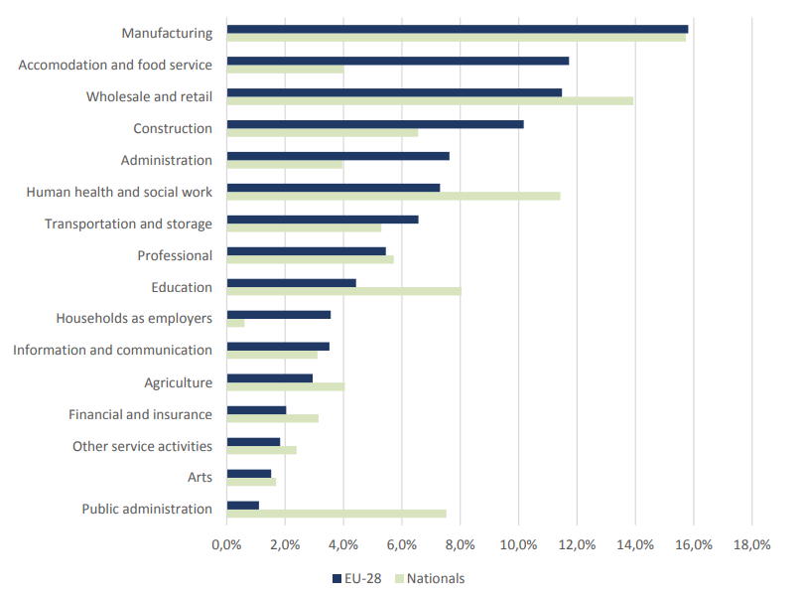

*Source: 2017 Annual Report on intra-EU Labour Mobility; EU-LFS 2016, Milieu calculation*

Figure 6 – Status with regard to the implementation in the Member States of the exchange of job vacancies (June 2018)

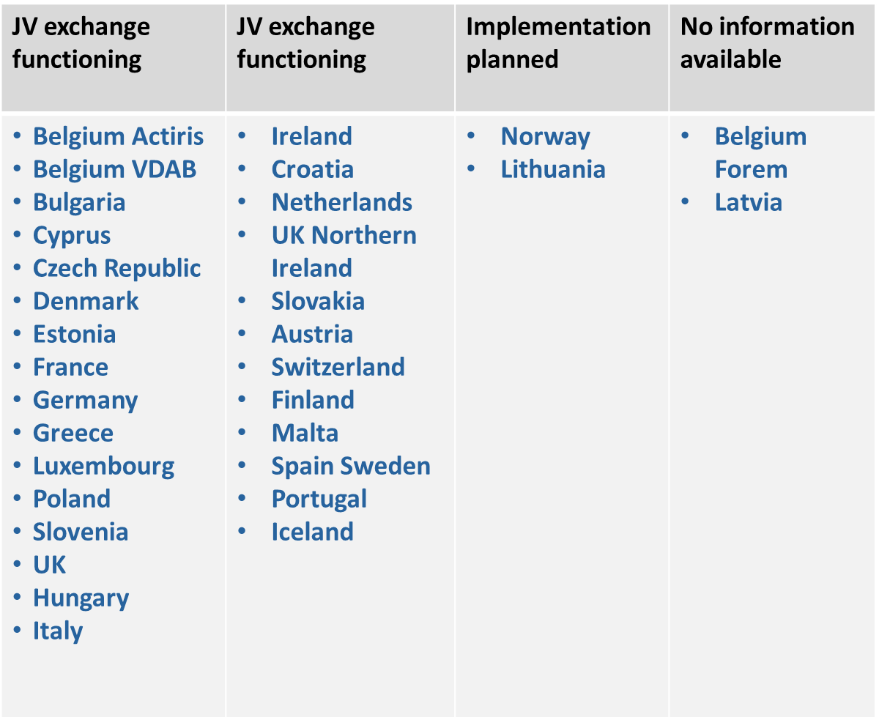

Figure 7 – Status with regard to the implementation in the Member States of the exchange of CVs (June 2018)

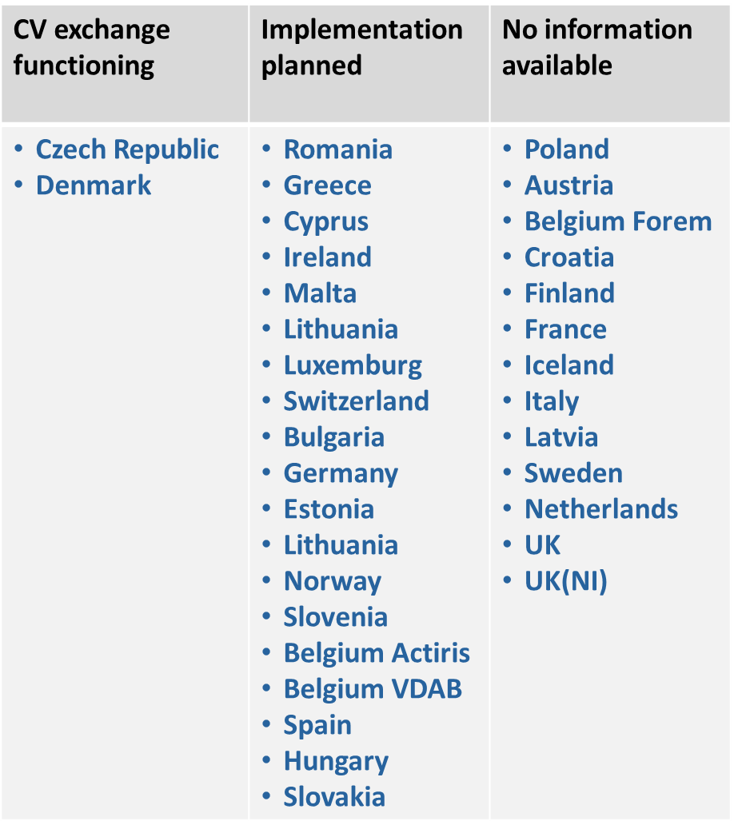

1. Note: The terms ‘workers’ and ‘employees’ are used as synonyms in this report. Furthermore, “*the Court of Justice has held that the freedom of movement of workers contained in Article 45 TFEU also entails certain rights for nationals of Member States moving within the Union for the purposes of seeking employment. The concept of ‘worker’ should therefore, for the purposes of this Regulation, be understood to cover jobseekers, regardless of whether they are currently in an employment relationship.*” (Regulation (EU) 2016/589, Recital 7).
2. The objectives of the EURES Network are laid down in Article 6 of Regulation (EU) 2016/589.
3. EURES Portal, [available at: https://ec.europa.eu/eures/public/en/homepage](https://ec.europa.eu/eures/public/en/homepage)
4. In this report, ‘EURES staff’ means personnel directly or indirectly involved in the delivery of services and other activities of the EURES network pursuant to Regulation (EU) 2016/589 and its implementing measures.
5. Commission Decision 93/569/EEC of 22 October 1993 on the implementing of Council Regulation (EEC) No 1612/68 on freedom of movement for workers within the Community as regards, in particular, a network entitled Eures (European Employment Services).
6. Commission Implementing Decision (EU) 2017/1255 of 11 July 2017 on a template for the description of national systems and procedures to admit organisations to become EURES Members and Partners.

   Commission Implementing Decision (EU) 2017/1256 of 11 July 2017 on templates and procedures for the exchange of information on the EURES network national work programmes at Union level.

   Commission Implementing Decision (EU) 2017/1257 of 11 July 2017 on the technical standards and formats required for a uniform system to enable matching of job vacancies with job applications and CVs on the EURES Portal.

   Commission Implementing Decision (EU) 2018/170 of 2 February 2018 on uniform detailed specifications for data collection and analysis to monitor and evaluate the functioning of the EURES network.

   Commission Implementing Decision (EU) 2018/1020 of 18 July 2018 on the adoption and updating of the list of skills, competences and occupations of the European classification for the purpose of automated matching through the EURES common IT platform.

   Commission Implementing Decision (EU) 2018/1021 of 18 July 2018 on the adoption of technical standards and formats necessary for the operation of the automated matching through the common IT platform using the European classification and the interoperability between national systems and the European classification.
7. Member States may exclude job offers “*which due to their nature or to national rules are open only to citizens of a specific country*”, “*relating to categories of apprenticeships and traineeships which, having mainly a learning component, are part of national education systems or which are funded publicly as part of a Member State’s active labour market policies*” and “*other job vacancies as part of a Member State’s active labour market policies*”, as per Article 17 of Regulation (EU) 2016/589.
8. Data from the EURES Single Market Scoreboard, 2017: <http://ec.europa.eu/internal_market/scoreboard/_docs/2018/eures/2018-scoreboard-eures_en.pdf>.
9. Until 2017, the number of placements were reported by EURES advisers on a voluntary basis (about 50-60% of all reporting) and EURES advisers are not systematically informed of placements by jobseekers or employers.
10. EURES Programming Cycle, Assessment of National Activity Reports 2016 and 2017.
11. As set out in Article 3(7) of Regulation (EU) 2016/589.
12. Data and monitoring reports are only available for the cross-border partnerships that receive funding under the EURES Axis of EASI. As an indication, 11 CBPs have done so successfully in EU budget year of 2014 (VP/2014/011), 12 in the EU budget year of 2015 (VP/2015/008), 10 in the EU budget year 2016 (call for proposals VP/2016/005), and 9 for the EU budget year of 2017 (VP/2017/006).
13. European Commission, EURES Cross-Border Partnerships, First Monitoring Report (2016) and Second Monitoring Report (2017).
14. National Activity Report Italy 2016.
15. European Council, Conclusions, 28-29 June 2012. Available at: <http://europa.eu/rapid/press-release_DOC-12-8_en.htm>.
16. As measured on the EURES portal on 23 August 2018.
17. Idem.
18. European Commission, Your First EURES Job, Targeted Mobility Schemes, 5th Progress Monitoring Report, July – December 2017, published in July 2018.
19. European Commission, Your First EURES Job, Targeted Mobility Schemes, 4th Progress Monitoring Report, January-June 2017, published in December 2017.
20. European Commission, Your First EURES Job, Targeted Mobility Schemes, 5th Progress Monitoring Report, July – December 2017, published in July 2018.
21. European Commission, Reactivate Progress Monitoring Report, February 2018 (Draft).
22. Information provided on the EURES Portal: <https://ec.europa.eu/eures/public/en/your-first-eures-job-emp> (accessed on 2 August 2018).
23. The term ‘EURES adviser’ is still frequently used in the EURES network, although it is no longer an officially recognised term with the entry into force of the Regulation (EU) 2016/589, which only refers to ‘EURES staff’ as the human resources involved in EURES.
24. For details, see Annex: Figure 2 – Number of EURES advisers and similar staff at EU level in 2017
25. Regulation (EU) 1304/2013 of the European Parliament and of the Council of 17 December 2013 on the European Social Fund and repealing Council Regulation (EC) No 1081/2006, Recital 5 and Article 3(a)(i).
26. Regulation (EU) 1296/2013 of the European Parliament and of the Council on of 11 December 2013 on a European Union Programme for Employment and Social Innovation ("EaSI") and amending Decision No 283/2010/EU establishing a European Progress Microfinance Facility for employment and social inclusion, Article 20 (b).
27. <https://www.pzc.nl/zeeuws-vlaanderen/grensarbeiders-sneller-te-vinden-via-app~ae498da1/>
28. <https://jeunes.leforem.be/>
29. In order to have a better overview of national EURES social media channels and their reach, ECO carries out a mapping exercise of EURES social media channels every year.
30. Commission Implementing Decision (EU) 2018/170 of 2 February 2018 on uniform detailed specifications for data collection and analysis to monitor and evaluate the functioning of the EURES network.
31. Single Market Scoreboard 2017 <http://ec.europa.eu/internal_market/scoreboard/performance_by_governance_tool/eures/index_en.htm> (accessed 2 August 2018). ECO reports that ‘in 2017, a total of 696 participants took part in onsite trainings, 480 in online trainings and 132 in the Consolidation Phase, covering 30 countries; in the first half of 2018, 360 participants from 27 EURES Member countries were scheduled classroom trainings. The quality of the training offer is monitored through customer feedback. In 2017, this highlighted that the majority of participants found the courses to be useful and well organised and the content applicable.’
32. Annual reports on intra-EU labour mobility 2016 and 2017 are available from the EU bookshop.
33. The report “Labour shortages and surpluses 2017” is available from the EU bookshop.
34. The table is not exhaustive as some specific budget items are not included such as the support to the EEA countries and social partners (depending on the call for proposals) and hosting fees for the portal.
35. Regulation 2016/589, Annex I: Minimum common criteria.
36. An implementing act, referring to Art.11(8) with a template for the description of the national system and procedures for sharing information between Member States has not yet been adopted.
37. For details on the status of the implementation in the individual Member States, see Annex figures 6 and 7.
38. This point was also a finding in the European Court of Auditors Special Report n°.6 (2018), accessible on: <http://publications.europa.eu/webpub/eca/special-reports/eu-labour-mobility-6-2018/en/>.
39. The total working-age population in the EU-28 in 2016 was 305,883,690.
40. The number indicates the total number of PDs A1 issued by EU-28 Member States referring to Regulation 883/2004. PDs A1 are issued for persons insured in a Member State other than the Member State of (temporary) employment. The number of PDs A1 is not necessarily equal to the number of posted workers. The total number of PDs A1 in 2016 was approximately two million, including the 1.6 million under Article 12 (on posting of employed and self-employed) as well as persons active in two or more Member States under Article 13 of Regulation (EC) No 883/2004) (620,185 PDs A1) and to other categories (44,538 PDs A1). Note that differences exist in the definition of ‘posting’ between Regulation (EC) No 883/2004 and Regulation 96/71/EC (Posting of Workers Directive).