

# 1. INTRODUCTION

With the entry into force of the Directive (EU) 2018/2001 on the promotion of the use of energy from renewable sources (RED II) on 24 December 2018, a new future-proof framework is established towards meeting the binding Union target of at least 32 % renewable energy in gross final energy consumption by 2030. This framework will build on the progress being achieved under the current Directive including *inter alia* the obligation for Member States to keep the 2020 targets as baseline of their respective trajectories for the next decade. This is further complemented by the other elements of the Clean Energy for All Europeans package[1].

Renewable energy is at the core of the Energy Union’s priorities. The Directive 2009/28/EC on the promotion of the use of energy from renewable sources[2] (RED I) is a central element in the Energy Union policy and a key driver for meeting the renewable energy targets for 2020.

The political priority of the European Union to become the global leader of renewables is underpinned by the presence of renewables in all five dimensions of the Energy Union. In terms of *energy security* renewables reduce the import dependency of fossil fuels. It is estimated that the increase in the use of renewable energy compared with the level of renewable energy consumption in 2005 allowed the EU to cut its demand for fossil fuels by 143 Mtoe in 2016[3] (approximately 12 % of total primary fossil fuel consumption). Similarly, Europe’s energy import dependence, notably as regards imports of oil and gas, will fall from todays 55% to 20% in 2050 thanks to a primary energy supply that would largely come from renewable energy sources[4]. For the *internal energy market,* renewables play an increasing role in particular for the power market where close to one third (30.8%) of the EU 28 gross electricity production was generated by renewables in 2017[5].

Also for renewable gases an increasing role is observed. An illustrative example is that the share of biogas in relation to the total consumption of gas was 18.6% in July 2018 in Denmark, which is an increase of 50% compared to the year before[6]. On *energy efficiency*, a reduced energy consumption is tightly linked to the reaching a higher share of renewables and the increased integration of small-scale renewables in buildings, improving the energy performance in a cost effective way. Furthermore, renewable energy plays a significant role for *decarbonisation* and in 2016 renewables have contributed to 460 Mt of gross avoided CO2 emissions (more than the total GHG emissions of Italy in 2016)[7] and it is estimated to grow to 499 Mt[8] in 2017. Additionally, renewables are a key contributor to the *innovation* dimension. In the area of renewables, 53% of inventions from EU based companies acquire patent protection outside Europe[9]. This demonstrates high-value of the innovation, since the protection is done with the view that it has scope to reach, and be successful in foreign markets. This makes the EU a global innovation leader as it is a higher share than any of the other major economies[10]. In this respect, as recognised by the International Renewable Energy Agency (IRENA), Europe has become a lighthouse in showing successful pathways to a renewables-based energy future, being at the forefront in energy innovation[11].

The leadership is also present for the different renewable technologies along their supply chains. For some technologies, like wind turbines, EU manufacturers accounted for at least 41 % of the new global installed capacity in 2016[12]. As regards EU PV industry, EU PV equipment manufacturers are leading with a global market share of 50%, while EU inverter manufacturers have a global market share of above 18%[13]. Further, to maintain and expand its position as the global leader in emerging renewable ocean energy technologies, for instance, the Commission engaged with Member States to join efforts to increase deployment and meet the cost-reduction targets set out in the SET-Plan[14]. The Commission has set up the Clean Energy Industrial Forum on Renewables to strengthen industrial basis for renewables in Europe. In close cooperation with the key actors of the sector, the Forum proposes actions to improve the competitiveness of the European supply chain for renewables.

The benefits of renewables expand well beyond the impacts on the five political dimensions above. Renewable energies are a source of economic growth and jobs for Europeans, in particular local jobs with more than 1.4 million people that are currently working in the sector and with a related turnover that is estimated to €154.7 billion[15].The recent report on energy prices and costs in Europe[16] documents furthermore positive impacts on industrial competitiveness since the greater amounts of renewable energy are a key factor behind the fall in wholesale energy prices in recent years. As highlighted by IRENA, the growing deployment of renewables has also set in motion a global energy transformation with significant implications for geopolitics and the EU is clearly in a frontrunner position[17].

They also contribute to lowering air pollution and helping developing countries with access to affordable and clean energy. Between 2011 and 2016, renewable power generation capacity grew with almost 10 GW and the number of people benefiting from off-grid renewable energy solutions grew six-fold, reaching more than 133 million[18]. It is estimated that by 2030, renewable energy sources will power over 60% of new electricity access, and stand-alone and mini-grid systems will provide the means for almost half of new access[19]. Last but not least, and most important, the lower cost of the technology, combined with digitalisation is making renewables the real driving force for consumers to be empowered and to play a key role in the energy transition.

This report provides the latest insights into progress made up to 2017 towards the 20% target for renewable energy in 2020 and addresses other European Commission reporting obligations under RED I and the Directive on Indirect Land Use Change (ILUC)[20]. The statistics on energy transmitted by Member States to Eurostat up to January 2019 are used as primary data source for evaluating progress towards the 2020 target. This report builds on the Member States 4th biannual renewable energy progress report covering the period 2015/16[21], as well as complementary technical analysis made in the course of 2018. It also includes an overview of the potential in terms of co-operation mechanisms and assessments of the administrative frameworks and biofuels sustainability.

# 2. EU-28 PROGRESS IN DEPLOYING RENEWABLE ENERGY

In 2017, the EU reached a share of 17.52% of renewable energy in gross final energy consumption, against a target of 20% for 2020, and above the indicative trajectory of 16% for 2017/2018. In addition, the EU as a whole is also above the slightly more ambitious trajectory defined by Member States themselves in their National Renewable Energy Action Plans (NREAPs)[22]. The EU is on track to reach its 2020 target. Over the past years, at EU level, there has been a continuous increase in the overall share of renewable energy sources (RES) and in the sectoral shares of renewable energy in electricity (RES-E), heating and cooling (RES-H&C), and, to a lesser extent, transport (RES-T).

However, the pace of increase of the renewable energy share has slowed down since 2014. Comparing to the share of 16.19% in 2014, the average increase over the period 2014-2017 was only of 0.44 percentage points a year, lower than the annual average increase of 0.83 percentage points a year that will be required to reach a 20% share in 2020. As the indicative trajectory from RED I is steeper in the last years, a sustained effort will be required to meet targets.

With regard to individual sectors, at EU level the renewable energy share in electricity and heating and cooling has been systematically above the levels defined by Member States in their NREAPs, while for transport, the share of renewables is basically following the planned trajectory.

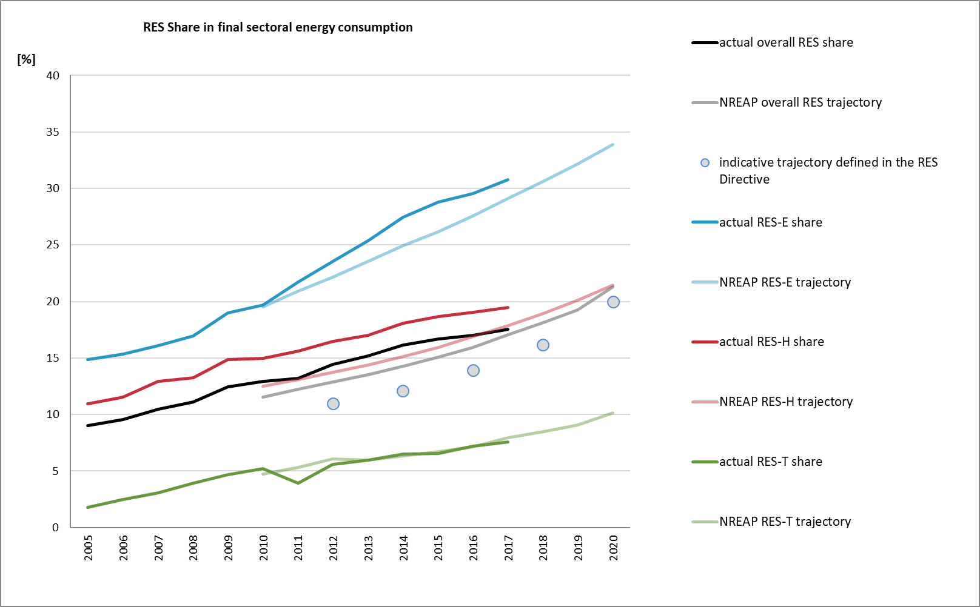

***Figure 1****: Actual and planned renewable energy shares for the EU 28 (2005-2020, %). Source: Eurostat and National Renewable Energy Action plans (NREAP)*

In terms of the absolute consumption of renewable energy, the heating and cooling sector provides the largest contribution with a total of 102 Mtoe in 2017, closely followed by renewable electricity, with a consumption of 86.7 Mtoe, and the transport sector, with a consumption of 23.65 Mtoe[23].

The main renewable sources used in energy consumption were biomass for heating and cooling, hydropower and wind for electricity, and biofuels for transport. In the electricity sector, a clear paradigm shift is happening towards renewables. One of the key factors has been the decline in the cost of electricity from solar PV and wind power, which over the period from 2009 to 2018 fell with nearly 75% and about 50% (depending on the market) respectively, due to capital costs reductions, advances in efficiency and supply chain improvements and competitive tendering for support schemes. In 2018, the Ourika project in Portugal was the first European solar project developed without any kind of public support. In Germany, the market premiums paid for a 1.4 MW solar PV project was below the market value for solar power in summer 2018, and in Denmark new wind power projects were developed for a fixed feed-in tariff of 2.5 EUR/MWh. In both Germany and the Netherlands, the tenders for the development of a 1610 and 700 MW offshore wind parks received zero-subsidy bids.

The decline in costs is also one of the key drivers for an increase in corporate sourcing of renewables, especially in the case where corporate energy users sign a direct power purchase agreement with a renewable energy developer. Over the period from 2015 to 2018, corporate power purchase agreements for renewable electricity in Europe[24] quadrupled from 506 MW to 1967 MW.

# 3. DETAILED ASSESSMENTS OF MEMBER STATES PROGRESS AND PROJECTIONS BY 2020

## Progress in electricity, heating & cooling and transport

The renewable energy shares reflect the historic diversity in Member States’ energy mix and their differences in renewable energy potential, with shares ranging from 6,4% in Luxembourg to 54,5% in Sweden in 2017 (see figure 2).

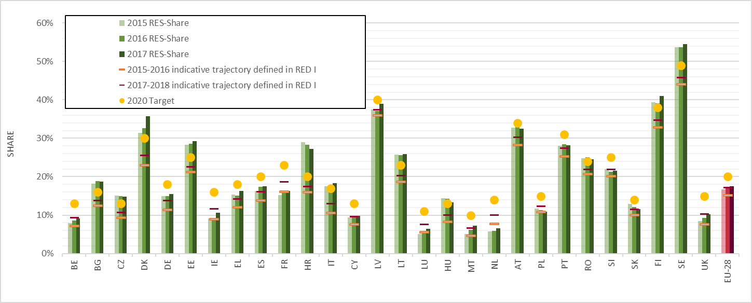

**Figure 2**: *EU and Member States renewable energy shares in gross final energy consumption 2015-17 vs. trajectories set in* RED I *(source: Eurostat)*

On the basis of the 4th renewable energy progress reports of the Member States (“progress reports”), that cover the period 2015-2016[25], 25 Member States were above their indicative trajectory of RED I for the period 2015/2016. Among the 3 Member States that were below their RED I trajectories, the Netherlands shows the largest gap, with an actual average share of 5.9% for 2015/2016, versus an indicative RED trajectory of 7.6%. The gap to the planned NREAP share of 9.7% renewable energy in 2016 is even larger. The country continues to be behind the planned RES-E trajectory and also somewhat delayed regarding its planned RES-T development. Luxembourg and France were also below their indicative RED I trajectories for 2015/2016, although only by a limited margin.

The Eurostat figures for 2017 do not show any significantly different picture. There are 11 Member States (Bulgaria, the Czech Republic, Denmark, Estonia, Finland, Croatia, Hungary, Italy, Lithuania, Romania, and Sweden) that have already achieved a share corresponding to their 2020 target. Out of the remaining 17 Member States, 10 Member States are already on, or above, their interim trajectories set in RED I for 2017-2018. The remaining 7 Member States (Belgium, France, Ireland, Luxembourg, the Netherlands, Poland, Slovenia) would need to step up efforts to comply with the average 2017-2018 trajectory towards 2020.

Looking at the absolute levels of consumption of renewable energy in EU 28, there is a significant increase from 189 Mtoe in 2015 to 204 Mtoe in 2017 i.e. 8%. However, in the same period the gross final consumption of energy raised from 1125 Mtoe to 1159 Mtoe, which resulted in a decreasing impact for renewable energy share, since this is calculated as the final renewable energy consumption divided with the gross final consumption of energy. This demand increase is one of the underlying key factors behind the lowering of the renewable energy share in 2017 compared to 2016 in 9 Member States (Austria, Bulgaria, Czech Republic, Hungary, Poland, Portugal, Romania and Slovakia).

Sectorial renewable energy shares grew for a large majority of the Member States between 2015-2017. However, for some Member States, the sectorial shares change by only less than 0.3 percentage points. This is the case for 9 Member States in RES-E (Bulgaria, Czech Republic, Spain, Hungary, Poland, Romania, Slovenia, Slovakia, Sweden), 7 in RES-H&C (Czech Republic, Germany, Hungary, Austria, Poland, Slovenia, Slovakia), and 10 for RES-T (Czech Republic, Denmark, Estonia, Hungary, Cyprus, Latvia, Luxembourg, Austria, Poland, Finland).

For the transport sector, where all Member States should reach the same target of 10%, this slowdown could be challenging in the 8 Member States (Estonia, Greece, Hungary, Cyprus, Latvia, Lithuania, Poland, Slovenia) that have less than 5% renewable energy consumption in the transport sector and that would therefore need a steep increase to reach the 10% target. The recourse to statistical transfers for the transport sector, enabled by the ILUC Directive is also a possible avenue to explore.

## Co-operation mechanisms

Co-operation mechanisms are based on Articles 6 to 11 of RED I. They include several mechanisms through which Member States can cooperate on renewable energy such as statistical transfers, joint projects and joint support schemes. Statistical transfers are particularly relevant to facilitate target achievement since they enable Member States that have reached a higher renewable energy share than their national target to transfer their surplus to another Member States. There are currently two agreements to make use of these statistical transfers between Luxembourg and Lithuania and between Luxembourg and Estonia. In both cases, they stipulate that Luxembourg will receive statistical transfers for the period 2018 – 2020.

According to the estimates that Member States have included in their progress reports, there would be an overall 12564 ktoe excess production of renewable energy, compared to the indicative trajectory, available for potential statistical transfers in 2020. This corresponds to around half of France gross final consumption of energy from renewable sources. For a Member State that may not meet the 2020 target using their own renewable sources, this could be a viable option to meet their target cost-effectively (see table 1).

|  |  |  |  |  |  |  |  |  |  |  |  |  |
| --- | --- | --- | --- | --- | --- | --- | --- | --- | --- | --- | --- | --- |
|  | **2009** | **2010** | **2011** | **2012** | **2013** | **2014** | **2015** | **2016** | **2017** | **2018** | **2019** | **2020** |
| Belgium |  |  | 0 | 0 | 0 | 0 | 0 | 0 | 0 | 0 | 0 | 0 |
| Bulgaria |  | 372 | 357 | 528 | 641 | 601 | 610 | 691 | 420 | 471 | 411 | 341 |
| Czech Republic |  | 0 | 0 | 0 | 0 | 1145 | 1039 | 947 | 863 | 892 | 678 | 643 |
| Denmark |  |  | 694 | 834 | 1123 | 1106 | 1223 | 1452 | 552 | 619 |  | 63 |
| Germany |  |  | 6895 | 8436 | 6546 | 9390 | 7272 | 7911 | 4130 | 5976 |  | 3065 |
| Estonia | 101 | 117 | 135 | 122 | 75 | 94 | 154 | 163 | 186 | 235 | 279 | 296 |
| Ireland |  |  |  | 93 | -14 | 111 | 79 | 26 | -142 | -12 | -239 | -366 |
| Greece |  | 137 | 201 | 320 | 242 | 195 | 137 | -162 | 737 | 743 | 683 | 529 |
| Spain |  |  | 2290 | 3083 | 2720 | 3357 | 1990 | 2963 | 2049 | 2793 |  | 839 |
| France |  | -641 | -2708 | -1877 | -1565 | -3721 | -4048 | -4075 | 0 | 0 | 0 | 0 |
| Italy | 8324 | 8613 | 7405 | 10011 | 10937 | 9343 | 9468 | 7789 | 7259 | 5828 | 4462 | 3397 |
| Cyprus | 0 | -11 | 28 | 44 | 45 | 43 | 29 | 29 | 57 | 34 | 21 | 0 |
| Latvia |  |  |  |  |  |  | -69 | -127 |  |  |  |  |
| Luxembourg | 0 | 0 | 0 | 0 | 0 | 0 | 0 | 0 | 0 | -50 |  | -120 |
| Hungary |  | 968 | 1150 | 1213 | 1295 | 883 | 970 | 803 |  |  |  |  |
| Malta |  |  |  |  |  |  | 4 | 10 |  |  |  | 0 |
| Netherlands |  |  |  |  |  |  | 0 | 0 | 0 | 0 | 0 | 0 |
| Austria | 0 | 0 | 0 | 0 | 0 | 0 | 0 | 0 | 0 | 0 | 0 | 0 |
| Poland |  | 543 | 729 | 929 | 530 | 93 | 174 | -260 | 968 | 968 |  | 587 |
| Portugal |  |  | 83 | 82 | 84 | 144 | 128 | 154 | 81 | 131 | -4 | 50 |
| Romania | 1153 | 1306 | 794 | 942 | 645 | 692 | 1089 | 886 | 258 | 405 | 263 | 0 |
| Slovenia | 0 | 0 | 0 | 0 | 0 | 0 | 0 | 0 | 0 | 0 | 0 | 0 |
| Slovakia |  |  | 302 | 254 | 142 | 222 | 305 | 364 | 90 | 110 |  | 0 |
| Finland | 0 | 0 | 0 | 0 | 0 | 0 | 0 | 0 | 0 | 0 | 0 | 0 |
| Sweden | 2407 | 2141 | 2482 | 3318 | 3214 | 3335 | 3347 | 3475 | 3215 | 3610 | 3428 | 3241 |
| Total | **11985** | **13544** | **20838** | **28332** | **26660** | **27033** | **23901** | **23038** | **20722** | **22752** | **9982** | **12564** |

**Table 1**: *Actual and estimated excess and/or deficit production of renewable energy in Member States compared to the indicative RED trajectory (ktoe). Source: Navigant 2019[26], Member States reports[27].*

## Projections

In order to assess the feasibility of 2020 target achievement, a modelling exercise[28] has been carried out for the Commission. The analysis explores to what extent Current Policy Initiatives (CPI) on renewable energy (as reported by the Member States in their progress reports), complemented by Planned Policy Initiatives (PPI), would be sufficient to trigger the targeted renewable energy deployment in the running up to 2020, for each Member State. This modelling finds that a renewable energy share of 18.1% to 20.7% can be expected for 2020 at EU level with currently implemented and planned renewable energy policy initiatives[29]. A number of Member States is expected to perform well in the remaining years, reaching deployment levels beyond their target levels.

However, for 11 Member States (Belgium, Cyprus France, Greece, Ireland, Luxembourg, Malta, the Netherlands, Poland, Portugal and the United Kingdom), currently implemented renewable energy policies and already planned renewable energy policy initiatives appear today to be insufficient to trigger the required renewable energy volumes purely domestically.

In addition, for 7 Member States (Austria, Germany, Latvia, Romania, Slovenia, Slovakia and Spain) there is some uncertainty related to 2020 renewable energy target achievement. Their capability of meeting their 2020 national binding targets will to a great extend depend on the levels of energy demand in case there would be a large increase in energy demand that brings their energy consumption back in line with the original trend indicated by the latest EU reference scenario. Taking into account the agreed co-operation mechanisms for Luxembourg, Estonia and Lithuania, the results are shown in figure 4.

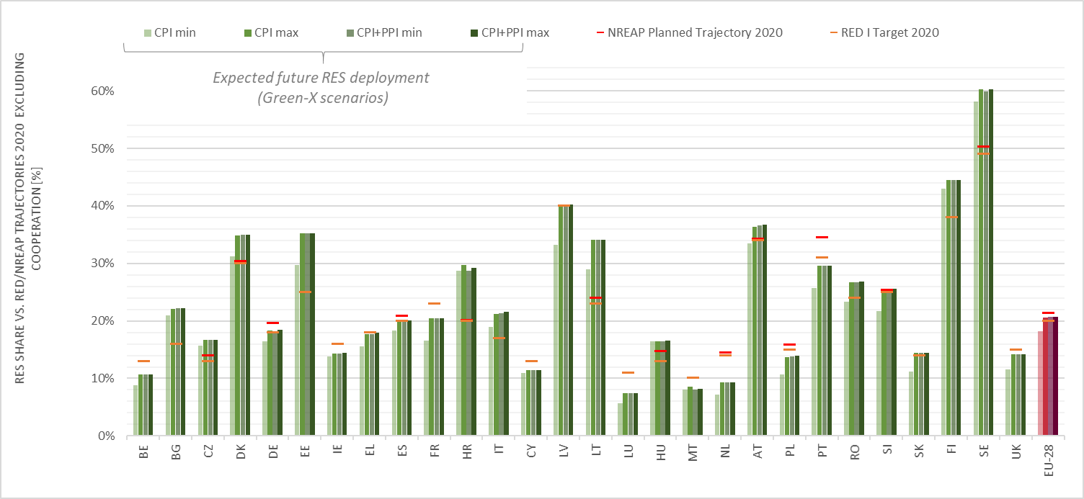

**Figure 3**. *Expected renewable energy share in 2020 vs. 2020 RED targets and 2020 planned (NREAP) targets (%) excluding cooperation. (Navigant 2019[30])*

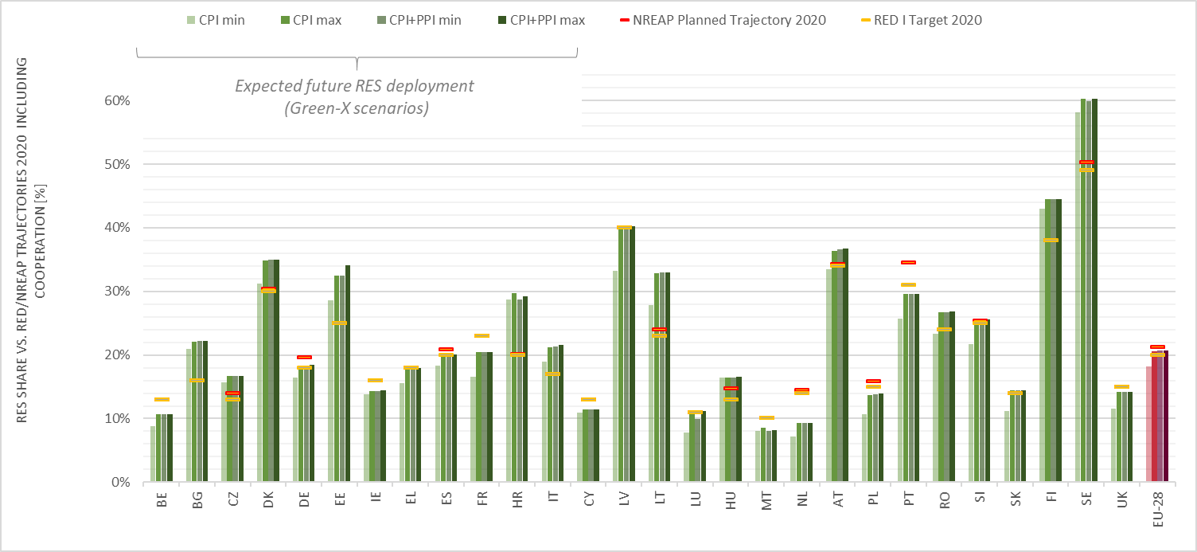

**Figure 4**. *Expected renewable energy shares in 2020 vs. 2020 RED targets and 2020 planned (NREAP) targets, including cooperation mechanisms (MS, %). Source: Navigant 2019.*

Due to the relatively low total energy consumption of Luxembourg, the transfers from Estonia and Lithuania have a significant impact on Luxembourg’s capability to achieve its target: Luxembourg is expected to meet its 11% 2020 target in the most optimistic scenarios. These same transfers have a limited impact for both Estonia’s and Lithuania’s renewable energy share, which only decrease by 0.7% for Estonia and 0.9% for Lithuania in the worst case scenario.

Going forward, according to their draft 2030 National Energy and Climate Plans[31], all Member States have already tabled their national contributions to the EU level binding target of at least 32 % which would make renewables the backbone of the Union energy system. By June 2019, the Commission will assess whether these national contributions, and the associated policies and measures, are in line with the EU ambition, and, if appropriate, issue recommendations to Member States.

## Administrative barriers

In their 4th national renewable energy progress reports, Member States report on measures to streamline administrative procedures for renewable energy projects (pursuant article 13 of RED I). According to external analysis[32], in global terms, a large share of the relevant measures in the REDI have been successfully implemented across the Member States. These measures include, amongst others: facilitated procedures for small-scale projects, requirements on system operators to provide cost estimates and other necessary information, requirements on the distribution of costs of grid development and grid connection of renewable energy, consideration of RES-E in the national network development plan, and the existence of support schemes promoting the use of renewable energy.

However, barriers related to building and planning procedures have increased in recent years. For the electricity sector, the development towards larger projects has imposed some barriers, since such projects have additional requirements in terms of spatial and environmental planning. For the heating and cooling sector, the barriers are mainly due to shortcomings related to the capacities of the district heating networks, while the transport sector mainly sees barriers arising from the lack of adequate infrastructure both for biofuels and electric vehicles. The integration of the increasing RES capacities in the grid is also a persisting challenge for the majority of the Member States. The barriers mainly arise from high cost of grid connection as well as from the lack of predictability and transparency of the grid connection procedures.

# 4. ASSESSMENT OF SUSTAINABILITY OF BIOFUELS[33]

## Overview of biofuel consumption in the EU

In 2016, the EU consumption of sustainable biofuels amounted to 13,840 ktoe. Of this, 11,083 ktoe (80%) was biodiesel and 2,620 ktoe (19%) was bioethanol. Most (64%) of the biodiesel consumed in the EU in 2016 was produced from feedstocks from the EU, mainly from rapeseed (~38%), used cooking oil (13%), animal fat (8%) and tall oil (2.5%). Of the remaining 36% of biodiesel consumed in the EU, 19.6% was palm oil from Indonesia (13.3%) and Malaysia (6.3%), 6.1% was rapeseed from mainly Australia (2.6%), Ukraine (1.8%) and Canada (1.2%), 4.8% was used cooking oil from various countries outside the EU and 4.3% was soybean from mainly the United States (1.5%) and Brazil (1.5%).

Ethanol consumed in the EU is produced also mainly from EU feedstocks (65%), including from wheat (~25%), corn (~22%) and sugar beet (17%) and only a small amount (~1%) from cellulosic ethanol. Ethanol-based feedstock from outside the EU includes corn (16.4%), wheat (2.9%) and sugar cane (2.9%) from various parts. The main third countries producing feedstock for bioethanol consumed in the EU include Ukraine (9.8%), Russia (2.1%), Brazil (1.8%), the US (1.7%) and Canada (1.6%).

It is estimated that almost all biogas consumed in the EU in 2016 was sourced from domestic feedstock, chiefly from crops and agro/food waste (including manure) (75%), followed by landfill gas (16%) and sewage sludge gas (9%). The origin of bioliquids, which in 2016 accounted for less than 1% of all bioenergy consumed in the EU, is difficult to ascertain as Member States do not split between feedstocks used for biofuels and bioliquids.

|  |  |  |  |  |  |  |  |
| --- | --- | --- | --- | --- | --- | --- | --- |
|  | Biogas | *Biogasoline* | *Biodiesel* | *Other liquid biofuels* | *Bio jet kerosene* | Total Liquid biofuels | Total |
| Road | 131 | *2,619* | *11,041* | *4.5* | *-* | 13,664 | **13,796** |
| Rail | 0.0 |  | *32.9* | *0.0* | *-* | 32.9 | **33.1** |
| International aviation | - | *0.0* | *0.0* | *0.0* | *0.0* | 0.0 | **0** |
| Domestic aviation | - | *0.0* | *0.0* | *0.0* | *0.0* | 0.0 | **0** |
| Domestic Navigation | 0.0 | *1.4* | *3.5* | *0.0* | *-* | 5.0 | **5.0** |
| Non-specified transport | 0.5 | *0.0* | *6.2* | *0.0* | *0.0* | 6.2 | **6.7** |
| **Total** | **132** | ***2,620*** | ***11,083*** | ***4.5*** | ***0.0*** | **13,708** | **13,840** |

**Table 2**: *Final bioenergy consumption in EU transport (2016, ktoe). Source: Eurostat*

## Impacts of biofuels consumed in the EU

It is estimated that 4.9 Mha of land was required for the production of crops for EU biofuel consumption in 2016, based on an analysis of the origin of biofuels feedstock.[34] Of that amount, 3.6 Mha (73%) is located within the EU and the remaining 1.3 Mha (26%) is located in third countries. In terms of the total amount of cropland dedicated to biofuel production, in the EU it was 3.1% (on the basis of an estimate of total EU cropland of 115 Mha), with rapeseed representing 56% of the share of the total land used for biofuels production. From the four main countries outside the EU supplying crops for the production of biofuels which are consumed in the EU (Ukraine, Brazil, Indonesia and Malaysia), less than 0.5% of their total cropland was attributed to this use.

According to information reported by Member States, total emission savings from the use of biofuels in transport in the EU amounted to 33.2 Mtonne CO2eq in 2016. Taking into account ILUC emissions estimated using 2016 crop feedstock volumes multiplied by the corresponding mean ILUC values from the ILUC Directive, total emission savings from the use of biofuels in transport in the EU are reduced to 11.8 Mtonne of CO2eq (with a range from 7.4 to 20.4 Mtonnes of CO2eq savings)[35].

A recent comprehensive review[36] of the latest available scientific literature conducted for the Commission indicates that biodiesel is associated with the most significant ILUC impacts (with a median ILUC emission level of 52 gCO2-eq/MJ), with the highest estimates within that category being for palm oil biodiesel, which also has the highest variation in results. Food and feed-crop based ethanol has a median ILUC emission level of 21 gCO2-eq/MJ. In comparison, the provisional estimated ILUC emissions listed in Annex VIII of the recast Renewable Energy Directive are 55 gCO2eq/MJ for oil crops, 12 gCO2eq/MJ for cereals and other starch-rich crops, and 13 gCO2eq/MJ for sugars. The review contains further information on the indirect impacts of biofuels.

The cultivation of feedstocks used for the production of biofuels consumed in the EU can potentially result in negative environmental impacts, which are site-specific and depend on the agricultural practices applied[37]. In their Progress Reports, most Member States point to limited cultivation of feedstock used in biofuel production compared to total agricultural activities, and consider therefore that associated environmental impacts are insignificant. Several Member States point out that all agricultural production is regulated with respect to environmental impacts and therefore consider that no more impacts should be expected from biofuel crop production than other crop production[38]. A detailed assessment of the environmental impacts of the production of biofuels consumed in the EU is contained in an external study[39] . A comprehensive report providing the latest available data and assessment on the status of production expansion of food and feed crops worldwide has also been published recently by the Commission[40].

The EU bioenergy sustainability framework has been reinforced under the recast Renewable Energy Directive. In particular, the Directive sets national limits, which will gradually decrease to zero by 2030, for high-ILUC biofuels, bioliquids and biomass fuels produced from food or feed crops for which a significant expansion of the production area into land with high carbon stock is observed. These limits will affect the amount of these fuels that can be counted when calculating the overall share of renewables and the share of renewables in transport. The Directive however makes it possible to exempt from the national caps those biofuels, bioliquids and biomass fuels that are certified as low ILUC-risk.

To implement this approach, on 13 March 2019 the Commission adopted a Delegated Act on high and low-ILUC risk biofuels[41], which is now with the Council and European Parliament for scrutiny. Generally, the EU decided to focus in the future on the promotion of advanced biofuels and other low carbon fuels, such as renewable electricity and renewable liquid and gaseous transport fuels of non-biological origin. Advanced biofuels have only a very small market share today but there is a significant potential to scale-up production. The Commission will continue to promote the development of advanced biofuels including by exploring sources for potential new feedstocks. While at this stage there is no sufficient scientific evidence available to justify an enlargement of the feedstock base for advanced biofuels laid down in Annex IX of REDII, the Commission will continue to assess whether additional feedstocks could be used for the production of advanced biofuels in the future[42].

## Operation of the voluntary schemes recognised by the Commission

RED I empowers the Commission to recognise international or national certification schemes, referred to as voluntary schemes, which operators can use to demonstrate compliance with the sustainability and greenhouse gas saving criteria of the Directive for biofuels and bioliquids. Currently, 14 voluntary schemes have been recognised for this purpose[43]. Member States are required to accept the evidence regarding the sustainability criteria obtained by operators participating in these schemes. This provision greatly facilitates the implementation of the sustainability criteria as it allows operators to provide the required evidence following a single administrative procedure in all EU Member States[44]. Each voluntary scheme on which a decision has been adopted and which has been in operation for the last twelve months is required to deliver annually a report to the Commission[45].

Over the last few years, voluntary schemes have become the main tool to demonstrate compliance with the EU biofuel sustainability criteria. During the calendar year 2017, 21,429 kilotons (kt) of liquid biofuels (including pure vegetable oil), 140,045 thousand m3 of biomethane (equivalent to around 100.8 kt), and 119,119 kt of feedstock have been certified to comply with the EU sustainability criteria as set out in Articles 17(2)-(5) of the Renewable Energy Directive. Looking in more detail at the certified liquid biofuels, 12,198 kt (57% of the total amount) was biodiesel and 6,224 kt (29%) was bioethanol. The rest was made up of Hydrotreated Vegetable Oil (HVO) biofuels (1,784 kt, 8%), pure vegetable oil (1,053 kt, 5%) and other fuels. The largest volumes of certified feedstock used for biofuels were rapeseed (27%), palm oil (16%), used cooking oil (13%) and corn (12%).

The Commission only recognises schemes that fulfil adequate standards of reliability, transparency and independent auditing. For this purpose, the Commission conducts a thorough assessment of the voluntary schemes requesting recognition[46]. This ensures that, among other things: feedstock producers comply with the sustainability criteria of RED I, information on sustainability characteristics is traceable to the origin of the feedstock, companies are audited before they start to participate in the scheme, retroactive audits take place regularly and auditors are external and independent.

In recent years, the governance of the voluntary schemes has received increasing public scrutiny[47]. In order to address these concerns and guarantee robust implementation, Article 30 of REDII includes strengthened rules for the verification of the bioenergy sustainability criteria, including stronger national and EU oversight of voluntary schemes and third party auditing. In addition, the Commission is required to adopt detailed implementing rules on adequate standards of reliability, transparency and independent auditing and require all recognized voluntary schemes to apply them. Finally, the Commission will establish a European database in order to improve the tracing of sustainable biofuels.

|  |  |  |  |
| --- | --- | --- | --- |
| **Voluntary scheme** | **Scope** | | |
| *Name* | *Feedstock type* | *Feedstock origin* | *Supply chain covered* |
| International Sustainability and Carbon Certification (ISCC) | Wide range of feedstocks | Global | Full supply chain |
| Bonsucro EU | Sugar cane | Global | Full supply chain |
| Roundtable on Sustainable Biomaterial EU RED (RSB EU RED) | Wide range of feedstocks | Global | Full supply chain |
| RTRS EU RED | Soy | Global | Full supply chain |
| U.S. Soybean Sustainability Assurance Protocol (SSAP) | Soy | US | From cultivation to place of export |
| Biomass Biofuels voluntary scheme (2BSvs) | Wide range of feedstocks | Global | Full supply chain |
| Scottish Quality Farm Assured Combinable Crops Limited (SQC) | All cereals and oilseeds | North Great Britain | Until the first feedstock delivery point |
| Red Tractor Farm Assurance Combinable Crops & Sugar Beet (Red Tractor) | Cereals, oilseeds, sugar beet | UK | Until the first feedstock delivery point |
| REDcert | Wide range of feedstocks | Europe | Full supply chain |
| Better Biomass | Wide range of feedstocks | Global | Full supply chain |
| Gafta Trade Assurance Scheme | Wide range of feedstocks | Global | Chain of custody from farm gate to first processor |
| KZR INiG System | Wide range of feedstocks | Europe | Full supply chain |
| Trade Assurance Scheme for Combinable Crops (TASC) | Combinable crops, such as cereals, oilseeds and sugar beet | United Kingdom | Chain of custody from farm gate to first processor |
| Universal Feed Assurance Scheme(UFAS) | Feed ingredients and compound feeds as well as combinable crops | United Kingdom | Chain of custody from farm gate to first processor |

***Table 3****: Voluntary schemes currently recognised by the Commission*

# 5. CONCLUSIONS

The EU is on track for reaching its renewable energy target for 2020. In 2017, the share of renewable energy in the EU energy mix has reached 17.52%. Investments in renewable energy are increasingly driven by the market and the share of public subsidies is falling. This has been triggered by the significant cost reductions in renewable energy technologies, the decrease of subsidies through more competitive support schemes and exemplified by the numerous zero or low cost auction results in several European countries.

However, the pace of increase of the renewable energy share has slowed down since 2014. While the EU is still on track to meet its renewable energy 2020 targets, efforts should be stepped up in the remaining period until 2020 to ensure this is the case, also in connection with expected higher energy consumption in the future. In 2017, 11 Member States already have a renewable energy share above their respective 2020 targets. 10 other Member States met or exceeded their average indicative trajectory from the Renewable Energy Directive for the two-year period 2017-2018. There are, however, 7 Member States (Belgium, France, Ireland, Luxembourg, The Netherlands, Poland and Slovenia) that would need additional efforts in order to comply with the average 2017-2018 indicative trajectory towards 2020.

In order to meet 2020 renewable energy targets, and sustain these levels as a baseline from 2021 onwards, most Member States are encouraged to continue stepping up efforts to both deploy renewables across the three sectors, while at the same time reducing energy consumption. Recent modelling has shown that the currently implemented renewable energy policies and already planned renewable energy policy initiatives might be insufficient in a number of Member States to reach their national binding targets in time, if only domestic supply, without cooperation mechanisms, is considered. Finally, Member States should consider the possibility of using statistical transfers, as foreseen in the Renewables Directive, either as a way to ensure target achievement when there is a deficit, or to sell their potential surpluses to other Member States. The Commission stands ready to actively support Member States in this regard and facilitate the necessary cooperation.

In this context, the new mobilisation of efforts at all levels and across the European Union is on-going. This is taking place inter alia through the dedicated Task Force on energy efficiency launched by the Commission, alongside the new renewable energy auctions already announced in several Member States for instance in France, the Netherlands, and Portugal, or the wider use of corporate power purchase agreements through which European companies bought a record amount of wind power capacity in 2018. These measures are expected to bring results in the years to come.

Biofuels consumed in the EU continue to be largely produced from domestic feedstock. The EU sustainability criteria have been successful in minimizing the risk of major direct environmental impacts associated to biofuels, irrespective of whether they are produced domestically, or imported from third countries. Over the last few years, voluntary schemes recognized by the European Commission have become the main tool to demonstrate compliance with the EU biofuel sustainability criteria, and therefore they have been subject to increased public scrutiny. Furthermore, RED II includes a reinforced sustainability framework for all bioenergy uses (not limited to biofuels, but covering also biomass and biogas use in heat and power), including a new approach limiting the role of high ILUC-risk biofuels. The governance of the voluntary schemes has been strengthened, including the robustness of third party auditing.

1. <https://ec.europa.eu/energy/en/topics/energy-strategy-and-energy-union/clean-energy-all-europeans>
2. Directive 2009/28/EC of the European Parliament and of the Council of 23 April 2009 on the promotion of the use of energy from renewable sources, OJL 140, p. 16-62
3. <https://www.eea.europa.eu/publications/renewable-energy-in-europe-2018>
4. COM(2018) 773: A Clean Planet for all. A European strategic long-term vision for a prosperous, modern, competitive and climate neutral economy
5. Eurostat
6. News release from Energinet.dk 31st August 2018
7. <https://www.eea.europa.eu/publications/renewable-energy-in-europe-2018/>
8. EEA, estimates for 2017
9. JRC (2017), Monitoring R&I in Low-Carbon Energy Technologies, <http://publications.jrc.ec.europa.eu/repository/handle/JRC105642>   
10. United States, Japan, South Korea, China
11. IRENA (2019), Report on [Innovation landscape for a renewable-powered future: Solutions to integrate variable renewables](https://irena.org/publications/2019/Feb/Innovation-landscape-for-a-renewable-powered-future), launched in Brussels on 19 February 2019
12. JRC (2017) Supply chain of renewable energy technologies in Europe
13. Hoogland O., Van der Lijn, N., Rademaekers, K., Gentili, P., Colozza, P., Morichi, C., 2017, Assessment of Photovoltaics (PV) Task F Strategies to rebuild the European PV sector, Trinomics
14. <https://ec.europa.eu/energy/en/topics/technology-and-innovation/strategic-energy-technology-plan>
15. Eurobserv’ER (2019) 2018 barometer. https://www.eurobserv-er.org/18th-annual-overview-barometer/
16. https://ec.europa.eu/energy/en/data-analysis/energy-prices-and-costs
17. IRENA (2019). A New World: the geopolitics of the energy transformation
18. IRENA (2018), Off-grid Renewable Energy Solutions: Global and Regional Status and Trends.
19. IEA (2017) WEO-2017 Special Report: Energy Access Outlook.
20. Directive (EU) 2015/1513
21. <https://ec.europa.eu/energy/en/topics/renewable-energy/progress-reports>
22. <https://ec.europa.eu/energy/en/topics/renewable-energy/national-action-plans>
23. Eurostat SHARES 2017. Using the multipliers set in RED I
24. Including Norway
25. <https://ec.europa.eu/energy/en/topics/renewable-energy/progress-reports>
26. Navigant 2019: [Technical assistance in realisation of the 4th report on progress of renewable energy in the EU, final report](https://ec.europa.eu/energy/sites/ener/files/documents/technical_assistance_in_realisation_of_the_4th_report_on_progress_of_renewable_energy_in_the_eu-final_report.pdf)
27. The table only includes Member States that provided this specific information in their progress report
28. The scenario calculation was done by application of the Green-X model , which is a simulation tool for renewable energy policy instruments in Europe <https://green-x.at/>.
29. The range indicates the uncertainty related to key input parameter for the model-based assessment of future renewable energy progress. Future energy demand (growth) and the policy implementation play a decisive role in this respect
30. Navigant 2019: [Technical assistance in realisation of the 4th report on progress of renewable energy in the EU, final report](https://ec.europa.eu/energy/sites/ener/files/documents/technical_assistance_in_realisation_of_the_4th_report_on_progress_of_renewable_energy_in_the_eu-final_report.pdf)
31. https://ec.europa.eu/energy/en/topics/energy-strategy-and-energy-union/governance-energy-union/national-energy-climate-plans
32. Navigant 2019
33. Main source for the data and assessement contained in this section: Navigant, 2019: Technical assistance in realisation of the 2018 report on biofuels sustainability.
34. The analysis of biofuels feedstock takes into account international trade in biofuels and their feedstocks, and conversion efficiencies.
35. Calculated on the basis of the provisional estimated indirect land-use change emissions from biofuel, bioliquid and biomass fuel feedstock (g CO2eq/MJ) in Annex VIII of Directive (EU) 2018/2001. For further details, See Navigant 2019.
36. Wageningen Research, Netherlands Environmental Assessment Agency and CENER, 2017, Study on reporting requirements on biofuels and bioliquids stemming from the Directive (EU) 2015/1513.
37. It should however be noted that neither site-specific data nor data related specifically to the local environmental impacts of cultivation of feedstocks for biofuel production are available.
38. Note that the current Common Agricultural Policy (CAP) contributes substantially to support biodiversity and promote sustainable farming systems through the complementary actions of a range of various instruments. As regards the future CAP post 2020 one of the nine specific CAP objectives is to contribute to the protection of biodiversity, enhance ecosystem services and preserve habitats and landscape. The policy aims to increase the level of environmental and climate ambition.
39. Navigant 2019.
40. EC, 2019, Report on the status of production expansion of relevant food and feed crops worldwide.
41. C(2019) 2055 final.
42. The review of the list of feedstock set out in Parts A and B of Annex IX of the Directive with a view to adding feedstock that meet a set of strict criteria will take place by June 2021.
43. https://ec.europa.eu/energy/sites/ener/files/documents/voluntary_schemes_overview_february_2019.pdf
44. The Communication from the Commission on voluntary schemes and default values (2010/C 160/01) has set out the principles how the Commission carries out its responsibilities leading to such decisions. This document was complemented by a communication on the practical implementation of the EU biofuels and bioliquids sustainability scheme ((2010/C 160/02)).
45. Navigant, 2019. Review of voluntary scheme annual reports.
46. Details the recognition process of voluntary schemes can be found on the following Commission website: <https://ec.europa.eu/energy/en/topics/renewable-energy/biofuels/voluntary-schemes>.
47. European Court of Auditors (ECA), 2016, Special report No 18/2016: The EU system for the certification of sustainable biofuels.