

# Introduction

In December 2018, the European Parliament and the Council of the European Union adopted the revised Energy Efficiency Directive (EED)[1]. The revised EED set the 2030 energy efficiency target to be at least 32,5 %[2]. It also included a possible upward revision clause, which increases the level of ambition compared to efforts required to meet the 2020 targets. Energy efficiency is strong driver to achieve the 2020 and 2030 climate targets and also a key building block for the Commission’s proposal for ‘A European strategic long-term vision for a prosperous, modern, competitive and climate-neutral economy’[3] tabled in November 2018.

In this context, it is important that the 2020 targets for energy efficiency are met with measures that can continue to deliver energy savings in the next decade.

This report provides the latest insights into progress made up until 2017 to meet the 20 % target before 2020.[4] The official European statistics on energy, which Member States sent to Eurostat up to January 2019, were used as the primary data source. The report builds on the 2017 Energy Efficiency Progress Report,[5] the 2018 Annual Reports submitted by Member States, and complementary analysis carried out during 2018. To better understand the factors behind recent energy trends, a decomposition analysis developed by the Joint Research Centre (JRC)[6] and the Odyssee-Mure project[7] was used.

The main findings are as follows:

* Following a gradual decrease between 2007 and 2014, energy consumption increased between 2014 and 2017.
* Primary energy consumption rose by 0,9 % in 2017 compared to 2016. Final energy consumption increased by 1,1 % in 2017. At present, both are slightly above the fixed trajectory towards the 2020 target.
* Weather variations[8] are one of the main reasons for the fluctuations observed in energy consumption in recent years. Weather-corrected figures for energy consumption are less volatile, but also show a rebound trend since 2014 (Figure 1).
* Increases in economic activity continue to push energy consumption up. Energy savings have helped offset the impact of these increases, leading to gradual improvements in energy intensity. However, in recent years, energy savings were not high enough to offset the impact of the growth in economic activity, possibly also due to the delays in implementing energy efficiency policies in some Member States.
* Based on an assessment of the latest national energy efficiency action plans (NEEAPs) and 2018 annual reports, it is clear that, collectively, Member States are making good progress in achieving energy savings under Article 7 of the EED. However, some Member States are lagging behind and might not reach their cumulative savings requirements for 2014–2020.

If the increasing trend in energy consumption observed since 2014 continues in the coming years, reaching the 2020 target both for primary and final energy consumption could be at risk. Therefore, there is a need to further intensify efforts to deliver energy savings in the short term.

In order to better assess the growing energy consumption trend and identify a possible way forward, in July 2018 the European Commission set up a Task Force on mobilising efforts to reach the EU energy efficiency targets for 2020.[9] So far, the Task Force highlights in particular the need to better mobilise funding, increase the rate and depth of building renovation and ensure that minimum energy performance standards are met.

**Figure 1**: GDP and weather-corrected final energy consumption, 1995-2016[10]

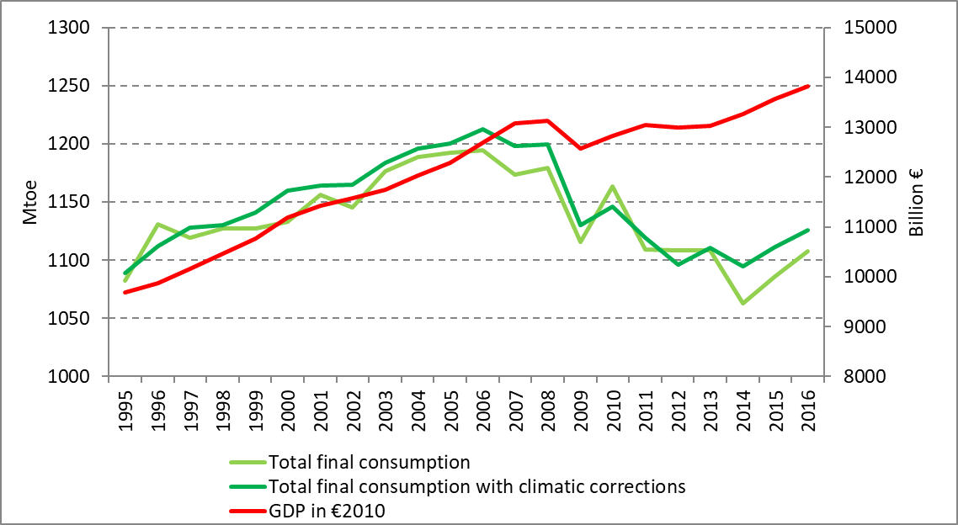

*Source: Odyssee-Mure*

# Progress towards the EU’s 2020 energy efficiency target

Final energy consumption[11] in the EU fell by 5,9 %, from 1193 Mtoe in 2005 to 1122 Mtoe in 2017. This is 3,3 % above the 2020 final energy consumption target of 1086 Mtoe. It decreased at an annual average rate of 0,5 % between 2005 and 2017, although the downward trend was interrupted in 2015 when final energy consumption started to rise again (it rose by 1,1 % in 2017 compared to the previous year).

In 2017, higher energy consumption was mainly seen in transport (+2,5 % year-on-year increase) and industry (+1,6 %). Energy consumption did not change in the services sector, and it decreased in the residential sector (-0,5 %).

Transport accounted for 34 % of final energy consumption in 2017, followed by the residential sector, industry (25 % each), the services sector (13 %) and other sectors (3 %).

Primary energy consumption in the EU dropped by 9,2  %, from 1720 Mtoe in 2005 to 1561 Mtoe in 2017. This is 5,3 % above the 2020 target of 1483 Mtoe. It decreased on average by 0,8 % per year between 2005 and 2017, but has been rising again since 2015. A year-on-year increase of 0,9 % was recorded in 2017.

# National targets

Until 2017, 17 Member States managed to reduce or keep the final energy consumption level below their hypothetical linear trajectory for reaching their estimated targets by 2020.[12] For primary energy consumption, however, 15 Member States were still above their hypothetical linear trajectories in 2017.[13] Overall, the final energy consumption of 17 Member States (a decrease from 18 in 2015) was below the indicative 2020 final energy target in 2017.[14] Only 14 Member States (a decrease from 17 in 2015) reached or managed to keep their primary energy consumption level below their indicative 2020 target in 2017.[15]

Note that, unlike for the 2030 contributions, there is no requirement for national 2020 targets to add up to the EU target. In fact, there is a gap between the sum of national targets and the EU target. For final energy consumption, the national indicative targets add up to a total of 1085 Mtoe, i.e. 1 Mtoe below the EU target; for primary energy consumption, they add up to 1533 Mtoe i.e. 50 Mtoe above the EU target.[16]

# Energy consumption trends in Member States

Since 2005, final energy consumption has fallen in all Member States except Cyprus, Lithuania, Malta, Austria and Poland. However, when compared to 2016, final energy consumption rose in 24 Member States in 2017, with the highest increases recorded in Slovakia (+7 %), Malta (+6,7 %) and Poland (+6,5 %). The biggest reductions were seen in Belgium (-1,2 %), the United Kingdom (-0,8 %) and Italy (-0,6 %).

Since 2005, primary energy consumption has fallen in all Member States except Estonia, Cyprus and Poland. Countries with the largest primary energy consumption decline include Lithuania (-23,4 %), Greece (-23,2 %), the United Kingdom (-20,8 %) and Italy (-17 %). However, in 2017 primary energy consumption increased in 20 Member States compared to the previous year, with the highest increases in Malta (+12,9 %), Romania (+5,7 %) and Spain (+5,4 %). Estonia reported the highest year-on-year decrease (-4,2 %) compared to 2016, followed by the United Kingdom (-1,6 %) and Ireland (-1,4 %).

The declining trend reversed in the three-year period from 2014 to 2017, as final energy consumption rose in all Member States and primary energy consumption in 23 Member States[17] compared to 2014. However, the increase in primary consumption in this period was smaller than the growth of GDP. This translates into a reduction of primary energy intensity in all but six Member States (Belgium, Greece, Italy, Hungary, Austria and Portugal).

**Figure 2**: Relative change in primary energy consumption, primary energy intensity[18] and GDP, 2014-2017

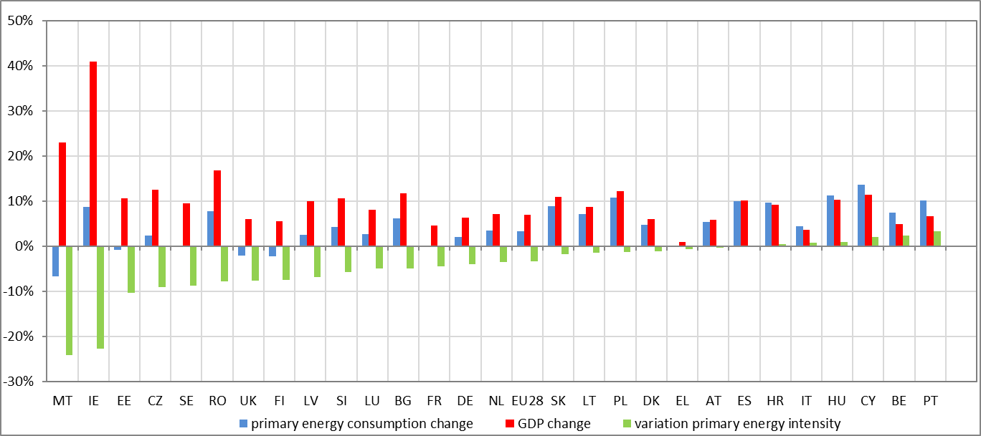

*Source: Eurostat*

In order to better understand the factors behind recent increases in energy consumption, the European Commission organised an expert workshop which provided input for a report presenting the drivers of recent energy consumption trends.[19] The analysis of the possible factors that have influenced the increase in consumption trends in the years since 2014 indicates that there are differences between sectors: the main increase in energy consumption was seen in buildings (residential and services) in spite of a slight downward trend in 2017, followed by transport, while energy consumption in industry grew very little. Consumption in energy supply (generation, transmission and distribution) fell because of the shift to renewable energy in electricity generation. The report also confirmed that there is no single reason for why energy consumption in the EU has increased since 2014. The increase could be partly the result of good economic performance since 2014, partly due to low-oil prices and partly due to colder winters in 2015 and 2016, and the mix of these will vary across sectors.

To discuss the growing energy consumption trends and identify possible solutions to put the EU back on track to achieving the 2020 energy efficiency targets, Member State representatives met twice in the autumn of 2018 in the framework of a dedicated Task Force created by the Commission. The report on the work carried out by the Task Force[20] identified some additional causes of the growth in energy consumption related to national contexts. These included: (i) delayed implementation of energy efficiency policies; (ii) a difference between estimated energy savings and actual energy savings achieved; (iii) insufficient consideration of the impact of behavioural aspects such as the rebound effect; (iv) lack of funding for energy efficiency policies; and (v) restrictions related to EU state aid rules.

A more quantitative analysis of the different factors behind the changes in energy consumption is possible thanks to the decomposition analysis carried out by the JRC[21] and Odyssee-Mure.[22] However, both analyses only cover data until 2016.

The main factor of reducing primary energy consumption was the drop in final energy demand due to improvements in final energy intensity (Figure 3). This contributed to a total drop of 122 Mtoe in primary energy, equivalent to 7 % of consumption in 2005. Improvements in transformation efficiency accounted for a drop of 30 Mtoe in 2005-2016. Decreases in distribution losses and conversion sector consumption produced an additional reduction of 9,5 Mtoe in primary energy consumption. The increasing share of renewable energy in gross final energy consumption, which grew from 9 % to 17 %[23] at EU level, also decreased primary energy consumption levels. However, increasing use of electricity had a counterbalancing effect, so overall the transformation efficiency effect of -30 Mtoe (equivalent to a -2 % decline compared to the 2005 primary energy consumption) was rather moderate.

Figure 3: Breakdown of changes in EU-28 primary energy consumption (Mtoe) for 2005-2016 using the additive Logarithmic Mean Divisia Index (LMDI) approach

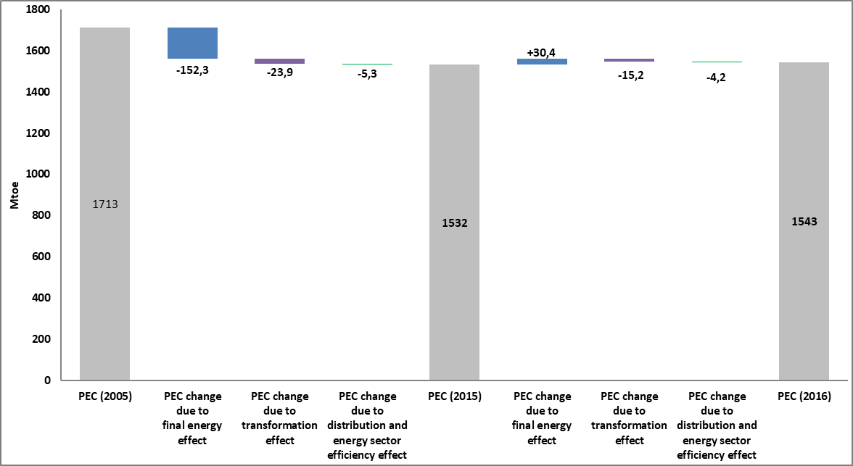

*Source: JRC*

The fall in final energy consumption was mainly driven by the decreases in industry (-15 % in 2017 compared to 2005) and in the residential sector (-9 %). In contrast, energy consumption increased in the services sector (+4 %) and in transport (+3 %) compared to 2005.

**Figure 4**: Breakdown of changes in EU-28 final energy consumption (Mtoe) for 2005-2016 using the additive Logarithmic Mean Divisia Index (LMDI) approach

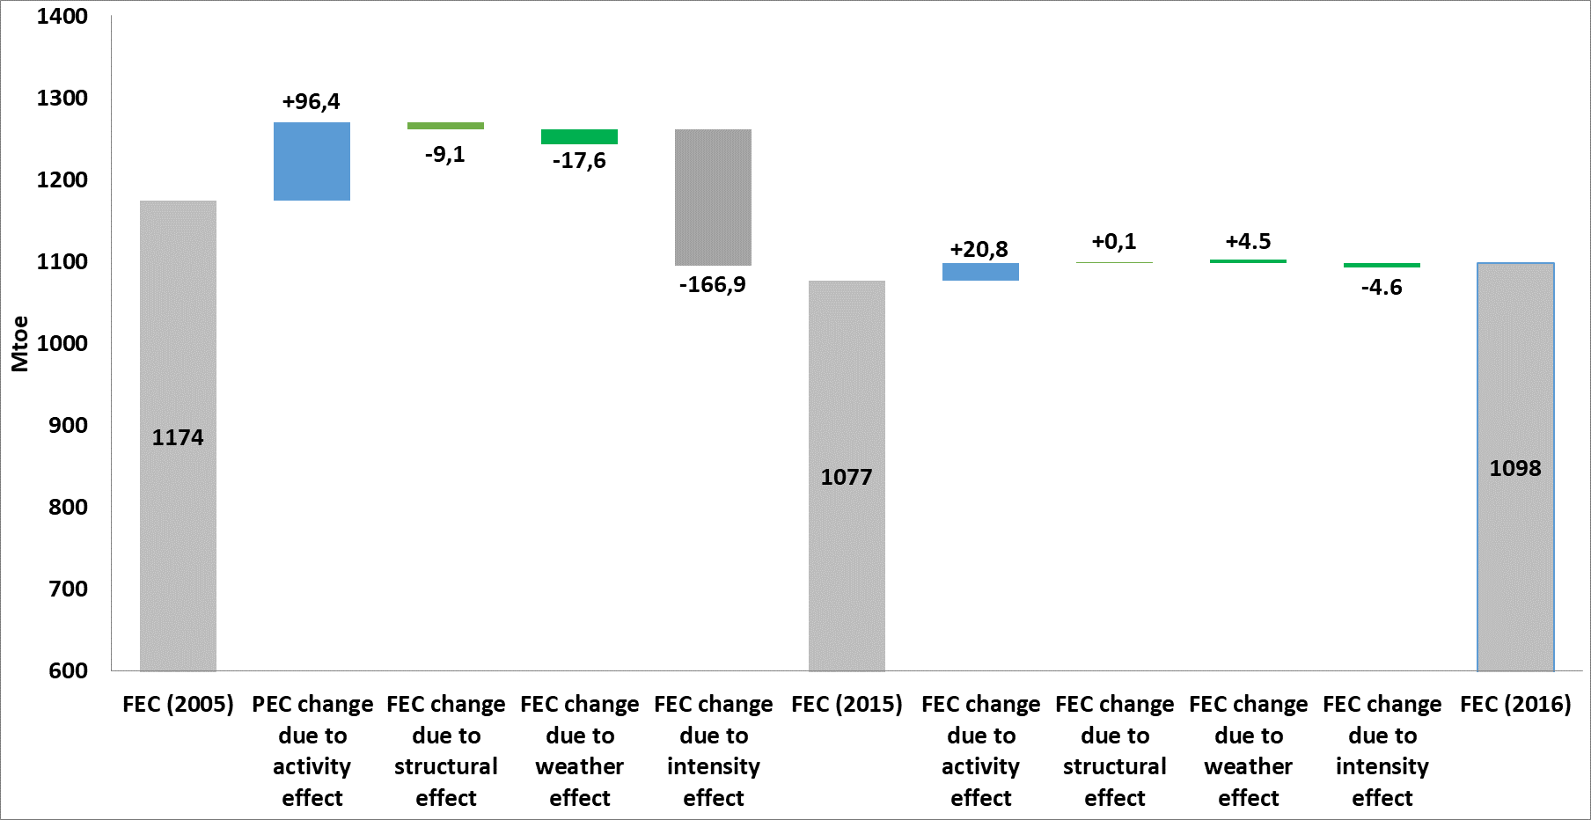

*Source: JRC*

The JRC analysis indicates that, as for primary energy, the drop in final energy consumption for the 2005-2016 period was due to improvements in final energy intensity (-171,4 Mtoe), which offset the increase in energy consumption due to economic growth (+117,4 Mtoe). Structural shifts towards more energy efficient sectors accounted for a drop in final energy consumption of 9,1 Mtoe, while warmer winters resulted in a decrease of energy consumption by 13,1 Mtoe. This resulted in a drop in final energy consumption from 1174 to 1098 Mtoe across the EU in 2005-2016 (see Figure 4).

In 2015-2016, an increase of +20,8 Mtoe in total final energy consumption was recorded across the EU. In this short period, the improvements in intensity (-4,6 Mtoe) were not sufficient to counterbalance the effect of economic growth (activity effect: +20,9 Mtoe) and colder weather (+4,5 Mtoe).

The Odyssee-Mure analysis shows similar trends for the 2005-2016 period. It confirms that energy savings played a major role in offsetting the increase in consumption driven by the activity effect, lifestyles and demography over this period. However, the significance of various factors and their magnitude are not the same due to differences in the methodology and data used as input. Lower primary energy consumption was mainly driven by a decrease in final energy consumption (-85 Mtoe), but the role of efficiency improvements and changes in the fuel mix in power generation were also quite significant (-75 Mtoe). Looking at final energy consumption, the activity effect led to an increase of 58 Mtoe, while lifestyle and demography accounted for an additional 32 Mtoe and 25 Mtoe, respectively. These increases were offset by much higher energy savings between 2005 and 2016 (-163 Mtoe), while structural change and weather led to a further reduction of 11 Mtoe each.

## Industrial sector

The final energy consumption of industry in the EU decreased in absolute terms from 332 Mtoe in 2005 to 283 Mtoe in 2017 (-15 %). However, in some countries industry increased its energy consumption during this period, namely in Hungary (+25 %), Malta (+9 %), Latvia (+7 %), Austria (+7 %), Belgium, Germany and Poland (by less than 5 % each). Compared to the previous year, the EU’s final energy consumption in industry increased by 1,6 % in 2017, but developments across Member States varied (11 Member States recorded a decline). The countries with the highest increases included Luxembourg, Poland, Denmark (around +4 %), Finland and Belgium (+3 %). The volume of industrial production rose by 9 % between 2014 and 2017 (3,4 % in 2017 year-on-year), but this growth in activity was only partially reflected in changes in energy consumption which rose by 2 % in the same period.

In terms of energy intensity,[24] almost all Member States managed to improve their industry performance between 2005 and 2017, leading to an overall reduction in energy intensity of 22 % in the EU. Only Hungary (+24 %), Greece (+17 %) and Latvia (+9 %) increased their final energy consumption as a proportion of gross value added (GVA) of their industrial sector. On the other hand, Romania, Estonia, Bulgaria and Ireland recorded the biggest improvements (over 50 %). Looking at annual developments compared to 2016, only Greece, Latvia, Hungary and Cyprus recorded an increase in the energy intensity of industry in 2017, while all other Member States continued to improve their performance.

## Residential sector

The final energy consumption of the residential sector dropped by some 9 % from 310 Mtoe in 2005 to 284 Mtoe in 2017. However, energy use rose by 7 % between 2014 and 2017 (with a -0,5% decrease in 2017). This increase was to some extent a result of colder winter weather, following the exceptionally warm winter of 2014, given that space heating energy consumption accounts for around 2/3 of residential energy consumption. Weather-corrected heating energy consumption has been relatively flat since 2010, following some reductions in the preceding years. In 2017, the number of heating degree-days was only slightly higher than in 2016, and energy consumption actually declined by 0,5 % year-on-year. Although space cooling still accounts for a rather limited proportion of energy consumption, it has been growing fast in some countries, while the number of cooling degree-days almost doubled in 2017 compared to 2014.[25]

It seems that the wealth effect (reflected among others by a higher number and a bigger average floor area of dwellings) and lifestyle changes (for example the increasing penetration of new small appliances) could be additional factors behind the recent hikes in energy consumption. For public buildings, a greater level of energy comfort has been specified as one of the factors contributing to the increased energy consumption trend.[26]

Residential sector intensity in terms of energy consumption per population decreased in the EU by some 12 % in 2005-2017 (it also decreased by almost 1 % in 2017 compared to 2016). Developments have not been uniform across Member States, though. In seven countries, performance deteriorated, with the biggest increases in intensity recorded in Bulgaria (+20 %), Lithuania (+14 %) and Malta (+8 %). In contrast, Belgium (-26 %), Ireland (-25 %) and the United Kingdom (-23 %) managed to reduce their intensity the most.

## Services sector

The services sector recorded the highest increase in energy consumption from 2005 to 2017 (+4 %). This increase reflected to some extent the high growth of activity levels — the GVA of the services sector rose by some 19 % between 2005 and 2017. The relationship between rising employment and energy consumption in the services sector is more evident, with energy consumption rising during the period of relatively strong employment growth to 2008 and again in the period since 2014. In addition, with an estimated 45 % of the services sector’s energy consumption used for space heating, winter temperatures also have a significant year-to-year impact on its overall consumption.

Final energy intensity in services improved by 13 % in the 2005-2017 period. The biggest improvements were seen in Ireland, Hungary, Slovakia, Austria and Sweden. Compared to 2016, the EU’s energy intensity improved further in 2017; energy consumption remained stable while the sector’s GVA rose by some 2 %.

## Transport sector

The EU’s final energy consumption in transport[27] increased by 2,5 % from 369 Mtoe in 2005 to 378 Mtoe in 2017. In 2017, 19 Member States increased their energy consumption in this sector compared to 2005 levels.[28] Consumption increased significantly (by more than 40 % since 2005) in Poland, Romania, Lithuania and Malta. In contrast, it fell by more than 10 % in Greece and Italy.

The EU’s final energy consumption in transport rose by 2,5 % from 2017 to 2016, with all but three Member States[29] reporting an increase. This hike is a continuation of the growing trend since 2014 — transport sector energy use rose by 7 % between 2014 and 2017. About 81 % of final energy consumption in transport is in road transport, and oil products (gasoline and diesel) are by far the biggest energy carriers used in the sector. Aviation accounts for a growing proportion of overall transport energy consumption, increasing by 14 % in the same period. Countries with the largest year-on-year increase include Poland (+16 %), Slovakia (+13 %), Croatia, Malta and Romania (+8 % each).

The growth in transport activity and the low-oil prices during that period were the main reasons for the increasing energy consumption. The passenger transport activity increased by 8,3 % between 2012 and 2016, following three years of decline. The increase of 3,2 % in 2016 was the fastest growth rate in the last 20 years. The freight transport activity has also increased since 2012, rising by 7,9 % until 2016. Despite this upward trend, the number of tonne kilometres transported is still 2,4 % lower than its peak level in 2007. In addition, congestion, especially in big cities, has further contributed to the increased energy demand in the transport sector.

There is a strong correlation between economic growth and commercial road freight transport demand, while the relationship between GDP growth and passenger transport is more complicated and is affected by a multitude of factors. Relatively lower fuel prices are also reported to have put upwards pressure on transport fuel demand, and the changing macroeconomic environment has influenced the relationship between fuel prices and the demand for transportation in the EU over the period since 2000. Concerning the modal shift at EU level, changes in the proportion of different passenger transport modes used did not have a major impact on energy consumption in the past few years. However, the continued increase in air travel is exerting some upward pressure. In the freight transport, the modal shares have remained broadly constant over time.

The efficiency of the light passenger vehicle segment has been improving over time and the rising number of new registrations has helped to improve the fuel economy of the whole fleet. However, a particularly high rise in registrations has been observed in the past years in the sports utility vehicle (SUV) segment. In comparison with other car types, SUVs have characteristics such as large frontal areas and high drag coefficients that have a negative impact on fuel consumption. According to JATO[30], in Europe, SUVs accounted for 26 % of all passenger car sales in 2016, up from 8 % in 2007. In addition, according to LMC[31], this strong upward trend is expected to continue, with SUVs reaching 34 % of all European passenger car sales in 2020.

# State of play/ status of transposition of the EED

In close cooperation with Member States, the Commission continues to monitor the transposition and implementation of the EED.

In 2018, the Commission continued the structured dialogue (EU pilot information requests) initiated with the Member States the previous year to ensure that all the obligations and requirements under the EED are correctly reflected in national legislation and policy. Following the assessment of replies to the EU pilots, the Commission sent letters of formal notice to all Member States to seek further clarification on the remaining outstanding issues.

As concerns the obligation to report to the Commission, all national energy efficiency action plans that were due by the end of April 2017 were submitted, albeit several with significant delays. A total of 10 Member States included updates of their targets or projections for 2020 in their 2017 NEEAPs. These revised targets indicated an increase in the gap between the aggregated expected contributions and the EU target. The NEEAPs contain detailed information on the energy efficiency policies and measures planned by Member States for the following three-year period in order to achieve their national energy efficiency targets. An overview and assessment of the new measures and the use of different instruments (regulatory, financial, taxation, energy efficiency obligation schemes) has been provided in a JRC report.[32] This report also analyses the implementation of the energy efficiency measures across different sectors (residential, industry, transport, agriculture and public sector) and assesses the energy savings to be generated by the main policy initiatives and programmes.

As required under Article 24 of the EED, all Member State 2018 annual reports were submitted during 2018. However, the timeline of submission as well as the quality and completeness of the information provided could still be improved. The JRC analysed these annual reports in 2018.[33]

## Progress under Article 7 (energy savings obligation)

Under Article 7, Member States have reported achieved savings for 2014-2016; at EU level these amounted to 54 547 ktoe in cumulative terms. This is approximately 24 % of the sum of all cumulative energy savings required by the end of 2020, and approximately 10 % more than the estimated amount of savings for 2014-2016, assuming a linear delivery of required savings. Although the sum of the energy savings at EU level shows a higher amount of savings for 2016, progress under Article 7 should be considered at national level: each Member State should achieve its energy savings requirements by the end of 2020.

The analysis shows that several Member States are lagging behind in terms of achieved savings for 2016, with Bulgaria, Croatia, Cyprus, the Czech Republic, Greece, Latvia, Luxemburg and Portugal having achieved less than 60 % of required savings for 2016. France, Hungary, Italy, Lithuania and Spain achieved more than 80 % but are still below what was required for 2016. On the other hand, Austria, Belgium, Denmark, Estonia, Finland, Germany, Ireland, Malta, the Netherlands, Poland, Romania, Slovakia, Slovenia, Sweden and the UK are on track or achieved more energy savings than required for 2014- 2016.

In their latest annual report, nine countries[34] communicated that they had introduced new policy measures. Furthermore, some countries updated their estimates of expected/realised savings for 2014 and 2015 from the previously communicated policy measures.

Most (approximately one third) energy savings were achieved through energy efficiency obligation schemes, 23 % due to energy or CO2 taxes and 18 % because of financing schemes or fiscal measures. Only a minor proportion of energy savings was achieved due to labelling schemes and national funds.

Figure 5. Distribution of cumulative energy savings in 2014-2016 per policy measure type

*Source: Own calculations based on the 2018 national annual reports*

More than two thirds of the achieved savings (68 %) were due to cross cutting measures that target different sectors, including buildings. The remaining energy savings were achieved thanks to measures targeting households (12 %) and transport (9 %), followed by industry (6 %) and the services sector (2 %). For 3 % of reported savings, the sector was unclear.

## Progress under Article 5 (exemplary role of buildings used by public bodies)

When submitting their 2018 annual reports, seven Member States did not provide the requested update regarding Article 5, whilst thirteen Member States did not comply with this reporting obligation in the previous year. Among these, Sweden, Finland, Belgium, Greece, Romania and Malta did not notify the Commission of their achievements for the last two years.

Among the Member States that have chosen the default approach,[35] there are six that achieved their annual targets in terms of renovated floor area. These are: Estonia, Spain, Italy, Lithuania, Latvia, Luxembourg and Slovenia. Among the Member States that have implemented the alternative approach, six Member States achieved their annual energy saving targets. These are the Czech Republic, France, Croatia, Ireland, the Netherlands and Poland. At the same time, seven countries provided relevant data indicating that they have fulfilled their cumulative targets under Article 5 for 2014-2017. These are Cyprus, Germany, Ireland, Croatia, Finland, Poland and the UK.

# Conclusion

The 2017 data show continued growth of energy consumption since 2014. The increases in the last three years up to 2017 moved energy consumption slightly above the linear trajectory for the 2020 targets. While the 2015 and 2016 winters were colder than in 2014, which increased demand for space heating, it is clear that weather effects are not the sole driver of the recent hikes. Economic growth, increasing wealth and lifestyle changes also increased the demand for energy. While energy efficiency measures largely offset these effects in the past, because of delays in implementing some of the policies and fewer new efforts, achieved savings were insufficient to reduce energy consumption.

The two different decomposition analysis methodologies analysed in this report confirmed that energy efficiency was a key driver of the improvements in energy intensity across sectors. Until recently, these were sufficient to neutralise the surge in energy demand driven by economic activity, higher heating and cooling comfort standards, and changes in behaviour and lifestyle. However, more recently the amount of savings achieved seems to have diminished while the positive effects of activity increased.

In this context, it has become clear that there is a need to step up efforts not only to reach the 2020 targets but also to set the right basis for the subsequent decade when an even higher level of ambition will be required. Additional efforts to improve energy efficiency would also have complementary benefits, such as lower energy bills, better health (through improved air quality), more comfort and less energy poverty.

The Task Force set up by the European Commission agreed that there is a need to address the delivery gap in achieving the EU 2020 targets. A set of solutions was identified as a way forward. Firstly, it is necessary to ensure full implementation of the existing legislation, as there have been delays in transposing and implementing both the Energy Efficiency and Energy Performance of Buildings Directives. This includes full achievement of the energy savings obligation under Article 7 and meeting the requirement to carry out regular inspections under Article 14&15 of the EPBD. Furthermore, it is important to make full use of the remaining funding opportunities under the European Structural and Investment Funds and to implement additional measures at national level.

The European Commission has intensified the exchange of information and best practice, and has initiated the process to strengthen Member States’ market surveillance of product efficiency requirements. It also aims to help Member States to build capacity for promoting building renovation in the public sector, including through the use of energy service contracting. Several measures recently adopted or in the pipeline should bring additional energy savings in a slightly longer time perspective after 2020. These include the legally binding national climate targets 2021-2030 for sectors like transports and buildings not covered by the EU Emission Trading System, recently agreed stricter CO2 standards for light duty vehicles beyond 2020, together with an improved monitoring system, CO2 emission standards for new trucks, the legislative package of new energy performance standards and labelling for products, and the strengthened Article 7 in the revised EED. The fact that the revised EPBD better incorporates the digital dimension will facilitate deployment of ICT and smart technologies which are expected to play an important role in increasing the energy performance of buildings and reducing energy consumption in buildings in the coming years. The improved coordination and corrective mechanisms under the Regulation for the Governance of the Energy Union[36] should also help put the EU back on track in case of insufficient ambition and progress in the post-2020 period.

The Commission will continue to monitor the Member States’ progress towards their indicative national energy efficiency targets for 2020, as well as their implementation of the EED. It will report on progress to the Task Force in the summer of 2019 when the preliminary data for 2018 will be available for assessment.

The Commission also invites the European Parliament and the Council to express their views on this assessment.

**Table 1: Overview of indicators**



* The ‘+’ symbol is used if Member States decreased their primary and final energy consumption between 2005 and 2017 at a rate which is higher than the rate of decrease which would be needed in the period 2005 to 2020 to meet the 2020 primary and final energy consumption targets. The ‘-’ symbol is used for the other cases. FEC stands for final energy consumption, PEC for primary energy consumption.

**Table 2: Overview of indicators**



**Table 3: Overview of reported energy savings for 2016 under Article 7 (ktoe)**

|  | 2016 | | | Progress towards the target | | | |
| --- | --- | --- | --- | --- | --- | --- | --- |
| **New savings** | **Total annual savings** | **Cumulative savings over 2014-2016** | **Total cumulative savings required by 2020 (target)** | **Progress towards total cumulative savings requirement by 2020** | **Estimated annual savings required for 2014- 2016** | **2014-2016 compared to estimated annual savings** |
| Austria | 389 | 1 026 | 1 908 | 5 200 | 37 % | 1 114 | 171 % |
| Belgium | 226 | 779 | 1 640 | 6 911 | 24 % | 1 481 | 111 % |
| Bulgaria | 50 | 99 | 178 | 1 942 | 9 % | 416 | 43 % |
| Croatia | 15 | n.a. | 62 | 1 296 | 5 % | 278 | 22 % |
| Cyprus | 2 | 6 | 14 | 242 | 6 % | 52 | 28 % |
| Czech Republic | 150 | 310 | 521 | 4 882 | 11 % | 1 046 | 50 % |
| Denmark | 256 | 699 | 1 346 | 3 841 | 35 % | 823 | 163 % |
| Estonia | 77 | 184 | 284 | 610 | 47 % | 131 | 217 % |
| Finland | 562 | n.a. | 4 775 | 4 213* | 113 % | 903 | 529 % |
| France | 943 | 2 887 | 6 489 | 31 384 | 21 % | 6 725 | 96 % |
| Germany | 2 637 | 4 085 | 9 943 | 41 989 | 24 % | 8 998 | 111 % |
| Greece | 40 | 174 | 394 | 3 333 | 12 % | 714 | 55 % |
| Hungary | 72 | 292 | 641 | 3 680 | 17 % | 788 | 81 % |
| Ireland | 116 | 330 | 609 | 2 164 | 28 % | 464 | 131 % |
| Italy | n.a. | 1 993 | 4 638 | 25 502 | 18 % | 5 465 | 85 % |
| Latvia | 15 | 32 | 58 | 851 | 7 % | 182 | 32 % |
| Lithuania | 23 | 86 | 188 | 1 004 | 19 % | 215 | 87 % |
| Luxembourg | n.a. | 14 | 24 | 515 | 5 % | 110 | 22 % |
| Malta | n.a. | 8 | 16 | 67 | 24 % | 14 | 112 % |
| Netherlands | 586 | 3 416 | 5 211 | 11 512 | 45 % | 2 467 | 211 % |
| Poland | n.a. | n.a. | 3 268 | 14 818 | 22 % | 3 175 | 103 % |
| Portugal | 29 | 94 | 206 | 2 532 | 8 % | 543 | 38 % |
| Romania | n.a. | 667 | 1 368 | 5 817 | 24 % | 1 247 | 110 % |
| Slovakia | 56 | 241 | 497 | 2 284** | 22 % | 489 | 102 % |
| Slovenia | 37 | 180 | 285 | 945 | 30 % | 203 | 141 % |
| Spain | 514 | 1 536 | 3 180 | 15 979 | 20 % | 3 424 | 93 % |
| Sweden | n.a. | 1 505 | 3 021 | 9 114 | 33% | 1 953 | 155% |
| UK | n.a. | 2 984 | 6 208 | 27 859 | 22 % | 5 970 | 104 % |
| **Total** | **6 794** | **24 633** | **54 547** | **230 486** | **24 %** | **49 390** | **110 %** |

*Source: Information reported by Member States and complemented by the Commission’s calculations and approximations where necessary.*

1. Directive 2018/2002/EU.
2. The 32,5 % target for 2030 translates into final energy consumption of 956 Mtoe and/or primary energy consumption of 1273 Mtoe in the EU28.
3. COM(2018) 773 final
4. The 2020 target involves lowering the EU28’s final energy consumption to at most 1086 Mtoe, and its primary energy consumption to at most 1483 Mtoe.
5. COM(2017) 687 final.
6. Economidou, M. and Romàn Collado, R. (2019), [*Assessing the progress towards the EU efficiency targets using index decomposition analysis 2015-2016*](https://ec.europa.eu/commission/sites/beta-political/files/assessing-progress-energy-efficiency-targets_en.pdf), JRC Science for Policy Report.
7. <http://www.indicators.odyssee-mure.eu/decomposition.html>.
8. An exceptionally warm winter in 2014 resulted in much lower heating needs that year. 2015, 2016 and 2017 winter temperatures were more in line with the climatic average (although still below the long-term average), increasing heating needs as well as energy consumption in the residential- and service sectors.
9. European Commission (2019), [*Report of the work of the Task Force on mobilising efforts to reach the EU Energy efficiency targets for 2020*](https://ec.europa.eu/energy/sites/ener/files/report_of_the_work_of_task_force_mobilising_efforts_to_reach_eu_ee_targets_for_2020.pdf)*.*
10. The weather correction factor was calculated as a proportion of heating degree days (HDD) in a given year over the average HDD from 1980 to 2004. This correction factor was applied to the energy consumption used for space heating in the residential sector.
11. Indicators from Eurostat’s new energy balances are used to monitor progress towards achieving the Europe 2020-2030 energy efficiency target.
12. Except Belgium, Bulgaria, Germany, Estonia, France, Lithuania, Hungary, Austria, Poland, Slovakia and Sweden.
13. Except Belgium, Bulgaria, Germany, Estonia, Ireland, France, Cyprus, Hungary, the Netherlands, Austria, Poland, Portugal and Sweden.
14. Except Belgium, Bulgaria, Germany, Estonia, France, Lithuania, Hungary, Austria, Slovakia, Sweden, the United Kingdom.
15. Except Belgium, Bulgaria, Cyprus, Germany, France, Austria, the Netherlands, Sweden and the United Kingdom.
16. The difference can be even bigger given that the levels of primary energy consumption and final energy consumption for some national targets do not follow the right methodology.
17. Note that in 2014 there was an exceptionally warm winter, so part of the increase in energy consumption is a consequence of a correction to more average winter temperatures.
18. Primary energy consumption in relation to GDP
19. Samuel Thomas (2018), [*Drivers of recent energy consumption trends across sectors in EU28*](https://ec.europa.eu/energy/en/studies/drivers-recent-energy-consumption-trends-across-sectors-eu28)*.*

    Energy Consumption Trends Workshop Report.
20. European Commission (2019), *Report of the work … op. cit.*
21. Economidou, M. and Romàn Collado, R. *op. cit.*
22. <http://www.indicators.odyssee-mure.eu/decomposition.html>.
23. 2016 data.
24. Energy consumption relative to gross value added (GVA).
25. Tsemekidi Tzeiranaki S., Bertoldi P (et al.) (2018), [*Energy consumption and energy efficiency trends in the EU-28 for the period 2000-2016*](https://ec.europa.eu/jrc/en/publication/eur-scientific-and-technical-research-reports/energy-consumption-and-energy-efficiency-trends-eu-28-period-2000-2016)*,* JRC Science for Policy Report
26. Samuel Thomas (2018), cp. cit.
27. Including pipeline transport, contrary to the approach taken in COM(2015) 574 final as the 2020 energy efficiency targets do not exclude pipeline transport.
28. A comparison of Member States should be undertaken with caution because final energy consumption is based on the fuels sold rather than the fuels used in the territory of a country.
29. Belgium, Italy and Slovenia.
30. Munoz, F., (2018), [*The global domination of SUVs continues in 2017*](https://www.jato.com/global-domination-suvs-continues-2017)*.*
31. LMC (2018), [*Automotive sales, production, powertrain forecasting*](https://lmc-auto.com)*.*
32. Economidou, M., Labanca, N. (et al.) (2019), [*Assessment of the Second National Energy Efficiency Action Plans under the Energy Efficiency* Directive](https://ec.europa.eu/jrc/en/publication/eur-scientific-and-technical-research-reports/assessment-second-national-energy-efficiency-action-plans-under-energy-efficiency-directive), JRC Science for Policy Report.
33. Tsemekidi-Tzeiranaki, S., Labanca, N. (et al.) (2019), [*Analysis of the annual reports 2018 under the Energy Efficiency Directive*](https://ec.europa.eu/jrc/en/publication/analysis-annual-reports-2018-under-energy-efficiency-directive)*,* JRC Technical Reports.
34. Bulgaria, Cyprus, Estonia, Greece, Hungary, Italy, Latvia, Portugal and Spain.
35. Article 5 requires Member States to each year renovate 3 % of the total floor area of heated and/or cooled buildings over 250 m2 owned and occupied by central government which do not meet minimum energy requirements to meet at least the minimum energy performance requirements (default approach) or take other cost-effective measures to achieve equivalent energy savings (alternative approach).
36. COM(2016) 759 final.