

‘*The European Union is a community of law. Respecting the rule of law and abiding by Court decisions are not optional*’

President of the Commission, Jean-Claude Juncker, 2018 State of the Union Address([1])

‘*Respect for the rule of law is not only a prerequisite for the protection of all the fundamental values listed in Article 2. It is also a pre-requisite for upholding all rights and obligations deriving from the Treaties and for establishing mutual trust of citizens, businesses and national authorities in the legal systems of all other Member States*’([2])

First Vice-President, Frans Timmermans, EP Plenary Debate, 28 February 2018

‘*We are working on increasing the trust in justice. Providing sufficient financial resources to the justice system is not a cost, [it] is an investment. […] The country with a well functioning judiciary is more likely attracting investors.*’ ([3])

Commissioner Jourová, Vienna, 30 November 2018

**1. Introduction**

The independence, quality and efficiency, as the essential elements of effective justice systems, are crucial for upholding the rule of law and the values upon which the EU is founded. Effective justice systems are essential for the implementation of EU law. National courts act as EU courts when applying EU law. It is national courts in the first place that ensure that the rights and obligations provided under EU law are enforced effectively ([4]). As noted by the Court of Justice of the European Union, the very existence of effective judicial protection by independent courts is the essence of the rule of law ([5]).

The Communication on *Further strengthening the Rule of Law within the Union* – *State of play and possible next steps*, adopted on 3 April 2019, identifies the EU Justice Scoreboard as part of the EU’s toolbox to strengthen the rule of law by contributing in promoting judicial reform and standards on the rule of law ([6]). Respect for the rule of law, including the independence of justice systems, has a significant impact on investment decisions and on attracting businesses. For this reason, improving the effectiveness of national justice systems is a priority of the European Semester — the EU’s annual cycle of economic policy coordination. The Annual Growth Survey 2019, which identifies the economic and social priorities for the EU and its Member States for the year ahead, reiterates the link between, on the one side, the rule of law and effective justice systems and, on the other side, a business-friendly environment and economic growth ([7]).

For monitoring justice reforms and their impact in Member States, since 2013, the EU Justice Scoreboard (‘the Scoreboard’) presents an annual overview of indicators with relevance for the independence, quality and efficiency of justice, essential parameters of an effective justice system. The 2019 edition further develops the indicators on all three elements and, for the first time, presents indicators on:

* the detailed spending of financial resources in each justice system;
* the standards applied to improve the quality of judgments in highest courts;
* the management powers over the national prosecution services, and the appointment and dismissal of national prosecutors;
* the authorities involved in disciplinary proceedings regarding judges;
* the standards and practices on managing caseloads and backlogs in courts.

***What is the EU Justice Scoreboard?***

The EU Justice Scoreboard is a comparative information tool that aims to assist the EU and Member States on an annual basis to improve the effectiveness of their national justice systems by providing objective, reliable and comparable data on a number of indicators relevant for the assessment of the quality, independence and efficiency of justice systems in all Member States. The Scoreboard does not present an overall single ranking but an overview of how all the justice systems function, based on indicators that are of common interest for all Member States.

The Scoreboard does not promote any particular type of justice system and treats all Member States on an equal footing.

Independence, quality and efficiency are essential parameters of an effective justice system, whatever the model of the national justice system or the legal tradition in which it is anchored. Figures on these three parameters should be read together, as all three elements are necessary for the effectiveness of a justice system and are often interlinked (initiatives aimed at improving one of them may have an influence on the other).

The Scoreboard mainly focuses on litigious civil and commercial cases as well as administrative cases in order to assist Member States in their efforts to create a more investment, business and citizen-friendly environment. The Scoreboard is a comparative tool which evolves in dialogue with Member States and the European Parliament ([8]). Its objective is to identify the essential parameters of an effective justice system and to provide relevant data on an annual basis.

***What is the methodology of the EU Justice Scoreboard?***

The Scoreboard uses a range of sources of information. Large parts of the quantitative data are provided by the Council of Europe Commission for the Evaluation of the Efficiency of Justice (CEPEJ) with which the Commission has concluded a contract to carry out a specific annual study. These data cover the period from 2010 to 2017, and have been provided by Member States according to CEPEJ’s methodology. The study also provides detailed comments and country-specific factsheets that give more context. They should be read together with the figures ([9]).

Data on the length of proceedings collected by CEPEJ show the ‘disposition time’ which is a calculated length of court proceedings (based on a ratio between pending and resolved cases). Data on courts’ efficiency in applying EU law in specific areas show the average length of proceedings derived from actual length of court cases. It should be noted that the length of court proceedings may vary substantially geographically within a Member State, particularly in urban centres where commercial activities may lead to a higher caseload.

Other sources of data are: the group of contact persons on national justice systems ([10]), the European Network of Councils for the Judiciary (ENCJ) ([11]), the Network of the Presidents of the Supreme Judicial Courts of the EU (NPSJC) ([12]), Association of the Councils of State and Supreme Administrative Jurisdictions of the EU (ACA-Europe) ([13]), the European Competition Network (ECN) ([14]), the Communications Committee (COCOM) ([15]), the European Observatory on infringements of intellectual property rights ([16]), the Expert Group on Money Laundering and Terrorist Financing (EGMLTF) ([17]), Eurostat ([18]), the European Judicial Training Network (EJTN) ([19]), and the World Economic Forum (WEF) ([20]).

The methodology for the Scoreboard has been further developed in close cooperation with the group of contact persons on national justice systems, particularly through a questionnaire and collecting data on certain aspects of the functioning of justice systems.

The availability of data, in particular for indicators on the efficiency of justice systems, continues to improve as many Member States have invested in their capacity to produce better judicial statistics. Where difficulties in gathering or providing data continue to exist, this is either due to insufficient statistical capacity or to the fact that the national categories for which data are collected do not exactly correspond to the ones used for the Scoreboard. Only in very few cases, the data gap is due to the lack of willingness of certain national authorities to contribute. The Commission continues to encourage Member States to further reduce this data gap and to actively engage in the exchange of best practices.

***How does the EU Justice Scoreboard feed into the European Semester?***

The Scoreboard provides elements for assessing the quality, independence and efficiency of national justice systems and thereby aims at helping Member States to improve the effectiveness of their national justice systems. This makes it easier to identify shortcomings and best practices and to keep track of challenges and progress. In the context of the European Semester, country-specific assessments are carried out through bilateral dialogue with the national authorities and stakeholders concerned. This assessment is reflected in the annual country reports within the Semester and combines the insight from the scoreboard with qualitative analysis, taking into account the characteristics of the legal systems and the broader context of the Member States concerned. The analysis under the Semester may lead to the Commission proposing to the Council to adopt country-specific recommendations on the improvement of national justice systems in individual Member States.

***Why are effective justice systems important for an investment friendly environment?***

Effective justice systems which uphold the rule of law have since a long time been identified as having a positive economic impact. Where judicial systems guarantee the enforcement of rights, creditors are more likely to lend, businesses are dissuaded from opportunistic behaviour, transaction costs are reduced and innovative businesses are more likely to invest. The beneficial impact of well-functioning national justice systems for the economy is supported by a wide range of studies and academic literature, including from the International Monetary Fund ([21]) the European Central Bank ([22]), the OECD ([23]), the World Economic Forum ([24]), and the World Bank ([25]).

A recent study has found that reducing the length of court proceedings by 1%(measured in disposition time ([26])) may increase growth of firms ([27]) and that a higher percentage of companies perceiving the justice system as independent by 1% tends to be associated with higher turnover and productivity growth ([28]). Another study has indicated a positive correlation between perceived judicial independence and Foreign Direct Investment flows in Central and Eastern Europe ([29]).

In addition, several surveys have highlighted the importance of the effectiveness of national justice systems for companies. For example, in one survey,93% of large enterprises replied that they systematically review the rule of law conditions (including court independence) on a continuing basis in the countries they invest in ([30])and, in another, more than half of small and medium-sized enterprises replied that cost and excessive length of judicial proceedings, respectively, were among the main reasons for not starting court proceedings over infringement of intellectual property rights (IPR) ([31]).

**2. Context: Key developments in justice reforms in 2018**

**2.1. Mapping of justice reforms**

In 2018, a large number of Member States continued their efforts to further improve the effectiveness of their justice systems. Figure 1 presents an overview of adopted and envisaged measures across the different functional areas of the justice systems of Member States.

**Figure 1: Legislative and regulatory activity concerning justice systems in 2018** *(adopted measures/initiatives under negotiation per Member State)**(source: European Commission (*[32]*))*

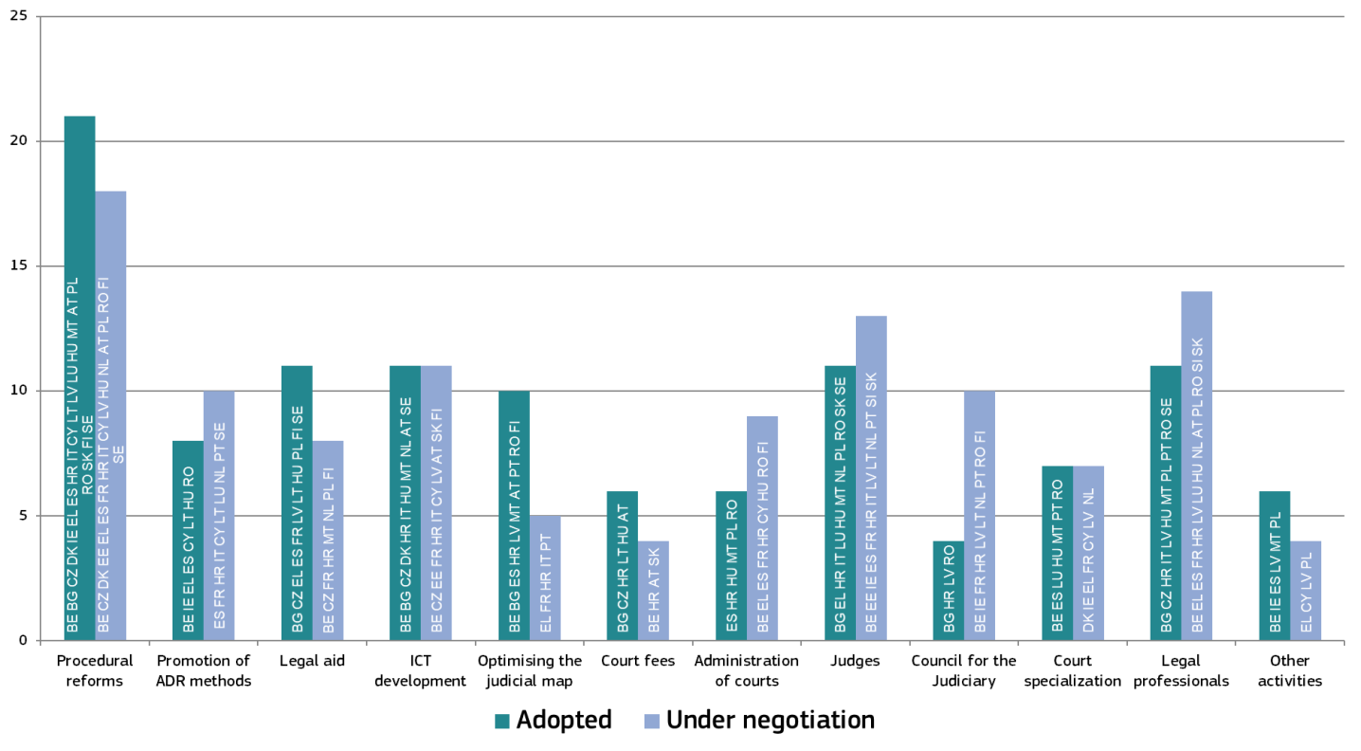

In 2018, procedural law continued to be an area of particular focus in many Member States and a significant amount of legislative activity was either ongoing or planned for the near future. The status of judges, reforms in the area of legal professionals, ICT development, legal aid and measures to optimize judicial maps also saw elevated activity. A comparison with the previous Scoreboard shows that the level of activity gathered further momentum in certain areas as Member States followed-up on earlier announced reform plans while in some areas, further reforms are to be expected in the near future. This also confirms the observation that justice reforms take time − sometimes several years from their initial announcement until the adoption of legislative and regulatory measures and their actual implementation.

**2.2. Monitoring of justice reforms**

In 2018, the Commission continued to monitor reform efforts undertaken by Member States.

*− Results of the 2018 European Semester –*

Improving the independence, quality and efficiency of justice systems is a well-established priority of the structural reforms encouraged through the European Semester. The European Semester cycle starts every year in November when the Commission presents its priorities for the next year (Communication on the Annual Growth Survey). In February, the Commission services present country specific assessments in the Country Reports covering all matters dealt with by the Semester. In May/June, the Commission presents its proposals for the country-specific recommendations that are addressed to Member States. These recommendations are adopted in July by the Council after having been endorsed by the European Council.

In the 2018 European Semester, based on a proposal from the Commission, the Council addressed country-specific recommendations to five Member States relating to their justice system ([33]). In addition to those Member States that received country specific recommendations, a further 11 Member States are facing specific challenges as regards their justice systems, including the rule of law and the independence of justice, which are being monitored by the Commission through the European Semester ([34]).

*− 2018 Reports under the Cooperation and Verification Mechanism –*

The Cooperation and Verification Mechanism (CVM) was set up at the accession of Bulgaria and Romania to the European Union in 2007 ([35])to address shortcomings in judicial reform and the fight against corruption and, as regards Bulgaria, also the fight against organised crime. Since then, CVM reports have sought to help focus the efforts of the Bulgarian and Romanian authorities through specific recommendations, and have charted the progress made ([36]).

In the November 2018 CVM reports, the Commission took stock of progress against the recommendations that were contained in the previous reports. The report on Romania noted that while Romania had taken some steps to implement the final recommendations, recent developments reversed the course of progress and called into question the positive assessment made back in January 2017. For Bulgaria, the report came to the conclusion that several recommendations had already been implemented and a number of others were close to implementation. The Commission has given appropriate follow-up to both these reports.

**2.3. Supporting justice reforms**

*− European Structural and Investment Funds −*

The Commission financially supports certain justice reforms through the European Structural and Investment Funds (ESI Funds). Since 2007, 16 Member States have used both the European Social Fund (ESF) and the European Regional Development Fund (ERDF) to improve the effectiveness of their justice systems ([37]). Between 2007 and 2020, more than EUR 900 million will have been committed to increasing the efficiency and improve the quality of justice systems in these Member States ([38]). Funded activities include:

* Developing and upgrading business processes in courts and introducing case management systems or developing or upgrading human resources management processes;
* Digitalisation of court services and purchase of information and communication technology (ICT) systems;
* Providing training to judges, prosecutors, court staff, bailiffs, public notaries, lawyers and raising citizens’ awareness of their rights.

The Commission pays particular attention to ensure that EU funds are adequately used for the appropriate reforms in line with rule of law. The Commission emphasises the importance of taking a result-oriented approach when implementing the funding priorities and calls upon Member States to evaluate the impact of ESI Funds support.

*− Technical support −*

Member States are also drawing on the Commission’s technical support available through the Structural Reform Support Service (SRSS) under the Structural Reform Support Programme ([39]) which has a total budget of EUR 222.8 million over the period 2017-2020. Since 2017, 16 Member States ([40]) have already been receiving or have requested technical support for a wide range of areas. This includes for example technical support to improve the efficiency of the court system, for reforming the judicial map, on court organisation, on the design or implementation of e-justice programmes and cyber justice, on case-management systems, on the selection and promotion process for judges, for the training of judges and for the out-of-court resolution of consumer disputes. In May 2018, the Commission also presented its proposals for the next multiannual financing period 2021-2027 and in particular for a new Reform Support Programmewith an overall budget of EUR 25 billionto provide financial and technical support to all Member States in order to pursue and implement reforms aimed at modernising their economies, notably reform priorities identified in the context of the European Semester ([41]).

**2.4. Guaranteeing judicial independence**

There are various instruments the EU is using with a view to enforce the respect of judicial independence in Member States in order to protect the functioning of the Union.

*− Infringement proceedings and rulings of the Court of Justice of the European Union –*

The Commission is committed to pursuing cases where national law prevents national judicial systems from ensuring that EU law is applied effectively in line with the requirements of the rule of law and Article 47 of the Charter on Fundamental Rights of the EU ([42]).

In September 2018, the Commission decided to refer Poland to the Court of Justice of the European Union for violation of judicial irremovability and independence by the Law on the Supreme Court ([43]). The Commission’s concerns relate to the abrupt lowering of the retirement age of Supreme Court judges and the discretionary power given to the President of the Republic to prolong the active service of these judges without any clear criteria and no judicial review of the final decision taken in this respect, which the Commission considers a violation of Article 19(1) TEU read in connection with Article 47 of the Charter ([44]). On 17 December 2018, the Court of Justice of the European Union issued interim measures, as requested by the Commission, ordering Poland to restore the Supreme Court to its situation before 3 April 2018, when the contested law entered into force, until the final judgment is rendered in the case ([45]). On 1 January 2019, a law adopted by the Polish Parliament to implement the Court’s order entered into force. On 11 April 2019, the Advocate General at the Court of Justice considered that the Court should rule that the provisions of Polish legislation relating to the lowering of the retirement age for Supreme Court judges are contrary to EU law as they violate the principles of irremovability of judges and of judicial independence ([46]).

On 3 April 2019, the Commission launched an infringement procedure by sending a Letter of Formal Notice to Poland regarding the new disciplinary regime for ordinary court judges, on the grounds that it undermines their judicial independence by not offering necessary guarantees to protect them from political control ([47]).

The importance for Member States to ensure the independence of national courts, as a matter of EU law, has been highlighted by the recent case law of the Court of Justice of the European Union ([48]). In particular, the Court clarified that the requirement of judicial independence also means that the disciplinary regime governing those who have the task of adjudicating in a dispute must display the necessary guarantees in order to prevent any risk of it being used as a system of political control of the content of judicial decisions ([49]).

In 2018, a number of national courts seized the Court of Justice of the European Union within the preliminary reference mechanism (Article 267 TFEU), seeking clarifications on the EU law requirements of judicial independence. In particular, the Polish Supreme Court referred six such cases ([50]), the Polish Supreme Administrative Court one ([51]), and ordinary courts three ([52]) ([53]).

*− Article 7 TEU proceedings and the rule of law framework −*

Article 7(1) TEU provides for a preventive mechanism that can be activated in case of a "clear risk of a serious breach" of the values set out in Article 2 TEU and Article 7(2) TEU provides for a sanctioning mechanism only in case of a "serious and persistent breach by a Member State" of these values. The Rule of Law Framework was set out by the Commission in 2014 ([54]), and its role has been acknowledged by the Court ([55]). It provides a staged process of dialogue with a Member State, structured with opinions and recommendations from the Commission. The goal is to prevent the emergence of a systemic threat to the rule of law, at which point an Article 7 TEU procedure would be required. The first – and so far only – time the Rule of Law Framework has been used came with the start of a dialogue with Poland in January 2016 ([56]). While the dialogue helped identifying problems and framing the discussion, it did not solve the detected rule of law deficiencies and the Commission triggered the Article 7(1) TEU procedure in December 2017 ([57]). On 26 June, 18 September, and 11 December 2018, the Council held three hearings on Poland in the framework of Article 7(1) TEU.

On 12 September 2018, the European Parliament submitted a reasoned proposal in accordance with Article 7(1) TEU for the Council to determine that there is a clear risk of a serious breach by Hungary of the fundamental values of the EU ([58]).

**3. Key findings of the 2019 EU Justice Scoreboard**

Efficiency, quality and independence are the main parameters of an effective justice system, and the Scoreboard presents indicators on all three.

**3.1. Efficiency of justice systems**

The Scoreboard presents indicators for the efficiency of proceedings in the broad areas of civil, commercial and administrative cases and in specific areas where administrative authorities and courts apply EU law ([59]).

**3.1.1. Developments in caseload**

The caseload of Member States’ justice systems is high and remains stable, even if it varies considerably between Member States (Figure 2). This shows the importance of continuing efforts to ensure the effectiveness of justice system.

**Figure 2: Number of incoming civil, commercial, administrative and other cases** (*)*(1st instance/per 100 inhabitants) (source: CEPEJ study (*[60]*))*

*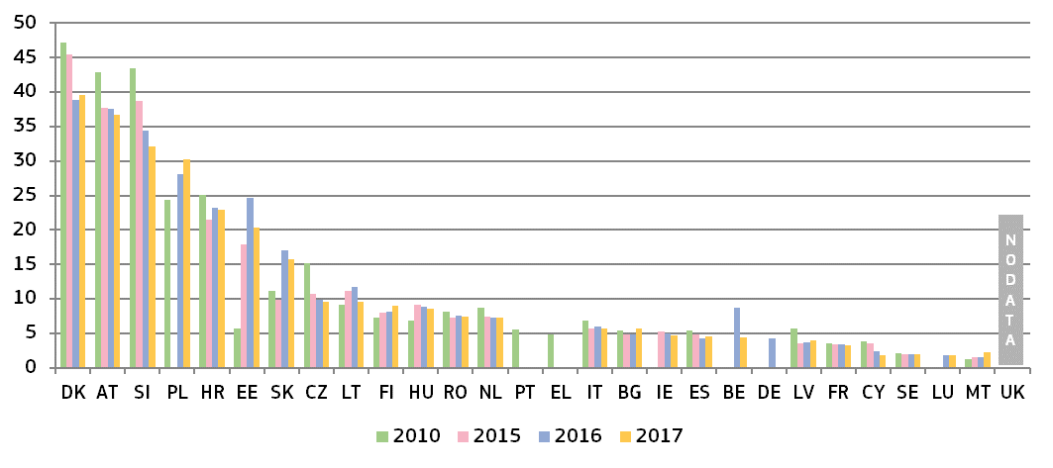(*) Under the CEPEJ methodology, this category includes all civil and commercial litigious and non-litigious cases, non-litigious land and business registry cases, other registry cases, other non-litigious cases, administrative law cases and other non-criminal cases. Methodology changes in SK.*

**Figure 3: Number of incoming civil and commercial litigious cases** (*)*(1st instance/per 100 inhabitants) (source: CEPEJ study)*

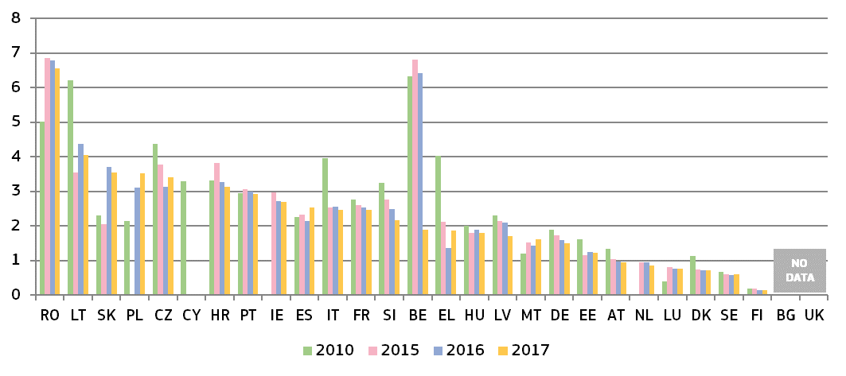

*(*) Under the CEPEJ methodology, litigious civil/commercial cases concern disputes between parties, e.g. disputes regarding contracts. Non-litigious civil/commercial cases concern uncontested proceedings, e.g. uncontested payment orders. Methodology changes in* ***EL*** *and* ***SK****. Data for* ***NL*** *include non-litigious cases.*

**Figure 4: Number of incoming administrative cases** (*)*(1st instance/per 100 inhabitants) (source: CEPEJ study)*

**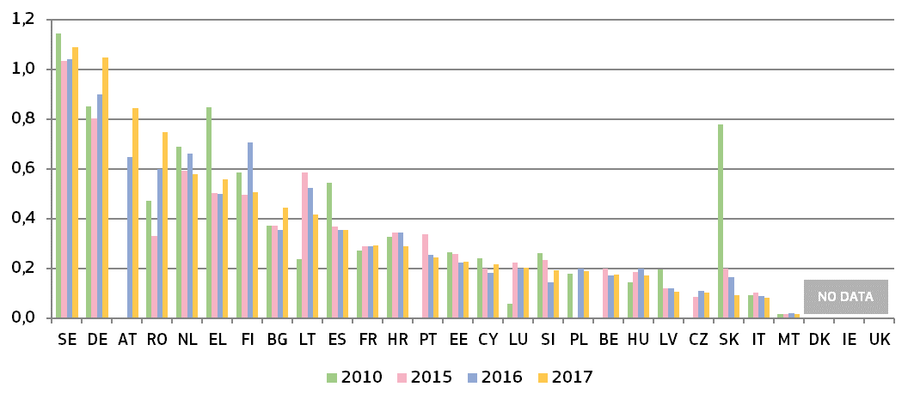***(*) Under the CEPEJ methodology, administrative law cases concern disputes between citizens and local, regional or national authorities. Methodology changes in* ***EL*** *and* ***SK****.* ***DK*** *and* ***IE*** *do not record administrative cases separately.*

**3.1.2. General data on efficiency**

The indicators on the efficiency of proceedings in the broad areas of civil, commercial and administrative cases are: length of proceedings (disposition time); clearance rate; and number of pending cases.

*− Length of proceedings* –

The length of proceedings indicates the estimated time (in days) needed to resolve a case in court, meaning the time taken by the court to reach a decision at first instance. The ‘disposition time’ indicator is the number of unresolved cases divided by the number of resolved cases at the end of a year multiplied by 365 (days) ([61]). Figures mostly concern proceedings at first instance courts and compare, where available, data for 2010, 2015, 2016 and 2017 ([62]). Two figures show the disposition time in 2017 in civil and commercial litigious cases, and administrative cases at all court instances.

**Figure 5: Time needed to resolve civil, commercial, administrative and other cases** (*)*(1st instance/in days) (source: CEPEJ study)*

*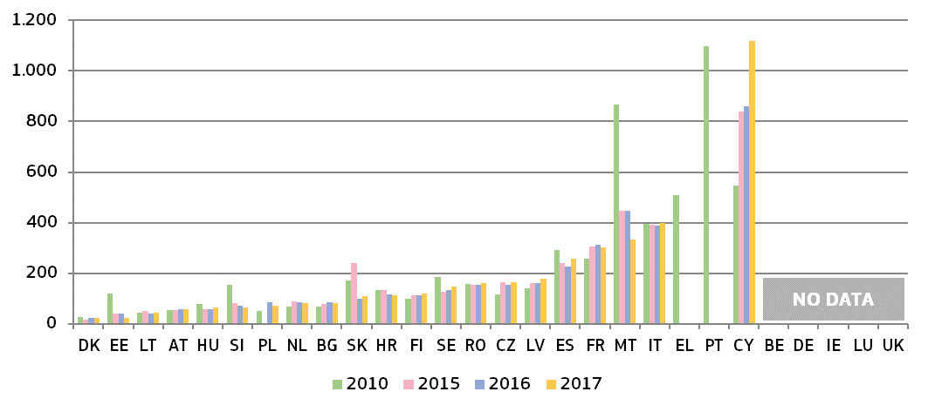(*) Under the CEPEJ methodology, this category includes all civil and commercial litigious and non-litigious cases, non-litigious land and business registry cases, other registry cases, other non-litigious cases, administrative law cases and other non-criminal cases. Methodology changes in* ***SK****. Pending cases include all instances in* ***CZ*** *and**, until 2016, in* ***SK****.*

**Figure 6: Time needed to resolve litigious civil and commercial cases** (*)*(1st instance/in days) (source: CEPEJ study)*

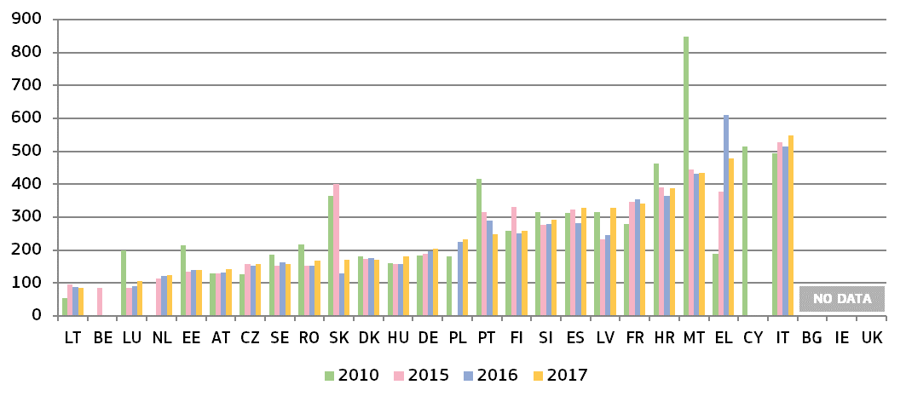*(*)**Under the CEPEJ methodology, litigious civil/commercial cases concern disputes between parties, e.g. disputes regarding contracts. Non-litigious civil/commercial cases concern uncontested proceedings, e.g. uncontested payment orders. Methodology changes in* ***EL*** *and* ***SK****. Pending cases include all instances in* ***CZ*** *and, until 2016, in* ***SK****.* *Data for* ***NL*** *include non-litigious cases.*

**Figure 7: Time needed to resolve litigious civil and commercial cases** (*) **at all court instances in 2017** *(1st, 2nd and 3rd instance/in days) (source: CEPEJ study)*

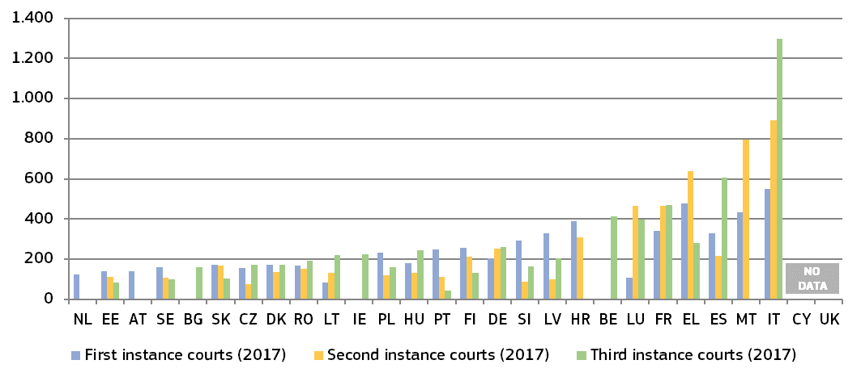

*(*) The order is determined by the court instance with the longest proceedings in each Member State. No data available for first and second instance courts in* ***BE****,* ***BG*** *and* ***IE****, for second and third instance courts in* ***NL*** *and* ***AT****, for third instance courts in* ***HR****. No third instance court in* ***MT****. Access to third instance court may be limited in some Member States.*

**Figure 8: Time needed to resolve administrative cases** (*) *(1st instance/in days) (source: CEPEJ study*

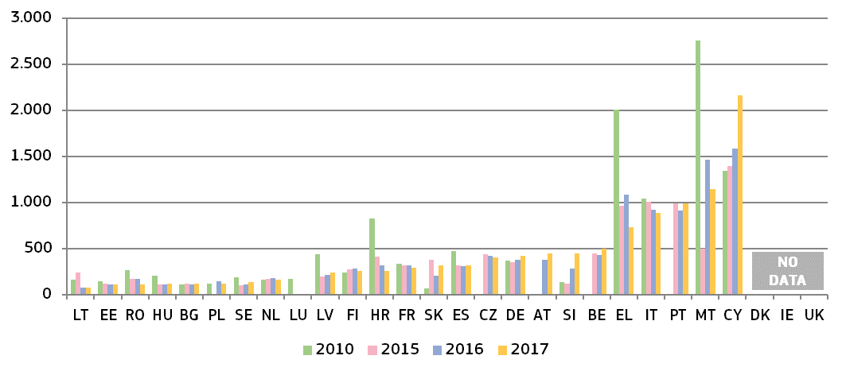

*(*)**Administrative law cases concern disputes between citizens and local, regional or national authorities, under the CEPEJ methodology. Methodology changes in* ***EL*** *and* ***SK****. Pending cases include all court instances in* ***CZ*** *and, until 2016, in* ***SK****.* ***DK*** *and* ***IE*** *do not record administrative cases separately.*

**Figure 9: Time needed to resolve administrative cases** (*) **at all court instances in 2017***(1st and, where applicable, 2nd and 3rd instance/in days) (source: CEPEJ study)*

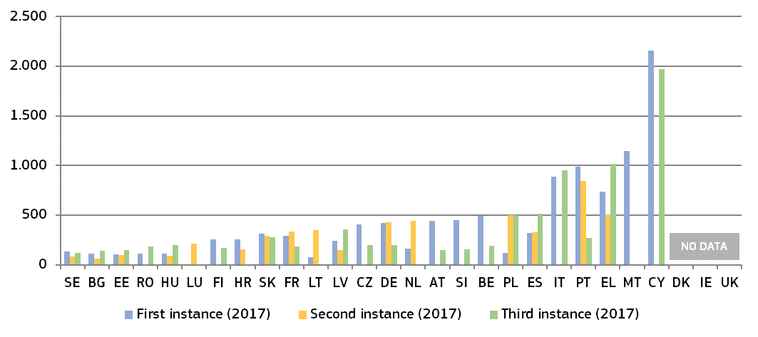

*(*)**The order is determined by the court instance with the longest proceedings in each Member State. No data available: for first instance court in* ***LU****, for second instance courts in* ***MT*** *and* ***RO****, and for third instance court in* ***NL****. The supreme or another highest court is the only appeal instance in* ***CZ****,* ***IT****,* ***CY****,* ***AT****,* ***SI*** *and* ***FI****. No third instance court for these types of cases in* ***HR****,* ***LT****,* ***LU****, and* ***MT****. The highest Administrative Court is the first and only instance for certain cases in* ***BE****. Access to third instance court may be limited in some Member States.* ***DK*** *and* ***IE*** *do not record administrative cases separately.*

*− Clearance rate* –

The clearance rate is the ratio of the number of resolved cases over the number of incoming cases. It measures whether a court is keeping up with its incoming caseload. When the clearance rate is about 100 % or higher, it means the judicial system is able to resolve at least as many cases as that come in. When the clearance rate is below 100 %, it means that the courts are resolving fewer cases than the number of incoming cases.

**Figure 10: Rate of resolving civil, commercial, administrative and other cases** (*)*(1st instance/in % — values higher than 100 % indicate that more cases are resolved than come in, while values below 100 % indicate that fewer cases are resolved than come in) (source: CEPEJ study)*

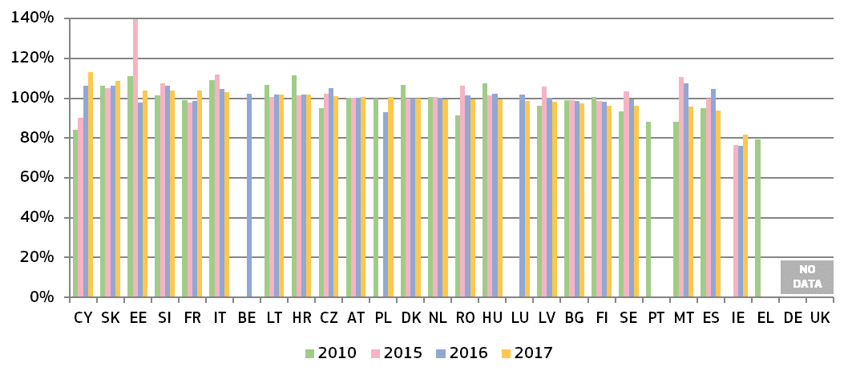

*(*) Methodology changes in* ***SK****.* ***IE:*** *the number of resolved cases is expected to be underreported due to the methodology.*

**Figure 11: Rate of resolving litigious civil and commercial cases** (*)*(1st instance/in %) (source: CEPEJ study)*

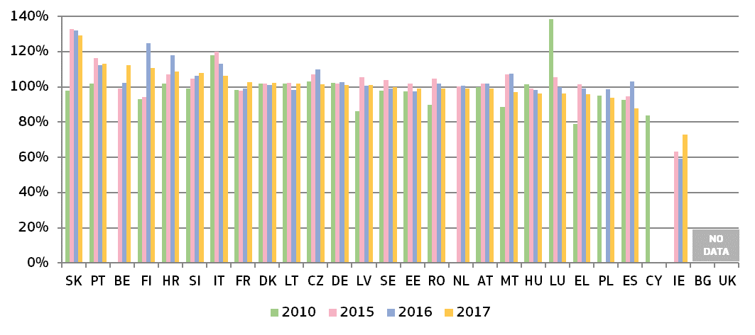*(*) Methodology changes in* ***EL*** *and* ***SK****.* ***IE:*** *the number of resolved cases is expected to be underreported due to the methodology. Data for* ***NL*** *include non-litigious cases.*

**Figure 12: Rate of resolving administrative cases** (*)*(1st instance/in %) (source: CEPEJ study)*

*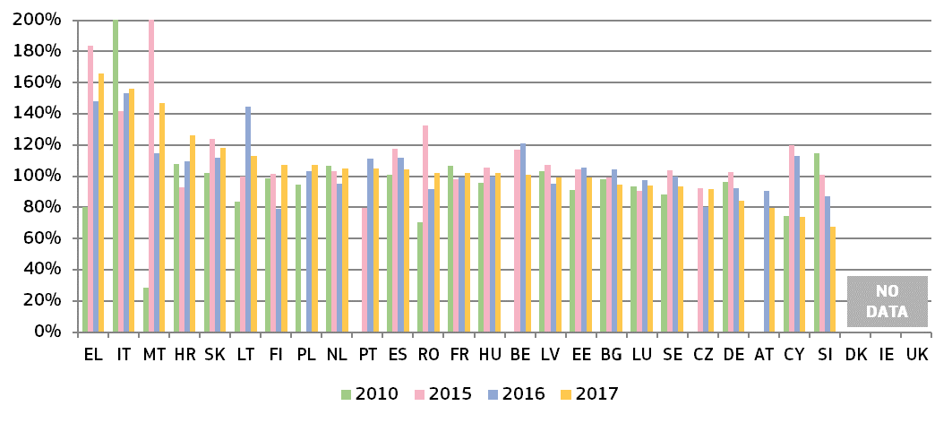(\**) *Past values for some Member States have been reduced for presentation purposes (****MT*** *in 2015=411 %;* ***IT*** *in 2010=316 %); Methodology changes in* ***EL*** *and* ***SK****.* ***DK*** *and* ***IE*** *do not record administrative cases separately.*

*− Pending cases* –

The number of pending cases expresses the number of cases that remains to be dealt with at the end of the year in question. It also influences the disposition time.

**Figure 13: Number of pending civil, commercial and administrative and other cases** (*)*(1st instance/per 100 inhabitants) (source: CEPEJ study)*

*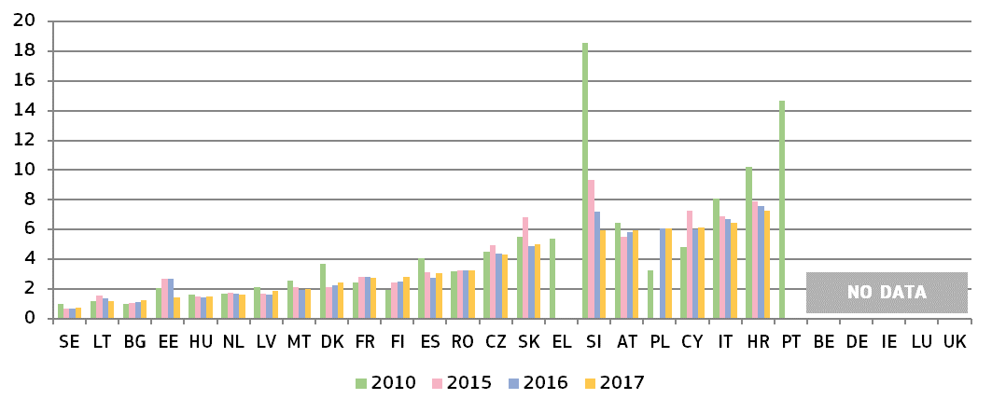(*) Methodology changes in* ***SK****. Pending cases include all instances in* ***CZ*** *and, until 2016, in* ***SK****.*

**Figure 14: Number of pending litigious civil and commercial cases** (*)*(1st instance/per 100 inhabitants) (source: CEPEJ study)*

*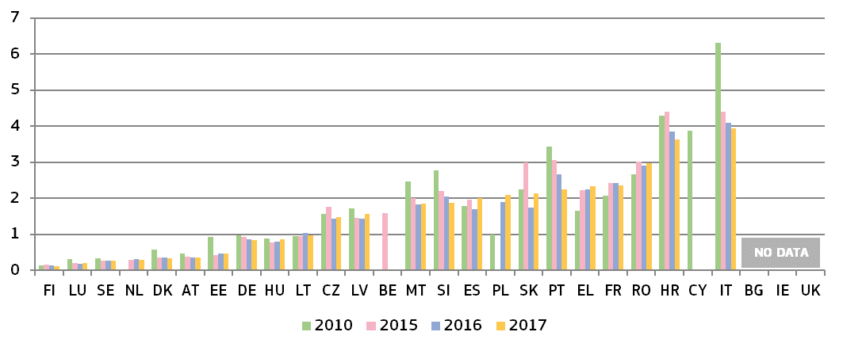(*) Methodology changes in* ***EL*** *and* ***SK****. Pending cases include all instances in* ***CZ*** *and, until 2016, in* ***SK****. Data for* ***NL*** *include non-litigious cases.*

**Figure 15: Number of pending administrative cases** (*)*(1st instance/per 100 inhabitants) (source: CEPEJ study)*

*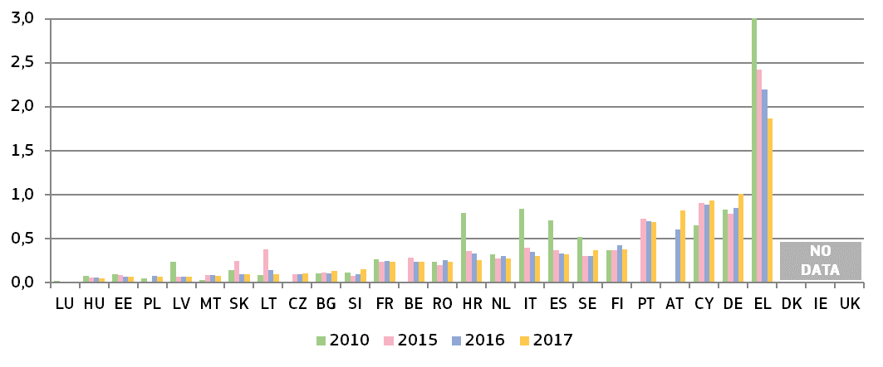**(*)* *Past values for some Member States have been reduced for presentation purposes (****EL*** *in 2010=3.7). Methodology changes in* ***EL*** *and* ***SK****. Pending cases include all instances in* ***CZ*** *and, until 2016, in* ***SK****.* ***DK*** *and* ***IE*** *do not record administrative cases separately.*

**3.1.3. Efficiency in specific areas of EU law**

This section complements the general data on the efficiency of justice systems and presents the average length of proceedings ([63]) in specific areas when EU law is involved. The 2019 Scoreboard builds on previous data in the areas of competition, electronic communications, EU trademark, and anti-money laundering. The areas are selected because of their relevance for the single market and the business environment. In general, long delays in judicial proceedings may have negative consequences on rights stemming from EU law, e.g. when appropriate remedies are no longer available or serious financial damages become irrecoverable.

*– Competition –*

Effective enforcement of competition law ensures a level playing field for businesses and is therefore essential for an attractive business environment. Figure 16 below presents the average length of cases against decisions of national competition authorities applying Articles 101 and 102 TFEU ([64]).

**Figure 16: Competition: Average length of judicial review** (*) *(1st instance/in days) (source: European Commission with the European Competition Network)*

***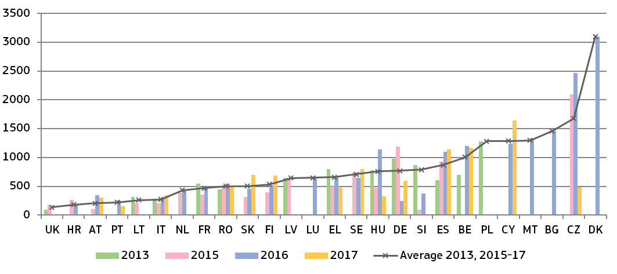****(*)* ***EE:*** *no cases.* ***IE*** *and* ***AT:*** *scenario is not applicable as the authorities do not have powers to take respective decisions.* ***AT:*** *data includes cases decided by the Cartel Court involving an infringement of Articles 101 and 102 TFEU, but not based on appeals against the national competition authority. An estimation of length was used in* ***BG, IT.*** *An empty column can indicate that the Member State reported no cases for the year. The number of cases is low (below 5 per year) in many Member States, which can make the annual data dependent on one exceptionally long or short case. A number of the longest cases in the dataset included the time needed for a reference to the Court of Justice of the European Union (e.g.* ***LT****), a constitutional review (e.g.* ***SK****) or specific procedural delays (e.g.* ***CZ****,* ***EL****,* ***HU****).*

*– Electronic communications –*

The objective of EU electronic communications legislation is to raise competition, to contribute to the development of the single market and to generate investment, innovation and growth. The positive effects for consumers can be achieved through effective enforcement of this legislation which can lead to lower end-user prices and better quality services. Figure 17 below presents the average length of judicial review cases against decisions of national regulatory authorities applying EU law on electronic communications ([65]). It covers a broad spectrum of cases, ranging from more complex ‘market analysis’ reviews to consumer-focused issues.

**Figure 17: Electronic communications: Average length of judicial review cases** (*) *(1st instance/in days) (source: European Commission with the Communications Committee)*

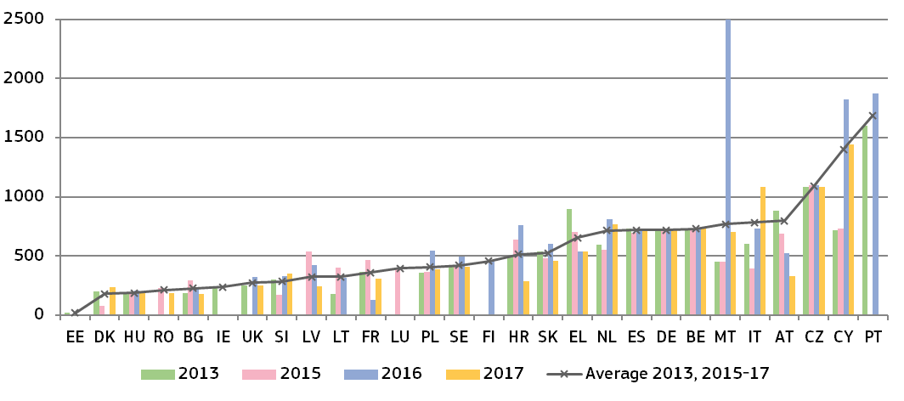(*) *The number of cases varies by Member State. An empty column indicates that the Member State reported no cases for the year (except* ***PT*** *for 2017: no data). In some court instances, the limited number of relevant cases (****LV****,* ***LT****,* ***MT****,* ***SK****,* ***SE****) can make the annual data dependent on one exceptionally long or short case and result in large variations from one year to the other.* ***DK:*** *quasi-judicial body in charge of 1st instance appeals.* ***ES****,* ***AT****, and* ***PL:*** *different courts in charge depending on the subject matter.* ***MT:*** *an exceptionally long case of 2 500 days was reported in 2016, which related to a complex issue whereby a local authority, together with several residents, filed proceedings in relation to alleged harmful emissions from base mobile radiocommunications stations.*

*– EU trademark –*

Effective enforcement of intellectual property rights is essential to stimulate investment into innovation. EU legislation on EU trademarks ([66]) gives a significant role to the national courts, which act as EU courts and take decisions affecting the single market. Figure 18 below shows average length of EU trademark infringement cases in litigation among private parties.

**Figure 18: EU trademark: Average length of EU trademark infringement cases** (*) *(1st instance/in days) (source: European Commission with the European Observatory on infringements of intellectual property rights)*

*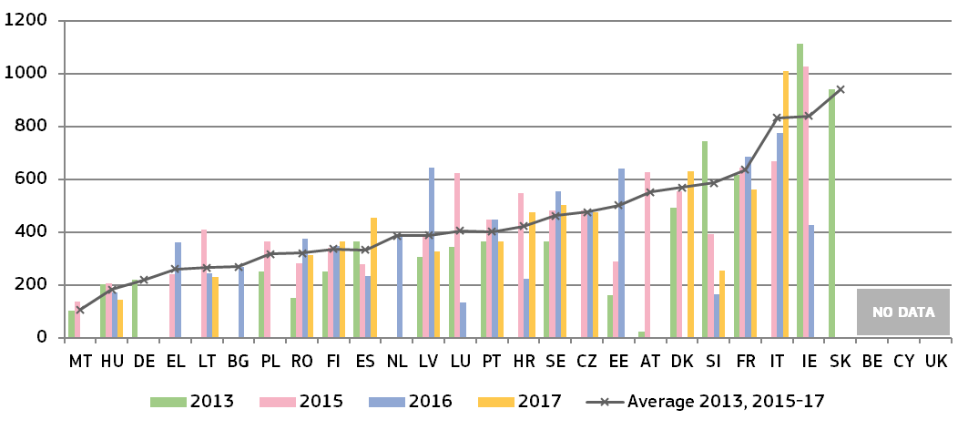(*)* ***FR****,* ***IT****,* ***LT****,* ***LU:*** *a sample of cases used for data of certain years.* ***BG:*** *estimation by courts used for 2016.* ***PL:*** *estimation by courts used for 2015. Particularly long cases affecting the average reported in* ***EE****,* ***IE****,* ***LV*** *and* ***SE****.* ***EL:*** *data based on weighted average length from two courts.* ***ES:*** *cases concerning other EU IP titles are included in the calculation of average length.* ***DK:*** *data from all trademark cases - not only EU - in Commercial and Maritime High Courts.*

*– Money Laundering –*

In addition to contributing to the fight against crime, the effectiveness of the fight against money laundering is crucial for the soundness, integrity and stability of the financial sector, the confidence in the financial system and fair competition in the single market ([67]). As underlined by the International Monetary Fund, money laundering can discourage foreign investment, distort international capital flows and have negative consequences for a country’s macroeconomic performance, resulting in welfare losses, draining resources from more productive economic activities ([68]). The Anti-Money Laundering Directive requires Member States to maintain statistics on the effectiveness of their systems to combat money laundering or terrorist financing ([69]). In cooperation with Member States, an updated questionnaire collected data on the judicial phases of the national anti-money laundering regimes. Figure 19 shows the average length of first instance court cases dealing with money laundering criminal offences.

**Figure 19: Money laundering: Average length of court cases** (*) *(1st instance/in days) (source: European Commission with the Expert Group on Money Laundering and Financing of Terrorism)*

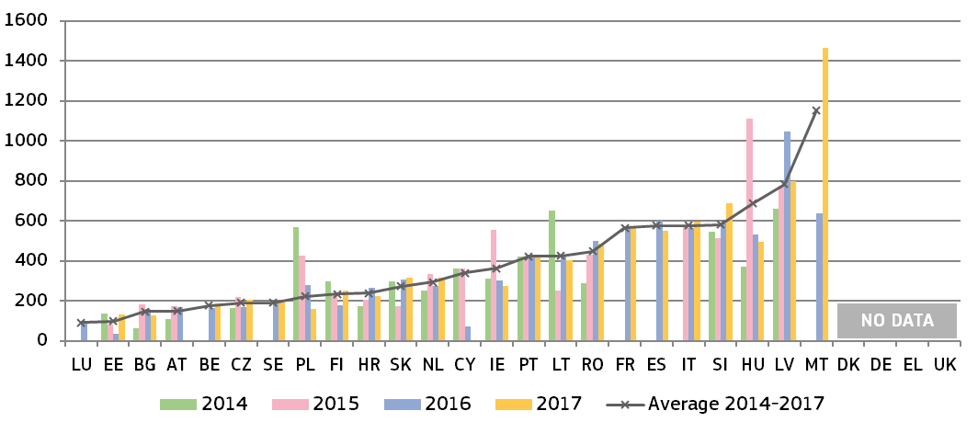

*(*) No data for 2017:* ***LU****,* ***AT****,* ***CY****,* ***PL*** *and* ***FR****.* ***ES:*** *estimated length.* ***LV:*** *Due to a relatively low number of cases in 2016, there are various factors possibly impacting the length of proceeding, e.g. a stay in a single case for objective reasons.* ***PL:*** *Calculation of length for 2016 based on a randomly selected sample of cases.****SE:*** *calculation in 2017 based on a sample of resolved cases.* ***IT:*** *data refer to the responding courts, covering about 91% of the total proceedings in 2015, and about 99% in 2016 and 2017; data refer to both trial and preliminary court hearing.*

|  |
| --- |
| **3.1.4. Summary on the efficiency of justice systems**  An efficient justice system manages its caseload and backlog of cases, and delivers its decisions without undue delay. The main indicators used by the EU Justice Scoreboard to monitor the efficiency of justice systems are therefore the *length of proceedings* (estimated or average time in days needed to resolve a case), the clearance rate (the ratio of the number of resolved cases over the number of incoming cases) and the number of *pending cases* (that remains to be dealt with at the end of the year).  *General data on efficiency*  The 2019 EU Justice Scoreboard contains data on efficiency spanning eight years (2010-2017). This time-span allows to identify certain trends and to take into account that justice reforms often take time to show their impact.  Looking at the available data since 2010 in civil, commercial and administrative cases, efficiency has improved or remained stable in eleven Member States, while it decreased, albeit often only marginally, in ten Member States.  Positive developments can be observed in most of the Member States which have been identified in the context of the European Semester as facing specific challenges ([70]):   * Since 2010, in nearly all of those Member States, the **length of first instance court proceedings** in the broad ‘all cases’ category (Figure 5) and the litigious civil and commercial cases (Figure 6) has decreased or remained stable. In administrative cases (Figure 8), the length of proceedings since 2010 decreased or remained stable in most of these Member States. However, a few Member States facing the most substantial challenges showed an increase in the length of proceedings in 2017. * The Scoreboard presents data on the **length of proceedings in all court instances** for the litigious civil and commercial (Figure 7) and administrative cases (Figure 9). Data show that in a number of Member States identified as facing challenges with the length of proceedings in first instance courts, higher instance courts perform in a more efficient manner. On the contrary, for some other Member States facing challenges, the average length of proceedings in higher instance courts is even longer than in first instance courts. * In the broad ‘all cases’, and the litigious civil and commercial cases categories (Figures 10 and 11), the overall number of Member States where the **clearance rate** is less than 100 % has decreased since 2010. In 2017, nearly all Member States, including those facing challenges, reported a high clearance rate (more than 97 %), which means that courts are generally able to deal with the incoming cases in these categories. In administrative cases (Figure 12), a larger variation of the clearance rate can be observed from one year to another and while it overall remains lower than in other categories of cases, some Member States have made good progress. * Since 2010, progress is continuing in almost all Member States facing the most substantial challenges with their **backlog**, regardless of the category of cases. Often substantial progress in reducing pending cases has been made for both litigious civil and commercial cases (Figure 14) and administrative cases (Figure 15). Despite these improvements, significant differences between Member States with comparatively few pending cases and those with a high number of pending cases remain.   *Efficiency in specific areas of EU law*  Data on the average length of proceedings in specific areas of EU law (Figures 16-19) provide an insight into the functioning of justice systems in these types of business-related disputes.  Data on efficiency in specific areas of law are collected on the basis of narrowly defined scenarios and the number of relevant cases may appear low. However, as compared to the calculated length of proceedings presented in the general data on efficiency, these figures provide for an actual average length of all relevant cases in specific areas in a year. It is therefore worth noting that several Member States which do not appear as facing challenges on the basis of general data on efficiency report significantly longer average length of cases in specific areas of EU law. At the same time, the length of proceedings in different specific areas may also vary considerably in the same Member State.  The figures in specific areas of EU law show the following trends :   * For **competition cases** (Figure 16), the overall caseload faced by courts across Member States decreased significantly, resulting in reduced length of judicial review in seven Member States, while it remained stable or increased in seven other Member States. As a sign of improvement, in 2017, only three Member States reported an average length exceeding 1000 days compared to eight Member States one year earlier. * In the area of **electronic communications** (Figure 17), despite marked increase in case-loads faced by courts, a positive trend, sometimes significantly, in terms of reduced length of proceedings can be observed across the EU and only very few Member States did not manage to reduce or at least maintain previous average lengths of proceedings. * As regards **EU trademark infringement cases** (Figure 18), in 2017 courts in some Member States managed to cope better with caseload and reduced the time needed to resolve cases, while in others, the average length increased quite significantly. * The effective fight against **money laundering** is crucial in protecting the financial system, fair competition and preventing negative economic consequences. Challenges in length of court proceedings when dealing with money laundering offences, may influence the effective fight against money laundering. The 2019 EU Justice Scoreboard presents updated data on the length of judicial proceedings dealing with money laundering offences (Figure 19), which show that while in about half of Member States the first instance court proceedings take up to a year on average, these proceedings take around two years on average in several Member States facing challenges ([71]). |

**3.2. Quality of justice systems**

There is no single way of measuring the quality of justice systems. The 2019 EU Justice Scoreboard continues examining factors that are generally accepted as relevant to improve the quality of justice. As in the previous years, they are grouped into four categories:

1) accessibility of justice for citizens and businesses;

2) adequate material and human resources;

3) putting in place assessment tools; and

4) using quality standards.

**3.2.1. Accessibility**

Accessibility is required throughout the whole justice chain to enable obtaining relevant information — about the justice system, how to initiate a claim and the related financial aspects, the state of play of proceedings up until their end — so that the judgment can be swiftly accessed online ([72]).

*– Giving information about the justice system –*

Citizen-friendly justice requires that information about the judicial system is provided in a way that is not only easily accessible but also presents the information in a tailor-made form for specific groups of society who would otherwise have difficulties in accessing the information. Figure 20 shows the availability of online information about specific aspects of the judicial system and for specific groups of society.

**Figure 20**: **Availability of online information about the judicial system for the general public**(*)*(source: European Commission ([73]))*

*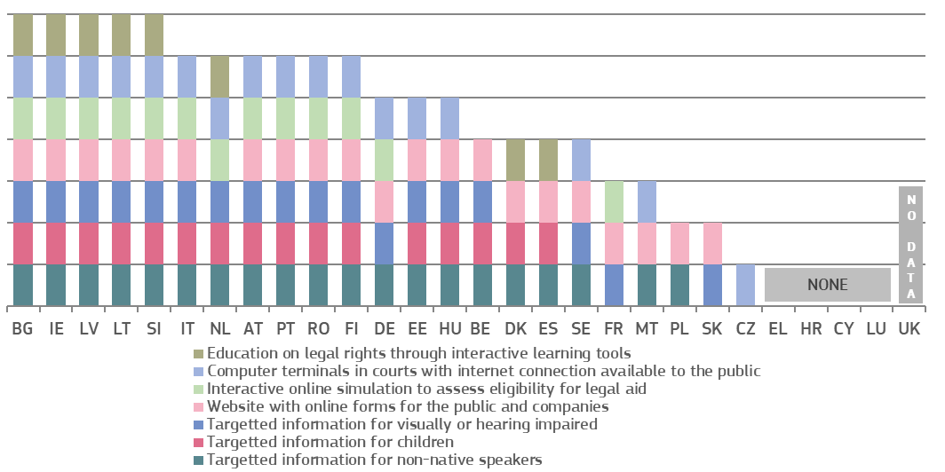(*) DE: Each federal state and the federal level decide which information to provide online.*

*– Legal aid and court fees –*

Access to legal aid is a fundamental right enshrined in the Charter ([74]). Most Member States grant legal aid on the basis of the applicant’s income ([75]).

Figure 21 shows the availability of full or partial legal aid in the scenario of a claim of EUR 6 000 in the context of each Member State’s income and living conditions ([76]). It compares the income thresholds for granting legal aid, expressed as percentage of the Eurostat poverty threshold in each Member State. For example, if the threshold for legal aid appears at 20 %, it means that an applicant with an income 20 % higher than the Eurostat poverty threshold in his or her Member State will be still eligible for legal aid. On the contrary, if the threshold for legal aid appears at below 0 it means that a person with income below the poverty threshold may not be eligible for legal aid.

Some Member States operate a legal aid system that provides for 100 % coverage of the costs linked to litigation (full legal aid), complemented by a system covering partial costs (partial legal aid), the latter applying eligibility criteria different from that of the former. Other Member States operate either only a full or only a partial legal aid system.

**Figure 21: Income threshold for legal aid in a specific consumer case** (*)*(differences in % from Eurostat poverty threshold) (source: European Commission with the CCBE([77]))*

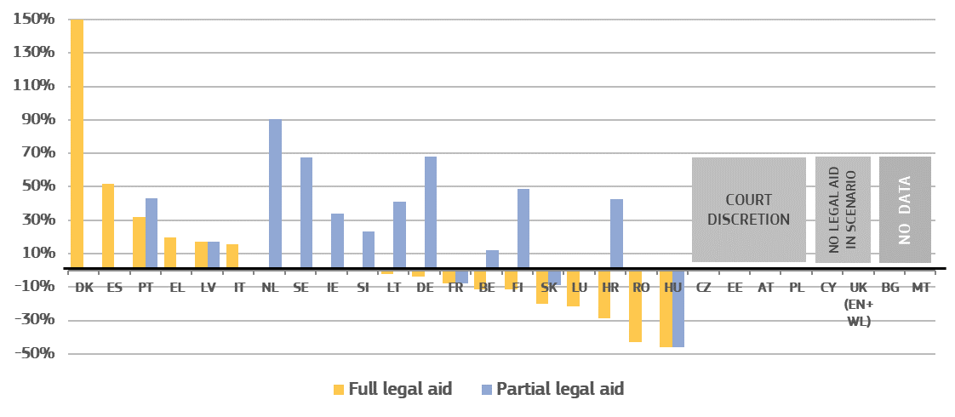

*(*)* ***LV:*** *income thresholds are not comparable with previous year due to adaptation of methodology for calculation.* ***EE:*** *decision to grant legal aid is not based on the level of financial resources of the applicant.* ***IE:*** *income threshold for full legal aid is not comparable with the previous year due to adaptation of methodology for calculation; partial legal aid has to take into account also the disposable assets of the applicant.*

Most Member States require parties to pay a court fee when starting judicial proceedings. Recipients of legal aid are often exempt from paying court fees. Only EE, IE, NL and SI require a recipient of legal aid to pay a court fee. In CZ the court decides on an individual basis to exempt a legal aid recipient from paying court fees. Figure 22 compares for two scenarios the level of the court fee presented as a share of the value of the claim. If, for example, in the figure below the court fee appears at 10 % of a EUR 6 000 claim, the consumer will have to pay a EUR 600 court fee to start a judicial proceeding. The low value claim is based on the Eurostat poverty threshold for each Member State.

**Figure 22: Court fee to start a judicial proceeding in a specific consumer case** (*)(*level of court fee as a share of the value of the claim*) *(source: European Commission with the CCBE([78]))*

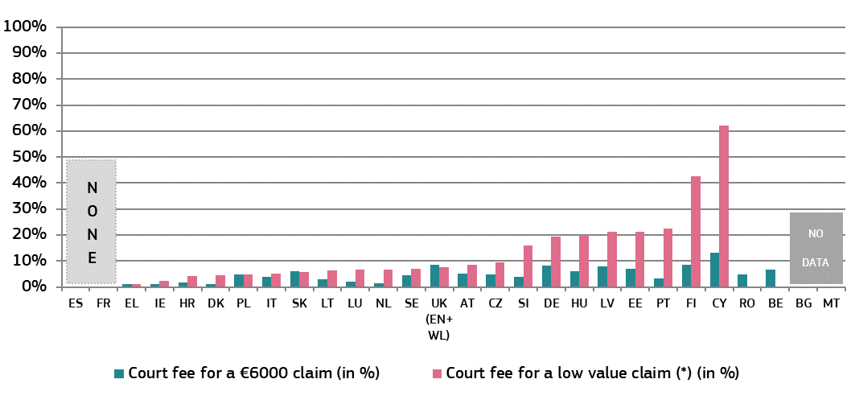

*(*) ‘Low value claim’ is a claim corresponding to the Eurostat poverty threshold for a single person in each Member State, converted to monthly income (e.g. in 2018, this value ranged between €110 in* ***RO*** *and €1 716 in LU).* ***BE*** *and* ***RO:*** *no information on court fees for a low value claim was provided.* ***LU:*** *Litigants have to pay bailiff fees to start proceedings as a plaintiff unless they benefit from legal aid.* ***NL:*** *Court fees for income <€2 242/month.*

*– Submitting and following a claim online –*

The ability to complete specific steps in the judicial procedure by electronic means is an important part of the quality of justice systems because the electronic submission of claims, the possibility to monitor and advance a proceeding online can ease access to justice and reduce delays and costs. ICT systems in courts also play an increasing role in cross-border cooperation between judicial authorities and also facilitate the implementation of EU legislation, for example, on small claims procedures.

**Figure 23: Availability of electronic means**  (*)*(0 = available in 0 % of courts, 4 = available in 100 % of courts ([79])) (source: CEPEJ study)*

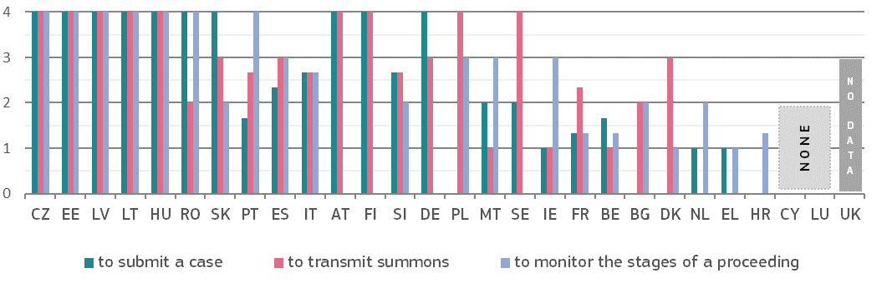

*(*)* ***DK*** *and* ***RO:*** *cases may be submitted to courts by email.*

*– Information to parties –*

Figure 24 presents standards on the way parties are informed and the type of information they receive about the progress of their case, with particular focus on the use of electronic or automatic methods. Certain Member States have an automated e-mail or SMS notification system providing information about delays, timetables or general case progress. Others give online access to the information during the case, while some leave it at the discretion of the courts.

**Figure 24: Standards on information about case progress** *(source: European Commission ([80]))*

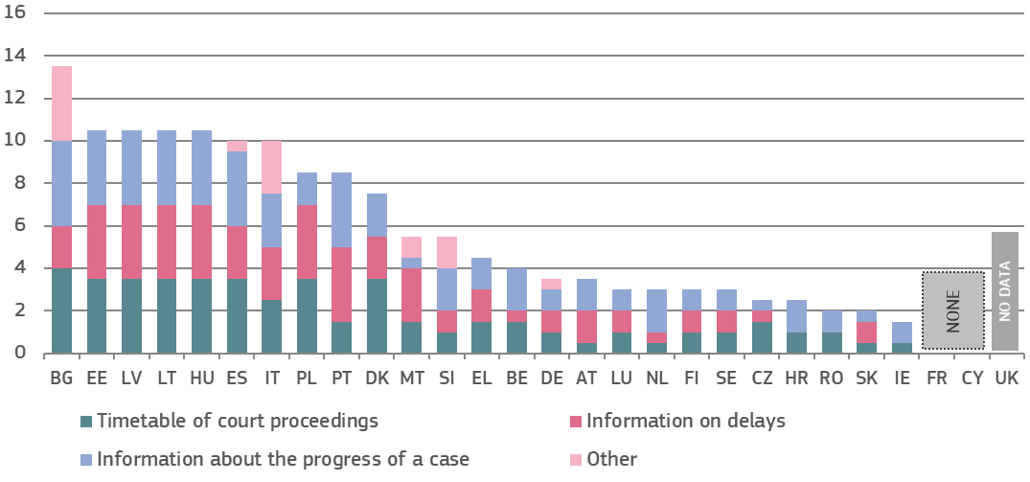

*(*) Maximum possible: 16 points. Member States were awarded points depending on the method used to provide each type of information. 1.5 points for automatic notification by e-mail or SMS, 1 point for online access to the case during the case proceedings, 0.5 points for each information upon request by parties, court discretion or any other method used.* ***LU:*** *communications done by email are not legally binding (still on implementation phase).* ***SI:*** *The new Court Rules provide the obligation for courts to enable an on-line view of data recorded in case register systems. It is still to be implemented.*

*– Accessing judgments –*

Ensuring access to judgments online increases the transparency of justice systems, helps citizens and businesses understand their rights and can contribute to consistency in case-law. The arrangements for online publication of judgments are essential for creating user-friendly search facilities ([81]), that make case-law more accessible to legal professionals and the general public. The online publication of court decisions requires balancing a variety of interests, within the boundaries set by legal and policy frameworks ([82]). The European Commission supports open data initiatives from the public sector, including the judicial system ([83]).

**Figure 25: Online accessibility to published judgments to the general public** (*)*(civil/commercial, administrative and criminal cases, all instances) (source: European Commission ([84]))*

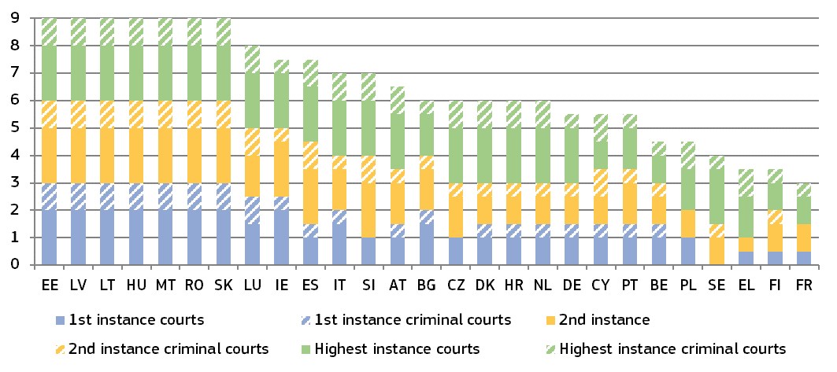

*(*) Maximum possible: 9 points. For each court instance, one point was given if all judgments are available for civil/commercial and administrative and criminal cases respectively (0.5 when some judgments are available). For Member States with only two court instances, points have been given for three court instances by mirroring the respective higher instance court of the non-existing instance. For those Member States that do not distinguish the two areas of law (civil/commercial and administrative), the same number of points have been given for both areas.* ***BG:*** *Court of Cassation criminal decision are all published except those containing classified information.* ***LU*** *and* ***SE:*** *courts do not publish judgments regularly online (only landmark cases).* ***LV:*** *for judgment adopted in non-public hearing, only the publicly announced parts are published online.* ***DE:*** *each federal state decides on online availability of 1st instance judgments.* ***IE:*** *for criminal cases, summary cases are not generally the subject of a written judgment.* ***CY:*** *for administrative and criminal cases judges decide on which judgments to be published.* ***NL:*** *courts decide on publication according to published criteria.* ***PL:*** *for administrative cases, the chief of unit in every court decides on the publication.* ***PT:*** *for civil and criminal cases, a commission within the court decides on the publication.*

**Figure 26: Arrangements for online publication of judgments in all instances** (*) *(civil/commercial, administrative and criminal cases, all instances) (source: European Commission ([85]))*

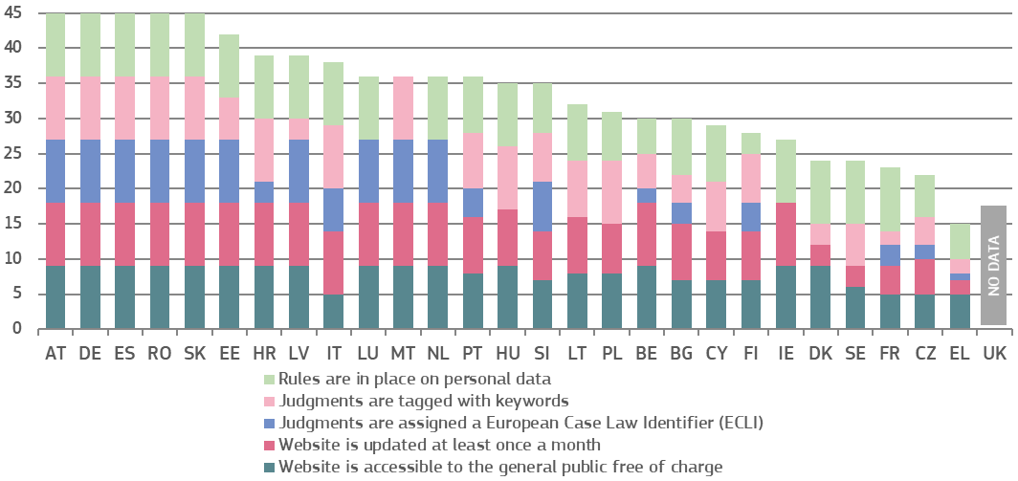

*(*) Maximum possible: 45 points. For each of the three instances, three points can be given if civil/commercial, administrative and criminal cases are covered. If e.g. only one of the three categories of cases is covered only one point per instance is given. Where a Member State has only two instances, points have been accorded for three instances by mirroring the respective higher instance of the non-existing instance.* *For those Member States which do not distinguish between administrative and civil/commercial cases, the same points have been allocated for both areas of law.* ***CZ:*** *some of the 2nd instance judgments in civil/commercial cases are assigned ECLI.* ***IE:*** *Administrative cases are in effect subsumed within the category civil and commercial cases in the Irish legal order.* ***NL:*** *no keywords, but a table of contents is added to every published judgment.*

*– Accessing alternative dispute resolution methods –*

Figure 27 shows Member States’ efforts in promoting the voluntary use of alternative dispute resolution methods through specific incentives, which may vary depending on the area of law ([86]).

**Figure 27: Promotion of and incentives for using ADR methods** (*)*(source: European Commission ([87]))*

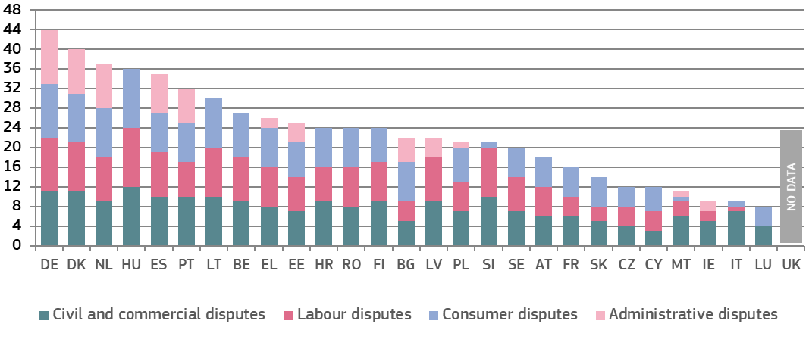

*(*) Maximum possible: 48 points. Aggregated data based on the following indicators: 1) website providing information on ADR, 2) publicity campaigns in media, 3) brochures to the general public, 4) court provides specific information sessions on ADR upon request, 5) ADR/mediation coordinator at courts, 6) publication of evaluations on the use of ADR, 7) publication of statistics on the use of ADR, 8) legal aid covers costs (in part or in full) incurred with ADR, 9) full or partial refund of court fees (including stamp duties, if ADR is successful, 10) no lawyer for ADR procedure required, 11) judge can act as mediator and 12) agreement reached by the parties becomes enforceable in court. For each of these 12 indicators, one point was given for each area of law.* ***DK:*** *each court has an ambassador responsible for promoting the use of mediation. Administrative courts have the possibility to propose to the parties to turn to mediation.* ***IE:*** *administrative cases are subsumed within the category civil and commercial cases.* ***EL:*** *ADR exists in the area of public procurement procedure before Administrative Courts of appeal.* ***ES:*** *ADR is mandatory in labour law cases.* ***LT:*** *a secretary at the National Courts Administration coordinates the judicial mediation processes in courts.* ***PT:*** *for civil/commercial disputes, court fees are refunded only in case of justices for peace.* ***SK:*** *the Slovak legal order does not support the use of ADR for administrative purposes.* ***SE:*** *judges have procedural discretion on ADR. Indeed, seeking friendly settlements is a mandatory task for the judge unless it is inappropriate.*

**3.2.2. Resources**

Sufficient resources, including the necessary investments into physical and technical infrastructure, and well-qualified, trained and adequately remunerated personnel of all categories, are necessary for the good functioning of the justice system. Without adequate facilities, tools or personnel with the required qualifications, skills and access to continuous training, the quality of proceedings and decisions is put at stake.

*– Financial resources –*

The figures below show the actual government expenditure on operation of the justice system (excluding prisons), both per inhabitant (Figure 28) and as a share of gross domestic product (GDP) (Figure 29), the criteria for determining the financial resources (Figure 30), and, finally, the main categories of expenditure on law courts (Figure 31) ([88]).

**Figure 28: General government total expenditure on law courts** (*)*(in EUR per inhabitant) (source: Eurostat)*

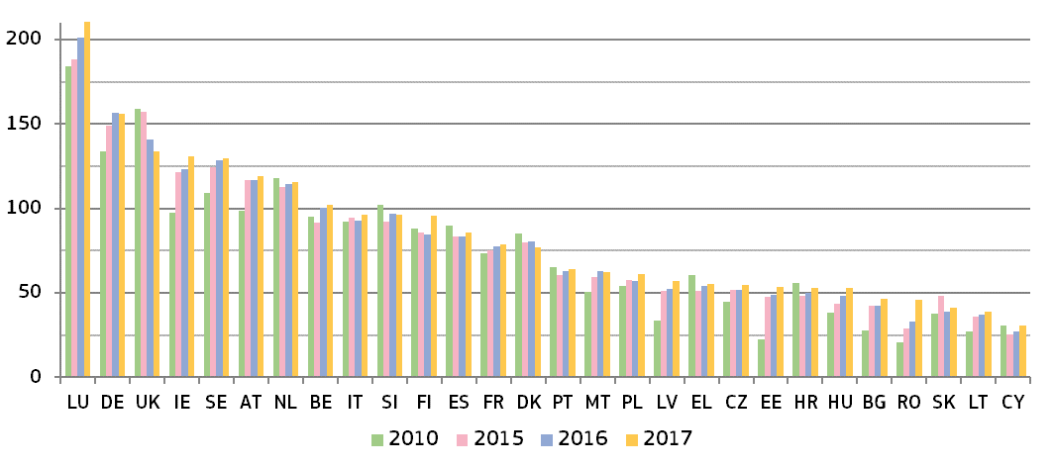

*(*) Member States are ordered according to the expenditure in 2017 (from highest to lowest). 2017 data for* ***ES****,* ***FR****,* ***HR****,* ***NL*** *and* ***SK*** *are provisional.*

**Figure 29: General government total expenditure on law courts** (*)*(as a percentage of GDP) (source: Eurostat)*

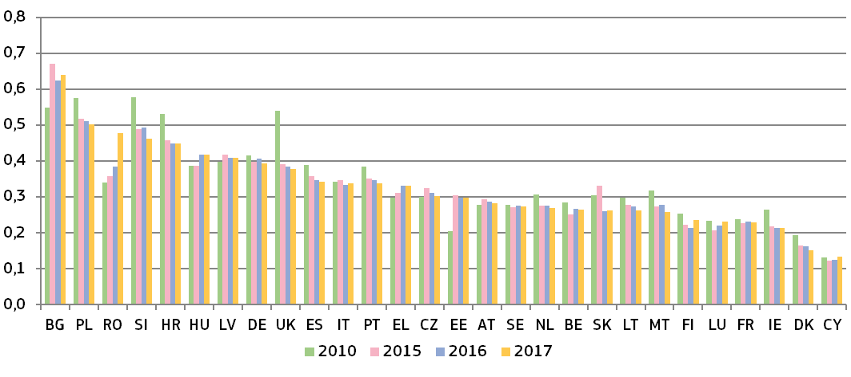

*(*) Member States are ordered according to the expenditure in 2017 (from highest to lowest). 2017 data for* ***ES****,* ***FR****,* ***HR****,* ***NL*** *and* ***SK*** *are provisional.*

Figure 30 shows which state power (judiciary, legislature or executive) sets the criteria on determining financial resources for the judiciary, and the type of criteria used.

**Figure 30: Criteria for determining financial resources for the judiciary** (*) ([89])

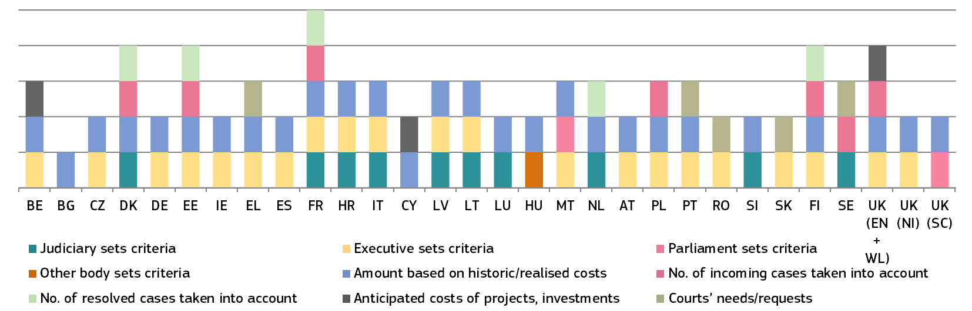

*(*)* ***DK:*** *number of incoming and resolved cases at courts of 1st instance courts are taken into account.* ***DE****: only for the Supreme Federal Court’s budget — as regards courts of 1st and 2nd instance. Judicial systems vary between the federal states.* ***EE:*** *number of incoming and resolved cases for courts of 1st and 2nd instance courts.* ***FR:*** *number of incoming and resolved cases for courts of all instances.* *The number of resolved cases based on an evaluation of the costs for courts is taken into account.* ***IT:*** *the Ministry of Justice defines criteria for civil and criminal courts, while the Council for the Judiciary (CPGA) defines criteria for administrative courts.* ***HU:*** *law states that the salaries of judges must be determined in the act on the central budget in such a way that the amount must not be lower than it had been in the previous year.* ***NL:*** *the number of resolved cases based on an evaluation of the costs for courts is taken into account****. FI:*** *The number of resolved cases based on an evaluation of the costs for courts is taken into account.*

Figure 31 shows, for the first time, the main economic categories comprising government expenditure on law courts: 1) wages and salaries of judges and court staff, including social contributions (‘compensation of employees’ ([90])), 2) operating costs for goods and services consumed by the law courts such as building rentals, office consumables, energy and legal aid (‘intermediate consumption’ ([91])), 3) investment in fixed assets, such as court buildings and software (‘gross fixed capital formation’ ([92])), and 4) other expenditure.

**Figure 31: General government total expenditure on law courts** *(in 2017, as a percentage of expenditure) (source: Eurostat)*

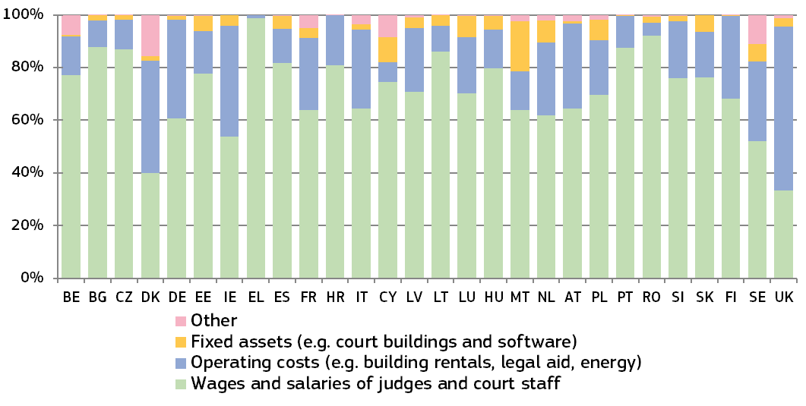

*– Human resources –*

Adequate human resources are essential for the quality of a justice system. Diversity among judges, including gender balance, adds complementary knowledge, skills and experience and reflects the reality of society.

**Figure 32: Number of judges** (*)*(per 100 000 inhabitants) (source: CEPEJ study)*

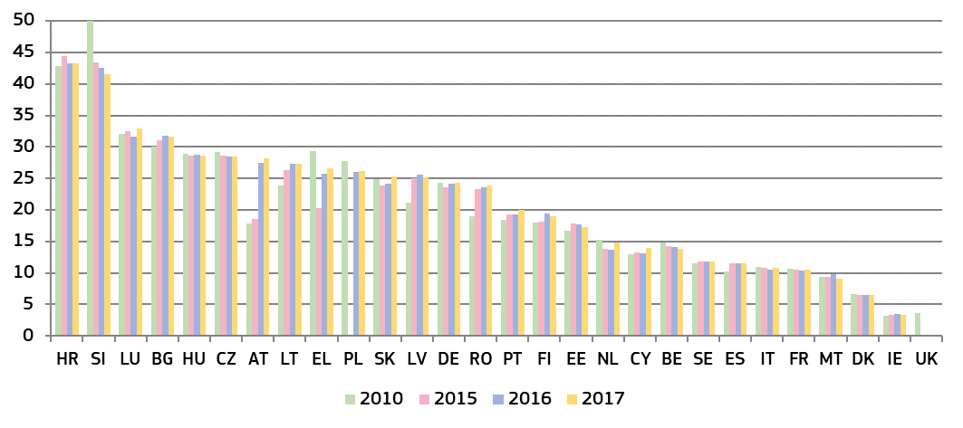

*(*) This category consists of judges working full-time, under the CEPEJ methodology. It does not include the Rechtspfleger/court clerks that exist in some Member States.* ***AT:*** *Data on administrative justice is introduced for 2016 cycle for the first time.* ***EL:*** *the total number of professional judges includes different categories over the years shown above, which partly explains their variation. Since 2016, data on number of professional judges includes all the ranks for criminal and political justice as well as administrative judges.* ***IT:*** *The regional administrative courts, regional audit commissions, local tax commissions and military courts are not taken into consideration.* ***UK:*** *weighted average of the three jurisdictions. Data for 2010 contains 2012 data for* ***UK (NI)****.* ***LU:*** *numbers have been revised following an improved methodology.*

**Figure 33: Proportion of female professional judges at 1st and 2nd instance courts in 2017** *(source: CEPEJ study)*

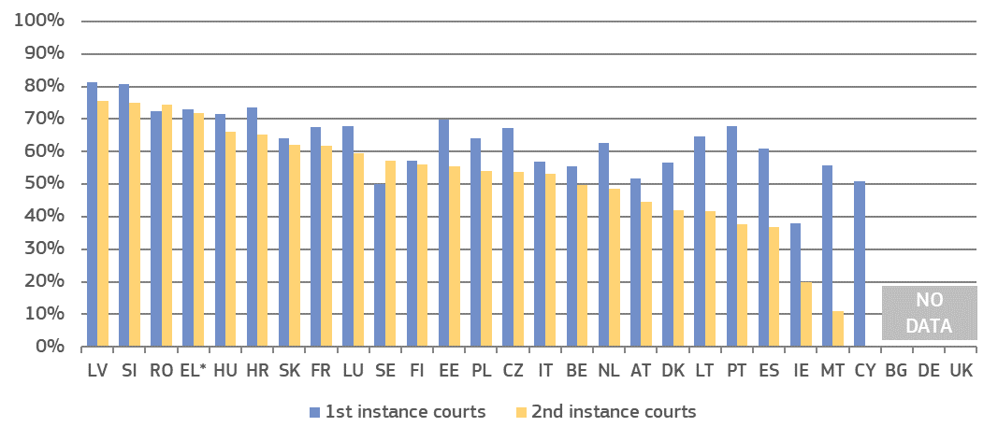

*(*) EL: data for 2016.*

**Figure 34****: Proportion of female professional judges at Supreme Courts in 2017 and 2018** (*) *(source: European Commission ([93]))*

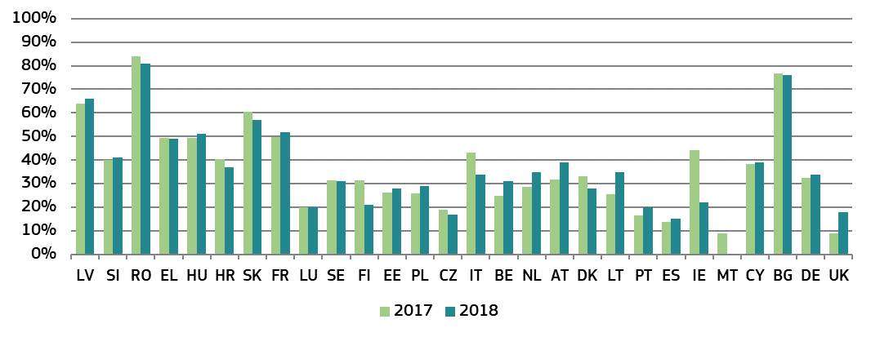

*(*) The Member States are in the same order as in Figure 33.*

**Figure 35: Number of lawyers** (*)*(per 100 000 inhabitants) (source: CEPEJ study)*

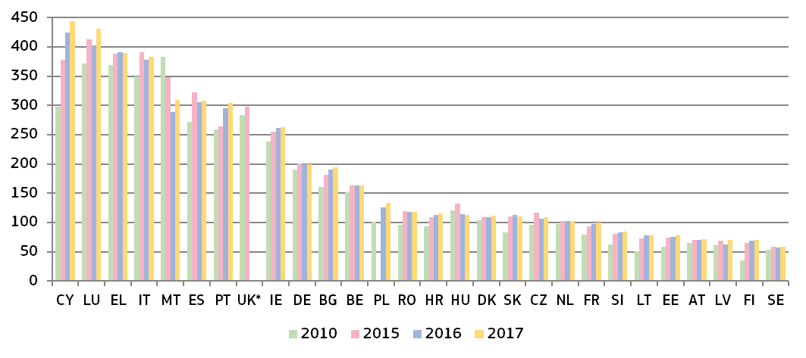

*(*) Under CEPEJ methodology a lawyer is a person qualified and authorised according to national law to plead and act on behalf of his or her clients, to engage in the practice of law, to appear before the courts or advise and represent his or her clients in legal matters (Recommendation Rec (2000)21 of the Committee of Ministers of the Council of Europe on the freedom of exercise of the profession of lawyer).* ***DE:*** *no distinction is made between different groups of lawyers in Germany, such as between solicitors and barristers.* ***FI:*** *since 2015, the number of lawyers provided includes both the number of lawyers working in the private sector and the number of lawyers working in the public sector.* ***UK:*** *data for 2010 and 2014.*

*– Training –*

Judicial training is important in contributing to the quality of judicial decisions and the justice service delivered to citizens. The data set out below cover judicial training in a broad range of areas, including communication with parties and the press and on judicial skills.

**Figure 36**Error! No sequence specified.**: Judges participating in continuous training activities in EU law or in the law of another Member State** (*) *(as a percentage of total number of judges) (source: European Commission ([94]))*

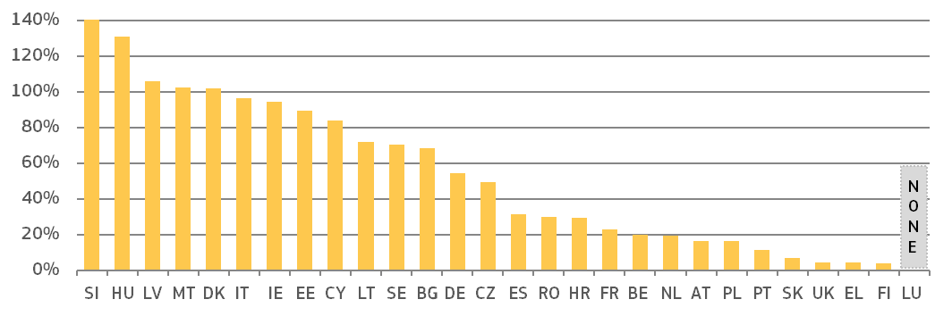

*(*) Values for some Member States have been reduced for presentation purposes (SI=257%). In several Member States the ratio of participants exceeds 100 %, meaning that some participants attended more than one training activity.* ***DK:*** *including court staff.* ***IT:*** *The regional administrative courts, regional audit commissions, local tax commissions and military courts are not taken into consideration.* ***AT:*** *including prosecutors.* ***UK:*** *Data are for 2016.*

**Figure 37: Share of continuous training of judges on various types of skills** (*)*(as a percentage of total number of judges receiving these types of training) (source: European Commission ([95]))*

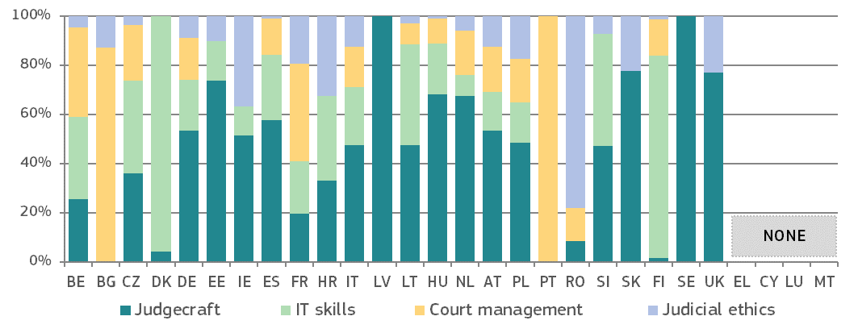

*(*)**The table shows the distribution of judges participating in continuous training activities (i.e. those taking place after the initial training period to become a judge) in each of the four identified areas as a percentage of the total number of judges trained in these types of training. Legal training activities are not taken into account. Judicial training authorities in* ***EL****,* ***CY****,* ***LU*** *and* ***MT*** *did not provide specific training activities on the selected skills.* ***DK:*** *including court staff.* ***AT:*** *including prosecutors.* ***UK*** *data are for England and Wales.*

**Figure 38: Availability of training for judges on communication** (*) *(source: European Commission ([96]))*

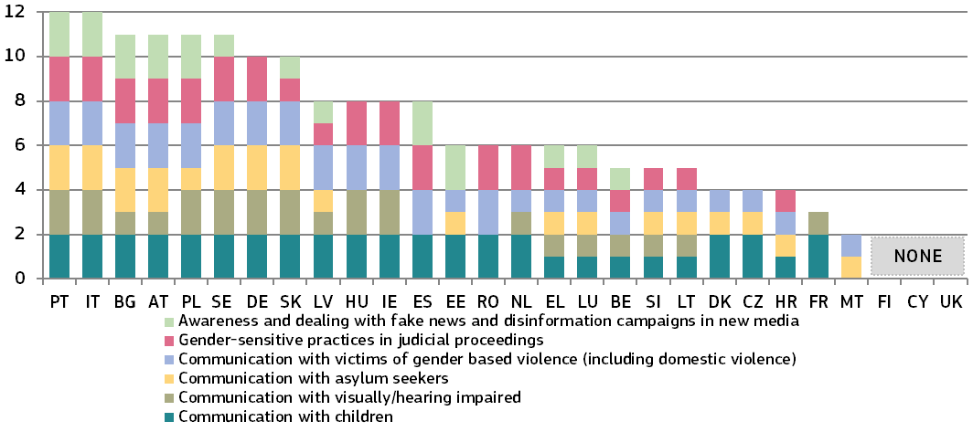

*(*) Maximum possible: 12 points. Member States were given 1 point if they have initial training and 1 point if they have continuous training (maximum of 2 points for each type of training). DK: no training is offered on communicating with people who are visually or hearing impaired because the state offers a visually or hearing impaired people support in form of tools or an assistant in the courtroom, e.g. a deaf interpreter.*

**3.2.3. Assessment tools**

Monitoring and evaluation of court activities help to detect shortcomings and needs, and therefore help the justice system increase its quality. Regular evaluation could improve the justice system’s responsiveness to current and future challenges. Adequate ICT tools could provide real-time case management systems and could help to provide nationwide standardised court statistics. In addition, they could be used for the management of backlogs and automated early-warning systems. Surveys are essential to assess how justice systems operate from the perspective of legal professionals and court users. An adequate follow-up of surveys is a prerequisite to improve the quality of justice systems.

**Figure 39: Availability of monitoring and evaluation of court activities** (*)*(source: CEPEJ study ([97]))*

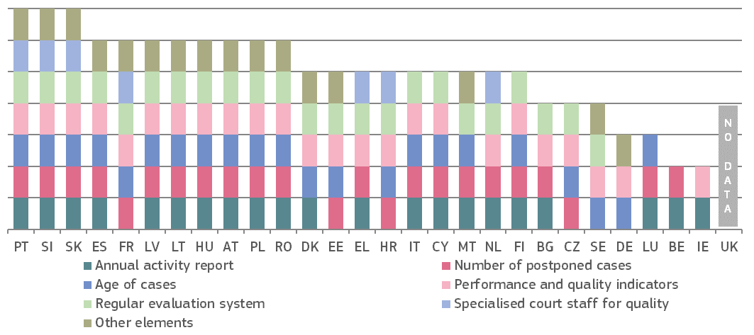

*(*) The evaluation system refers to the performance of court systems, using indicators and targets.* *In 2018, all Member States reported having a system that allows them to monitor the number of incoming cases and delivered decisions, as well as the length of proceedings making these categories superfluous for the above figure. Similarly, the more in-depth work on quality standards has superseded their use as an evaluation category. Data on ‘other elements’ include e.g. clearance rate (****AT****,* ***FR****), number of appealed cases and enforcement procedures (****ES****), number of cases according to types of disputes (****SK****), outcome of the case, e.g. full or partial satisfaction (****SK****), final convictions and suspended cases (****RO****) and number of court sessions (****PL****).*

**Figure 40: Availability of ICT for case management and court activity statistics***(0 = available in 0 % of courts, 4 = available in 100 % of courts ([98])) (source: CEPEJ study)*

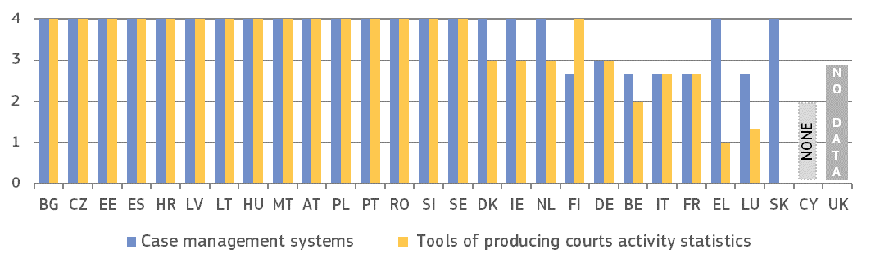

**Figure 41: Topics of surveys conducted among court users or legal professionals** (*) *(source: European Commission ([99]))*

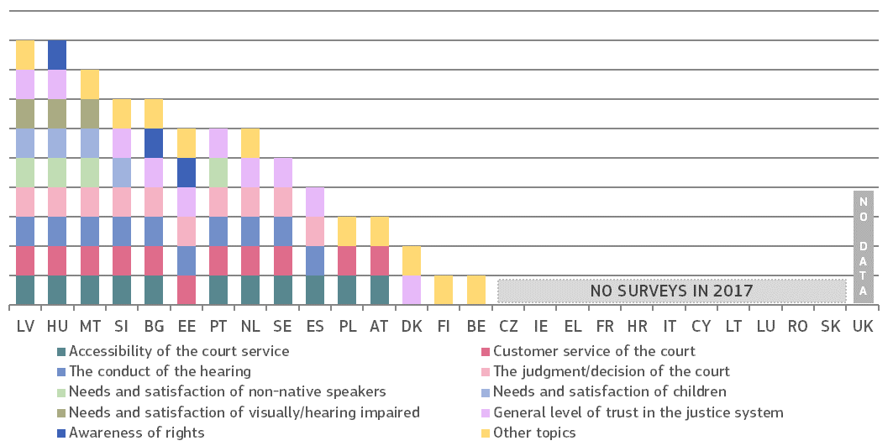

*(*) Member States were given one point per survey topic indicated regardless of whether the survey was conducted at national, regional or court level. ‘Other topics’ include: physical accessibility (****MT****); usability of the online portal with court information (****DK****); access to court ingformation (****PT****), and availibility of readibility of forms and instructions to complete them (****PL****). This category also covers surveys among court staff, e.g. integrity of judges (****HU****), level of knowledge and personal culture of court service employees (****PL****) and property profile of the judiciary (****AT****), and qualitative aspects, such as satisfaction (****AT****), quality of sentencing (****MT****), loyalty towards the courts (****PT****) and conception of appropriate punishment (****FI****).*

**Figure 42: Follow-up of surveys conducted among court users or legal professionals** (*) *(source: European Commission ([100]))*

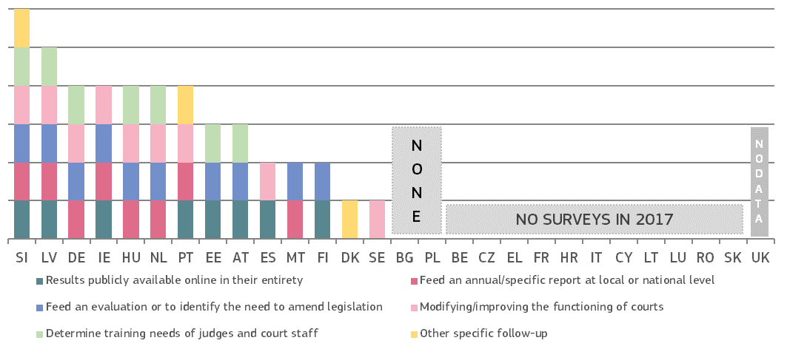

*(*) Member States were given one point per type of follow-up. The category ‘other specific follow-up’ included: guideline and framework for new online portal (****DK****), guideline for policy and operational direction, (****MT****), improve general perceptions about justice system (****PT****),* *and publication of informative tools for general public.* ***IE:*** *data refer to the probate survey conducted in 2016.*

**3.2.4. Standards**

Standards can drive up the quality of justice systems. For the first time, based on data gathered by the Association of the Councils of State and Supreme Administrative Jurisdictions of the EU (ACA-Europe) and the Network of the Presidents of the Supreme Judicial Courts of the EU (NPSJC), the 2019 EU Justice Scoreboard presents an overview of the practices used at the highest and lower courts that contribute to the quality of judgments (Figure 43).

Following the examination of standard measures on timing and information to parties in the previous edition, the 2019 EU Justice Scoreboard focuses on timing, backlogs and timeframes as a management tool in the judiciary ([101]). Figure 44 presents an overview of which Member States use standard measures on time limits, timeframes and backlogs. Time limits are quantitative deadlines, e.g. maximum number of days between the registration of a case until the first hearing. Backlogs are cases older than an identified period of time. Timeframes are measurable targets/practices e.g. specifying a pre-defined share of cases to be completed within a certain time period. Figure 45 presents which bodies set, monitor and follow-up on backlog standards, and Figure 46 shows in more detail certain aspects related to timeframes.

*– Quality of judgments –*

High quality judicial decisions are generally perceived as those that are clearly drafted, structured and that strike a proper balance between clear reasoning and conciseness, thus being easily understood and enforceable. The wording and structure of judicial decisions may also have an impact on how well they can be processed by software programmes, in particular Natural Language Processing (NLP) applications. This end result can only be achieved through the combination of a complex and multifaceted set of elements, such as the high quality professional training of judges, the adoption of good pratices regarding drafting and the monitoring of the quality of the decisions, in the respect of the independence of the judiciary. The Association of the Councils of State and Supreme Administrative Jurisdictions of the EU (ACA-Europe) developed a questionnaire that was replied to by the Supreme Administrative Courts, and by the Supreme Courts (members of the Network of the Presidents of the Supreme Judicial Courts of the EU (NPSJC). Without entering into the merits of individual decisions, Figure 43 presents the standards adopted by the Member States regarding selected indicators considered to contribute to the overall quality of judgments.

**Figure 43: Standards applied to improve the quality of judgments in highest courts** (*)*(source: European Commission with ACA-Europe and NPSJC)*

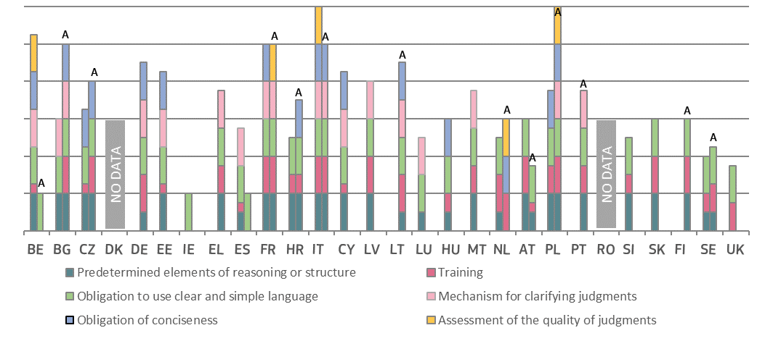

*(*) For each Member State, left column presents the practices in Supreme Courts, right column presents the practices in Supreme Administrative Courts (column marked with letter “A”). The Member States appear in the alphabetical order of their geographical names in the original language. Member States were given one point per indicator of the quality of judgments. Training includes the legal training of judges on the structure of written decisions (0.25 points), legal training of Supreme Courts’ judges on the style of reasoning of written judgments, legal training of lower courts’ judges on the style of reasoning of written decisions (0.25 points) and training on the drafting of judgments (university, judges’ school or on the job) (0.25 points). An obligation to use clear and simple language is considered to exist whether required by law, regulation or professional practice (1 point). The obligation of conciseness is considered to be applicable whether based on law, court regulations or practices (1 point). The assessment of the quality of judgments refers to the existence of an internal mechanism at the level of the Supreme Court to assess the global quality of its own decisions (1 point). IT, Corte Suprema di Cassazione: although a procedural tool for clarification of judgments does not exist, in some situations, certain aspects of the case may still be clarified at the stage of the execution of the decision before a competent judge.* ***DK*** *and* ***RO****: no data. Participating courts:* ***BE:*** *Cour de Cassation (Supreme Court) and Conseil d’Etat (Council of State)* ***BG:*** *Върховен касационен съд (Supreme Court) and Върховен административен съд (Supreme Administrative Court).* ***CZ:*** *Nejvyšší soud (Supreme Court) and Nejvyšší správní soud (Supreme Administrative Court)* ***DE:*** *Bundesverwaltungsgericht (Federal Administrative Court).* ***EE:*** *Riikohus (Supreme Court).* ***IE:*** *Chúirt Uachtarach (Supreme Court).* ***EL:*** *Συμβούλιο της Επικρατείας (Council of State).* ***ES:*** *Tribunal Supremo (Supreme Court).* ***FR:*** *Cour de Cassation (Supreme Court) and Conseil d’Etat (Council of State).* ***HR:*** *Vrhovni sud (Supreme Court) and Visoki upravni (Supreme Administrative Court).* ***IT:*** *Corte Suprema di Cassazione (Supreme Court) and Consiglio de Stato (Council of State).* ***CY:*** *Ανώτατο Δικαστήριο (Supreme Court).* ***LV:*** *Augstākā tiesa (Supreme Court).* ***LT:*** *Vyriausiasis Administracinis Teismas (Supreme Administrative Court).* ***LU:*** *Cour de Cassation (Supreme Court).* ***HU:*** *Kúria (Supreme Court).* ***MT:*** *Court of Appeal.* ***NL:*** *Hoge Raad (Supreme Court) and Raad van State (Council of State).* ***AT:*** *Oberster Gerichtshof (Supreme Court) and Verwaltungsgerichtshof (Supreme Administrative Court).* ***PL:*** *Sąd Najwyższy (Supreme Court) and Naczelny Sąd Administracyjny (Supreme Administrative Court).* ***PT:*** *Supremo Tribunal Administrativo (Supreme Administrative Court).* ***SI:*** *Vrhovno sodišče (Supreme Court).* ***SK:*** *Najvyšší súd (Supreme Court).* ***FI:*** *Korkein hallinto-oikeus (Supreme Administrative Court).* ***SE:*** *Högsta domstolen (Supreme Court) and Högsta förvaltningsdomstolen (Supreme Administrative Court).* ***UK:*** *Supreme Court.*

**Figure 44: Standards on timing** (*) *(source: European Commission ([102]))*

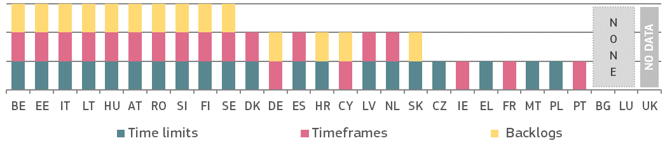

*(*) Member States were given 1 point if standards are defined, regardless of the area (civil/commercial, administrative, or other).*

Figure 45 focuses on standards on backlogs, which consist of delay reducing measures to improve the pace of definition in litigation. The figure shows the competences of the different powers of the Member States to set, monitor and follow-up standards on backlogs. Figure 46 focuses on timeframes, which can be an effective management tool in the judiciary since they can help to detect potential issues on efficiency and assist in identifying solutions (e.g. additional human or financial resources, reorganisation of court management process, temporary assistance to a court).

**Figure 45: Setting and monitoring of standards on backlogs**(*) *(source: European Commission (*[103]*))*

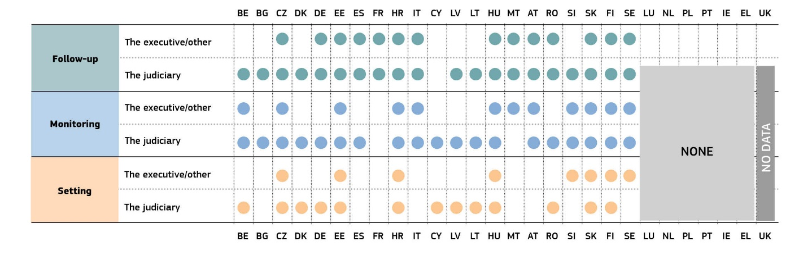

*(*) The ‘executive’ encompasses institutions under direct or indirect control by the government. ‘Other’ refers to the National Office for the Judiciary in HU, headed by its president elected by qualified majority of the Parliament from among judges for a period of nine years. The ‘judiciary’ includes bodies such as court presidents, Councils for the Judiciary, judges’ bodies. HU: The National Office for the Judiciary is involved in setting, monitoring and follow-up of standards on backlogs.*

**Figure 46: Timeframes: definition, automatic monitoring and follow-up** (*)(*source: European Commission ([104])*)

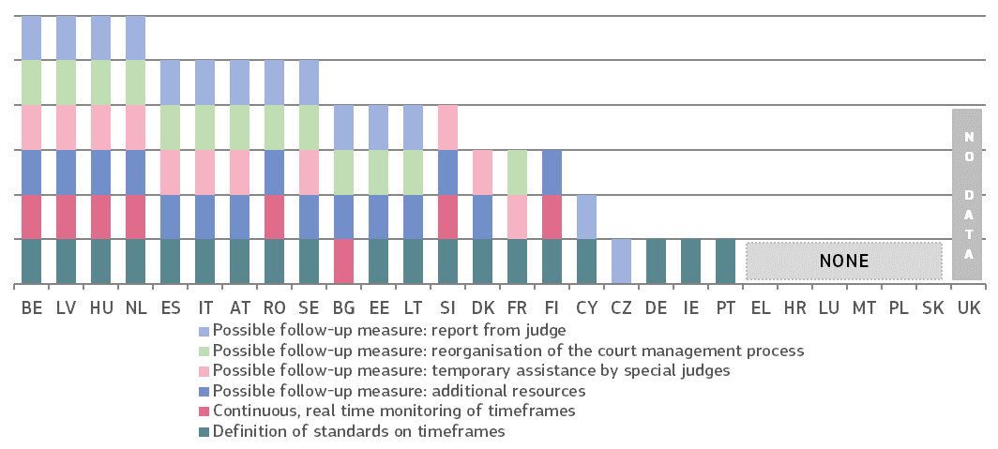

|  |
| --- |
| **3.2.5. Summary on the quality of justice systems**  Easy access, sufficient resources, effective assessment tools and appropriate standards and practices are the factors that contribute to a high quality of justice systems. Citizens and business expect high-quality decisions from an effective justice system ([105]). The 2019 EU Justice Scoreboard develops its comparative examination of these factors.  *Accessibility*  This edition looks at elements contributing to a citizen-friendly justice system:   * Almost all Member States provide access to **some online information** about their judicial system, including a centralised web portal with online forms and interactive education on legal rights (Figure 20). Differences appear on the content of the information and how adequate these are with people’s needs. For example,as to the possibility to calculate legal aid through online simulation, an improved number of Member States (13) enable people to find out whether they are eligible for legal aid. While information for non-native speakers is available in the majority of Member States, this is not always the case withtargeted information for children and visually or hearing impaired people. * The **availability of legal aid and the level of court fees**have a major impact on access to justice, in particular for people in poverty*.* Figure 21 shows that in some Member States, consumers whose income is below the Eurostat poverty threshold would not receive legal aid. Compared to last year, though, two of such Member States have made legal aid more reachable. At the same time, over the years, legal aid has become less accessible in some Member States. The level of court fees (Figure 22) has remained largely stable since 2016 although in several Member States, the court fees have raised as a proportion of the claim, especially for low value claims, imputable to the increase of the minimum court fee applicable. The difficulty in benefiting from legal aid in combination with partly significant levels of court fees in some Member States could have a dissuasive effect for people in poverty to access justice. * The **availability of electronic means** during the judicial procedure contributes to easier access to justice and the reduction of delays and costs. Figure 23 shows that in more than half of the Member States, electronic submission of claims is not in place or is possible only to a limited extent and that not all Member States allow following the progress of court proceedings online. * Most Member States have standards on how to **inform the parties about the progress of their case**, the court timetable or potential delays (Figure 24). Compared to previous years, a few Member States have considerably improved these standards. The differences between Member States relate mainly to the methods used. While some Member States have a system with automated e-Mail or SMS notification providing information about delays, timetables or general case progress, others simply give online access to the information about the case, and some also leave it at the discretion of the courts. * Compared to previous years, **online access to court judgments** (Figure 25) has improved especially as to the publication of judgments of the highest instance: 19 Member States publish all civil/commercial and administrative judgments. For the first time, the EU Justice Scoreboard presents the publication of criminal judgments. They indicate that 19 Member States publish all criminal judgments of the highest instance.The positive developments invite all Member States to further improve as decisions at the highest instance play an important role for the consistency of case law. As various arrangements for online publication (Figure 26) could facilitate searches for relevant case-law, tagging judgments with keywords and greater use of the European Case Law identifier (ECLI) could be further developed. * The number of Member States promoting the voluntary use of **alternative dispute resolution methods** (ADR) (Figure 27) for private disputes continues to grow compared to previous years. This is mainly achieved by introducing more incentives for the use of ADR across different areas of law. Administrative disputes have also been taken into consideration and less than half of the Member States allow ADR in the field.   *Resources*  High quality justice systems in Member States require sufficient levels of financial and human resources, including the necessary investments into physical and technical infrastructure, appropriate initial and continuous training, as well as diversity among judges, including gender balance. The 2019 EU Justice Scoreboard shows the following:   * In terms of**financial resources**, data show that, overall, in 2017, general government total expenditure on law courts remained mostly stable in Member States, with significant differences in actual amounts, both in EUR per inhabitant and as a percentage of GDP between Member States persisting (Figures 28 and 29). However, fewer Member States increased their expenditure in 2017 compared to 2016. Member States mostly use historical or actual cost for determining financial resources for the judiciary, while few rely on the actual workload or court requests (Figure 30). * For the first time, based on data gathered by the Eurostat, the 2019 EU Justice Scoreboard also presents the **breakdown of total expenditure into different categories**. Figure 31 reveals significant differences in spending patterns among Member States. On the one hand, while the wages and salaries of judges and court staff (including social contributions) represent the biggest share in most Member States, investment into fixed assets such as court buildings and software is very low, and even absent in some cases. The expenditure on operating costs (e.g. building rentals, legal aid and other consumables), on the other hand, is considerably higher in some Member States (Figure 31). * **Women** represent a large majority among judges**.** In first and second instance courts they prevail in the majority of Member States (Figure 33). This is then reversed, though, in Supreme Courts where women represent less than fifty percent of judges in most Member States (Figure 34). However, the proportion of female judges at Supreme Courts has grown since 2010 in most Member States. * On the **training of judges,** while most Member States provide continuos training in EU law, the law of another Member State and on judgecraft fewer offer training on IT skills, court management and judicial ethics (Figure 37). On the training on communicating with vulnerable group of parties, there appear to be improvements at the benefit of children, persons visually or hearing impaired and victims of gender based violence (Figure 38), less so with respect to asylum seekers. Less than half of Member States provide trainings on awareness raising and ability to deal with fake news and social media issues.   *Assessment tools*   * **Monitoring and evaluation** of court activities (Figure 39) exists in all Member States. It generally includes different performance and quality indicators and regular reporting. Almost all Member States monitor the number and length of court cases and have regular evaluation systems. Compared to previous years, several Member States have extended monitoring to more specific elements and some involved more specialised court staff for quality. * Many Member States have yet to implement **ICT case management systems** to their full potential, and no improvements have been achieved compared to previous years (Figure 40). These systems serve various purposes, including generating statistics, and are to be implemented consistently across the whole justice system. Some Member States have early-warning systems to detect malfunctions or non-compliance with case processing standards, which enables the finding of timely solutions. In some Member States, it is still not possible to ensure nationwide data collection across all justice areas. * The **use of surveys** among court users and legal professionals (Figure 41) has decreased, with a rising number of Member States opting not to conduct any surveys. Accessibility, customer service, court hearing and judgment, as well as general trust in the justice system remained key survey topics, but only a few Member States inquired about the satisfaction of groups with special needs and the awarness of rights. Almost all Member States who used surveys also ensured follow-up (Figure 42), while the extent of the follow up continued to vary greatly. Results generally were made public and fed into reports, while in most of the Member States the survey results allowed to identify the need to amend legislation.   *Standards*  Standards can drive up the quality of justice systems. This edition continues to examine in more detail certain standards aiming to improve the timing of proceedings and the information provided to the parties. For the first time, the 2019 EU Justice Scoreboard also includes data on the standards regarding the quality of judgments.   * Based on data gathered by ACA-Europe and NPSJC, Figure 43 shows that thestandards regarding the **quality of judgments** differ considerably among Member States, and, in some Member States, even between the courts considered. However, most Member states provide some kind of professional training for judges on the structure, style of reasoning and drafting of judgments.   In most Member States, the **structure and reasoning of decisions** include predetermined elements. In addition, in some Member States, court users have access to mechanisms to obtain clarifications regarding court decisions, an interesting practice to improve citizen-friendly justice systems.  Supreme Courts that deploy **instruments of self-assessment of the quality** of their decisions are a minority, although such practice, while respecting the independence of the judiciary, could allow improvements.   * Most Member States use **standards on timing**. However, certain Member States facing particular challenges on efficiency are currently not using such standards. Standards on backlogs are still not as widespread as those fixing time limits (e.g. fixed time from the registration of a case until the first hearing) and time frames (e.g. specifying a pre-defined share of cases to be completed within a certain time) (Figure 44). * Standards on **backlogs** are a useful tool that can contribute to better case management and improved efficiency. Figure 45 shows that backlogs are mostly set solely by the judiciary or in cooperation with the executive. The monitoring and follow-up is mainly under the responsibility of the judiciary, while, in some Member States, the executive also plays a role on the monitoring and follow-up phases. * While most Member States have standards on **timeframes**(Figure 46), only a few have continuous monitoring mechanisms on the predefined timeframes. The 2019 EU Justice Scoreboard shows that the majority of Member States deploy additional resources on follow-up measures, which, however, differ in their scope. The most common follow-up measure is the reorganisation of the court management process, while the possibility of temporary assistance by special judges is only foreseen by few Member States. |

**3.3. Independence**

Judicial independence is a requirement stemming from the principle of effective judicial protection referred to in Article 19 TEU, and from the right to an effective remedy before a court or tribunal enshrined in the Charter of Fundamental Rights of the EU (Article 47) ([106]). It guarantees the fairness, predictability and certainty of the legal system, which are vital elements for the rule of law and for an attractive investment environment. The perceived independence of the judiciary is a growth-enhancing factor, as a perceived lack of independence can deter investments. In addition to indicators on perceived judicial independence from various sources, the Scoreboard presents a number of indicators on how justice systems are organised to protect judicial independence in certain types of situations where independence could be at risk. Reflecting the input from the European Network of Councils for the Judiciary (ENCJ), the Network of the Presidents of the Supreme Judicial Courts of the EU (NPSJC) and the Association of the Councils of State and Supreme Administrative Jurisdictions of the EU (ACA-Europe), the 2019 EU Justice Scoreboard shows new or updated indicators in relation to legal safeguards on the disciplinary proceedings regarding judges and the appointment of judges-members of the Councils for the Judiciary, and on the organisation of the prosecution services.

**3.3.1. Perceived judicial independence**

**Figure 47: Perceived independence of courts and judges among the general public** (*) *(source: Eurobarometer ([107]) — light colours: 2016, 2017 and 2018, dark colours: 2019)*

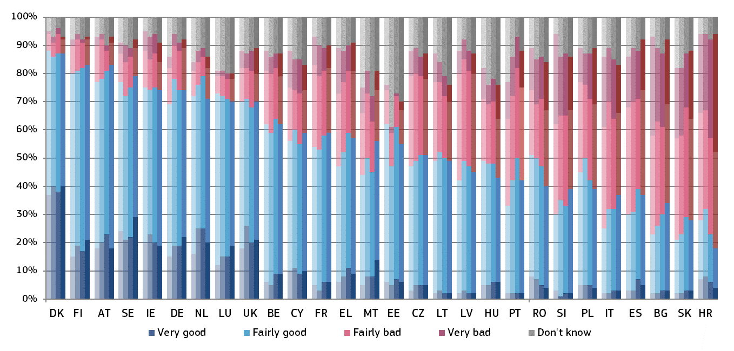

*(*) Member States are ordered first by the percentage of respondents who stated that the independence of courts and judges is very good or fairly good (total good); if some Member States have the same percentage of total good, then they are ordered by the percentage of respondents who stated that the independence of courts and judges is fairly bad or very bad (total bad); if some Member States have the same percentage of total good and total bad, then they are ordered by the percentage of respondents who stated that the independence of courts and judges is very good; if some Member States have the same percentage of total good, total bad and of very good, then they are ordered by the percentage of respondents who stated that the independence of courts and judges is very bad.*

Figure 48 shows the main reasons given by respondents for the perceived lack of independence of courts and judges. Respondents among the general public, who rated the independence of the justice system as being ‘fairly bad’ or ‘very bad’, could choose between three reasons to explain their rating. The Member States are listed in the same order as in Figure 47.

**Figure 48: Main reasons among the general public for the perceived lack of independence** *(share of all respondents* **—** *higher value means more influence) (source: Eurobarometer ([108]))*

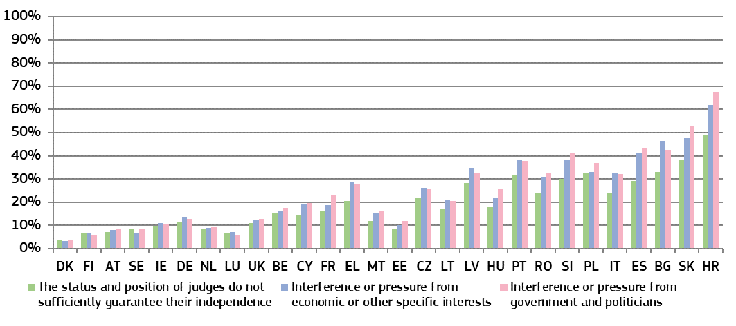

**Figure 49: Perceived independence of courts and judges among companies**(*) *(source: Eurobarometer ([109])* **—** *light colours: 2016, 2017 and 2018, dark colours: 2019)*

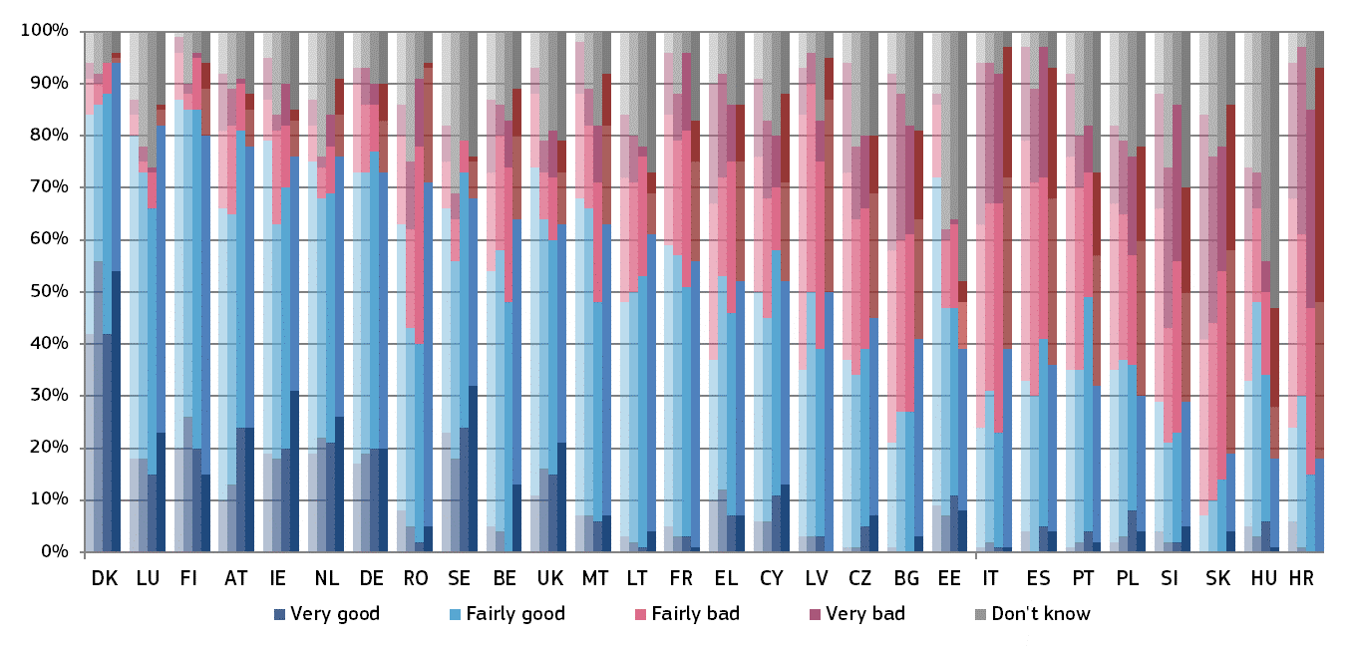

*(*) Member States are ordered first by the percentage of respondents who stated that the independence of courts and judges is very good or fairly good (total good); if some Member States have the same percentage of total good, then they are ordered by the percentage of respondents who stated that the independence of courts and judges is fairly bad or very bad (total bad); if some Member States have the same percentage of total good and total bad, then they are ordered by the percentage of respondents who stated that the independence of courts and judges is very good; if some Member States have the same percentage of total good, total bad and of very good, then they are ordered by the percentage of respondents who stated that the independence of courts and judges is very bad.*

Figure 50 shows the main reasons given by respondents for the perceived lack of independence of courts and judges. Respondents among companies, who rated the independence of the justice system as being ‘fairly bad’ or ‘very bad’, could choose between three reasons to explain their rating. The Member States are listed in the same order as in Figure 49.

**Figure 50: Main reasons among companies for the perceived lack of independence** *(rate of all respondents* **—** *higher value means more influence) (source: Eurobarometer ([110]))*

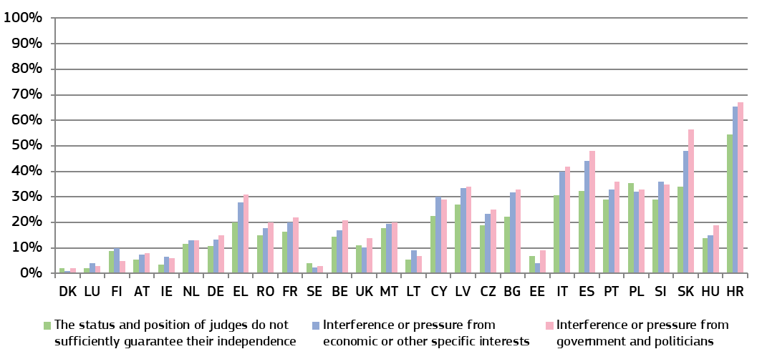

**Figure 51: WEF: businesses’ perception of judicial independence** *(perception* **—** *higher value means better perception) (source: World Economic Forum (*[111]*))*

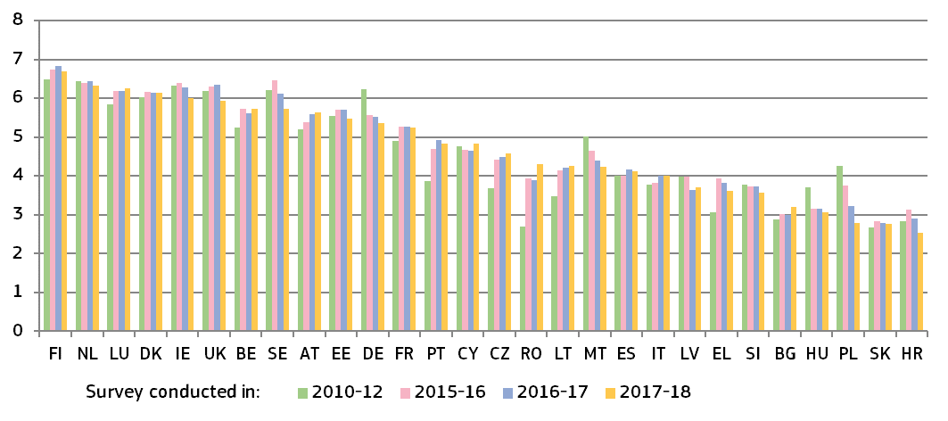

**3.3.2. Structural independence**

The guarantees of structural independence require rules, particularly as regards the composition of the court and the appointment, length of service and grounds for abstention, rejection and dismissal of its members, in order to dispel any reasonable doubt in the minds of individuals as to the imperviousness of that court to external factors and its neutrality with respect to the interests before it ([112]).

European standards have been developed, particularly by the Council of Europe, for example in the *2010 Council of Europe Recommendation on judges: independence, efficiency and responsibilities* ([113]). The Scoreboard presents a number of indicators on how justice systems are organised to safeguard judicial independence.

For the first time, this edition of the Scoreboard includes indicators on bodies and authorities involved in disciplinary proceedings regarding judges (Figures 52 and 53), and, as last year, shows an indicator on the appointment of judges-members of the Councils for the Judiciary (Figure 54) ([114]). The 2019 EU Justice Scoreboard expands its overview of how prosecution services are managed and organised in the Member States (Figures 55, 56 and 57) ([115]). The figures present the national frameworks as they were in place in December 2018.

The figures presented in the Scoreboard do not provide an assessment or present quantitative data on the effectiveness of the safeguards. They are not intended to reflect the complexity and details of the safeguards. Having more safeguards does not, in itself, ensure the effectiveness of a justice system. It should also be noted that implementing policies and practices to promote integrity and prevent corruption within the judiciary is also essential to guarantee judicial independence. Ultimately, the effective protection of judicial independence requires a culture of integrity and impartiality, shared by magistrates and respected by the wider society.

*–* *Safeguards on disciplinary proceedings regarding judges –*

Disciplinary proceedings regarding judges are among the most sensitive situations in relation to judicial independence. According to the Court of Justice of the European Union, “the requirement of independence also means that the disciplinary regime governing those who have the task of adjudicating in a dispute must display the necessary guarantees in order to prevent any risk of it being used as a system of political control of the content of judicial decisions.” ([116]) The set of guarantees identified by the Court of Justice as essential for safeguarding the independence of the judiciary include rules which define both conduct amounting to disciplinary offences and the penalties actually applicable, rules which provide for the involvement of an independent body in accordance with a procedure which fully safeguards the rights enshrined in Articles 47 and 48 of the Charter, in particular the rights of the defence, and rules which lay down the possibility of bringing legal proceedings challenging the disciplinary bodies’ decisions ([117]). The Court of Justice held that “Article 267 TFEU gives national courts the widest discretion in referring matters to the Court (…) at whatever stage of the proceedings they consider appropriate” ([118]). The Court added that any national rule inhibiting this discretion “in order to avoid being (…) exposed to disciplinary penalties” is “detrimental to the prerogatives granted to national courts and tribunals by Article 267 TFEU and, consequently, to the effectiveness of the cooperation between the Court and the national court (…) established by the preliminary ruling mechanism” ([119]). The Court later stated that “not being exposed to disciplinary sanctions for (…) sending request for a preliminary ruling to the Court (…) constitutes a guarantee essential to judicial independence” ([120]).

According to the Council of Europe standards, disciplinary proceedings regarding judges may follow where they fail to carry out their duties in an efficient and proper manner ([121]). The interpretation of the law, assessment of facts or weighing of evidence carried out by judges to determine cases should not give rise to civil or disciplinary liability, except in case of malice and gross negligence ([122]). Moreover, disciplinary proceedings should be conducted by an independent authority as a court with all the guarantees of a fair trial. The judge under disciplinary proceeding should have the right to challenge the decision and the sanction. Disciplinary sanctions should be proportionate ([123]).

Figure 52 presents an overview of the authorities that decide on disciplinary sanctions regarding ordinary judges, which can be either (a) regular independent authorities such as courts (Supreme Court, Administrative Court or Court President) or Councils for the judiciary, or (b) other authorities whose members are specifically appointed by the Council for the Judiciary, by judges or by the executive to decide in disciplinary proceedings regarding judges.

**Figure 52: Authority deciding on disciplinary sanctions regarding judges** (*) *([124])*

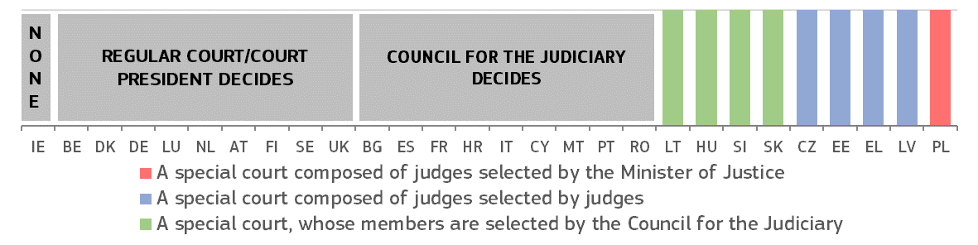

*(*)* ***BG:*** *Lighter disciplinary sanctions may be imposed by the Court President.* ***CZ:*** *Disciplinary cases are examined by disciplinary chambers of the Supreme Administrative Court. The members are proposed by the President of the Court among a list of judges and they are chosen by sortition.* ***DK:*** *The Court of Indictment and Revision whose members are proposed by several actors (judiciary, law firm and public organisation) and appointed by the Ministry of Justice following the recommendation of the Judicial Appointments Council (independent body) decides.* ***DE:*** *Disciplinary measures can be applied in formal disciplinary proceedings (Section 63 German Judiciary Act) by service courts (‘Dienstgerichte der Länder’ concerning federal state judges, and ‘Dienstgericht des Bundes’ concerning federal judges), which are special panels in regular courts. The members of these panels are appointed by the judges (‘Präsidium’) of the particular court (higher regional court or regional court, or the Federal Court of Justice). Less severe disciplinary measures, such as reprimand, can be issued in a disciplinary ruling (Section 64 German Judiciary Act) by either a court president or the ministry of justice (both at the level of federal states and at federal level).* ***EE:*** *disciplinary cases are examined by the Disciplinary Chamber of Judges appointed by the Supreme Court and by the General Assembly of all Estonian judges.* ***IE:*** *Judges are not subject to a disciplinary body or disciplinary regime apart from the procedure under the Constitution under which a judge may be removed from office for stated misbehaviour or incapacity upon resolutions passed by both Houses of Parliament (the Oireachtas) calling for his/her removal.* ***EL:*** *The disciplinary authority over judges is exercised, in the first and second instance, by councils composed of regular judges of higher rank chosen by lot. Disciplinary authority over high ranking judges is exercised by the Supreme Disciplinary Council.* ***LV:*** *Disciplinary cases are examined by the Judicial Disciplinary Committee whose members are appointed by the general meeting of judges.* ***ES:*** *Disciplinary decisions regarding minor disciplinary offences are made by the governance chamber of the respective Court of the district where the disciplined judge sits (High Court of Justice, National Court and Supreme Court).* ***LT:*** *At first instance, the Judicial Court of Honour, whose members and chairperson (judge, elected by the Council for the Judiciary) are laid out in the Ruling of the Council for the Judiciary, decides. It is composed of six judges selected and appointed by the Council for the Judiciary, two members appointed by the President of the Republic and two members appointed by the Speaker of the Seimas. At second instance, the Supreme Court decides.* ***HU:*** *Disciplinary cases are examined by the Service Tribunal appointed by the Council for the Judiciary.* ***MT:*** *The Commission for the Administration of Justice decides.* ***PL:*** *The Minister of Justice selects disciplinary judges after a non-binding consultation with the National Council for the Judiciary.* ***SI:*** *The disciplinary court is appointed by the Council for the Judiciary among members of the Council itself and among judges proposed by the Supreme Court.* ***SK:*** *Disciplinary panels are appointed by the Council for the Judiciary. For the President and Vice President of the Supreme Court, the Constitutional Court is competent for disciplinary proceedings.* ***SE:*** *A permanent judge may be removed from office only if he has committed a serious crime or repeatedly neglected his duties and thereby shown himself manifestly unfit to hold the office. Should the decision to remove the judge from office have been made by another authority than a court (in practice by the National Disciplinary Offence Board), the judge concerned may call upon a court to review that decision.* ***UK (EN&WL):*** *The Lord Chief Justice has the power, with the agreement of Lord Chancellor, to give a judge formal advice, a formal warning or a reprimand, or to suspend them from office in certain circumstances.* ***UK (NI):*** *Disciplinary cases are decided by Lord Chief Justice and Judicial Appointments Ombudsman.*

Figure 53 presents an overview of the investigative bodies, which carry out the formal investigation during disciplinary proceedings regarding judges. It does not concern preliminary enquiries to decide whether or not to initiate a formal disciplinary proceeding. The investigation phase is a particularly sensitive step within disciplinary proceedings, which could affect judicial independence. The investigative power can be exercised either (a) by regular independent authorities such as Court Presidents or Councils for the Judiciary, or (b) by other investigators who are specifically appointed -by the Council of the Judiciary, by judges or by other authorities- for conducting investigations in disciplinary proceedings regarding judges.

**Figure 53: Investigator in charge of formal disciplinary proceedings regarding judges** (*) ([125])

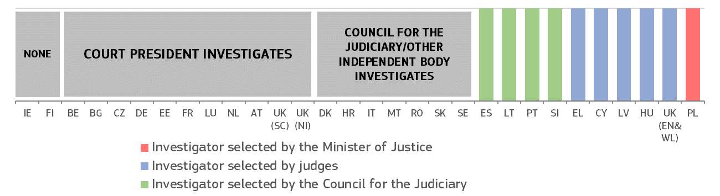

*(*)* ***BG:*** *The relevant administrative head of the court or the Judge’s College to the Supreme Judicial**Council of Bulgaria investigates.* ***CZ:*** *The minister of justice can also conduct some preliminary enquiries in order to prepare the motion to initiate disciplinary proceedings, normally consulting the president of the court where the concerned judge sits.* ***DK:*** *The Director of the Public Prosecution investigates.* ***DE:*** *There is no formal pre-investigatory phase. In disciplinary orders, concerning less severe disciplinary measures such as reprimand, the court president and the highest service authority (usually the ministry of justice, both at the level of federal states and at federal level) assess the facts. The highest service authority decides whether to launch a disciplinary proceeding before the court. Then the court carries out formal investigations.* ***EE:*** *The President of a court or the Chancellor of Justice (Ombudsman) can conduct an investigation.* ***IE:*** *The judges are not subject to a disciplinary body or disciplinary regime apart from the procedure under the Constitution under which a judge may be removed from office for stated misbehaviour or incapacity upon resolutions passed by both Houses of Parliament (the Oireachtas) calling for his/her removal.* ***EL:*** *Civil and Criminal Courts: The Judicial Inspection Body which is elected from among judges by lot. Administrative courts: The investigator is chosen by lot among the members of the Council of State.* ***ES:*** *The Promoter of disciplinary action is appointed by the General Council for the Judiciary; the Promoter is selected from a pool of judges of the Supreme Court and Magistrates with more than 25 years of legal experience, but exclusively exercises the functions of Promoter during his mandate.* ***IT:*** *The Prosecutor General at the Supreme Court (who is a member of the Council for the Judiciary) is entitled to conduct the investigation.* ***CY:*** *The Investigative judge, appointed by the Supreme Court, investigates.* ***LV:*** *The Judicial Disciplinary Committee investigates.* ***HU:*** *The Disciplinary Commissioner, appointed by the Service Tribunal (disciplinary court), investigates.* ***LT:*** *The Judicial Ethics and Discipline Commission, whose members and chairperson (elected by the Council for the Judiciary) are laid out in the Ruling of the Council for the Judiciary, is composed of four judges appointed by the Council for the Judiciary, two members appointed by the President of the Republic, and one member appointed by the Speaker of the Seimas, investigates. The chairperson of the Judicial Ethics and Discipline Commission has the right to delegate the court president in which the judge is working or the president of the higher court to carry out the investigation and present the results of the investigation.* ***MT:*** *The Commission for the Administration of Justice investigates.* ***NL:*** *The Prosecutor-General investigates.* ***PL:*** *The Minister of Justice appoints the Disciplinary Officer for ordinary court judges and his/her two deputies (they, in turn, can appoint their own deputies from among candidates proposed by judges, but under some circumstances can appoint deputies of their own choosing) to investigate. The Minister of Justice can take over any ongoing investigation by appointing an ad hoc Disciplinary Officer of the Minister of Justice.* ***PT:*** *The Council for the judiciary appoints the Judicial Inspection Body, which investigates.* ***RO:*** *The Judicial Inspection Body investigates.* ***SI:*** *The Judicial Council appoints a disciplinary prosecutor from among candidates proposed by the Supreme Court, to investigate.* ***SK:*** *The Disciplinary panel, appointed by the Council for the Judiciary, conducts the investigation.* ***SE:*** *The Parliamentary Ombudsmen and the Chancellor of Justice act as prosecutors in cases of serious malpractice.* ***UK (EN&WL):*** *Depending on the nature of the case and what stage of the disciplinary process the case is at, different authorities consider complaints at different stages of the disciplinary process: the Judicial Conduct and Investigations Office considers the papers in the first instance; nominated judges, selected by Lord Chief Justice, typically make decisions on the papers alone, but do have the discretion to interview parties; disciplinary panels, selected by Lord Chief Justice and Lord Chancellor, typically look at the papers and take evidence from the subject of the complaint in person; and investigating judges, selected by Lord Chief Justice, usually interview the subject of the complaint and might also interview other parties. It should be noted that not every complaint goes through all of these stages.* ***UK (NI):*** *Lord Chief Justice for Northern Ireland.*

*– Safeguards on the nomination of judges-members of the Councils for the Judiciary –*

Councils for the judiciary are essential bodies for ensuring the independence of justice. It is for the Member States to organise their justice systems, including deciding on whether or not to establish a Council for the Judiciary. However, well established European standards, in particular the Recommendation CM/Rec(2010)12, recommend that ‘not less than half the members of [Councils for the Judiciary] should be judges chosen by their peers from all levels of the judiciary and with respect for pluralism inside the judiciary’ ([126]). The figure below describes whether the judiciary is involved in the appointment of judges-members of the Councils for the Judiciary.

**Figure 54: Appointment of judges-members of the Councils for the Judiciary: involvement of the judiciary** (*) ([127])

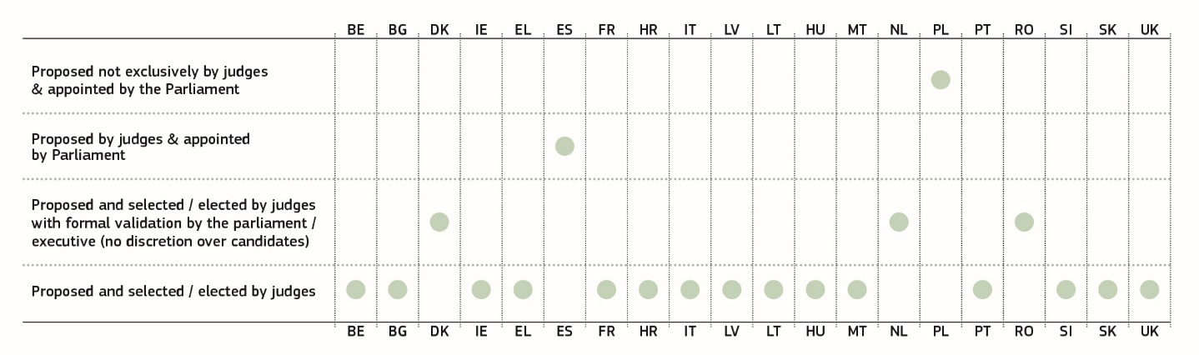

*(*) The Member States appear in the alphabetical order of their geographical names in the original language. The figure presents the national frameworks as they were in place in December 2017.* ***DK:*** *judges-members of the Council are selected by judges. All members are formally appointed by the Minister of Justice.* ***EL:*** *judges-members are selected by lot.* ***ES:*** *judges-members are appointed by the Parliament — the Council communicates to the Parliament the list of candidates who have received the support of a judges’ association or of 25 judges.* ***NL:*** *judges-members are selected by the judiciary and are appointed on the proposal of the Council, based among others on the advice of a selection committee (consisting mainly of judges and court staff). All members of the Council are formally appointed by a Royal Decree, an administrative act, which does not leave any room for discretion to the executive.* ***PL:*** *Candidate judges-members are proposed by groups of at least 2 000 citizens or 25 judges. From among the candidates, the deputies’ clubs select up to nine candidates, from which a committee of the lower chamber of the Parliament (Sejm) establishes a final list of 15 candidates, who are appointed by the Sejm.* ***RO:*** *The campaign and election of judges-members are organised by the Superior Council of Magistracy. Once the final list of elected judges-members is confirmed, the Senate will validate it "en bloc". The Senate may refuse to validate the list only in case of infringement of the law in the procedure for the election of the members of the council and only if the infringement has had an influence over the result of the election. The Senate cannot exercise discretion over the choice of candidates* ***UK:*** *judges-members are selected by judges.*

*– Safeguards relating to the functioning of national prosecution services in the EU –*

Public prosecution plays a major role in the criminal justice system as well as in cooperation in criminal matters. The proper functioning of the national prosecution service is important for fighting money laundering and corruption. According to the Court of Justice case-law, in the context of the Framework Decision on the European Arrest Warrant ([128]), the public prosecutor’s office can be considered a Member State judicial authority responsible for administering criminal justice whenever it can be distinguished from the executive, in accordance with the principle of the separation of powers which characterises the operation of the rule of law ([129]).

The organisation of national prosecution services varies throughout the EU and there is no uniform model for all Member States. However, there is a widespread tendency to allocate for a more independent prosecutor’s office, rather than one subordinated or linked to the executive ([130]). Management powers over national prosecutors, together with procedures for appointment and dismissal of prosecutors may influence the extent of the independence of a prosecution service. Whatever the model of the national justice system or the legal tradition in which it is anchored, European standards require that Member States take effective measures to guarantee that public prosecutors are able to fulfil their professional duties and responsibilities under adequate legal and organisational conditions ([131]) and without unjustified interference ([132]). In particular, where the government gives instruction of a general nature, for example on crime policy, such instructions must be in writing and published in an adequate way ([133]). Where the government has the power to give instructions to prosecute a specific case, such instructions must carry with them adequate guarantees ([134]). According to the 2000 Recommendation of the Committee of Ministers of the Council of Europe, instructions not to prosecute should be prohibited ([135]). Interested parties (including victims) should be able to challenge a decision of a public prosecutor not to prosecute a case ([136]).

Figure 55 presents an overview of the distribution of the main management powers over national prosecutors between different authorities. The figure shows which authority, either the Prosecutor General; the Council for the Judiciary/Prosecutorial Council; the Minister of Justice/Government/President; or the Parliament, has the following management powers:

1) to issue general guidance regarding prosecution policy,

2) to give instructions regarding prosecution in individual cases,

3) to evaluate a prosecutor,

4) to promote a prosecutor,

5) to remove an individual case which was assigned to a prosecutor (transfer a case),

6) to decide on a disciplinary measure regarding a prosecutor, and

7) to transfer prosecutors without their consent.

Apart from these selected main management powers, the same or other authorities may have additional powers over national prosecution services (e.g. the power to solve conflicts of competence between Member States' public prosecution offices; to acquire data and information from lower prosecution offices). It should be noted that other authorities may have a role in the above listed management powers (e.g. a disciplinary court may decide on certain disciplinary measures).

Figure 55 presents only a factual overview of certain aspects of the organisation of the prosecution services and does not assess their effective functioning, which requires a qualitative assessment taking into account the specific circumstances of each Member State.

The percentage represents the distribution of the seven management powers referred to above among the four possible authorities, without any weighting in terms of the importance of each point*.*

**Figure 55: Distribution of main management powers over national prosecution services** (*)*(source: European Commission with the Expert Group on Money Laundering and Financing of Terrorism)*

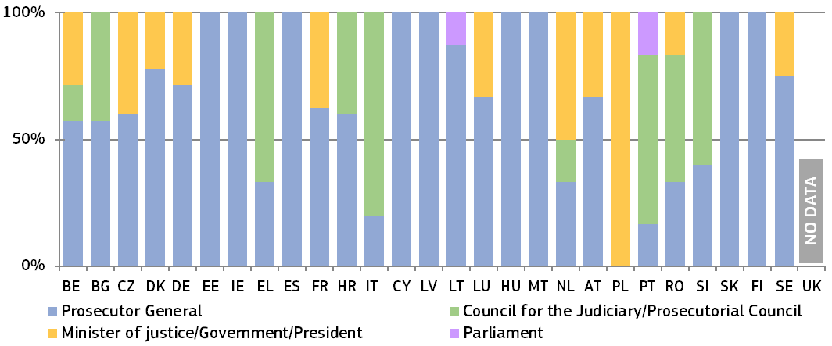

*(*) The Member States appear in the alphabetical order of their geographical names in the original language. The main management powers of the Prosecutor General are described in Figure 56.* ***BE:*** *Council for the Judiciary: power to decide on promotion of prosecutors. Minister of Justice: power to issue general guidance regarding prosecution policy on advice of the Board of prosecutors general and to give instructions regarding prosecution in individual cases (a right of positive injunction to prosecute is foreseen in art. 364 of the Code of Criminal Procedure and art. 151 (1) of the Constitution).* ***BG:*** *Council for the Judiciary (Prosecutor's college of the Supreme Judicial Council): powers to decide on a disciplinary measure regarding a prosecutor, on individual evaluation and on promotion of prosecutors. Minister of Justice may propose the appointment, promotion, demotion, transfer and release from office of judges, prosecutors and investigating magistrates.* ***CZ:*** *Minister of Justice: power to decide on the promotion of prosecutors; power to transfer prosecutors without their consent only in case of organisational changes based on the law.* ***DK:*** *Minister of Justice: powers to decide on disciplinary measures regarding prosecutors and to decide on promotion of prosecutors.* ***DE:*** *Minister of Justice: power to issue general guidance regarding prosecution policy and to give instructions regarding prosecution in individual cases.* ***EE:*** *Disciplinary proceedings shall be initiated at the request of an interested person or on their own initiative by the Minister of Justice against the Prosecutor General, chief state prosecutor or chief prosecutor.* ***EL:*** *Supreme Judicial Council: power to promote and transfer public prosecutors, effected by Presidential decree.* *Minister of Justice is exceptionally allowed to issue general information directives to prosecutors in relation to the application of the legal instruments adopted within the Council of the European Union concerning the judicial cooperation of the Member States in the fields of the prevention and combating of certain types of crimes.* ***ES:*** *Fiscal Council (Prosecutorial Council) has the power to review decisions made by the Prosecutor General in cases set in law.* ***FR:*** *Minister of Justice: power to issue general guidance regarding prosecution policy; power to decide on disciplinary measures regarding prosecutors on the opinion of the High Council for the Judiciary (Conseil Supérieur de la Magistrature) (Article 65 of the French Constitution and Articles 48, 58-1 and 59 of the Statutory Order). If the Minister intends to take a decision that is more serious than the one proposed by the High Council for the Judiciary, the Council must be consulted again (section 58 (1) of the Statutory Order). The President of the Republic issues a decree to promote a prosecutor on the opinion of the Council for the Judiciary. High Council for the Judiciary gives opinion on disciplinary measures, transfers of prosecutors without consent, and promotion of prosecutors.* ***HR:*** *State Attorneys Council: power to decide on disciplinary measures and to promote prosecutors.* ***IT:*** *Council for the Judiciary: powers to decide on a disciplinary measure regarding a prosecutor, to transfer prosecutors without their consent, to decide on individual evaluation of a prosecutor, and to promote a prosecutor.* ***CY:*** *Council for the Judiciary dismisses the Prosecutor General.* ***LV:*** *Council of the Prosecutor General: according to the Article 29, part 2 of the Law on Prosecution Office, the Council as a collegiate advisory institution reviews the main issues related to the organization and operation of the Prosecution Office and performs other functions provided in the law (e.g. develops and adopts statutes governing selection, traineeship and qualification examination of applicants to the Prosecutor’s position and statutes for evaluation of prosecutors’ professional performance).* ***LT:*** *Parliament (Seimas) sets the operational priorities of the Prosecution Service and conducts parliamentary scrutiny of non-procedural actions.* ***LU:*** *Minister of Justice may instruct prosecution services to prosecute in a case (but cannot instruct not to prosecute). However, there have not been any instructions since more than 20 years. There is no legal requirement to consult a prosecutor or seek the opinion of the Prosecutor General on such an instruction. The Grand-Duke, as the Head of State, has the competence to decide on promotion of prosecutors, on the basis of a favourable opinion by the state prosecutor / General Prosecutor.* ***MT:*** *The police have the exclusive competence to institute and undertake criminal proceedings and act as prosecutors before the inferior courts; the Attorney General acts as a prosecutor before the Superior Courts when the compilation of evidence before the Inferior Courts is concluded.* ***NL:*** *Attorney General's Council (College van procureurs-generaal): power to issue general guidance regarding prosecution policy. Minister of Justice: power to issue general guidance regarding prosecution policy and to decide on certain disciplinary measure on prosecutors; it may instruct prosecution services to prosecute or not to prosecute in a case, but needs to beforehand obtain a written reasoned opinion of the Attorney General's Council (College van procureurs-generaal) on the suggested instructions, and notification to Parliament is required. However, so far, there has only been one such case more than twenty years ago. The Head of the Public Prosecution Service within the district where the Public Prosecutor is working has the power to decide on disciplinary measures and on the evaluation of prosecutors.* ***AT:*** *Minister of Justice: power to issue general guidance regarding prosecution policy and to give instructions regarding prosecution in individual cases with the approval of an independent body (Weisungsrat) established at the General Prosecutors office. The powers of the Prosecutor General do not include direct management over the prosecution service as referred to in the chart. The other management powers shown in the chart are held either by the Superior Prosecutor or by the Independent Personnel Board (Personalkommission), consisting of four members, who must be public prosecutors (see comments under Figure 56). As regards the promotion of a prosecutor, it requires an application for a higher position and follows the rules applicable to an appointment as a prosecutor (i.e. proposal by the independent Personal Board (Personalkommission), appointment by the Federal President delegated to the Minister of Justice). The power to decide on a disciplinary measure regarding a prosecutor resides with the Disciplinary Courts, which also have the power to transfer a prosecutor as a sanction.* ***PL:*** *Prosecutor General is also the Minister of Justice.* ***PT:*** *Council for Judiciary: power to decide on a disciplinary measure regarding a prosecutor, to transfer prosecutors without their consent, to decide on individual evaluation of a prosecutor and on promotion of a prosecutor. Parliament can issue general guidance regarding prosecution policy.* ***RO:*** *Council for Judiciary: power to decide on a disciplinary measure regarding a prosecutor and to decide on promotion of a prosecutor (according to Article 40 par 2 letter i) of the Law no 317/2004, the Prosecutorial Section within the Superior Council of Magistracy (SCM) issues the promotion decision of the prosecutors, but the promotion is decided only after a competition (Article 43 of the Law no 303/2004)). Minister of Justice, according* *to the recently amended article 69 of Law no. 304/2004 on judicial organisation, may ask the General Public Prosecutor of the Public Prosecutor's Office next to the High Court of Cassation and Justice, or, as the case may be, the General Public Prosecutor of the National Anti-Corruption Public Prosecutor's Office, for information on the activity of the Public Prosecutor's Offices and may issue written guidelines about the steps to be taken in crime prevention and control. According to Article 40 par 2 letter h) of the Law no 317/2004 on SCM, the Prosecutorial Section within the SCM is competent to decide on complaints against the final decision of the evaluation committee (the rating). According to Article 39 par 3 of the Law no 303/2004 on the judges and prosecutors statute, the individual evaluation of the prosecutors is performed by special committees constituted on the decision of the SCM.* ***SI:*** *State Prosecutorial Council: powers to transfer prosecutors without their consent, to decide on individual evaluation of a prosecutor, to decide on promotion of a prosecutor. Moreover, the State Prosecutorial Council is responsible for the appointment and dismissal of the heads of district state prosecutor’s offices, performance assessment and promotion, transfers, secondments and participation in the appointment procedure of state prosecutors, providing opinions on the policy of prosecution, performance assessment and efficiency of functioning of the state prosecutor’s offices, the protection of self-dependence in the performance of state prosecutorial service and the performance of other matters in accordance with the State Prosecutor's Office Act.* ***SK:*** *The powers of the Prosecutorial Council (Prosecutors’ Board) do not include direct management over the prosecution service as referred to in the chart. The Prosecutors’ Board has other powers (e.g. decides on the objections of a prosecutor against the content of the evaluation, which the Head of the Public Service Office has not complied with, and expresses its opinion on the temporary assignment of a prosecutor to another Prosecution Office).* ***SE:*** *Government can issue general guidance regarding prosecution policy.*

Figure 56 presents a factual overview of the main management powers of the Prosecutor General over prosecutors: 1) to issue general guidance regarding prosecution policy, 2) to give instructions regarding prosecution in individual cases, 3) to evaluate a prosecutor, 4) to promote a prosecutor, 5) to remove an individual case which was assigned to a prosecutor (transfer a case), 6) to decide on a disciplinary measure regarding a prosecutor, and 7) to transfer prosecutors without their consent. In addition to these powers, the Prosecutor General may have other powers, which are not shown in the figure ([137]).

**Figure 56: Management powers of the Prosecutor General** (*)*(source: European Commission with the Expert Group on Money Laundering and Financing of Terrorism)*

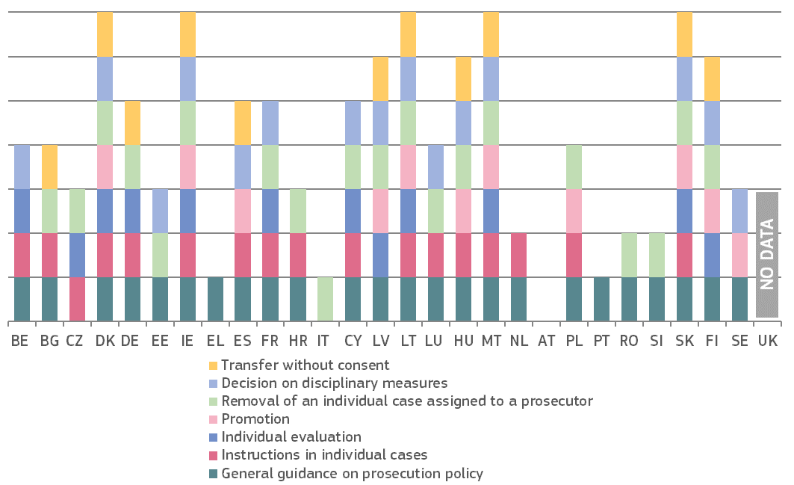

*(*) The Member States appear in the alphabetical order of their geographical names in the original language.* ***BE:*** *As to the* *power to give instructions regarding prosecution in individual cases, a right of injunction to prosecute upon the Prosecutor of the King is provided by art. 364 of the Code of Criminal Procedure. Articles 150 (2) and 138 (2) of the Code of Civil Procedure provide a general right to exercise authority upon the Prosecutor of the King.* ***CZ:*** *power to give instructions regarding prosecution in individual cases only within the Prosecutor General Office and towards high public prosecutor offices.* ***EL:*** *The Public Prosecutor of the Supreme Court (i.e. General Prosecutor) has the right to address to all prosecutors of the country general directions and recommendations relating to the performance of their duties, without of course the addressees of its directives and recommendations being bound by the formulation and the expression of their opinion.* ***ES:*** *The Attorney General sets internal orders and instructions appropriate to the service and to the exercise of prosecuting functions, which may be general or related to specific matters. The general guidelines are essential in order to maintain the principle of unity of action and are fundamentally defined through circulars, instructions and consultations.* *As to the transfer without consent just in cases of high workload.* ***IT:*** *The Prosecutors General at the Court of Appeal have the powers to remove an individual case which was assigned to a territorial prosecutor, in case of inaction; in addition to this, they have the power to acquire data and information from the prosecution offices of the district (or territorial) and to send to the Prosecutor General at the Court of Cassation, in order to verify the correct and uniform functioning of the prosecution offices and compliance with the rules on due process. The Prosecutor General at the Court of Cassation is in charge by Law of the control over the National Anti-Mafia Directorate; moreover, he is in charge of resolving the conflicts of competence between two or more territorial prosecution offices.* ***CY:*** *The Attorney General has the power to decide on disciplinary measures regarding prosecutors in case of minor disciplinary violations. In case of serious disciplinary offences, the Attorney General does not propose sanctions but recommends the initiation of disciplinary measures by the Public Service Commission.* ***LT:*** *As to the power to give instructions on individual cases, the Prosecutor General cannot instruct on which decision to make; as to the power to decide on promotion of prosecutors, the Prosecutor General decides on the conclusions of the Prosecutor Selection Commission or the Chief Prosecutor Selection Commission.* ***LU:*** *The Prosecutor General has the power to instruct prosecution services to prosecute in a case (but cannot instruct not to prosecute). As to the promotion of a prosecutor, the state prosecutor / Prosecutor General, with a favourable opinion, suggests the promotion to the executive and the Head of State signs the nomination.* ***AT:*** *The powers of the Prosecutor General do not include direct management over the prosecution service as referred to in the chart. Superior Prosecutors have the following powers: to issue general guidance regarding prosecution policy within their respective districts, to give instructions regarding prosecution in individual cases, to transfer prosecutors without their consent for organisational reasons (e.g. having to cope with excessive workload or long term sick leaves at one prosecution authority-only within his or her district and for a limited time). Head of the respective prosecution authority has the power to give instructions regarding prosecution in individual cases and to remove an individual case, which was assigned to a prosecutor (transfer a case). The Independent Personnel Body (Personalkommission), consisting of four members, who must be public prosecutors, has the power to evaluate a prosecutor.* ***PL:*** *The Prosecutor general is also the Minister of Justice.* ***RO:*** *The General Prosecutor has the power to transfer an individual case from a prosecution unit to another prosecution unit and to issue general guidance regarding prosecution policies (recommendations), in order to guarantee a unitary approach on criminal investigations.* ***SI:*** *Both the Prosecutor General and the head of State Prosecutor’s Offices have the powers to issue general guidance on prosecution policy and to remove an individual case assigned to a prosecutor.*

Figure 57 presents an overview of the authorities (Council for the Judiciary/Prosecutorial Council/Court, Ministry of Justice, Prosecutor General/prosecution service) dealing with the appointment and the dismissal of national prosecutors, and does not show the appointment and dismissal of Prosecutors General or other assimilated management positions. The figure shows the diversity of models of organisation of the prosecution service across Member States gathering around the executive power or the judiciary. The figure also shows the role of the Prosecutor General and Councils for the Judiciary/Prosecutorial Councils as important actors both in the appointment and in the dismissal of prosecutors.

**Figure 57: Appointment and dismissal of national prosecutors** (*)*(source: European Commission with the Expert Group on Money Laundering and Financing of Terrorism)*

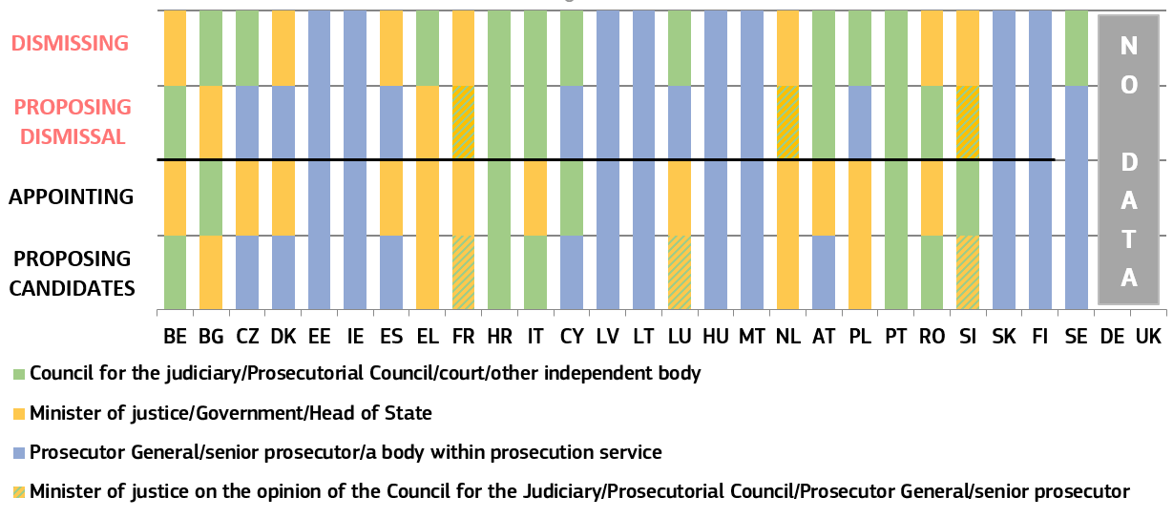

*(*)* ***BE:*** *Proposal for appointment: Council for the Judiciary. Decision on appointment: Head of State on advice of the Minister of Justice. Proposal for dismissal: disciplinary court. Decision on dismissal: Head of State on advice of the Minister of Justice.* ***BG:*** *Decision on appointment and dismissal: the Prosecutors’ Chamber of the Council for the Judiciary.* ***CZ:*** *Proposal for appointment: Prosecutor General. Proposal for dismissal: Prosecutor General, Chief Public Prosecutors and Minister of justice. Decision on dismissal: Court.* ***DK:*** *Proposal for appointment: Prosecutor General proposes the final candidates for the position of prosecutor trainees (for the duration of approximately three years) to the Ministry of Justice who appoints the candidates. If a prosecutor trainee passes the examination and subsequently the training, the candidate will become a prosecutor.* ***EE:*** *Proposal for appointment: prosecutors' competition committee for specialised prosecutors, district prosecutors and assistant prosecutors; chief prosecutors for senior prosecutors. Decision on appointment and dismissal: Prosecutor General.* ***IE:*** *Proposal for appointment: a recruitment competition under a recruitment licence issued by the Commission on Public Service Appointments (CPSA) held normally by the Office of the Director of Public Prosecutions (or potentially by the Public Appointment Service). Decision on appointment: Director of Public Prosecutions. Proposal for dismissal: Office of the Director of Public Prosecutions, in accordance with terms and conditions set by the Minister of Finance, Public Expenditure & Reform. Decision on dismissal: Deputy Director of Public Prosecutions (Director of Public Prosecutions for prosecutors graded as principal officers and upwards).* ***ES:*** *Proposal for appointment: National Prosecutor following a report from the Fiscal Council, after hearing the Superior Fiscal Council of the respective Autonomous Community in the case of posts in the Public Prosecutor's Offices of its territorial scope. Decision on appointment: the Government. Proposal for dismissal: Attorney General. Decision on dismissal: Minister of Justice, after a favourable report form the Fiscal Council.* ***EL:*** *Proposal for appointment: Ministry of Justice annually issues a ministerial decision concerning the entrance examination to the National School of Judges for candidate Public Prosecutors. The selection process -held by a five-member committee- currently consists of written and oral exercises. Once they enter the Greek National School of Judges, the successful candidates, start a 16-month course of study in both theory and practice. This training is followed by an examination used to rank them by order of merit. Depending on their rank, they will be appointed to the competent court. Decision on appointment: Candidates are appointed as Public Prosecutors by a Presidential decree. Proposal for dismissal: Minister of Justice. Decision on dismissal: a court judgment by Disciplinary Councils provided for in Article 91 § 2 of the Constitution and are composed of professionals judges.* ***FR:*** *Proposal for appointment: Minister of Justice on non- binding advice of the Council of the Judiciary. Decision on appointment: President of the Republic. Proposal for dismissal: Minister of Justice on non-binding advice of the Council of the Judiciary. Decision on dismissal: President of the Republic.* ***IT:*** *Decision on appointment: after the proposal of the Council, the Minister of Justice issues a ministerial decree, without any discretion not to appoint or to appoint any other candidate than the proposed candidate prosecutor.* ***CY:*** *Proposal for appointment/dismissal: Attorney General. Decision on appointment/dismissal: Public Service Commission with the opinion of the Attorney General.* ***LT:*** *Proposal for appointment: Prosecution Selection Commission (composed by two prosecutors nominated by the Collegiate Council, two prosecutors nominated by the Prosecutor General and one member nominated by each the President of the Republic, the Speaker of the Seimas and the Prime Minister). Decision on appointment: Prosecutor General. Proposal for dismissal: Prosecutors’ Ethics (same composition as the Prosecution Selection Commission).* ***LU:*** *Proposal for appointment: The Minister of Justice, on the favourable opinion of the Prosecutor General, proposes a nomination to the Grand-Duke. Decision on appointment: Head of State. Proposal for dismissal: Prosecutor General. Decision on dismissal: Court.* ***HU:*** *Proposal/decision on appointment: Senior Prosecutor. Proposal for dismissal: Senior Prosecutor. Decision on dismissal: Prosecutor General.* ***MT:*** *The police have the exclusive competence to institute and undertake criminal proceedings and act as prosecutors before the inferior courts; the Attorney General acts as a prosecutor before the Superior Courts when the compilation of evidence before the Inferior Courts is concluded.* ***NL:*** *Proposal for appointment: Minister of Justice. Decision on appointment is taken by royal decree (the appointing authority has an obligation by constitutional practice to follow the proposal to appoint the candidate for the post of prosecutor). Proposal for dismissal: Minister of Justice on advice of the Head of the prosecution office. Decision on dismissal is taken by royal decree.* ***AT:*** *Proposal for appointment: Independent Personnel Body (Personalkommission) consisting of four members, who must be public prosecutors. Decision on appointment: Federal President delegates the decision to the Minister of Justice. Proposal and decision on dismissal: Disciplinary Court.* ***PL:*** *Proposal for and decision on appointment: Prosecutor General - who is also the Minister of Justice - upon a motion of the National Public Prosecutor. A competent public prosecutor's office’s board gives an opinion on a candidate for the post of prosecutor. Proposal for dismissal: National prosecutor. Decision on dismissal: Disciplinary court; in very limited situations, also the Prosecutor General can dismiss a prosecutor at the request of the National Prosecutor. The opinion on dismissal of a prosecutor is given by the meeting of public prosecutors of the National Public Prosecutor’s Office or competent Regional Prosecutor’s Office.* ***RO:*** *Proposal for appointment: Superior Council of Magistracy. Decision on appointment: President (the appointing authority has an obligation by law to follow the proposal to appoint the candidate for the post of prosecutor).* ***SI:*** *Proposal for appointment: Minister of Justice on the opinion of the Council for the Prosecution Service. Decision on appointment: Council for the Prosecution Service (the appointing authority has not an obligation to follow the proposal to appoint the candidate for the post of prosecutor). Proposal for dismissal: Council for the Prosecution Service. Decision on dismissal: Government on the proposal from the Minister of Justice.* ***SK:*** *Proposal for appointment: Chairman of the Selection Board of the General Prosecutor´s Office. Appointment and dismissal: Prosecutor General.* ***FI:*** *Appointment and dismissal: Prosecutor General.* ***SE:*** *Proposal for, decision on appointment: Director of human resources of the Swedish prosecution authority, on the opinion of the Prosecutor General. Proposal for dismissal: Director of human resources of the Swedish prosecution authority. Decision on dismissal: Court on the opinion of the Prosecutor General.*

|  |
| --- |
| **3.3.3. Summary on judicial independence**  Judicial independence is a fundamental element of an effective justice system. It is vital for upholding the rule of law, the fairness of judicial proceedings and the trust of citizens and businesses in the legal system. For this reason, any justice reform should uphold the rule of law and comply with European standards on judicial independence. The Scoreboard shows trends in perceived judicial independence among the general public and businesses. This edition also presents some selected indicators concerning legal safeguards in relation to the bodies involved in disciplinary proceedings regarding judges and of the management of the prosecution services. The structural indicators do not in themselves allow for conclusions to be drawn about the independence of the judiciaries of the Member States, but represent possible elements which may be taken as a starting point for such an analysis.   * The 2019 Scoreboard presents the developments in **perceived independence** from surveys of citizens (Eurobarometer) and companies (Eurobarometer and World Economic Forum):   + All surveys generally show *similar results*,in particular as regards the composition of the two groups of Member States that have the highest and the lowest perceived judicial independence.   + The World Economic Forum survey (Figure 51), presented for the seventh time, shows that businesses’ perception of independencehas *improved* or *remained stable* in about three-fifths of the Member States when compared to 2010. Also among the Member States facing specific challenges ([138]), the perception of independence *improved* or *remained stable* in nearly three-fifths of those countries looking over the eight-year period. However, compared to 2016-17, businesses’ perception of independence *decreased* in about three-fifths of all Member States.   + The Eurobarometer survey among the general public (Figure 47), presented for the fourth time, shows that the perception of independence has *improved* in about two-thirds of the Member States when compared to 2016. The general public’s perception of independence has *improved* in more than two-thirds among the Members States facing specific challenges looking over the four-year period. However, compared to last year, the general public’s perception of independence *decreased* in about three-fifths of all Member States (in more than two-thirds of Members States facing specific challenges, and about half of other Member States).   + The Eurobarometer survey among the companies (Figure 49), presented for the fourth time, shows that the perception of independence has *improved* in about two-thirds of the Member States both compared to 2016 and to the last year (compared to last year this was the case in more than two-thirds of Members States facing specific challenges, and about three-fifths of other Member States).   + Among the reasons for the perceived lack of independence of courts and judges, the *interference or pressure from government and politicians* was the most stated reason, followed by the pressure from economic or other specific interests. Both reasons are still notable for several Member States where perceived independence is very low (Figures 48 and 50).   + Among the reasons for good perception of independence of courts and judges, nearly four-fifth of companies and of citizens (equivalent to 40 % or 44 % of all respondents, respectively) named the *guarantees provided by the status and position of judges*. * The 2019 EU Justice Scoreboard presents overviews on the disciplinary authorities dealing with proceedings regarding judges as well as competence of the judiciary, the executive and the parliament in the selection of judges-members of the Councils for the Judiciary, and some managerial and organisational aspects of the prosecution services: * Figure 52 presents an overview of the authorities in charge of **disciplinary proceedings regarding judges**. In the majority of Member States, the authority deciding on disciplinary sanctions is an independent authority such as a court (Supreme Court, Administrative Court or Court President) or a Council for the judiciary, while in some Member States it is a special court whose members are specifically selected or appointed (by the Council for the Judiciary, by Judges or, in one Member State, by the Minister of Justice) to act in disciplinary proceedings. * Figure 53 presents an overview of who is the **investigator in charge of disciplinary investigations regarding judges**. In the majority of Member States, the investigator is a Court President or a Council for the Judiciary. In some Member States the investigator is specifically selected either by judges or by the Council of the Judiciary or, in one Member State, by the Minister of Justice. * Figure 54 shows the involvement of the judiciary in the **appointment of judges-members of the Council for the Judiciary.** It is up to the Member States to organise their justice systems, including whether or not to establish a Council for the Judiciary. However, where a Council for the Judiciary has been established by a Member State, the independence of the Council must be guaranteed in line with European standards. In almost all Member States, the judges-members of the Councils are proposed and elected or selected by judges. * Figure 55 presents an overview of the distribution**,** among different authorities, of the **main management powers over national prosecutors**. Figure 56 presents a factual overview of the main management powers of the Prosecutor General over prosecutors. These figures show that in some Member States there is a certain level of concentration in one single authority of the main management powers relating to the prosecution services. Figure 57 presents an overview of the authorities involved in the **appointment and dismissal procedures for national prosecutors**. While the situation varies widely among Member States, in most countries the Council for the Judiciary/Prosecutorial Council or the prosecution service is involved. |

**4. CONCLUSIONS**

This seventh edition of the EU Justice Scoreboard shows that a large number of Member States have continued their efforts to further improve the effectiveness of national justice systems. However, challenges remain to ensure full trust of citizens in the legal systems of those Member States where guarantees of status and position of judges might be at risk and so their independence. The Commission has taken the necessary action and continues to monitor the situation in Member States. It is committed to ensure that any justice reform respects EU law and European standards on rule of law.

1. 2018 State of the Union Address delivered before the European Parliament on 12 September 2018: <https://ec.europa.eu/commission/sites/beta-political/files/soteu2018-speech_en_0.pdf>
2. Commission Statement by First Vice-President Timmermans, European Parliament Plenary debate of 28 February 2018 on the Commission decision to activate Article 7(1) TEU as regards the situation in Poland.
3. Speech delivered in Vienna on 30 November 2018, at the Conference on the Effectiveness of Justice Systems.
4. Article 19 of Treaty on European Union (TEU).
5. Judgment of the Court (Grand Chamber) of 27 February 2018, *Associação Sindical dos Juízes Portugueses v Tribunal de Contas*, C-64/16, ECLI:EU:C:2018:117.
6. COM (2019) 163
7. Communication from the Commission — Annual Growth Survey 2019, 21.11.2018, COM(2018) 770 final, p. 12.
8. The European Parliament adopted the resolution of 29 May 2018 on the 2017 EU Justice Scoreboard (P8_TA(2018)0216) which has informed the preparation of this edition and will inform the preparation of future editions of the EU Justice Scoreboard.
9. <https://ec.europa.eu/info/strategy/justice-and-fundamental-rights/effective-justice/eu-justice-scoreboard_en>
10. In view of the preparation of the EU Justice Scoreboard and to promote the exchange of best practices on the effectiveness of justice systems, the Commission asked Member States to designate two contact persons, one from the judiciary and one from the ministry of justice. Regular meetings of this informal group are taking place.
11. ENCJ unites the national institutions in the Member States that are independent of the executive and legislature, and who are responsible for the support of the judiciaries in the independent delivery of justice: <https://www.encj.eu/>
12. NPSJC provides a forum through which European institutions are given an opportunity to request the opinions of Supreme Courts and to bring them closer by encouraging discussion and the exchange of ideas: <http://network-presidents.eu/>
13. ACA-Europe is composed of the Court of Justice of the EU and the Councils of State or the Supreme administrative jurisdictions of each EU Member State: <http://www.juradmin.eu/index.php/en/>
14. The ECN has been established as a forum for discussion and cooperation of European competition authorities in cases where Articles 101 and 102 of the Treaty on the Functioning of the EU are applied. The ECN is the framework for the close cooperation mechanisms of Council Regulation 1/2003. Through the ECN, the Commission and the national competition authorities in all EU Member States cooperate with each other: <http://ec.europa.eu/competition/ecn/index_en.html>
15. COCOM is composed of representatives of EU Member States. Its main role is to provide an opinion on the draft measures that the Commission intends to adopt on Digital Market issues: <https://ec.europa.eu/digital-single-market/en/communications-committee>
16. The European Observatory on Infringements of Intellectual Property Rights is a network of experts and specialist stakeholders. It is composed of public- and private-sector representatives, who collaborate in active working groups. <https://euipo.europa.eu/ohimportal/en/web/observatory/home>
17. EGMLTF meets regularly to share views and help the Commission define policy and draft new legislation on Anti-Money Laundering and Terrorist Financing: <http://ec.europa.eu/justice/civil/financial-crime/index_en.htm>
18. Eurostat is the statistical office of the EU: <http://ec.europa.eu/eurostat/about/overview>
19. EJTN is the principal platform and promoter for the training and exchange of knowledge of the European judiciary. It develops training standards and curricula, coordinates judicial training exchanges and programmes, disseminates training expertise and promotes cooperation between EU judicial training institutions. EJTN has some 34 members representing EU states as well as EU transnational bodies. <http://www.ejtn.eu/>
20. WEF is an International Organisation for Public-Private Cooperation, whose members are companies: <https://www.weforum.org/>
21. IMF, Regional Economic Outlook, November 2017, *Europe: Europe Hitting its Stride,* pp. xviii, pp. 40, 70: <https://www.imf.org/~/media/Files/Publications/REO/EUR/2017/November/eur-booked-print.ashx?la=en>
22. ECB, ‘Structural policies in the euro area’, June 2018, ECB Occasional Paper Series No 210: <https://www.ecb.europa.eu/pub/pdf/scpops/ecb.op210.en.pdf?3db9355b1d1599799aa0e475e5624651>
23. See e.g. ‘What makes civil justice effective?’, OECD Economics Department Policy Notes, No. 18 June 2013 and ‘The Economics of Civil Justice: New Cross-Country Data and Empirics’, OECD Economics Department Working Papers, No. 1060.
24. World Economic Forum, ‘The Global Competitiveness Report 2018’, October 2018: <https://www.weforum.org/reports/the-global-competitveness-report-2018>
25. World Bank, ‘World Development Report 2017: Governance and the Law, Chapter 3: The role of law’, pp. 83, 140: <http://www.worldbank.org/en/publication/wdr2017>
26. ‘Disposition Time’ indicator is the number of unresolved cases divided by the number of resolved cases at the end of a year multiplied by 365 (days). It is a standard indicator defined by Council of Europe's CEPEJ: <http://www.coe.int/t/dghl/cooperation/cepej/evaluation/default_en.asp>
27. Vincenzo Bove and Leandro Elia; The judicial system and economic development across EU Member States, JRC Technical Report, EUR 28440 EN, Publications Office of the EU, Luxembourg, 2017: <http://publications.jrc.ec.europa.eu/repository/bitstream/JRC104594/jrc104594__2017_the_judicial_system_and_economic_development_across_eu_member_states.pdf>
28. *Idem.*
29. Effect of judicial independence to FDI into Eastern Europe and South Asia; Bülent Dogru; 2012, MPRA Munich Personal RePEc Archive: <https://mpra.ub.uni-muenchen.de/40471/1/MPRA_paper_40322.pdf> . EU MS included in the study were: BG, HR, CZ, EE, HU, LV, LT, RO, SK and SI.
30. The Economist Intelligence Unit: "Risk and Return – Foreign Direct Investment and the Rule of Law", 2015 <http://www.biicl.org/documents/625_d4_fdi_main_report.pdf>, p.22
31. EU Intellectual Property Office (EUIPO), Intellectual Property (IP) SME Scoreboard 2016: <https://euipo.europa.eu/tunnel-web/secure/webdav/guest/document_library/observatory/documents/sme_scoreboard_study_2016/Executive-summary_en.pdf>
32. The information has been collected in cooperation with the group of contact persons on national justice systems for 26 Member States. The UK did not submit information. DE explained that a number of reforms are under way as regards judiciary, where the scope and scale of the reform process can vary within the 16 federal states.
33. HR, IT, CY, PT, SK. See Council Recommendation of 13 July 2018 on the 2018  National Reform Programme of Croatia and delivering a Council opinion on the 2018 Convergence Programme of Croatia (2018/C 320/10); Council Recommendation of 13 July 2018 on the 2018 National Reform Programme of Italy and delivering a Council opinion on the 2018 Stability Programme of Italy, (2018/C 320/11); Council Recommendation of 13 July 2018 on the 2018 National Reform Programme of Cyprus and delivering a Council opinion on the 2018 Stability Programme of Cyprus, (2018/C 320/12); Council Recommendation of 13 July 2018 on the 2018 National Reform Programme of Portugal and delivering a Council opinion on the 2018 Stability Programme of Portugal, (2018/C 320/21); Council Recommendation of 13 July 2018 on the 2018 National Reform Programme of Slovakia and delivering a Council opinion on the 2018 Stability Programme of Slovakia, (2018/C 320/24).
34. BE, BG, IE, EL, ES, LV, HU, MT, PL, RO, SI. These challenges have been reflected in the recitals of the Country-Specific Recommendations and the country reports relating to these Member States. The most recent 2019 country reports, published on 27 February 2019, are available at: <https://ec.europa.eu/info/publications/2019-european-semester-country-reports_en>
35. Conclusions of the Council of Ministers, 17 October 2006 (13339/06); Commission Decision of 13 December 2006 establishing a mechanism for cooperation and verification of progress in Bulgaria to address specific benchmarks in the areas of judicial reform and the fight against corruption and organised crime (notified under document number C(2006) 6570).

    Conclusions of the Council of Ministers, 17 October 2006 (13339/06); Commission Decision of 13 December 2006 establishing a mechanism for cooperation and verification of progress in Romania to address specific benchmarks in the areas of judicial reform and the fight against corruption (notified under document number C (2006) 6569).
36. <https://ec.europa.eu/info/strategy/justice-and-fundamental-rights/effective-justice/rule-law/assistance-bulgaria-and-romania-under-cvm/reports-progress-bulgaria-and-romania_en>
37. BG, CZ, EE, EL, ES, HR, IT, LV, LT, HU, MT, PL, PT, RO, SI, and SK.
38. The information presented is based on data collected in autumn 2017 and updated in June 2018. Since the current programming period 2014 – 2020 is ongoing, the total amounts dedicated to justice systems may increase and the allocations to the various types of activities may change until the end of the programming period in 2023.
39. <https://ec.europa.eu/info/funding-tenders/funding-opportunities/funding-programmes/overview-funding-programmes/structural-reform-support-programme-srsp_en>
40. BE, BG, CZ, EE, EL, ES, HR, IT, CY, LV, HU, MT, PL, PT, SI and SK.
41. See press release IP/18/3972, 31 May 2018, available at: <http://europa.eu/rapid/press-release_IP-18-3972_en.htm>
42. Communication from the Commission — EU law: Better results through better application (2017/C 18/02) (OJ C 18, 19.1.2017, p. 10–20).
43. In December 2017, the Commission decided to refer the Polish Government to the Court of Justice of the European Union for breach of EU law by the Law on the Ordinary Courts Organisation. The Commission considers that the law in question violates Article 19(1) TEU in combination with Article 47 of the Charter of Fundamental Rights. For more details, see: <http://europa.eu/rapid/press-release_IP-17-5367_en.pdf>
44. <http://europa.eu/rapid/press-release_IP-18-5830_en.htm>
45. <https://curia.europa.eu/jcms/upload/docs/application/pdf/2018-12/cp180204en.pdf>
46. See Opinion of Advocate General E. Tanchev of 11 April 2019, European Commission v Republic of Poland, ECLI:EU:C:2019:325.
47. See press release IP/19/1957, 3 April 2019, available at: <http://europa.eu/rapid/press-release_IP-19-1957_en.pdf>
48. See in particular the judgment of the Court (Grand Chamber) of 27 February 2018, *Associação Sindical dos Juízes Portugueses v Tribunal de Contas*, C-64/16, ECLI:EU:C:2018:117, available at: <https://goo.gl/utc5GR>. Judgment of the Court (Grand Chamber) of 25 July 2018*, LM,* C-216/18 PPU, ECLI:EU:C:2018:586, available at: <https://goo.gl/ty1fnk>.
49. Judgment of the Court (Grand Chamber) of 25 July 2018*, LM,* C-216/18 PPU, ECLI:EU:C:2018:586, para. 67, available at: <https://goo.gl/ty1fnk>.
50. Cases C-522/18; C-537/18; C-585/18; C-624/18; C-625/18; C-668/18.
51. Case C-824/18.
52. Cases C-558/18; C-563/18; C-623/18.
53. These requests for preliminary rulings concern, *i.a*., the compliance of the new disciplinary regime for judges, of the composition of the National Council for the Judiciary, and of the newly established disciplinary chamber of the Supreme Court, with EU requirements on judicial independence.
54. Communication from the Commission to the European Parliament and the Council of 11 March 2014, ‘A new EU Framework to Strengthen the Rule of Law’, COM(2014) 158 final/2. See also press release IP-14-237, 11 March 2014, available at: <http://europa.eu/rapid/press-release_IP-14-237_en.htm>
55. See case C-619/18 R, *Commission v Poland*, order of 17 December 2018.
56. The dialogue took place from January 2016 to December 2017. The Commission adopted one opinion on 1 June 2016 and four recommendations on 27 July 2016, 21 December 2016, 26 July 2017 and 20 December 2017. On 20 December 2017, the Commission concluded that there is a clear risk of a serious breach of the rule of law in Poland and therefore proposed to the Council to adopt a decision under Article 7(1) TEU.
57. COM(2017) 835 final.
58. <http://www.europarl.europa.eu/news/en/press-room/20180906IPR12104/rule-of-law-in-hungary-parliament-calls-on-the-eu-to-act>
59. The enforcement of court decisions is also important for the efficiency of a justice system. However, comparable data are not available in most Member States.
60. 2019 Study on the functioning of judicial systems in the EU Member States, carried out by the CEPEJ Secretariat for the Commission: <https://ec.europa.eu/info/strategy/justice-and-fundamental-rights/effective-justice/eu-justice-scoreboard_en>
61. Length of proceedings, clearance rate and number of pending cases are standard indicators defined by CEPEJ: <http://www.coe.int/t/dghl/cooperation/cepej/evaluation/default_en.asp>
62. The years were chosen to keep the seven-year perspective with 2010 as a baseline, while at the same time not overcrowding the figures. Data for 2012, 2013 and 2014 are available in the CEPEJ report.
63. The length of proceedings in specific areas is calculated in calendar days, counting from the day when an action or appeal was lodged before the court (or the indictment became final) and the day on which the court adopted its decision (Figures 18-21, 23 and 24). Values are ranked based on a weighted average of data for 2013, 2014, 2015 and 2016 for Figures 18-21, data for 2015 and 2016 for Figure 23, and data for 2014, 2015 and 2016 for Figures 22 and 24. Where data was not available for all years, the average reflects the available data, calculated based on all cases, a sample of cases or estimations.
64. See <http://eur-lex.europa.eu/legal-content/EN/TXT/PDF/?uri=CELEX:12012E/TXT&from=EN>.
65. The calculation has been made based on the length of cases of appeal against national regulatory authority decisions applying national laws that implement the Regulatory Framework for Electronic Communications (Directives 2002/19/EC (Access Directive), Directive 2002/20/EC (Authorisation Directive), Directive 2002/21/EC (Framework Directive), Directive 2002/22/EC (Universal Service Directive), and other relevant EU law such as the Radio Spectrum Policy Programme, Commission Spectrum Decisions, excluding Directive 2002/58/EC on privacy and electronic communications.
66. Regulation (EU) 2017/1001 of the European Parliament and of the Council of 14 June 2017 on the European Union trade mark (OJ L 154, 16.62017, p. 1-99).
67. Recital 2 of Directive (EU) 2015/849 of the European Parliament and of the Council of 20 May 2015 on the prevention of the use of the financial system for the purposes of money laundering or terrorist financing.
68. IMF Factsheet, 6 October 2016: <http://www.imf.org/en/About/Factsheets/Sheets/2016/08/01/16/31/Fight-Against-Money-Laundering-the-Financing-of-Terrorism>
69. Article 44(1) of the Directive (EU) 2015/849. See also the revised article 44 in Directive (EU) 2018/843, which entered into force in June 2018 and has to be implemented by Member States by January 2020, at the latest.
70. See Section 2 [HR, IT, CY, PT, SK, which received 2018 European Semester Country-Specific Recommendations, and BE, BG, IE, EL, ES, LV, HU, MT, PL, RO, and SI for which the challenges have been reflected in the recitals of the 2018 Country-Specific Recommendations and the 2019 European Semester Country Reports relating to those Member States].

    Variance in the results over the eight years analysed may be explained by contextual factors (variations of more than 10 % of incoming cases are not unusual) or systemic deficiencies (lack of flexibility and responsiveness or inconsistencies in the process of reform).
71. Directive (EU) 2018/1673 of the European Parliament and of the Council of 23 October 2018 on combating money laundering by criminal law will eliminate legal obstacles that may delay prosecution, such as that a prosecution for money laundering can only start when the proceedings for the underlying predicate offence have been concluded. Member States have to transpose the Directive before 8 December 2020.
72. To be noted that the Association of the Councils of State and Supreme Administrative jurisdictions (ACA) has published a transversal study on ‘[Access to administrative supreme courts and to their decisions](http://www.juradmin.eu/images/media_kit/aca_surveys/Transversal-Analysis.pdf)’: <http://www.juradmin.eu/images/media_kit/aca_surveys/Transversal-Analysis---Annex-1.pdf>
73. 2018 data collected in cooperation with the group of contact persons on national justice systems.
74. Article 47(3) of the Charter of Fundamental Rights of the EU.
75. Member States use different methods to establish the eligibility threshold, e.g. different reference periods (monthly/annual income). About half of the Member States also have a threshold related to the personal capital of the applicant. This is not taken into account for this figure. In BE, IE, ES, FR, HR, HU, LT, LV, LU and NL certain categories of persons (e.g. individuals who receive certain benefits) are automatically entitled to receive legal aid in civil/commercial disputes. Additional criteria that Member States may use such as the merit of the case are not reflected in this figure. Although not directly related to the figure, it should be noted that in several Member States (AT, CZ, DE, DK, EE, ES, FR, IT, NL, PL, PT, SI, UK(EW)) legal aid is not limited to natural persons.
76. In order to collect comparable data, each Member State’s respective Eurostat poverty threshold has been converted to monthly income. The at-risk-of-poverty (AROP) threshold is set at 60 % of the national median equivalised disposable household income. European Survey on Income and Living Conditions, Eurostat table ilc_li01, available at: <http://ec.europa.eu/eurostat/web/income-and-living-conditions/data/database>.
77. 2018 data collected through replies by CCBE members to a questionnaire based on the following specific scenario: a dispute of a consumer with a company (two different values of the claim have been indicated: €6 000 and the Eurostat poverty threshold in each Member State). Given that conditions for legal aid depend on the applicant’s situation, the following scenario was used: a single 35-year-old employed applicant without any dependant and legal expenses insurance, with a regular income and a rented apartment.
78. The data refer to income thresholds valid in 2018 and have been collected through replies by CCBE members to a questionnaire based on the following specific scenario: a dispute of a consumer with a company (two different values of the claim have been indicated: €6 000 and the Eurostat poverty threshold in each Member State).
79. Data concern 2017. Equipment rate from 100 % (device completely deployed) to 0 % (device non‑existing) indicates the functional presence in courts of the device covered by the graph, according to the following scale: (100 % = 4 points if applicable to all matters / 1.33 points per specific matter; 50-99 % = 3 points if applicable to all matters / 1 point per specific matter; 10-49 % = 2 points if applicable to all matters / 0.66 point per specific matter; 1-9 % = 1 point if applicable to all matters / 0.33 points per specific matter. Matter relates to the type of litigation handled (civil/commercial, criminal, administrative or other).
80. 2018 data collected in cooperation with the group of contact persons on national justice systems.
81. See *Best practice guide for managing Supreme Courts*, under the project Supreme Courts as guarantee for effectiveness of judicial systems, p. 29.
82. Conclusions of the Council and the representatives of the Governments of the Member States meeting within the Council on Best Practices regarding the Online Publication of Court Decisions (OJ C 362, 8.10.2018, p. 2).
83. <https://ec.europa.eu/digital-single-market/en/open-data>
84. 2018 data collected in cooperation with the group of contact persons on national justice systems.
85. 2018 data collected in cooperation with the group of contact persons on national justice systems.
86. The methods to promote and incentivise the use of ADR do not cover compulsory requirements to use ADR before going to court, as such requirements raise concerns about their compatibility with the right to an effective remedy before a tribunal enshrined in the EU Charter of Fundamental Rights.
87. 2018 data collected in cooperation with the group of contact persons on national justice systems.
88. General government total (actual) expenditure on the administration, operation or support of administrative, civil and criminal law courts and the judicial system, including enforcement of fines and legal settlements imposed by the courts and operation of parole probation systems, and legal aid as well as legal representation and advice on behalf of government or on behalf of others provided by government in cash or in services, excluding prison administrations (National Accounts Data, Classification of the Functions of Government (COFOG), group 03.3), Eurostat table *gov_10a_exp,* available at: <http://ec.europa.eu/eurostat/data/database>.
89. Data collected through an updated questionnaire drawn up by the Commission in close association with the ENCJ. Responses from Member States without Councils for the Judiciary were obtained through cooperation with the Network of the Presidents of the Supreme Judicial Courts of the EU.
90. Compensation of employees consists of wages and salaries in cash or in kind (D.11) and employer's actual and imputed social contributions (D.121 and D.122). See: <https://ec.europa.eu/eurostat/statistics-explained/index.php?title=Glossary:Compensation_of_employees>.
91. Intermediate consumption is a national accounts concept which measures the value of the goods and services consumed as inputs by a process of production. It excludes [fixed assets](https://ec.europa.eu/eurostat/statistics-explained/index.php?title=Glossary:Fixed_assets) whose consumption is recorded as consumption of [fixed capital](https://ec.europa.eu/eurostat/statistics-explained/index.php?title=Glossary:Fixed_capital). The goods and services may be either transformed or used up by the production process.

    See <https://ec.europa.eu/eurostat/statistics-explained/index.php?title=Glossary:Intermediate_consumption>.
92. Gross fixed capital formation, abbreviated as GFCF, consists of resident producers’ investments, deducting disposals, in fixed [assets](https://ec.europa.eu/eurostat/statistics-explained/index.php?title=Glossary:Asset) during a given period. It also includes certain additions to the value of non-produced assets realized by producers or institutional units. Fixed assets are tangible or intangible assets produced as outputs from production processes that are used repeatedly, or continuously, for more than one year. See <https://ec.europa.eu/eurostat/statistics-explained/index.php?title=Glossary:Gross_fixed_capital_formation_(GFCF)>.
93. 2018 data. European Institute for Gender Equality, Gender Statistics Database, available at: <http://eige.europa.eu/lt/gender-statistics/dgs/indicator/wmidm_jud_natcrt__wmid_natcrt_supcrt> .
94. 2017 data collected in cooperation with the European Judicial Training Network and CEPEJ.
95. 2017 data collected in cooperation with the European Judicial Training Network and CEPEJ. ‘Judgecraft’ includes activities such as conducting hearings, writing decisions or rhetoric.
96. 2018 data collected in cooperation with the group of contact persons on national justice systems.
97. 2017 data.
98. 2017 data. Equipment rate from 100 % (device completely deployed) to 0 % (device non-existing) indicates the functional presence in courts of the device covered by the graph, according to the following scale: 100 % = 4 points if applicable to all matters / 1.33 points per specific matter; 50-99 % = 3 points if applicable to all matters / 1 point per specific matter; 10-49 % = 2 points if applicable to all matters / 0.66 point per specific matter; 1-9 % = 1 point if applicable to all matters / 0.33 points per specific matter. Matter relates to the type of litigation handled (civil/commercial, criminal, administrative or other).
99. 2017 data collected in cooperation with the group of contact persons on national justice systems.
100. 2017 data collected in cooperation with the group of contact persons on national justice systems.
101. In the EU Justice Scoreboard, the standards on time limits and timeframes go beyond the requirements stemming from the right to a hearing within a reasonable time as enshrined in Article 47 of the Charter of Fundamental Rights of the EU and in Article 6 of the European Convention on Human Rights.
102. 2018 data collected in cooperation with the group of contact persons on national justice systems.
103. 2018 data collected in cooperation with the group of contact persons on national justice systems.
104. 2018 data collected in cooperation with the group of contact persons on national justice systems.
105. The use of Artificial Intelligence in justice systems has become a topical issue. In April 2018, the Commission adopted a Communication on Artificial Intelligence for Europe (COM(2018)237 final); it highlighted the importance of investments in key application areas such as public administration, including justice. In the coming years the EU Justice Scoreboard could give an overview of the situation in the Member States. Figures 26 and 43 (arrangements for online publication of judgments, and practices for the quality of judgments) already present data related to factors that are crucial for the development of a robust “Legal tech” industry in Europe.
106. See <http://eur-lex.europa.eu/legal-content/EN/TXT/PDF/?uri=CELEX:12012P/TXT&from=EN>.
107. Eurobarometer survey FL474, conducted between 9 and 11 January 2019. Replies to the question: ‘From what you know, how would you rate the justice system in (our country) in terms of the independence of courts and judges? Would you say it is very good, fairly good, fairly bad or very bad?’, see: <https://ec.europa.eu/info/strategy/justice-and-fundamental-rights/effective-justice/eu-justice-scoreboard_en>.
108. Eurobarometer survey FL474, replies to the question: ‘Could you tell me to what extent each of the following reasons explains your rating of the independence of the justice system in (our country): very much, somewhat, not really, not at all?’.
109. Eurobarometer survey FL475, conducted between 7 January and 16 January 2019. Replies to the question: ‘From what you know, how would you rate the justice system in (our country) in terms of the independence of courts and judges? Would you say it is very good, fairly good, fairly bad or very bad?’, see: <https://ec.europa.eu/info/strategy/justice-and-fundamental-rights/effective-justice/eu-justice-scoreboard_en>.
110. Eurobarometer survey FL475; replies to the question: ‘Could you tell me to what extent each of the following reasons explains your rating of the independence of the justice system in (our country): very much, somewhat, not really, not at all?’.
111. The World Economic Forum (WEF) bases its indicator on survey answers to the question: ‘In your country, how independent is the judicial system from influences of the government, individuals, or companies? [1 = not independent at all; 7 = entirely independent]’. Responses to the survey came from a representative sample of businesses representing the main sectors of the economy (agriculture, manufacturing industry, non-manufacturing industry, and services) in all the Member States concerned. The survey is administered in a variety of formats, including face-to-face or telephone interviews with business executives, mailed paper forms, and online surveys. See <https://www.weforum.org/reports/the-global-competitveness-report-2018>
112. See Court of Justice of the European Union, judgment of 25 July 2018, *LM*, C-216/18 PPU, ECLI:EU:C:2018:586. para 66. See also paragraphs 46 and 47 of the Recommendation CM/Rec(2010)12 Judges: Independence, Efficiency and Responsibility (adopted by the Committee of Ministers of the Council of Europe on 17 November 2010) and Explanatory Memorandum, which provide that the authority taking decisions on the selection and career of judges should be independent of the executive and legislative powers. With a view to guaranteeing its independence, at least half of the members of the authority should be judges chosen by their peers. However, where the constitutional or other legal provisions prescribe that the head of state, the government or the legislative power take decisions concerning the selection and career of judges, an independent and competent authority drawn in substantial part from the judiciary (without prejudice to the rules applicable to councils for the judiciary contained in Chapter IV) should be authorised to make recommendations or express opinions which the relevant appointing authority follows in practice.
113. See Recommendation CM/Rec(2010)12 Judges: Independence, Efficiency and Responsibility, adopted by the Committee of Ministers of the Council of Europe on 17 November 2010 and Explanatory Memorandum (hereinafter: ‘the Recommendation CM/Rec(2010)12’).
114. The figures are based on the responses to an updated questionnaire drawn up by the Commission in close association with the ENCJ. Responses to the updated questionnaire from Member States that have no Councils for the Judiciary, are not ENCJ members, or their ENCJ membership has been suspended (CZ, DE, EE, CY, LU, AT, PL and FI) were obtained through cooperation with the Network of the Presidents of the Supreme Judicial Courts of the EU.
115. The figures are based on responses to an updated questionnaire drawn up by the Commission in close cooperation with the Expert Group on Money Laundering and Financing of Terrorism.
116. See Court of Justice of the European Union, judgment of 25 July 2018*, LM,* C-216/18 PPU, ECLI:EU:C:2018:586, para 67.
117. See Court of Justice of the European Union, judgment of 25 July 2018*, LM,* C-216/18 PPU, ECLI:EU:C:2018:586, para 67.
118. See Court of Justice of the European Union, judgment of 5 July 2016, *Ognyanov,* C-614/14, ECLI:EU:C:2016:514, para. 17.
119. See Court of Justice of the European Union, judgment of 5 July 2016, *Ognyanov,* C-614/14, ECLI:EU:C:2016:514, para. 25.
120. See Court of Justice of the European Union, order of 12 February 2019, *RH*, C-8/19, ECLI:EU:C:2019:110, para. 47.
121. Para 69 of the Recommendation CM/Rec(2010)12.
122. Para 66 of the Recommendation CM/Rec(2010)12.
123. Para 69 of the Recommendation CM/Rec(2010)12.
124. Data collected through an updated questionnaire drawn up by the Commission in close association with the ENCJ. Responses to the updated questionnaire from Member States that have no Councils for the Judiciary, are not ENCJ members, or their ENCJ membership has been suspended were obtained through cooperation with the NPSC.
125. Data collected through an updated questionnaire drawn up by the Commission in close association with the ENCJ. Responses to the updated questionnaire from Member States that have no Councils for the Judiciary, are not ENCJ members, or their ENCJ membership has been suspended were obtained through cooperation with the NPSC.
126. Recommendation CM/Rec(2010)12, para. 27; see also 2016 CoE action plan, C item (ii); Opinion no.10(2007) of the Consultative Council of European Judges (CCJE) to the attention of the Committee of Ministers of the Council of Europe on the Council for the Judiciary at the service of society, para. 27; and ENCJ, *Councils for the Judiciary Report 2010-11*, para. 2.3.
127. Data collected through an updated questionnaire drawn up by the Commission in close association with the ENCJ.
128. OJ L 190, 18.7.2002, p. 1.
129. Court of Justice of the European Union, judgment of 10 November 2016, *Openbaar Ministerie v Ruslanas Kovalkovas,* Case C-477/16 PPU, paras 34 and 36, ECLI:EU:C:2016:861; judgment of 10 November 2016, *Openbaar Ministerie v Halil Ibrahim Özçelik*, C‑453/16 PPU, ECLI:EU:C:2016:860, paras. 32 and 34. See also Opinion No. 13(2018) Independence, accountability and ethics of prosecutors, adopted by the Consultative Council of European Prosecutors (CCPE), recommendation xii.
130. CDL-AD(2010)040-e Report on European Standards as regards the Independence of the Judicial System: Part II — the Prosecution Service — Adopted by the Venice Commission — at its 85th plenary session (Venice, 17-18 December 2010), para. 26.
131. Recommendation Rec(2000)19 on the role of public prosecution in the criminal justice system, adopted by the Committee of Ministers of the Council of Europe on 6 October 2000 (the 2000 Recommendation), para. 4.
132. The 2000 Recommendation, paras 11 and 13. See also Opinion No. 13(2018) Independence, accountability and ethics of prosecutors, adopted by the Consultative Council of European Prosecutors (CCPE), recommendations i and iii.
133. The 2000 Recommendation, para. 13, point c).
134. The 2000 Recommendation, para. 13, point d).
135. The 2000 Recommendation, para. 13, point f). See also Opinion No. 13(2018) Independence, accountability and ethics of prosecutors, adopted by the Consultative Council of European Prosecutors (CCPE), recommendation iv.
136. The 2000 Recommendation, para. 34.
137. For example, the Prosecutor General may play a role in bodies responsible for decisions regarding prosecutors, even if not taking such decisions directly.
138. See footnote 72.