

REPORT FROM THE COMMISSION

Annual Synthesis Report for the year 2017 on the implementation of the FLEGT licensing scheme provided for in Regulation (EC) No 2173/2005 of 20 December 2005 on the establishment of a FLEGT licensing scheme for imports of timber into the European Community

**1. Introduction and background**

In 2005, the European Union (EU) adopted Regulation (EC) No 2173/2005[1] of 20 December 2005 on the establishment of a FLEGT licensing scheme for imports of timber into the European Community (hereinafter the FLEGT Regulation), as part of the implementation of the 2003 EU Action Plan on Forest Law Enforcement, Governance and Trade (FLEGT)[2]. In 2008, the Commission also adopted Implementing Regulation (EC) No 1024/2008[3] laying down detailed measures for the implementation of the FLEGT Regulation.

The FLEGT Regulation lays down rules for the implementation of the FLEGT licensing scheme through the conclusion of Voluntary Partnership Agreements (VPAs) with timber producing countries, including a requirement for imports into the EU of timber products originating in FLEGT partner countries to be covered by a FLEGT licence.

The FLEGT licensing scheme became operational on 15 November 2016 with Indonesia. In 2017, Indonesia was the only country to operate such scheme.

In accordance with Article 8(1) of the FLEGT Regulation, Member States are required to submit an annual report covering the previous calendar year.

In line with Article 8(3), the Commission then prepares and makes public an annual synthesis report based on the information submitted by the Member States in their annual reports.

This second report[4] provides an analysis of the first full year of implementation of the FLEGT licensing scheme across the EU and outlines conclusions and next steps.

A more detailed analysis of the national reports, prepared for the Commission by UNEP-WCMC, is available on the Commission website[5]. It indicates that only 21 Member States submitted their report within the deadline.

In line with Article 8(1) of the FLEGT Regulation, Member States report on:

1. quantities of timber products imported into the Member State under the FLEGT licensing scheme, as per Harmonised System (HS) Commodity Heading specified in Annexes II and III and per each partner country;
2. the number of FLEGT licences received[6], as per HS Heading specified in Annexes II and III and per each partner country;
3. the number of cases and quantities of timber products involved where Article 6(1) -on shipments not covered by a FLEGT licence- has been applied[7].

To facilitate the reporting by the Member States, a reporting format was laid down by the Commission in line with Article 8(2). To facilitate the monitoring of the FLEGT licensing scheme, the format includes not only the data required under Article 8(1), but also essential information on the key obligations of Member States under the FLEGT Regulation (e.g. designated Competent Authority/ies, penalties), as well as information on practical aspects of the implementation of the scheme.

The reporting format was updated for the 2017 reporting exercise, taking into account relevant experience gained from the first reporting exercise covering the year 2016. The format was agreed upon with the Member States in the FLEGT/EUTR Expert Group. Furthermore, to reduce the administrative burden, reporting was done through an online survey, with some sections pre-filled with information provided in the previous report.

1. **Implementation state of play**

The FLEGT Regulation requires Member States to designate Competent Authority/ies and to adopt effective, proportionate and dissuasive penalties to enforce the Regulation. The national reports are a means to assess the status of implementation and the level of consistency achieved across the Member States.

* 1. **Designation of Competent Authorities**

In accordance with Article 7(1) of the FLEGT Regulation, all Member States have designated a Competent Authority (CA) or Competent Authorities (CAs)[8] and all but one (Portugal) reporting Member States provided information on the legislative act designating the CAs.

In 9 Member States, the customs authority has been designated as the CA for FLEGT licensing, or as part of the CA. In 19 Member States, customs and the CA are separate authorities. In these Member States, it is important that arrangements are in place to ensure that the authorities are able to cooperate effectively on the processing of FLEGT licences, with the CA able to delegate relevant tasks to customs and obtain the information required to verify that a FLEGT licence corresponds to a given shipment. This delegation of tasks has been established in all of these Member States, either by an agreement or a Memorandum of Understanding. The frequency and arrangement of data exchange varied across Member States.

* 1. **Quantities of timber imported and related number of** **FLEGT Licences**

*Number of licences*

In 2017, 26 Member States (all Member States except Latvia and Luxembourg) received FLEGT licences. A total of 28,826 FLEGT licences was reported to have been received, with the numbers of licences varying considerably across Member States (Figure 1). Over 98% (28,467) of the FLEGT licences received were validated/approved by the Competent Authorities.

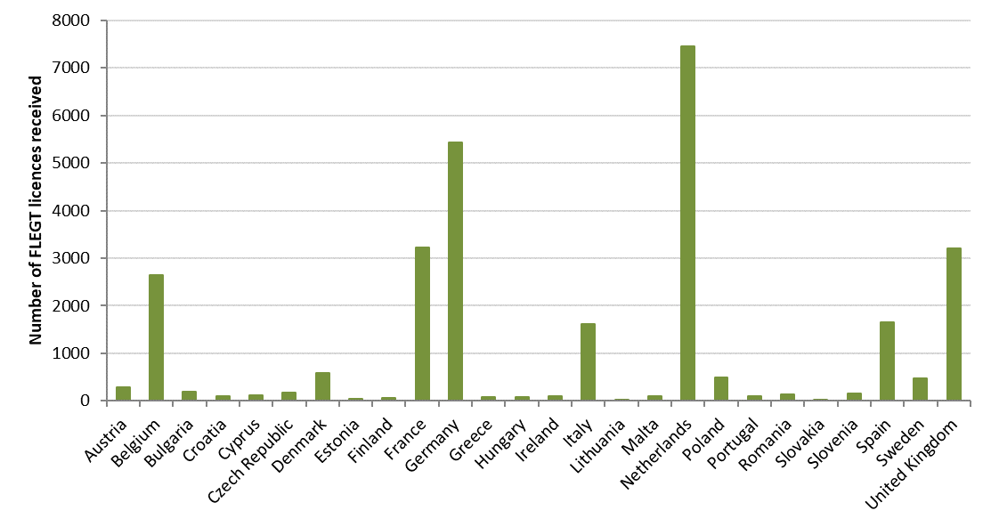

**Figure 1**: Number of FLEGT licences received in 2017.

*Quantities imported*

Over 658 million kg of FLEGT-licensed timber and timber products were reported on validated FLEGT licences in 2017[9],[10]. The main FLEGT-licensed product types imported into the EU by weight included paper products (HS 4802 and 4803), furniture (HS 9403 and 9401), plywood, veneered panels and similar laminated wood (HS 4412), builder’s joinery and carpentry (HS 4418), and continuously shaped wood (HS 4409) (Figure 2). The main importing Member States for these products are shown in Figure 3.

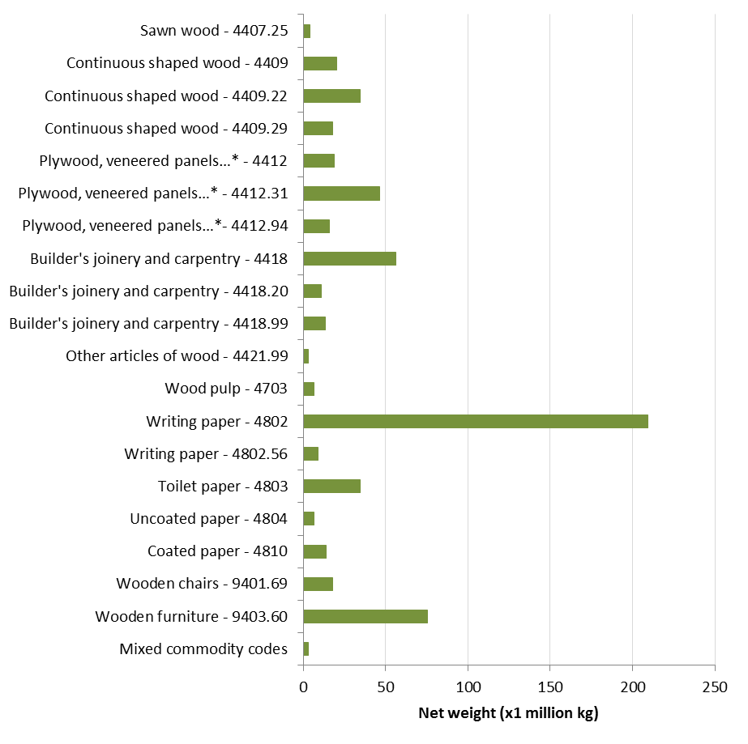

*Plywood, veneered panels and similar laminated wood.

**Figure 2**: Quantities of FLEGT-licensed products reported by HS code** on validated FLEGT licences from Indonesia into the EU in 2017, reported by weight (kg)*** (see Annex A for full description of the HS codes). ** Where possible, HS codes were reconciled to 6 digits; 4-digit HS codes only include trade reported by Member States at the 4 digit level. *** Quantity was reported by weight on 28 331 (>99%) of FLEGT licences, which may not be representative of all trade.

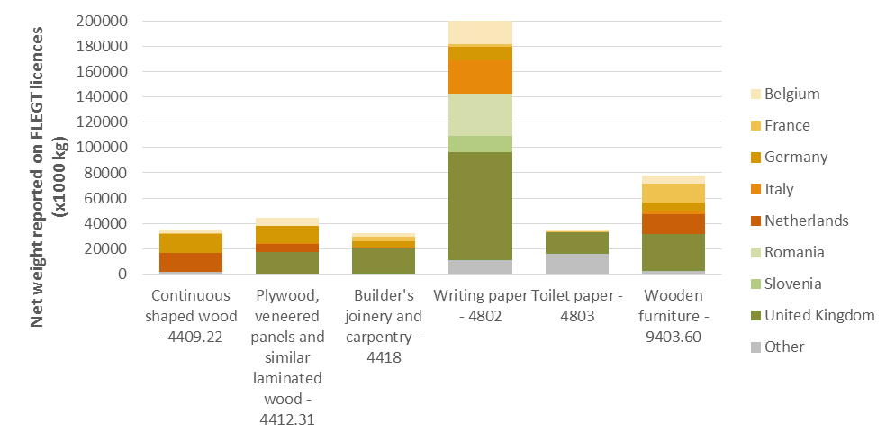

**Figure 3**: Main EU importing Member States for the six main FLEGT-licensed products reported by HS code* on validated FLEGT licences from Indonesia into the EU in 2017, reported by weight (kg) (see Annex A for full description of the HS codes). * Where possible, HS codes were reconciled to 6 digits; 4-digit HS codes only include trade reported by Member States at the 4 digit level.

*Taxa imported*

Information on taxa in trade was provided by 23 of the 26 Member States reporting trade in 2017. Hungary, the Netherlands and the United Kingdom, which together accounted for 311.1 million kg of timber on validated FLEGT licences, did not provide information about the species in trade. In addition to this, over 498,000 kg of timber on validated FLEGT licences was reported without taxa by the other 23 Member States.

In total, 115 different species and 57 higher taxa (e.g. genera) were individually reported on validated FLEGT licences in 2017 (comprising 176.5 million kg), along with a further 170.7 million kg of mixed taxa shipments. Where individual taxa were specified, the most highly traded taxa by weight were *Acacia mangium* (mangium), *Shorea* (meranti) and *Tectona grandis* (teak).

*Processing FLEGT licences*

The FLEGIT/TRACES system[11] was used to process FLEGT licences in 20 Member States, whilst 9 Member States used national systems; Austria reported using both FLEGIT/TRACES and a national system. Member States reported also on the format in which FLEGT licences were submitted; 14 Member States reported receiving FLEGT licences in more than one format. In total, 19 Member States reported the submission of paper licences, 18 reported licences submitted via FLEGIT/TRACES, 3 by national electronic systems and 2 via email.

* 1. **Further verification of FLEGT licences and shipments**

According to Article 5(4) of the FLEGT Regulation, the CAs shall decide on the need for further verification of shipments using a risk-based approach. Provisions are in place in 22 Member States to carry out further verification checks on FLEGT licences, and in 23 Member States to carry out further verification checks on FLEGT shipments (Annex B, Table 1 & 2). A total of 1,144 FLEGT licences had additional verification checks carried out in 2017 (for example by contacting LIU, the Indonesian Licensing Information Unit, for further verification), with checks carried out by 17 Member States. Additionally, the Netherlands reported carrying out additional verification checks daily, but did not record the number of checks in order to limit the administrative burden.

Member States reported using a number of risk criteria to establish whether additional verification of a FLEGT licence or shipment is needed, including in cases of mismatches between the FLEGT licence information and other documentation (Annex B, Table 1 & 2). Nineteen Member States reported using SILK, the Indonesian Timber Legality Information System, to verify the FLEGT licences they received from operators, including 6 Member States who reported ‘sometimes’ using SILK.

A total of 218 physical inspections of FLEGT-licensed shipments were carried out by 12 Member States in 2017, with the shipment matching the details of the FLEGT licence in 94.6% of the cases.

The Commission, in line with Article 3(2) of implementing Regulation (EC) 1024/2008, has provided –and continues to provide when necessary– the Member States with the names and other relevant details of the Licensing Authorities designated by Indonesia, authenticated specimens of stamps and signatures for each Licensing Authority, and specimens of the FLEGT licence template used by Indonesia.

* 1. **Provisions for penalties**

Article 5(8) of the FLEGT Regulation provides that "*each Member State shall determine the penalties to be imposed where the provisions of this Regulation are infringed. Such penalties shall be effective, proportionate and dissuasive*." Eighteen Member States have provisions in place for administrative fines, 16 for criminal fines, 20 to impose imprisonment, 5 to suspend the authority to trade and 8 for notices of remedial action or warning letters. Potential maximum penalties for imprisonment range from 1 month to 15 years (16 Member States reported maximum potential penalties of 1-5 years).

In line with Article 5(7) of the FLEGT Regulation, customs may suspend the release of or detain timber products where they have reason to believe that the licence may not be valid. Twenty-three Member States reported that they may seize timber products, and 21 Member States reported that the disposal of confiscated timber is provided for in their national legislation (Figure 4). Where the disposal of confiscated timber is provided for in national legislation, 10 Member States reported this to be the responsibility of customs, and 5 Member States reported this to be the responsibility of the CA.

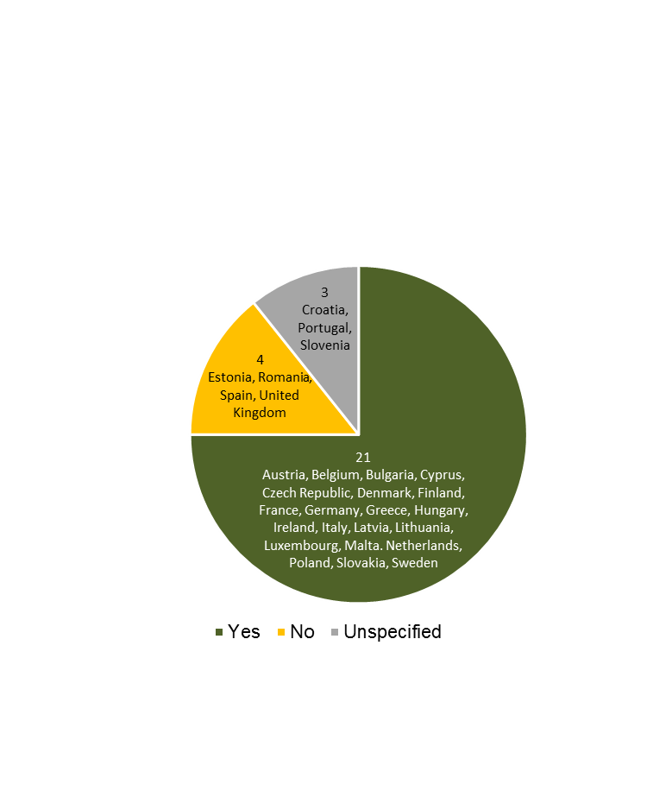 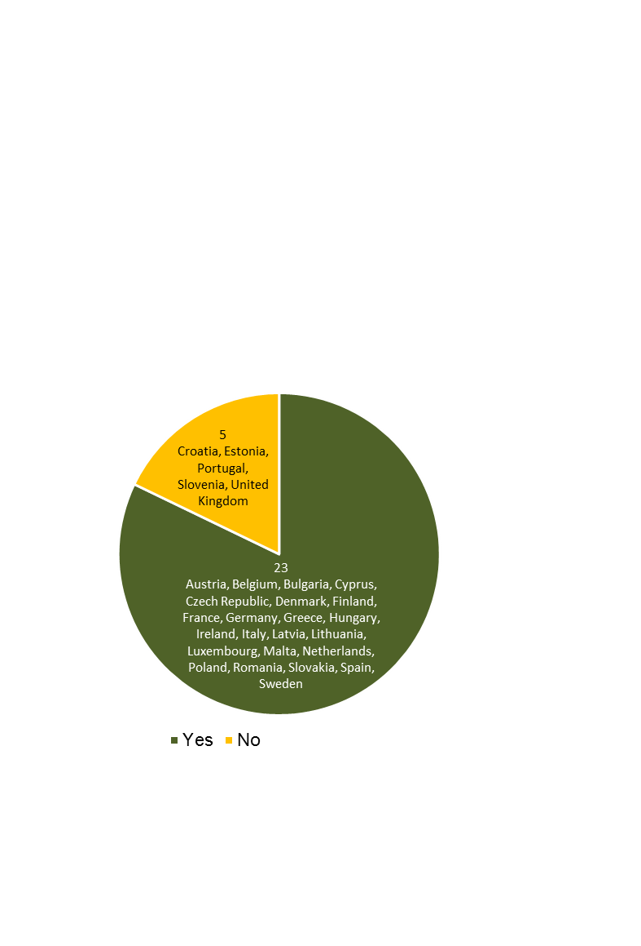

A) B)

**Figure 4:** Member States with (A) penalties that include the seizure or confiscation of timber shipments, (B) provisions for the disposal of confiscated timber established in their national legislation.

* 1. **Penalties applied**

In 2017, 11 Member States reported not having approved[12] a combined total of 107 FLEGT licences, with the largest number not being approved by Italy (63) (Figure 5). Two Member States (Austria and Estonia) applied Article 6(1)[13] to a combined total of 4 cases weighing 4,475 kg in 2017, all of which resulted in administrative penalties. One Member State (Germany) applied Article 6(2)[14], due to an alleged forged licence.

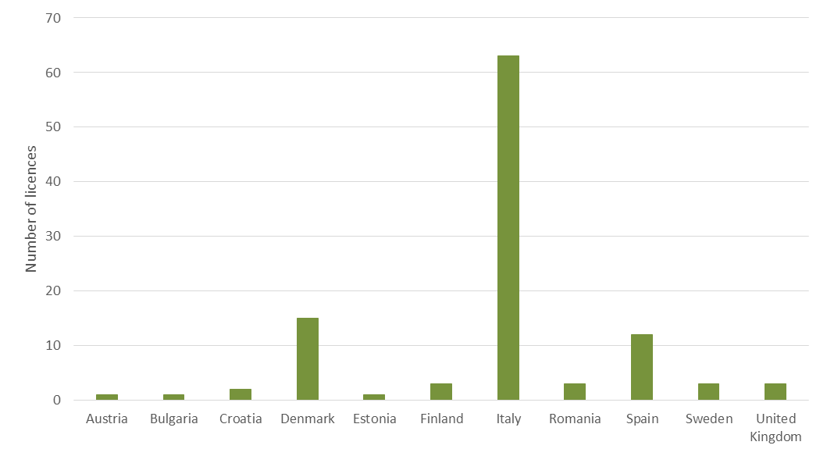

**Figure 5:** Number of FLEGT licences not approved in 2017.

* 1. **Fees for processing FLEGT licences**

Member States may charge fees for the processing of FLEGT licences, as per Article 5(6) of the FLEGT Regulation. Six Member States reported doing so, with fees ranging from around EUR 11 (GBP 9.60) to up to EUR 105.90 (Annex B, Table 3).

**2.7 Other implementing measures**

Twenty-one Member States provided information on other implementing measures and challenges. Ten of these reported collaborating with other CAs and 6 with the European Commission; these collaborations were considered to be positive. Several implementation challenges were raised by one or more Member States, including: the need for more practical guidance on implementing the FLEGT Regulation on the ground (e.g. for customs officers), making FLEGIT more user friendly, and giving CAs greater access to data on SILK. Member States also commented on issues arising from receiving incomplete or damaged FLEGT licences, on issues with mismatching information between FLEGT licences and customs declarations, and on the administrative burden of resolving these issues.

**3. Conclusions**

The second report on the implementation of the FLEGT licensing scheme shows that it has progressed well. In 2017 -the first full year of implementation of FLEGT licensing scheme- 28,826 licences were received, of which over 98% (accounting for over 658 million kg of timber and timber products) were approved. Positive collaboration has been reported between CAs and with the Commission. The number of Member States charging fees for processing FLEGT licenses increased, with a smaller range of fees compared to the one previously reported.

Some challenges still remain, including mismatching information between FLEGT licences and customs declarations, and restricted access of Member States to data on SILK.

**4. Next Steps**

The Commission will continue to work in cooperation with Member States on the effective and consistent application of the FLEGT Regulation across the EU, including by developing additional guidance documents and on revising the *Customs and FLEGT Implementation Guidelines,* where necessary,in the light of the experience to date. The Commission will also continue to work in cooperation with Member States on the improvement of reporting, including the consistent reporting of data on FLEGT licences and customs declarations, the consistent use of measurement units and the further improvement of the reporting format, taking into account the experience gained. Furthermore, the Commission will encourage Member States that do not currently use FLEGIT/TRACES to do so, as it will -inter alia- facilitate reporting. Finally, the Commission will continue to work on the further improvement of the FLEGIT/TRACES IT system, taking into account the experience and suggestions by Member States and cooperate on data exchange with Member States that have developed their own national electronic systems.

In parallel, the Commission will continue to work closely with the Indonesian authorities to address the issues and challenges identified above, as part of the broader discussions on the implementation of the EU-Indonesia FLEGT VPA and monitoring of its impacts. The Commission has also launched pilot work with Indonesia on the integration of the respective IT systems, i.e. FLEGIT/TRACES, with SILK, towards a fully electronic-based licensing system in the future.

**Annex A**

**Harmonised System (HS) codes of FLEGT products imported in 2017**

| HS code | Details |
| --- | --- |
| 4407 | Wood sawn or chipped lengthwise, sliced or peeled, planed, sanded or end-jointed, of a thickness exceeding 6 mm. |
| 4407.25 | Wood, tropical; dark red meranti, light red meranti and meranti bakau, sawn or chipped lengthwise, sliced or peeled, whether or not planed, sanded or end-jointed, thicker than 6mm |
| 4409 | Wood (including strips and friezes for parquet flooring, not assembled) continuously shaped (tongued, grooved, rebated, chamfered, V-jointed, beaded, moulded, rounded or the like) along any of its edges, ends or faces, whether or not planed, sanded or end-jointed. |
| 4409.22 | Wood; tropical (including unassembled strips and friezes for parquet flooring), continuously shaped along any edges, ends or faces, whether or not planed, sanded or end-jointed |
| 4409.29 | Wood (including strips and friezes for parquet flooring, not assembled) continuously shaped (tongued, grooved, rebated, chamfered, V jointed, beaded, moulded, rounded or the like) along any of its edges, ends or faces, whether or not planed, sanded or end jointed, non-coniferous (not from rattan) |
| 4412 | Plywood, veneered panels and similar laminated wood |
| 4412.31 | Plywood; consisting only of sheets of wood (not bamboo), each ply 6mm or thinner, with at least one outer ply of tropical wood |
| 4412.94 | Blockboard, laminboard and battenboard (not bamboo, and other than plywood consisting only of sheets of wood each ply 6mm or thinner) |
| 4414 | Wooden frames for paintings, photographs, mirrors or similar objects (not from bamboo nor rattan) |
| 4418 | Builders' joinery and carpentry of wood, including cellular wood panels, assembled flooring panels, shingles and shakes |
| 4418.20 | Wood; doors and their frames and thresholds |
| 4418.99 | Wood; builders' joinery and carpentry of wood n.e.c. in heading no. 4418, other than of bamboo |
| 4421 | Wooden articles n.e.c. in heading no. 4414 to 4420 |
| 4421.99 | Wood; not of bamboo, articles n.e.c. in heading no. 4414 to 4420 (excluding clothes hangers) |
| 4703 | Chemical wood pulp, soda or sulphate, other than dissolving grades |
| 4802 | Uncoated paper and paperboard, of a kind used for writing, printing or other graphic purposes, and punch card stock and punch tape paper, in rolls or sheets, other than paper of heading No 4801 or 4803 ; handmade paper and paperboard : |
| 4802.56 | Uncoated paper and paperboard (not 4801 or 4803); printing, writing or graphic, 10% or less by weight of mechanical or chemi-mechanical processed fibre, weight 40-150g/m2, in sheets 435mm or less by 297mm or less (unfolded) |
| 4803 | Tissue, towel, napkin stock or similar; for household or sanitary uses, cellulose wadding, webs of cellulose fibres, in rolls over 36cm in width or rectangular sheets with one side exceeding 36cm when unfolded |
| 4804 | Uncoated kraft paper and paperboard, in rolls or sheets, other than that of heading no. 4802 or 4803 |
| 4810 | Paper and paperboard, coated on one or both sides with kaolin (China clay) or other inorganic substances, with or without binder, and with no other coating, whether or not surface-coloured, surface-decorated or printed, in rolls or rectangular (including square) sheets, of any size (not from non-wooden nor recycled material) |
| 4821 | Paper or paperboard labels of all kinds, whether or not printed |
| 9401 | Seats (other than those of heading 94.02), whether or not convertible into beds, and parts thereof |
| 9401.69 | Seats; with wooden frames, not upholstered, (excluding medical, surgical, dental, veterinary or barber furniture) |
| 9403 | Other furniture and parts thereof |
| 9403.60 | Furniture; wooden, other than for office, kitchen or bedroom use |

**Annex B**

**Table 1: Criteria used to determine whether additional verification of a FLEGT licence was required, where reported by Member States.**

|  |  |  |  |  |  |  |  |  |
| --- | --- | --- | --- | --- | --- | --- | --- | --- |
| Country | Agency carrying out checks* | Species | Operator | Volume/ weight of shipment | HS codes | Country of origin | Mismatch of document information | Other issues** |
| Austria | CA | ✓ |  | ✓ | ✓ |  | ✓ |  |
| Belgium | CA & C |  |  |  |  |  | ✓ |  |
| Bulgaria | CA |  | ✓ | ✓ | ✓ |  | ✓ |  |
| Cyprus | CA |  |  |  |  |  | ✓ | Unspecified |
| Czech Republic | CA & C | ✓ |  |  | ✓ |  | ✓ | Unspecified |
| Denmark | CA |  |  |  | ✓ |  | ✓ | Unspecified |
| Estonia | C | ✓ |  | ✓ | ✓ | ✓ | ✓ | e.g. only copy of FLEGT licence is provided |
| Finland | CA | ✓ |  | ✓ | ✓ |  | ✓ | Licence not existing in SILK-database, stamp and/ or signature missing, licence is not printed on an official paper |
| Germany | CA | ✓ | ✓ | ✓ | ✓ | ✓ | ✓ | Compare against SILK licence information |
| Hungary | CA |  |  | ✓ | ✓ |  | ✓ | Unspecified |
| Ireland | CA |  |  |  |  |  | ✓ | Comparison against licence information on SILK |
| Italy | CA & C |  |  | ✓ | ✓ |  | ✓ |  |
| Latvia | CA |  |  |  | ✓ |  | ✓ | CA checks legality of licences in Indonesian Timber legality information system |
| Lithuania | C | ✓ |  | ✓ |  |  | ✓ | Unspecified |
| Malta | CA & C |  |  |  |  |  | ✓ | Unspecified |
| Netherlands | CA |  |  | ✓ |  |  | ✓ | Unspecified |
| Poland | CA |  |  | ✓ | ✓ |  |  | Doubts related to the authenticity of the signature on the FLEGT licence |
| Slovakia | CA | ✓ | ✓ | ✓ | ✓ | ✓ | ✓ |  |
| Slovenia | CA & C |  |  |  |  |  | ✓ | Unspecified |
| Spain | CA |  |  |  |  |  |  | [When the licence does not exist or does not coincide with SILK or when it is expired] |
| Sweden | CA & Other (LIU) | ✓ | ✓ |  | ✓ | ✓ |  | The licence has no signature, stamps, other mandatory information; the signature is missing in SILK or no longer valid; the licence is no longer valid. |
| United Kingdom | CA |  | ✓ | ✓ | ✓ |  | ✓ | Mismatch in United Kingdom and Indonesian Trade Tariff codes |

* CA = Competent Authority; C = customs.

** Text in square brackets ‘[ ]’ has been translated or summarised from comments provided by the Member States.

**Table 2: Criteria used to determine whether additional verification of a FLEGT licensed shipment was required, where reported by Member States.**

| Country | Agency carrying out checks* | Species | Operator | Volume/weight of shipment | HS codes | Country of origin | Mismatch of document information | Other issues with FLEGT licence | Random spot checks | Other issues |
| --- | --- | --- | --- | --- | --- | --- | --- | --- | --- | --- |
| Austria | CA & C | ✓ |  | ✓ | ✓ |  | ✓ |  | ✓ |  |
| Belgium | C & Other ** |  |  |  |  |  |  |  | ✓ | ✓ |
| Bulgaria | C & Other (Executive Forestry Agency) |  |  | ✓ | ✓ |  | ✓ | ✓ | ✓ | ✓ |
| Croatia | C |  |  |  |  |  | ✓ |  |  |  |
| Cyprus | CA & Other (unspecified) |  |  |  |  |  |  | ✓ |  | ✓ |
| Czech Republic | CA & C | ✓ |  |  | ✓ |  | ✓ | ✓ |  |  |
| Denmark | CA & C & Other (unspecified) | ✓ |  |  |  | ✓ | ✓ | ✓ | ✓ | ✓ |
| Estonia | C & Other (unspecified) | ✓ |  |  | ✓ |  | ✓ | ✓ | ✓ | ✓ |
| Finland | CA & C | ✓ |  | ✓ | ✓ |  | ✓ |  | ✓ |  |
| France | C & Other (unspecified) |  |  |  |  |  | ✓ | ✓ | ✓ |  |
| Germany | CA & C | ✓ | ✓ | ✓ | ✓ | ✓ | ✓ | ✓ | ✓ |  |
| Ireland | CA |  |  |  |  |  | ✓ | ✓ | ✓ |  |
| Italy | CA & C |  |  | ✓ | ✓ |  | ✓ |  |  |  |
| Lithuania | C & Other (unspecified) |  |  |  |  |  | ✓ | ✓ | ✓ | ✓ |
| Malta | CA & C & Other (unspecified) |  |  |  |  |  | ✓ | ✓ | ✓ | ✓ |
| Netherlands | C & Other (unspecified) | ✓ |  | ✓ | ✓ | ✓ |  | ✓ | ✓ | ✓ |
| Poland | C & Other (unspecified) | ✓ |  | ✓ | ✓ |  | ✓ | ✓ |  | ✓ |
| Romania | CA & C & Other (unspecified) |  |  | ✓ |  |  |  | ✓ |  | ✓ |
| Slovakia | CA & C | ✓ | ✓ | ✓ | ✓ | ✓ | ✓ |  |  |  |
| Slovenia | CA & C & Other (Financial Administration) |  |  |  |  |  | ✓ | ✓ |  | ✓ |
| Spain | CA & C |  |  | *** |  |  |  |  |  | ✓ |
| Sweden | C |  |  |  | ✓ |  | ✓ | ✓ |  |  |
| United Kingdom | C & Other (Border Force) |  |  |  | ✓ |  | ✓ | ✓ | ✓ | ✓ |

* CA=Competent Authority; C=customs.

** Belgian CA is planning to do additional risk based checks (species, volume, HS codes, country of origin) in collaboration with customs.

*** Spain: customs check that the weight of shipments do not exceed 10% of the weight indicated on the licence.

**Table 3: Approximate levels of fees and basis of calculation for those Member States charging importers for the processing of FLEGT licences**

|  |  |  |
| --- | --- | --- |
| Country | Level of fee [converted] | Basis for fee calculation |
| Austria | EUR 105.90 | Fees were calculated based on - the number of imports from the beginning of 2015 to the end of May 2016 - estimated time needed to check a licence in the office - estimated duration and costs (working time, travelling costs) of physical checks |
| Belgium | EUR 50 (only for shipments >500kg) | Legal basis for fee |
| Finland | EUR 70 | Legal basis for fee; based on average staff time spent processing a FLEGT licence |
| Greece | EUR 100 | Legal basis for fee |
| Italy | EUR 50 | Based on average staff time spent processing a FLEGT licence |
| United Kingdom | GBP 9.60 [EUR 11.26] | Legal basis for fee; based on average staff time spent processing a FLEGT licence |

1. OJ L 347, 30.12.2005, p.1.
2. COM/2003/0251 final
3. OJ L 277, 18.10.2008, p.23.
4. The first report covered the period 15 November-31 December 2016, COM/(2018/)448 final
5. <http://ec.europa.eu/environment/forests/flegt.htm>
6. i.e. the number of licences lodged with the CA
7. i.e. acting in accordance with national legislation in cases of shipments not covered by a FLEGT licence
8. See <http://ec.europa.eu/environment/forests/pdf/list_competent_authorities_flegt.pdf>
9. Over 99% (28 331) of validated FLEGT licences reported the weight of the commodity in trade; in the 136 instances where weight was not reported, a further 443 m3 and 801 913 items were reported.

   To prevent double-counting, where quantity was reported in more than one metric, the weight was taken preferentially over the volume or number of items because it was the most frequently reported metric. Where weight was not reported, volume was taken preferentially over the number of items.
10. This report only includes data from FLEGT licences. Although Member States reported data from customs declarations, these were not always directly comparable with the data on FLEGT licences, due to the use of different units of measure.
11. FLEGIT/TRACES is a web application - a component of the TRACES NT system (TRAde Control and Expert System, New Technology) - and can be used by EU importers and their agents, the Member States’ FLEGT Competent Authorities and the EU customs for the electronic verification and management of FLEGT Licences in a quick and secure way.
12. This may include FLEGT licences that were rejected and those that were ignored (e.g. cases where a FLEGT licence was submitted for timber products not covered by the VPA with Indonesia).
13. Article 6(1) states that, if Competent Authorities establish that a shipment is not covered by a FLEGT license and its import is thus prohibited, they shall act in accordance with their national legislation in force.
14. Article 6(2): Member States shall notify the Commission of any information suggesting that the provisions of this Regulation are being, or have been, circumvented.